ONTARIO regulation 17/03
made under the
Commodity Futures Act
Made: November 13, 2002
Approved: January 10, 2003
Filed: February 5, 2003
Printed in The Ontario Gazette: February 22, 2003
Amending Reg. 90 of R.R.O. 1990
(General)
1. The heading before section 39 and section 39 of Regulation 90 of the Revised Regulations of Ontario, 1990 are revoked.
2. Section 43 of the Regulation is revoked and the following substituted:
43. Upon receipt and review of a notice to the Director under Ontario Securities Commission Rule 33-506 (Commodity Futures Act) Registration Information, the Director may require an application for amendment of registration prepared in accordance with Form 12 or 13.
3. (1) Subsection 3 (1) of Schedule 1 to the Regulation is amended by striking out “Form 7 (or a letter in lieu thereof)” and substituting “Form 33-506F2 or 33-506F4 (made under Ontario Securities Commission Rule 33-506 (Commodity Futures Act) Registration Information)”.
(2) Subsection 3 (2) of Schedule 1 to the Regulation is amended by striking out “Form 7 (or a letter in lieu thereof)” and substituting “Form 33-506F4 (made under Ontario Securities Commission Rule 33-506 (Commodity Futures Act) Registration Information)”.
(3) Subsection 4 (1) of Schedule 1 to the Regulation is amended by striking out “Form 7 (or a letter in lieu thereof)” and substituting “Form 33-506F2 or 33-506F4 (made under Ontario Securities Commission Rule 33-506 (Commodity Futures Act) Registration Information)”.
(4) Subsection 4 (2) of Schedule 1 to the Regulation is amended by striking out the portion before clause (b) and substituting the following:
(2) No fee is payable under subsection (1) if the application in Form 33-506F2 or 33-506F4 (made under Ontario Securities Commission Rule 33-506 (Commodity Futures Act) Registration Information) is,
(a) filed as part of an application in Form 5; or
. . . . .
(5) Subsection 6 (1) of Schedule 1 to the Regulation is amended by striking out the portion before clause (b) and substituting the following:
(1) Subject to subsection (2), an application for registration as a representative, partner or officer of an adviser in Form 33-506F2 or 33-506F4 (made under Ontario Securities Commission Rule 33-506 (Commodity Futures Act) Registration Information) shall be accompanied by a fee of,
(a) $125, if the applicant is registered or applying to be registered under the Securities Act as a representative, partner or officer of the advisor; or
. . . . .
(6) Subsection 6 (2) of Schedule 1 to the Regulation is amended by striking out the portion before clause (b) and substituting the following:
(2) No fee is payable under subsection (1) if the application in Form 33-506F2 or 33-506F4 (made under Ontario Securities Commission Rule 33-506 (Commodity Futures Act) Registration Information) is,
(a) filed as part of an application in Form 5; or
. . . . .
(7) Subsections 8 (1), (2) and (3) of Schedule 1 to the Regulation are revoked and the following substituted:
(1) An applicant for renewal of registration as a dealer or adviser shall pay the fee calculated under section 2 or 5, as applicable, on or before December 31 in each year.
(2) The calculation under section 2 or 5 of the fee payable by an applicant for renewal of registration shall be based on,
(a) the number of branch and sub-branch offices on December 31 of the current year, as shown in the records of the Commission;
(b) the representatives, floor traders, salespersons, partners and officers on December 31 of the current year, as shown in the records of the Commission; and
(c) the information contained in the audited consolidated financial statements or Joint Regulatory Financial Questionnaire and Report filed most recently before December 31 of the current year.
(8) Sections 13, 14 and 15 of Schedule 1 to the Regulation are revoked and the following substituted:
13. A notice submitted by a dealer or adviser under Rule 33-506 (Commodity Futures Act) Registration Information shall be accompanied by a fee of $125 for each of the following changes:
1. A change in the address for service of the dealer or adviser.
2. A change in the head office address of the dealer or adviser.
3. A change in the name of the dealer or adviser.
4. A change in a category of registration of the dealer or adviser.
5. A change in the auditor of the dealer or adviser.
6. A change in the financial year end of the dealer or adviser.
7. A change in the officers, directors or partners of the dealer or adviser.
8. A change in the holders of the voting securities of the dealer or adviser.
9. The opening of a business location, other than a new head office, and any change to business location information submitted on Form 33-506F3 (made under Ontario Securities Commission Rule 33-506 (Commodity Futures Act) Registration Information).
14. Upon an amalgamation or merger of two or more registrants, the successor registrant shall pay a fee of $125 in respect of each change referred to in section 13 that occurs to each predecessor registrant as a result of the amalgamation or merger.
4. Form 5 of the Regulation is revoked and the following substituted:
Form 5
Commodity Futures Act
Application for registration as futures commission merchant
introducing broker or advisor
Insert regs\Graphics\Source Law\2003\17\170005ae.tif
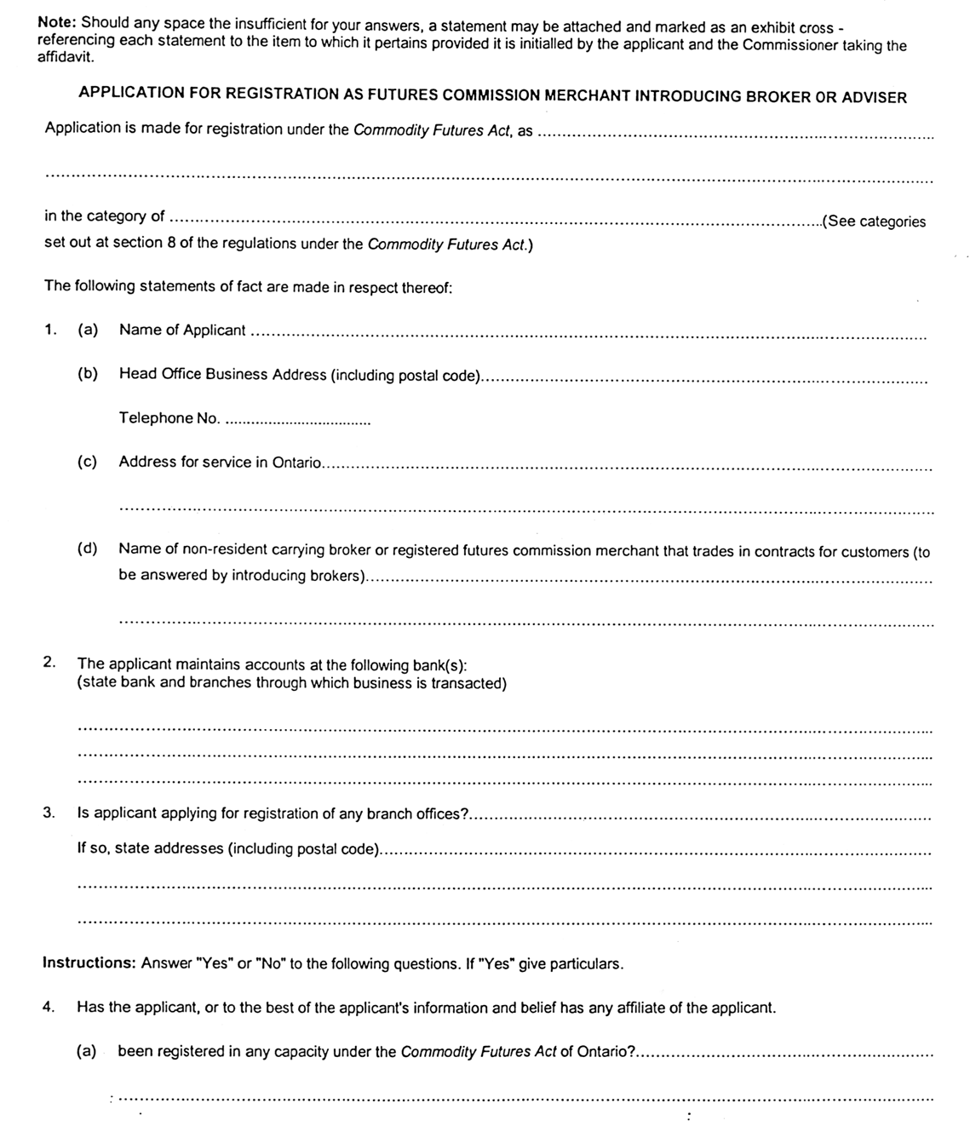
Insert regs\Graphics\Source Law\2003\17\170005be.tif
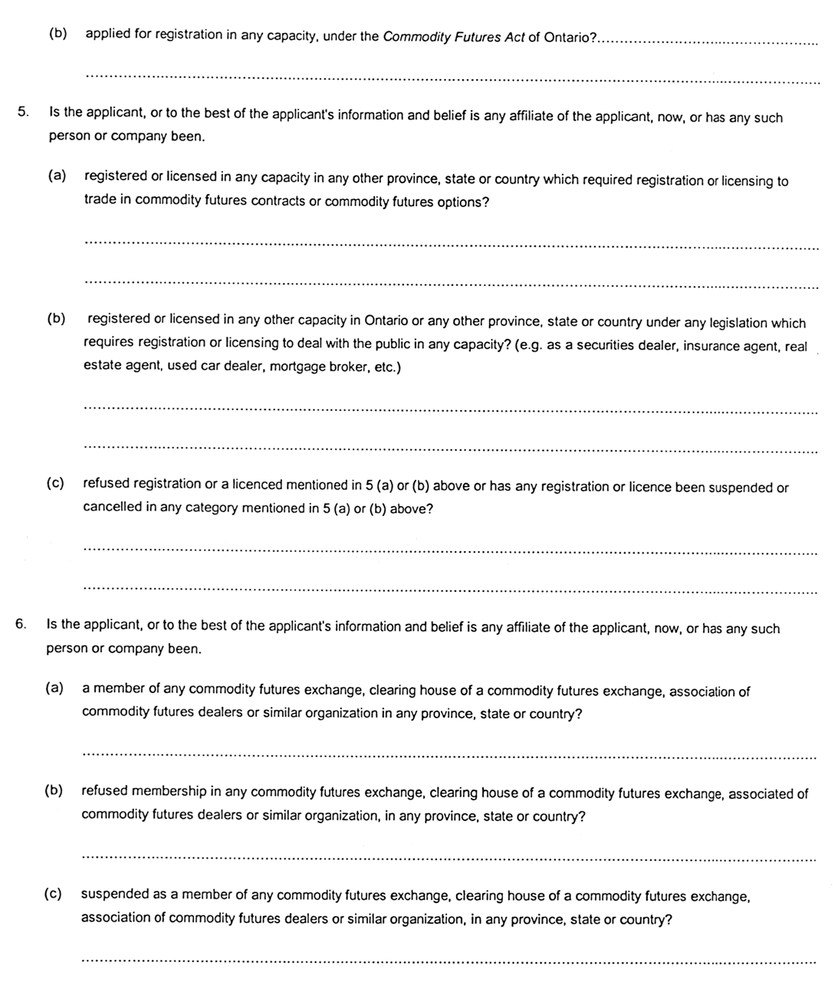
Insert regs\Graphics\Source Law\2003\17\170005ce.tif
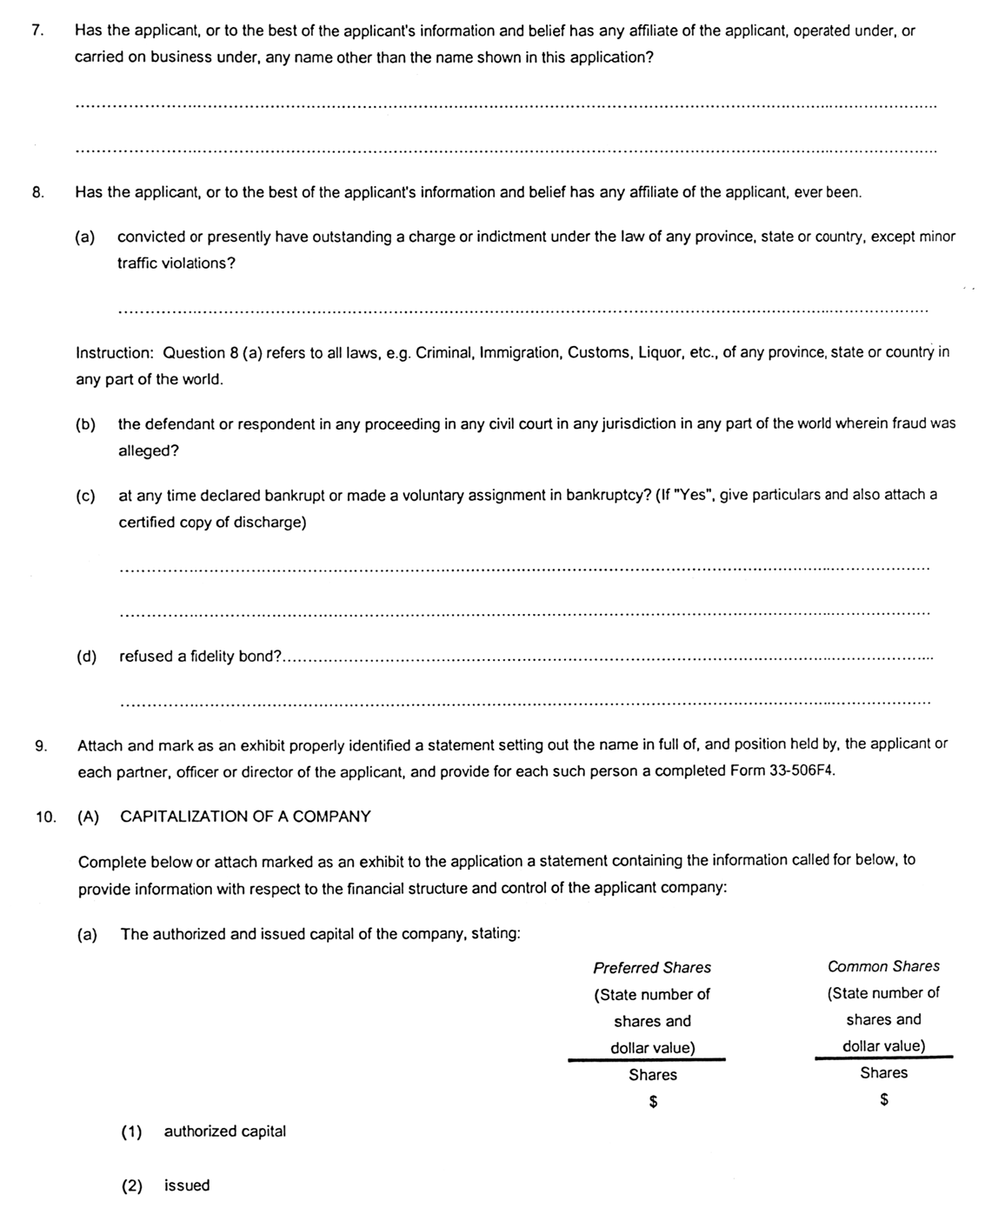
Insert regs\Graphics\Source Law\2003\17\170005de.tif
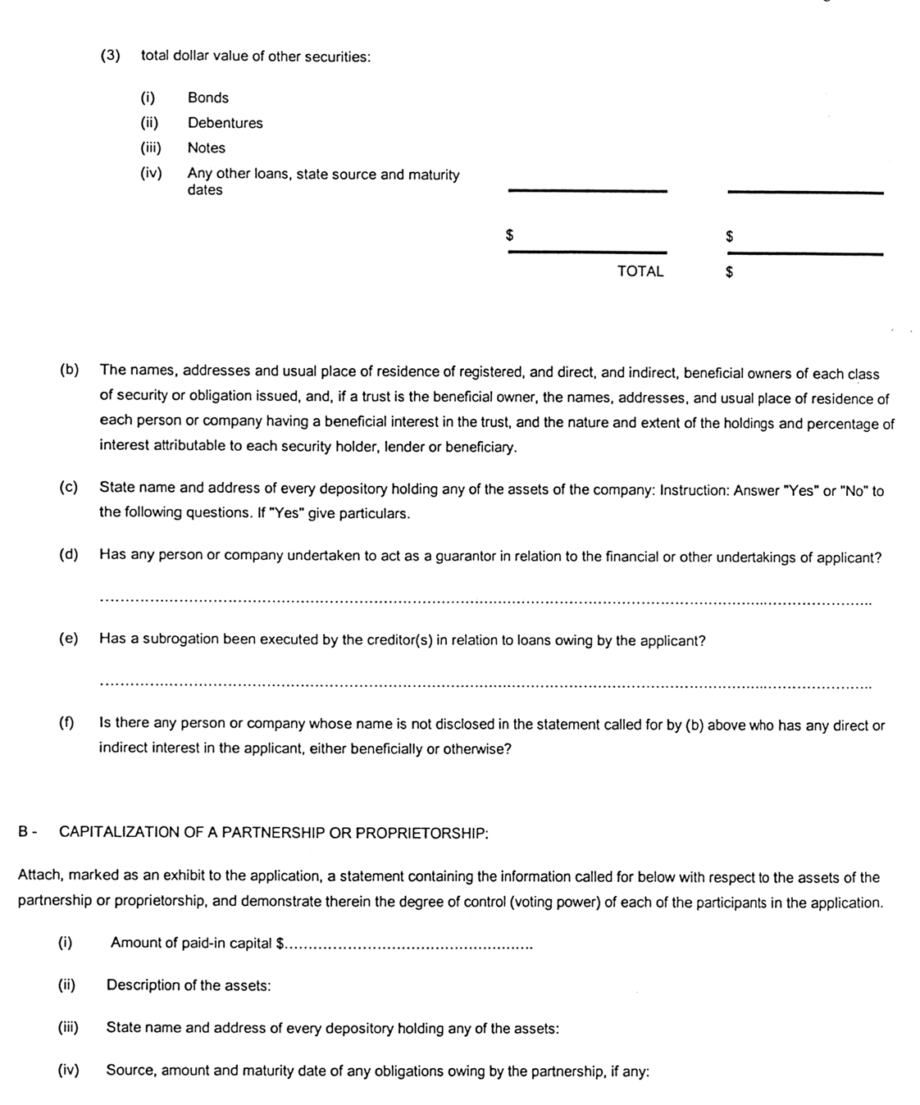
Insert regs\Graphics\Source Law\2003\17\170005ee.tif
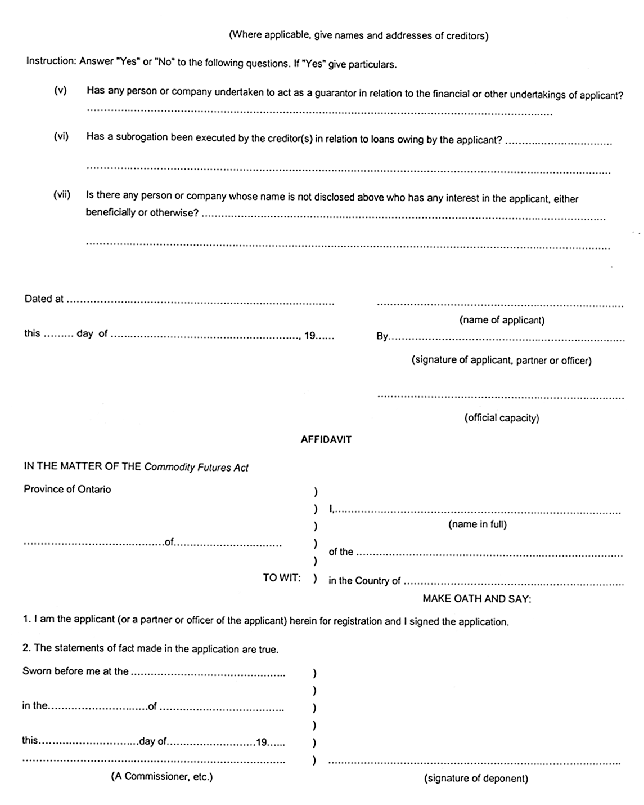
5. Forms 7 and 8 of the Regulation are revoked.
6. This Regulation comes into force on the day that the rule made by the Ontario Securities Commission on November 12, 2002 entitled “Ontario Securities Commission Rule 33-506 (Commodity Futures Act) Registration Information” comes into force.
Ontario Securities Commission:
Howard Wetston
Vice Chair
David A. Brown
Chair
Dated on November 13, 2002.
Note: The rule made by the Ontario Securities Commission on November 12, 2002 entitled “Ontario Securities Commission Rule 33-506 (Commodity Futures Act) Registration Information” comes into force on February 21, 2003.

Back to top

