Highway Traffic Act
Code de la route
ONTARIO REGULATION 393/02
Definitions and requirements under section 142.1 of the act (yielding right of way to buses)
Consolidation Period: From April 27, 2015 to the e-Laws currency date.
Last amendment: 87/15.
Legislative History: 87/15.
This Regulation is made in English only.
Definitions
1. (1) For the purposes of section 142.1 of the Act,
“bus” means a bus that,
(a) is used for the transportation of passengers or passengers and express freight for compensation,
(b) is at least 25 feet long and 8 feet wide, and
(c) has a sign affixed as close as possible to its rear left turn signal light that has the dimensions and bears the markings as illustrated in the following Figure:
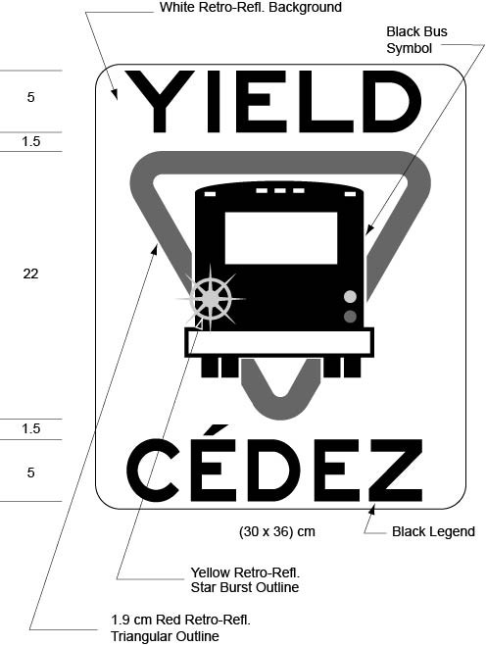
“bus bay” means that portion of the highway beside a bus stop sign that is used by buses for the boarding and alighting of passengers, the use of which portion of the highway requires buses to exit from and subsequently re-enter an adjacent lane of traffic. O. Reg. 393/02, s. 1 (1); O. Reg. 87/15, s. 1.
(2) The dimensions of the sign referred to in clause (c) of the definition of “bus” in subsection (1) may be greater than the dimensions prescribed and illustrated in the Figure to that definition so long as each dimension is increased and, when increased, has the same relation to the other dimensions of the sign as the dimensions prescribed and illustrated in that Figure have to each other. O. Reg. 393/02, s. 1 (2).
Signalling intention to re-enter traffic
2. The driver of a bus shall indicate his or her intention to re-enter the lane of traffic adjacent to a bus bay,
(a) by the use of a mechanical or electrical signal device as described in subsection 142 (6) of the Act; or
(b) by means of the hand and arm in accordance with subsection 142 (4) of the Act. O. Reg. 393/02, s. 2.
3. Omitted (provides for coming into force of provisions of this Regulation). O. Reg. 393/02, s. 3.

Back to top

