Highway Traffic Act
Code de la route
ONTARIO REGULATION 620/05
High OccupanCy Vehicle Lanes
Historical version for the period July 28, 2015 to August 18, 2015.
Last amendment: O. Reg. 101/15.
This Regulation is made in English only.
CONTENTS
1. | Designation of high occupancy vehicle lanes
2. | Use of high occupancy vehicle lanes
3. | Buffer zones
4. | Roadway markings
5. | Signs
6. | Definition — “Games period”
7. | Use of high occupancy vehicle lanes during the Games period
8. | Entry and exit lane markings on temporary high occupancy vehicle lanes during the Games period
9. | Roadway markings on temporary high occupancy vehicle lanes during the Games period
10. | Signs on affected high occupancy vehicle lanes during the Games period
Schedule A | Highway no. 404
Schedule B | Highway no. 403
Schedule C | Highway no. 417
Schedule D | Queen elizabeth way and highway no. 403
Schedule E | Queen elizabeth way
Schedule F | Highway no. 401
Schedule G | Highway no. 427

Designation of high occupancy vehicle lanes
1. The left lane of the part of the King’s Highway described in a schedule to this Regulation is designated as a high occupancy vehicle lane for the hours, days and months specified in the schedule. O. Reg. 620/05, s. 1.
Use of high occupancy vehicle lanes
2. No person shall operate a motor vehicle or a commercial motor vehicle in a high occupancy vehicle lane unless one of the following circumstances exists:
1. In the case of a motor vehicle, the vehicle has at least two persons occupying seating positions.
2. In the case of a commercial motor vehicle,
i. the vehicle has at least two persons occupying seating positions, and
ii. the length of the vehicle or the total length of the vehicle and any vehicle being towed is less than 6.5 metres.
3. The vehicle is a bus.
4. The person is operating an emergency vehicle, as defined in section 144 of the Act, in the performance of his or her duties.
5. The person is operating the vehicle in the lawful performance of his or her duties as a police officer.
6. The person is operating a vehicle owned or leased by the Province of Ontario in the lawful performance of his or her duties as an officer appointed for carrying out the provisions of the Act.
7. The person is operating a vehicle engaged in road construction or maintenance activities in or near the high occupancy vehicle lane.
8. The person is operating a tow truck that has been requested to provide towing or repair services to a disabled vehicle in or near a high occupancy vehicle lane by a police officer, an officer appointed for carrying out the provisions of the Act, or a person driving the disabled vehicle, and operating the tow truck in the high occupancy vehicle lane is necessary to attend at and depart from the location of the disabled vehicle. O. Reg. 620/05, s. 2.
9. The person is operating a motor vehicle to which are attached valid number plates that,
i. are issued by the Ministry,
ii. have green lettering on a white background, and
iii. display the words “GREEN VEHICLE” or “VÉHICULE ÉCOLOGIQUE”.
Note: On July 1, 2016, paragraph 9 is revoked. See: O. Reg. 236/10, ss. 2, 3; O. Reg. 99/15, s. 6.
10. The vehicle is a taxicab or limousine that,
i. is being operated by a person who has a valid licence, permit or authorization issued by a municipality or airport authority to operate the vehicle for the purpose of providing passenger transportation services, and
ii. has mounted on the rear of the vehicle a valid plate bearing an identification number issued by the municipality or airport authority for the use of the vehicle for that purpose. O. Reg. 620/05, s. 2; O. Reg. 236/10, s. 1; O Reg. 177/12, s. 1 (1).
Note: On July 1, 2016, paragraph 10 is revoked. See: O. Reg. 177/12, ss. 1 (2), 2 (2); O. Reg. 99/15, s. 7.
Buffer zones
3. (1) Entry and exit points at which vehicles may enter or exit high occupancy vehicle lanes are located between buffer zones, illustrated in Figure A in section 4. O. Reg. 620/05, s. 3 (1).
(2) No person shall operate a motor vehicle or commercial motor vehicle to enter or exit a high occupancy vehicle lane by crossing a buffer zone, unless the movement can be made safely and one of the following circumstances exists:
1. The person is directed to make the movement by,
i. a police officer, or
ii. a traffic control person, where construction or maintenance work is being carried out adjacent to the high occupancy vehicle lane.
Note: On August 19, 2015, paragraph 1 is revoked and the following substituted: (See: O. Reg. 99/15, s. 1 (2))
1. The person is directed to make the movement by a police officer.
2. The person is operating an emergency vehicle, as defined in section 144 of the Act, in the performance of his or her duties.
3. The person is operating the vehicle in the lawful performance of his or her duties as a police officer.
4. The person is operating a vehicle owned or leased by the Province of Ontario in the lawful performance of his or her duties as an officer appointed for carrying out the provisions of the Act.
5. The person is operating a vehicle engaged in road construction or maintenance activities in or near the high occupancy vehicle lane.
6. The person is operating a tow truck that has been requested to provide towing or repair services to a disabled vehicle in or near a high occupancy vehicle lane by a police officer, an officer appointed for carrying out the provisions of the Act, or a person driving the disabled vehicle, and crossing the buffer zone is necessary to attend at and depart from the location of the disabled vehicle.
7. The person is complying with the requirements of section 159 of the Act. O. Reg. 620/05, s. 3 (2); O. Reg. 99/15, s. 1 (1, 3).
(3) Subsection 148 (2) of the Act does not apply to a person operating a vehicle in a high occupancy vehicle lane. O. Reg. 620/05, s. 3 (3).
(4) In this section,
“construction or maintenance work” and “traffic control person” have the same meanings as in subsection 146.1 (7) of the Act. O. Reg. 99/15, s. 1 (4).
Note: On August 19, 2015, subsection (4) is revoked. (See: O. Reg. 99/15, s. 1 (5))
Roadway markings
4. A high occupancy vehicle lane shall have the following roadway markings, as illustrated in Figure A:
1. Painted white diamond markings on the surface of the roadway of the high occupancy vehicle lane, placed periodically along the length of the lane.
2. Painted white buffer zone markings on the surface of the roadway separating high occupancy vehicle lanes from other highway lanes.
3. Painted white continuity lane markings on the surface of the roadway between buffer zones indicating points at which vehicles may enter or exit a high occupancy vehicle lane.
figure a
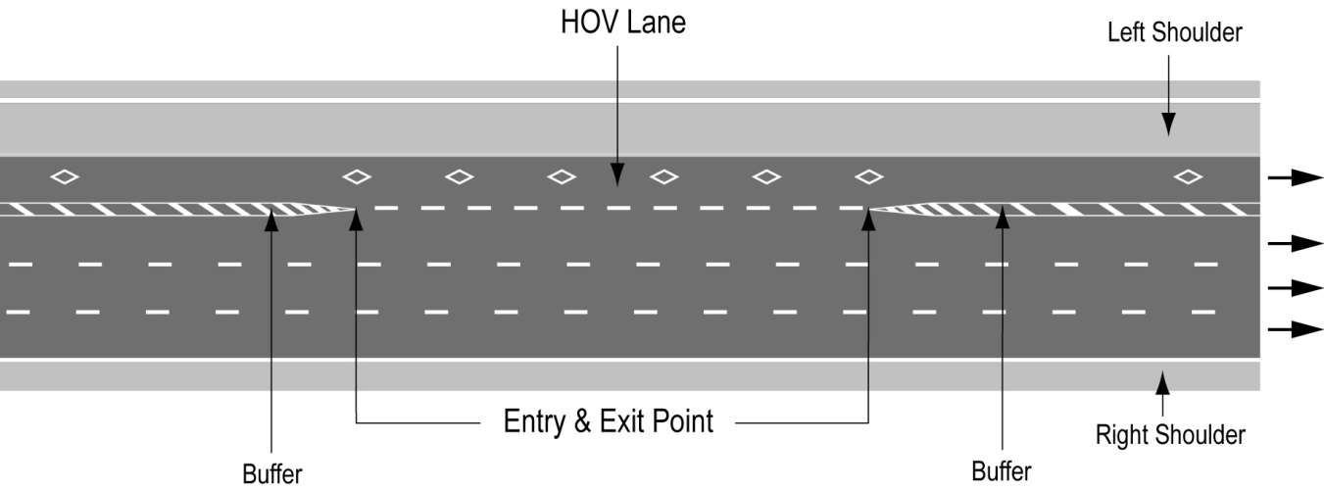
Text alternative: Illustration of “Figure A” showing an overhead plan of a divided highway with the high occupancy vehicle lane as the leftmost lane on a highway. The lane has white diamond markings on the roadway and broken white lines indicating the entry and exit points. Diagonal lines painted between solid lines before and after the entry and exit points indicate the buffer between the high occupancy vehicle lane and the lane beside it. The left shoulder is indicated to the left of the high occupancy vehicle lane. This text alternative is provided for convenience only and does not form part of the official law.
O. Reg. 620/05, s. 4; O. Reg. 89/15, s. 1.
Signs
5. (1) The commencement of a high occupancy vehicle lane shall be indicated by an overhead sign that has the dimensions and bears the markings as illustrated in Figure B.
figure b
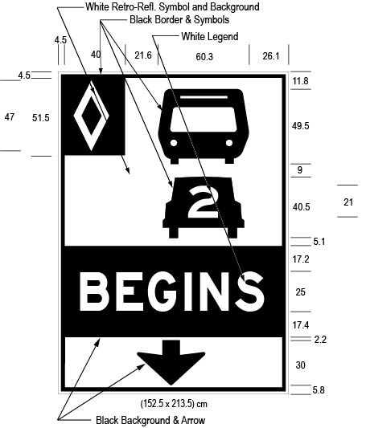
Text alternative: Illustration of an overhead high occupancy vehicle lane sign labelled as “Figure B”. The sign contains three rectangles, stacked on top of one another. The top rectangle has a white reflective background and contains a symbol of a bus on top of a symbol of a car with the number “2” inside it. A white diamond shape in a small black rectangle appears in the upper left corner of this rectangle. The middle rectangle contains the word “BEGINS” in white letters on a reflective black background. The bottom rectangle has a white reflective background and contains a thick black arrow pointing down. The following measurements are written below the sign: (152.5 x 213.5) cm. The sign is surrounded by measurements of its different elements. This text alternative is provided for convenience only and does not form part of the official law.
O. Reg. 620/05, s. 5 (1); O. Reg. 89/15, s. 2 (1).
(2) Despite subsection (1), in an area designated in the Schedule to the French Language Services Act, the commencement of a high occupancy vehicle lane shall be indicated by an overhead sign that has the dimensions and bears the markings as illustrated in Figure C.
figure c
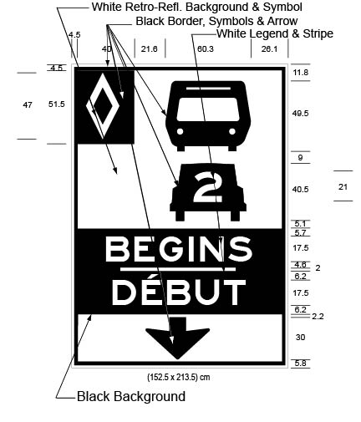
Text alternative: Illustration of an overhead high occupancy vehicle lane sign labelled as “Figure C”. The sign contains three rectangles, stacked on top of one another. The top rectangle has a white reflective background and contains a symbol of a bus on top of a symbol of a car with the number “2” inside it. A white diamond shape in a small black rectangle appears in the upper left corner of this rectangle. The middle rectangle contains the word “BEGINS/DÉBUT” in white letters on a reflective black background. The bottom rectangle has a white reflective background and contains a thick black arrow pointing down. The following measurements are written below the sign: (152.5 x 213.5) cm. The sign is surrounded by measurements of its different elements. This text alternative is provided for convenience only and does not form part of the official law.
O. Reg. 620/05, s. 5 (2); O. Reg. 89/15, s. 2 (2).
(3) High occupancy vehicle lane signs shall be erected along the length of a high occupancy vehicle lane and shall have the dimensions and bear the markings as illustrated in Figure D:
figure d
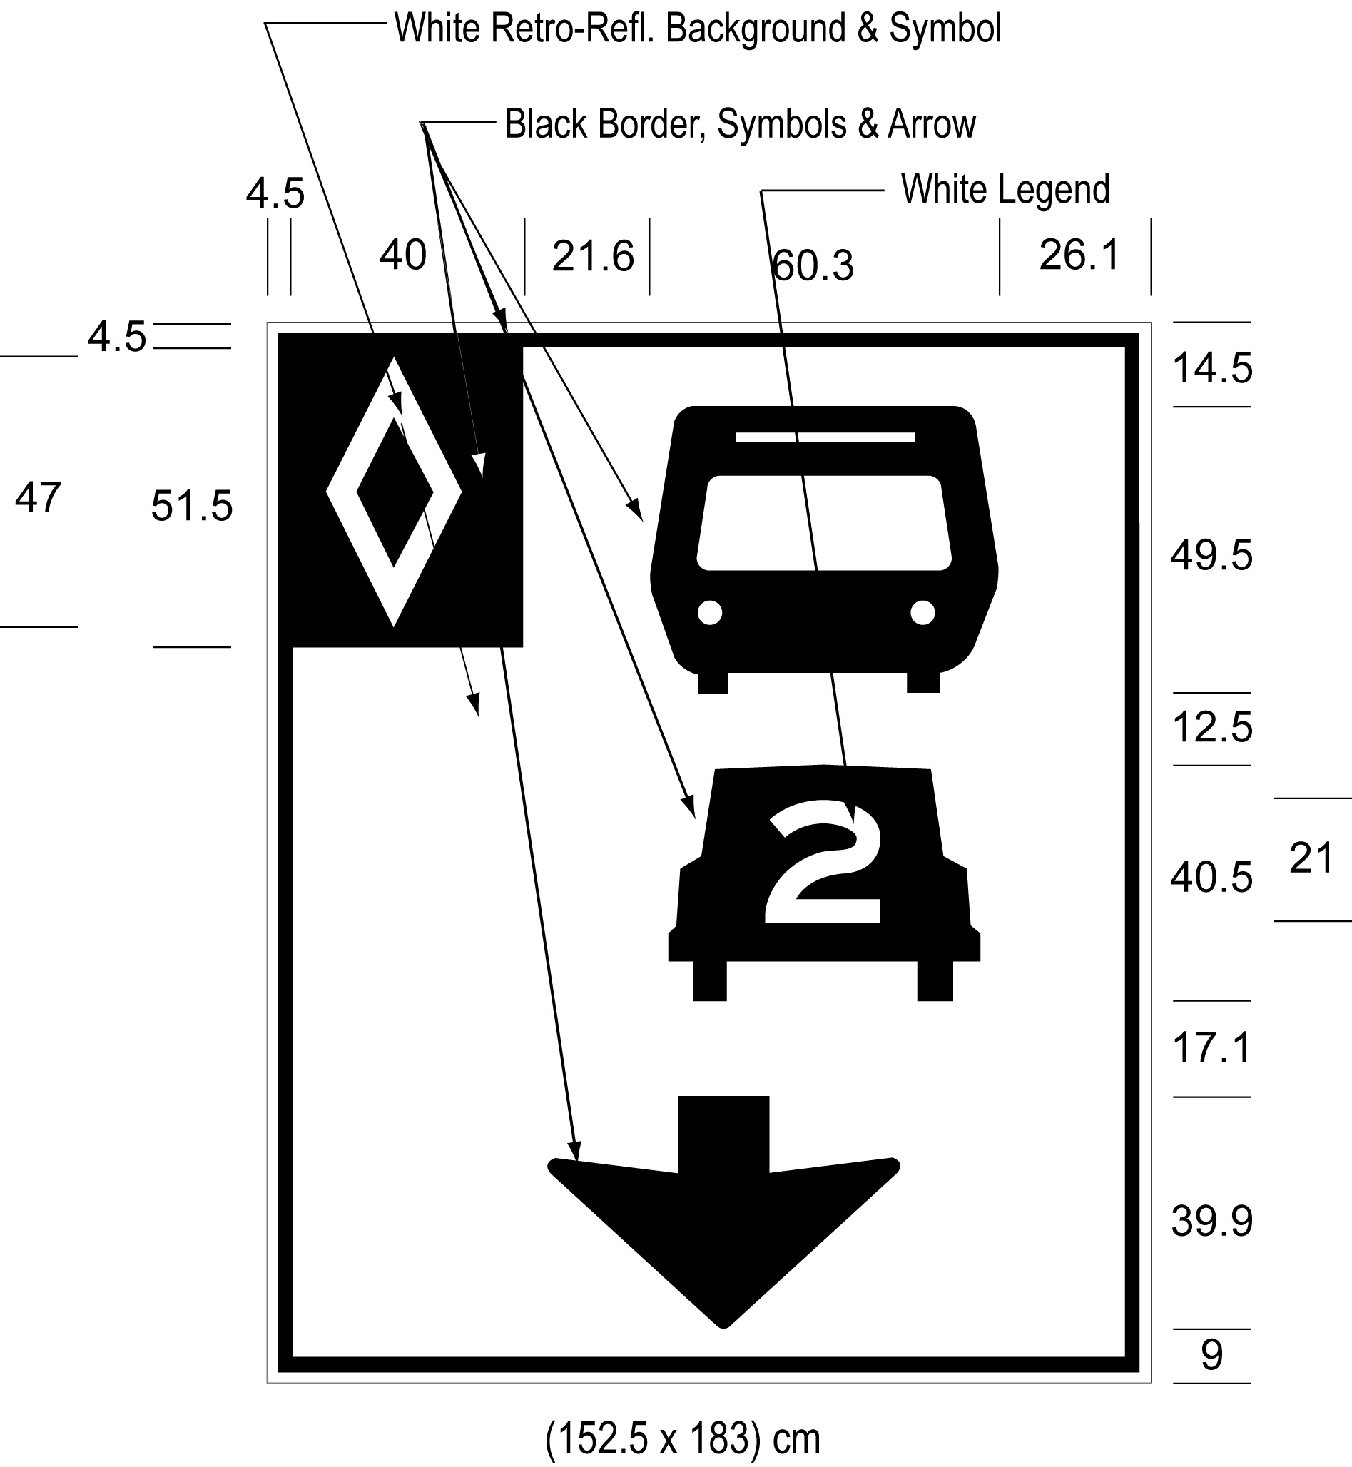
Text alternative: Illustration of an overhead high occupancy vehicle lane sign labelled as “Figure D”. The sign has a white reflective background and contains a symbol of a bus on top of a symbol of a car with the number “2” inside it, below which appears a thick black arrow pointing down. A white diamond shape in a small black rectangle appears in the upper left corner of this rectangle. The following measurements are written below the sign: (152.5 x 183) cm. The sign is surrounded by measurements of its different elements. This text alternative is provided for convenience only and does not form part of the official law.
O. Reg. 620/05, s. 5 (3); O. Reg. 89/15, s. 2 (3).
(4) High occupancy vehicle lane signs shall not be more than four kilometres apart from each other. O. Reg. 620/05, s. 5 (4).
(5) The end of a high occupancy vehicle lane shall be indicated by an overhead sign that has the dimensions and bears the markings as illustrated in Figure E or by a ground mounted sign that has the dimensions and bears the markings as illustrated in Figure F.
figure e
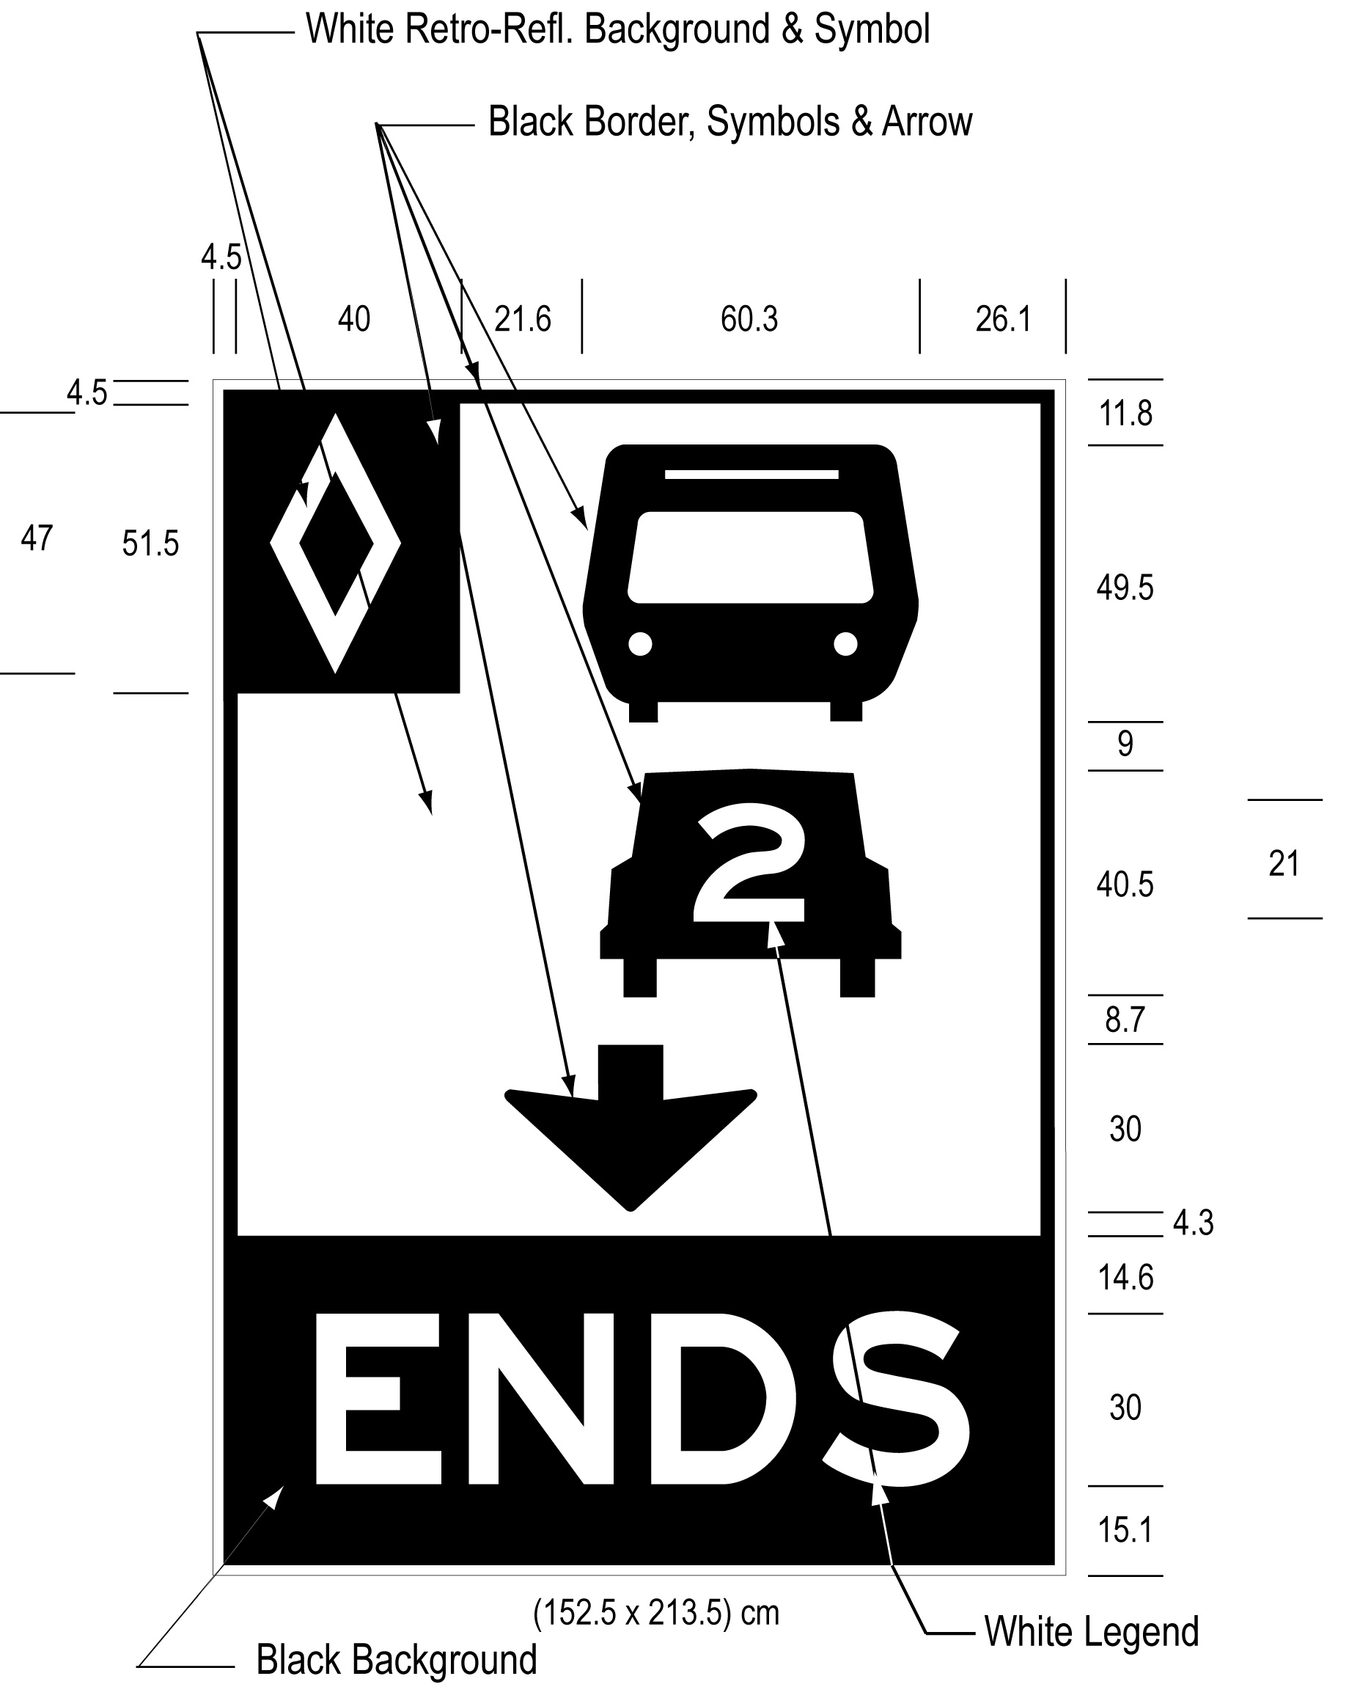
Text alternative: Illustration of an overhead high occupancy vehicle lane sign labelled as “Figure E”. The sign contains two rectangles, stacked on top of one another. The top rectangle has a white reflective background and contains a symbol of a bus on top of a symbol of a car with the number “2” inside it, below which appears a thick black arrow pointing down. A white diamond shape in a small black rectangle appears in the upper left corner of this rectangle. The bottom rectangle contains the word “ENDS” in white letters on a reflective black background. The following measurements are written below the sign: (152.5 x 213.5) cm. The sign is surrounded by measurements of its different elements. This text alternative is provided for convenience only and does not form part of the official law.
figure f
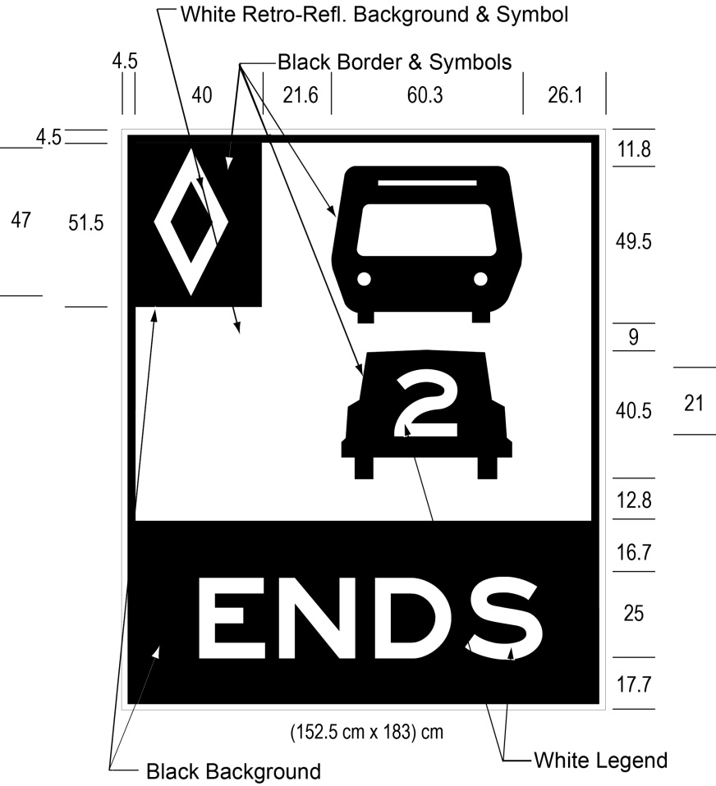
Text alternative: Illustration of a ground mounted high occupancy vehicle lane sign labelled as “Figure F”. The sign contains two rectangles, stacked on top of one another. The top rectangle has a white reflective background and contains a symbol of a bus on top of a symbol of a car with the number “2” inside it. A white diamond shape in a small black rectangle appears in the upper left corner of this rectangle. The bottom rectangle contains the word “ENDS” in white letters on a reflective black background. The following measurements are written below the sign: (152.5 x 183) cm. The sign is surrounded by measurements of its different elements. This text alternative is provided for convenience only and does not form part of the official law.
O. Reg. 620/05, s. 5 (5); O. Reg. 89/15, s. 2 (4).
(6) Despite subsection (5), in an area designated in the Schedule to the French Language Services Act, the end of a high occupancy vehicle lane shall be indicated by an overhead sign that has the dimensions and bears the markings as illustrated in Figure G or by a ground mounted sign that has the dimensions and bears the markings as illustrated in Figure H.
figure g
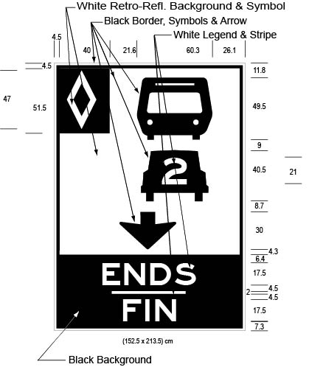
Text alternative: Illustration of an overhead high occupancy vehicle lane sign labelled as “Figure G”. The sign contains two rectangles, stacked on top of one another. The top rectangle has a white reflective background and contains a symbol of a bus on top of a symbol of a car with the number “2” inside it, below which appears a thick black arrow pointing down. A white diamond shape in a small black rectangle appears in the upper left corner of this rectangle. The bottom rectangle contains the word “ENDS/FIN” in white letters on a reflective black background. The following measurements are written below the sign: (152.5 x 213.5) cm. The sign is surrounded by measurements of its different elements. This text alternative is provided for convenience only and does not form part of the official law.
figure h
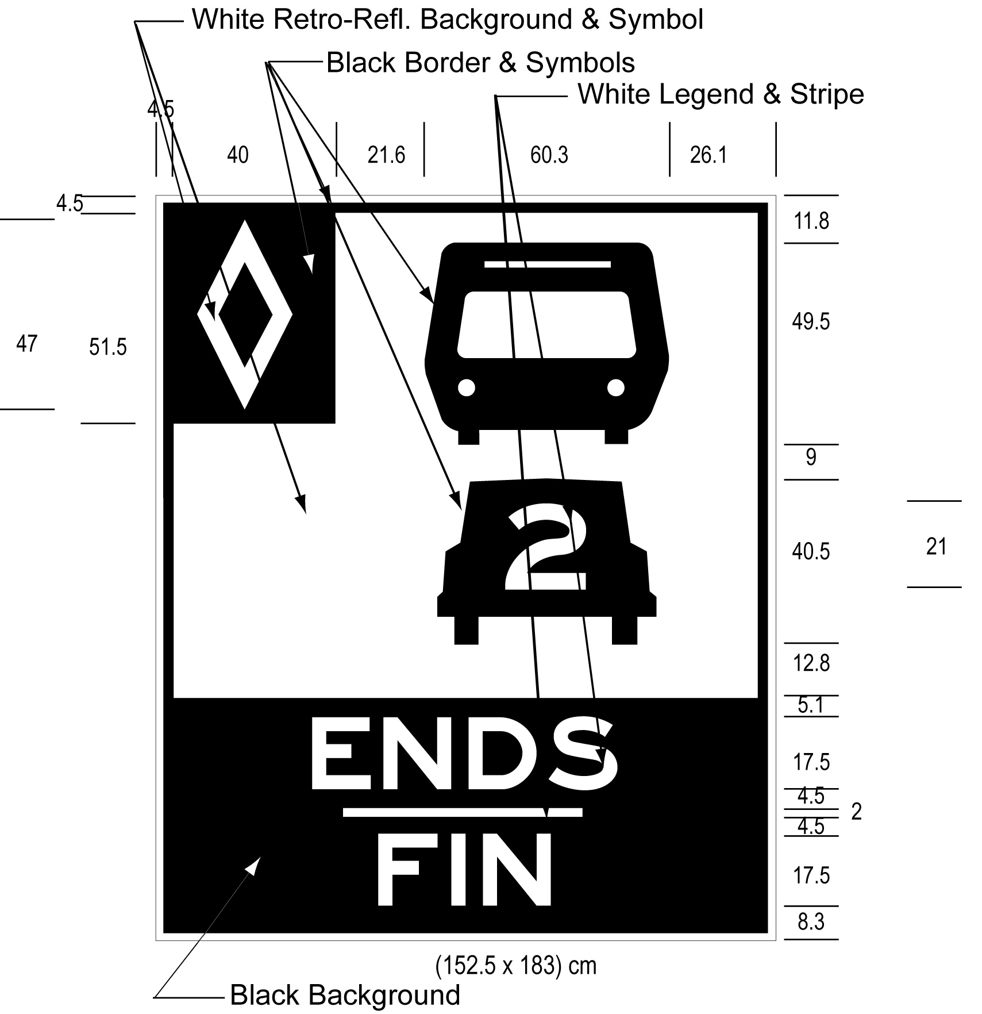
Text alternative: Illustration of a ground mounted high occupancy vehicle lane sign labelled as “Figure H”. The sign contains two rectangles, stacked on top of one another. The top rectangle has a white reflective background and contains a symbol of a bus on top of a symbol of a car with the number “2” inside it. A white diamond shape in a small black rectangle appears in the upper left corner of this rectangle. The bottom rectangle contains the word “ENDS/FIN” in white letters on a reflective black background. The following measurements are written below the sign: (152.5 x 183) cm. The sign is surrounded by measurements of its different elements. This text alternative is provided for convenience only and does not form part of the official law.
O. Reg. 620/05, s. 5 (6); O. Reg. 89/15, s. 2 (5).
(7) A sign prohibiting the crossing of a buffer zone shall have the dimensions and bear the markings as illustrated in,
(a) Figure I or J, if the sign is an overhead sign; or
(b) Figure K or L, if the sign is a ground mounted sign.
figure i
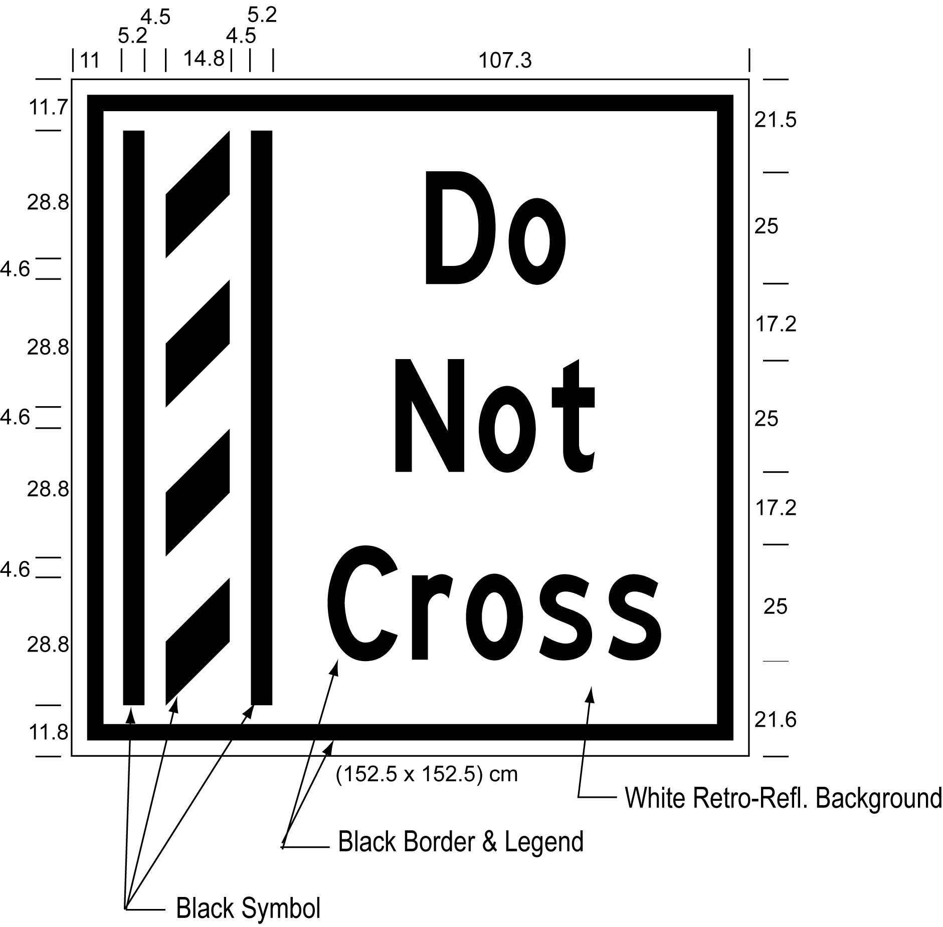
Text alternative: Illustration of an overhead buffer zone sign labelled as “Figure I”. The sign contains an image on the left of a buffer zone as diagonal lines painted between solid lines and on the right contains the words “Do Not Cross”. The sign has a white reflective background with the buffer zone image and words appearing in black. The following measurements are written below the sign: (152.5 x 152.5) cm. The sign is surrounded by measurements of its different elements. This text alternative is provided for convenience only and does not form part of the official law.
figure j
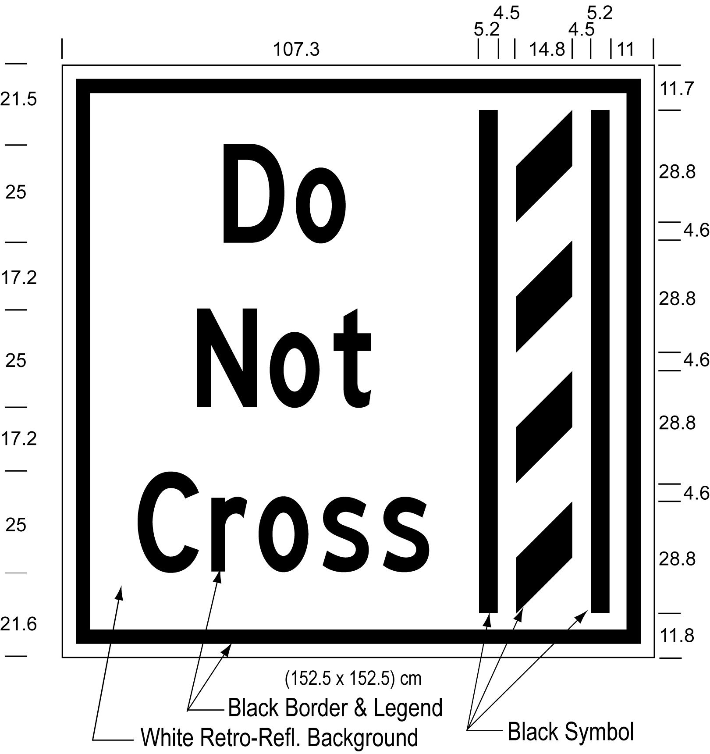
Text alternative: Illustration of an overhead buffer zone sign labelled as “Figure J”. The sign contains an image on the right of a buffer zone as diagonal lines painted between solid lines and on the left contains the words “Do Not Cross”. The sign has a white reflective background with the buffer zone image and words appearing in black. The following measurements are written below the sign: (152.5 x 152.5) cm. The sign is surrounded by measurements of its different elements. This text alternative is provided for convenience only and does not form part of the official law.
figure k
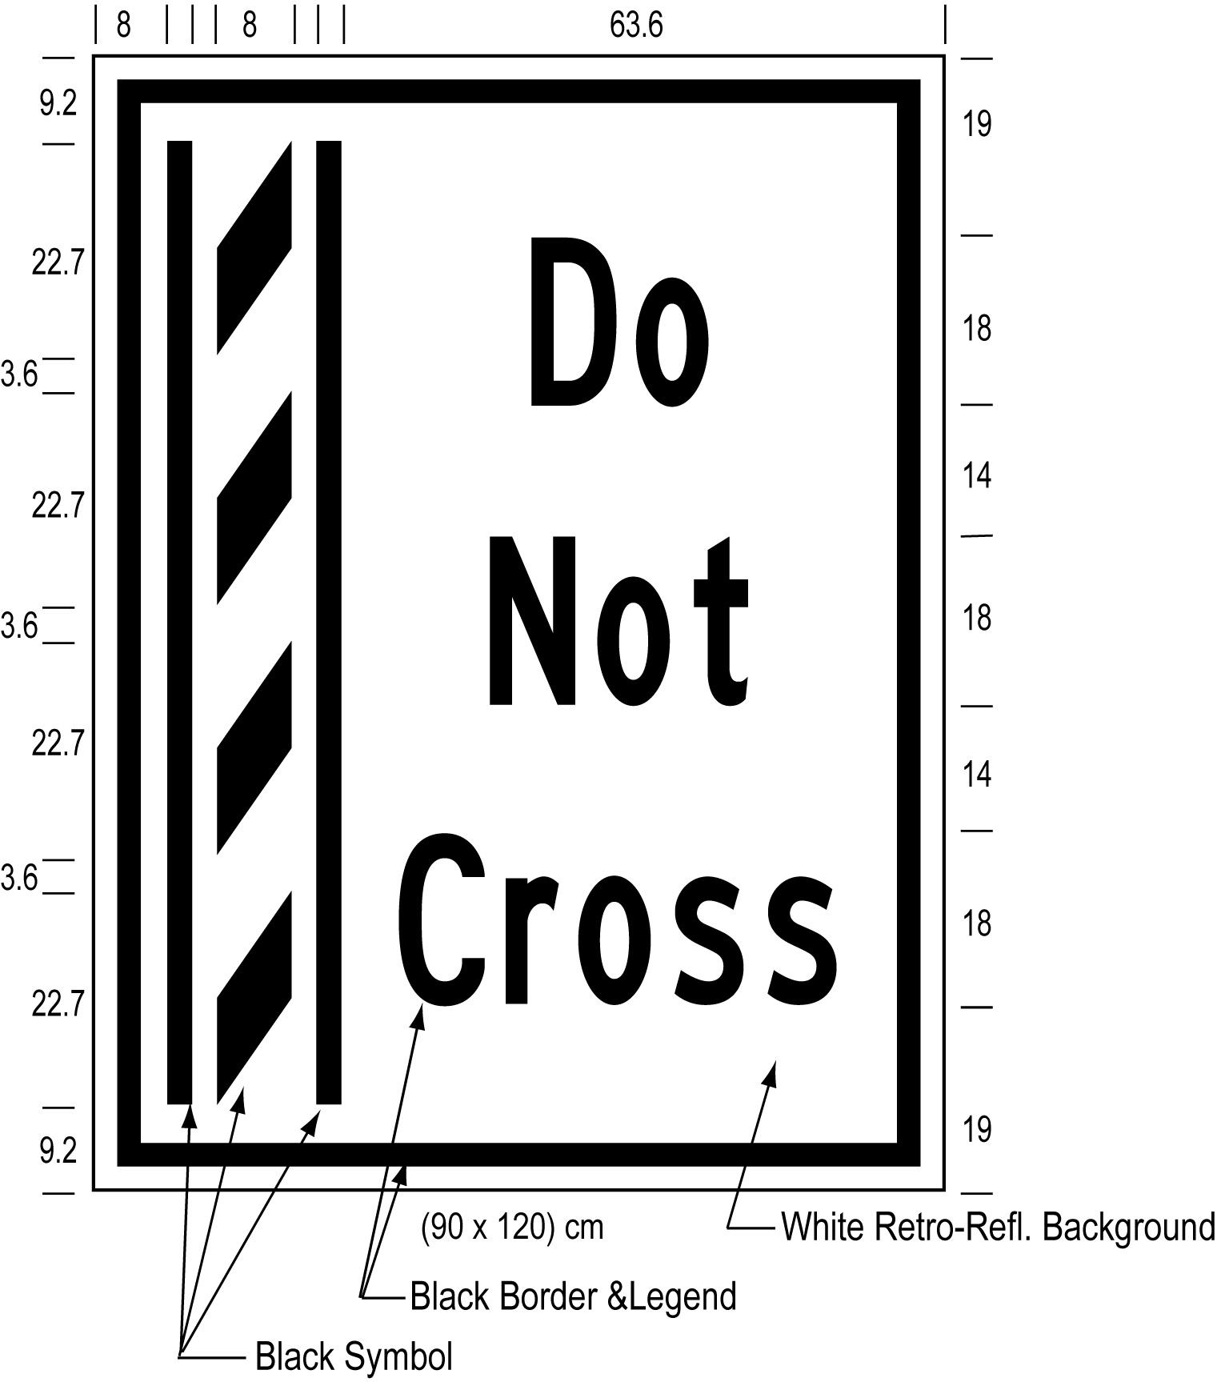
Text alternative: Illustration of a ground mounted buffer zone sign labelled as “Figure K”. The sign contains an image on the left of a buffer zone as diagonal lines painted between solid lines and on the right contains the words “Do Not Cross”. The sign has a white reflective background with the buffer zone image and words appearing in black. The following measurements are written below the sign: (90 x 120) cm. The sign is surrounded by measurements of its different elements. This text alternative is provided for convenience only and does not form part of the official law.
figure l
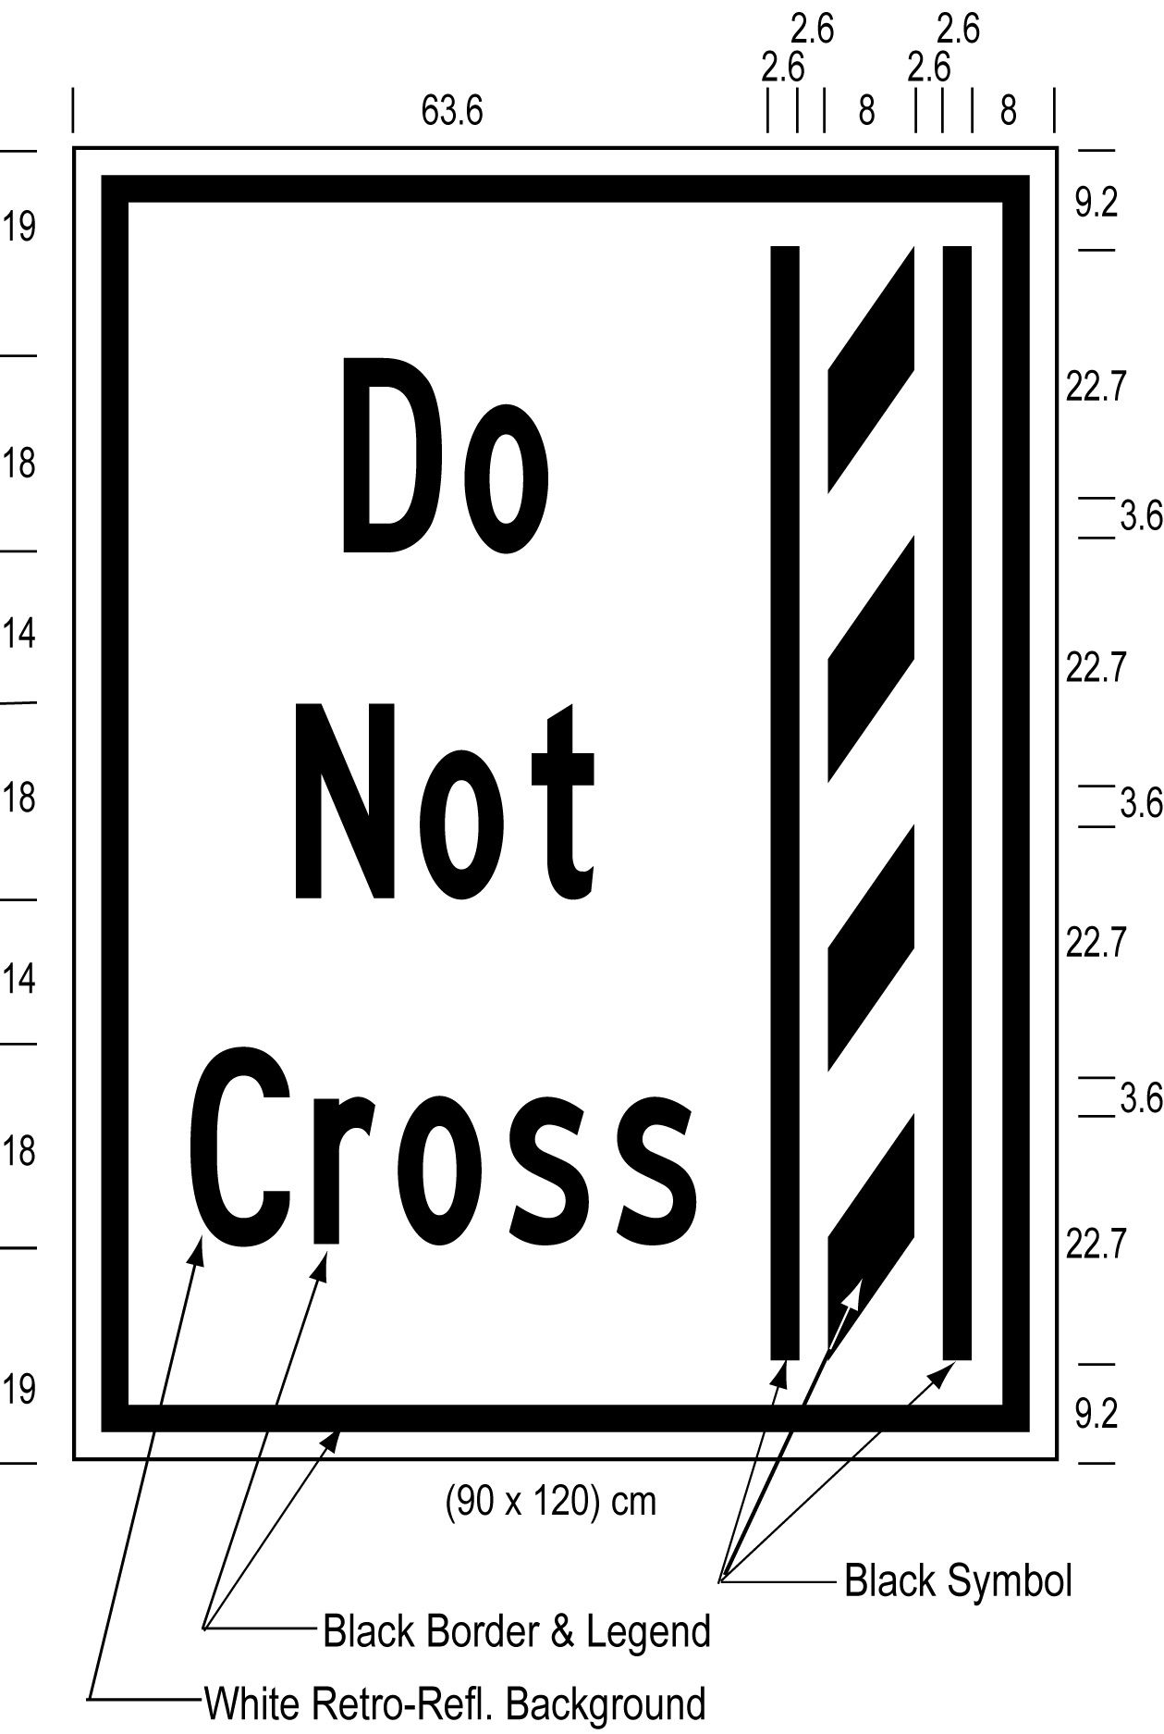
Text alternative: Illustration of a ground mounted buffer zone sign labelled as “Figure L”. The sign contains an image on the right of a buffer zone as diagonal lines painted between solid lines and on the left contains the words “Do Not Cross”. The sign has a white reflective background with the buffer zone image and words appearing in black. The following measurements are written below the sign: (90 x 120) cm. The sign is surrounded by measurements of its different elements. This text alternative is provided for convenience only and does not form part of the official law.
O. Reg. 620/05, s. 5 (7); O. Reg. 89/15, s. 2 (6).
(8) Despite subsection (7), in an area designated in the Schedule to the French Language Services Act, a sign prohibiting the crossing of a buffer zone shall have the dimensions and bear the markings as illustrated in,
(a) Figure M or N, if the sign is an overhead sign; or
(b) Figure O or P, if the sign is a ground mounted sign.
figure M
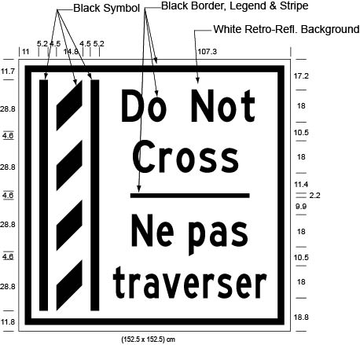
Text alternative: Illustration of an overhead buffer zone sign labelled as “Figure M”. The sign contains an image on the left of a buffer zone as diagonal lines painted between solid lines and on the right contains the words “Do Not Cross/Ne pas traverser”. The sign has a white reflective background with the buffer zone image and words appearing in black. The following measurements are written below the sign: (152.5 x 152.5) cm. The sign is surrounded by measurements of its different elements. This text alternative is provided for convenience only and does not form part of the official law.
figure n
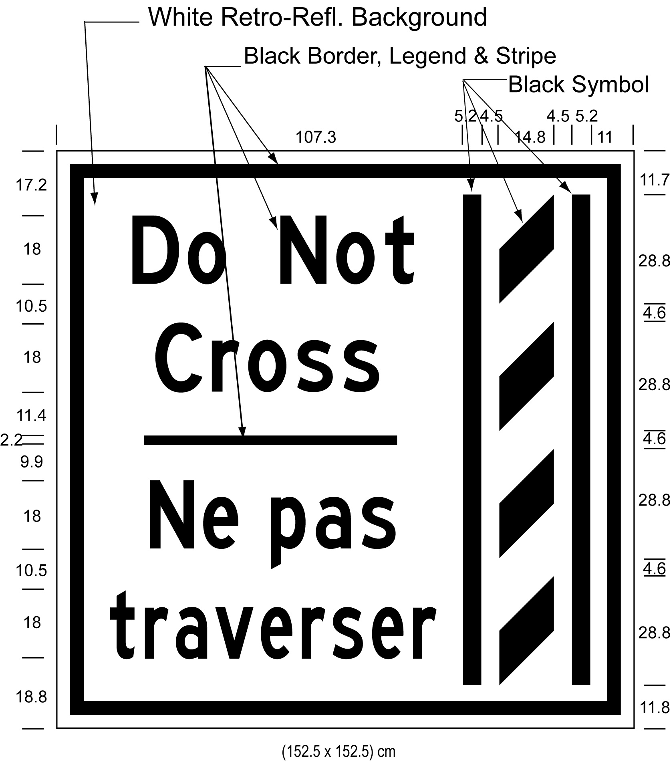
Text alternative: Illustration of an overhead buffer zone sign labelled as “Figure N”. The sign contains an image on the right of a buffer zone as diagonal lines painted between solid lines and on the left contains the words “Do Not Cross/Ne pas traverser”. The sign has a white reflective background with the buffer zone image and words appearing in black. The following measurements are written below the sign: (152.5 x 152.5) cm. The sign is surrounded by measurements of its different elements. This text alternative is provided for convenience only and does not form part of the official law.
figure o
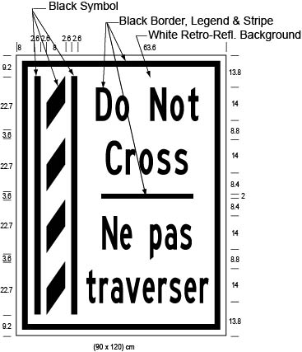
Text alternative: Illustration of a ground mounted buffer zone sign labelled as “Figure O”. The sign contains an image on the left of a buffer zone as diagonal lines painted between solid lines and on the right contains the words “Do Not Cross/Ne pas traverser”. The sign has a white reflective background with the buffer zone image and words appearing in black. The following measurements are written below the sign: (90 x 120) cm. The sign is surrounded by measurements of its different elements. This text alternative is provided for convenience only and does not form part of the official law.
figure p
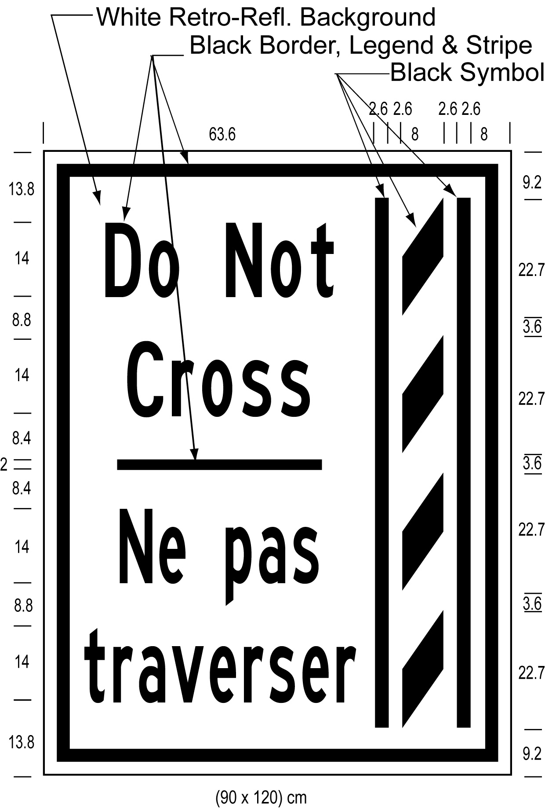
Text alternative: Illustration of a ground mounted buffer zone sign labelled as “Figure P”. The sign contains an image on the right of a buffer zone as diagonal lines painted between solid lines and on the left contains the words “Do Not Cross/Ne pas traverser”. The sign has a white reflective background with the buffer zone image and words appearing in black. The following measurements are written below the sign: (90 x 120) cm. The sign is surrounded by measurements of its different elements. This text alternative is provided for convenience only and does not form part of the official law.
O. Reg. 620/05, s. 5 (8); O. Reg. 89/15, s. 2 (7).
(9) The dimensions of a sign may differ from those prescribed in this section as long as the dimensions are in the same proportion to each other as the dimensions prescribed in this section are to each other. O. Reg. 620/05, s. 5 (9).
(10) An overhead sign shall be erected directly above the high occupancy vehicle lane and a ground mounted sign shall be erected on the side of the highway facing approaching traffic. O. Reg. 620/05, s. 5 (10).
Definition — “Games period”
6. In sections 7 to 10 and in Schedules A, D, E, F and G,
“Games period” means the period beginning on June 29, 2015 and ending on August 18, 2015, which includes the period when the Toronto 2015 Pan American Games and the Toronto 2015 ParaPan American Games are being held (July 10 to 26, 2015 and August 7 to 15, 2015, respectively). O. Reg. 99/15, s. 2 (1).
Note: On August 19, 2015, section 6 is revoked. (See: O. Reg. 99/15, s. 2 (2))
Use of high occupancy vehicle lanes during the Games period
7. Despite section 2, during the Games period, no person shall operate a motor vehicle or a commercial motor vehicle in a high occupancy vehicle lane on a part of the King’s Highway described in Schedule A, D, E, F or G unless one of the following circumstances exists:
1. In the case of a motor vehicle, the vehicle has at least two persons occupying seating positions.
2. In the case of a commercial motor vehicle,
i. the vehicle has at least two persons occupying seating positions, and
ii. the length of the vehicle or the total length of the vehicle and any vehicle being towed is less than 6.5 metres.
3. The vehicle is a bus.
4. The person is operating an emergency vehicle, as defined in section 144 of the Act, in the performance of his or her duties.
5. The person is operating the vehicle in the lawful performance of his or her duties as a police officer.
6. The person is operating a vehicle owned or leased by the Province of Ontario in the lawful performance of his or her duties as an officer appointed for carrying out the provisions of the Act.
7. The person is operating a vehicle engaged in road construction or maintenance activities in or near the high occupancy vehicle lane.
8. The person is operating a tow truck that has been requested to provide towing or repair services to a disabled vehicle in or near a high occupancy vehicle lane by a police officer, an officer appointed for carrying out the provisions of the Act, or a person driving the disabled vehicle, and operating the tow truck in the high occupancy vehicle lane is necessary to attend at and depart from the location of the disabled vehicle.
9. The person is operating a motor vehicle to which are attached valid number plates that,
i. are issued by the Ministry,
ii. have green lettering on a white background, and
iii. display the words “GREEN VEHICLE” or “VÉHICULE ÉCOLOGIQUE”.
10. The vehicle is a taxicab or limousine that,
i. is being operated by a person who has a valid licence, permit or authorization issued by a municipality or airport authority to operate the vehicle for the purpose of providing passenger transportation services, and
ii. has mounted on the rear of the vehicle a valid plate bearing an identification number issued by the municipality or airport authority for the use of the vehicle for that purpose.
11. The vehicle displays on its windshield a permit that,
i. is issued by Toronto Organizing Committee for the 2015 Pan American and Parapan American Games, and
ii. displays the words “Games Permit” or “Permis Jeux”. O. Reg. 99/15, s. 2 (1); O. Reg. 101/15, s. 1.
Note: On August 19, 2015, section 7 is revoked. (See: O. Reg. 99/15, s. 2 (3))
Entry and exit lane markings on temporary high occupancy vehicle lanes during the Games period
8. Despite subsection 3 (1), during the Games period, vehicles may enter or exit high occupancy vehicle lanes on a part of the King’s Highway described in Schedule E, F or G anywhere along the lane, as indicated by continuity lines lane markings described in paragraph 2 of section 9 and illustrated in Figure A.1 in that section, except if the continuity lines lane markings are adjacent to a solid line lane marking, as described in paragraph 3 of section 9 and illustrated in Figure A.2 in that section, in which case vehicles may exit but may not enter the lane. O. Reg. 99/15, s. 2 (1).
Note: On August 19, 2015, section 8 is revoked. (See: O. Reg. 99/15, s. 2 (3))
Roadway markings on temporary high occupancy vehicle lanes during the Games period
9. Despite section 4, a high occupancy vehicle lane on a part of the King’s Highway described in Schedule E, F or G shall have the following roadway markings on the surface of the roadway of the high occupancy vehicle lane, as illustrated in Figure A.1 or A.2:
1. Painted white diamond markings, placed periodically along the length of the high occupancy vehicle lane.
2. Painted white continuity lines lane markings, consisting of one long followed by two short broken lines, placed all along the length of the high occupancy vehicle lane to indicate that vehicles may enter or exit all along the lane, except if the continuity lines lane markings are adjacent to a solid line lane marking.
3. Painted white solid line lane markings, placed along the length of the high occupancy vehicle lane and adjacent to the continuity lines lane markings to indicate that vehicles may exit but may not enter the lane.
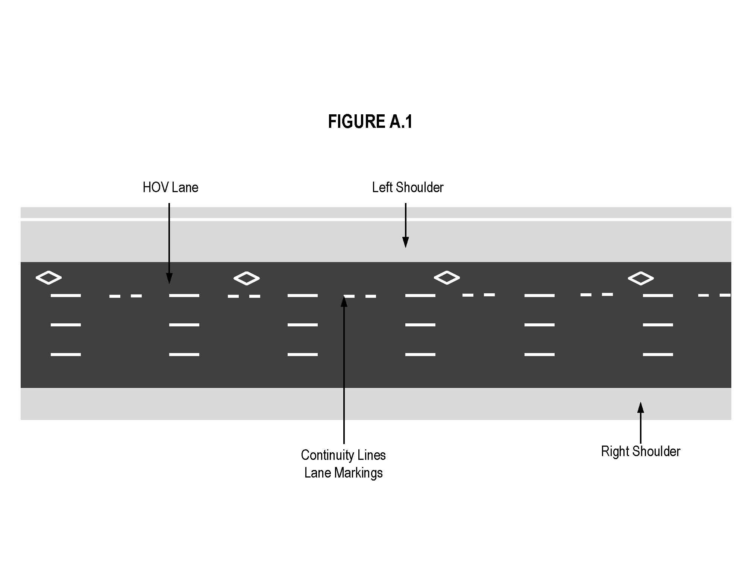
Text alternative: Illustration of “Figure A.1” showing an overhead plan of a divided highway with the high occupancy vehicle lane as the leftmost lane on a highway. The lane has white diamond markings on the roadway and white continuity lines for entry or exit into or from the lane. The left shoulder is indicated to the left of the high occupancy vehicle lane. This text alternative is provided for convenience only and does not form part of the official law.
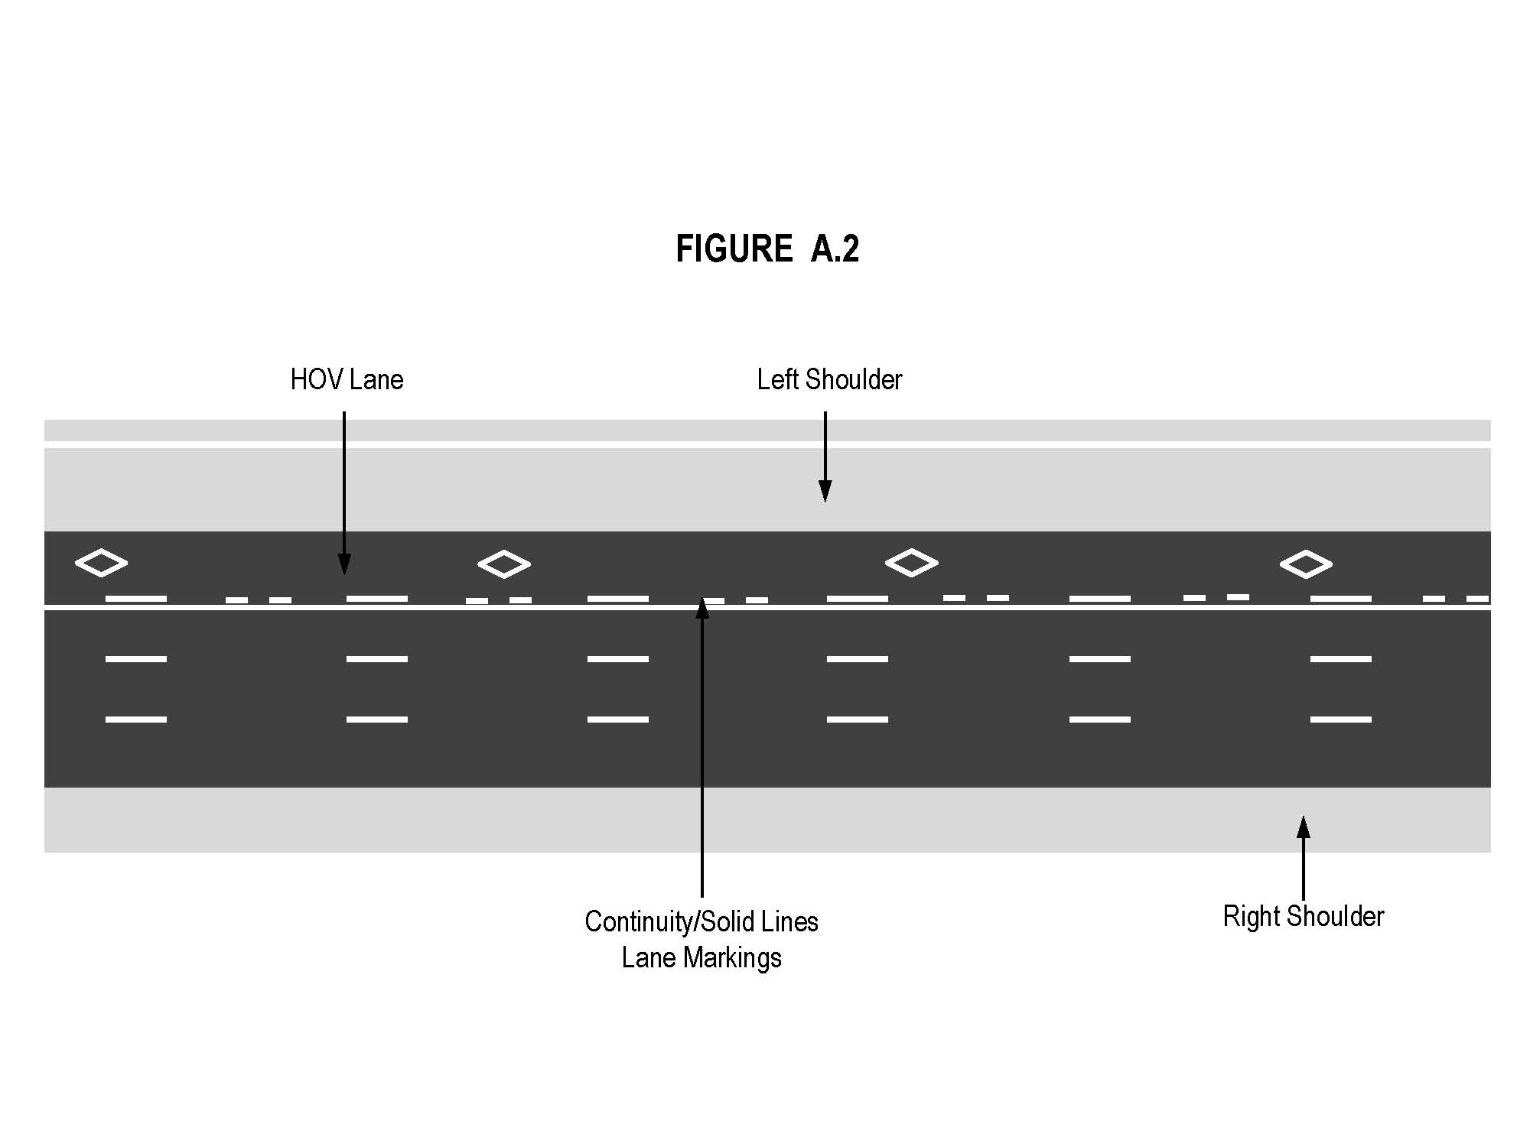
Text alternative: Illustration of “Figure A.2” showing an overhead plan of a divided highway with the high occupancy vehicle lane as the leftmost lane on a highway. The lane has white diamond markings on the roadway, white continuity lines adjacent to a solid white line indicating exit only from the high occupancy vehicle lane. The left shoulder is indicated to the left of the high occupancy vehicle lane. This text alternative is provided for convenience only and does not form part of the official law.
O. Reg. 99/15, s. 2 (1).
Note: On August 19, 2015, section 9 is revoked. (See: O. Reg. 99/15, s. 2 (3))
Signs on affected high occupancy vehicle lanes during the Games period
10. (1) Despite subsection 5 (1), during the Games period, the commencement of a high occupancy vehicle lane on a part of the King’s Highway described in Schedule A, D, E, F or G shall be indicated by an overhead or ground-mounted sign that has the dimensions and bears the markings as illustrated in Figure B.1
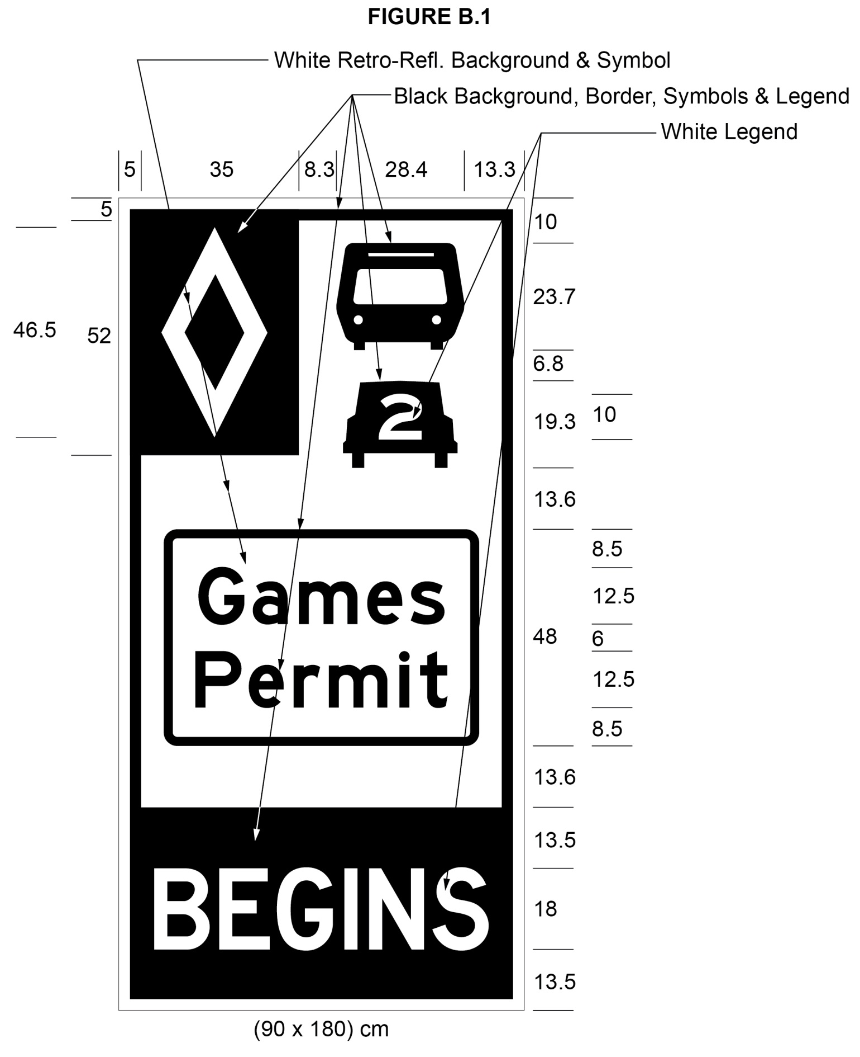
Text alternative: Illustration of a high occupancy vehicle lane sign labeled as “Figure B.1”. The sign contains two rectangles, stacked on top of one another. The top rectangle has a white reflective background and contains a symbol of a bus on top of a symbol of a car with the number “2” inside it. A white diamond shape in a small black rectangle appears in the upper left corner of this rectangle. Below that, in the middle of the sign, are the words “Games Permit” in black letters inside the black outline of a rectangle. The bottom rectangle contains the word “BEGINS” in white letters on a reflective black background. The following measurements are written below the sign: (90 x 180) cm. The sign is surrounded by measurements of its different elements. This text alternative is provided for convenience only and does not form part of the official law.
O. Reg. 99/15, s. 2 (1); O. Reg. 101/15, s. 2 (1).
(2) Despite subsection 5 (2) and subsection (1) of this section, during the Games period, in an area designated in the Schedule to the French Language Services Act, the commencement of a high occupancy vehicle lane on a part of the King’s Highway described in Schedule A, D, E, F or G shall be indicated by an overhead or ground-mounted sign that has the dimensions and bears the markings as illustrated in Figure C.1.
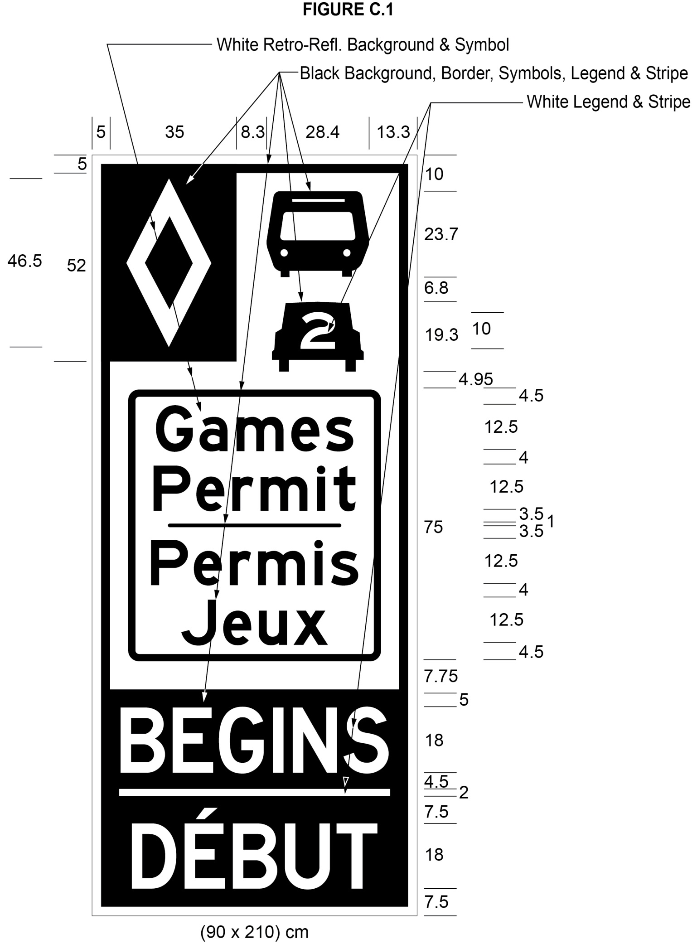
Text alternative: Illustration of a high occupancy vehicle lane sign labeled as “Figure C.1”. The sign contains two rectangles, stacked on top of one another. The top rectangle has a white reflective background and contains a symbol of a bus on top of a symbol of a car with the number “2” inside it. A white diamond shape in a small black rectangle appears in the upper left corner of this rectangle. Below that, in the middle of the sign, are the words “Games Permit/Permis Jeux” in black letters inside the black outline of a rectangle. The bottom rectangle contains the word “BEGINS/DÉBUT” in white letters on a reflective black background. The following measurements are written below the sign: (90 x 210) cm. The sign is surrounded by measurements of its different elements. This text alternative is provided for convenience only and does not form part of the official law.
O. Reg. 99/15, s. 2 (1); O. Reg. 101/15, s. 2 (2).
(3) Despite subsection 5 (3), during the Games period, high occupancy vehicle lane signs on a part of the King’s Highway described in Schedule A, D, E, F or G shall be erected along the length of a high occupancy vehicle lane and shall have the dimensions and bear the markings as illustrated in Figure D.1.
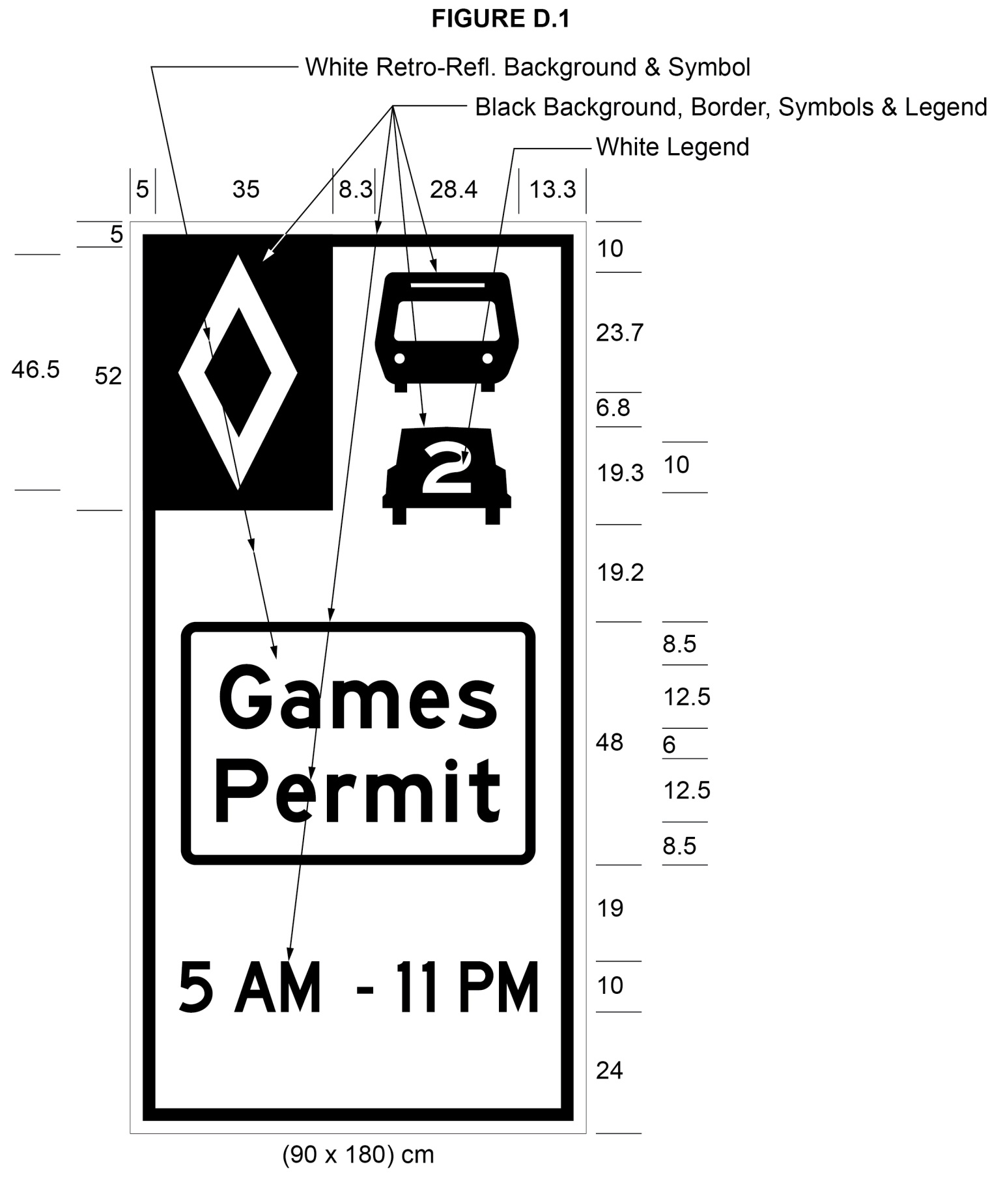
Text alternative: Illustration of a high occupancy vehicle lane sign labeled as “Figure D.1”. The sign has a white reflective background and contains a symbol of a bus on top of a symbol of a car with the number “2” inside it. A white diamond shape in a small black rectangle appears in the upper left corner of this rectangle. Below that, in the middle of the sign are the words “Games Permit” in black letters inside the black outline of a rectangle. The text “5 AM – 11 PM” appears at the bottom of the sign in black letters on a white reflective background. The following measurements are written below the sign: (90 x 180) cm. The sign is surrounded by measurements of its different elements. This text alternative is provided for convenience only and does not form part of the official law.
O. Reg. 99/15, s. 2 (1); O. Reg. 101/15, s. 2 (3).
(4) Despite subsection 5 (5), during the Games period, the end of a high occupancy vehicle lane on a part of the King’s Highway described in Schedule A, D, E, F or G shall be indicated by an overhead or ground-mounted sign that has the dimensions and bears the markings as illustrated in Figure E.1.
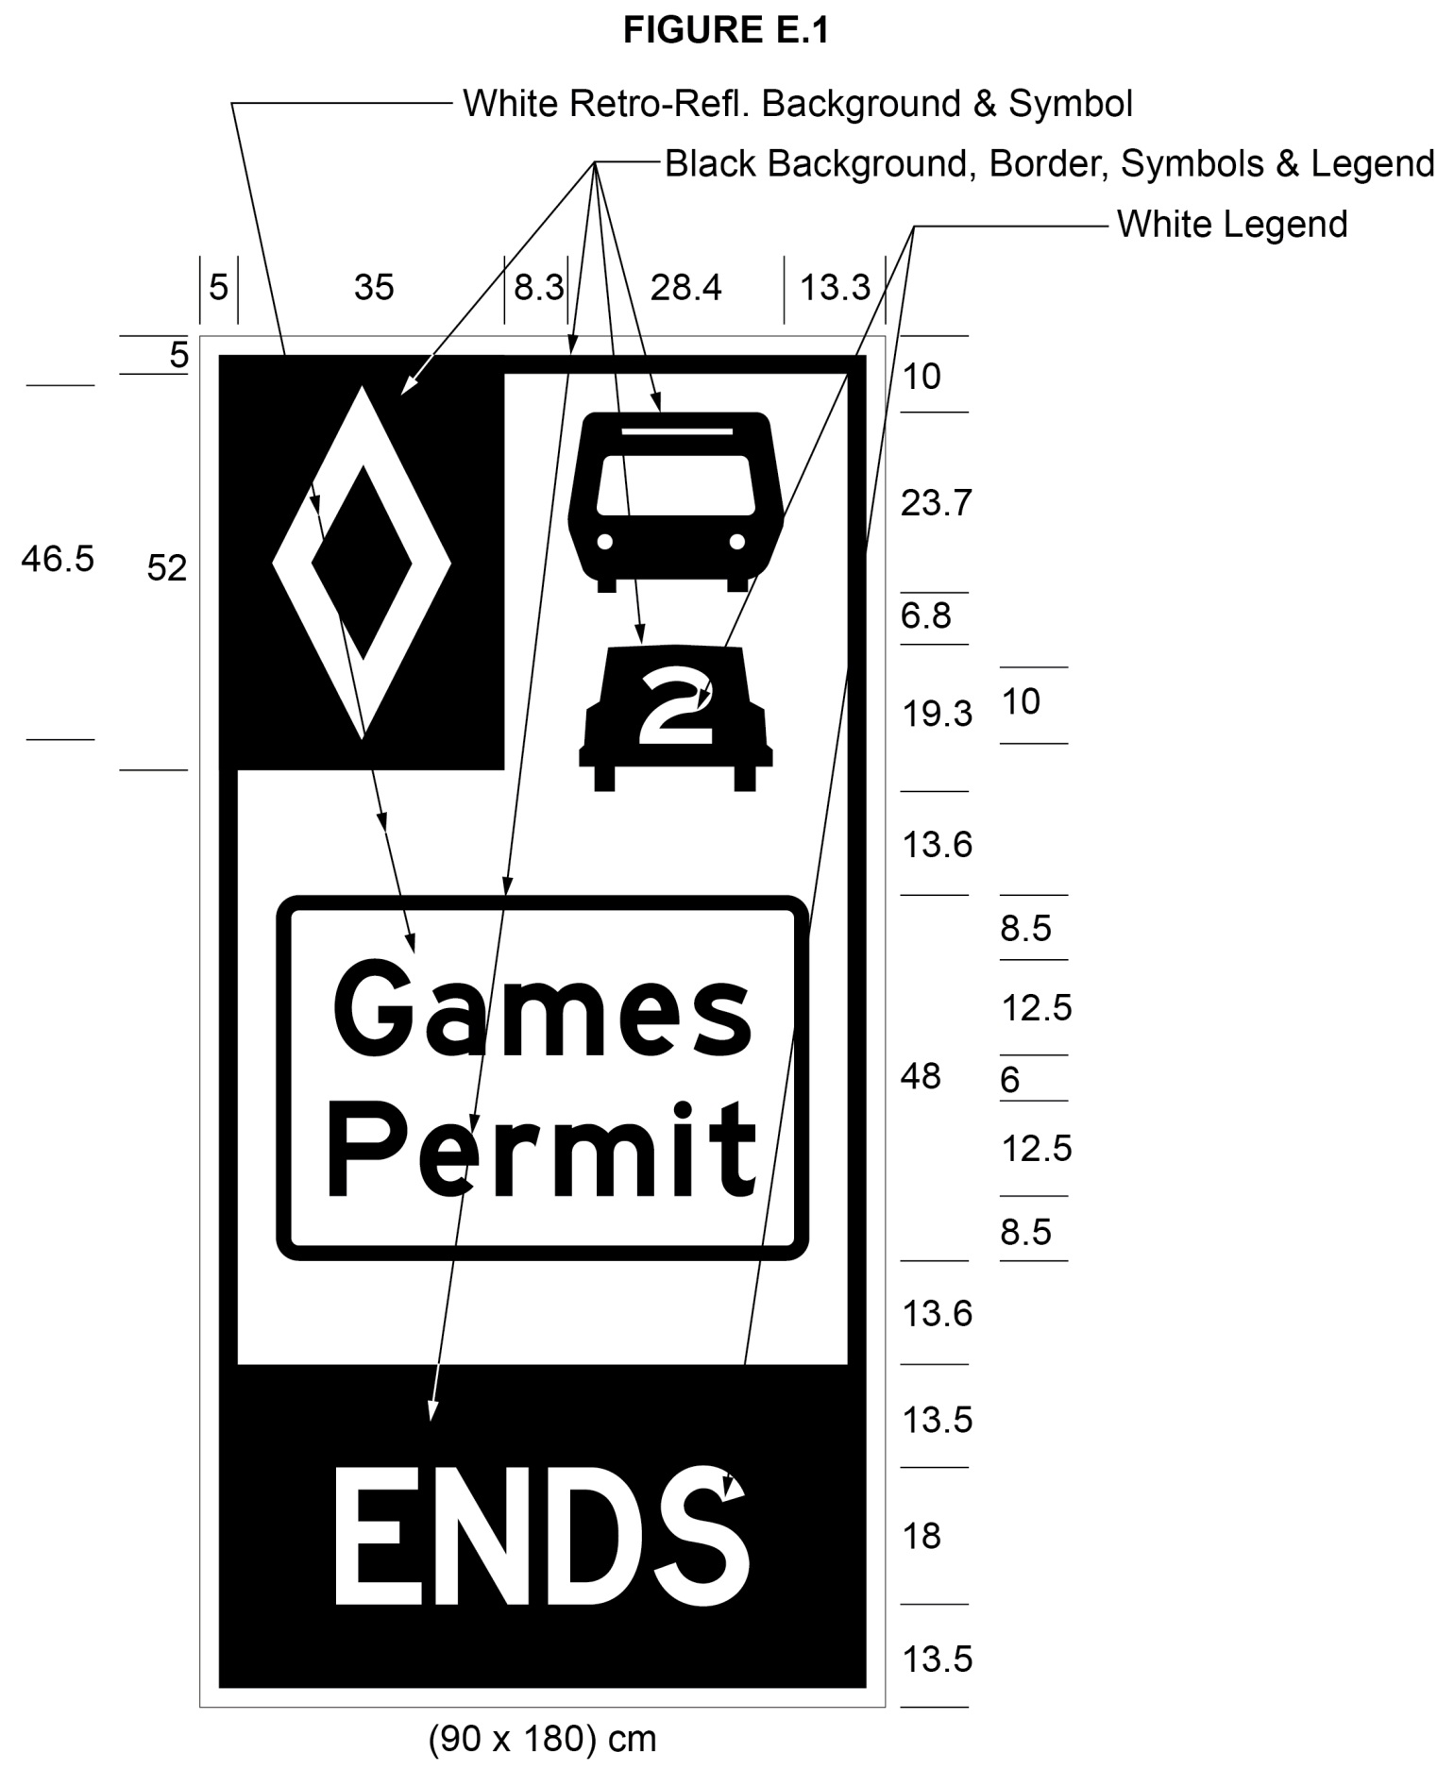
Text alternative: Illustration of a high occupancy vehicle lane sign labeled as “Figure E.1”. The sign contains two rectangles, stacked on top of one another. The top rectangle has a white reflective background and contains a symbol of a bus on top of a symbol of a car with the number “2” inside it. A white diamond shape in a small black rectangle appears in the upper left corner of this rectangle. Below that, in the middle of the sign, are the words “Games Permit” in black letters inside the black outline of a rectangle. The bottom rectangle contains the word “ENDS” in white letters on a reflective black background. The following measurements are written below the sign: (90 x 180) cm. The sign is surrounded by measurements of its different elements. This text alternative is provided for convenience only and does not form part of the official law.
O. Reg. 99/15, s. 2 (1); O. Reg. 101/15, s. 2 (4).
(5) Despite subsection 5 (6) and subsection (4) of this section, during the Games period, in an area designated in the Schedule to the French Language Services Act, the end of a high occupancy vehicle lane on a part of the King’s Highway described in Schedule A, D, E, F or G shall be indicated by an overhead or ground mounted sign that has the dimensions and bears the markings as illustrated in Figure G.1.
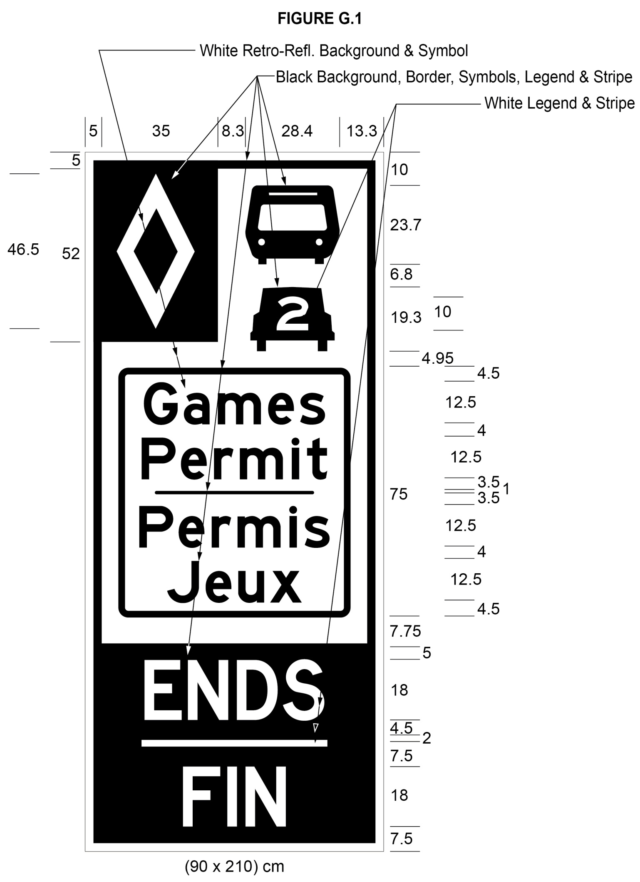
Text alternative: Illustration of a high occupancy vehicle lane sign labeled as “Figure G.1”. The sign contains two rectangles, stacked on top of one another. The top rectangle has a white reflective background and contains a symbol of a bus on top of a symbol of a car with the number “2” inside it. A white diamond shape in a small black rectangle appears in the upper left corner of this rectangle. Below that, in the middle of the sign, are the words “Games Permit/Permis Jeux” in black letters inside the black outline of a rectangle. The bottom rectangle contains the word “ENDS/FIN” in white letters on a reflective black background. The following measurements are written below the sign: (90 x 210) cm. The sign is surrounded by measurements of its different elements. This text alternative is provided for convenience only and does not form part of the official law.
O. Reg. 99/15, s. 2 (1); O. Reg. 101/15, s. 2 (5).
(6) The dimensions of a sign may differ from those prescribed in this section as long as the dimensions are in the same proportion to each other as the dimensions prescribed in this section are to each other. O. Reg. 99/15, s. 2 (1).
Note: On August 19, 2015, section 10 is revoked. (See: O. Reg. 99/15, s. 2 (3))
SCHEDULE A
HIGHWAY NO. 404
1. (1) That part of the King’s Highway known as No. 404 (southbound) lying between a point situate 1,100 metres measured southerly from its intersection with the centre line of the roadway known as 16th Avenue in The Regional Municipality of York, and a point situate 1,090 metres measured southerly from its intersection with the centre line of the roadway known as Sheppard Avenue in the City of Toronto.
(2) That part of the King’s Highway known as No. 404 (northbound) lying between a point situate 210 metres measured northerly from its intersection with the centre line of the roadway known as Van Horne Avenue in the City of Toronto and a point situate 567 metres measured southerly from its intersection with the centre line of the roadway known as Regional Road Highway 7 in The Regional Municipality of York.
(3) This designation is effective 24 hours a day, seven days a week and every month of the year.
(4) Despite subsection (3), during the Games period, this designation is effective between the hours of 5 a.m. and 11 p.m., seven days a week.
Note: On August 19, 2015, subsection (4) is revoked. (See: O. Reg. 99/15, s. 3 (2))
O. Reg. 620/05, Sched. A; O. Reg. 356/07, s. 1; O. Reg. 99/15, s. 3 (1).
SCHEDULE B
HIGHWAY NO. 403
1. (1) That part of the King’s Highway known as No. 403 (eastbound) in the City of Mississauga in The Regional Municipality of Peel lying between a point situate 886 metres measured westerly from its intersection with the centre line of the roadway known as Winston Churchill Boulevard, and a point situate 30 metres measured southerly from its intersection with the centre line of the roadway known as Matheson Boulevard.
(2) That part of the King’s Highway known as No. 403 (westbound) in the City of Mississauga in The Regional Municipality of Peel lying between a point situate 150 metres measured easterly from its intersection with the centre line of the roadway known as Matheson Boulevard, and a point situate 520 metres measured easterly from its intersection with the centre line of the roadway known as Winston Churchill Boulevard.
(3) This designation is effective 24 hours a day, seven days a week and every month of the year.
O. Reg. 620/05, Sched. B.
SCHEDULE C
HIGHWAY NO. 417
1. (1) That part of the King’s Highway known as No. 417 (eastbound) in the City of Ottawa lying between a point situate 415 metres measured westerly from its intersection with the centre line of the roadway known as Palladium Drive and a point situate 14 metres measured westerly from its intersection with the centre line of the roadway known as Moodie Drive.
(2) This designation is effective 24 hours a day, seven days a week and every month of the year.
2. (1) That part of the King’s Highway known as No. 417 (westbound) in the City of Ottawa lying between a point situate 1,105 metres measured westerly from its intersection with the centre line of the roadway known as Moodie Drive and a point situate 465 metres measured easterly from its intersection with the centre line of the roadway known as Palladium Drive.
(2) This designation is effective 24 hours a day, seven days a week and every month of the year.
O. Reg. 205/14, s. 1.
SCHEDULE D
queen elizabeth way and HIGHWAY NO. 403
1. (1) That part of the King’s Highway known as Queen Elizabeth Way and No. 403 (eastbound) in The Regional Municipality of Halton lying between a point situate 39 metres measured westerly from its intersection with the centre line of the roadway known as Guelph Line in the City of Burlington and a point situate 101 metres measured westerly from its intersection with the centre line of the roadway known as Trafalgar Road in the Town of Oakville.
(2) That part of the King’s Highway known as Queen Elizabeth Way/Highway 403 (westbound) in The Regional Municipality of Halton lying between a point situate 185 metres measured easterly from its intersection with the centre line of the roadway known as Trafalgar Road and in the Town of Oakville and a point situate 380 metres measured easterly from its intersection with the centre line of the roadway known as Guelph Line in the City of Burlington.
(3) This designation is effective 24 hours a day, seven days a week and every month of the year.
(4) Despite subsection (3), during the Games period, this designation is effective between the hours of 5 a.m. and 11 p.m., seven days a week.
Note: On August 19, 2015, subsection (4) is revoked. (See: O. Reg. 99/15, s. 4 (2))
O. Reg. 435/10, s. 1; O. Reg. 459/11, s. 1; O. Reg. 99/15, s. 4 (1).
Schedule E
QUEEN ELIZABETH WAY
1. (1) That part of the King’s Highway known as Queen Elizabeth Way (eastbound) lying between a point situate 101 metres measured westerly from its intersection with the centre line of the roadway known as Trafalgar Road in the Town of Oakville and a point situate at the westerly limit of the roadway known as Gardiner Expressway in the City of Toronto.
(2) That part of the King’s Highway known as Queen Elizabeth Way (westbound) lying between a point situate at the westerly limit of the roadway known as Gardiner Expressway in the City of Toronto and a point situate 162 metres measured easterly from its intersection with the centre line of the roadway known as Trafalgar Road in the Town of Oakville.
(3) This designation is effective between the hours of 5 a.m. and 11 p.m., seven days a week during the Games period.
O. Reg. 99/15, s. 5 (1).
Note: On August 19, 2015, Schedule E is revoked. (See: O. Reg. 99/15, s. 5 (2))
Schedule F
HIGHWAY NO. 401
1. (1) That part of the King’s Highway known as No. 401 (eastbound) lying between a point situate 490 metres measured westerly from its intersection with the centre line of the roadway known as Warden Avenue in the City of Toronto and a point situate 501 metres measured westerly from its intersection with the centre line of the roadway known as Westney Road in the City of Ajax.
(2) That part of the King’s Highway known as No. 401 (westbound) lying between a point situate 1416 metres measured easterly from its intersection with the centre line of the roadway known as Liverpool Road in the City of Pickering and a point situate 400 metres measured easterly from its intersection with the centre line of the roadway known as Victoria Park Avenue in the City of Toronto.
(3) That part of the King’s Highway known as No. 401 (westbound) in the City of Mississauga lying between a point situate 752 metres measured easterly from its intersection with the centre line of the roadway known as Dixie Road and a point situate 350 metres measured easterly from its intersection with the centre line of the roadway known as Kennedy Road.
(4) This designation is effective between the hours of 5 a.m. and 11 p.m., seven days a week during the Games period.
O. Reg. 99/15, s. 5 (1).
Note: On August 19, 2015, Schedule F is revoked. (See: O. Reg. 99/15, s. 5 (2))
Schedule g
HIGHWAY NO. 427
1. (1) That part of the King’s Highway known as No. 427 (southbound) in the City of Toronto lying between a point situate 650 metres measured northerly from its intersection with the centre line of the roadway known as Burnhamthorpe Road and a point situate 948 metres measured northerly from its intersection with the centre line of the roadway known as North Queen Street.
(2) That part of the King’s Highway known as No. 427 (northbound) in the City of Toronto lying between a point situate 812 metres measured southerly from its intersection with the centre line of the roadway known as Bloor Street and a point situate 20 metres measured southerly from its intersection with the centre line of the roadway known as Rathburn Road.
(3) This designation is effective between the hours of 5 a.m. and 11 p.m., seven days a week during the Games period.
O. Reg. 99/15, s. 5 (1).
Note: On August 19, 2015, Schedule G is revoked. (See: O. Reg. 99/15, s. 5 (2))

