Highway Traffic Act
ONTARIO REGULATION 227/16
PILOT PROJECT — HOT LANES
Historical version for the period November 1, 2021 to December 31, 2021.
Note: This Regulation is revoked on June 21, 2028. (See: O. Reg. 227/16, s. 14)
Last amendment: 733/21.
Legislative History: 733/21.
This Regulation is made in English only.
CONTENTS
Definitions
1. | Definitions
Pilot Project
2. | Pilot project established
Designation of HOT Lanes
3. | Designation of HOT lanes
HOT Permits
4. | Use of HOT lanes
5. | Issuance, renewal of HOT permits
6. | Term of validity
7. | Application for HOT permits
8. | Display of HOT permit
9. | Inspection of HOT permit
10. | HOT permit not transferable
11. | Fee for HOT permit
Data Collection
12. | Data collection
HOT Lane Signage
13. | Signs
14. | Revocation
Schedule 1 | Queen elizabeth way and highway no. 403
Schedule 2 | Highway no. 410
Schedule 3 | Highway no. 403

Definitions
Definitions
1. (1) In this Regulation,
“HOT lane” means an HOV lane that is designated under this Regulation;
“HOT permit” means a permit issued under this Regulation and includes a temporary HOT permit;
“HOV lane” means a high occupancy vehicle lane designated under the HOV Regulation;
“HOV Regulation” means Ontario Regulation 620/05 (High Occupancy Vehicle Lanes) made under the Act;
“permit period” means, subject to subsection (2), the three-month period for which an HOT permit is issued or renewed.
(2) The permit period for an HOT permit issued for the initial permit period of the pilot project described in section 2 may be longer than three months, as set out on the permit.
Pilot Project
Pilot project established
2. (1) A pilot project is established to evaluate the impact on highway traffic of extending the use of HOV lanes to motor vehicles with only one occupant on the payment of a fee.
(2) The Minister shall conduct and complete the evaluation described in subsection (1) before the twelfth anniversary of the day this Regulation is filed and may conduct interim evaluations before that date.
Designation of HOT Lanes
Designation of HOT lanes
3. (1) The lanes described in Schedule 1 are designated as HOT lanes.
Note: On January 1, 2022, subsection 3 (1) of the Regulation is amended by striking out “Schedule 1” and substituting “Schedules 1, 2 and 3”. (See: O. Reg. 733/21, s. 1)
(2) The designations are effective 24 hours a day, seven days a week and every month of the year and in all conditions and circumstances.
HOT Permits
Use of HOT lanes
4. (1) Despite section 2 of the HOV Regulation, a person may operate a motor vehicle in an HOT lane without another occupant in the motor vehicle if there is a valid HOT permit for the motor vehicle for the current permit period and it is displayed in or on the motor vehicle in accordance with section 8 of this Regulation or, in the case of a temporary HOT permit, it is carried in the motor vehicle.
(2) Despite section 2 of the HOV Regulation, a person may operate a commercial motor vehicle in an HOT lane without another occupant in the commercial motor vehicle if both of the following circumstances exist:
1. There is a valid HOT permit for the commercial motor vehicle for the current permit period and it is displayed in or on the commercial motor vehicle in accordance with section 8 of this Regulation or, in the case of a temporary HOT permit, it is carried in the commercial motor vehicle.
2. The length of the commercial motor vehicle or the total length of the commercial motor vehicle and any vehicle being towed is less than 6.5 metres.
Issuance, renewal of HOT permits
5. (1) Subject to subsections (3) and (4), the Ministry may issue an HOT permit for a permit period to a person who applies for the permit in accordance with section 7 and pays the required fee.
(2) Subject to subsections (3), (4) and (5), the Ministry may renew a valid HOT permit if the holder applies for renewal of the permit in accordance with section 7 for the permit period immediately following the current permit period and pays the required fee.
(3) The Ministry may refuse to issue or renew an HOT permit if any requirements of this Regulation applicable to the applicant, including subsection 12 (2), or to the motor vehicle that is the subject of the application, are not complied with.
(4) The Ministry may limit the total number of HOT permits issued and renewed for any permit period.
(5) The Ministry may limit the number of consecutive permit periods for which HOT permits may be renewed.
Term of validity
6. (1) An HOT permit issued or renewed under this Regulation is valid for the permit period unless,
(a) it is cancelled; or
(b) the vehicle permit issued under subsection 7 (7) of the Act for the motor vehicle for which the HOT permit was issued no longer has current validation.
(2) A temporary HOT permit is valid for 14 days from the date of its issue.
Application for HOT permits
7. (1) Any person may apply to the Ministry for an HOT permit for a motor vehicle for which there is a validated vehicle permit issued under subsection 7 (7) of the Act.
(2) Subject to subsection (5), the holder of an HOT permit may apply to the Ministry for renewal of an HOT permit for a motor vehicle for which there is a validated vehicle permit issued under subsection 7 (7) of the Act.
(3) An application for an HOT permit or for renewal of an HOT permit must be submitted in the form and manner and by the date required by the Ministry and must include the information and documents required by the Ministry.
(4) The holder of a valid HOT permit shall notify the Ministry of any change in the information provided to the Ministry in the application for the issuance or renewal of the permit as required by the Ministry in the application.
(5) The holder of an HOT permit who has renewed the HOT permit for the maximum number of consecutive permit periods permitted by the Ministry may not apply for renewal of the HOT permit; however, that holder may apply for the issuance of a new HOT permit.
Display of HOT permit
8. (1) A valid HOT permit must be displayed in or on the motor vehicle in a clearly visible position and as specified by the Ministry.
(2) In the case of a commercial motor vehicle towing another vehicle, the valid HOT permit must be displayed in or on the commercial motor vehicle that is towing the other vehicle in a clearly visible position and as specified by the Ministry.
(3) A temporary HOT permit must be carried in the motor vehicle.
(4) No person shall display an HOT permit in or on a motor vehicle if the HOT permit is no longer valid or if the HOT permit has not been issued for that motor vehicle.
Inspection of HOT permit
9. Every person operating a motor vehicle in an HOT lane pursuant to this Regulation shall, upon the demand of a police officer,
(a) allow the police officer to inspect the HOT permit displayed in or on the motor vehicle;
(b) in the case of a temporary HOT permit, surrender the temporary HOT permit for inspection by the police officer.
HOT permit not transferable
10. (1) An HOT permit may not be used for a motor vehicle other than the motor vehicle for which the HOT permit is issued.
(2) The Ministry, on the request of an HOT permit holder, may cancel the HOT permit and issue a replacement HOT permit for another motor vehicle for which the HOT permit holder holds a validated vehicle permit issued under subsection 7 (7) of the Act.
Fee for HOT permit
11. The fee for the issuance or renewal of an HOT permit for a permit period is $180.
Data Collection
Data collection
12. (1) The Ministry may, from time to time and in any form or manner, request that a person who holds an HOT permit, or who at any time within the previous two years held an HOT permit, provide the Ministry with any information needed by the Minister to conduct the evaluations required by subsection 2 (2), including information on the use of HOT lanes under the pilot project, or any aspect of that use that may be specified by the Ministry.
(2) A person shall provide the Ministry with the information requested under subsection (1) in the form and manner and by the time required by the Ministry.
HOT Lane Signage
Signs
13. (1) The commencement of an HOT lane shall be indicated by a ground mounted sign that has the dimensions and bears the markings as illustrated in Figure A.
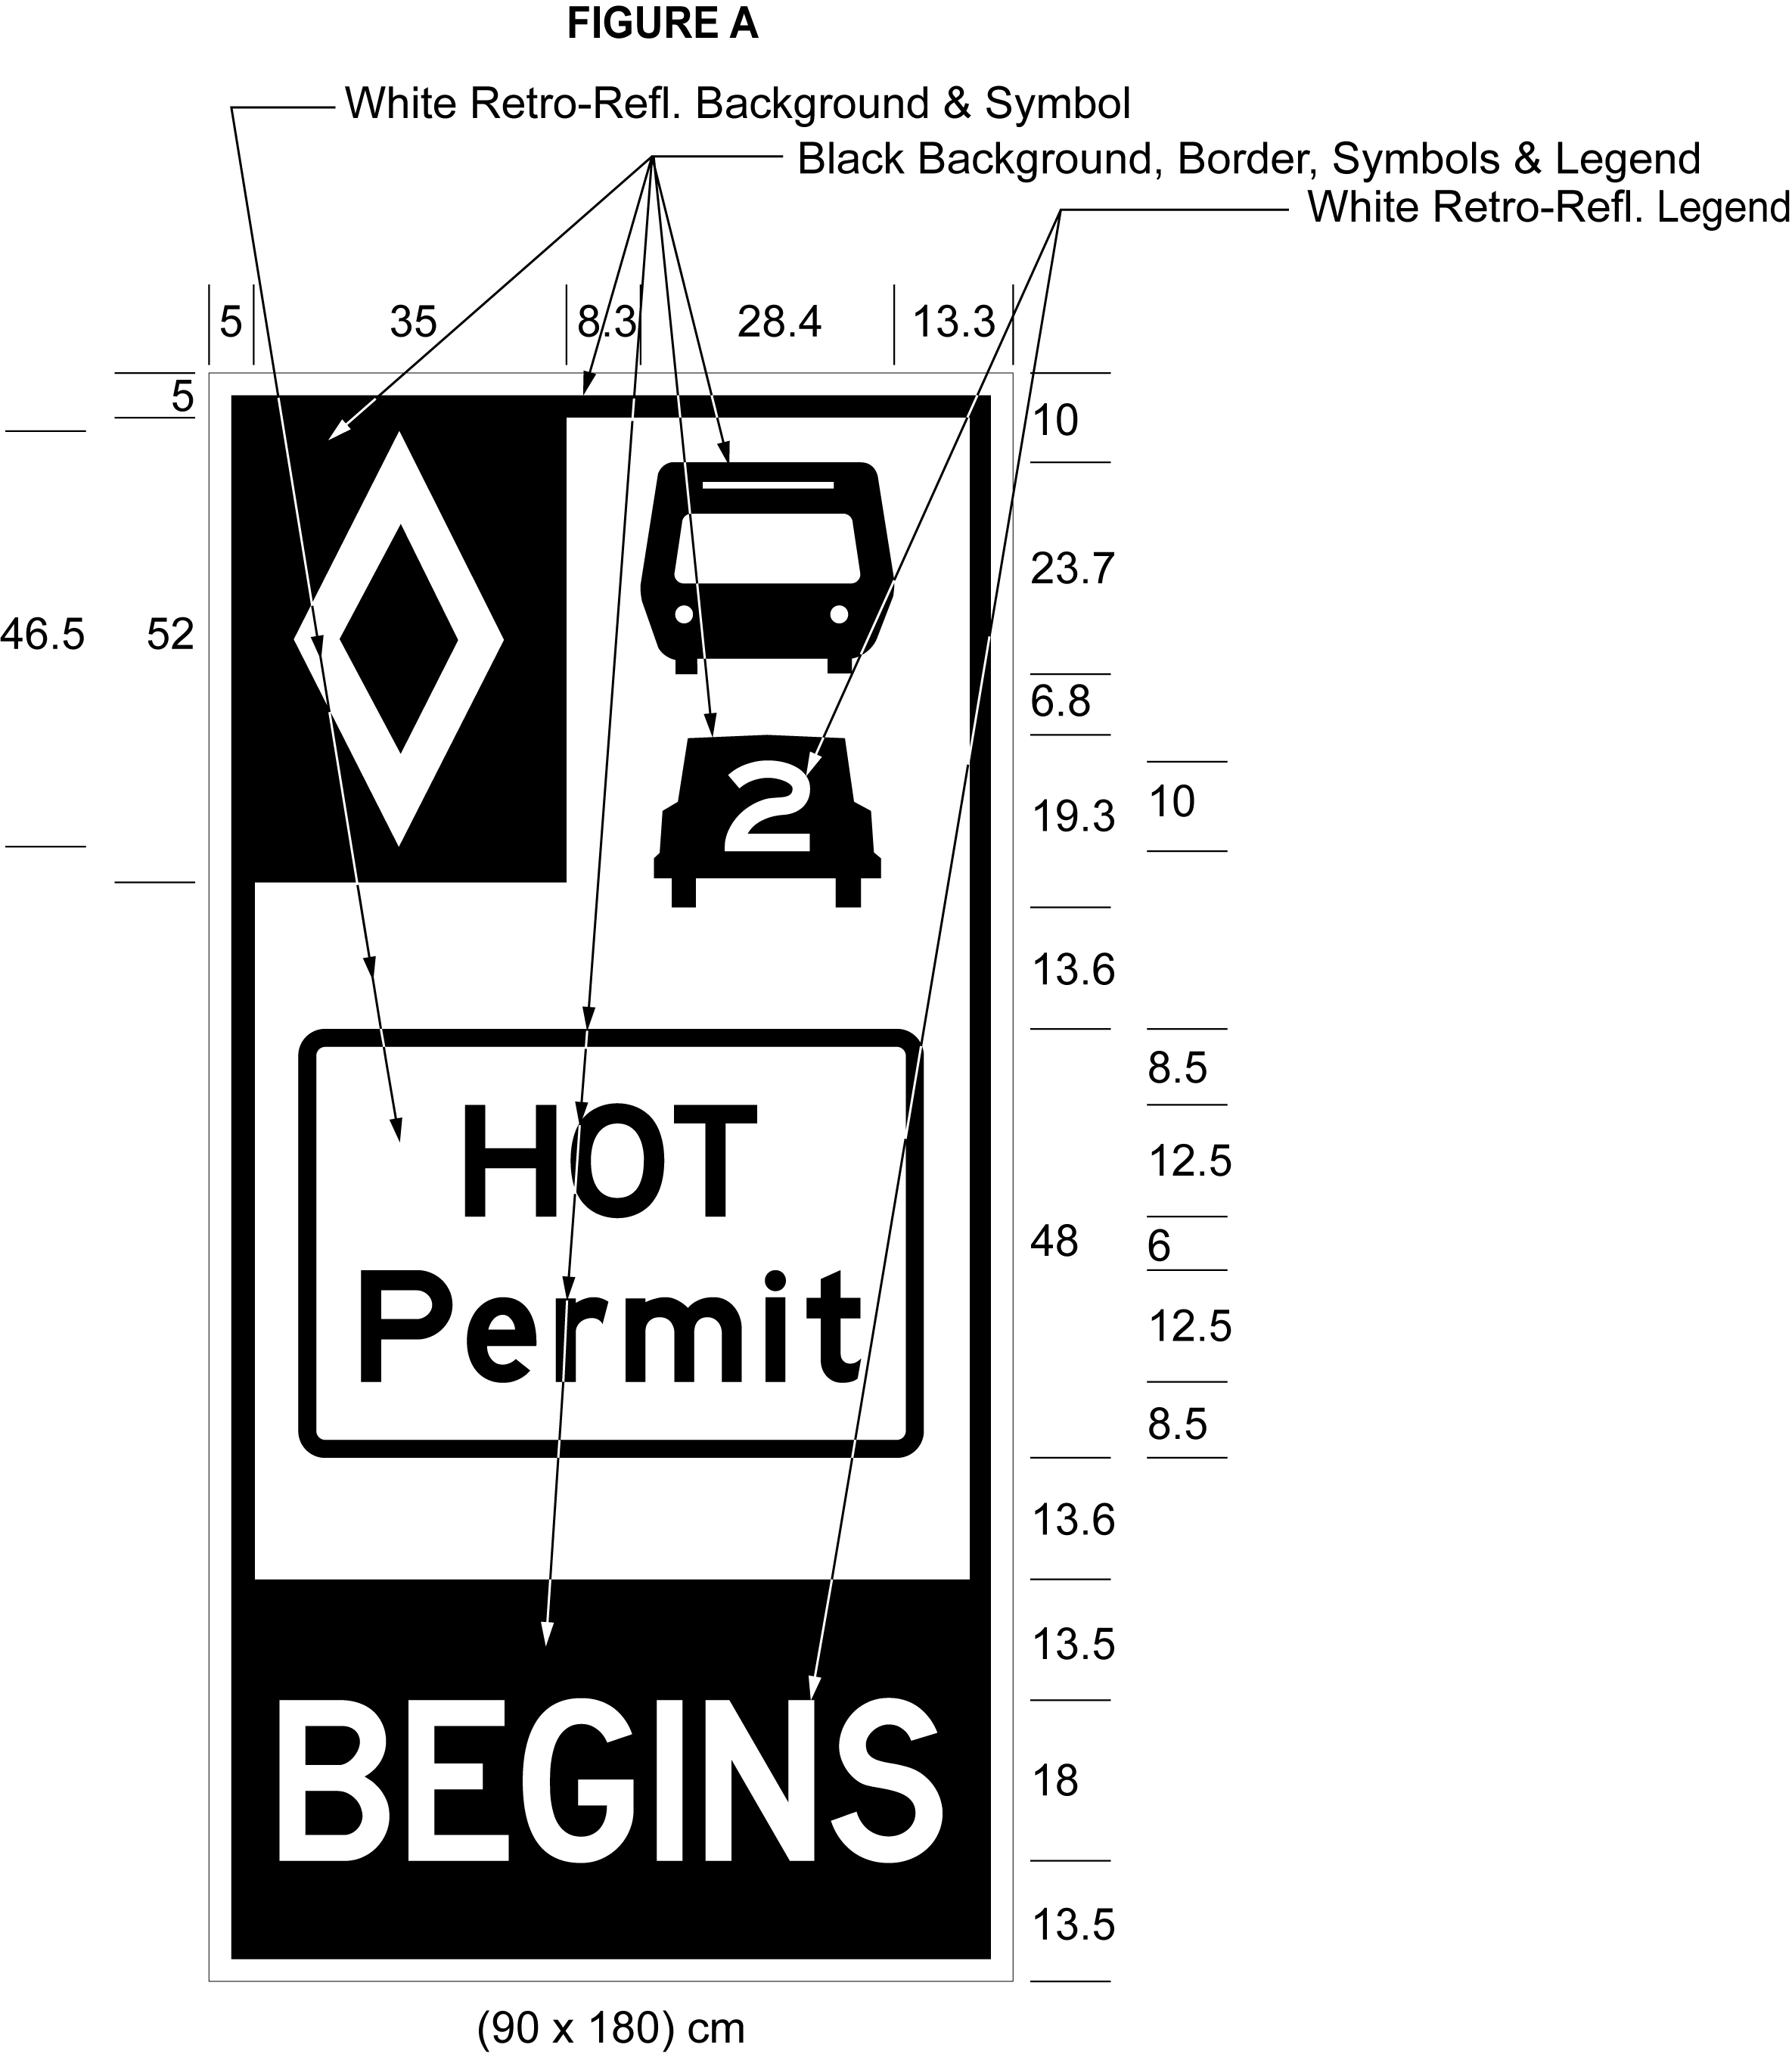
Text alternative: Illustration of a sign labelled as “Figure A”. The sign contains two rectangles, stacked on top of one another. The top rectangle has a white reflective background and contains a symbol of a bus on top of a symbol of a car with the number “2” inside it. A white diamond shape in a small black rectangle appears in the upper left corner of this rectangle. The words “HOT permit” appear on the bottom half of this rectangle inside a rectangular outline. The bottom rectangle has a black background and contains the word “BEGINS” in white reflective letters. The following measurements are written below the sign: (90 x 180) cm. The sign is surrounded by measurements of its different elements. This text alternative is provided for convenience only and does not form part of the official law.
Note: On January 1, 2022, Figure A to subsection 13 (1) of the Regulation is revoked and the following substituted: (See: O. Reg. 733/21, s. 2 (1))
Figure A
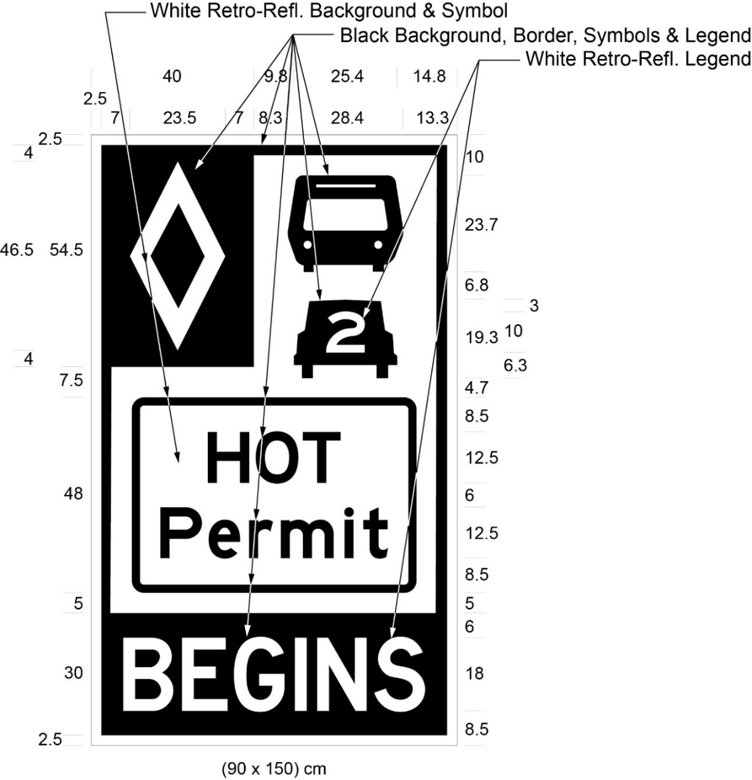
Text alternative: Illustration of a sign labelled as “Figure A”. The sign contains two rectangles, stacked on top of one another. The top rectangle has a white reflective background and contains a symbol of a bus on top of a symbol of a car with the number “2” inside it. A white diamond shape in a small black rectangle appears in the upper left corner of this rectangle. The words “HOT Permit” appear on the bottom half of this rectangle inside a rectangular outline. The bottom rectangle has a black background and contains the word “BEGINS” in white reflective letters. The following measurements are written below the sign: (90 x 150) cm. The sign is surrounded by measurements of its different elements. This text alternative is provided for convenience only and does not form part of the official law.
(2) Despite subsection (1), in an area designated in the Schedule to the French Language Services Act, the commencement of an HOT lane shall be indicated by a ground mounted sign that has the dimensions and bears the markings as illustrated in Figure B.
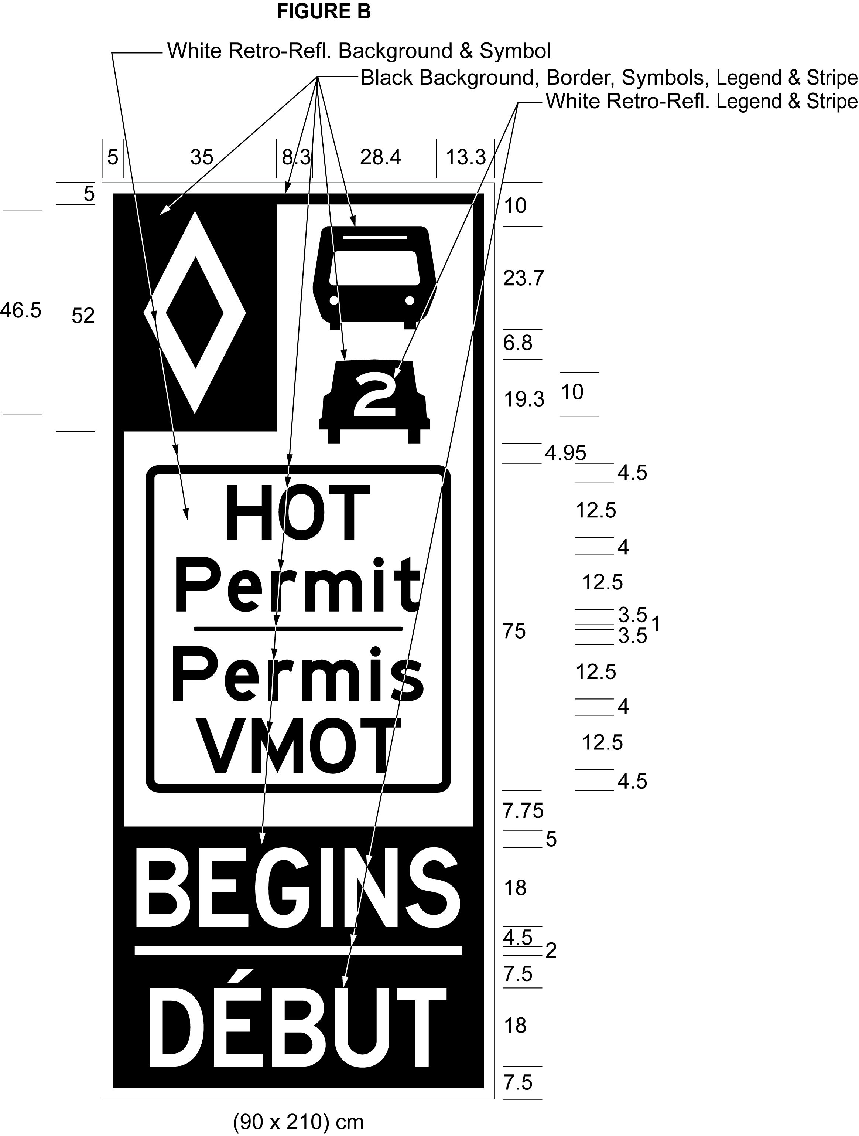
Text alternative: Illustration of a sign labelled as “Figure B”. The sign contains two rectangles, stacked on top of one another. The top rectangle has a white reflective background and a symbol of a bus on top of a symbol of a car with the number “2” inside it. A white diamond shape in a small black rectangle appears in the upper left corner of this rectangle. The words “HOT permit/Permis VMOT” appear on the bottom half of this rectangle inside a rectangular outline. The bottom rectangle has a black background and contains the words “BEGINS/DÉBUT” in white reflective letters. The following measurements are written below the sign: (90 x 210) cm. The sign is surrounded by measurements of its different elements. This text alternative is provided for convenience only and does not form part of the official law.
Note: On January 1, 2022, Figure B to subsection 13 (2) of the Regulation is revoked and the following substituted: (See: O. Reg. 733/21, s. 2 (2))
Figure B
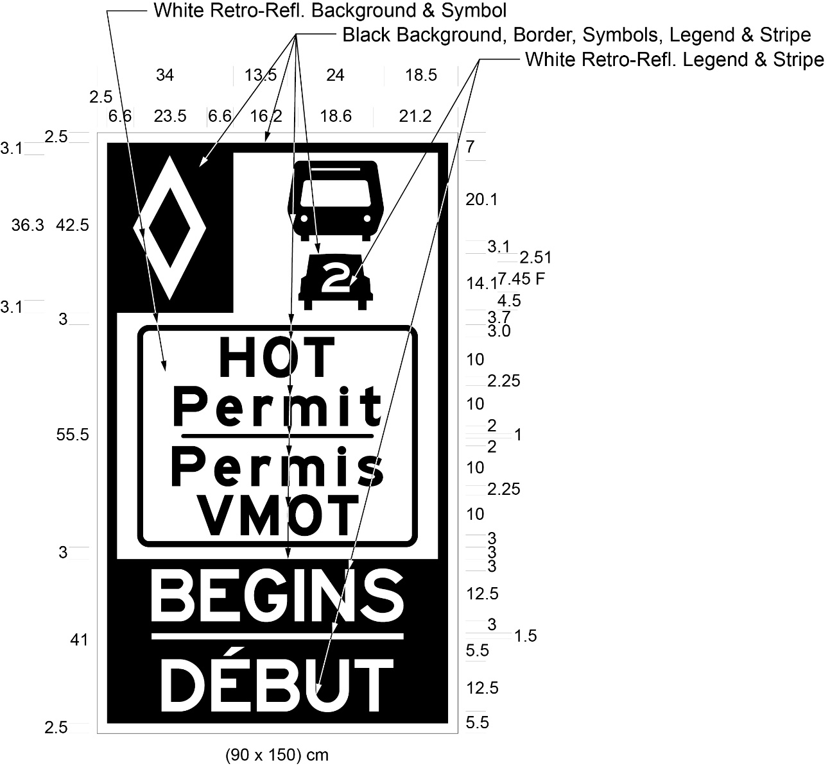
Text alternative: Illustration of a sign labelled as “Figure B”. The sign contains two rectangles, stacked on top of one another. The top rectangle has a white reflective background and a symbol of a bus on top of a symbol of a car with the number “2” inside it. A white diamond shape in a small black rectangle appears in the upper left corner of this rectangle. The words “HOT Permit/Permis VMOT” appear on the bottom half of this rectangle inside a rectangular outline. The bottom rectangle has a black background and contains the words “BEGINS/DÉBUT” in white reflective letters. The following measurements are written below the sign: (90 x 150) cm. The sign is surrounded by measurements of its different elements. This text alternative is provided for convenience only and does not form part of the official law.
(3) Ground mounted signs shall be erected along the length of an HOT lane and shall have the dimensions and bear the markings as illustrated in Figure C.
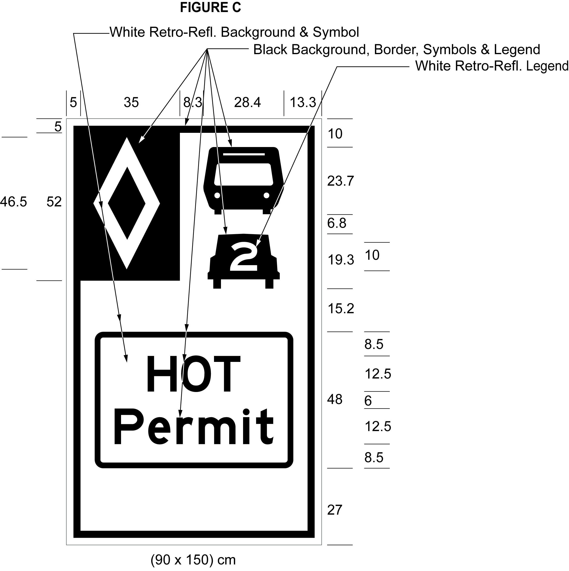
Text alternative: Illustration of a sign labelled as “Figure C”. The sign has a white reflective background and a symbol of a bus on top of a symbol of a car with the number “2” inside it. A white diamond shape in a small black rectangle appears in the upper left corner of the sign. The words “HOT permit” appear below the symbols inside a rectangular outline. The following measurements are written below the sign: (90 x 150) cm. The sign is surrounded by measurements of its different elements. This text alternative is provided for convenience only and does not form part of the official law.
Note: On January 1, 2022, Figure C to subsection 13 (3) of the Regulation is revoked and the following substituted: (See: O. Reg. 733/21, s. 2 (3))
Figure C
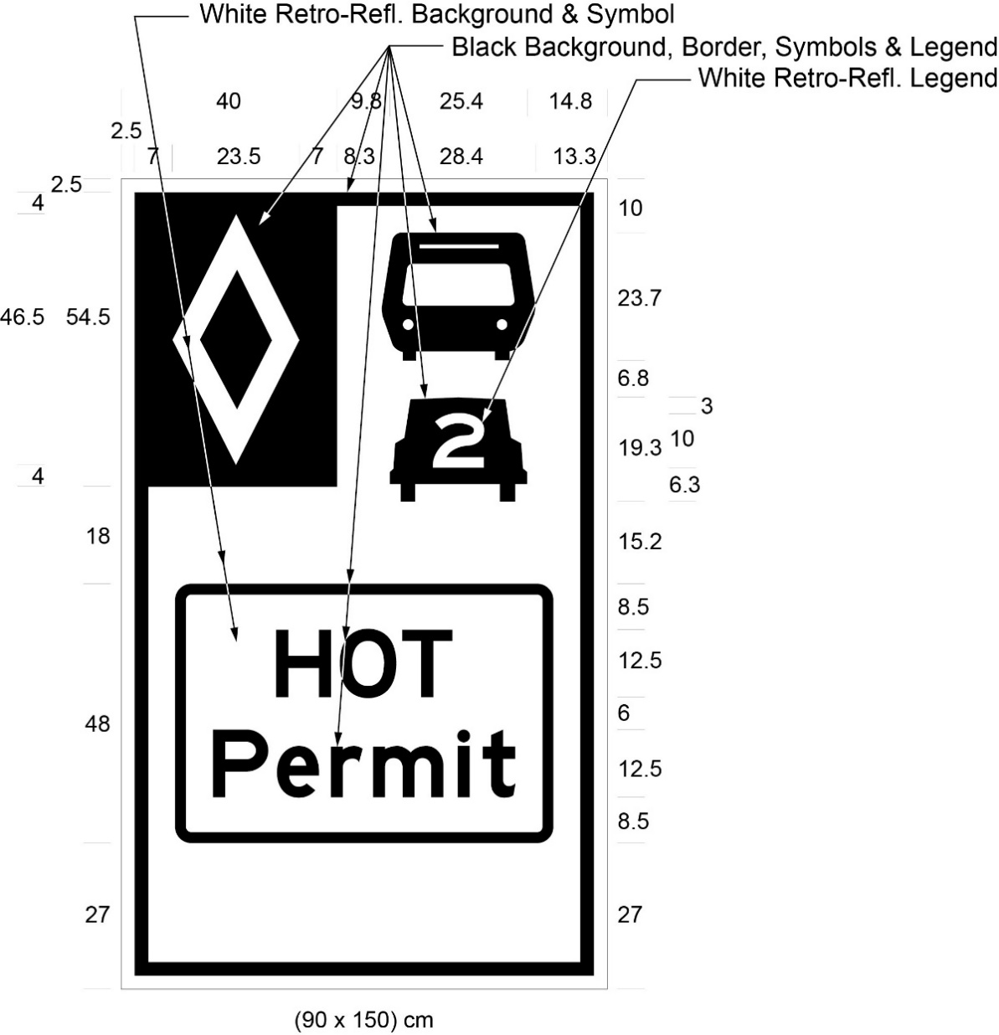
Text alternative: Illustration of a sign labelled as “Figure C”. The sign has a white reflective background and a symbol of a bus on top of a symbol of a car with the number “2” inside it. A white diamond shape in a small black rectangle appears in the upper left corner of the sign. The words “HOT Permit” appear below the symbols inside a rectangular outline. The following measurements are written below the sign: (90 x 150) cm. The sign is surrounded by measurements of its different elements. This text alternative is provided for convenience only and does not form part of the official law.
(4) Despite subsection (3), in an area designated in the Schedule to the French Language Services Act, ground mounted signs shall be erected along the length of an HOT lane and shall have the dimensions and bear the markings as illustrated in Figure D.
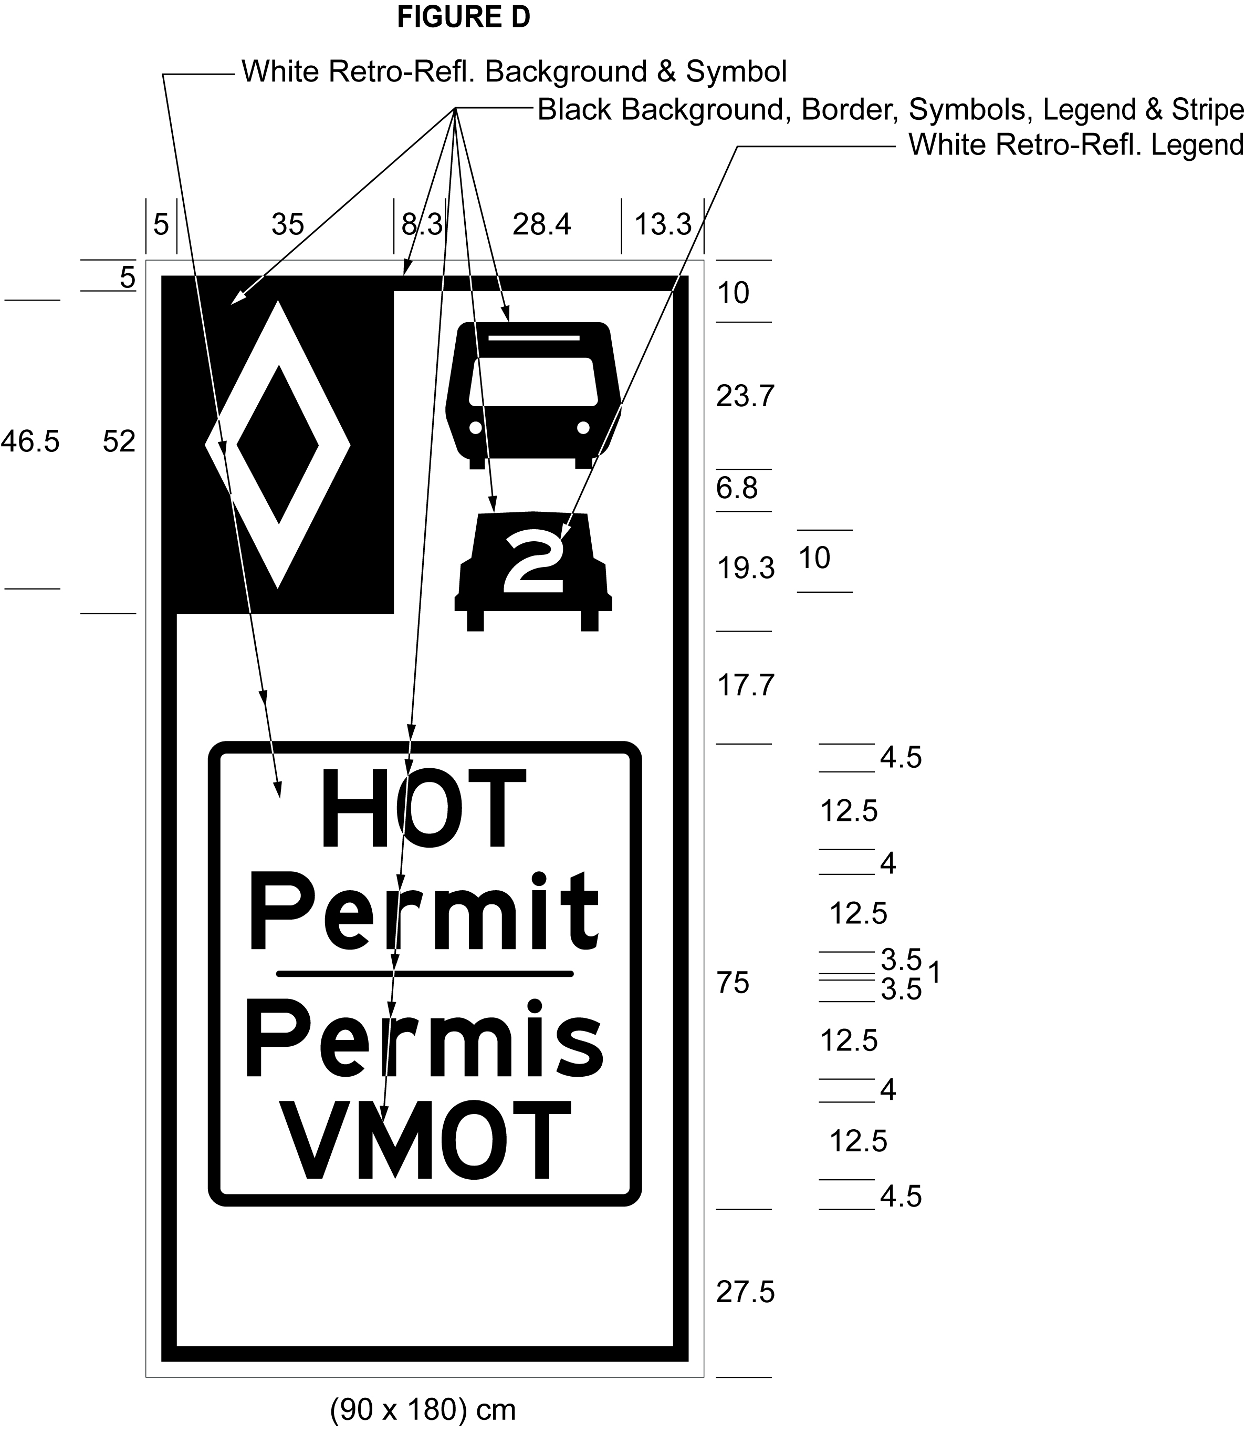
Text alternative: Illustration of a sign labelled as “Figure D”. The sign has a white reflective background and a symbol of a bus on top of a symbol of a car with the number “2” inside it. A white diamond shape in a small black rectangle appears in the upper left corner of the sign. The words “HOT permit/Permis VMOT” appear below the symbols inside a rectangular outline. The following measurements are written below the sign: (90 x 180) cm. The sign is surrounded by measurements of its different elements. This text alternative is provided for convenience only and does not form part of the official law.
Note: On January 1, 2022, Figure D to subsection 13 (4) of the Regulation is revoked and the following substituted: (See: O. Reg. 733/21, s. 2 (4))
Figure D
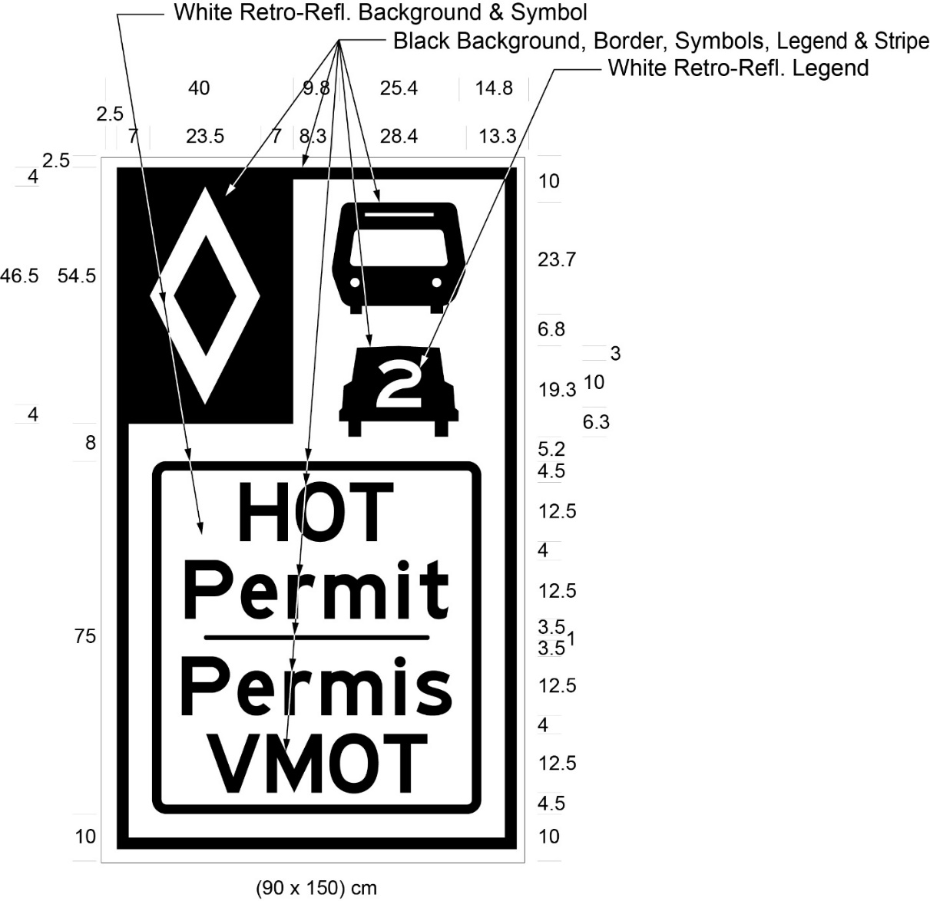
Text alternative: Illustration of a sign labelled as “Figure D”. The sign has a white reflective background and a symbol of a bus on top of a symbol of a car with the number “2” inside it. A white diamond shape in a small black rectangle appears in the upper left corner of the sign. The words “HOT Permit/Permis VMOT” appear below the symbols inside a rectangular outline. The following measurements are written below the sign: (90 x 150) cm. The sign is surrounded by measurements of its different elements. This text alternative is provided for convenience only and does not form part of the official law.
(5) Signs erected under subsection (3) or (4) shall not be more than four kilometres apart from each other.
(6) The end of an HOT lane shall be indicated by a ground mounted sign that has the dimensions and bears the markings as illustrated in Figure E.
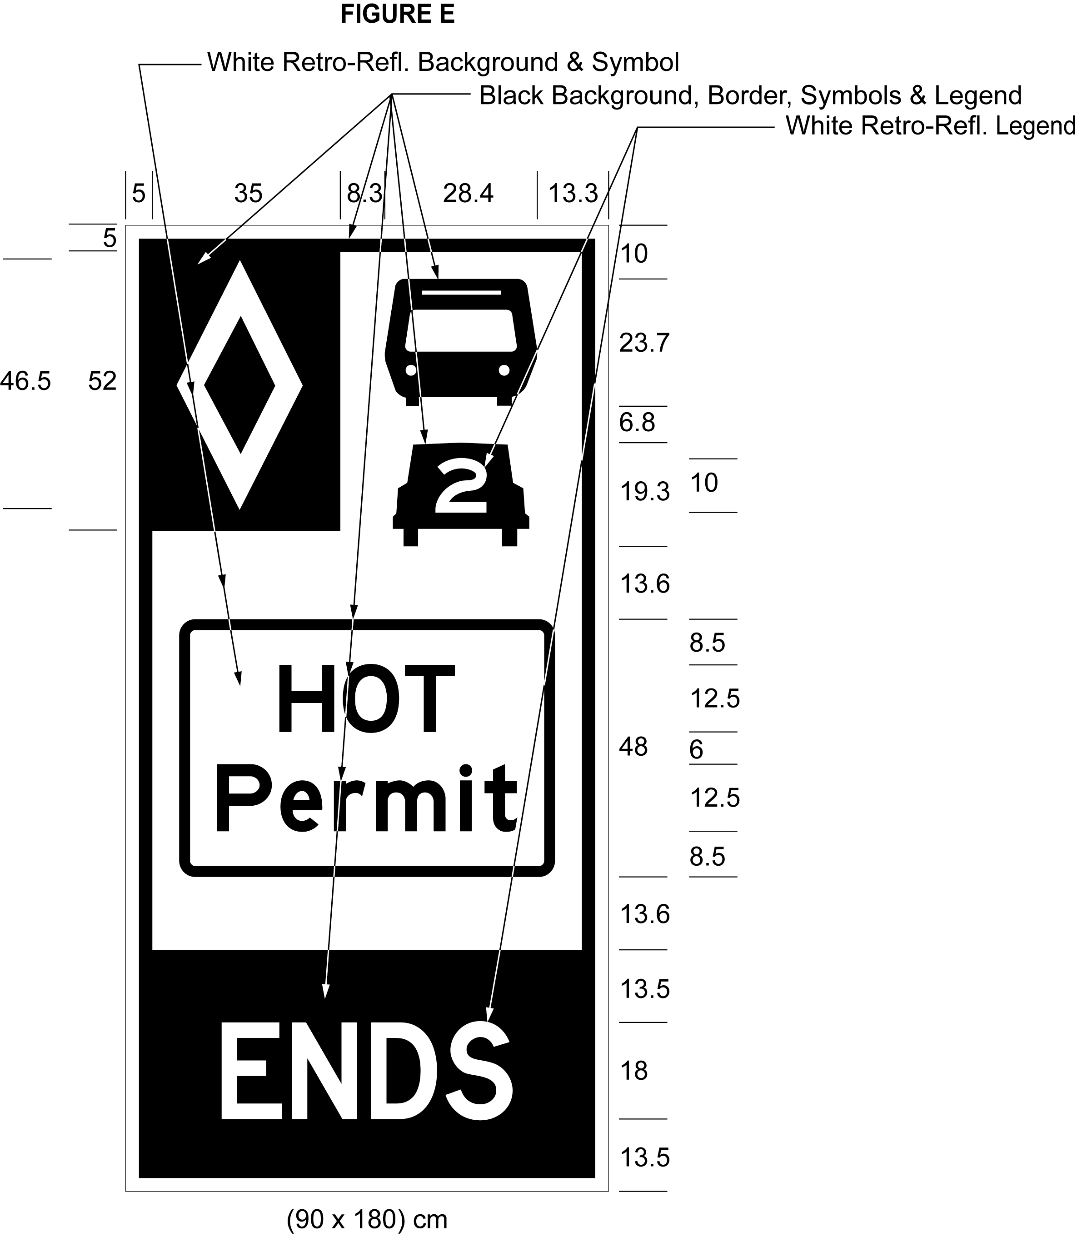
Text alternative: Illustration of a sign labelled as “Figure E”. The sign contains two rectangles, stacked on top of one another. The top rectangle has a white reflective background and a symbol of a bus on top of a symbol of a car with the number “2” inside it. A white diamond shape in a small black rectangle appears in the upper left corner of this rectangle. The words “HOT permit” appear on the bottom half of this rectangle inside a rectangular outline. The bottom rectangle has a black background and contains the word “ENDS” in white reflective letters. The following measurements are written below the sign: (90 x 180) cm. The sign is surrounded by measurements of its different elements. This text alternative is provided for convenience only and does not form part of the official law.
Note: On January 1, 2022, Figure E to subsection 13 (6) of the Regulation is revoked and the following substituted: (See: O. Reg. 733/21, s. 2 (5))
Figure E
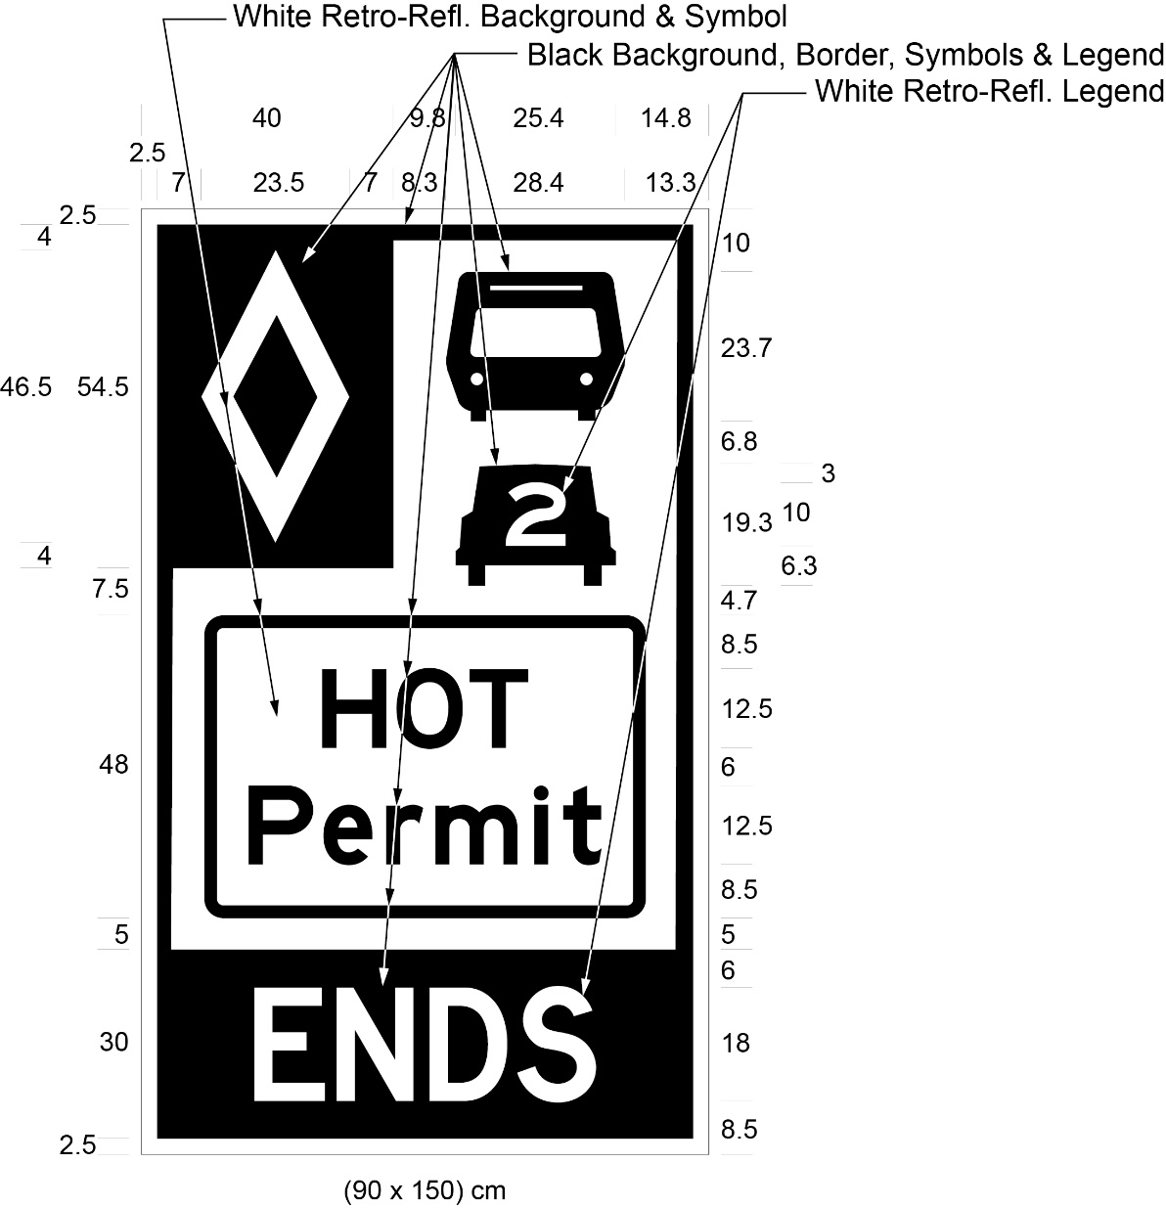
Text alternative: Illustration of a sign labelled as “Figure E”. The sign contains two rectangles, stacked on top of one another. The top rectangle has a white reflective background and a symbol of a bus on top of a symbol of a car with the number “2” inside it. A white diamond shape in a small black rectangle appears in the upper left corner of this rectangle. The words “HOT Permit” appear on the bottom half of this rectangle inside a rectangular outline. The bottom rectangle has a black background and contains the word “ENDS” in white reflective letters. The following measurements are written below the sign: (90 x 150) cm. The sign is surrounded by measurements of its different elements. This text alternative is provided for convenience only and does not form part of the official law.
(7) Despite subsection (6), in an area designated in the Schedule to the French Language Services Act, the end of an HOT lane shall be indicated by a ground mounted sign that has the dimensions and bears the markings as illustrated in Figure F.
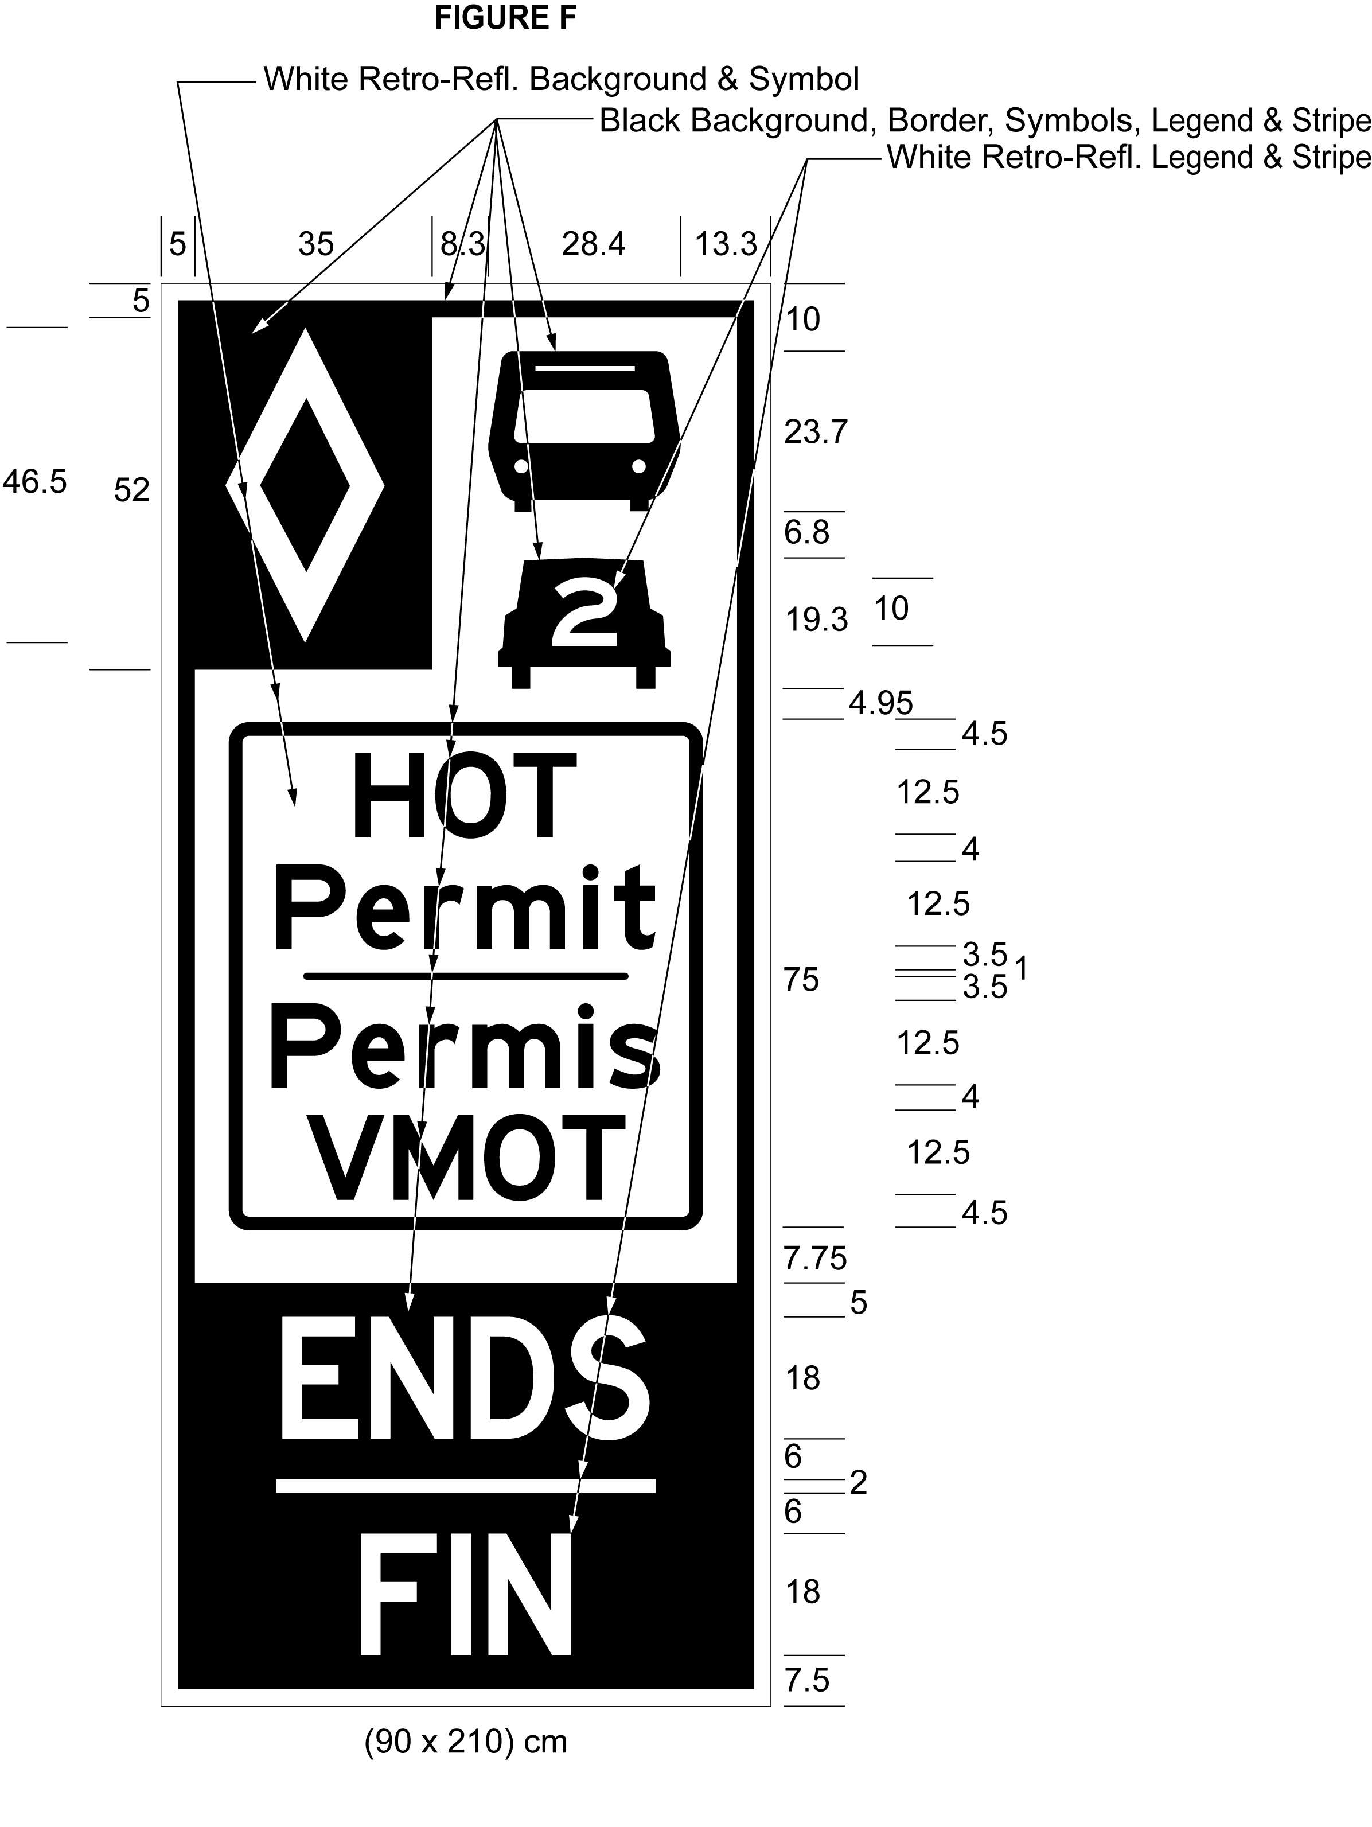
Text alternative: Illustration of a sign labelled as “Figure F”. The sign contains two rectangles, stacked on top of one another. The top rectangle has a white reflective background and a symbol of a bus on top of a symbol of a car with the number “2” inside it. A white diamond shape in a small black rectangle appears in the upper left corner of this rectangle. The words “HOT permit/Permis VMOT” appear on the bottom half of this rectangle inside a rectangular outline. The bottom rectangle has a black background and contains the words “ENDS/FIN” in white reflective letters. The following measurements are written below the sign: (90 x 210) cm. The sign is surrounded by measurements of its different elements. This text alternative is provided for convenience only and does not form part of the official law.
Note: On January 1, 2022, Figure F to subsection 13 (7) of the Regulation is revoked and the following substituted: (See: O. Reg. 733/21, s. 2 (6))
Figure F
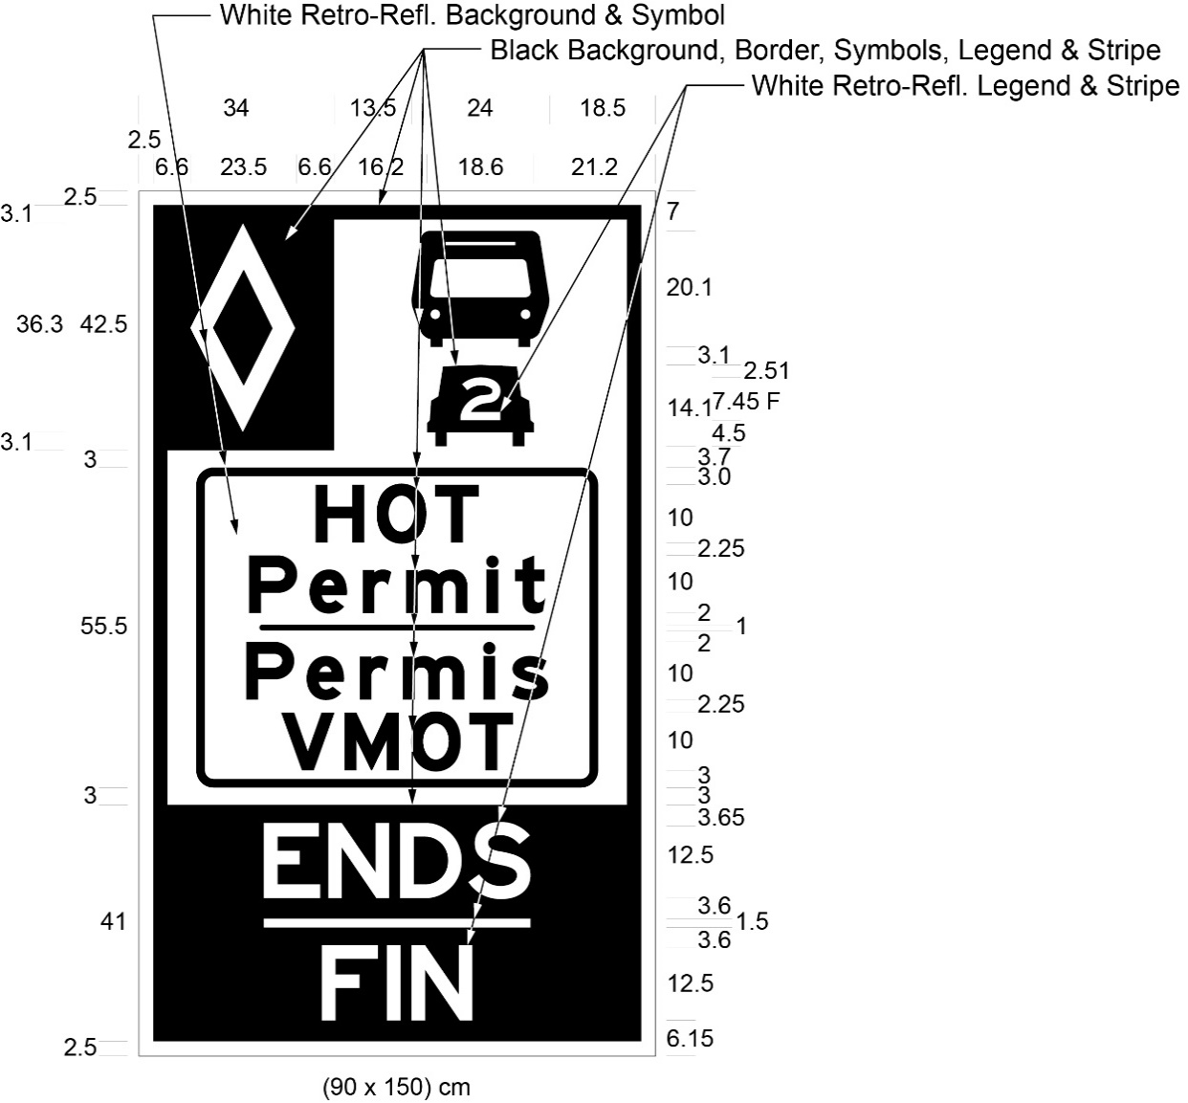
Text alternative: Illustration of a sign labelled as “Figure F”. The sign contains two rectangles, stacked on top of one another. The top rectangle has a white reflective background and a symbol of a bus on top of a symbol of a car with the number “2” inside it. A white diamond shape in a small black rectangle appears in the upper left corner of this rectangle. The words “HOT Permit/Permis VMOT” appear on the bottom half of this rectangle inside a rectangular outline. The bottom rectangle has a black background and contains the words “ENDS/FIN” in white reflective letters. The following measurements are written below the sign: (90 x 150) cm. The sign is surrounded by measurements of its different elements. This text alternative is provided for convenience only and does not form part of the official law.
(8) The dimensions of a sign may differ from those prescribed in this section as long as the dimensions are in the same proportion to each other as the dimensions prescribed in this section are to each other.
(9) The signs required by this section shall be erected on the side of the highway facing approaching traffic.
(10) The signs required by this section are in addition to the signs required by section 5 of the HOV Regulation.
Revocation
14. This Regulation is revoked on the twelfth anniversary of the day it is filed.
15. Omitted (provides for coming into force of provisions of this Regulation).
Schedule 1
QUEEN ELIZABETH WAY AND HIGHWAY NO. 403
1. (1) The left lane of that part of the King’s Highway known as Queen Elizabeth Way and No. 403 (eastbound) in The Regional Municipality of Halton lying between a point situate 39 metres measured westerly from its intersection with the centre line of the roadway known as Guelph Line in the City of Burlington and a point situate 101 metres measured westerly from its intersection with the centre line of the roadway known as Trafalgar Road in the Town of Oakville.
(2) The left lane of that part of the King’s Highway known as Queen Elizabeth Way and No. 403 (westbound) in The Regional Municipality of Halton lying between a point situate 185 metres measured easterly from its intersection with the centre line of the roadway known as Trafalgar Road and in the Town of Oakville and a point situate 380 metres measured easterly from its intersection with the centre line of the roadway known as Guelph Line in the City of Burlington.
O. Reg. 227/16, Sched. 1.
Note: On January 1, 2022, the Regulation is amended by adding the following Schedules: (See: O. Reg. 733/21, s. 3)
Schedule 2
Highway no. 410
1. (1) That part of the King’s Highway known as No. 410 (northbound) in The Regional Municipality of Peel lying between a point situate at its intersection with the King’s Highway known as No. 401 in the City of Mississauga and a point situate 350 metres measured southerly from its intersection with the centre line of the roadway known as Clark Boulevard in the City of Brampton.
(2) That part of the King’s Highway known as No. 410 (southbound) in The Regional Municipality of Peel lying between a point situate 40 metres measured northerly from its intersection with the centre line of the roadway known as Glidden Road in the City of Brampton and a point situate 800 metres measured northerly from its intersection with the centre line of the King’s Highway known as No. 401 in the City of Mississauga.
O. Reg. 733/21, s. 3.
Schedule 3
HIGHWAY NO. 403
1. (1) That part of the King’s Highway known as No. 403 (eastbound) in the City of Mississauga in The Regional Municipality of Peel lying between a point situate 886 metres measured westerly from its intersection with the centre line of the roadway known as Winston Churchill Boulevard and a point situate 30 metres measured southerly from its intersection with the centre line of the roadway known as Matheson Boulevard.
(2) That part of the King’s Highway known as No. 403 (westbound) in the City of Mississauga in The Regional Municipality of Peel lying between a point situate 150 metres measured southerly from its intersection with the centre line of the roadway known as Matheson Boulevard and a point situate 520 metres measured easterly from its intersection with the centre line of the roadway known as Winston Churchill Boulevard.
2. That part of the King’s Highway known as No. 403 (eastbound) in the City of Mississauga in The Regional Municipality of Peel lying in the collector lanes between a point situate 600 metres measured southerly from its intersection with the centre line of the roadway known as Matheson Boulevard and a point situate at its intersection with the King’s Highway known as No. 401.
O. Reg. 733/21, s. 3.

