Highway Traffic Act
ONTARIO REGULATION 325/21
RESTRICTED TOWING ZONES
Historical version for the period April 30, 2021 to June 30, 2021.
Note: THIS REGULATION IS NOT YET IN FORCE. It comes into force on July 1, 2021.
Note: This Regulation is revoked on July 1, 2026, the fifth anniversary of the day section 2 comes into force. (See: O. Reg. 325/21, s. 10)
No amendments.
This is the English version of a bilingual regulation.
Definitions
1. In this Regulation,
“authorized” means authorized by the Ministry to provide towing services in a restricted towing zone and “authorization” has a corresponding meaning; (“autorisé”, “autorisation”)
“person in charge of a tow truck” includes a driver of a tow truck; (“personne ayant la charge d’une dépanneuse”)
“restricted towing zone” means a highway or part of a highway designated in section 7; (“zone restreinte de dépannage”)
“towing services” means towing, recovery or roadside assistance services and includes impoundment of vehicles ordered by a police officer; (“services de dépannage”)
“towing services provider” means a person or operator who provides towing services; (“fournisseur de services de dépannage”)
“tow truck” includes,
(a) a motor vehicle commonly known as a tow truck,
(b) a motor vehicle with a flatbed that can tilt to load,
(c) a motor vehicle that is designed, modified, configured or equipped so that it is capable of towing other motor vehicles, and
(d) a motor vehicle that is used by a person who offers or provides roadside assistance services. (“dépanneuse”)
Pilot project
2. (1) A pilot project to evaluate the use of restricted towing zones on highways is established.
(2) The Minister shall conduct and complete an evaluation of the use of restricted towing zones on highways under this Regulation on or before the fifth anniversary of the day this Regulation is filed.
Prohibitions
3. (1) No person shall provide or offer to provide towing services in a restricted towing zone except as permitted by this Regulation.
(2) Where a towing services provider is authorized to provide towing services in a restricted towing zone, no other towing services provider shall provide or offer to provide towing services in the restricted towing zone.
(3) Subsection (1) does not apply to a person in charge of a police department vehicle, a road service vehicle or other vehicle owned or operated by or on behalf of the road authority that has jurisdiction over the highway, or to a person acting under the direction of a police officer.
Permitted use
4. (1) The Ministry may authorize a towing services provider to provide towing services in a restricted towing zone.
(2) A towing services provider that is authorized to provide towing services in a restricted towing zone may provide or offer to provide towing services to owners, drivers or other persons in charge of a motor vehicle in the restricted towing zone.
Tow trucks to be marked
5. (1) Every authorized towing services provider shall ensure that every tow truck providing towing services on its behalf in a restricted towing zone,
(a) displays the name of the towing services provider; and
(b) displays in a clearly visible position on each side of and on the back of the tow truck a sign showing its authorization to provide towing services in the restricted towing zone.
(2) No person shall drive or operate a tow truck displaying information described in clause (1) (a) or (b) unless the person is providing towing services on behalf of the authorized towing services provider.
Documents to be carried and surrendered
6. (1) Every person in charge of a tow truck providing towing services for or on behalf of an authorized towing services provider in a restricted towing zone shall carry proof of the authorization and upon the demand of a police officer or an officer appointed for carrying out the provisions of the Act shall surrender it for inspection.
(2) Every person in charge of a tow truck providing towing services for or on behalf of an authorized towing services provider in a restricted towing zone shall provide to the driver, owner or other person in charge of a motor vehicle in the restricted towing zone such information as the Ministry requires about the towing services prior to providing the towing services.
Restricted towing zones
7. (1) The following zones, consisting of the highways or parts of highways indicated, are designated as restricted towing zones in each direction of travel:
1. Zone 1: Highway 401 from Highway 400 to Morningside Avenue.
2. Zone 2:
i. Highway 401 from Highway 400 to Regional Road 25.
ii. Highway 427 from Evans Avenue to Highway 409.
iii. Highway 409 from Highway 427 to Highway 401.
3. Zone 3: Highway 400 from Highway 401 to Highway 9.
4. Zone 4: QEW from Highway 427 to Brant Street.
(2) A restricted towing zone referred to in subsection (1) includes all ramps to and from a highway or part of a highway designated in that subsection, other than ramps to and from the private toll highway known as Highway 407, but does not include any ONRoute rest stop, truck inspection station or carpool lot.
Signs
8. (1) An overhead sign or a ground mounted sign may be erected on a highway or part of a highway that is a restricted towing zone indicating that it is a restricted towing zone.
(2) If a ground mounted sign referred to in subsection (1) is erected, it shall have the dimensions and bear the markings as illustrated in the following figure:
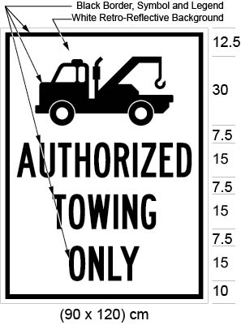
Text alternative: Illustration of “restricted towing zone” sign. The top portion of the sign contains the symbol of a tow truck. The symbol is in black on a white retro-reflective background. The bottom portion of the sign contains the words “AUTHORIZED TOWING ONLY” in black text on a white retro-reflective background. The following measurements are written below the sign: (90 × 120) cm. The sign is surrounded by measurements of its different elements. This text alternative is provided for convenience only and does not form part of the official law.
(3) Despite subsection (2), a ground mounted sign referred to in subsection (1) that has the dimensions and bears the markings as illustrated in the following figure may be erected on a highway or part of a highway that is designated under section 7 as a restricted towing zone in an area designated in the Schedule to the French Language Services Act:
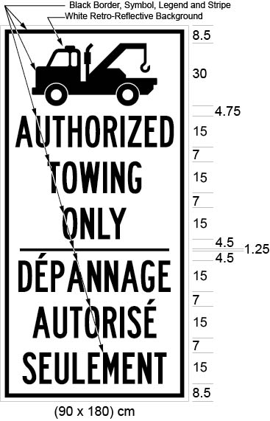
Text alternative: Illustration of “restricted towing zone” sign. The top portion of the sign contains the symbol of a tow truck. The symbol is in black on a white retro-reflective background. The bottom portion of the sign contains the words “AUTHORIZED TOWING ONLY / DÉPANNAGE AUTORISÉ SEULEMENT” in black text on a white retro-reflective background. The following measurements are written below the sign: (90 × 180) cm. The sign is surrounded by measurements of its different elements. This text alternative is provided for convenience only and does not form part of the official law.
(4) An overhead sign or a ground mounted sign may be erected at the beginning of a restricted towing zone.
(5) If a ground mounted sign referred to in subsection (4) is erected, it shall have the dimensions and bear the markings as illustrated in the following figure:
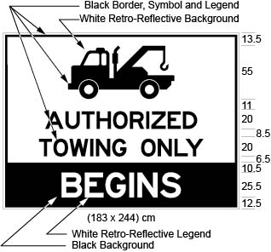
Text alternative: Illustration of “restricted towing zone” sign. The top portion of the sign contains the symbol of a tow truck. The symbol is in black on a white retro-reflective background. The middle portion of the sign contains the words “AUTHORIZED TOWING ONLY” in black text on a white retro-reflective background. The bottom portion of the sign contains the words “BEGINS” in white text on a black background. The following measurements are written below the sign: (183 × 244) cm. The sign is surrounded by measurements of its different elements. This text alternative is provided for convenience only and does not form part of the official law.
(6) Despite subsection (5), a ground mounted sign referred to in subsection (4) that has the dimensions and bears the markings as illustrated in the following figure may be erected at the beginning of a restricted towing zone in an area designated in the Schedule to the French Language Services Act:
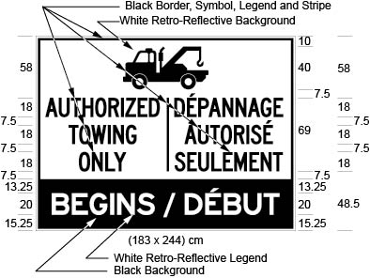
Text alternative: Illustration of “restricted towing zone” sign. The top portion of the sign contains the symbol of a tow truck. The symbol is in black on a white retro-reflective background. The middle portion of the sign contains the words “AUTHORIZED TOWING ONLY / DÉPANNAGE AUTORISÉ SEULEMENT” in black text on a white retro-reflective background. The bottom portion of the sign contains the words “BEGINS / DÉBUT” in white text on a black background. The following measurements are written below the sign: (183 × 244) cm. The sign is surrounded by measurements of its different elements. This text alternative is provided for convenience only and does not form part of the official law.
(7) An overhead sign or a ground mounted sign may be erected at the end of a restricted towing zone.
(8) If a ground mounted sign referred to in subsection (7) is erected, it shall have the dimensions and bear the markings as illustrated in the following figure:
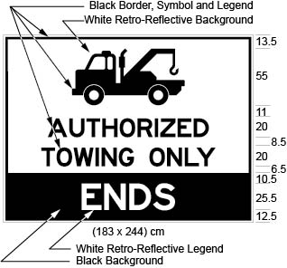
Text alternative: Illustration of “restricted towing zone” sign. The top portion of the sign contains the symbol of a tow truck. The symbol is in black on a white retro-reflective background. The middle portion of the sign contains the words “AUTHORIZED TOWING ONLY” in black text on a white retro-reflective background. The bottom portion of the sign contains the words “ENDS” in white text on a black background. The following measurements are written below the sign: (183 × 244) cm. The sign is surrounded by measurements of its different elements. This text alternative is provided for convenience only and does not form part of the official law.
(9) Despite subsection (8), a ground mounted sign referred to in subsection (7) that has the dimensions and bears the markings as illustrated in the following figure may be erected at the end of a restricted towing zone in an area designated in the Schedule to the French Language Services Act:
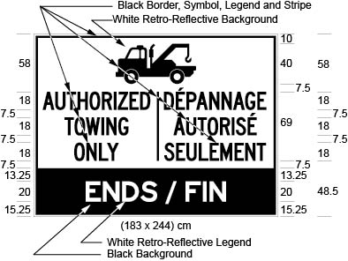
Text alternative: Illustration of “restricted towing zone” sign. The top portion of the sign contains the symbol of a tow truck. The symbol is in black on a white retro-reflective background. The middle portion of the sign contains the words “AUTHORIZED TOWING ONLY / DÉPANNAGE AUTORISÉ SEULEMENT” in black text on a white retro-reflective background. The bottom portion of the sign contains the words “ENDS / FIN” in white text on a black background. The following measurements are written below the sign: (183 × 244) cm. The sign is surrounded by measurements of its different elements. This text alternative is provided for convenience only and does not form part of the official law.
(10) The dimensions of a sign may be greater than the dimensions prescribed and illustrated in this section so long as each dimension is increased and, when increased, has the same relation to the other dimensions of the sign as the dimensions prescribed and illustrated in this Regulation have to each other.
(11) Where a sign is erected it shall be placed so as to be visible at all times to the traffic approaching the sign.
(12) Where a bridge, ramp or structure is located at the beginning or end of a restricted towing zone, the signs erected at the beginning or end of a restricted towing zone may be placed as close as practicable to the beginning or end of the restricted towing zone, subject to subsection (11).
Reports
9. (1) If requested to do so by the Minister, an authorized towing services provider shall report to the Minister on its provision of towing services in a restricted towing zone.
(2) The report shall be in writing and shall address any aspect of the provision of towing services in a restricted towing zone that the Minister specifies in the request.
10. This Regulation is revoked.
11. Omitted (provides for coming into force of provisions of this Regulation).

