Highway Traffic Act
ONTARIO REGULATION 418/21
PASSENGER TRANSPORTATION VEHICLES
Historical version for the period April 6, 2022 to April 10, 2022.
Last amendment: 314/22.
Legislative History: 199/22, 314/22.
This is the English version of a bilingual regulation.
CONTENTS
1. | Interpretation
2. | Non-application — ambulances, carpool vehicles etc.
3. | Application — Metrolinx, ONTC
4. | Non-application — travel within a municipality
5. | Application — travel outside a municipality
6. | Non-application of by-laws, s. 195.1 of the Act
7. | Scheduled service and tariff
8. | Driver qualifications
9. | Passenger seating
10. | Luggage and freight
11. | Fire extinguisher
12. | Interior lights
13. | Trailers
14. | Insurance
15. | Annual report
Schedule 1 | Bus with trailer combination
Schedule 2 | School bus with trailer combination
Schedule 3 | Passenger vehicle with trailer combination

Interpretation
1. (1) In this Regulation,
“carpool” means an arrangement to transport persons on a one-way or round trip where the taking of passengers is incidental to the driver’s purpose for the trip and includes arrangements to transport persons on a round trip between the residences, or places reasonably convenient to the residences, of any or all of the driver and passengers and a common destination, including the driver’s and passengers’ place of employment or education, or a place reasonably convenient to the driver’s and passengers’ various places of employment or education; (“covoiturage”)
“carpool vehicle” means, subject to subsection (2), a motor vehicle that has seating for one to nine passengers and that is used in a carpool; (“véhicule de covoiturage”)
“operator” means, in relation to a passenger transportation vehicle,
(a) the person directly or indirectly responsible for the operation of the vehicle, including the conduct of the driver of the vehicle and the carriage of passengers in the vehicle, and
(b) in the absence of evidence to the contrary, the holder of the plate portion of the permit for the vehicle. (“utilisateur”)
(2) A carpool vehicle does not include a motor vehicle while it is being operated by or under contract with a school board or other authority in charge of a school for the transportation of children to or from a school.
Non-application — ambulances, carpool vehicles etc.
2. (1) This Regulation, except section 13, does not apply to a passenger transportation vehicle that belongs to one or more of the following classes of vehicles:
1. Ambulances or patient transfer services vehicles.
2. Carpool vehicles, if the carpool vehicle is transporting one or more passengers who are part of a carpool and the following criteria are met:
i. No fee is charged or paid to the driver, owner or lessee of the carpool vehicle for the passengers’ transportation, except an amount to reimburse the expenses of operating the motor vehicle on a non-profit basis.
ii. The driver of the carpool vehicle does not take passengers on more than one one-way or round trip in a day.
3. Municipally-licensed passenger vehicles.
4. Vehicles operated by or on behalf of a child care centre licensed under the Child Care and Early Years Act, 2014.
5. Vehicles transporting only the persons described in subsection (2) if the vehicle is operated by or on behalf of,
i. a service provider under the Home Care and Community Services Act, 1994, or
Note: On May 1, 2022, the day section 3 of Schedule 1 to the Connecting People to Home and Community Care Act, 2020 comes into force, subparagraph 5 i of subsection 2 (1) of the Regulation is revoked and the following substituted: (See: O. Reg. 199/22, s. 1 (1))
i. a health service provider or Ontario Health Team that provides home and community care services under the Connecting Care Act, 2019,
i.1 an Indigenous organization that provides home and community care services pursuant to an agreement under paragraph 4.1 of subsection 6 (1) of the Ministry of Health and Long-Term Care Act, or
ii. a licensee under the Long-Term Care Homes Act, 2007.
Note: On April 11, 2022, the day section 204 of Schedule 1 (Fixing Long-Term Care Act, 2021) to the Providing More Care, Protecting Seniors, and Building More Beds Act, 2021 comes into force, subparagraph 5 ii of subsection 2 (1) of the Regulation is amended by striking out “the Long-Term Care Homes Act, 2007” at the end and substituting “the Fixing Long-Term Care Act, 2021”. (See: O. Reg. 314/22, s. 1 (1))
(2) Paragraph 5 of subsection (1) applies in respect of the following persons:
1. A resident of a long-term care home under the Long-Term Care Homes Act, 2007 who is determined to be eligible under the Home Care and Community Services Act, 1994 for the transportation service being provided.
Note: On May 1, 2022, the day section 3 of Schedule 1 to the Connecting People to Home and Community Care Act, 2020 comes into force, paragraph 1 of subsection 2 (2) of the Regulation is amended by striking out “under the Home Care and Community Services Act, 1994” and substituting “in accordance with Ontario Regulation 187/22 (Home and Community Care Services) made under the Connecting Care Act, 2019”. (See: O. Reg. 199/22, s. 1 (2))
Note: On April 11, 2022, the day section 204 of Schedule 1 (Fixing Long-Term Care Act, 2021) to the Providing More Care, Protecting Seniors, and Building More Beds Act, 2021 comes into force, paragraph 1 of subsection 2 (2) of the Regulation is amended by striking out “the Long-Term Care Homes Act, 2007” and substituting “the Fixing Long-Term Care Act, 2021”. (See: O. Reg. 314/22, s. 1 (2))
2. A person who is determined by an approved agency to be eligible under the Home Care and Community Services Act, 1994 for the transportation service being provided.
Note: On May 1, 2022, the day section 3 of Schedule 1 to the Connecting People to Home and Community Care Act, 2020 comes into force, paragraph 2 of subsection 2 (2) of the Regulation is revoked and the following substituted: (See: O. Reg. 199/22, s. 1 (3))
2. A person who is determined to be eligible in accordance with Ontario Regulation 187/22 (Home and Community Care Services) made under the Connecting Care Act, 2019 for the transportation service being provided.
2.1 A person who is receiving a service that is substantially equivalent to a transportation service described in paragraph 2 and that is provided by an Indigenous organization that has entered into an agreement pursuant to paragraph 4.1 of subsection 6 (1) of the Ministry of Health and Long-Term Care Act.
3. For a person mentioned in paragraph 1 or 2, one attendant or escort accompanying the person.
Note: On May 1, 2022, the day section 3 of Schedule 1 to the Connecting People to Home and Community Care Act, 2020 comes into force, paragraph 3 of subsection 2 (2) of the Regulation is revoked and the following substituted: (See: O. Reg. 199/22, s. 1 (3))
3. For a person mentioned in paragraph 1, 2 or 2.1, one attendant or escort accompanying the person.
(3) In this section,
“municipally-licensed passenger vehicle” means a motor vehicle, other than a bus, operating under a municipal business licence to provide passenger transportation services, and includes taxicabs, limousines and private transportation company vehicles; (“véhicule de transport de passagers autorisé par un permis municipal”)
“patient transfer services vehicle” means a motor vehicle, other than an ambulance, that is used to transport passengers who require medical transportation services. (“véhicule fournissant un service de transfert de patients”)
Application — Metrolinx, ONTC
3. This Regulation, except sections 7 and 15, applies to passenger transportation vehicles operated by Metrolinx or the Ontario Northland Transportation Commission.
Non-application — travel within a municipality
4. Despite sections 2 and 3, this Regulation does not apply to a passenger transportation vehicle that is operated wholly within,
(a) a local municipality;
(b) the Regional Municipality of Waterloo; or
(c) the Regional Municipality of Niagara.
Application — travel outside a municipality
5. This Regulation applies to passenger transportation vehicles operated by or on behalf of a municipality providing transportation to passengers to or from the municipality, except for the following provisions:
1. Section 7.
2. Subsection 10 (3).
3. Section 15.
Non-application of by-laws, s. 195.1 of the Act
6. (1) A business licensing by-law of a municipality that applies to owners, operators or drivers of vehicles providing passenger transportation for compensation does not apply in respect of a vehicle that is part of a class designated under subsection (2) that,
(a) travels between two points, at least one of which is outside the municipality; and
(b) does not take on and discharge the same passenger within the municipality.
(2) The following are designated as classes of passenger transportation vehicles for the purposes of subsection (1):
1. Passenger transportation vehicles that have a valid U10 vehicle permit within the meaning of Regulation 628 of the Revised Regulations of Ontario, 1990 (Vehicle Permits) made under the Act.
2. Carpool vehicles described in paragraph 2 of subsection 2 (1).
(3) For the purposes of clause (1) (a) and clause 195.1 (1) (a) of the Act, travelling between two points includes travelling between two points and making one or more stops along the route.
Scheduled service and tariff
7. (1) The tariff set out in this section applies between operators of passenger transportation vehicles and the passengers of those vehicles.
(2) If an operator of a passenger transportation vehicle advertises that a service will be offered at a scheduled time, the operator shall ensure that the scheduled service is provided unless the operator gives notice in accordance with subsections (3) and (4).
(3) Subject to subsection (4), notice of the cancellation of a scheduled service shall be given as soon as possible and not less than 48 hours in advance of the scheduled time of the service by,
(a) emailing, texting or otherwise electronically transmitting the notice to each passenger who has provided the operator with such information that allows the operator to give notice by one of those means;
(b) posting the notice on a website where the notice would be likely to come to the attention of someone searching for the schedule in respect of the service; and
(c) posting the notice at each location where the service was scheduled to stop.
(4) In the event of an unforeseen emergency that makes it impossible to give notice in accordance with subsection (3), the operator shall give notice as soon as possible by the method or methods most likely to come to the attention of passengers.
Driver qualifications
8. No person shall drive a passenger transportation vehicle on a highway, and no operator shall cause or permit a passenger transportation vehicle to be driven on a highway, unless the driver is at least 18 years of age and is,
(a) a fully licensed driver with respect to the class of motor vehicle under Ontario Regulation 340/94 (Drivers’ Licences) made under the Act; or
(b) the holder of a valid, equivalent driver’s licence from another jurisdiction to whom an exemption under section 34 of the Act applies.
Passenger seating
9. (1) No driver or operator shall cause or permit passengers to ride on any part of a passenger transportation vehicle other than the seats.
(2) Subsection (1) does not apply in respect of a bus if the number of standing passengers on the bus is not more than one-third of the number of passengers for which seats are provided.
(3) No driver or operator shall cause or permit a passenger on a passenger transportation vehicle that is a bus to stand forward of the back of the driver’s seat.
Luggage and freight
10. (1) No person shall drive a passenger transportation vehicle on a highway, and no operator shall cause or permit a passenger transportation vehicle to be driven on a highway, if any luggage or other load extends beyond the body limits of the vehicle.
(2) Subsection (1) does not apply in respect of bicycles that are securely fastened to an exterior bicycle rack.
(3) No person shall drive a passenger transportation vehicle on a highway, and no operator shall cause or permit a passenger transportation vehicle to be driven on a highway, unless any luggage or load carried in the interior of the vehicle is securely loaded so that it cannot,
(a) interfere with the entry and exit of passengers from the vehicle; or
(b) fall or shift in a way that could contact or interfere with a passenger or the driver.
Fire extinguisher
11. No person shall drive a passenger transportation vehicle on a highway, and no operator shall cause or permit a passenger transportation vehicle to be driven on a highway, unless it is equipped with an adequate fire extinguisher that is kept in good working order, is securely fastened to the vehicle and is readily accessible to the driver.
Interior lights
12. In the case of a passenger transportation vehicle that is a bus with 15 or more passenger seats, no person shall drive the vehicle on a highway, and no operator shall cause or permit the vehicle to be driven on a highway, unless the interior light or lights required by section 20 of Regulation 587 of the Revised Regulations of Ontario, 1990 (Equipment) made under the Act are kept constantly lighted between sunset and sunrise when there are passengers in the vehicle.
Trailers
13. (1) No driver shall drive a passenger transportation vehicle drawing a trailer on a highway, and no operator shall cause or permit a passenger transportation vehicle drawing a trailer to be driven on a highway, unless the combination of the passenger transportation vehicle and the trailer,
(a) meets one of the configuration descriptions set out in Schedule 1, 2 or 3; and
(b) complies with the dimensional and weight limits set out in the applicable Schedule.
(2) In the case of a passenger transportation vehicle that is an inter-city bus drawing a trailer, Schedule 1 sets out,
(a) the dimensional limits for the purposes of section 109 of the Act; and
(b) the weight limits for the purposes of sections 115 to 118 of the Act.
(3) Sections 2 and 37 of Ontario Regulation 413/05 (Vehicle Weights and Dimensions — For Safe, Productive and Infrastructure-Friendly Vehicles) made under the Act apply, with necessary modifications, in respect of this section and Schedules 1, 2 and 3.
Insurance
14. No owner, lessee or operator shall cause or permit a passenger transportation vehicle to be driven on a highway unless the following insurance requirements are met in respect of the passenger transportation vehicle:
1. The insurance must meet the requirements set out in the Compulsory Automobile Insurance Act.
2. A passenger transportation vehicle that has the passenger seating capacity set out in Column 1 of the Table to this section must have the amount of insurance set out opposite the passenger seating capacity in Column 2. The insurance must be against loss or damage resulting from bodily injury to or death of one or more passengers.
3. There must be insurance in the amount of $5,000 for damage to the property of all passengers of a passenger transportation vehicle.
TABLE
Item | Column 1  Passenger seating capacity | Column 2  Amount of insurance, in dollars
1. | 1 to 7 passengers | 2,000,000
2. | 8 to 12 passengers | 5,000,000
3. | 13 or more passengers | 8,000,000

Annual report
15. (1) The Ministry may require that the operator, owner or lessee of a passenger transportation vehicle report to the Ministry on their operations and activities by completing and submitting a report using a form approved by the Ministry.
(2) Notice of a requirement under subsection (1) may be served on the operator, owner or lessee at the most recent address or email address for the operator, owner or lessee in the Ministry’s records,
(a) personally;
(b) by regular mail;
(c) by courier; or
(d) by email.
(3) The notice is deemed to have been served on the operator, owner or lessee,
(a) on the day it was delivered personally;
(b) on the fifth day after it was couriered;
(c) on the fifth day after it was mailed; or
(d) on the day after it was sent by email.
(4) Upon receipt of a notice under subsection (1), the owner, lessee or operator shall complete and submit the required report within the time or by the date specified by the Ministry.
(5) The Ministry shall not require that an owner, lessee or operator of a passenger transportation vehicle complete and submit a report more than once in a 12-month period, except when necessary to clarify or complete information in a report previously submitted or when a previous report was submitted late.
16. Omitted (provides for coming into force of provisions of this Regulation).
Schedule 1
bus with trailer combination
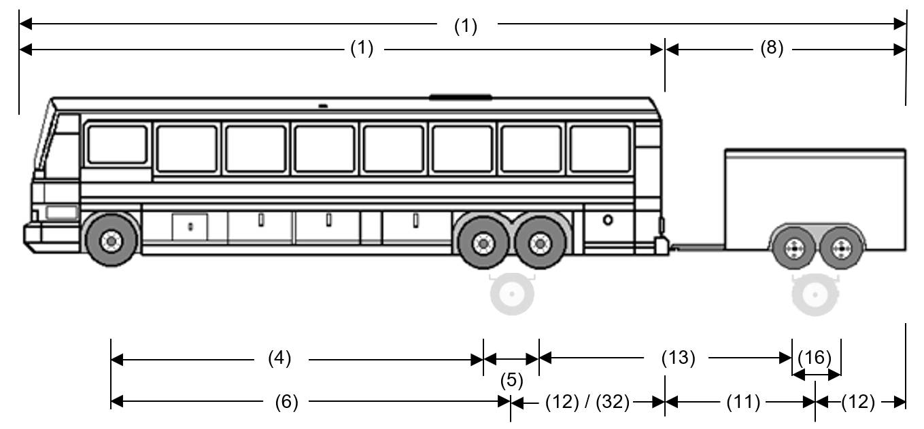
Configuration Description
This combination of vehicles is composed of a bus and a pony trailer with one axle unit or axle group. The bus is a motor coach or inter-city bus with reclining seats. It is not a school bus and was not designed as a school bus. It is not an articulated bus or a double decker bus. It is not equipped with a fifth wheel assembly.
The front axle of the bus is a single axle with single tires. The rear axles are a single, a tandem drive axle or a two axle group. If the rear axles are a two axle group, they are composed of a single drive axle in front and a tag axle in the rear.
The axle unit or axle group of the pony trailer may be a single axle, a two axle group or a tandem axle. The trailer has a single drawbar.
Dimensional Limit Chart
Vehicle | Ref | Feature | Dimensional Limit
Overall | (1) | Overall Length | Max. 23.0m
Overall | (2) | Width | Max. 2.6m
Overall | (3) | Height | Max. 4.15m
Bus | (1) | Length (Inter-city Bus) | Max. 14.0m
Bus | (1) | Length (Not an Inter-city Bus) | Max. 12.5m
Bus | (4) | Inter-axle Spacing | Not controlled
Bus | (5) | Rear Tandem or Two Axle Group Spread | 1.2m to 1.85m
Bus | (6) | Wheelbase | Not controlled
Bus | (12) | Effective Rear Overhang | Max. 4.0m
Trailer | (8) | Length | 12.5m
Trailer | (11) | Wheelbase | Min. 3.84m
Trailer | (12) | Effective Rear Overhang | Max. 4.0m
Trailer | (13) | Inter-vehicle-unit Distance between: Two axle group or tandem and single | Min. 3.0m
Trailer | (13) | Inter-vehicle-unit Distance between: Two axle group or tandem and tandem | Min. 5.0m
Trailer | (16) | Two Axle Group or Tandem Spread | > 1.0m to 1.85m
Trailer | (19) | Track Width (single or dual tires) | 2.0m to 2.6m
Trailer | (32) | Hitch Offset | Max. 4.0m

WEIGHT LIMIT CHARTS
FRONT AXLE MAXIMUM (LOWEST OF A, B AND C)
Feature | Weight Limit
a) by manufacturer’s axle rating or default | i. GAWR (if verified), or  ii. If GAWR not verified, the lower of:  1. 5,000 kg, and  2. the sum of the maximum tire load ratings
b) by tire width | 11 kg × combined tire widths in mm
c) by axle unit description | Single Axle: 9,000 kg

OTHER AXLE MAXIMUMS (LOWEST OF A, B AND C)
Feature | Weight Limit
a) by manufacturer’s axle rating or default | i. GAWR (if verified), or  ii. If GAWR not verified, the sum of the maximum tire load ratings
b) by tire width | Tag Axle (Vehicle built after June 30, 2011) (tire width 150 mm or more): 10 kg × combined tire widths in mm  Tag Axle (Vehicle built before July 1, 2011) (tire width 150 mm or more): 11 kg × combined tire widths in mm  Drive and Trailer Axles (tire width 150 mm or more): 10 kg × combined tire widths in mm  Any axle with tire width less than 150 mm: 9 kg × combined tire widths in mm
c) by axle unit description | Single Drive Axle: 10,000 kg  Tag Axle (by Two Axle Group spacing)  1.2 < 1.3m: 6,300 kg  1.3 < 1.4m: 6,700 kg  1.4 < 1.5m: 7,000 kg  1.5 < 1.85m: 7,400 kg  Tandem Drive Axle: 18,000 kg  Trailer Axle Unit — single, two axles, or tandem: 4,600 kg
Allowable Gross Vehicle Weight: | Actual weight on the front axle plus other axle maximums

Schedule 2
SCHOOL BUS with TRAILER combination
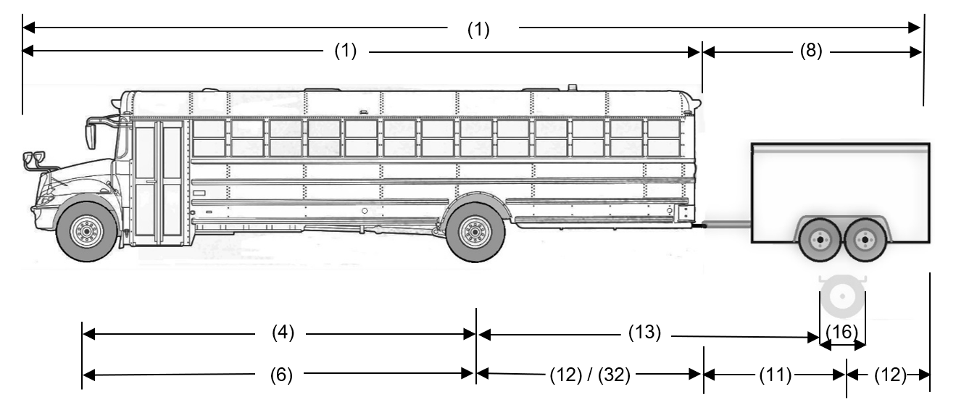
Configuration Description
This combination of vehicles is composed of a school bus, or a bus that was originally designed as a school bus, and a pony trailer with one axle unit or axle group. The bus is not a double decker bus or an articulated bus. The bus has 20 or more passenger seats. It is not equipped with a fifth wheel assembly.
The front axle of the bus is a single axle with single tires. The drive axle is a single axle.
The trailer is a pony trailer and the axle unit or axle group may be a single axle, a two axle group or a tandem axle. The trailer has a single drawbar.
Dimensional Limit Chart
Vehicle | Ref | Feature | Dimensional Limit
Overall | (1) | Overall Length | Max. 23.0m
Overall | (2) | Width | Max. 2.6m
Overall | (3) | Height | Max. 4.15m
Bus | (1) | Length | Max. 12.5m
Bus | (4) | Inter-axle Spacing | Not controlled
Bus | (6) | Wheelbase | Not controlled
Bus | (12) | Effective Rear Overhang | Max. 4.0m
Trailer | (8) | Length | Max. 12.5m
Trailer | (11) | Wheelbase - If an enclosed cargo type trailer | Min. 3.05m
Trailer | (11) | Wheelbase - If an open box trailer | Min. 3.66m
Trailer | (12) | Effective Rear Overhang | Max. 4.0m
Trailer | (13) | Inter-vehicle-unit Distance between:  Single and single or tandem | Min. 3.0m
Trailer | (16) | Two Axle Group or Tandem Spread | > 1.0 m to 1.85m
Trailer | (19) | Track Width (single or dual tires) | 2.0m to 2.6m
Trailer | (32) | Hitch Offset (if drawing a trailer) | Max. 4.0m

WEIGHT LIMIT CHART
FRONT AXLE MAXIMUM (LOWEST OF A, B AND C)
Feature | Weight Limit
a) by manufacturer’s axle rating or default | i. GAWR (if verified), or  ii. If GAWR not verified, the lower of:  1. 5,000 kg, and  2. the sum of the maximum tire load ratings
b) by tire width | 11 kg × combined tire widths in mm
c) by axle unit description | Single Axle: 9,000 kg

WEIGHT LIMIT CHART
OTHER AXLE MAXIMUM (LOWEST OF A, B AND C)
Feature | Weight Limit
a) by manufacturer’s axle rating or default | i. GAWR (if verified), or  ii. If GAWR not verified, the sum of the maximum tire load ratings
b) by tire width | Drive and Trailer Axles (tire width 150 mm or greater) — 10 kg × combined tire widths in mm  Drive and Trailer Axles (tire width less than 150 mm) — 9 kg × combined tire widths in mm
c) by axle unit description | Single Drive Axle: 10,000 kg  Trailer axle unit — single, two axles, or tandem based on GVWR of the bus  GVWR 11,500 kg or higher: No trailer allowed  GVWR greater than 7,000 kg and less or equal to 11,500 kg based on type of trailer hitch offset:  If an enclosed cargo type trailer and hitch offset is:  Less or equal to 3.5m and trailer wheelbase 3.66m or more: 1,500 kg  Less or equal to 3.5m and trailer wheelbase less than 3.66m: 1,250 kg  Greater than 3.5m: 1,100 kg  If an open box trailer and hitch offset is:  Less or equal to 3.5m: 1,500 kg  Greater than 3.5 m: 1,100 kg  GVWR less or equal to 7,000 kg: 1,500 kg
Allowable Gross Vehicle Weight: | Actual weight on the front axle plus other axle maximums

schedule 3
passenger vehicle with trailer COMBINATION
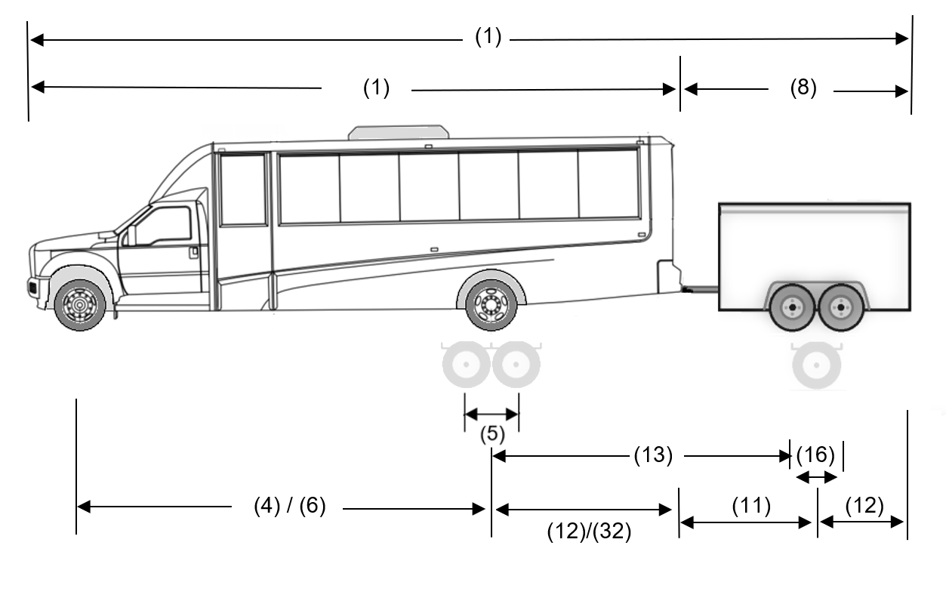
Configuration Description
This combination of vehicles is composed of a motor vehicle and a pony trailer with one axle unit or axle group. The motor vehicle has fewer than 20 passenger seats. The front axle is a single axle with single tires. The drive axles are a single axle, a two axle group or a dual axle.
The trailer is a pony trailer and the axle unit or axle group may be a single axle, a two axle group or a tandem axle. The trailer has a single drawbar.
Dimensional Limit Chart
Vehicle | Ref | Feature | Dimensional Limit
Overall | (1) | Overall Length | Max. 23.0m
Overall | (2) | Width | Max. 2.6m
Overall | (3) | Height | Max. 4.15m
Bus | (1) | Length | Max. 7.5m
Bus | (4) | Inter-axle Spacing | Not controlled
Bus | (5) | Rear Dual or Two Axle Group Spread | 1.2m to 1.85m
Bus | (6) | Wheelbase | Not controlled
Bus | (12) | Effective Rear Overhang | Max. 2.0m
Trailer | (8) | Length | Max. 12.5m
Trailer | (11) | Wheelbase - If an enclosed cargo type trailer | Min. 2.1m
Trailer | (11) | Wheelbase - If an open box trailer | Min. 2.34m
Trailer | (12) | Effective Rear Overhang | Max. 4.0m
Trailer | (13) | Inter-vehicle-unit Distance | Min 3.0m
Trailer | (16) | Two Axle Group or Tandem Spread | > 1.0m to 1.85m
Trailer | (19) | Track Width (single or dual tires) | 2.0m to 2.6m
Trailer | (32) | Hitch Offset (if drawing a trailer) | Not controlled

WEIGHT LIMIT CHART
FRONT AXLE MAXIMUM (LOWEST OF A, B AND C)
Feature | Weight Limit
a) by manufacturer’s axle rating or default | i. GAWR (if verified), or  ii. If GAWR not verified, the lower of:  1. 1,500 kg, and  2. the sum of the maximum tire load ratings
b) by tire width | 11 kg × combined tire widths in mm
c) by axle unit description | Single Axle: not controlled

WEIGHT LIMIT CHART
OTHER AXLE MAXIMUM (LOWEST OF A, B AND C)
Feature | Weight Limit
a) by manufacturer’s axle rating or default | i. GAWR (if verified), or  ii. If GAWR not verified, the sum of the maximum tire load ratings
b) by tire width | Drive and Trailer Axles (tire width 150 mm or greater) — 10 kg × combined tire widths in mm  Drive and Trailer Axles (tire width less than 150 mm) — 9 kg × combined tire widths in mm
c) by axle unit description | Motor vehicle axle weights not controlled  Trailer axle unit — single, two axles, or tandem based on GVWR of the motor vehicle:  GVWR 8,850 kg or greater: no trailer allowed  GVWR greater than 4,500 kg but less than 8,850 kg  If an enclosed cargo type trailer and trailer wheelbase is:  Less or equal to 3.5m: 1,600 kg  Greater than 3.5m but less or equal to 4.0m: 3,200 kg  Greater than 4.0m: 4,600 kg  If an open box trailer: 1,600 kg  GVWR 4,500 kg or less based on type of trailer and trailer wheelbase:  If an enclosed cargo type trailer and trailer wheelbase is:  Less or equal to 3.5m: 1,500 kg  Greater than 3.5m but less or equal to 4.0m: 3,000 kg  Greater than 4.0m: 4,500 kg  If an open box trailer: 1,500 kg
Allowable Gross Vehicle Weight | Actual weight on the front axle plus other axle maximums

