Corporations Act
R.R.O. 1990, REGULATION 181
GENERAL
Historical version for the period December 10, 2016 to May 25, 2017.
Last amendment: O. Reg. 373/16.
This is the English version of a bilingual regulation.
CONTENTS
 |  | Sections
 | Names | 1-9
 | Capital | 10
 | Objects | 11-12
 | Miscellaneous | 13-15
 | Form of Documents | 16-16.1
 | Forms | 17-25
 | Continuation | 26-27.1
 | Insider Reporting | 28-29
 | Information Circular | 30-31
 | Beneficial Ownership of Shares | 32
 | Searches | 33-36
Form 14 | Initial report of insider
Form 15 | Report of insider on changes in ownership of, or control or direction over, capital securities
Form 16 | Information circular
Names
1. (1) The following documents shall accompany any application for letters patent, supplementary letters patent, an extra-provincial licence or an amended extra-provincial licence containing a proposed name for a corporation or a change of corporate name:
1. An original Ontario biased or weighted computer printed search report for the same name as the proposed name from the new updated automated name search system (NUANS) owned by the Department of Consumer and Corporate Affairs, Canada, dated not more than ninety days before the submission of the application.
2. Any consent or consent and undertaking required by the Act or by the Minister. R.R.O. 1990, Reg. 181, s. 1 (1); O. Reg. 638/94, s. 1.
(2) A computer printed search report referred to in subsection (1) shall accompany an application for revival under section 317 of the Act if the application changes the name of the corporation or at least ten years have elapsed since the corporation was dissolved. O. Reg. 248/05, s. 1.
(3) The computer printed search report referred to in subsection (1) is not required where the application is for letters patent, supplementary letters patent, reservation of a name or revival for a corporation incorporated under Part III of the Act if incorporation is required by a government authority as a condition to the awarding of financial assistance under a government program. R.R.O. 1990, Reg. 181, s. 1 (3); O. Reg. 625/93, s. 1 (2).
2. (1) Revoked: O. Reg. 625/93, s. 2 (1).
(2) No name that is identified in a computer printed search report as proposed in Ontario shall be used as a corporate name by a person other than the one who proposed the name unless a consent in writing has been obtained from the person who first proposed the name. O. Reg. 625/93, s. 2 (2).
2.1 A corporate name shall not contain a word, expression or abbreviation the use of which is prohibited or restricted under an Act or regulation of Ontario or Canada, unless the restriction is satisfied. O. Reg. 342/15, s. 1.
3. (1) The following words and expressions shall not be used in a corporate name:
1. “Amalgamated”, “fusionné” or any other related word or expression in French, unless the corporation is an amalgamated corporation resulting from the amalgamation of two or more corporations.
2. Revoked: O. Reg. 625/93, s. 3 (2).
3. “College”, “collège”, “institute”, “institut”, “university” or “université”, except with a consent in writing on behalf of the Ministry of Education and Training.
4. “Engineer”, “ingénieur”, “engineering”, “génie” or “ingénierie” or any variation thereof, except with the consent in writing of the Association of Professional Engineers of Ontario.
5. Revoked: O. Reg. 248/05, s. 2.
6. “Royal”, where used as an adjective, unless the consent of the Crown has been obtained through the Secretary of State.
7. Numerals indicating the year of incorporation, unless the proposed corporation is the successor to a corporation the name of which is the same as or similar to the proposed corporation, or the year is the year of amalgamation of the corporation.
8. Any word or expression that would lead to an inference that the corporation is a business corporation. R.R.O. 1990, Reg. 181, s. 3 (1); O. Reg. 625/93, s. 3 (1-3); O. Reg. 248/05, s. 2.
(2) The name of a fraternal society incorporated under section 176 of the Act shall include the words “fraternal society” or “société fraternelle”. O. Reg. 625/93, s. 3 (4).
(3) The name of a pension fund or employees’ mutual benefit society incorporated under section 185 of the Act shall include the words “pension fund society”, “employees’ mutual benefit society”, “caisse de retraite” or “société de secours mutuel d’employés”, as the case may be, and the name in whole or in part of the parent corporation. O. Reg. 625/93, s. 3 (4).
(4) If the name of a corporation includes the word “veteran”, “ancien combattant” or any abbreviation or derivation of those words, the letters patent of the corporation shall provide that at all times at least 95 per cent of the members of the corporation shall be composed of war veterans, their spouses or children, unless the name has been in continuous use for at least 20 years. O. Reg. 43/00, s. 1 (1); O. Reg. 301/05, s. 1 (1).
(5) In subsection (4),
“spouse” means,
(a) a spouse as defined in section 1 of the Family Law Act, or
(b) either of two persons who live together in a conjugal relationship outside marriage; (“conjoint”)
“war veteran” means a person who served in the armed forces of any country while that country was in a state of war. (“ancien combattant”) R.R.O. 1990, Reg. 181, s. 3 (5); O. Reg. 43/00, s. 1 (2); O. Reg. 301/05, s. 1 (2, 3).
4. The name of a corporation formed by the amalgamation of two or more corporations may be the same as the name of one of the amalgamating corporations, if the name is not a number name. O. Reg. 625/93, s. 4.
5. Unless the proposed corporate name has been in continuous use for at least twenty years before the date of filing the application, or unless the proposed corporate name has through use acquired a meaning that renders the name distinctive, a corporate name shall not be,
(a) too general;
(b) primarily or only a given name or surname used alone of an individual who is living or has died within thirty years preceding the date of filing an application for letters patent or supplementary letters containing the name;
(c) primarily or only a geographic name used alone. R.R.O. 1990, Reg. 181, s. 5.
6. (1) A corporate name shall not contain a word or expression, an element of which is the family name of a particular individual, who is living or who has died within the previous thirty years whether or not preceded by a given name or initials, unless the individual, his or her heir, executor, administrator, assigns or guardian consents in writing to the use of the name. R.R.O. 1990, Reg. 181, s. 6 (1).
(2) Subsection (1) does not apply where the corporation that will use the proposed name is the successor or affiliate of another corporation that has, as an element of its name, the family name, if,
(a) the other corporation consents in writing to the use of the name; and
(b) where the proposed name would contravene clause 13 (1) (a) of the Act, the other corporation undertakes in writing to dissolve itself or to change its name to a name that complies with clause 13 (1) (a) of the Act within six months after the incorporation of the new corporation. R.R.O. 1990, Reg. 181, s. 6 (2).
(3) Subsection (1) does not apply where,
(a) the required consent cannot be obtained; and
(b) the family name is of historic or patriotic significance and has a connection with the objects of the corporation. R.R.O. 1990, Reg. 181, s. 6 (3).
7. A corporate name shall not contain any word or expression in any language that describes in a misleading manner the activities or services in association with which the corporate name is proposed to be used. R.R.O. 1990, Reg. 181, s. 7.
8. (1) Only letters from the Roman alphabet or Arabic numerals or a combination thereof, and punctuation marks and other marks set out in subsection (2), may form part of the name of a corporation. R.R.O. 1990, Reg. 181, s. 8 (1).
(2) The following punctuation marks and other marks are permitted as part of a corporation name:
! “ ” « » # $ % & ’ ( ) * + , – . / \ : ; < = > ? [ ] '˄≤ ≥ ¸ ´ ` ^ ¨ @
O. Reg. 625/93, s. 5; O. Reg. 248/05, s. 3.
(3) A corporate name shall not consist only or primarily of a combination of marks set out in subsection (2) and at least the first three characters of the corporate name shall be letters from the Roman alphabet or Arabic numerals or a combination thereof. R.R.O. 1990, Reg. 181, s. 8 (3).
9. (1) The name of a corporation shall not exceed 120 characters in length, including punctuation marks and spaces. O. Reg. 248/05, s. 4.
(2) The name of a corporation shall be set out in an application filed under the Act in block capital letters and with only one space between each word. O. Reg. 248/05, s. 4.
Capital
10. Where preference shares of a class have attached thereto conditions, restrictions, limitations or prohibitions on the right to vote, the preferences, rights, conditions, restrictions, limitations or prohibitions attaching to that class of preference shares shall provide that the holders of that class are entitled to notice of any meeting of shareholders called for the purpose of authorizing the dissolution of the company or the sale of its undertaking or a substantial part thereof. R.R.O. 1990, Reg. 181, s. 10.
Objects
11. Revoked: O. Reg. 625/93, s. 6.
12. (1) Where the proposed objects of a corporation include horse racing, the application for letters patent or supplementary letters patent shall be accompanied by the consent in writing of the Ontario Racing Commission. R.R.O. 1990, Reg. 181, s. 12 (1).
(2) The proposed objects of a corporation shall not include dog racing, but may include the breeding of racing dogs. R.R.O. 1990, Reg. 181, s. 12 (2).
Miscellaneous
13. Where the letters patent or supplementary letters patent of a corporation provide that the directors of the corporation shall be elected for a term of more than one year, the term shall be an integral number of years, not exceeding five. R.R.O. 1990, Reg. 181, s. 13.
14. The letters patent or supplementary letters patent of a private company may provide that an application for an order accepting the surrender of the charter of the company may be authorized at a general meeting of its shareholders duly called for that purpose by a majority of the votes cast at the meeting or by at least 50 per cent of the votes of all shareholders entitled to vote at the meeting. R.R.O. 1990, Reg. 181, s. 14.
15. (1) Revoked: O. Reg. 192/99, s. 1 (1).
(2) A notice of resolution requiring the voluntary winding up of a corporation required to be filed with the Minister under subsection 231 (1) of the Act shall be signed manually by a director or officer of the corporation or by the liquidator. R.R.O. 1990, Reg. 181, s. 15 (2).
(3) A notice required to be filed by a liquidator with the Minister under subsection 266 (2) of the Act shall be signed manually by the liquidator. R.R.O. 1990, Reg. 181, s. 15 (3).
(4) Revoked: O. Reg. 192/99, s. 1 (2).
(5) A notice signed by an agent or attorney on behalf of a director or officer of a corporation or a liquidator is not a notice signed manually by the director, officer or liquidator. R.R.O. 1990, Reg. 181, s. 15 (5).
Form of Documents
16. (1) All documents delivered to or filed with the Minister including all affidavits, applications, assurances, balance sheets, by-laws, consents, dissents, notices and statements shall be printed, typewritten or reproduced legibly, in a manner suitable for photographing on microfilm, on one side of good quality white paper that is,
(a) 210 millimetres by 297 millimetres with a margin of 30 millimetres on the left-hand side; or
(b) 8 ½ inches by 11 inches, with a margin of 1 ¼ inches on the left-hand side. R.R.O. 1990, Reg. 181, s. 16 (1).
(2) A document consisting of two or more pages shall have no backing or binding and shall be stapled in the upper left-hand corner and each page shall be numbered consecutively. R.R.O. 1990, Reg. 181, s. 16 (2).
(3) Where a form is provided by the Minister, the form or a facsimile of the form reproduced on good quality white paper of the size set out in subsection (1) shall be used. R.R.O. 1990, Reg. 181, s. 16 (3).
16.1 If a corporation has a seal, it may set out the seal on any form prescribed by this Regulation. O. Reg. 189/99, s. 1.
Forms
17., 18. Revoked: O. Reg. 248/05, s. 5.
19. (1) Revoked: O. Reg. 248/05, s. 6.
(2) Where an application for supplementary letters patent is made under clause 34 (1) (b) of the Act or under clause 131 (1) (b) of the Act, the application shall contain a statement that the corporation is not insolvent within the meaning of subsection (4). R.R.O. 1990, Reg. 181, s. 19 (2).
(3) Where the application is one to which section 35 of the Act applies, the application shall contain a statement that the corporation is not insolvent and, after the issue of the supplementary letters patent, will not be insolvent within the meaning of subsection (4). R.R.O. 1990, Reg. 181, s. 19 (3).
(4) For the purposes of this section, a corporation is insolvent if its liabilities exceed the realizable value of its assets or if the corporation is unable to pay its debts as they become due. R.R.O. 1990, Reg. 181, s. 19 (4).
20. Revoked: O. Reg. 402/95, s. 2.
21. Revoked: O. Reg. 192/99, s. 2.
22. Revoked: O. Reg. 248/05, s. 7.
23. (1) An application for an order accepting the surrender of a charter of a corporation under subsection 319 (1) of the Act or for an order terminating the existence of a corporation under section 320 of the Act shall be accompanied by,
(a) in the case of a company, a consent from the Corporations Tax Branch of the Ministry of Finance; and
(b) in the case of a company that is a reporting issuer under the Securities Act, a consent from the Ontario Securities Commission. O. Reg. 248/05, s. 8 (1).
(2) Revoked: O. Reg. 248/05, s. 8 (1).
(3) Where a shareholder or member is unknown or the shareholder’s or member’s whereabouts is unknown and the corporation has delivered or conveyed the shareholder’s or member’s share of the property to the Public Guardian and Trustee to be held in trust for the shareholder or member or where a creditor is unknown or his, her or its whereabouts is unknown and the corporation has paid to the Public Guardian and Trustee an amount equal to the amount of the debt due to the creditor to be held in trust for the creditor, the application shall set out a statement to that effect. R.R.O. 1990, Reg. 181, s. 23 (3); O. Reg. 248/05, s. 8 (2).
24. An application for an order to revive a dissolved corporation under subsection 317 (14) of the Act shall be accompanied by,
(a) a consent to the revival of the corporation issued by the Minister responsible for the administration of the Forfeited Corporate Property Act, 2015, if that Minister has notified the Minister as defined in section 1 of the Corporations Act that if an application for an order to revive the corporation is submitted, the consent of the Minister responsible for the administration of the Forfeited Corporate Property Act, 2015 must be obtained before the order is issued;
(b) a consent to the revival of the corporation issued by the Minister responsible for the administration of the Environmental Protection Act, if that Minister has notified the Minister as defined in section 1 of the Corporations Act that if an application for an order to revive the corporation is submitted, the consent of the Minister responsible for the administration of the Environmental Protection Act must be obtained before the order is issued;
(c) a consent to the revival of the corporation issued by the Minister responsible for the administration of the Mining Act, except Part IV of that Act, if that Minister has notified the Minister as defined in section 1 of the Corporations Act that if an application for an order to revive the corporation is submitted, the consent of the Minister responsible for the administration of the Mining Act, except Part IV of that Act, must be obtained before the order is issued;
(d) a consent to the revival of the corporation issued by the Public Guardian and Trustee, if he or she has notified the Minister as defined in section 1 of the Corporations Act that if an application for an order to revive the corporation is submitted, the consent of the Public Guardian and Trustee must be obtained before the order is issued; and
(e) a consent to the revival of the corporation issued by the Minister of Finance, if the corporation is a company. O. Reg. 373/16, s. 1.
25. Revoked: O. Reg. 248/05, s. 10.
Continuation
26. Revoked: O. Reg. 248/05, s. 10.
27. (1) Revoked: O. Reg. 248/05, s. 11.
(2) Except in the case of continuance under the laws of another Canadian jurisdiction, the application for authorization to be continued as a corporation under the laws of another jurisdiction shall be accompanied by a legal opinion stating that the laws of the other jurisdiction provide that,
(a) the corporation’s property continues as its property;
(b) the corporation continues to be liable for its obligations;
(c) an existing cause of action, claim or liability to prosecution is unaffected;
(d) the corporation may continue to prosecute a civil, criminal or administrative action or proceeding being prosecuted by or against it;
(e) a conviction, ruling, order or judgment against the corporation may be enforced against it and a ruling, order or judgment in favour of the corporation may be enforced by it. O. Reg. 177/94, s. 3; O. Reg. 189/99, s. 2.
27.1 Revoked: O. Reg. 248/05, s. 12.
Insider Reporting
28. A report required to be filed by an insider under subsections 73 (1) and (2) of the Act shall be prepared in accordance with Form 14. R.R.O. 1990, Reg. 181, s. 28.
29. A report of subsequent changes required to be filed by an insider under subsection 73 (3) of the Act shall be prepared in accordance with Form 15. R.R.O. 1990, Reg. 181, s. 29.
Information Circular
30. (1) An information circular shall be prepared in accordance with Form 16. R.R.O. 1990, Reg. 181, s. 30 (1).
(2) The information required by Form 16 shall be given as of a date specified in the circular, which date shall be a date occurring not more than thirty days before the date on which the information circular is first sent to any shareholders of the corporation. R.R.O. 1990, Reg. 181, s. 30 (2).
(3) The information contained in an information circular shall be clearly presented and the statements contained therein shall be divided into groups according to subject-matter and each group of statements shall be preceded by an appropriate heading. R.R.O. 1990, Reg. 181, s. 30 (3).
(4) The order of items set out in Form 16 need not be followed. R.R.O. 1990, Reg. 181, s. 30 (4).
(5) Where practicable and appropriate, the information required by Form 16 shall be presented in tabular form. R.R.O. 1990, Reg. 181, s. 30 (5).
(6) All amounts required by Form 16 shall be stated in figures. R.R.O. 1990, Reg. 181, s. 30 (6).
(7) Information required to be set out under more than one item in Form 16 need only be set out under one of the items. R.R.O. 1990, Reg. 181, s. 30 (7).
(8) No statement need be made in an information circular that an item is inapplicable and answers to items that are inapplicable may be omitted. R.R.O. 1990, Reg. 181, s. 30 (8).
(9) Information that is not known by or is unavailable to the person on whose behalf an information circular is prepared and that is not reasonably within the power of that person to ascertain or obtain may be omitted from the information circular if a brief statement is made in the information circular indicating the reasons why the information is not known or is unavailable. R.R.O. 1990, Reg. 181, s. 30 (9).
(10) An information circular prepared for a meeting need not contain any information contained in any other information circular, notice of meeting or form of proxy sent to a person whose proxies are being solicited for the same meeting if reference is made in the information circular to the document that contains the information. R.R.O. 1990, Reg. 181, s. 30 (10).
31. Every person who sends or delivers to shareholders an information circular or proxy to which sections 83 to 89 of the Act apply in respect of a meeting of shareholders of a company shall forthwith file with the Ontario Securities Commission a copy of the information circular, proxy and all other material sent or delivered by the person in connection with the meeting. R.R.O. 1990, Reg. 181, s. 31.
Beneficial Ownership of Shares
32. (1) For the purposes of section 73 of the Act, a report filed by a company that includes a statement of capital securities beneficially owned or deemed to be beneficially owned by a subsidiary of the company under clause 72 (2) (c) of the Act or that includes a statement of changes in the subsidiary’s beneficial ownership of capital securities shall be deemed to be a report filed by the subsidiary and the subsidiary need not file a separate report. R.R.O. 1990, Reg. 181, s. 32 (1).
(2) For the purposes of section 73 of the Act, a report filed by an individual that includes a statement of capital securities beneficially owned or deemed to be beneficially owned under clause 72 (2) (b) of the Act by a company controlled by the individual or by an affiliate, if any, of the controlled company or that includes a statement of changes in the beneficial ownership of the capital securities of the controlled company or affiliate shall be deemed to be a report filed by the controlled company or by the affiliate and the controlled company and the affiliate need not file a separate report. R.R.O. 1990, Reg. 181, s. 32 (2).
Searches
33. If a required fee is paid for a search requested in person, the Minister may produce for examination the original documents on file, if any, in which case no microfiche or microfiche copy of the documents will be supplied. O. Reg. 192/99, s. 3.
33.1 Revoked: O. Reg. 192/99, s. 3.
34.-36. Revoked: O. Reg. 192/99, s. 3.
Schedule Revoked: O. Reg. 192/99, s. 4.
Forms 1-3 Revoked: O. Reg. 248/05, s. 13.
Form 4 Revoked: O. Reg. 402/95, s. 3.
Forms 5-12 Revoked: O. Reg. 248/05, s. 13.
Form 12.1 Revoked: O. Reg. 248/05, s. 13.
Form 13 Revoked: O. Reg. 248/05, s. 13.
Form 13.1 Revoked: O. Reg. 248/05, s. 13.
Form 14
INITIAL REPORT OF INSIDER
Corporations Act
Insert regs\graphics\1990\181\181014ae.tif
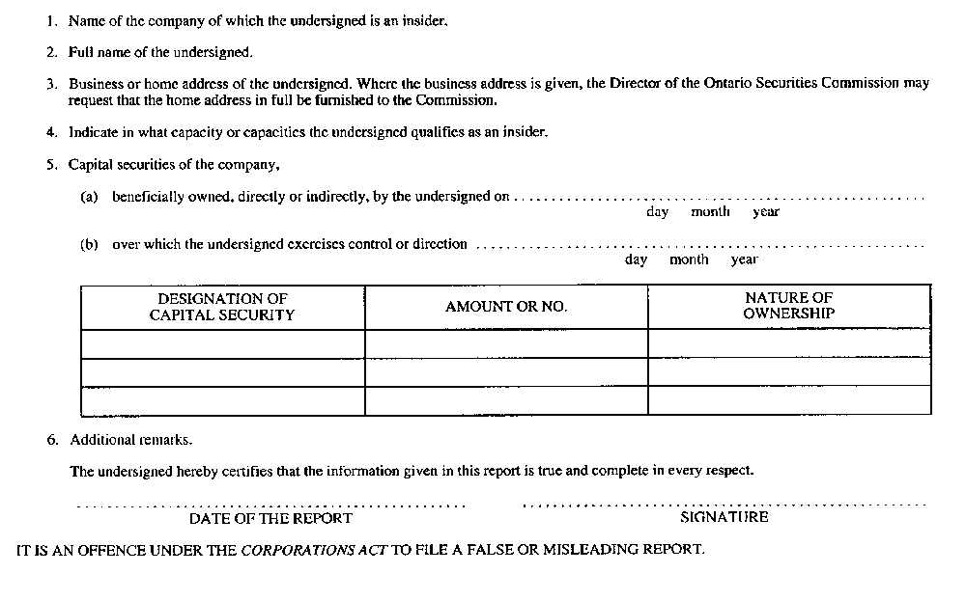
R.R.O. 1990, Reg. 181, Form 14.
Form 15
REPORT OF INSIDER on changes in ownership of, or control or direction over, capital securities
Corporations Act
Insert regs\graphics\1990\181\181015ae.tif
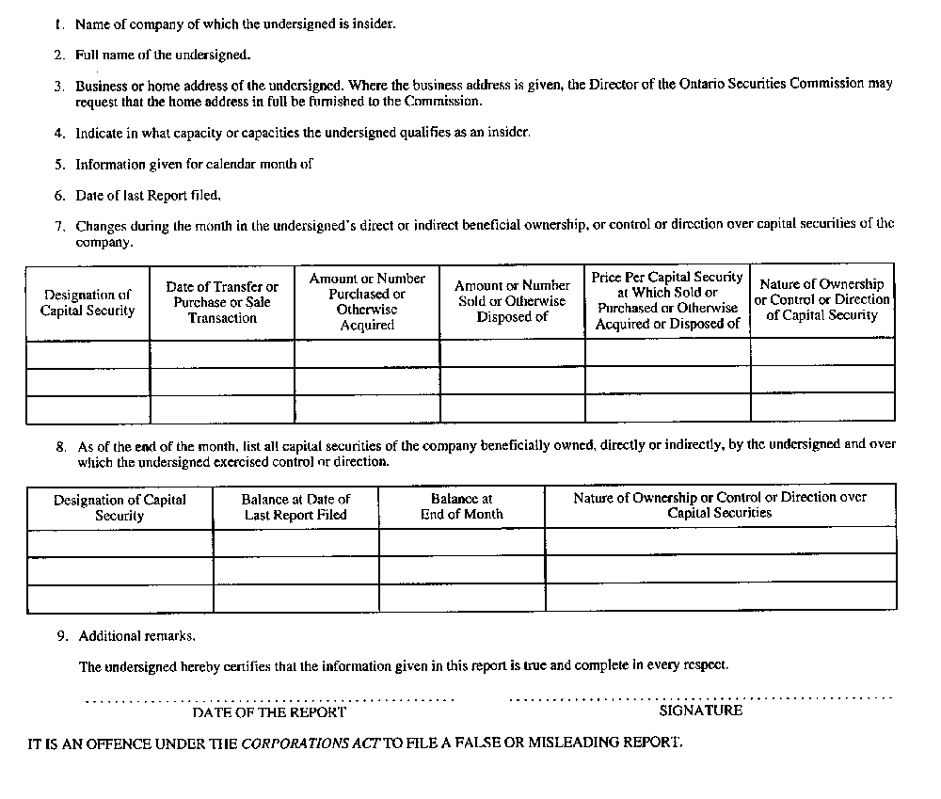
R.R.O. 1990, Reg. 181, Form 15.
Form 16
information circular
Corporations Act
Insert regs\graphics\1990\181\181016ae.tif
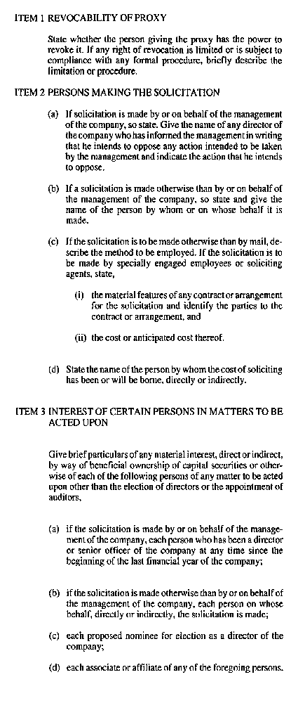
Insert regs\graphics\1990\181\181016be.tif
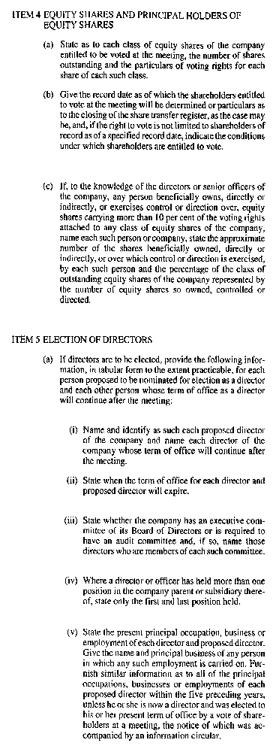
Insert regs\graphics\1990\181\181016ce.tif
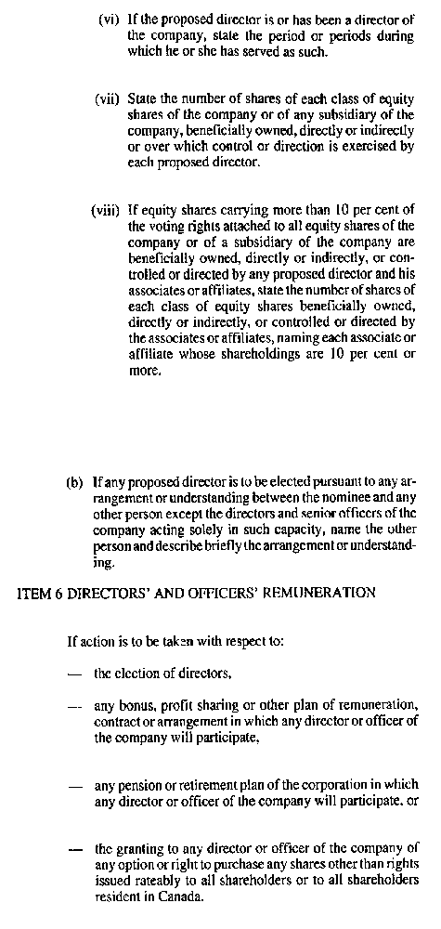
Insert regs\graphics\1990\181\181016de.tif
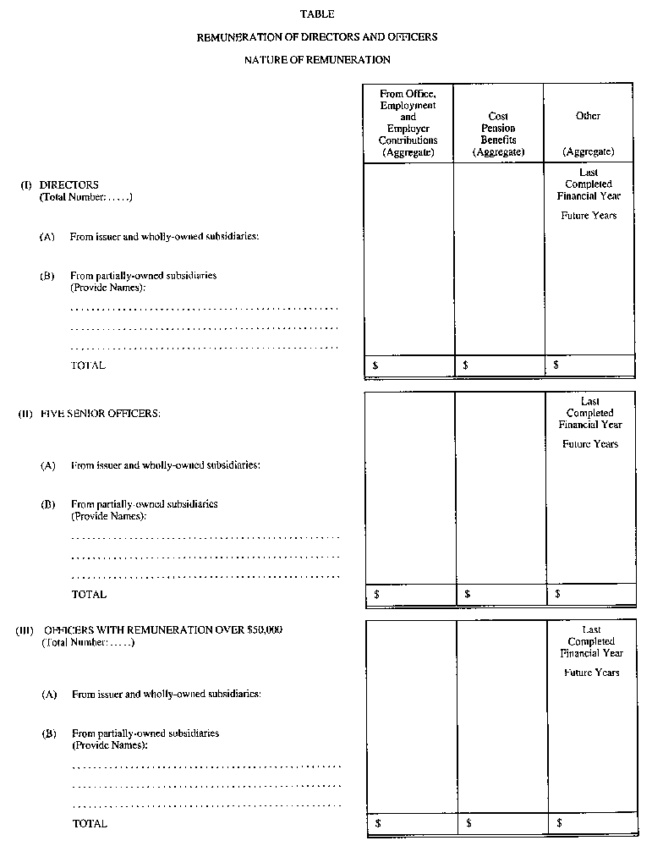
Insert regs\graphics\1990\181\181016ee.tif
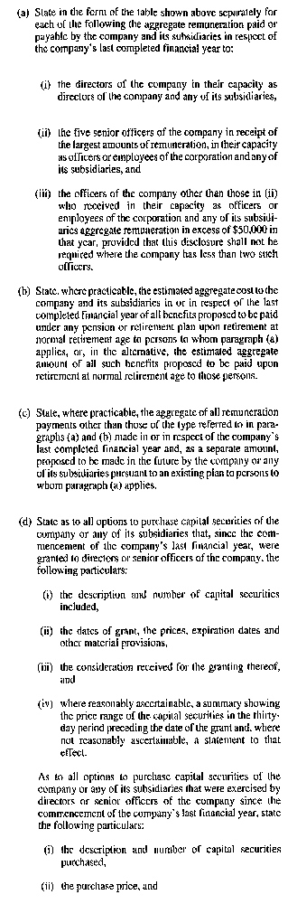
Insert regs\graphics\1990\181\181016fe.tif
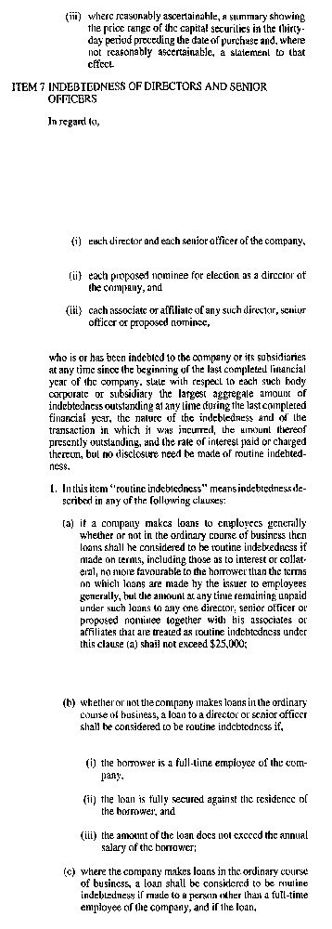
Insert regs\graphics\1990\181\181016ge.tif
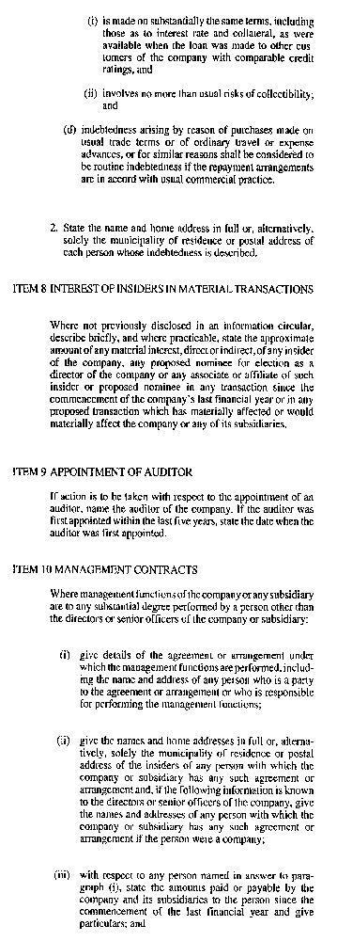
Insert regs\graphics\1990\181\181016he.tif
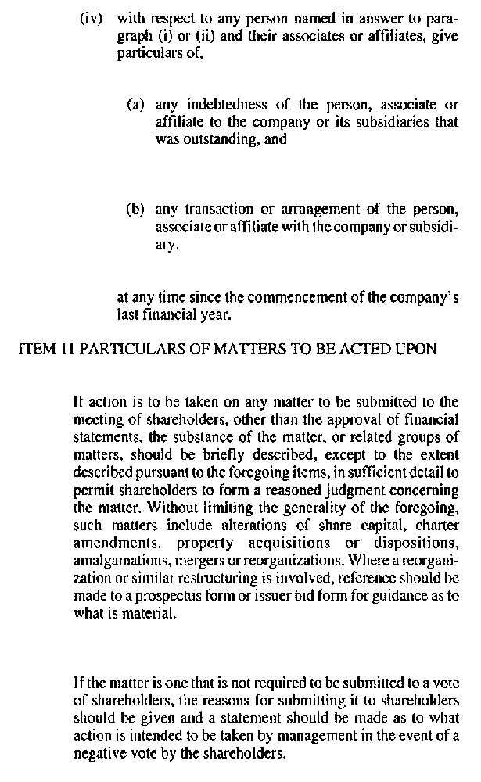
R.R.O. 1990, Reg. 181, Form 16.

