Expropriations Act
R.R.O. 1990, REGULATION 363
FORMS
Historical version for the period March 21, 2003 to August 31, 2015.
Last amendment: O. Reg. 93/03.
This is the English version of a bilingual regulation.
1. (1) An application for approval to expropriate land shall be in Form 1. R.R.O. 1990, Reg. 363, s. 1 (1).
(2) A notice of application for approval to expropriate land served and published by an expropriating authority under subsection 6 (1) of the Act shall be in Form 2. R.R.O. 1990, Reg. 363, s. 1 (2).
(3) A notice of a hearing served under subsection 7 (3) of the Act shall be in Form 3. R.R.O. 1990, Reg. 363, s. 1 (3).
(4) A notice indicating the grounds on which an expropriating authority intends to rely at a hearing and served by it under subsection 7 (4) of the Act shall be in Form 4. R.R.O. 1990, Reg. 363, s. 1 (4).
(5) A certificate of approval of the approving authority under subsection 8 (3) of the Act shall be in Form 5 or, if endorsed on a plan of the land intended for registration under section 9 of the Act, shall be in Form 6. R.R.O. 1990, Reg. 363, s. 1 (5).
(6) A notice of expropriation of land served by an expropriating authority under subsection 10 (1) of the Act shall be in Form 7 and the expropriating authority shall, with each such service, furnish the person so served with a notice of election in Form 8. R.R.O. 1990, Reg. 363, s. 1 (6).
(7) A notice of requirement of possession served by an expropriating authority under subsection 39 (1) of the Act shall be in Form 9. R.R.O. 1990, Reg. 363, s. 1 (7).
(8) A notice of abandonment of land under subsection 41 (1) of the Act shall be in Form 10. R.R.O. 1990, Reg. 363, s. 1 (8).
(9) A declaration of abandonment under subsection 41 (2) of the Act shall,
(a) where the abandoned land is registered under the Registry Act, be in Form 11; and
(b) where the abandoned land is registered under the Land Titles Act, be in Form 12. R.R.O. 1990, Reg. 363, s. 1 (9).
Form 1
APPLICATION FOR APPROVAL TO EXPROPRIATE LAND
Expropriations Act
Insert regs\graphics\1990\363\363001ae.tif
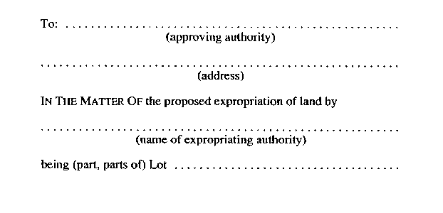
Insert regs\graphics\1990\363\363001be.tif
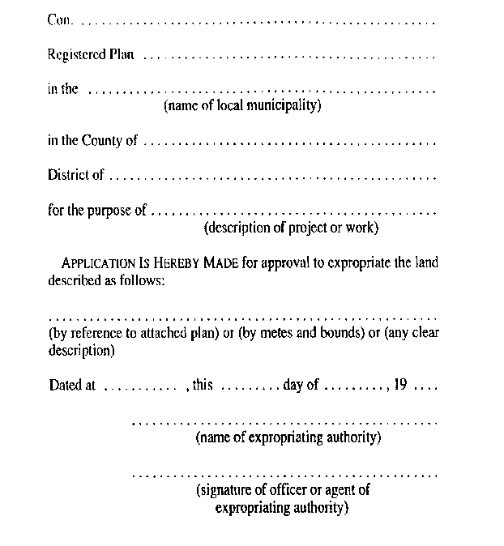
R.R.O. 1990, Reg. 363, Form 1.
Form 2
NOTICE OF APPLICATION FOR APPROVAL TO EXPROPRIATE LAND
Expropriations Act
Insert regs\graphics\1990\363\363002ae.tif
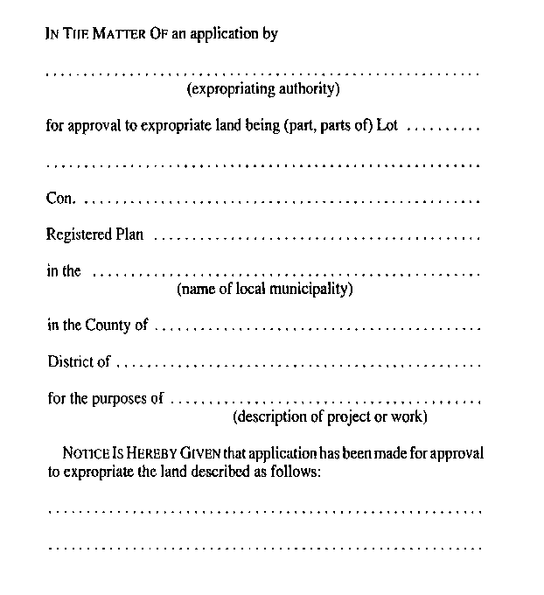
Insert regs\graphics\1990\363\363002be.tif
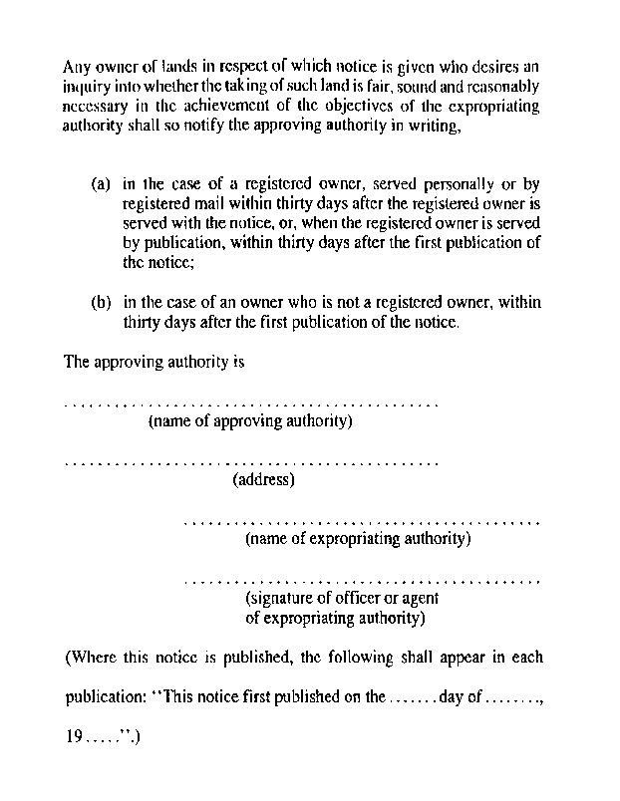
R.R.O. 1990, Reg. 363, Form 2.
Form 3
NOTICE OF HEARING
Expropriations Act
Insert regs\graphics\1990\363\363003ae.tif
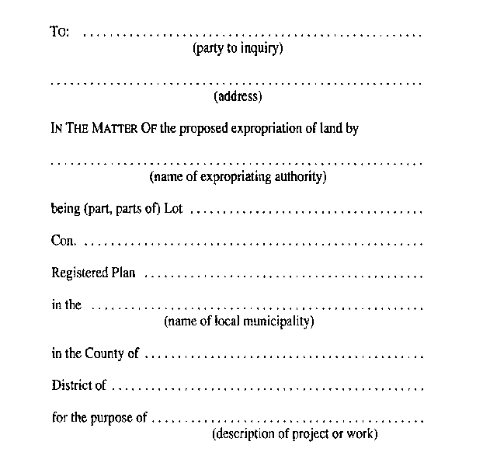
Insert regs\graphics\1990\363\363003be.tif
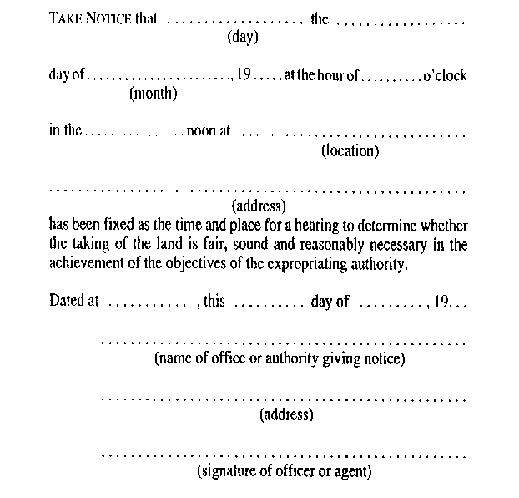
R.R.O. 1990, Reg. 363, Form 3.
Form 4
NOTICE OF GROUNDS
Expropriations Act
Insert regs\graphics\1990\363\363004ae.tif
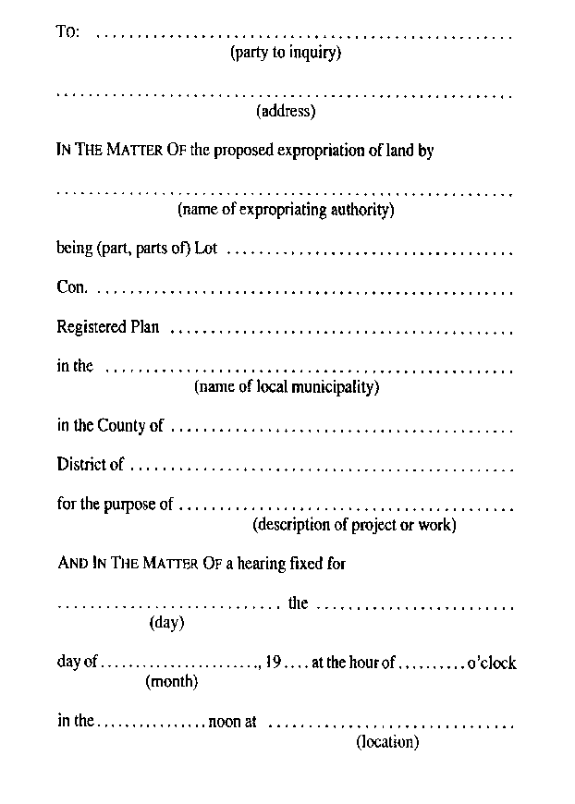
Insert regs\graphics\1990\363\363004be.tif
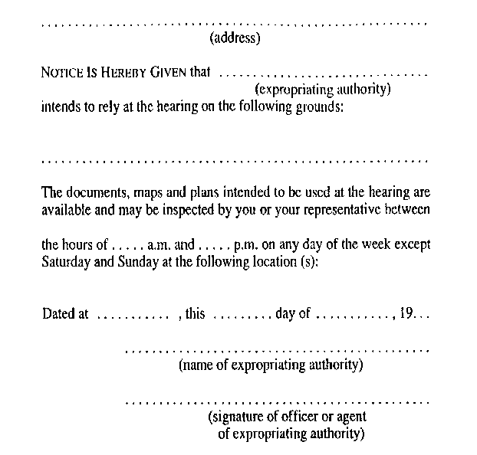
R.R.O. 1990, Reg. 363, Form 4.
Form 5
CERTIFICATE OF APPROVAL
Expropriations Act
Insert regs\graphics\1990\363\363005ae.tif
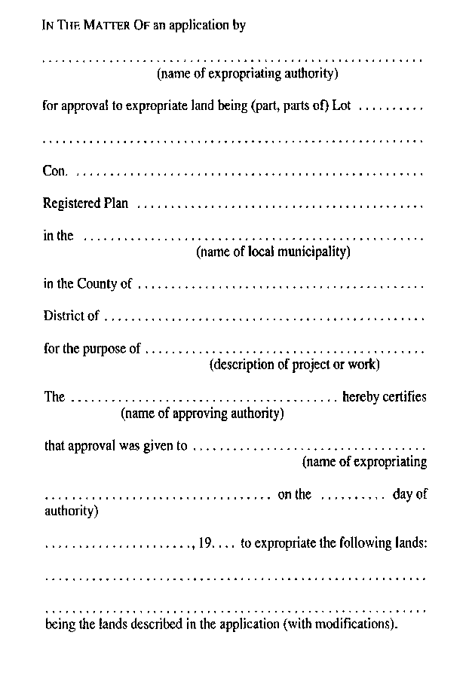
Insert regs\graphics\1990\363\363005be.tif
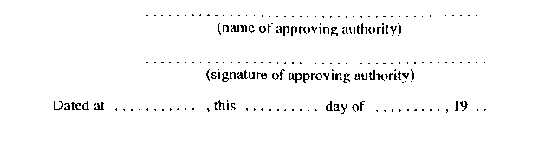
R.R.O. 1990, Reg. 363, Form 5.
Form 6
CERTIFICATE OF APPROVAL (on expropriation plan)
Expropriations Act
Insert regs\graphics\1990\363\363006ae.tif
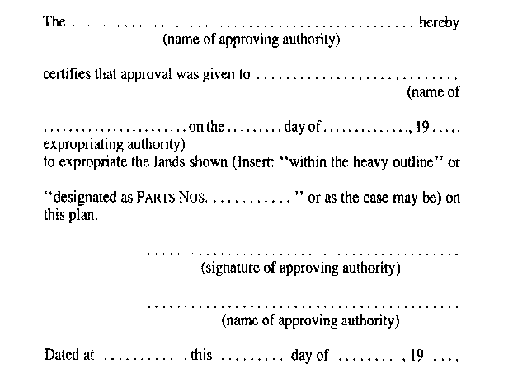
R.R.O. 1990, Reg. 363, Form 6.
Form 7
notice of expropriation
Expropriations Act
Insert regs\graphics\1990\363\363007ae.tif
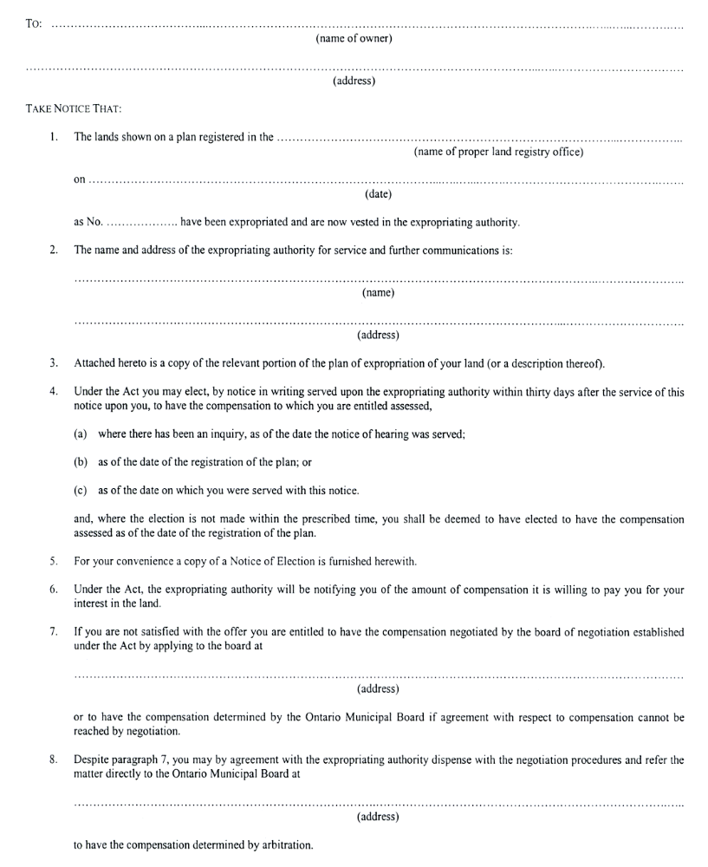
Insert regs\graphics\1990\363\363007be.tif
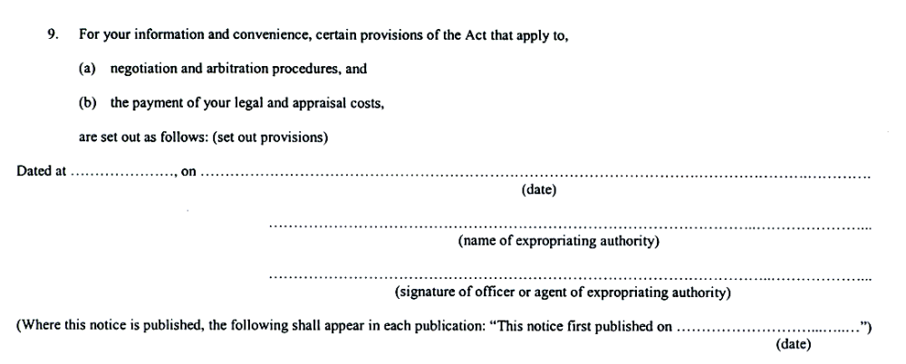
O. Reg. 93/03, s. 1.
Form 8
notice of election
Expropriations Act
Insert regs\graphics\1990\363\363008ae.tif
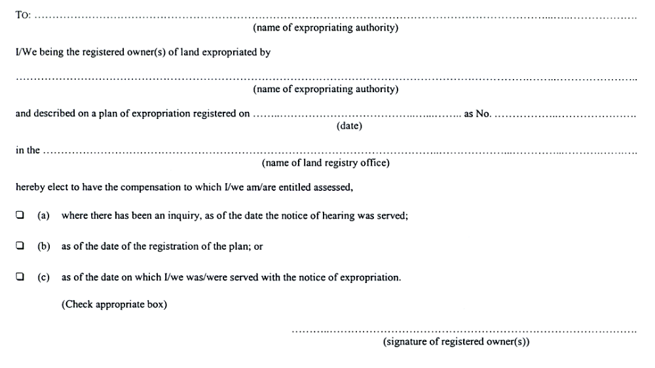
O. Reg. 93/03, s. 1.
Form 9
NOTICE OF POSSESSION
Expropriations Act
Insert regs\graphics\1990\363\363009ae.tif
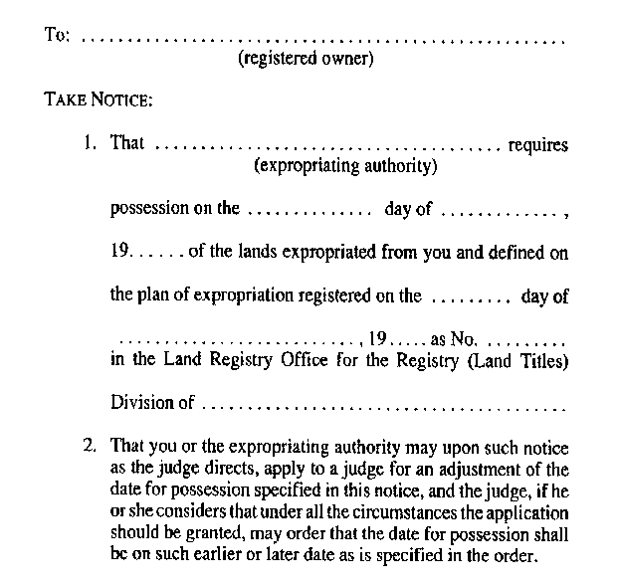
Insert regs\graphics\1990\363\363009be.tif
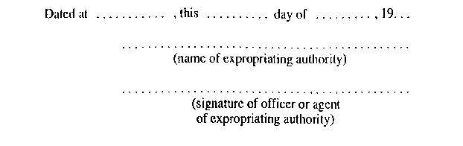
R.R.O. 1990, Reg. 363, Form 9.
Form 10
NOTICE OF ABANDONMENT OF LAND
Expropriations Act
Insert regs\graphics\1990\363\363010ae.tif
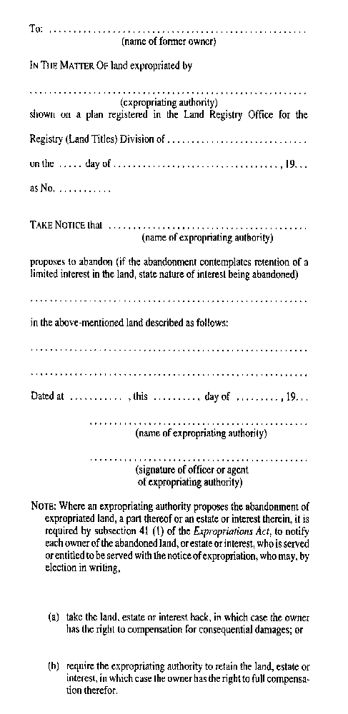
R.R.O. 1990, Reg. 363, Form 10.
Form 11
DECLARATION OF ABANDONMENT
Expropriations Act
Insert regs\graphics\1990\363\363011ae.tif
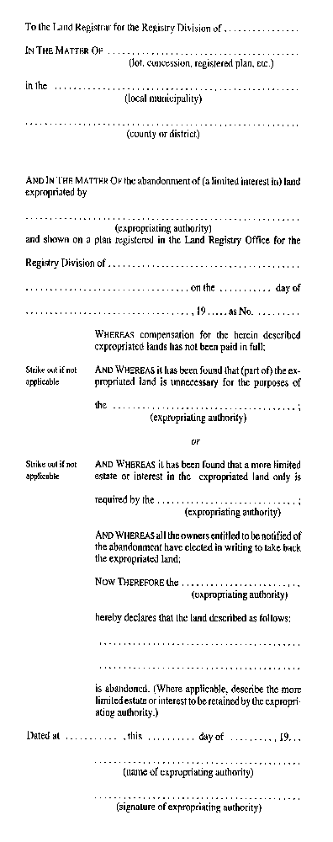
Insert regs\graphics\1990\363\363011be.tif

R.R.O. 1990, Reg. 363, Form 11.
Form 12
DECLARATION OF ABANDONMENT
Expropriations Act
Insert regs\graphics\1990\363\363012ae.tif
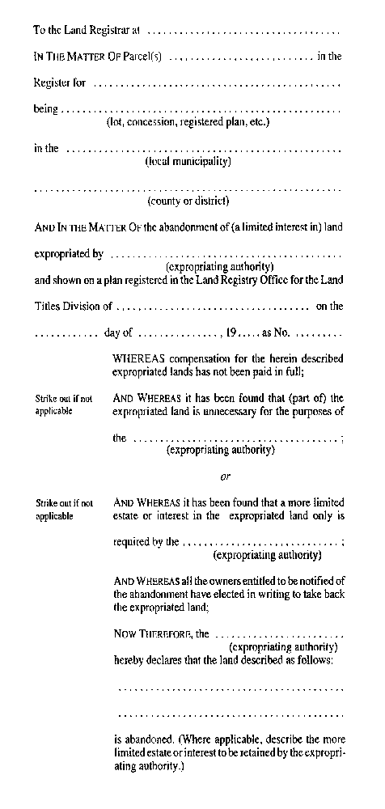
Insert regs\graphics\1990\363\363012be.tif
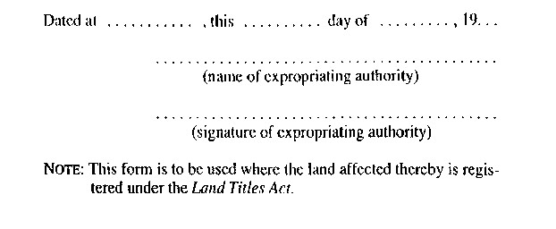
R.R.O. 1990, Reg. 363, Form 12.

