Health Protection and Promotion Act
R.R.O. 1990, REGULATION 569
REPORTS
Historical version for the period June 11, 2015 to June 30, 2015.
Last amendment: O. Reg. 141/15.
This is the English version of a bilingual regulation.
1. (1) A report required under section 25, 26 or 27 of the Act shall, with respect to the person to whom the report relates, contain the following information:
1. Name and address in full.
2. Date of birth in full.
3. Sex.
4. Date of onset of symptoms. R.R.O. 1990, Reg. 569, s. 1 (1).
(2) A person who makes a report under section 25 or 26 or subsection 27 (1) or (2) of the Act and gives the information set out in subsection (1) shall, upon the request of the medical officer of health, give to the medical officer of health such additional information respecting the reportable disease or communicable disease, as the case may be, as the medical officer of health considers necessary. R.R.O. 1990, Reg. 569, s. 1 (2); O. Reg. 1/05, s. 1 (1).
(3) Despite subsection (1), a report under section 25 or 26 of the Act with respect to leprosy shall be made in Form 3. O. Reg. 1/05, s. 1 (2).
2. A report required under section 28 of the Act shall, with respect to the pupil to whom the report relates, contain the following information:
1. Name and address in full.
2. Date of birth in full.
3. Sex.
4. Name and address in full of the school that the pupil attends. R.R.O. 1990, Reg. 569, s. 2.
3. A report made under subsection 29 (1) of the Act shall, with respect to the person to whom the finding was made, be made within twenty-four hours of the making of the finding and shall contain the following information:
1. Name and address in full.
2. Date of birth in full.
3. Sex.
4. Date when the specimen was taken that yielded the positive finding.
5. Name and address in full of the physician, registered nurse in the extended class, or dentist attending the person. R.R.O. 1990, Reg. 569, s. 3; O. Reg. 426/07, s. 1.
3.1 (1) The operator of a laboratory shall report every finding that indicates the presumptive presence of a reportable disease to the medical officer of health in the area in which the person who gives rise to the case resides. O. Reg. 426/07, s. 2.
Note: On July 1, 2015, Subsection 3.1 (1) of the Regulation is amended by striking out “The operator” at the beginning and substituting “Subject to the same exemptions that would apply under section 5.1, the operator”. (See: O. Reg. 141/15, s. 1)
(2) A report made under subsection (1) shall, with respect to the person to whom the finding was made, be made within twenty-four hours of the making of the finding and shall contain the following information:
1. Name and address in full.
2. Date of birth in full.
3. Sex.
4. Date when the specimen was taken that yielded the presumptive finding.
5. Name and address in full of the physician, registered nurse in the extended class or dentist attending the person. O. Reg. 426/07, s. 2.
4. A report made under section 30 of the Act shall, with respect to the deceased, contain the following information:
1. Name and address in full.
2. Date of birth in full.
3. Date of death in full.
4. Name and address in full of the physician or registered nurse in the extended class who attended the deceased. R.R.O. 1990, Reg. 569, s. 4; O. Reg. 426/07, s. 3.
5. A report under section 25 or 26 of the Act shall contain the following information in addition to the information required under subsection 1 (1):
1. Syphilis:
i. The date of diagnosis.
ii. The name and address of the physician or registered nurse in the extended class attending the person.
iii. The name of the hospital and the date of admission if the person is admitted to a hospital or the name of the hospital and the date of each visit if the person is seen as an out-patient of the hospital.
iv. Duration, stage and site of infection.
v. Drugs and dosage used for previous treatment, if any, of the infection.
vi. If previous treatment given, the place, date and physician or registered nurse in the extended class responsible for the administration of the treatment.
vii. Current treatment, if any, of the infection, setting out the drugs and dosage used.
viii. If current treatment is being given, the place, date and physician or registered nurse in the extended class responsible for the administration of treatment.
ix. Laboratory findings and investigative tests including, without being limited to, serological tests, microscopic examination and cerebrospinal fluid examinations, together with the results of the tests.
x. The person responsible for tracing contacts of the person.
xi. Place where infection is believed to have been acquired.
xii. The number of contacts of the person who have been traced.
2. Chancroid, Chlamydia trachomatis infections, Gonorrhoea:
i. The date of diagnosis.
ii. The name and address of the physician or registered nurse in the extended class attending the person.
iii. The name of the hospital, the date of admission and the date of discharge if the person is admitted to hospital.
iv. Place where infection is believed to have been acquired.
v. The person responsible for tracing the contacts of the person.
vi. The number of contacts who have been traced.
vii. The agent of disease.
viii. Medical condition of the person including signs and symptoms of the infection.
ix. The case classification of the person.
x. Laboratory findings and investigative tests including, without being limited to, culture and antimicrobial sensitivity, serological tests, microscopic examination and cerebrospinal fluid examination, together with the results of the tests.
xi. The source of infection including history of exposures.
xii. Risk factors for the disease.
xiii. The travel history of the person, including:
A. Date and place of entry into country where disease acquired.
B. Date of departure from country where disease acquired.
C. Travel within country where disease acquired by date, place and length of stay.
xiv. Initial treatment, if any, of the infection, including, without being limited to, the drugs and dosage used.
xv. If initial treatment has been given, the place, date and physician or registered nurse in the extended class responsible for administration of treatment.
xvi. Final effective treatment including, without being limited to, the drugs and dosage used.
xvii. If effective treatment has been given, the place, date and physician or registered nurse in the extended class responsible for administration of treatment.
xviii. The date of death and relation of the infection to the cause of death, if the person is deceased.
3. Acquired Immune Deficiency Syndrome (AIDS):
i. The date of diagnosis.
ii. The name and telephone number of the physician or registered nurse in the extended class attending the person.
iii. The name of the hospital if the person is admitted to a hospital or is an outpatient.
iv. Medical conditions of the person including laboratory findings and date of onset of symptoms that are indicative of Acquired Immune Deficiency Syndrome.
v. Other medical conditions of the person that may have caused immuno-suppression (exclusion criteria).
vi. Country of birth, date of arrival in Canada, race and residence of the person at onset of illness.
vii. Current status of person infected (alive or dead) (if dead give date of death).
viii. Information preceding the diagnosis of Acquired Immune Deficiency Syndrome with respect to,
A. sexual relations of the person with a male partner,
B. sexual relations of the person with a female partner,
C. use by the person of needles for self-injection of drugs not prescribed by a physician or registered nurse in the extended class, or
D. receipt by the person of blood or blood products (give dates).
ix. Information, preceding the diagnosis of Acquired Immune Deficiency Syndrome, with respect to heterosexual relations of the person with another person who is,
A. an intravenous abuser,
B. a bisexual man,
C. a person with hemophilia or a coagulation disorder,
D. a blood transfusion recipient with Acquired Immune Deficiency Syndrome or documented Human Immune Virus infection,
E. a person with Acquired Immune Deficiency Syndrome or documented Human Immune Virus infection,
F. a person who was born or resided in a country where heterosexual transmission of Acquired Immune Deficiency Syndrome predominates (specify country).
x. Information preceding the diagnosis of Acquired Immune Deficiency Syndrome, as to whether the person has worked or is working in a health care or clinical laboratory setting (give occupation and setting).
xi. Information, preceding the diagnosis of Acquired Immune Deficiency Syndrome, as to whether there are no identifiable risk factors or any other exposures that could have been the source of the infection.
xii. Information, in the case of a child who is one year of age or older but less than sixteen years of age, as to whether the child was infected as a result of perinatal transmission.
4. Lassa Fever, Hemorrhagic fevers including Ebola virus disease, Marburg virus disease and Hemorrhagic fevers from other viral causes and Plague:
i. The date of diagnosis.
ii. The name and address of the physician or registered nurse in the extended class attending the person.
iii. The name of the hospital and the date of admission if the person is admitted to a hospital.
iv. Travel history outside Canada.
A. Date and place of entry into country where disease acquired.
B. Date of departure from country where disease acquired.
C. Date and time of entry into Canada and carrier and flight number if applicable.
D. Travel within country where disease acquired by date, place and length of stay.
E. Any other places visited en route to Canada.
v. List places and method of travel within Canada in the week prior to and since onset of illness.
vi. Exposure to any of the following. (Give date and time).
A. Rodents or monkeys.
B. Persons with a similar illness.
C. Virus in a laboratory.
vii. Clinical history.
A. Date of onset of illness.
B. Symptoms and signs of the illness.
C. History of malaria or malaria prophylaxis.
viii. Laboratory specimens.
A. List all specimens collected by type and date.
B. Name of laboratory where specimens may be located.
ix. State if ambulance was used and date of use.
5. Chickenpox (Varicella), Diphtheria, Haemophilus influenzae b disease, invasive, Measles, Meningitis, acute, Meningococcal disease, invasive, Mumps, Pertussis (Whooping Cough), Pneumococcal disease, invasive, Poliomyelitis, acute, Rubella, Rubella, congenital syndrome, Tetanus:
i. The date of the diagnosis.
ii. The agent of disease.
iii. The name and address of the physician or registered nurse in the extended class attending the person.
iv. Medical condition and status of the person including signs, symptoms and site, if any, of the infection.
v. The clinical history of the person, including:
A. The name of the hospital, date of admission and the date of discharge from the hospital if the person is admitted to hospital or the name of the hospital if the person is seen as an out-patient of the hospital.
B. The date and duration of isolation, if isolated.
C. Vaccination history.
vi. The case classification of the person.
vii. Laboratory findings and investigative tests including, without being limited, to culture and antimicrobial sensitivity, serological tests, microscopic examination and cerebrospinal fluid examination, together with the results of the tests.
viii. Association with outbreak and outbreak number, if applicable.
ix. Current treatment, if any, of the infection, setting out the drugs and dosage used and the date treatment commenced and ended.
x. Completion of the course of treatment including the major mode of therapy and the treatment compliance.
xi. Place where infection is believed to have been acquired.
xii. The source of infection including history of exposures and potential for community transmission.
xiii. Risk factors for the disease.
xiv. The immigration status and origin of the person, including:
A. Country of birth.
B. Country of last residence.
C. Date of arrival in Canada.
D. Immigration status at time of arrival in Canada.
xv. The travel history of the person, including:
A. Date and place of entry into country where disease acquired.
B. Date of departure from country where disease acquired.
C. Date and time of entry into Canada and carrier and flight number, if applicable.
D. Travel within country where disease acquired by date, place and length of stay.
E. Any other places visited en route to and from Canada.
xvi. List places and method of travel within Canada prior to and since the onset of illness.
xvii. The employment details of the person including job title and place of employment.
xviii. The name and address of the school the person attends, if applicable, including the classroom.
xix. Health unit responsible for identifying contacts.
xx. Names of health units with contacts.
xxi. Number of contacts identified.
xxii. Number of contacts traced.
xxiii. Number of contacts tested and treated, if applicable.
xxiv. Results of testing of contacts, if applicable.
xxv. Outcome:
A. If the person is deceased, date and cause of death.
B. Complications.
C. Absconded — lost to follow-up before treatment completion.
D. Other.
6. Tuberculosis:
i. The date of the diagnosis.
ii. The agent of disease.
iii. The name and address of the physician or registered nurse in the extended class attending the person.
iv. Medical condition and status of the person including signs, symptoms and site, if any, of the infection.
v. The clinical history of the person, including:
A. The name of the hospital, date of admission and the date of discharge from the hospital if the person is admitted to hospital or the name of the hospital if the person is seen as an out-patient of the hospital.
B. The date and duration of isolation, if isolated.
C. Vaccination history.
D. Reactivation of old disease and years of previous treatment setting out the drugs and dosages used and the dates treatment commenced and ended.
vi. The case classification of the person.
vii. Laboratory findings and investigative tests including, without being limited to, culture and antimicrobial sensitivity, serological tests, X-ray examination, microscopic examination and cerebrospinal fluid examination, together with the results of the tests.
viii. Current treatment, if any, of the infection, setting out the drugs and dosage used and the date treatment commenced and ended.
ix. Completion of the course of treatment including the major mode of therapy (Directly Observed Therapy — daily or intermittent or Daily, self-administered) and the treatment compliance estimate (80%, 50-79%, less than 50% or unknown).
x. Place where infection is believed to have been acquired.
xi. The source of infection including history of exposures.
xii. Risk factors for the disease.
xiii. The immigration status and origin of the person, including:
A. Country of birth.
B. Country of last residence.
C. Immigration Medical Surveillance serial number or Inland Processing Number.
D. Date of arrival in Canada.
E. Reported for medical surveillance (has made contact with health unit or equivalent agency in other jurisdiction.)
F. Has had medical assessment in Canada for immigration surveillance.
G. Immigration status at time of arrival in Canada.
H. Country of birth of parents if person is under 20 years of age and Canadian born non-Aboriginal.
xiv. The registered Indian status of the person.
xv. The travel history of the person, including:
A. Date and place of entry into country where disease acquired.
B. Date of departure from country where disease acquired.
C. Date and time of entry into Canada and carrier and flight number, if applicable.
D. Travel within country where disease acquired by date, place and length of stay.
E. Any other places visited en route to and from Canada.
xvi. List places and method of travel within Canada prior to and since the onset of illness.
xvii. The employment details of the person including job title and place of employment.
xviii. The name and address of the school the person attends, if applicable, including the classroom.
xix. Health unit responsible for identifying contacts.
xx. Names of health units with contacts.
xxi. Number of contacts identified.
xxii. Number of contacts traced.
xxiii. Number of contacts tested and number of contacts treated.
xxiv. Results of testing of contacts.
xxv. Outcome:
A. If the person is deceased, date of death and cause of death.
B. Complications.
C. Absconded — lost to follow-up before treatment completion.
D. Other.
7. Cytomegalovirus infection, congenital, Group B Streptococcal Disease, neonatal, Herpes, neonatal, Ophthalmia Neonatorum:
i. The date of the diagnosis.
ii. The name and address of the physician or registered nurse in the extended class attending the person.
iii. The name of the hospital, the date of admission and the date of discharge if the person is admitted to hospital.
iv. The contacts who have been traced.
v. Medical condition of the person including signs and symptoms of the infection.
vi. The case classification of the person.
vii. Laboratory findings and other investigative test results including, without being limited to, culture and antimicrobial sensitivity, serological tests, microscopic examination and cerebrospinal fluid examination, together with the results of the tests.
viii. Initial treatment, if any, of the infection including, without being limited to, the drugs and dosage used.
ix. Final effective treatment including, without being limited to, the drugs and dosage used.
x. Risk factors for the disease.
xi. The date of death and relation of the infection to the cause of death, if deceased.
8. Malaria, Yellow Fever:
i. The date of the diagnosis.
ii. The name and address of the physician or registered nurse in the extended class attending the person.
iii. The name of the hospital, the date of admission and the date of discharge if the person is admitted to hospital.
iv. Place where infection is believed to have been acquired.
v. The agent of disease and sub-type.
vi. Medical condition of the person including signs and symptoms of the infection.
vii. The case classification of the person.
viii. Association with outbreak and outbreak number, if applicable.
ix. Laboratory findings and investigative tests including, without being limited to, culture and antimicrobial sensitivity, serological tests, microscopic examination and cerebrospinal fluid examination, together with the results of the tests.
x. The source of infection including history of exposures.
xi. Risk factors for the disease.
xii. The travel history of the person, including:
A. Date and place of entry into country where disease acquired.
B. Date of departure from country where disease acquired.
C. Travel within country where disease acquired by date, place and length of stay.
xiii. History of malaria and malaria prophylaxis or history of yellow fever vaccination.
xiv. Initial treatment, if any, of the infection including, without being limited to, the drugs and dosage used.
xv. If initial treatment given, the place, date and physician responsible for administration of treatment.
xvi. Final effective treatment including, without being limited to, the drugs and dosage used.
xvii. If effective treatment has been given, place, date and physician responsible for administration of treatment.
xviii. The date of death and relation of the infection to the cause of death, if deceased.
9. Group A Streptococcal disease, invasive:
i. The date of the diagnosis.
ii. The agent of disease.
iii. The name and address of the physician or registered nurse in the extended class attending the person.
iv. Medical condition and status of the person including clinical severity, signs, symptoms and site, if any, of the infection.
v. The clinical history of the person, including:
A. The name of the hospital, date of admission and the date of discharge from the hospital if the person is admitted to hospital.
B. The date and duration of isolation, if isolated.
vi. The case classification of the person.
vii. Laboratory findings and investigative tests including, without being limited to, culture and antimicrobial sensitivity, serological tests, microscopic examination and cerebrospinal fluid examination, together with the results of the tests.
viii. Association with outbreak and outbreak number, if applicable.
ix. Current treatment, if any, of the infection, setting out the drugs and dosage used and the date treatment commenced and ended.
x. Antibiotic resistance, if applicable.
xi. Place where infection is believed to have been acquired.
xii. The source of infection including history of exposures.
xiii. Risk factors for the disease.
xiv. The employment details of the person including job title and place of employment.
xv. The name and address of the school the person attends, if applicable, including the classroom.
xvi. Health unit responsible for identifying contacts.
xvii. Names of health units with contacts.
xviii. Number of contacts identified.
xix. Number of contacts traced.
xx. Number of contacts tested and treated, if applicable.
xxi. Results of testing contacts, if applicable.
xxii. The date of death and relation of the infection to the cause of death, if the person is deceased.
10. Influenza:
i. The date of diagnosis.
ii. The agent of disease, including subtype.
iii. The name and address of the physician or registered nurse in the extended class attending the person.
iv. Medical condition and status of the person including signs, symptoms and site, if any, of the infection.
v. The clinical history of the person, including:
A. The name of the hospital, date of admission and the date of discharge from the hospital if the person is admitted to hospital or the name of the hospital if the person is seen as an out-patient of the hospital.
B. The date and duration of isolation, if isolated.
C. Vaccination history.
vi. The case classification of the person.
vii. Laboratory findings including, without being limited to, antigen detection, culture and viral strain identification, genetic typing and serological tests.
viii. Association with outbreak and outbreak number, if applicable.
ix. Current treatment, if any, of the infection, setting out the drugs and dosage used and the date treatment commenced and ended.
x. Place where infection is believed to have been acquired.
xi. The source of infection including history of exposures.
xii. Risk factors for the disease.
xiii. The travel history of the person, if applicable, including:
A. Date and place of entry into country where disease acquired.
B. Date of departure from country where disease acquired.
C. Date and time of entry into Canada and carrier and flight number, if applicable.
D. Travel within country where disease acquired by date, place and length of stay.
E. Any other places visited en route to Canada.
xiv. List places and method of travel within Canada prior to and since the onset of illness, if applicable.
xv. The employment details of the person including job title and place of employment.
xvi. The name and address of the school the person attends, if applicable, including the classroom.
xvii. Health unit responsible for identifying contacts.
xviii. Names of health units with contacts.
xix. Number of contacts identified.
xx. Number of contacts traced.
xxi. Number of contacts tested and treated, if applicable.
xxii. The date of death and relation of the infection to the cause of death, if the person is deceased.
11. Severe Acute Respiratory Syndrome (SARS):
i. The date of the diagnosis.
ii. The agent of disease.
iii. The name and address of the physician or registered nurse in the extended class attending the person.
iv. Medical condition and status of the person including signs, symptoms and site, if any, of the infection.
v. The clinical history of the person, including:
A. The name of the hospital, date of admission and the date of discharge from the hospital if the person is admitted to hospital, or transferred to another hospital or the name of the hospital if the person is seen as an out-patient of the hospital.
B. The date and duration of isolation, if isolated.
C. The date and duration of quarantine, if quarantined.
D. Vaccination history.
vi. The case classification of the person.
vii. The date of any change of case classification and details of the change.
viii. Laboratory findings and investigative tests including, without being limited to, culture and antimicrobial sensitivity, serological tests, microscopic examination, X-ray examination and cerebrospinal fluid examination, together with the results of the tests.
ix. Association with outbreak and outbreak number, if applicable.
x. Current treatment, if any, of the infection, setting out the drugs and dosage used and the date treatment commenced and ended.
xi. Place where infection is believed to have been acquired.
xii. The source of infection including history of exposures, and potential for community transmission.
xiii. Risk factors for the disease.
xiv. The travel history of the person, including:
A. Date and place of entry into country where disease acquired.
B. Date of departure from country where disease acquired.
C. Date and time of entry into Canada and carrier and flight number, if applicable.
D. Travel within country where disease acquired by date, place and length of stay.
E. Any other places visited en route to Canada.
xv. List places and method of travel within Canada prior to and since the onset of illness.
xvi. The employment details of the person including job title and place of employment.
xvii. The name and address of the school the person attends, if applicable, including the classroom.
xviii. Health unit responsible for identifying contacts.
xix. Names of health units with contacts.
xx. Number of contacts identified.
xxi. Number of contacts traced.
xxii. Number of contacts quarantined.
xxiii. Number of contacts tested and treated, if applicable.
xxiv. Results of testing contacts, if applicable.
xxv. The date of death and relation of the infection to the cause of death, if deceased.
12. Respiratory infection outbreaks in institutions:
i. The name and address of the institution and the contact person.
ii. The agent of disease, if known.
iii. The onset date and clinical details of symptoms in first and last cases.
iv. A description of the outbreak and an outbreak definition including, without being limited to a description of symptoms and laboratory findings.
v. The date the outbreak was declared and the outbreak number.
vi. The date the outbreak was declared over.
vii. The total number of cases in residents and all persons who carry on activities in the facility including employees, nurses, students, medical house staff, physicians, registered nurses in the extended class, contract workers and volunteers (“staff”).
viii. The total number of residents and staff vaccinated prior to and during the outbreak and the total number of cases in residents and staff that were vaccinated prior to and during the outbreak.
ix. The total number of cases in residents and staff of admissions to hospital, X-ray confirmation of pneumonia, and deaths during the outbreak period.
x. Measures taken to monitor the facility for signs and symptoms consistent with the outbreak in persons who are residents or staff of the institution including the line list which shall include the name and location of residents and staff within the institution exhibiting signs and symptoms consistent with the description of the outbreak including clinical details and when the symptoms commenced and ended.
xi. Number of residents and staff in the entire institution and in areas of the institution affected by the outbreak.
xii. The name of the hospital, the date of admission and the date of discharge of any person who is a resident or staff member or any person who is admitted to hospital with signs and symptoms consistent with the definition of the outbreak.
xiii. Medical condition and status of persons exhibiting signs and symptoms consistent with the definition of the outbreak.
xiv. The name of any resident or staff member of the institution who dies during the outbreak period whether the cause of death is the respiratory infection or any other cause and including the time and date of death, the location of the death and cause of death.
xv. The details of any notification made to any other institution regarding the declaration of an outbreak in the institution for the purposes of preventing the spread of infection.
xvi. Laboratory findings and investigative tests including, without being limited to, antigen detection, culture and antimicrobial sensitivity, serological tests, microscopic examination, cerebrospinal fluid examination and X-ray examination, together with the results of the tests.
xvii. Current treatment, if any, of the persons exhibiting signs and symptoms consistent with the outbreak, setting out the drugs and dosage used and the date treatment commenced.
xviii. Infection control measures utilized to minimize the impact of the outbreak on the residents and staff and to prevent the spread of the infection including, but not limited to, influenza immunization, exclusion of non-immunized persons from the facility, the use of antiviral medications, isolation of ill persons, increased environmental sanitation and restriction of visitors.
xix. Place where infection is believed to have been acquired.
xx. The source of infection including history of exposures.
xxi. Risk factors for the disease.
xxii. Health units responsible for identifying contacts.
xxiii. Names of health units with contacts.
xxiv. Number of contacts identified.
xxv. Number of contacts traced.
xxvi. Number of contacts tested and treated, if applicable.
xxvii. Results of testing contacts, if applicable.
xxviii. Verification of staff immunization policies.
13. Encephalitis, including primary, viral, post-infectious, vaccine-related, subacute sclerosing panencephalitis, and unspecified:
i. The date of the diagnosis.
ii. The agent of disease.
iii. The name and address of the physician or registered nurse in the extended class attending the person.
iv. Medical condition and the current status of the person including signs and symptoms.
v. The name of the hospital and the date of admission and the date of discharge if the person is admitted to hospital or the name and date of visits if the person is seen as an out-patient of the hospital.
vi. The case classification of the person.
vii. The outcome of the disease.
viii. Laboratory findings and investigative tests including, without being limited to, culture and antimicrobial sensitivity, serological tests, microscopic examination and cerebrospinal fluid examination, together with the results of the tests.
ix. Association with outbreak and outbreak number, if applicable.
x. Current treatment, if any, of the infection, setting out the drugs and dosage used and the date treatment commenced and ended.
xi. Place where infection is believed to have been acquired.
xii. The source of infection including history of exposures.
xiii. Risk factors for the disease.
xiv. The travel history of the person, including:
A. Date and place of entry into country where disease acquired.
B. Date of departure from country where disease acquired.
C. Date and time of entry into Canada and carrier and flight number, if applicable.
D. Travel within country where disease acquired by date, place and length of stay.
E. Any other places visited en route to Canada.
xv. List places and method of travel within Canada prior to and since the onset of illness.
xvi. The employment details of the person including job title and place of employment.
xvii. The name and address of the school the person attends, if applicable, including classroom.
xviii. The date of death and relation of the infection to the cause of death, if deceased.
14. Hepatitis B, Hepatitis C, Hepatitis D (Delta hepatitis):
i. The date of the diagnosis.
ii. The agent of disease.
iii. The name and address of the physician or registered nurse in the extended class attending the person.
iv. The name of the hospital, the date of admission and the date of discharge if the person is admitted to hospital or the name of the hospital if the person is seen as an out-patient of the hospital.
v. History of immunization and post exposure prophylaxis as appropriate.
vi. The case classification of the person.
vii. Laboratory findings and investigative tests including, without being limited to, serological tests, microscopic examination and cerebrospinal fluid examination, together with the results of the tests.
viii. Association with outbreak and outbreak number, if applicable.
ix. The source of infection including history of exposures.
x. Risk factors for the disease.
xi. Place where infection is believed to have been acquired.
xii. The travel history of the person, including:
A. Date and place of entry into country where disease acquired.
B. Date of departure from country where disease acquired.
C. Travel within country where disease acquired by date, place and length of stay.
xiii. The employment details of the person including job title and place of employment, if applicable.
xiv. The name and address of the school the person attends, if applicable, including classroom.
xv. The person responsible for tracing the contacts of the person (hepatitis B and Delta only).
xvi. The contacts who have been traced (hepatitis B and Delta only).
xvii. The date of death and relation of the infection to the cause of death, if deceased.
15. Transmissible Spongiform Encephalopathy, including Creutzfeldt-Jakob Disease, all types, Gerstmann-Sträussler-Scheinker Syndrome, Fatal Familial Insomnia and Kuru:
i. The date of the diagnosis.
ii. The name and address of the physician or registered nurse in the extended class attending the person.
iii. The name of the hospital and the date of admission if the person is admitted to a hospital or is seen as an out-patient of the hospital.
iv. Laboratory findings and investigative tests including, without being limited to, 14-3-3 protein test, cerebrospinal fluid examination, microscopic examination, electroencephalogram, magnetic resonance imaging, computerized axial tomography and biopsy, together with the results of the tests.
v. History and physical examination findings of the person.
vi. Dates of organ, blood or blood product donated or received.
vii. Name of institution where performed, and dates, with respect to invasive procedures to person including, without being limited to, lumbar puncture, surgery and endoscopy.
viii. Countries of residence and duration of residence or travel.
ix. Genetic history of transmissible spongiform encephalopathy.
x. Date of death, if the person is deceased.
xi. Autopsy findings.
16. Amebiasis, Anthrax, Botulism, Brucellosis, Campylobacter enteritis, Cholera, Cryptosporidiosis, Cyclosporiasis, Food poisoning — all causes, Gastroenteritis, institutional outbreaks, Giardiasis, Hantavirus Pulmonary Syndrome, Hepatitis A viral infections, Legionellosis, Listeriosis, Lyme Disease, Paratyphoid Fever, Psittacosis/Ornithosis, Q Fever, Rabies, Salmonellosis, Shigellosis, Trichinosis, Tularemia, Typhoid Fever, West Nile Virus Illness, Verotoxin-producing E. coli infection indicator conditions, including Haemolytic Uraemic Syndrome (HUS), Yersiniosis:
i. The date of the diagnosis.
ii. The agent of disease.
iii. The name and address of the physician or registered nurse in the extended class attending the person.
iv. Medical condition of the person including signs and symptoms of the infection.
v. The name of the hospital and the date of admission and the date of discharge if the person is admitted to hospital or the name of the hospital if the person is seen as an out-patient of the hospital.
vi. The case classification of the person.
vii. Laboratory findings and investigative tests including, without being limited to, culture and antimicrobial sensitivity, serological tests, microscopic examination and cerebrospinal fluid examination, together with the results of the tests.
viii. Association with outbreak and outbreak number, if applicable.
ix. Current treatment, if any, of the infection, setting out the drugs and dosage used and the dates treatment commenced and ended.
x. Place, including geographic location, where infection is believed to have been acquired.
xi. The source of infection including history of exposures and potential for community spread.
xii. Risk factors for the disease.
xiii. The travel history of the person, including:
A. Date and place of entry into country or countries where disease is believed to have been acquired.
B. Date of departure from country or countries where disease is believed to have been acquired.
C. Date and time of entry into Canada and carrier and flight number, if applicable.
D. Travel within country or countries where disease is believed to have been acquired by date, place and length of stay.
E. Any other places visited en route to and from Canada.
xiv. The immigration status and origin of the person, including:
A. Country of birth.
B. Country of last residence.
C. Date of arrival to Canada.
xv. List places and method of travel within Canada for the period of time equal to at least two incubation periods of the disease prior to and since the onset of illness.
xvi. The employment details of the person including job title and place of employment.
xvii. The name and address of the school the person attends, if applicable, including classroom.
xviii. The outcome of the disease.
xix. The date of death and relation of the infection to the cause of death, if the person is deceased.
17. Smallpox:
i. The date of the diagnosis.
ii. The agent of disease.
iii. The name and address of the physician or registered nurse in the extended class attending the person.
iv. Medical condition and status of the person including signs and symptoms of the infection.
v. The clinical history of the person, including:
A. The name of the hospital, date of admission and the date of discharge from the hospital if the person is admitted to hospital, or transferred to another hospital or the name of the hospital if the person is seen as an out-patient of the hospital.
B. The date and duration of isolation, if isolated.
C. The date and duration of quarantine, if quarantined.
D. Vaccination history.
vi. The case classification of the person.
vii. The date of any change of case classification and details of the change.
viii. Laboratory findings and investigative tests including, without being limited to culture and antimicrobial sensitivity, serological tests, microscopic examination and cerebrospinal fluid examination, together with the results of the tests.
ix. Association with outbreak and outbreak number, if applicable.
x. Current treatment, if any, of the infection, setting out the drugs and dosage used and the date treatment commenced and ended.
xi. Place, including geographical location, where infection is believed to have been acquired.
xii. The source of infection including history of exposures and potential for community transmission.
xiii. Risk factors for the disease.
xiv. The travel history of the person, including:
A. Date and place of entry into country where disease acquired.
B. Date of departure from country where disease acquired.
C. Date and time of entry into Canada and carrier and flight number, if applicable.
D. Travel within country where disease acquired by date, place and length of stay.
E. Any other places visited en route to Canada.
xv. List places and method of travel within Canada prior to and since the onset of illness.
xvi. The employment details of the person including job title and place of employment.
xvii. The name and address of the school the person attends, if applicable, including the classroom.
xviii. Health unit responsible for identifying contacts.
xix. Names of health units with contacts.
xx. Number of contacts identified.
xxi. Number of contacts traced.
xxii. Number of contacts quarantined.
xxiii. Number of contacts tested and treated, if applicable.
xxiv. Results of testing contacts, if applicable.
xxv. The date of death and relation of the infection to the cause of death, if deceased. R.R.O. 1990, Reg. 569, s. 5; O. Reg. 1/05, s. 2; O. Reg. 426/07, s. 4.
5.1 (1) In this section,
“AIDS” means Acquired Immune Deficiency Syndrome; (“sida”)
“HIV” means Human Immunodeficiency Virus. (“VIH”) O. Reg. 749/91, s. 1.
(2) A physician or registered nurse in the extended class who provides professional services to a patient in a clinic set out in Schedule 1 and who is required to report under section 26 of the Act following a test to determine if the patient is infected with an agent of AIDS is exempt from reporting the patient’s name and address if, before the test was ordered, the patient received counselling about preventing the transmission of HIV infection. O. Reg. 749/91, s. 1; O. Reg. 84/95, s. 1 (1); O. Reg. 377/06, s. 1 (1); O. Reg. 426/07, s. 5.
(3) The operator of a laboratory is exempt from reporting, under section 29 of the Act, the name and address of a person who has tested positive for an agent of AIDS if the test is in relation to professional services provided at a clinic set out in Schedule 1. O. Reg. 749/91, s. 1; O. Reg. 84/95, s. 1 (2); O. Reg. 377/06, s. 1 (2).
(4) Revoked: O. Reg. 84/95, s. 1 (3).
Note: On July 1, 2015, Section 5.1 of the Regulation is amended by adding the following subsection: (See: O. Reg. 141/15, s. 2)
(4) A physician, registered nurse in the extended class or operator of a laboratory is exempt from reporting, under section 26 or 29 of the Act, the name and address of a patient with respect to whom a subsequent viral load test is conducted after an initial test was conducted at a clinic set out in Schedule 1. O. Reg. 141/15, s. 2.
5.2 A report under subsection 27 (1) of the Act in respect of Clostridium difficile associated disease (CDAD) outbreaks in public hospitals shall contain the following information in addition to the information required under subsection 1 (1):
1. The name and address of the hospital and the contact person.
2. The agent of disease.
3. The date the outbreak was declared, the date the outbreak was declared over, and the outbreak number.
4. The onset date of the index case and of the last case.
5. The total number of cases.
6. The total number of deaths in cases associated with the outbreak during the outbreak period.
7. Disease control measures utilized to minimize the impact of the outbreak and to prevent the spread of disease.
8. Quantification of the population at risk for the disease in the entire hospital and in the area affected by the outbreak during the outbreak period including, without being limited to, the number of patient days for the entire hospital and the number of patient days for the area affected by the outbreak.
9. Measures taken to monitor the hospital for signs and symptoms consistent with the outbreak in patients of the hospital, including a line list.
10. For each case:
i. The date of admission and the date of discharge.
ii. Laboratory findings and investigative tests including, without being limited to, toxin testing, culture, strain typing, histopathological and colonoscopic examination, together with the results of the tests.
iii. The onset date and clinical details of signs and symptoms.
iv. The date of death and the relation of the disease to the cause of death.
v. Treatment, if any, of the disease.
vi. Complications and outcome of the disease.
vii. The place where the disease is believed to have been acquired.
viii. Risk factors for the disease including, without being limited to, previous exposure to a health care setting and history of antibiotic use. O. Reg. 306/08, s. 1.
6. (1) Where a medical officer of health receives a report made under section 25, 26, 27 or 28, subsection 29 (2) or section 30 of the Act, he or she shall immediately forward a copy of the report to the Public Health Division of the Ministry in a secure manner. O. Reg. 1/05, s. 3.
(2) Revoked: O. Reg. 143/05, s. 1.
7. (1) A report required under subsection 38 (3) of the Act shall, with respect to the person to whom the report relates, contain the following information:
1. Name, address and telephone number in full.
2. Date of birth in full.
3. Sex.
4. The name, address and telephone number of the parent or guardian of the person experiencing the adverse event if the person is a minor.
5. The name and address of the physician or registered nurse in the extended class attending the person.
6. The name of the hospital, the date of admission, and date of discharge, if the person was admitted to hospital as a result of the reportable event.
7. Signs and symptoms relating to the reportable event and, if known, the time and date of onset of each symptom relating to the reportable event.
8. The treatment prescribed, setting out drugs and dosage used, if the person sought medical care as a result of the reportable event.
9. The name of the hospital, the date seen, and the name of the physician or registered nurse in the extended class attending the person, if the person was seen as an out-patient of a hospital as a result of the reportable event.
10. Laboratory findings including the dates and results of testing and other investigative procedures relating to the reportable event.
11. The outcome of the reportable event on the date of the report; specifically, whether the person who had experienced the reportable event had fully recovered, had a residual health effect or died.
12. The name and manufacturer of each vaccine related to the reportable event, the date and time on which the vaccine was administered, and the dose, site of administration, route, lot number and expiry date of the vaccine related to the reportable event, and any prior dates on which the same vaccine had been administered.
13. The name and manufacturer of each vaccine received prior to and associated with the reportable event. O. Reg. 1/05, s. 4; O. Reg. 426/07, s. 6.
(2) A medical officer of health who receives a report under subsection 38 (3) of the Act shall report to the Ministry in respect of the adverse event report. O. Reg. 1/05, s. 4.
8. Any report made under the Act that is referred to in this Regulation shall be forwarded to the Ministry using the integrated Public Health Information System (iPHIS), or any other method specified by the Ministry. O. Reg. 1/05, s. 4.
SCHEDULE 1
1. Algoma Health Unit, 99 Foster Drive, Sault Ste. Marie.
2. Anishnawbe Health Toronto, 225 Queen Street East, Toronto.
3. Bay Centre for Birth Control, Women’s College Hospital, 790 Bay Street, Toronto.
4. Birth Control & Venereal Disease Information Centre, 2828 Bathurst Street, Toronto.
5. Carlington Community and Health Services, 900 Merivale Road, Ottawa.
6. Central Toronto Community Health Centres — Queen West Site, 168 Bathurst Street, Toronto.
7. Centre francophone de Toronto, 22 College Street, Toronto.
8. Centretown Community Health Centre, 420 Cooper Street, Ottawa.
9. City of Hamilton Public Health and Community Services Department, 71 Main Street West, Hamilton.
10. Durham Region Health Department, 605 Rossland Road East, Whitby.
11. Elgin-St. Thomas Health Unit, 99 Edward Street, St. Thomas.
12. Équipe de santé familiale communautaire de l’est d’Ottawa, 225 rue Donald, Ottawa.
13. Halton Region Health Department, 5353 Lakeshore Road, Burlington.
14. Hassle Free Clinic, 66 Gerrard Street East, Toronto.
15. Kensington Midwives, 340 College Street, Toronto.
16. Kingston, Frontenac and Lennox and Addington Health Unit, 221 Portsmouth Avenue, Kingston.
17. Lawrence Heights Community Health Centre, 12 Flemington Road, Toronto.
18. London InterCommunity Health Centre, 659 Dundas Street East, London.
19. Midwifery Collective of Essex County, 33 Princess Street, Leamington.
20. Municipality of Chatham-Kent Health and Family Services Public Health Unit, 435 Grand Avenue West, Chatham.
21. North Bay Parry Sound District Health Unit, 681 Commercial Street, North Bay.
22. Northwestern Health Unit, 21 Wolsley Street, Kenora.
23. Ottawa Inner City Health, 500 Old St. Patrick Street, Ottawa.
24. Ottawa Public Health Department, 179 Clarence Street, Ottawa.
25. Ottawa Valley Midwives, 130 Lansdowne Avenue, Carleton Place.
26. Parkdale Community Health Centre, 1229 Queen Street West, Toronto.
27. Peel Health Department, 44 Peel Centre Drive, 2nd floor, Brampton.
28. Pinecrest-Queensway Health and Community Services, 1365 Richmond Road, Ottawa.
29. Planned Parenthood of Toronto, 36B Prince Arthur Avenue, Toronto.
30. Porcupine Health Unit, 169 Pine Street South, Timmins.
31. Region of Waterloo Public Health, 99 Regina Street South, Waterloo.
32. Regional Municipality of York, Public Health Branch, 17250 Yonge Street, Newmarket.
33. Regional Niagara Public Health Department, 573 Glenridge Avenue, Niagara Falls.
34. Rexdale Community Health Centre, 8 Taber Road, Toronto.
35. Sages Femmes Rouge Valley Midwives, 6758 Kingston Road, Toronto.
36. Sandy Hill Community Health Centre, 221 Nelson Street, Ottawa.
37. Simcoe Muskoka District Health Unit, 15 Sperling Drive, Barrie.
38. Somerset West Community Health Centre, 55 Eccles Street, Ottawa.
39. South-East Ottawa Community Health Centre, 1355 Bank Street, Ottawa.
40. Sudbury and District Health Unit, 1300 Paris Street, Sudbury.
41. Thunder Bay District Health Unit, 999 Balmoral Street, Thunder Bay.
42. Timiskaming Health Unit, 421 Shepherdson Road, New Liskeard.
43. Toronto Public Health, 277 Victoria Street, Toronto.
44. Transitions for Youth, 3365 Harvester Road, Burlington.
45. Wabano Centre for Aboriginal Health, 299 Montreal Road, Vanier.
46. Wassay Gezhig Na Nahn Dah We Igamig, 4th Avenue South, Kenora.
47. Wellington-Dufferin-Guelph Health Unit, 8460 Wellington Road #19, Belwood.
48. Windsor Regional Hospital, Metropolitan Campus, 1995 Lens Avenue, Windsor.
49. Windsor-Essex County Health Unit, 1005 Ouellette Avenue, Windsor.
50. Women’s Health in Women’s Hands, 2 Carlton Street, Toronto.
O. Reg. 274/07, s. 1.
Forms 1, 2 Revoked: O. Reg. 1/05, s. 5.
Form 3
NOTIFICATION OF NEW ACTIVE — LEPROSY (HANSEN’S DISEASE)
Health Protection and Promotion Act
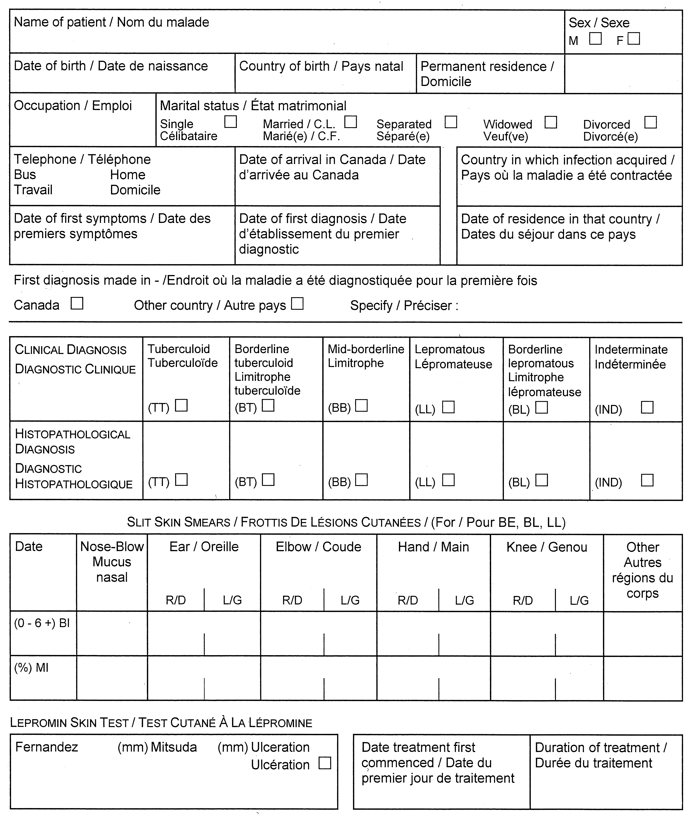
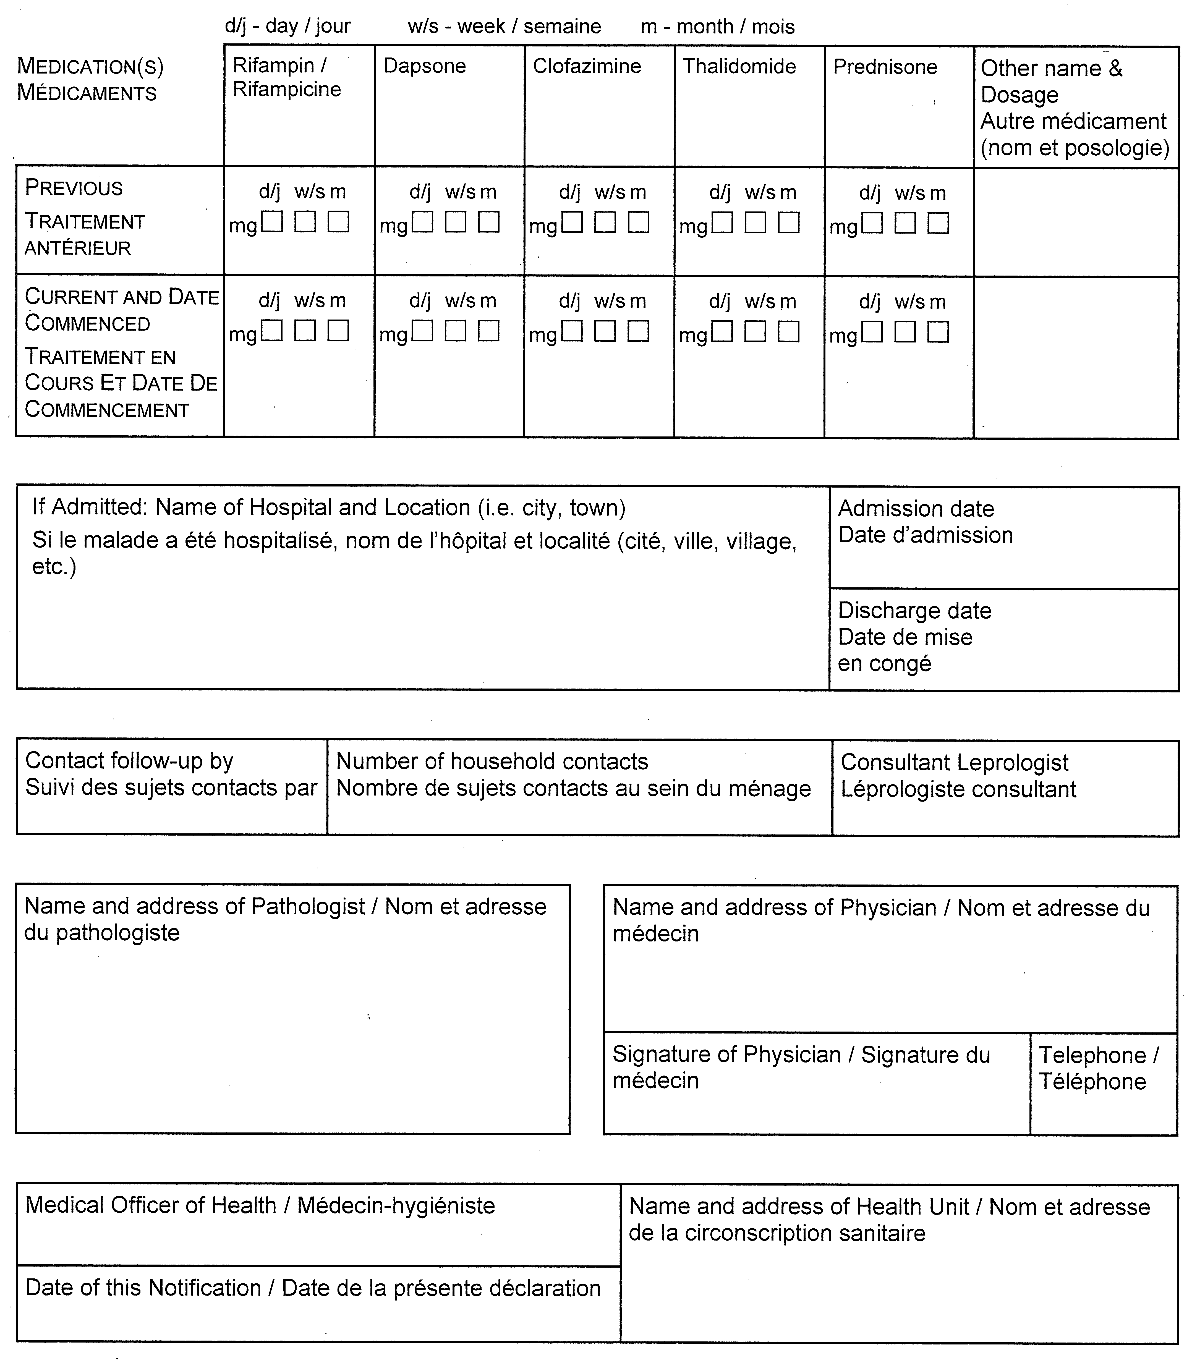
O. Reg. 606/91, s. 2.

