Highway Traffic Act
Code de la route
R.R.O. 1990, REGULATION 599
HIGHWAY CLOSINGS
Consolidation Period: From April 16, 2008 to the e-Laws currency date.
Last amendment: 94/08.
Legislative History: 643/92, 94/08.
This Regulation is made in English only.
1. For the purposes of section 134 of the Act, a police officer may close a highway or any part thereof by either of the following methods:
1. By,
i. posting or causing to be posted a Do Not Enter sign as prescribed in subsection 2 (1) in such a manner that the sign faces approaching traffic and that the bottom edge of the sign is not less than one metre above the roadway, and
ii. placing or causing to be placed not fewer than three traffic control devices of the type prescribed in clause 2 (2) (a) or two traffic control devices of the type prescribed in clauses 2 (2) (b) and (c) in such a manner that the control devices stand in a line at right angles to approaching traffic with not more than one metre separating each pair of control devices.
2. By deploying or causing to be deployed across the roadway a highway ramp gate traffic control device as prescribed in subsection 2 (3) that was installed by the road authority having jurisdiction and control of the highway and locking it in place. O. Reg. 94/08, s. 1
2. (1) A Do Not Enter sign shall,
(a) be square or rectangular in shape and shall be not less than sixty centimetres in width and sixty centimetres in height; and
(b) bear the markings and have the minimum dimensions as prescribed and illustrated in Figure 1. R.R.O. 1990, Reg. 599, s. 2 (1).
(2) A traffic control device may,
(a) be conical in shape, not less than 45 centimetres in height, have a white retro-reflective collar and bear the markings and have the minimum dimensions as prescribed and illustrated in Figure 2;
(b) be rectangular in shape, not less than 90 centimetres in height and not less than 20 centimetres in width and bear the markings and have the minimum dimensions as prescribed and illustrated in Figure 3;
(c) be a barricade, not less than 100 centimetres in width and 100 centimetres in height and bear the markings and have the minimum dimensions as prescribed and illustrated in Figure 4; or
(d) be rectangular in shape, not less than 20 centimetres in height and not less than 90 centimetres in width, with black bars on an orange retro-reflective background and bear the markings and have the minimum dimensions as prescribed and illustrated in Figure 5. O. Reg. 94/08, s. 2 (1).
(3) A highway ramp gate traffic control device shall,
(a) be a barrier that extends across the width of the roadway when deployed such that it blocks vehicular access to the highway;
(b) be capable of being locked in place;
(c) have on it at least one Do Not Enter sign, as prescribed in subsection (1), in such a manner that the sign faces approaching traffic and the bottom edge of the sign is not less than one metre above the roadway; and
(d) have at least two traffic control devices, as prescribed in clause (2) (d), on the same plane on either side of the Do Not Enter sign in such a manner that the long edges of the control devices are horizontal to the roadway and facing approaching traffic. O. Reg. 94/08, s. 2 (2).
Figure 1
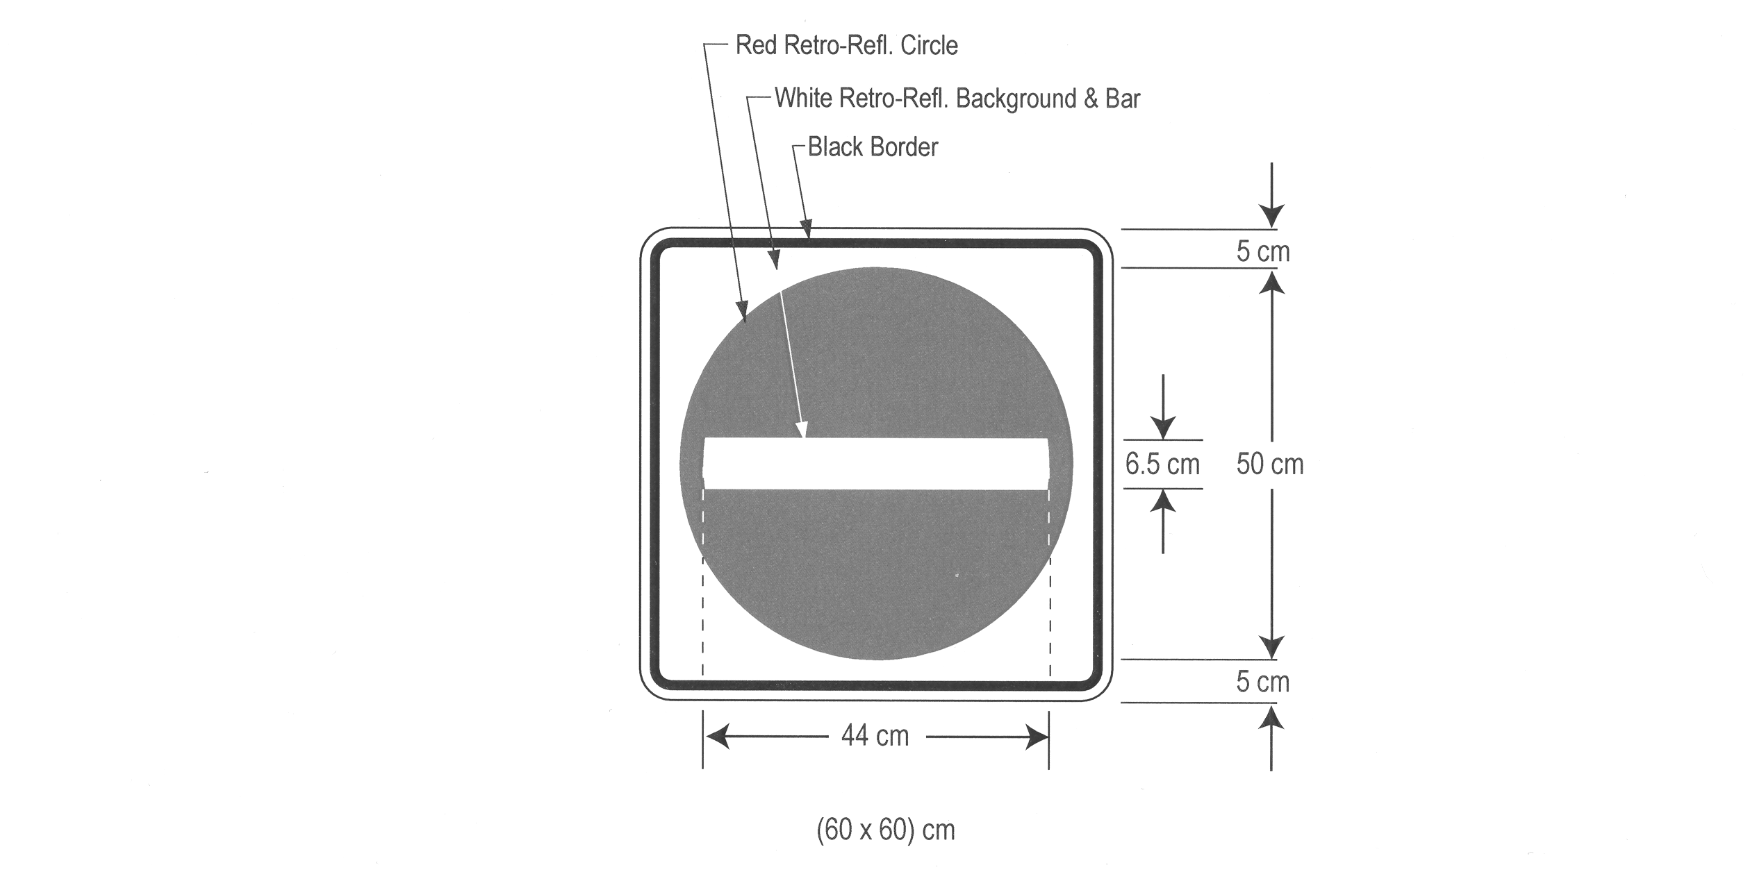
Text alternative: Illustration of sign with DO NOT ENTER symbol consisting of a red circle with a white horizontal bar across the middle. The measurements are written below the sign: (60 x 60 cm). This text alternative is provided for convenience only and does not form part of the official law.
O. Reg. 94/08, s. 2 (3).
Figure 2

Text alternative: Illustration of a conical traffic control device measuring 45 cm high and having an orange or black base, an orange body and a white reflective band near the top. This text alternative is provided for convenience only and does not form part of the official law.
O. Reg. 94/08, s. 2 (3).
Figure 3
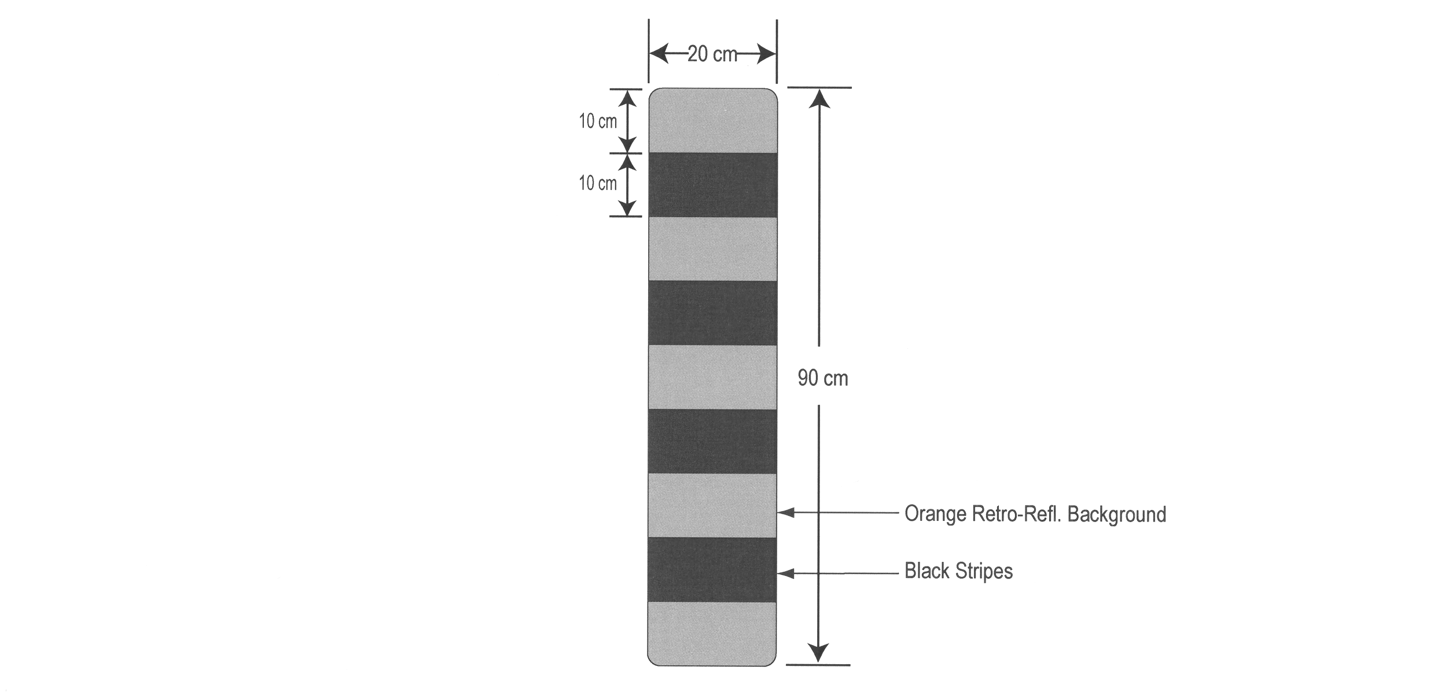
Text alternative: Illustration of a vertical rectangular traffic control device consisting of alternating markings of four black and five orange horizontal stripes. The sign measures 90 cm in height by 20 cm in width and is surrounded by dimensions of its different elements. This text alternative is provided for convenience only and does not form part of the official law.
O. Reg. 94/08, s. 2 (3).
Figure 4
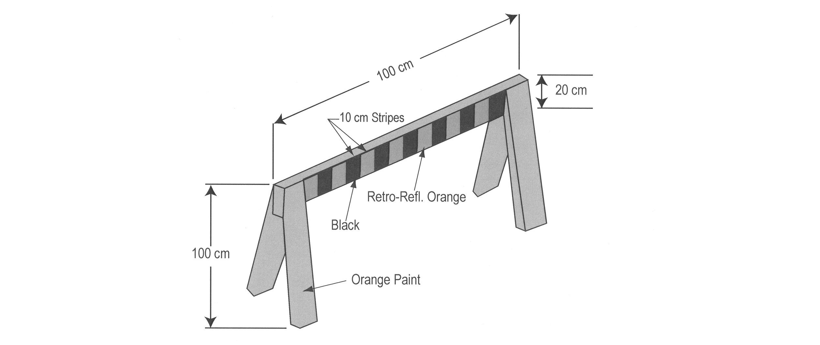
Text alternative: Illustration of an orange traffic control barricade consisting of a horizontal rectangular bar supported by 2 legs at each end. The orange cross bar has 7 black 10 cm stripes spaced every 10 cm. The top edge of this saw horse type device is 100 cm above the roadway and measures 100 cm in length. This text alternative is provided for convenience only and does not form part of the official law.
O. Reg. 94/08, s. 2 (3).
Figure 5

Text alternative: Illustration of a horizontal rectangular traffic control device consisting of alternating markings of four black and five orange vertical stripes. The sign measures 90 cm in width by 20 cm in height and is surrounded by dimensions of its different elements. This text alternative is provided for convenience only and does not form part of the official law.
O. Reg. 94/08, s. 2 (3).

Back to top

