Highway Traffic Act
R.R.O. 1990, REGULATION 606
PORTABLE LANE CONTROL SIGNAL SYSTEMS
Historical version for the period March 11, 2022 to March 31, 2022.
Note: This Regulation is revoked on April 1, 2022, the day subsection 12 (1) of Schedule 1 to the Moving Ontarians More Safely Act, 2021 comes into force. (See: O. Reg. 185/22, s. 14)
Last amendment: 185/22.
Legislative History: 443/93, 442/06, 90/15, 185/22.
This is the English version of a bilingual regulation.
1. Every portable lane control signal system shall consist of at least one set of green, amber and red signal-lights for each direction from which traffic to be controlled by the system approaches. R.R.O. 1990, Reg. 606, s. 1.
2. (1) Each set of signal-lights in a portable lane control signal system shall be arranged vertically in the following order, commencing at the bottom: green, amber and red. R.R.O. 1990, Reg. 606, s. 2 (1).
(2) A portable lane control signal system shall not be operated in such a manner as to show the green and amber signal-lights illuminated simultaneously. R.R.O. 1990, Reg. 606, s. 2 (2).
(3) Each lamp and each lens in a signal-light shall be maintained in such a manner that the signal-light, when illuminated, is clearly visible to approaching traffic at a distance of at least 100 metres. R.R.O. 1990, Reg. 606, s. 2 (3).
(4) Each signal-light lens shall be at least twenty centimetres in diameter and the signal head containing the set of signal-lights shall be mounted on a yellow backboard not less than 100 centimetres in height and not less than fifty centimetres in width, as illustrated in the following figure:
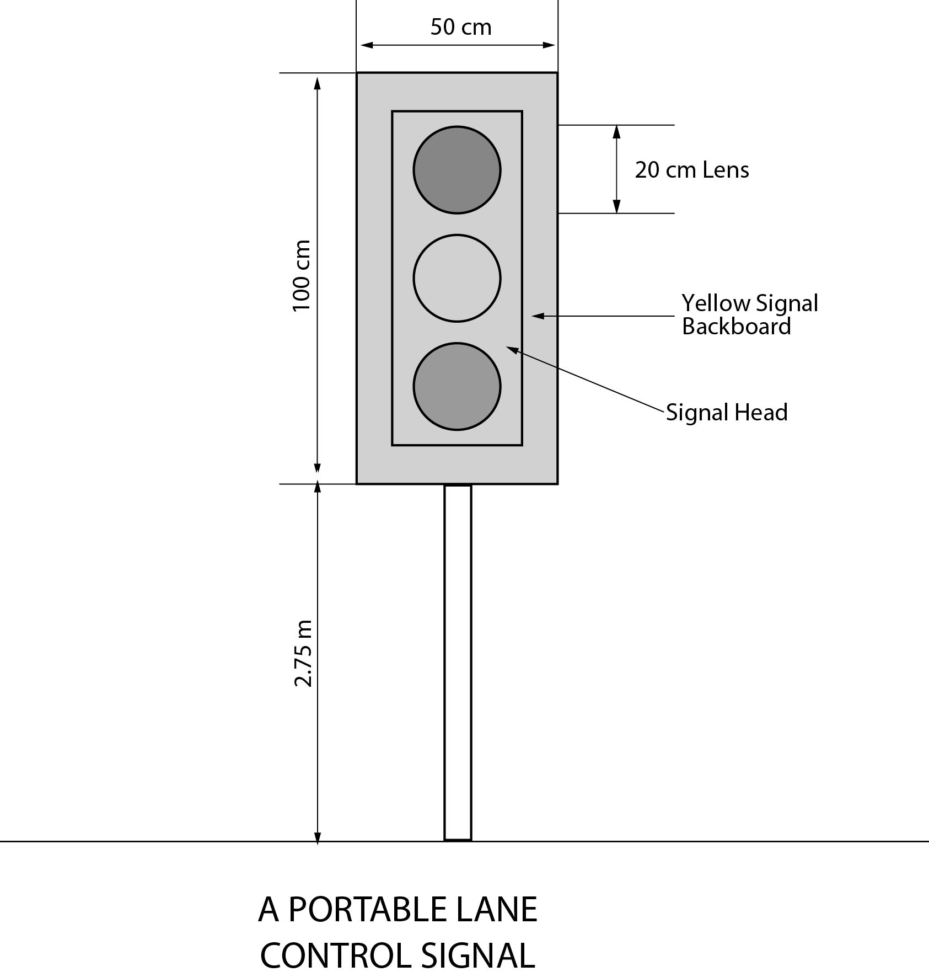
Text alternative: Illustration of portable lane control signal as described in subsection 2 (4). Bottom of signal backboard is 2.75 m above ground. The yellow backboard for the traffic signal head is rectangular in shape measuring 100 cm high and 50 cm wide. Each of the three circular lenses is 20 cm in diameter. This text alternative is provided for convenience only and does not form part of the official law.
R.R.O. 1990, Reg. 606, s. 2 (4); O. Reg. 90/15, s. 1.
3. (1) Each set of signal-lights in a portable lane control signal system shall be placed to the right of, facing and clearly visible to approaching traffic. R.R.O. 1990, Reg. 606, s. 3 (1).
(2) The bottom edge of the backboard of each set of signal-lights shall be not less than 2.75 metres above the level of the roadway. R.R.O. 1990, Reg. 606, s. 3 (2).
(3) A portable lane control signal system shall not be located at an intersection or pedestrian crossover. R.R.O. 1990, Reg. 606, s. 3 (3).
(4) A portable lane control signal system shall not be located in any place or manner so as to conflict with any signal-light traffic control system. R.R.O. 1990, Reg. 606, s. 3 (4).
4. (1) Three signs described in subsection (2) and having retro-reflective backgrounds shall be erected for each direction from which traffic to be controlled by the portable lane control signal system approaches. R.R.O. 1990, Reg. 606, s. 4 (1).
(2) The signs shall be erected in front of a set of signal-lights to the right of, facing and clearly visible to approaching traffic and shall be arranged in the following sequence, commencing farthest from the portable lane control signal system:
1. A do not pass sign, as prescribed in Regulation 615 of the Revised Regulations of Ontario, 1990.
2. A warning sign with an orange background indicating that a set of signal-lights is ahead.
3. A sign indicating the location at which a driver approaching a set of signal-lights is to bring his or her vehicle to a stop,
as illustrated in the following diagram:
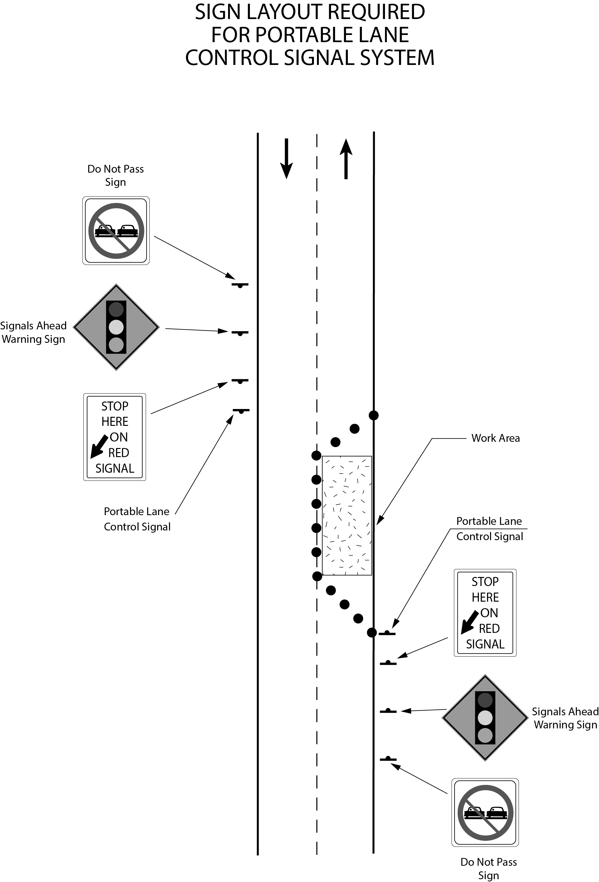
Text alternative: Diagram of the placement of a portable lane control signal system placed on the right side facing each direction of traffic on a highway along with three signs erected prior to the portable lane control signal and facing traffic. The outermost sign is a “DO NOT PASS” sign, followed by a “SIGNALS AHEAD” warning sign and finally a “STOP HERE ON RED SIGNAL” sign that has a thick, black arrow pointed diagonally and downward. The last sign is placed the closest to the portable lane control signal system in front of the coned off work area which is blocking half of the roadway in the diagram. This text alternative is provided for convenience only and does not form part of the official law.
R.R.O. 1990, Reg. 606, s. 4 (2); O. Reg. 90/15, s. 2 (1).
(3) In an area designated under the French Language Services Act, the signs described in subsection (2) shall be erected as illustrated in the following diagram:
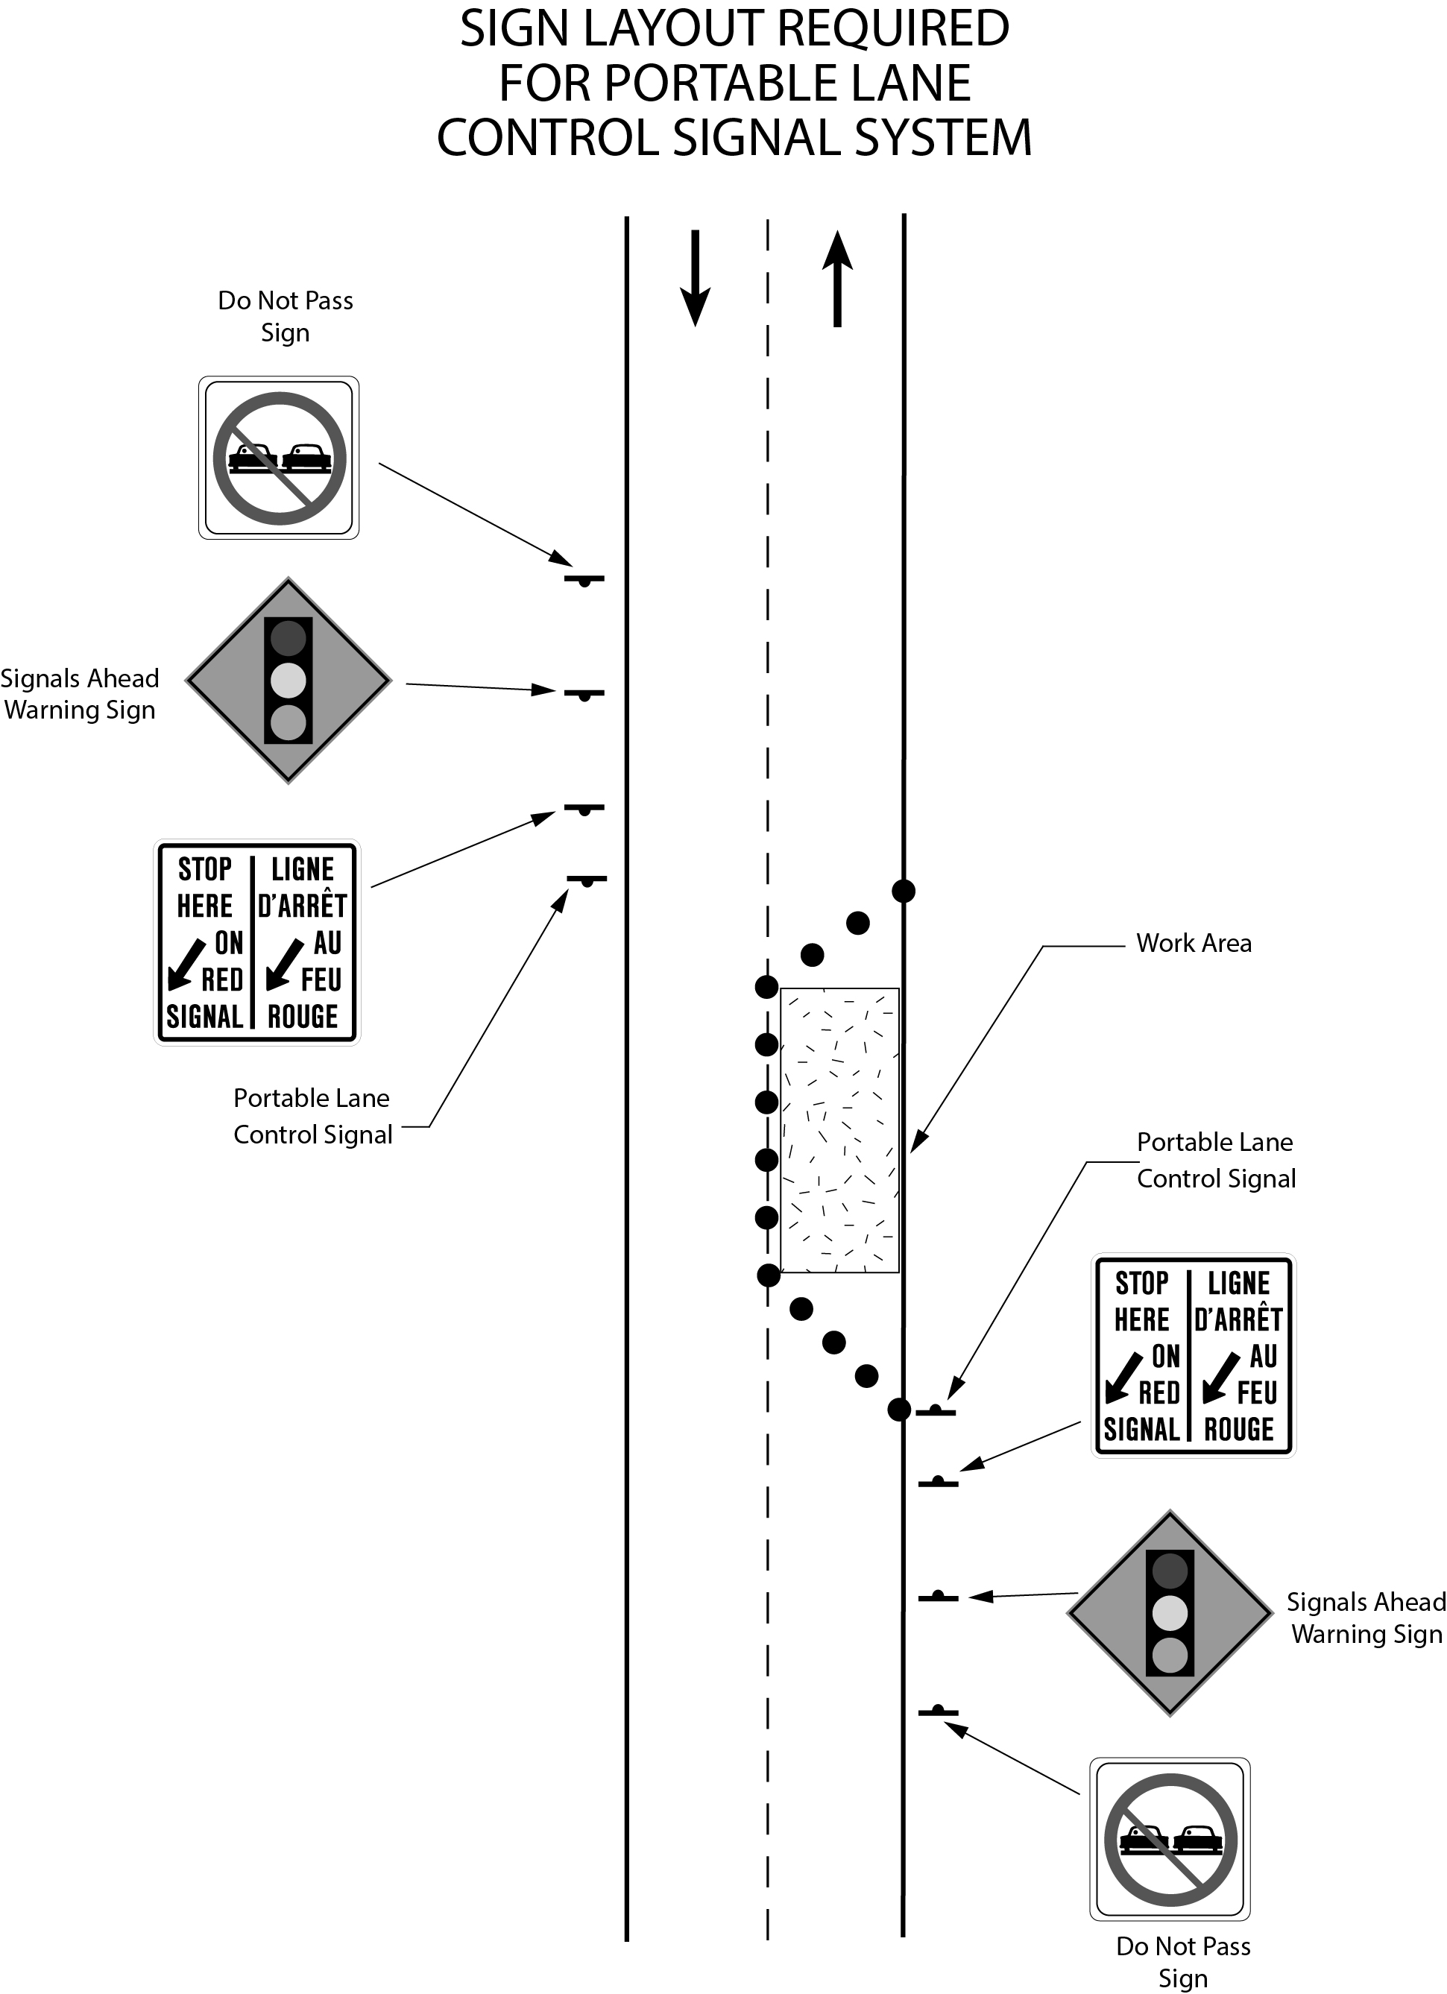
Text alternative: Diagram of the placement of a portable lane control signal system placed on the right side facing each direction of traffic on a highway along with three signs erected prior to the portable lane control signal and facing traffic. The outermost sign is a “DO NOT PASS” sign, followed by a “SIGNALS AHEAD” warning sign and finally a “STOP HERE ON RED SIGNAL / LIGNE D’ARRÊT AU FEU ROUGE” sign that has a thick, black arrow pointed diagonally and downward. The last sign is placed the closest to the portable lane control signal system in front of the coned off work area which is blocking half of the roadway in the diagram. This text alternative is provided for convenience only and does not form part of the official law.
O. Reg. 443/93, s. 1; O. Reg. 90/15, s. 2 (2).
(4) A municipality that is situated in a designated area but that has not passed a by-law under subsection 14 (1) of the French Language Services Act is not required to erect the signs illustrated in subsection (3). O. Reg. 443/93, s. 1.

