Français
Highway Traffic Act
R.R.O. 1990, REGULATION 616
SLOW MOVING VEHICLE SIGN
Consolidation Period: From April 27, 2015 to the e-Laws currency date.
Last amendment: 94/15.
Legislative History: 423/96, 407/09, 94/15.
This is the English version of a bilingual regulation.
1. (1) The slow moving vehicle sign to be attached to a slow moving vehicle as defined in subsection 76 (2) of the Act shall be in the shape of a base-down equilateral triangle, fluorescent yellow-orange in colour with a dark red retro-reflective border, and shall be of the dimensions and size as prescribed and illustrated in the following Figure:
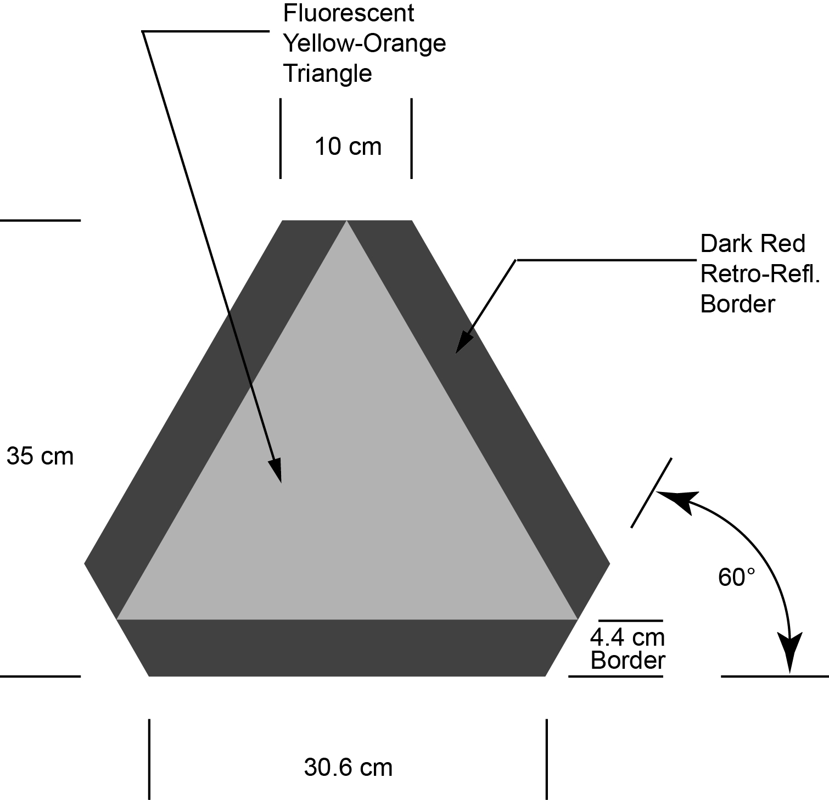
R.R.O. 1990, Reg. 616, s. 1 (1); O. Reg. 423/96, s. 1; O. Reg. 94/15, s 1.
(2) The sign referred to in subsection (1) shall be bonded to a durable rigid weatherproof-base surface. R.R.O. 1990, Reg. 616, s. 1 (2).
(3) The brightness of the retro-reflective material referred to in subsection (1) shall comply with the requirements of the Schedule. R.R.O. 1990, Reg. 616, s. 1 (3).
2. (1) The sign referred to in section 1 shall be mounted,
(a) base down in a plane perpendicular to the direction of travel of the vehicle;
(b) where practicable, on the rear of the vehicle or combination of vehicles at the centre of mass; and
(c) not less than one-half metre or more than 2 metres above the roadway. O. Reg. 423/96, s. 2.
(2) The sign shall be clearly visible for a distance of not less than 150 metres from the rear of the vehicle or combination of vehicles. O. Reg. 423/96, s. 2.
3. The sign referred to in section 1 shall be free from dirt and obstruction and shall be so affixed as to be plainly visible at all times and the view of the sign shall not be obscured or obstructed by any part of the vehicle or any attachment thereto or by the load carried. R.R.O. 1990, Reg. 616, s. 3.
4. The dimensions of a slow moving vehicle sign may be greater than the dimensions prescribed and illustrated in section 1 so long as each dimension is increased and, when increased, has the same relation to the other dimensions of the sign as the dimensions prescribed and illustrated have to each other. R.R.O. 1990, Reg. 616, s. 4.
5. A slow moving vehicle sign shall be deemed to meet the requirements of this Regulation if the sign is marked with the monogram of the Canadian Standards Association Testing Laboratories. R.R.O. 1990, Reg. 616, s. 5.
6. (1) Subsection 76 (1) of the Act and sections 1 to 5 of this Regulation do not apply to a horse-drawn vehicle when driven by a person whose religious convictions or beliefs prohibit the display of the slow moving vehicle sign. O. Reg. 423/96, s. 3.
(2) A person described in subsection (1) shall not drive a horse-drawn vehicle on a highway unless a marker is displayed on the vehicle in accordance with this section. O. Reg. 423/96, s. 3.
(3) The marker shall be visible from a distance of at least 150 metres when illuminated by a lighted lamp on a vehicle that is approaching or overtaking the horse-drawn vehicle during,
(a) the period beginning one-half hour before sunset and ending one-half hour after sunrise; and
(b) any other period during which, due to insufficient light or unfavourable atmospheric conditions, persons and vehicles on the highway are not clearly discernible at a distance of 150 metres or less. O. Reg. 423/96, s. 3.
(4) The marker shall consist of five strips of grey, silver or white reflective material, each at least 2.5 centimetres wide. O. Reg. 423/96, s. 3.
(5) Four of the strips shall be affixed to the outside perimeter of the rear of the vehicle in accordance with the following rules:
1. One strip shall be affixed to the top of the rear of the vehicle, be placed horizontally and be at least 56 centimetres long.
2. One strip shall be affixed to each of the two sides of the rear of the vehicle, be placed vertically and be at least 42 centimetres long.
3. One strip shall be affixed to the bottom of the rear of the vehicle, be placed horizontally and be at least 28 centimetres long. O. Reg. 423/96, s. 3.
(6) The fifth strip shall be affixed as high as possible on the left side of the front of the vehicle, be placed vertically and be at least 14 centimetres long. O. Reg. 423/96, s. 3.
(7) The marker shall be free from dirt and obstruction and shall be affixed so as to be plainly visible at all times and the view of the marker shall not be obscured or obstructed by any part of the vehicle, by any attachment to the vehicle or by the load carried. O. Reg. 423/96, s. 3.
SCHEDULE
BRIGHTNESS OF REFLECTIVE MATERIAL

Item | Column 1  Angle of incidence (degrees) | Column 2  Minimum brightness if angle of divergence is 0.2 degrees  (average candle power/foot candle/square foot of material) | Column 3  Minimum brightness if angle of divergence is 0.5 degrees  (average candle power/foot candle/square foot of material)
1 | 0 | 10.0 | 5.0
2 | 15 | 7.0 | 4.0
3 | 30 | 5.0 | 2.0
4 | 45 | 1.0 | 0.5
O. Reg. 94/15, s. 2.

Français

Back to top

