Line Fences Act
R.R.O. 1990, REGULATION 715
FORMS
Historical version for the period December 4, 2003 to May 1, 2014.
Last amendment: O. Reg. 406/03.
This is the English version of a bilingual regulation.
1. (1) The request for fence-viewers to be given to the clerk of a municipality by a person desiring to initiate proceedings under subsection 4 (1) of the Act shall be in Form 1.
(2) The notice required to be given by the clerk of a municipality to an owner or an occupant under subsection 4 (2) of the Act shall be in Form 2.
(3) The notice required to be given by the clerk of a municipality to a fence-viewer under subsection 4 (2) of the Act shall be in Form 3. R.R.O. 1990, Reg. 715, s. 1.
2. An award of fence-viewers made under subsection 8 (1) of the Act shall be in Form 4. R.R.O. 1990, Reg. 715, s. 2.
3. (1) The notice of appeal served by an owner under subsection 10 (1) of the Act shall be in Form 5.
(2) The affidavit of service of a notice of appeal required to be filed by an owner under subsection 10 (1) of the Act shall be in Form 6. R.R.O. 1990, Reg. 715, s. 3.
4. (1) The notice required to be given by the clerk of a municipality to an owner or occupant under subsection 11 (8) of the Act shall be in Form 7.
(2) The notice required to be given by the clerk of a municipality to a fence-viewer under subsection 11 (8) of the Act shall be in Form 8. R.R.O. 1990, Reg. 715, s. 4.
5. (1) A certificate of default made by fence-viewers under clause 12 (1) (a) of the Act shall be in Form 9.
(2) A certificate of default made by fence-viewers under clause 12 (1) (b) of the Act shall be in Form 10.
(3) A notice given under subsection 12 (8) of the Act by the treasurer of a municipality to an adjoining owner against whom an award is being enforced shall be in Form 11. R.R.O. 1990, Reg. 715, s. 5.
6. A determination with directions made by fence-viewers under subsection 13 (6) of the Act shall be in Form 12. R.R.O. 1990, Reg. 715, s. 6.
7. A decision made by fence-viewers under subsection 14 (1) of the Act shall be in Form 13. R.R.O. 1990, Reg. 715, s. 7.
8. An agreement in writing registered under section 16 of the Act shall be in Form 14. R.R.O. 1990, Reg. 715, s. 8.
9. An agreement in writing registered under subsection 23 (3) of the Act shall be in Form 15. R.R.O. 1990, Reg. 715, s. 9.
Form 1
REQUEST FOR FENCE-VIEWERS — (Subsection 4 (1) of the act)
Line Fences Act
Insert regs\graphics\1990\715\715001ae.tif
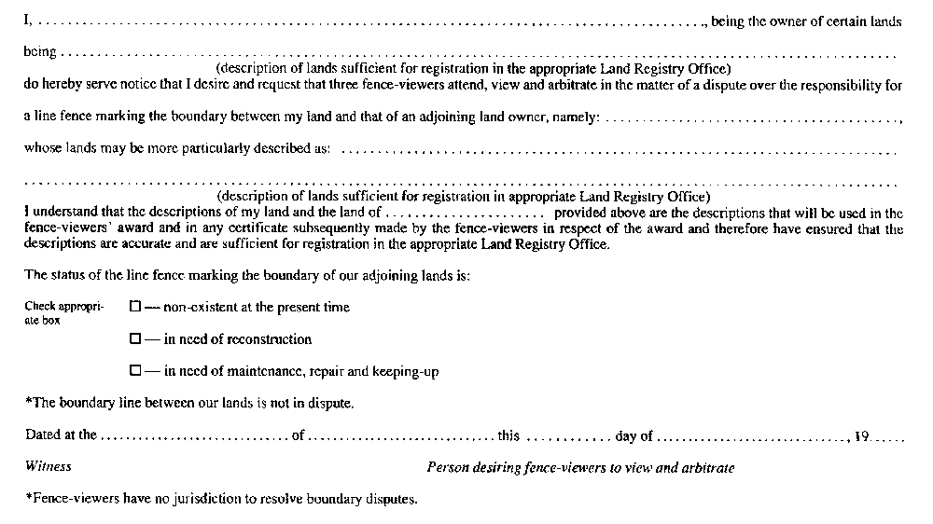
R.R.O. 1990, Reg. 715, Form 1.
Form 2
CLERK’S NOTICE TO PARTIES (DISPUTE) — (Subsection 4 (2) of the act)
Line Fences Act
Insert regs\graphics\1990\715\715002ae.tif
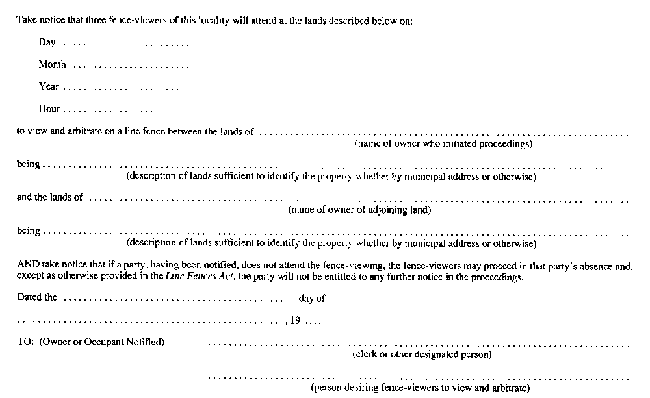
R.R.O. 1990, Reg. 715, Form 2.
Form 3
CLERK’S NOTICE TO FENCE-VIEWERS (DISPUTE) — (Subsection 4 (2) of the act)
Line Fences Act
Insert regs\graphics\1990\715\715003ae.tif
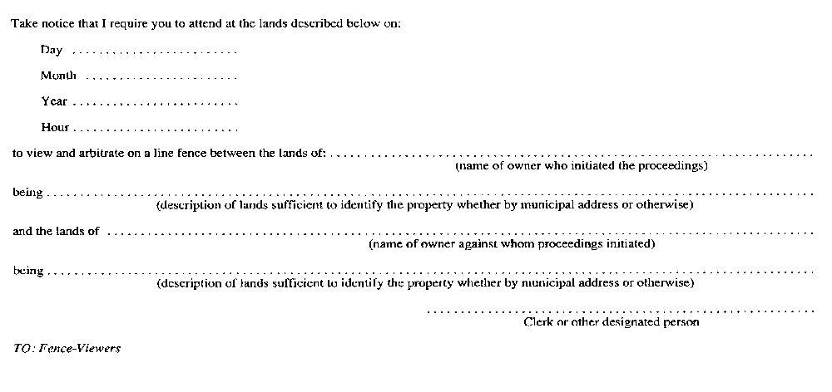
R.R.O. 1990, Reg. 715, Form 3.
Form 4
AWARD — (Subsection 8 (1) of the act)
Line Fences Act
Insert regs\graphics\1990\715\715004ae.tif
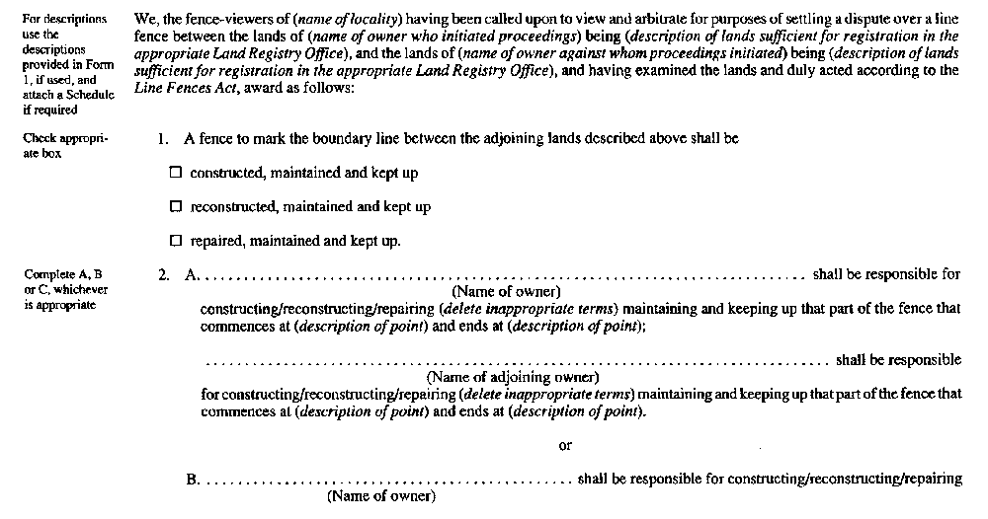
Insert regs\graphics\1990\715\715004be.tif
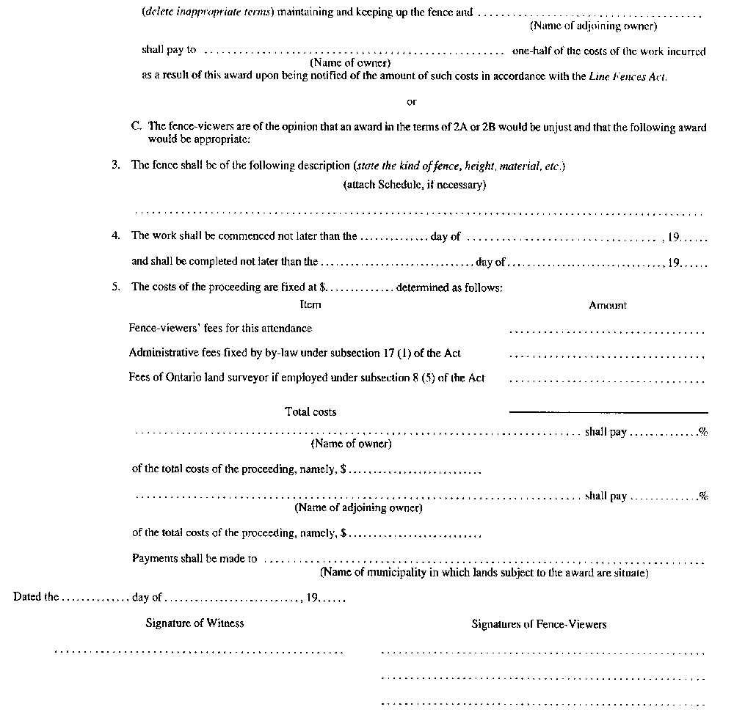
R.R.O. 1990, Reg. 715, Form 4.
Form 5
OWNER’S NOTICE OF APPEAL FROM FENCE-VIEWERS’ AWARD — (Subsection 10 (1) of the act)
Line Fences Act
Insert regs\graphics\1990\715\715005ae.tif
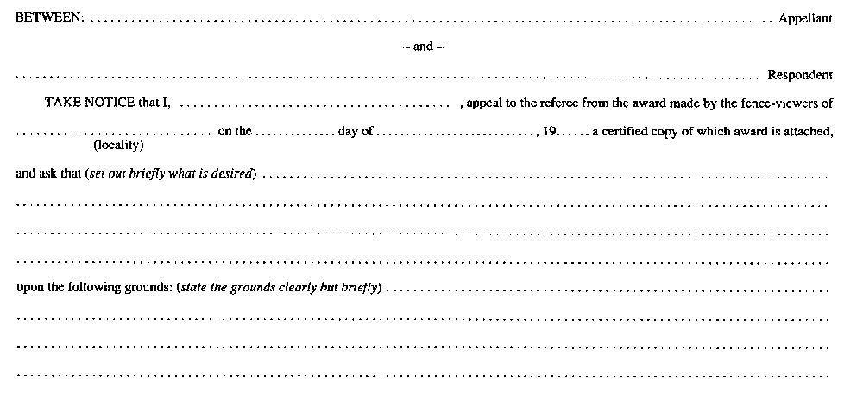
Insert regs\graphics\1990\715\715005be.tif
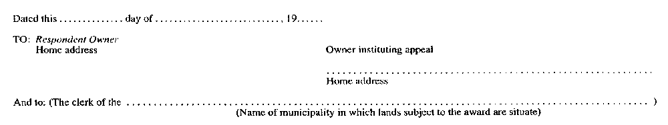
R.R.O. 1990, Reg. 715, Form 5.
Form 6
AFFIDAVIT OF SERVICE OF NOTICE OF APPEAL — (Subsection 10 (1) of the act)
Line Fences Act
Insert regs\graphics\1990\715\715006ae.tif
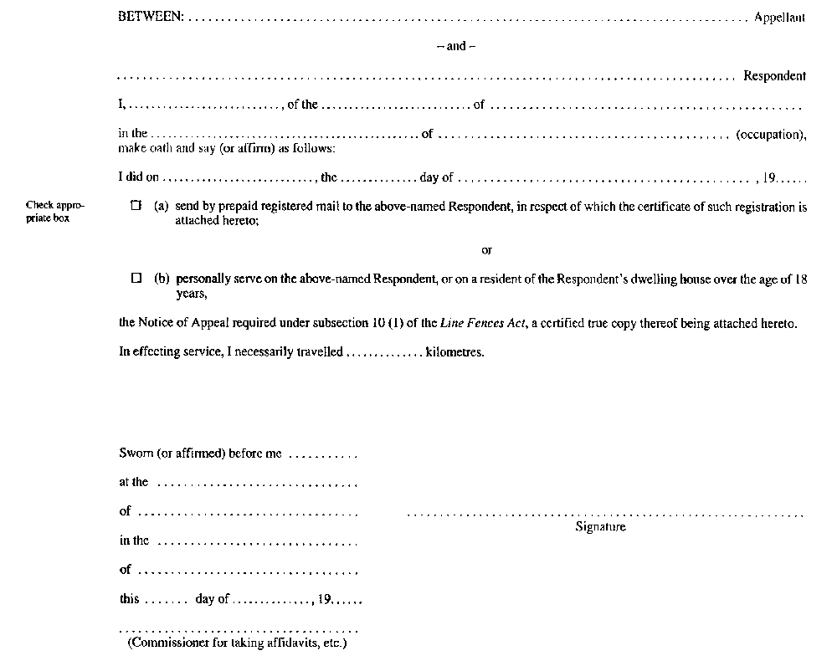
R.R.O. 1990, Reg. 715, Form 6.
Form 7
CLERK’S NOTICE TO PARTIES (CERTIFICATION) — (Subsection 11 (8) of the act)
Line Fences Act
Insert regs\graphics\1990\715\715007ae.tif
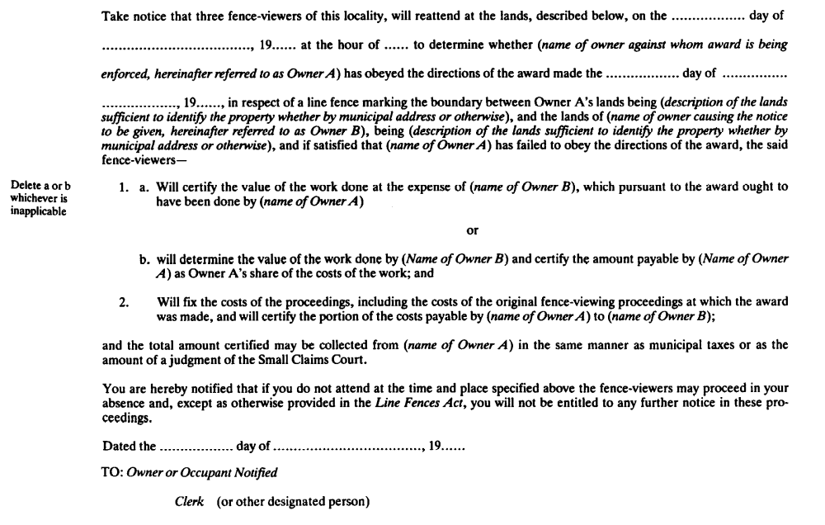
R.R.O. 1990, Reg. 715, Form 7.
Form 8
CLERK’S NOTICE TO FENCE-VIEWERS (CERTIFICATION) — (Subsection 11 (8) of the act)
Line Fences Act
Insert regs\graphics\1990\715\715008ae.tif
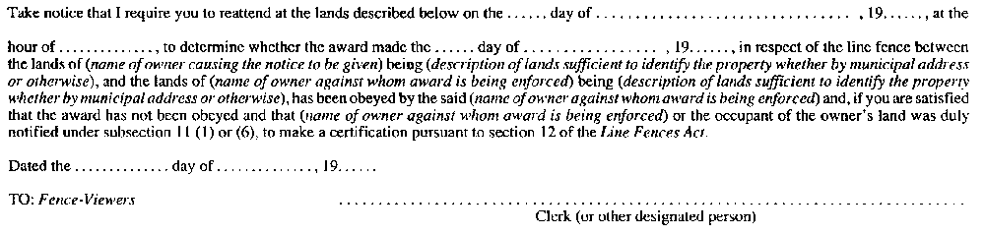
R.R.O. 1990, Reg. 715, Form 8.
Form 9
CERTIFICATE OF DEFAULT (WORK NOT DONE) — (Clause 12 (1) (a) of the act)
Line Fences Act
Insert regs\graphics\1990\715\715009ae.tif
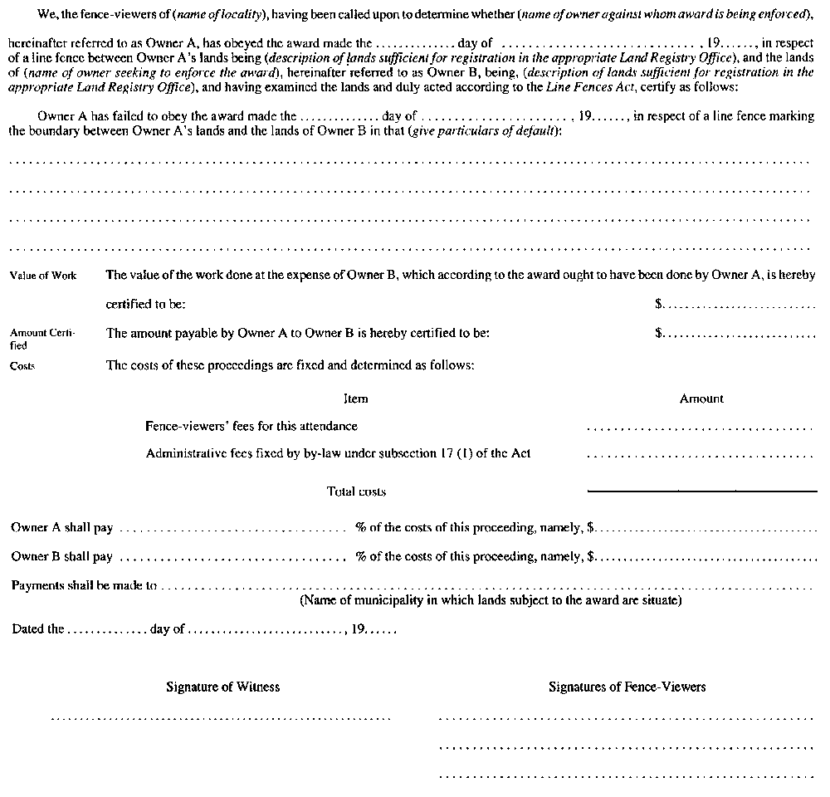
R.R.O. 1990, Reg. 715, Form 9.
Form 10
CERTIFICATE OF DEFAULT (PAYMENT NOT MADE) — (Clause 12 (1) (b) of the act)
Line Fences Act
Insert regs\graphics\1990\715\715010ae.tif
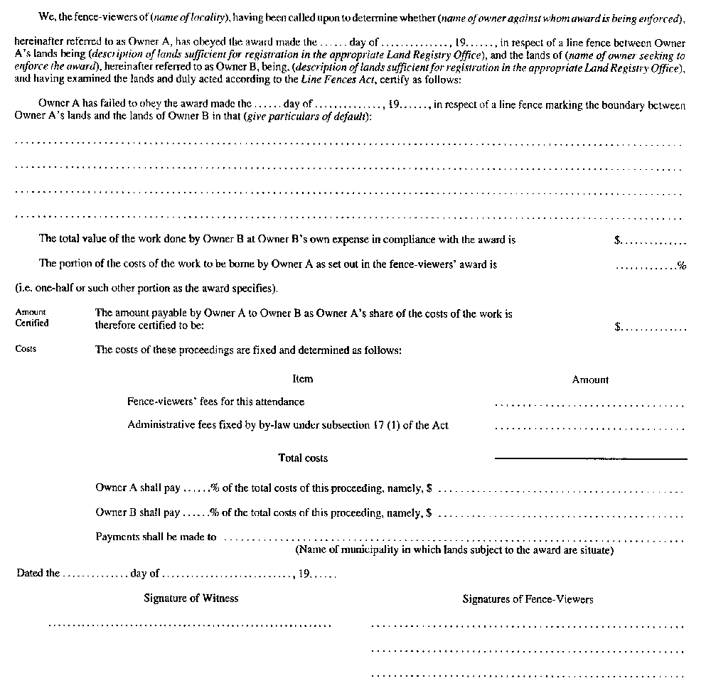
R.R.O. 1990, Reg. 715, Form 10.
Form 11
Treasurer’s Notice of amount owed to municipality by defaulting owner — (Subsection 12 (8) of the act)
Line Fences Act
Insert regs\graphics\1990\715\715011ae.tif
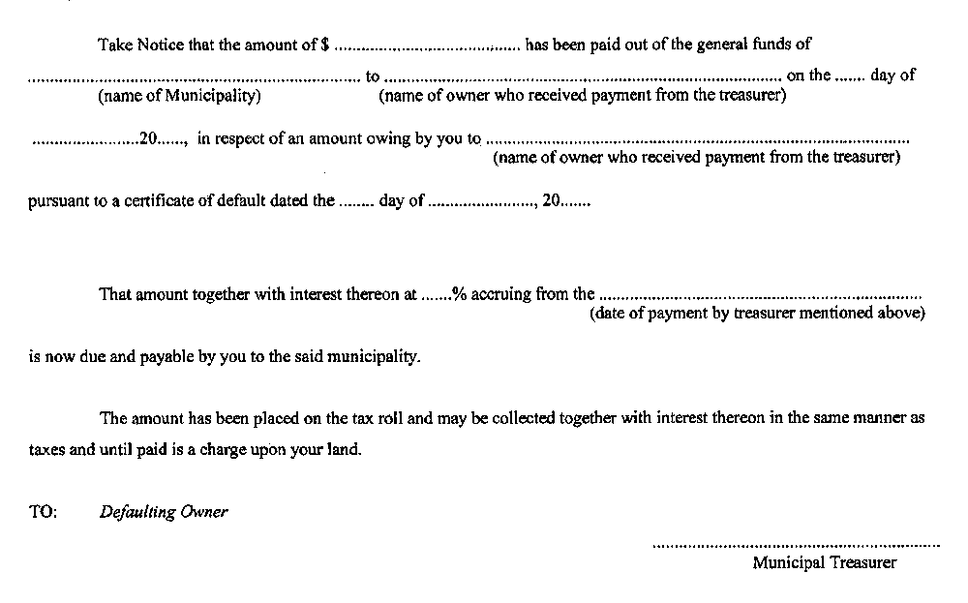
O. Reg. 406/03, s. 1.
Form 12
DETERMINATION WITH DIRECTIONS — (Subsection 13 (6) of the act)
Line Fences Act
Insert regs\graphics\1990\715\715012ae.tif
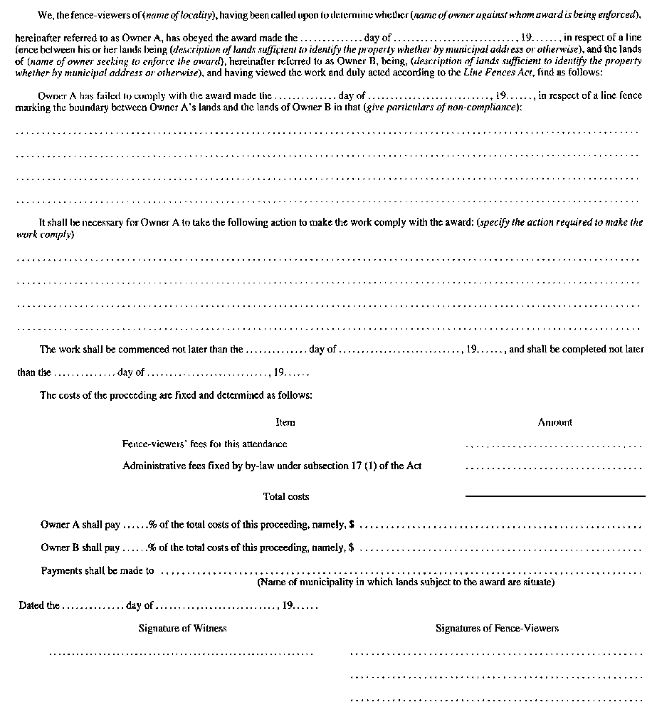
R.R.O. 1990, Reg. 715, Form 12.
Form 13
DECISION OF FENCE-VIEWERS WHERE NO AWARD, CERTIFICATION, ETC., IS MADE — (Subsection 14 (1) of the act)
Line Fences Act
Insert regs\graphics\1990\715\715013ae.tif
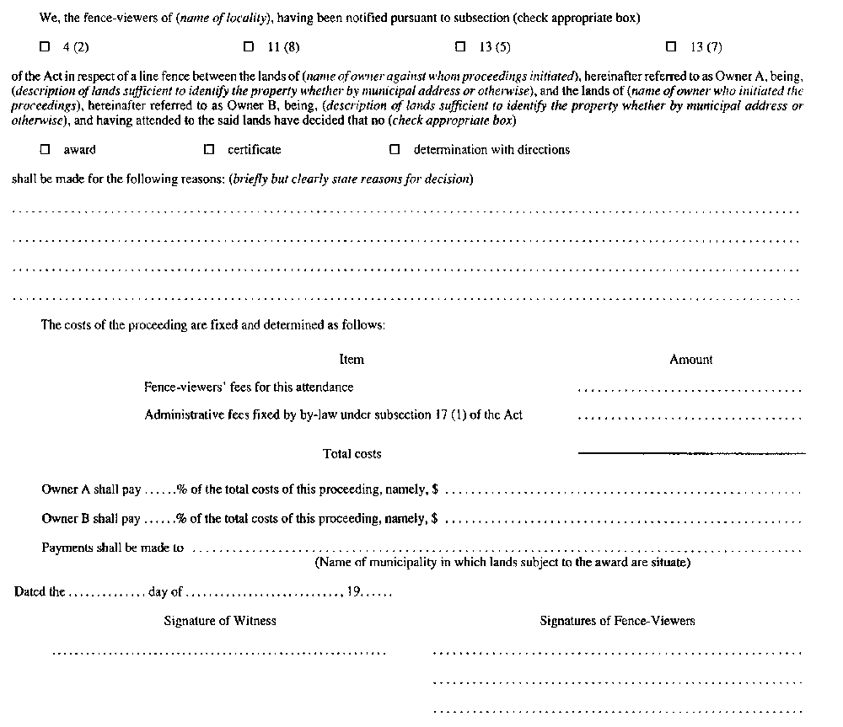
R.R.O. 1990, Reg. 715, Form 13.
Form 14
AGREEMENT — (Section 16 of the act)
Line Fences Act
Insert regs\graphics\1990\715\715014ae.tif
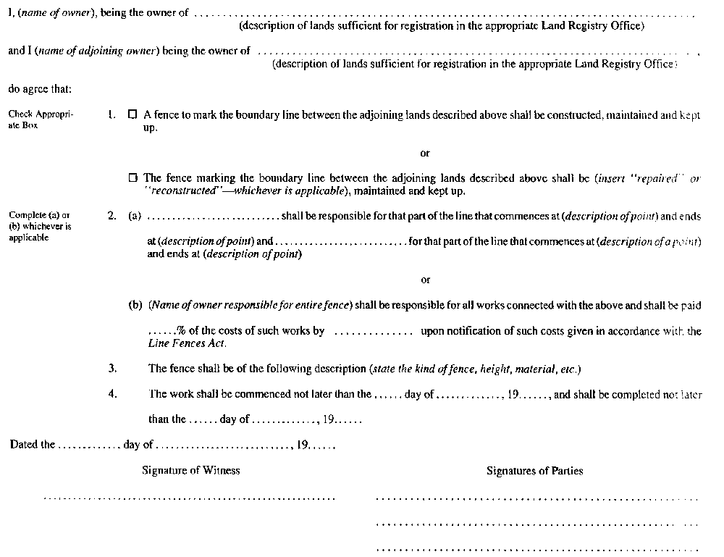
R.R.O. 1990, Reg. 715, Form 14.
Form 15
agreement (where one party is a municipality or local board) — (Subsection 23 (3) of the act)
Line Fences Act
Insert regs\graphics\1990\715\715015ae.tif
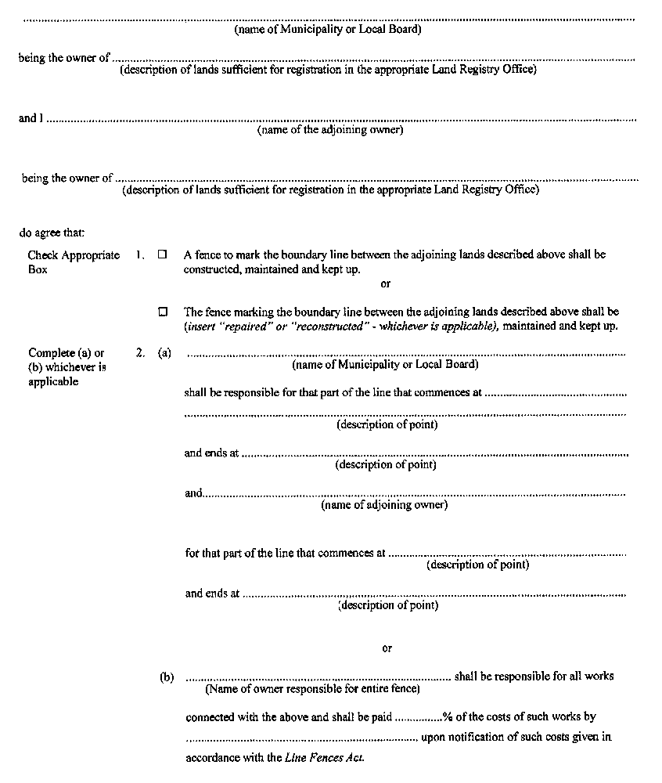
Insert regs\graphics\1990\715\715015be.tif
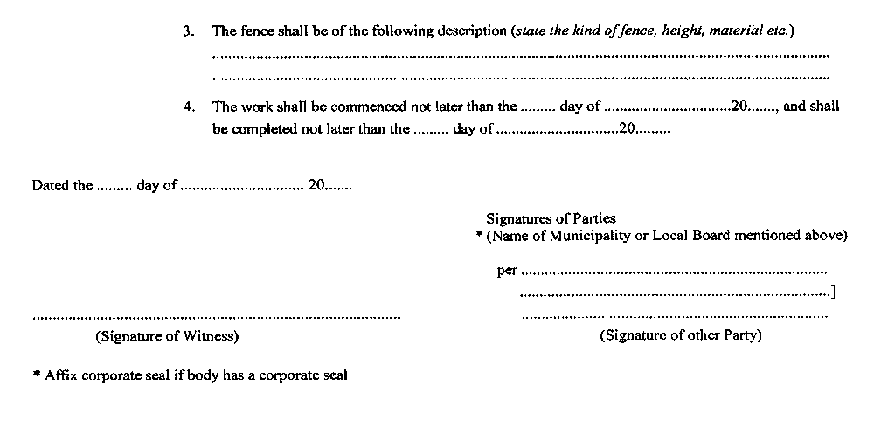
O. Reg. 406/03, s. 1.

