Local Roads Boards Act
Loi sur les régies des routes locales
R.R.O. 1990, REGULATION 736
GENERAL
Consolidation Period: From January 24, 1991 to the e-Laws currency date.
Last amendment: 18/91.
Legislative History: 18/91.
This Regulation is made in English only.
1. (1) The declaration of office of a person elected or appointed to a board shall be in Form 1.
(2) The declaration of office of a person appointed secretary-treasurer of a board shall be in Form 2. R.R.O. 1990, Reg. 736, s. 1.
2. A petition under subsection 7 (7) of the Act shall be in Form 3. R.R.O. 1990, Reg. 736, s. 2.
3. The costs to be paid under subsection 35 (1) of the Act are $20. R.R.O. 1990, Reg. 736, s. 3.
4. A caution filed under subsection 35 (1) of the Act shall be in,
(a) Form 4, where the caution is filed in a land registry office for a land titles division; and
(b) Form 5, where the caution is filed in a land registry office for a registry division. R.R.O. 1990, Reg. 736, s. 4.
5. A withdrawal of a caution filed under subsection 35 (1) of the Act shall be in,
(a) Form 6, where the withdrawal is filed in a land registry office for a land titles division; and
(b) Form 7, where the withdrawal is filed in a land registry office for a registry division. R.R.O. 1990, Reg. 736, s. 5.
6. A notice to an owner sent by registered mail under subsection 35 (1) of the Act shall be in Form 8. R.R.O. 1990, Reg. 736, s. 6.
7. The dimensions of Forms 4, 5, 6, 7 and 8 shall be not less than eight inches by thirteen and one-half inches and not greater than eight and one-half inches by fourteen inches and the forms shall be written, typed or printed on one side of paper of good quality. R.R.O. 1990, Reg. 736, s. 7.
Form 1
TRUSTEE’S DECLARATION OF OFFICE
Local Roads Boards Act
Insert regs\graphics\1990\736\736001ae.tif
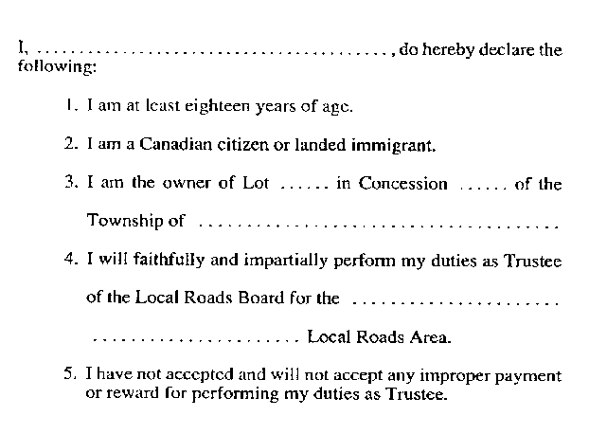
Insert regs\graphics\1990\736\736001be.tif
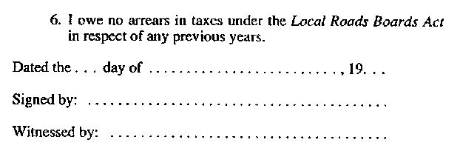
Formule 1
DÉCLARATION D’ENTRÉE EN FONCTION DE L’ADMINISTRATEUR
Loi sur les régies des routes locales
Insert regs\graphics\1990\736\736001af.tif
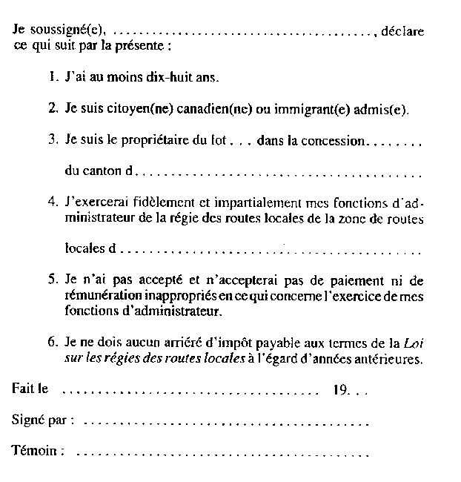
O. Reg. 18/91, s. 1.
Form 2
DECLARATION OF SECRETARY-TREASURER
Local Roads Boards Act
Insert regs\graphics\1990\736\736002ae.tif

Insert regs\graphics\1990\736\736002be.tif
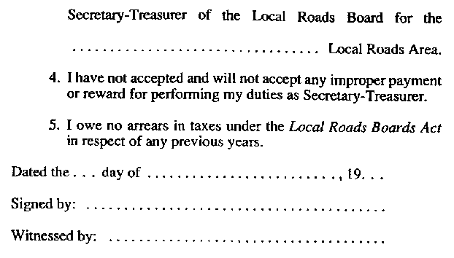
Formule 2
DÉCLARATION DU SECRÉTAIRE-TRÉSORIER
Loi sur les régies des routes locales
Insert regs\graphics\1990\736\736002af.tif
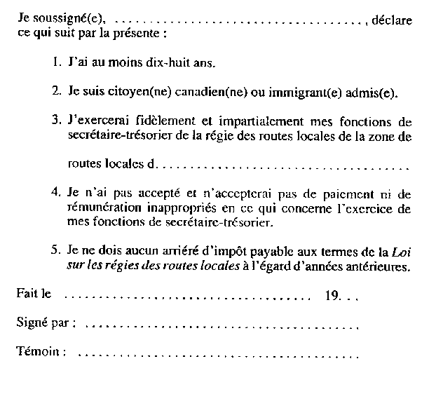
O. Reg. 18/91, s. 1.
Form 3
PETITION
Local Roads Boards Act
Insert regs\graphics\1990\736\736003ae.tif
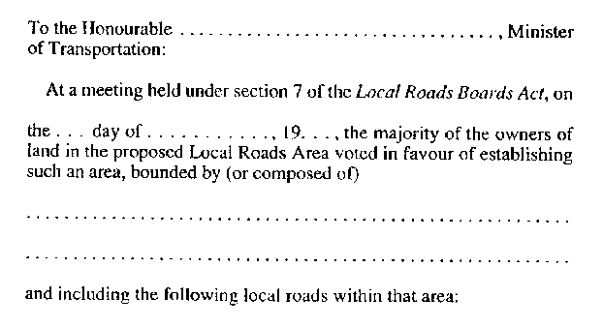
Insert regs\graphics\1990\736\736003be.tif
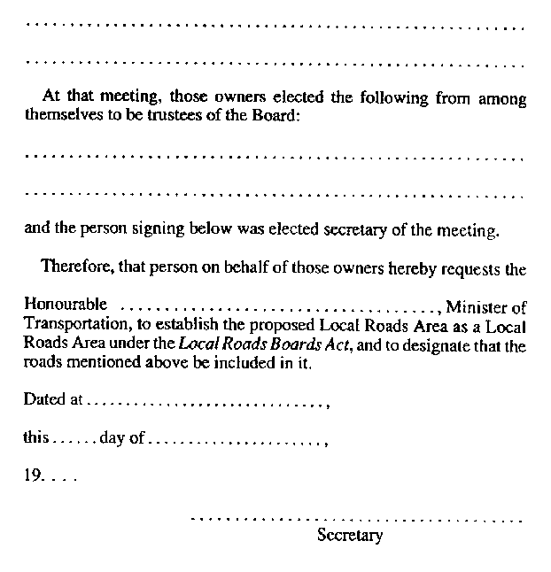
Formule 3
PÉTITION
Loi sur les régies des routes locales
Insert regs\graphics\1990\736\736003af.tif
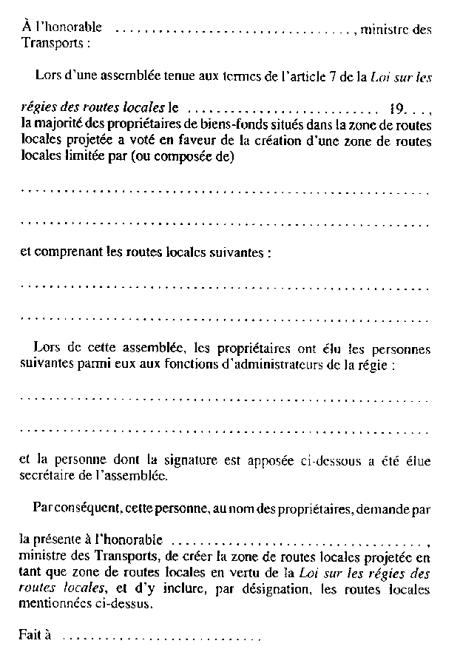
Insert regs\graphics\1990\736\736003bf.tif
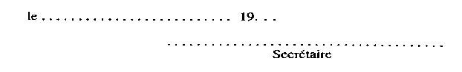
O. Reg. 18/91, s. 1.
Form 4
CAUTION
Local Roads Boards Act
Insert regs\graphics\1990\736\736004ae.tif
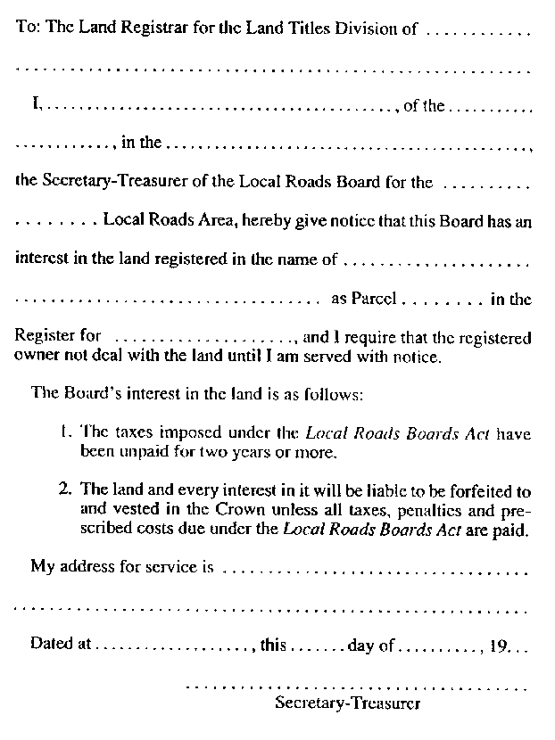
Formule 4
AVERTISSEMENT
Loi sur les régies des routes locales
Insert regs\graphics\1990\736\736004af.tif
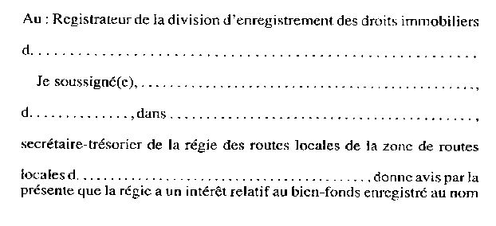
Insert regs\graphics\1990\736\736004bf.tif
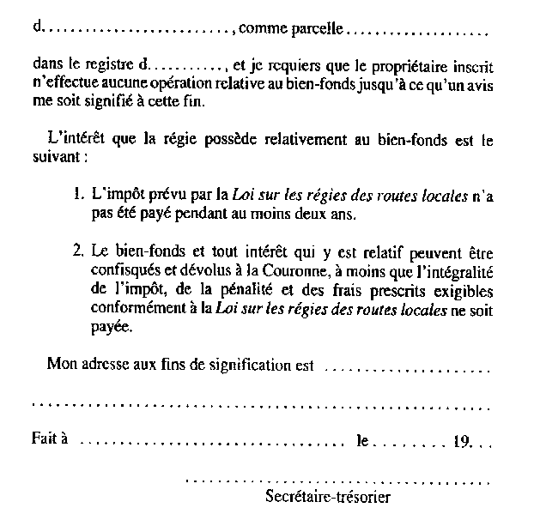
O. Reg. 18/91, s. 1.
Form 5
CAUTION
Local Roads Boards Act
Insert regs\graphics\1990\736\736005ae.tif
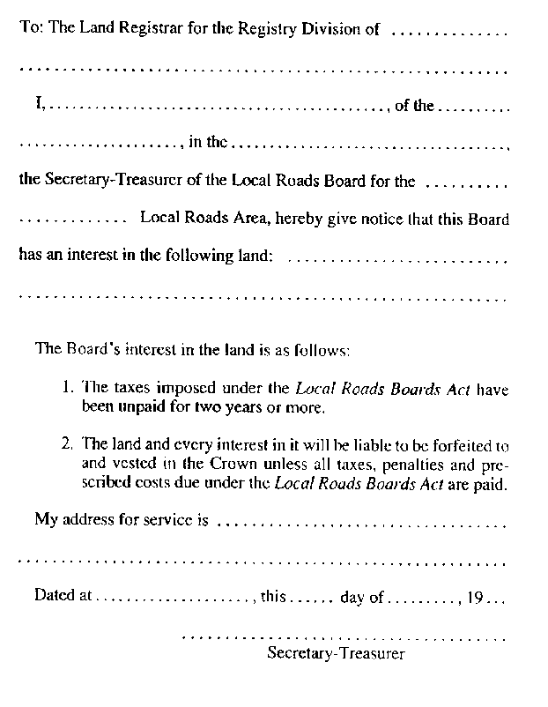
Formule 5
AVERTISSEMENT
Loi sur les régies des routes locales
Insert regs\graphics\1990\736\736005af.tif
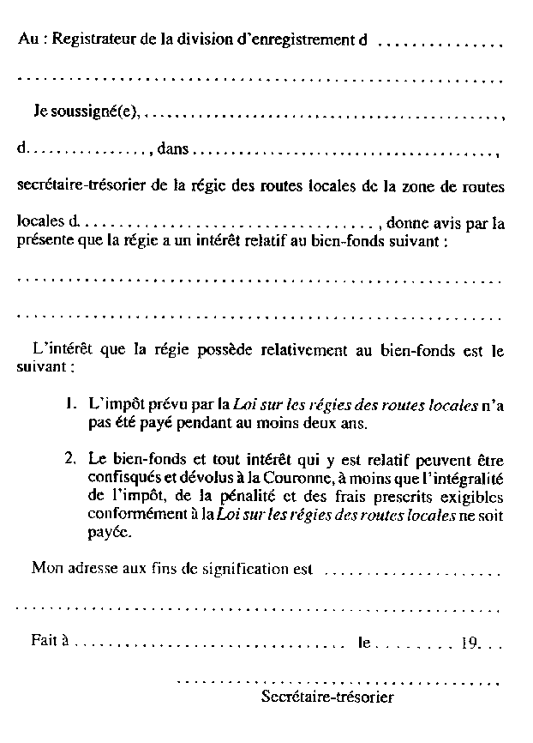
O. Reg. 18/91, s. 1.
Form 6
WITHDRAWAL OF CAUTION
Local Roads Boards Act
Insert regs\graphics\1990\736\736006ae.tif
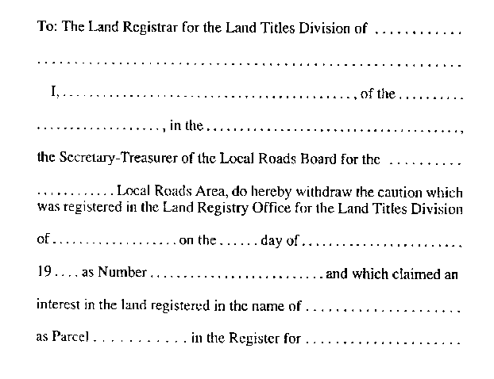
Insert regs\graphics\1990\736\736006be.tif

Formule 6
RETRAIT D’AVERTISSEMENT
Loi sur les régies des routes locales
Insert regs\graphics\1990\736\736006af.tif
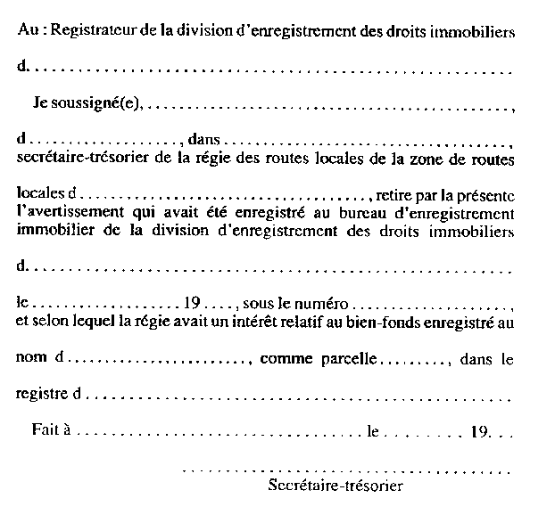
O. Reg. 18/91, s. 1.
Form 7
WITHDRAWAL OF CAUTION
Local Roads Boards Act
Insert regs\graphics\1990\736\736007ae.tif
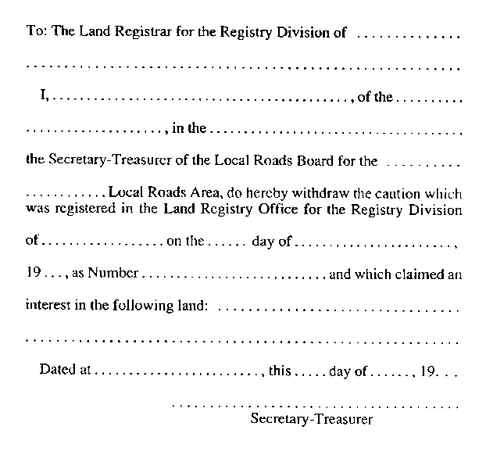
Formule 7
RETRAIT D’AVERTISSEMENT
Loi sur les régies des routes locales
Insert regs\graphics\1990\736\736007af.tif
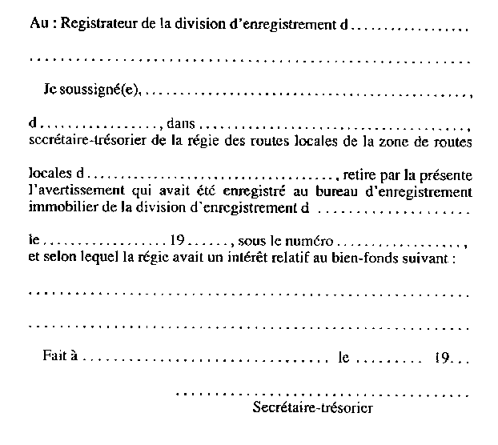
O. Reg. 18/91, s. 1.
Form 8
NOTICE OF TAX ARREARS
Local Roads Boards Act
Insert regs\graphics\1990\736\736008ae.tif
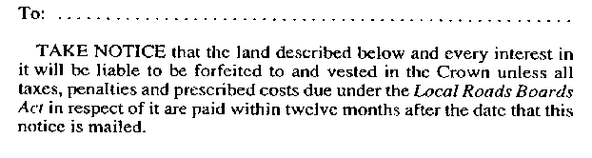
Insert regs\graphics\1990\736\736008be.tif
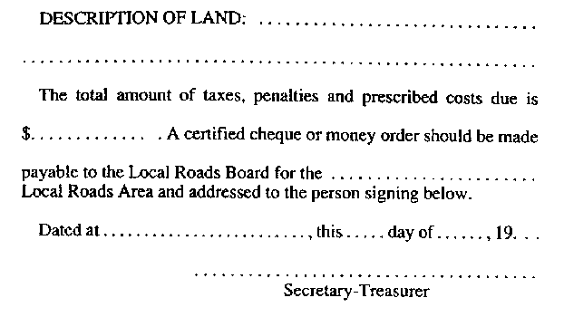
Formule 8
AVIS D’ARRIÉRÉS D’IMPÔT
Loi sur les régies des routes locales
Insert regs\graphics\1990\736\736008af.tif
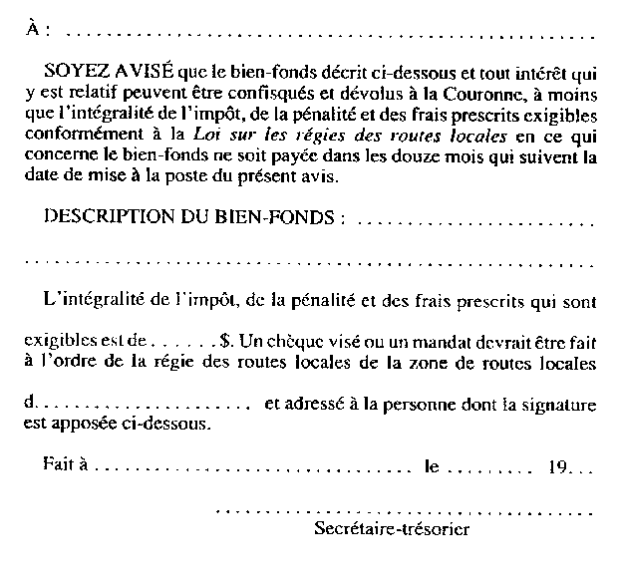
O. Reg. 18/91, s. 1.

Back to top

