Français
Police Services Act
R.R.O. 1990, REGULATION 925
ARBITRATION
Note: This Regulation was revoked on April 1, 2024. (See: O. Reg. 132/24, s. 1)
Last amendment: 132/24.
Legislative History: 38/05, 132/24.
This is the English version of a bilingual regulation.
1. A copy of a decision of an arbitration board for filing in the Ontario Court (General Division), under subsection 124 (7) of the Act shall be in Form 1. R.R.O. 1990, Reg. 925, s. 1.
Form 1
Police Services Act
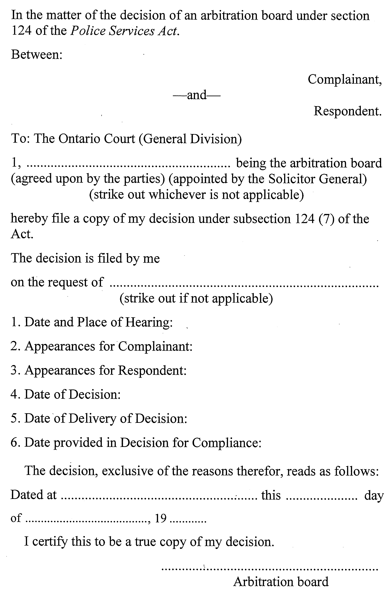
R.R.O. 1990, Reg. 925, Form 1.

Français

Back to top

