Education Act
Loi sur l’éducation
ONTARIO REGULATION 78/97
Amended to O. Reg. 222/04
GENERAL LEGISLATIVE GRANTS, 1997
Note: This Regulation was revoked on August 13, 2004. See: O. Reg. 222/04, s. 1.
This Regulation is made in English only.
Definitions
1. In this Regulation, the following definitions apply for a board for the year 1997,
“assessment” means the sum of,
(a) the residential and farm assessment as defined in section 248 of the Act, and
(b) the quotient obtained by dividing by 0.85 the commercial assessment as defined in section 248 of the Act,
that is rateable for the purposes of the board;
“A.E.F. for grant purposes”, for a municipality or locality, means the assessment equalization factor provided by the Minister for this purpose;
“capital appurtenances” means,
(a) school sites and additions and improvements thereto,
(b) school buildings, including permanent fixtures thereof, and additions, alterations and renovations to such buildings and permanent fixtures,
(c) buildings that are not school buildings, including permanent fixtures thereof, and additions, alterations and renovations to such buildings and permanent fixtures,
(d) vehicles and watercraft used for the transportation of pupils, and replacements of such vehicles and watercraft, and
(e) furniture and equipment and replacements thereof and library resource materials for the initial equipping of a library resource centre, but excluding therefrom items referred to in clause (d) and permanent fixtures of a building;
“capital element included in rent”, in respect of rental of computer equipment for instructional purposes and rental of accommodation and school sites, means the total rental revenue or rental expenditure, as the case may be, that is in excess of the cost of services that are included as part of the rental contract, except that in the case of rental of computer equipment or accommodation for instructional purposes, the capital element in rent cannot be less than the portion designated by the Minister for inclusion in the determination of the recognized expenditure of the board;
“continuing education A.D.E. for grant purposes” means the sum of the portion of the average daily enrolment calculated under section 3 of Ontario Regulation 79/97 (Calculation of Average Daily Enrolment) that is in respect of pupils of the board enrolled in a course approved by the Minister,
(a) established for adults for which one or more credits or credit equivalents may be granted or in an independent study course and, in the case of a separate school board other than a Roman Catholic school board, the course is in the intermediate division,
(b) of citizenship and language instruction for persons admitted to Canada as permanent residents under the Immigration Act (Canada),
(c) of English or French as a second language for adults whose first language is neither English nor French, or
(d) of Native language instruction for adults,
and in the case of,
(e) a course described in clause (a), except for a pupil enrolled in an independent study course, for French-speaking adults in which French is the language of instruction,
(f) a course described in clause (b), (c) or (d), or
(g) a course described in clause (a), except for a pupil enrolled in an independent study course, offered in a secondary school that has an enrolment of fewer than 120 pupils per grade and that is located in a territorial district more than 80 kilometres from all other secondary schools in the Province that have the same language of instruction,
where the number of pupils is fewer than 15, such number shall be increased by five or a lesser number, as the case requires, to a maximum of 15 for the purpose of calculating the continuing education A.D.E. for grant purposes;
“current cost of operating” means the current expenditure of the board less the sum of,
(a) current expenditure for,
(i) the capital element included in rent payable,
(ii) transportation of pupils and persons qualified to be resident pupils to and from a school, a facility referred to in subsection 190 (3) of the Act or a centre referred to in subsection 190 (4) thereof,
(iii) transportation of pupils from one school to another school or a facility referred to in subsection 190 (3) of the Act,
(iv) board, lodging and weekly transportation of pupils under sections 190, 289 and 291 of the Act,
(v) capital appurtenances,
(vi) debt charges, other than debt charges in respect of the interest payments on debentures issued for operating purposes under Part III of the Municipal Affairs Act,
(vii) tuition fees in respect of resident-external pupils of the board,
(viii) P.A.C. in respect of resident-external pupils of the board,
(ix) relocation of portable classrooms,
(x) restoration of destroyed and damaged capital appurtenances, and
(xi) interest on short-term borrowings for the purchase of capital appurtenances,
(b) the sum of,
(i) tax adjustments,
(ii) the costs of performing the duties of a municipal council in territory without municipal organization,
(iii) provision for a reserve for working funds,
(iv) provision for a reserve under section 237 or 238 of the Education Act as it read on December 31, 1997,
(v) the total payments made by the board to parents and guardians under the Fairness for Parents and Employees Act (Teachers’ Withdrawal of Services), 1997,
(vi) the product of the administration fee of $3.00 and the number of claims under the Fairness for Parents and Employees Act (Teachers’ Withdrawal of Services), 1997 for which payment has been sent to the parent or guardian on or before March 6, 1998 or for which payment has been received by the parent or guardian on or before March 6, 1998, and
(vii) allocation to reserve funds,
(c) current revenue from sources other than,
(i) legislative grants except payments under subsections 17 (2) and 18 (2), section 26, subsections 27 (1) and (4) and sections 40 and 41,
(ii) taxes, payments in lieu of taxes and trailer fees,
(iii) tuition fees in respect of non-resident pupils of the board,
(iv) the P.A.C. in respect of non-resident pupils of the board,
(v) the capital element included in rent receivable,
(vi) disposal of capital appurtenances,
(vii) insurance proceeds in respect of capital appurtenances,
(viii) transfers from other funds,
(ix) transfers from a reserve for working funds,
(x) transfer from a reserve for tax reduction,
(xi) accrued interest on debentures sold at date of sale thereof,
(xii) interest earned on capital funds,
(xiii) reimbursements of expenditure for transportation of pupils including payments under section 35,
(xiv) grants, except legislative grants, or other reimbursements for capital expenditure from the revenue fund,
(xv) donations directed in writing by the donor to the purchase of a capital appurtenance and so applied,
(xvi) fees in respect of continuing education and summer school courses and classes, and
(xvii) transfers from a reserve under section 237 or 238 of the Education Act as it read on December 31, 1997, and
(d) the greater of,
(i) the sum of the amounts calculated under subclause 28 (a) (i) and section 29, and
(ii) the current expenditure of the board for continuing education and summer school courses or classes operated by the board;
“day school A.D.E. of non-resident pupils” means the portion of the average daily enrolment calculated under section 2 of Ontario Regulation 79/97 (Calculation of Average Daily Enrolment) that is in respect of non-resident pupils of the board other than pupils aged 21 or over or pupils enrolled in a junior kindergarten;
“day school A.D.E. of resident-external pupils” means the portion of the average daily enrolment calculated under section 2 of Ontario Regulation 79/97 (Calculation of Average Daily Enrolment) that is in respect of resident-external pupils of the board other than pupils aged 21 or over or pupils enrolled in a junior kindergarten;
“day school A.D.E. of resident-internal pupils” means the portion of the average daily enrolment calculated under section 2 of Ontario Regulation 79/97 (Calculation of Average Daily Enrolment) that is in respect of resident-internal pupils of the board other than pupils aged 21 or over or pupils enrolled in a junior kindergarten;
“elementary school pupil” means a pupil who is enrolled in a school operated by,
(a) a district school area board, a Protestant separate school board, a Roman Catholic separate school board other than a Roman Catholic school board, or
(b) a board of education or a Roman Catholic school board for the purposes of receiving education in the primary division, junior division or first two years of the intermediate division;
“eligible sum for French as a first language” means the sum of,
(a) in respect of elementary school pupils, the sum of,
(i) the product of $291 and the enrolment for a program provided in a French-language instructional unit, and
(ii) where in 1997 the board establishes under section 289 of the Act a class in which French is the language of instruction in an elementary school where no such class was provided prior to September 2, 1974 and such class is approved by the Minister for grant purposes,
(A) $5,400 if the class established in 1997 is the first,
(B) $3,240 if the class established in 1997 is the second,
(C) $2,160 if the class established in 1997 is the third,
such class in the school, and
(b) in respect of secondary school pupils, the sum of the products obtained by multiplying the enrolment for a program in a subject in a class established under section 291 of the Act in which French is the language of instruction, by the number of credits or credit equivalents that may be granted to a pupil for the subject or by,
(i) $89 in the case of pupils enrolled in the intermediate division, or
(ii) $95 in the case of pupils enrolled in the senior division,
subject to the limitation that the maximum number of credits or courses for which no credit may be granted that may be taken into account for the purpose of this clause in respect of any one pupil is five;
“eligible sum for French as a second language” means the sum of,
(a) in respect of elementary school pupils, the sum of,
(i) the product of $119 and the enrolment for a program in classes established for pupils whose first language is not French of an average of 20 or more minutes but less than 40 minutes per school day of instruction in French,
(ii) the product of $229 and the enrolment for a program in classes established for pupils whose first language is not French of an average of 40 or more minutes but less than 60 minutes per school day of instruction in French,
(iii) the product of $260 and the enrolment for a program in classes established for pupils whose first language is not French of an average of 60 or more minutes but less than 150 minutes per school day of instruction in French, and
(iv) the product of $291 and the enrolment for a program in classes established for pupils whose first language is not French of an average of,
(A) 150 minutes or more per school day of instruction in French, for pupils other than pupils enrolled in junior kindergarten or kindergarten, or
(B) 75 minutes or more per school day of instruction in French, for pupils enrolled in junior kindergarten or kindergarten, and
(b) in respect of secondary school pupils, the sum of,
(i) the products obtained by multiplying the enrolment for a program in the subject of French that is established for pupils whose first language is not French, by the number of credits or credit equivalents that may be granted to a pupil for such subject, and by,
(A) $57 in the case of a subject offered in the intermediate division, or
(B) $75 in the case of a subject offered in the senior division, and
(ii) the products obtained by multiplying the enrolment for a program established for pupils whose first language is not French and in which a subject other than French is taught in the French language, by the number of credits or credit equivalents that may be granted to a pupil for such subject, and by,
(A) $94 in the case of a subject offered in the intermediate division, or
(B) $145 in the case of a subject offered in the senior division;
“eligible sum for full-day kindergarten” means the product of,
(a) the sum of $4,065 and the amounts per pupil that are set out in Columns 10 and 11 of Table 2 opposite the name of the board in Column 1 of Table 2,
(b) 0.50, and
(c) the sum of the products of the number of resident-internal and non-resident pupils of the board,
(i) who on the last school day of October, 1996 are enrolled for an average of 300 or more minutes per school day in a kindergarten operated by the board and 0.6, and
(ii) who on the last school day of October, 1997 are enrolled for an average of 300 or more minutes per school day in a kindergarten operated by the board and 0.4;
“eligible sum for junior kindergarten” means the product of,
(a) the sum of $4,065 and the amounts per pupil that are set out in Columns 10 and 11 of Table 2 opposite the name of the board in Column 1 of Table 2, and
(b) the portion of the average daily enrolment calculated under section 2 of Ontario Regulation 79/97 (Calculation of Average Daily Enrolment) that is in respect of resident-internal pupils of the board enrolled in a junior kindergarten;
“eligible sum for Native as a second language” means the sum of,
(a) in respect of elementary school pupils, the sum of,
(i) the product of $219 and the enrolment in a Native language program of an average of 20 or more minutes but less than 40 minutes per school day,
(ii) the product of $389 and the enrolment in a Native language program of an average of 40 or more minutes per school day, and
(b) in respect of secondary school pupils, the sum of the products obtained by multiplying the enrolment in a Native language program by the number of credits or credit equivalents that may be granted to a pupil for such program, and by,
(i) $57 in the case of a program offered in the intermediate division, or
(ii) $75 in the case of a program offered in the senior division;
“enrolment for a program” means the sum of,
(a) the product of 0.6 and the number of resident-internal pupils and non-resident pupils of the board who on the last school day of October, 1996 are registered in the program, other than pupils aged 21 or over, and
(b) the product of 0.4 and the number of resident-internal pupils and non-resident pupils of the board who on the last school day of October, 1997 are registered in the program, other than pupils aged 21 or over;
“enrolment in a Native language program” means the sum of the products of the number of resident-internal pupils and non-resident pupils of the board, other than those whose fees are receivable from Canada or from a band, council of a band or education authority authorized by the Crown in right of Canada to provide education for Indians,
(a) who on the last school day of October, 1996 are registered in the program and 0.6, and
(b) who on the last school day of October, 1997 are registered in the program and 0.4;
“E.A.” means equalized assessment for a board and is equal to the sum of the equalized assessment for the municipalities or localities within the jurisdiction of the board;
“equalized assessment for a municipality or locality” means the quotient obtained by dividing the product of 100 and the sum of the assessment and the equivalent assessment for the municipality or locality by the A.E.F. for grant purposes;
“equivalent assessment for a municipality or locality” means the amount of assessment that would yield an amount equal to the sums payable or allocated by the municipality or locality to a board in respect of,
(a) the tax levied under subsections 159 (12) and (13) of the Municipal Act that is paid or allocated to the board, and
(b) payments in lieu of taxes,
if such assessment were levied upon at the rate levied in 1996 in the municipality or locality for the purposes of the board on residential and farm assessment, or such amount as adjusted by the Minister;
“isolate board” means a district school area board, a rural separate school board, a combined Roman Catholic separate school board, a Protestant separate school board or a secondary school board;
“maximum recognized day school O.E.” means the amount calculated as follows,
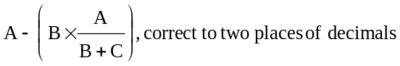
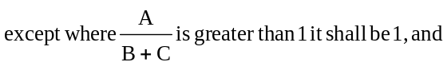
where,
A = the sum of,
(a) the product of $4,065 and the portion of the day school A.D.E. of resident-internal pupils that is in respect of elementary school pupils, and
(b) the product of $4,957 and the portion of the day school A.D.E. of resident-internal pupils that is in respect of secondary school pupils,
B = the excess of,
(a) the total of the salaries, wages and related employee benefits that are not payable to teachers and other employees of the board because of a strike or lockout, other than salaries, wages and employee benefits for instruction of summer schools, international languages classes and courses referred to in the definition “continuing education A.D.E. for grant purposes”,
over,
(b) the expenditures incurred by the board that are approved by the Minister and are attributable to a strike or lockout of the employees for which the savings for salaries, wages and employee benefits are included in clause (a) except a provision for a reserve for tax reduction, and
C = O.E. less tuition fees in respect of resident-external pupils of the board;
“MR” means the standard mill rate for R.O.E. and is equal to 0.011627, except that in the case of an unextended area board, it is equal to 0.006447 for elementary school purposes or 0.005180 for secondary school purposes;
“MR1” means the standard mill rate for recognized extraordinary expenditure and is equal to 0.000113, except that in the case of an unextended area board, it is equal to 0.000073 for elementary school purposes or 0.000040 for secondary school purposes;
“MR2” means the standard mill rate for operating expenditure and is equal to 0.000263, except that in the case of an unextended area board, it is equal to 0.000159 for elementary school purposes or 0.000104 for secondary school purposes;
“non-resident pupil” of a board means a pupil, other than a pupil from outside Ontario enrolled at a school under a student exchange program approved by the board, who is enrolled at a school operated by the board,
(a) in respect of whom,
(i) the Minister pays the cost of education,
(ii) the board charges a fee to another board,
(iii) the board may charge a fee to Canada, to a board appointed under section 68 of the Act or to a source outside Ontario, or
(iv) the board may charge a fee to a band, the council of a band or education authority that is authorized by the Crown in the right of Canada to provide education for Indians,
(b) who is a registered Indian residing on a reserve as defined in the Indian Act (Canada), or
(c) who is a pupil in Canada as a visitor or as a student under the Immigration Act (Canada) for whom the board is required under subsection 49 (6) of the Act to charge the maximum fee calculated in accordance with the regulations;
“O.E.” means ordinary expenditure and is equal to the current cost of operating increased by current expenditure for tuition fees in respect of resident-external pupils of the board, and reduced by the sum of,
(a) the eligible sum for French as a first language, the eligible sum for French as a second language, the eligible sum for junior kindergarten, the eligible sum for full-day kindergarten, the eligible sum for Native as a second language,
(b) cost of education payable under sections 32 to 34, inclusive, reduced by the P.A.C. included in such cost of education,
(c) current revenue for tuition fees in respect of non-resident pupils of the board,
(d) grants for reduction in class size for grades 1 and 2 determined under section 22,
(e) grants for small schools, small boards, small sections, goods and services, compensatory education, declining enrolment, language instruction, mixed schools and technical education determined under sections 10, 11, 12, 13, 14, 15, 19, 20 and 25, respectively,
(f) assistance for open-access tuition fees determined under section 39,
(g) grants providing special compensation for pooling determined under section 45,
(h) grants for French-language equivalency determined under section 16, and
(i) the amount described as A in the calculation of the grant for pay equity determined under section 30;
“payment in lieu of taxes” means, in respect of a municipality, the sum of,
(a) the amounts payable by the municipality to the board under subsection 7 (10) of the Housing Development Act, under subsection 445 (4) of the Municipal Act and under subsection 52 (9) of the Power Corporation Act,
(b) the amount paid by the municipality to the board that is in excess of the amount requisitioned by the board and which is in respect of an allocation of taxes or payments in lieu of taxes other than the amount receivable by the board under section 35 of the Assessment Act,
(c) the amounts receivable by the board from subscriptions in lieu of taxes, and
(d) the amounts payable by the municipality to the board under section 2 of the Municipal and School Board Payments Adjustment Act;
“psychiatric facility” means a children’s mental health centre established or approved under subsection 8 (1) of Part I (Flexible Services) of the Child and Family Services Act, or a facility designated as a psychiatric facility under the Mental Health Act and includes the private hospital known as “The Villa” and located in the City of Vaughan;
“pupil aged 21 and over” means a secondary school pupil enrolled in the period from January 1, 1997 to August 31, 1997, who is 21 years of age or over as of December 31, 1996, or a secondary school pupil enrolled in the period from September 1, 1997 to December 31, 1997, who is 21 years of age or over as of December 31, 1997;
“P.A.C.” means the pupil accommodation charge for a pupil and is equal to the product of the portion of the average daily enrolment calculated under section 2 of Ontario Regulation 79/97 (Calculation of Average Daily Enrolment) that is in respect of the pupil and $141 in the case of an elementary school pupil or $282 in the case of a secondary school pupil;
“R.E.E.” means recognized extraordinary expenditure and is equal to the sum of,
(a) debt charges payable by the board or on its behalf by a municipality or a county in respect of the portion of a debenture approved by the Minister for grant purposes,
(b) the restoration of the items referred to in clauses (d) and (e) of the definition “capital appurtenances” up to the amount of the proceeds of insurance in respect of their loss,
(c) the lesser of,
(i) expenditure for items referred to in clause (e) of the definition “capital appurtenances” less the sum of,
(A) such expenditure included in clause (b),
(B) such expenditure eligible for grant under subsection 27 (3) or section 50, and
(C) current revenue from donations that is not deducted in the determination of current cost of operating under subclause (c) (xv) of the definition of “current cost of operating” except such revenue from donations that is applied to expenditure for capital appurtenances that is other than expenditure for furniture and equipment included in this subclause, and
(ii) the sum of,
(A) current revenue from the sale or disposal of items referred to in clause (e) of the definition of “capital appurtenances”,
(B) the product of $20 and the day school A.D.E. of resident-internal pupils of the board,
less the portion of the revenue from the sale or disposal of, and from insurance proceeds in respect of, capital appurtenances that is designated by the Minister as deductible from R.E.E.,
(d) the portion approved by the Minister for grant purposes of the capital element included in rent payable,
(e) the P.A.C. in respect of resident-external pupils of the board,
(f) the portion of the expenditure for the relocation of portable classrooms that is not in excess of the product of $4,250 and the number of relocations approved by the Minister, and
less the sum of,
(g) the P.A.C. in respect of non-resident pupils of the board, and
(h) the portion of the capital element included in rent receivable that is designated by the Minister as deductible from R.E.E.;
“R.O.E.” means recognized ordinary expenditure and is equal to the lesser of the O.E. and the sum of,
(a) the maximum recognized day school O.E.,
(b) the teacher qualifications and experience adjustment,
(c) the recognized tuition fees, and
(d) the sum of,
(i) the portion of the expenditure that is approved by the Minister for training assistance of designated persons as specified in Regulation 312 of the Revised Regulations of Ontario, 1990 (Training Assistance), and
(ii) the portion of the salaries, wages and benefits paid by the board to designated persons referred to in subclause (i) that is approved by the Minister and that is in respect of the portion of the designated person’s contract time during 1997 that is specified, in a written agreement between the designated person and the board, as being directed towards training and released from board-assigned duties;
“recognized expenditure for instructional computers” means the sum of,
(a) the portion of the expenditure approved by the Minister for the purchase or lease of computer hardware for instructional purposes,
(b) the portion of the expenditure approved by the Minister for the training of teachers in the use of computer technology for instructional purposes, and
(c) the portion of the expenditure approved by the Minister for the purchase of computer software for instructional purposes;
“recognized tuition fees” means the expenditure for tuition fees less the sum of,
(a) the product of $4,065 in the case of an elementary school pupil or $4,957 in the case of a secondary school pupil and the number by which the average daily enrolment in respect of resident-external pupils of the board is increased for fee purposes by the application of factors determined under subsection 3 (4) of Ontario Regulation 81/97 (Calculation of Fees for Pupils),
(b) the sum of the amounts that are determined for the board, in respect of each of the boards with which the board has the same or part of the same area of jurisdiction, calculated as follows,
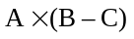
where,
A = the portion of the day school A.D.E. of resident-external pupils of the board that is in respect of secondary school pupils for whom fees are payable to the board that has the same or part of the same area of jurisdiction,
B = the tuition fee charged by the board that has the same or part of the same area of jurisdiction as determined under clause 3 (1) (c) of Ontario Regulation 81/97 (Calculation of Fees for Pupils), that is in respect of secondary school pupils, and
C = the sum of $4,957 and the amounts per pupil that are set out in Columns 10 and 11 of Table 2 opposite the name of the board in Column 1 of Table 2 and, where the amount is negative, it shall be zero, and
(c) the product of $2,257 and the portion of the average daily enrolment calculated under section 2 of Ontario Regulation 79/97, (Calculation of Average Daily Enrolment) that is in respect of resident-external pupils aged 21 or over;
“resident-external pupil” of a board means a pupil whose fee is payable by the board;
“resident-internal pupil” of a board means a pupil, other than a non-resident pupil, who is enrolled at a school operated by the board;
“secondary school pupil” means a pupil who is enrolled in a school operated by,
(a) a secondary school board, or
(b) a board of education or a Roman Catholic school board for the purposes of receiving education in the last two years of the intermediate division or in the senior division;
“summer school A.D.E. for grant purposes” means the sum of,
(a) in respect of elementary school pupils, the portion of the average daily enrolment calculated under section 3 of Ontario Regulation 79/97 (Calculation of Average Daily Enrolment) that is in respect of pupils enrolled in summer schools in a course of study for the developmentally delayed and the course is approved by the Minister for grant purposes, and
(b) in respect of secondary school pupils, the portion of the average daily enrolment calculated under section 3 of Ontario Regulation 79/97 (Calculation of Average Daily Enrolment) that is in respect of pupils enrolled in summer schools in a course for which credits or credit equivalents may be granted, and the course is approved by the Minister for grant purposes;
“teacher qualifications and experience adjustment” means the product of,
(a) the day school A.D.E. of resident-internal pupils of the board,
(b) the amount per pupil that is set out in Column 11 of Table 2 opposite the name of the board in Column 1 of Table 2, and
(c) where a strike or lockout of certain employees of the board occurs during the year, the ratio of the O.E. to the sum of the O.E. and the excess described as B in the definition of “maximum recognized day school O.E.”;
“tuition fees” means fees for instruction of pupils, less any P.A.C. that is included therein in respect of such pupils;
“unextended area board” means a board that is not entitled to levy both elementary and secondary school rates on all its supporters. O. Reg. 78/97, s. 1; O. Reg. 245/98, s. 1.
Conditions
2. (1) The legislative grant payable for 1997 to a board other than an isolate board or a board appointed under section 68 of the Act shall be the sum of the amounts calculated under sections 8 to 45, inclusive, and sections 50 and 51. O. Reg. 78/97, s. 2 (1); O. Reg. 245/98, s. 2.
(2) The legislative grant payable for 1997 to an isolate board shall be the sum of the amounts calculated under sections 32 to 35, inclusive, and section 47.
(3) The legislative grant payable for 1997 to a board appointed under section 68 of the Act shall be the sum of the amounts calculated under sections 32 to 35, inclusive, and section 49.
(4) Calculations under this Regulation shall, unless otherwise provided, be made using data for 1997. O. Reg. 78/97, s. 2 (2-4).
3. For the purposes of this Regulation, The Metropolitan Toronto School Board and the boards of education as provided in section 123 of the Municipality of Metropolitan Toronto Act shall be deemed to be one divisional board of education and the area municipalities as provided in section 1 of that Act shall be deemed to be one urban municipality. O. Reg. 78/97, s. 3.
4. (1) The legislative grant payable to an unextended area board shall be calculated separately for elementary school purposes and for secondary school purposes.
(2) The legislative grant payable to a board for elementary school purposes shall be applied to elementary school purposes.
(3) The legislative grant payable to a board for secondary school purposes shall be applied to secondary school purposes. O. Reg. 78/97, s. 4.
5. (1) Where, in respect of a board, the calculation made to determine a legislative grant described under a section of this Regulation results in a negative amount, the sum of the amounts calculated as payable under the other section or sections of this Regulation shall be reduced by the negative amount, and the remainder obtained thereby is the legislative grant payable to the board.
(2) Notwithstanding subsection (1), where a board enters into an agreement with the Minister to make an equalization contribution for 1997 under section 257.2 of the Act, the legislative grant payable to the board shall not be less than the sum of,
(a) the product of,
(i) the amount calculated for the board under section 27, and
(ii) an estimate approved by the Minister of the average number of pupils enrolled on each school day in 1997 in the educational programs provided by the board in the facilities referred to in section 27 and who, except as to residence, would be qualified to be resident pupils of another board, divided by the average number of pupils enrolled on each school day in 1997 in the educational programs provided by the board in the facilities referred to in section 27;
(b) the product of,
(i) the amount calculated for the board under sections 32 to 35, inclusive, and
(ii) an estimate approved by the Minister of the average number of pupils enrolled on each school day in 1997 for whom a grant is payable under sections 32 to 35, inclusive, and who, except as to residence, would be qualified to be resident pupils of another board, divided by the average number of pupils enrolled on each school day in 1997 for whom a grant is payable under sections 32 to 35, inclusive; and
(c) the sum of the amounts calculated under section 50 in respect of projects approved by the Minister under the Canada-Ontario Infrastructure Works Program. O. Reg. 78/97, s. 5.
6. (1) Despite sections 2, 4 and 5, the legislative grant payable for 1997 to a board to which subsection (2) applies shall not be less than the amount calculated as follows:
1. Take the legislative grant payable to the board for 1996 under Ontario Regulation 116/96.
2. Subtract the grant payable to the board for 1996 under section 50 of Ontario Regulation 116/96.
3. Subtract the lesser of the two amounts calculated under subsection (1.1).
4. Add the legislative grant payable to the board for 1997 under section 50.
5. Add the legislative grant payable to the board for 1997 under section 51.
6. Subtract the amount determined under subsection (1.2).
(1.1) The two amounts referred to in paragraph 3 of subsection (1) are as follows:
1. The product of 0.15 and the result obtained under paragraph 2 of subsection (1).
2. The product of 0.03 and the result for elementary and secondary school purposes of,
i. taking the current cost of operating for the board for 1996, as determined under Ontario Regulation 116/96,
ii. adding the current expenditures of the board for 1996 described in subclauses (a) (ii), (iii), (iv) and (vii) of the definition of “current cost of operating” in section 1 of Ontario Regulation 116/96, and
iii. subtracting the 1996 revenue of the board from tuition fees in respect of non-resident pupils of the board.
(1.2) The amount referred to in paragraph 6 of subsection (1) shall be determined as follows:
1. Calculate the grant that would be payable to the board under section 8 if the excess described as B in the definition of “maximum recognized day school O.E.” in section 1 equalled zero.
2. Subtract the grant actually payable under section 8 from the amount calculated under paragraph 1. O. Reg. 245/98, s. 3.
(2) Subsection (1) applies to a board, other than an isolate board or a board appointed under section 68 of the Act, where,
(a) the sum of the day school A.D.E. of resident-internal pupils and the day school A.D.E. of resident-external pupils for elementary and secondary purposes is less than 10,000; or
(b) the quotient obtained by dividing,
(i) the excess for elementary and secondary purposes of the O.E. of the board for 1996 over its R.O.E. for 1996,
by,
(ii) the sum of the day school A.D.E. of resident-internal pupils and the day school A.D.E. of resident-external pupils for 1996 for the board for elementary and secondary purposes,
is less than $500.
(3) In clause (1) (c) and (2) (b), words and terms have the same meaning as in Ontario Regulation 116/96. O. Reg. 78/97, s. 6 (2, 3).
7. (1) The calculation and payment to a board of the legislative grant for the year 1997 shall be made in accordance with the Regulation.
(2) The legislative grant payable under this Regulation shall be paid in the number of instalments and at the times designated by the Minister.
(3) The legislative grant payable under this Regulation shall be paid on an estimated basis during 1997 and such adjustments as may be necessary shall be made when the actual financial data and average daily enrolments are available.
(4) Where the portion of the moneys appropriated by the legislature for legislative grants to boards for the provincial fiscal year 1997-98 that is allocated by the Minister to pay the balance owing under a regulation in respect of legislative grants for a previous year and the instalments payable during the provincial fiscal year 1997-98 under this Regulation except this subsection is more than sufficient or insufficient for such purposes, the Minister may increase or decrease, as the case may be, the total of the legislative grants payable under section 8 by the amount of such surplus or insufficiency by adjusting the mill rates referred to in the definition of “MR”.
(5) It is a condition of the payment to a board of a legislative grant that the board comply with the Acts administered by the Minister and with the regulations and policy and program initiatives authorized under those Acts and, if a board fails to comply, the Minister may withhold all or part of a legislative grant payable until the board takes the action necessary to correct the condition that caused the grant to be withheld.
(6) Where the legislative grant payable under this Regulation is overpaid, the board shall refund the amount of the overpayment to the Province of Ontario.
(7) Where the legislative grant payable under this Regulation is underpaid, the amount of the underpayment shall be paid to the board.
(8) Where the amount payable to a board under a previous regulation was either overpaid or underpaid, the overpayment or underpayment, as the case may be, shall be deducted from or added to the legislative grant payable under this Regulation to the board that has jurisdiction in the area for which the adjustment is necessary.
(9) Where a board is convicted of an offence or is held by a court to have contravened an Act, the Minister may exclude from grant assistance the expenditure by the board for legal fees payable and fines and damage awards imposed in respect of such conviction or contravention. O. Reg. 78/97, s. 7.
Category 1 — Basic Per Pupil Grant
grant for recognized ordinary expenditure
8. A board shall be paid a grant calculated as follows,
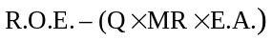
where,
Q = the quotient, correct to five places of decimals, obtained by dividing R.O.E. by the sum of,
(a) the maximum recognized day school O.E.,
(b) the amount determined in the definition of “maximum recognized day school O.E.” in respect of the portion of the formula therein described as,
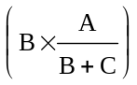
(c) the product of the portion of the day school A.D.E. of resident-external pupils of the board that is in respect of elementary school pupils and the sum of $4,065 and the amount per pupil that is set out in Column 10 of Table 2 opposite the name of the board in Column 1 of Table 2, and
(d) the product of the portion of the day school A.D.E. of resident-external pupils of the board that is in respect of secondary school pupils and the sum of $4,957 and the amount per pupil that is set out in Column 10 of Table 2 opposite the name of the board in Column 1 of Table 2.
O. Reg. 78/97, s. 8.
Category 2 — Board Specific Grants
grant for french as a first language
9. A board shall be paid, in respect of schools and classes established under section 289 or 291 of the Act where French is the language of instruction, a grant equal to the eligible sum for French as a first language. O. Reg. 78/97, s. 9.
grant for small schools
10. A board shall be paid, in respect of the additional costs to the board of operating small isolated schools, a grant equal to the product of the day school A.D.E. of resident-internal pupils of the board and the amount per pupil that is set out in Column 2 of Table 2 opposite the name of the board in Column 1 of Table 2. O. Reg. 78/97, s. 10.
grant for small boards
11. A board shall be paid, in respect of the additional administrative costs of operating a board with a low enrolment, a grant equal to the product of the day school A.D.E. of resident-internal pupils of the board and the amount per pupil that is set out in Column 3 of Table 2 opposite the name of the board in Column 1 of Table 2. O. Reg. 78/97, s. 11.
grant for small sections
12. A board shall be paid, in respect of the additional administrative costs of operating a section with a low enrolment, a grant equal to the product of the day school A.D.E. of resident-internal pupils of the board and the amount per pupil that is set out in Column 4 of Table 2 opposite the name of the board in Column 1 of Table 2. O. Reg. 78/97, s. 12.
grant for goods and services
13. A board shall be paid, in respect of the additional costs to the board of purchasing goods and obtaining services in remote areas, a grant equal to the product of the day school A.D.E. of resident-internal pupils of the board and the amount per pupil that is set out in Column 5 of Table 2 opposite the name of the board in Column 1 of Table 2. O. Reg. 78/97, s. 13.
grant for compensatory education
14. A board shall be paid, in respect of the additional costs to the board of providing compensatory education programs and services, a grant equal to the product of the day school A.D.E. of resident-internal pupils of the board and the amount per pupil that is set out in Column 6 of Table 2 opposite the name of the board in Column 1 of Table 2. O. Reg. 78/97, s. 14.
grant for declining enrolment
15. A board shall be paid, in respect of declining enrolment, a grant equal to the sum of the amounts calculated separately in respect of elementary school pupils and in respect of secondary school pupils, as follows,
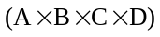
where,
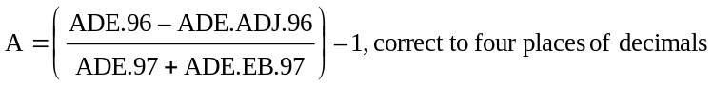
B = 0.5 if C is less than or equal to 4,000,
= 0.25 if C is greater than or equal to 14,000,
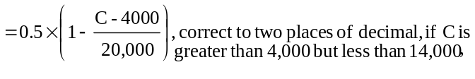
C = the portion of the day school A.D.E. of resident-internal pupils of the board that is in respect of elementary school pupils or secondary school pupils, as the case requires,
D = the sum of $4,065 for elementary school purposes or $4,957 for secondary school purposes as the case requires and the amount per pupil that is set out in Column 10 of Table 2 opposite the name of the board in Column 1 of Table 2,
where,
ADE.97 means the sum of the day school A.D.E. of resident-internal pupils and the day school A.D.E. of non-resident pupils that is in respect of elementary school pupils or secondary school pupils, as the case requires,
ADE.96 means the sum of the day school A.D.E. of resident-internal pupils and the day school A.D.E. of non-resident pupils as defined in Ontario Regulation 116/96 (General Legislative Grants, 1996) that is in respect of elementary school pupils or secondary school pupils, as the case requires,
ADE.EB.97 means the amount by which ADE.97 was reduced as a result of the transfer of elementary or secondary schools referred to in section 40, as the case requires,
ADE.ADJ.96 means the product of 1.5 and the amount defined as ADE.ADJ.95 in section 15 of Ontario Regulation 116/96 (General Legislative Grants), and
where the amount calculated under this section is a negative amount, it shall be zero.
O. Reg. 78/97, s. 15.
grant for french-language equivalency
16. (1) A public French-language board shall be paid a grant in respect of equivalency to the public English-language boards that have the same or part of the same area of jurisdiction.
(2) A Roman Catholic French-language board shall be paid a grant in respect of equivalency to the Roman Catholic English-language boards that have the same or part of the same area of jurisdiction.
(3) The grant paid to the public or Roman Catholic French-language board under subsection (1) or (2) shall be equal to the sum of,
(a) the sum of the amounts that are determined in respect of each of the public or Roman Catholic English-language boards, as the case may be, that have the same or part of the same area of jurisdiction as the French-language board, calculated as follows,
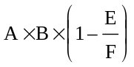
where,
A = the portion of the day school A.D.E. of resident-internal pupils of the French-language board that reside in the jurisdiction of the English-language board,
B = the over-ceiling expenditure per pupil of the English-language board,
E = the quotient obtained by dividing the E.A. for the French-language board by the sum of the day school A.D.E. of resident-internal pupils and the day school A.D.E. of resident-external pupils of the French-language board, and
F = the quotient obtained by dividing the E.A. for the English-language board by the sum of the day school A.D.E. of resident-internal pupils and the day school A.D.E. of resident-external pupils of the English-language board; and
(b) the sum of the amounts that are determined in respect of each of the boards that have the same or part of the same area of jurisdiction as the French-language board, calculated as follows,
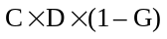
where,
C = the portion of the day school A.D.E. of resident-external pupils of the French-language board that is in respect of secondary school pupils for whom fees are payable to the board that has the same or part of the same area of jurisdiction as the French-language board,
D = the lesser of the over-ceiling expenditure per pupil of the French-language board or the over-ceiling expenditure per pupil of the board that has the same or part of the same area of jurisdiction as the French-language board, and
G = the wealth ratio of the French-language board.
(4) For the purpose of this section,
“over-ceiling expenditure per pupil” for a board means the quotient obtained by dividing,
(a) the current cost of operating of the board, increased by the strike savings referred to as item B in the definition of “maximum recognized day school O.E.”, and reduced by the sum of the eligible sum for French as a first language, the eligible sum for French as a second language, the eligible sum for Native as a second language, the eligible sum for full-day kindergarten, the amount described as A in the calculation of the grant for pay equity under section 30, the grants for declining enrolment, reduction in class-size in grades 1 and 2 and special compensation for pooling determined under sections 15, 22 and 45, respectively, and the sum of the amounts calculated for elementary school purposes and for secondary school purposes equal to the product of the average daily enrolment calculated under section 2 of Ontario Regulation 79/97 (Calculation of Average Daily Enrolment) that is in respect of resident-internal and non-resident pupils of the board and the sum of $4,065 in the case of elementary school pupils or $4,957 in the case of secondary school pupils and the amounts per pupil that are set out in Columns 10 and 11 of Table 2 opposite the name of the board in Column 1 of Table 2,
by,
(b) the average daily enrolment calculated under section 2 of Ontario Regulation 79/97 (Calculation of Average Daily Enrolment) that is in respect of resident-internal and non-resident pupils of the board;
“public English-language board” means a board, but does not include a public French-language board, a Roman Catholic English-language board, a Roman Catholic French-language board or a Protestant separate school board;
“public French-language board” means a board established under subsection 11 (13) of the Act that is not a Roman Catholic French-language board;
“Roman Catholic English-language board” means a separate school board but does not include a Roman Catholic French-language board;
“Roman Catholic French-language board” means a board established under subsection 11 (13) of the Act, the members of which are required to be Roman Catholic;
“wealth ratio”, for a public or Roman Catholic French-language board, means the quotient obtained by dividing the amount described as E for the French-language board by the sum of the amounts that are determined in respect of each of the public or Roman Catholic English-language boards, as the case may be, that have the same or part of the same area of jurisdiction, calculated as follows,
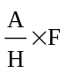
where A and F have the same meaning as described in subsection (3), and
H = the day school A.D.E. of resident-internal pupils of the French-language board.
O. Reg. 78/97, s. 16.
Category 3 — Program Specific Grants
grant for french as a second language
17. (1) A board shall be paid, in respect of instruction in French in classes established for pupils whose first language is not French, a grant calculated as follows,
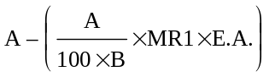
where,
A = the eligible sum for French as a second language,
B = the sum of,
(a) the day school A.D.E. of resident-internal pupils, and
(b) the day school A.D.E. of non-resident pupils.
(2) Where, in 1997, a board offers for the first time in a secondary school other than a French-language secondary school or a school having a French-language instructional unit, a course for which credit may be granted and in which French is the language of instruction for pupils whose first language is not French, and the course is in a subject other than French or is a special course in the subject of French designed for graduates of an elementary school program of extended or immersion French, the board shall be paid a grant of $3,374 for each such course except that such grant shall not be paid in respect of a course that increases the total number of such courses in a grade at the school to more than four. O. Reg. 78/97, s. 17.
grant for native as a second language
18. (1) A board shall be paid, in respect of Native as a second language instruction, a grant calculated as follows,
where,
A = the eligible sum for Native as a second language,
B = the sum of,
(i) the day school A.D.E. of resident-internal pupils, and
(ii) the day school A.D.E. of non-resident pupils.
(2) A board, other than a board that operated a Native as a second language program on or before the last school day of September, 1992, shall be paid a grant equal to the product of $200 and the number of resident-internal and non-resident pupils of the board who on the last school day of October, 1997 are registered in a Native as a second language program operated by the board. O. Reg. 78/97, s. 18.
grant for additional language instruction
19. A board shall be paid, in respect of the additional costs to the board of providing language instruction programs in English-language schools or classes for pupils whose first language is not English or in French-language schools or classes for pupils whose first language is not French in order that they may take advantage of regular instruction in the school or class, a grant equal to the product of the day school A.D.E. of resident-internal pupils of the board and the amount per pupil that is set out in Column 7 of Table 2 opposite the name of the board in Column 1 of Table 2. O. Reg. 78/97, s. 19.
grant for mixed language secondary schools
20. A board shall be paid, in respect of the additional costs to the board of providing courses in the minority language of a mixed language secondary school, a grant equal to the product of the day school A.D.E. of resident-internal pupils of the board and the amount per pupil that is set out in Column 8 of Table 2 opposite the name of the board in Column 1 of Table 2. O. Reg. 78/97, s. 20.
grants for junior kindergarten and full-day kindergarten
21. (1) A board shall be paid, in respect of junior kindergarten, a grant calculated as follows,
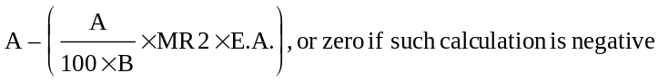
where,
A = the eligible sum for junior kindergarten,
B = the sum of,
(a) the day school A.D.E. of resident-internal pupils, and
(b) the day school A.D.E. of resident-external pupils.
(2) A board shall be paid, in respect of full-day kindergarten, a grant calculated as follows,
where,
A = the eligible sum for full-day kindergarten,
B = the sum of,
(a) the day school A.D.E. of resident-internal pupils, and
(b) the day school A.D.E. of non-resident pupils.
O. Reg. 78/97, s. 21.
grant for reduction in class-size in grades 1 and 2
22. A board shall be paid a grant equal to the sum of,
(a) the product of 1.5 and the portion of the grant payable to the board that is calculated under clause 22 (b) of Ontario Regulation 116/96 (General Legislative Grants); and
(b) the product of,
(i) the number of resident-internal and non-resident pupils of the board who, on the last school day of October, 1997 are enrolled in the primary division in the first two years of the program of studies immediately following kindergarten in a class other than a self-contained class for exceptional pupils,
(ii) 0.4, and
(iii) the lesser of,
a. $700, and
b. 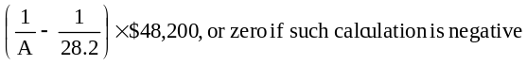
where,
A = the average class-size for pupils enrolled in the primary division in the first two years of the program of studies immediately following kindergarten and is calculated by dividing the number of pupils determined under subclause (i) by the number of regular classroom teachers or portions thereof employed and assigned by the board to teach pupils described under subclause (i), and the calculation so determined is subject to the approval of the Minister.
O. Reg. 78/97, s. 22.
grants for instructional computers and recognized extraordinary expenditure
23. (1) A board shall be paid, in respect of the provision of instructional computers, a grant calculated as follows,
where,
A = recognized expenditure for instructional computers,
B = the sum of the day school A.D.E. of resident-internal pupils and the day school A.D.E. of non-resident pupils.
(2) A board shall be paid, in respect of recognized extraordinary expenditure, a grant calculated as follows,
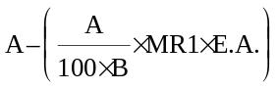
where,
A = R.E.E.,
B = the sum of the day school A.D.E. of resident-internal pupils and the day school A.D.E. of resident-external pupils.
O. Reg. 78/97, s. 23.
grant for pupil transportation
24. A board shall be paid, in respect of the transportation of pupils, a grant equal to the lesser of,
(a) the current expenditure for,
(i) transportation of pupils and persons qualified to be resident pupils to and from a school, a facility referred to in subsection 190 (3) of the Act or to a centre referred to in subsection 190 (4) thereof,
(ii) transportation of pupils from one school to another school or a facility referred to in subsection 190 (3) of the Act, and
(iii) board, lodging and weekly transportation of pupils under sections 190, 289 and 291 of the Act; and
(b) the sum of,
(i) the amount calculated as follows,
(ii) the amount calculated as follows,
where,
A = the amount per pupil that is set out in Column 2 of Table 3 opposite the name of the board in Column 1 of Table 3, and
B = the sum of the day school A.D.E. of resident-internal pupils, the day school A.D.E. of resident-external pupils and the average daily enrolment calculated under section 2 of Ontario Regulation 79/97 (Calculation of Average Daily Enrolment) that is in respect of resident-internal and resident-external pupils enrolled in a junior kindergarten, and
C = the portion of the current expenditure for transportation that is in respect of transportation to and from the Ontario School for the Blind, an Ontario School for the Deaf or a demonstration school established by or operated under an agreement with the Minister for pupils with severe communicational exceptionalities.
O. Reg. 78/97, s. 24.
grant for technical education
25. A board shall be paid, in respect of the additional costs to the board of providing technical education programs and services, a grant equal to the product of the day school A.D.E. of resident-internal pupils of the board and the amount per pupil that is set out in Column 9 of Table 2 opposite the name of the board in Column 1 of Table 2. O. Reg. 78/97, s. 25.
grants for programs in lieu of provincial services for blind, deaf or deaf-blind pupils
26. (1) Where a board provides in its schools a special education program in lieu of an education program provided in a provincial school for blind, deaf or deaf-blind pupils or other program approved by the Minister, the board, subject to the approval of the Minister, shall be paid a grant equal to the product of,
(a) the sum of the number of teachers approved by the Minister and one-half of the number of teacher assistants approved by the Minister employed by the board for the purpose of providing such a special education program; and
(b) $48,200 in the case of a program for elementary school pupils or $55,400 in the case of a program for secondary school pupils.
(2) Subject to the approval of the Minister, where a board employs a qualified interpreter to assist an exceptional pupil who is otherwise admissible to a provincial school and who is identified by the board’s identification, placement and review committee, established under Regulation 305 of the Revised Regulations of Ontario, 1990 as deaf or hard-of-hearing or employs a qualified transcriber to assist the teacher of an exceptional pupil who is identified by the board’s identification, placement and review committee as blind, the board shall be paid a grant calculated as follows,
where,
A = the sum of,
(a) the number of interpreters approved by the Minister multiplied by $34,000, and
(b) the number of transcribers approved by the Minister multiplied by $28,000,
B = the sum of,
(a) the day school A.D.E. of resident-internal pupils, and
(b) the day school A.D.E. of non-resident pupils.
O. Reg. 78/97, s. 26.
grants for education programs in care, treatment and correctional facilities
27. (1) Where a board employs a teacher to provide an educational program in,
(a) a psychiatric facility;
(b) an approved charitable institution as defined in the Charitable Institutions Act;
(c) an agency approved under subsection 8 (1) of Part I (Flexible Services) of the Child and Family Services Act;
(d) an approved home as defined in the Homes for Retarded Persons Act;
(e) a place of temporary detention, open custody or secure custody continued or established under section 89 of Part IV (Young Offenders) of the Child and Family Services Act;
(f) a home for special care approved or licensed under the Homes for Special Care Act;
(g) a Crippled Children’s Treatment Centre classified as a Group K Hospital under the Public Hospitals Act;
(h) The Hospital for Sick Children, Toronto;
(i) The Children’s Hospital of Eastern Ontario, Ottawa;
(j) Bloorview Children’s Hospital, Toronto;
(k) Children’s Hospital of Western Ontario, London;
(l) Lyndhurst Hospital, Toronto;
(m) a hospital in which an education program is discontinued subsequent to December, 1980 as a result of dissolution of a board established under section 68 of the Act;
(n) a nursing home approved or licensed under the Nursing Homes Act;
(o) a correctional institution as defined in the Ministry of Correctional Services Act;
(p) a place of secure or open custody designated under section 24 of the Young Offenders Act (Canada) or place of temporary detention designated under subsection 7 (1) of that Act,
that is situated within the area of jurisdiction of the board and in which no education program is provided by the Ministry and the Minister approves such education program, the board shall be paid a grant equal to,
(q) the expenditure in 1997 for salary and related employee benefits of the teacher and an additional amount not in excess of $2,500 per teacher in respect of the expenditure of the board for administrative, consultative and supervisory services, for replacement of furniture and equipment and for the purchase of instructional supplies in respect of such program; and
(r) expenditure in 1997 for salary and related employee benefits of a teacher assistant to assist a teacher in the provision of such educational program and an additional amount not in excess of $1,220 for each such teacher assistant.
(2) The approval of the Minister referred to in subsection (1) shall be given only where the board has entered into a written agreement with the facility, home or institution, or the administrator thereof setting out the responsibilities of the facility, home or institution for the provision of accommodation and the responsibilities of the board for the provision of the education program, including the number of teachers that the board agrees to provide.
(3) Where a board referred to in subsection (1) incurs an expenditure for furniture or equipment or both for a classroom for an education program referred to in subsection (1), the board shall be paid a grant equal to the approved portion of such expenditure, except that the grant in respect of furniture and equipment for the classroom shall in no case exceed $3,300.
(4) Where a board enters into a written agreement with a facility or hospital referred to in subsection (1), or with the administrator of such facility, to provide an educational program that was previously provided in the facility or hospital by the Ministry and the Minister approves such education program, the Minister may pay the board, in lieu of other grants payable under this Regulation in respect of the program, an amount equal to the operating cost that is approved by the Minister for the program. O. Reg. 78/97, s. 27.
grant for adult education, continuing education and summer school
28. A board shall be paid, in respect of adult education, continuing education and summer school classes and courses, a grant equal to the sum of,
(a) the greater of,
(i) the product of,
a. $2,257, and
b. the sum of the continuing education A.D.E. for grant purposes and the summer school A.D.E. for grant purposes,
(ii) the product of,
a. $4,957
b. the quotient obtained by dividing the grant payable to the board under section 8 by the R.O.E., and
c. the sum calculated in sub-subclause (a) (i) b;
(b) the product of,
(i) $2,257, and
(ii) the portion of the average daily enrolment calculated under section 2 of Ontario Regulation 79/97 (Calculation of Average Daily Enrolment) that is in respect of resident-internal and resident-external pupils aged 21 or over; and
(c) the product of 1.5 and the portion of the grant payable to the board that is calculated under clause 28 (c) of Ontario Regulation 116/96 (General Legislative Grants). O. Reg. 78/97, s. 28.
grant for international languages (elementary)
29. Where a board conducts classes that are approved by the Minister as part of an international languages program (elementary) in a language other than English or French, the board shall be paid a grant in respect of each such class that is equal to the product of $41 and the number of hours of classroom instruction except that where the quotient obtained by dividing the number of elementary school pupils enrolled in all such classes conducted by the board by the number of such classes is less than 25, the $41 per hour rate is reduced by the product of $1.00 and the difference between such quotient and 25. O. Reg. 78/97, s. 29.
grant for pay equity
30. (1) A board shall be paid, in respect of pay equity adjustments, a grant equal to the following amount:
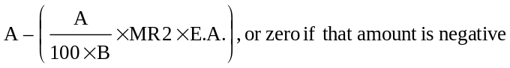
where,
A = the lesser of,
i. the sum of the eligible expenditure for pay equity in 1997 and the eligible expenditure for pay equity that was not recognized in 1996, and
ii. the sum of,
(a) the product of $120 and the sum, in respect of elementary school pupils, of the day school A.D.E. of resident-internal pupils and the day school A.D.E. of non-resident pupils of the board, and
(b) the product of $50 and the sum, in respect of secondary school pupils, of the day school A.D.E. of resident-internal pupils and the day school A.D.E. of non-resident pupils of the board,
B = the sum of the day school A.D.E. of resident-internal pupils and the day school A.D.E. of non-resident pupils.
(2) For the purpose of this section,
“eligible expenditure for pay equity in 1997” means the sum of,
(a) the amount by which the board’s total expenditures in 1997 for adjustments in compensation in accordance with a pay equity plan under the Pay Equity Act exceed the board’s total expenditures in 1996 for adjustments in compensation in accordance with a pay equity plan under the Pay Equity Act, and
(b) the eligible expenditure for pay equity in 1996 as defined in section 30 of Ontario Regulation 116/96 (General Legislative Grants);
“eligible expenditure for pay equity that was not recognized in 1996” means the amount by which the sum described in paragraph i exceeds the sum described in paragraph ii of the definition of A in section 30 of Ontario Regulation 116/96 (General Legislative Grants). O. Reg. 78/97, s. 30.
assistance for cost of education and for board, lodging and transportation
31. (1) For the purpose of sections 32 to 38, inclusive,
(a) “cost of education” means an amount equal to the fee calculated under section 3 or 4, as the case requires, of Ontario Regulation 81/97 (Calculation of Fees for Pupils);
(b) “Crown establishment” means an establishment maintained by a Department of the Government of Canada, a Crown company, The Royal Canadian Mounted Police or Atomic Energy of Canada Limited, on lands held by the Crown in right of Canada that are not assessable for school purposes, and includes a reserve as defined in the Indian Act (Canada);
(c) “Ontario Government establishment” means an establishment maintained by a Ministry of the Government of Ontario on lands held by the Crown in right of Ontario or an establishment maintained by Ontario Hydro on lands held by it and in respect of which no payment attributable to elementary or secondary school purposes is made under the provisions of subsection 52 (9) of the Power Corporation Act.
(2) For the purposes of sections 32 to 38, inclusive, a person shall be considered not to reside in an Ontario Government establishment where the person resides in a residence owned by the person on lands that are within the Ontario Government establishment. O. Reg. 78/97, s. 31.
32. Where a pupil who is not resident in a Crown Establishment resides in a territorial district on land that is not part of a,
(a) school section and the pupil attends a public school;
(b) school section or separate school zone and the pupil attends a separate school; or
(c) secondary school district and the pupil attends a secondary school,
operated by a board, the Minister shall pay the board the cost of education of the pupil. O. Reg. 78/97, s. 32.
33. Where a pupil, whose parent or guardian resides on land that is not rateable for school purposes, resides in an Ontario Government establishment and attends a school operated by a board, the Minister shall pay the board the cost of education of the pupil. O. Reg. 78/97, s. 33.
34. Where a pupil,
(a) who is resident within,
(i) a psychiatric facility,
(ii) an approved charitable institution as defined in the Charitable Institutions Act,
(iii) an agency approved under subsection 8 (1) of Part I (Flexible Services) of the Child and Family Services Act,
(iv) an approved home as defined in the Homes for Retarded Persons Act,
(v) a home for special care approved or licensed under the Homes for Special Care Act,
(vi) a nursing home approved or licensed under the Nursing Homes Act, or
(vii) a place of secure custody or open custody designated under section 24 of the Young Offenders Act (Canada) or place of temporary detention designated under subsection 7 (1) of that Act;
(b) who is detained in a place of temporary detention, open custody or secure custody continued or established under section 89 of Part IV (Young Offenders) of the Child and Family Services Act;
(c) who is detained in a correctional institution as defined in the Ministry of Correctional Services Act;
(d) who is placed in an approved home as defined in the Mental Hospitals Act; or
(e) who is a ward of the Crown under Part III (Child Protection) of the Child and Family Services Act, a ward of a children’s aid society or in the care of a children’s aid society and who has not been placed for adoption on a probationary basis,
attends a day school operated by a board and the pupil is registered as a non-resident pupil in respect of whom no fee is receivable from Canada under an agreement made pursuant to section 187 or 188 of the Act, the Minister shall pay the board the cost of education of the pupil. O. Reg. 78/97, s. 34.
35. (1) Where a board provides transportation to and from school or from school to school for a pupil for whom the Minister pays the cost of education, the Minister shall pay the board an amount approved by the Minister for grant purposes for transportation of the pupil.
(2) Where, under subsection 190 (9) or (12) of the Act, a board reimburses a parent or guardian of a pupil for whom the Minister pays the cost of education for the cost of board and lodging and transportation once a week from the pupil’s residence to school and return, the Minister shall pay the board an amount approved by the Minister for grant purposes of the expenditure in respect of the pupil for board, lodging and transportation. O. Reg. 78/97, s. 35.
payments to governing authorities
36. Where a pupil who is not a resident in a Crown Establishment attends a school supported by local taxation in Manitoba or Quebec and the pupil resides in a territorial district on land that is not part of,
(a) a school section or separate school zone and the pupil attends an elementary school; or
(b) a secondary school district and the pupil attends a secondary school,
the Minister shall pay the governing authorities of the school the amount agreed upon between the governing authorities of the school and the Minister. O. Reg. 78/97, s. 36.
37. Where a pupil,
(a) resides in a territorial district;
(b) is resident in a school section, a separate school zone or a Crown establishment; and
(c) attends an elementary school that is supported by taxation in Manitoba or Quebec,
and where, in the opinion of the Minister,
(d) daily transportation to the elementary school that the pupil would be required to attend in Ontario is impracticable due to distance and terrain; and
(e) the provision of board, lodging and transportation once a week is impracticable because of the age or handicap of the pupil,
the Minister shall pay the governing authorities of the elementary school in respect of the education and related costs of such pupil amounts agreed upon between the governing authorities of the elementary school and the Minister. O. Reg. 78/97, s. 37.
38. Where a pupil,
(a) resides in a territorial district;
(b) is not resident in a school section, a separate school zone or a Crown establishment; and
(c) attends a school on a reserve operated by Canada, council of a band or education authority authorized by the Crown in right of Canada to provide education for Indians,
the Minister shall pay the governing authorities of the school in respect of the education of such pupil an amount agreed upon between the governing authorities of the school and the Minister. O. Reg. 78/97, s. 38.
assistance for open-access tuition fees
39. (1) A board other than a board referred to in subsection (2) shall be paid a grant equal to the sum of the amounts that are determined in respect of each of the boards with which the board has substantially the same or part of the same area of jurisdiction, calculated as follows,
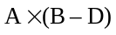
where A and B have the same meaning as in clause (b) of the definition of “recognized tuition fees”, and
where,
D = the greater of,
(i) the amount referred to as C in clause (b) of the definition of “recognized tuition fees”, and
(ii) the tuition fee that would be charged by the board for a non-resident pupil of the board as determined under clause 3 (1) (c) of Ontario Regulation 81/97 (Calculation of Fees for Pupils) that is in respect of secondary school pupils,
and where the amount is negative, it shall be zero.
(2) A Roman Catholic school board to which subsection 129 (4) of the Act applies shall be paid a grant equal to the sum of the amounts that are determined in respect of each of the public boards with which the board has substantially the same or part of the same area of jurisdiction, calculated as follows,
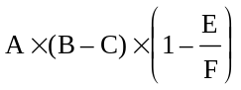
where A, B and C have the same meaning as in clause (b) of the definition of “recognized tuition fees”, and
where,
E = the quotient obtained by dividing the E.A. for the Roman Catholic school board by the day school A.D.E. of resident-internal pupils and the day school A.D.E. of resident-external pupils of the Roman Catholic school board, and
F = the quotient obtained by dividing the E.A. for the public board with which the Roman Catholic school board has substantially the same or part of the same area of jurisdiction by the sum of the day school A.D.E. of resident-internal pupils and the day school A.D.E. of resident-external pupils of the public board.
O. Reg. 78/97, s. 39.
assistance for en bloc transfer
40. (1) A public board set out in Column 1 of Table 4 other than a board referred to in subsections (2) and (3) shall be paid a grant set out opposite in Column 2 of Table 4 in respect of the transfer, as an entire educational program, of one or more secondary schools operated by the public board to a Roman Catholic school board, by agreement between the two boards and the transfer is approved by the Minister, to assist the public board in offsetting operating costs in respect of employee salaries and benefits and administrative and other expenditures that are related to the operation of the school or schools and that could not be transferred to the Roman Catholic school board.
(2) The Middlesex County Board of Education shall be paid a grant set out in Column 2 of Table 4 opposite the name of the board in Column 1 of Table 4 in respect of the transfer, as an entire educational program, of one or more schools to the Board of Education for the City of London by agreement between the two boards and the transfer is approved by the Minister, to assist in offsetting operating costs in respect of employee salaries and benefits and administrative and other expenditures that related to the operation of the school or schools and that could not be transferred to the Board of Education for the City of London. O. Reg. 78/97, s. 40.
secondary school reorganization grant
41. Where, on or after January 1, 1993, as a result of the reorganization of a French-English mixed language secondary school operated by the board prior to September 1, 1985, a board establishes a French-language secondary school under section 291 of the Act, a grant, subject to the approval of the Minister, is payable to the board as follows,
(a) where such school commenced operation in 1993, 1994 or 1995,
(i) $485 per day school pupil enrolled at the school on the last day in October of 1997 where such enrolment is 100 or fewer, or
(ii) the lesser of $60,700 and the amount of $42,400 plus $61 per day school pupil enrolled at the school on the last day in October of 1997 where such enrolment is greater than 100;
(b) where such school commenced operation in 1996,
(i) $970 per day school pupil enrolled at the school on the last day in October of 1997 where such enrolment is 100 or fewer, or
(ii) the lesser of $121,400 and the amount of $84,800 plus $122 per day school pupil enrolled at the school on the last day in October of 1997 where such enrolment is greater than 100; and
(c) where such school commences operation in 1997,
(i) $1,455 per day school pupil enrolled at the school on the last day in October of 1997 where such enrolment is 100 or fewer, or
(ii) the lesser of $182,100 and the amount of $127,200 plus $183 per day school pupil enrolled at the school on the last day in October of 1997 where such enrolment is greater than 100. O. Reg. 78/97, s. 41.
adjustment in respect of change in tax revenue
42. For the purpose of this section and section 43,
(a) “equalized assessment for a board for 1996” means equalized assessment for a board as defined in Ontario Regulation 116/96 (General Legislative Grants) except that equivalent assessment for a municipality or locality shall be calculated using the rate levied in 1996 rather than the rate levied in 1995;
(b) “change in taxation for 1996” for a board is the amount calculated as follows,
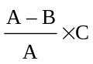
where,
A = the equalized assessment for the board for 1996 that is calculated using, for each organized municipality within the jurisdiction of the board,
I. the assessment for 1996,
II. the tax levied under subsections 159 (12) and (13) of the Municipal Act that is allocated or paid to the board in 1996, and
III. the payment in lieu of taxes for 1996 payable to the board,
as shown in the audited financial report of such municipality for 1996,
B = the equalized assessment for the board for 1996,
C = the amounts the board requisitioned on, or levied or caused to be levied in, the municipalities and localities within the jurisdiction of the board,
and the amount calculated may be a positive or negative amount;
(c) “net adjustment in tax revenue”, in respect of a board, is calculated as follows,
C – B – A
where,
A = the change in taxation for 1996 for the board,
B = taxes receivable in 1996 under section 35 of the Assessment Act,
C = amounts charged to the board by a municipality in 1996 under section 421 of the Municipal Act, other than taxes receivable in 1996 but cancelled or reduced by resolution of the board, or by resolutions of more than one board,
and the amount calculated may be a positive or negative amount;
(d) “net expenditure for 1996” means, in respect of a board, the excess of,
(i) the sum of the current expenditure for 1996, amounts provided in 1996 for reserves and reserve funds, and tax adjustments charged to the board in 1996,
over,
(ii) current revenue for 1996 including transfers in such year from reserves and other funds and excluding current revenue from taxes, subscriptions in lieu of taxes, payments in lieu of taxes and trailer fees;
(e) “net recognized expenditure for 1996” means the excess of the sum of R.O.E., R.E.E., expenditure approved for capital project grants, recognized expenditure for instructional computers, the eligible sum for junior kindergarten, the eligible sum for full-day kindergarten, the eligible sum for French as a second language and the eligible sum for Native as a second language as defined in section 1 of Ontario Regulation 116/96 (General Legislative Grants), the amount described as A in the calculation of the grant for pay equity in section 30 of such Regulation, taxes receivable in 1996 under section 35 of the Assessment Act, and amounts charged to the board by a municipality in 1996 under section 421 of the Municipal Act over the sum of grants payable under sections 8, 30 and 50 and subsections 17 (1), 18 (1), 21 (1), 21 (2), 23 (1) and 23 (2) of such Regulation, as adjusted under section 43 thereof. O. Reg. 78/97, s. 42.
43. In respect of a board, an amount calculated as follows,
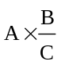
where,
A = the net adjustment in the tax revenue for the board determined under clause 42 (c),
B = the net recognized expenditure for 1996 for the board determined under clause 42 (e), and
C = the net expenditure for 1996 for the board determined under clause 42 (d),
shall,
(a) where the calculation results in a positive amount, be added to the grants payable to the board; and
(b) where the calculation results in a negative amount, be deducted from the grants payable to the board. O. Reg. 78/97, s. 43.
assistance in respect of debentures
44. A board shall be paid a grant equal to the sum of,
(a) the portion acceptable to the Minister in respect of expenditure for debt charges on debentures issued by the board, or on its behalf, on a secondary school building that is being used jointly by a public board and a Roman Catholic school board; and
(b) the lesser of the amounts determined by the following calculations:
(i) A – (0.000097 × E.A.), or zero if such calculation is negative, and
(ii) 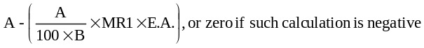
where,
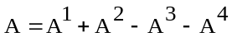
A¹ = the portion acceptable to the Minister in respect of expenditure for debt charges on debentures issued by the board, or on its behalf, prior to April 1, 1980 that is not approved by the Minister for inclusion in R.E.E.,
A² = in the case of a Roman Catholic school board, the portion acceptable to the Minister in respect of payments made to a public board or a diocese in respect of debt charges on debentures related to a lease or purchase of a school building,
A³ = the portion of the debt charges included in A1 that is in respect of debt charges described in clause (a),
A⁴ = in the case of a public board, the portion acceptable to the Minister in respect of payments received from a Roman Catholic school board in respect of debt charges on debentures related to a lease or purchase of a school building,
B = day school A.D.E. of resident-internal pupils of the board.
O. Reg. 78/97, s. 44.
special compensation for pooling
45. A public board set out in Column 1 of Table 1 shall be paid a grant in the amount set out opposite in Column 2 of Table 1 in respect of the assessment and tax adjustments effected by Ontario Regulations 123/92 and 124/92. O. Reg. 78/97, s. 45.
grant for an isolate board
46. (1) For the purpose of section 47,
(a) “local taxation for grant purposes” means the sum of,
(i) the payment in lieu of taxes receivable by the isolate board,
(ii) the portion of tax levied under subsections 159 (12) and (13) of the Municipal Act that is allocated or paid to the isolate board, and
(iii) the sum of the products obtained by multiplying, for each municipality or locality within the area of jurisdiction of the isolate board,
a. the quotient obtained by dividing the product of 100 and the assessment by the A.E.F. for grant purposes, and
b. 0.006995 for elementary school purposes, or 0.005478 for secondary school purposes,
except where the municipality or locality is within the area of jurisdiction of a divisional board of education or a district or county combined separate school board, in which case the amount determined for the municipality or locality for the purpose of this subclause shall be the product of the assessment for the municipality or locality, 0.001 and the mill rate levied on residential property in the municipality or locality for elementary or secondary school purposes, as the case may be, in respect of such divisional board or district or county separate school board;
(b) “net expenditure” means the positive or negative sum obtained by subtracting from the isolate board’s expenditure that is acceptable to the Minister an amount that is acceptable to the Minister as revenue of the isolate board from grants payable under sections 32 to 35, inclusive, and from sources other than local taxation and legislative grants.
(2) Where an isolate board operates a junior kindergarten on the last school day of October, 1997, the amount set out in sub-subclause (1) (a) (iii) b for elementary school purposes shall be multiplied by 1.05.
(3) Where an isolate board operates a junior kindergarten on the last school day of October, 1997 and the jurisdiction of the isolate board is within the area of jurisdiction of a divisional board of education or a district or county combined separate school board that, on the last school day of October, 1997, does not operate a junior kindergarten, the amounts determined for the municipalities or localities for the purpose of sub-subclause (1) (a) (iii) b shall be multiplied by 1.05. O. Reg. 78/97, s. 46.
47. (1) Where, in respect of an isolate board except an isolate board referred to in subsection (3), the net expenditure exceeds the local taxation for grant purposes, a grant equal to such excess shall be paid to the isolate board.
(2) Where, in respect of an isolate board except an isolate board referred to in subsection (3), the local taxation for grant purposes exceeds the net expenditure, a portion of the legislative grants paid to the isolate board in previous years equal to such excess shall be paid by the isolate board to the Province of Ontario.
(3) Where, in the year 1997,
(a) a district school area board is elected for a new district school area, a secondary school board is formed for a new secondary school district or a separate school board is elected for a new separate school zone;
(b) information respecting the totals of the commercial assessment and of the residential and farm assessment rateable for public school purposes in the district school area, for secondary school purposes in the secondary school district or for separate school purposes in the separate school zone, as the case may be, is not available prior to July 1; and
(c) such isolate board commences to operate a school on or after July 1 or enters into an agreement with another board for the education in such year of its resident pupils,
the isolate board shall be paid a grant equal to its net expenditure. O. Reg. 78/97, s. 47.
grant for a board on tax exempt land
48. For the purposes of section 49, “cost of operating” means,
(a) the current expenditure that is acceptable to the Minister for grant purposes excluding expenditure for debt charges, capital appurtenances, restoration of destroyed and damaged capital appurtenances, capital element included in rent, provision for a reserve for working funds, provisions for reserve funds and P.A.C. for resident-external pupils,
less the sum of,
(b) current revenue from sources other than from,
(i) legislative grants,
(ii) the organization for which the board was established, and
(iii) refunds of expenditure, no part of which is eligible for grant; and
(c) the excess of current expenditure for,
(i) transportation of pupils, and
(ii) board, lodging and weekly transportation of pupils,
over, in each case, the amount approved by the Minister for such purpose. O. Reg. 78/97, s. 48.
49. A board that is appointed under section 68 of the Act and that operates a school in a sanatorium, a hospital, a crippled children’s treatment centre or a centre for the treatment of cerebral palsy shall be paid a grant of,
(a) 80 per cent of the salaries of teachers, temporary teachers and teacher assistants for the current year;
(b) 80 per cent of the excess of,
(i) expenditure for the current year approved by the Minister for grant purposes for transportation of pupils, and board, lodging and weekly transportation of pupils,
over,
(ii) the general legislative grants payable under section 35; and
(c) 50 per cent of the excess of,
(i) the sum of the cost of operating for the current year and the revenue for the current year referred to in clause 48 (b),
over,
(ii) expenditure for the current year for,
a. salaries of teachers, temporary teachers and teacher assistants,
b. transportation of pupils, and
c. board, lodging and weekly transportation of pupils. O. Reg. 78/97, s. 49.
Category 4 — Capital Project Grant
capital project grant
50. (1) A board shall be paid a grant in respect of each project of the board for the acquisition of capital appurtenances that is approved by the Minister for capital grant financing equal to the product of,
(a) the lesser of the project cost approved by the Minister for grant purposes and the actual expenditure of the board for the project; and
(b) the rate mentioned in subsection (2) or (3).
(2) The rate for a project for which final approval was obtained by a board in 1997 is the appropriate rate set out in Column 2, 3 or 4 of Table 5 opposite the name of the board in Column 1 of that table.
(3) The rate for a project other than a project referred to in subsection (2) is the rate that was actually approved for the project at the time of final approval of the project. O. Reg. 78/97, s. 50.
51. (1) A board shall be paid a grant under this section if the amount calculated as follows is negative:
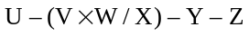
where,
U = the amount calculated for the board as the excess described as B in the definition of “maximum recognized day school O.E.” in section 1,
V = the amount calculated for the board as
for the purposes of the definition of “maximum recognized day school O.E.” in section 1,
W = the grant for recognized ordinary expenditure, as calculated for the board under section 8,
X = the R.O.E. for the board,
except that where (V × W/X) is a negative amount, the amount shall be deemed to be zero,
Y = the total payments made by the board to parents and guardians under the Fairness for Parents and Employees Act (Teachers’ Withdrawal of Services), 1997, and
Z = the product of the administration fee of $3.00 and the number of claims under the Fairness for Parents and Employees Act (Teachers’ Withdrawal of Services), 1997 for which payment has been sent to the parent or guardian on or before March 6, 1998 or for which payment has been received by the parent or guardian on or before March 6, 1998.
(2) The amount of the grant payable to the board under this section is the amount by which the amount calculated under subsection (1) is less than zero.
(3) For the purposes of calculating the values of U and V as required by subsection (1), the excess described as B in the definition of “maximum recognized day school O.E.” in section 1 shall be deemed to be zero in respect of a strike or lock-out that occurred before the adoption of the board’s estimates for 1997. O. Reg. 245/98, s. 4.
TABLE 1
SPECIAL COMPENSATION FOR POOLING
Insert regs\graphics\1997\78\078001au.tif
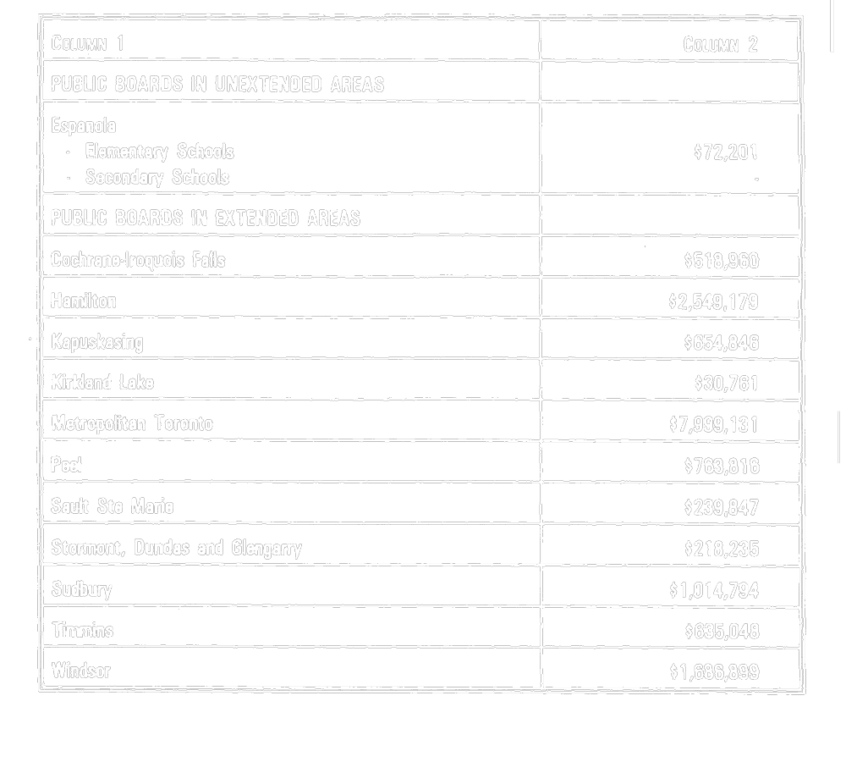
O. Reg. 78/97, Table 1.
TABLE 2
1997 selected grants ($’s per pupil)
Insert regs\graphics\1997\78\078002au.tif
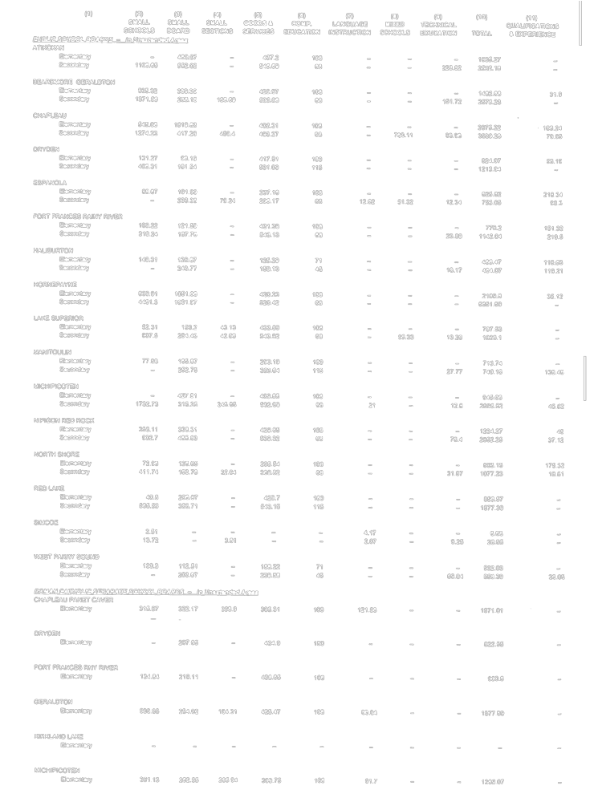
Insert regs\graphics\1997\78\078002bu.tif
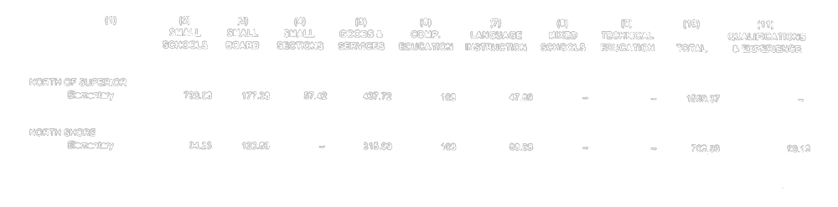
Insert regs\graphics\1997\78\078002cu.tif
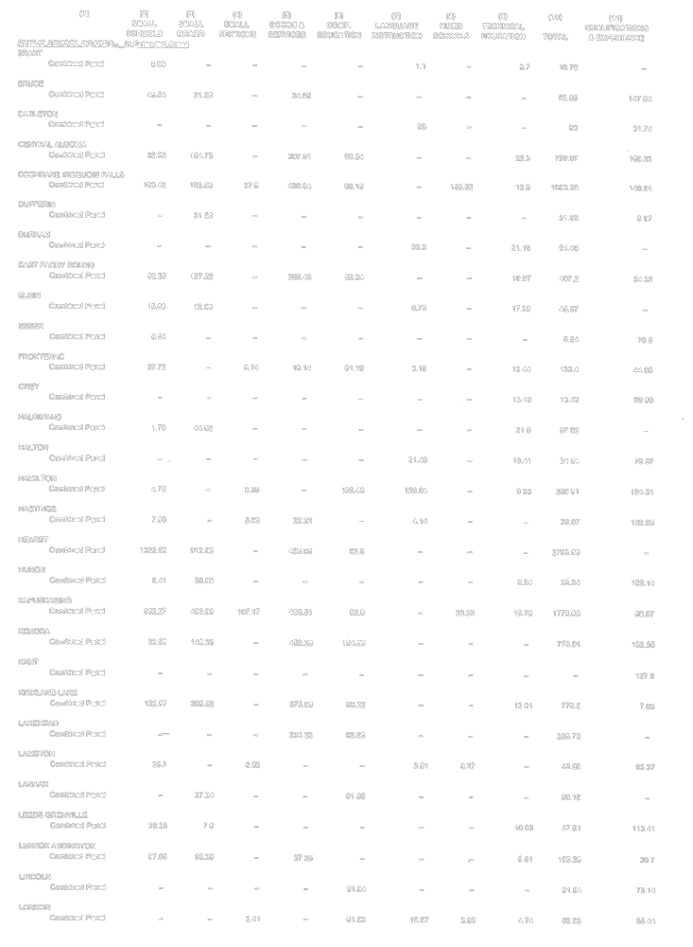
Insert regs\graphics\1997\78\078002du.tif
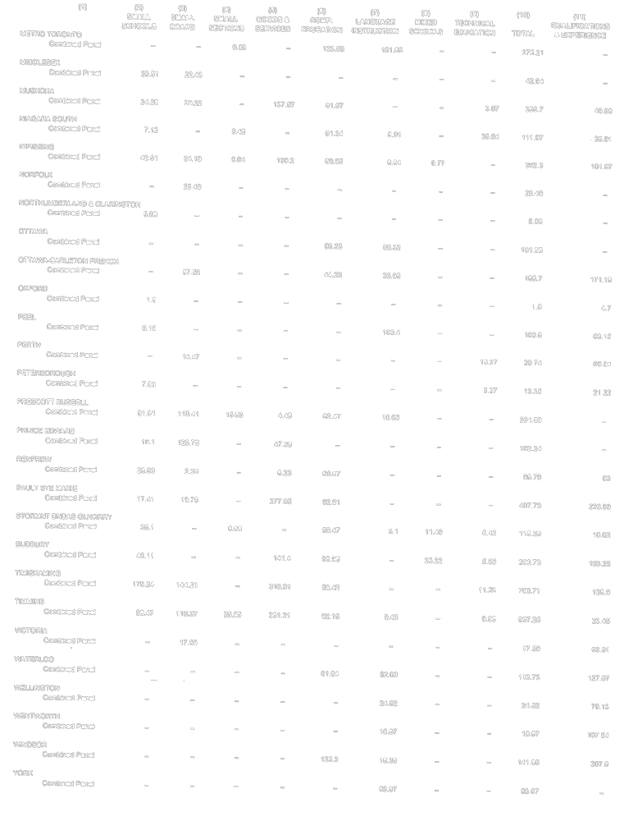
Insert regs\graphics\1997\78\078002eu.tif
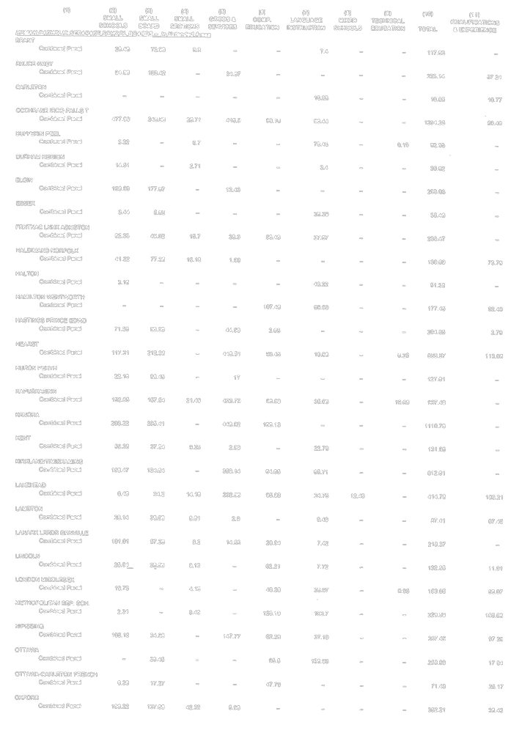
Insert regs\graphics\1997\78\078002fu.tif
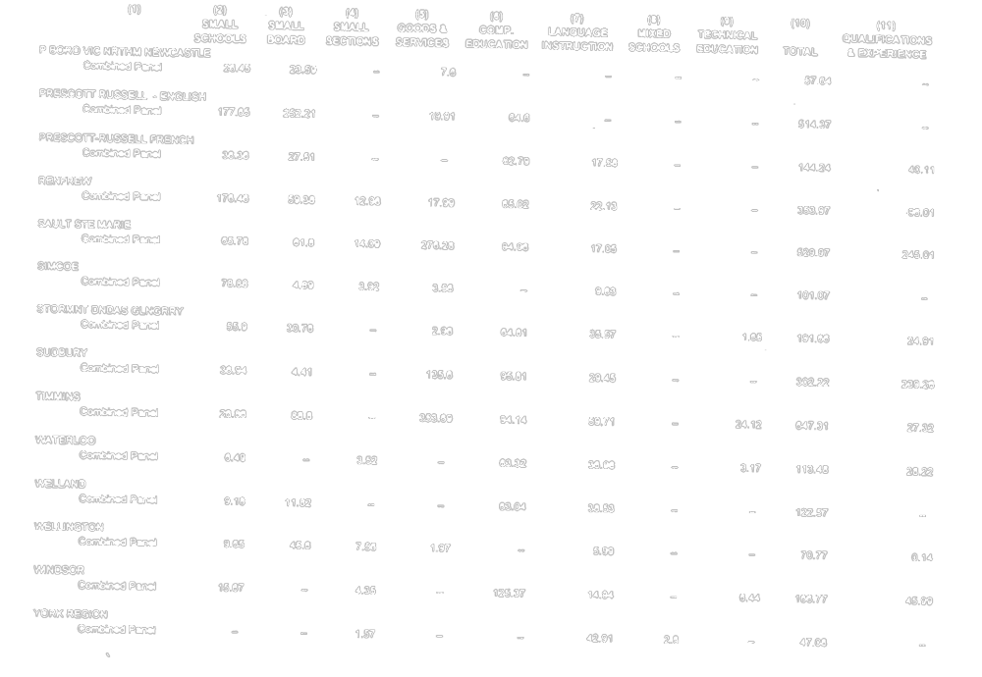
O. Reg. 78/97, Table 2.
TABLE 3
transportation
Insert regs\graphics\1997\78\078003au.tif
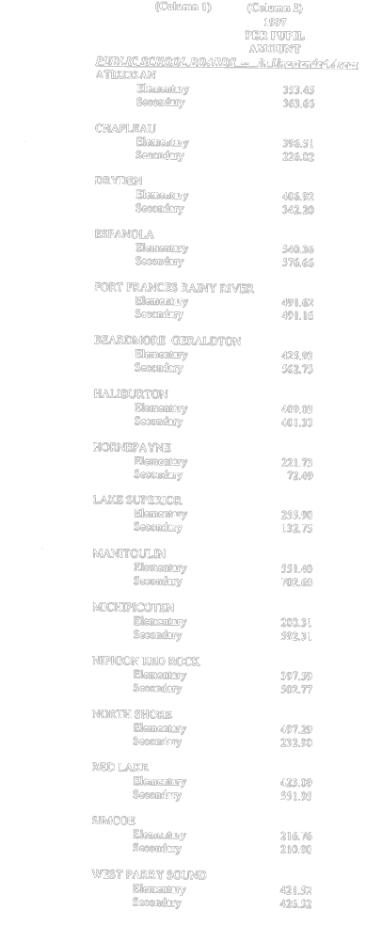
Insert regs\graphics\1997\78\078003bu.tif
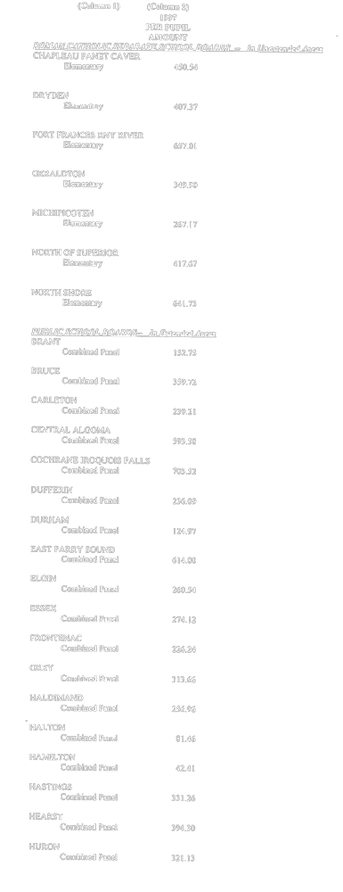
Insert regs\graphics\1997\78\078003cu.tif
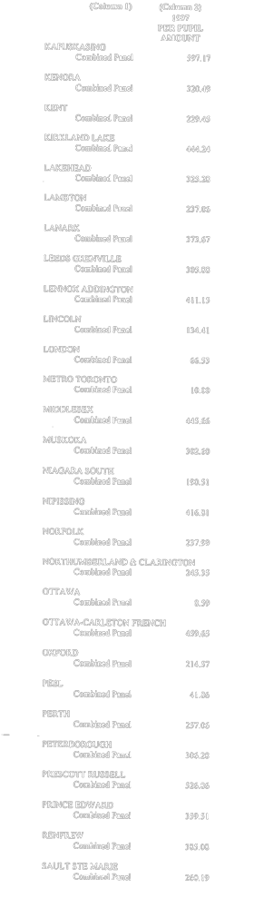
Insert regs\graphics\1997\78\078003du.tif
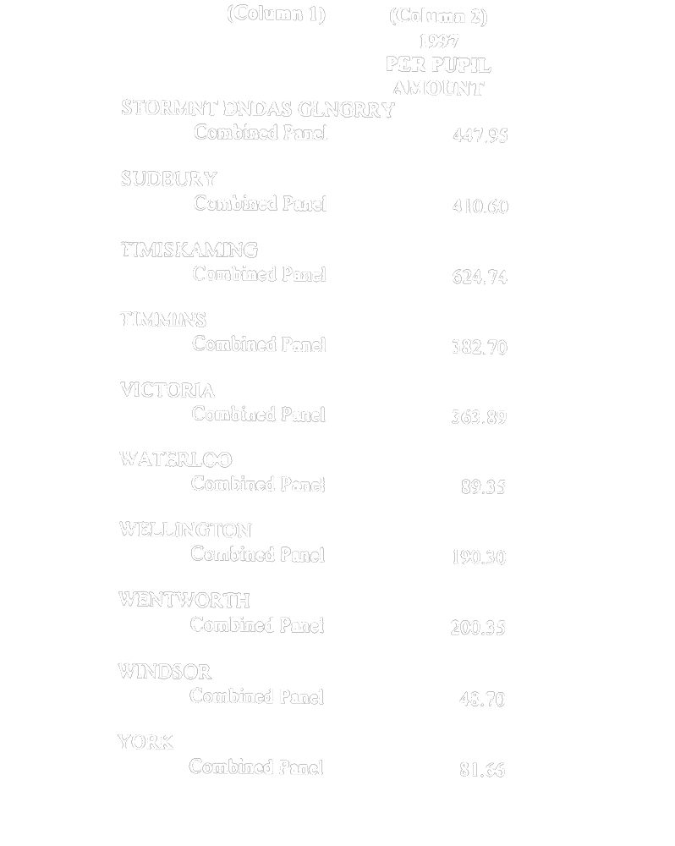
Insert regs\graphics\1997\78\078003eu.tif
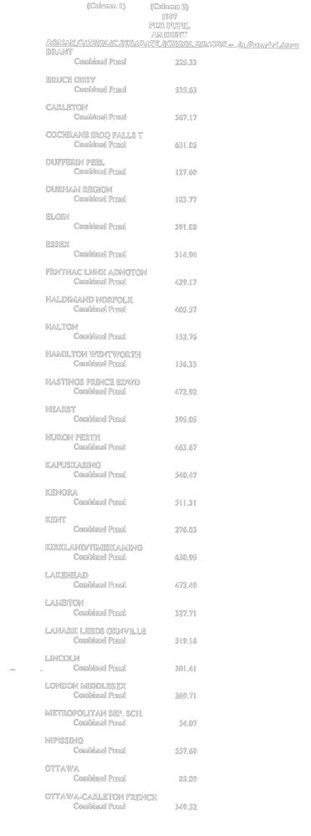
Insert regs\graphics\1997\78\078003fu.tif
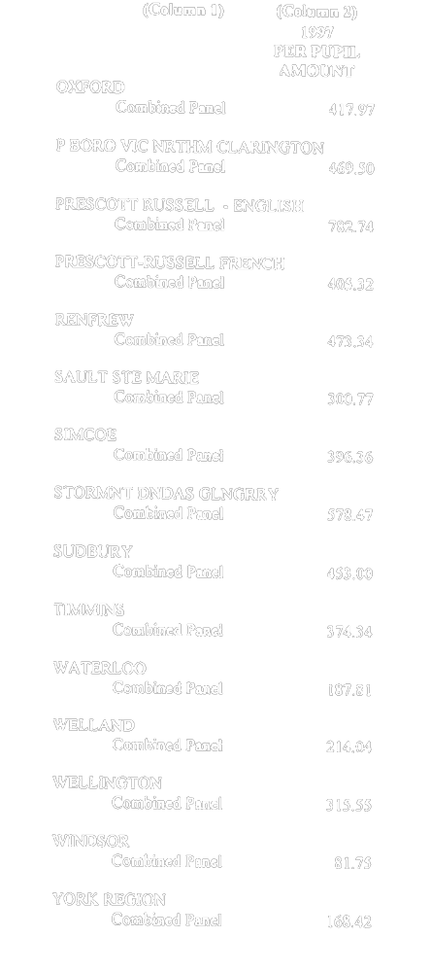
O. Reg. 78/97, Table 3.
TABLE 4
SPECIAL ASSISTANCE FOR EN BLOC TRANSFER
Insert regs\graphics\1997\78\078004au.tif
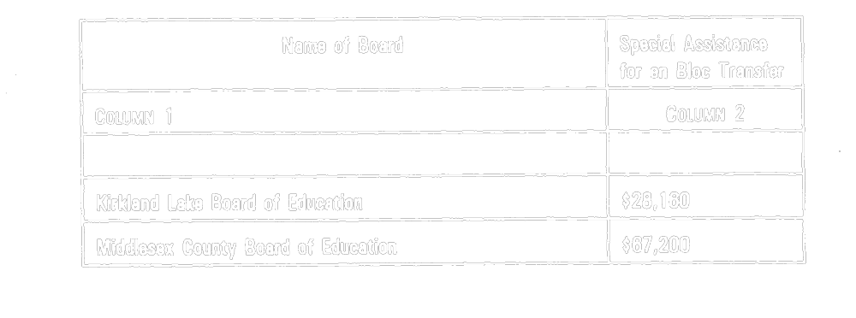
O. Reg. 78/97, Table 4.
TABLE 5
Insert regs\graphics\1997\78\078005au.tif
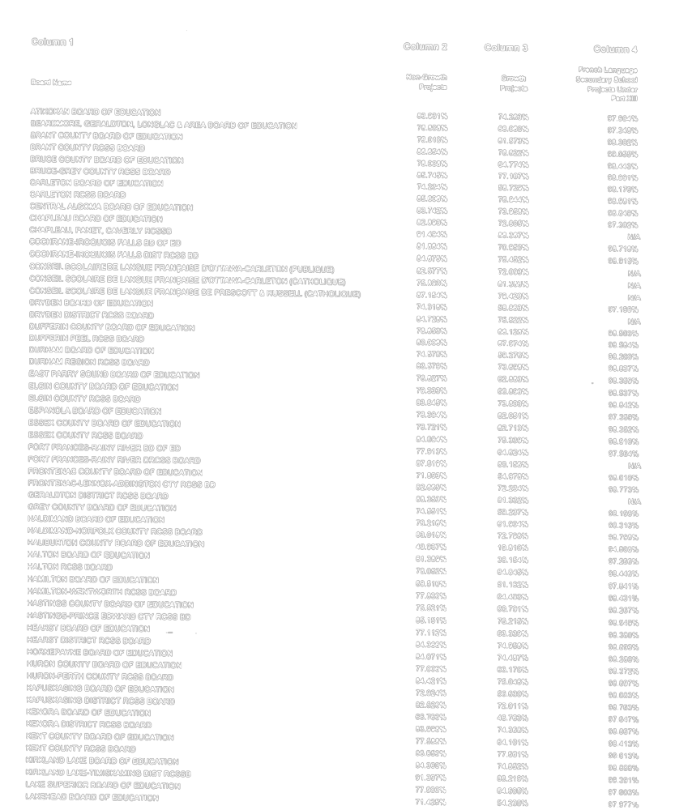
Insert regs\graphics\1997\78\078005bu.tif
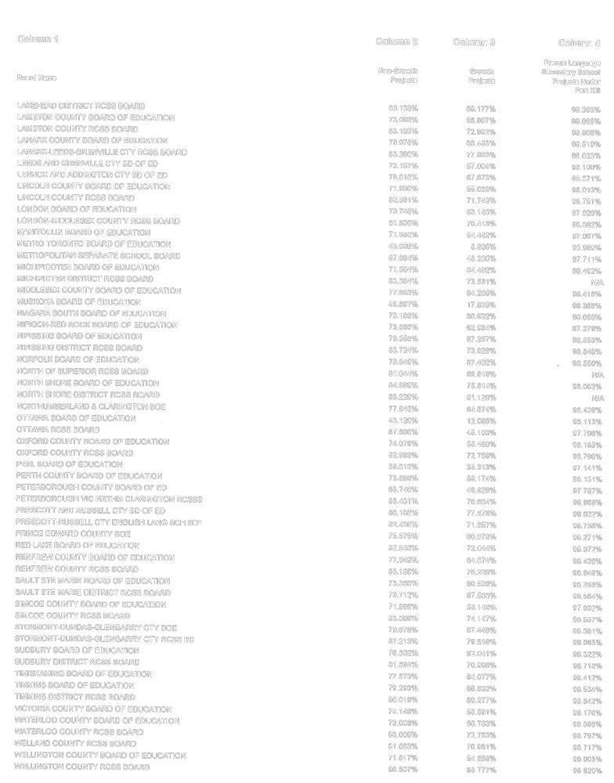
Insert regs\graphics\1997\78\078005cu.tif
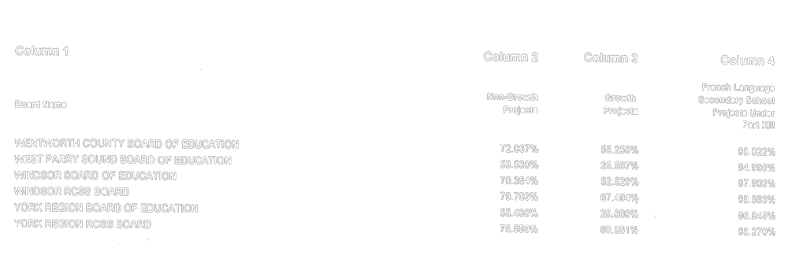
O. Reg. 78/97, Table 5.

Back to top

