Courts of Justice Act
ONTARIO REGULATION 114/99
Amended to O. Reg. 89/04
FAMILY LAW RULES
Historical version for the period December 31, 2004 to March 9, 2006.
Disclaimer: The HTML version of this consolidation is not an official copy of the law because some portion of it may not be fully legible. The Word version remains an official copy of the law.
This is the English version of a bilingual regulation.
CONTENTS
1. | General
2. | Interpretation
3. | Time
4. | Representation
5. | Where a case starts and is to be heard
6. | Service of documents
7. | Parties
8. | Starting a case
8.1 | Mandatory information program in the Superior Court of Justice in Toronto
9. | Continuing record
10. | Answering a case
11. | Amending an application, answer or reply
12. | Withdrawing, combining or splitting cases
13. | Financial statements
14. | Motions for temporary orders
15. | Motions to change a final order or agreement
16. | Summary judgment
17. | Conferences
18. | Offers to settle
19. | Document disclosure
20. | Questioning a witness and disclosure
21. | Report of Children’s Lawyer
22. | Admission of facts
23. | Evidence and trial
24. | Costs
25. | Orders
26. | Enforcement of orders
27. | Requiring financial information
28. | Seizure and sale
29. | Garnishment
30. | Default hearing
31. | Contempt of court
32. | Bonds, recognizances and warrants
33. | Child protection
34. | Adoption
35. | Change of name
36. | Divorce
37. | Interjurisdictional Support Orders Act, 2002
37.1 | Provisional Orders and Confirmation of Provisional Orders ⎯ Divorce Act, Family Law Act
38. | Appeals
39. | Case management in Family Court of Superior Court of Justice
40. | Case management in Ontario Court of Justice
41. | Case management in the Superior Court of Justice (other than the family court of the Superior Court of Justice)
RULE 1: GENERAL
SHORT TITLE
1. (1) These rules may be cited as the Family Law Rules. O. Reg. 114/99, r. 1 (1).
CASES AND COURTS TO WHICH RULES APPLY
(2) These rules apply to all family law cases in the Family Court of the Superior Court of Justice, in the Superior Court of Justice and in the Ontario Court of Justice,
(a) under,
(i) the Change of Name Act,
(ii) Parts III, VI and VII of the Child and Family Services Act,
(iii) the Children’s Law Reform Act, except sections 59 and 60,
(iv) the Divorce Act (Canada),
(v) the Family Law Act, except Part V,
(vi) the Family Responsibility and Support Arrears Enforcement Act, 1996,
(vii) sections 6 and 9 of the Marriage Act, and
(viii) the Interjurisdictional Support Orders Act, 2002;
(b) for the interpretation, enforcement or variation of a marriage contract, cohabitation agreement, separation agreement or paternity agreement;
(c) for a constructive or resulting trust or a monetary award as compensation for unjust enrichment between persons who have cohabited; and
(d) for annulment of a marriage or a declaration of validity or invalidity of a marriage. O. Reg. 441/99, s. 1 (2); O. Reg. 56/03, s. 1; O. Reg. 89/04, s. 1 (1).
(2.1) Revoked: O. Reg. 89/04, s. 1 (2).
CASE MANAGEMENT IN FAMILY COURT OF SUPERIOR COURT OF JUSTICE
(3) Despite subrule (2), rule 39 (case management in the Family Court of the Superior Court of Justice) applies only to cases in the Family Court of the Superior Court of Justice, which has jurisdiction in the following municipalities:
Regional Municipality of Durham
County of Frontenac
County of Haliburton
City of Hamilton
County of Lanark
United Counties of Leeds and Grenville
County of Lennox and Addington
County of Middlesex
Territorial District of Muskoka
The part of The Regional Municipality of Niagara that was the County of Lincoln as it existed on December 31, 1969
County of Northumberland
City of Ottawa
County of Peterborough
United Counties of Prescott and Russell
County of Simcoe
United Counties of Stormont, Dundas and Glengarry
City of Kawartha Lakes
Regional Municipality of York.
O. Reg. 441/99, s. 1 (2); O. Reg. 202/01, s. 1.
CASE MANAGEMENT IN ONTARIO COURT OF JUSTICE
(4) Despite subrule (2), rule 40 (case management in the Ontario Court of Justice) applies only to cases in the Ontario Court of Justice. O. Reg. 114/99, r. 1 (4).
CASE MANAGEMENT IN THE SUPERIOR COURT OF JUSTICE
(4.1) Despite subrule (2), rule 41 (case management in the Superior Court of Justice, other than the Family Court of the Superior Court of Justice) applies only to cases in the Superior Court of Justice that are not in the Family Court of the Superior Court of Justice. O. Reg. 89/04, s. 1 (3).
FAMILY LAW CASE COMBINED WITH OTHER MATTER
(5) If a case in the court combines a family law case to which these rules apply with another matter to which these rules would not otherwise apply, the parties may agree or the court on motion may order that these rules apply to the combined case or part of it. O. Reg. 114/99, r. 1 (5).
CONDITIONS AND DIRECTIONS
(6) When making an order, the court may impose conditions and give directions as appropriate. O. Reg. 114/99, r. 1 (6).
MATTERS NOT COVERED IN RULES
(7) If these rules do not cover a matter adequately, the court may give directions, and the practice shall be decided by analogy to these rules, by reference to the Courts of Justice Act and the Act governing the case and, if the court considers it appropriate, by reference to the Rules of Civil Procedure. O. Reg. 114/99, r. 1 (7).
FAILURE TO FOLLOW RULES OR OBEY ORDER
(8) The court may deal with a failure to follow these rules, or a failure to obey an order in the case or a related case, by making any order that it considers necessary for a just determination of the matter, on any conditions that the court considers appropriate, including,
(a) an order for costs;
(b) an order dismissing a claim made by a party who has wilfully failed to follow the rules or obey the order. O. Reg. 114/99, r. 1 (8).
USE OF FORMS
(9) The forms authorized by these rules and set out in the Appendix of Forms shall be used where applicable and may be adjusted as needed to fit the situation. O. Reg. 114/99, r. 1 (9).
FORMAT OF WRITTEN DOCUMENTS
(10) Every written document in a case,
(a) shall be legibly typed or printed;
(b) shall be on white paper, or on white or nearly white paper with recycled paper content; and
(c) may appear on one or both sides of the page. O. Reg. 114/99, r. 1 (10).
PRACTICE DIRECTIONS, ETC.
(11) A practice direction, notice, memorandum or guide for the conduct of cases in any area shall be,
(a) approved in advance by the Chief Justice or Chief Judge of the court;
(b) filed with the secretary of the Family Rules Committee; and
(c) published in the Ontario Reports. O. Reg. 114/99, r. 1 (11).
OLD PRACTICE DIRECTIONS, ETC.
(12) Practice directions, notices, memoranda and guides that were issued before these rules take effect no longer apply. O. Reg. 114/99, r. 1 (12).
TRANSITIONAL PROVISION
(13) If a case was started in the Superior Court of Justice, other than in the Family Court of the Superior Court of Justice, before July 1, 2004, the following applies:
1. The case or a step in the case shall be carried on under these rules on or after July 1, 2004.
2. If the case was not governed by the Family Case Management Rules for the Superior Court of Justice in Toronto or by the Essex Family Case Management Rules before July 1, 2004 and a step in the case is taken on or after that date, the timetable set out in subrule 41 (5) and subrules 41 (6), (7) and (8) apply as if the case started on the date on which the step was taken.
3. If the case was governed by the Family Case Management Rules for the Superior Court of Justice in Toronto before July 1, 2004, the timetable established for the case when it was started applies to the case on or after July 1, 2004.
4. If the case was governed by the Essex Family Case Management Rules before July 1, 2004 and a family consent timetable was made by the court before that date, the family consent timetable continues to apply to the case on or after July 1, 2004.
5. If the case was governed by the Essex Family Case Management Rules before July 1, 2004 but no family consent timetable was made by the court before that date,
i. the case management order expires on July 1, 2004, and
ii. if a step in the case is taken on or after July 1, 2004, the timetable set out in subrule 41 (5) and subrules 41 (6), (7) and (8) apply to the case as if the case started on the date on which the step was taken. O. Reg. 89/04, s. 1 (4).
TRANSITION: OLD FORMS
(14) For cases started in the Superior Court of Justice, other than the Family Court of the Superior Court of Justice, before July 1, 2004, a form in use under the rules that applied before July 1, 2004 may continue to be used, if it contains substantially the same information as the form required by these rules, until January 1, 2005. O. Reg. 89/04, s. 1 (5).
RULE 2: INTERPRETATION
DEFINITIONS
2. (1) In these rules,
“address” means a person’s street or municipal address, mailing address, telephone number, fax number and electronic mail address; (“adresse”)
“appellant” means a person who starts an appeal; (“appelant”)
“applicant” means a person who starts an application; (“requérant”)
“application” means, as the context requires, the document that starts a case or the procedure by which new cases are brought to the court for a final order or provisional order; (“requête”)
“bond” includes a recognizance, and expressions that refer to the posting of a bond include the act of entering into a recognizance; (“cautionnement”)
“case” means an application or any other method allowed in law for bringing a matter to the court for a final order or provisional order, and includes all motions, enforcements and appeals; (“cause”)
“change”, when used to refer to an order or agreement, means to vary, suspend or discharge, or a variation, suspension or discharge (depending on whether the word is used as a verb or as a noun); (“modifier”, “modification”)
“child” means a child as defined in the Act governing the case or, if not defined in that Act, a person under the age of 18 years, and in a case under the Divorce Act (Canada) includes a “child of the marriage” within the meaning of that Act; (“enfant”)
“child protection case” means a case under Part III of the Child and Family Services Act; (“cause portant sur la protection d’un enfant”)
“clerk” means a person who has the authority of a clerk or a registrar of the court; (“greffier”)
“contempt motion” means a motion for a contempt order; (“motion pour outrage”)
“contempt order” means an order finding a person in contempt of court; (“ordonnance pour outrage”)
“continuing record” means the record containing all the written documents in a case that are filed with the court, as continuously updated as required by these rules, but does not include a trial record; (“dossier continu”)
“corporation” French version only.
“court” means the court in which a case is being heard; (“tribunal”)
“default hearing” means a hearing under section 41 of the Family Responsibility and Support Arrears Enforcement Act, 1996 in which a payor is required to come to court to explain why payment has not been made as required by a support order; (“audience sur le défaut”)
“Director of the Family Responsibility Office” means the Director of the Family Responsibility Office under the Family Responsibility and Support Arrears Enforcement Act, 1996, and “Director” has the same meaning, unless the context requires otherwise; (“directeur du Bureau des obligations familiales”, “directeur”)
“document” means information, sound or images recorded by any method; (“document”)
“enforcement” means the use of one or more remedies mentioned in rule 26 (enforcement of orders) to enforce an order; (“exécution”)
“file” means to file with proof of service in the court office in the municipality,
(a) where the case or enforcement is started, or
(b) to which the case or enforcement is transferred; (“déposer”)
“final order” means an order, other than a temporary order, that decides a claim in an application, including,
(a) an order made on motion that changes a final order,
(b) a judgment, and
(c) an order that decides a party’s rights, in an issue between the parties or between a party and a non-party; (“ordonnance définitive”)
“government agency” means the Crown, a Crown agency, a municipal government or agency, a children’s aid society or any other public body; (“organisme gouvernemental”)
“income source” has the same meaning as in the Family Responsibility and Support Arrears Enforcement Act, 1996; (“source de revenu”)
“lawyer” means a lawyer licensed to practise in Ontario; (“avocat”)
“legal aid rate” means the rate payable by the Ontario Legal Aid Plan on an account submitted by a lawyer for copying in the lawyer’s office; (“tarif de l’aide juridique”)
“mail”, when used as a noun, means ordinary or regular mail, and when used as a verb means to send by ordinary or regular mail; (“poste”)
“municipality” means a county, district, district municipality, regional municipality, the City of Toronto or a municipal corporation formed from the amalgamation of all the municipalities of a county, district, district municipality or regional municipality, and includes,
(a) an Indian reserve within the territorial area of a municipality, and
(b) the part of The Regional Municipality of Niagara that was the County of Lincoln as it existed on December 31, 1969; (“municipalité”)
“on motion” means on motion of a party or a person having an interest in the case; (“sur motion”)
“payment order” means a temporary or final order, but not a provisional order, requiring a person to pay money to another person, including,
(a) an order to pay an amount under Part I or II of the Family Law Act or the corresponding provisions of a predecessor Act,
(b) a support order,
(c) a support deduction order,
(d) an order under section 60 or subsection 154 (2) of the Child and Family Services Act, or under the corresponding provision of a predecessor Act,
(e) a payment order made under rules 26 to 32 (enforcement measures) or under section 41 of the Family Responsibility and Support Arrears Enforcement Act, 1996,
(f) a fine for contempt of court,
(g) an order of forfeiture of a bond or recognizance,
(h) an order requiring a party to pay the fees and expenses of,
(i) an assessor, mediator or other expert named by the court, or
(ii) a person conducting a blood test to help determine a child’s parentage, and
(i) the costs and disbursements in a case; (“ordonnance de paiement”)
“payor” means a person required to pay money under an order or agreement, and includes the estate trustee of a payor who died; (“payeur”)
“periodic payment” means an amount payable at regular intervals and includes an amount payable in instalments; (“paiement périodique”)
“property claim” means a claim,
(a) under Part I of the Family Law Act,
(b) for a constructive or resulting trust, or
(c) for a monetary award as compensation for unjust enrichment; (“demande portant sur des biens”)
“provisional order” means an order that is not effective until confirmed by a court; (“ordonnance conditionnelle”)
“recipient” means a person entitled to receive money or costs under a payment order or agreement, including,
(a) a guardian or person with custody of a child who is entitled to money for the child’s benefit under an order,
(b) in the case of a support order made under the Family Law Act, an agency referred to in subsection 33 (3) of that Act,
(c) in the case of a support order made under the Divorce Act (Canada), an agency referred to in subsection 20.1 (1) of that Act,
(d) a children’s aid society entitled to money under an order made under section 60 or subsection 154 (2) of the Child and Family Services Act, or the corresponding provision in a predecessor Act,
(e) an assessor, mediator or other expert entitled to fees and expenses from the party named in the order, and
(f) the estate trustee of a person who was entitled to money under an order at the time of his or her death; (“bénéficiaire”)
“Registrar General” means the Registrar General under the Vital Statistics Act; (“registraire général de l’état civil”)
“respondent” means a person against whom a claim is made in an application, answer or appeal; (“intimé”)
“special party” means a party who is a child or who is or appears to be mentally incapable for the purposes of the Substitute Decisions Act, 1992 in respect of an issue in the case and who, as a result, requires legal representation, but does not include a child in a custody, access, child protection, adoption or child support case; (“partie spéciale”)
“support deduction order” means a support deduction order as defined in section 1 of the Family Responsibility and Support Arrears Enforcement Act, 1996; (“ordonnance de retenue des aliments”)
“support order” means an order described in subsection 34 (1) of the Family Law Act or a support order as defined in subsection 2 (1) of the Divorce Act (Canada) or in section 1 of the Family Responsibility and Support Arrears Enforcement Act, 1996; (“ordonnance alimentaire”)
“temporary order” means an order that says it is effective only for a limited time, and includes an interim order; (“ordonnance temporaire”)
“transcript” includes an electronic recording; (“transcription”)
“trial” includes a hearing; (“procès”)
“uncontested trial” means a trial at which only the party making the claim provides evidence and submissions. (“procès non contesté”) O. Reg. 114/99, r. 2 (1); O. Reg. 544/99, s. 2.
PRIMARY OBJECTIVE
(2) The primary objective of these rules is to enable the court to deal with cases justly. O. Reg. 114/99, r. 2 (2).
DEALING WITH CASES JUSTLY
(3) Dealing with a case justly includes,
(a) ensuring that the procedure is fair to all parties;
(b) saving expense and time;
(c) dealing with the case in ways that are appropriate to its importance and complexity; and
(d) giving appropriate court resources to the case while taking account of the need to give resources to other cases. O. Reg. 114/99, r. 2 (3).
DUTY TO PROMOTE PRIMARY OBJECTIVE
(4) The court is required to apply these rules to promote the primary objective, and parties and their lawyers are required to help the court to promote the primary objective. O. Reg. 114/99, r. 2 (4).
DUTY TO MANAGE CASES
(5) The court shall promote the primary objective by active management of cases, which includes,
(a) at an early stage, identifying the issues, and separating and disposing of those that do not need full investigation and trial;
(b) encouraging and facilitating use of alternatives to the court process;
(c) helping the parties to settle all or part of the case;
(d) setting timetables or otherwise controlling the progress of the case;
(e) considering whether the likely benefits of taking a step justify the cost;
(f) dealing with as many aspects of the case as possible on the same occasion; and
(g) if appropriate, dealing with the case without parties and their lawyers needing to come to court, on the basis of written documents or by holding a telephone or video conference. O. Reg. 114/99, r. 2 (5).
RULE 3: TIME
COUNTING DAYS
3. (1) In these rules or an order, the number of days between two events is counted as follows:
1. The first day is the day after the first event.
2. The last day is the day of the second event. O. Reg. 114/99, r. 3 (1).
COUNTING DAYS — SHORT PERIODS
(2) If a rule or order provides a period of less than seven days for something to be done, Saturdays, Sundays and other days when all court offices are closed do not count as part of the period. O. Reg. 114/99, r. 3 (2).
DAY WHEN COURT OFFICES CLOSED
(3) If the last day of a period of time under these rules or an order falls on a day when court offices are closed, the period ends on the next day they are open. O. Reg. 114/99, r. 3 (3).
COUNTING DAYS — EXAMPLES
(4) The following are examples of how time is counted under these rules:
1. Notice of a motion must be served not later than four days before the motion date (see subrule 14 (11)). Saturday and Sunday are not counted, because the notice period is less than seven days (see subrule (2)). Service on the day set out in the left column below is in time for the motion to be heard on the day set out in the right column below.
Service on | Motion may be heard on the following
Monday | Friday
Tuesday | Monday
Wednesday | Tuesday
Thursday | Wednesday
Friday | Thursday
Saturday | Friday
Sunday | Friday

2. A respondent who is served with an application in Canada has 30 days to serve an answer (see subrule 10 (1)). A respondent who is served with an application on October 1 is in time if the answer is served on or before October 31. A respondent served on November 1 is in time if the answer is served on or before December 1.
3. If the last day for doing something under these rules or an order is New Year’s Day, January 1, which is a day when court offices are closed, the time expires on January 2. If January 2 is a Saturday, Sunday or other day when court offices are closed, the time expires on January 3. If January 3 is a day when court offices are closed, the time expires on January 4. O. Reg. 114/99, r. 3 (4); O. Reg. 544/99, s. 3 (1).
ORDER TO LENGTHEN OR SHORTEN TIME
(5) The court may make an order to lengthen or shorten any time set out in these rules or an order, except that it may lengthen a time set out in subrule 33 (1) (timetable for child protection cases) only if the best interests of the child require it. O. Reg. 114/99, r. 3 (5).
WRITTEN CONSENT TO CHANGE TIME
(6) The parties may, by consent in writing, change any time set out in these rules, except that they may not change a time set out in,
(a) clause 14 (11) (c) (confirmation of motion);
(b) subrules 17 (14) and (14.1) (confirmation of conference, late briefs);
(c) subrule 33 (1) (timetable for child protection cases);
(d) rule 39 (case management in Family Court of Superior Court of Justice); or
(e) rule 40 (case management in Ontario Court of Justice). O. Reg. 202/01, s. 2.
LATE DOCUMENTS REFUSED BY COURT OFFICE
(7) The staff at a court office shall refuse to accept a document that a person asks to file after,
(a) the time specified in these rules; or
(b) the later time specified in a consent under subrule (6), a statute that applies to the case, or a court order. O. Reg. 544/99, s. 3 (2).
RULE 4: REPRESENTATION
REPRESENTATION FOR A PARTY
4. (1) A party may,
(a) appear without a lawyer or other representative;
(b) be represented by a lawyer; or
(c) be represented by a person who is not a lawyer, but only if the court gives permission in advance. O. Reg. 114/99, r. 4 (1).
PRIVATE REPRESENTATION OF SPECIAL PARTY
(2) The court may authorize a person to represent a special party if the person is,
(a) appropriate for the task; and
(b) willing to act as representative. O. Reg. 114/99, r. 4 (2).
PUBLIC LAW OFFICER TO REPRESENT SPECIAL PARTY
(3) If there is no appropriate person willing to act as a special party’s representative, the court may authorize the Children’s Lawyer or the Public Guardian and Trustee to act as representative, but only with that official’s consent. O. Reg. 114/99, r. 4 (3).
SERVICE OF AUTHORIZATION TO REPRESENT
(4) An order under subrule (2) or (3) shall be served immediately, by the person who asked for the order or by any other person named by the court,
(a) on the representative; and
(b) on every party in the case. O. Reg. 114/99, r. 4 (4).
REPRESENTATION OF PARTY WHO DIES
(5) If a party dies after the start of a case, the court may make the estate trustee a party instead, on motion without notice. O. Reg. 114/99, r. 4 (5).
AUTHORIZING REPRESENTATIVE FOR PARTY WHO DIES
(6) If the party has no estate trustee, the court may authorize an appropriate person to act as representative, with that person’s consent, given in advance. O. Reg. 114/99, r. 4 (6).
LAWYER FOR CHILD
(7) In a case that involves a child who is not a party, the court may authorize a lawyer to represent the child, and then the child has the rights of a party, unless the court orders otherwise. O. Reg. 114/99, r. 4 (7).
CHILD’S RIGHTS SUBJECT TO STATUTE
(8) Subrule (7) is subject to section 38 (legal representation of child, protection hearing) and subsection 114 (6) (legal representation of child, secure treatment hearing) of the Child and Family Services Act. O. Reg. 114/99, r. 4 (8).
CHOICE OF LAWYER
(9) A party appearing without a lawyer may choose a lawyer by,
(a) serving on every other party and filing a notice of change in representation (Form 4) containing the lawyer’s consent to act; or
(b) having a lawyer come to court on the party’s behalf. O. Reg. 114/99, r. 4 (9).
CHANGE IN REPRESENTATION
(10) Except as subrule (10.1) provides, a party represented by a lawyer may, by serving on every other party and filing a notice of change in representation (Form 4),
(a) change lawyers; or
(b) appear without a lawyer. O. Reg. 91/03, s. 1.
EXCEPTION, CHILD PROTECTION CASE SCHEDULED FOR TRIAL
(10.1) In a child protection case that has been scheduled for trial or placed on a trial list, a party may act under clause (10) (b) only with the court’s permission, obtained in advance by motion made with notice. O. Reg. 91/03, s. 1.
NOTICE OF CHANGE IN REPRESENTATION
(11) A notice of change in representation shall,
(a) contain the party’s address for service, if the party wants to appear without a lawyer; or
(b) show the name and address of the new lawyer, if the party wants to change lawyers. O. Reg. 114/99, r. 4 (11).
LAWYER’S REMOVAL FROM THE CASE
(12) A lawyer may make a motion for an order to be removed from the case, with notice to the client and to,
(a) the Children’s Lawyer, if the client is a child;
(b) the Public Guardian and Trustee, if the client is or appears to be mentally incapable in respect of an issue in the case. O. Reg. 114/99, r. 4 (12).
NOTICE OF MOTION TO REMOVE LAWYER
(13) Notice of a motion to remove a lawyer shall also be served on the other parties to the case, but the evidence in support of the motion shall not be served on them, shall not be put into the continuing record and shall not be kept in the court file after the motion is heard. O. Reg. 114/99, r. 4 (13).
AFFIDAVIT IN SUPPORT OF MOTION TO REMOVE LAWYER
(14) The affidavit in support of the motion shall indicate what stage the case is at, the next event in the case and any scheduled dates. O. Reg. 114/99, r. 4 (14).
CONTENTS AND SERVICE OF ORDER REMOVING LAWYER
(15) The order removing the lawyer from the case shall,
(a) set out the client’s last known address for service; and
(b) be served on all other parties, served on the client by mail, fax or electronic mail at the client’s last known address and filed immediately. O. Reg. 114/99, r. 4 (15).
RULE 5: WHERE A CASE STARTS AND IS TO BE HEARD
WHERE CASE STARTS
5. (1) Subject to sections 21.8 and 21.11 of the Courts of Justice Act (territorial jurisdiction — Family Court), a case shall be started,
(a) in the municipality where a party resides;
(b) if the case deals with custody of or access to a child, in the municipality where the child ordinarily resides, except for cases described in,
(i) section 22 (jurisdiction of an Ontario court) of the Children’s Law Reform Act, and
(ii) subsection 48 (2) (place for child protection hearing) and subsection 150 (1) (place for adoption proceeding) of the Child and Family Services Act; or
(c) in a municipality chosen by all parties, but only with the court’s permission given in advance in that municipality. O. Reg. 114/99, r. 5 (1).
STARTING CASE — DANGER TO CHILD OR PARTY
(2) Subject to sections 21.8 and 21.11 of the Courts of Justice Act, if there is immediate danger that a child may be removed from Ontario or immediate danger to a child’s or party’s health or safety, a party may start a case in any municipality and a motion may be heard in that municipality, but the case shall be transferred to a municipality referred to in subrule (1) immediately after the motion is heard, unless the court orders otherwise. O. Reg. 114/99, r. 5 (2).
CLERK TO REFUSE DOCUMENTS IF CASE IN WRONG PLACE
(3) The clerk shall refuse to accept an application for filing unless,
(a) the case is started in the municipality where a party resides;
(b) the case deals with custody of or access to a child and is started in the municipality where the child ordinarily resides;
(c) the case is started in a municipality chosen by all parties and the order permitting the case to be started there is filed with the application; or
(d) the lawyer or party asking to file the application says in writing that the case is one that is permitted by clause (1) (b) or subrule (2) to be started in that municipality. O. Reg. 114/99, r. 5 (3).
PLACE FOR STEPS OTHER THAN ENFORCEMENT
(4) All steps in the case, other than enforcement, shall take place in the municipality where the case is started or transferred. O. Reg. 114/99, r. 5 (4).
PLACE FOR ENFORCEMENT — PAYMENT ORDERS
(5) All steps in enforcement of a payment order, including a motion to suspend a support deduction order, shall take place,
(a) in the municipality where the recipient resides;
(b) if the recipient does not reside in Ontario, in the municipality where the order is filed with the court for enforcement;
(c) if the person enforcing the order consents, in the municipality where the payor resides; or
(d) in a motion under section 26 (income source dispute) of the Family Responsibility and Support Arrears Enforcement Act, 1996, in the municipality where the income source resides. O. Reg. 114/99, r. 5 (5).
PLACE FOR ENFORCEMENT — OTHER ORDERS
(6) All steps in the enforcement of an order other than a payment order shall take place,
(a) if the order involves custody of or access to a child,
(i) in the municipality where the child ordinarily resides, or
(ii) if the child does not ordinarily reside in Ontario, in the municipality to which the child has the closest connection;
(b) if the order involves property, in the municipality where the person enforcing the order resides or the municipality where the property is located; or
(c) in a municipality chosen by all parties, but only with the court’s permission given in advance in that municipality. O. Reg. 114/99, r. 5 (6).
ALTERNATIVE PLACE FOR ENFORCEMENT — ORDER ENFORCED BY CONTEMPT MOTION
(7) An order, other than a payment order, that is being enforced by a contempt motion may also be enforced in the municipality in which the order was made. O. Reg. 114/99, r. 5 (7).
TRANSFER TO ANOTHER MUNICIPALITY
(8) If it is substantially more convenient to deal with a case or any step in the case in another municipality, the court may, on motion, order that the case or step be transferred there. O. Reg. 114/99, r. 5 (8).
CHANGE OF PLACE FOR CHILD PROTECTION CASE
(9) Notice of a motion under subsection 48 (3) of the Child and Family Services Act to transfer a case to a place within the jurisdiction of another children’s aid society shall be served on the parties and the other children’s aid society, with the evidence in support of the motion. O. Reg. 114/99, r. 5 (9).
RULE 6: SERVICE OF DOCUMENTS
METHODS OF SERVICE
6. (1) Service of a document under these rules may be carried out by regular service or by special service in accordance with this rule, unless an Act, rule or order provides otherwise. O. Reg. 114/99, r. 6 (1).
REGULAR SERVICE
(2) Regular service of a document on a person is carried out by,
(a) mailing a copy to the person’s lawyer or, if none, to the person;
(b) sending a copy by courier to the person’s lawyer or, if none, to the person;
(c) depositing a copy at a document exchange to which the person’s lawyer belongs;
(d) faxing a copy to the person’s lawyer or, if none, to the person; or
(e) carrying out special service. O. Reg. 114/99, r. 6 (2).
SPECIAL SERVICE
(3) Special service of a document on a person is carried out by,
(a) leaving a copy,
(i) with the person to be served,
(ii) if the person is or appears to be mentally incapable in respect of an issue in the case, with the person and with the guardian of the person’s property or, if none, with the Public Guardian and Trustee,
(iii) if the person is a child, with the child and with the child’s lawyer, if any,
(iv) if the person is a corporation, with an officer, director or agent of the corporation, or with a person at any place of business of the corporation who appears to be managing the place, or
(v) if the person is a children’s aid society, with an officer, director or employee of the society;
(b) leaving a copy with the person’s lawyer of record in the case, or with a lawyer who accepts service in writing on a copy of the document;
(c) mailing a copy to the person, together with an acknowledgment of service in the form of a prepaid return postcard (Form 6), all in an envelope that is addressed to the person and has the sender’s return address (but service under this clause is not valid unless the return postcard, signed by the person, is filed in the continuing record); or
(d) leaving a copy at the person’s place of residence, in an envelope addressed to the person, with anyone who appears to be an adult person resident at the same address and, on the same day or on the next, mailing another copy to the person at that address. O. Reg. 114/99, r. 6 (3).
SPECIAL SERVICE — DOCUMENTS THAT COULD LEAD TO IMPRISONMENT
(4) Special service of the following documents shall be carried out only by a method set out in subclause (3) (a), unless the court orders otherwise:
1. A notice of contempt motion.
2. A summons to witness.
3. A notice of motion or notice of default hearing in which the person to be served faces a possibility of imprisonment. O. Reg. 114/99, r. 6 (4).
REGULAR SERVICE AT ADDRESS ON LATEST DOCUMENT
(5) Regular service may be carried out at the address for service shown on the latest document filed by the person to be served. O. Reg. 114/99, r. 6 (5).
NOTICE OF ADDRESS CHANGE
(6) A party whose address for service changes shall immediately serve notice of the change on the other parties and file it. O. Reg. 114/99, r. 6 (6).
SERVICE OUTSIDE BUSINESS HOURS
(7) If a document is served by any method after 4 p.m. on a day when court offices are open or at any time on a day when they are not open, service is effective on the next day when they are open. O. Reg. 114/99, r. 6 (7).
HOURS OF FAX SERVICE
(8) Service of a document by fax may be carried out only before 4 p.m. on a day when court offices are open, unless the parties consent or the court orders otherwise. O. Reg. 114/99, r. 6 (8).
EFFECTIVE DATE, SERVICE BY MAIL
(9) Service of a document by mail is effective on the fifth day after it was mailed. O. Reg. 114/99, r. 6 (9).
EFFECTIVE DATE, SERVICE BY COURIER
(10) Service of a document by courier is effective on the day after the courier picks it up. O. Reg. 114/99, r. 6 (10).
EFFECTIVE DATE, SERVICE BY DOCUMENT EXCHANGE
(11) Service by deposit at a document exchange is effective only if the copy deposited and an additional copy of the document are date-stamped by the document exchange in the presence of the person depositing the copy, and then service is effective on the day after the date on the stamp. O. Reg. 114/99, r. 6 (11).
INFORMATION TO BE INCLUDED WITH DOCUMENT SERVED BY FAX
(12) A document that is served by fax shall show, on its first page,
(a) the sender’s name, address, telephone number and fax number;
(b) the name of the person or lawyer to be served;
(c) the date and time of the fax;
(d) the total number of pages faxed; and
(e) the name and telephone number of a person to contact in case of transmission difficulties. O. Reg. 114/99, r. 6 (12).
MAXIMUM LENGTH OF DOCUMENT THAT MAY BE FAXED
(13) Service of a document or documents relating to a single step in a case may be carried out by fax only if the total number of pages (including any cover page or back sheet) is not more than 16, unless the parties consent in advance or the court orders otherwise. O. Reg. 114/99, r. 6 (13).
DOCUMENTS THAT MAY NOT BE FAXED
(14) A trial record, appeal record, factum or book of authorities may not be served by fax at any time unless the person to be served consents in advance. O. Reg. 114/99, r. 6 (14).
SUBSTITUTED SERVICE
(15) The court may, on motion without notice, order that a document be served by substituted service, using a method chosen by the court, if the party making the motion,
(a) provides detailed evidence showing,
(i) what steps have been taken to locate the person to be served, and
(ii) if the person has been located, what steps have been taken to serve the document on that person; and
(b) shows that the method of service could reasonably be expected to bring the document to the person’s attention. O. Reg. 114/99, r. 6 (15).
SERVICE NOT REQUIRED
(16) The court may, on motion without notice, order that service is not required if,
(a) reasonable efforts to locate the person to be served have not been or would not be successful; and
(b) there is no method of substituted service that could reasonably be expected to bring the document to the person’s attention. O. Reg. 114/99, r. 6 (16).
SERVICE BY ADVERTISEMENT
(17) If the court orders service by advertisement, Form 6A shall be used. O. Reg. 114/99, r. 6 (17).
APPROVING IRREGULAR SERVICE
(18) When a document has been served by a method not allowed by these rules or by an order, the court may make an order approving the service if the document,
(a) came to the attention of the person to be served; or
(b) would have come to the person’s attention if the person had not been evading service. O. Reg. 114/99, r. 6 (18).
PROOF OF SERVICE
(19) Service of a document may be proved by,
(a) an acceptance or admission of service, written by the person to be served or the person’s lawyer;
(b) an affidavit of service (Form 6B);
(c) the return postcard mentioned in clause (3) (c); or
(d) the date stamp on a copy of the document served by deposit at a document exchange. O. Reg. 114/99, r. 6 (19).
RULE 7: PARTIES
WHO ARE PARTIES — CASE
7. (1) A person who makes a claim in a case or against whom a claim is made in a case is a party to the case. O. Reg. 114/99, r. 7 (1).
WHO ARE PARTIES — MOTION
(2) For purposes of a motion only, a person who is affected by a motion is also a party, but this does not apply to a child affected by a motion relating to custody, access, child protection, adoption or child support. O. Reg. 114/99, r. 7 (2).
PERSONS WHO MUST BE NAMED AS PARTIES
(3) A person starting a case shall name,
(a) as an applicant, every person who makes a claim;
(b) as a respondent,
(i) every person against whom a claim is made, and
(ii) every other person who should be a party to enable the court to decide all the issues in the case. O. Reg. 114/99, r. 7 (3).
PARTIES IN CASES INVOLVING CHILDREN
(4) In any of the following cases, every parent or other person who has care and control of the child involved, except a foster parent under the Child and Family Services Act, shall be named as a party, unless the court orders otherwise:
1. A case about custody of or access to a child.
2. A child protection case.
3. A secure treatment case (Part VI of the Child and Family Services Act). O. Reg. 114/99, r. 7 (4).
PARTY ADDED BY COURT ORDER
(5) The court may order that any person who should be a party shall be added as a party, and may give directions for service on that person. O. Reg. 114/99, r. 7 (5).
PERMANENT CASE NAME AND COURT FILE NUMBER
(6) The court file number given to a case and the description of the parties as applicants and respondents in the case shall remain the same on a motion to change an order, a status review application, an enforcement or an appeal, no matter who starts it, with the following exceptions:
1. In an enforcement of a payment order, the parties may be described instead as payors, recipients and garnishees.
2. In an appeal, the parties shall also be described as appellants and respondents.
3. When a case is transferred to another municipality, it may be given a new court file number. O. Reg. 114/99, r. 7 (6).
RULE 8: STARTING A CASE
FILING AN APPLICATION
8. (1) To start a case, a person shall file an application (Form 8, 8A, 8B, 8C, 8D or 8D.1) and, if required, a summary of court cases (Form 8E). O. Reg. 114/99, r. 8 (1); O. Reg. 337/02, s. 1.
CHANGE TO ORDER OR AGREEMENT — BY MOTION
(2) A party who wants to ask the court to change an order or agreement shall do so only by a motion under rule 15 (except in a status review application under the Child and Family Services Act, to which that rule does not apply). O. Reg. 114/99, r. 8 (2).
CLAIMS IN APPLICATION
(3) An application may contain,
(a) a claim against more than one person; and
(b) more than one claim against the same person. O. Reg. 114/99, r. 8 (3).
COURT DATE SET WHEN APPLICATION FILED
(4) When an application is filed, the clerk shall,
(a) set a court date, except as provided by subrule 39 (7) (case management, standard track) and subrule 41 (4) (case management, clerk’s role); and
(b) seal the application with the court seal. O. Reg. 114/99, r. 8 (4); O. Reg. 89/04, s. 2.
SERVICE OF APPLICATION
(5) The application shall be served immediately on every other party, and special service shall be used unless the party is listed in subrule (6). O. Reg. 114/99, r. 8 (5).
SERVICE ON OFFICIALS, AGENCIES, ETC.
(6) The application may be served by regular service,
(a) on a foster parent, at the foster parent’s residence;
(b) on a representative of a band or native community, by serving the chief or other person who appears to be in charge of its management;
(c) on any of the following persons, at their place of business:
1. A Director appointed under section 5 of the Child and Family Services Act.
2. A local director appointed under section 16 of the Child and Family Services Act.
3. An administrator in charge of a secure treatment program under Part VI of the Child and Family Services Act.
4. A children’s aid society.
5. The Minister of Community and Social Services.
6. An agency referred to in subsection 33 (3) of the Family Law Act or subsection 20.1 (1) of the Divorce Act (Canada).
7. The Director of the Family Responsibility Office.
8. The Children’s Lawyer.
9. The Public Guardian and Trustee.
10. The Registrar General. O. Reg. 114/99, r. 8 (6).
SERVING PROTECTION APPLICATION ON CHILD
(7) In a child protection case in which the child is entitled to notice, the application shall be served on the child by special service. O. Reg. 114/99, r. 8 (7).
SERVING SECURE TREATMENT APPLICATION ON CHILD
(8) An application for secure treatment (Part VI of the Child and Family Services Act) shall be served on the child by special service. O. Reg. 114/99, r. 8 (8).
SERVING APPLICATION ON CHILD’S LAWYER
(9) If an order has been made for legal representation of a child under section 38 or subsection 114 (6) of the Child and Family Services Act or under subrule 4 (7), the applicant, or another party directed by the court, shall serve all documents in the continuing record and any status review application on the child’s lawyer by regular service. O. Reg. 114/99, r. 8 (9).
SERVING PROTECTION APPLICATION BEFORE START OF CASE
(10) If a child is brought to a place of safety (section 40, 42 or 43 of the Child and Family Services Act) or a homemaker remains or is placed on premises (subsection 78 (2) of that Act), an application may be served without being sealed by the clerk, if it is filed on or before the court date. O. Reg. 114/99, r. 8 (10).
APPLICATION NOT SERVED ON OR BEFORE COURT DATE
(11) If an application is not served on a respondent on or before the court date, at the applicant’s request the clerk shall set a new court date for that respondent and the applicant shall make the necessary change to the application and serve it immediately on that respondent. O. Reg. 114/99, r. 8 (11).
RULE 8.1: MANDATORY INFORMATION PROGRAM IN THE SUPERIOR COURT OF JUSTICE IN TORONTO
APPLICATION OF RULE
8.1 (1) This rule applies to,
(a) divorce cases started in the Superior Court of Justice in Toronto after July 1, 1998 in which any claim, other than a divorce, costs and the incorporation of the terms of an agreement or prior court order, is made; and
(b) cases governed by Parts I, II and III of the Family Law Act and Part III of the Children’s Law Reform Act and started in the Superior Court of Justice in Toronto after July 1, 1998 in which any claim, other than costs, the incorporation of the terms of an agreement or prior court order and change of the terms of a final order, is made. O. Reg. 89/04, s. 3.
EXCEPTION
(2) Subrules (4) to (7) do not apply to,
(a) a person or agency referred to in subsection 33 (3) of the Family Law Act;
(b) the Director of the Family Responsibility Office. O. Reg. 89/04, s. 3.
CONTENT OF PROGRAM
(3) The program referred to in this rule shall provide parties to cases referred to in subrule (1) with information about separation and the legal process, and may include information on topics such as,
(a) the options available for resolving differences, including alternatives to going to court;
(b) the impact the separation of parents has on children; and
(c) resources available to deal with problems arising from separation. O. Reg. 89/04, s. 3.
ATTENDANCE COMPULSORY
(4) Each party to a case shall attend the program no later than 45 days after the case is started. O. Reg. 89/04, s. 3.
APPOINTMENTS TO ATTEND
(5) The applicant shall arrange his or her own appointment to attend the program, obtain an appointment for the respondent from the person who conducts the program, and serve notice of the respondent’s appointment with the application. O. Reg. 89/04, s. 3.
CERTIFICATE
(6) The person who conducts the program shall provide for each party who attends a certificate of attendance, which shall be filed as soon as possible, and in any event not later than 2 p.m. on the second day before the day of the case conference, if one is scheduled. O. Reg. 89/04, s. 3.
NO OTHER STEPS
(7) A party shall not take any step in the case before his or her certificate of attendance is filed, except that a respondent may serve and file an answer and a party may make an appointment for a case conference. O. Reg. 89/04, s. 3.
EXCEPTION
(8) The court may, on motion, order that any or all of subrules (4) to (7) do not apply to the party because of urgency or hardship or for some other reason in the interest of justice. O. Reg. 89/04, s. 3.
REVOCATION
(9) This rule is revoked on December 31, 2007. O. Reg. 89/04, s. 3.
RULE 9: CONTINUING RECORD
CONTINUING RECORD CREATED
9. (1) A person starting a case shall,
(a) prepare a single continuing record of the case, to be the court’s permanent record of the case; and
(b) serve it on all other parties and file it, along with the affidavits of service or other documents proving that the continuing record was served. O. Reg. 89/04, s. 4.
CONTINUING RECORD NOT REQUIRED
(2) It is not necessary to start a continuing record in the following circumstances:
1. A joint application for divorce case.
2. An uncontested divorce case except that if the respondent files an answer, the respondent shall start the continuing record on filing the answer.
3. The applicant files a change information form (Form 15) except that if the respondent files an affidavit that sets out any disagreement, the respondent shall start the continuing record on filing the affidavit.
4. The case is started in the Superior Court of Justice, other than the Family Court of the Superior Court of Justice, before July 1, 2004 and a party files a notice of change in representation (Form 4) or a party’s lawyer files a notice of motion to be removed as lawyer on or after July 1, 2004.
5. The parties file a consent motion for a final order. O. Reg. 89/04, s. 4.
SUPPORT ENFORCEMENT CONTINUING RECORD
(3) If a support order is filed with the Director of the Family Responsibility Office, the person bringing the case before the court shall prepare the continuing record, and the continuing record shall be called the support enforcement continuing record. O. Reg. 89/04, s. 4.
CHILD PROTECTION CONTINUING RECORD
(4) In an application for a child protection order, the continuing record shall be called the child protection continuing record. O. Reg. 89/04, s. 4.
STATUS REVIEW CONTINUING RECORD
(5) In an application for a status review of a child protection order, the continuing record shall be called the status review continuing record. O. Reg. 89/04, s. 4.
FORMAL REQUIREMENTS OF CONTINUING RECORD
(6) In preparing and maintaining a continuing record, support enforcement continuing record, child protection continuing record and status review continuing record under this rule, the parties shall meet the requirements set out in the document entitled “Formal Requirements of the Continuing Record under the Family Law Rules”, dated March 1, 2004, published by the Family Rules Committee and available through the website www.ontariocourts.on.ca. O. Reg. 89/04, s. 4.
SEPARATION OF SINGLE RECORD
(7) Instead of the single continuing record mentioned in subrule (1), the continuing record may be separated into separate records for the applicant and the respondent, in accordance with the following:
1. In any case the court may order separate records on its own initiative or at the request of either party at a case conference, settlement conference or trial management conference.
2. In a standard track case referred to in subrule 39 (7) or a case under rule 41, any party may, on filing their first document in the case, elect that the continuing record consist of separate records.
3. If the court orders separate records and there is more than one applicant and respondent, the court may order separate records for each applicant and respondent.
4. If the record consists of separate records, the separate records are called the applicant’s record and the respondent’s record. O. Reg. 89/04, s. 4.
COMBINING SEPARATED RECORDS
(8) If the continuing record has been separated, the court may order the records to be combined into a single record on its own initiative or at the request of either party at a case conference, settlement conference or trial management conference. O. Reg. 89/04, s. 4.
COMBINING SEPARATED RECORDS ON CONSENT
(9) If the continuing record has been separated, the parties may, if they agree, combine the separate records into a single continuing record, in which case the parties shall arrange together for the combining of the records. O. Reg. 89/04, s. 4.
BY WHOM RECORD IS SEPARATED OR COMBINED
(10) If the court orders that the continuing record,
(a) be separated or combined on its own initiative, the court shall give directions as to which party shall separate or combine the record, as the case requires;
(b) be separated or combined at the request of a party at a case conference, settlement conference or trial management conference, the party that makes the request shall separate or combine the record, as the case requires, unless the court orders otherwise. O. Reg. 89/04, s. 4.
MAINTAINING CONTINUING RECORD
(11) The parties are responsible, under the clerk’s supervision, for adding to a continuing record that has not been separated all documents filed in the case and, in the case of separated records, each party is responsible, under the clerk’s supervision, for adding the documents the party files to the party’s own record. O. Reg. 89/04, s. 4.
DUTIES OF PARTY SERVING DOCUMENTS
(12) A party serving documents shall,
(a) if the continuing record has not been separated,
(i) serve and file any documents that are not already in the continuing record, and
(ii) serve with the documents an updated cumulative table of contents listing the documents being filed; and
(b) if the continuing record has been separated,
(i) serve and file any documents that are not already in the party’s separate record, and
(ii) serve with the documents an updated cumulative table of contents listing the documents being filed in the party’s separate record. O. Reg. 89/04, s. 4.
NO SERVICE OR FILING OF DOCUMENTS ALREADY IN RECORD
(13) A party shall not serve or file any document that is already in the record, despite any requirement in these rules that the document be served and filed. O. Reg. 89/04, s. 4.
SPECIAL CASE: CHILDREN’S LAWYER
(14) If the continuing record has been separated and the Children’s Lawyer has been appointed as the legal representative of a child who is not a party under subsection 89 (3.1) of the Courts of Justice Act, the Children’s Lawyer may prepare, serve and file a separate record in accordance with this rule as if the Children’s Lawyer were a party. O. Reg. 89/04, s. 4.
DOCUMENTS REFERRED TO BY TAB IN RECORD
(15) A party who is relying on a document in the record shall refer to it by its tab in the record, except in a support enforcement continuing record. O. Reg. 89/04, s. 4.
DOCUMENTS NOT TO BE REMOVED FROM RECORD
(16) No document shall be removed from the continuing record except by order. O. Reg. 89/04, s. 4.
WRITTEN REASONS FOR ORDER
(17) If the court gives written reasons for making an order,
(a) they may be endorsed by hand on an endorsement sheet, or the endorsement may be a short note on the endorsement sheet saying that written reasons are being given separately;
(b) the clerk shall add a copy of the reasons to the endorsements section of the record; and
(c) the clerk shall send a copy to the parties by mail, fax or electronic mail. O. Reg. 89/04, s. 4.
new record on motion to change final order
(18) If the court has made a final order and a motion to change is made, a new continuing record shall be prepared and this rule applies to the new continuing record. O. Reg. 89/04, s. 4.
APPEAL
(19) If a final order is appealed, only the notice of appeal and any order of the appeal court (and no other appeal document) shall be added to the record. O. Reg. 89/04, s. 4.
TRANSFER OF RECORD IF CASE TRANSFERRED
(20) If the court transfers a case to another municipality the clerk shall, on request, transfer the record to the clerk at the court office in the other municipality, and the record shall be used there as if the case had started in the other municipality. O. Reg. 89/04, s. 4.
CONFIRMATION OF SUPPORT ORDER
(21) When a provisional support order or a provisional change to a support order is sent to a court in Ontario for confirmation,
(a) if the provisional order or change was made in Ontario, the clerk shall send the continuing record to the court office where the confirmation is to take place and the respondent shall update it as this rule requires; and
(b) if the provisional order or change was not made in Ontario, the clerk shall prepare the continuing record and the respondent shall update it as this rule requires. O. Reg. 89/04, s. 4.
TRANSITIONAL PROVISION, CASES IN THE SUPERIOR COURT OF JUSTICE
(22) This rule applies to cases started in the Superior Court of Justice before July 1, 2004, in the following manner:
1. Any party may at any time prepare, serve and file the continuing record as described in this rule. This rule then applies to all documents filed afterward.
2. If neither party has filed the continuing record in accordance with paragraph 1, the first party who files a document on or after July 1, 2004 shall start the continuing record as described in this rule. This rule then applies to all documents filed afterward.
3. Despite paragraph 2, the court may free a party from the obligation to start the continuing record, and give other directions about the form and content of the record for the case.
4. The continuing record is started with the documents starting and answering the case, a summary of court cases (Form 8E) and the parties’ most recent financial statements, unless the court orders otherwise. O. Reg. 89/04, s. 4.
TRANSITIONAL PROVISION, CASES IN FAMILY COURT OF SUPERIOR COURT OF JUSTICE OR ONTARIO COURT OF JUSTICE
(23) Despite this rule, a case started in the Family Court of the Superior Court of Justice or the Ontario Court of Justice before July 1, 2004 continues on or after that date to be governed by the predecessor of this rule, as it read on June 30, 2004, except that a party may request that the continuing record be separated under paragraph 1 of subrule (7) and if the record is separated, this rule applies to all documents filed thereafter. O. Reg. 89/04, s. 4.
RULE 10: ANSWERING A CASE
SERVING AND FILING ANSWER
10. (1) A person against whom an application is made shall serve an answer (Form 10, 33B or 33B.1) on every other party and file it within 30 days after being served with the application. O. Reg. 114/99, r. 10 (1); O. Reg. 91/03, s. 2.
TIME FOR ANSWER — APPLICATION SERVED OUTSIDE CANADA OR U.S.A.
(2) If an application is served outside Canada or the United States of America, the time for serving and filing an answer is 60 days. O. Reg. 114/99, r. 10 (2).
EXCEPTION — PLACEMENT FOR ADOPTION
(2.1) In an application to dispense with a parent’s consent before adoption placement, (Form 8D.1), the time for serving the answer is,
(a) 20 days, if the application is served in Canada or the United States of America;
(b) 40 days, if the application is served outside Canada or the United States of America. O. Reg. 337/02, s. 2.
ANSWER MAY INCLUDE CLAIM
(3) A respondent may include in the answer,
(a) a claim against the applicant;
(b) a claim against any other person, who then also becomes a respondent in the case. O. Reg. 114/99, r. 10 (3).
ANSWER BY ADDED RESPONDENT
(4) Subrules (1) to (3) apply to a respondent added under subrule (3), except that the time for serving and filing an answer is 14 days after service on the added respondent, or 30 days if the added respondent is served outside Canada or the United States of America. O. Reg. 114/99, r. 10 (4).
NO ANSWER OR ANSWER STRUCK OUT
(5) If a respondent does not serve and file an answer as this rule requires, or if the answer is struck out by an order,
(a) the respondent is not entitled to any further notice of steps in the case (except as subrule 25 (13) (service of order) provides);
(b) the respondent is not entitled to participate in the case in any way;
(c) the court may deal with the case in the respondent’s absence; and
(d) the clerk may set a date for an uncontested trial. O. Reg. 114/99, r. 10 (5).
REPLY
(6) A party may, within 10 days after being served with an answer, serve and file a reply (Form 10A) in response to a claim made in the answer. O. Reg. 114/99, r. 10 (6).
RULE 11: AMENDING AN APPLICATION, ANSWER OR REPLY
AMENDING APPLICATION WITHOUT COURT’S PERMISSION
11. (1) An applicant may amend the application without the court’s permission as follows:
1. If no answer has been filed, by serving and filing an amended application in the manner set out in rule 8 (starting a case).
2. If an answer has been filed, by serving and filing an amended application in the manner set out in rule 8 and also filing the consent of all parties to the amendment. O. Reg. 114/99, r. 11 (1).
AMENDING ANSWER WITHOUT COURT’S PERMISSION
(2) A respondent may amend the answer without the court’s permission as follows:
1. If the application has been amended, by serving and filing an amended answer within 14 days after being served with the amended application.
2. If the application has not been amended, by serving and filing an amended answer and also filing the consent of all parties to the amendment. O. Reg. 114/99, r. 11 (2).
CHILD PROTECTION, AMENDMENTS WITHOUT COURT’S PERMISSION
(2.1) In a child protection case, if a significant change relating to the child happens after the original document is filed,
(a) the applicant may serve and file an amended application, an amended plan of care or both; and
(b) the respondent may serve and file an amended answer and plan of care. O. Reg. 91/03, s. 3.
AMENDING APPLICATION OR ANSWER WITH COURT’S PERMISSION
(3) On motion, the court shall give permission to a party to amend an application, answer or reply, unless the amendment would disadvantage another party in a way for which costs or an adjournment could not compensate. O. Reg. 114/99, r. 11 (3).
HOW AMENDMENT IS SHOWN
(4) An amendment shall be clearly shown by underlining all changes, and the rule or order permitting the amendment and the date of the amendment shall be noted in the margin of each amended page. O. Reg. 114/99, r. 11 (4).
RULE 12: WITHDRAWING, COMBINING OR SPLITTING CASES
WITHDRAWING APPLICATION, ANSWER OR REPLY
12. (1) A party who does not want to continue with all or part of a case may withdraw all or part of the application, answer or reply by serving a notice of withdrawal (Form 12) on every other party and filing it. O. Reg. 114/99, r. 12 (1).
WITHDRAWAL — SPECIAL PARTY’S APPLICATION, ANSWER OR REPLY
(2) A special party’s application, answer or reply may be withdrawn (whether in whole or in part) only with the court’s permission, and the notice of motion for permission shall be served on every other party and on,
(a) the Children’s Lawyer, if the special party is a child;
(b) the Public Guardian and Trustee, if the special party is not a child. O. Reg. 114/99, r. 12 (2).
COSTS PAYABLE ON WITHDRAWAL
(3) A party who withdraws all or part of an application, answer or reply shall pay the costs of every other party in relation to the withdrawn application, answer, reply or part, up to the date of the withdrawal, unless the court orders or the parties agree otherwise. O. Reg. 114/99, r. 12 (3).
COSTS ON WITHDRAWAL BY GOVERNMENT AGENCY
(4) Despite subrule (3), if the party is a government agency, costs are in the court’s discretion. O. Reg. 114/99, r. 12 (4).
COMBINING AND SPLITTING CASES
(5) If it would be more convenient to hear two or more cases, claims or issues together or to split a case into two or more separate cases, claims or issues, the court may, on motion, order accordingly. O. Reg. 114/99, r. 12 (5).
SPLITTING DIVORCE FROM OTHER ISSUES
(6) The court may, on motion, make an order splitting a divorce from the other issues in a case if,
(a) neither spouse will be disadvantaged by the order; and
(b) reasonable arrangements have been made for the support of any children of the marriage. O. Reg. 114/99, r. 12 (6).
RULE 13: FINANCIAL STATEMENTS
FINANCIAL STATEMENT WITH APPLICATION, ANSWER OR MOTION
13. (1) If an application, answer or notice of motion contains a claim for support, a property claim, or a claim for exclusive possession of the matrimonial home and its contents,
(a) the party making the claim shall serve and file a financial statement (Form 13 or 13.1) with the document that contains the claim; and
(b) the party against whom the claim is made shall serve and file a financial statement within the time for serving and filing an answer, reply or affidavit in response to the motion, whether the party is serving an answer, reply or affidavit in response to the motion or not. O. Reg. 92/03, s. 1 (1).
FORM 13 FOR SUPPORT CLAIM WITHOUT PROPERTY CLAIM
(1.1) If the application, answer or notice of motion contains a claim for support but does not contain a property claim or a claim for exclusive possession of the matrimonial home and its contents, the financial statement used by the parties under these rules shall be in Form 13. O. Reg. 92/03, s. 1 (1).
FORM 13.1 FOR PROPERTY CLAIM WITH OR WITHOUT SUPPORT CLAIM
(1.2) If the application, answer or notice of motion contains a property claim or a claim for exclusive possession of the matrimonial home and its contents, the financial statement used by the parties under these rules shall be in Form 13.1, whether a claim for support is also included or not. O. Reg. 92/03, s. 1 (1).
EXCEPTION, CERTAIN SUPPORT CLAIMS
(1.3) If the only claim for support contained in the application, answer or notice of motion is a claim for child support in the amount specified in the table of the applicable child support guidelines, the party making the claim is not required to file a financial statement, unless the application, answer or notice of motion also contains a property claim or a claim for exclusive possession of the matrimonial home and its contents. O. Reg. 92/03, s. 1 (1).
TRANSITION
(1.4) A person who files a financial statement or a new financial statement on or after April 28, 2003, is required to use Form 13 or Form 13.1, as the case may be, as made by Ontario Regulation 92/03, even if the case was started before April 28, 2003. O. Reg. 92/03, s. 1 (1).
CLAIM FOR PAYMENT ORDER UNDER CFSA
(2) If an application, answer or notice of motion contains a claim for a payment order under section 60 of the Child and Family Services Act, clause (1) (a) does not apply to the children’s aid society but clause (1) (b) applies to the party against whom the claim is made. O. Reg. 114/99, r. 13 (2); O. Reg. 92/03, s. 1 (2).
FINANCIAL STATEMENTS IN CUSTODY and access CASES
(3) If an application, answer or notice of motion contains a claim for custody of or access to a child and this rule does not otherwise require the parties to serve and file financial statements, the court may order each party to serve and file a financial statement in Form 13 within the time decided by the court. O. Reg. 92/03, s. 1 (3).
FINANCIAL STATEMENT WITH MOTION TO CHANGE SUPPORT
(4) The following requirements apply if a motion contains a claim for a change in a support order or agreement:
1. The party making the motion shall serve and file a financial statement with the notice of motion.
2. The party against whom the claim is made shall serve and file a financial statement as soon as possible after being served with the notice of motion, but in any event no later than two days before the motion date. Any affidavit in response to the motion shall be served and filed at the same time as the financial statement. O. Reg. 114/99, r. 13 (4).
NO FINANCIAL STATEMENT FROM ASSIGNEE
(5) The assignee of a support order is not required to serve and file a financial statement under subrule (4). O. Reg. 114/99, r. 13 (5).
FULL DISCLOSURE IN FINANCIAL STATEMENT
(6) A party who serves and files a financial statement shall,
(a) make full and frank disclosure of the party’s financial situation;
(b) attach any documents to prove the party’s income that the financial statement requires;
(c) follow the instructions set out in the form; and
(d) fully complete all portions of the statement. O. Reg. 114/99, r. 13 (6).
NOTICES OF ASSESSMENT REQUIRED
(7) The clerk shall not accept a party’s financial statement for filing unless,
(a) copies of the party’s notices of assessment for the three previous taxation years are attached as the form requires; or
(b) the financial statement contains the party’s signed direction to the Canada Customs and Revenue Agency (Form 13A) for disclosure of the party’s income and deduction printouts. O. Reg. 89/04, s. 5.
INCOME TAX RETURNS
(7.1) Income tax returns attached to a party’s financial statement are not required to be filed in the continuing record unless the court orders otherwise. O. Reg. 89/04, s. 5.
NO FINANCIAL STATEMENT BY CONSENT — SPOUSAL SUPPORT IN DIVORCE
(8) Parties to a claim for spousal support under the Divorce Act (Canada) do not need to serve and file financial statements if they file a consent,
(a) agreeing not to serve and file financial statements; or
(b) agreeing to a specified amount of support, or to no support. O. Reg. 114/99, r. 13 (8).
NO FINANCIAL STATEMENT BY CONSENT — CHANGE IN SUPPORT
(9) Parties to a consent motion for a change in support do not need to serve and file financial statements if they file a consent agreeing not to serve and file them. O. Reg. 114/99, r. 13 (9).
DOCUMENTS NOT TO BE FILED WITHOUT FINANCIAL STATEMENT
(10) The clerk shall not accept an application, answer, reply, notice of motion or affidavit in response for filing without a financial statement if these rules require the document to be filed with a financial statement. O. Reg. 114/99, r. 13 (10).
ADDITIONAL FINANCIAL INFORMATION
(11) If a party believes that another party’s financial statement does not contain enough information for a full understanding of the other party’s financial circumstances,
(a) the party shall ask the other party to give the necessary additional information; and
(b) if the other party does not give it within seven days, the court may, on motion, order the other party to give the information or to serve and file a new financial statement. O. Reg. 114/99, r. 13 (11).
UPDATING FINANCIAL STATEMENT
(12) Before any case conference, motion, settlement conference or trial, each party shall update the information in any financial statement that is more than 30 days old by serving and filing,
(a) a new financial statement; or
(b) an affidavit saying that the information in the last statement has not changed and is still true. O. Reg. 202/01, s. 3 (2).
MINOR CHANGES
(12.1) If there have been minor changes but no major changes to the information in a party’s past statement, the party may serve and file, instead of a new financial statement, an affidavit with details of the changes. O. Reg. 202/01, s. 3 (2).
TIME FOR UPDATING
(12.2) The material described in subrules (12) and (12.1) shall be served and filed as follows:
1. For a case conference or settlement conference requested by a party, the requesting party shall serve and file at least seven days before the conference date and the other party shall serve and file at least four days before that date.
2. For a case conference or settlement conference that is not requested by a party, the applicant shall serve and file at least seven days before the conference date and the respondent shall serve and file at least four days before that date.
3. For a motion, the party making the motion shall serve and file at least seven days before the motion date and the other party shall serve and file at least four days before that date.
4. For a trial, the applicant shall serve and file at least seven days before the trial date and the respondent shall serve and file at least four days before that date. O. Reg. 202/01, s. 3 (2).
QUESTIONING ON FINANCIAL STATEMENT
(13) A party may be questioned under rule 20 on a financial statement provided under this rule, but only after a request for information has been made under clause (11) (a). O. Reg. 114/99, r. 13 (13).
NET FAMILY PROPERTY STATEMENT
(14) Each party to a property claim under Part I of the Family Law Act shall serve and file a net family property statement (Form 13B) or, if the party has already served a net family property statement, an affidavit saying that the information in that statement has not changed and is still true,
(a) not less than seven days before a settlement conference; and
(b) not more than 30 days and not less than seven days before a trial. O. Reg. 114/99, r. 13 (14).
CORRECTING AND UPDATING STATEMENT OR ANSWER
(15) As soon as a party discovers that information in the party’s financial statement or net family property statement or in a response the party gave under this rule is incorrect or incomplete, or that there has been a material change in the information provided, the party shall immediately serve on every other party to the claim and file the correct information or a new statement containing the correct information, together with any documents substantiating it. O. Reg. 114/99, r. 13 (15).
ORDER TO FILE STATEMENT
(16) If a party has not served and filed a financial statement or net family property statement or information as required by this rule or an Act, the court may, on motion without notice, order the party to serve and file the document or information and, if it makes that order, shall also order the party to pay costs. O. Reg. 114/99, r. 13 (16).
FAILURE TO OBEY ORDER TO FILE STATEMENT OR GIVE INFORMATION
(17) If a party does not obey an order to serve and file a financial statement or net family property statement or to give information as this rule requires, the court may,
(a) dismiss the party’s case;
(b) strike out any document filed by the party;
(c) make a contempt order against the party;
(d) order that any information that should have appeared on the statement may not be used by the party at the motion or trial;
(e) make any other appropriate order. O. Reg. 114/99, r. 13 (17).
RULE 14: MOTIONS FOR TEMPORARY ORDERS
WHEN TO MAKE MOTION
14. (1) A person who wants any of the following may make a motion:
1. A temporary order for a claim made in an application.
2. Directions on how to carry on the case.
3. A change in a temporary order. O. Reg. 114/99, r. 14 (1); O. Reg. 544/99, s. 6; O. Reg. 89/04, s. 6 (2).
WHO MAY MAKE MOTION
(2) A motion may be made by a party to the case or by a person with an interest in the case. O. Reg. 114/99, r. 14 (2).
PARTIES TO MOTION
(3) A person who is affected by a motion is also a party, for purposes of the motion only, but this does not apply to a child affected by a motion relating to custody, access, child protection, adoption or child support. O. Reg. 114/99, r. 14 (3).
NO MOTION BEFORE CASE CONFERENCE ON SUBSTANTIVE ISSUES COMPLETED
(4) No notice of motion or supporting evidence may be served and no motion may be heard before a case conference dealing with the substantive issues in the case has been completed. O. Reg. 89/04, s. 6 (3).
(4.1) Revoked: O. Reg. 89/04, s. 6 (3).
URGENCY, HARDSHIP ETC.
(4.2) Subrule (4) does not apply if the court is of the opinion that there is a situation of urgency or hardship or that a case conference is not required for some other reason in the interest of justice. O. Reg. 202/01, s. 4 (1); O. Reg. 89/04, s. 6 (4).
(5) Revoked: O. Reg. 89/04, s. 6 (5).
OTHER MOTIONS
(6) Subrule (4) does not apply to a motion,
(a) to change a temporary order under subrule 15 (14) (fraud, mistake, lack of notice);
(b) for a contempt order under rule 31 or an order striking out a document under subrule (22);
(c) for summary judgment under rule 16;
(d) to require the Director of the Family Responsibility Office to refrain from suspending a licence;
(e) to limit or suspend a support deduction order;
(e.1) in a child protection case;
(e.2) made without notice, made on consent, that is unopposed or that is limited to procedural, uncomplicated or unopposed matters (Form 14B);
(e.3) made in an appeal;
(f) for an oral hearing under subrule 37 (8) or 37.1 (8); or
(g) to set aside the registration of an interjurisdictional support order made outside Canada. O. Reg. 114/99, r. 14 (6); O. Reg. 56/03, s. 2; O. Reg. 91/03, s. 4; O. Reg. 89/04, s. 6 (6).
MOTION INVOLVING COMPLICATED MATTERS
(7) The judge who hears a motion involving complicated matters may,
(a) order that the motion or any part of it be heard as a trial; and
(b) give any directions that are necessary. O. Reg. 114/99, r. 14 (7).
MOTION BY TELEPHONE OR VIDEO CONFERENCE
(8) A party who wants a motion to be heard by telephone or video conference shall,
(a) obtain an appointment from the clerk for the hearing of the motion;
(b) make the necessary arrangements;
(c) serve a notice of the appointment and arrangements on all other parties, and file it; and
(d) participate in the motion as the notice specifies. O. Reg. 114/99, r. 14 (8).
DOCUMENTS FOR A MOTION
(9) A motion, whether made with or without notice,
(a) requires a notice of motion (Form 14) and an affidavit (Form 14A); and
(b) may be supported by additional evidence. O. Reg. 114/99, r. 14 (9).
PROCEDURAL, UNCOMPLICATED OR UNOPPOSED MATTERS — MOTION FORM
(10) If a motion is limited to procedural, uncomplicated or unopposed matters, the party making the motion may use a motion form (Form 14B) instead of a notice of motion and affidavit. O. Reg. 114/99, r. 14 (10).
MOTION WITH NOTICE
(11) A party making a motion with notice shall,
(a) serve the documents mentioned in subrule (9) or (10) on all other parties, not later than four days before the motion date;
(b) file the documents as soon as possible after service, but not later than two days before the motion date; and
(c) file a confirmation (Form 14C) not later than 2 p.m. two days before the motion date. O. Reg. 114/99, r. 14 (11); O. Reg. 202/01, s. 4 (2).
NO LATE DOCUMENTS
(11.1) No documents for use on the motion may be served or filed after 2 p.m. two days before the motion date. O. Reg. 202/01. s. 4 (3).
MOTION WITHOUT NOTICE
(12) A motion may be made without notice if,
(a) the nature or circumstances of the motion make notice unnecessary or not reasonably possible;
(b) there is an immediate danger of a child’s removal from Ontario, and the delay involved in serving a notice of motion would probably have serious consequences;
(c) there is an immediate danger to the health or safety of a child or of the party making the motion, and the delay involved in serving a notice of motion would probably have serious consequences; or
(d) service of a notice of motion would probably have serious consequences. O. Reg. 114/99, r. 14 (12).
FILING FOR MOTION WITHOUT NOTICE
(13) The documents for use on a motion without notice shall be filed on or before the motion date, unless the court orders otherwise. O. Reg. 114/99, r. 14 (13).
ORDER MADE ON MOTION WITHOUT NOTICE
(14) An order made on motion without notice (Form 14D) shall require the matter to come back to the court and, if possible, to the same judge, within 14 days or on a date chosen by the court. O. Reg. 114/99, r. 14 (14).
SERVICE OF ORDER MADE WITHOUT NOTICE
(15) An order made on motion without notice shall be served immediately on all parties affected, together with all documents used on the motion, unless the court orders otherwise. O. Reg. 114/99, r. 14 (15).
WITHDRAWING A MOTION
(16) A party making a motion may withdraw it in the same way as an application or answer is withdrawn under rule 12. O. Reg. 114/99, r. 14 (16).
EVIDENCE ON A MOTION
(17) Evidence on a motion may be given by any one or more of the following methods:
1. An affidavit or other admissible evidence in writing.
2. A transcript of the questions and answers on a questioning under rule 20.
3. With the court’s permission, oral evidence. O. Reg. 114/99, r. 14 (17).
AFFIDAVIT BASED ON PERSONAL KNOWLEDGE
(18) An affidavit for use on a motion shall, as much as possible, contain only information within the personal knowledge of the person signing the affidavit. O. Reg. 114/99, r. 14 (18).
AFFIDAVIT BASED ON OTHER INFORMATION
(19) The affidavit may also contain information that the person learned from someone else, but only if,
(a) the source of the information is identified by name and the affidavit states that the person signing it believes the information is true; and
(b) in addition, if the motion is a contempt motion under rule 31, the information is not likely to be disputed. O. Reg. 114/99, r. 14 (19).
RESTRICTIONS ON EVIDENCE
(20) The following restrictions apply to evidence for use on a motion, unless the court orders otherwise:
1. The party making the motion shall serve all the evidence in support of the motion with the notice of motion.
2. The party responding to the motion shall then serve all the evidence in response.
3. The party making the motion may then serve evidence replying to any new matters raised by the evidence served by the party responding to the motion.
4. No other evidence may be used. O. Reg. 114/99, r. 14 (20).
NO MOTIONS WITHOUT COURT’S PERMISSION
(21) If a party tries to delay the case or add to its costs or in any other way to abuse the court’s process by making numerous motions without merit, the court may order the party not to make any other motions in the case without the court’s permission. O. Reg. 114/99, r. 14 (21).
MOTION TO STRIKE OUT DOCUMENT
(22) The court may, on motion, strike out all or part of any document that may delay or make it difficult to have a fair trial or that is inflammatory, a waste of time, a nuisance or an abuse of the court process. O. Reg. 114/99, r. 14 (22).
FAILURE TO OBEY ORDER MADE ON MOTION
(23) A party who does not obey an order that was made on motion is not entitled to any further order from the court unless the court orders that this subrule does not apply, and the court may on motion, in addition to any other remedy allowed under these rules,
(a) dismiss the party’s case or strike out the party’s answer or any other document filed by the party;
(b) postpone the trial or any other step in the case;
(c) make any other order that is appropriate, including an order for costs. O. Reg. 114/99, r. 14 (23); O. Reg. 89/04, s. 6 (7).
RULE 15: MOTIONS TO CHANGE A FINAL ORDER OR AGREEMENT
APPLICATION
15. (0.1) This rule applies,
(a) to motions to change an agreement for support filed under section 35 of the Family Law Act;
(b) to motions to change a final order, except a final order in a child protection case that is reviewable under section 64 of the Child and Family Services Act. O. Reg. 89/04, s. 7 (2).
SPECIAL SERVICE, MINIMUM NOTICE PERIOD — MOTION TO CHANGE FINAL ORDER OR AGREEMENT
(1) Notice of a motion to change a final order or agreement and the supporting evidence shall be served by special service (subrule 6 (3)), and not by regular service,
(a) not later than 30 days before the motion is to be heard, if the party to be served resides in Canada or the United States of America;
(b) not later than 60 days before the motion is to be heard, if the party to be served resides elsewhere. O. Reg. 114/99, r. 15 (1).
REGULAR SERVICE ON OFFICIALS, AGENCIES, ETC.
(2) Despite subrule (1), the notice of motion and evidence may be served on the persons mentioned in subrule 8 (6) (officials, agencies, etc.) by regular service. O. Reg. 114/99, r. 15 (2).
MOTION NOT TO BE HEARD BEFORE CASE CONFERENCE
(2.1) A party may serve a notice of motion and supporting evidence for an order to change a final order or agreement before a case conference has been held, but the motion may not be heard before a case conference has been completed. O. Reg. 89/04, s. 7 (3).
PLACE FOR MOTION TO CHANGE ORDER OR AGREEMENT
(3) Rule 5 (where a case starts) applies to a motion to change an order or agreement as if the motion were a new case. O. Reg. 114/99, r. 15 (3).
CHANGE OF SUPPORT — SERVICE ON ASSIGNEE OF SUPPORT
(4) In a motion to change a support order or agreement that has been assigned to a person or agency, as the Divorce Act (Canada) and the Family Law Act permit, the parties shall serve their documents on the assignee as if the assignee were also a party. O. Reg. 114/99, r. 15 (4).
ASSIGNEE MAY BECOME PARTY
(5) On serving and filing a notice claiming a financial interest in the motion, the assignee becomes a respondent to the extent of the financial interest. O. Reg. 114/99, r. 15 (5).
SANCTIONS IF ASSIGNEE NOT SERVED
(6) If the assignee is not served as subrule (4) requires,
(a) the court may at any time, on motion by the assignee with notice to the other parties, set aside the changed order to the extent that it affects the assignee’s financial interest;
(b) the party who asked for the change has the burden of proving that the changed order should not be set aside; and
(c) if the changed order is set aside, the assignee is entitled to full recovery of its costs of the motion to set aside, unless the court orders otherwise. O. Reg. 114/99, r. 15 (6).
CONTENTS OF AFFIDAVIT
(7) An affidavit for use on a motion to change an order or agreement shall set out,
(a) the place where the parties and the children ordinarily reside;
(b) the name and birth date of each child to whom a proposed change relates;
(c) whether a party has married or begun living with another person;
(d) details of current custody and access arrangements;
(e) details of current support arrangements, including details of any unpaid support;
(f) details of the change asked for and of the changed circumstances that are grounds for a change in the order or agreement;
(g) details of any efforts made to mediate or settle the issues and of any assessment report on custody or access;
(h) in a motion to change a support order or agreement, whether the support was assigned and any details of the assignment known to the party asking for the change;
(i) in a motion to change a child support order or agreement, income and financial information required by section 21 of the applicable child support guidelines; and
(j) in a motion to change a child support order or agreement to an amount different from the amount in the table of the applicable child support guidelines, evidence to satisfy the court that it should make the order asked for. O. Reg. 114/99, r. 15 (7).
EXHIBIT TO AFFIDAVIT
(8) In addition, a copy of any existing order or agreement that deals with custody, access or support shall be attached as an exhibit to the affidavit. O. Reg. 89/04, s. 7 (4).
CHILD SUPPORT CHANGE ON CONSENT
(9) Subrule (10) applies instead of subrule (7) if the parties have agreed to an order,
(a) that changes only a child support order or agreement; and
(b) the only terms of which are one or more of the following:
1. Payment of child support, whether in accordance with the applicable child support guidelines or not, or ending child support.
2. Suspension, reduction or cancellation of unpaid child support.
3. Payment of unpaid child support in accordance with a payment schedule.
4. Payment of costs. O. Reg. 114/99, r. 15 (9).
CHILD SUPPORT CHANGE ON CONSENT — MATERIAL TO BE FILED
(10) In a case described in subrule (9), instead of serving and filing a notice of motion and the affidavit described in subrule (7), the parties shall file,
(a) a change information form (Form 15) with all required attachments;
(b) a consent (Form 15A);
(c) five copies of a draft order;
(d) a stamped envelope addressed to each party;
(e) a support deduction order information form prescribed under the Family Responsibility and Support Arrears Enforcement Act, 1996; and
(f) a draft support deduction order. O. Reg. 114/99, r. 15 (10).
CONSENT MOTION — PARTIES NOT TO COME TO COURT
(11) If the parties have filed the material described in subrule (10),
(a) they shall not come to court, but the clerk shall present the material to a judge; and
(b) the judge may make the order asked for, or require one or both parties to file further material or come to court. O. Reg. 114/99, r. 15 (11).
CONTESTED CHILD SUPPORT CHANGE — MATERIAL TO BE SERVED
(12) If a motion to change a child support order or agreement is not proceeding with the other party’s consent,
(a) the party asking for the change may serve and file a change information form (Form 15) with all required attachments, instead of an affidavit;
(b) the party responding to the motion shall serve and file an affidavit that sets out any disagreement with the evidence of the party asking for the change; and
(c) if a party claims that an order should not be made in accordance with the tables in the applicable child support guidelines, the support recipient and the support payor shall each serve and file an affidavit containing the evidence required by the following sections of the applicable child support guidelines, or the evidence that is otherwise necessary to satisfy the court that it should make the order asked for:
Section 4 (income over $150,000)
Section 5 (step-parent)
Section 7 (special expenses)
Section 8 (split custody)
Section 9 (shared custody)
Section 10 (undue hardship)
Section 21 (income and financial information)
O. Reg. 114/99, r. 15 (12).
POWERS OF COURT
(13) If the court is of the opinion that a motion, whether made on consent or not, cannot be properly dealt with because of the material filed, because of the matters in dispute or for any other reason, the court may give directions, including directions for a trial. O. Reg. 114/99, r. 15 (13).
CHANGING ORDER — FRAUD, MISTAKE, LACK OF NOTICE
(14) The court may, on motion, change an order that,
(a) was obtained by fraud;
(b) contains a mistake;
(c) needs to be changed to deal with a matter that was before the court but that it did not decide;
(d) was made on a motion without notice; or
(e) was made on a motion with notice, if through accident or inadequate notice an affected party did not appear on the motion. O. Reg. 114/99, r. 15 (14).
APPLICATION OF RULE 14
(15) Rule 14 applies with necessary modifications to a motion to change a final order or agreement. O. Reg. 89/04, s. 7 (5).
MOTION UNDER RULE 14
(16) A motion under rule 14 may be made on a motion to change a final order or agreement. O. Reg. 89/04, s. 7 (5).
RULE 16: SUMMARY JUDGMENT
WHEN AVAILABLE
16. (1) After the respondent has served an answer or after the time for serving an answer has expired, a party may make a motion for summary judgment for a final order without a trial on all or part of any claim made or any defence presented in the case. O. Reg. 114/99, r. 16 (1).
AVAILABLE IN ANY CASE EXCEPT DIVORCE
(2) A motion for summary judgment under subrule (1) may be made in any case (including a child protection case) that does not include a divorce claim. O. Reg. 114/99, r. 16 (2).
DIVORCE CLAIM
(3) In a case that includes a divorce claim, the procedure provided in rule 36 (divorce) for an uncontested divorce may be used, or the divorce claim may be split from the rest of the case under subrule 12 (6). O. Reg. 114/99, r. 16 (3).
EVIDENCE REQUIRED
(4) The party making the motion shall serve an affidavit or other evidence that sets out specific facts showing that there is no genuine issue requiring a trial. O. Reg. 114/99, r. 16 (4).
EVIDENCE OF RESPONDING PARTY
(4.1) In response to the affidavit or other evidence served by the party making the motion, the party responding to the motion may not rest on mere allegations or denials but shall set out, in an affidavit or other evidence, specific facts showing that there is a genuine issue for trial. O. Reg. 91/03, s. 5.
EVIDENCE NOT FROM PERSONAL KNOWLEDGE
(5) If a party’s evidence is not from a person who has personal knowledge of the facts in dispute, the court may draw conclusions unfavourable to the party. O. Reg. 114/99, r. 16 (5).
NO ISSUE FOR TRIAL
(6) If there is no genuine issue requiring a trial of a claim or defence, the court shall make a final order accordingly. O. Reg. 114/99, r. 16 (6).
ONLY ISSUE AMOUNT OF ENTITLEMENT
(7) If the only genuine issue is the amount to which a party is entitled, the court shall order a trial to decide the amount. O. Reg. 114/99, r. 16 (7).
ONLY ISSUE QUESTION OF LAW
(8) If the only genuine issue is a question of law, the court shall decide the issue and make a final order accordingly. O. Reg. 114/99, r. 16 (8).
ORDER GIVING DIRECTIONS
(9) If the court does not make a final order, or makes an order for a trial of an issue, the court may also,
(a) specify what facts are not in dispute, state the issues and give directions about how and when the case will go to trial (in which case the order governs how the trial proceeds, unless the trial judge orders otherwise to prevent injustice);
(b) give directions; and
(c) impose conditions (for example, require a party to pay money into court as security, or limit a party’s pretrial disclosure). O. Reg. 114/99, r. 16 (9).
COSTS OF UNSUCCESSFUL MOTION
(10) If the party who made the motion has no success on the motion, the court shall decide the amount of the other party’s costs of the motion on a full recovery basis and order the party who made the motion to pay them immediately, unless the motion was justified, although unsuccessful. O. Reg. 114/99, r. 16 (10).
COSTS — BAD FAITH
(11) If a party has acted in bad faith, the court shall decide the costs of the motion on a full recovery basis and shall order the party to pay them immediately. O. Reg. 114/99, r. 16 (11).
MOTION FOR SUMMARY DECISION ON LEGAL ISSUE
(12) The court may, on motion,
(a) decide a question of law before trial, if the decision may dispose of all or part of the case, substantially shorten the trial or save substantial costs;
(b) strike out an application, answer or reply because it sets out no reasonable claim or defence in law; or
(c) dismiss or suspend a case because,
(i) the court has no jurisdiction over it,
(ii) a party has no legal capacity to carry on the case,
(iii) there is another case going on between the same parties about the same matter, or
(iv) the case is a waste of time, a nuisance or an abuse of the court process. O. Reg. 114/99, r. 16 (12).
EVIDENCE ON MOTION FOR SUMMARY DECISION OF LEGAL ISSUE
(13) On a motion under subrule (12), evidence is admissible only if the parties consent or the court gives permission. O. Reg. 114/99, r. 16 (13).
RULE 17: CONFERENCES
CONFERENCES IN DEFENDED CASES
17. (1) In each case in which an answer is filed,
(a) a judge shall conduct at least one case conference, except as subrule (1.1) provides; and
(b) a judge may conduct a settlement conference, a trial management conference or both. O. Reg. 91/03, s. 6 (1).
EXCEPTION, CASE CONFERENCE OPTIONAL IN CHILD PROTECTION CASE
(1.1) In a child protection case, a case conference may be conducted if,
(a) a party requests it; or
(b) the court considers it appropriate. O. Reg. 91/03, s. 6 (1).
UNDEFENDED CASES
(2) If no answer is filed,
(a) the clerk shall, on request, schedule a case conference or set a date for an uncontested trial or, in an uncontested divorce case, prepare the documents for a judge; and
(b) a settlement conference or trial management conference shall be conducted only if the court orders it. O. Reg. 114/99, r. 17 (2); O. Reg. 544/99, s. 8 (1); O. Reg. 202/01, s. 5 (1).
MOTIONS TO CHANGE ORDER OR AGREEMENT
(3) Subrule (1) applies, with necessary changes, to a motion to change a final order or agreement under rule 15 in which an affidavit is served in response to the motion. O. Reg. 114/99, r. 17 (3).
PURPOSES OF CASE CONFERENCE
(4) The purposes of a case conference include,
(a) exploring the chances of settling the case;
(b) identifying the issues that are in dispute and those that are not in dispute;
(c) exploring ways to resolve the issues that are in dispute;
(d) ensuring disclosure of the relevant evidence;
(e) noting admissions that may simplify the case;
(f) setting the date for the next step in the case;
(g) if possible, having the parties agree to a specific timetable for the steps to be taken in the case before it comes to trial;
(h) organizing a settlement conference, or holding one if appropriate; and
(i) giving directions with respect to any intended motion, including the preparation of a specific timetable for the exchange of material for the motion and ordering the filing of summaries of argument, if appropriate. O. Reg. 114/99, r. 17 (4); O. Reg. 89/04, s. 8 (1).
case conference notice
(4.1) A party who asks for a case conference shall serve and file a case conference notice (Form 17). O. Reg. 544/99, s. 8 (2); O. Reg. 202/01, s. 5 (2).
PURPOSES OF SETTLEMENT CONFERENCE
(5) The purposes of a settlement conference include,
(a) exploring the chances of settling the case;
(b) settling or narrowing the issues in dispute;
(c) ensuring disclosure of the relevant evidence;
(d) noting admissions that may simplify the case;
(e) if possible, obtaining a view of how the court might decide the case;
(f) considering any other matter that may help in a quick and just conclusion of the case;
(g) if the case is not settled, identifying the witnesses and other evidence to be presented at trial, estimating the time needed for trial and scheduling the case for trial; and
(h) organizing a trial management conference, or holding one if appropriate. O. Reg. 114/99, r. 17 (5).
PURPOSES OF TRIAL MANAGEMENT CONFERENCE
(6) The purposes of a trial management conference include,
(a) exploring the chances of settling the case;
(b) arranging to receive evidence by a written report, an agreed statement of facts, an affidavit or another method, if appropriate;
(c) deciding how the trial will proceed;
(d) ensuring that the parties know what witnesses will testify and what other evidence will be presented at trial;
(e) estimating the time needed for trial; and
(f) setting the trial date, if this has not already been done. O. Reg. 114/99, r. 17 (6).
COMBINED CONFERENCE
(7) On the direction of the judge, part or all of a case conference, settlement conference and trial management conference may be combined. O. Reg. 89/04, s. 8 (2).
ORDERS AT CONFERENCE
(8) At a case conference, settlement conference or trial management conference the judge may, if it is appropriate to do so,
(a) make an order for document disclosure (rule 19), questioning (rule 20) or filing of summaries of argument on a motion, set the times for events in the case or give directions for the next step or steps in the case;
(a.1) order that the evidence of a witness at trial be given by affidavit;
(b) if notice has been served, make a temporary or final order;
(c) make an unopposed order or an order on consent; and
(d) on consent, refer any issue for alternative dispute resolution. O. Reg. 114/99, r. 17 (8); O. Reg. 202/01, s. 5 (3, 4); O. Reg. 89/04, s. 8 (3).
CONFERENCES WITH A NON-JUDGE
(9) A case conference or settlement conference may be conducted by a person who has been named by the appropriate senior judge, unless a party requests a conference with a judge. O. Reg. 114/99, r. 17 (9).
SETTLEMENT CONFERENCE WITH JUDGE BEFORE CASE SET FOR TRIAL
(10) A case shall not be scheduled for trial unless,
(a) a judge has conducted a settlement conference; or
(b) a judge has ordered that the case be scheduled for trial. O. Reg. 114/99, r. 17 (10).
CASE CONFERENCE — MOTION TO CHANGE FINAL ORDER OR AGREEMENT
(11) Except in a child protection case, a motion for an order to change a final order or agreement under rule 15 shall not be heard before a case conference has been completed. O. Reg. 91/03, s. 6 (2); O. Reg. 89/04, s. 8 (4).
ENFORCEMENT — CONFERENCES OPTIONAL
(12) In an enforcement, a case conference, settlement conference or trial management conference may be held at a party’s request or on a judge’s direction. O. Reg. 114/99, r. 17 (12).
PARTIES TO SERVE BRIEFS
(13) For each conference, each party shall serve and file a case conference brief (Form 17A or Form 17B), settlement conference brief (Form 17C or Form 17D) or trial management conference brief (Form 17E), as appropriate. O. Reg. 202/01, s. 5 (5).
CASE CONFERENCE BRIEF IN CHILD PROTECTION CASE
(13.0.1) In a child protection case, a case conference brief shall be served and filed only if a case conference is being held under subrule (1.1). O. Reg. 91/03, s. 6 (3).
TIME FOR SERVICE OF BRIEFS
(13.1) The party requesting the conference (or, if the conference is not requested by a party, the applicant) shall serve and file a brief not later than seven days before the date scheduled for the conference and the other party shall do so not later than four days before that date. O. Reg. 202/01, s. 5 (5).
PARTIES TO CONFIRM ATTENDANCE
(14) Not later than 2 p.m. two days before the date scheduled for the conference, each party shall file a confirmation (Form 14C). O. Reg. 114/99, r. 17 (14); O. Reg. 202/01, s. 5 (6).
NO LATE BRIEFS
(14.1) No brief or other document for use at the conference may be served or filed after 2 p.m. two days before the date scheduled for the conference. O. Reg. 202/01, s. 5 (7).
PARTIES AND LAWYERS TO COME TO CONFERENCE
(15) The following shall come to each conference:
1. The parties, unless the court orders otherwise.
2. For each represented party, the lawyer with full knowledge of and authority in the case. O. Reg. 114/99, r. 17 (15).
PARTICIPATION BY TELEPHONE OR VIDEO CONFERENCE
(16) With permission obtained in advance from the judge who is to conduct a conference, a party or lawyer may participate in the conference by telephone or video conference. O. Reg. 114/99, r. 17 (16).
SETTING UP TELEPHONE OR VIDEO CONFERENCE
(17) A party or lawyer who has permission to participate by telephone or video conference shall,
(a) make the necessary arrangements;
(b) serve a notice of the arrangements on all other parties and file it; and
(c) participate in the conference as the notice specifies. O. Reg. 114/99, r. 17 (17).
COSTS OF ADJOURNED CONFERENCE
(18) If a conference is adjourned because a party is not prepared, has not served the required brief, has not made the required disclosure or has otherwise not followed these rules, the judge shall,
(a) order the party to pay the costs of the conference immediately;
(b) decide the amount of the costs; and
(c) give any directions that are needed. O. Reg. 114/99, r. 17 (18).
CONFERENCE AGREEMENT
(19) No agreement reached at a conference is effective until it is signed by the parties, witnessed and, in a case involving a special party, approved by the court. O. Reg. 114/99, r. 17 (19).
AGREEMENT FILED IN CONTINUING RECORD
(20) The agreement shall be filed as part of the continuing record, unless the court orders otherwise. O. Reg. 114/99, r. 17 (20).
CONTINUING RECORD, TRIAL MANAGEMENT CONFERENCE BRIEFS
(21) Trial management conference briefs form part of the continuing record. O. Reg. 89/04, s. 8 (5).
CONTINUING RECORD, CASE CONFERENCE BRIEFS
(22) Case conference briefs do not form part of the continuing record unless the court orders otherwise and shall be returned at the end of the conference to the parties who filed them or be destroyed by court staff immediately after the conference. O. Reg. 89/04, s. 8 (5).
DELETIONS FROM CASE CONFERENCE BRIEF INCLUDED IN RECORD
(22.1) If the court orders that a case conference brief form part of the continuing record, that portion of the brief that deals with settlement of the case shall be deleted. O. Reg. 89/04, s. 8 (5).
CONTINUING RECORD, SETTLEMENT CONFERENCE BRIEFS
(22.2) Settlement conference briefs do not form part of the continuing record and shall be returned at the end of the conference to the parties who filed them or be destroyed by the court staff immediately after the conference. O. Reg. 89/04, s. 8 (5).
CONFIDENTIALITY OF SETTLEMENT CONFERENCE
(23) No brief or evidence prepared for a settlement conference and no statement made at a settlement conference shall be disclosed to any other judge, except in,
(a) an agreement reached at a settlement conference; or
(b) an order. O. Reg. 114/99, r. 17 (23).
SETTLEMENT CONFERENCE JUDGE CANNOT HEAR ISSUE
(24) A judge who conducts a settlement conference about an issue shall not hear the issue, except as subrule (25) provides. O. Reg. 91/03, s. 6 (4).
EXCEPTION, CHILD PROTECTION CASE
(25) In a child protection case, if a finding that the child is in need of protection is made without a trial and a trial is needed to determine which order should be made under section 57 of the Child and Family Services Act, any judge who has not conducted a settlement conference on that issue may conduct the trial. O. Reg. 91/03, s. 6 (4).
RULE 18: OFFERS TO SETTLE
DEFINITION
18. (1) In this rule,
“offer” means an offer to settle one or more claims in a case, motion, appeal or enforcement, and includes a counter-offer. O. Reg. 114/99, r. 18 (1).
APPLICATION
(2) This rule applies to an offer made at any time, even before the case is started. O. Reg. 114/99, r. 18 (2).
MAKING AN OFFER
(3) A party may serve an offer on any other party. O. Reg. 114/99, r. 18 (3).
OFFER TO BE SIGNED BY PARTY AND LAWYER
(4) An offer shall be signed personally by the party making it and also by the party’s lawyer, if any. O. Reg. 114/99, r. 18 (4).
WITHDRAWING AN OFFER
(5) A party who made an offer may withdraw it by serving a notice of withdrawal, at any time before the offer is accepted. O. Reg. 114/99, r. 18 (5).
TIME-LIMITED OFFER
(6) An offer that is not accepted within the time set out in the offer is considered to have been withdrawn. O. Reg. 114/99, r. 18 (6).
OFFER EXPIRES WHEN COURT BEGINS TO GIVE DECISION
(7) An offer may not be accepted after the court begins to give a decision that disposes of a claim dealt with in the offer. O. Reg. 114/99, r. 18 (7).
CONFIDENTIALITY OF OFFER
(8) The terms of an offer,
(a) shall not be mentioned in any document filed in the continuing record; and
(b) shall not be mentioned to the judge hearing the claim dealt with in the offer, until the judge has dealt with all the issues in dispute except costs. O. Reg. 114/99, r. 18 (8).
ACCEPTING AN OFFER
(9) The only valid way of accepting an offer is by serving an acceptance on the party who made the offer, at any time before,
(a) the offer is withdrawn; or
(b) the court begins to give a decision that disposes of a claim dealt with in the offer. O. Reg. 114/99, r. 18 (9).
OFFER REMAINS OPEN DESPITE REJECTION OR COUNTER-OFFER
(10) A party may accept an offer in accordance with subrule (9) even if the party has previously rejected the offer or made a counter-offer. O. Reg. 114/99, r. 18 (10).
COSTS NOT DEALT WITH IN OFFER
(11) If an accepted offer does not deal with costs, either party is entitled to ask the court for costs. O. Reg. 114/99, r. 18 (11).
COURT APPROVAL, OFFER INVOLVING SPECIAL PARTY
(12) A special party may make, withdraw and accept an offer, but another party’s acceptance of a special party’s offer and a special party’s acceptance of another party’s offer are not binding on the special party until the court approves. O. Reg. 114/99, r. 18 (12).
FAILURE TO CARRY OUT TERMS OF ACCEPTED OFFER
(13) If a party to an accepted offer does not carry out the terms of the offer, the other party may,
(a) make a motion to turn the parts of the offer within the court’s jurisdiction into an order; or
(b) continue the case as if the offer had never been accepted. O. Reg. 114/99, r. 18 (13).
COSTS CONSEQUENCES OF FAILURE TO ACCEPT OFFER
(14) A party who makes an offer is, unless the court orders otherwise, entitled to costs to the date the offer was served and full recovery of costs from that date, if the following conditions are met:
1. If the offer relates to a motion, it is made at least one day before the motion date.
2. If the offer relates to a trial or the hearing of a step other than a motion, it is made at least seven days before the trial or hearing date.
3. The offer does not expire and is not withdrawn before the hearing starts.
4. The offer is not accepted.
5. The party who made the offer obtains an order that is as favourable as or more favourable than the offer. O. Reg. 114/99, r. 18 (14).
COSTS CONSEQUENCES — BURDEN OF PROOF
(15) The burden of proving that the order is as favourable as or more favourable than the offer to settle is on the party who claims the benefit of subrule (14). O. Reg. 114/99, r. 18 (15).
COSTS — DISCRETION OF COURT
(16) When the court exercises its discretion over costs, it may take into account any written offer to settle, the date it was made and its terms, even if subrule (14) does not apply. O. Reg. 114/99, r. 18 (16).
RULE 19: DOCUMENT DISCLOSURE
AFFIDAVIT LISTING DOCUMENTS
19. (1) Every party shall, within 10 days after another party’s request, give the other party an affidavit listing every document that is,
(a) relevant to any issue in the case; and
(b) in the party’s control, or available to the party on request. O. Reg. 114/99, r. 19 (1).
ACCESS TO LISTED DOCUMENTS
(2) The other party is entitled, on request,
(a) to examine any document listed in the affidavit, unless it is protected by a legal privilege; and
(b) to receive, at the party’s own expense at the legal aid rate, a copy of any document that the party is entitled to examine under clause (a). O. Reg. 114/99, r. 19 (2).
ACCESS TO DOCUMENTS MENTIONED IN COURT PAPERS
(3) Subrule (2) also applies, with necessary changes, to a document mentioned in a party’s application, answer, reply, notice of motion, affidavit, financial statement or net family property statement. O. Reg. 114/99, r. 19 (3).
DOCUMENTS PROTECTED BY LEGAL PRIVILEGE
(4) If a party claims that a document is protected by a legal privilege, the court may, on motion, examine it and decide the issue. O. Reg. 114/99, r. 19 (4).
USE OF PRIVILEGED DOCUMENTS
(5) A party who claims that a document is protected by a legal privilege may use it at trial only,
(a) if the other party has been allowed to examine the document and been supplied with a copy, free of charge, at least 30 days before the settlement conference; or
(b) on the conditions the trial judge considers appropriate, including an adjournment if necessary. O. Reg. 114/99, r. 19 (5).
DOCUMENTS OF SUBSIDIARY OR AFFILIATED CORPORATION
(6) The court may, on motion, order a party to give another party an affidavit listing the documents that are,
(a) relevant to any issue in the case; and
(b) in the control of, or available on request to a corporation that is controlled, directly or indirectly, by the party or by another corporation that the party controls directly or indirectly. O. Reg. 114/99, r. 19 (6).
ACCESS TO LISTED DOCUMENTS
(7) Subrule (2) also applies, with necessary changes, to any document listed in an affidavit ordered under subrule (6). O. Reg. 114/99, r. 19 (7).
DOCUMENTS OMITTED FROM AFFIDAVIT OR FOUND LATER
(8) A party who, after serving an affidavit required under subrule (1) or (6), finds a document that should have been listed in it, or finds that the list is not correct or not complete, shall immediately serve on the other party a new affidavit listing the correct information. O. Reg. 114/99, r. 19 (8).
ACCESS TO ADDITIONAL DOCUMENTS
(9) The other party is entitled, on request,
(a) to examine any document listed in an affidavit served under subrule (8), unless it is protected by a legal privilege; and
(b) to receive, free of charge, a copy of any document that the party is entitled to examine under clause (a). O. Reg. 114/99, r. 19 (9).
FAILURE TO FOLLOW RULE OR OBEY ORDER
(10) If a party does not follow this rule or obey an order made under this rule, the court may, on motion, do one or more of the following:
1. Order the party to give another party an affidavit, let the other party examine a document or supply the other party with a copy free of charge.
2. Order that a document favourable to the party’s case may not be used except with the court’s permission.
3. Order that the party is not entitled to obtain disclosure under these rules until the party follows the rule or obeys the order.
4. Dismiss the party’s case or strike out the party’s answer.
5. Order the party to pay the other party’s costs for the steps taken under this rule, and decide the amount of the costs.
6. Make a contempt order against the party.
7. Make any other order that is appropriate. O. Reg. 114/99, r. 19 (10).
DOCUMENT IN NON-PARTY’S CONTROL
(11) If a document is in a non-party’s control, or is available only to the non-party, and is not protected by a legal privilege, and it would be unfair to a party to go on with the case without the document, the court may, on motion with notice served on every party and served on the non-party by special service,
(a) order the non-party to let the party examine the document and to supply the party with a copy at the legal aid rate; and
(b) order that a copy be prepared and used for all purposes of the case instead of the original. O. Reg. 114/99, r. 19 (11).
RULE 20: QUESTIONING A WITNESS AND DISCLOSURE
QUESTIONING — PROCEDURE
20. (1) Questioning under this rule shall take place orally under oath or affirmation. O. Reg. 114/99, r. 20 (1).
CROSS-EXAMINATION
(2) The right to question a person includes the right to cross-examine. O. Reg. 114/99, r. 20 (2).
CHILD PROTECTION CASE — AVAILABLE AS OF RIGHT
(3) In a child protection case, a party is entitled to obtain information from another party about any issue in the case,
(a) by questioning the other party, in which case the party shall serve the other party with a summons to witness (Form 23) by a method of special service set out in clause 6 (3) (a); or
(b) by affidavit or by another method, in which case the party shall serve the other party with a request for information (Form 20). O. Reg. 114/99, r. 20 (3).
OTHER CASES — CONSENT OR ORDER
(4) In a case other than a child protection case, a party is entitled to obtain information from another party about any issue in the case,
(a) with the other party’s consent; or
(b) by an order under subrule (5). O. Reg. 114/99, r. 20 (4).
ORDER FOR QUESTIONING OR DISCLOSURE
(5) The court may, on motion, order that a person (whether a party or not) be questioned by a party or disclose information by affidavit or by another method about any issue in the case, if the following conditions are met:
1. It would be unfair to the party who wants the questioning or disclosure to carry on with the case without it.
2. The information is not easily available by any other method.
3. The questioning or disclosure will not cause unacceptable delay or undue expense. O. Reg. 114/99, r. 20 (5).
QUESTIONING SPECIAL PARTY
(6) If a person to be questioned is a special party, the court may, on motion, order that someone else be questioned in addition to or in place of the person. O. Reg. 114/99, r. 20 (6).
QUESTIONING ABOUT AFFIDAVIT OR NET FAMILY PROPERTY STATEMENT
(7) The court may make an order under subrule (5) that a person be questioned or disclose details about information in an affidavit or net family property statement. O. Reg. 114/99, r. 20 (7).
QUESTIONING OR DISCLOSURE — PRECONDITIONS
(8) A party who wants to question a person or obtain information by affidavit or by another method may do so only if the party,
(a) has served and filed any answer, financial statement or net family property statement that these rules require; and
(b) promises in writing not to serve or file any further material for the next step in the case, except in reply to the answers or information obtained. O. Reg. 114/99, r. 20 (8).
NOTICE AND SUMMONS TO NON-PARTY
(9) The court may make an order under this rule affecting a non-party only if the non-party has been served with the notice of motion, a summons to witness (Form 23) and the witness fee required by subrule 23 (4), all by special service (subrule 6 (3)). O. Reg. 114/99, r. 20 (9).
PENALTY FOR FAILURE TO OBEY SUMMONS
(10) Subrule 23 (7) (failure to obey summons to witness) applies, with necessary changes, if a person summoned under subrule (9) fails to obey the summons. O. Reg. 114/99, r. 20 (10).
PLACE OF QUESTIONING
(11) The questioning shall take place in the municipality in which the person to be questioned lives, unless that person and the party who wants to do the questioning agree to hold it in another municipality. O. Reg. 114/99, r. 20 (11).
OTHER ARRANGEMENTS FOR QUESTIONING
(12) If the person to be questioned and the party who wants to do the questioning do not agree on one or more of the following matters, the court shall, on motion, make an order to decide the matter:
1. The date and time for the questioning.
2. The person responsible for recording the questioning.
3. The method for recording the questioning.
4. Payment of the expenses of the person to be questioned, if a non-party. O. Reg. 114/99, r. 20 (12).
NOTICE TO PARTIES
(13) The parties shall, not later than three days before the questioning, be served with notice of the name of the person to be questioned and the address, date and time of the questioning. O. Reg. 114/99, r. 20 (13).
QUESTIONING PERSON OUTSIDE ONTARIO
(14) If a person to be questioned lives outside Ontario and will not come to Ontario for questioning, the court may decide,
(a) the date, time and place for the questioning;
(b) how much notice the person should be given;
(c) the person before whom the questioning will be held;
(d) the amount of the witness fee to be paid to the person to be questioned;
(e) the method for recording the questioning;
(f) where necessary, that the clerk shall issue,
(i) an authorization to a commissioner (Form 20A) who is to supervise the questioning outside Ontario, and
(ii) a letter of request (Form 20B) to the appropriate court or authorities outside Ontario, asking for their assistance in getting the person to be questioned to come before the commissioner; and
(g) any other related matter. O. Reg. 114/99, r. 20 (14).
COMMISSIONER’S DUTIES
(15) A commissioner authorized under subrule (14) shall,
(a) supervise the questioning according to the terms of the court’s authorization, these rules and Ontario’s law of evidence, unless the law of the place where the questioning is to be held requires some other manner of questioning;
(b) make and keep a copy of the record of the questioning and, if possible, of the exhibits, if any;
(c) deliver the original record, any exhibits and the authorization to the clerk who issued it; and
(d) notify the party who asked for the questioning that the record has been delivered to the clerk. O. Reg. 114/99, r. 20 (15).
ORDER TO BRING DOCUMENTS OR THINGS
(16) An order for questioning and a summons to witness may also require the person to bring any document or thing that is,
(a) relevant to any issue in the case; and
(b) in the person’s control or available to the person on request. O. Reg. 114/99, r. 20 (16).
OTHER RULES APPLY
(17) Subrules 19 (2), (4) and (5) (right to examine document and obtain copy, documents protected by legal privilege, use of privileged documents) apply, with necessary changes, to the documents mentioned in the order. O. Reg. 114/99, r. 20 (17).
SCOPE OF QUESTIONS
(18) A person to be questioned may be asked about,
(a) the names of persons who might reasonably be expected to know about the claims in the case and, with the court’s permission, their addresses;
(b) the names of the witnesses whom a party intends to call at trial and, with the court’s permission, their addresses;
(c) the names, addresses, findings, conclusions and opinions of expert witnesses whom a party intends to call or on whose reports the party intends to rely at trial;
(d) if it is relevant to the case, the existence and details of any insurance policy under which the insurance company may be required to pay all or part of an order for the payment of money in the case or to pay back to a party money that the party has paid under an order; and
(e) any other matter in dispute in the case. O. Reg. 114/99, r. 20 (18).
REFUSAL TO ANSWER QUESTION
(19) If a person being questioned refuses to answer a question,
(a) the court may, on motion,
(i) decide whether the question is proper,
(ii) give directions for the person’s return to the questioning, and
(iii) make a contempt order against the person; and
(b) if the person is a party or is questioned on behalf or in place of a party, the party shall not use the information that was refused as evidence in the case, unless the court gives permission under subrule (20). O. Reg. 114/99, r. 20 (19).
COURT’S PERMISSION
(20) The court shall give permission unless the use of the information would cause harm to another party or an unacceptable delay in the trial, and may impose any appropriate conditions on the permission, including an adjournment if necessary. O. Reg. 114/99, r. 20 (20).
DUTY TO CORRECT OR UPDATE ANSWERS
(21) A person who has been questioned or who has provided information in writing by affidavit or by another method and who finds that an answer or information given was incorrect or incomplete, or is no longer correct or complete, shall immediately provide the correct and complete information in writing to all parties. O. Reg. 114/99, r. 20 (21).
LAWYER ANSWERING
(22) If there is no objection, questions may be answered by the lawyer for a person being questioned, and the answer shall be taken as the person’s own answer unless the person corrects or changes it before the questioning ends. O. Reg. 114/99, r. 20 (22).
METHOD FOR RECORDING QUESTIONING
(23) All the questions and answers at a questioning shall be recorded electronically or manually. O. Reg. 114/99, r. 20 (23).
OBLIGATION TO KEEP INFORMATION CONFIDENTIAL
(24) When a party obtains evidence under this rule, rule 13 (financial statements) or rule 19 (document disclosure), the party and the party’s lawyer may use the evidence and any information obtained from it only for the purposes of the case in which the evidence was obtained, subject to the exceptions in subrule (25). O. Reg. 114/99, r. 20 (24).
USE OF INFORMATION PERMITTED
(25) Evidence and any information obtained from it may be used for other purposes,
(a) if the person who gave the evidence consents;
(b) if the evidence is filed with the court, given at a hearing or referred to at a hearing;
(c) to impeach the testimony of a witness in another case; or
(d) in a later case between the same parties or their successors, if the case in which the evidence was obtained was withdrawn or dismissed. O. Reg. 114/99, r. 20 (25).
COURT MAY LIFT OBLIGATION OF CONFIDENTIALITY
(26) The court may, on motion, give a party permission to disclose evidence or information obtained from it if the interests of justice outweigh any harm that would result to the party who provided the evidence. O. Reg. 114/99, r. 20 (26).
RULE 21: REPORT OF CHILDREN’S LAWYER
REPORT OF CHILDREN’S LAWYER
21. When the Children’s Lawyer investigates and reports on custody of or access to a child under section 112 of the Courts of Justice Act,
(a) the Children’s Lawyer shall first serve notice on the parties and file it;
(b) the parties shall, from the time they are served with the notice, serve the Children’s Lawyer with every document in the case that involves the child’s custody, access, support, health or education, as if the Children’s Lawyer were a party in the case;
(c) the Children’s Lawyer has the same rights as a party to document disclosure (rule 19) and questioning witnesses (rule 20) about any matter involving the child’s custody, access, support, health or education;
(d) within 90 days after serving the notice under clause (a), the Children’s Lawyer shall serve a report on the parties and file it;
(e) within 30 days after being served with the report, a party may serve and file a statement disputing anything in it; and
(f) the trial shall not be held and the court shall not make a final order in the case until the 30 days referred to in clause (e) expire or the parties file a statement giving up their right to that time. O. Reg. 114/99, r. 21.
RULE 22: ADMISSION OF FACTS
MEANING OF ADMISSION THAT DOCUMENT GENUINE
22. (1) An admission that a document is genuine is an admission,
(a) if the document is said to be an original, that it was written, signed or sealed as it appears to have been;
(b) if it is said to be a copy, that it is a complete and accurate copy; and
(c) if it is said to be a copy of a document that is ordinarily sent from one person to another (for example, a letter, fax or electronic message), that it was sent as it appears to have been sent and was received by the person to whom it is addressed. O. Reg. 114/99, r. 22 (1).
REQUEST TO ADMIT
(2) At any time, by serving a request to admit (Form 22) on another party, a party may ask the other party to admit, for purposes of the case only, that a fact is true or that a document is genuine. O. Reg. 114/99, r. 22 (2).
COPY OF DOCUMENT TO BE ATTACHED
(3) A copy of any document mentioned in the request to admit shall be attached to it, unless the other party already has a copy or it is impractical to attach a copy. O. Reg. 114/99, r. 22 (3).
RESPONSE REQUIRED WITHIN 20 DAYS
(4) The party on whom the request to admit is served is considered to have admitted, for purposes of the case only, that the fact is true or that the document is genuine, unless the party serves a response (Form 22A) within 20 days,
(a) denying that a particular fact mentioned in the request is true or that a particular document mentioned in the request is genuine; or
(b) refusing to admit that a particular fact mentioned in the request is true or that a particular document mentioned in the request is genuine, and giving the reasons for each refusal. O. Reg. 114/99, r. 22 (4).
WITHDRAWING ADMISSION
(5) An admission that a fact is true or that a document is genuine (whether contained in a document served in the case or resulting from subrule (4)), may be withdrawn only with the other party’s consent or with the court’s permission. O. Reg. 114/99, r. 22 (5).
RULE 23: EVIDENCE AND TRIAL
TRIAL RECORD
23. (1) At least 30 days before the start of the trial, the applicant shall serve and file a trial record containing a table of contents and the following documents:
1. The application, answer and reply, if any.
2. Any agreed statement of facts.
3. If relevant to an issue at trial, financial statements and net family property statements by all parties, completed not more than 30 days before the record is served.
4. Any assessment report ordered by the court or obtained by consent of the parties.
5. Any temporary order relating to a matter still in dispute.
6. Any order relating to the trial.
7. The relevant parts of any transcript on which the party intends to rely at trial.
8. Any expert report on which the party intends to rely at trial. O. Reg. 114/99, r. 23 (1); O. Reg. 202/01, s. 6 (1, 2).
RESPONDENT MAY ADD TO TRIAL RECORD
(2) Not later than seven days before the start of the trial, a respondent may serve, file and add to the trial record any document referred to in subrule (1) that is not already in the trial record. O. Reg. 114/99, r. 23 (2).
SUMMONS TO WITNESS
(3) A party who wants a witness to give evidence in court or to be questioned and to bring documents or other things shall serve on the witness a summons to witness (Form 23), together with the witness fee set out in subrule (4). O. Reg. 114/99, r. 23 (3).
WITNESS FEE
(4) A person summoned as a witness shall be paid, for each day that the person is needed in court or to be questioned,
(a) $50 for coming to court or to be questioned;
(b) travel money in the amount of,
(i) $5, if the person lives in the city or town where the person gives evidence,
(ii) 30 cents per kilometre each way, if the person lives elsewhere but within 300 kilometres of the court or place of questioning,
(iii) the cheapest available air fare plus $10 a day for airport parking and 30 cents per kilometre each way from the person’s home to the airport and from the airport to the court or place of questioning, if the person lives 300 or more kilometres from the court or place of questioning; and
(c) $100 per night for meals and overnight stay, if the person does not live in the city or town where the trial is held and needs to stay overnight. O. Reg. 114/99, r. 23 (4).
MEANING OF “CITY OR TOWN”
(4.1) For the purposes of subrule (4), a municipality shall be considered a city or town if it was a city or town on December 31, 2002. O. Reg. 92/03, s. 2.
CONTINUING EFFECT OF SUMMONS
(5) A summons to witness remains in effect until it is no longer necessary to have the witness present. O. Reg. 114/99, r. 23 (5).
SUMMONS FOR ORIGINAL DOCUMENT
(6) If a document can be proved by a certified copy, a party who wants a witness to bring the original shall not serve a summons on the witness for that purpose without the court’s permission. O. Reg. 114/99, r. 23 (6).
FAILURE TO OBEY SUMMONS
(7) The court may issue a warrant for arrest (Form 32B) to bring a witness before the court if,
(a) the witness has been served as subrule (3) requires, but has not obeyed the summons; and
(b) it is necessary to have the witness present in court or at a questioning. O. Reg. 114/99, r. 23 (7).
INTERPROVINCIAL SUMMONS TO WITNESS
(8) A summons to a witness outside Ontario under the Interprovincial Summonses Act shall be in Form 23A. O. Reg. 114/99, r. 23 (8).
SETTING ASIDE SUMMONS TO WITNESS
(9) The court may, on motion, order that a summons to witness be set aside. O. Reg. 114/99, r. 23 (9).
ATTENDANCE OF A PRISONER
(10) If it is necessary to have a prisoner come to court or to be questioned, the court may order (Form 23B) the prisoner’s custodian to deliver the prisoner on payment of the fee set out in the regulations under the Administration of Justice Act. O. Reg. 114/99, r. 23 (10).
CALLING OPPOSING PARTY AS WITNESS
(11) A party may call the opposing party as a witness and may cross-examine the opposing party. O. Reg. 544/99, s. 9.
ATTENDANCE OF OPPOSING PARTY
(11.1) A party who wishes to call an opposing party as a witness may have the opposing party attend,
(a) by serving a summons under subrule (3) on the opposing party; or
(b) by serving on the opposing party’s lawyer, at least 10 days before the start of the trial, a notice of intention to call the opposing party as a witness. O. Reg. 544/99, s. 9.
OPPOSING PARTY DISOBEYING SUMMONS
(12) When an opposing party has been served with a summons under subrule (3), the court may make a final order in favour of the party calling the witness, adjourn the case or make any other appropriate order, including a contempt order, if the opposing party,
(a) does not come to or remain in court as required by the summons; or
(b) refuses to be sworn or to affirm, to answer any proper question or to bring any document or thing named in the summons. O. Reg. 114/99, r. 23 (12).
READING OPPOSING PARTY’S ANSWERS INTO EVIDENCE
(13) An answer or information given under rule 20 (questioning) by an opposing party may be read into evidence at trial if it is otherwise proper evidence, even if the opposing party has already testified at trial. O. Reg. 114/99, r. 23 (13).
READING OTHER PERSON’S ANSWERS INTO EVIDENCE
(14) Subrule (13) also applies, with necessary changes, to an answer or information given by a person questioned on behalf of or in place of an opposing party, unless the trial judge orders otherwise. O. Reg. 114/99, r. 23 (14).
USING ANSWERS — SPECIAL CIRCUMSTANCES
(15) Subrule (13) is subject to the following:
1. If the answer or information is being read into evidence to show that a witness’s testimony at trial is not to be believed, answers or information given by the witness earlier must be put to the witness as sections 20 and 21 of the Evidence Act require.
2. At the request of an opposing party, the trial judge may direct the party reading the answer or information into evidence to read in, as well, any other answer or information that qualifies or explains what the party has read into evidence.
3. A special party’s answer or information may be read into evidence only with the trial judge’s permission. O. Reg. 114/99, r. 23 (15).
REBUTTING ANSWERS
(16) A party who has read answers or information into evidence at trial may introduce other evidence to rebut the answers or information. O. Reg. 114/99, r. 23 (16).
USING ANSWERS OF WITNESS NOT AVAILABLE FOR TRIAL
(17) The trial judge may give a party permission to read into evidence all or part of the answers or information given under rule 20 (questioning) by a person who is unable or unwilling to testify at the trial, but before doing so the judge shall consider,
(a) the importance of the evidence;
(b) the general principle that trial evidence should be given orally in court;
(c) the extent to which the person was cross-examined; and
(d) any other relevant factor. O. Reg. 114/99, r. 23 (17).
TAKING EVIDENCE BEFORE TRIAL
(18) The court may order that a witness whose evidence is necessary at trial may give evidence before trial at a place and before a person named in the order, and then may accept the transcript as evidence. O. Reg. 114/99, r. 23 (18).
TAKING EVIDENCE BEFORE TRIAL OUTSIDE ONTARIO
(19) If a witness whose evidence is necessary at trial lives outside Ontario, subrules 20 (14) and (15) (questioning person outside Ontario, commissioner’s duties) apply, with necessary changes. O. Reg. 114/99, r. 23 (19).
EVIDENCE BY AFFIDAVIT OR ELECTRONIC RECORDING
(20) The court may allow a witness to give evidence at trial by affidavit or electronic recording if,
(a) the parties consent;
(b) the witness is ill or unavailable to come to court for some other good reason;
(c) the evidence concerns minor or uncontroversial issues; or
(d) it is in the interests of justice to do so. O. Reg. 114/99, r. 23 (20).
DIRECTION, EVIDENCE BY AFFIDAVIT
(20.1) A direction made at a conference that the evidence of a witness be given by affidavit shall be followed at trial unless the trial judge orders otherwise. O. Reg. 202/01, s. 6 (3).
CONDITIONS FOR USE OF AFFIDAVIT OR ELECTRONIC RECORDING
(21) Evidence at trial by affidavit or electronic recording may be used only if,
(a) the use is in accordance with an order under subrule (20);
(b) the evidence is served at least 30 days before the start of the trial; and
(c) the evidence would have been admissible if given by the witness in court. O. Reg. 114/99, r. 23 (21); O. Reg. 202/01, s. 6 (4).
AFFIDAVIT EVIDENCE AT UNCONTESTED TRIAL
(22) At an uncontested trial, evidence by affidavit in Form 14A or Form 23C may be used without an order under subrule (20), unless the court directs that oral evidence must be given. O. Reg. 114/99, r. 23 (22); O. Reg. 202/01, s. 6 (5).
EXPERT WITNESS REPORT SERVED BEFORE TRIAL
(23) A party who wants to call an expert witness at trial shall, at least 14 days before the start of the trial, serve on all other parties and file a report that,
(a) is signed by the expert;
(b) sets out the expert’s name, address and qualifications; and
(c) summarizes the expert’s proposed evidence. O. Reg. 114/99, r. 23 (23); O. Reg. 202/01, s. 6 (6).
FAILURE TO SERVE EXPERT WITNESS REPORT
(24) A party who has not followed subrule (23) may not call the expert witness unless the trial judge allows otherwise. O. Reg. 114/99, r. 23 (24).
RULE 24: costs
SUCCESSFUL PARTY PRESUMED ENTITLED TO COSTS
24. (1) There is a presumption that a successful party is entitled to the costs of a motion, enforcement, case or appeal. O. Reg. 114/99, r. 24 (1).
NO PRESUMPTION IN CHILD PROTECTION CASE OR IF PARTY IS GOVERNMENT AGENCY
(2) The presumption does not apply in a child protection case or to a party that is a government agency. O. Reg. 114/99, r. 24 (2); O. Reg. 544/99, s. 10 (1).
COURT’S DISCRETION — COSTS FOR OR AGAINST GOVERNMENT AGENCY
(3) The court has discretion to award costs to or against a party that is a government agency, whether it is successful or unsuccessful. O. Reg. 114/99, r. 24 (3); O. Reg. 544/99, s. 10 (2).
SUCCESSFUL PARTY WHO HAS BEHAVED UNREASONABLY
(4) Despite subrule (1), a successful party who has behaved unreasonably during a case may be deprived of all or part of the party’s own costs or ordered to pay all or part of the unsuccessful party’s costs. O. Reg. 114/99, r. 24 (4).
DECISION ON REASONABLENESS
(5) In deciding whether a party has behaved reasonably or unreasonably, the court shall examine,
(a) the party’s behaviour in relation to the issues from the time they arose, including whether the party made an offer to settle;
(b) the reasonableness of any offer the party made; and
(c) any offer the party withdrew or failed to accept. O. Reg. 114/99, r. 24 (5).
DIVIDED SUCCESS
(6) If success in a step in a case is divided, the court may apportion costs as appropriate. O. Reg. 114/99, r. 24 (6).
ABSENT OR UNPREPARED PARTY
(7) If a party does not appear at a step in the case, or appears but is not properly prepared to deal with the issues at that step, the court shall award costs against the party unless the court orders otherwise in the interests of justice. O. Reg. 114/99, r. 24 (7).
BAD FAITH
(8) If a party has acted in bad faith, the court shall decide costs on a full recovery basis and shall order the party to pay them immediately. O. Reg. 114/99, r. 24 (8).
COSTS CAUSED BY FAULT OF LAWYER OR AGENT
(9) If a party’s lawyer or agent has run up costs without reasonable cause or has wasted costs, the court may, on motion or on its own initiative, after giving the lawyer or agent an opportunity to be heard,
(a) order that the lawyer or agent shall not charge the client fees or disbursements for work specified in the order, and order the lawyer or agent to repay money that the client has already paid toward costs;
(b) order the lawyer or agent to repay the client any costs that the client has been ordered to pay another party;
(c) order the lawyer or agent personally to pay the costs of any party; and
(d) order that a copy of an order under this subrule be given to the client. O. Reg. 114/99, r. 24 (9).
COSTS TO BE DECIDED AT EACH STEP
(10) Promptly after each step in the case, the judge or other person who dealt with that step shall decide in a summary manner who, if anyone, is entitled to costs, and set the amount of costs. O. Reg. 114/99, r. 24 (10).
FACTORS IN COSTS
(11) A person setting the amount of costs shall consider,
(a) the importance, complexity or difficulty of the issues;
(b) the reasonableness or unreasonableness of each party’s behaviour in the case;
(c) the lawyer’s rates;
(d) the time properly spent on the case, including conversations between the lawyer and the party or witnesses, drafting documents and correspondence, attempts to settle, preparation, hearing, argument, and preparation and signature of the order;
(e) expenses properly paid or payable; and
(f) any other relevant matter. O. Reg. 114/99, r. 24 (11).
PAYMENT OF EXPENSES
(12) The court may make an order that a party pay an amount of money to another party to cover part or all of the expenses of carrying on the case, including a lawyer’s fees. O. Reg. 114/99, r. 24 (12).
ORDER FOR SECURITY FOR COSTS
(13) A judge may, on motion, make an order for security for costs that is just, based on one or more of the following factors:
1. A party ordinarily resides outside Ontario.
2. A party has an order against the other party for costs that remains unpaid, in the same case or another case.
3. A party is a corporation and there is good reason to believe it does not have enough assets in Ontario to pay costs.
4. There is good reason to believe that the case is a waste of time or a nuisance and that the party does not have enough assets in Ontario to pay costs.
5. A statute entitles the party to security for costs. O. Reg. 114/99, r. 24 (13).
AMOUNT AND FORM OF SECURITY
(14) The judge shall determine the amount of the security, its form and the method of giving it. O. Reg. 114/99, r. 24 (14).
EFFECT OF ORDER FOR SECURITY
(15) Until the security has been given, a party against whom there is an order for security for costs may not take any step in the case, except to appeal from the order, unless a judge orders otherwise. O. Reg. 114/99, r. 24 (15).
FAILURE TO GIVE SECURITY
(16) If the party does not give the security as ordered, a judge may, on motion, dismiss the party’s case or strike out the party’s answer or any other document filed by the party, and then subrule (15) no longer applies. O. Reg. 114/99, r. 24 (16).
SECURITY MAY BE CHANGED
(17) The amount of the security, its form and the method of giving it may be changed by order at any time. O. Reg. 114/99, r. 24 (17).
RULE 25: ORDERS
CONSENT ORDER
25. (1) If the parties agree, the court may make an order under these rules or an Act without having the parties or their lawyers come to court. O. Reg. 114/99, r. 25 (1).
SUCCESSFUL PARTY PREPARES DRAFT ORDER
(2) The party in whose favour an order is made shall prepare a draft of the order (Form 25, 25A, 25B, 25C or 25D), unless the court orders otherwise. O. Reg. 114/99, r. 25 (2).
OTHER PARTY MAY PREPARE DRAFT ORDER
(3) If the party in whose favour an order is made does not have a lawyer or does not prepare a draft order within 10 days after the order is made, any other party may prepare the draft order, unless the court orders otherwise. O. Reg. 114/99, r. 25 (3).
APPROVAL OF DRAFT ORDER
(4) A party who prepares an order shall serve a draft, for approval of its form and content, on every other party who was in court or was represented when the order was made (including a child who has a lawyer). O. Reg. 114/99, r. 25 (4).
SETTLING CONTENTS OF DISPUTED ORDER
(5) Unless the court orders otherwise, a party who disagrees with the form or content of a draft order shall serve, on every party who was served under subrule (4) and on the party who served the draft order,
(a) a notice disputing approval (Form 25E);
(b) a copy of the order, redrafted as proposed; and
(c) notice of a time and date at which the clerk will settle the order by telephone conference. O. Reg. 114/99, r. 25 (5).
TIME AND DATE
(6) The time and date shall be set by the clerk and shall be within five days after service of the notice disputing approval. O. Reg. 114/99, r. 25 (6).
DISPUTED ORDER — SETTLEMENT BY JUDGE
(7) If unable to settle the order at the telephone conference, the clerk shall, as soon as possible, refer the order to the judge who made it, to be settled at a further telephone conference, unless the judge orders the parties to come to court for settlement of the order. O. Reg. 114/99, r. 25 (7).
NO APPROVAL REQUIRED IF NO RESPONSE FROM OTHER PARTY
(8) If no approval or notice disputing approval (Form 25E) is served within 10 days after the draft order is served for approval, it may be signed without approval. O. Reg. 114/99, r. 25 (8).
NO APPROVAL REQUIRED FOR CERTAIN ORDERS
(9) If an order dismisses a motion, case or appeal, without costs, or is prepared by the clerk under subrule (11), it may be signed without approval. O. Reg. 114/99, r. 25 (9).
NO APPROVAL REQUIRED IN EMERGENCIES
(10) If the delay involved in getting an order approved would have serious consequences, the judge who made it may sign it without approval. O. Reg. 114/99, r. 25 (10).
WHEN CLERK PREPARES ORDER
(11) The clerk shall prepare the order for signature,
(a) within 10 days after it is made, if no party has a lawyer;
(b) as soon as it is made,
(i) if it is a support deduction order under the Family Responsibility and Support Arrears Enforcement Act, 1996 or an order under the Interjurisdictional Support Orders Act, 2002, or
(ii) if the judge directs the clerk to do so. O. Reg. 56/03, s. 3.
WHO SIGNS ORDER
(12) An order may be signed by the judge who made it or by the clerk. O. Reg. 114/99, r. 25 (12).
SERVICE OF ORDER
(13) Unless the court orders otherwise, the person who prepared an order shall serve it, by regular service (subrule 6 (2)) or by mail, fax or electronic mail to the person’s last known address,
(a) on every other party, including a respondent to whom subrule 10 (5) (no notice to respondent) applies;
(b) if a child involved in the case has a lawyer, on the lawyer; and
(c) on any other person named by the court. O. Reg. 114/99, r. 25 (13).
SUPPORT DEDUCTION ORDER NOT SERVED
(14) A support deduction order under the Family Responsibility and Support Arrears Enforcement Act, 1996 does not have to be served. O. Reg. 114/99, r. 25 (14).
SERVICE OF CROWN WARDSHIP ORDER
(15) An order for Crown wardship under Part III of the Child and Family Services Act shall be served on the following persons, in addition to the ones mentioned in subrule (13):
1. The child, if that Act requires notice to the child.
2. Any foster parent or other person who is entitled to notice under subsection 39 (3) of that Act.
3. A Director appointed under that Act. O. Reg. 114/99, r. 25 (15).
SERVICE OF SECURE TREATMENT ORDER
(16) An order for secure treatment under Part VI of the Child and Family Services Act shall be served on the administrator of the secure treatment program, in addition to the persons mentioned in subrule (13). O. Reg. 114/99, r. 25 (16).
SERVICE OF ADOPTION ORDER
(17) An adoption order shall be served on the following persons, in addition to the ones mentioned in subrule (13):
1. The adopted child, if the child gave consent under subsection 137 (6) of the Child and Family Services Act.
2. The persons mentioned in subsection 162 (3) of that Act. O. Reg. 114/99, r. 25 (17).
EFFECTIVE DATE
(18) An order is effective from the date on which it is made, unless it states otherwise. O. Reg. 114/99, r. 25 (18).
RULE 26: ENFORCEMENT OF ORDERS
WHERE TO ENFORCE AN ORDER
26. (1) The place for enforcement of an order is governed by subrules 5 (5) and (6) (place for starting enforcement). O. Reg. 114/99, r. 26 (1).
HOW TO ENFORCE AN ORDER
(2) An order that has not been obeyed may, in addition to any other method of enforcement provided by law, be enforced as provided by subrules (3) and (4). O. Reg. 114/99, r. 26 (2).
PAYMENT ORDERS
(3) A payment order may be enforced by,
(a) a request for a financial statement (subrule 27 (1));
(b) a request for disclosure from an income source (subrule 27 (7));
(c) a financial examination (subrule 27 (11));
(d) seizure and sale (rule 28);
(e) garnishment (rule 29);
(f) a default hearing (rule 30), if the order is a support order;
(g) the appointment of a receiver under section 101 of the Courts of Justice Act; and
(h) registration under section 42 of the Family Responsibility and Support Arrears Enforcement Act, 1996. O. Reg. 114/99, r. 26 (3).
OTHER ORDERS
(4) An order other than a payment order may be enforced by,
(a) a writ of temporary seizure of property (subrule 28 (10));
(b) a contempt order (rule 31); and
(c) the appointment of a receiver under section 101 of the Courts of Justice Act. O. Reg. 114/99, r. 26 (4).
STATEMENT OF MONEY OWED
(5) A statement of money owed shall be in Form 26, with a copy of the order that is in default attached. O. Reg. 114/99, r. 26 (5).
SPECIAL FORMS FOR STATEMENT OF MONEY OWED
(6) Despite subrule (5),
(a) if the Family Responsibility and Support Arrears Enforcement Act, 1996 applies, a statement of arrears in the form used by the Director may be used instead of Form 26;
(b) if the Interjurisdictional Support Orders Act, 2002 applies, a document receivable under section 49 of that Act may be used instead of Form 26. O. Reg. 114/99, r. 26 (6); O. Reg. 544/99, s. 11 (1); O. Reg. 56/03, s. 4.
RECIPIENT’S OR DIRECTOR’S ENTITLEMENT TO COSTS
(7) Unless the court orders otherwise, the recipient or the Director is entitled to the costs,
(a) of carrying out a financial examination; and
(b) of issuing, serving, filing and enforcing a writ of seizure and sale, a writ of temporary seizure and a notice of garnishment and of changing them by statutory declaration. O. Reg. 114/99, r. 26 (7).
ENFORCEMENT OF ADMINISTRATIVE COSTS
(8) For the purpose of subrule (7), the recipient or the Director may collect under a writ of seizure and sale, a notice of garnishment or a statutory declaration changing either of them,
(a) the amounts set out in the regulations under the Administration of Justice Act and awarded under rule 24 (costs) for filing and renewing with the sheriff a writ of seizure and sale or a writ of temporary seizure;
(b) payments made to a sheriff, clerk, official examiner, court reporter or other public officer in accordance with the regulations under the Administration of Justice Act and awarded under rule 24 (costs), on filing with the sheriff or clerk a copy of a receipt for each payment or an affidavit setting out the payments made; and
(c) the actual expense for carrying out a financial examination, or any other costs to which the recipient or the Director is entitled under subrule (7), on filing with the sheriff or clerk an affidavit (Form 26A) setting out the items of expense in detail. O. Reg. 114/99, r. 26 (8).
AFFIDAVIT FOR FILING DOMESTIC CONTRACT OR PATERNITY AGREEMENT
(9) An affidavit for filing a domestic contract or paternity agreement under subsection 35 (1) of the Family Law Act shall be in Form 26B. O. Reg. 114/99, r. 26 (9).
DIRECTOR’S STATUS
(10) If the Director enforces an order under the Family Responsibility and Support Arrears Enforcement Act, 1996, anything in these rules relating to enforcement by the person in whose favour the order was made applies to the Director. O. Reg. 114/99, r. 26 (10).
FILING AND REFILING WITH THE DIRECTOR
(11) A person who files or refiles a support order in the Director’s office shall immediately send notice of the filing, by mail, fax or electronic mail, to the clerk at any court office where the recipient is enforcing the order. O. Reg. 114/99, r. 26 (11); O. Reg. 544/99, s. 11 (2).
TRANSFERRING ENFORCEMENT FROM RECIPIENT TO DIRECTOR
(12) A recipient who files a support order in the Director’s office shall, on the Director’s request, assign to the Director any enforcement that the recipient has started, and then the Director may continue with the enforcement as if the Director had started it. O. Reg. 114/99, r. 26 (12).
TRANSFERRING ENFORCEMENT FROM DIRECTOR TO RECIPIENT
(13) If the parties withdraw a support order from the Director’s office, the Director shall, on the recipient’s request, given to the Director at the same time as the notice of withdrawal, assign to the recipient any enforcement that the Director has started, and then the recipient may continue with the enforcement as if the recipient had started it. O. Reg. 114/99, r. 26 (13).
NOTICE OF TRANSFER OF ENFORCEMENT
(14) A person who continues an enforcement under subrule (12) or (13) shall immediately send a notice of transfer of enforcement (Form 26C), by mail, fax or electronic mail to,
(a) all parties to the enforcement;
(b) the clerk at every court office where the enforcement is being carried on; and
(c) every sheriff who is involved with the enforcement at the time of transfer. O. Reg. 114/99, r. 26 (14); O. Reg. 544/99, s. 11 (3).
PLACE OF REGISTRATION OF SUPPORT ORDER UNDER THE DIVORCE ACT (CANADA)
(15) If a person wants to enforce an order for support made outside Ontario under the Divorce Act (Canada), the order shall be registered in a court, as defined in subsection 20 (1) of that Act, as follows:
1. If the recipient resides in Ontario, in the municipality where the recipient resides.
2. If the recipient does not reside in Ontario, in the municipality where the payor resides.
3. If neither the recipient nor the payor resides in Ontario, in the municipality where any property owned by the payor is located or, if the payor doesn’t have any property, in any municipality. O. Reg. 89/04, s. 9.
PLACE OF REGISTRATION OF CUSTODY OR ACCESS ORDER UNDER THE DIVORCE ACT (CANADA)
(16) If a person wants to enforce an order involving custody of or access to a child that is made outside Ontario under the Divorce Act (Canada), the order shall be registered in a court, as defined in subsection 20 (1) of that Act, in accordance with clause 5 (6) (a) of these rules. O. Reg. 89/04, s. 9.
REGISTRATION REQUIREMENTS
(17) The person requesting the registration shall send to the court a certified copy of the order and a written request that the order be registered under paragraph 20 (3) (a) of the Divorce Act (Canada). O. Reg. 89/04, s. 9.
RULE 27: REQUIRING FINANCIAL INFORMATION
REQUEST FOR FINANCIAL STATEMENT
27. (1) If a payment order is in default, a recipient may serve a request for a financial statement (Form 27) on the payor. O. Reg. 114/99, r. 27 (1).
EFFECT OF REQUEST FOR FINANCIAL STATEMENT
(2) Within 15 days after being served with the request, the payor shall send a completed financial statement (Form 13) to the recipient by mail, fax or electronic mail. O. Reg. 114/99, r. 27 (2).
FREQUENCY OF REQUESTS FOR FINANCIAL STATEMENTS
(3) A recipient may request a financial statement only once in a six-month period, unless the court gives the recipient permission to do so more often. O. Reg. 114/99, r. 27 (3).
ApplicatioN of rule 13
(4) If a party is required under this rule to give a financial statement, the following subrules apply with necessary changes:
13 (6) (full disclosure)
13 (7) or (7.1) (income tax documents)
13 (11) (additional information)
13 (12) (updating financial statement)
13 (15) (correcting and updating)
13 (16) (order to file statement)
13 (17) (failure to file).
O. Reg. 114/99, r. 27 (4); O. Reg. 89/04, s. 10.
ORDER FOR FINANCIAL STATEMENT
(5) The court may, on motion, order a payor to serve and file a financial statement. O. Reg. 114/99, r. 27 (5).
FAILURE TO OBEY ORDER
(6) If the payor does not serve and file a financial statement within 10 days after being served with the order, the court may, on motion with special service (subrule 6 (3)), order that the payor be imprisoned continuously or intermittently for not more than 40 days. O. Reg. 114/99, r. 27 (6).
REQUEST FOR STATEMENT OF INCOME FROM INCOME SOURCE
(7) If a payment order is in default, the recipient may serve a request for a statement of income (Form 27A) on an income source of the payor, requiring the income source to prepare and send to the recipient, by mail, fax or electronic mail, a statement of income (Form 27B). O. Reg. 114/99, r. 27 (7); O. Reg. 544/99, s. 12.
FREQUENCY OF REQUESTS FOR STATEMENT OF INCOME
(8) A recipient may request a statement of income from an income source only once in a six-month period, unless the court gives the recipient permission to do so more often. O. Reg. 114/99, r. 27 (8).
ORDER FOR STATEMENT OF INCOME
(9) The court may, on the recipient’s motion, order an income source to serve and file a statement of income. O. Reg. 114/99, r. 27 (9).
INCOME SOURCE’S FAILURE TO OBEY ORDER
(10) If the income source does not serve and file a statement of income within 10 days after being served with the order, the court may, on the recipient’s motion, order the income source to post a bond (Form 32). O. Reg. 114/99, r. 27 (10).
APPOINTMENT FOR FINANCIAL EXAMINATION
(11) If a payment order is in default, the recipient may serve on the payor, by special service (subrule 6 (3)), an appointment for a financial examination (Form 27C), requiring the payor to,
(a) come to a financial examination;
(b) bring to the examination any document or thing named in the appointment that is in the payor’s control or available to the payor on request, relevant to the enforcement of the order, and not protected by a legal privilege; and
(c) serve a financial statement (Form 13) on the recipient, not later than seven days before the date of the examination. O. Reg. 114/99, r. 27 (11).
FINANCIAL EXAMINATION OF PERSON OTHER THAN PAYOR
(12) If a payment order is in default and a person other than the payor may know about the matters listed in subrule (17), the recipient may require that person to come to a financial examination by serving a summons to witness (Form 23) and the witness fee (subrule 23 (4)) on the person by special service (subrule 6 (3)). O. Reg. 114/99, r. 27 (12).
PLACE WHERE FINANCIAL EXAMINATION HELD
(13) A financial examination shall be held,
(a) in a place where the parties and the person to be examined agree;
(b) where the person to be examined lives in Ontario, in the municipality where the person lives; or
(c) in a place chosen by the court. O. Reg. 114/99, r. 27 (13).
OTHER RULES APPLY
(14) Subrules 19 (4), (5) and (8) (documents protected by legal privilege, use of privileged documents, documents omitted from affidavit) and 23 (7) (failure to obey summons) apply to a financial examination, with necessary changes. O. Reg. 114/99, r. 27 (14).
NOTICE OF TIME AND PLACE OF EXAMINATION
(15) A payor who is served with an appointment or a person who is served with a summons for a financial examination shall have at least 10 days’ notice of the time and place of the examination. O. Reg. 114/99, r. 27 (15).
BEFORE WHOM EXAMINATION IS HELD, METHOD OF RECORDING
(16) A financial examination shall be held under oath or affirmation, before a person chosen by agreement of the payor and recipient or in accordance with subrule 20 (12) (other arrangements for questioning), and shall be recorded by a method chosen in the same way. O. Reg. 114/99, r. 27 (16).
SCOPE OF EXAMINATION
(17) On a financial examination, the payor or other person may be questioned about,
(a) the reason for the payor’s default;
(b) the payor’s income and property;
(c) the debts owed to and by the payor;
(d) the disposal of any property by the payor either before or after the making of the order that is in default;
(e) the payor’s past, present and future ability to pay under the order;
(f) whether the payor intends to obey the order, and any reason for not doing so; and
(g) any other matter relevant to the enforcement of the order. O. Reg. 114/99, r. 27 (17).
RESISTANCE TO EXAMINATION
(18) Subrule (19) applies if a payor who is served with an appointment or a person who is served with a summons for a financial examination,
(a) does not come to the examination as required by the appointment or summons;
(b) does not serve on the recipient a financial statement as required by the appointment;
(c) comes to the examination, but does not bring a document or thing named in the appointment or summons; or
(d) comes to the examination, but refuses to take an oath or affirm or to answer a question. O. Reg. 114/99, r. 27 (18).
ORDER FOR ANOTHER EXAMINATION
(19) The court may, on motion, make an order and give directions for another financial examination of the payor or other person and may in addition require the payor or person to post a bond (Form 32). O. Reg. 114/99, r. 27 (19).
IMPRISONMENT
(20) If a payor or other person, without sufficient excuse, fails to obey an order or direction made under subrule (19), the court may, on motion with special service (subrule 6 (3)), order that the payor or person be imprisoned continuously or intermittently for not more than 40 days. O. Reg. 114/99, r. 27 (20).
IMPRISONMENT POWER IS ADDITIONAL
(21) The court may exercise its power under subrule (20) in addition to or instead of its power of forfeiture under rule 32 (bonds, recognizances and warrants). O. Reg. 114/99, r. 27 (21).
FREQUENCY OF EXAMINATIONS
(22) A recipient may conduct only one financial examination of a payor and one financial examination of any other person in a six-month period, or more often with the court’s permission. O. Reg. 114/99, r. 27 (22).
RULE 28: SEIZURE AND SALE
ISSUE OF WRIT OF SEIZURE AND SALE
28. (1) The clerk shall issue a writ of seizure and sale (Form 28) if a recipient files,
(a) a request for a writ of seizure and sale (Form 28A); and
(b) a statement of money owed (subrules 26 (5) and (6)). O. Reg. 114/99, r. 28 (1); O. Reg. 544/99, s. 13 (1).
STATUTORY DECLARATION TO CHANGE AMOUNT OWED
(2) The statutory declaration to sheriff mentioned in section 44 of the Family Responsibility and Support Arrears Enforcement Act, 1996 shall be in Form 28B. O. Reg. 114/99, r. 28 (2).
STATUTORY DECLARATION IF ORDER CHANGED
(3) If a court changes a payment order that is being enforced by a writ of seizure and sale, a statutory declaration to sheriff (Form 28B) may be filed with the sheriff and once filed, it has the same effect as a declaration mentioned in subrule (2). O. Reg. 114/99, r. 28 (3).
DURATION OF WRIT
(4) A writ of seizure and sale continues in effect until,
(a) the recipient withdraws it under subrule (7); or
(b) the court orders otherwise under subrule (8). O. Reg. 114/99, r. 28 (4); O. Reg. 544/99, s. 13 (2).
WRIT ISSUED UNDER FORMER RULES
(5) A writ directing the sheriff to seize and sell a payor’s property that was issued by the court under the rules that applied before these rules take effect has the same legal effect as a writ of seizure and sale issued under these rules, and does not expire except as subrule (4) provides. O. Reg. 544/99, s. 13 (3).
NOTIFYING SHERIFF OF PAYMENT RECEIVED
(6) If a writ of seizure and sale has been filed with a sheriff,
(a) the recipient shall, on the sheriff’s request, provide a statutory declaration setting out details of all payments received by or on behalf of the recipient; and
(b) the sheriff shall update the writ accordingly. O. Reg. 114/99, r. 28 (6).
WITHDRAWING WRIT
(7) The person who obtained a writ to enforce an order shall immediately withdraw it from every sheriff’s office where it has been filed if,
(a) the person no longer wants to enforce the order by a writ;
(b) in the case of a payment order, the payor’s obligation to make periodic payments under the order has ended and all other amounts owing under it have been paid; or
(c) in the case of any other order, the person against whom the writ was issued has obeyed the order. O. Reg. 114/99, r. 28 (7).
ORDER CHANGING, WITHDRAWING OR SUSPENDING WRIT
(8) The court may, on motion, make an order changing the terms of a writ, withdrawing it or temporarily suspending it, even if the writ was issued by another court in Ontario. O. Reg. 114/99, r. 28 (8).
SERVICE OF ORDER
(9) The person making the motion, or another person named by the court, shall serve a copy of the order on,
(a) every sheriff in whose office the writ has been filed; and
(b) if the writ was issued by the court in another place, or by another court, on the clerk of the court in the other place or the clerk of the other court. O. Reg. 114/99, r. 28 (9).
WRIT OF TEMPORARY SEIZURE OF PROPERTY
(10) The court may, on motion with special service (subrule 6 (3)), give permission to issue a writ of temporary seizure (Form 28C) directing the sheriff to take possession of and hold all or part of the land and other property of a person against whom an order has been made and to hold any income from the property until the writ is withdrawn or the court orders otherwise. O. Reg. 114/99, r. 28 (10); O. Reg. 89/04, s. 11 (1).
ELECTRONIC WRITS
(11) If a recipient is entitled to the issue of a writ of seizure and sale by the Superior Court of Justice, the recipient is entitled to the electronic issue and filing of the writ in accordance with the Rules of Civil Procedure. O. Reg. 89/04, s. 11 (2).
RULE 29: GARNISHMENT
ISSUE OF NOTICE OR NOTICES OF GARNISHMENT
29. (1) The clerk shall issue as many notices of garnishment (Form 29A or 29B) as a recipient requests if the recipient files,
(a) a request for garnishment (Form 29) or an extra-provincial garnishment process referred to in section 50 of the Family Responsibility and Support Arrears Enforcement Act, 1996; and
(b) a statement of money owed (subrules 26 (5) and (6)). O. Reg. 114/99, r. 29 (1); O. Reg. 544/99, s. 14 (1).
ONE RECIPIENT AND ONE GARNISHEE PER NOTICE
(2) Each notice of garnishment shall name only one recipient and one garnishee. O. Reg. 114/99, r. 29 (2).
SERVICE ON PAYOR AND GARNISHEE
(3) The notice of garnishment shall be served on the payor and on the garnishee but the payor shall, in addition, be served with the documents filed under subrule (1). O. Reg. 114/99, r. 29 (3).
EFFECT OF NOTICE OF GARNISHMENT
(4) A notice of garnishment attaches,
(a) every debt that is payable by the garnishee to the payor at the time the notice is served; and
(b) every debt that is payable by the garnishee to the payor,
(i) after the notice is served, or
(ii) on the fulfilment of a condition after the notice is served. O. Reg. 114/99, r. 29 (4).
DURATION
(5) The notice of garnishment continues in effect from the time of service on the garnishee until it is withdrawn or stopped under this rule or until the court orders otherwise under this rule. O. Reg. 114/99, r. 29 (5).
FINANCIAL INSTITUTION
(6) If the garnishee is a financial institution, the notice of garnishment and all further notices required to be served under this rule shall be served at the branch of the institution where the debt to the payor is payable, unless subrule (6.1) applies. O. Reg. 56/03, s. 5.
federally regulated financial institution — GARNISHment re support
(6.1) If the garnishee is a financial institution to which the Bank Act (Canada), the Cooperative Credit Associations Act (Canada) or the Trust and Loan Companies Act (Canada) applies and the garnishment enforces a support order, the notice of garnishment and all further notices required to be served under this rule,
(a) shall be served at the designated office of the institution established for this purpose; and
(b) shall be accompanied by a statement to garnishee financial institution re support (Form 29J). O. Reg. 56/03, s. 5.
NEW ACCOUNTS
(6.2) Subrules (4) and (5) do not apply to money in an account opened after a notice of garnishment is served as described in subrule (6) or (6.1). O. Reg. 56/03, s. 5.
JOINT DEBTS GARNISHABLE
(7) Subrules (4) and (5) also apply to debts owed to the payor and another person jointly. O. Reg. 114/99, r. 29 (7).
PROCEDURE WHEN JOINT DEBT GARNISHED
(8) If a garnishee has been served with a notice of garnishment and the garnishee owes a debt to which subrules (4) and (5) apply to the payor and another person jointly,
(a) the garnishee shall pay, in accordance with subrule (11), half of the debt, or the larger or smaller amount that the court orders;
(b) the garnishee shall immediately send the other person a notice to co-owner of debt (Form 29C) by mail, fax or electronic mail, to the person’s address in the garnishee’s records; and
(c) the garnishee shall immediately serve the notice to co-owner of debt on the recipient or the Director, depending on who is enforcing the order, and on the sheriff or clerk if the sheriff or clerk is to receive the money under subrule (11) or (12). O. Reg. 114/99, r. 29 (8).
JOINT DEBT — MONEY TO BE HELD
(9) Despite subrule (12), if served with notice under clause (8) (c), the sheriff, clerk or Director shall hold the money received for 30 days, and may pay it out when the 30 days expire, unless the other person serves and files a dispute within the 30 days. O. Reg. 114/99, r. 29 (9).
PAYMENT OF ARREARS DOES NOT END GARNISHMENT
(10) A notice of garnishment continues to attach future periodic payments even though the total amount owed when it was served is fully paid up. O. Reg. 114/99, r. 29 (10).
PERSONS TO WHOM GARNISHEE MAKES PAYMENTS
(11) A garnishee who has been served with a notice of garnishment shall make the required payments to,
(a) the Director, if the notice of garnishment relates to an order being enforced by the Director;
(b) the clerk, if the notice of garnishment does not relate to an order being enforced by the Director. O. Reg. 114/99, r. 29 (11).
CLERK OR DIRECTOR TO PAY OUT MONEY
(12) On receiving money under a notice of garnishment, the Director or clerk shall, even if a dispute has been filed, but subject to subrules (9) and (13), immediately pay,
(a) to the recipient, any part of the money that comes within the priority created by subsection 4 (1) of the Creditors’ Relief Act; and
(b) to the sheriff, any part of the money that exceeds that priority. O. Reg. 114/99, r. 29 (12).
ORDER THAT SUBRULE (12) DOES NOT APPLY
(13) The court may, at a garnishment hearing or on a motion to change the garnishment under this rule, order that subrule (12) does not apply. O. Reg. 114/99, r. 29 (13).
CHANGE IN GARNISHMENT, INDEXED SUPPORT
(14) If a notice of garnishment enforces a support order that indexes periodic payments for inflation, the recipient may serve on the garnishee and on the payor a statutory declaration of indexed support (Form 29D) setting out the new amount to be paid under the order, and file the declaration with the court. O. Reg. 114/99, r. 29 (14).
EFFECT OF STATUTORY DECLARATION OF INDEXED SUPPORT
(15) A statutory declaration of indexed support requires the garnishee to pay the new amount set out in the declaration from the time it is served on the garnishee. O. Reg. 114/99, r. 29 (15).
GARNISHMENT DISPUTE
(16) Within 10 days after being served with a notice of garnishment or a statutory declaration of indexed support, a payor, garnishee or co-owner of a debt may serve on the other parties and file a dispute (Form 29E, 29F or 29G). O. Reg. 114/99, r. 29 (16).
NOTICE OF GARNISHMENT HEARING
(17) The clerk shall, on request, issue a notice of garnishment hearing (Form 29H),
(a) within 10 days after a dispute is served and filed; or
(b) if the recipient says that the garnishee has not paid any money or has not paid enough money. O. Reg. 114/99, r. 29 (17).
SERVICE OF NOTICE
(18) The clerk shall serve and file the notice not later than 10 days before the hearing. O. Reg. 114/99, r. 29 (18).
GARNISHMENT HEARING
(19) At a garnishment hearing, the court may make one or more of the following temporary or final orders:
1. An order dismissing the dispute.
2. An order that changes how much is being garnished on account of a periodic payment order. The court may make an order under this paragraph even if it does not have the authority to change the payment order itself.
2.1 An order that changes how much is being garnished on account of a periodic payment order and that, at the same time, changes the payment order itself. The court may make an order under this paragraph only if,
i. the payment order is one that the court has the authority to change, and
ii. the parties to the payment order agree to the change, or one of those parties has served and filed notice of a motion to have the change made.
3. An order changing how much is being garnished on account of a non-periodic payment order.
4. An order suspending the garnishment or any term of it, while the hearing is adjourned or until the court orders otherwise.
5. An order setting aside the notice of garnishment or any statutory declaration of indexed support.
6. An order that garnished money held or received by the clerk, Director or sheriff be held in court.
7. An order that garnished money that has been paid out in error to the recipient be paid into and held in court, returned to the garnishee or sent to the payor or to the co-owner of the debt.
8. An order that garnished money held in court be returned to the garnishee or be sent to the payor, the co-owner of the debt, the sheriff, the clerk or the Director.
9. An order deciding how much remains owing under a payment order that is being enforced by garnishment against the payor or garnishee.
10. If the garnishee has not paid what was required by the notice of garnishment or statutory declaration of indexed support, an order that the garnishee pay all or part of what was required.
11. An order deciding who is entitled to the costs of the garnishment hearing and setting the amount of the costs. O. Reg. 114/99, r. 29 (19); O. Reg. 544/99, s. 14 (2).
CHANGING GARNISHMENT AT OTHER TIMES
(20) The court may also use the powers listed in subrule (19), on motion or on its own initiative, even if the notice of garnishment was issued by another court,
(a) on a motion under section 7 of the Wages Act;
(b) if the court replaces a temporary payment order with a final payment order;
(c) if the court indexes or changes a payment order; or
(d) if the court allows an appeal. O. Reg. 114/99, r. 29 (20).
CHANGING GARNISHMENT WHEN ABILITY TO PAY CHANGES
(21) If there has been a material change in the payor’s circumstances affecting the payor’s ability to pay, the court may, on motion, use the powers listed in subrule (19). O. Reg. 114/99, r. 29 (21).
GARNISHEE’S PAYMENT PAYS DEBT
(22) Payment of a debt by a garnishee under a notice of garnishment or statutory declaration of indexed support pays off the debt between the garnishee and the payor to the extent of the payment. O. Reg. 114/99, r. 29 (22).
NOTICE BY GARNISHEE — PAYOR NOT WORKING OR RECEIVING MONEY
(23) Within 10 days after a payor stops working for or is no longer receiving any money from a garnishee, the garnishee shall send a notice as subrule (27) requires,
(a) saying that the payor is no longer working for or is no longer receiving any money from the garnishee;
(b) giving the date on which the payor stopped working for or receiving money from the garnishee and the date of the last payment to the payor from the garnishee; and
(c) giving the name and address of any other income source of the payor, if known. O. Reg. 114/99, r. 29 (23).
NOTICE BY GARNISHEE — PAYOR WORKING OR RECEIVING MONEY AGAIN
(24) Within 10 days after the payor returns to work for or starts to receive money again from the garnishee, the garnishee shall send another notice as subrule (27) requires, saying that the payor has returned to work for or started to receive money again from the garnishee. O. Reg. 114/99, r. 29 (24).
NOTICE BY PAYOR — WORKING OR RECEIVING MONEY AGAIN
(25) Within 10 days after returning to work for or starting to receive money again from the garnishee, the payor shall send a notice as subrule (27) requires, saying that the payor has returned to work for or started to receive money again from the garnishee. O. Reg. 114/99, r. 29 (25).
NOTICE BY PAYOR — NEW INCOME SOURCE
(26) Within 10 days after starting to work for or receive money from a new income source, the payor shall send a notice as subrule (27) requires, saying that the payor has started to work for or to receive money from the new income source. O. Reg. 114/99, r. 29 (26).
NOTICE SENT TO CLERK AND RECIPIENT OR DIRECTOR
(27) A notice referred to in subrule (23), (24), (25) or (26) shall be sent to the clerk, and to the recipient or the Director (depending on who is enforcing the order), by mail, fax or electronic mail. O. Reg. 114/99, r. 29 (27).
NOTICE BY CLERK
(28) When the clerk receives a notice under subrule (26), the clerk shall immediately notify the recipient or the Director (depending on who is enforcing the order) by mail, fax or electronic mail. O. Reg. 114/99, r. 29 (28).
NEW NOTICE OF GARNISHMENT
(29) If no written objection is received within 10 days, the clerk shall,
(a) issue a new notice of garnishment directed to the new garnishee, requiring the same deductions as were required to be made, under the previous notice of garnishment or statutory declaration of indexed support, on the day that the notice under subrule (26) was received; and
(b) send a copy of the new notice of garnishment to the payor and the new garnishee, by mail, fax or electronic mail. O. Reg. 114/99, r. 29 (29).
EFFECT OF NEW NOTICE OF GARNISHMENT
(30) Issuing a new notice of garnishment under clause (29) (a) does not cancel any previous notice of garnishment or statutory declaration of indexed support. O. Reg. 114/99, r. 29 (30).
NOTICE TO STOP GARNISHMENT
(31) The recipient shall immediately send a notice to stop garnishment (Form 29I), by mail, fax or electronic mail, to the garnishee and payor and file it with the clerk if,
(a) the recipient no longer wants to enforce the order by garnishment; or
(b) the requirement to make periodic payments under the order has ended and all other amounts owing under the order have been paid. O. Reg. 114/99, r. 29 (31); O. Reg. 544/99, s. 14 (3).
OLD ORDERS
(32) This rule applies, with necessary changes, to,
(a) an attachment order made under section 30 of the Family Law Reform Act (chapter 152 of the Revised Statutes of Ontario, 1980); and
(b) a garnishment order issued by the court under the rules that were in effect before January 1, 1985. O. Reg. 114/99, r. 29 (32).
RULE 30: DEFAULT HEARING
ISSUING NOTICE OF DEFAULT HEARING
30. (1) The clerk shall issue a notice of default hearing (Form 30),
(a) if the support order is being enforced by the recipient, when the recipient files a request for a default hearing (Form 30A) and a statement of money owed (subrule 26 (5));
(b) if it is being enforced by the Director, when the Director files a statement of money owed. O. Reg. 114/99, r. 30 (1).
SERVING NOTICE OF DEFAULT HEARING
(2) The notice of default hearing shall be served on the payor by special service (subrule 6 (3)) and filed. O. Reg. 114/99, r. 30 (2).
PAYOR’S DISPUTE
(3) Within 10 days after being served with the notice, the payor shall serve on the recipient and file,
(a) a financial statement (Form 13); and
(b) a default dispute (Form 30B). O. Reg. 114/99, r. 30 (3).
UPDATING STATEMENT OF MONEY OWED
(4) The recipient shall serve and file a new statement of money owed (subrule 26 (5)) not more than seven days before the default hearing. O. Reg. 114/99, r. 30 (4).
WHEN DIRECTOR TO UPDATE STATEMENT
(5) Despite subrule 26 (10), subrule (4) applies to the Director only if,
(a) the amount the Director is asking the court to enforce is greater than the amount shown in the notice of default hearing; or
(b) the court directs it. O. Reg. 114/99, r. 30 (5).
STATEMENT OF MONEY OWED PRESUMED CORRECT
(6) The payor is presumed to admit that the recipient’s statement of money owed is correct, unless the payor has filed a default dispute stating that the statement of money owed is not correct and giving detailed reasons. O. Reg. 114/99, r. 30 (6).
ARREARS ENFORCEABLE TO DATE OF HEARING
(7) At the default hearing, the court may decide and enforce the amount owing as of the date of the hearing. O. Reg. 114/99, r. 30 (7).
CONDITIONAL IMPRISONMENT
(8) The court may make an order under clause 41 (9) (g) or (h) of the Family Responsibility and Support Arrears Enforcement Act, 1996, suspending the payor’s imprisonment on appropriate conditions. O. Reg. 114/99, r. 30 (8).
ISSUING WARRANT OF COMMITTAL
(9) If the recipient, on a motion with special service (subrule 6 (3)) on the payor, states by affidavit (or by oral evidence, with the court’s permission) that the payor has not obeyed a condition that was imposed under subrule (8), the court may issue a warrant of committal against the payor, subject to subsection 41 (13) (variation of order) of the Family Responsibility and Support Arrears Enforcement Act, 1996. O. Reg. 114/99, r. 30 (9).
RULE 31: CONTEMPT OF COURT
WHEN CONTEMPT MOTION AVAILABLE
31. (1) An order, other than a payment order, may be enforced by a contempt motion made in the case in which the order was made, even if another penalty is available. O. Reg. 114/99, r. 31 (1).
NOTICE OF CONTEMPT MOTION
(2) The notice of contempt motion (Form 31) shall be served together with a supporting affidavit, by special service as provided in clause 6 (3) (a), unless the court orders otherwise. O. Reg. 114/99, r. 31 (2).
AFFIDAVIT FOR CONTEMPT MOTION
(3) The supporting affidavit may contain statements of information that the person signing the affidavit learned from someone else, but only if the requirements of subrule 14 (19) are satisfied. O. Reg. 114/99, r. 31 (3).
WARRANT TO BRING TO COURT
(4) To bring before the court a person against whom a contempt motion is made, the court may issue a warrant for the person’s arrest if,
(a) the person’s attendance is necessary in the interest of justice; and
(b) the person is not likely to attend voluntarily. O. Reg. 114/99, r. 31 (4).
CONTEMPT ORDERS
(5) If the court finds a person in contempt of the court, it may order that the person,
(a) be imprisoned for any period and on any conditions that are just;
(b) pay a fine in any amount that is appropriate;
(c) pay an amount to a party as a penalty;
(d) do anything else that the court decides is appropriate;
(e) not do what the court forbids;
(f) pay costs in an amount decided by the court; and
(g) obey any other order. O. Reg. 114/99, r. 31 (5).
WRIT OF TEMPORARY SEIZURE
(6) The court may also give permission to issue a writ of temporary seizure (Form 28C) against the person’s property. O. Reg. 114/99, r. 31 (6).
LIMITED IMPRISONMENT OR FINE
(7) In a contempt order under one of the following provisions, the period of imprisonment and the amount of a fine may not be greater than the relevant Act allows:
1. Section 38 of the Children’s Law Reform Act.
2. Section 49 of the Family Law Act.
3. Section 53 of the Family Responsibility and Support Arrears Enforcement Act, 1996. O. Reg. 114/99, r. 31 (7).
CONDITIONAL IMPRISONMENT OR FINE
(8) A contempt order for imprisonment or for the payment of a fine may be suspended on appropriate conditions. O. Reg. 114/99, r. 31 (8).
ISSUING WARRANT OF COMMITTAL
(9) If a party, on a motion with special service (subrule 6 (3)) on the person in contempt, states by an affidavit in Form 32C (or by oral evidence, with the court’s permission) that the person has not obeyed a condition imposed under subrule (8), the court may issue a warrant of committal against the person. O. Reg. 114/99, r. 31 (9).
PAYMENT OF FINE
(10) A contempt order for the payment of a fine shall require the person in contempt to pay the fine,
(a) in a single payment, immediately or before a date that the court chooses; or
(b) in instalments, over a period of time that the court considers appropriate. O. Reg. 114/99, r. 31 (10).
CORPORATION IN CONTEMPT
(11) If a corporation is found in contempt, the court may also make an order under subrule (5), (6) or (7) against any officer or director of the corporation. O. Reg. 114/99, r. 31 (11).
CHANGE IN CONTEMPT ORDER
(12) The court may, on motion, change an order under this rule, give directions and make any other order that is just. O. Reg. 114/99, r. 31 (12).
RULE 32: BONDS, RECOGNIZANCES AND WARRANTS
WARRANT TO BRING A PERSON TO COURT
32. (1) If a person does not come to court after being served with notice of a case, enforcement or motion that may result in an order requiring the person to post a bond,
(a) the court may issue a warrant for the person’s arrest, to bring the person before the court, and adjourn the case to await the person’s arrival; or
(b) the court may,
(i) hear and decide the case in the person’s absence and, if appropriate, make an order requiring the person to post a bond, and
(ii) if the person has been served with the order and does not post the bond by the date set out in the order, issue a warrant for the person’s arrest, on motion without notice, to bring the person before the court. O. Reg. 114/99, r. 32 (1).
FORM OF BOND AND OTHER REQUIREMENTS
(2) A bond shall be in Form 32, does not need a seal, and shall,
(a) have at least one surety, unless the court orders otherwise;
(b) list the conditions that the court considers appropriate;
(c) set out an amount of money to be forfeited if the conditions are not obeyed;
(d) shall require the person posting the bond to deposit the money with the clerk immediately, unless the court orders otherwise; and
(e) name the person to whom any forfeited money is to be paid out. O. Reg. 114/99, r. 32 (2).
PERSON BEFORE WHOM RECOGNIZANCE TO BE ENTERED INTO
(3) A recognizance shall be entered into before a judge, a justice of the peace or the clerk. O. Reg. 114/99, r. 32 (3).
CHANGE OF CONDITIONS IN A BOND
(4) The court may, on motion, change any condition in a bond if there has been a material change in a party’s circumstances since the date of the order for posting the bond or the date of an order under this subrule, whichever is more recent. O. Reg. 114/99, r. 32 (4).
CHANGE IN BOND UNDER CHILDREN’S LAW REFORM ACT
(5) In the case of a bond under the Children’s Law Reform Act, subrule (4) also applies to a material change in circumstances that affects or is likely to affect the best interests of the child. O. Reg. 114/99, r. 32 (5).
REMOVAL OR REPLACEMENT OF SURETY
(6) The court may, on motion, order that a surety be removed or be replaced by another person as surety, in which case as soon as the order is made, the surety who is removed or replaced is free from any obligation under the bond. O. Reg. 114/99, r. 32 (6).
MOTION TO ENFORCE BOND
(7) A person requesting the court’s permission to enforce a bond under subsection 143 (1) (enforcement of recognizance or bond) of the Courts of Justice Act shall serve a notice of forfeiture motion (Form 32A), with a copy of the bond attached, on the person said to have broken the bond and on each surety. O. Reg. 114/99, r. 32 (7).
FORFEITURE IF NO DEPOSIT MADE
(8) If an order of forfeiture of a bond is made and no deposit was required, or a deposit was required but was not made, the order shall require the payor or surety to pay the required amount to the person to whom the bond is payable,
(a) in a single payment, immediately or before a date that the court chooses; or
(b) in instalments, over a period of time that the court considers appropriate. O. Reg. 114/99, r. 32 (8).
CHANGE IN PAYMENT SCHEDULE
(9) If time is allowed for payment under subrule (8), the court may, on a later motion by the payor or a surety, allow further time for payment. O. Reg. 114/99, r. 32 (9).
ORDER FOR FORFEITURE OF DEPOSIT
(10) If an order of forfeiture of a bond is made and a deposit was required and was made, the order shall direct the clerk to pay the required amount immediately to the person to whom the bond is made payable. O. Reg. 114/99, r. 32 (10).
CANCELLING BOND
(11) The court may, on motion, make an order under subrule (4), or an order cancelling the bond and directing a refund of all or part of the deposit, if,
(a) a payor or surety made a deposit under the bond;
(b) the conditions of the bond have not been broken; and
(c) the conditions have expired or, although they have not expired or do not have an expiry date, the payor or surety has good reasons for getting the conditions of the bond changed. O. Reg. 114/99, r. 32 (11).
FORM OF WARRANT FOR ARREST
(12) A warrant for arrest issued against any of the following shall be in Form 32B:
1. A payor who does not file a financial statement ordered under subsection 40 (4) of the Family Responsibility and Support Arrears Enforcement Act, 1996 or under these rules.
2. A payor who does not come to a default hearing under section 41 of the Family Responsibility and Support Arrears Enforcement Act, 1996.
3. An absconding respondent under subsection 43 (1) or 59 (2) of the Family Law Act.
4. An absconding payor under subsection 49 (1) of the Family Responsibility and Support Arrears Enforcement Act, 1996.
5. A witness who does not come to court or remain in attendance as required by a summons to witness.
6. A person who does not come to court in a case that may result in an order requiring the person to post a bond under these rules.
7. A person who does not obey an order requiring the person to post a bond under these rules.
8. A person against whom a contempt motion is made.
9. Any other person liable to arrest under an order.
10. Any other person liable to arrest for committing an offence. O. Reg. 114/99, r. 32 (12).
BAIL ON ARREST
(13) Section 150 (interim release by justice of the peace) of the Provincial Offences Act applies, with necessary changes, to an arrest made under a warrant mentioned in paragraph 1, 2, 3 or 4 of subrule (12). O. Reg. 114/99, r. 32 (13).
AFFIDAVIT FOR WARRANT OF COMMITTAL
(14) An affidavit in support of a motion for a warrant of committal shall be in Form 32C. O. Reg. 114/99, r. 32 (14).
FORM OF WARRANT OF COMMITTAL
(15) A warrant of committal issued to enforce an order of imprisonment shall be in Form 32D. O. Reg. 114/99, r. 32 (15).
RULE 33: CHILD PROTECTION
TIMETABLE
33. (1) Every child protection case, including a status review application, is governed by the following timetable:
Step in the case | Maximum time for completion, from start of case
First hearing, if child has been apprehended | 5 days
Service and filing of answers and plans of care | 30 days
Temporary care and custody hearing | 35 days
Settlement conference | 80 days
Hearing | 120 days
O. Reg. 91/03, s. 7 (1).
CASE MANAGEMENT JUDGE
(2) Wherever possible, at the start of the case a judge shall be assigned to manage it and monitor its progress. O. Reg. 114/99, r. 33 (2).
COURT MAY LENGTHEN TIMES ONLY IN BEST INTERESTS OF CHILD
(3) The court may lengthen a time shown in the timetable only if the best interests of the child require it. O. Reg. 114/99, r. 33 (3).
PARTIES MAY NOT LENGTHEN TIMES
(4) The parties may not lengthen a time shown in the timetable by consent under subrule 3 (6). O. Reg. 114/99, r. 33 (4).
PLAN OF CARE OR SUPERVISION TO BE SERVED
(5) A party who wants the court to consider a plan of care or supervision shall serve it on the other parties and file it not later than seven days before the case conference, even if that is sooner than the timetable would require. O. Reg. 114/99, r. 33 (5).
TEMPORARY CARE AND CUSTODY HEARING — AFFIDAVIT EVIDENCE
(6) The evidence at a temporary care and custody hearing shall be given by affidavit, unless the court orders otherwise. O. Reg. 114/99, r. 33 (6).
STATUS REVIEW
(6.1) A status review application under clause 64 (2) (a) or (b) of the Child and Family Services Act shall be served at least 30 days before the date the order for society supervision or society wardship expires. O. Reg. 91/03, s. 7 (2).
FORMS FOR CHILD PROTECTION CASES
(7) In a child protection case,
(a) an information for a warrant to apprehend a child shall be in Form 33;
(b) a warrant to apprehend a child shall be in Form 33A;
(c) an applicant’s plan of care for a child shall be,
(i) if the applicant is a children’s aid society, in Form 33B, and
(ii) if the applicant is not a children’s aid society, in Form 33B.1;
(c.1) a respondent’s answer and plan of care for a child shall be,
(i) if the respondent is not a children’s aid society, in Form 33B.1,
(ii) if the respondent is a children’s aid society, in Form 10 and Form 33B;
(d) an agreed statement of facts in a child protection case shall be in Form 33C; and
(e) an agreed statement of facts in a status review application shall be in Form 33D. O. Reg. 114/99, r. 33 (7); O. Reg. 91/03, s. 7 (3).
FORMS FOR SECURE TREATMENT CASES
(8) In an application under Part VI (secure treatment) of the Child and Family Services Act, a consent signed by the child shall be in Form 33E and a consent signed by any other person shall be in Form 33F. O. Reg. 114/99, r. 33 (8).
RULE 34: ADOPTION
CFSA DEFINITIONS APPLY
34. (1) The definitions in the Child and Family Services Act apply to this rule and, in particular,
“Director” means a Director within the meaning of the Act. O. Reg. 114/99, r. 34 (1).
MEANING OF “ACT”
(2) In this rule,
“Act” means the Child and Family Services Act. O. Reg. 114/99, r. 34 (2).
USE OF INITIALS IN DOCUMENTS
(2.1) An applicant or respondent may be referred to by only the first letter of his or her surname in any document in the case, except that,
(a) the applicant’s full names shall appear in the adoption order; and
(b) the child’s full names shall appear in the adoption order, unless the court orders that the child’s first name and the first letter of his or her surname be used. O. Reg. 337/02, s. 3 (1).
CERTIFIED COPY OF ORDER FROM OUTSIDE ONTARIO
(3) When this rule requires a copy of an order to be filed and the order in question was made outside Ontario, it shall be a copy that is certified by an official of the court or other authority that made it. O. Reg. 114/99, r. 34 (3).
MATERIAL TO BE FILED WITH ADOPTION APPLICATIONS
(4) The following shall be filed with every application for an adoption:
1. A certified copy of the statement of live birth of the child, or an equivalent that satisfies the court.
2. If required, the child’s consent to adoption (Form 34) or a notice of motion and supporting affidavit for an order under subsection 137 (9) of the Act dispensing with the child’s consent.
3. If the child is not a Crown ward, an affidavit of parentage (Form 34A) or any other evidence about parentage that the court requires from the child’s parent or a person named by the court.
4. If the applicant has a spouse who has not joined in the application, a consent to the child’s adoption by the spouse (Form 34B).
5. If required by the Act or by an order, a Director’s or local director’s statement on adoption (Form 34C) under subsection 149 (1) or (6) of the Act.
6. An affidavit signed by the applicant (Form 34D) that includes details about the applicant’s education, employment, health, background and ability to support and care for the child, a history of the relationship between the parent and the child and any other evidence relating to the best interests of the child, and states whether the child is an Indian or a native person. O. Reg. 114/99, r. 34 (4); O. Reg. 337/02, s. 3 (2).
REPORT OF CHILD’S ADJUSTMENT
(5) A report under subsection 149 (5) or (6) of the Act of the child’s adjustment in the applicant’s home shall also be filed with the application if the child is under 16 years of age, or is 16 years of age or older but has not withdrawn from parental control and has not married. O. Reg. 114/99, r. 34 (5).
ADDITIONAL MATERIAL — CROWN WARD
(6) If the child is a Crown ward, the following shall also be filed with the application:
1. A Director’s consent to adoption (Form 34E).
2. A copy of any order under subsection 58 (1) of the Act ending access to the child.
3. A copy of the order of Crown wardship.
4. Proof of service of the orders referred to in paragraphs 2 and 3, or a copy of any order dispensing with service.
5. An affidavit, signed by a person delegated by the local director of the children’s aid society that has placed the child for adoption, stating that there is no appeal in progress from an order referred to in paragraph 2 or 3, or that the appeal period has expired without an appeal being filed, or that an appeal was filed but has been withdrawn or finally dismissed.
6. If the child is an Indian or native person, proof of 30 days written notice to the child’s band or native community of the intention to place the child for adoption. O. Reg. 114/99, r. 34 (6); O. Reg. 337/02, s. 3 (3).
ADDITIONAL MATERIAL — CHILD NOT CROWN WARD
(7) If the child is not a Crown ward and is placed for adoption by a licensee or children’s aid society, the following shall also be filed with the application:
1. A copy of any custody or access order that is in force and is known to the person placing the child, or to an applicant.
2. Revoked: O. Reg. 337/02, s. 3 (4).
3. A consent to adoption (Form 34F) under section 137 of the Act from every parent, other than the applicant, of whom the person placing the child or an applicant is aware. An order under section 138 of the Act dispensing with a parent’s consent may be filed instead of the consent.
4. An affidavit (Form 34G) signed by the licensee or by an authorized employee of the children’s aid society (depending on who is placing the child).
5. If the child is placed by a licensee, a copy of the licensee’s licence to make the placement at the time of placing the child for adoption.
6. If the child is an Indian or native person, proof of 30 days written notice to the child’s band or native community of the intention to place the child for adoption. O. Reg. 114/99, r. 34 (7); O. Reg. 337/02, s. 3 (4-6).
ADDITIONAL MATERIAL — RELATIVE OR STEP-PARENT
(8) If the applicant is the child’s relative or the spouse of the child’s parent, an affidavit from each applicant (Form 34H) shall also be filed with the application. O. Reg. 114/99, r. 34 (8).
APPLICATION BY STEP-PARENT OR RELATIVE
(9) An application by a relative of the child or the spouse of the child’s parent,
(a) shall not be commenced until the 21-day period referred to in subsection 137 (8) of the Act has expired; and
(b) shall be accompanied by the applicant’s affidavit confirming that he or she did not receive a withdrawal of consent during the 21-day period. O. Reg. 337/02, s. 3 (7).
STEP-PARENT ADOPTION, parent’s CONSENT
(10) An application by the spouse of the child’s parent shall be accompanied by the parent’s consent (Form 34I). O. Reg. 337/02, s. 3 (7).
INDEPENDENT LEGAL ADVICE, CHILD’S CONSENT
(11) The consent of a child to be adopted (Form 34) shall be witnessed by a representative of the Children’s Lawyer, who shall complete the affidavit of execution and independent legal advice contained in the form. O. Reg. 337/02, s. 3 (7).
INDEPENDENT LEGAL ADVICE, CONSENT OF PARENT UNDER 18
(11.1) The consent of a person under the age of 18 years who is a parent of the child to be adopted (Form 34F) shall be witnessed by a representative of the Children’s Lawyer, who shall complete an affidavit of execution and independent legal advice (Form 34J). O. Reg. 337/02, s. 3 (7).
INDEPENDENT LEGAL ADVICE, ADULT PARENT’S CONSENT
(12) The consent of an adult parent of the child to be adopted shall be witnessed by an independent lawyer, who shall complete the affidavit of execution and independent legal advice. O. Reg. 114/99, r. 34 (12); O. Reg. 337/02, s. 3 (8).
COPY OF CONSENT FOR PERSON SIGNING
(13) A person who signs a consent to an adoption shall be given a copy of the consent and of the affidavit of execution and independent legal advice. O. Reg. 114/99, r. 34 (13).
WITHDRAWAL OF CONSENT BY PARENT
(13.1) A parent who has given consent to an adoption under subsection 137 (2) of the Act may withdraw the consent under subsection 137 (8) of the Act in accordance with the following:
1. If the child is placed for adoption by a children’s aid society, the parent who wishes to withdraw the consent shall ensure that the children’s aid society receives the written withdrawal within 21 days after the consent was given.
2. If the child is placed for adoption by a licensee, the parent who wishes to withdraw the consent shall ensure that the licensee receives the written withdrawal within 21 days after the consent was given.
3. If a relative of the child or a spouse of a parent proposes to apply to adopt the child, the parent who wishes to withdraw the consent shall ensure that the relative or spouse receives the written withdrawal within 21 days after the consent was given. O. Reg. 337/02, s. 3 (9).
WITHDRAWAL OF CONSENT BY CHILD AGED SEVEN OR OLDER
(13.2) A child who has given consent to an adoption under subsection 137 (6) of the Act may withdraw the consent under subsection 137 (8) of the Act in accordance with the following:
1. The withdrawal shall be signed within 21 days after the consent was given, and witnessed by the person who witnessed the consent under subrule (11) or by another representative of the Children’s Lawyer.
2. The person who witnesses the withdrawal shall give the original withdrawal document to the child and promptly serve a copy on the children’s aid society, licensee, relative or spouse, as the case may be, by regular service. O. Reg. 337/02, s. 3 (9).
MOTION TO WITHDRAW CONSENT
(14) Despite subrule 5 (4) (place for steps other than enforcement), a motion to withdraw a consent to an adoption under subsection 139 (1) of the Act shall be made in,
(a) the municipality where the person who gave the consent lives; or
(b) in any other place that the court decides. O. Reg. 114/99, r. 34 (14); O. Reg. 337/02, s. 3 (10).
CLERK TO CHECK ADOPTION APPLICATION
(15) Before the application is presented to a judge, the clerk shall,
(a) review the application and other documents filed to see whether they are in order; and
(b) prepare a certificate (Form 34K). O. Reg. 114/99, r. 34 (15).
DISPENSING WITH CONSENT BEFORE PLACEMENT
(16) In an application to dispense with a parent’s consent before placement for adoption,
(a) the applicant may be the licensee, a parent, the children’s aid society or the person who wants to adopt;
(b) the respondent is the person who has not given consent;
(c) if an order that service is not required is sought, the request shall be made in the application and not by motion;
(d) if the application is being served, the applicant shall serve and file with it an affidavit (Form 14A) setting out the facts of the case;
(e) if the application is not being served, the applicant shall file with it an affidavit (Form 14A) setting out the facts of the case, and the clerk shall send the case to a judge for a decision on the basis of affidavit evidence. O. Reg. 337/02, s. 3 (11).
(17) Revoked: O. Reg. 114/99, s. 34 (18).
(18) Spent: O. Reg. 337/02, s. 3 (11).
RULE 35: CHANGE OF NAME
TIME FOR APPLICATION
35. (1) An application under subsection 7 (3) (application to court for change of name) of the Change of Name Act shall be made within 30 days after the applicant is notified that the Registrar General has refused to make the requested change of name. O. Reg. 114/99, r. 35 (1).
SERVICE ON THE REGISTRAR GENERAL
(2) The applicant shall serve the application and any supporting material on the Registrar General by delivering or mailing a copy of the documents to the Deputy Registrar General. O. Reg. 114/99, r. 35 (2).
REGISTRAR GENERAL’S REASONS FOR REFUSAL
(3) Within 15 days after being served under subrule (2), the Registrar General may file reasons for refusing to make the requested change of name. O. Reg. 114/99, r. 35 (3).
RULE 36: DIVORCE
APPLICATION FOR DIVORCE
36. (1) Either spouse may start a divorce case by,
(a) filing an application naming the other spouse as a respondent; or
(b) filing a joint application with no respondent. O. Reg. 114/99, r. 36 (1).
JOINT APPLICATION
(2) In a joint application, the divorce and any other order sought shall be made only with the consent of both spouses. O. Reg. 114/99, r. 36 (2).
ALLEGATION OF ADULTERY
(3) In an application for divorce claiming that the other spouse committed adultery with another person, that person does not need to be named, but if named, shall be served with the application and has all the rights of a respondent in the case. O. Reg. 114/99, r. 36 (3).
MARRIAGE CERTIFICATE AND CENTRAL DIVORCE REGISTRY CERTIFICATE
(4) The court shall not grant a divorce until the following have been filed:
1. A marriage certificate or marriage registration certificate, unless the application states that it is impractical to obtain a certificate and explains why.
2. A report on earlier divorce cases started by either spouse, issued under the Central Registry of Divorce Proceedings Regulations (Canada). O. Reg. 114/99, r. 36 (4).
DIVORCE BASED ON AFFIDAVIT EVIDENCE
(5) If the respondent files no answer, or files one and later withdraws it, the applicant shall file an affidavit (Form 36) that,
(a) confirms that all the information in the application is correct, except as stated in the affidavit;
(b) if no marriage certificate or marriage registration certificate has been filed, provides sufficient information to prove the marriage;
(c) contains proof of any previous divorce or the death of a party’s previous spouse, unless the marriage took place in Canada;
(d) contains the information about arrangements for support of any children of the marriage required by paragraph 11 (1) (b) of the Divorce Act (Canada), and attaches as exhibits the income and financial information required by section 21 of the child support guidelines; and
(e) contains any other information necessary for the court to grant the divorce. O. Reg. 114/99, r. 36 (5).
DRAFT DIVORCE ORDER
(6) The applicant shall file with the affidavit,
(a) three copies of a draft divorce order (Form 25A);
(b) a stamped envelope addressed to each party; and
(c) if the divorce order is to contain a support order,
(i) an extra copy of the draft divorce order for the clerk to file with the Director of the Family Responsibility Office, and
(ii) two copies of a draft support deduction order. O. Reg. 114/99, r. 36 (6).
CLERK TO PRESENT PAPERS TO JUDGE
(7) When the documents mentioned in subrules (4) to (6) have been filed, the clerk shall prepare a certificate (Form 36A) and present the documents to a judge, who may,
(a) grant the divorce as set out in the draft order;
(b) have the clerk return the documents to the applicant to make any needed corrections; or
(c) grant the divorce but make changes to the draft order, or refuse to grant the divorce, after giving the applicant a chance to file an additional affidavit or come to court to explain why the order should be made without change. O. Reg. 114/99, r. 36 (7).
DIVORCE CERTIFICATE
(8) When a divorce takes effect, the clerk shall, on either party’s request,
(a) check the continuing record to verify that,
(i) no appeal has been taken from the divorce order, or any appeal from it has been disposed of, and
(ii) no order has been made extending the time for an appeal, or any extended time has expired without an appeal; and
(b) if satisfied of those matters, issue a divorce certificate (Form 36B) and mail it to the parties, unless the court orders otherwise. O. Reg. 114/99, r. 36 (8).
(9) Revoked: O. Reg. 89/04, s. 12.
RULE 37: interjurisdictional SUPPORT ORDERS Act, 2002
APPLICATION
37. (1) This rule applies to cases under the Act. O. Reg. 56/03, s. 6.
DEFINITIONS
(2) In this rule,
“Act” means the Interjurisdictional Support Orders Act, 2002; (“Loi”)
“appropriate authority” has the same meaning as in the Act; (“autorité compétente”)
“designated authority” has the same meaning as in the Act; (“autorité désignée”)
“general regulation” means Ontario Regulation 55/03; (“règlement général”)
“send”, when used in reference to a person, means to,
(a) mail to the person’s lawyer or, if none, to the person,
(b) send by courier to the person’s lawyer or, if none, to the person,
(c) deposit at a document exchange to which the person’s lawyer belongs, or
(d) fax to the person’s lawyer or, if none, to the person. (“envoyer”) O. Reg. 56/03, s. 6.
NOTICE OF HEARING
(3) When the court receives a support application or a support variation application the clerk shall, under section 10 or 33 of the Act,
(a) serve on the respondent, by special service,
(i) the notice of hearing mentioned in clause 10 (b) or 33 (b) of the Act (Form 37),
(ii) a copy of the documents sent by the designated authority, and
(iii) blank response forms; and
(b) send to the designated authority a copy of the notice of hearing and an information sheet (Form 37A). O. Reg. 56/03, s. 6.
INFORMATION AND DOCUMENTS TO BE PROVIDED BY RESPONDENT
(4) The respondent shall file, within 30 days after service of the notice of hearing,
(a) an answer in Form N under the general regulation,
(i) identifying any issues the respondent intends to raise with respect to the support application, and
(ii) containing the financial information referred to in subsection 21 (1) of Ontario Regulation 391/97 (Child Support Guidelines), if the support application includes a claim for child support;
(b) an affidavit (Form 14A) setting out the evidence on which the respondent relies; and
(c) a financial statement in Form K under the general regulation. O. Reg. 56/03, s. 6.
RESPONDENT’S FINANCIAL STATEMENT
(5) The respondent is required to file a financial statement whether he or she intends to dispute the claim or not. O. Reg. 56/03, s. 6.
APPLICANT’S FINANCIAL STATEMENT
(6) The fact that the applicant has provided financial information in a form different than that required by these rules does not affect the case. O. Reg. 56/03, s. 6.
WRITTEN HEARING
(7) Unless the court orders otherwise under subrule (9), the application shall be dealt with on the basis of written documents without the parties or their lawyers needing to come to court. O. Reg. 56/03, s. 6.
REQUEST FOR ORAL HEARING
(8) The respondent may request an oral hearing by filing a motion (Form 14B) within 30 days after being served with the notice of hearing. O. Reg. 56/03, s. 6.
ORDER FOR ORAL HEARING
(9) The court may order an oral hearing, on the respondent’s motion or on its own initiative, if it is satisfied that an oral hearing is necessary to deal with the case justly. O. Reg. 56/03, s. 6.
DIRECTION TO REQUEST FURTHER INFORMATION OR DOCUMENTS
(10) A direction to request further information or documents under clause 11 (2) (a) or 34 (2) (a) of the Act shall be in Form 37B, and a statement of the court’s reasons for requesting further evidence shall be attached to the direction. O. Reg. 56/03, s. 6.
DIRECTION TO BE SENT TO RESPONDENT
(11) When a direction is sent to the designated authority under clause 11 (2) (a) of the Act, the clerk shall also send a copy to the respondent. O. Reg. 56/03, s. 6.
ADJOURNMENT
(12) When the court adjourns the hearing under clause 11 (2) (b) or 34 (2) (b) of the Act, it shall specify the date on which the hearing is to continue. O. Reg. 56/03, s. 6.
COPIES OF FURTHER INFORMATION OR DOCUMENTS
(13) When the court receives the further information or documents, the clerk shall promptly prepare a notice of continuation of hearing (Form 37C) and send it, with copies of the information or documents, to the respondent and to the designated authority. O. Reg. 56/03, s. 6.
RESPONDENT’S AFFIDAVIT
(14) If the respondent wishes to respond to the further information or documents, he or she shall file an affidavit (Form 14A) containing the response with the court, within 30 days after receiving the notice of continuation of hearing. O. Reg. 56/03, s. 6.
PREPARATION OF ORDER
(15) The clerk shall prepare the order for signature as soon as it is made, in accordance with subrule 25 (11). O. Reg. 56/03, s. 6.
SENDING COPIES OF ORDER TO RESPONDENT AND DESIGNATED AUTHORITY
(16) The court shall send,
(a) a copy of the order to the respondent, addressed to the respondent’s last known address if sent by mail; and
(b) a certified copy of the order to the designated authority. O. Reg. 56/03, s. 6.
SENDING COPY OF ORDER TO APPROPRIATE AUTHORITY
(17) The designated authority shall send the certified copy of the order to the appropriate authority. O. Reg. 56/03, s. 6.
NOTICE OF REGISTRATION, ORDER MADE OUTSIDE CANADA
(18) For the purpose of subsection 20 (1) of the Act, the clerk of the Ontario court shall give notice of the registration of an order made outside Canada by providing a notice in Form 37D, as described in subrule (19), to any party to the order who is believed to ordinarily reside in Ontario. O. Reg. 56/03, s. 6.
SENDING OR SPECIAL SERVICE
(19) If the party to whom notice is to be provided applied for the order in Ontario, the clerk shall send the notice to the party, but in any other case, the clerk shall serve the notice on the party by special service. O. Reg. 56/03, s. 6.
MOTION TO SET ASIDE REGISTRATION
(20) For the purpose of subsection 20 (3) of the Act, a party shall give notice of a motion to set aside the registration of an order made outside Canada by,
(a) filing in the Ontario court a notice of motion (Form 14) setting out the grounds for the motion;
(b) sending the notice of motion and supporting documents to the claimant at the address shown in the order; and
(c) serving the notice of motion and supporting documents on the designated authority by regular service at least 10 days before the motion hearing date. O. Reg. 56/03, s. 6.
DESIGNATED AUTHORITY NEED NOT APPEAR ON MOTION
(21) The designated authority is not required to appear on the motion to set aside registration. O. Reg. 56/03, s. 6.
NOTICE OF DECISION OR ORDER
(22) When the court makes a decision or order under section 20 of the Act, the clerk shall send copies of the order, with the court’s reasons, if any,
(a) to each party, addressed to the party’s last known address if sent by mail; and
(b) to the designated authority. O. Reg. 56/03, s. 6.
PARTY IN RECIPROCATING JURISDICTION
(23) If a party ordinarily resides in a reciprocating jurisdiction and the order was originally sent to Ontario for registration by the appropriate authority there, the clerk may send it to that appropriate authority rather than sending it to the party as set out in clause (22) (a). O. Reg. 56/03, s. 6.
PROVISIONAL ORDERS
(24) When the court makes a provisional order under section 7 or 30 of the Act, the clerk shall send the following to the designated authority, to be sent to the reciprocating jurisdiction:
1. One copy of,
i. the application (Form A under the general regulation),
ii. the applicant’s financial statement (Form K under the general regulation), and
iii. a statement giving any information about the respondent’s identification, whereabouts, income, assets and liabilities.
2. Three certified copies of,
i. the applicant’s evidence and, if reasonably possible, the exhibits, and
ii. the provisional order. O. Reg. 56/03, s. 6.
FURTHER EVIDENCE
(25) When the court that made a provisional order receives a request for further evidence from the confirming court under subsection 7 (4) or 30 (4) of the Act, the clerk shall send to the applicant a notice for taking further evidence (Form 37E) and a copy of the documents sent by the confirming court. O. Reg. 56/03, s. 6.
RULE 37.1: PROVISIONAL ORDERS AND CONFIRMATION OF
PROVISIONAL ORDERS — divorce act, family law act
APPLICATION
37.1 (1) This rule applies to orders made under sections 18 and 19 of the Divorce Act (Canada) and under section 44 of the Family Law Act. O. Reg. 56/03, s. 6.
DEFINITIONS
(2) In this rule,
“confirming court” means,
(a) in the case of an order under section 19 of the Divorce Act (Canada), the court in Ontario or another province or territory of Canada that has jurisdiction to confirm a provisional variation of the order, or
(b) for the purpose of section 44 of the Family Law Act,
(i) the Ontario Court of Justice sitting in the municipality where the respondent resides, or
(ii) the Family Court of the Superior Court of Justice, if the respondent resides in an area where that court has jurisdiction; (“tribunal d’homologation”)
“originating court” means,
(a) in the case of an order under section 18 of the Divorce Act (Canada), the court in Ontario or another province or territory of Canada that has jurisdiction under section 5 of that Act to deal with an application for a provisional variation of the order, or
(b) for the purpose of section 44 of the Family Law Act,
(i) the Ontario Court of Justice sitting in the municipality where the provisional order is made, or
(ii) the Family Court of the Superior Court of Justice when it makes the provisional order; (“tribunal d’origine”)
“send”, when used in reference to a person, means to,
(a) mail to the person’s lawyer or, if none, to the person,
(b) send by courier to the person’s lawyer or, if none, to the person,
(c) deposit at a document exchange to which the person’s lawyer belongs, or
(d) fax to the person’s lawyer or, if none, to the person. (“envoyer”) O. Reg. 56/03, s. 6.
DOCUMENTS TO BE SENT TO CONFIRMING COURT
(3) When the court makes a provisional order under section 18 of the Divorce Act (Canada) or section 44 of the Family Law Act, the clerk shall send the following to the confirming court (if it is in Ontario) or to the Attorney General to be sent to the confirming court (if it is outside Ontario):
1. One copy of,
i. the application (Form 8),
ii. the applicant’s financial statement (Form 13),
iii. a statement giving any information about the respondent’s identification, whereabouts, income, assets and liabilities, and
iv. if the confirming court is in another municipality in Ontario, proof that the application was served on the respondent.
2. Three certified copies of,
i. the applicant’s evidence and, if reasonably possible, the exhibits, and
ii. the provisional order. O. Reg. 56/03, s. 6.
NO FINANCIAL STATEMENT FROM FOREIGN APPLICANT
(4) When a confirming court in Ontario receives a provisional order made outside Ontario, the applicant does not have to file a financial statement. O. Reg. 56/03, s. 6.
NOTICE OF CONFIRMATION HEARING
(5) A clerk of a confirming court in Ontario who receives a provisional order shall,
(a) serve on the respondent, by special service (subrule 6 (3)),
(i) a notice of hearing (Form 37),
(ii) a copy of the documents sent by the originating court, and
(iii) blank response forms; and
(b) send a notice of hearing and an information sheet (Form 37A) to,
(i) the applicant,
(ii) the clerk of the originating court, and
(iii) the Attorney General, if the provisional order was made outside Ontario. O. Reg. 56/03, s. 6.
RESPONDENT’S FINANCIAL STATEMENT
(6) A respondent at a confirmation hearing under section 19 of the Divorce Act (Canada) shall serve and file a financial statement (Form 13) within 30 days after service of the notice of confirmation hearing. O. Reg. 56/03, s. 6.
WRITTEN HEARING
(7) Unless the court orders otherwise under subrule (9), the application shall be dealt with on the basis of written documents without the parties or their lawyers needing to come to court. O. Reg. 56/03, s. 6.
REQUEST FOR ORAL HEARING
(8) The respondent may request an oral hearing by filing a motion (Form 14B) within 30 days after being served with the notice of hearing. O. Reg. 56/03, s. 6.
ORDER FOR ORAL HEARING
(9) The court may order an oral hearing, on the applicant’s motion or on its own initiative, if it is satisfied that an oral hearing is necessary to deal with the case justly. O. Reg. 56/03, s. 6.
COURT RECEIVES REQUEST FOR FURTHER EVIDENCE
(10) When an originating court in Ontario receives a request for further evidence from the confirming court, the clerk shall send to the applicant a notice for taking further evidence (Form 37E) and a copy of the documents sent by the confirming court. O. Reg. 56/03, s. 6.
COURT SENDS REQUEST FOR FURTHER EVIDENCE
(11) When a confirming court in Ontario requests further evidence from the originating court,
(a) the confirming court shall adjourn the confirmation hearing to a new date; and
(b) the clerk shall send to the originating court two certified copies of the evidence taken in the confirming court. O. Reg. 56/03, s. 6.
CONTINUING THE CONFIRMATION HEARING
(12) When a confirming court in Ontario receives further evidence from the originating court, the clerk shall promptly prepare a notice of continuation of hearing (Form 37C) and send it, with copies of the evidence, to the respondent and, if the provisional order was made outside Ontario, to the Attorney General. O. Reg. 56/03, s. 6.
RESPONDENT’S AFFIDAVIT
(13) If the respondent wishes to respond to the further evidence, he or she shall file an affidavit containing the response with the court, within 30 days after receiving the notice of continuation of hearing. O. Reg. 56/03, s. 6.
RULE 38: APPEALS
RULES THAT APPLY IN APPEALS TO DIVISIONAL COURT AND COURT OF APPEAL
38. (1) Rules 61, 62 and 63 of the Rules of Civil Procedure apply with necessary modifications, including those modifications set out in subrules (2) and (3),
(a) if an appeal lies to the Divisional Court or the Court of Appeal;
(b) if leave to appeal to the Divisional Court or the Court of Appeal is required,
in a family law case as described in subrule 1 (2). O. Reg. 89/04, s. 13.
MODIFICATIONS IN CHILD PROTECTION APPEALS
(2) If the appeal is brought in a case under the Child and Family Services Act, the following time periods apply instead of the time periods mentioned in the referenced provisions of the Rules of Civil Procedure:
1. The time period referred to in clause 61.09 (1) (a) shall be 14 days after filing the notice of appeal if there is no transcript.
2. The time period referred to in clause 61.09 (1) (b) shall be 30 days after receiving notice that the evidence has been transcribed.
3. The time period referred to in clause 61.12 (2) shall be 30 days after service of the appeal book and compendium, exhibit book, transcript of evidence, if any, and appellant’s factum.
4. The time period referred to in clause 61.13 (2) (a) shall be 30 days after the registrar receives notice that the evidence has been transcribed.
5. The time period referred to in clause 61.13 (2) (b) shall be six months after filing the notice of appeal.
6. The time period referred to in subrule 62.01 (2) for serving the notice of appeal shall be 30 days. O. Reg. 89/04, s. 13.
APPEAL OF TEMPORARY ORDER IN CHILD AND FAMILY SERVICES ACT CASE
(3) In an appeal of a temporary order made in a case under the Child and Family Services Act and brought to the Divisional Court under clause 19 (1) (b) of the Courts of Justice Act, the motion for leave to appeal shall be combined with the notice of appeal and heard together with the appeal. O. Reg. 89/04, s. 13.
APPEALS TO THE SUPERIOR COURT OF JUSTICE
(4) Subrules (5) to (45) apply to an appeal from an order of the Ontario Court of Justice to the Superior Court of Justice under,
(a) section 48 of the Family Law Act;
(b) section 73 of the Children’s Law Reform Act;
(c) sections 69 and 156 of the Child and Family Services Act;
(d) section 40 of the Interjurisdictional Support Orders Act, 2002;
(e) section 40 of the Courts of Justice Act; and
(f) any other statute to which these rules apply, unless the statute provides for another procedure. O. Reg. 89/04, s. 13.
HOW TO START APPEAL
(5) To start an appeal from a final order of the Ontario Court of Justice to the Superior Court of Justice under any of the provisions listed in subrule (4), a party shall,
(a) within 30 days after the date of the order or decision being appealed from, serve a notice of appeal (Form 38) by regular service on,
(i) every other party affected by the appeal or entitled to appeal,
(ii) the clerk of the court in the place where the order was made, and
(iii) if the appeal is under section 69 of the Child and Family Services Act, every other person entitled to notice under subsection 39 (3) of that Act who appeared at the hearing; and
(b) within 10 days after serving the notice of appeal, file it. O. Reg. 89/04, s. 13.
STARTING APPEAL OF TEMPORARY ORDER
(6) Subrule (5) applies to the starting of an appeal from a temporary order of the Ontario Court of Justice to the Superior Court of Justice except that the notice of appeal shall be served within seven days after the date of the temporary order. O. Reg. 89/04, s. 13.
SAME, CHILD AND FAMILY SERVICES ACT CASE
(7) To start an appeal from a temporary order of the Ontario Court of Justice to the Superior Court of Justice in a case under the Child and Family Services Act, subrule (5) applies and the notice of appeal shall be served within 30 days after the date of the temporary order. O. Reg. 89/04, s. 13.
NAME OF CASE UNCHANGED
(8) The name of a case in an appeal shall be the same as the name of the case in the order appealed from and shall identify the parties as appellant and respondent. O. Reg. 89/04, s. 13.
APPEAL BY RESPONDENT
(9) If the respondent in an appeal also wants to appeal the same order, this rule applies, with necessary modifications, to the respondent’s appeal, and the two appeals shall be heard together. O. Reg. 89/04, s. 13.
GROUNDS STATED IN NOTICE OF APPEAL
(10) The notice of appeal shall state the order that the appellant wants the appeal court to make and the legal grounds for the appeal. O. Reg. 89/04, s. 13.
OTHER GROUNDS
(11) At the hearing of the appeal, no grounds other than the ones stated in the notice of appeal may be argued unless the court gives permission. O. Reg. 89/04, s. 13.
TRANSCRIPT OF EVIDENCE
(12) If the appeal requires a transcript of evidence, the appellant shall, within 30 days after filing the notice of appeal, file proof that the transcript has been ordered. O. Reg. 89/04, s. 13.
CONSULTATION WITH RESPONDENT
(13) The appellant shall determine if the appeal requires a transcript of evidence in consultation with the respondent. O. Reg. 89/04, s. 13.
AGREEMENT ON EVIDENCE TO BE TRANSCRIBED
(14) If the appellant and respondent agree about what evidence needs to be transcribed, the appellant shall order the agreed evidence transcribed. O. Reg. 89/04, s. 13.
NO AGREEMENT
(15) If the appellant and respondent cannot agree, the appellant shall order a transcript of all of the oral evidence from the hearing of the decision under appeal unless the court orders otherwise. O. Reg. 89/04, s. 13.
COURT REPORTER’S DUTY
(16) When the court reporter has completed the transcript, he or she shall promptly notify the appellant, the respondent and the court office in the court where the appeal will be heard. O. Reg. 89/04, s. 13.
CONTENTS OF APPELLANT’S APPEAL RECORD
(17) The appellant’s appeal record shall contain a copy of the following documents, in the following order:
1. A table of contents describing each document, including each exhibit, by its nature and date and, for an exhibit, by exhibit number or letter.
2. The notice of appeal.
3. The order being appealed, as signed, and any reasons given by the court appealed from, as well as a further printed copy of the reasons if they are handwritten.
4. A transcript of the oral evidence.
5. Any other material that was before the court appealed from and that is necessary for the appeal. O. Reg. 89/04, s. 13.
CONTENTS OF APPELLANT’S FACTUM
(18) The appellant’s factum shall be not more than 30 pages long, shall be signed by the appellant’s lawyer or, if none, by the appellant and shall consist of the following parts, containing paragraphs numbered consecutively from the beginning to the end of the factum:
1. Part 1: Identification. A statement identifying the appellant and respondent and the court appealed from, and stating the result in that court.
2. Part 2: Overview. A brief overview of the case and the issues on the appeal.
3. Part 3: Facts. A brief summary of the facts relevant to the appeal, with reference to the evidence by page and line as necessary.
4. Part 4: Issues. A brief statement of each issue, followed by a brief argument referring to the law relating to that issue.
5. Part 5: Order. A precise statement of the order the appeal court is asked to make, including any order for costs.
6. Part 6: Time estimate. An estimate of how much time will be needed for the appellant’s oral argument, not including reply to the respondent’s argument.
7. Part 7: List of authorities. A list of all statutes, regulations, rules, cases and other authorities referred to in the factum.
8. Part 8: Legislation. A copy of all relevant provisions of statutes, regulations and rules. O. Reg. 89/04, s. 13.
RESPONDENT’S FACTUM AND APPEAL RECORD
(19) The respondent shall, within the timeline set out in subrule (21) or (22), serve on every other party to the appeal and file,
(a) a respondent’s factum (subrule (20)); and
(b) if applicable, a respondent’s appeal record containing a copy of any material that was before the court appealed from which are necessary for the appeal but are not included in the appellant’s appeal record. O. Reg. 89/04, s. 13.
CONTENTS OF RESPONDENT’S FACTUM
(20) The respondent’s factum shall be not more than 30 pages long, shall be signed by the respondent’s lawyer or, if none, by the respondent and shall consist of the following parts, containing paragraphs numbered consecutively from the beginning to the end of the factum:
1. Part 1: Overview. A brief overview of the case and the issues on the appeal.
2. Part 2: Facts. A brief statement of the facts in the appellant’s factum that the respondent accepts as correct and the facts that the respondent says are incorrect, and a brief summary of any additional facts relied on by the respondent, with reference to the evidence by page and line as necessary.
3. Part 3: Issues. A statement of the respondent’s position on each issue raised by the appellant, followed by a brief argument referring to the law relating to that issue.
4. Part 4: Additional issues. A brief statement of each additional issue raised by the respondent, followed by a brief argument referring to the law relating to that issue.
5. Part 5: Order. A precise statement of the order the appeal court is asked to make, including any order for costs.
6. Part 6: Time estimate. An estimate of how much time will be needed for the respondent’s oral argument.
7. Part 7: List of authorities. A list of all statutes, regulations, rules, cases and other authorities referred to in the factum.
8. Part 8: Legislation. A copy of all relevant provisions of statutes, regulations and rules not included in the appellant’s factum. O. Reg. 89/04, s. 13.
TIMELINES FOR SERVING AND FILING OF RECORDS AND FACTUMS OTHER THAN IN CHILD AND FAMILY SERVICES ACT CASES
(21) Except for appeals in cases under the Child and Family Services Act, the following timelines for serving appeal records and factums apply:
1. If a transcript is required, the appellant’s appeal record and factum shall be served on the respondent and any other person entitled to be heard in the appeal and filed within 60 days from the date of receiving notice that evidence has been transcribed.
2. If no transcript is required, the appellant’s appeal record and factum shall be served on the respondent and any other person entitled to be heard in the appeal and filed within 30 days of filing of the notice of appeal.
3. The respondent’s appeal record and factum shall be served on the appellant and any other person entitled to be heard on the appeal and filed within 60 days from the serving of the appellant’s appeal record and factum. O. Reg. 89/04, s. 13.
TIMELINES FOR SERVING AND FILING OF RECORDS AND FACTUMS IN CHILD AND FAMILY SERVICES ACT CASES
(22) For appeals of cases under the Child and Family Services Act, the following timelines for serving appeal records and factums apply:
1. If a transcript is required, the appellant’s appeal record and factum shall be served on the respondent and any other person entitled to be heard in the appeal and filed within 30 days from the date of receiving notice that evidence has been transcribed.
2. If no transcript is required, the appellant’s appeal record and factum shall be served on the respondent and any other person entitled to be heard in the appeal and filed within 14 days of filing of the notice of appeal.
3. The respondent’s appeal record and factum shall be served on the appellant and any other person entitled to be heard on the appeal and filed within 30 days from the serving of the appellant’s appeal record and factum. O. Reg. 89/04, s. 13.
SCHEDULING OF HEARING
(23) When the appellant’s appeal record and factum have been filed and the respondent’s factum and appeal record, if any, have been filed, or the time for their filing has expired, the clerk shall schedule the appeal for hearing. O. Reg. 89/04, s. 13.
PROMPT HEARING OF CFSA APPEALS
(24) An appeal under the Child and Family Services Act shall be heard within 30 days after the appellant’s appeal record and factum are filed. O. Reg. 89/04, s. 13.
MOTIONS IN APPEALS
(25) If a person needs to bring a motion in an appeal, rule 14 applies with necessary modifications to the motion. O. Reg. 89/04, s. 13.
SECURITY FOR COSTS OF APPEAL
(26) On a motion by the respondent for security for costs, the court may make an order for security for costs that is just, if it is satisfied that,
(a) there is good reason to believe that the appeal is a waste of time, a nuisance, or an abuse of the court process and that the appellant has insufficient assets in Ontario to pay the costs of the appeal;
(b) an order for security for costs could be made against the appellant under subrule 24 (13); or
(c) for other good reason, security for costs should be ordered. O. Reg. 89/04, s. 13.
DISMISSAL FOR FAILURE TO OBEY ORDER
(27) If an appellant does not obey an order under subrule (26), the court may on motion dismiss the appeal. O. Reg. 89/04, s. 13.
MOTION FOR SUMMARY JUDGMENT IN APPEAL
(28) After the notice of appeal is filed, the respondent or any other person who is entitled to be heard on the appeal may make a motion for summary judgment or for summary decision on a legal issue without a hearing of the appeal, and rule 16 applies to the motion with necessary modifications. O. Reg. 89/04, s. 13.
MOTION TO RECEIVE FURTHER EVIDENCE
(29) Any person entitled to be heard in the appeal may bring a motion to admit further evidence under clause 134 (4) (b) of the Courts of Justice Act. O. Reg. 89/04, s. 13.
MOTION FOR DISMISSAL FOR DELAY
(30) If the appellant has not,
(a) filed proof that a transcript of evidence was ordered under subrule (12);
(b) served and filed the appeal record and factum within the timelines set out in subrule (21) or (22) or such longer time as may have been ordered by the court,
the respondent may file a procedural motion (Form 14B) to have the appeal dismissed for delay. O. Reg. 89/04, s. 13.
WITHDRAWAL OF APPEAL
(31) The appellant may withdraw an appeal by serving a notice of withdrawal (Form 12) on every other party and filing it. O. Reg. 89/04, s. 13.
DEEMED WITHDRAWAL
(32) If a person serves a notice of appeal and does not file it within 10 days as required by clause (5) (b), the appeal shall be deemed to be withdrawn unless the court orders otherwise. O. Reg. 89/04, s. 13.
AUTOMATIC STAYS PENDING APPEAL, SUPPORT ORDERS
(33) The service of a notice of appeal from a temporary or final order does not stay a support order or an order that enforces a support order. O. Reg. 89/04, s. 13.
OTHER PAYMENT ORDERS
(34) The service of a notice of appeal from a temporary or final order stays, until the disposition of the appeal, any other payment order. O. Reg. 89/04, s. 13.
STAY BY ORDER OF COURT
(35) A temporary or final order may be stayed on any conditions that the court considers appropriate,
(a) by an order of the court that made the order;
(b) by an order of the Superior Court of Justice. O. Reg. 89/04, s. 13.
EXPIRY OF STAY GRANTED BY COURT that made ORDER
(36) A stay granted under clause (35) (a) expires if no notice of appeal is served and the time for service has expired. O. Reg. 89/04, s. 13.
POWERS OF superior court of justice
(37) A stay granted under subrule (35) may be set aside or changed by the Superior Court of Justice. O. Reg. 89/04, s. 13.
EFFECT OF STAY GENERALLY
(38) If an order is stayed, no steps may be taken under the order or for its enforcement, except,
(a) by order of the Superior Court of Justice; or
(b) as provided in subrules (39) and (40). O. Reg. 89/04, s. 13.
SETTLING OF ORDER
(39) A stay does not prevent the settling or signing of the order. O. Reg. 89/04, s. 13.
WRIT OF EXECUTION
(40) A stay does not prevent the issue of a writ of seizure and sale or the filing of the writ in a sheriff’s office or land registry office, but no instruction or direction to enforce the writ shall be given to a sheriff while the stay remains in effect. O. Reg. 89/04, s. 13.
CERTIFICATE OF STAY
(41) If an order is stayed, the clerk of the court that granted the stay shall, if requested by a party to the appeal, issue a certificate of stay in Form 63A under the Rules of Civil Procedure with necessary modifications. O. Reg. 89/04, s. 13.
STAY OF SUPPORT ORDER
(42) A party who obtains a stay of a support order shall obtain a certificate of stay under subrule (41) and file it immediately in the office of the Director of the Family Responsibility Office if the stay relates to a support order being enforced by the Director. O. Reg. 89/04, s. 13.
CERTIFICATE FILED WITH SHERIFF’S OFFICE
(43) If a certificate of stay is filed with the sheriff’s office, the sheriff shall not begin or continue enforcement of the order until satisfied that the stay is no longer in effect. O. Reg. 89/04, s. 13.
REQUEST FOR CERTIFICATE
(44) A request for a certificate of stay under subrule (41) shall state whether the stay is under subrule (34) or by order under subrule (35) and, if under subrule (35), shall set out the particulars of the order. O. Reg. 89/04, s. 13.
SETTING ASIDE WRIT OF EXECUTION
(45) The court may set aside the issue or filing of a writ of seizure and sale if the party making the motion or the appellant gives security satisfactory to the court. O. Reg. 89/04, s. 13.
RULE 39: CASE MANAGEMENT IN FAMILY COURT OF SUPERIOR COURT OF JUSTICE
CASE MANAGEMENT IN CERTAIN AREAS ONLY
39. (1) This rule applies only to cases in the Family Court of the Superior Court of Justice, which has jurisdiction in the municipalities listed in subrule 1 (3). O. Reg. 114/99, r. 39 (1).
EXCLUDED CASES
(2) This rule does not apply to,
(a) enforcements;
(b) child protection cases; or
(c) cases under rule 37 or 37.1. O. Reg. 56/03, s. 7.
PARTIES MAY NOT LENGTHEN TIMES
(3) A time set out in this rule may be lengthened only by order of the case management judge and not by the parties’ consent under subrule 3 (6). O. Reg. 114/99, r. 39 (3).
FAST TRACK
(4) Applications to which this rule applies, except the ones mentioned in subrule (7), and motions to change a final order or agreement are fast track cases (subrules (5) and (6)). O. Reg. 114/99, r. 39 (4).
FAST TRACK — FIRST COURT DATE
(5) In a fast track case the clerk shall, on or before the first court date,
(a) confirm that all necessary documents have been served and filed;
(b) refer the parties to sources of information about the court process, alternatives to court (including mediation), the effects of separation and divorce on children and community resources that may help the parties and their children;
(c) if an answer has been filed in response to an application, or if an affidavit has been filed in response to a motion to change a final order or agreement, confirm that the case is ready for a hearing, case conference or settlement conference and schedule it accordingly;
(d) if no answer has been filed in response to an application, send the case to a judge for a decision on the basis of affidavit evidence or, on request of the applicant, schedule a case conference; and
(e) if no affidavit has been filed in response to a motion to change a final order or agreement, send the case to a judge for a decision on the basis of affidavit evidence or, on request of a party who made the motion, schedule a case conference. O. Reg. 114/99, r. 39 (5); O. Reg. 202/01, s. 7; O. Reg. 89/04, s. 14 (1).
FAST TRACK — CASE MANAGEMENT JUDGE ASSIGNED AT START
(6) In a fast track case, a case management judge shall be assigned by the first time the case comes before a judge. O. Reg. 114/99, r. 39 (6).
STANDARD TRACK
(7) Applications in which the applicant makes a claim for a divorce or a property claim are standard track cases (subrule (8)). O. Reg. 114/99, r. 39 (7).
FEATURES OF STANDARD TRACK
(8) In a standard track case,
(a) the clerk shall not set a court date when the application is filed;
(b) a case management judge shall be assigned when a case conference or a motion is scheduled, whichever comes first; and
(c) the clerk shall schedule a case conference on any party’s request. O. Reg. 114/99, r. 39 (8); O. Reg. 89/04, s. 14 (2).
FUNCTIONS OF CASE MANAGEMENT JUDGE
(9) The case management judge assigned to a case,
(a) shall generally supervise its progress;
(b) shall conduct the case conference and the settlement conference;
(c) may schedule a case conference or settlement conference at any time, on the judge’s own initiative;
(d) shall hear motions in the case, when available to hear motions; and
(e) may, on motion, set aside an order of the clerk under subrule (12). O. Reg. 114/99, r. 39 (9).
SUBSTITUTE CASE MANAGEMENT JUDGE
(10) If the case management judge is, for any reason, unavailable to continue as the case management judge, another case management judge may be assigned for part or all of the case. O. Reg. 114/99, r. 39 (10).
NOTICE, CASE NOT SCHEDULED FOR TRIAL AFTER 200 DAYS
(11) If a case has not been scheduled for trial within 200 days after it was started, the clerk shall serve a notice (Form 39) on the parties by mail, fax or electronic mail saying that the case will be dismissed without further notice unless one of the parties, within 30 days after the notice is served,
(a) files an agreement signed by all parties and their lawyers, if any, for a final order disposing of all issues in the case, and a notice of motion for an order carrying out the agreement; or
(b) arranges a case conference or settlement conference for the first available date. O. Reg. 114/99, r. 39 (11).
DISMISSAL AFTER NOTICE
(12) If the clerk serves a notice under subrule (11) and no party takes any of the steps set out in clauses (11) (a) and (b) within 30 days after the notice is served, the clerk shall prepare and sign an order dismissing the case, with no costs payable by any party. O. Reg. 114/99, r. 39 (12).
SERVICE OF DISMISSAL ORDER BY CLERK
(13) The clerk shall serve the order on each party by mail, fax or electronic mail. O. Reg. 114/99, r. 39 (13).
SERVICE OF DISMISSAL ORDER BY LAWYER ON CLIENT
(14) A lawyer who is served with a dismissal order on behalf of a client shall serve it on the client by mail, fax or electronic mail and file proof of service of the order. O. Reg. 114/99, r. 39 (14).
TRANSITIONAL PROVISION
(15) If a case was started before these rules come into effect, but a party serves and files a document or requests a case conference after they come into effect,
(a) the clerk shall serve the notice (Form 39) mentioned in subrule (11) if the case has not been scheduled for trial within 200 days after it was started or within 90 days after the party files the document or requests the case conference, whichever comes later; and
(b) once the notice is served, this rule applies with necessary changes. O. Reg. 114/99, r. 39 (15).
RULE 40: CASE MANAGEMENT IN ONTARIO COURT OF JUSTICE
CASE MANAGEMENT IN CERTAIN AREAS ONLY
40. (1) This rule applies only to cases in the Ontario Court of Justice. O. Reg. 114/99, r. 40 (1).
EXCLUDED CASES
(2) This rule does not apply to,
(a) enforcements;
(b) child protection cases; or
(c) cases under rule 37 or 37.1. O. Reg. 56/03, s. 8.
PARTIES MAY NOT LENGTHEN TIMES
(3) A time set out in this rule may be lengthened only by order and not by the parties’ consent under subrule 3 (6). O. Reg. 114/99, r. 40 (3).
FIRST COURT DATE
(4) The clerk shall, on or before the first court date,
(a) confirm that all necessary documents have been served and filed;
(b) refer the parties to sources of information about the court process, alternatives to court (including mediation), the effects of separation and divorce on children and community resources that may help the parties and their children;
(c) if an answer has been filed in response to an application, or if an affidavit has been filed in response to a motion to change a final order or agreement, confirm that the case is ready for a hearing, case conference or settlement conference and schedule it accordingly;
(d) if no answer has been filed in response to an application, send the case to a judge for a decision on the basis of affidavit evidence or, on request of the applicant, schedule a case conference; and
(e) if no affidavit has been filed in response to a motion to change a final order or agreement, send the case to a judge for a decision on the basis of affidavit evidence or, on request of a party who made the motion, schedule a case conference. O. Reg. 114/99, r. 40 (4); O. Reg. 202/01, s. 8; O. Reg. 89/04, s. 15.
NOTICE, CASE NOT SCHEDULED FOR TRIAL AFTER 200 DAYS
(5) If a case has not been scheduled for trial within 200 days after it was started, the clerk shall serve a notice (Form 39) on the parties by mail, fax or electronic mail saying that the case will be dismissed without further notice unless one of the parties, within 30 days after the notice is served,
(a) files an agreement signed by all parties and their lawyers, if any, for a final order disposing of all issues in the case, and a notice of motion for an order carrying out the agreement; or
(b) arranges a case conference or settlement conference for the first available date. O. Reg. 114/99, r. 40 (5).
DISMISSAL AFTER NOTICE
(6) If the clerk serves a notice under subrule (5) and no party takes any of the steps set out in clauses (5) (a) and (b) within 30 days after the notice is served, the clerk shall prepare and sign an order dismissing the case, with no costs payable by any party. O. Reg. 114/99, r. 40 (6).
SERVICE OF DISMISSAL ORDER BY CLERK
(7) The clerk shall serve the order on each party by mail, fax or electronic mail. O. Reg. 114/99, r. 40 (7).
SERVICE OF DISMISSAL ORDER BY LAWYER ON CLIENT
(8) A lawyer who is served with a dismissal order on behalf of a client shall serve it on the client by mail, fax or electronic mail and file proof of service of the order. O. Reg. 114/99, r. 40 (8).
JUDGE MAY SET CLERK’S ORDER ASIDE
(9) A judge may, on motion, set aside an order of the clerk under subrule (6). O. Reg. 114/99, r. 40 (9).
TRANSITIONAL PROVISION
(10) If a case was started before these rules come into effect, but a party serves and files a document or requests a case conference after they come into effect,
(a) the clerk shall serve the notice (Form 39) mentioned in subrule (5) if the case has not been scheduled for trial within 200 days after it was started or within 90 days after the party files the document or requests the case conference, whichever comes later; and
(b) once the notice is served, subrules (5) to (9) apply with necessary changes. O. Reg. 114/99, r. 40 (10).
RULE 41: CASE MANAGEMENT IN THE SUPERIOR COURT OF JUSTICE (OTHER THAN THE FAMILY COURT OF THE SUPERIOR COURT OF JUSTICE)
CASE MANAGEMENT
41. (1) This rule applies only to cases in the Superior Court of Justice, other than cases in the Family Court of the Superior Court of Justice, started on or after July 1, 2004. O. Reg. 89/04, s. 16.
EXCLUDED CASES
(2) This rule does not apply to,
(a) enforcements; or
(b) cases under rule 37 or 37.1. O. Reg. 89/04, s. 16.
PARTIES MAY NOT LENGTHEN TIMES
(3) A time set out in this rule may be lengthened only by order of the court and not by the parties’ consent under subrule 3 (6). O. Reg. 89/04, s. 16.
CLERK’S ROLE
(4) The clerk shall not set a court date when the application is filed, and the case shall come before the court when a case conference or a motion is scheduled, whichever comes first, and the clerk shall schedule a case conference on any party’s request. O. Reg. 89/04, s. 16.
NOTICE, CASE NOT SCHEDULED FOR TRIAL AFTER 200 DAYS
(5) If a case has not been scheduled for trial within 200 days after it was started, the clerk shall serve a notice (Form 39) on the parties by mail, fax or electronic mail saying that the case will be dismissed without further notice unless one of the parties, within 30 days after the notice is served,
(a) files an agreement signed by all the parties and their lawyers, if any, for a final order disposing of all issues in the case, and a notice of motion for an order carrying out the agreement; or
(b) arranges a case conference or settlement conference for the first available date. O. Reg. 89/04, s. 16.
DISMISSAL AFTER NOTICE
(6) If the clerk serves a notice under subrule (5) and no party takes any of the steps set out in clauses (5) (a) and (b) within 30 days after the notice is served, the clerk shall prepare and sign an order dismissing the case, with no costs payable by any party. O. Reg. 89/04, s. 16.
SERVICE OF DISMISSAL ORDER
(7) The clerk shall serve the order on each party by mail, fax or electronic mail. O. Reg. 89/04, s. 16.
SERVICE OF DISMISSAL ORDER BY LAWYER ON CLIENT
(8) A lawyer who is served with a dismissal order on behalf of a client shall serve it on the client by mail, fax or electronic mail and file proof of service of the order. O. Reg. 89/04, s. 16.
42. Omitted (revokes other Regulations). O. Reg. 114/99, s. 42.
43. Omitted (provides for coming into force of provisions of this Regulation). O. Reg. 114/99, s. 43.
TABLE OF FORMS
Form  number | Title | Rule creating form
4 | Notice of change in representation | 4 (9)
6 | Acknowledgment of service | 6 (3)
6A | Advertisement | 6 (17)
6B | Affidavit of service | 6 (19)
8 | Application | 8 (1)
8A | Application (divorce) | 8 (1)
8B | Application (child protection and status review) | 8 (1)
8C | Application (secure treatment) | 8 (1)
8D | Application (adoption) | 8 (1)
8D.1 | Application (dispense with parent’s consent to adoption before placement) | 8 (1)
8E | Summary of court cases | 8 (1)
10 | Answer | 10 (1)
10A | Reply | 10 (6)
12 | Notice of withdrawal | 12 (1)
13 | Financial statement | 13 (1)
13.1 | Financial statement | 13 (1)
13A | Direction to Canada Customs and Revenue Agency | 13 (7)
13B | Net family property statement | 13 (14)
14 | Notice of motion | 14 (9)
14A | Affidavit (general) | 14 (9)
14B | Motion form | 14 (10)
14C | Confirmation | 14 (11)
14D | Order on motion without notice | 14 (14)
15 | Change information form (motion to change child support) | 15 (10)
15A | Consent (motion to change child support) | 15 (10)
17 | Conference notice | 17 (4.1)
17A | Case conference brief ― General | 17 (13)
17B | Case conference brief | 17 (13)
17C | Settlement conference brief ― General | 17 (13)
17D | Settlement conference brief | 17 (13)
17E | Trial management conference brief | 17 (13)
20 | Request for information | 20 (3)
20A | Authorization to commissioner | 20 (14)
20B | Letter of request | 20 (14)
22 | Request to admit | 22 (2)
22A | Response to request to admit | 22 (4)
23 | Summons to witness | 23 (3)
23A | Summons to witness outside Ontario | 23 (8)
23B | Order for prisoner’s  attendance | 23 (10)
23C | Affidavit for uncontested trial | 23 (22)
25 | Order (general) | 25 (2)
25A | Divorce order | 25 (2)
25B | Secure treatment order | 25 (2)
25C | Adoption order | 25 (2)
25D | Order (uncontested trial) | 25 (2)
25E | Notice disputing approval of order | 25 (5)
26 | Statement of money owed | 26 (5)
26A | Affidavit of enforcement expenses | 26 (8)
26B | Affidavit for filing domestic contract or paternity agreement with court | 26 (9)
26C | Notice of transfer of enforcement | 26 (14)
27 | Request for financial statement | 27 (1)
27A | Request for statement of income | 27 (7)
27B | Statement of income from income source | 27 (7)
27C | Appointment for financial examination | 27 (11)
28 | Writ of seizure and sale | 28 (1)
28A | Request for writ of seizure and sale | 28 (1)
28B | Statutory declaration to sheriff | 28 (2)
28C | Writ of temporary seizure | 28 (10)
29 | Request for garnishment | 29 (1)
29A | Notice of garnishment  (lump-sum debt) | 29 (1)
29B | Notice of garnishment (periodic debt) | 29 (1)
29C | Notice to co-owner of debt | 29 (8)
29D | Statutory declaration of indexed support | 29 (14)
29E | Dispute (payor) | 29 (16)
29F | Dispute (garnishee) | 29 (16)
29G | Dispute (co-owner of debt) | 29 (16)
29H | Notice of garnishment hearing | 29 (17)
29I | Notice to stop garnishment | 29 (31)
29J | Statement to garnishee financial institution re support | 29 (6.1)
30 | Notice of default hearing | 30 (1)
30A | Request for default hearing | 30 (1)
30B | Default dispute | 30 (3)
31 | Notice of contempt motion | 31 (2)
32 | Bond (recognizance) | 32 (2)
32A | Notice of forfeiture motion | 32 (7)
32B | Warrant for arrest | 32 (12)
32C | Affidavit for warrant of  committal | 32 (14)
32D | Warrant of committal | 32 (15)
33 | Information for warrant to apprehend child | 33 (7)
33A | Warrant to apprehend child | 33 (7)
33B | Plan of care for child(ren) | 33 (7)
33B.1 | Answer and plan of care | 33 (7)
33C | Statement of agreed facts (child protection) | 33 (7)
33D | Statement of agreed facts (status review) | 33 (7)
33E | Child’s consent to secure treatment | 33 (8)
33F | Consent to secure treatment (person other than child) | 33 (8)
34 | Child’s consent to adoption | 34 (4)
34A | Affidavit of parentage | 34 (4)
34B | Non-parent’s consent to adoption by spouse | 34 (4)
34C | Director’s or local director’s statement on adoption | 34 (4)
34D | Affidavit of adoption applicant(s) | 34 (4)
34E | Director’s consent to adoption | 34 (6)
34F | Parent’s or custodian’s consent to adoption | 34 (7)
34G | Affidavit of adoption licensee or society employee | 34 (7)
34H | Affidavit of adopting relative or stepparent | 34 (8)
34I | Parent’s consent to adoption by spouse | 34 (10)
34J | Affidavit of execution and independent legal advice (Children’s Lawyer) | 34 (11.1)
34K | Certificate of clerk (adoption) | 34 (15)
36 | Affidavit for divorce | 36 (5)
36A | Certificate of clerk (divorce) | 36 (7)
36B | Certificate of divorce | 36 (8)
37 | Notice of hearing | 37 (3)
37A | Information sheet | 37 (3)
37B | Direction to request further information | 37 (10)
37C | Notice of continuation of hearing | 37 (13)
37D | Notice of registration of order | 37 (18)
37E | Notice for taking further evidence | 37 (25)
38 | Notice of appeal | 38 (2)
39 | Notice of approaching dismissal | 39 (11)

Form 4
Courts of Justice Act
notice of change in representation
Insert regs\graphics\1999\114\114004ae.tif
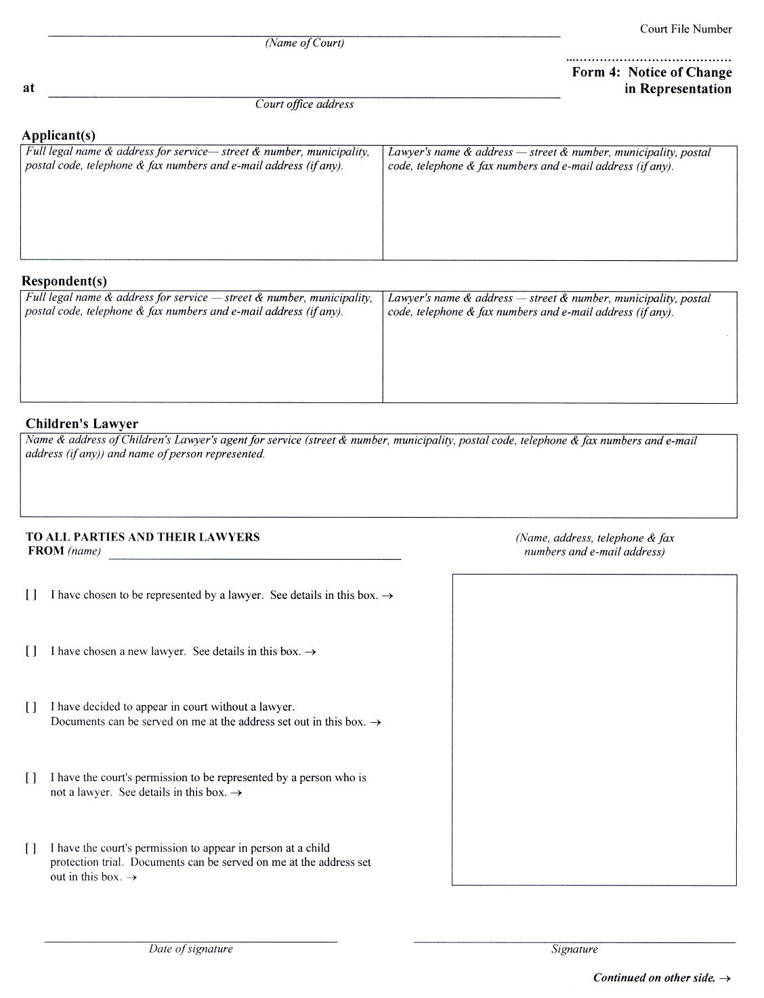
Insert regs\graphics\1999\114\114004be.tif
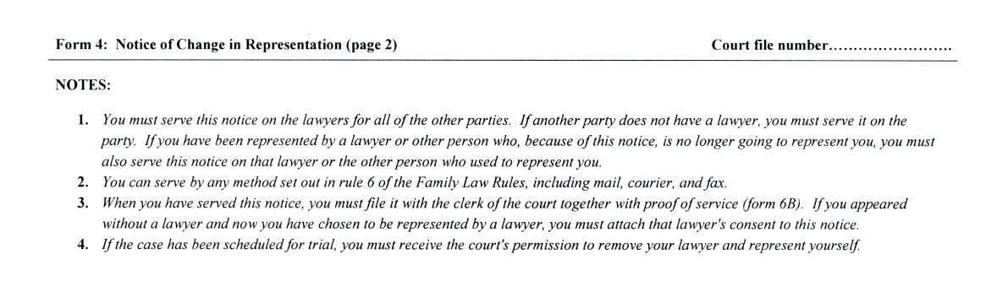
O. Reg. 91/03, s. 8 (1).
Form 6
Courts of Justice Act
Acknowledgement of service
Insert regs\graphics\1999\114\1140006e.tif
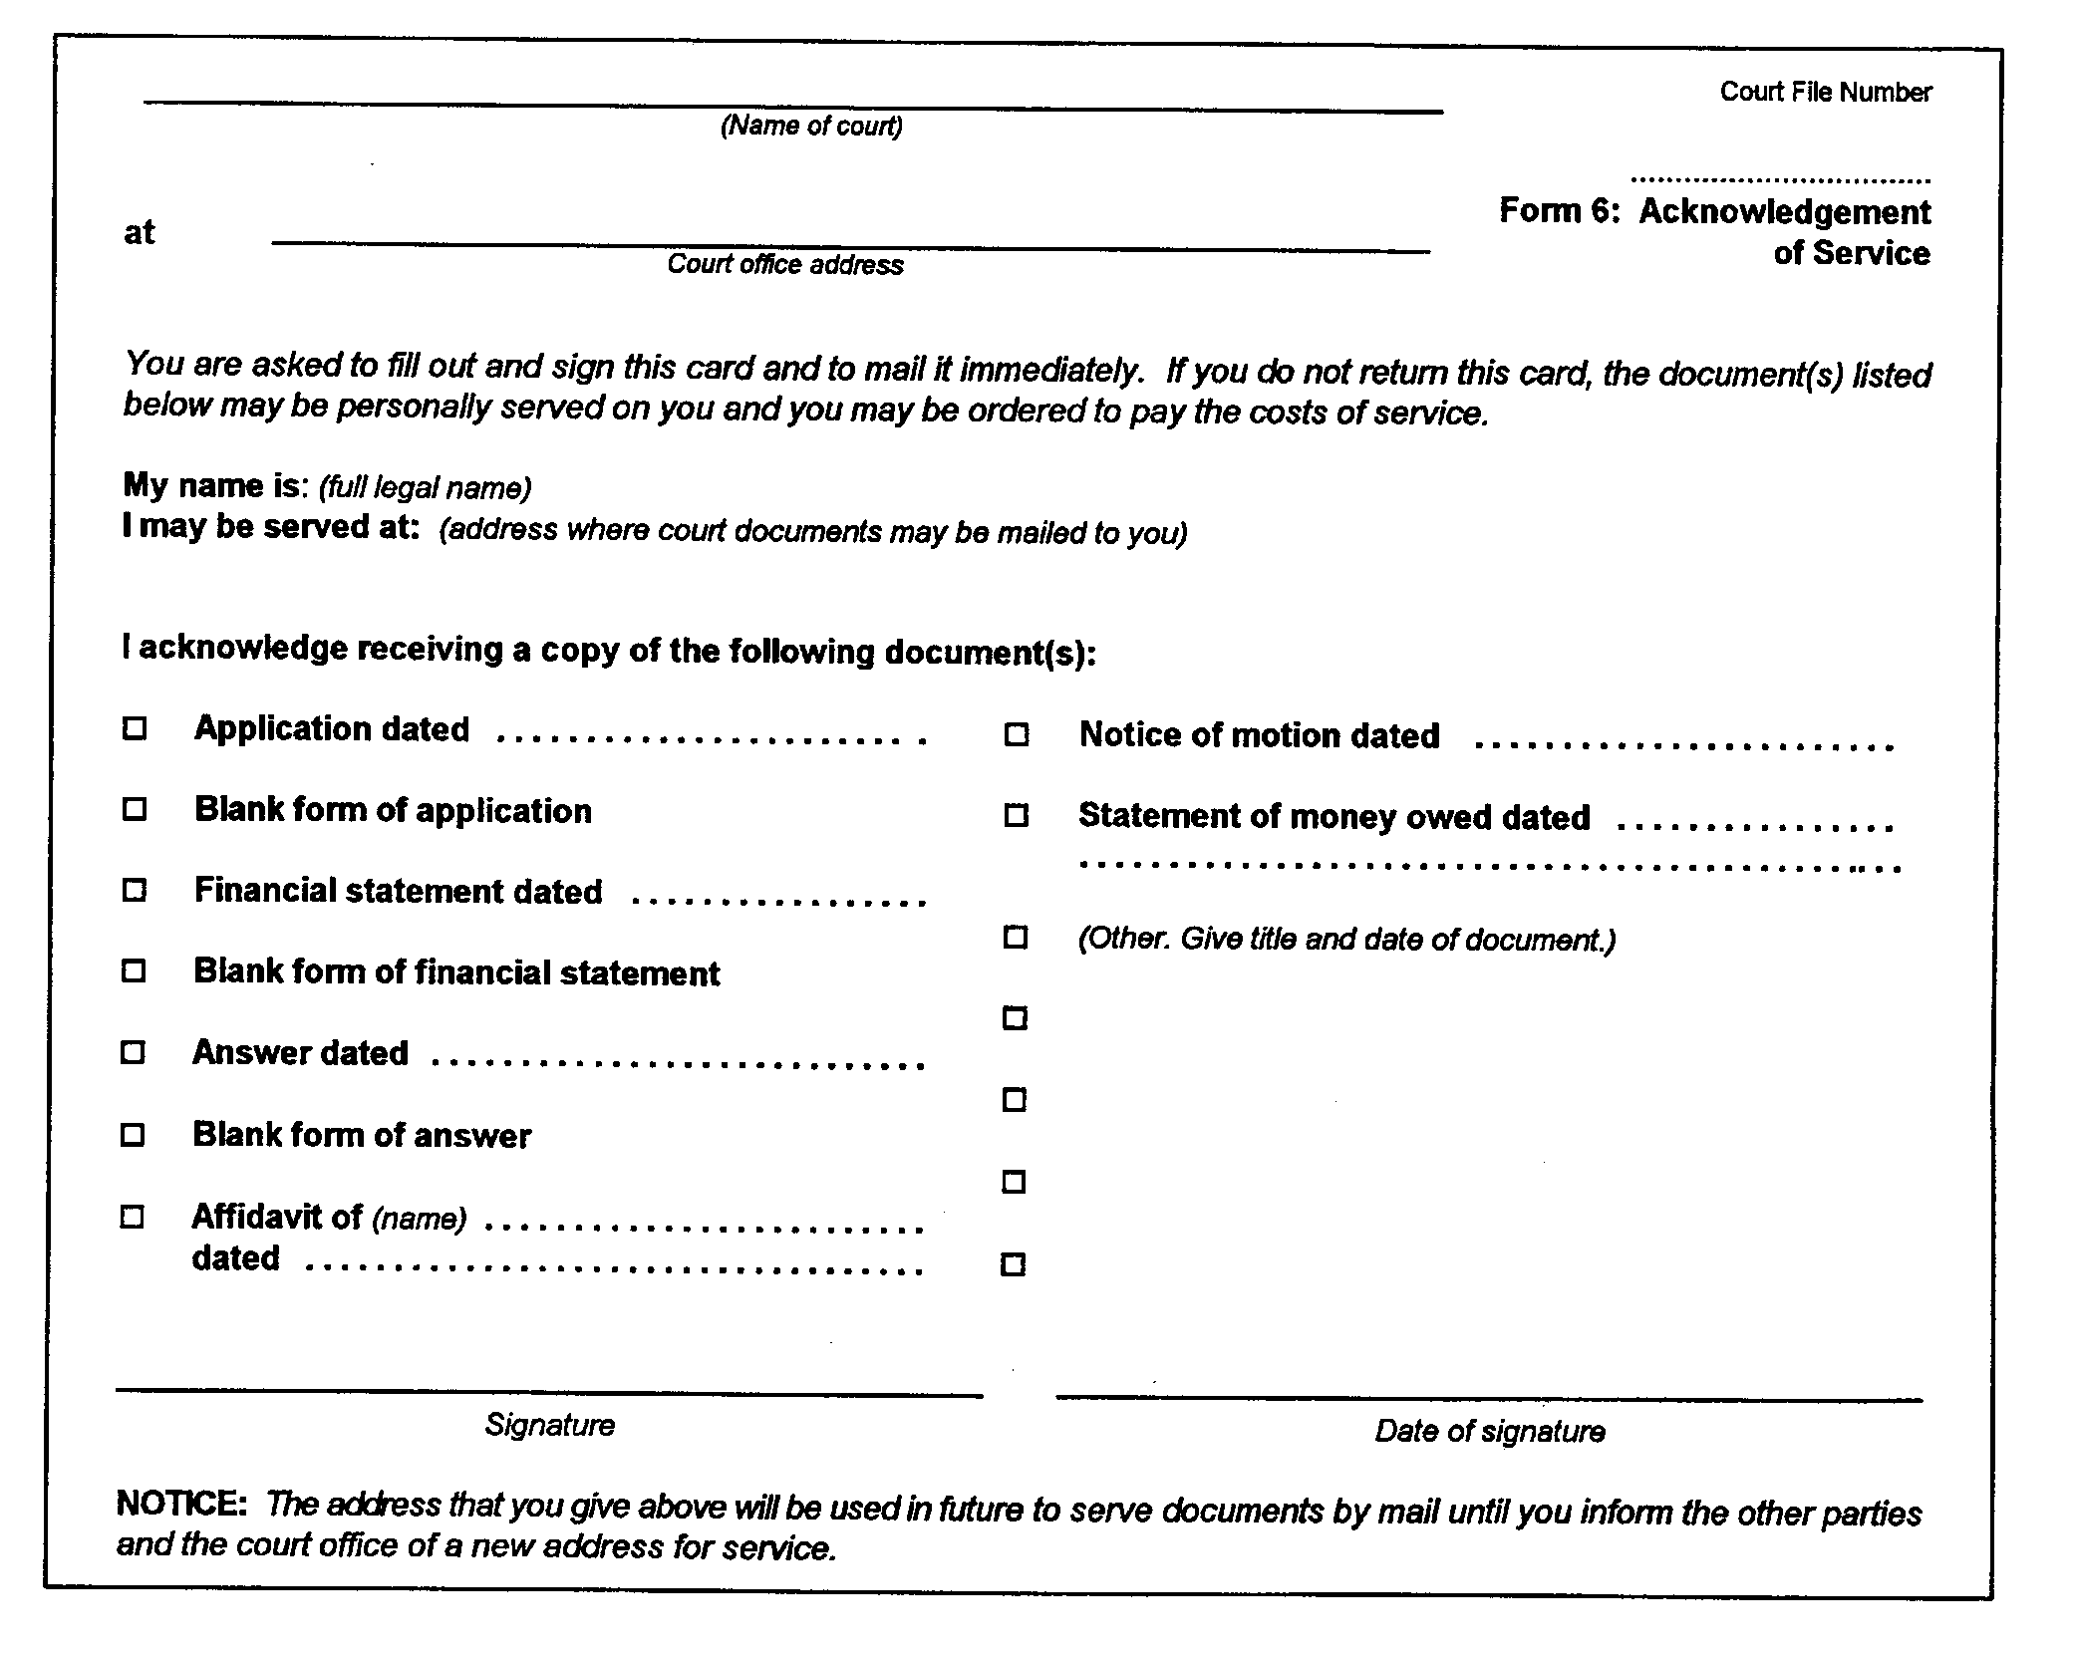
O. Reg. 114/99, Form 6.
Form 6A
Courts of Justice Act
ADVERTISEMENT
Insert regs\graphics\1999\114\114006ae.tif
O. Reg. 114/99, Form 6A.
Form 6B
Courts of Justice Act
affidavit of service
Insert regs\graphics\1999\114\11406bae.tif
Insert regs\graphics\1999\114\11406bbe.tif
O. Reg. 544/99, s. 15 (1).
Form 8
Courts of Justice Act
application
Insert regs\graphics\1999\114\114008ae.tif
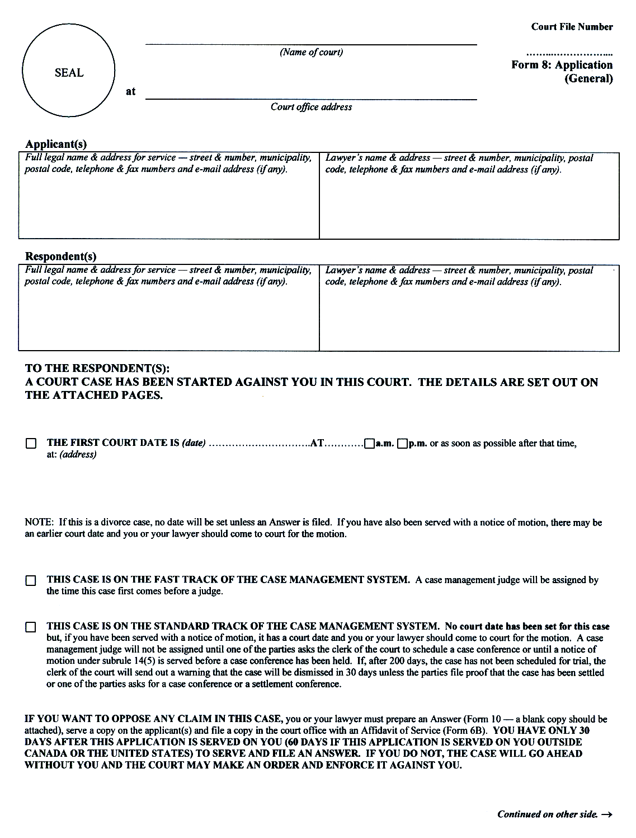
Insert regs\graphics\1999\114\114008be.tif
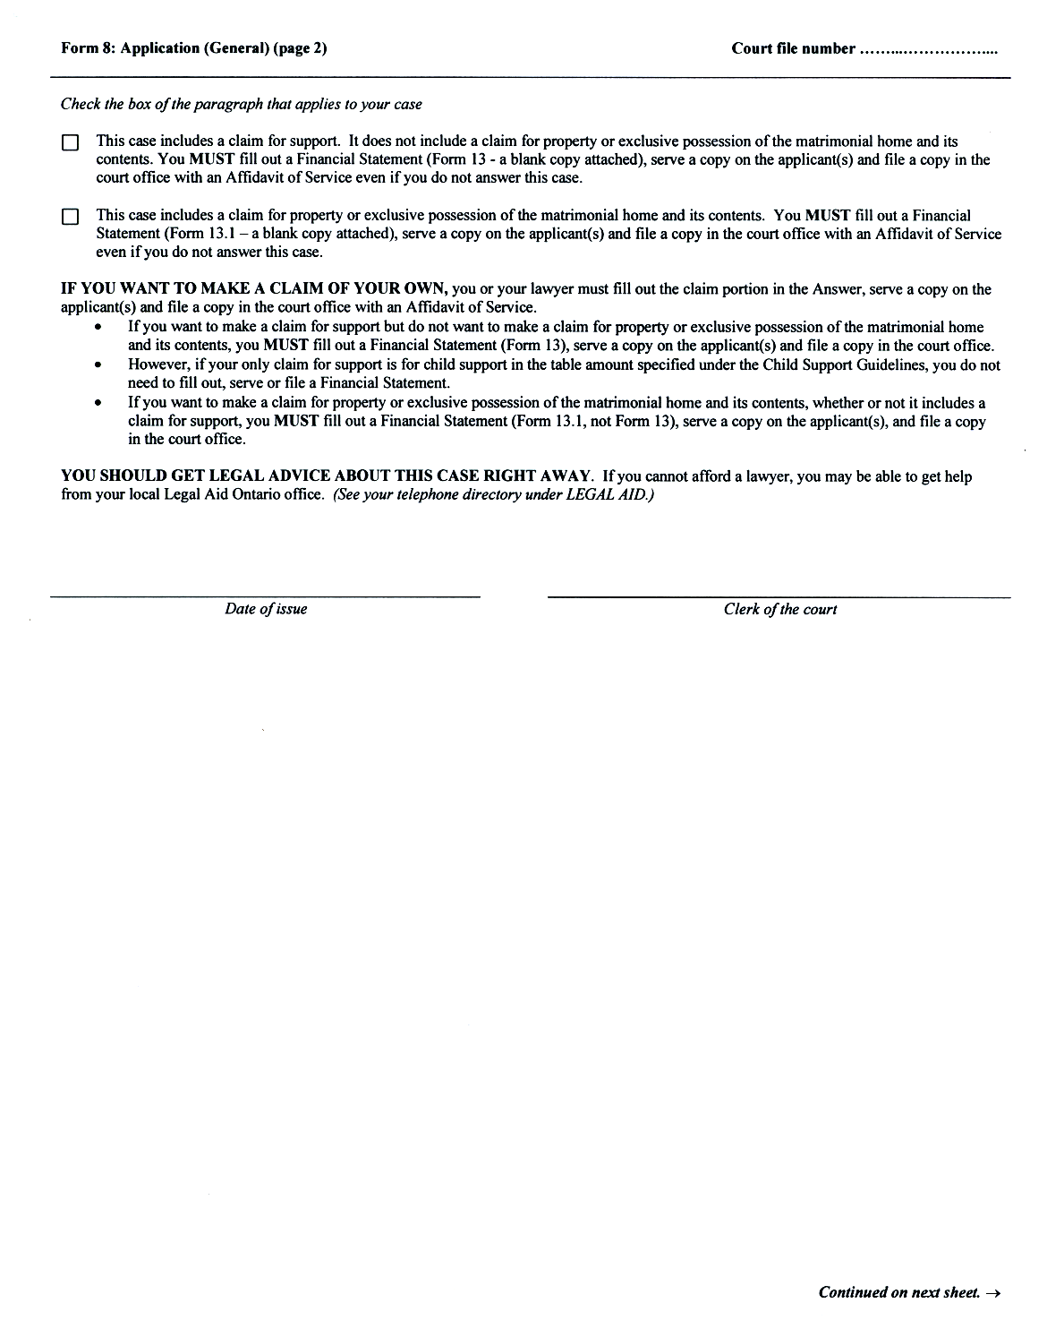
Insert regs\graphics\1999\114\114008ce.tif
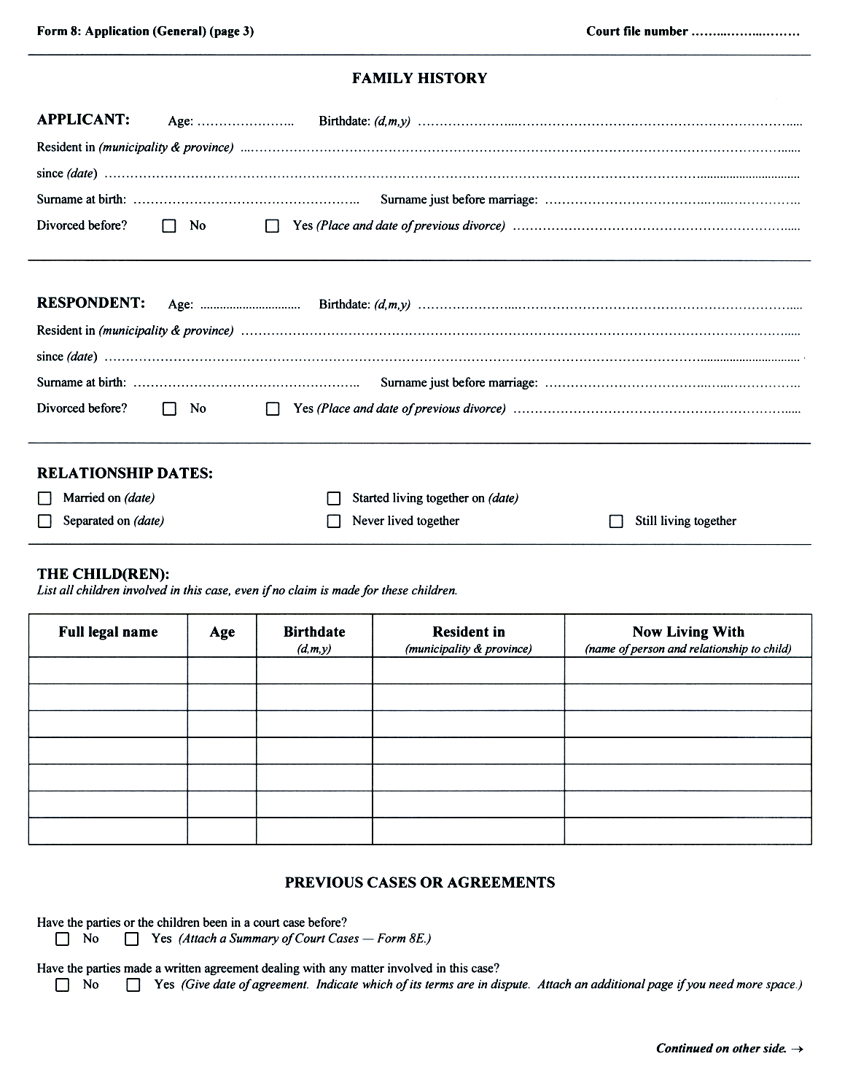
Insert regs\graphics\1999\114\114008de.tif
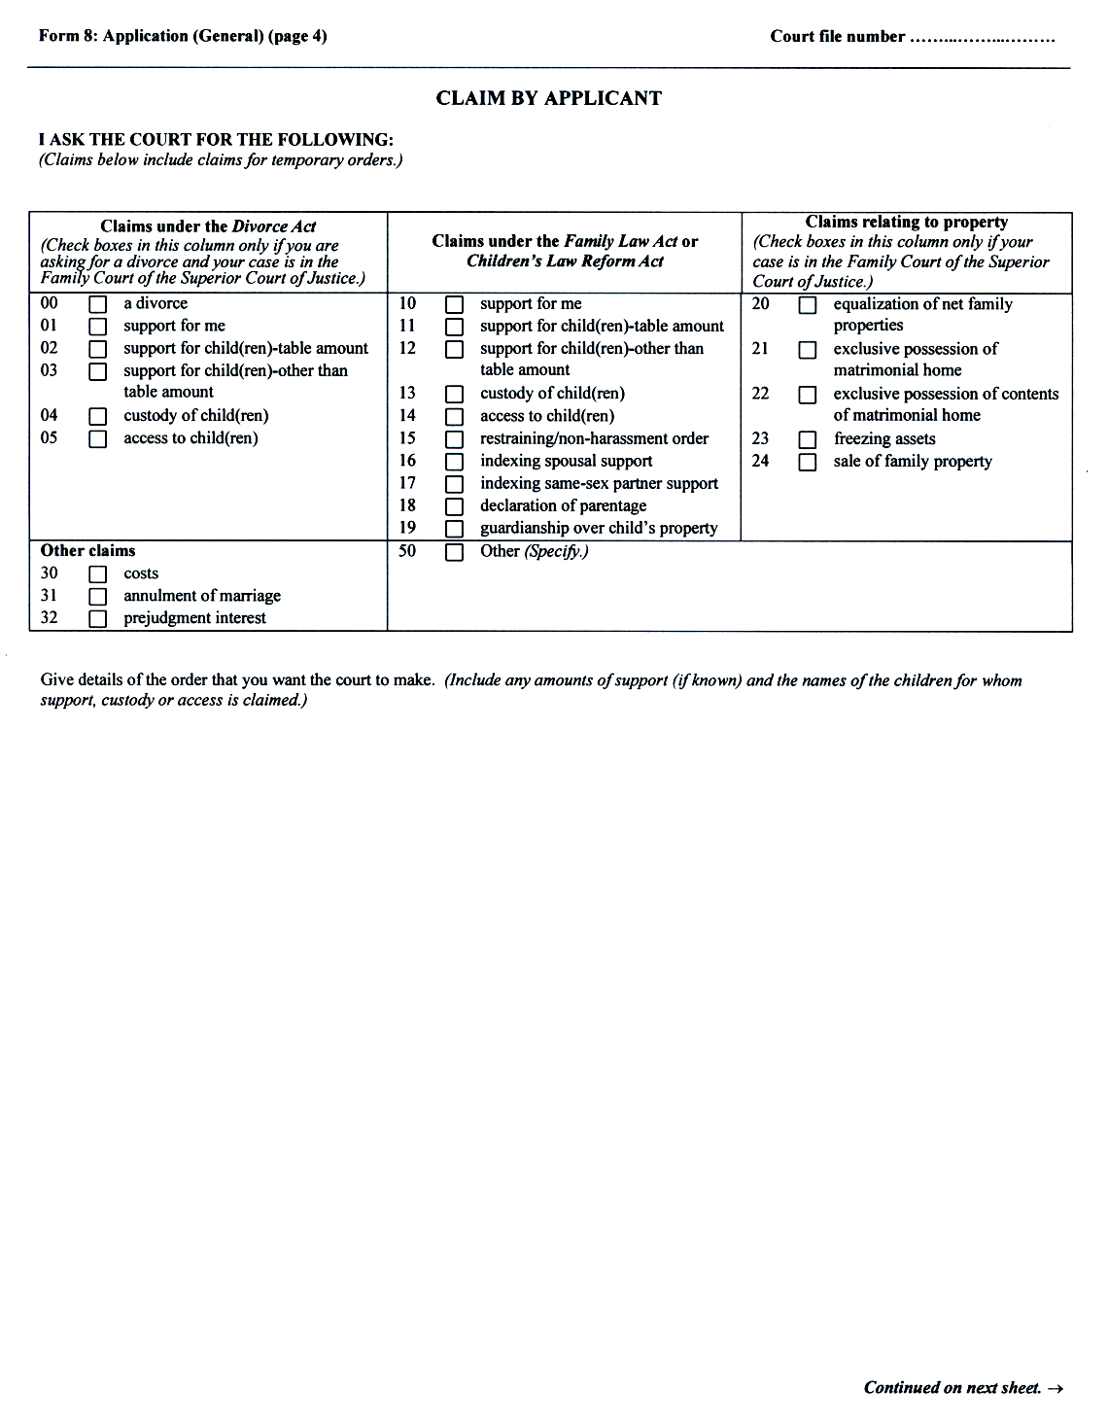
Insert regs\graphics\1999\114\114008ee.tif
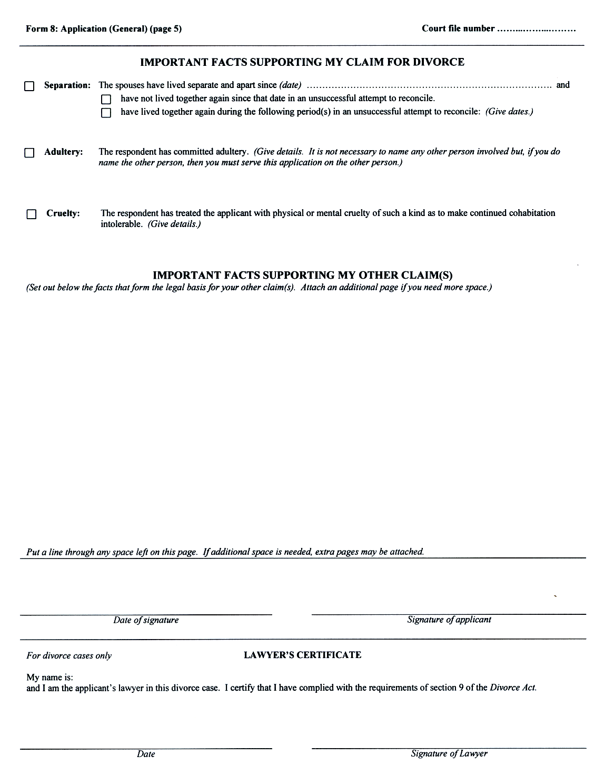
O. Reg. 92/03, s. 3 (1).
Form 8A
Courts of Justice Act
application (Divorce)
Insert regs\graphics\1999\114\11408Aae.tif
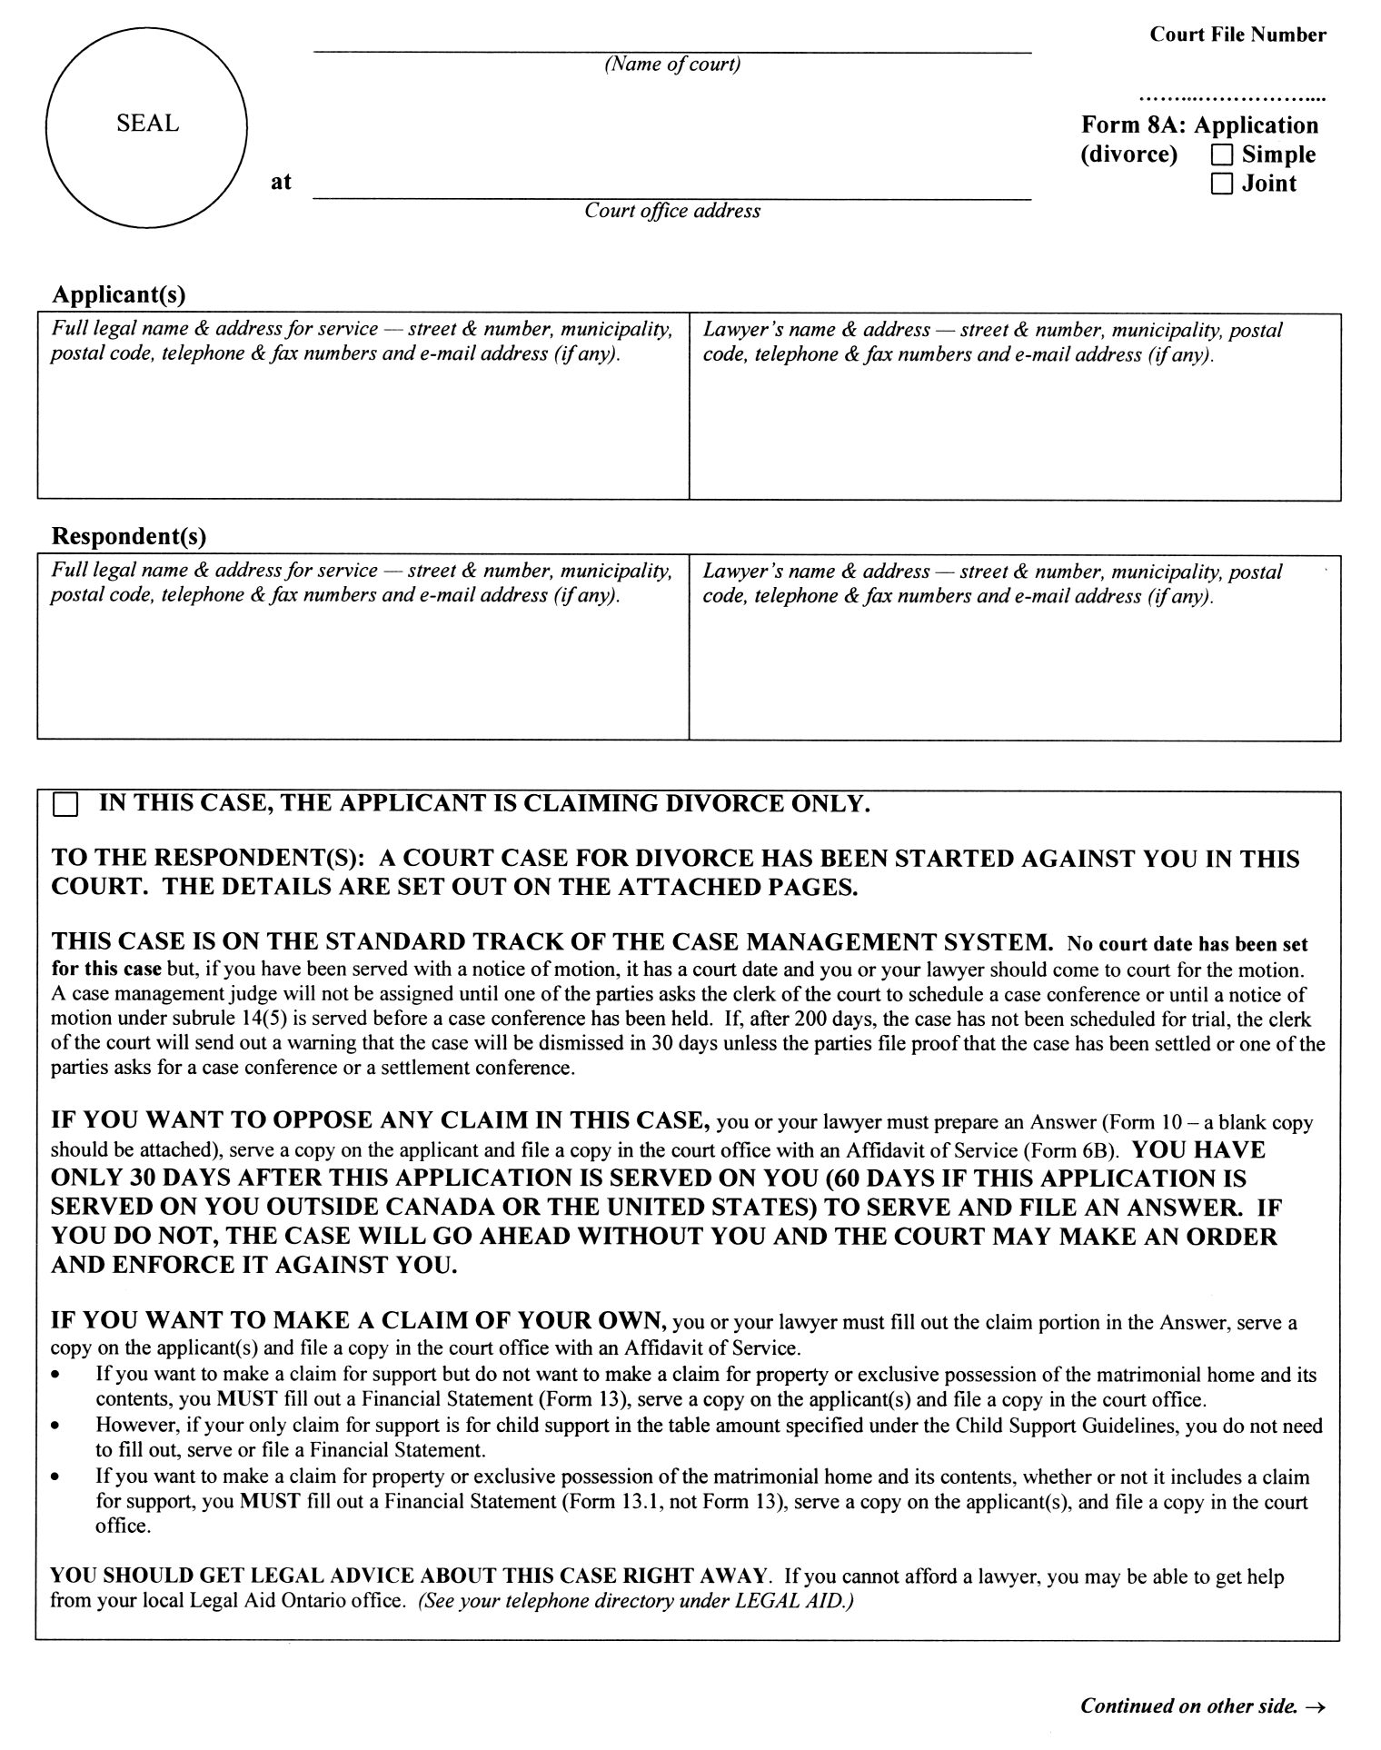
Insert regs\graphics\1999\114\11408Abe.tif
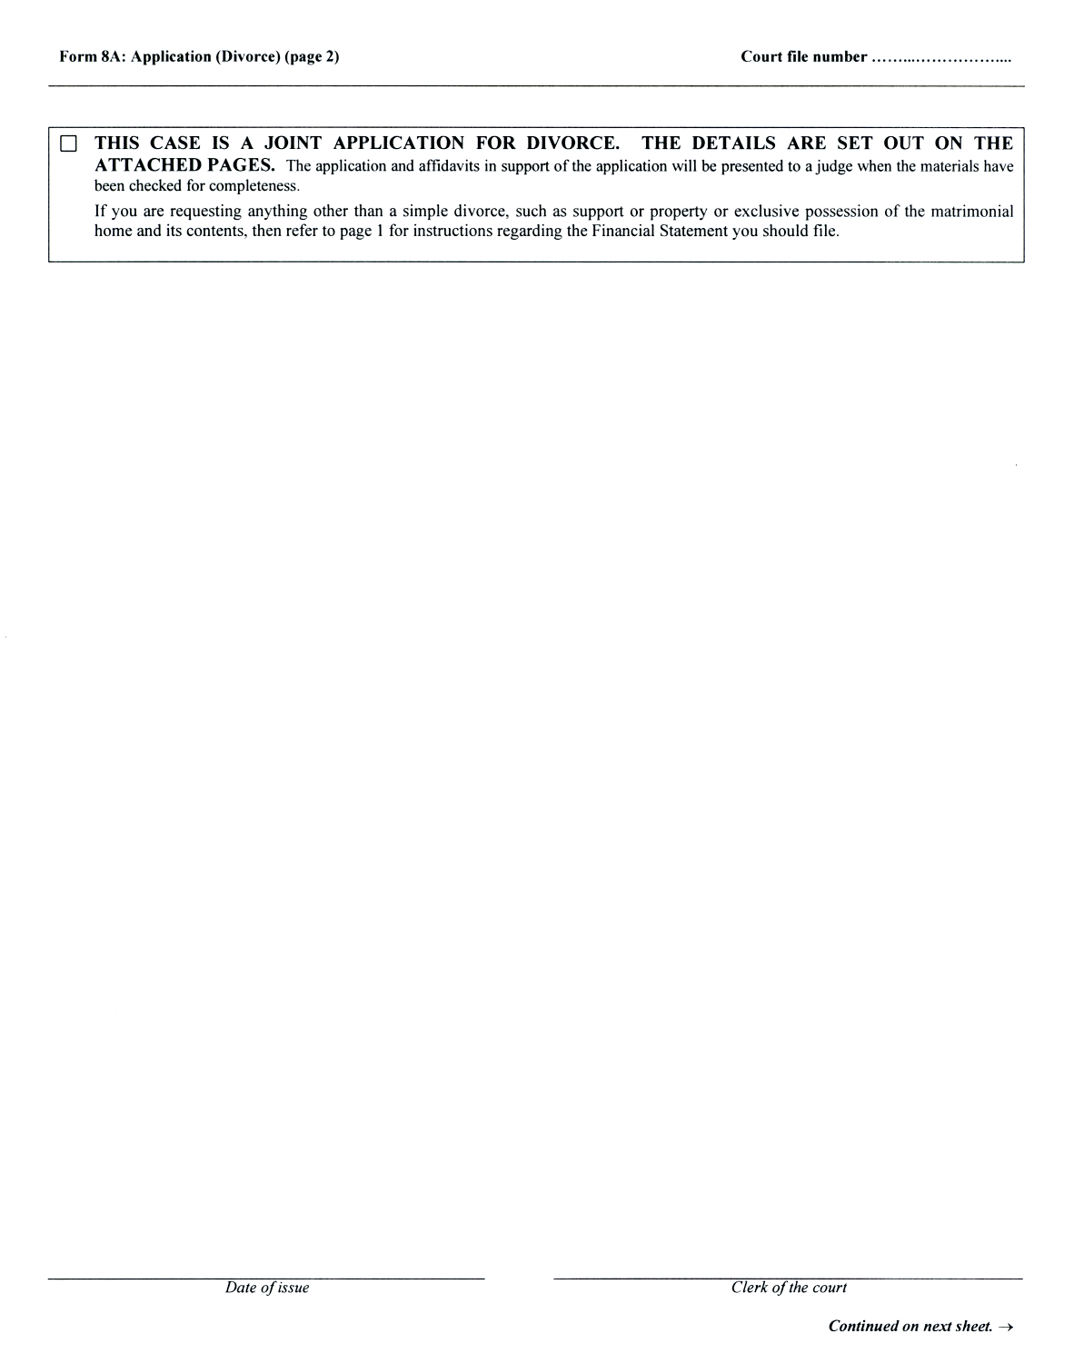
Insert regs\graphics\1999\114\11408Ace.tif
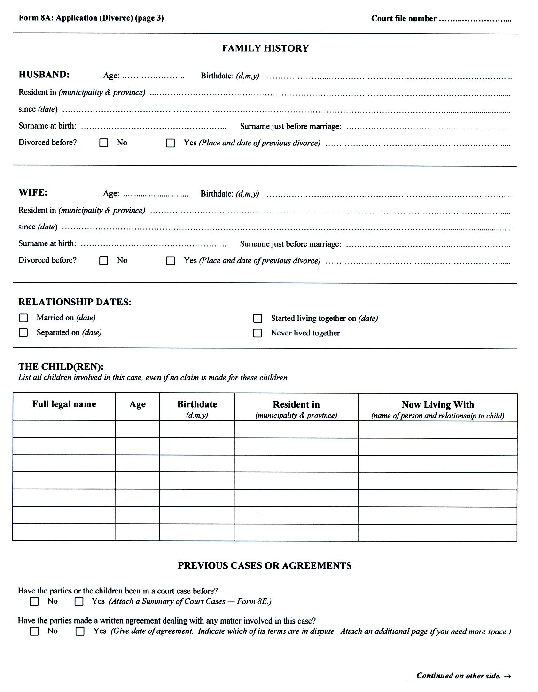
Insert regs\graphics\1999\114\11408Ade.tif
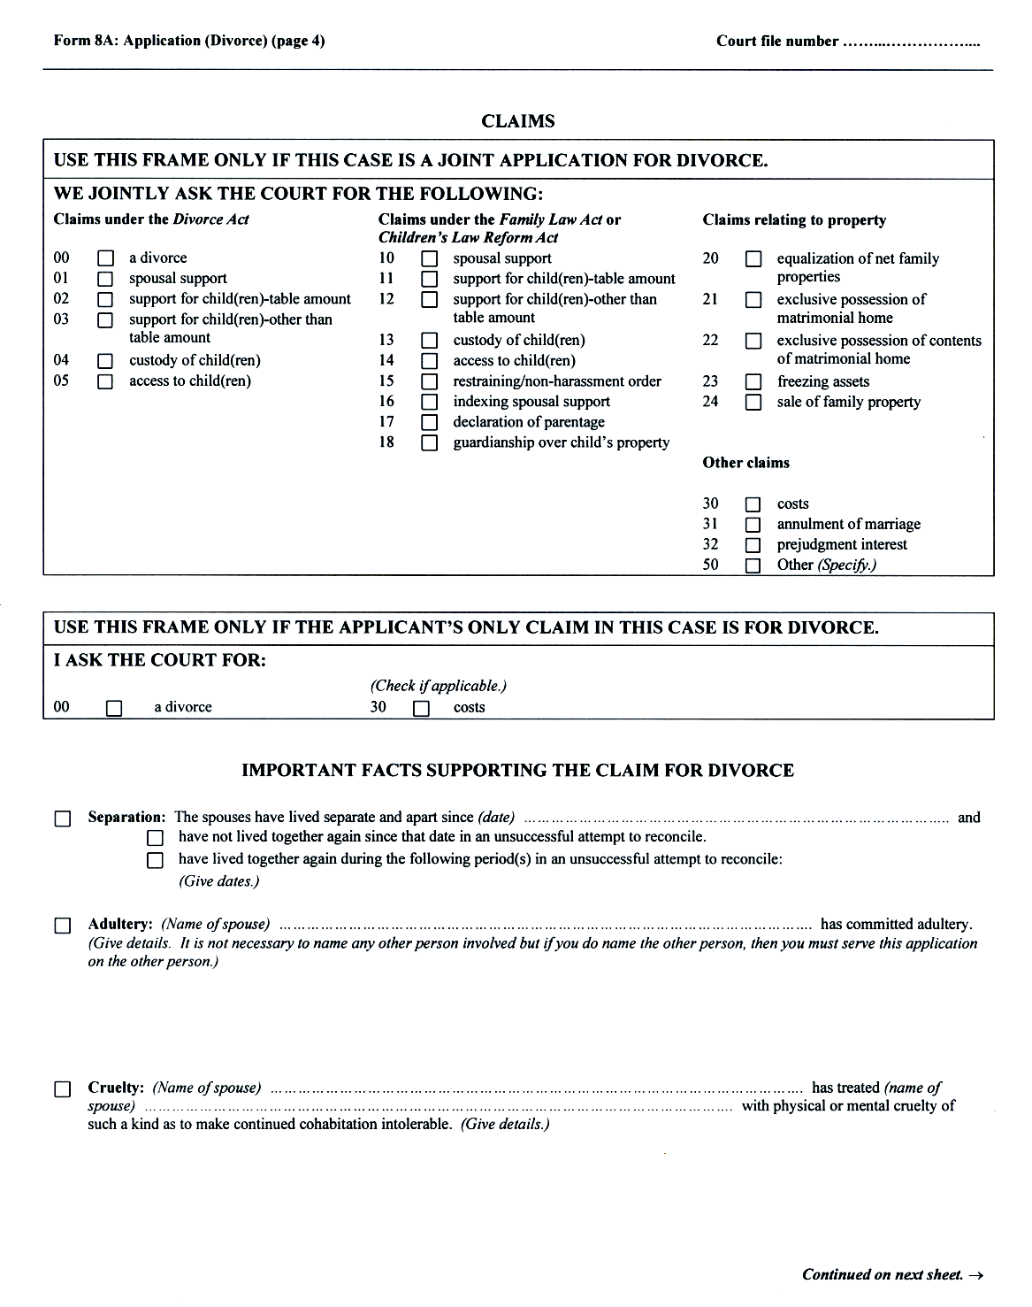
Insert regs\graphics\1999\114\11408Aee.tif
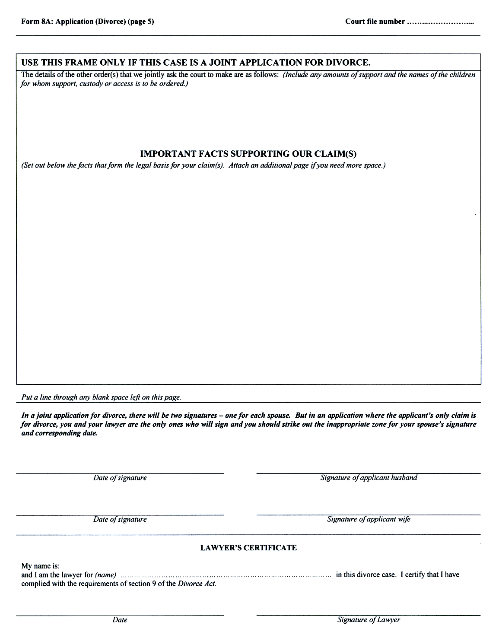
O. Reg. 92/03, s. 3 (1).
Form 8B
Courts of Justice Act
application (child protection and status review)
Insert regs\graphics\1999\114\11408Bae.tif
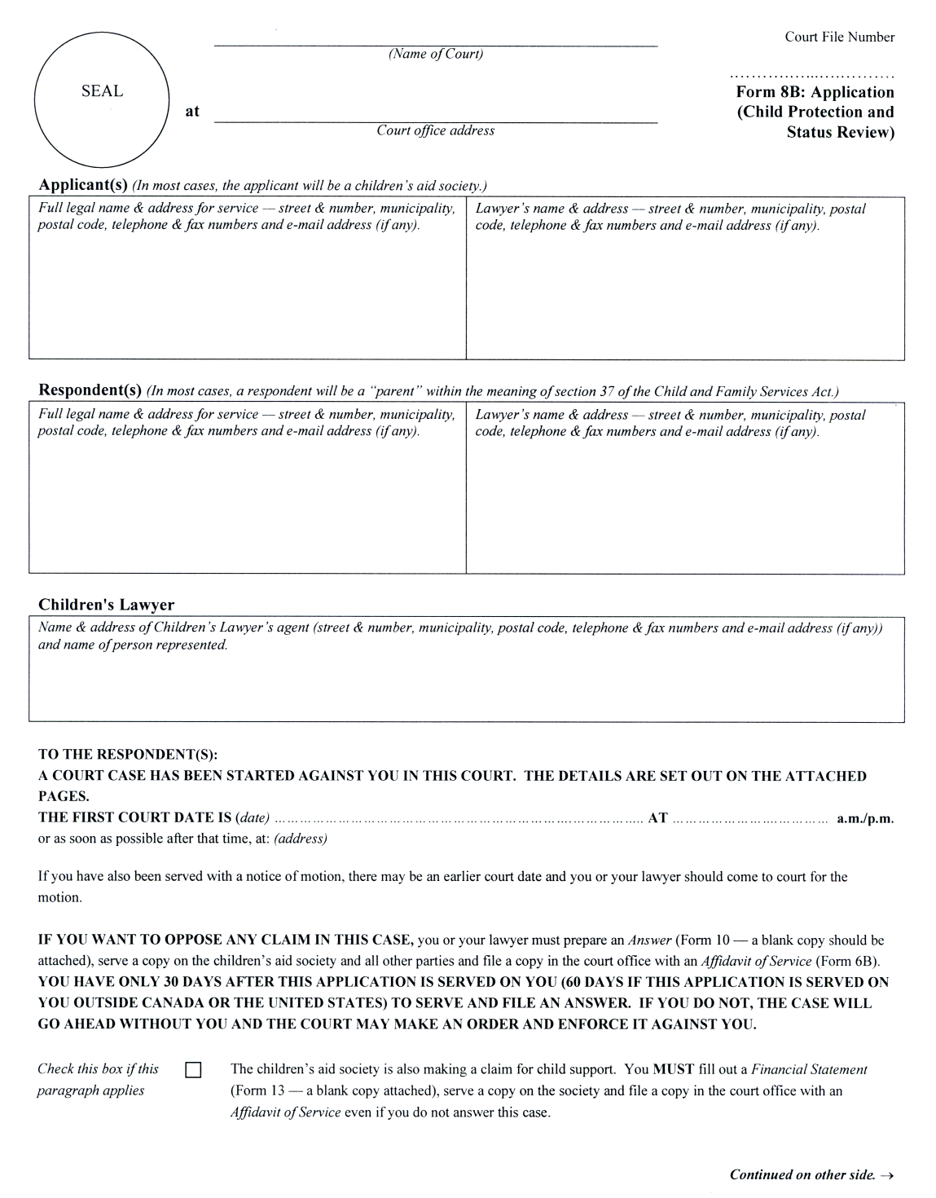
Insert regs\graphics\1999\114\11408Bbe.tif
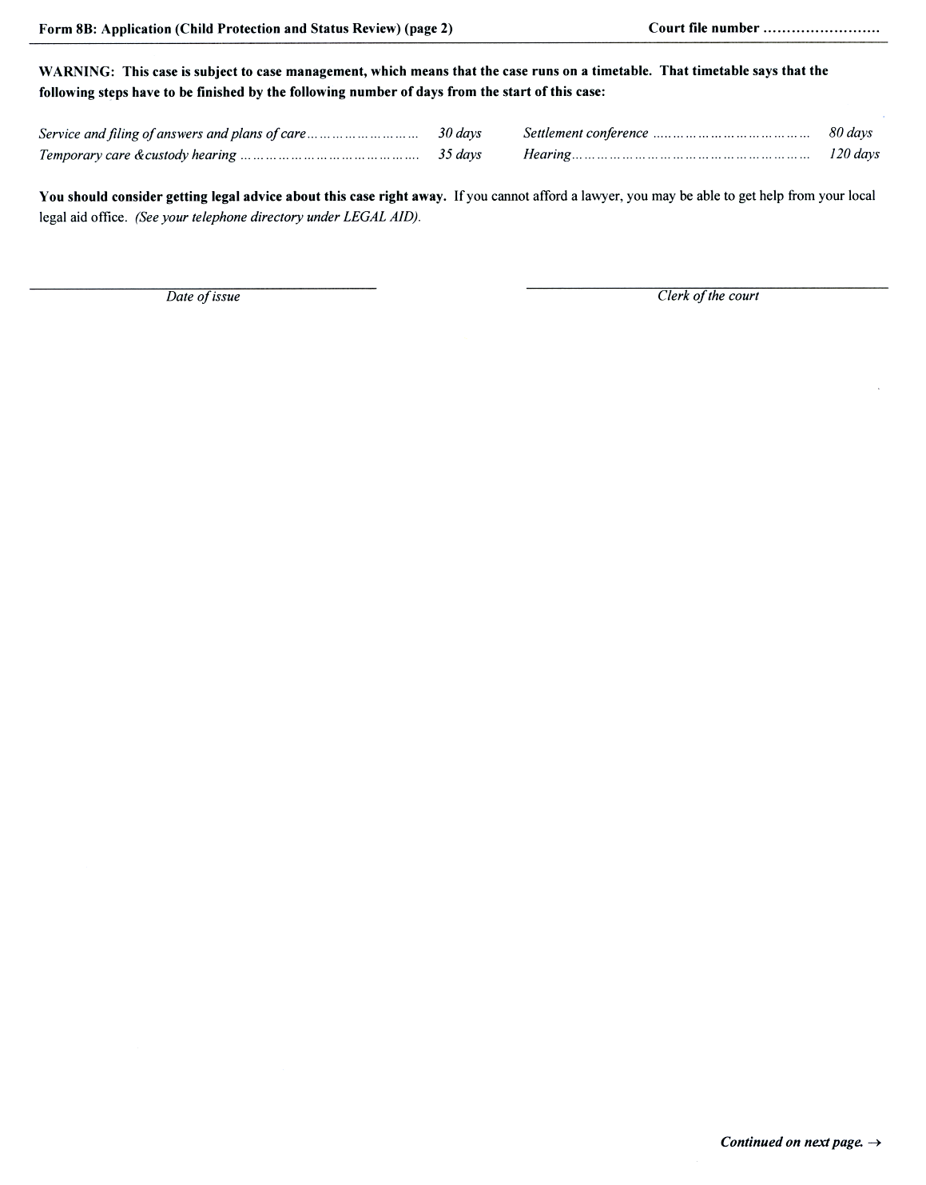
Insert regs\graphics\1999\114\11408Bce.tif
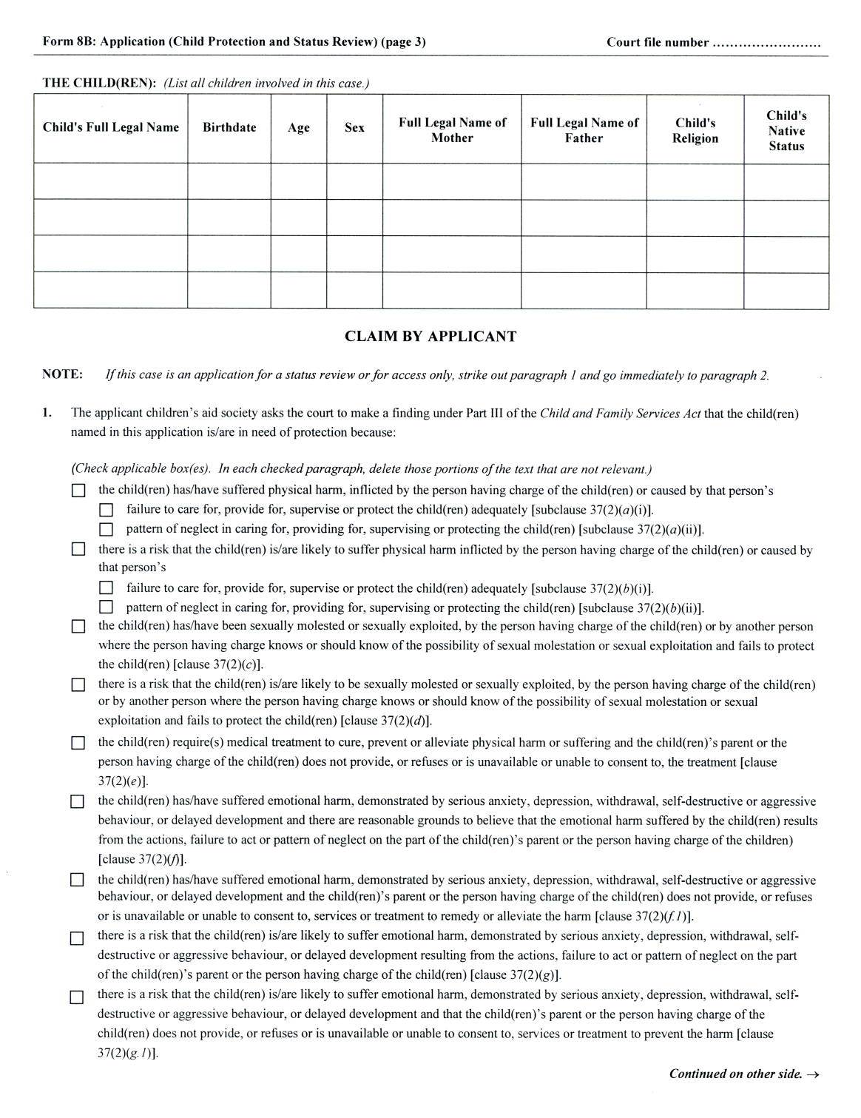
Insert regs\graphics\1999\114\11408Bde.tif
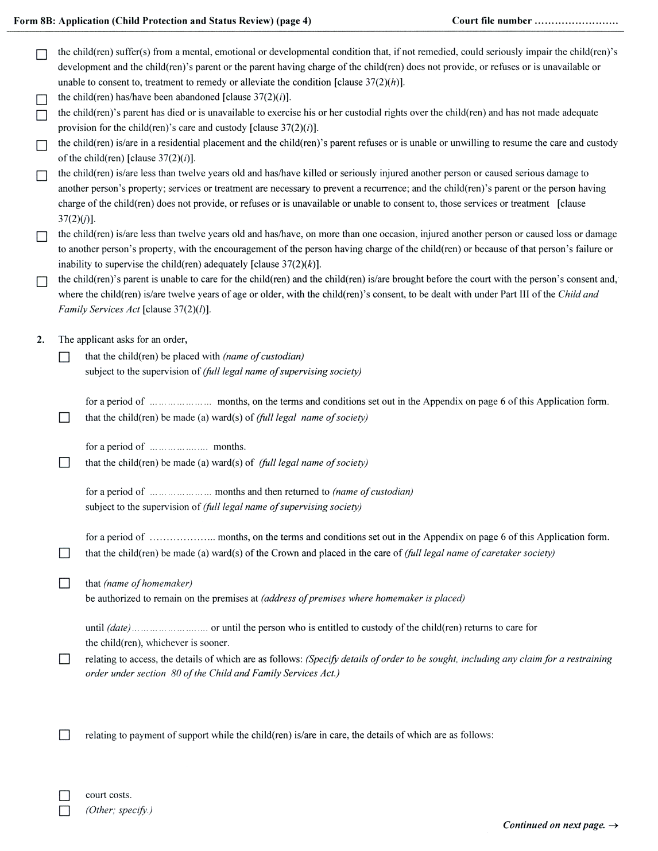
Insert regs\graphics\1999\114\11408Bee.tif
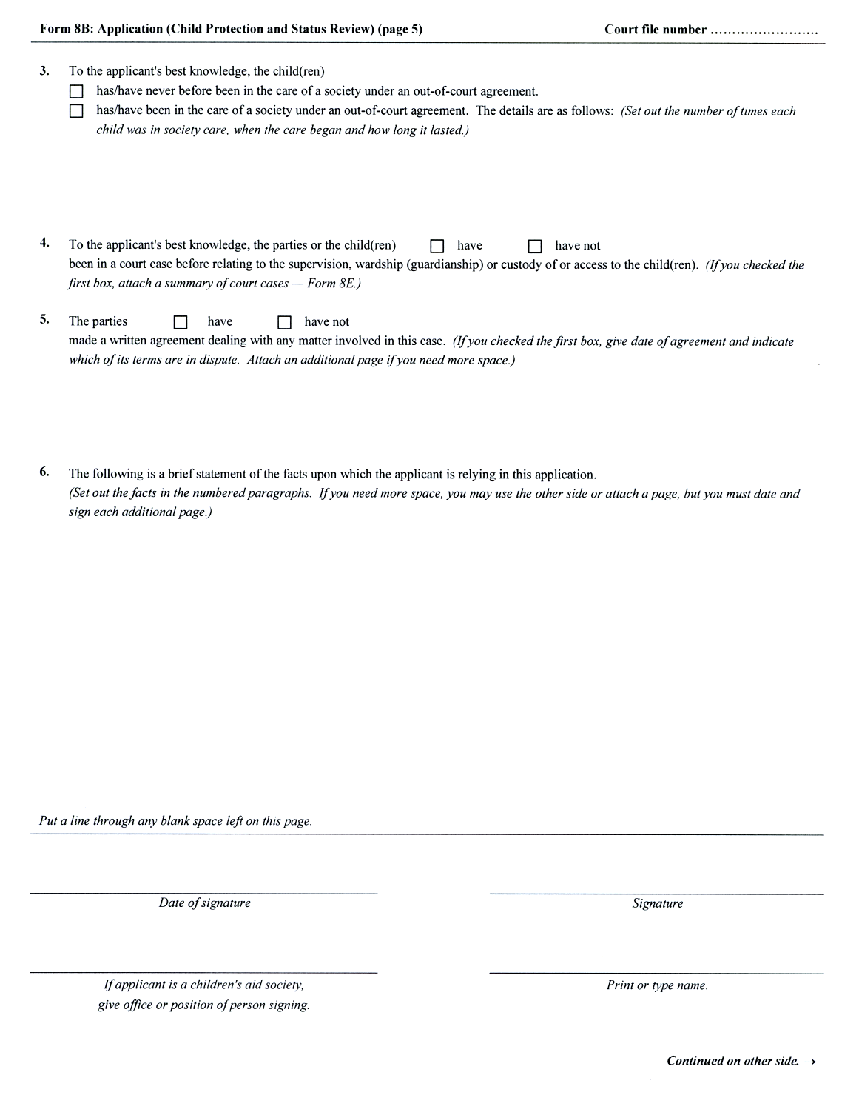
Insert regs\graphics\1999\114\11408Bfe.tif

O. Reg. 91/03, s. 8 (2).
Form 8C
Courts of Justice Act
application (Secure treatment)
Insert regs\graphics\1999\114\11408cae.tif
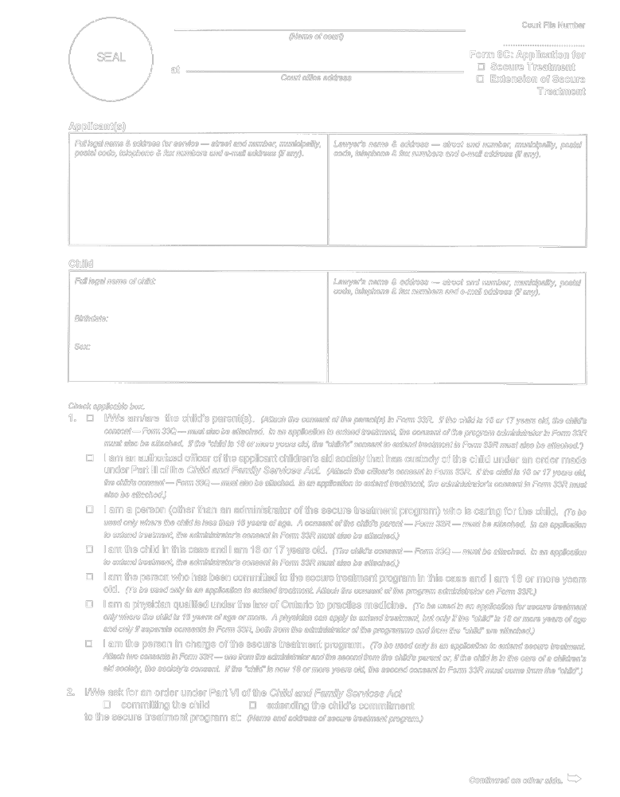
Insert regs\graphics\1999\114\11408cbe.tif
O. Reg. 114/99, Form 8C.
Form 8D
Courts of Justice Act
APPLICATION (ADOPTION)
Insert regs\graphics\1999\114\11408Dae.tif
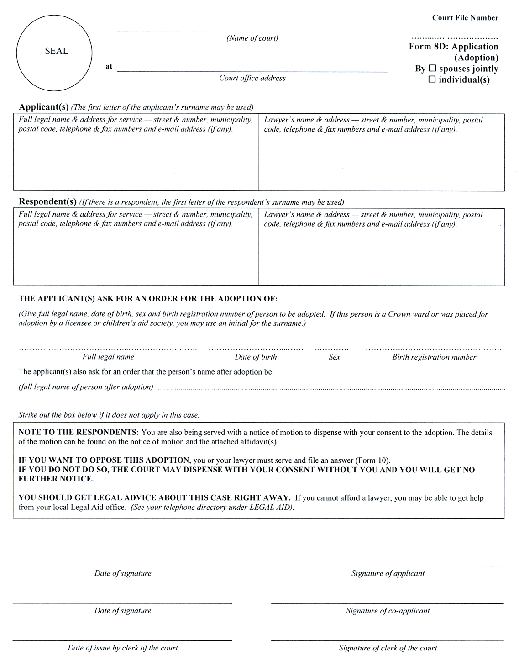
O. Reg. 337/02, s. 4 (1).
Form 8D.1
Courts of Justice Act
APPLICATION (DISPENSE WITH PARENT’S CONSENT TO ADOPTION BEFORE PLACEMENT)
Insert regs\graphics\1999/114\11408d1e.tif
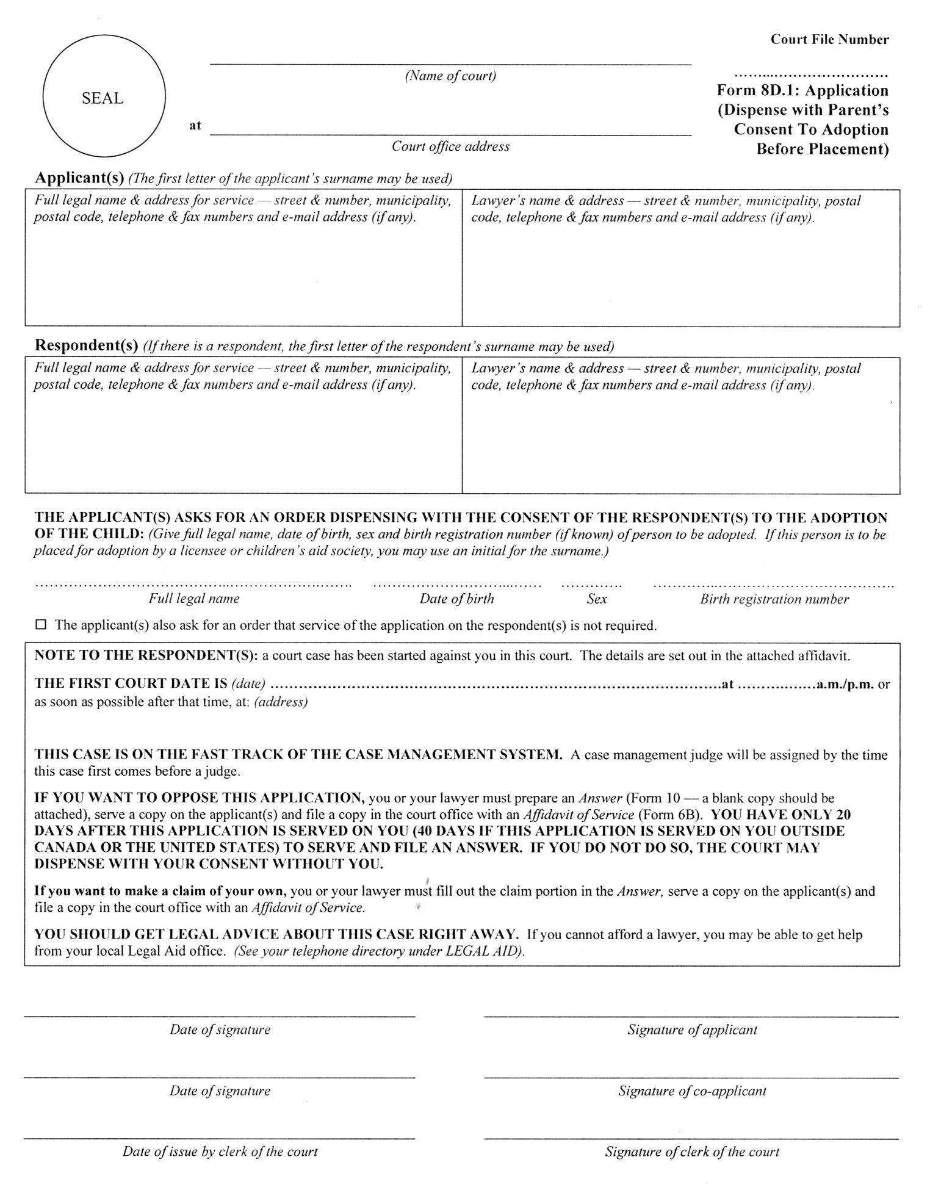
O. Reg. 337/02, s. 4 (1).
Form 8E
Courts of Justice Act
summary of court cases
Insert regs\graphics\1999\114\11408eae.tif
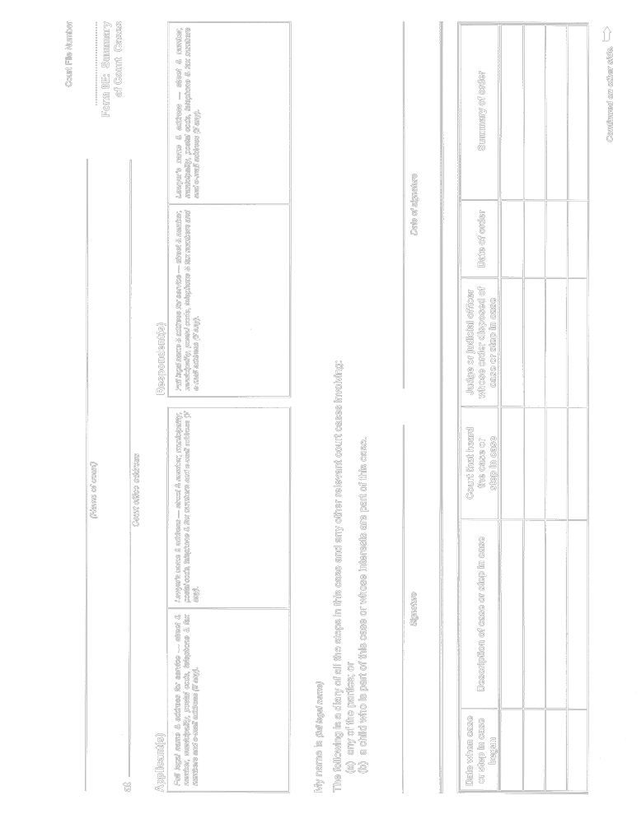
Insert regs\graphics\1999\114\11408ebe.tif
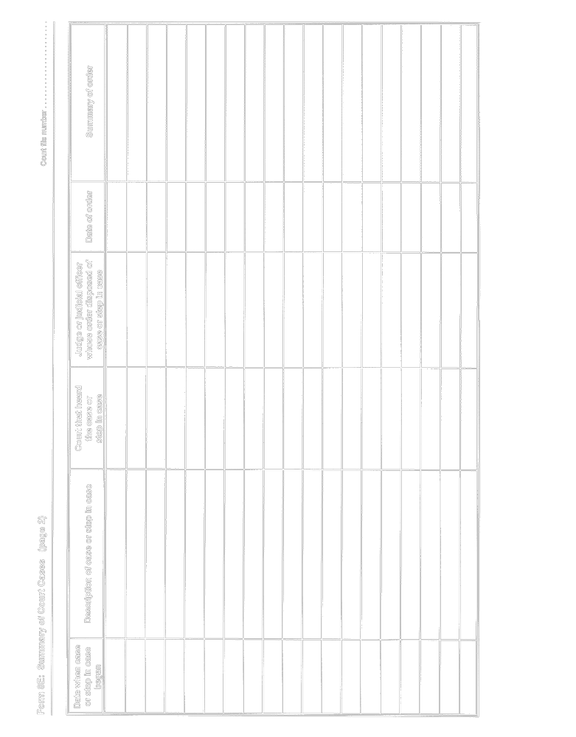
Insert regs\graphics\1999\114\11408ece.tif
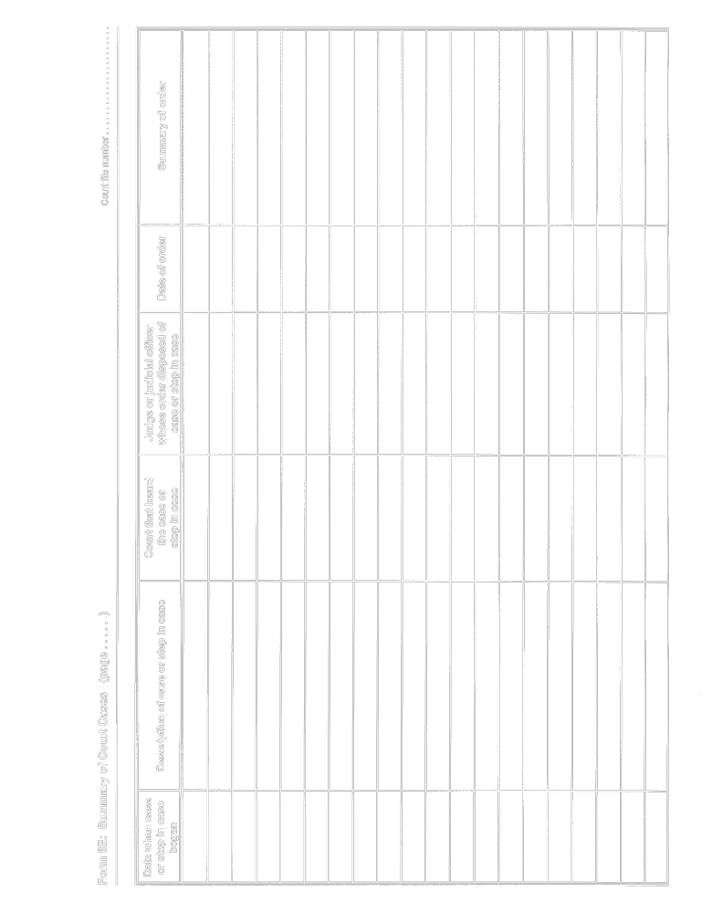
Insert regs\graphics\1999\114\11408ede.tif
O. Reg. 114/99, Form 8E.
Form 10
Courts of Justice Act
answer
Insert regs\graphics\1999\114\114010ae.tif
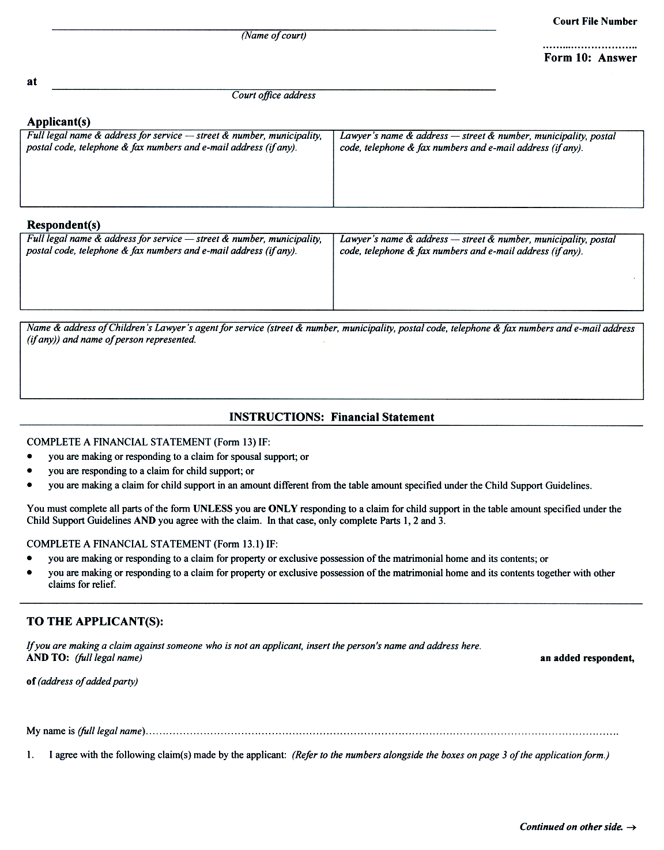
Insert regs\graphics\1999\114\114010be.tif
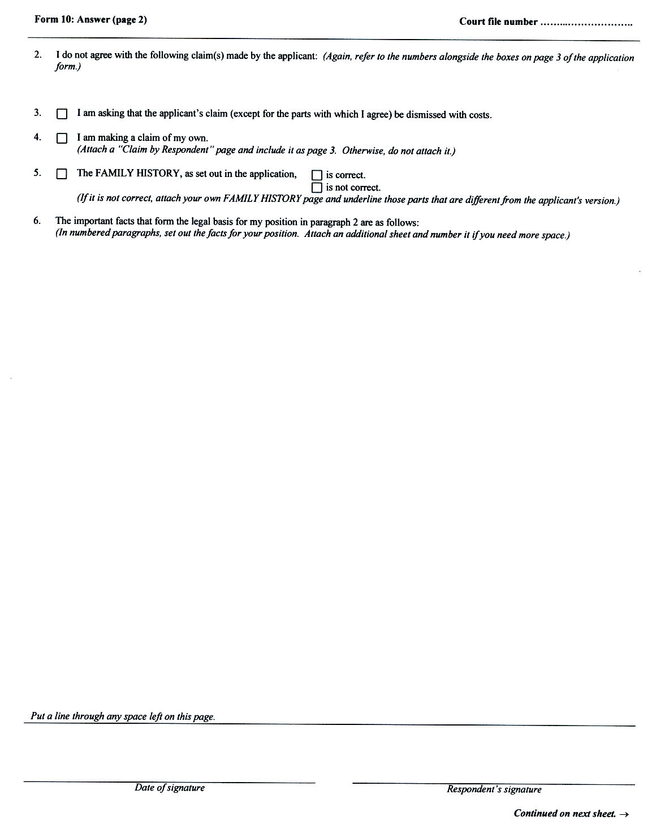
Insert regs\graphics\1999\114\114010ce.tif
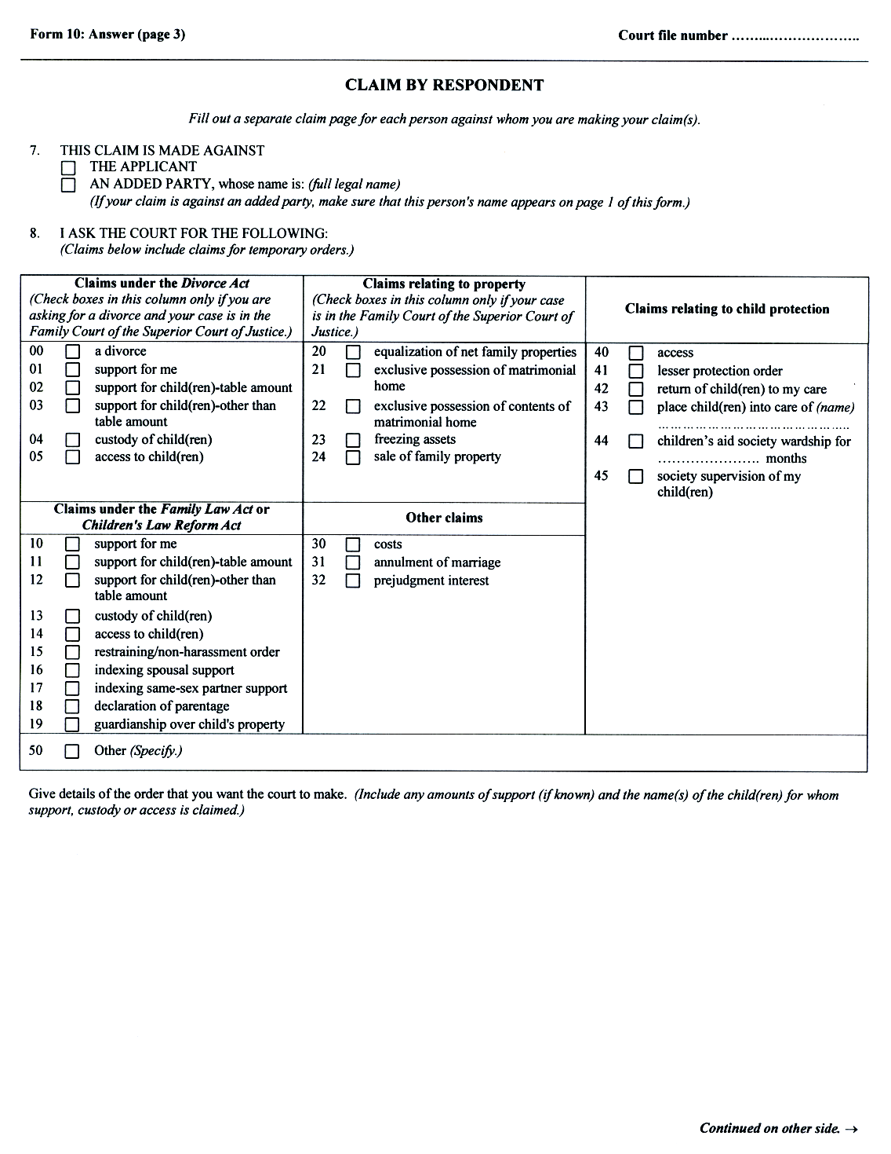
Insert regs\graphics\1999\114\114010de.tif
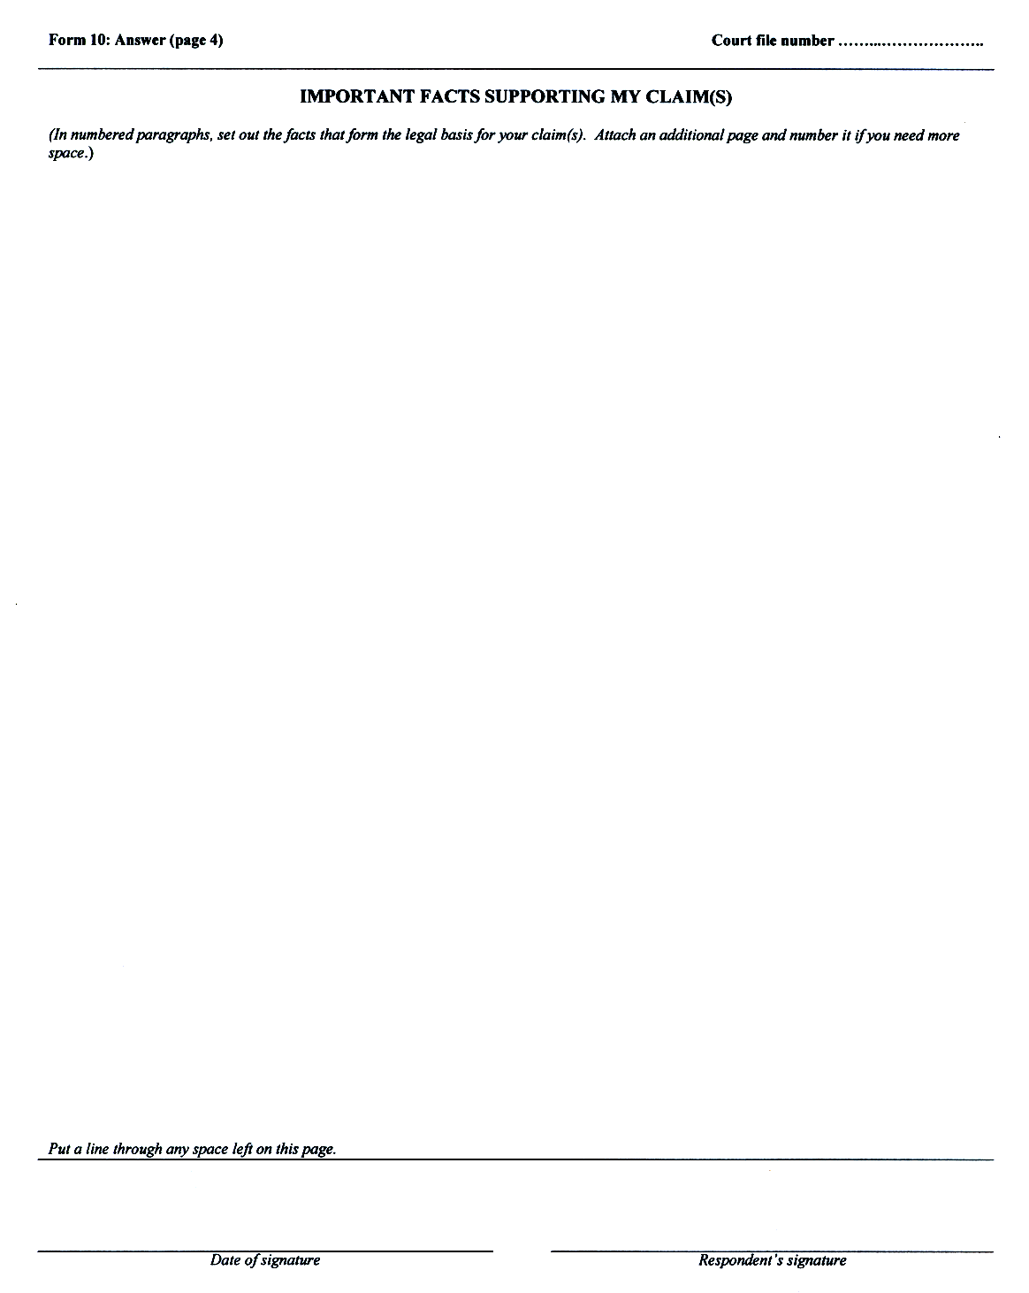
O. Reg. 92/03, s. 3 (2).
Form 10A
Courts of Justice Act
reply
Insert regs\graphics\1999\114\11410Aae.tif
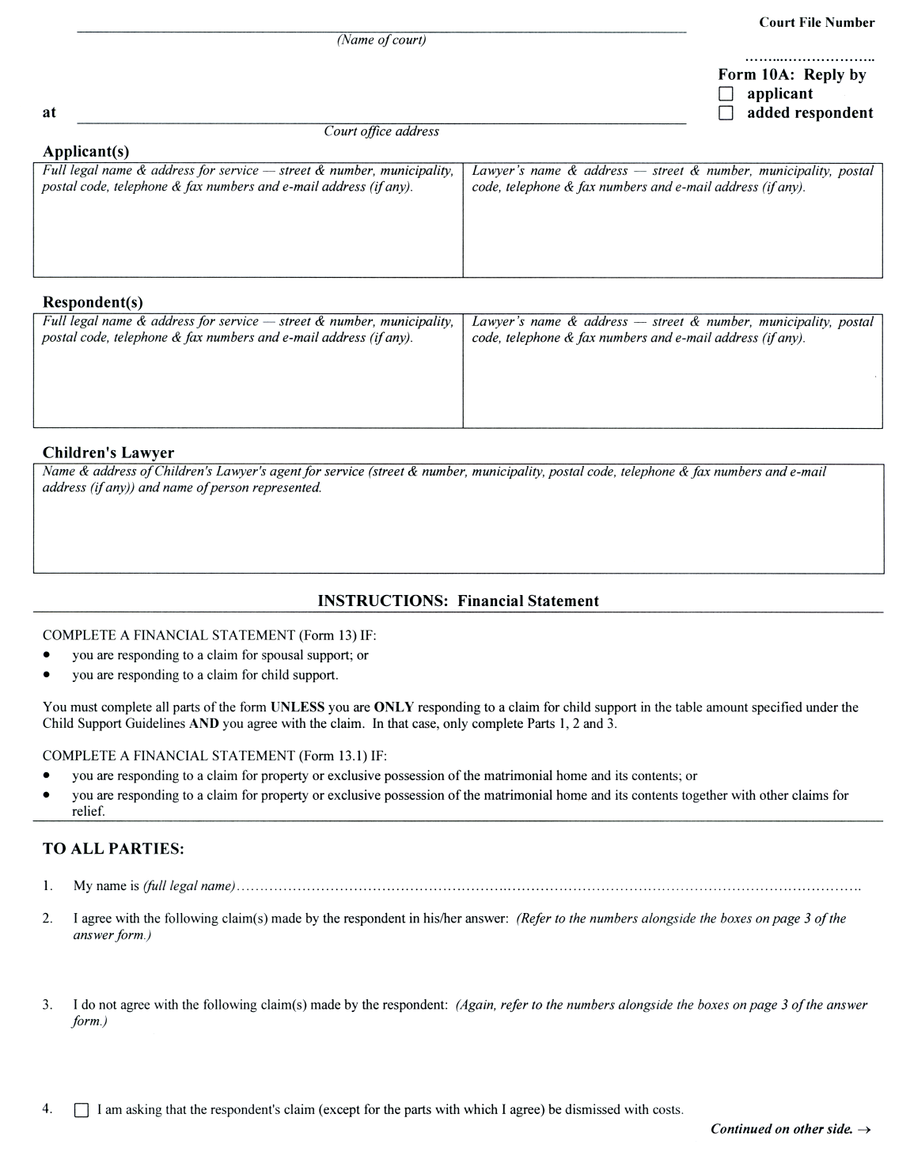
Insert regs\graphics\1999\114\11410Abe.tif
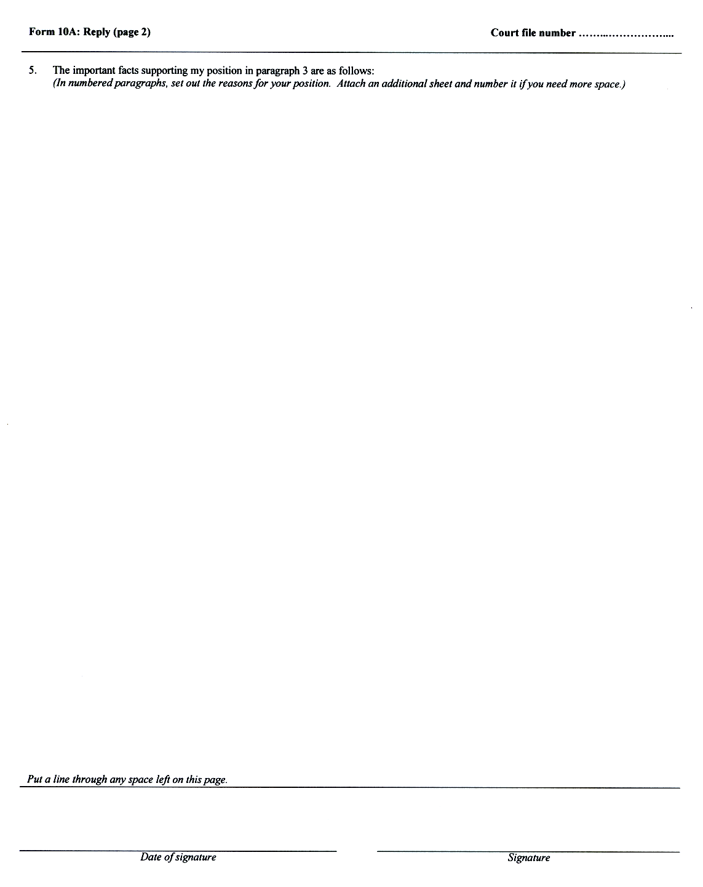
O. Reg. 92/03, s. 3 (2).
Form 12
Courts of Justice Act
notice of withdrawal
Insert regs\graphics\1999\114\1140012e.tif
O. Reg. 114/99, Form 12.
Form 13
Courts of Justice Act
financial statement
Insert regs\graphics\1999\114\114013ae.tif
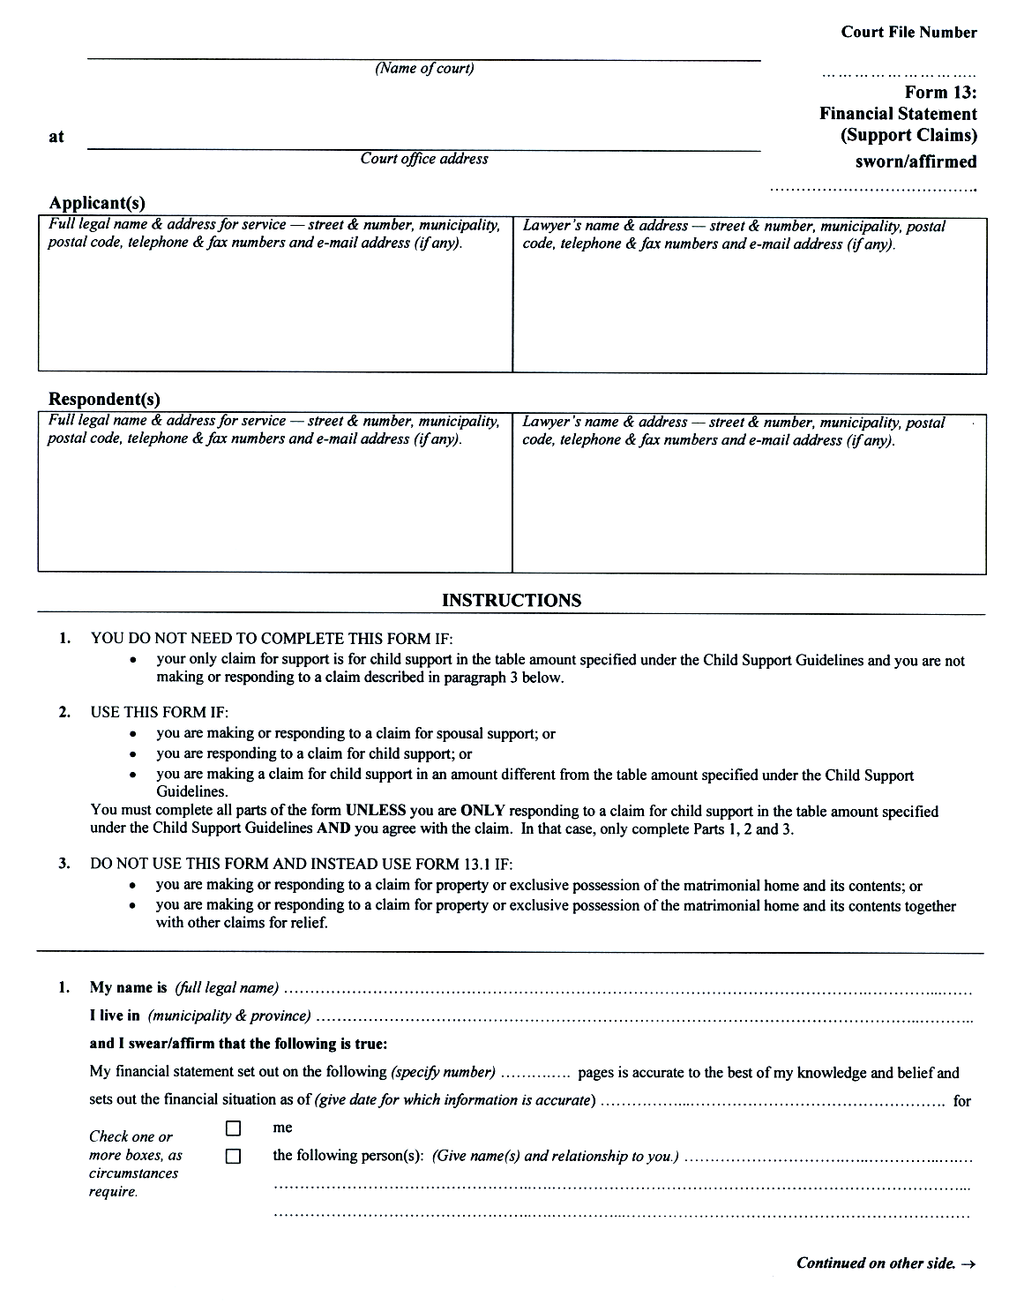
Insert regs\graphics\1999\114\114013be.tif
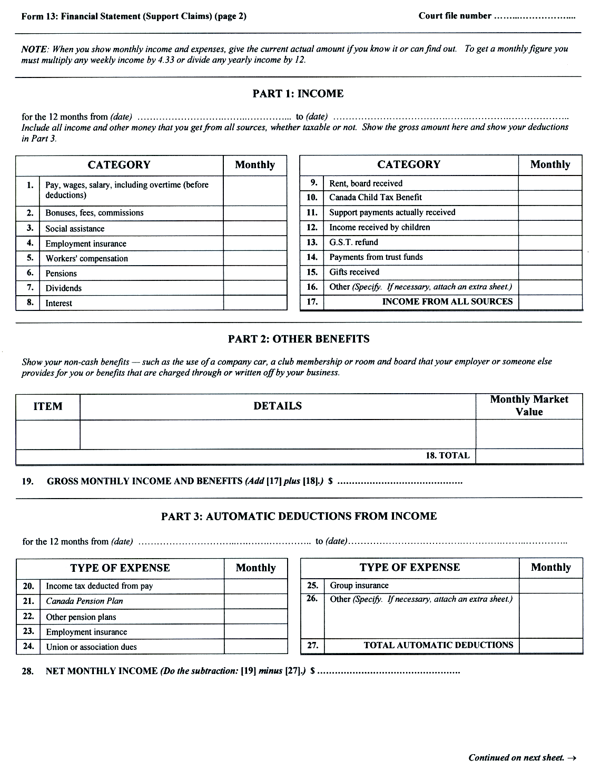
Insert regs\graphics\1999\114\114013ce.tif
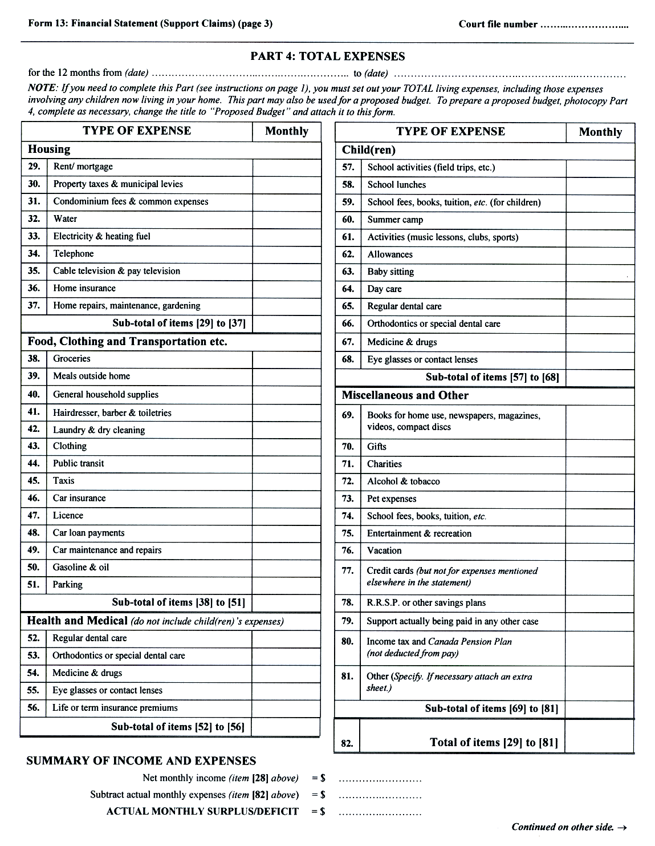
Insert regs\graphics\1999\114\114013de.tif
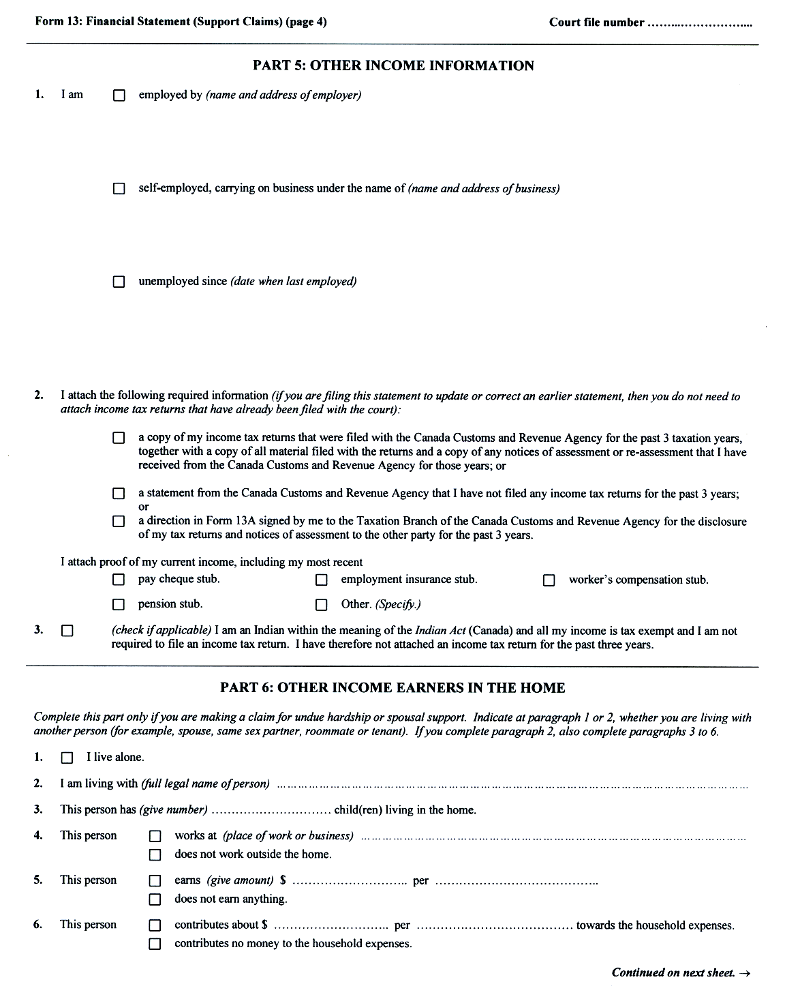
Insert regs\graphics\1999\114\114013ee.tif
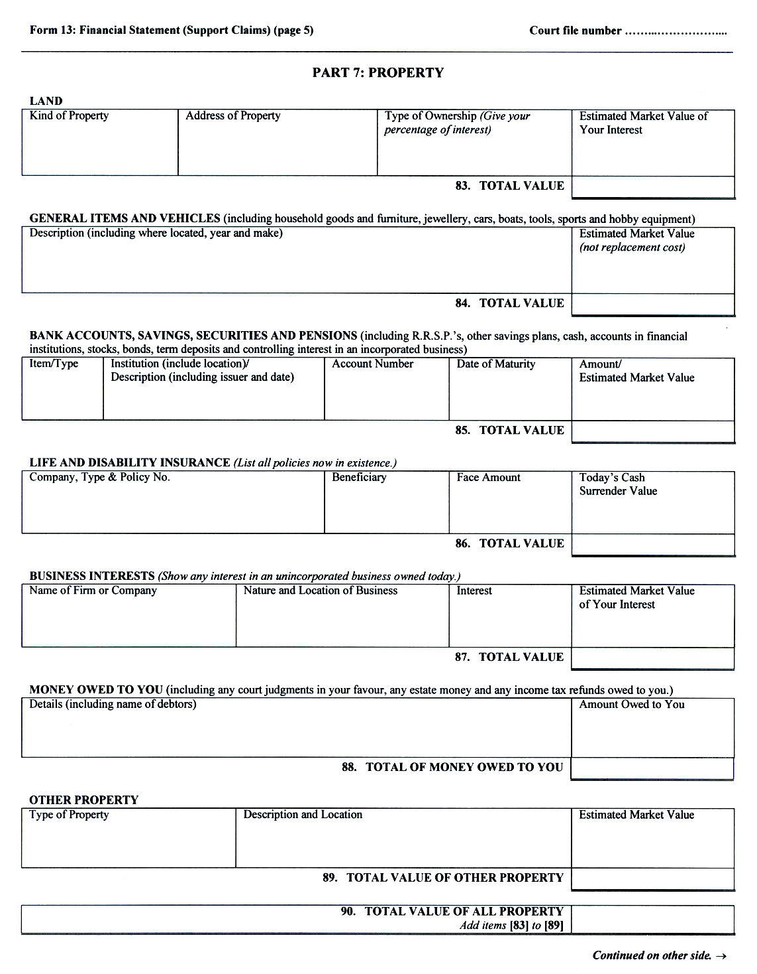
Insert regs\graphics\1999\114\114013fe.tif
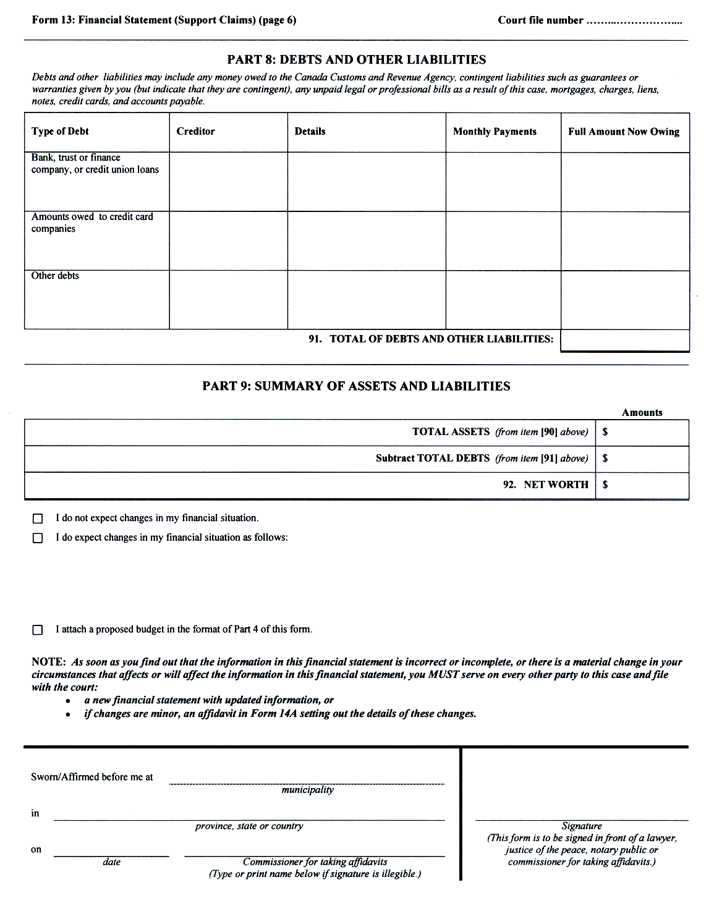
O. Reg. 92/03, s. 3 (3).
Form 13.1
Courts of Justice Act
financial statement
Insert regs\graphics\1999\114\114131ae.tif
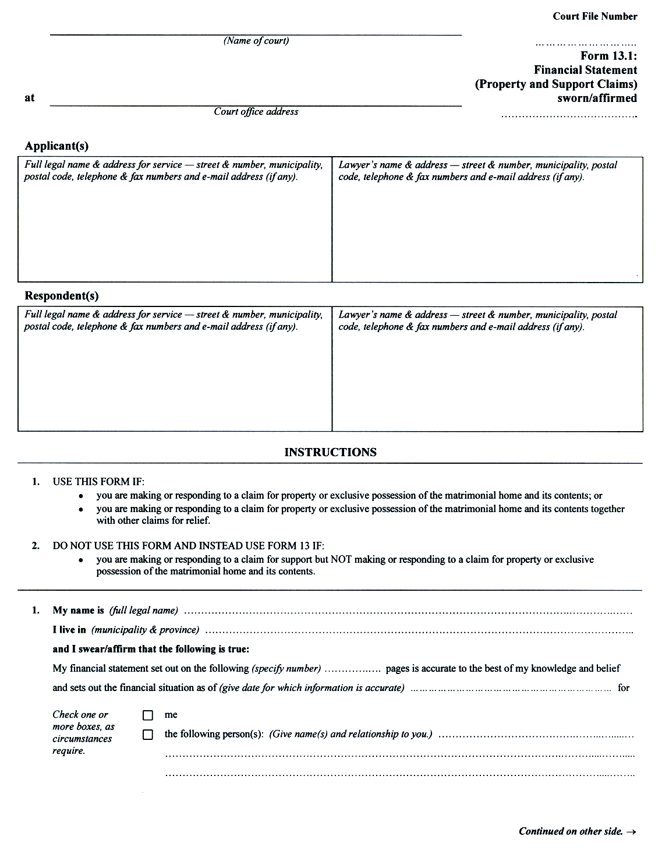
Insert regs\graphics\1999\114\114131be.tif
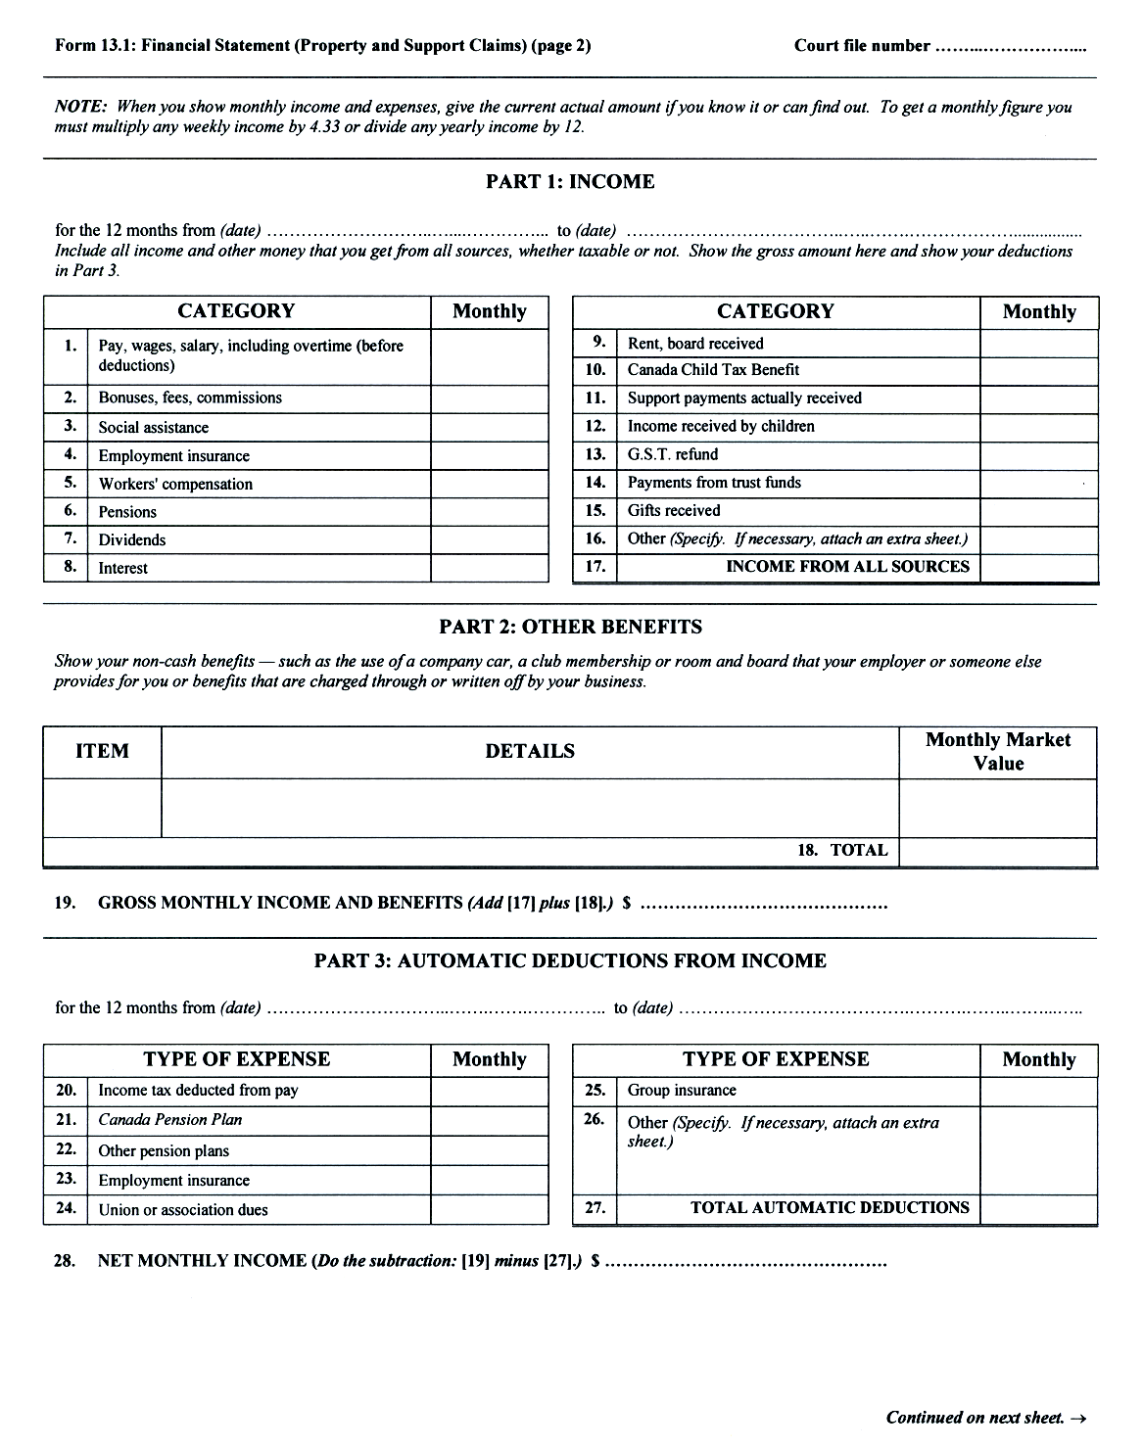
Insert regs\graphics\1999\114\114131ce.tif
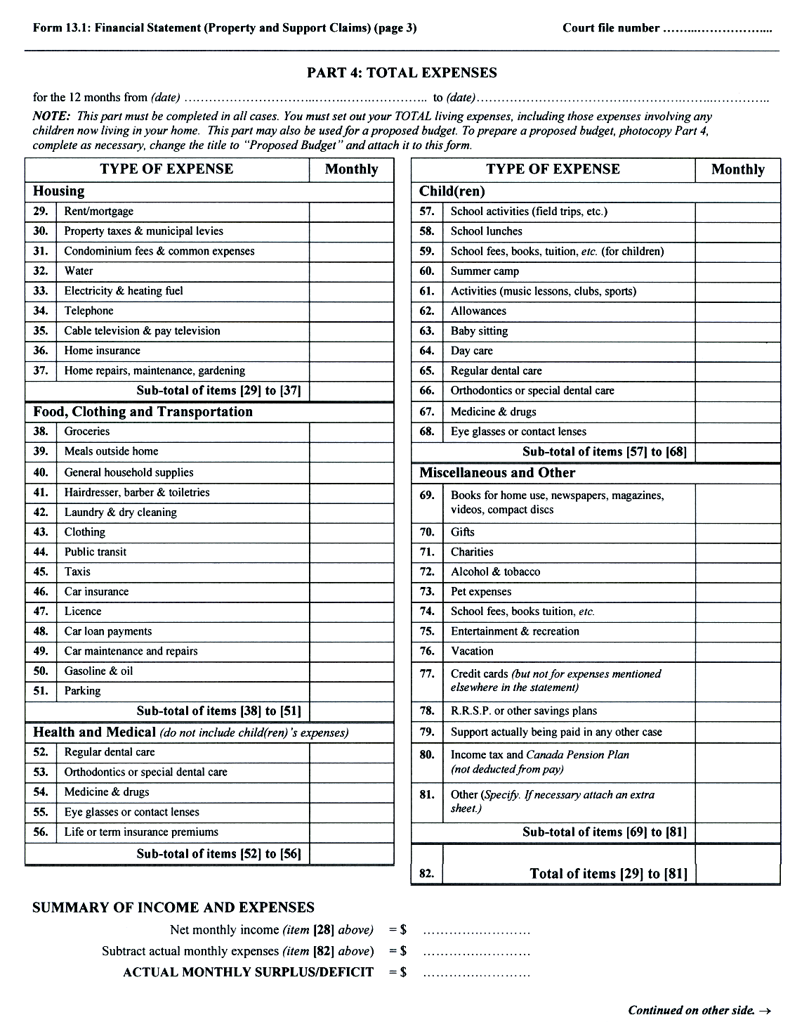
Insert regs\graphics\1999\114\114131de.tif
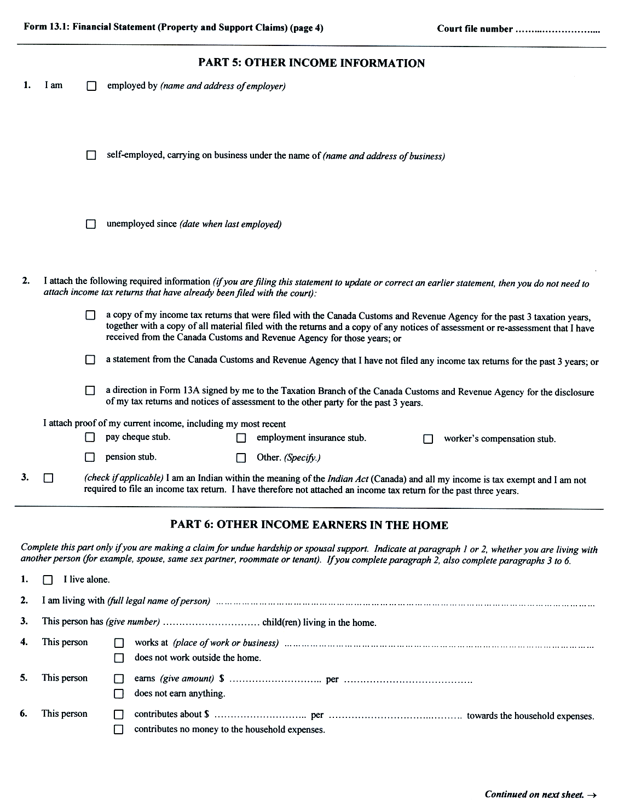
Insert regs\graphics\1999\114\114131ee.tif
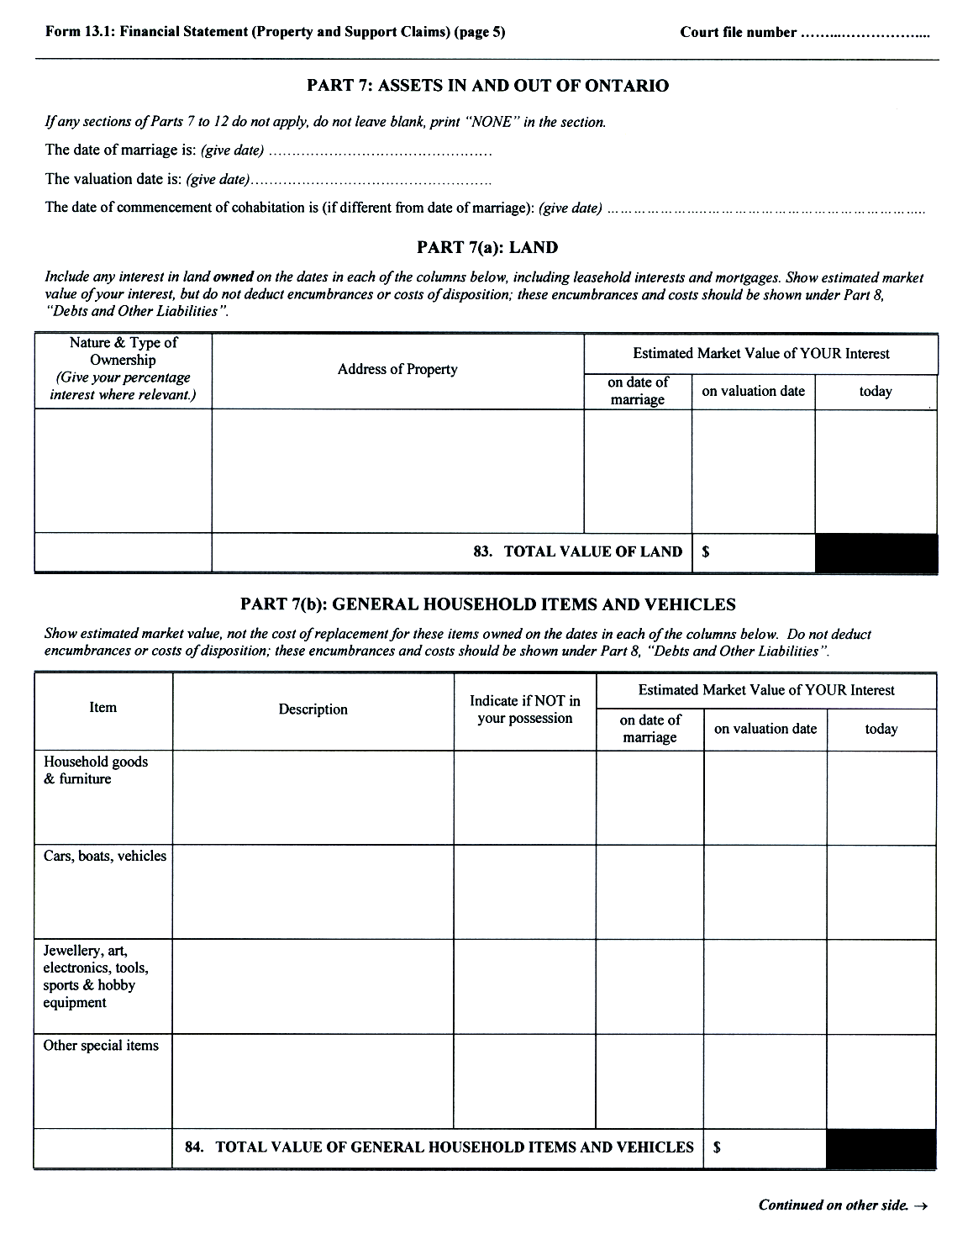
Insert regs\graphics\1999\114\114131fe.tif
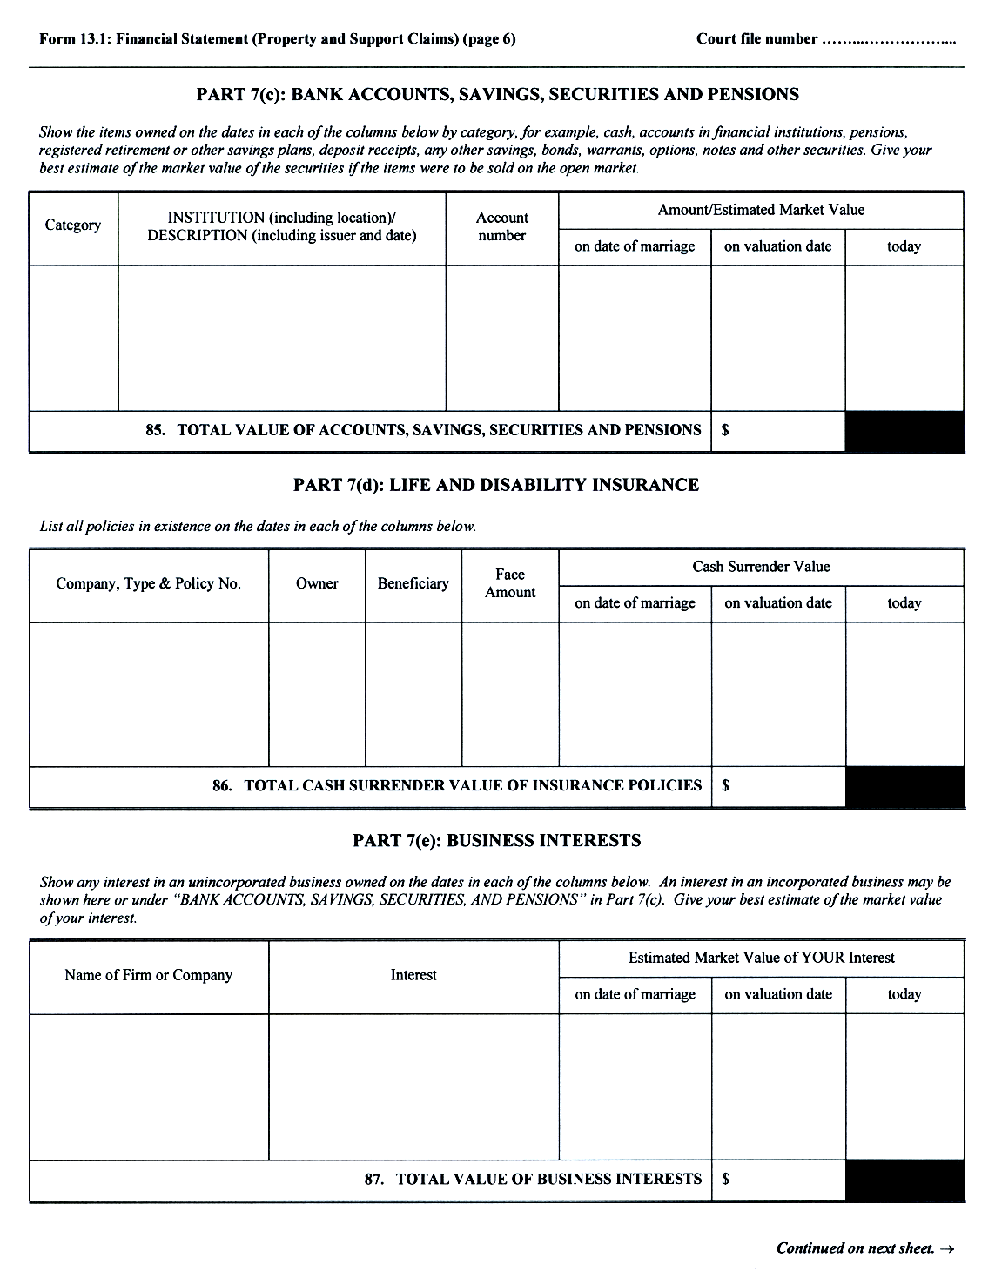
Insert regs\graphics\1999\114\114131ge.tif
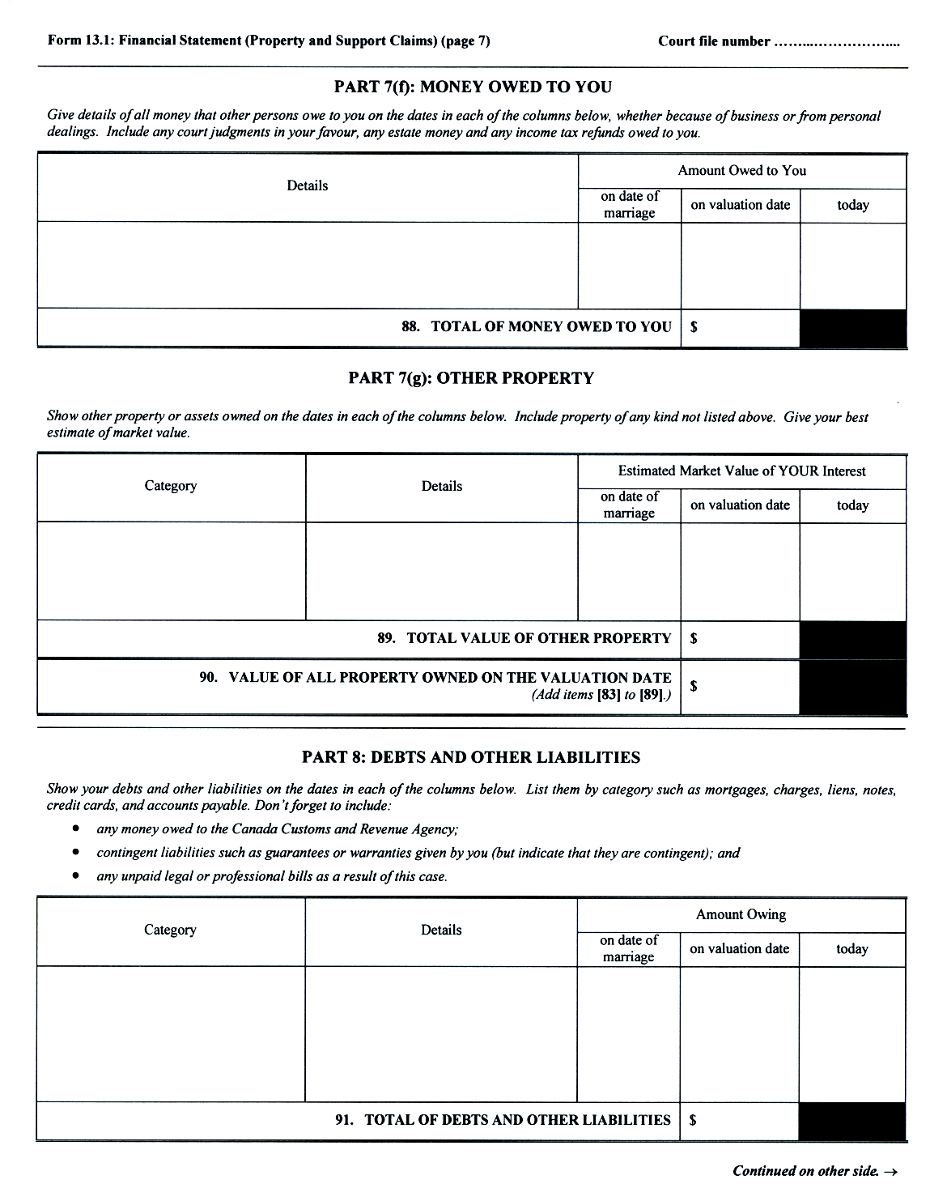
Insert regs\graphics\1999\114\114131he.tif
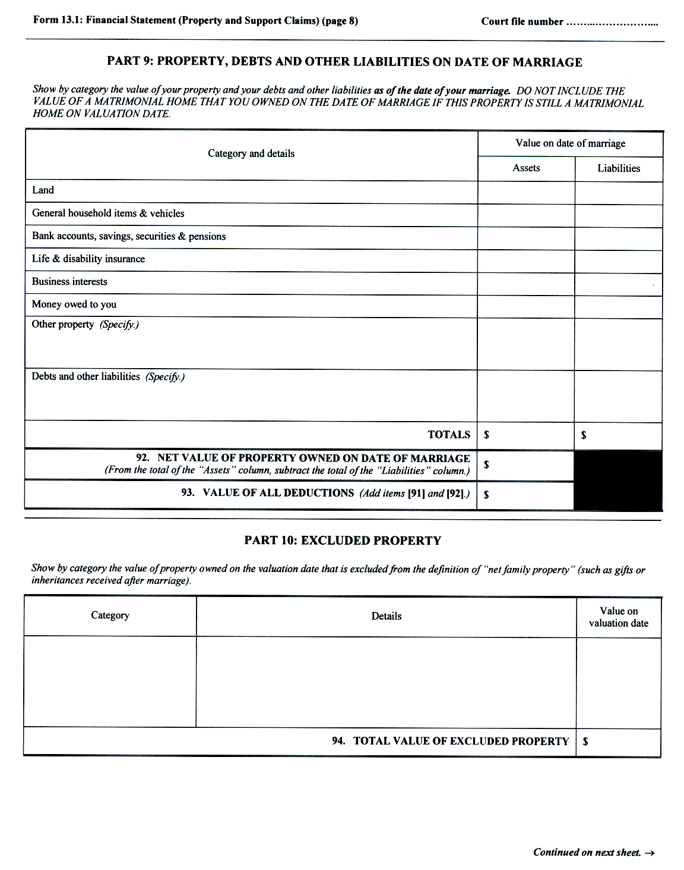
Insert regs\graphics\1999\114\114131ie.tif
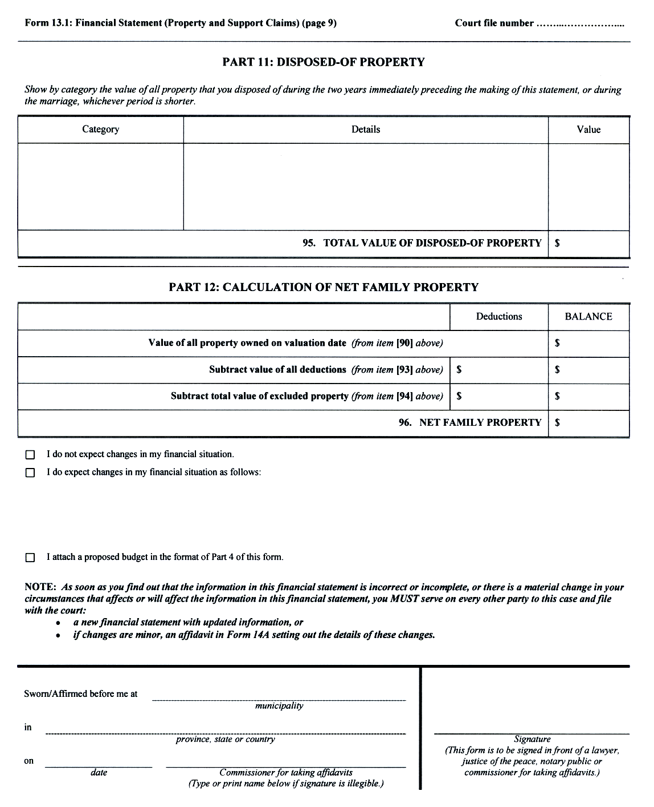
O. Reg. 92/03, s. 3 (3).
Form 13A
Courts of Justice Act
direction to canada customs and revenue agency
Court File Number

……...……………………
Form 13A: Direction to Canada Customs and Revenue Agency
(Name of court)

at
Court office address

Applicant(s)
Full legal name & address for service — street & number, municipality, postal code, telephone & fax numbers and e-mail address (if any). | Lawyer’s name & address — street & number, municipality, postal code, telephone & fax numbers and e-mail address (if any).

Respondent(s)
Full legal name & address for service — street & number, municipality, postal code, telephone & fax numbers and e-mail address (if any). | Lawyer’s name & address — street & number, municipality, postal code, telephone & fax numbers and e-mail address (if any).

TO THE CANADA CUSTOMS AND REVENUE AGENCY:

My name is (full legal name)
My latest address shown on tax records is:

My social insurance number is:
I authorize the Canada Customs and Revenue Agency to release to (name and address of other party or other party’s lawyer)

copies of income and deduction printouts showing my income as assessed by the Canada Customs and Revenue Agency for the following years:

Ontario’s Family Law Rules require the release of this information which will be used in this case only for:
- a claim for support, property or exclusive possession of the matrimonial home and its contents; or
- any other purpose ordered by the court.
I understand that this information will become part of the court file, which is a public record.

Date of signature |  | Signature of taxpayer
O. Reg. 202/01, s. 9.
Form 13B
Courts of Justice Act
net family property statement
Insert regs\graphics\1999\114\11413bae.tif
Insert regs\graphics\1999\114\11413bbe.tif
Insert regs\graphics\1999\114\11413bce.tif
O. Reg. 544/99, s. 15 (1).
Form 14
Courts of Justice Act
notice of motion
Insert regs\graphics\1999\114\114014ae.tif
Insert regs\graphics\1999\114\114014be.tif
O. Reg. 114/99, Form 14.
Form 14A
Courts of Justice Act
affidavit (general)
Insert regs\graphics\1999\114\11414aae.tif
Insert regs\graphics\1999\114\11414abe.tif
O. Reg. 114/99, Form 14A.
Form 14B
Courts of Justice Act
motion form
Insert regs\graphics\1999\114\11414bae.tif
Insert regs\graphics\1999\114\11414bbe.tif
O. Reg. 114/99, Form 14B.
Form 14C
Courts of Justice Act
Confirmation
Court File Number

……...……………………
Form 14C: Confirmation
(Name of court) |  |  | Court File Number  ……...……………………  Form 14C: Confirmation
at |  |  | Court File Number  ……...……………………  Form 14C: Confirmation
 | Court office address |  | Court File Number  ……...……………………  Form 14C: Confirmation
Applicant(s)
Full legal name & address for service — street & number, municipality, postal code, telephone & fax numbers and e-mail address (if any). |  | Lawyer’s name & address — street & number, municipality, postal code, telephone & fax numbers and e-mail address (if any).

Respondent(s)
Full legal name & address for service — street & number, municipality, postal code, telephone & fax numbers and e-mail address (if any). | Lawyer’s name & address — street & number, municipality, postal code, telephone & fax numbers and e-mail address (if any).

Name & address of Children’s Lawyer’s agent (street & number, municipality, postal code, telephone & fax numbers and e-mail address (if any)) and name of person represented.

1. My name is (full legal name)
and I am ◻ the lawyer for (name)
◻ (Other. Specify.)
2. I have ◻ not been able to contact the opposing lawyer or party in this case to confirm the matters set out in paragraphs 3 to 7 below because: (Give reason for inability to contact other side).
◻ contacted the opposing lawyer or party and have confirmed the matters set out in paragraphs 3 to 7 below.
3. The scheduled date and time for this
◻ motion ◻ case conference ◻ settlement conference ◻ trial management conference
is (date) at am/pm.
(complete only if motion is being confirmed)
◻ A case conference was held on the issues in this motion before Justice
◻ A case conference has not been held on the issues in this motion.
4. This matter is going ahead
◻ on all the issues.
◻ on only the following issues: (Specify.)
◻ for a consent order regarding: (Specify.)
◻ for an adjournment on consent to (date) because
(Give reason.)
◻ for a contested adjournment to (date) asked for
by (name of person asking for adjournment) because
(Give reason.)
5. The judge should read pages/tabs of the continuing record.
6. Total time estimate: applicant: minutes; respondent minutes; for a total of minutes.
7. The case management judge for this case is Justice

Date of signature |  | Lawyer’s or party’s signature
O. Reg. 202/01, s. 9.
Form 14D
Courts of Justice Act
order on motion without notice
Insert regs\graphics\1999\114\11414dae.tif
Insert regs\graphics\1999\114\11414dbe.tif
O. Reg. 114/99, Form 14D.
Form 15
Courts of Justice Act
change information form
(motion to change child support)

Court File Number

……...……………………
Form 15: Change Information Form (motion to change child support)
(Name of court)

at
Court office address

Recipient(s)
Full legal name & address for service — street & number, municipality, postal code, telephone & fax numbers and e-mail address (if any). | Lawyer’s name & address — street & number, municipality, postal code, telephone & fax numbers and e-mail address (if any).

Payor
Full legal name & address for service — street & number, municipality, postal code, telephone & fax numbers and e-mail address (if any). | Lawyer’s name & address — street & number, municipality, postal code, telephone & fax numbers and e-mail address (if any).

PART 1 — GENERAL INFORMATION
(This part should be filled out to the best ability of the party asking for a change in a child support order.)
My name is (full legal name)
I live in (municipality & province)
and I swear/affirm that the following is true:
1. I am the ◻ support recipient. ◻ support payor.
2. The payor, (payor’s full legal name)
was born on (date of birth) , lives in (municipality & province)
and, at the present time, is ◻ married ◻ living in a spousal relationship ◻ (Other. Specify.)
◻ separated ◻ living in a same-sex
partner relationship
3. The recipient, (recipient’s full legal name)
was born on (date of birth) , lives in (municipality & province)
and, at the present time, is ◻ married ◻ living in a spousal relationship ◻ (Other. Specify.)
◻ separated ◻ living in a same-sex
partner relationship
4. The payor and the recipient:
◻ were married on (date) ◻ started living together on (date)
◻ separated on (date) ◻ never lived together.
5. The following chart gives basic information about the child(ren) in this case:
List all children involved in this case, even those for whom no support is being claimed.
 | Child’s full  legal name | Age | Birthdate | Lives in  (municipality & province) | Now living with  (name of person and relationship to child) |  | Support claimed for child?  (YES or NO)
 |  |  |  |  |  | Continued on other side. →
Form 15: Change Information Form
(motion to change child support) (page 2) Court file number

Child’s full  legal name | Age | Birthdate | Lives in  (municipality & province) | Now living with  (name of person and relationship to child) | Support claimed for child?  (YES or NO)
6. The access arrangements for the child(ren) are as follows:
Child’s name | Access arrangement
7. I attach a copy of the existing ◻ court order
◻ agreement

that deals with the child support to be varied. The details of this order/agreement are as follows:
Date of order or Agreement | Present child support payment | Other terms of child support  (such as cost-of-living increases) | Present support payment (if any) for spouse or same-sex partner
 | $ ,  per |  | $ ,  per
8. The payment status of this order/agreement as of today is as follows:
 | Child support  owed to recipient | Child support  owed to other(s)  (such as Ministry of Community & Social Services) | Spousal or same-sex partner support owed to recipient |  | Spousal or same-sex partner support owed to other(s) (such as Ministry of Community & Social Services)
 | $ | $ | $ |  | $
 | (If money is owing, attach a statement of money owed (Form 26)).
9. This order/agreement ◻ has never been
◻ has been
assigned to ◻ the Ontario Ministry of Community and Social Services
◻ the municipality of (name)
- (Other. Specify.)
The details of this assignment are (Give date of assignment, indicate whether it is still in effect and add any other information known to you.)

 |  |  |  | Continued on next sheet. →
Form 15: Change Information Form
(motion to change child support) (page 3) Court file number

10. I am asking to change the child support in the order/agreement because:
◻ the order/agreement was made before the applicable child support guidelines came into effect.
◻ a change in circumstances has taken place. (Give details of change in circumstances.)

11. I ask that the child support be calculated as follows:
◻ the basic table amount listed in the child support guidelines of (give a dollar amount where possible) $ per month for the (number of children) child(ren) on the basis of the payor’s total annual income of (give a dollar amount where possible) $ , with payments to begin on (date) .
◻ the following special or extraordinary expenses (add-ons):

Child’s name | Type of expense | Amount | Payor’s share | Child’s contribution | Termination date (if known)
 |  | $ | $ | $
 |  | $ | $ | $
 |  | $ | $ | $

◻ an amount of $ per month, which is different from the table amount listed in the child support guidelines, with payments to start on (date)

The reason(s) for my request for a different amount is/are that:
◻ the parties consent to a different amount.
◻ I have attached a separate sheet to this form that explains why this is a reasonable arrangement for the child(ren).
◻ The recipient is getting social assistance payments from a public agency whose consent to this arrangement is needed. I am attaching the agency’s consent to this form.

◻ as can be seen from paragraphs 5 and 6 above, the parties have shared custody to the child(ren) (the payor has a child at least 40 per cent of the time).
◻ I have attached a separate sheet to this form that compares the table amounts from the child support guidelines for each of
the parties and that shows the increased cost of the shared custody arrangement and shows the financial circumstances of each party and of each child for whom support is claimed.
◻ The parties are consenting to this arrangement and I have attached a separate sheet to this form that explains why this is a
reasonable arrangement for the child(ren).

◻ as can be seen from paragraph 5 above, custody of the child(ren) is split between the parties. I have attached a separate sheet to this form that calculates the difference between the amount that each party would otherwise pay to the other under the guidelines.
◻ a child is 18 or more years old and I attach to this form a separate sheet that calculates the amount of support for this child.
◻ a child contributes to his/her own support and I attach to this form a separate sheet showing the amount of the child’s own income.
◻ the payor’s annual income is over $150,000 and I have attached to this form a separate sheet that calculates the amount of support that I want to be put in an order
◻ under the order/agreement, (name of child) is the subject of special provisions
that I have detailed on a separate sheet that I have attached to this form.
◻ the payor stands in the place of a natural parent to (name of child) and I attach to this form a separate sheet that gives the details of another parent’s duty to pay support for this child as well as the details of the calculation of the amount of support requested.
◻ the amount listed in the child support guidelines would cause undue hardship to me or to the child(ren) for whom support is claimed. I attach to this form a separate sheet that compares the living standards of the parties.

Continued on other side. →
Form 15: Change Information Form
(motion to change child support) (page 4) Court file number

12. I ask that the child support owed be paid off as follows:
◻ the child support owed to (name of recipient) should be fixed at $
as of (date) and to be paid off at the rate of $ per month, with payments to begin on (date)
◻ the child support owed to (name of agency or other person) should be fixed at $
as of (date) and to be paid off at the rate of $ per month, with payments to begin on (date)
Sworn/Affirmed before me at
municipality
in
province, state or country
on  date |  | Signature  (This form is to be signed in front of a lawyer, justice of the peace, notary public or commissioner for taking affidavits.)
on  date | Commissioner for taking affidavits  (Type or print name below if signature is illegible).

PART 2 — INFORMATION FROM SUPPORT PAYOR

My name is (full legal name)

I live in (municipality & province)

and I swear/affirm that the following is true:

13. I am the support payor in this case.

14. My total income will be $ for this year.

15. On the basis of my annual income, the table amount from the child support guidelines for (number of children) ………..…… child(ren) is
$ per month.

16. My financial statement ◻ is attached ◻ is not attached.
(NOTE: You do not need to attach a financial statement if you and the other party have filled out the appropriate portion of the consent (Form 15A) and have agreed not to file a financial statement. Nevertheless, because the child support guidelines have a new way of computing the amount of child support, YOU MUST PROVIDE THE COURT WITH NEW ADDITIONAL INFORMATION. That amount is set out in a table that is geared to the payor’s annual income and to the number of children who are entitled to support. Under certain conditions, the annual income of the recipient may also be taken into account, in which case, the recipient will have to provide the court with the same additional information in paragraphs 19 and 20 below.)

17. I attach the following financial information about me:
(a) a copy of every personal income tax return that I filed with Revenue Canada for the 3 most recent taxation years;
(b) a copy of every notice of assessment or re-assessment from Revenue Canada of those returns; and
(c) ◻ (applies only if you are an employee) proof of this year’s earnings from my employer as required by clause 21 (1) (c) of the child support guidelines.
◻ (applies only if you are self-employed, or you are a partner in a partnership or you control a corporation or are a beneficiary under a trust) the documents listed in clause 21 (1) (d), (e), (f) or (g) of the child support guidelines.
Sworn/Affirmed before me at
municipality
in
province, state or country
on  date |  | Signature  (This form is to be signed in front of a lawyer, justice of the peace, notary public or commissioner for taking affidavits.)
on  date | Commissioner for taking affidavits  (Type or print name below if signature is illegible.)
 |  |  | Continued on next sheet. →
Form 15: Change Information Form
(motion to change child support) (page 5) Court file number ...……….

PART 3 — INFORMATION FROM SUPPORT RECIPIENT

Because the child support guidelines have a new way of computing the amount of child support, YOU MUST PROVIDE THE COURT WITH NEW ADDITIONAL INFORMATION. That amount is set out in a table that is geared to the payor’s annual income and to the number of children who are entitled to support. Under certain conditions, the annual income of the recipient may also be taken into account, in which case, the recipient will have to provide the court with the same additional information in paragraphs 19 and 20 below.

My name is (full legal name)

I live in (municipality & province)

and I swear/affirm that the following is true:

18. I am the support recipient in this case.

Fill in paragraphs 19 and 20 only if:
- the change for which you are asking is for an amount that is different from that calculated under the appropriate table in the child support guidelines;  - the change for which you are asking relates to a child over the age of 18 years, a child for whom the payor stands in the place of a parent or a child with respect to whom the payor has access or physical custody not less than 40 per cent of the time over the course of the year;  - each party has custody of one or more children;  - the payor’s annual income as determined under the guidelines is more than $150,000;  - either party claims that an order according to the guidelines amount would result in undue hardship. |  |  | 19. My total income  ◻ will be $ for this year;  ◻ was $ for last year; and  ◻ was $ for the year before that.  20. I attach the following financial information about me:  (a) a copy of every personal income tax return that I filed with Revenue Canada for the three most recent taxation years;  (b) a copy of every notice of assessment or re-assessment from Revenue Canada of those returns; and  (c) ◻ [applies only if you are an employee] proof of this year’s earnings from my employer as required by clause 21 (1) (c) of the child support guidelines.  ◻ [applies only if you are self-employed, or you are a partner in a partnership or you control a corporation or are a beneficiary under a trust] the documents listed in clause 21 (1) (d), (e), (f), or (g) of the child support guidelines.
21. My financial statement ◻ is attached ◻ is not attached.
(NOTE: You do not need to attach a financial statement if you and the other party have signed a consent in Form 15A.)
Sworn/Affirmed before me at
municipality
in
province, state or country
on  date |  |  |  | Signature  (This form is to be signed in front of a lawyer, justice of the peace, notary public or commissioner for taking affidavits.)
Commissioner for taking affidavits
(Type or print name below if signature is illegible.)
O. Reg. 202/01, s. 9.
Form 15A
Courts of Justice Act
consent (motion to change child support)
Insert regs\graphics\1999\114\11415aae.tif
Insert regs\graphics\1999\114\11415abe.tif
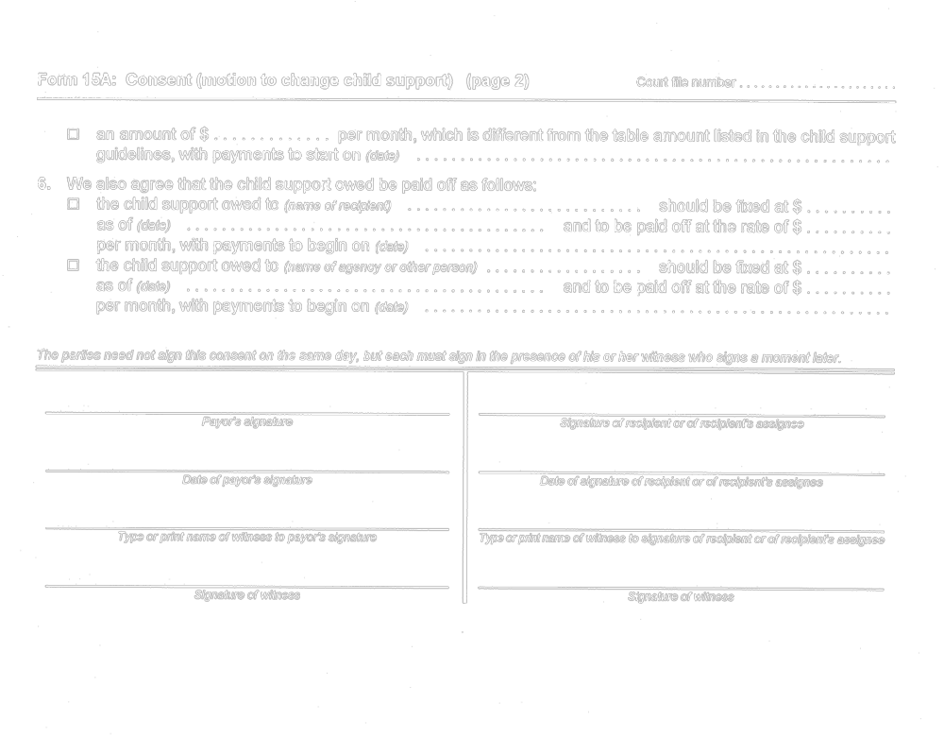
O. Reg. 114/99, Form 15A.
Form 17
Courts of Justice Act
conference NOTICE
Court File Number

……...……………………
Form 17:
Conference
Notice
(Name of court)
at
 | Court office address
Applicant(s)
Full legal name & address for service — street & number, municipality, postal code, telephone & fax numbers and e-mail address (if any). |  | Lawyer’s name & address — street & number, municipality, postal code, telephone & fax numbers and e-mail address (if any).

Respondent(s)
Full legal name & address for service — street & number, municipality, postal code, telephone & fax numbers and e-mail address (if any). | Lawyer’s name & address — street & number, municipality, postal code, telephone & fax numbers and e-mail address (if any).

Name & address of Children’s Lawyer’s agent (street & number, municipality, postal code, telephone & fax numbers and e-mail address (if any)) and name of person represented.

TO: (name of party or parties or lawyer(s))
A ◻ CASE CONFERENCE ◻ SETTLEMENT CONFERENCE ◻ TRIAL MANAGEMENT CONFERENCE
WILL BE HELD at (place of conference)
at a.m./p.m. on (date)
The conference has been arranged at the request of
◻ the applicant ◻ the respondent
◻ the case management judge ◻ (Other; specify.) ………………………………….…….……….…………………………
to deal with the following issues:
You must participate at that time and date by
◻ coming to court at the address set out above.
◻ video-conference or telephone at (location of video terminal or telephone)

as agreed under arrangements already made by (name of person)
for video/telephone conferencing
IF YOU DO NOT PARTICIPATE AS SET OUT ABOVE, THE CASE MAY GO ON WITHOUT YOU OR THE COURT MAY DISMISS THE CASE.
Date of signature |  | Signature of clerk of the court

NOTE: The party requesting the conference (or, if the conference is not requested by a party, the applicant) must serve and file a case conference brief (Form 17A or 17B), settlement conference brief (Form 17C or 17D) or trial management conference brief (Form 17E) not later than seven days before the date scheduled for the conference. The other party must serve and file a brief not later than four days before the conference date. Each party must also file a confirmation (Form 14C) not later than 2 p.m. two days before the conference.
O. Reg. 202/01, s. 10.
Form 17A
Courts of Justice Act
case conference brief — general
Court File Number

……...……………………
Form 17A:
Case Conference Brief - General
(Name of court)

at
Court office address

Name of party filing this brief |  | Date of case conference

Applicant(s)
Full legal name & address for service — street & number, municipality, postal code, telephone & fax numbers and e-mail address (if any). | Lawyer’s name & address — street & number, municipality, postal code, telephone & fax numbers and e-mail address (if any).

Respondent(s)
Full legal name & address for service — street & number, municipality, postal code, telephone & fax numbers and e-mail address (if any). | Lawyer’s name & address — street & number, municipality, postal code, telephone & fax numbers and e-mail address (if any).

Name & address of Children’s Lawyer’s agent (street & number, municipality, postal code, telephone & fax numbers and e-mail address (if any)) and name of person represented.

— PART 1: FAMILY FACTS —
1. APPLICANT: Age: Birthdate:
2. RESPONDENT: Age: Birthdate:
3. RELATIONSHIP DATES:
◻ Married on (date) ◻ Started living together on (date)
◻ Separated on (date) ◻ Never lived together.
◻ Other (Explain.)

4. The basic information about the child(ren) is as follows:

Child’s full legal name | Age | Birthdate  (day, month, year) | Grade/Year and school |  | Now living with
 |  |  |  | Continued on other side. →

Form 17A: Case Conference Brief - General (page 2) Court file number

— PART 2: ISSUES —

5. What are the issues in this case that HAVE been settled:
◻ child custody ◻ spousal support ◻ ownership of property
◻ access ◻ same-sex partner support ◻ possession of home
◻ restraining order ◻ child support ◻ equalization of net family property

◻ (Other. Specify.)

6. What are the issues in this case that have NOT yet been settled:
◻ child custody ◻ spousal support ◻ ownership of property
◻ access ◻ same-sex partner support ◻ possession of home
◻ restraining order ◻ child support ◻ equalization of net family property
(Attach net family property statement, Form 13B)
◻ (Other. Specify.)

7. If child or spousal or same-sex partner support is an issue, give the income of the parties:

Applicant: $ per year for the year 20
Respondent: $ per year for the year 20

8. Have you explored any ways to settle the issues that are still in dispute in this case?
◻ No ◻ Yes. (Give details.)

9. Have any of the issues that have been settled been turned into a court order or a written agreement?
◻ No
◻ Yes ◻ an order dated
◻ a written agreement that is attached.

10. Have the parents attended a family law or parenting education session?
◻ No. (Should they attend one? .)
◻ Yes. (Give details.)

— PART 3: ISSUES FOR THIS CASE CONFERENCE —

11. What are the issues for this case conference? What are the important facts for this case conference?

Continued on next sheet. →

Form 17A: Case Conference Brief - General (page 3) Court file number ……...….

12. What is your proposal to resolve these issues?

13. Do you want the court to make a temporary or final order at the case conference about any of these issues?
◻ No. ◻ Yes. (Give details.)

— PART 4: FINANCIAL INFORMATION —

NOTE: — If a claim for support has been made in this case, you must serve and file a new financial statement (Form 13 or 13.1), if it is different from the one filed in the continuing record or if the one in the continuing record is more than 30 days old. If there are minor changes but no major changes in your financial statement, you can serve and file an affidavit with details of the changes instead of a new financial statement. If you have not yet filed a financial statement in the continuing record, you must do it now. The page/tab number of the financial statement in the continuing record is …………

14. If a claim is being made for child support and a claim is made for special expenses under the child support guidelines, give details of those expenses or attach additional information.

15. If a claim is made for child support and you claim that the child support guideline table amount should not be ordered, briefly outline the reasons here or attach an additional page.

Continued on other side. →

Form 17A: Case Conference Brief - General (page 4) Court file number

— PART 5: PROCEDURAL ISSUES —

16. If custody or access issues are not yet settled:
(a) Is a custody or access assessment needed?
◻ No. ◻ Yes. (Give names of possible assessors.)

(b) Does a child or a parent under 18 years of age need legal representation from the Office of the Children’s Lawyer?
◻ No. ◻ Yes. (Give details and reasons.)

17. Does any party need an order for the disclosure of documents, the questioning of witnesses, a property valuation or any other matter in this case?
◻ No. ◻ Yes. (Give details.)

18. Are any other procedural orders needed?
◻ No. ◻ Yes. (Give details.)

19. Have all the persons who should be parties in this case been added as parties?
◻ Yes. ◻ No. (Who needs to be added?)

20. Are there any other issues that should be reviewed at the case conference?
◻ No. ◻ Yes. (Give details.)

Date of party’s signature |  | Signature of party
Date of lawyer’s signature |  | Signature of party’s lawyer

O. Reg. 202/01, s. 10; O. Reg. 92/03, s. 3 (4).
Form 17B
Courts of Justice Act
case conference brief
Court File Number

……...……………………
Form 17B: Case
Conference Brief for
◻ Protection Application
◻ Status Review
(Name of court)
at
Court office address

Name of party filing this brief |  | Date of case conference

Applicant(s)
Full legal name & address for service — street & number, municipality, postal code, telephone & fax numbers and e-mail address (if any). | Lawyer’s name & address — street & number, municipality, postal code, telephone & fax numbers and e-mail address (if any).

Respondent(s)
Full legal name & address for service — street & number, municipality, postal code, telephone & fax numbers and e-mail address (if any). | Lawyer’s name & address — street & number, municipality, postal code, telephone & fax numbers and e-mail address (if any).

Respondent(s)
Full legal name & address for service — street & number, municipality, postal code, telephone & fax numbers and e-mail address (if any). | Lawyer’s name & address — street & number, municipality, postal code, telephone & fax numbers and e-mail address (if any).

Respondent(s)
Full legal name & address for service — street & number, municipality, postal code, telephone & fax numbers and e-mail address (if any). | Lawyer’s name & address — street & number, municipality, postal code, telephone & fax numbers and e-mail address (if any).

Name & address of Children’s Lawyer’s agent (street & number, municipality, postal code, telephone & fax numbers and e-mail address (if any)) and name of person represented.

Continued on other side. →
Form 17B: Case Conference Brief for
Protection Application or Status Review (page 2) Court file number

— PART 1: BASIC INFORMATION ABOUT THE CHILD(REN) —

1. The basic information about the child(ren) is as follows:

Child’s full legal name | Age | Birthdate  (day, month, year) | Full legal name of every parent of child and relationship to child  (See subsection 37 (1) of the Child and Family Services Act.) | Date of  apprehension  of child

2. Where is the child living at the time of this conference?

3. What is the total length of time that any child less than six years old has been in care? (Attach more detail if necessary.)
Name of child Total length of time
4. What is the total length of time any child six years old or more has been in care? (Attach more details if necessary.)
Name of child Total length of time
5. What religious faith, if any, is the child being raised in? (Give the name of the child and the child’s religion.)

6. Is any child an Indian or native person?
◻ No. ◻ Yes. (Give the name, address, band number and telephone number of the band to which the child belongs.)

7. If the child was brought to a place of safety before the hearing, name the person from whose care and the place from which the child was removed.

8. Has everyone who is entitled to notice in this case been served?
◻ Yes. ◻ No. (Do you want an order for substituted service on any person or an order that service is not required?
Give details.)

— PART 2: OUTSTANDING ISSUES —

(Complete only Part 2A – Protection Application or Part 2B – Status Review, not both)
Part 2A – Protection Application
9. The parties have reached an agreement or the court has made an order on the following issues:
◻ findings of fact set out in Part 1 above
◻ temporary care and custody ◻ access
◻ finding that child is in need of protection
◻ placing the child(ren) with (name of person)
for months under supervision.
◻ society wardship for months. ◻ Crown wardship with access
◻ (Other. Specify.) ◻ Crown wardship without access

Continued on next sheet. →

Form 17B: Case Conference Brief for
Protection Application or Status Review (page 3) Court file number

The details of this agreement or order are:

10. What are the issues in this case that have NOT yet been resolved?
◻ findings of fact set out in Part 1 above
◻ temporary care and custody ◻ access
◻ finding that child is in need of protection
◻ placing the child(ren) with (name of person)
for months under supervision.
◻ society wardship for months. ◻ Crown wardship with access
◻ (Other. Specify.) ◻ Crown wardship without access

Part 2B - Status Review

11. The parties have reached an agreement or the court has made an order on the following issues:
◻ temporary care and custody ◻ access
◻ placing the child(ren) with (name of person)
for months under supervision.
◻ society wardship for months. ◻ Crown wardship with access
◻ (Other. Specify.) ◻ Crown wardship without access

The details of this agreement or order are:

12. What are the issues in this case that have NOT yet been resolved?
◻ temporary care and custody ◻ access
◻ placing the child(ren) with (name of person)
for months under supervision.
◻ society wardship for months. ◻ Crown wardship with access
◻ (Other. Specify.) ◻ Crown wardship without access

— PART 3: ISSUES FOR THIS CASE CONFERENCE —

13. Have you explored any ways to settle the issues that are still in dispute in this case?
◻ No. ◻ Yes. (Give details.)

14. What are the issues for this case conference? What are the important facts for this case conference?

Continued on other side. →

Form 17B: Case Conference Brief for
Protection Application or Status Review (page 4) Court file number

15. What is your proposal to resolve these issues?

— PART 4: PROCEDURAL ISSUES —

16. Does the children’s aid society want an assessment?
◻ No. ◻ Yes. (Give names of possible assessors and the type of assessment recommended.)

17. Do the other parties agree with the children’s aid society’s proposal for an assessment?
◻ No. ◻ Yes.

18. Have you served a plan of care on the other parties?
◻ No. ◻ Yes. (A copy of the plan of care must be filed in the continuing record.) The plan can be found at tab/page
of the continuing record.

19. Does a child or a parent under 18 years of age need legal representation from the Office of the Children’s Lawyer?
◻ No. ◻ Yes. (Give details and reasons.)

20. Do you want an order for the disclosure of documents, the questioning of witnesses or any other matter in this case?
◻ No. ◻ Yes. (Give details.)

Date of party’s signature |  | Signature of party
Date of lawyer’s signature |  | Signature of party’s lawyer

O. Reg. 202/01, s. 10.
Form 17C
Courts of Justice Act
settlement conference brief — general
(Name of court)  at  Court office address |  |  | Court File Number  Form 17C: Settlement  Conference Brief - General
Name of party filing this brief |  | Date of settlement conference

Applicant(s)
Full legal name & address for service — street & number, municipality, postal code, telephone & fax and e-mail address (if any). | Lawyer’s name & address — street & number, municipality, postal code, telephone & fax numbers and e-mail address (if any).
Respondent(s)
Full legal name & address for service — street & number, municipality, postal code, telephone & fax and e-mail address (if any). | Lawyer’s name & address — street & number, municipality, postal code, telephone & fax numbers and e-mail address (if any).

Name & address of Children’s Lawyer’s agent assigned to case — street & number, municipality, postal code, telephone & fax numbers and e-mail address (if any).

—— PART 1: FAMILY FACTS ——

1. APPLICANT: |  |  | Age: |  | Birthdate:
2. RESPONDENT: |  |  | Age: |  | Birthdate:
3. RELATIONSHIP DATES:
◻ | Married on (date) |  |  |  |  | ◻ |  | Started living together on (date)
◻ | Separated on (date) |  |  |  |  | ◻ |  | Never lived together.
◻ | Other (Explain.)
4. The basic information about the child(ren) is as follows:
Child’s full legal name |  | Age |  | Birthdate  (day, month, year) |  |  | Grade/Year and school |  | Now living with
 |  |  |  |  |  |  |  |  |  | Continued on other side. →

Form 17C: Settlement Conference Brief - General (page 2) Court file number …………..

—— PART 2: ISSUES ——
If you want to refer to anything else that is not in the continuing record and that does not need to be in the continuing record, you must attach it to this brief. In particular, attach any valuations or experts’ reports that are not in the record.
If you want to refer to a report or document that has already been filed in the continuing record, just give the page number(s) or tab number of that document in the continuing record.
If you are updating a document that is already in the continuing record, you must file the updated document in the continuing record and then refer to it by the page number(s) or tab numbers of that update in the continuing record

5. | What are the issues in this case that HAVE been settled or about which an order has been made:
 | ◻ | child custody |  |  | ◻ | spousal support |  | ◻ | ownership of property
 | ◻ | access |  |  | ◻ | same-sex partner support |  | ◻ | possession of home
 | ◻ | restraining order |  |  | ◻ | child support |  | ◻ | equalization of net family property
 | ◻ | (Other. Specify.)
6. | What are the issues in this case that have NOT yet been settled:
 | ◻ | child custody |  |  | ◻ | spousal support |  | ◻ | ownership of property
 | ◻ | access |  |  | ◻ | same-sex partner support |  | ◻ | possession of home
 | ◻ | restraining order |  |  | ◻ | child support |  | ◻ | equalization of net family property
 |  |  |  |  |  |  |  |  | (Attach net family property statement, Form 13B.),
 | ◻ | (Other. Specify.)
7. | If child or spousal or same sex partner support is an issue, give the income of the parties:
 | Applicant: $ |  |  | per year for the year 20…..
 | Respondent: $ |  |  | per year for the year 20…..
8. | What are the issues for this settlement conference? What are the important facts for this settlement conference?
9. | Do you want the court to make a temporary or final order about any of these issues at the settlement conference?
 | ◻ No |  |  | ◻ Yes. (Give details.)
 |  |  |  |  |  |  |  |  | Continued on next sheet. →

Form 17C: Settlement Conference Brief - General (page 3) Court file number

10. | Have any of the issues that have been settled been turned into a court order or a written agreement?
 | ◻ |  | No
 | ◻ |  | Yes | ◻ |  | an order dated
 |  |  |  | ◻ |  | a written agreement, which is attached.
—— PART 3: PROCEDURAL MATTERS ——
11. | If there is a custody or access assessment in this case, is it finished?
 | ◻ |  | Yes. (If it is not already filed in the continuing record, file it now. Give the tab/page number(s) of the assessment: )
 | ◻ |  | No. (Explain why the assessment is not ready.)
12. | If the Children’s Lawyer is involved in this case, has the Children’s Lawyer told the parties what its position is on the issues involving the children?
 | ◻ |  | Yes. (What is the Children’s Lawyer’s position. Explain below.)
 | ◻ |  | No. (Explain below.)
13. | Have the parties finished the disclosing of documents and the questioning of witnesses?
 | ◻ |  | Yes.
 | ◻ |  | No. (State what hasn’t been done.)
14. | Are there any further procedural orders needed in this case?
 | ◻ |  | No.
 | ◻ |  | Yes. (Explain.)
15. | I estimate that the trial time needed for my part of this trial is days; the other side’s part of this trial is days.
 |  |  |  |  |  |  |  |  | Continued on other side. →

Form 17C: Settlement Conference Brief - General (page 4) Court file number …………….

——— PART 4: OFFER TO SETTLE ———
16. | The following is my offer to settle the outstanding issues in this case:
 | ◻ | offer to settle all issues | ◻ | offer to settle some of the issues

NOTE:— If you have already made an offer and it is still open for acceptance, attach a copy to this brief.
If you have not made an offer to settle, you must make one here. If you do not have enough information about all the issues, make a partial offer on those issues for which you do have enough information.
The other side can accept your offer. And if the other side does accept it, the accepted offer becomes a binding contract and can be turned into a court order that can be enforced against you. The other side can make a counter-offer.
In your offer for child support, give detailed calculations for any claim for special expenses or for undue hardship. If your offer deals with spousal or same sex-partner support, it will be helpful to your case if you attach detailed calculations showing the effect of income tax on any proposed support order.

Put a line through any space left on this page. If additional space is needed, extra pages may be attached.
Date of party’s signature |  | Signature of party
Date of lawyer’s signature |  | Signature of party’s lawyer
O. Reg. 202/01, s. 10.

Form 17D
Courts of Justice Act
Settlement Conference Brief
(Name of court)  at  Court office address |  |  | Court File Number  Form 17D: Settlement  Conference Brief for  ◻ Protection Application  ◻ Status Review
Name of party filing this brief |  | Date of settlement conference

Applicant(s)
Full legal name & address for service — street & number, municipality, postal code, telephone & fax numbers and e-mail address (if any). | Lawyer’s name & address — street & number, municipality, postal code, telephone & fax numbers and e-mail address (if any).
Respondent(s)
Full legal name & address for service — street & number, municipality, postal code, telephone & fax numbers and e-mail address (if any). | Lawyer’s name & address — street & number, municipality, postal code, telephone & fax numbers and e-mail address (if any).
Respondent(s)
Full legal name & address for service — street & number, municipality, postal code, telephone & fax numbers and e-mail address (if any). | Lawyer’s name & address — street & number, municipality, postal code, telephone & fax numbers and e-mail address (if any).
Respondent(s)
Full legal name & address for service — street & number, municipality, postal code, telephone & fax numbers and e-mail address (if any). | Lawyer’s name & address — street & number, municipality, postal code, telephone & fax numbers and e-mail address (if any).

Name & address of Children’s Lawyer’s agent (street & number, municipality, postal code, telephone & fax numbers and e-mail address (if any)) and name of person represented.

Continued on other side. →
Form 17D: Settlement Conference Brief for
Protection Application or Status Review (page 2) Court file number

—— PART 1: BASIC INFORMATION ABOUT THE CHILD(REN) ——
1. | The basic information about the child(ren) is as follows:
Child’s full legal name |  | Age | Birthdate  (day, month, year) | Full legal name of every parent of child and relationship to child  (See subsection 37 (1) of the  Child and Family Services Act.) | Date of  apprehension  of child

2. | Where is the child living at the time of this conference?
3. | What is the total length of time that any child less than six years old has been in care? (Attach more detail if necessary.)
Name of child |  |  |  |  |  |  | Total length of time
4. | What is the total length of time any child six years old or more has been in care? (Attach more details if necessary.)
Name of child |  |  |  |  |  |  | Total length of time
5. | Is any child an Indian or native person?
 | ◻ | No. | ◻ |  | Yes. (Give the name, address, band number and telephone number of the band to which the child belongs.)
6. | What religious faith, if any, is the child being raised in? (Give the name of the child and the child’s religion.)
7. | If the child was brought to a place of safety before the hearing, name the person from whose care and the place from which the child was removed.
8. | Has everyone who is entitled to notice in this case been served?
 | ◻ | Yes. |  | ◻ |  | No. (Do you want an order for substituted service on any person or an order that service is not required?
 | Give details.)

Continued on next sheet. →

Form 17D: Settlement Conference Brief for
Protection Application or Status Review (page 3) Court file number

——— PART 2: OUTSTANDING ISSUES ———
NOTE:— if you want to refer to a report or document that has already been filed in the continuing record, just give the page number(s) or tab number of that document in the continuing record. If you are updating a document that is already in the continuing record, you must file the updated document in the continuing record and then refer to it by the page number(s) or tab numbers of that update in the continuing record. If you want to refer to anything else that is not in the continuing record and that does not need to be in the continuing record, you must attach it to this brief.

 | (Complete only Part 2A - Protection Application or Part 2B - Status Review, not both)
 | Part 2A - Protection Application
9. | The parties have reached an agreement or the court has made an order on the following issues:
 | ◻ | findings of fact set out in Part 1 above
 | ◻ | temporary care and custody |  |  |  |  | ◻ | Access
 | ◻ | finding that child is in need of protection
 | ◻ | placing the child(ren) with (name of person)  for months under supervision.
 | ◻ | society wardship for months. |  |  |  |  | ◻ | Crown wardship with access
 | ◻ | (Other. Specify.) |  |  |  |  | ◻ | Crown wardship without access
 | The details of this agreement or order are:
10. | What are the issues in this case that have NOT yet been resolved?
 | ◻ | findings of fact set out in Part 1 above
 | ◻ | temporary care and custody |  |  |  |  | ◻ | Access
 | ◻ | finding that child is in need of protection
 | ◻ | placing the child(ren) with (name of person)  for months under supervision.
 | ◻ | society wardship for months. |  |  |  |  | ◻ | Crown wardship with access
 | ◻ | (Other. Specify.) |  |  |  |  | ◻ | Crown wardship without access
 | Part 2B - Status Review
11. | The parties have reached an agreement or the court has made an order on the following issues:
 | ◻ | temporary care and custody |  |  |  |  | ◻ | Access
 | ◻ | placing the child(ren) with (name of person)  for months under supervision.
 | ◻ | society wardship for months. |  |  |  |  | ◻ | Crown wardship with access
 | ◻ | (Other. Specify.) |  |  |  |  | ◻ | Crown wardship without access
 | The details of this agreement or order are:
12. | What are the issues in this case that have NOT yet been resolved?
 | ◻ | temporary care and custody |  |  |  |  | ◻ | Access
 | ◻ | placing the child(ren) with (name of person)  for months under supervision.
 | ◻ | society wardship for months. |  |  |  |  | ◻ | Crown wardship with access
 | ◻ | (Other. Specify.) |  |  |  |  | ◻ | Crown wardship without access
 |  |  |  |  |  |  |  | Continued on other side. →
Form 17D: Settlement Conference Brief for
Protection Application or Status Review (page 4) Court file number

—— PART 3: PROCEDURAL ISSUES ——

13. | If there is an assessment in this case, is it finished?
 | ◻ | Yes. (If it is not already filed in the continuing record, file it now. Give the tab/page number(s) of the assessment: )
 | ◻ | No. (Explain why the assessment is not ready.)
14. | If the Children’s Lawyer is involved in this case, has the Children’s Lawyer told the parties what its position is on the issues involving the children?
 | ◻ | Yes. (What is the Children’s Lawyer’s position? Explain below.)
 | ◻ | No. (Explain below.)
15. | Have you served and filed a plan of care?
 | ◻ | No. | ◻ |  | Yes. (A copy of the plan of care must be filed in the continuing record.) The plan can be found at tab/page of the continuing record.
16. | Have the parties finished the disclosing of documents and the questioning of witnesses?
 | ◻ | Yes.
 | ◻ | No. (State what hasn’t been done.)
17. | Are there any further procedural orders needed in this case?
 | ◻ | No.
 | ◻ | Yes. (Explain.)
18. | Has an order been made for affidavit evidence at trial? (Give details).
 |  |  |  |  |  | Continued on next sheet. →
Form 17D: Settlement Conference Brief for
Protection Application or Status Review (page 5) Court file number

——— PART 4: OFFER TO SETTLE ———

19. | The following is my offer to settle the outstanding issues in this case:
If you have already made an offer and it is still open for acceptance, attach a copy to this brief.

The other side can accept your offer. And if the other side does accept it, the accepted offer becomes a binding contract and can be turned into a court order that can be enforced against you. The other side can make a counter-offer.

Put a line through any space left on this page. If additional space is needed, extra pages may be attached.
Date of party’s signature |  | Signature of party
Date of lawyer’s signature |  | Signature of party’s lawyer

O. Reg. 202/01, s. 10; O. Reg. 91/03, s. 8 (3).
Form 17E
Courts of Justice Act
Trial Management conference brief
Court File Number

……...……………………
Form 17E: Trial
Management
Conference Brief
(Name of court)
at
 | Court office address
Name of party filing this brief |  |  | Date of trial management conference

Applicant(s)
Full legal name & address for service — street & number, municipality, postal code, telephone & fax numbers and e-mail address (if any). | Lawyer’s name & address — street & number, municipality, postal code, telephone & fax numbers and e-mail address (if any).

Respondent(s)
Full legal name & address for service — street & number, municipality, postal code, telephone & fax numbers and e-mail address (if any). | Lawyer’s name & address — street & number, municipality, postal code, telephone & fax numbers and e-mail address (if any).

Name & address of Children’s Lawyer’s agent (street & number, municipality, postal code, telephone & fax numbers and e-mail address (if any)) and name of person represented.

— PART 1: THE ISSUES —
1. What are the issues in this case that HAVE been settled or about which an order has been made:
Child protection cases | ◻ access ◻ finding in need of protection  ◻ placing the child(ren) with (name of person)  for months under supervision.  ◻ society wardship for months. ◻ Crown wardship.  ◻ (Other. Specify.)
All other cases | ◻ child custody ◻ spousal support ◻ ownership of property  ◻ access ◻ same-sex partner support ◻ possession of home  ◻ restraining order ◻ child support ◻ equalization of net family property  ◻ (Other. Specify.)  Attach a copy of any agreement that the judge should read to prepare for the trial management conference.
2. What are the issues in this case that have NOT yet been settled:
Child protection cases | ◻ access ◻ finding in need of protection  ◻ placing the child(ren) with (name of person)  for months under supervision.  ◻ society wardship for months. ◻ Crown wardship.  ◻ (Other. Specify.)
All other cases | ◻ child custody ◻ spousal support ◻ ownership of property  ◻ access ◻ same-sex partner support ◻ possession of home  ◻ restraining order ◻ child support ◻ equalization of net family property  (Attach net family property statement, Form 13B.)  ◻ (Other. Specify.)
 |  | Continued on other side. →
Form 17E: Trial Management Conference Brief (page 2) Court file number

3. Where is the child living at the time of this conference?

— PART 2: ISSUES FOR TRIAL —
4. Attach an outline of your opening statement for the trial, including:
(a) what you consider to be the undisputed facts;
(b) the theory of your case on the disputed issues;
(c) a brief summary of the evidence you plan to present at trial; and
(d) the orders you are asking the trial judge to make.

5. These are the witnesses whom I plan to have testify for me, the topics about which they will testify and my current estimate of the length of time for the testimony of each witness, including cross-examination:

Name of witness | Topic about which witness will testify | Current time estimate for witness

6. I estimate that the trial time needed for my part of this trial is days; the other side’s part of this trial is days.

— PART 3: PROCEDURAL MATTERS —
7. Have the parties signed a statement of agreed facts?
◻ Yes. (Attach a copy.) ◻ No. (Explain why not.)

8. Have the parties finished the disclosing of documents and the questioning of witnesses?
◻ Yes. ◻ No. (Indicate what has not been done.)

9. Attach a list of the relevant orders in this case. (Attach the summary of court cases — Form 8E.)

Continued on next sheet. →

Form 17E: Trial Management Conference Brief (page 3) Court file number …..…..….

10. Are there any orders or directions for trial that have not been carried out?
◻ No. ◻ Yes. (Explain.)

11. Have the parties produced a joint document brief?
◻ Yes. (Attach a copy.) ◻ No. (Explain why not.)

12. Has an order been made for affidavit evidence at trial?
◻ Yes. ◻ No. (Explain.)

13. Are there any preliminary or procedural matters that need to be dealt with before or at the start of the trial?
◻ No. ◻ Yes. (Explain.)

14. Have you served a request to admit?
◻ Yes. ◻ No. (Explain.)

Date of party’s signature |  | Signature of party
Date of lawyer’s signature |  | Signature of party’s lawyer
O. Reg. 202/01, s. 10.
Form 20
Courts of Justice Act
request for information
Insert regs\graphics\1999\114\1140020e.tif
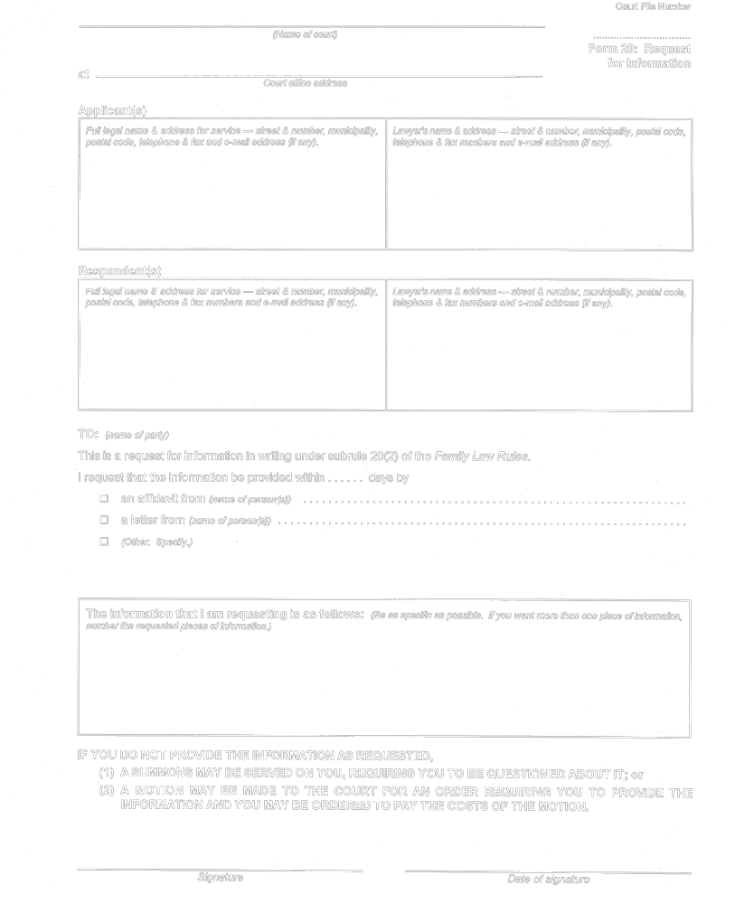
O. Reg. 114/99, Form 20.
Form 20A
Courts of Justice Act
authorization to commissioner
Insert regs\graphics\1999\114\11420aae.tif
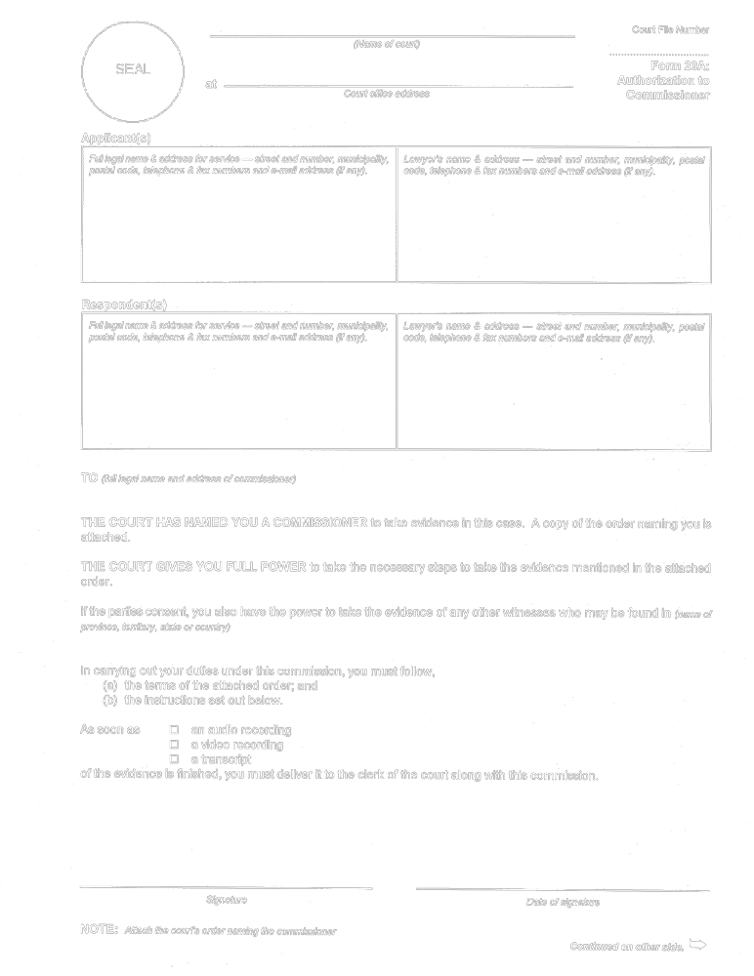
Insert regs\graphics\1999\114\11420abe.tif
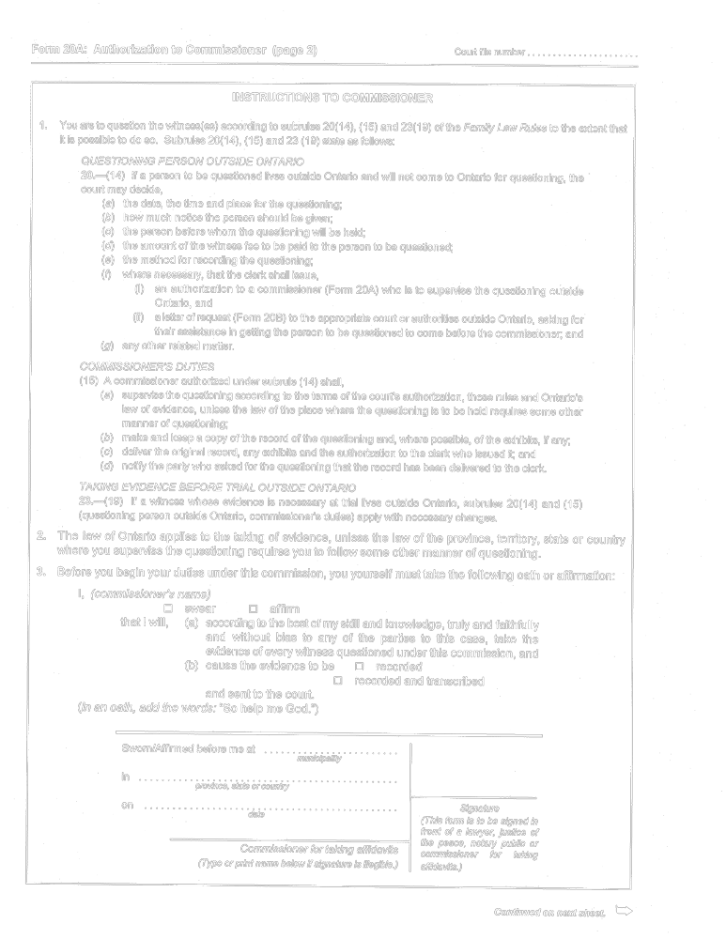
Insert regs\graphics\1999\114\11420ace.tif
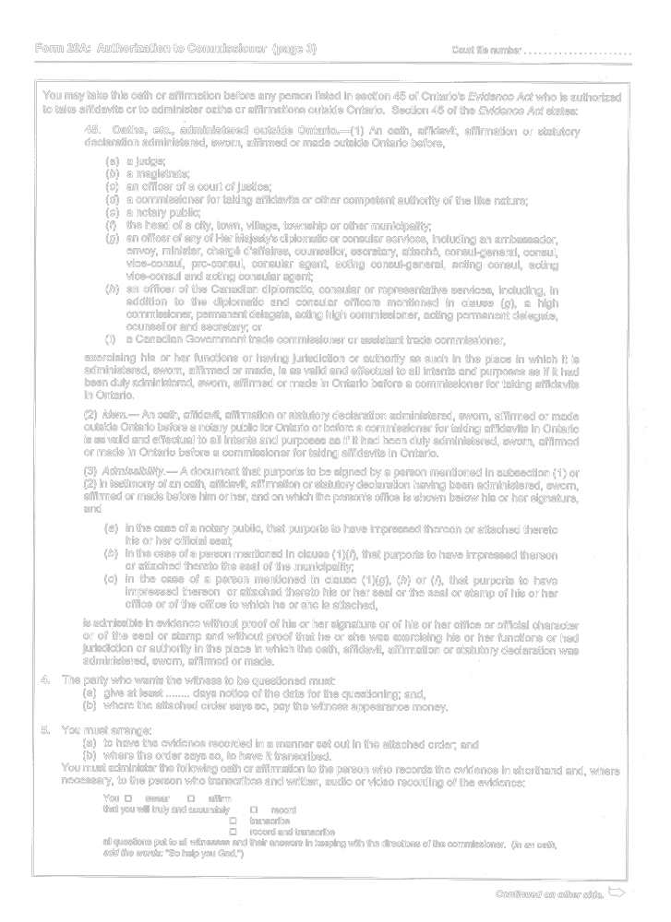
Insert regs\graphics\1999\114\11420ade.tif
Insert regs\graphics\1999\114\11420aee.tif
O. Reg. 114/99, Form 20A.
Form 20B
Courts of Justice Act
letter of request
Insert regs\graphics\1999\114\11420bae.tif
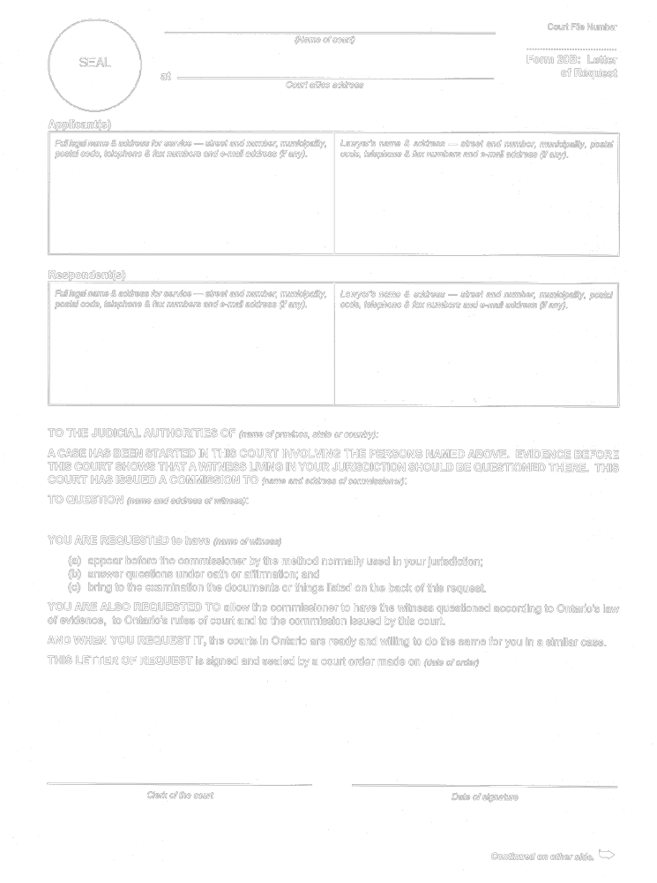
Insert regs\graphics\1999\114\11420bbe.tif

O. Reg. 114/99, Form 20B.
Form 22
Courts of Justice Act
request to admit
Insert regs\graphics\1999\114\114022ae.tif
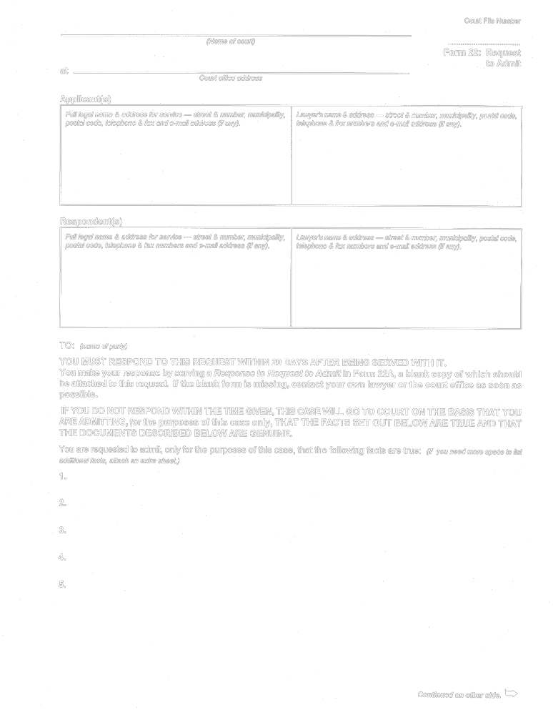
Insert regs\graphics\1999\114\114022be.tif
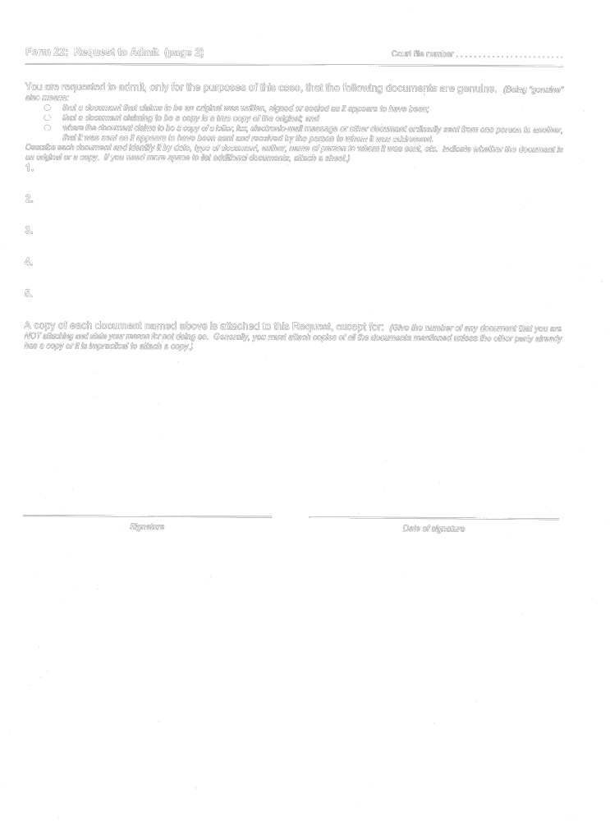
O. Reg. 114/99, Form 22.
Form 22A
Courts of Justice Act
response to request to admit
Insert regs\graphics\1999\114\11422aae.tif
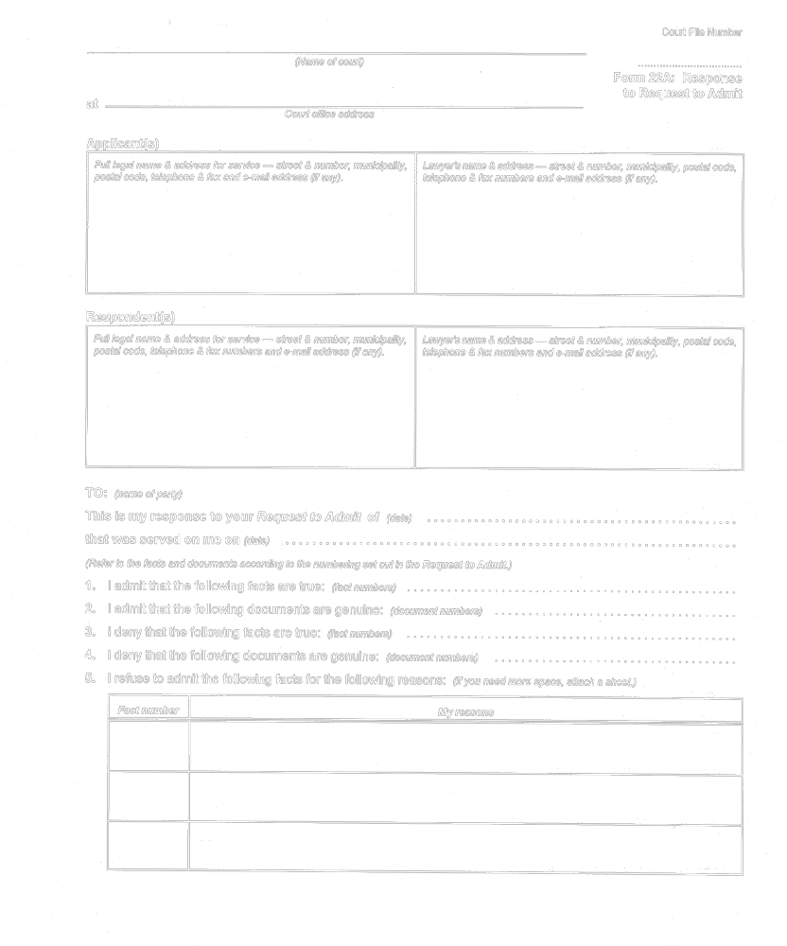
Insert regs\graphics\1999\114\11422abe.tif
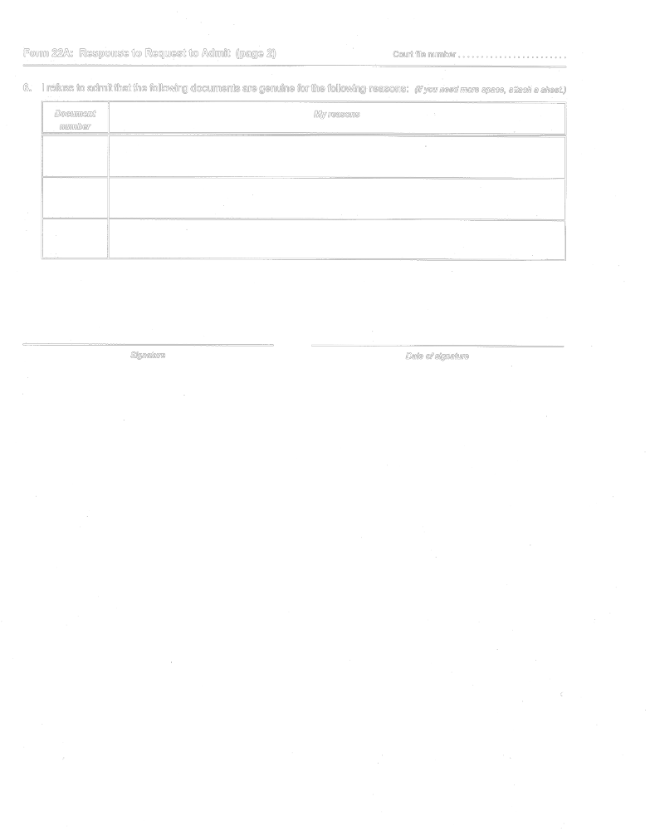
O. Reg. 114/99, Form 22A.
Form 23
Courts of Justice Act
summons to witness
Insert regs\graphics\1999\114\114023ae.tif
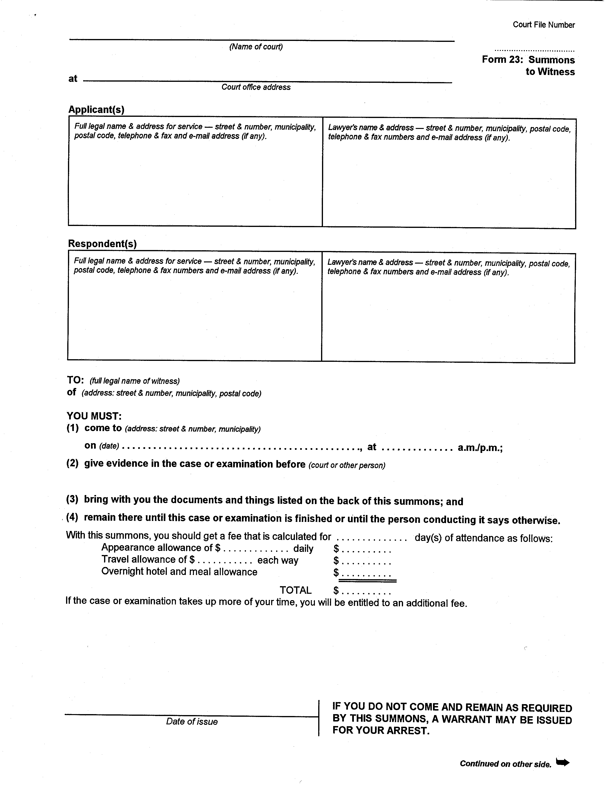
Insert regs\graphics\1999\114\114023be.tif
O. Reg. 114/99, Form 23.
Form 23A
Courts of Justice Act
summons to witness outside ontario
Insert regs\graphics\1999\114\11423aae.tif
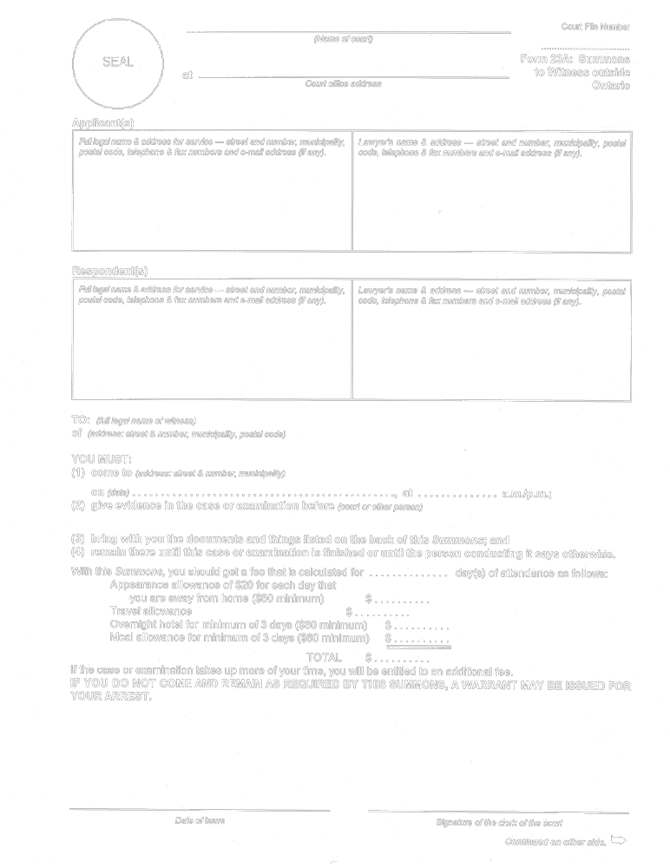
Insert regs\graphics\1999\114\11423abe.tif
Insert regs\graphics\1999\114\11423ace.tif
O. Reg. 114/99, Form 23A.
Form 23B
Courts of Justice Act
order for prisoner’s attendance
Insert regs\graphics\1999\114\11423be.tif
O. Reg. 114/99, Form 23B.
Form 23C
Courts of Justice Act
affidavit for uncontested trial
Court File Number

……...……………………
Form 23C: Affidavit for Uncontested Trial, dated
………………………….
(Name of court)
at
Court office address

Applicant(s)
Full legal name & address for service — street & number, municipality, postal code, telephone & fax numbers and e-mail address (if any). | Lawyer’s name & address — street & number, municipality, postal code, telephone & fax numbers and e-mail address (if any).

Respondent(s)
Full legal name & address for service — street & number, municipality,  postal code, telephone & fax numbers and e-mail address (if any). | Lawyer’s name & address — street & number, municipality, postal code, telephone & fax numbers and e-mail address (if any).

My name is (full legal name)

I live in (municipality & province)

and I swear/affirm that the following is true:

1. I am the applicant in this case.

2. There is/are (number) child(ren) from our relationship, namely:

 | Full Legal Name | Age | Birthdate | Resident in  (municipality & province) | Now living with  (name of person and relationship to child)

3. I am asking for the following order:
◻ custody of the child(ren) named above
◻ access to the child(ren) named above
◻ support for (name of recipient(s))
◻ a restraining order against the respondent (name)
◻ (Other. Specify.)
4. The respondent and I were:
◻ married on (date) ◻ started living together on (date)
◻ separated on (date) ◻ never lived together.
Continued on other side. →
Form 23C: Affidavit for Uncontested Trial (page 2) Court file number …..…….

CUSTODY AND ACCESS
Fill out this section if you are claiming custody of one or more of the children.
5. An order giving me custody of the child(ren) is in the best interests of the child(ren) because: (Give reasons.)
6. An order giving the respondent access to the children
◻ is ◻ is not
in the best interests of the child(ren) because: (Give reasons.)
7. If an order for access is made, it should be:
◻ reasonable access on reasonable notice;
◻ reasonable access on reasonable notice including but not limited to the terms below;
◻ on the following terms:
- every other weekend from p.m. on Friday until p.m. on Sunday or Monday, if Monday is a statutory holiday,
starting on (date)
◻ alternate spring breaks, starting in (year)
◻ weeks during the summer vacation, to be decided by the parties before April 1 of each year.
- one-half of the Christmas break, starting on (date) and ending on (date) to be shared as follows:

◻ Father’s Day with the father; Mother’s Day with the mother.-
◻ (Other. Specify.)

Continued on next sheet. →

Form 23C: Affidavit for Uncontested Trial (page 3) Court file number

CHILD SUPPORT
Fill out this section if you are claiming child support.
8. I am claiming support for (number) child(ren).
9. To the best of my knowledge, the source(s) of the respondent’s income is/are: (Check one or more boxes as circumstances require.)
◻ employment income at (employer’s name and address)

◻ commissions, tips, overtime, bonuses, etc.
◻ self-employment as (name or nature of respondent’s business)
◻ (Other. Specify.)

I believe that the respondent’s current annual income from all income sources is $ for the following reasons:
(Give your reasons for believing the dollar amount set out.)

SPOUSAL SUPPORT
Fill out this section if you are claiming support for yourself.
11. I need spousal support for the following reasons: (Give details of your financial needs.)

SAME-SEX PARTNER SUPPORT
Fill out this section if you are claiming support for yourself.
12. I need same-sex partner support for the following reasons: (Give details of your financial needs.)

Continued on other side. →

Form 23C: Affidavit for Uncontested Trial (page 4) Court file number …...……...

RESTRAINING ORDER
Fill out this section if you are claiming a restraining order against the respondent.
13. I need an order to restrain the respondent from annoying, molesting or harassing me and my children or from approaching within (distance) ……………… metres of: (Check off one or more boxes.)
◻ me
◻ my home at (address)
◻ my place of work at (address)
◻ the child(ren)
◻ the child(ren)’s school(s): (Give names of school(s))

◻ (Other. Specify.)

for the following reasons: (Give your reasons for needing a restraining order at all and for the distances involved.)

Continued on next sheet. →

Form 23C: Affidavit for Uncontested Trial (page 5) Court file number ……...…...

LACK OF SERVICE
Fill out this section if the respondent is not going to be served or has not been served.
NOTE: The Family Law Rules require all documents to be served on the opposing party. The court will make an order even without service, but only in very unusual circumstances such as:
1. An emergency situation where there is not enough time to serve documents or where serving them would put you or your child in danger or would have other serious consequences.
2. Where the court is satisfied that every effort has been made to find the other party and that it is impossible to serve him or her by any means.

14. My application/motion is not being served on the respondent for the following reasons:

OTHER ISSUES

Put a line through any space left on this page.
Sworn/Affirmed before me at
municipality
in
province, state or country
on  date |  | Signature  (This form is to be signed in front of a lawyer, justice of the peace, notary public or commissioner for taking affidavits.)
on  date | Commissioner for taking affidavits  (Type or print name below if signature is illegible.)
O. Reg. 202/01, s. 11.
Form 25
Courts of Justice Act
order (general)
Insert regs\graphics\1999\114\114025ae.tif
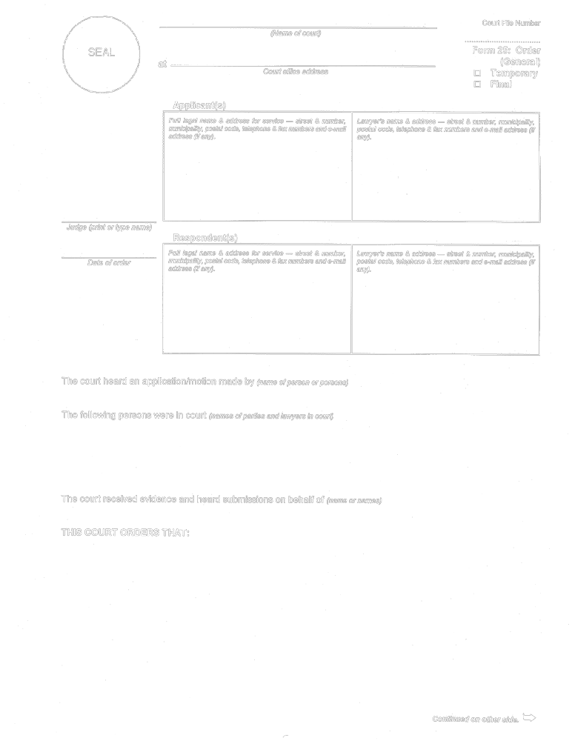
Insert regs\graphics\1999\114\114025be.tif

O. Reg. 114/99, Form 25.
Form 25A
Courts of Justice Act
divorce order
Insert regs\graphics\1999\114\11425aae.tif
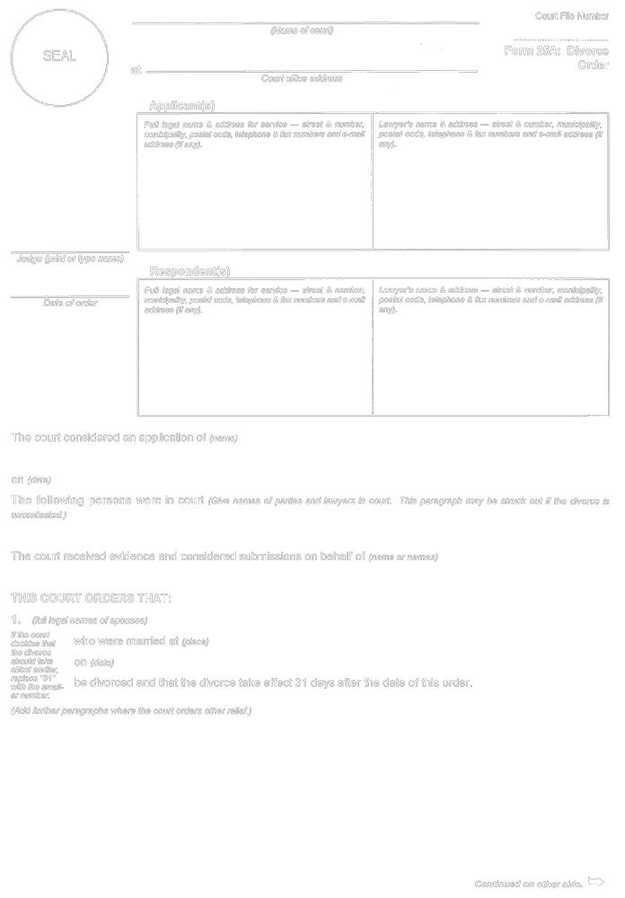
Insert regs\graphics\1999\114\11425abe.tif

O. Reg. 544/99, s. 15 (3).
Form 25B
Courts of Justice Act
secure treatment order
Insert regs\graphics\1999\114\11425bae.tif
Insert regs\graphics\1999\114\11425bbe.tif
O. Reg. 114/99, Form 25B.
Form 25C
Courts of Justice Act
adoption order
Insert regs\graphics\1999\114\11425Cae.tif
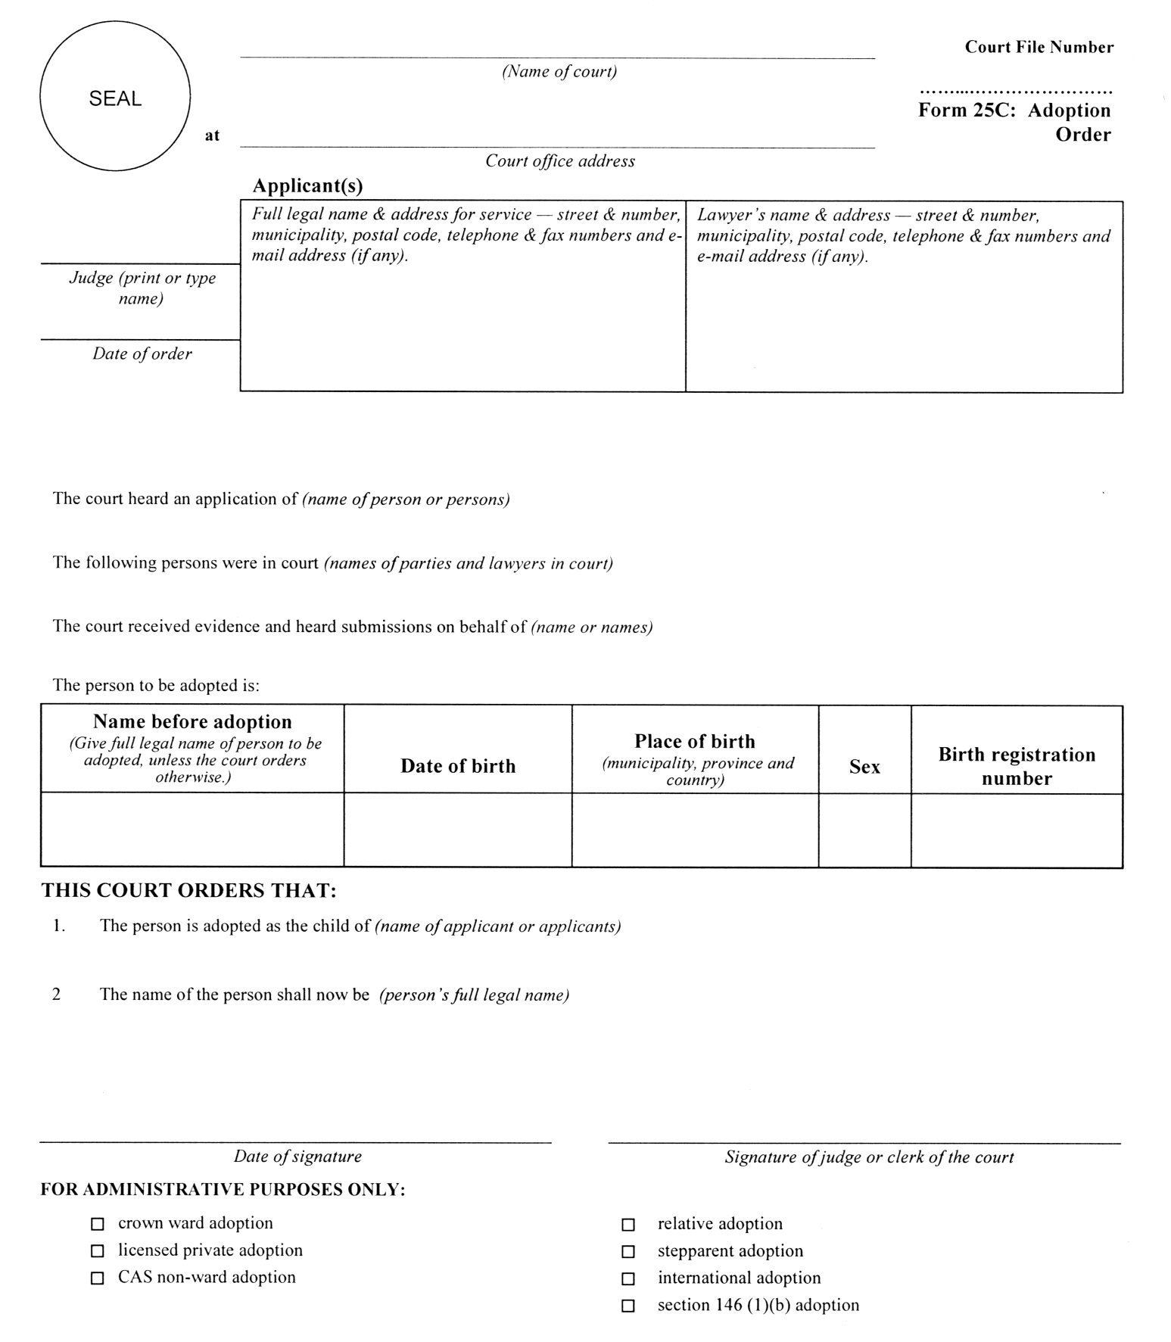
O. Reg. 337/02, s. 4 (2).
Form 25D
Courts of Justice Act
order (uncontested trial)
Court File Number

……...……………………
Form 25D: Order (Uncontested Trial)
◻ Temporary
◻ Final
SEAL |  | at | (Name of court)
 |  |  | Court office address
 | Applicant(s)
 | Full legal name & address for service — street & number, municipality, postal code, telephone & fax numbers and e-mail address (if any). |  |  | Lawyer’s name & address — street & number, municipality, postal code, telephone & fax numbers and e-mail address (if any).
Judge
(print or type name)

 | Respondent(s)
 | Full legal name & address for service — street & number, municipality, postal code, telephone & fax numbers and e-mail address (if any). | Lawyer’s name & address — street & number, municipality, postal code, telephone & fax numbers and e-mail address (if any).
Date of order

Name & address of Children’s Lawyer’s agent (street & number, municipality, postal code, telephone & fax numbers and e-mail address (if any)) and name of person represented.

The court considered an application/motion made by (name of person or persons)

The following persons were in court (names of parties and lawyers in court)

The court received evidence and submissions on behalf of (name or names)

This order affects the following children:
Child’s full legal name | Date of birth (d, m, y) | Sex

PARENTAGE
◻ 1. THIS COURT FINDS that:
◻ each child mentioned above is a child of the marriage within the meaning of the Divorce Act (Canada).
◻ the applicant and respondent are parents of each child mentioned above within the meaning of the Family Law Act and the Children’s Law Reform Act.
- (Other. Specify.)
Continued on other side. →
Form 25D: Order (Uncontested Trial) (page 2) Court file number ……..…..

CUSTODY
◻ 2. THIS COURT ORDERS that (name(s)) shall have
◻ temporary ◻ final
◻ sole ◻ joint
custody of each child mentioned above.

ACCESS
◻ 3. THIS COURT ORDERS that (name(s)) shall have
◻ temporary ◻ final
access to each child mentioned above. The terms of access are:
◻ reasonable access on reasonable notice;
◻ reasonable access on reasonable notice including but not limited to the terms below;
◻ as follows:
- every other weekend from p.m. on Friday until p.m. on Sunday or Monday, if Monday is a statutory
holiday, starting on (date)
◻ alternate spring breaks, starting in (year)
◻ weeks during the summer vacation, to be decided by the parties before April 1 of each year.
◻ one-half of the Christmas break, starting on (date) and ending on (date) to be shared as follows:

◻ Father’s Day with the father, Mother’s Day with the mother.
◻ (Other. Specify.)

CHILD SUPPORT
◻ 4. THIS COURT FINDS that (name of payor) has an income of $ and IT

ORDERS that (name of payor) pay to (name of recipient) . the
sum of $ per month for the support of the child(ren) named above, starting on (date)

Fill in this frame only if there is a claim for add-ons for the child(ren).
THIS COURT FINDS that (name of recipient) has an income of $ and
IT ORDERS that (name of payor pay to (name of recipient)

the sum of $ per month for the special or extraordinary expenses (add-ons) of the child(ren) named above, starting on (date) .

The details of this amount are as follows:
Name of child | Nature of special or extraordinary expense | Amount
 |  | Continued on next sheet. →

Form 25D: Order (Uncontested Trial) (page 3) Court file number ………..…

SPOUSAL SUPPORT
◻ 5. THIS COURT ORDERS that (name of payor)
pay to (name of recipient) ◻ temporary ◻ final
spousal support in the amount of $ per starting on (date)

◻ 6. THIS COURT ORDERS that the support under paragraph 5 of this order be indexed and changed annually according to the indexing factor in subsection 34 (6) of the Family Law Act.

SAME-SEX PARTNER SUPPORT
◻ 7. THIS COURT ORDERS that (name of payor)
pay to (name of recipient) ◻ temporary ◻ final
same-sex partner support in the amount of $ per starting on (date)

◻ 8. THIS COURT ORDERS that the same-sex partner support under paragraph 7 of this order be indexed and changed annually according to the indexing factor in subsection 34 (6) of the Family Law Act.
SUPPORT MONEY OWED
◻ 9. THIS COURT FINDS that the amount of support owed is $ as of (date)
AND THIS COURT ORDERS that (name of payor)
pay off this amount ◻ by (date)
◻ at the rate of $ per starting on (date)

SUPPORT — ENFORCEMENT
◻ 10. THIS COURT ORDERS that unless the support order is withdrawn from the office of the Director of the Family Responsibility Office, it shall be enforced by the Director and amounts owing under the order shall be paid to the Director, who shall pay them to the person to whom they are owed.

◻ 11. THIS COURT ORDERS that the clerk issue a support deduction order under section 11 of the Family Responsibility and Support Arrears Enforcement Act, 1996 for the periodic support.

PROPERTY
◻ 12. THIS COURT ORDERS that

Continued on other side. →
Form 25D: Order (Uncontested Trial) (page 4) Court file number ………...

DISCLOSURE
◻ 13. THIS COURT ORDERS that (name)
serve and file the following before the next court date:
◻ a current financial statement.
◻ (Other. Specify.)

OTHER MATTERS
◻ 14. THIS COURT ORDERS that

COSTS
◻ 15. THIS COURT ORDERS that costs be paid by (name)
to (name) fixed at $

ADJOURNMENT
◻ 16. THIS COURT ORDERS that the matter(s) of

be adjourned to (date) at (time) for: (purpose)

INTEREST
◻ 17. THIS COURT ORDERS that interest be payable on amounts owing under this order at the rate of per cent per year.

Put a line through any space left on this page. If additional space is needed, extra pages may be attached.

Date of signature |  | Signature of judge or clerk of the court
O. Reg. 202/01, s. 11.
Form 25E
Courts of Justice Act
notice disputing approval of order
Insert regs\graphics\1999\114\114025ee.tif
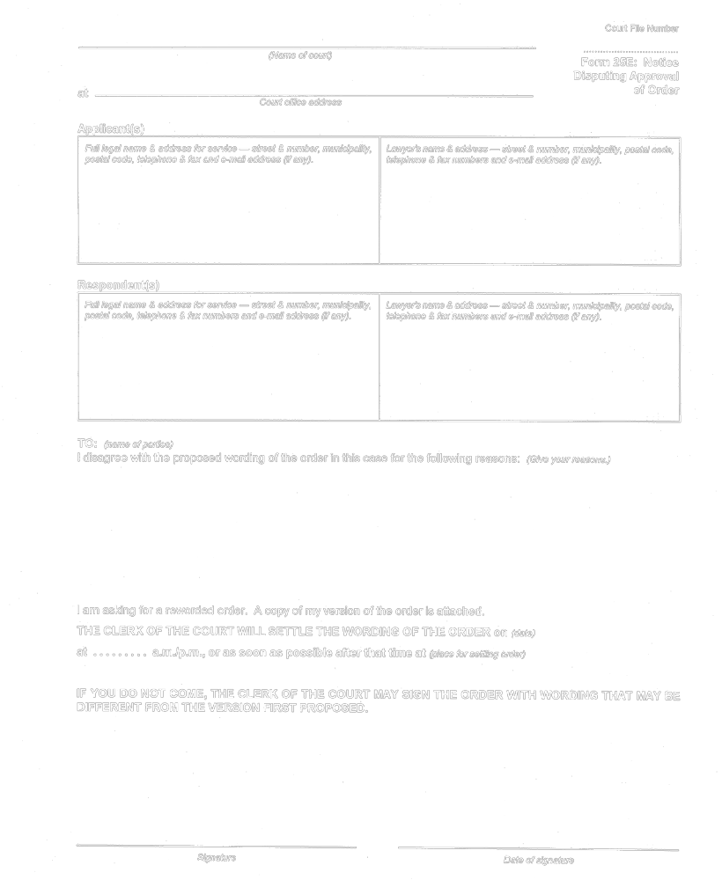
O. Reg. 114/99, Form 25E.
Form 26
Courts of Justice Act
statement of money owed
Insert regs\graphics\1999\114\114026ae.tif
Insert regs\graphics\1999\114\114026be.tif
Insert regs\graphics\1999\114\114026ce.tif
Insert regs\graphics\1999\114\114026de.tif
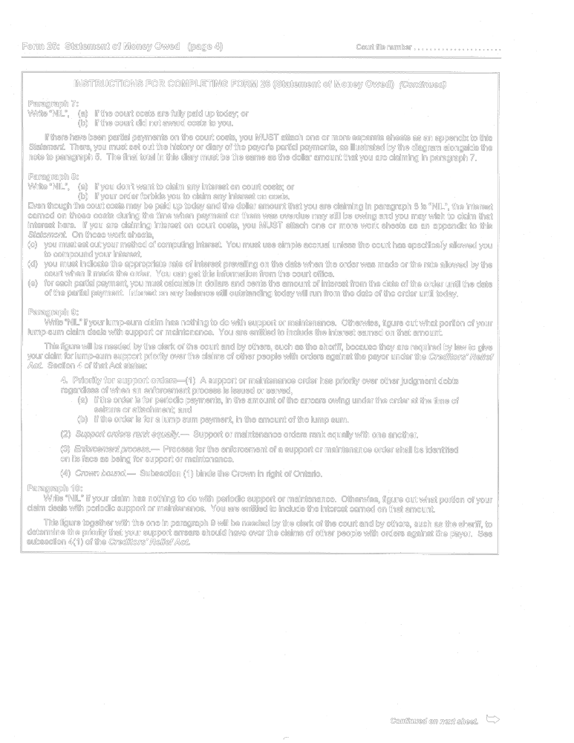
Insert regs\graphics\1999\114\114026ee.tif
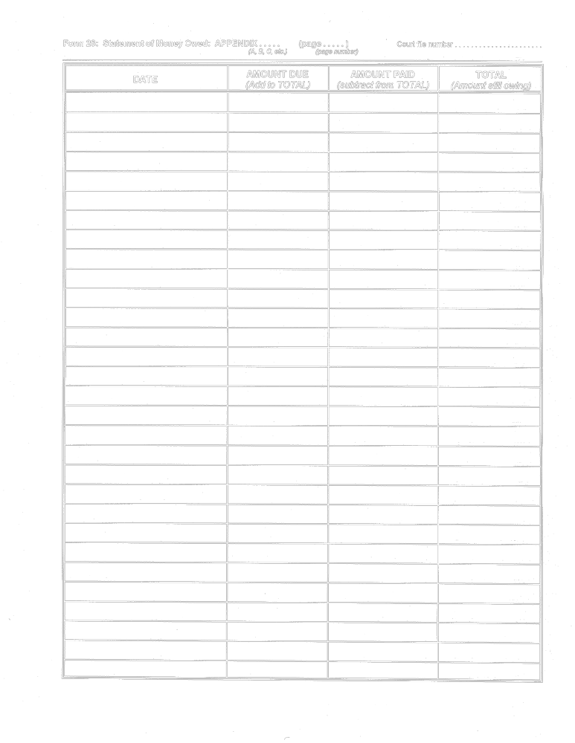
Insert regs\graphics\1999\114\114026fe.tif
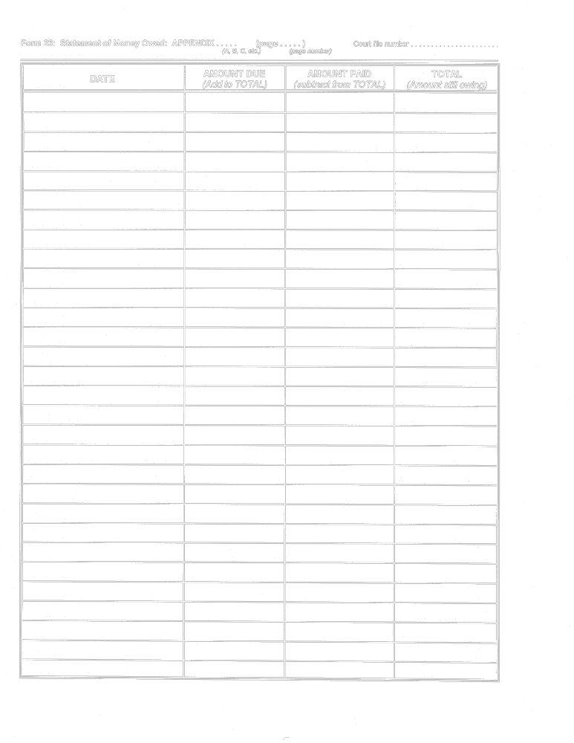
Insert regs\graphics\1999\114\114026ge.tif
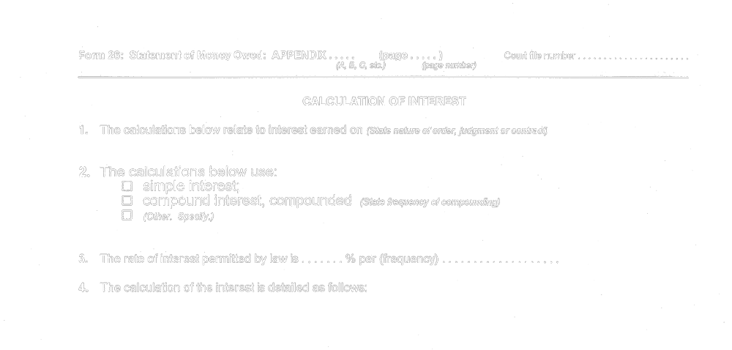
O. Reg. 114/99, Form 26.
Form 26A
Courts of Justice Act
affidavit of enforcement expenses
Insert regs\graphics\1999\114\11426aae.tif
Insert regs\graphics\1999\114\11426abe.tif
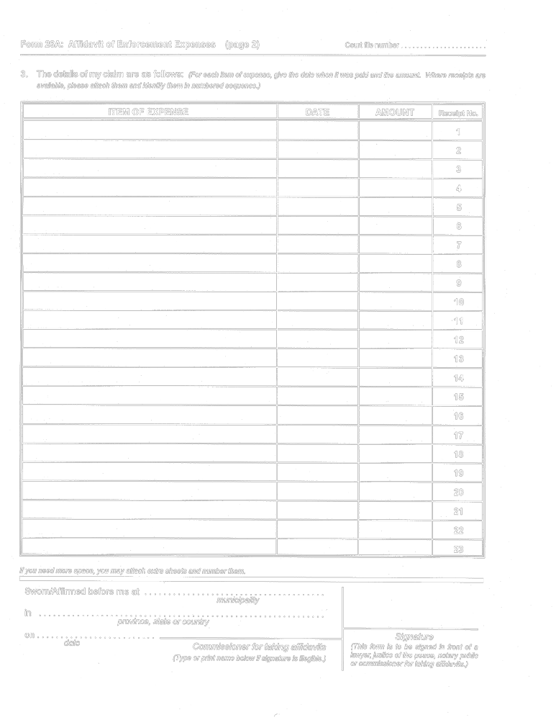
O. Reg. 114/99, Form 26A.
Form 26B
Courts of Justice Act
affidavit for filing domestic contract or paternity agreement with court
Insert regs\graphics\1999\114\11426be.tif
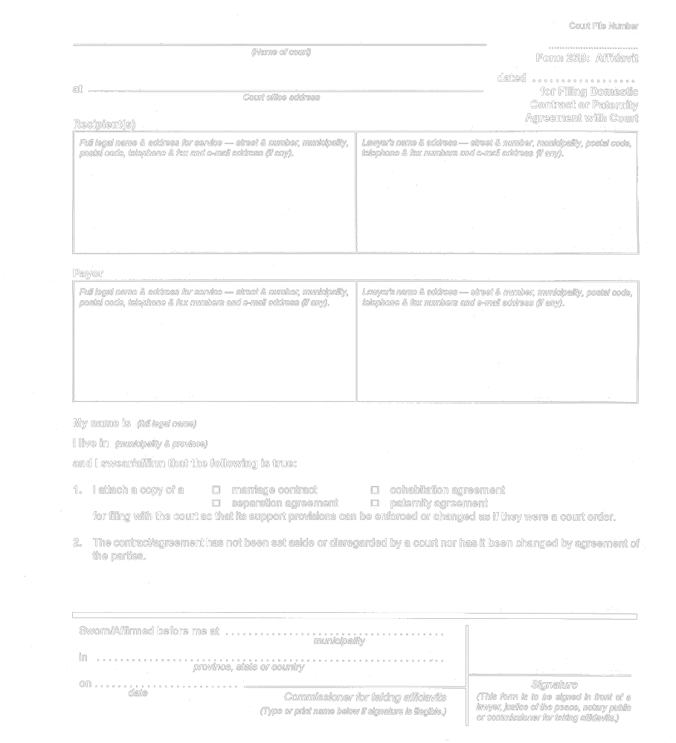
O. Reg. 114/99, Form 26B.
Form 26C
Courts of Justice Act
NOTICE OF TRANSFER OF ENFORCEMENT
Insert regs\graphics\1999\114\11426cae.tif
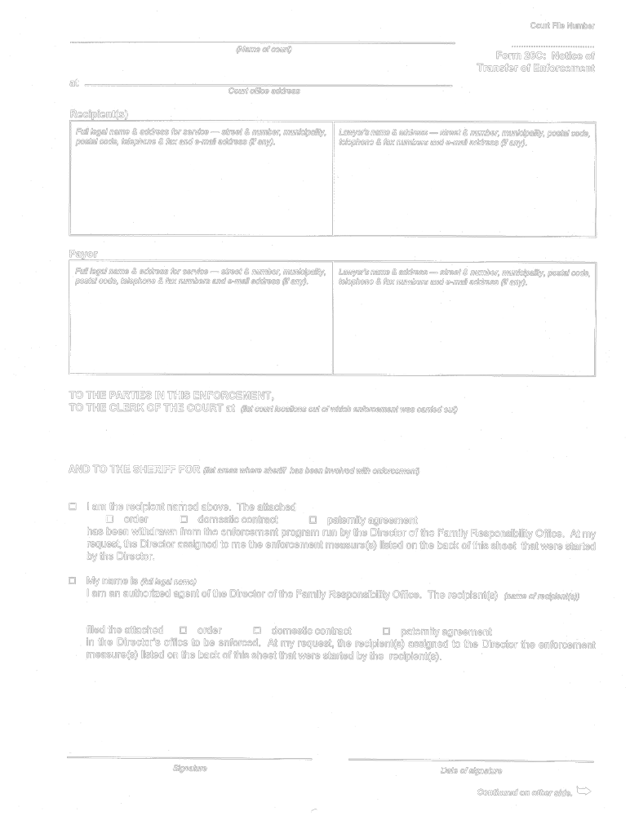
Insert regs\graphics\1999\114\11426cbe.tif
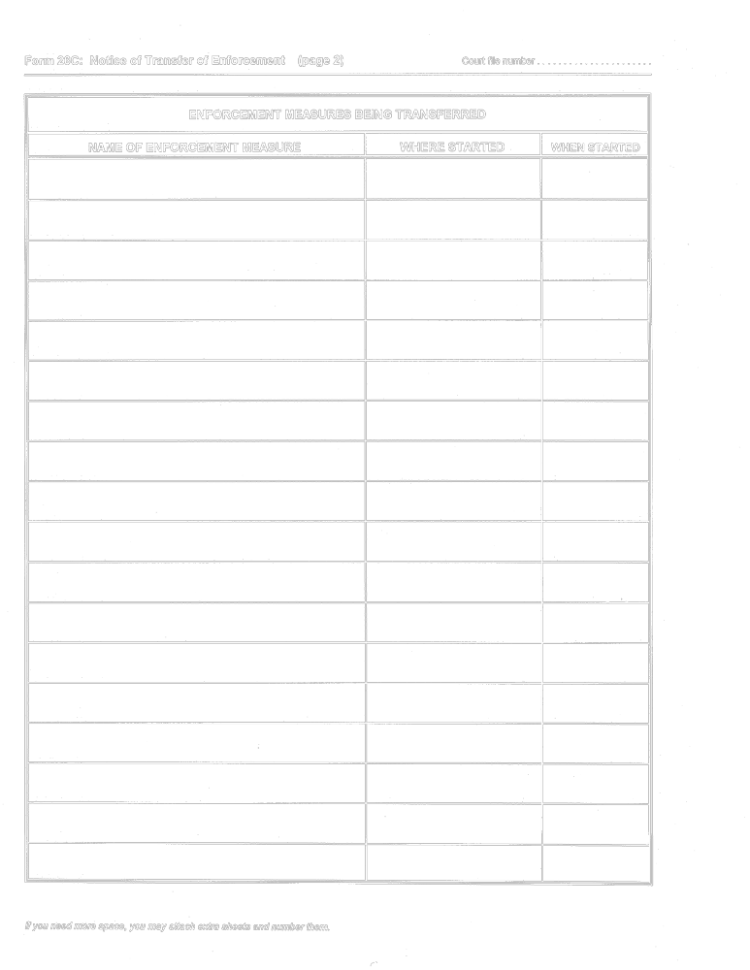
O. Reg. 114/99, Form 26C.
Form 27
Courts of Justice Act
REQUEST FOR FINANCIAL STATEMENT
Insert regs\graphics\1999\114\1140027e.tif
O. Reg. 114/99, Form 27.
Form 27A
Courts of Justice Act
REQUEST FOR STATEMENT OF INCOME
Insert regs\graphics\1999\114\114027ae.tif
O. Reg. 114/99, Form 27A.
Form 27B
Courts of Justice Act
statement of income from income source
Insert regs\graphics\1999\114\114027be.tif
O. Reg. 114/99, Form 27B.
Form 27C
Courts of Justice Act
appointment for financial examination
Insert regs\graphics\1999\114\11427cae.tif
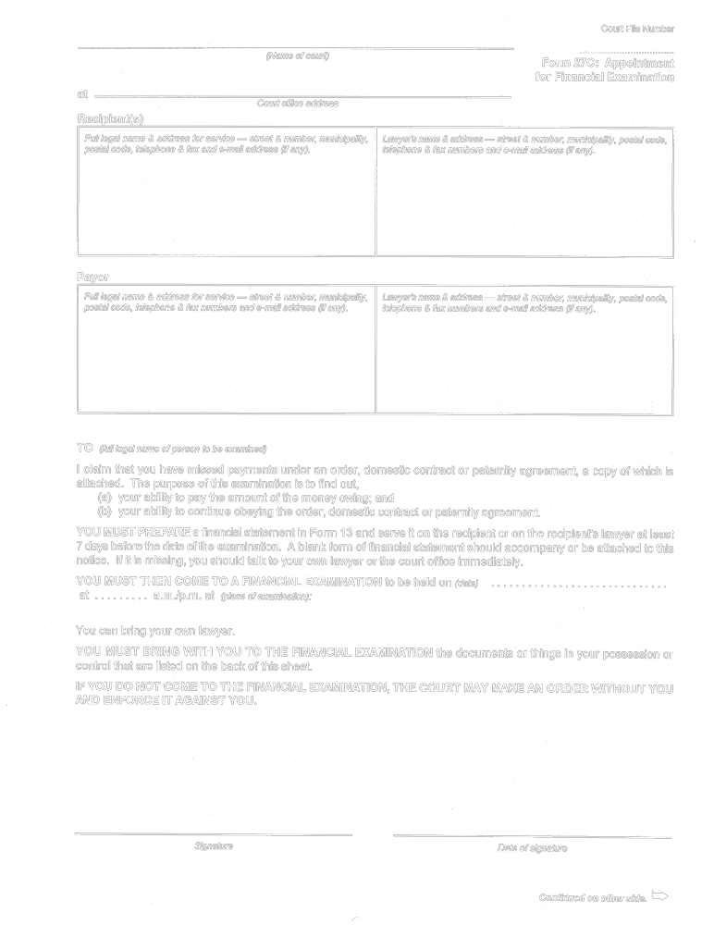
Insert regs\graphics\1999\114\11427cbe.tif
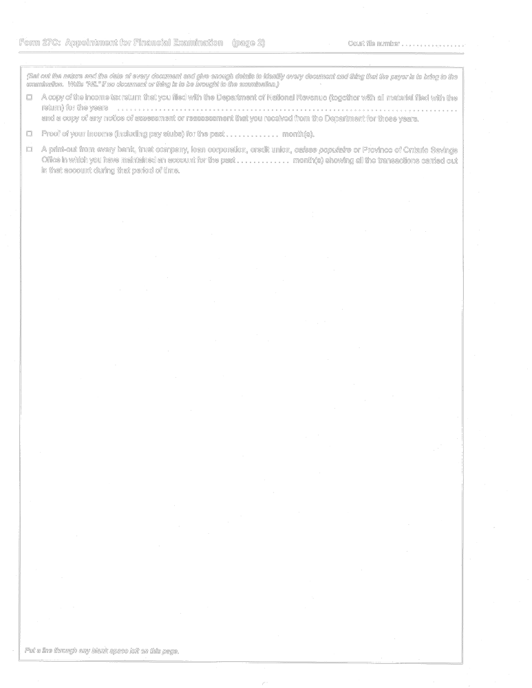
O. Reg. 114/99, Form 27C.
form 28
Courts of Justice Act
writ of seizure and sale
Insert regs\Graphics\Source Law\2004\89\890028ae.tif
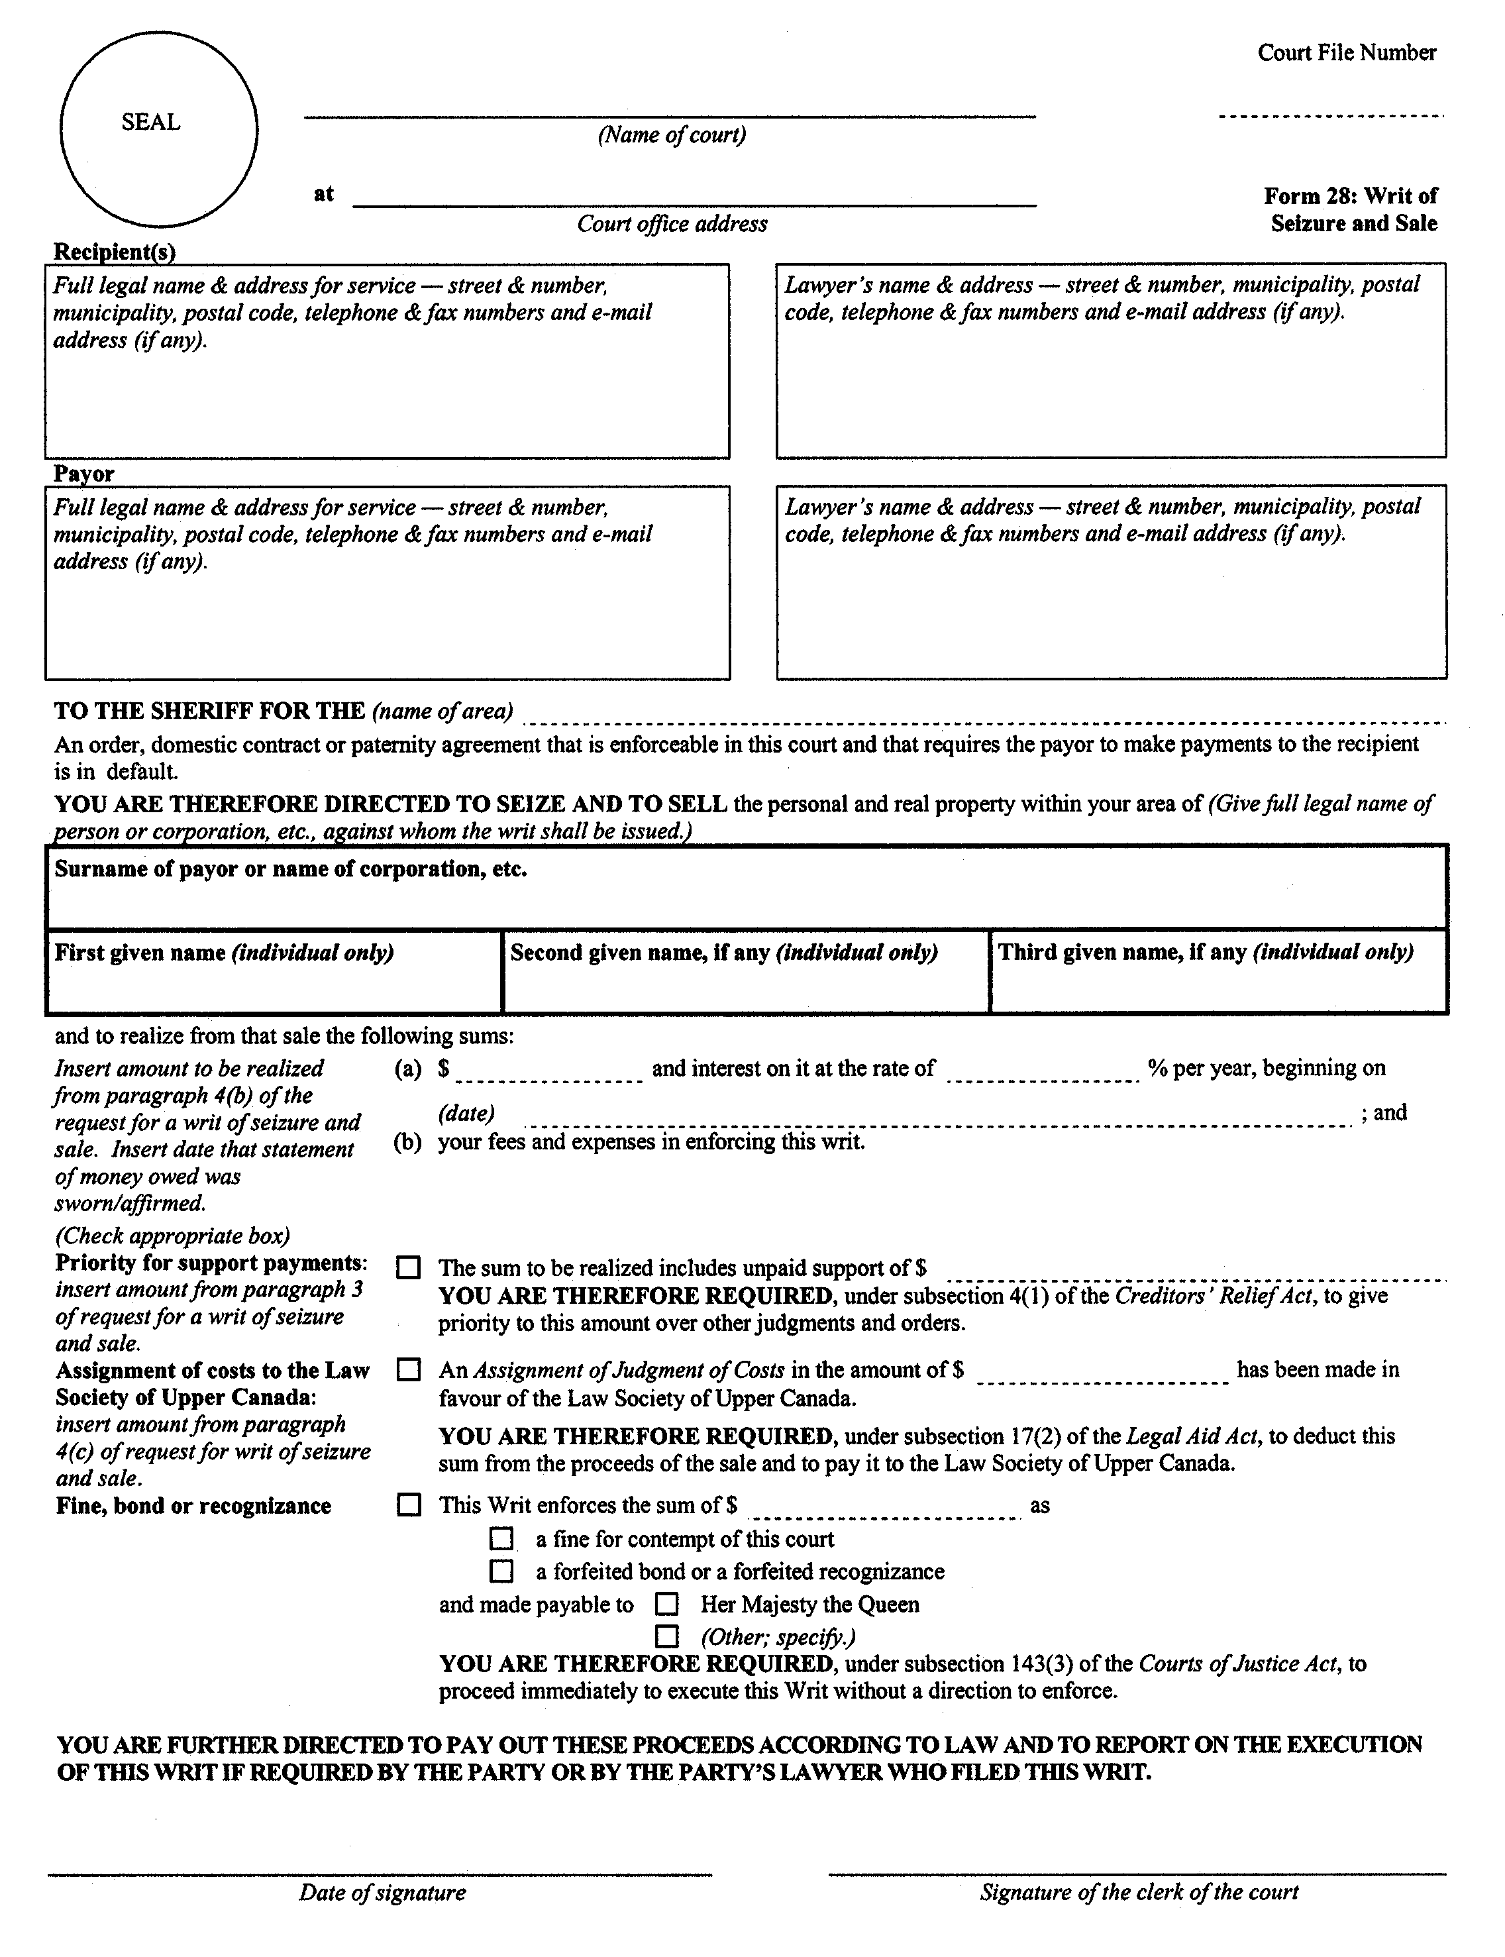
Insert regs\Graphics\Source Law\2004\89\890028be.tif
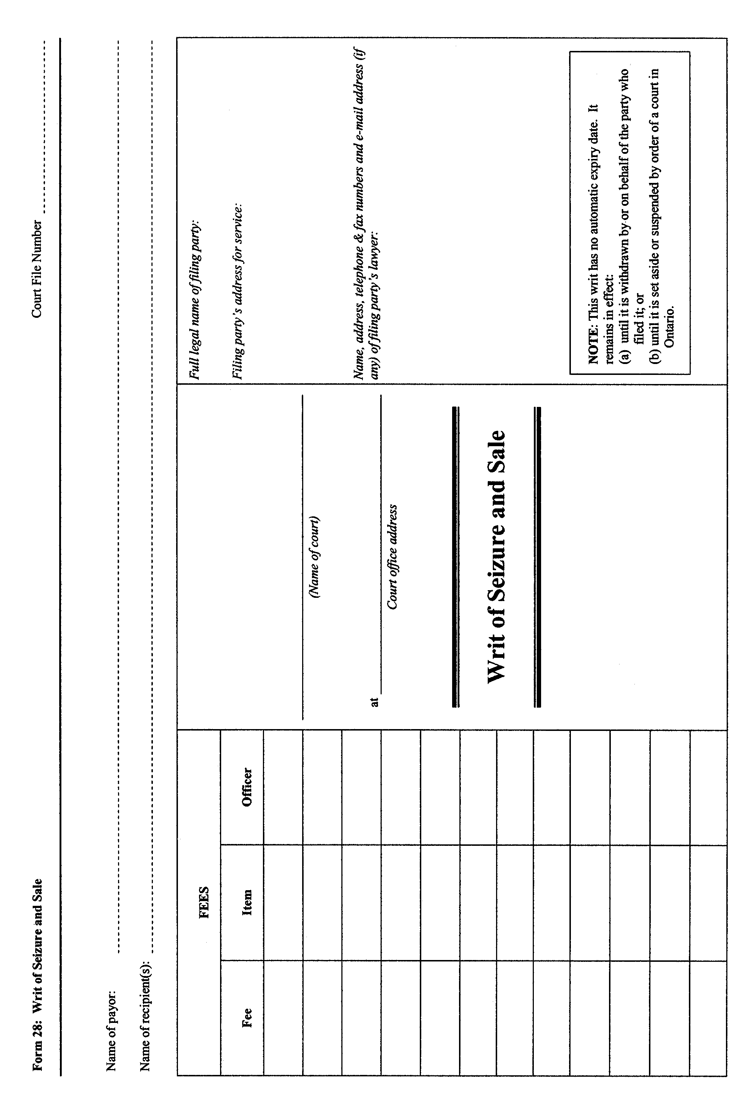
O. Reg. 89/04, s. 17.
Form 28A
Courts of Justice Act
request for writ of seizure and sale
Insert regs\graphics\1999\114\11428ae.tif
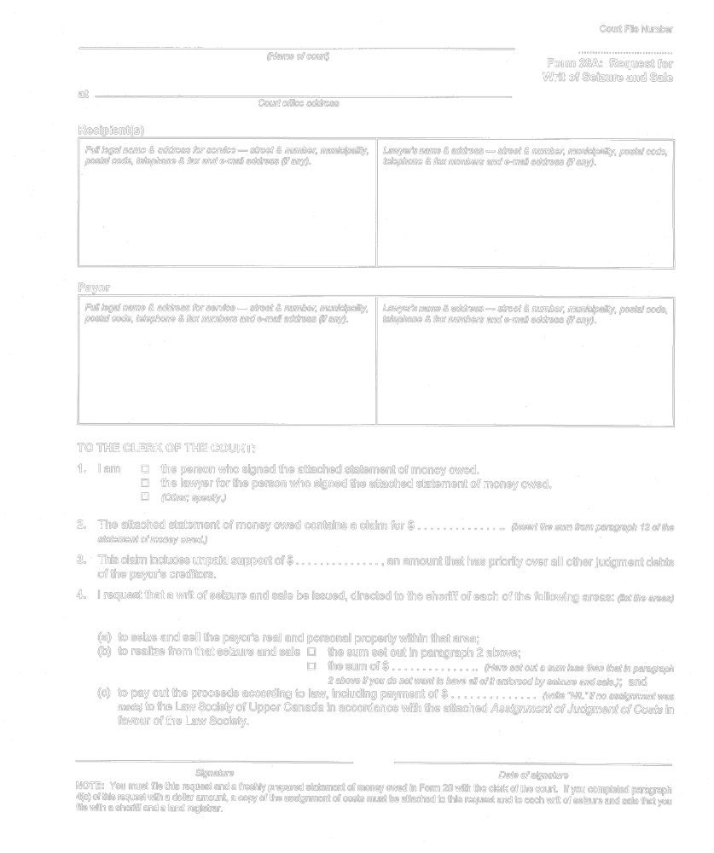
O. Reg. 114/99, Form 28A.
Form 28B
Courts of Justice Act
statutory declaration to sheriff
Insert regs\graphics\1999\114\11428be.tif
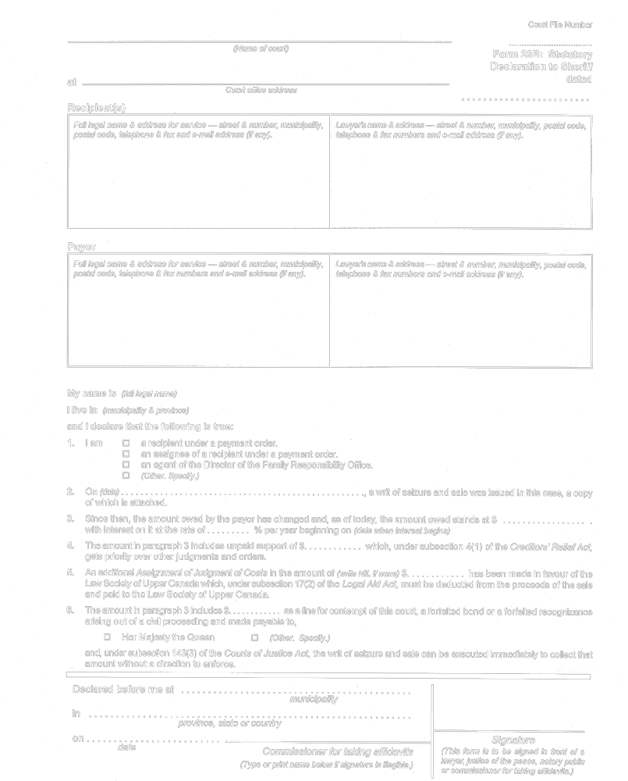
O. Reg. 114/99, Form 28B.
form 28C
Courts of Justice Act
writ of temporary seizure
Insert regs\Graphics\Source Law\2004\89\89028Cae.tif
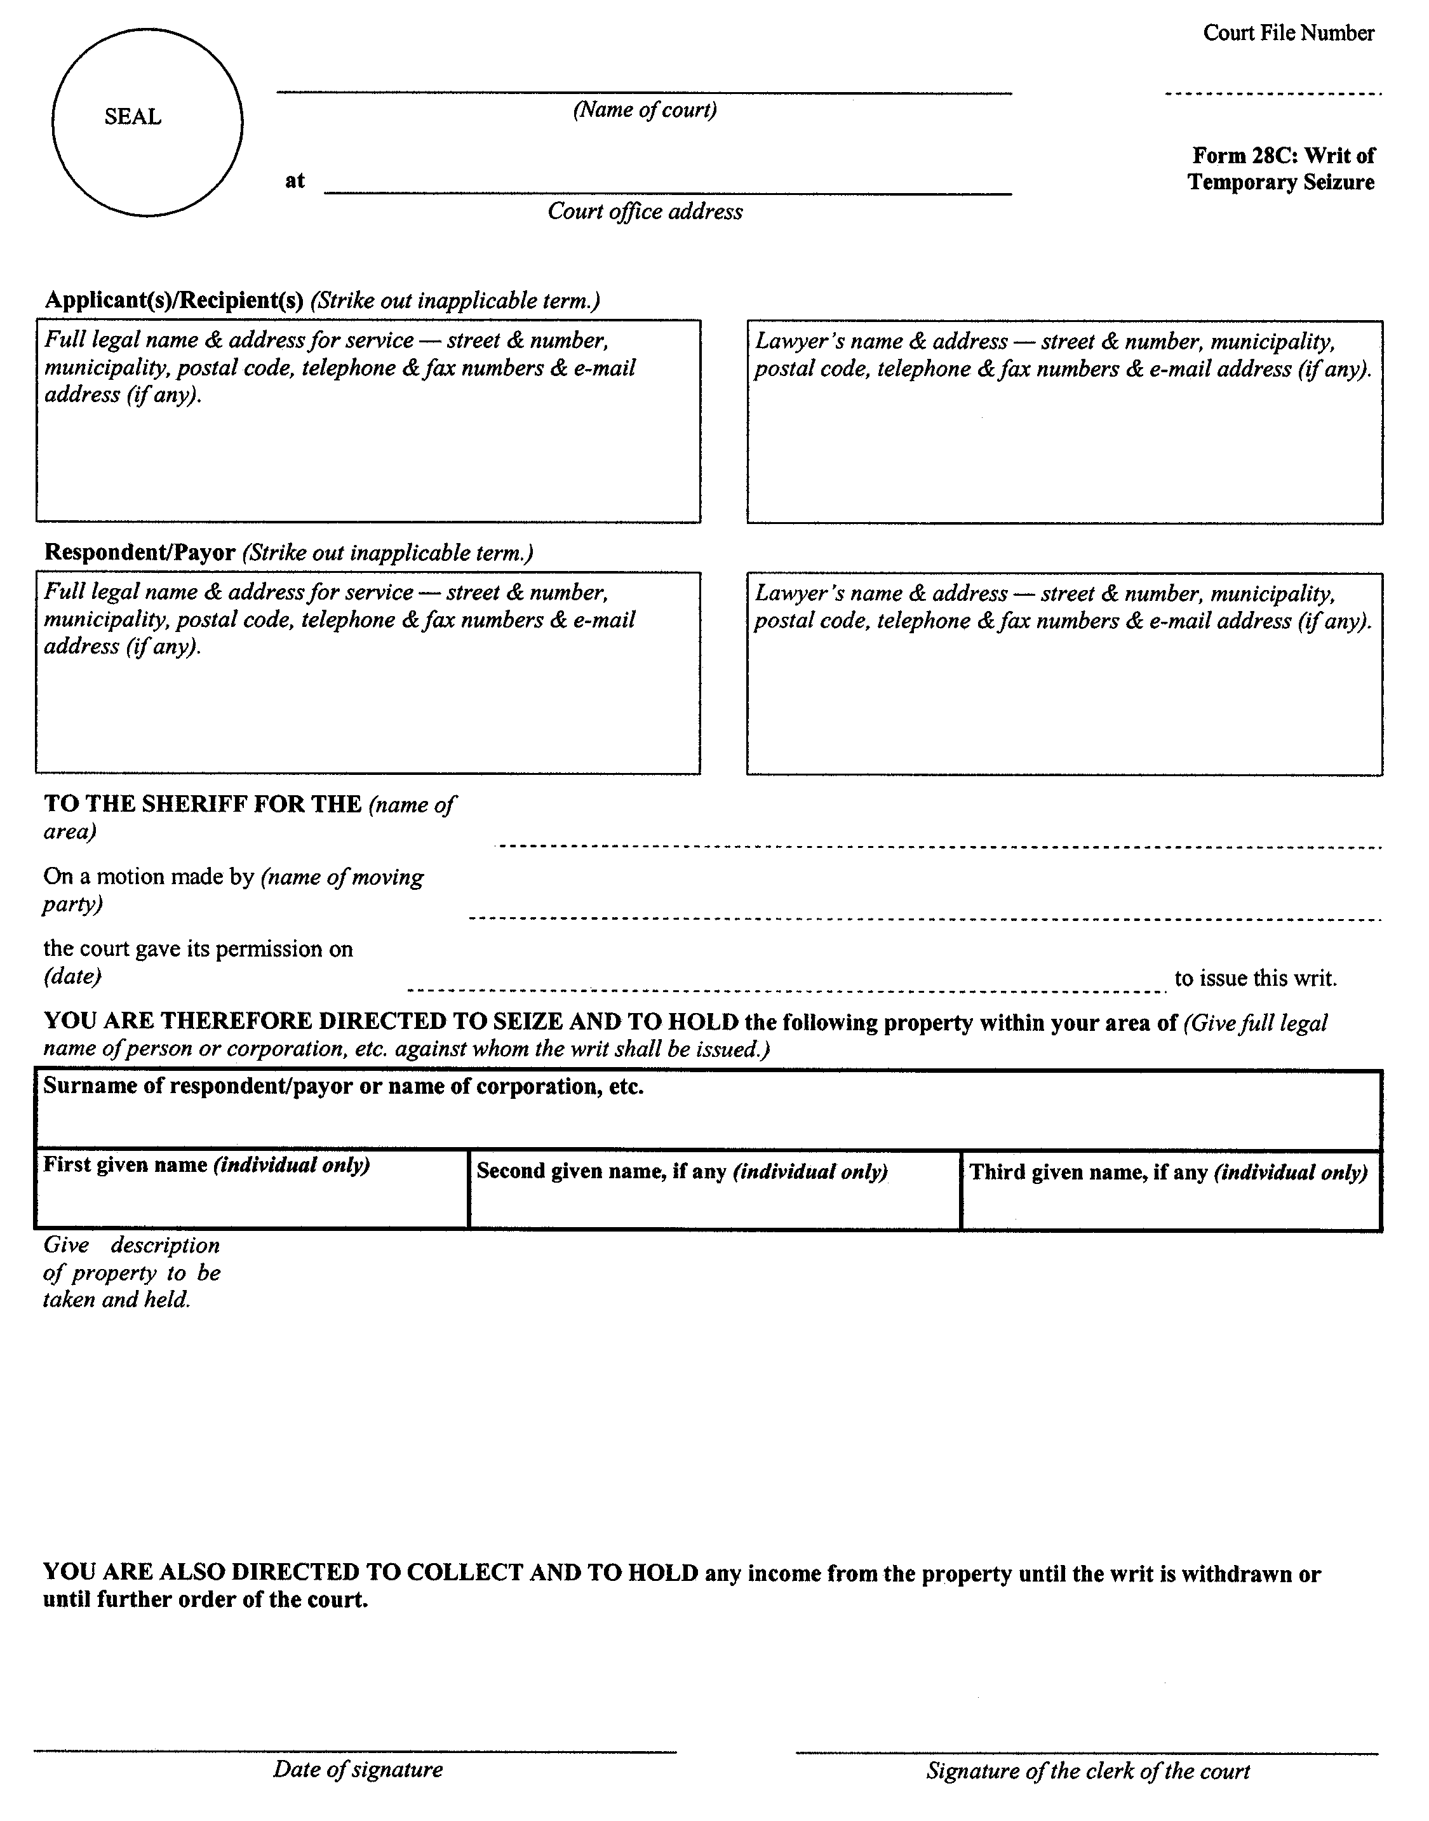
O. Reg. 89/04, s. 17.
Form 29
Courts of Justice Act
request for garnishment
Insert regs\graphics\1999\114\114029ae.tif
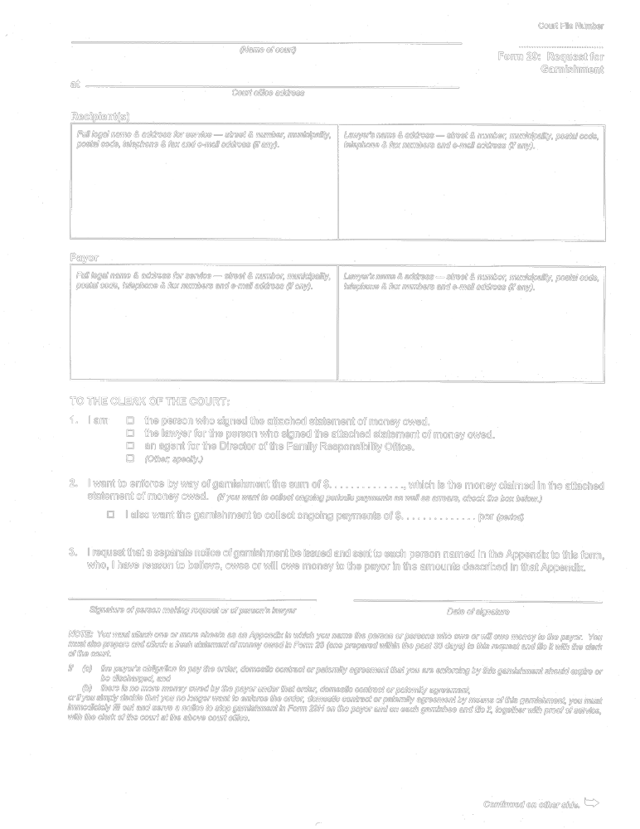
Insert regs\graphics\1999\114\114029be.tif
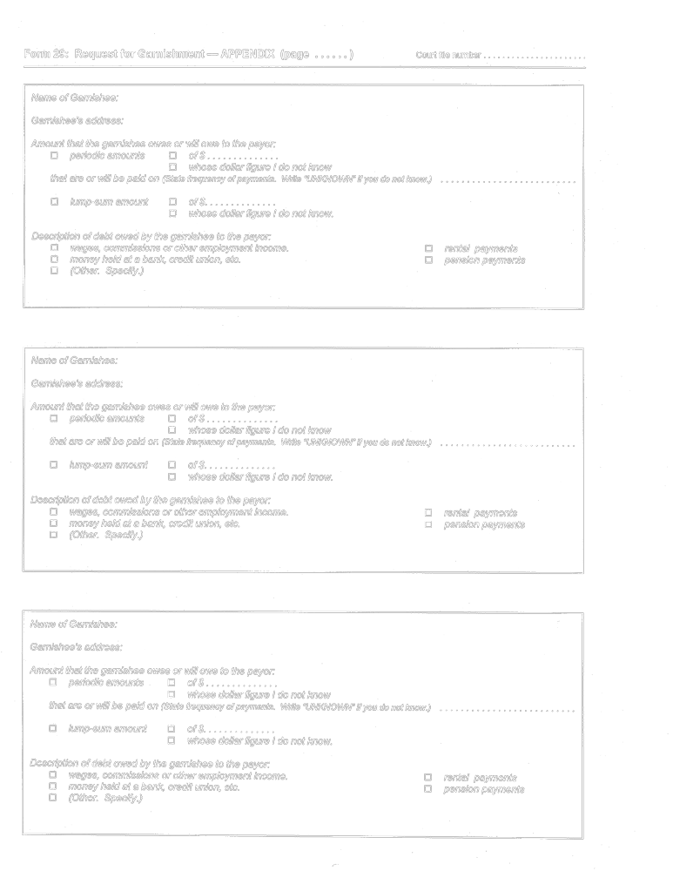
Insert regs\graphics\1999\114\114029ce.tif
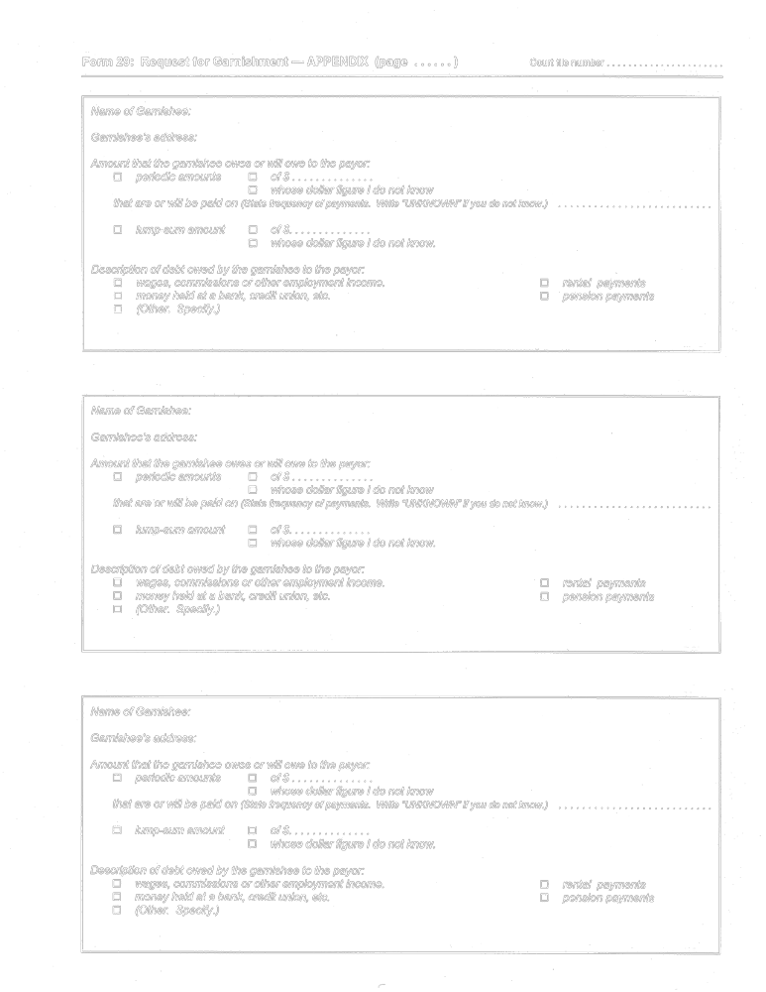
Insert regs\graphics\1999\114\114029de.tif
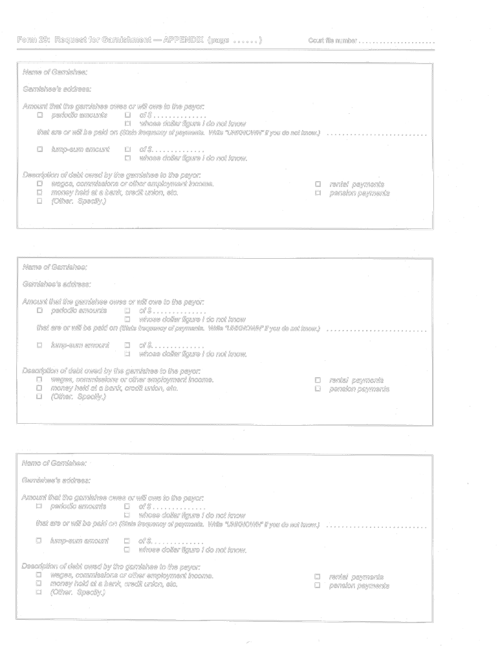
O. Reg. 114/99, Form 29.
Form 29A
Courts of Justice Act
NOTICE OF GARNISHMENT (LUMP-SUM DEBT)
Insert regs\graphics\1999\114\11429Aae.tif
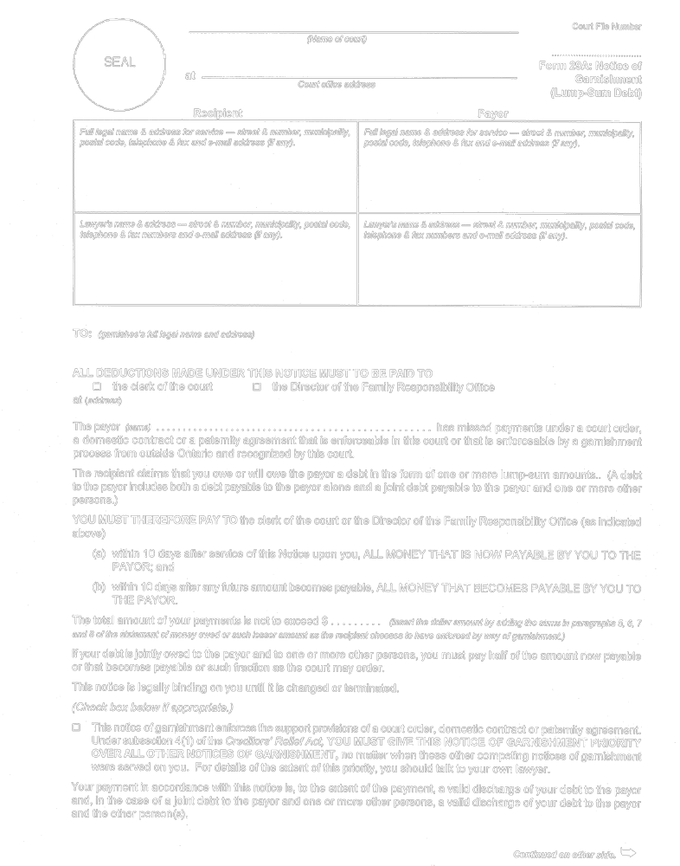
Insert regs\graphics\1999\114\11429Abe.tif
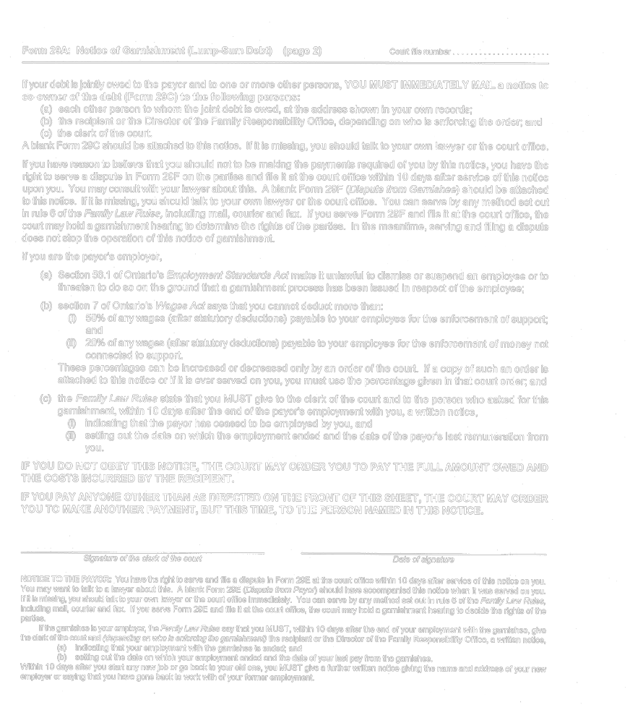
Reg. 114/99, Form 29A.
Form 29B
Courts of Justice Act
notice of garnishment (periodic debt)
Insert regs\graphics\1999\114\11429Bae.tif
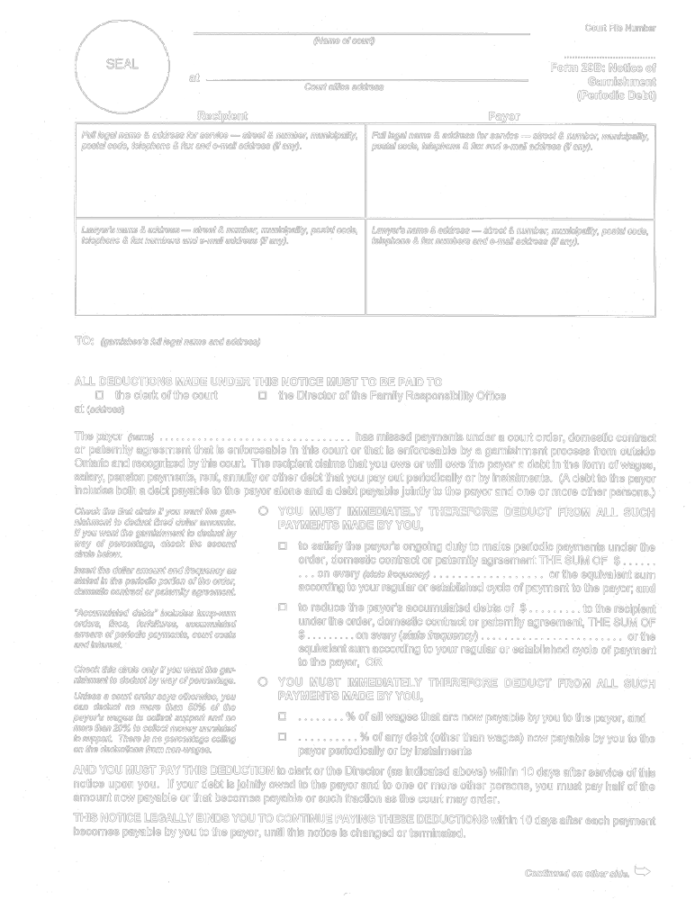
Insert regs\graphics\1999\114\11429Bbe.tif
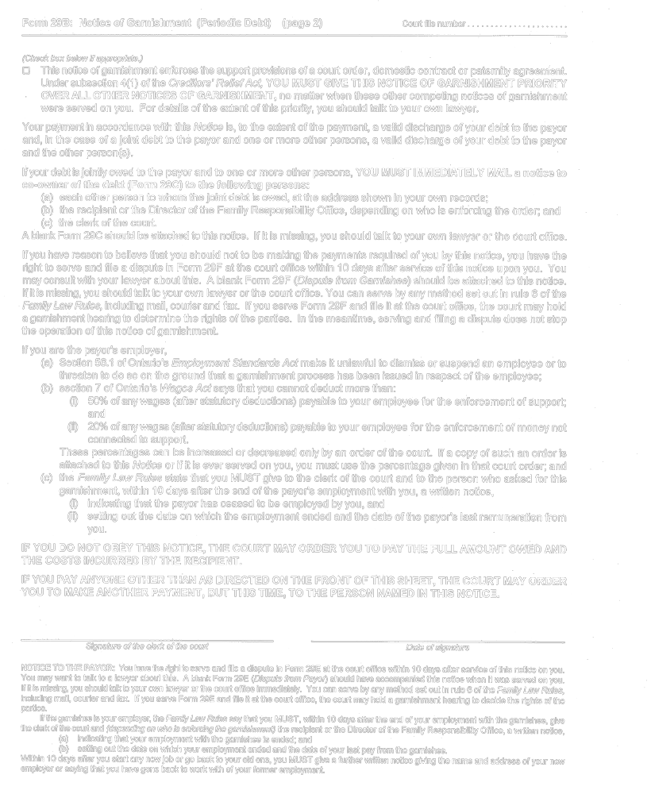
O. Reg. 114/99, Form 29B.
Form 29C
Courts of Justice Act
notice to co-owner of debt
Insert regs\graphics\1999\114\11429Cae.tif
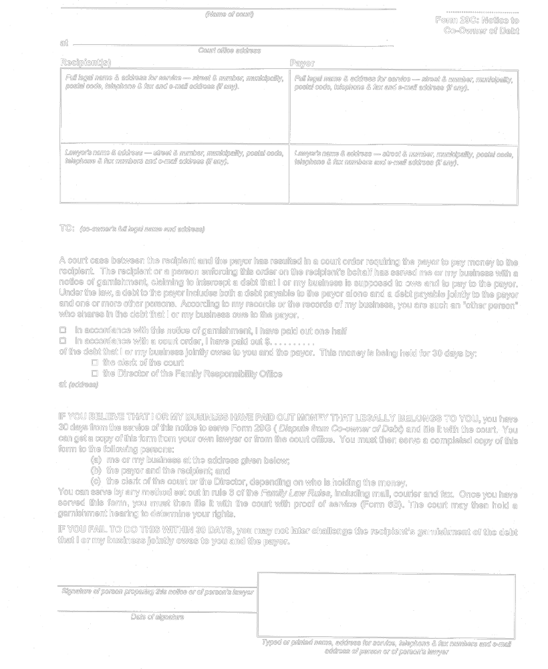
O. Reg. 114/99, Form 29C.
Form 29D
Courts of Justice Act
statutory declaration of indexed support
Insert regs\graphics\1999\114\11429Dae.tif
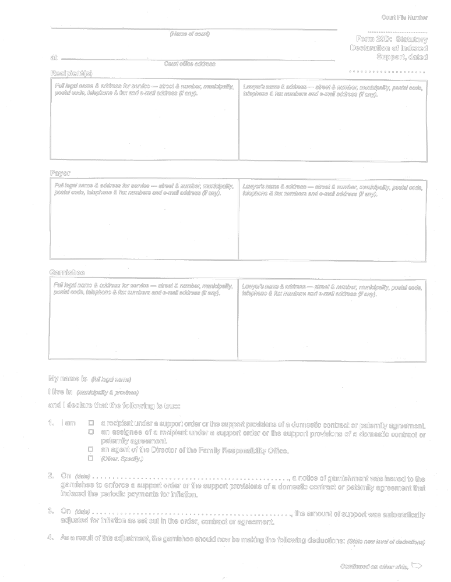
Insert regs\graphics\1999\114\11429Dbe.tif
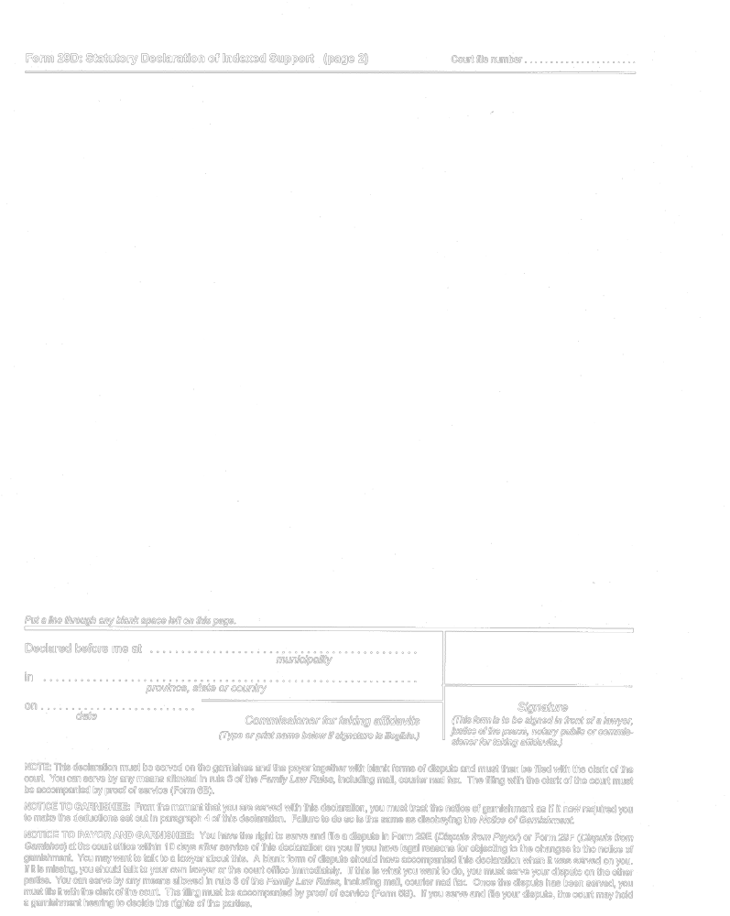
O. Reg. 114/99, Form 29D.
Form 29E
Courts of Justice Act
dispute (payor)
Insert regs\graphics\1999\114\11429Eae.tif
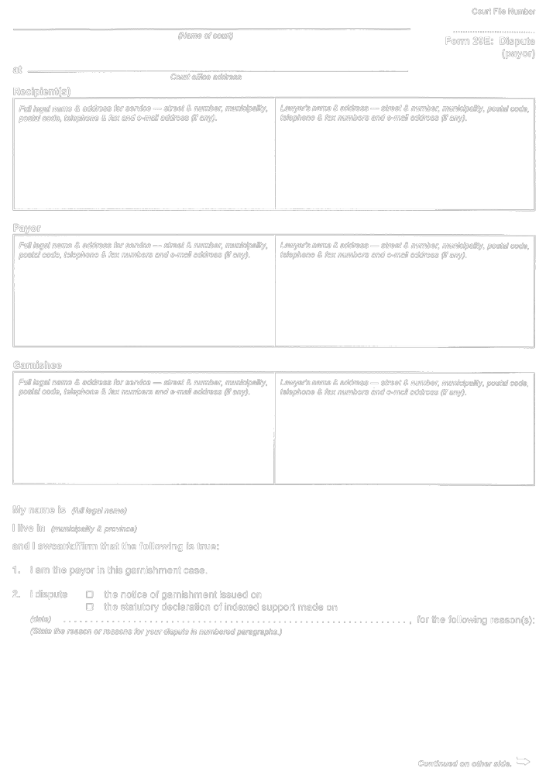
Insert regs\graphics\1999\114\11429Ebe.tif
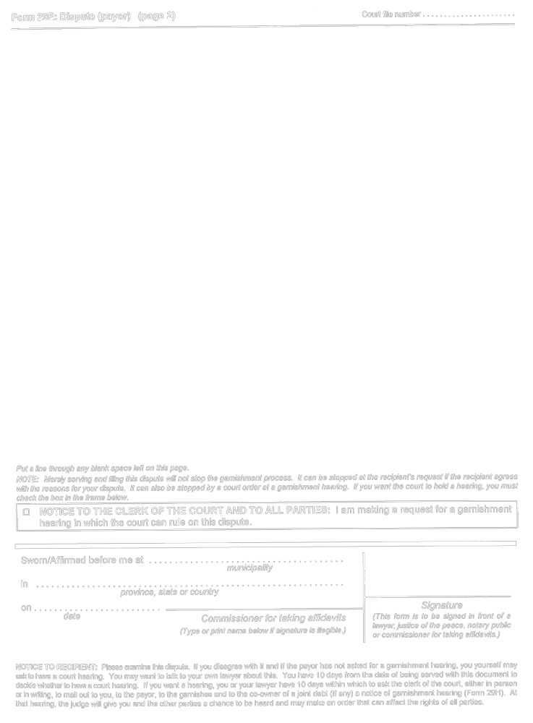
O. Reg. 544/99, s. 15 (3).
Form 29F
Courts of Justice Act
dispute (garnishee)
Insert regs\graphics\1999\114\11429Fae.tif
Insert regs\graphics\1999\114\11429Fbe.tif
O. Reg. 544/99, s. 15 (3).
Form 29G
Courts of Justice Act
dispute (co-owner of debt)
Insert regs\graphics\1999\114\11429Gae.tif
Insert regs\graphics\1999\114\11429Gbe.tif
O. Reg. 544/99, s. 15 (3).
Form 29H
Courts of Justice Act
notice of garnishment hearing
Insert regs\graphics\1999\114\11429Hae.tif
O. Reg. 114/99, Form 29H.
Form 29I
Courts of Justice Act
notice to stop garnishment
Insert regs\graphics\1999\114\11429Iae.tif
O. Reg. 114/99, Form 29I.
Form 29J
Courts of Justice Act
statement to garnishee Financial institution re support
Insert regs\graphics\1999\114\11429Jae.tif
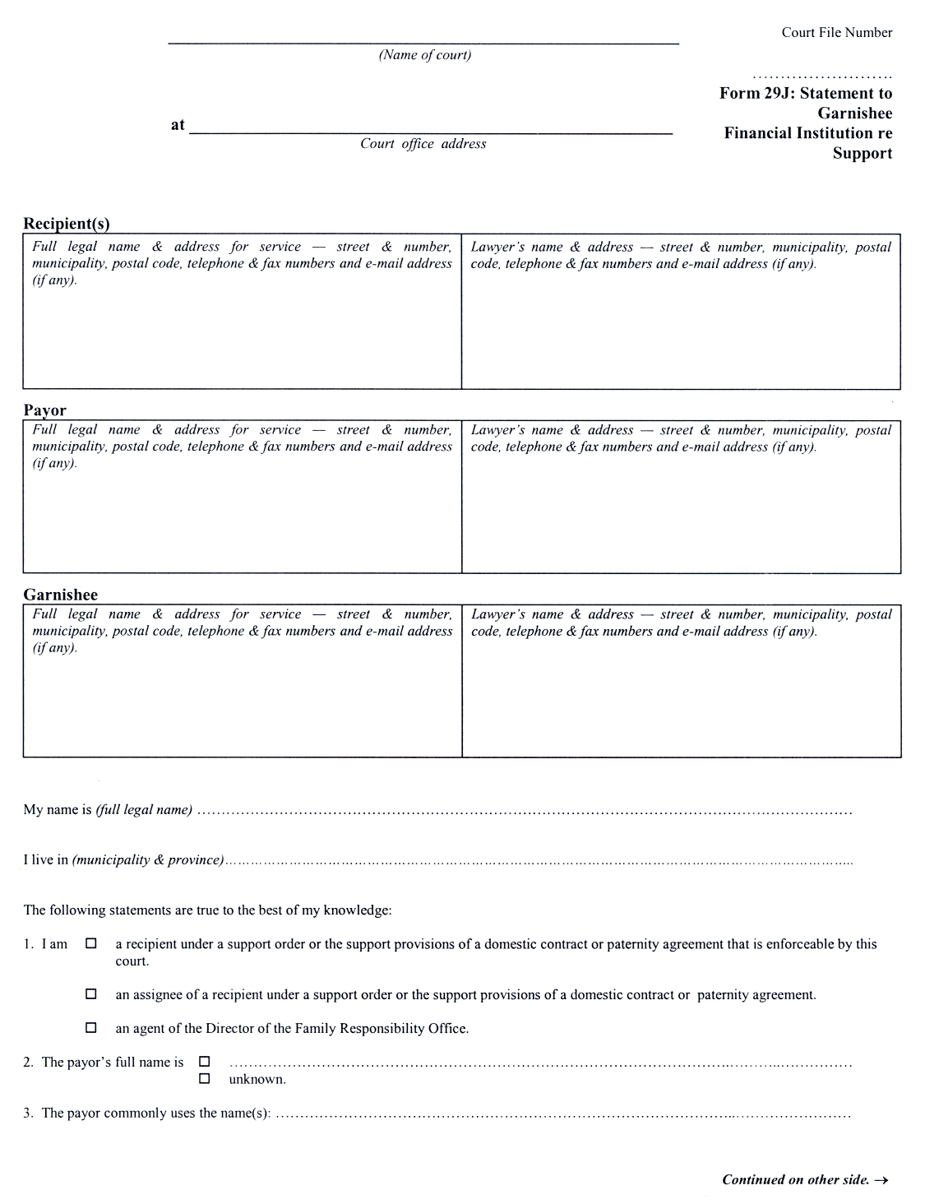
Insert regs\graphics\1999\114\11429Jbe.tif
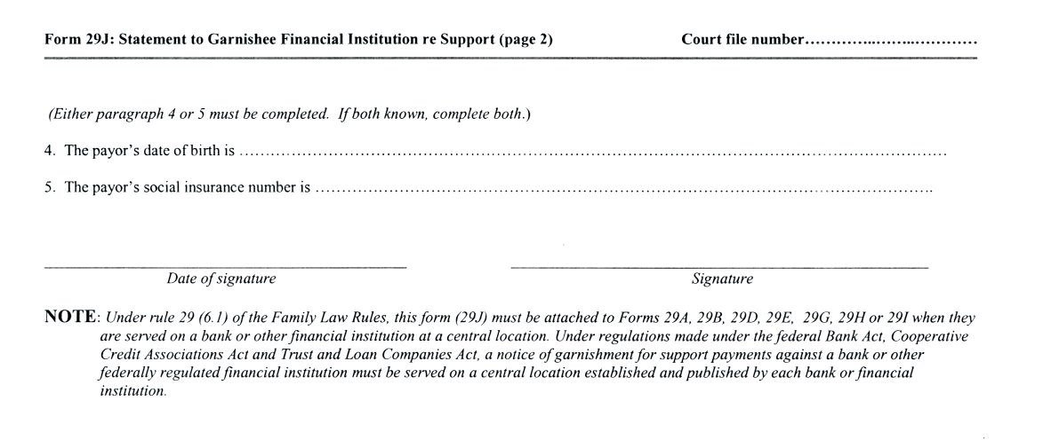
O. Reg. 56/03, s. 9.
Form 30
Courts of Justice Act
notice of default hearing
Insert regs\graphics\1999\114\1140030e.tif
O. Reg. 114/99, Form 30.
Form 30A
Courts of Justice Act
request for default hearing
Insert regs\graphics\1999\114\11430Aae.tif
O. Reg. 114/99, Form 30A.
Form 30B
Courts of Justice Act
default dispute
Insert regs\graphics\1999\114\11430Bae.tif
Insert regs\graphics\1999\114\11430Bbe.tif
O. Reg. 114/99, Form 30B.
Form 31
Courts of Justice Act
notice of contempt motion
Insert regs\graphics\1999\114\1140031e.tif
O. Reg. 114/99, Form 31.
Form 32
Courts of Justice Act
bond (recognizance)
Insert regs\graphics\1999\114\114032ae.tif
Insert regs\graphics\1999\114\114032be.tif
O. Reg. 114/99, Form 32.
Form 32A
Courts of Justice Act
notice of forfeiture motion
Insert regs\graphics\1999\114\11432Aae.tif
O. Reg. 114/99, Form 32A.
Form 32B
Courts of Justice Act
warrant for arrest
Insert regs\graphics\1999\114\11432Bae.tif
Insert regs\graphics\1999\114\11432Bbe.tif
O. Reg. 114/99, Form 32B.
Form 32C
Courts of Justice Act
affidavit for warrant of committal
Insert regs\graphics\1999\114\11432Cae.tif
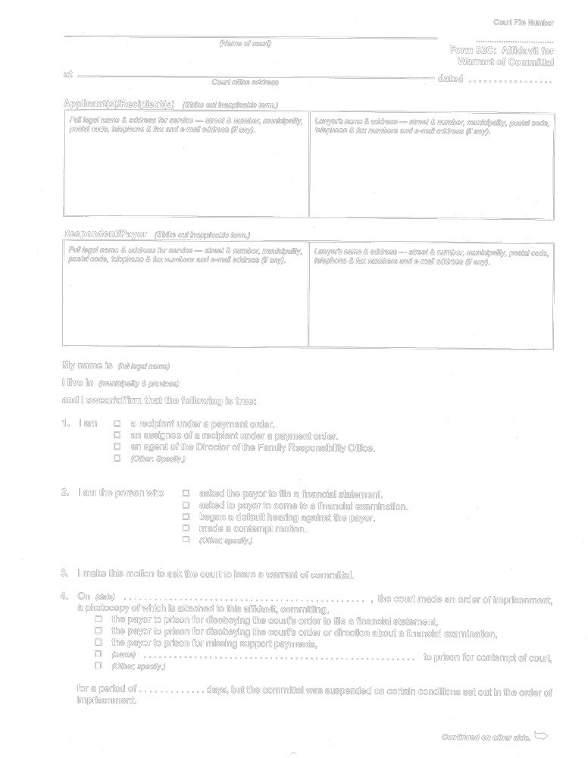
Insert regs\graphics\1999\114\11432Cbe.tif
O. Reg. 114/99, Form 32C.
Form 32D
Courts of Justice Act
warrant of committal
Insert regs\graphics\1999\114\11432Dae.tif
Insert regs\graphics\1999\114\11432Dbe.tif
O. Reg. 114/99, Form 32D.
Form 33
Courts of Justice Act
information for warrant to apprehend child
Insert regs\graphics\1999\114\1140033e.tif
O. Reg. 114/99, Form 33.
Form 33A
Courts of Justice Act
warrant to apprehend child
Insert regs\graphics\1999\114\11433Aae.tif
Insert regs\graphics\1999\114\11433Abe.tif
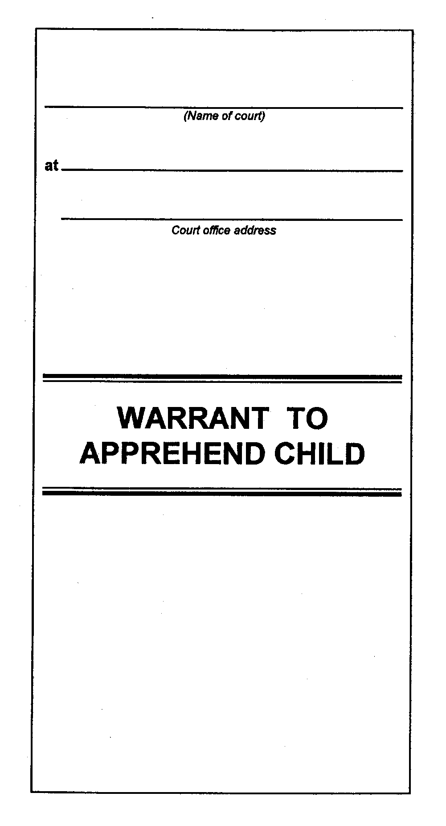
O. Reg. 114/99, Form 33A.
Form 33B
Courts of Justice Act
plan of care for child(ren)
Insert regs\graphics\1999\114\11433Bae.tif
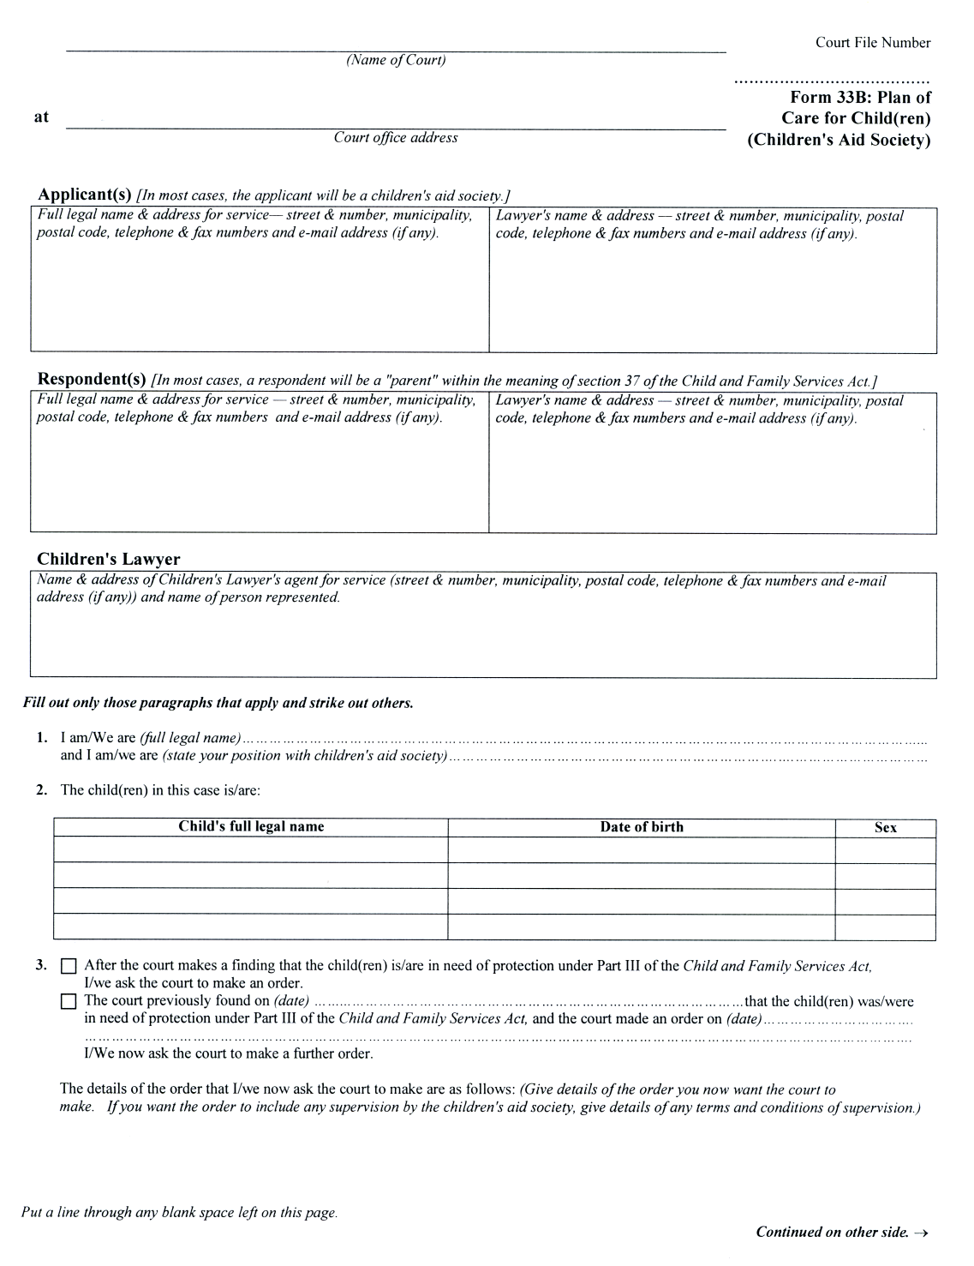
Insert regs\graphics\1999\114\11433Bbe.tif
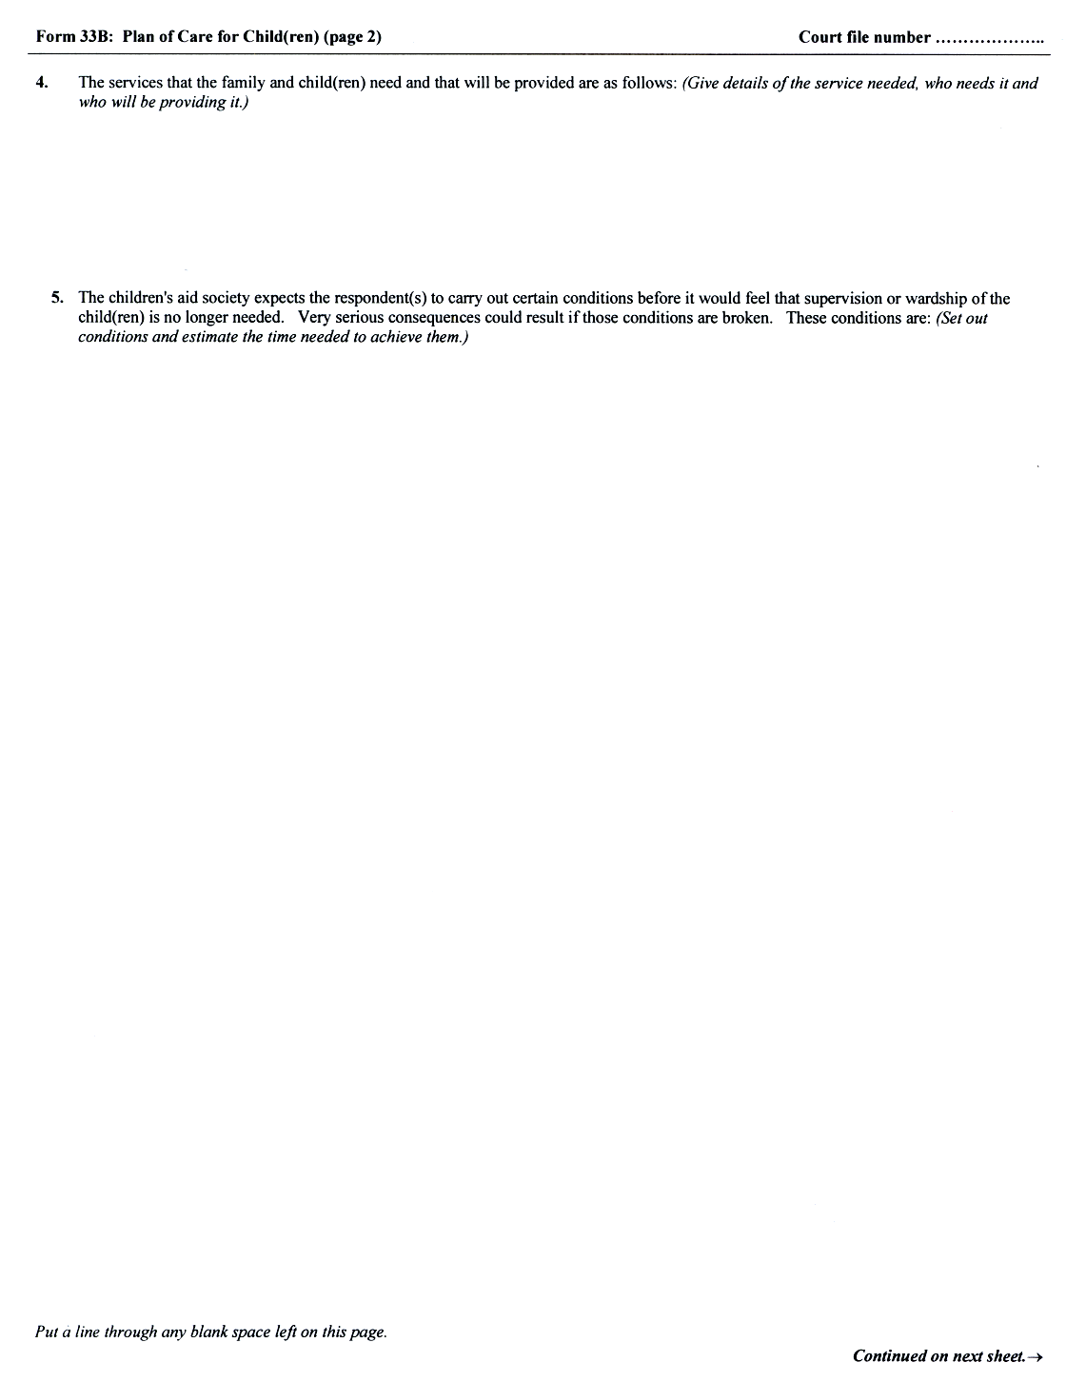
Insert regs\graphics\1999\114\11433Bce.tif
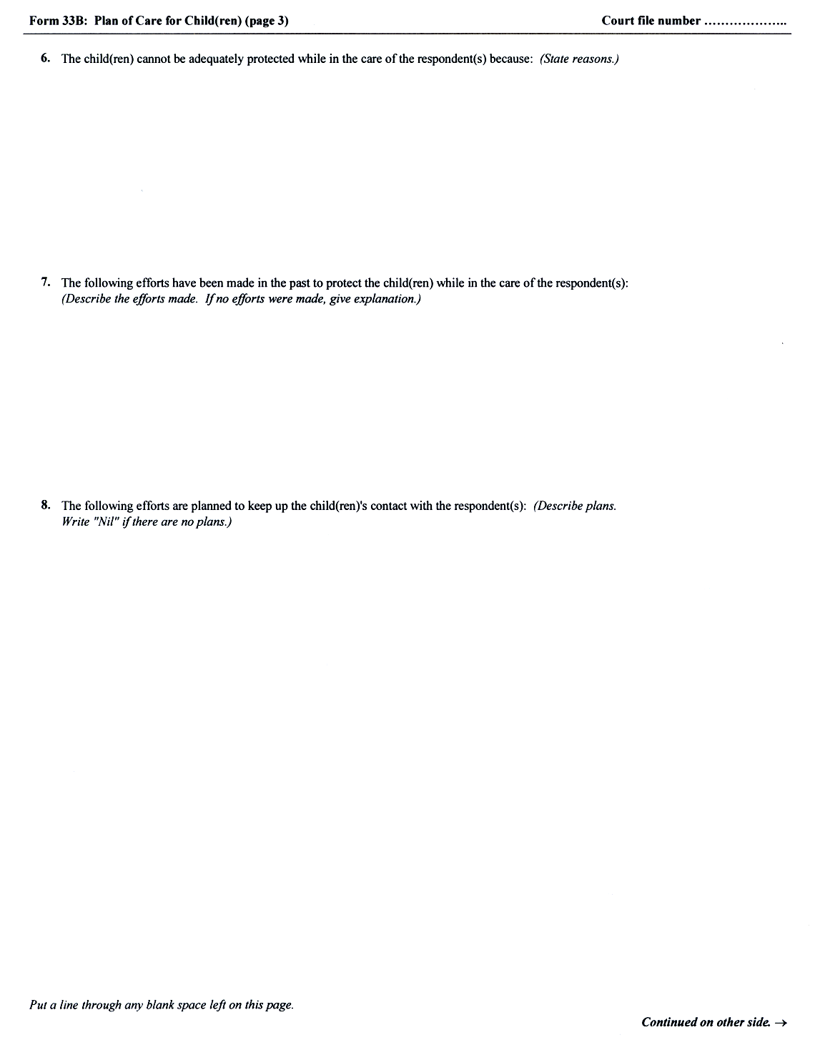
Insert regs\graphics\1999\114\11433Bde.tif
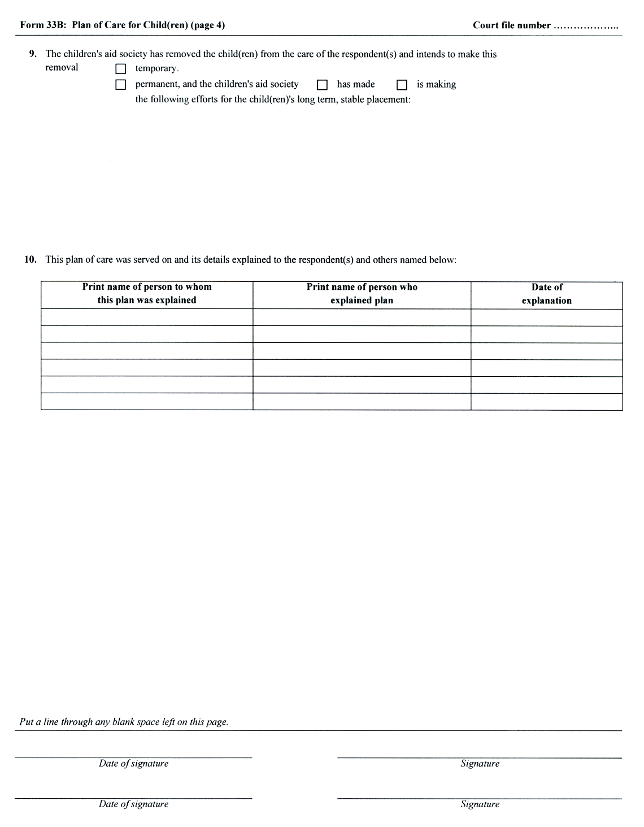
O. Reg. 91/03, s. 8 (4).
Form 33B.1
Courts of Justice Act
answer and plan of care
Insert regs\graphics\1999\114\11433B1ae.tif
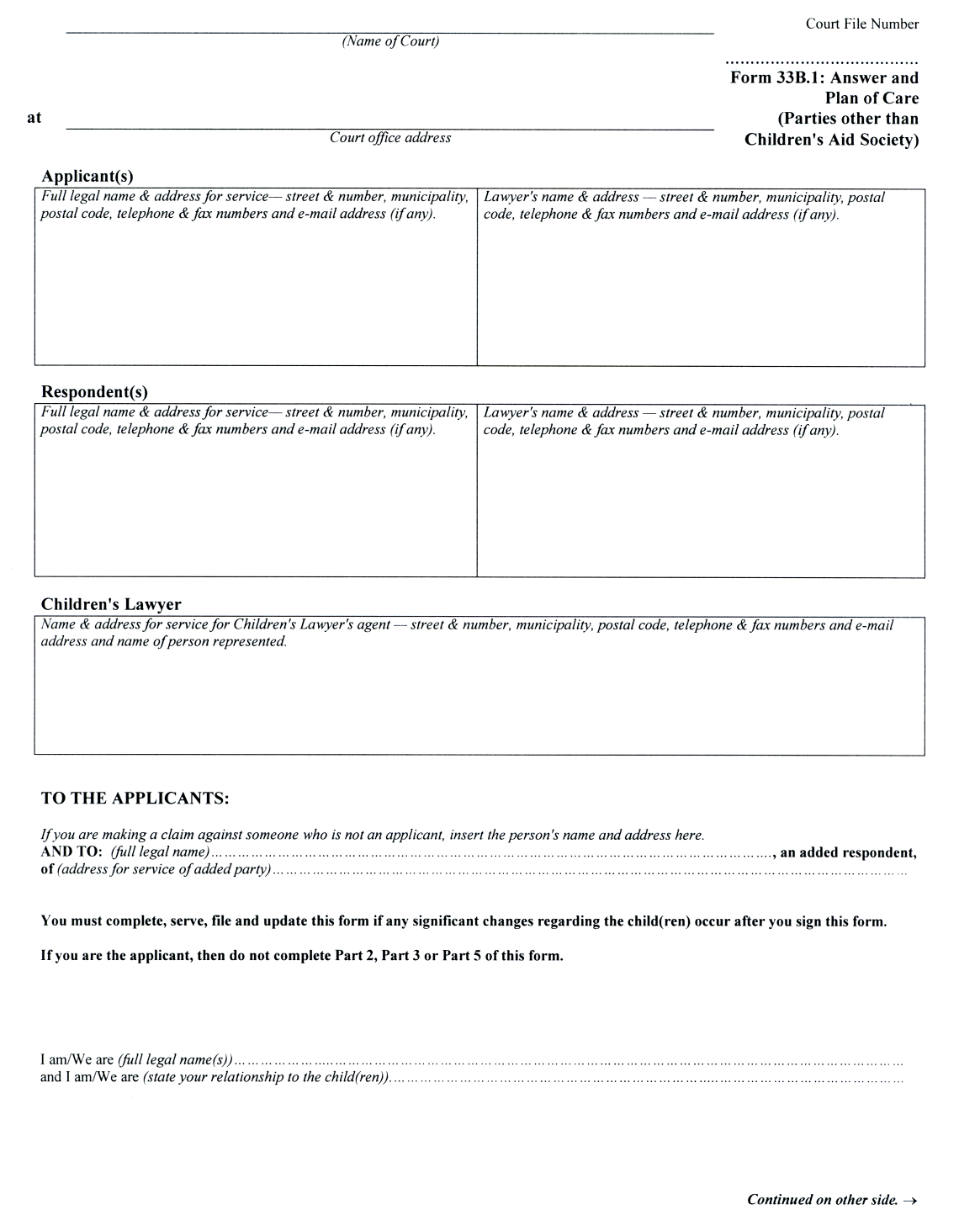
Insert regs\graphics\1999\114\11433B1be.tif
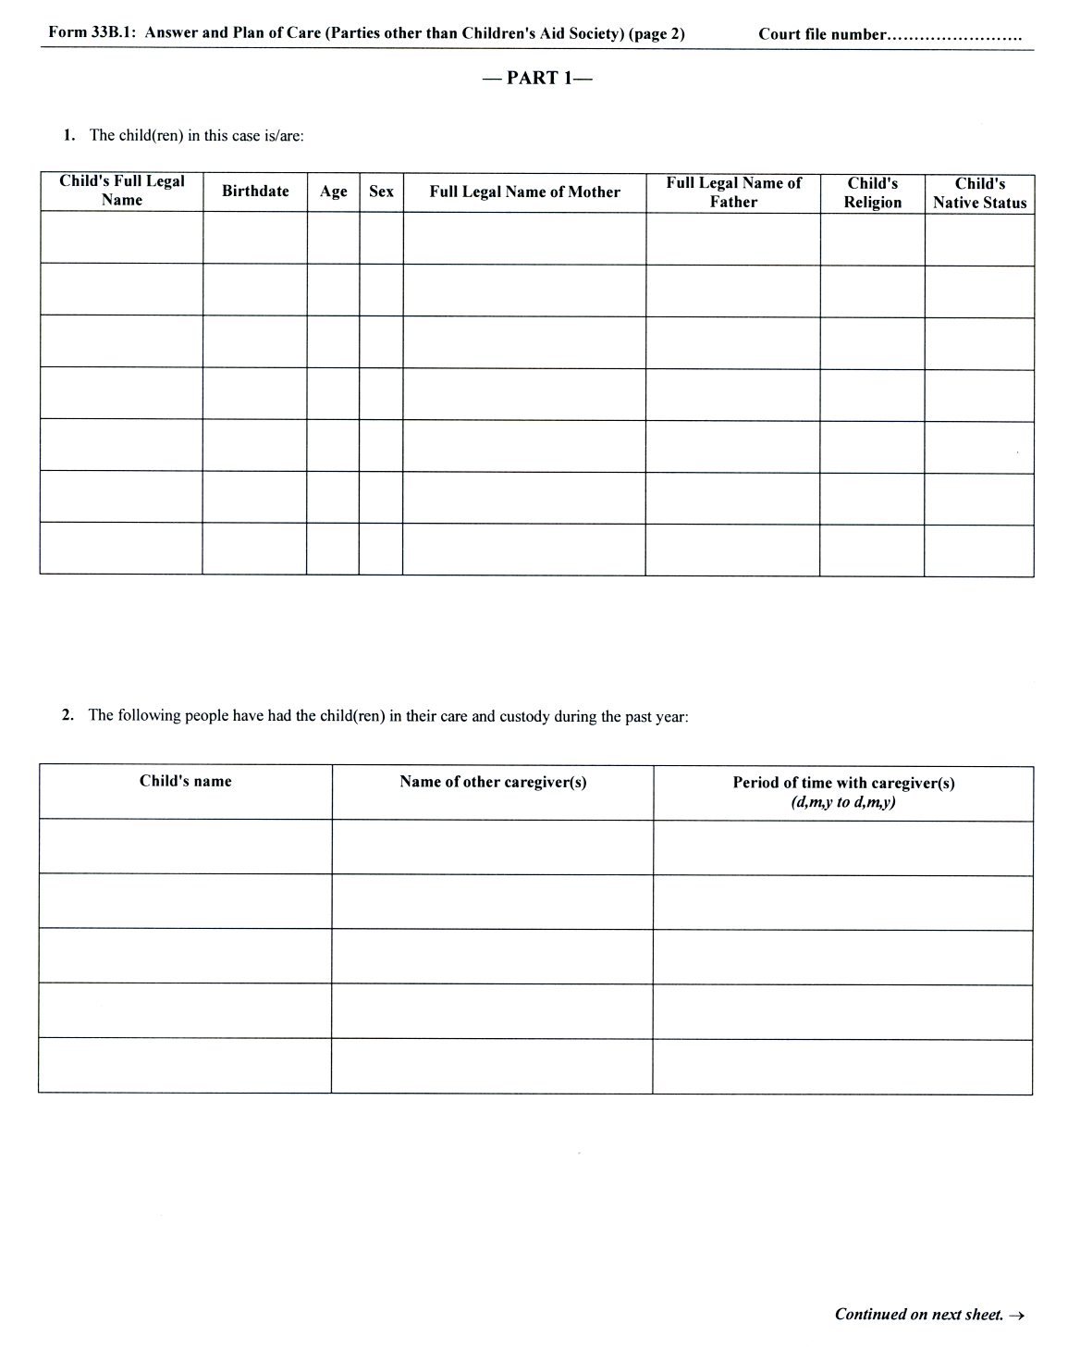
Insert regs\graphics\1999\114\11433B1ce.tif
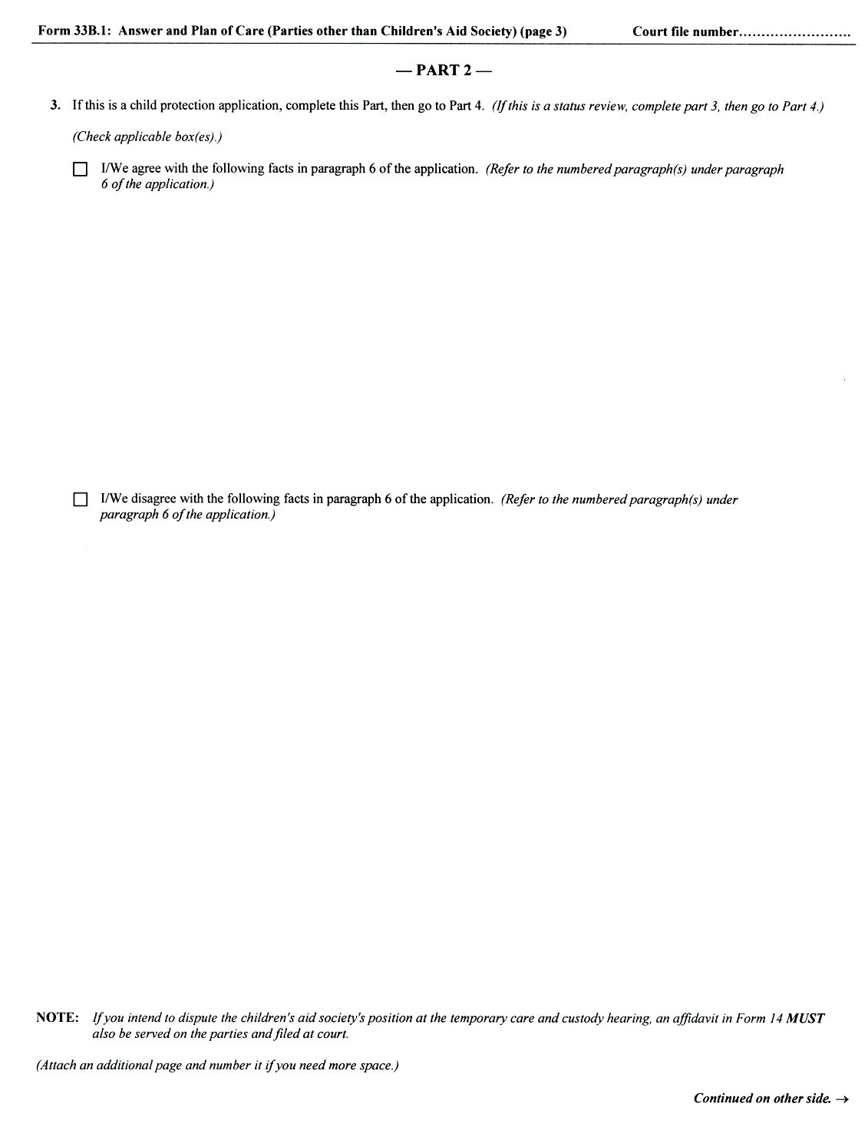
Insert regs\graphics\1999\114\11433B1de.tif
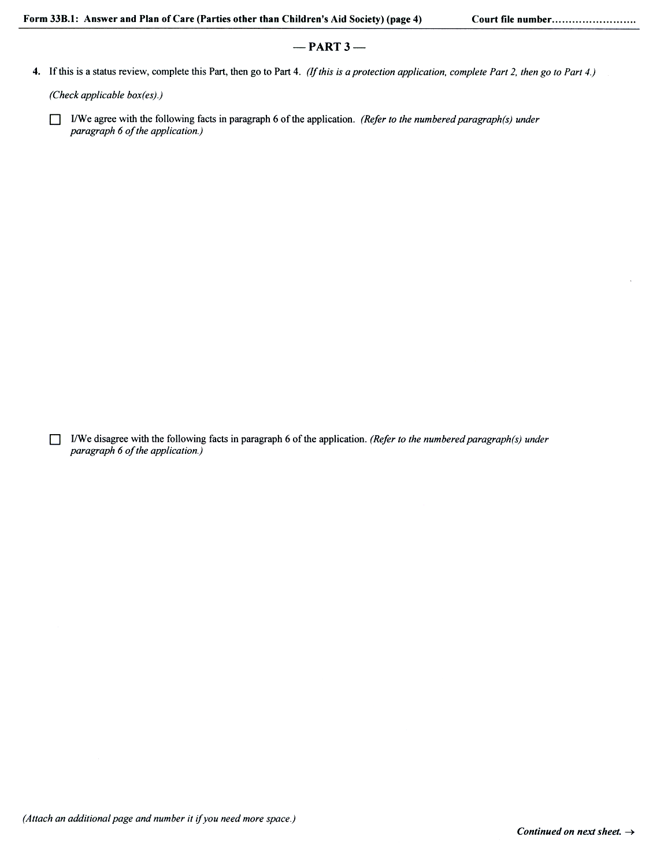
Insert regs\graphics\1999\114\11433B1ee.tif
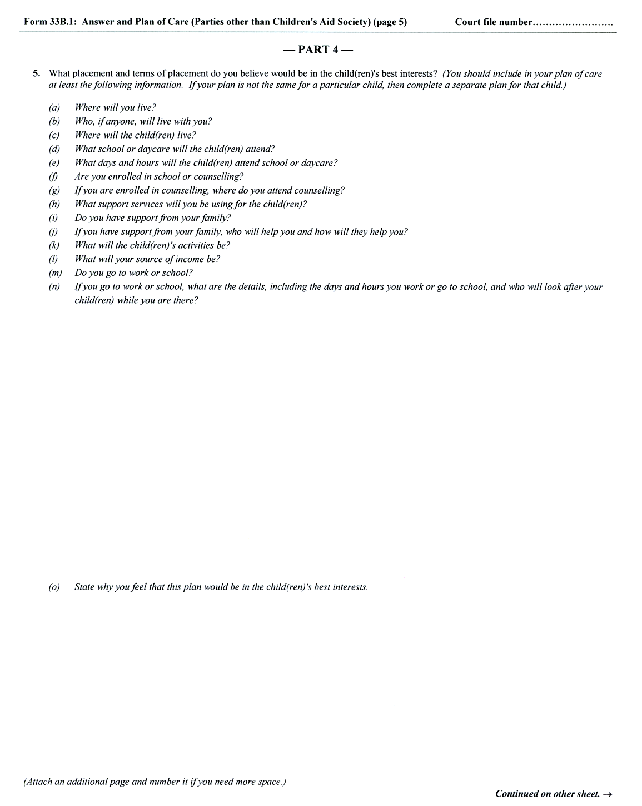
Insert regs\graphics\1999\114\11433B1fe.tif
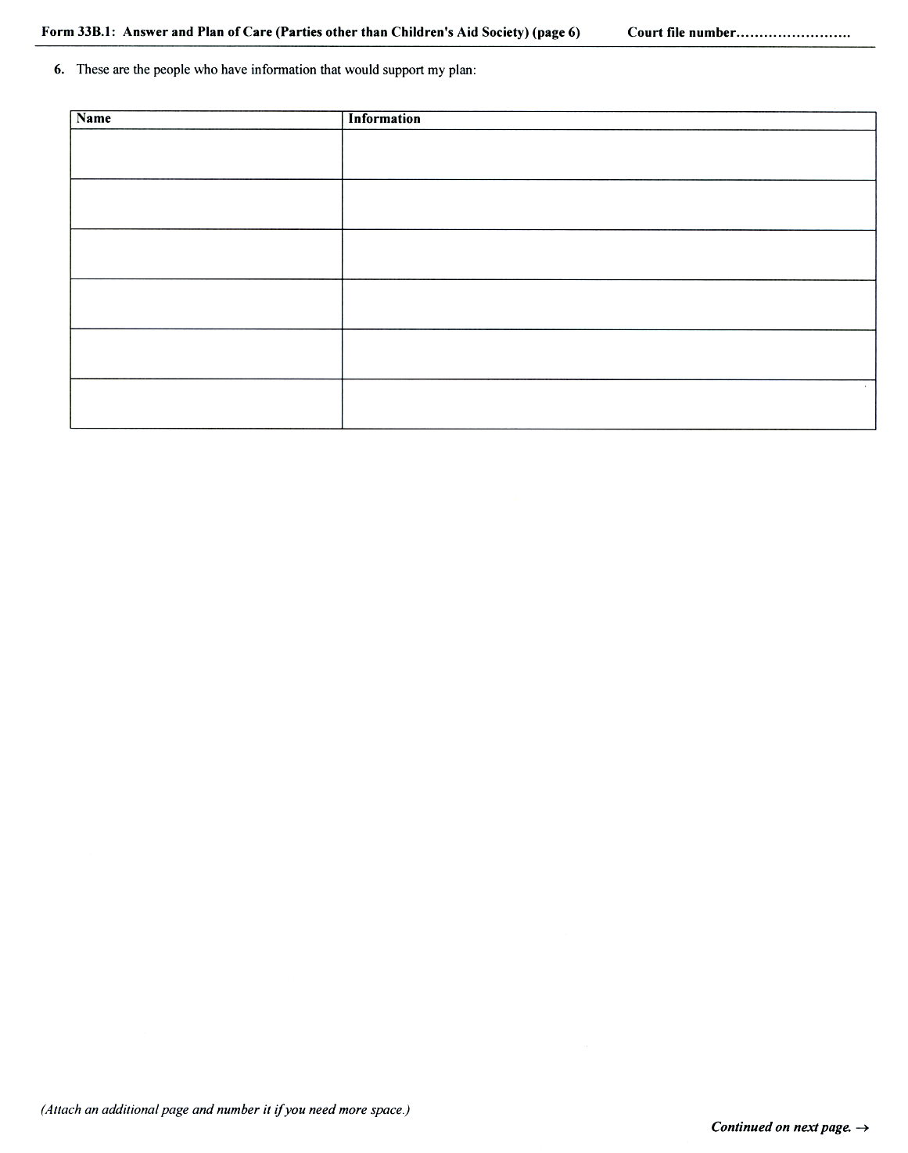
Insert regs\graphics\1999\114\11433B1ge.tif
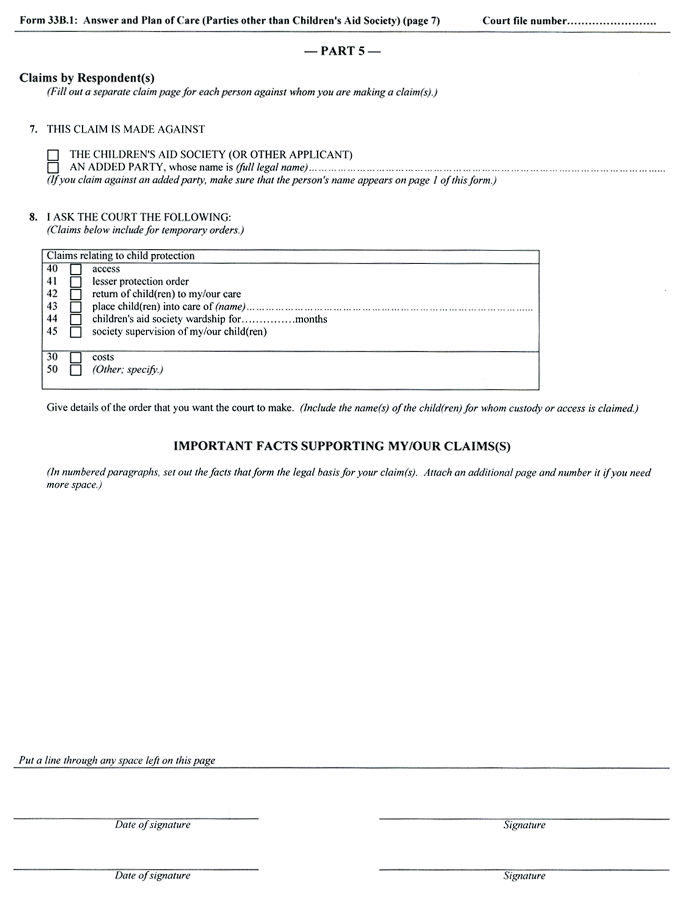
O. Reg. 91/03, s. 8 (4).
Form 33C
Courts of Justice Act
statement of agreed facts (child protection)
(Name of court)  at  Court office address | Court File Number  Form 33C: Statement  of Agreed Facts  (Child Protection)

Applicant(s) [In most cases, the applicant will be a children’s aid society.]

Full legal name & address for service — street & number, municipality, postal code, telephone & fax and e-mail address (if any). | Lawyer’s name & address — street & number, municipality, postal code, telephone & fax numbers and e-mail address (if any).
Respondent(s) [In most cases, a respondent will be a “parent” within the meaning of section 37 of the Child and Family Services Act.]
Full legal name & address for service — street & number, municipality, postal code, telephone & fax and e-mail address (if any). | Lawyer’s name & address — street & number, municipality, postal code, telephone & fax numbers and e-mail address (if any).

THE PEOPLE SIGNING THIS AGREEMENT ARE:
(Give full legal name. If you are a respondent, state your relationship to the child(ren). If you are an employee of the children’s aid society, state your position within the society.)

Print or type full legal name | Relationship to child OR position within children’s aid society
Signature | Date of signature

Print or type full legal name | Relationship to child OR position within children’s aid society
Signature | Date of signature

Print or type full legal name | Relationship to child OR position within children’s aid society
Signature | Date of signature

Print or type full legal name | Relationship to child OR position within children’s aid society
Signature | Date of signature

WE AGREE: | (a)  (b) | that the statements made on this form are true; and  that this form may be filed with the court and may be read to the court as evidence, without affecting anyone’s right to test that evidence by cross-examination or to bring in other evidence.

Form 33C: Statement of Agreed Facts (Child Protection) (page 2) Court file number

1. The information about the child(ren) in this case is as follows:
Full legal name of first child: | Date of birth | Age | Sex
Child’s religion
Child’s Indian or native status
Name of child’s band or native community
If child was apprehended, address and identity of place from which child was removed
Full legal name of child’s mother by birth or by adoption
Full legal name of child’s father by birth or by adoption
Father’s status as “parent” under statute

Full legal name of second child: | Date of birth | Age | Sex
Child’s religion
Child’s Indian or native status
Name of child’s band or native community
If child was apprehended, address and identity of place from which child was removed
Full legal name of child’s mother by birth or by adoption
Full legal name of child’s father by birth or by adoption
Father’s status as “parent” under statute

Full legal name of third child: | Date of birth | Age | Sex
Child’s religion
Child’s Indian or native status
Name of child’s band or native community
If child was apprehended, address and identity of place from which child was removed
Full legal name of child’s mother by birth or by adoption
Full legal name of child’s father by birth or by adoption
Father’s status as “parent” under statute

If there are more children, attach a sheet and number it.

Form 33C: Statement of Agreed Facts (Child Protection) (page 3) Court file number

2. The details of the children’s aid society’s previous involvement with one or more of these children in this case are as follows:
(Write “Nil” if no involvement. Indicate any involvement with children’s aid society in another part of Ontario or a child protection agency outside Ontario. Please remember that this is a statement of AGREED FACTS. That means that you must not set out something as a fact if another party disagrees with it. If you cannot agree at all about anything, write: “No agreement reached.”)

3. The child(ren) was/were apprehended because:
(If there was no apprehension, write “Nil”. Again, there must be full agreement by all parties. Any point on which there is disagreement must be excluded. If there is no agreement at all on anything, write “No agreement reached.”)

4. We agree that the court should make a finding that the child(ren) is/are in need of protection on the following reason(s):
(Use only the reasons listed on page 3 of the application [Form 8B]. Any reason on which there is disagreement must be excluded. If there is no agreement at all, write, “No agreement reached.” In any event, the court can always make some other finding.)

4.1 The following important events relating to the child(ren)’s best interests have occurred since the date this application began:

5. We agree that the order that would best serve the best interests of the child(ren) is:
(Again, list only the terms and conditions on which there is full agreement by all parties. If there is no agreement at all, write, “No agreement reached.” In any event, the court is always free to make some other order. If the order on which you all agree would remove the child(ren) from the care of the person who had the child(ren) before the case started, explain why less disruptive options would not be enough to protect the child(ren).)

Put a line through any blank space left on this page.
O. Reg. 250/00, s. 1; O. Reg. 91/03, s. 8 (5).
Form 33D
Courts of Justice Act
statement of agreed facts (status review)
(Name of court)  at  Court office address | Court File Number  Form 33D: Statement  of Agreed Facts  (Status Review)

Applicant(s) [In most cases, the applicant will be a children’s aid society.]
Full legal name & address for service — street & number, municipality, postal code, telephone & fax and e-mail address (if any). | Lawyer’s name & address — street & number, municipality, postal code, telephone & fax numbers and e-mail address (if any).

Respondent(s) [In most cases, a respondent will be a “parent” within the meaning of section 37 of the Child and Family Services Act.]
Full legal name & address for service — street & number, municipality, postal code, telephone & fax and e-mail address (if any). | Lawyer’s name & address — street & number, municipality, postal code, telephone & fax numbers and e-mail address (if any).

THE PEOPLE SIGNING THIS AGREEMENT ARE:
(Give full legal name. If you are a respondent, state your relationship to the child(ren). If you are an employee of the children’s aid society, state your position within the society.)
Print or type full legal name | Relationship to child OR position within children’s aid society
Signature | Date of signature

Print or type full legal name | Relationship to child OR position within children’s aid society
Signature | Date of signature

Print or type full legal name | Relationship to child OR position within children’s aid society
Signature | Date of signature

Print or type full legal name | Relationship to child OR position within children’s aid society
Signature | Date of signature

WE AGREE: | (a) | that the statements made on this form are true; and
 | (b) | that this form may be filed with the court and may be read to the court as evidence, without affecting anyone’s right to test that evidence by cross-examination or to bring in other evidence.

Form 33D: Statement of Agreed Facts (Status Review) (page 2) Court file number

1. The information about the child(ren) in this case is as follows:

Full legal name of first child: | Date of birth | Age | Sex
Child’s religion
Child’s Indian or native status
Name of child’s band or native community
If child was apprehended, address and identity of place from which child was removed
Full legal name of child’s mother by birth or by adoption
Full legal name of child’s father by birth or by adoption
Father’s status as “parent” under statute

Full legal name of second child: | Date of birth | Age | Sex
Child’s religion
Child’s Indian or native status
Name of child’s band or native community
If child was apprehended, address and identity of place from which child was removed
Full legal name of child’s mother by birth or by adoption
Full legal name of child’s father by birth or by adoption
Father’s status as “parent” under statute

Full legal name of third child: | Date of birth | Age | Sex
Child’s religion
Child’s Indian or native status
Name of child’s band or native community
If child was apprehended, address and identity of place from which child was removed
Full legal name of child’s mother by birth or by adoption
Full legal name of child’s father by birth or by adoption
Father’s status as “parent” under statute
If there are more children, attach a sheet and number it.

Form 33D: Statement of Agreed Facts (Status Review) (page 3) Court file number

2. | The most recent protection order dealing with the child(ren) in paragraph 1 was made on (date)  and it said that: (State substance of order.)
3. | Since the order under review was made the following person(s) has/have become a “parent” under Part III of the Child and Family Services Act:

Full legal name | Relationship to child

4. Since that order was made, the following important events have happened:
(Describe only the events on which you can ALL agree. Please remember that this is a statement of AGREED FACTS. That means that you must not set out something as a fact if at least one of the persons signing this statement disagrees with it. If you cannot agree at all about anything, write: “No agreement reached.”)

5. We agree that an order of the court is needed now and that it would best serve the best interests of the child(ren) because:
(If there is no agreement that an order needs to be made, write: “No agreement reached on need for an order.” If you agree that an order needs to be made, give reasons for it and set out its terms and conditions. If any person disagrees with a reason, term or condition, then you must not include that reason, term or condition. If you cannot agree on any reasons, write: “No agreement reached on reasons for order.” If you cannot agree on any terms or conditions of the order, write: “No agreement reached on terms and conditions of order.”)

Put a line through any blank space left on this page.

O. Reg. 250/00, s. 1; O. Reg. 91/03, s. 8 (6).
Form 33E
Courts of Justice Act
child’s consent to secure treatment
Insert regs\graphics\1999\114\11433eae.tif
Insert regs\graphics\1999\114\11433ebe.tif
O. Reg. 114/99, Form 33E.
Form 33F
Courts of Justice Act
consent to secure treatment (person other than child)
Insert regs\graphics\1999\114\114033fe.tif
O. Reg. 114/99, Form 33F.
Form 34
Courts of Justice Act
child’s consent to adoption
Insert regs\graphics\1999\114\114034ae.tif
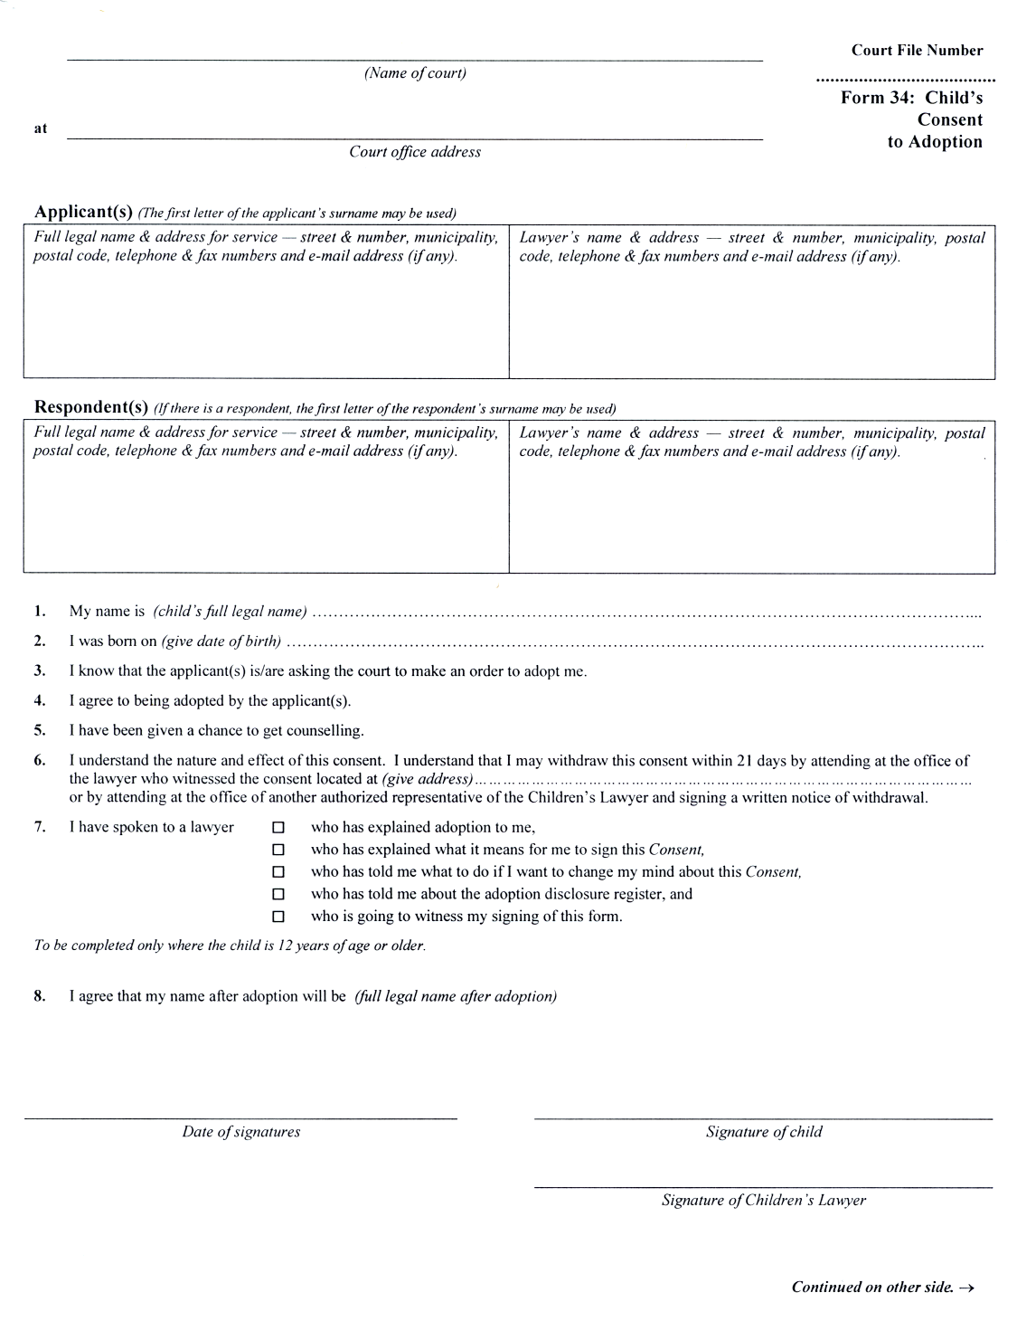
Insert regs\graphics\1999\114\114034be.tif
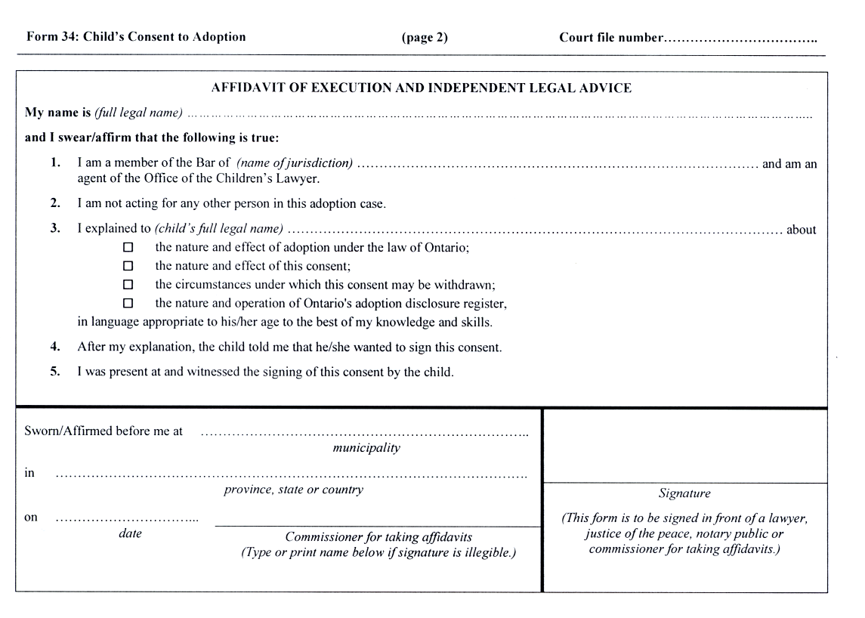
O. Reg. 337/02, s. 4 (3).
Form 34A
Courts of Justice Act
affidavit of parentage
Insert regs\graphics\1999\114\11434aae.tif
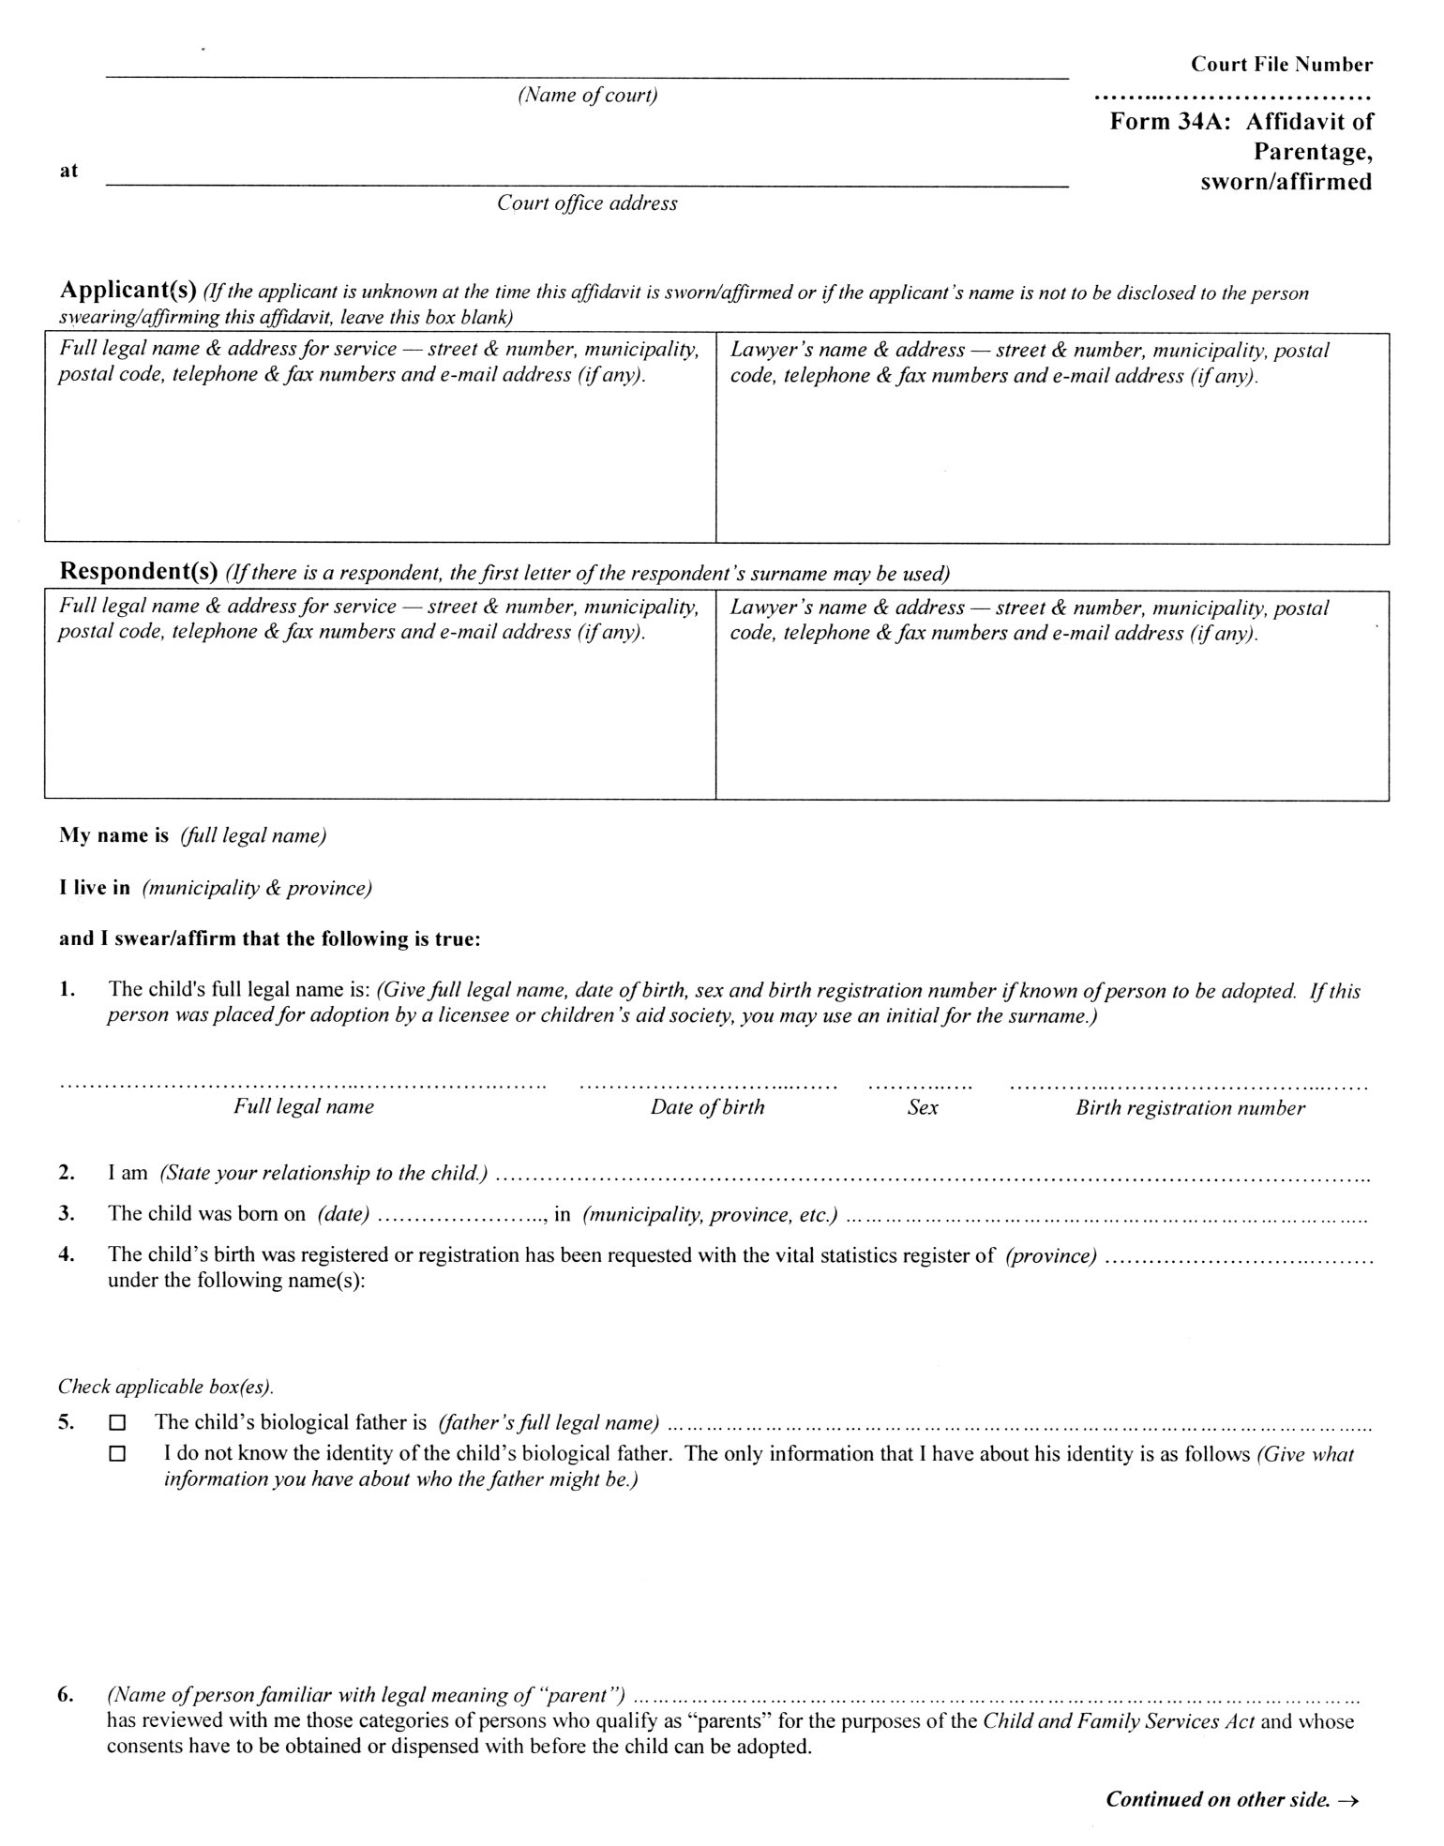
Insert regs\graphics\1999\114\11434abe.tif
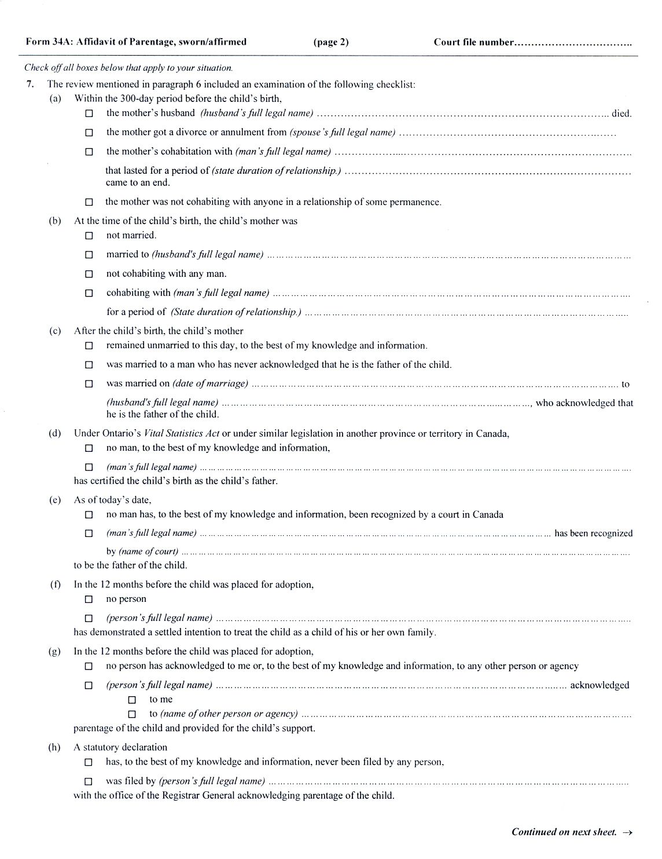
Insert regs\graphics\1999\114\11434ace.tif
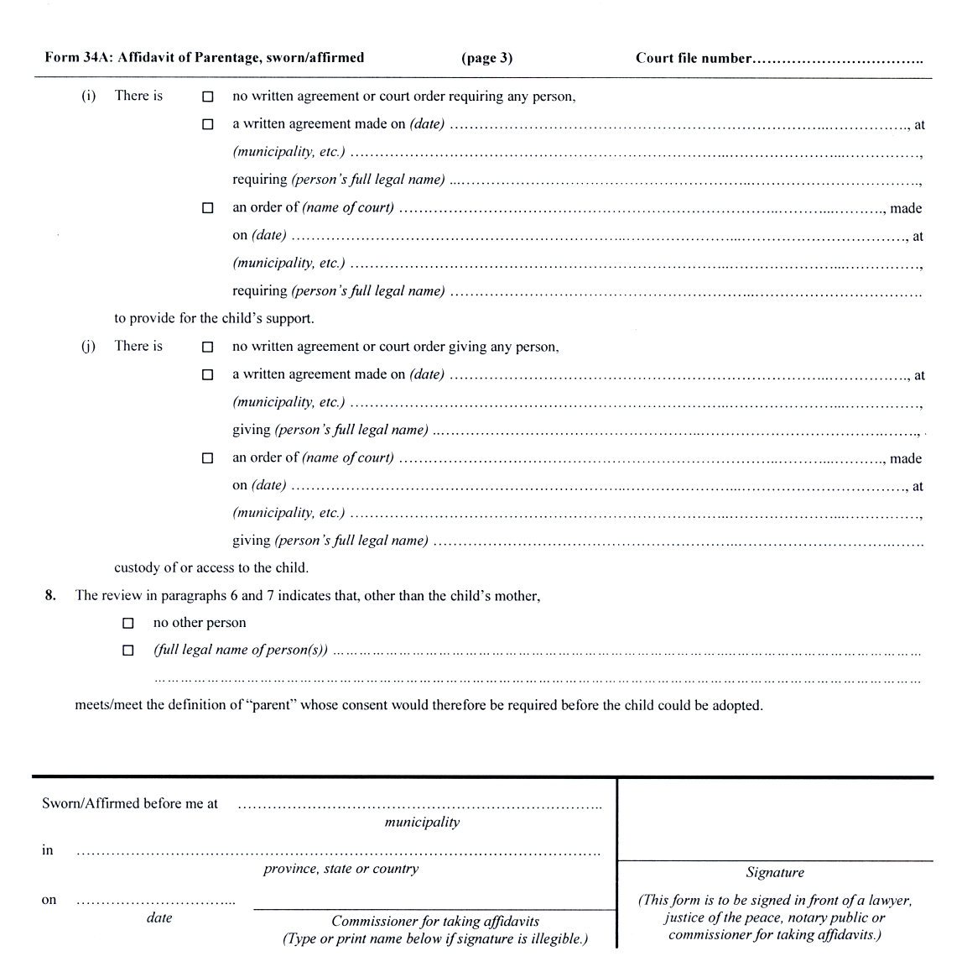
O. Reg. 337/02, s. 4 (3).
Form 34B
Courts of Justice Act
non-parent’s consent to adoption by spouse
Insert regs\graphics\1999\114\11434Bae.tif
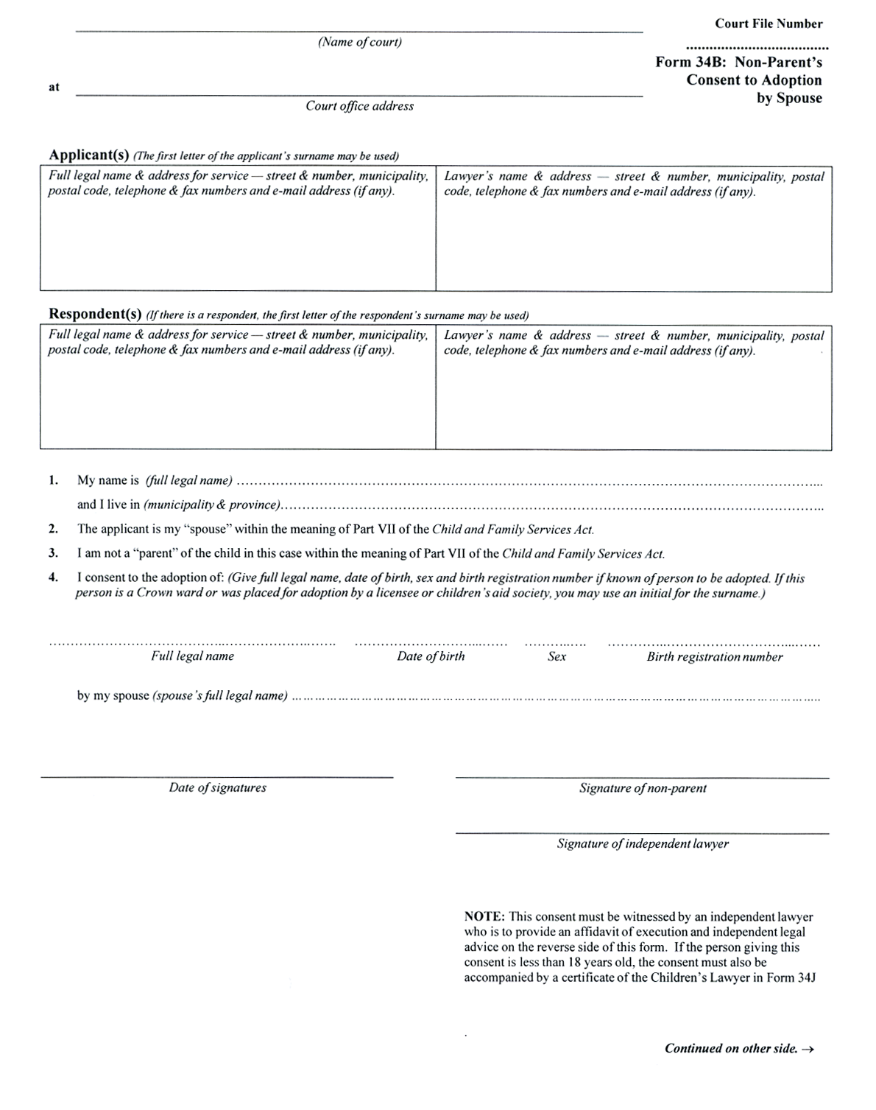
Insert regs\graphics\1999\114\11434Bbe.tif
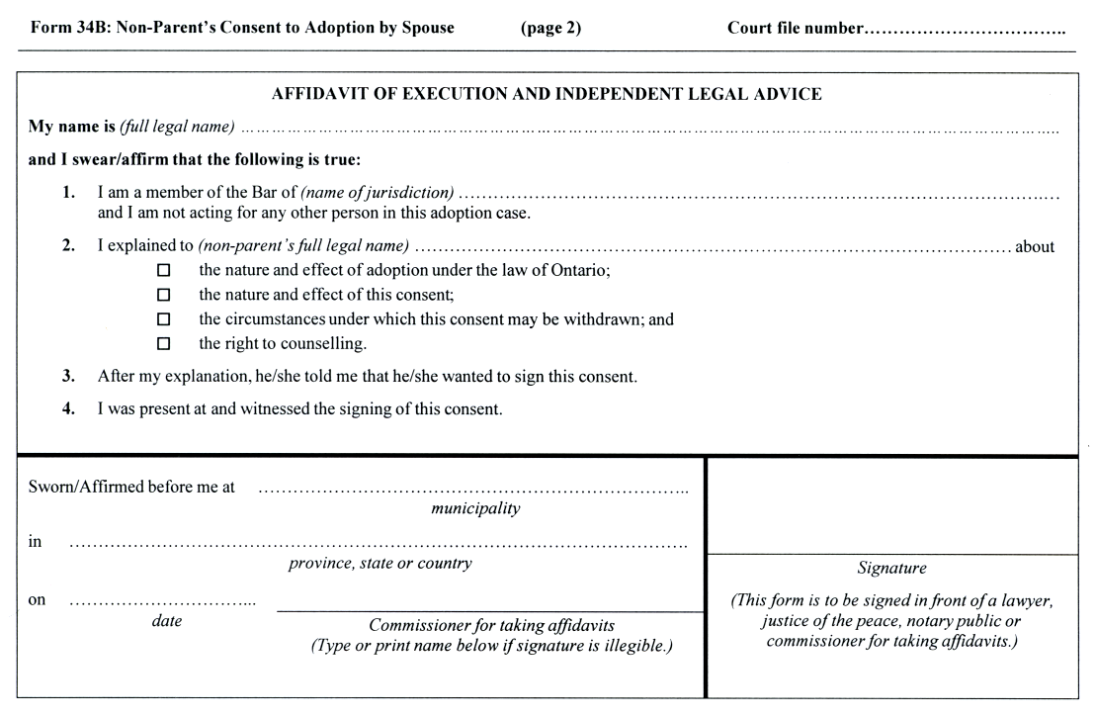
O. Reg. 91/03, s. 8 (7).
Form 34C
Courts of Justice Act
director’s or local director’s statement on adoption
Insert regs\graphics\1999\114\11434cae.tif
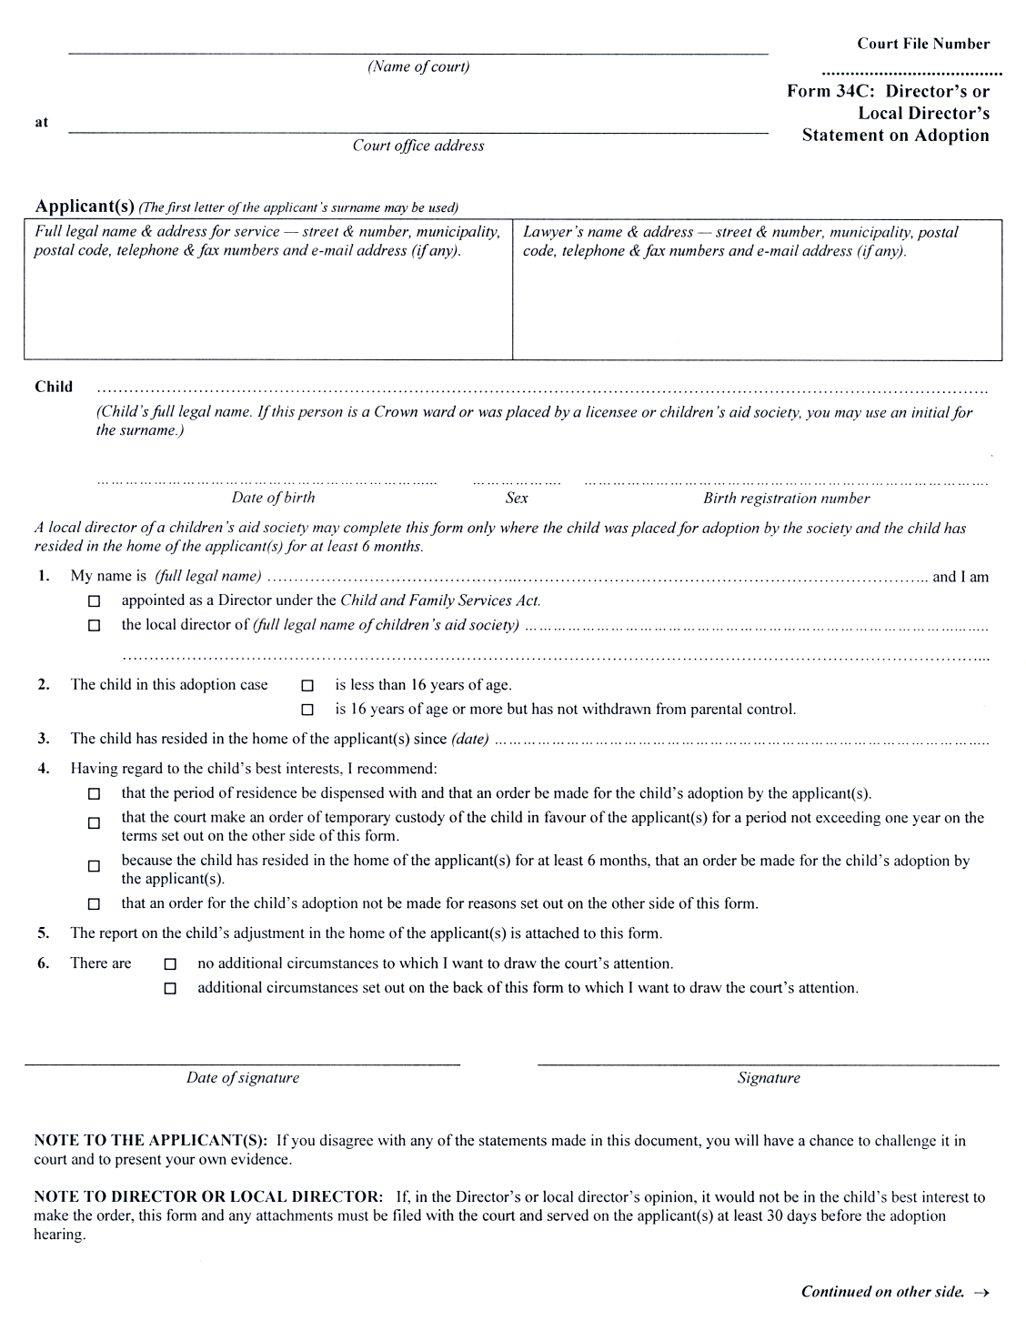
Insert regs\graphics\1999\114\11434cbe.tif
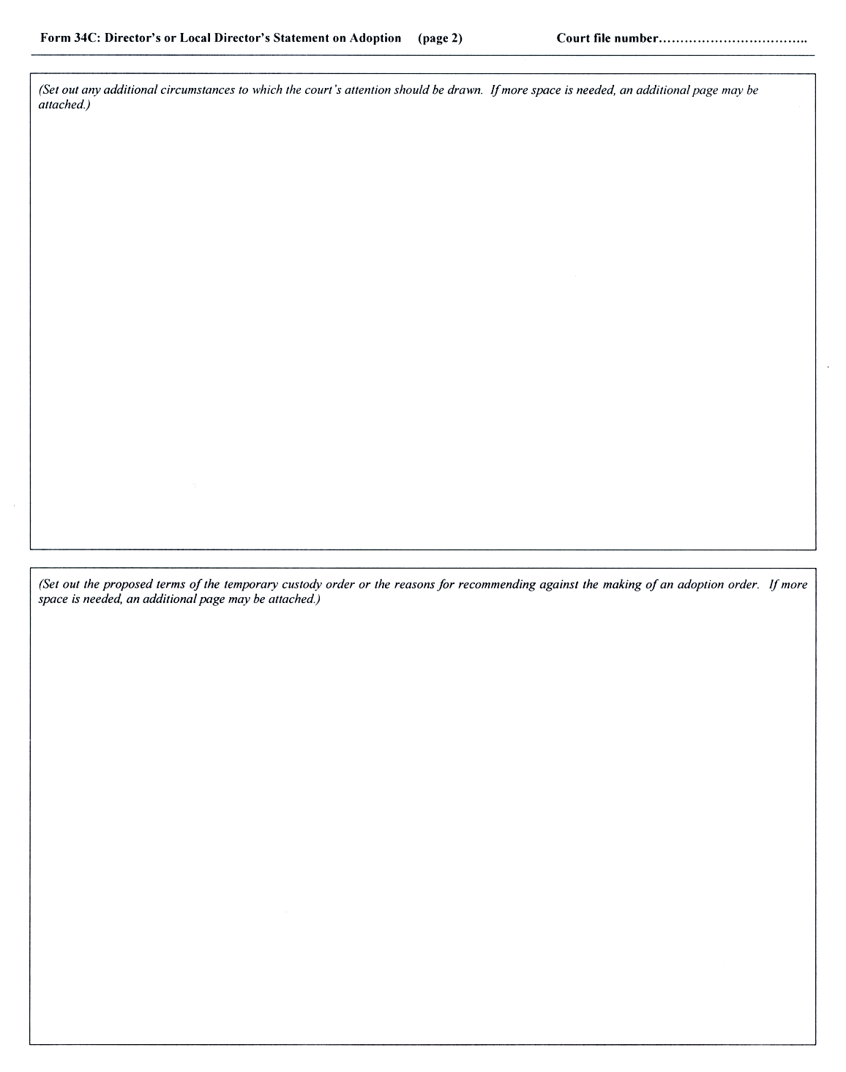
O. Reg. 337/02, s. 4 (3).
Form 34D
Courts of Justice Act
affidavit of adoption applicant(s)
Insert regs\graphics\1999\114\11434dae.tif
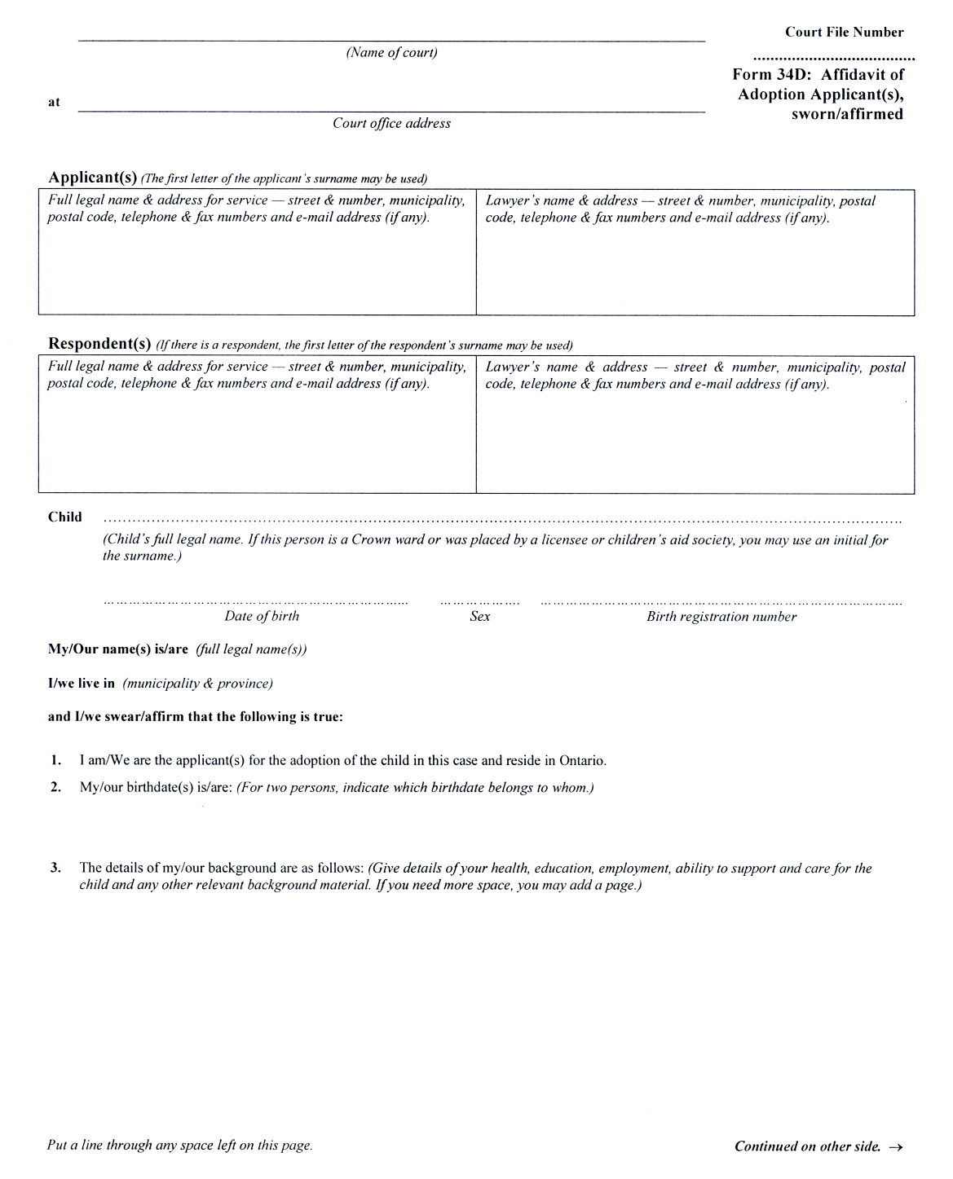
Insert regs\graphics\1999\114\11434dbe.tif

Insert regs\graphics\1999\114\11434dce.tif
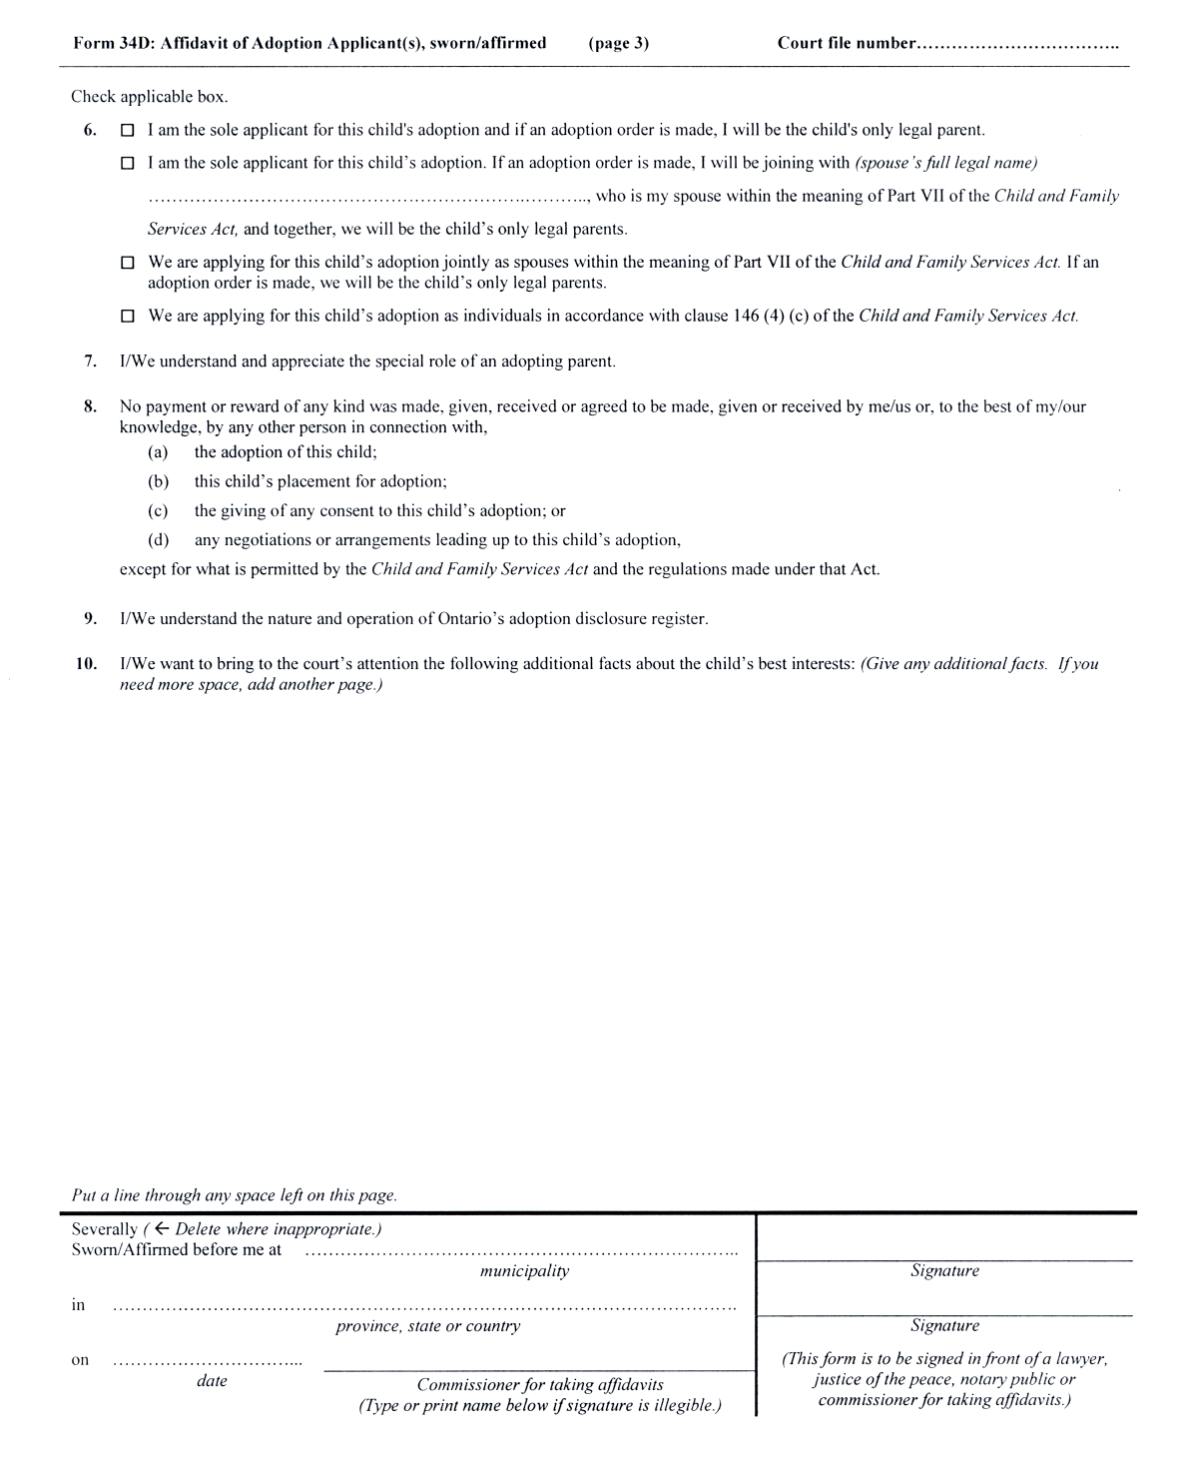
O. Reg. 337/02, s. 4 (3).
Form 34E
Courts of Justice Act
director’s consent to adoption
Insert regs\graphics\1999\114\114034ee.tif
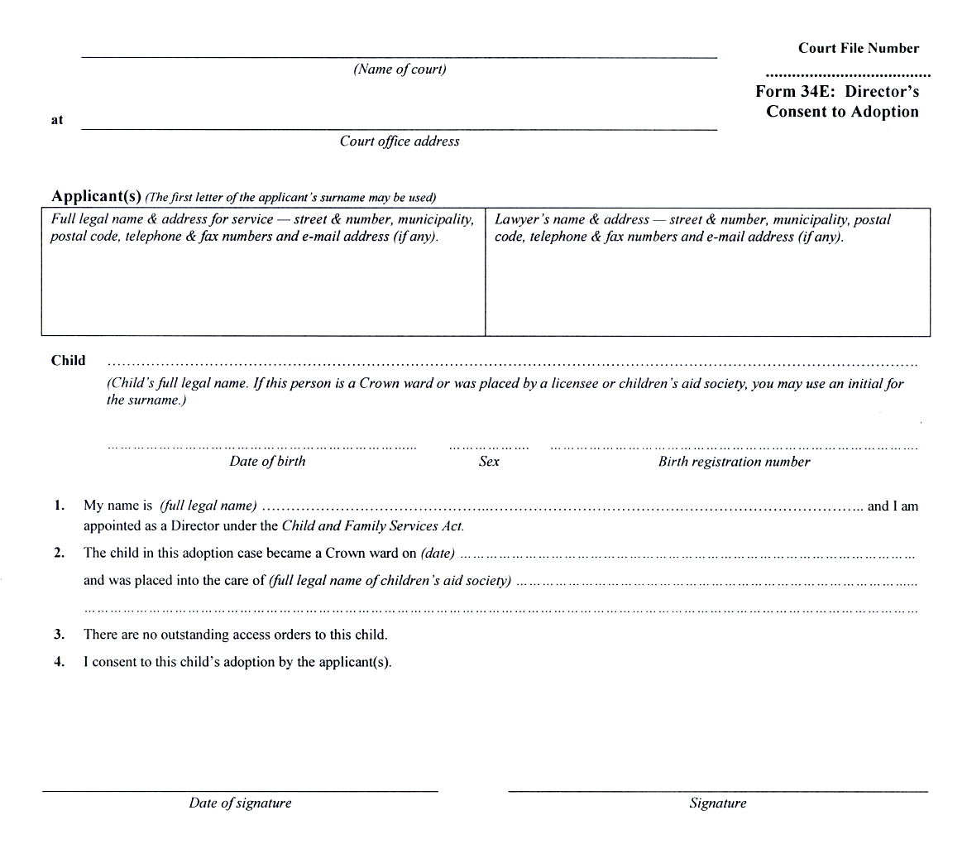
O. Reg. 337/02, s. 4 (3).
Form 34F
Courts of Justice Act
parent’s or custodian’s consent to adoption
Insert regs\graphics\1999\114\11434fae.tif
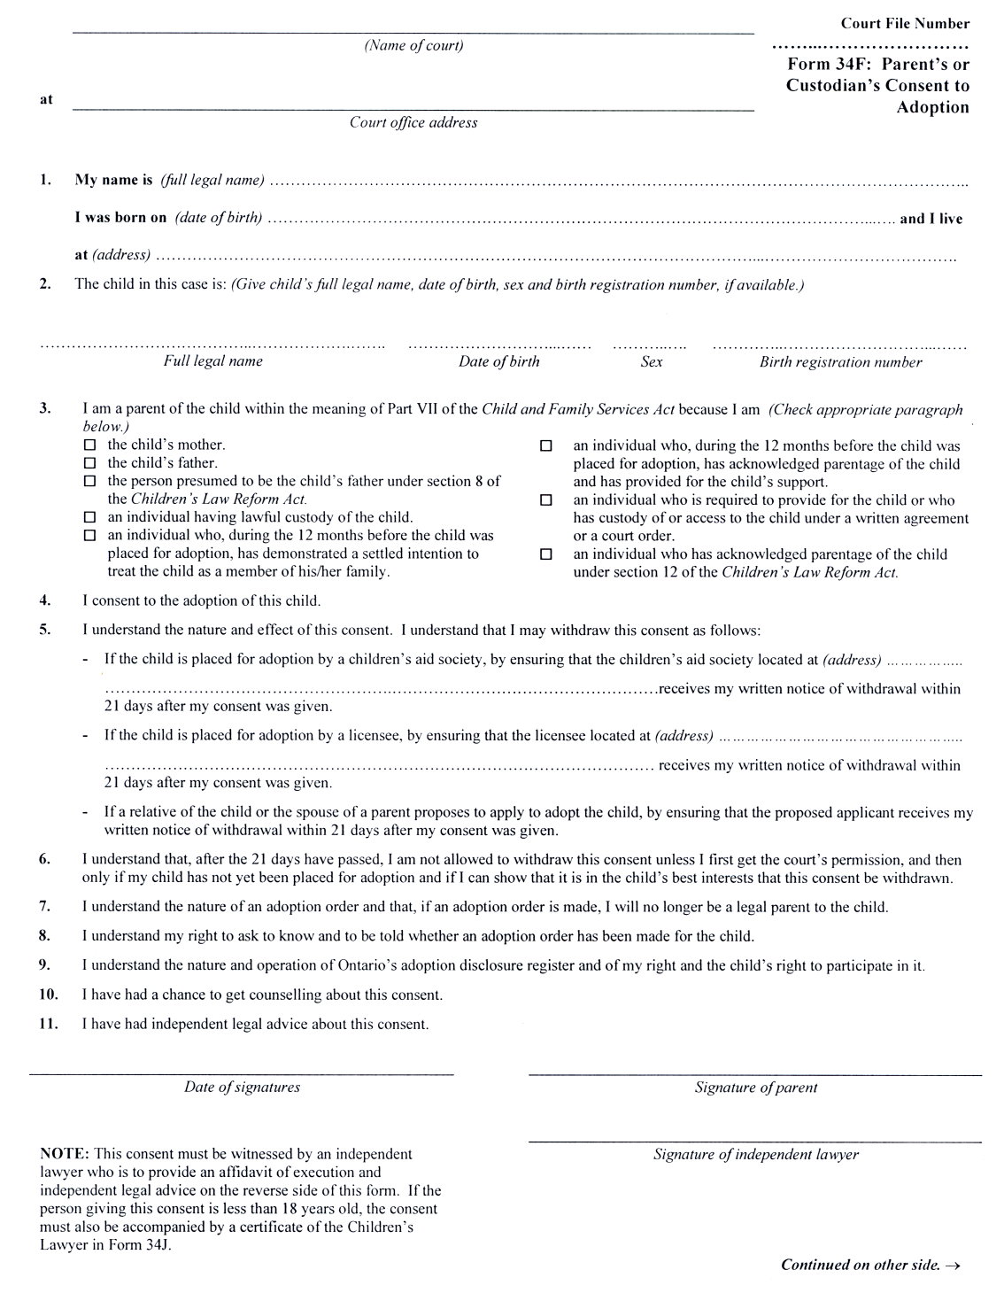
Insert regs\graphics\1999\114\11434fbe.tif
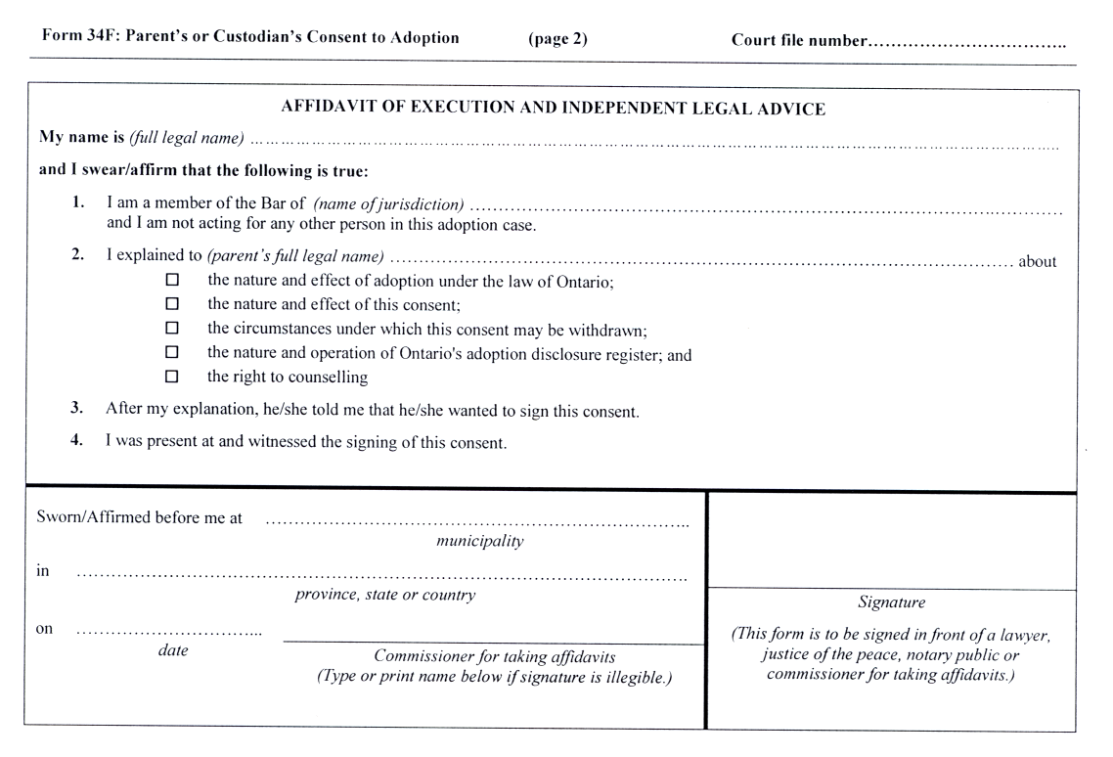
O. Reg. 337/02, s. 4 (3).
Form 34G
Courts of Justice Act
affidavit of adoption licensee or society employee
Insert regs\graphics\1999\114\11434gae.tif
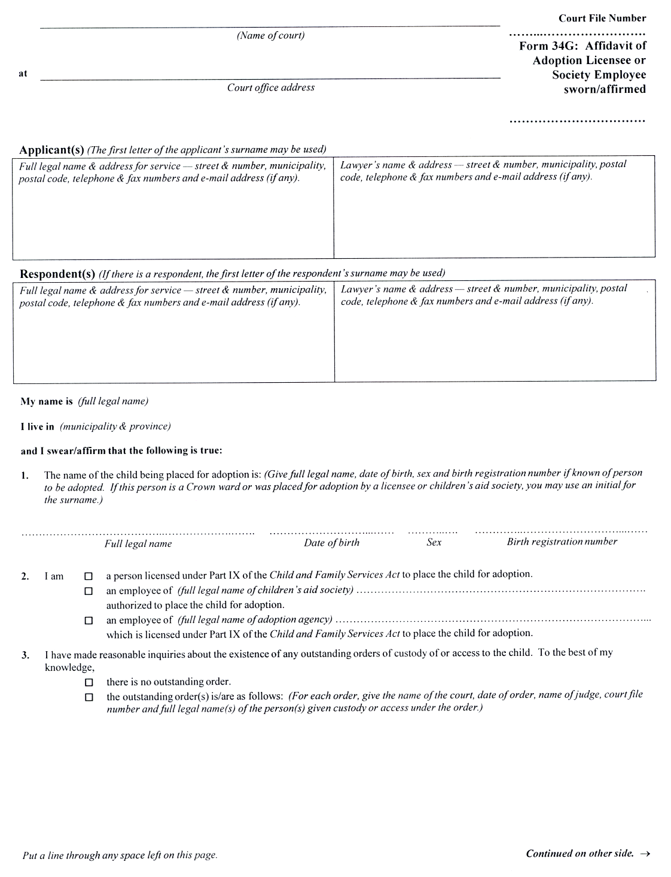
Insert regs\graphics\1999\114\11434gbe.tif
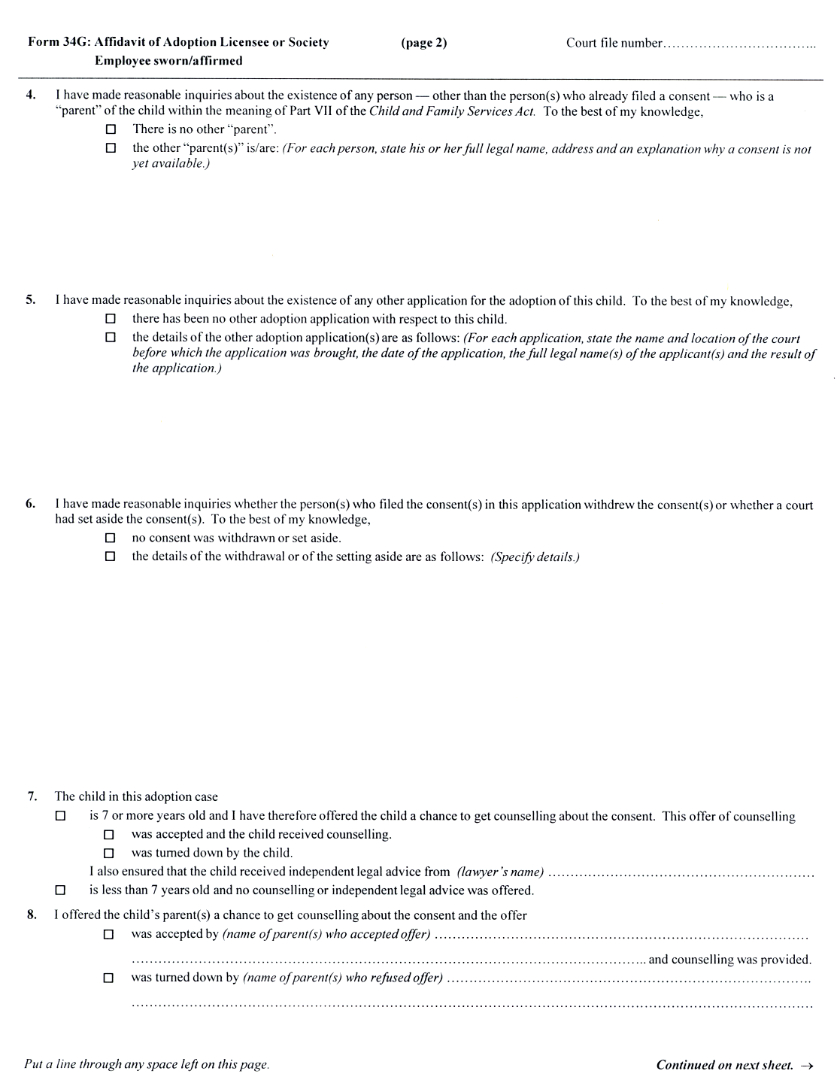
Insert regs\graphics\1999\114\11434gce.tif
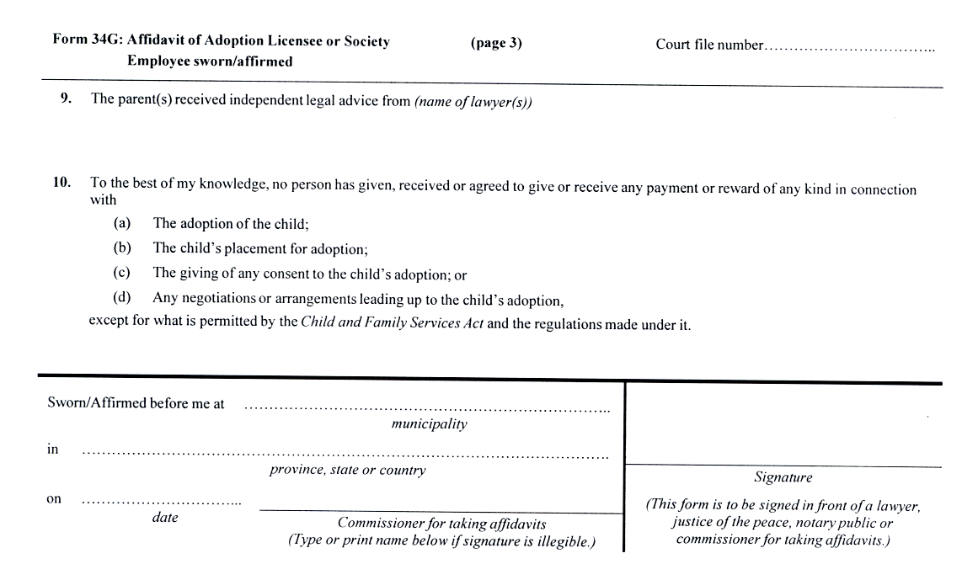
O. Reg. 337/02, s. 4 (3).
Form 34H
Courts of Justice Act
affidavit of adopting relative or stepparent
Insert regs\graphics\1999\114\11434hae.tif
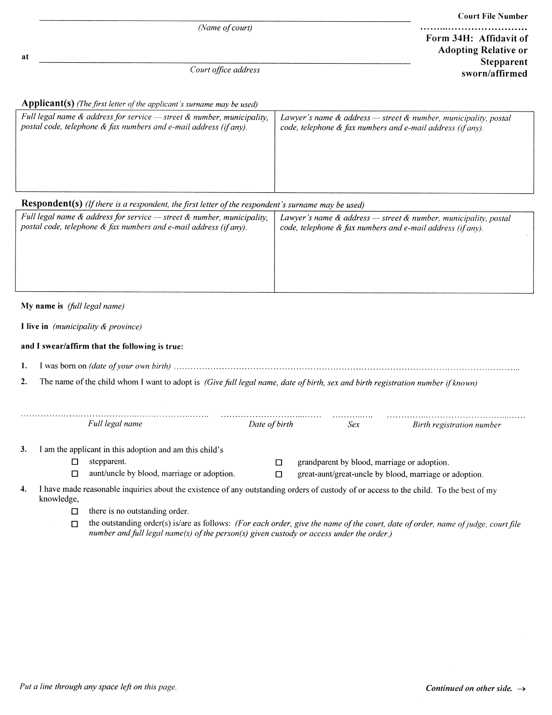
Insert regs\graphics\1999\114\11434hbe.tif
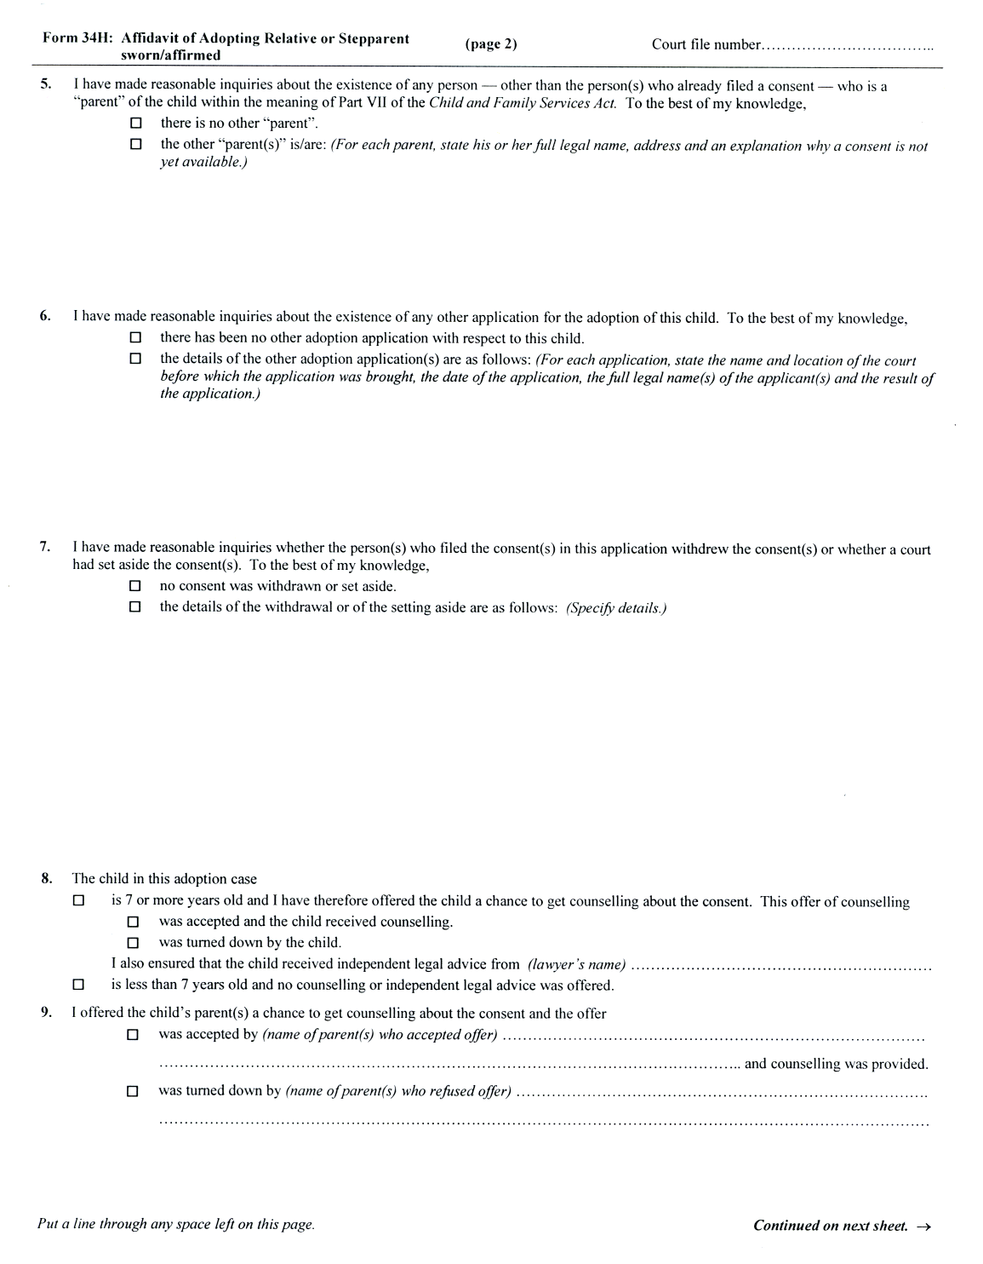
Insert regs\graphics\1999\114\11434hce.tif
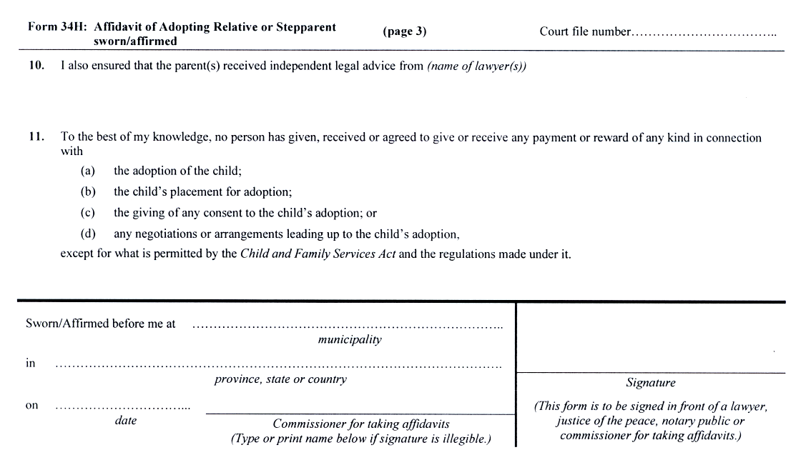
O. Reg. 337/02, s. 4 (3).
Form 34I
Courts of Justice Act
parent’s consent to adoption by spouse
Insert regs\graphics\1999\114\11434iae.tif
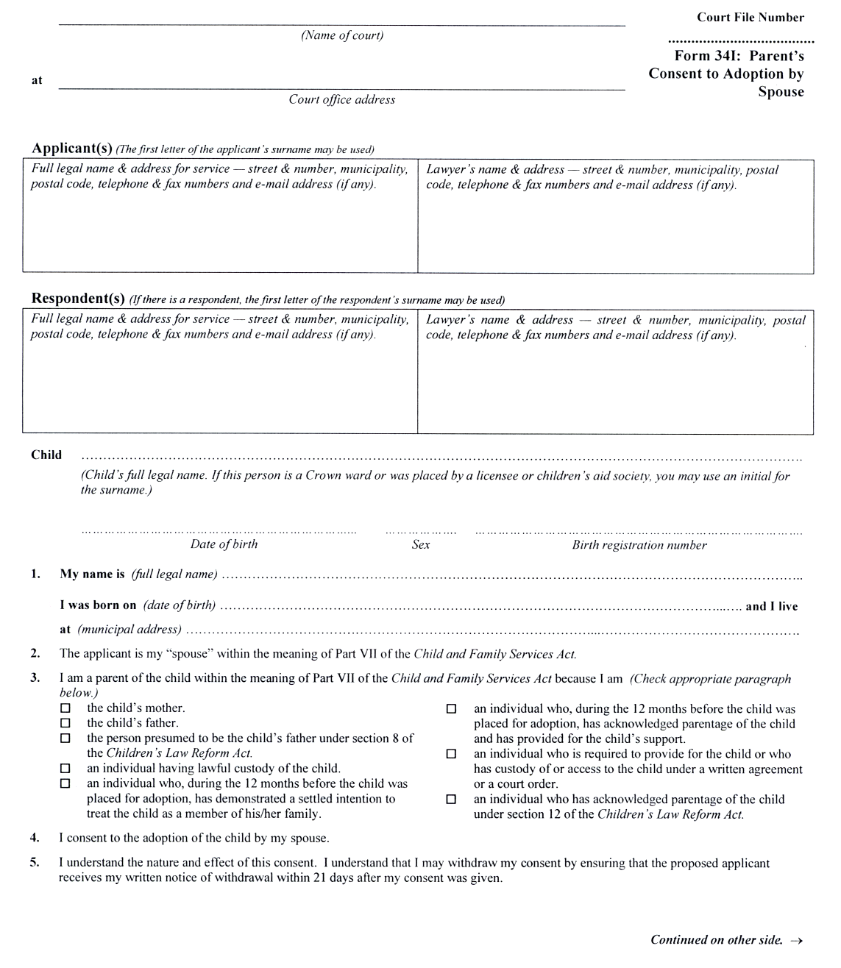
Insert regs\graphics\1999\114\11434ibe.tif
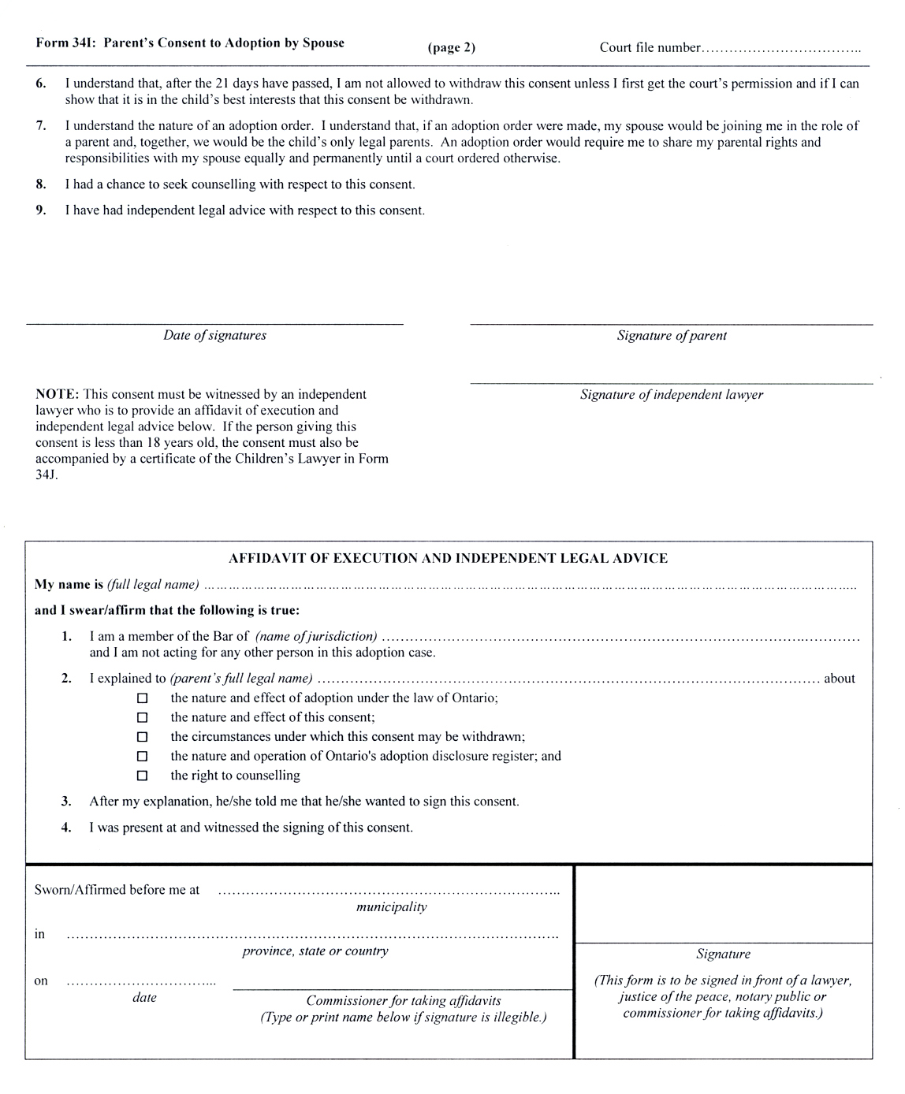
O. Reg. 337/02, s. 4 (3).
Form 34J
Courts of Justice Act
affidavit of execution and independent legal advice (children’s lawyer)
Insert regs\graphics\1999\114\114034je.tif
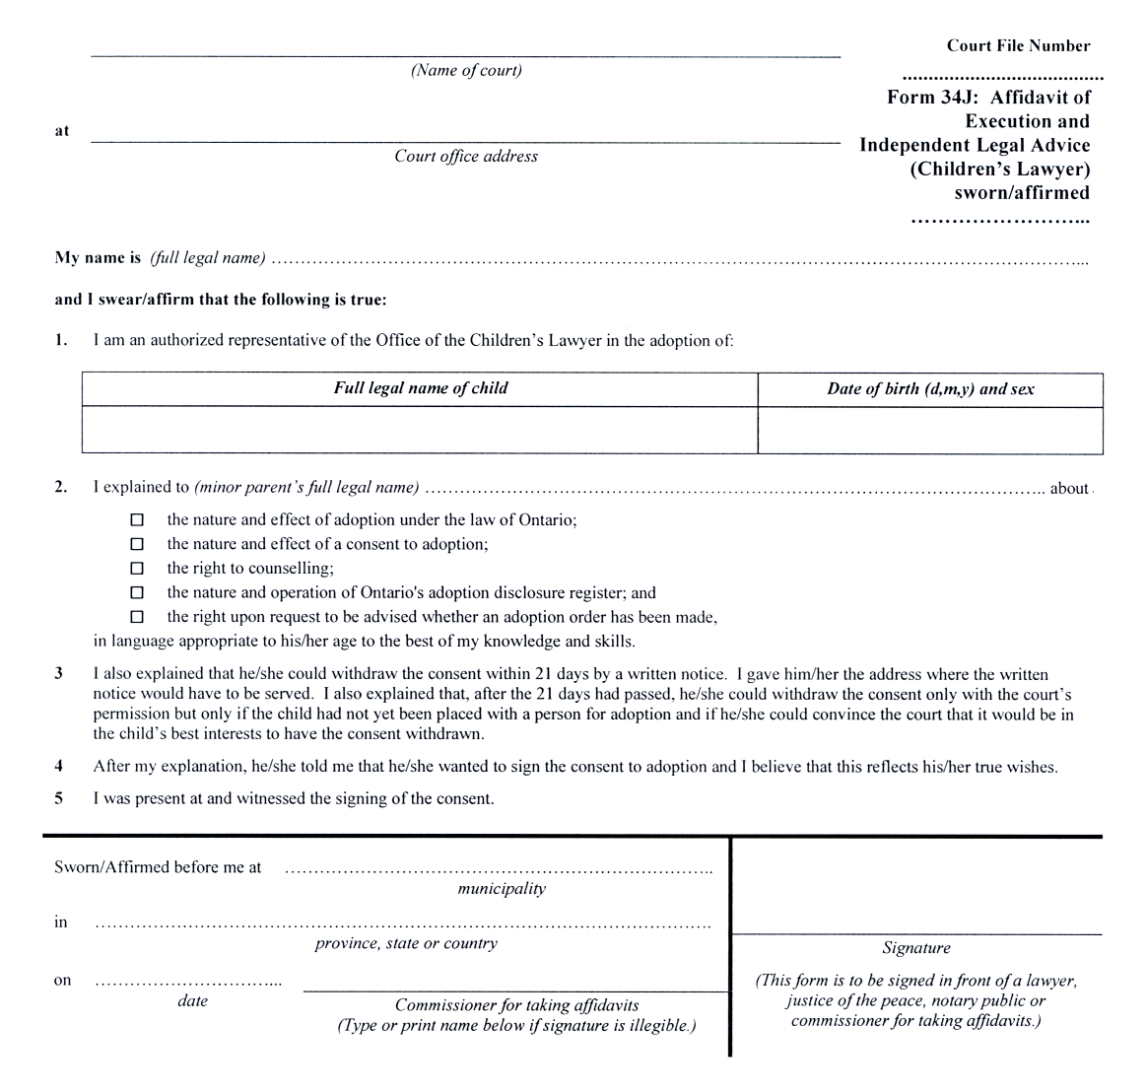
O. Reg. 337/02, s. 4 (3).
Form 34K
Courts of Justice Act
certificate of clerk (adoption)
Insert regs\graphics\1999\114\11434kae.tif
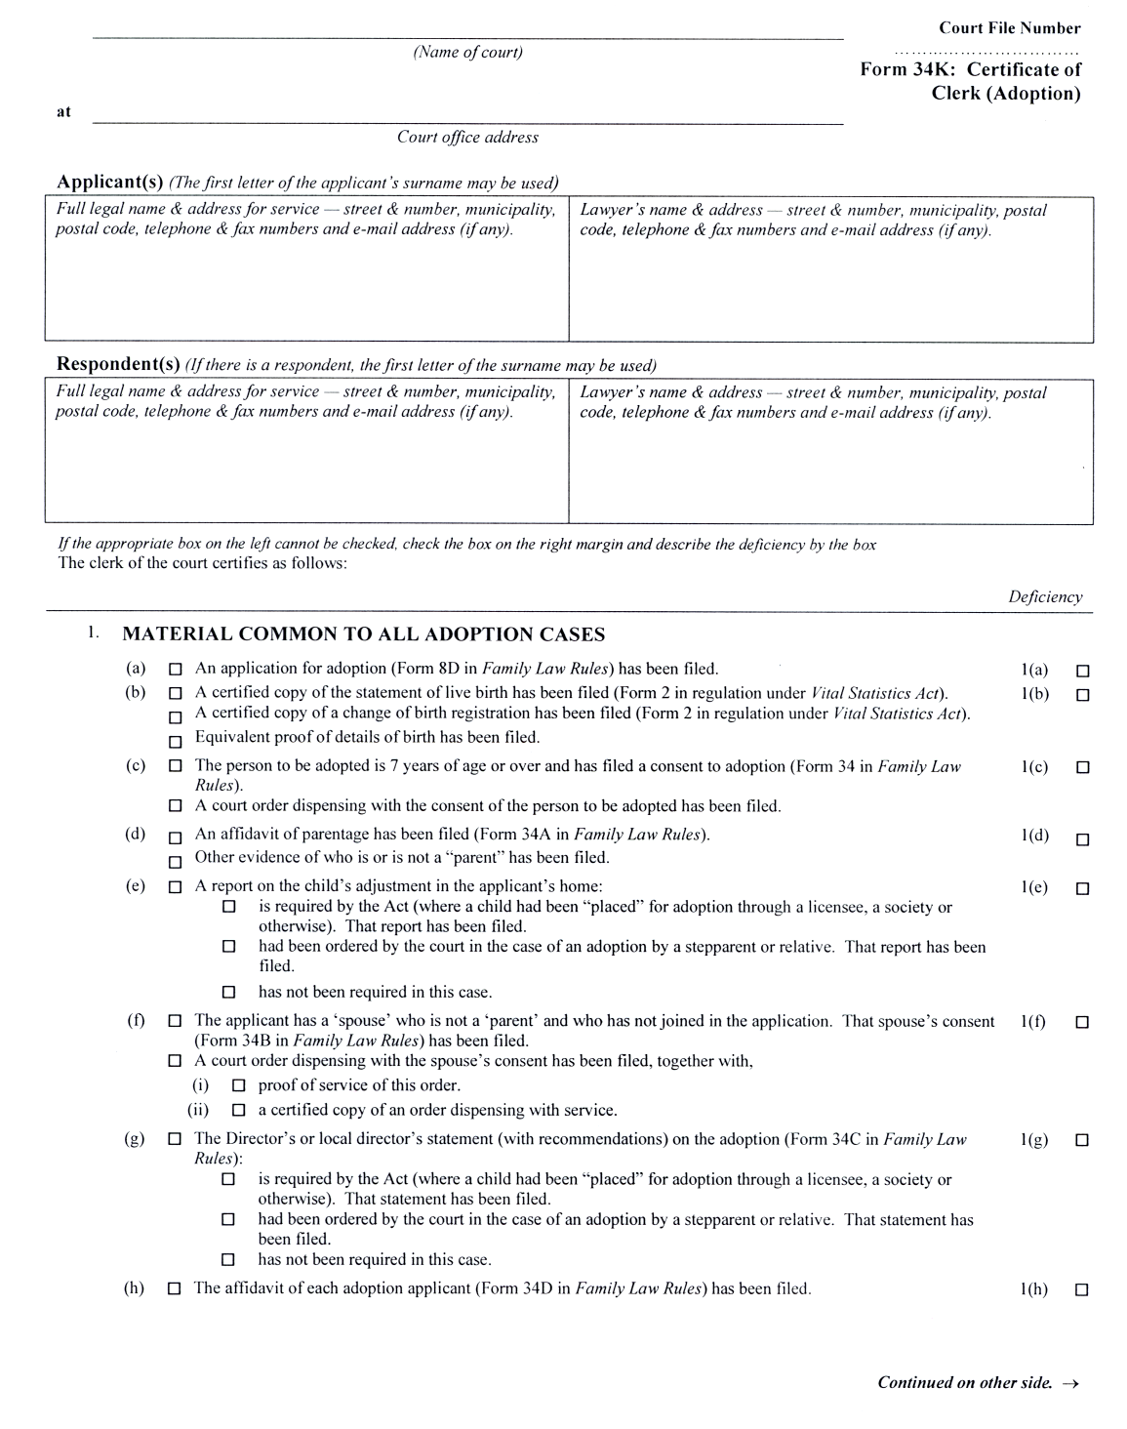
Insert regs\graphics\1999\114\11434kbe.tif
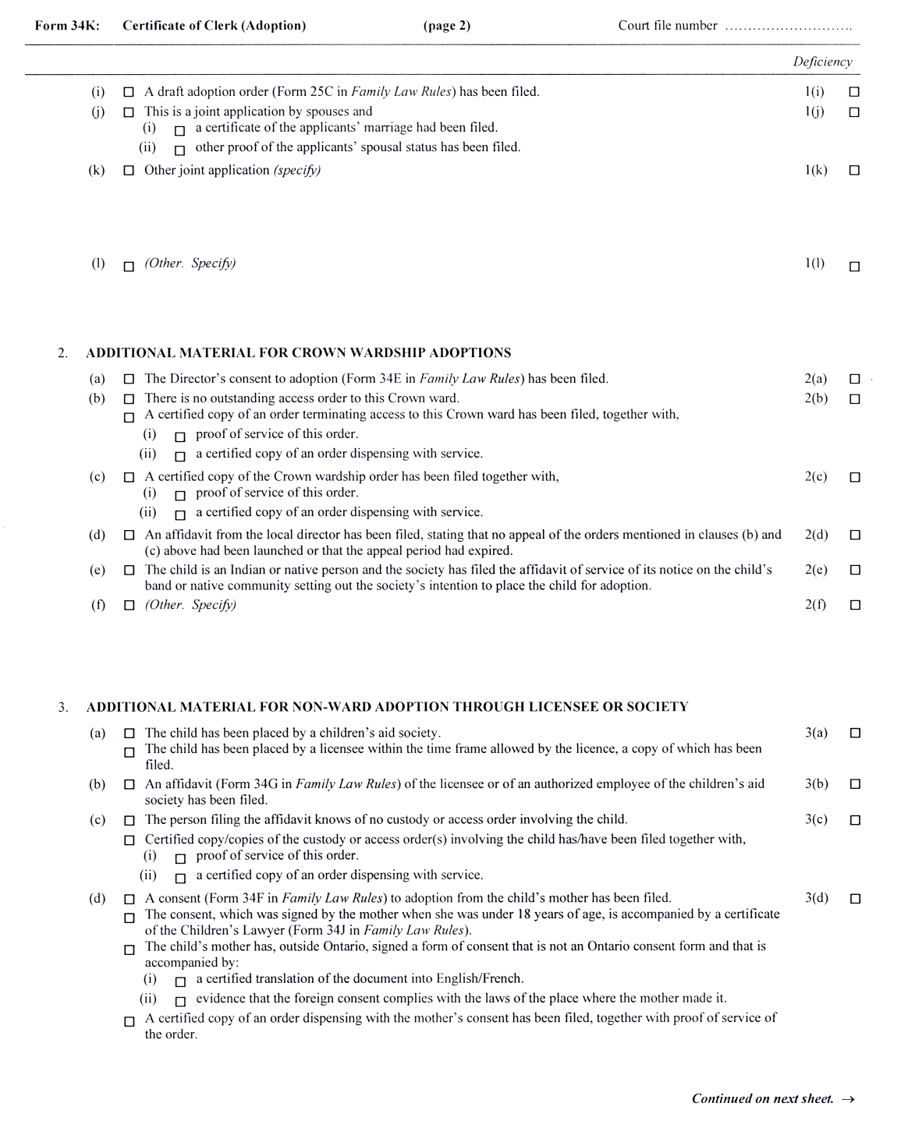
Insert regs\graphics\1999\114\11434kce.tif
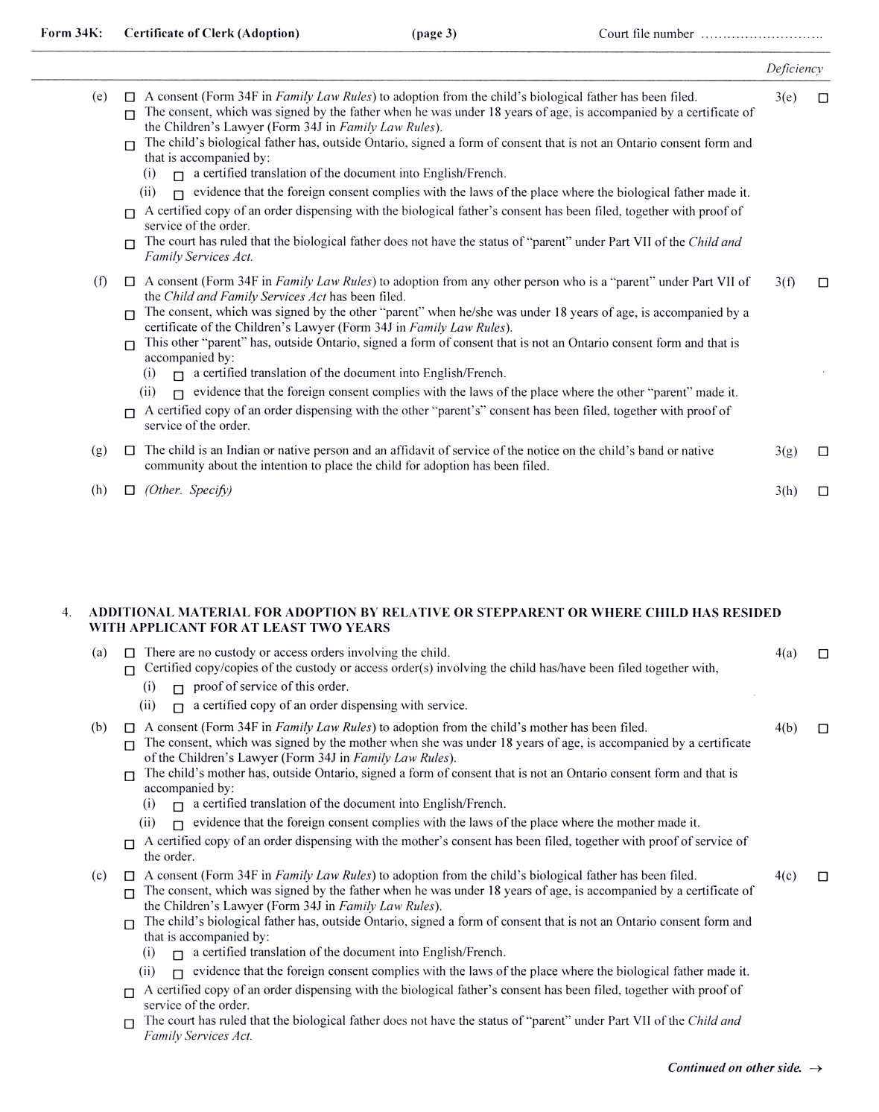
Insert regs\graphics\1999\114\11434kde.tif
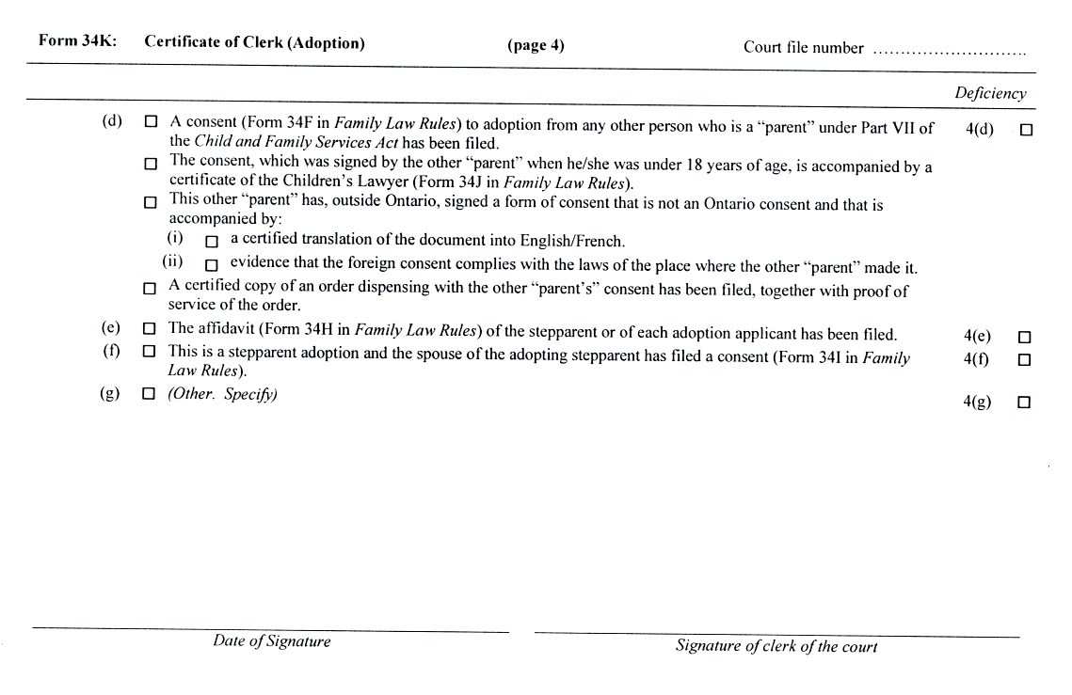
O. Reg. 337/02, s. 4 (3).
Form 36
Courts of Justice Act
affidavit for divorce
Insert regs\graphics\1999\114\114036ae.tif
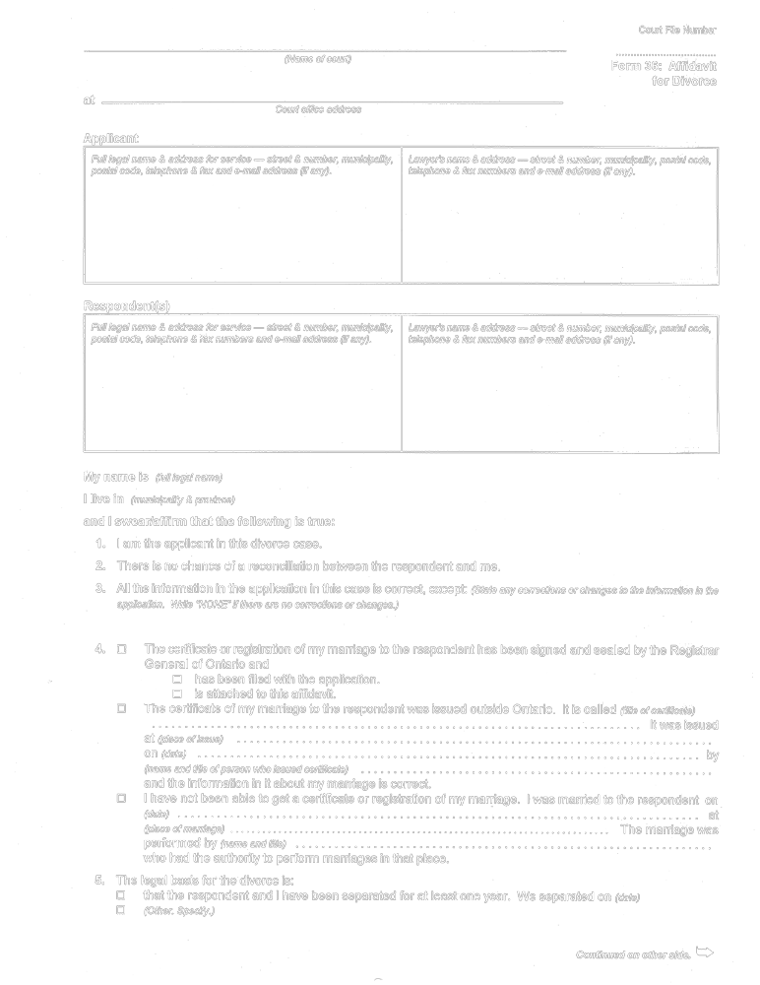
Insert regs\graphics\1999\114\114036be.tif
Insert regs\graphics\1999\114\114036ce.tif
Insert regs\graphics\1999\114\114036de.tif
O. Reg. 114/99, Form 36.
Form 36A
Courts of Justice Act
certificate of clerk (divorce)
Insert regs\graphics\1999\114\11436aae.tif
Insert regs\graphics\1999\114\11436abe.tif
O. Reg. 114/99, Form 36A.
Form 36B
Courts of Justice Act
certificate of divorce
Insert regs\graphics\1999\114\11436Bae.tif
O. Reg. 114/99, Form 36B.
Form 37
Courts of Justice Act
Notice of Hearing
Insert regs\graphics\1999\114\114037ae.tif
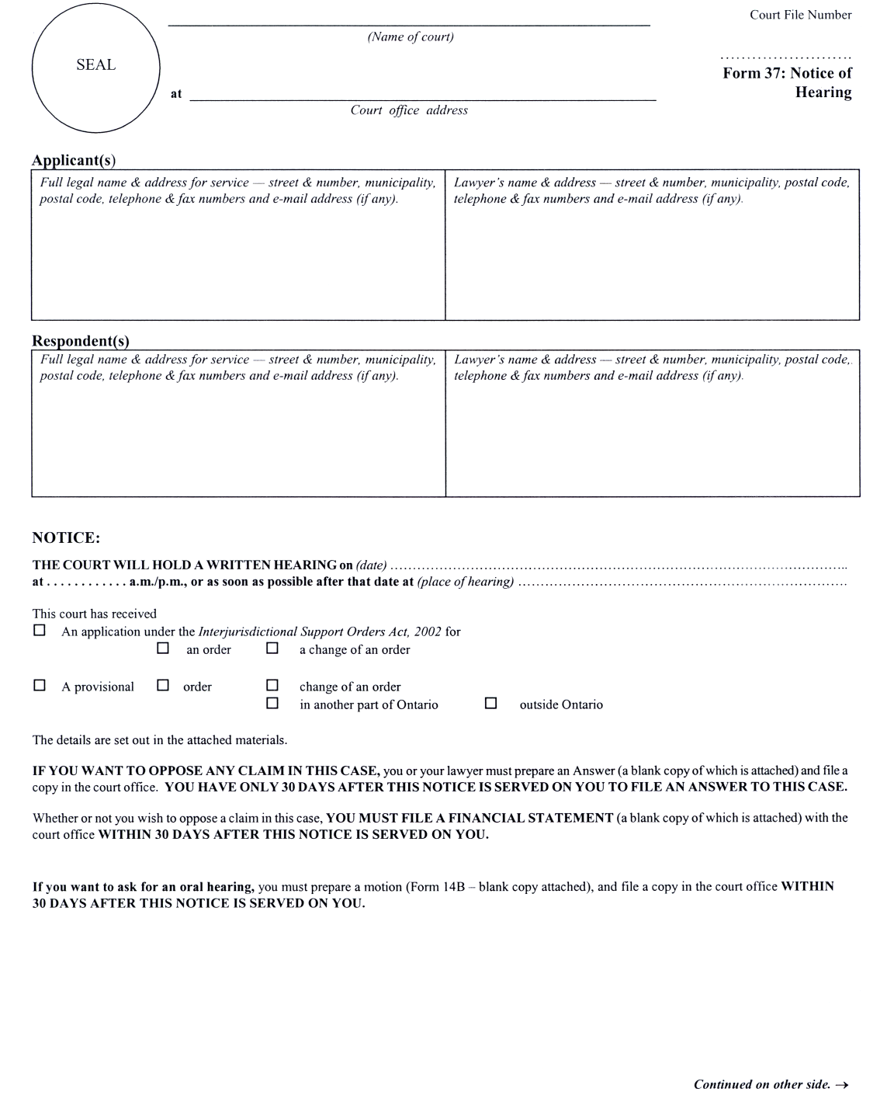
Insert regs\graphics\1999\114\114037be.tif
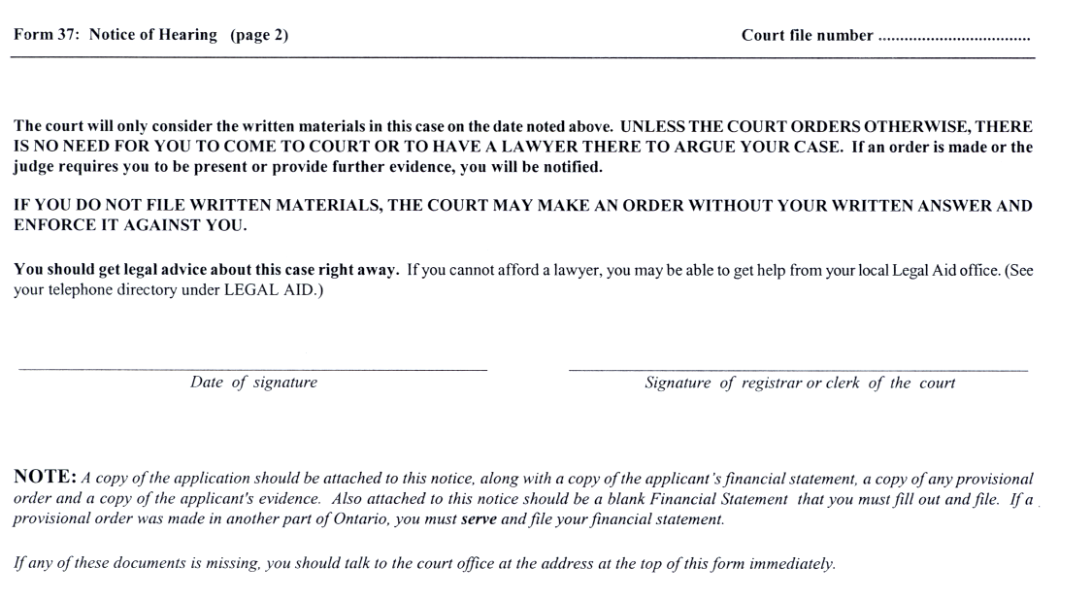
O. Reg. 56/03, s. 10.
Form 37A
Courts of Justice Act
Information sheet
Insert regs\graphics\1999\114\11437Aae.tif
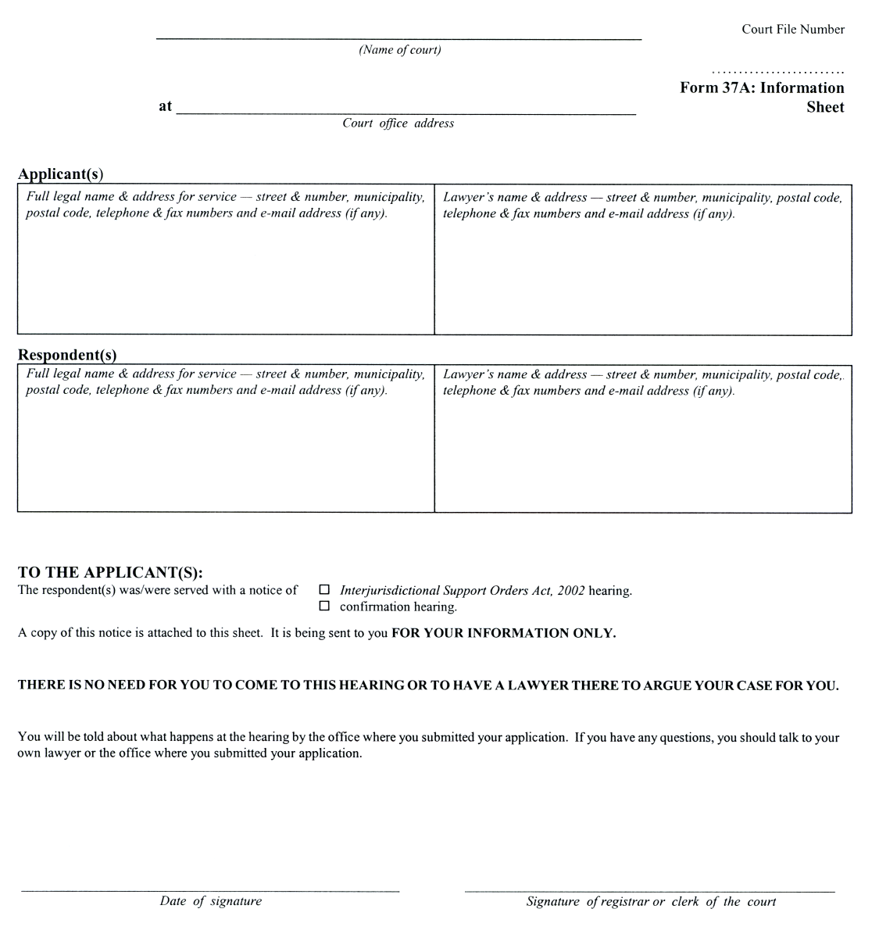
O. Reg. 56/03, s. 10.
Form 37B
Courts of Justice Act
Direction to request further information
Insert regs\graphics\1999\114\11437Bae.tif
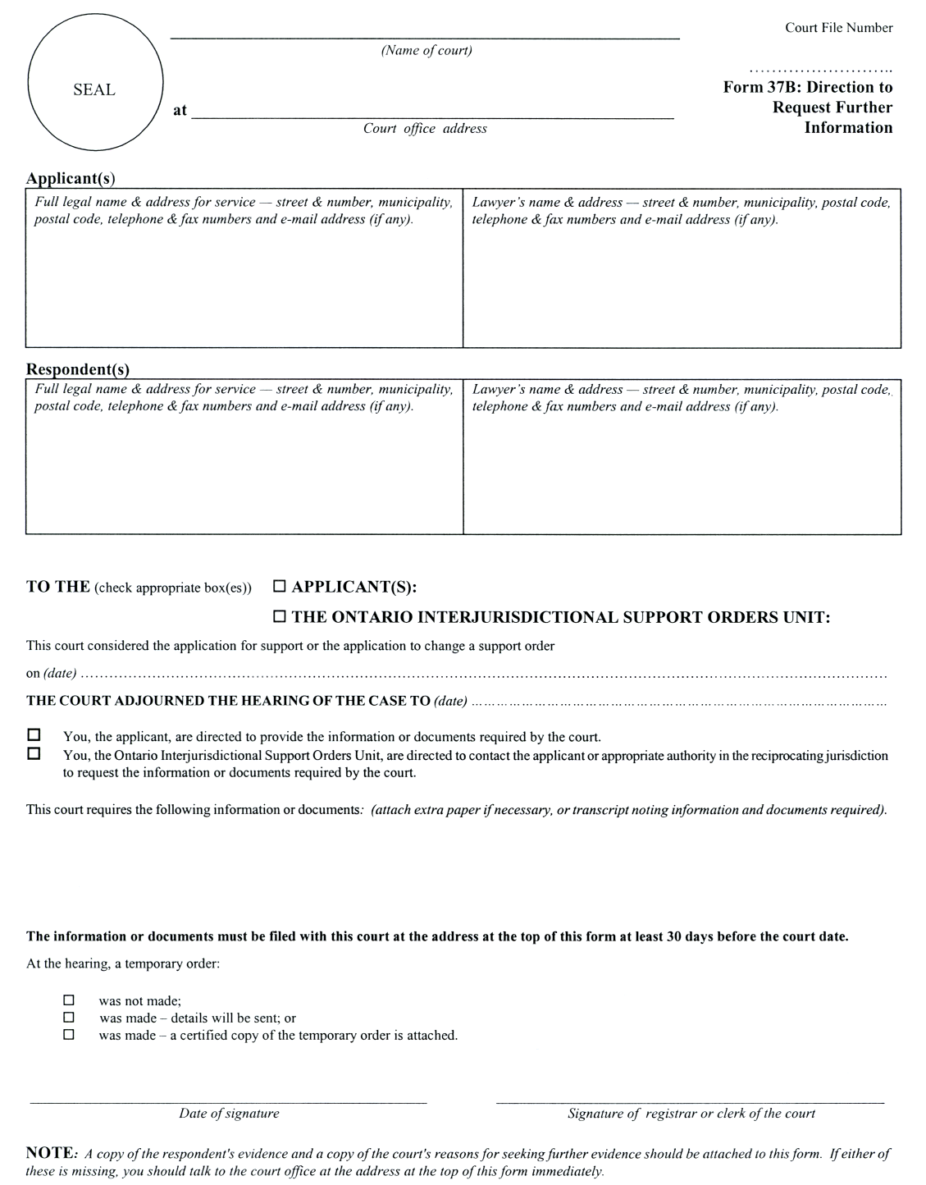
O. Reg. 56/03, s. 10.
Form 37C
Courts of Justice Act
notice of continuation of hearing
Insert regs\graphics\1999\114\11437Cae.tif
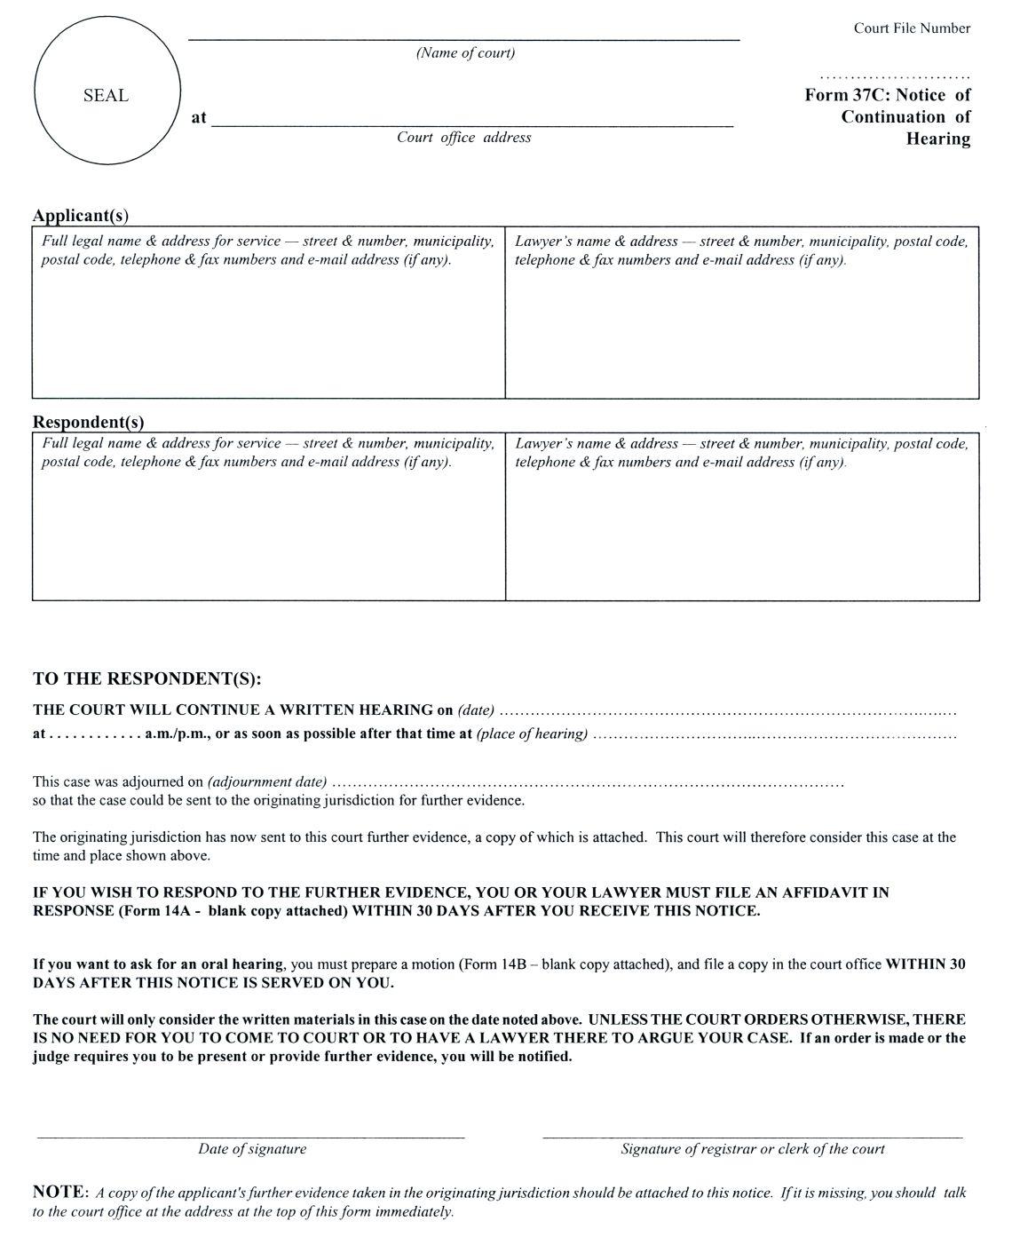
O. Reg. 56/03, s. 10.
Form 37D
Courts of Justice Act
notice of registration of order
Insert regs\graphics\1999\114\11437Dae.tif
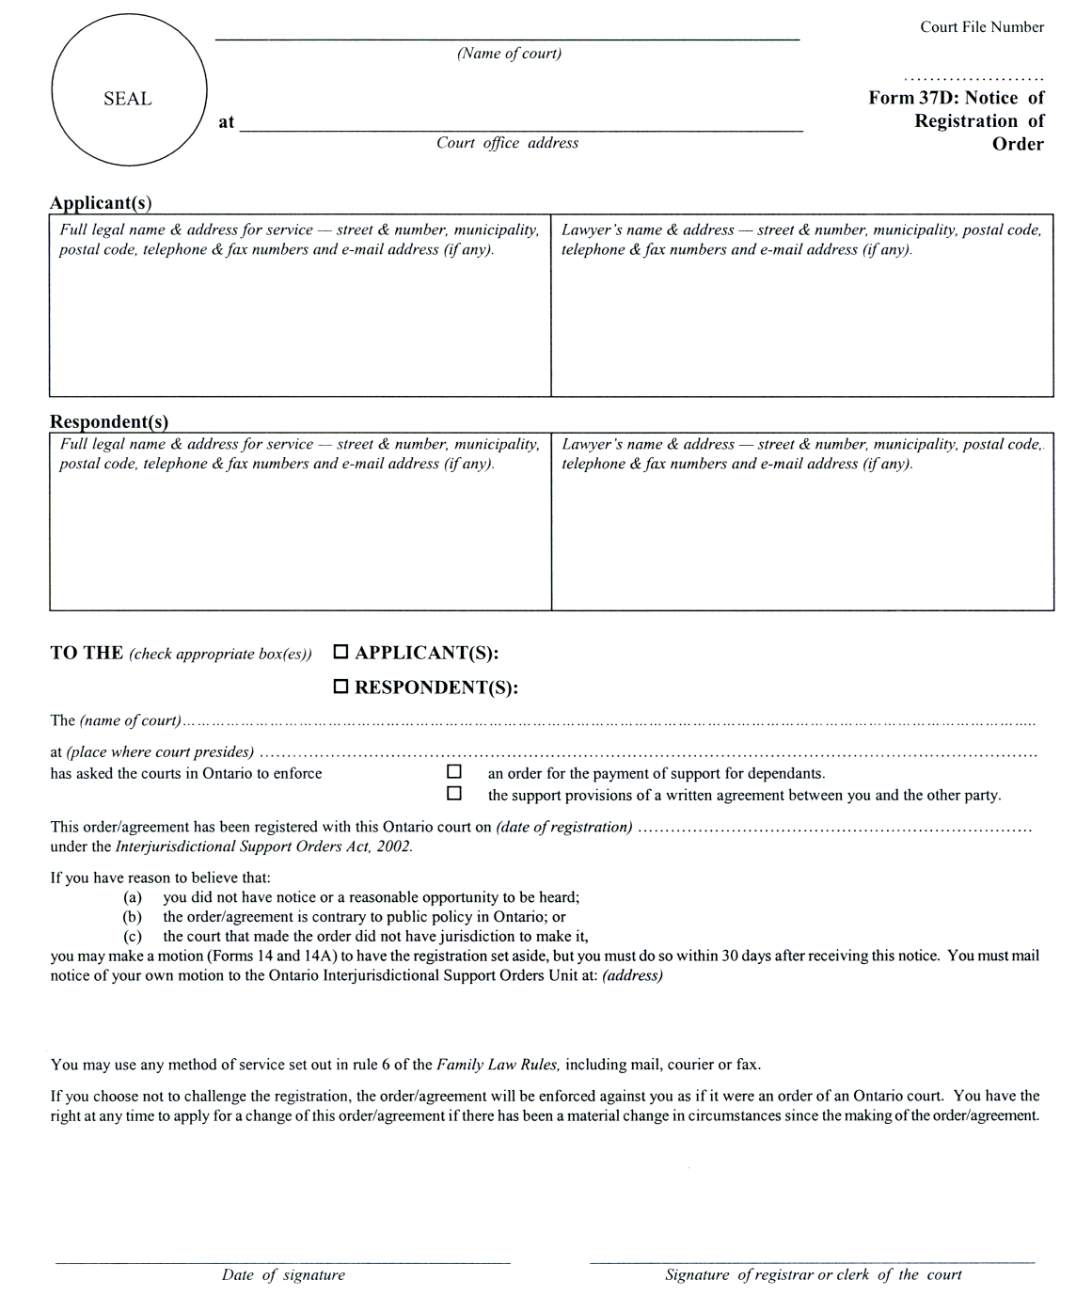
O. Reg. 56/03, s. 10.
Form 37E
Courts of Justice Act
notice for taking further evidence
Insert regs\graphics\1999\114\11437Eae.tif
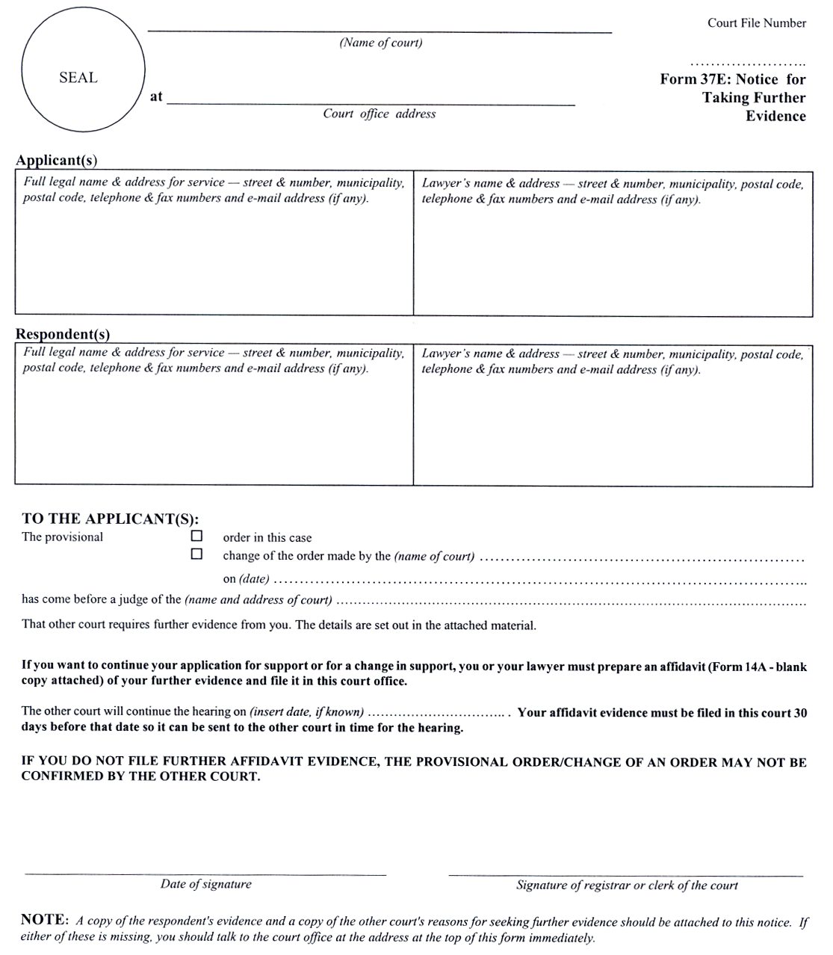
O. Reg. 56/03, s. 10.
Form 38
Courts of Justice Act
notice of appeal
Court File Number

……...……………………
Form 38:
Notice of Appeal
(Name of court) |  | Court File Number  ……...……………………  Form 38:  Notice of Appeal
at |  | Court File Number  ……...……………………  Form 38:  Notice of Appeal
 | Court office address | Court File Number  ……...……………………  Form 38:  Notice of Appeal

Applicant(s) Check the appropriate box: ◻ Appellant ◻ Respondent in this appeal
Full legal name & address for service — street & number, municipality, postal code, telephone & fax numbers and e-mail address (if any). | Lawyer’s name & address — street & number, municipality, postal code, telephone & fax numbers and e-mail address (if any).

Respondent(s) Check the appropriate box: ◻ Appellant ◻ Respondent in this appeal
Full legal name & address for service — street & number, municipality,  postal code, telephone & fax numbers and e-mail address (if any). | Lawyer’s name & address — street & number, municipality, postal code, telephone & fax numbers and e-mail address (if any).

Name & address of Children’s Lawyer’s agent (street & number, municipality, postal code, telephone & fax numbers and e-mail address (if any)) and name of person represented.

My name is (name of party making this appeal)
I APPEAL TO THE (name of court)
at (municipality)
from the following order or decision:
Date of order:
Name of court that made it:
Name of judge who made it:
Place where it was made:
It was: ◻ a final order. ◻ a temporary order.

I ask that this order be set aside and that an order be made as follows: (Set out briefly the order that you want the appeal court to make.)

Continued on other side. →
Form 38: Notice of Appeal (page 2) Court file number ………………….
The legal grounds for my appeal are: (Set out in numbered paragraphs the legal basis of your appeal.)

Draw a line through any space left on this page.
NOTE TO THE APPELLANT: You have 30 days to serve this notice on the other parties in the case and you must file it with the clerk of the appeal court with proof of service (Form 6B) within 10 days after that.
NOTE TO THE RESPONDENT: If you want to oppose this appeal, you or your lawyer must prepare a respondent’s factum required by subrule 38(9) of the Family Law Rules, serve a copy on the appellant(s) and file a copy with the clerk of the appeal court with proof of service (Form 6B). You must serve and file a respondent’s factum at least 3 days before the hearing of the appeal. If you do not, the appeal will go ahead without you and the court may make a new order and enforce it against you.
Date of signature |  | Signature

O. Reg. 202/01, s. 11.
form 39
Courts of Justice Act
notice of approaching dismissal
Insert regs\Graphics\Source Law\2004\89\890039ae.tif
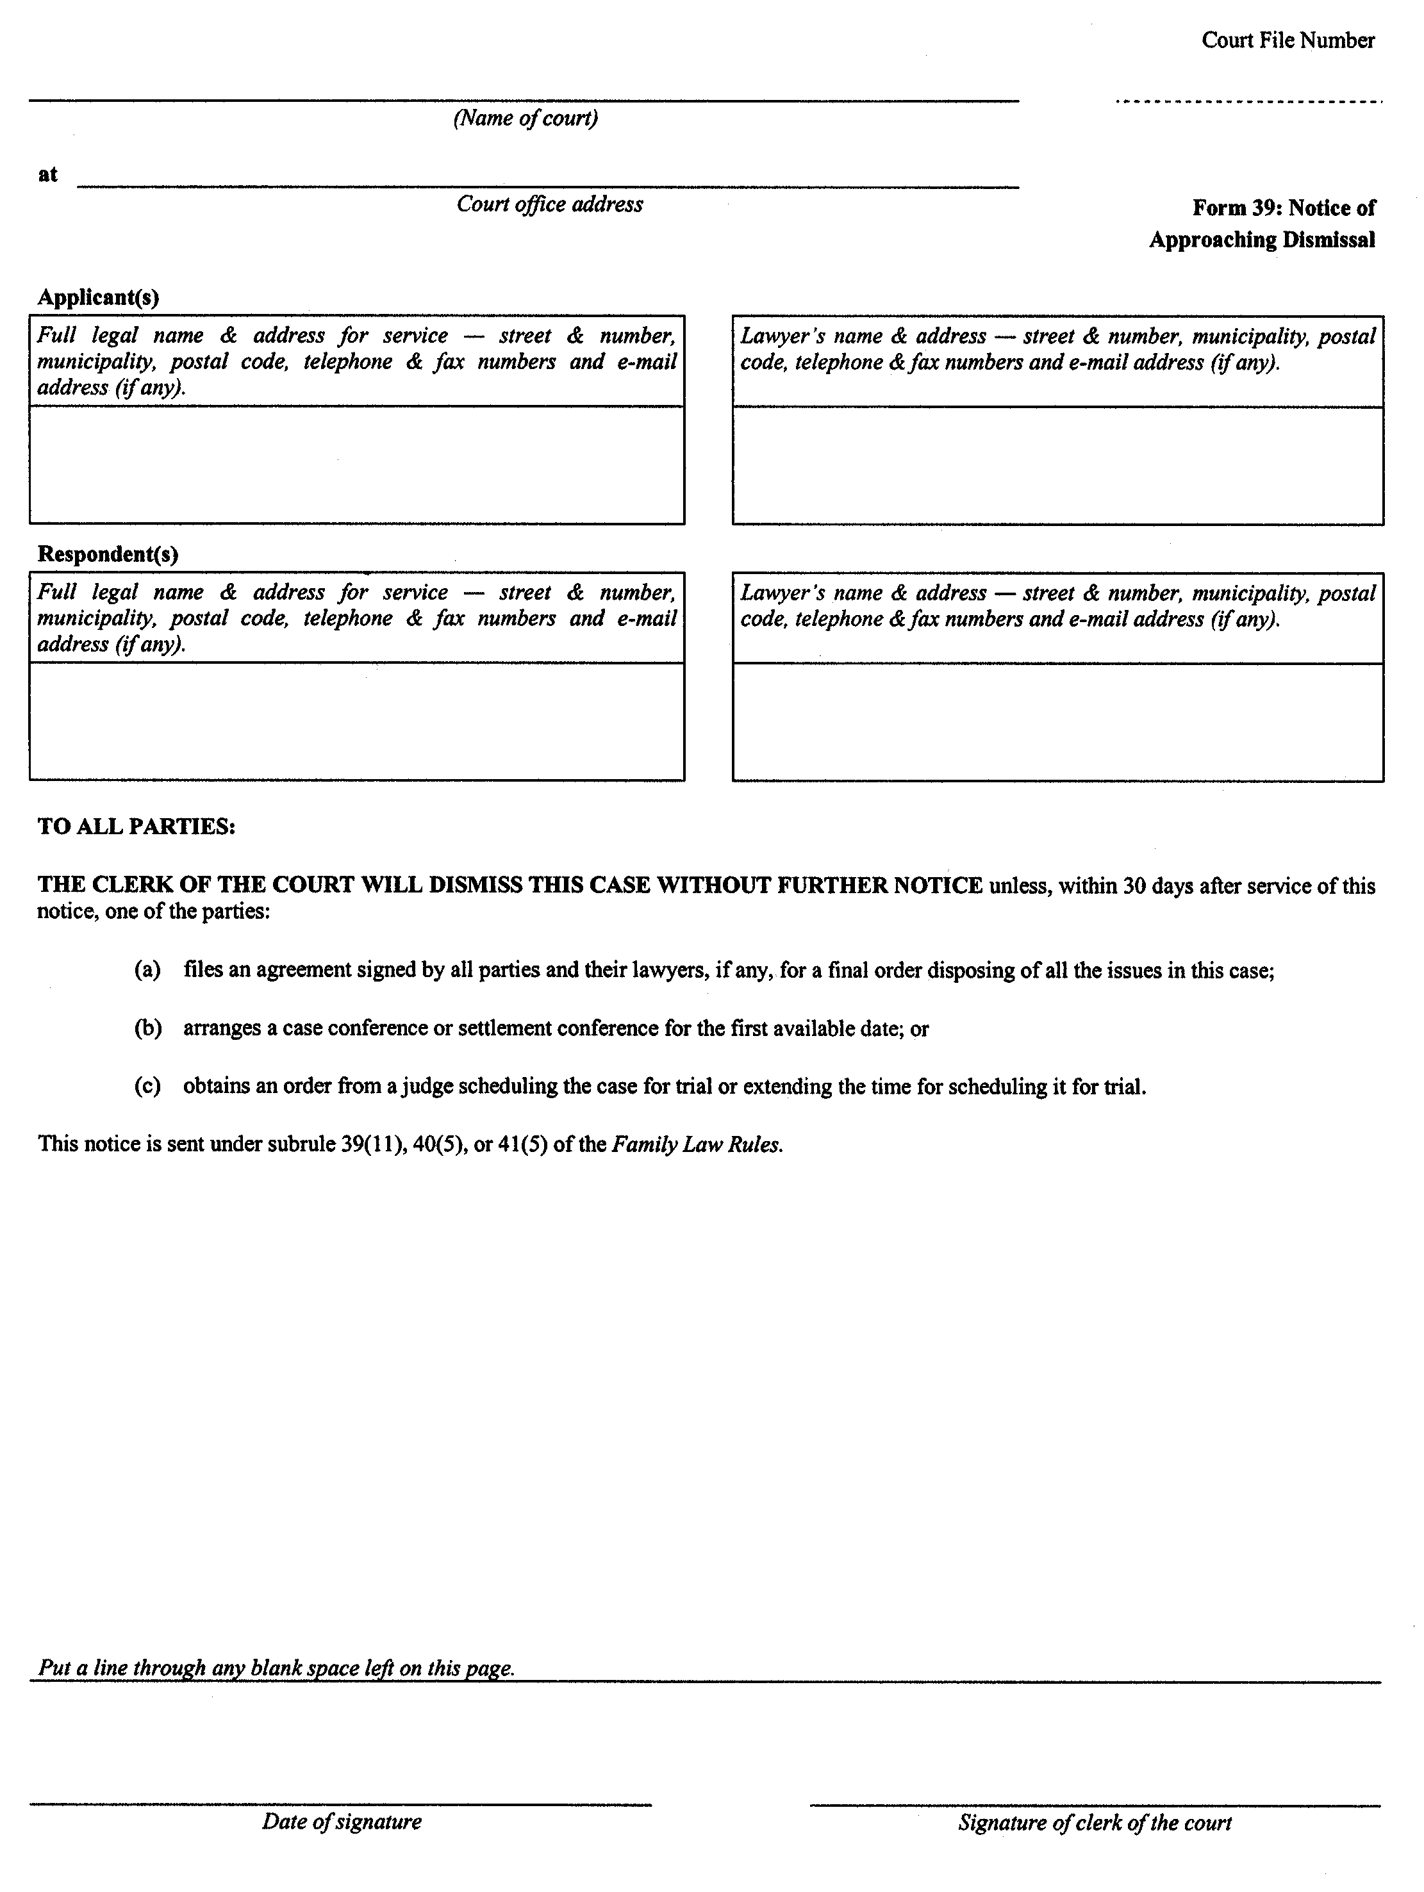
O. Reg. 89/04, s. 17.

