ONTARIO REGULATION 45/00
made under the
Child and Family Services Act
Made: February 2, 2000
Filed: February 4, 2000
Amending Reg. 70 of R.R.O. 1990
(General)
Note: Since the end of 1998, Regulation 70 has been amended by Ontario Regulation 199/99. Previous amendments are listed in the Table of Regulations in the Statutes of Ontario, 1998.
1. (1) Part III of Regulation 70 of the Revised Regulations of Ontario, 1990 is amended by adding the following section:
36.1 (1) A warrant for access to a record or a specified part of a record under section 74.1 of the Act shall be in Form 42.
(2) An information in support of a warrant for access to a record or a specified part of a record under section 74.1 of the Act shall be in Form 43.
(2) Part III of the Regulation is amended by adding the following sections:
36.2 (1) A warrant for access to a record or a specified part of a record under section 74.2 of the Act shall be in Form 44.
(2) An information in support of a warrant for access to a record or a specified part of a record under section 74.2 of the Act shall be in Form 45.
36.3 (1) To apply for a warrant under section 74.2 of the Act, a Director or a person designated by a society may, instead of submitting to the justice an information on oath, submit to the justice by facsimile transmission an information that is not on oath but that includes a written statement, signed by the Director or the person designated by the society, stating that all matters contained in the information are true to his or her knowledge and belief.
(2) A written statement described in subsection (1) shall be deemed to be a statement made under oath.
(3) A justice who receives by facsimile transmission an information described in subsection (1) shall, as soon as practicable, cause the information, certified by the justice as to the place, time and date of its receipt, to be filed with the clerk of the court having jurisdiction in the area where the warrant is to be executed.
(4) A justice who issues a warrant under subsection 74.2 (3) of the Act on the basis of an information submitted by facsimile transmission under subsection (1) shall,
(a) complete and sign the warrant, noting on its face the date on which, and the time and place at which, it was issued;
(b) send the warrant by facsimile transmission to the Director or person designated by a society who submitted the information; and
(c) as soon as practicable after the warrant is issued, cause it to be filed with the clerk of the court having jurisdiction in the area where the warrant is to be executed.
2. The Regulation is amended by adding the following Forms:
Form 42
Child and Family Services Act
Warrant for Access to Record(s)
(Section 74.1 of the Act)
Insert regs\graphics\1990\70\070042ae.tif
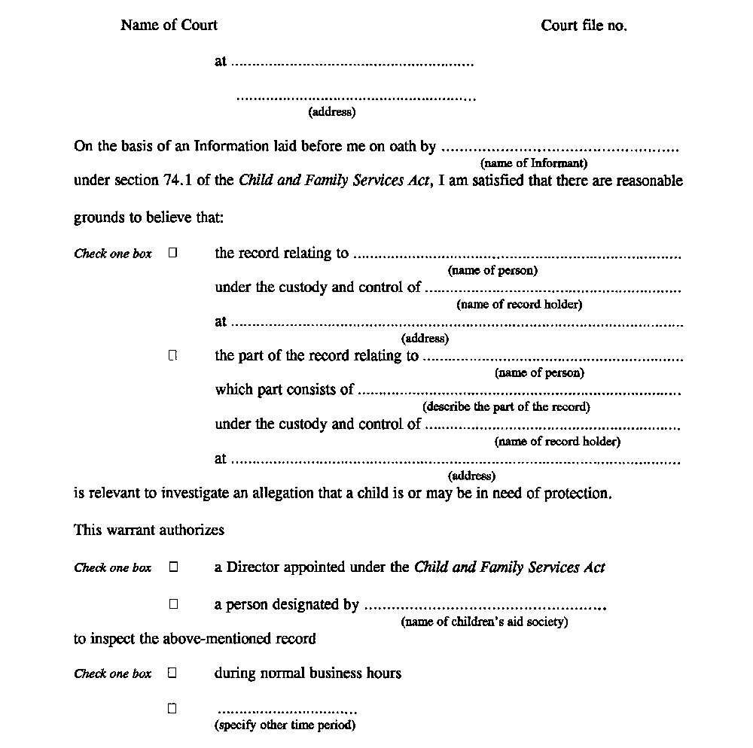
Insert regs\graphics\1990\70\070042be.tif
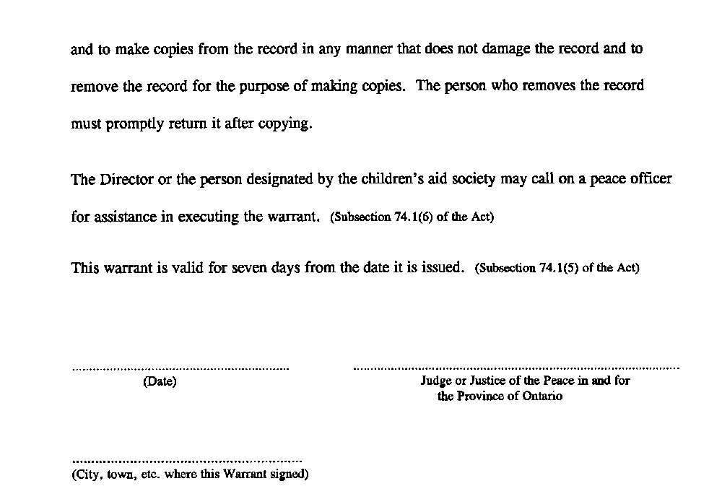
Form 43
Child and Family Services Act
information in support of a warrant for access to a record
(Section 74.1 of the Act)
Insert regs\graphics\1990\70\070043ae.tif
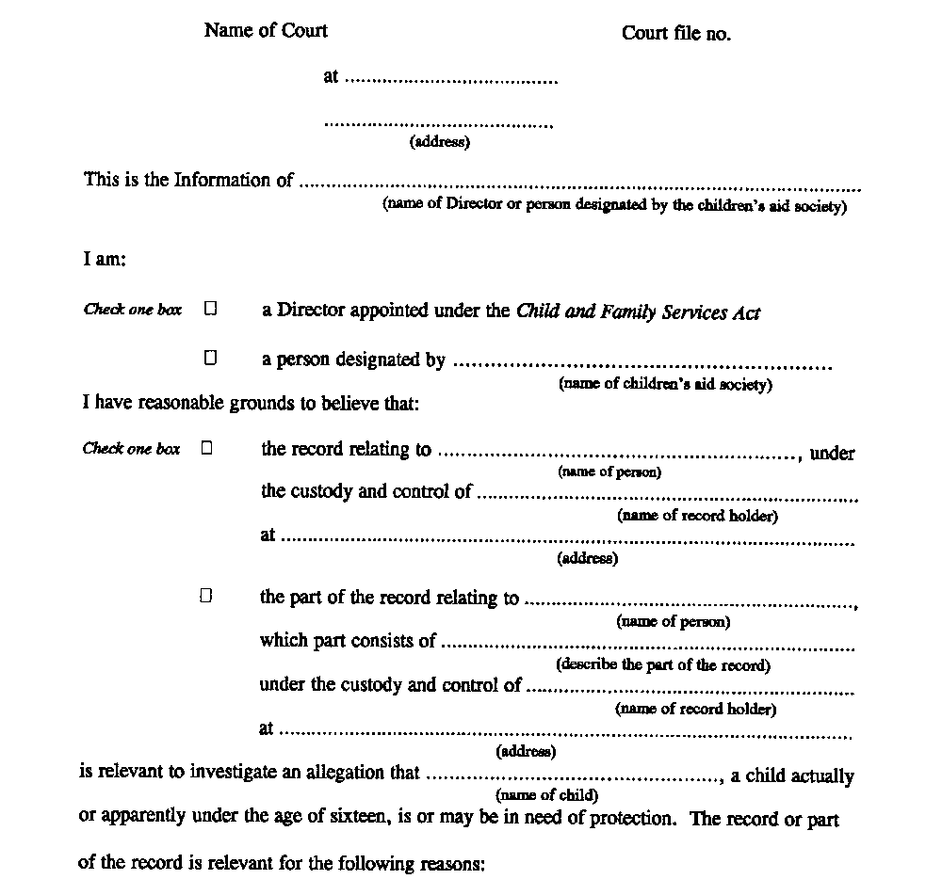
Insert regs\graphics\1990\70\070043be.tif
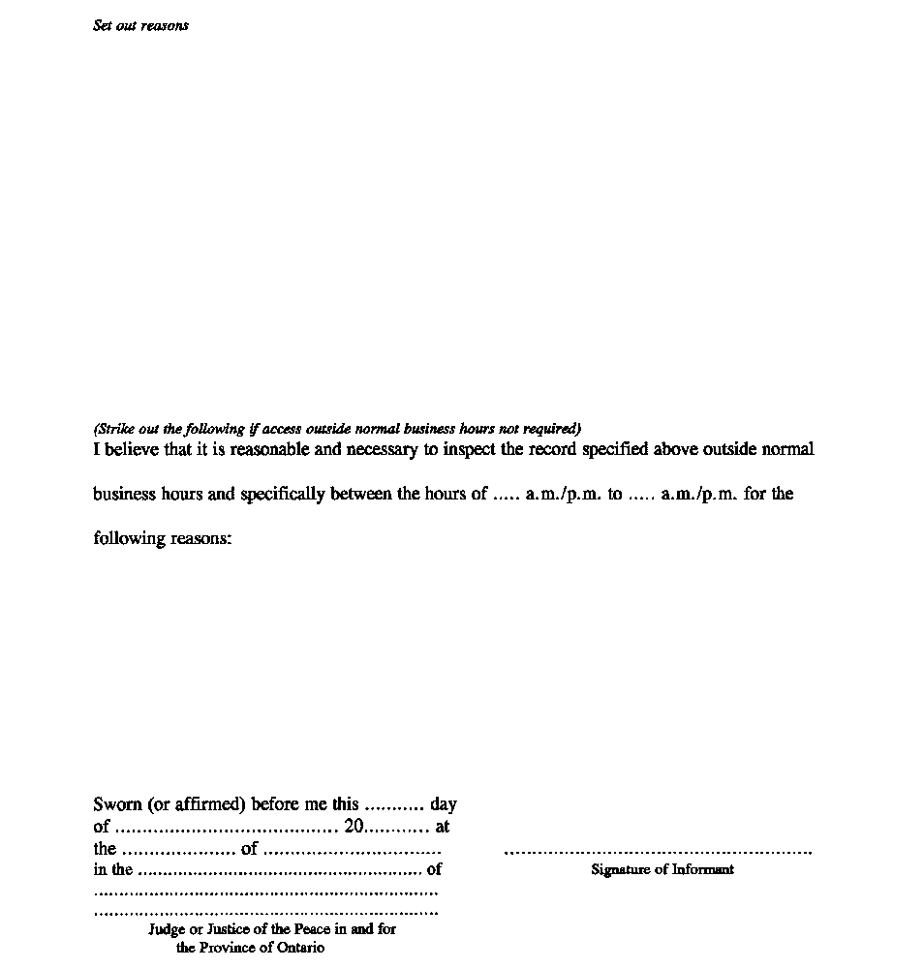
3. The Regulation is amended by adding the following Forms:
Form 44
Child and Family Services Act
warrant (telewarrant) for access to record(s)
(Section 74.2 of the Act)
Insert regs\graphics\1990\70\070044ae.tif
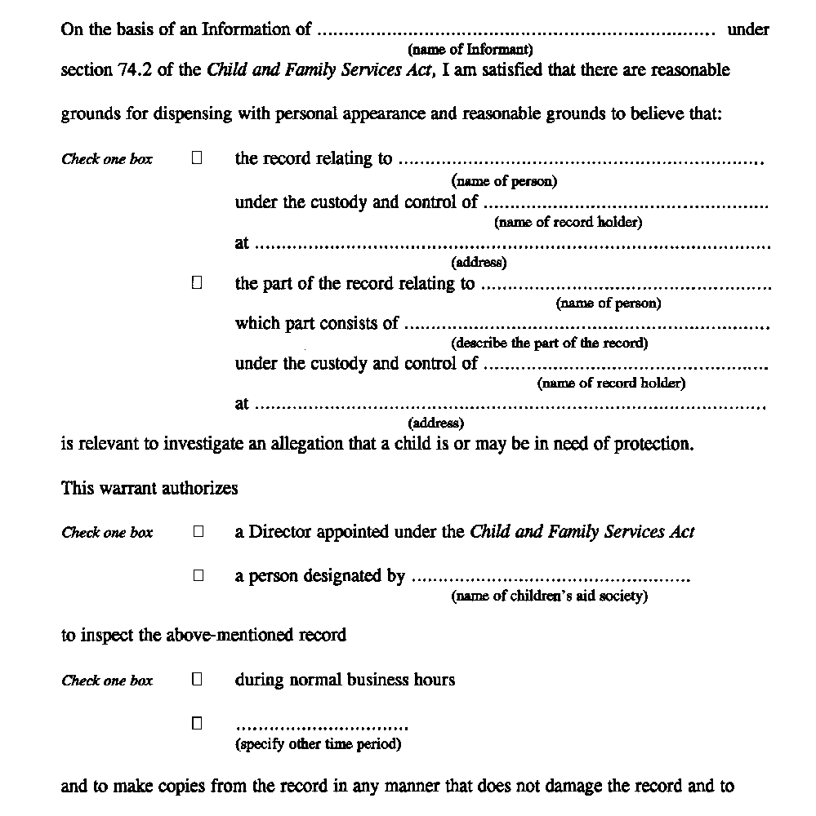
Insert regs\graphics\1990\70\070044be.tif
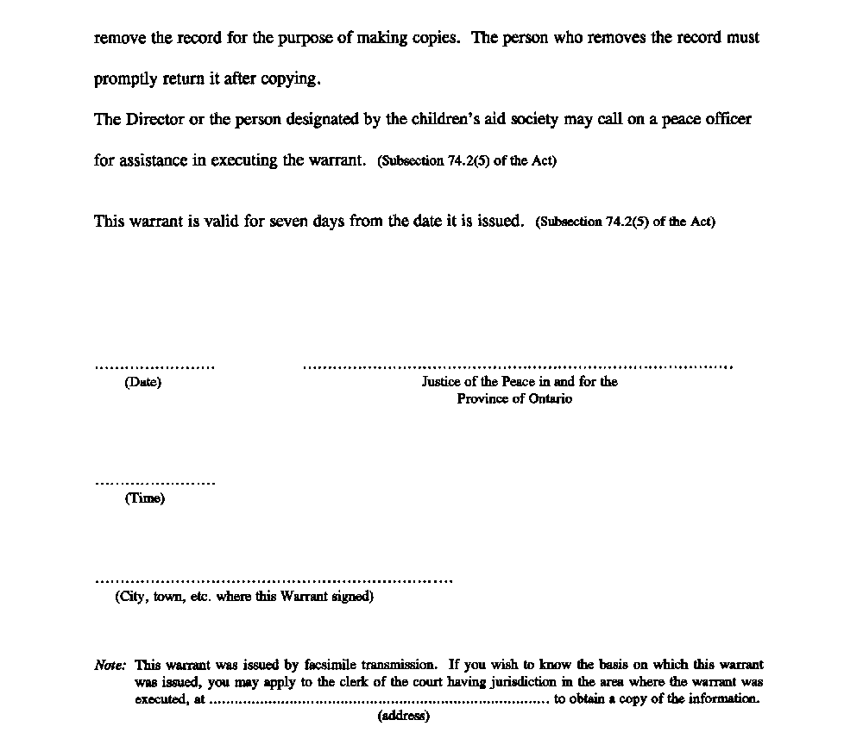

Form 45
Child and Family Services Act
information In support of a warrant (telewarrant) for access to a record
(Section 74.2 of the Act)
Insert regs\graphics\1990\70\070045ae.tif
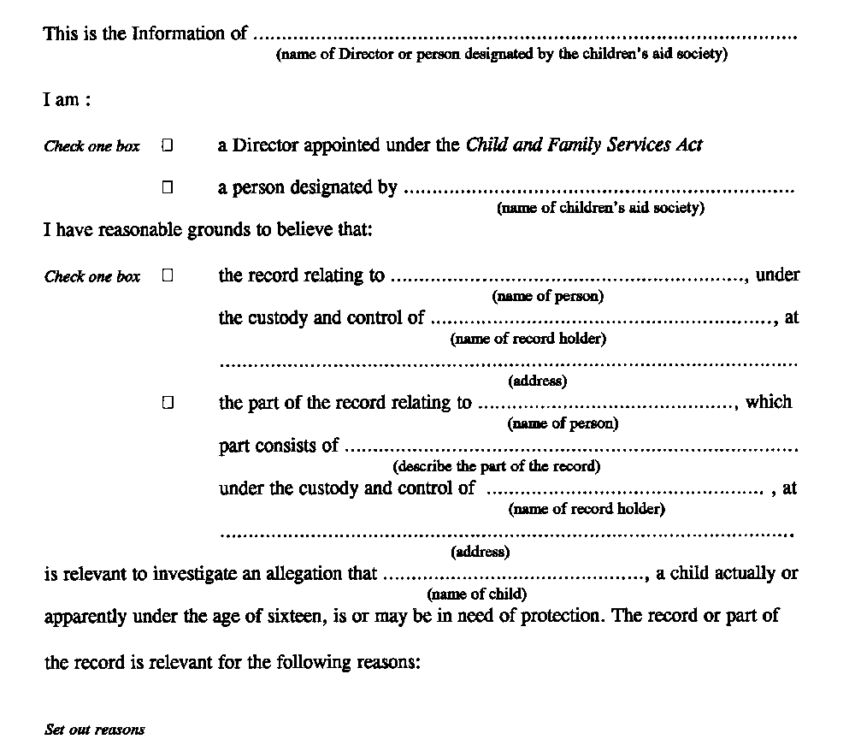
Insert regs\graphics\1990\70\070045be.tif
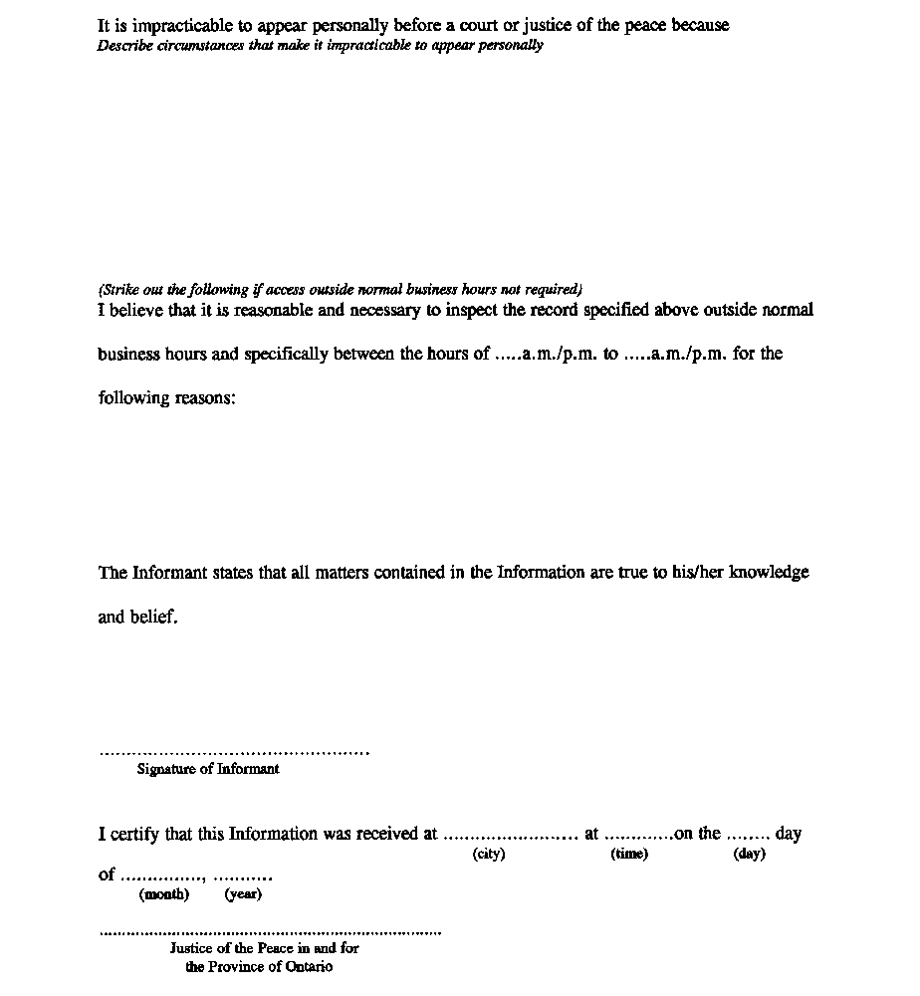
4. (1) Subsection 1 (1) and section 2 come into force on the day section 25 of the Child and Family Services Amendment Act (Child Welfare Reform), 1999 comes into force.
(2) Subsection 1 (2) and section 3 come into force on the day section 26 of the Child and Family Services Amendment Act (Child Welfare Reform), 1999 comes into force.

Back to top

