ONTARIO regulation 48/01
made under the
condominium act, 1998
Made: March 5, 2001
Filed: March 5, 2001
Printed in The Ontario Gazette: March 24, 2001
general
Contents

Part |  | Sections
I | Definitions and Application | 1-3
II | Declaration and Description | 4-11
 | Place of Registration | 4
 | Declaration | 5-8
 | Description | 9-11
III | General | 12-26
IV | Reserve Fund Studies | 27-33
V | Amalgamation | 34-38
VI | Common Elements Condominium Corporations | 39-46
VII | Phased Condominium Corporations | 47-55
VIII | Vacant Land Condominium Corporations | 56-58
IX | Leasehold Condominium Corporations | 59-62
X | Transitional | 63, 64
XI | Revocations and Commencement | 65, 66
PART I
DEFINITIONS AND APPLICATION
Definitions
1. In this Regulation,
“amalgamation” means an amalgamation under Part VII of the Act and “amalgamate” has a corresponding meaning;
“beneficiary” means a person on whose behalf a payment described in subsection 81 (1) of the Act has been made in respect of a proposed unit or a proposed common interest in a common elements condominium corporation and includes the person’s successors and assigns;
“Condominium Corporations Index” means the Condominium Corporations Index mentioned in subsection 3 (3) of the Act;
“Condominium Register” means the Condominium Register mentioned in subsection 3 (4) of the Act;
“deposit receipt” means a deposit receipt described in paragraph 2 of subsection 20 (2);
“easement” means an easement, right of way, right or licence in the nature of an easement, profit à prendre or other incorporeal hereditament, but does not include any of those that arise by operation of law;
“insurer” means the insurer under a policy;
“land registrar” means the land registrar in whose registry or land titles division, as the case may be, the property is situated;
“parcel of tied land” means a parcel of land described in clause 139 (1) (a) of the Act in the case of a common elements condominium corporation and to which a common interest of an owner in the corporation attaches under clause 139 (2) (a) of the Act;
“phase” means the additional units and common elements in a phased condominium corporation that are created in accordance with Part XI of the Act upon the registration of an amendment to both the declaration and description;
“policy” means a policy described in paragraph 1 of subsection 20 (2);
“standard condominium corporation” means a freehold condominium corporation that is not a common elements condominium corporation or a vacant land condominium corporation;
“warranty corporation” means the corporation designated under section 2 of the Ontario New Home Warranties Plan Act.
Non-application of Corporations Information Act
2. Despite subsection 5 (4) of the Act, the Corporations Information Act does not apply to any corporations.
Standard condominium corporations
3. Corporations created before Part II of the Act came into force and continued as corporations under subsection 178 (1) of the Act are classified as standard condominium corporations.
PART II
DECLARATION AND DESCRIPTION
Place of Registration
Place of registration
4. A declaration and description shall not be registered unless,
(a) the property described in Schedule A to the declaration, is situated entirely within the boundaries of one land titles division, the Land Titles Act applies to all the property and the declarant is the registered owner of the property with an absolute title under that Act; or
(b) the property described in Schedule A to the declaration, is situated entirely within the boundaries of one registry division, the Registry Act applies to all the property and the declarant holds a certificate of title to the property issued under Part I of the Certification of Titles Act within 10 years before the registration.
Declaration
Contents
5. (1) A declaration shall not be received for registration unless,
(a) it is executed by the declarant;
(b) it meets the execution requirements for registration of a transfer/deed of land under the Land Titles Act or the Registry Act, as the case may be;
(c) the first page of the declaration contains a statement that the registration of the declaration and description will create a standard condominium corporation;
(d) it contains schedules known as Schedules A, B, C, D, E, F and G;
(e) the land registrar has received the description for the property and it is capable of being registered; and
(f) the declaration complies with this Regulation and all other legal requirements.
(2) Schedule A shall include,
(a) a description of the land and interests appurtenant to the land intended to be governed by the Act, including a description of every easement, as shown on the description that, upon the registration of the declaration and description, will be appurtenant to the land or to which the land will be subject; and
(b) a statement signed by the solicitor registering the declaration that, in his or her opinion, based on the parcel register or abstract index and the plans and documents recorded in them,
(i) the legal description is correct,
(ii) the easements mentioned in clause (a) will exist in law upon the registration of the declaration and description, and
(iii) the declarant is the registered owner of the land and appurtenant interests.
(3) Schedule B shall contain the consent under clause 7 (2) (b) of the Act, in Form 1, of every person having a registered mortgage against the land or interests appurtenant to the land, as the land and the interests are described in the description.
(4) Schedule C shall,
(a) specify the boundaries of each unit by reference to the buildings or monuments mentioned in subsections 6 (4), (5) and (6) of Ontario Regulation 49/01;
(b) fully describe the monuments mentioned in subsections 6 (4), (5) and (6) of Ontario Regulation 49/01 and the relationship of the boundaries of the units to them;
(c) contain a statement signed by an Ontario land surveyor licensed under the Surveyors Act certifying that the written description of the monuments and boundaries of the units accurately corresponds with the diagrams of the units described in clause 8 (1) (d) of the Act and shown on the plans of survey of the description prepared in accordance with Ontario Regulation 49/01;
(5) Schedule D shall contain,
(a) a statement of the proportions, expressed in percentages totalling 100 per cent, of the common interests appurtenant to the units; and
(b) a statement of the proportions, expressed in percentages totalling 100 per cent, allocated to the units, in which the owners are to contribute to the common expenses.
(6) Schedule E shall contain a statement specifying the common expenses of the corporation or may be left blank if the declarant so elects.
(7) Schedule F shall contain a specification of all parts of the common elements that are to be used by the owners of one or more designated units and not by all the owners or shall indicate that there are no such parts if that is the case.
(8) Schedule G shall contain,
(a) a certificate, in Form 2, of an architect certifying that all buildings on the property have been constructed in accordance with the regulations made under the Act, with respect to all or some matters listed in the paragraphs of the definition of “has been constructed” in subsection 6 (1); or
(b) one or more certificates of an engineer, in Form 2, certifying that all buildings on the property have been constructed in accordance with the regulations made under the Act, with respect to all or some matters listed in the paragraphs of the definition of “has been constructed” in subsection 6 (1).
(9) Every matter listed in the paragraphs of the definition of “has been constructed” in subsection 6 (1) shall be certified to in the certificates in Form 2 that are contained in Schedule G.
(10) A declaration may contain schedules in addition to the schedules that it is required to contain under this Regulation.
Construction complete
6. (1) For the purposes of subsection 5 (8),
“has been constructed” means, with respect to each building on the property, constructed at least to the following state:
1. The exterior building envelope, including roofing assembly, exterior wall cladding, doors and windows, caulking and sealants, is weather resistant if required by the construction documents and has been completed in general conformity with the construction documents.
2. Floor assemblies are constructed to the sub-floor.
3. Walls and ceilings of the common elements, excluding interior structural walls and columns in a unit, are completed to the drywall (including taping and sanding), plaster or other final covering.
4. All underground garages, if any, have walls and floor assemblies in place.
5. All elevating devices, if any, as defined in the Elevating Devices Act, are licensed under that Act if it requires a licence, except for elevating devices contained wholly in a unit and designed for use only within the unit.
6. All installations with respect to the provision of water and sewage services are in place.
7. All installations with respect to the provision of heat and ventilation are in place and heat and ventilation can be provided.
8. All installations with respect to the provision of air conditioning, if any, are in place.
9. All installations with respect to the provision of electricity are in place.
10. All indoor and outdoor swimming pools, if any, are roughed in to the extent that they are ready to receive finishes, equipment and accessories.
11. Subject to paragraphs 2 and 3, the boundaries of the units are completed to the drywall (not including taping and sanding), plaster or other final covering, and perimeter doors are in place.
(2) Despite paragraph 2 of subsection (1), with respect to units intended for non-residential purposes that are not ancillary to units intended for residential purposes, the lowermost floor does not have to be in place if it is at grade.
(3) Despite paragraphs 3 and 11 of subsection (1), with respect to units intended for non-residential purposes that are not ancillary to units intended for residential purposes, wall or ceiling coverings, interior perimeter doors, interior partitions or walls between units or between units and common elements do not have to be in place.
Restrictions: amalgamation
7. (1) A declaration shall not be registered if,
(a) it contains provisions requiring an owner, a future owner or anyone on the owner’s or future owner’s behalf to consent in writing to an amalgamation; or
(b) it contains provisions relating to an amalgamation.
(2) If a declaration contains a provision that is inconsistent with subsection (1), the declaration shall be deemed to contain another provision stating that the inconsistent provision is void.
Amendments
8. An amendment made under section 107 of the Act to a declaration is exempt from subsection 7 (1) of the Act and clause 7 (2) (b) of the Act and is not required to contain any statements or schedules described in section 5 that are in the registered declaration and that are not being amended by the amendment.
Description
Contents
9. (1) A description shall not be received for registration unless,
(a) it complies with all legal requirements; and
(b) the land registrar has received the declaration for the property and it is capable of being registered.
(2) Despite clause 8 (1) (b) of the Act, a description of a corporation shall not contain the architectural plans described in that clause if,
(a) it contains the structural plans described in that clause; and
(b) Schedule G to the declaration does not contain the certificate of an architect described in clause 5 (8) (a).
(3) Despite clause 8 (1) (e) of the Act, a description of a corporation shall not contain the certificates described in that clause.
(4) In addition to all other material that it is required to contain, a description shall contain a description of all easements and similar interests to which the property is subject.
(5) The description of the easements and similar interests to which the property is subject and the description of the interests appurtenant to the property required by clause 8 (1) (g) of the Act shall be combined and shall be in Form 3.
Forms
10. (1) The land registrar’s certificate of registration that clause 11 (1) (a) of Ontario Regulation 49/01 requires to be on the description shall be in Form 4.
(2) The surveyor’s certificate that clause 11 (1) (c) of Ontario Regulation 49/01 requires to be on the description shall be in Form 5.
(3) The certificate that clause 11 (1) (e) or (f) or subsection 21 (2) of Ontario Regulation 49/01 requires to be on the description and that is made by the declarant or, if the description is being registered to effect an amalgamation, the persons authorized to bind each of the amalgamating corporations, shall be in Form 6.
(4) The surveyor’s certificate that clause 11 (3) (b) of Ontario Regulation 49/01 requires to be on the description shall be in Form 7.
Amendments
11. All persons are exempt from subsections 9 (2) and (3) of the Act when applying to register an amendment to the description made under section 109 or 110 of the Act.
PART III
GENERAL
Performance audit
12. (1) In subsection (2),
“telecommunications” means the emission, transmission or reception of any combination of signs, signals, writing, images, sound, data, alphanumeric characters or intelligence of any nature by wire, cable, radio or an optical, electromagnetic or any similar technical system.
(2) For the purpose of clause 44 (5) (a) of the Act, the person who conducts the performance audit shall inspect the elevating devices, as defined in the Elevating Devices Act, if any, of the buildings on the property and the telecommunications systems, if any, that service the buildings.
(3) For the purpose of clause 44 (5) (b) of the Act, the person who conducts the performance audit shall inspect the sprinkler systems, if any, and the outside parking areas, if any.
(4) In addition to the material specified in subsection 44 (8) of the Act, the written report mentioned in that subsection shall also include a copy of the current declaration and description registered in respect of the corporation, including all amendments to that declaration and description.
Proxies
13. An instrument appointing a proxy to vote at a meeting of owners may be in,
(a) Form 8, in the case of a proxy, other than for the election or removal of a director;
(b) Form 9, in the case of a proxy that includes a proxy for the election of a director, other than for the election of a director for the remainder of the term of a director who has been removed; or
(c) Form 10, in the case of a proxy that includes a proxy for the removal of a director or the election of a director for the remainder of the term of a director who has been removed.
By-laws
14. The certificate of the officer of a corporation mentioned in subsection 38 (1) of Ontario Regulation 49/01 in respect of a by-law shall be in Form 11.
Records
15. The corporation shall keep copies of the status certificates that it has issued under section 76 of the Act within the previous 10 years.
Financial statements
16. (1) A corporation shall have its financial statements prepared in the manner and in accordance with the accounting principles specified in the Handbook of the Canadian Institute of Chartered Accountants.
(2) The auditor’s report mentioned in subsection 67 (1) of the Act shall be prepared in the manner and in accordance with the auditing standards specified in the Handbook of the Canadian Institute of Chartered Accountants.
(3) In addition to the material specified in subsection 66 (2) of the Act, the financial statements shall also include,
(a) a comparison between,
(i) the amount of contributions to the reserve fund that the corporation has collected, and
(ii) the amount that, according to the board’s plan for funding of the reserve fund under subsection 94 (8) of the Act, the corporation was required to collect as contributions to the reserve fund; and
(b) a comparison between,
(i) the amount of expenditures from the reserve fund that the corporation has made, and
(ii) the amount of proposed expenditures that, according to the board’s plan for funding of the reserve fund under subsection 94 (8) of the Act, the corporation was to have made from the reserve fund.
(4) If a director makes a disclosure of an interest in a contract or transaction under section 40 of the Act and the corporation has entered into the contract or transaction, whether before or after the disclosure, the financial statements shall also include a brief description of the nature of the contract or transaction, the amount of money involved in it and the nature and extent of the director’s interest in it.
(5) If an officer makes a disclosure of an interest in a contract or transaction under section 41 of the Act and the corporation has entered into the contract or transaction, whether before or after the disclosure, the financial statements shall also include a brief description of the nature of the contract or transaction, the amount of money involved in it and the nature and extent of the officer’s interest in it.
Disclosure statement
17. (1) In addition to the material specified in subsection 72 (3) of the Act, a disclosure statement mentioned in that subsection shall include,
(a) a copy of sections 73 and 74 of the Act;
(b) a statement that, under subsection 82 (8) of the Act, the declarant is entitled to retain the excess of all interest earned on money held in trust over the interest that it is required to pay to the purchaser under section 82 of the Act;
(c) a statement whether a part of the common elements may be used for commercial or other purposes not ancillary to residential purposes;
(d) if there is no by-law or proposed by-law of the corporation establishing what constitutes a standard unit, a copy of the schedule that the declarant intends to deliver to the board under clause 43 (5) (h) of the Act;
(e) a statement,
(i) indicating whether visitors must pay for parking and what the anticipated costs are,
(ii) indicating whether there is visitor parking on the property, and
(iii) if there is no visitor parking on the property, indicating whether visitor parking is available elsewhere and if so, describing where;
(f) an identification of the major assets and property that the declarant has indicated that it may provide, even though it is not required to do so;
(g) an indication of the units and assets that the corporation is required to purchase, the services that it is required to acquire and the agreements and leases that it is required to enter into with the declarant or a subsidiary body corporate, holding body corporate or affiliated body corporate of the declarant; and
(h) with respect to land that is owned by the declarant, or by a subsidiary body corporate, holding body corporate or affiliated body corporate of the declarant, and that is adjacent to the land described in the description, a statement indicating,
(i) the current use of the land,
(ii) the representations, if any, that the declarant has made respecting the future use of the land, and
(iii) a summary of the applications, if any, respecting the use of the land that have been submitted to an approval authority.
(2) In subsection (1),
“affiliated body corporate” means a body corporate that is deemed to be affiliated with another body corporate under subsection 1 (4) of the Business Corporations Act;
“body corporate” means a body corporate with or without share capital;
“holding body corporate” means a body corporate that is deemed to be the holding body of another body corporate under subsection 1 (3) of the Business Corporations Act;
“subsidiary body corporate” means a body corporate that is deemed to be a subsidiary of another body corporate under subsection 1 (2) of the Business Corporations Act.
(3) The table of contents in the disclosure statement mentioned in subsection 72 (4) of the Act shall be in Form 12.
Status certificate
18. (1) A status certificate shall be in Form 13.
(2) The fee that a corporation may charge for providing a status certificate, including all material that is required to be included in it, shall not exceed $100, inclusive of all applicable taxes.
Sale of units
19. (1) The prescribed rate of interest for the purpose of paragraph 1 of subsection 80 (4) of the Act shall be the rate of interest that the Bank of Canada has most recently reported as the chartered bank administered interest rate for a conventional one year mortgage as of the first of the month in which the purchaser assumes interim occupancy of a proposed unit or is required to do so under the agreement of purchase and sale.
(2) In subsection (3),
“bank rate” means the bank rate established by the Bank of Canada as the minimum rate at which the Bank of Canada makes short-term advances to members of the Canadian Payments Association.
(3) The prescribed rate of interest for the purpose of subsections 73 (3), 74 (9) and 82 (1), (5) and (7) of the Act shall be,
(a) for the period from April 1 to September 30 of each year, 2 per cent per annum below the bank rate at the end of March 31 of that year; and
(b) for the period from October 1 of each year to March 31 in the following year, 2 per cent per annum below the bank rate at the end of September 30 immediately before that October.
Trustees and security
20. (1) The following classes are prescribed as trustees for the purpose of subsection 81 (1) of the Act:
1. Persons, other than the declarant’s solicitor, who are entitled to practise law in Ontario as solicitors.
2. A partnership, other than the declarant’s solicitor, of persons who are entitled to practise law in Ontario as solicitors.
3. Escrow agents for deposits with respect to a project who have entered into a deposit trust agreement with the declarant and either the warranty corporation or an insurer to govern money to be held in trust under section 81 of the Act with respect to the project.
(2) The following classes are prescribed as security for the purpose of clause 81 (7) (b) of the Act:
1. Policies that insure against the loss of payments described in subsection 81 (1) of the Act and the interest payable by the declarant on the payments, that meet the requirements of section 21 and that are in effect.
2. Deposit receipts executed by the warranty corporation that provide for compensation to a beneficiary in accordance with section 22, that meet the requirements of that section and that are in effect.
Insurance policies
21. (1) A policy shall take effect when it has been executed by or on behalf of the insurer and the declarant and when it has been delivered to the trustee or the declarant’s solicitor holding the money for which the policy is being provided as security.
(2) The trustee or the declarant’s solicitor, as the case may be, shall hold the policy in trust for the beneficiary until the insurer is no longer liable under it in accordance with subsection (8).
(3) The declarant shall pay the premiums in respect of a policy and shall not directly or indirectly transfer the cost of the premiums to the beneficiary.
(4) The obligations of the insurer to the beneficiary under a policy shall not be affected by,
(a) failure of the declarant to pay any premiums owing under the policy;
(b) failure of the declarant to notify the insurer of the receipt of payments described in subsection 81 (1) of the Act; or
(c) breach of any term or condition of the policy.
(5) Upon request, the trustee or the declarant’s solicitor, as the case may be, shall deliver the policy to the beneficiary so that the beneficiary can make a claim under it.
(6) Immediately upon receiving written notice of a claim by the beneficiary under a policy, the insurer shall provide the beneficiary with forms upon which to make proof of loss.
(7) An insurer that receives written notice of a claim under subsection (6) shall pay the beneficiary within 60 days after the right of the beneficiary to payment under the policy has been established.
(8) An insurer shall remain liable under a policy until,
(a) the declarant delivers to the beneficiary a deed in registerable form to the unit, in respect of which the beneficiary or a person on the beneficiary’s behalf has made a payment described in subsection 81 (1) of the Act;
(b) the declarant pays the beneficiary all money paid under subsection 81 (1) of the Act and interest on it payable by the declarant under the Act;
(c) the insurer pays the beneficiary the amount of the loss;
(d) the beneficiary acknowledges in writing that,
(i) the beneficiary is not entitled to the payments made by or on behalf of the beneficiary under subsection 81 (1) of the Act in respect of a proposed unit in the corporation and the interest payable on the payments by the declarant, and
(ii) the insurer is no longer liable under the policy; or
(e) a court of competent jurisdiction has made a final determination that the beneficiary is not entitled to the payments made by or on behalf of the beneficiary under subsection 81 (1) of the Act in respect of a proposed unit in the corporation and the interest payable on the payments by the declarant.
(9) An insurer who is required to make a payment under a policy shall pay interest to the beneficiary to the date of payment of the loss at the rate prescribed under subsection 19 (3).
(10) A provision in a policy that derogates in any manner from any right or benefit that this section confers on a beneficiary is void to the extent that it derogates from the right or benefit.
Deposit receipts
22. (1) A deposit receipt shall take effect when it has been executed by the beneficiary and by or on behalf of the warranty corporation and the declarant and when it has been delivered to the trustee or the declarant’s solicitor, as the case may be, holding the money for which the deposit receipt is being provided as security.
(2) A deposit receipt shall contain a statement that payments described in clause 81 (1) (a) or (c) of the Act are not covered by a deposit receipt and that they must be held in trust in accordance with section 81 of the Act.
(3) A deposit receipt shall not constitute prescribed security for the purposes of paragraph 2 of subsection 20 (2) unless, by the terms of the deposit receipt, the amount of compensation that the warranty corporation is liable to pay to a beneficiary under it is,
(a) if the amount of the payments described in clause 81 (1) (b) of the Act made by or on behalf of the beneficiary is $20,000 or less, the amount so paid; or
(b) if the amount of the payments described in clause 81 (1) (b) of the Act made by or on behalf of the beneficiary is more than $20,000, $20,000 or such greater amount that may be provided under the deposit receipt.
(4) A deposit receipt that establishes a limit on the liability of the warranty corporation shall not constitute prescribed security for the purposes of paragraph 2 of subsection 20 (2) unless it contains a statement that whatever amount is paid by or on behalf of the beneficiary to the declarant in excess of the limit is subject to section 81 of the Act.
(5) The beneficiary is not liable for the payment to an insurer of any premium payable in respect of a policy of insurance that the warranty corporation takes out to insure its obligation to pay under a deposit receipt.
(6) The declarant shall not directly or indirectly charge the beneficiary for any costs relating to the deposit receipt.
(7) The obligations of the warranty corporation to the beneficiary under a deposit receipt shall not be affected by,
(a) failure of the declarant to comply with any term or condition of the declarant’s agreement with the warranty corporation;
(b) failure of the declarant to notify the warranty corporation or its insurer or insurers of the receipt of payments described in clause 81 (1) (b) of the Act;
(c) failure of the warranty corporation to notify its insurer or insurers of the receipt of payments described in clause 81 (1) (b) of the Act;
(d) breach of any term or condition of the deposit receipt; or
(e) breach by the beneficiary or the declarant of any term or condition of a policy of insurance that the warranty corporation takes out to insure its obligation to pay under a deposit receipt.
(8) Immediately upon receiving written notice of a claim by the beneficiary under a deposit receipt, the warranty corporation shall provide the beneficiary with forms upon which to make proof of loss.
(9) If the warranty corporation receives written notice of a claim under subsection (8), it shall pay the beneficiary within 60 days after the right of the beneficiary to payment under the deposit receipt has been established.
(10) The warranty corporation shall remain liable under a deposit receipt until,
(a) the declarant delivers to the beneficiary a deed in registerable form to the unit in respect of which the beneficiary or a person on the beneficiary’s behalf has made a payment described in clause 81 (1) (b) of the Act;
(b) the declarant pays the beneficiary all money paid under clause 81 (1) (b) of the Act and interest on it payable by the declarant under the Act;
(c) the warranty corporation pays to the beneficiary the amount of the loss to the extent of the warranty corporation’s liability under the deposit receipt;
(d) the beneficiary acknowledges in writing that,
(i) the beneficiary is not entitled to the payments made by or on behalf of the beneficiary under subsection 81 (1) of the Act in respect of a proposed unit in the corporation and the interest payable on the payments by the declarant, and
(ii) the insurer is no longer liable under the policy; or
(e) a court of competent jurisdiction has made a final determination that the beneficiary is not entitled to the payments made by or on behalf of the beneficiary under subsection 81 (1) of the Act in respect of a proposed unit in the corporation and the interest payable on the payments by the declarant.
(11) If the warranty corporation is required to make a payment under a deposit receipt, it shall pay interest to the beneficiary to the date of payment of the loss at the rate prescribed under subsection 19 (3).
(12) A provision in a deposit receipt that derogates in any manner from any right or benefit that this section confers on a beneficiary is void to the extent that it derogates from the right or benefit.
Lease of units
23. For the purpose of section 83 of the Act,
“lease” includes a sublease or assignment of lease.
Notice of lien
24. The notice that subsection 85 (4) of the Act requires the corporation to give to the owner for a lien mentioned in that subsection shall be in Form 14.
Changes to common elements
25. (1) In addition to the matters specified in clause 98 (1) (b) of the Act, the agreement described in that clause shall specify who will have the ownership of the proposed addition, alteration or improvement to the common elements under subsection 98 (2) of the Act.
(2) For the purpose of clause 98 (2) (e) of the Act, the board must be satisfied that the proposed addition, alteration or improvement to the common elements under subsection 98 (2) of the Act will not contravene the by-laws or rules of the corporation and will not have an adverse effect on the rest of the common elements.
Termination
26. Sections 122 and 123 of the Act do not apply to a corporation if the total of the proportions, expressed in percentages, of the common interests, as specified in the registered declaration, is not equal to 100 per cent.
PART IV
RESERVE FUND STUDIES
Definitions
27. In this Part,
“component inventory” means an inventory, in a reserve fund study of a corporation, of each item of the common elements and assets of the corporation that requires, or is expected to require within at least 30 years of the date of the study, major repair or replacement where the cost of replacement is not less than $500;
“comprehensive study” means a comprehensive reserve fund study that meets the requirements of this Regulation;
“updated study based on a site inspection” means a comprehensive study that has been revised so that it is current as of the date of the revision, where the revision is based on a site inspection of the property and where the revision has been conducted in accordance with the requirements of this Regulation;
“updated study not based on a site inspection” means a comprehensive study that has been revised so that it is current as of the date of the revision, where the revision is not based on a site inspection of the property and where the revision has been conducted in accordance with the requirements of this Regulation.
Classes
28. The following classes of reserve fund studies are established:
1. Comprehensive study.
2. Updated study based on a site inspection.
3. Updated study not based on a site inspection.
Contents of studies
29. (1) A reserve fund study shall consist of a physical analysis and a financial analysis.
(2) The physical analysis shall consist of,
(a) the component inventory of the corporation; and
(b) an assessment of each item in the component inventory that states its actual or estimated year of acquisition, its present or estimated age, its normal expected life, its remaining life expectancy, the estimated year for its major repair or replacement, its estimated cost of major repair or replacement as of the date of the study, the percentage of that cost of major repair or replacement to be covered by the reserve fund and the adjusted cost resulting from the application of that percentage.
(3) The financial analysis shall consist of,
(a) a description of the financial status of the reserve fund as of the date of the study; and
(b) a recommended funding plan projected over a period of at least 30 consecutive years, beginning with the current fiscal year of the corporation, that shows the minimum balance of the reserve fund during the period and, for each projected year,
(i) the estimated cost of major repair or replacement of the common elements and assets of the corporation based on current costs for the year in which the study is conducted,
(ii) the estimated cost of major repair or replacement of the common elements and assets of the corporation at the estimated time of the repair or replacement based on an assumed annual inflation rate,
(iii) the annual inflation rate described in subclause (ii),
(iv) the estimated opening balance of the reserve fund,
(v) the recommended amount of contributions to the reserve fund, determined on a cash flow basis, that are required to offset adequately the expected cost in the year of the expected major repair or replacement of each item in the component inventory,
(vi) the estimated interest that will be earned on the reserve fund based on an assumed annual interest rate,
(vii) the annual interest rate described in subclause (vi),
(viii) the total of the amounts described in subclauses (v) and (vi),
(ix) the increase, if any, expressed as a percentage, in the recommended amount of contributions to the reserve fund over the recommended amount of contributions for the immediately preceding year, and
(x) the estimated closing balance of the reserve fund.
(4) In preparing or updating the component inventory of the corporation, the person conducting the study shall review,
(a) the declaration and description;
(b) if any, the current by-laws or proposed by-laws of the corporation establishing what constitutes a standard unit; and
(c) if there is no by-law described in clause (b), a copy of the schedule that the declarant intends to deliver or has delivered to the board under clause 43 (5) (h) of the Act.
(5) In preparing or updating the financial analysis described in subsection (3), the person conducting the study shall review,
(a) the most recent audited financial statements of the corporation or, if section 60 of the Act does not require the corporation to appoint auditors, the most recent financial statements of the corporation;
(b) all reciprocal cost sharing agreements, if any, of the corporation;
(c) the most recent reserve fund study of the corporation; and
(d) the most recent notice, if any, of future funding of the reserve fund sent to the owners under clause 94 (9) (a) of the Act.
Method of conducting studies
30. (1) The person conducting a reserve fund study shall sign it.
(2) A comprehensive study or an updated study based on a site inspection shall be based on,
(a) a visual site inspection of the property, including a visual inspection of each item in the component inventory where practicable;
(b) all other inspections of each item in the component inventory that the person conducting the study considers appropriate or necessary;
(c) a verification of records of the corporation; and
(d) interviews with those of the corporation’s directors, officers, employees and agents that the person conducting the study considers appropriate.
(3) As part of preparing the assessment described in clause 29 (2) (b) in a comprehensive study or updating the assessment in an updated study based on a site inspection, the person conducting the study shall review,
(a) all existing warranties, guarantees and service contracts for each item in the component inventory;
(b) the as-built architectural, structural, engineering, mechanical, electrical and plumbing plans for the property that are in the custody or under the control of the corporation;
(c) the as-built specifications for the buildings that are in the custody or under the control of the corporation;
(d) the plans for underground site services, site grading, drainage and landscaping, and television, radio or other communications services for the property that are in the custody or under the control of the corporation;
(e) the repair and maintenance records and schedules in the custody or under the control of the corporation; and
(f) all other records of the corporation that the person conducting the study requires in order to prepare the assessment.
(4) An updated study not based on a site inspection shall be based on a verification of records of the corporation and interviews with those of its directors, officers, employees and agents that the person conducting the study considers appropriate.
(5) In addition to the material that a reserve fund study is required to contain, the study may contain all further information and analysis that the person conducting the study or the board considers appropriate or necessary.
Time for studies
31. (1) A corporation created before the day section 94 of the Act comes into force shall conduct a comprehensive study within three years of that day except if,
(a) on that day it has a comprehensive study that meets the requirements of this Regulation; and
(b) it conducts an updated study based on a site inspection within three years of that day.
(2) The reserve fund study that subsection 94 (4) of the Act requires a corporation created on or after the day section 94 of the Act comes into force to conduct within the year following the registration of the declaration and description shall be a comprehensive study.
(3) A corporation shall conduct a reserve fund study within three years of completing the reserve fund study that it is required to conduct under subsection (1) or (2), as the case may be, and after that, within every three years after completing the immediately preceding reserve fund study.
(4) A reserve fund study that a corporation is required to conduct under subsection (3) shall be,
(a) a comprehensive study;
(b) an updated study not based on a site inspection, if the immediately preceding reserve fund study for the corporation was a comprehensive study or an updated study based on a site inspection; or
(c) an updated study based on a site inspection, if the immediately preceding reserve fund study for the corporation was an updated study not based on a site inspection.
Person conducting studies
32. (1) Subject to subsection (2), the following classes are prescribed as persons who may conduct a reserve fund study:
1. Members of the Appraisal Institute of Canada holding the designation of Accredited Appraiser Canadian Institute.
2. Persons who hold a certificate of practice within the meaning of the Architects Act.
3. Members of the Ontario Association of Certified Engineering Technicians and Technologists who are registered as certified engineering technologists under the Ontario Association of Certified Engineering Technicians and Technologists Act, 1998.
4. Members of the Real Estate Institute of Canada holding the designation of certified reserve planner.
5. Persons who hold a certificate of authorization within the meaning of the Professional Engineers Act.
6. Graduates of Ryerson Polytechnic University with a Bachelor of Technology (Architectural Science) — Building Science Option or Architecture Option.
7. Members of the Canadian Institute of Quantity Surveyors holding the designation of professional quantity surveyor.
8. Members of the Association of Architectural Technologists of Ontario holding the designation of architectural technologist, architecte-technologue or registered building technologist under the Association of Architectural Technologists of Ontario Act, 1996.
(2) A person who conducts a reserve fund study shall not,
(a) be a director, officer or property manager of the corporation;
(b) directly or indirectly, have an interest in,
(i) a contract or transaction to which a director or officer of the corporation is a party in a capacity other than as a director or officer of the corporation, or
(ii) a proposed contract or transaction to which a director or officer of the corporation will be a party in a capacity other than as a director or officer of the corporation;
(c) be the spouse, same-sex partner, son or daughter of a director or officer of the corporation or son or daughter of the spouse or same-sex partner of a director or officer of the corporation;
(d) be an owner as defined in the Act in relation to the corporation; or
(e) be a person who lives on the property managed by the corporation under section 17 of the Act.
(3) In subsection (2),
“same-sex partner” means either of two persons of the same sex who live together in a conjugal relationship outside marriage;
“spouse” means,
(a) a spouse as defined in section 1 of the Family Law Act, or
(b) either of two persons of the opposite sex who live together in a conjugal relationship outside marriage.
(4) A person who conducts a reserve fund study shall be insured under a policy of liability insurance that includes,
(a) coverage for liability for errors, omissions and negligent acts arising out of conducting or not conducting a reserve fund study, subject to the exclusions, conditions and terms that are consistent with normal insurance industry practice;
(b) a policy limit for each single claim of not less than $1 million per occurrence;
(c) an aggregate policy limit in the amount of not less than $2 million per year for all claims in the year or an automatic policy limit reinstatement feature; and
(d) a maximum deductible amount of $3,500 per occurrence.
(5) A person who conducts a reserve fund study shall ensure that the policy of liability insurance is valid at the time the reserve fund study is completed and is kept valid for a period of at least three years after that time.
(6) Upon request, the person shall provide to the corporation a certificate of the policy of liability insurance.
Plan for future funding
33. (1) Except in the case of a corporation to which subsection (2) applies, the prescribed period of time for the purpose of subsection 94 (8) of the Act shall be the fiscal year of the corporation following the fiscal year in which the reserve fund study is completed.
(2) In the case of all reserve fund studies that a corporation created before the day section 94 of the Act comes into force is required to conduct after that date under subsection 31 (1) and within 10 years after the date of the first reserve fund study that it is required to conduct after that coming into force date, the prescribed period of time for the purpose of subsection 94 (8) of the Act shall be 10 years from the date of that first reserve fund study.
(3) The notice that the board is required to send under subsection 94 (9) of the Act shall be in Form 15.
PART V
AMALGAMATION
Conditions for amalgamation
34. (1) No corporations may amalgamate unless,
(a) they are standard condominium corporations;
(b) in respect of each of the amalgamating corporations that is a phased condominium corporation, all phases have been completed or more than 10 years have passed since the registration of the declaration and description that created the corporation;
(c) in respect of each of the amalgamating corporations, a turn-over meeting has been held under section 43 of the Act, or a predecessor of it, and, to the best of the knowledge of the board, the declarant has delivered to the board everything that section, or a predecessor of it, required the declarant to deliver;
(d) each of the amalgamating corporations has conducted, in accordance with Part IV, a comprehensive reserve fund study or an updated study based on a site inspection within the year before the board gives the owners the notice of meeting described in subsection 120 (3) of the Act; and
(e) each of the amalgamating corporations has entered into an interim agreement with each other dealing with the conduct of the affairs of each of the corporations from the day that the board of the first corporation to give the notice of meeting described in subsection 120 (3) of the Act has given that notice, until the corporations amalgamate or until their boards determine that the amalgamation will not proceed.
(2) The agreement mentioned in clause (1) (e) shall deal with matters including expenditures from the reserve fund, borrowing of funds, making, amending or repealing by-laws, entering into new contracts, initiation of any legal proceedings, any substantial addition, alteration, or improvement to the common elements, any substantial change in the assets of the corporation, and any substantial change in a service that the corporation provides to the owners.
(3) The agreement mentioned in clause (1) (e) shall not contravene the regulations made under the Act or the declaration, by-laws or rules of each of the amalgamating corporations.
(4) In addition to the requirements of subsection 120 (3) of the Act, the notice of meeting described in that subsection shall include,
(a) a copy of the comprehensive reserve fund study or the updated study based on a site inspection that the corporation is required to conduct under clause (1) (d);
(b) a copy of the interim agreement described in clause (1) (e);
(c) an estimate of the costs of carrying out the proposed amalgamation for each of the amalgamating corporations; and
(d) one of the following statements:
1. A statement describing the provisions of the proposed declaration, description, by-laws and rules that, in the opinion of the board giving the notice, differ significantly from those contained in the declaration, description, by-laws and rules of the amalgamating corporation.
2. A statement that there are no provisions in the proposed declaration, description, by-laws and rules that, in the opinion of the board giving the notice, differ significantly from those contained in the declaration, description, by-laws and rules of the amalgamating corporation.
(5) The consent in writing mentioned in clause 120 (1) (b) of the Act,
(a) must not be executed before the meeting held in accordance with subsections 120 (2) and (3) of the Act; and
(b) must be executed by,
(i) if the owner is an individual, the owner,
(ii) if the owner is a corporation, the persons authorized to bind the corporation, or
(iii) if a mortgagee is entitled to execute the consent in the place of the owner under section 48 of the Act, the individual mortgagee or, if the mortgagee is a corporation, the persons authorized to bind the corporation.
Place of registration
35. (1) Section 4 does not apply to a declaration and description that are being registered to effect an amalgamation.
(2) A declaration and description that are being registered to effect an amalgamation shall not be registered unless,
(a) the property described in the description is situated entirely within the boundaries of one land titles division and the Land Titles Act applies to all the property; or
(b) the property described in the description is situated entirely within the boundaries of one registry division and the Registry Act applies to all the property.
Declaration
36. (1) This section applies to a declaration only if it is being registered to effect an amalgamation.
(2) Subsection 7 (1) of the Act and clause 5 (1) (a) of this Regulation, do not apply to a declaration.
(3) In addition to the requirements of subsection 5 (1), a declaration shall not be received for registration unless,
(a) it is executed by the officers of each amalgamating corporation who are duly authorized to sign on behalf of the corporation; and
(b) the property consists only of the property of each of the amalgamating corporations and there is no change in the boundaries of the units of each of the amalgamating corporations.
(4) A declaration shall not be received for registration if the amalgamated corporation would be a phased condominium corporation.
(5) Despite clause 5 (2) (b), the statement of the solicitor contained in Schedule A to the declaration and described in that clause shall not contain the statement described in subclause 5 (2) (b) (iii) but, if there are easements that will merge and no longer exist in law upon the registration of the declaration and description, the statement of the solicitor shall set out a legal description of the easements and the most recent registered instrument number in which they are fully described and shall contain a statement that the easements will merge and no longer exist in law upon the registration of the declaration and description.
(6) Clause 7 (2) (b) of the Act does not apply to a declaration and despite clause 5 (1) (d), a declaration shall not contain a Schedule B.
(7) In addition to the requirements of subsection 5 (4), Schedule C to the declaration shall contain,
(a) a list indicating all units in the amalgamating corporations and what units they will become in the amalgamated corporation; and
(b) a list indicating all units in the amalgamated corporation and what units they were in the amalgamating corporations.
(8) In addition to the requirements of clause 5 (4) (c), the statement of an Ontario land surveyor contained in Schedule C to the declaration and described in that clause shall certify that the lists described in clauses (7) (a) and (b) are accurate and complete.
(9) Subsection 5 (6) does not apply to a declaration.
(10) Schedule E to the declaration shall contain a statement specifying the common expenses of the amalgamated corporation or may be left blank if the amalgamating corporations so elect.
(11) Despite clause 5 (1) (d), a declaration shall not contain a Schedule G.
(12) In addition to the requirements of subsection 7 (2) of the Act, a declaration shall include,
(a) a statement by the persons authorized to bind each of the amalgamating corporations that their corporation has complied with section 120 of the Act and the regulations made under the Act; and
(b) a statement by the persons authorized to bind each of the amalgamating corporations that is a phased condominium corporation, that all phases have been completed or more than 10 years have passed since the registration of the declaration and description that created the amalgamating corporation.
(13) Clause 7 (1) (b) does not apply to a declaration.
Description
37. Clauses 8 (1) (b) and (e) of the Act do not apply to a description effecting an amalgamation.
Reserve fund studies
38. (1) Section 31 and subsections 33 (1) and (2) do not apply to an amalgamated corporation.
(2) An amalgamated corporation shall conduct a comprehensive reserve fund study within three years of the date that any of the amalgamating corporations completes the latest reserve fund study that it is required to conduct before the amalgamation.
(3) An amalgamated corporation shall conduct a reserve fund study within three years of completing the reserve fund study that it is required to conduct under subsection (2) and, after that, within every three years after completing the immediately preceding reserve fund study.
(4) A reserve fund study that an amalgamated corporation is required to conduct under subsection (3) shall be,
(a) a comprehensive study;
(b) an updated study not based on a site inspection, if the immediately preceding reserve fund study for the corporation was a comprehensive study or an updated study based on a site inspection; or
(c) an updated study based on a site inspection, if the immediately preceding reserve fund study for the corporation was an updated study not based on a site inspection.
(5) Except in the case of a corporation to which subsection (6) applies, the prescribed period of time for the purpose of subsection 94 (8) of the Act shall be the fiscal year of the corporation following the fiscal year in which the reserve fund study is completed.
(6) In the case of all reserve fund studies that an amalgamated corporation, of which all the amalgamating corporations were created before the day section 94 of the Act comes into force, is required to conduct within 10 years after the date of the earliest reserve fund study that any of the incorporating corporations was required to conduct under subsection 31 (1), the prescribed period of time for the purpose of subsection 94 (8) of the Act shall be 10 years from the date of the earliest reserve fund study that any of the amalgamating corporations was required to conduct under subsection 31 (1).
PART VI
COMMON ELEMENTS CONDOMINIUM CORPORATIONS
Place of registration
39. In addition to the requirements of section 4, a declaration and description for a common elements condominium corporation shall not be registered unless,
(a) if the Land Titles Act applies to the property described in the description, all the parcels of tied land are situated entirely within the boundaries of the land titles division within which the property is situated and the owner of the freehold estate in each of the parcels is the registered owner of the parcel with an absolute title under that Act; or
(b) if the Registry Act applies to the property described in the description, all the parcels of tied land are situated entirely within the boundaries of the registry division within which the property is situated and the owner of the freehold estate in each of the parcels holds a certificate of title to the parcel issued under Part I of the Certification of Titles Act within 10 years before the registration.
Declaration
40. (1) In addition to the requirements of subsection 5 (1), a declaration for a common elements condominium corporation shall not be received for registration unless,
(a) the first page of the declaration contains,
(i) a statement that the registration of the declaration and description will create a common elements condominium corporation, and
(ii) a statement that a parcel of tied land may not be divided into two or more parcels unless an amendment is registered to the declaration that takes into account the division of the parcel of tied land; and
(b) it contains schedules known as Schedules H, I and J.
(2) Despite clause 5 (1) (c), the first page of a declaration for a common elements condominium corporation shall not contain the statement described in that clause.
(3) In addition to the requirements of subsection 5 (3), Schedule B to the declaration for a common elements condominium corporation shall contain a consent in Form 16 of every person having a registered mortgage against a parcel of tied land.
(4) Despite clause 5 (1) (d), a declaration for a common elements condominium corporation shall not contain a Schedule C.
(5) Subsection 5 (5) does not apply to a declaration for a common elements condominium corporation.
(6) Schedule D to the declaration for a common elements condominium corporation shall contain,
(a) a statement that the common elements are intended for the use and enjoyment of the owners for the purpose of clause 140 (a) of the Act;
(b) a legal description of the parcels of tied land for the purpose of clause 140 (b) of the Act;
(c) a statement of the proportions, expressed in percentages totalling 100 per cent, of the common interest that will attach to each parcel of tied land; and
(d) a statement of the proportions, expressed in percentages totalling 100 per cent, allocated to the parcels of tied land, in which the owners are to contribute to the common expenses.
(7) Subsection 5 (7) does not apply to a declaration for a common elements condominium corporation.
(8) Schedule F to the declaration for a common elements condominium corporation shall contain a specification of all parts of the common elements that are to be used by the owners of one or more designated common interests and not by all the owners or shall indicate that there are no such parts if that is the case.
(9) Despite clause 5 (1) (d), a declaration for a common elements condominium corporation shall not contain a Schedule G if the declaration and description show that there are no buildings, structures, facilities or services included in the common elements.
(10) Subsections 5 (8) and (9) and section 6 do not apply to a declaration for a common elements condominium corporation.
(11) Schedule G to the declaration for a common elements condominium corporation shall contain,
(a) a certificate, in Form 17, of an architect certifying that,
(i) all buildings and structures that the declaration and description show are included in the common elements have been completed and installed in accordance with the regulations made under the Act, with respect to all or some matters listed in the paragraphs of the definition of “has been completed and installed” in section 41, and
(ii) some or all of the facilities and services that the declaration and description show are included in the common elements have been installed and provided in accordance with the definition of “has been installed and provided” in section 41; or
(b) one or more certificates of an engineer, in Form 17, certifying that,
(i) all buildings and structures that the declaration and description show are included in the common elements have been completed and installed in accordance with the regulations made under the Act, with respect to some matters listed in the paragraphs of the definition of “has been completed and installed” in section 41, and
(ii) some or all of the facilities and services that the declaration and description show are included in the common elements have been installed and provided in accordance with the definition of “has been installed and provided” in section 41.
(12) In a declaration for a common elements condominium corporation,
(a) every matter listed in the paragraphs of the definition of “has been completed and installed” in section 41 shall be certified to in the certificates in Form 17 that are contained in Schedule G; and
(b) the certificates in Form 17 that are contained in Schedule G shall certify that all facilities and services that the declaration and description show are included in the common elements have been installed and provided in accordance with the definition of “has been installed and provided” in section 41.
(13) If the declaration and description for a common elements condominium corporation show that there are no buildings or structures included in the common elements, the certificates in Form 17 contained in the declaration shall not contain the certification described in subclauses (11) (a) (i) and (b) (i) and clause (12) (a) does not apply to the declaration.
(14) If the declaration and description for a common elements condominium corporation show that there are no facilities or services included in the common elements, the certificates in Form 17 contained in the declaration shall not contain the certification described in subclauses (11) (a) (ii) and (b) (ii) and clause (12) (b) does not apply to the declaration.
(15) Schedule H shall contain,
(a) a list, in individual items numbered consecutively beginning with the number “1”, of all buildings, structures, facilities and services that are included in the common elements; and
(b) a brief description of each item sufficient to identify it.
(16) The list shall show each of the items identified under one of the following headings as appropriate:
1. Buildings and structures.
2. Facilities and services.
(17) Schedule I shall be the certificate that is described in clause 139 (1) (b) of the Act, that is in the form required by subsection 43 (1) of Ontario Regulation 49/01 and that is signed by each of the owners of a common interest in the corporation.
(18) Schedule J shall be the notice that is described in subsection 139 (2) (b) of the Act and that is in the form required by subsection 43 (2) of Ontario Regulation 49/01.
Construction complete
41. For the purposes of subsections 40 (11) and 56 (7),
“has been completed and installed” means, with respect to each building and structure that the declaration and description show are included in the common elements, constructed at least to the following state:
1. The exterior building envelope, including roofing assembly, exterior wall cladding, doors and windows, caulking and sealants, is weather resistant if required by the construction documents and has been completed in general conformity with the construction documents.
2. Floor assemblies are constructed and completed to the final covering.
3. Walls and ceilings are completed to the drywall (including taping and sanding), plaster or other final covering.
4. All underground garages, if any, have walls and floor assemblies in place.
5. All elevating devices, if any, as defined in the Elevating Devices Act, are licensed under that Act if it requires a licence.
6. All installations with respect to the provision of water and sewage services, if any, are in place and operable.
7. All installations with respect to the provision of heat and ventilation, if any, are in place and heat and ventilation can be provided.
8. All installations with respect to the provision of air conditioning, if any, are in place and operable.
9. All installations with respect to the provision of electricity, if any, are in place and operable.
10. All indoor and outdoor swimming pools, if any, are completed and operable;
“has been installed and provided” means, with respect to the facilities and services that the declaration and description show are included in the common elements, installed and provided in accordance with the requirements of the municipalities in which the land is situated or the requirements of the Minister of Municipal Affairs and Housing, if the land is not situated in a municipality.
Parcels of tied land
42. (1) A declarant is exempt from clause 139 (2) (b) of the Act.
(2) Subsection 139 (3) of the Act does not apply to a common elements condominium corporation.
(3) A parcel of tied land set out in Schedule D to the declaration may not be divided into two or more parcels of tied land unless an amendment is registered to the declaration that takes into account the division of the parcel of tied land.
Description
43. (1) Subsection 9 (2) does not apply to a description for a common elements condominium corporation.
(2) Despite clause 8 (1) (b) of the Act, a description for a common elements condominium corporation shall not contain the architectural plans described in that clause if,
(a) it contains the structural plans described in that clause and, in accordance with subsection 40 (11), Schedule G to the declaration does not contain the certificate of an architect mentioned in that subsection; or
(b) the declaration and description for the corporation show that there are no buildings, structures, facilities or services included in the common elements.
Provisions for owner-occupied units
44. Subsections 28 (3), 46 (3) and 51 (5) to (8) of the Act do not apply to a common interest in a common elements condominium corporation.
Security
45. (1) Subsection 20 (2) and section 22 do not apply to a common elements condominium corporation.
(2) The following class is prescribed as security for the purpose of clause 81 (7) (b) of the Act: policies that insure against the loss of payments described in subsection 81 (1) of the Act and the interest payable by the declarant on the payments, that meet the requirements of section 21 and that are in effect.
Insurance policies
46. (1) Subsections 21 (2) and (8) do not apply to a common elements condominium corporation.
(2) In the case of a common elements condominium corporation, the trustee or the declarant’s solicitor, as the case may be, shall hold the policy in trust for the beneficiary until the insurer is no longer liable under it in accordance with subsection (3).
(3) In the case of a common elements condominium corporation, an insurer shall remain liable under a policy until,
(a) the declarant delivers to the beneficiary a deed in registerable form to the common interest in the corporation, in respect of which the beneficiary or a person on the beneficiary’s behalf has made a payment described in subsection 81 (1) of the Act;
(b) the declarant pays the beneficiary all money paid under subsection 81 (1) of the Act and interest on it payable by the declarant under the Act;
(c) the insurer pays the beneficiary the amount of the loss;
(d) the common interest, in respect of which the beneficiary or a person on the beneficiary’s behalf has made a payment described in subsection 81 (1) of the Act, has attached to the beneficiary’s parcel of tied land;
(e) the beneficiary acknowledges in writing that,
(i) the beneficiary is not entitled to the payments made by or on behalf of the beneficiary under subsection 81 (1) of the Act in respect of a proposed common interest in the corporation and the interest payable on the payments by the declarant, and
(ii) the insurer is no longer liable under the policy; or
(f) a court of competent jurisdiction has made a final determination that the beneficiary is not entitled to the payments made by or on behalf of the beneficiary under subsection 81 (1) of the Act in respect of a proposed common interest in the corporation and the interest payable on the payments by the declarant.
PART VII
PHASED CONDOMINIUM CORPORATIONS
Definition
47. In this Part,
“servient lands” means the land owned by the declarant that is not included in the property upon the registration of the declaration and description, or the most recent amendments to the declaration and description, but that will be included in the property after the declarant has created all phases that it is entitled to create in the corporation, including the buildings and structures on the land.
Place of registration
48. (1) Section 4 does not apply to a phased condominium corporation.
(2) A declaration and description for a phased condominium corporation shall not be registered unless,
(a) the property and the servient lands, as the property and those lands are described in Schedule A to the declaration, are situated entirely within the boundaries of one land titles division, the Land Titles Act applies to all the property and, if any, the servient lands and the declarant is the registered owner of the property and, if any, the servient lands, with an absolute title under that Act; or
(b) the property and the servient lands, as the property and those lands are described in Schedule A to the declaration, are situated entirely within the boundaries of one registry division, the Registry Act applies to all the property and, if any, the servient lands and the declarant holds a certificate of title to the property and, if any, the servient lands, issued under Part I of the Certification of Titles Act within 10 years before the registration.
Declaration
49. (1) Despite clause 5 (1) (c), the first page of a declaration for a phased condominium corporation shall not contain the statement described in that clause.
(2) In addition to the requirements of subsection 5 (1), a declaration for a phased condominium corporation shall not be received for registration unless the first page of the declaration contains a statement that the registration of the declaration and description will create a standard condominium corporation that is a phased condominium corporation.
(3) In addition to the requirements of clause 5 (2) (b), the statement of a solicitor contained in Schedule A to the declaration for a phased condominium corporation and described in that clause shall set out a legal description of the lands that will be the servient lands and shall contain a statement that the legal description is a legal description of the servient lands.
(4) In addition to the requirements of subsection 5 (3), Schedule B to the declaration of a phased condominium corporation shall contain the consent, in Form 1, of every person having a registered mortgage against the servient lands.
Description
50. Despite clause 145 (1) (d) of the Act, a description of a phased condominium corporation shall not contain the legal description of the lands that will be the servient lands.
Restrictions on creating phases
51. Amendments to a declaration and description creating a phase shall not be registered unless,
(a) the corporation is a standard condominium corporation;
(b) the declaration contains the statement described in subsection 49 (2);
(c) Schedule A to the declaration contains the legal description of the lands that will be the servient lands;
(d) the phase contains at least one unit;
(e) the units and common elements included in the phase are not part of an existing building on the property;
(f) more than 60 days have passed since the registration of the declaration and description that created the corporation or the registration of the latest amendments to the declaration and description creating a phase, whichever is the later;
(g) there is no outstanding application to the Superior Court of Justice for an injunction under subsection 149 (2) of the Act and the Superior Court has not issued an injunction to prevent the registration of the amendments creating the phase;
(h) the amendments are registered no later than 10 years after the registration of the declaration and description that created the corporation; and
(i) the amendments comply with all other legal requirements.
Amendment to declaration for phase
52. (1) Except as provided in this section, sections 5 and 6 do not apply to an amendment to a declaration creating a phase.
(2) An amendment to a declaration creating a phase shall not be received for registration unless,
(a) it is executed by the declarant;
(b) it meets the execution requirements for registration of a transfer/deed of land under the Land Titles Act or the Registry Act, as the case may be;
(c) it contains a statement that at least 60 days have passed since the declarant delivered to the corporation the documents described in clauses 149 (1) (a), (b) and (c) of the Act;
(d) it contains a statement setting out the date on which the board was elected at a meeting of owners and stating that,
(i) the meeting was held at a time when the declarant did not own the majority of the units,
(ii) more than 60 days have passed since the registration of the declaration and description that created the corporation or the registration of the latest amendments to the declaration and description creating a phase, whichever is the later, and
(iii) there is no outstanding application to the Superior Court of Justice for an injunction under subsection 149 (2) of the Act and the Superior Court has not issued an injunction to prevent the registration of the amendments creating the phase;
(e) it replaces Schedule A to the declaration with Schedule A described in subsection (3);
(f) it amends Schedule B to the declaration to include the consent, in Form 18, of every person having a registered mortgage against the land included in the phase or interests appurtenant to the land, as the land and the interests are described in the amendment to the description required for creating the phase;
(g) it amends Schedule C to the declaration to include, with respect to the land included in the phase, the material that subsection 5 (4) requires;
(h) it replaces Schedule D to the declaration with Schedule D described in subsection (4);
(i) it amends Schedule F to the declaration to include,
(i) a specification of all parts of the common elements contained in the phase that are to be used by the owners of one or more designated units and not by all the owners or,
(ii) a statement that there are no parts described in subclause (i), if that is the case;
(j) it amends Schedule G to the declaration to include the material described in subsection (5); and
(k) it contains a schedule known as Schedule K.
(3) Schedule A to the amendment to the declaration shall contain,
(a) the description of the property that was included in Schedule A to the declaration, as originally registered, except for the easements that will merge and no longer exist in law upon the registration of the amendment to the declaration and that are described in the Schedule as required by subclause (e) (i), and the description shall be identified as “FIRSTLY” or “PREMIÈREMENT”;
(b) the descriptions, in order of their registration, of all phases that have already been created, as described in amendments to Schedule A to the declaration, except for the easements that will merge and no longer exist in law upon the registration of the amendment to the declaration and that are described in the Schedule as required by subclause (e) (i), and the descriptions shall be identified consecutively starting with “SECONDLY” or “DEUXIÈMEMENT”;
(c) a legal description, identified with the next consecutive ordinal number, of the land included in the phase and interests appurtenant to the land intended to be governed by the Act, including a description of every easement, as shown on the amendment to the description that, upon the registration of the amendments to the declaration and description, will be appurtenant to the phase or to which the phase will be subject;
(d) a statement signed by the solicitor registering the amendment to the declaration that sets out a legal description of the lands that will be the servient lands, if any, and that states that, in his or her opinion, based on the parcel register or abstract index and the plans and documents recorded in them,
(i) the legal description mentioned in clause (c) is correct,
(ii) the easements mentioned in clause (c) will exist in law upon the registration of the amendment to the declaration and description creating the phase,
(iii) the legal description of the land that will be the servient lands is set out in the solicitor’s statement, and
(iv) the declarant is the registered owner of the land included in the phase and interests appurtenant to the land; and
(e) if there are easements that will merge and no longer exist in law upon the registration of the amendment to the declaration, a statement signed by the solicitor registering the amendment to the declaration that,
(i) sets out a legal description of the easements and the most recent registered instrument number in which they are fully described, and
(ii) states that, in his or her opinion, based on the parcel register or abstract index and the plans and documents recorded in them, the easements will merge and no longer exist in law upon the registration of the amendment to the declaration.
(4) Schedule D to the amendment to the declaration shall contain,
(a) a statement of the proportions, expressed in percentages totalling 100 per cent, of the common interests appurtenant to the units in the corporation after the creation of the phase; and
(b) a statement of the proportions, expressed in percentages totalling 100 per cent, allocated to the units in the corporation, in which the owners after the creation of the phase are to contribute to the common expenses.
(5) The material to be added to Schedule G to the declaration is,
(a) the certificates, with respect to the land included in the phase, that subsections 5 (8) and (9) and section 6 require; and
(b) a statement from any of the municipalities in which the land included in the phase is situated, or from the Minister of Municipal Affairs and Housing if the land is not situated in a municipality, that,
(i) all facilities and services have been installed or provided as the person making the statement determines are necessary to ensure the independent operation of the corporation if no subsequent phases are created, or
(ii) a bond or other security has been posted that is sufficient to ensure the independent operation of the corporation if no subsequent phases are created.
(6) The statement described in clause (5) (b) shall be signed by a person authorized to bind the municipality or the Minister making the statement.
(7) For the purposes of clause 146 (11) (a) of the Act, the facilities and services covered by the bond or the security mentioned in that clause have been installed or provided when there are no facilities and services remaining to be installed or provided that the person making the statement described in clause (5) (b) determines are necessary to ensure the independent operation of the corporation if no subsequent phases are created.
(8) Schedule K to the amendment to the declaration shall contain,
(a) a statement of all conditions that the approval authority, in approving or exempting under section 9 of the Act the amendment to the description creating the phase, requires the amendment to the declaration to mention; or
(b) a statement that there are no conditions described in clause (a), if that is the case.
(9) An amendment to a declaration creating a phase may also contain,
(a) an amendment to Schedule E to the declaration specifying the common expenses of the corporation, whether or not the Schedule has been previously left blank; or
(b) any other amendments to the declaration that are a result solely of creating the phase.
Amendment to description for phase
53. (1) Despite clause 146 (5) (b) of the Act, an amendment to a description creating a phase shall not contain the legal description of the lands that will be the servient lands.
(2) Subsections 9 (4) and (5) do not apply to an amendment to a description creating a phase.
(3) In addition to all other material that it is required to contain, an amendment to a description creating a phase shall contain a description of all easements and similar interests to which the land included in the phase is subject.
(4) The description of the easements and similar interests to which the land included in the phase is subject and the description of the interests appurtenant to the land required by clause 8 (1) (g) of the Act shall be combined and shall be in Form 3.
Forms for amendments creating phase
54. (1) Amendments to the declaration and description creating a phase shall be in Form 19.
(2) Subsection 10 (1) does not apply to an amendment to a description creating a phase.
(3) The land registrar’s certificate of registration that clause 11 (1) (a) of Ontario Regulation 49/01 requires to be on an amendment to a description creating a phase shall be in Form 20.
Disclosure statement
55. In addition to the material specified in subsection 72 (3) of the Act, a disclosure statement mentioned in that subsection for a phased condominium corporation shall include a statement that no amendments to the declaration and description creating a phase may be registered after more than 10 years after the registration of the declaration and description that created the corporation
PART VIII
VACANT LAND CONDOMINIUM CORPORATIONS
Declaration
56. (1) In addition to the requirements of subsection 5 (1), a declaration for a vacant land condominium corporation shall not be received for registration unless,
(a) despite clause 155 (1) (a) of the Act, none of the units are part of a building or structure and none of the units include part of a building or structure, except if a building or structure is located entirely within the boundaries of the unit;
(b) the first page of the declaration contains a statement that the registration of the declaration and description will create a vacant land condominium corporation; and
(c) it contains a schedule known as Schedule H that complies with subsections 40 (15) and (16).
(2) Despite clause 5 (1) (c), the first page of a declaration for a vacant land condominium corporation shall not contain the statement described in that clause.
(3) Subsection 5 (4) does not apply to a declaration for a vacant land condominium corporation.
(4) Schedule C to the declaration for a vacant land condominium corporation shall contain a statement signed by an Ontario land surveyor licensed under the Surveyors Act certifying that the boundaries of the units are controlled by the monuments illustrated on the plan of survey described in clause 157 (1) (a) of the Act.
(5) Despite clause 5 (1) (d), a declaration for a vacant land condominium corporation shall not contain a Schedule G if the declaration and description show that there are no buildings, structures, facilities or services included in the common elements.
(6) Subsections 5 (8) and (9) and section 6 do not apply to a declaration for a vacant land condominium corporation.
(7) Schedule G to the declaration for a vacant land condominium corporation shall contain the statement described in clause (8) (b) or,
(a) a certificate, in Form 17, of an architect certifying that,
(i) all buildings and structures that the declaration and description show are included in the common elements have been completed and installed in accordance with the regulations made under the Act, with respect to all or some matters listed in the paragraphs of the definition of “has been completed and installed” in section 41, and
(ii) some or all of the facilities and services that the declaration and description show are included in the common elements have been installed and provided in accordance with the definition of “has been installed and provided” in section 41; or
(b) one or more certificates of an engineer, in Form 17, certifying that,
(i) all buildings and structures that the declaration and description show are included in the common elements have been completed and installed in accordance with the regulations made under the Act, with respect to some matters listed in the paragraphs of the definition of “has been completed and installed” in section 41, and
(ii) some or all of the facilities and services that the declaration and description show are included in the common elements have been installed and provided in accordance with the definition of “has been installed and provided” in section 41.
(8) If Schedule G to the declaration for a vacant land condominium corporation does not contain the required certificates described in clause (7) (a) or (b), it shall contain,
(a) a statement by the declarant that the certificates will be included in an amendment to the description; and
(b) a statement from any of the municipalities in which the land is situated, or the Minister of Municipal Affairs and Housing if the land is not situated in a municipality, stating that a bond or other security that is acceptable to the municipalities in which the land is situated or the Minister, as the case may be, has been posted that is sufficient to ensure that,
(i) the buildings and structures that the declaration and description show are included in the common elements will be completed and installed in accordance with the regulations made under the Act,
(ii) the facilities and services that the declaration and description show are included in the common elements will be installed and provided in accordance with the regulations made under the Act,
(iii) the items described in clause 158 (3) (b) of the Act will be included in an amendment to the description.
(9) The statement described in clause (8) (b) shall be signed by a person authorized to bind the municipality or the Minister, as the case may be.
(10) In a declaration for a vacant land condominium corporation,
(a) every matter listed in the paragraphs of the definition of “has been completed and installed” in section 41 shall be certified to in the certificates in Form 17 that are contained in Schedule G; and
(b) the certificates in Form 17 that are contained in Schedule G shall certify that all facilities and services that the declaration and description show are included in the common elements have been installed and provided in accordance with the definition of “has been installed and provided” in section 41.
(11) If the declaration and description for a vacant land condominium corporation show that there are no buildings or structures included in the common elements, the certificates in Form 17 contained in the declaration shall not contain the certification described in subclauses (7) (a) (i) and (b) (i) and clause (10) (a) does not apply to the declaration.
(12) If the declaration and description for a vacant land condominium corporation show that there are no facilities or services included in the common elements, the certificates in Form 17 contained in the declaration shall not contain the certification described in subclauses (7) (a) (ii) and (b) (ii) and clause (10) (b) does not apply to the declaration.
Description
57. (1) Subsections 9 (2), (3) and (5) do not apply to a description for a vacant land condominium corporation.
(2) Despite clause 157 (1) (b) of the Act, a description for a vacant land condominium corporation shall not contain the architectural plans described in that clause if,
(a) it contains the structural plans described in that clause and, in accordance with subsection 56 (7), Schedule G to the declaration does not contain the certificate of an architect mentioned in that subsection; or
(b) the declaration and description for the corporation show that there are no buildings, structures, facilities or services included in the common elements.
(3) Despite clause 157 (1) (c) of the Act, a description of a corporation shall not contain the certificates described in that clause.
(4) The description of the easements and similar interests to which the property is subject and the description of the interests appurtenant to the property required by clause 157 (1) (d) of the Act shall be combined and shall be in Form 3.
Amendment to description
58. (1) Despite subsection 157 (1) of the Act and clause 158 (3) (b) of the Act, an amendment described in that clause to the description for a vacant land condominium corporation shall be in Form 21 and shall not contain the material described in clauses 157 (1) (a), (c) and (d) of the Act.
(2) A declarant is exempt from subsections 9 (2) and (3) of the Act when applying to register an amendment described in clause 158 (3) (b) of the Act to the description for a vacant land condominium corporation.
(3) If Schedule G to the declaration for a vacant land condominium corporation is required to contain the certificates described in clause 56 (7) (a) or (b) and does not contain them, the amendment described in clause 158 (3) (b) of the Act to the description shall contain them.
PART IX
LEASEHOLD CONDOMINIUM CORPORATIONS
Restrictions on creation
59. A declaration and description for a leasehold condominium corporation shall not be registered unless,
(a) the term of the leasehold interests in the units in the corporation and their appurtenant common interests is the same as, or less than, the unexpired term of the leasehold interest affecting the property;
(b) the owners of the leasehold interests in the units in the corporation are the owners, as tenants in common, of the leasehold estate in the property under a lease with the lessor; and
(c) one of the following situations applies:
1. The property described in the description is situated entirely within the boundaries of one land titles division, the Land Titles Act applies to all the property, the lessor is the registered owner of the property with an absolute title under that Act and the declarant is the registered owner of a leasehold parcel of land that consists of or includes the property.
2. The property described in the description is situated entirely within the boundaries of one registry division, the Registry Act applies to all the property and the lessor holds a certificate of title to the property issued under Part I of the Certification of Titles Act within 10 years before the registration.
Declaration
60. (1) In addition to the requirements of subsection 5 (1), a declaration for a leasehold condominium corporation shall not be received for registration unless,
(a) it is executed by the lessor;
(b) the first page of the declaration contains,
(i) a statement that the registration of the declaration and description will create a leasehold condominium corporation, and
(ii) a statement that the building and improvements to the property form part of the property;
(c) it contains schedules known as Schedules L and M; and
(d) it contains a statement that no person shall terminate the leasehold interest in the units and their appurtenant common interests except in accordance with the Act.
(2) Despite clause 5 (1) (c), the first page of a declaration for a leasehold condominium corporation shall not contain the statement described in that clause.
(3) Schedule L shall set out all provisions of the leasehold interests that affect the property, the corporation and the owners and that are binding on them, and shall include,
(a) a statement that the provisions of the leasehold interests set out in the Schedule are binding on the property, the corporation and the owners;
(b) a statement of the term of the leasehold interests of the owners;
(c) a schedule setting out the amount of rent for the property payable by the corporation on behalf of the owners to the lessor and the times at which the rent is payable for at least the first five years immediately following the registration of the declaration and description; and
(d) a formula to determine the amount of rent for the property payable by the corporation on behalf of the owners to the lessor and the times at which the rent is payable during the remainder of the term of the owners’ leasehold interests following the time for which the schedule described in clause (c) states the amount of rent payable.
(4) Schedule M shall contain a statement signed by the solicitor registering the declaration that, in his or her opinion, based on the parcel register or abstract index and the plans and documents recorded in them,
(a) the lessor is the registered owner of the freehold estate in the land and appurtenant interests;
(b) the declarant is the registered owner of the leasehold estate in the land and appurtenant interests; and
(c) the lease of the declarant in the land and appurtenant interests is a valid and subsisting lease for a term, for which the statement specifies the length.
Amendment to declaration
61. The amendment that subsection 174 (8) of the Act requires a leasehold condominium corporation to register to the declaration shall be in Form 22.
Forms
62. (1) The notice that clause 174 (1) (a) of the Act requires the lessor to give a leasehold condominium corporation if the lessor intends to renew all the leasehold interests shall be in Form 23.
(2) The notice that clause 174 (1) (b) of the Act requires the lessor to give a leasehold condominium corporation if the lessor intends to not renew all the leasehold interests shall be in Form 24.
(3) The notice that subsection 174 (4) of the Act requires the corporation to send to the owners shall be in Form 25.
(4) The notice that subsection 174 (6) of the Act requires the corporation to give to the lessor shall be in Form 26.
PART X
TRANSITIONAL
Declaration and description
63. (1) If, before the day Part II of the Act comes into force, a description, including an amendment to a description, was acceptable for registration except for not having the approval or exemption from approval under the Planning Act required by section 50 of the Condominium Act,
(a) sections 5, 6, 8, 9, 10 and 11 and Forms 1 to 7 do not apply to the description, including the amendment to the description, and the declaration, including the amendment to the declaration, that is required to accompany the description; and
(b) despite section 63 of this Regulation, sections 2, 8 and 9, subsections 15 (1), (2) and (3) and Forms 7, 8 and 9 of Regulation 96 of the Revised Regulations of Ontario, 1990 and Regulation 97 of the Revised Regulations of Ontario, 1990, as they read immediately before that day, continue to apply to the description, including the amendment to the description, and the declaration, including the amendment to the declaration, that is required to accompany the description.
(2) This section is revoked on the 180th day after the day Part II of the Act comes into force.
Disclosure and sale of units
64. If, on or before the day sections 44, 72 to 75 and 78 to 82 of the Act come into force, the declarant with respect to a corporation has entered into one or more agreements of purchase and sale for a unit or proposed unit in the corporation,
(a) sections 12, 17 and 19 to 22 do not apply; and
(b) despite subsection 63 (1) of this Regulation, sections 34 to 37 of Regulation 96 of the Revised Regulations of Ontario, 1990, as those sections existed immediately before the revocation of that Regulation, continue to apply.
PART XI
REVOCATIONS AND COMMENCEMENT
Revocations
65. (1) Regulation 96 of the Revised Regulations of Ontario, 1990 and Ontario Regulations 179/91, 129/92 and 148/92 are revoked.
(2) Regulation 97 of the Revised Regulations of Ontario, 1990 and Ontario Regulation 180/91 are revoked.
Commencement
66. This Regulation comes into force on the day Part II of the Act comes into force.
Form 1
CONSENT (SCHEDULE B TO DECLARATION) (under clause 7 (2) (b) of the Condominium Act, 1998)
Condominium Act, 1998
Insert regs\Graphics\Source Law\2001\48\048001ae.tif
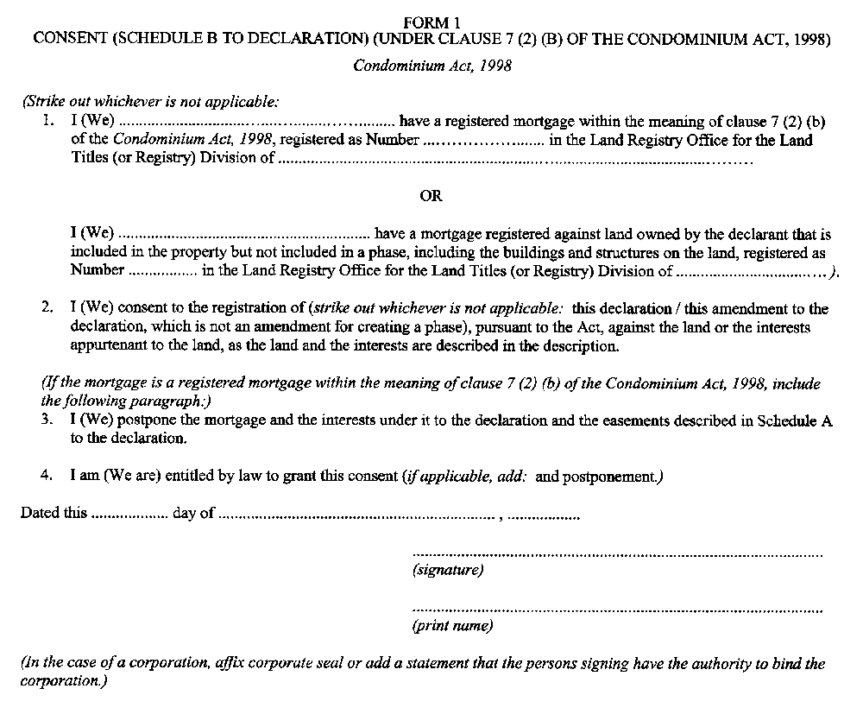
Form 2
CERTIFICATE OF ARCHITECT OR ENGINEER (SCHEDULE G TO DECLARATION FOR A STANDARD OR LEASEHOLD CONDOMINIUM CORPORATION) (under clause 8 (1) (e) or (h) of the Condominium Act, 1998)
Condominium Act, 1998
Insert regs\Graphics\Source Law\2001\48\048002ae.tif
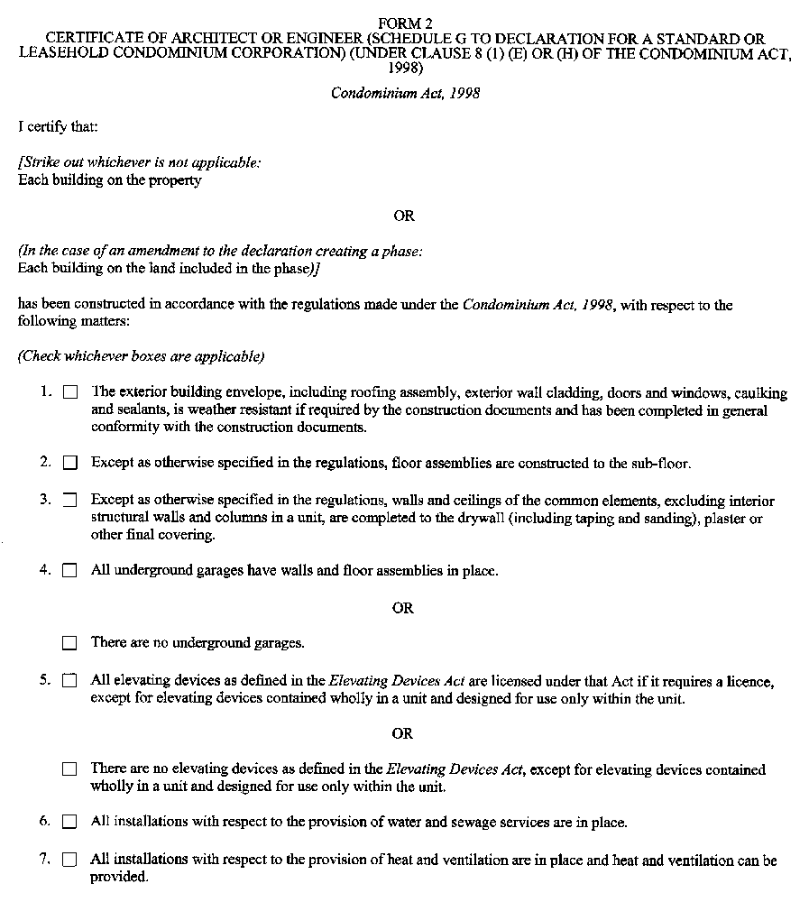
Insert regs\Graphics\Source Law\2001\48\048002be.tif
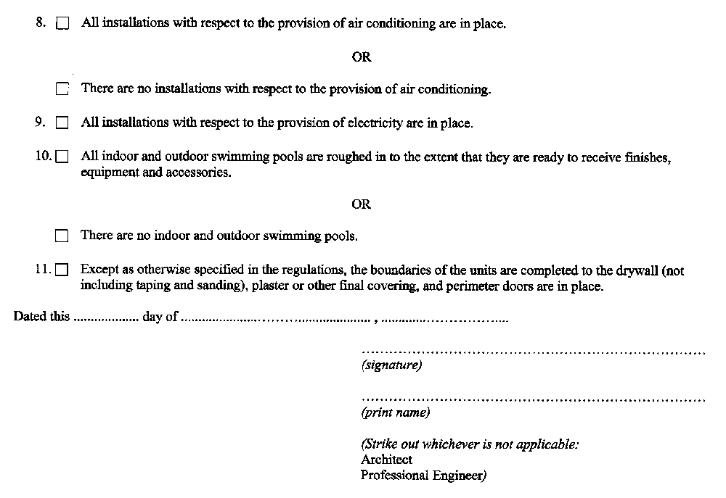
Form 3
Condominium Act, 1998
Insert regs\Graphics\Source Law\2001\48\048003ae.tif
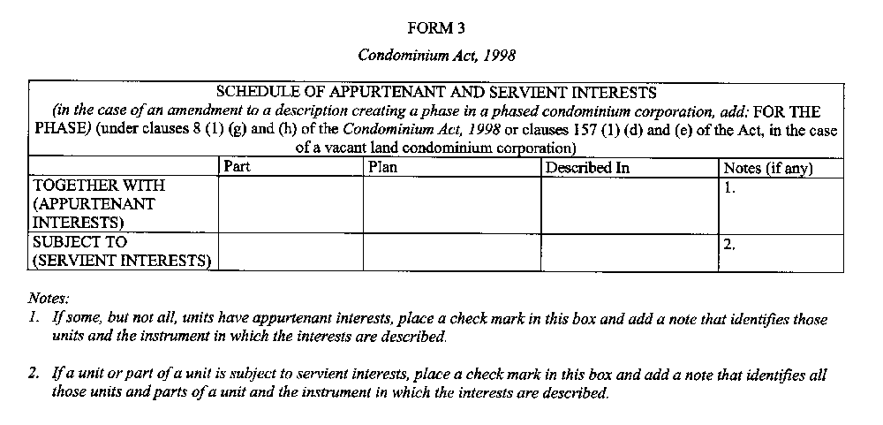
Form 4
CERTIFICATE OF REGISTRATION
Condominium Act, 1998
Insert regs\Graphics\Source Law\2001\48\048004ae.tif
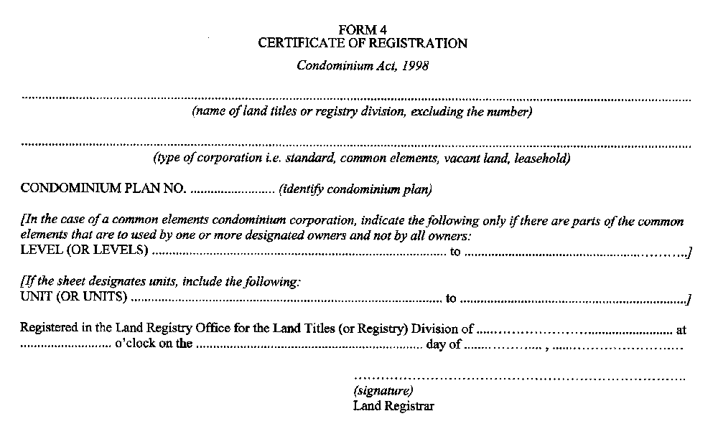
Form 5
SURVEYOR’S CERTIFICATE
Condominium Act, 1998
Insert regs\Graphics\Source Law\2001\48\048005ae.tif
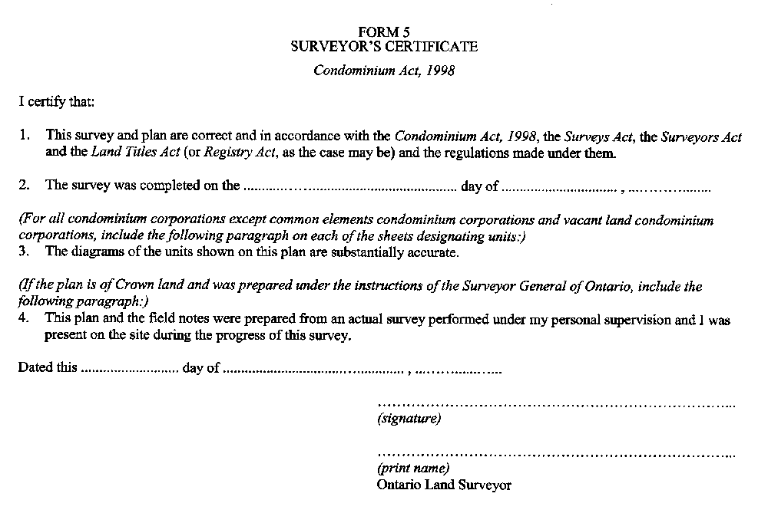
Form 6
CERTIFICATE OF DECLARANT OR OF AMALGAMATING CORPORATIONS
Condominium Act, 1998
Insert regs\Graphics\Source Law\2001\48\048006ae.tif
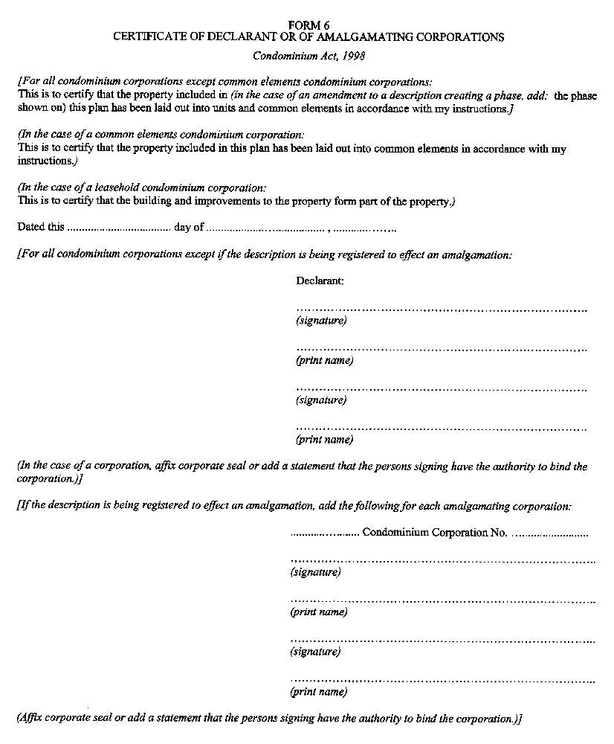
Form 7
SURVEYOR’S CERTIFICATE EXCLUSIVE USE COMMON ELEMENTS
Condominium Act, 1998
Insert regs\Graphics\Source Law\2001\48\048007ae.tif
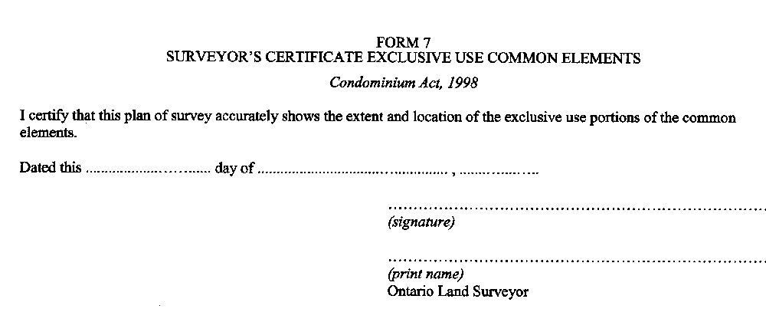
Form 8
PROXY FOR GENERAL MATTERS (under subsection 52 (6) of the Condominium Act, 1998)
Condominium Act, 1998
Insert regs\Graphics\Source Law\2001\48\048008ae.tif
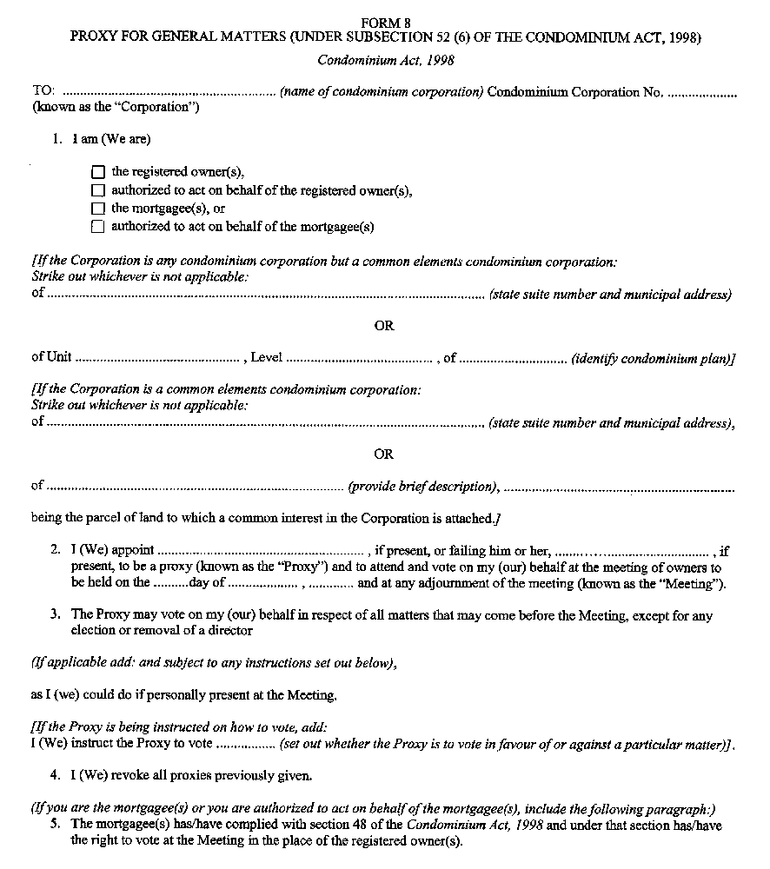
Insert regs\Graphics\Source Law\2001\48\048008be.tif
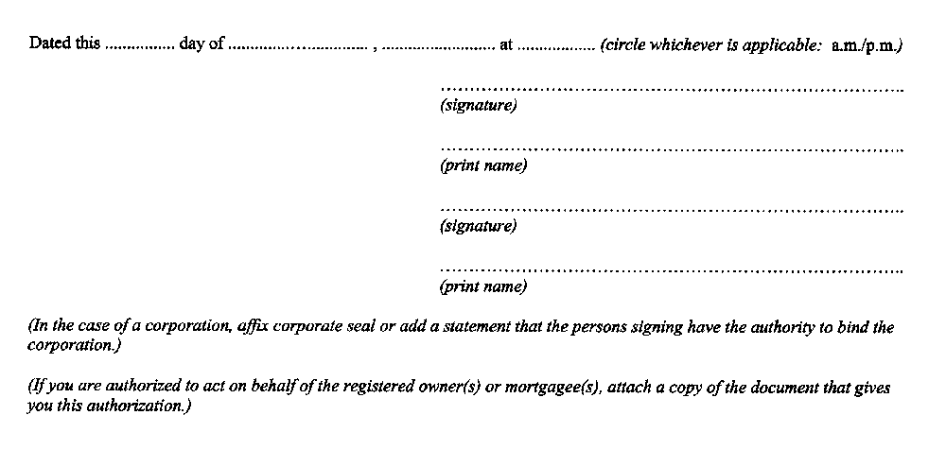
Form 9
PROXY FOR GENERAL MATTERS AND FOR THE ELECTION OF DIRECTORS (under subsection 52 (6) of the Condominium Act, 1998)
Condominium Act, 1998
Insert regs\Graphics\Source Law\2001\48\048009ae.tif
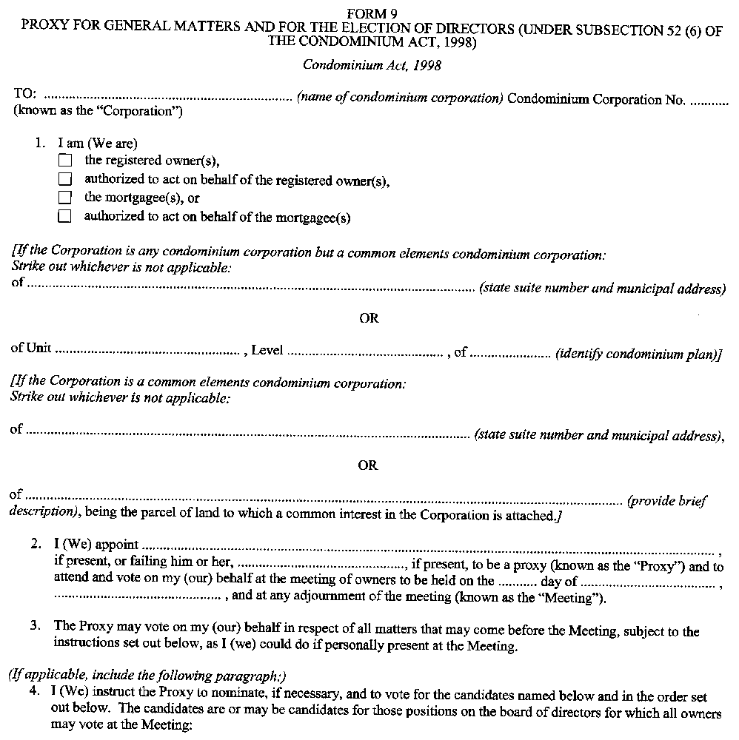
Insert regs\Graphics\Source Law\2001\48\048009be.tif
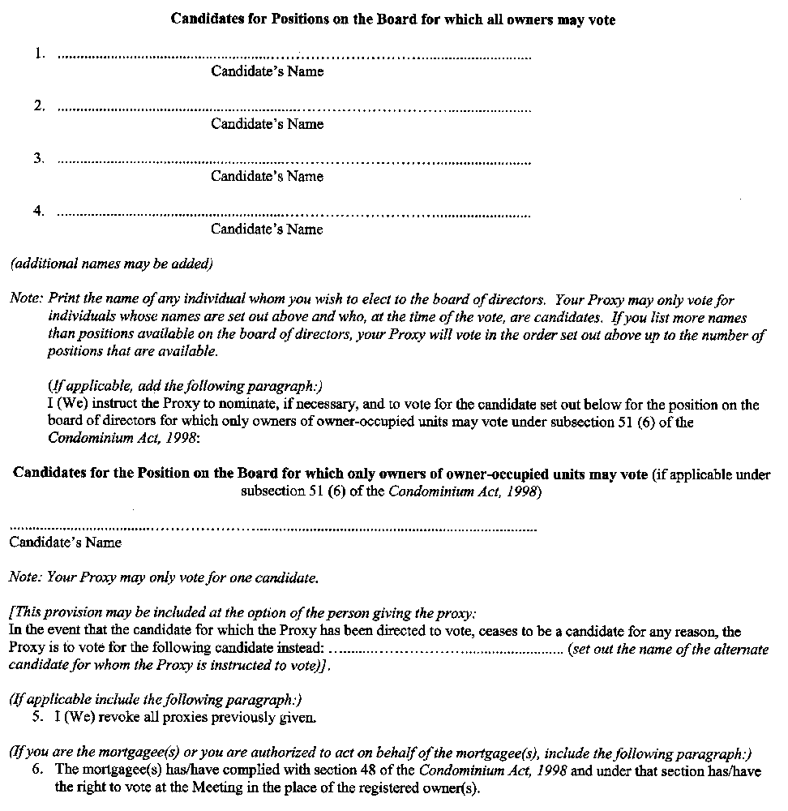
Insert regs\Graphics\Source Law\2001\48\048009ce.tif
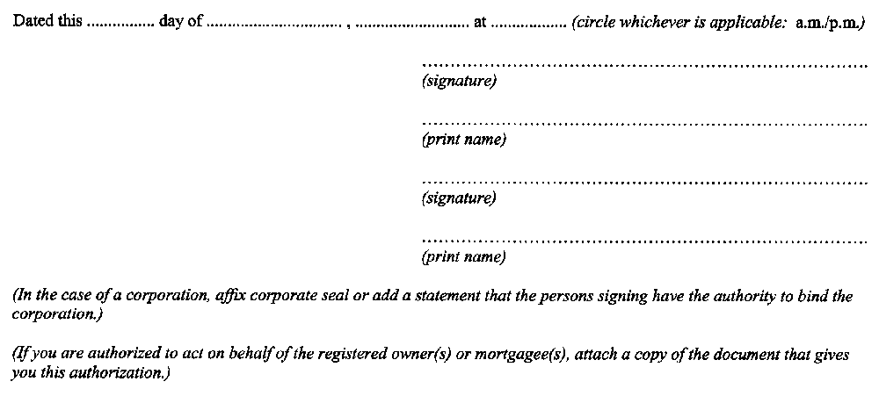
Form 10
PROXY FOR GENERAL MATTERS AND FOR THE REMOVAL OF DIRECTORS AND ELECTION OF SUBSTITUTES (under subsection 33 (2) of the Condominium Act, 1998)
Condominium Act, 1998
Insert regs\Graphics\Source Law\2001\48\048010ae.tif
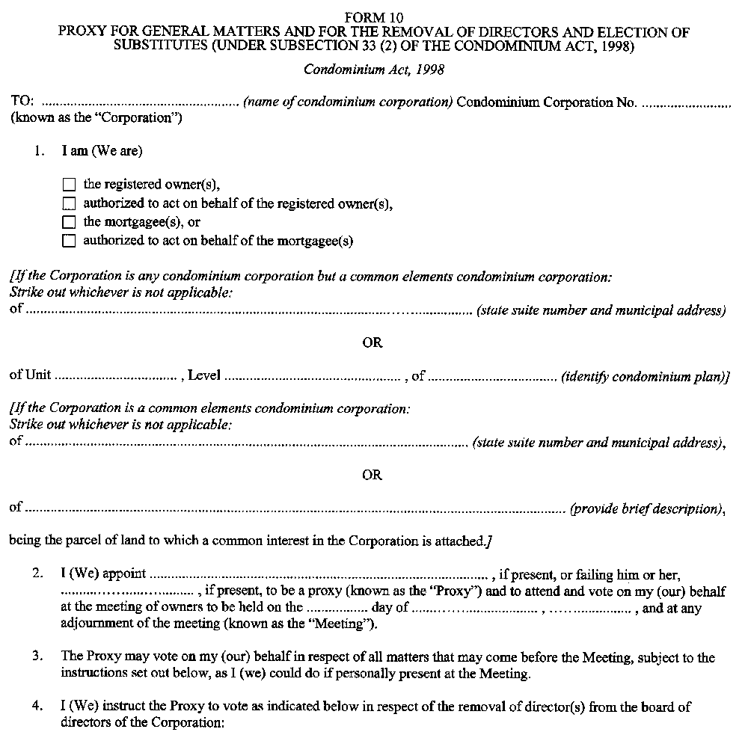
Insert regs\Graphics\Source Law\2001\48\048010be.tif
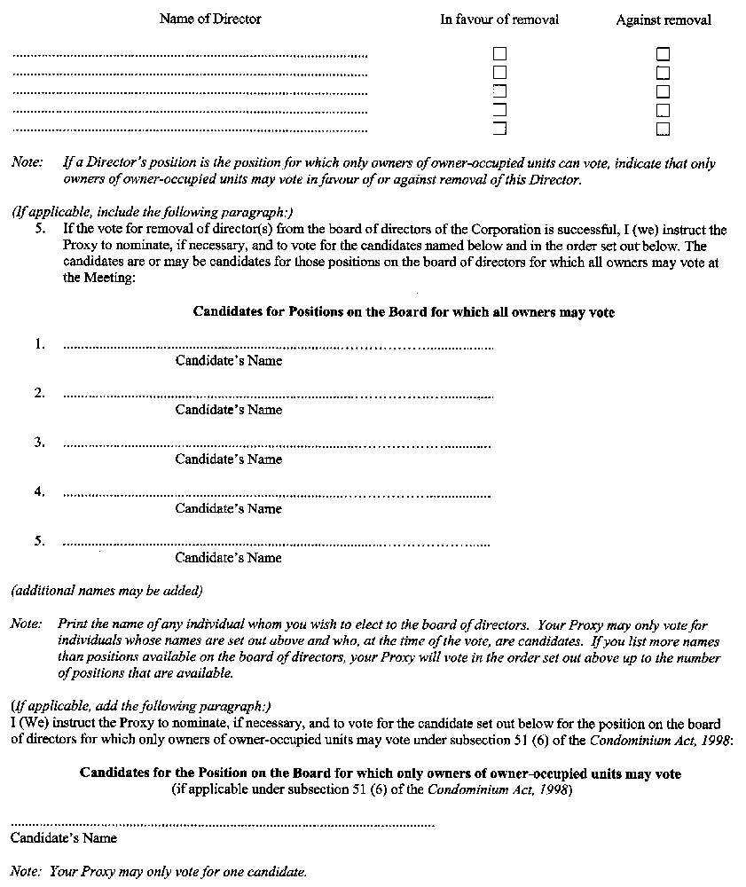
Insert regs\Graphics\Source Law\2001\48\048010ce.tif
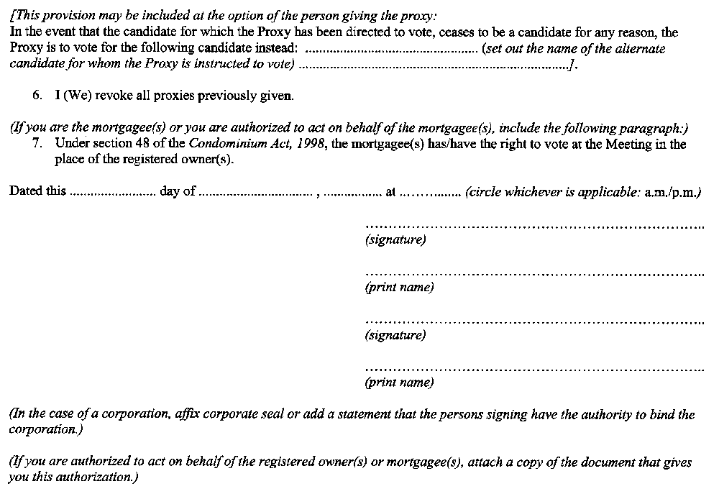
Form 11
CERTIFICATE IN RESPECT OF A BY-LAW (UNDER SUBSECTION 56 (9) OF THE CONDOMINIUM ACT, 1998)
Condominium Act, 1998
Insert regs\Graphics\Source Law\2001\48\048011ae.tif
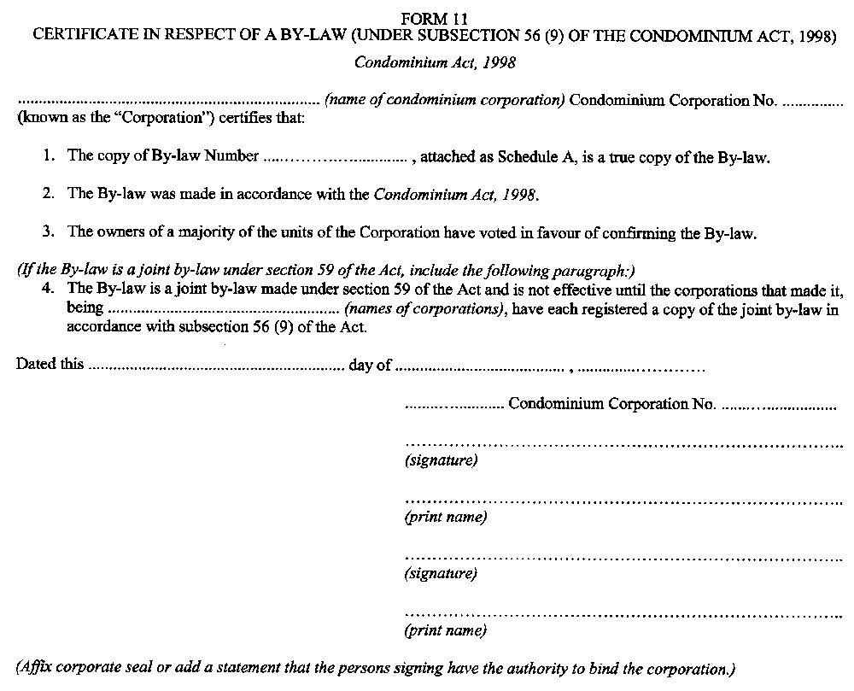
Form 12
DISCLOSURE STATEMENT TABLE OF CONTENTS (UNDER SUBSECTION 72 (4) OF THE CONDOMINIUM ACT, 1998)
Condominium Act, 1998
Insert regs\Graphics\Source Law\2001\48\048012ae.tif
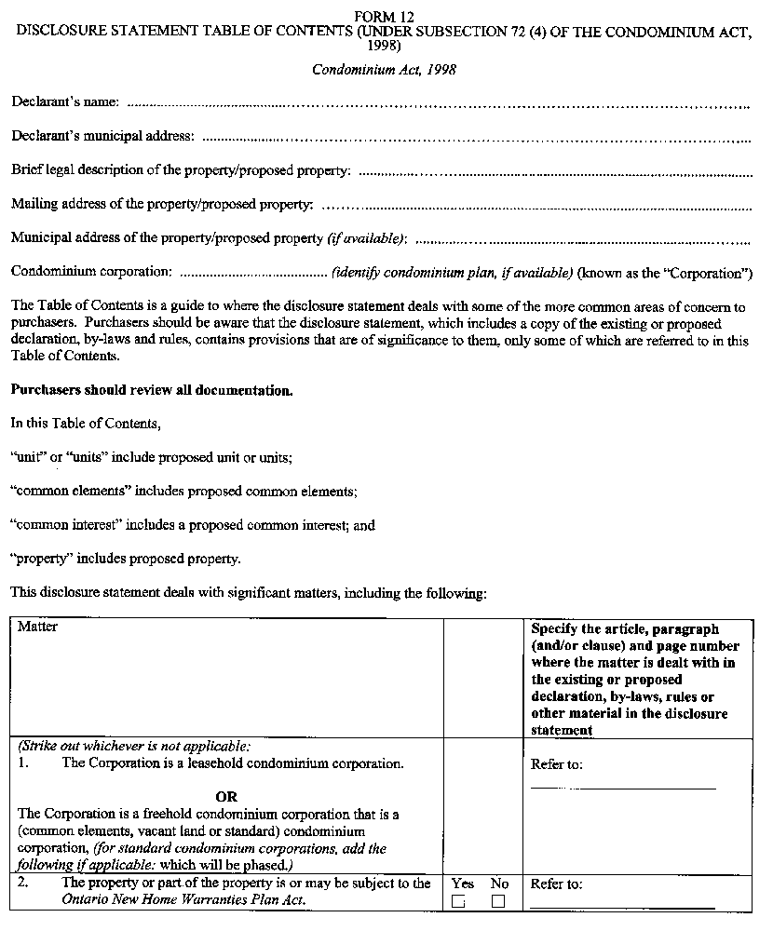
Insert regs\Graphics\Source Law\2001\48\048012be.tif
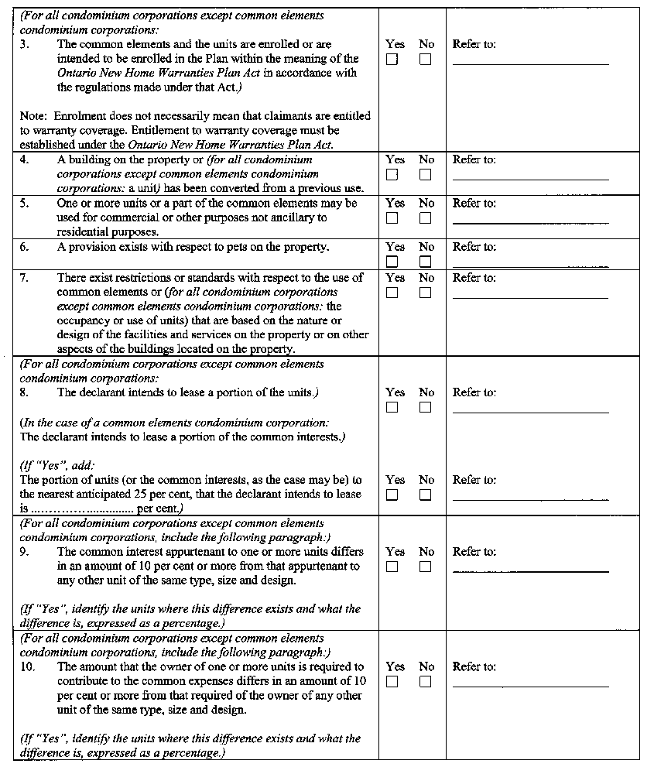
Insert regs\Graphics\Source Law\2001\48\048012ce.tif
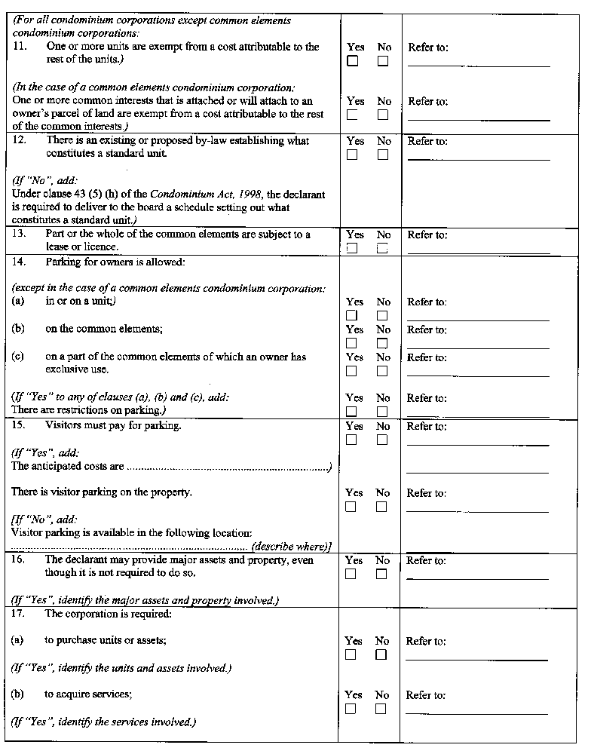
Insert regs\Graphics\Source Law\2001\48\048012de.tif
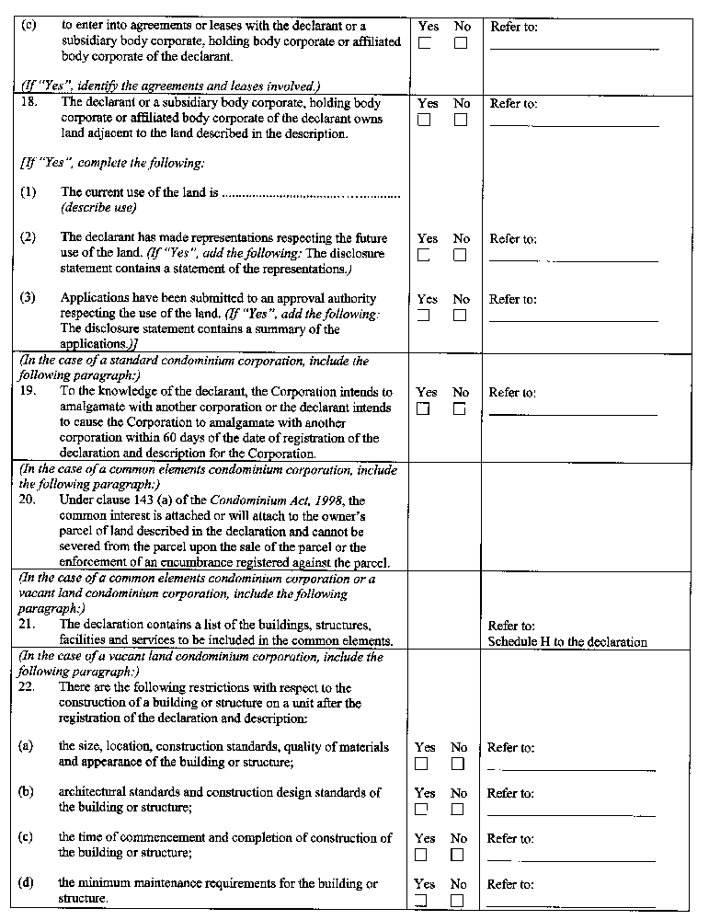
Insert regs\Graphics\Source Law\2001\48\048012ee.tif
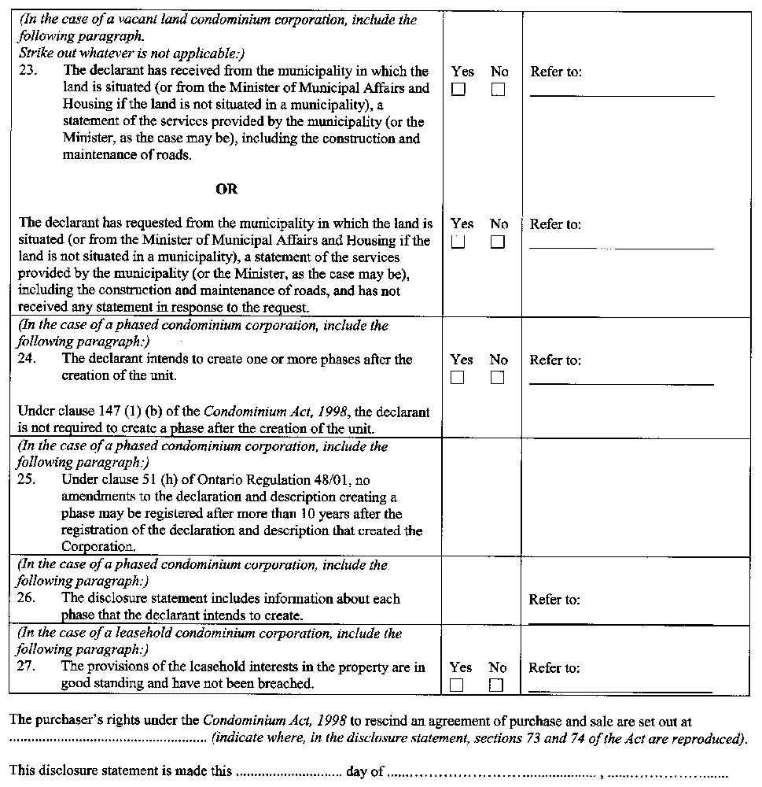
Form 13
STATUS CERTIFICATE (UNDER SUBSECTION 76 (1) OF THE CONDOMINIUM ACT, 1998)
Condominium Act, 1998
Insert regs\Graphics\Source Law\2001\48\048013ae.tif
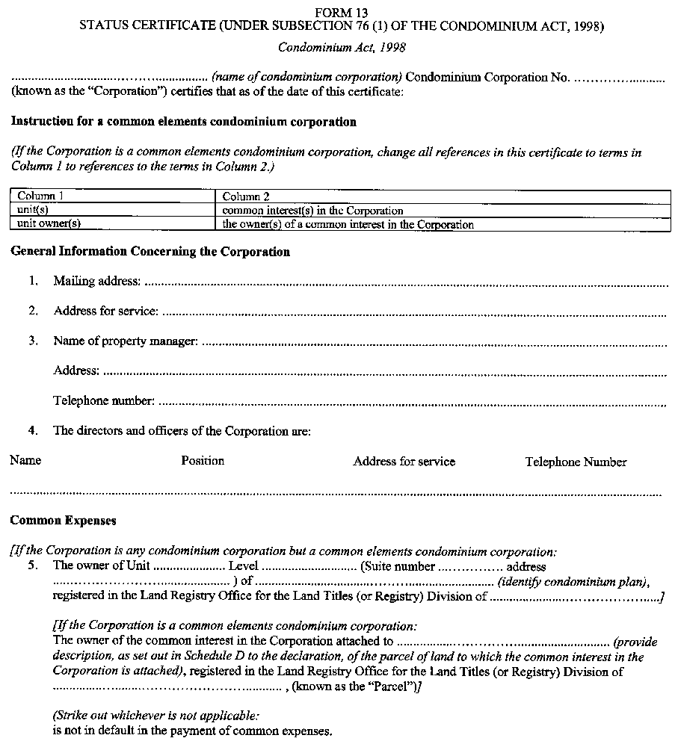
Insert regs\Graphics\Source Law\2001\48\048013be.tif
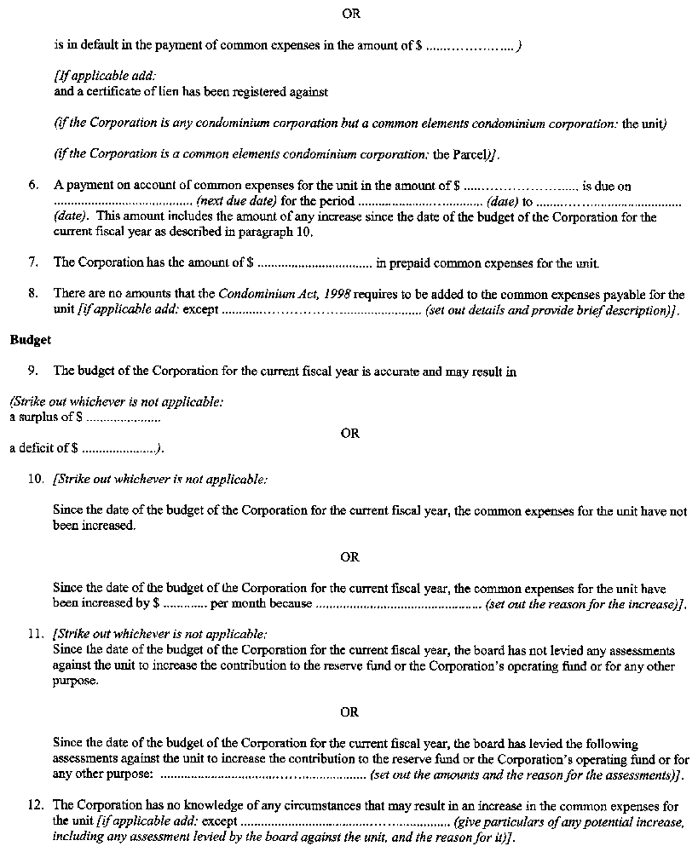
Insert regs\Graphics\Source Law\2001\48\048013ce.tif
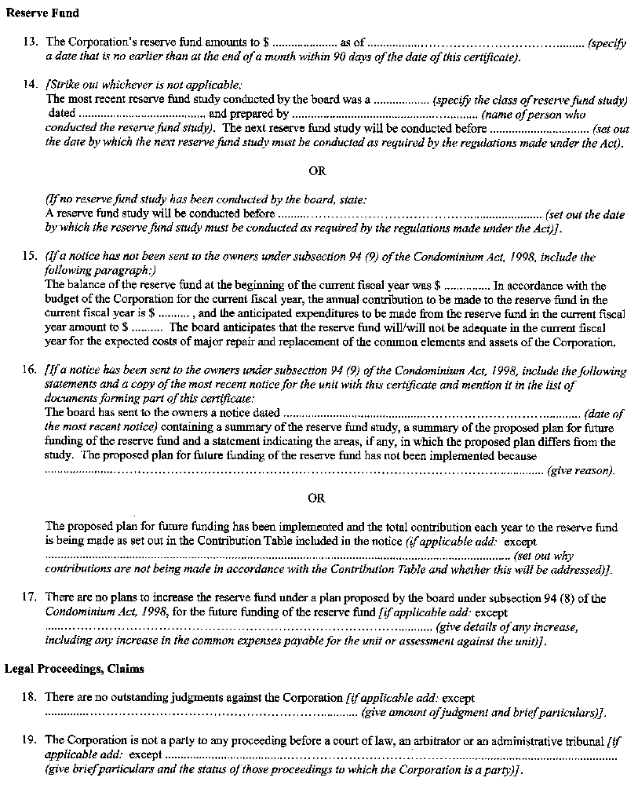
Insert regs\Graphics\Source Law\2001\48\048013de.tif
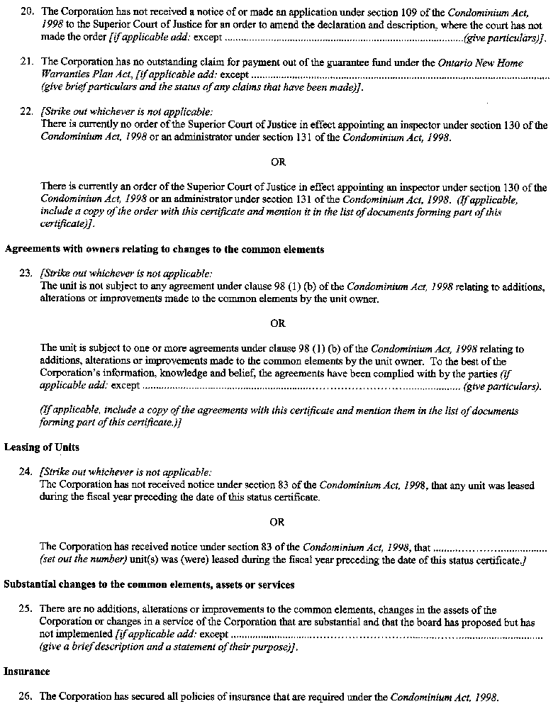
Insert regs\Graphics\Source Law\2001\48\048013ee.tif
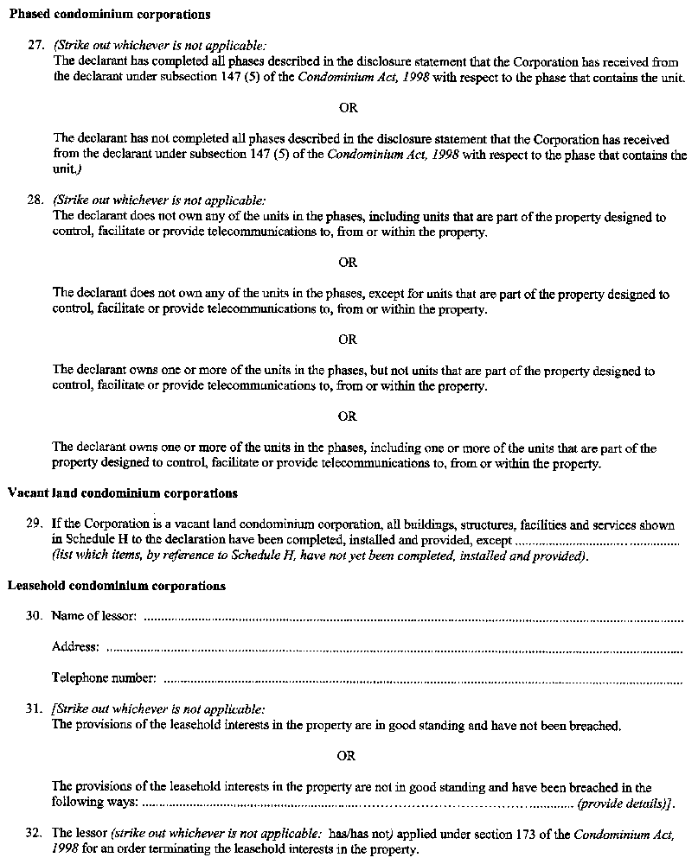
Insert regs\Graphics\Source Law\2001\48\048013fe.tif
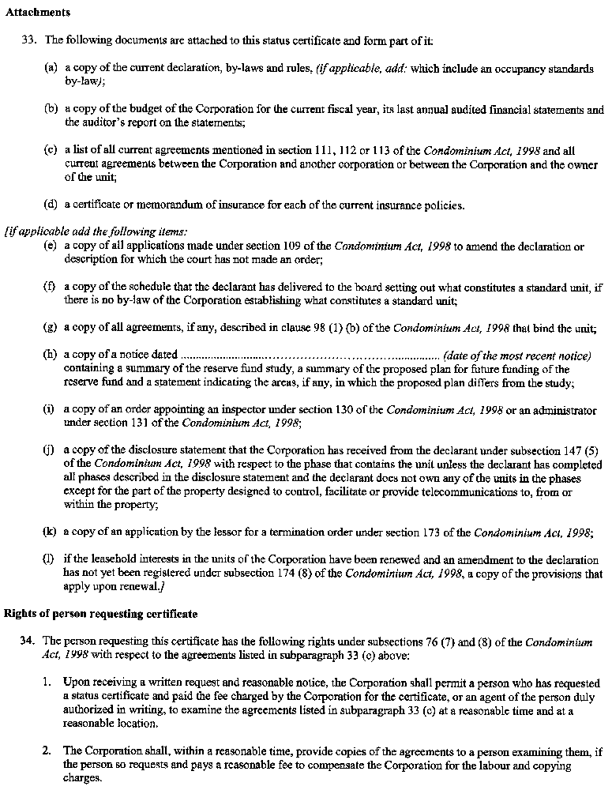
Insert regs\Graphics\Source Law\2001\48\048013ge.tif
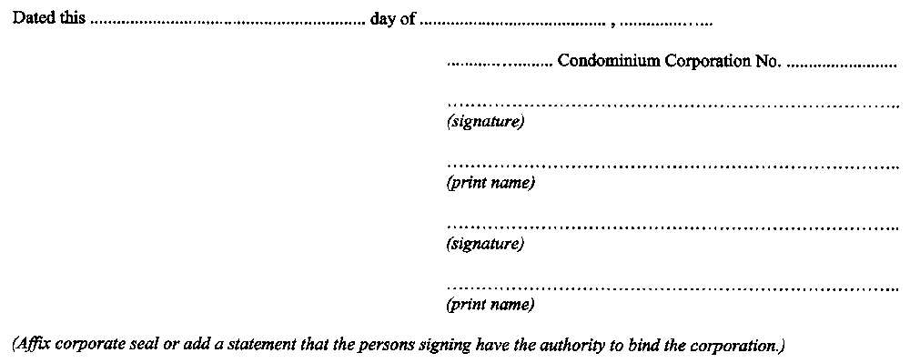

Form 14
NOTICE OF LIEN TO OWNER (UNDER SUBSECTION 85 (4) OF THE CONDOMINIUM ACT, 1998)
Condominium Act, 1998
Insert regs\Graphics\Source Law\2001\48\048014ae.tif
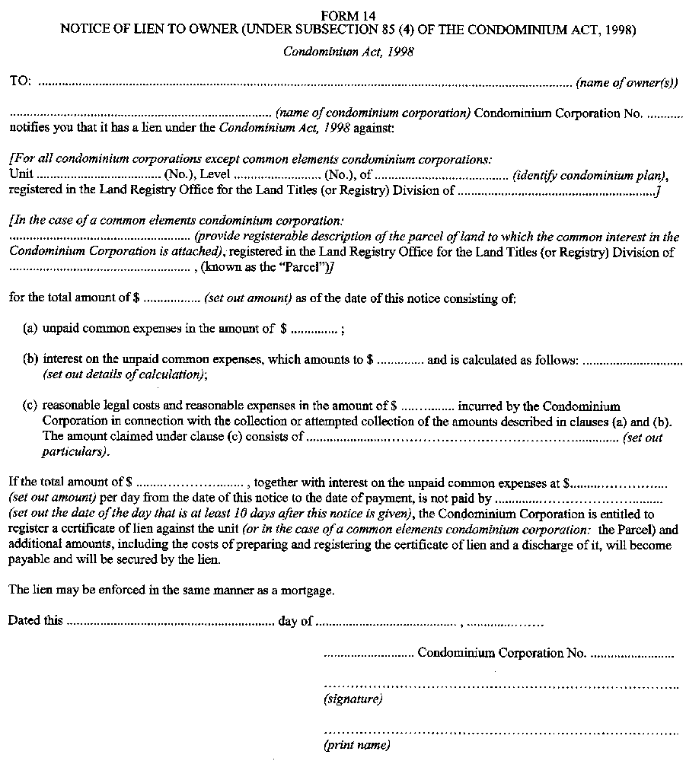
Insert regs\Graphics\Source Law\2001\48\048014be.tif

Form 15
NOTICE OF FUTURE FUNDING OF THE RESERVE FUND (UNDER SUBSECTION 94 (9) OF THE CONDOMINIUM ACT, 1998)
Condominium Act, 1998
Insert regs\Graphics\Source Law\2001\48\048015ae.tif
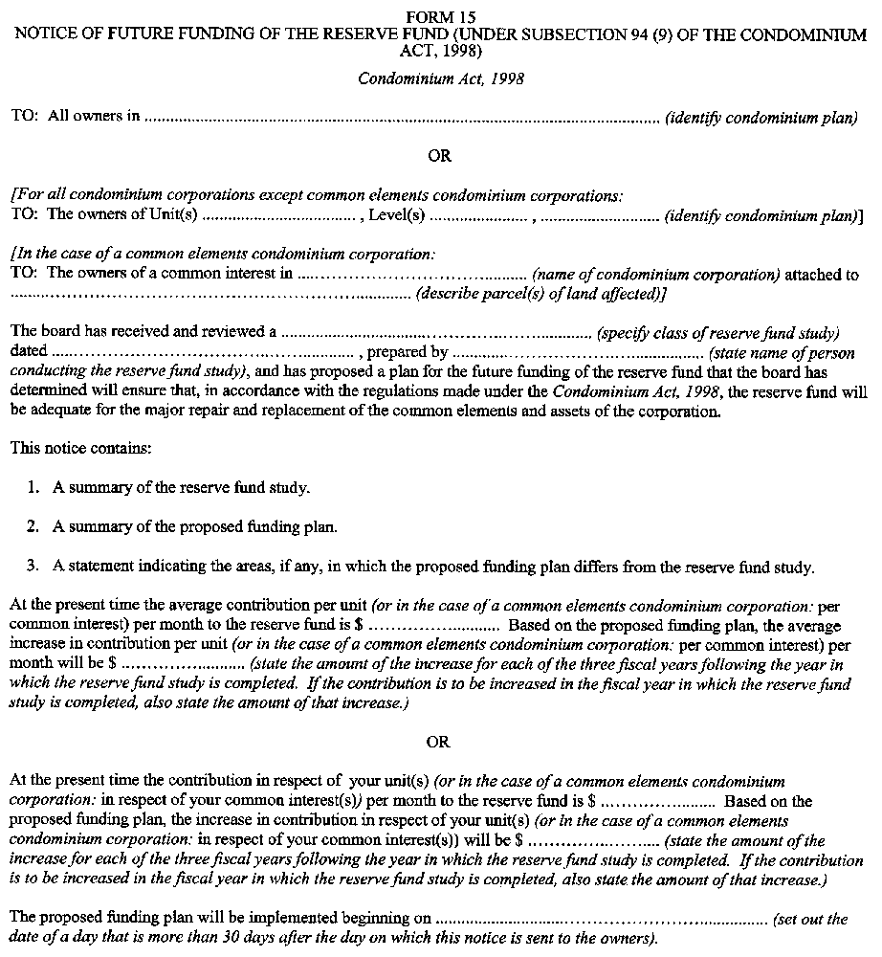
Insert regs\Graphics\Source Law\2001\48\048015be.tif
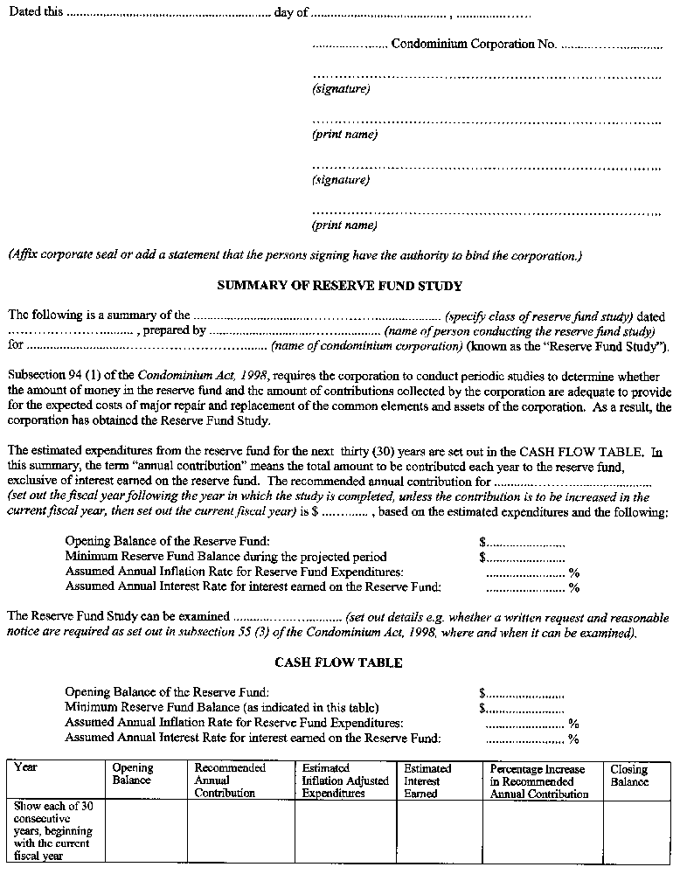
Insert regs\Graphics\Source Law\2001\48\048015ce.tif
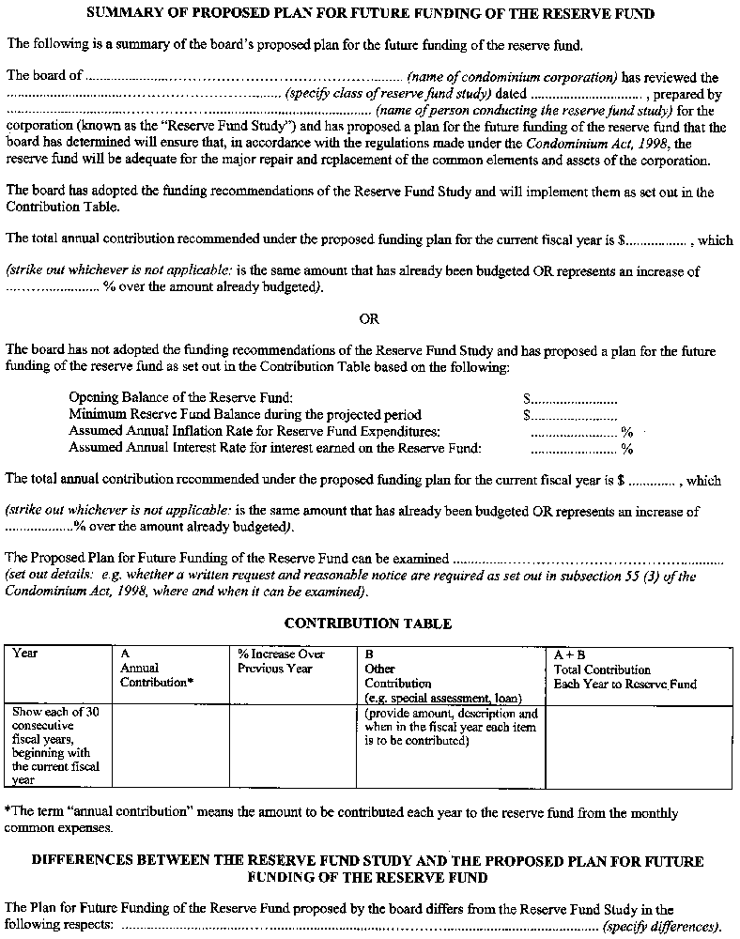
Form 16
CONSENT TO ATTACHMENT OF A COMMON INTEREST (SCHEDULE B TO DECLARATION FOR A COMMON ELEMENTS CONDOMINIUM CORPORATION) (under clause 140 (c) of the Condominium Act, 1998)
Condominium Act, 1998
Insert regs\Graphics\Source Law\2001\48\048016ae.tif
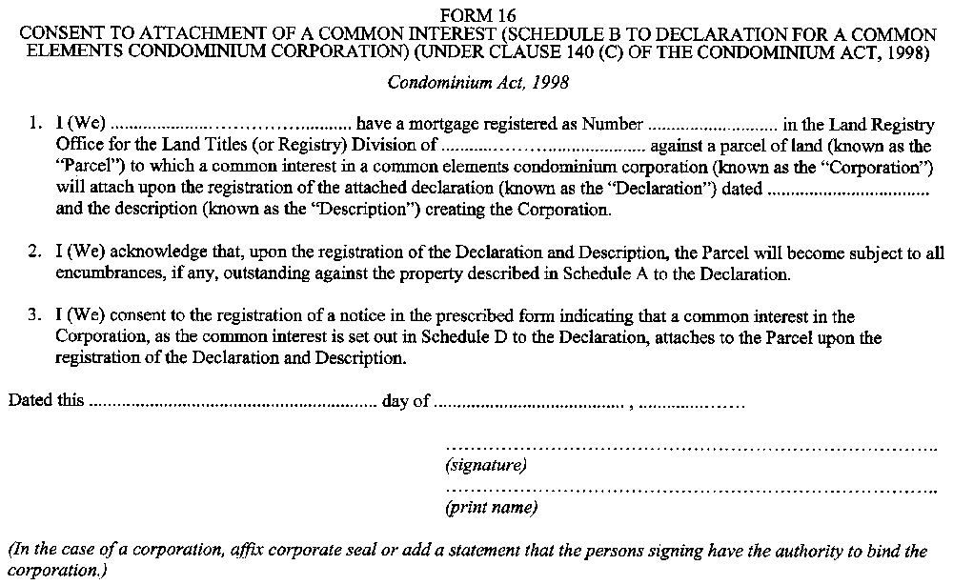
Form 17
CERTIFICATE OF ARCHITECT OR ENGINEER (SCHEDULE G TO DECLARATION FOR A COMMON ELEMENTS OR VACANT LAND CONDOMINIUM CORPORATION) (under clauses 8 (1) (e) and (h) or clauses 157 (1) (c) and (e) of the Condominium Act, 1998)
Condominium Act, 1998
Insert regs\Graphics\Source Law\2001\48\048017ae.tif
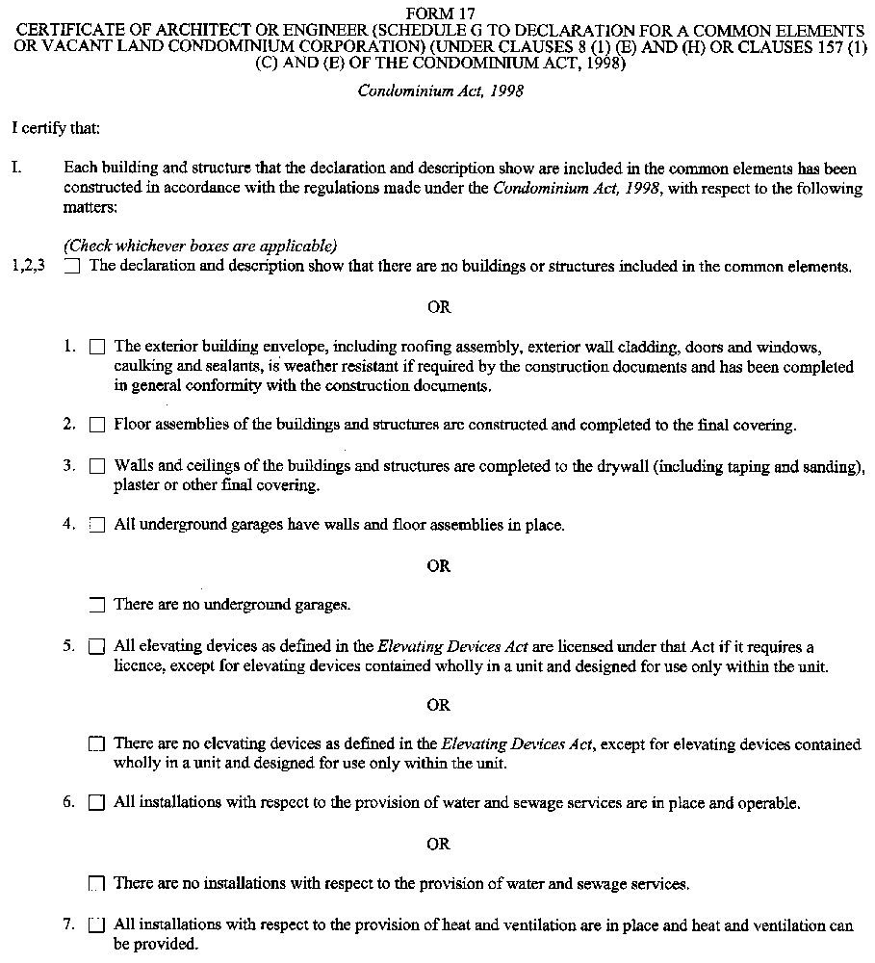
Insert regs\Graphics\Source Law\2001\48\048017be.tif
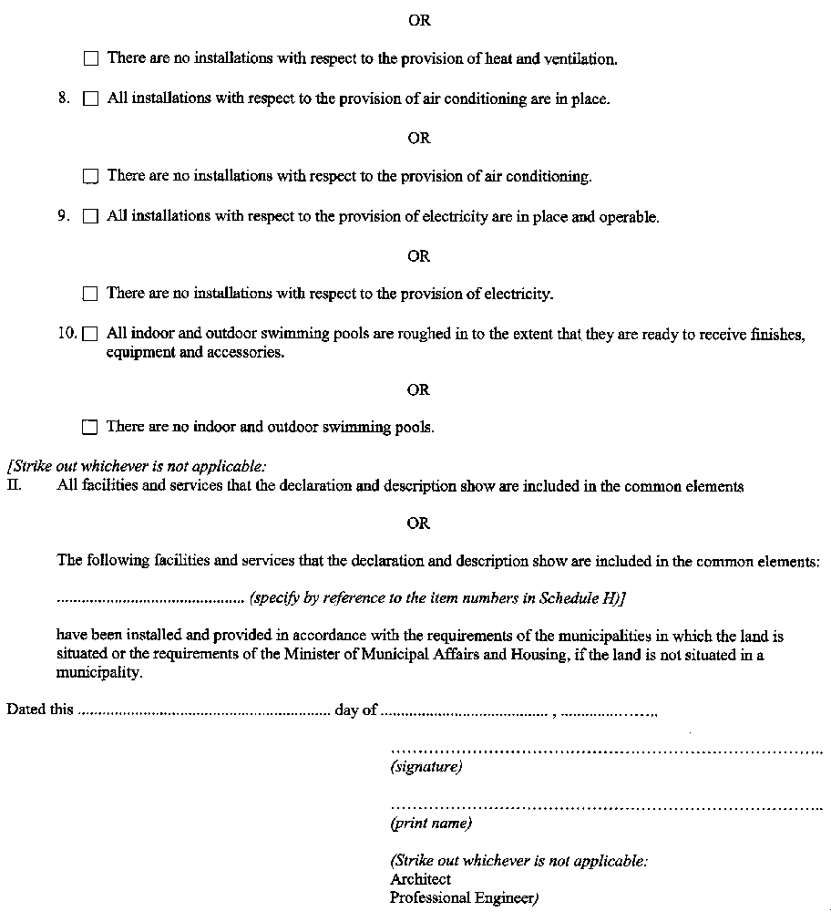
Form 18
CONSENT AND POSTPONEMENT (AMENDMENT TO SCHEDULE B TO DECLARATION OF A PHASED CONDOMINIUM CORPORATION TO CREATE A PHASE) (under clause 146 (4) (a) of the Condominium Act, 1998)
Condominium Act, 1998
Insert regs\Graphics\Source Law\2001\48\048018ae.tif
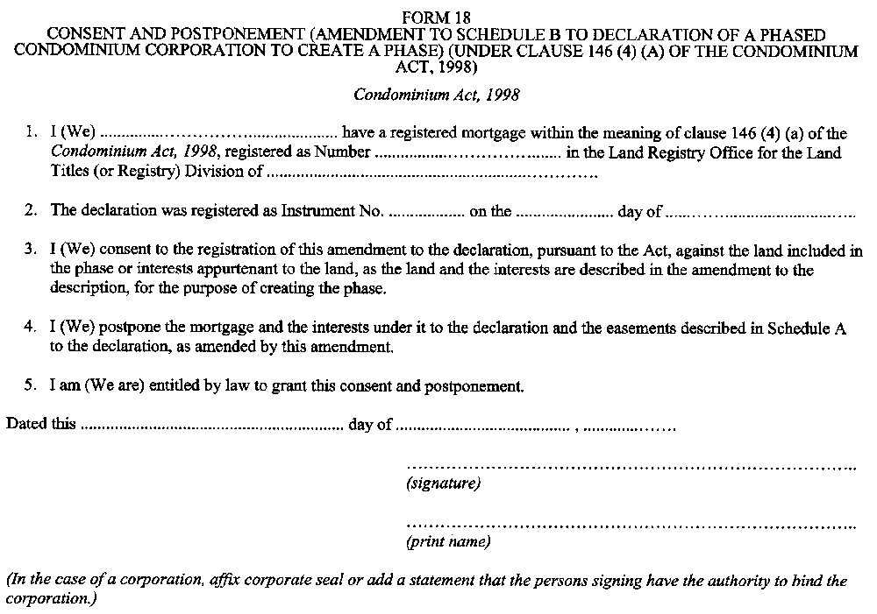
Form 19
AMENDMENT TO DECLARATION AND DESCRIPTION TO CREATE A PHASE (subsection 146 (3) of the Condominium Act, 1998)
Condominium Act, 1998
Insert regs\Graphics\Source Law\2001\48\048019ae.tif
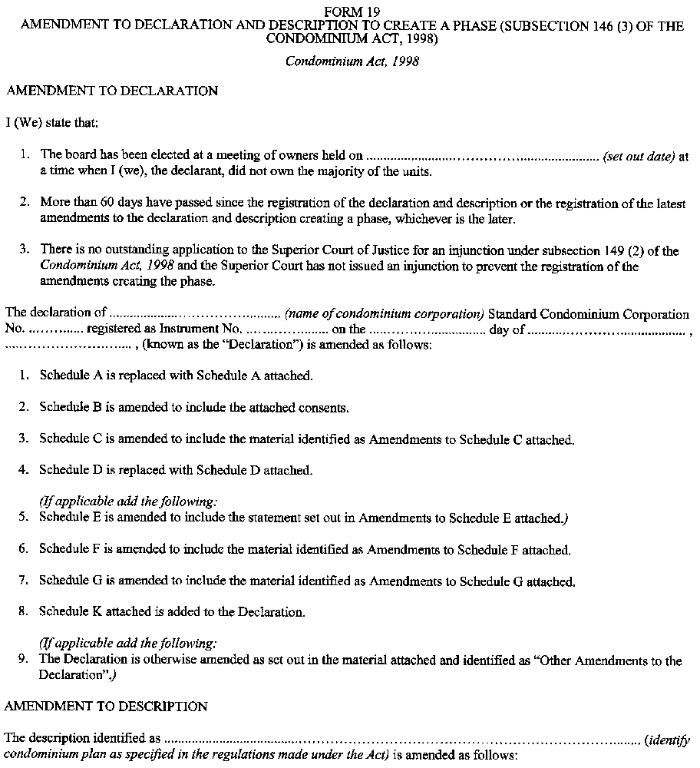
Insert regs\Graphics\Source Law\2001\48\048019be.tif
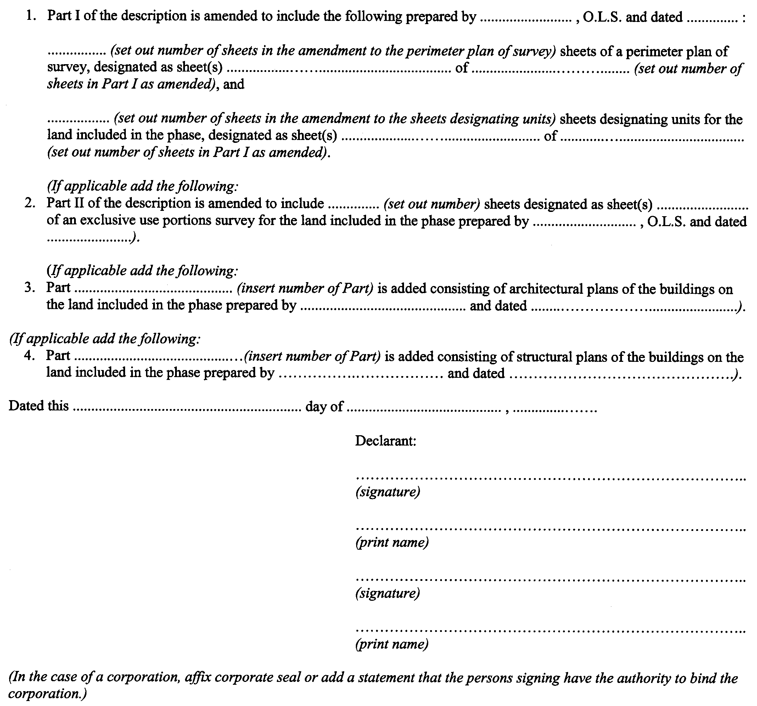
Form 20
CERTIFICATE OF REGISTRATION OF AMENDMENT TO DECLARATION AND DESCRIPTION CREATING A PHASE
Condominium Act, 1998
Insert regs\Graphics\Source Law\2001\48\048020ae.tif
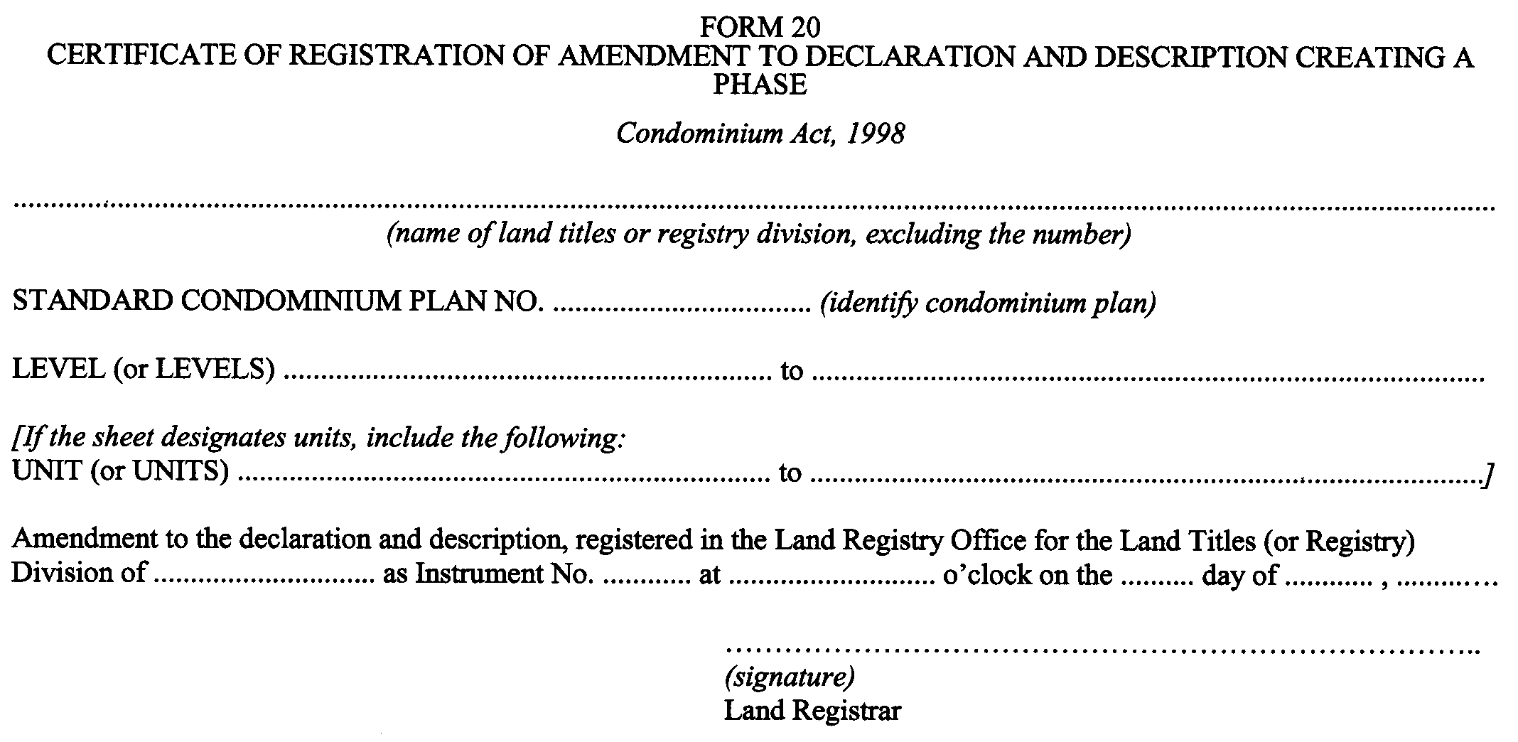
Form 21
AMENDMENT TO DESCRIPTION FOR A VACANT LAND CONDOMINIUM CORPORATION (under clause 158 (3) (b) of the Condominium Act, 1998)
Condominium Act, 1998
Insert regs\Graphics\Source Law\2001\48\048021ae.tif
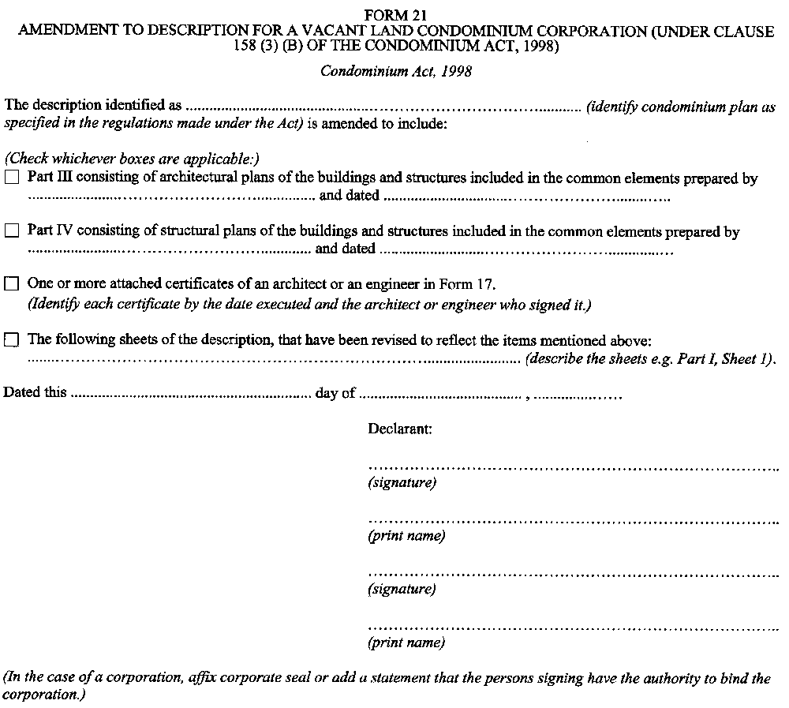
Form 22
AMENDMENT TO DECLARATION FOR A LEASEHOLD CONDOMINIUM CORPORATION (under subsection 174 (8) of the Condominium Act, 1998)
Condominium Act, 1998
Insert regs\Graphics\Source Law\2001\48\048022ae.tif
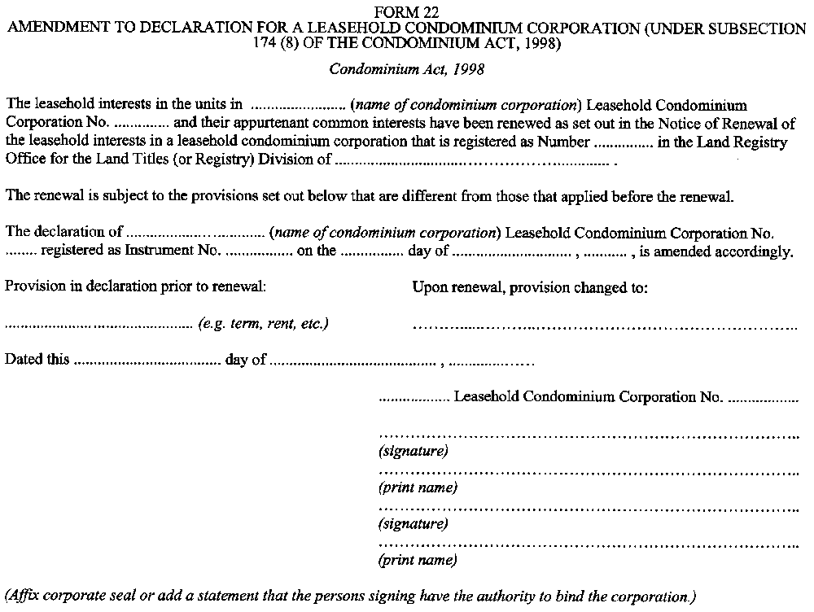
Form 23
NOTICE OF INTENTION TO RENEW THE LEASEHOLD INTERESTS IN A LEASEHOLD CONDOMINIUM CORPORATION (under clause 174 (1) (a) of the Condominium Act, 1998)
Condominium Act, 1998
Insert regs\Graphics\Source Law\2001\48\048023ae.tif
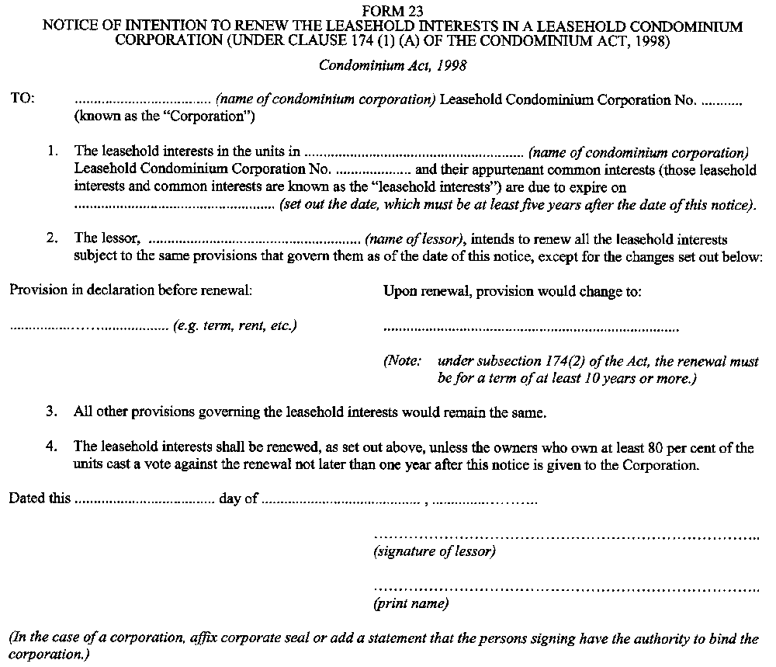
Form 24
NOTICE OF INTENTION NOT TO RENEW THE LEASEHOLD INTERESTS IN A LEASEHOLD CONDOMINIUM CORPORATION (under clause 174 (1) (b) of the Condominium Act, 1998)
Condominium Act, 1998
Insert regs\Graphics\Source Law\2001\48\048024ae.tif
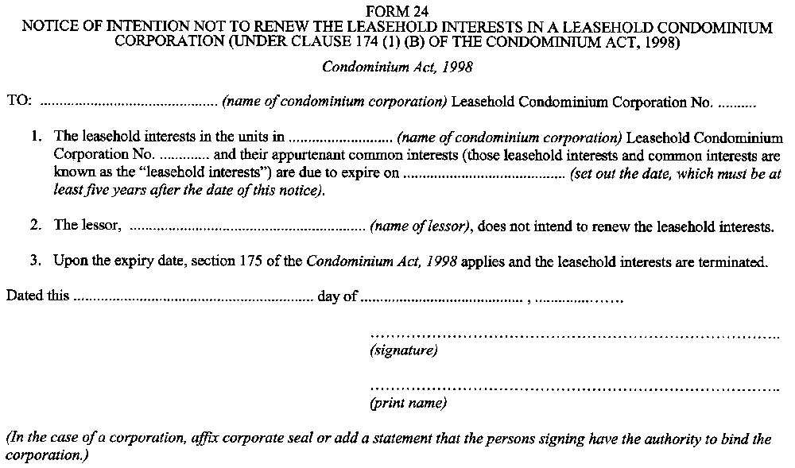
Form 25
NOTICE OF DEEMED RENEWAL OF LEASEHOLD INTERESTS IN A LEASEHOLD CONDOMINIUM CORPORATION (under subsection 174 (4) of the Condominium Act, 1998)
Condominium Act, 1998
Insert regs\Graphics\Source Law\2001\48\048025ae.tif
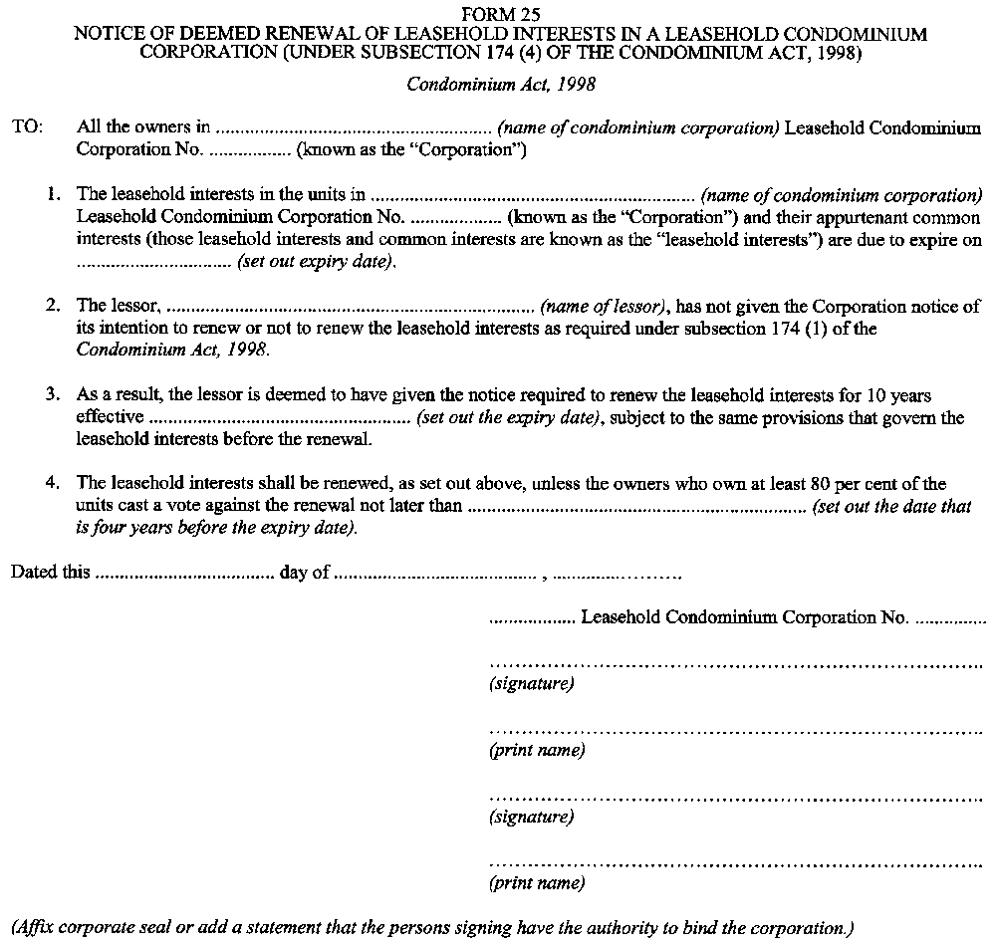
Form 26
NOTICE OF NON-RENEWAL OF LEASEHOLD INTERESTS IN A LEASEHOLD CONDOMINIUM CORPORATION (under subsection 174 (6) of the Condominium Act, 1998)
Condominium Act, 1998
Insert regs\Graphics\Source Law\2001\48\048026ae.tif
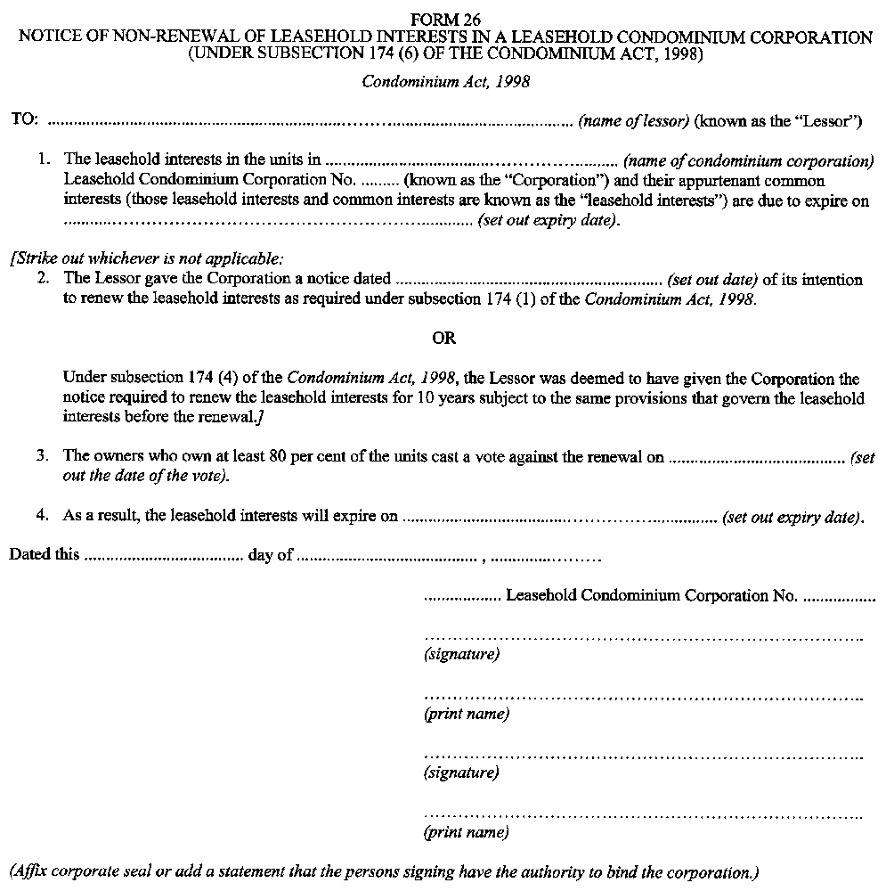

Back to top

