Français
ontario regulation 337/02
made under the
Courts of justice act
Made: June 18, 2002
Approved: December 4, 2002
Filed: December 6, 2002
Printed in The Ontario Gazette: December 21, 2002
Amending O. Reg. 114/99
(Family Law Rules)
1. Subrule 8 (1) of Ontario Regulation 114/99 is amended by striking out “(Form 8, 8A, 8B, 8C or 8D)” and substituting “(Form 8, 8A, 8B, 8C, 8D or 8D.1)”.
2. Rule 10 of the Regulation is amended by adding the following subrule:
EXCEPTION — PLACEMENT FOR ADOPTION
(2.1) In an application to dispense with a parent’s consent before adoption placement, (Form 8D.1), the time for serving the answer is,
(a) 20 days, if the application is served in Canada or the United States of America;
(b) 40 days, if the application is served outside Canada or the United States of America.
3. (1) Rule 34 of the Regulation is amended by adding the following subrule:
USE OF INITIALS IN DOCUMENTS
(2.1) An applicant or respondent may be referred to by only the first letter of his or her surname in any document in the case, except that,
(a) the applicant’s full names shall appear in the adoption order; and
(b) the child’s full names shall appear in the adoption order, unless the court orders that the child’s first name and the first letter of his or her surname be used.
(2) Paragraph 3 of subrule 34 (4) of the Regulation is amended by striking out “the person giving the child up for adoption”.
(3) Subrule 34 (6) of the Regulation is amended by adding the following paragraph:
6. If the child is an Indian or native person, proof of 30 days written notice to the child’s band or native community of the intention to place the child for adoption.
(4) Paragraph 2 of subrule 34 (7) of the Regulation is revoked.
(5) Paragraph 3 of subrule 34 (7) of the Regulation is revoked and the following substituted:
3. A consent to adoption (Form 34F) under section 137 of the Act from every parent, other than the applicant, of whom the person placing the child or an applicant is aware. An order under section 138 of the Act dispensing with a parent’s consent may be filed instead of the consent.
(6) Subrule 34 (7) of the Regulation is amended by adding the following paragraph:
6. If the child is an Indian or native person, proof of 30 days written notice to the child’s band or native community of the intention to place the child for adoption.
(7) Subrules 34 (9), (10) and (11) of the Regulation are revoked and the following substituted:
APPLICATION BY STEP-PARENT OR RELATIVE
(9) An application by a relative of the child or the spouse of the child’s parent,
(a) shall not be commenced until the 21-day period referred to in subsection 137 (8) of the Act has expired; and
(b) shall be accompanied by the applicant’s affidavit confirming that he or she did not receive a withdrawal of consent during the 21-day period.
STEP-PARENT ADOPTION, parent’s CONSENT
(10) An application by the spouse of the child’s parent shall be accompanied by the parent’s consent (Form 34I).
INDEPENDENT LEGAL ADVICE, CHILD’S CONSENT
(11) The consent of a child to be adopted (Form 34) shall be witnessed by a representative of the Children’s Lawyer, who shall complete the affidavit of execution and independent legal advice contained in the form.
INDEPENDENT LEGAL ADVICE, CONSENT OF PARENT UNDER 18
(11.1) The consent of a person under the age of 18 years who is a parent of the child to be adopted (Form 34F) shall be witnessed by a representative of the Children’s Lawyer, who shall complete an affidavit of execution and independent legal advice (Form 34J).
(8) Subrule 34 (12) of the Regulation is amended by striking out “or other person with legal custody or control”.
(9) Rule 34 of the Regulation is amended by adding the following subrules:
WITHDRAWAL OF CONSENT BY PARENT
(13.1) A parent who has given consent to an adoption under subsection 137 (2) of the Act may withdraw the consent under subsection 137 (8) of the Act in accordance with the following:
1. If the child is placed for adoption by a children’s aid society, the parent who wishes to withdraw the consent shall ensure that the children’s aid society receives the written withdrawal within 21 days after the consent was given.
2. If the child is placed for adoption by a licensee, the parent who wishes to withdraw the consent shall ensure that the licensee receives the written withdrawal within 21 days after the consent was given.
3. If a relative of the child or a spouse of a parent proposes to apply to adopt the child, the parent who wishes to withdraw the consent shall ensure that the relative or spouse receives the written withdrawal within 21 days after the consent was given.
WITHDRAWAL OF CONSENT BY CHILD AGED SEVEN OR OLDER
(13.2) A child who has given consent to an adoption under subsection 137 (6) of the Act may withdraw the consent under subsection 137 (8) of the Act in accordance with the following:
1. The withdrawal shall be signed within 21 days after the consent was given, and witnessed by the person who witnessed the consent under subrule (11) or by another representative of the Children’s Lawyer.
2. The person who witnesses the withdrawal shall give the original withdrawal document to the child and promptly serve a copy on the children’s aid society, licensee, relative or spouse, as the case may be, by regular service.
(10) Subrule 34 (14) of the Regulation is amended by striking out “a motion to withdraw a consent to an adoption” and substituting “a motion to withdraw a consent to an adoption under subsection 139 (1) of the Act”.
(11) Rule 34 of the Regulation is amended by adding the following subrules:
DISPENSING WITH CONSENT BEFORE PLACEMENT
(16) In an application to dispense with a parent’s consent before placement for adoption,
(a) the applicant may be the licensee, a parent, the children’s aid society or the person who wants to adopt;
(b) the respondent is the person who has not given consent;
(c) if an order that service is not required is sought, the request shall be made in the application and not by motion;
(d) if the application is being served, the applicant shall serve and file with it an affidavit (Form 14A) setting out the facts of the case;
(e) if the application is not being served, the applicant shall file with it an affidavit (Form 14A) setting out the facts of the case, and the clerk shall send the case to a judge for a decision on the basis of affidavit evidence.
TRANSITIONAL PROVISION —- CONSENT, EVIDENCE OF PARENTAGE
(17) If a consent to adoption was validly given before November 15, 1999,
(a) it remains valid under these rules; and
(b) the evidence of parentage is acceptable if it was acceptable under the rules in effect when the consent was given.
REVOCATION
(18) Subrule (17) is revoked on December 31, 2004.
4. (1) Form 8D of the Regulation is revoked and the following substituted:
Form 8D
Courts of Justice Act
APPLICATION (adoption)
Insert regs\Graphics\Source Law\2002\337\337008de.tif
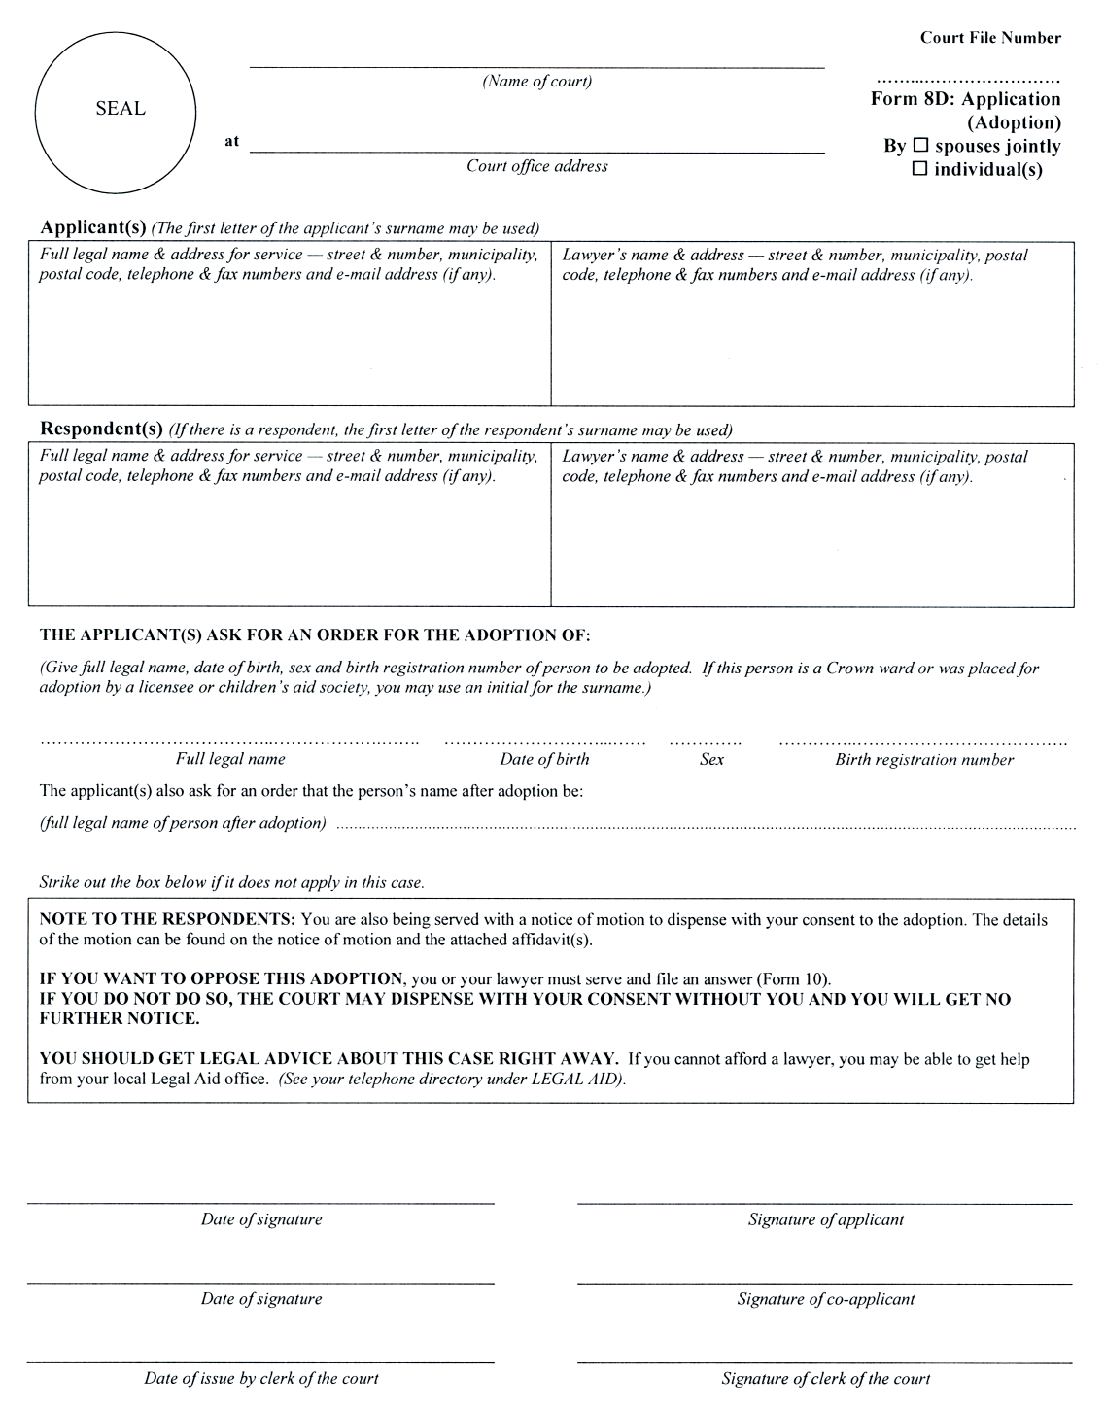
Form 8D.1
Courts of Justice Act
APPLICATION (DISPENSE WITH PARENT’S CONSENT TO adoption BEFORE PLACEMENT)
Insert regs\Graphics\Source Law\2002\337\33708d1e.tif
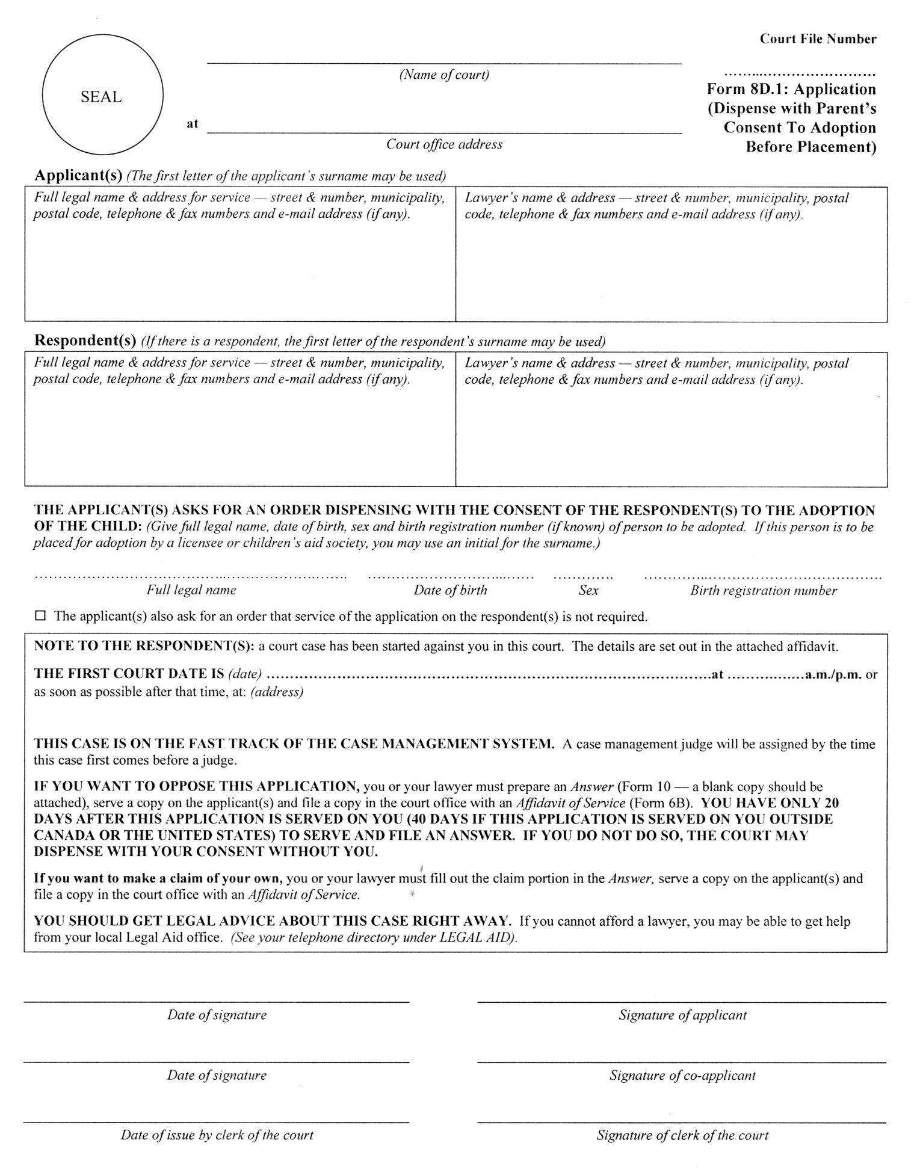
(2) Form 25C of the Regulation is revoked and the following substituted:
Form 25C
Courts of Justice Act
adoption ORDER
Insert regs\Graphics\Source Law\2002\337\337025ce.tif
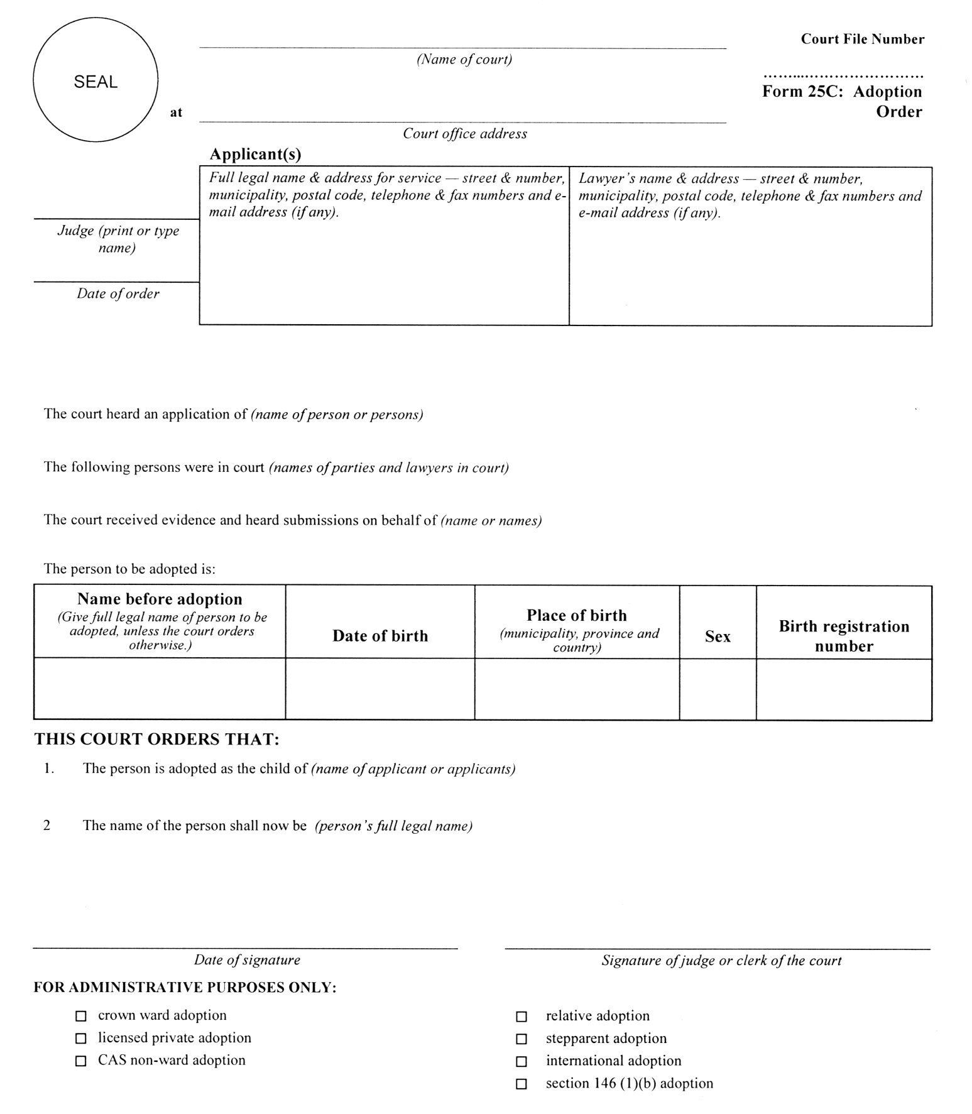
(3) Forms 34, 34A, 34B, 34C, 34D, 34E, 34F, 34G, 34H, 34I, 34J and 34K of the Regulation are revoked and the following substituted:
Form 34
Courts of Justice Act
child’s consent to adoption
Insert regs\Graphics\Source Law\2002\337\337034ae.tif
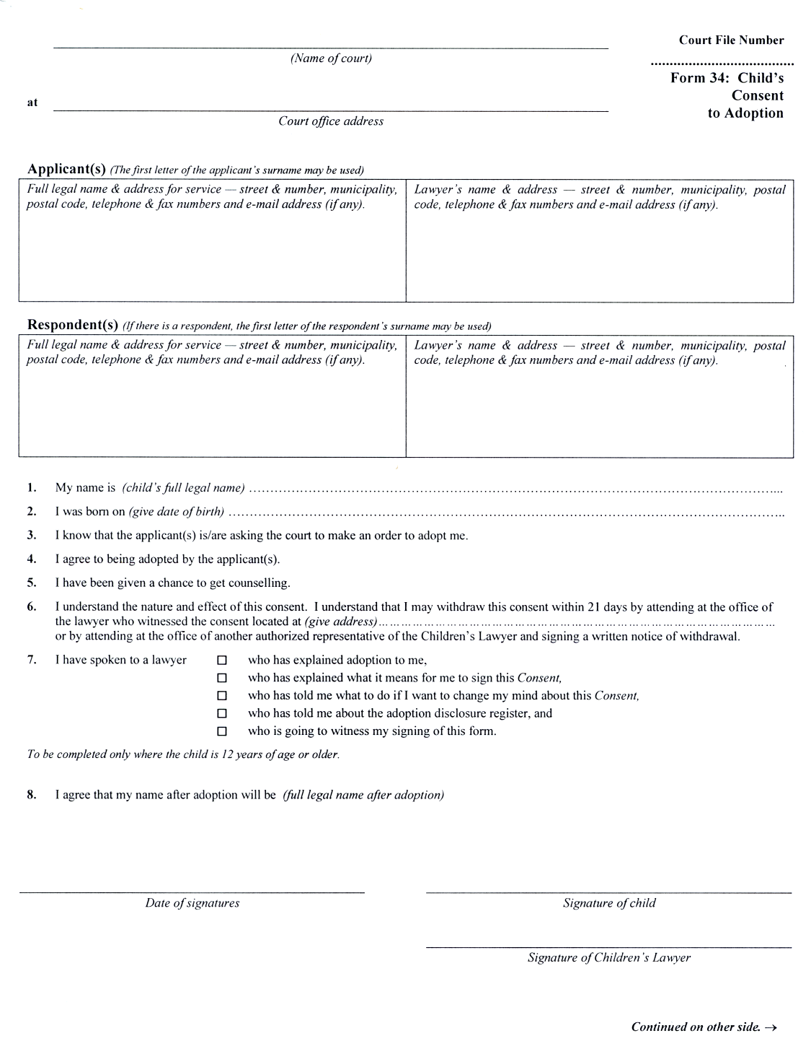
Insert regs\Graphics\Source Law\2002\337\337034be.tif
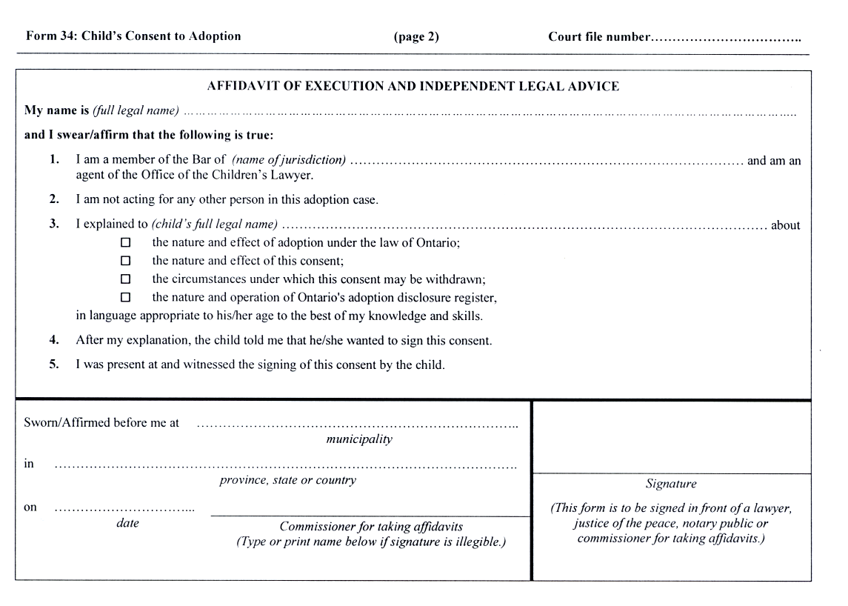
Form 34A
Courts of Justice Act
Affidavit of pARENtage
Insert regs\Graphics\Source Law\2002\337\33734aae.tif
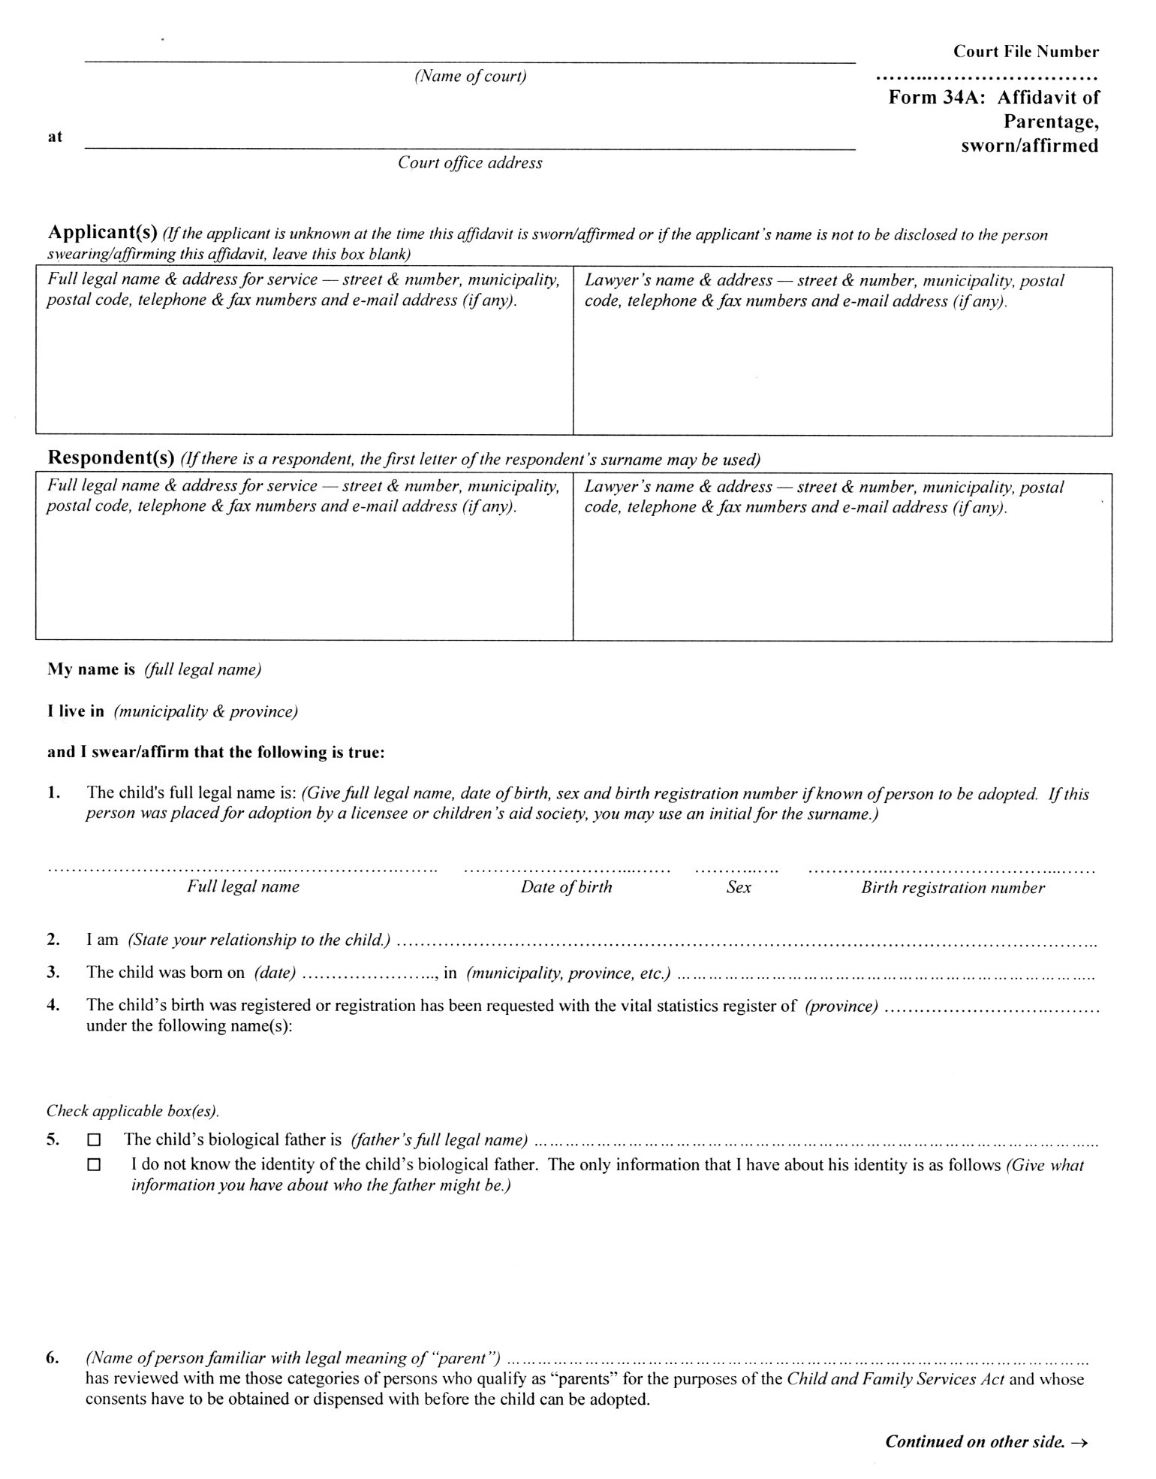
Insert regs\Graphics\Source Law\2002\337\33734abe.tif
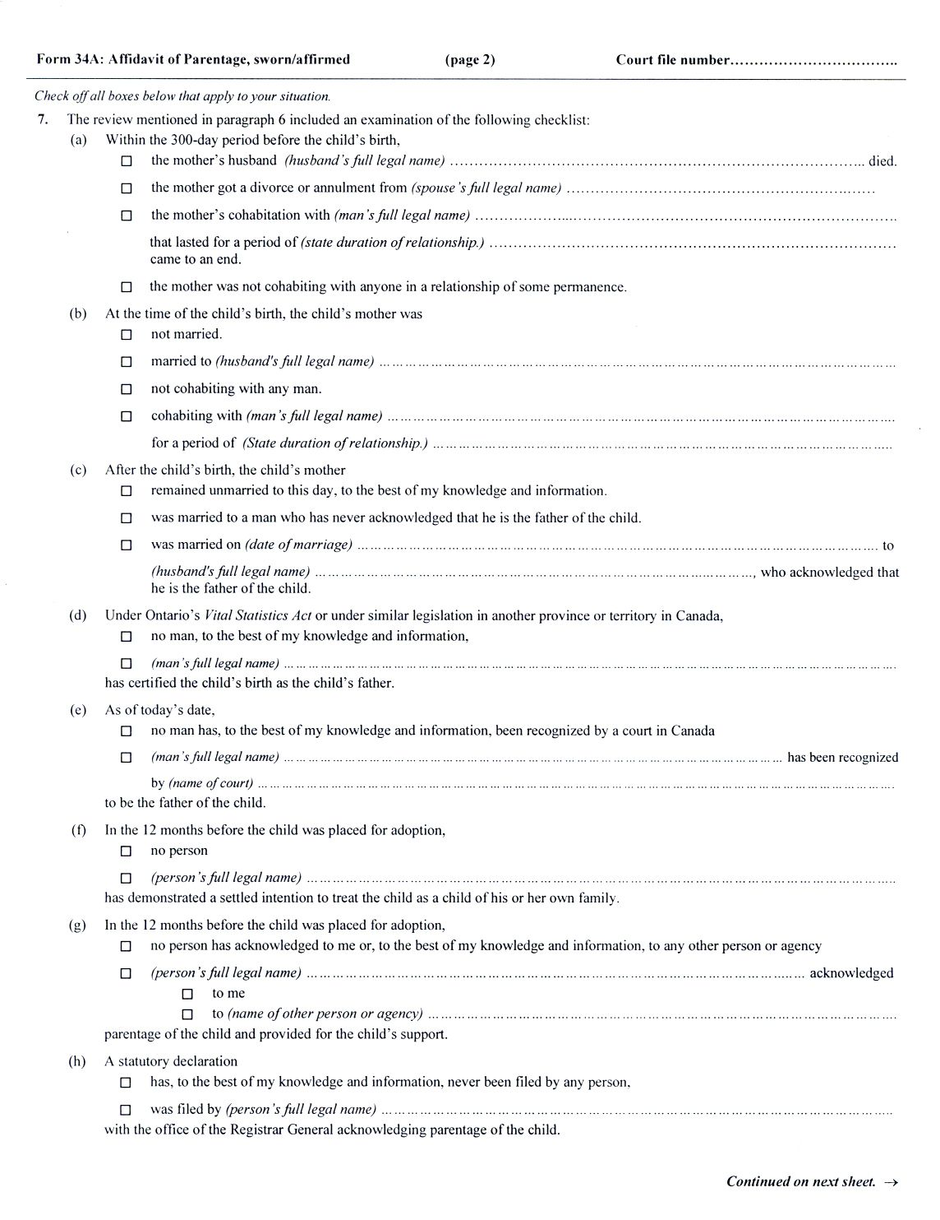
Insert regs\Graphics\Source Law\2002\337\33734ace.tif
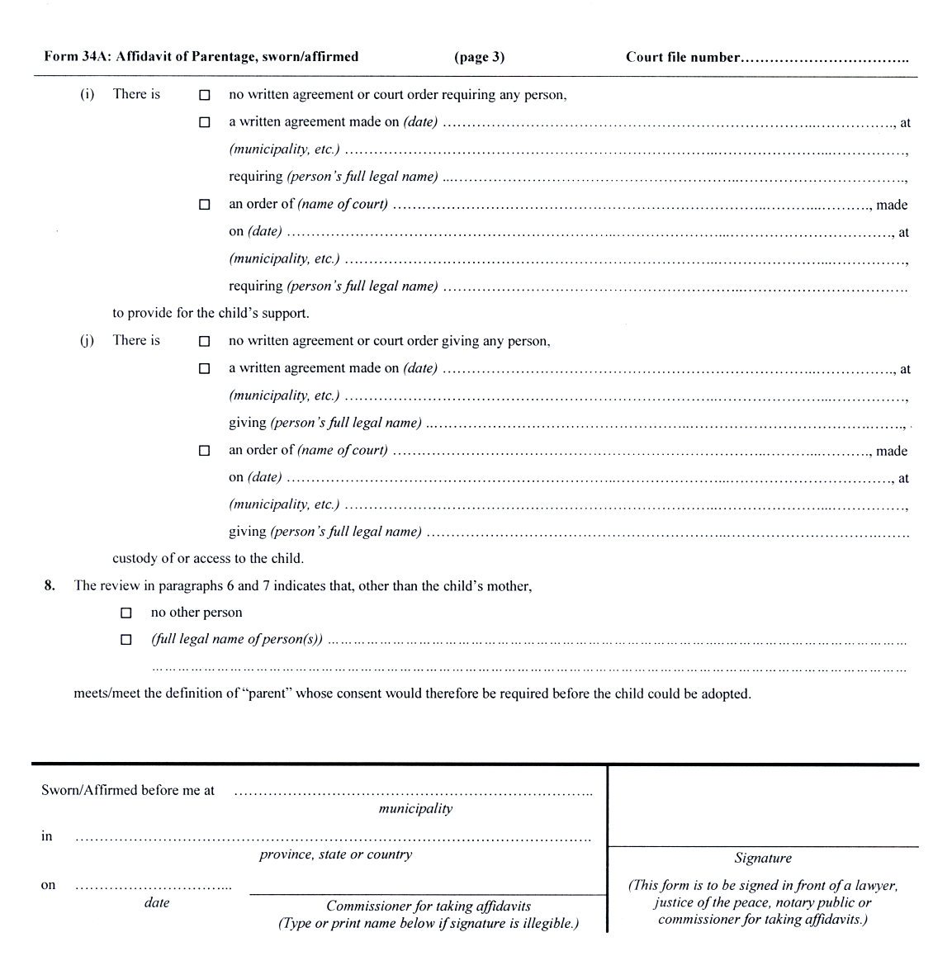
Form 34B
Courts of Justice Act
non-parent’s consent to adoption by spouse
Insert regs\Graphics\Source Law\2002\337\33734bae.tif
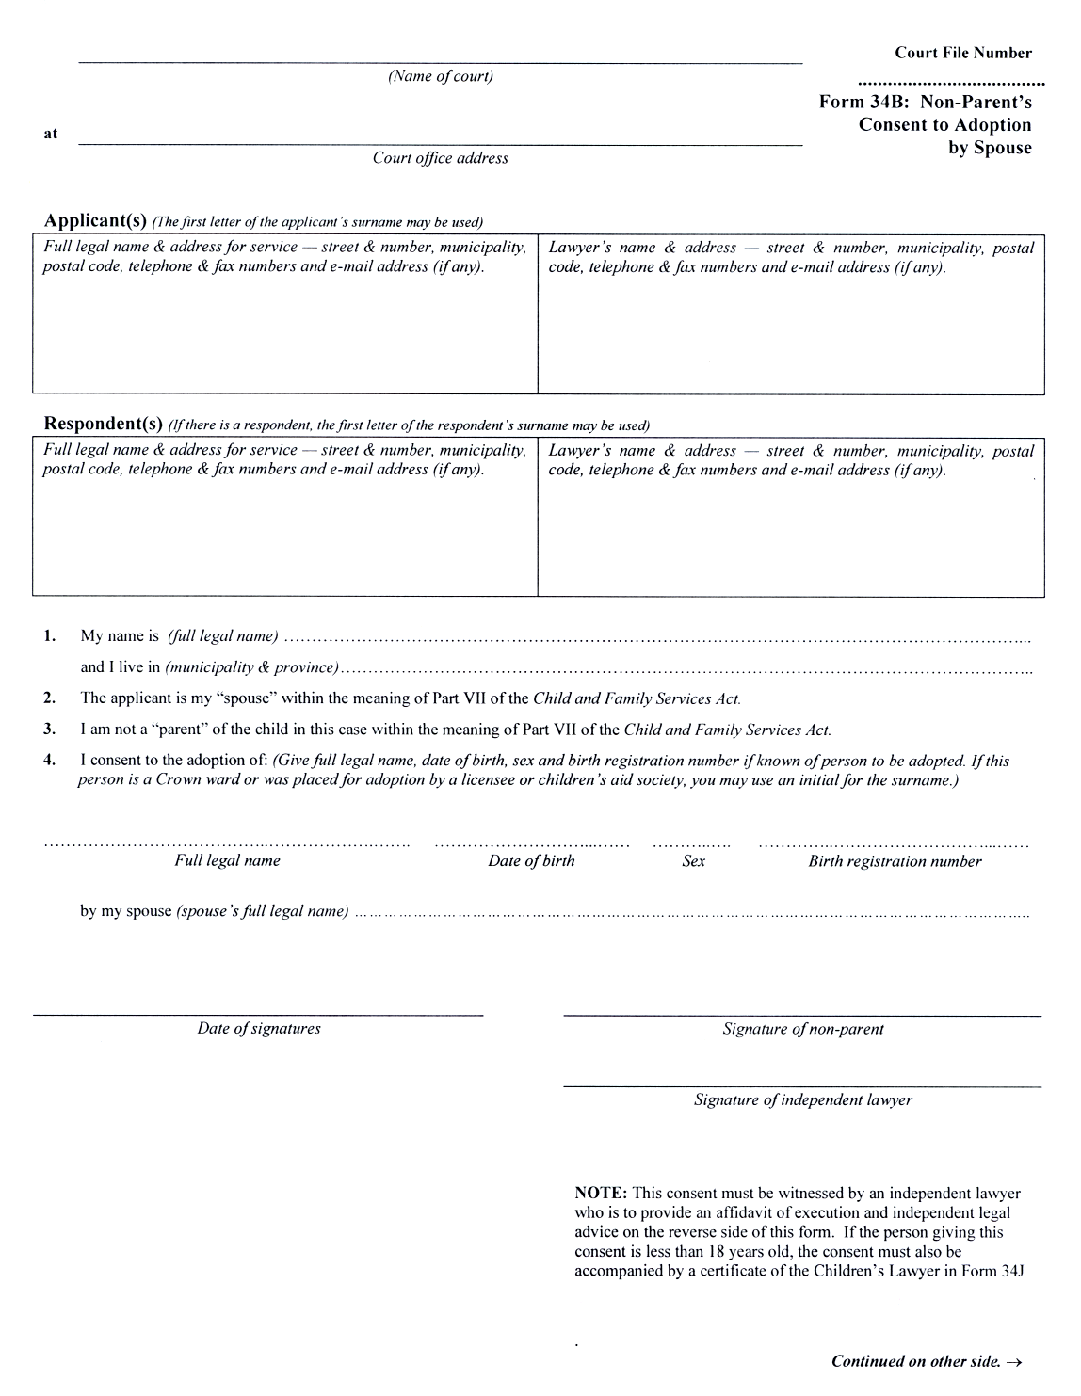
Insert regs\Graphics\Source Law\2002\337\33734bbe.tif
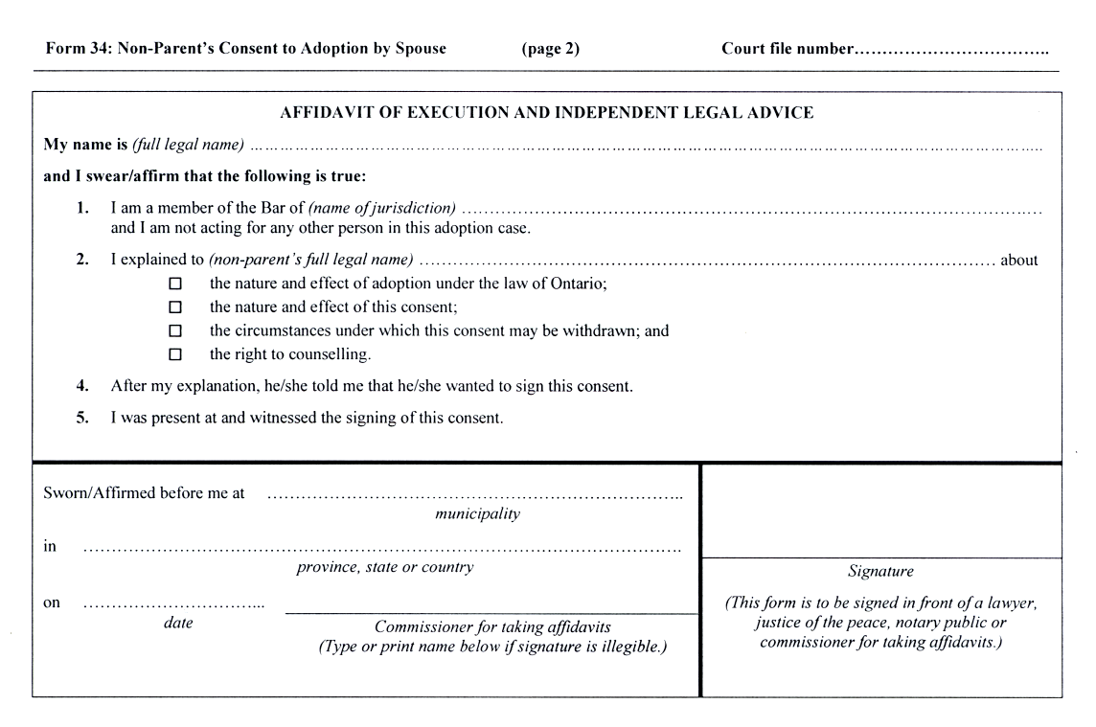
Form 34C
Courts of Justice Act
DIRECTOR’S OR LOCAL DIRECTOR’S STATEMENT ON ADOPTION
Insert regs\Graphics\Source Law\2002\337\33734cae.tif
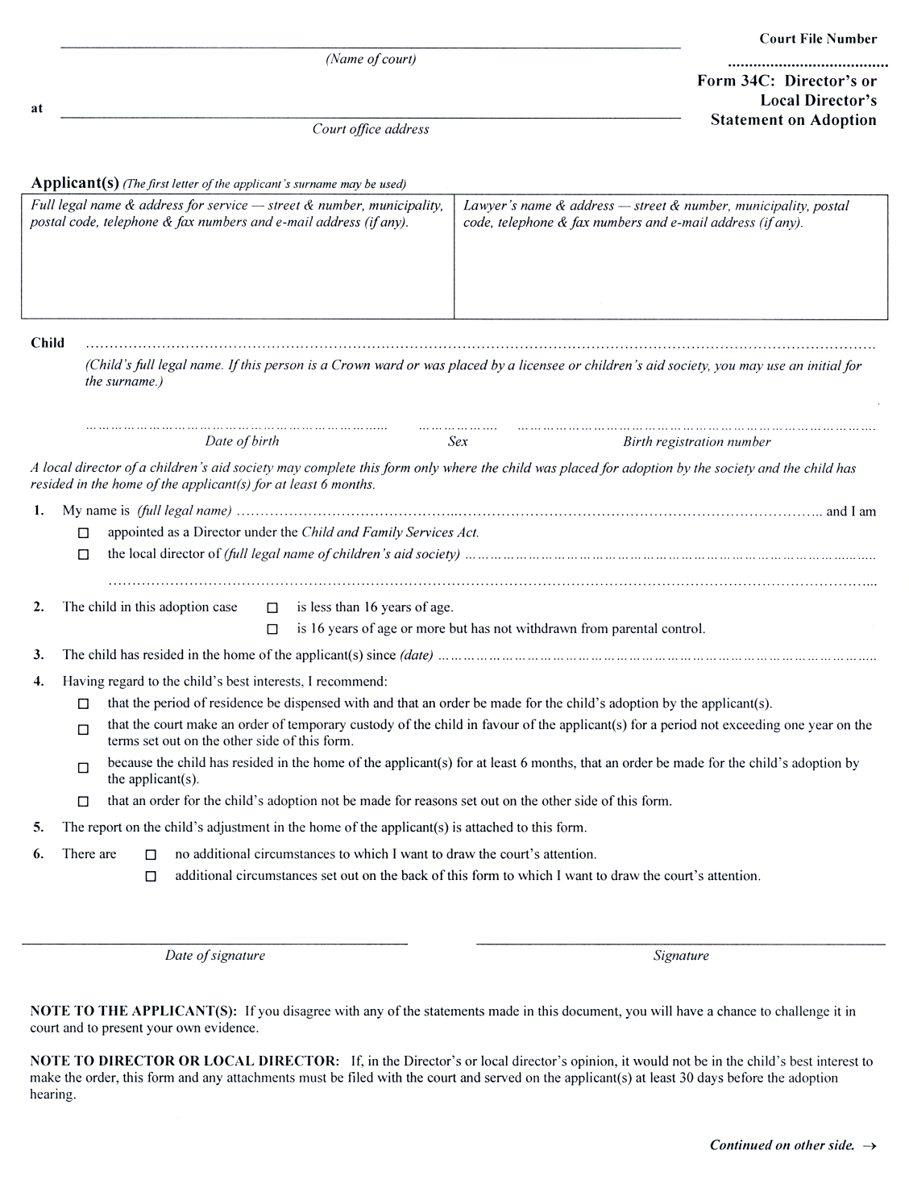
Insert regs\Graphics\Source Law\2002\337\33734cbe.tif
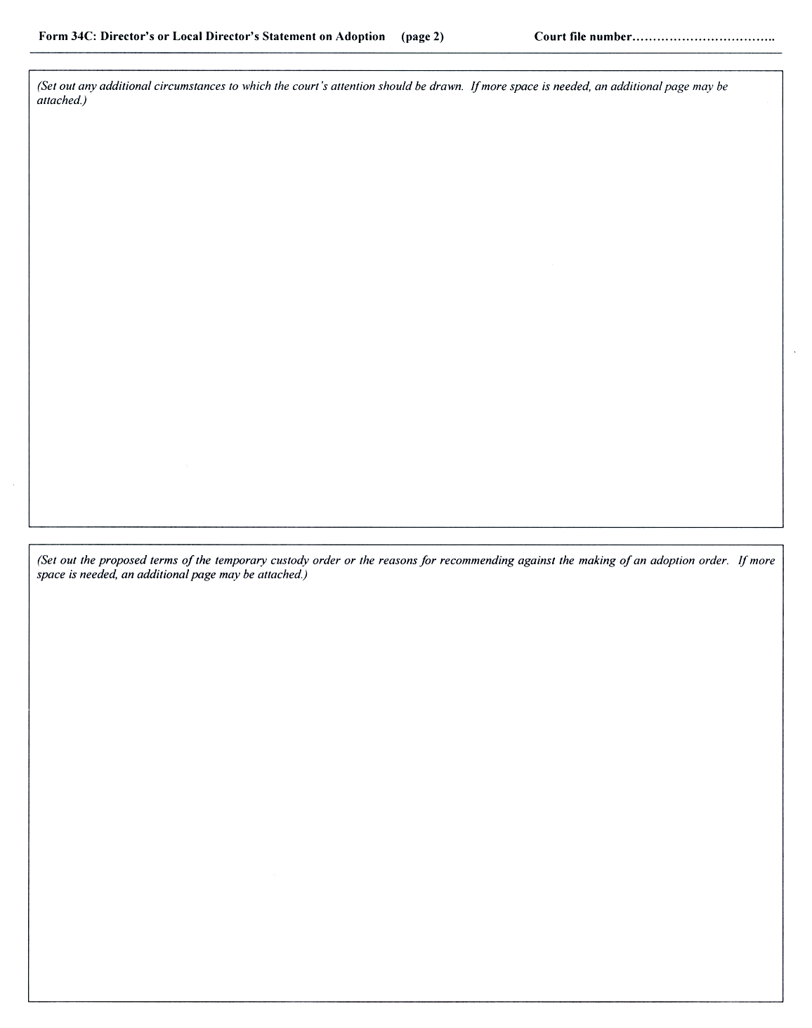
Form 34D
Courts of Justice Act
AffidaVIt of adoption applicant(s)
Insert regs\Graphics\Source Law\2002\337\33734dae.tif
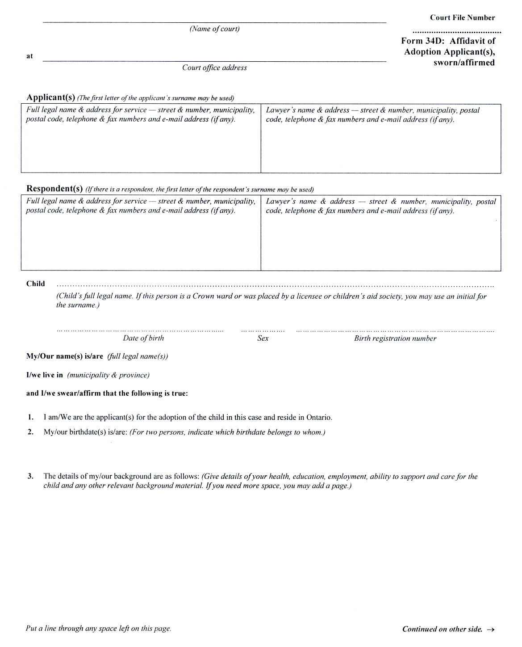
Insert regs\Graphics\Source Law\2002\337\33734dbe.tif

Insert regs\Graphics\Source Law\2002\337\33734dce.tif
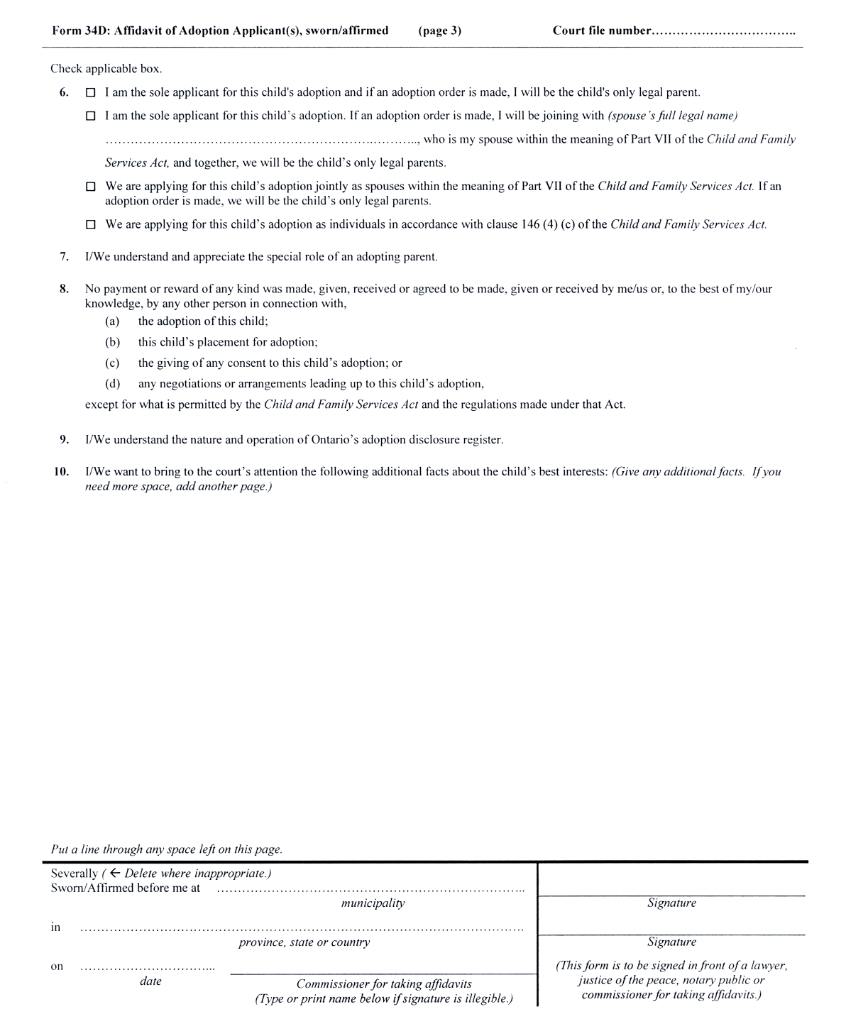
Form 34E
Courts of Justice Act
director’s consent to adoption
Insert regs\Graphics\Source Law\2002\337\337034ee.tif
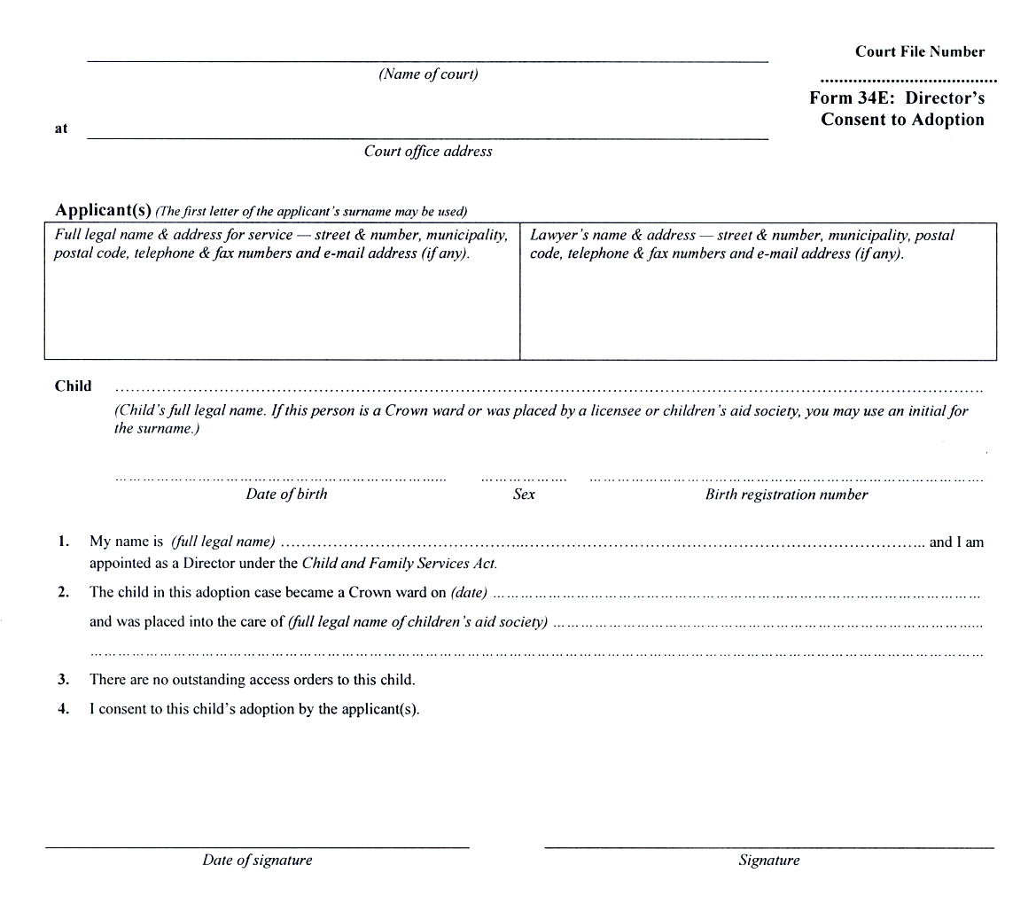
Form 34F
Courts of Justice Act
parent’s or custodian’s consent to adoption
Insert regs\Graphics\Source Law\2002\337\33734fae.tif
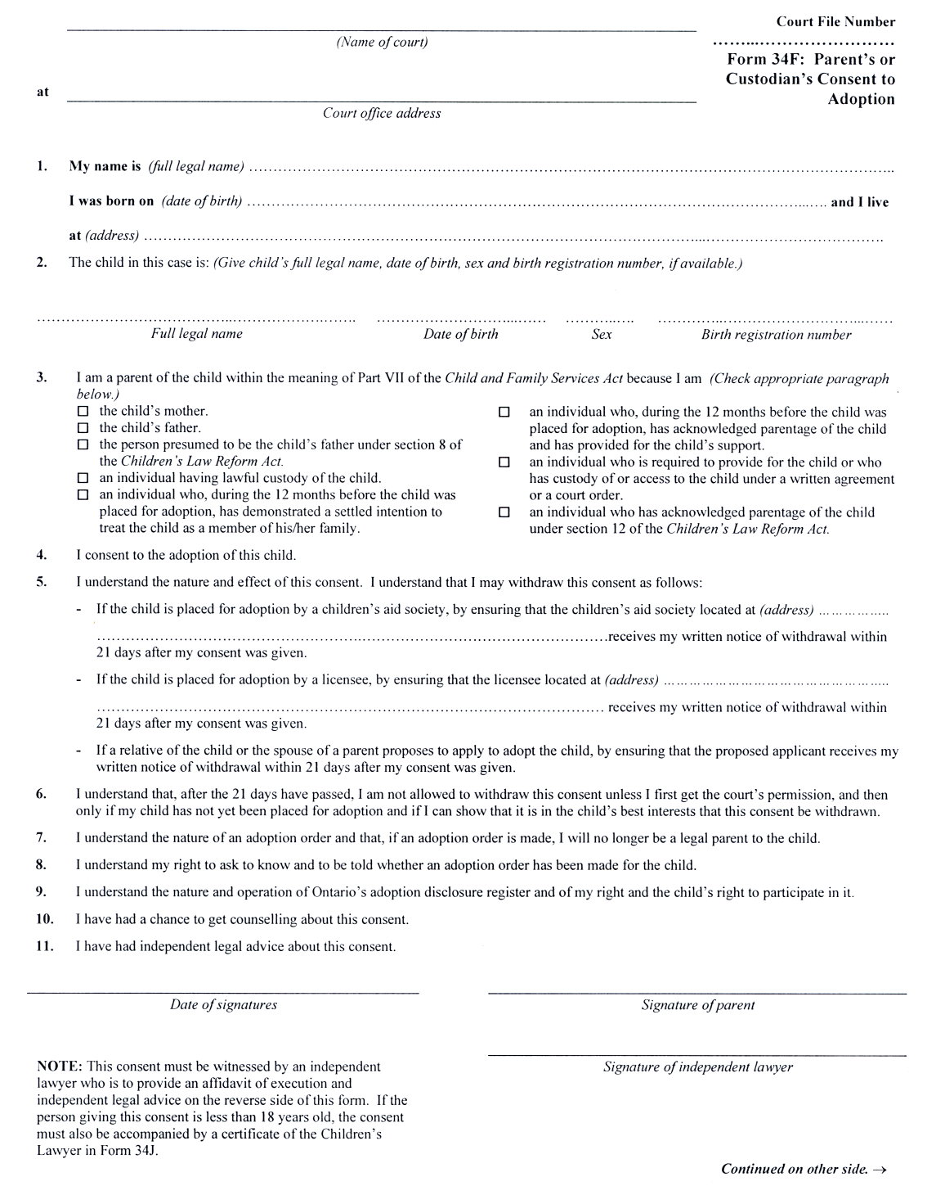
Insert regs\Graphics\Source Law\2002\337\33734fbe.tif
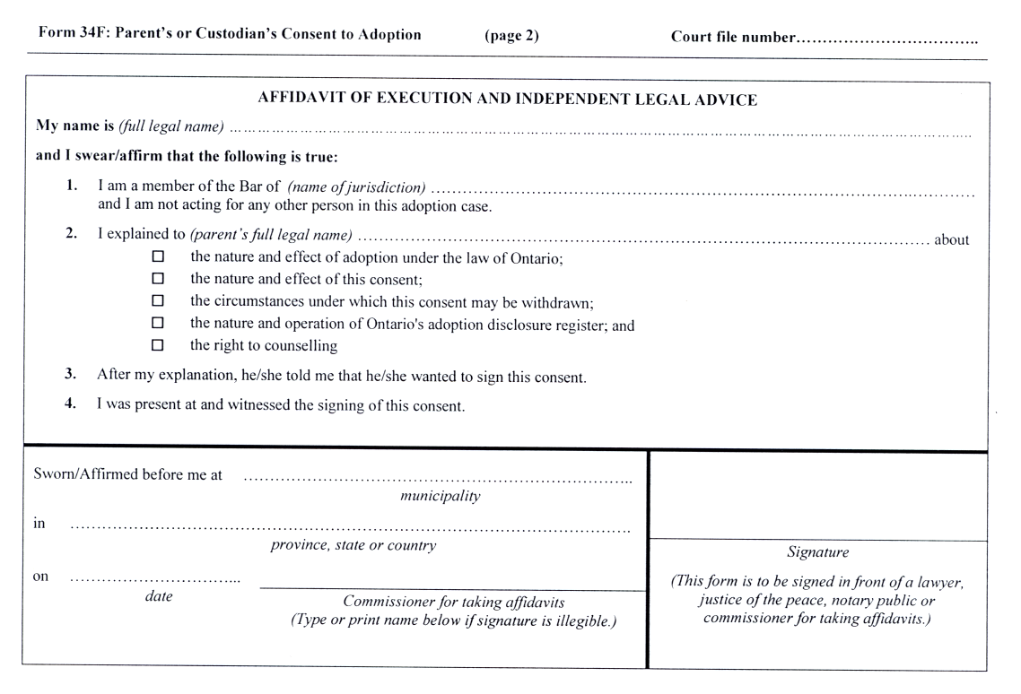
Form 34G
Courts of Justice Act
AffidaVIt of adoption licensee or society employee
Insert regs\Graphics\Source Law\2002\337\33734gae.tif
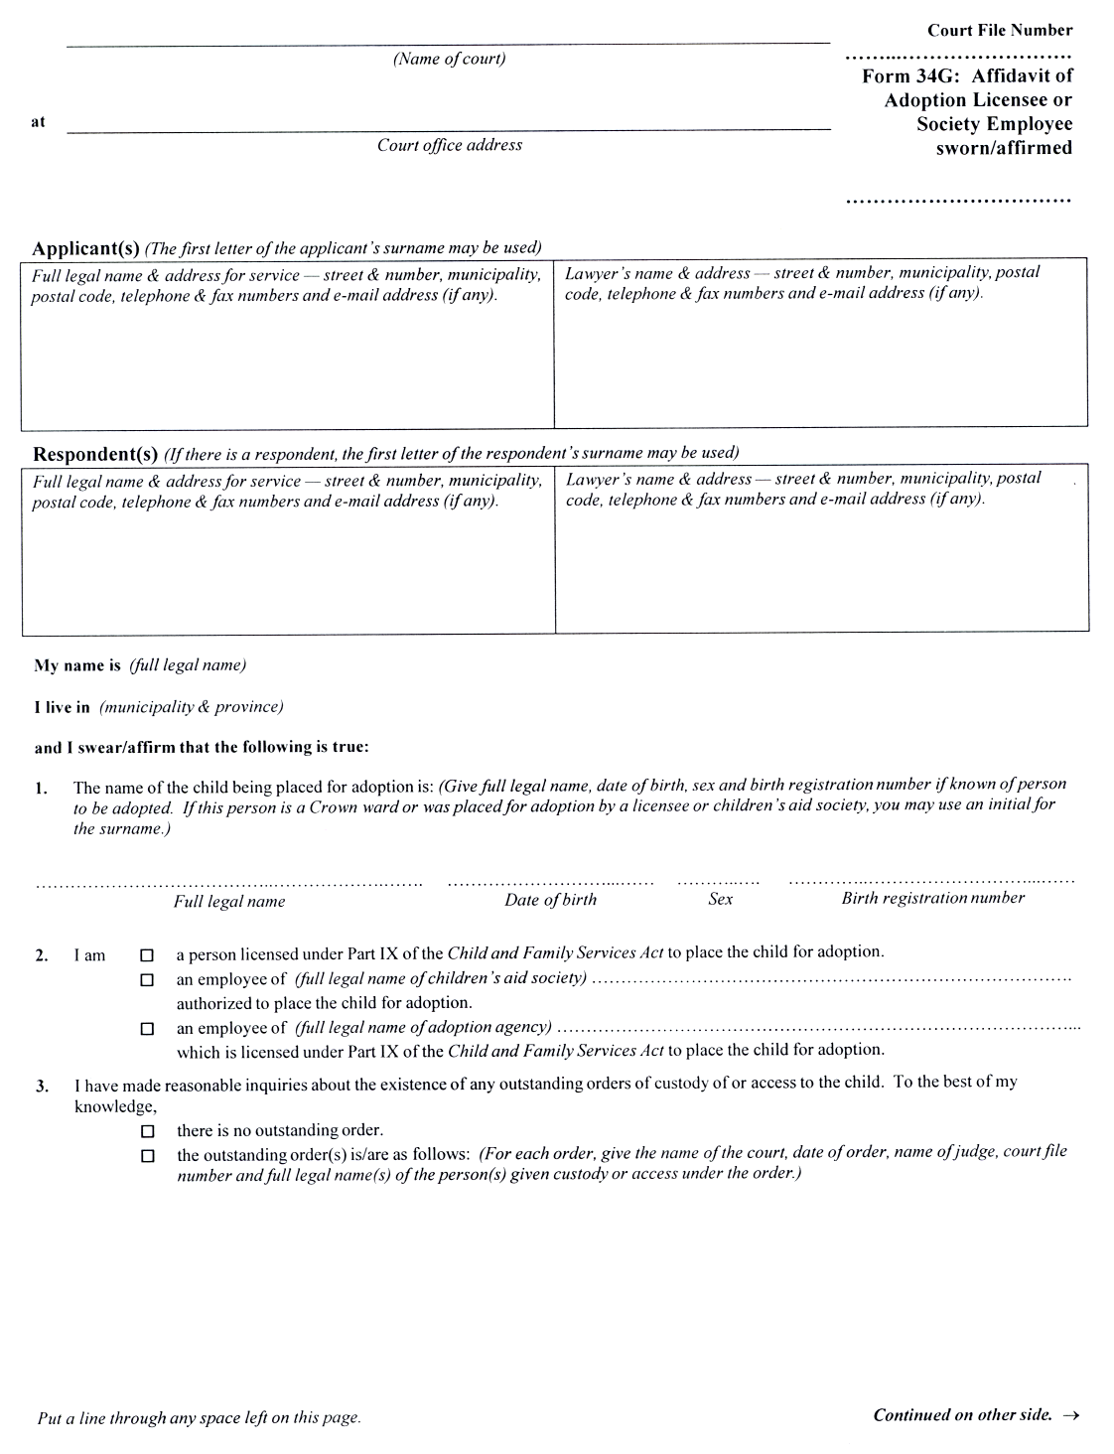
Insert regs\Graphics\Source Law\2002\337\33734gbe.tif
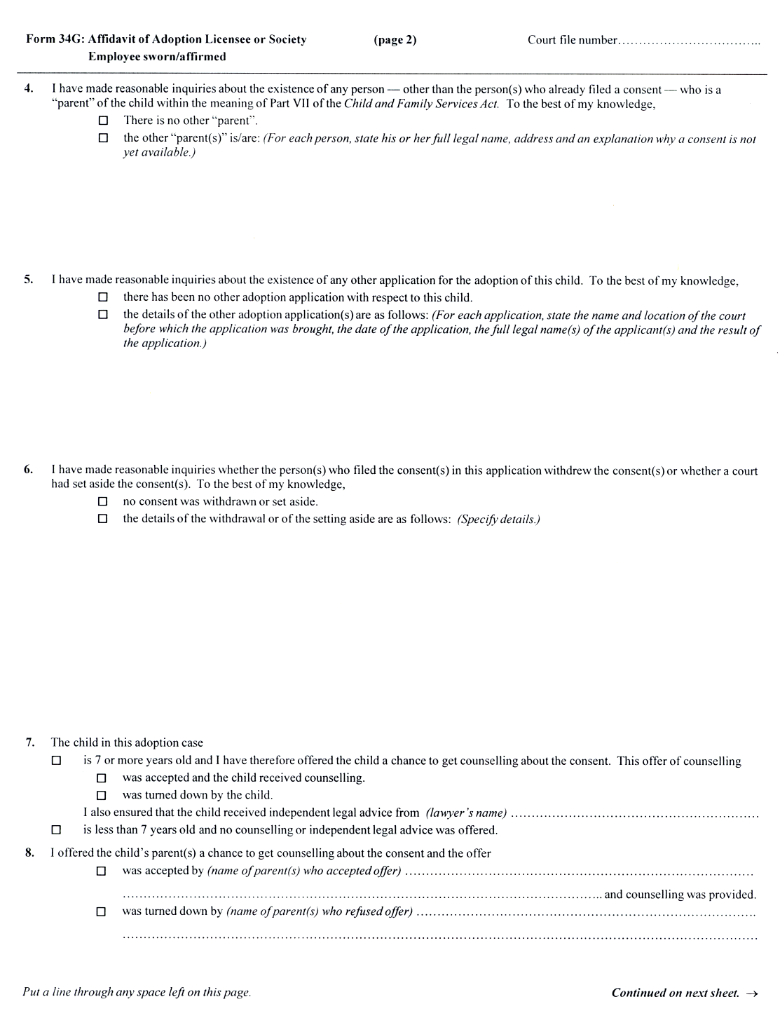
Insert regs\Graphics\Source Law\2002\337\33734gce.tif
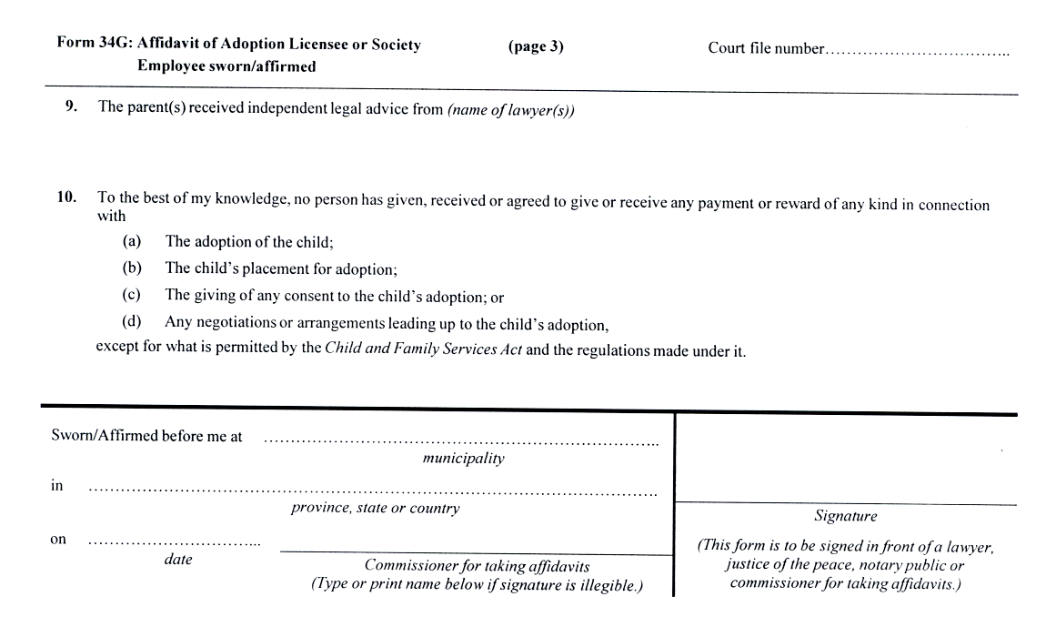
Form 34H
Courts of Justice Act
AffidaVIt of adopting relative or stepparent
Insert regs\Graphics\Source Law\2002\337\33734hae.tif
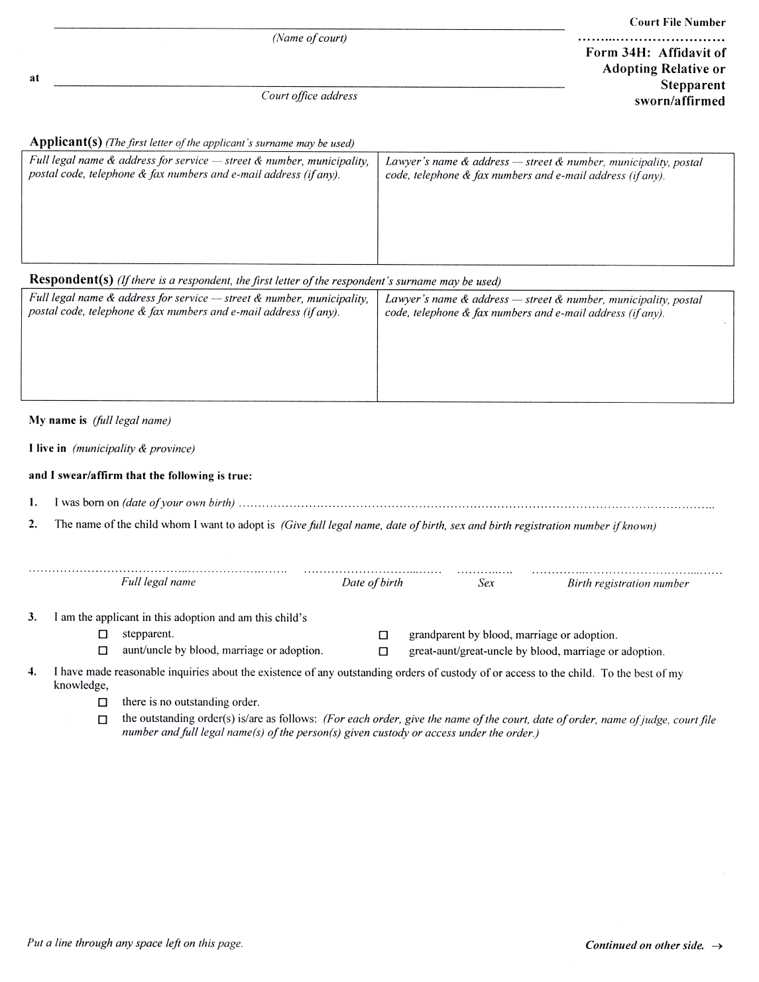
Insert regs\Graphics\Source Law\2002\337\33734hbe.tif
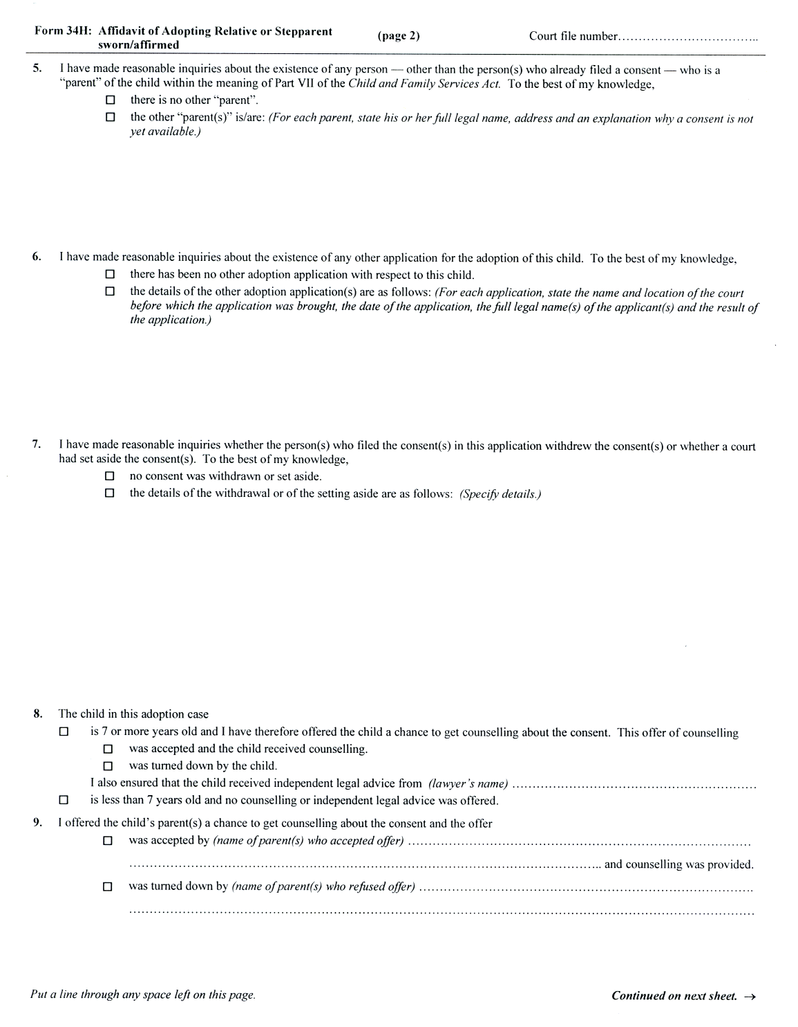
Insert regs\Graphics\Source Law\2002\337\33734hce.tif
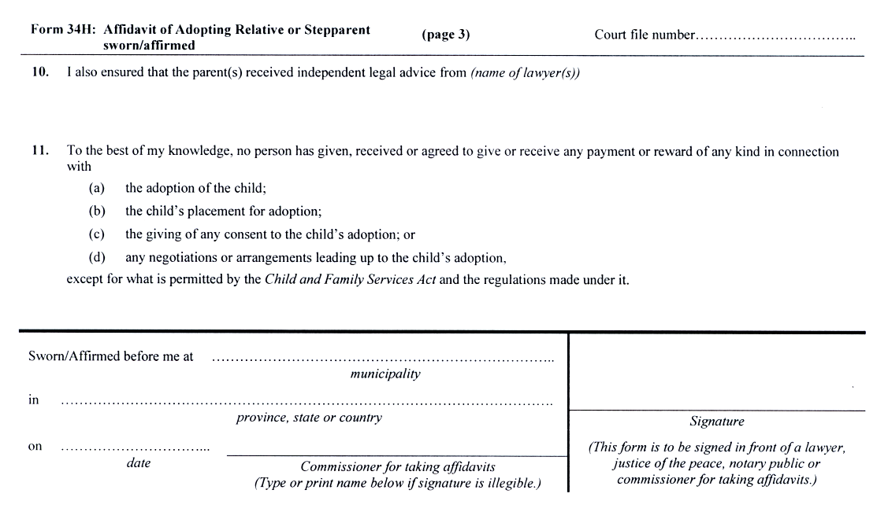
Form 34I
Courts of Justice Act
parent’s consent to adoption by spouse
Insert regs\Graphics\Source Law\2002\337\33734iae.tif
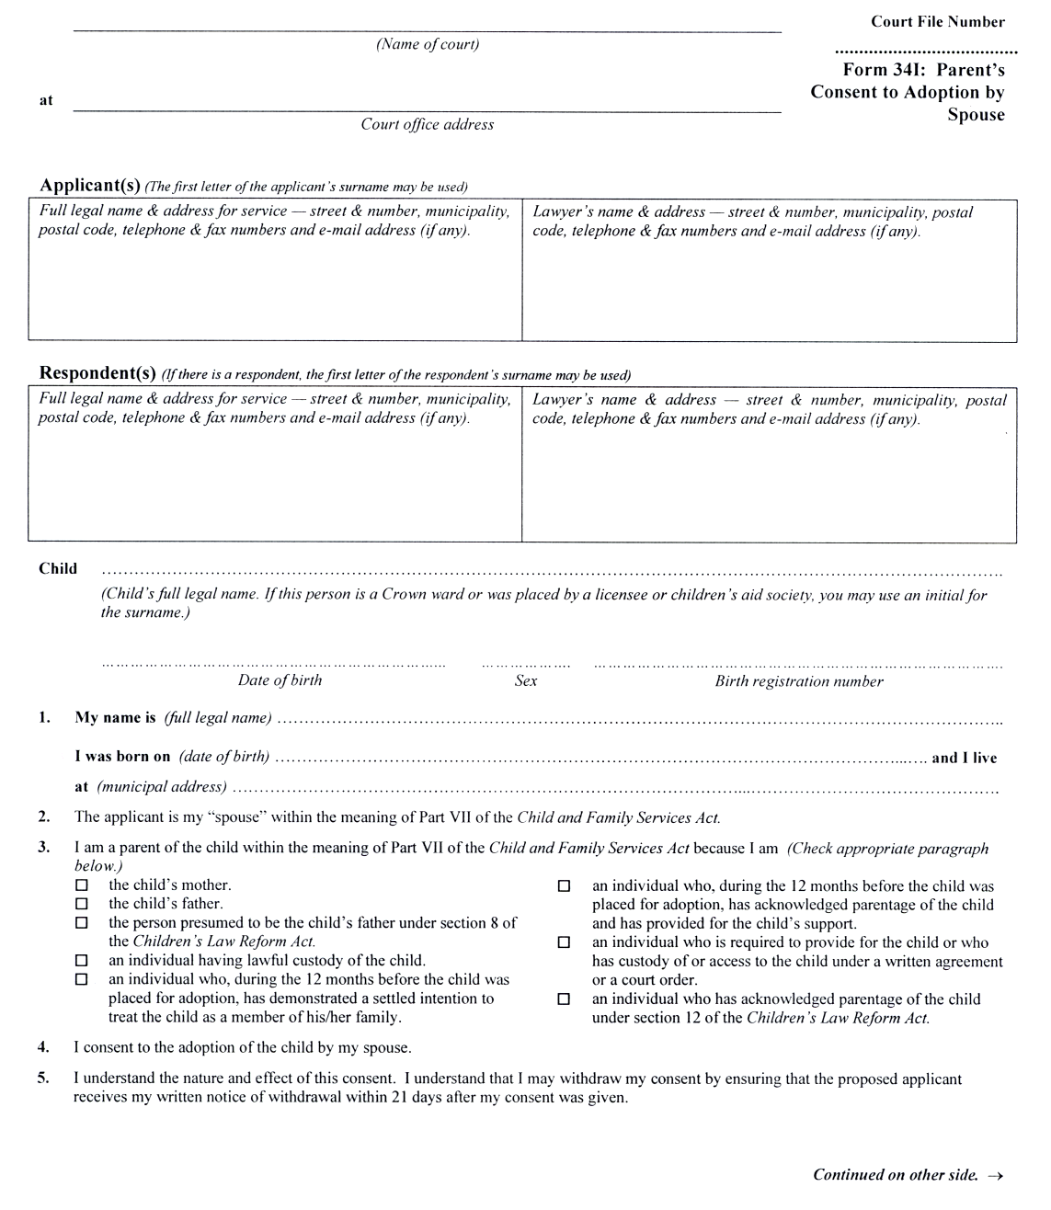
Insert regs\Graphics\Source Law\2002\337\33734ibe.tif
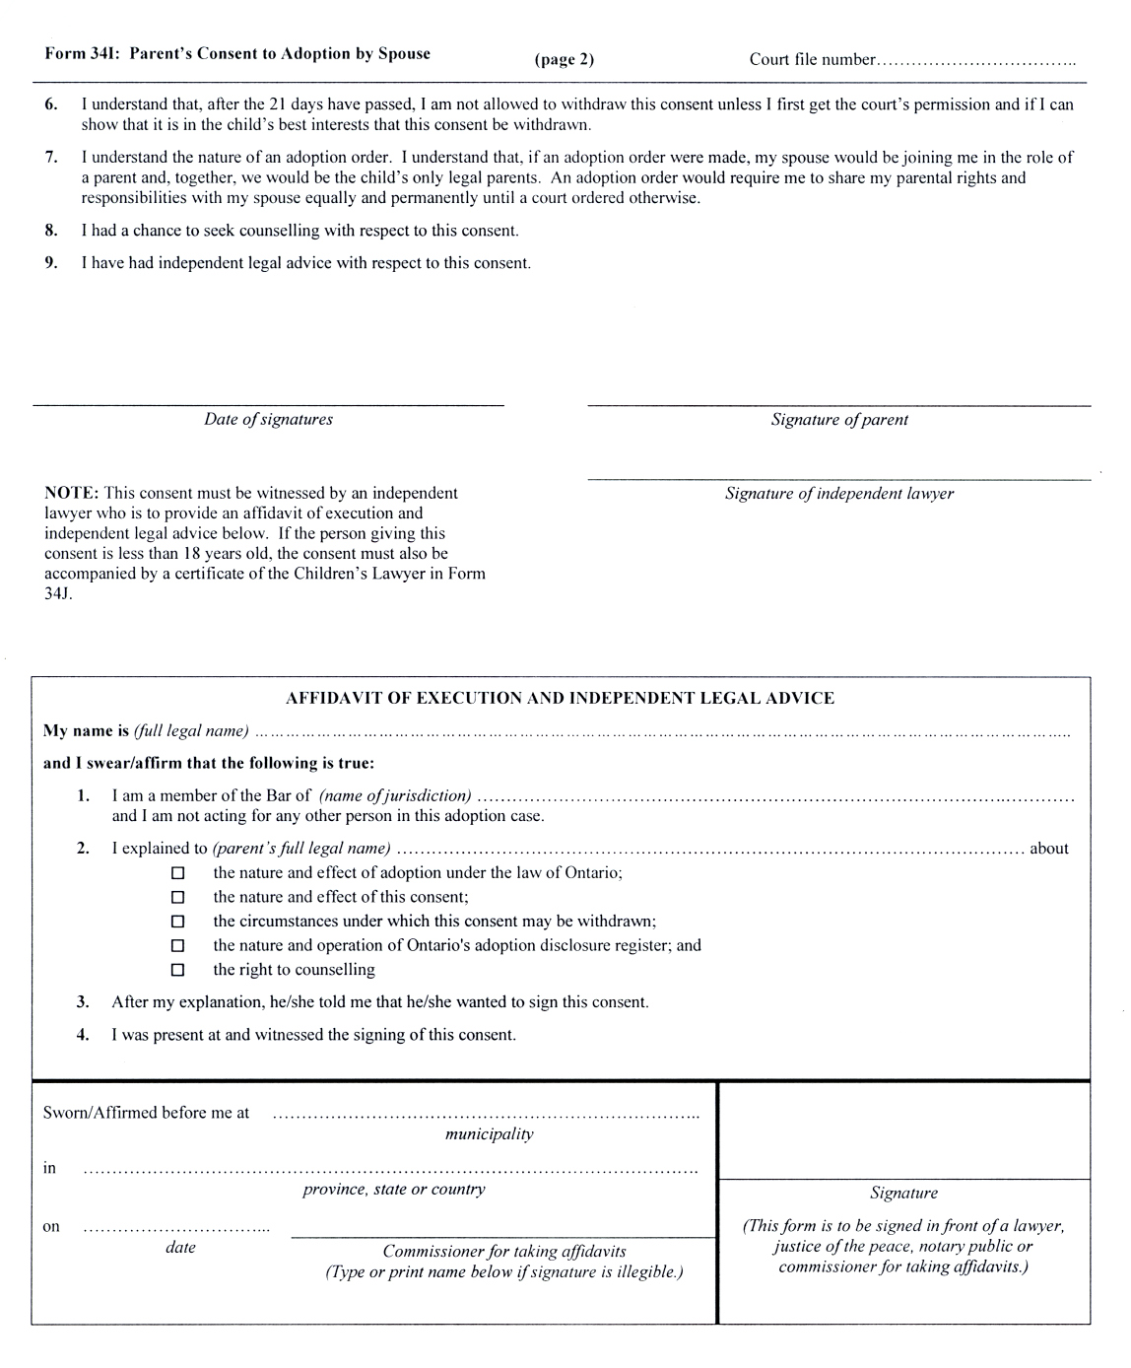
Form 34J
Courts of Justice Act
AffidaVIt of execution and Independent legal advice
(children’s lawyer)
Insert regs\Graphics\Source Law\2002\337\337034je.tif
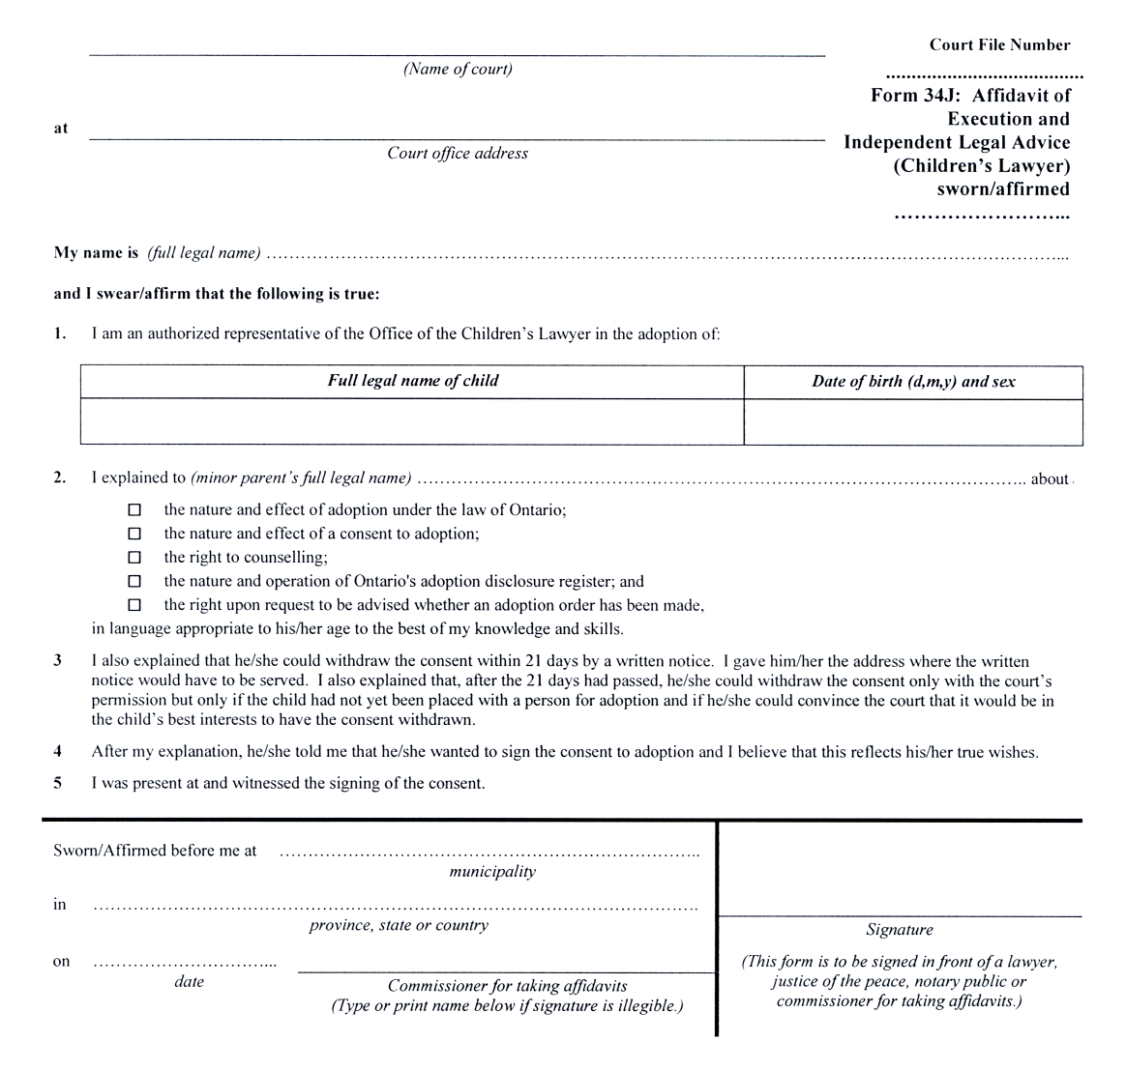
Form 34K
Courts of Justice Act
certificate of clerk (adoption)
Insert regs\Graphics\Source Law\2002\337\33734kae.tif
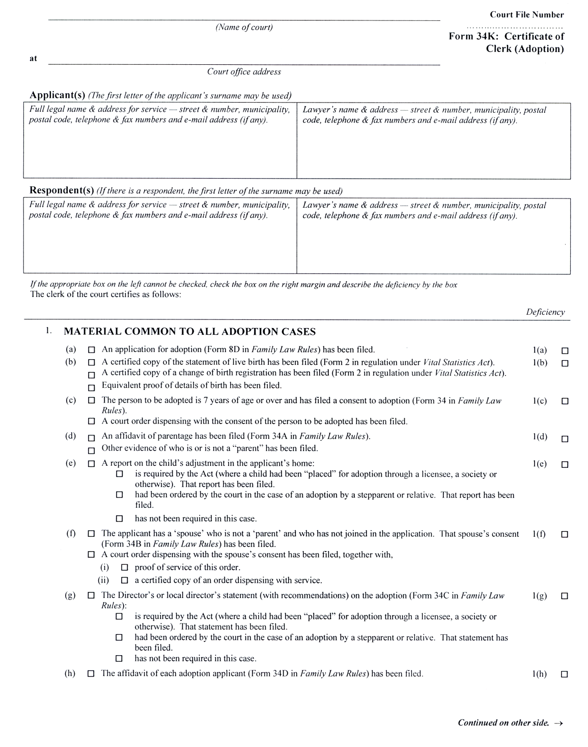
Insert regs\Graphics\Source Law\2002\337\33734kbe.tif
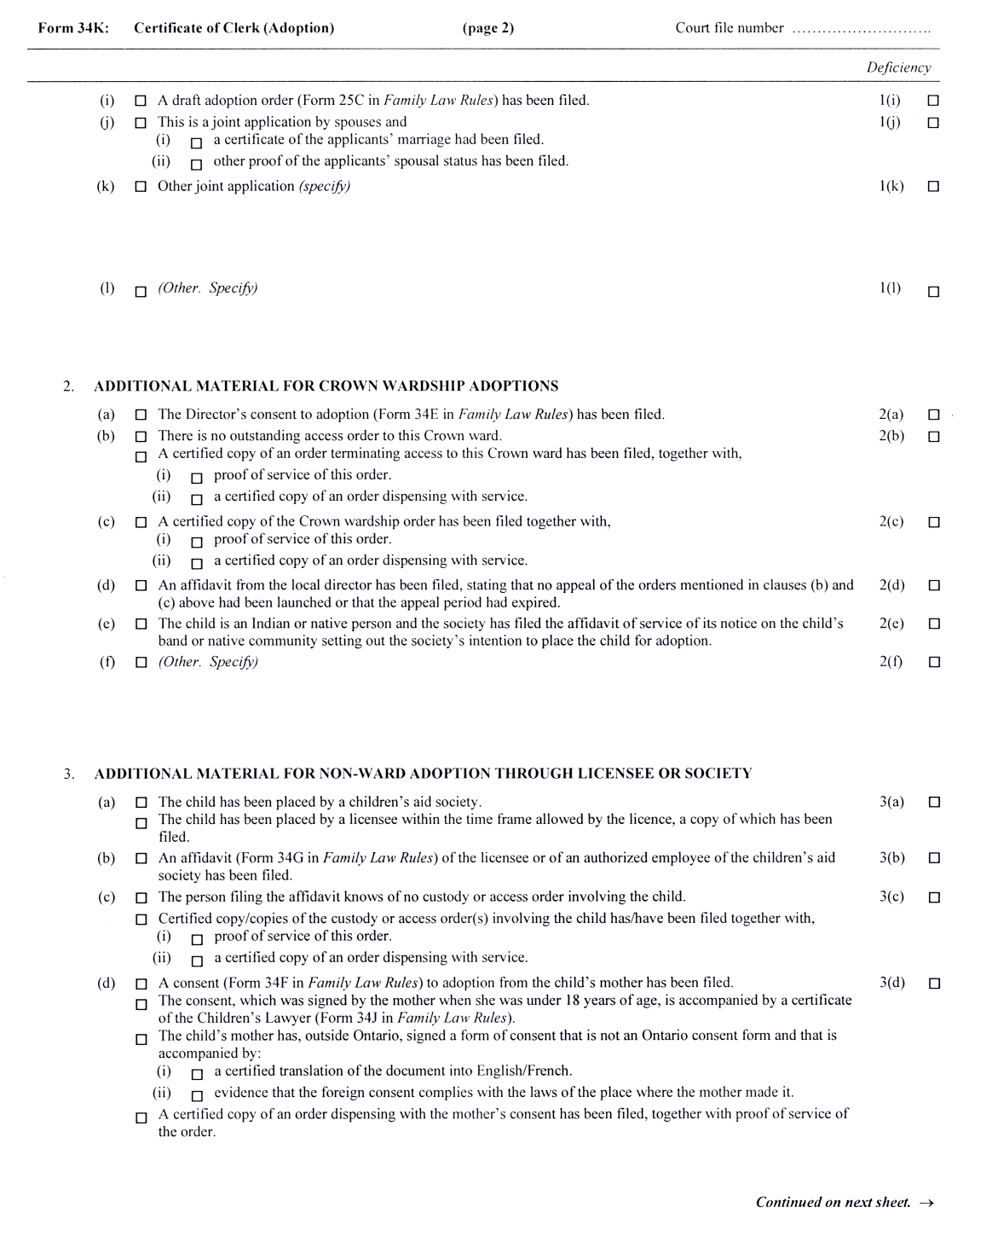
Insert regs\Graphics\Source Law\2002\337\33734kce.tif
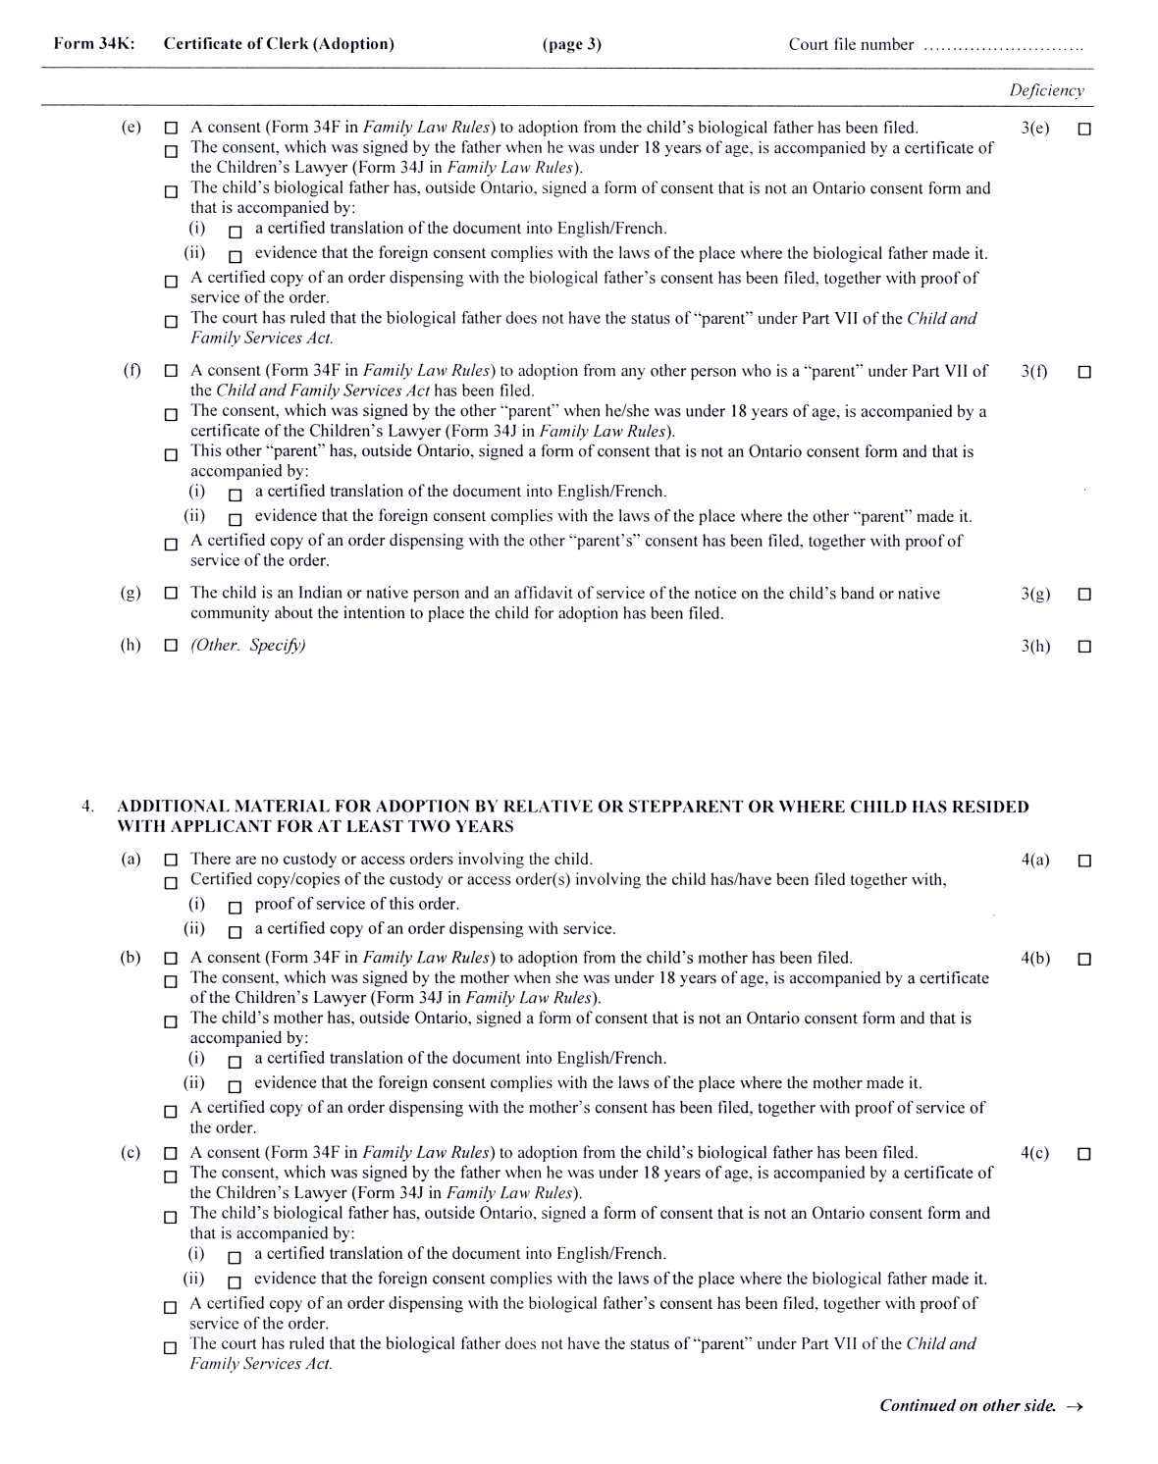
Insert regs\Graphics\Source Law\2002\337\33734kde.tif
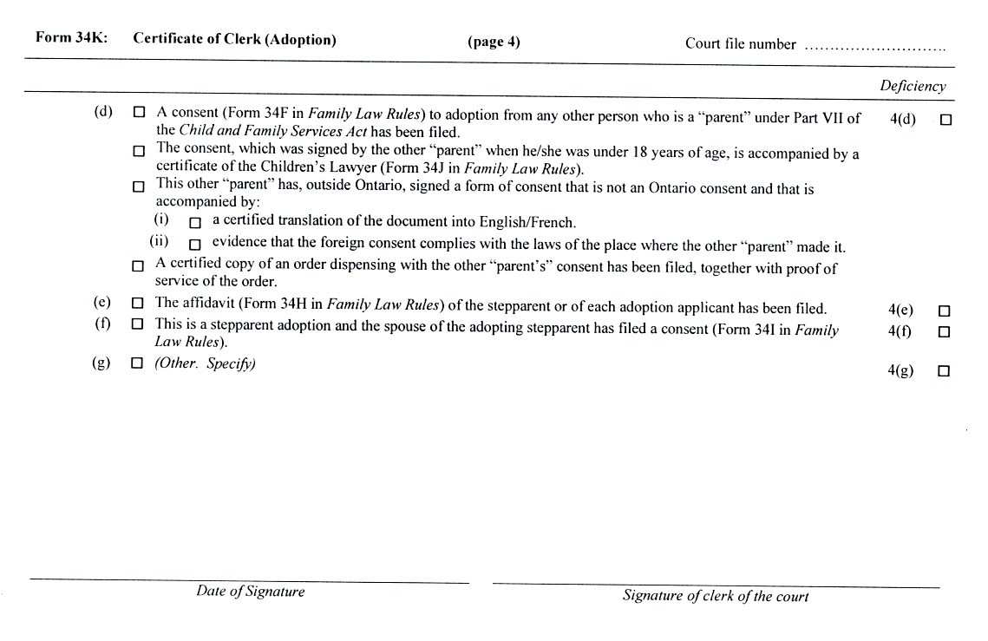
5. This Regulation comes into force on December 31, 2002.
51/02

Français

Back to top

