Français
ONTARIO regulation 19/03
made under the
courts of justice act
Made: October 17, 2002
Approved: February 3, 2003
Filed: February 5, 2003
Printed in The Ontario Gazette: February 22, 2003
Amending Reg. 194 of R.R.O. 1990
(Rules of Civil Procedure)
1. (1) Subrule 4.07 (3) of Regulation 194 of the Revised Regulations of Ontario, 1990 is revoked and the following substituted:
Appeal Book and Compendium
(3) An appeal book and compendium shall be bound front and back in buff covers.
(2) Subrule 4.07 (4) of the Regulation is amended by striking out “appeal book” and substituting “appeal book and compendium”.
(3) Subrule 4.07 (5.1) of the Regulation is revoked.
2. Subrule 7.07 (1) of the Regulation is revoked and the following substituted:
(1) If a party to an action is under a disability, the party may be noted in default under rule 19.01 only with leave of a judge.
3. Rule 7 of the Regulation is amended by adding the following rule:
DISCONTINUANCE BY OR AGAINST PARTY UNDER DISABILITY
7.07.1 (1) If a party to an action is under a disability, the action may be discontinued by or against the party under rule 23.01 only with leave of a judge.
(2) Notice of a motion for leave under subrule (1) shall be served,
(a) on the litigation guardian of the party under disability; and
(b) on the Children’s Lawyer, unless,
(i) the Public Guardian and Trustee is the litigation guardian, or
(ii) a judge orders otherwise.
4. Subrule 16.05 (3.2) of the Regulation is amended by striking out “appeal book” and substituting “appeal book and compendium”.
5. Subrule 19.01 (4) of the Regulation is revoked and the following substituted:
Party under Disability
(4) If a party to an action is under disability, the party may be noted in default only with leave of a judge obtained on motion under rule 7.07.
6. Subrule 23.01 (2) of the Regulation is revoked and the following substituted:
(2) If a party to an action is under disability, the action may be discontinued by or against the party only with leave of a judge obtained on motion under rule 7.07.1.
7. Rule 30.09 of the Regulation is amended by striking out “not later than ten days after the action is set down for trial” and substituting “at least 90 days before the commencement of the trial”.
8. Rule 37.02 of the Regulation is amended by adding the following subrule:
Jurisdiction of Registrar
(3) The registrar shall make an order granting the relief sought on a motion for an order on consent, if,
(a) the consent of all parties (including the consent of any party to be added, deleted or substituted) is filed;
(b) the consent states that no party affected by the order is under disability; and
(c) the order sought is for,
(i) amendment of a pleading, notice of application or notice of motion,
(ii) addition, deletion or substitution of a party,
(iii) removal of a solicitor as solicitor of record,
(iv) setting aside the noting of a party in default,
(v) setting aside a default judgment,
(vi) discharge of a certificate of pending litigation,
(vii) security for costs in a specified amount,
(viii) re-attendance of a witness to answer questions on an examination,
(ix) fulfilment of undertakings given on an examination, or
(x) dismissal of a proceeding, with or without costs.
9. Rule 37.04 of the Regulation is amended by striking out “within a master’s jurisdiction” and substituting “within the jurisdiction of a master or registrar”.
10. Subrule 59.02 (1) of the Regulation is amended by striking out “appeal book” and substituting “appeal book and compendium”.
11. Subrule 61.04 (3) of the Regulation is revoked and the following substituted:
Notice of Appeal
(3) The notice of appeal (Form 61A) shall state,
(a) the relief sought;
(b) the grounds of appeal; and
(c) the basis for the appellate court’s jurisdiction, including references to,
(i) any provision of a statute or regulation establishing jurisdiction,
(ii) whether the order appealed from is final or interlocutory,
(iii) whether leave to appeal is necessary and if so whether it has been granted, and
(iv) any other facts relevant to establishing jurisdiction.
12. Subrule 61.05 (4) of the Regulation is amended by striking out “appeal books” and substituting “appeal book and compendium”.
13. (1) Subclauses 61.09 (3) (a) (i) and (ii) of the Regulation are revoked and the following substituted:
(i) the appeal book and compendium referred to in rule 61.10,
(ii) the exhibit book referred to in rule 61.10.1,
(2) Subclauses 61.09 (3) (b) (i) and (ii) of the Regulation are revoked and the following substituted:
(i) three copies of the appeal book and compendium, and where the appeal is to be heard by five judges, two additional copies,
(ii) one copy of the exhibit book,
(3) Subclause 61.09 (3) (c) (i) of the Regulation is revoked and the following substituted:
(i) stating that the appeal book and compendium, exhibit book, transcripts, if any, and appellant’s factum have been filed, and
(4) Subrule 61.09 (4) of the Regulation is revoked and the following substituted:
Relief from Compliance
(4) If it is necessary to do so in the interest of justice, a judge of the appellate court may give special directions and vary the rules governing the appeal book and compendium, the exhibit book, the transcript of evidence and the appellant’s factum.
14. Rule 61.10 of the Regulation is revoked and the following substituted:
APPEAL BOOK AND COMPENDIUM
61.10 (1) The appeal book and compendium shall contain, in consecutively numbered pages with numbered tabs arranged in the following order,
(a) a table of contents describing each document by its nature and date;
(b) a copy of the notice of appeal and of any notice of cross-appeal or supplementary notice of appeal or cross-appeal;
(c) a copy of the order or decision appealed from as signed and entered;
(d) a copy of the reasons of the court or tribunal appealed from, with a further typed or printed copy if the reasons are handwritten;
(e) if an earlier order or decision was the subject of the hearing before the court or tribunal appealed from, a copy of the order or decision, as signed and entered, and a copy of any reasons for it, with a further typed or printed copy if the reasons are handwritten;
(f) a copy of the pleadings or notice of application or of any other document that initiated the proceeding or defines the issues in it;
(g) a copy of any excerpts from a transcript of evidence that are referred to in the appellant’s factum;
(h) a copy of any exhibits that are referred to in the appellant’s factum;
(i) a copy of any other documents relevant to the hearing of the appeal that are referred to in the appellant’s factum;
(j) a copy of the certificates or agreement respecting evidence referred to in rule 61.05;
(k) a copy of any order made in respect of the conduct of the appeal; and
(l) a certificate (Form 61H) signed by the appellant’s lawyer, or on the lawyer’s behalf by someone he or she has specifically authorized, stating that the contents of the appeal book and compendium are complete and legible.
(2) The Registrar may refuse to accept an appeal book and compendium if it does not comply with these rules or is not legible.
15. Rule 61.10.1 of the Regulation is revoked and the following substituted:
EXHIBIT BOOK
61.10.1 The exhibit book shall contain, in consecutively numbered pages with numbered tabs arranged in the following order,
(a) a table of contents describing each exhibit by its nature, date and exhibit number or letter;
(b) any affidavit evidence, including exhibits, that the parties have not agreed to omit;
(c) transcripts of evidence used on a motion or application that the parties have not agreed to omit; and
(d) a copy of each exhibit filed at a hearing or marked on an examination that the parties have not agreed to omit, arranged in order by date (or, if there are documents with common characteristics, grouped accordingly in order by date) and not by exhibit number.
16. (1) Clause 61.11 (1) (c) of the Regulation is revoked and the following substituted:
(c) Part III, containing a concise summary of the facts relevant to the issues on the appeal, with such reference to the transcript of evidence and the exhibits as is necessary;
(2) Rule 61.11 of the Regulation is amended by adding the following subrule:
(1.1) References to the transcript of evidence shall be by tab, page number and line in the appeal book and compendium, and references to exhibits shall be by page number in the exhibit book and by tab and page number in the appeal book and compendium.
17. Rule 61.12 of the Regulation is revoked and the following substituted:
RESPONDENT’S FACTUM AND COMPENDIUM
Filing and Service
61.12 (1) Every respondent shall,
(a) serve on every other party to the appeal,
(i) a typed or printed copy of the respondent’s factum, and
(ii) the respondent’s compendium;
(b) file with the Registrar, with proof of service,
(i) three typed or printed copies of the respondent’s factum, and where the appeal is to be heard by five judges, two additional copies, and
(ii) three copies of the respondent’s compendium, and where the appeal is to be heard by five judges, two additional copies; and
(c) file with the Registrar an electronic version of the respondent’s factum.
Time for Delivery
(2) The respondent’s factum and compendium shall be delivered within 60 days after service of the appeal book and compendium, exhibit book, transcript of evidence, if any, and appellant’s factum.
Contents of Respondent’s Factum
(3) The respondent’s factum shall be signed by the respondent’s counsel, or on counsel’s behalf by someone he or she has specifically authorized, and shall consist of,
(a) Part I, containing a concise overview statement describing the nature of the case and of the issues;
(b) Part II, containing a statement of the facts in the appellant’s summary of relevant facts that the respondent accepts as correct and those facts with which the respondent disagrees, and a concise summary of any additional facts relied on, with such reference to the transcript of evidence and the exhibits as is necessary;
(c) Part III, containing the position of the respondent with respect to each issue raised by the appellant, immediately followed by a concise argument with reference to the law and authorities relating to that issue;
(d) Part IV, containing a statement of any additional issues raised by the respondent, the statement of each issue to be followed by a concise argument with reference to the law and authorities relating to that issue;
(e) Part V, containing a statement of the order that the appellate court will be asked to make, including any order for costs;
(f) a certificate stating,
(i) that an order under subrule 61.09 (2) (original record and exhibits) has been obtained or is not required, and
(ii) how much time (expressed in hours or fractions of an hour) counsel estimates will be required for his or her oral argument, not including reply;
(g) Schedule A, containing a list of the authorities referred to; and
(h) Schedule B, containing the text of all relevant provisions of statutes, regulations and by-laws that are not included in Schedule B to the appellant’s factum.
(4) References to the transcript of evidence shall be by tab, page number and line in the respondent’s compendium, and references to exhibits shall be by page number in the exhibit book and by tab and page number in the respondent’s compendium.
(5) Parts I to V shall be arranged in paragraphs numbered consecutively throughout the factum.
Cross-Appeal
(6) Where a respondent has served a notice of cross-appeal under rule 61.07,
(a) the respondent shall prepare a factum as an appellant by cross-appeal and deliver it with or incorporate it in the respondent’s factum; and
(b) the appellant shall deliver a factum as a respondent to the cross-appeal within ten days after service of the respondent’s factum.
Contents of Respondent’s Compendium
(7) The respondent’s compendium shall contain, in consecutively numbered pages with numbered tabs arranged in the following order,
(a) a table of contents describing each document by its nature and date;
(b) a copy of any excerpts from a transcript of evidence that are referred to in the respondent’s factum;
(c) a copy of any exhibits that are referred to in the respondent’s factum; and
(d) a copy of any other documents relevant to the hearing of the appeal that are referred to in the respondent’s factum.
Relief from Compliance
(8) If it is necessary to do so in the interest of justice, a judge of the appellate court may give special directions and vary the rules governing the respondent’s factum and the respondent’s compendium.
18. Rule 61.12.1 of the Regulation is revoked.
19. Subrule 61.13 (4) of the Regulation is amended by striking out “appeal book” and substituting “appeal book and compendium”.
20. Subrule 76.01 (1) of the Regulation is revoked and the following substituted:
(1) The simplified procedure set out in this Rule does not apply to,
(a) actions under the Class Proceedings Act, 1992;
(b) actions under the Construction Lien Act, except trust claims;
(c) actions under Rule 69, 70 or 77.
21. Form 4F of the Regulation is amended by striking out “Constitutional Law Branch, 8th floor, 720 Bay Street” and substituting “Constitutional Law Branch, 4th floor, 720 Bay Street”.
22. (1) Form 30A of the Regulation is amended by striking out “(Signature of solicitor)” and substituting “(Signature of lawyer)”.
(2) Form 30B of the Regulation is amended by striking out “(Signature of solicitor)” and substituting “(Signature of lawyer)”.
23. Form 61A of the Regulation is revoked and the following substituted:
Form 61A
Courts of Justice Act
notice of appeal to an appellate court
(General heading in accordance with Form 61B)
Insert regs\Graphics\Source Law\2003\19\19061aae.tif
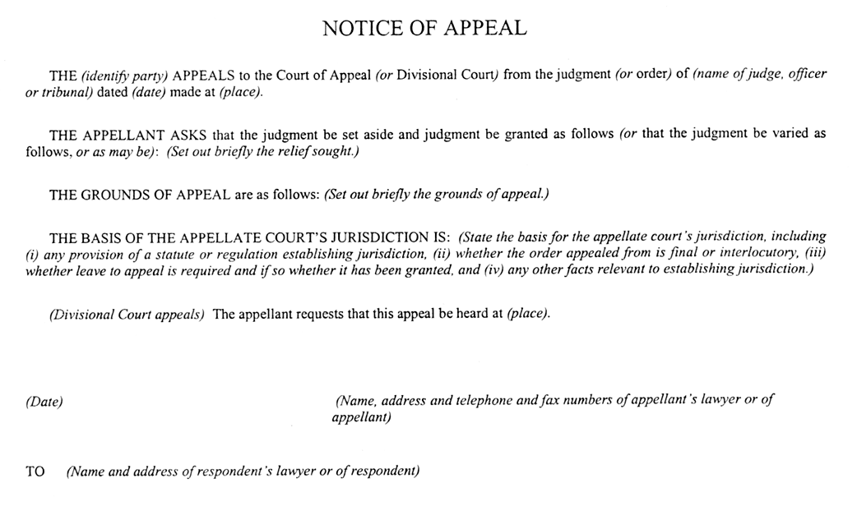
24. Form 61H of the Regulation is amended,
(a) by striking out “appeal books” wherever it appears and substituting in each case “appeal book and compendium”; and
(b) by striking out “are complete and legible” and substituting “is complete and legible”.
25. Form 70A of the Regulation is revoked.
26. Item 32 of Part II of Tariff A of the Regulation is revoked and the following substituted:
32. For copies of records, appeal books and compendiums, and factums, a reasonable amount.
27. This Regulation comes into force on June 30, 2003.

Français

Back to top

