Français
ontario regulation 93/03
made under the
expropriations act
Made: March 19, 2003
Filed: March 21, 2003
Printed in The Ontario Gazette: April 5, 2003
Amending Reg. 363 of R.R.O. 1990
(Forms)
1. Forms 7 and 8 of Regulation 363 of the Revised Regulations of Ontario, 1990 are revoked and the following substituted:
Form 7
Expropriations Act
notice of expropriation
Insert regs\Graphics\Source Law\2003\93\930007ae.tif
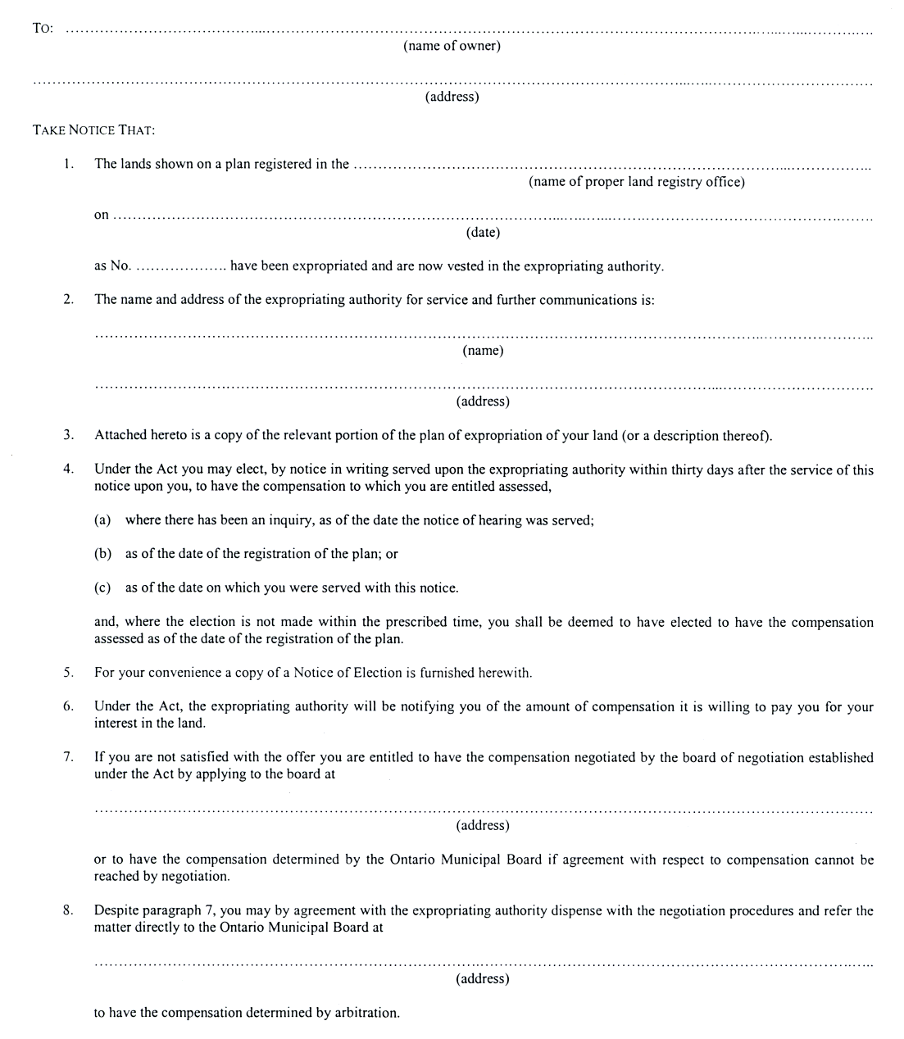
Insert regs\Graphics\Source Law\2003\93\930007be.tif
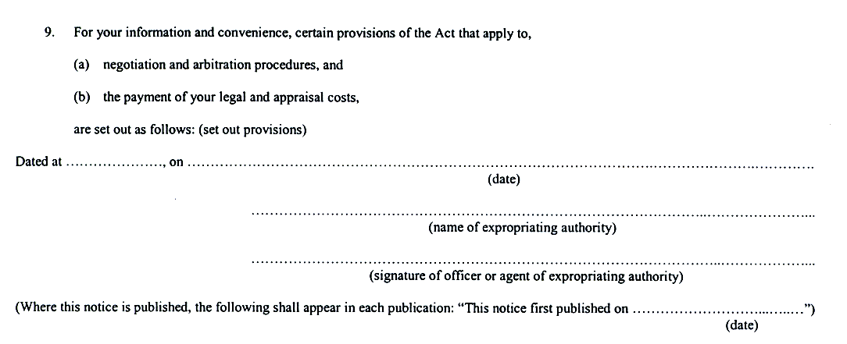
Form 8
Expropriations Act
notice of election
Insert regs\Graphics\Source Law\2003\93\930008ae.tif
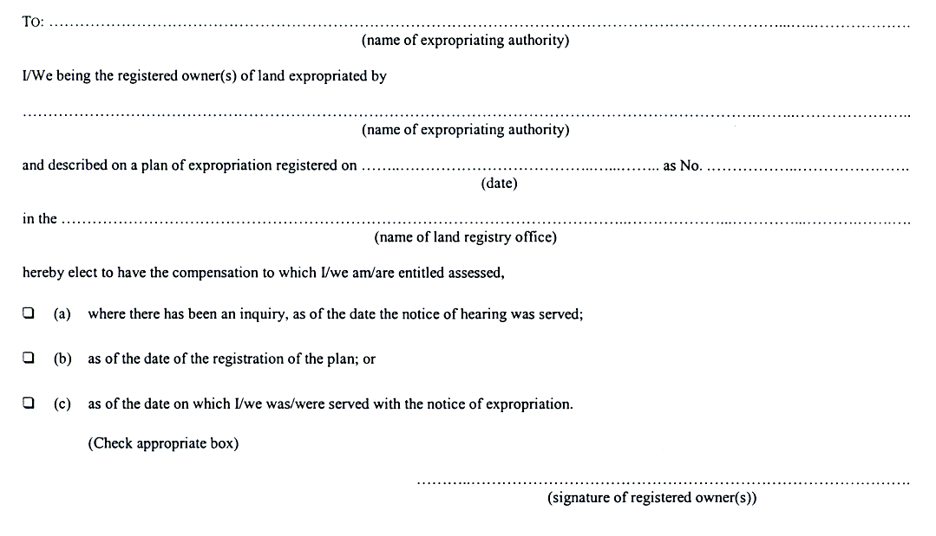

Français

Back to top

