Français
ontario regulation 89/04
made under the
Courts of Justice Act
Made: March 2, 2004
Approved: March 31, 2004
Filed: April 2, 2004
Printed in The Ontario Gazette: April 17, 2004
Amending O. Reg. 114/99
(Family Law Rules)
1. (1) Subrule 1 (2) of Ontario Regulation 114/99 is amended by striking out the portion before clause (a) and substituting the following:
CASES AND COURTS TO WHICH RULES APPLY
(2) These rules apply to all family law cases in the Family Court of the Superior Court of Justice, in the Superior Court of Justice and in the Ontario Court of Justice,
. . . . .
(2) Subrule 1 (2.1) of the Regulation is revoked.
(3) Rule 1 of the Regulation is amended by adding the following subrule:
CASE MANAGEMENT IN THE SUPERIOR COURT OF JUSTICE
(4.1) Despite subrule (2), rule 41 (case management in the Superior Court of Justice, other than the Family Court of the Superior Court of Justice) applies only to cases in the Superior Court of Justice that are not in the Family Court of the Superior Court of Justice.
(4) Subrule 1 (13) of the Regulation is revoked and the following substituted:
TRANSITIONAL PROVISION
(13) If a case was started in the Superior Court of Justice, other than in the Family Court of the Superior Court of Justice, before July 1, 2004, the following applies:
1. The case or a step in the case shall be carried on under these rules on or after July 1, 2004.
2. If the case was not governed by the Family Case Management Rules for the Superior Court of Justice in Toronto or by the Essex Family Case Management Rules before July 1, 2004 and a step in the case is taken on or after that date, the timetable set out in subrule 41 (5) and subrules 41 (6), (7) and (8) apply as if the case started on the date on which the step was taken.
3. If the case was governed by the Family Case Management Rules for the Superior Court of Justice in Toronto before July 1, 2004, the timetable established for the case when it was started applies to the case on or after July 1, 2004.
4. If the case was governed by the Essex Family Case Management Rules before July 1, 2004 and a family consent timetable was made by the court before that date, the family consent timetable continues to apply to the case on or after July 1, 2004.
5. If the case was governed by the Essex Family Case Management Rules before July 1, 2004 but no family consent timetable was made by the court before that date,
i. the case management order expires on July 1, 2004, and
ii. if a step in the case is taken on or after July 1, 2004, the timetable set out in subrule 41 (5) and subrules 41 (6), (7) and (8) apply to the case as if the case started on the date on which the step was taken.
(5) Subrule 1 (14) of the Regulation is revoked and the following substituted:
TRANSITION: OLD FORMS
(14) For cases started in the Superior Court of Justice, other than the Family Court of the Superior Court of Justice, before July 1, 2004, a form in use under the rules that applied before July 1, 2004 may continue to be used, if it contains substantially the same information as the form required by these rules, until January 1, 2005.
2. Subrule 8 (4) of the Regulation is amended by adding “and subrule 41 (4) (case management, clerk’s role)” after “subrule 39 (7) (case management, standard track)”.
3. The Regulation is amended by adding the following rule:
RULE 8.1: MANDATORY INFORMATION PROGRAM IN THE SUPERIOR COURT OF JUSTICE IN TORONTO
APPLICATION OF RULE
8.1 (1) This rule applies to,
(a) divorce cases started in the Superior Court of Justice in Toronto after July 1, 1998 in which any claim, other than a divorce, costs and the incorporation of the terms of an agreement or prior court order, is made; and
(b) cases governed by Parts I, II and III of the Family Law Act and Part III of the Children’s Law Reform Act and started in the Superior Court of Justice in Toronto after July 1, 1998 in which any claim, other than costs, the incorporation of the terms of an agreement or prior court order and change of the terms of a final order, is made.
EXCEPTION
(2) Subrules (4) to (7) do not apply to,
(a) a person or agency referred to in subsection 33 (3) of the Family Law Act;
(b) the Director of the Family Responsibility Office.
CONTENT OF PROGRAM
(3) The program referred to in this rule shall provide parties to cases referred to in subrule (1) with information about separation and the legal process, and may include information on topics such as,
(a) the options available for resolving differences, including alternatives to going to court;
(b) the impact the separation of parents has on children; and
(c) resources available to deal with problems arising from separation.
ATTENDANCE COMPULSORY
(4) Each party to a case shall attend the program no later than 45 days after the case is started.
APPOINTMENTS TO ATTEND
(5) The applicant shall arrange his or her own appointment to attend the program, obtain an appointment for the respondent from the person who conducts the program, and serve notice of the respondent’s appointment with the application.
CERTIFICATE
(6) The person who conducts the program shall provide for each party who attends a certificate of attendance, which shall be filed as soon as possible, and in any event not later than 2 p.m. on the second day before the day of the case conference, if one is scheduled.
NO OTHER STEPS
(7) A party shall not take any step in the case before his or her certificate of attendance is filed, except that a respondent may serve and file an answer and a party may make an appointment for a case conference.
EXCEPTION
(8) The court may, on motion, order that any or all of subrules (4) to (7) do not apply to the party because of urgency or hardship or for some other reason in the interest of justice.
REVOCATION
(9) This rule is revoked on December 31, 2007.
4. Rule 9 of the Regulation is revoked and the following substituted:
RULE 9: CONTINUING RECORD
CONTINUING RECORD CREATED
9. (1) A person starting a case shall,
(a) prepare a single continuing record of the case, to be the court’s permanent record of the case; and
(b) serve it on all other parties and file it, along with the affidavits of service or other documents proving that the continuing record was served.
CONTINUING RECORD NOT REQUIRED
(2) It is not necessary to start a continuing record in the following circumstances:
1. A joint application for divorce case.
2. An uncontested divorce case except that if the respondent files an answer, the respondent shall start the continuing record on filing the answer.
3. The applicant files a change information form (Form 15) except that if the respondent files an affidavit that sets out any disagreement, the respondent shall start the continuing record on filing the affidavit.
4. The case is started in the Superior Court of Justice, other than the Family Court of the Superior Court of Justice, before July 1, 2004 and a party files a notice of change in representation (Form 4) or a party’s lawyer files a notice of motion to be removed as lawyer on or after July 1, 2004.
5. The parties file a consent motion for a final order.
SUPPORT ENFORCEMENT CONTINUING RECORD
(3) If a support order is filed with the Director of the Family Responsibility Office, the person bringing the case before the court shall prepare the continuing record, and the continuing record shall be called the support enforcement continuing record.
CHILD PROTECTION CONTINUING RECORD
(4) In an application for a child protection order, the continuing record shall be called the child protection continuing record.
STATUS REVIEW CONTINUING RECORD
(5) In an application for a status review of a child protection order, the continuing record shall be called the status review continuing record.
FORMAL REQUIREMENTS OF CONTINUING RECORD
(6) In preparing and maintaining a continuing record, support enforcement continuing record, child protection continuing record and status review continuing record under this rule, the parties shall meet the requirements set out in the document entitled “Formal Requirements of the Continuing Record under the Family Law Rules”, dated March 1, 2004, published by the Family Rules Committee and available through the web site www.ontariocourts.on.ca.
SEPARATION OF SINGLE RECORD
(7) Instead of the single continuing record mentioned in subrule (1), the continuing record may be separated into separate records for the applicant and the respondent, in accordance with the following:
1. In any case the court may order separate records on its own initiative or at the request of either party at a case conference, settlement conference or trial management conference.
2. In a standard track case referred to in subrule 39 (7) or a case under rule 41, any party may, on filing their first document in the case, elect that the continuing record consist of separate records.
3. If the court orders separate records and there is more than one applicant and respondent, the court may order separate records for each applicant and respondent.
4. If the record consists of separate records, the separate records are called the applicant’s record and the respondent’s record.
COMBINING SEPARATED RECORDS
(8) If the continuing record has been separated, the court may order the records to be combined into a single record on its own initiative or at the request of either party at a case conference, settlement conference or trial management conference.
COMBINING SEPARATED RECORDS ON CONSENT
(9) If the continuing record has been separated, the parties may, if they agree, combine the separate records into a single continuing record, in which case the parties shall arrange together for the combining of the records.
BY WHOM RECORD IS SEPARATED OR COMBINED
(10) If the court orders that the continuing record,
(a) be separated or combined on its own initiative, the court shall give directions as to which party shall separate or combine the record, as the case requires;
(b) be separated or combined at the request of a party at a case conference, settlement conference or trial management conference, the party that makes the request shall separate or combine the record, as the case requires, unless the court orders otherwise.
MAINTAINING CONTINUING RECORD
(11) The parties are responsible, under the clerk’s supervision, for adding to a continuing record that has not been separated all documents filed in the case and, in the case of separated records, each party is responsible, under the clerk’s supervision, for adding the documents the party files to the party’s own record.
DUTIES OF PARTY SERVING DOCUMENTS
(12) A party serving documents shall,
(a) if the continuing record has not been separated,
(i) serve and file any documents that are not already in the continuing record, and
(ii) serve with the documents an updated cumulative table of contents listing the documents being filed; and
(b) if the continuing record has been separated,
(i) serve and file any documents that are not already in the party’s separate record, and
(ii) serve with the documents an updated cumulative table of contents listing the documents being filed in the party’s separate record.
NO SERVICE OR FILING OF DOCUMENTS ALREADY IN RECORD
(13) A party shall not serve or file any document that is already in the record, despite any requirement in these rules that the document be served and filed.
SPECIAL CASE: CHILDREN’S LAWYER
(14) If the continuing record has been separated and the Children’s Lawyer has been appointed as the legal representative of a child who is not a party under subsection 89 (3.1) of the Courts of Justice Act, the Children’s Lawyer may prepare, serve and file a separate record in accordance with this rule as if the Children’s Lawyer were a party.
DOCUMENTS REFERRED TO BY TAB IN RECORD
(15) A party who is relying on a document in the record shall refer to it by its tab in the record, except in a support enforcement continuing record.
DOCUMENTS NOT TO BE REMOVED FROM RECORD
(16) No document shall be removed from the continuing record except by order.
WRITTEN REASONS FOR ORDER
(17) If the court gives written reasons for making an order,
(a) they may be endorsed by hand on an endorsement sheet, or the endorsement may be a short note on the endorsement sheet saying that written reasons are being given separately;
(b) the clerk shall add a copy of the reasons to the endorsements section of the record; and
(c) the clerk shall send a copy to the parties by mail, fax or electronic mail.
new record on motion to change final order
(18) If the court has made a final order and a motion to change is made, a new continuing record shall be prepared and this rule applies to the new continuing record.
APPEAL
(19) If a final order is appealed, only the notice of appeal and any order of the appeal court (and no other appeal document) shall be added to the record.
TRANSFER OF RECORD IF CASE TRANSFERRED
(20) If the court transfers a case to another municipality the clerk shall, on request, transfer the record to the clerk at the court office in the other municipality, and the record shall be used there as if the case had started in the other municipality.
CONFIRMATION OF SUPPORT ORDER
(21) When a provisional support order or a provisional change to a support order is sent to a court in Ontario for confirmation,
(a) if the provisional order or change was made in Ontario, the clerk shall send the continuing record to the court office where the confirmation is to take place and the respondent shall update it as this rule requires; and
(b) if the provisional order or change was not made in Ontario, the clerk shall prepare the continuing record and the respondent shall update it as this rule requires.
TRANSITIONAL PROVISION, CASES IN THE SUPERIOR COURT OF JUSTICE
(22) This rule applies to cases started in the Superior Court of Justice before July 1, 2004, in the following manner:
1. Any party may at any time prepare, serve and file the continuing record as described in this rule. This rule then applies to all documents filed afterward.
2. If neither party has filed the continuing record in accordance with paragraph 1, the first party who files a document on or after July 1, 2004 shall start the continuing record as described in this rule. This rule then applies to all documents filed afterward.
3. Despite paragraph 2, the court may free a party from the obligation to start the continuing record, and give other directions about the form and content of the record for the case.
4. The continuing record is started with the documents starting and answering the case, a summary of court cases (Form 8E) and the parties’ most recent financial statements, unless the court orders otherwise.
TRANSITIONAL PROVISION, CASES IN FAMILY COURT OF SUPERIOR COURT OF JUSTICE OR ONTARIO COURT OF JUSTICE
(23) Despite this rule, a case started in the Family Court of the Superior Court of Justice or the Ontario Court of Justice before July 1, 2004 continues on or after that date to be governed by the predecessor of this rule, as it read on June 30, 2004, except that a party may request that the continuing record be separated under paragraph 1 of subrule (7) and if the record is separated, this rule applies to all documents filed thereafter.
5. Subrule 13 (7) of the Regulation is revoked and the following substituted:
NOTICES OF ASSESSMENT REQUIRED
(7) The clerk shall not accept a party’s financial statement for filing unless,
(a) copies of the party’s notices of assessment for the three previous taxation years are attached as the form requires; or
(b) the financial statement contains the party’s signed direction to the Canada Customs and Revenue Agency (Form 13A) for disclosure of the party’s income and deduction printouts.
INCOME TAX RETURNS
(7.1) Income tax returns attached to a party’s financial statement are not required to be filed in the continuing record unless the court orders otherwise.
6. (1) The title to Rule 14 of the Regulation is revoked and the following substituted:
RULE 14: MOTIONS FOR TEMPORARY ORDERS
(2) Paragraph 3 of subrule 14 (1) of the Regulation is revoked and the following substituted:
3. A change in a temporary order.
(3) Subrules 14 (4) and (4.1) of the Regulation are revoked and the following substituted:
NO MOTION BEFORE CASE CONFERENCE ON SUBSTANTIVE ISSUES COMPLETED
(4) No notice of motion or supporting evidence may be served and no motion may be heard before a case conference dealing with the substantive issues in the case has been completed.
(4) Subrule 14 (4.2) of the Regulation is amended by striking out “Subrules (4) and (4.1) do” and substituting “Subrule (4) does”.
(5) Subrule 14 (5) of the Regulation is revoked.
(6) Subrule 14 (6) of the Regulation is amended by adding the following clauses:
(e.2) made without notice, made on consent, that is unopposed or that is limited to procedural, uncomplicated or unopposed matters (Form 14B);
(e.3) made in an appeal;
(7) Clause 14 (23) (b) of the Regulation is revoked and the following substituted:
(b) postpone the trial or any other step in the case;
7. (1) The title to Rule 15 of the Regulation is revoked and the following substituted:
RULE 15: MOTIONS TO CHANGE A FINAL ORDER OR AGREEMENT
(2) Subrule 15 (0.1) of the Regulation is revoked and the following substituted:
APPLICATION
(0.1) This rule applies,
(a) to motions to change an agreement for support filed under section 35 of the Family Law Act;
(b) to motions to change a final order, except a final order in a child protection case that is reviewable under section 64 of the Child and Family Services Act.
(3) Rule 15 of the Regulation is amended by adding the following subrule:
MOTION NOT TO BE HEARD BEFORE CASE CONFERENCE
(2.1) A party may serve a notice of motion and supporting evidence for an order to change a final order or agreement before a case conference has been held, but the motion may not be heard before a case conference has been completed.
(4) Subrule 15 (8) of the Regulation is revoked and the following substituted:
EXHIBIT TO AFFIDAVIT
(8) In addition, a copy of any existing order or agreement that deals with custody, access or support shall be attached as an exhibit to the affidavit.
(5) Rule 15 of the Regulation is amended by adding the following subrules:
APPLICATION OF RULE 14
(15) Rule 14 applies with necessary modifications to a motion to change a final order or agreement.
MOTION UNDER RULE 14
(16) A motion under rule 14 may be made on a motion to change a final order or agreement.
8. (1) Subrule 17 (4) of the Regulation is amended by striking out “and” at the end of clause (g), by adding “and” at the end of clause (h) and by adding the following clause:
(i) giving directions with respect to any intended motion, including the preparation of a specific timetable for the exchange of material for the motion and ordering the filing of summaries of argument, if appropriate.
(2) Subrule 17 (7) of the Regulation is revoked and the following substituted:
COMBINED CONFERENCE
(7) On the direction of the judge, part or all of a case conference, settlement conference and trial management conference may be combined.
(3) Clause 17 (8) (a) of the Regulation is revoked and the following substituted:
(a) make an order for document disclosure (rule 19), questioning (rule 20) or filing of summaries of argument on a motion, set the times for events in the case or give directions for the next step or steps in the case;
(4) Subrule 17 (11) of the Regulation is amended by striking out “held” at the end and substituting “completed”.
(5) Subrules 17 (21), (22), (22.1) and (22.2) of the Regulation are revoked and the following substituted:
CONTINUING RECORD, TRIAL MANAGEMENT CONFERENCE BRIEFS
(21) Trial management conference briefs form part of the continuing record.
CONTINUING RECORD, CASE CONFERENCE BRIEFS
(22) Case conference briefs do not form part of the continuing record unless the court orders otherwise and shall be returned at the end of the conference to the parties who filed them or be destroyed by court staff immediately after the conference.
DELETIONS FROM CASE CONFERENCE BRIEF INCLUDED IN RECORD
(22.1) If the court orders that a case conference brief form part of the continuing record, that portion of the brief that deals with settlement of the case shall be deleted.
CONTINUING RECORD, SETTLEMENT CONFERENCE BRIEFS
(22.2) Settlement conference briefs do not form part of the continuing record and shall be returned at the end of the conference to the parties who filed them or be destroyed by the court staff immediately after the conference.
9. Rule 26 of the Regulation is amended by adding the following subrules:
PLACE OF REGISTRATION OF SUPPORT ORDER UNDER THE DIVORCE ACT (CANADA)
(15) If a person wants to enforce an order for support made outside Ontario under the Divorce Act (Canada), the order shall be registered in a court, as defined in subsection 20 (1) of that Act, as follows:
1. If the recipient resides in Ontario, in the municipality where the recipient resides.
2. If the recipient does not reside in Ontario, in the municipality where the payor resides.
3. If neither the recipient nor the payor resides in Ontario, in the municipality where any property owned by the payor is located or, if the payor doesn’t have any property, in any municipality.
PLACE OF REGISTRATION OF CUSTODY OR ACCESS ORDER UNDER THE DIVORCE ACT (CANADA)
(16) If a person wants to enforce an order involving custody of or access to a child that is made outside Ontario under the Divorce Act (Canada), the order shall be registered in a court, as defined in subsection 20 (1) of that Act, in accordance with clause 5 (6) (a) of these rules.
REGISTRATION REQUIREMENTS
(17) The person requesting the registration shall send to the court a certified copy of the order and a written request that the order be registered under paragraph 20 (3) (a) of the Divorce Act (Canada).
10. Subrule 27 (4) of the Regulation is amended by adding “or (7.1)” immediately after “13 (7)”.
11. (1) Subrule 28 (10) of the Regulation is amended by striking out “until the person obeys the order” at the end and substituting “until the writ is withdrawn or the court orders otherwise”.
(2) Rule 28 of the Regulation is amended by adding the following subrule:
ELECTRONIC WRITS
(11) If a recipient is entitled to the issue of a writ of seizure and sale by the Superior Court of Justice, the recipient is entitled to the electronic issue and filing of the writ in accordance with the Rules of Civil Procedure.
12. Subrule 36 (9) of the Regulation is revoked.
13. Rule 38 of the Regulation is revoked and the following substituted:
RULE 38: APPEALS
RULES THAT APPLY IN APPEALS TO DIVISIONAL COURT AND COURT OF APPEAL
38. (1) Rules 61, 62 and 63 of the Rules of Civil Procedure apply with necessary modifications, including those modifications set out in subrules (2) and (3),
(a) if an appeal lies to the Divisional Court or the Court of Appeal;
(b) if leave to appeal to the Divisional Court or the Court of Appeal is required,
in a family law case as described in subrule 1 (2).
MODIFICATIONS IN CHILD PROTECTION APPEALS
(2) If the appeal is brought in a case under the Child and Family Services Act, the following time periods apply instead of the time periods mentioned in the referenced provisions of the Rules of Civil Procedure:
1. The time period referred to in clause 61.09 (1) (a) shall be 14 days after filing the notice of appeal if there is no transcript.
2. The time period referred to in clause 61.09 (1) (b) shall be 30 days after receiving notice that the evidence has been transcribed.
3. The time period referred to in clause 61.12 (2) shall be 30 days after service of the appeal book and compendium, exhibit book, transcript of evidence, if any, and appellant’s factum.
4. The time period referred to in clause 61.13 (2) (a) shall be 30 days after the registrar receives notice that the evidence has been transcribed.
5. The time period referred to in clause 61.13 (2) (b) shall be six months after filing the notice of appeal.
6. The time period referred to in subrule 62.01 (2) for serving the notice of appeal shall be 30 days.
APPEAL OF TEMPORARY ORDER IN CHILD AND FAMILY SERVICES ACT CASE
(3) In an appeal of a temporary order made in a case under the Child and Family Services Act and brought to the Divisional Court under clause 19 (1) (b) of the Courts of Justice Act, the motion for leave to appeal shall be combined with the notice of appeal and heard together with the appeal.
APPEALS TO THE SUPERIOR COURT OF JUSTICE
(4) Subrules (5) to (45) apply to an appeal from an order of the Ontario Court of Justice to the Superior Court of Justice under,
(a) section 48 of the Family Law Act;
(b) section 73 of the Children’s Law Reform Act;
(c) sections 69 and 156 of the Child and Family Services Act;
(d) section 40 of the Interjurisdictional Support Orders Act, 2002;
(e) section 40 of the Courts of Justice Act; and
(f) any other statute to which these rules apply, unless the statute provides for another procedure.
HOW TO START APPEAL
(5) To start an appeal from a final order of the Ontario Court of Justice to the Superior Court of Justice under any of the provisions listed in subrule (4), a party shall,
(a) within 30 days after the date of the order or decision being appealed from, serve a notice of appeal (Form 38) by regular service on,
(i) every other party affected by the appeal or entitled to appeal,
(ii) the clerk of the court in the place where the order was made, and
(iii) if the appeal is under section 69 of the Child and Family Services Act, every other person entitled to notice under subsection 39 (3) of that Act who appeared at the hearing; and
(b) within 10 days after serving the notice of appeal, file it.
STARTING APPEAL OF TEMPORARY ORDER
(6) Subrule (5) applies to the starting of an appeal from a temporary order of the Ontario Court of Justice to the Superior Court of Justice except that the notice of appeal shall be served within seven days after the date of the temporary order.
SAME, CHILD AND FAMILY SERVICES ACT CASE
(7) To start an appeal from a temporary order of the Ontario Court of Justice to the Superior Court of Justice in a case under the Child and Family Services Act, subrule (5) applies and the notice of appeal shall be served within 30 days after the date of the temporary order.
NAME OF CASE UNCHANGED
(8) The name of a case in an appeal shall be the same as the name of the case in the order appealed from and shall identify the parties as appellant and respondent.
APPEAL BY RESPONDENT
(9) If the respondent in an appeal also wants to appeal the same order, this rule applies, with necessary modifications, to the respondent’s appeal, and the two appeals shall be heard together.
GROUNDS STATED IN NOTICE OF APPEAL
(10) The notice of appeal shall state the order that the appellant wants the appeal court to make and the legal grounds for the appeal.
OTHER GROUNDS
(11) At the hearing of the appeal, no grounds other than the ones stated in the notice of appeal may be argued unless the court gives permission.
TRANSCRIPT OF EVIDENCE
(12) If the appeal requires a transcript of evidence, the appellant shall, within 30 days after filing the notice of appeal, file proof that the transcript has been ordered.
CONSULTATION WITH RESPONDENT
(13) The appellant shall determine if the appeal requires a transcript of evidence in consultation with the respondent.
AGREEMENT ON EVIDENCE TO BE TRANSCRIBED
(14) If the appellant and respondent agree about what evidence needs to be transcribed, the appellant shall order the agreed evidence transcribed.
NO AGREEMENT
(15) If the appellant and respondent cannot agree, the appellant shall order a transcript of all of the oral evidence from the hearing of the decision under appeal unless the court orders otherwise.
COURT REPORTER’S DUTY
(16) When the court reporter has completed the transcript, he or she shall promptly notify the appellant, the respondent and the court office in the court where the appeal will be heard.
CONTENTS OF APPELLANT’S APPEAL RECORD
(17) The appellant’s appeal record shall contain a copy of the following documents, in the following order:
1. A table of contents describing each document, including each exhibit, by its nature and date and, for an exhibit, by exhibit number or letter.
2. The notice of appeal.
3. The order being appealed, as signed, and any reasons given by the court appealed from, as well as a further printed copy of the reasons if they are handwritten.
4. A transcript of the oral evidence.
5. Any other material that was before the court appealed from and that is necessary for the appeal.
CONTENTS OF APPELLANT’S FACTUM
(18) The appellant’s factum shall be not more than 30 pages long, shall be signed by the appellant’s lawyer or, if none, by the appellant and shall consist of the following parts, containing paragraphs numbered consecutively from the beginning to the end of the factum:
1. Part 1: Identification. A statement identifying the appellant and respondent and the court appealed from, and stating the result in that court.
2. Part 2: Overview. A brief overview of the case and the issues on the appeal.
3. Part 3: Facts. A brief summary of the facts relevant to the appeal, with reference to the evidence by page and line as necessary.
4. Part 4: Issues. A brief statement of each issue, followed by a brief argument referring to the law relating to that issue.
5. Part 5: Order. A precise statement of the order the appeal court is asked to make, including any order for costs.
6. Part 6: Time estimate. An estimate of how much time will be needed for the appellant’s oral argument, not including reply to the respondent’s argument.
7. Part 7: List of authorities. A list of all statutes, regulations, rules, cases and other authorities referred to in the factum.
8. Part 8: Legislation. A copy of all relevant provisions of statutes, regulations and rules.
RESPONDENT’S FACTUM AND APPEAL RECORD
(19) The respondent shall, within the timeline set out in subrule (21) or (22), serve on every other party to the appeal and file,
(a) a respondent’s factum (subrule (20)); and
(b) if applicable, a respondent’s appeal record containing a copy of any material that was before the court appealed from which are necessary for the appeal but are not included in the appellant’s appeal record.
CONTENTS OF RESPONDENT’S FACTUM
(20) The respondent’s factum shall be not more than 30 pages long, shall be signed by the respondent’s lawyer or, if none, by the respondent and shall consist of the following parts, containing paragraphs numbered consecutively from the beginning to the end of the factum:
1. Part 1: Overview. A brief overview of the case and the issues on the appeal.
2. Part 2: Facts. A brief statement of the facts in the appellant’s factum that the respondent accepts as correct and the facts that the respondent says are incorrect, and a brief summary of any additional facts relied on by the respondent, with reference to the evidence by page and line as necessary.
3. Part 3: Issues. A statement of the respondent’s position on each issue raised by the appellant, followed by a brief argument referring to the law relating to that issue.
4. Part 4: Additional issues. A brief statement of each additional issue raised by the respondent, followed by a brief argument referring to the law relating to that issue.
5. Part 5: Order. A precise statement of the order the appeal court is asked to make, including any order for costs.
6. Part 6: Time estimate. An estimate of how much time will be needed for the respondent’s oral argument.
7. Part 7: List of authorities. A list of all statutes, regulations, rules, cases and other authorities referred to in the factum.
8. Part 8: Legislation. A copy of all relevant provisions of statutes, regulations and rules not included in the appellant’s factum.
TIMELINES FOR SERVING AND FILING OF RECORDS AND FACTUMS OTHER THAN IN CHILD AND FAMILY SERVICES ACT CASES
(21) Except for appeals in cases under the Child and Family Services Act, the following timelines for serving appeal records and factums apply:
1. If a transcript is required, the appellant’s appeal record and factum shall be served on the respondent and any other person entitled to be heard in the appeal and filed within 60 days from the date of receiving notice that evidence has been transcribed.
2. If no transcript is required, the appellant’s appeal record and factum shall be served on the respondent and any other person entitled to be heard in the appeal and filed within 30 days of filing of the notice of appeal.
3. The respondent’s appeal record and factum shall be served on the appellant and any other person entitled to be heard on the appeal and filed within 60 days from the serving of the appellant’s appeal record and factum.
TIMELINES FOR SERVING AND FILING OF RECORDS AND FACTUMS IN CHILD AND FAMILY SERVICES ACT CASES
(22) For appeals of cases under the Child and Family Services Act, the following timelines for serving appeal records and factums apply:
1. If a transcript is required, the appellant’s appeal record and factum shall be served on the respondent and any other person entitled to be heard in the appeal and filed within 30 days from the date of receiving notice that evidence has been transcribed.
2. If no transcript is required, the appellant’s appeal record and factum shall be served on the respondent and any other person entitled to be heard in the appeal and filed within 14 days of filing of the notice of appeal.
3. The respondent’s appeal record and factum shall be served on the appellant and any other person entitled to be heard on the appeal and filed within 30 days from the serving of the appellant’s appeal record and factum.
SCHEDULING OF HEARING
(23) When the appellant’s appeal record and factum have been filed and the respondent’s factum and appeal record, if any, have been filed, or the time for their filing has expired, the clerk shall schedule the appeal for hearing.
PROMPT HEARING OF CFSA APPEALS
(24) An appeal under the Child and Family Services Act shall be heard within 30 days after the appellant’s appeal record and factum are filed.
MOTIONS IN APPEALS
(25) If a person needs to bring a motion in an appeal, rule 14 applies with necessary modifications to the motion.
SECURITY FOR COSTS OF APPEAL
(26) On a motion by the respondent for security for costs, the court may make an order for security for costs that is just, if it is satisfied that,
(a) there is good reason to believe that the appeal is a waste of time, a nuisance, or an abuse of the court process and that the appellant has insufficient assets in Ontario to pay the costs of the appeal;
(b) an order for security for costs could be made against the appellant under subrule 24 (13); or
(c) for other good reason, security for costs should be ordered.
DISMISSAL FOR FAILURE TO OBEY ORDER
(27) If an appellant does not obey an order under subrule (26), the court may on motion dismiss the appeal.
MOTION FOR SUMMARY JUDGMENT IN APPEAL
(28) After the notice of appeal is filed, the respondent or any other person who is entitled to be heard on the appeal may make a motion for summary judgment or for summary decision on a legal issue without a hearing of the appeal, and rule 16 applies to the motion with necessary modifications.
MOTION TO RECEIVE FURTHER EVIDENCE
(29) Any person entitled to be heard in the appeal may bring a motion to admit further evidence under clause 134 (4) (b) of the Courts of Justice Act.
MOTION FOR DISMISSAL FOR DELAY
(30) If the appellant has not,
(a) filed proof that a transcript of evidence was ordered under subrule (12);
(b) served and filed the appeal record and factum within the timelines set out in subrule (21) or (22) or such longer time as may have been ordered by the court,
the respondent may file a procedural motion (Form 14B) to have the appeal dismissed for delay.
WITHDRAWAL OF APPEAL
(31) The appellant may withdraw an appeal by serving a notice of withdrawal (Form 12) on every other party and filing it.
DEEMED WITHDRAWAL
(32) If a person serves a notice of appeal and does not file it within 10 days as required by clause (5) (b), the appeal shall be deemed to be withdrawn unless the court orders otherwise.
AUTOMATIC STAYS PENDING APPEAL, SUPPORT ORDERS
(33) The service of a notice of appeal from a temporary or final order does not stay a support order or an order that enforces a support order.
OTHER PAYMENT ORDERS
(34) The service of a notice of appeal from a temporary or final order stays, until the disposition of the appeal, any other payment order.
STAY BY ORDER OF COURT
(35) A temporary or final order may be stayed on any conditions that the court considers appropriate,
(a) by an order of the court that made the order;
(b) by an order of the Superior Court of Justice.
EXPIRY OF STAY GRANTED BY COURT that made ORDER
(36) A stay granted under clause (35) (a) expires if no notice of appeal is served and the time for service has expired.
POWERS OF superior court of justice
(37) A stay granted under subrule (35) may be set aside or changed by the Superior Court of Justice.
EFFECT OF STAY GENERALLY
(38) If an order is stayed, no steps may be taken under the order or for its enforcement, except,
(a) by order of the Superior Court of Justice; or
(b) as provided in subrules (39) and (40).
SETTLING OF ORDER
(39) A stay does not prevent the settling or signing of the order.
WRIT OF EXECUTION
(40) A stay does not prevent the issue of a writ of seizure and sale or the filing of the writ in a sheriff’s office or land registry office, but no instruction or direction to enforce the writ shall be given to a sheriff while the stay remains in effect.
CERTIFICATE OF STAY
(41) If an order is stayed, the clerk of the court that granted the stay shall, if requested by a party to the appeal, issue a certificate of stay in Form 63A under the Rules of Civil Procedure with necessary modifications.
STAY OF SUPPORT ORDER
(42) A party who obtains a stay of a support order shall obtain a certificate of stay under subrule (41) and file it immediately in the office of the Director of the Family Responsibility Office if the stay relates to a support order being enforced by the Director.
CERTIFICATE FILED WITH SHERIFF’S OFFICE
(43) If a certificate of stay is filed with the sheriff’s office, the sheriff shall not begin or continue enforcement of the order until satisfied that the stay is no longer in effect.
REQUEST FOR CERTIFICATE
(44) A request for a certificate of stay under subrule (41) shall state whether the stay is under subrule (34) or by order under subrule (35) and, if under subrule (35), shall set out the particulars of the order.
SETTING ASIDE WRIT OF EXECUTION
(45) The court may set aside the issue or filing of a writ of seizure and sale if the party making the motion or the appellant gives security satisfactory to the court.
14. (1) Clauses 39 (5) (c) and (d) of the Regulation are revoked and the following substituted:
(c) if an answer has been filed in response to an application, or if an affidavit has been filed in response to a motion to change a final order or agreement, confirm that the case is ready for a hearing, case conference or settlement conference and schedule it accordingly;
(d) if no answer has been filed in response to an application, send the case to a judge for a decision on the basis of affidavit evidence or, on request of the applicant, schedule a case conference; and
(e) if no affidavit has been filed in response to a motion to change a final order or agreement, send the case to a judge for a decision on the basis of affidavit evidence or, on request of a party who made the motion, schedule a case conference.
(2) Clause 39 (8) (b) of the Regulation is revoked and the following substituted:
(b) a case management judge shall be assigned when a case conference or a motion is scheduled, whichever comes first; and
15. Clauses 40 (4) (c) and (d) of the Regulation are revoked and the following substituted:
(c) if an answer has been filed in response to an application, or if an affidavit has been filed in response to a motion to change a final order or agreement, confirm that the case is ready for a hearing, case conference or settlement conference and schedule it accordingly;
(d) if no answer has been filed in response to an application, send the case to a judge for a decision on the basis of affidavit evidence or, on request of the applicant, schedule a case conference; and
(e) if no affidavit has been filed in response to a motion to change a final order or agreement, send the case to a judge for a decision on the basis of affidavit evidence or, on request of a party who made the motion, schedule a case conference.
16. Rule 41 of the Regulation is revoked and the following substituted:
RULE 41: CASE MANAGEMENT IN THE SUPERIOR COURT OF JUSTICE (OTHER THAN THE FAMILY COURT OF THE SUPERIOR COURT OF JUSTICE)
CASE MANAGEMENT
41. (1) This rule applies only to cases in the Superior Court of Justice, other than cases in the Family Court of the Superior Court of Justice, started on or after July 1, 2004.
EXCLUDED CASES
(2) This rule does not apply to,
(a) enforcements; or
(b) cases under rule 37 or 37.1.
PARTIES MAY NOT LENGTHEN TIMES
(3) A time set out in this rule may be lengthened only by order of the court and not by the parties’ consent under subrule 3 (6).
CLERK’S ROLE
(4) The clerk shall not set a court date when the application is filed, and the case shall come before the court when a case conference or a motion is scheduled, whichever comes first, and the clerk shall schedule a case conference on any party’s request.
NOTICE, CASE NOT SCHEDULED FOR TRIAL AFTER 200 DAYS
(5) If a case has not been scheduled for trial within 200 days after it was started, the clerk shall serve a notice (Form 39) on the parties by mail, fax or electronic mail saying that the case will be dismissed without further notice unless one of the parties, within 30 days after the notice is served,
(a) files an agreement signed by all the parties and their lawyers, if any, for a final order disposing of all issues in the case, and a notice of motion for an order carrying out the agreement; or
(b) arranges a case conference or settlement conference for the first available date.
DISMISSAL AFTER NOTICE
(6) If the clerk serves a notice under subrule (5) and no party takes any of the steps set out in clauses (5) (a) and (b) within 30 days after the notice is served, the clerk shall prepare and sign an order dismissing the case, with no costs payable by any party.
SERVICE OF DISMISSAL ORDER
(7) The clerk shall serve the order on each party by mail, fax or electronic mail.
SERVICE OF DISMISSAL ORDER BY LAWYER ON CLIENT
(8) A lawyer who is served with a dismissal order on behalf of a client shall serve it on the client by mail, fax or electronic mail and file proof of service of the order.
17. Forms 28, 28C and 39 of the Regulation are revoked and the following substituted:
form 28
Courts of Justice Act
writ of seizure and sale
Insert regs\Graphics\Source Law\2004\89\890028ae.tif
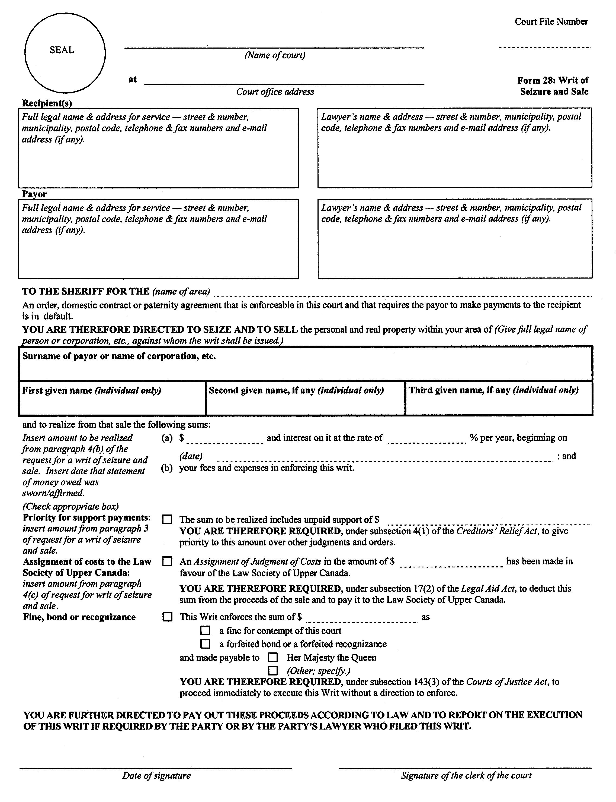
Insert regs\Graphics\Source Law\2004\89\890028be.tif
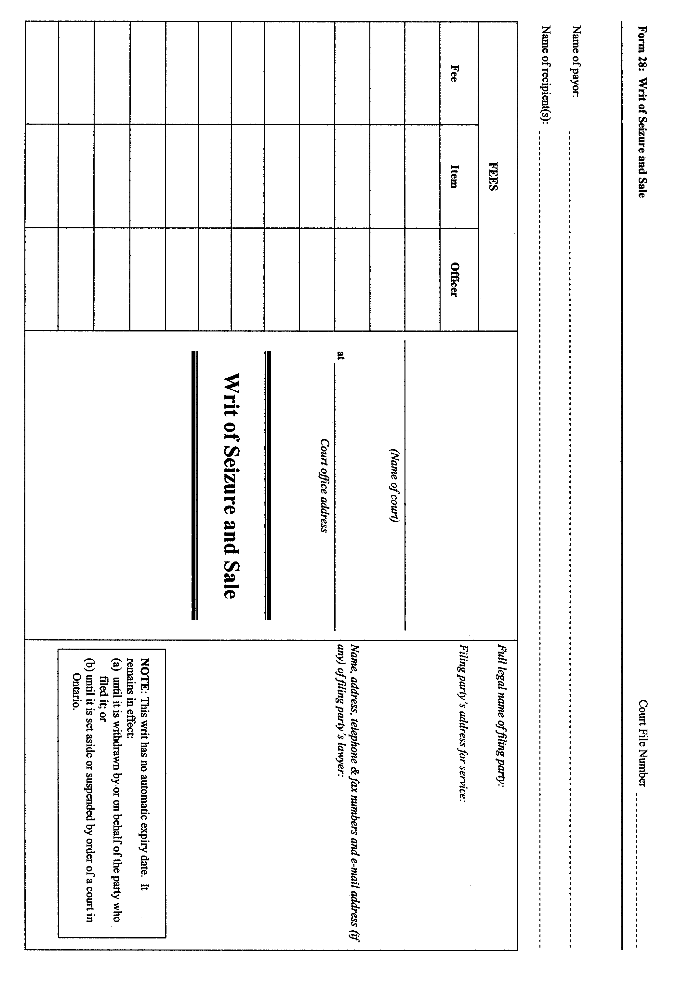
. . . . .
form 28C
Courts of Justice Act
writ of temporary seizure
Insert regs\Graphics\Source Law\2004\89\89028Cae.tif
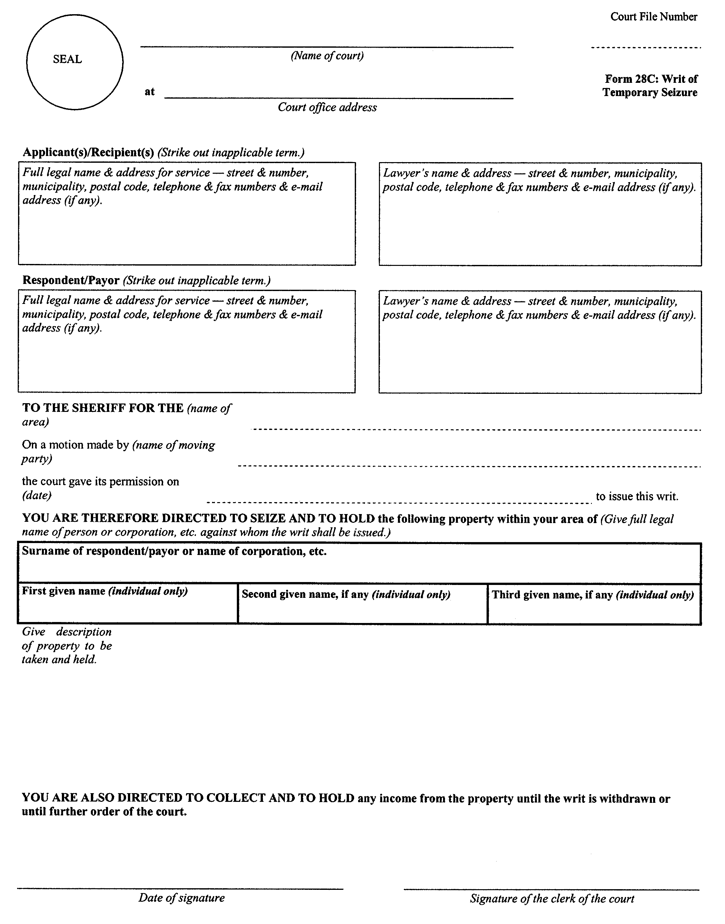
. . . . .
form 39
Courts of Justice Act
notice of approaching dismissal
Insert regs\Graphics\Source Law\2004\89\890039ae.tif
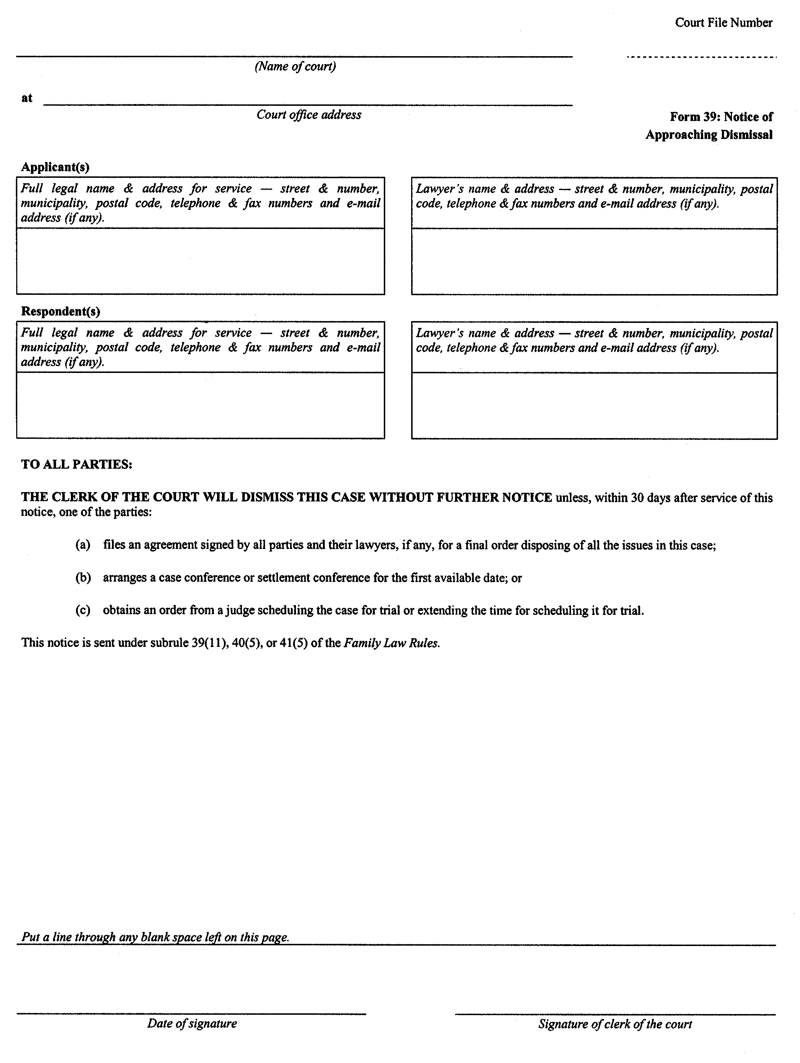
18. This Regulation comes into force on July 1, 2004.

Français

Back to top

