Français
ontario regulation 132/04
made under the
courts of justice act
Made: October 1, 2003
Approved: May 12, 2004
Filed: May 18, 2004
Printed in The Ontario Gazette: June 5, 2004
Amending Reg. 194 of R.R.O. 1990
(Rules of Civil Procedure)
1. Rule 1.07 of Regulation 194 of the Revised Regulations of Ontario, 1990 is revoked and the following substituted:
PRACTICE DIRECTIONS
Definition
1.07 (1) In this rule,
“practice direction” means a direction, notice, guide or similar publication for the purpose of governing, subject to these rules, the practice for proceedings.
Court of Appeal
(2) A practice direction for proceedings in the Court of Appeal shall be signed by the Chief Justice of Ontario.
Superior Court of Justice
(3) A practice direction for proceedings in the Superior Court of Justice throughout Ontario shall be signed by the Chief Justice of the Superior Court of Justice.
(4) A practice direction for proceedings in the Superior Court of Justice in a region shall be signed by the regional senior judge and countersigned by the Chief Justice of the Superior Court of Justice.
Filing, Posting and Publication of Notice
(5) A practice direction shall be filed with the secretary of the Civil Rules Committee and posted on the Ontario Courts web site (www.ontariocourts.on.ca), and notice of the practice direction shall be published in the Ontario Reports.
Effective Date
(6) A practice direction does not come into effect before it is filed and posted and notice of it is published as described in subrule (5).
2. Rule 1 of the Regulation is amended by adding the following rule:
COMMUNICATIONS OUT OF COURT
1.09 When a proceeding is pending before the court, no party to the proceeding and no party’s lawyer shall communicate about the proceeding with a judge, master or case management master out of court, directly or indirectly, unless,
(a) all the parties consent, in advance, to the out-of-court communication; or
(b) the court directs otherwise.
3. Rule 14.03.1 of the Regulation is amended by striking out “actions to which subrule 76.02 (1) applies” and substituting “actions to which subrule 76.02 (1), (2) or (2.1) applies”.
4. Rule 15 of the Regulation is amended by adding the following rule:
LAWYER FROM ANOTHER PROVINCE
15.07 If a lawyer from another province practises law in Ontario and represents a party to a proceeding, as authorized under the by-laws of the Law Society of Upper Canada, any party to the proceeding may move for directions for the conduct of the proceeding.
5. Rule 25.03 of the Regulation is amended by adding the following subrule:
Documents Referred to in Pleading
(4) A party who serves a pleading shall at the same time serve, at the party’s own expense, a copy of every document referred to in the pleading.
6. Clause 30.01 (1) (a) of the Regulation is revoked and the following substituted:
(a) “document” includes a sound recording, videotape, film, photograph, chart, graph, map, plan, survey, book of account, and data and information in electronic form; and
7. Subrules 31.03 (2), (3) and (4) of the Regulation are revoked and the following substituted:
On Behalf of Corporation
(2) Where a corporation may be examined for discovery,
(a) the examining party may examine any officer, director or employee on behalf of the corporation, but the court on motion of the corporation before the examination may order the examining party to examine another officer, director or employee; and
(b) the examining party may examine more than one officer, director or employee only with the consent of the parties or the leave of the court.
On Behalf of Partnership or Sole Proprietorship
(3) Where an action is brought by or against a partnership or a sole proprietorship using the firm name,
(a) each person who was, or is alleged to have been, a partner or the sole proprietor, as the case may be, at a material time, may be examined on behalf of the partnership or sole proprietorship; and
(b) the examining party may examine one or more employees of the partnership or sole proprietorship only with the consent of the parties or the leave of the court.
8. Rule 37.10 of the Regulation is amended by adding the following subrule:
Refusals and Undertakings Chart
(10) On a motion to compel answers or to have undertakings given on an examination or cross-examination satisfied,
(a) the moving party shall serve on every other party to the motion and file with proof of service, in the court office where the motion is to be heard, at least three days before the hearing, a refusals and undertakings chart (Form 37C) that sets out,
(i) the issue that is the subject of the refusal or undertaking and its connection to the pleadings or affidavit,
(ii) the question number and a reference to the page of the transcript where the question appears, and
(iii) the exact words of the question; and
(b) the responding party shall serve on the moving party and every other party to the motion and file with proof of service, in the court office where the motion is to be heard, at least two days before the hearing, a copy of the undertakings and refusals chart that was served by the moving party completed so as to show,
(i) the answer provided, or
(ii) the basis for the refusal to answer the question or satisfy the undertaking.
9. Subrule 37.14 (1) of the Regulation is amended by striking out the portion before clause (a) and substituting the following:
(1) A party or other person who,
. . . . .
10. Subrule 38.11 (1) of the Regulation is amended by striking out “A person who” at the beginning and substituting “A party or other person who”.
11. The French version of rule 49.05 of the Regulation is amended by striking out “sous réserve des droits de l’offrant” and substituting “sous toutes réserves”.
12. The English version of clause 59.03 (3) (c) of the Regulation is amended by striking out “undertaking made” and substituting “undertaking given”.
13. Rule 75.1.01 of the Regulation is revoked.
14. Clause 75.1.02 (1) (a) of the Regulation is revoked and the following substituted:
(a) that are commenced in,
(i) the City of Toronto on or after September 1, 1999,
(ii) The Regional Municipality of Ottawa-Carleton on or after September 1, 1999 but before January 1, 2001,
(iii) the City of Ottawa on or after January 1, 2001, or
(iv) the County of Essex on or after January 1, 2005; and
15. Subrule 75.1.05 (6) of the Regulation is revoked and the following substituted:
Non-Compliance
(6) If there is non-compliance with a direction given under subrule (4) or (5), the matter shall be referred,
(a) in the City of Toronto, to a judge; and
(b) in the City of Ottawa and in the County of Essex, to a judge or a case management master.
16. Subrule 75.1.10 (1) of the Regulation is revoked and the following substituted:
(1) When a certificate of non-compliance is filed, the party with carriage of the mediation shall, within 15 days after the date fixed for the mediation session that was cancelled, bring a motion for further directions before,
(a) the judge who made the order under rule 75.1.05;
(b) any other judge who is available; or
(c) in the City of Ottawa or in the County of Essex, a case management master.
17. Rule 75.1.14 of the Regulation is revoked.
18. (1) Rule 76.02 of the Regulation is amended by adding the following subrule:
(2.1) If there are two or more defendants, the procedure set out in this Rule shall be used if the plaintiff’s claim against each defendant, considered separately, meets the requirements of subrule (1).
(2) Subrule 76.02 (7) of the Regulation is amended by striking out the portion before clause (a) and substituting the following:
(7) An action that was not commenced under this Rule, or that was commenced under this Rule but continued under the ordinary procedure, is continued under this Rule if,
. . . . .
19. (1) Subrule 76.13 (1) of the Regulation is amended by striking out “complied with subrule 76.02 (1)” and substituting “complied with subrule 76.02 (1), (2) or (2.1)”.
(2) Subclause 76.13 (3) (b) (ii) of the Regulation is amended by striking out “do not comply with subrule 76.02 (1)” and substituting “do not comply with subrule 76.02 (1), (2) or (2.1)”.
(3) Subrule 76.13 (7) of the Regulation is amended by striking out “complied with subrule 76.02 (1)” and substituting “complied with subrule 76.02 (1), (2) or (2.1)”.
20. Clause 77.09.1 (5) (d) of the Regulation is revoked and the following substituted:
(d) the number and kind of the parties or prospective parties, and whether they are represented;
21. Form 4F of the Regulation is revoked and the following substituted:
Form 4F
Courts of Justice Act
NOTICE OF CONSTITUTIONAL QUESTION
(General heading)
notice of constitutional question
Insert regs\Graphics\Source Law\2004\132\13204Fae.tif
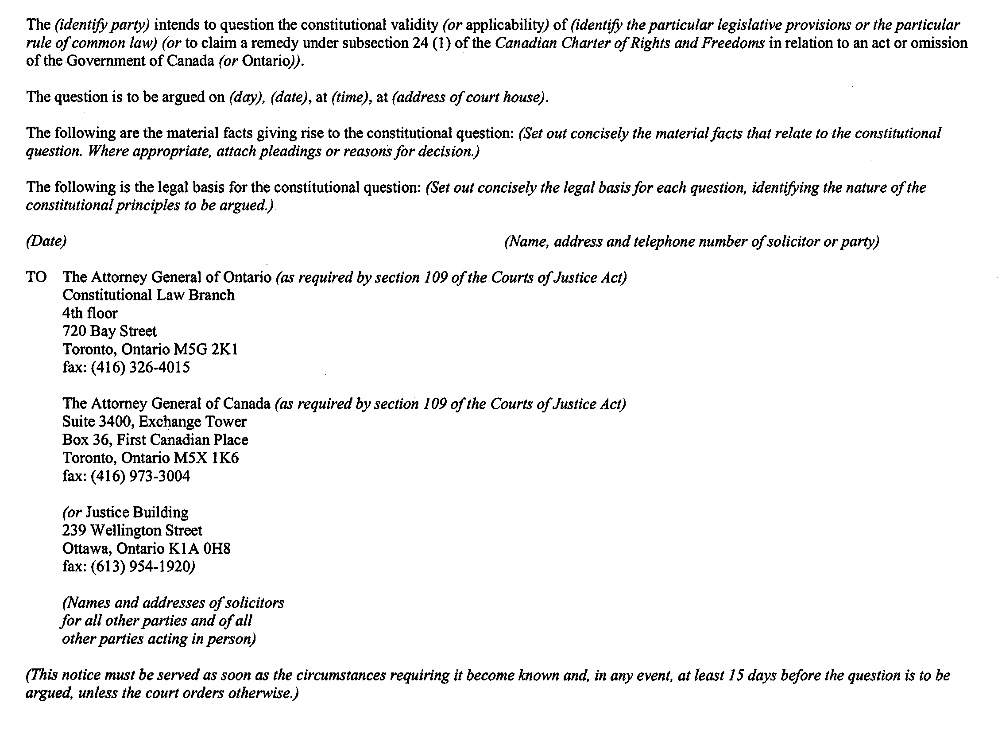
22. The Regulation is amended by adding the following Form:
Form 37C
Courts of Justice Act
refusals and undertakings chart
(General heading)
refusals and undertakings chart
Insert regs\Graphics\Source Law\2004\132\13237Cae.tif
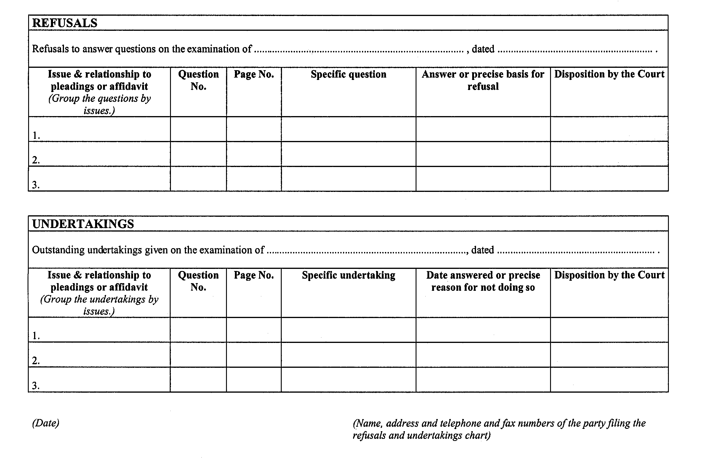
23. Form 68A of the Regulation is revoked and the following substituted:
Form 68A
Courts of Justice Act
NOTICE OF application to divisional court for judicial review
(General heading)
Insert regs\Graphics\Source Law\2004\132\13268Aae.tif
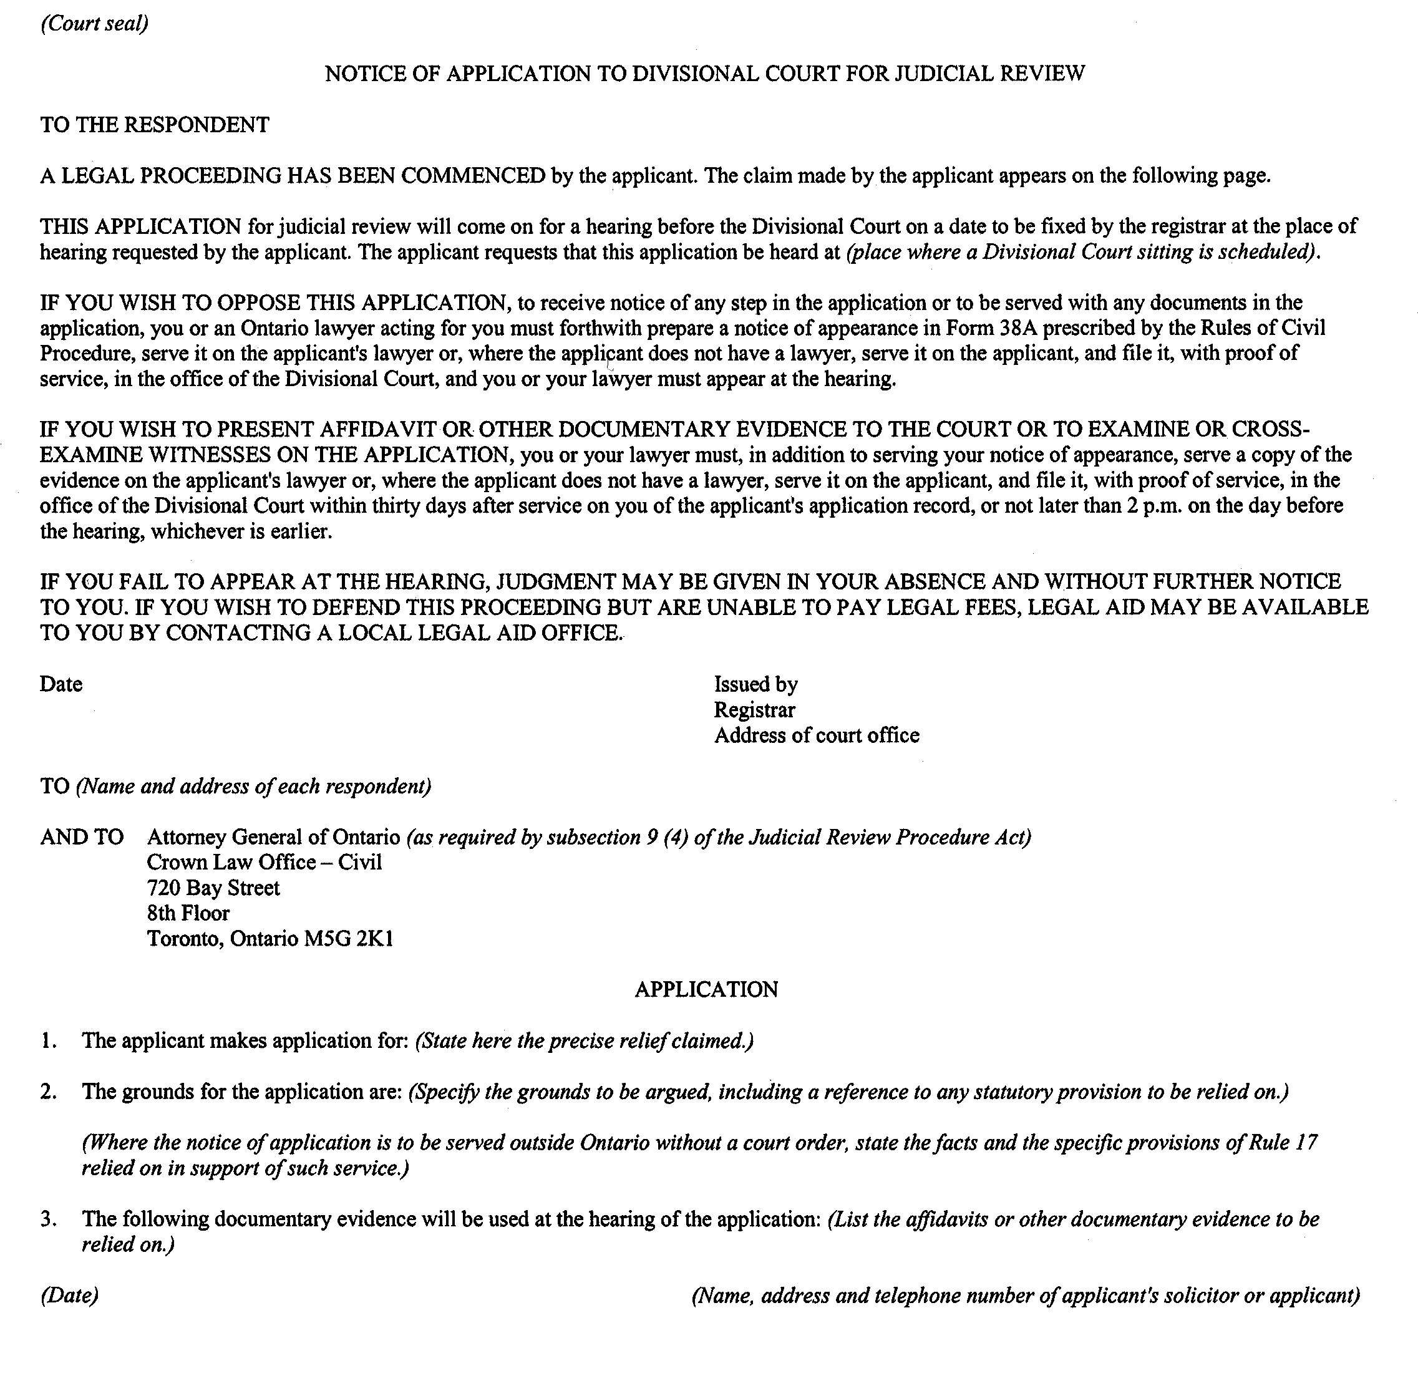
24. Forms 74.1, 74.2, 74.3, 74.4, 74.4.1, 74.5, 74.5.1, 74.6, 74.7, 74.14, 74.15, 74.16, 74.17, 74.20.1, 74.21, 74.24, 74.27, 74.30 and 75.1 of the Regulation are revoked and the following substituted:
Form 74.1
Courts of Justice Act
notice to estate registrar of deposit of will or codicil
ontario
superior court of justice
notice
Insert regs\Graphics\Source Law\2004\132\132741ae.tif
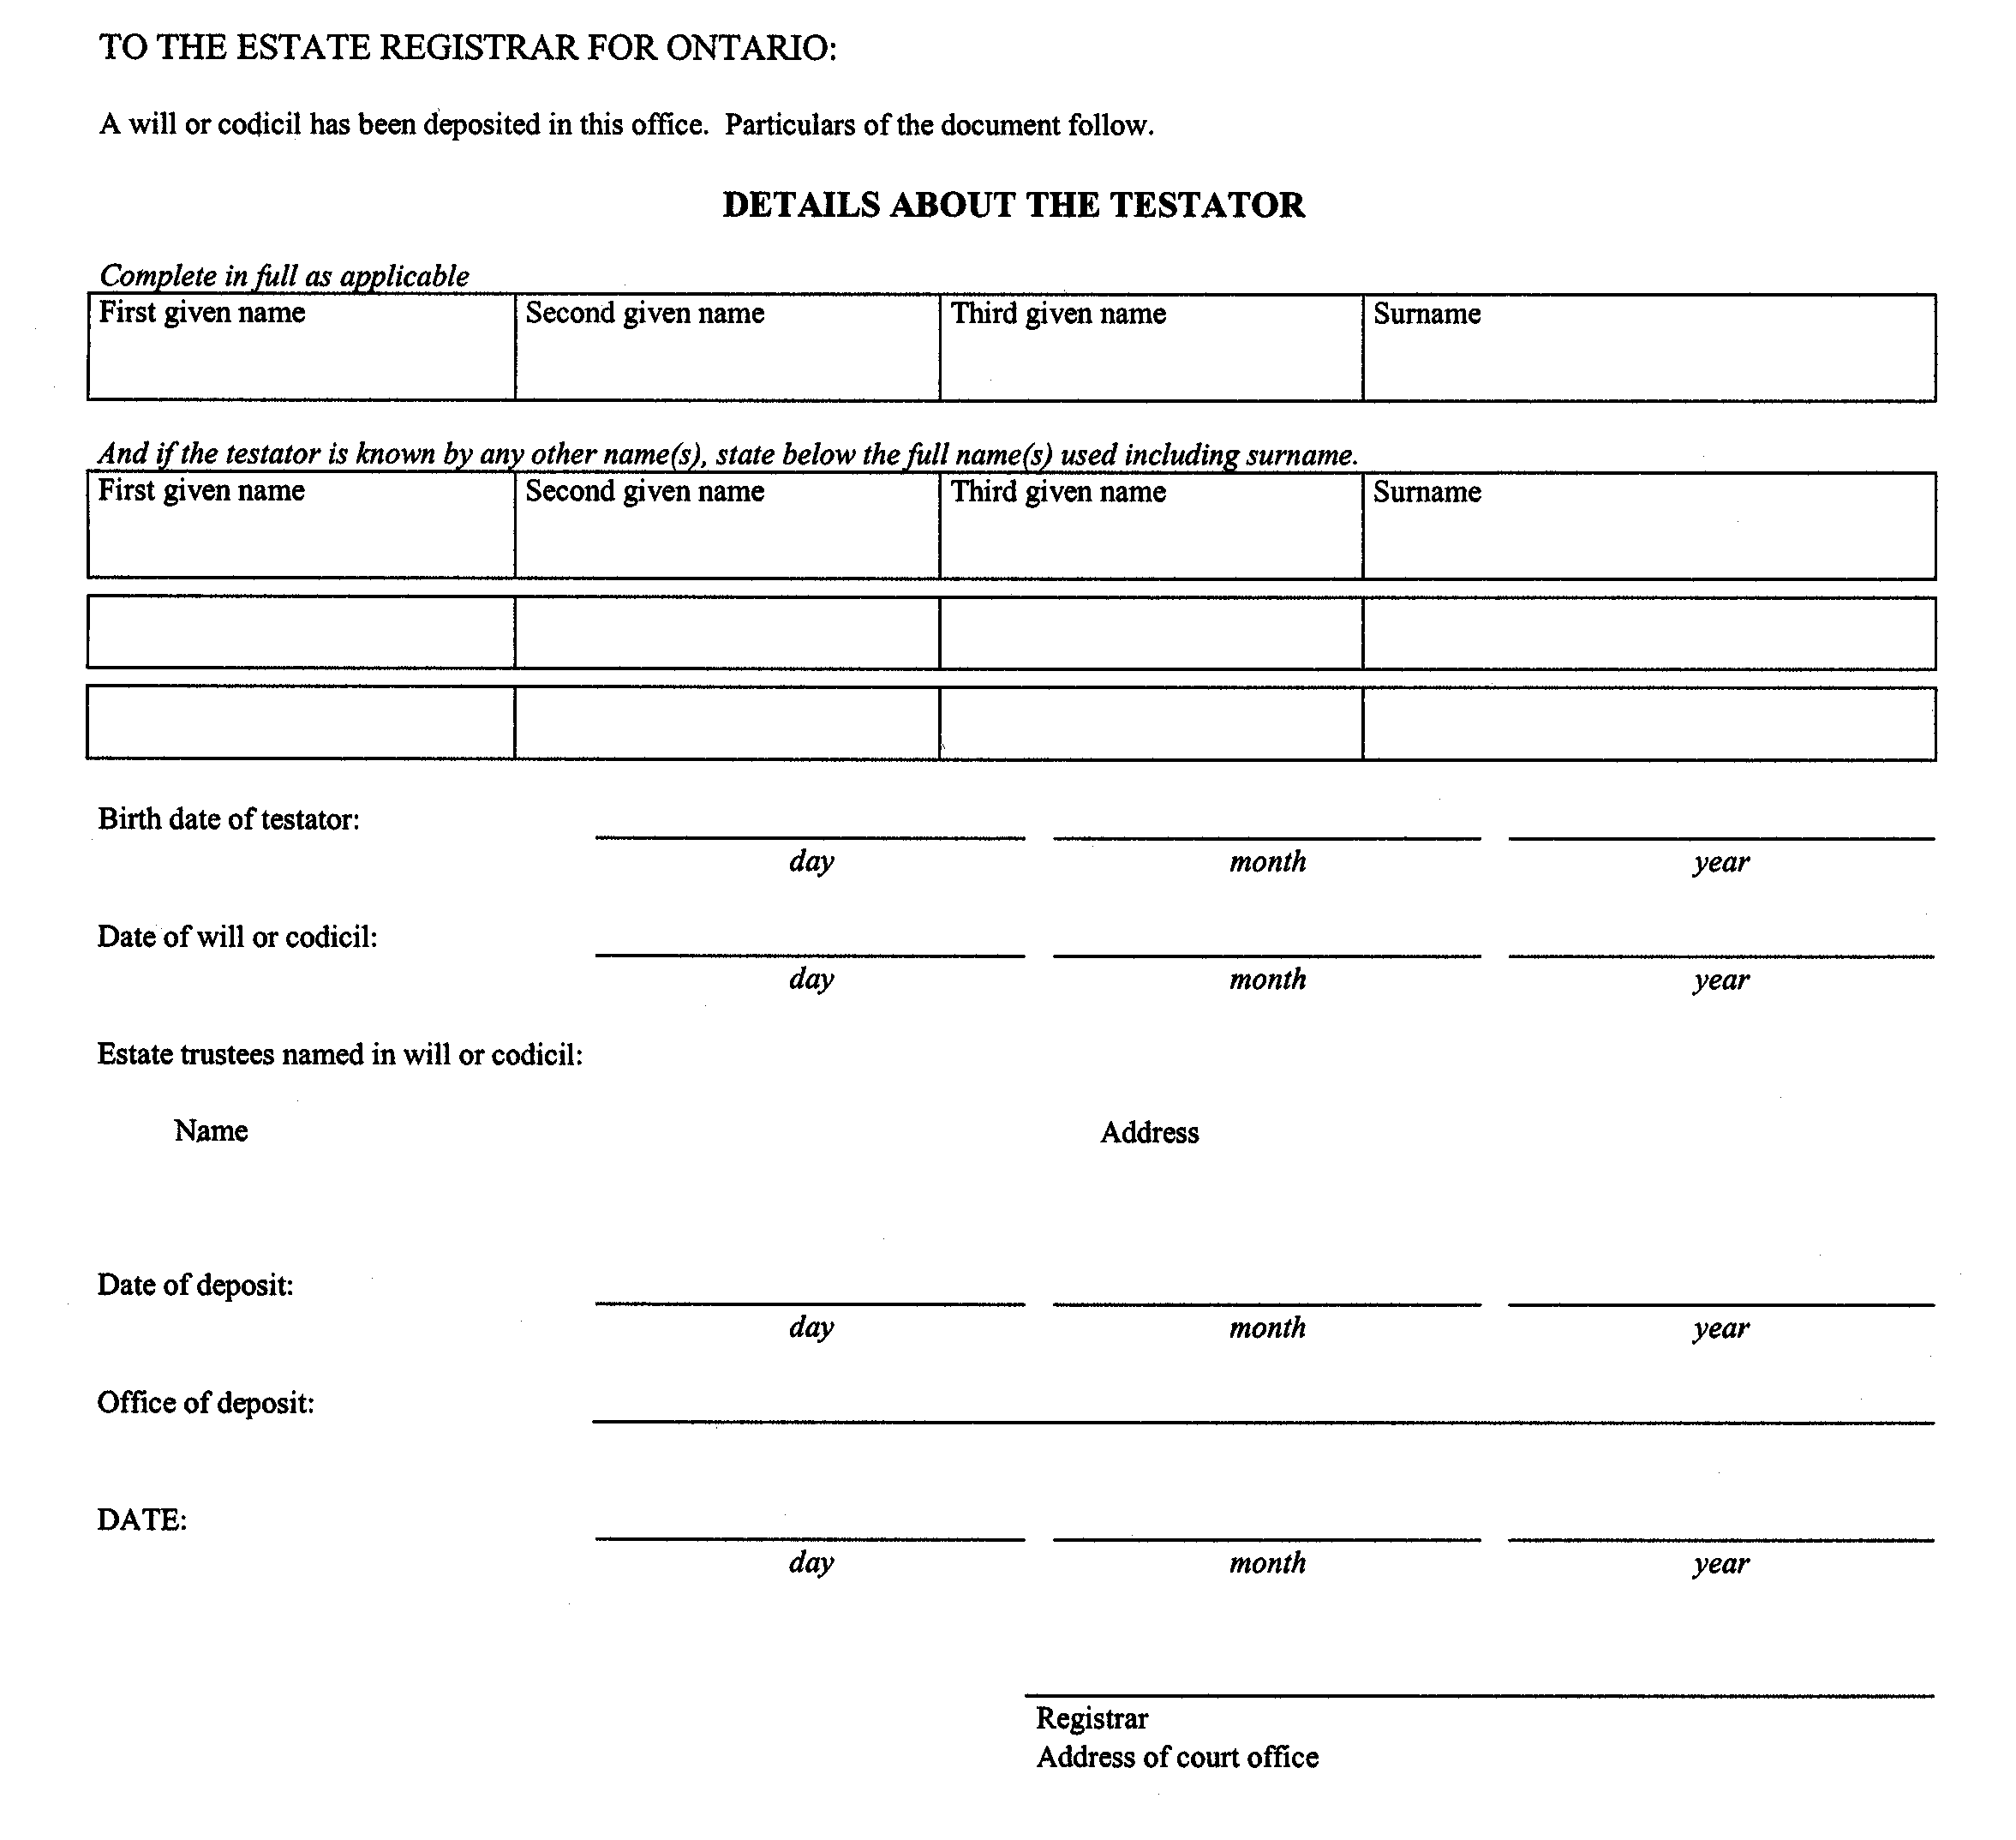
Form 74.2
Courts of Justice Act
notice to estate registrar of withdrawal of will or codicil
ontario
superior court of justice
notice
Insert regs\Graphics\Source Law\2004\132\132742ae.tif
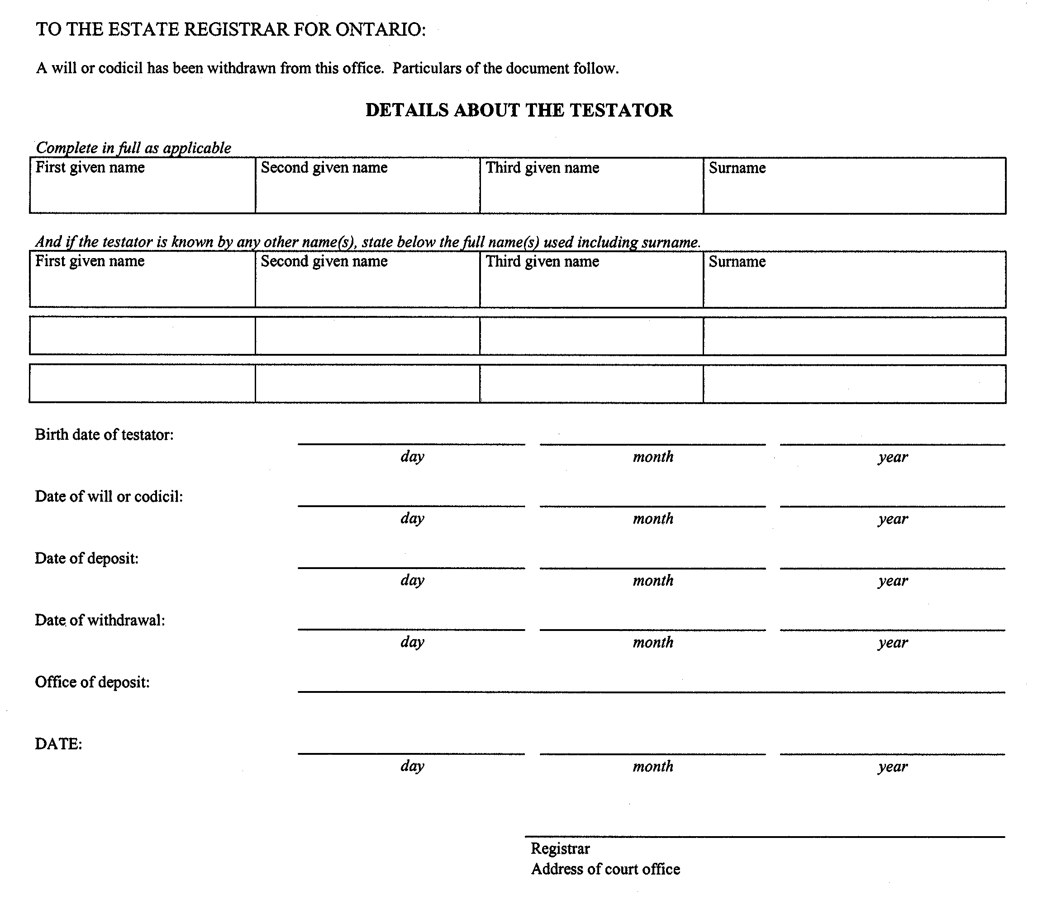
Form 74.3
Courts of Justice Act
request for notice of commencment of proceeding
ontario
superior court of justice
Insert regs\Graphics\Source Law\2004\132\132743ae.tif
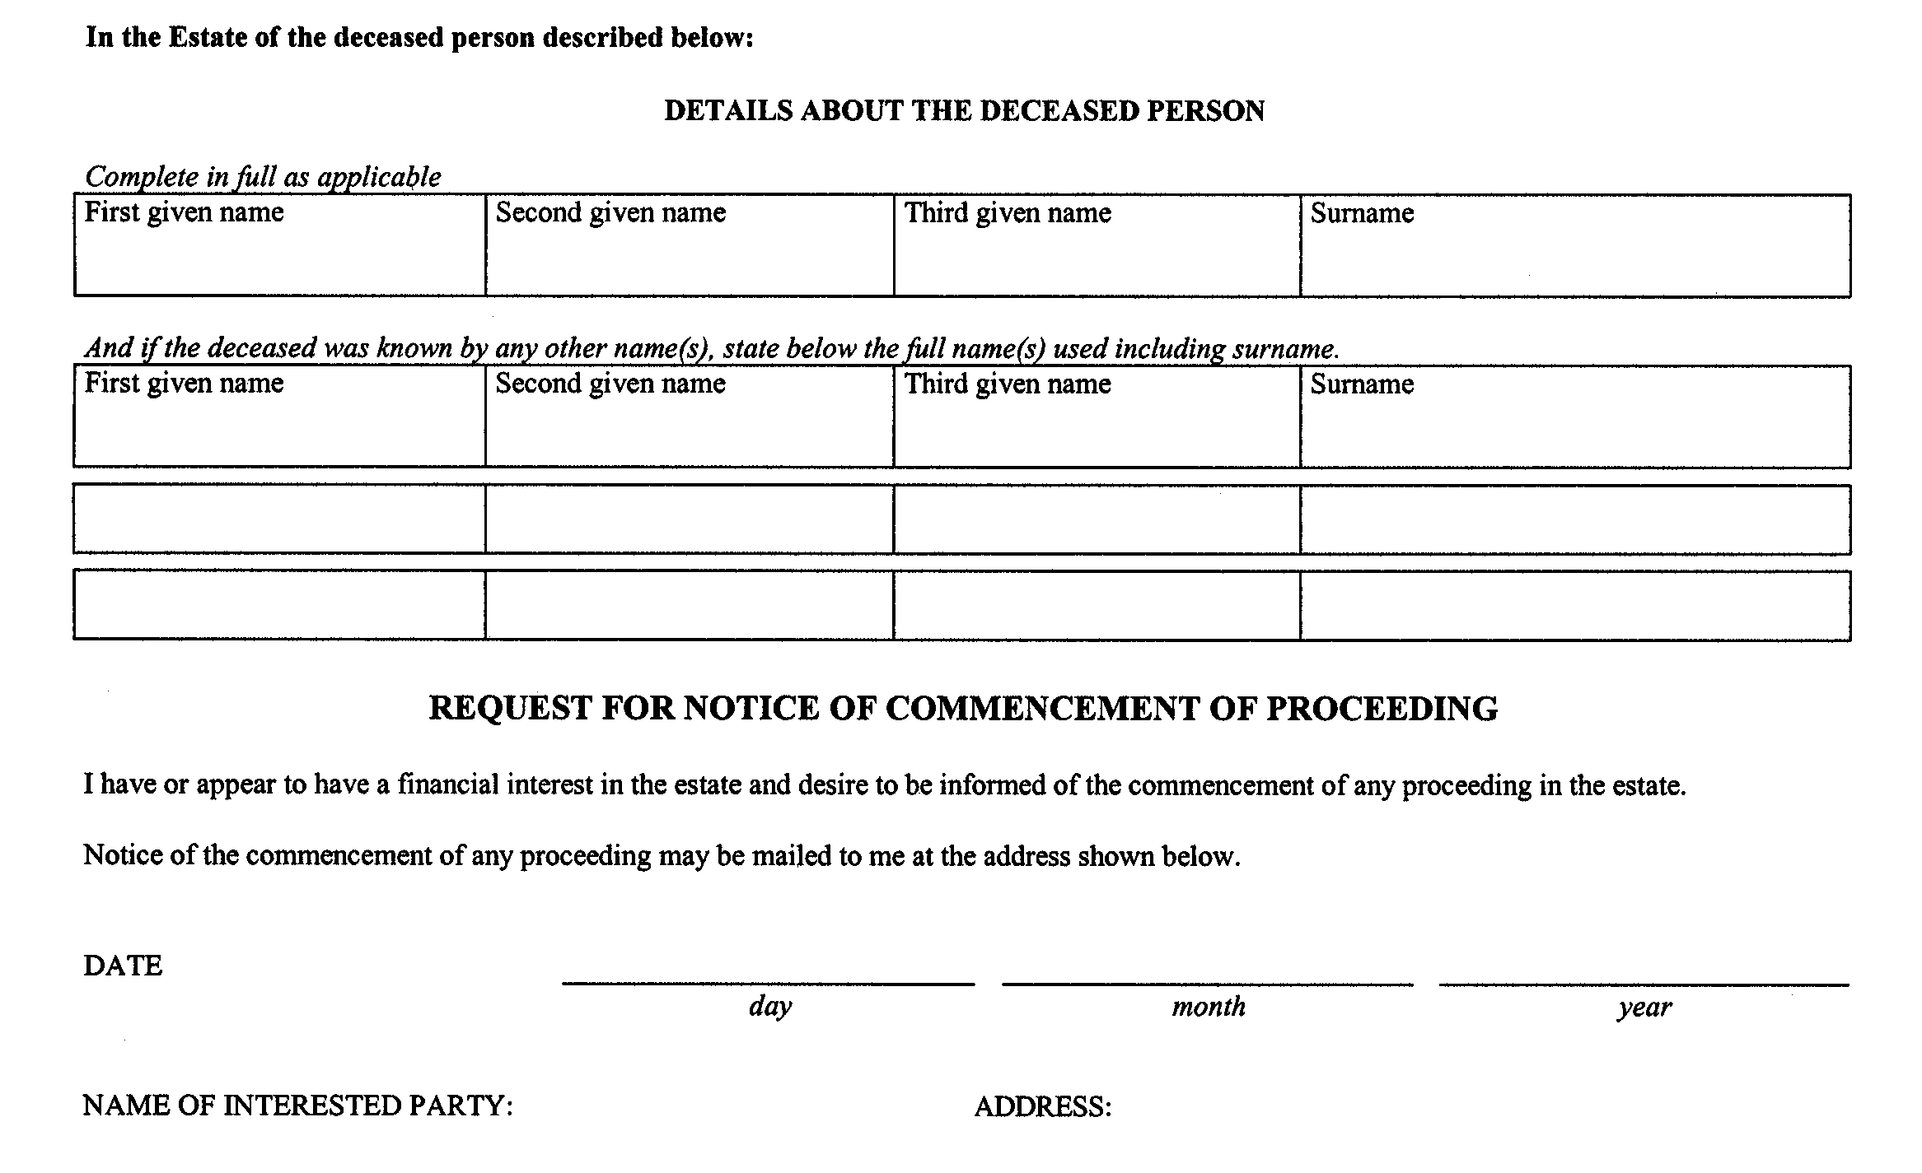
Form 74.4
Courts of Justice Act
Application for certificate of appointment of estate trustee with a will (individual applicant)
Insert regs\Graphics\Source Law\2004\132\132744ae.tif
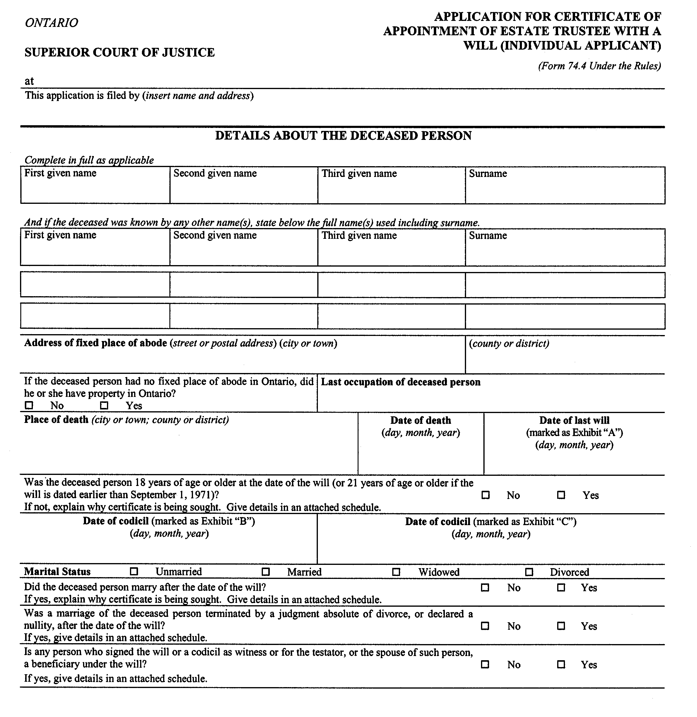
Insert regs\Graphics\Source Law\2004\132\132744be.tif
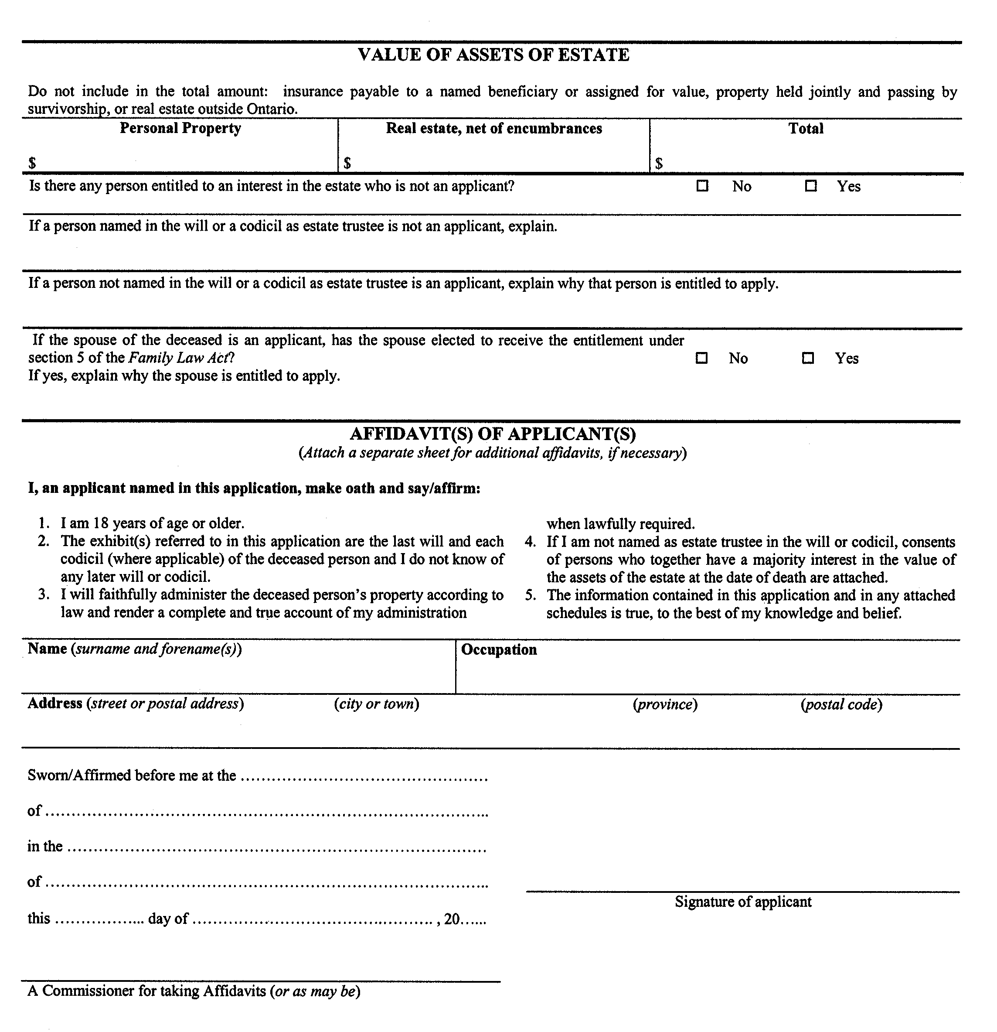
Insert regs\Graphics\Source Law\2004\132\132744ce.tif
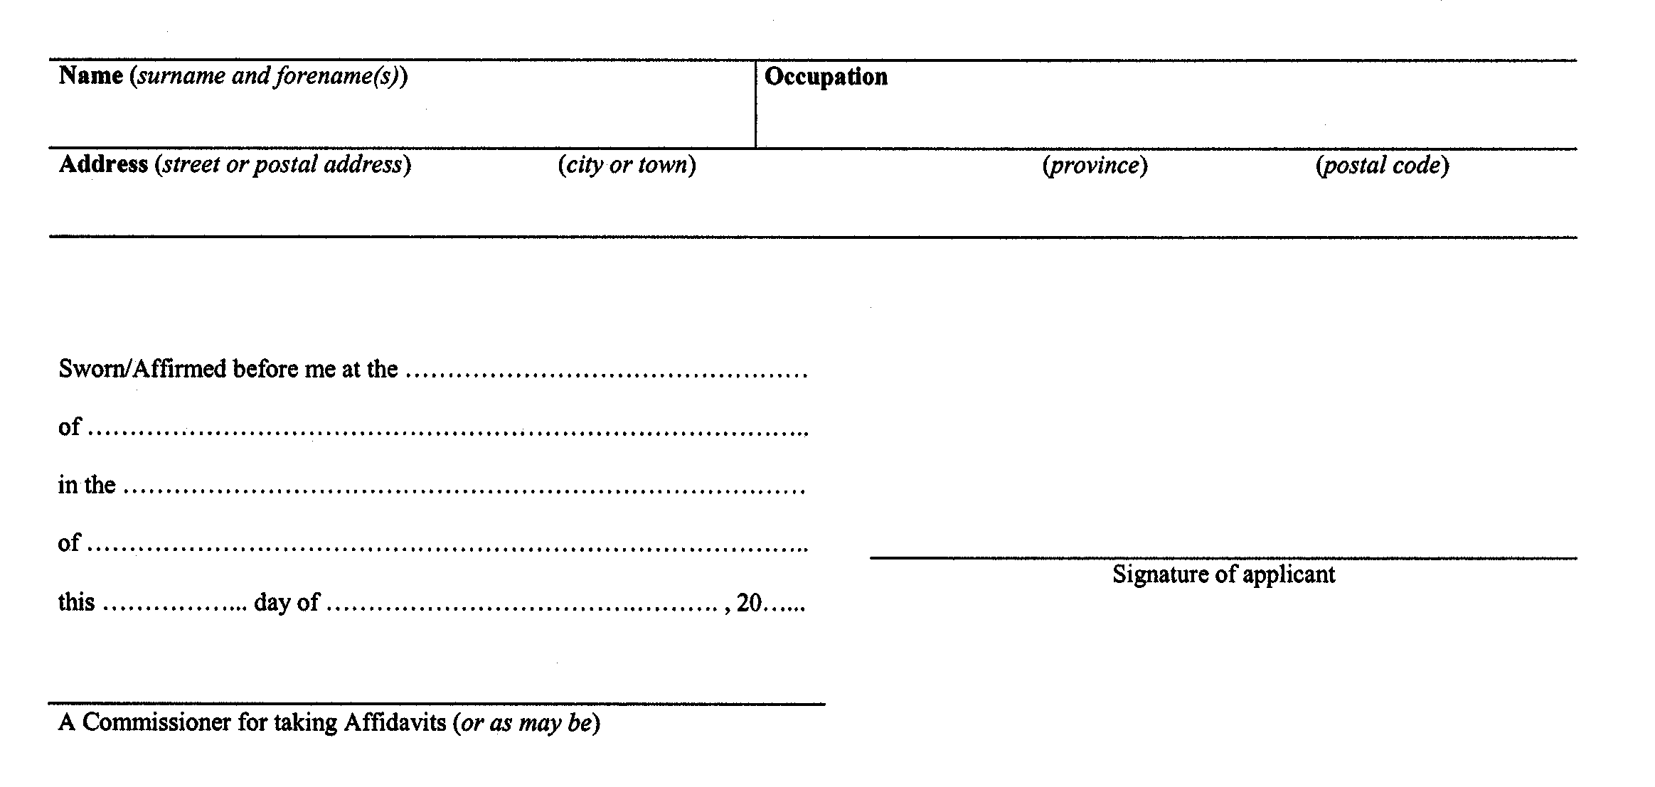
Form 74.4.1
Courts of Justice Act
application for certificate of appointment of estate trustee with a will (individual applicant) limited to assets referred to in the will
Insert regs\Graphics\Source Law\2004\132\1327441ae.tif
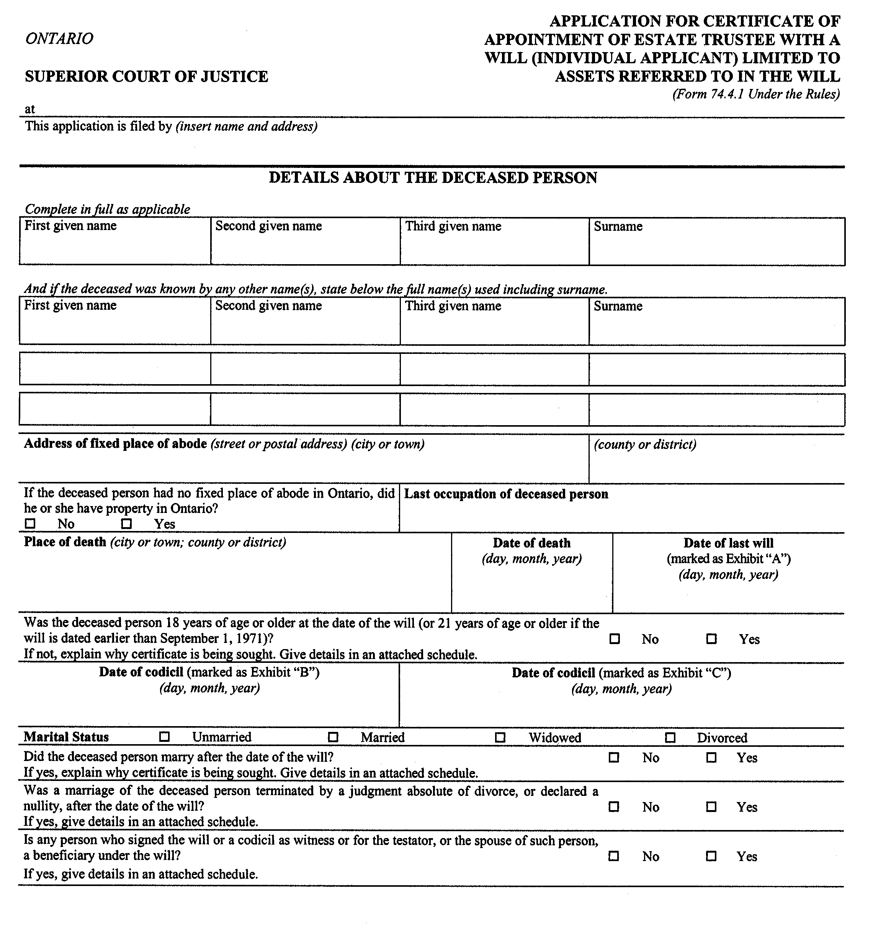
Insert regs\Graphics\Source Law\2004\132\1327441be.tif
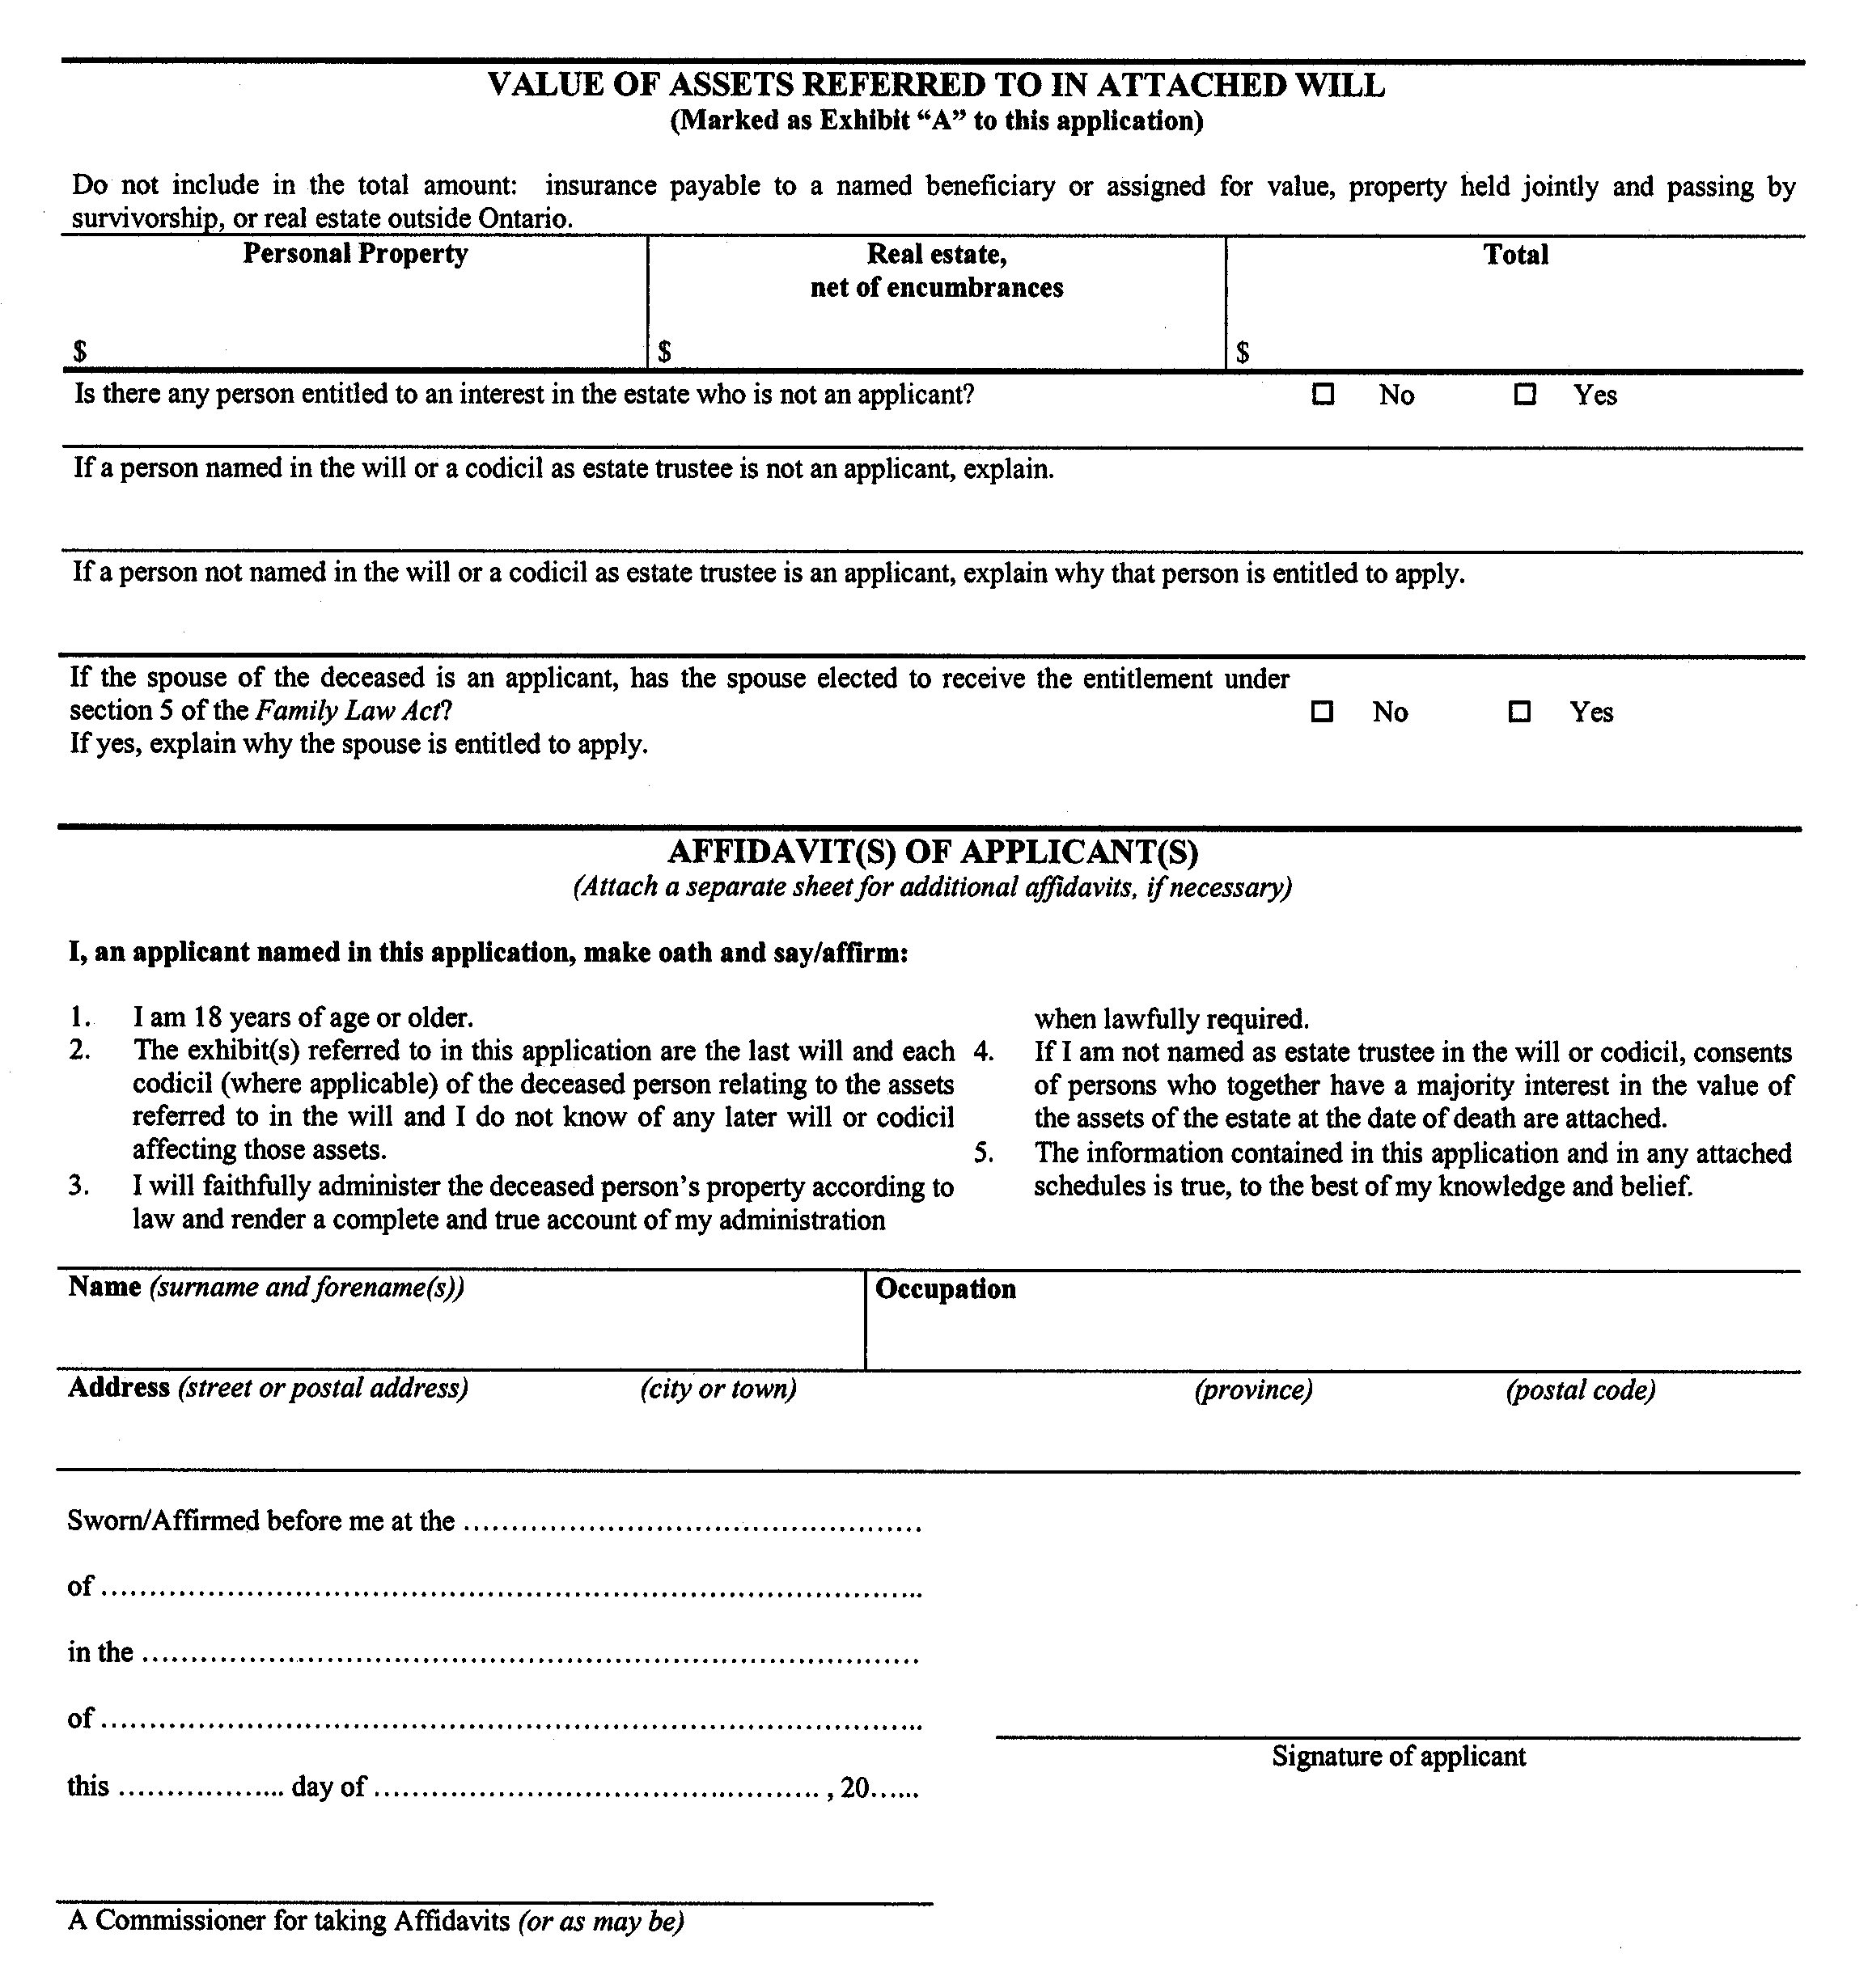
Insert regs\Graphics\Source Law\2004\132\1327441ce.tif
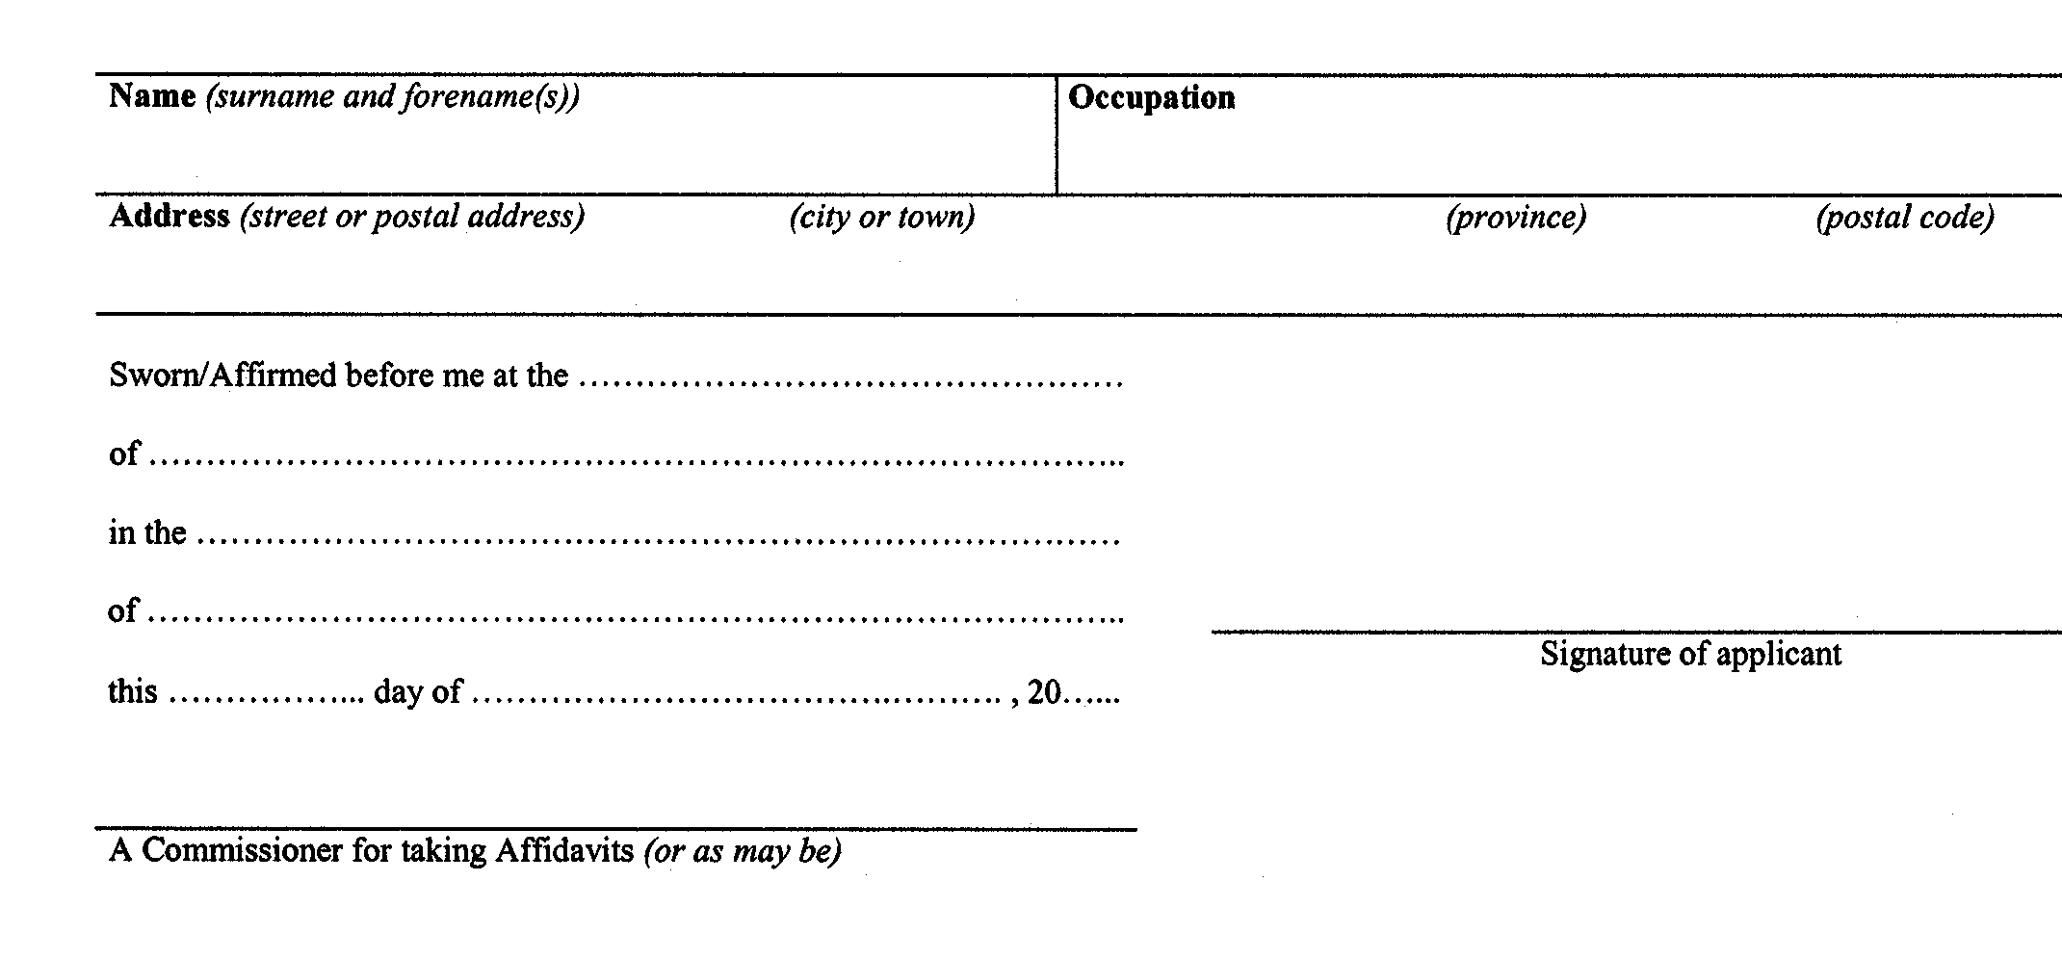
Form 74.5
Courts of Justice Act
application for certificate of appointment of estate trustee with a will (corporate applicant)
Insert regs\Graphics\Source Law\2004\132\132745ae.tif
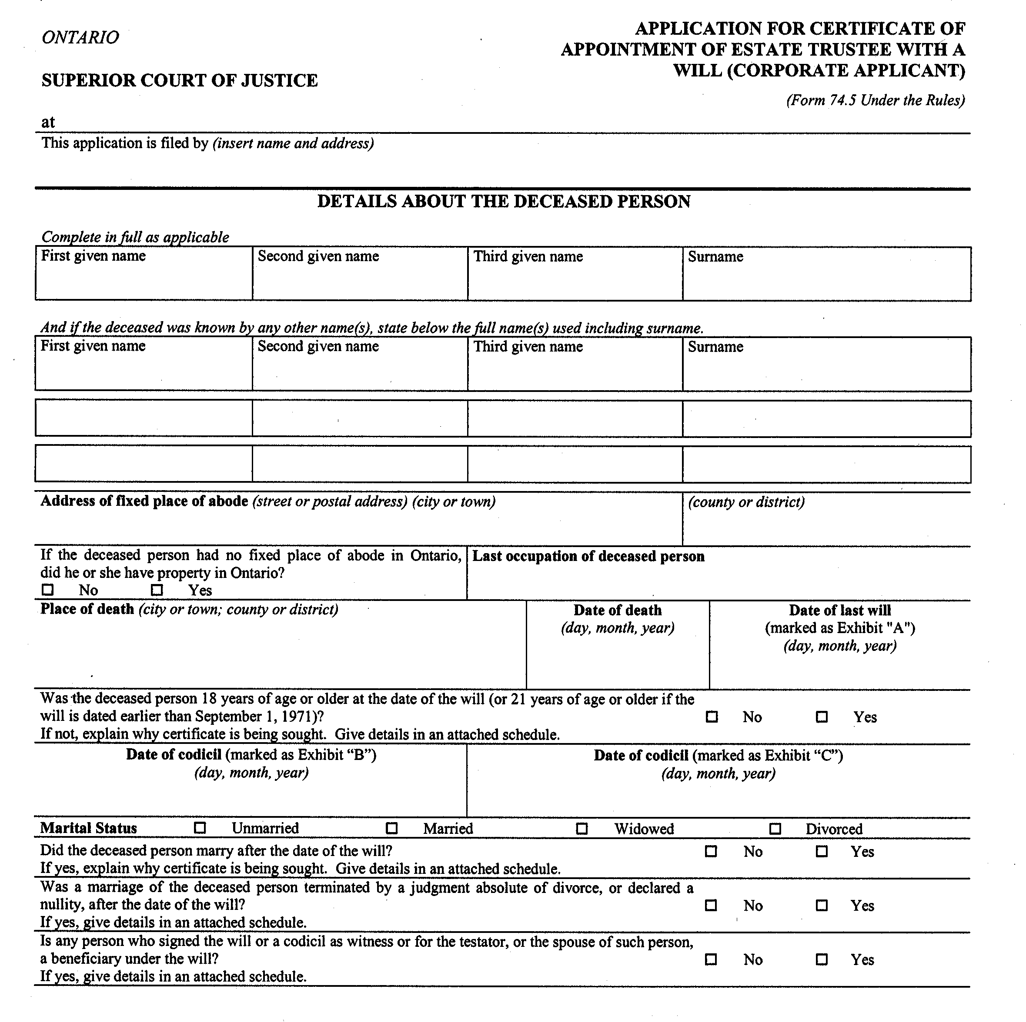
Insert regs\Graphics\Source Law\2004\132\132745be.tif
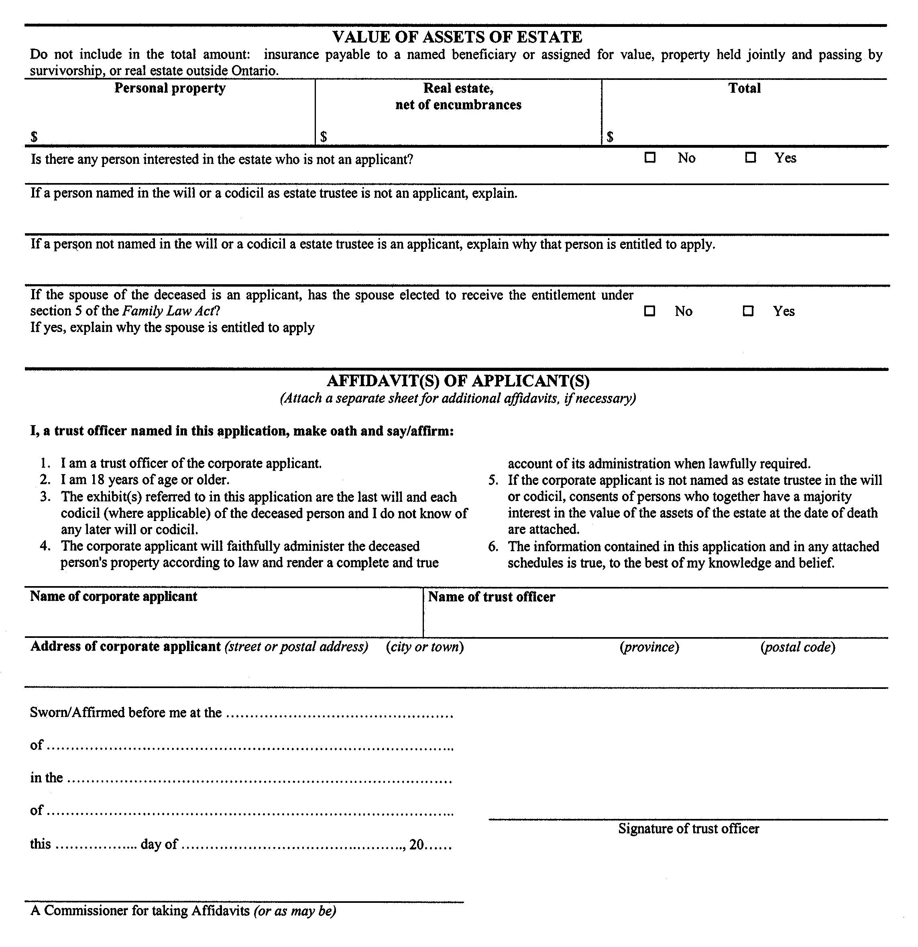
Insert regs\Graphics\Source Law\2004\132\132745ce.tif
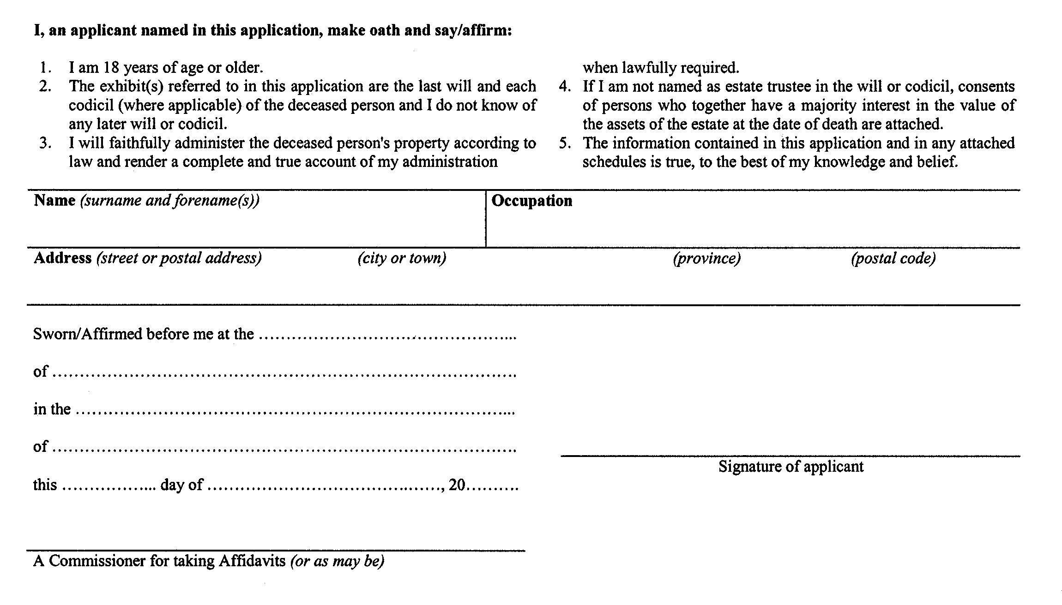
Form 74.5.1
Courts of Justice Act
application for certificate of appointment of estate trustee with a will (corporate applicant) limited to assets referred to in the will
Insert regs\Graphics\Source Law\2004\132\1327451ae.tif
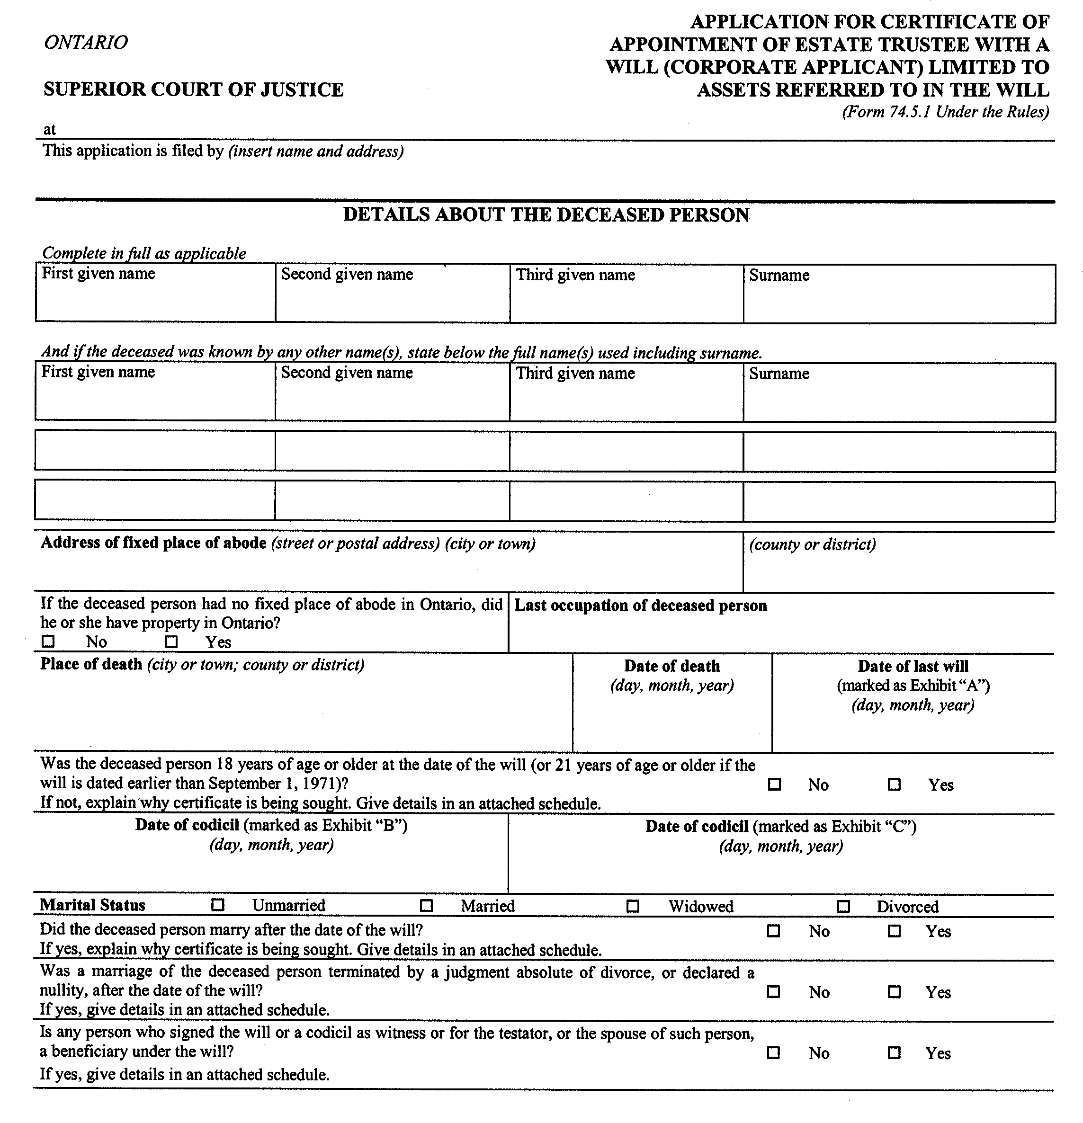
Insert regs\Graphics\Source Law\2004\132\1327451be.tif
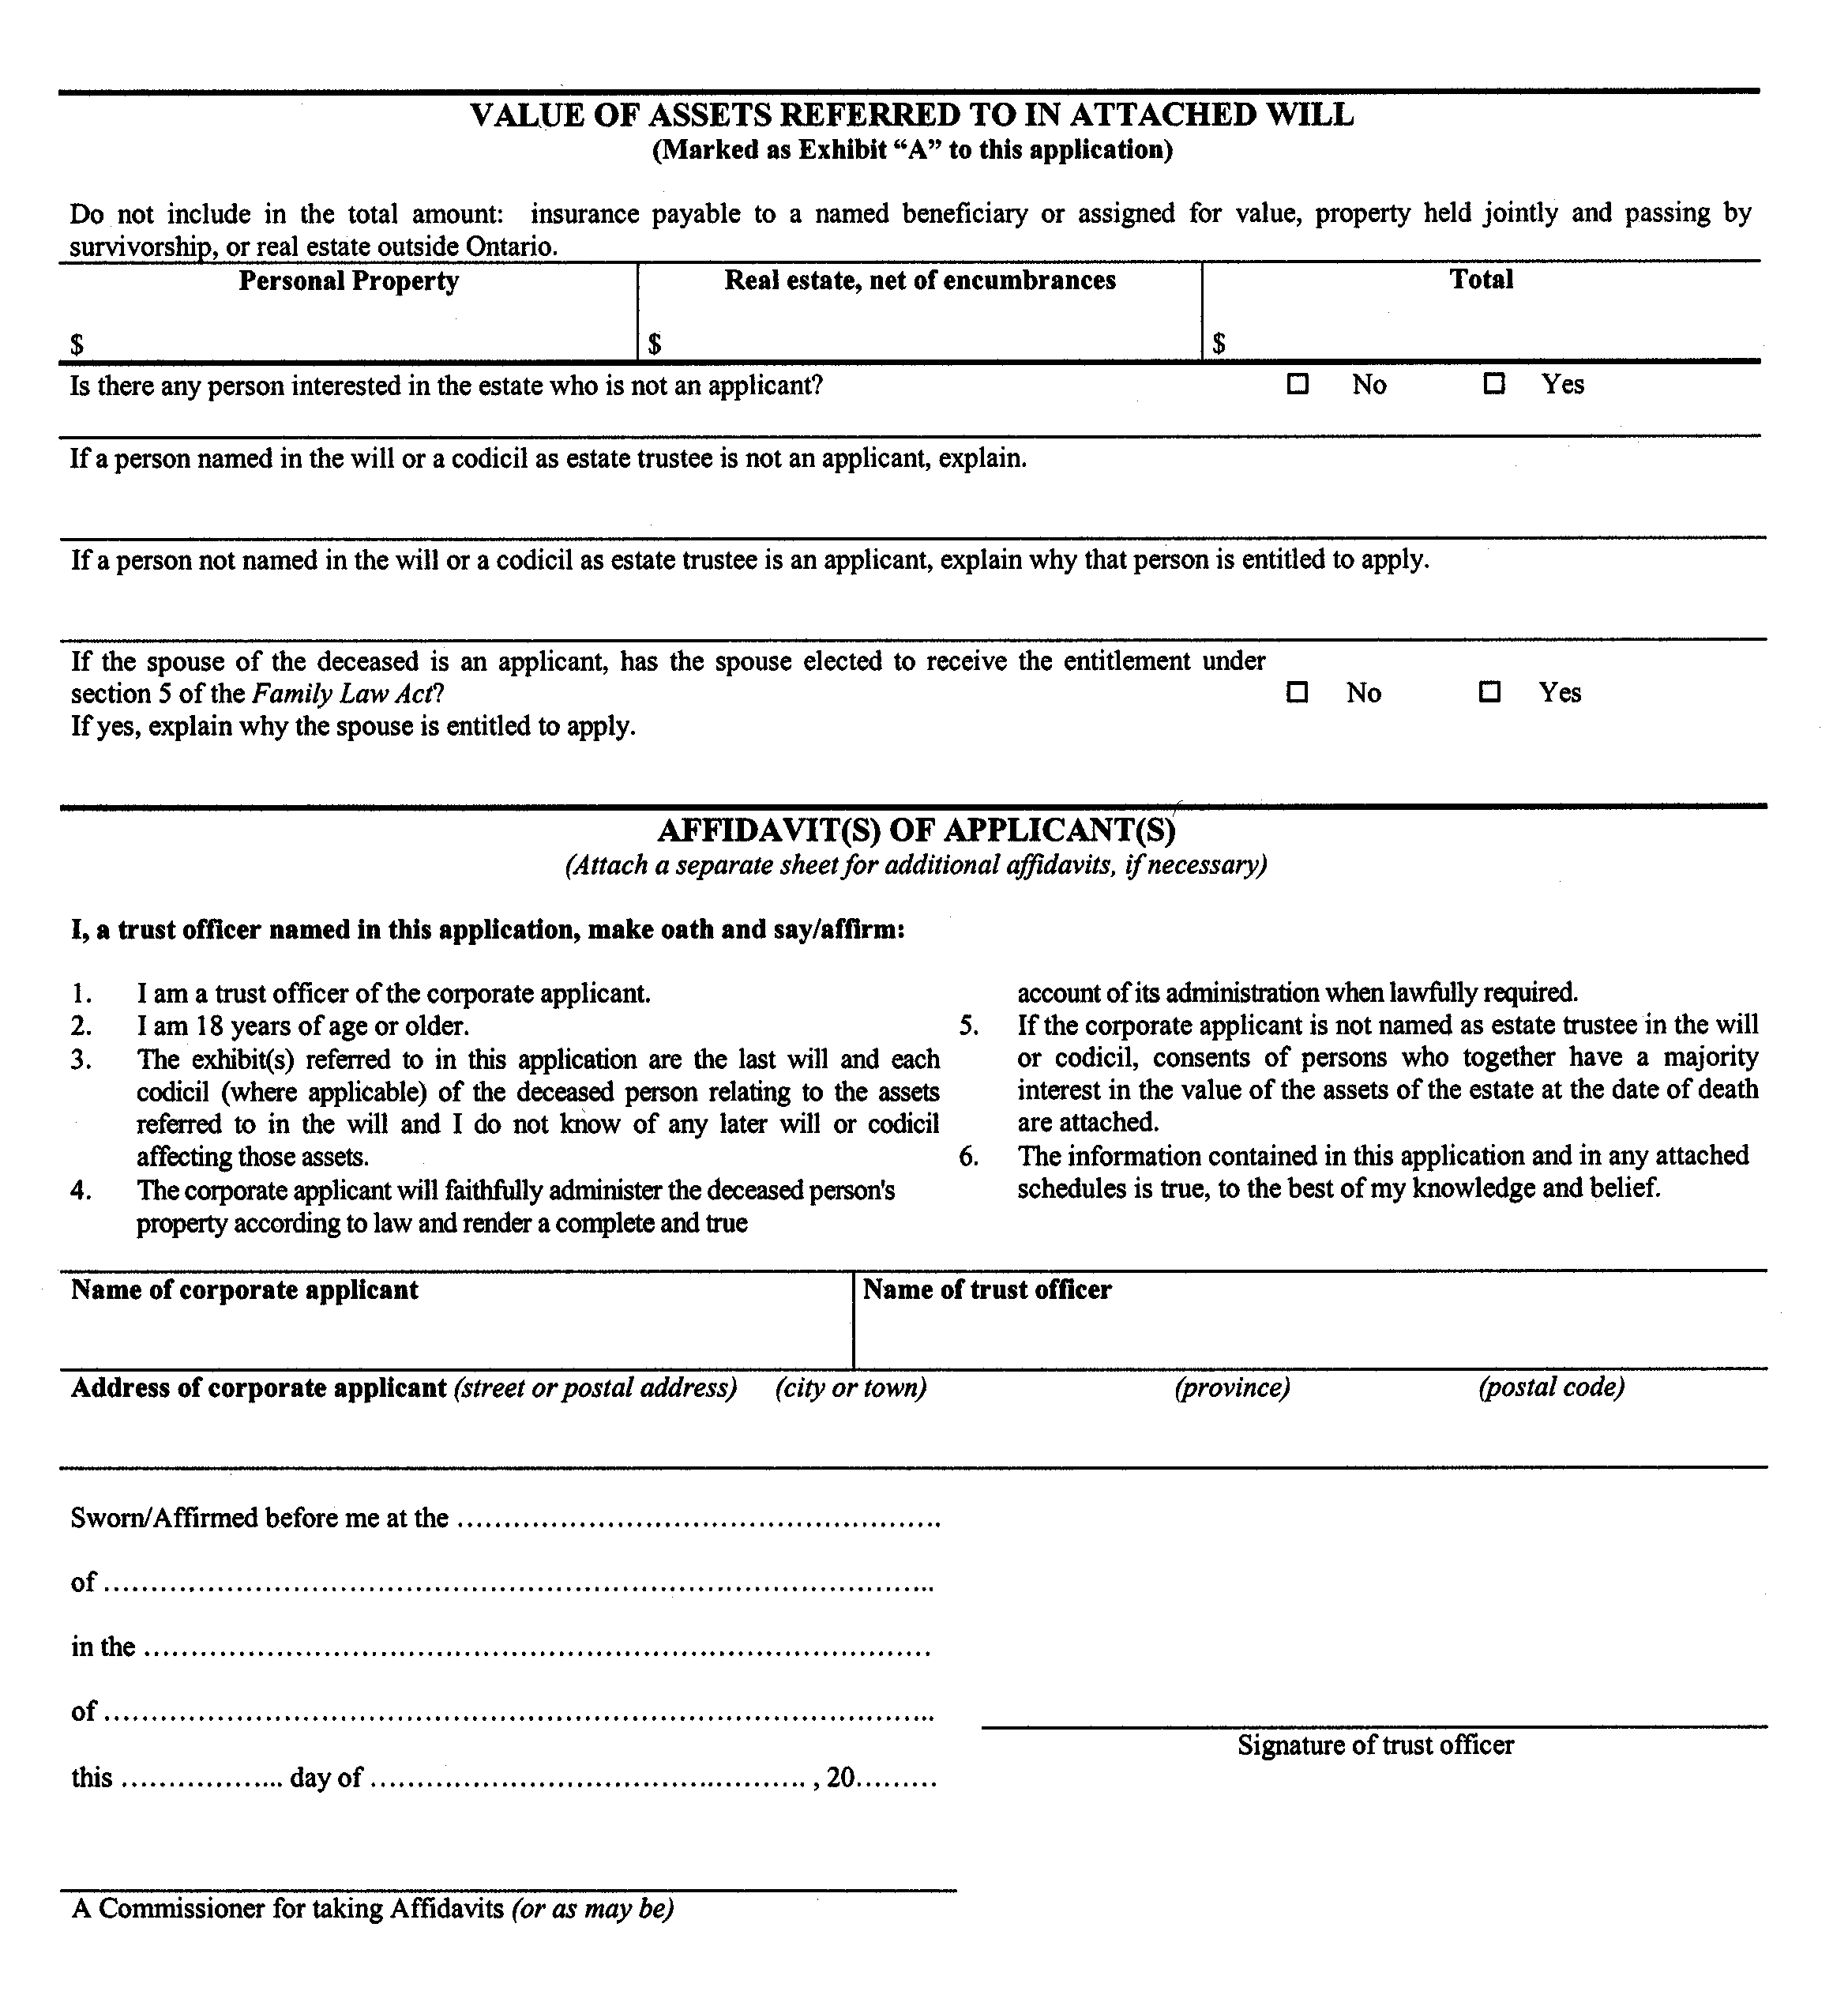
Insert regs\Graphics\Source Law\2004\132\1327451ce.tif
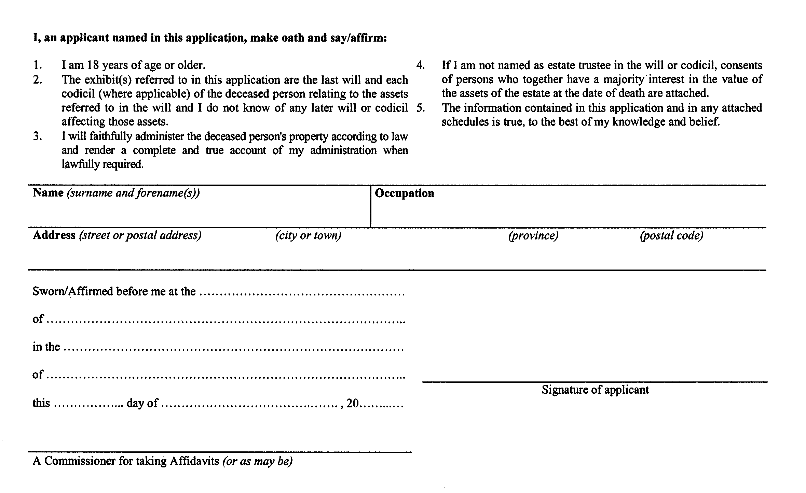
Form 74.6
Courts of Justice Act
affidavit of service of notice
ontario
superior court of justice
Insert regs\Graphics\Source Law\2004\132\132746ae.tif
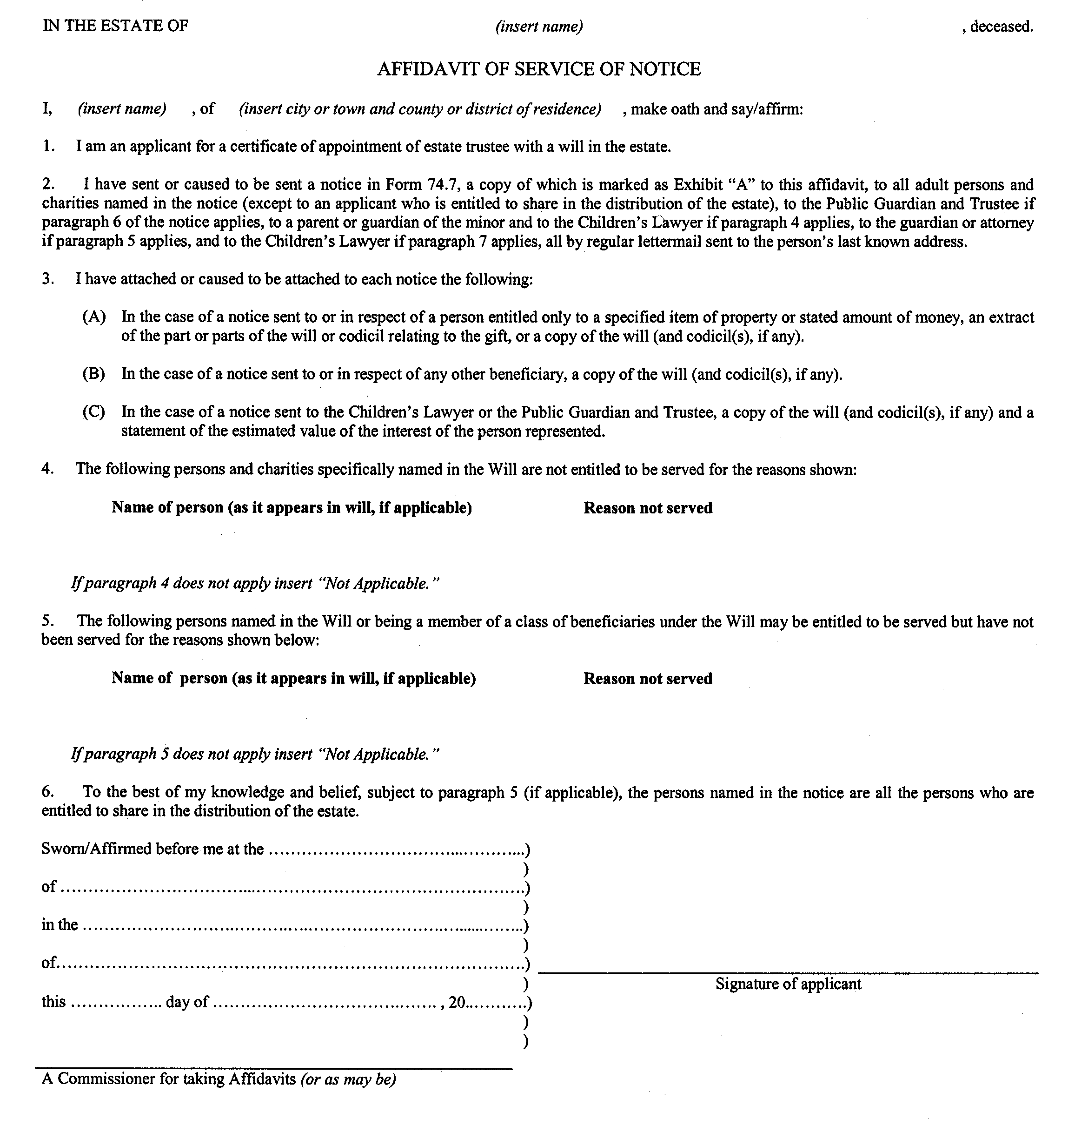
Form 74.7
Courts of Justice Act
notice of an application for a certificate of appointment of estate trustee with a will
ontario
superior court of justice
Insert regs\Graphics\Source Law\2004\132\132747ae.tif
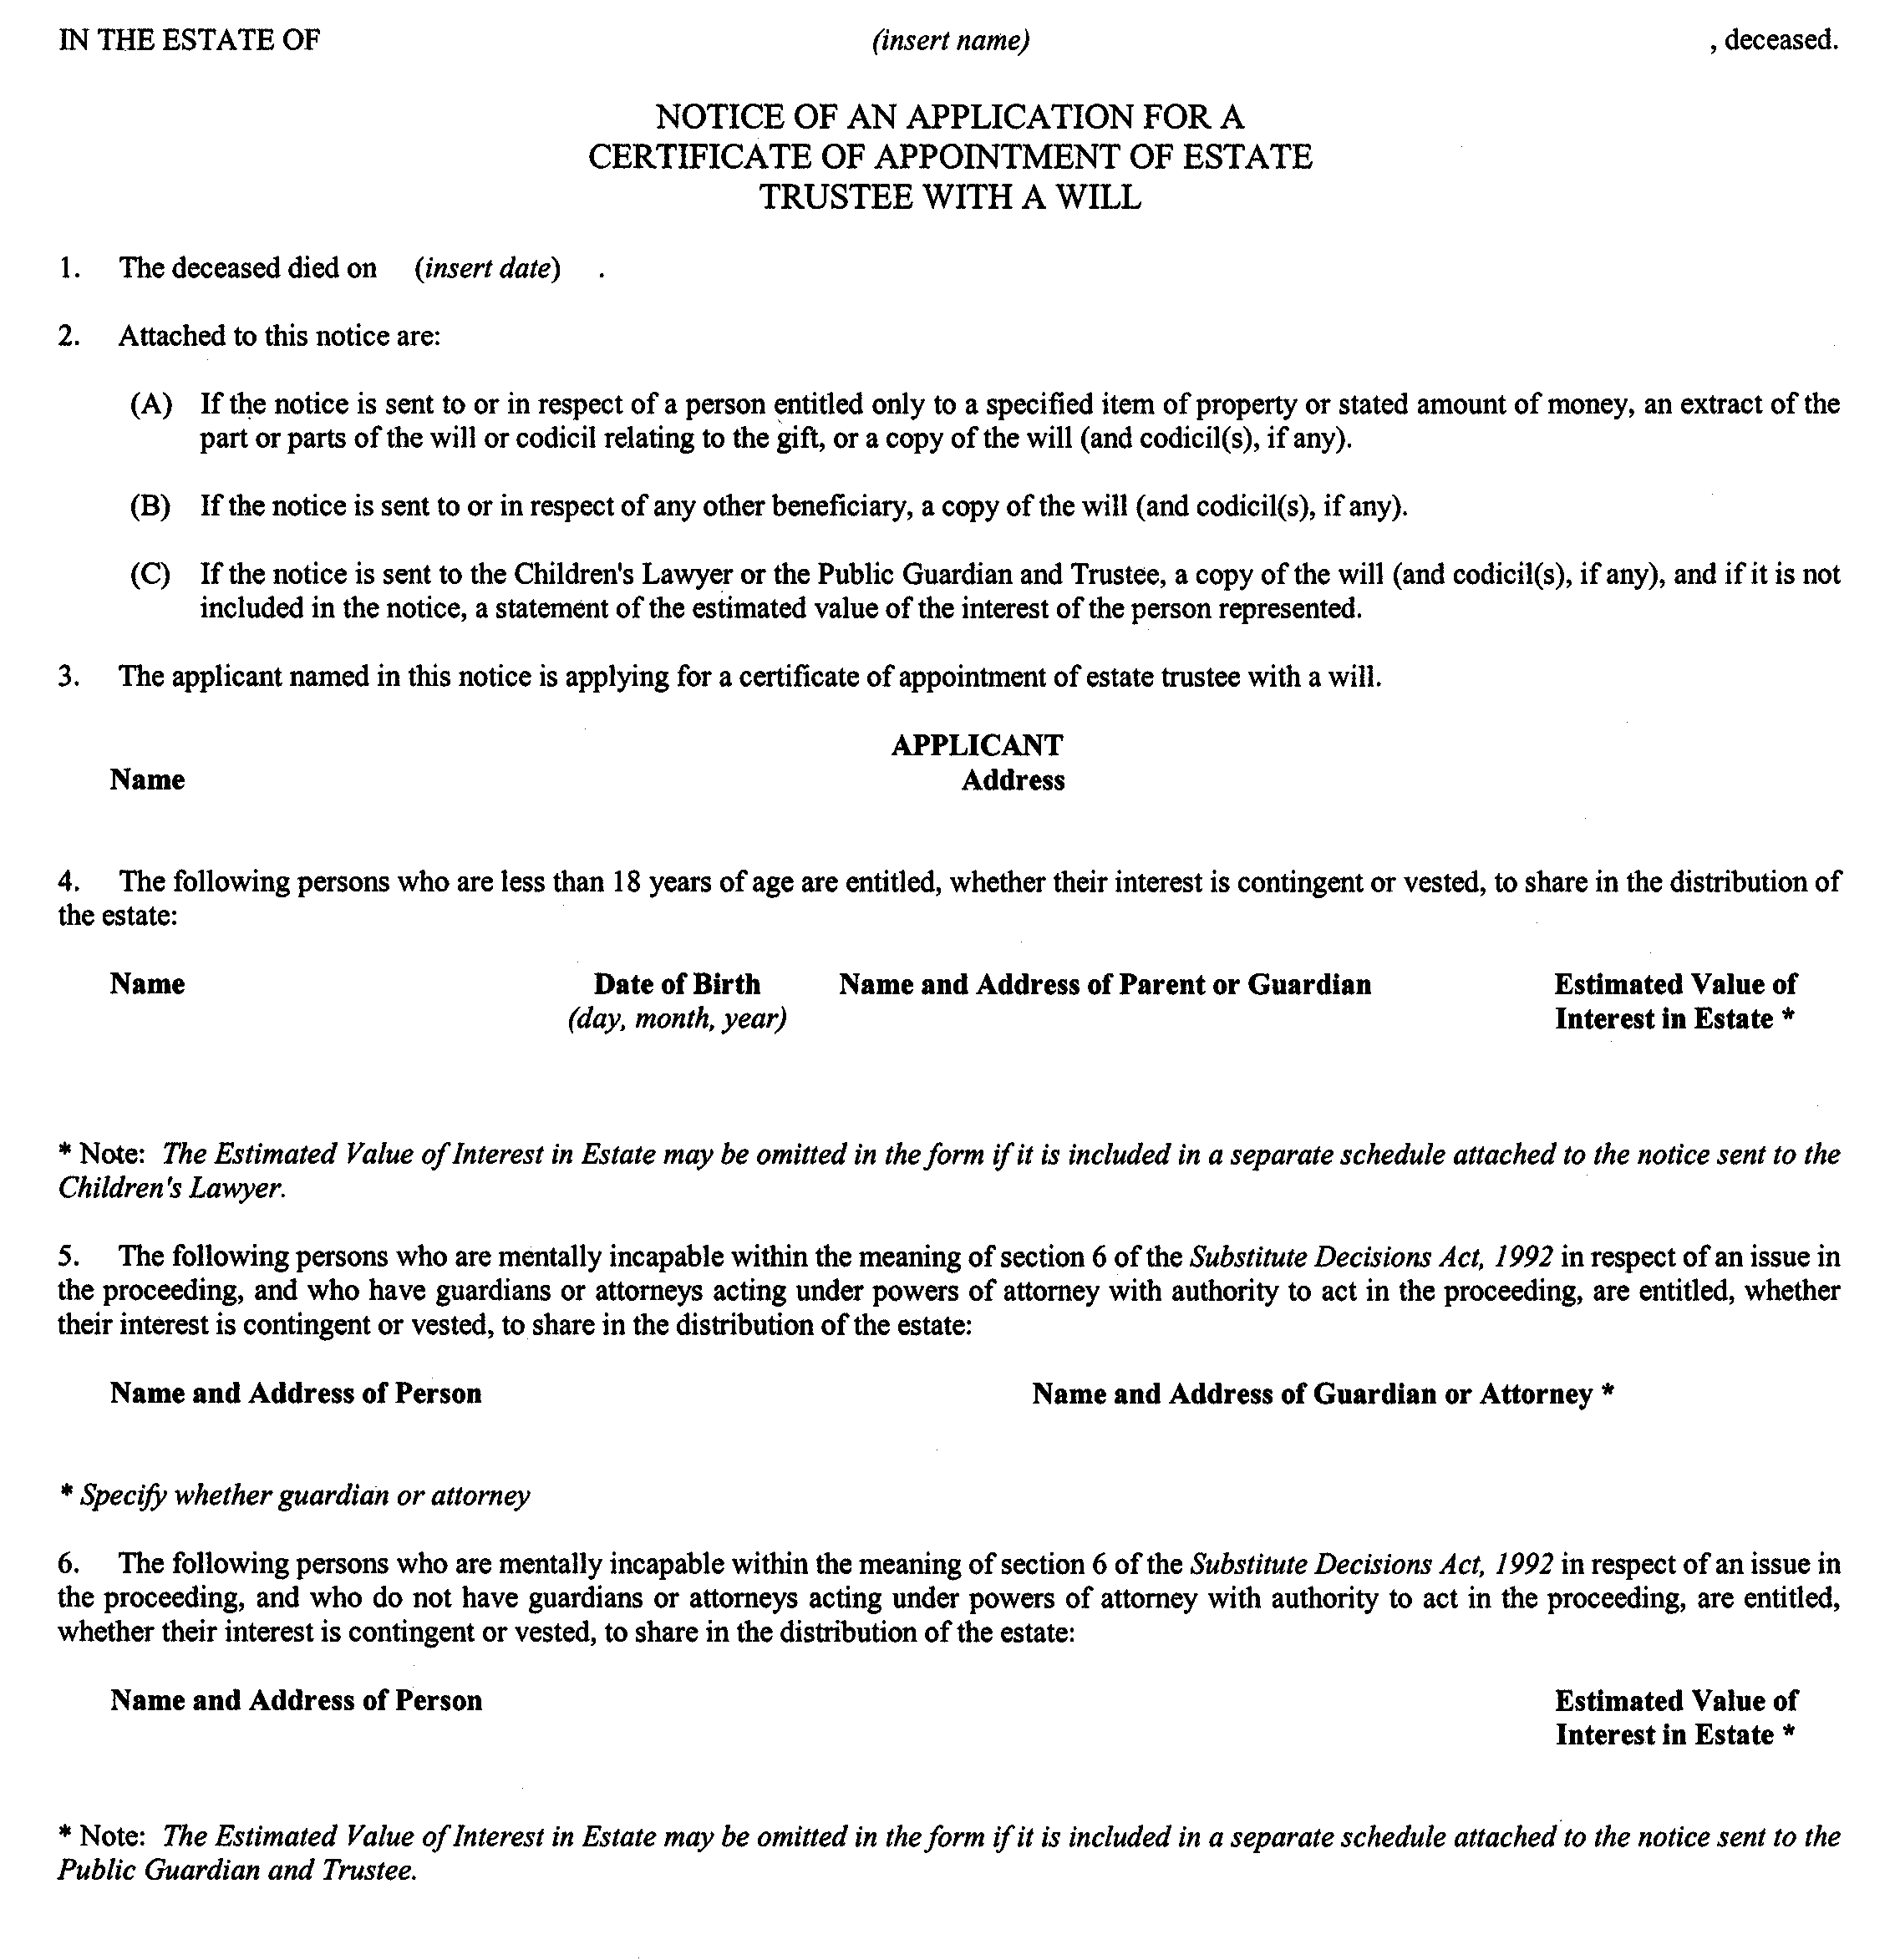
Insert regs\Graphics\Source Law\2004\132\132747be.tif
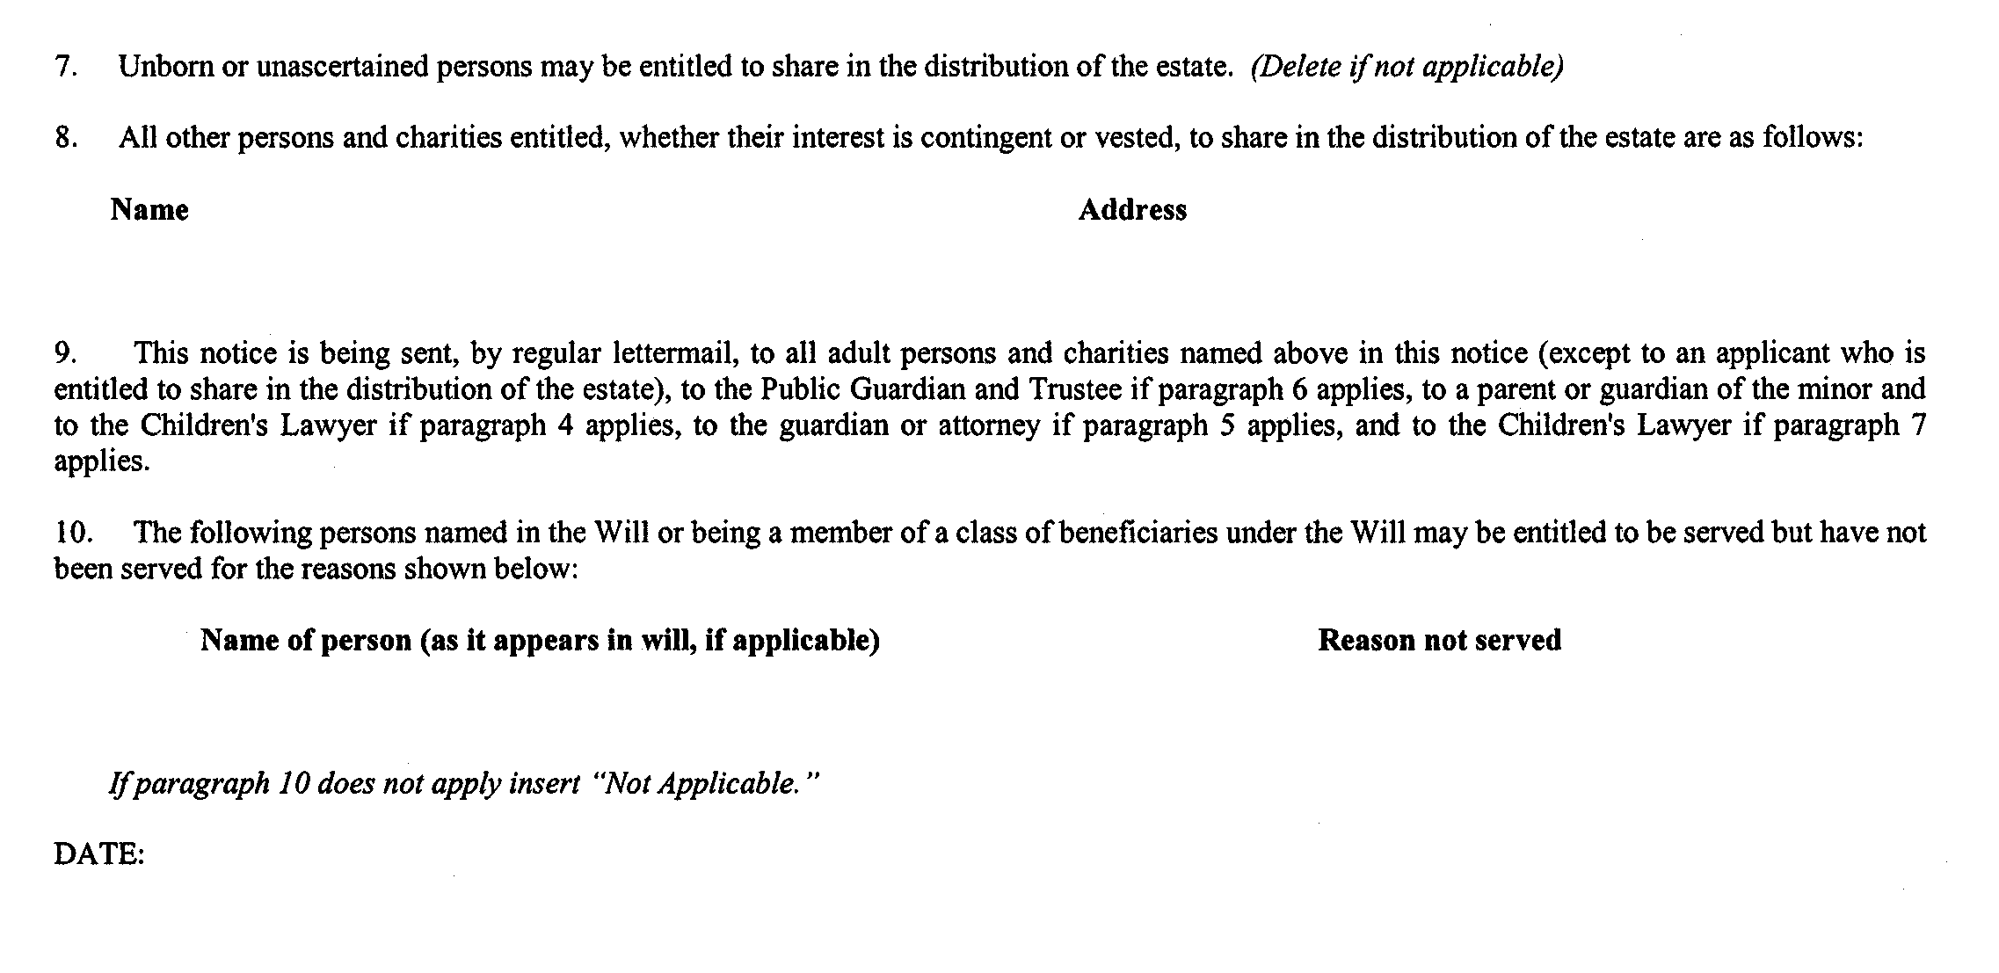
. . . . .
Form 74.14
Courts of Justice Act
application for certificate of appointment of estate trustee without a will (individual applicant)
Insert regs\Graphics\Source Law\2004\132\1327414ae.tif
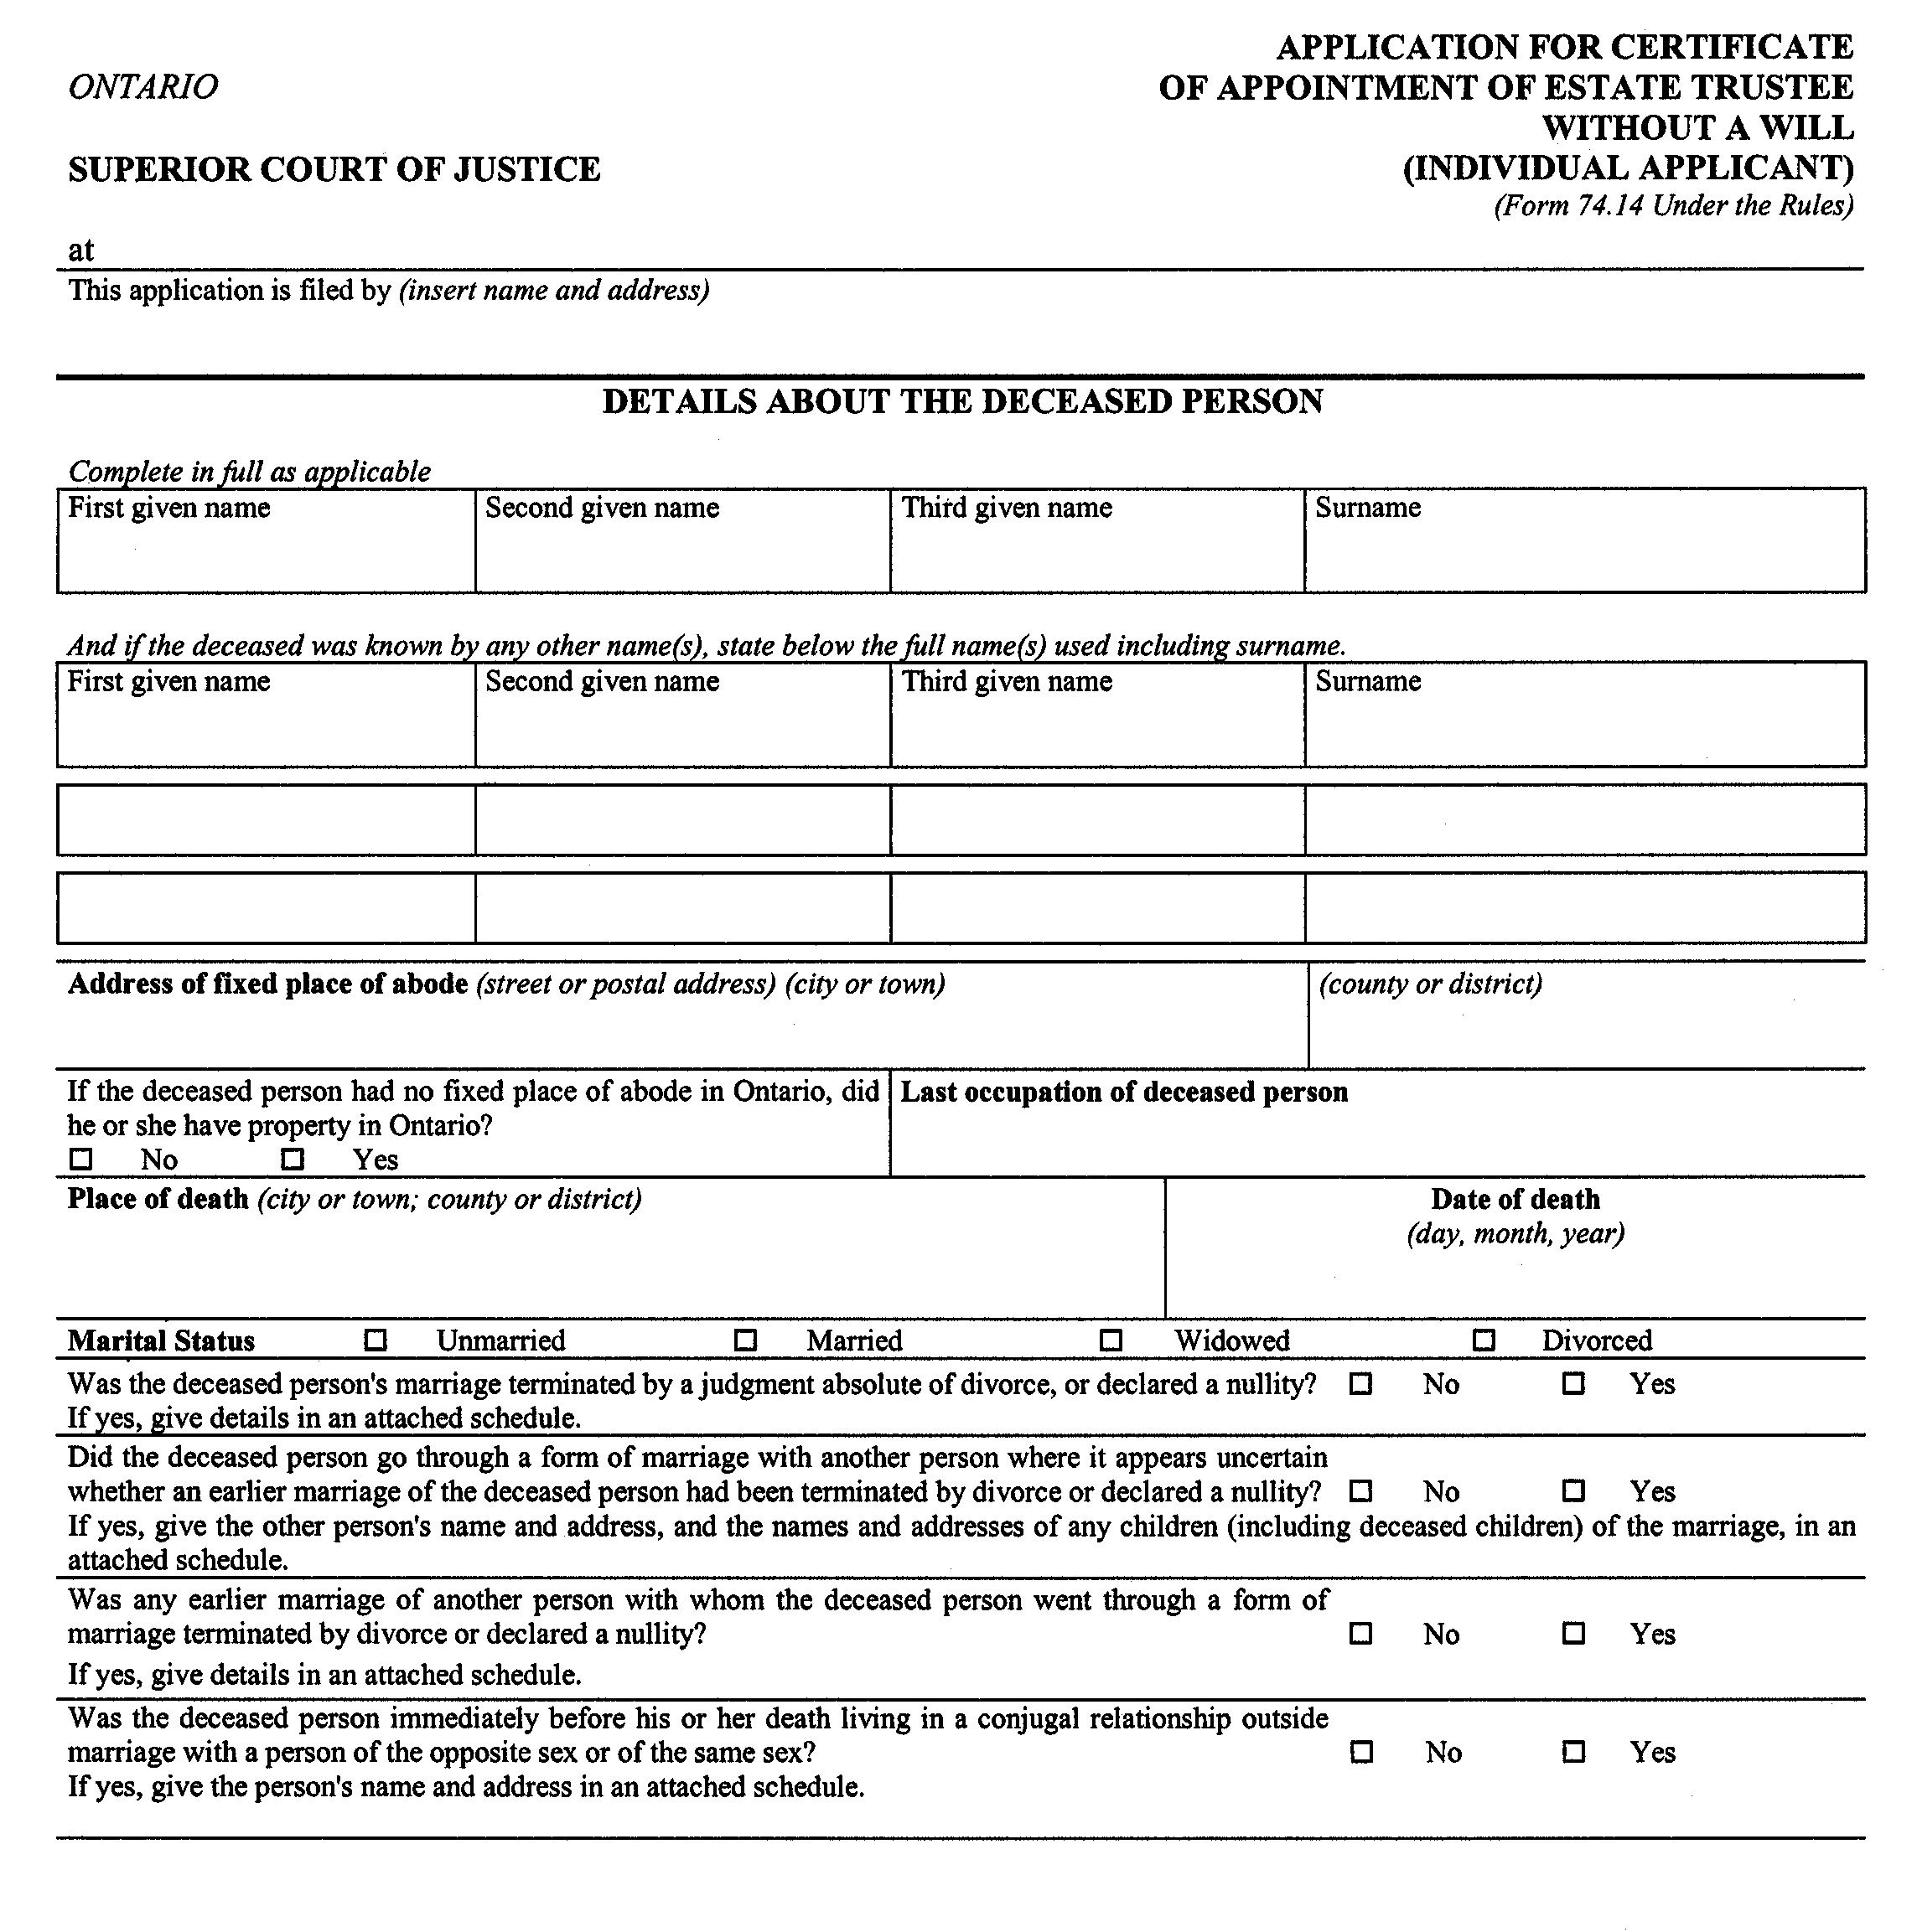
Insert regs\Graphics\Source Law\2004\132\1327414be.tif
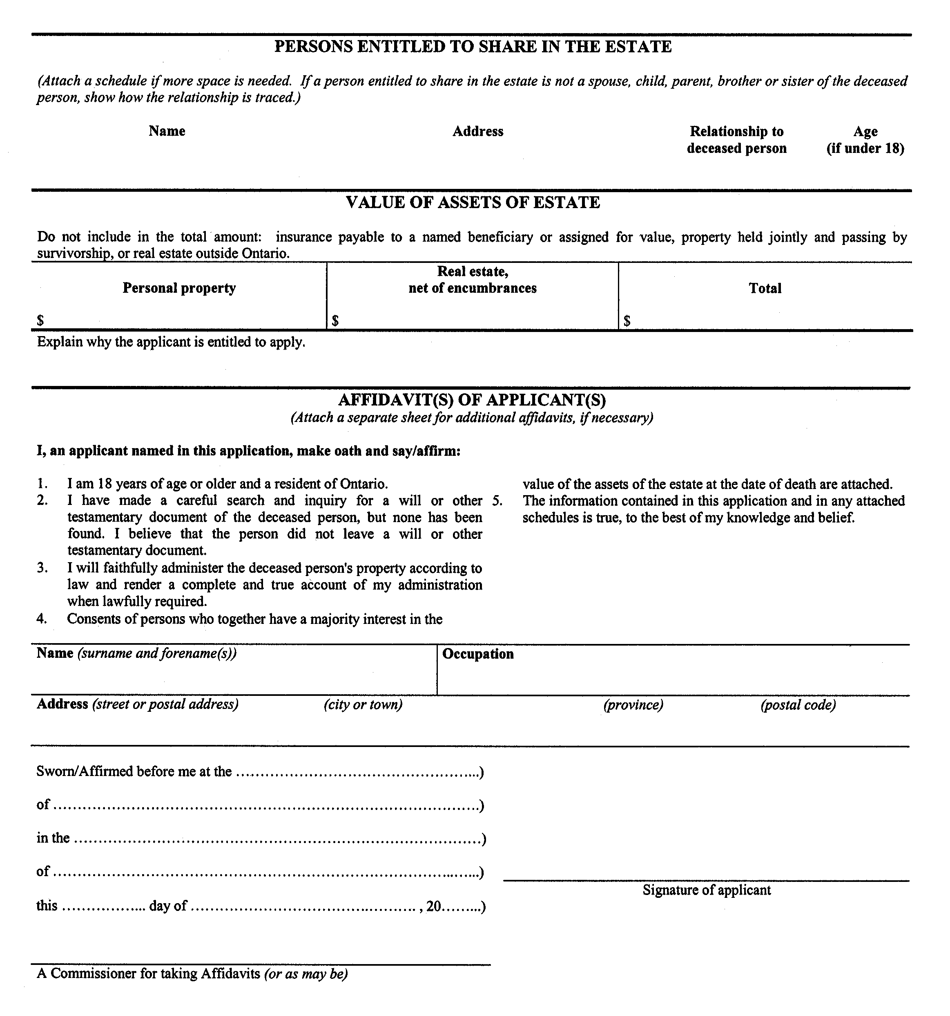
Insert regs\Graphics\Source Law\2004\132\1327414ce.tif
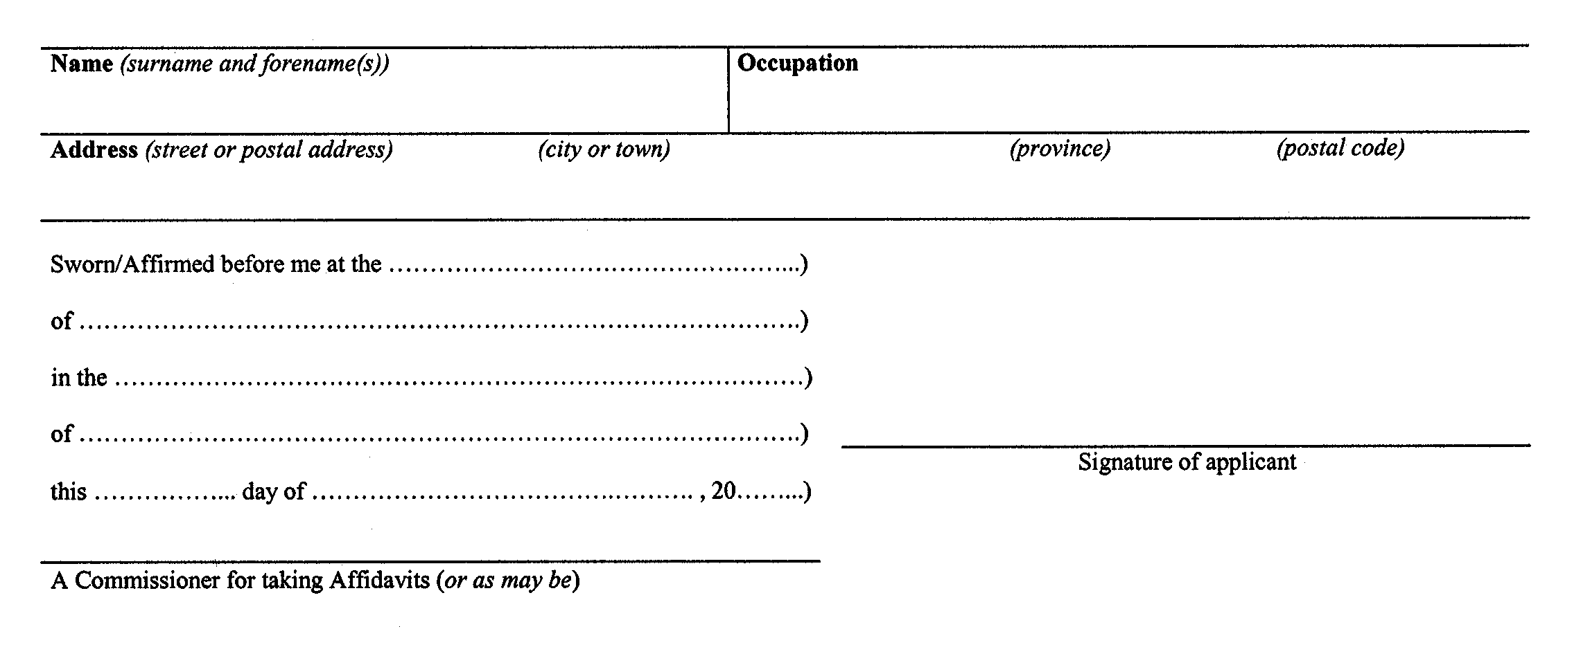
Form 74.15
Courts of Justice Act
application for certificate of appointment of estate trustee without a will (corporate applicant)
Insert regs\Graphics\Source Law\2004\132\1327415ae.tif
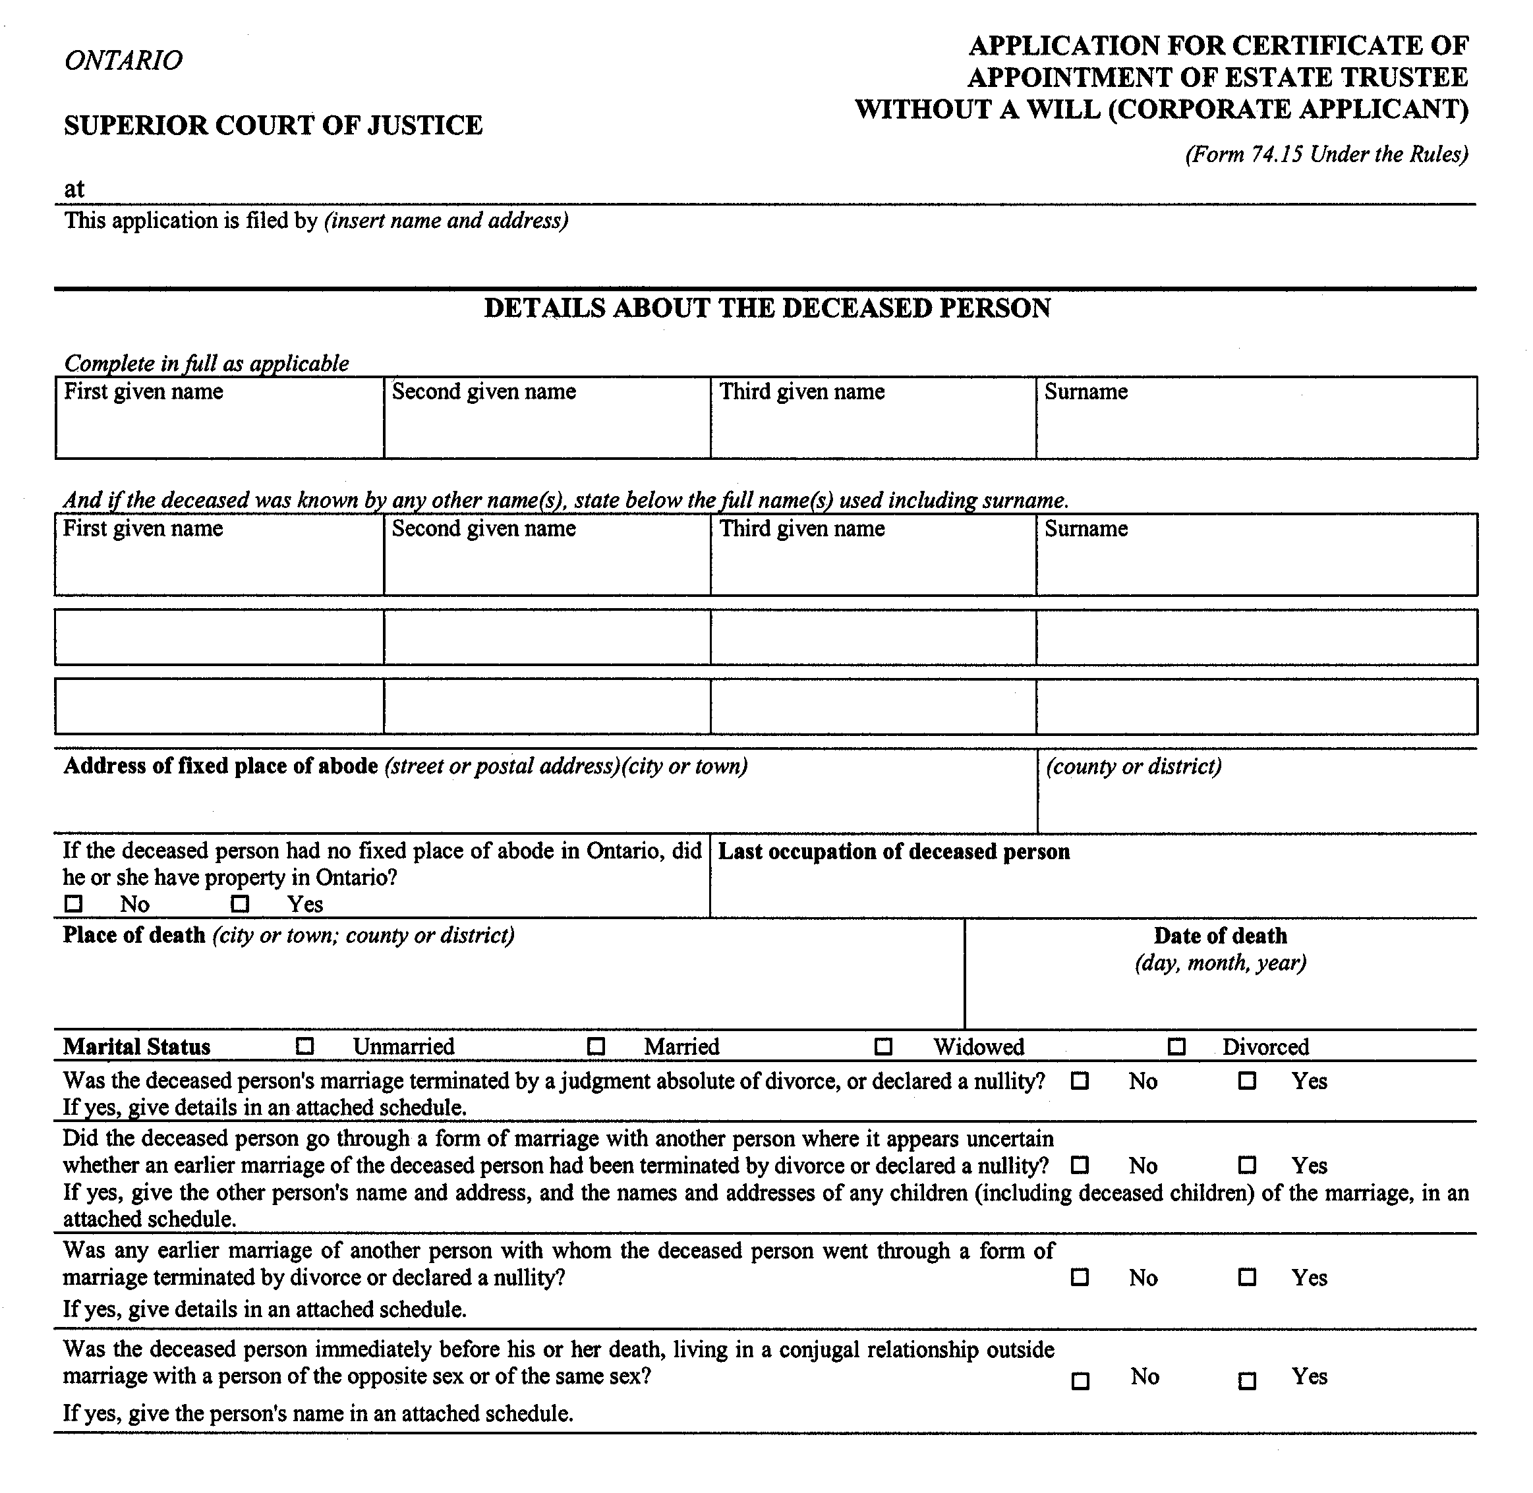
Insert regs\Graphics\Source Law\2004\132\1327415be.tif
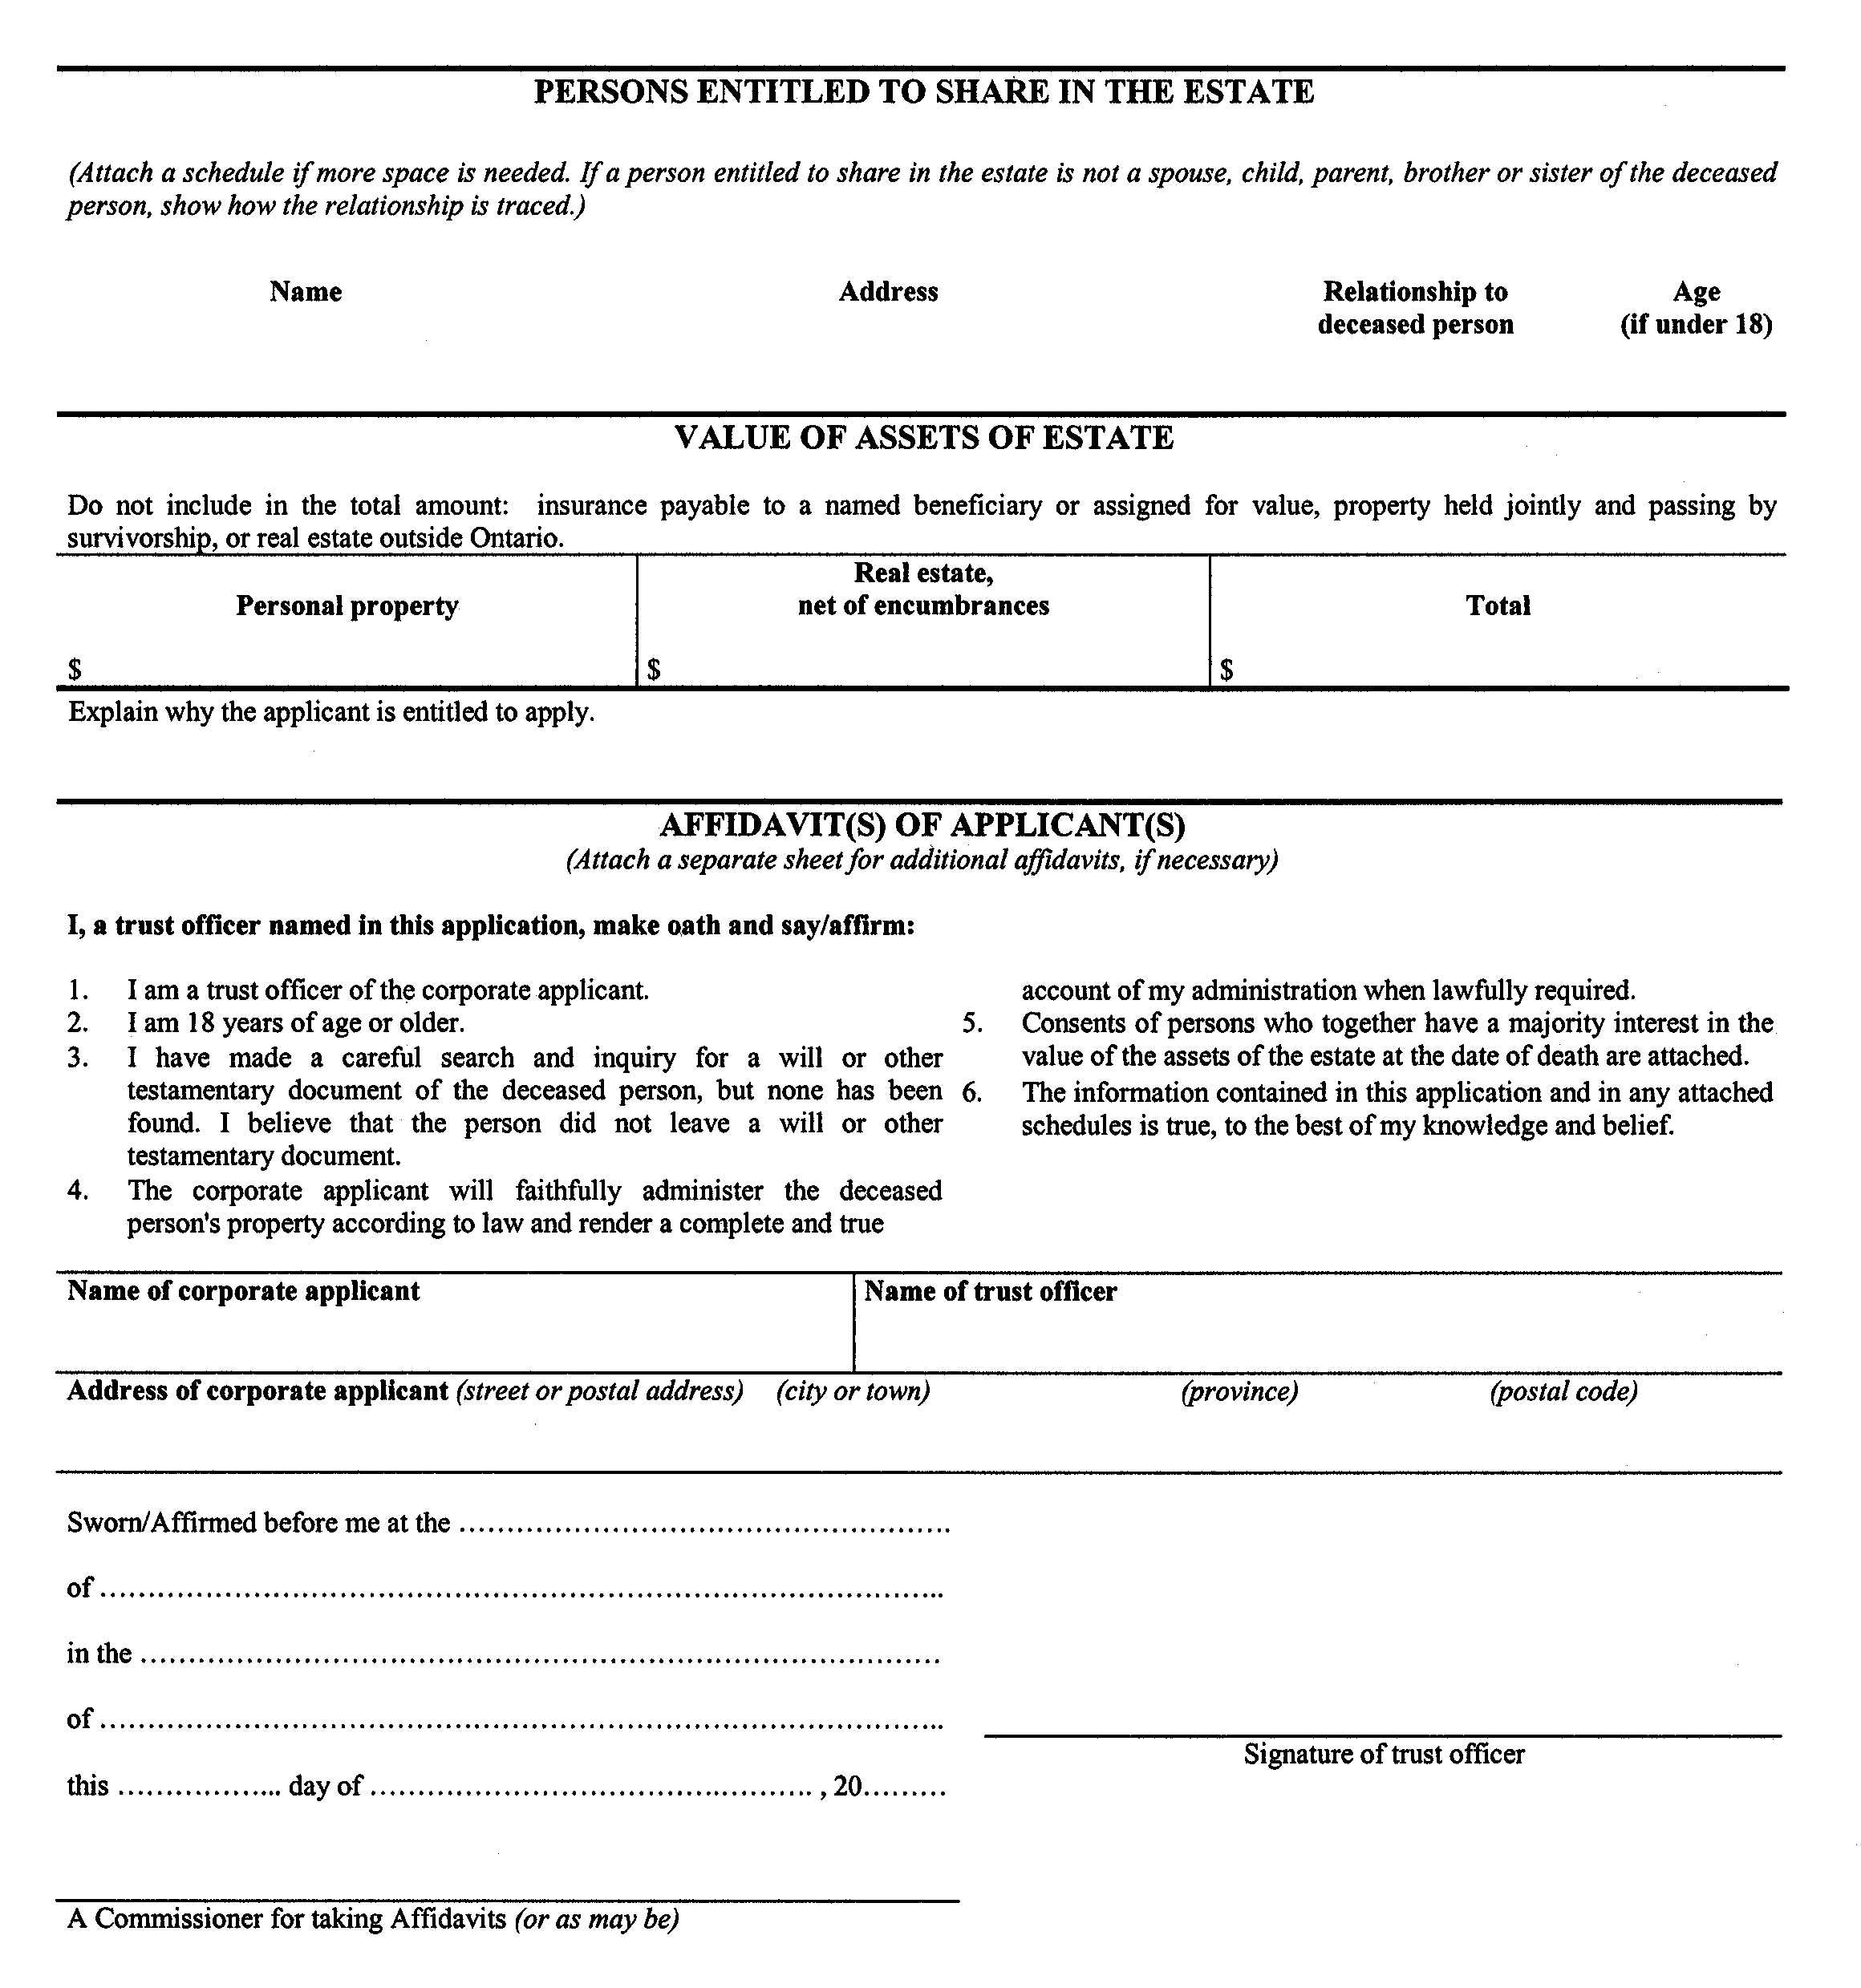
Form 74.16
Courts of Justice Act
affidavit of service of notice
ontario
superior court of justice
Insert regs\Graphics\Source Law\2004\132\1327416ae.tif
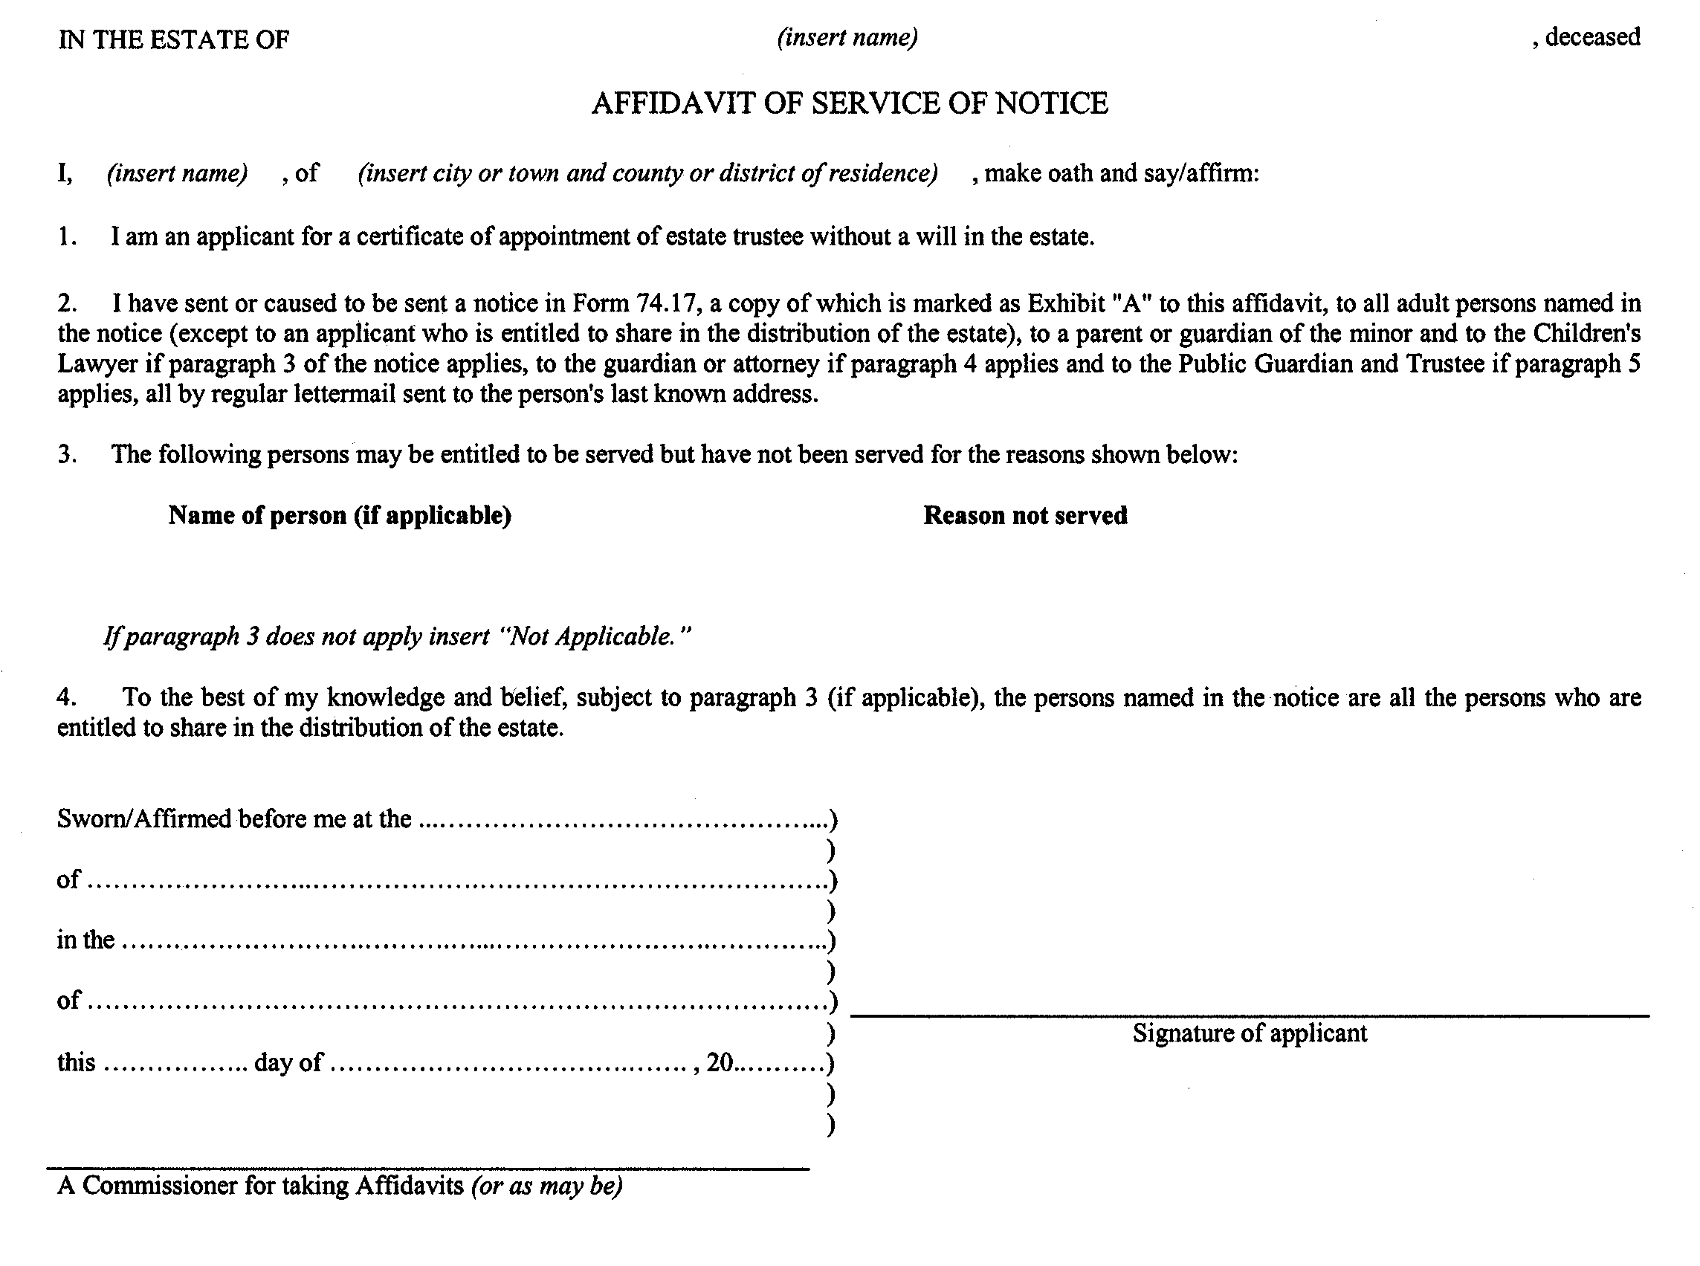
Form 74.17
Courts of Justice Act
notice of an application for a certificate of appointment of estate trustee without a will
ontario
superior court of justice
Insert regs\Graphics\Source Law\2004\132\1327417ae.tif
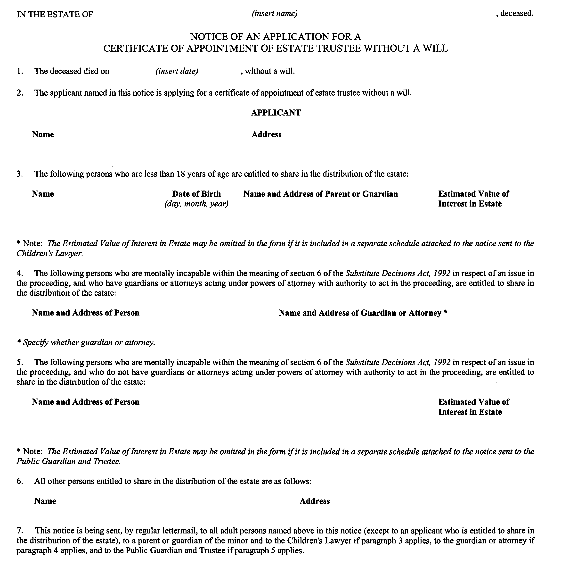
Insert regs\Graphics\Source Law\2004\132\1327417be.tif
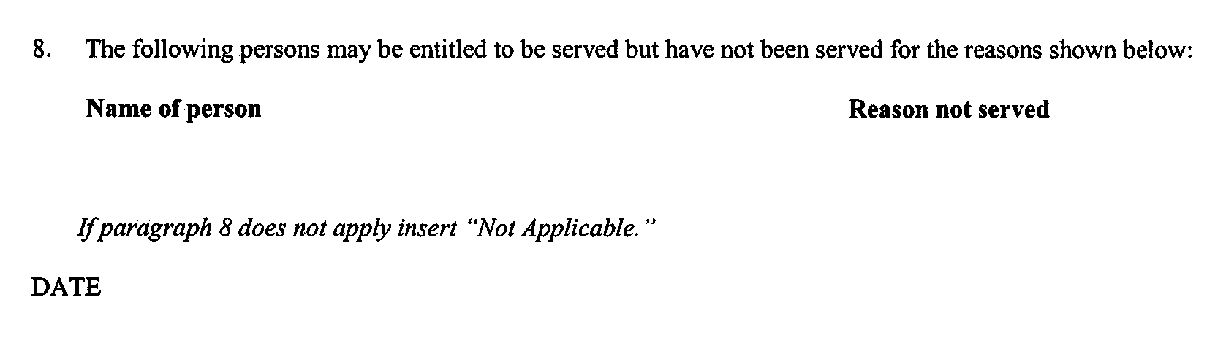
. . . . .
Form 74.20.1
Courts of Justice Act
application for certificate of appointment of a foreign estate trustee’s nominee as estate trustee without a will
Insert regs\Graphics\Source Law\2004\132\13274201ae.tif
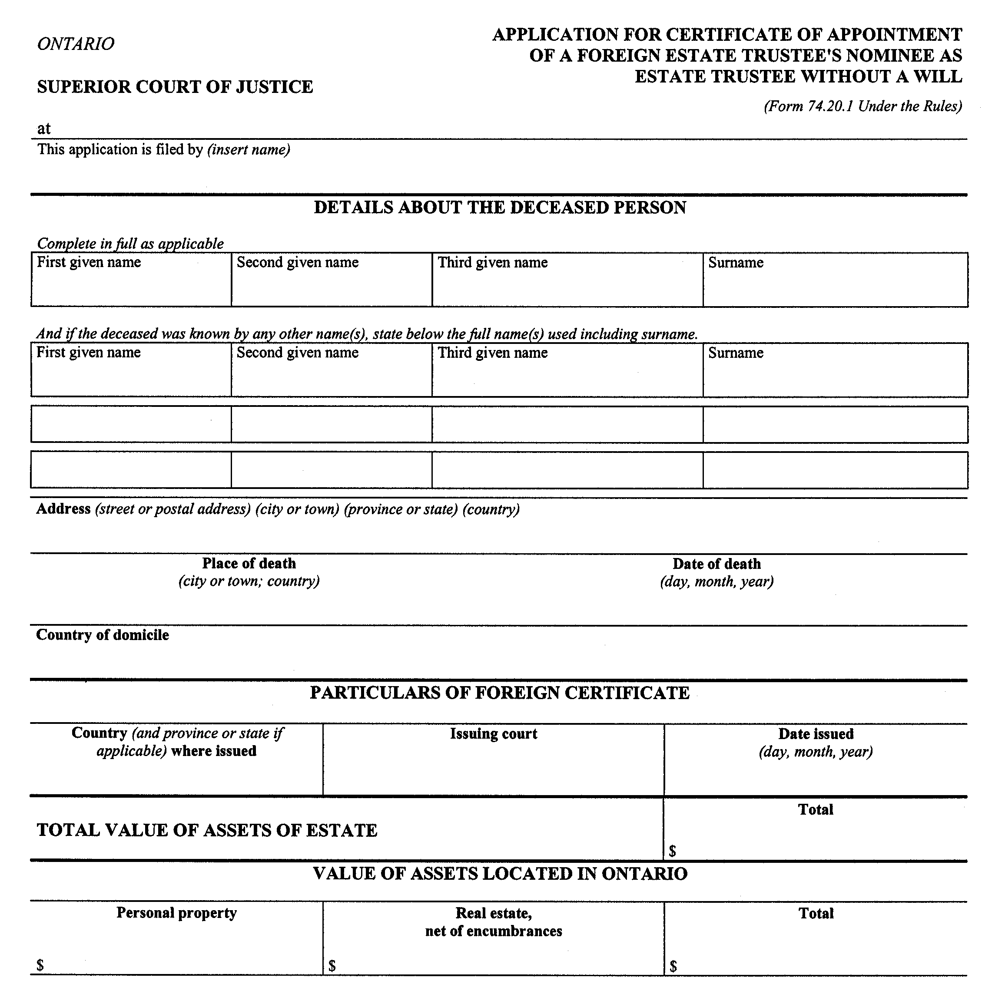
Insert regs\Graphics\Source Law\2004\132\13274201be.tif
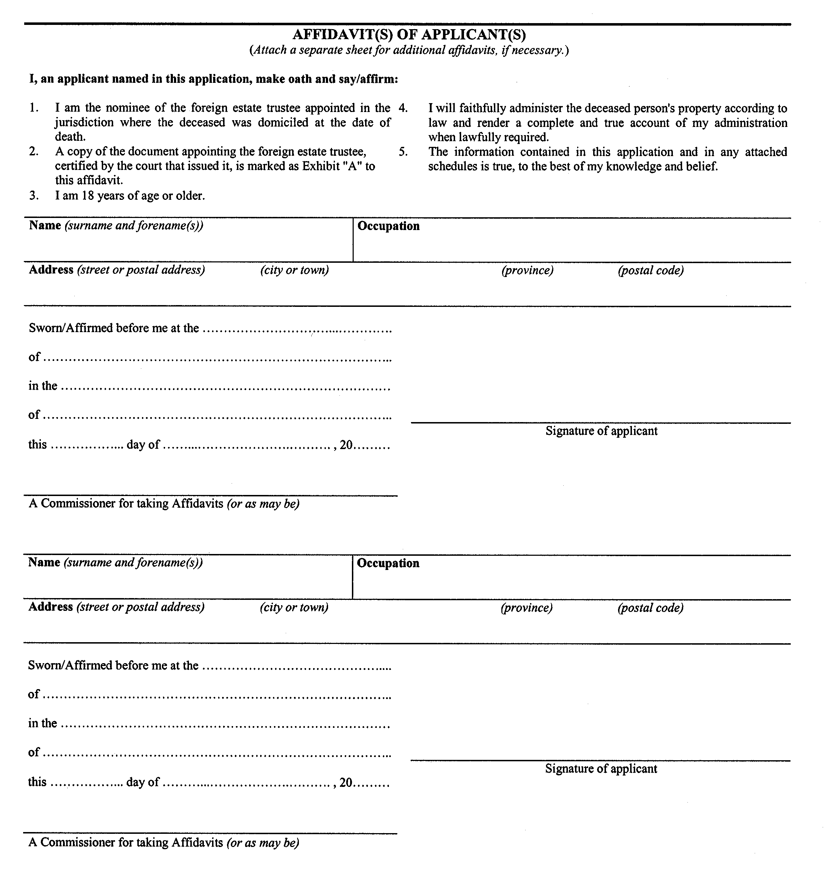
. . . . .
Form 74.21
Courts of Justice Act
application for certificate of appointment as succeeding estate trustee with a will
Insert regs\Graphics\Source Law\2004\132\1327421ae.tif
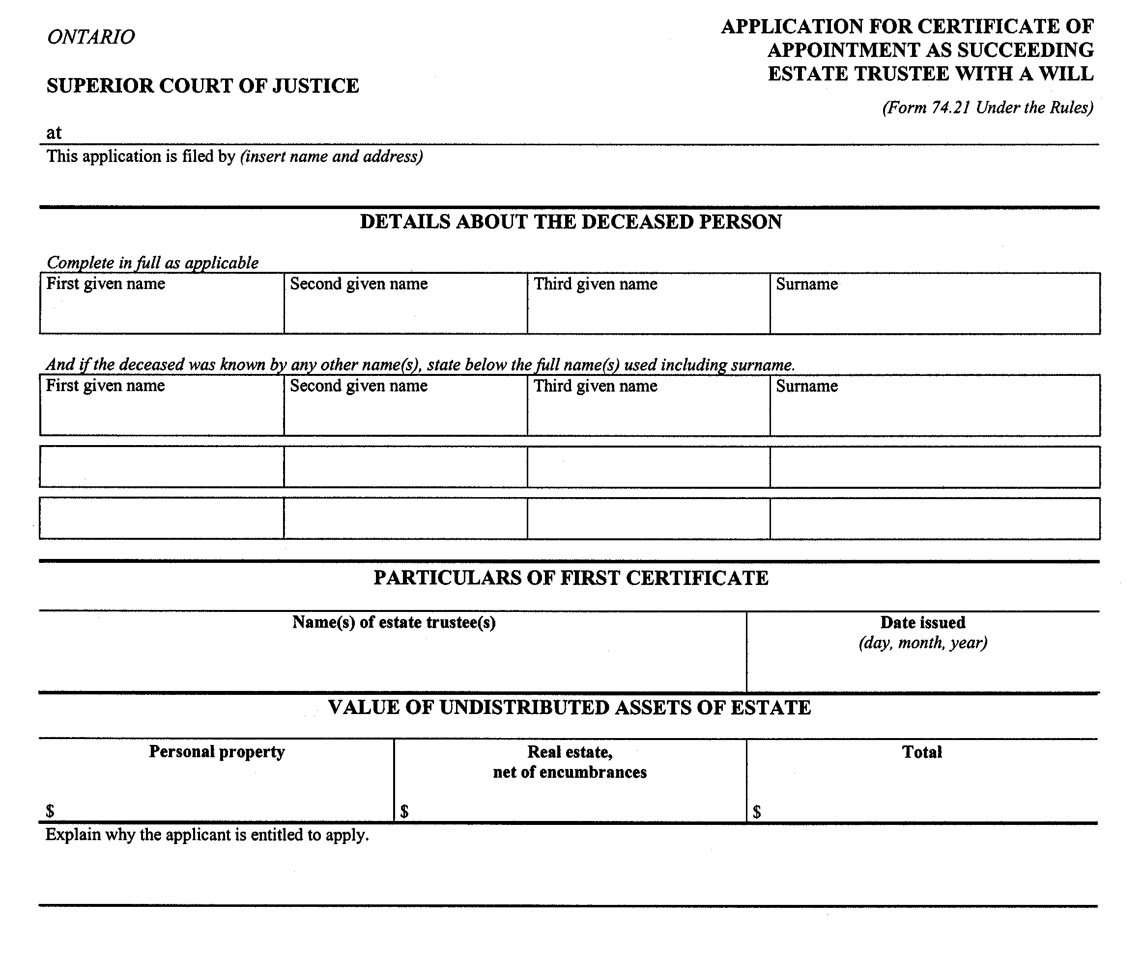
Insert regs\Graphics\Source Law\2004\132\1327421be.tif
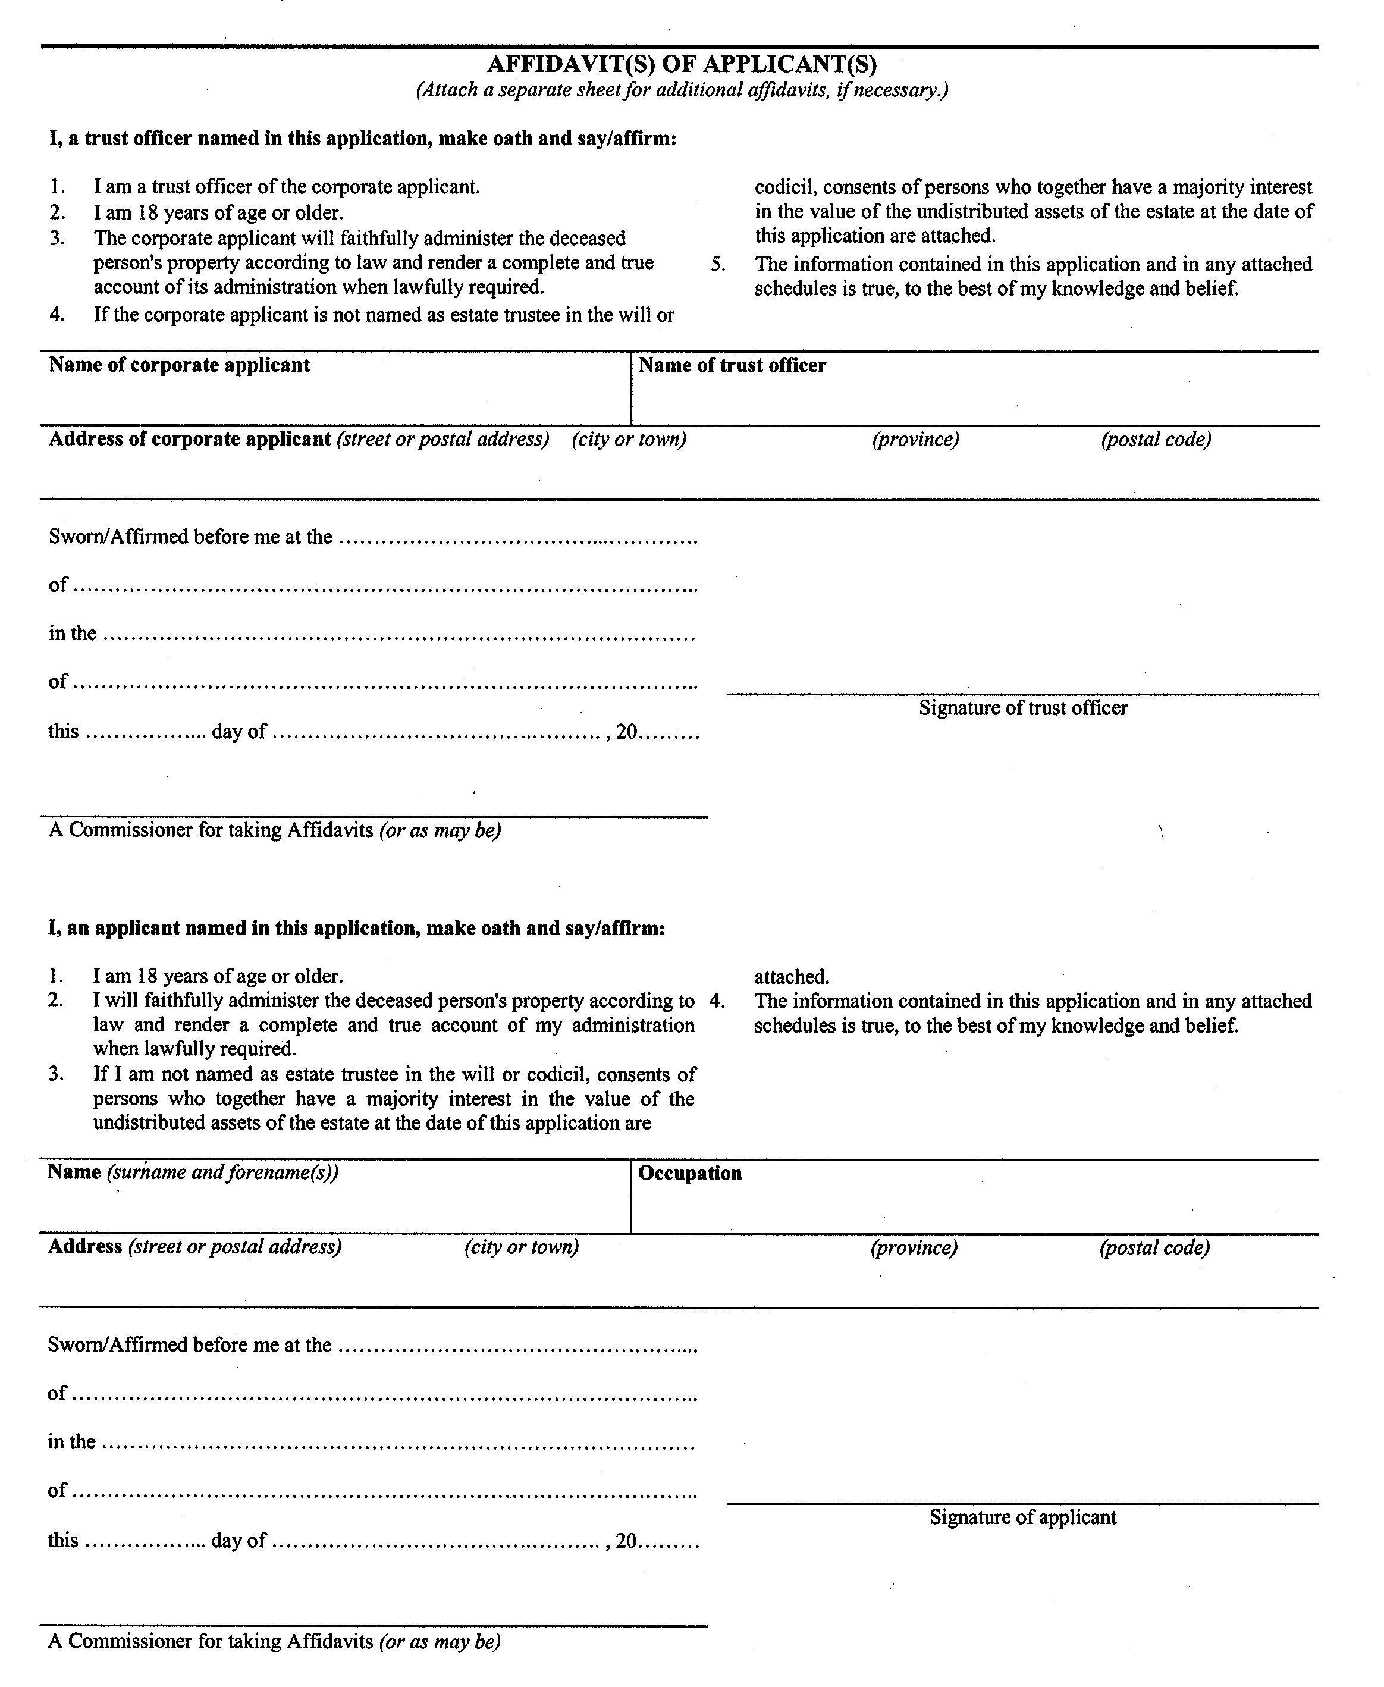
. . . . .
Form 74.24
Courts of Justice Act
application for certificate of appointment as succeeding estate trustee without a will
Insert regs\Graphics\Source Law\2004\132\1327424ae.tif
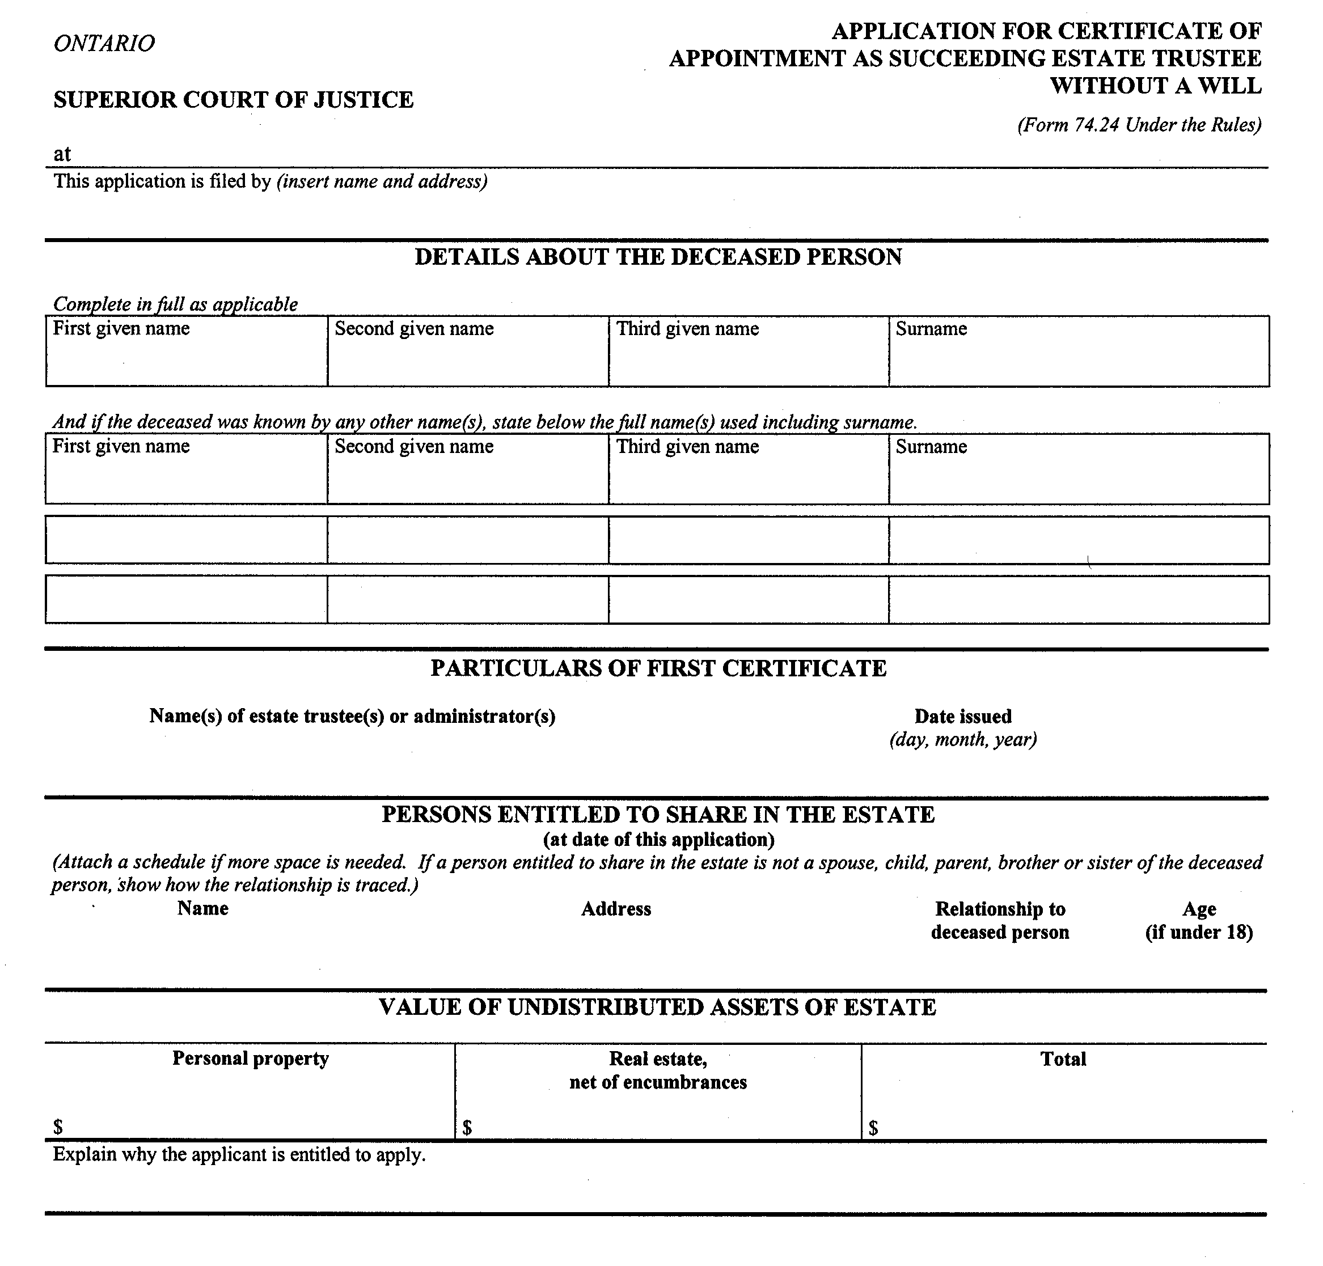
Insert regs\Graphics\Source Law\2004\132\1327424be.tif
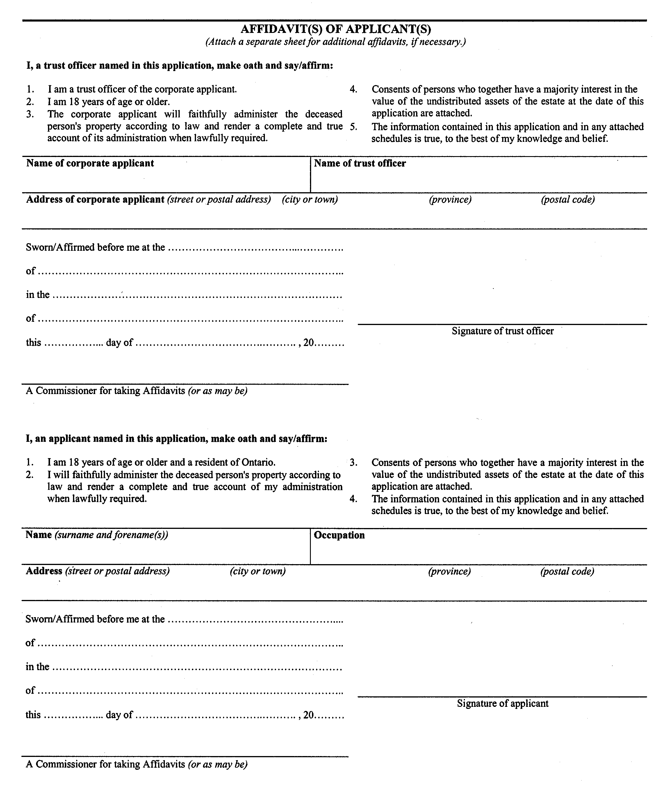
. . . . .
Form 74.27
Courts of Justice Act
application for confirmation by resealing of appointment or certificate of ancillary appointment of estate trustee
Insert regs\Graphics\Source Law\2004\132\1327427ae.tif
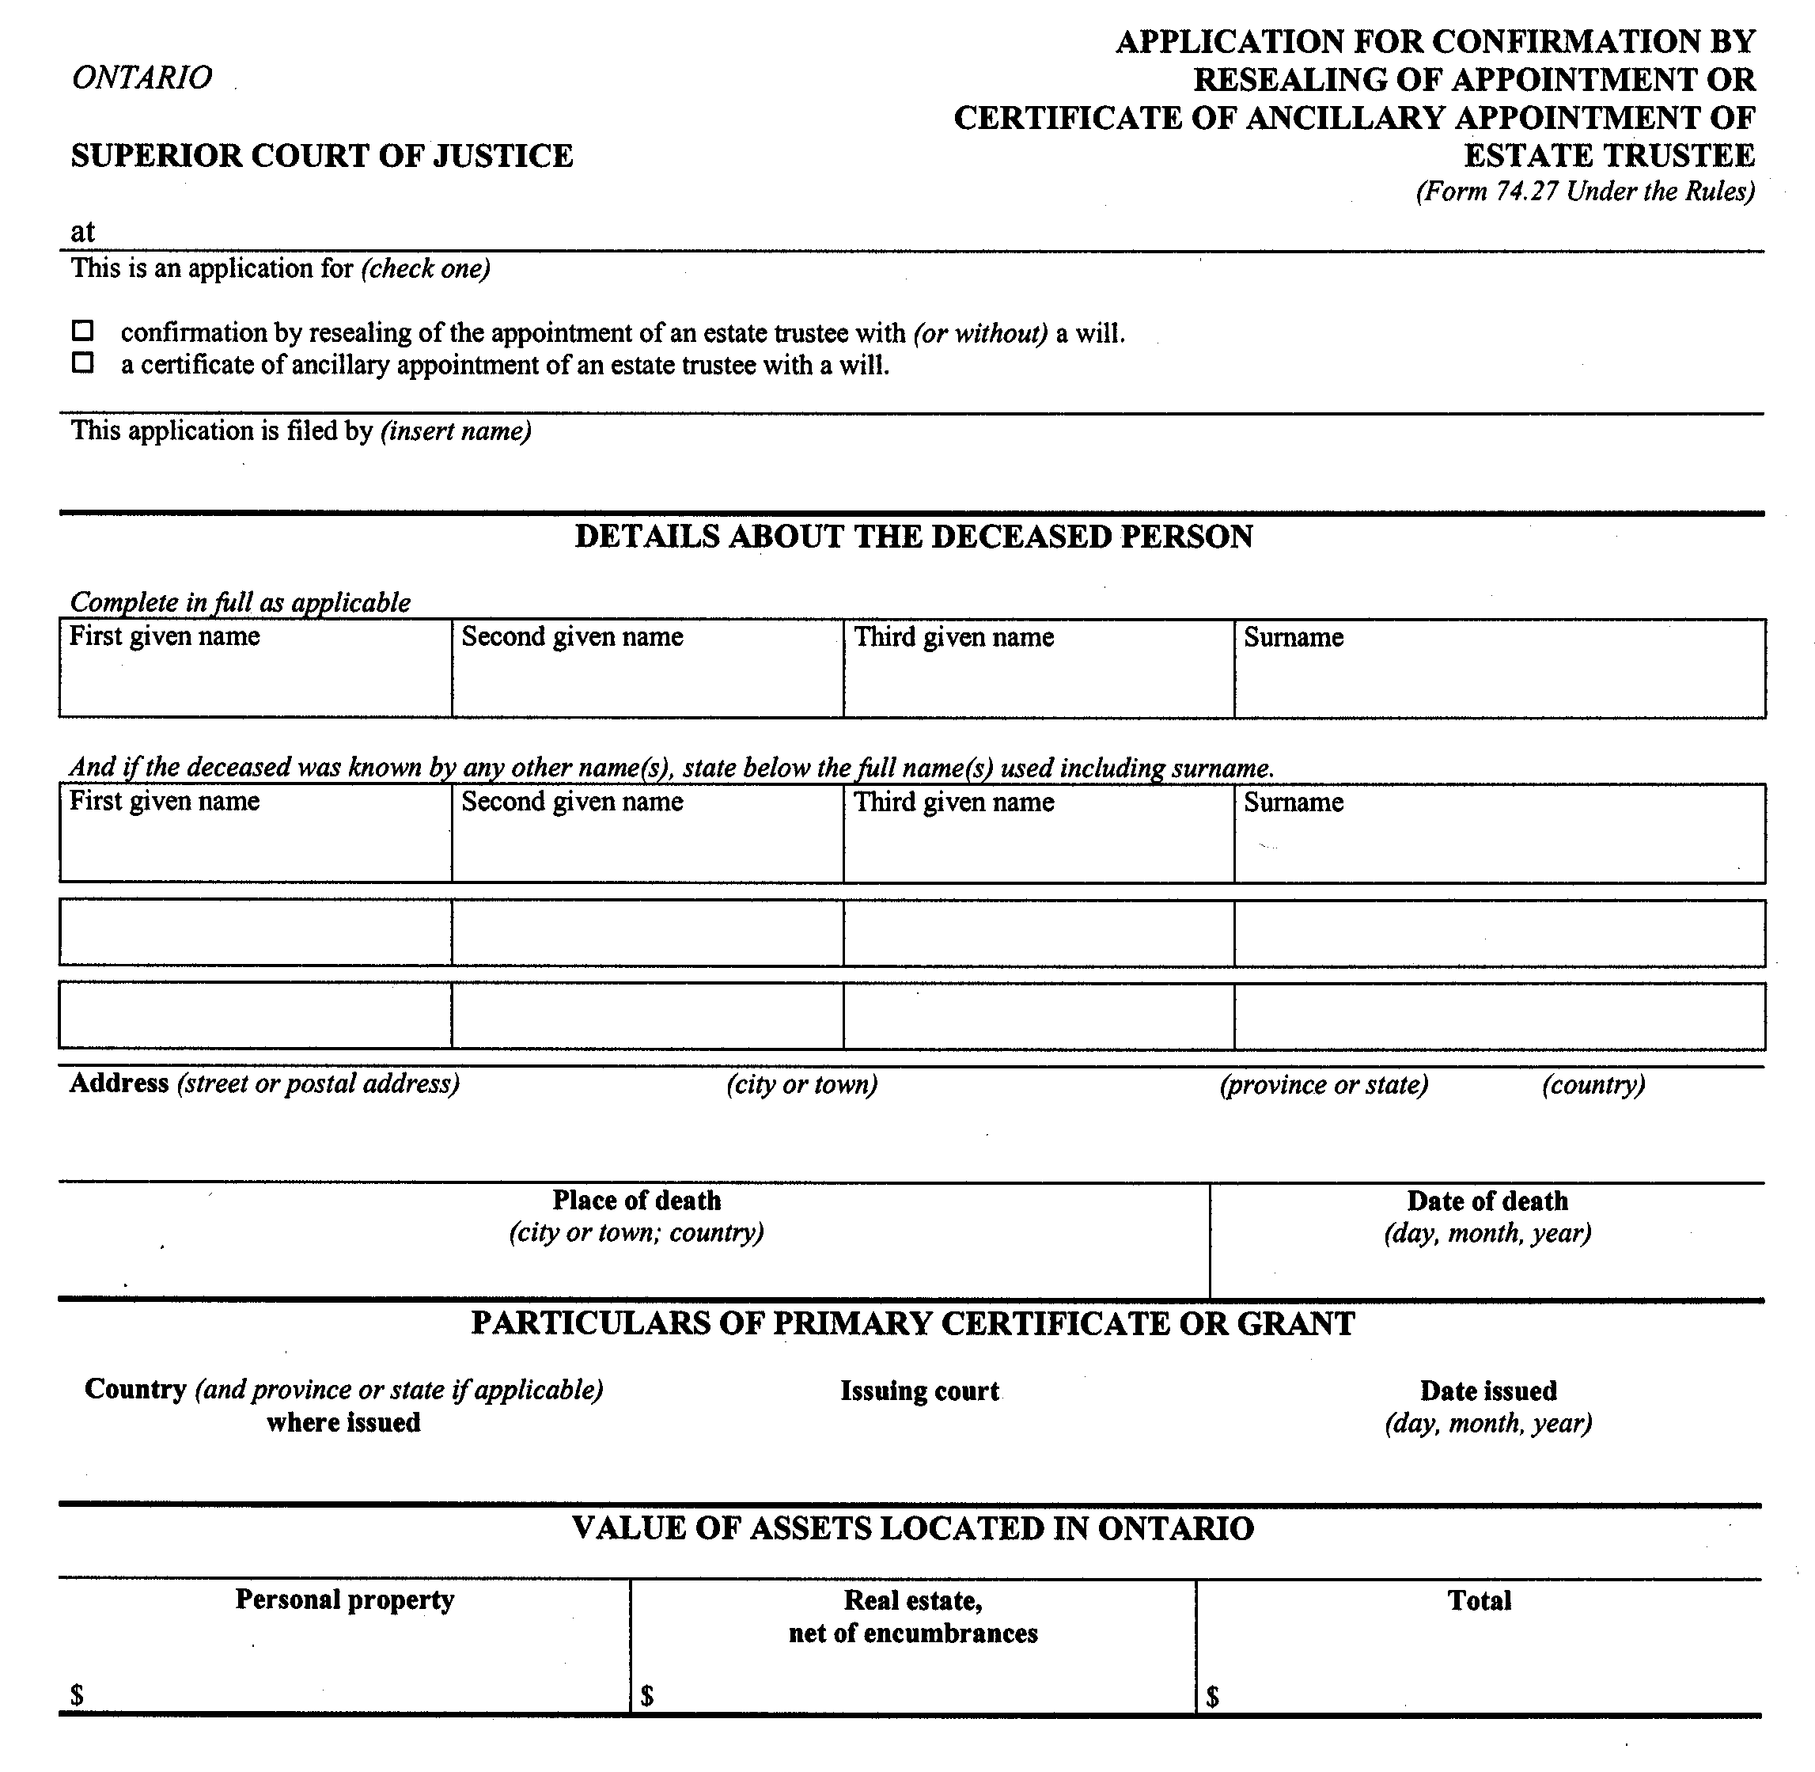
Insert regs\Graphics\Source Law\2004\132\1327427be.tif
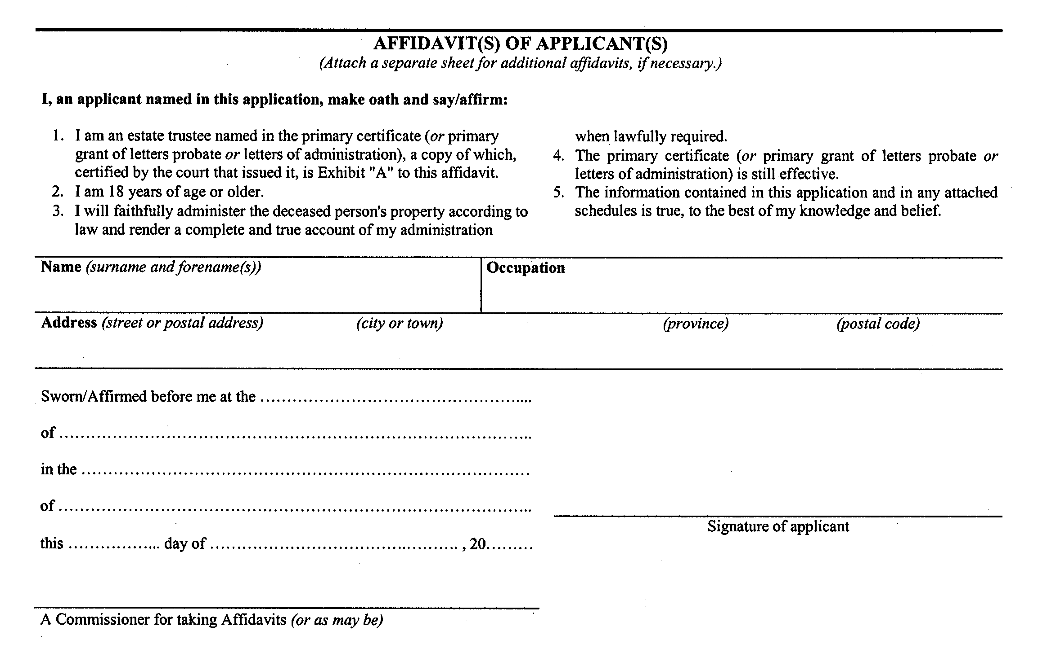
. . . . .
Form 74.30
Courts of Justice Act
application for certificate of appointment of estate trustee during litigation
Insert regs\Graphics\Source Law\2004\132\1327430ae.tif
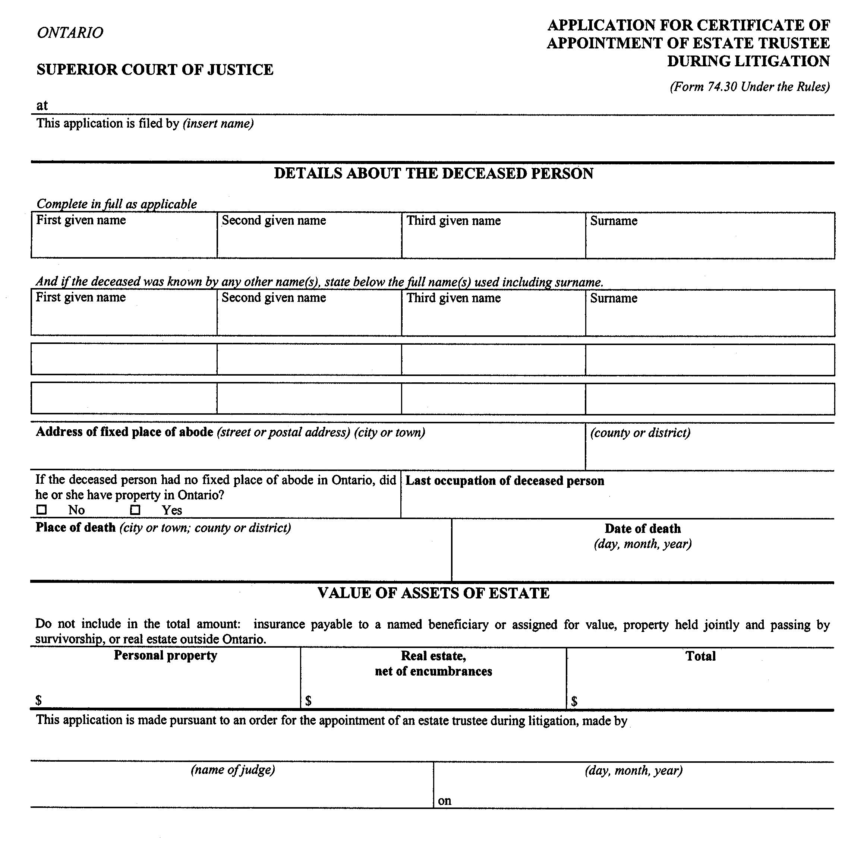
Insert regs\Graphics\Source Law\2004\132\1327430be.tif
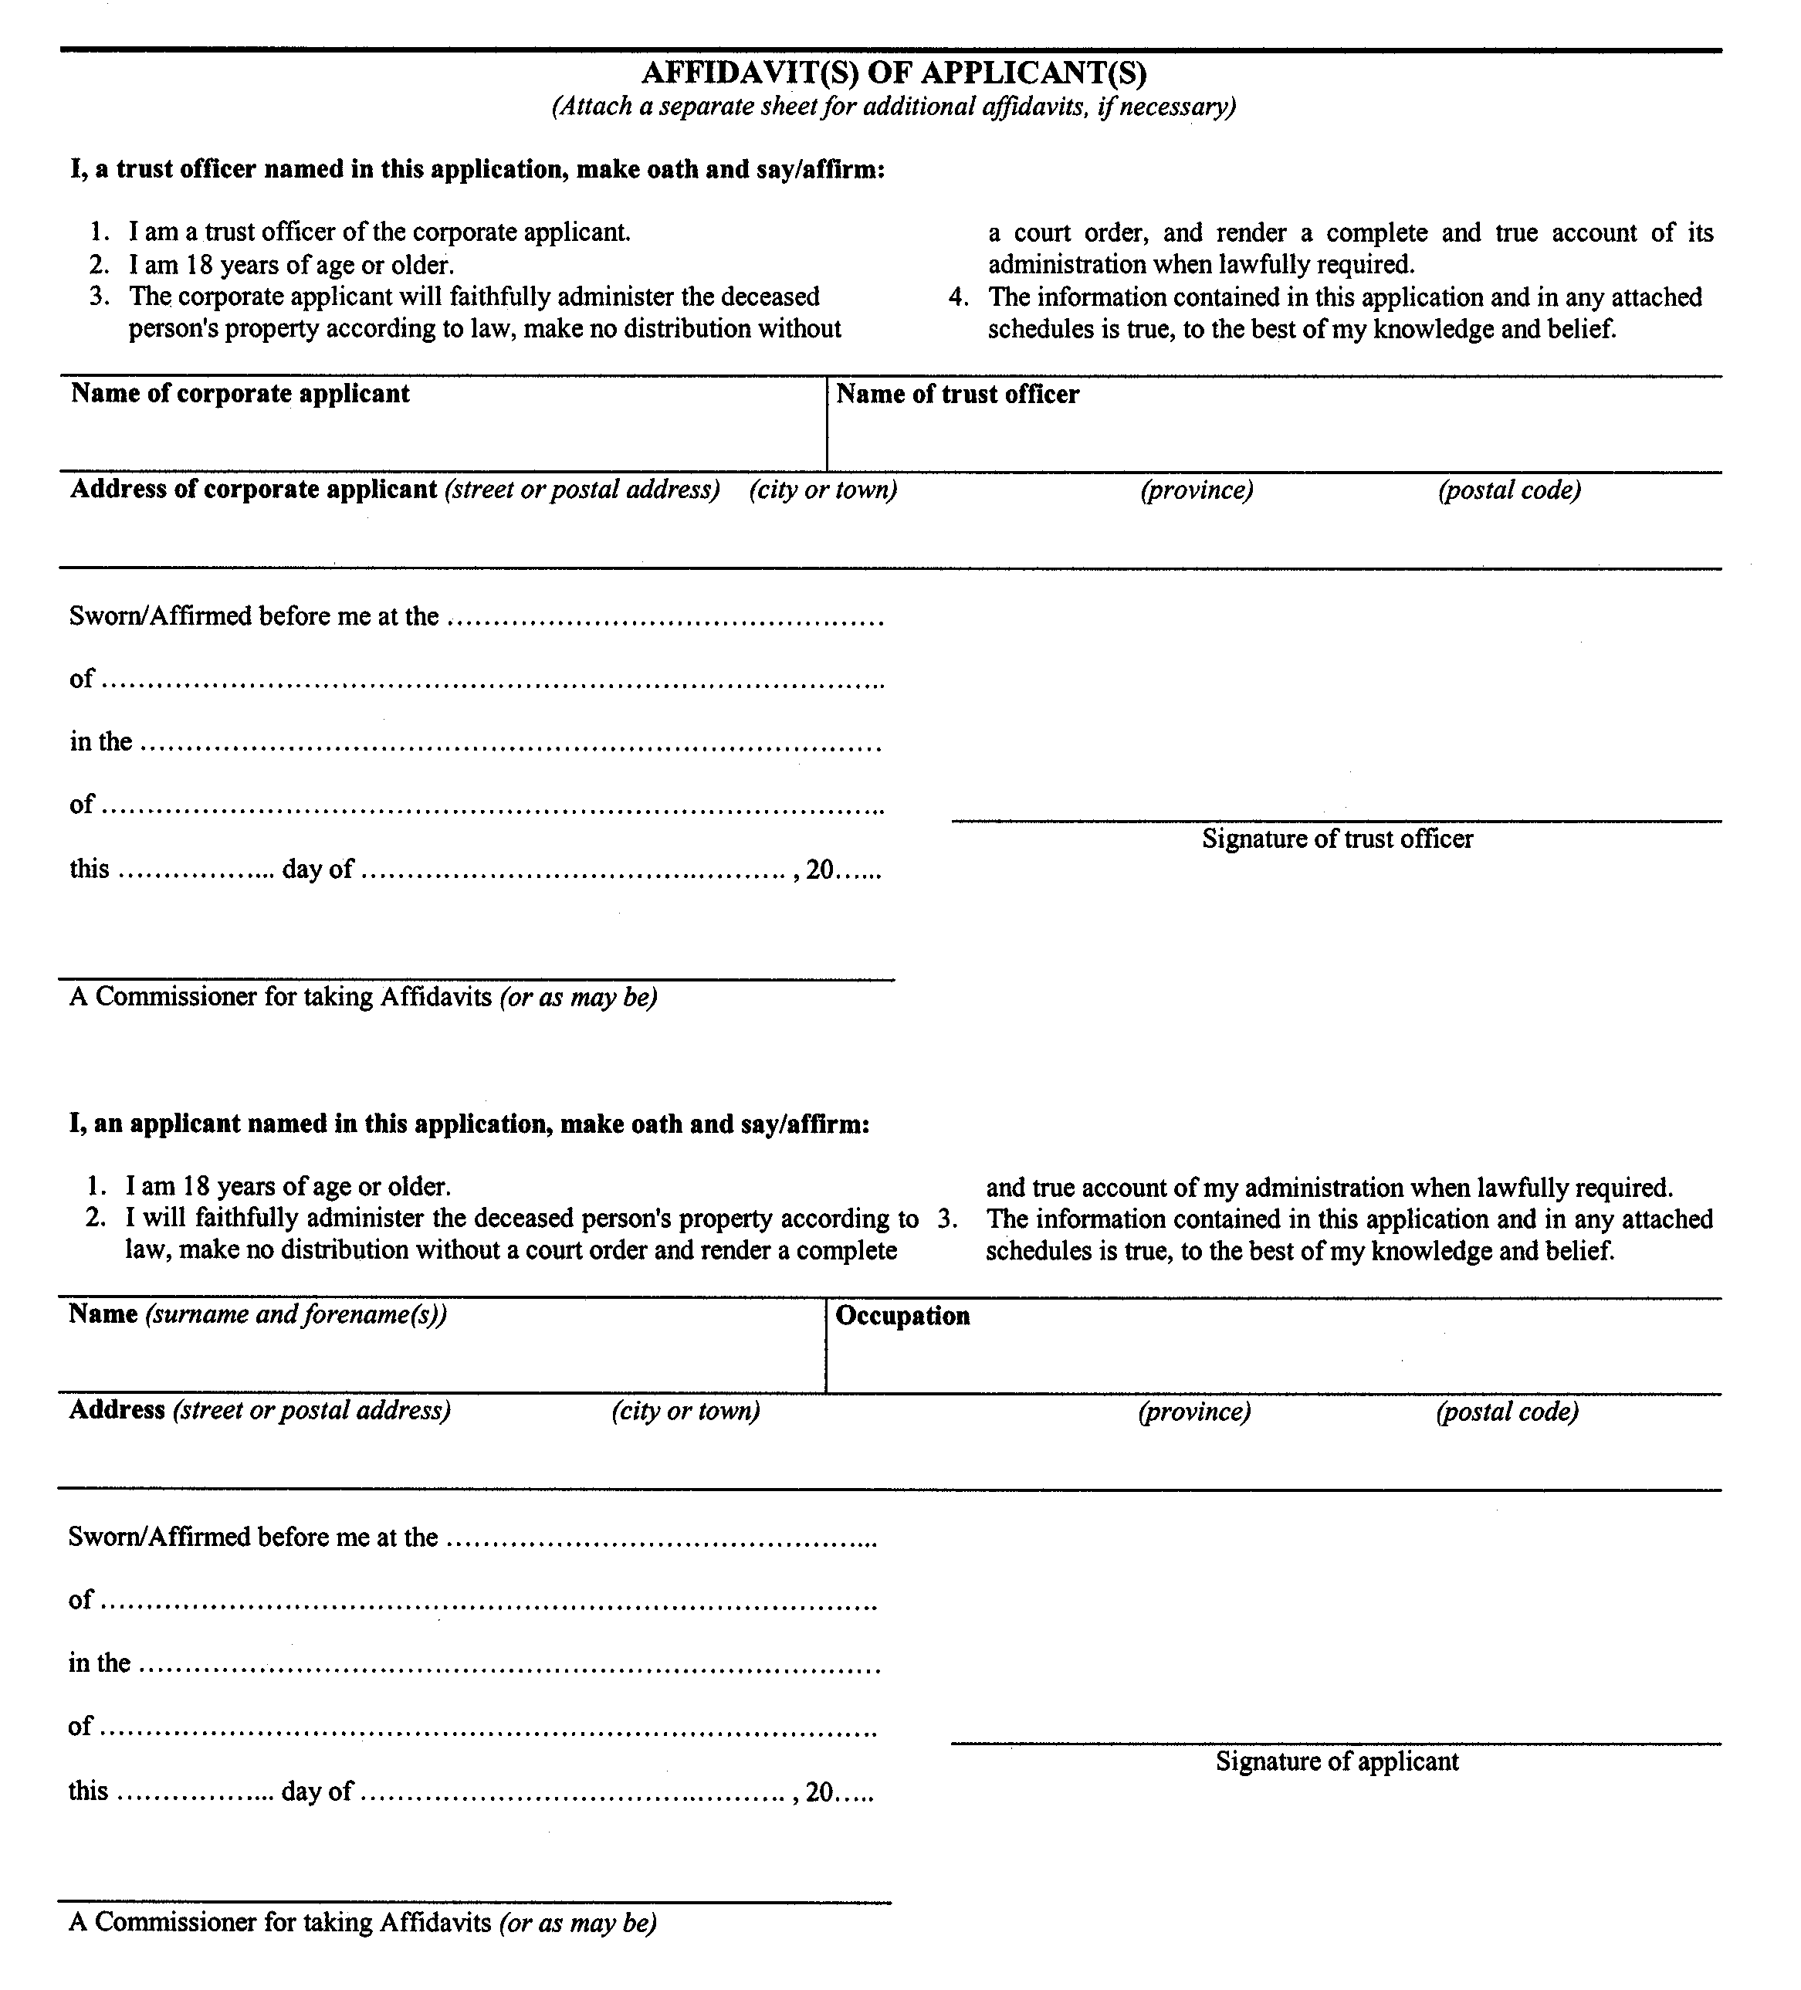
. . . . .
Form 75.1
Courts of Justice Act
notice of objection
ontario
superior court of justice
Insert regs\Graphics\Source Law\2004\132\132751ae.tif
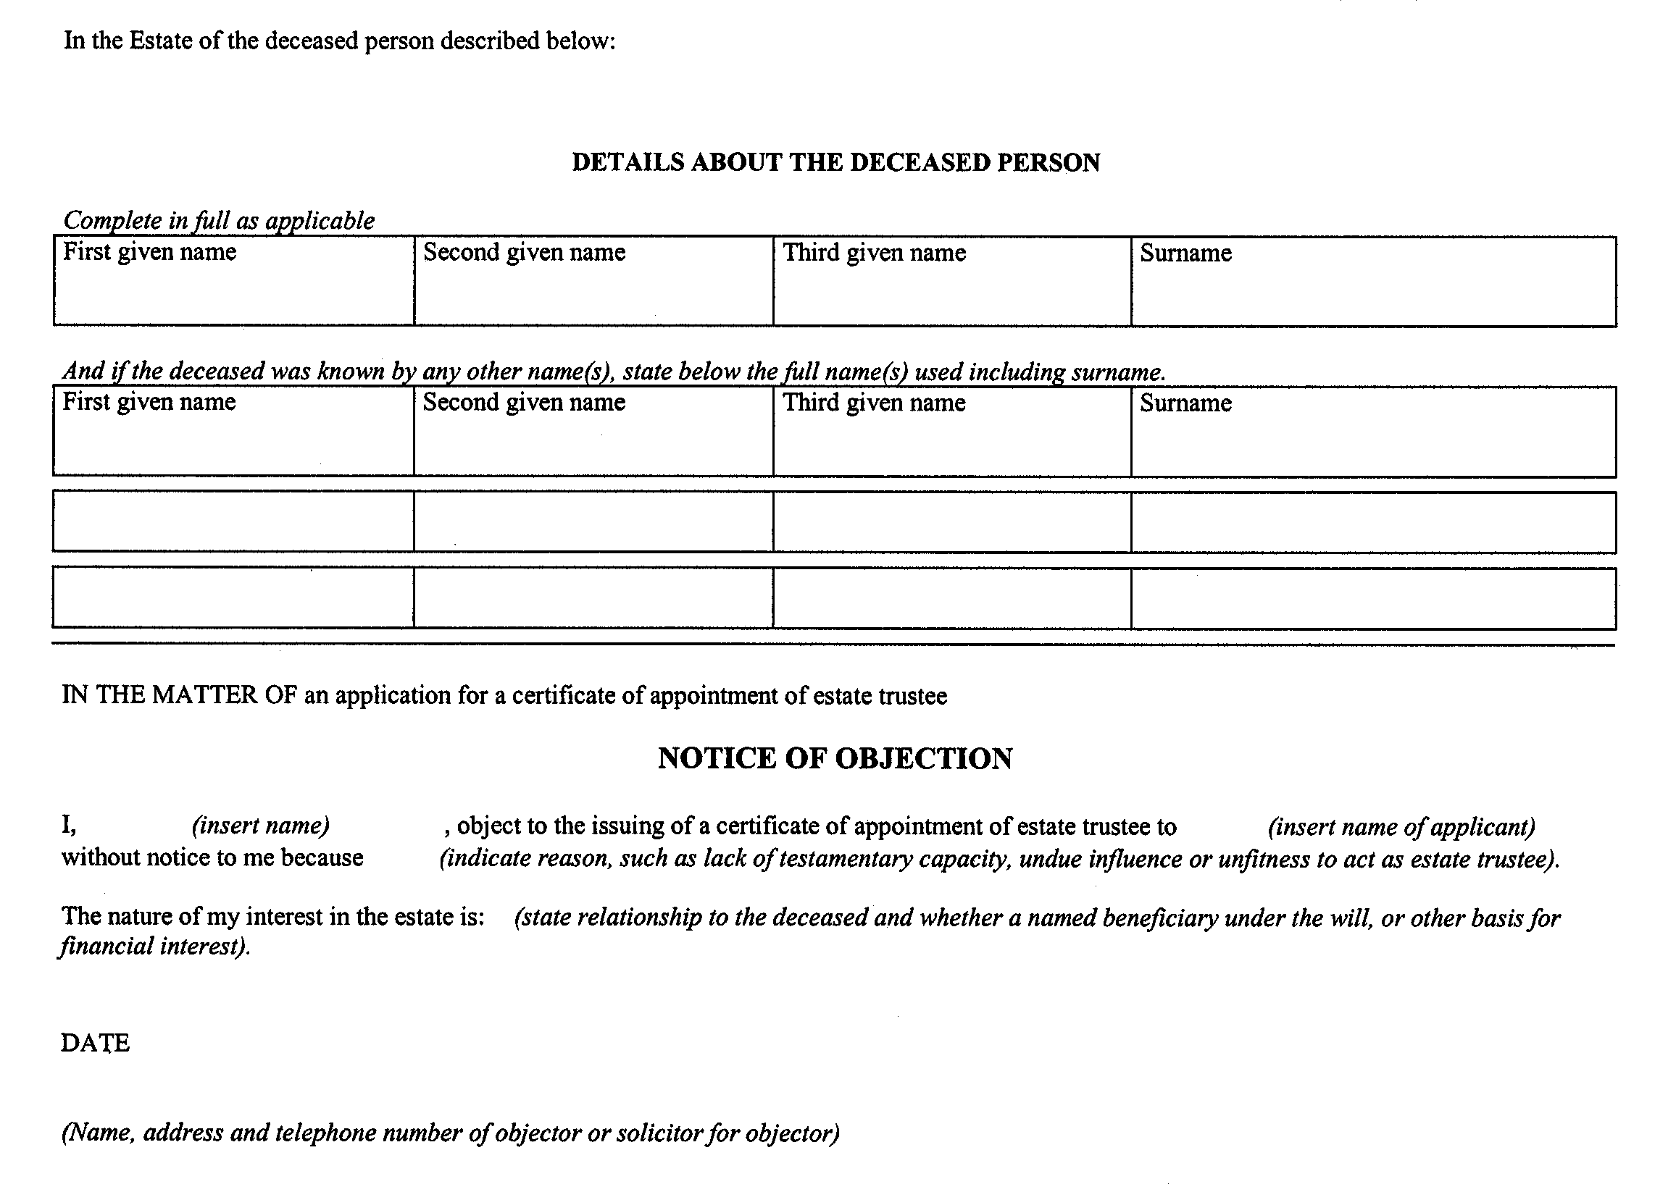
25. (1) Subject to subsection (2), this Regulation comes into force on January 1, 2005.
(2) Sections 13 and 17 come into force on July 1, 2004.

Français

Back to top

