ontario regulation 308/04
made under the
Highway Traffic Act
Made: September 30, 2004
Filed: October 4, 2004
Printed in The Ontario Gazette: October 23, 2004
Amending Reg. 612 of R.R.O. 1990
(School Buses)
1. (1) Subsection 1 (1) of Regulation 612 of the Revised Regulations of Ontario, 1990 is amended by striking out the portion before clause (a) and substituting the following:
(1) Every school bus, as defined in subsection 175 (1) of the Act, that is registered in Ontario shall,
. . . . .
(2) Clause 1 (1) (c) of the Regulation is revoked and the following substituted:
(c) be equipped with signal lights that have an effective illuminating area of at least 120 square centimetres, that produce a light of an intensity that is clearly visible at a distance of at least 150 metres and that are attached and operated as follows:
1. One or two signal lights shall be placed on each side of the front of the bus in as high a position as is practicable and only one light on each side shall operate at a time so as to produce flashes of red light alternately on opposite sides of the bus that are visible only from the front of the bus.
2. One or two signal lights shall be placed on each side of the rear of the bus in as high a position as is practicable and as far apart as is practicable and only one light on each side shall operate at a time so as to produce flashes of red light alternately on opposite sides of the bus that are visible only from the rear of the bus.
3. In the case of a school bus equipped with two signal lights on each side, the two innermost signal lights shall be actuated when the school bus is about to stop on a highway for a purpose described in clause 175 (6) (a) of the Act and the two outermost signal lights shall be actuated while the school bus is stopped on a highway as described in clause 175 (6) (c) of the Act.
4. The signal lights shall be actuated by a control device accessible to the driver and equipped to give the driver a clear and unmistakable signal either visible or audible when the signal lights are operating;
(3) Subclause 1 (1) (d) (i) of the Regulation is revoked and the following substituted:
(i) in the case of a school bus manufactured in accordance with Canadian Standards Association Standard D250-98 or D250-03, that complies with the Standard to which it was manufactured, or
(4) Subclause 1 (1) (d) (ii) of the Regulation is amended by striking out the portion before sub-subclause (A) and substituting the following:
(ii) in the case of a school bus not manufactured in accordance with Canadian Standards Association Standard D250-98 or D250-03, that, unless it complies with either Standard, consists of a sturdy dustproof metal or plastic container containing,
. . . . .
(5) Section 1 of the Regulation is amended by adding the following subsections:
(1.1) Every school bus referred to in subsection (1) and registered in Ontario shall display,
(a) a sign affixed to the bottom of the left window on the rear of the school bus that has the dimensions and bears the markings as illustrated in Figure 1; and
(b) a sign affixed to the bottom of the right window on the rear of the bus that has the dimensions and bears the markings as illustrated in Figure 2.
Figure 1
Insert regs\Graphics\Source Law\2004\308\308fg01ae.tif
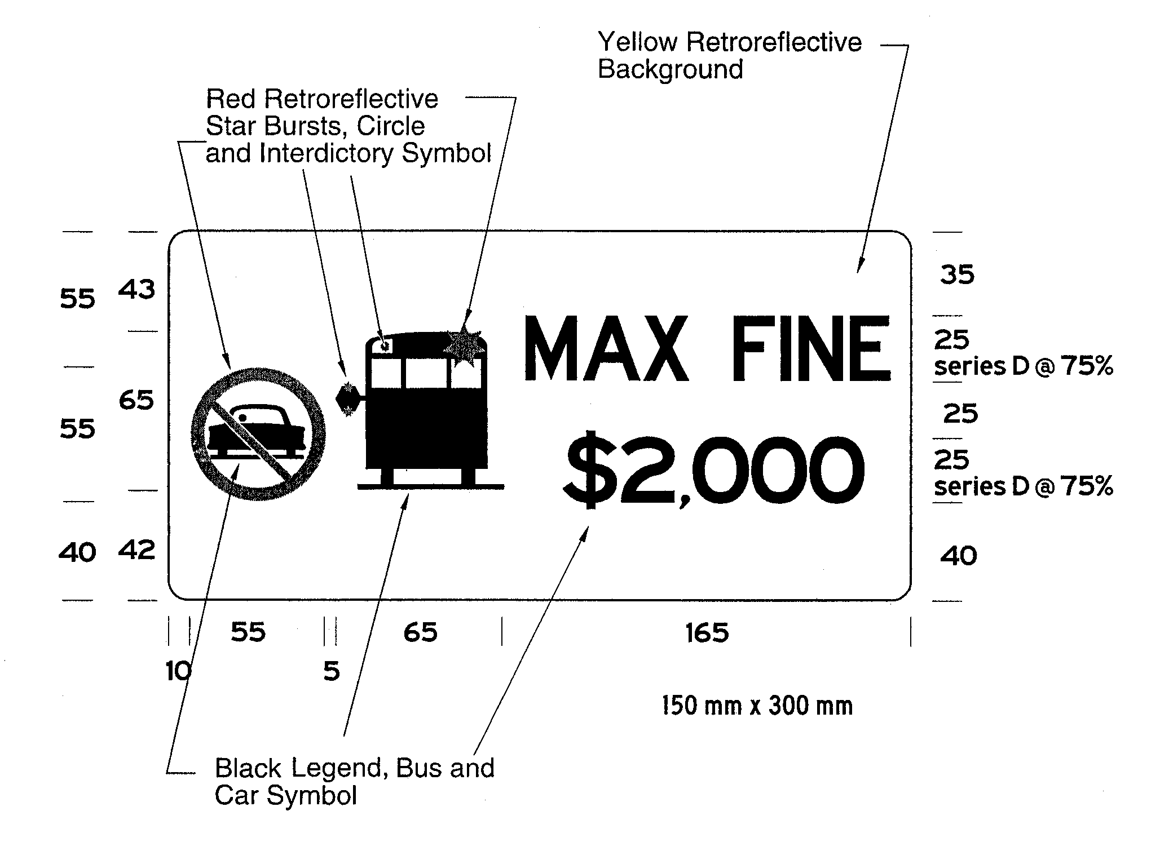
Figure 2
Insert regs\Graphics\Source Law\2004\308\308fg02af.tif
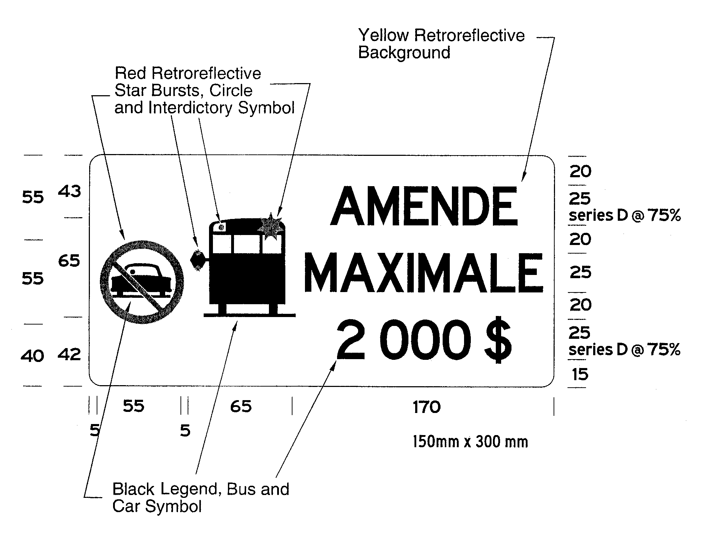
(1.2) If the dimensions of the left or right window on the rear of a school bus cannot accommodate either or both of the signs as required by subsection (1.1), both signs shall be affixed to the rear bumper directly below the locations prescribed by clauses (1.1) (a) and (b).
(1.3) The signs affixed in accordance with subsection (1.1) or (1.2) must be visible at all times to vehicles approaching from the rear of the school bus and shall not be obstructed by any part of or attachment to the school bus.
(1.4) The signs required by subsection (1.1) must meet the performance requirements of any of the types of sheeting specified in the American Society for Testing and Materials Standard D 4956-01a and the sheeting must have a Luminance Factor (Y%) of at least 15.
2. (1) Clause 2 (1) (c) of the Regulation is revoked and the following substituted:
(c) in the case of a school bus manufactured on or after June 1, 2000 and before January 1, 2005, Canadian Standards Association Standard D250-98 or D250-03;
(d) in the case of a school bus manufactured on or after January 1, 2005, Canadian Standards Association Standard D250-03.
(2) Subsection 2 (2) of the Regulation is revoked and the following substituted:
(2) No person shall operate or permit the operation of a school bus registered in Ontario and manufactured in accordance with Canadian Standards Association Standard D250-98 or D250-03 unless the school bus continues to meet the Standard to which it was manufactured.
3. Subsection 4 (1) of the Regulation is amended by striking out “A school purpose vehicle” at the beginning and substituting “A school purposes vehicle”.
4. Schedule 1 to the Regulation is amended by adding the following paragraph:
17. Pedestrian-Student Safety Crossing Arm

Back to top

