ontario regulation 94/08
made under the
highway traffic act
Made: March 31, 2008
Filed: April 16, 2008
Published on e-Laws: April 21, 2008
Printed in The Ontario Gazette: May 3, 2008
Amending Reg. 599 of R.R.O. 1990
(Highway Closings)
1. Section 1 of Regulation 599 of the Revised Regulations of Ontario, 1990 is revoked and the following substituted:
1. For the purposes of section 134 of the Act, a police officer may close a highway or any part thereof by either of the following methods:
1. By,
i. posting or causing to be posted a Do Not Enter sign as prescribed in subsection 2 (1) in such a manner that the sign faces approaching traffic and that the bottom edge of the sign is not less than one metre above the roadway, and
ii. placing or causing to be placed not fewer than three traffic control devices of the type prescribed in clause 2 (2) (a) or two traffic control devices of the type prescribed in clauses 2 (2) (b) and (c) in such a manner that the control devices stand in a line at right angles to approaching traffic with not more than one metre separating each pair of control devices.
2. By deploying or causing to be deployed across the roadway a highway ramp gate traffic control device as prescribed in subsection 2 (3) that was installed by the road authority having jurisdiction and control of the highway and locking it in place.
2. (1) Subsection 2 (2) of the Regulation is revoked and the following substituted:
(2) A traffic control device may,
(a) be conical in shape, not less than 45 centimetres in height, have a white retro-reflective collar and bear the markings and have the minimum dimensions as prescribed and illustrated in Figure 2;
(b) be rectangular in shape, not less than 90 centimetres in height and not less than 20 centimetres in width and bear the markings and have the minimum dimensions as prescribed and illustrated in Figure 3;
(c) be a barricade, not less than 100 centimetres in width and 100 centimetres in height and bear the markings and have the minimum dimensions as prescribed and illustrated in Figure 4; or
(d) be rectangular in shape, not less than 20 centimetres in height and not less than 90 centimetres in width, with black bars on an orange retro-reflective background and bear the markings and have the minimum dimensions as prescribed and illustrated in Figure 5.
(2) Section 2 of the Regulation is amended by adding the following subsection:
(3) A highway ramp gate traffic control device shall,
(a) be a barrier that extends across the width of the roadway when deployed such that it blocks vehicular access to the highway;
(b) be capable of being locked in place;
(c) have on it at least one Do Not Enter sign, as prescribed in subsection (1), in such a manner that the sign faces approaching traffic and the bottom edge of the sign is not less than one metre above the roadway; and
(d) have at least two traffic control devices, as prescribed in clause (2) (d), on the same plane on either side of the Do Not Enter sign in such a manner that the long edges of the control devices are horizontal to the roadway and facing approaching traffic.
(3) Figures 1, 2, 3 and 4 to section 2 of the Regulation are revoked and the following substituted:
Figure 1
Insert regs\Graphics\Source Law\2008\94\094FG1ae.tif
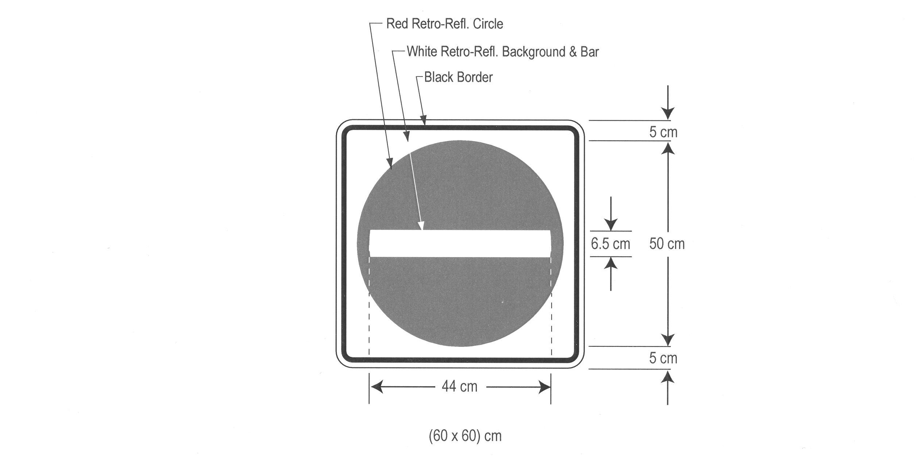
Figure 2
Insert regs\Graphics\Source Law\2008\94\094FG2ae.tif

Figure 3
Insert regs\Graphics\Source Law\2008\94\094FG3ae.tif
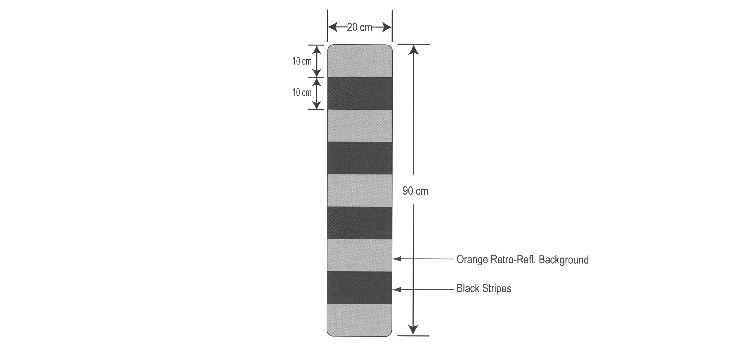
Figure 4
Insert regs\Graphics\Source Law\2008\94\094FG4ae.tif
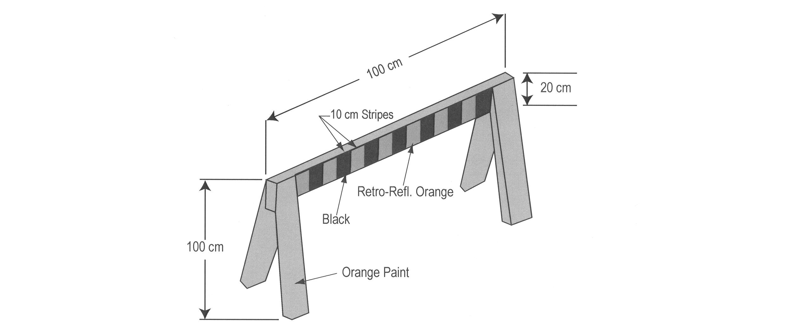
Figure 5
Insert regs\Graphics\Source Law\2008\94\094FG5ae.tif

3. This Regulation comes into force on the day it is filed.
Made by:
Jim Bradley
Minister of Transportation
Date made: March 31, 2008.

Back to top

