ontario regulation 175/08
made under the
highway traffic act
Made: June 4, 2008
Filed: June 5, 2008
Published on e-Laws: June 6, 2008
Printed in The Ontario Gazette: June 21, 2008
Amending Reg. 615 of R.R.O. 1990
(Signs)
1. Subsection 2 (1) of Regulation 615 of the Revised Regulations of Ontario, 1990 is amended by striking out “a city, town, village, police village” in the portion before clause (a) and substituting “a local municipality”.
2. Section 3 of the Regulation is revoked and the following substituted:
3. (1) The commencement of the part of a highway for which a maximum rate of speed is prescribed shall be indicated by a speed limit sign accompanied immediately below by a sign bearing the markings and having the dimensions as illustrated in the following Figure:
Insert regs\Graphics\Source Law\2008\175\175001ae.tif
(2) Despite subsection (1), in an area designated by the French Language Services Act, the commencement of the part of a highway for which a maximum rate of speed is prescribed shall be indicated by a speed limit sign accompanied immediately below by a sign bearing the markings and having the dimensions as illustrated in the following Figure:
Insert regs\Graphics\Source Law\2008\175\175002ae.tif
3. (1) Figure A and Figure B to subsection 5 (1) of the Regulation are revoked and the following substituted:
Insert regs\Graphics\Source Law\2008\175\175003ae.tif
Insert regs\Graphics\Source Law\2008\175\175004ae.tif
(2) Subsection 5 (1.0.1) of the Regulation is revoked and the following substituted:
(1.0.1) A speed limit sign that is similar to a sign illustrated in Figure A or Figure B to subsection (1), except that it has white symbols and a white border on a blue background instead of black symbols and a black border on a retro-reflective fluorescent yellow-green background, and that is in place on the day this subsection comes into force, is deemed to comply with clause (1) (a) or (b), as the case may be, until it is replaced.
(3) Figure C to clause 5 (1.1) (b) of the Regulation is revoked and the following substituted:
Insert regs\Graphics\Source Law\2008\175\175005ae.tif
(4) Section 5 of the Regulation is amended by adding the following subsection:
(1.2) A speed limit sign that is similar to the sign illustrated in Figure C to clause (1.1) (b), except that it has white symbols and a white border on a blue background instead of black symbols and a black border on a retro-reflective fluorescent yellow-green background, and that is in place on the day this subsection comes into force, is deemed to comply with subsection (1.1) until it is replaced.
(5) Subsections 5 (4) and (5.1) of the Regulation are revoked and the following substituted:
(5.1) A sign referred to in clauses (1.1) (a) and (b) shall be not less than 30 centimetres in height and not less than 60 centimetres in width, shall bear the legend “MAXIMUM” in black letters not less than 8 centimetres in height and shall display the speed limit prescribed by by-law in black numerals not less than 12.5 centimetres in height on a white background.
(6) Section 5 of the Regulation is amended by adding the following subsection:
(8) A reference in subsection (2), (3), (4), (5), (5.1) or (7) to a sign referred to in clause (1) (a) or (1.1) (a) or (1) (b) or (1.1) (b) or subsection (1) or (1.1) is deemed to include a sign referred to in subsection (1.0.1) or (1.2), as the case may be.
(7) Subsections 5 (1.0.1), (1.2) and (8) of the Regulation are revoked.
4. (1) The Figure to subsection 5.1 (1) of the Regulation is revoked and the following substituted:
Insert regs\Graphics\Source Law\2008\175\175006ae.tif
(2) The Figure to subsection 5.1 (1.1) of the Regulation is revoked and the following substituted:
Insert regs\Graphics\Source Law\2008\175\175007ae.tif
(3) Section 5.1 of the Regulation is amended by adding the following subsections:
(1.2) A speed limit sign that is similar to a sign illustrated in subsection (1) or (1.1), except that it has white symbols and a white border on a blue background instead of black symbols and a black border on a retro-reflective fluorescent yellow-green background, and that is in place on the day this subsection comes into force, is deemed to comply with subsection (1) or (1.1), as the case may be, until it is replaced.
. . . . .
(6) A reference in subsection (2), (3) or (5) to a sign referred to in subsection (1) or (1.1) is deemed to include a sign referred to in subsection (1.2).
(4) Subsections 5.1 (1.2) and (6) of the Regulation are revoked.
5. Section 19 of the Regulation is revoked and the following substituted:
19. A yield right-of-way sign shall be erected so that the left edge of the sign is not more than 4 metres from the edge of the roadway.
6. (1) The Figure to paragraph 1 of subsection 20.1 (2) of the Regulation is revoked and the following substituted:
Insert regs\Graphics\Source Law\2008\175\175008ae.tif
(2) The Figure to paragraph 2 of subsection 20.1 (2) of the Regulation is revoked and the following substituted:
Insert regs\Graphics\Source Law\2008\175\175009ae.tif
7. (1) The Figure to subsection 20.3 (1) of the Regulation is revoked and the following substituted:
Insert regs\Graphics\Source Law\2008\175\175010ae.tif
(2) The Figure to subsection 20.3 (2) of the Regulation is revoked and the following substituted:
Insert regs\Graphics\Source Law\2008\175\175011ae.tif
8. Sections 20.7, 20.8 and 20.9 of the Regulation are revoked.
9. (1) Section 40 of the Regulation is revoked and the following substituted:
Load Restriction Sign
40. (1) A Load Restriction sign erected on or after June 1, 2008 shall bear the markings and have the dimensions as illustrated in the following Figure:
Insert regs\Graphics\Source Law\2008\175\175012ae.tif
(2) A Load Restriction sign described in subsection (1) shall have one or both of the following Figures appended to it:
Insert regs\Graphics\Source Law\2008\175\175013ae.tif
Insert regs\Graphics\Source Law\2008\175\175014ae.tif
(3) A Load Restriction sign erected on or after March 1, 1980 and before June 1, 2008 shall,
(a) be not less than 60 centimetres in width and 75 centimetres in height;
(b) bear the words “Load Restriction in Effect” and indicate the maximum number of tonnes per axle permitted on the highway; and
(c) bear the markings and have the dimensions as illustrated in the following Figure:
Insert regs\Graphics\Source Law\2008\175\175S40ae.tif
(2) Subsection 40 (1) of the Regulation is amended by striking out “erected on or after June 1, 2008”.
(3) Subsection 40 (3) of the Regulation is revoked.
10. (1) Section 40.1 of the Regulation is revoked and the following substituted:
40.1 (1) A Load Restriction sign erected on or after June 1, 2008 in an area designated by the French Language Services Act shall bear the markings and have the dimensions as prescribed and illustrated in subsection 40 (1).
(2) A Load Restriction sign described in subsection (1) shall have one or both of the following Figures appended to it:
Insert regs\Graphics\Source Law\2008\175\175015ae.tif
Insert regs\Graphics\Source Law\2008\175\175016ae.tif
(3) A Load Restriction sign erected before June 1, 2008 in an area designated by the French Language Services Act shall,
(a) be not less than 60 centimetres in width and 75 centimetres in height;
(b) be erected below, to the right of or up to 100 metres beyond the sign required by section 40;
(c) bear the words “Limite de chargement en vigueur” and indicate the maximum number of tonnes per axle permitted on the highway; and
(d) bear the markings and have the dimensions as illustrated in the following Figure:
Insert regs\Graphics\Source Law\2008\175\175S401ae.tif
(2) Subsection 40.1 (1) of the Regulation is amended by striking out “erected on or after June 1, 2008”.
(3) Subsection 40.1 (3) of the Regulation is revoked.
11. (1) Subsection 41 (1.1) of the Regulation is amended by striking out “until it is replaced” at the end and substituting “until January 1, 2011”.
(2) Subsection 41 (1.1) of the Regulation is revoked.
12. (1) The Figure to subsection 42 (2) of the Regulation is revoked and the following substituted:
Insert regs\Graphics\Source Law\2008\175\175017ae.tif
(2) The Figure to subsection 42 (3) of the Regulation is revoked and the following substituted:
Insert regs\Graphics\Source Law\2008\175\175018ae.tif
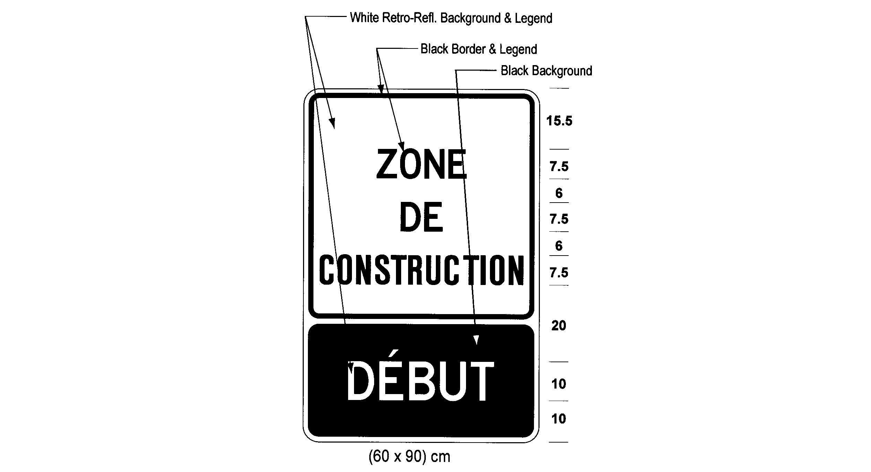
(3) The Figure to subsection 42 (4) of the Regulation is revoked and the following substituted:
Insert regs\Graphics\Source Law\2008\175\175019ae.tif
(4) The Figure to subsection 42 (5) of the Regulation is revoked and the following substituted:
Insert regs\Graphics\Source Law\2008\175\175020ae.tif
13. Subsection 42.1 (3) of the Regulation is revoked and the following substituted:
(3) The other side of a traffic control stop or slow sign shall be retro-reflective fluorescent yellow-green in colour with a black diamond-shaped border that is at least 317 millimetres by 317 millimetres and the word “slow” in the centre of the sign written in legible black upper case letters 120 millimetres high.
14. Subsection 43 (2) of the Regulation is revoked and the following substituted:
(2) A Buses Excepted tab sign as prescribed and illustrated in subsection (1) or (1.1) may be erected immediately below a sign prescribed in section 21, 22 or 34.
15. Section 45 of the Regulation is revoked and the following substituted:
45. A sign prescribed by this Regulation, other than a sign prescribed by section 13, 14, 15, 24, 25, 26 or 27, shall be so placed as to be visible at all times for a distance of at least 60 metres to the traffic approaching the sign.
16. Section 50 of the Regulation is revoked and the following substituted:
50. (1) A sign prescribed by a provision of this Regulation may show days and times other than those shown in the Figure to that provision.
(2) A sign prescribed by a provision of this Regulation shall show the prescribed speed and not 00 km/h, if that is the speed shown in the Figure to that provision.
(3) The signs prescribed by clauses 41 (1) (a) and (b) shall show the prescribed number of tonnes and not 00 tonnes as shown in the Figures to those clauses.
17. (1) Subject to subsection (2) and (3), this Regulation comes into force on the day it is filed.
(2) Subsections 3 (7), 4 (4), 9 (2) and (3) and 10 (2) and (3) come into force on January 1, 2015.
(3) Subsection 11 (2) comes into force on January 1, 2011.

Back to top

