Français
ontario regulation 231/10
made under the
Juries Act
Made: June 1, 2010
Filed: June 10, 2010
Published on e-Laws: June 14, 2010
Printed in The Ontario Gazette: June 26, 2010
Amending Reg. 680 of R.R.O. 1990
(General)
1. Regulation 680 of the Revised Regulations of Ontario, 1990 is amended by adding the following section:
9.1 For the purposes of subsection 18.2 (4) of the Act, the sheriff may enter into an agreement with the Ontario Provincial Police.
2. Forms 1 to 9 of the Regulation are revoked and the following substituted:
FORM 1
QUESTIONNAIRE About QUALIFICATIONS FOR JURY SERVICE
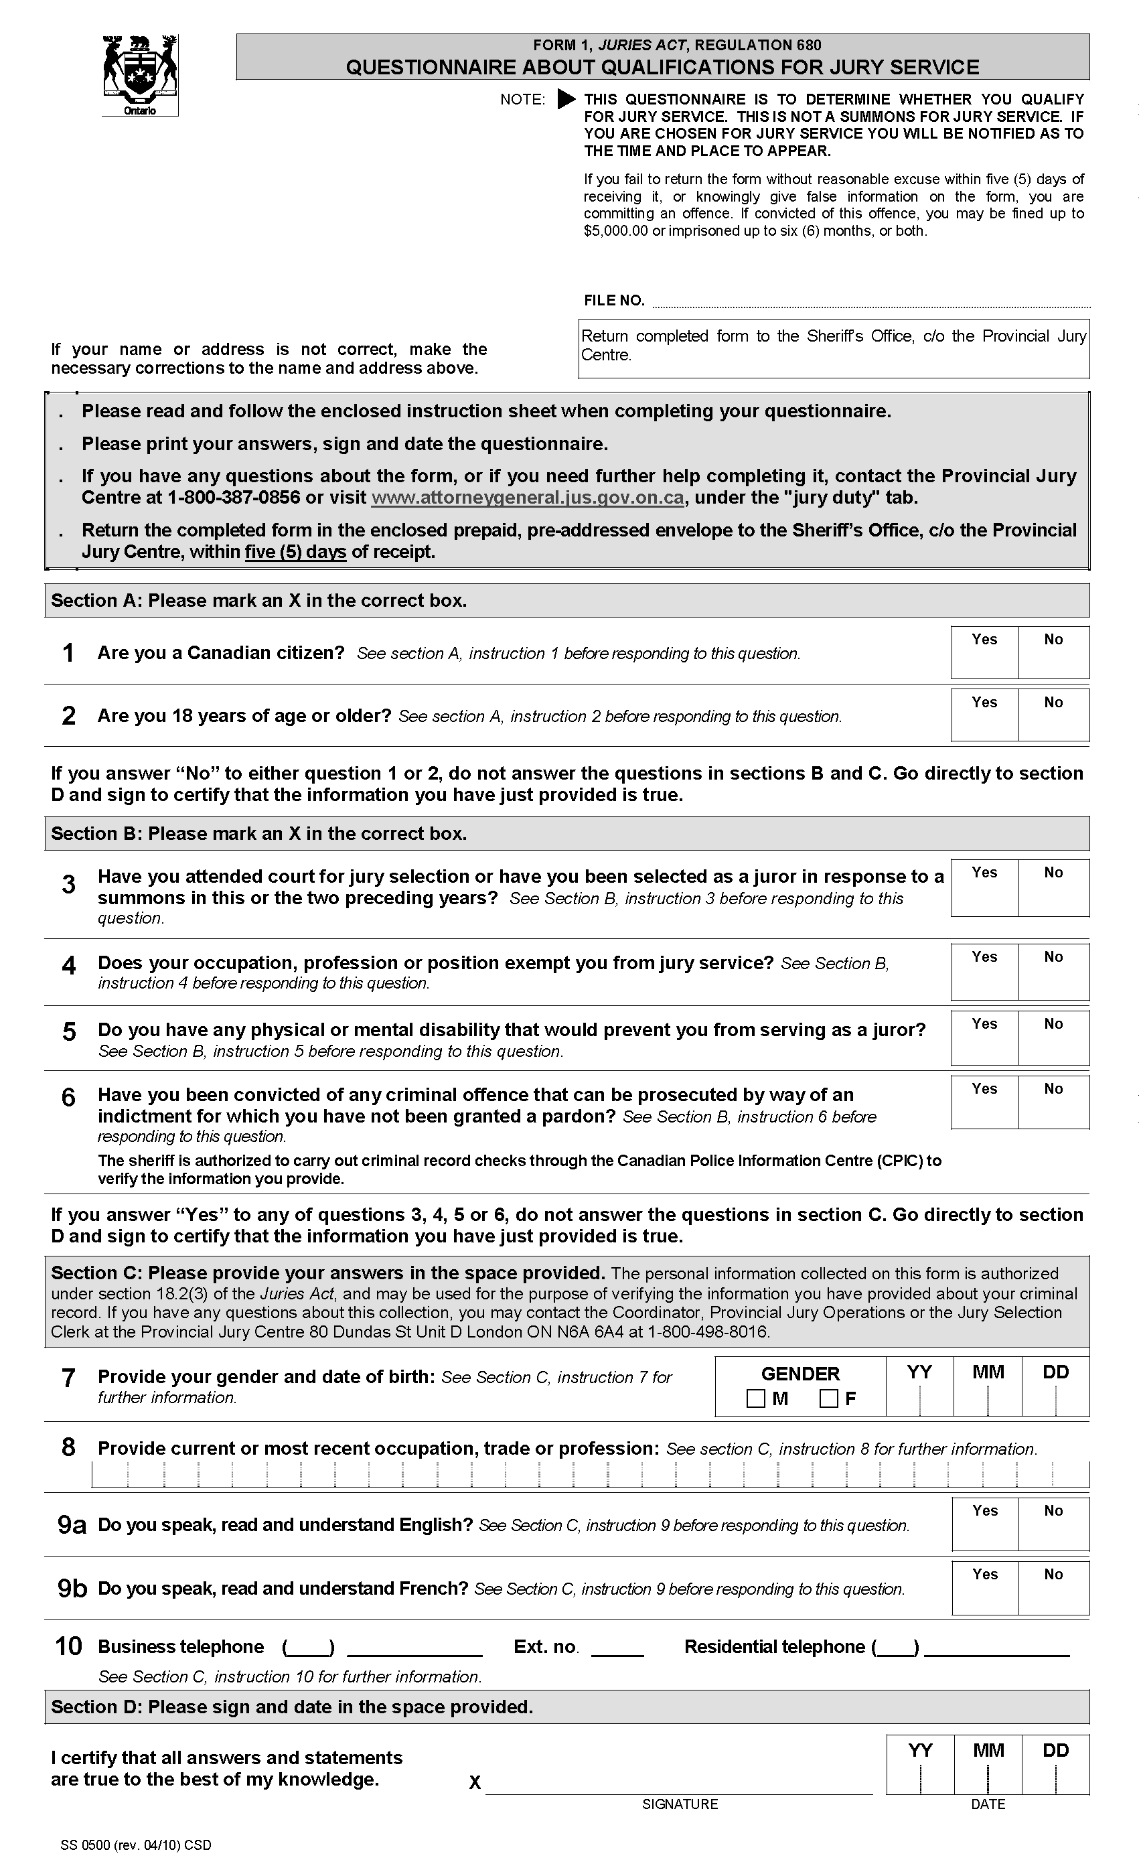
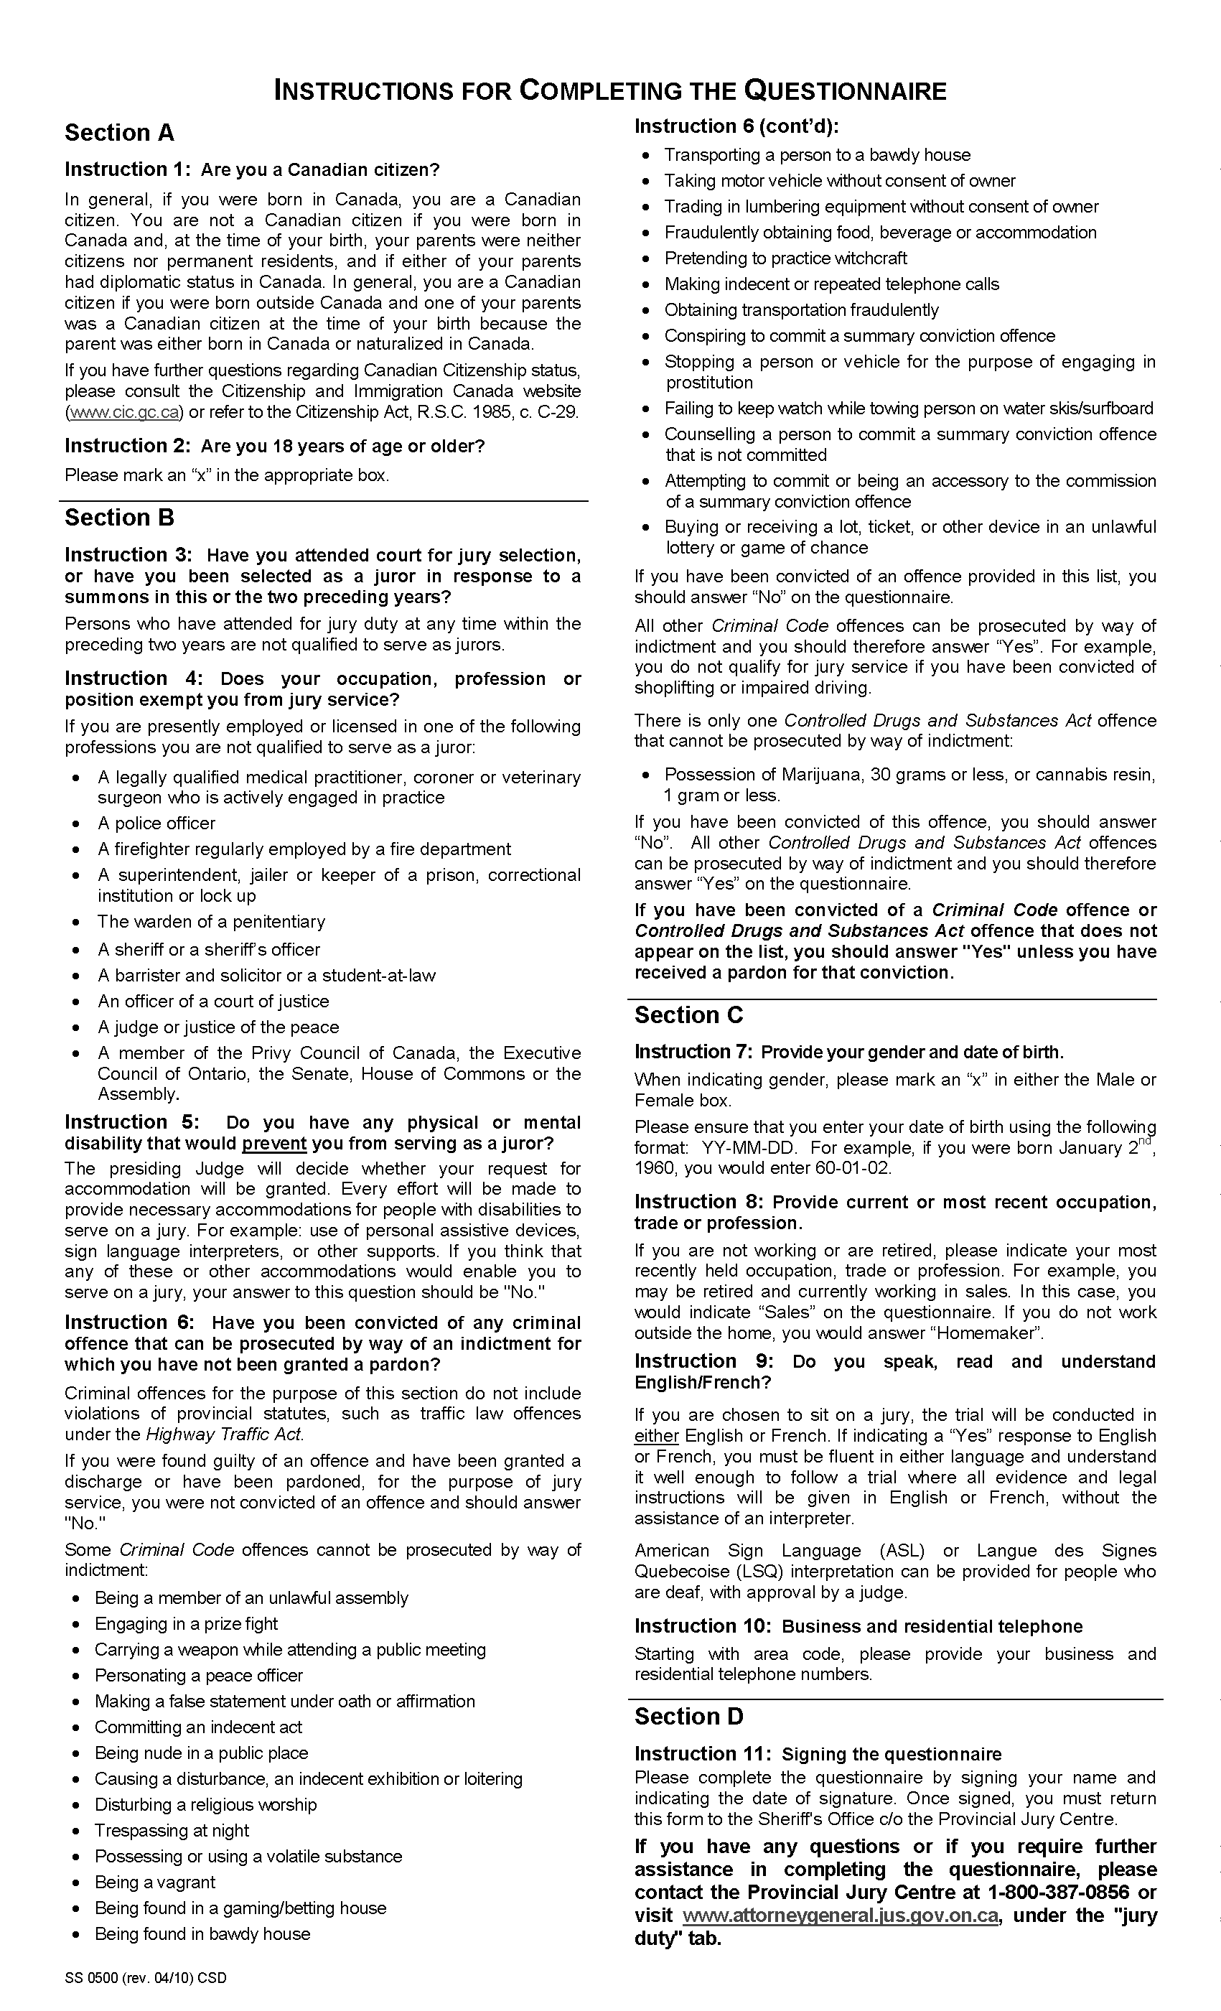
Form 2 / Formule 2
Jury Roll / Liste Des JurÉS
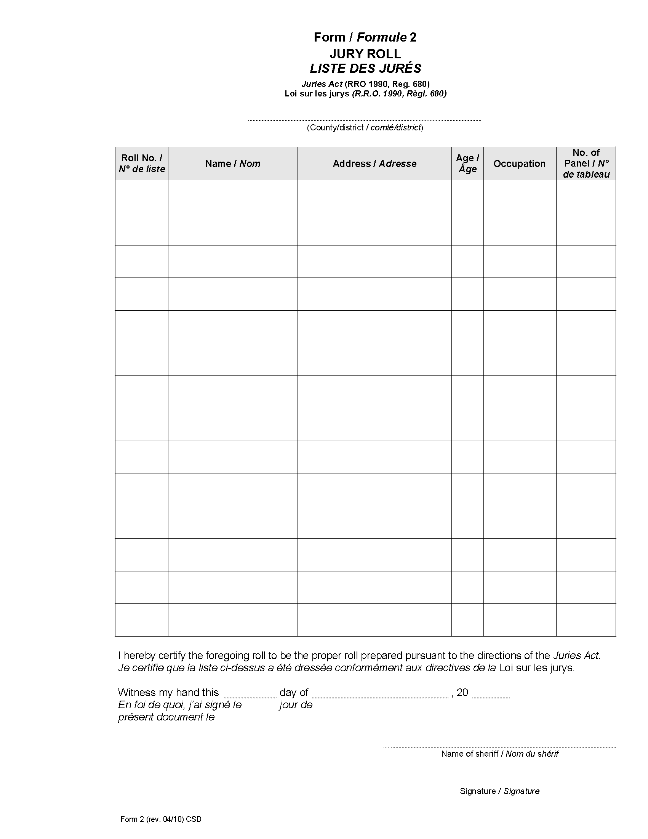
Form 3 / Formule 3
Precept from Judge to Sheriff /
Citation dÉlivrÉE par un juge À un shÉrif
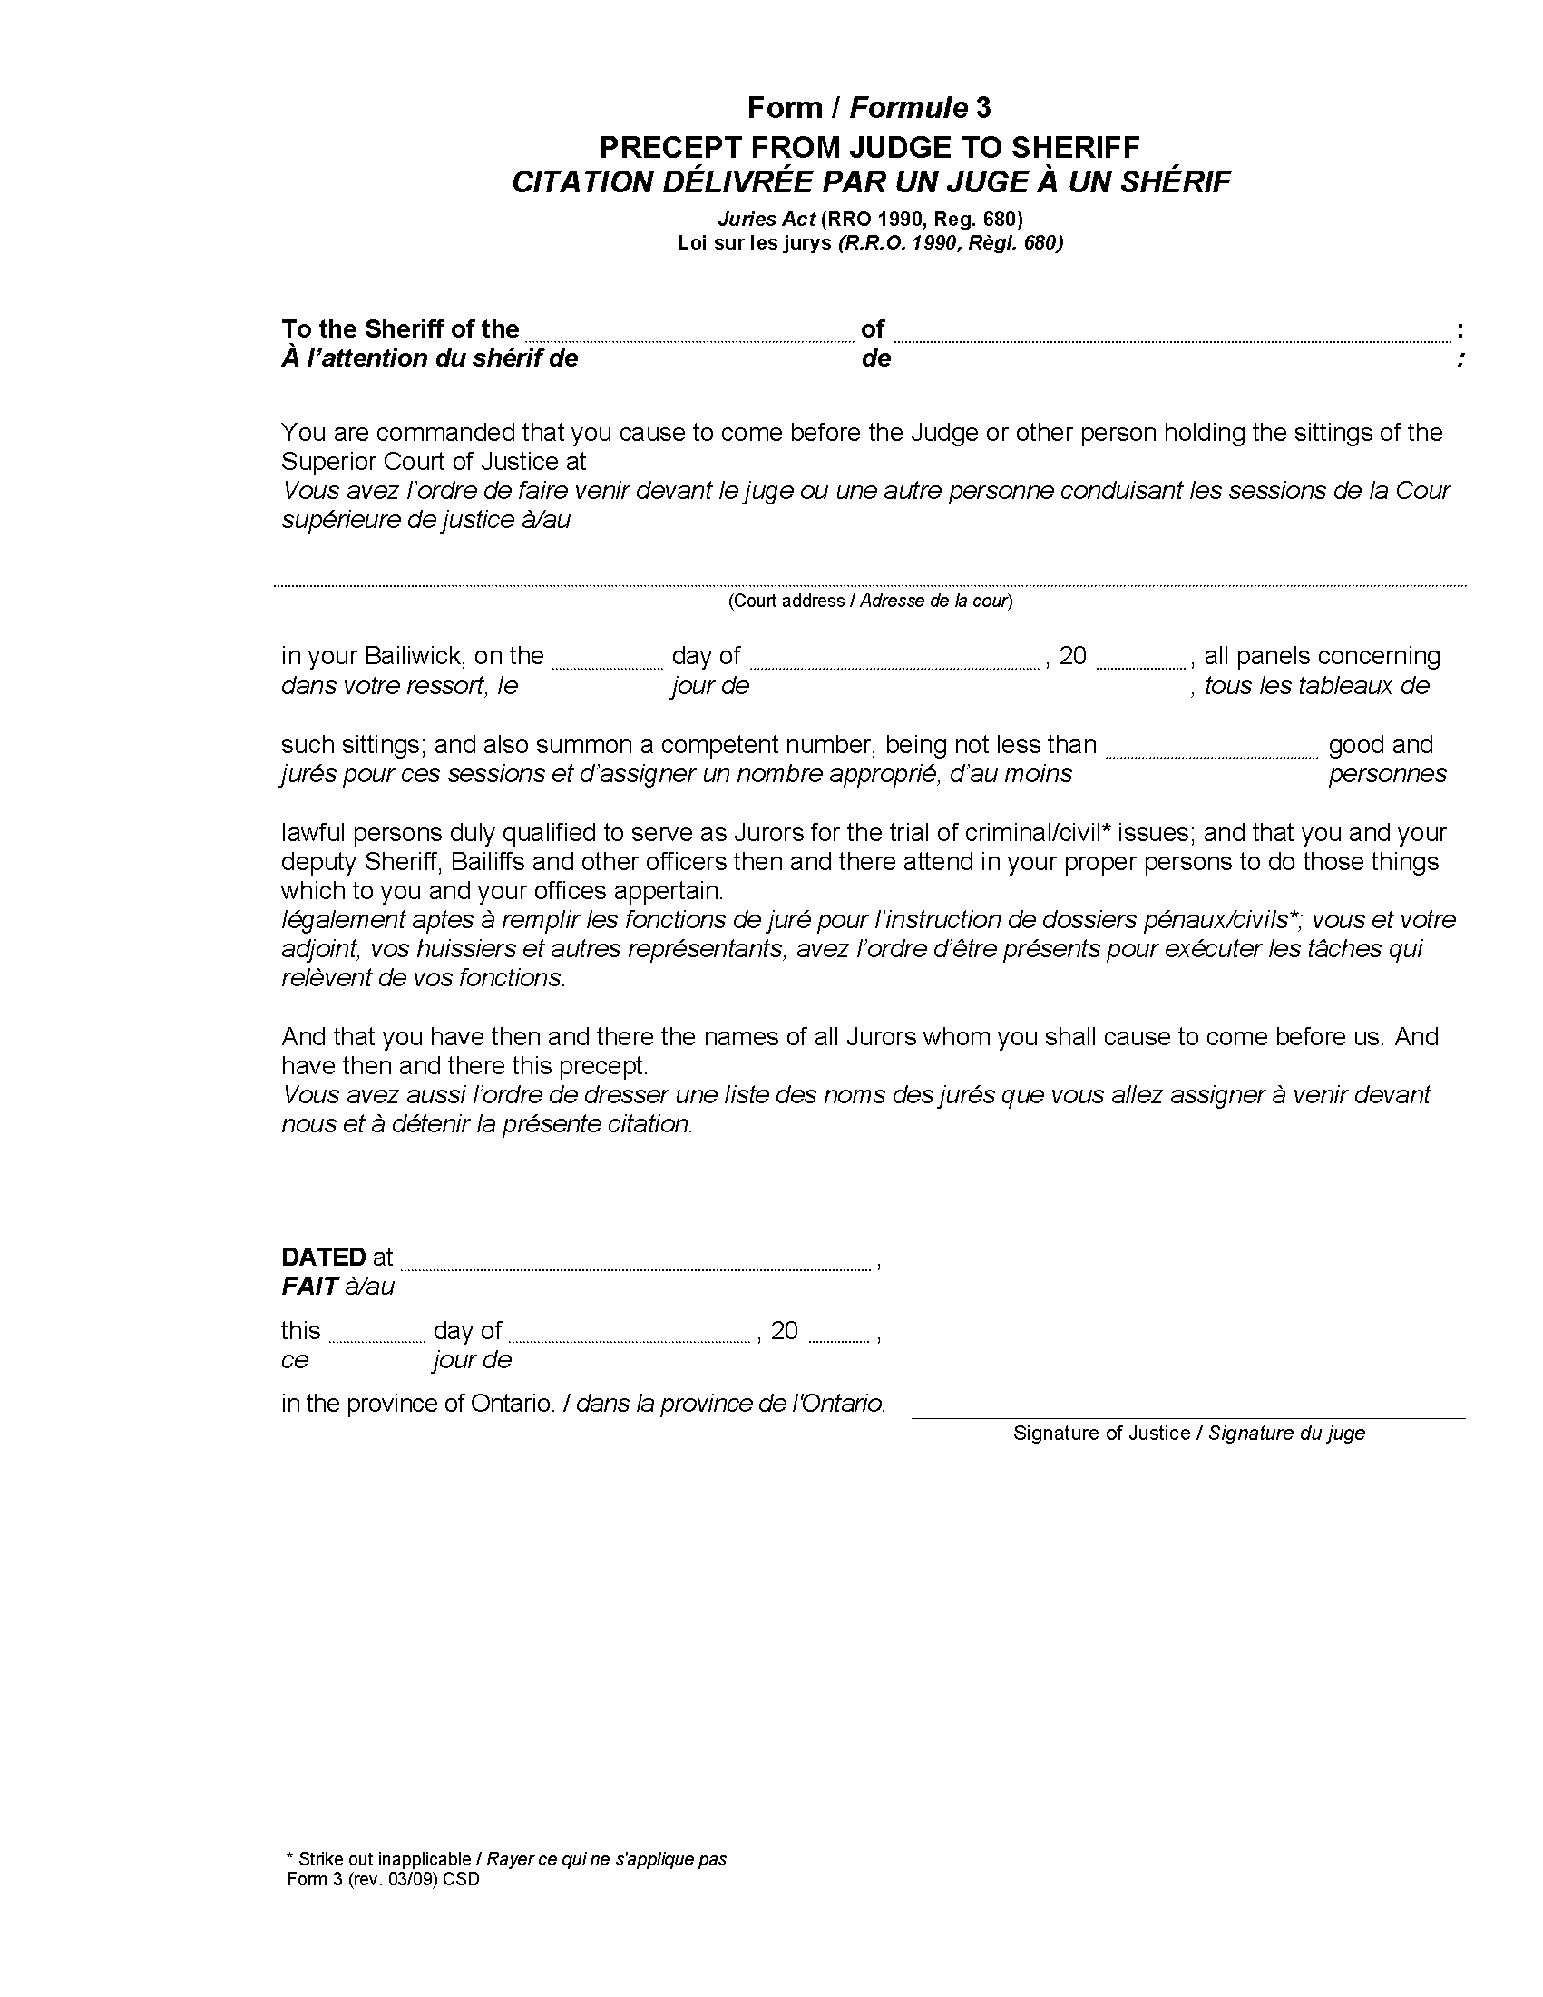
Form 4 / Formule 4
Summons / Assignation
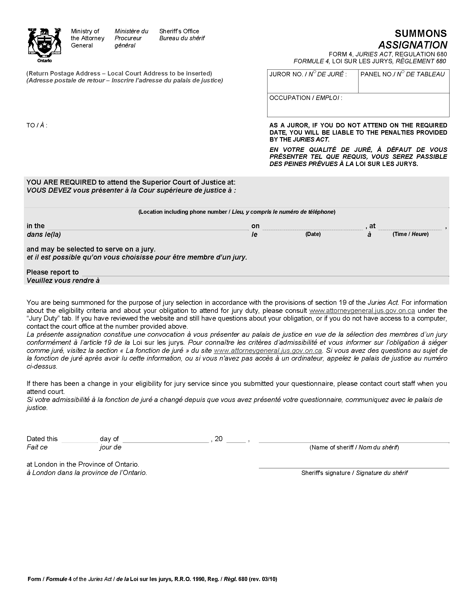
Form 5 / Formule 5
Notice to Sheriff regarding number of jurors required /
Avis au shÉrif sur le nombre de jurÉs requis
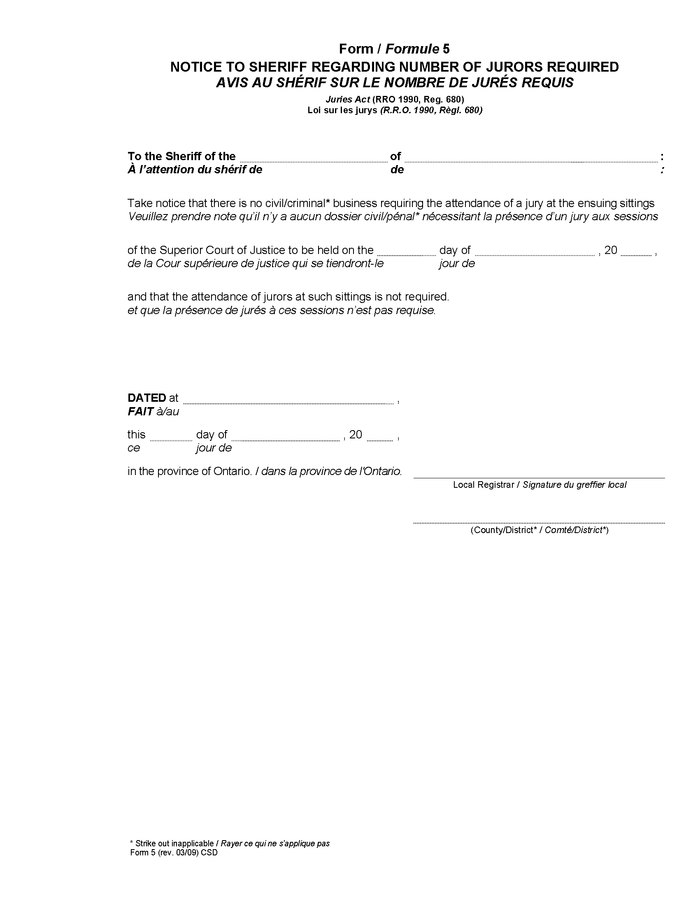
Form 6 / Formule 6
Notice to sheriff regarding number of jurors required on opening day /
avis au shÉrif concernant le nombre de jurÉs requis À l’Ouverture de la session
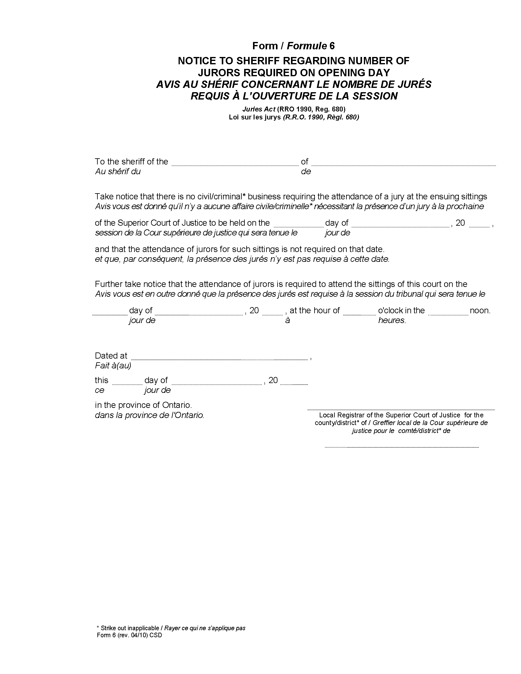
Form 7 / formule 7
notice to juror regarding cancellation of summons /
avis au jurÉ — Annulation d’assignation
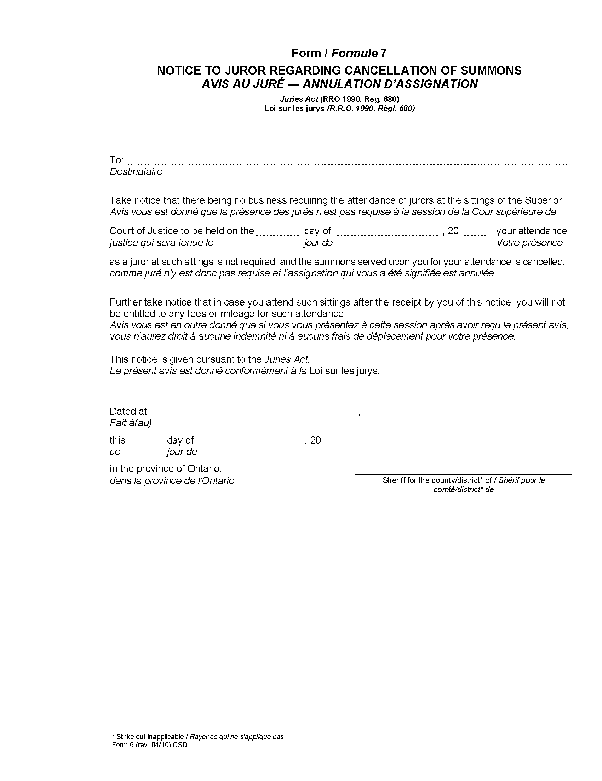
Form 8 / Formule 8
Notice to juror regarding amendment of date to report for service /
avis au jurÉ sur la modification de la date de convocation pour remplir les fonctions de jurÉ
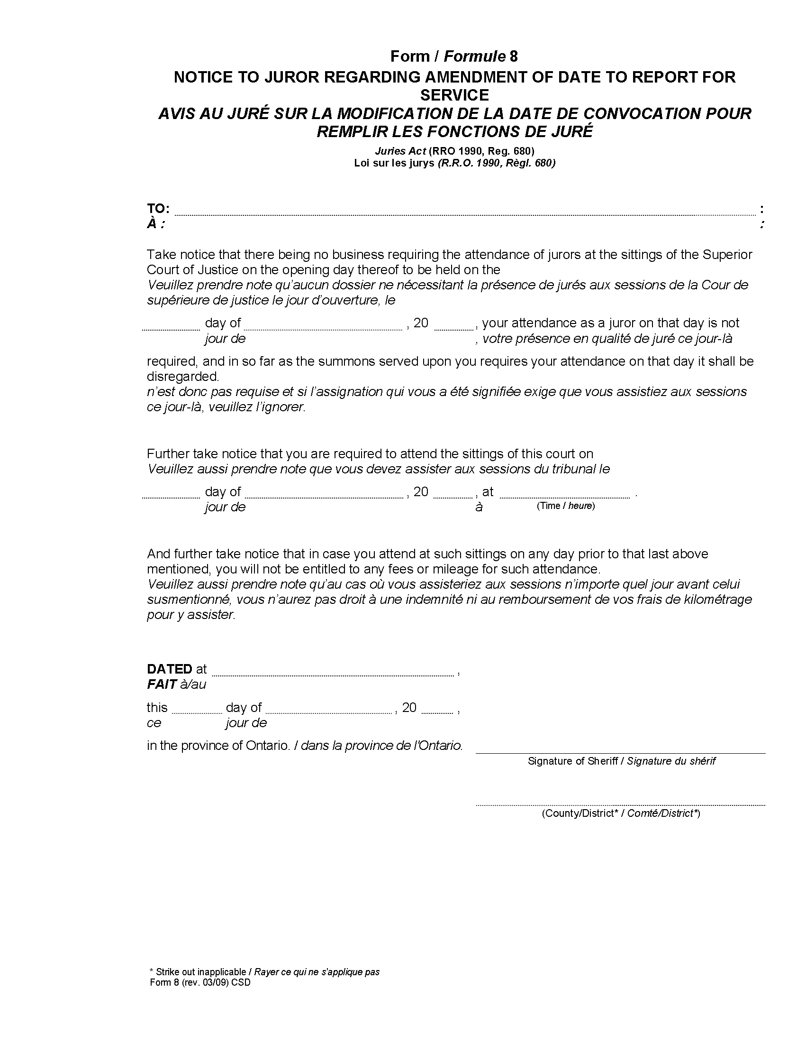
Form 9 / Formule 9
Jury panels for the superior court of justice /
Tableaux du jury pour la cour supÉrieure de justice
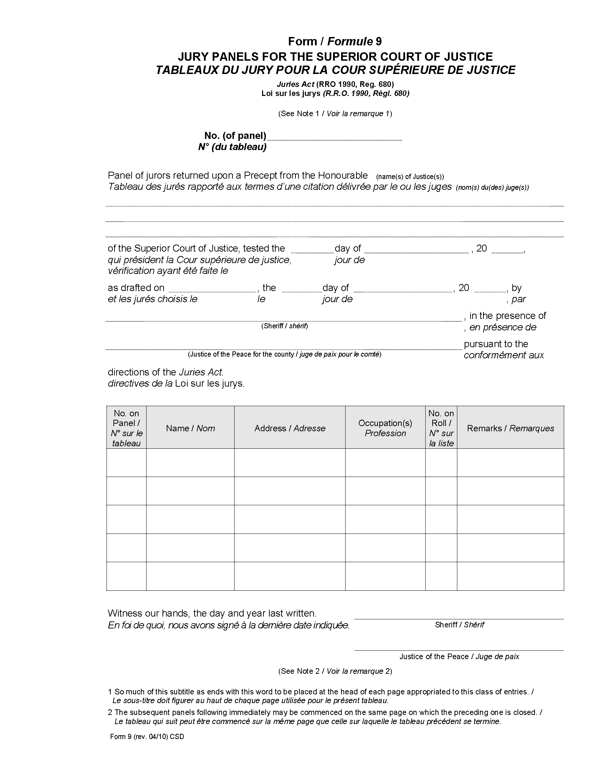
3. (1) Subject to subsections (2) and (3), this Regulation comes into force on the day it is filed.
(2) Section 1 comes into force on the later of the day subsection 38 (7) of Schedule 2 to the Good Government Act, 2009 comes into force and the day this Regulation is filed.
(3) Section 2 comes into force on the later of the day subsection 38 (2) of Schedule 2 to the Good Government Act, 2009 comes into force and the day this Regulation is filed.

Français

Back to top

