ontario regulation 85/15
made under the
highway traffic act
Made: April 22, 2015
Filed: April 27, 2015
Published on e-Laws: April 27, 2015
Printed in The Ontario Gazette: May 16, 2015
Amending Reg. 626 of R.R.O. 1990
(traffic control signal systems)
1. (1) The Figure to subsection 1 (7) of Regulation 626 of the Revised Regulations of Ontario, 1990 is revoked and the following substituted:
Figure
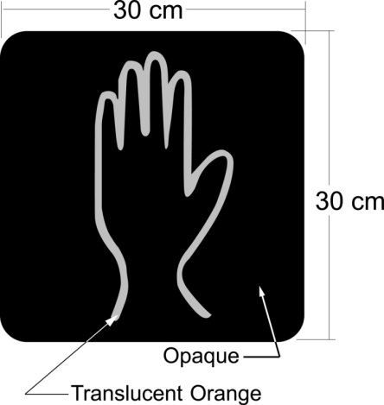
(2) Figures 1 and 2 to subsection 1 (8) of the Regulation are revoked and the following substituted:
Figure 1
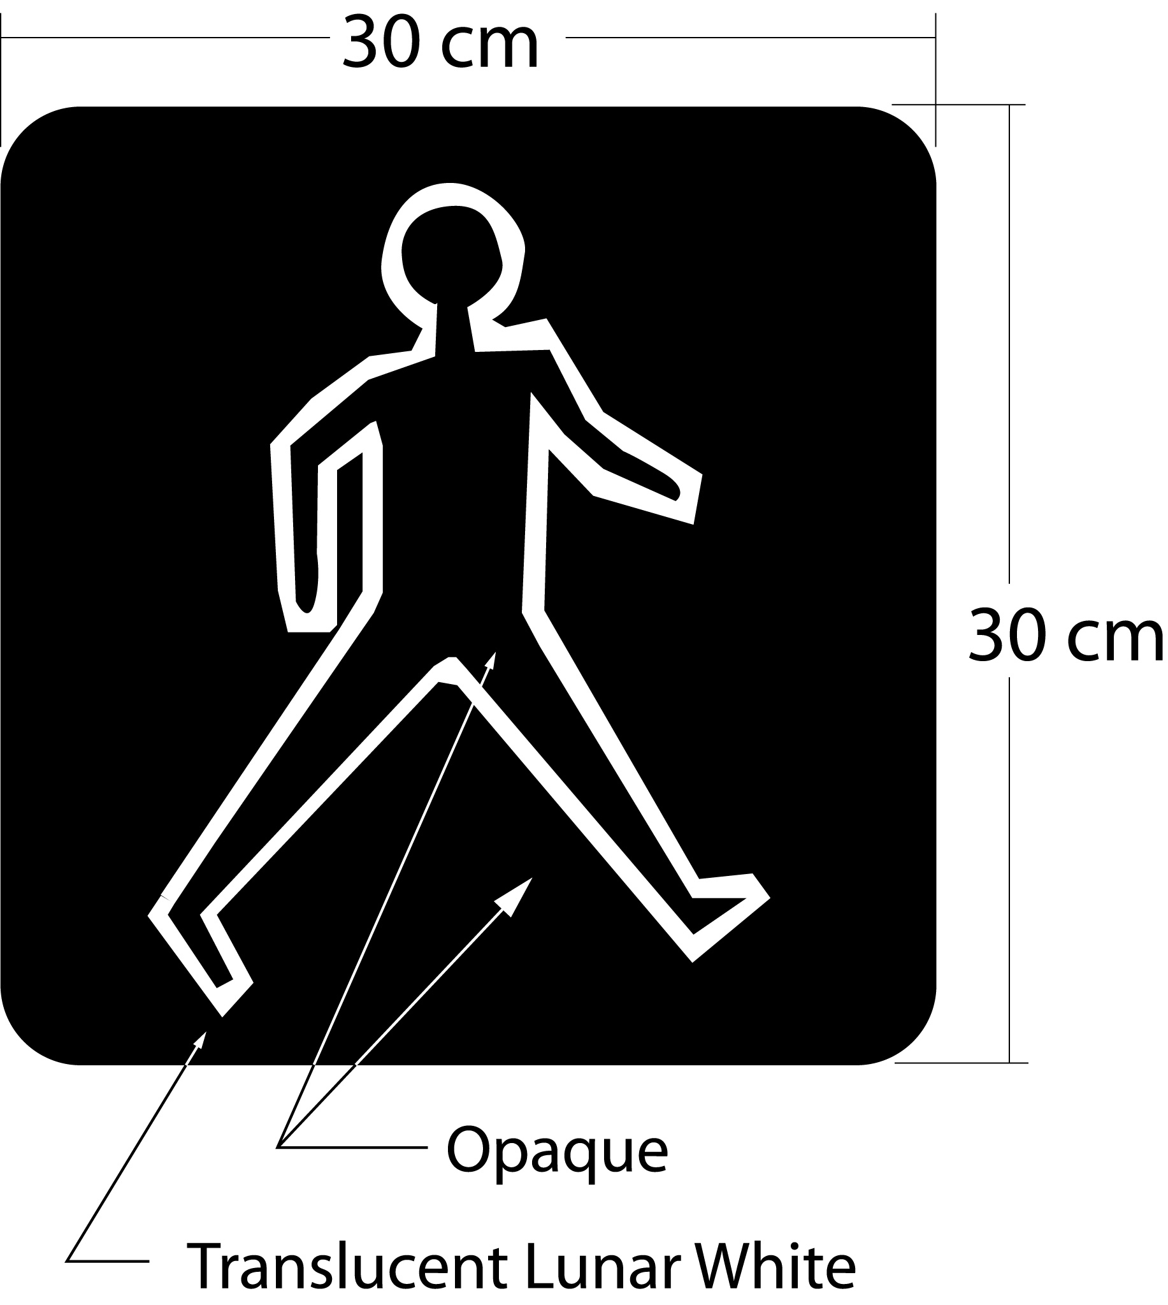
Figure 2
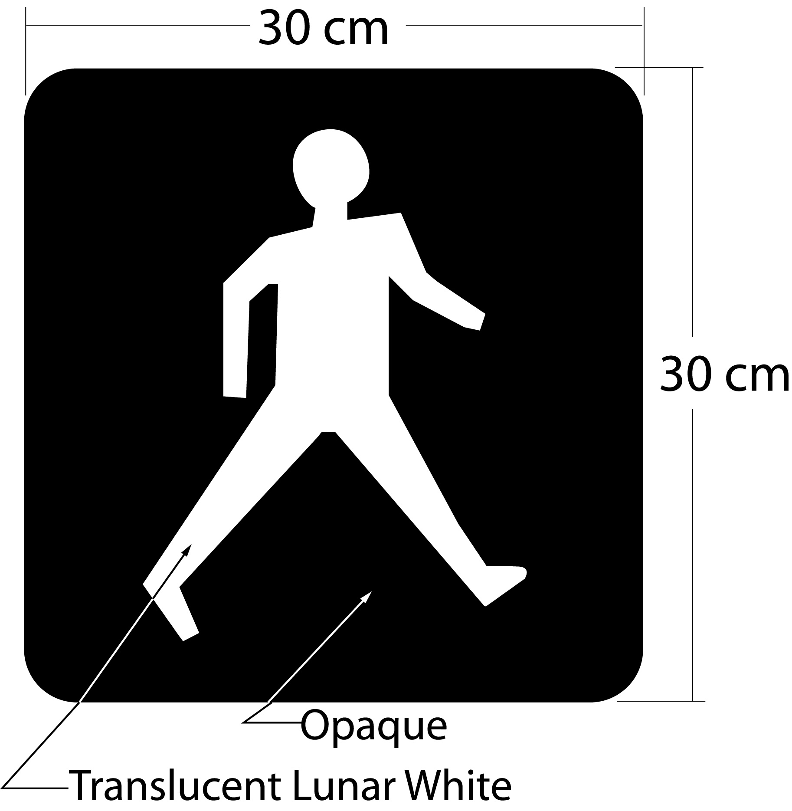
Commencement
2. This Regulation comes into force on the day it is filed.

Back to top

