ontario regulation 88/15
made under the
HIGHWAY Traffic act
Made: April 2, 2015
Filed: April 27, 2015
Published on e-Laws: April 27, 2015
Printed in The Ontario Gazette: May 16, 2015
Amending O. Reg. 618/05
(DESIGNATION OF BUS BY-PASS SHOULDERS ON KING’S HIGHWAY)
1. (1) Figures 1 and 2 to subsection 2 (1) of Ontario Regulation 618/05 are revoked and the following substituted:
figure 1
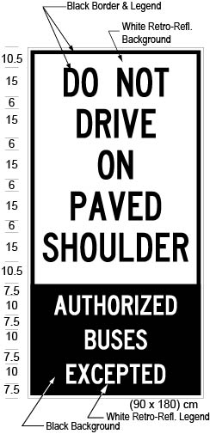
Text alternative: Illustration of a ground-mounted sign labelled as “Figure 1”. The sign contains two rectangles, stacked on top of one another. The top rectangle contains the words “DO NOT DRIVE ON PAVED SHOULDER” in black lettering on a white reflective background. The bottom rectangle contains the words “AUTHORIZED BUSES EXCEPTED” in white lettering on a black reflective background. The following measurements are written below the sign: (90 x 180) cm. The sign is surrounded by dimensions of its different elements. This text alternative is provided for convenience only and does not form part of the official law.
figure 2
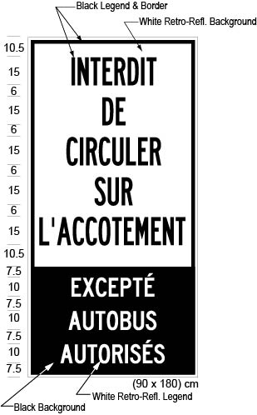
Text alternative: Illustration of a ground-mounted sign labelled as “Figure 2”. The sign contains two rectangles, stacked on top of one another. The top rectangle contains the words “INTERDIT DE CIRCULER SUR L’ACCOTEMENT” in black lettering on a white reflective background. The bottom rectangle contains the words “EXCEPTÉ AUTOBUS AUTORISÉS” in white lettering on a black reflective background. The following measurements are written below the sign: (90 x 180) cm. The sign is surrounded by dimensions of its different elements. This text alternative is provided for convenience only and does not form part of the official law.
(2) Figures 3 and 4 to subsection 2 (2) of the Regulation are revoked and the following substituted:
figure 3
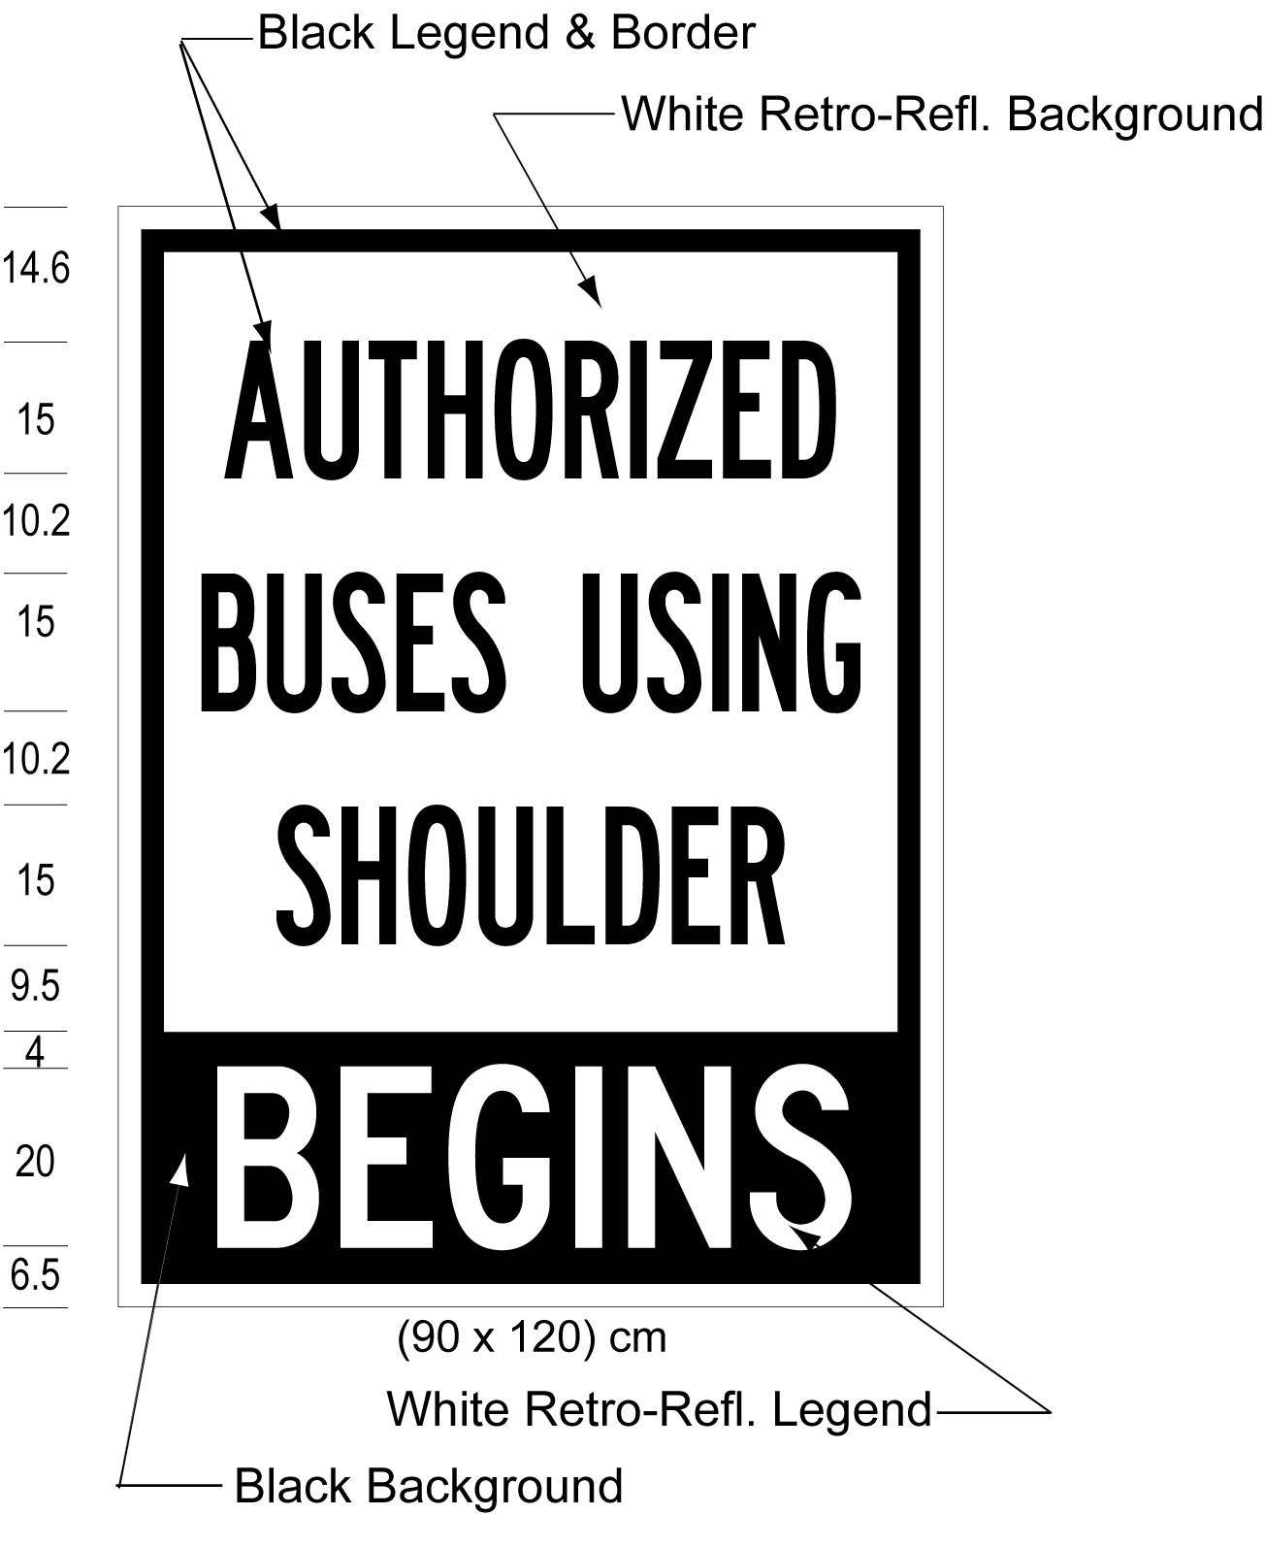
Text alternative: Illustration of a ground-mounted sign labelled as “Figure 3”. The sign contains two rectangles, stacked on top of one another. The top rectangle contains the words “AUTHORIZED BUSES USING SHOULDER” in black lettering on a white reflective background. The bottom rectangle contains the words “BEGINS” in white lettering on a black reflective background. The following measurements are written below the sign: (90 x 120) cm. The sign is surrounded by dimensions of its different elements. This text alternative is provided for convenience only and does not form part of the official law.
figure 4
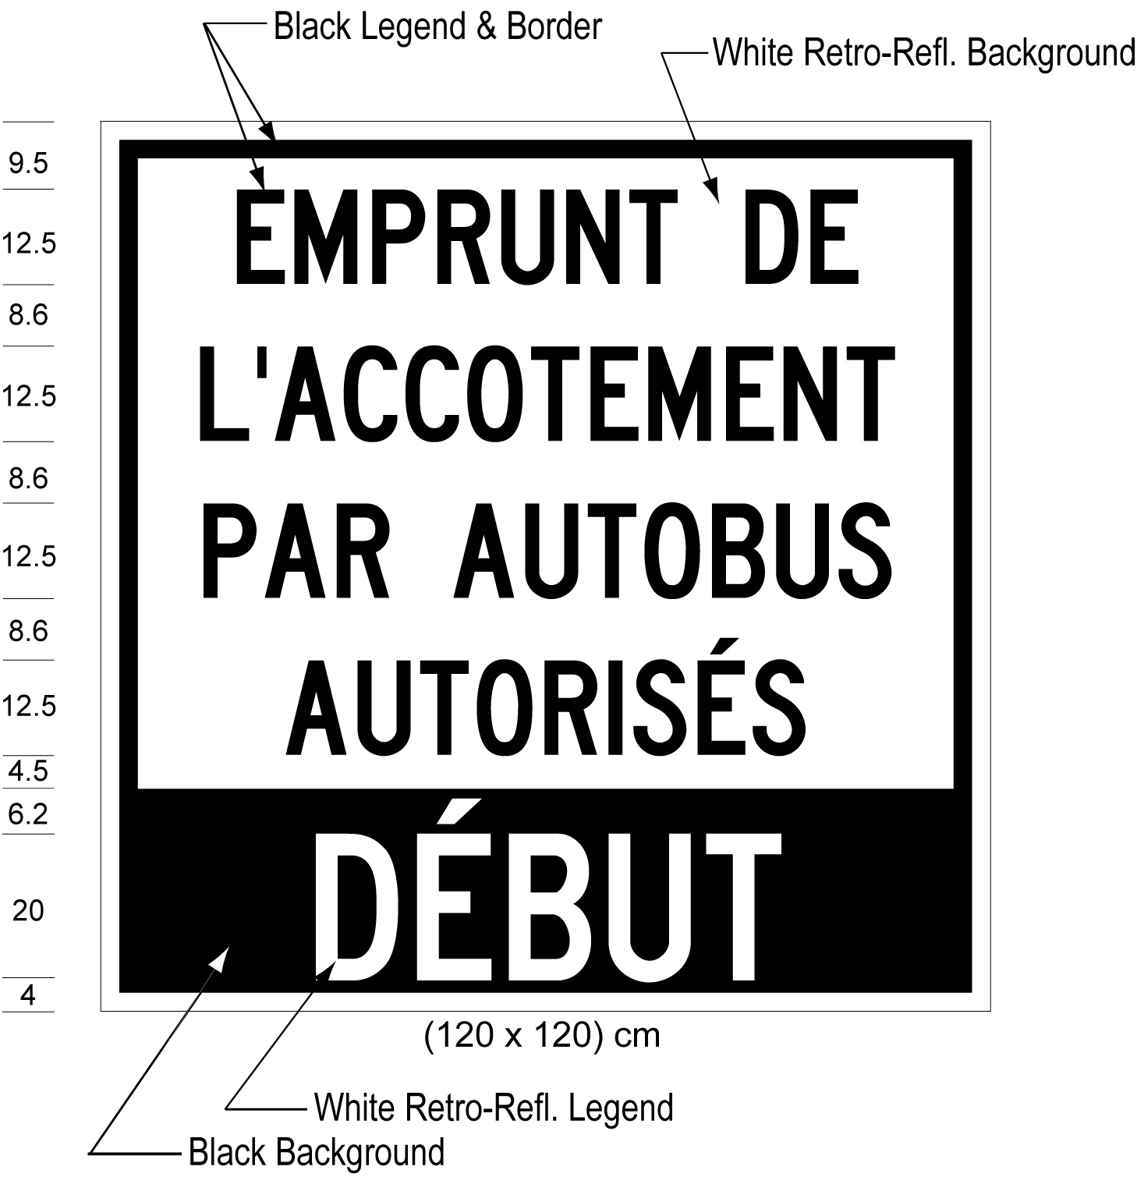
Text alternative: Illustration of a ground-mounted sign labelled as “Figure 4”. The sign contains two rectangles, stacked on top of one another. The top rectangle contains the words “EMPRUNT DE L’ACCOTEMENT PAR AUTOBUS AUTORISÉS” in black lettering on a white reflective background. The bottom rectangle contains the words “DÉBUT” in white lettering on a black reflective background. The following measurements are written below the sign: (120 x 120) cm. Measurements for the height of the lettering and horizontal spacing between the lines of text appear to the left of the sign. This text alternative is provided for convenience only and does not form part of the official law.
(3) Figures 5 and 6 to subsection 2 (3) of the Regulation are revoked and the following substituted:
figure 5
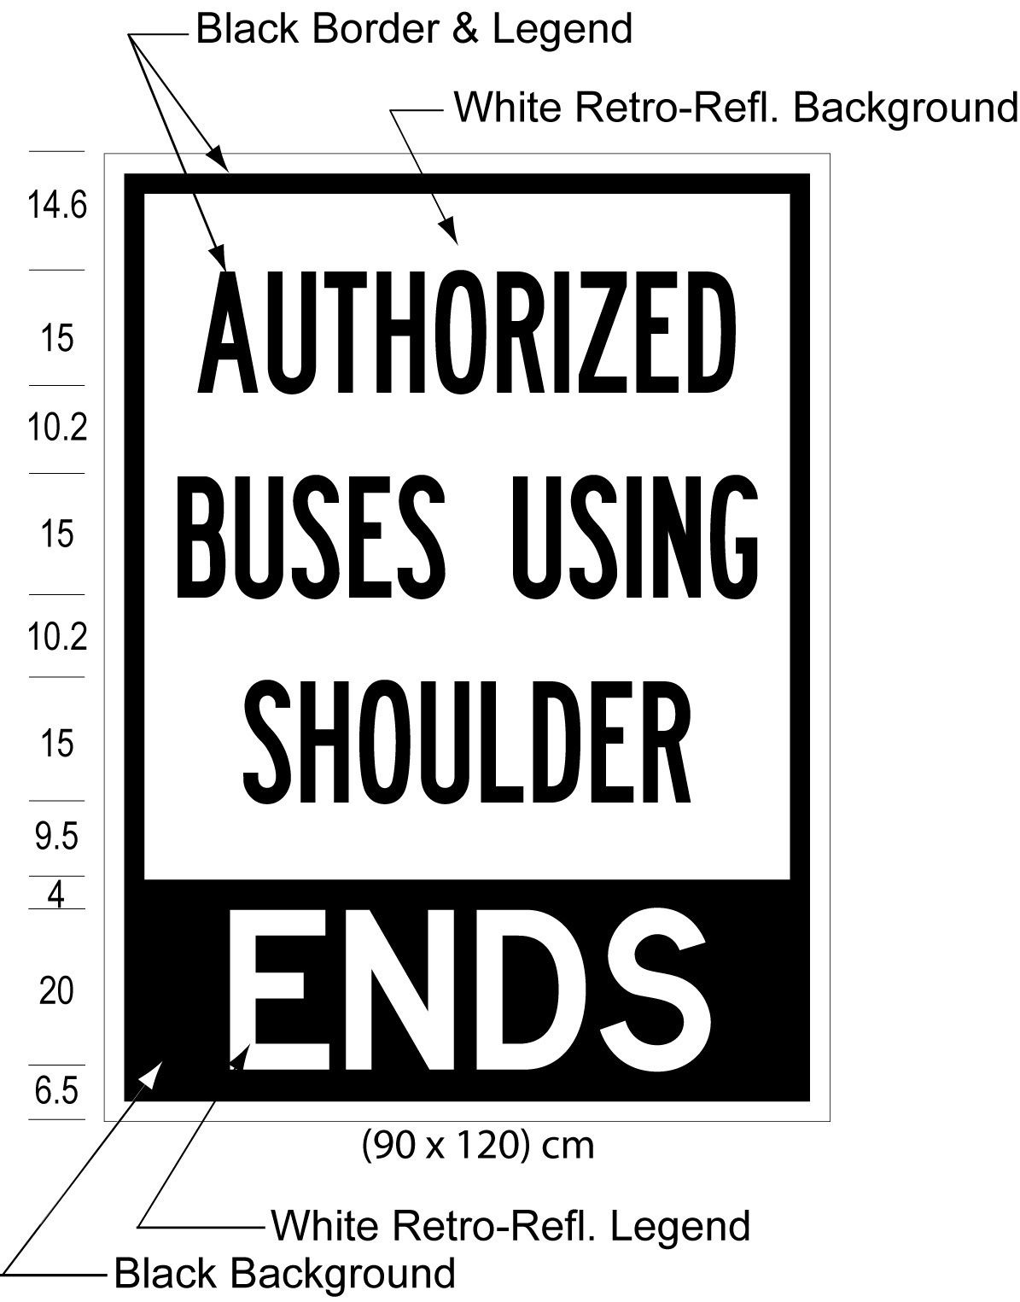
Text alternative: Illustration of a ground-mounted sign labelled as “Figure 5”. The sign contains two rectangles, stacked on top of one another. The top rectangle contains the words “AUTHORIZED BUSES USING SHOULDER” in black lettering on a white reflective background. The bottom rectangle contains the words “ENDS” in white lettering on a black reflective background. The following measurements are written below the sign: (90 x 120) cm. Measurements for the height of the lettering and horizontal spacing between the lines of text appear to the left of the sign. This text alternative is provided for convenience only and does not form part of the official law.
figure 6
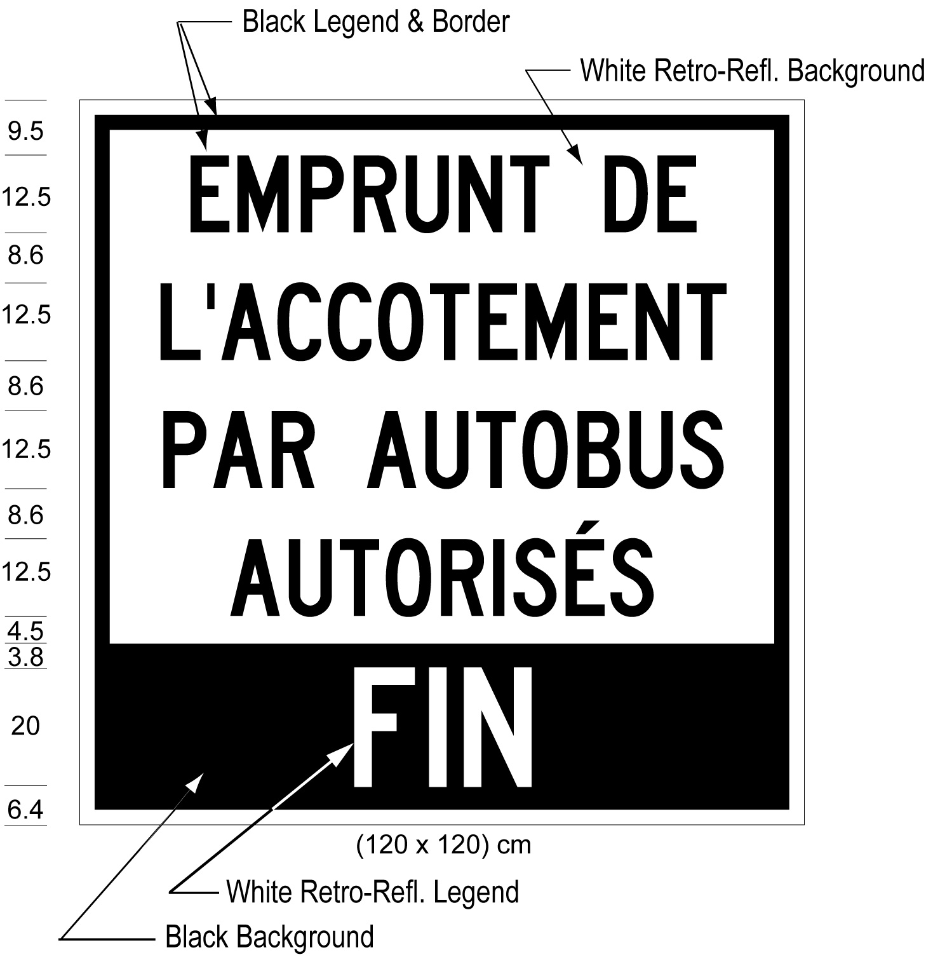
Text alternative: Illustration of a ground-mounted sign labelled as “Figure 6”. The sign contains two rectangles, stacked on top of one another. The top rectangle contains the words “EMPRUNT DE L’ACCOTEMENT PAR AUTOBUS AUTORISÉS” in black lettering on a white reflective background. The bottom rectangle contains the words “FIN” in white lettering on a black reflective background. The following measurements are written below the sign: (120 x 120) cm. Measurements for the height of the lettering and horizontal spacing between the lines of text appear to the left of the sign. This text alternative is provided for convenience only and does not form part of the official law.
Commencement
2. This Regulation comes into force on the day it is filed.
Made by:
Steven Del Duca
Minister of Transportation
Date made: April 2, 2015.

Back to top

