ontario regulation 89/15
made under the
HIGHWAY Traffic act
Made: April 2, 2015
Filed: April 27, 2015
Published on e-Laws: April 27, 2015
Printed in The Ontario Gazette: May 16, 2015
Amending O. Reg. 620/05
(HIGH OCCUPANCY VEHICLE LANES)
1. Figure A to section 4 of Ontario Regulation 620/05 is revoked and the following substituted:
figure a
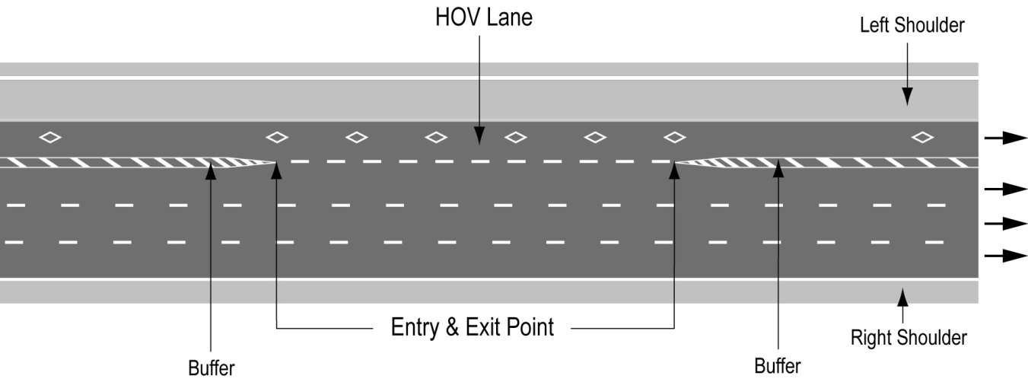
Text alternative: Illustration of “Figure A” showing an overhead plan of a divided highway with the high occupancy vehicle lane as the leftmost lane on a highway. The lane has white diamond markings on the roadway and broken white lines indicating the entry and exit points. Diagonal lines painted between solid lines before and after the entry and exit points indicate the buffer between the high occupancy vehicle lane and the lane beside it. The left shoulder is indicated to the left of the high occupancy vehicle lane. This text alternative is provided for convenience only and does not form part of the official law.
2. (1) Figure B to subsection 5 (1) of the Regulation is revoked and the following substituted:
figure b
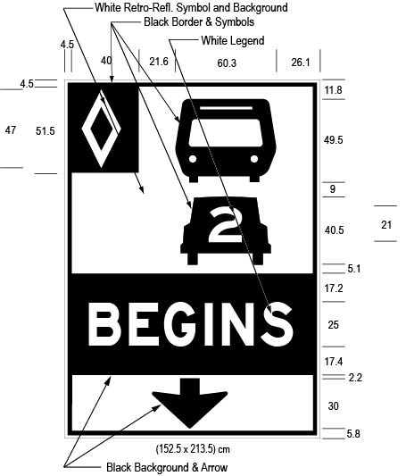
Text alternative: Illustration of an overhead high occupancy vehicle lane sign labelled as “Figure B”. The sign contains three rectangles, stacked on top of one another. The top rectangle has a white reflective background and contains a symbol of a bus on top of a symbol of a car with the number “2” inside it. A white diamond shape in a small black rectangle appears in the upper left corner of this rectangle. The middle rectangle contains the word “BEGINS” in white letters on a reflective black background. The bottom rectangle has a white reflective background and contains a thick black arrow pointing down. The following measurements are written below the sign: (152.5 x 213.5) cm. The sign is surrounded by measurements of its different elements. This text alternative is provided for convenience only and does not form part of the official law.
(2) Figure C to subsection 5 (2) of the Regulation is revoked and the following substituted:
figure c
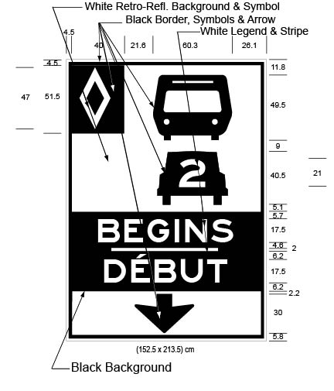
Text alternative: Illustration of an overhead high occupancy vehicle lane sign labelled as “Figure C”. The sign contains three rectangles, stacked on top of one another. The top rectangle has a white reflective background and contains a symbol of a bus on top of a symbol of a car with the number “2” inside it. A white diamond shape in a small black rectangle appears in the upper left corner of this rectangle. The middle rectangle contains the word “BEGINS/DÉBUT” in white letters on a reflective black background. The bottom rectangle has a white reflective background and contains a thick black arrow pointing down. The following measurements are written below the sign: (152.5 x 213.5) cm. The sign is surrounded by measurements of its different elements. This text alternative is provided for convenience only and does not form part of the official law.
(3) Figure D to subsection 5 (3) of the Regulation is revoked and the following substituted:
figure d
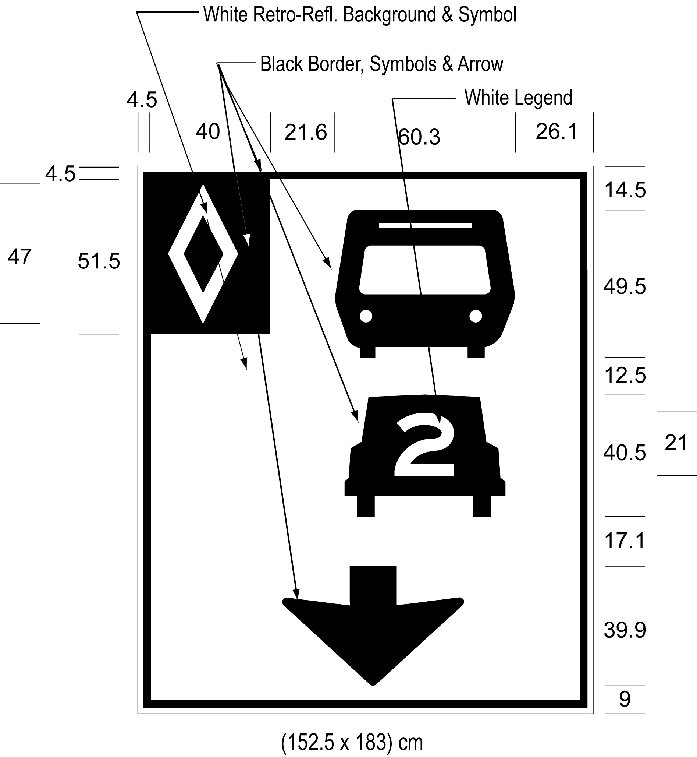
Text alternative: Illustration of an overhead high occupancy vehicle lane sign labelled as “Figure D”. The sign has a white reflective background and contains a symbol of a bus on top of a symbol of a car with the number “2” inside it, below which appears a thick black arrow pointing down. A white diamond shape in a small black rectangle appears in the upper left corner of this rectangle. The following measurements are written below the sign: (152.5 x 183) cm. The sign is surrounded by measurements of its different elements. This text alternative is provided for convenience only and does not form part of the official law.
(4) Figures E and F to subsection 5 (5) of the Regulation are revoked and the following substituted:
figure e
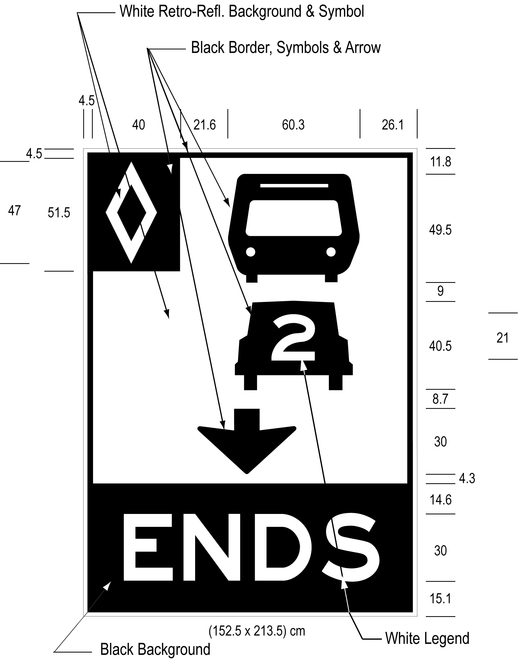
Text alternative: Illustration of an overhead high occupancy vehicle lane sign labelled as “Figure E”. The sign contains two rectangles, stacked on top of one another. The top rectangle has a white reflective background and contains a symbol of a bus on top of a symbol of a car with the number “2” inside it, below which appears a thick black arrow pointing down. A white diamond shape in a small black rectangle appears in the upper left corner of this rectangle. The bottom rectangle contains the word “ENDS” in white letters on a reflective black background. The following measurements are written below the sign: (152.5 x 213.5) cm. The sign is surrounded by measurements of its different elements. This text alternative is provided for convenience only and does not form part of the official law.
figure f
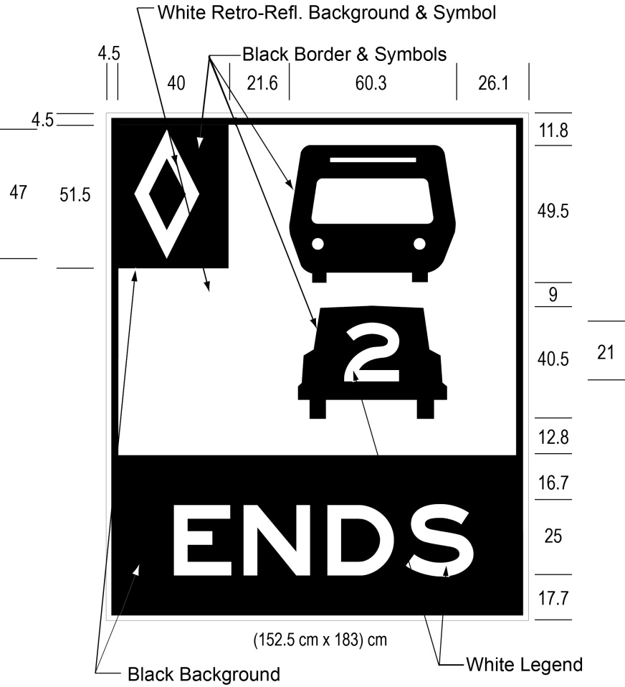
Text alternative: Illustration of a ground mounted high occupancy vehicle lane sign labelled as “Figure F”. The sign contains two rectangles, stacked on top of one another. The top rectangle has a white reflective background and contains a symbol of a bus on top of a symbol of a car with the number “2” inside it. A white diamond shape in a small black rectangle appears in the upper left corner of this rectangle. The bottom rectangle contains the word “ENDS” in white letters on a reflective black background. The following measurements are written below the sign: (152.5 x 183) cm. The sign is surrounded by measurements of its different elements. This text alternative is provided for convenience only and does not form part of the official law.
(5) Figures G and H to subsection 5 (6) of the Regulation are revoked and the following substituted:
figure g
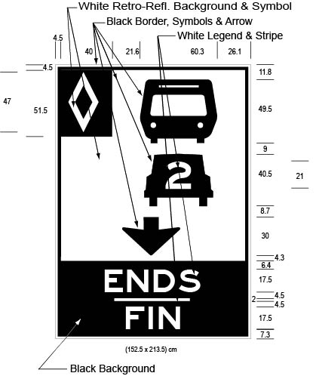
Text alternative: Illustration of an overhead high occupancy vehicle lane sign labelled as “Figure G”. The sign contains two rectangles, stacked on top of one another. The top rectangle has a white reflective background and contains a symbol of a bus on top of a symbol of a car with the number “2” inside it, below which appears a thick black arrow pointing down. A white diamond shape in a small black rectangle appears in the upper left corner of this rectangle. The bottom rectangle contains the word “ENDS/FIN” in white letters on a reflective black background. The following measurements are written below the sign: (152.5 x 213.5) cm. The sign is surrounded by measurements of its different elements. This text alternative is provided for convenience only and does not form part of the official law.
figure h
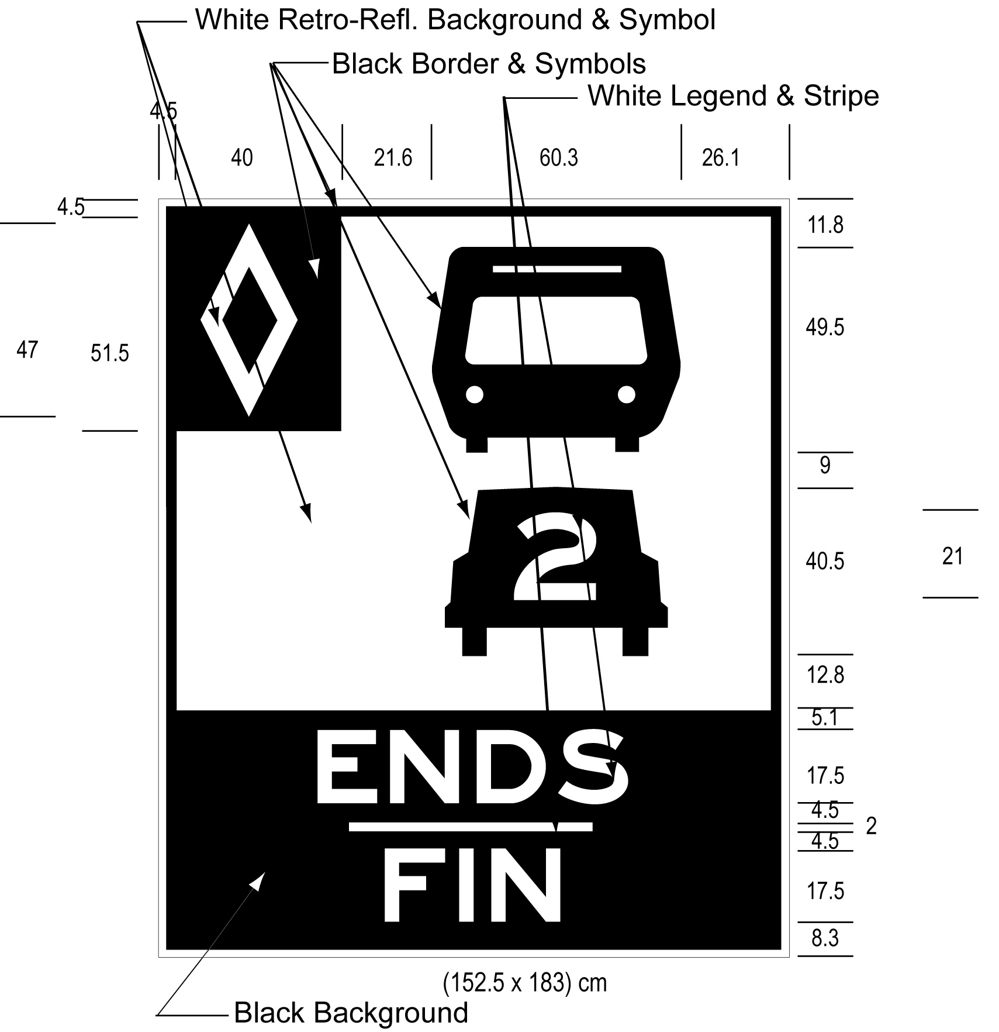
Text alternative: Illustration of a ground mounted high occupancy vehicle lane sign labelled as “Figure H”. The sign contains two rectangles, stacked on top of one another. The top rectangle has a white reflective background and contains a symbol of a bus on top of a symbol of a car with the number “2” inside it. A white diamond shape in a small black rectangle appears in the upper left corner of this rectangle. The bottom rectangle contains the word “ENDS/FIN” in white letters on a reflective black background. The following measurements are written below the sign: (152.5 x 183) cm. The sign is surrounded by measurements of its different elements. This text alternative is provided for convenience only and does not form part of the official law.
(6) Figures I, J, K and L to subsection 5 (7) of the Regulation are revoked and the following substituted:
figure i
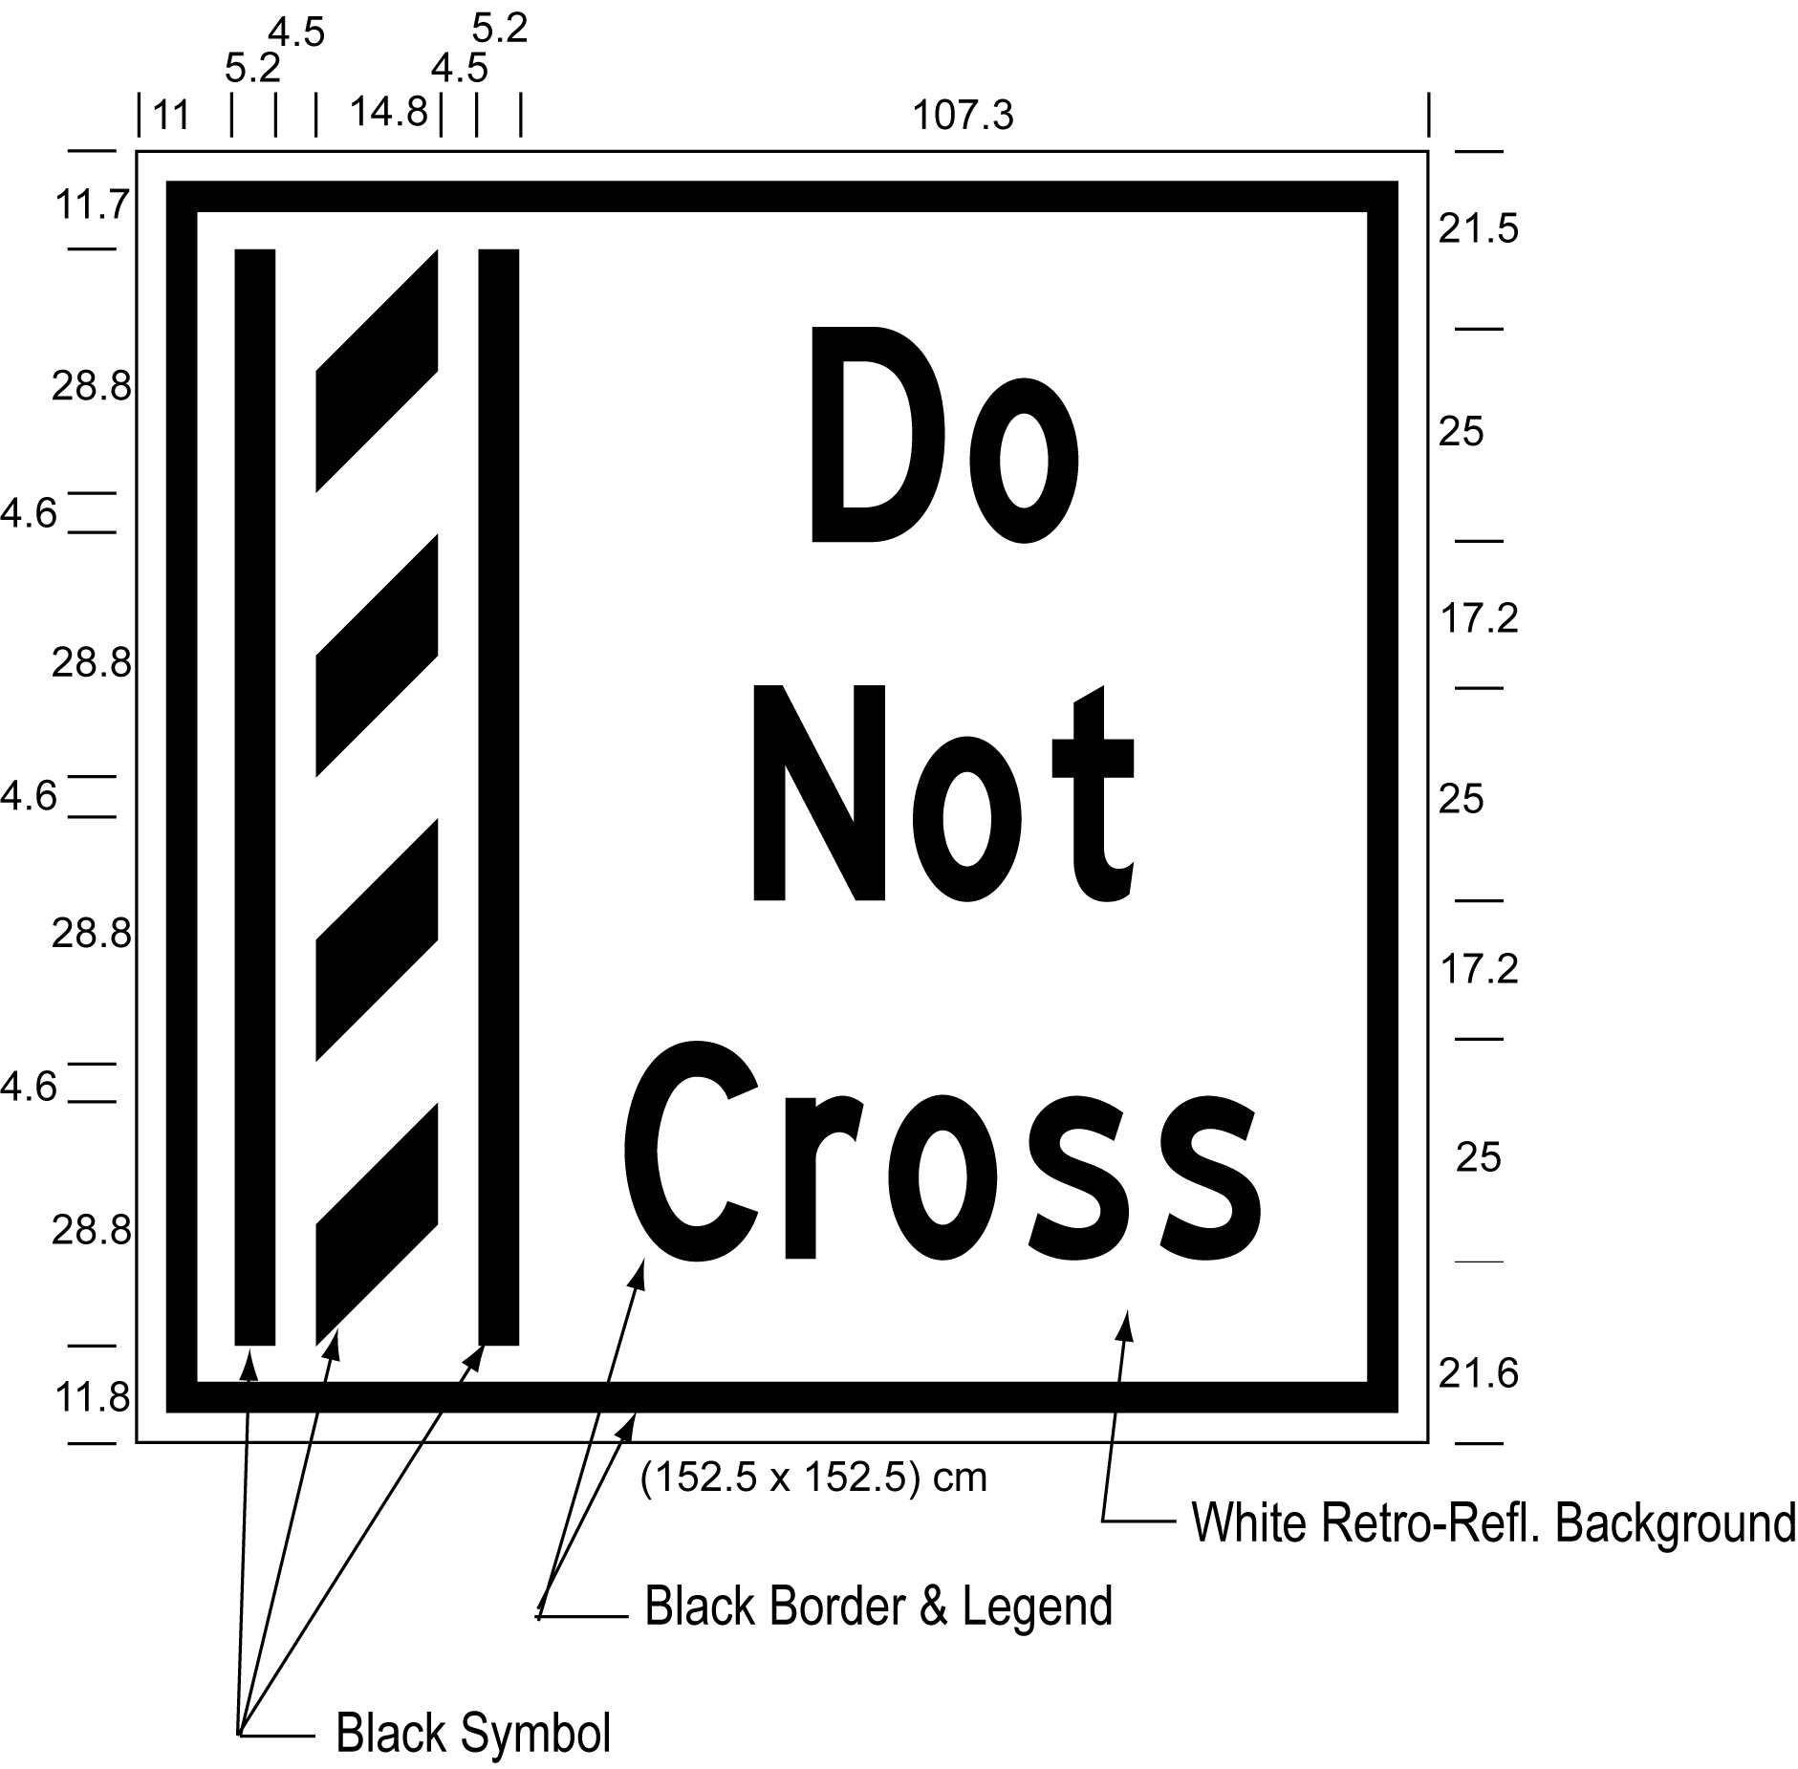
Text alternative: Illustration of an overhead buffer zone sign labelled as “Figure I”. The sign contains an image on the left of a buffer zone as diagonal lines painted between solid lines and on the right contains the words “Do Not Cross”. The sign has a white reflective background with the buffer zone image and words appearing in black. The following measurements are written below the sign: (152.5 x 152.5) cm. The sign is surrounded by measurements of its different elements. This text alternative is provided for convenience only and does not form part of the official law.
figure j
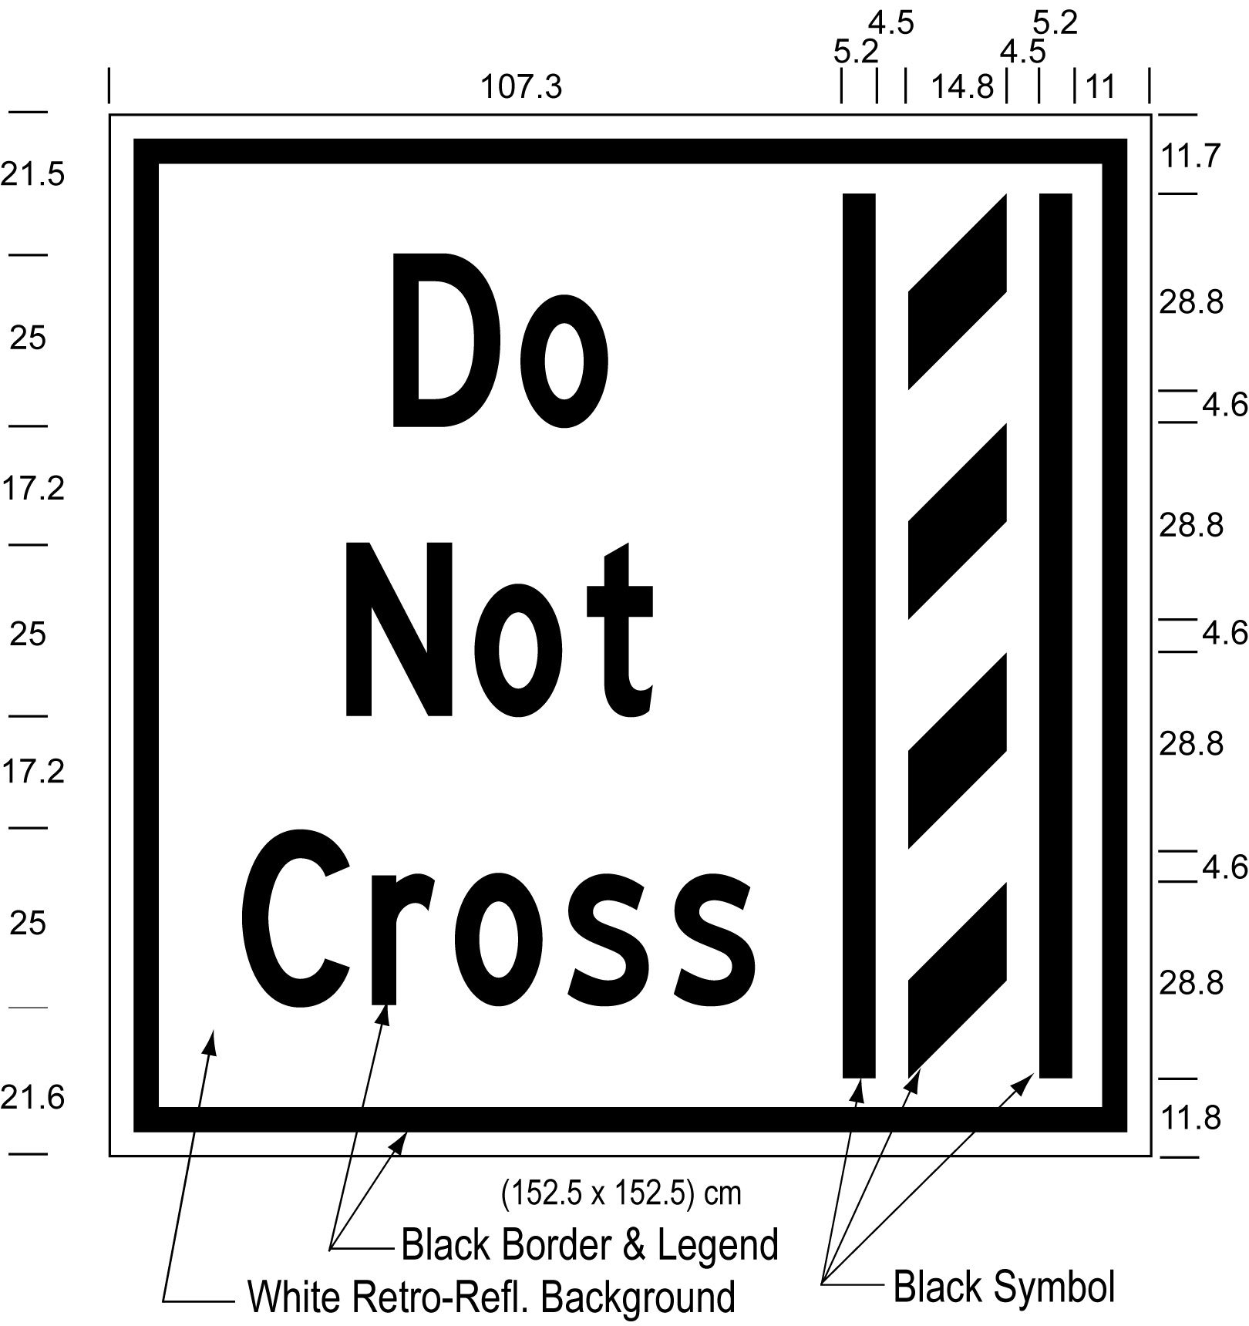
Text alternative: Illustration of an overhead buffer zone sign labelled as “Figure J”. The sign contains an image on the right of a buffer zone as diagonal lines painted between solid lines and on the left contains the words “Do Not Cross”. The sign has a white reflective background with the buffer zone image and words appearing in black. The following measurements are written below the sign: (152.5 x 152.5) cm. The sign is surrounded by measurements of its different elements. This text alternative is provided for convenience only and does not form part of the official law.
figure k
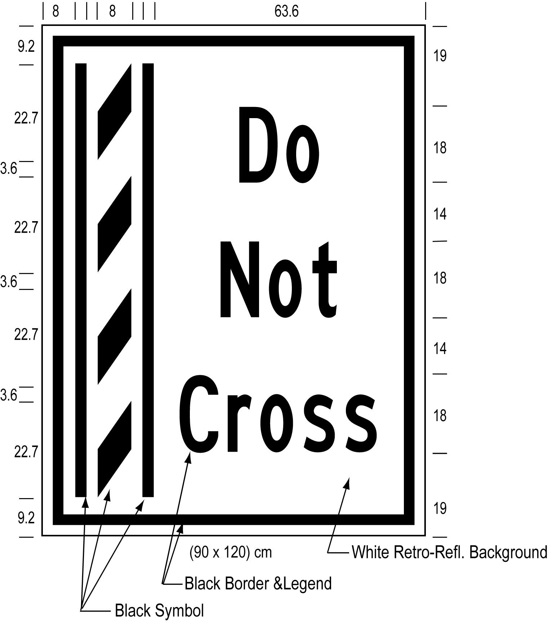
Text alternative: Illustration of a ground mounted buffer zone sign labelled as “Figure K”. The sign contains an image on the left of a buffer zone as diagonal lines painted between solid lines and on the right contains the words “Do Not Cross”. The sign has a white reflective background with the buffer zone image and words appearing in black. The following measurements are written below the sign: (90 x 120) cm. The sign is surrounded by measurements of its different elements. This text alternative is provided for convenience only and does not form part of the official law.
figure l
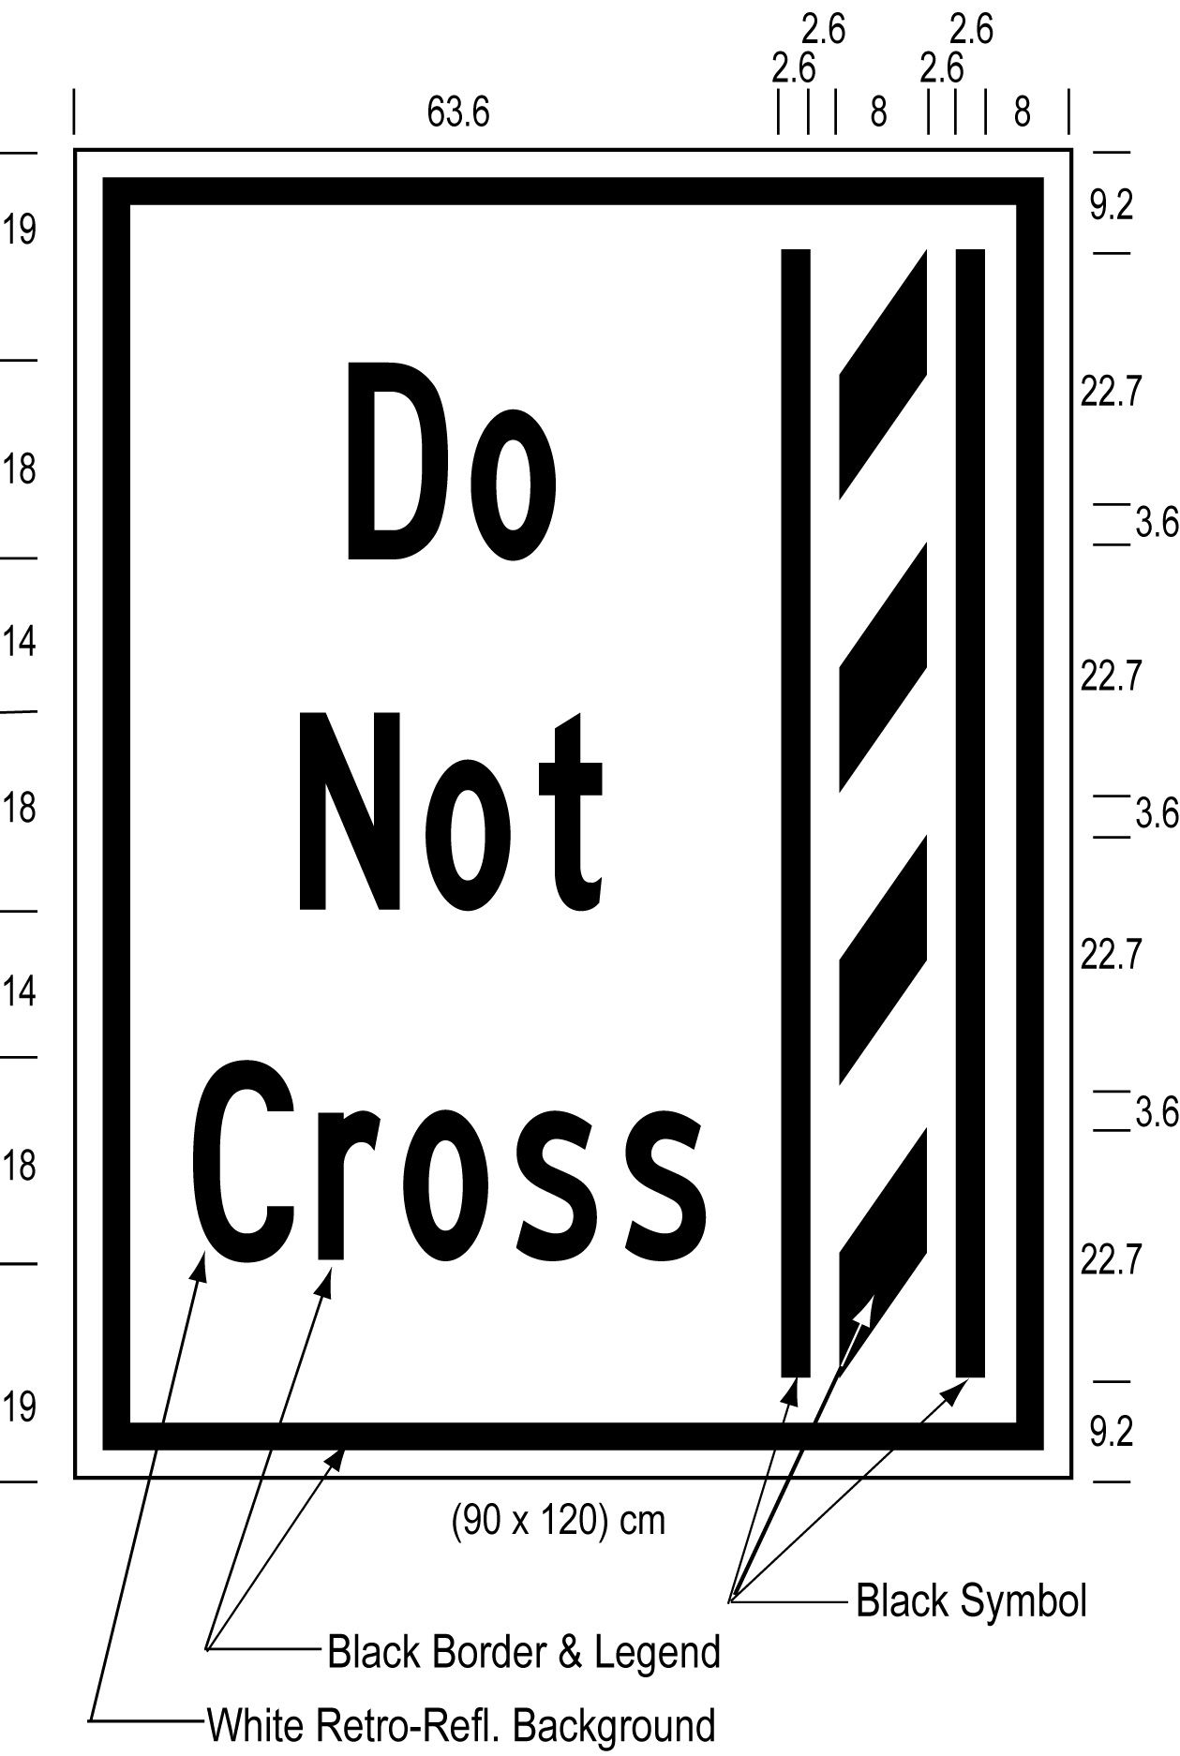
Text alternative: Illustration of a ground mounted buffer zone sign labelled as “Figure L”. The sign contains an image on the right of a buffer zone as diagonal lines painted between solid lines and on the left contains the words “Do Not Cross”. The sign has a white reflective background with the buffer zone image and words appearing in black. The following measurements are written below the sign: (90 x 120) cm. The sign is surrounded by measurements of its different elements. This text alternative is provided for convenience only and does not form part of the official law.
(7) Figures M, N, O and P to subsection 5 (8) of the Regulation are revoked and the following substituted:
figure M
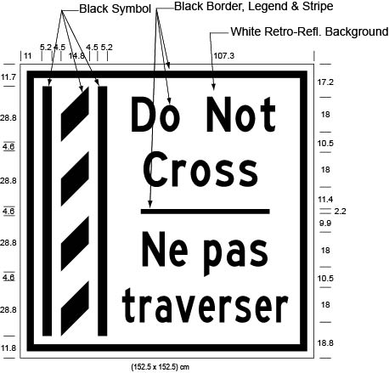
Text alternative: Illustration of an overhead buffer zone sign labelled as “Figure M”. The sign contains an image on the left of a buffer zone as diagonal lines painted between solid lines and on the right contains the words “Do Not Cross/Ne pas traverser”. The sign has a white reflective background with the buffer zone image and words appearing in black. The following measurements are written below the sign: (152.5 x 152.5) cm. The sign is surrounded by measurements of its different elements. This text alternative is provided for convenience only and does not form part of the official law.
figure n
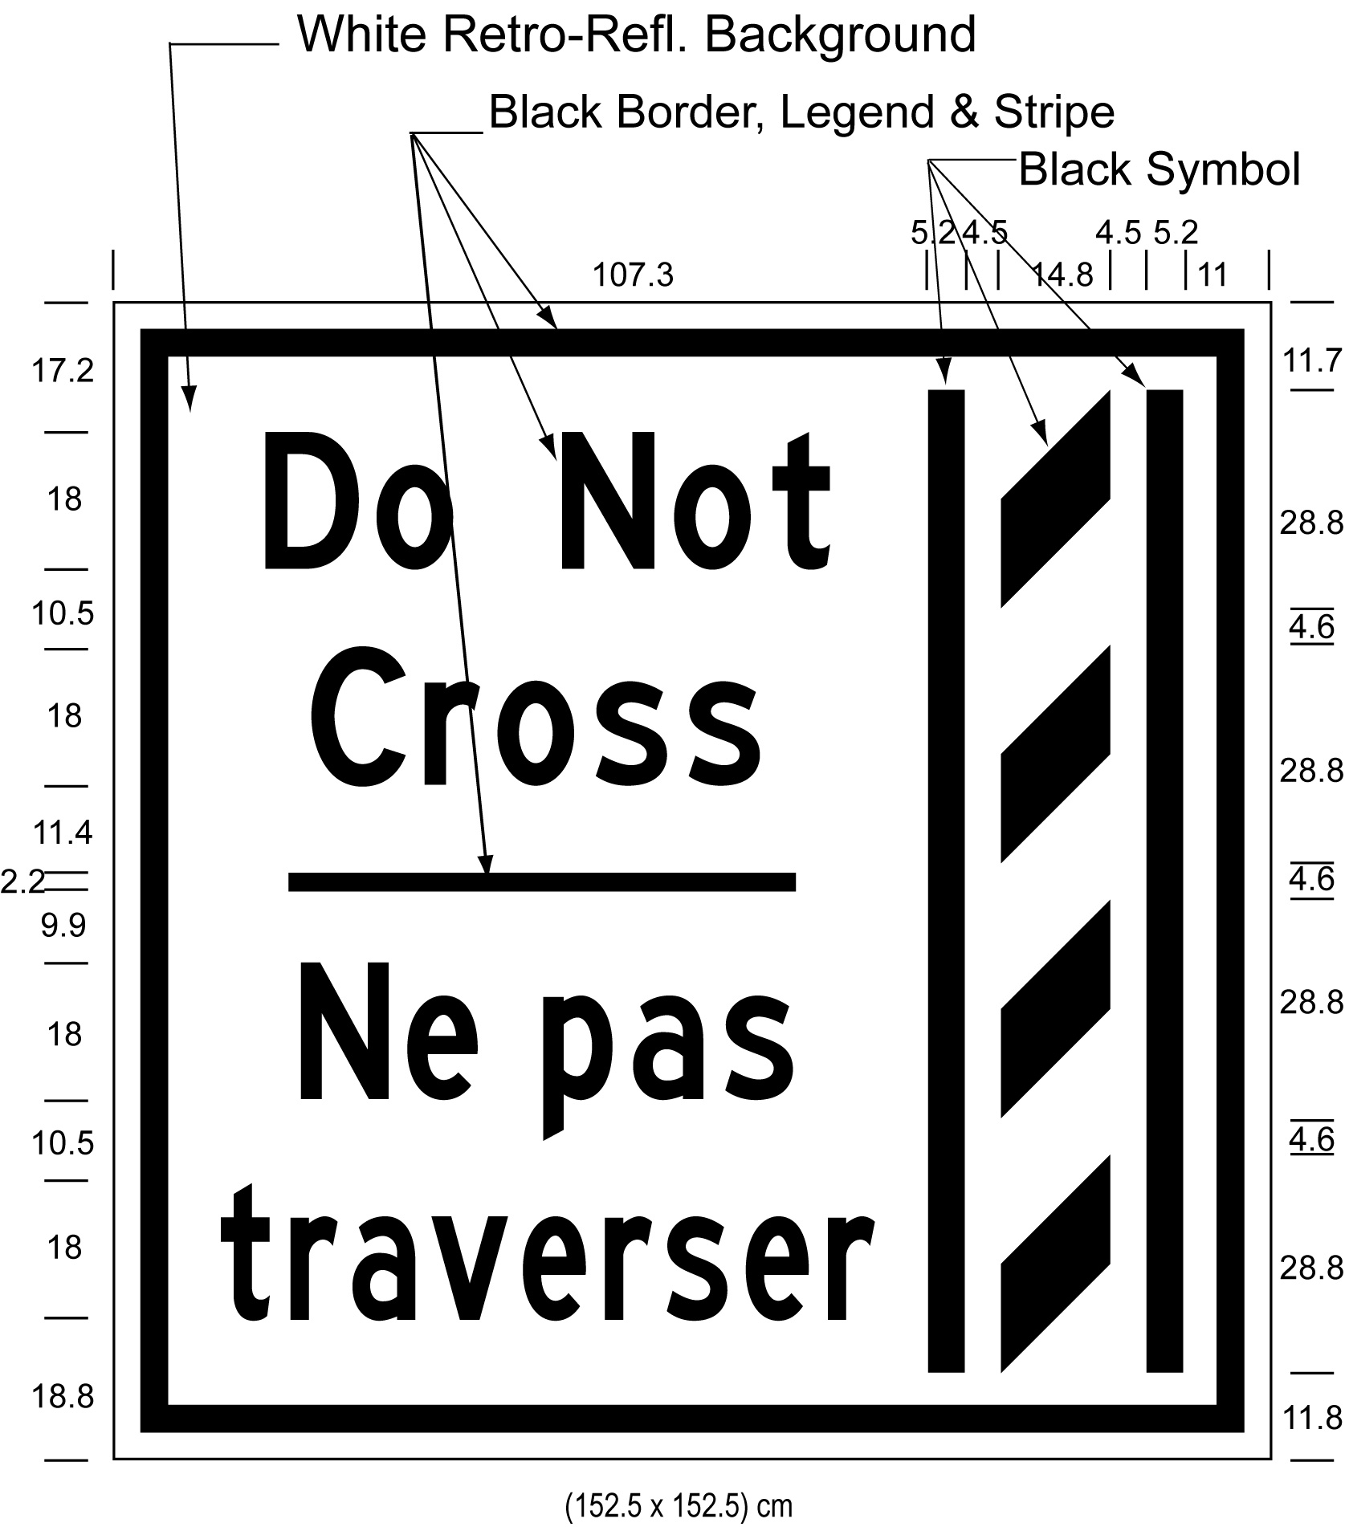
Text alternative: Illustration of an overhead buffer zone sign labelled as “Figure N”. The sign contains an image on the right of a buffer zone as diagonal lines painted between solid lines and on the left contains the words “Do Not Cross/Ne pas traverser”. The sign has a white reflective background with the buffer zone image and words appearing in black. The following measurements are written below the sign: (152.5 x 152.5) cm. The sign is surrounded by measurements of its different elements. This text alternative is provided for convenience only and does not form part of the official law.
figure o
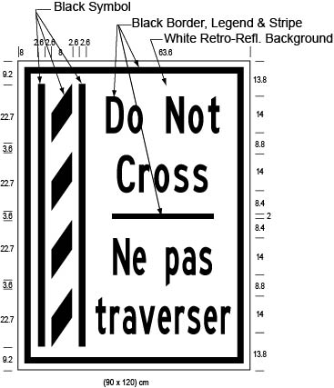
Text alternative: Illustration of a ground mounted buffer zone sign labelled as “Figure O”. The sign contains an image on the left of a buffer zone as diagonal lines painted between solid lines and on the right contains the words “Do Not Cross/Ne pas traverser”. The sign has a white reflective background with the buffer zone image and words appearing in black. The following measurements are written below the sign: (90 x 120) cm. The sign is surrounded by measurements of its different elements. This text alternative is provided for convenience only and does not form part of the official law.
figure p
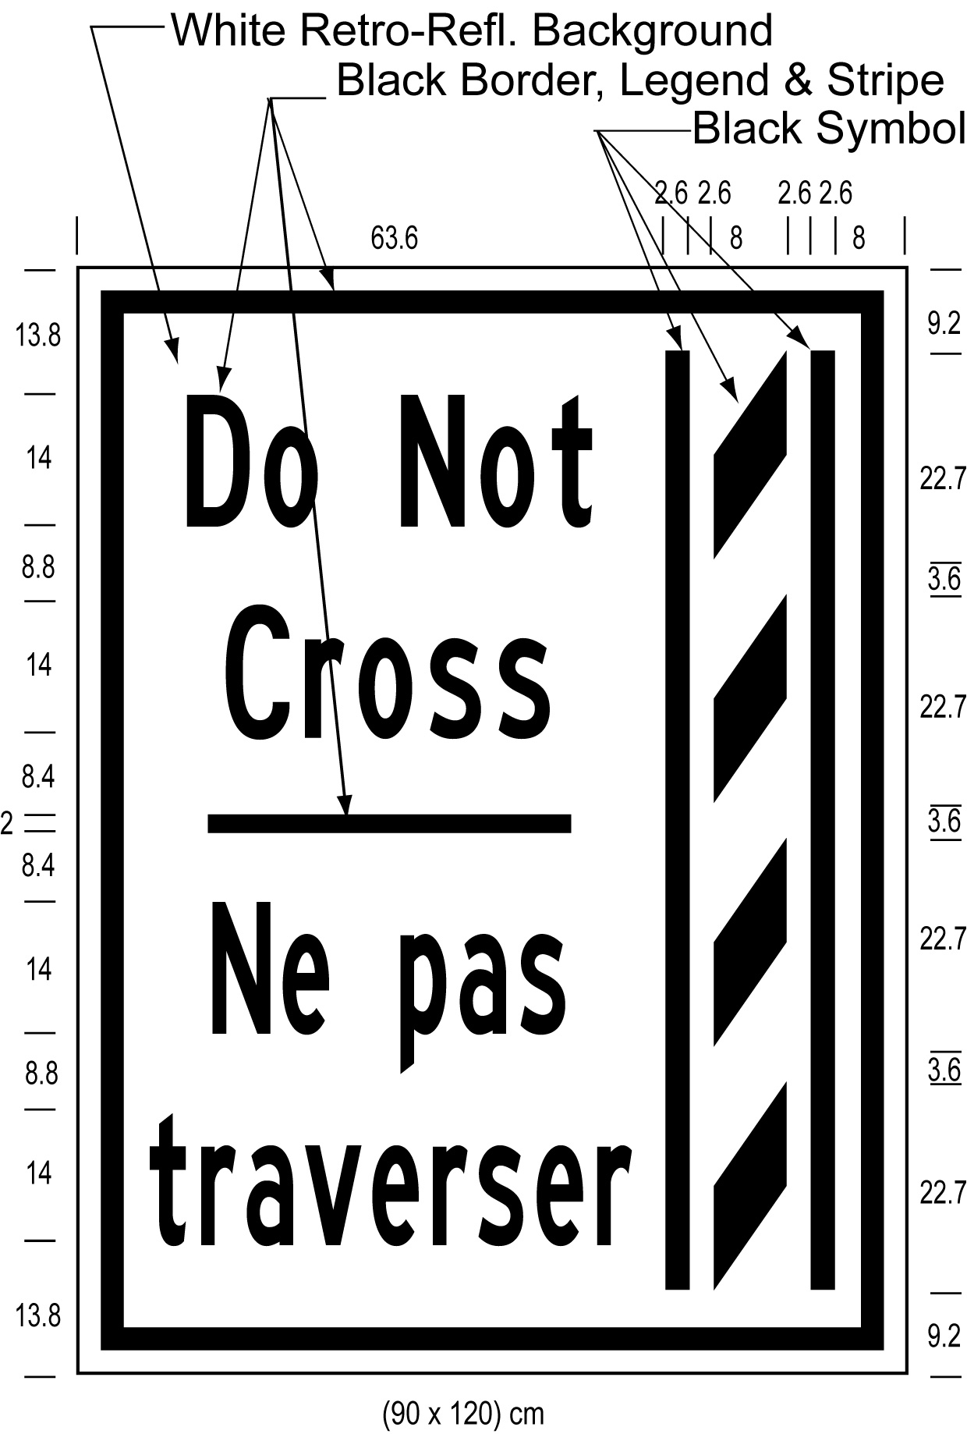
Text alternative: Illustration of a ground mounted buffer zone sign labelled as “Figure P”. The sign contains an image on the right of a buffer zone as diagonal lines painted between solid lines and on the left contains the words “Do Not Cross/Ne pas traverser”. The sign has a white reflective background with the buffer zone image and words appearing in black. The following measurements are written below the sign: (90 x 120) cm. The sign is surrounded by measurements of its different elements. This text alternative is provided for convenience only and does not form part of the official law.
Commencement
3. This Regulation comes into force on the day it is filed.
Made by:
Steven Del Duca
Minister of Transportation
Date made: April 2, 2015.

Back to top

