Français
ontario regulation 90/15
made under the
highway traffic act
Made: April 22, 2015
Filed: April 27, 2015
Published on e-Laws: April 27, 2015
Printed in The Ontario Gazette: May 16, 2015
Amending Reg. 606 of R.R.O. 1990
(PORTABLE LANE CONTROL SIGNAL SYSTEMS)
1. The Figure to subsection 2 (4) of Regulation 606 of the Revised Regulations of Ontario, 1990 is revoked and the following substituted:
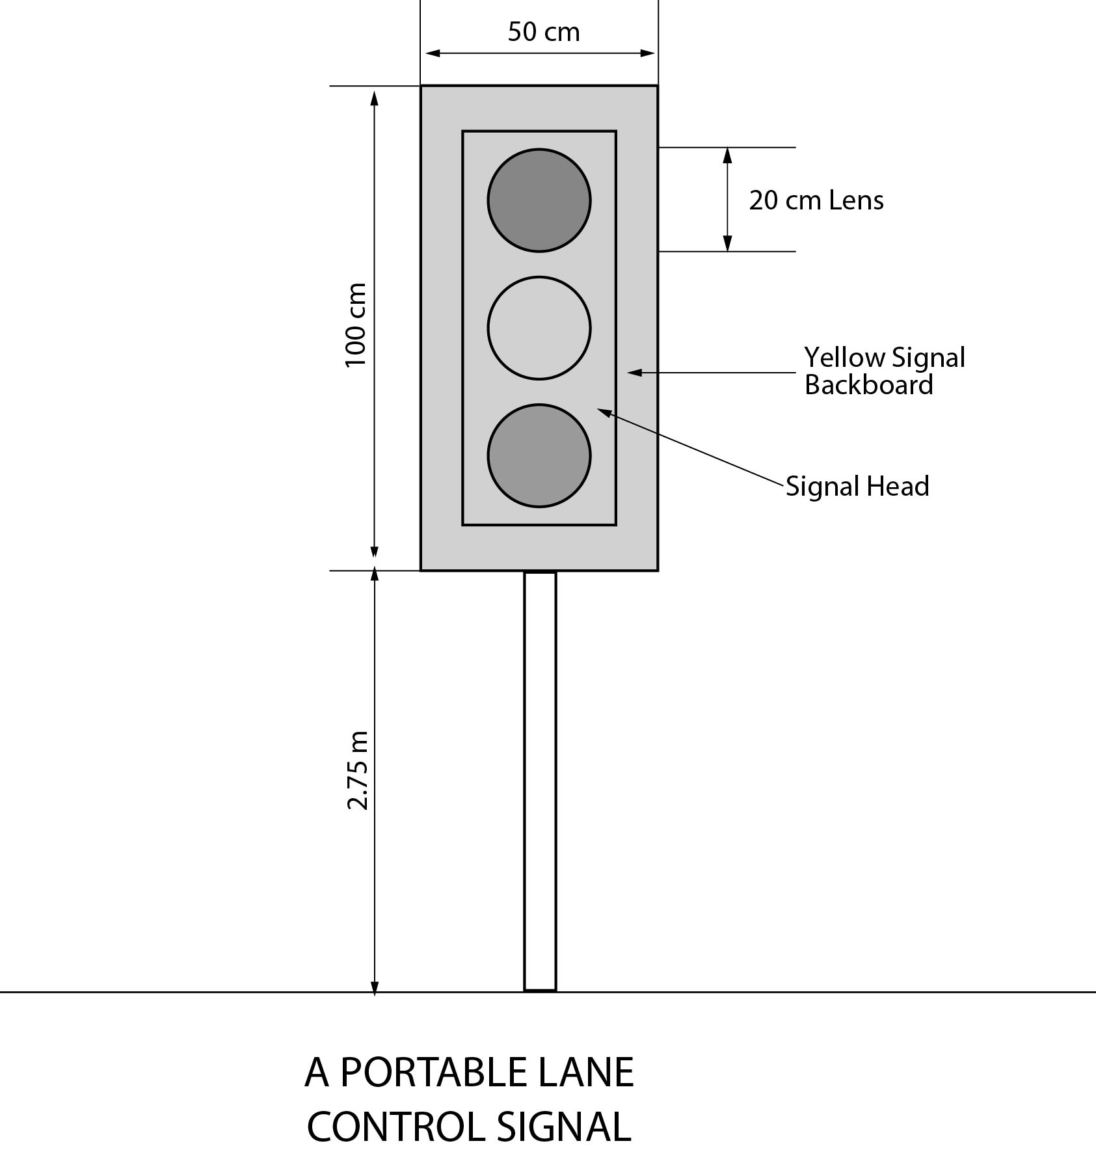
Text alternative: Illustration of portable lane control signal as described in subsection 2 (4). Bottom of signal backboard is 2.75 m above ground. The yellow backboard for the traffic signal head is rectangular in shape measuring 100 cm high and 50 cm wide. Each of the three circular lenses is 20 cm in diameter. This text alternative is provided for convenience only and does not form part of the official law.
2. (1) The Figure to subsection 4 (2) of the Regulation is revoked and the following substituted:
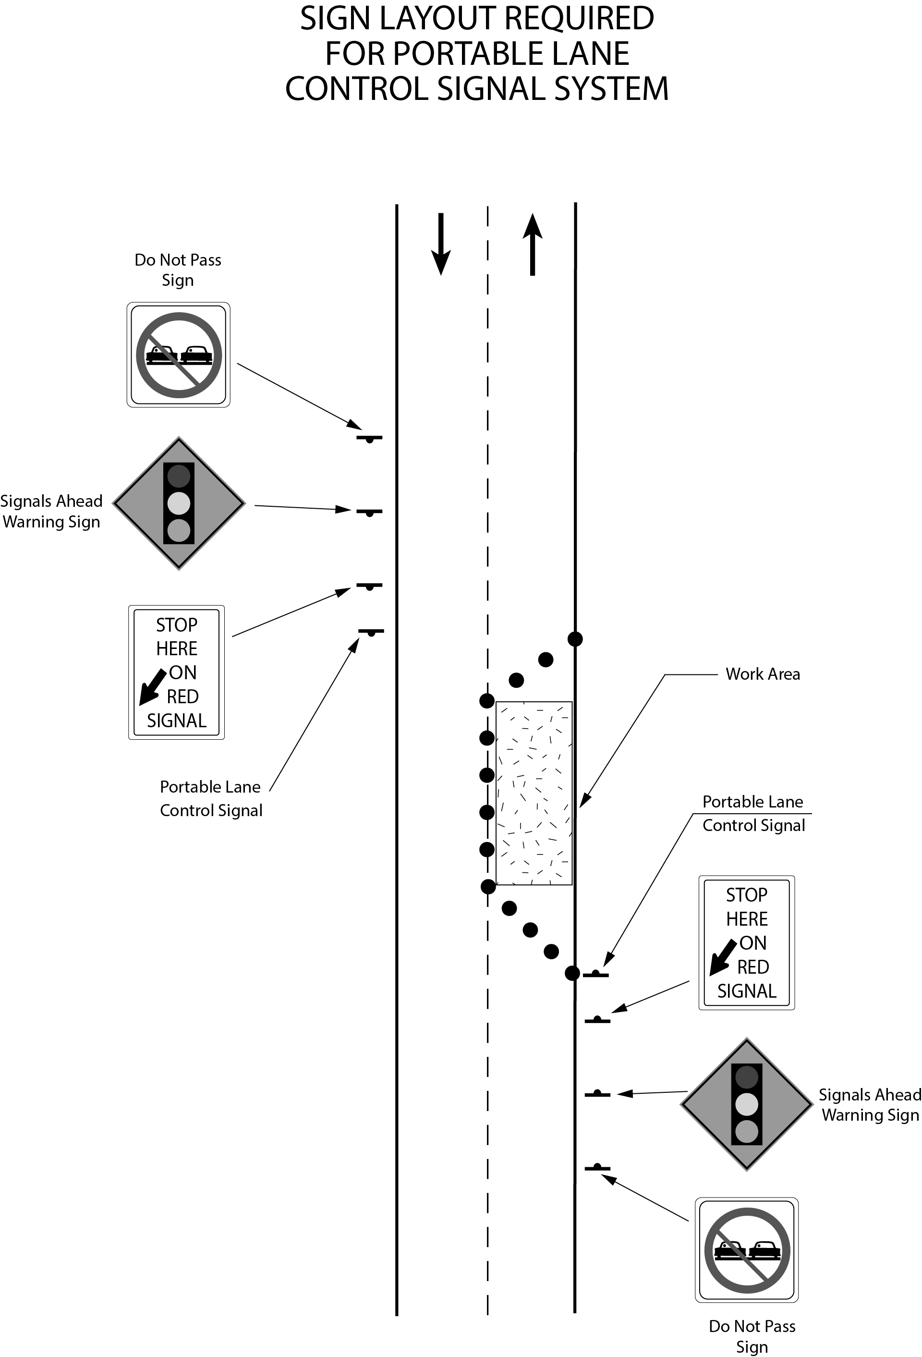
Text alternative: Diagram of the placement of a portable lane control signal system placed on the right side facing each direction of traffic on a highway along with three signs erected prior to the portable lane control signal and facing traffic. The outermost sign is a “DO NOT PASS” sign, followed by a “SIGNALS AHEAD” warning sign and finally a “STOP HERE ON RED SIGNAL” sign that has a thick, black arrow pointed diagonally and downward. The last sign is placed the closest to the portable lane control signal system in front of the coned off work area which is blocking half of the roadway in the diagram. This text alternative is provided for convenience only and does not form part of the official law.
(2) The Figure to subsection 4 (3) of the Regulation is revoked and the following substituted:
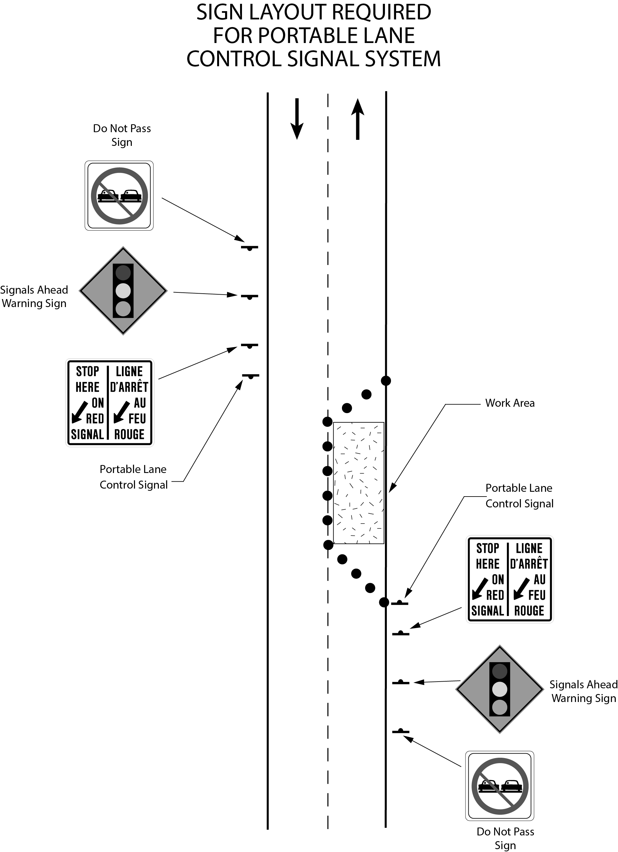
Text alternative: Diagram of the placement of a portable lane control signal system placed on the right side facing each direction of traffic on a highway along with three signs erected prior to the portable lane control signal and facing traffic. The outermost sign is a “DO NOT PASS” sign, followed by a “SIGNALS AHEAD” warning sign and finally a “STOP HERE ON RED SIGNAL / LIGNE D’ARRÊT AU FEU ROUGE” sign that has a thick, black arrow pointed diagonally and downward. The last sign is placed the closest to the portable lane control signal system in front of the coned off work area which is blocking half of the roadway in the diagram. This text alternative is provided for convenience only and does not form part of the official law.
Commencement
3. This Regulation comes into force on the day it is filed.

Français

Back to top

