ontario regulation 91/15
made under the
HIGHWAY Traffic act
Made: April 2, 2015
Filed: April 27, 2015
Published on e-Laws: April 27, 2015
Printed in The Ontario Gazette: May 16, 2015
Amending Reg. 608 of R.R.O. 1990
(RESTRICTED USE OF LEFT LANES BY COMMERCIAL MOTOR VEHICLES)
1. (1) The Figure to subsection 2 (1) of Regulation 608 of the Revised Regulations of Ontario, 1990 is revoked and the following substituted:
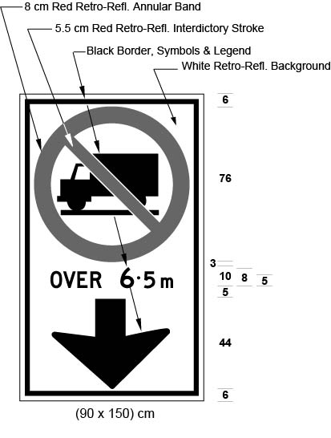
Text alternative: Illustration of an overhead sign containing an image at the top of a truck in a circle with an interdictory stroke “no” symbol. Below that appear the words “OVER 6.5 m” and a black arrow appears at the bottom of the sign pointing down. The sign has a white reflective background with the truck image, arrow and words appearing in black. The circular “no” symbol is in red. The following measurements are written below the sign: (90 x 150) cm. The sign is surrounded by measurements of its different elements. This text alternative is provided for convenience only and does not form part of the official law.
(2) The Figure to subsection 2 (1.1) of the Regulation is revoked and the following substituted:
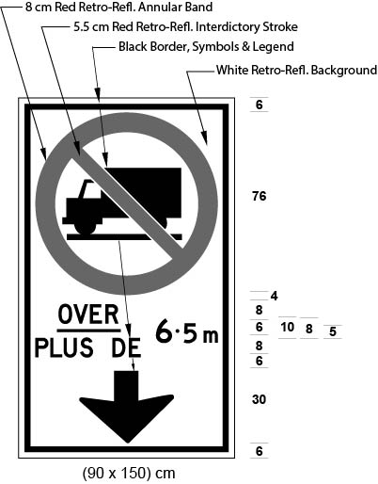
Text alternative: Illustration of an overhead sign containing an image at the top of a truck in a circle with an interdictory stroke “no” symbol. Below that appear the words “OVER/PLUS DE 6.5 m” and a black arrow appears at the bottom of the sign pointing down. The sign has a white reflective background with the truck image, arrow and words appearing in black. The circular “no” symbol is in red. The following measurements are written below the sign: (90 x 150) cm. The sign is surrounded by measurements of its different elements. This text alternative is provided for convenience only and does not form part of the official law.
2. (1) The Figure to subsection 3 (1) of the Regulation is revoked and the following substituted:
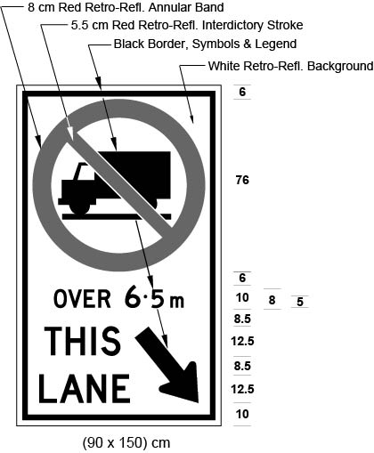
Text alternative: Illustration of a ground mounted sign containing an image at the top of a truck in a circle with an interdictory stroke “no” symbol. Below that appear the words “OVER 6.5 m”. At the bottom of the sign on the left side appear the words “THIS LANE” and on the right side appears a black arrow pointing down and diagonally to the right. The sign has a white reflective background with the truck image, arrow and words appearing in black. The circular “no” symbol is in red. The following measurements are written below the sign: (90 x 150) cm. The sign is surrounded by measurements of its different elements. This text alternative is provided for convenience only and does not form part of the official law.
(2) The Figure to subsection 3 (1.1) of the Regulation is revoked and the following substituted:
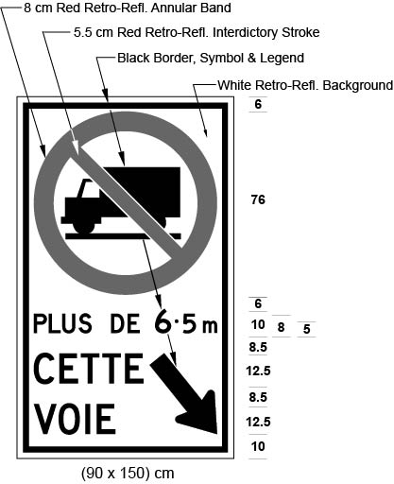
Text alternative: Illustration of a ground mounted sign containing an image at the top of a truck in a circle with an interdictory stroke “no” symbol. Below that appear the words “PLUS DE 6.5 m”. At the bottom of the sign on the left side appear the words “CETTE VOIE” and on the right side appears a black arrow pointing down and diagonally to the right. The sign has a white reflective background with the truck image, arrow and words appearing in black. The circular “no” symbol is in red. The following measurements are written below the sign: (90 x 150) cm. The sign is surrounded by measurements of its different elements. This text alternative is provided for convenience only and does not form part of the official law.
Commencement
3. This Regulation comes into force on the day it is filed.
Made by:
Steven Del Duca
Minister of Transportation
Date made: April 2, 2015.

Back to top

