Français
ontario regulation 92/15
made under the
highway traffic act
Made: April 22, 2015
Filed: April 27, 2015
Published on e-Laws: April 27, 2015
Printed in The Ontario Gazette: May 16, 2015
Amending Reg. 612 of R.R.O. 1990
(school buses)
1. Figures 1 and 2 to subsection 3 (4) of Regulation 612 of the Revised Regulations of Ontario, 1990 are revoked and the following substituted:
figure 1
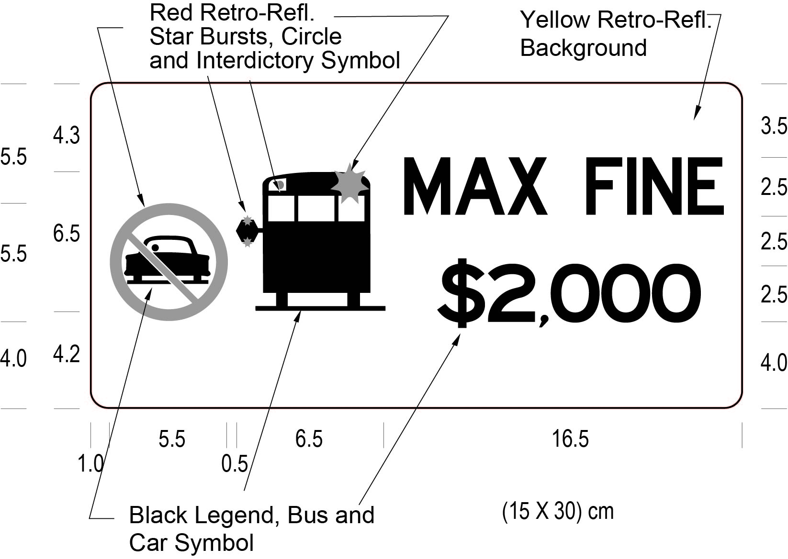
Text alternative: Illustration of a sign labelled as Figure 1. The sign contains the “no passing” circle symbol with an interdictory stroke on the left side. Beside that is a solid black image of a stopped school bus with its stop arm extended. On the right side of the sign appear the words “MAX FINE $2,000”. The following measurements are written below the sign: (15 x 30) cm. The sign has a yellow reflective background and the symbols and wording appear in black. The sign is surrounded by measurements of its different elements. This text alternative is provided for convenience only and does not form part of the official law.
figure 2
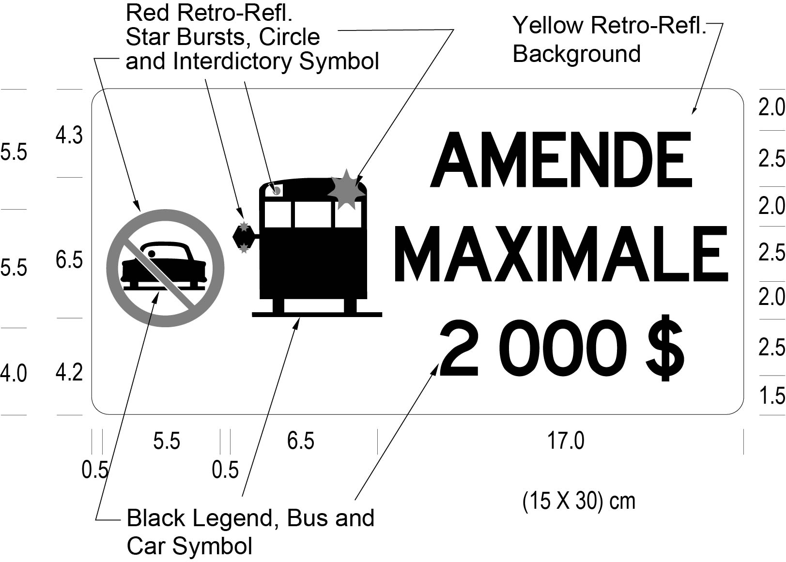
Text alternative: Illustration of a sign labelled as Figure 2. The sign contains a “no passing” circle symbol with an interdictory stroke on the left side. Beside that is a solid black image of a stopped school bus with its stop arm extended. On the right side of the sign appear the words “AMENDE MAXIMALE 2 000 $”. The following measurements are written below the sign: (15 x 30) cm. The sign has a yellow reflective background and the symbols and wording appear in black. The sign is surrounded by measurements of its different elements. This text alternative is provided for convenience only and does not form part of the official law.
Commencement
2. This Regulation comes into force on the day it is filed.

Français

Back to top

