ontario regulation 93/15
made under the
HIGHWAY Traffic act
Made: April 22, 2015
Filed: April 27, 2015
Published on e-Laws: April 27, 2015
Printed in The Ontario Gazette: May 16, 2015
Amending Reg. 615 of R.R.O. 1990
(SignS)
1. (1) The Figure to clause 21 (2) (b) of Regulation 615 of the Revised Regulations of Ontario, 1990 is revoked and the following substituted:
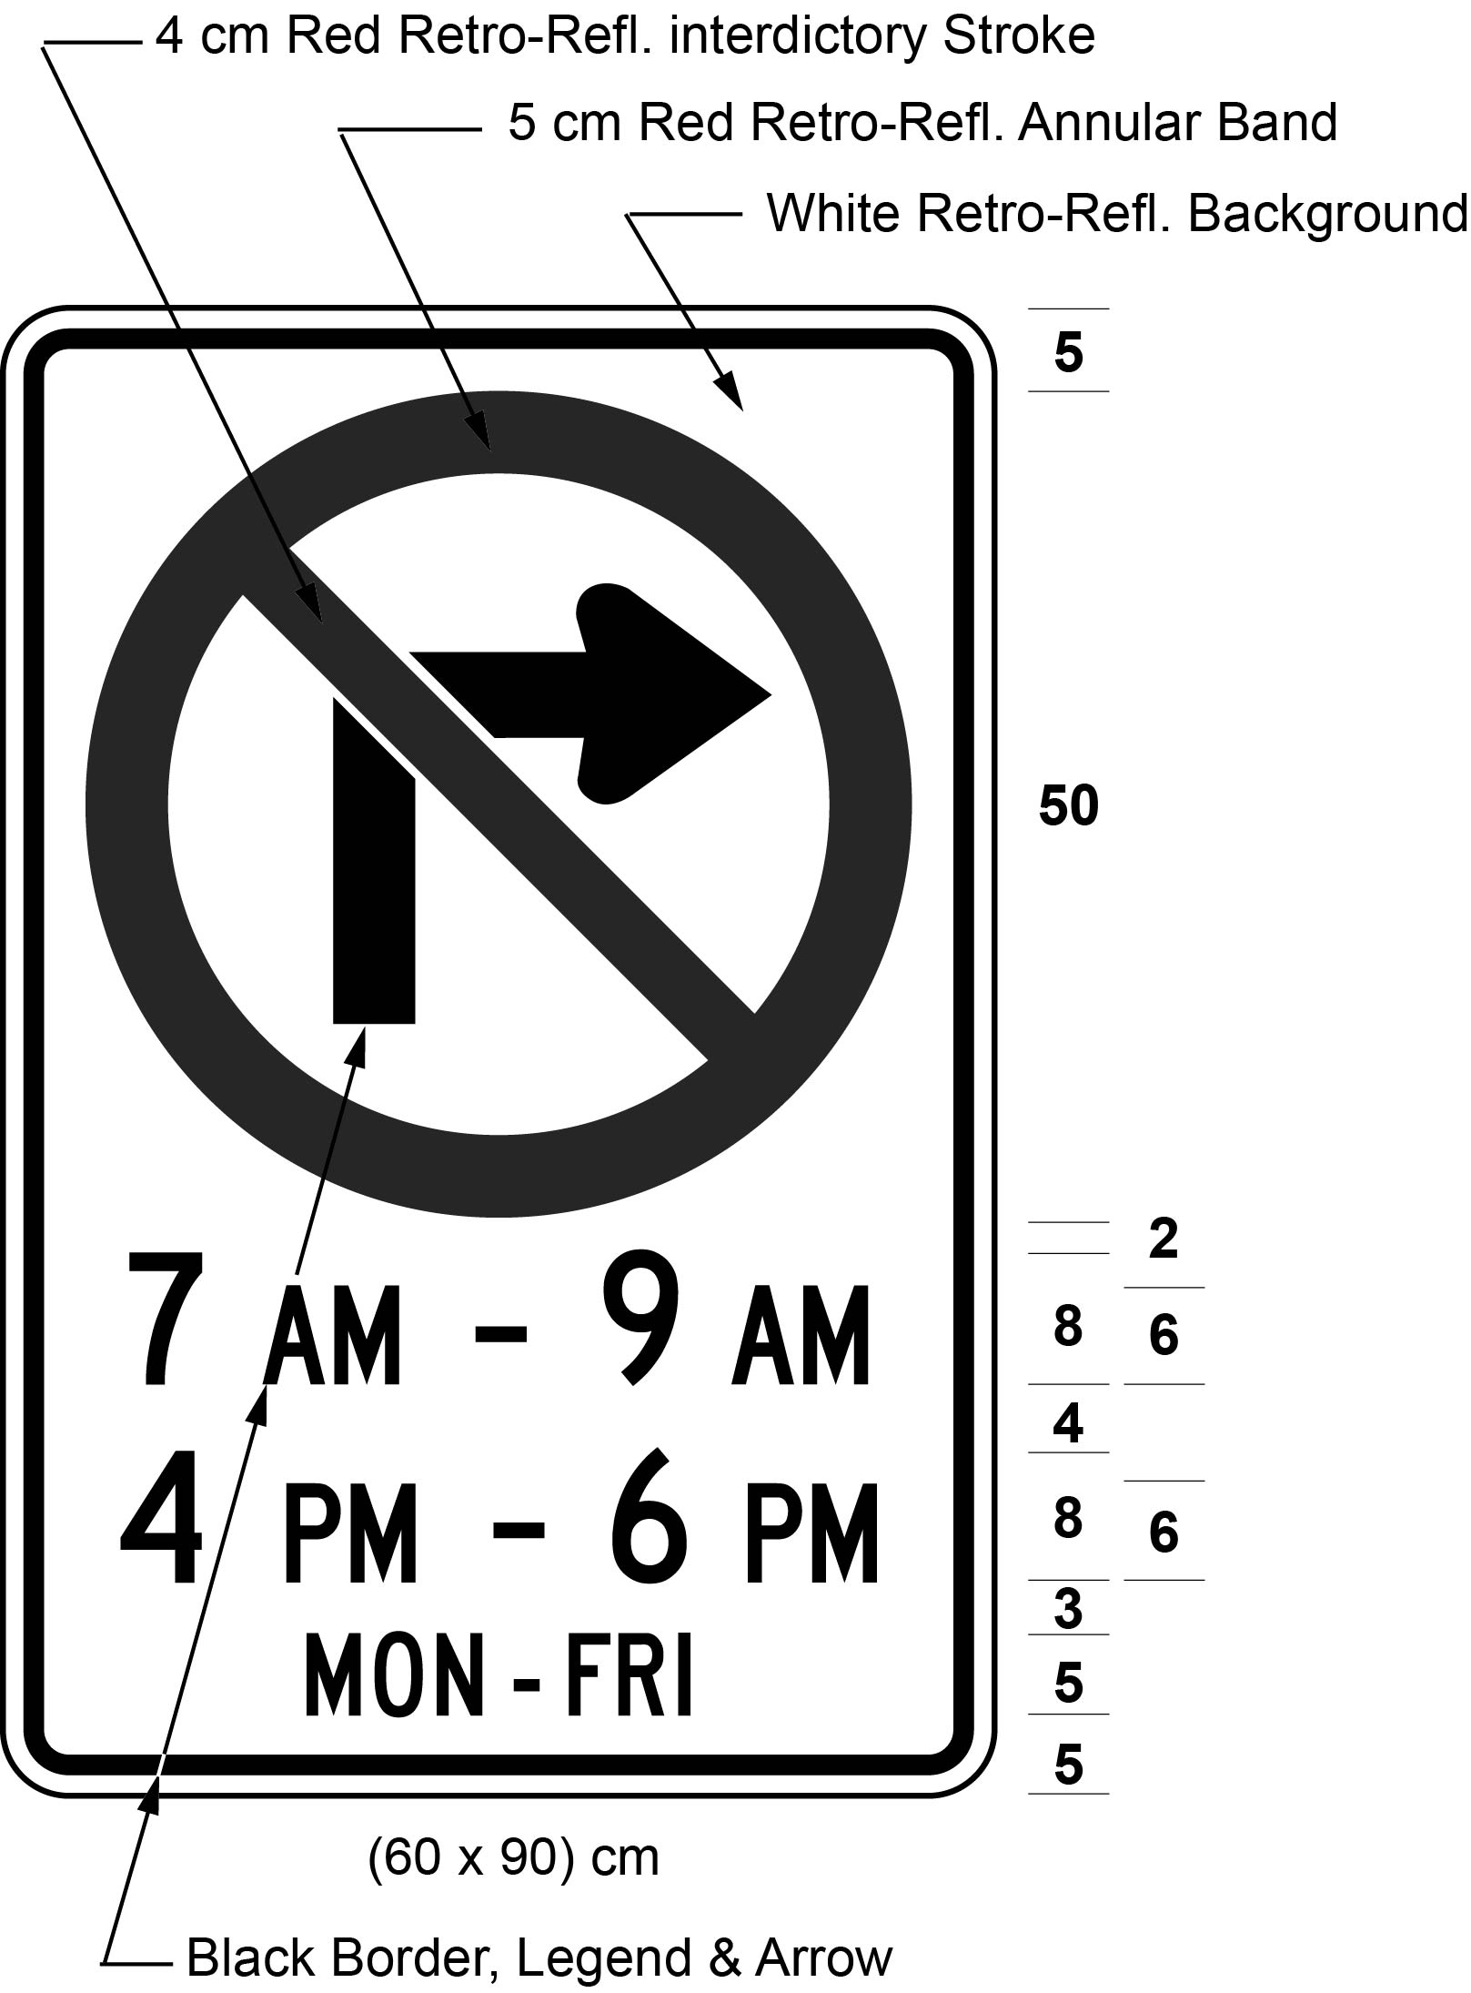
Text alternative: Illustration of a sign with a no right turn symbol consisting of a right turn black arrow inside a red circle with an interdictory stroke, on white retro-reflective background with a black border and the text “7 AM - 9 AM”, “4 PM - 6 PM”, “MON-FRI”. Size indicated (60 x 90) cm. This text alternative is provided for convenience only and does not form part of the official law.
(2) The Figure to subsection 21 (2.1) of the Regulation is revoked and the following substituted:
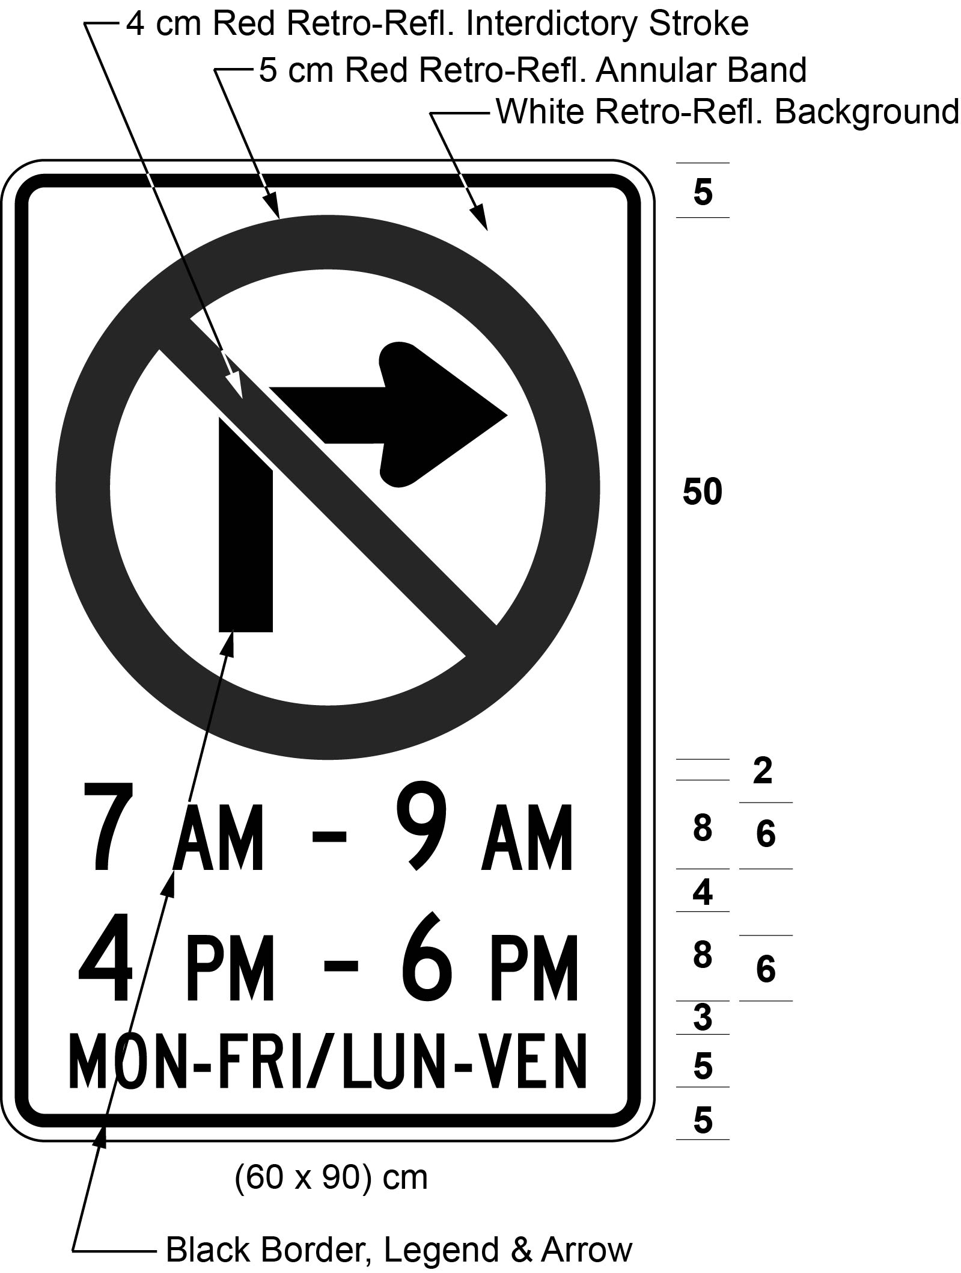
Text alternative: Illustration of a sign with a no right turn symbol consisting of a right turn black arrow inside a red circle with an interdictory stroke, on white retro-reflective background with a black border and the text “7 AM - 9 AM”, “4 PM - 6 PM”, “MON-FRI / LUN-VEN”. Size indicated (60 x 90) cm. This text alternative is provided for convenience only and does not form part of the official law.
(3) The Figure to subsection 21 (5.1) of the Regulation is revoked and the following substituted:
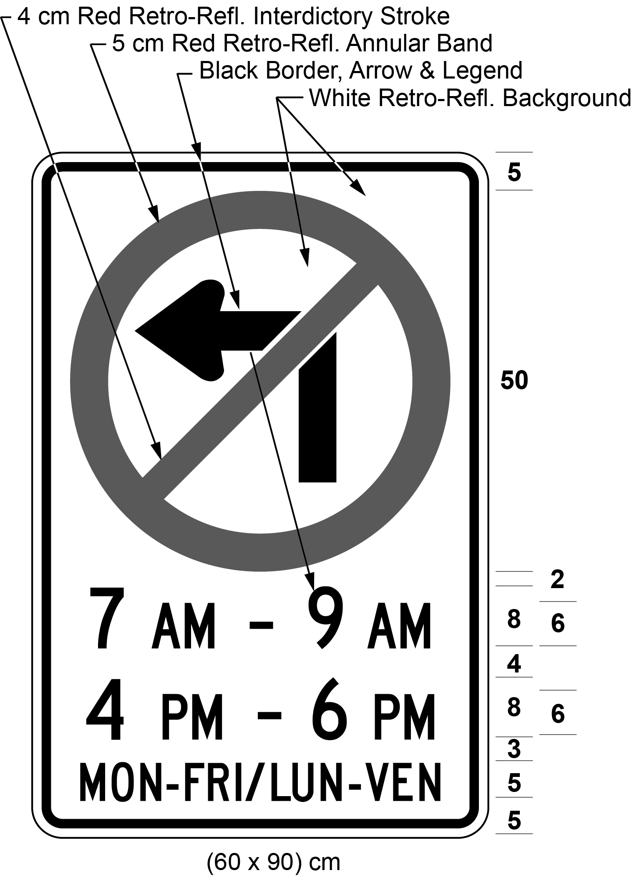
Text alternative: Illustration of a sign with a no left turn symbol consisting of a left turn black arrow inside a red circle with an interdictory stroke, on white retro-reflective background with a black border and the text “7 AM - 9 AM”, “4 PM - 6 PM”, “MON-FRI/LUN-VEN”. Size indicated (60 x 90) cm. This text alternative is provided for convenience only and does not form part of the official law.
2. (1) The Figure to clause 22 (7) (b) of the Regulation is revoked and the following substituted:
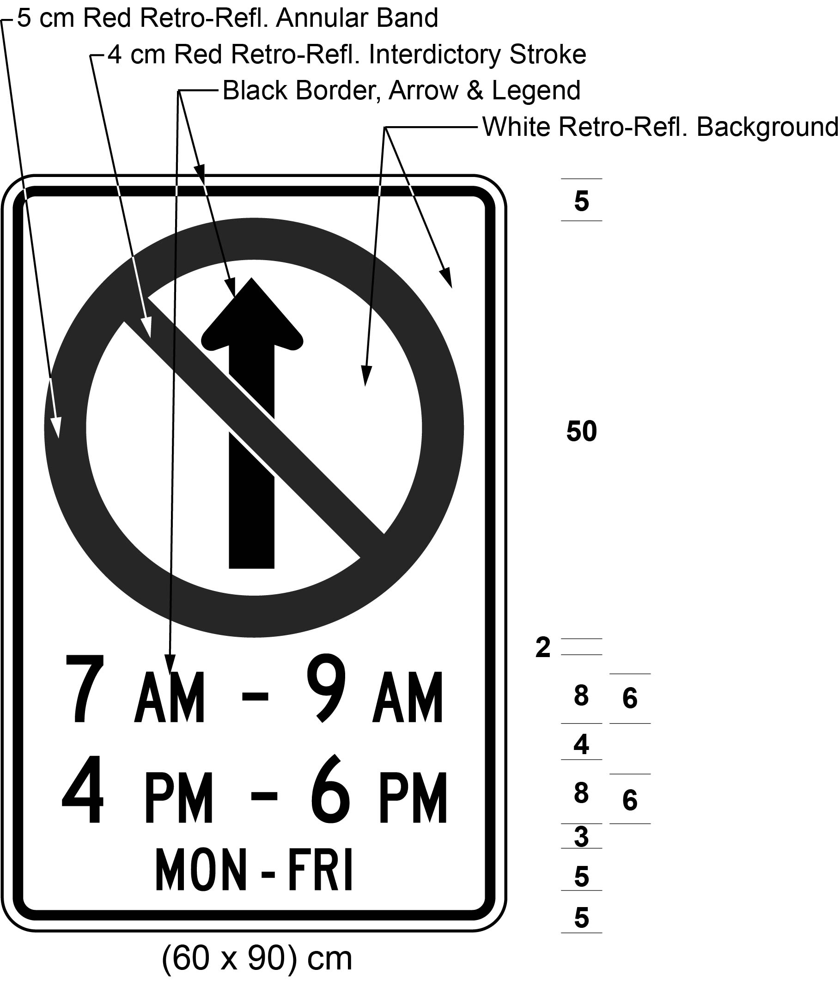
Text alternative: Illustration of a sign with a no proceeding straight symbol consisting of a black arrow proceeding straight, inside a red a circle with an interdictory stroke on white retro-reflective background with a black border, and the text “7 AM - 9 AM”, “4 PM - 6 PM”, and “MON-FRI”. Indicated size (60 x 90) cm. This text alternative is provided for convenience only and does not form part of the official law.
(2) The Figure to clause 22 (7.1) (b) of the Regulation is revoked and the following substituted:
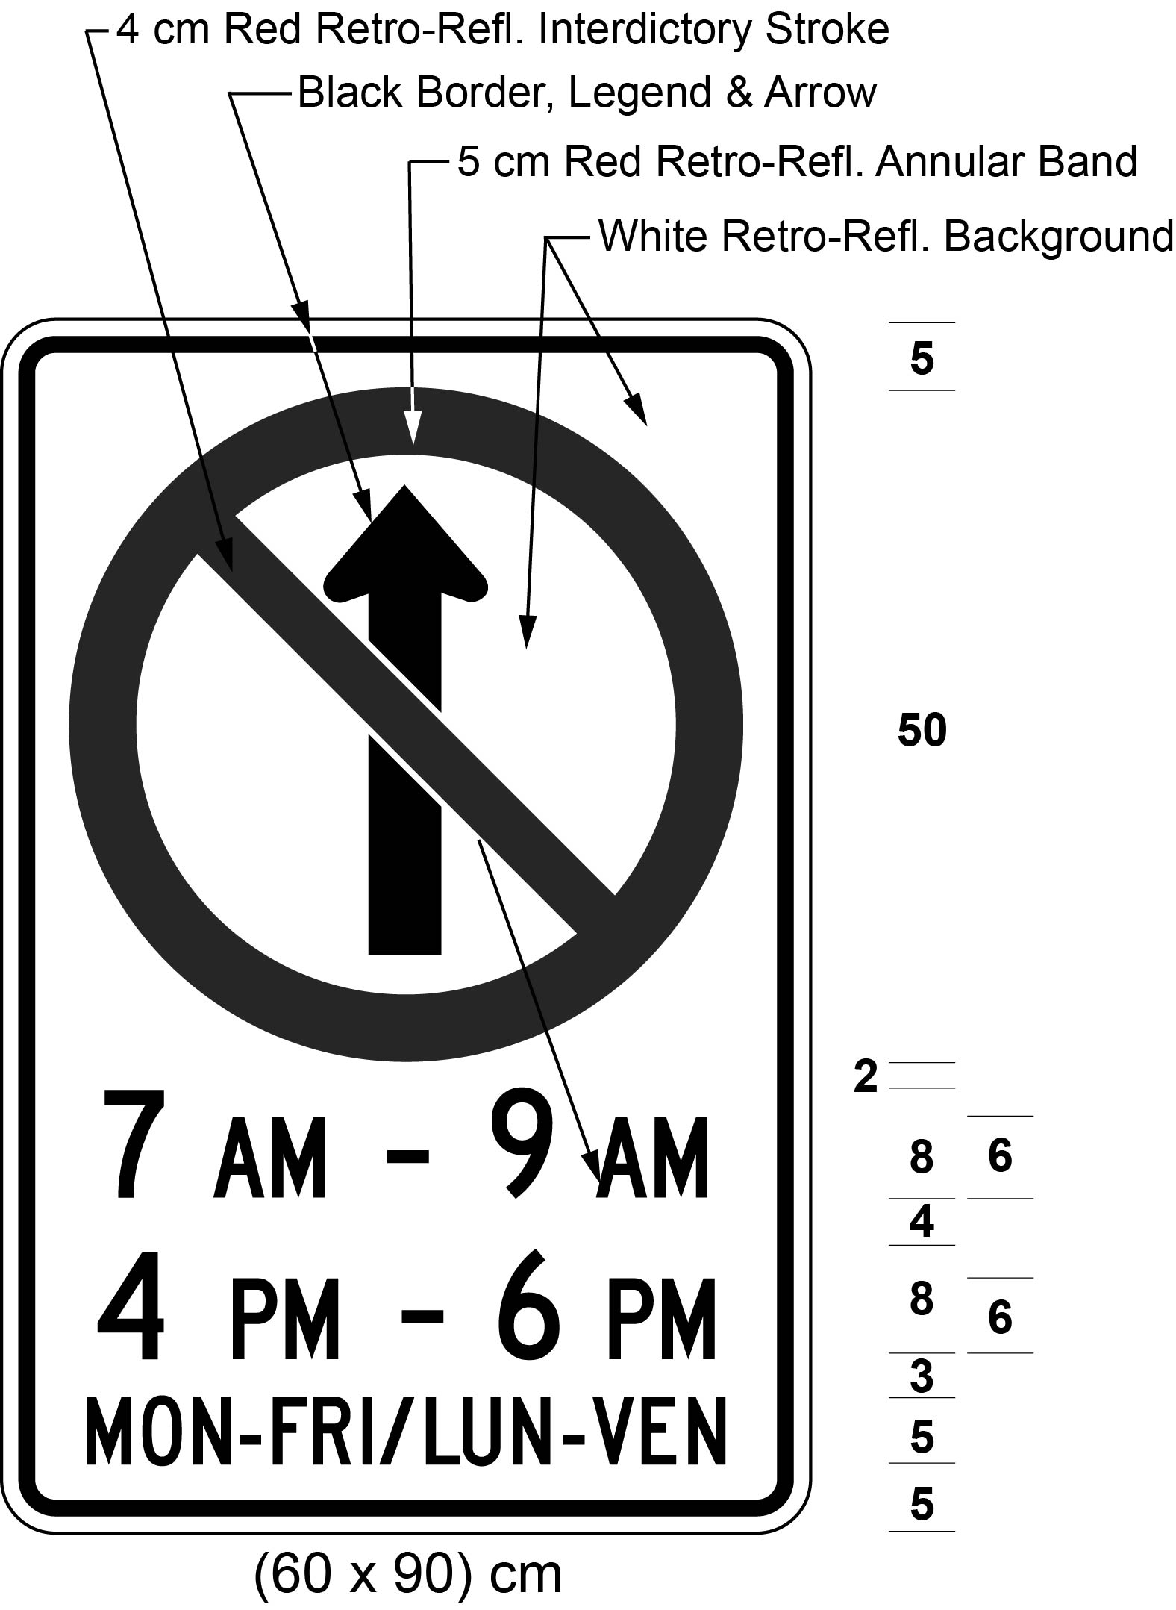
Text alternative: Illustration of a sign with a no proceeding straight symbol consisting of a black arrow proceeding straight, inside a red a circle with an interdictory stroke on white retro-reflective background with a black border, and the text “7 AM - 9 AM”, “4 PM - 6 PM”, and “MON-FRI/LUN-VEN”. Indicated size (60 x 90) cm. This text alternative is provided for convenience only and does not form part of the official law.
3. The Figure to clause 24 (b) of the Regulation is revoked and the following substituted:
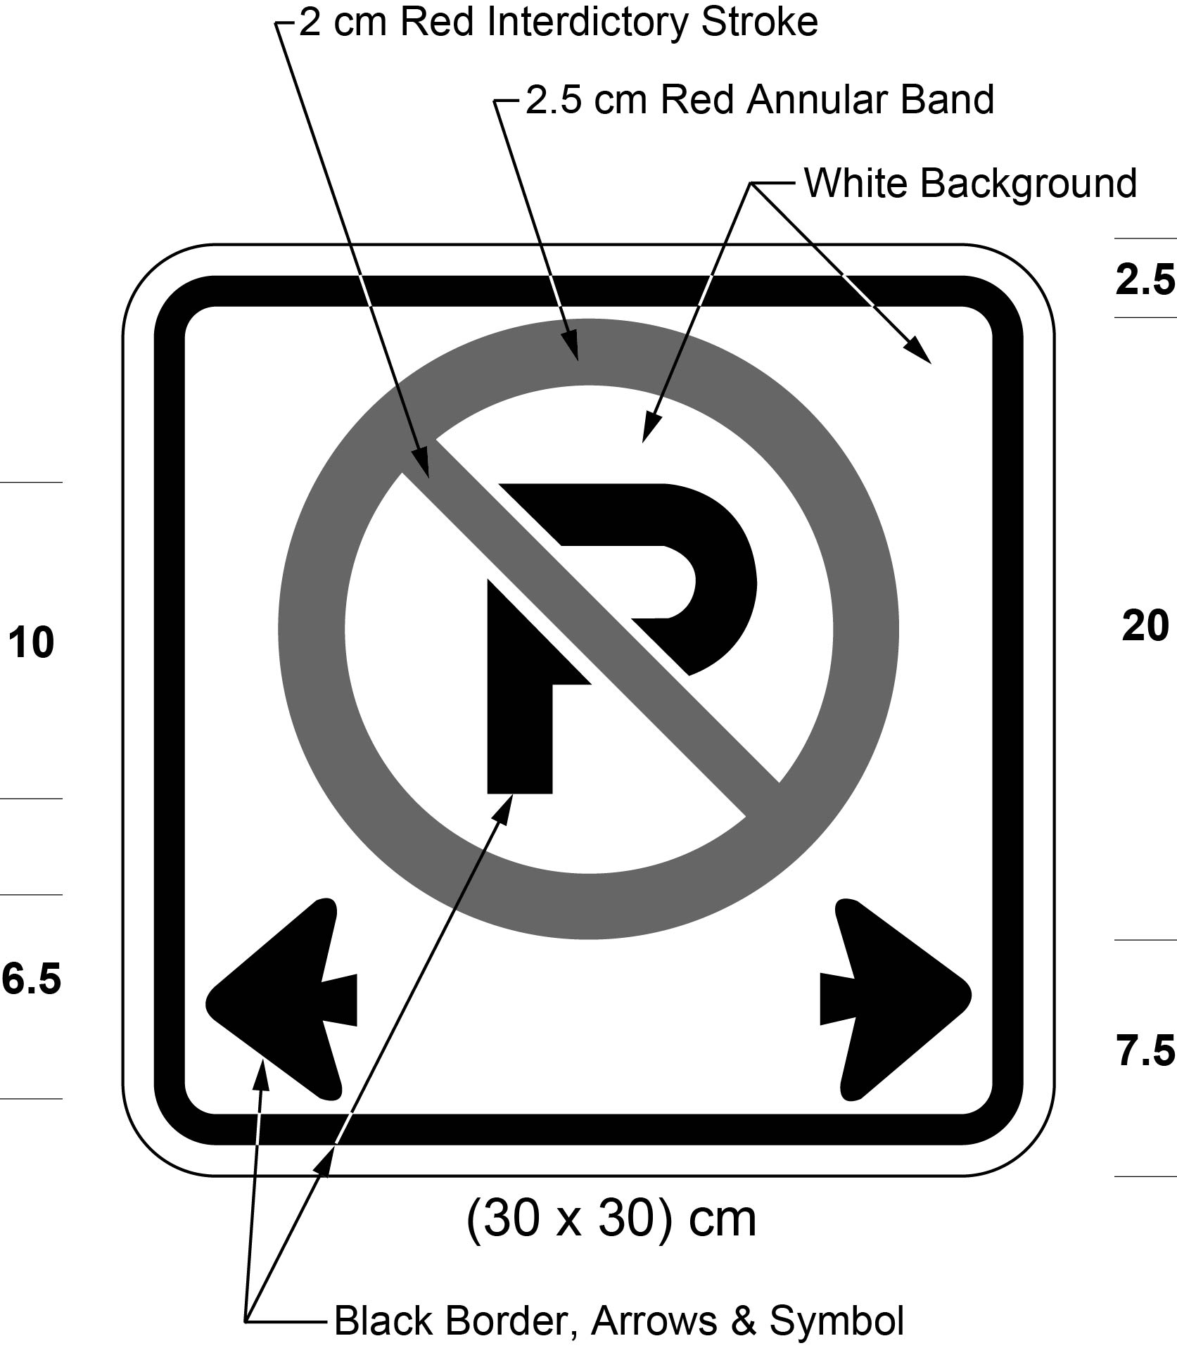
Text alternative: Illustration of a sign with a no parking symbol consisting of a black letter “P” inside a red circle with an interdictory stroke above two black arrows pointing left and right, on a white background with a black border. Indicated size (30 x 30) cm. This text alternative is provided for convenience only and does not form part of the official law.
4. The Figure to subsection 27 (2) of the Regulation is revoked and the following substituted:
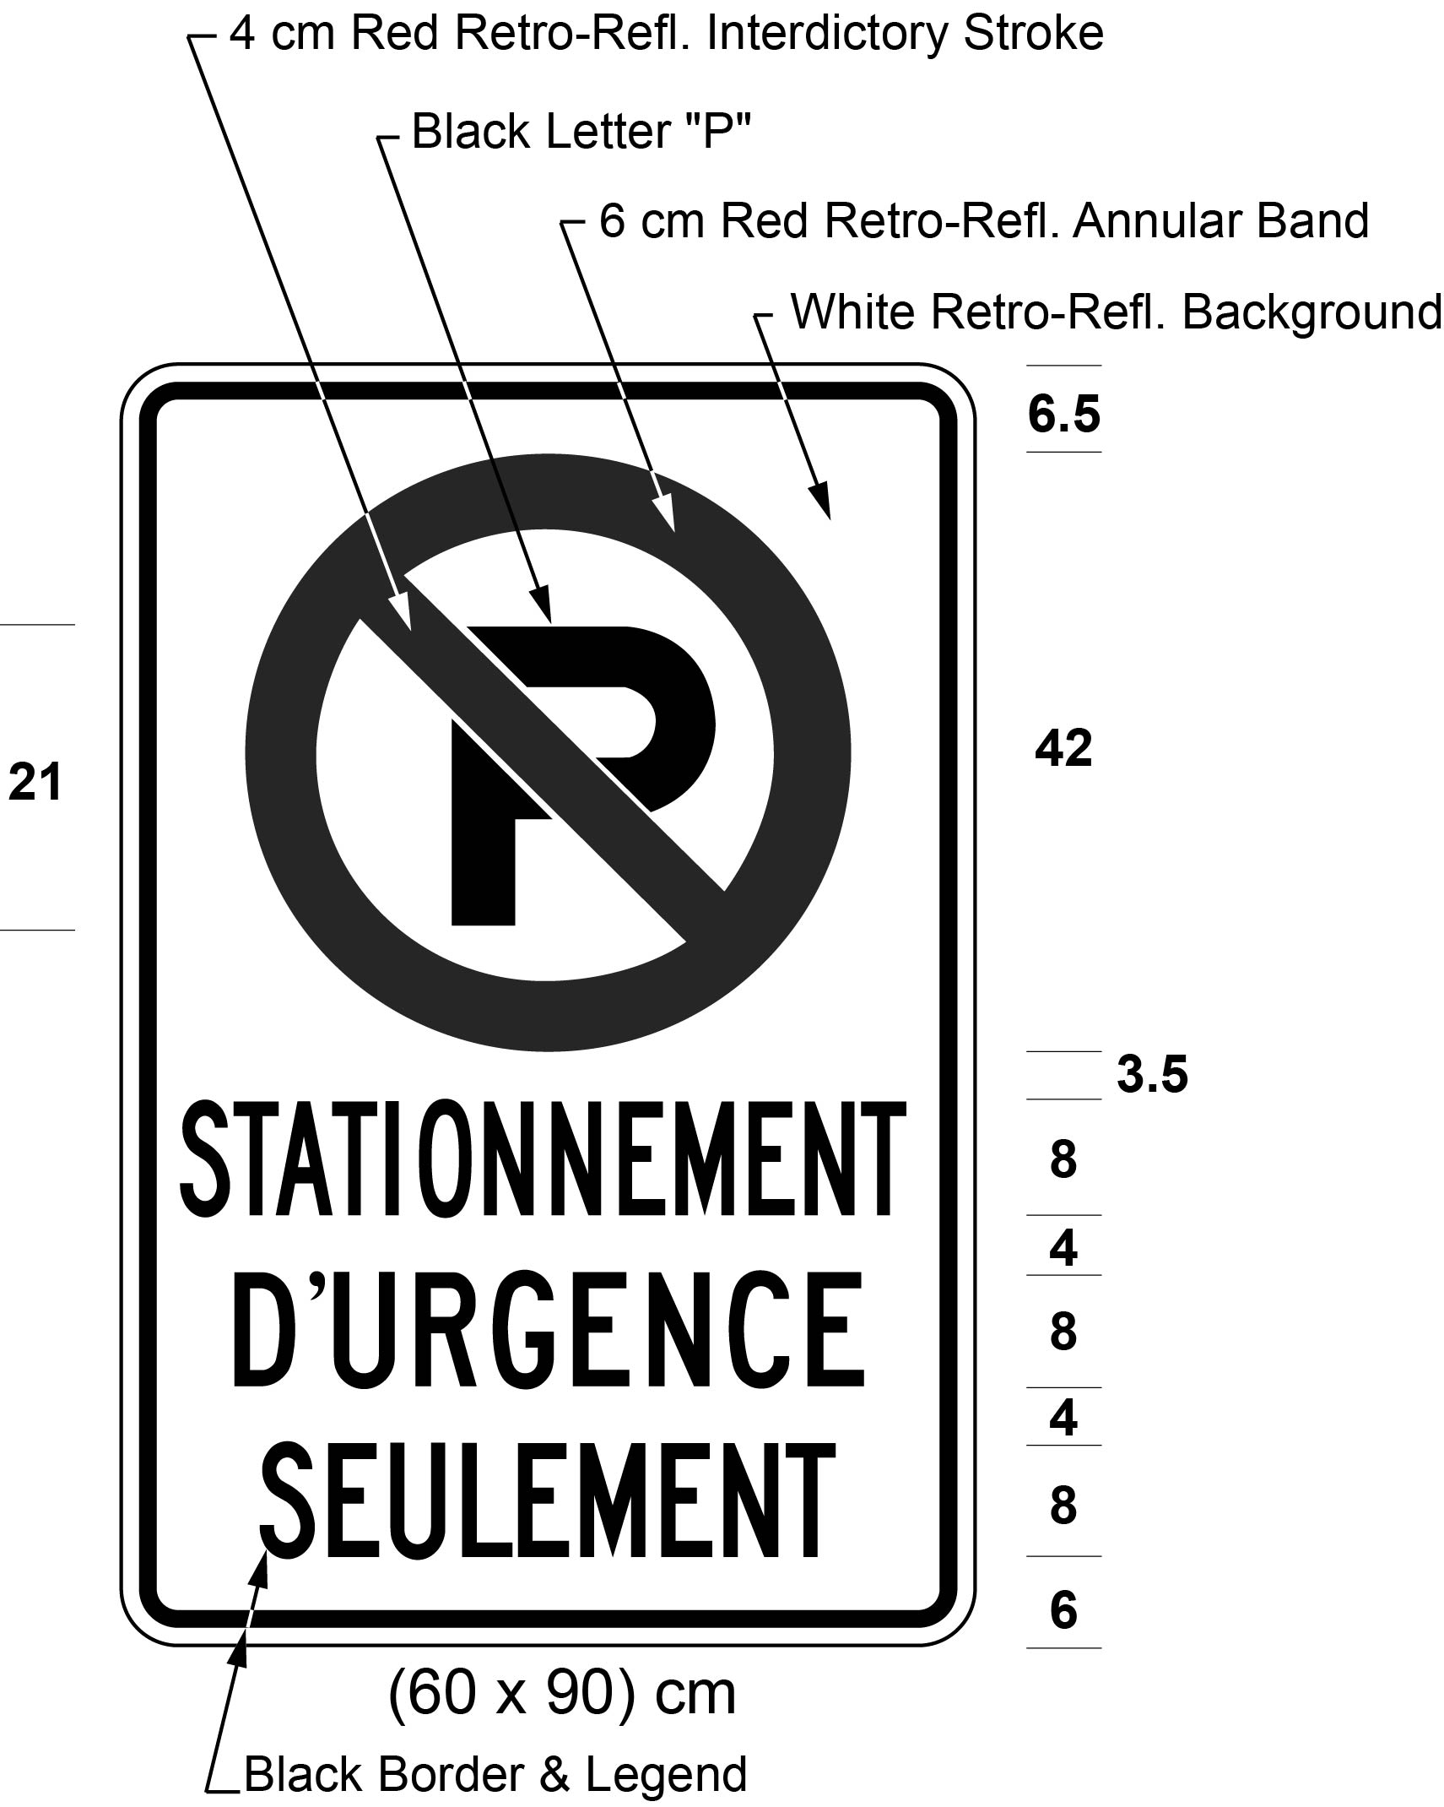
Text alternative: Illustration of a sign with a no parking symbol consisting of a black letter “P” inside a red circle with an interdictory stroke, above the text “STATIONNEMENT D’URGENCE SEULEMENT”, on white retro-reflective background with a black border. Indicated size (60 x 90) cm. This text alternative is provided for convenience only and does not form part of the official law.
5. The Figure to clause 30 (1) (b) of the Regulation is revoked and the following substituted:
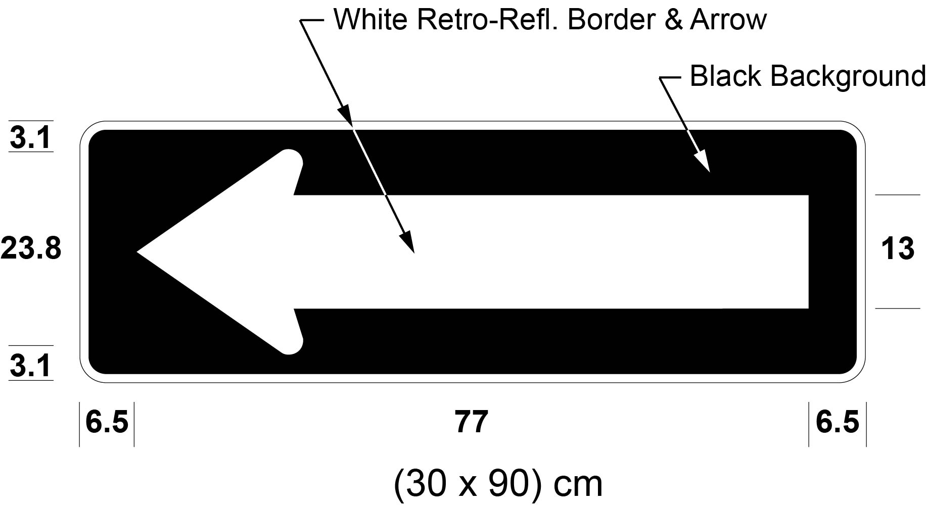
6. The Figure to subsection 32 (1) of the Regulation is revoked and the following substituted:
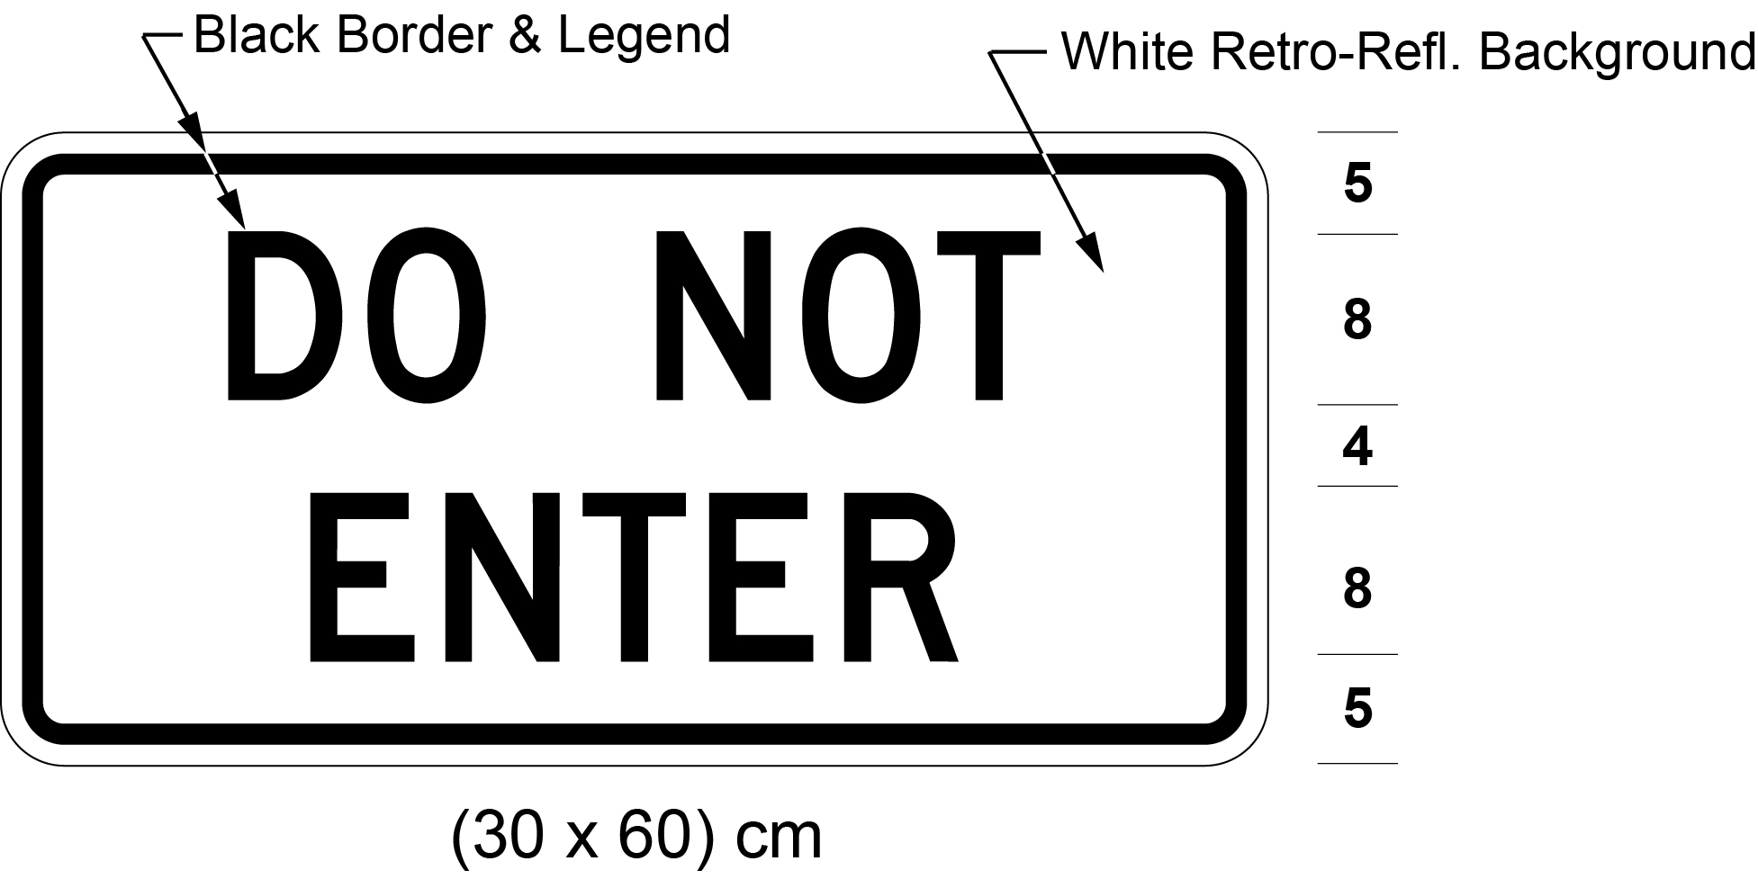
7. (1) Figures 3, 4, 5 and 6 to clause 34 (2) (d) of the Regulation are revoked and the following substituted:
Figure 3
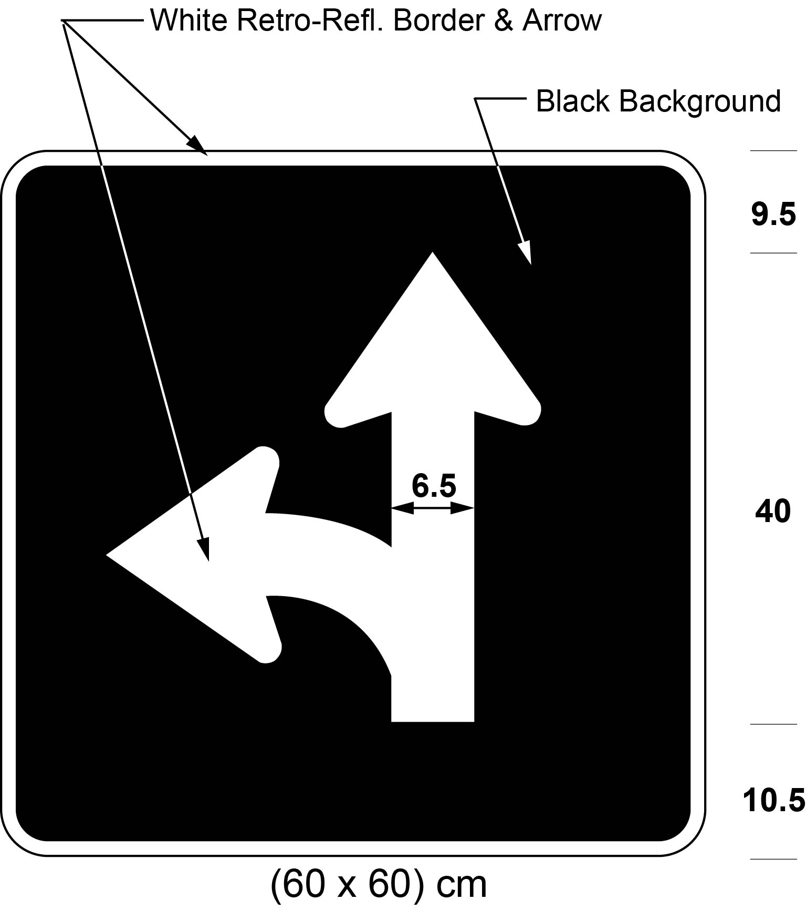
Figure 4
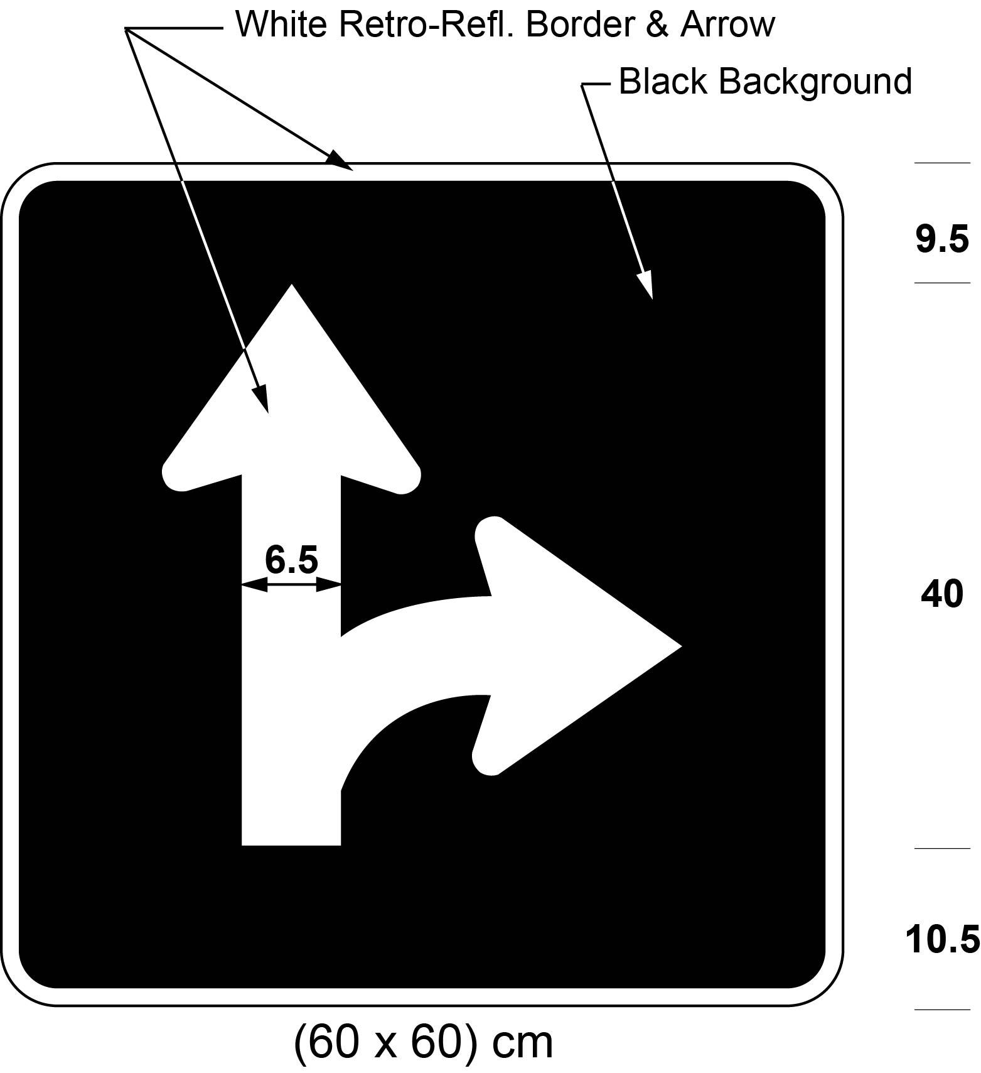
Figure 5
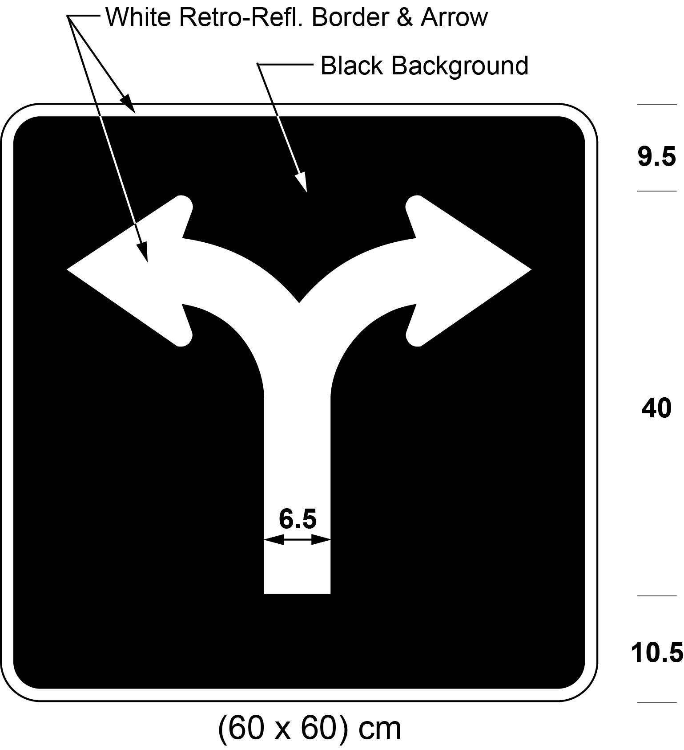
Figure 6
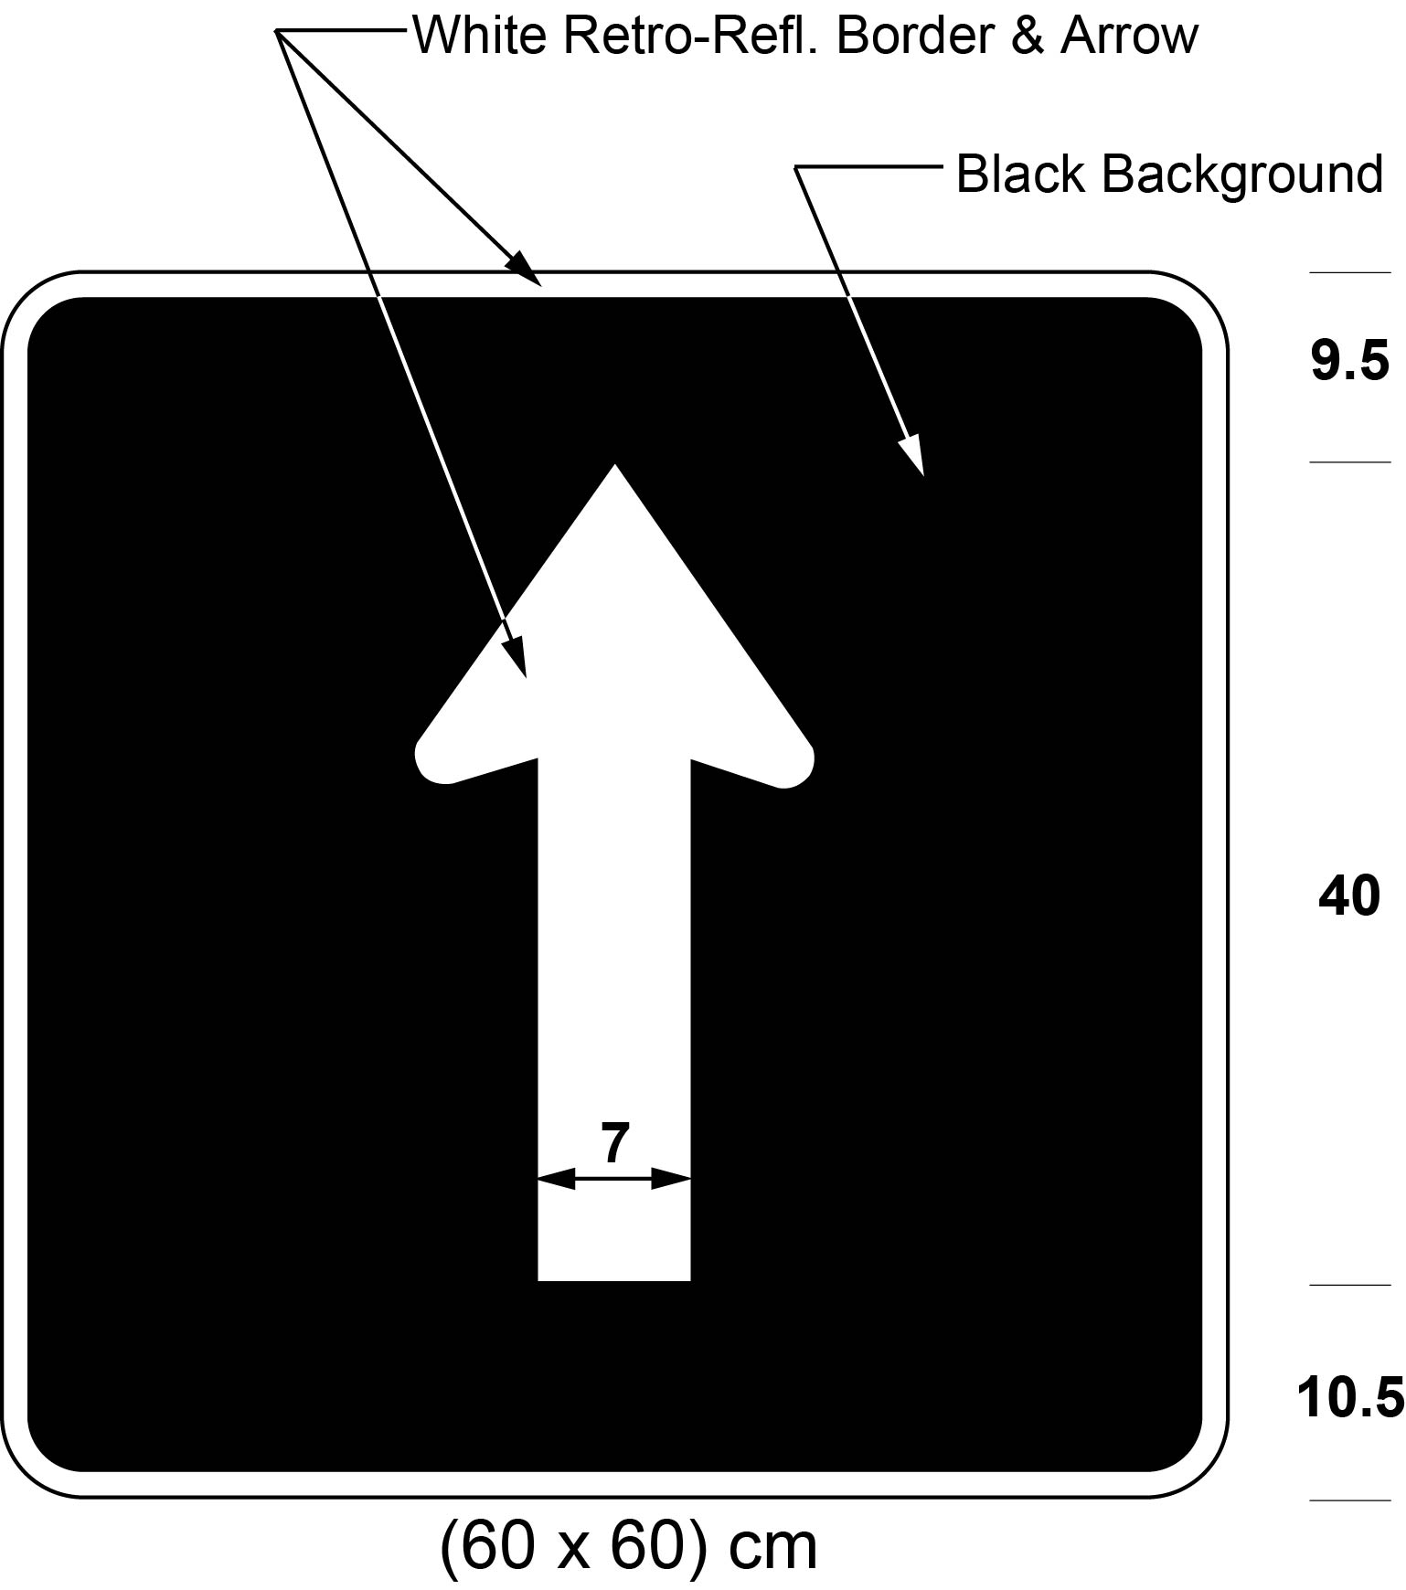
(2) Figure 2 to subsection 34 (6) of the Regulation is revoked and the following substituted:
Figure 2
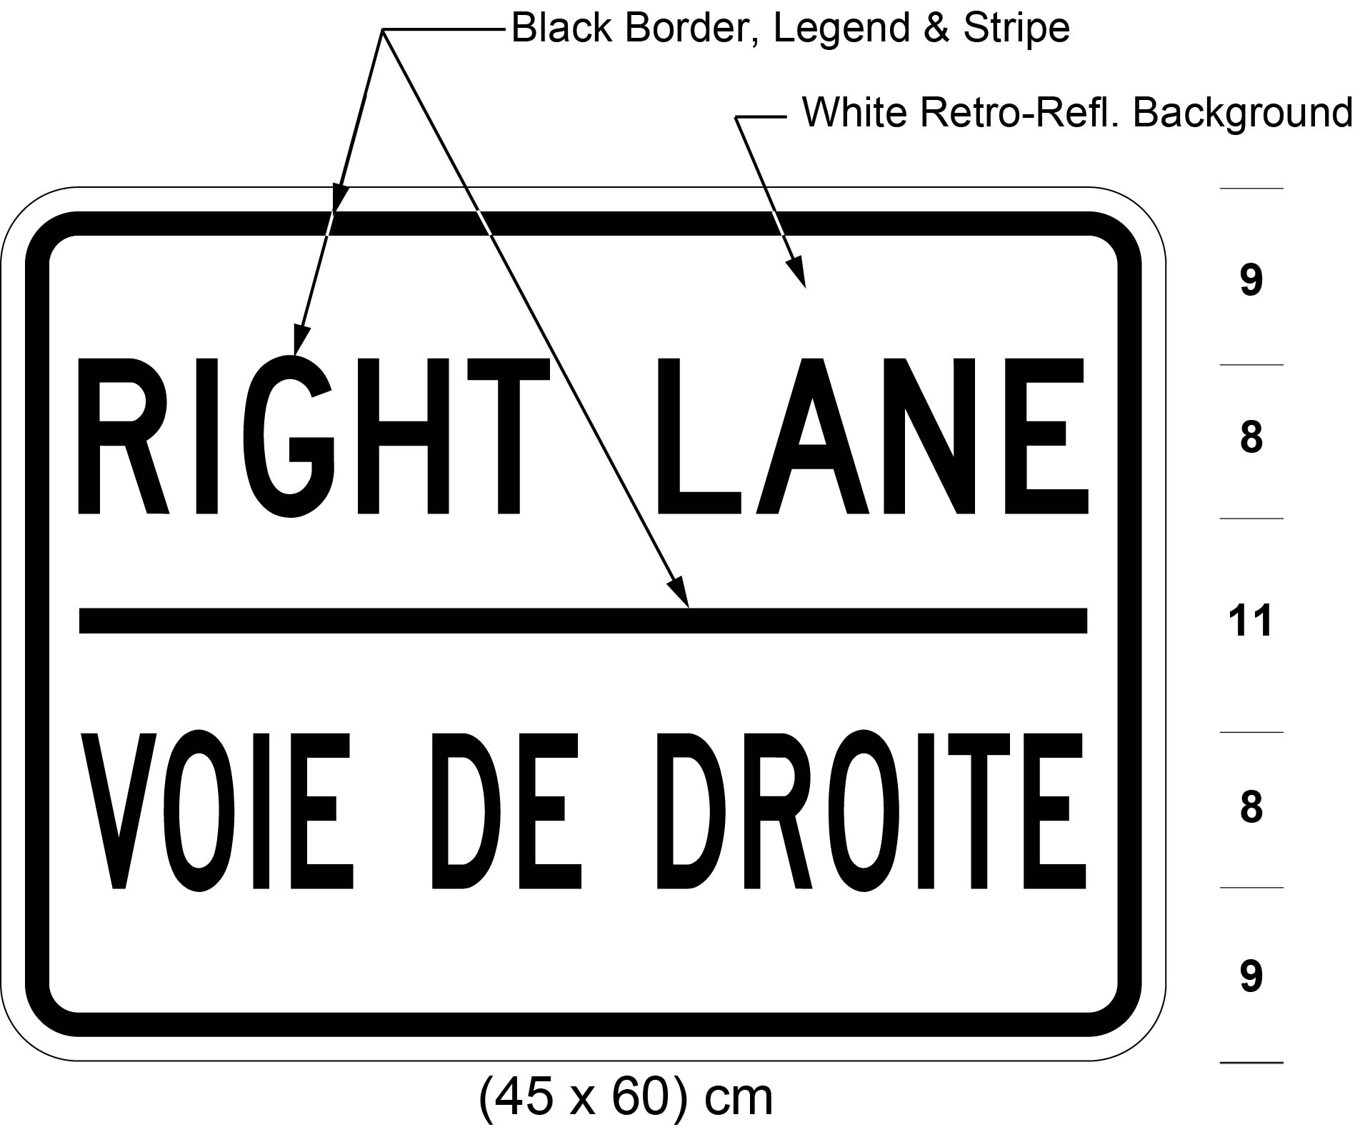
8. The Figure to clause 35 (b) of the Regulation is revoked and the following substituted:
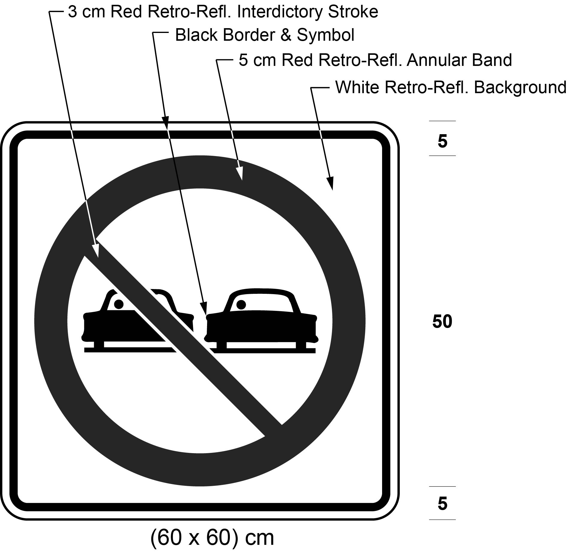
9. The Figure to clause 36 (b) of the Regulation is revoked and the following substituted:
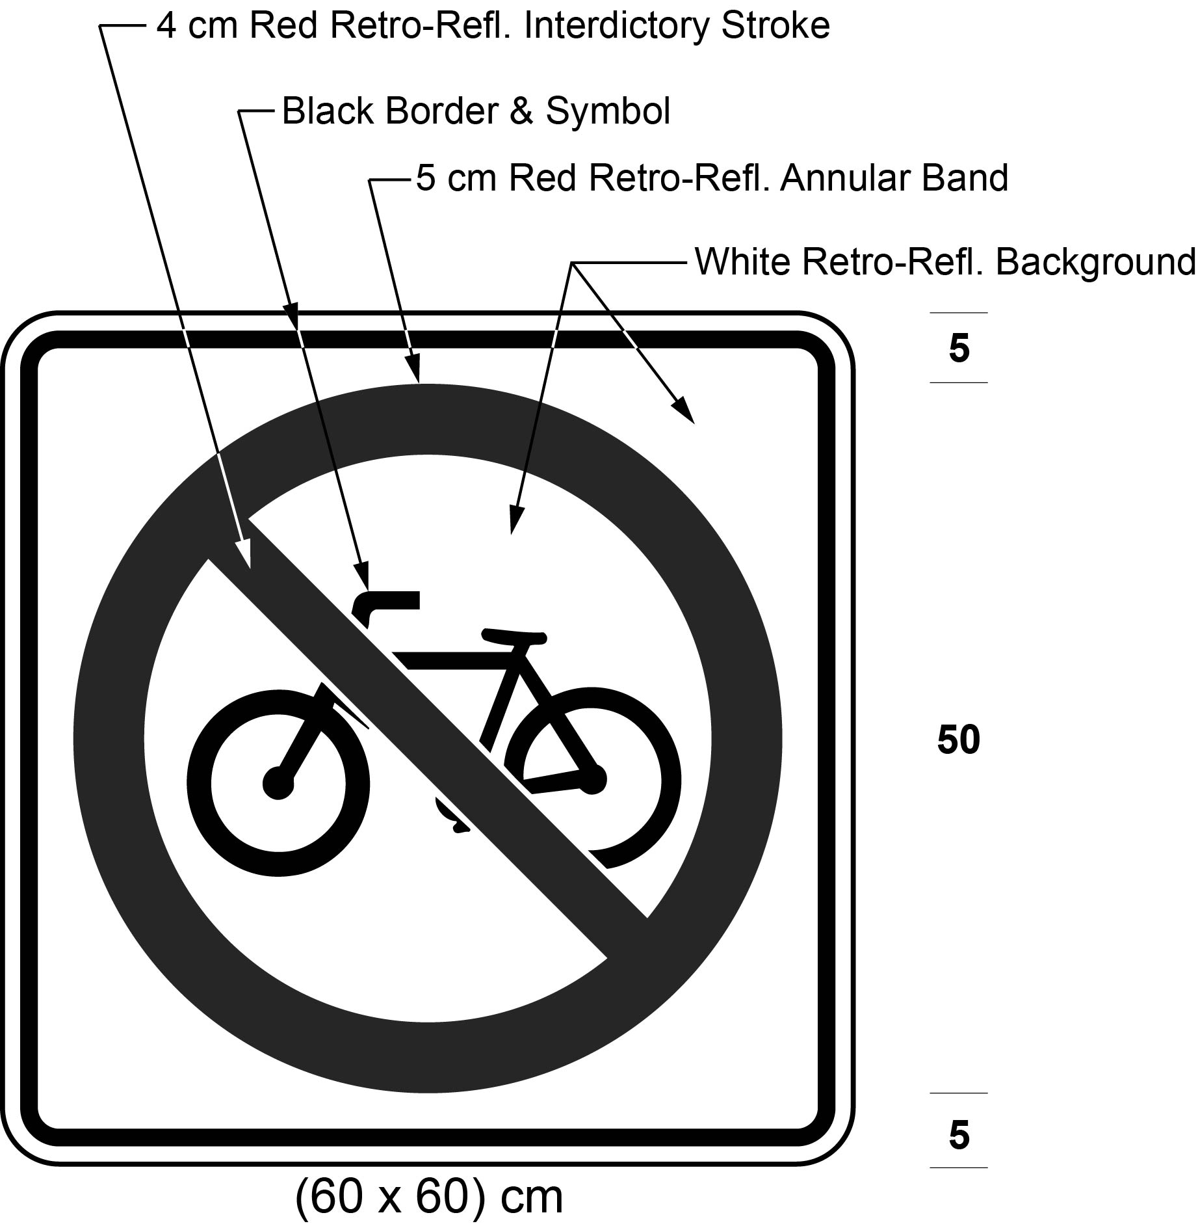
10. (1) Figure 1 to subclause 41 (1) (a) (iii) of the Regulation is revoked and the following substituted:
Figure 1
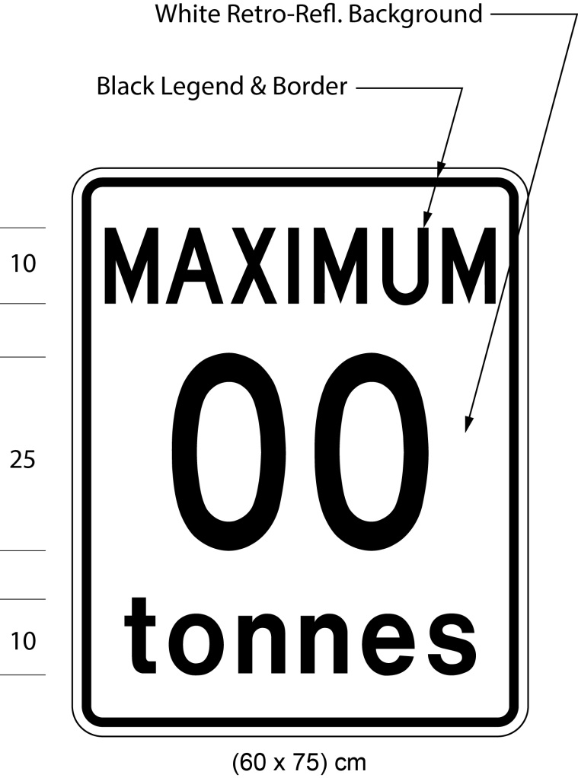
(2) Figure 2 to subclause 41 (1) (b) (vi) of the Regulation is revoked and the following substituted:
Figure 2
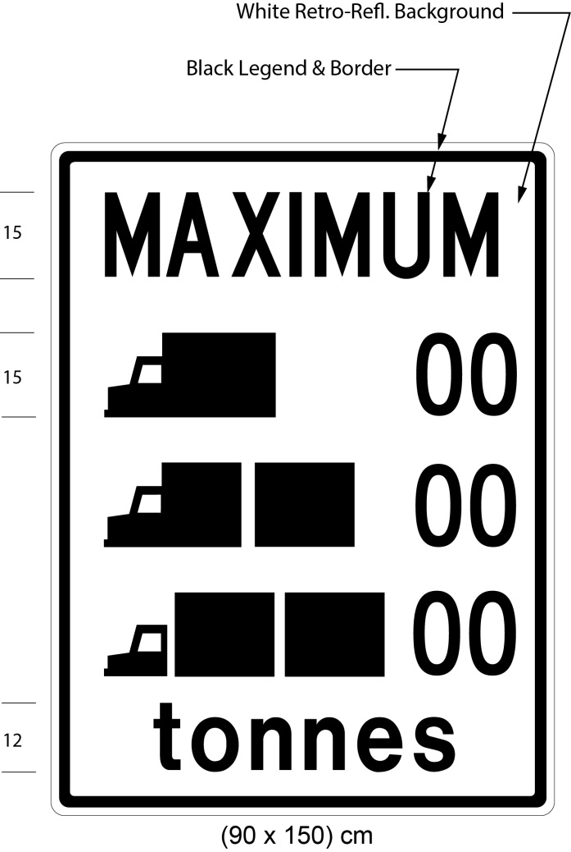
11. (1) The Figure to subsection 42 (2) of the Regulation is revoked and the following substituted:
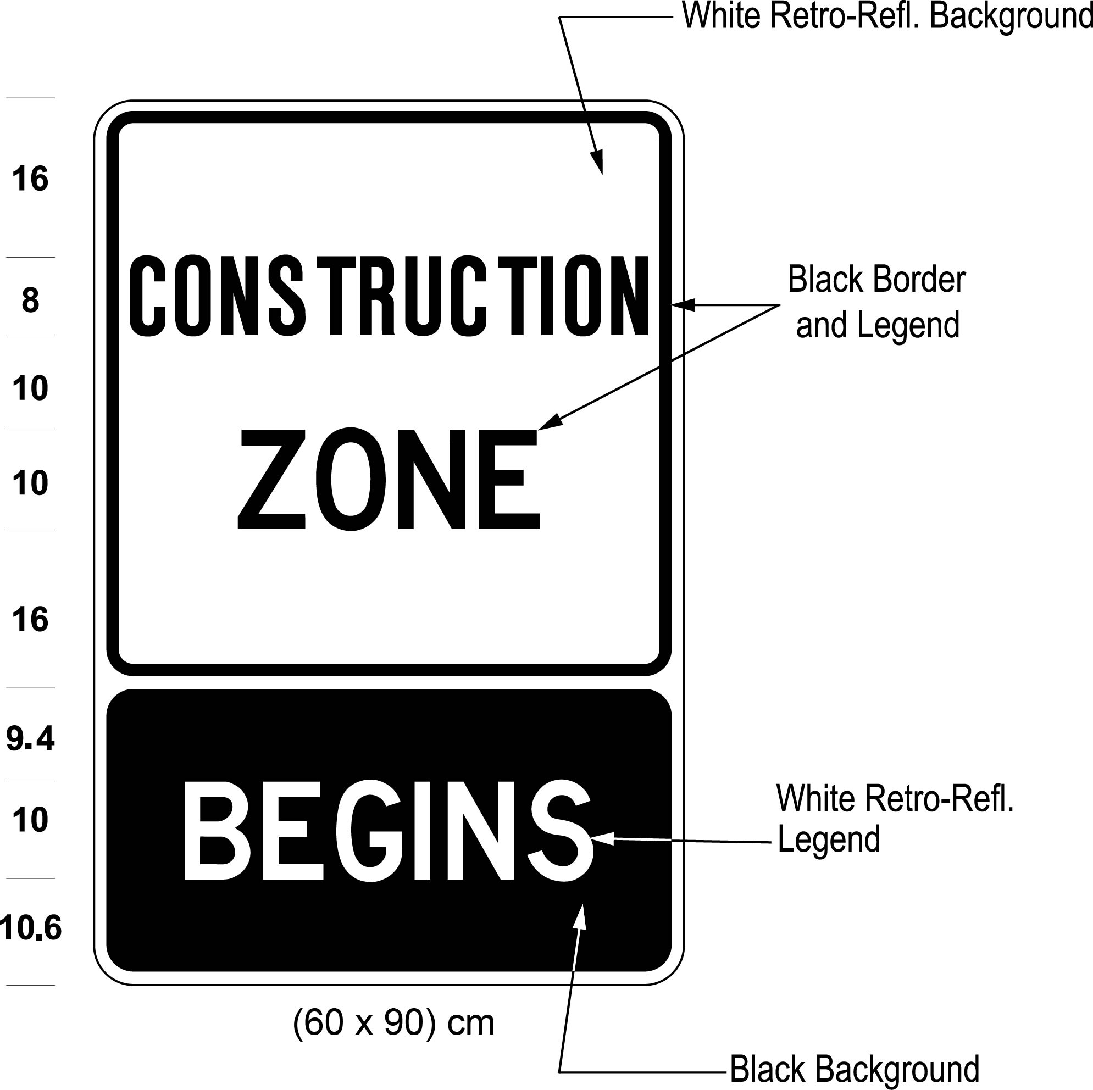
(2) The Figure to subsection 42 (3) of the Regulation is revoked and the following substituted:
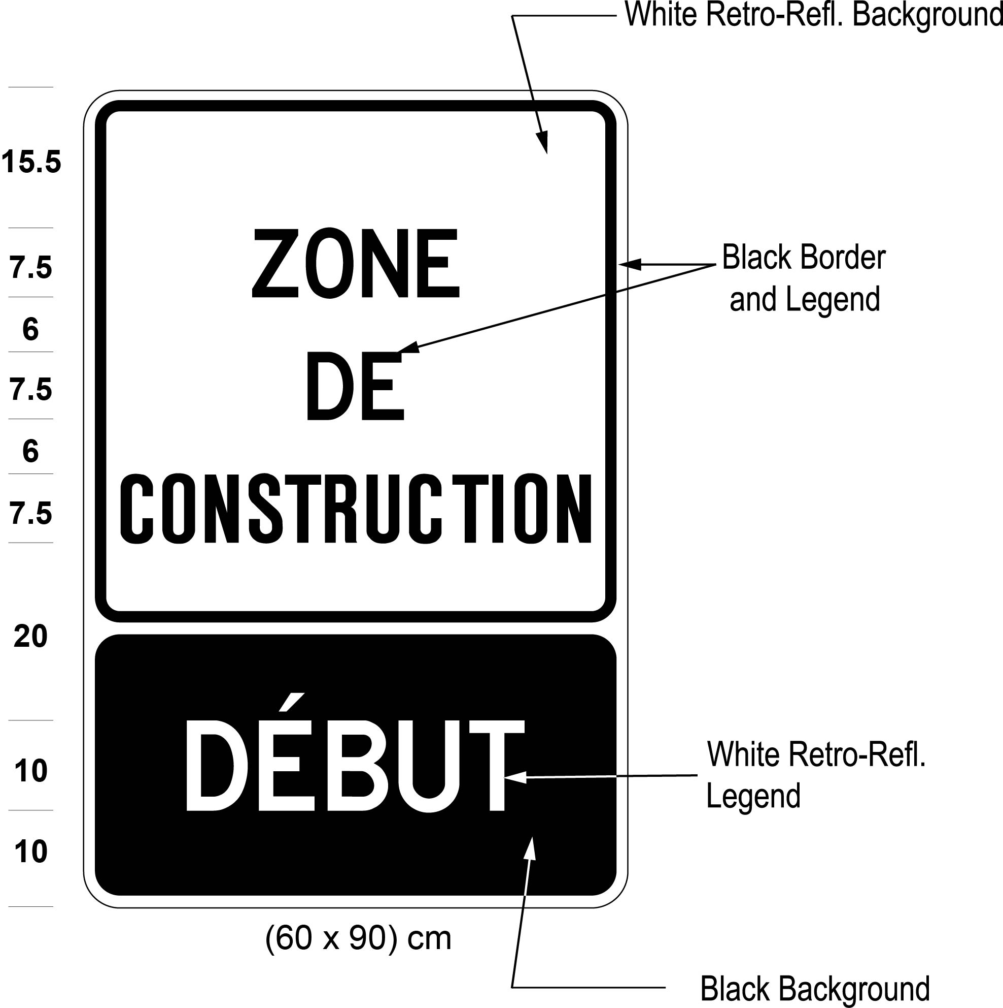
12. Figure 2 to section 43.1 of the Regulation is revoked and the following substituted:
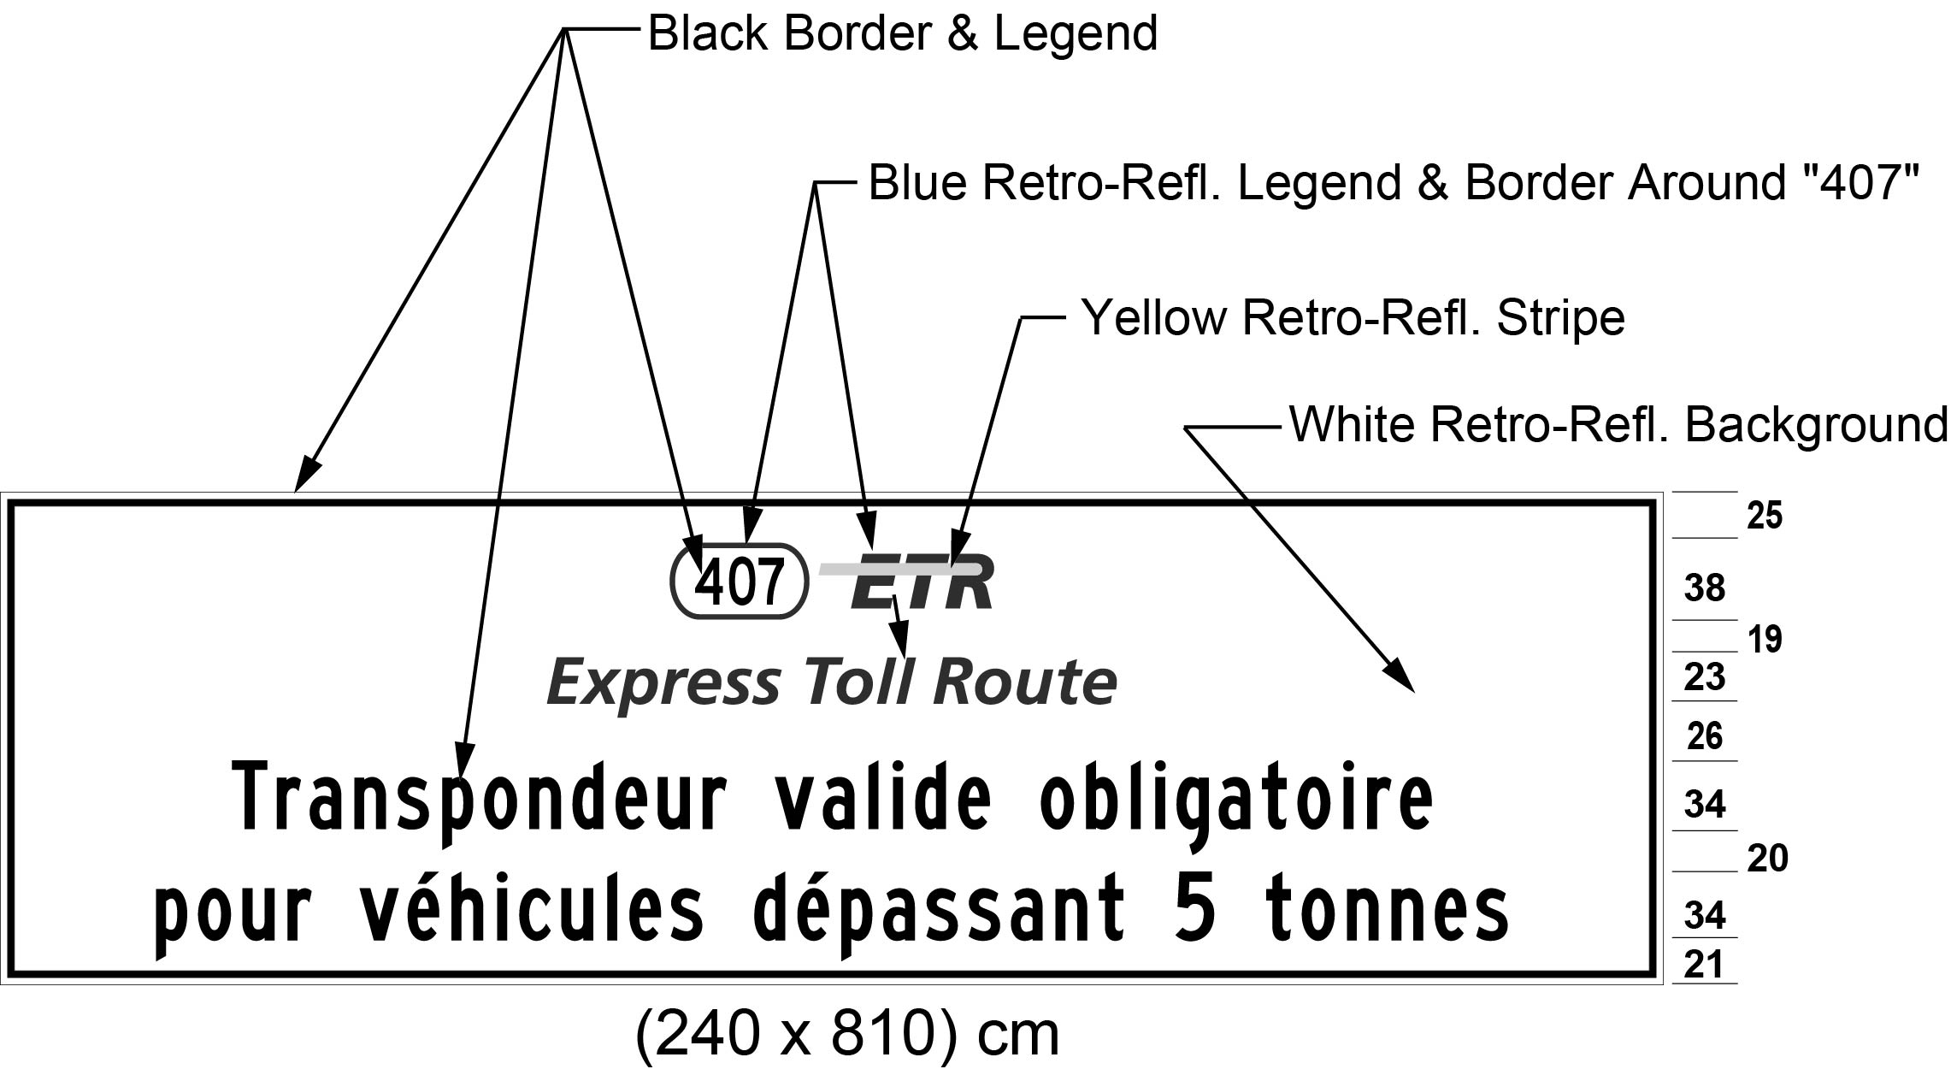
Text alternative: Illustration of sign with 407 ETR symbol above the words “Express Toll Route” and the text “Transpondeur valide obligatoire pour véhicules dépassant 5 tonnes”, on a white retro-reflective background with a black border. Indicated sign size: (240 x 810) cm. This text alternative is provided for convenience only and does not form part of the official law.
Commencement
13. This Regulation comes into force on the day it is filed.

Back to top

