ontario regulation 101/15
made under the
Highway Traffic Act
Made: April 29, 2015
Filed: May 1, 2015
Published on e-Laws: May 1, 2015
Printed in The Ontario Gazette: May 16, 2015
Amending O. Reg. 620/05
(HIGH OCCUPANCY VEHICLE LANES)
1. (1) Paragraph 1 of section 7 of Ontario Regulation 620/05 is amended by striking out “three persons” and substituting “two persons”.
(2) Subparagraph 2 i of section 7 of the Regulation is amended by striking out “three persons” and substituting “two persons”.
2. (1) Subsection 10 (1) of the Regulation is amended by striking out Figure B.1 and substituting the following:
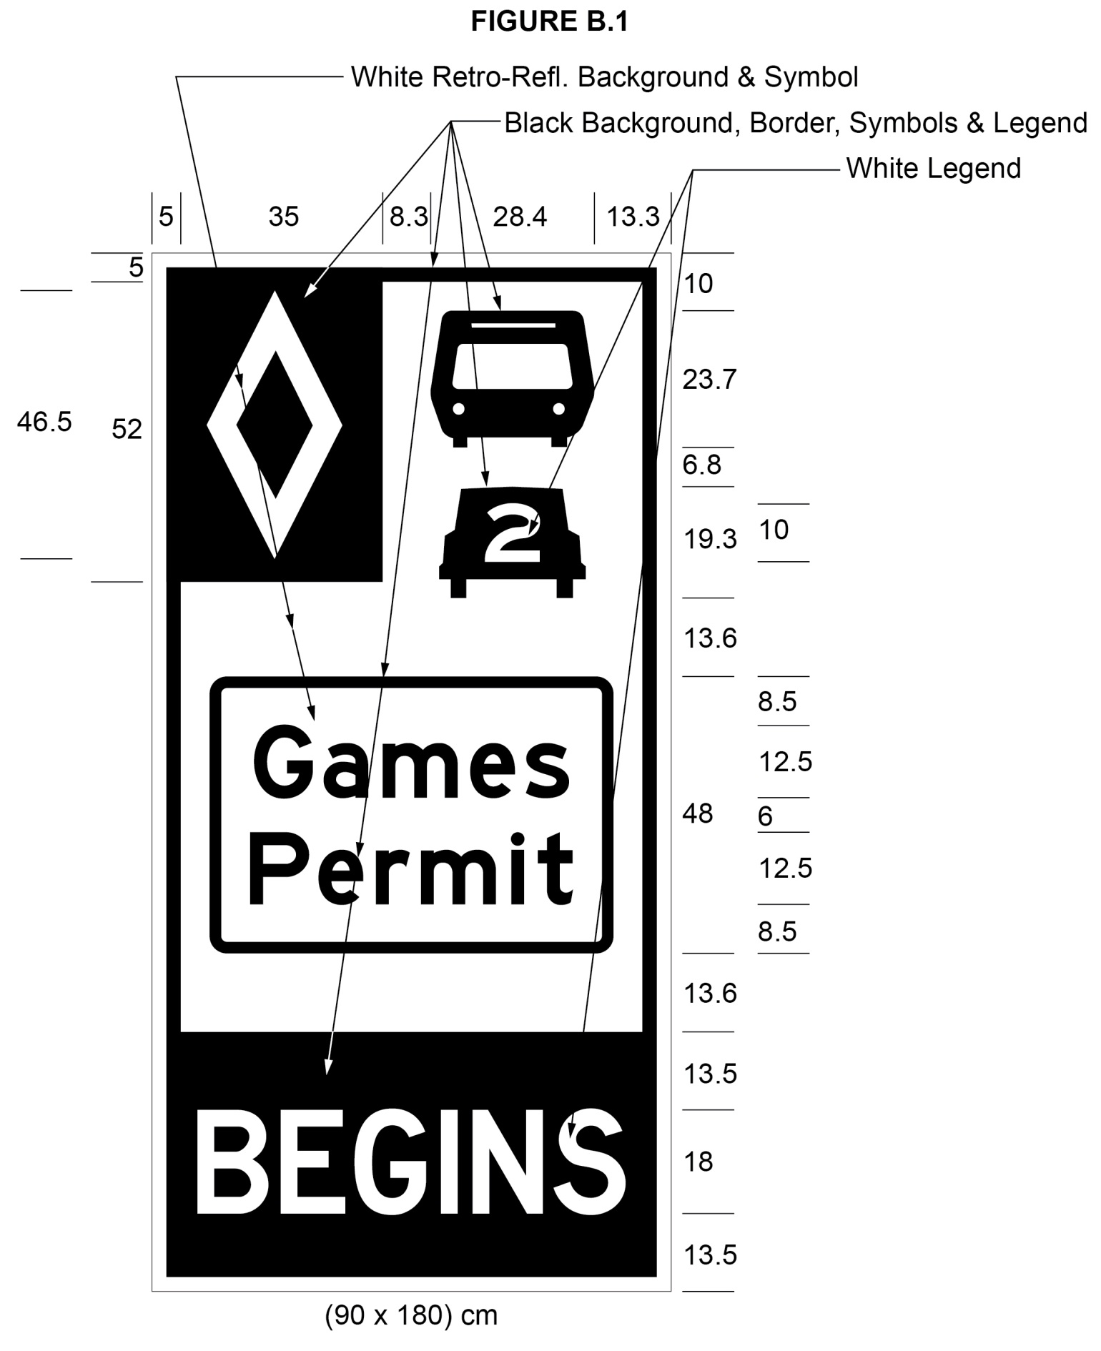
Text alternative: Illustration of a high occupancy vehicle lane sign labeled as “Figure B.1”. The sign contains two rectangles, stacked on top of one another. The top rectangle has a white reflective background and contains a symbol of a bus on top of a symbol of a car with the number “2” inside it. A white diamond shape in a small black rectangle appears in the upper left corner of this rectangle. Below that, in the middle of the sign, are the words “Games Permit” in black letters inside the black outline of a rectangle. The bottom rectangle contains the word “BEGINS” in white letters on a reflective black background. The following measurements are written below the sign: (90 x 180) cm. The sign is surrounded by measurements of its different elements. This text alternative is provided for convenience only and does not form part of the official law.
(2) Subsection 10 (2) of the Regulation is amended by striking out Figure C.1 and substituting the following:
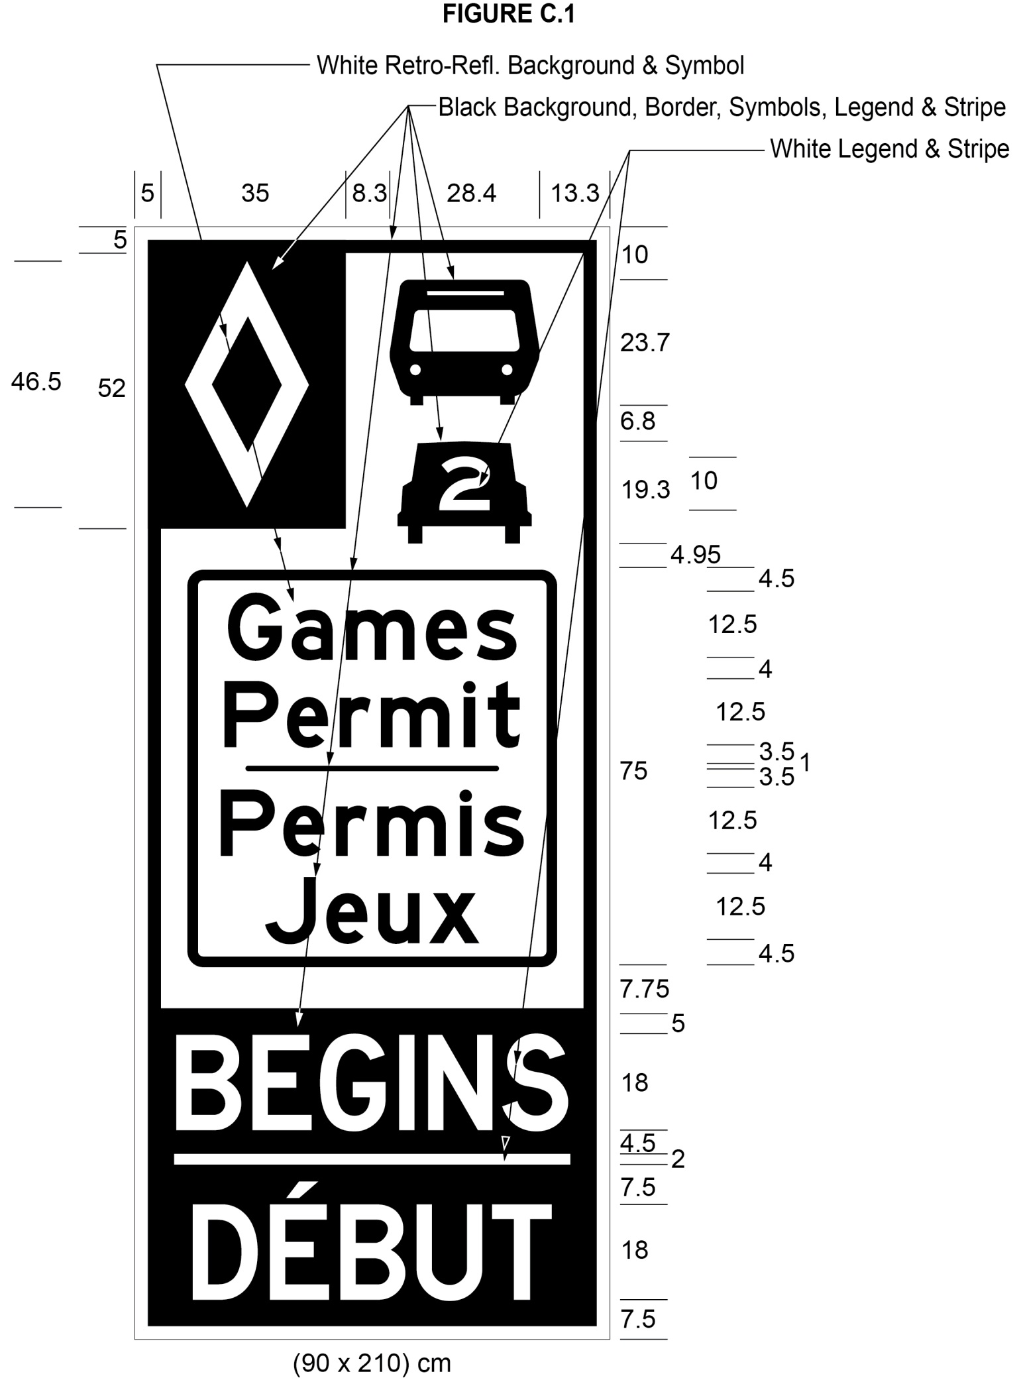
Text alternative: Illustration of a high occupancy vehicle lane sign labeled as “Figure C.1”. The sign contains two rectangles, stacked on top of one another. The top rectangle has a white reflective background and contains a symbol of a bus on top of a symbol of a car with the number “2” inside it. A white diamond shape in a small black rectangle appears in the upper left corner of this rectangle. Below that, in the middle of the sign, are the words “Games Permit/Permis Jeux” in black letters inside the black outline of a rectangle. The bottom rectangle contains the word “BEGINS/DÉBUT” in white letters on a reflective black background. The following measurements are written below the sign: (90 x 210) cm. The sign is surrounded by measurements of its different elements. This text alternative is provided for convenience only and does not form part of the official law.
(3) Subsection 10 (3) of the Regulation is amended by striking out Figure D.1 and substituting the following:
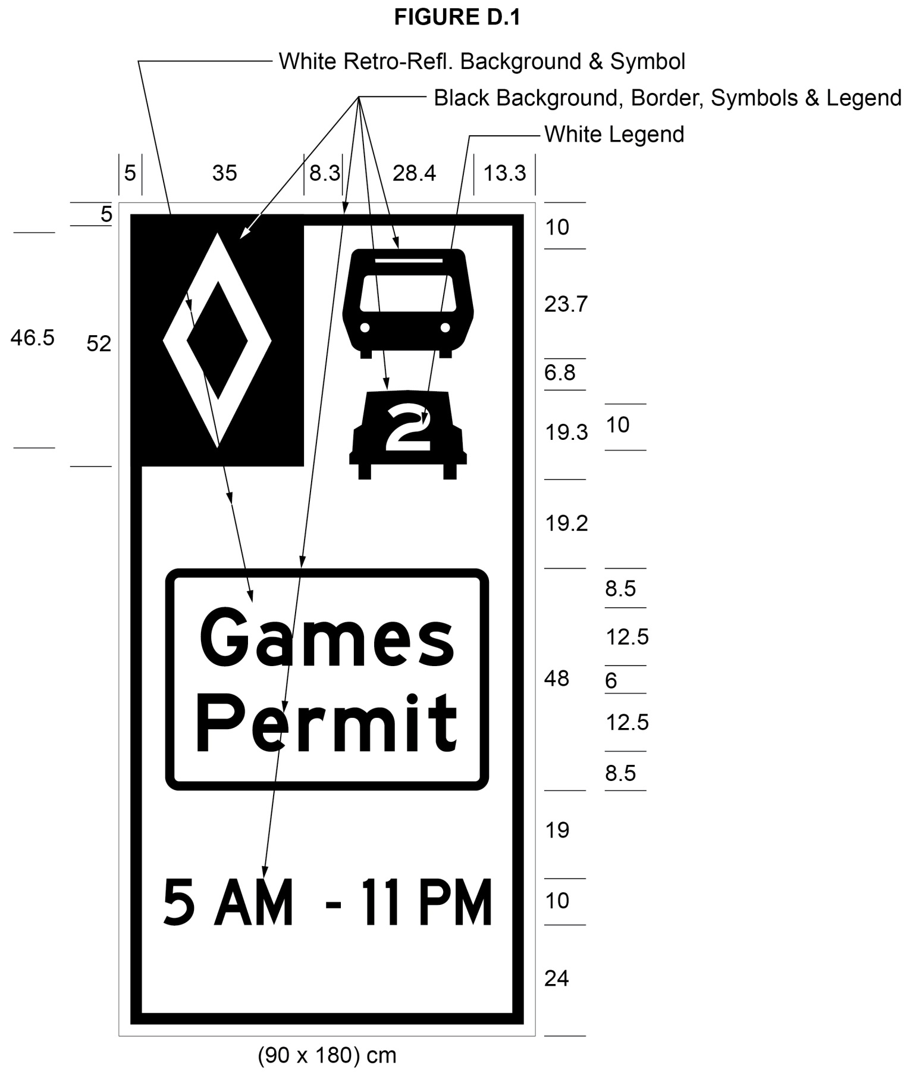
Text alternative: Illustration of a high occupancy vehicle lane sign labeled as “Figure D.1”. The sign has a white reflective background and contains a symbol of a bus on top of a symbol of a car with the number “2” inside it. A white diamond shape in a small black rectangle appears in the upper left corner of this rectangle. Below that, in the middle of the sign are the words “Games Permit” in black letters inside the black outline of a rectangle. The text “5 AM – 11 PM” appears at the bottom of the sign in black letters on a white reflective background. The following measurements are written below the sign: (90 x 180) cm. The sign is surrounded by measurements of its different elements. This text alternative is provided for convenience only and does not form part of the official law.
(4) Subsection 10 (4) of the Regulation is amended by striking out Figure E.1 and substituting the following:
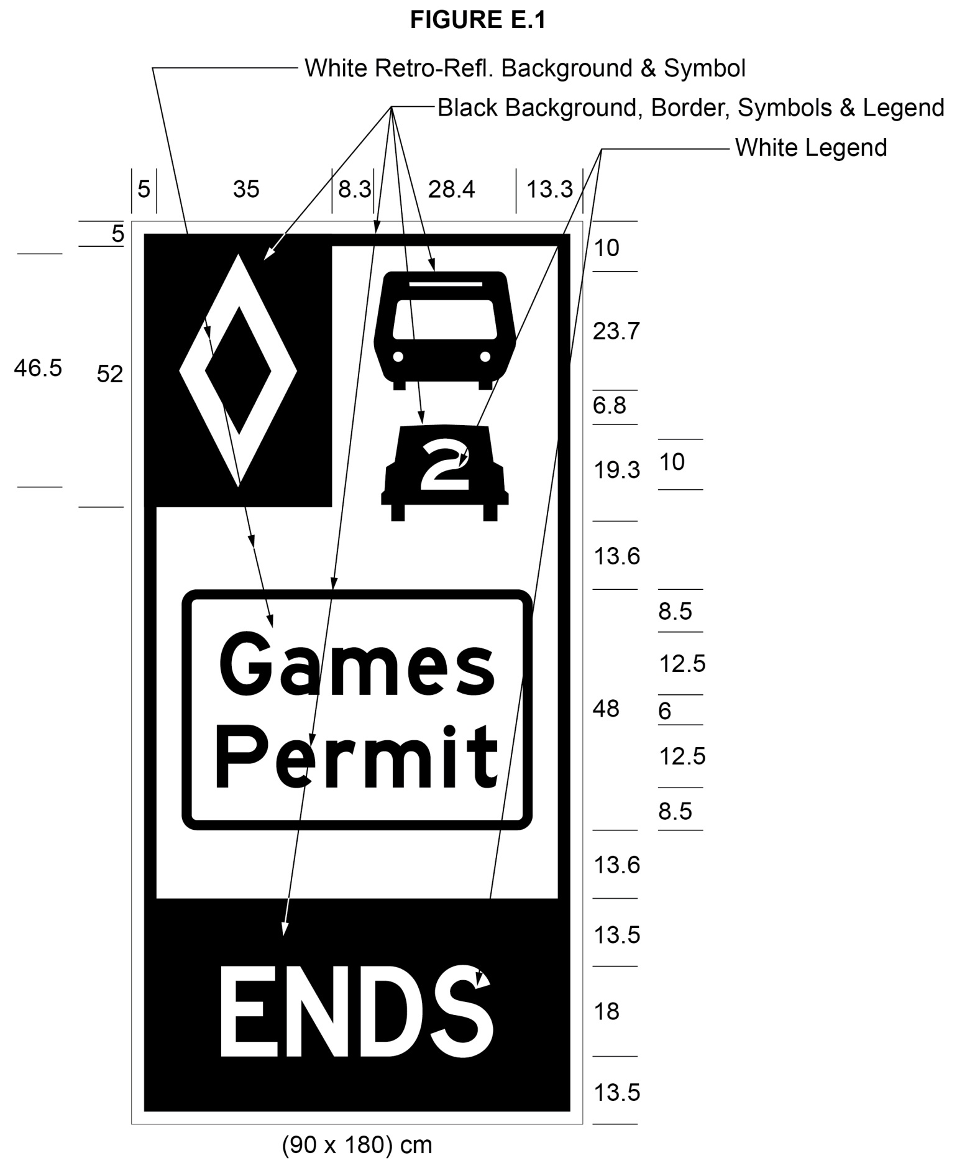
Text alternative: Illustration of a high occupancy vehicle lane sign labeled as “Figure E.1”. The sign contains two rectangles, stacked on top of one another. The top rectangle has a white reflective background and contains a symbol of a bus on top of a symbol of a car with the number “2” inside it. A white diamond shape in a small black rectangle appears in the upper left corner of this rectangle. Below that, in the middle of the sign, are the words “Games Permit” in black letters inside the black outline of a rectangle. The bottom rectangle contains the word “ENDS” in white letters on a reflective black background. The following measurements are written below the sign: (90 x 180) cm. The sign is surrounded by measurements of its different elements. This text alternative is provided for convenience only and does not form part of the official law.
(5) Subsection 10 (5) of the Regulation is amended by striking out Figure G.1 and substituting the following:
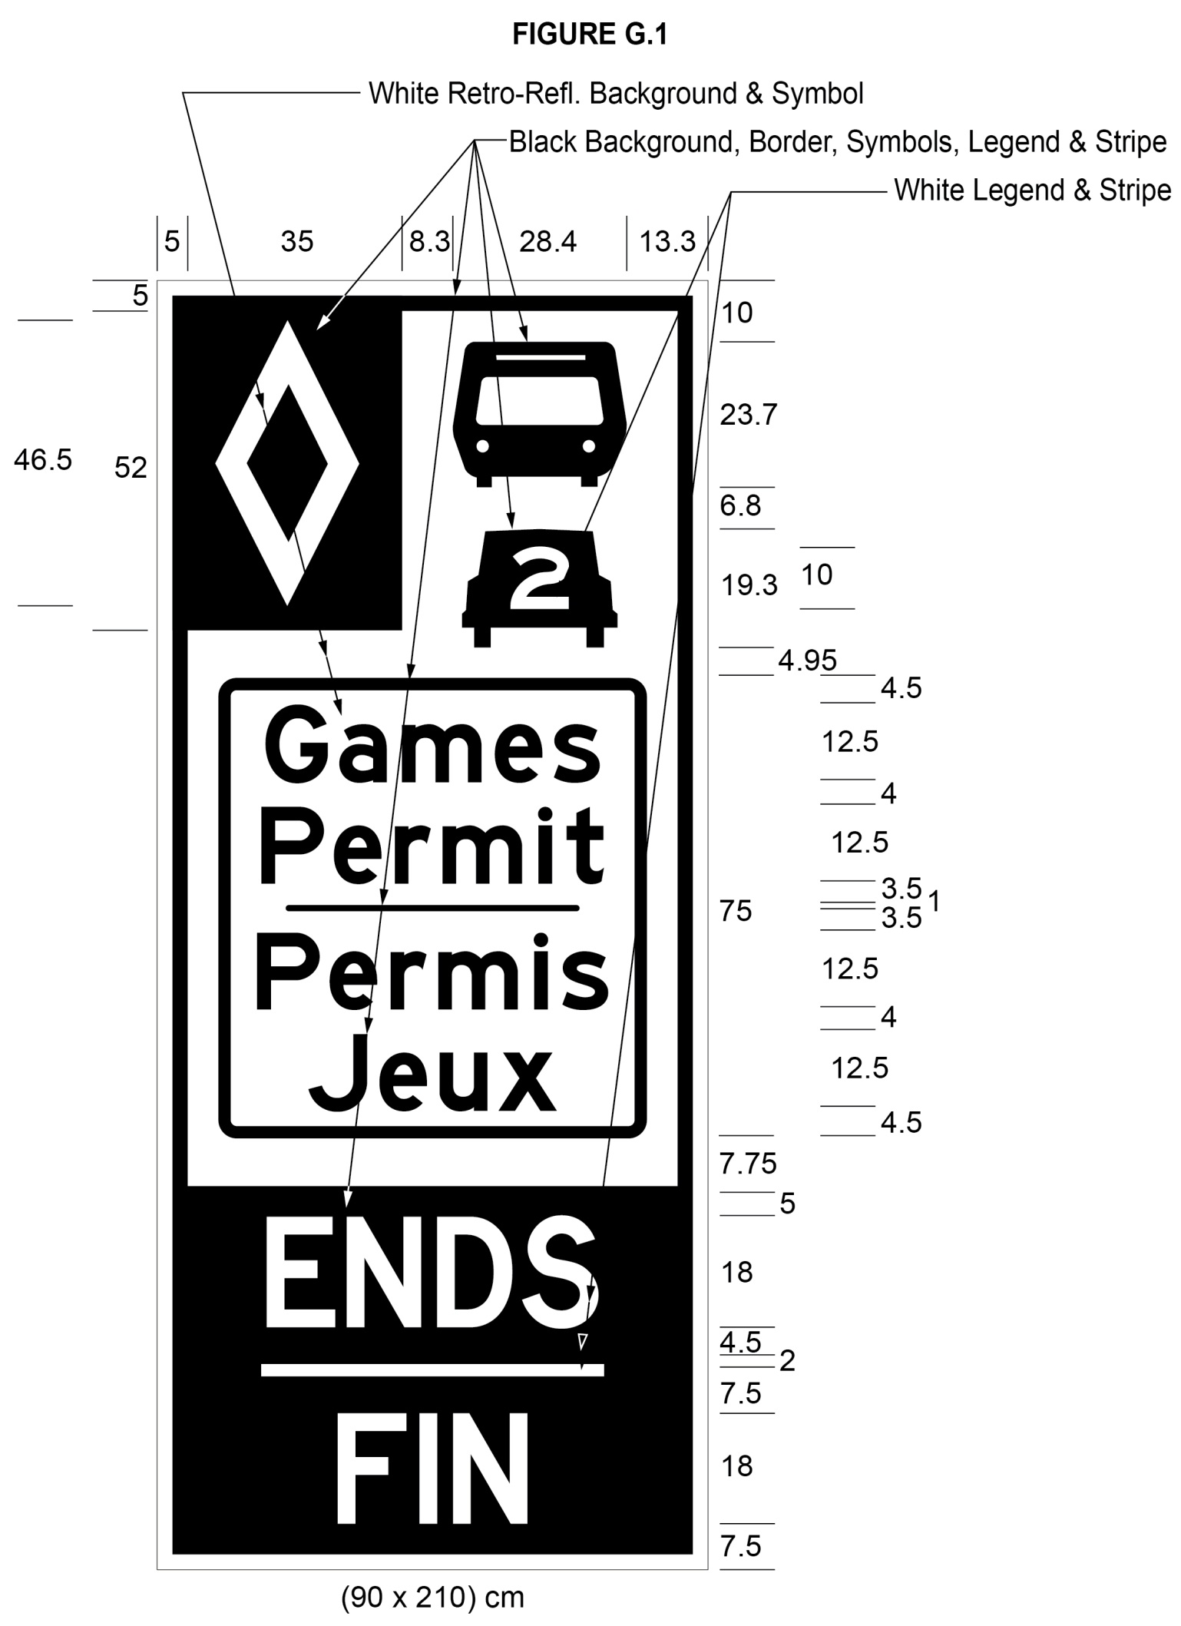
Text alternative: Illustration of a high occupancy vehicle lane sign labeled as “Figure G.1”. The sign contains two rectangles, stacked on top of one another. The top rectangle has a white reflective background and contains a symbol of a bus on top of a symbol of a car with the number “2” inside it. A white diamond shape in a small black rectangle appears in the upper left corner of this rectangle. Below that, in the middle of the sign, are the words “Games Permit/Permis Jeux” in black letters inside the black outline of a rectangle. The bottom rectangle contains the word “ENDS/FIN” in white letters on a reflective black background. The following measurements are written below the sign: (90 x 210) cm. The sign is surrounded by measurements of its different elements. This text alternative is provided for convenience only and does not form part of the official law.
Commencement
3. This Regulation comes into force on the later of July 28, 2015 and the day this Regulation is filed.
Made by:
Steven Del Duca
Minister of Transportation
Date made: April 29, 2015.

Back to top

