ontario regulation 301/18
made under the
Highway Traffic Act
Made: April 18, 2018
Filed: April 23, 2018
Published on e-Laws: April 23, 2018
Printed in The Ontario Gazette: May 12, 2018
Amending Reg. 615 of R.R.O. 1990
(SIGNS)
1. Regulation 615 of the Revised Regulations of Ontario, 1990 is amended by adding the following section:
5.1.1 (1) For the purposes of subsection 128 (2.1) of the Act, a speed limit sign as prescribed in section 1 shall be erected indicating the commencement of a designated area within which a maximum rate of speed for all highways within that area has been prescribed to be a rate of speed lower than that specified in clause 128 (1) (a) of the Act.
(2) The speed limit sign shall be erected on each highway that enters the designated area at the boundary of the designated area.
(3) The speed limit sign shall be accompanied immediately below by a sign bearing the markings and having the dimensions as illustrated in the following Figure:
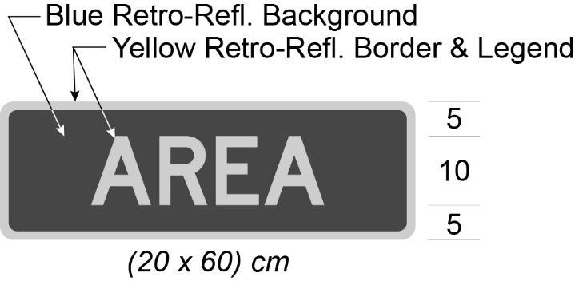
(4) Despite subsection (3), in an area designated by the French Language Services Act, the speed limit sign shall be accompanied immediately below by a sign bearing the markings and having the dimensions as illustrated in the following Figure:
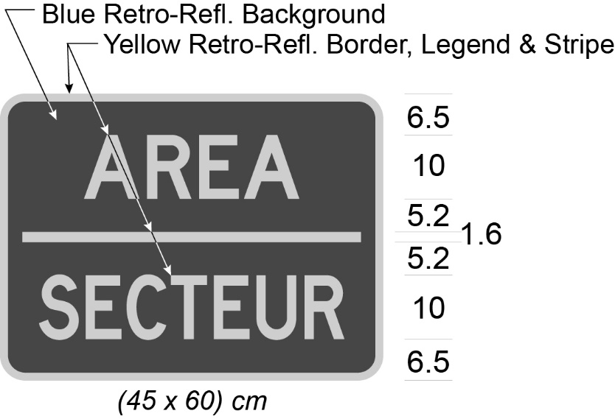
(5) The speed limit sign and sign required by subsection (3) shall be accompanied immediately below by a sign described in subsection 3 (1).
(6) Despite subsection (5), in an area designated by the French Language Services Act, the speed limit sign and sign required by subsection (4) shall be accompanied immediately below by a sign described in subsection 3 (2).
(7) Where the designated area referred to in subsection (1) comes to an end, a speed limit sign described in subsection (1) shall be erected and shall be accompanied immediately below by a sign required by subsection (3) and by a sign bearing the markings and having the dimensions as illustrated in the following Figure:
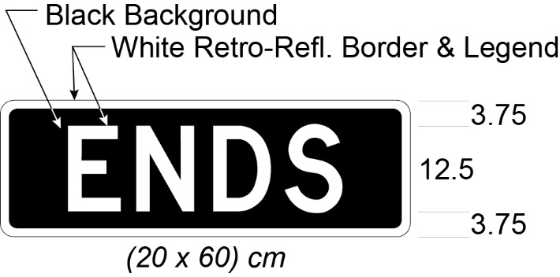
(8) Despite subsection (7), in an area designated by the French Language Services Act, where the designated area referred to in subsection (1) comes to an end, a speed limit sign described in subsection (1) shall be erected and shall be accompanied immediately below by a sign required by subsection (4) and by a sign bearing the markings and having the dimensions as illustrated in the following Figure:
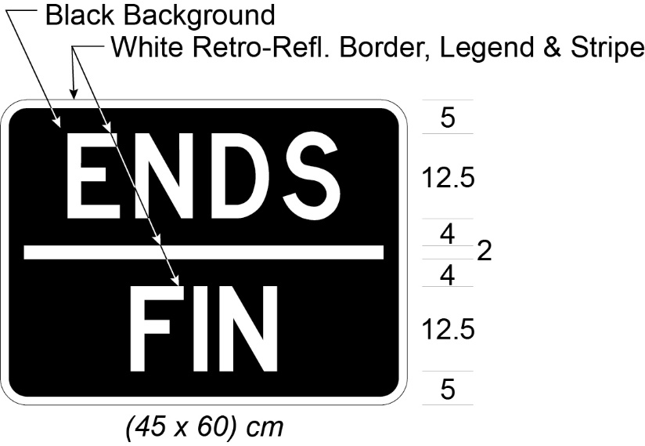
(9) Where a speed limit sign is erected within a designated area other than at the boundary and the sign indicates the rate of speed that is prescribed for the area, it shall be accompanied immediately below by a sign required by subsection (3) or, in an area designated by the French Language Services Act, by a sign required by subsection (4).
(10) Section 2 does not apply to a sign erected under this section.
Commencement
2. This Regulation comes into force on the later of the day subsection 4 (1) of the Safer School Zones Act, 2017 comes into force and the day this Regulation is filed.

Back to top

