ontario regulation 462/20
made under the
Highway Traffic Act
Made: August 20, 2020
Filed: August 21, 2020
Published on e-Laws: August 21, 2020
Printed in The Ontario Gazette: September 5, 2020
Amending Reg. 615 of R.R.O. 1990
(SIGNS)
1. Regulation 615 of the Revised Regulations of Ontario, 1990 is amended by adding the following section:
27.1 (1) Subject to subsection (2), a sign identifying an electric vehicle charging station for the purpose of section 30.2 of the Act shall be not less than 45 centimetres in height and not less than 30 centimetres in width and bear the markings and have the dimensions as described and illustrated in Figure 1.
(2) A sign described in subsection (1) that is erected in an area designated by the French Language Services Act shall bear the markings and have the dimensions as described and illustrated in Figure 2.
Figure 1
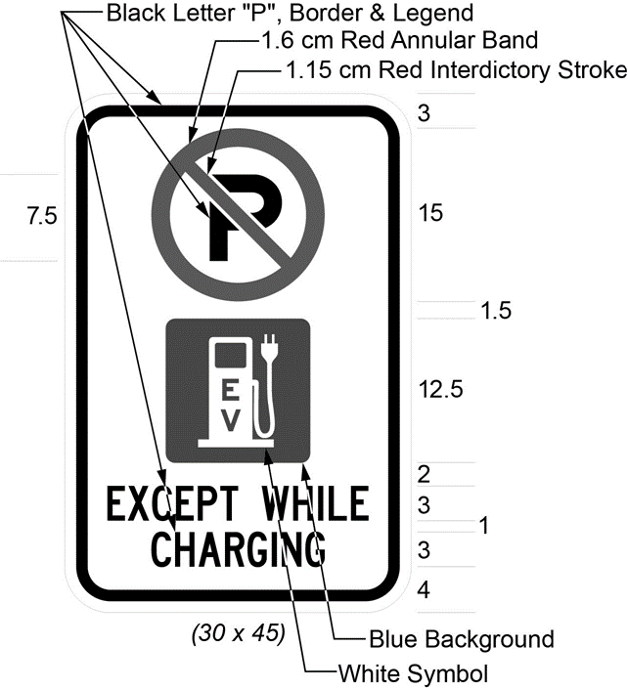
Text alternative: An illustration of an electric vehicle charging parking sign. At the top of the sign, a large letter “P” inside a “no” symbol appears. Below this, a symbol of an electric vehicle charging station appears. Below this, at the bottom of the sign, the phrase “EXCEPT WHILE CHARGING” appears. The following measurements are written below the sign: (30 x 45) cm. The sign appears in black and white, but is surrounded by arrows pointing to its different elements indicating the colours in which they must appear, and arrows identifying the size measurements of the elements of the sign and the distance between the elements. This text alternative is provided for convenience only and does not form part of the official law.
Figure 2
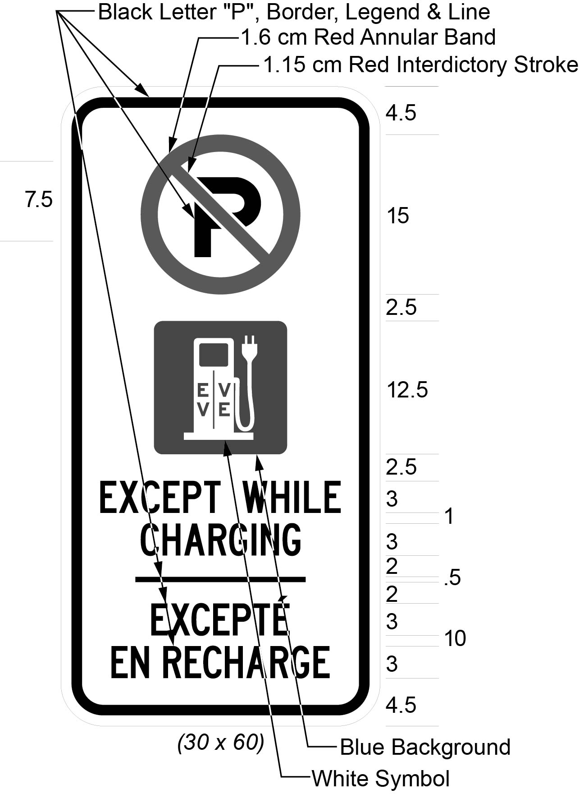
Text alternative: An illustration of an electric vehicle charging parking sign. At the top of the sign, a large letter “P” inside a “no” symbol appears. Below this, a symbol of an electric vehicle charging station appears. Below this, at the bottom of the sign, the phrase “EXCEPT WHILE CHARGING/EXCEPTÉ EN RECHARGE” appears. The following measurements are written below the sign: (30 x 60) cm. The sign appears in black and white, but is surrounded by arrows pointing to its different elements indicating the colours in which they must appear, and arrows identifying the size measurements of the elements of the sign and the distance between the elements. This text alternative is provided for convenience only and does not form part of the official law.
Commencement
2. This Regulation comes into force on the later of the day section 30.2 of the Highway Traffic Act comes into force and the day this Regulation is filed.

Back to top

