ontario regulation 733/21
made under the
Highway Traffic Act
Made: October 28, 2021
Filed: November 1, 2021
Published on e-Laws: November 1, 2021
Printed in The Ontario Gazette: November 20, 2021
Amending O. Reg. 227/16
(PILOT PROJECT — HOT LANES)
1. Subsection 3 (1) of Ontario Regulation 227/16 is amended by striking out “Schedule 1” and substituting “Schedules 1, 2 and 3”.
2. (1) Figure A to subsection 13 (1) of the Regulation is revoked and the following substituted:
Figure A
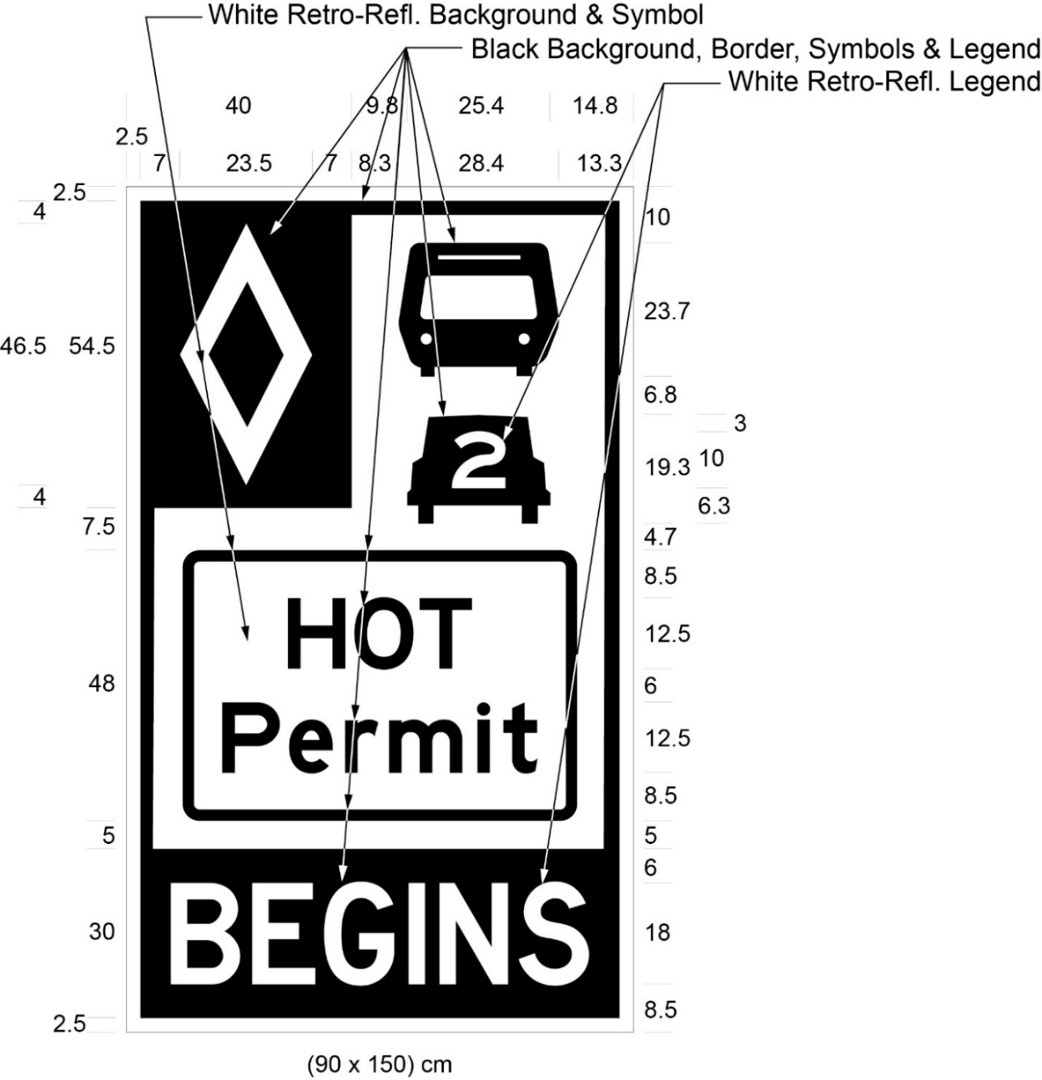
Text alternative: Illustration of a sign labelled as “Figure A”. The sign contains two rectangles, stacked on top of one another. The top rectangle has a white reflective background and contains a symbol of a bus on top of a symbol of a car with the number “2” inside it. A white diamond shape in a small black rectangle appears in the upper left corner of this rectangle. The words “HOT Permit” appear on the bottom half of this rectangle inside a rectangular outline. The bottom rectangle has a black background and contains the word “BEGINS” in white reflective letters. The following measurements are written below the sign: (90 x 150) cm. The sign is surrounded by measurements of its different elements. This text alternative is provided for convenience only and does not form part of the official law.
(2) Figure B to subsection 13 (2) of the Regulation is revoked and the following substituted:
Figure B
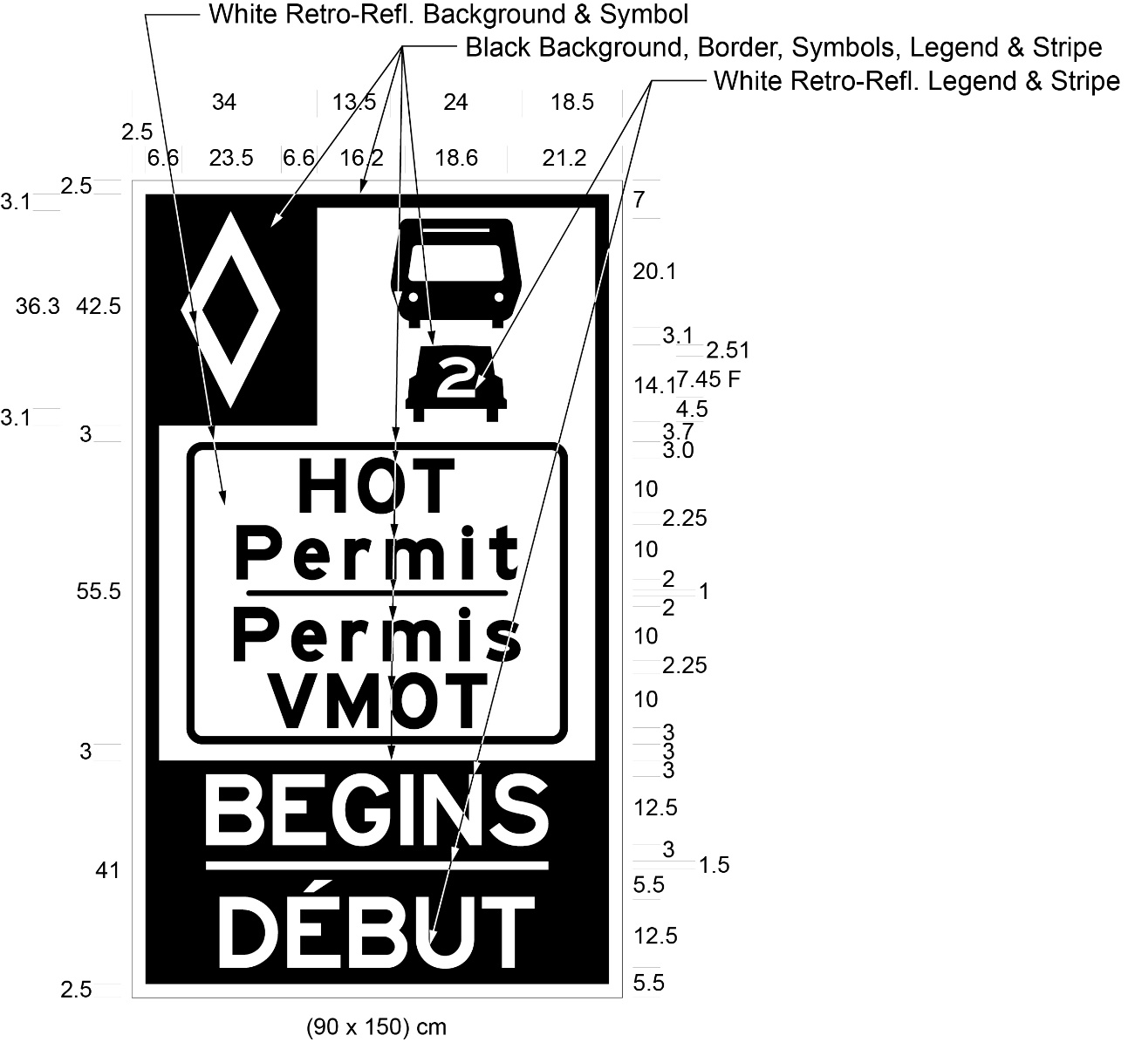
Text alternative: Illustration of a sign labelled as “Figure B”. The sign contains two rectangles, stacked on top of one another. The top rectangle has a white reflective background and a symbol of a bus on top of a symbol of a car with the number “2” inside it. A white diamond shape in a small black rectangle appears in the upper left corner of this rectangle. The words “HOT Permit/Permis VMOT” appear on the bottom half of this rectangle inside a rectangular outline. The bottom rectangle has a black background and contains the words “BEGINS/DÉBUT” in white reflective letters. The following measurements are written below the sign: (90 x 150) cm. The sign is surrounded by measurements of its different elements. This text alternative is provided for convenience only and does not form part of the official law.
(3) Figure C to subsection 13 (3) of the Regulation is revoked and the following substituted:
Figure C
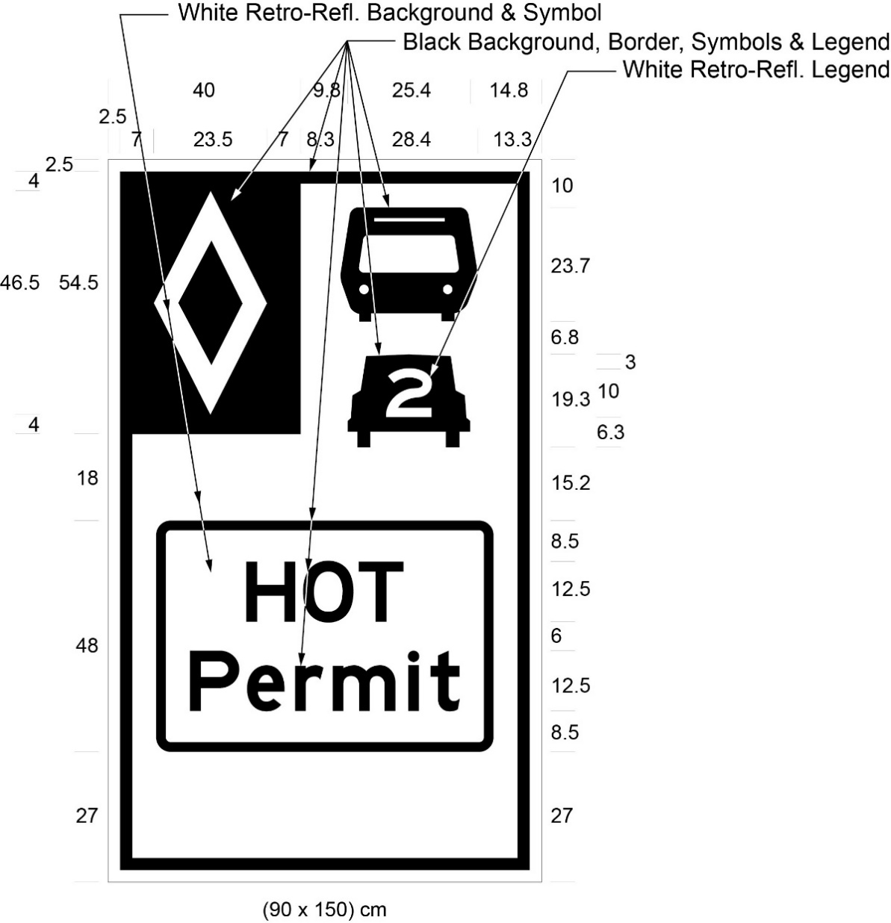
Text alternative: Illustration of a sign labelled as “Figure C”. The sign has a white reflective background and a symbol of a bus on top of a symbol of a car with the number “2” inside it. A white diamond shape in a small black rectangle appears in the upper left corner of the sign. The words “HOT Permit” appear below the symbols inside a rectangular outline. The following measurements are written below the sign: (90 x 150) cm. The sign is surrounded by measurements of its different elements. This text alternative is provided for convenience only and does not form part of the official law.
(4) Figure D to subsection 13 (4) of the Regulation is revoked and the following substituted:
Figure D
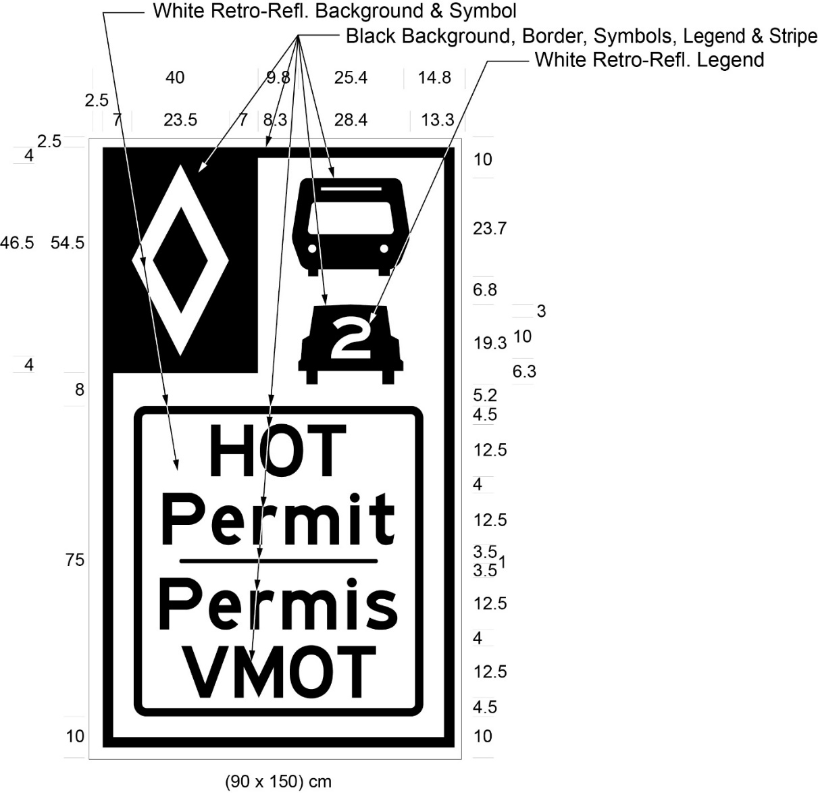
Text alternative: Illustration of a sign labelled as “Figure D”. The sign has a white reflective background and a symbol of a bus on top of a symbol of a car with the number “2” inside it. A white diamond shape in a small black rectangle appears in the upper left corner of the sign. The words “HOT Permit/Permis VMOT” appear below the symbols inside a rectangular outline. The following measurements are written below the sign: (90 x 150) cm. The sign is surrounded by measurements of its different elements. This text alternative is provided for convenience only and does not form part of the official law.
(5) Figure E to subsection 13 (6) of the Regulation is revoked and the following substituted:
Figure E
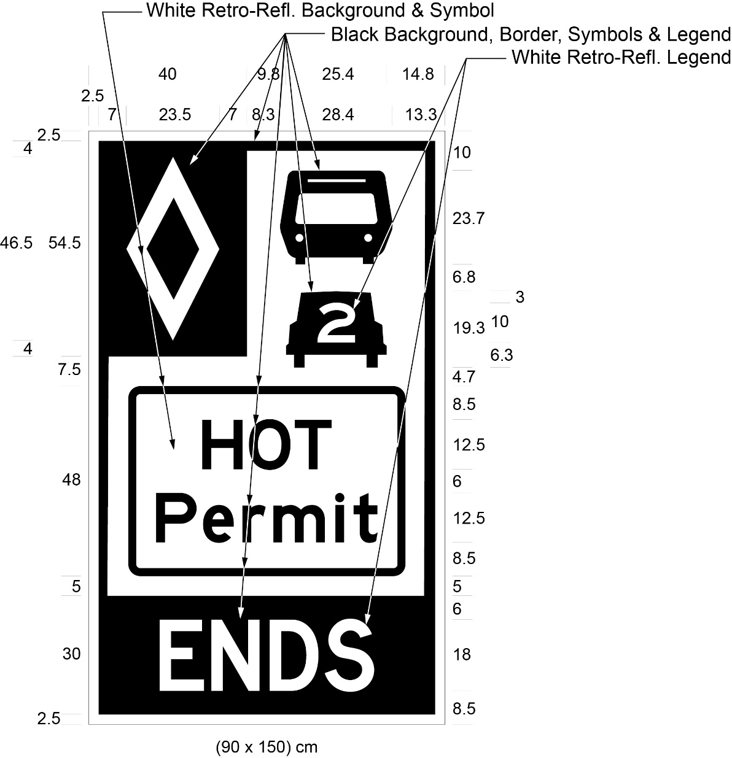
Text alternative: Illustration of a sign labelled as “Figure E”. The sign contains two rectangles, stacked on top of one another. The top rectangle has a white reflective background and a symbol of a bus on top of a symbol of a car with the number “2” inside it. A white diamond shape in a small black rectangle appears in the upper left corner of this rectangle. The words “HOT Permit” appear on the bottom half of this rectangle inside a rectangular outline. The bottom rectangle has a black background and contains the word “ENDS” in white reflective letters. The following measurements are written below the sign: (90 x 150) cm. The sign is surrounded by measurements of its different elements. This text alternative is provided for convenience only and does not form part of the official law.
(6) Figure F to subsection 13 (7) of the Regulation is revoked and the following substituted:
Figure F
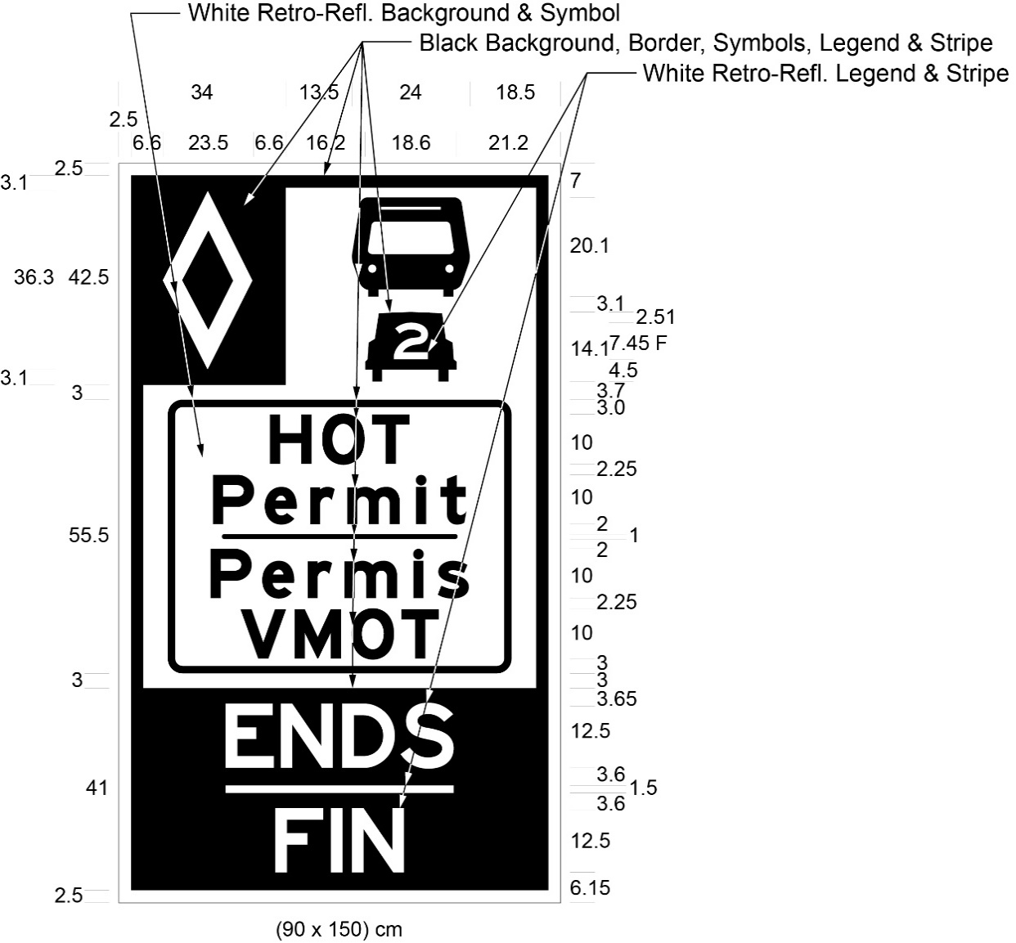
Text alternative: Illustration of a sign labelled as “Figure F”. The sign contains two rectangles, stacked on top of one another. The top rectangle has a white reflective background and a symbol of a bus on top of a symbol of a car with the number “2” inside it. A white diamond shape in a small black rectangle appears in the upper left corner of this rectangle. The words “HOT Permit/Permis VMOT” appear on the bottom half of this rectangle inside a rectangular outline. The bottom rectangle has a black background and contains the words “ENDS/FIN” in white reflective letters. The following measurements are written below the sign: (90 x 150) cm. The sign is surrounded by measurements of its different elements. This text alternative is provided for convenience only and does not form part of the official law.
3. The Regulation is amended by adding the following Schedules:
Schedule 2
Highway no. 410
1. (1) That part of the King’s Highway known as No. 410 (northbound) in The Regional Municipality of Peel lying between a point situate at its intersection with the King’s Highway known as No. 401 in the City of Mississauga and a point situate 350 metres measured southerly from its intersection with the centre line of the roadway known as Clark Boulevard in the City of Brampton.
(2) That part of the King’s Highway known as No. 410 (southbound) in The Regional Municipality of Peel lying between a point situate 40 metres measured northerly from its intersection with the centre line of the roadway known as Glidden Road in the City of Brampton and a point situate 800 metres measured northerly from its intersection with the centre line of the King’s Highway known as No. 401 in the City of Mississauga.
Schedule 3
HIGHWAY NO. 403
1. (1) That part of the King’s Highway known as No. 403 (eastbound) in the City of Mississauga in The Regional Municipality of Peel lying between a point situate 886 metres measured westerly from its intersection with the centre line of the roadway known as Winston Churchill Boulevard and a point situate 30 metres measured southerly from its intersection with the centre line of the roadway known as Matheson Boulevard.
(2) That part of the King’s Highway known as No. 403 (westbound) in the City of Mississauga in The Regional Municipality of Peel lying between a point situate 150 metres measured southerly from its intersection with the centre line of the roadway known as Matheson Boulevard and a point situate 520 metres measured easterly from its intersection with the centre line of the roadway known as Winston Churchill Boulevard.
2. That part of the King’s Highway known as No. 403 (eastbound) in the City of Mississauga in The Regional Municipality of Peel lying in the collector lanes between a point situate 600 metres measured southerly from its intersection with the centre line of the roadway known as Matheson Boulevard and a point situate at its intersection with the King’s Highway known as No. 401.
Commencement
4. This Regulation comes into force on the later of January 1, 2022 and the day it is filed.

Back to top

