ontario regulation 868/21
made under the
Highway Traffic Act
Made: September 21, 2021
Filed: December 20, 2021
Published on e-Laws: December 20, 2021
Printed in The Ontario Gazette: January 8, 2022
Amending O. Reg. 620/05
(HIGH OCCUPANCY VEHICLE LANES)
1. Section 1 of Ontario Regulation 620/05 is amended by adding the following subsection:
(2) A high occupancy vehicle transfer lane, as shown in Figures B, C and D to section 4, is deemed to be a part of the high occupancy vehicle lane to which it is adjacent.
2. Subsection 3 (1) of the Regulation is amended by striking out “Figure A” and substituting “Figure A, B, C or D”.
3. (1) Section 4 of the Regulation is amended by striking out “Figure A” in the portion before paragraph 1 and substituting “Figure A, B, C or D”.
(2) Section 4 of the Regulation is amended by adding the following Figures:

Figure B
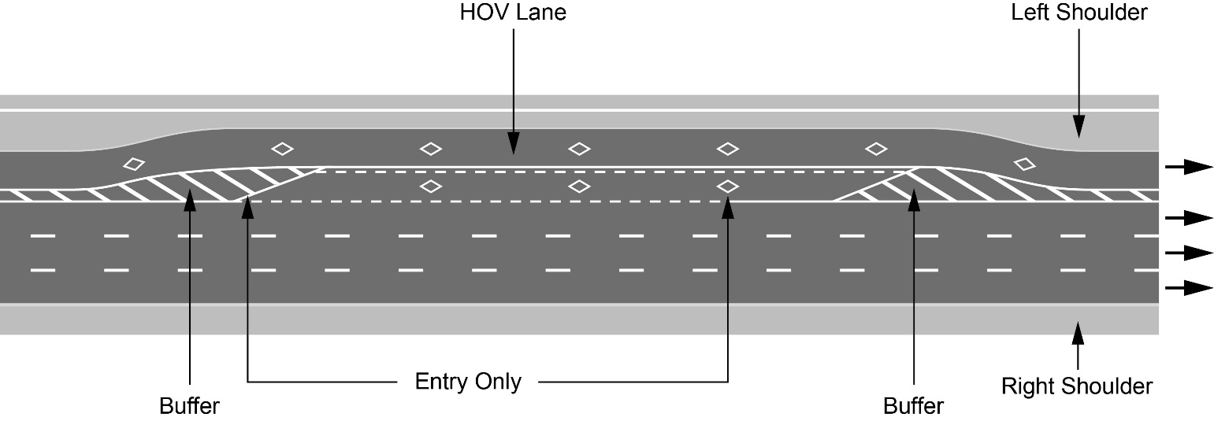
Text alternative: Illustration of “Figure B” showing an overhead plan of a divided highway with the high occupancy vehicle lane as the leftmost lane on a highway and an entry-only transfer lane adjacent to the high occupancy vehicle lane situated along the entry point markings. The high occupancy vehicle lane and the transfer lane have white diamond markings on the roadway and broken white lines indicating the entry points. Diagonal lines painted between solid lines before and after the transfer lane entry points indicate the buffer between the high occupancy vehicle lane and the lane beside it. The left shoulder is indicated to the left of the high occupancy vehicle lane. This text alternative is provided for convenience only and does not form part of the official law.
Figure C
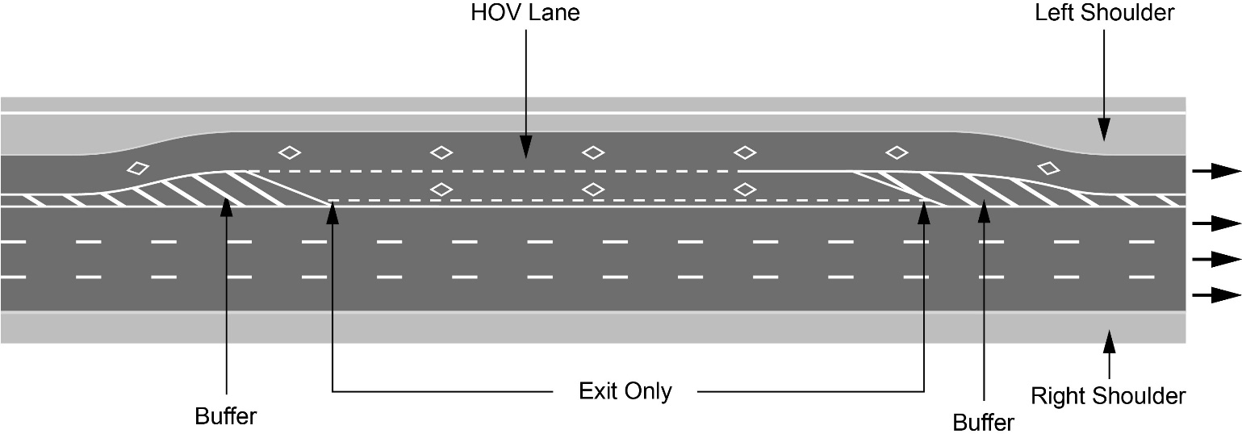
Text alternative: Illustration of “Figure C” showing an overhead plan of a divided highway with the high occupancy vehicle lane as the leftmost lane on a highway and an exit-only transfer lane adjacent to the high occupancy vehicle lane situated along the exit point markings. The high occupancy vehicle lane and the transfer lane have white diamond markings on the roadway and broken white lines indicating the exit points. Diagonal lines painted between solid lines before and after the transfer lane exit points indicate the buffer between the high occupancy vehicle lane and the lane beside it. The left shoulder is indicated to the left of the high occupancy vehicle lane. This text alternative is provided for convenience only and does not form part of the official law.
Figure D
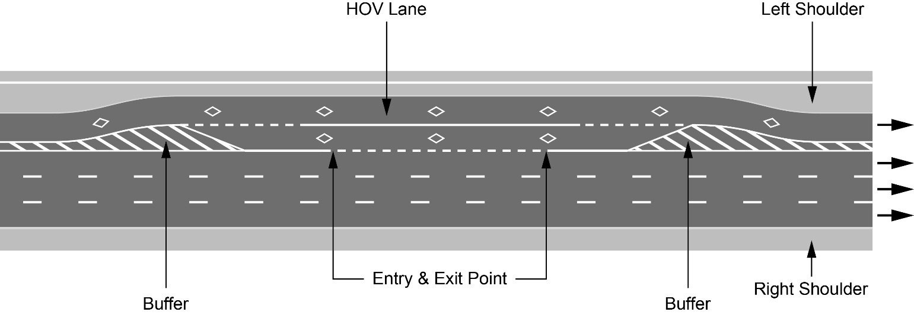
Text alternative: Illustration of “Figure D” showing an overhead plan of a divided highway with the high occupancy vehicle lane as the leftmost lane on a highway and an entry and exit transfer lane adjacent to the high occupancy vehicle lane situated along the entry and exit point markings. The high occupancy vehicle lane and the transfer lane have white diamond markings on the roadway and broken white lines indicating the entry and exit points. Diagonal lines painted between solid lines before and after the transfer lane entry and exit points indicate the buffer between the high occupancy vehicle lane and the lane beside it. The left shoulder is indicated to the left of the high occupancy vehicle lane. This text alternative is provided for convenience only and does not form part of the official law.
4. Section 5 of the Regulation is amended by adding the following subsection:
(11) Despite subsection (10), an overhead sign is not required to be erected over a high occupancy vehicle transfer lane.

Commencement
5. This Regulation comes into force on the day it is filed.
Made by:
Caroline Mulroney
Minister of Transportation
Date made: September 21, 2021

Back to top

