Français

chapter 19
An Act to resolve labour disputes involving school board employees represented by the Canadian Union of Public Employees
Assented to November 3, 2022
CONTENTS
Preamble
Interpretation and Application
1. | Definitions
2. | Interpretation
3. | Application of Act
4. | Application of School Boards Collective Bargaining Act, 2014
Collective Agreements
5. | New collective agreements
Strikes and Lock-outs
6. | Duties of employer and employee bargaining agency
7. | Prohibition re strike
8. | Prohibition re lock-out
9. | Offence
10. | Unlawful strike or lock-out
11. | Complaints re unlawful strike
12. | Rights of Labour Act
Application of Charter and Human Rights Code and Limits on Courts, etc.
13. | Application of Charter and Human Rights Code
14. | Restrictions on jurisdiction
15. | No cause of action re enactment of Act, etc.
Regulations
16. | Regulations, general
17. | Transitional regulations
18. | Retroactive regulations
Commencement and Short Title
19. | Commencement
20. | Short title
Schedule 1

Preamble
The negative impact of the COVID-19 pandemic on student learning and their mental health and well-being requires all education partners to work together to provide stability and to ensure that after two years of pandemic disruptions and learning loss there are no further interruptions to learning, so students can be supported to achieve their full potential. The Government, through its Plan to Catch Up, is supporting Ontario’s students by enabling them to benefit from a normal school experience, including academic engagement, extracurricular activities and other opportunities in school that contribute to their learning and development.
The Government is committed to bargaining with its education labour partners to reach negotiated settlements within a responsible fiscal framework. However, the Canadian Union of Public Employees (CUPE) has taken steps to initiate strike action in early November 2022, two months into the school year. Such action would destabilize the school experience for Ontario’s students and threaten their learning recovery.
This Act would terminate any on-going strike or lock-out by, or in respect of, employees of school boards who are represented by CUPE, restoring and maintaining stability for students in class. This Act would deem fair, fiscally responsible collective agreements to be in operation with respect to those employees for the period beginning on the date this Act receives Royal Assent and ending on August 31, 2026.
In order to secure the purposes of this Act against legal challenges, which may create destabilizing uncertainty for students and families, this Act would provide that it shall operate notwithstanding sections 2, 7 and 15 of the Canadian Charter of Rights and Freedoms and despite the Human Rights Code.
Therefore, His Majesty, by and with the advice and consent of the Legislative Assembly of the Province of Ontario, enacts as follows:
Interpretation and Application
Definitions
1 In this Act,
“bargaining agent” means the Canadian Union of Public Employees and any of its affiliated local trade unions; (“agent négociateur”)
“bargaining unit” means a bargaining unit of employees of a school board represented by the bargaining agent; (“unité de négociation”)
“employee bargaining agency” means the Canadian Union of Public Employees designated as the employee bargaining agency under subsection 3 (1) of Ontario Regulation 144/22 (The 2022 Round of Collective Bargaining) for the purposes of subsection 20 (2) of the School Boards Collective Bargaining Act, 2014; (“organisme négociateur syndical”)
“employees” means the employees in any bargaining unit; (“employés”)
“employer” means a school board that employs employees; (“employeur”)
“employer bargaining agency” means the council of trustees’ associations designated as the employer bargaining agency under subsection 3 (2) of Ontario Regulation 144/22 (The 2022 Round of Collective Bargaining) for the purposes of subsection 21 (6) of the School Boards Collective Bargaining Act, 2014; (“organisme négociateur patronal”)
“Minister” means the Minister of Education or such other member of the Executive Council to whom responsibility for the administration of this Act may be assigned or transferred under the Executive Council Act; (“ministre”)
“new central terms” means the terms, including letters of understanding, contained in the document provided on behalf of the Crown to the bargaining agent on October 30, 2022, the text of which is set out in Schedule 1 to this Act; (“nouvelles conditions négociées centralement”)
“new collective agreement” means a new collective agreement that is deemed to be in operation under subsection 5 (1). (“nouvelle convention collective”)
Interpretation
2 (1) Expressions used in this Act have the same meaning as in the School Boards Collective Bargaining Act, 2014, unless the context requires otherwise.
Constitutional rights and privileges
(2) This Act does not prejudicially affect any right or privilege guaranteed by section 93 of the Constitution Act, 1867 or by section 23 of the Canadian Charter of Rights and Freedoms, and every authority given by this Act shall be exercised in a manner consistent with those rights and privileges.
School board as employer
(3) Nothing in this Act changes the status of a school board as the employer of its employees and the application of this Act does not create an employment relationship between the Crown and employees or a deemed employment relationship between them for the purposes of this or any other Act or any law.
Application of Act
3 This Act applies to every employer, every employee, the bargaining agent, the employer bargaining agency and the employee bargaining agency.
Application of School Boards Collective Bargaining Act, 2014
4 (1) Except as modified by this Act, the School Boards Collective Bargaining Act, 2014 continues to apply.
Same, conflict
(2) In the event of a conflict between this Act and the School Boards Collective Bargaining Act, 2014, the Labour Relations Act, 1995 or the Education Act, this Act prevails.
Collective Agreements
New collective agreements
5 (1) As soon as this Act receives Royal Assent, new collective agreements between every employer and the bargaining agent are deemed to be in operation with respect to every bargaining unit.
Same
(2) A new collective agreement is deemed to be a collective agreement for the purposes of the School Boards Collective Bargaining Act, 2014 and the Labour Relations Act, 1995.
Terms of agreement
(3) A new collective agreement includes:
1. The new central terms.
2. Subject to subsections (5) and (6), the local terms set out in the collective agreement that expired on August 31, 2022 and that applied with respect to the applicable bargaining unit.
3. The terms and conditions that, under the School Boards Collective Bargaining Act, 2014 and the Labour Relations Act, 1995, are deemed to be included in it.
No further changes to compensation terms
(4) No decision, direction, order or award, or any other determination made by any court, administrative tribunal, arbitrator, mediator-arbitrator or arbitration board, under the Canadian Charter of Rights and Freedoms or otherwise, after this Act receives Royal Assent, that affects a central or local term respecting compensation that applied to a bargaining unit during the period from September 1, 2019 to August 31, 2022 shall alter, modify or otherwise affect any amounts payable as compensation to an employee under a new collective agreement.
Nullification of local terms
(5) Any local term that has the effect of limiting the ability of the employer to implement a program to support employee attendance is null and void to that extent.
Local terms modified by new central terms
(6) Any modification or adjustment to a local term, or any nullification or substitution of a local term, that is required under the new central terms is deemed to have been made.
Term of operation
(7) A new collective agreement shall have a commencement date that is the day this Act receives Royal Assent and an expiry date of August 31, 2026.
Strikes and Lock-outs
Duties of employer and employee bargaining agency
Application of section
6 (1) This section applies if a strike or lock-out involving any employees is in effect immediately before this Act receives Royal Assent.
Resumption of operations
(2) As soon as this Act receives Royal Assent, every employer shall use all reasonable efforts to resume any operations interrupted during any strike or lock-out, by or with respect to any employees, that is in effect immediately before this Act receives Royal Assent.
Termination of lock-out
(3) As soon as this Act receives Royal Assent, every employer and employer bargaining agency shall terminate any lock-out of employees that is in effect immediately before this Act receives Royal Assent.
Termination of strike
(4) As soon as this Act receives Royal Assent, the bargaining agent and employee bargaining agency shall terminate any strike by employees that is in effect immediately before this Act receives Royal Assent.
Same
(5) As soon as this Act receives Royal Assent, each employee shall terminate any strike that is in effect immediately before this Act receives Royal Assent and shall, without delay, resume the performance of the duties of the employee’s employment or shall continue performing them, as the case may be.
Exception
(6) Subsection (5) does not preclude an employee from not reporting to work and performing the employee’s duties for reasons of health or by mutual consent of the employee and the employer.
Prohibition re strike
7 (1) No employee shall strike and no person, bargaining agent or employee bargaining agency shall call or authorize or threaten to call or authorize a strike by any employees during the term of operation of the new collective agreement.
Same
(2) No officer, official or agent of the bargaining agent or employee bargaining agency shall counsel, procure, support, authorize, threaten or encourage a strike by any employees during the term of operation of the new collective agreement.
Prohibition re lock-out
8 (1) No employer or employer bargaining agency shall lock out, call for, authorize or require a lock-out or threaten to call for, authorize or require a lock-out of any employees during the term of operation of the new collective agreement.
Same
(2) No officer, official or agent of an employer or employer bargaining agency shall counsel, procure, support, authorize, require, threaten or encourage a lock-out of any employees during the term of operation of the new collective agreement.
Offence
9 (1) A person, including the bargaining agent, the employee bargaining agency, an employer or the employer bargaining agency, who contravenes or fails to comply with section 6, 7, or 8 is guilty of an offence under this Act and on conviction is liable,
(a) in the case of an individual, to a fine of not more than $4,000; or
(b) in any other case, to a fine of not more than $500,000.
Continuing offence
(2) Each day of a contravention or failure to comply constitutes a separate offence.
Related matters
(3) Subsections 104 (1) and (2) of the Labour Relations Act, 1995 do not apply with respect to an offence under this Act.
Same
(4) Subsection 104 (3) and sections 105, 106, 107 and 109 of the Labour Relations Act, 1995 apply, with necessary modifications, with respect to an offence under this Act.
Exception for prosecutions instituted by the Crown
(5) Despite subsection (4), section 109 of the Labour Relations Act, 1995 does not apply to a prosecution for an offence under this Act instituted by the Crown.
Unlawful strike or lock-out
10 Contravention of section 6, 7 or 8 is an unlawful strike or lock-out for the purposes of the Labour Relations Act, 1995.
Complaints re unlawful strike
11 (1) Despite subsection 45 (1) of the School Boards Collective Bargaining Act, 2014, the Minister may, without the consent of the employer bargaining agency, make a complaint under section 100 of the Labour Relations Act, 1995 with respect to an unlawful strike in contravention of section 6 or 7.
Other rights to make a complaint not affected
(2) Subsection (1) does not limit the right of the employer bargaining agency or an employer to make a complaint under section 100 of the Labour Relations Act, 1995.
Other provisions that apply
(3) Sections 102, 103 and 108 of the Labour Relations Act, 1995 apply, with necessary modifications, with respect to a complaint under section 100 of that Act with respect to an unlawful strike in contravention of section 6 or 7.
Rights of Labour Act
12 Nothing in the Rights of Labour Act prevents or affects the operation or enforcement of this Act against any person including the bargaining agent.
Application of Charter and Human Rights Code and Limits on Courts, etc.
Application of Charter and Human Rights Code
Charter
13 (1) Pursuant to subsection 33 (1) of the Canadian Charter of Rights and Freedoms, this Act is declared to operate notwithstanding sections 2, 7 and 15 of the Canadian Charter of Rights and Freedoms.
Human Rights Code
(2) This Act applies despite the Human Rights Code.
Same, regulations
(3) For greater certainty, subsections (1) and (2) apply to regulations made under this Act.
Restrictions on jurisdiction
Limit on jurisdiction of OLRB
14 (1) The Ontario Labour Relations Board shall not inquire into or make a decision on whether a provision of this Act or of the new central terms, or a regulation made, or any action taken under this Act, is constitutional or is in conflict with the Human Rights Code.
Same
(2) The Ontario Labour Relations Board shall not inquire into or make a decision on whether any action by the Crown or by any of the Crown’s current or former ministers, agents, appointees or employees under this Act is constitutional or is in conflict with the Human Rights Code.
Limit on jurisdiction of arbitrators
(3) An arbitrator, mediator-arbitrator, arbitration board or any administrative tribunal shall not inquire into or make a decision on whether a provision of this Act or of the new central terms, or a regulation, order or decision made under this Act is constitutional or is in conflict with the Human Rights Code.
Same
(4) An arbitrator, mediator-arbitrator, arbitration board or any administrative tribunal shall not inquire into or make a decision on whether any action by the Crown or any of the Crown’s current or former ministers, agents, appointees or employees under this Act is constitutional or is in conflict with the Human Rights Code.
No cause of action re enactment of Act, etc.
15 (1) No cause of action or other legal basis for a proceeding arises against the Crown or any of the Crown’s current or former ministers, agents, appointees and employees as a direct or indirect result of,
(a) the enactment, amendment or repeal of any provision of this Act or the making, amendment or revocation of any provision of a regulation made under this Act, or the establishment of any provision of the new central terms; or
(b) anything done or not done in order to comply with this Act or the regulations made under this Act.
Proceedings barred
(2) Subject to subsection (5), no proceeding, including but not limited to any proceeding in contract, restitution, unjust enrichment, tort, misfeasance, bad faith, trust, fiduciary obligation, or otherwise, that is directly or indirectly based on or related to anything referred to in subsection (1) may be brought or maintained against a person referred to in that subsection.
Application
(3) Subject to subsection (5), and without limiting the generality of subsections (1) and (2), those subsections apply to any court, arbitral or administrative proceeding, including any application, claim or complaint, claiming any remedy or relief, including specific performance, injunction, declaratory relief, damages or any other remedy under any Act or any form of damages or any other remedy or relief, or a claim to be compensated for any losses, including loss of earnings, loss of revenue or loss of profit.
Same
(4) For greater certainty, subsection (3) applies to any proceedings, including any application, claim or complaint, claiming damages or any other remedy under subsection 24 (1) of the Canadian Charter of Rights and Freedoms or subsection 52 (1) of the Constitution Act, 1982 for any purported infringement of section 2, 7 or 15 of the Canadian Charter of Rights and Freedoms.
Same
(5) For greater certainty, subsections (1) to (3) do not preclude an application for judicial review, but no remedy shall be granted in an application for judicial review with respect to any purported infringement referred to in subsection (4).
Retrospective effect
(6) Subsections (1) and (2) apply regardless of whether the cause of action or other legal basis for the proceeding arose before, on or after this section or a regulation made under this Act comes into force.
Proceedings set aside
(7) Any proceeding referred to in subsection (2) commenced before the day this section or a regulation made under this Act comes into force is deemed to have been dismissed, without costs, on the day on which the cause of action or other legal basis for the proceeding is extinguished under subsection (1) and any decision in a proceeding referred to in subsection (2) is of no effect.
No unfair labour practice
(8) For greater certainty, and despite any other Act, anything referred to in subsection (1) is not a contravention by the Crown of section 17, section 59 or sections 70 to 88 of the Labour Relations Act, 1995 or of any provision of the School Boards Collective Bargaining Act, 2014.
No application to the OLRB
(9) For greater certainty, no application may be made to the Ontario Labour Relations Board alleging a contravention by the Crown of section 17, section 59 or sections 70 to 88 of the Labour Relations Act, 1995 or of any provision of the School Boards Collective Bargaining Act, 2014 with respect to anything referred to in subsection (1).
Termination of OLRB applications
(10) For greater certainty, any application that is before the Ontario Labour Relations Board alleging a contravention by the Crown of section 17, section 59 or sections 70 to 88 of the Labour Relations Act, 1995 or of any provision of the School Boards Collective Bargaining Act, 2014 with respect to anything referred to in subsection (1) is terminated.
Not entitled to be compensated
(11) Despite any other Act or law, including sections 2, 7 and 15 of the Canadian Charter of Rights and Freedoms, no person is entitled to be compensated for any loss or damages, including loss of revenues, loss of profit or loss of expected earnings or denial or reduction of compensation that would otherwise have been payable to any person, arising from anything referred to in subsection (1).
Regulations
Regulations, general
16 The Lieutenant Governor in Council may make regulations for carrying out the purposes and provisions of this Act.
Transitional regulations
17 (1) The Lieutenant Governor in Council may make regulations providing for any transitional matter that the Lieutenant Governor in Council considers necessary or advisable in connection with the implementation of this Act.
Same
(2) In the event of a conflict between this Act and a regulation made under subsection (1), the regulation prevails.
Retroactive regulations
18 (1) If it so provides, a regulation made under section 16 or 17 is effective with reference to a period before the regulation was filed.
Application to existing proceedings, existing legal basis for proceedings
(2) If it so provides, a regulation made under section 16 or 17 may apply to,
(a) a proceeding, including an application, claim or complaint, that existed before the regulation comes into force; and
(b) the legal basis for a proceeding or a potential proceeding, including a cause of action, in circumstances where the legal basis existed before the regulation comes into force.
Commencement and Short Title
Commencement
19 This Act comes into force on the day it receives Royal Assent.
Short title
20 The short title of this Act is the Keeping Students in Class Act, 2022.
Schedule 1
CUPE – PART A: CENTRAL TERMS
C1.00 Structure AND ORGANIZATION of Collective Agreement
C1.1 Separate Central and Local Terms
The collective agreement shall consist of two parts. Part “A” shall comprise those terms which are central terms. Part “B” shall comprise those terms which are local terms.
C1.2 Implementation
Part “A” may include provisions respecting the implementation of central terms by the school board and the Union. Any such provision shall be binding on the school board and the Union. Should a provision in Part A conflict with a provision in Part B, the provision in Part A, Central Terms will apply.
C1.3 Parties
a) The parties to the collective agreement are the school board and the Union.
b) Central collective bargaining shall be conducted by the central employer and employee bargaining agencies representing the local parties.
C1.4 Single Collective Agreement
Central terms and local terms shall together constitute a single collective agreement for all purposes.
c2.00 definitions
C2.1 Unless otherwise specified, the following definitions shall apply only with respect to their usage in standard central terms. Where the same word is used in Part B of this collective agreement, the definition in that part, or any existing local interpretation, shall prevail.
C2.2 The “Central Parties” shall be defined as the employer bargaining agency, the Council of Trustees’ Associations/Conseil d’Associations des Employeurs (CTA/CAE) and the employee bargaining agency, the Canadian Union of Public Employees/Syndicat Canadien de la Fonction Publique (CUPE/SCFP).
CUPE/SCFP refers to the designated employee bargaining agency pursuant to subsection 20 (1) of the School Boards Collective Bargaining Act, 2014 for central bargaining with respect to employees in the bargaining units for which CUPE/SCFP is the designated employee bargaining agency.
CTA/CAE refers to the designated employer bargaining agency pursuant to subsection 21 (6) of the School Boards Collective Bargaining Act, 2014 for central bargaining with respect to employees in the bargaining units for which CUPE/SCFP is the designated employee bargaining agency. The CTA/CAE is composed of:
1. ACÉPO refers to l’Association des conseils scolaires des écoles publiques de l’Ontario as the designated bargaining agency for every French-language public district school board.
2. AFOCSC refers to l’Association franco-ontarienne des conseils scolaires catholiques as the designated bargaining agency for every French-language Catholic district school board.
3. OCSTA refers to the Ontario Catholic School Trustees' Association as the designated bargaining agency for every English-language Catholic district school board.
4. OPSBA refers to the Ontario Public School Boards' Association as the designated bargaining agency for every English-language public district school board, including isolate boards.
“School board” (also referred to as “Board” or “Employer”) shall have the same meaning as in the School Boards Collective Bargaining Act, 2014.
C3.00 Length of Term/Notice to Bargain
C3.1 Term of Agreement
This agreement shall expire on August 31, 2026.
C3.2 Term of Letters of Agreement/Understanding
All central letters of agreement/understanding appended to this agreement, or entered into after the execution of this agreement shall, unless otherwise stated therein, form part of the collective agreement, run concurrently with it, and have the same termination date as the agreement.
C3.3 Amendment of Terms
In accordance with Section 42 of the School Boards Collective Bargaining Act, 2014, the central terms of this agreement, excepting term, may be amended at any time during the life of the agreement upon mutual consent of the central parties and agreement of the Crown. It is understood the union will follow its internal approval process.
C3.4 Notice to Bargain
a) Where central bargaining is required under the School Boards Collective Bargaining Act, 2014, notice to bargain centrally shall be in accordance with Sections 31 and 28 of that Act, and with Section 59 of the Labour Relations Act, 1995.
Notice to commence bargaining shall be given by a central party:
i. within 90 (ninety) days of the expiry date of the collective agreement; or
ii. within such greater period agreed upon by the parties; or
iii. within any greater period set by regulation by the Minister of Education.
b) Notice to bargain centrally constitutes notice to bargain locally.
c) Estoppel notices with respect to central matters shall be delivered by central parties. Estoppel notices shall be delivered on the first day of central matters bargaining.
C4.00 CENTRAL DISPUTE RESOLUTION process
The following process pertains exclusively to disputes and grievances on central matters that have been referred to the central process. In accordance with the School Board Collective Bargaining Act, 2014 central matters may also be grieved locally, in which case local grievance processes will apply. In the event that central language is being grieved locally, the local parties shall provide the grievance to their respective central agents. Where a local grievance has been filed, the central parties will jointly recommend in writing to the Local Parties that the local grievance be held in abeyance until the Central Dispute Resolution Committee, the Central Parties, or the Crown takes action under Article 4.
C4.1 Statement of Purpose
a. The purposes of the Central Dispute Resolution Process (“CDRP”) shall include the expeditious processing and resolution of disputes through consultation, discussion, mediation or arbitration, and the avoidance thereby of multiplicity of proceedings.
C4.2 Parties to the Process
a. There shall be established a Central Dispute Resolution Committee (“the Committee”), which shall be composed of equal representation of up to four (4) representatives each of the employer bargaining agency and employee bargaining agency (“the central parties”), and up to three representatives of the Crown. The Committee will be co-chaired by a representative from each bargaining agency. All correspondence to the Committee will be sent to both co-chairs.
b. The Central Parties and the Crown will provide a written list of representatives appointed to the Committee with contact information every September. Any changes in representation will be confirmed in writing.
c. A local party shall not be party to the CDRP, or to the Committee, except to the extent its interests are represented by its respective central party on the Committee.
d. For the purposes of this section, “central party” means an employer bargaining agency or employee bargaining agency, and “local party” means an employer or trade union party to a local collective agreement.
C4.3 Meetings of the Committee
The Committee shall meet eight times during the school year. The parties may schedule additional meetings by mutual agreement.
C4.4 Selection of Representatives
a. Each central party and the Crown shall select its own representatives to the Committee.
C4.5 Mandate of the Committee
The mandate of the Committee shall be as follows:
a. Dispute Resolution
A review of any dispute referred to the Committee respecting the interpretation, application, administration, alleged violation, or arbitrability of central terms in the agreement, for the purposes of determining whether the dispute might be settled, withdrawn, referred to mediation/arbitration as a formal grievance, or referred to the local grievance procedure in accordance with this section.
b. Not Adjudicative
It is clearly understood that the Committee is not adjudicative in nature. Unless otherwise agreed to by the parties, decisions of the committee are without prejudice or precedent.
C4.6 Role of the Central Parties and Crown
a. The central parties shall each have the following rights:
i. To file a dispute with the Committee.
ii. To file a dispute as a grievance with the Committee.
iii. To engage in settlement discussions, and to mutually settle a dispute or grievance.
iv. To withdraw a dispute or grievance it filed.
v. To mutually agree to refer a dispute or grievance to the local grievance procedure.
vi. To refer a grievance it filed to final and binding arbitration.
vii. To mutually agree to voluntary mediation.
b. The Crown shall have the following rights:
i. To give or withhold approval to the employer bargaining agency, to any proposed settlement.
ii. To participate in any matter referred to arbitration.
iii. To participate in voluntary mediation.
C4.7 Referral of Disputes
a. Either central party must refer a dispute to the Committee for discussion and review
C4.8 Carriage Rights
a. The parties to settlement discussions shall be the central parties. The Crown may participate in settlement discussions.
C4.9 Responsibility to Communicate
a. It shall be the responsibility of a central party to refer a dispute to the Committee, or to arbitration, in a timely manner.
b. It shall be the responsibility of each central party to inform their respective local parties of the Committee’s disposition of the dispute at each step in the CDRP, including mediation and arbitration, and to direct them accordingly.
C4.10 Language of Proceedings
a. Where a dispute arises uniquely under a collective agreement in the French language, the documentation shall be provided, and the proceedings conducted in French. Interpretative and translation services shall be provided accordingly to ensure that non-francophone participants are able to participate effectively.
b. Where such a dispute is filed:
i. The decision of the Committee shall be available in both French and English.
ii. Mediation and arbitration shall be conducted in the French language with interpretative and translation services provided accordingly.
c. Arbitration decisions and settlements that may have an impact on French language school boards shall be translated accordingly.
C4.11 Definition of Dispute
a. A dispute can include:
i. A matter in dispute between the central parties respecting the interpretation, application, administration, alleged violation, or arbitrability of central terms in the agreement.
C4.12 Notice of Disputes
Notice of the dispute will be submitted on the form provided in Appendix A and sent to the responding party, in order to provide an opportunity to respond. The Crown shall be provided with a copy.
a. Notice of the dispute shall include the following:
i. Any central provision of the collective agreement alleged to have been violated.
ii. The provision of any statute, regulation, policy, guideline, or directive at issue.
iii. A comprehensive statement of any relevant facts.
iv. The remedy requested.
C4.13 Referral to the Committee
a. A central party that has a dispute regarding the interpretation, application, administration, alleged violation, or arbitrability of a central term, shall refer it forthwith to the Committee by notice of dispute to the co-chair of the other central party, with a copy to the Crown, but in no case later than thirty (30) working days after becoming aware of the dispute. Where the responding party wishes to provide a written response prior to the Committee meeting, that response shall be forwarded to the other Central party and the Crown.
b. The Committee shall conduct a review of the dispute. The Committee will meet to review the dispute within twenty (20) working days or at the next scheduled meeting of the Committee.
c. If the dispute is not settled or withdrawn, within twenty (20) working days of the Committee meeting, the central party submitting the dispute may:
I. Continue informal discussions; or
II. Refer the dispute back to the local grievance procedure
d. If the dispute remains unresolved for longer than sixty (60) working days the dispute may be referred as a grievance. Once referred as a grievance the parties may:
i. Refer the grievance to Voluntary Mediation or Expedited Mediation
ii. Refer the grievance to Arbitration.
C4.14 Timelines
a. Timelines may be extended by mutual consent of the parties.
b. Working days shall be defined as Monday through Friday excluding statutory holidays.
c. Disputes that arise during non-instructional days (Summer months, Christmas Break, and March Break) will have timelines automatically extended.
d. Local grievance timelines will be held in abeyance while the dispute is in the CDRP, in the event that the matter is referred back locally.
C4.15 Voluntary Mediation /Expedited Meditation
a. The central parties may, on mutual agreement, request the assistance of a mediator.
b. Where the central parties have agreed to mediation, the cost shall be shared equally between the central parties.
c. Timelines shall be held in abeyance from the time of referral to mediation until the completion of the mediation process. The referral of a grievance to mediation is without prejudice to either parties’ position on jurisdictional matters, including timeliness.
d. The Parties agree to refer any mediation to agreed-upon mediator(s). In selecting a mediator, the parties shall have regard to reasonable availability, sector knowledge, and linguistic competence.
e. The parties shall contact mediator(s) to establish three dates for mediation. Dates shall be scheduled in consultation with the parties. One of the expedited mediation sessions shall be conducted in French and two of the expedited mediation sessions shall be conducted in English every school year of the agreement unless agreed otherwise by the parties.
f. It is understood that the resolution of any grievance under the mediation process shall be without prejudice and shall not be raised or relied upon by either party or the Crown in any future proceeding, except for enforcement purposes.
g. The parties may jointly set down up to 5 (five) grievances for each review.
h. The mediator shall have the authority to assist the parties in a mediated resolution to the grievance.
i. Each party shall prepare a mediation brief to assist the mediator, which shall include the following:
- A short description of the grievance.
- A statement of relevant facts.
- A list of any relevant provisions of the collective agreement.
- Any relevant documentation.
j. The description of the grievance and the relevant facts shall not be typically longer than two pages.
k. The party raising the grievance shall provide the opposing party (and the Crown, where applicable) with a complete brief no later than thirty (30) days prior to the scheduled review.
l. The responding party shall provide their brief no later than five (5) days prior to the scheduled review.
m. The Crown may provide a brief no later than two (2) days prior to the review.
n. Where the matter is not resolved, the mediator is not seized to arbitrate the grievance.
C4.16 Arbitration
a. Arbitration shall be by a single arbitrator.
b. In order to have an expeditious process, the parties shall consider sharing prior to the hearing the following, “Written Briefs”, “Will Say Statements” “Agreed Statement of Facts” and the case law the parties intend to rely on. The parties will make best efforts to respond to disclosure requests in a timely fashion prior to the hearing.
c. The central parties shall use the mutually agreed-to list of arbitrators set out in Letter of Understanding #8. Arbitrators on the list will be used in rotation, based on availability. On mutual agreement, the parties may add to or delete from the list during the term of the agreement, as required.
d. The Parties shall select an arbitrator from the list subject to their availability to hear the matter within eighteen (18) months, on a date convenient to the parties. If none of the arbitrators on the list are able to convene a hearing within eighteen (18) months, the parties shall appoint a mutually agreed to arbitrator who is available within eighteen (18) months.
e. The central parties may refer multiple grievances to a single arbitrator.
f. The cost of proceedings, including arbitrator fees and rental of space, shall be shared equally between the central parties.
g. This does not preclude either Party from proceeding to expedited arbitration under the Labour Relations Act.
C5.00 Benefits
The parties have agreed to participate in the Provincial Benefit Trust set out in the CUPE Education Workers Benefit Trust Agreement and Declaration of Trust (“CUPE EWBT”) established February 28, 2018. The date on which the board and the bargaining unit commenced participation in the Trust shall be referred to herein as the "Participation Date".
The parties agree that, once all employees to whom this collective agreement applies transition to the CUPE EWBT, all references to existing life, health and dental benefits plans in the applicable local collective agreement shall be removed from that local agreement.
Consistent with section 144.1 of the Income Tax Act (Canada) (“ITA”) Boards’ benefit plans can only be moved into the Trust, such that the Trust will be in compliance with the ITA and Canada Revenue Agency administrative requirements for an ELHT.
Post Participation Date, the following shall apply:
C5.1 Eligibility and Coverage
a) The Trust will maintain eligibility for CUPE represented employees who currently have benefits and any newly hired eligible employee covered by the local terms of applicable collective agreement ("CUPE represented employees").
b) The Trust is also permitted to provide coverage to other active employee groups in the education sector with the consent of their bargaining agents and employer or, for non-union groups, in accordance with an agreement between the Trustees and the applicable Board.
c) Retirees who were previously represented by CUPE, who were, and still are members of a Board benefit plan as at the participation date are eligible to receive benefits through the CUPE EWBT based on prior arrangements with the Board.
d) No individuals who retire after the Participation Date are eligible.
C5.2 Funding
Funding related to the CUPE EWBT will be based on the following:
a) Funding amounts:
- The current rate will increase by 1% effective November 7, 2022 ($5,712.00 per FTE)
- September 1, 2023: increase of 1% ($5,769.12 per FTE)
- September 1, 2024: increase of 1% ($5,826.82 per FTE)
- September 1, 2025: increase of 1% ($5,885.08 per FTE)
- August 31, 2026: increase of 4% ($6,120.48 per FTE)
b) Funding in C5.2a) shall be temporarily reduced by 10% from the date of this agreement until the amendments to the CUPE EWBT Agreement and Declaration of Trust relating to the reconciliation process in C5.4c) and strike contributions in C5.4e) are in effect; and
c) If the remittance or recoveries process outlined in C5.4 c) is not completed by August 31, of the year following the year being reconciled, the funding rate in effect for September 1st in that year shall be reduced by 10% until all the remittances and recoveries for all school boards are processed.
C5.3 Cost Sharing
The terms and conditions of any existing Employee Assistance Program/Employee Family Assistance Program shall remain the responsibility of the respective Board and not the Trust maintaining current employer and employee co-share where they exist. The Board shall maintain its contribution to all statutory benefits as required by legislation (including but not limited to Canada Pension Plan, Employment Insurance, Employer Health Tax, etc.).
Any cost sharing or funding arrangements regarding the EI rebate will remain status quo.
C5.4 Full-Time Equivalent (FTE) and Employer Contributions
a) The FTE used to determine the Board’s benefits contributions will be based on the Estimates of the Education Finance Information System (“EFIS”) average of the Board’s FTE as of October 31st and March 31st of each year.
b) For the purposes of (a) above, the FTE positions will be those consistent with Appendix H of the EFIS for job classifications that are eligible for benefits.
c) Monthly amounts paid by boards to the CUPE EWBT administrator based on Estimates by FTE will be reconciled by the Crown to the actual average FTE reported by the applicable boards in the staffing schedule by Employee/Bargaining group for each school year ending August 31. If the reconciliation of FTE results in any identified differences in funding, those funds shall be remitted to or recovered from the CUPE EWBT, as applicable, in a lump sum upon notice to the CUPE EWBT, but no later than August 31 of the year following the reconciliation process.
d) In the case of a dispute regarding the FTE number of members for whom the provincial benefits package is being provided, the dispute will be resolved between the Board and CUPE. If no resolution to the issue can be achieved, it shall be subject to the Central Dispute Resolution Process.
e) For the purposes of section 7.3 of the CUPE EWBT Agreement and Declaration of Trust, during a period of strike or lock-out resulting in CUPE represented employees withdrawing full services, the trustees shall advise CUPE and the CUPE EWBT administrator, for the purposes of reimbursing the CUPE EWBT and reducing the employer contributions, of the amount of contributions of each applicable employer made during the strike or lockout, based on the following calculation:
i. the per FTE funding in effect during the period of strike or lockout multiplied by the Estimates average CUPE FTE reported by the applicable school board in the staffing schedule by Employee/Bargaining group as of October 31st and March 31st for the school year impacted by the strike (i.e. the FTE used to invoice the school board for the applicable school year);
ii. Divide C5.4 e) i) by the number of contractual working days of the CUPE represented employees (based on their schedule in the collective agreement);
iii. Multiply C5.4 e) ii) by the number of strike or lockout days for CUPE represented employees at the school board.
C5.5 Payment in Lieu of Benefits
a) All employees not transferred to the Trust who received pay in lieu of benefits under a collective agreement in effect as of August 31, 2014, shall continue to receive the same benefit.
b) New hires after the Participation Date who are eligible for benefits from the CUPE EWBT are not eligible for pay in lieu of benefits.
C5.6 Benefits Committee
a) A benefits committee comprised of the employee representatives, the employer representatives, including the Crown, and Trust Representatives will meet to address all matters that may arise in the operation of the Trust.
C5.7 Privacy
a) The Parties agree to inform the Trust Plan Administrator, that in accordance with applicable privacy legislation, the Trust Plan Administrator shall limit the collection, use and disclosure of personal information to information that is necessary for the purpose of providing benefits administration services. The Trust Plan Administrator’s policy shall also be based on the Personal Information Protection and Electronic Documents Act (PIPEDA).
C6.00 Sick leave AND SHORT TERM LEAVE DISABILITY PLAN
Sick Leave provisions applicable to the 2022-2023 fiscal year are found in LOU #18. The following language shall apply effective as of the 2023-2024 fiscal year.
C6.1 Sick Leave/Short Term Leave Disability Plan
Definitions:
The definitions below shall be exclusively used for this article.
“Full year” refers to the ordinary period of employment for the position.
“Permanent Employees” means all employees who are not casual employees, or employees working in a long-term supply assignment, as defined below.
“Long Term Supply Assignment” means, in relation to an employee,
i. a long-term supply assignment within the meaning of the local collective agreement, or
ii. where no such definition exists, a long-term supply assignment will be defined as twelve (12) days of continuous employment in one assignment.
“Casual Employees” means,
i. A casual employee within the meaning of the local collective agreement,
ii. If clause (i) does not apply, an employee who is a casual employee as agreed upon by the board and the bargaining agent, or
iii. If clauses (i) and (ii) do not apply, an employee who is not regularly scheduled to work.
Notwithstanding the above, an employee working in a Long-Term Supply Assignment shall not be considered a casual employee for purposes of sick leave entitlement under this article while working in the assignment.
“Fiscal Year” means September 1 to August 31.
“Wages” is defined as the amount of money the employee would have otherwise received over a period of absence, excluding overtime.
Sick Leave Plan
a) Sick Leave Benefit Plan
The Board will provide a Sick Leave Benefit Plan which will provide sick leave days and short-term leave disability coverage to provide protection against loss of income when ill or injured as defined below. An employee, other than a casual employee as defined above, is eligible for benefits under this article.
Sick leave days may be used for reasons of personal illness, personal injury, personal medical appointments, or personal dental emergencies only. Appointments shall be scheduled outside of working hours, where possible.
Employees receiving benefits under the Workplace Safety and Insurance Act, or under a LTD plan, are not entitled to benefits under a school board’s sick leave and short term leave disability plan for the same condition.
b) Sick Leave Days
Permanent Employees
Subject to paragraphs d), e) and f) below, permanent Employees will be allocated eleven (11) sick leave days payable at one hundred percent (100%) of wages on the first day of each fiscal year.
Where an employee exhausts their allocation of eleven (11) sick leave days, and does not qualify or is not approved for the Short Term Leave Disability Plan under (c), below, subsequent absences due only to personal illness or personal injury will be payable at fifty percent (50%) of wages for a maximum of five (5) days per fiscal year. These days will be deducted from the employee’s Short Term Leave Disability Plan allocation under (c), below, and are eligible for top up in accordance with 6.1(k), below.
Employees on Long-Term Supply Assignments
Subject to paragraph d) below, employees completing a full-year long-term supply assignment will be allocated eleven (11) sick leave days payable at one hundred percent (100%) of wages at the start of the assignment.
An employee completing a long-term supply assignment that is less than a full year will be allocated eleven (11) sick leave days payable at one hundred percent (100%) of wages pro-rated to reflect the proportion the long-term supply assignment bears to the length of the regular work year for the position.
Where an employee exhausts their allocation of eleven (11) sick leave days, and does not qualify or is not approved for Short Term Leave Disability Plan under (c), below, subsequent absences due only to personal illness or personal injury will be payable at fifty percent (50%) of wages for a maximum of five (5) days per fiscal year. These days will be deducted from the employee’s Short Term Leave Disability Plan allocation under (c), below, and are eligible for top up in accordance with 6.1(k), below.
c) Short Term Leave Disability Plan
The STLDP plan will only be available for absences for personal illness or personal injury of a minimum duration of five (5) consecutive days, or as otherwise approved by the Board with supporting medical documentation. Employees can only access the STLDP plan when they have exhausted the sick leave days allocation as per C6 b).
Permanent Employees
Subject to paragraphs d), e) and f) below, permanent employees will be allocated one hundred and twenty (120) short-term leave disability days at the start of each fiscal year for periods of approved leave due to personal illness or personal injury. Permanent Employees approved for short term leave disability coverage shall receive payment equivalent to ninety percent (90%) of wages.
A permanent employee wishing to access short term leave disability payments must apply with supporting medical documentation at the earliest opportunity.
Employees on Long-Term Supply Assignments
Subject to paragraph d) below, employees completing a full year long-term supply assignment will, for periods of approved leave due to personal illness or personal injury, be allocated one hundred and twenty (120) short-term leave disability days payable at ninety percent (90%) of wages at the start of the assignment.
An employee completing a long-term supply assignment that is less than a full year will be allocated one hundred and twenty (120) short-term leave disability days payable at ninety percent (90%) of wages prorated to reflect the proportion the long term supply assignment bears to the length of the regular work year for the position.
An employee wishing to access short term leave disability payments must apply with supporting medical documentation at the earliest opportunity.
d) Eligibility and Allocation
A sick leave day/short term leave disability day will be allocated and paid in accordance with current local practice.
An employee whose first day of employment falls on a day after the first day of the fiscal year shall have their allocation prorated.
Any changes to hours of work during a fiscal year shall result in an adjustment to the allocation.
Permanent Employees
The allocations outlined in paragraphs b) and c) above will be provided on the first day of each fiscal year, subject to the exceptions below:
i. Where a Permanent Employee is accessing sick leave and/or the short-term leave disability plan in a fiscal year and the absence continues into the following fiscal year for the same medical condition, the Permanent Employee will continue to access any unused sick leave days or short-term disability days from the previous fiscal year’s allocation.
ii. A new allocation will not be provided to the Permanent Employee until s/he has returned to work and completed eleven (11) consecutive working days at their regular working hours. The Permanent Employee’s new sick leave allocation will be eleven (11) sick leave days payable at 100% wages. The Permanent Employee will also be allocated one hundred and twenty (120) short-term leave disability days based on the provisions outlined in c) above, reduced by any paid sick days already taken in the current fiscal year.
iii. If a Permanent Employee is absent on his/her last regularly scheduled work day and the first regularly scheduled work day of the following year for unrelated reasons, the allocation outlined above will be provided on the first day of the fiscal year, provided the employee submits medical documentation to support the absence, in accordance with paragraph (h).
Employees on Long-Term Supply Assignments
Employees completing long term supply assignments may only access sick leave and short term leave disability in the fiscal year in which the allocation was provided. Any remaining allocation may be used in subsequent long-term supply assignments, provided these occur within the same fiscal year.
Employees employed in a long term supply assignment which is less than the ordinary period of employment for the position shall have their sick leave and short term leave disability allocations pro-rated accordingly.
Where the length of the long-term supply assignment is not known in advance, a projected length must be determined at the start of the assignment in order for the appropriate allocation of sick leave/short-term leave disability to occur. If a change is made to the length of the assignment, an adjustment will be made to the allocation and applied retroactively.
e) Refresh Provision for Permanent Employees
Permanent Employees returning from LTD or WSIB leave to resume their regular working hours must complete eleven (11) consecutive working days at their regular working hours to receive a new allocation of sick/short-term leave disability days. If the Employee has a recurrence of the same illness or injury, s/he is required to apply to reopen the previous LTD or WSIB claim, as applicable.
The Local union and Local school board agree to continue to cooperate in the implementation and administration of early intervention and safe return to work processes as a component of the Short-Term Leave and Long-Term Disability Plans.
In the event the Employee exhausts his/her sick/short-term leave disability allocation from the previous year and continues to work part-time, their salary will be reduced accordingly and a pro-rated sick/short-term leave disability allocation for the employee’s working portion of the current year will be provided. The new pro-rated sick/short-term leave disability allocation may not be used to top-up from part-time to full-time hours. Any changes to hours of work during a fiscal year shall result in an adjustment to the allocation.
For the purposes of d) and e) of this article, eleven (11) consecutive working days of employment shall not include a period of leave for a medical appointment, which is related to the illness/injury that had been the reason for the employee’s previous absence, but days worked before and after such leave shall be considered consecutive. It shall be the employee’s obligation to provide medical confirmation that the appointment was related to the illness/injury.
f) WSIB & LTD
An Employee who is receiving benefits under the Workplace Safety and Insurance Act, or under an LTD plan, is not entitled to benefits under a school board’s sick leave and short term leave disability plan for the same condition unless the employee is on a graduated return to work program then WSIB/LTD remains the first payer.
For clarity, where an employee is receiving partial benefits under WSIB/LTD, they may be entitled to receive benefits under the sick leave plan, subject to the circumstances of the specific situation. During the interim period from the date of the injury/incident or illness to the date of the approval by the WSIB/LTD of the claim, the employee may access sick leave and short term leave and disability coverage. A reconciliation of sick leave deductions made and payments provided, will be undertaken by the school board once the WSIB/LTD has adjudicated and approved the claim. In the event that the WSIB/LTD does not approve the claim, the school board shall deal with the absence consistent with the terms of the sick leave and short term leave disability plans.
g) Graduated Return to Work
Where an Employee is not receiving benefits from another source and is working less than his/her regular working hours in the course of a graduated return-to-work as the Employee recovers from an illness or injury, the Employee may use any unused sick/short term leave disability allocation remaining, if any, for the portion of the day where the Employee is unable to work due to illness or injury. A partial sick/short term leave disability day will be deducted for an absence of a partial day in the same proportion as the duration of the absence is to an employee’s regular hours.
Where an employee returns on a graduated return to work from a WSIB/LTD claim, and is working less than his/her regular hours, WSIB and LTD will be used to top up the employee’s wages, as approved and if applicable.
Where an employee returns on a graduated return to work from an illness which commenced in the previous fiscal year,
- and is not receiving benefits from another source;
- and is working less than his/her regular hours of work;
- and has sick leave days and/or short-term leave disability days remaining from the previous year,
the employee can access those remaining days to top up their wages proportional to the hours not worked.
Where an employee returns on a graduated return to work from an illness which commenced in the previous fiscal year,
- and is not receiving benefits from another source,
- and is working less than his/her regular hours of work,
- and has no sick leave days and/ or short-term disability days remaining from the previous year,
the employee will receive 11 days of sick leave paid at 100% of wages prorated to the new reduced working hours. When the employee’s hours of work increase during the graduated return to work, the employee’s sick leave will be adjusted in accordance with the new schedule. In accordance with paragraph c), the Employee will also be allocated one hundred and twenty (120) short-term leave disability days payable at ninety percent (90%) of regular salary proportional to the hours scheduled to work under the graduated return to work. The new pro-rated sick/short-term leave allocation may not be used to top-up from part-time to full-time hours.
h) Proof of Illness
Sick Leave Days
A Board may request medical confirmation of illness or injury and any restrictions or limitations any Employee may have, confirming the dates of absence and the reason thereof (omitting a diagnosis). Medical confirmation is to be provided by the Employee for absences of five (5) consecutive working days or longer. The medical confirmation may be required to be provided on the form contained in Appendix C.
Short-Term Leave Disability Days
In order to access short-term leave disability, medical confirmation shall be provided on the form attached as Appendix C.
Where an Employee does not provide satisfactory medical confirmation as requested or required, or otherwise declines to participate and/or cooperate in the administration of the Sick Leave Plan or Short Term Leave Disability Plan, access to compensation may be suspended or denied. Before access to compensation is denied, discussion will occur between the union and the school board. Compensation will not be denied for the sole reason that the medical practitioner refuses to provide the required medical information. A school board may require an independent medical examination to be completed by a medical practitioner qualified in respect of the illness or injury of the Board’s choice at the Board’s expense.
In cases where the Employee’s failure to cooperate is the result of a medical condition, the Board shall consider those extenuating circumstances in arriving at a decision.
i) Notification of Sick Leave Days
The Board shall notify employees and the Bargaining Unit, when they have exhausted their 11-day allocation of sick leave at one hundred percent (100%) of salary.
j) Pension Contributions While on Short Term Disability
Contributions for OMERS Plan Members:
When an employee/plan member is on short-term leave disability and receiving less than 100% of regular salary, the Board will continue to deduct and remit OMERS contributions based on 100% of the employee/plan member’s regular pay.
Contributions for OTPP Plan Members:
i. When an employee/plan member is on short-term leave disability and receiving less than 100% of regular salary, the Board will continue to deduct and remit OTPP contributions based on 100% of the employee/plan member’s regular pay.
ii. If the plan employee/plan member exceeds the maximum allowable paid sick leave before qualifying for Long-Term Disability (LTD)/Long Term Income Protection (LTIP), pension contributions will cease. The employee/plan member is entitled to complete a purchase of credited service, subject to existing plan provisions for periods of absence due to illness between contributions ceasing under a paid short-term sick leave provision and qualification for Long-Term Disability (LTD)/Long-Term Income Protection (LTIP) when employee contributions are waived. If an employee/plan member is not approved for LTD/LTIP, such absence shall be subject to existing plan provisions.
k) Top-up Provisions
Employees accessing the five days paid at 50% as set out in paragraph 6.1(b) or short-term leave disability days as set out in paragraph 6.1(c) will have access to any unused sick leave days from their last fiscal year worked for the purpose of topping up wages to one hundred percent (100%).
This top-up is calculated as follows:
The allocation of sick leave days in their last year worked less the number of sick leave days used.
Each top-up from 90% to 100% or from 50% to 100% requires the corresponding fraction of a day available for top-up.
In addition to the top-up bank, top-up for compassionate reasons may be considered at the discretion of the board on a case by case basis. The top-up will not exceed two (2) days and is dependent on having two (2) unused Short-Term Paid Leave Days/Miscellaneous Personal Leave Days in the current year. These days can be used to top-up the salary of the five days paid at 50% as set out in paragraph 6.1(b) or short term leave disability days as set out in paragraph 6.1(c).
When employees use any part of a short-term leave disability day, they may access their top up bank to top up their salary to 100%.
l) Sick Leave to Establish EI Maternity Benefits
If the Employee will be able to establish a new EI Maternity Benefit claim in the six weeks immediately following the birth of her child through access to sick leave days at 100% of her regular salary, she shall be eligible for up to six weeks leave at 100% of her regular salary without deduction from the sick days or short-term disability leave days (remainder of six weeks topped-up as SEB).
c7.00 Central labour relations committee
C7.1 Preamble
The Council of Trustees’ Associations (CTA) and the Canadian Union of Public Employees (CUPE) agree to establish a joint Central Labour Relations Committee (Committee) to promote and facilitate communication between rounds of bargaining on issues of joint interest.
C7.2 Membership
The Committee shall include four (4) representatives from CUPE/SCFP and four (4) representatives from the CTA. The parties may mutually agree to invite the Crown and/or other persons to attend meetings in order to provide support and resources as required.
C7.3 Co-Chair Selection
CUPE/SCFP and CTA representatives will each select one co-chair. The two Co-Chairs will govern the group’s agendas, work and meetings.
C7.4 Meetings
The Committee will meet within sixty (60) calendar days of November 7, 2022. The Committee shall meet on agreed upon dates three (3) times in each school year, or more often as mutually agreed.
C7.5 Agenda and Minutes
a) Agendas of reasonable length detailing issues in a clear and concise fashion will be developed jointly between the co-chairs, translated into the French language and provided to committee members at least ten (10) working days prior to the scheduled date of the meeting. Agenda items should be of general concern to the parties as opposed to personal concerns of individual employees. It is not the mandate of the Committee to deal with matters that have been filed as central disputes. With mutual consent, additional items may be added prior to, or at the meeting.
b) The minutes will be produced by the CTA and agreed upon by the parties on an item-by-item basis. The minutes will reflect the items discussed and any agreement or disagreement on solutions. Where the matter is deferred, the minutes will reflect which party is responsible for follow-up. The minutes will be translated into the French language and authorized for distribution to the parties and the Crown once signed by a representative from both parties.
C7.6 Without Prejudice or Precedent
The parties to the Committee agree that any discussion at the Committee will be on a without-prejudice and without-precedent basis, unless agreed otherwise.
C7.7 Cost of Labour Relations Meetings
The parties agree that efforts will be made to minimize costs related to the committee.
C8.00 CUPE/SCFP MEMBERS ON PROVINCIAL COMMITTEES
CUPE/SCFP appointees to Provincial Committees will not have their participation charged against local collective agreement union release time or days.
C9.00 ATTENDANCE AT MANDATORY MEETINGS/SCHOOL EVENTS
Where an employee is required through clear direction by the board to attend work outside of regular working hours, the provisions of the local collective agreement regarding hours of work and compensation, including any relevant overtime/lieu time provisions, shall apply.
Required attendance outside of regular working hours may include, but is not limited to school staff meetings, parent/teacher interviews, curriculum nights, Individual Education Plan and Identification Placement Review Committee meetings, and consultations with board professional staff.
c10.00 Casual seniority EMPLOYEE LIST
On or before September 1, 2016, School Boards shall establish a seniority list for casual/temporary employees, where a list does not currently exist. This will be a separate list from permanent employees and shall have as its sole purpose to track length of service with the Board. Further, the list shall have no other force or effect on local collective agreements other than those that may already exist for casual/temporary employees in the 2008-12 local collective agreement.
c11.00 union representation as it relates to central bargaining
Negotiations Committee
At all central bargaining meetings with the Employer representatives the Union will be represented by the OSBCU negotiations committee.
The union will be consulted prior to the tendering process for the broader central bargaining location. The tendering process shall be conducted in accordance with the OPS Procurement Directive.
C12.00 STATUTORY LEAVES OF ABSENCE/SEB
C12.1 Family Medical Leave or Critical Illness Leave
a) Family Medical Leave or Critical Illness leaves granted to an employee under this Article shall be in accordance with the provisions of the Employment Standards Act, as amended.
b) The employee will provide to the employer such evidence as necessary to prove entitlement under the ESA.
c) An employee contemplating taking such leave(s) shall notify the employer of the intended date the leave is to begin and the anticipated date of return to active employment.
d) Seniority and experience continue to accrue during such leave(s).
e) Where an employee is on such leave(s), the Employer shall continue to pay its share of the benefit premiums, where applicable. To maintain participation and coverage under the Collective Agreement, the employee must agree to provide for payment for the employee’s share of the benefit premiums, where applicable.
f) In order to receive pay for such leaves, an employee must access Employment Insurance and the Supplemental Employment Benefit (SEB) in accordance with g) to j), if allowable by legislation. An employee who is eligible for E.I. is not entitled to benefits under a school board’s sick leave and short term disability plan.
Supplemental Employment Benefits (SEB)
g) The Employer shall provide for permanent employees who access such Leaves, a SEB plan to top up their E.I. Benefits. The permanent employee who is eligible for such leave shall receive 100% salary for a period not to exceed eight (8) weeks provided the period falls within the work year and during a period for which the permanent employee would normally be paid. The SEB Plan pay will be the difference between the gross amount the employee receives from E.I. and their regular gross pay.
h) Employees completing a term assignment shall also be eligible for the SEB plan with the length of the benefit limited by the length of the assignment.
i) SEB payments are available only to supplement E.I. benefits during the absence period as specified in this plan.
j) The employee must provide the Board with proof that he/she has applied for and is in receipt of employment insurance benefits in accordance with the Employment Insurance Act, as amended, before SEB is payable.
C13.00 MERGER, AMALGAMATION OR INTEGRATION
The parties (OSBCU and the CTA) agree to meet within 30 days (or another mutually agreed time) of receiving written notice of a decision to fully or partially merge, amalgamate or integrate a school board or authority. The Crown shall receive an invitation to participate in the meeting. The parties agree to discuss the impact to the affected school board or authority of the merger, amalgamation or integration, including possible redeployment strategies.
C14.00 SPECIALIZED RECRUITMENT AND RETENTION
The following language applies to a particular position that requires post-secondary training, licensing, and is not funded on a provincial grid. It also includes a position in the information technology sector requiring specialized skills.
Where a school board determines that an evaluation is necessary, and where the compensation package for the position is determined to be below the local market value outside of the education sector, as evidenced by a local market value assessment, the applicable school board may temporarily adjust the base wage or salary rate for the position following a discussion between the local Parties.
C15.00 PROFESSIONAL ACTIVITY DAYS
If the Ministry of Education declares a change in the number of PA Days, there will be no loss of pay for CUPE members (excluding casual employees) as a result of the change. The scheduling of PA days shall not change the number of paid days for the work year as per the Collective Agreement.
APPENDIX A
CUPE / COUNCIL OF TRUSTEES’ ASSOCIATIONS
NOTICE OF CENTRAL DISPUTE
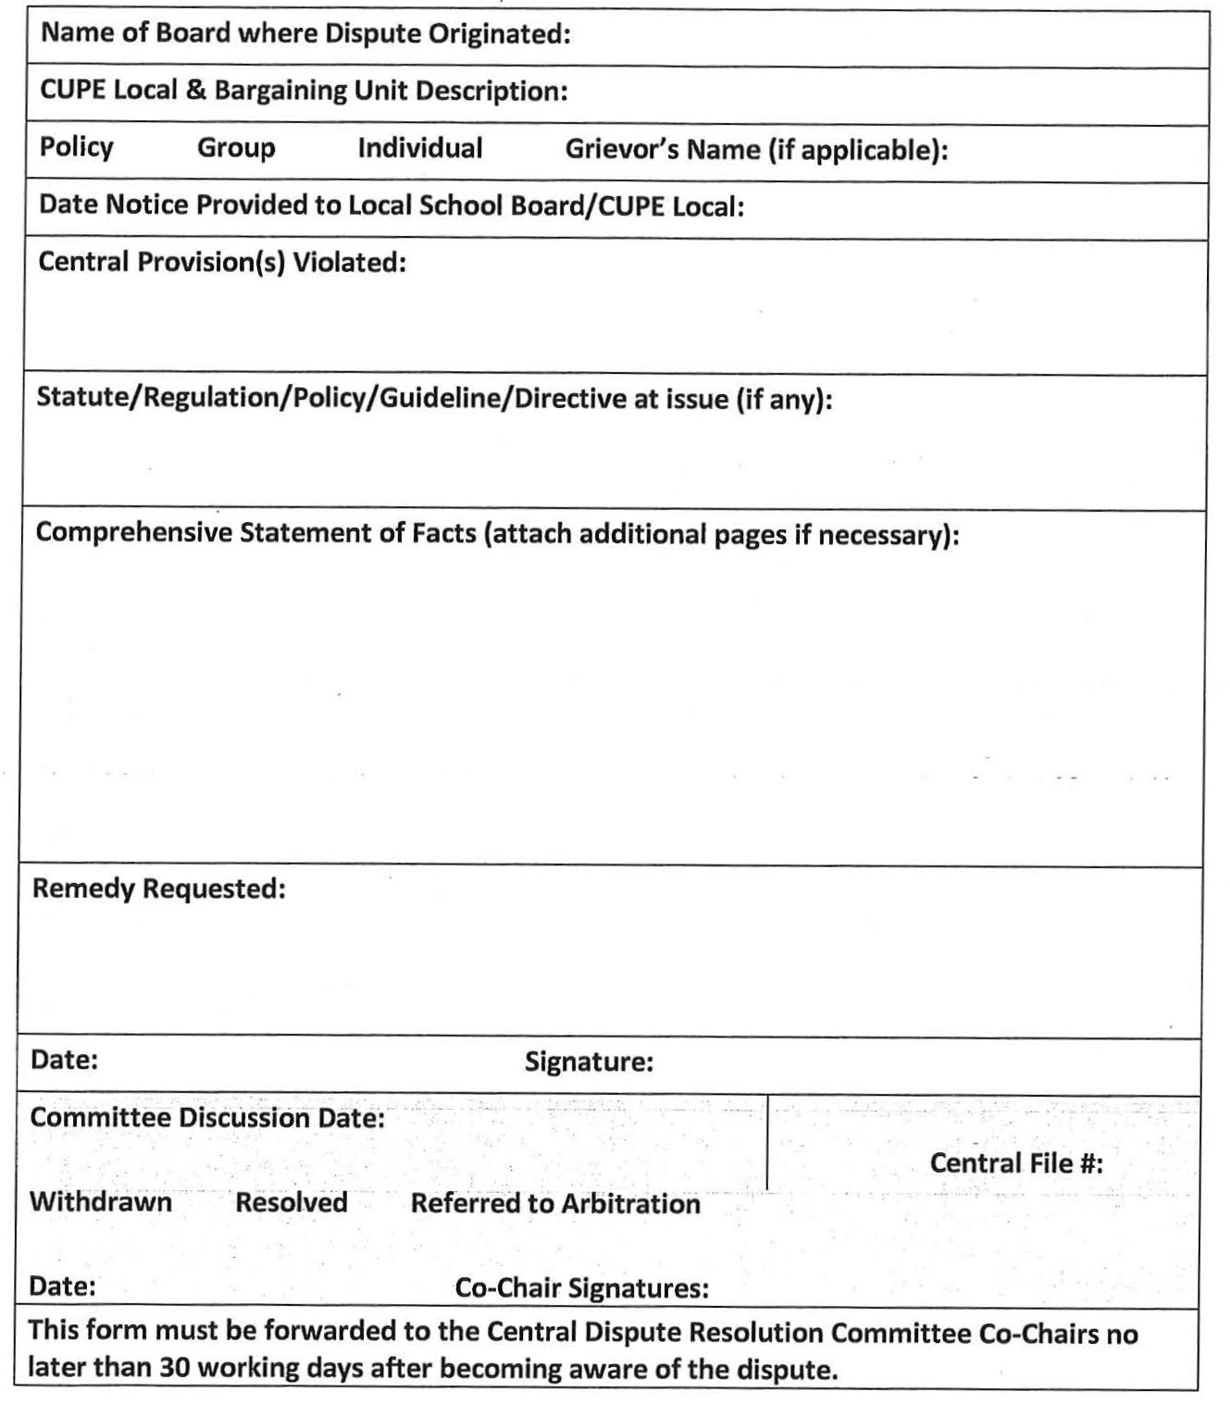
APPENDIX B
Sick Leave Credit-Based Retirement Gratuities (where applicable)
1) An Employee is not eligible to receive a sick leave credit gratuity after August 31, 2012, except a sick leave credit gratuity that the Employee had accumulated and was eligible to receive as of that day.
2) If the Employee is eligible to receive a sick leave credit gratuity, upon the Employee’s retirement, the gratuity shall be paid out at the lesser of,
a) the rate of pay specified by the board’s system of sick leave credit gratuities that applied to the Employee on August 31, 2012; and
b) the Employee’s salary as of August 31, 2012.
3) If a sick leave credit gratuity is payable upon the death of an Employee, the gratuity shall be paid out upon death consistent with the rate in accordance with subsection (2).
4) For greater clarity, all eligibility requirements must have been met as of August 31, 2012 to be eligible for the aforementioned payment upon retirement, and except where there are grievances pending, the Employer and Union agree that any and all wind-up payments to which Employees without the necessary years of service were entitled to under Ontario Regulation 01/13: Sick Leave Credits and Sick Leave Credit Gratuities, have been paid.
5) For the purposes of the following board, despite anything in the board’s system of sick leave credit gratuities, it is a condition of eligibility to receive a sick leave credit gratuity that the Employee have 10 years of service with the board:
i. Near North District School Board
ii. Hamilton-Wentworth District School Board
iii. Huron Perth Catholic District School Board
iv. Peterborough Victoria Northumberland and Clarington Catholic District School Board
v. Hamilton-Wentworth Catholic District School Board
vi. Waterloo Catholic District School Board
vii. Limestone District School Board
viii. Conseil scolaire catholique MonAvenir
ix. Conseil scolaire Viamonde
Other Retirement Gratuities
An employee is not eligible to receive any non-sick leave credit retirement gratuity (such as, but not limited to, service gratuities or RRSP contributions) after August 31, 2012.
APPENDIX C - Medical Certificate
PART 1
The Board may request this medical confirmation in accordance with Article C6.1 h)
Part 2 of this form is to provide the Employer with information to assess whether the employee is able to perform the essential duties of their position and to understand restrictions and/or limitations to assess workplace accommodation, if appropriate.
Part 2 need only be completed for a return to work for which an accommodation may be appropriate.
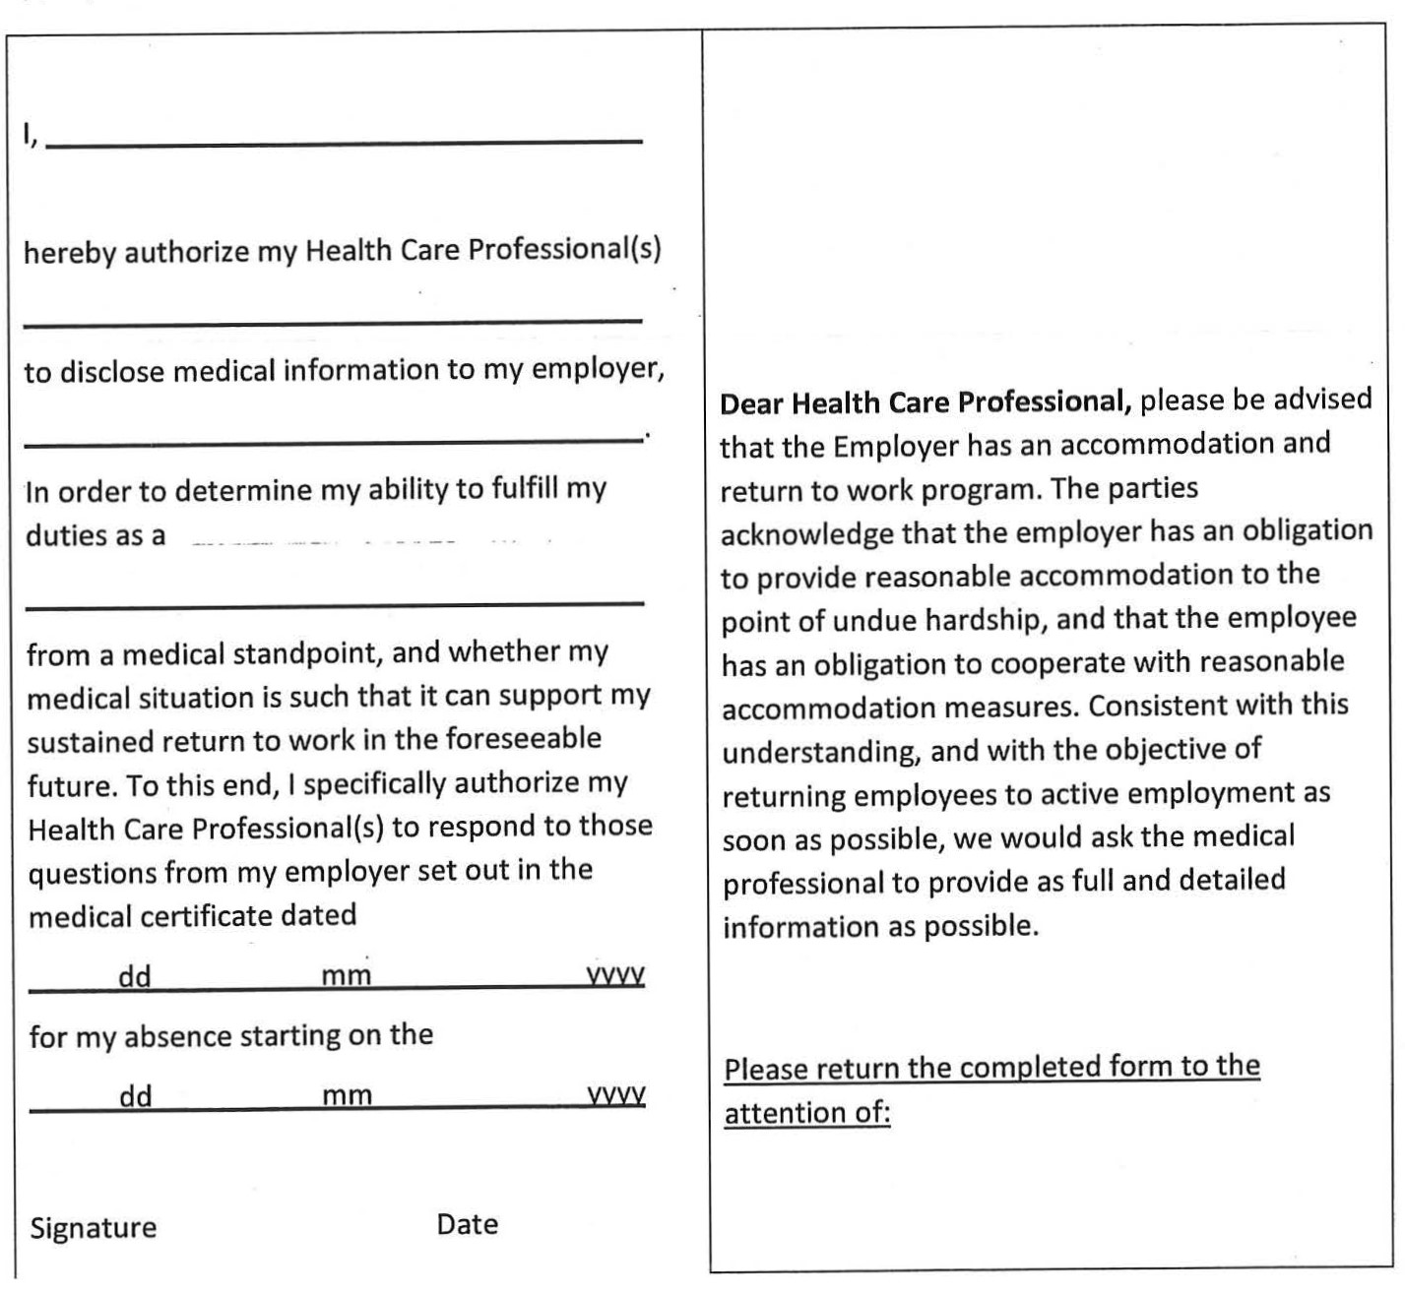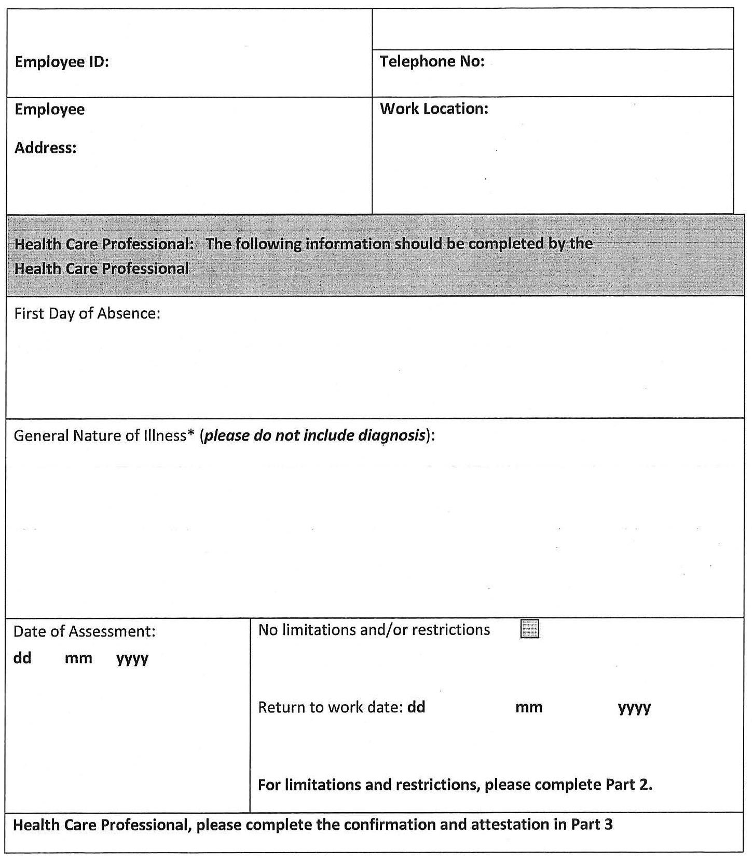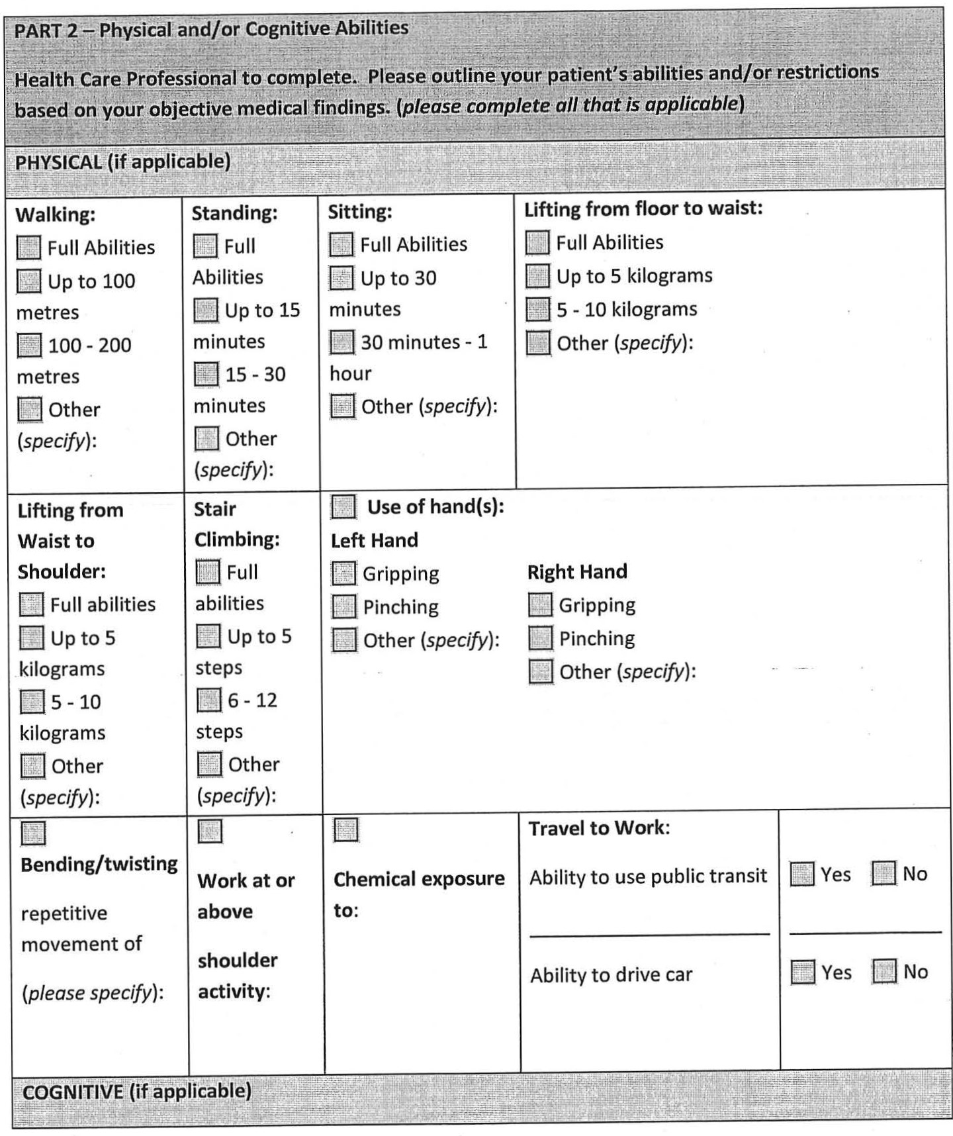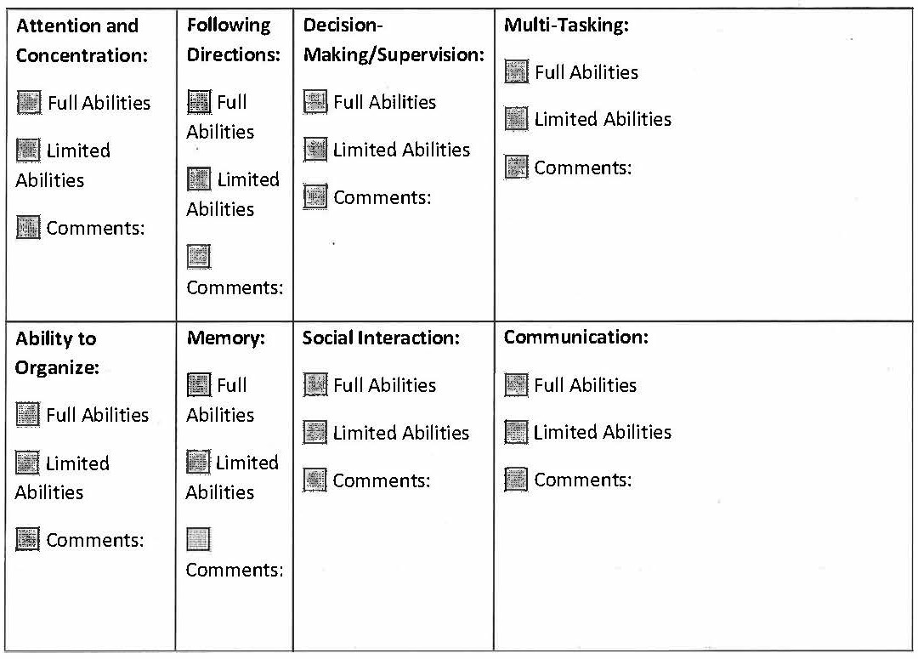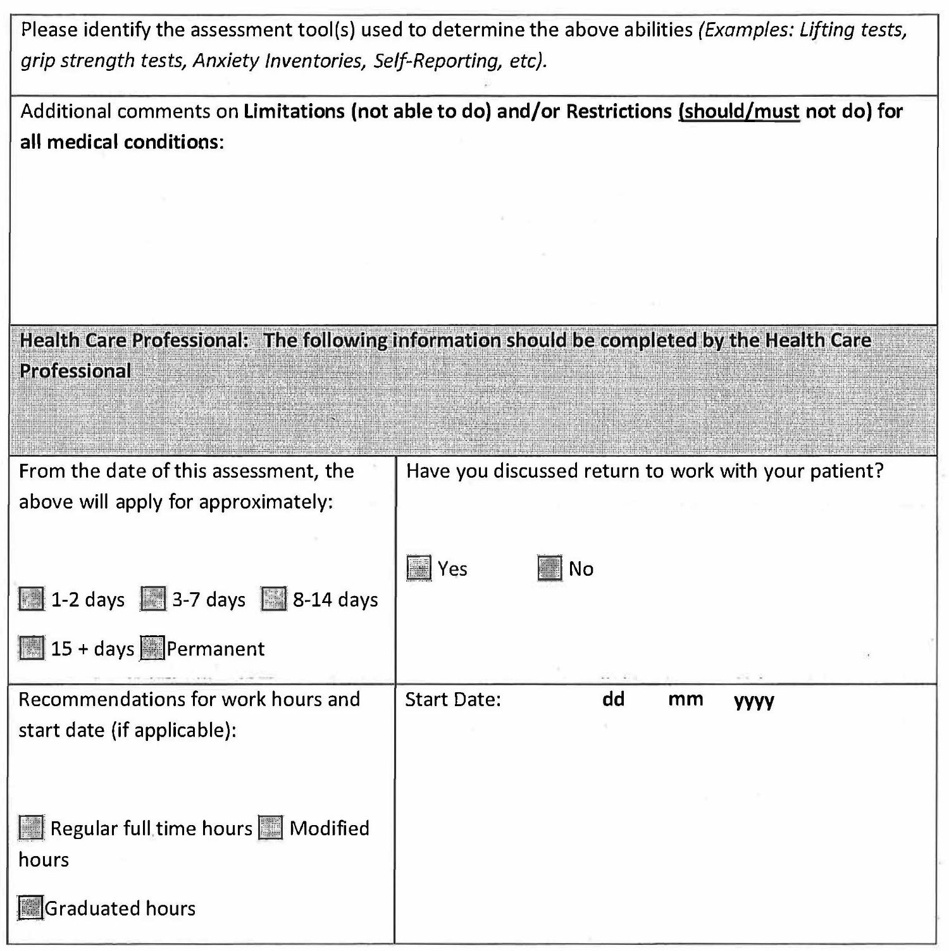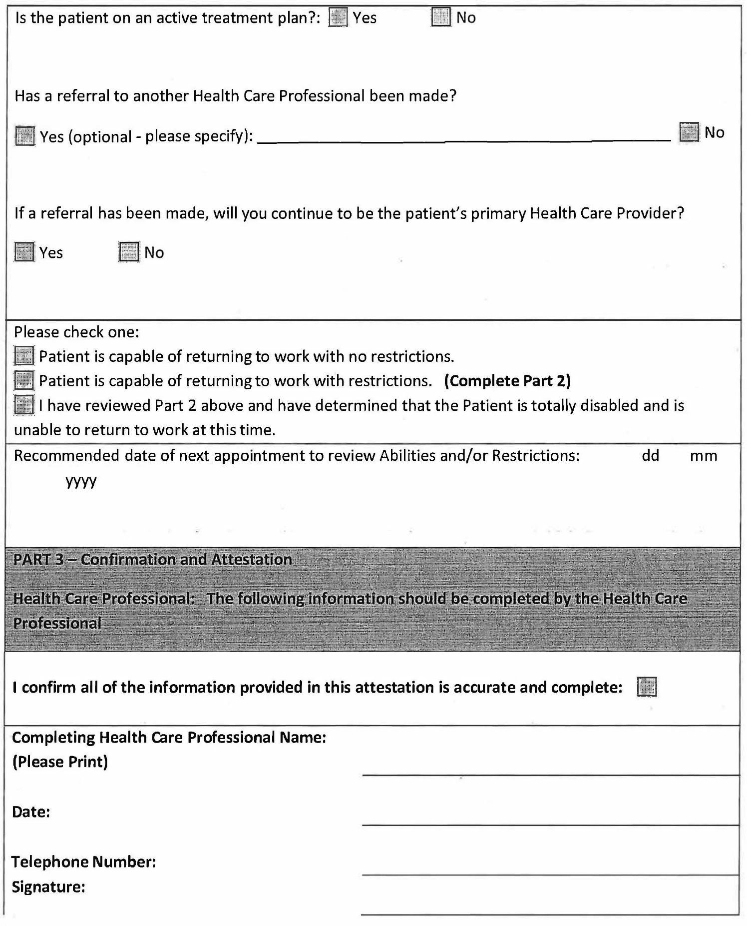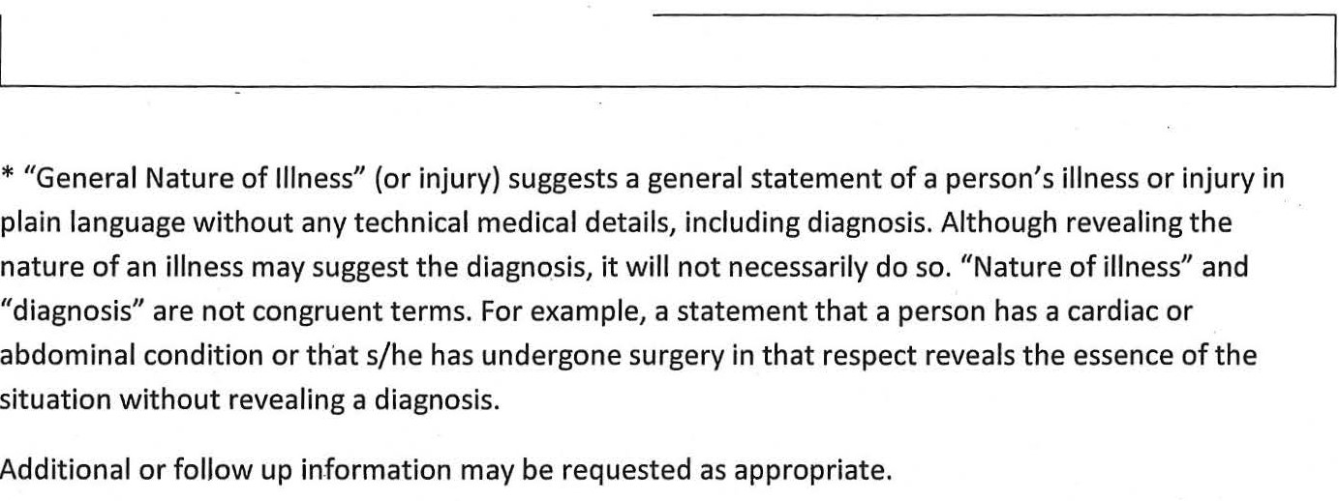
LETTER OF UNDERSTANDING #1
BETWEEN
The Canadian Union of Public Employees
(Hereinafter ‘CUPE’)
AND
The Council of Trustees’ Associations
(Hereinafter the ‘CTA/CAE’)
Re: Status Quo Central Items
All provisions of the central terms that have not been amended remain status quo. In addition, the following central issues have been addressed at the central table and the language relating to these provisions shall remain status quo. For further clarity, if language exists in part B, such language as it pertains to the following items is to be retained. The issues listed below shall not be subject to local bargaining or to amendment by the local parties.
Issues:
− Paid Vacations
− OMERS
− Work week (excluding scheduling)
− Work year (excluding scheduling)
− Hours of Work (excluding scheduling)
− Preparation Time
− Staffing levels (including staffing levels related to permits and leases and replacement staffing)
− Staff development as it relates to access to professional and staff developments
− Allowances/Premiums (excluding percentage increase)
LETTER OF UNDERSTANDING #2
BETWEEN
The Canadian Union of Public Employees
(Hereinafter ‘CUPE’)
AND
The Council of Trustees’ Associations
(Hereinafter the ‘CTA/CAE’)
Re: Status Quo Central Items and Items Requiring Amendment and Incorporation
The parties agree that the following central issues have been addressed at the central table and that the provisions shall remain status quo or are altered as outlined below. The following language must, however, be aligned with current local provisions. The following issues are not subject to local bargaining or amendment by the local parties. Any disputes arising from these provisions may form the subject of a central dispute.
PREGNANCY/PARENTAL LEAVES OF ABSENCE/SEB – EI WAITING PERIOD
The parties agree that the issue of the statutory amendment to the Employment Insurance Act resulting in a reduction of the employment insurance waiting period has been addressed at the central table and the intent of any existing local collective agreement provisions shall remain status quo. Therefore, where a school board’s local collective agreement language references a two-week waiting period and required payment for the two-week waiting period, the board shall ensure that the funds payable from the board to a permanent employee taking an approved leave of 12 months or greater, shall reflect the full sum that would have been payable prior to the reduction of the waiting period.
Provisions with regard to waiting periods and/or payments during such waiting periods shall not be subject to local bargaining or amendment by local parties. However, existing local collective agreement language may need to be revised in order to align with the terms herein and to accord with the relevant statutory change that reduced the waiting period to one week.
STATUTORY/PUBLIC HOLIDAYS
School boards shall ensure that within their local collective agreement terms, Family Day is included as a statutory/public holiday.
WSIB TOP-UP
If a class of employee was entitled to receive WSIB top-up on August 31, 2012 deducted from sick leave, the parties who have not yet do so must incorporate those same provisions without deduction from sick leave. The top-up amount to a maximum of four (4) years and six (6) month shall be included in the 2019-2022 collective agreement.
For parties who have yet to incorporate or aligned local language into the 2014-2017 collective agreement, the following shall apply:
Common Central Provisions
Maternity Benefits/SEB Plan
a) A full-time and part-time permanent Employee who is eligible for pregnancy leave pursuant to the Employment Standards Act, shall receive *100% salary through a Supplemental Employment Benefit (SEB) plan for a total of *eight (8) weeks (*or insert local superior provision reflecting status quo) immediately following the birth of her child with no deduction from sick leave or the Short Term Leave Disability Program (STLDP).
b) Full-time and part-time permanent Employees not eligible for a SEB plan as a result of failing to qualify for Employment Insurance will be eligible to receive 100% of salary from the employer for a total of eight (8) weeks with no deduction from sick leave or STLDP.
c) Where any part of the eight (8) weeks falls during the period of time that is not eligible for pay (i.e. summer, March Break, etc.), the full eight (8) weeks of top up shall continue to be paid.
d) Full-time and part-time permanent Employees who require longer than the eight (8) week recuperation period shall have access to sick leave and the STLDP subject to meeting the requirements to provide acceptable medical verification.
e) Employees completing a long term supply assignment of 6 months or more shall be eligible for the SEB as described herein for a maximum of eight (8) weeks or the remaining number of weeks in their current assignment after the birth of her child, whichever is less.
f) Employees not defined above have no entitlement to the benefits outlined in this article.
SHORT TERM PAID LEAVES
The parties agree that the issue of short term paid leaves has been addressed at the central table and the provisions shall remain status quo to the provisions in current local collective agreements. For clarity, any leave of absence in the 2008-2012 local collective agreement that utilized deduction from sick leave, for reasons other than personal illness shall be granted without loss of salary or deduction from sick leave, to a maximum of 5 days per school year. For further clarity, those boards that had 5 or less shall remain at that level. Boards that had 5 or more days shall be capped at 5 days. These days shall not be used for the purpose of sick leave, nor shall they accumulate from year to year.
Short term paid leave provisions in the 2008-12 collective agreement that did not utilize deduction from sick leave remain status quo and must be incorporated into the 2014-17 collective agreement.
Provisions with regard to short term paid leaves shall not subject to local bargaining or amendment by local parties. However, existing local collective agreement language may need to be revised in order to align with the terms herein.
RETIREMENT GRATUITIES
The issue of Retirement Gratuities has been addressed at the Central Table and the parties agree that formulae contained in current local collective agreements for calculating Retirement Gratuities shall govern payment of retirement gratuities and be limited in their application to terms outlined in Appendix B - Retirement Gratuities.
The following language shall be inserted unaltered as a preamble to Retirement Gratuity language into every collective agreement:
“Retirement Gratuities were frozen as of August 31, 2012. Employees are not eligible to receive a sick leave credit gratuity or any non-sick leave credit retirement gratuity (such as, but not limited to, service gratuities or RRSP contributions) after August 31, 2012, except a sick leave credit gratuity that the Employee had accumulated and was eligible to receive as of that day. The following language applies only to those employees eligible for the gratuity above.”
SICK LEAVE TO BRIDGE LONG TERM DISABILITY WAITING PERIOD
Boards which have Long Term Disability waiting periods greater than 131 days shall ensure there is language that accords with the following entitlement:
An Employee who has applied for long-term disability is eligible for additional short term disability leave days up to the maximum difference between the long-term disability waiting period and 131 days. The additional days shall be payable at 90% and shall be used only to bridge the employee to the long-term disability waiting period if, under a collective agreement in effect on August 31, 2012, the employee was required to wait more than 131 days before being eligible for benefits under a long-term disability plan and the collective agreement did not allow the employee the option of reducing that waiting period.
LETTER OF UNDERSTANDING #3
BETWEEN
The Canadian Union of Public Employees
(Hereinafter ‘CUPE’)
AND
The Council of Trustees’ Associations
(Hereinafter the ‘CTA/CAE’)
Re: Job Security: Protected Complement
The parties acknowledge that education workers contribute in a significant way to student achievement and well-being.
1. Effective as of November 7, 2022, the Board undertakes to maintain its Protected Complement, except in cases of:
a. A catastrophic or unforeseeable event or circumstance;
b. Declining enrolment;
c. Funding reductions directly related to services provided by bargaining unit members; or
d. School closure and/or school consolidation.
2. Where complement reductions are required pursuant to 1. above, they shall be achieved as follows:
a. In the case of declining enrolment, complement reductions shall occur at a rate not greater than the rate of student loss, and
b. In the case of funding reductions, complement reductions shall not exceed the amount of such funding reductions, and
c. In the case of school closure and/or school consolidation, complement reductions shall not exceed the number of staff prior to school closure/consolidation at the affected location(s).
Local collective agreement language will be respected, regarding notification to the union of complement reduction. In the case where there is no local language the board will notify the union within twenty (20) working days of determining there is to be a complement reduction.
3. For the purpose of this Letter of Understanding, at any relevant time, the overall protected complement is equal to:
a. The FTE number (excluding temporary, casual and/or occasional positions) as of November 7, 2022. The FTE number is to be agreed to by the parties through consultation at the local level. Appropriate disclosure will be provided during this consultation. Disputes with regard to the FTE number may be referred to the Central Dispute Resolution Process no later than December 9, 2022;
b. Minus any attrition, defined as positions that become vacant and are not replaced, of bargaining unit members which occurs after November 7, 2022. For clarity, positions may become vacant as a result of resignation, retirement, dismissal, or internal posting/transfer processes.
4. Once the FTE number has been established in accordance with paragraph 3, above, the local parties shall jointly report the number to the Central Labour Relations Committee.
5. Reductions as may be required in 1. above shall only be achieved through lay-off after consultation with the union on alternative measures, which may include:
a. priority for available temporary, casual and/or occasional assignments;
b. the establishment of a permanent supply pool where feasible;
c. the development of a voluntary workforce reduction program (contingent on full provincial government funding).
6. Where local collective agreement language currently exists that provides a superior benefit specifically with regard to protected complement FTE number, that language will prevail.
7. This Letter of Understanding expires on August 30, 2026.
LETTER OF UNDERSTANDING #4
BETWEEN
The Canadian Union of Public Employees
(Hereinafter ‘CUPE’)
AND
The Council of Trustees’ Associations
(Hereinafter the ‘CTA/CAE’)
Re: Apprenticeship Program
The Crown shall create a one-time Priorities and Partnerships Fund (PPF) for distribution, consistent with the Ontario Public Sector Transfer Payment Accountability Directive, in the amount of $4.5 million for the duration of the agreement. Any unspent funds at the conclusion of the agreement will be returned to the Crown. Funds from this PPF shall be allocated to school boards during the 2023-2024 school year, on the basis of joint applications received from school boards and CUPE locals for skilled trades apprenticeships.
The purpose of the PPF is to provide on-the-job skilled trades training for CUPE employees as apprentices.
Representatives of the central parties and the Crown will review, update, and revise the existing distribution model and application process.
It is understood that the purpose of the apprenticeship program is not to reduce current complement/positions.
LETTER OF UNDERSTANDING #5
BETWEEN
The Canadian Union of Public Employees
(Hereinafter ‘CUPE’)
AND
The Council of Trustees’ Associations
(Hereinafter the ‘CTA/CAE’)
AND
The Crown
Re: Education Worker Diverse and Inclusive Workforce Committee – Terms of Reference
PREAMBLE:
The parties recognize the importance of embracing diversity and moving beyond tolerance and celebration to inclusivity and respect in our workplaces. Organizations are strengthened when employers can draw upon a broad range of talents, skills, and perspectives. The parties further recognize that a diverse and inclusive workforce may contribute to student success.
I. MANDATE OF THE COMMITTEE
The mandate of the Education Worker Diverse and Inclusive Workforce Committee is to jointly explore and identify best practices that support diversity, equity, inclusion and to foster diverse and inclusive workforces reflective of Ontario’s diverse communities.
II. DELIVERABLES
The committee will identify existing recruitment, retention and promotion strategies that aim to eliminate barriers for individuals who identify as members of historically underrepresented groups. In addition, the committee will review training and education programs that support the creation of positive, equitable and inclusive workplaces, and foster diverse and inclusive workforces.
Once jointly identified, materials and resources may be shared with school boards and CUPE locals.
III. MEMBERSHIP
The Committee shall include nine (9) members - five (5) representatives from CUPE/SCFP and four (4) representatives from the CTA. Up to two (2) advisors from the Ministry of Education shall act in a resource capacity to the committee. Other persons may attend meetings in order to provide support and resources as mutually agreed. Up to one (1) representative from each of the four (4) employee bargaining agencies at the other education workers tables will be invited to participate on the Committee.
Should there be interest from other Education Worker tables in creating a comparable committee, the parties shall discuss the creation of a Provincial Education Worker Diverse and Inclusive Workforce Committee. If other comparable Education Worker committees are created, and in the absence of a Provincial Education Worker Diverse Workforce Committee, the parties shall discuss holding joint meetings.
IV. CO-CHAIR SELECTION
CUPE/SCFP and CTA representatives will each select one co-chair. The two Co-Chairs will govern the group’s work and meetings.
LETTER OF UNDERSTANDING #6
BETWEEN
The Canadian Union of Public Employees
(Hereinafter ‘CUPE’)
AND
The Council of Trustees’ Associations
(Hereinafter the ‘CTA/CAE’)
Re: Sick Leave
Any existing collective agreement provisions with respect to the items listed below, that do not conflict with the clauses in the Sick Leave article in the Central Agreement, shall remain status quo for the term of this collective agreement:
1. Responsibility for payment for medical documents.
2. Sick leave deduction for absences of partial days.
LETTER OF UNDERSTANDING #7
BETWEEN
The Canadian Union of Public Employees
(Hereinafter ‘CUPE’)
AND
The Council of Trustees’ Associations
(Hereinafter the ‘CTA/CAE’)
Re: Central Labour Relations Committee
The Central Labour Relations Committee will discuss the following topics:
Discussion of pilot project on arbitration
Sick Leave and Short Term Leave Disability Plan
Any other issues raised by the parties
The parties will schedule no fewer than four (4) meetings per year and that agenda items shall be exchanged one week prior to the meeting.
LETTER OF UNDERSTANDING #8
BETWEEN
The Council of Trustees’ Associations
(hereinafter the “CTA/CAE”)
AND
The Canadian Union of Public Employees
(hereinafter “CUPE”)
RE: List of Arbitrators
The following is the list of Agreed-To Arbitrators referenced in Article C4 of the Central Terms of the Collective Agreement.

English Language: | French Language:
Christopher Albertyn | Michelle Flaherty
Paula Knopf | Kathleen O’Neil
Brian Sheehan  Jesse Nyman  Matthew Wilson  Bernard Fishbein | Bram Herlich  Graham Clarke  Geneviève Debané

The parties agree that bilingual Arbitrators may also be used on English cases.
This Letter of Understanding expires on August 31, 2026.
LETTER OF UNDERSTANDING #9
BETWEEN
The Canadian Union of Public Employees
(Hereinafter ‘CUPE’)
AND
The Council of Trustees’ Associations
(Hereinafter the ‘CTA/CAE’)
AND
The Crown
Re: Children’s Mental Health, Special Needs, and Other Initiatives
The parties acknowledge the ongoing implementation of the children’s Mental Health Strategy, the Special Needs Strategy, and other initiatives within the province of Ontario.
The parties further acknowledge the importance of initiatives being implemented within the provincial school system including but not limited to the addition of Mental Health Leads, and the protocol for partnerships with external agencies/service providers.
It is agreed and affirmed that the purpose of the initiatives is to enhance existing mental health and at risk supports to school boards in partnership with existing professional student services support staff and other school personnel. It is not the intention that these enhanced initiatives displace CUPE workers, nor diminish their hours of work.
LETTER OF UNDERSTANDING #10
BETWEEN
The Canadian Union of Public Employees
(Hereinafter ‘CUPE’)
AND
The Council of Trustees’ Associations
(Hereinafter the ‘CTA/CAE’)
AND
The Crown
Re: Provincial Working Group – Health and Safety
The parties confirm their intent to continue to participate in the Provincial Working Group – Health and Safety in accordance with the Terms of Reference dated November 7, 2018, including any updates to such Terms of Reference. The purpose of the working group is to consider areas related to health and safety in order to continue to build and strengthen a culture of health and safety mindedness in the education sector.
Where best practices are identified by the working group, those practices will be shared with school boards.
LETTER OF UNDERSTANDING # 11
BETWEEN
The Canadian Union of Public Employees
(Hereinafter ‘CUPE’)
AND
The Council of Trustees’ Associations
(Hereinafter the ‘CTA/CAE’)
AND
The Crown
RE: Ministry Initiatives Committee
The Provincial Committee on Ministry Initiatives provides advice to the Ministry of Education, on new or existing ministry initiatives/strategies to support improvement to achievement and well-being of all learners. The Crown may convene a meeting of this committee to discuss such initiatives.
CUPE-OSBCU will be an active participant in the consultation process at the Ministry Initiatives Committee.
LETTER OF UNDERSTANDING #12
BETWEEN
The Canadian Union of Public Employees
(Hereinafter ‘CUPE’)
AND
The Council of Trustees’ Associations
(Hereinafter the ‘CTA/CAE’)
AND
The Crown
RE: Bereavement Leave
1. The issue of bereavement leave has been addressed at the central table.
2. Where local (Part B) collective agreement terms provide for a total paid bereavement leave entitlement for Permanent Employees of less than three (3) days, boards shall insert the following into the local (Part B) collective agreement, with such language replacing existing language in its entirety:
Permanent Employees shall be provided with three (3) consecutive regularly scheduled work days’ bereavement leave without loss of salary or wages immediately upon the death of or to attend a funeral for an employee’s spouse, parent, step-parent, child, step-child, grandparent, grandchild, sibling, spouse’s parent, or child’s spouse.
3. Where local (Part B) collective agreement terms provide for a total paid bereavement leave entitlement for Permanent Employees of three (3) days or more, there shall be no change to such language and this Letter of Understanding shall not apply.
4. Permanent Employees shall be as defined in local collective agreement terms, or if no such definition exists in a particular collective agreement, as defined in C6.
5. For clarity, while the specific provisions above (including the number of bereavement leave days and eligibility criteria) are not subject to local bargaining or amendment by the local parties, the local parties shall be permitted to discuss, as a local matter, the administration terms associated with bereavement leave.
LETTER OF UNDERSTANDING #13
BETWEEN
The Canadian Union of Public Employees
(Hereinafter ‘CUPE’)
AND
The Council of Trustees’ Associations
(Hereinafter the ‘CTA/CAE’)
AND
The Crown
RE: Compensation
School boards shall adjust their current salary grids and wage schedules in accordance with the schedule below (for clarity, eligibility for adjustment shall be determined on an annual basis):
For education worker positions that have an annualized full-time equivalency salary rate less than $43,000 or, for positions paid on an hourly basis, an hourly rate of less than $25.95, in either case determined based on the top (highest) step of the applicable job classification pay grid:
i. Effective November 7, 2022, an increase of 2.5% ;
ii. Effective September 1, 2023, an increase of 2.5%;
iii. Effective September 1, 2024, an increase of 2.5%;
iv. Effective September 1, 2025, an increase of 2.5%.
Education workers in positions with wages/salaries increased under (i) above will receive a one-time payment of 2.5% of the salary/wages earned in respect of the 67 calendar days immediately prior to November 7, 2022.
For education worker positions that have an annualized full-time equivalency salary rate of $43,000 or more, or for positions paid on an hourly basis, an hourly rate of $25.95 or more, in either case determined based on the top (highest) step of the applicable job classification pay grid:
v. Effective November 7, 2022, an increase of 1.5% ;
vi. Effective September 1, 2023, an increase of 1.5%;
vii. Effective September 1, 2024, an increase of 1.5%;
viii. Effective September 1, 2025, an increase of 1.5%.
Education workers in positions with wages/salaries increased under (v) above will receive a one-time payment of 1.5% of the salary/wages earned in respect of the 67 calendar days immediately prior to November 7, 2022.
Premiums and allowances will be increased by 1.9% on November 7, 2022, and September 1 of each subsequent year of the collective agreement.
Increases noted above will be implemented within 90 days of the applicable effective date. One-time payments noted above will be paid within 90 days of November 7, 2022.
LETTER OF UNDERSTANDING #14
BETWEEN
The Canadian Union of Public Employees
(Hereinafter ‘CUPE’)
AND
The Council of Trustees’ Associations
(Hereinafter the ‘CTA/CAE’)
AND
The Crown
RE: Community Use of Schools
Conditional upon the approval by the Lieutenant-Governor-in-Council (if applicable), the Crown will maintain the investment in community use of schools funding, in the Grants for Student Needs (as shown in the table below), for the duration of this collective agreement.
It is intended that this funding be used to staff schools with CUPE custodians during community use, consistent with local collective agreements and existing board policies, procedures and practices. Where current practices do not provide CUPE custodial staff for community use events, and where policies and procedures allow, the funding will be used to provide CUPE custodial staffing to the extent of the available funds.

Community Use of Schools Investment
School Board Name | $
Algoma DSB | 4,417
Algonquin and Lakeshore Catholic DSB | 4,558
Bluewater DSB | 7,113
Bruce-Grey Catholic DSB | 1,608
Catholic DSB of Eastern Ontario | 4,814
CÉP de l'Est de l'Ontario | 6,144
CS catholique Mon Avenir | 6,415
CS catholique Providence | 4,228
CS Viamonde | 4,747
CSD catholique de l'Est ontarien | 5,191
CSD catholique des Grandes Rivières | 3,613
CSD catholique du Centre-Est de l'Ontario | 7,802
CSD catholique du Nouvel-Ontario | 3,574
CSD catholique Franco-Nord | 1,260
CSD du Grand Nord de l'Ontario | 1,977
CSD du Nord-Est de l'Ontario | 1,119
DSB of Niagara | 14,460
DSB Ontario North East | 4,951
Dufferin-Peel Catholic DSB | 31,209
Durham Catholic DSB | 8,163
Durham DSB | 25,822
Grand Erie DSB | 10,719
Greater Essex County DSB | 12,354
Halton Catholic DSB | 11,833
Halton DSB | 21,477
Hamilton-Wentworth Catholic DSB | 165
Hamilton-Wentworth DSB | 17,826
Hastings and Prince Edward DSB | 6,802
Huron Perth Catholic DSB | 47
Huron-Superior Catholic DSB | 2,064
Kawartha Pine Ridge DSB | 12,589
Keewatin-Patricia DSB | 2,820
Lakehead DSB | 3,792
Lambton Kent DSB | 9,693
Limestone DSB | 8,416
London District Catholic School Board | 7,165
Near North DSB | 4,719
Niagara Catholic DSB | 8,288
Nipissing-Parry Sound Catholic DSB | 1,291
Northeastern Catholic DSB | 1,143
Northwest Catholic DSB | 518
Ottawa Catholic DSB | 231
Peel DSB | 55,581
Peterborough V N C Catholic DSB | 5,638
Rainbow DSB | 6,140
Rainy River DSB | 1,384
Renfrew County Catholic DSB | 1,816
Renfrew County DSB | 4,763
Simcoe County DSB | 17,471
Simcoe Muskoka Catholic DSB | 7,466
St. Clair Catholic DSB | 3,211
Sudbury Catholic DSB | 2,384
Thames Valley DSB | 29,002
Toronto Catholic DSB | 34,196
Toronto DSB | 85,953
Trillium Lakelands DSB | 6,961
Upper Canada DSB | 12,895
Upper Grand DSB | 11,029
Waterloo Catholic DSB | 87
Wellington Catholic DSB | 2,950
York Catholic DSB | 20,341
York Region DSB | 45,435
TOTAL | 651,835

LETTER OF UNDERSTANDING #15
BETWEEN
The Canadian Union of Public Employees
(Hereinafter ‘CUPE’)
AND
The Council of Trustees’ Associations
(Hereinafter the ‘CTA/CAE’)
AND
The Crown
RE: Long-term Disability (LTD)
Effective January 1, 2023, the Dufferin-Peel Catholic District School Board shall adjust its LTD plan provisions to reflect the following:
- Premium share: 75% employer and 25% employee
- Benefit level as percentage of salary and maximum monthly benefit amounts: no change
- Waiting/qualifying period: 120 working days
The waiting/qualifying period noted above shall only apply to claims filed on or after January 1, 2023.
LETTER OF UNDERSTANDING #16
BETWEEN
The Canadian Union of Public Employees
(Hereinafter ‘CUPE’)
AND
The Council of Trustees’ Associations
(Hereinafter the ‘CTA/CAE’)
AND
The Crown
RE: Supports for Students Fund
A. Special Education Staff Amount
In recognition of the role that education assistants, child and youth workers/counsellors and professional student services personnel play in supporting special education, the Crown will, conditional upon the approval by the Lieutenant-Governor-in-Council (if applicable), make a system investment in each year of the collective agreement, to be utilized for special education needs.
The school board’s share of the special education staffing amount shall be allocated for each CUPE bargaining unit based on the FTE of that bargaining unit for the following staffing categories: educational assistants, child and youth workers and professional student services personnel compared to the board’s total FTE of educational assistants, child and youth workers and professional student services personnel.
The tables below provide the funding amounts as a result of this system investment.
B. Other Staffing Amount
In recognition of the role that office, clerical and technical, and custodial and maintenance employees play in promoting safe, healthy and caring schools, the Crown will, conditional upon the approval by the Lieutenant-Governor-in-Council (if applicable), make a system investment in each year of the collective agreement.
The school board’s share shall be allocated for each CUPE bargaining unit based on the FTE of that bargaining unit for the following staffing categories: office, clerical and technical, custodial and maintenance education workers compared to the board’s total FTE of office, clerical and technical, custodial and maintenance education workers.
The tables below provide the funding amounts as a result of this system investment.

Supports for Students Fund - CUPE | 2022-23 |  |  | 2023-24
DSB Name | Special Education Staff Amount | Other Staffing Amount | TOTAL | Special Education Staff Amount | Other Staffing Amount | TOTAL
Algoma DSB | $- | $173,713 | $173,713 | $- | $177,013 | $177,013
Algonquin and Lakeshore Catholic DSB | $380,517 | $309,470 | $689,986 | $387,746 | $315,350 | $703,096
Bluewater DSB | $- | $233,316 | $233,316 | $- | $237,749 | $237,749
Bruce-Grey Catholic DSB | $161,744 | $96,163 | $257,907 | $164,817 | $97,990 | $262,807
Catholic DSB of Eastern Ontario | $393,833 | $339,609 | $733,442 | $401,316 | $346,062 | $747,377
CÉP de l'Est de l'Ontario | $- | $378,834 | $378,834 | $- | $386,032 | $386,032
CS catholique MonAvenir | $- | $204,123 | $204,123 | $- | $208,001 | $208,001
CS catholique Providence | $320,705 | $288,259 | $608,963 | $326,798 | $293,735 | $620,534
CS Viamonde | $- | $163,075 | $163,075 | $- | $166,173 | $166,173
CSD catholique de l'Est ontarien | $- | $247,510 | $247,510 | $- | $252,213 | $252,213
CSD catholique des Grandes Rivières | $- | $101,211 | $101,211 | $- | $103,134 | $103,134
CSD catholique du Centre-Est de l'Ontario | $- | $179,983 | $179,983 | $- | $183,402 | $183,402
CSD catholique du Nouvel-Ontario | $- | $127,694 | $127,694 | $- | $130,120 | $130,120
CSD catholique Franco-Nord | $- | $41,776 | $41,776 | $- | $42,570 | $42,570
CSP du Grand Nord de l'Ontario | $- | $61,987 | $61,987 | $- | $63,165 | $63,165
CSP du Nord-Est de l'Ontario | $122,327 | $93,528 | $215,855 | $124,651 | $95,305 | $219,956
DSB of Niagara | $936,869 | $747,597 | $1,684,465 | $954,669 | $761,801 | $1,716,470
DSB Ontario North East | $- | $185,171 | $185,171 | $- | $188,689 | $188,689
Dufferin-Peel Catholic DSB | $- | $1,671,481 | $1,671,481 | $- | $1,703,239 | $1,703,239
Durham Catholic DSB | $425,211 | $407,556 | $832,767 | $433,290 | $415,300 | $848,590
Durham DSB | $1,686,919 | $1,358,314 | $3,045,233 | $1,718,970 | $1,384,122 | $3,103,093
Grand Erie DSB | $701,924 | $588,862 | $1,290,786 | $715,260 | $600,050 | $1,315,311
Greater Essex County DSB | $- | $745,142 | $745,142 | $- | $759,300 | $759,300
Halton Catholic DSB | $688,178 | $621,901 | $1,310,079 | $701,253 | $633,717 | $1,334,971
Halton DSB | $- | $526,376 | $526,376 | $- | $536,378 | $536,378
Hamilton-Wentworth Catholic DSB | $794,273 | $233,617 | $1,027,890 | $809,364 | $238,056 | $1,047,420
Hamilton-Wentworth DSB | $- | $559,881 | $559,881 | $- | $570,518 | $570,518
Hastings and Prince Edward DSB | $454,776 | $336,954 | $791,729 | $463,416 | $343,356 | $806,772
Huron Perth Catholic DSB | $169,755 | $53,480 | $223,234 | $172,980 | $54,496 | $227,476
Huron-Superior Catholic DSB | $219,775 | $164,787 | $384,562 | $223,951 | $167,918 | $391,869
Kawartha Pine Ridge DSB | $916,390 | $703,263 | $1,619,654 | $933,802 | $716,625 | $1,650,427
Keewatin-Patricia DSB | $- | $143,379 | $143,379 | $- | $146,104 | $146,104
Lakehead DSB | $- | $139,981 | $139,981 | $- | $142,641 | $142,641
Lambton Kent DSB | $656,210 | $491,214 | $1,147,423 | $668,678 | $500,547 | $1,169,224
Limestone DSB | $515,503 | $430,974 | $946,477 | $525,298 | $439,163 | $964,460
London District Catholic School Board | $508,130 | $363,556 | $871,687 | $517,785 | $370,464 | $888,249
Near North DSB | $- | $287,689 | $287,689 | $- | $293,155 | $293,155
Niagara Catholic DSB | $554,091 | $460,927 | $1,015,018 | $564,619 | $469,685 | $1,034,303
Nipissing-Parry Sound Catholic DSB | $- | $32,670 | $32,670 | $- | $33,291 | $33,291
Northeastern Catholic DSB | $114,409 | $72,872 | $187,281 | $116,582 | $74,257 | $190,839
Northwest Catholic DSB | $97,542 | $45,727 | $143,269 | $99,395 | $46,596 | $145,991
Ottawa Catholic DSB | $976,350 | $383,672 | $1,360,021 | $994,900 | $390,961 | $1,385,862
Peel DSB | $- | $3,003,247 | $3,003,247 | $- | $3,060,309 | $3,060,309
Peterborough V N C Catholic DSB | $442,659 | $360,854 | $803,513 | $451,070 | $367,710 | $818,779
Rainbow DSB | $- | $217,241 | $217,241 | $- | $221,369 | $221,369
Rainy River DSB | $- | $40,696 | $40,696 | $- | $41,469 | $41,469
Renfrew County Catholic DSB | $- | $60,113 | $60,113 | $- | $61,255 | $61,255
Renfrew County DSB | $- | $242,331 | $242,331 | $- | $246,935 | $246,935
Simcoe County DSB | $- | $579,761 | $579,761 | $- | $590,777 | $590,777
Simcoe Muskoka Catholic DSB | $- | $272,860 | $272,860 | $- | $278,045 | $278,045
St. Clair Catholic DSB | $271,594 | $190,934 | $462,527 | $276,754 | $194,561 | $471,315
Sudbury Catholic DSB | $- | $79,653 | $79,653 | $- | $81,167 | $81,167
Thames Valley DSB | $1,767,053 | $1,542,369 | $3,309,422 | $1,800,627 | $1,571,674 | $3,372,301
Toronto Catholic DSB | $1,739,213 | $1,989,287 | $3,728,499 | $1,772,258 | $2,027,083 | $3,799,341
Toronto DSB | $4,789,953 | $4,470,794 | $9,260,747 | $4,880,962 | $4,555,739 | $9,436,701
Trillium Lakelands DSB | $507,119 | $437,134 | $944,253 | $516,754 | $445,440 | $962,194
Upper Canada DSB | $787,608 | $683,840 | $1,471,448 | $802,572 | $696,833 | $1,499,405
Upper Grand DSB | $- | $334,760 | $334,760 | $- | $341,121 | $341,121
Waterloo Catholic DSB | $513,196 | $195,265 | $708,461 | $522,947 | $198,975 | $721,922
Wellington Catholic DSB | $- | $80,946 | $80,946 | $- | $82,483 | $82,483
Windsor-Essex Catholic DSB | $536,466 | $- | $536,466 | $546,659 | $- | $546,659
York Catholic DSB | $1,157,439 | $985,731 | $2,143,169 | $1,179,430 | $1,004,459 | $2,183,890
York Region DSB | $2,618,870 | $2,335,737 | $4,954,607 | $2,668,629 | $2,380,116 | $5,048,745
Totals | $26,926,598 | $32,900,844 | $59,827,442 | $27,438,204 | $33,525,960 | $60,964,164

Supports for Students Fund - CUPE | 2024-25 |  |  | 2025-26
DSB Name | Special Education Staff Amount | Other Staffing Amount | TOTAL | Special Education Staff Amount | Other Staffing Amount | TOTAL
Algoma DSB | $- | $180,377 | $180,377 | $- | $183,804 | $183,804
Algonquin and Lakeshore Catholic DSB | $395,114 | $321,341 | $716,455 | $402,621 | $327,447 | $730,068
Bluewater DSB | $- | $242,266 | $242,266 | $- | $246,869 | $246,869
Bruce-Grey Catholic DSB | $167,949 | $ 99,852 | $267,800 | $171,140 | $101,749 | $272,889
Catholic DSB of Eastern Ontario | $408,941 | $352,637 | $761,577 | $416,710 | $359,337 | $776,047
CÉP de l'Est de l'Ontario | $- | $393,366 | $393,366 | $- | $400,840 | $400,840
CS catholique MonAvenir | $- | $211,953 | $211,953 | $- | $215,980 | $215,980
CS catholique Providence | $333,007 | $299,316 | $632,324 | $339,334 | $305,003 | $644,338
CS Viamonde | $- | $169,331 | $169,331 | $- | $172,548 | $172,548
CSD catholique de l'Est ontarien | $- | $257,005 | $257,005 | $- | $261,888 | $261,888
CSD catholique des Grandes Rivières | $- | $105,094 | $105,094 | $- | $107,090 | $107,090
CSD catholique du Centre-Est de l'Ontario | $- | $186,887 | $186,887 | $- | $190,438 | $190,438
CSD catholique du Nouvel-Ontario | $- | $132,592 | $132,592 | $- | $135,112 | $135,112
CSD catholique Franco-Nord | $- | $ 43,379 | $ 43,379 | $- | $ 44,203 | $ 44,203
CSP du Grand Nord de l'Ontario | $- | $ 64,365 | $ 64,365 | $- | $ 65,588 | $ 65,588
CSP du Nord-Est de l'Ontario | $127,020 | $ 97,116 | $224,135 | $129,433 | $ 98,961 | $228,394
DSB of Niagara | $972,808 | $776,275 | $1,749,083 | $991,291 | $791,025 | $1,782,316
DSB Ontario North East | $- | $192,274 | $192,274 | $- | $195,927 | $195,927
Dufferin-Peel Catholic DSB | $- | $1,735,600 | $1,735,600 | $- | $1,768,577 | $1,768,577
Durham Catholic DSB | $441,523 | $423,190 | $864,713 | $449,912 | $431,231 | $881,143
Durham DSB | $1,751,631 | $1,410,420 | $3,162,051 | $1,784,912 | $1,437,218 | $3,222,130
Grand Erie DSB | $728,850 | $611,451 | $1,340,302 | $742,699 | $623,069 | $1,365,767
Greater Essex County DSB | $- | $773,727 | $773,727 | $- | $788,427 | $788,427
Halton Catholic DSB | $714,577 | $645,758 | $1,360,335 | $728,154 | $658,028 | $1,386,182
Halton DSB | $- | $546,569 | $546,569 | $- | $556,953 | $556,953
Hamilton-Wentworth Catholic DSB | $824,742 | $242,579 | $1,067,321 | $840,412 | $247,188 | $1,087,600
Hamilton-Wentworth DSB | $- | $581,358 | $581,358 | $- | $592,404 | $592,404
Hastings and Prince Edward DSB | $472,221 | $349,879 | $822,101 | $481,194 | $356,527 | $837,721
Huron Perth Catholic DSB | $176,267 | $ 55,531 | $231,798 | $179,616 | $ 56,586 | $236,202
Huron-Superior Catholic DSB | $228,206 | $171,109 | $399,315 | $232,542 | $174,360 | $406,902
Kawartha Pine Ridge DSB | $951,544 | $730,241 | $1,681,785 | $969,623 | $744,116 | $1,713,739
Keewatin-Patricia DSB | $- | $148,880 | $148,880 | $- | $151,708 | $151,708
Lakehead DSB | $- | $145,351 | $145,351 | $- | $148,113 | $148,113
Lambton Kent DSB | $681,382 | $510,057 | $1,191,439 | $694,329 | $519,748 | $1,214,077
Limestone DSB | $535,278 | $447,507 | $982,785 | $545,449 | $456,009 | $1,001,458
London District Catholic School Board | $527,623 | $377,503 | $905,125 | $537,648 | $384,675 | $922,323
Near North DSB | $- | $298,725 | $298,725 | $- | $304,401 | $304,401
Niagara Catholic DSB | $575,347 | $478,609 | $1,053,955 | $586,278 | $487,702 | $1,073,980
Nipissing-Parry Sound Catholic DSB | $- | $ 33,923 | $ 33,923 | $- | $ 34,568 | $ 34,568
Northeastern Catholic DSB | $118,797 | $ 75,668 | $194,465 | $121,055 | $ 77,105 | $198,160
Northwest Catholic DSB | $101,284 | $ 47,481 | $148,764 | $103,208 | $ 48,383 | $151,591
Ottawa Catholic DSB | $1,013,803 | $398,390 | $1,412,193 | $1,033,066 | $405,959 | $1,439,025
Peel DSB | $- | $3,118,455 | $3,118,455 | $- | $3,177,706 | $3,177,706
Peterborough V N C Catholic DSB | $459,640 | $374,696 | $834,336 | $468,373 | $381,816 | $850,189
Rainbow DSB | $- | $225,575 | $225,575 | $- | $229,861 | $229,861
Rainy River DSB | $- | $ 42,257 | $ 42,257 | $- | $ 43,060 | $ 43,060
Renfrew County Catholic DSB | $- | $ 62,419 | $ 62,419 | $- | $ 63,605 | $ 63,605
Renfrew County DSB | $- | $251,627 | $251,627 | $- | $256,408 | $256,408
Simcoe County DSB | $- | $602,002 | $602,002 | $- | $613,440 | $613,440
Simcoe Muskoka Catholic DSB | $- | $283,327 | $283,327 | $- | $288,711 | $288,711
St. Clair Catholic DSB | $282,013 | $198,258 | $480,270 | $287,371 | $202,025 | $489,396
Sudbury Catholic DSB | $- | $ 82,709 | $ 82,709 | $- | $ 84,280 | $ 84,280
Thames Valley DSB | $ 1,834,839 | $1,601,536 | $3,436,374 | $1,869,701 | $1,631,965 | $3,501,666
Toronto Catholic DSB | $1,805,931 | $2,065,598 | $3,871,528 | $1,840,243 | $2,104,844 | $3,945,087
Toronto DSB | $4,973,700 | $4,642,298 | $9,615,998 | $5,068,200 | $4,730,502 | $9,798,702
Trillium Lakelands DSB | $526,572 | $453,903 | $980,476 | $536,577 | $462,527 | $999,105
Upper Canada DSB | $817,821 | $710,073 | $1,527,894 | $833,360 | $723,564 | $1,556,924
Upper Grand DSB | $- | $347,602 | $347,602 | $- | $354,207 | $354,207
Waterloo Catholic DSB | $532,883 | $202,755 | $735,639 | $543,008 | $206,608 | $749,616
Wellington Catholic DSB | $- | $ 84,051 | $ 84,051 | $- | $ 85,648 | $ 85,648
Windsor-Essex Catholic DSB | $557,046 | $- | $557,046 | $567,629 | $- | $567,629
York Catholic DSB | $1,201,839 | $1,023,544 | $2,225,384 | $1,224,674 | $1,042,992 | $2,267,666
York Region DSB | $2,719,333 | $2,425,338 | $5,144,671 | $2,771,000 | $2,471,420 | $5,242,420
Totals | $ 27,959,529 | $ 34,162,954 | $ 62,122,483 | $ 28,490,761 | $ 34,812,050 | $ 63,302,810

LETTER OF UNDERSTANDING #17
BETWEEN
The Canadian Union of Public Employees
(Hereinafter ‘CUPE’)
AND
The Council of Trustees’ Associations
(Hereinafter the ‘CTA/CAE’)
AND
The Crown
RE: Short Term Paid Leave
1. The issue of short term paid leave has been addressed at the central table and will remain status quo with the exception of the following.
2. The boards shall ensure that within their local (Part B) collective agreement terms, existing language with respect to short term paid leave shall be amended to allow Indigenous employees to use existing short term paid leave for purposes of:
a. Voting in elections as indicated by a self-governing Indigenous authority where the employee’s working hours do not otherwise provide three consecutive hours free from work; and
b. Attendance at Indigenous cultural/ceremonial events.
3. For clarity, provisions with regard to the number of days of short term paid leave shall not be subject to local bargaining or amendment by local parties and remain status quo at a maximum of five (5) days per school year.
LETTER OF UNDERSTANDING #18
BETWEEN
The Canadian Union of Public Employees
(Hereinafter ‘CUPE’)
AND
The Council of Trustees’ Associations
(Hereinafter the ‘CTA/CAE’)
AND
The Crown
RE: ARTICLE C6 – SICK LEAVE
THE FOLLOWING LANGUAGE FROM THE SEPTEMBER 1, 2019 – AUGUST 31, 2022 CENTRAL AGREEMENT WILL REMAIN IN EFFECT UNTIL AUGUST 31, 2023. THEREAFTER IT WILL BE CONSIDERED A HISTORICAL APPENDIX FOR REFERENCE PURPOSES ONLY.
C6.00 Sick leave
C6.1 Sick Leave/Short Term Leave and Disability Plan
Definitions:
The definitions below shall be exclusively used for this article.
“Full year” refers to the ordinary period of employment for the position.
“Permanent Employees” – means all employees who are not casual employees, or employees working in a long-term supply assignment, as defined below.
“Long Term Supply Assignment” means, in relation to an employee,
i. a long term supply assignment within the meaning of the local collective agreement, or
ii. where no such definition exists, a long term supply assignment will be defined as twelve (12) days of continuous employment in one assignment.
“Casual Employees” means,
i. A casual employee within the meaning of the local collective agreement,
ii. If clause (i) does not apply, an employee who is a casual employee as agreed upon by the board and the bargaining agent, or
iii. If clauses (i) and (ii) do not apply, an employee who is not regularly scheduled to work.
Notwithstanding the above, an employee working in a Long Term Supply Assignment shall not be considered a casual employee for purposes of sick leave entitlement under this article while working in the assignment.
“Fiscal Year” means September 1 to August 31.
“Wages” is defined as the amount of money the employee would have otherwise received over a period of absence, excluding overtime.
a) Sick Leave Benefit Plan
The Board will provide a Sick Leave Benefit Plan which will provide sick leave days and short term disability coverage to provide protection against loss of income when ill or injured as defined below. An employee, other than a casual employee as defined above, is eligible for benefits under this article.
Sick leave days may be used for reasons of personal illness, personal injury, personal medical appointments, or personal dental emergencies only. Appointments shall be scheduled outside of working hours, where possible.
Employees receiving benefits under the Workplace Safety and Insurance Act, or under a LTD plan, are not entitled to benefits under a school board’s sick leave and short term disability plan for the same condition.
b) Sick Leave Days Payable at 100% Wages
Permanent Employees
Subject to paragraphs d), e) and f) below, Employees will be allocated eleven (11) sick days payable at one hundred percent (100%) of wages on the first day of each fiscal year, or the first day of employment.
Employees on Long Term Supply Assignments
Subject to paragraph d) below, Employees completing a, full-year long term supply assignment shall be allocated eleven (11) sick days payable at one hundred percent (100%) of wages at the start of the assignment. An employee completing a long term supply assignment that is less than a full year will be allocated eleven (11) sick days payable at one hundred percent (100%) reduced to reflect the proportion the long term supply assignment bears to the length of the regular work year for the position.
c) Short Term Disability Coverage – Days Payable at 90% Wages
Permanent Employees
Subject to paragraphs d), e) and f) below, permanent Employees will be allocated one hundred and twenty (120) short-term disability days at the start of each fiscal year or the first day of employment. Permanent Employees eligible to access short term disability coverage shall receive payment equivalent to ninety percent (90%) of regular wages.
Employees on Long Term Supply Assignments
Subject to paragraph d) below, Employees completing a full year long term supply assignment shall be allocated one hundred and twenty (120) short term disability days payable at ninety percent (90%) of wages at the start of the assignment.
An employee completing a long term supply assignment that is less than a full year will be allocated one hundred and twenty (120) short term disability days payable at ninety percent (90%) of wages reduced to reflect the proportion the long term supply assignment bears to the length of the regular work year for the position.
d) Eligibility and Allocation
A sick leave day/short term disability leave day will be allocated and paid in accordance with current Local practice.
Any changes to hours of work during a fiscal year shall result in an adjustment to the allocation.
Permanent Employees
The allocations outlined in paragraphs b) and c) above will be provided on the first day of each fiscal year, or the first day of employment, subject to the exceptions below:
Where a permanent Employee is accessing sick leave and/or the short-term disability plan in a fiscal year and the absence continues into the following fiscal year for the same medical condition, the permanent Employee will continue to access any unused sick leave days or short-term disability days from the previous fiscal year’s allocation.
A new allocation will not be provided to the permanent Employee until s/he has returned to work and completed eleven (11) consecutive working days at their regular working hours. The permanent Employee’s new sick leave allocation will be eleven (11) sick leave days payable at 100% wages. The permanent Employee will also be allocated one hundred and twenty (120) short term disability leave days based on the provisions outlined in c) above reduced by any paid sick days already taken in the current fiscal year.
If a permanent Employee is absent on his/her last regularly scheduled work day and the first regularly scheduled work day of the following year for unrelated reasons, the allocation outlined above will be provided on the first day of the fiscal year, provided the employee submits medical documentation to support the absence, in accordance with paragraph (h).
Employees on Long Term Supply Assignments
Employees completing long term supply assignments may only access sick leave and short term disability leave in the fiscal year in which the allocation was provided. Any remaining allocation may be used in subsequent long term supply assignments, provided these occur within the same fiscal year.
Employees employed in a long term supply assignment which is less than the ordinary period of employment for the position shall have their sick leave and short term disability allocations pro-rated accordingly.
Where the length of the long term supply assignment is not known in advance, a projected length must be determined at the start of the assignment in order for the appropriate allocation of sick leave/short term disability leave to occur. If a change is made to the length of the assignment, an adjustment will be made to the allocation and applied retroactively.
e) Refresh Provision for Permanent Employees
Permanent Employees returning from LTD or workplace insurance leave to resume their regular working hours must complete eleven (11) consecutive working days at their regular working hours to receive a new allocation of sick/short-term disability leave. If the Employee has a recurrence of the same illness or injury, s/he is required to apply to reopen the previous LTD or WSIB claim, as applicable.
The Local union and Local school board agree to continue to cooperate in the implementation and administration of early intervention and safe return to work processes as a component of the Short Term Leave and Long Term Disability Plans.
In the event the Employee exhausts his/her sick/short-term disability leave allocation from the previous year and continues to work part-time, their salary will be reduced accordingly and a pro-rated sick/short-term allocation for the employee’s working portion of the current year will be provided. The new pro-rated sick/short-term leave allocation may not be used to top-up from part-time to full-time hours. Any changes to hours of work during a fiscal year shall result in an adjustment to the allocation.
For the purposes of d) and e) of this article, eleven (11) consecutive working days of employment shall not include a period of leave for a medical appointment, which is related to the illness/injury that had been the reason for the employee’s previous absence, but days worked before and after such leave shall be considered consecutive. It shall be the employee’s obligation to provide medical confirmation that the appointment was related to the illness/injury.
f) WSIB & LTD
An Employee who is receiving benefits under the Workplace Safety and Insurance Act, or under a LTD plan, is not entitled to benefits under a school board’s sick leave and short term disability plan for the same condition unless the employee is on a graduated return to work program then WSIB/LTD remains the first payor.
For clarity, where an employee is receiving partial benefits under WSIB/LTD, they may be entitled to receive benefits under the sick leave plan, subject to the circumstances of the specific situation. During the interim period from the date of the injury/incident or illness to the date of the approval by the WSIB/LTD of the claim, the employee may access sick leave and short term leave and disability coverage. A reconciliation of sick leave deductions made and payments provided, will be undertaken by the school board once the WSIB/LTD has adjudicated and approved the claim. In the event that the WSIB/LTD does not approve the claim, the school board shall deal with the absence consistent with the terms of the sick leave and short term leave and disability plans.
g) Graduated Return to Work
Where an Employee is not receiving benefits from another source and is working less than his/her regular working hours in the course of a graduated return-to-work as the Employee recovers from an illness or injury, the Employee may use any unused sick/short term disability allocation remaining, if any, for the portion of the day where the Employee is unable to work due to illness or injury. A partial sick/short term leave day will be deducted for an absence of a partial day in the same proportion as the duration of the absence is to an employee’s regular hours.
Where an employee returns on a graduated return to work from a WSIB/LTD claim, and is working less than his/her regular hours, WSIB and LTD will be used to top up the employee’s wages, as approved and if applicable.
Where an employee returns on a graduated return to work from an illness which commenced in the previous fiscal year,
- and is not receiving benefits from another source;
- and is working less than his/her regular hours of work;
- and has sick leave days and/or short term disability days remaining from the previous year
The employee can access those remaining days to top up their wages proportional to the hours not worked.
Where an employee returns on a graduated return to work from an illness which commenced in the previous fiscal year,
- and is not receiving benefits from another source,
- and is working less than his/her regular hours of work,
- and has no sick leave days and/ or short term disability days remaining from the previous year,
the employee will receive 11 days of sick leave paid at 100% of the new reduced working hours. When the employee’s hours of work increase during the graduated return to work, the employee’s sick leave will be adjusted in accordance with the new schedule. In accordance with paragraph c), the Employee will also be allocated one hundred and twenty (120) short term disability days payable at ninety percent (90%) of regular salary proportional to the hours scheduled to work under the graduated return to work. The new pro-rated sick/short-term leave allocation may not be used to top-up from part-time to full-time hours.
h) Proof of Illness
Sick Leave Days Payable at 100%
A Board may request medical confirmation of illness or injury and any restrictions or limitations any Employee may have, confirming the dates of absence and the reason thereof (omitting a diagnosis). Medical confirmation is to be provided by the Employee for absences of five (5) consecutive working days or longer. The medical confirmation may be required to be provided on the form contained in Appendix C.
Short Term Disability Leave
In order to access short term disability leave medical confirmation may be requested and shall be provided on the form attached as Appendix “C” to this Agreement.
In either instance where an Employee does not provide medical confirmation as requested, or otherwise declines to participate and/or cooperate in the administration of the Sick Leave Plan, access to compensation may be suspended or denied. Before access to compensation is denied, discussion will occur between the Union and the school board. Compensation will not be denied for the sole reason that the medical practitioner refuses to provide the required medical information. A school Board may require an independent medical examination to be completed by a medical practitioner qualified in respect of the illness or injury of the Board’s choice at the Board’s expense.
In cases where the Employee’s failure to cooperate is the result of a medical condition, the Board shall consider those extenuating circumstances in arriving at a decision.
i) Notification of Sick Leave Days
The Board shall notify employees and the Bargaining Unit, when they have exhausted their 11 day allocation of sick leave at 100% of salary.
j) Pension Contributions While on Short Term Disability
Contributions for OMERS Plan Members:
When an employee/plan member is on short-term sick leave and receiving less than 100% of regular salary, the Board will continue to deduct and remit OMERS contributions based on 100% of the employee/plan member’s regular pay.
Contributions for OTPP Plan Members:
iii. When an employee/plan member is on short term sick leave and receiving less than 100% of regular salary, the Board will continue to deduct and remit OTPP contributions based on 100% of the employee/plan member’s regular pay.
iv. If the plan employee/plan member exceeds the maximum allowable paid sick leave before qualifying for Long Term Disability (LTD)/Long Term Income Protection (LTIP), pension contributions will cease. The employee/plan member is entitled to complete a purchase of credited service, subject to existing plan provisions for periods of absence due to illness between contributions ceasing under a paid short term sick leave provision and qualification for Long Term Disability (LTD)/Long Term Income Protection (LTIP) when employee contributions are waived. If an employee/plan member is not approved for LTD/LTIP, such absence shall be subject to existing plan provisions.
k) Top-up Provisions
Employees accessing short term disability leave as set out in paragraph c) will have access to any unused sick leave days from their last fiscal year worked for the purpose of topping up wages to one hundred percent (100%) under the short term disability leave.
This top-up is calculated as follows:
Eleven (11) days less the number of sick leave days used in the most recent fiscal year worked.
Each top-up to 100% from 90 to 100% requires the corresponding fraction of a day available for top-up.
In addition to the top-up bank, top-up for compassionate reasons may be considered at the discretion of the board on a case by case basis. The top-up will not exceed two (2) days and is dependent on having two (2) unused Short Term Paid Leave Days/Miscellaneous Personal Leave Days in the current year. These days can be used to top-up salary under the short term disability leave.
When employees use any part of a short term disability leave day they may access their top up bank to top up their salary to 100%.
l) Sick Leave to Establish EI Maternity Benefits
If the Employee will be able to establish a new EI Maternity Benefit claim in the six weeks immediately following the birth of her child through access to sick leave at 100% of her regular salary, she shall be eligible for up to six weeks leave at 100% of her regular salary without deduction from the sick days or short term disability leave days (remainder of six weeks topped-up as SEB).

Français

Back to top

