Courts of Justice Act
ONTARIO REGULATION 334/02
Amended to O. Reg. 421/03
essex family case management rules
Historical version for the period December 5, 2003 to April 1, 2004.
Note: This Regulation is revoked on July 1, 2005. See: O. Reg. 334/02, r. 11.
This is the English version of a bilingual regulation.
SCOPE
Application
1. (1) These rules apply to family proceedings that are commenced in the Superior Court of Justice in the County of Essex. O. Reg. 334/02, r. 1 (1).
Exception, motions to vary child support orders
(2) Despite subrule (1), these rules do not apply to motions described in subrule 69.24.1 (1) of the Rules of Civil Procedure. O. Reg. 334/02, r. 1 (2).
RULES OF CIVIL PROCEDURE
2. The Rules of Civil Procedure also apply to proceedings to which these rules apply, but these rules prevail in the event of conflict. O. Reg. 334/02, r. 2.
INTERPRETATION
3. (1) These rules shall be liberally interpreted to secure the just, most expeditious and least expensive determination, on the merits, of proceedings to which they apply. O. Reg. 334/02, r. 3 (1).
Matters not provided for
(2) If matters are not provided for in these rules, the practice shall be determined by analogy to them. O. Reg. 334/02, r. 3 (2).
Dispensing with compliance
(3) The court may dispense with compliance with any provision of these rules if it is just and necessary to do so. O. Reg. 334/02, r. 3 (3).
TIME
4. (1) The court may by order extend or abridge any time prescribed by these rules or an order, on such terms as are just. O. Reg. 334/02, r. 4 (1).
(2) A motion for an order extending time may be made before or after the expiration of the time prescribed. O. Reg. 334/02, r. 4 (2).
DEFINITIONS
5. In these rules,
“action” includes a divorce action; (“action”)
“Day 1” means the day on which a proceeding is commenced; (“jour premier”)
“defendant” includes the respondent in a divorce action or in an application; (“défendeur”)
“plaintiff” includes the petitioner in a divorce action and the applicant in an application. (“demandeur”) O. Reg. 334/02, r. 5.
FAMILY track
Case information statement
6. (1) When an originating process to which these rules apply is issued on or after December 31, 2002, the plaintiff shall file a case information statement (Form 1). O. Reg. 334/02, r. 6 (1).
Case management order
(2) When the plaintiff files the case information statement, the court shall make a case management order in Form 2 assigning the proceeding to the family track. O. Reg. 334/02, r. 6 (2).
Timetable
(3) Paragraphs 1, 3, 4, 6, 7, 8, 9, 10, and 12 to 27 apply to an action and paragraphs 2, 5, 7, 11 and 12 to 27 apply to an application.
Petition or statement of claim
1. The plaintiff shall serve the petition or statement of claim, together with the financial statement if required, the case information statement and the case management order, within 30 days after Day 1, and file them with proof of service within 40 days after Day 1. However, proof of service is not required with respect to a defendant who files an answer or statement of defence within 44 days after Day 1.
Notice of application
2. The applicant shall serve a notice of application, together with the case management order, the financial statement if required, and all other documents to be used at the hearing in support of the application, within 10 days after Day 1, and file them with proof of service within 17 days after Day 1.
Default — action
3. If the plaintiff does not comply with paragraph 1 and remains in default on the 45th day after Day 1, the registrar shall immediately serve on the plaintiff a notice that the action will be dismissed against each defendant with respect to whom the plaintiff is in default if the default is not cured within 15 days after service of the notice. If the plaintiff does not cure the default within that time, the registrar shall dismiss the action against each defendant with respect to whom the plaintiff is in default.
Answer or statement of defence — action
4. The defendant shall serve the answer or statement of defence, together with the financial statement if required, within 30 days after the date of service of the petition or statement of claim, and shall file them with proof of service within 40 days after that date.
Notice of appearance — application
5. The respondent shall serve a notice of appearance, an affidavit in opposition to the application and all other required documents within 10 days after the date of service of the notice of application referred to in paragraph 2 and shall file them with proof of service within 15 days after that date. After that time, the respondent may file the documents only with leave.
Default — action
6. On the 45th day after the date of service of the petition or statement of claim, the registrar shall note in default a defendant who has not yet complied with paragraph 4.
Service outside Ontario
7. If the defendant is served with the petition or statement of claim or with the notice of application outside Ontario, the periods for serving and filing the answer or statement of defence, or the notice of appearance and the other materials referred to in paragraph 5, are extended (by 20 days, in the case of service elsewhere in Canada or in the United States, or by 40 days, in the case of service anywhere else) and the other time periods applicable to the action or application shall be adjusted accordingly.
Notice of action, notice of intent to defend — action
8. The time periods applicable to the action are not extended if a notice of action or notice of intent to defend is used.
Reply — action
9. The reply, if any, shall be delivered within 20 days after delivery of the answer or statement of defence. No reply shall be delivered after that time without leave of the court.
Listing for management conference — action
10. After pleadings are closed in the action and in any counterclaim, crossclaim or third party claim, the registrar shall fix the date and time for the management conference.
Listing for management conference — application
11. After the respondent has served and filed the documents referred to in paragraph 5, the registrar shall fix the date and time for the management conference.
Rescheduling management conference
12. The court or the registrar may reschedule the management conference for another date at the request of any party.
Documents for management conference
13. At least seven days before the date of the management conference, every party shall serve on every other party and file with proof of service a management conference brief, including a summary of the issues in the proceeding, a net family property statement if required, with copies of documents substantiating the calculations, and a list of documents still to be obtained.
Failure to file documents
14. If a party does not file the documents referred to in paragraph 13 within the prescribed time period, the person who presides at the management conference may make an order requiring the party to pay costs in an amount determined in accordance with paragraph 15, immediately and regardless of the outcome of the proceeding, and may fix a date on which the party shall appear with counsel to explain the default to the court.
Costs
15. When a party is required to pay costs under paragraph 14, 18 or 20, every opposing party who is separately represented by counsel is entitled to costs in the amount of $500. Two or more opposing parties who are represented by the same counsel are jointly entitled to costs in that amount.
Management conference
16. All parties, as well as counsel, shall attend the management conference, unless an order excusing a party is made before the date fixed for the management conference.
17. A judge, a master or a person designated by the regional senior judge shall preside at the management conference, shall discuss with the parties the possibility of settlement and may give all necessary directions, including a direction for the immediate trial of an issue.
Failure to comply with direction
18. If a party fails to comply with a direction given at the management conference, the person presiding may make an order requiring the party to pay costs in an amount determined in accordance with paragraph 15, immediately and regardless of the outcome of the proceeding, and may fix a date on which the party shall appear with counsel to explain the default to the court.
Date and time of pre-trial conference
19. At the management conference, the person presiding may also fix the date and time for the pre-trial conference and fix a date by which all parties shall file pre-trial conference briefs. The date fixed for filing pre-trial conference briefs shall be at least seven days before the date fixed for the pre-trial conference.
Failure to file pre-trial conference brief
20. If a party does not file a pre-trial conference brief by the date fixed under paragraph 19, the person presiding at the pre-trial conference may make an order requiring the party to pay costs in an amount determined in accordance with paragraph 15, immediately and regardless of the outcome of the proceeding, and fixing a date on which the party shall appear with counsel to explain the default to the court.
No further examinations for discovery or motions without leave
21. After the date fixed for the pre-trial conference, no party may examine for discovery or make a motion without leave.
Refusal of leave
22. If leave for a motion requiring leave is refused, the moving party shall, unless the court orders otherwise, pay costs in an amount determined in accordance with paragraph 23, immediately and regardless of the outcome of the proceeding.
Costs
23. When a party is required to pay costs under paragraph 22, every opposing party who is separately represented by counsel is entitled to costs in an amount not less than $350. Two or more opposing parties who are represented by the same counsel are jointly entitled to costs in that amount.
Pre-trial conference
24. All parties, as well as counsel, shall attend the pre-trial conference, unless an order excusing a party is made before the date fixed for the pre-trial conference.
Who shall preside
25. The person who presided at the management conference may also preside at the pre-trial conference.
Trial or hearing date and setting down for trial
26. At the pre-trial conference, the person presiding may fix a trial or hearing date, which shall be at least 30 days after the pre-trial conference, and if a trial date is fixed, shall fix a date by which the trial record must be filed. If the trial record is not filed by the date fixed, the registrar may place the matter before a judge, who may make such order as appears just, and the registrar shall serve the order on the parties.
Trial or hearing
27. The trial or hearing shall begin within one year of Day 1 unless the court orders otherwise. O. Reg. 334/02, r. 6 (3).
Counterclaims, crossclaims, third party claims and counter-applications
(4) A counterclaim, crossclaim or third party claim and a counter-application shall follow the family track. O. Reg. 334/02, r. 6 (4).
AFFIDAVIT EVIDENCE OR ALTERNATIVE DISPUTE RESOLUTION
7. At a management or pre-trial conference, or on a motion, the court may,
(a) order that the evidence of an expert or other witness on behalf of a party be given by affidavit, on condition that the affidavit be served on all other parties at least 10 days before trial and that the witness be available for cross-examination at trial; or
(b) refer any issue, on consent of the parties, to an arbitrator, mediator or other person, on such terms, including reports back to the court, as appear appropriate. O. Reg. 334/02, r. 7.
CASE MANAGEMENT ADVISORY COMMITTEE
8. The Case Management Advisory Committee referred to in rule 77.16 of the Rules of Civil Procedure shall,
(a) monitor and evaluate the operation of case management under these rules; and
(b) consider proposals for amendments to these rules that are submitted to it and present recommendations for amendments to the Family Rules Committee. O. Reg. 334/02, r. 8.
TITLE
9. These rules may be cited as the Essex Family Case Management Rules. O. Reg. 334/02, r. 9.
10. Omitted (provides for coming into force of provisions of this Regulation). O. Reg. 334/02, r. 10.
11. Omitted (provides for the revocation of this Regulation). O. Reg. 421/03, s. 1.
Form 1
CASE INFORMATION STATEMENT (fAMILY tRACK)
Courts of Justice Act
Insert regs\graphics\2002\334\334001ae.tif
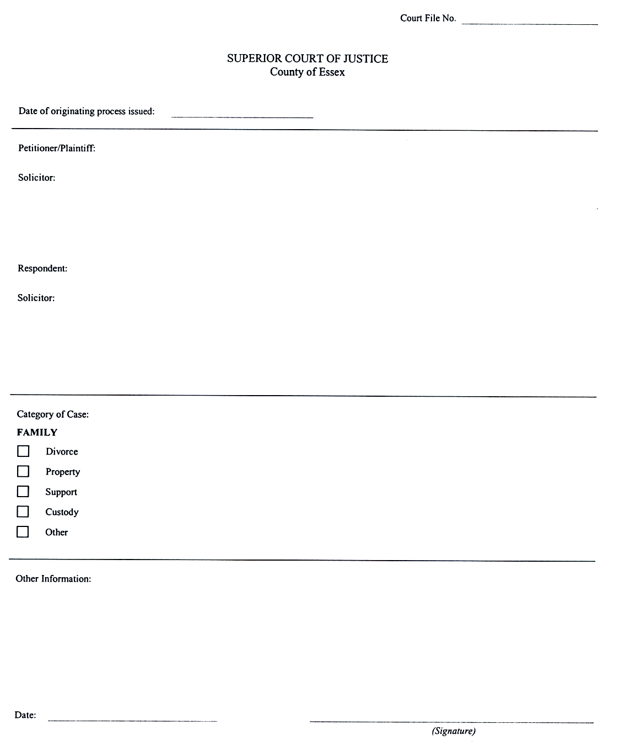
O. Reg. 334/02, Form 1.
Form 2
CASE MANAGEMENT ORDER (fAMILY tRACK)
Courts of Justice Act
Insert regs\graphics\2002\334\334002ae.tif
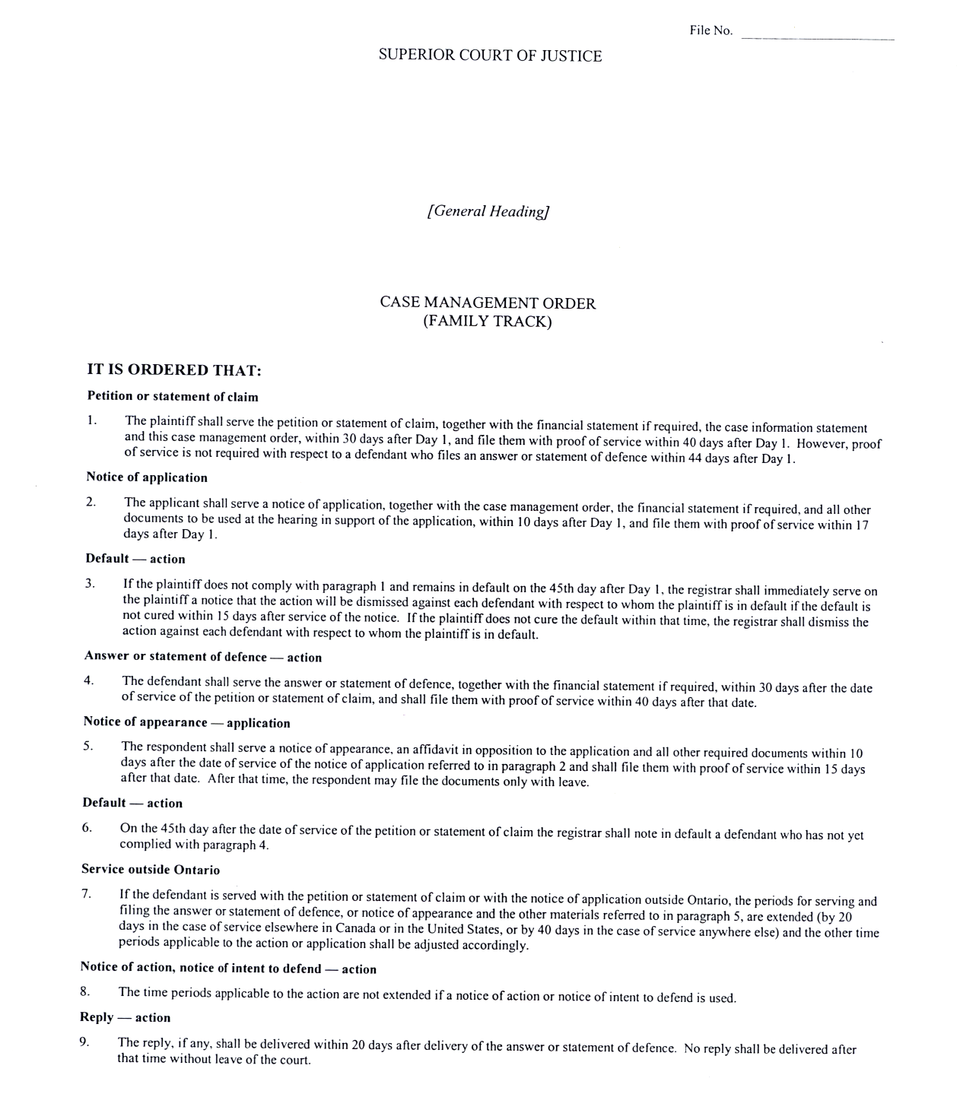
Insert regs\graphics\2002\334\334002be.tif
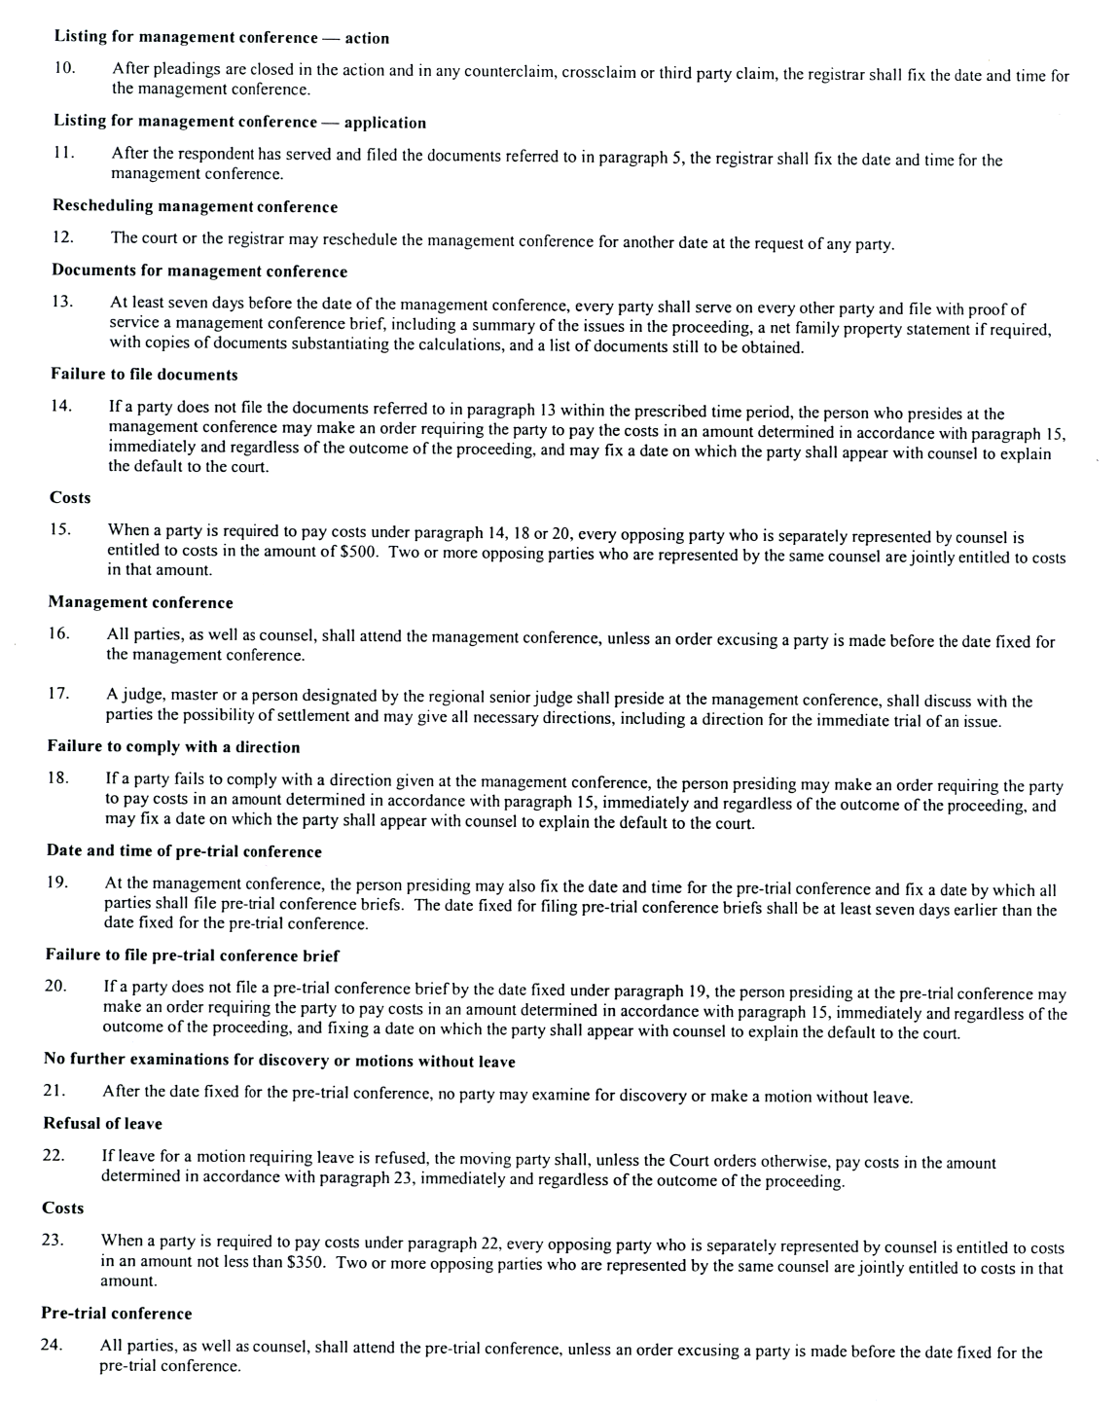
Insert regs\graphics\2002\334\334002ce.tif

O. Reg. 334/02, Form 2.

Back to top

