City of Toronto Act, 2006
ONTARIO REGULATION 579/06
No Amendments
Toronto Tax Sales Rules
Historical version for the period December 27, 2006 to December 31, 2006.
Note: This Regulation comes into force on January 1, 2007. See: O. Reg. 579/06, s. 29.
This is the English version of a bilingual regulation.
Skip Table of Contents
CONTENTS
PART I
INTERPRETATION AND FORMS
1. | Definition
2. | Public sale of land
3. | Required information on documents
4. | Forms
PART II
SALE BY PUBLIC TENDER
5. | Advertisement
6. | Tender
7. | Receipt of tender
8. | Withdrawn tender
9. | Opening of tenders
10. | Notice of vesting
11. | Two remaining tenders
12. | One remaining tender
PART III
SALE BY PUBLIC AUCTION
13. | Advertisement
14. | Auctioneer
15. | Duties of auctioneer
16. | Highest bidder is purchaser
17. | Failure to pay
18. | No bids
19. | Receipt
20. | Auction closed
21. | List
PART IV
GENERAL
22. | Postponement of sale
23. | Returning tenders
24. | Registration
25. | Condition
26. | Method of payment
27. | Forfeited funds
28. | Transition
Schedule 1 | Tax arrears certificate
Schedule 2 | Tax arrears cancellation certificate
Schedule 3 | Tax deed
Schedule 4 | Notice of vesting
Form 1 | Notice of registration of tax arrears certificate
Form 2 | Statutory declaration regarding sending of notice
Form 3 | Final notice
Form 4 | Statutory declaration regarding the sending of final notice
Form 5 | Payment into court — statement of facts
Form 6 | Sale of land by public tender
Form 7 | Tender to purchase
Form 8 | Sale of land by public auction
Form 9 | Mining Act information
Form 10 | Final notice of readvertisement
PART I
Interpretation and FORMS
Definition
1. In this Regulation,
“accumulated taxes” means real property taxes that have accumulated with respect to a parcel of land from the first day of advertising of the parcel for sale by public sale until the day a successful purchaser is declared. O. Reg. 579/06, s. 1.
Public sale of land
2. A public sale of land under the Act shall be conducted in accordance with this Regulation. O. Reg. 579/06, s. 2.
Required information on documents
3. (1) A tax arrears certificate shall contain the information set out in Schedule 1. O. Reg. 579/06, s. 3 (1).
(2) A tax arrears cancellation certificate referred to in subsection 346 (2), 349 (6) or 353 (3) or (6) of the Act or subsection 22 (2) of this Regulation shall contain the information set out in Schedule 2. O. Reg. 579/06, s. 3 (2).
(3) A tax deed and the statement of compliance related to it, as required by clause 350 (5) (a) and subsection 350 (6) of the Act, shall contain the information set out in Schedule 3. O. Reg. 579/06, s. 3 (3).
(4) A notice of vesting and the statement of compliance related to it, as required by clause 350 (5) (b) and subsection 350 (6) of the Act, shall contain the information set out in Schedule 4. O. Reg. 579/06, s. 3 (4).
Forms
4. (1) A notice required by section 345 of the Act shall be in Form 1. O. Reg. 579/06, s. 4 (1).
(2) A statutory declaration required by subsection 345 (3) of the Act shall be in Form 2. O. Reg. 579/06, s. 4 (2).
(3) A final notice required by subsection 350 (1) of the Act shall be in Form 3. O. Reg. 579/06, s. 4 (3).
(4) A statutory declaration required by subsection 350 (2) of the Act shall be in Form 4. O. Reg. 579/06, s. 4 (4).
(5) The statement required by subsection 351 (2) of the Act shall be in Form 5. O. Reg. 579/06, s. 4 (5).
(6) A notice required by subsection 351.1 (2) of the Act shall be in Form 10. O. Reg. 579/06, s. 4 (6).
PART II
SALE BY PUBLIC TENDER
Advertisement
5. (1) If the treasurer conducts a sale by public tender, the advertisement required by clause 350 (2) (b) of the Act shall be in Form 6 and the treasurer shall allow at least seven days after the publication of the last advertisement in The Ontario Gazette or newspaper for the submission of tenders. O. Reg. 579/06, s. 5 (1).
(2) An advertisement may relate to the sale of any number of parcels of land. O. Reg. 579/06, s. 5 (2).
Tender
6. (1) A tender shall be in Form 7 and shall be,
(a) typewritten or legibly handwritten in ink;
(b) accompanied by a deposit of at least 20 per cent of the tender amount, which deposit shall be made by way of money order or by way of bank draft or cheque certified by a bank or trust corporation;
(c) submitted in a sealed envelope which indicates on it that it is a tax sale and provides a short description or municipal address of the land sufficient to permit the treasurer to identify the parcel of land to which the tender relates; and
(d) addressed to the treasurer. O. Reg. 579/06, s. 6 (1).
(2) A tender shall relate to only one parcel of land. O. Reg. 579/06, s. 6 (2).
Receipt of tender
7. (1) On receiving an envelope identified as containing a tender, the treasurer shall mark on it the time and date on which it was received and shall retain it unopened in a safe place. O. Reg. 579/06, s. 7 (1).
(2) For the purposes of this Part, where two or more tenders are equal, the tender that was received earlier shall be deemed to be the higher. O. Reg. 579/06, s. 7 (2).
Withdrawn tender
8. (1) A tender is withdrawn if the tenderer’s written request to have the tender withdrawn is received by the treasurer before 3 p.m. local time on the last date for receiving tenders. O. Reg. 579/06, s. 8 (1).
(2) The envelope containing a withdrawn tender shall be opened at the time of the opening of the sealed envelopes. O. Reg. 579/06, s. 8 (2).
Opening of tenders
9. (1) The treasurer, at a place in the City that is open to the public, shall open the sealed envelopes containing the tenders as soon as possible after 3 p.m. local time on the last date for receiving tenders. O. Reg. 579/06, s. 9 (1).
(2) The sealed envelopes shall be opened in the presence of at least one person who did not submit a tender, which person may be a city employee. O. Reg. 579/06, s. 9 (2).
(3) After opening the sealed envelopes, the treasurer shall examine their contents and shall reject every tender that,
(a) is not equal to or greater than the minimum tender amount as shown in the advertisement;
(b) does not comply with section 6;
(c) includes any term or condition not provided for in this Regulation; or
(d) has been withdrawn as set out in subsection 8 (1). O. Reg. 579/06, s. 9 (3).
(4) After complying with subsection (3), the treasurer shall reject all but the two highest of the remaining tenders. O. Reg. 579/06, s. 9 (4).
(5) Every rejected tender shall be returned to the tenderer together with the tenderer’s deposit, if any, and a statement of the reason for rejection. O. Reg. 579/06, s. 9 (5).
Notice of vesting
10. If, after complying with section 9, no tenders remain, the treasurer shall declare that there is no successful purchaser. O. Reg. 579/06, s. 10.
Two remaining tenders
11. (1) If, after complying with section 9, two tenders remain, the treasurer shall immediately notify the higher tenderer, by ordinary mail sent to the address shown in the tender, that the tenderer will be declared to be the successful purchaser if, within 14 days of the mailing of the notice, the balance of the amount tendered, the applicable land transfer tax and the accumulated taxes are paid, in cash, to the treasurer. O. Reg. 579/06, s. 11 (1).
(2) If the higher tenderer makes the payment as set out in subsection (1), the treasurer shall declare the tenderer to be the successful purchaser. O. Reg. 579/06, s. 11 (2).
(3) If the higher tenderer does not make the payment as set out in subsection (1), the tenderer’s deposit shall be immediately forfeited to the City and the treasurer shall offer the parcel of land to the lower tenderer in accordance with section 12. O. Reg. 579/06, s. 11 (3).
One remaining tender
12. (1) If, after complying with section 9, only one tender remains or if, in accordance with subsection 11 (3), the treasurer is required to offer the parcel of land to the lower tenderer, the treasurer shall immediately notify the tenderer, by ordinary mail sent to the address shown in the tender, that the tenderer will be declared to be the successful purchaser if, within 14 days of the mailing of the notice, the balance of the amount tendered, the applicable land transfer tax and the accumulated taxes are paid, in cash, to the treasurer. O. Reg. 579/06, s. 12 (1).
(2) If the tenderer makes the payment as set out in subsection (1), the treasurer shall declare the tenderer to be the successful purchaser. O. Reg. 579/06, s. 12 (2).
(3) If the tenderer does not make the payment as set out in subsection (1),
(a) the treasurer shall declare that there is no successful purchaser and may register a notice of vesting in the name of the City; and
(b) the tenderer’s deposit shall be immediately forfeited to the City. O. Reg. 579/06, s. 12 (3).
PART III
SALE BY PUBLIC AUCTION
Advertisement
13. (1) If the treasurer conducts a sale by public auction, the advertisement required by clause 350 (2) (b) of the Act shall be in Form 8 and the treasurer shall allow at least seven days after the publication of the last advertisement in The Ontario Gazette or newspaper before holding the auction. O. Reg. 579/06, s. 13 (1).
(2) The auction shall be held at such place in the City as the treasurer may name in the advertisement. O. Reg. 579/06, s. 13 (2).
(3) An advertisement may relate to the sale of any number of parcels of land. O. Reg. 579/06, s. 13 (3).
Auctioneer
14. (1) The treasurer or such other person as the treasurer may name shall act as auctioneer. O. Reg. 579/06, s. 14 (1).
(2) The auctioneer shall open the auction by declaring the tax sale officially open and by reading out sections 15, 16, 17 and 18. O. Reg. 579/06, s. 14 (2).
Duties of auctioneer
15. For each parcel of land to be sold during the auction, the auctioneer shall,
(a) in opening or reopening the bidding on the parcel, state the minimum bid as set out in the advertisement;
(b) acknowledge each bidder, repeat each bid made and call for higher bids; and
(c) if no higher bid is made, repeat the last bid three times and if there is still no higher bid, acknowledge the highest bidder. O. Reg. 579/06, s. 15.
Highest bidder is purchaser
16. The highest bidder shall be declared to be the successful purchaser if the bidder immediately pays the amount bid, the applicable land transfer tax and the accumulated taxes, in cash, to the auctioneer. O. Reg. 579/06, s. 16.
Failure to pay
17. If the highest bidder fails to make the payment as set out in section 16 and the bidding has not been previously reopened under this Regulation, the auctioneer shall immediately reopen the bidding. O. Reg. 579/06, s. 17.
No bids
18. If no bid is made for a parcel of land after the opening of the bidding or if, after the reopening of the bidding under section 17, no bid is made or there is no successful purchaser, the auctioneer shall declare that there is no successful purchaser. O. Reg. 579/06, s. 18.
Receipt
19. The auctioneer shall issue a receipt to the successful purchaser for the amounts received under section 16 and the receipt shall include a legal description of the parcel of land and the name of the purchaser and the name in which the tax deed will be registered. O. Reg. 579/06, s. 19.
Auction closed
20. The auctioneer shall declare the auction closed upon completion of the bidding on all the parcels of land offered for sale in the auction. O. Reg. 579/06, s. 20.
List
21. The auctioneer shall prepare and keep a list showing each parcel of land offered for sale in the auction and the name and address of the successful purchaser or, where there is no successful purchaser, that there is no successful purchaser. O. Reg. 579/06, s. 21.
PART IV
GENERAL
Postponement of sale
22. (1) If, after a public sale under the Act is advertised in accordance with clause 350 (2) (b) of the Act, the treasurer is of the opinion that completing the sale would be impractical or would be unfair to the bidders or tenderers, the treasurer may postpone the sale and conduct it on a later date after readvertising it in accordance with clause 350 (2) (b) of the Act. O. Reg. 579/06, s. 22 (1).
(2) If a public sale is postponed under subsection (1) and the rescheduled sale does not occur within 90 days after the date that was originally advertised for the sale, the treasurer shall immediately register a tax arrears cancellation certificate. O. Reg. 579/06, s. 22 (2).
(3) Subsection (2) does not prevent the treasurer from registering a new tax arrears certificate and proceeding under Part XIV of the Act. O. Reg. 579/06, s. 22 (3).
Returning tenders
23. If the treasurer postpones or cancels a sale by public tender, the treasurer shall,
(a) open the sealed envelopes, if he or she has not already done so; and
(b) return to the tenderers any tenders that he or she retains together with the appropriate deposits, if any, and a statement setting out the reason for the return. O. Reg. 579/06, s. 23.
Registration
24. As soon as possible after a successful purchaser is declared in a sale under the Act, the treasurer shall prepare and register the necessary documents in accordance with the Act. O. Reg. 579/06, s. 24.
Condition
25. If the City is referred to in Schedule 2 to Regulation 995 of the Revised Regulations of Ontario, 1990 (Forms and Records) made under the Registry Act, the treasurer, before registering a tax deed or a notice of vesting, shall obtain a statement in Form 9 signed by an authorized employee of the Ministry of Northern Development and Mines. O. Reg. 579/06, s. 25.
Method of payment
26. Subject to clause 6 (1) (b), any payment required by this Regulation to be made in cash may be made by way of cash or money order or by way of bank draft or cheque certified by a bank or trust corporation. O. Reg. 579/06, s. 26.
Forfeited funds
27. All deposits forfeited under this Regulation to the City shall form part of the general funds of the City. O. Reg. 579/06, s. 27.
Transition
28. (1) If a tax arrears certificate in respect of vacant land has been registered before January 1, 2003 in accordance with clause 3 (1) (b) of the Municipal Tax Sales Act, as it read before January 1, 2003, the proceedings in respect of the sale of that land may continue even though the period in which the tax arrears were owing before the registration of the certificate may be less than the period specified in subsection 344 (1) of the City of Toronto Act, 2006. O. Reg. 579/06, s. 28 (1).
(2) If a tax arrears certificate in respect of land has been registered before January 1, 2007, the proceedings in respect of the sale of that land may continue as if the certificate had been registered under the City of Toronto Act, 2006. O. Reg. 579/06, s. 28 (2).
29. Omitted (provides for coming into force of provisions of this Regulation). O. Reg. 579/06, s. 29.
Schedule 1
tax arrears certificate
A tax arrears certificate shall contain the following information:
1. A statement that the certificate is in respect of land located in the City.
2. The street address of the land or, if there is no street address, the location of the land.
3. A statement by the treasurer verifying,
i. the amount of tax arrears owing on December 31 of the relevant year and that at least part of the amount plus any additional real property taxes and costs are still owing to the City, and
ii. that the land described in the certificate will be sold by public sale if the cancellation price is not paid within one year following the date of registration of the certificate.
4. The name of the treasurer and the date of the statement.
5. A notice setting out,
i. that the time period for paying the cancellation price may be extended if the City authorizes an extension agreement with the owner of the land before the expiry of the one-year period,
ii. that the cancellation price will be calculated as of the date that the amount of the tax arrears is paid to the City and may be higher than the amount set out in the certificate,
iii. that, if there is no successful purchaser at the public sale, the land, upon registration of a notice of vesting, will vest in the City, and
iv. the title and address of the person to whom any enquiries may be directed, including an address for service.
6. A legal description of the land.
O. Reg. 579/06, Sched. 1.
Schedule 2
tax arrears cancellation certificate
A tax arrears cancellation certificate referred to in subsection 346 (2), 349 (6) or 353 (3) or (6) of the Act or subsection 22 (2) of the regulation shall contain the following information:
1. A statement that the certificate is in respect of land located in the City.
2. The street address of the land or, if there is no street address, the location of the land.
3. A statement by the treasurer verifying that,
i. the tax arrears certificate registered on (date of registration) as (instrument number) is cancelled in respect of the land described in the tax arrears cancellation certificate,
ii. the cancellation price (choose A or B as appropriate),
A. remains unpaid and a new tax arrears certificate may be registered in this matter, or
B. was paid on (date of payment),
iii. if the cancellation price was paid, it was paid by or on behalf of (choose A or B as appropriate),
A. the owner or the spouse of the owner of the land or a person who was not entitled to receive notice under subsection 345 (1) of the City of Toronto Act, 2006 and accordingly there is no lien on the land described in this document in respect of the payment, or
B. a person, other than the owner or spouse of the owner of the land, who was entitled to receive notice under subsection 345 (1) of the City of Toronto Act, 2006 or an assignee of such person and, as a result of the payment, (name and address of person) has a lien on the land for (amount of lien) and the lien has priority over the interest of any person to whom notice was sent under section 345 of that Act.
4. The name of the treasurer and the date of the statement.
5. The title and address of the person to whom any enquiries may be directed, including an address for service.
6. A legal description of the land.
O. Reg. 579/06, Sched. 2.
Schedule 3
TAX DEED
A tax deed and the statement of compliance related to it, as required by clause 350 (5) (a) and subsection 350 (6) of the Act, shall contain the following information:
1. A statement that the tax deed is in respect of land located in the City.
2. The street address of the land or, if there is no street address, the location of the land.
3. A statement that, by virtue of the City of Toronto Act, 2006, the registration of the tax deed vests in the transferee an estate in fee simple in the land together with all rights, privileges and appurtenances and free from all estates and interests except,
i. easements and restrictive covenants that run with the land,
ii. any estates and interests of the Crown in right of Canada or Ontario, other than an estate or interest acquired by the Crown in right of Ontario due to an escheat or forfeiture under the Business Corporations Act or the Corporations Act, and
iii. any interest or title acquired by adverse possession by abutting landowners before registration of the tax deed.
4. A statement that the registration of the tax deed vests in the transferee any interest in or title to adjoining land acquired by adverse possession before the registration of the tax deed if the person originally acquiring the interest or title did so as a consequence of possession of the land described in the tax deed.
5. A statement by the treasurer verifying that,
i. a tax arrears certificate was registered as (instrument number) with respect to the land at least one year before the land was advertised for sale,
ii. notices were sent and statutory declarations were made in substantial compliance with the applicable provisions of the City of Toronto Act, 2006, the Municipal Act, 2001, the Municipal Tax Sales Act, as it read before January 1, 2003, and the regulations under those Acts,
iii. the cancellation price was not paid within one year following the date of the registration of the tax arrears certificate,
iv. there was no subsisting extension agreement when the land was advertised for sale,
v. the land was advertised for sale in substantial compliance with the applicable provisions of the City of Toronto Act, 2006, the Municipal Act, 2001, and the regulations under those Acts,
vi. if applicable, the City passed a by-law under subsection 350 (3) of the City of Toronto Act, 2006 or subsection 379 (3) of the Municipal Act, 2001, as the case may be, excluding mobile homes from the sale of the land.
6. If applicable, a statement by the treasurer verifying that the Ministry of Northern Development and Mines has advised the City that the land described in this tax deed (choose i or ii as appropriate),
i. is liable to a tax imposed under the Mining Act and accordingly, under section 355 of the City of Toronto Act, 2006, the registration of this document creates a severance of the surface rights from the mining rights, or
ii. is not liable to a tax imposed under the Mining Act and accordingly, under section 355 of the City of Toronto Act, 2006, the registration of this document does not create a severance of the surface rights from the mining rights.
7. The title and address of the person to whom any enquiries may be directed, including an address for service.
8. A legal description of the land.
O. Reg. 579/06, Sched. 3.
Schedule 4
NOTICE OF VESTING
A notice of vesting and the statement of compliance related to it, as required by clause 350 (5) (b) and subsection 350 (6) of the Act, shall contain the following information:
1. A statement that the notice is in respect of land located in the City.
2. The street address of the land or, if there is no street address, the location of the land.
3. A statement that registration is made under the City of Toronto Act, 2006 and, under that Act, the City attempted to sell the land described in the notice of vesting for arrears of taxes but could not find a successful purchaser and, accordingly, the registration of the notice vests the land described in the notice of vesting in the City.
4. A statement that, by virtue of the City of Toronto Act, 2006, the registration of the notice of vesting vests in the City an estate in fee simple in the land together with all rights, privileges and appurtenances and free from all estates and interests, including all estates and interests of the Crown in right of Ontario, except,
i. easements and restrictive covenants that run with the land, including those for the benefit of the Crown in right of Ontario,
ii. any estates and interests of the Crown in right of Canada, and
iii. any interest or title acquired by adverse possession by abutting landowners, including the Crown in right of Ontario, before registration of the notice of vesting.
5. A statement that the registration of the notice of vesting vests in the City any interest in or title to adjoining land acquired by adverse possession before the registration of the notice if the person originally acquiring the interest or title did so as a consequence of possession of the land described in the notice.
6. A statement by the treasurer verifying that,
i. a tax arrears certificate was registered as (instrument number) with respect to the land at least one year before the land was advertised for sale,
ii. notices were sent and statutory declarations were made in substantial compliance with the applicable provisions of the City of Toronto Act, 2006, the Municipal Act, 2001, the Municipal Tax Sales Act, as it read before January 1, 2003, and the regulations under those Acts,
iii. the cancellation price was not paid within one year following the date of the registration of the tax arrears certificate,
iv. there was no subsisting extension agreement when the land was advertised for sale,
v. the land was advertised for sale in substantial compliance with the applicable provisions of the City of Toronto Act, 2006, the Municipal Act, 2001, and the regulations under those Acts,
vi. if applicable, the City passed a by-law under subsection 350 (3) of the City of Toronto Act, 2006 or subsection 379 (3) of the Municipal Act, 2001, as the case may be, excluding mobile homes from the sale of the land.
7. If applicable, a statement by the treasurer verifying that the Ministry of Northern Development and Mines has advised the City that the land described in this notice (choose i or ii as appropriate),
i. is liable to a tax imposed under the Mining Act and accordingly, under section 355 of the City of Toronto Act, 2006, the registration of this notice creates a severance of the surface rights from the mining rights, or
ii. is not liable to a tax imposed under the Mining Act and accordingly, under section 355 of the City of Toronto Act, 2006, the registration of this notice does not create a severance of the surface rights from the mining rights.
8. The title and address of the person to whom any enquiries may be directed, including an address for service.
9. A legal description of the land.
O. Reg. 579/06, Sched. 4.
Form 1
NOTICE OF REGISTRATION OF TAX ARREARS CERTIFICATE
City of Toronto Act, 2006
Insert regs\Graphics\Source Law\2006\579\579001ae.tif
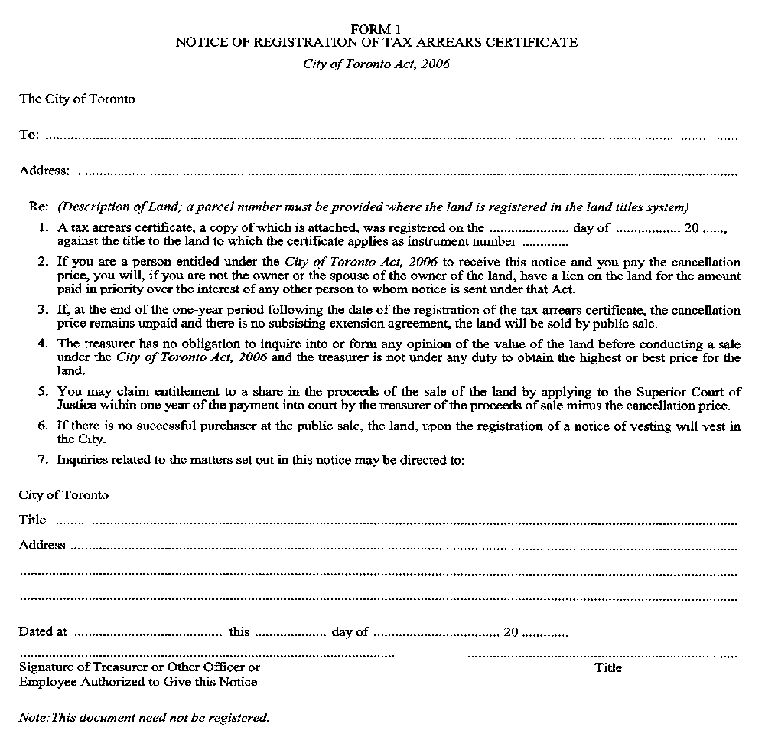
O. Reg. 579/06, Form 1.
Form 2
STATUTORY DECLARATION REGARDING SENDING OF NOTICE
City of Toronto Act, 2006
Insert regs\Graphics\Source Law\2006\579\579002ae.tif
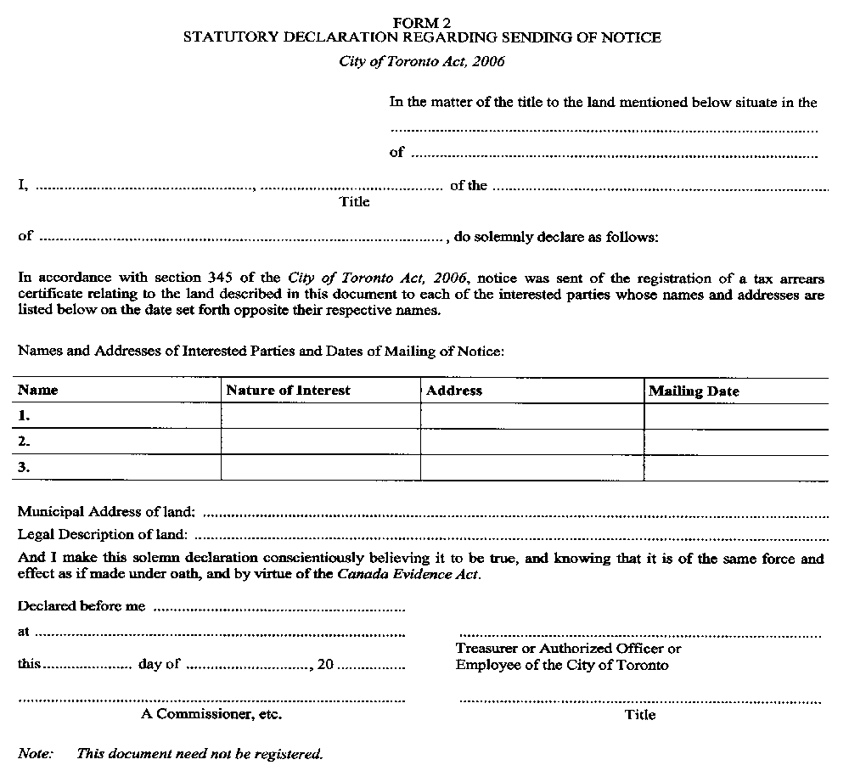
O. Reg. 579/06, Form 2.
Form 3
FINAL NOTICE
City of Toronto Act, 2006
Insert regs\Graphics\Source Law\2006\579\579003ae.tif
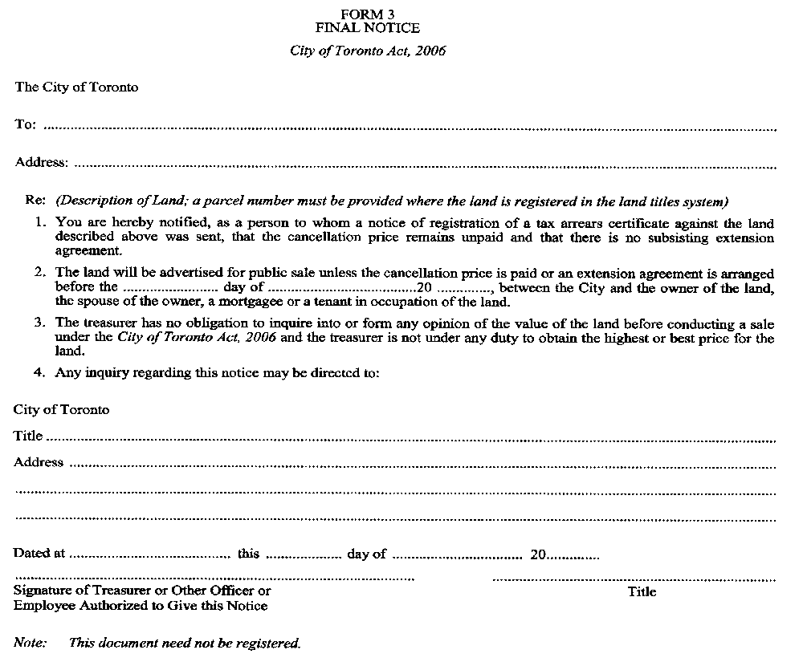
O. Reg. 579/06, Form 3.
Form 4
STATUTORY DECLARATION REGARDING THE SENDING OF FINAL NOTICE
City of Toronto Act, 2006
Insert regs\Graphics\Source Law\2006\579\579004ae.tif
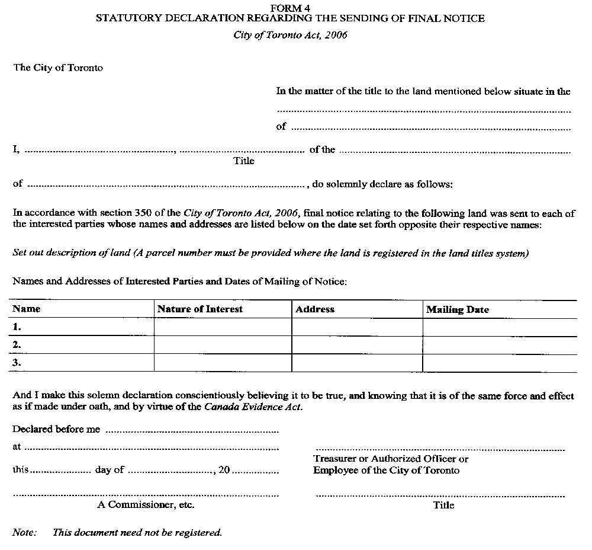
O. Reg. 579/06, Form 4.
Form 5
PAYMENT INTO COURT — statement OF FACTS
City of Toronto Act, 2006
Insert regs\Graphics\Source Law\2006\579\579005ae.tif
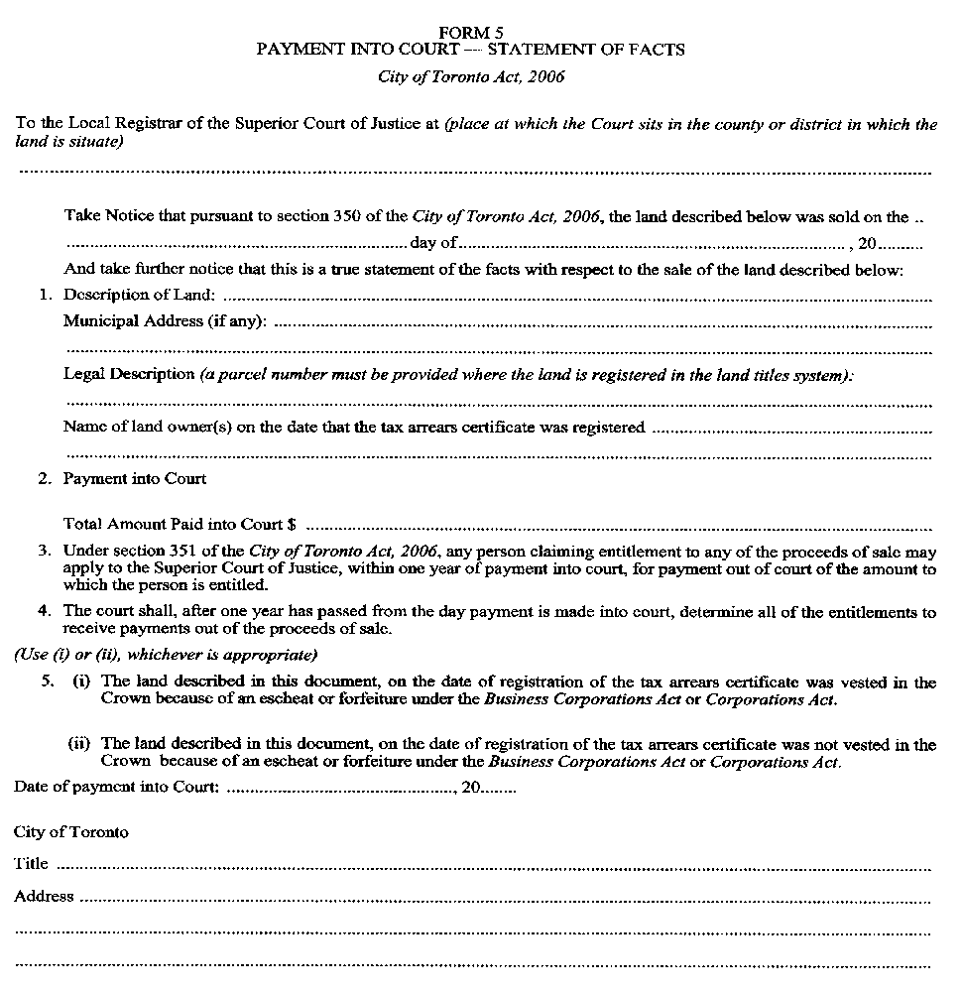
O. Reg. 579/06, Form 5.
Form 6
SALE OF LAND BY PUBLIC TENDER
City of Toronto Act, 2006
Insert regs\Graphics\Source Law\2006\579\579006ae.tif
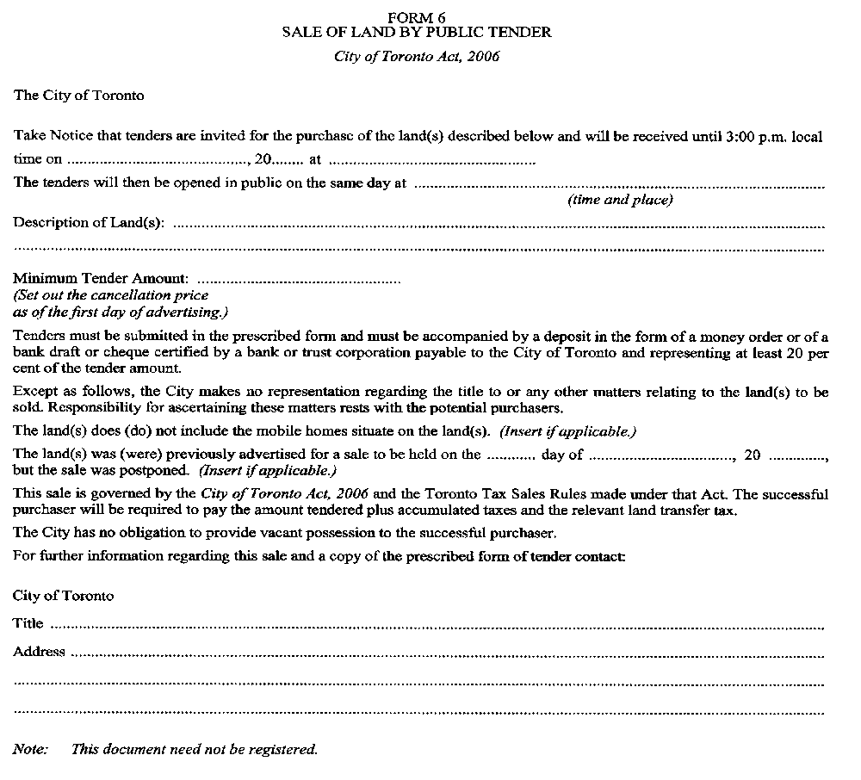
O. Reg. 579/06, Form 6.
Form 7
TENDER TO PURCHASE
City of Toronto Act, 2006
Insert regs\Graphics\Source Law\2006\579\579007ae.tif
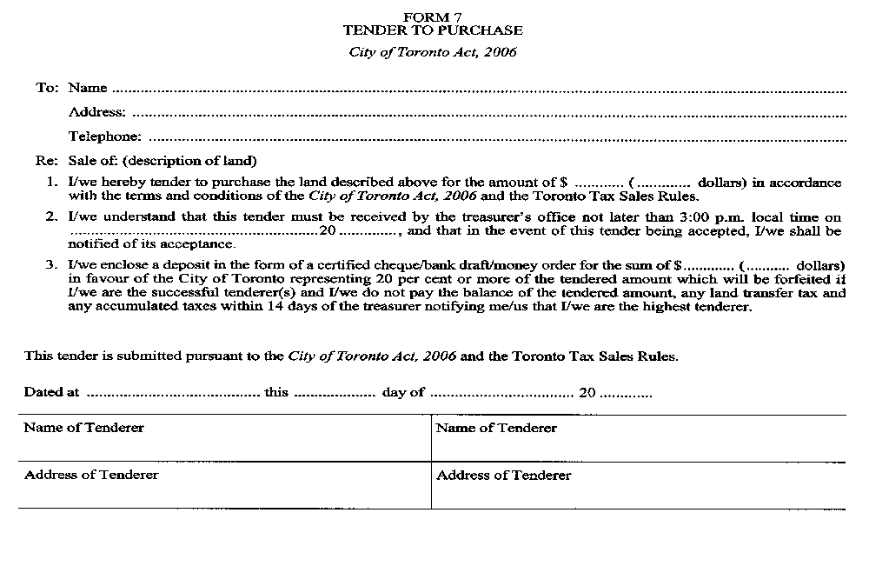
O. Reg. 579/06, Form 7.
Form 8
SALE OF LAND BY PUBLIC AUCTION
City of Toronto Act, 2006
Insert regs\Graphics\Source Law\2006\579\579008ae.tif
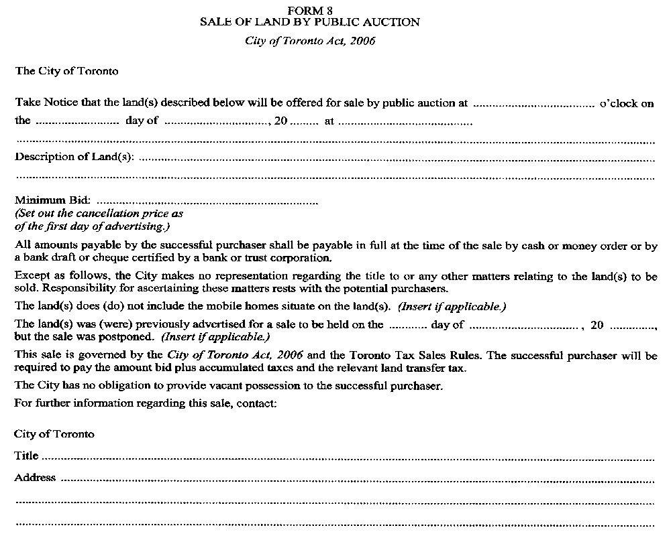
O. Reg. 579/06, Form 8.
Form 9
MINING ACT INFORMATION
City of Toronto Act, 2006
Insert regs\Graphics\Source Law\2006\579\579009ae.tif
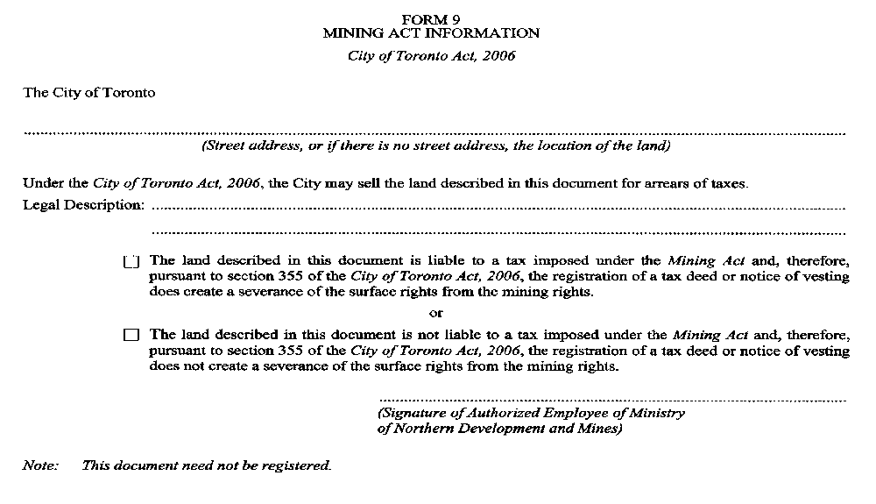
O. Reg. 579/06, Form 9.
FORM 10
final notice of readvertisement
City of Toronto Act, 2006
Insert regs\Graphics\Source Law\2006\579\579010ae.tif
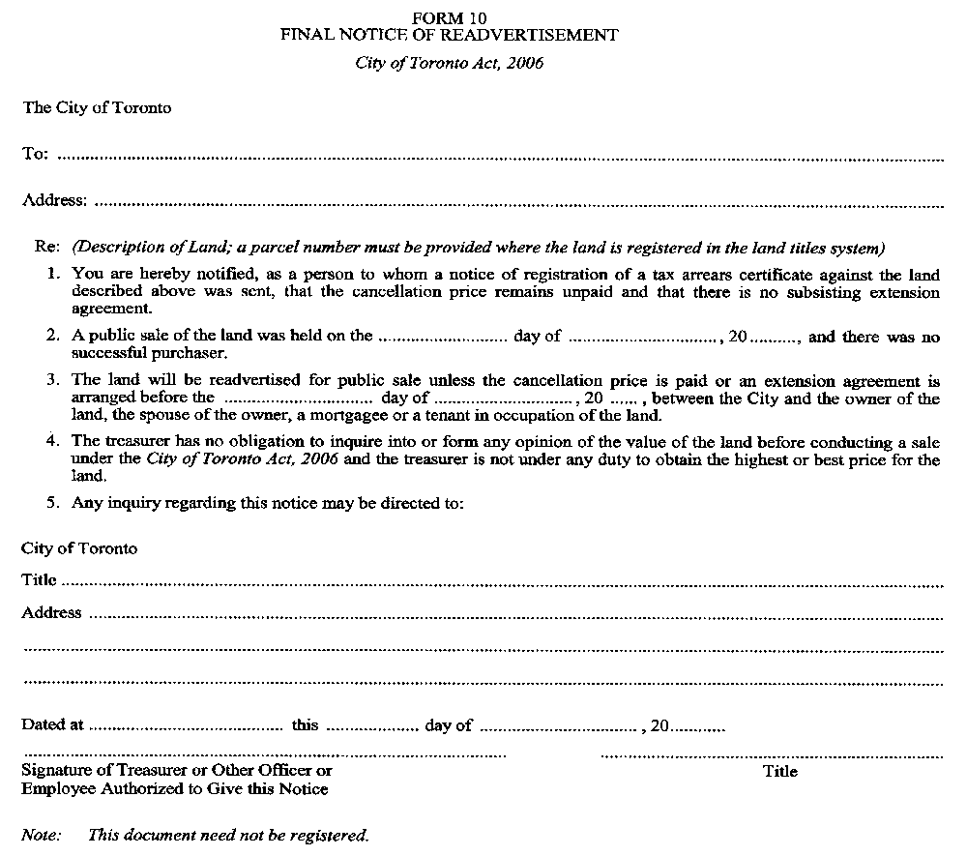
O. Reg. 579/06, Form 10.

Back to top

