Courts of Justice Act
R.R.O. 1990, REGULATION 194
Amended to O. Reg. 132/04
RULES OF CIVIL PROCEDURE
Historical version for the period July 1, 2004 to July 2, 2004.
Disclaimer: The HTML version of this consolidation is not an official copy of the law because some portion of it may not be fully legible. The Word version remains an official copy of the law.
This is the English version of a bilingual regulation.
SUMMARY OF CONTENTS
GENERAL MATTERS
Rule
1 | Citation, Application and Interpretation
2 | Non-Compliance with the Rules
3 | Time
4 | Court Documents
PARTIES AND JOINDER
5 | Joinder of Claims and Parties
6 | Consolidation or Hearing Together
7 | Parties under Disability
8 | Partnerships and Sole Proprietorships
9 | Estates and Trusts
10 | Representation Order
11 | Transfer or Transmission of Interest
12 | Class Proceedings and Other Representative Proceedings
13 | Intervention
COMMENCEMENT OF PROCEEDINGS
13.1 | Place of Commencement and Hearing or Trial
14 | Originating Process
15 | Representation by Solicitor
SERVICE
16 | Service of Documents
17 | Service outside Ontario
18 | Time for Delivery of Statement of Defence
DISPOSITION WITHOUT TRIAL
19 | Default Proceedings
20 | Summary Judgment
21 | Determination of an Issue Before Trial
22 | Special Case
23 | Discontinuance and Withdrawal
24 | Dismissal of Action for Delay
24.1 | Mandatory Mediation
PLEADINGS
25 | Pleadings in an Action
26 | Amendment of Pleadings
27 | Counterclaim
28 | Crossclaim
29 | Third Party Claim
DISCOVERY
30 | Discovery of Documents
30.1 | Deemed Undertaking
31 | Examination for Discovery
32 | Inspection of Property
33 | Medical Examination of Parties
EXAMINATIONS OUT OF COURT
34 | Procedure on Oral Examinations
35 | Procedure on Examination for Discovery by Written Questions
36 | Taking Evidence Before Trial
MOTIONS AND APPLICATIONS
37 | Motions — Jurisdiction and Procedure
38 | Applications — Jurisdiction and Procedure
39 | Evidence on Motions and Applications
PRESERVATION OF RIGHTS IN PENDING LITIGATION
40 | Interlocutory Injunction or Mandatory Order
41 | Appointment of Receiver
42 | Certificate of Pending Litigation
43 | Interpleader
44 | Interim Recovery of Personal Property
45 | Interim Preservation of Property
PRE-TRIAL PROCEDURES
46 | Place of Trial
47 | Jury Notice
48 | Listing for Trial
49 | Offer to Settle
50 | Pre-Trial Conference
51 | Admissions
TRIALS
52 | Trial Procedure
53 | Evidence at Trial
REFERENCES
54 | Directing a Reference
55 | Procedure on a Reference
COSTS
56 | Security for Costs
57 | Costs of Proceedings
58 | Assessment of Costs
ORDERS
59 | Orders
60 | Enforcement of Orders
APPEALS
61 | Appeals to an Appellate Court
62 | Appeals from Interlocutory Orders and Other Appeals to a Judge
63 | Stay Pending Appeal
PARTICULAR PROCEEDINGS
64 | Mortgage Actions
65 | Proceedings for Administration
66 | Partition Proceedings
67 | Proceedings Concerning the Estates of Minors
68 | Proceedings for Judicial Review
72 | Payment into and out of Court
73 | Reciprocal Enforcement of United Kingdom Judgments
74 | Estates — Non-Contentious Proceedings
75 | Estates — Contentious Proceedings
75.1 | Mandatory Mediation — Estates, Trusts and Substitute Decisions
76 | Simplified Procedure
77 | Civil Case Management
TABLE OF FORMS
FORMS
TARIFF A Solicitors’ Fees and Disbursements Allowable Under Rule 58.05
TARIFF C Solicitors’ Costs Allowed on Passing of Accounts without a Hearing
TABLE OF CONTENTS
GENERAL MATTERS
RULE 1 CITATION, APPLICATION AND INTERPRETATION
1.01 |  | Citation
1.02 |  | Application of Rules
1.03 |  | Definitions
1.04 |  | Interpretation
1.05 |  | Orders on Terms
1.06 |  | Forms
1.07 |  | Practice Directions
1.07 |  | Practice Directions
1.08 |  | Telephone and Video Conferences
1.09 |  | Communications out of Court
RULE 2 NON-COMPLIANCE WITH THE RULES
2.01 |  | Effect of Non-Compliance
2.02 |  | Attacking Irregularity
2.03 |  | Court May Dispense with Compliance
RULE 3 TIME
3.01 |  | Computation
3.02 |  | Extension or Abridgment
3.03 |  | When Proceedings May be Heard
RULE 4 COURT DOCUMENTS
4.01 |  | Format
4.02 |  | Contents
4.02.1 |  | Bilingual Documents
4.03 |  | Certified Copies of Court Documents
4.04 |  | Notice to be Given in Writing or Electronically
4.05 |  | Issuing and Filing of Documents
4.05.1 |  | Electronic Documents
4.06 |  | Affidavits
4.07 |  | Binding of Documents
4.08 |  | Requisition
4.09 |  | Transcripts
4.10 |  | Transmission of Documents
4.11 |  | Notice of Constitutional Question
PARTIES AND JOINDER
RULE 5 JOINDER OF CLAIMS AND PARTIES
5.01 |  | Joinder of Claims
5.02 |  | Joinder of Parties
5.03 |  | Joinder of Necessary Parties
5.04 |  | Misjoinder, Non-Joinder and Parties Incorrectly  Named
5.05 |  | Relief against Joinder
RULE 6 CONSOLIDATION OR HEARING TOGETHER
6.01 |  | Where Order May be Made
6.02 |  | Discretion of Presiding Judge
RULE 7 PARTIES UNDER DISABILITY
7.01 |  | Representation by Litigation Guardian
7.02 |  | Litigation Guardian for Plaintiff or Applicant
7.03 |  | Litigation Guardian for Defendant or Respondent
7.04 |  | Representation of Persons under Disability
7.05 |  | Powers and Duties of Litigation Guardian
7.06 |  | Removal or Substitution of Litigation Guardian
7.07 |  | Noting Party under Disability in Default
7.07.1 |  | Discontinuance by or Against Party under Disability
7.08 |  | Approval of Settlement
7.09 |  | Money to be Paid into Court
RULE 8 PARTNERSHIPS AND SOLE PROPRIETORSHIPS
8.01 |  | Partnerships
8.02 |  | Defence
8.03 |  | Notice to Alleged Partner where Enforcement Sought against Partner
8.04 |  | Person Defending Separately
8.05 |  | Disclosure of Partners
8.06 |  | Enforcement of Order
8.07 |  | Sole Proprietorships
RULE 9 ESTATES AND TRUSTS
9.01 |  | Proceedings by or against Executor, Administrator or Trustee
9.02 |  | Proceeding against Estate that has no Executor or Administrator
9.03 |  | Remedial Provisions
RULE 10 REPRESENTATION ORDER
10.01 |  | Representation of an Interested Person who cannot be Ascertained
10.02 |  | Representation of a Deceased Person
10.03 |  | Relief from Binding Effect of Order
RULE 11 TRANSFER OR TRANSMISSION OF INTEREST
11.01 |  | Effect of Transfer or Transmission
11.02 |  | Order to Continue
11.03 |  | Failure to Obtain Order to Continue Action
RULE 12 CLASS PROCEEDINGS AND OTHER REPRESENTATIVE PROCEEDINGS
12.01 |  | Definitions
12.02 |  | Title of Proceeding
12.03 |  | Discovery of Class Members
12.04 |  | Costs
12.05 |  | Contents of Judgments and Orders
12.06 |  | Leave to Appeal
12.07 |  | Proceeding against Representative Defendant
12.08 |  | Proceeding by Unincorporated Association or Trade Union
RULE 13 INTERVENTION
13.01 |  | Leave to Intervene as Added Party
13.02 |  | Leave to Intervene as Friend of the Court
13.03 |  | Leave to Intervene in Divisional Court or Court of Appeal
COMMENCEMENT OF PROCEEDINGS
RULE 13.1 PLACE OF COMMENCEMENT AND HEARING OR TRIAL
13.1.01 |  | Place of Commencement
13.1.02 |  | Transfer
RULE 14 ORIGINATING PROCESS
14.01 |  | How Proceedings Commenced
14.02 |  | Proceedings by Action as General Rule
14.03 |  | Actions — By Statement of Claim or Notice of Action
14.03.1 |  | Ordinary and Simplified Procedure
14.05 |  | Applications — By Notice of Application
14.06 |  | Title of Proceeding
14.07 |  | How Originating Process Issued
14.08 |  | Time for Service in Actions
14.09 |  | Striking out or Amending
14.10 |  | Dismissal of Action where Defendant Pays Claim
RULE 15 REPRESENTATION BY SOLICITOR
15.01 |  | Where Solicitor is Required
15.02 |  | Notice of Authority to Commence Proceeding
15.03 |  | Change in Representation by Party
15.04 |  | Motion by Solicitor for Removal as Solicitor of Record
15.05 |  | Duty of Solicitor of Record
15.06 |  | Where a Solicitor of Record has Ceased to Practise
15.07 |  | Lawyer From Another Province
SERVICE
RULE 16 SERVICE OF DOCUMENTS
16.01 |  | General Rules for Manner of Service
16.02 |  | Personal Service
16.03 |  | Alternatives to Personal Service
16.04 |  | Substituted Service or Dispensing with Service
16.05 |  | Service on Solicitor of Record
16.06 |  | Service by Mail
16.07 |  | Where Document does not Reach Person Served
16.08 |  | Validating Service
16.09 |  | Proof of Service
RULE 17 SERVICE OUTSIDE ONTARIO
17.01 |  | Definition
17.02 |  | Service outside Ontario without Leave
17.03 |  | Service outside Ontario with Leave
17.04 |  | Additional Requirements for Service outside Ontario
17.05 |  | Manner of Service outside Ontario
17.06 |  | Motion to Set Aside Service outside Ontario
RULE 18 TIME FOR DELIVERY OF STATEMENT OF DEFENCE
18.01 |  | Time for Delivery of Statement of Defence
18.02 |  | Notice of Intent to Defend
DISPOSITION WITHOUT TRIAL
RULE 19 DEFAULT PROCEEDINGS
19.01 |  | Noting Default
19.02 |  | Consequences of Noting Default
19.03 |  | Setting Aside the Noting of Default
19.04 |  | By Signing Default Judgment
19.05 |  | By Motion for Judgment
19.06 |  | Facts Must Entitle Plaintiff to Judgment
19.07 |  | Effect of Default Judgment
19.08 |  | Setting Aside Default Judgment
19.09 |  | Application to Counterclaims, Crossclaims and Third Party Claims
RULE 20 SUMMARY JUDGMENT
20.01 |  | Where Available
20.02 |  | Affidavits
20.03 |  | Factums Required
20.04 |  | Disposition of Motion
20.05 |  | Where a Trial is Necessary
20.06 |  | Costs Sanctions for Improper Use of Rule
20.07 |  | Effect of Summary Judgment
20.08 |  | Stay of Execution
20.09 |  | Application to Counterclaims, Crossclaims and Third Party Claims
RULE 21 DETERMINATION OF AN ISSUE BEFORE TRIAL
21.01 |  | Where Available
21.02 |  | Motion to be Made Promptly
21.03 |  | Factums Required
RULE 22 SPECIAL CASE
22.01 |  | Where Available
22.02 |  | Factums Required
22.03 |  | Removal into Court of Appeal
22.04 |  | Form of Special Case
22.05 |  | Hearing of Special Case
RULE 23 DISCONTINUANCE AND WITHDRAWAL
23.01 |  | Discontinuance by Plaintiff
23.02 |  | Effect of Discontinuance on Counterclaim
23.03 |  | Effect of Discontinuance on Crossclaim or Third Party Claim
23.04 |  | Effect of Discontinuance on Subsequent Action
23.05 |  | Costs of Discontinuance
23.06 |  | Withdrawal by Defendant
23.07 |  | Application to Counterclaims, Crossclaims and Third Party Claims
RULE 24 DISMISSAL OF ACTION FOR DELAY
24.01 |  | Where Available
24.02 |  | Notice Where Plaintiff under Disability
24.03 |  | Effect of Dismissal on Counterclaim
24.04 |  | Effect of Dismissal on Crossclaim or Third Party Claim
24.05 |  | Effect on Subsequent Action
24.06 |  | Application to Counterclaims, Crossclaims and Third Party Claims
RULE 24.1 MANDATORY MEDIATION
24.1.01 |  | Purpose
24.1.02 |  | Nature of Mediation
24.1.03 |  | Definitions
24.1.04 |  | Application
24.1.05 |  | Exemption from Mediation
24.1.06 |  | Mediation Co-ordinator
24.1.07 |  | Local Mediation Committees
24.1.08 |  | Mediators
24.1.09 |  | Mediation Session
24.1.10 |  | Procedure before Mediation Session
24.1.11 |  | Attendance at Mediation Session
24.1.12 |  | Failure to Attend
24.1.13 |  | Non-Compliance
24.1.14 |  | Confidentiality
24.1.15 |  | Outcome of Mediation
24.1.16 |  | Consent Order for Additional Mediation Session
PLEADINGS
RULE 25 PLEADINGS IN AN ACTION
25.01 |  | Pleadings Required or Permitted
25.02 |  | Form of Pleadings
25.03 |  | Service of Pleadings
25.04 |  | Time For Delivery of Pleadings
25.05 |  | Close of Pleadings
25.06 |  | Rules of Pleading — Applicable to All Pleadings
25.07 |  | Rules of Pleading — Applicable to Defences
25.08 |  | Where a Reply is Necessary
25.09 |  | Rules of Pleading — Applicable to Replies
25.10 |  | Particulars
25.11 |  | Striking Out a Pleading or Other Document
RULE 26 AMENDMENT OF PLEADINGS
26.01 |  | General Power of Court
26.02 |  | When Amendments May be Made
26.03 |  | How Amendments Made
26.04 |  | Service of Amended Pleading
26.05 |  | Responding to an Amended Pleading
26.06 |  | Amendment at Trial
RULE 27 COUNTERCLAIM
27.01 |  | Where Available
27.02 |  | Statement of Defence and Counterclaim
27.03 |  | Counterclaim to be Issued where Defendant to Counterclaim not already Party to Main Action
27.04 |  | Time for Delivery or Service of Defence and Counterclaim
27.05 |  | Time for Delivery of Defence to Counterclaim
27.06 |  | Time for Delivery of Reply to Defence to Counterclaim
27.07 |  | Amending Defence to Add Counterclaim
27.08 |  | Trial of Counterclaim
27.09 |  | Disposition of Counterclaim
27.10 |  | Application to Counterclaims, Crossclaims and Third Party Claims
RULE 28 CROSSCLAIM
28.01 |  | Where Available
28.02 |  | Statement of Defence and Crossclaim
28.03 |  | Amending Defence to Add Crossclaim
28.04 |  | Time for Delivery of Statement of Defence and Crossclaim
28.05 |  | Time for Delivery of Defence to Crossclaim
28.06 |  | Contents of Defence to Crossclaim
28.07 |  | Effect of Default of Defence to Crossclaim
28.08 |  | Time for Delivery of Reply to Defence to Crossclaim
28.09 |  | Trial of Crossclaim
28.10 |  | Prejudice or Delay to Plaintiff
28.11 |  | Application to Counterclaims and Third Party Claims
RULE 29 THIRD PARTY CLAIM
29.01 |  | Where Available
29.02 |  | Time for Third Party Claim
29.03 |  | Third Party Defence
29.04 |  | Reply to Third Party Defence
29.05 |  | Defence of Main Action by Third Party
29.06 |  | Effect of Third Party Defence
29.07 |  | Effect of Default of Third Party
29.08 |  | Trial of Third Party Claim
29.09 |  | Prejudice or Delay to Plaintiff
29.10 |  | Third Party Directions
29.11 |  | Fourth and Subsequent Party Claims
29.12 |  | Application to Fourth and Subsequent Party Claims
29.13 |  | Application to Counterclaims and Crossclaims
DISCOVERY
RULE 30 DISCOVERY OF DOCUMENTS
30.01 |  | Interpretation
30.02 |  | Scope of Documentary Discovery
30.03 |  | Affidavit of Documents
30.04 |  | Inspection of Documents
30.05 |  | Disclosure or Production not Admission of Relevance
30.06 |  | Where Affidavit Incomplete or Privilege Improperly Claimed
30.07 |  | Documents or Errors Subsequently Discovered
30.08 |  | Effect of Failure to Disclose or Produce for Inspection
30.09 |  | Privileged Document Not to be Used Without Leave
30.10 |  | Production from Non-Parties With Leave
30.11 |  | Document Deposited for Safe Keeping
RULE 30.1 DEEMED UNDERTAKING
30.1.01 |  | Application
RULE 31 EXAMINATION FOR DISCOVERY
31.01 |  | Definition
31.02 |  | Form of Examination
31.03 |  | Who May Examine and be Examined
31.04 |  | When Examination may be Initiated
31.05 |  | Oral Examination by More Than One Party
31.06 |  | Scope of Examination
31.07 |  | Refusal or Failure to Answer
31.08 |  | Effect of Counsel Answering
31.09 |  | Information Subsequently Obtained
31.10 |  | Discovery of Non-Parties with Leave
31.11 |  | Use of Examination for Discovery at Trial
RULE 32 INSPECTION OF PROPERTY
32.01 |  | Order for Inspection
RULE 33 MEDICAL EXAMINATION OF PARTIES
33.01 |  | Motion for Medical Examination
33.02 |  | Order for Examination
33.03 |  | Dispute as to Scope of Examination
33.04 |  | Provision of Information to Party Obtaining Order
33.05 |  | Who May Attend on Examination
33.06 |  | Medical Reports
33.07 |  | Penalty for Failure to Comply
33.08 |  | Examination by Consent
EXAMINATIONS OUT OF COURT
RULE 34 PROCEDURE ON ORAL EXAMINATIONS
34.01 |  | Application of the Rule
34.02 |  | Before Whom to be Held
34.03 |  | Place of Examination
34.04 |  | How Attendance Required
34.05 |  | Notice of Time and Place
34.06 |  | Examinations on Consent
34.07 |  | Where Person to be Examined Resides outside Ontario
34.08 |  | Person to be Examined to be Sworn
34.09 |  | Interpreter
34.10 |  | Production of Documents on Examination
34.11 |  | Re-Examination
34.12 |  | Objections and Rulings
34.14 |  | Improper Conduct of Examination
34.15 |  | Sanctions for Default or Misconduct by Person to be Examined
34.16 |  | Examination to be Recorded
34.17 |  | Typewritten Transcript
34.18 |  | Filing of Transcript
34.19 |  | Videotaping or Other Recording of Examination
RULE 35 PROCEDURE ON EXAMINATION FOR DISCOVERY BY WRITTEN QUESTIONS
35.01 |  | Questions
35.02 |  | Answers
35.03 |  | Objections
35.04 |  | Failure to Answer
35.05 |  | Improper Conduct of Examination
35.06 |  | Filing Questions and Answers
RULE 36 TAKING EVIDENCE BEFORE TRIAL
36.01 |  | Where Available
36.02 |  | Procedure
36.03 |  | Examinations outside Ontario
36.04 |  | Use at Trial
MOTIONS AND APPLICATIONS
RULE 37 MOTIONS — JURISDICTION AND PROCEDURE
37.01 |  | Notice of Motion
37.02 |  | Jurisdiction to Hear a Motion
37.03 |  | Place of Hearing of Motions
37.04 |  | Motions — To Whom to be Made
37.05 |  | Hearing Date for Motions
37.06 |  | Content of Notice
37.07 |  | Service of Notice
37.08 |  | Filing of Notice of Motion
37.09 |  | Abandoned Motions
37.10 |  | Material for Use on Motions
37.10.1 |  | Confirmation of Motion
37.11 |  | Hearing in Absence of Public
37.12.1 |  | Hearing Without Oral Argument
37.13 |  | Disposition of Motion
37.14 |  | Setting Aside, Varying or Amending Orders
37.15 |  | Motions in a Complicated Proceeding or Series of Proceedings
37.16 |  | Prohibiting Motions without Leave
37.17 |  | Motion Before Commencement of Proceeding
RULE 38 APPLICATIONS — JURISDICTION AND PROCEDURE
38.01 |  | Application of the Rule
38.02 |  | Applications — To Whom to be Made
38.03 |  | Place and Date of Hearing
38.04 |  | Content of Notice
38.05 |  | Issuing of Notice
38.06 |  | Service of Notice
38.07 |  | Notice of Appearance
38.08 |  | Abandoned Applications
38.09 |  | Material for Use on Application
38.09.1 |  | Confirmation of Application
38.10 |  | Disposition of Application
38.11 |  | Setting Aside Judgment on Application Made Without Notice
RULE 39 EVIDENCE ON MOTIONS AND APPLICATIONS
39.01 |  | Evidence by Affidavit
39.02 |  | Evidence by Cross-Examination on Affidavit
39.03 |  | Evidence by Examination of a Witness
39.04 |  | Evidence by Examination For Discovery
PRESERVATION OF RIGHTS IN PENDINg LITIGATION
RULE 40 INTERLOCUTORY INJUNCTION OR MANDATORY ORDER
40.01 |  | How Obtained
40.02 |  | Where Motion Made Without Notice
40.03 |  | Undertaking
40.04 |  | Factums Required
RULE 41 APPOINTMENT OF RECEIVER
41.01 |  | Definition
41.02 |  | How Obtained
41.03 |  | Form of Order
41.04 |  | Reference of Conduct of Receivership
41.05 |  | Directions
41.06 |  | Discharge
RULE 42 CERTIFICATE OF PENDING LITIGATION
42.01 |  | Issuing of Certificate
42.02 |  | Discharge of Certificate
RULE 43 INTERPLEADER
43.01 |  | Definition
43.02 |  | Where Available
43.03 |  | How Obtained
43.04 |  | Disposition of Application or Motion
43.05 |  | Sheriff’s Interpleader
RULE 44 INTERIM RECOVERY OF PERSONAL PROPERTY
44.01 |  | Motion for Interim Order
44.02 |  | Order to Contain Description and Value of Property
44.03 |  | Disposition of Motion
44.04 |  | Condition and Form of Security
44.05 |  | Setting Aside Order
44.06 |  | Release of Security
44.07 |  | Duty of Sheriff
44.08 |  | Where Defendant Prevents Recovery
RULE 45 INTERIM PRESERVATION OF PROPERTY
45.01 |  | Interim Order for Preservation or Sale
45.02 |  | Specific Fund
45.03 |  | Recovery of Personal Property Held as Security
PRE-TRIAL PROCEDURES
RULE 46 place of trial
46.01 |  | County Where Proceeding Commenced or Transferred
RULE 47 JURY NOTICE
47.01 |  | Actions to be Tried With a Jury
47.02 |  | Striking Out Jury Notice
RULE 48 LISTING FOR TRIAL
48.01 |  | When and by Whom Action May be Set Down for Trial
48.02 |  | How Action is Set Down for Trial
48.03 |  | Trial Record
48.04 |  | Consequences of Setting Down or Consent
48.05 |  | Placing Undefended Action on Trial List
48.06 |  | Placing Defended Action on Trial List
48.07 |  | Consequences of Action Being Placed on Trial List
48.08 |  | Separate Trial Lists
48.09 |  | Separate Speedy Trial List
48.10 |  | Actions Traversed or Remaining on List at Conclusion of Sitting
48.11 |  | Actions Struck Off Trial List
48.12 |  | Duty to Inform Registrar of Settlement
48.13 |  | Application of the Rule
48.14 |  | Action Not on Trial List Within Two Years
RULE 49 OFFER TO SETTLE
49.01 |  | Definitions
49.02 |  | Where Available
49.03 |  | Time for Making Offer
49.04 |  | Withdrawal or Expiry of Offer
49.05 |  | Effect of Offer
49.06 |  | Disclosure of Offer to Court
49.07 |  | Acceptance of Offer
49.08 |  | Parties under Disability
49.09 |  | Failure to Comply with Accepted Offer
49.10 |  | Costs Consequences of Failure to Accept
49.11 |  | Multiple Defendants
49.12 |  | Offer to Contribute
49.13 |  | Discretion of Court
49.14 |  | Application to Counterclaims, Crossclaims and  Third Party Claims
RULE 50 PRE-TRIAL CONFERENCE
50.01 |  | Where Available
50.02 |  | Memorandum or Order
50.03 |  | No Disclosure to the Court
50.04 |  | Pre-Trial Judge Cannot Preside at Hearing
50.05 |  | Documents to be Made Available
50.06 |  | Costs of Pre-Trial Conference
50.07 |  | Conference before Trial Judge
RULE 51 ADMISSIONS
51.01 |  | Interpretation
51.02 |  | Request to Admit Fact or Document
51.03 |  | Effect of Request to Admit
51.04 |  | Costs on Refusal to Admit
51.05 |  | Withdrawal of Admission
51.06 |  | Order Based on Admission of Fact or Document
TRIALS
RULE 52 TRIAL PROCEDURE
52.01 |  | Failure to Attend at Trial
52.02 |  | Adjournment of Trial
52.03 |  | Court Appointed Experts
52.04 |  | Exhibits
52.05 |  | View by Judge or Jury
52.06 |  | Exclusion of Witnesses
52.07 |  | Order of Presentation in Jury Trials
52.08 |  | Disagreement of the Jury
52.09 |  | Recording Jury Verdict
52.10 |  | Failure to Prove a Fact or Document
RULE 53 EVIDENCE AT TRIAL
53.01 |  | Evidence by Witnesses
53.02 |  | Evidence by Affidavit
53.03 |  | Expert Witnesses
53.04 |  | Compelling Attendance at Trial
53.05 |  | Interprovincial Subpoena
53.06 |  | Compelling Attendance of Witness in Custody
53.07 |  | Calling Adverse Party as Witness
53.08 |  | Evidence Admissible only with Leave
53.09 |  | Calculation of Awards for Future Pecuniary Damages
53.10 |  | Prejudgment Interest Rate for Non-Pecuniary Damages
REFERENCES
RULE 54 DIRECTING A REFERENCE
54.01 |  | Application of Rules 54 and 55
54.02 |  | Where Reference May be Directed
54.03 |  | To Whom Reference May be Directed
54.04 |  | Order Directing a Reference
54.05 |  | Motions on a Reference
54.06 |  | Report on Reference
54.07 |  | Report Must be Confirmed
54.08 |  | Confirmation on Motion where Report Back Required
54.09 |  | Confirmation by Passage of Time where Report Back not Required
54.10 |  | Referee Unable to Continue or Complete Reference
RULE 55 PROCEDURE ON A REFERENCE
55.01 |  | General Provisions for Conduct of Reference
55.02 |  | Procedure on a Reference Generally
55.03 |  | Procedure to Ascertain Interested Persons and Verify Claims
55.04 |  | Procedure on Taking of Accounts
55.05 |  | Direction for Payment of Money
55.06 |  | Reference for Conduct of Sale
55.07 |  | Reference to Appoint Guardian or Receiver
COSTS
RULE 56 SECURITY FOR COSTS
56.01 |  | Where Available
56.02 |  | Declaration of Plaintiff’s or Applicant’s Place of Residence
56.03 |  | Motion for Security
56.04 |  | Amount and Form of Security and Time for Furnishing
56.05 |  | Form and Effect of Order
56.06 |  | Default of Plaintiff or Applicant
56.07 |  | Amount May be Varied
56.08 |  | Notice of Compliance
56.09 |  | Security for Costs as Term of Relief
RULE 57 COSTS OF PROCEEDINGS
57.01 |  | General Principles
57.02 |  | Directions to Assessment Officer
57.03 |  | Costs of a Motion
57.04 |  | Costs on Settlement
57.05 |  | Costs where Action Brought in Wrong Court
57.06 |  | Costs of Litigation Guardian
57.07 |  | Liability of Solicitor for Costs
RULE 58 ASSESSMENT OF COSTS
58.01 |  | General
58.02 |  | Who May Assess Costs
58.03 |  | Assessment at Instance of Party Entitled
58.04 |  | Assessment at Instance of Party Liable
58.05 |  | Assessment in Accordance with Tariffs
58.06 |  | Factors to be Considered on Assessment
58.07 |  | Costs of Abandoned Proceeding
58.08 |  | Costs of Particular Proceedings
58.09 |  | Certificate of Assessment
58.10 |  | Objections to Assessment
58.11 |  | Appeal from Assessment
58.12 |  | Costs of a Sheriff
ORDERS
RULE 59 ORDERS
59.01 |  | Effective Date
59.02 |  | Endorsement by Judge or Officer
59.03 |  | Preparation and Form of Order
59.04 |  | Signing Orders
59.05 |  | Entry of Order
59.06 |  | Amending, Setting Aside or Varying Order
59.07 |  | Satisfaction of Order
RULE 60 ENFORCEMENT OF ORDERS
60.01 |  | Definitions
60.02 |  | Enforcement of Order for Payment or Recovery of Money
60.03 |  | Enforcement of Order for Possession of Land
60.04 |  | Enforcement of Order for Recovery of Personal Property
60.05 |  | Enforcement of Order to Do or Abstain From Doing any Act
60.06 |  | Enforcement by or against a Person Not a Party
60.07 |  | Writ of Seizure and Sale
60.07.1 |  | Warrant Issued by Minister of Finance
60.08 |  | Garnishment
60.09 |  | Writ of Sequestration
60.10 |  | Writ of Possession
60.11 |  | Contempt Order
60.12 |  | Failure to Comply with Interlocutory Order
60.13 |  | Dispute of Ownership of Property Seized by Sheriff
60.14 |  | Sheriff’s Report on Execution of Writ
60.15 |  | Removal or Withdrawal of Writ from Sheriff’s File
60.16 |  | Duty of Person Filing Writ with Sheriff
60.17 |  | Motion for Directions
60.18 |  | Examination in Aid of Execution
60.19 |  | Costs of Enforcement
APPEALS
RULE 61 APPEALS TO AN APPELLATE COURT
61.01 |  | Application of the Rule
61.02 |  | Definition
61.03 |  | Motion for Leave to Appeal to Divisional Court
61.03.1 |  | Motion for Leave to Appeal to Court of Appeal
61.04 |  | Commencement of Appeals
61.05 |  | Certificate or Agreement Respecting Evidence
61.06 |  | Security for Costs of Appeal
61.07 |  | Cross-Appeals
61.08 |  | Amendment of Notice of Appeal or Cross-Appeal
61.09 |  | Perfecting Appeals
61.10 |  | Appeal Book and Compendium
61.10.1 |  | Exhibit Book
61.11 |  | Appellant’s Factum
61.12 |  | Repondent’s Factum and Compendium
61.13 |  | Dismissal for Delay
61.13.1 |  | Failure to Obtain Order to Continue Appeal
61.14 |  | Abandoned Appeals
61.15 |  | Cross-Appeal where Appeal Dismissed for Delay or Abandoned
61.16 |  | Motions in Appellate Court
RULE 62 APPEALS FROM INTERLOCUTORY ORDERS AND OTHER APPEALS TO A JUDGE
62.01 |  | Procedure on Appeal
62.02 |  | Motion for Leave to Appeal
RULE 63 STAY PENDING APPEAL
63.01 |  | Automatic Stay on Delivery of Notice of Appeal
63.02 |  | Stay by Order
63.03 |  | Effect of Stay
PARTICULAR PROCEEDINGS
RULE 64 MORTGAGE ACTIONS
64.01 |  | Definition
64.02 |  | Default Judgment with Reference
64.03 |  | Foreclosure Actions
64.04 |  | Sale Actions
64.05 |  | Redemption Actions
64.06 |  | Procedure on Mortgage References Generally
RULE 65 PROCEEDINGS FOR ADMINISTRATION
65.01 |  | Where Available
65.02 |  | Where a Reference is Directed
RULE 66 PARTITION PROCEEDINGS
66.01 |  | Where Available
66.02 |  | Form of Judgment
66.03 |  | Proceeds of Sale
RULE 67 PROCEEDINGS CONCERNING THE ESTATES OF MINORS
67.01 |  | How Commenced
67.02 |  | Affidavit in Support
67.03 |  | Where Consent Required
RULE 68 PROCEEDINGS FOR JUDICIAL REVIEW
68.01 |  | How Commenced
68.02 |  | Applicable Procedure
68.03 |  | Hearing Date in Divisional Court
68.04 |  | Application Records and Factums
68.05 |  | Certificate of Perfection
68.06 |  | Dismissal for Delay
RULE 72 PAYMENT INTO AND OUT OF COURT
72.01 |  | Definitions
72.02 |  | Payment into Court
72.03 |  | Payment out of Court
72.04 |  | Discharge of a Mortgage
72.05 |  | Stop Order
RULE 73 RECIPROCAL ENFORCEMENT OF UNITED KINGDOM JUDGMENTS
73.01 |  | Definitions
73.02 |  | Application for Registration of Judgment
73.03 |  | Enforcement of Judgment
RULE 74 ESTATES — NON-CONTENTIOUS PROCEEDINGS
74.01 |  | Definitions
74.02 |  | Deposit of Wills and Codicils for Safekeeping
74.03 |  | Request for Notice of Commencement of Proceeding
74.04 |  | Certificate of Appointment of Estate Trustee With a Will
74.05 |  | Certificate of Appointment of Estate Trustee Without a Will
74.05.1 |  | Certificate of Appointment of Foreign Estate Trustee’s Nominee as Estate Trustee Without a Will
74.06 |  | Certificate of Appointment of Succeeding Estate Trustee With a Will
74.07 |  | Certificate of Appointment of Succeeding Estate Trustee Without a Will
74.08 |  | Confirmation by Resealing of Appointment of Estate Trustee With or Without a Will
74.09 |  | Certificate of Ancillary Appointment of Estate Trustee With a Will
74.10 |  | Certificate of Appointment of Estate Trustee during Litigation
74.11 |  | Bonds
74.12 |  | General Procedure on Applications for Certificates of Appointment of Estate Trustees
74.13 |  | Deposit Equal to Tax
74.14 |  | Issuing Certificate of Appointment of Estate Trustee
74.15 |  | Orders for Assistance
74.16 |  | Passing of Estate Accounts
74.17 |  | Form of Accounts
74.18 |  | Application to Pass Accounts
RULE 75 ESTATES — CONTENTIOUS PROCEEDINGS
75.01 |  | Formal Proof of Testamentary Instrument
75.02 |  | Proof of Lost or Destroyed Will
75.03 |  | Objection to Issuing Certificate of Appointment
75.04 |  | Revocation of Certificate of Appointment
75.05 |  | Return of Certificate
75.06 |  | Application or Motion for Directions
75.07 |  | Procedure Where Statement of Claim Served
75.07.1 |  | Submission of Rights to Court
75.08 |  | Claims Against an Estate
75.09 |  | Solicitor of Record
RULE 75.1 MANDATORY MEDIATION — ESTATES, TRUSTS AND SUBSTITUTE DECISIONS
75.1.02 |  | Scope
75.1.03 |  | Definitions
75.1.04 |  | Exemption From Mediation
75.1.05 |  | Directions for Conduct of Mediation
75.1.06 |  | Mediators
75.1.07 |  | Choice of Mediator
75.1.08 |  | Procedure Before Mediation Session
75.1.09 |  | Attendance at Mediation Session
75.1.10 |  | Remedy for Non-Compliance
75.1.11 |  | Confidentiality
75.1.12 |  | Outcome of Mediation
75.1.13 |  | Consent Order for Additional Mediation Session
RULE 76 SIMPLIFIED PROCEDURE
76.01 |  | Application of Rule
76.02 |  | Availability of Simplified Procedure
76.03 |  | Affidavit of Documents
76.04 |  | No Discovery, Cross-Examination on an Affidavit or Examination of a Witness
76.05 |  | Motions
76.06 |  | Dismissal by Registrar
76.07 |  | Summary Judgment
76.08 |  | Settlement Discussion and Documentary Disclosure
76.09 |  | How Defended Action is Set Down for Trial or Summary Trial
76.10 |  | Pre-Trial Conference
76.11 |  | Placing Defended Action on Trial List
76.12 |  | Summary Trial
76.13 |  | Costs Consequences
RULE 77 CIVIL CASE MANAGEMENT
77.01 |  | Application and Interpretation
77.02 |  | Purpose
77.03 |  | Definitions
77.04 |  | Case Management Master
77.05 |  | Other Matters
77.06 |  | Commencement of Proceeding
77.07 |  | Change of Track
77.08 |  | Dismissal by Registrar
77.09 |  | Defence of Proceeding
77.09.1 |  | Assignment of Particular Judge
77.10 |  | Timetables and Compliance with Time Requirements
77.11 |  | Case Management Powers
77.12 |  | Motions
77.13 |  | Case Conference
77.14 |  | Settlement Conferences
77.15 |  | Trial Management Conference
77.16 |  | Case Management Advisory Committee
77.17 |  | Transition
GENERAL MATTERS
RULE 1 CITATION, APPLICATION AND INTERPRETATION
CITATION
Short Title
1.01 (1) These rules may be cited as the Rules of Civil Procedure. R.R.O. 1990, Reg. 194, r. 1.01 (1).
Subdivision
(2) In these rules,
(a) all the provisions identified by the same number to the left of the decimal point comprise a Rule (for example, Rule 1, which consists of rules 1.01 to 1.08);
(b) a provision identified by a number with a decimal point is a rule (for example, rule 1.01); and
(c) a rule may be subdivided into,
(i) subrules (for example, subrule 1.01 (2)),
(ii) clauses (for example, clause 1.01 (2) (c) or 2.02 (a)),
(iii) subclauses (for example, subclause 1.01 (2) (c) (iii) or 7.01 (c) (i)),
(iv) paragraphs (for example, paragraph 1 of subrule 52.07 (1)), and
(v) definitions (for example, the definition of “action” in rule 1.03). R.R.O. 1990, Reg. 194, r. 1.01 (2); O. Reg. 284/01, s. 1.
Alternative Method of Referring to Rules
(3) In a proceeding in a court, it is sufficient to refer to a rule or subdivision of a rule as “rule” followed by the number of the rule, subrule, clause, subclause or paragraph (for example, rule 1.01, rule 1.01 (2), rule 1.01 (2) (c), rule 1.01 (2) (c) (iii) or rule 52.07 (1) 1). R.R.O. 1990, Reg. 194, r. 1.01 (3).
APPLICATION OF RULES
Court of Appeal and Superior Court of Justice
1.02 (1) These rules apply to all civil proceedings in the Court of Appeal and in the Superior Court of Justice, subject to the following exceptions:
1. They do not apply to proceedings in the Small Claims Court, which are governed by Regulation 201 of the Revised Regulations of Ontario, 1990.
2. They do not apply to proceedings governed by Ontario Regulation 114/99 (Family Law Rules), except as provided in those rules.
3. They do not apply if a statute provides for a different procedure. R.R.O. 1990, Reg. 194, r. 1.02 (1); O. Reg. 484/94, s. 1; O. Reg. 288/99, s. 1 (1, 2); O. Reg. 292/99, s. 1 (1, 2); O. Reg. 131/04, s. 1 (1, 2).
Combined Proceeding in Family Court of Superior Court of Justice
(1.1) Where a proceeding combines a matter to which the Family Law Rules apply with a matter to which these rules would ordinarily apply, the parties may agree, or the court on motion may order, that the Family Law Rules apply to the combined proceeding or part of it. O. Reg. 131/04, s. 1 (3).
(2) Revoked: O. Reg. 504/00, s. 1.
(3) Revoked: O. Reg. 504/00, s. 1.
(4) Revoked: O. Reg. 504/00, s. 1.
DEFINITIONS
1.03 (1) In these rules, unless the context requires otherwise,
“action” means a proceeding that is not an application and includes a proceeding commenced by,
(a) statement of claim,
(b) notice of action,
(c) counterclaim,
(d) crossclaim, or
(e) third or subsequent party claim; (“action”)
“appellant” means a person who brings an appeal; (“appelant”)
“appellate court” means the Court of Appeal or the Divisional Court, as the circumstances require; (“tribunal d’appel”)
“applicant” means a person who makes an application; (“requérant”)
“application” means a proceeding commenced by notice of application; (“requête”)
“county” includes a district, a regional or district municipality, and the City of Toronto; (“comté”)
“court” means the court in which a proceeding is pending and, in the case of a proceeding in the Superior Court of Justice, includes,
(a) a master having jurisdiction to hear motions under Rule 37, and
(b) a case management master; (“tribunal”)
“defendant” means a person against whom an action is commenced; (“défendeur”)
“deliver” means serve and file with proof of service, and “delivery” has a corresponding meaning; (“remettre”, “remise”)
“disability”, where used in respect of a person or party, means that the person or party is,
(a) a minor,
(b) mentally incapable within the meaning of section 6 or 45 of the Substitute Decisions Act, 1992 in respect of an issue in the proceeding, whether the person or party has a guardian or not, or
(c) an absentee within the meaning of the Absentees Act; (“incapable”, “incapacité”)
“discovery” means discovery of documents, examination for discovery, inspection of property and medical examination of a party as provided under Rules 30 to 33; (“enquête préalable”)
“document” includes data and information in electronic form; (“document”)
“electronic” includes created, recorded, transmitted or stored in digital form or in other intangible form by electronic, magnetic or optical means or by any other means that has capabilities for creation, recording, transmission or storage similar to those means, and “electronically” has a corresponding meaning; (“électronique”, “par voie électronique”)
“hearing” means the hearing of an application, motion, reference, appeal or assessment of costs, or a trial; (“audience”)
“holiday” means,
(a) any Saturday or Sunday,
(b) New Year’s Day,
(c) Good Friday,
(d) Easter Monday,
(e) Victoria Day,
(f) Canada Day,
(g) Civic Holiday,
(h) Labour Day,
(i) Thanksgiving Day,
(j) Remembrance Day,
(k) Christmas Day,
(l) Boxing Day, and
(m) any special holiday proclaimed by the Governor General or the Lieutenant Governor,
and where New Year’s Day, Canada Day or Remembrance Day falls on a Saturday or Sunday, the following Monday is a holiday, and where Christmas Day falls on a Saturday or Sunday, the following Monday and Tuesday are holidays, and where Christmas Day falls on a Friday, the following Monday is a holiday; (“jour férié”)
“judge” means a judge of the court; (“juge”)
“judgment” means a decision that finally disposes of an application or action on its merits and includes a judgment entered in consequence of the default of a party; (“jugement”)
“motion” means a motion in a proceeding or an intended proceeding; (“motion”)
“moving party” means a person who makes a motion; (“auteur de la motion”)
“order” includes a judgment; (“ordonnance”)
“originating process” means a document whose issuing commences a proceeding under these rules, and includes,
(a) a statement of claim,
(b) a notice of action,
(c) a notice of application,
(d) an application for a certificate of appointment of an estate trustee,
(e) a counterclaim against a person who is not already a party to the main action, and
(f) a third or subsequent party claim,
but does not include a counterclaim that is only against persons who are parties to the main action, a crossclaim or a notice of motion; (“acte introductif d’instance”)
“partial indemnity costs” mean costs awarded under the partial indemnity scale of a costs grid established by Part I of Tariff A, and “on a partial indemnity basis” has a corresponding meaning; (“dépens d’indemnisation partielle”)
“plaintiff” means a person who commences an action; (“demandeur”)
“proceeding” means an action or application; (“instance”)
“referee” means the person to whom a reference in a proceeding is directed; (“arbitre”)
“registrar” means the Registrar of the Divisional Court or Court of Appeal, or a local registrar of the Superior Court of Justice, as the circumstances require; (“greffier”)
“respondent” means a person against whom an application is made or an appeal is brought, as the circumstances require; (“intimé”)
“responding party” means a person against whom a motion is made; (“partie intimée”)
“solicitor’s office” means the office of the solicitor of record as set out in the last document filed by him or her; (“bureau du procureur”)
“statute” includes a statute passed by the Parliament of Canada; (“loi”)
“substantial indemnity costs” mean costs awarded under the substantial indemnity scale of a costs grid established by Part I of Tariff A, and “on a substantial indemnity basis” has a corresponding meaning. (“dépens d’indemnisation substantielle”)
R.R.O. 1990, Reg. 194, r. 1.03; O. Reg. 535/92, s. 2; O. Reg. 484/94, s. 2; O. Reg. 69/95, s. 1; O. Reg. 442/97, s. 1; O. Reg. 570/98, s. 1; O. Reg. 292/99, s. 1 (2); O. Reg. 427/01, s. 1 (1); O. Reg. 284/01, s. 2; O. Reg. 14/04, s. 1 (1); O. Reg. 131/04, s. 2.
(2) Revoked: O. Reg. 14/04, s. 1 (2).
INTERPRETATION
General Principle
1.04 (1) These rules shall be liberally construed to secure the just, most expeditious and least expensive determination of every civil proceeding on its merits. R.R.O. 1990, Reg. 194, r. 1.04 (1).
Matters Not Provided For
(2) Where matters are not provided for in these rules, the practice shall be determined by analogy to them. R.R.O. 1990, Reg. 194, r. 1.04 (2).
Party Acting in Person
(3) Where a party to a proceeding is not represented by a solicitor but acts in person in accordance with subrule 15.01 (2) or (3), anything these rules require or permit a solicitor to do shall be done by the party. R.R.O. 1990, Reg. 194, r. 1.04 (3).
“Party and Party” Costs
(4) If a statute, regulation or other document refers to party and party costs, these rules apply as if the reference were to partial indemnity costs. O. Reg. 284/01, s. 3.
“Solicitor and Client” Costs
(5) If a statute, regulation or other document refers to solicitor and client costs, these rules apply as if the reference were to substantial indemnity costs. O. Reg. 284/01, s. 3.
ORDERS ON TERMS
1.05 When making an order under these rules the court may impose such terms and give such directions as are just. R.R.O. 1990, Reg. 194, r. 1.05.
FORMS
1.06 The forms prescribed in these rules shall be used where applicable and with such variations as the circumstances require. R.R.O. 1990, Reg. 194, r. 1.06.
PRACTICE DIRECTIONS
Court of Appeal
1.07 (1) A practice direction, notice or guide for proceedings in the Court of Appeal shall be signed by the Chief Justice of Ontario, filed with the secretary of the Civil Rules Committee and published in the Ontario Reports. O. Reg. 770/92, s. 2.
Superior Court of Justice
(2) A practice direction, notice or guide for proceedings in the Superior Court of Justice shall be signed or countersigned by the Chief Justice of the Superior Court of Justice, filed with the secretary of the Civil Rules Committee and published in the Ontario Reports. O. Reg. 770/92, s. 2; O. Reg. 292/99, ss. 1 (2), 2 (1), 3.
Effective Date
(3) A practice direction, notice or guide shall not come into effect before being published in the Ontario Reports, unless the relevant chief justice is of the opinion that it is necessary to bring it into effect before that time, in which case it shall so indicate and shall state the date on which it comes into effect. O. Reg. 770/92, s. 2.
Note: On January 1, 2005, Rule 1.07 is revoked and the following substituted:
PRACTICE DIRECTIONS
Definition
1.07 (1) In this rule,
“practice direction” means a direction, notice, guide or similar publication for the purpose of governing, subject to these rules, the practice for proceedings. O. Reg. 132/04, s. 1.
Court of Appeal
(2) A practice direction for proceedings in the Court of Appeal shall be signed by the Chief Justice of Ontario. O. Reg. 132/04, s. 1.
Superior Court of Justice
(3) A practice direction for proceedings in the Superior Court of Justice throughout Ontario shall be signed by the Chief Justice of the Superior Court of Justice. O. Reg. 132/04, s. 1.
(4) A practice direction for proceedings in the Superior Court of Justice in a region shall be signed by the regional senior judge and countersigned by the Chief Justice of the Superior Court of Justice. O. Reg. 132/04, s. 1.
Filing, Posting and Publication of Notice
(5) A practice direction shall be filed with the secretary of the Civil Rules Committee and posted on the Ontario Courts web site (www.ontariocourts.on.ca), and notice of the practice direction shall be published in the Ontario Reports. O. Reg. 132/04, s. 1.
Effective Date
(6) A practice direction does not come into effect before it is filed and posted and notice of it is published as described in subrule (5). O. Reg. 132/04, s. 1.
See: O. Reg. 132/04, ss. 1, 25 (1).
Telephone and Video Conferences
Where Available
1.08 (1) If facilities for a telephone or video conference are available at the court or are provided by a party, all or part of any of the following proceedings or steps in a proceeding may be heard or conducted by telephone or video conference as permitted by subrules (2) to (5):
1. A motion (Rule 37).
2. An application (Rule 38).
3. A status hearing (Rule 48.14).
4. At trial, the oral evidence of a witness and the argument.
5. A reference (Rule 55.02).
6. An appeal or a motion for leave to appeal (Rules 61 and 62).
7. A proceeding for judicial review.
8. A pre-trial conference, a case conference, a settlement conference or a trial management conference. O. Reg. 288/99, s. 2; O. Reg. 24/00, s. 1.
Consent
(2) If the parties consent to a telephone or video conference and if the presiding judge or officer permits it, one of the parties shall make the necessary arrangements. O. Reg. 288/99, s. 2.
Order, No Consent
(3) If the parties do not consent, the court on motion may make an order directing a telephone or video conference on such terms as are just. O. Reg. 288/99, s. 2.
(4) The judge or officer presiding at a proceeding or step in a proceeding may set aside or vary an order made under subrule (3). O. Reg. 288/99, s. 2.
Factors to Consider
(5) In deciding whether to permit or to direct a telephone or video conference, the court shall consider,
(a) the general principle that evidence and argument should be presented orally in open court;
(b) the importance of the evidence to the determination of the issues in the case;
(c) the effect of the telephone or video conference on the court’s ability to make findings, including determinations about the credibility of witnesses;
(d) the importance in the circumstances of the case of observing the demeanour of a witness;
(e) whether a party, witness or solicitor for a party is unable to attend because of infirmity, illness or any other reason;
(f) the balance of convenience between the party wishing the telephone or video conference and the party or parties opposing; and
(g) any other relevant matter. O. Reg. 288/99, s. 2.
Arrangements for Conference
(6) Where the court permits or directs a telephone or video conference, the court may direct a party to make the necessary arrangements and to give notice of those arrangements to the other parties and to the court. O. Reg. 288/99, s. 2.
Note: On January 1, 2005, Rule 1 is amended by adding the following rule:
COMMUNICATIONS OUT OF COURT
1.09 When a proceeding is pending before the court, no party to the proceeding and no party’s lawyer shall communicate about the proceeding with a judge, master or case management master out of court, directly or indirectly, unless,
(a) all the parties consent, in advance, to the out-of-court communication; or
(b) the court directs otherwise. O. Reg. 132/04, s. 2.
See: O. Reg. 132/04, ss. 2, 25 (1).
RULE 2 NON-COMPLIANCE WITH THE RULES
EFFECT OF NON-COMPLIANCE
2.01 (1) A failure to comply with these rules is an irregularity and does not render a proceeding or a step, document or order in a proceeding a nullity, and the court,
(a) may grant all necessary amendments or other relief, on such terms as are just, to secure the just determination of the real matters in dispute; or
(b) only where and as necessary in the interest of justice, may set aside the proceeding or a step, document or order in the proceeding in whole or in part. R.R.O. 1990, Reg. 194, r. 2.01 (1).
(2) The court shall not set aside an originating process on the ground that the proceeding should have been commenced by an originating process other than the one employed. R.R.O. 1990, Reg. 194, r. 2.01 (2).
ATTACKING IRREGULARITY
2.02 A motion to attack a proceeding or a step, document or order in a proceeding for irregularity shall not be made, except with leave of the court,
(a) after the expiry of a reasonable time after the moving party knows or ought reasonably to have known of the irregularity; or
(b) if the moving party has taken any further step in the proceeding after obtaining knowledge of the irregularity. R.R.O. 1990, Reg. 194, r. 2.02.
COURT MAY DISPENSE WITH COMPLIANCE
2.03 The court may, only where and as necessary in the interest of justice, dispense with compliance with any rule at any time. R.R.O. 1990, Reg. 194, r. 2.03.
RULE 3 TIME
COMPUTATION
3.01 (1) In the computation of time under these rules or an order, except where a contrary intention appears,
(a) where there is a reference to a number of days between two events, they shall be counted by excluding the day on which the first event happens and including the day on which the second event happens, even if they are described as clear days or the words “at least” are used;
(b) where a period of less than seven days is prescribed, holidays shall not be counted;
(c) where the time for doing an act under these rules expires on a holiday, the act may be done on the next day that is not a holiday; and
(d) service of a document, other than an originating process, made after 4 p.m. or at any time on a holiday shall be deemed to have been made on the next day that is not a holiday. R.R.O. 1990, Reg. 194, r. 3.01 (1).
(2) Where a time of day is mentioned in these rules or in any document in a proceeding, the time referred to shall be taken as the time observed locally. R.R.O. 1990, Reg. 194, r. 3.01 (2).
EXTENSION OR ABRIDGMENT
General Powers of Court
3.02 (1) Subject to subrule (3), the court may by order extend or abridge any time prescribed by these rules or an order, on such terms as are just. R.R.O. 1990, Reg. 194, r. 3.02 (1).
(2) A motion for an order extending time may be made before or after the expiration of the time prescribed. R.R.O. 1990, Reg. 194, r. 3.02 (2).
Times in Appeals
(3) An order under subrule (1) extending or abridging a time prescribed by these rules and relating to an appeal to an appellate court may be made only by a judge of the appellate court. R.R.O. 1990, Reg. 194, r. 3.02 (3).
Consent in Writing
(4) A time prescribed by these rules for serving, filing or delivering a document may be extended or abridged by filing a consent, except as provided in subrule 77.01 (4) (no extension by consent in case management). O. Reg. 555/96, s. 1; O. Reg. 427/01, s. 2.
WHEN PROCEEDINGS MAY BE HEARD
Hearings Throughout the Year
3.03 (1) Proceedings may be heard throughout the year, except that from December 24th to the following January 6th no trial of an action shall be held unless the consent of all parties is filed or the court orders otherwise. O. Reg. 770/92, s. 3; O. Reg. 427/01, s. 3.
In Absence of Opposite Party
(2) No motion, reference, examination, assessment of costs or other matter, except a motion made without notice, shall proceed before a judge, master or other officer in the absence of the opposite party until fifteen minutes after the time fixed for it. R.R.O. 1990, Reg. 194, r. 3.03 (2).
RULE 4 COURT DOCUMENTS
FORMAT
Standards — Documents in Writing
4.01 (1) A document in writing in a proceeding shall meet the following standards:
1. The text shall be printed, typewritten, written or reproduced legibly, with double spaces between the lines and a margin of approximately 40 millimetres on the left-hand side.
2. The characters used shall be of at least 12 point or 10 pitch size.
3. Good quality white paper or good quality near white recycled paper 216 millimetres by 279 millimetres shall be used. O. Reg. 427/01, s. 4 (1).
One Side or Both
(2) The text may appear on one side or on both sides of the paper. O. Reg. 396/91, s. 2.
Standards — Electronic Documents
(3) A document mentioned in rule 4.05.1 is sufficient, despite subrule (1), if it meets the standards of the software authorized by the Ministry of the Attorney General. O. Reg. 14/04, s. 2.
(4)-(11) Revoked: O. Reg. 14/04, s. 2.
4.01.1 Revoked: O. Reg. 288/99, s. 4.
contents
General Heading
4.02 (1) Every document in a proceeding shall have a heading in accordance with Form 4A (actions) or 4B (applications) that sets out,
(a) the name of the court and the court file number; and
(b) the title of the proceeding in accordance with rule 14.06 (action or application), but in a document other than an originating process, pleading, record, order or report, where there are more than two parties to the proceeding, a short title showing the names of the first party on each side followed by the words “and others” may be used. R.R.O. 1990, Reg. 194, r. 4.02 (1); O. Reg. 131/04, s. 3.
(1.1) Clause (1) (b) does not apply to documents in proceedings under Rules 74 and 75. O. Reg. 484/94, s. 3.
Body of Document
(2) Every document in a proceeding shall contain,
(a) the title of the document;
(b) its date;
(c) where the document is filed by a party and not issued by a registrar or is an originating process, the name, address and telephone number of the solicitor filing the document or, where a party acts in person, his or her name, address for service and telephone number; and
(d) where the document is issued by a registrar, the address of the court office in which the proceeding was commenced or, in the case of an application to the Divisional Court, the address of the court office in the place where the application is to be heard. R.R.O. 1990, Reg. 194, r. 4.02 (2).
Backsheet
(3) Every document in a proceeding shall have a backsheet in accordance with Form 4C that sets out,
(a) the short title of the proceeding;
(b) the name of the court and the court file number;
(c) in the case of an affidavit, the deponent’s name and the date when he or she swore it;
(d) the location of the court office in which the proceeding was commenced;
(e) the title of the document;
(f) The name, address, telephone number and law society Registration number of the solicitor serving or filing the document or, where a party acts in person, his or her name, address for service and telephone number;
(g) the fax number, if any, of the solicitor serving or filing the document or, where a party acts in person, his or her fax number, if any; and
(h) the fax number, if known, of the person on whom the document is served. R.R.O. 1990, Reg. 194, r. 4.02 (3); O. Reg. 333/96, s. 1 (1); O. Reg. 457/01, s. 1.
(4) Revoked: O. Reg. 333/96, s. 1 (2).
bilingual documents
4.02.1 A pleading or other documents written in French that may be filed under section 126 of the Courts of Justice Act may also include a version of all or part of the text written in English. O. Reg. 653/00, s. 1.
CERTIFIED COPIES OF COURT DOCUMENTS
4.03 On the requisition of a person entitled to see a document in the court file under section 137 of the Courts of Justice Act and on payment of the prescribed fee the registrar shall issue a certified copy of the document. R.R.O. 1990, Reg. 194, r. 4.03.
NOTICE TO BE GIVEN IN WRITING OR ELECTRONICALLY
4.04 (1) A notice required to be given by these rules shall be given,
(a) in writing; or
(b) electronically, if the use of electronic means is authorized. O. Reg. 427/01, s. 5 (1).
(2) Revoked: O. Reg. 14/04, s. 3.
(3) Revoked: O. Reg. 14/04, s. 3.
ISSUING AND FILING OF DOCUMENTS
Issuing Documents
4.05 (1) A document may be issued on personal attendance in the court office by the party seeking to issue it or by someone on the party’s behalf. R.R.O. 1990, Reg. 194, r. 4.05 (1); O. Reg. 452/98, s. 3 (1).
Electronic Issuing
(1.1) A document mentioned in rule 4.05.1 may be issued electronically by using the authorized software. O. Reg. 14/04, s. 4 (1).
Deemed Issuing
(1.2) A document issued under subrule (1.1) shall be deemed to have been issued by the Superior Court of Justice. O. Reg. 14/04, s. 4 (1).
(1.2.1) Revoked: O. Reg. 14/04, s. 4 (1).
(1.2.2) Revoked: O. Reg. 14/04, s. 4 (1).
Notice — Document Issued
(1.3) After a document is issued electronically, notice that it was issued shall be sent to the party that had it issued. O. Reg. 427/01, s. 6 (3).
Place of Filing
(2) The following requirements govern the place of filing of documents in proceedings, unless the documents are filed in the course of a hearing or these rules provide otherwise:
1. All documents required to be filed in a proceeding shall be filed in the court office in which the proceeding was commenced, subject to paragraphs 2 and 3.
2. If the proceeding has been transferred to another county in accordance with rule 13.1.02, the documents shall be filed in the court office in the new county, subject to paragraph 3.
3. An affidavit, transcript, record or factum to be used at a hearing shall be filed in the court office in the county where the hearing is to be held. O. Reg. 14/04, s. 4 (2).
(3) Revoked: O. Reg. 14/04, s. 4 (2).
Filing by Leaving in Court Office or by Mail
(4) Any document, other than one that is to be issued, may be filed by leaving it in the proper court office or mailing it to the proper court office, accompanied by the prescribed fee. R.R.O. 1990, Reg. 194, r. 4.05 (4).
Electronic Filing
(4.1) A document mentioned in rule 4.05.1 may be filed electronically by using the authorized software. O. Reg. 14/04, s. 4 (3).
(4.1.1) Revoked: O. Reg. 14/04, s. 4 (3).
(4.1.2) Revoked: O. Reg. 14/04, s. 4 (3).
Notice — Document Filed
(4.2) After a document is filed electronically, notice that it was filed shall be sent to the party that filed it. O. Reg. 427/01, s. 6 (6).
Date of Filing where Filed by Mail
(5) Where a document is filed by mail, the date of the filing stamp of the court office on the document shall be deemed to be the date of its filing, unless the court orders otherwise. R.R.O. 1990, Reg. 194, r. 4.05 (5).
Where Document Filed by Mail not Received
(6) Where a court office has no record of the receipt of a document alleged to have been filed by mail, the document shall be deemed not to have been filed, unless the court orders otherwise. R.R.O. 1990, Reg. 194, r. 4.05 (6).
ELECTRONIC DOCUMENTS
4.05.1 (1) Revoked: O. Reg. 14/04, s. 5 (1).
(2) A lawyer, another person who has filed a requisition with the registrar or the Workplace Safety and Insurance Board may use the authorized software to issue or to file electronically the following documents, to date them and to record the date of issue or filing:
1. A declaration under subrule 60.02 (3) to enforce a certificate of assessment.
2. A requisition under subrule 60.07 (1.1) or (1.2).
3. A writ of seizure and sale under subrule 60.07 (1.1) or (1.2).
4. A request to renew under subrule 60.07 (8.1).
5. An amendment to the writ under subrule 60.07 (11.1).
6. A change of address under subrule 60.07 (12.2).
7. A withdrawal of writ under subrule 60.15 (4). O. Reg. 288/99, s. 6; O. Reg. 263/03, s. 1 (1); O. Reg. 14/04, s. 5 (2).
(3) The Minister of Finance may use the authorized software to file electronically the following documents, to date them and to record the date of issue or filing:
1. A warrant described in rule 60.07.1.
2. A request to renew under subrule 60.07 (8.1) that relates to a warrant described in rule 60.07.1.
3. An amendment under subrule 60.07 (11.1) that relates to a warrant described in rule 60.07.1.
4. A withdrawal under subrule 60.15 (4) that relates to a warrant described in rule 60.07.1. O. Reg. 263/03, s. 1 (2); O. Reg. 14/04, s. 5 (3).
4.05.2 Revoked: R.R.O. 1990, Reg. 194, r. 4.05.2 (6). See: O. Reg. 308/02, s. 5; O. Reg. 14/04, s. 6.
AFFIDAVITS
Format
4.06 (1) An affidavit used in a proceeding shall,
(a) be in Form 4D;
(b) be expressed in the first person;
(c) state the full name of the deponent and, if the deponent is a party or a solicitor, officer, director, member or employee of a party, shall state that fact;
(d) be divided into paragraphs, numbered consecutively, with each paragraph being confined as far as possible to a particular statement of fact; and
(e) be signed by the deponent and sworn or affirmed before a person authorized to administer oaths or affirmations. R.R.O. 1990, Reg. 194, r. 4.06 (1).
Contents
(2) An affidavit shall be confined to the statement of facts within the personal knowledge of the deponent or to other evidence that the deponent could give if testifying as a witness in court, except where these rules provide otherwise. R.R.O. 1990, Reg. 194, r. 4.06 (2).
Exhibits
(3) An exhibit that is referred to in an affidavit shall be marked as such by the person taking the affidavit and where the exhibit,
(a) is referred to as being attached to the affidavit, it shall be attached to and filed with the affidavit;
(b) is referred to as being produced and shown to the deponent, it shall not be attached to the affidavit or filed with it, but shall be left with the registrar for the use of the court, and on the disposition of the matter in respect of which the affidavit was filed, the exhibit shall be returned to the solicitor or party who filed the affidavit, unless the court orders otherwise; and
(c) is a document, a copy shall be served with the affidavit, unless it is impractical to do so. R.R.O. 1990, Reg. 194, r. 4.06 (3).
By Two or More Deponents
(4) Where an affidavit is made by two or more deponents, there shall be a separate jurat for each deponent, unless all the deponents make the affidavit before the same person at the same time, in which case one jurat containing the words “Sworn (or affirmed) by the above-named deponents” may be used. R.R.O. 1990, Reg. 194, r. 4.06 (4).
For a Corporation
(5) Where these rules require an affidavit to be made by a party and the party is a corporation, the affidavit may be made for the corporation by an officer, director or employee of the corporation. R.R.O. 1990, Reg. 194, r. 4.06 (5).
For a Partnership
(6) Where these rules require an affidavit to be made by a party and the party is a partnership, the affidavit may be made for the partnership by a member or employee of the partnership. R.R.O. 1990, Reg. 194, r. 4.06 (6).
By an Illiterate or Blind Person
(7) Where it appears to a person taking an affidavit that the deponent is illiterate or blind, the person shall certify in the jurat that the affidavit was read in his or her presence to the deponent, that the deponent appeared to understand it, and that the deponent signed the affidavit or placed his or her mark on it in the presence of the person taking the affidavit. R.R.O. 1990, Reg. 194, r. 4.06 (7).
By a Person who does not Understand the Language
(8) Where it appears to a person taking an affidavit that the deponent does not understand the language used in the affidavit, the person shall certify in the jurat that the affidavit was interpreted to the deponent in the person’s presence by a named interpreter who took an oath or made an affirmation before him or her to interpret the affidavit correctly. R.R.O. 1990, Reg. 194, r. 4.06 (8).
Alterations
(9) Any interlineation, erasure or other alteration in an affidavit shall be initialled by the person taking the affidavit and, unless so initialled, the affidavit shall not be used without leave of the presiding judge or officer. R.R.O. 1990, Reg. 194, r. 4.06 (9).
BINDING OF DOCUMENTS
Records
4.07 (1) Records for motions, applications, trials and appeals shall have a light blue backsheet. O. Reg. 219/91, s. 2.
Transcripts
(2) Transcripts of evidence for use on a motion or application or at trial shall have a light grey backsheet. O. Reg. 219/91, s. 2.
Appeal Book and Compendium
(3) An appeal book and compendium shall be bound front and back in buff covers. O. Reg. 19/03, s. 1 (1).
Transcripts on Appeal
(4) Transcripts of evidence for use in an appeal shall be bound front and back in red covers, except where the transcript forms part of the appeal book and compendium or record and, where there is more than one volume of transcripts, the volumes shall be clearly numbered. O. Reg. 219/91, s. 2; O. Reg. 19/03, s. 1 (2).
Factums and Case Books
(5) A factum or case book filed by an applicant, moving party or appellant shall be bound front and back in white covers, and a factum or case book of a respondent or responding party shall be bound front and back in green covers. O. Reg. 770/92, s. 4.
(5.1) Revoked: O. Reg. 19/03, s. 1 (3).
Cover Stock
(6) Backsheets and covers shall be of 176g/m² cover stock. O. Reg. 219/91, s. 2.
REQUISITION
4.08 Where a party is entitled to require the registrar to carry out a duty under these rules, the party may do so by filing a requisition (Form 4E) and paying the prescribed fee, if any. R.R.O. 1990, Reg. 194, r. 4.08.
TRANSCRIPTS
Paper Size
4.09 (1) Evidence shall be transcribed on paper 216 millimetres by 279 millimetres in size with a margin 25 millimetres wide on the left side delimited by a vertical line. R.R.O. 1990, Reg. 194, r. 4.09 (1).
Heading
(2) The name of the court or, in the case of an examiner, the examiner’s name, title and location shall be stated on a single line no more than 15 millimetres from the top of the first page. R.R.O. 1990, Reg. 194, r. 4.09 (2).
Standards
(3) The text shall be typewritten on thirty-two lines numbered in the margin at every fifth line. R.R.O. 1990, Reg. 194, r. 4.09 (3).
(4) Headings, such as swearing of a witness, direct examination and cross-examination, shall be capitalized and separated from the preceding text by the space of a numbered line, and the number of lines of text on the page may be reduced by one for each heading that appears on the page. R.R.O. 1990, Reg. 194, r. 4.09 (4).
(5) Every question shall commence on a new line and shall begin with the designation “Q.”, followed, within 10 millimetres, by the question. R.R.O. 1990, Reg. 194, r. 4.09 (5).
(6) Every answer shall commence on a new line and shall begin with the designation “A.”, followed, within 10 millimetres, by the answer. R.R.O. 1990, Reg. 194, r. 4.09 (6).
(7) The first line of a question or answer shall be indented 35 millimetres from the margin and shall be 130 millimetres in length. R.R.O. 1990, Reg. 194, r. 4.09 (7).
(8) In a transcript of evidence taken in court, every line of a question or answer, other than the first line, shall begin at the margin and shall be 165 millimetres in length. R.R.O. 1990, Reg. 194, r. 4.09 (8).
(9) In a transcript of evidence taken out of court, every line of a question or answer, other than the first line, shall begin 15 millimetres from the margin and shall be 150 millimetres in length, and questions shall be numbered consecutively by means of a number placed in the 15 millimetres to the right of the margin. R.R.O. 1990, Reg. 194, r. 4.09 (9).
(10) Lines of text other than questions and answers shall be indented 35 millimetres from the margin and shall be 130 millimetres in length. R.R.O. 1990, Reg. 194, r. 4.09 (10).
(11) Every transcript of evidence taken in court or out of court shall have,
(a) a cover page setting out,
(i) the court,
(ii) the title of the proceeding,
(iii) the nature of the hearing or examination,
(iv) the place and date of the hearing or examination,
(v) the name of the presiding judge or officer, and
(vi) the names of counsel; and
(b) a table of contents setting out,
(i) the name of each witness with the page number at which the examination, cross-examination and re-examination of the witness commence,
(ii) the page number at which the charge to the jury, the objections to the charge and the re-charge commence,
(iii) the page number at which the reasons for judgment commence,
(iv) a list of the exhibits with the page number at which they were made exhibits, and
(v) at the foot of the page, the date the transcript was ordered, the date it was completed and the date the parties were notified of its completion. R.R.O. 1990, Reg. 194, r. 4.09 (11).
TRANSMISSION OF DOCUMENTS
4.10 (1) Where documents filed with the court or exhibits in the custody of an officer are required for use at another location, the registrar shall send them to the registrar at the other location on a party’s requisition, on payment of the prescribed fee. R.R.O. 1990, Reg. 194, r. 4.10 (1).
(2) Documents or exhibits that have been filed at or sent to a location other than where the proceeding was commenced for a hearing at that location shall be sent by the registrar, after the completion of the hearing, to the registrar at the court office where the proceeding was commenced. R.R.O. 1990, Reg. 194, r. 4.10 (2).
NOTICE OF CONSTITUTIONAL QUESTION
4.11 The notice of constitutional question referred to in section 109 of the Courts of Justice Act shall be in Form 4F. R.R.O. 1990, Reg. 194, r. 4.11.
PARTIES AND JOINDER
RULE 5 JOINDER OF CLAIMS AND PARTIES
JOINDER OF CLAIMS
5.01 (1) A plaintiff or applicant may in the same proceeding join any claims the plaintiff or applicant has against an opposite party. R.R.O. 1990, Reg. 194, r. 5.01 (1).
(2) A plaintiff or applicant may sue in different capacities and a defendant or respondent may be sued in different capacities in the same proceeding. R.R.O. 1990, Reg. 194, r. 5.01 (2).
(3) Where there is more than one defendant or respondent, it is not necessary for each to have an interest in all the relief claimed or in each claim included in the proceeding. R.R.O. 1990, Reg. 194, r. 5.01 (3).
JOINDER OF PARTIES
Multiple Plaintiffs or Applicants
5.02 (1) Two or more persons who are represented by the same solicitor of record may join as plaintiffs or applicants in the same proceeding where,
(a) they assert, whether jointly, severally or in the alternative, any claims to relief arising out of the same transaction or occurrence, or series of transactions or occurrences;
(b) a common question of law or fact may arise in the proceeding; or
(c) it appears that their joining in the same proceeding may promote the convenient administration of justice. R.R.O. 1990, Reg. 194, r. 5.02 (1).
Multiple Defendants or Respondents
(2) Two or more persons may be joined as defendants or respondents where,
(a) there are asserted against them, whether jointly, severally or in the alternative, any claims to relief arising out of the same transaction or occurrence, or series of transactions or occurrences;
(b) a common question of law or fact may arise in the proceeding;
(c) there is doubt as to the person or persons from whom the plaintiff or applicant is entitled to relief;
(d) damage or loss has been caused to the same plaintiff or applicant by more than one person, whether or not there is any factual connection between the several claims apart from the involvement of the plaintiff or applicant, and there is doubt as to the person or persons from whom the plaintiff or applicant is entitled to relief or the respective amounts for which each may be liable; or
(e) it appears that their being joined in the same proceeding may promote the convenient administration of justice. R.R.O. 1990, Reg. 194, r. 5.02 (2).
JOINDER OF NECESSARY PARTIES
General Rule
5.03 (1) Every person whose presence is necessary to enable the court to adjudicate effectively and completely on the issues in a proceeding shall be joined as a party to the proceeding. R.R.O. 1990, Reg. 194, r. 5.03 (1).
Claim by Person Jointly Entitled
(2) A plaintiff or applicant who claims relief to which any other person is jointly entitled with the plaintiff or applicant shall join, as a party to the proceeding, each person so entitled. R.R.O. 1990, Reg. 194, r. 5.03 (2).
Claim by Assignee of Chose in Action
(3) In a proceeding by the assignee of a debt or other chose in action, the assignor shall be joined as a party unless,
(a) the assignment is absolute and not by way of charge only; and
(b) notice in writing has been given to the person liable in respect of the debt or chose in action that it has been assigned to the assignee. R.R.O. 1990, Reg. 194, r. 5.03 (3).
Power of Court to Add Parties
(4) The court may order that any person who ought to have been joined as a party or whose presence as a party is necessary to enable the court to adjudicate effectively and completely on the issues in the proceeding shall be added as a party. R.R.O. 1990, Reg. 194, r. 5.03 (4).
Party Added as Defendant or Respondent
(5) A person who is required to be joined as a party under subrule (1), (2) or (3) and who does not consent to be joined as a plaintiff or applicant shall be made a defendant or respondent. R.R.O. 1990, Reg. 194, r. 5.03 (5).
Relief Against Joinder of Party
(6) The court may by order relieve against the requirement of joinder under this rule. R.R.O. 1990, Reg. 194, r. 5.03 (6).
MISJOINDER, NON-JOINDER AND PARTIES INCORRECTLY NAMED
Proceeding not to be Defeated
5.04 (1) No proceeding shall be defeated by reason of the misjoinder or non-joinder of any party and the court may, in a proceeding, determine the issues in dispute so far as they affect the rights of the parties to the proceeding and pronounce judgment without prejudice to the rights of all persons who are not parties. R.R.O. 1990, Reg. 194, r. 5.04 (1).
Adding, Deleting or Substituting Parties
(2) At any stage of a proceeding the court may by order add, delete or substitute a party or correct the name of a party incorrectly named, on such terms as are just, unless prejudice would result that could not be compensated for by costs or an adjournment. R.R.O. 1990, Reg. 194, r. 5.04 (2).
Adding Plaintiff or Applicant
(3) No person shall be added as a plaintiff or applicant unless the person’s consent is filed. R.R.O. 1990, Reg. 194, r. 5.04 (3).
RELIEF AGAINST JOINDER
5.05 Where it appears that the joinder of multiple claims or parties in the same proceeding may unduly complicate or delay the hearing or cause undue prejudice to a party, the court may,
(a) order separate hearings;
(b) require one or more of the claims to be asserted, if at all, in another proceeding;
(c) order that a party be compensated by costs for having to attend, or be relieved from attending, any part of a hearing in which the party has no interest;
(d) stay the proceeding against a defendant or respondent, pending the hearing of the proceeding against another defendant or respondent, on condition that the party against whom the proceeding is stayed is bound by the findings made at the hearing against the other defendant or respondent; or
(e) make such other order as is just. R.R.O. 1990, Reg. 194, r. 5.05.
RULE 6 CONSOLIDATION OR HEARING TOGETHER
WHERE ORDER MAY BE MADE
6.01 (1) Where two or more proceedings are pending in the court and it appears to the court that,
(a) they have a question of law or fact in common;
(b) the relief claimed in them arises out of the same transaction or occurrence or series of transactions or occurrences; or
(c) for any other reason an order ought to be made under this rule,
the court may order that,
(d) the proceedings be consolidated, or heard at the same time or one immediately after the other; or
(e) any of the proceedings be,
(i) stayed until after the determination of any other of them, or
(ii) asserted by way of counterclaim in any other of them. R.R.O. 1990, Reg. 194, r. 6.01 (1).
(2) In the order, the court may give such directions as are just to avoid unnecessary costs or delay and, for that purpose, the court may dispense with service of a notice of listing for trial and abridge the time for placing an action on the trial list. R.R.O. 1990, Reg. 194, r. 6.01 (2).
DISCRETION OF PRESIDING JUDGE
6.02 Where the court has made an order that proceedings be heard either at the same time or one immediately after the other, the judge presiding at the hearing nevertheless has discretion to order otherwise. R.R.O. 1990, Reg. 194, r. 6.02.
RULE 7 PARTIES UNDER DISABILITY
REPRESENTATION BY LITIGATION GUARDIAN
Party under Disability
7.01 (1) Unless the court orders or a statute provides otherwise, a proceeding shall be commenced, continued or defended on behalf of a party under disability by a litigation guardian. O. Reg. 69/95, s. 2.
Substitute Decisions Act Applications
(2) Despite subrule (1), an application under the Substitute Decisions Act, 1992 may be commenced, continued and defended without the appointment of a litigation guardian for the respondent in respect of whom the application is made, unless the court orders otherwise. O. Reg. 69/95, s. 2.
Previously Appointed Committees
(3) A committee named by order or statute before April 3, 1995 is the litigation guardian of the person in respect of whom the committee was named, and shall be referred to as the litigation guardian for all purposes. O. Reg. 377/95, s. 2.
(4) Subrule (3) also applies to the Public Guardian and Trustee acting under an order made under subsection 72 (1) or (2) of the Mental Health Act as it read before April 3, 1995. O. Reg. 69/95, s. 2.
LITIGATION GUARDIAN FOR PLAINTIFF OR APPLICANT
Court Appointment Unnecessary
7.02 (1) Any person who is not under disability may act, without being appointed by the court, as litigation guardian for a plaintiff or applicant who is under disability, subject to subrule (1.1). O. Reg. 69/95, s. 3 (1).
Mentally Incapable Person or Absentee
(1.1) Unless the court orders otherwise, where a plaintiff or applicant,
(a) is mentally incapable and has a guardian with authority to act as litigation guardian in the proceeding, the guardian shall act as litigation guardian;
(b) is mentally incapable and does not have a guardian with authority to act as litigation guardian in the proceeding, but has an attorney under a power of attorney with that authority, the attorney shall act as litigation guardian;
(c) is an absentee and a committee of his or her estate has been appointed under the Absentees Act, the committee shall act as litigation guardian;
(d) is a person in respect of whom an order was made under subsection 72 (1) or (2) of the Mental Health Act as it read before April 3, 1995, the Public Guardian and Trustee shall act as litigation guardian. O. Reg. 69/95, s. 3 (1).
Affidavit to be Filed
(2) No person except the Children’s Lawyer or the Public Guardian and Trustee shall act as litigation guardian for a plaintiff or applicant who is under disability until the person has filed an affidavit in which the person,
(a) consents to act as litigation guardian in the proceeding;
(b) confirms that he or she has given written authority to a named lawyer to act in the proceeding;
(c) provides evidence concerning the nature and extent of the disability;
(d) in the case of a minor, states the minor’s birth date;
(e) states whether he or she and the person under disability are ordinarily resident in Ontario;
(f) sets out his or her relationship, if any, to the person under disability;
(g) states that he or she has no interest in the proceeding adverse to that of the person under disability; and
(h) acknowledges that he or she has been informed of his or her liability to pay personally any costs awarded against him or her or against the person under disability. O. Reg. 14/04, s. 7.
(3) Revoked: O. Reg. 14/04, s. 7.
LITIGATION GUARDIAN FOR DEFENDANT OR RESPONDENT
Generally must be Appointed by Court
7.03 (1) No person shall act as a litigation guardian for a defendant or respondent who is under disability until appointed by the court, except as provided in subrule (2), (2.1) or (3). R.R.O. 1990, Reg. 194, r. 7.03 (1); O. Reg. 69/95, s. 4 (1).
Where Minor Interested in Estate or Trust
(2) Where a proceeding is against a minor in respect of the minor’s interest in an estate or trust, the Children’s Lawyer shall act as the litigation guardian of the minor defendant or respondent, unless the court orders otherwise. R.R.O. 1990, Reg. 194, r. 7.03 (2); O. Reg. 69/95, s. 19.
Mentally Incapable Person or Absentee
(2.1) Unless the court orders otherwise, where a proceeding is against,
(a) a mentally incapable person who has a guardian with authority to act as litigation guardian in the proceeding, the guardian shall act as litigation guardian;
(b) a mentally incapable person who does not have a guardian with authority to act as litigation guardian in the proceeding but has an attorney under a power of attorney with that authority, the attorney shall act as litigation guardian;
(c) an absentee, and a committee of his or her estate has been appointed under the Absentees Act, the committee shall act as litigation guardian;
(d) a person in respect of whom an order has been made under subsection 72 (1) or (2) of the Mental Health Act as it read before April 3, 1995, the Public Guardian and Trustee shall act as litigation guardian. O. Reg. 69/95, s. 4 (2).
Affidavit by Guardian or Attorney
(2.2) A person who has authority under subrule (2.1) to act as litigation guardian shall, before acting in that capacity in a proceeding, file an affidavit containing the information referred to in subrule (10). O. Reg. 14/04, s. 8.
(2.3) Revoked: O. Reg. 14/04, s. 8.
Defending Counterclaim
(3) A litigation guardian for a plaintiff may defend a counterclaim without being appointed by the court. R.R.O. 1990, Reg. 194, r. 7.03 (3).
Motion by Person Seeking to be Litigation Guardian
(4) A person who seeks to be the litigation guardian of a defendant or respondent under disability shall move to be appointed by the court before acting as litigation guardian. R.R.O. 1990, Reg. 194, r. 7.03 (4).
Motion by Plaintiff or Applicant to Appoint Litigation Guardian
(5) Where a defendant or respondent under disability has been served with an originating process and no motion has been made under subrule (4) for the appointment of a litigation guardian, a plaintiff or applicant, before taking any further step in the proceeding, shall move for an order appointing a litigation guardian for the party under disability. R.R.O. 1990, Reg. 194, r. 7.03 (5).
(6) At least ten days before moving for the appointment of a litigation guardian, a plaintiff or applicant shall serve a request for appointment of litigation guardian (Form 7A) on the party under disability personally or by an alternative to personal service under rule 16.03. R.R.O. 1990, Reg. 194, r. 7.03 (6).
(7) The request may be served on the party under disability with the originating process. R.R.O. 1990, Reg. 194, r. 7.03 (7).
(8) A motion for the appointment of a litigation guardian may be made without notice to the party under disability. R.R.O. 1990, Reg. 194, r. 7.03 (8).
(9) A plaintiff or applicant who moves to appoint the Children’s Lawyer or the Public Guardian and Trustee as the litigation guardian shall serve the notice of motion and the material required by subrule (10) on the Children’s Lawyer or the Public Guardian and Trustee. R.R.O. 1990, Reg. 194, r. 7.03 (9); O. Reg. 69/95, ss. 19, 20.
Evidence on Motion to Appoint
(10) A person who moves for the appointment of a litigation guardian shall provide evidence on the motion concerning,
(a) the nature of the proceeding;
(b) the date on which the cause of action arose and the date on which the proceeding was commenced;
(c) service on the party under disability of the originating process and the request for appointment of litigation guardian;
(d) the nature and extent of the disability;
(e) in the case of a minor, the minor’s birth date;
(f) whether the person under disability ordinarily resides in Ontario and,
except where the proposed litigation guardian is the Children’s Lawyer or the Public Guardian and Trustee, evidence,
(g) concerning the relationship, if any, of the proposed litigation guardian to the party under disability;
(h) whether the proposed litigation guardian ordinarily resides in Ontario;
(i) that the proposed litigation guardian,
(i) consents to act as litigation guardian in the proceeding,
(ii) is a proper person to be appointed,
(iii) has no interest in the proceeding adverse to that of the party under disability, and
(iv) acknowledges having been informed that he or she may incur costs that may not be recovered from another party. R.R.O. 1990, Reg. 194, r. 7.03 (10); O. Reg. 69/95, ss. 19, 20.
REPRESENTATION OF PERSONS UNDER DISABILITY
Litigation guardian for party
7.04 (1) Unless there is some other proper person willing and able to act as litigation guardian for a party under disability, the court shall appoint,
(a) the Children’s Lawyer, if the party is a minor;
(b) the Public Guardian and Trustee, if the party is mentally incapable within the meaning of section 6 or 45 of the Substitute Decisions Act, 1992 in respect of an issue in the proceeding and there is no guardian or attorney under a power of attorney with authority to act as litigation guardian;
(c) either of them, if clauses (a) and (b) both apply to the party. O. Reg. 69/95, s. 5.
Legal representative for minor who is not a party
(2) Where, in the opinion of the court, the interests of a minor who is not a party require separate representation in a proceeding, the court may request and may by order authorize the Children’s Lawyer, or some other proper person who is willing and able to act, to act as the person’s legal representative. O. Reg. 69/95, s. 5.
Litigation guardian for incapable person who is not a party
(3) Where, in the opinion of the court, the interests of a mentally incapable person who is not a minor and not a party require separate representation in a proceeding, the court may appoint as the mentally incapable person’s litigation guardian the Public Guardian and Trustee or some other proper person who is willing and able to act. O. Reg. 69/95, s. 5.
POWERS AND DUTIES OF LITIGATION GUARDIAN
7.05 (1) Where a party is under disability, anything that a party in a proceeding is required or authorized to do may be done by the party’s litigation guardian. R.R.O. 1990, Reg. 194, r. 7.05 (1); O. Reg. 69/95, s. 18.
(2) A litigation guardian shall diligently attend to the interests of the person under disability and take all steps necessary for the protection of those interests, including the commencement and conduct of a counterclaim, crossclaim or third party claim. R.R.O. 1990, Reg. 194, r. 7.05 (2); O. Reg. 69/95, s. 18.
(3) A litigation guardian other than the Children’s Lawyer or the Public Guardian and Trustee shall be represented by a solicitor and shall instruct the solicitor in the conduct of the proceeding. R.R.O. 1990, Reg. 194, r. 7.05 (3); O. Reg. 69/95, ss. 18-20.
REMOVAL OR SUBSTITUTION OF LITIGATION GUARDIAN
7.06 (1) Where, in the course of a proceeding,
(a) a minor for whom a litigation guardian has been acting reaches the age of majority, the minor or the litigation guardian may, on filing an affidavit stating that the minor has reached the age of majority, obtain from the registrar an order to continue (Form 7B) authorizing the minor to continue the proceeding without the litigation guardian;
(b) a party under any other disability for whom a litigation guardian has been acting ceases to be under disability, the party or the litigation guardian may move without notice for an order to continue the proceeding without the litigation guardian,
and the order shall be served forthwith on every other party and on the litigation guardian. R.R.O. 1990, Reg. 194, r. 7.06 (1); O. Reg. 69/95, s. 18.
(2) Where it appears to the court that a litigation guardian is not acting in the best interests of the party under disability, the court may substitute the Children’s Lawyer, the Public Guardian and Trustee or any other person as litigation guardian. R.R.O. 1990, Reg. 194, r. 7.06 (2); O. Reg. 69/95, ss. 19, 20.
NOTING PARTY UNDER DISABILITY IN DEFAULT
7.07 (1) If a party to an action is under a disability, the party may be noted in default under rule 19.01 only with leave of a judge. O. Reg. 19/03, s. 2.
(2) Notice of a motion for leave under subrule (1) shall be served,
(a) on the litigation guardian of the party under disability; and
(b) on the Children’s Lawyer, unless,
(i) the Public Guardian and Trustee is the litigation guardian, or
(ii) a judge orders otherwise. R.R.O. 1990, Reg. 194, r. 7.07 (2); O. Reg. 69/95, ss. 18-20.
DISCONTINUANCE BY OR AGAINST PARTY UNDER DISABILITY
7.07.1 (1) If a party to an action is under a disability, the action may be discontinued by or against the party under rule 23.01 only with leave of a judge. O. Reg. 19/03, s. 3.
(2) Notice of a motion for leave under subrule (1) shall be served,
(a) on the litigation guardian of the party under disability; and
(b) on the Children’s Lawyer, unless,
(i) the Public Guardian and Trustee is the litigation guardian, or
(ii) a judge orders otherwise. O. Reg. 19/03, s. 3.
APPROVAL OF SETTLEMENT
Settlement Requires Judge’s Approval
7.08 (1) No settlement of a claim made by or against a person under disability, whether or not a proceeding has been commenced in respect of the claim, is binding on the person without the approval of a judge. R.R.O. 1990, Reg. 194, r. 7.08 (1).
(2) Judgment may not be obtained on consent in favour of or against a party under disability without the approval of a judge. R.R.O. 1990, Reg. 194, r. 7.08 (2).
Where no Proceeding Commenced
(3) Where an agreement for the settlement of a claim made by or against a person under disability is reached before a proceeding is commenced in respect of the claim, approval of a judge shall be obtained on an application. R.R.O. 1990, Reg. 194, r. 7.08 (3).
Material Required for Approval
(4) On a motion or application for the approval of a judge under this rule, there shall be served and filed with the notice of motion or notice of application,
(a) an affidavit of the litigation guardian setting out the material facts and the reasons supporting the proposed settlement and the position of the litigation guardian in respect of the settlement;
(b) an affidavit of the solicitor acting for the litigation guardian setting out the solicitor’s position in respect of the proposed settlement;
(c) where the person under disability is a minor who is over the age of sixteen years, the minor’s consent in writing, unless the judge orders otherwise; and
(d) a copy of the proposed minutes of settlement. R.R.O. 1990, Reg. 194, r. 7.08 (4); O. Reg. 69/95, s. 18.
Notice to Children’s Lawyer or Public Guardian and Trustee
(5) On a motion or application for the approval of a judge under this rule, the judge may direct that the material referred to in subrule (4) be served on the Children’s Lawyer or on the Public Guardian and Trustee as the litigation guardian of the party under disability and may direct the Children’s Lawyer or the Public Guardian and Trustee, as the case may be, to make an oral or written report stating any objections he or she has to the proposed settlement and making recommendations, with reasons, in connection with the proposed settlement. R.R.O. 1990, Reg. 194, r. 7.08 (5); O. Reg. 69/95, ss. 18-20.
MONEY TO BE PAID INTO COURT
7.09 (1) Any money payable to a person under disability under an order or a settlement shall be paid into court, unless a judge orders otherwise. R.R.O. 1990, Reg. 194, r. 7.09 (1).
(2) Any money paid to the Children’s Lawyer on behalf of a person under disability shall be paid into court, unless a judge orders otherwise. R.R.O. 1990, Reg. 194, r. 7.09 (2); O. Reg. 69/95, s. 19.
RULE 8 PARTNERSHIPS AND SOLE PROPRIETORSHIPS
PARTNERSHIPS
8.01 (1) A proceeding by or against two or more persons as partners may be commenced using the firm name of the partnership. R.R.O. 1990, Reg. 194, r. 8.01 (1).
(2) Subrule (1) extends to a proceeding between partnerships having one or more partners in common. O. Reg. 535/92, s. 4.
DEFENCE
8.02 Where a proceeding is commenced against a partnership using the firm name, the partnership’s defence shall be delivered in the firm name and no person who admits having been a partner at any material time may defend the proceeding separately, except with leave of the court. R.R.O. 1990, Reg. 194, r. 8.02.
NOTICE TO ALLEGED PARTNER WHERE ENFORCEMENT SOUGHT AGAINST PARTNER
8.03 (1) In a proceeding against a partnership using the firm name, where a plaintiff or applicant seeks an order that will be enforceable personally against a person as a partner, the plaintiff or applicant may serve the person with the originating process, together with a notice to alleged partner (Form 8A) stating that the person was a partner at a material time specified in the notice. R.R.O. 1990, Reg. 194, r. 8.03 (1).
(2) A person served as provided in subrule (1) shall be deemed to have been a partner at the material time, unless the person defends the proceeding separately denying that he or she was a partner at the material time. R.R.O. 1990, Reg. 194, r. 8.03 (2).
PERSON DEFENDING SEPARATELY
8.04 A person becomes a party to a proceeding as a defendant or respondent, and the title of the proceeding shall be amended accordingly, if the person defends a proceeding separately,
(a) denying having been a partner at the material time; or
(b) with leave of the court under rule 8.02. R.R.O. 1990, Reg. 194, r. 8.04.
DISCLOSURE OF PARTNERS
8.05 (1) Where a proceeding is commenced by or against a partnership using the firm name, any other party may serve a notice requiring the partnership to disclose forthwith in writing the names and addresses of all the partners constituting the partnership at a time specified in the notice and, where the present address of a partner is unknown, the partnership shall disclose the last known address of that partner. R.R.O. 1990, Reg. 194, r. 8.05 (1).
(2) Where a partnership fails to comply with a notice under subrule (1), its claim may be dismissed or the proceeding stayed or its defence may be struck out. R.R.O. 1990, Reg. 194, r. 8.05 (2).
(3) Where the name of a partner is disclosed pursuant to a notice under subrule (1) and the partner has not been served as provided in rule 8.03, the partner may be so served within fifteen days after the name is disclosed. R.R.O. 1990, Reg. 194, r. 8.05 (3).
ENFORCEMENT OF ORDER
Against Partnership Property
8.06 (1) An order against a partnership using the firm name may be enforced against the property of the partnership. R.R.O. 1990, Reg. 194, r. 8.06 (1).
Against Person Served as Alleged Partner
(2) An order against a partnership using the firm name may also be enforced, where the order or a subsequent order so provides, against any person who was served as provided in rule 8.03 and who,
(a) under that rule, is deemed to have been a partner;
(b) has admitted having been a partner; or
(c) has been adjudged to have been a partner,
at the material time. R.R.O. 1990, Reg. 194, r. 8.06 (2).
Against Person not Served as Alleged Partner
(3) Where, after an order has been made against a partnership using the firm name, the party obtaining it claims to be entitled to enforce it against any person alleged to be a partner other than a person who was served as provided in rule 8.03, the party may move before a judge for leave to do so, and the judge may grant leave if the liability of the person as a partner is not disputed or, if disputed, after the liability has been determined in such manner as the judge directs. R.R.O. 1990, Reg. 194, r. 8.06 (3).
SOLE PROPRIETORSHIPS
8.07 (1) Where a person carries on business in a business name other than his or her own name, a proceeding may be commenced by or against the person using the business name. R.R.O. 1990, Reg. 194, r. 8.07 (1).
(2) Rules 8.01 to 8.06 apply, with necessary modifications, to a proceeding by or against a sole proprietor using a business name, as though the sole proprietor were a partner and the business name were the firm name of a partnership. R.R.O. 1990, Reg. 194, r. 8.07 (2).
RULE 9 ESTATES AND TRUSTS
PROCEEDINGS BY OR AGAINST EXECUTOR, ADMINISTRATOR OR TRUSTEE
General Rule
9.01 (1) A proceeding may be brought by or against an executor, administrator or trustee as representing an estate or trust and its beneficiaries without joining the beneficiaries as parties. R.R.O. 1990, Reg. 194, r. 9.01 (1).
Exceptions
(2) Subrule (1) does not apply to a proceeding,
(a) to establish or contest the validity of a will;
(b) for the interpretation of a will;
(c) to remove or replace an executor, administrator or trustee;
(d) against an executor, administrator or trustee for fraud or misconduct; or
(e) for the administration of an estate or the execution of a trust by the court. R.R.O. 1990, Reg. 194, r. 9.01 (2).
Executor, Administrator or Trustee Refusing to be Joined
(3) Where a proceeding is commenced by executors, administrators or trustees, any executor, administrator or trustee who does not consent to be joined as a plaintiff or applicant shall be made a defendant or respondent. R.R.O. 1990, Reg. 194, r. 9.01 (3).
Beneficiaries and Others Added by Order
(4) The court may order that any beneficiary, creditor or other interested person be made a party to a proceeding by or against an executor, administrator or trustee. R.R.O. 1990, Reg. 194, r. 9.01 (4).
PROCEEDING AGAINST ESTATE THAT HAS NO EXECUTOR OR ADMINISTRATOR
9.02 (1) Where it is sought to commence or continue a proceeding against the estate of a deceased person who has no executor or administrator, the court on motion may appoint a litigation administrator to represent the estate for the purposes of the proceeding. R.R.O. 1990, Reg. 194, r. 9.02 (1).
(2) An order in a proceeding to which a litigation administrator is a party binds or benefits the estate of the deceased person, but has no effect on the litigation administrator in a personal capacity, unless a judge orders otherwise. R.R.O. 1990, Reg. 194, r. 9.02 (2).
REMEDIAL PROVISIONS
Proceeding Commenced before Probate or Administration
9.03 (1) Where a proceeding is commenced by or against a person as executor or administrator before a grant of probate or administration has been made and the person subsequently receives a grant of probate or administration, the proceeding shall be deemed to have been properly constituted from its commencement. R.R.O. 1990, Reg. 194, r. 9.03 (1).
Proceeding Brought by or against Estate
(2) A proceeding commenced by or against the estate of a deceased person,
(a) by naming “the estate of A.B., deceased”, “the personal representative of A.B., deceased” or any similar designation; or
(b) in which the wrong person is named as the personal representative,
shall not be treated as a nullity, but the court may order that the proceeding be continued by or against the proper executor or administrator of the deceased or against a litigation administrator appointed for the purpose of the proceeding, and the title of the proceeding shall be amended accordingly. R.R.O. 1990, Reg. 194, r. 9.03 (2).
Proceeding Commenced in the Name of or Against a Deceased Person
(3) A proceeding commenced in the name of or against a person who has died before its commencement shall not be treated as a nullity, but the court may order that the proceeding be continued by or against the executor or administrator or a litigation administrator appointed for the purpose of the proceeding and the title of the proceeding shall be amended accordingly. R.R.O. 1990, Reg. 194, r. 9.03 (3).
Where There is an Executor or Administrator and a Litigation Administrator has been Appointed
(4) Where it appears that a deceased person for whom a litigation administrator has been appointed had an executor or administrator at the time of the appointment, the proceeding shall not be treated as a nullity, but the court may order that the proceeding be continued against the executor or administrator and the title of the proceeding shall be amended accordingly. R.R.O. 1990, Reg. 194, r. 9.03 (4).
General Power
(5) A proceeding by or against a deceased person or an estate shall not be treated as a nullity because it was not properly constituted, but the court may order that the proceeding be reconstituted by analogy to the provisions of this rule. R.R.O. 1990, Reg. 194, r. 9.03 (5).
Stay of Proceeding until Properly Constituted
(6) No further step in a proceeding referred to in subrule (2), (3), (4) or (5) shall be taken until it is properly constituted and, unless it is properly constituted within a reasonable time, the court may dismiss the proceeding or make such other order as is just. R.R.O. 1990, Reg. 194, r. 9.03 (6).
Terms May be Imposed
(7) On making an order under this rule, the court may impose such terms as are just, including a term that an executor or an administrator shall not be personally liable in respect of any part of the estate of a deceased person that the executor or administrator has distributed or otherwise dealt with in good faith while not aware that a proceeding had been commenced against the deceased person or the estate. R.R.O. 1990, Reg. 194, r. 9.03 (7).
RULE 10 REPRESENTATION ORDER
REPRESENTATION OF AN INTERESTED PERSON WHO CANNOT BE ASCERTAINED
Proceedings in which Order may be Made
10.01 (1) In a proceeding concerning,
(a) the interpretation of a deed, will, contract or other instrument, or the interpretation of a statute, order in council, regulation or municipal by-law or resolution;
(b) the determination of a question arising in the administration of an estate or trust;
(c) the approval of a sale, purchase, settlement or other transaction;
(d) the approval of an arrangement under the Variation of Trusts Act;
(e) the administration of the estate of a deceased person; or
(f) any other matter where it appears necessary or desirable to make an order under this subrule,
a judge may by order appoint one or more persons to represent any person or class of persons who are unborn or unascertained or who have a present, future, contingent or unascertained interest in or may be affected by the proceeding and who cannot be readily ascertained, found or served. R.R.O. 1990, Reg. 194, r. 10.01 (1).
Order Binds Represented Persons
(2) Where an appointment is made under subrule (1), an order in the proceeding is binding on a person or class so represented, subject to rule 10.03. R.R.O. 1990, Reg. 194, r. 10.01 (2).
Settlement Affecting Persons who are not Parties
(3) Where in a proceeding referred to in subrule (1) a settlement is proposed and some of the persons interested in the settlement are not parties to the proceeding, but,
(a) those persons are represented by a person appointed under subrule (1) who assents to the settlement; or
(b) there are other persons having the same interest who are parties to the proceeding and assent to the settlement,
the judge, if satisfied that the settlement will be for the benefit of the interested persons who are not parties and that to require service on them would cause undue expense or delay, may approve the settlement on behalf of those persons. R.R.O. 1990, Reg. 194, r. 10.01 (3).
(4) A settlement approved under subrule (3) binds the interested persons who are not parties, subject to rule 10.03. R.R.O. 1990, Reg. 194, r. 10.01 (4).
REPRESENTATION OF A DECEASED PERSON
10.02 Where it appears to a judge that the estate of a deceased person has an interest in a matter in question in the proceeding and there is no executor or administrator of the estate, the judge may order that the proceeding continue in the absence of a person representing the estate of the deceased person or may by order appoint a person to represent the estate for the purposes of the proceeding, and an order in the proceeding binds the estate of the deceased person, subject to rule 10.03, as if the executor or administrator of the estate of that person had been a party to the proceeding. R.R.O. 1990, Reg. 194, r. 10.02.
RELIEF FROM BINDING EFFECT OF ORDER
10.03 Where a person or an estate is bound by reason of a representation order made under subrule 10.01 (1) or rule 10.02, an approval under subrule 10.01 (3) or an order that the proceeding continue made under rule 10.02, a judge may order in the same or a subsequent proceeding that the person or estate not be bound where the judge is satisfied that,
(a) the order or approval was obtained by fraud or non-disclosure of material facts;
(b) the interests of the person or estate were different from those represented at the hearing; or
(c) for some other sufficient reason the order or approval should be set aside. R.R.O. 1990, Reg. 194, r. 10.03.
RULE 11 TRANSFER OR TRANSMISSION OF INTEREST
EFFECT OF TRANSFER OR TRANSMISSION
11.01 Where at any stage of a proceeding the interest or liability of a party is transferred or transmitted to another person by assignment, bankruptcy, death or other means, the proceeding shall be stayed with respect to the party whose interest or liability has been transferred or transmitted until an order to continue the proceeding by or against the other person has been obtained. R.R.O. 1990, Reg. 194, r. 11.01; O. Reg. 14/04, s. 9.
ORDER TO CONTINUE
11.02 (1) Where a transfer or transmission of the interest or liability of a party takes place while a proceeding is pending, any interested person may, on filing an affidavit verifying the transfer or transmission of interest or liability, obtain on requisition from the registrar an order to continue (Form 11A), without notice to any other party. R.R.O. 1990, Reg. 194, r. 11.02 (1).
(2) An order to continue shall be served forthwith on every other party. R.R.O. 1990, Reg. 194, r. 11.02 (2).
FAILURE TO OBTAIN ORDER TO CONTINUE ACTION
11.03 Where a transfer or transmission of the interest of a plaintiff takes place while an action is pending and no order to continue is obtained within a reasonable time, a defendant may move to have the action dismissed for delay, and rules 24.02 to 24.05 apply, with necessary modifications. R.R.O. 1990, Reg. 194, r. 11.03.
RULE 12 CLASS PROCEEDINGS AND OTHER REPRESENTATIVE PROCEEDINGS
DEFINITIONS
12.01 In rules 12.02 to 12.06,
“Act” means the Class Proceedings Act, 1992; (“Loi”)
“Foundation” means The Law Foundation of Ontario; (“Fondation”)
“Fund” means the Class Proceedings Fund of the Foundation. (“Fonds”) O. Reg. 770/92, s. 5; O. Reg. 465/93, s. 2 (2).
TITLE OF PROCEEDING
12.02 (1) In a proceeding commenced under subsection 2 (1) of the Act, the title of the proceeding shall include, after the names of the parties, “Proceeding under the Class Proceedings Act, 1992”. O. Reg. 770/92, s. 5.
(2) In a proceeding referred to in section 3 or 4 of the Act, the notice of motion for an order certifying the proceeding, the order certifying it and all subsequent documents shall include, after the names of the parties, “Proceeding under the Class Proceedings Act, 1992”. O. Reg. 770/92, s. 5.
DISCOVERY OF CLASS MEMBERS
12.03 (1) For the purpose of subrule 31.11 (1) (reading in examination), a class member who is examined for discovery under subsection 15 (2) of the Act is examined in addition to the party. O. Reg. 770/92, s. 5.
(2) Rule 31.10 (discovery of non-parties) and clause 34.15 (1) (b) (sanctions for default or misconduct) do not apply when a class member is examined for discovery under subsection 15 (2) of the Act. O. Reg. 770/92, s. 5.
COSTS
Application of Rule
12.04 (1) This rule applies to class proceedings in which the plaintiff or applicant has received financial support from the Fund. O. Reg. 770/92, s. 5.
Notice to Foundation, Opportunity to Participate
(2) If the court is of the opinion that the defendant or respondent may be entitled to an award of costs, the court shall direct the plaintiff or applicant to give notice to the Foundation. O. Reg. 113/01, s. 1.
(3) When the court has made a direction under subsection (2),
(a) no order for costs or assessment of costs shall be made unless the Foundation has had an opportunity to present evidence and make submissions in respect of costs; and
(b) the Foundation is a party for the purpose of an appeal in relation to costs. O. Reg. 113/01, s. 1.
Failure to Accept Defendant’s Offer
(4) Subrule 49.10 (2) (costs consequences of offer) does not apply. O. Reg. 113/01, s. 1.
CONTENTS OF JUDGMENTS AND ORDERS
12.05 (1) A judgment in a class proceeding or an order approving a settlement, discontinuance or abandonment of a class proceeding under section 29 of the Act shall contain directions with respect to,
(a) the distribution of amounts awarded under section 24 or 25 of the Act, and the costs of distribution;
(b) the payment of amounts owing under an enforceable agreement made under section 32 of the Act between a solicitor and a representative party;
(c) the payment of the costs of the proceeding; and
(d) the payment of any levy in favour of the Fund under clause 59.5 (1) (g) of the Law Society Act. O. Reg. 770/92, s. 5.
(2) An order certifying two or more proceedings as a class proceeding under section 3 of the Act or decertifying a class proceeding under section 10 of the Act shall contain directions with respect to pleadings and other procedural matters. O. Reg. 770/92, s. 5.
LEAVE TO APPEAL
Leave to be Obtained from Another Judge
12.06 (1) Leave to appeal to the Divisional Court under subsection 30 (2), (9), (10) or (11) of the Act shall be obtained from a judge other than the judge who made the order. O. Reg. 465/93, s. 2 (3).
Certification Order — Grounds
(2) Leave to appeal from an order under subsection 30 (2) of the Act shall be granted only on the grounds provided in subrule 62.02 (4). O. Reg. 465/93, s. 2 (3).
Order Awarding $3,000 or less or Dismissing Claim — Grounds
(3) Leave to appeal from an order under subsection 30 (9), (10) or (11) of the Act shall not be granted unless,
(a) there has been a miscarriage of justice; or
(b) the order may be used as a precedent in determining the rights of other class members or the defendant in the proceeding under section 24 or 25 of the Act and there is good reason to doubt the correctness of the order. O. Reg. 465/93, s. 2 (3).
Procedure
(4) Subrules 62.02 (2), (3), (5), (6), (7) and (8) (procedure on motion for leave to appeal) apply to the motion for leave to appeal. O. Reg. 465/93, s. 2 (3).
PROCEEDING AGAINST REPRESENTATIVE DEFENDANT
12.07 Where numerous persons have the same interest, one or more of them may defend a proceeding on behalf or for the benefit of all, or may be authorized by the court to do so. O. Reg. 465/93, s. 2 (3).
PROCEEDING BY UNINCORPORATED ASSOCIATION OR TRADE UNION
12.08 Where numerous persons are members of an unincorporated association or trade union and a proceeding under the Class Proceedings Act, 1992 would be an unduly expensive or inconvenient means for determining their claims, one or more of them may be authorized by the court to bring a proceeding on behalf of or for the benefit of all. O. Reg. 288/99, s. 9.
RULE 13 INTERVENTION
LEAVE TO INTERVENE AS ADDED PARTY
13.01 (1) A person who is not a party to a proceeding may move for leave to intervene as an added party if the person claims,
(a) an interest in the subject matter of the proceeding;
(b) that the person may be adversely affected by a judgment in the proceeding; or
(c) that there exists between the person and one or more of the parties to the proceeding a question of law or fact in common with one or more of the questions in issue in the proceeding. R.R.O. 1990, Reg. 194, r. 13.01 (1).
(2) On the motion, the court shall consider whether the intervention will unduly delay or prejudice the determination of the rights of the parties to the proceeding and the court may add the person as a party to the proceeding and may make such order as is just. R.R.O. 1990, Reg. 194, r. 13.01 (2).
LEAVE TO INTERVENE AS FRIEND OF THE COURT
13.02 Any person may, with leave of a judge or at the invitation of the presiding judge or master, and without becoming a party to the proceeding, intervene as a friend of the court for the purpose of rendering assistance to the court by way of argument. R.R.O. 1990, Reg. 194, r. 13.02.
LEAVE TO INTERVENE IN DIVISIONAL COURT OR COURT OF APPEAL
13.03 (1) Leave to intervene in the Divisional Court as an added party or as a friend of the court may be granted by a panel of the court, the Chief Justice or Associate Chief Justice of the Superior Court of Justice or a judge designated by either of them. R.R.O. 1990, Reg. 194, r. 13.03 (1); O. Reg. 292/99, s. 4.
(2) Leave to intervene as an added party or as a friend of the court in the Court of Appeal may be granted by a panel of the court, the Chief Justice of Ontario or the Associate Chief Justice of Ontario. R.R.O. 1990, Reg. 194, r. 13.03 (2).
COMMENCEMENT OF PROCEEDINGS
RULE 13.1 PLACE OF COMMENCEMENT AND HEARING OR TRIAL
PLACE OF COMMENCEMENT
Statute or Rule Governing Place of Commencement, Trial or Hearing
13.1.01 (1) If a statute or rule requires a proceeding to be commenced, brought, tried or heard in a particular county, the proceeding shall be commenced at a court office in that county and the county shall be named in the originating process. O. Reg. 14/04, s. 10.
Choice of Place
(2) If subrule (1) does not apply, the proceeding may be commenced at any court office in any county named in the originating process. O. Reg. 14/04, s. 10.
TRANSFER
Motion to Transfer to Another County
13.1.02 (1) If subrule 13.1.01 (1) applies to a proceeding but a plaintiff or applicant commences it in another place, the court may, on its own initiative or on any party’s motion, order that the proceeding be transferred to the county where it should have been commenced. O. Reg. 14/04, s. 10.
(2) If subrule (1) does not apply, the court may, on any party’s motion, make an order to transfer the proceeding to a county other than the one where it was commenced, if the court is satisfied,
(a) that it is likely that a fair hearing cannot be held in the county where the proceeding was commenced; or
(b) that a transfer is desirable in the interest of justice, having regard to,
(i) where a substantial part of the events or omissions that gave rise to the claim occurred,
(ii) where a substantial part of the damages were sustained,
(iii) where the subject-matter of the proceeding is or was located,
(iv) any local community’s interest in the subject-matter of the proceeding,
(v) the convenience of the parties, the witnesses and the court,
(vi) whether there are counterclaims, crossclaims, or third or subsequent party claims,
(vii) any advantages or disadvantages of a particular place with respect to securing the just, most expeditious and least expensive determination of the proceeding on its merits,
(viii) whether judges and court facilities are available at the other county, and
(ix) any other relevant matter. O. Reg. 14/04, s. 10.
(3) If an order has previously been made under subrule (2), any party may make a further motion, and in that case subrule (2) applies with necessary modifications. O. Reg. 14/04, s. 10.
Transfer on Initiative of Regional Senior Judge
(4) If subrule (1) does not apply, the regional senior judge in whose region the proceeding was commenced may, on his or her own initiative and subject to subrules (5) and (6), make an order to transfer the proceeding to another county in the same region. O. Reg. 14/04, s. 10.
(5) Before making an order under subrule (4), the regional senior judge shall direct the parties to appear before him or her, by personal attendance or under rule 1.08 (telephone and video conference), to consider whether the order should be made. O. Reg. 14/04, s. 10.
(6) An order under subrule (4) may be made only if the regional senior judge is satisfied that the transfer is desirable in the interest of justice, having regard to the factors listed in subclauses (2) (b) (i) to (ix). O. Reg. 14/04, s. 10.
(7) If an order has previously been made under subrule (4), a further order may be made, and in that case subrule (4) applies with necessary modifications. O. Reg. 14/04, s. 10.
Effect of Order
(8) If an order is made under subrule (1), (2) or (4),
(a) the court file shall be transferred to the court office in the county to which the proceeding has been transferred; and
(b) all further documents required to be filed in the proceeding shall be filed there. O. Reg. 14/04, s. 10.
Transition
(9) Subrules (1), (2) and (3) apply only to proceedings commenced on or after July 1, 2004. O. Reg. 14/04, s. 10.
(10) Subrules (4), (5), (6) and (7) apply to proceedings whether they were commenced before, on or after July 1, 2004. O. Reg. 14/04, s. 10.
(11) In the case of a proceeding commenced before July 1, 2004, the court may order, on a party’s motion, that the trial be held at a place other than that named in the statement of claim if the court is satisfied that,
(a) the balance of convenience substantially favours the holding of the trial at another place; or
(b) it is likely that a fair trial cannot be had at the place named in the statement of claim. O. Reg. 14/04, s. 10.
Revocation
(12) Subrules (9), (10) and (11) are revoked on July 1, 2005. O. Reg. 14/04, s. 10.
RULE 14 ORIGINATING PROCESS
HOW PROCEEDINGS COMMENCED
By Issuing Originating Process
14.01 (1) A proceeding shall be commenced by the issuing of an originating process. O. Reg. 14/04, s. 11.
Exceptions
(2) A counterclaim that is only against persons who are already parties to the main action, and a crossclaim, shall be commenced by the delivery of the pleading containing the counterclaim or crossclaim, and the pleading need not be issued. O. Reg. 131/04, s. 4.
(2.1) An application for a certificate of appointment of estate trustee under Rule 74 need not be issued. O. Reg. 484/94, s. 4 (2).
Where Leave Required
(3) Where leave to commence a proceeding is required, it shall be obtained by motion. R.R.O. 1990, Reg. 194, r. 14.01 (3).
(4) A party may rely on a fact that occurs after the commencement of a proceeding, even though the fact gives rise to a new claim or defence, and, if necessary, may move to amend an originating process or pleading to allege the fact. R.R.O. 1990, Reg. 194, r. 14.01 (4).
14.01.1 Revoked: O. Reg. 457/01, s. 2.
PROCEEDINGS BY ACTION AS GENERAL RULE
14.02 Every proceeding in the court shall be by action, except where a statute or these rules provide otherwise. R.R.O. 1990, Reg. 194, r. 14.02.
ACTIONs — BY STATEMENT OF CLAIM OR NOTICE OF ACTION
Statement of Claim
14.03 (1) The originating process for the commencement of an action is a statement of claim (Form 14A (general) or 14B (mortgage actions)), except as provided by,
(a) subrule (2) (notice of action);
(b) Revoked: O. Reg. 131/04, s. 5 (1).
(c) rule 27.03 (counterclaim against person not already a party);
(d) subrule 29.02 (1) (third party claim); and
(e) rule 29.11 (fourth and subsequent party claims). R.R.O. 1990, Reg. 194, r. 14.03 (1); O. Reg. 131/04, s. 5 (1).
Notice of Action
(2) Where there is insufficient time to prepare a statement of claim, an action may be commenced by the issuing of a notice of action (Form 14C) that contains a short statement of the nature of the claim. R.R.O. 1990, Reg. 194, r. 14.03 (2); O. Reg. 131/04, s. 5 (2).
(3) Where a notice of action is used, the plaintiff shall file a statement of claim (Form 14D) within thirty days after the notice of action is issued, and no statement of claim shall be filed thereafter except with the written consent of the defendant or with leave of the court obtained on notice to the defendant. R.R.O. 1990, Reg. 194, r. 14.03 (3).
(4) The notice of action shall not be served separately from the statement of claim. R.R.O. 1990, Reg. 194, r. 14.03 (4).
Information for Court Use
(4.1) Form 14F (Information for court use) shall be filed together with Form 14A, 14B or 14C, as the case may be. O. Reg. 206/02, s. 2; O. Reg. 263/03, s. 2.
Statement of Claim may Alter or Extend Claim
(5) In an action commenced by the issuing of a notice of action, the statement of claim may alter or extend the claim stated in the notice of action. R.R.O. 1990, Reg. 194, r. 14.03 (5).
ORDINARY AND SIMPLIFIED PROCEDURE
14.03.1 The simplified procedure set out in Rule 76 shall be used in actions to which subrule 76.02 (1) applies, and may be used in other actions in accordance with subrule 76.02 (3); otherwise, the ordinary procedure set out in these Rules shall be used in all proceedings. O. Reg. 652/00, s. 1. O. Reg. 284/01, s. 4.
Note: On January 1, 2005, Rule 14.03.1 is amended by striking out “actions to which subrule 76.02 (1) applies” and substituting “actions to which subrule 76.02 (1), (2) or (2.1) applies”. See: O. Reg. 132/04, ss. 3, 25 (1).
14.04 Revoked: O. Reg. 131/04, s. 6.
APPLICATIONS — BY NOTICE OF APPLICATION
Notice of Application
14.05 (1) The originating process for the commencement of an application is a notice of application (Form 14E, 68A or 73A) or an application for a certificate of appointment of an estate trustee (Form 74.4, 74.5, 74.14, 74.15, 74.21, 74.24, 74.27 or 74.30). R.R.O. 1990, Reg. 194, r. 14.05 (1); O. Reg. 484/94, s. 5.
Application under Statute
(2) A proceeding may be commenced by an application to the Superior Court of Justice or to a judge of that court, if a statute so authorizes. R.R.O. 1990, Reg. 194, r. 14.05 (2); O. Reg. 292/99, s. 1 (2).
Application under Rules
(3) A proceeding may be brought by application where these rules authorize the commencement of a proceeding by application or where the relief claimed is,
(a) the opinion, advice or direction of the court on a question affecting the rights of a person in respect of the administration of the estate of a deceased person or the execution of a trust;
(b) an order directing executors, administrators or trustees to do or abstain from doing any particular act in respect of an estate or trust for which they are responsible;
(c) the removal or replacement of one or more executors, administrators or trustees, or the fixing of their compensation;
(d) the determination of rights that depend on the interpretation of a deed, will, contract or other instrument, or on the interpretation of a statute, order in council, regulation or municipal by-law or resolution;
(e) the declaration of an interest in or charge on land, including the nature and extent of the interest or charge or the boundaries of the land, or the settling of the priority of interests or charges;
(f) the approval of an arrangement or compromise or the approval of a purchase, sale, mortgage, lease or variation of trust;
(g) an injunction, mandatory order or declaration or the appointment of a receiver or other consequential relief when ancillary to relief claimed in a proceeding properly commenced by a notice of application;
(g.1) for a remedy under the Canadian Charter of Rights and Freedoms; or
(h) in respect of any matter where it is unlikely that there will be any material facts in dispute. R.R.O. 1990, Reg. 194, r. 14.05 (3); O. Reg. 396/91, s. 3.
TITLE OF PROCEEDING
14.06 (1) Every originating process shall contain a title of the proceeding setting out the names of all the parties and the capacity in which they are made parties, if other than their personal capacity. R.R.O. 1990, Reg. 194, r. 14.06 (1).
(2) In an action, the title of the proceeding shall name the party commencing the action as the plaintiff and the opposite party as the defendant. R.R.O. 1990, Reg. 194, r. 14.06 (2); O. Reg. 131/04. s. 7.
(3) In an application, the title of the proceeding shall name the party commencing the application as the applicant and the opposite party, if any, as the respondent and the notice of application shall state the statutory provision or rule, if any, under which the application is made. R.R.O. 1990, Reg. 194, r. 14.06 (3).
Exception
(4) Subrules (1), (2) and (3) do not apply to proceedings under Rules 74 and 75. O. Reg. 484/94, s. 6.
HOW ORIGINATING PROCESS ISSUED
14.07 (1) An originating process is issued by the registrar’s act of dating, signing and sealing it with the seal of the court and assigning to it a court file number. R.R.O. 1990, Reg. 194, r. 14.07 (1).
(2) A copy of the originating process shall be filed in the court file when it is issued. R.R.O. 1990, Reg. 194, r. 14.07 (2).
(3) Revoked: O. Reg. 14/04, s. 12.
TIME FOR SERVICE IN ACTIONS
14.08 (1) Where an action is commenced by a statement of claim, the statement of claim shall be served within six months after it is issued. R.R.O. 1990, Reg. 194, r. 14.08 (1).
(2) Where an action is commenced by a notice of action, the notice of action and the statement of claim shall be served together within six months after the notice of action is issued. R.R.O. 1990, Reg. 194, r. 14.08 (2).
Dismissal by Registrar
(3) Subrules (1) and (2) are subject to rules 76.06 and 77.08, which provide that in certain circumstances the registrar shall make an order dismissing the action as abandoned. O. Reg. 284/01, s. 5.
STRIKING OUT OR AMENDING
14.09 An originating process that is not a pleading may be struck out or amended in the same manner as a pleading. R.R.O. 1990, Reg. 194, r. 14.09.
DISMISSAL OF ACTION WHERE DEFENDANT PAYS CLAIM
14.10 (1) Where the plaintiff’s claim is for money only, a defendant, on paying within the time prescribed for delivery of a defence or at any time before being noted in default, the amount of the plaintiff’s claim and the amount claimed for costs, may on motion have the court dismiss the action. R.R.O. 1990, Reg. 194, r. 14.10 (1).
(2) A defendant who considers the amount claimed for costs to be excessive may pay, within the time prescribed for delivery of a defence or at any time before being noted in default, the amount of the plaintiff’s claim and the sum of $400 for costs, and the court on motion may dismiss the action and may fix and order payment of the plaintiff’s costs or may order payment of the plaintiff’s costs as assessed under Rule 58. R.R.O. 1990, Reg. 194, r. 14.10 (2); O. Reg. 653/00, s. 2.
RULE 15 REPRESENTATION BY SOLICITOR
WHERE SOLICITOR IS REQUIRED
15.01 (1) A party to a proceeding who is under disability or acts in a representative capacity shall be represented by a solicitor. R.R.O. 1990, Reg. 194, r. 15.01 (1).
(2) A party to a proceeding that is a corporation shall be represented by a solicitor, except with leave of the court. R.R.O. 1990, Reg. 194, r. 15.01 (2).
(3) Any other party to a proceeding may act in person or be represented by a solicitor. R.R.O. 1990, Reg. 194, r. 15.01 (3).
NOTICE OF AUTHORITY TO COMMENCE PROCEEDING
Request for Notice by Solicitor
15.02 (1) A person who is served with an originating process may deliver a request that the solicitor who is named in the originating process as the solicitor for the plaintiff or applicant deliver a notice declaring whether he or she commenced or authorized the commencement of the proceeding or whether his or her client authorized the commencement of the proceeding. O. Reg. 427/01, s. 9.
Power of Court
(2) If the solicitor fails to deliver a notice in accordance with the request, the court may,
(a) order the solicitor to do so;
(b) stay the proceeding; and
(c) order the solicitor to pay the costs of the proceeding. O. Reg. 427/01, s. 9.
Proceeding Commenced without Solicitor’s Authority
(3) If the solicitor declares that he or she did not commence or authorize the commencement of the proceeding, the court may, on motion without notice, stay or dismiss the proceeding. O. Reg. 427/01, s. 9.
Proceeding Commenced without Client’s Authority
(4) If a solicitor has commenced a proceeding without the authority of his or her client, the court may, on motion, stay or dismiss the proceeding and order the solicitor to pay the costs of the proceeding. O. Reg. 427/01, s. 9.
Effect of Stay
(5) If a proceeding is stayed under this rule, no further step may be taken without leave of the court. O. Reg. 427/01, s. 9.
CHANGE IN REPRESENTATION BY PARTY
Notice of Change of Solicitor
15.03 (1) A party who has a solicitor of record may change the solicitor of record by serving on the solicitor and every other party and filing, with proof of service, a notice of change of solicitor (Form 15A) giving the name, address and telephone number of the new solicitor. R.R.O. 1990, Reg. 194, r. 15.03 (1).
Notice of Appointment of Solicitor
(2) A party acting in person may appoint a solicitor of record by serving on every other party and filing, with proof of service, a notice of appointment of solicitor (Form 15B) giving the name, address and telephone number of the solicitor of record. R.R.O. 1990, Reg. 194, r. 15.03 (2).
Notice of Intention to Act in Person
(3) Subject to subrule 15.01 (1) or (2), a party who has a solicitor of record may elect to act in person by serving on the solicitor and every other party and filing, with proof of service, a notice of intention to act in person (Form 15C) that sets out the party’s address for service and telephone number. R.R.O. 1990, Reg. 194, r. 15.03 (3).
Claim for Solicitor’s Lien
(4) A party may move, on notice to the party’s former solicitor of record, for an order determining whether and to what extent the solicitor has a right to a solicitor’s lien. O. Reg. 377/95, s. 3.
(5) In the order, the court may impose such terms as are just in connection with the lien and its discharge. O. Reg. 377/95, s. 3.
MOTION BY SOLICITOR FOR REMOVAL AS SOLICITOR OF RECORD
Client to be Served
15.04 (1) A solicitor may move, on notice to his or her client, for an order removing him or her as solicitor of record. R.R.O. 1990, Reg. 194, r. 15.04 (1).
(2) Service of a notice of motion for the removal of a solicitor from the record and service of the order shall be made on the client personally or by an alternative to personal service under rule 16.03 or by mailing a copy to the client at the client’s last known address. R.R.O. 1990, Reg. 194, r. 15.04 (2).
Party under Disability
(3) Where the party for whom the solicitor is acting is under disability, the notice of motion and the order shall also be served on the litigation guardian and,
(a) where the party is a minor, on the Children’s Lawyer; and
(b) in any other case, on the Public Guardian and Trustee. R.R.O. 1990, Reg. 194, r. 15.04 (3); O. Reg. 69/95, ss. 18-20.
Contents of Order
(4) The order removing a solicitor from the record shall include,
(a) the client’s last known address, or the address for service if different;
(b) the client’s telephone number and fax number, if any, unless the court orders otherwise; and
(c) if the client is a corporation, the text of subrules (6) and (7). O. Reg. 288/99, s. 11.
Proof of Service of Order to be Filed
(5) Proof of service of the order shall be filed forthwith after it is served. R.R.O. 1990, Reg. 194, r. 15.04 (5).
Corporations
(6) A client that is a corporation shall, within 30 days after being served with the order removing the solicitor from the record,
(a) appoint a new solicitor of record by serving a notice under subrule 15.03 (2); or
(b) obtain and serve an order under subrule 15.01 (2) granting it leave to be represented by a person other than a solicitor. O. Reg. 739/94, s. 1 (2); O. Reg. 536/96, s. 1.
(7) If the corporation fails to comply with subrule (6),
(a) the court may dismiss its proceeding or strike out its defence; and
(b) in an appeal,
(i) a judge of the appellate court may, on motion, dismiss the corporation’s appeal, or
(ii) the court hearing the appeal may deny it the right to be heard. O. Reg. 171/98, s. 1.
DUTY OF SOLICITOR OF RECORD
15.05 A solicitor of record shall act as and remains the solicitor of record for his or her client until,
(a) the client delivers a notice under rule 15.03; or
(b) an order removing the solicitor from the record has been entered, served on the client and every other party and, where required by subrule 15.04 (3), in accordance with that subrule, and filed with proof of service. R.R.O. 1990, Reg. 194, r. 15.05.
WHERE A SOLICITOR OF RECORD HAS CEASED TO PRACTISE
15.06 Where the solicitor of record for a party has ceased to practise law, and the party for whom the solicitor acted has not served a notice under rule 15.03, any other party may serve a document on the party by mailing a copy to the party at the party’s last known address, or may move for directions. R.R.O. 1990, Reg. 194, r. 15.06.
Note: On January 1, 2005, Rule 15 is amended by adding the following rule:
LAWYER FROM ANOTHER PROVINCE
15.07 If a lawyer from another province practises law in Ontario and represents a party to a proceeding, as authorized under the by-laws of the Law Society of Upper Canada, any party to the proceeding may move for directions for the conduct of the proceeding. O. Reg. 132/04, s. 4.
See: O. Reg. 132/04, ss. 4, 25 (1).
SERVICE
RULE 16 SERVICE OF DOCUMENTS
GENERAL RULES FOR MANNER OF SERVICE
Originating Process
16.01 (1) An originating process shall be served personally as provided in rule 16.02 or by an alternative to personal service as provided in rule 16.03. R.R.O. 1990, Reg. 194, r. 16.01 (1); O. Reg. 131/04, s. 8.
(2) A party who has not been served with the originating process but delivers a defence, notice of intent to defend or notice of appearance shall be deemed to have been served with the originating process as of the date of delivery. O. Reg. 113/01, s. 2.
All Other Documents
(3) No other document need be served personally, or by an alternative to personal service, unless these rules or an order require personal service or an alternative to personal service. R.R.O. 1990, Reg. 194, r. 16.01 (3).
(4) Any document that is not required to be served personally or by an alternative to personal service,
(a) shall be served on a party who has a solicitor of record by serving the solicitor, and service may be made in a manner provided in rule 16.05;
(b) may be served on a party acting in person or on a person who is not a party,
(i) by mailing a copy of the document to the last address for service provided by the party or person or, if no such address has been provided, to the party’s or person’s last known address, or
(ii) by personal service or by an alternative to personal service. R.R.O. 1990, Reg. 194, r. 16.01 (4).
PERSONAL SERVICE
16.02 (1) Where a document is to be served personally, the service shall be made,
Individual
(a) on an individual, other than a person under disability, by leaving a copy of the document with the individual;
Municipality
(b) on a municipal corporation, by leaving a copy of the document with the chair, mayor, warden or reeve of the municipality, with the clerk or deputy clerk of the municipality or with a solicitor for the municipality;
Corporation
(c) on any other corporation, by leaving a copy of the document with an officer, director or agent of the corporation, or with a person at any place of business of the corporation who appears to be in control or management of the place of business;
Board or Commission
(d) on a board or commission, by leaving a copy of the document with a member or officer of the board or commission;
Person outside Ontario Carrying on Business in Ontario
(e) on a person outside Ontario who carries on business in Ontario, by leaving a copy of the document with anyone carrying on business in Ontario for the person;
Crown in Right of Canada
(f) on Her Majesty the Queen in right of Canada, in accordance with subsection 23 (2) of the Crown Liability and Proceedings Act (Canada);
Crown in Right of Ontario
(g) on Her Majesty the Queen in right of Ontario, in accordance with section 10 of the Proceedings Against the Crown Act;
Attorney General
(h) on the Attorney General of Ontario, by leaving a copy of the document with a solicitor in the Crown Law Office (Civil Law) of the Ministry of the Attorney General;
Absentee
(i) on an absentee, by leaving a copy of the document with the absentee’s litigation guardian, if there is one or, if not, with the Public Guardian and Trustee;
Minor
(j) on a minor, by leaving a copy of the document with the litigation guardian if one has been appointed or, if not, with the minor and, where the minor resides with a parent or other person having the care or lawful custody of the minor, by leaving another copy of the document with the parent or other person, but, where the proceeding is in respect of the minor’s interest in an estate or trust, the minor shall be served by leaving with the Children’s Lawyer a copy of the document bearing the name and address of the minor;
Mentally Incapable Person
(k) on a mentally incapable person,
(i) if there is a guardian or an attorney acting under a validated power of attorney for personal care with authority to act in the proceeding, by leaving a copy of the document with the guardian or attorney,
(ii) if there is no guardian or attorney acting under a validated power of attorney for personal care with authority to act in the proceeding but there is an attorney under a power of attorney with authority to act in the proceeding, by leaving a copy of the document with the attorney and leaving an additional copy with the person,
(iii) if there is neither a guardian nor an attorney with authority to act in the proceeding, by leaving a copy of the document bearing the person’s name and address with the Public Guardian and Trustee and leaving an additional copy with the person;
(l) Revoked: O. Reg. 69/95, s. 6 (2).
Partnership
(m) on a partnership, by leaving a copy of the document with any one or more of the partners or with a person at the principal place of business of the partnership who appears to be in control or management of the place of business; and
Sole Proprietorship
(n) on a sole proprietorship, by leaving a copy of the document with the sole proprietor or with a person at the principal place of business of the sole proprietorship who appears to be in control or management of the place of business. R.R.O. 1990, Reg. 194, r. 16.02 (1); O. Reg. 465/93, s. 3; O. Reg. 69/95, ss. 6, 19, 20; O. Reg. 536/96, s. 2.
(2) A person effecting personal service of a document need not produce the original document or have it in his or her possession. R.R.O. 1990, Reg. 194, r. 16.02 (2).
ALTERNATIVES TO PERSONAL SERVICE
Where Available
16.03 (1) Where these rules or an order of the court permit service by an alternative to personal service, service shall be made in accordance with this rule. R.R.O. 1990, Reg. 194, r. 16.03 (1).
Acceptance of Service by Solicitor
(2) Service on a party who has a solicitor may be made by leaving a copy of the document with the solicitor or an employee in the solicitor’s office, but service under this subrule is effective only if the solicitor endorses on the document or a copy of it an acceptance of service and the date of the acceptance. R.R.O. 1990, Reg. 194, r. 16.03 (2).
(3) By accepting service the solicitor shall be deemed to represent to the court that the solicitor has the authority of his or her client to accept service. R.R.O. 1990, Reg. 194, r. 16.03 (3).
Service by Mail to Last Known Address
(4) Service of a document may be made by sending a copy of the document together with an acknowledgment of receipt card (Form 16A) by mail to the last known address of the person to be served, but service by mail under this subrule is only effective as of the date the sender receives the card. O. Reg. 24/00, s. 3.
Service at Place of Residence
(5) Where an attempt is made to effect personal service at a person’s place of residence and for any reason personal service cannot be effected, the document may be served by,
(a) leaving a copy, in a sealed envelope addressed to the person, at the place of residence with anyone who appears to be an adult member of the same household; and
(b) on the same day or the following day mailing another copy of the document to the person at the place of residence,
and service in this manner is effective on the fifth day after the document is mailed. R.R.O. 1990, Reg. 194, r. 16.03 (5).
Service on a Corporation
(6) Where the head office, registered office or principal place of business of a corporation or, in the case of an extra-provincial corporation, the attorney for service in Ontario cannot be found at the last address recorded with the Ministry of Consumer and Commercial Relations, service may be made on the corporation by mailing a copy of the document to the corporation or to the attorney for service in Ontario, as the case may be, at that address. R.R.O. 1990, Reg. 194, r. 16.03 (6).
SUBSTITUTED SERVICE OR DISPENSING WITH SERVICE
Where Order May be Made
16.04 (1) Where it appears to the court that it is impractical for any reason to effect prompt service of an originating process or any other document required to be served personally or by an alternative to personal service under these rules, the court may make an order for substituted service or, where necessary in the interest of justice, may dispense with service. R.R.O. 1990, Reg. 194, r. 16.04 (1).
Effective Date of Service
(2) In an order for substituted service, the court shall specify when service in accordance with the order is effective. R.R.O. 1990, Reg. 194, r. 16.04 (2).
(3) Where an order is made dispensing with service of a document, the document shall be deemed to have been served on the date of the order for the purpose of the computation of time under these rules. R.R.O. 1990, Reg. 194, r. 16.04 (3).
SERVICE ON SOLICITOR OF RECORD
16.05 (1) Service of a document on the solicitor of record of a party may be made,
(a) by mailing a copy to the solicitor’s office;
(b) by leaving a copy with a solicitor or employee in the solicitor’s office;
(c) by depositing a copy at a document exchange of which the solicitor is a member or subscriber, but service under this clause is effective only if the document or a copy of it and the copy deposited are date stamped by the document exchange in the presence of the person depositing the copy;
(d) by faxing a copy to the solicitor’s office in accordance with subrules (3), (3.1) and (3.2) but, where service is made under this clause between 4 p.m. and midnight, it shall be deemed to have been made on the following day;
(e) by sending a copy to the solicitor’s office by courier; or
(f) by e-mailing a copy to the solicitor’s office in accordance with subrule (4), but service under this rule is effective only if the solicitor of record provides by e-mail an acceptance of service and the date of the acceptance, and where the e-mail acceptance is received between 4 p.m. and midnight, service shall be deemed to have been made on the following day. R.R.O. 1990, Reg. 194, r. 16.05 (1); O. Reg. 535/92, s. 5 (1); O. Reg. 351/94, s. 1 (1); O. Reg. 536/96, s. 3 (1); O. Reg. 24/00, s. 4 (1); O. Reg. 206/02, s. 3 (1, 2).
(2) Service of a document by depositing a copy at a document exchange under clause (1) (c) is effective on the day following the day on which it was deposited and date stamped, unless that following day is a holiday, in which case service is effective on the next day that is not a holiday. R.R.O. 1990, Reg. 194, r. 16.05 (2).
(2.1) Service of a document by sending a copy by courier under clause (1) (e) is effective on the second day following the day the courier was given the document, unless that second day is a holiday, in which case service is effective on the next day that is not a holiday. O. Reg. 351/94, s. 1 (2).
(3) A document that is served by fax shall include a cover page indicating,
(a) the sender’s name, address and telephone number;
(b) the name of the solicitor to be served;
(c) the date and time of transmission;
(d) the total number of pages transmitted, including the cover page;
(e) the fax number of the sender; and
(f) the name and telephone number of a person to contact in the event of transmission problems. O. Reg. 536/96, s. 3 (2).
Fax of Certain Documents
(3.1) A document of 16 pages or more inclusive of the cover page and the backsheet may be served by fax only between 4 p.m. and 8 a.m. the following day, unless the party to be served gives prior consent. O. Reg. 536/96, s. 3 (2); O. Reg. 206/02, s. 3 (3).
(3.2) A motion record, application record, trial record, appeal book and compendium or book of authorities may not be served by fax at any time unless the party to be served gives prior consent. O. Reg. 536/96, s. 3 (2); O. Reg. 19/03, s. 4.
E-mail, Required Information
(4) The e-mail message to which a document served under clause (1) (f) is attached shall include,
(a) the sender’s name, address, telephone number, fax number and e-mail address;
(b) the date and time of transmission; and
(c) the name and telephone number of a person to contact in the event of transmission problems. O. Reg. 24/00, s. 4 (2).
SERVICE BY MAIL
Manner of Service
16.06 (1) Where a document is to be served by mail under these rules, a copy of the document shall be served by regular lettermail or by registered mail. O. Reg. 535/92, s. 6 (1).
Effective Date
(2) Service of a document by mail, except under subrule 16.03 (4), is effective on the fifth day after the document is mailed but the document may be filed with proof of service before service becomes effective. R.R.O. 1990, Reg. 194, r. 16.06 (2); O. Reg. 535/92, s. 6 (2).
WHERE DOCUMENT DOES NOT REACH PERSON SERVED
16.07 Even though a person has been served with a document in accordance with these rules, the person may show on a motion to set aside the consequences of default, for an extension of time or in support of a request for an adjournment, that the document,
(a) did not come to the person’s notice; or
(b) came to the person’s notice only at some time later than when it was served or is deemed to have been served. R.R.O. 1990, Reg. 194, r. 16.07.
VALIDATING SERVICE
16.08 Where a document has been served in a manner other than one authorized by these rules or an order, the court may make an order validating the service where the court is satisfied that,
(a) the document came to the notice of the person to be served; or
(b) the document was served in such a manner that it would have come to the notice of the person to be served, except for the person’s own attempts to evade service. R.R.O. 1990, Reg. 194, r. 16.08.
PROOF OF SERVICE
Affidavit of Service
16.09 (1) Service of a document may be proved by an affidavit of the person who served it (Form 16B). R.R.O. 1990, Reg. 194, r. 16.09 (1).
Sheriff’s Certificate
(2) Personal service or service under subrule 16.03 (5) (service at place of residence) of a document by a sheriff or sheriff’s officer may be proved by a certificate of service (Form 16C). R.R.O. 1990, Reg. 194, r. 16.09 (2).
Solicitor’s Admission or Acceptance
(3) A solicitor’s written admission or acceptance of service is sufficient proof of service and need not be verified by affidavit. R.R.O. 1990, Reg. 194, r. 16.09 (3).
Document Exchange
(4) Service of a document under clause 16.05 (1) (c) (document exchange) may be proved by the date stamp on the document or a copy of it. R.R.O. 1990, Reg. 194, r. 16.09 (4).
Proof of Service on Document
(5) The affidavit or certificate of service may be printed on the backsheet or on a stamp or sticker affixed to the backsheet of the document served. R.R.O. 1990, Reg. 194, r. 16.09 (5).
(6) Service of a document under clause 16.05 (1) (f) (e-mail) may be proved by a certificate of service of the person who served the document stating that he or she,
(a) served the document by e-mailing a copy in accordance with subrule (4) and received by e-mail an acceptance of service, with the date and time of the acceptance;
(b) has sworn an affidavit of service containing the particulars set out in the certificate of service;
(c) has kept the affidavit of service; and
(d) will, on the request of the court or a party, produce the affidavit of service. O. Reg. 24/00, s. 5.
RULE 17 SERVICE OUTSIDE ONTARIO
DEFINITION
17.01 In rules 17.02 to 17.06,
“originating process” includes a counterclaim against only parties to the main action, and a crossclaim. R.R.O. 1990, Reg. 194, r. 17.01.
SERVICE OUTSIDE ONTARIO WITHOUT LEAVE
17.02 A party to a proceeding may, without a court order, be served outside Ontario with an originating process or notice of a reference where the proceeding against the party consists of a claim or claims,
Property in Ontario
(a) in respect of real or personal property in Ontario;
Administration of Estates
(b) in respect of the administration of the estate of a deceased person,
(i) in respect of real property in Ontario, or
(ii) in respect of personal property, where the deceased person, at the time of death, was resident in Ontario;
Interpretation of an Instrument
(c) for the interpretation, rectification, enforcement or setting aside of a deed, will, contract or other instrument in respect of,
(i) real or personal property in Ontario, or
(ii) the personal property of a deceased person who, at the time of death, was resident in Ontario;
Trustee Where Assets Include Property in Ontario
(d) against a trustee in respect of the execution of a trust contained in a written instrument where the assets of the trust include real or personal property in Ontario;
Mortgage on Property in Ontario
(e) for foreclosure, sale, payment, possession or redemption in respect of a mortgage, charge or lien on real or personal property in Ontario;
Contracts
(f) in respect of a contract where,
(i) the contract was made in Ontario,
(ii) the contract provides that it is to be governed by or interpreted in accordance with the law of Ontario,
(iii) the parties to the contract have agreed that the courts of Ontario are to have jurisdiction over legal proceedings in respect of the contract, or
(iv) a breach of the contract has been committed in Ontario, even though the breach was preceded or accompanied by a breach outside Ontario that rendered impossible the performance of the part of the contract that ought to have been performed in Ontario;
Tort Committed in Ontario
(g) in respect of a tort committed in Ontario;
Damage Sustained in Ontario
(h) in respect of damage sustained in Ontario arising from a tort, breach of contract, breach of fiduciary duty or breach of confidence, wherever committed;
Injunctions
(i) for an injunction ordering a party to do, or refrain from doing, anything in Ontario or affecting real or personal property in Ontario;
(j) Revoked: O. Reg. 131/04, s. 9.
(k) Revoked: O. Reg. 131/04, s. 9.
(l) Revoked: O. Reg. 131/04, s. 9.
Judgment of Court Outside Ontario
(m) on a judgment of a court outside Ontario;
Authorized by Statute
(n) authorized by statute to be made against a person outside Ontario by a proceeding commenced in Ontario;
Necessary or Proper Party
(o) against a person outside Ontario who is a necessary or proper party to a proceeding properly brought against another person served in Ontario;
Person Resident or Carrying on Business in Ontario
(p) against a person ordinarily resident or carrying on business in Ontario;
Counterclaim, Crossclaim or Third Party Claim
(q) properly the subject matter of a counterclaim, crossclaim or third or subsequent party claim under these rules; or
Taxes
(r) made by or on behalf of the Crown or a municipal corporation to recover money owing for taxes or other debts due to the Crown or the municipality. R.R.O. 1990, Reg. 194, r. 17.02; O. Reg. 171/98, s. 2; O. Reg. 131/04, s. 9.
SERVICE OUTSIDE ONTARIO WITH LEAVE
17.03 (1) In any case to which rule 17.02 does not apply, the court may grant leave to serve an originating process or notice of a reference outside Ontario. R.R.O. 1990, Reg. 194, r. 17.03 (1).
(2) A motion for leave to serve a party outside Ontario may be made without notice, and shall be supported by an affidavit or other evidence showing in which place or country the person is or probably may be found, and the grounds on which the motion is made. R.R.O. 1990, Reg. 194, r. 17.03 (2).
ADDITIONAL REQUIREMENTS FOR SERVICE OUTSIDE ONTARIO
17.04 (1) An originating process served outside Ontario without leave shall disclose the facts and specifically refer to the provision of rule 17.02 relied on in support of such service. R.R.O. 1990, Reg. 194, r. 17.04 (1).
(2) Where an originating process is served outside Ontario with leave of the court, the originating process shall be served together with the order granting leave and any affidavit or other evidence used to obtain the order. R.R.O. 1990, Reg. 194, r. 17.04 (2).
MANNER OF SERVICE OUTSIDE ONTARIO
Definitions
17.05 (1) In this rule,
“contracting state” means a contracting state under the Convention; (“État contractant”)
“Convention” means the Convention on the Service Abroad of Judicial and Extrajudicial Documents in Civil or Commercial Matters signed at The Hague on November 15, 1965. (“Convention”) R.R.O. 1990, Reg. 194, r. 17.05 (1).
General Manner of Service
(2) An originating process or other document to be served outside Ontario in a jurisdiction that is not a contracting state may be served in the manner provided by these rules for service in Ontario, or in the manner provided by the law of the jurisdiction where service is made, if service made in that manner could reasonably be expected to come to the notice of the person to be served. R.R.O. 1990, Reg. 194, r. 17.05 (2).
Manner of Service in Convention States
(3) An originating process or other document to be served outside Ontario in a contracting state shall be served,
(a) through the central authority in the contracting state; or
(b) in a manner that is permitted by Article 10 of the Convention and that would be permitted by these rules if the document were being served in Ontario. O. Reg. 535/92, s. 7.
Proof of Service
(4) Service may be proved,
(a) in the manner provided by these rules for proof of service in Ontario;
(b) in the manner provided by the law of the jurisdiction where service is made; or
(c) in accordance with the Convention, if service is made in a contracting state (Forms 17A to 17C). R.R.O. 1990, Reg. 194, r. 17.05 (4).
MOTION TO SET ASIDE SERVICE OUTSIDE ONTARIO
17.06 (1) A party who has been served with an originating process outside Ontario may move, before delivering a defence, notice of intent to defend or notice of appearance,
(a) for an order setting aside the service and any order that authorized the service; or
(b) for an order staying the proceeding. R.R.O. 1990, Reg. 194, r. 17.06 (1).
(2) The court may make an order under subrule (1) or such other order as is just where it is satisfied that,
(a) service outside Ontario is not authorized by these rules;
(b) an order granting leave to serve outside Ontario should be set aside; or
(c) Ontario is not a convenient forum for the hearing of the proceeding. R.R.O. 1990, Reg. 194, r. 17.06 (2).
(3) Where on a motion under subrule (1) the court concludes that service outside Ontario is not authorized by these rules, but the case is one in which it would have been appropriate to grant leave to serve outside Ontario under rule 17.03, the court may make an order validating the service. R.R.O. 1990, Reg. 194, r. 17.06 (3).
(4) The making of a motion under subrule (1) is not in itself a submission to the jurisdiction of the court over the moving party. R.R.O. 1990, Reg. 194, r. 17.06 (4).
RULE 18 TIME FOR DELIVERY OF STATEMENT OF DEFENCE
TIME FOR DELIVERY OF STATEMENT OF DEFENCE
18.01 Except as provided in rule 18.02 or subrule 19.01 (5) (late delivery of defence) or 27.04 (2) (counterclaim against plaintiff and non-party), a statement of defence (Form 18A) shall be delivered,
(a) within twenty days after service of the statement of claim, where the defendant is served in Ontario;
(b) within forty days after service of the statement of claim, where the defendant is served elsewhere in Canada or in the United States of America; or
(c) within sixty days after service of the statement of claim, where the defendant is served anywhere else. R.R.O. 1990, Reg. 194, r. 18.01.
NOTICE OF INTENT TO DEFEND
18.02 (1) A defendant who is served with a statement of claim and intends to defend the action may deliver a notice of intent to defend (Form 18B) within the time prescribed for delivery of a statement of defence. R.R.O. 1990, Reg. 194, r. 18.02 (1).
(2) A defendant who delivers a notice of intent to defend within the prescribed time is entitled to ten days, in addition to the time prescribed by rule 18.01, within which to deliver a statement of defence. R.R.O. 1990, Reg. 194, r. 18.02 (2).
(3) Subrules (1) and (2) apply, with necessary modifications, to,
(a) a defendant to a counterclaim who is not already a party to the main action and who has been served with a statement of defence and counterclaim; and
(b) a third party who has been served with a third party claim. R.R.O. 1990, Reg. 194, r. 18.02 (3).
18.03 Revoked: O. Reg. 457/01, s. 4.
DISPOSITION WITHOUT TRIAL
RULE 19 DEFAULT PROCEEDINGS
NOTING DEFAULT
Where no Defence Delivered
19.01 (1) Where a defendant fails to deliver a statement of defence within the prescribed time, the plaintiff may, on filing proof of service of the statement of claim, or of deemed service under subrule 16.01 (2), require the registrar to note the defendant in default. R.R.O. 1990, Reg. 194, r. 19.01 (1); O. Reg. 113/01, s. 3.
Noting Default Electronically
(1.1) Where a plaintiff files electronically a requisition for the noting in default of a defendant and the registrar notes the defendant in default, the registrar shall send the plaintiff confirmation of the noting in default. O. Reg. 288/99, s. 12.
Where Defence Struck Out
(2) Where the statement of defence of a defendant has been struck out,
(a) without leave to deliver another; or
(b) with leave to deliver another, and the defendant has failed to deliver another within the time allowed,
the plaintiff may, on filing a copy of the order striking out the statement of defence, require the registrar to note the defendant in default. R.R.O. 1990, Reg. 194, r. 19.01 (2).
Noting of Default by Co-defendant
(3) Where a plaintiff has failed to require the registrar to note a defendant in default, the court on motion of any other defendant who has delivered a statement of defence, on notice to the plaintiff, may order the registrar to note the other defendant in default. R.R.O. 1990, Reg. 194, r. 19.01 (3)
Party under Disability
(4) If a party to an action is under disability, the party may be noted in default only with leave of a judge obtained on motion under rule 7.07. O. Reg. 19/03, s. 5.
Late Delivery of Defence
(5) A defendant may deliver a statement of defence at any time before being noted in default under this rule. R.R.O. 1990, Reg. 194, r. 19.01 (5).
CONSEQUENCES OF NOTING DEFAULT
19.02 (1) A defendant who has been noted in default,
(a) is deemed to admit the truth of all allegations of fact made in the statement of claim; and
(b) shall not deliver a statement of defence or take any other step in the action, other than a motion to set aside the noting of default or any judgment obtained by reason of the default, except with leave of the court or the consent of the plaintiff. R.R.O. 1990, Reg. 194, r. 19.02 (1).
(2) Despite any other rule, where a defendant has been noted in default, any step in the action that requires the consent of a defendant may be taken without the consent of the defendant in default. R.R.O. 1990, Reg. 194, r. 19.02 (2).
(3) Despite any other rule, a defendant who has been noted in default is not entitled to notice of any step in the action and need not be served with any document in the action, except where the court orders otherwise or where a party requires the personal attendance of the defendant, and except as provided in,
(a) subrule 26.04 (3) (amended pleading);
(b) subrule 27.04 (3) (counterclaim);
(c) subrule 28.04 (2) (crossclaim);
(d) subrule 29.11 (2) (fourth or subsequent party claim);
(e) subrule 54.08 (1) (motion for confirmation of report on reference);
(f) subrule 54.09 (1) (report on reference);
(g) subrule 54.09 (3) (motion to oppose confirmation of report on reference);
(h) subrule 55.02 (2) (notice of hearing for directions on reference);
(i) clause 64.03 (8) (a) (notice of taking of account in foreclosure action);
(j) subrule 64.03 (24) (notice of reference in action converted from foreclosure to sale);
(k) subrule 64.04 (7) (notice of taking of account in sale action);
(l) subrule 64.06 (8) (notice of reference in mortgage action);
(m) subrule 64.06 (17) (report on reference in mortgage action); and
(n) subrule 64.06 (21) (notice of change of account);
(o) Revoked: O. Reg. 131/04, s. 10 (2).
(p) Revoked: O. Reg. 131/04, s. 10 (2).
R.R.O. 1990, Reg. 194, r. 19.02 (3); O. Reg. 69/95, s. 19; O. Reg. 131/04, s. 10.
SETTING ASIDE THE NOTING OF DEFAULT
19.03 (1) The noting of default may be set aside by the court on such terms as are just. R.R.O. 1990, Reg. 194, r. 19.03 (1).
(2) Where a defendant delivers a statement of defence with the consent of the plaintiff under clause 19.02 (1) (b), the noting of default against the defendant shall be deemed to have been set aside. R.R.O. 1990, Reg. 194, r. 19.03 (2).
BY SIGNING DEFAULT JUDGMENT
Where Available
19.04 (1) Where a defendant has been noted in default, the plaintiff may require the registrar to sign judgment against the defendant in respect of a claim for,
(a) a debt or liquidated demand in money, including interest if claimed in the statement of claim (Form 19A);
(b) the recovery of possession of land (Form 19B);
(c) the recovery of possession of personal property (Form 19C); or
(d) foreclosure, sale or redemption of a mortgage (Forms 64B to 64D, 64G to 64K and 64M). R.R.O. 1990, Reg. 194, r. 19.04 (1).
(1.1) Revoked: O. Reg. 14/04, s. 13.
Requisition for Default Judgment
(2) Before the signing of default judgment, the plaintiff shall file with the registrar a requisition for default judgment (Form 19D),
(a) stating that the claim comes within the class of cases for which default judgment may properly be signed;
(b) stating whether there has been any partial payment of the claim and setting out the date and amount of any partial payment;
(c) where the plaintiff has claimed prejudgment interest in the statement of claim, setting out how the interest is calculated;
(d) where the plaintiff has claimed postjudgment interest in the statement of claim at a rate other than as provided in section 129 of the Courts of Justice Act, setting out the rate; and
(e) stating whether the plaintiff wishes costs to be fixed by the registrar or assessed. R.R.O. 1990, Reg. 194, r. 19.04 (2).
Registrar may Decline to Sign Default Judgment
(3) The registrar may decline to sign default judgment if uncertain,
(a) whether the claim comes within the class of cases for which default judgment may properly be signed; or
(b) of the amount or rate that is properly recoverable for prejudgment or postjudgment interest. O. Reg. 171/98, s. 4.
(3.1) If the registrar declines to sign default judgment, the plaintiff may,
(a) move before a judge for judgment under rule 19.05; or
(b) in the case of a claim referred to in subrule (1), make a motion to the court for default judgment. O. Reg. 171/98, s. 4.
Where Claim Partially Satisfied
(4) Where the claim has been partially satisfied, the default judgment shall be confined to the remainder of the claim. R.R.O. 1990, Reg. 194, r. 19.04 (4).
Postjudgment Interest
(5) Where the registrar signs default judgment and the plaintiff has claimed postjudgment interest in the statement of claim at a rate other than as provided in section 129 of the Courts of Justice Act, the default judgment shall provide for postjudgment interest at the rate claimed. R.R.O. 1990, Reg. 194, r. 19.04 (5).
Costs
(6) On signing a default judgment, the registrar shall fix the costs under Tariff A to which the plaintiff is entitled against the defendant in default and shall include the costs in the judgment unless,
(a) the judgment directs a reference; or
(b) the plaintiff states in the requisition that he or she wishes to have the costs assessed,
in which case the judgment shall include costs to be determined on the reference or on assessment. R.R.O. 1990, Reg. 194, r. 19.04 (6).
BY MOTION FOR JUDGMENT
19.05 (1) Where a defendant has been noted in default, the plaintiff may move before a judge for judgment against the defendant on the statement of claim in respect of any claim for which default judgment has not been signed. R.R.O. 1990, Reg. 194, r. 19.05 (1).
(2) A motion for judgment under subrule (1) shall be supported by evidence given by affidavit if the claim is for unliquidated damages. R.R.O. 1990, Reg. 194, r. 19.05 (2); O. Reg. 131/04, s. 11.
(3) On a motion for judgment under subrule (1), the judge may grant judgment, dismiss the action or order that the action proceed to trial and that oral evidence be presented. R.R.O. 1990, Reg. 194, r. 19.05 (3).
(4) Where an action proceeds to trial, a motion for judgment on the statement of claim against a defendant noted in default may be made at the trial. R.R.O. 1990, Reg. 194, r. 19.05 (4).
FACTS MUST ENTITLE PLAINTIFF TO JUDGMENT
19.06 A plaintiff is not entitled to judgment on a motion for judgment or at trial merely because the facts alleged in the statement of claim are deemed to be admitted, unless the facts entitle the plaintiff to judgment. R.R.O. 1990, Reg. 194, r. 19.06.
EFFECT OF DEFAULT JUDGMENT
19.07 A judgment obtained against a defendant who has been noted in default does not prevent the plaintiff from proceeding against the same defendant for any other relief. R.R.O. 1990, Reg. 194, r. 19.07.
SETTING ASIDE DEFAULT JUDGMENT
19.08 (1) A judgment against a defendant who has been noted in default that is signed by the registrar or granted by the court on motion under rule 19.04 may be set aside or varied by the court on such terms as are just. R.R.O. 1990, Reg. 194, r. 19.08 (1).
(2) A judgment against a defendant who has been noted in default that is obtained on a motion for judgment on the statement of claim under rule 19.05 or that is obtained after trial may be set aside or varied by a judge on such terms as are just. R.R.O. 1990, Reg. 194, r. 19.08 (2).
(3) On setting aside a judgment under subrule (1) or (2) the court or judge may also set aside the noting of default under rule 19.03. R.R.O. 1990, Reg. 194, r. 19.08 (3).
APPLICATION TO COUNTERCLAIMS, CROSSCLAIMS AND THIRD PARTY CLAIMS
19.09 Rules 19.01 to 19.08 apply, with necessary modifications, to counterclaims, crossclaims and third party claims, subject to rules 28.07 (default of defence to crossclaim) and 29.07 (default of defence to third party claim). R.R.O. 1990, Reg. 194, r. 19.09.
RULE 20 SUMMARY JUDGMENT
WHERE AVAILABLE
To Plaintiff
20.01 (1) A plaintiff may, after the defendant has delivered a statement of defence or served a notice of motion, move with supporting affidavit material or other evidence for summary judgment on all or part of the claim in the statement of claim. R.R.O. 1990, Reg. 194, r. 20.01 (1).
(2) The plaintiff may move, without notice, for leave to serve a notice of motion for summary judgment together with the statement of claim, and leave may be given where special urgency is shown, subject to such directions as are just. R.R.O. 1990, Reg. 194, r. 20.01 (2).
To Defendant
(3) A defendant may, after delivering a statement of defence, move with supporting affidavit material or other evidence for summary judgment dismissing all or part of the claim in the statement of claim. R.R.O. 1990, Reg. 194, r. 20.01 (3).
AFFIDAVITS
20.02 An affidavit for use on a motion for summary judgment may be made on information and belief as provided in subrule 39.01 (4), but on the hearing of the motion an adverse inference may be drawn, if appropriate, from the failure of a party to provide the evidence of persons having personal knowledge of contested facts. R.R.O. 1990, Reg. 194, r. 20.02; O. Reg. 533/95, s. 2.
FACTUMS REQUIRED
20.03 (1) On a motion for summary judgment, each party shall serve on every other party to the motion a factum consisting of a concise argument stating the facts and law relied on by the party. O. Reg. 14/04, s. 14.
(2) The moving party’s factum shall be served at least four days before the hearing. O. Reg. 14/04, s. 14.
(3) The responding party’s factum shall be served at least two days before the hearing. O. Reg. 14/04, s. 14.
(4) Each party’s factum shall be filed, with proof of service, in the court office where the motion is to be heard, at least two days before the hearing. O. Reg. 14/04, s. 14.
DISPOSITION OF MOTION
General
20.04 (1) In response to affidavit material or other evidence supporting a motion for summary judgment, a responding party may not rest on the mere allegations or denials of the party’s pleadings, but must set out, in affidavit material or other evidence, specific facts showing that there is a genuine issue for trial. R.R.O. 1990, Reg. 194, r. 20.04 (1); O. Reg. 533/95, s. 3.
(2) The court shall grant summary judgment if,
(a) the court is satisfied that there is no genuine issue for trial with respect to a claim or defence; or
(b) the parties agree to have all or part of the claim determined by a summary judgment and the court is satisfied that it is appropriate to grant summary judgment. O. Reg. 284/01, s. 6.
Only Genuine Issue Is Amount
(3) Where the court is satisfied that the only genuine issue is the amount to which the moving party is entitled, the court may order a trial of that issue or grant judgment with a reference to determine the amount. R.R.O. 1990, Reg. 194, r. 20.04 (3).
Only Genuine Issue Is Question Of Law
(4) Where the court is satisfied that the only genuine issue is a question of law, the court may determine the question and grant judgment accordingly, but where the motion is made to a master, it shall be adjourned to be heard by a judge. R.R.O. 1990, Reg. 194, r. 20.04 (4).
Only Claim Is For An Accounting
(5) Where the plaintiff is the moving party and claims an accounting and the defendant fails to satisfy the court that there is a preliminary issue to be tried, the court may grant judgment on the claim with a reference to take the accounts. R.R.O. 1990, Reg. 194, r. 20.04 (5).
WHERE A TRIAL IS NECESSARY
Powers of Court
20.05 (1) Where summary judgment is refused or is granted only in part, the court may make an order specifying what material facts are not in dispute and defining the issues to be tried and may order that the action proceed to trial by being,
(a) placed forthwith, or within a specified time, on a list of cases requiring speedy trial; or
(b) set down in the normal course, or within a specified time, for trial. R.R.O. 1990, Reg. 194, r. 20.05 (1).
(2) At the trial the facts so specified shall be deemed to be established and the trial shall be conducted accordingly, unless the trial judge orders otherwise to prevent injustice. R.R.O. 1990, Reg. 194, r. 20.05 (2).
Imposition of Terms
(3) Where an action is ordered to proceed to trial, in whole or in part, the court may give such directions or impose such terms as are just, including an order,
(a) for payment into court of all or part of the claim;
(b) for security for costs; and
(c) that the nature and scope of discovery, if any, be limited to matters not covered by the affidavits filed on the motion and any cross-examinations on them, and that the affidavits and cross-examinations may be used at trial in the same manner as an examination for discovery. R.R.O. 1990, Reg. 194, r. 20.05 (3).
Failure to Comply with Order
(4) Where a party fails to comply with an order for payment into court or for security for costs, the court on motion of the opposite party may dismiss the action, strike out the statement of defence or make such other order as is just. R.R.O. 1990, Reg. 194, r. 20.05 (4).
(5) Where on a motion under subrule (4) the statement of defence is struck out, the defendant shall be deemed to be noted in default. R.R.O. 1990, Reg. 194, r. 20.05 (5).
COSTS SANCTIONS FOR IMPROPER USE OF RULE
Where Motion Fails
20.06 (1) Where, on a motion for summary judgment, the moving party obtains no relief, the court shall fix the opposite party’s costs of the motion on a substantial indemnity basis and order the moving party to pay them forthwith unless the court is satisfied that the making of the motion, although unsuccessful, was nevertheless reasonable. R.R.O. 1990, Reg. 194, r. 20.06 (1); O. Reg. 284/01, s. 7 (1); O. Reg. 284/01, s. 7 (2).
Where A Party Has Acted In Bad Faith
(2) Where it appears to the court that a party to a motion for summary judgment has acted in bad faith or primarily for the purpose of delay, the court may fix the costs of the motion on a substantial indemnity basis and order the party to pay them forthwith. R.R.O. 1990, Reg. 194, r. 20.06 (2).
EFFECT OF SUMMARY JUDGMENT
20.07 A plaintiff who obtains summary judgment may proceed against the same defendant for any other relief. R.R.O. 1990, Reg. 194, r. 20.07.
STAY OF EXECUTION
20.08 Where it appears that the enforcement of a summary judgment ought to be stayed pending the determination of any other issue in the action or a counterclaim, crossclaim or third party claim, the court may so order on such terms as are just. R.R.O. 1990, Reg. 194, r. 20.08.
APPLICATION TO COUNTERCLAIMS, CROSSCLAIMS AND THIRD PARTY CLAIMS
20.09 Rules 20.01 to 20.08 apply, with necessary modifications, to counterclaims, crossclaims and third party claims. R.R.O. 1990, Reg. 194, r. 20.09.
RULE 21 DETERMINATION OF AN ISSUE BEFORE TRIAL
WHERE AVAILABLE
To Any Party on a Question of Law
21.01 (1) A party may move before a judge,
(a) for the determination, before trial, of a question of law raised by a pleading in an action where the determination of the question may dispose of all or part of the action, substantially shorten the trial or result in a substantial saving of costs; or
(b) to strike out a pleading on the ground that it discloses no reasonable cause of action or defence,
and the judge may make an order or grant judgment accordingly. R.R.O. 1990, Reg. 194, r. 21.01 (1).
(2) No evidence is admissible on a motion,
(a) under clause (1) (a), except with leave of a judge or on consent of the parties;
(b) under clause (1) (b). R.R.O. 1990, Reg. 194, r. 21.01 (2).
To Defendant
(3) A defendant may move before a judge to have an action stayed or dismissed on the ground that,
Jurisdiction
(a) the court has no jurisdiction over the subject matter of the action;
Capacity
(b) the plaintiff is without legal capacity to commence or continue the action or the defendant does not have the legal capacity to be sued;
Another Proceeding Pending
(c) another proceeding is pending in Ontario or another jurisdiction between the same parties in respect of the same subject matter; or
Action Frivolous, Vexatious or Abuse of Process
(d) the action is frivolous or vexatious or is otherwise an abuse of the process of the court,
and the judge may make an order or grant judgment accordingly. R.R.O. 1990, Reg. 194, r. 21.01 (3).
MOTION TO BE MADE PROMPTLY
21.02 A motion under rule 21.01 shall be made promptly and a failure to do so may be taken into account by the court in awarding costs. R.R.O. 1990, Reg. 194, r. 21.02.
FACTUMS REQUIRED
21.03 (1) On a motion under rule 21.01, each party shall serve on every other party to the motion a factum consisting of a concise argument stating the facts and law relied on by the party. O. Reg. 14/04, s. 15.
(2) The moving party’s factum shall be served at least four days before the hearing. O. Reg. 14/04, s. 15.
(3) The responding party’s factum shall be served at least two days before the hearing. O. Reg. 14/04, s. 15.
(4) Each party’s factum shall be filed, with proof of service, in the court office where the motion is to be heard, at least two days before the hearing. O. Reg. 14/04, s. 15.
RULE 22 SPECIAL CASE
WHERE AVAILABLE
22.01 (1) Where the parties to a proceeding concur in stating a question of law in the form of a special case for the opinion of the court, any party may move before a judge to have the special case determined. R.R.O. 1990, Reg. 194, r. 22.01 (1).
(2) Where the judge is satisfied that the determination of the question may dispose of all or part of the proceeding, substantially shorten the hearing or result in a substantial saving of costs, the judge may hear and determine the special case. R.R.O. 1990, Reg. 194, r. 22.01 (2).
FACTUMS REQUIRED
22.02 (1) On a motion under rule 22.01, each party shall serve on every other party to the motion a factum consisting of a concise argument stating the facts and law relied on by the party. O. Reg. 14/04, s. 16.
(2) The moving party’s factum shall be served at least four days before the hearing. O. Reg. 14/04, s. 16.
(3) The responding party’s factum shall be served at least two days before the hearing. O. Reg. 14/04, s. 16.
(4) Each party’s factum shall be filed, with proof of service, in the court office where the motion is to be heard, at least two days before the hearing. O. Reg. 14/04, s. 16.
REMOVAL INTO COURT OF APPEAL
22.03 (1) A motion under rule 22.01 may be made to a judge of the Court of Appeal for leave to have a special case determined in the first instance by that court and the judge may grant leave where subrule 22.01 (2) is satisfied and where the special case raises an issue in respect of which,
(a) there are conflicting decisions of judges in Ontario and there is no decision of an appellate court in Ontario;
(b) there is a conflict between decisions of an appellate court in Ontario and an appellate court of another province, or between decisions of appellate courts of two or more other provinces; or
(c) one of the parties seeks to establish that a decision of an appellate court in Ontario should not be followed. R.R.O. 1990, Reg. 194, r. 22.03 (1).
(2) A judge who grants leave under subrule (1) may give directions in respect of the time and form in which the case is to be listed for hearing and the exchange and filing of factums, and subject to any such directions, Rule 61 (appeals to an appellate court) applies with necessary modifications. R.R.O. 1990, Reg. 194, r. 22.03 (2).
FORM OF SPECIAL CASE
22.04 A special case (Form 22A) shall,
(a) set out concisely the material facts, as agreed on by the parties, that are necessary to enable the court to determine the question stated;
(b) refer to and include a copy of any documents that are necessary to determine the question;
(c) set out the relief sought, as agreed on by the parties, on the determination of the question of law; and
(d) be signed by the solicitors for the parties. R.R.O. 1990, Reg. 194, r. 22.04.
HEARING OF SPECIAL CASE
22.05 (1) On the hearing of a special case the court may draw any reasonable inference from the facts agreed on by the parties and documents referred to in the special case. R.R.O. 1990, Reg. 194, r. 22.05 (1).
(2) On the determination of the question of law the court may make an order or grant judgment accordingly. R.R.O. 1990, Reg. 194, r. 22.05 (2).
RULE 23 DISCONTINUANCE AND WITHDRAWAL
DISCONTINUANCE BY PLAINTIFF
23.01 (1) A plaintiff may discontinue all or part of an action against any defendant,
(a) before the close of pleadings, by serving on all parties who have been served with the statement of claim a notice of discontinuance (Form 23A) and filing the notice with proof of service;
(b) after the close of pleadings, with leave of the court; or
(c) at any time, by filing the consent of all parties. R.R.O. 1990, Reg. 194, r. 23.01 (1); O. Reg. 427/01, s. 10.
(2) If a party to an action is under disability, the action may be discontinued by or against the party only with leave of a judge obtained on motion under rule 7.07.1. O. Reg. 19/03, s. 6.
EFFECT OF DISCONTINUANCE ON COUNTERCLAIM
23.02 Where an action is discontinued against a defendant who has counterclaimed, the defendant may deliver within thirty days after the discontinuance a notice of election to proceed with the counterclaim (Form 23B), and if the defendant fails to do so, the counterclaim shall be deemed to be discontinued without costs. R.R.O. 1990, Reg. 194, r. 23.02.
EFFECT OF DISCONTINUANCE ON CROSSCLAIM OR THIRD PARTY CLAIM
23.03 (1) Where an action is discontinued against a defendant who has crossclaimed or made a third party claim, the crossclaim or third party claim shall be deemed to be dismissed with costs thirty days after the discontinuance unless the court orders otherwise during the thirty-day period. R.R.O. 1990, Reg. 194, r. 23.03.
Effect of deemed dismissal on subsequent action
(2) The deemed dismissal is not a defence to a subsequent action unless the court orders otherwise during the thirty-day period. O. Reg. 770/92, s. 6.
EFFECT OF DISCONTINUANCE ON SUBSEQUENT ACTION
23.04 (1) The discontinuance of all or part of an action is not a defence to a subsequent action, unless the order giving leave to discontinue or a consent filed by the parties provides otherwise. R.R.O. 1990, Reg. 194, r. 23.04 (1).
(2) Where a plaintiff has discontinued and is liable for costs of an action, and another action involving the same subject matter is subsequently brought between the same parties or their representatives or successors in interest before payment of the costs of the discontinued action, the court may order a stay of the subsequent action until the costs of the discontinued action have been paid. R.R.O. 1990, Reg. 194, r. 23.04 (2).
COSTS OF DISCONTINUANCE
23.05 Where a plaintiff discontinues an action against a defendant,
(a) the defendant is entitled to the costs of the action; and
(b) where the defendant has made a crossclaim or third party claim that is deemed to be dismissed under rule 23.03, the defendant is entitled to recover from the plaintiff,
(i) the costs payable under rule 23.03, and
(ii) the defendant’s own costs of the crossclaim or third party claim,
unless the court orders otherwise. R.R.O. 1990, Reg. 194, r. 23.05.
WITHDRAWAL BY DEFENDANT
23.06 (1) A defendant may withdraw all or part of the statement of defence with respect to any plaintiff at any time by delivering to all parties a notice of withdrawal of defence (Form 23C), but,
(a) where the defendant has crossclaimed or made a third party claim, leave to withdraw must be obtained from the court; and
(b) where the defendant seeks to withdraw an admission in the statement of defence, rule 51.05 (withdrawal of admission) applies. R.R.O. 1990, Reg. 194, r. 23.06 (1).
(2) Where a defendant withdraws the whole of the statement of defence, the defendant shall be deemed to be noted in default. R.R.O. 1990, Reg. 194, r. 23.06 (2).
APPLICATION TO COUNTERCLAIMS, CROSSCLAIMS AND THIRD PARTY CLAIMS
23.07 Rules 23.01 to 23.06 apply, with necessary modifications, to counterclaims, crossclaims and third party claims. R.R.O. 1990, Reg. 194, r. 23.07.
RULE 24 DISMISSAL OF ACTION FOR DELAY
WHERE AVAILABLE
24.01 (1) A defendant who is not in default under these rules or an order of the court may move to have an action dismissed for delay where the plaintiff has failed,
(a) to serve the statement of claim on all the defendants within the prescribed time;
(b) to have noted in default any defendant who has failed to deliver a statement of defence, within thirty days after the default;
(c) to set the action down for trial within six months after the close of pleadings; or
(d) Revoked: R.R.O. 1990. Reg. 194, r. 24.01 (2).
(e) to move for leave to restore to a trial list an action that has been struck off the trial list, within thirty days after the action was struck off. R.R.O. 1990, Reg. 194, r. 24.01; R.R.O. 1990, Reg. 194, r. 24.01 (2); O. Reg. 770/92, s. 7; O. Reg. 533/95, s. 4 (1).
(2) Spent: O. Reg. 533/95, s. 4 (2).
NOTICE WHERE PLAINTIFF UNDER DISABILITY
24.02 Where the plaintiff is under disability, notice of a motion to dismiss the action for delay shall be served on,
(a) the litigation guardian of the plaintiff; and
(b) on the Children’s Lawyer, unless,
(i) the Public Guardian and Trustee is litigation guardian of the plaintiff, or
(ii) a judge orders otherwise. R.R.O. 1990, Reg. 194, r. 24.02; O. Reg. 69/95, ss. 18-20.
EFFECT OF DISMISSAL ON COUNTERCLAIM
24.03 Where an action against a defendant who has counterclaimed is dismissed for delay, the defendant may within thirty days after the dismissal deliver a notice of election to proceed with the counterclaim (Form 23B), and if the defendant fails to do so, the counterclaim shall be deemed to be discontinued without costs. R.R.O. 1990, Reg. 194, r. 24.03.
EFFECT OF DISMISSAL ON CROSSCLAIM OR THIRD PARTY CLAIM
24.04 (1) Unless the court orders otherwise, where an action against a defendant who has crossclaimed or made a third party claim is dismissed for delay,
(a) the crossclaim or third party claim shall be deemed to be dismissed with costs; and
(b) the defendant may recover those costs and his or her own costs of the crossclaim or third party claim from the plaintiff. R.R.O. 1990, Reg. 194, r. 24.04.
Effect of deemed dismissal on subsequent action
(2) The deemed dismissal is not a defence to a subsequent action unless the order dismissing the action provides otherwise. O. Reg. 770/92, s. 8.
EFFECT ON SUBSEQUENT ACTION
24.05 (1) The dismissal of an action for delay is not a defence to a subsequent action unless the order dismissing the action provides otherwise. R.R.O. 1990, Reg. 194, r. 24.05 (1).
(2) Where a plaintiff’s action has been dismissed for delay with costs, and another action involving the same subject matter is subsequently brought between the same parties or their representatives or successors in interest before payment of the costs of the dismissed action, the court may order a stay of the subsequent action until the costs of the dismissed action have been paid. R.R.O. 1990, Reg. 194, r. 24.05 (2).
APPLICATION TO COUNTERCLAIMS, CROSSCLAIMS AND THIRD PARTY CLAIMS
24.06 Rules 24.01 to 24.05 apply, with necessary modifications, to counterclaims, crossclaims and third party claims. R.R.O. 1990, Reg. 194, r. 24.06.
RULE 24.1 MANDATORY MEDIATION
PURPOSE
24.1.01 This Rule establishes a pilot project for mandatory mediation in case managed actions, in order to reduce cost and delay in litigation and facilitate the early and fair resolution of disputes. O. Reg. 453/98, s. 1.
NATURE OF MEDIATION
24.1.02 In mediation, a neutral third party facilitates communication among the parties to a dispute, to assist them in reaching a mutually acceptable resolution. O. Reg. 453/98, s. 1.
DEFINITIONS
24.1.03 In rules 24.1.04 to 24.1.16,
“defence” means,
(a) Revoked: O. Reg. 457/01, s. 5.
(b) a notice of intent to defend,
(c) a statement of defence, and
(d) a notice of motion in response to an action, other than a motion challenging the court’s jurisdiction; (“défense”)
“mediation co-ordinator” means the person designated under rule 24.1.06. (“coordonnateur de la médiation”) O. Reg. 453/98, s. 1; O. Reg. 627/98, s. 2; O. Reg. 457/01, s. 5.
APPLICATION
Scope
24.1.04 (1) This Rule applies to actions that are,
(a) commenced in,
(i) the City of Toronto on or after January 4, 1999,
(ii) The Regional Municipality of Ottawa-Carleton on or after January 4, 1999 but before January 1, 2001,
(iii) the City of Ottawa on or after January 1, 2001, or
(iv) the County of Essex on or after December 31, 2002; and
(b) described in subrule (2). O. Reg. 244/01, s. 1; O. Reg. 206/02, s. 7.
(2) The actions referred to in clause (1) (b) are,
(a) actions governed by Rule 77 (Civil Case Management); and
(b) actions governed by Rule 76 (Simplified Procedure) and assigned to mandatory mediation by the regional senior judge. O. Reg. 244/01, s. 1.
Exceptions, Certain Actions
(2.1) Despite subrules (1) and (2), this Rule does not apply to:
1. An action under the Substitute Decisions Act, 1992 or Part V of the Succession Law Reform Act.
2. An action in relation to a matter that was the subject of a mediation under section 258.6 of the Insurance Act, if the mediation was conducted less than a year before the delivery of the first defence in the action. O. Reg. 244/01, s. 1.
Proceedings Against the Crown Act
(3) In an action to which the Proceedings Against the Crown Act applies, if the notice required by section 7 of that Act has not been served, the Crown in right of Ontario is entitled to participate in mediation under this Rule but is not required to do so. O. Reg. 453/98, s. 1.
EXEMPTION FROM MEDIATION
24.1.05 The court may make an order on a party’s motion exempting the action from this Rule. O. Reg. 453/98, s. 1.
MEDIATION CO-ORDINATOR
24.1.06 The Attorney General or his or her delegate may designate a person as mediation co-ordinator for a county named in the Schedule to subrule 24.1.04 (1), to be responsible for the administration of mediation in the county under this Rule. O. Reg. 453/98, s. 1.
LOCAL MEDIATION COMMITTEES
Establishment
24.1.07 (1) There shall be a local mediation committee in each county named in the Schedule to subrule 24.1.04 (1). O. Reg. 453/98, s. 1.
Membership
(2) The members of each committee shall be appointed by the Attorney General so as to represent lawyers, mediators, the general public and persons employed in the administration of the courts. O. Reg. 453/98, s. 1.
(3) The Chief Justice of the Superior Court of Justice shall appoint a judge to be a member of each committee. O. Reg. 453/98, s. 1; O. Reg. 292/99, s. 3.
Functions
(4) Each committee shall,
(a) compile and keep current a list of mediators for the purposes of subrule 24.1.08 (1), in accordance with guidelines approved by the Attorney General;
(b) monitor the performance of the mediators named in the list;
(c) receive and respond to complaints about mediators named in the list. O. Reg. 453/98, s. 1.
(5) In carrying out their functions under subrule (4), committees may add mediators to the list and remove mediators from the list. O. Reg. 457/01, s. 6.
MEDIATORS
List of Mediators
24.1.08 (1) The mediation co-ordinator for a county shall maintain a list of mediators for the county, as compiled and kept current by the local mediation committee. O. Reg. 453/98, s. 1.
(2) A mediation under this Rule shall be conducted by,
(a) a person chosen by the agreement of the parties from the list for a county;
(b) a person assigned by the mediation co-ordinator under subrule 24.1.09 (6) from the list for the county; or
(c) a person who is not named on a list, if the parties consent. O. Reg. 453/98, s. 1.
(3) Every person who conducts a mediation under subrule (2), whether named on the list or not, is required to comply with this Rule. O. Reg. 453/98, s. 1.
(4) Without limiting the generality of subrule (3), every person who conducts a mediation under subrule (2) shall comply with subrule 24.1.15 (1) (mediator’s report). O. Reg. 453/98, s. 1.
MEDIATION SESSION
Time Limit
24.1.09 (1) A mediation session shall take place within 90 days after the first defence has been filed, unless the court orders otherwise. O. Reg. 453/98, s. 1.
Extension or Abridgment of Time
(2) In considering whether to exercise the power conferred by subrule (1), the court shall take into account all the circumstances, including,
(a) the number of parties, the state of the pleadings and the complexity of the issues in the action;
(b) whether a party intends to bring a motion under Rule 20 (Summary Judgment), Rule 21 (Determination of an Issue Before Trial) or Rule 22 (Special Case);
(c) whether the mediation will be more likely to succeed if the 90-day period is extended to allow the parties to obtain evidence under,
(i) Rule 30 (Discovery of Documents),
(ii) Rule 31 (Examination for Discovery),
(iii) Rule 32 (Inspection of Property),
(iv) Rule 33 (Medical Examination), or
(v) Rule 35 (Examination for Discovery by Written Questions); and
(d) whether, given the nature of the case or the circumstances of the parties, the mediation will be more likely to succeed if the 90-day period is extended or abridged. O. Reg. 244/01, s. 2.
Postponement
(3) Despite subrule (1), in the case of an action on the standard track, the mediation session may be postponed for up to 60 days if the consent of the parties is filed with the mediation co-ordinator. O. Reg. 453/98, s. 1.
Selection of Mediator
(4) The parties shall choose a mediator under subrule 24.1.08 (2). O. Reg. 453/98, s. 1.
(5) Within 30 days after the filing of the first defence, the plaintiff shall file with the mediation co-ordinator a notice (Form 24.1A) stating the mediator’s name and the date of the mediation session. O. Reg. 453/98, s. 1.
Assignment of Mediator
(6) If the mediation co-ordinator does not, within the times provided, if any, receive an order under subrule (1), a consent under subrule (3), a notice under subrule (5), a mediator’s report or a notice that the action has been settled, he or she shall immediately assign a mediator from the list. O. Reg. 453/98, s. 1.
(7) The assigned mediator shall immediately fix a date for the mediation session and shall, at least 20 days before that date, serve on every party a notice (Form 24.1B) stating the place, date and time of the session and advising that attendance is obligatory. O. Reg. 453/98, s. 1.
(8) The assigned mediator shall provide a copy of the notice to the mediation co-ordinator. O. Reg. 453/98, s. 1.
PROCEDURE BEFORE MEDIATION SESSION
Statement of Issues
24.1.10 (1) At least seven days before the mediation session, every party shall prepare a statement in Form 24.1C and provide a copy to every other party and to the mediator. O. Reg. 453/98, s. 1.
(2) The statement shall identify the factual and legal issues in dispute and briefly set out the position and interests of the party making the statement. O. Reg. 453/98, s. 1.
(3) The party making the statement shall attach to it any documents that the party considers of central importance in the action. O. Reg. 453/98, s. 1.
Copy of Pleadings
(4) The plaintiff shall include a copy of the pleadings with the copy of the statement that is provided to the mediator. O. Reg. 453/98, s. 1.
Non-Compliance
(5) If it is not practical to conduct a mediation session because a party fails to comply with subrule (1), the mediator shall cancel the session and immediately file with the mediation co-ordinator a certificate of non-compliance (Form 24.1D). O. Reg. 453/98, s. 1.
ATTENDANCE AT MEDIATION SESSION
Who is Required to Attend
24.1.11 (1) The parties, and their lawyers if the parties are represented, are required to attend the mediation session unless the court orders otherwise. O. Reg. 453/98, s. 1.
Representative of Insurer
(1.1) If an insurer may be liable to satisfy all or part of a judgment in the action or to indemnify or reimburse a party for money paid in satisfaction of all or part of a judgment in the action, a representative of the insurer is also required to attend the mediation session, unless the court orders otherwise. O. Reg. 244/01, s. 3.
Authority to Settle
(2) A party who requires another person’s approval before agreeing to a settlement shall, before the mediation session, arrange to have ready telephone access to the other person throughout the session, whether it takes place during or after regular business hours. O. Reg. 453/98, s. 1.
FAILURE TO ATTEND
Non-Compliance
24.1.12 If it is not practical to conduct a scheduled mediation session because a party fails to attend within the first 30 minutes of the time appointed for the commencement of the session, the mediator shall cancel the session and immediately file with the mediation co-ordinator a certificate of non-compliance (Form 24.1D). O. Reg. 453/98, s. 1.
NON-COMPLIANCE
24.1.13 (1) When a certificate of non-compliance is filed, the mediation co-ordinator shall refer the matter to a case management master or case management judge. O. Reg. 453/98, s. 1.
(2) The case management master or case management judge may convene a case conference under subrule 77.13 (1), and may,
(a) establish a timetable for the action;
(b) strike out any document filed by a party;
(c) dismiss the action, if the non-complying party is a plaintiff, or strike out the statement of defence, if that party is a defendant;
(d) order a party to pay costs;
(e) make any other order that is just. O. Reg. 453/98, s. 1.
(3) Subrules 77.13 (7) and 77.14 (9) do not apply to the case conference. O. Reg. 453/98, s. 1.
CONFIDENTIALITY
24.1.14 All communications at a mediation session and the mediator’s notes and records shall be deemed to be without prejudice settlement discussions. O. Reg. 453/98, s. 1.
OUTCOME OF MEDIATION
Mediator’s Report
24.1.15 (1) Within 10 days after the mediation is concluded, the mediator shall give the mediation co-ordinator and the parties a report on the mediation. O. Reg. 453/98, s. 1.
(2) The mediation co-ordinator for the county may remove from the list maintained under subrule 24.1.08 (1) the name of a mediator who does not comply with subrule (1). O. Reg. 453/98, s. 1.
Agreement
(3) If there is an agreement resolving some or all of the issues in dispute, it shall be signed by the parties or their lawyers. O. Reg. 453/98, s. 1.
(4) If the agreement settles the action, the defendant shall file a notice to that effect,
(a) in the case of an unconditional agreement, within 10 days after the agreement is signed;
(b) in the case of a conditional agreement, within 10 days after the condition is satisfied. O. Reg. 453/98, s. 1.
Failure to Comply with Signed Agreement
(5) Where a party to a signed agreement fails to comply with its terms, any other party to the agreement may,
(a) make a motion to a judge for judgment in the terms of the agreement, and the judge may grant judgment accordingly; or
(b) continue the action as if there had been no agreement. O. Reg. 453/98, s. 1; O. Reg. 288/99, s. 14.
CONSENT ORDER FOR ADDITIONAL MEDIATION SESSION
24.1.16 (1) With the consent of the parties the court may, at any stage in the action, make an order requiring the parties to participate in an additional mediation session. O. Reg. 453/98, s. 1.
(2) The court may include any necessary directions in the order. O. Reg. 453/98, s. 1.
(3) Rules 24.1.09 to 24.1.15 apply in respect of the additional session, with necessary modifications. O. Reg. 453/98, s. 1.
24.1.17 Revoked: O. Reg. 244/01, s. 4.
PLEADINGS
RULE 25 PLEADINGS IN AN ACTION
PLEADINGS REQUIRED OR PERMITTED
Action Commenced by Statement of Claim or Notice of Action
25.01 (1) In an action commenced by statement of claim or notice of action, pleadings shall consist of the statement of claim (Form 14A, 14B or 14D), statement of defence (Form 18A) and reply (Form 25A), if any. R.R.O. 1990, Reg. 194, r. 25.01 (1).
Counterclaim
(2) In a counterclaim, pleadings shall consist of the counterclaim (Form 27A or 27B), defence to counterclaim (Form 27C) and reply to defence to counterclaim (Form 27D), if any. R.R.O. 1990, Reg. 194, r. 25.01 (2).
Crossclaim
(3) In a crossclaim, pleadings shall consist of the crossclaim (Form 28A), defence to crossclaim (Form 28B) and reply to defence to crossclaim (Form 28C), if any. R.R.O. 1990, Reg. 194, r. 25.01 (3).
Third Party Claim
(4) In a third party claim, pleadings shall consist of the third party claim (Form 29A), third party defence (Form 29B) and reply to third party defence (Form 29C), if any. R.R.O. 1990, Reg. 194, r. 25.01 (4).
Pleading Subsequent to Reply
(5) No pleading subsequent to a reply shall be delivered without the consent of the opposite party or leave of the court. R.R.O. 1990, Reg. 194, r. 25.01 (5); O. Reg. 427/01, s. 11.
FORM OF PLEADINGS
25.02 Pleadings shall be divided into paragraphs numbered consecutively, and each allegation shall, so far as is practical, be contained in a separate paragraph. R.R.O. 1990, Reg. 194, r. 25.02.
SERVICE OF PLEADINGS
Who is to be Served
25.03 (1) Every pleading shall be served,
(a) initially on every opposite party and on every other party who has delivered a pleading or a notice of intention to defend in the main action or in a counterclaim, crossclaim or third or subsequent party claim in the main action; and
(b) subsequently on every other party forthwith after the party delivers a pleading or a notice of intention to defend in the main action or in a counterclaim, crossclaim or third or subsequent party claim in the main action. R.R.O. 1990, Reg. 194, r. 25.03 (1).
Service on Added Parties
(2) Where a person is added as a party to an action, the party doing so shall serve on the added party all the pleadings previously delivered in the main action and in any counterclaim, crossclaim or third or subsequent party claim in the main action, unless the court orders otherwise. R.R.O. 1990, Reg. 194, r. 25.03 (2).
Where Personal Service Not Required
(3) Where a pleading is an originating process, personal service on parties other than an opposite party is not required. R.R.O. 1990, Reg. 194, r. 25.03 (3).
Note: On January 1, 2005, Rule 25.03 is amended by adding the following subrule:
Documents Referred to in Pleading
(4) A party who serves a pleading shall at the same time serve, at the party’s own expense, a copy of every document referred to in the pleading. O. Reg. 132/04, s. 5.
See: O. Reg. 132/04, ss. 5, 25 (1).
TIME FOR DELIVERY OF PLEADINGS
Statement of Claim
25.04 (1) The time for service of a statement of claim is prescribed by rule 14.08. R.R.O. 1990, Reg. 194, r. 25.04 (1).
Statement of Defence
(2) The time for delivery of a statement of defence is prescribed by rule 18.01. R.R.O. 1990, Reg. 194, r. 25.04 (2).
Reply
(3) A reply, if any, shall be delivered within ten days after service of the statement of defence except where the defendant counterclaims, in which case a reply and defence to counterclaim, if any, shall be delivered within twenty days after service of the statement of defence and counterclaim. R.R.O. 1990, Reg. 194, r. 25.04 (3).
In a Counterclaim
(4) The time for delivery of pleadings in a counterclaim is prescribed by Rule 27. R.R.O. 1990, Reg. 194, r. 25.04 (4).
In a Crossclaim
(5) The time for delivery of pleadings in a crossclaim is prescribed by Rule 28. R.R.O. 1990, Reg. 194, r. 25.04 (5).
In a Third Party Claim
(6) The time for delivery of pleadings in a third party claim is prescribed by Rule 29. R.R.O. 1990, Reg. 194, r. 25.04 (6).
CLOSE OF PLEADINGS
25.05 Pleadings in an action are closed when,
(a) the plaintiff has delivered a reply to every defence in the action or the time for delivery of a reply has expired; and
(b) every defendant who is in default in delivering a defence in the action has been noted in default. R.R.O. 1990, Reg. 194, r. 25.05.
RULES OF PLEADING — APPLICABLE TO ALL PLEADINGS
Material Facts
25.06 (1) Every pleading shall contain a concise statement of the material facts on which the party relies for the claim or defence, but not the evidence by which those facts are to be proved. R.R.O. 1990, Reg. 194, r. 25.06 (1).
Pleading Law
(2) A party may raise any point of law in a pleading, but conclusions of law may be pleaded only if the material facts supporting them are pleaded. R.R.O. 1990, Reg. 194, r. 25.06 (2).
Condition Precedent
(3) Allegations of the performance or occurrence of all conditions precedent to the assertion of a claim or defence of a party are implied in the party’s pleading and need not be set out, and an opposite party who intends to contest the performance or occurrence of a condition precedent shall specify in the opposite party’s pleading the condition and its non-performance or non-occurrence. R.R.O. 1990, Reg. 194, r. 25.06 (3).
Inconsistent Pleading
(4) A party may make inconsistent allegations in a pleading where the pleading makes it clear that they are being pleaded in the alternative. R.R.O. 1990, Reg. 194, r. 25.06 (4).
(5) An allegation that is inconsistent with an allegation made in a party’s previous pleading or that raises a new ground of claim shall not be made in a subsequent pleading but by way of amendment to the previous pleading. R.R.O. 1990, Reg. 194, r. 25.06 (5).
Notice
(6) Where notice to a person is alleged, it is sufficient to allege notice as a fact unless the form or a precise term of the notice is material. R.R.O. 1990, Reg. 194, r. 25.06 (6).
Documents or Conversations
(7) The effect of a document or the purport of a conversation, if material, shall be pleaded as briefly as possible, but the precise words of the document or conversation need not be pleaded unless those words are themselves material. R.R.O. 1990, Reg. 194, r. 25.06 (7).
Nature of Act or Condition of Mind
(8) Where fraud, misrepresentation, breach of trust, malice or intent is alleged, the pleading shall contain full particulars, but knowledge may be alleged as a fact without pleading the circumstances from which it is to be inferred. O. Reg. 61/96, s. 1.
Claim for Relief
(9) Where a pleading contains a claim for relief, the nature of the relief claimed shall be specified and, where damages are claimed,
(a) the amount claimed for each claimant in respect of each claim shall be stated; and
(b) the amounts and particulars of special damages need only be pleaded to the extent that they are known at the date of the pleading, but notice of any further amounts and particulars shall be delivered forthwith after they become known and, in any event, not less than ten days before trial. R.R.O. 1990, Reg. 194, r. 25.06 (9).
RULES OF PLEADING — APPLICABLE TO DEFENCES
Admissions
25.07 (1) In a defence, a party shall admit every allegation of fact in the opposite party’s pleading that the party does not dispute. R.R.O. 1990, Reg. 194, r. 25.07 (1).
Denials
(2) Subject to subrule (6), all allegations of fact that are not denied in a party’s defence shall be deemed to be admitted unless the party pleads having no knowledge in respect of the fact. R.R.O. 1990, Reg. 194, r. 25.07 (2).
Different Version of Facts
(3) Where a party intends to prove a version of the facts different from that pleaded by the opposite party, a denial of the version so pleaded is not sufficient, but the party shall plead the party’s own version of the facts in the defence. R.R.O. 1990, Reg. 194, r. 25.07 (3).
Affirmative Defences
(4) In a defence, a party shall plead any matter on which the party intends to rely to defeat the claim of the opposite party and which, if not specifically pleaded, might take the opposite party by surprise or raise an issue that has not been raised in the opposite party’s pleading. R.R.O. 1990, Reg. 194, r. 25.07 (4).
Effect of Denial of Agreement
(5) Where an agreement is alleged in a pleading, a denial of the agreement by the opposite party shall be construed only as a denial of the making of the agreement or of the facts from which the agreement may be implied by law, and not as a denial of the legality or sufficiency in law of the agreement. R.R.O. 1990, Reg. 194, r. 25.07 (5).
Damages
(6) In an action for damages, the amount of damages shall be deemed to be in issue unless specifically admitted. R.R.O. 1990, Reg. 194, r. 25.07 (6).
WHERE A REPLY IS NECESSARY
Different Version of Facts
25.08 (1) A party who intends to prove a version of the facts different from that pleaded in the opposite party’s defence shall deliver a reply setting out the different version, unless it has already been pleaded in the claim. R.R.O. 1990, Reg. 194, r. 25.08 (1).
Affirmative Reply
(2) A party who intends to reply in response to a defence on any matter that might, if not specifically pleaded, take the opposite party by surprise or raise an issue that has not been raised by a previous pleading shall deliver a reply setting out that matter, subject to subrule 25.06 (5) (inconsistent claims or new claims). R.R.O. 1990, Reg. 194, r. 25.08 (2).
Reply Only Where Required
(3) A party shall not deliver a reply except where required to do so by subrule (1) or (2). R.R.O. 1990, Reg. 194, r. 25.08 (3).
Deemed Denial of Allegations Where No Reply
(4) A party who does not deliver a reply within the prescribed time shall be deemed to deny the allegations of fact made in the defence of the opposite party. R.R.O. 1990, Reg. 194, r. 25.08 (4).
RULES OF PLEADING — APPLICABLE TO REPLIES
Admissions
25.09 (1) A party who delivers a reply shall admit every allegation of fact in the opposite party’s defence that the party does not dispute. R.R.O. 1990, Reg. 194, r. 25.09 (1).
Effect of Denial of Agreement
(2) Where an agreement is alleged in a defence, a denial of the agreement in the opposite party’s reply, or a deemed denial under subrule 25.08 (4), shall be construed only as a denial of the making of the agreement or of the facts from which the agreement may be implied by law, and not as a denial of the legality or sufficiency in law of the agreement. R.R.O. 1990, Reg. 194, r. 25.09 (2).
PARTICULARS
25.10 Where a party demands particulars of an allegation in the pleading of an opposite party, and the opposite party fails to supply them within seven days, the court may order particulars to be delivered within a specified time. R.R.O. 1990, Reg. 194, r. 25.10.
STRIKING OUT A PLEADING OR OTHER DOCUMENT
25.11 The court may strike out or expunge all or part of a pleading or other document, with or without leave to amend, on the ground that the pleading or other document,
(a) may prejudice or delay the fair trial of the action;
(b) is scandalous, frivolous or vexatious; or
(c) is an abuse of the process of the court. R.R.O. 1990, Reg. 194, r. 25.11.
RULE 26 AMENDMENT OF PLEADINGS
GENERAL POWER OF COURT
26.01 On motion at any stage of an action the court shall grant leave to amend a pleading on such terms as are just, unless prejudice would result that could not be compensated for by costs or an adjournment. R.R.O. 1990, Reg. 194, r. 26.01.
WHEN AMENDMENTS MAY BE MADE
26.02 A party may amend the party’s pleading,
(a) without leave, before the close of pleadings, if the amendment does not include or necessitate the addition, deletion or substitution of a party to the action;
(b) on filing the consent of all parties and, where a person is to be added or substituted as a party, the person’s consent; or
(c) with leave of the court. R.R.O. 1990, Reg. 194, r. 26.02.
HOW AMENDMENTS MADE
26.03 (1) An amendment to a pleading shall be made on the face of the copy filed in the court office, except that where the amendment is so extensive as to make the amended pleading difficult or inconvenient to read the party shall file a fresh copy of the original pleading as amended, bearing the date of the original pleading and the title of the pleading preceded by the word “amended”. R.R.O. 1990, Reg. 194, r. 26.03 (1).
(2) An amendment to a pleading shall be underlined so as to distinguish the amended wording from the original, and the registrar shall note on the amended pleading the date on which, and the authority by which, the amendment was made. R.R.O. 1990, Reg. 194, r. 26.03 (2).
(3) Where a pleading has been amended more than once each subsequent amendment shall be underlined with an additional line for each occasion. R.R.O. 1990, Reg. 194, r. 26.03 (3).
SERVICE OF AMENDED PLEADING
Service on Every Party to Action and Related Actions
26.04 (1) An amended pleading shall be served forthwith on every person who is, at the time of service, a party to the main action or to a counterclaim, crossclaim or third party claim in the main action, unless the court orders otherwise. R.R.O. 1990, Reg. 194, r. 26.04 (1).
(2) Proof of service of an amended pleading other than an originating process shall be filed forthwith after it is served. R.R.O. 1990, Reg. 194, r. 26.04 (2).
Amended Originating Process
(3) Where an amended pleading is an originating process,
(a) it need not be served personally on a party who was served with the original pleading and responded to it; and
(b) it shall be served personally or by an alternative to personal service under rule 16.03 on an opposite party who has not responded to the original pleading, whether or not the party has been noted in default. R.R.O. 1990, Reg. 194, r. 26.04 (3).
RESPONDING TO AN AMENDED PLEADING
26.05 (1) A party shall respond to an amended pleading within the time remaining for responding to the original pleading, or within ten days after service of the amended pleading, whichever is the longer period, unless the court orders otherwise. R.R.O. 1990, Reg. 194, r. 26.05 (1).
(2) A party who has responded to a pleading that is subsequently amended and does not respond to the amended pleading within the prescribed time shall be deemed to rely on the party’s original pleading in answer to the amended pleading. R.R.O. 1990, Reg. 194, r. 26.05 (2).
AMENDMENT AT TRIAL
26.06 Where a pleading is amended at the trial, and the amendment is made on the face of the record, an order need not be taken out and the pleading as amended need not be filed or served unless the court orders otherwise. R.R.O. 1990, Reg. 194, r. 26.06.
RULE 27 COUNTERCLAIM
WHERE AVAILABLE
Against the Plaintiff
27.01 (1) A defendant may assert, by way of counterclaim in the main action, any right or claim against the plaintiff including a claim for contribution or indemnity under the Negligence Act in respect of another party’s claim against the defendant. R.R.O. 1990, Reg. 194, r. 27.01 (1); O. Reg. 396/91, s. 4.
Against the Plaintiff and Another Person
(2) A defendant who counterclaims against a plaintiff may join as a defendant to the counterclaim any other person, whether a party to the main action or not, who is a necessary or proper party to the counterclaim. R.R.O. 1990, Reg. 194, r. 27.01 (2).
STATEMENT OF DEFENCE AND COUNTERCLAIM
27.02 A counterclaim (Form 27A or 27B) shall be included in the same document as the statement of defence and the document shall be entitled a statement of defence and counterclaim. R.R.O. 1990, Reg. 194, r. 27.02.
COUNTERCLAIM TO BE ISSUED WHERE DEFENDANT TO COUNTERCLAIM NOT ALREADY PARTY TO MAIN ACTION
27.03 Where a person who is not already a party to the main action is made a defendant to the counterclaim, the statement of defence and counterclaim,
(a) shall be issued,
(i) within the time prescribed by rule 18.01 for delivery of the statement of defence in the main action or at any time before the defendant is noted in default, or
(ii) subsequently with leave of the court; and
(b) shall contain a second title of proceeding showing who is the plaintiff by counterclaim and who are defendants to the counterclaim. R.R.O. 1990, Reg. 194, r. 27.03.
TIME FOR DELIVERY OR SERVICE OF DEFENCE AND COUNTERCLAIM
Where all Parties are Parties to Main Action
27.04 (1) Where a counterclaim is only against the plaintiff, or only against the plaintiff and another person who is already a party to the main action, the statement of defence and counterclaim shall be delivered within the time prescribed by rule 18.01 for the delivery of the statement of defence in the main action, or at any time before the defendant is noted in default. R.R.O. 1990, Reg. 194, r. 27.04 (1).
Where New Party is Brought in
(2) Where a counterclaim is against the plaintiff and a defendant to the counterclaim who is not already a party to the main action, the statement of defence and counterclaim shall be served, after it has been issued, on the parties to the main action and, together with all the pleadings previously delivered in the main action, on a defendant to the counterclaim who is not already a party to the main action, and shall be filed with proof of service,
(a) within thirty days after the statement of defence and counterclaim is issued or at any time before the defendant is noted in default; or
(b) subsequently with leave of the court. R.R.O. 1990, Reg. 194, r. 27.04 (2).
(3) A statement of defence and counterclaim need not be served personally on any person who is a party to the main action, except where a defendant to the counterclaim is also a defendant in the main action and has failed to deliver a notice of intent to defend or a statement of defence in the main action, in which case the defendant shall be served personally or by an alternative to personal service under rule 16.03 whether or not the defendant has been noted in default in the main action. R.R.O. 1990, Reg. 194, r. 27.04 (3).
TIME FOR DELIVERY OF DEFENCE TO COUNTERCLAIM
27.05 (1) The plaintiff and any other defendant to a counterclaim who is already a party to the main action shall deliver a defence to counterclaim (Form 27C) within twenty days after service of the statement of defence and counterclaim. R.R.O. 1990, Reg. 194, r. 27.05 (1).
(2) Where the plaintiff delivers a reply in the main action, the defence to counterclaim shall be included in the same document as the reply and the document shall be entitled a reply and defence to counterclaim. R.R.O. 1990, Reg. 194, r. 27.05 (2).
(3) Except as provided in subrule 18.02 (3) (notice of intent to defend) or 19.01 (5) (late delivery of defence), a defendant to a counterclaim who is not already a party to the main action shall deliver a defence to counterclaim,
(a) within twenty days after service of the statement of defence and counterclaim, where the defendant to the counterclaim is served in Ontario;
(b) within forty days after service of the statement of defence and counterclaim, where the defendant to the counterclaim is served elsewhere in Canada or in the United States of America; or
(c) within sixty days after service of the statement of defence and counterclaim, where the defendant to the counterclaim is served anywhere else. R.R.O. 1990, Reg. 194, r. 27.05 (3).
TIME FOR DELIVERY OF REPLY TO DEFENCE TO COUNTERCLAIM
27.06 A reply to defence to counterclaim (Form 27D), if any, shall be delivered within ten days after service of the defence to counterclaim. R.R.O. 1990, Reg. 194, r. 27.06.
AMENDING DEFENCE TO ADD COUNTERCLAIM
27.07 (1) A defendant who has delivered a statement of defence that does not contain a counterclaim and who wishes to counterclaim only against the plaintiff or only against the plaintiff and another person who is already a party to the main action may amend the statement of defence in accordance with rules 26.02 and 26.03 in order to add the counterclaim, and rule 26.05 (responding to amended pleading) applies to the amended statement of defence and counterclaim. R.R.O. 1990, Reg. 194, r. 27.07 (1).
(2) A defendant who has delivered a statement of defence that does not contain a counterclaim and who wishes to counterclaim against the plaintiff and another person who is not already a party to the main action may, with leave of the court, have the registrar issue an amended statement of defence and counterclaim, and rule 26.05 (responding to amended pleading) applies to the amended statement of defence and counterclaim. R.R.O. 1990, Reg. 194, r. 27.07 (2).
TRIAL OF COUNTERCLAIM
27.08 (1) A counterclaim shall be tried at the trial of the main action, unless the court orders otherwise. R.R.O. 1990, Reg. 194, r. 27.08 (1).
(2) Where it appears that a counterclaim may unduly complicate or delay the trial of the main action, or cause undue prejudice to a party, the court may order separate trials or order that the counterclaim proceed as a separate action. R.R.O. 1990, Reg. 194, r. 27.08 (2).
DISPOSITION OF COUNTERCLAIM
Where Claim in Main Action not Disputed
27.09 (1) Where a defendant does not dispute the claim of the plaintiff in the main action, but asserts a counterclaim, the court may stay the main action or grant judgment, with or without a stay of execution, until the counterclaim is disposed of. R.R.O. 1990, Reg. 194, r. 27.09 (1).
Where Counterclaim not Disputed
(2) Where the plaintiff does not dispute the counterclaim of a defendant, the court may stay the counterclaim or grant judgment, with or without a stay of execution, until the main action is disposed of. R.R.O. 1990, Reg. 194, r. 27.09 (2).
Where Both Claim and Counterclaim Succeed
(3) Where both the plaintiff in the main action and the plaintiff by counterclaim succeed, either in whole or in part, and there is a resulting balance in favour of one of them, the court may in a proper case give judgment for the balance and dismiss the smaller claim and may make such order for costs of the claim and counterclaim as is just. R.R.O. 1990, Reg. 194, r. 27.09 (3).
APPLICATION TO COUNTERCLAIMS, CROSSCLAIMS AND THIRD PARTY CLAIMS
27.10 Rules 27.01 to 27.09 apply, with necessary modifications, to the assertion of a counterclaim by a defendant to a counterclaim, by a defendant to a crossclaim and by a third party. R.R.O. 1990, Reg. 194, r. 27.10.
RULE 28 CROSSCLAIM
WHERE AVAILABLE
28.01 (1) A defendant may crossclaim against a co-defendant who,
(a) is or may be liable to the defendant for all or part of the plaintiff’s claim;
(b) is or may be liable to the defendant for an independent claim for damages or other relief arising out of,
(i) a transaction or occurrence or series of transactions or occurrences involved in the main action, or
(ii) a related transaction or occurrence or series of transactions or occurrences; or
(c) should be bound by the determination of an issue arising between the plaintiff and the defendant. R.R.O. 1990, Reg. 194, r. 28.01 (1).
(2) A defendant who claims contribution from a co-defendant under the Negligence Act shall do so by way of crossclaim. R.R.O. 1990, Reg. 194, r. 28.01 (2).
STATEMENT OF DEFENCE AND CROSSCLAIM
28.02 A crossclaim (Form 28A) shall be included in the same document as the statement of defence and the document shall be entitled a statement of defence and crossclaim. R.R.O. 1990, Reg. 194, r. 28.02.
AMENDING DEFENCE TO ADD CROSSCLAIM
28.03 A defendant who has delivered a statement of defence that does not contain a crossclaim and who wishes to crossclaim may amend the statement of defence in accordance with rules 26.02 and 26.03 in order to add the crossclaim, and rule 26.05 (responding to amended pleading) applies to the amended statement of defence and crossclaim. R.R.O. 1990, Reg. 194, r. 28.03.
TIME FOR DELIVERY OF STATEMENT OF DEFENCE AND CROSSCLAIM
28.04 (1) A statement of defence and crossclaim shall be delivered,
(a) within the time prescribed by rule 18.01 for delivery of the statement of defence in the main action or at any time before the defendant is noted in default; or
(b) subsequently with leave, which the court shall grant unless the plaintiff would be prejudiced thereby. R.R.O. 1990, Reg. 194, r. 28.04 (1).
(2) A statement of defence and crossclaim need not be served personally on a defendant against whom a crossclaim is made, unless the defendant has failed to deliver a notice of intent to defend or a statement of defence in the main action, in which case the defendant shall be served personally or by an alternative to personal service under rule 16.03, whether or not the defendant has been noted in default in the main action. R.R.O. 1990, Reg. 194, r. 28.04 (2).
TIME FOR DELIVERY OF DEFENCE TO CROSSCLAIM
Defence to Crossclaim
28.05 (1) Subject to subrule (2), a defence to crossclaim (Form 28B) shall be delivered within twenty days after service of the statement of defence and crossclaim. R.R.O. 1990, Reg. 194, r. 28.05 (1).
Where Defence to Crossclaim not Required
(2) Where,
(a) a crossclaim contains no claim other than a claim for contribution or indemnity under the Negligence Act;
(b) the defendant to the crossclaim has delivered a statement of defence in the main action; and
(c) the defendant to the crossclaim in response to the crossclaim relies on the facts pleaded in the defendant’s statement of defence in the main action and not on a different version of the facts or on any matter that might, if not specifically pleaded, take the crossclaiming defendant by surprise,
the defendant to the crossclaim need not deliver a defence to the crossclaim and shall be deemed to deny the allegations of fact made in the crossclaim and to rely on the facts pleaded in the statement of defence in the main action. R.R.O. 1990, Reg. 194, r. 28.05 (2).
CONTENTS OF DEFENCE TO CROSSCLAIM
May Defend Against Crossclaim and Against Plaintiff’s Claim Against Co-defendant
28.06 (1) In a defence to crossclaim, the defendant may,
(a) defend against the crossclaim; and
(b) where appropriate, defend against the plaintiff’s claim against the crossclaiming defendant, in which case the defendant may raise any defence open to the crossclaiming defendant. R.R.O. 1990, Reg. 194, r. 28.06 (1).
Separate Part for Defence Against Plaintiff
(2) Where the defendant defends against the plaintiff’s claim against the crossclaiming defendant, the defence to crossclaim shall contain a separate part entitled a defence to plaintiff’s claim against crossclaiming defendant. R.R.O. 1990, Reg. 194, r. 28.06 (2).
Consequence of Defending Against Plaintiff
(3) A defendant who defends against the plaintiff’s claim against the crossclaiming defendant,
(a) has the same rights and obligations in the action, including those in respect of discovery, trial and appeal, as a defendant to that claim; and
(b) is bound by any order or determination made in the main action between the plaintiff and the crossclaiming defendant. R.R.O. 1990, Reg. 194, r. 28.06 (3).
Time for Reply by Plaintiff
(4) The plaintiff’s reply, if any, to the defence to plaintiff’s claim against crossclaiming defendant shall be delivered within ten days after service of that defence. R.R.O. 1990, Reg. 194, r. 28.06 (4).
Consequence of Not Defending Against Plaintiff
(5) A defendant who does not defend against the plaintiff’s claim against the crossclaiming defendant is bound by any order or determination made in the main action between the plaintiff and the crossclaiming defendant. R.R.O. 1990, Reg. 194, r. 28.06 (5).
EFFECT OF DEFAULT OF DEFENCE TO CROSSCLAIM
28.07 Where a defendant against whom a crossclaim is made is noted in default in respect of the crossclaim, the crossclaiming defendant may obtain judgment against the other defendant only at the trial of the main action or on motion to a judge. R.R.O. 1990, Reg. 194, r. 28.07.
TIME FOR DELIVERY OF REPLY TO DEFENCE TO CROSSCLAIM
28.08 A reply to defence to crossclaim (Form 28C), if any, shall be delivered within ten days after service of the defence to crossclaim. R.R.O. 1990, Reg. 194, r. 28.08.
TRIAL OF CROSSCLAIM
28.09 A crossclaim shall be tried at or immediately after the trial of the main action, unless the court orders otherwise. R.R.O. 1990, Reg. 194, r. 28.09.
PREJUDICE OR DELAY TO PLAINTIFF
28.10 A plaintiff is not to be prejudiced or unnecessarily delayed by reason of a crossclaim, and on motion by the plaintiff the court may make such order or impose such terms, including an order that the crossclaim proceed as a separate action, as are necessary to prevent prejudice or delay where that may be done without injustice to the parties to the crossclaim. R.R.O. 1990, Reg. 194, r. 28.10.
APPLICATION TO COUNTERCLAIMS AND THIRD PARTY CLAIMS
28.11 Rules 28.01 to 28.10 apply, with necessary modifications, to the assertion of a crossclaim between co-defendants to a counterclaim or between third parties to a third party claim. R.R.O. 1990, Reg. 194, r. 28.11.
RULE 29 THIRD PARTY CLAIM
WHERE AVAILABLE
29.01 A defendant may commence a third party claim against any person who is not a party to the action and who,
(a) is or may be liable to the defendant for all or part of the plaintiff’s claim;
(b) is or may be liable to the defendant for an independent claim for damages or other relief arising out of,
(i) a transaction or occurrence or series of transactions or occurrences involved in the main action, or
(ii) a related transaction or occurrence or series of transactions or occurrences; or
(c) should be bound by the determination of an issue arising between the plaintiff and the defendant. R.R.O. 1990, Reg. 194, r. 29.01.
TIME FOR THIRD PARTY CLAIM
Issuing
29.02 (1) A third party claim (Form 29A) shall be issued within 10 days after the defendant delivers a statement of defence, or at any time before the defendant is noted in default, whichever is earlier. O. Reg. 351/94, s. 2.
Exception, reply
(1.1) A third party claim may be issued within 10 days after the plaintiff delivers a reply in the main action to the defendant’s statement of defence. O. Reg. 351/94, s. 2.
Exceptions, consent and leave
(1.2) A third party claim may be issued at any time with the plaintiff’s consent or with leave, which the court shall grant unless the plaintiff would be prejudiced thereby. O. Reg. 351/94, s. 2.
Service
(2) A third party claim shall be served on the third party personally or by an alternative to personal service under rule 16.03, together with all the pleadings previously delivered in the main action or in any counterclaim, crossclaim or third or subsequent party claim in the main action, within thirty days after the third party claim is issued. R.R.O. 1990, Reg. 194, r. 29.02 (2).
(3) A third party claim shall also be served on every other party to the main action within the time for service on the third party, but personal service is not required. R.R.O. 1990, Reg. 194, r. 29.02 (3).
THIRD PARTY DEFENCE
29.03 Except as provided in subrule 18.02 (3) (notice of intent to defend) or 19.01 (5) (late filing of defence), a third party may defend against the third party claim by delivering a third party defence (Form 29B),
(a) within twenty days after service of the third party claim, where the third party is served in Ontario;
(b) within forty days after service of the third party claim, where the defendant is served elsewhere in Canada or in the United States of America; or
(c) within sixty days after service of the third party claim, where the third party is served anywhere else. R.R.O. 1990, Reg. 194, r. 29.03.
REPLY TO THIRD PARTY DEFENCE
29.04 A reply to third party defence (Form 29C), if any, shall be delivered within ten days after service of the third party defence. R.R.O. 1990, Reg. 194, r. 29.04.
DEFENCE OF MAIN ACTION BY THIRD PARTY
Third Party May Defend Main Action
29.05 (1) Where appropriate, the third party may defend against the plaintiff’s claim against the defendant by delivering a statement of defence in the main action, in which the third party may raise any defence open to the defendant. R.R.O. 1990, Reg. 194, r. 29.05 (1).
Consequence of Defending Main Action
(2) A third party who delivers a statement of defence in the main action,
(a) has the same rights and obligations in the main action, including those in respect of discovery, trial and appeal, as a defendant in the main action; and
(b) is bound by any order or determination made in the main action between the plaintiff and the defendant who made the third party claim. R.R.O. 1990, Reg. 194, r. 29.05 (2).
Time for Statement of Defence
(3) The statement of defence of the third party shall be delivered within the time prescribed by rule 29.03 for the delivery of the third party defence. R.R.O. 1990, Reg. 194, r. 29.05 (3).
Time for Reply
(4) The plaintiff’s reply, if any, to the statement of defence of the third party shall be delivered within ten days after service of that statement of defence. R.R.O. 1990, Reg. 194, r. 29.05 (4).
Consequence of Not Defending Main Action
(5) A third party who does not deliver a statement of defence in the main action is bound by any order or determination made in the main action between the plaintiff and the defendant who made the third party claim. R.R.O. 1990, Reg. 194, r. 29.05 (5).
EFFECT OF THIRD PARTY DEFENCE
29.06 Where a third party has delivered a third party defence,
(a) the third party shall be served with all subsequent documents in the main action;
(b) judgment in the main action on consent or after the noting of the defendant in default may be obtained only on notice to the third party; and
(c) where the defendant making the third party claim has also made a crossclaim against a co-defendant, the co-defendant and the third party have the same rights to discovery from each other as if they were parties to the same action. R.R.O. 1990, Reg. 194, r. 29.06.
EFFECT OF DEFAULT OF THIRD PARTY
29.07 Where a third party has been noted in default, the defendant may obtain judgment against the third party only at the trial of the main action or on motion to a judge. R.R.O. 1990, Reg. 194, r. 29.07.
TRIAL OF THIRD PARTY CLAIM
29.08 (1) After the close of pleadings in the third party claim it shall be listed for trial as an action as provided in Rule 48 without undue delay and placed on the trial list immediately after the main action. R.R.O. 1990, Reg. 194, r. 29.08 (1).
(2) The third party claim shall be tried at or immediately after the trial of the main action, unless the court orders otherwise. R.R.O. 1990, Reg. 194, r. 29.08 (2).
PREJUDICE OR DELAY TO PLAINTIFF
29.09 A plaintiff is not to be prejudiced or unnecessarily delayed by reason of a third party claim, and on motion by the plaintiff the court may make such order or impose such terms, including an order that the third party claim proceed as a separate action, as are necessary to prevent prejudice or delay where that may be done without injustice to the defendant or the third party. R.R.O. 1990, Reg. 194, r. 29.09.
THIRD PARTY DIRECTIONS
29.10 Any party affected by a third party claim may move for directions in respect of any matter of procedure not otherwise provided for in these rules. R.R.O. 1990, Reg. 194, r. 29.10.
FOURTH AND SUBSEQUENT PARTY CLAIMS
29.11 (1) A third party may, by commencing a fourth party claim, assert against any person not already a party to the third party claim any claim that is properly the subject matter of a third party claim, and rules 29.01 to 29.10 apply, with necessary modifications, to the fourth party claim. R.R.O. 1990, Reg. 194, r. 29.11 (1).
(2) A fourth party claim need not be served personally on a fourth party who is a party to the main action, unless the fourth party is a defendant in that action and has failed to deliver a notice of intent to defend or a statement of defence in the main action, in which case the fourth party shall be served personally or by an alternative to personal service under rule 16.03, whether or not the fourth party has been noted in default in the main action. R.R.O. 1990, Reg. 194, r. 29.11 (2).
(2.1) Despite subrule 29.02 (2), when a fourth party claim is served on a person who is already a party to the main action or to any counterclaim, crossclaim or third party claim in the main action, the pleadings previously delivered in the main action or in any counterclaim, crossclaim or third party claim in the main action need not be served. O. Reg. 770/92, s. 9.
(3) A fourth or subsequent party may assert any claim that is properly the subject matter of a third party claim in like manner as a third party claim. R.R.O. 1990, Reg. 194, r. 29.11 (3).
APPLICATION TO FOURTH AND SUBSEQUENT PARTY CLAIMS
29.12 The provisions of these rules that apply to third party claims apply, with necessary modifications, to fourth and subsequent party claims. R.R.O. 1990, Reg. 194, r. 29.12.
APPLICATION TO COUNTERCLAIMS AND CROSSCLAIMS
29.13 Rules 29.01 to 29.12 apply, with necessary modifications, to the assertion of a third party claim by a defendant to a counterclaim or by a defendant to a crossclaim. R.R.O. 1990, Reg. 194, r. 29.13.
DISCOVERY
RULE 30 DISCOVERY OF DOCUMENTS
INTERPRETATION
30.01 (1) In rules 30.02 to 30.11,
(a) “document” includes a sound recording, videotape, film, photograph, chart, graph, map, plan, survey, book of account and data and information recorded or stored by means of any device; and
Note: On January 1, 2005, clause (a) is revoked and the following substituted:
(a) “document” includes a sound recording, videotape, film, photograph, chart, graph, map, plan, survey, book of account, and data and information in electronic form; and
See: O. Reg. 132/04, ss. 6, 25 (1).
(b) a document shall be deemed to be in a party’s power if that party is entitled to obtain the original document or a copy of it and the party seeking it is not so entitled. R.R.O. 1990, Reg. 194, r. 30.01 (1); O. Reg. 427/01, s. 12.
(2) In subrule 30.02 (4),
(a) a corporation is a subsidiary of another corporation where it is controlled directly or indirectly by the other corporation; and
(b) a corporation is affiliated with another corporation where,
(i) one corporation is the subsidiary of the other,
(ii) both corporations are subsidiaries of the same corporation, or
(iii) both corporations are controlled directly or indirectly by the same person or persons. R.R.O. 1990, Reg. 194, r. 30.01 (2).
SCOPE OF DOCUMENTARY DISCOVERY
Disclosure
30.02 (1) Every document relating to any matter in issue in an action that is or has been in the possession, control or power of a party to the action shall be disclosed as provided in rules 30.03 to 30.10, whether or not privilege is claimed in respect of the document. R.R.O. 1990, Reg. 194, r. 30.02 (1).
Production for Inspection
(2) Every document relating to any matter in issue in an action that is in the possession, control or power of a party to the action shall be produced for inspection if requested, as provided in rules 30.03 to 30.10, unless privilege is claimed in respect of the document. R.R.O. 1990, Reg. 194, r. 30.02 (2).
Insurance Policy
(3) A party shall disclose and, if requested, produce for inspection any insurance policy under which an insurer may be liable,
(a) to satisfy all or part of a judgment in the action; or
(b) to indemnify or reimburse a party for money paid in satisfaction of all or part of the judgment,
but no information concerning the insurance policy is admissible in evidence unless it is relevant to an issue in the action. R.R.O. 1990, Reg. 194, r. 30.02 (3).
Subsidiary and Affiliated Corporations and Corporations Controlled by Party
(4) The court may order a party to disclose all relevant documents in the possession, control or power of the party’s subsidiary or affiliated corporation or of a corporation controlled directly or indirectly by the party and to produce for inspection all such documents that are not privileged. R.R.O. 1990, Reg. 194, r. 30.02 (4).
AFFIDAVIT OF DOCUMENTS
Party to Serve Affidavit
30.03 (1) A party to an action shall, within ten days after the close of pleadings, serve on every other party an affidavit of documents (Form 30A or 30B) disclosing to the full extent of the party’s knowledge, information and belief all documents relating to any matter in issue in the action that are or have been in the party’s possession, control or power. R.R.O. 1990, Reg. 194, r. 30.03 (1).
Contents
(2) The affidavit shall list and describe, in separate schedules, all documents relating to any matter in issue in the action,
(a) that are in the party’s possession, control or power and that the party does not object to producing;
(b) that are or were in the party’s possession, control or power and for which the party claims privilege, and the grounds for the claim; and
(c) that were formerly in the party’s possession, control or power, but are no longer in the party’s possession, control or power, whether or not privilege is claimed for them, together with a statement of when and how the party lost possession or control of or power over them and their present location. R.R.O. 1990, Reg. 194, r. 30.03 (2).
(3) The affidavit shall also contain a statement that the party has never had in the party’s possession, control or power any document relating to any matter in issue in the action other than those listed in the affidavit. R.R.O. 1990, Reg. 194, r. 30.03 (3).
Lawyer's Certificate
(4) Where the party is represented by a lawyer, the lawyer shall certify on the affidavit that he or she has explained to the deponent,
(a) the necessity of making full disclosure of all documents relating to any matter in issue in the action; and
(b) what kinds of documents are likely to be relevant to the allegations made in the pleadings. O. Reg. 653/00, s. 3.
Affidavit not to be Filed
(5) An affidavit of documents shall not be filed unless it is relevant to an issue on a pending motion or at trial. R.R.O. 1990, Reg. 194, r. 30.03 (5).
INSPECTION OF DOCUMENTS
Request to Inspect
30.04 (1) A party who serves on another party a request to inspect documents (Form 30C) is entitled to inspect any document that is not privileged and that is referred to in the other party’s affidavit of documents as being in that party’s possession, control or power. R.R.O. 1990, Reg. 194, r. 30.04 (1).
(2) A request to inspect documents may also be used to obtain the inspection of any document in another party’s possession, control or power that is referred to in the originating process, pleadings or an affidavit served by the other party. R.R.O. 1990, Reg. 194, r. 30.04 (2).
(3) A party on whom a request to inspect documents is served shall forthwith inform the party making the request of a date within five days after the service of the request to inspect documents and of a time between 9:30 a.m. and 4:30 p.m. when the documents may be inspected at the office of the solicitor of the party served, or at some other convenient place, and shall at the time and place named make the documents available for inspection. R.R.O. 1990, Reg. 194, r. 30.04 (3).
Documents to be Taken to Examination and Trial
(4) Unless the parties agree otherwise, all documents listed in a party’s affidavit of documents that are not privileged and all documents previously produced for inspection by the party shall, without notice, summons or order, be taken to and produced at,
(a) the examination for discovery of the party or of a person on behalf or in place of or in addition to the party; and
(b) the trial of the action. R.R.O. 1990, Reg. 194, r. 30.04 (4).
Court may Order Production
(5) The court may at any time order production for inspection of documents that are not privileged and that are in the possession, control or power of a party. R.R.O. 1990, Reg. 194, r. 30.04 (5).
Court may Inspect to Determine Claim of Privilege
(6) Where privilege is claimed for a document, the court may inspect the document to determine the validity of the claim. R.R.O. 1990, Reg. 194, r. 30.04 (6).
Copying of Documents
(7) Where a document is produced for inspection, the party inspecting the document is entitled to make a copy of it at the party’s own expense, if it can be reproduced, unless the person having possession or control of or power over the document agrees to make a copy, in which case the person shall be reimbursed for the cost of making the copy. R.R.O. 1990, Reg. 194, r. 30.04 (7).
Divided Disclosure or Production
(8) Where a document may become relevant only after the determination of an issue in the action and disclosure or production for inspection of the document before the issue is determined would seriously prejudice a party, the court on the party’s motion may grant leave to withhold disclosure or production until after the issue has been determined. R.R.O. 1990, Reg. 194, r. 30.04 (8).
DISCLOSURE OR PRODUCTION NOT ADMISSION OF RELEVANCE
30.05 The disclosure or production of a document for inspection shall not be taken as an admission of its relevance or admissibility. R.R.O. 1990, Reg. 194, r. 30.05.
WHERE AFFIDAVIT INCOMPLETE OR PRIVILEGE IMPROPERLY CLAIMED
30.06 Where the court is satisfied by any evidence that a relevant document in a party’s possession, control or power may have been omitted from the party’s affidavit of documents, or that a claim of privilege may have been improperly made, the court may,
(a) order cross-examination on the affidavit of documents;
(b) order service of a further and better affidavit of documents;
(c) order the disclosure or production for inspection of the document, or a part of the document, if it is not privileged; and
(d) inspect the document for the purpose of determining its relevance or the validity of a claim of privilege. R.R.O. 1990, Reg. 194, r. 30.06.
DOCUMENTS OR ERRORS SUBSEQUENTLY DISCOVERED
30.07 Where a party, after serving an affidavit of documents,
(a) comes into possession or control of or obtains power over a document that relates to a matter in issue in the action and that is not privileged; or
(b) discovers that the affidavit is inaccurate or incomplete,
the party shall forthwith serve a supplementary affidavit specifying the extent to which the affidavit of documents requires modification and disclosing any additional documents. R.R.O. 1990, Reg. 194, r. 30.07.
EFFECT OF FAILURE TO DISCLOSE OR PRODUCE FOR INSPECTION
Failure to Disclose or Produce Document
30.08 (1) Where a party fails to disclose a document in an affidavit of documents or a supplementary affidavit, or fails to produce a document for inspection in compliance with these rules, an order of the court or an undertaking,
(a) if the document is favourable to the party’s case, the party may not use the document at the trial, except with leave of the trial judge; or
(b) if the document is not favourable to the party’s case, the court may make such order as is just. R.R.O. 1990, Reg. 194, r. 30.08 (1); O. Reg. 504/00, s. 3.
Failure to Serve Affidavit or Produce Document
(2) Where a party fails to serve an affidavit of documents or produce a document for inspection in compliance with these rules or fails to comply with an order of the court under rules 30.02 to 30.11, the court may,
(a) revoke or suspend the party’s right, if any, to initiate or continue an examination for discovery;
(b) dismiss the action, if the party is a plaintiff, or strike out the statement of defence, if the party is a defendant; and
(c) make such other order as is just. R.R.O. 1990, Reg. 194, r. 30.08 (2).
PRIVILEGED DOCUMENT NOT TO BE USED WITHOUT LEAVE
30.09 Where a party has claimed privilege in respect of a document and does not abandon the claim by giving notice in writing and providing a copy of the document or producing it for inspection at least 90 days before the commencement of the trial, the party may not use the document at the trial, except to impeach the testimony of a witness or with leave of the trial judge. R.R.O. 1990, Reg. 194, r. 30.09; O. Reg. 19/03, s. 7.
PRODUCTION FROM NON-PARTIES WITH LEAVE
Order for Inspection
30.10 (1) The court may, on motion by a party, order production for inspection of a document that is in the possession, control or power of a person not a party and is not privileged where the court is satisfied that,
(a) the document is relevant to a material issue in the action; and
(b) it would be unfair to require the moving party to proceed to trial without having discovery of the document. R.R.O. 1990, Reg. 194, r. 30.10 (1).
Notice of Motion
(2) A motion for an order under subrule (1) shall be made on notice,
(a) to every other party; and
(b) to the person not a party, served personally or by an alternative to personal service under rule 16.03. R.R.O. 1990, Reg. 194, r. 30.10 (2).
Court may Inspect Document
(3) Where privilege is claimed for a document referred to in subrule (1), or where the court is uncertain of the relevance of or necessity for discovery of the document, the court may inspect the document to determine the issue. R.R.O. 1990, Reg. 194, r. 30.10 (3).
Preparation of Certified Copy
(4) The court may give directions respecting the preparation of a certified copy of a document referred to in subrule (1) and the certified copy may be used for all purposes in place of the original. R.R.O. 1990, Reg. 194, r. 30.10 (4).
DOCUMENT DEPOSITED FOR SAFE KEEPING
30.11 The court may order that a relevant document be deposited for safe keeping with the registrar and thereafter the document shall not be inspected by any person except with leave of the court. R.R.O. 1990, Reg. 194, r. 30.11.
RULE 30.1 DEEMED UNDERTAKING
Application
30.1.01 (1) This Rule applies to,
(a) evidence obtained under,
(i) Rule 30 (documentary discovery),
(ii) Rule 31 (examination for discovery),
(iii) Rule 32 (inspection of property),
(iv) Rule 33 (medical examination),
(v) Rule 35 (examination for discovery by written questions); and
(b) information obtained from evidence referred to in clause (a). O. Reg. 61/96, s. 2; O. Reg. 627/98, s. 3.
(2) This Rule does not apply to evidence or information obtained otherwise than under the rules referred to in subrule (1). O. Reg. 61/96, s. 2.
Deemed Undertaking
(3) All parties and their counsel are deemed to undertake not to use evidence or information to which this Rule applies for any purposes other than those of the proceeding in which the evidence was obtained. O. Reg. 61/96, s. 2.
Exceptions
(4) Subrule (3) does not prohibit a use to which the person who disclosed the evidence consents. O. Reg. 61/96, s. 2.
(5) Subrule (3) does not prohibit the use, for any purpose, of,
(a) evidence that is filed with the court;
(b) evidence that is given or referred to during a hearing;
(c) information obtained from evidence referred to in clause (a) or (b). O. Reg. 61/96, s. 2.
(6) Subrule (3) does not prohibit the use of evidence obtained in one proceeding, or information obtained from such evidence, to impeach the testimony of a witness in another proceeding. O. Reg. 61/96, s. 2.
(7) Subrule (3) does not prohibit the use of evidence or information in accordance with subrule 31.11 (8) (subsequent action). O. Reg. 61/96, s. 2.
Order that Undertaking does not Apply
(8) If satisfied that the interest of justice outweighs any prejudice that would result to a party who disclosed evidence, the court may order that subrule (3) does not apply to the evidence or to information obtained from it, and may impose such terms and give such directions as are just. O. Reg. 61/96, s. 2; O. Reg. 263/03, s. 3.
RULE 31 EXAMINATION FOR DISCOVERY
DEFINITION
31.01 In rules 31.02 to 31.11,
“document” has the same meaning as in clause 30.01 (1) (a). R.R.O. 1990, Reg. 194, r. 31.01.
FORM OF EXAMINATION
31.02 (1) Subject to subrule (2), an examination for discovery may take the form of an oral examination or, at the option of the examining party, an examination by written questions and answers, but the examining party is not entitled to subject a person to both forms of examination except with leave of the court. R.R.O. 1990, Reg. 194, r. 31.02 (1).
(2) Where more than one party is entitled to examine a person, the examination for discovery shall take the form of an oral examination, unless all the parties entitled to examine the person agree otherwise. R.R.O. 1990, Reg. 194, r. 31.02 (2).
WHO MAY EXAMINE AND BE EXAMINED
Generally
31.03 (1) A party to an action may examine for discovery any other party adverse in interest, once, and may examine that party more than once only with leave of the court, but a party may examine more than one person as permitted by subrules (3) to (8). R.R.O. 1990, Reg. 194, r. 31.03 (1).
On Behalf of Corporation
(2) Where a corporation may be examined for discovery, the examining party may examine any officer, director or employee on behalf of the corporation, but the court on motion of the corporation before the examination may order the examining party to examine another officer, director or employee. R.R.O. 1990, Reg. 194, r. 31.03 (2).
Note: On January 1, 2005, subrule (2) is revoked and the following substituted:
On Behalf of Corporation
(2) Where a corporation may be examined for discovery,
(a) the examining party may examine any officer, director or employee on behalf of the corporation, but the court on motion of the corporation before the examination may order the examining party to examine another officer, director or employee; and
(b) the examining party may examine more than one officer, director or employee only with the consent of the parties or the leave of the court. O. Reg. 132/04, s. 7.
See: O. Reg. 132/04, ss. 7, 25 (1).
(3) Where an officer, director or employee of a corporation has been examined, no other officer, director or employee of the corporation may be examined without leave of the court. R.R.O. 1990, Reg. 194, r. 31.03 (3).
Note: On January 1, 2005, subrule (3) is revoked and the following substituted:
On Behalf of Partnership or Sole Proprietorship
(3) Where an action is brought by or against a partnership or a sole proprietorship using the firm name,
(a) each person who was, or is alleged to have been, a partner or the sole proprietor, as the case may be, at a material time, may be examined on behalf of the partnership or sole proprietorship; and
(b) the examining party may examine one or more employees of the partnership or sole proprietorship only with the consent of the parties or the leave of the court. O. Reg. 132/04, s. 7.
See: O. Reg. 132/04, ss. 7, 25 (1).
On Behalf of Partnership or Sole Proprietorship
(4) Where an action is brought by or against a partnership or a sole proprietorship using the firm name, each person who was, or is alleged to have been, a partner or the sole proprietor, as the case may be, at a material time, may be examined on behalf of the partnership or sole proprietorship. R.R.O. 1990, Reg. 194, r. 31.03 (4).
Note: On January 1, 2005, subrule (4) is revoked. See: O. Reg. 132/04, ss. 7, 25 (1).
In Place of Person under Disability
(5) Where an action is brought by or against a party under disability,
(a) the litigation guardian may be examined in place of the person under disability; or
(b) at the option of the examining party, the person under disability may be examined if he or she is competent to give evidence,
but where the litigation guardian is the Children’s Lawyer or the Public Guardian and Trustee, the litigation guardian may be examined only with leave of the court. R.R.O. 1990, Reg. 194, r. 31.03 (5); O. Reg. 69/95, ss. 18-20.
Assignee
(6) Where an action is brought by or against an assignee, the assignor may be examined in addition to the assignee. R.R.O. 1990, Reg. 194, r. 31.03 (6).
Trustee in Bankruptcy
(7) Where an action is brought by or against a trustee of the estate of a bankrupt, the bankrupt may be examined in addition to the trustee. R.R.O. 1990, Reg. 194, r. 31.03 (7).
Nominal Party
(8) Where an action is brought or defended for the immediate benefit of a person who is not a party, the person may be examined in addition to the party bringing or defending the action. R.R.O. 1990, Reg. 194, r. 31.03 (8).
Limiting Multiple Examinations
(9) Where a party is entitled to examine for discovery,
(a) more than one person under this rule; or
(b) multiple parties who are in the same interest,
but the court is satisfied that multiple examinations would be oppressive, vexatious or unnecessary, the court may impose such limits on the right of discovery as are just. R.R.O. 1990, Reg. 194, r. 31.03 (9).
WHEN EXAMINATION MAY BE INITIATED
Examination of Plaintiff
31.04 (1) A party who seeks to examine a plaintiff for discovery may serve a notice of examination under rule 34.04 or written questions under rule 35.01 only after delivering a statement of defence and, unless the parties agree otherwise, serving an affidavit of documents. R.R.O. 1990, Reg. 194, r. 31.04 (1).
Examination of Defendant
(2) A party who seeks to examine a defendant for discovery may serve a notice of examination under rule 34.04 or written questions under rule 35.01 only after,
(a) the defendant has delivered a statement of defence and, unless the parties agree otherwise, the examining party has served an affidavit of documents; or
(b) the defendant has been noted in default. R.R.O. 1990, Reg. 194, r. 31.04 (2).
Completion of Examination
(3) The party who first serves on another party a notice of examination under rule 34.04 or written questions under rule 35.01 may examine first and may complete the examination before being examined by another party, unless the court orders otherwise. R.R.O. 1990, Reg. 194, r. 31.04 (3).
ORAL EXAMINATION BY MORE THAN ONE PARTY
31.05 Unless the court orders or the parties agree otherwise, where more than one party is entitled to examine a party or person for discovery without leave, there shall be only one oral examination, which may be initiated by any party adverse to the party,
(a) who is to be examined; or
(b) on behalf or in place of whom, or in addition to whom, a person is to be examined. R.R.O. 1990, Reg. 194, r. 31.05.
SCOPE OF EXAMINATION
General
31.06 (1) A person examined for discovery shall answer, to the best of his or her knowledge, information and belief, any proper question relating to any matter in issue in the action or to any matter made discoverable by subrules (2) to (4) and no question may be objected to on the ground that,
(a) the information sought is evidence;
(b) the question constitutes cross-examination, unless the question is directed solely to the credibility of the witness; or
(c) the question constitutes cross-examination on the affidavit of documents of the party being examined. R.R.O. 1990, Reg. 194, r. 31.06 (1).
Identity of Persons Having Knowledge
(2) A party may on an examination for discovery obtain disclosure of the names and addresses of persons who might reasonably be expected to have knowledge of transactions or occurrences in issue in the action, unless the court orders otherwise. R.R.O. 1990, Reg. 194, r. 31.06 (2).
Expert Opinions
(3) A party may on an examination for discovery obtain disclosure of the findings, opinions and conclusions of an expert engaged by or on behalf of the party being examined that relate to a matter in issue in the action and of the expert’s name and address, but the party being examined need not disclose the information or the name and address of the expert where,
(a) the findings, opinions and conclusions of the expert relating to any matter in issue in the action were made or formed in preparation for contemplated or pending litigation and for no other purpose; and
(b) the party being examined undertakes not to call the expert as a witness at the trial. R.R.O. 1990, Reg. 194, r. 31.06 (3).
Insurance Policies
(4) A party may on an examination for discovery obtain disclosure of,
(a) the existence and contents of any insurance policy under which an insurer may be liable to satisfy all or part of a judgment in the action or to indemnify or reimburse a party for money paid in satisfaction of all or part of the judgment; and
(b) the amount of money available under the policy, and any conditions affecting its availability. R.R.O. 1990, Reg. 194, r. 31.06 (4).
(5) No information concerning the insurance policy is admissible in evidence unless it is relevant to an issue in the action. R.R.O. 1990, Reg. 194, r. 31.06 (5).
Divided Discovery
(6) Where information may become relevant only after the determination of an issue in the action and the disclosure of the information before the issue is determined would seriously prejudice a party, the court on the party’s motion may grant leave to withhold the information until after the issue has been determined. R.R.O. 1990, Reg. 194, r. 31.06 (6).
REFUSAL OR FAILURE TO ANSWER
Effect of Refusal to Answer
31.07 (1) Where a party, or a person examined for discovery on behalf of or in place of a party, has refused to answer a proper question or to answer a question on the ground of privilege, and has failed to furnish the information in writing not later than 60 days before the trial begins, the party may not introduce the information at trial except with leave of the trial judge. O. Reg. 504/00, s. 4.
Effect of Failure to Answer in Accordance with undertaking
(2) Where a party, or a person examined for discovery on behalf of or in place of a party, has undertaken to answer a question but has failed to furnish the information in writing not later than 60 days before the trial begins, the party may not introduce the information at trial except with leave of the trial judge. O. Reg. 504/00, s. 4.
Additional Sanction
(3) The sanction provided by subrules (1) and (2) is in addition to the sanctions provided by rule 34.15 (sanctions for default in examination). O. Reg. 504/00, s. 4.
EFFECT OF COUNSEL ANSWERING
31.08 Questions on an oral examination for discovery shall be answered by the person being examined but, where there is no objection, the question may be answered by his or her counsel and the answer shall be deemed to be the answer of the person being examined unless, before the conclusion of the examination, the person repudiates, contradicts or qualifies the answer. R.R.O. 1990, Reg. 194, r. 31.08.
INFORMATION SUBSEQUENTLY OBTAINED
Duty to Correct Answers
31.09 (1) Where a party has been examined for discovery or a person has been examined for discovery on behalf or in place of, or in addition to the party, and the party subsequently discovers that the answer to a question on the examination,
(a) was incorrect or incomplete when made; or
(b) is no longer correct and complete,
the party shall forthwith provide the information in writing to every other party. R.R.O. 1990, Reg. 194, r. 31.09 (1).
Consequences of Correcting Answers
(2) Where a party provides information in writing under subrule (1),
(a) the writing may be treated at a hearing as if it formed part of the original examination of the person examined; and
(b) any adverse party may require that the information be verified by affidavit of the party or be the subject of further examination for discovery. R.R.O. 1990, Reg. 194, r. 31.09 (2).
Sanction for Failing to Correct Answers
(3) Where a party has failed to comply with subrule (1) or a requirement under clause (2) (b), and the information subsequently discovered is,
(a) favourable to the party’s case, the party may not introduce the information at the trial, except with leave of the trial judge; or
(b) not favourable to the party’s case, the court may make such order as is just. R.R.O. 1990, Reg. 194, r. 31.09 (3).
DISCOVERY OF NON-PARTIES WITH LEAVE
General
31.10 (1) The court may grant leave, on such terms respecting costs and other matters as are just, to examine for discovery any person who there is reason to believe has information relevant to a material issue in the action, other than an expert engaged by or on behalf of a party in preparation for contemplated or pending litigation. R.R.O. 1990, Reg. 194, r. 31.10 (1).
Test for Granting Leave
(2) An order under subrule (1) shall not be made unless the court is satisfied that,
(a) the moving party has been unable to obtain the information from other persons whom the moving party is entitled to examine for discovery, or from the person the party seeks to examine;
(b) it would be unfair to require the moving party to proceed to trial without having the opportunity of examining the person; and
(c) the examination will not,
(i) unduly delay the commencement of the trial of the action,
(ii) entail unreasonable expense for other parties, or
(iii) result in unfairness to the person the moving party seeks to examine. R.R.O. 1990, Reg. 194, r. 31.10 (2).
Costs Consequences for Examining Party
(3) A party who examines a person orally under this rule shall serve every party who attended or was represented on the examination with the transcript free of charge, unless the court orders otherwise. R.R.O. 1990, Reg. 194, r. 31.10 (3).
(4) The examining party is not entitled to recover the costs of the examination from another party unless the court expressly orders otherwise. R.R.O. 1990, Reg. 194, r. 31.10 (4).
Limitation on Use at Trial
(5) The evidence of a person examined under this rule may not be read into evidence at trial under subrule 31.11 (1). R.R.O. 1990, Reg. 194, r. 31.10 (5).
USE OF EXAMINATION FOR DISCOVERY AT TRIAL
Reading in Examination of Party
31.11 (1) At the trial of an action, a party may read into evidence as part of the party’s own case against an adverse party any part of the evidence given on the examination for discovery of,
(a) the adverse party; or
(b) a person examined for discovery on behalf or in place of, or in addition to the adverse party, unless the trial judge orders otherwise,
if the evidence is otherwise admissible, whether the party or person has already given evidence or not. R.R.O. 1990, Reg. 194, r. 31.11 (1).
Impeachment
(2) The evidence given on an examination for discovery may be used for the purpose of impeaching the testimony of the deponent as a witness in the same manner as any previous inconsistent statement by that witness. R.R.O. 1990, Reg. 194, r. 31.11 (2).
Qualifying Answers
(3) Where only part of the evidence given on an examination for discovery is read into or used in evidence, at the request of an adverse party the trial judge may direct the introduction of any other part of the evidence that qualifies or explains the part first introduced. R.R.O. 1990, Reg. 194, r. 31.11 (3).
Rebuttal
(4) A party who reads into evidence as part of the party’s own case evidence given on an examination for discovery of an adverse party, or a person examined for discovery on behalf or in place of or in addition to an adverse party, may rebut that evidence by introducing any other admissible evidence. R.R.O. 1990, Reg. 194, r. 31.11 (4).
Party under Disability
(5) The evidence given on the examination for discovery of a party under disability may be read into or used in evidence at the trial only with leave of the trial judge. R.R.O. 1990, Reg. 194, r. 31.11 (5).
Unavailability of Deponent
(6) Where a person examined for discovery,
(a) has died;
(b) is unable to testify because of infirmity or illness;
(c) for any other sufficient reason cannot be compelled to attend at the trial; or
(d) refuses to take an oath or make an affirmation or to answer any proper question,
any party may, with leave of the trial judge, read into evidence all or part of the evidence given on the examination for discovery as the evidence of the person examined, to the extent that it would be admissible if the person were testifying in court. R.R.O. 1990, Reg. 194, r. 31.11 (6).
(7) In deciding whether to grant leave under subrule (6), the trial judge shall consider,
(a) the extent to which the person was cross-examined on the examination for discovery;
(b) the importance of the evidence in the proceeding;
(c) the general principle that evidence should be presented orally in court; and
(d) any other relevant factor. R.R.O. 1990, Reg. 194, r. 31.11 (7).
Subsequent Action
(8) Where an action has been discontinued or dismissed and another action involving the same subject matter is subsequently brought between the same parties or their representatives or successors in interest, the evidence given on an examination for discovery taken in the former action may be read into or used in evidence at the trial of the subsequent action as if it had been taken in the subsequent action. R.R.O. 1990, Reg. 194, r. 31.11 (8).
RULE 32 INSPECTION OF PROPERTY
ORDER FOR INSPECTION
32.01 (1) The court may make an order for the inspection of real or personal property where it appears to be necessary for the proper determination of an issue in a proceeding. R.R.O. 1990, Reg. 194, r. 32.01 (1).
(2) For the purpose of the inspection, the court may,
(a) authorize entry on or into and the taking of temporary possession of any property in the possession of a party or of a person not a party;
(b) permit the measuring, surveying or photographing of the property in question, or of any particular object or operation on the property; and
(c) permit the taking of samples, the making of observations or the conducting of tests or experiments. R.R.O. 1990, Reg. 194, r. 32.01 (2).
(3) The order shall specify the time, place and manner of the inspection and may impose such other terms, including the payment of compensation, as are just. R.R.O. 1990, Reg. 194, r. 32.01 (3).
(4) No order for inspection shall be made without notice to the person in possession of the property unless,
(a) service of notice, or the delay necessary to serve notice, might entail serious consequences to the moving party; or
(b) the court dispenses with service of notice for any other sufficient reason. R.R.O. 1990, Reg. 194, r. 32.01 (4).
RULE 33 MEDICAL EXAMINATION OF PARTIES
MOTION FOR MEDICAL EXAMINATION
33.01 A motion by an adverse party for an order under section 105 of the Courts of Justice Act for the physical or mental examination of a party whose physical or mental condition is in question in a proceeding shall be made on notice to every other party. R.R.O. 1990, Reg. 194, r. 33.01.
ORDER FOR EXAMINATION
Contents of Order
33.02 (1) An order under section 105 of the Courts of Justice Act may specify the time, place and purpose of the examination and shall name the health practitioner or practitioners by whom it is to be conducted. R.R.O. 1990, Reg. 194, r. 33.02 (1).
Further Examinations
(2) The court may order a second examination or further examinations on such terms respecting costs and other matters as are just. R.R.O. 1990, Reg. 194, r. 33.02 (2).
DISPUTE AS TO SCOPE OF EXAMINATION
33.03 The court may on motion determine any dispute relating to the scope of an examination. R.R.O. 1990, Reg. 194, r. 33.03.
PROVISION OF INFORMATION TO PARTY OBTAINING ORDER
Interpretation
33.04 (1) Subrule 30.01 (1) (meaning of “document”, “power”) applies to subrule (2). R.R.O. 1990, Reg. 194, r. 33.04 (1).
Party to be Examined must Provide Information
(2) The party to be examined shall, unless the court orders otherwise, provide to the party obtaining the order, at least seven days before the examination, a copy of,
(a) any report made by a health practitioner who has treated or examined the party to be examined in respect of the mental or physical condition in question, other than a practitioner whose report was made in preparation for contemplated or pending litigation and for no other purpose, and whom the party to be examined undertakes not to call as a witness at the hearing; and
(b) any hospital record or other medical document relating to the mental or physical condition in question that is in the possession, control or power of the party other than a document made in preparation for contemplated or pending litigation and for no other purpose, and in respect of which the party to be examined undertakes not to call evidence at the hearing. R.R.O. 1990, Reg. 194, r. 33.04 (2).
WHO MAY ATTEND ON EXAMINATION
33.05 No person other than the person being examined, the examining health practitioner and such assistants as the practitioner requires for the purpose of the examination shall be present at the examination, unless the court orders otherwise. R.R.O. 1990, Reg. 194, r. 33.05.
MEDICAL REPORTS
Preparation of Report
33.06 (1) After conducting an examination, the examining health practitioner shall prepare a written report setting out his or her observations, the results of any tests made and his or her conclusions, diagnosis and prognosis and shall forthwith provide the report to the party who obtained the order. R.R.O. 1990, Reg. 194, r. 33.06 (1).
Service of Report
(2) The party who obtained the order shall forthwith serve the report on every other party. R.R.O. 1990, Reg. 194, r. 33.06 (2).
PENALTY FOR FAILURE TO COMPLY
33.07 A party who fails to comply with section 105 of the Courts of Justice Act or an order made under that section or with rule 33.04 is liable, if a plaintiff or applicant, to have the proceeding dismissed or, if a defendant or respondent, to have the statement of defence or affidavit in response to the application struck out. R.R.O. 1990, Reg. 194, r. 33.07.
EXAMINATION BY CONSENT
33.08 Rules 33.01 to 33.07 apply to a physical or mental examination conducted on the consent in writing of the parties, except to the extent that they are waived by the consent. R.R.O. 1990, Reg. 194, r. 33.08.
EXAMINATIONS OUT OF COURT
RULE 34 PROCEDURE ON ORAL EXAMINATIONS
APPLICATION OF THE RULE
34.01 Rules 34.02 to 34.19 apply to,
(a) an oral examination for discovery under Rule 31;
(b) the taking of evidence before trial under rule 36.01, subject to rule 36.02;
(c) a cross-examination on an affidavit for use on a motion or application under rule 39.02;
(d) the examination out of court of a witness before the hearing of a pending motion or application under rule 39.03; and
(e) an examination in aid of execution under rule 60.18. R.R.O. 1990, Reg. 194, r. 34.01.
BEFORE WHOM TO BE HELD
34.02 (1) An oral examination to be held in Ontario shall be held at a time and place set out in the notice of examination or summons to a witness, before a person assigned by,
(a) an official examiner;
(b) a reporting service agreed on by the parties; or
(c) a reporting service named by the examining party. O. Reg. 171/98, s. 8.
(2) A person who objects to being examined at the time or place set out in the notice of examination or before a person assigned under subrule (1) may make a motion to show that the time, place or person is unsuitable for the proper conduct of the examination. O. Reg. 171/98, s. 8.
(3) If a motion under subrule (2) is dismissed, the court shall fix the responding party’s costs on a substantial indemnity basis and order the moving party to pay them forthwith, unless the court is satisfied that the making of the motion, although unsuccessful, was nevertheless reasonable. O. Reg. 171/98, s. 8; O. Reg. 284/01, s. 8.
PLACE OF EXAMINATION
34.03 Where the person to be examined resides in Ontario, the examination shall take place in the county in which the person resides, unless the court orders or the person to be examined and all the parties agree otherwise. R.R.O. 1990, Reg. 194, r. 34.03.
HOW ATTENDANCE REQUIRED
Party
34.04 (1) Where the person to be examined is a party to the proceeding, a notice of examination (Form 34A) shall be served,
(a) on the party’s solicitor of record; or
(b) where the party acts in person, on the party, personally or by an alternative to personal service. R.R.O. 1990, Reg. 194, r. 34.04 (1); O. Reg. 739/94, s. 2 (1).
Person Examined on Behalf or in Place of Party
(2) Where a person is to be examined for discovery or in aid of execution on behalf or in place of a party, a notice of examination shall be served,
(a) on the party’s solicitor of record; or
(b) on the person to be examined, personally and not by an alternative to personal service. R.R.O. 1990, Reg. 194, r. 34.04 (2).
Deponent of Affidavit
(3) Where a person is to be cross-examined on an affidavit, a notice of examination shall be served,
(a) on the solicitor for the party who filed the affidavit; or
(b) where the party who filed the affidavit acts in person, on the person to be cross-examined, personally and not by an alternative to personal service. R.R.O. 1990, Reg. 194, r. 34.04 (3); O. Reg. 739/94, s. 2 (2).
Others
(4) Where the person to be examined,
(a) is neither a party nor a person referred to in subrule (2) or (3); and
(b) resides in Ontario,
the person shall be served with a summons to witness (Form 34B), personally and not by an alternative to personal service. R.R.O. 1990, Reg. 194, r. 34.04 (4).
Attendance Money
(5) When a summons to witness is served on a witness, attendance money calculated in accordance with Tariff A shall be paid or tendered to the witness at the same time. R.R.O. 1990, Reg. 194, r. 34.04 (5).
Summons may be Issued in Blank
(6) On the request of a party or a solicitor and on payment of the prescribed fee, a registrar shall sign, seal and issue a blank summons to witness and the party or solicitor may complete the summons and insert the names of any number of witnesses. R.R.O. 1990, Reg. 194, r. 34.04 (6).
Person Outside Ontario
(7) Rule 53.05 (summons to a witness outside Ontario) applies to the securing of the attendance for examination of a person outside Ontario and the attendance money paid or tendered to the person shall be calculated in accordance with the Interprovincial Summonses Act. R.R.O. 1990, Reg. 194, r. 34.04 (7).
Person in Custody
(8) Rule 53.06 (compelling attendance of witness in custody) applies to the securing of the attendance for examination of a person in custody. R.R.O. 1990, Reg. 194, r. 34.04 (8).
34.04.1 Revoked: O. Reg. 171/98, s. 9.
NOTICE OF TIME AND PLACE
Person to be Examined
34.05 (1) Where the person to be examined resides in Ontario, he or she shall be given not less than two days notice of the time and place of the examination, unless the court orders otherwise. R.R.O. 1990, Reg. 194, r. 34.05 (1).
Every Other Party
(2) Every party to the proceeding other than the examining party shall be given not less than two days notice of the time and place of the examination. R.R.O. 1990, Reg. 194, r. 34.05 (2).
EXAMINATIONS ON CONSENT
34.06 A person to be examined and all the parties may consent to the time and place of the examination and,
(a) to the minimum notice period and the form of notice; or
(b) to dispense with notice. R.R.O. 1990, Reg. 194, r. 34.06.
WHERE PERSON TO BE EXAMINED RESIDES OUTSIDE ONTARIO
Contents of Order for Examination
34.07 (1) Where the person to be examined resides outside Ontario, the court may determine,
(a) whether the examination is to take place in or outside Ontario;
(b) the time and place of the examination;
(c) the minimum notice period;
(d) the person before whom the examination is to be conducted;
(e) the amount of attendance money to be paid to the person to be examined; and
(f) any other matter respecting the holding of the examination. R.R.O. 1990, Reg. 194, r. 34.07 (1).
Commission and Letter of Request
(2) Where the person is to be examined outside Ontario, the order under subrule (1) shall be in Form 34E and shall, if the moving party requests it, provide for the issuing of,
(a) a commission (Form 34C) authorizing the taking of evidence before a named commissioner; and
(b) a letter of request (Form 34D) directed to the judicial authorities of the jurisdiction in which the person is to be found, requesting the issuing of such process as is necessary to compel the person to attend and be examined before the commissioner. R.R.O. 1990, Reg. 194, r. 34.07 (2).
(3) The commission and letter of request shall be prepared and issued by the registrar. R.R.O. 1990, Reg. 194, r. 34.07 (3).
Attendance Money
(4) Where the person to be examined resides outside Ontario and is not a party or a person to be examined on behalf or in place of a party, the examining party shall pay or tender to the person to be examined the amount of attendance money fixed by the order under subrule (1). R.R.O. 1990, Reg. 194, r. 34.07 (4).
Duties of Commissioner
(5) A commissioner shall, to the extent that it is possible to do so, conduct the examination in the form of oral questions and answers in accordance with these rules, the law of evidence of Ontario and the terms of the commission, unless some other form of examination is required by the order or the law of the place where the examination is conducted. R.R.O. 1990, Reg. 194, r. 34.07 (5).
(6) As soon as the transcript of the examination is prepared, the commissioner shall,
(a) return the commission, together with the original transcript and exhibits, to the registrar who issued it;
(b) keep a copy of the transcript and, where practicable, the exhibits; and
(c) notify the parties who appeared at the examination that the transcript is complete and has been returned to the registrar who issued the commission. R.R.O. 1990, Reg. 194, r. 34.07 (6).
Examining Party to Serve Transcript
(7) The registrar shall send the transcript to the solicitor for the examining party and the solicitor shall forthwith serve every other party with the transcript free of charge. R.R.O. 1990, Reg. 194, r. 34.07 (7).
PERSON TO BE EXAMINED TO BE SWORN
34.08 (1) Before being examined, the person to be examined shall take an oath or make an affirmation and, where the examination is conducted in Ontario, the oath or affirmation shall be administered by an official examiner or by a person authorized to administer oaths in Ontario. R.R.O. 1990, Reg. 194, r. 34.08 (1).
(2) Where the examination is conducted outside Ontario, the oath or affirmation may be administered by the person before whom the examination is conducted, a person authorized to administer oaths in Ontario or a person authorized to take affidavits or administer oaths or affirmations in the jurisdiction where the examination is conducted. R.R.O. 1990, Reg. 194, r. 34.08 (2).
INTERPRETER
34.09 (1) Where the person to be examined does not understand the language or languages in which the examination is to be conducted or is deaf or mute, a competent and independent interpreter shall, before the person is examined, take an oath or make an affirmation to interpret accurately the administration of the oath or affirmation and the questions to and answers of the person being examined. R.R.O. 1990, Reg. 194, r. 34.09 (1).
(2) Where an interpreter is required by subrule (1) for the examination of,
(a) a party or a person on behalf or in place of a party, the party shall provide the interpreter;
(b) any other person, the examining party shall provide the interpreter,
unless the interpretation is from English to French or from French to English and an interpreter is provided by the Ministry of the Attorney General. R.R.O. 1990, Reg. 194, r. 34.09 (2).
PRODUCTION OF DOCUMENTS ON EXAMINATION
Interpretation
34.10 (1) Subrule 30.01 (1) (meaning of “document”, “power”) applies to subrules (2), (3) and (4). R.R.O. 1990, Reg. 194, r. 34.10 (1).
Person to be Examined Must Bring Required Documents and Things
(2) The person to be examined shall bring to the examination and produce for inspection,
(a) on an examination for discovery, all documents in his or her possession, control or power that are not privileged and that subrule 30.04 (4) requires the person to bring; and
(b) on any examination, including an examination for discovery, all documents and things in his or her possession, control or power that are not privileged and that the notice of examination or summons to witness requires the person to bring. R.R.O. 1990, Reg. 194, r. 34.10 (2).
Notice or Summons May Require Documents and Things
(3) Unless the court orders otherwise, the notice of examination or summons to witness may require the person to be examined to bring to the examination and produce for inspection,
(a) all documents and things relating to any matter in issue in the proceeding that are in his or her possession, control or power and are not privileged; or
(b) such documents or things described in clause (a) as are specified in the notice or summons. R.R.O. 1990, Reg. 194, r. 34.10 (3).
Duty to Produce Other Documents
(4) Where a person admits, on an examination, that he or she has possession or control of or power over any other document that relates to a matter in issue in the proceeding and is not privileged, the person shall produce it for inspection by the examining party forthwith, if the person has the document at the examination, and if not, within two days thereafter, unless the court orders otherwise. R.R.O. 1990, Reg. 194, r. 34.10 (4).
RE-EXAMINATION
On Examination for Discovery
34.11 (1) A person being examined for discovery may be re-examined by his or her own counsel and by any party adverse in interest to the examining party. R.R.O. 1990, Reg. 194, r. 34.11 (1).
On Cross-Examination on Affidavit or Examination in Aid of Execution
(2) A person being cross-examined on an affidavit or examined in aid of execution may be re-examined by his or her own counsel. R.R.O. 1990, Reg. 194, r. 34.11 (2).
Timing and Form
(3) The re-examination shall take place immediately after the examination or cross-examination and shall not take the form of a cross-examination. R.R.O. 1990, Reg. 194, r. 34.11 (3).
On Examination for Motion or Application
(4) Re-examination of a witness examined,
(a) before the hearing of a motion or application, is governed by subrule 39.03 (2); and
(b) at the hearing of a motion or application, is governed by subrule 39.03 (4). R.R.O. 1990, Reg. 194, r. 34.11 (4).
On Examination Before Trial
(5) Re-examination of a witness examined before trial under Rule 36 is governed by subrule 36.02 (2). R.R.O. 1990, Reg. 194, r. 34.11 (5).
OBJECTIONS AND RULINGS
34.12 (1) Where a question is objected to, the objector shall state briefly the reason for the objection, and the question and the brief statement shall be recorded. R.R.O. 1990, Reg. 194, r. 34.12 (1).
(2) A question that is objected to may be answered with the objector’s consent, and where the question is answered, a ruling shall be obtained from the court before the evidence is used at a hearing. R.R.O. 1990, Reg. 194, r. 34.12 (2).
(3) A ruling on the propriety of a question that is objected to and not answered may be obtained on motion to the court. R.R.O. 1990, Reg. 194, r. 34.12 (3).
34.13 Revoked: O. Reg. 171/98, s. 10.
IMPROPER CONDUCT OF EXAMINATION
Adjournment to Seek Directions
34.14 (1) An examination may be adjourned by the person being examined or by a party present or represented at the examination, for the purpose of moving for directions with respect to the continuation of the examination or for an order terminating the examination or limiting its scope, where,
(a) the right to examine is being abused by an excess of improper questions or interfered with by an excess of improper interruptions or objections;
(b) the examination is being conducted in bad faith, or in an unreasonable manner so as to annoy, embarrass or oppress the person being examined;
(c) many of the answers to the questions are evasive, unresponsive or unduly lengthy; or
(d) there has been a neglect or improper refusal to produce a relevant document on the examination. R.R.O. 1990, Reg. 194, r. 34.14 (1).
Sanctions for Improper Conduct or Adjournment
(2) Where the court finds that,
(a) a person’s improper conduct necessitated a motion under subrule (1); or
(b) a person improperly adjourned an examination under subrule (1),
the court may order the person to pay personally and forthwith the costs of the motion, any costs thrown away and the costs of any continuation of the examination and the court may fix the costs and make such other order as is just. R.R.O. 1990, Reg. 194, r. 34.14 (2).
SANCTIONS FOR DEFAULT OR MISCONDUCT BY PERSON TO BE EXAMINED
34.15 (1) Where a person fails to attend at the time and place fixed for an examination in the notice of examination or summons to witness or at the time and place agreed on by the parties, or refuses to take an oath or make an affirmation, to answer any proper question, to produce a document or thing that he or she is required to produce or to comply with an order under rule 34.14, the court may,
(a) where an objection to a question is held to be improper, order or permit the person being examined to reattend at his or her own expense and answer the question, in which case the person shall also answer any proper questions arising from the answer;
(b) where the person is a party or, on an examination for discovery, a person examined on behalf or in place of a party, dismiss the party’s proceeding or strike out the party’s defence;
(c) strike out all or part of the person’s evidence, including any affidavit made by the person; and
(d) make such other order as is just. R.R.O. 1990, Reg. 194, r. 34.15 (1).
(2) Where a person does not comply with an order under rule 34.14 or subrule (1), a judge may make a contempt order against the person. R.R.O. 1990, Reg. 194, r. 34.15 (2).
EXAMINATION TO BE RECORDED
34.16 Every examination shall be recorded in its entirety in question and answer form in a manner that permits the preparation of a typewritten transcript of the examination, unless the court orders or the parties agree otherwise. R.R.O. 1990, Reg. 194, r. 34.16.
TYPEWRITTEN TRANSCRIPT
34.17 (1) Where a party so requests, the official examiner or person who recorded an examination shall have a typewritten transcript of the examination prepared and completed within four weeks after receipt of the request. R.R.O. 1990, Reg. 194, r. 34.17 (1).
(2) The transcript shall be certified as correct by the person who recorded the examination, but need not be read to or signed by the person examined. R.R.O. 1990, Reg. 194, r. 34.17 (2).
(3) As soon as the transcript is prepared, the official examiner or person who recorded the examination shall send one copy to each party who has ordered and paid for a transcript and, if a party so requests and pays for it, shall provide an additional copy for the use of the court. R.R.O. 1990, Reg. 194, r. 34.17 (3).
FILING OF TRANSCRIPT
Party to Have Transcript Available
34.18 (1) It is the responsibility of a party who intends to refer to evidence given on an examination to have a copy of the transcript of the examination available for filing with the court. R.R.O. 1990, Reg. 194, r. 34.18 (1).
Filing for Use on Motion or Application
(2) Where a party intends to refer to a transcript on the hearing of a motion or application, a copy of the transcript for the use of the court shall be filed in the court office where the motion or application is to be heard, at least two days before the hearing. R.R.O. 1990, Reg. 194, r. 34.18 (2); O. Reg. 171/98, s. 11.
(3) The party may file a copy of a portion of the transcript if the other parties consent. R.R.O. 1990, Reg. 194, r. 34.18 (3).
Filing for Use at Trial
(4) A copy of a transcript for the use of the court at trial shall not be filed until a party refers to it at trial, and the trial judge may read only the portions to which a party refers. R.R.O. 1990, Reg. 194, r. 34.18 (4).
VIDEOTAPING OR OTHER RECORDING OF EXAMINATION
34.19 (1) On consent of the parties or by order of the court, an examination may be recorded by videotape or other similar means and the tape or other recording may be filed for the use of the court along with the transcript. R.R.O. 1990, Reg. 194, r. 34.19 (1).
(2) Rule 34.18 applies, with necessary modifications, to a tape or other recording made under subrule (1). R.R.O. 1990, Reg. 194, r. 34.19 (2).
RULE 35 PROCEDURE ON EXAMINATION FOR DISCOVERY BY WRITTEN QUESTIONS
QUESTIONS
35.01 An examination for discovery by written questions and answers shall be conducted by serving a list of the questions to be answered (Form 35A) on the person to be examined and every other party. R.R.O. 1990, Reg. 194, r. 35.01.
ANSWERS
35.02 (1) Written questions shall be answered by the affidavit (Form 35B) of the person being examined, served on the examining party within fifteen days after service of the list of questions. R.R.O. 1990, Reg. 194, r. 35.02 (1).
(2) The examining party shall serve the answers on every other party forthwith. R.R.O. 1990, Reg. 194, r. 35.02 (2).
OBJECTIONS
35.03 An objection to answering a written question shall be made in the affidavit of the person being examined, with a brief statement of the reason for the objection. R.R.O. 1990, Reg. 194, r. 35.03.
FAILURE TO ANSWER
Further List of Questions
35.04 (1) Where the examining party is not satisfied with an answer or where an answer suggests a new line of questioning, the examining party may, within ten days after receiving the answer, serve a further list of written questions which shall be answered within fifteen days after service. R.R.O. 1990, Reg. 194, r. 35.04 (1).
Court Order for Further Answers
(2) Where the person being examined refuses or fails to answer a proper question or where the answer to a question is insufficient, the court may order the person to answer or give a further answer to the question or to answer any other question either by affidavit or on oral examination. R.R.O. 1990, Reg. 194, r. 35.04 (2).
Court Order for Oral Examination
(3) Where the court is satisfied, on reading all the answers to the written questions, that some or all of them are evasive, unresponsive or otherwise unsatisfactory, the court may order the person examined to submit to oral examination on such terms respecting costs and other matters as are just. R.R.O. 1990, Reg. 194, r. 35.04 (3).
Additional Sanctions
(4) Where a person refuses or fails to answer a proper question on a written examination or to produce a document that he or she is required to produce, the court may, in addition to imposing the sanctions provided in subrules (2) and (3),
(a) if the person is a party or a person examined on behalf or in place of a party, dismiss the party’s action or strike out the party’s defence;
(b) strike out all or part of the person’s evidence; and
(c) make such other order as is just. R.R.O. 1990, Reg. 194, r. 35.04 (4).
IMPROPER CONDUCT OF EXAMINATION
35.05 On motion by the person being examined, or by any party, the court may terminate the written examination or limit its scope where,
(a) the right to examine is being abused by an excess of improper questions; or
(b) the examination is being conducted in bad faith, or in an unreasonable manner so as to annoy, embarrass or oppress the person being examined. R.R.O. 1990, Reg. 194, r. 35.05.
FILING QUESTIONS AND ANSWERS
35.06 Rule 34.18 applies, with necessary modifications, to the filing of written questions and answers for the use of the court. R.R.O. 1990, Reg. 194, r. 35.06.
RULE 36 TAKING EVIDENCE BEFORE TRIAL
WHERE AVAILABLE
By Consent or by Order
36.01 (1) A party who intends to introduce the evidence of a person at trial may, with leave of the court or the consent of the parties, examine the person on oath or affirmation before trial for the purpose of having the person’s testimony available to be tendered as evidence at the trial. R.R.O. 1990, Reg. 194, r. 36.01 (1).
Discretion of Court
(2) In exercising its discretion to order an examination under subrule (1), the court shall take into account,
(a) the convenience of the person whom the party seeks to examine;
(b) the possibility that the person will be unavailable to testify at the trial by reason of death, infirmity or sickness;
(c) the possibility that the person will be beyond the jurisdiction of the court at the time of the trial;
(d) the expense of bringing the person to the trial;
(e) whether the witness ought to give evidence in person at the trial; and
(f) any other relevant consideration. R.R.O. 1990, Reg. 194, r. 36.01 (2).
Expert Witness
(3) Before moving for leave to examine an expert witness under subrule (1), the moving party shall serve on every other party the report of the expert witness referred to in subrule 53.03 (1) (calling expert witness at trial) unless the court orders otherwise. R.R.O. 1990, Reg. 194, r. 36.01 (3).
PROCEDURE
36.02 (1) Subject to subrule (2), Rule 34 applies to the examination of a witness under rule 36.01, unless the court orders otherwise. R.R.O. 1990, Reg. 194, r. 36.02 (1).
(2) A witness examined under rule 36.01 may be examined, cross-examined and re-examined in the same manner as a witness at trial. R.R.O. 1990, Reg. 194, r. 36.02 (2).
EXAMINATIONS OUTSIDE ONTARIO
36.03 Where an order is made under rule 36.01 for the examination of a witness outside Ontario, the order shall, if the moving party requests it, provide for the issuing of a commission and letter of request under subrules 34.07 (2) and (3) for the taking of the evidence of the witness and, on consent of the parties, any other witness in the same jurisdiction, and the order shall be in Form 34E. R.R.O. 1990, Reg. 194, r. 36.03.
USE AT TRIAL
36.04 (1) In subrules (2) to (7), where an action,
(a) is brought by or against a corporation, “party” includes an officer, director or employee of the corporation;
(b) is brought by or against a partnership or a sole proprietorship using the firm name, “party” includes each person who was, or is alleged to have been, a partner or the sole proprietor, as the case may be;
(c) is brought by or against a party under disability, “party” includes the litigation guardian;
(d) is brought by or against an assignee, “party” includes the assignor;
(e) is brought by or against a trustee of the estate of a bankrupt, “party” includes the bankrupt;
(f) is brought or defended for the immediate benefit of a person who is not a party, “party” includes the person for whose immediate benefit the action is brought or defended. R.R.O. 1990, Reg. 194, r. 36.04 (1); O. Reg. 69/95, s. 18.
(2) At trial any party may use the transcript and videotape or other recording of an examination under rule 36.01 or 36.03 of a witness who is not a party as the evidence of the witness, unless the court orders otherwise on the ground that the witness ought to give evidence at trial or for any other sufficient reason. R.R.O. 1990, Reg. 194, r. 36.04 (2).
(3) A witness who is not a party and whose evidence has been taken under rule 36.01 or 36.03 shall not be called to give evidence at the trial, except with leave of the trial judge. R.R.O. 1990, Reg. 194, r. 36.04 (3).
(4) With leave of the trial judge or the consent of the parties, a party may use at trial the transcript and a videotape or other recording of an examination under rule 36.01 of a witness who is a party as the evidence of the witness. R.R.O. 1990, Reg. 194, r. 36.04 (4).
(5) In exercising its discretion under subrule (4), the court shall take into account,
(a) whether the party is unavailable to testify by reason of death, infirmity or sickness;
(b) whether the party ought to give evidence in person at the trial; and
(c) any other relevant consideration. R.R.O. 1990, Reg. 194, r. 36.04 (5).
(6) Use of evidence taken under rule 36.01 or 36.03 is subject to any ruling by the trial judge respecting its admissibility. R.R.O. 1990, Reg. 194, r. 36.04 (6).
(7) The transcript and a videotape or other recording may be filed with the court at trial and need not be read or played at trial unless a party or the trial judge requires it. R.R.O. 1990, Reg. 194, r. 36.04 (7).
MOTIONS AND APPLICATIONS
RULE 37 MOTIONS — JURISDICTION AND PROCEDURE
NOTICE OF MOTION
37.01 A motion shall be made by a notice of motion (Form 37A) unless the nature of the motion or the circumstances make a notice of motion unnecessary. R.R.O. 1990, Reg. 194, r. 37.01.
JURISDICTION TO HEAR A MOTION
Jurisdiction of Judge
37.02 (1) A judge has jurisdiction to hear any motion in a proceeding. R.R.O. 1990, Reg. 194, r. 37.02 (1).
Jurisdiction of a Master
(2) A master has jurisdiction to hear any motion in a proceeding, and has all the jurisdiction of a judge in respect of a motion, except a motion,
(a) where the power to grant the relief sought is conferred expressly on a judge by a statute or rule;
(b) to set aside, vary or amend an order of a judge;
(c) to abridge or extend a time prescribed by an order that a master could not have made;
(d) for judgment on consent in favour of or against a party under disability;
(e) relating to the liberty of the subject;
(f) under section 4 or 5 of the Judicial Review Procedure Act; or
(g) in an appeal. R.R.O. 1990, Reg. 194, r. 37.02 (2).
Jurisdiction of Registrar
(3) The registrar shall make an order granting the relief sought on a motion for an order on consent, if,
(a) the consent of all parties (including the consent of any party to be added, deleted or substituted) is filed;
(b) the consent states that no party affected by the order is under disability; and
(c) the order sought is for,
(i) amendment of a pleading, notice of application or notice of motion,
(ii) addition, deletion or substitution of a party,
(iii) removal of a solicitor as solicitor of record,
(iv) setting aside the noting of a party in default,
(v) setting aside a default judgment,
(vi) discharge of a certificate of pending litigation,
(vii) security for costs in a specified amount,
(viii) re-attendance of a witness to answer questions on an examination,
(ix) fulfilment of undertakings given on an examination, or
(x) dismissal of a proceeding, with or without costs. O. Reg. 19/03, s. 8.
PLACE OF HEARING OF MOTIONS
37.03 (1) All motions shall be heard in the county where the proceeding was commenced or to which it has been transferred under rule 13.1.02, unless the court orders otherwise. O. Reg. 14/04, s. 17.
(2) Subrule (1) applies to a proceeding whether it was commenced before, on or after July 1, 2004. O. Reg. 14/04, s. 17.
Revocation
(3) Subrule (2) is revoked on July 1, 2005. O. Reg. 14/04, s. 17.
MOTIONS — TO WHOM TO BE MADE
37.04 A motion shall be made to the court if it is within the jurisdiction of a master or registrar and otherwise shall be made to a judge. R.R.O. 1990, Reg. 194, r. 37.04; O. Reg. 19/03, s. 9.
HEARING DATE FOR MOTIONS
Where no practice direction
37.05 (1) At any place where no practice direction concerning the scheduling of motions is in effect, a motion may be set down for hearing on any day on which a judge or master is scheduled to hear motions. O. Reg. 770/92, s. 10.
Exception, lengthy hearing
(2) If counsel estimates that the hearing of the motion will be more than two hours long, a hearing date shall be obtained from the registrar before the notice of motion is served. O. Reg. 770/92, s. 10.
Urgent motion
(3) An urgent motion may be set down for hearing on any day on which a judge or master is scheduled to hear motions, even if counsel estimates that the hearing is likely to be more than two hours long. O. Reg. 770/92, s. 10.
CONTENT OF NOTICE
37.06 Every notice of motion (Form 37A) shall,
(a) state the precise relief sought;
(b) state the grounds to be argued, including a reference to any statutory provision or rule to be relied on; and
(c) list the documentary evidence to be used at the hearing of the motion. R.R.O. 1990, Reg. 194, r. 37.06.
SERVICE OF NOTICE
Required as General Rule
37.07 (1) The notice of motion shall be served on any person or party who will be affected by the order sought, unless these rules provide otherwise. R.R.O. 1990, Reg. 194, r. 37.07 (1).
Where Not Required
(2) Where the nature of the motion or the circumstances render service of the notice of motion impracticable or unnecessary, the court may make an order without notice. R.R.O. 1990, Reg. 194, r. 37.07 (2).
(3) Where the delay necessary to effect service might entail serious consequences, the court may make an interim order without notice. R.R.O. 1990, Reg. 194, r. 37.07 (3).
(4) Unless the court orders or these rules provide otherwise, an order made without notice to a person or party affected by the order shall be served on the person or party, together with a copy of the notice of motion and all affidavits and other documents used at the hearing of the motion. O. Reg. 219/91, s. 3.
Where Notice Ought to Have Been Served
(5) Where it appears to the court that the notice of motion ought to have been served on a person who has not been served, the court may,
(a) dismiss the motion or dismiss it only against the person who was not served;
(b) adjourn the motion and direct that the notice of motion be served on the person; or
(c) direct that any order made on the motion be served on the person. R.R.O. 1990, Reg. 194, r. 37.07 (5).
Minimum Notice Period
(6) Where a motion is made on notice, the notice of motion shall be served at least four days before the date on which the motion is to be heard. R.R.O. 1990, Reg. 194, r. 37.07 (6); O. Reg. 171/98, s. 12.
FILING OF NOTICE OF MOTION
37.08 (1) Where a motion is made on notice, the notice of motion shall be filed with proof of service at least three days before the hearing date in the court office where the motion is to be heard. R.R.O. 1990, Reg. 194, r. 37.08 (1); O. Reg. 171/98, s. 13.
(2) Where service of the notice of motion is not required, it shall be filed at or before the hearing. R.R.O. 1990, Reg. 194, r. 37.08 (2).
ABANDONED MOTIONS
37.09 (1) A party who makes a motion may abandon it by delivering a notice of abandonment. R.R.O. 1990, Reg. 194, r. 37.09 (1).
(2) A party who serves a notice of motion and does not file it or appear at the hearing shall be deemed to have abandoned the motion unless the court orders otherwise. R.R.O. 1990, Reg. 194, r. 37.09 (2).
(3) Where a motion is abandoned or is deemed to have been abandoned, a responding party on whom the notice of motion was served is entitled to the costs of the motion forthwith, unless the court orders otherwise. R.R.O. 1990, Reg. 194, r. 37.09 (3).
MATERIAL FOR USE ON MOTIONS
Where Motion Record Required
37.10 (1) Where a motion is made on notice, the moving party shall, unless the court orders otherwise before or at the hearing of the motion, serve a motion record on every other party to the motion and file it, with proof of service, in the court office where the motion is to be heard, at least three days before the hearing, and the court file shall not be placed before the judge or master hearing the motion unless he or she requests it or a party requisitions it. R.R.O. 1990, Reg. 194, r. 37.10 (1); O. Reg. 171/98, s. 14 (1).
Contents of Motion Record
(2) The motion record shall contain, in consecutively numbered pages arranged in the following order,
(a) a table of contents describing each document, including each exhibit, by its nature and date and, in the case of an exhibit, by exhibit number or letter;
(b) a copy of the notice of motion;
(c) a copy of all affidavits and other material served by any party for use on the motion;
(d) a list of all relevant transcripts of evidence in chronological order, but not necessarily the transcripts themselves; and
(e) a copy of any other material in the court file that is necessary for the hearing of the motion. R.R.O. 1990, Reg. 194, r. 37.10 (2).
Responding Party’s Motion Record
(3) Where a motion record is served a responding party who is of the opinion that it is incomplete may serve on every other party, and file, with proof of service, in the court office where the motion is to be heard, at least two days before the hearing, a responding party’s motion record containing, in consecutively numbered pages arranged in the following order,
(a) a table of contents describing each document, including each exhibit, by its nature and date and, in the case of an exhibit, by exhibit number or letter; and
(b) a copy of any material to be used by the responding party on the motion and not included in the motion record. R.R.O. 1990, Reg. 194, r. 37.10 (3); O. Reg. 171/98, s. 14 (2).
Material may be Filed as Part of Record
(4) A notice of motion and any other material served by a party for use on a motion may be filed, together with proof of service, as part of the party’s motion record and need not be filed separately. R.R.O. 1990, Reg. 194, r. 37.10 (4).
Transcript of Evidence
(5) A party who intends to refer to a transcript of evidence at the hearing of a motion shall file a copy of the transcript as provided by rule 34.18. R.R.O. 1990, Reg. 194, r. 37.10 (5).
Factum
(6) A party may serve on every other party a factum consisting of a concise argument stating the facts and law relied on by the party. O. Reg. 14/04, s. 18.
(7) The moving party’s factum, if any, shall be served at least four days before the hearing. O. Reg. 14/04, s. 18.
(8) The responding party’s factum, if any, shall be served at least two days before the hearing. O. Reg. 14/04, s. 18.
(9) Each party’s factum, if any, shall be filed, with proof of service, in the court office where the motion is to be heard, at least two days before the hearing. O. Reg. 14/04, s. 18.
Note: On January 1, 2005, Rule 37.10 is amended by adding the following subrule:
Refusals and Undertakings Chart
(10) On a motion to compel answers or to have undertakings given on an examination or cross-examination satisfied,
(a) the moving party shall serve on every other party to the motion and file with proof of service, in the court office where the motion is to be heard, at least three days before the hearing, a refusals and undertakings chart (Form 37C) that sets out,
(i) the issue that is the subject of the refusal or undertaking and its connection to the pleadings or affidavit,
(ii) the question number and a reference to the page of the transcript where the question appears, and
(iii) the exact words of the question; and
(b) the responding party shall serve on the moving party and every other party to the motion and file with proof of service, in the court office where the motion is to be heard, at least two days before the hearing, a copy of the undertakings and refusals chart that was served by the moving party completed so as to show,
(i) the answer provided, or
(ii) the basis for the refusal to answer the question or satisfy the undertaking. O. Reg. 132/04, s. 8.
See: O. Reg. 132/04, ss. 8, 25 (1).
CONFIRMATION OF MOTION
Confirmation of Motion
37.10.1 (1) A party who makes a motion on notice to another party shall,
(a) confer or attempt to confer with the other party;
(b) not later than 2 p.m. two days before the hearing date, give the registrar a confirmation of motion (Form 37B) by,
(i) sending it by fax, or by e-mail if available in the court office, or
(ii) leaving it at the court office; and
(c) send a copy of the confirmation of motion to the other party by fax or e-mail. O. Reg. 14/04, s. 19.
Effect of Failure to Confirm
(2) If no confirmation is given, the motion shall not be heard, except by order of the court. O. Reg. 14/04, s. 19.
Duty to Update
(3) A party who has given a confirmation of motion and later determines that the confirmation is no longer correct shall immediately,
(a) give the registrar a corrected confirmation of motion (Form 37B) by,
(i) sending it by fax, or by e-mail if available in the court office, or
(ii) leaving it at the court office; and
(b) send a copy of the corrected confirmation of motion to the other party by fax or e-mail. O. Reg. 14/04, s. 19.
HEARING IN ABSENCE OF PUBLIC
37.11 (1) A motion may be heard in the absence of the public where,
(a) the motion is to be heard and determined without oral argument;
(b) because of urgency, it is impractical to have the motion heard in public;
(c) the motion is to be heard by conference telephone;
(d) the motion is made in the course of a pre-trial conference; or
(e) the motion is before a single judge of an appellate court. R.R.O. 1990, Reg. 194, r. 37.11 (1); O. Reg. 465/93, s. 4 (1); O. Reg. 24/00, s. 7.
(2) The hearing of all other motions shall be open to the public, except as provided in section 135 of the Courts of Justice Act, in which case the presiding judge or officer shall endorse on the notice of motion leave for a hearing in the absence of the public. R.R.O. 1990, Reg. 194, r. 37.11 (2).
37.12 Revoked: O. Reg. 288/99, s. 15.
HEARING WITHOUT ORAL ARGUMENT
Consent motions, unopposed motions and motions without notice
37.12.1 (1) Where a motion is on consent, unopposed or without notice under subrule 37.07 (2), the motion may be heard in writing without the attendance of the parties, unless the court orders otherwise. O. Reg. 465/93, s. 4 (2).
(2) Where the motion is on consent, the consent and a draft order shall be filed with the notice of motion. O. Reg. 766/93, s. 1 (1).
(3) Where the motion is unopposed, a notice from the responding party stating that the party does not oppose the motion and a draft order shall be filed with the notice of motion. O. Reg. 766/93, s. 1 (1).
Opposed Motions in Writing
(4) Where the issues of fact and law are not complex, the moving party may propose in the notice of motion that the motion be heard in writing without the attendance of the parties, in which case,
(a) the motion shall be made on at least fourteen days notice;
(b) the moving party shall serve with the notice of motion and immediately file, with proof of service in the court office where the motion is to be heard, a motion record, a draft order and a factum entitled factum for a motion in writing, setting out the moving party’s argument;
(c) the motion may be heard in writing without the attendance of the parties, unless the court orders otherwise. O. Reg. 465/93, s. 4 (2); O. Reg. 766/93, s. 1 (2).
(5) Within ten days after being served with the moving party’s material, the responding party shall serve and file, with proof of service, in the court office where the motion is to be heard,
(a) a consent to the motion;
(b) a notice that the responding party does not oppose the motion;
(c) a motion record, a notice that the responding party agrees to have the motion heard and determined in writing under this rule and a factum entitled factum for a motion in writing, setting out the party’s argument; or
(d) a notice that the responding party intends to make oral argument, along with any material intended to be relied upon by the party. O. Reg. 465/93, s. 4 (2).
(6) Where the responding party delivers a notice under subrule (5) that the party intends to make oral argument, the moving party may either attend the hearing and make oral argument or not attend and rely on the party’s motion record and factum. O. Reg. 465/93, s. 4 (2).
DISPOSITION OF MOTION
37.13 (1) On the hearing of a motion, the presiding judge or officer may grant the relief sought or dismiss or adjourn the motion, in whole or in part and with or without terms, and may,
(a) where the proceeding is an action, order that it be placed forthwith, or within a specified time, on a list of cases requiring speedy trial; or
(b) where the proceeding is an application, order that it be heard at such time and place as are just. R.R.O. 1990, Reg. 194, r. 37.13 (1).
(2) A judge who hears a motion may,
(a) in proper case, order that the motion be converted into a motion for judgment; or
(b) order the trial of an issue, with such directions as are just, and adjourn the motion to be disposed of by the trial judge. R.R.O. 1990, Reg. 194, r. 37.13 (2).
(3) Where on a motion a judge directs the trial of an issue, subrules 38.10 (2) and (3) (issue treated as action) apply with necessary modifications. R.R.O. 1990, Reg. 194, r. 37.13 (3).
Exception, motions in estate matters
(4) Clause (2) (b) and subrule (3) do not apply to motions under Rules 74 and 75. O. Reg. 484/94, s. 7.
SETTING ASIDE, VARYING OR AMENDING ORDERS
Motion to Set Aside or Vary
37.14 (1) A person who,
Note: On January 1, 2005, subrule (1) is amended by striking out the portion before clause (a) and substituting the following:
(1) A party or other person who,
See: O. Reg. 132/04, ss. 9, 25 (1).
(a) is affected by an order obtained on motion without notice;
(b) fails to appear on a motion through accident, mistake or insufficient notice; or
(c) is affected by an order of a registrar,
may move to set aside or vary the order, by a notice of motion that is served forthwith after the order comes to the person’s attention and names the first available hearing date that is at least three days after service of the notice of motion. R.R.O. 1990, Reg. 194, r. 37.14 (1).
(2) On a motion under subrule (1), the court may set aside or vary the order on such terms as are just. R.R.O. 1990, Reg. 194, r. 37.14 (2).
Order Made by Registrar
(3) A motion under subrule (1) or any other rule to set aside, vary or amend an order of a registrar may be made to a judge or master, at a place determined in accordance with rule 37.03 (place of hearing of motions). R.R.O. 1990, Reg. 194, r. 37.14 (3).
Order Made by Judge
(4) A motion under subrule (1) or any other rule to set aside, vary or amend an order of a judge may be made,
(a) to the judge who made it, at any place; or
(b) to any other judge, at a place determined in accordance with rule 37.03 (place of hearing of motions). R.R.O. 1990, Reg. 194, r. 37.14 (4).
Order Made by Master
(5) A motion under subrule (1) or any other rule to set aside, vary or amend an order of a master may be made,
(a) to the master who made it, at any place; or
(b) to any other master or to a judge, at a place determined in accordance with rule 37.03 (place of hearing of motions). R.R.O. 1990, Reg. 194, r. 37.14 (5).
Order Made in Court of Appeal or Divisional Court
(6) A motion under subrule (1) or any other rule to set aside, vary or amend an order made by a judge or panel of the Court of Appeal or Divisional Court may be made,
(a) where the order was made by a judge, to the judge who made it or any other judge of the court; or
(b) where the order was made by a panel of the court, to the panel that made it or any other panel of the court. R.R.O. 1990, Reg. 194, r. 37.14 (6).
MOTIONS IN A COMPLICATED PROCEEDING OR SERIES OF PROCEEDINGS
37.15 (1) Where a proceeding involves complicated issues or where there are two or more proceedings that involve similar issues, the Chief Justice or Associate Chief Justice of the Superior Court of Justice, a regional senior judge of the Superior Court of Justice or a judge designated by any of them may direct that all motions in the proceeding or proceedings be heard by a particular judge, and rule 37.03 (place of hearing of motions) does not apply to those motions. R.R.O. 1990, Reg. 194, r. 37.15 (1); O. Reg. 292/99, ss. 2 (3), 4.
(1.1) A judge who is directed to hear all motions under subrule (1) may refer to a master any motion within the jurisdiction of a master under subrule 37.02 (2) unless the judge who made the direction under subrule (1) directs otherwise. O. Reg. 348/97, s. 2.
(2) A judge who hears motions pursuant to a direction under subrule (1) shall not preside at the trial of the actions or the hearing of the applications. R.R.O. 1990, Reg. 194, r. 37.15 (2).
PROHIBITING MOTIONS WITHOUT LEAVE
37.16 On motion by any party, a judge or master may by order prohibit another party from making further motions in the proceeding without leave, where the judge or master on the hearing of the motion is satisfied that the other party is attempting to delay or add to the costs of the proceeding or otherwise abuse the process of the court by a multiplicity of frivolous or vexatious motions. R.R.O. 1990, Reg. 194, r. 37.16.
MOTION BEFORE COMMENCEMENT OF PROCEEDING
37.17 In an urgent case, a motion may be made before the commencement of a proceeding on the moving party’s undertaking to commence the proceeding forthwith. R.R.O. 1990, Reg. 194, r. 37.17.
RULE 38 APPLICATIONS — JURISDICTION AND PROCEDURE
APPLICATION OF THE RULE
38.01 (1) Rules 38.02 to 38.11 apply to all proceedings commenced by a notice of application under rule 14.05, subject to subrule (2). R.R.O. 1990, Reg. 194, r. 38.01 (1).
(2) Rules 38.02 and 38.09 do not apply to applications to the Divisional Court. R.R.O. 1990, Reg. 194, r. 38.01 (2).
APPLICATIONS — TO WHOM TO BE MADE
38.02 An application shall be made to a judge. R.R.O. 1990, Reg. 194, r. 38.02.
PLACE AND DATE OF HEARING
Place of Commencement
38.03 (1) The applicant shall, in the notice of application, name the place of commencement in accordance with rule 13.1.01, and the application shall be heard there. O. Reg. 14/04, s. 20 (1).
(1.1) Revoked: O. Reg. 14/04, s. 20 (2).
Hearing date where no practice direction
(2) At any place where no practice direction concerning the scheduling of applications is in effect, an application may be set down for hearing on any day on which a judge is scheduled to hear applications. O. Reg. 770/92, s. 11.
Exception, lengthy hearing
(3) If counsel estimates that the hearing of the application will be more than two hours long, a hearing date shall be obtained from the registrar before the notice of application is served. O. Reg. 770/92, s. 11.
Urgent application
(3.1) An urgent application may be set down for hearing on any day on which a judge is scheduled to hear applications, even if counsel estimates that the hearing is likely to be more than two hours long. O. Reg. 770/92, s. 11.
Counter-Application
(4) If a notice of application has been served and the respondent wishes to make an application against the applicant, or against the applicant and another person, the respondent shall make the application at the same place and time to the same judge, unless the court orders otherwise. O. Reg. 14/04, s. 20 (3).
CONTENT OF NOTICE
38.04 Every notice of application (Form 14E, 68A, 73A, 74.44 or 75.5) shall state,
(a) the precise relief sought;
(b) the grounds to be argued, including a reference to any statutory provision or rule to be relied on; and
(c) the documentary evidence to be used at the hearing of the application. R.R.O. 1990, Reg. 194, r. 38.04; O. Reg. 484/94, s. 8.
ISSUING OF NOTICE
38.05 A notice of application shall be issued as provided by rule 14.07 before it is served. R.R.O. 1990, Reg. 194, r. 38.05.
SERVICE OF NOTICE
Generally
38.06 (1) The notice of application shall be served on all parties and, where there is uncertainty whether anyone else should be served, the applicant may make a motion without notice to a judge for an order for directions. R.R.O. 1990, Reg. 194, r. 38.06 (1).
Where Notice Ought to Have Been Served
(2) Where it appears to the judge hearing the application that the notice of application ought to have been served on a person who has not been served, the judge may,
(a) dismiss the application or dismiss it only against the person who was not served;
(b) adjourn the application and direct that the notice of application be served on the person; or
(c) direct that any judgment made on the application be served on the person. R.R.O. 1990, Reg. 194, r. 38.06 (2).
Minimum Notice Period
(3) The notice of application shall be served at least ten days before the date of the hearing of the application, except where the notice is served outside Ontario, in which case it shall be served at least twenty days before the hearing date. R.R.O. 1990, Reg. 194, r. 38.06 (3).
Filing Proof of Service
(4) The notice of application shall be filed with proof of service at least four days before the hearing date in the court office where the application is to be heard. R.R.O. 1990, Reg. 194, r. 38.06 (4); O. Reg. 171/98, s. 15.
NOTICE OF APPEARANCE
38.07 (1) A respondent who has been served with a notice of application shall forthwith deliver a notice of appearance (Form 38A). R.R.O. 1990, Reg. 194, r. 38.07 (1).
(2) A respondent who has not delivered a notice of appearance is not entitled to,
(a) receive notice of any step in the application;
(b) receive any further document in the application, unless,
(i) the court orders otherwise, or
(ii) the document is an amended notice of application that changes the relief sought;
(c) file material, examine a witness or cross-examine on an affidavit on the application; or
(d) be heard at the hearing of the application, except with leave of the presiding judge. O. Reg. 351/94, s. 3.
(3) Despite subrule (2), a party who is served with a notice of application outside Ontario may make a motion under subrule 17.06 (1) before delivering a notice of appearance and is entitled to be served with material responding to the motion. O. Reg. 351/94, s. 3.
Exception, applications to pass accounts
(4) Subrules (1) and (2) do not apply to a notice of application to pass accounts under Rule 74. O. Reg. 484/94, s. 9.
38.07.1 Revoked: O. Reg. 457/01, s. 8.
ABANDONED APPLICATIONS
38.08 (1) The applicant may abandon an application by delivering a notice of abandonment. R.R.O. 1990, Reg. 194, r. 38.08 (1).
(2) An applicant who fails to appear at the hearing shall be deemed to have abandoned the application unless the court orders otherwise. R.R.O. 1990, Reg. 194, r. 38.08 (2).
(3) Where an application is abandoned or is deemed to have been abandoned, a respondent on whom the notice of application was served is entitled to the costs of the application, unless the court orders otherwise. R.R.O. 1990, Reg. 194, r. 38.08 (3).
(4) Where a party to an application is under disability, the application may be abandoned by or against that party only with leave of a judge, on notice to,
(a) the Children’s Lawyer, unless,
(i) the Public Guardian and Trustee is litigation guardian of the party, or
(ii) a judge orders otherwise; and
(b) where the party under disability is a respondent, the litigation guardian. R.R.O. 1990, Reg. 194, r. 38.08 (4); O. Reg. 69/95, ss. 18-20.
MATERIAL FOR USE ON APPLICATION
Application Record and Factum
38.09 (1) The applicant shall,
(a) serve an application record, together with a factum consisting of a concise argument stating the facts and law relied on by the applicant, at least four days before the hearing, on every respondent who has served a notice of appearance; and
(b) file the application record and factum, with proof of service, at least two days before the hearing, in the court office where the application is to be heard. R.R.O. 1990, Reg. 194, r. 38.09 (1); O. Reg. 171/98, s. 17 (1); O. Reg. 206/02, s. 9 (1).
(2) The applicant’s application record shall contain, in consecutively numbered pages arranged in the following order,
(a) a table of contents describing each document, including each exhibit, by its nature and date and, in the case of an exhibit, by exhibit number or letter;
(b) a copy of the notice of application;
(c) a copy of all affidavits and other material served by any party for use on the application;
(d) a list of all relevant transcripts of evidence in chronological order, but not necessarily the transcripts themselves; and
(e) a copy of any other material in the court file that is necessary for the hearing of the application. R.R.O. 1990, Reg. 194, r. 38.09 (2).
Respondent’s Application Record and Factum
(3) The respondent shall serve on every other party, at least two days before the hearing, a factum consisting of a concise argument stating the facts and law relied on by the respondent. O. Reg. 171/98, s. 17 (2); O. Reg. 206/02, s. 9 (2); O. Reg. 14/04, s. 21.
(3.1) If of the opinion that the application record is incomplete, the respondent may serve on every other party, at least two days before the hearing, a respondent’s application record containing, in consecutively numbered pages arranged in the following order,
(a) a table of contents describing each document, including each exhibit, by its nature and date and, in the case of an exhibit, by exhibit number or letter; and
(b) a copy of any material to be used by the respondent on the application and not included in the applicant’s application record. O. Reg. 171/98, s. 17 (2).
(3.2) The respondent’s factum, and the respondent’s application record, if any, shall be filed with proof of service in the court office where the application is to be heard, at least two days before the hearing. O. Reg. 171/98, s. 17 (2).
Dispensing with Record and Factum
(4) A judge, before or at the hearing of the application, may dispense with compliance with this rule in whole or in part. R.R.O. 1990, Reg. 194, r. 38.09 (4).
Material May be Filed as Part of Record
(5) Any material served by a party for use on an application may be filed, together with proof of service, as part of the party’s application record and need not be filed separately if the record is filed within the time prescribed for filing the notice or other material. R.R.O. 1990, Reg. 194, r. 38.09 (5).
Transcript of Evidence
(6) A party who intends to refer to a transcript of evidence at the hearing of an application shall file a copy of the transcript as provided by rule 34.18. R.R.O. 1990, Reg. 194, r. 38.09 (6).
Exceptions, applications in estate matters
(7) Subrules (1) to (6) do not apply to applications under Rule 74. O. Reg. 484/94, s. 10.
(8) Subrules (1) to (6) apply to applications under Rule 75, but neither the applicant nor the respondent is required to serve a factum. O. Reg. 484/94, s. 10.
CONFIRMATION OF APPLICATION
Confirmation of Application
38.09.1 (1) A party who makes an application on notice to another party shall,
(a) confer or attempt to confer with the other party;
(b) not later than 2 p.m. two days before the hearing date, give the registrar a confirmation of application (Form 38B) by,
(i) sending it by fax, or by e-mail if available in the court office, or
(ii) leaving it at the court office; and
(c) send a copy of the confirmation of application to the other party by fax or e-mail. O. Reg. 14/04, s. 22.
Effect of Failure to Confirm
(2) If no confirmation is given, the application shall not be heard, except by order of the court. O. Reg. 14/04, s. 22.
Duty to Update
(3) A party who has given a confirmation of application and later determines that the confirmation is no longer correct shall immediately,
(a) give the registrar a corrected confirmation of application (Form 38B), by,
(i) sending it by fax, or by e-mail if available in the court office, or
(ii) leaving it at the court office; and
(b) send a copy of the corrected confirmation of application to the other party by fax or e-mail. O. Reg. 14/04, s. 22.
DISPOSITION OF APPLICATION
38.10 (1) On the hearing of an application the presiding judge may,
(a) grant the relief sought or dismiss or adjourn the application, in whole or in part and with or without terms; or
(b) order that the whole application or any issue proceed to trial and give such directions as are just. R.R.O. 1990, Reg. 194, r. 38.10 (1).
(2) Where a trial of the whole application is directed, the proceeding shall thereafter be treated as an action, subject to the directions in the order directing the trial. R.R.O. 1990, Reg. 194, r. 38.10 (2).
(3) Where a trial of an issue in the application is directed, the order directing the trial may provide that the proceeding be treated as an action in respect of the issue to be tried, subject to any directions in the order, and shall provide that the application be adjourned to be disposed of by the trial judge. R.R.O. 1990, Reg. 194, r. 38.10 (3).
Exception, applications in estate matters
(4) Clause (1) (b) and subrules (2) and (3) do not apply to applications under Rules 74 and 75. O. Reg. 484/94, s. 11.
SETTING ASIDE JUDGMENT ON APPLICATION MADE WITHOUT NOTICE
38.11 (1) A person who is affected by a judgment on an application made without notice or who fails to appear at the hearing of an application through accident, mistake or insufficient notice may move to set aside or vary the judgment, by a notice of motion that is served forthwith after the judgment comes to the person’s attention and names the first available hearing date that is at least three days after service of the notice of motion. R.R.O. 1990, Reg. 194, r. 38.11 (1).
Note: On January 1, 2005, subrule (1) is amended by striking out “A person who” at the beginning and substituting “A party or other person who”. See: O. Reg. 132/04, ss. 10, 25 (1).
(2) A motion under subrule (1) may be made,
(a) at any place, to the judge who granted the judgment;
(b) at a place determined in accordance with rule 37.03 (place of hearing of motions), to any other judge;
(c) to the Divisional Court, in the case of a judgment of that court. R.R.O. 1990, Reg. 194, r. 38.11 (2).
(3) On a motion under subrule (1), the judgment may be set aside or varied on such terms as are just. R.R.O. 1990, Reg. 194, r. 38.11 (3).
38.12 Revoked: O. Reg. 288/99, s. 15.
RULE 39 EVIDENCE ON MOTIONS AND APPLICATIONS
EVIDENCE BY AFFIDAVIT
Generally
39.01 (1) Evidence on a motion or application may be given by affidavit unless a statute or these rules provide otherwise. R.R.O. 1990, Reg. 194, r. 39.01 (1).
Service and Filing
(2) Where a motion or application is made on notice, the affidavits on which the motion or application is founded shall be served with the notice of motion or notice of application and shall be filed with proof of service in the court office where the motion or application is to be heard at least two days before the hearing. R.R.O. 1990, Reg. 194, r. 39.01 (2); O. Reg. 171/98, s. 18 (1).
(3) All affidavits to be used at the hearing in opposition to a motion or application or in reply shall be served and filed with proof of service in the court office where the motion or application is to be heard at least two days before the hearing. R.R.O. 1990, Reg. 194, r. 39.01 (3); O. Reg. 171/98, s. 18 (2).
Contents — Motions
(4) An affidavit for use on a motion may contain statements of the deponent’s information and belief, if the source of the information and the fact of the belief are specified in the affidavit. R.R.O. 1990, Reg. 194, r. 39.01 (4).
Contents — Applications
(5) An affidavit for use on an application may contain statements of the deponent’s information and belief with respect to facts that are not contentious, if the source of the information and the fact of the belief are specified in the affidavit. R.R.O. 1990, Reg. 194, r. 39.01 (5).
Full and Fair Disclosure on Motion or Application Without Notice
(6) Where a motion or application is made without notice, the moving party or applicant shall make full and fair disclosure of all material facts, and failure to do so is in itself sufficient ground for setting aside any order obtained on the motion or application. R.R.O. 1990, Reg. 194, r. 39.01 (6).
EVIDENCE BY CROSS-EXAMINATION ON AFFIDAVIT
On a Motion or Application
39.02 (1) A party to a motion or application who has served every affidavit on which the party intends to rely and has completed all examinations under rule 39.03 may cross-examine the deponent of any affidavit served by a party who is adverse in interest on the motion or application. R.R.O. 1990, Reg. 194, r. 39.02 (1).
(2) A party who has cross-examined on an affidavit delivered by an adverse party shall not subsequently deliver an affidavit for use at the hearing or conduct an examination under rule 39.03 without leave or consent, and the court shall grant leave, on such terms as are just, where it is satisfied that the party ought to be permitted to respond to any matter raised on the cross-examination with evidence in the form of an affidavit or a transcript of an examination conducted under rule 39.03. R.R.O. 1990, Reg. 194, r. 39.02 (2).
To be Exercised with Reasonable Diligence
(3) The right to cross-examine shall be exercised with reasonable diligence, and the court may refuse an adjournment of a motion or application for the purpose of cross-examination where the party seeking the adjournment has failed to act with reasonable diligence. R.R.O. 1990, Reg. 194, r. 39.02 (3).
Additional Provisions Applicable to Motions
(4) On a motion other than a motion for summary judgment or a contempt order, a party who cross-examines on an affidavit,
(a) shall, where the party orders a transcript of the examination, purchase and serve a copy on every adverse party on the motion, free of charge; and
(b) is liable for the partial indemnity costs of every adverse party on the motion in respect of the cross-examination, regardless of the outcome of the proceeding, unless the court orders otherwise. R.R.O. 1990, Reg. 194, r. 39.02 (4); O. Reg. 284/01, s. 10.
EVIDENCE BY EXAMINATION OF A WITNESS
Before the Hearing
39.03 (1) Subject to subrule 39.02 (2), a person may be examined as a witness before the hearing of a pending motion or application for the purpose of having a transcript of his or her evidence available for use at the hearing. R.R.O. 1990, Reg. 194, r. 39.03 (1).
(2) A witness examined under subrule (1) may be cross-examined by the examining party and any other party and may then be re-examined by the examining party on matters raised by other parties, and the re-examination may take the form of cross-examination. R.R.O. 1990, Reg. 194, r. 39.03 (2).
To be Exercised with Reasonable Diligence
(3) The right to examine shall be exercised with reasonable diligence, and the court may refuse an adjournment of a motion or application for the purpose of an examination where the party seeking the adjournment has failed to act with reasonable diligence. R.R.O. 1990, Reg. 194, r. 39.03 (3).
At the Hearing
(4) With leave of the presiding judge or officer, a person may be examined at the hearing of a motion or application in the same manner as at a trial. R.R.O. 1990, Reg. 194, r. 39.03 (4).
Summons to Witness
(5) The attendance of a person to be examined under subrule (4) may be compelled in the same manner as provided in Rule 53 for a witness at a trial. R.R.O. 1990, Reg. 194, r. 39.03 (5).
EVIDENCE BY EXAMINATION FOR DISCOVERY
Adverse Party’s Examination
39.04 (1) On the hearing of a motion, a party may use in evidence an adverse party’s examination for discovery or the examination for discovery of any person examined on behalf or in place of, or in addition to, the adverse party, and rule 31.11 (use of discovery at trial) applies with necessary modifications. O. Reg. 534/95, s. 1.
Party’s Examination
(2) On the hearing of a motion, a party may not use in evidence the party’s own examination for discovery or the examination for discovery of any person examined on behalf or in place of, or in addition to, the party unless the other parties consent. O. Reg. 534/95, s. 1.
PRESERVATION OF RIGHTS IN PENDING LITIGATION
RULE 40 INTERLOCUTORY INJUNCTION OR MANDATORY ORDER
HOW OBTAINED
40.01 An interlocutory injunction or mandatory order under section 101 or 102 of the Courts of Justice Act may be obtained on motion to a judge by a party to a pending or intended proceeding. R.R.O. 1990, Reg. 194, r. 40.01.
WHERE MOTION MADE WITHOUT NOTICE
Maximum Duration
40.02 (1) An interlocutory injunction or mandatory order may be granted on motion without notice for a period not exceeding ten days. R.R.O. 1990, Reg. 194, r. 40.02 (1).
Extension
(2) Where an interlocutory injunction or mandatory order is granted on a motion without notice, a motion to extend the injunction or mandatory order may be made only on notice to every party affected by the order, unless the judge is satisfied that because a party has been evading service or because there are other exceptional circumstances, the injunction or mandatory order ought to be extended without notice to the party. R.R.O. 1990, Reg. 194, r. 40.02 (2).
(3) An extension may be granted on a motion without notice for a further period not exceeding ten days. R.R.O. 1990, Reg. 194, r. 40.02 (3).
Labour Injunctions Excepted
(4) Subrules (1) to (3) do not apply to a motion for an injunction in a labour dispute under section 102 of the Courts of Justice Act. R.R.O. 1990, Reg. 194, r. 40.02 (4).
UNDERTAKING
40.03 On a motion for an interlocutory injunction or mandatory order, the moving party shall, unless the court orders otherwise, undertake to abide by any order concerning damages that the court may make if it ultimately appears that the granting of the order has caused damage to the responding party for which the moving party ought to compensate the responding party. R.R.O. 1990, Reg. 194, r. 40.03.
FACTUMS REQUIRED
40.04 (1) On a motion under rule 40.01, each party shall serve on every other party to the motion a factum consisting of a concise argument stating the facts and law relied on by the party. O. Reg. 14/04, s. 23.
(2) The moving party’s factum shall be served at least four days before the hearing. O. Reg. 14/04, s. 23.
(3) The responding party’s factum shall be served at least two days before the hearing. O. Reg. 14/04, s. 23.
(4) Each party’s factum shall be filed, with proof of service, in the court office where the motion is to be heard, at least two days before the hearing. O. Reg. 14/04, s. 23.
RULE 41 APPOINTMENT OF RECEIVER
DEFINITION
41.01 In rules 41.02 to 41.06,
“receiver” means a receiver or receiver and manager. R.R.O. 1990, Reg. 194, r. 41.01.
HOW OBTAINED
41.02 The appointment of a receiver under section 101 of the Courts of Justice Act may be obtained on motion to a judge in a pending or intended proceeding. R.R.O. 1990, Reg. 194, r. 41.02.
FORM OF ORDER
41.03 An order appointing a receiver shall,
(a) name the person appointed or refer that issue in accordance with Rule 54;
(b) specify the amount and terms of the security, if any, to be furnished by the receiver for the proper performance of the receiver’s duties, or refer that issue in accordance with Rule 54;
(c) state whether the receiver is also appointed as manager and, if necessary, define the scope of the receiver’s managerial powers; and
(d) contain such directions and impose such terms as are just. R.R.O. 1990, Reg. 194, r. 41.03.
REFERENCE OF CONDUCT OF RECEIVERSHIP
41.04 An order appointing a receiver may refer the conduct of all or part of the receivership in accordance with Rule 54. R.R.O. 1990, Reg. 194, r. 41.04.
DIRECTIONS
41.05 A receiver may obtain directions at any time on motion to a judge, unless there has been a reference of the conduct of the receivership, in which case the motion shall be made to the referee. R.R.O. 1990, Reg. 194, r. 41.05.
DISCHARGE
41.06 A receiver may be discharged only by the order of a judge. R.R.O. 1990, Reg. 194, r. 41.06.
RULE 42 CERTIFICATE OF PENDING LITIGATION
ISSUING OF CERTIFICATE
Court Order Required
42.01 (1) A certificate of pending litigation (Form 42A) under section 103 of the Courts of Justice Act may be issued by a registrar only under an order of the court. R.R.O. 1990, Reg. 194, r. 42.01 (1).
Claim for Certificate to be in Originating Process
(2) A party who seeks a certificate of pending litigation shall include a claim for it in the originating process or pleading that commences the proceeding, together with a description of the land in question sufficient for registration. R.R.O. 1990, Reg. 194, r. 42.01 (2).
Motion Without Notice
(3) A motion for an order under subrule (1) may be made without notice. R.R.O. 1990, Reg. 194, r. 42.01 (3).
Order to be Served Forthwith
(4) A party who obtains an order under subrule (1) shall forthwith serve it, together with a copy of the notice of motion and all affidavits and other documents used at the hearing of the motion, on all parties against whom an interest in land is claimed in the proceeding. O. Reg. 219/91, s. 4.
DISCHARGE OF CERTIFICATE
42.02 (1) An order discharging a certificate of pending litigation under subsection 103 (6) of the Courts of Justice Act may be obtained on motion to the court. R.R.O. 1990, Reg. 194, r. 42.02 (1).
Factum
(2) Each party to a motion under subrule (1) shall, unless the motion is made on consent, serve on every other party to the motion a factum consisting of a concise argument stating the facts and law relied on by the party. O. Reg. 14/04, s. 24.
(3) The moving party’s factum, if any, shall be served at least four days before the hearing. O. Reg. 14/04, s. 24.
(4) The responding party’s factum, if any, shall be served at least two days before the hearing. O. Reg. 14/04, s. 24.
(5) Each party’s factum, if any, shall be filed, with proof of service, in the court office where the motion is to be heard, at least two days before the hearing. O. Reg. 14/04, s. 24.
RULE 43 INTERPLEADER
DEFINITION
43.01 In rules 43.02 to 43.04,
“property” means personal property and includes a debt. R.R.O. 1990, Reg. 194, r. 43.01.
WHERE AVAILABLE
43.02 Where two or more persons make adverse claims in respect of property against a person who,
(a) claims no beneficial interest in the property, other than a lien for costs, fees or expenses; and
(b) is willing to deposit the property with the court or dispose of it as the court directs,
that person may seek an interpleader order (Form 43A). R.R.O. 1990, Reg. 194, r. 43.02.
HOW OBTAINED
By Application Where no Proceeding Commenced
43.03 (1) Where no proceeding has been commenced in respect of the property in question, a person seeking an interpleader order shall make an application to a judge naming all the claimants as respondents and shall, in the notice of application, require them to attend the hearing to substantiate their claims. R.R.O. 1990, Reg. 194, r. 43.03 (1).
By Motion Where Proceeding has been Commenced
(2) Where a proceeding has been commenced in respect of the property, a person seeking an interpleader order shall make a motion in the proceeding to the court on notice to all the claimants and shall, in the notice of motion, require them to attend the hearing to substantiate their claims. R.R.O. 1990, Reg. 194, r. 43.03 (2).
Affidavit in Support
(3) The application or motion shall be supported by an affidavit identifying the property and containing the names and addresses of all claimants to the property of whom the deponent has knowledge and stating that the applicant or moving party,
(a) claims no beneficial interest in the property, other than a lien for costs, fees or expenses;
(b) does not collude with any of the claimants; and
(c) is willing to deposit the property with the court or dispose of it as the court directs. R.R.O. 1990, Reg. 194, r. 43.03 (3).
DISPOSITION OF APPLICATION OR MOTION
43.04 (1) On the hearing of an application or motion for an interpleader order, the court may,
(a) order that the applicant or moving party deposit the property with an officer of the court, sell it as the court directs or, in the case of money, pay it into court to await the outcome of a specified proceeding;
(b) declare that, on compliance with an order under clause (a), the liability of the applicant or moving party in respect of the property or its proceeds is extinguished; and
(c) order that the costs of the applicant or moving party be paid out of the property or its proceeds. R.R.O. 1990, Reg. 194, r. 43.04 (1).
(2) In an order under subrule (1), the court may,
(a) order a claimant to be made a party to a proceeding already commenced in substitution for or in addition to the moving party;
(b) order the trial of an issue between the claimants, define the issue to be tried and direct which claimant is to be plaintiff and which defendant;
(c) where the question is one of law and the facts are not in dispute, decide the question without directing the trial of an issue;
(d) on the request of a claimant, determine the rights of the claimants in a summary manner, if, having regard to the value of the property and the nature of the issues in dispute, it seems desirable to do so;
(e) where a claimant fails to attend the hearing, or attends and fails to comply with an order made in the course of the proceeding, make an order declaring that the claimant and all persons claiming under the claimant are forever barred from prosecuting a claim against the applicant or moving party and all persons claiming under the applicant or moving party, without affecting the rights of the claimants as between themselves;
(f) stay any further step in a proceeding in respect of the property; and
(g) make such other order as is just. R.R.O. 1990, Reg. 194, r. 43.04 (2).
(3) Where a motion for an interpleader order is made to a master and raises a genuine issue of fact or of law, the motion shall be adjourned to be heard by a judge. R.R.O. 1990, Reg. 194, r. 43.04 (3).
SHERIFF’S INTERPLEADER
Definition
43.05 (1) In this rule,
“property” means real or personal property and includes a debt; (“biens”)
“writ of execution” and “execution” include an order of attachment under the Absconding Debtors Act. (“bref d’exécution forcée”, “exécution forcée”) R.R.O. 1990, Reg. 194, r. 43.05 (1).
Sheriff May Move in Respect of Property Seized
(2) A sheriff may make a motion for an interpleader order (Form 43B) in respect of property or the proceeds of property taken or intended to be taken by the sheriff in the execution of any enforcement process where,
(a) the sheriff has received a claim in respect of the property; and
(b) an execution creditor has given the sheriff notice under rule 60.13 disputing the claim or the execution creditor at whose direction the sheriff took or intended to take the property has not given the notice required by subrule 60.13 (2) within the time prescribed by that subrule. R.R.O. 1990, Reg. 194, r. 43.05 (2).
Procedure
(3) The sheriff shall make only one motion in respect of the property. R.R.O. 1990, Reg. 194, r. 43.05 (3).
(4) The motion may be made in any proceeding in which a writ of execution was issued against the debtor, subject to subrules (6) and (7), and shall name as responding parties every claimant and all execution creditors, even though their executions were not issued in the same proceeding. R.R.O. 1990, Reg. 194, r. 43.05 (4).
Sale of Property that is Security for Debt
(5) Where personal property has been seized in execution by a sheriff, and a claimant claims to be entitled to the property as security for a debt, the court may order a sale of the property and direct that the proceeds of sale or an amount sufficient to answer the claim be paid into court pending determination of the claim. R.R.O. 1990, Reg. 194, r. 43.05 (5).
Executions from Different Courts
(6) A sheriff who has an execution issued by the Superior Court of Justice shall make the interpleader motion in that court, even if he or she also has an execution issued by another court, and despite rule 37.03 (place of hearing of motions), the motion shall be heard in the sheriff’s county. R.R.O. 1990, Reg. 194, r. 43.05 (6); O. Reg. 292/99, s. 1 (2).
(7) A sheriff who has no execution issued by the Superior Court of Justice but has an execution issued by another court shall make an application for an interpleader order to a judge of the Superior Court of Justice, although subrule (2) provides for a motion, and rules 43.01 to 43.04 and subrules (1) to (5) apply with necessary modifications. R.R.O. 1990, Reg. 194, r. 43.05 (7); O. Reg. 292/99, s. 1 (2).
RULE 44 INTERIM RECOVERY OF PERSONAL PROPERTY
MOTION FOR INTERIM ORDER
44.01 (1) An interim order under section 104 of the Courts of Justice Act for recovery of possession of personal property may be obtained on motion by the plaintiff, supported by an affidavit setting out,
(a) a description of the property sufficient to make it readily identifiable;
(b) the value of the property;
(c) that the plaintiff is the owner or lawfully entitled to possession of the property;
(d) that the property was unlawfully taken from the possession of the plaintiff or is unlawfully detained by the defendant; and
(e) the facts and circumstances giving rise to the unlawful taking or detention. R.R.O. 1990, Reg. 194, r. 44.01 (1).
(2) The notice of motion shall be served on the defendant unless the court is satisfied that there is reason to believe that the defendant may improperly attempt to prevent recovery of possession of the property or that, for any other sufficient reason, the order should be made without notice. R.R.O. 1990, Reg. 194, r. 44.01 (2).
ORDER TO CONTAIN DESCRIPTION AND VALUE OF PROPERTY
44.02 An interim order for recovery of possession of personal property shall contain a description of the property sufficient to make it readily identifiable and shall state the value of the property. R.R.O. 1990, Reg. 194, r. 44.02.
DISPOSITION OF MOTION
Where Made on Notice
44.03 (1) On a motion for an interim order for recovery of possession of personal property made on notice to the defendant, the court may,
(a) order the plaintiff to pay into court as security twice the value of the property as stated in the order, or such other amount as the court directs, or to give the appropriate sheriff security in such form and amount as the court approves, and direct the sheriff to take the property from the defendant and give it to the plaintiff;
(b) order the defendant to pay into court as security twice the value of the property as stated in the order, or such other amount as the court directs, or to give the plaintiff security in such form and amount as the court approves, and direct that the property remain in the possession of the defendant; or
(c) make such other order as is just. R.R.O. 1990, Reg. 194, r. 44.03 (1).
Where Made Without Notice
(2) On a motion for an interim order for the recovery of possession of personal property made without notice to the defendant, the court may,
(a) order the plaintiff to pay into court as security twice the value of the property as stated in the order, or such other amount as the court directs, or to give the appropriate sheriff security in such form and amount as the court approves, and direct the sheriff to take and detain the property for a period of ten days after service of the interim order on the defendant before giving it to the plaintiff; or
(b) make such other order as is just. R.R.O. 1990, Reg. 194, r. 44.03 (2).
CONDITION AND FORM OF SECURITY
44.04 (1) Where an interim order for the recovery of possession of personal property requires either party to give security, the condition of the security shall be that the party providing the security will return the property to the opposite party without delay when ordered to do so, and pay any damages and costs the opposite party has sustained by reason of the interim order. R.R.O. 1990, Reg. 194, r. 44.04 (1).
(2) Where the security is by bond, the bond shall be in Form 44A and shall remain in force until the security is released under rule 44.06. R.R.O. 1990, Reg. 194, r. 44.04 (2).
(3) Where the bond is to be given by a person other than an insurer licensed under the Insurance Act to write surety and fidelity insurance, the person giving the bond shall first be approved by the court. R.R.O. 1990, Reg. 194, r. 44.04 (3); O. Reg. 570/98, s. 2.
SETTING ASIDE ORDER
44.05 The court on motion may set aside or vary an interim order for the recovery of possession of personal property or stay enforcement of the order. R.R.O. 1990, Reg. 194, r. 44.05.
RELEASE OF SECURITY
44.06 Any security furnished pursuant to an order made under rule 44.03 may be released on the filing of the written consent of the parties or by order of the court. R.R.O. 1990, Reg. 194, r. 44.06.
DUTY OF SHERIFF
44.07 (1) Before proceeding to enforce an interim order for the recovery of possession of personal property, the sheriff shall ascertain that any security required by the order has been given. R.R.O. 1990, Reg. 194, r. 44.07 (1).
(2) The sheriff shall serve the order on the defendant when the property or any part of it is recovered or as soon thereafter as is possible. R.R.O. 1990, Reg. 194, r. 44.07 (2).
(3) Where the sheriff is unable to comply with the order, or it is dangerous to do so, the sheriff may move for directions from the court. R.R.O. 1990, Reg. 194, r. 44.07 (3).
(4) The sheriff shall, without delay after attempting to enforce the order and in any event within ten days after service of the order, report to the plaintiff on what property has been recovered and, where the sheriff has failed to recover possession of all or part of the property, on what property has not been recovered and the reason for his or her failure to recover it. R.R.O. 1990, Reg. 194, r. 44.07 (4).
WHERE DEFENDANT PREVENTS RECOVERY
44.08 Where the sheriff reports that the defendant has prevented the recovery of all or part of the property, the court may make an order,
(a) directing the sheriff to take any other personal property of the defendant, to the value of the property that the sheriff was prevented from recovering, and give it to the plaintiff; and
(b) directing the plaintiff to hold the substituted property until the defendant surrenders to the plaintiff the property that the sheriff was prevented from recovering. R.R.O. 1990, Reg. 194, r. 44.08.
RULE 45 INTERIM PRESERVATION OF PROPERTY
INTERIM ORDER FOR PRESERVATION OR SALE
45.01 (1) The court may make an interim order for the custody or preservation of any property in question in a proceeding or relevant to an issue in a proceeding, and for that purpose may authorize entry on or into any property in the possession of a party or of a person not a party. R.R.O. 1990, Reg. 194, r. 45.01 (1).
(2) Where the property is of a perishable nature or likely to deteriorate or for any other reason ought to be sold, the court may order its sale in such manner and on such terms as are just. R.R.O. 1990, Reg. 194, r. 45.01 (2).
SPECIFIC FUND
45.02 Where the right of a party to a specific fund is in question, the court may order the fund to be paid into court or otherwise secured on such terms as are just. R.R.O. 1990, Reg. 194, r. 45.02.
RECOVERY OF PERSONAL PROPERTY HELD AS SECURITY
45.03 (1) Where in a proceeding a party from whom the recovery of personal property is claimed does not dispute the title of the party making the claim, but claims the right to retain the property as security for a debt, the court may order the party claiming recovery of the property to pay into court or otherwise give security for the debt and such further sum, if any, for interest and costs as the court directs. R.R.O. 1990, Reg. 194, r. 45.03 (1).
(2) The affidavit in support of a motion under subrule (1) shall disclose the name of every person asserting a claim to possession of the property of whom the party claiming recovery has knowledge and every such person shall be served with notice of the motion. R.R.O. 1990, Reg. 194, r. 45.03 (2).
(3) On compliance with an order under subrule (1), the property shall be given to the party claiming recovery and the money in court or the security shall await the outcome of the proceeding. R.R.O. 1990, Reg. 194, r. 45.03 (3).
PRE-TRIAL PROCEDURES
RULE 46 PLACE OF TRIAL
COUNTY WHERE PROCEEDING COMMENCED OR TRANSFERRED
46.01 The trial of an action shall be held in the county where the proceeding was commenced or to which it has been transferred under rule 13.1.02, unless the court orders otherwise. O. Reg. 14/04, s. 25.
RULE 47 JURY NOTICE
ACTIONS TO BE TRIED WITH A JURY
47.01 A party to an action may require that the issues of fact be tried or the damages be assessed, or both, by a jury, by delivering a jury notice (Form 47A) at any time before the close of pleadings, unless section 108 of the Courts of Justice Act or another statute requires that the action be tried without a jury. R.R.O. 1990, Reg. 194, r. 47.01.
STRIKING OUT JURY NOTICE
Where Jury Notice not in Accordance with Statute or Rules
47.02 (1) A motion may be made to the court to strike out a jury notice on the ground that,
(a) a statute requires a trial without a jury; or
(b) the jury notice was not delivered in accordance with rule 47.01. R.R.O. 1990, Reg. 194, r. 47.02 (1).
Where Jury Trial Inappropriate
(2) A motion to strike out a jury notice on the ground that the action ought to be tried without a jury shall be made to a judge. R.R.O. 1990, Reg. 194, r. 47.02 (2).
Discretion of Trial Judge
(3) Where an order striking out a jury notice is refused, the refusal does not affect the discretion of the trial judge, in a proper case, to try the action without a jury. R.R.O. 1990, Reg. 194, r. 47.02 (3).
RULE 48 LISTING FOR TRIAL
WHEN AND BY WHOM ACTION MAY BE SET DOWN FOR TRIAL
48.01 After the close of pleadings, any party to an action or to a counterclaim or crossclaim in the action who is not in default under these rules or an order of the court and who is ready for trial may set the action down for trial, together with any counterclaim or crossclaim. R.R.O. 1990, Reg. 194, r. 48.01.
HOW ACTION IS SET DOWN FOR TRIAL
Defended Action
48.02 (1) Where an action is defended, a party who wishes to set it down for trial may do so by serving a trial record prepared in accordance with rule 48.03 on every party to the action or to a counterclaim or crossclaim in the action and on any third or subsequent party and forthwith filing the trial record with proof of service. O. Reg. 396/91, s. 5.
Undefended Action
(2) Where the court orders the trial of an undefended action, a party who wishes to set it down for trial may do so by filing a trial record prepared in accordance with rule 48.03. O. Reg. 396/91, s. 5.
Defended Third Party Claim
(3) Where an action is a defended third party claim, a party who wishes to set it down for trial shall, in addition to complying with subrule (1), serve the trial record in the third party claim on the plaintiff in the main action within the time for service on the parties to the third party claim and shall forthwith file proof of service. O. Reg. 396/91, s. 5.
Undefended Third Party Claim
(4) Where an action is an undefended third party claim, a party who wishes to set it down for trial shall serve the trial record in the third party claim on the plaintiff in the main action and shall forthwith file proof of service. O. Reg. 396/91, s. 5.
Trial at Another Place
(5) Where an action is to be tried at a place other than where it was commenced, the party filing the trial record shall by requisition require the court file, including the trial record, to be sent to the court office at the place of trial. O. Reg. 396/91, s. 5.
TRIAL RECORD
48.03 (1) The trial record shall contain, in the following order,
(a) a table of contents, describing each document by its nature and date;
(b) a copy of any jury notice;
(c) a copy of the pleadings, including those relating to any counterclaim or crossclaim;
(d) Revoked: O. Reg. 131/04, s. 12 (1).
(e) a copy of any demand or order for particulars of a pleading and the particulars delivered in response;
(f) a copy of any notice of amounts and particulars of special damages delivered under clause 25.06 (9) (b);
(g) a copy of any order respecting the trial; and
(h) a certificate signed by the solicitor setting the action down, stating,
(i) that the record contains the documents required by clauses (a) to (g),
(ii) that the time for delivery of pleadings has expired,
(iii) where applicable, that a defendant who has failed to deliver a statement of defence has been noted in default, and
(iv) where applicable, that judgment has been obtained or that the action has been discontinued or dismissed against a defendant. R.R.O. 1990, Reg. 194, r. 48.03 (1); O. Reg. 131/04, s. 12 (1, 2).
(2) It is the responsibility of the party who filed the trial record to place with the record, before the trial, a copy of,
(a) any notice of amounts and particulars of special damages delivered after the filing of the trial record;
(b) any order respecting the trial made after the filing of the trial record;
(c) any memorandum signed by counsel, or any order made by the court, following a pre-trial conference; and
(d) in an undefended action, any affidavit to be used in evidence.
(e) Revoked: O. Reg. 131/04, s. 12 (3).
(f) Revoked: O. Reg. 131/04, s. 12 (3).
R.R.O. 1990, Reg. 194, r. 48.03 (2); O. Reg. 69/95, s. 19; O. Reg. 131/04, s. 12 (3).
CONSEQUENCES OF SETTING DOWN OR CONSENT
48.04 (1) Any party who has set an action down for trial and any party who has consented to the action being placed on a trial list shall not initiate or continue any motion or form of discovery without leave of the court. R.R.O. 1990, Reg. 194, r. 48.04 (1).
(2) Subrule (1) does not,
(a) relieve a party from complying with undertakings given by the party on an examination for discovery;
(b) relieve a party from any obligation imposed by,
(i) rule 30.07 (disclosure of documents or errors subsequently discovered),
(ii) rule 30.09 (abandonment of claim of privilege),
(iii) rule 31.07 (disclosure of information refused on discovery),
(iv) rule 31.09 (disclosure of information subsequently obtained),
(v) rule 51.03 (duty to respond to request to admit),
(vi) rule 53.03 (service of report of expert witness); or
(vii) Revoked: O. Reg. 131/04, s. 13.
(c) preclude a party from resorting to rule 51.02 (request to admit facts or documents). R.R.O. 1990, Reg. 194, r. 48.04 (2); O. Reg. 131/04, s. 13.
PLACING UNDEFENDED ACTION ON TRIAL LIST
48.05 (1) In an undefended action, on receipt of the trial record the registrar at the place of trial shall forthwith place the action on the appropriate trial list. R.R.O. 1990, Reg. 194, r. 48.05 (1).
(2) An undefended action shall not be placed on a trial list for a sitting outside Toronto unless the trial record is received by the registrar at the place of trial at least ten days before the commencement of the sitting, except where a judge orders otherwise. R.R.O. 1990, Reg. 194, r. 48.05 (2).
(3) Revoked: O. Reg. 396/91, s. 6.
PLACING DEFENDED ACTION ON TRIAL LIST
48.06 (1) A defended action shall be placed on the appropriate trial list by the registrar sixty days after the action is set down for trial or, if the consent in writing of every party other than the party who set the action down is filed earlier, on the date of filing. O. Reg. 396/91, s. 7.
(2) A defended action shall not be placed on a trial list for a sitting outside Toronto later than ten days before the commencement of the sitting, except where a judge orders otherwise. O. Reg. 396/91, s. 7.
CONSEQUENCES OF ACTION BEING PLACED ON TRIAL LIST
48.07 Where an action is placed on a trial list,
(a) all parties shall be deemed to be ready for trial;
(b) a pre-trial conference in the action shall proceed as scheduled unless the judge or officer presiding at the conference orders otherwise; and
(c) the trial shall proceed when the action is reached on the trial list unless a judge orders otherwise. R.R.O. 1990, Reg. 194, r. 48.07.
SEPARATE TRIAL LISTS
48.08 (1) Actions to be tried with a jury shall be placed on a trial list of jury actions and actions to be tried without a jury shall be placed on a trial list of non-jury actions. R.R.O. 1990, Reg. 194, r. 48.08 (1).
(2) Where the next scheduled sitting in a place outside Toronto is for the trial of jury actions, the trial list of non-jury actions shall be added at the end of the trial list of jury actions. R.R.O. 1990, Reg. 194, r. 48.08 (2).
SEPARATE SPEEDY TRIAL LIST
48.09 The registrar shall keep a separate speedy trial list on which only actions for which a speedy trial has been ordered shall be listed. R.R.O. 1990, Reg. 194, r. 48.09.
ACTIONS TRAVERSED OR REMAINING ON LIST AT CONCLUSION OF SITTING
48.10 Unless a judge orders otherwise, all actions traversed to the next sitting and all actions remaining on the trial list at the conclusion of a sitting shall stand in the same order at the beginning of the next appropriate trial list. R.R.O. 1990, Reg. 194, r. 48.10.
ACTIONS STRUCK OFF TRIAL LIST
48.11 Where an action is struck off a trial list, it shall not thereafter be placed on any trial list except with leave of a judge. R.R.O. 1990, Reg. 194, r. 48.11.
DUTY TO INFORM REGISTRAR OF SETTLEMENT
48.12 Every party to an action, whether it is placed on a trial list or not, shall promptly inform the registrar of any settlement of the action and shall confirm in writing that the action has been settled. R.R.O. 1990, Reg. 194, r. 48.12.
APPLICATION OF THE RULE
48.13 Rules 48.01 to 48.12 apply to any proceeding in which the court has directed the trial of an issue, unless the court orders otherwise. R.R.O. 1990, Reg. 194, r. 48.13.
ACTION NOT ON TRIAL LIST WITHIN TWO YEARS
Status Notice
48.14 (1) Where an action in which a statement of defence has been filed has not been placed on a trial list or terminated by any means within two years after the filing of a statement of defence, the registrar shall serve on the parties a status notice (Form 48C) that the action will be dismissed for delay unless it is set down for trial or terminated within ninety days after service of the notice. O. Reg. 396/91, s. 8; O. Reg. 770/92, s. 13 (1).
(2) A solicitor who receives a status notice shall forthwith give a copy of the notice to his or her client. O. Reg. 396/91, s. 8.
Dismissal by Registrar
(3) The registrar shall dismiss the action for delay, with costs, ninety days after service of the status notice, unless,
(a) the action has been set down for trial;
(b) the action has been terminated by any means; or
(c) a judge presiding at a status hearing has ordered otherwise. O. Reg. 396/91, s. 8.
(4) Where an action is not set down for trial or terminated by any means within the time specified in an order made at a status hearing, the registrar shall dismiss the action for delay, with costs. O. Reg. 212/93, s. 4.
(4.0.1) The registrar shall serve an order made under subrule (3) or (4) (Form 48D) on the parties. O. Reg. 212/93, s. 4.
(4.1) A solicitor who is served with an order dismissing the action for delay shall forthwith give a copy of the order to his or her client, and shall file proof that a copy was given to the client. O. Reg. 770/92, s. 13 (2).
Status Hearing
(5) Where a status notice has been served, any party may request that the registrar arrange a status hearing, in which case the registrar shall mail to the parties a notice of the hearing, and the hearing shall be held before a judge. O. Reg. 396/91, s. 8.
Attendance at Status Hearing
(6) The solicitors of record shall attend, and the parties may attend, the status hearing. O. Reg. 396/91, s. 8.
(7) Where a party represented by a solicitor does not attend the hearing, the party’s solicitor shall file proof that a copy of the status notice and notice of the time and place of the status hearing were given to the party. O. Reg. 396/91, s. 8.
Disposition at Status Hearing
(8) At the status hearing, the plaintiff shall show cause why the action should not be dismissed for delay, and,
(a) if the presiding judge is satisfied that the action should proceed, the judge may set time periods for the completion of the remaining steps necessary to have the action placed on a trial list and may order that it be placed on a trial list within a specified time, or may adjourn the status hearing to a specified date, on such terms as are just; or
(b) if the presiding judge is not satisfied that the action should proceed, the judge may dismiss the action for delay. O. Reg. 396/91, s. 8.
Plaintiff Under Disability
(9) Where the plaintiff is under disability, the action may be dismissed for delay only if,
(a) the defendant gives notice to the Children’s Lawyer or, if the Public Guardian and Trustee is litigation guardian of the plaintiff, to the Public Guardian and Trustee; or
(b) the presiding judge or a judge on motion orders otherwise. O. Reg. 396/91, s. 8; O. Reg. 69/95, ss. 18-20.
Effect of Dismissal
(10) Rules 24.03 to 24.05 (effect of dismissal for delay) apply to an action dismissed for delay under subrule (3), (4) or (8). O. Reg. 396/91, s. 8.
(11) An order under this rule dismissing an action may be set aside under rule 37.14. O. Reg. 396/91, s. 8.
RULE 49 OFFER TO SETTLE
DEFINITIONS
49.01 In rules 49.02 to 49.14,
“defendant” includes a respondent; (“défendeur”)
“plaintiff” includes an applicant. (“demandeur”) R.R.O. 1990, Reg. 194, r. 49.01.
WHERE AVAILABLE
49.02 (1) A party to a proceeding may serve on any other party an offer to settle any one or more of the claims in the proceeding on the terms specified in the offer to settle (Form 49A). R.R.O. 1990, Reg. 194, r. 49.02 (1).
(2) Subrule (1) and rules 49.03 to 49.14 also apply to motions, with necessary modifications. O. Reg. 627/98, s. 4.
TIME FOR MAKING OFFER
49.03 An offer to settle may be made at any time, but where the offer to settle is made less than seven days before the hearing commences, the costs consequences referred to in rule 49.10 do not apply. R.R.O. 1990, Reg. 194, r. 49.03.
WITHDRAWAL OR EXPIRY OF OFFER
Withdrawal
49.04 (1) An offer to settle may be withdrawn at any time before it is accepted by serving written notice of withdrawal of the offer on the party to whom the offer was made. R.R.O. 1990, Reg. 194, r. 49.04 (1).
(2) The notice of withdrawal of the offer may be in Form 49B. R.R.O. 1990, Reg. 194, r. 49.04 (2).
Offer Expiring after Limited Time
(3) Where an offer to settle specifies a time within which it may be accepted and it is not accepted or withdrawn within that time, it shall be deemed to have been withdrawn when the time expires. R.R.O. 1990, Reg. 194, r. 49.04 (3).
Offer Expires when Court Disposes of Claim
(4) An offer may not be accepted after the court disposes of the claim in respect of which the offer is made. R.R.O. 1990, Reg. 194, r. 49.04 (4).
EFFECT OF OFFER
49.05 An offer to settle shall be deemed to be an offer of compromise made without prejudice. R.R.O. 1990, Reg. 194, r. 49.05.
Note: On January 1, 2005, The French version of rule 49.05 of the Regulation is amended by striking out “sous réserve des droits de l’offrant” and substituting “sous toutes réserves”. See: O. Reg. 132/04, ss. 11, 25 (1).
DISCLOSURE OF OFFER TO COURT
49.06 (1) No statement of the fact that an offer to settle has been made shall be contained in any pleading. R.R.O. 1990, Reg. 194, r. 49.06 (1).
(2) Where an offer to settle is not accepted, no communication respecting the offer shall be made to the court at the hearing of the proceeding until all questions of liability and the relief to be granted, other than costs, have been determined. R.R.O. 1990, Reg. 194, r. 49.06 (2).
(3) An offer to settle shall not be filed until all questions of liability and the relief to be granted in the proceeding, other than costs, have been determined. R.R.O. 1990, Reg. 194, r. 49.06 (3).
ACCEPTANCE OF OFFER
Generally
49.07 (1) An offer to settle may be accepted by serving an acceptance of offer (Form 49C) on the party who made the offer, at any time before it is withdrawn or the court disposes of the claim in respect of which it is made. R.R.O. 1990, Reg. 194, r. 49.07 (1).
(2) Where a party to whom an offer to settle is made rejects the offer or responds with a counter-offer that is not accepted, the party may thereafter accept the original offer to settle, unless it has been withdrawn or the court has disposed of the claim in respect of which it was made. R.R.O. 1990, Reg. 194, r. 49.07 (2).
Payment into Court or to Trustee as Term of Offer
(3) An offer by a plaintiff to settle a claim in return for the payment of money by a defendant may include a term that the defendant pay the money into court or to a trustee and the defendant may accept the offer only by paying the money in accordance with the offer and notifying the plaintiff of the payment. R.R.O. 1990, Reg. 194, r. 49.07 (3).
Payment into Court or to Trustee as a Condition of Acceptance
(4) Where a defendant offers to pay money to the plaintiff in settlement of a claim, the plaintiff may accept the offer with the condition that the defendant pay the money into court or to a trustee and, where the offer is so accepted and the defendant fails to pay the money in accordance with the acceptance, the plaintiff may proceed as provided in rule 49.09 for failure to comply with the terms of an accepted offer. R.R.O. 1990, Reg. 194, r. 49.07 (4).
Costs
(5) Where an accepted offer to settle does not provide for the disposition of costs, the plaintiff is entitled,
(a) where the offer was made by the defendant, to the plaintiff’s costs assessed to the date the plaintiff was served with the offer; or
(b) where the offer was made by the plaintiff, to the plaintiff’s costs assessed to the date that the notice of acceptance was served. R.R.O. 1990, Reg. 194, r. 49.07 (5).
Incorporating into Judgment
(6) Where an offer is accepted, the court may incorporate any of its terms into a judgment. R.R.O. 1990, Reg. 194, r. 49.07 (6).
Payment out of Court
(7) Where money is paid into court under subrule (3) or (4), it may be paid out on consent or by order. R.R.O. 1990, Reg. 194, r. 49.07 (7).
PARTIES UNDER DISABILITY
49.08 A party under disability may make, withdraw and accept an offer to settle, but no acceptance of an offer made by the party and no acceptance by the party of an offer made by another party is binding on the party until the settlement has been approved as provided in rule 7.08. R.R.O. 1990, Reg. 194, r. 49.08.
FAILURE TO COMPLY WITH ACCEPTED OFFER
49.09 Where a party to an accepted offer to settle fails to comply with the terms of the offer, the other party may,
(a) make a motion to a judge for judgment in the terms of the accepted offer, and the judge may grant judgment accordingly; or
(b) continue the proceeding as if there had been no accepted offer to settle. R.R.O. 1990, Reg. 194, r. 49.09.
COSTS CONSEQUENCES OF FAILURE TO ACCEPT
Plaintiff’s Offer
49.10 (1) Where an offer to settle,
(a) is made by a plaintiff at least seven days before the commencement of the hearing;
(b) is not withdrawn and does not expire before the commencement of the hearing; and
(c) is not accepted by the defendant,
and the plaintiff obtains a judgment as favourable as or more favourable than the terms of the offer to settle, the plaintiff is entitled to partial indemnity costs to the date the offer to settle was served and substantial indemnity costs from that date, unless the court orders otherwise. R.R.O. 1990, Reg. 194, r. 49.10 (1); O. Reg. 284/01, s. 11 (1).
Defendant’s Offer
(2) Where an offer to settle,
(a) is made by a defendant at least seven days before the commencement of the hearing;
(b) is not withdrawn and does not expire before the commencement of the hearing; and
(c) is not accepted by the plaintiff,
and the plaintiff obtains a judgment as favourable as or less favourable than the terms of the offer to settle, the plaintiff is entitled to partial indemnity costs to the date the offer was served and the defendant is entitled to partial indemnity costs from that date, unless the court orders otherwise. R.R.O. 1990, Reg. 194, r. 49.10 (2); O. Reg. 284/01, s. 11 (2).
Burden of Proof
(3) The burden of proving that the judgment is as favourable as the terms of the offer to settle, or more or less favourable, as the case may be, is on the party who claims the benefit of subrule (1) or (2). O. Reg. 219/91, s. 6.
MULTIPLE DEFENDANTS
49.11 Where there are two or more defendants, the plaintiff may offer to settle with any defendant and any defendant may offer to settle with the plaintiff, but where the defendants are alleged to be jointly or jointly and severally liable to the plaintiff in respect of a claim and rights of contribution or indemnity may exist between the defendants, the costs consequences prescribed by rule 49.10 do not apply to an offer to settle unless,
(a) in the case of an offer made by the plaintiff, the offer is made to all the defendants, and is an offer to settle the claim against all the defendants; or
(b) in the case of an offer made to the plaintiff,
(i) the offer is an offer to settle the plaintiff’s claim against all the defendants and to pay the costs of any defendant who does not join in making the offer, or
(ii) the offer is made by all the defendants and is an offer to settle the claim against all the defendants, and, by the terms of the offer, they are made jointly and severally liable to the plaintiff for the whole amount of the offer. R.R.O. 1990, Reg. 194, r. 49.11.
OFFER TO CONTRIBUTE
49.12 (1) Where two or more defendants are alleged to be jointly or jointly and severally liable to the plaintiff in respect of a claim, any defendant may serve on any other defendant an offer to contribute (Form 49D) toward a settlement of the claim. R.R.O. 1990, Reg. 194, r. 49.12 (1); O. Reg. 627/98, s. 5.
(2) The court may take an offer to contribute into account in determining whether another defendant should be ordered,
(a) to pay the costs of the defendant who made the offer; or
(b) to indemnify the defendant who made the offer for any costs that defendant is liable to pay to the plaintiff,
or to do both. R.R.O. 1990, Reg. 194, r. 49.12 (2).
(3) Rules 49.04, 49.05, 49.06 and 49.13 apply to an offer to contribute as if it were an offer to settle. R.R.O. 1990, Reg. 194, r. 49.12 (3).
DISCRETION OF COURT
49.13 Despite rules 49.03, 49.10 and 49.11, the court, in exercising its discretion with respect to costs, may take into account any offer to settle made in writing, the date the offer was made and the terms of the offer. R.R.O. 1990, Reg. 194, r. 49.13.
APPLICATION TO COUNTERCLAIMS, CROSSCLAIMS AND THIRD PARTY CLAIMS
49.14 Rules 49.01 to 49.13 apply, with necessary modifications, to counterclaims, crossclaims and third party claims. R.R.O. 1990, Reg. 194, r. 49.14.
RULE 50 PRE-TRIAL CONFERENCE
WHERE AVAILABLE
50.01 In an action or application, a judge may, at the request of a party or on his or her own initiative, direct the solicitors for the parties, either with or without the parties, and any party not represented by a solicitor, to appear before a judge or officer for a pre-trial conference to consider,
(a) the possibility of settlement of any or all of the issues in the proceeding;
(b) the simplification of the issues;
(c) the possibility of obtaining admissions that may facilitate the hearing;
(d) the question of liability;
(e) the amount of damages, where damages are claimed;
(f) the estimated duration of the hearing;
(g) the advisability of having the court appoint an expert;
(h) the advisability of fixing a date for the hearing;
(i) the advisability of directing a reference; and
(j) any other matter that may assist in the just, most expeditious and least expensive disposition of the proceeding. R.R.O. 1990, Reg. 194, r. 50.01.
MEMORANDUM OR ORDER
50.02 (1) At the conclusion of the conference,
(a) counsel may sign a memorandum setting out the results of the conference; and
(b) where the conference is conducted by a judge, the judge may make such order as he or she considers necessary or advisable with respect to the conduct of the proceeding,
and the memorandum or order binds the parties unless the judge or officer presiding at the hearing of the proceeding orders otherwise to prevent injustice. R.R.O. 1990, Reg. 194, r. 50.02 (1).
(2) A copy of a memorandum or order under subrule (1) shall be placed with the trial or application record. R.R.O. 1990, Reg. 194, r. 50.02 (2).
NO DISCLOSURE TO THE COURT
50.03 No communication shall be made to the judge or officer presiding at the hearing of the proceeding or a motion or reference in the proceeding with respect to any statement made at a pre-trial conference, except as disclosed in the memorandum or order under rule 50.02. R.R.O. 1990, Reg. 194, r. 50.03.
PRE-TRIAL JUDGE CANNOT PRESIDE AT HEARING
50.04 A judge who conducts a pre-trial conference shall not preside at the trial of the action or the hearing of the application. R.R.O. 1990, Reg. 194, r. 50.04.
DOCUMENTS TO BE MADE AVAILABLE
50.05 All documents intended to be used at the hearing that may be of assistance in achieving the purposes of a pre-trial conference, such as medical reports and reports of experts, shall be made available to the pre-trial conference judge or officer. R.R.O. 1990, Reg. 194, r. 50.05.
COSTS OF PRE-TRIAL CONFERENCE
50.06 A judge who conducts a pre-trial conference may make an order for costs of the pre-trial conference but in the absence of such an order or where the conference is conducted by an officer, the costs shall be assessed as part of the costs of the proceeding. R.R.O. 1990, Reg. 194, r. 50.06.
CONFERENCE BEFORE TRIAL JUDGE
50.07 Rule 50.04 does not prevent a judge before whom a proceeding has been called for hearing from holding a conference either before or during the hearing to consider any matter that may assist in the just, most expeditious and least expensive disposition of the proceeding without disqualifying himself or herself from presiding at the hearing. R.R.O. 1990, Reg. 194, r. 50.07; O. Reg. 284/01, s. 12.
50.08 Revoked: O. Reg. 288/99, s. 15.
RULE 51 ADMISSIONS
INTERPRETATION
51.01 In rules 51.02 to 51.06,
“authenticity” includes the fact that,
(a) a document that is said to be an original was printed, written, signed or executed as it purports to have been,
(b) a document that is said to be a copy is a true copy of the original, and
(c) where the document is a copy of a letter, telegram or telecommunication, the original was sent as it purports to have been sent and received by the person to whom it is addressed. R.R.O. 1990, Reg. 194, r. 51.01.
REQUEST TO ADMIT FACT OR DOCUMENT
51.02 (1) A party may at any time, by serving a request to admit (Form 51A), request any other party to admit, for the purposes of the proceeding only, the truth of a fact or the authenticity of a document. R.R.O. 1990, Reg. 194, r. 51.02 (1).
(2) A copy of any document mentioned in the request to admit shall, where practicable, be served with the request, unless a copy is already in the possession of the other party. R.R.O. 1990, Reg. 194, r. 51.02 (2).
EFFECT OF REQUEST TO ADMIT
Response Required Within Twenty Days
51.03 (1) A party on whom a request to admit is served shall respond to it within twenty days after it is served by serving on the requesting party a response to request to admit (Form 51B). R.R.O. 1990, Reg. 194, r. 51.03 (1).
Deemed Admission Where No Response
(2) Where the party on whom the request is served fails to serve a response as required by subrule (1), the party shall be deemed, for the purposes of the proceeding only, to admit the truth of the facts or the authenticity of the documents mentioned in the request to admit. R.R.O. 1990, Reg. 194, r. 51.03 (2).
Deemed Admission Unless Response Contains Denial or Reason for Refusal to Admit
(3) A party shall also be deemed, for the purposes of the proceeding only, to admit the truth of the facts or the authenticity of the documents mentioned in the request, unless the party’s response,
(a) specifically denies the truth of a fact or the authenticity of a document mentioned in the request; or
(b) refuses to admit the truth of a fact or the authenticity of a document and sets out the reason for the refusal. R.R.O. 1990, Reg. 194, r. 51.03 (3).
COSTS ON REFUSAL TO ADMIT
51.04 Where a party denies or refuses to admit the truth of a fact or the authenticity of a document after receiving a request to admit, and the fact or document is subsequently proved at the hearing, the court may take the denial or refusal into account in exercising its discretion respecting costs. R.R.O. 1990, Reg. 194, r. 51.04.
WITHDRAWAL OF ADMISSION
51.05 An admission made in response to a request to admit, a deemed admission under rule 51.03 or an admission in a pleading may be withdrawn on consent or with leave of the court. R.R.O. 1990, Reg. 194, r. 51.05.
ORDER BASED ON ADMISSION OF FACT OR DOCUMENT
Motion
51.06 (1) Where an admission of the truth of a fact or the authenticity of a document is made,
(a) in an affidavit filed by a party;
(b) in the examination for discovery of a party or a person examined for discovery on behalf of a party; or
(c) by a party on any other examination under oath or affirmation in or out of court,
any party may make a motion to a judge in the same or another proceeding for such order as the party may be entitled to on the admission without waiting for the determination of any other question between the parties, and the judge may make such order as is just. R.R.O. 1990, Reg. 194, r. 51.06 (1).
(2) Where an admission of the truth of a fact or the authenticity of a document is made by a party in a pleading or is made or deemed to be made by a party in response to a request to admit, any party may make a motion in the same proceeding to a judge for such order as the party may be entitled to on the admission without waiting for the determination of any question between the parties, and the judge may make such order as is just. R.R.O. 1990, Reg. 194, r. 51.06 (2).
Exception: Deemed Undertaking
(3) If Rule 30.1 applies to the admission, its use in another proceeding is subject to Rule 30.1 (deemed undertaking). O. Reg. 61/96, s. 3.
TRIALS
RULE 52 TRIAL PROCEDURE
FAILURE TO ATTEND AT TRIAL
52.01 (1) Where an action is called for trial and all the parties fail to attend, the trial judge may strike the action off the trial list. R.R.O. 1990, Reg. 194, r. 52.01 (1).
(2) Where an action is called for trial and a party fails to attend, the trial judge may,
(a) proceed with the trial in the absence of the party;
(b) where the plaintiff attends and the defendant fails to attend, dismiss the counterclaim, if any, and allow the plaintiff to prove the claim;
(c) where the defendant attends and the plaintiff fails to attend, dismiss the action and allow the defendant to prove the counterclaim, if any; or
(d) make such other order as is just. R.R.O. 1990, Reg. 194, r. 52.01 (2).
(3) A judge may set aside or vary, on such terms as are just, a judgment obtained against a party who failed to attend at the trial. R.R.O. 1990, Reg. 194, r. 52.01 (3).
ADJOURNMENT OF TRIAL
52.02 A judge may postpone or adjourn a trial to such time and place, and on such terms, as are just. R.R.O. 1990, Reg. 194, r. 52.02.
COURT APPOINTED EXPERTS
Appointment by Judge
52.03 (1) On motion by a party or on his or her own initiative, a judge may, at any time, appoint one or more independent experts to inquire into and report on any question of fact or opinion relevant to an issue in the action. R.R.O. 1990, Reg. 194, r. 52.03 (1).
(2) The expert shall be named by the judge and, where possible, shall be an expert agreed on by the parties. R.R.O. 1990, Reg. 194, r. 52.03 (2).
Contents of Order Appointing Expert
(3) The order shall contain the instructions to be given to the expert and the judge may make such further orders as he or she considers necessary to enable the expert to carry out the instructions, including, on motion by a party, an order for,
(a) inspection of property under Rule 32; or
(b) the physical or mental examination of a party under section 105 of the Courts of Justice Act. R.R.O. 1990, Reg. 194, r. 52.03 (3).
Remuneration of Expert
(4) The remuneration of an expert shall be fixed by the judge who appoints the expert, and shall include a fee for the expert’s report and an appropriate sum for each day that attendance at the trial is required. R.R.O. 1990, Reg. 194, r. 52.03 (4).
(5) The responsibility of the parties for payment of the remuneration of an expert shall be determined in the first instance by the judge. R.R.O. 1990, Reg. 194, r. 52.03 (5).
(6) Where a motion by a party for the appointment of an expert is opposed, the judge may, as a condition of making the appointment, require the party seeking the appointment to give such security for the remuneration of the expert as is just. R.R.O. 1990, Reg. 194, r. 52.03 (6).
Report
(7) The expert shall prepare a report and send it to the registrar and the registrar shall send a copy of the report to every party. R.R.O. 1990, Reg. 194, r. 52.03 (7).
(8) The report shall be filed as evidence at the trial of the action unless the trial judge orders otherwise. R.R.O. 1990, Reg. 194, r. 52.03 (8).
(9) The judge may direct the expert to make a further or supplementary report, and subrules (7) and (8) apply to that report. R.R.O. 1990, Reg. 194, r. 52.03 (9).
Cross-examination of Expert
(10) Any party may cross-examine the expert at the trial. R.R.O. 1990, Reg. 194, r. 52.03 (10).
Liability of Parties for Remuneration of Expert
(11) The liability of the parties for payment of the remuneration of the expert shall be determined by the trial judge at the end of the trial, and a party who has paid the expert in accordance with a determination under subrule (5), if not the party determined to be liable for payment under this subrule, shall be indemnified by the party determined to be liable. R.R.O. 1990, Reg. 194, r. 52.03 (11).
EXHIBITS
Marking and Numbering
52.04 (1) Exhibits shall be marked and numbered consecutively, and the registrar attending the trial shall make a list of the exhibits, giving a description of each exhibit, and stating by whom it was put in evidence and, where the person who produced it is not a party or a party’s solicitor, the name of that person. R.R.O. 1990, Reg. 194, r. 52.04 (1).
Return of Exhibits
(2) At any time following the trial judgment, on requisition by the solicitor or party who put an exhibit in evidence or the person who produced it and on the filing of the consent of all parties represented at the trial, the registrar may return the exhibit to the person making the requisition. R.R.O. 1990, Reg. 194, r. 52.04 (2).
(3) Subject to subrule (2), the exhibits shall remain in the possession of the registrar or the registrar of the court to which an appeal is taken,
(a) until the time for an appeal has expired; or
(b) where an appeal has been taken, until it has been disposed of. R.R.O. 1990, Reg. 194, r. 52.04 (3).
(4) On the expiration of the time for appeal or on the disposition of the appeal, the registrar on his or her own initiative shall return the exhibits to the respective solicitors or parties who put the exhibits in evidence at the trial. R.R.O. 1990, Reg. 194, r. 52.04 (4).
VIEW BY JUDGE OR JURY
52.05 The judge or judge and jury by whom an action is being tried or the court before whom an appeal is being heard may, in the presence of the parties or their counsel, inspect any property concerning which any question arises in the action, or the place where the cause of action arose. R.R.O. 1990, Reg. 194, r. 52.05.
EXCLUSION OF WITNESSES
Order for Exclusion
52.06 (1) The trial judge may, at the request of any party, order that a witness be excluded from the courtroom until called to give evidence, subject to subrule (2). R.R.O. 1990, Reg. 194, r. 52.06 (1).
Order not to Apply to Party or Witness Instructing Counsel
(2) An order under subrule (1) may not be made in respect of a party to the action or a witness whose presence is essential to instruct counsel for the party calling the witness, but the trial judge may require any such party or witness to give evidence before any other witnesses are called to give evidence on behalf of that party. R.R.O. 1990, Reg. 194, r. 52.06 (2).
No Communication with Excluded Witnesses
(3) Where an order is made excluding a witness from the courtroom, there shall be no communication to the witness of any evidence given during his or her absence from the courtroom, except with leave of the trial judge, until after the witness has been called and has given evidence. R.R.O. 1990, Reg. 194, r. 52.06 (3).
Exclusion of Persons Interfering with Trial
(4) Nothing in this rule prevents the trial judge from excluding from the courtroom any person who is interfering with the proper conduct of the trial. R.R.O. 1990, Reg. 194, r. 52.06 (4).
ORDER OF PRESENTATION IN JURY TRIALS
52.07 (1) On the trial of an action with a jury, the order of presentation shall be regulated as follows, unless the trial judge directs otherwise:
1. The plaintiff may make an opening address and, subject to paragraph 2, shall then adduce evidence.
2. A defendant may, with leave of the trial judge, make an opening address immediately after the opening address of the plaintiff, and before the plaintiff adduces any evidence.
3. When the plaintiff’s evidence is concluded, the defendant may make an opening address, unless he or she has already done so, and shall then adduce evidence.
4. When the defendant’s evidence is concluded, the plaintiff may adduce any proper reply evidence and the defendant shall then make a closing address, followed by the closing address of the plaintiff.
5. Where a defendant adduces no evidence after the conclusion of the plaintiff’s evidence, the plaintiff shall make a closing address, followed by the closing address of the defendant. R.R.O. 1990, Reg. 194, r. 52.07 (1).
(2) Where the burden of proof in respect of all matters in issue in the action lies on the defendant, the trial judge may reverse the order of presentation. R.R.O. 1990, Reg. 194, r. 52.07 (2).
(3) Where there are two or more defendants separately represented, the order of presentation shall be as directed by the trial judge. R.R.O. 1990, Reg. 194, r. 52.07 (3).
(4) Where a party is represented by counsel, the right to address the jury shall be exercised by counsel. R.R.O. 1990, Reg. 194, r. 52.07 (4).
DISAGREEMENT OF THE JURY
52.08 (1) Where the jury,
(a) disagrees;
(b) makes no finding on which judgment can be granted; or
(c) answers some but not all of the questions directed to it or gives conflicting answers, so that judgment cannot be granted on its findings,
the trial judge may direct that the action be retried with another jury at the same or any subsequent sitting, but where there is no evidence on which a judgment for the plaintiff could be based or where for any other reason the plaintiff is not entitled to judgment, the judge shall dismiss the action. R.R.O. 1990, Reg. 194, r. 52.08 (1).
(2) Where the answers given by a jury are sufficient to entitle a party to judgment on some but not all of the claims in the action, the judge may grant judgment on the claims in respect of which the answers are sufficient, and subrule (1) applies to the remaining claims. R.R.O. 1990, Reg. 194, r. 52.08 (2).
RECORDING JURY VERDICT
52.09 The verdict of a jury shall be endorsed on the trial record. R.R.O. 1990, Reg. 194, r. 52.09.
FAILURE TO PROVE A FACT OR DOCUMENT
52.10 Where, through accident, mistake or other cause, a party fails to prove some fact or document material to the party’s case,
(a) the judge may proceed with the trial subject to proof of the fact or document afterwards at such time and on such terms as the judge directs; or
(b) where the case is being tried by a jury, the judge may direct the jury to find a verdict as if the fact or document had been proved, and the verdict shall take effect on proof of the fact or document afterwards as directed, and, if it is not so proved, judgment shall be granted to the opposite party, unless the judge directs otherwise. R.R.O. 1990, Reg. 194, r. 52.10.
RULE 53 EVIDENCE AT TRIAL
EVIDENCE BY WITNESSES
Oral Evidence as General Rule
53.01 (1) Unless these rules provide otherwise, witnesses at the trial of an action shall be examined orally in court and the examination may consist of direct examination, cross-examination and re-examination. R.R.O. 1990, Reg. 194, r. 53.01 (1).
Trial Judge to Exercise Control
(2) The trial judge shall exercise reasonable control over the mode of interrogation of a witness so as to protect the witness from undue harassment or embarrassment and may disallow a question put to a witness that is vexatious or irrelevant to any matter that may properly be inquired into at the trial. R.R.O. 1990, Reg. 194, r. 53.01 (2).
(3) The trial judge may at any time direct that a witness be recalled for further examination. R.R.O. 1990, Reg. 194, r. 53.01 (3).
Leading Questions on Direct Examination
(4) Where a witness appears unwilling or unable to give responsive answers, the trial judge may permit the party calling the witness to examine him or her by means of leading questions. R.R.O. 1990, Reg. 194, r. 53.01 (4).
Interpreter
(5) Where a witness does not understand the language or languages in which the examination is to be conducted or is deaf or mute, a competent and independent interpreter shall, before the witness is called, take an oath or make an affirmation to interpret accurately the administration of the oath or affirmation to the witness, the questions put to the witness and his or her answers. R.R.O. 1990, Reg. 194, r. 53.01 (5).
(6) Where an interpreter is required under subrule (5), the party calling the witness shall provide the interpreter, unless the interpretation is to be from English to French or from French to English and an interpreter is provided by the Ministry of the Attorney General. R.R.O. 1990, Reg. 194, r. 53.01 (6).
EVIDENCE BY AFFIDAVIT
With Leave of Court
53.02 (1) Before or at the trial of an action, the court may make an order allowing the evidence of a witness or proof of a particular fact or document to be given by affidavit, unless an adverse party reasonably requires the attendance of the deponent at trial for cross-examination. R.R.O. 1990, Reg. 194, r. 53.02 (1).
(2) Where an order is made under subrule (1) before the trial, it may be set aside or varied by the trial judge where it appears necessary to do so in the interest of justice. R.R.O. 1990, Reg. 194, r. 53.02 (2).
EXPERT WITNESSES
Experts’ Reports
53.03 (1) A party who intends to call an expert witness at trial shall, not less than 90 days before the commencement of the trial, serve on every other party to the action a report, signed by the expert, setting out his or her name, address and qualifications and the substance of his or her proposed testimony. O. Reg. 348/97, s. 3.
(2) A party who intends to call an expert witness at trial to respond to the expert witness of another party shall, not less than 60 days before the commencement of the trial, serve on every other party to the action a report, signed by the expert setting out his or her name, address and qualifications and the substance of his or her proposed testimony. O. Reg. 348/97, s. 3.
Sanction for Failure to Address Issue in Report or Supplementary Report
(3) An expert witness may not testify with respect to an issue, except with leave of the trial judge, unless the substance of his or her testimony with respect to that issue is set out in,
(a) a report served under this rule; or
(b) a supplementary report served on every other party to the action not less than 30 days before the commencement of the trial. O. Reg. 348/97, s. 3.
Extension or Abridgment of Time
(4) The time provided for service of a report or supplementary report under this rule may be extended or abridged,
(a) by the judge or case management master at the pre-trial conference or at any conference under Rule 77; or
(b) by the court, on motion. O. Reg. 570/98. s. 3.
COMPELLING ATTENDANCE AT TRIAL
By Summons to Witness
53.04 (1) A party who requires the attendance of a person in Ontario as a witness at a trial may serve the person with a summons to witness (Form 53A) requiring him or her to attend the trial at the time and place stated in the summons, and the summons may also require the person to produce at the trial the documents or other things in his or her possession, control or power relating to the matters in question in the action that are specified in the summons. R.R.O. 1990, Reg. 194, r. 53.04 (1).
Summons may be Issued in Blank
(2) On the request of a party or a solicitor and on payment of the prescribed fee, a registrar shall sign, seal and issue a blank summons to witness and the party or solicitor may complete the summons and insert the names of any number of witnesses. R.R.O. 1990, Reg. 194, r. 53.04 (2).
Where Document may be Proved by Certified Copy
(3) No summons to witness for the production of an original record or document that may be proved by a certified copy shall be served without leave of the court. R.R.O. 1990, Reg. 194, r. 53.04 (3).
Summons to be Served Personally
(4) A summons to witness shall be served on the witness personally and not by an alternative to personal service and, at the same time, attendance money calculated in accordance with Tariff A shall be paid or tendered to the witness. R.R.O. 1990, Reg. 194, r. 53.04 (4).
(5) Service of a summons to witness and the payment or tender of attendance money may be proved by affidavit. R.R.O. 1990, Reg. 194, r. 53.04 (5).
Summons in Effect until Attendance No Longer Required
(6) A summons to witness continues to have effect until the attendance of the witness is no longer required. R.R.O. 1990, Reg. 194, r. 53.04 (6).
Sanctions for Failure to Obey Summons
(7) Where a witness whose evidence is material to an action is served with a summons to witness and the proper attendance money is paid or tendered to him or her, and the witness fails to attend at the trial or to remain in attendance in accordance with the requirements of the summons, the presiding judge may by a warrant for arrest (Form 53B) cause the witness to be apprehended anywhere within Ontario and forthwith brought before the court. R.R.O. 1990, Reg. 194, r. 53.04 (7).
(8) On being apprehended, the witness may be detained in custody until his or her presence is no longer required, or released on such terms as are just, and the witness may be ordered to pay the costs arising out of the failure to attend or remain in attendance. R.R.O. 1990, Reg. 194, r. 53.04 (8).
INTERPROVINCIAL SUBPOENA
53.05 A summons to a witness outside Ontario to compel his or her attendance under the Interprovincial Summonses Act shall be in Form 53C. R.R.O. 1990, Reg. 194, r. 53.05.
COMPELLING ATTENDANCE OF WITNESS IN CUSTODY
53.06 The court may make an order (Form 53D) for attendance of a witness in custody whose evidence is material to an action, directing the officer having custody of a prisoner to produce him or her, on payment of the fee prescribed under the Administration of Justice Act, for an examination authorized by these rules or as a witness at a hearing. R.R.O. 1990, Reg. 194, r. 53.06.
CALLING ADVERSE PARTY AS WITNESS
Persons to Whom Rule Applies
53.07 (1) Subrules (2) to (7) apply in respect of the following persons:
1. An adverse party.
2. An officer, director, employee or sole proprietor of an adverse party.
3. A partner of a partnership that is an adverse party. O. Reg. 536/96, s. 4.
Securing Attendance
(2) A party may secure the attendance of a person referred to in subrule (1) as a witness at a trial,
(a) by serving the person with a summons to witness, or by serving on the adverse party or the solicitor for the adverse party, at least 10 days before the commencement of the trial, a notice of intention to call the person as a witness; and
(b) by paying or tendering attendance money calculated in accordance with Tariff A at the same time. O. Reg. 536/96, s. 4.
(3) If a person referred to in subrule (1) is in attendance at the trial, it is unnecessary to serve the person with a summons or to pay attendance money to call the person as a witness. O. Reg. 536/96, s. 4.
When Adverse Party may be Called
(4) A party may call a person referred to in subrule (1) as a witness unless,
(a) the person has already testified; or
(b) the adverse party or the adverse party’s counsel undertakes to call the person as a witness. O. Reg. 536/96, s. 4.
Cross-examination
(5) A person referred to in subrule (1) may be cross-examined by the party who called him or her as a witness and by any other party who is adverse in interest to that person. O. Reg. 536/96, s. 4.
Re-examination
(6) After a cross-examination under subrule (5), the person may be re-examined by any party who is not entitled to cross-examine under that subrule. O. Reg. 536/96, s. 4.
Failure to testify
(7) The court may grant judgment in favour of the party calling the witness, adjourn the trial or make such other order as is just where a person required to testify under this rule,
(a) refuses or neglects to attend at the trial or to remain in attendance at the trial;
(b) refuses to be sworn; or
(c) refuses to answer any proper question put to him or her or to produce any document or other thing that he or she is required to produce. O. Reg. 536/96, s. 4.
EVIDENCE ADMISSIBLE ONLY WITH LEAVE
53.08 (1) If evidence is admissible only with leave of the trial judge under a provision listed in subrule (2), leave shall be granted on such terms as are just and with an adjournment if necessary, unless to do so will cause prejudice to the opposite party or will cause undue delay in the conduct of the trial. O. Reg. 284/01, s. 13.
(2) Subrule (1) applies with respect to the following provisions:
1. Subrule 30.08 (1) (failure to disclose document).
2. Rule 30.09 (failure to abandon claim of privilege).
3. Rule 31.07 (refusal to disclose information on discovery).
4. Subrule 31.09 (3) (failure to correct answers on discovery).
5. Subrule 53.03 (3) (failure to serve expert’s report).
6. Subrule 76.03 (3) (failure to disclose witness). O. Reg. 284/01, s. 13.
CALCULATION OF AWARDS FOR FUTURE PECUNIARY DAMAGES
Discount Rate
53.09 (1) The discount rate to be used in determining the amount of an award in respect of future pecuniary damages, to the extent that it reflects the difference between estimated investment and price inflation rates, is,
(a) for the 15-year period that follows the start of the trial, the average of the value for the last Wednesday in each month of the real rate of interest on long-term Government of Canada real return bonds (Series V121808, formerly Series B113911), as published in the Bank of Canada Weekly Financial Statistics for the 12 months ending on August 31 in the year before the year in which the trial begins, less 1 per cent and rounded to the nearest ¼ per cent; and
(b) for any later period covered by the award, 2.5 per cent per year. O. Reg. 488/99, s. 2; O. Reg. 263/03, s. 4 (1).
Gross Up
(2) In calculating the amount to be included in the award to offset any liability for income tax on income from investment of the award, the court shall,
(a) assume that the entire award will be invested in fixed income securities; and
(b) determine the rate to be assumed for future inflation in accordance with the following formula:
g rounded to the nearest ¼ per cent where,

“i” is the average of the value for the last Wednesday in each month of the nominal rate of interest on long-term Government of Canada bonds (Series V121758, formerly Series B113867), as published in the Bank of Canada Weekly Financial Statistics, for the 12 months ending on August 31 in the year before the year in which the trial begins;
“d” is,
(a) for the 15-year period that follows the start of the trial, the average of the value for the last Wednesday in each month of the real rate of interest on long-term Government of Canada real return bonds (Series V121808, formerly Series B113911), as published in the Bank of Canada Weekly Financial Statistics for the 12 months ending on August 31 in the year before the year in which the trial begins, less 1 per cent, and
(b) for any later period covered by the award, 2.5 per cent per year.
O. Reg. 488/99, s. 2; O. Reg. 263/03, s. 4 (2).
Note: Rule 53.09, as it read on December 31, 1999, continues to apply with respect to actions in which the trial has commenced before January 1, 2000. See: O. Reg. 488/99, s. 4.
PREJUDGMENT INTEREST RATE FOR NON-PECUNIARY DAMAGES
53.10 The prejudgment interest rate on damages for non-pecuniary loss in an action for personal injury is 5 per cent per year. R.R.O. 1990, Reg. 194, r. 53.10.
REFERENCES
RULE 54 DIRECTING A REFERENCE
APPLICATION OF RULES 54 AND 55
54.01 Rules 54 and 55 apply to references directed,
(a) under rule 54.02 or any other rule; and
(b) under a statute, subject to the provisions of the statute. R.R.O. 1990, Reg. 194, r. 54.01.
WHERE REFERENCE MAY BE DIRECTED
Reference of Whole Proceeding or Issue
54.02 (1) Subject to any right to have an issue tried by a jury, a judge may at any time in a proceeding direct a reference of the whole proceeding or a reference to determine an issue where,
(a) all affected parties consent;
(b) a prolonged examination of documents or an investigation is required that, in the opinion of the judge, cannot conveniently be made at trial; or
(c) a substantial issue in dispute requires the taking of accounts. R.R.O. 1990, Reg. 194, r. 54.02 (1).
Reference of Issue
(2) Subject to any right to have an issue tried by a jury, a judge may at any time in a proceeding direct a reference to determine an issue relating to,
(a) the taking of accounts;
(b) the conduct of a sale;
(c) the appointment by the court of a guardian or receiver, or the appointment by a person of an attorney under a power of attorney;
(d) the conduct of a guardianship or receivership or the exercise of the authority of an attorney acting under a power of attorney; or
(e) the enforcement of an order. R.R.O. 1990, Reg. 194, r. 54.02 (2); O. Reg. 69/95, s. 7.
TO WHOM REFERENCE MAY BE DIRECTED
Judge or Officer
54.03 (1) A reference may be directed to the referring judge, to another judge with that judge’s consent, to a registrar or other officer of the court or to a person agreed on by the parties. O. Reg. 570/98, s. 4.
Person Agreed on by Parties
(2) Where a reference is directed to a person agreed on by the parties, the person is, for the purposes of the reference, an officer of the court directing the reference. R.R.O. 1990, Reg. 194, r. 54.03 (2).
(3) The judge directing a reference to a person agreed on by the parties may,
(a) determine his or her remuneration and the liability of the parties for its payment;
(b) refer that issue to the person to whom the reference is directed; or
(c) reserve that issue until the report on the reference is confirmed. R.R.O. 1990, Reg. 194, r. 54.03 (3).
ORDER DIRECTING A REFERENCE
54.04 (1) An order directing a reference shall specify the nature and subject matter of the reference and who is to conduct it and may,
(a) direct in general terms that all necessary inquiries be made, accounts taken and costs assessed;
(b) contain directions for the conduct of the reference; and
(c) designate which party is to have carriage of the reference. R.R.O. 1990, Reg. 194, r. 54.04 (1).
(2) An order of a master or registrar directing a reference shall not require a report back, and the report or an interim report on the reference shall be confirmed under rule 54.09 (confirmation by passage of time). R.R.O. 1990, Reg. 194, r. 54.04 (2).
(3) A referee has, subject to the order directing the reference, all the powers these rules give to a referee. R.R.O. 1990, Reg. 194, r. 54.04 (3).
MOTIONS ON A REFERENCE
54.05 (1) A referee shall hear and dispose of any motion made in connection with the reference, but in the absence of or with the consent of the referee, a motion may be heard and disposed of by a judge or master. R.R.O. 1990, Reg. 194, r. 54.05 (1); O. Reg. 219/91, s. 7.
(2) Rule 37.03 (place of hearing of motions) does not apply to a motion made in connection with a reference and heard by the referee. R.R.O. 1990, Reg. 194, r. 54.05 (2).
(3) Where a referee has made an order on a motion in the reference, a person who is affected by the order may make a motion to a judge to set aside or vary the order by a notice of motion served within seven days after the order is made and naming the first available hearing date that is at least three days after service of the notice of motion. R.R.O. 1990, Reg. 194, r. 54.05 (3).
REPORT ON REFERENCE
54.06 A referee shall make a report that contains his or her findings and conclusions. R.R.O. 1990, Reg. 194, r. 54.06.
REPORT MUST BE CONFIRMED
54.07 (1) A report has no effect until it has been confirmed. R.R.O. 1990, Reg. 194, r. 54.07.
(2) A report shall be entered immediately after it has been confirmed and rule 59.05 (entry of order) applies, with necessary modifications. O. Reg. 396/91, s. 9.
CONFIRMATION ON MOTION WHERE REPORT BACK REQUIRED
54.08 (1) Where the order directing a reference requires the referee to report back, the report or an interim report on the reference may be confirmed only on a motion to the judge who directed the reference on notice to every party who appeared on the reference, and the judge may require the referee to give reasons for his or her findings and conclusions and may confirm the report in whole or in part or make such other order as is just. R.R.O. 1990, Reg. 194, r. 54.08 (1); O. Reg. 288/99, s. 17.
(2) Where the judge who directed the reference is unable for any reason to hear a motion for confirmation, the motion may be made to another judge. R.R.O. 1990, Reg. 194, r. 54.08 (2).
CONFIRMATION BY PASSAGE OF TIME WHERE REPORT BACK NOT REQUIRED
Fifteen-Day Period to Oppose Confirmation
54.09 (1) Where the order directing a reference does not require the referee to report back, the report or an interim report on the reference is confirmed,
(a) immediately on the filing of the consent of every party who appeared on the reference; or
(b) on the expiration of fifteen days after a copy, with proof of service on every party who appeared on the reference, has been filed in the office in which the proceeding was commenced, unless a notice of motion to oppose confirmation of a report is served within that time. O. Reg. 396/91, s. 10.
To Whom Motion to Oppose Confirmation Made
(2) A motion to oppose confirmation of a report shall be made to a judge other than the one who conducted the reference. R.R.O. 1990, Reg. 194, r. 54.09 (2).
Notice of Motion to Oppose Confirmation
(3) A notice of motion to oppose confirmation of a report shall,
(a) set out the grounds for opposing confirmation;
(b) be served within fifteen days after a copy of the report, with proof of service on every party who appeared on the reference, has been filed in the office in which the proceeding was commenced; and
(c) name the first available hearing date that is at least three days after service of the notice of motion. R.R.O. 1990, Reg. 194, r. 54.09 (3).
Motion for Immediate Confirmation
(4) A party who seeks confirmation before the expiration of the fifteen-day period prescribed in subrule (1) may make a motion to a judge for confirmation. R.R.O. 1990, Reg. 194, r. 54.09 (4).
Disposition of Motion
(5) A judge hearing a motion under subrule (2) or (4) may require the referee to give reasons for his or her findings and conclusions and may confirm the report in whole or in part or make such other order as is just. R.R.O. 1990, Reg. 194, r. 54.09 (5).
REFEREE UNABLE TO CONTINUE OR COMPLETE REFERENCE
54.10 Where a referee is unable for any reason to continue or complete a reference,
(a) the parties to the reference may by consent appoint a new referee; or
(b) any party to the reference may make a motion to a judge for directions for continuation or completion of the reference. O. Reg. 536/96, s. 5.
RULE 55 PROCEDURE ON A REFERENCE
GENERAL PROVISIONS FOR CONDUCT OF REFERENCE
Simple Procedure to be Adopted
55.01 (1) A referee shall, subject to any directions contained in the order directing the reference, devise and adopt the simplest, least expensive and most expeditious manner of conducting the reference and may,
(a) give such directions as are necessary; and
(b) dispense with any procedure ordinarily taken that the referee considers to be unnecessary, or adopt a procedure different from that ordinarily taken. R.R.O. 1990, Reg. 194, r. 55.01 (1).
Special Circumstances to be Reported
(2) A referee shall report on any special circumstances relating to the reference and shall generally inquire into, decide and report on all matters relating to the reference as fully as if they had been specifically referred. R.R.O. 1990, Reg. 194, r. 55.01 (2).
General Procedure
(3) Subject to subrule (1), a reference shall be conducted as far as possible in accordance with rules 55.01 to 55.07. R.R.O. 1990, Reg. 194, r. 55.01 (3).
PROCEDURE ON A REFERENCE GENERALLY
Hearing for Directions
55.02 (1) The party having carriage of the reference shall forthwith have the order directing the reference signed and entered and, within ten days after entry, request an appointment with the referee for a hearing to consider directions for the reference and, in default, any other party having an interest in the reference may assume carriage of it. R.R.O. 1990, Reg. 194, r. 55.02 (1).
(2) A notice of hearing for directions (Form 55A) and a copy of the order directing the reference shall be served on every other party to the proceeding at least five days before the hearing unless the referee directs or these rules provide otherwise. R.R.O. 1990, Reg. 194, r. 55.02 (2).
Directions
(3) At the hearing for directions, the referee shall give such directions for the conduct of the reference as are just, including,
(a) the time and place at which the reference is to proceed;
(b) any special directions concerning the parties who are to attend; and
(c) any special directions concerning what evidence is to be received and how documents are to be proved. R.R.O. 1990, Reg. 194, r. 55.02 (3).
(4) The directions may be varied or supplemented during the course of the reference. R.R.O. 1990, Reg. 194, r. 55.02 (4).
Adding Parties
(5) Where it appears to the referee that any person ought to be added as a party to the proceeding, the referee may make an order adding the person as a defendant or respondent and direct that the order, together with the order directing the reference and a notice to party added on reference (Form 55B), be served on the person, and on being served the person becomes a party to the proceeding. R.R.O. 1990, Reg. 194, r. 55.02 (5).
(6) A person served with a notice under subrule (5) may make a motion to a judge to set aside or vary the order directing the reference or the order adding the person as a party, by a notice of motion served within ten days after service of the notice under subrule (5), or where the person is served outside Ontario, within such further time as the referee directs, and naming the first available hearing date that is at least three days after service of the notice of motion. R.R.O. 1990, Reg. 194, r. 55.02 (6).
Failure to Appear on Reference
(7) A party who is served with notice of a reference under subrule (2) or (5) and does not appear in response to the notice is not entitled to notice of any step in the reference and need not be served with any document in the reference, unless the referee orders otherwise. R.R.O. 1990, Reg. 194, r. 55.02 (7).
Representation of Parties with Similar Interests
(8) Where it appears to the referee that two or more parties have substantially similar interests and can be adequately represented as a class, the referee may require them to be represented by the same solicitor and, where they cannot agree on a solicitor to represent them, the referee may designate a solicitor on such terms as are just. R.R.O. 1990, Reg. 194, r. 55.02 (8).
(9) A party referred to in subrule (8) who insists on being represented by a different solicitor shall not recover the costs of the separate representation and, unless the referee orders otherwise, shall pay all costs incurred by the other parties as a result of the separate representation. R.R.O. 1990, Reg. 194, r. 55.02 (9).
Amendment of Pleadings
(10) The referee may grant leave to make any necessary amendments to the pleadings that are not inconsistent with the order of reference. R.R.O. 1990, Reg. 194, r. 55.02 (10).
Procedure Book
(11) The referee shall keep a procedure book in which he or she shall note all steps taken and all directions given in respect of the reference, and the directions need not be embodied in a formal order or report to bind the parties. R.R.O. 1990, Reg. 194, r. 55.02 (11).
Transferring Carriage of Reference
(12) Where the party having carriage of the reference does not proceed with reasonable diligence, the referee may, on the motion of any other interested party, transfer carriage of the reference to another party. R.R.O. 1990, Reg. 194, r. 55.02 (12).
Evidence of Witnesses
(13) Witnesses on a reference shall be examined orally unless the referee directs otherwise, and evidence taken orally shall be recorded. R.R.O. 1990, Reg. 194, r. 55.02 (13).
(14) The attendance of a person to be examined on a reference may be compelled in the same manner as provided in Rule 53 for a witness at a trial. R.R.O. 1990, Reg. 194, r. 55.02 (14).
Expert Witnesses
(14.1) Rule 53.03 (expert witness) and rule 53.08 (evidence admissible only with leave) apply, with necessary modifications, to the calling of an expert witness on a reference. O. Reg. 535/92, s. 12.
Expert Appointed by Referee
(14.2) A referee may appoint an independent expert and rule 52.03 (court appointed expert) applies, with necessary modifications. O. Reg. 535/92, s. 12.
Examination of Party and Production of Documents
(15) The referee may require any party to be examined and to produce such documents as the referee thinks fit and may give directions for their inspection by any other party. R.R.O. 1990, Reg. 194, r. 55.02 (15).
Filing of Documents
(16) While a reference is pending, all documents relating to it shall be filed with the referee and, on completion of the reference, the documents shall be returned to the office in which the proceeding was commenced. R.R.O. 1990, Reg. 194, r. 55.02 (16).
Execution or Delivery of Instrument
(17) Where a person refuses or neglects to execute or deliver an instrument that becomes necessary under an order directing the reference, the referee may give directions for its execution or delivery. R.R.O. 1990, Reg. 194, r. 55.02 (17).
Rulings
(18) Where the referee has made a ruling on the admissibility of evidence or any other matter relating to the conduct of the reference, the referee shall, on the request of any party, set out the ruling and the reasons for it in the report or, in the discretion of the referee, in an interim report on the reference. R.R.O. 1990, Reg. 194, r. 55.02 (18).
Preparation of Report
(19) When the hearing of the reference is completed, the referee shall fix a date to settle the report and the party having carriage of the reference shall serve notice of the date on all parties who appeared on the reference unless the referee dispenses with notice. R.R.O. 1990, Reg. 194, r. 55.02 (19).
(20) The party having carriage of the reference shall prepare a draft report and present it to the referee on the day fixed for settling the report. R.R.O. 1990, Reg. 194, r. 55.02 (20).
(21) When the referee has settled and signed the report, the party having carriage of the reference shall forthwith serve it on all parties who appeared on the reference and file a copy with proof of service. R.R.O. 1990, Reg. 194, r. 55.02 (21).
(22) In a proceeding for the administration of the estate of a deceased person, the report shall, as far as possible, be in Form 55C. R.R.O. 1990, Reg. 194, r. 55.02 (22).
PROCEDURE TO ASCERTAIN INTERESTED PERSONS AND VERIFY CLAIMS
Publication of Advertisements
55.03 (1) The referee may direct the publication of advertisements for creditors or beneficiaries of an estate or trust, other unascertained persons, or their successors. R.R.O. 1990, Reg. 194, r. 55.03 (1).
Filing of Claims
(2) The advertisement shall specify a date by which and a place where interested persons may file their claims and shall notify them that, unless their claims are so filed, they may be excluded from the benefit of the order, but the referee may nevertheless accept a claim at a later time. R.R.O. 1990, Reg. 194, r. 55.03 (2).
Examination of Claims
(3) Before the day specified by the referee for the consideration of claims filed in response to the advertisement, the executor, administrator or trustee, or such other person as the referee directs, shall examine the claims and prepare an affidavit verifying a list of the claims filed in response to the advertisement and stating which claims he or she believes should be disallowed and the reasons for that belief. R.R.O. 1990, Reg. 194, r. 55.03 (3).
Adjudication of Contested Claims
(4) If a claim is contested, the referee shall order that a notice of contested claim (Form 55D), fixing a date for adjudication of the claim, be served on the claimant. R.R.O. 1990, Reg. 194, r. 55.03 (4).
PROCEDURE ON TAKING OF ACCOUNTS
Powers of Referee
55.04 (1) On the taking of accounts, the referee may,
(a) take the accounts with rests or otherwise;
(b) take account of money received or that might have been received but for wilful neglect or default;
(c) make allowance for occupation rent and determine the amount;
(d) take into account necessary repairs, lasting improvements, costs and other expenses properly incurred; and
(e) make all just allowances. R.R.O. 1990, Reg. 194, r. 55.04 (1).
Preparation of Accounts
(2) Where an account is to be taken, the party required to account, unless the referee directs otherwise, shall prepare the account in debit and credit form, verified by affidavit. R.R.O. 1990, Reg. 194, r. 55.04 (2).
(3) The items on each side of the account shall be numbered consecutively, and the account shall be referred to in the affidavit as an exhibit and shall not be attached to the affidavit. R.R.O. 1990, Reg. 194, r. 55.04 (3).
Books of Accounts as Proof
(4) The referee may direct that the books in which the accounts have been kept be taken as proof, in the absence of evidence to the contrary, of the matters contained in them. R.R.O. 1990, Reg. 194, r. 55.04 (4).
Production of Vouchers
(5) Before hearing a reference, the referee may fix a date for the purpose of taking the accounts and may direct the production and inspection of vouchers and, where appropriate, cross-examination on his or her affidavit of the party required to account or of the person who filed the affidavit on the party’s behalf or in the party’s place, with a view to ascertaining what is admitted and what is contested between the parties. R.R.O. 1990, Reg. 194, r. 55.04 (5).
Questioning Accounts
(6) A party who questions an account shall give particulars of the objection, with specific reference by number to the item in question, to the party required to account, and the referee may require the party to give further particulars of the objection. R.R.O. 1990, Reg. 194, r. 55.04 (6).
DIRECTION FOR PAYMENT OF MONEY
Payment into Financial Institution
55.05 (1) Where under an order directing a reference the referee directs money to be paid at a specified time and place, the referee shall direct it to be paid into a financial institution to the credit of the party entitled or to the joint credit of the party entitled and the Accountant of the Superior Court of Justice or local registrar. R.R.O. 1990, Reg. 194, r. 55.05 (1); O. Reg. 292/99, s. 5.
Payment Out
(2) Where money is directed to be paid out of court to the credit of the party entitled, the party may name the financial institution into which the party wishes it to be paid. R.R.O. 1990, Reg. 194, r. 55.05 (2).
(3) Where money has been paid to the joint credit of the party and the Accountant or registrar, the Accountant or registrar shall sign the cheque or direction for payment out on the production of the consent of the party paying in, verified by affidavit, or of the party’s solicitor, or, in the absence of the consent, on the order of the referee. R.R.O. 1990, Reg. 194, r. 55.05 (3).
Money Belonging to Minor
(4) Where it appears that money in court belongs to a minor, the referee shall require evidence of the age of the minor and shall, in the report, state the minor’s birth date and full address. R.R.O. 1990, Reg. 194, r. 55.05 (4).
Money to be Paid to Creditors
(5) Where an order of reference or a report directs the payment of money out of court to creditors, the person having carriage of the reference shall deposit with the Accountant or registrar a copy of the order or report and shall serve a notice to creditor (Form 55E) on each creditor stating that payment of the creditor’s claim, as allowed, may be obtained from the Accountant or registrar. R.R.O. 1990, Reg. 194, r. 55.05 (5).
REFERENCE FOR CONDUCT OF SALE
Method of Sale
55.06 (1) Where a sale is ordered, the referee may cause the property to be sold by public auction, private contract or tender, or partly by one method and partly by another. R.R.O. 1990, Reg. 194, r. 55.06 (1).
Advertisement
(2) Where property is directed to be sold by auction or tender, the party having carriage of the sale shall prepare a draft advertisement according to the instructions of the referee showing,
(a) the short title of the proceeding;
(b) that the sale is by order of the court;
(c) the time and place of the sale;
(d) a short description of the property to be sold;
(e) whether the property is to be sold in one lot or several and, if in several, in how many, and in what lots;
(f) the terms of payment;
(g) that the sale is subject to a reserve bid, if that is the case; and
(h) any conditions of sale different from those set out in Form 55F. R.R.O. 1990, Reg. 194, r. 55.06 (2).
Conditions of Sale
(3) The conditions of sale by auction or tender shall be those set out in Form 55F, subject to such modifications as the referee directs. R.R.O. 1990, Reg. 194, r. 55.06 (3).
Hearing for Directions
(4) At a hearing for directions under subrule 55.02 (3), the referee shall,
(a) settle the form of the advertisement;
(b) fix the time and place of sale;
(c) name an auctioneer, where one is to be employed;
(d) give directions for publication of the advertisement;
(e) give directions for obtaining appraisals;
(f) fix a reserve bid, if any; and
(g) make all other arrangements necessary for the sale. R.R.O. 1990, Reg. 194, r. 55.06 (4).
Who May Bid
(5) All parties may bid except the party having carriage of the sale and any trustee or agent for the party or other person in a fiduciary relationship to the party. R.R.O. 1990, Reg. 194, r. 55.06 (5).
(6) Where the party having carriage of the sale wishes to bid, the referee may transfer carriage of the sale to another party or to any other person. R.R.O. 1990, Reg. 194, r. 55.06 (6).
Who Conducts Sale
(7) Where no auctioneer is employed, the referee or a person designated by the referee shall conduct the sale. R.R.O. 1990, Reg. 194, r. 55.06 (7).
Purchaser to Sign Agreement
(8) The purchaser shall enter into an agreement of purchase and sale at the time of sale. R.R.O. 1990, Reg. 194, r. 55.06 (8).
Deposit
(9) The deposit required by the conditions of sale shall be paid to the party having carriage of the sale or the party’s solicitor at the time of sale and the party or solicitor shall forthwith pay the money into court in the name of the purchaser. R.R.O. 1990, Reg. 194, r. 55.06 (9).
Interim Report
(10) Where a sale is made through an auctioneer, the auctioneer shall make an affidavit concerning the result of the sale, and where no auctioneer is employed, the referee shall enter the result in the procedure book and, in either case, the referee may make an interim report on the sale (Form 55G). R.R.O. 1990, Reg. 194, r. 55.06 (10).
Objection to Sale
(11) A party may object to a sale by making a motion to the referee to set it aside, and notice of the motion shall be served on all parties to the reference and on the purchaser, who shall be deemed to be a party for the purpose of the motion. R.R.O. 1990, Reg. 194, r. 55.06 (11).
Completion of Sale
(12) The purchaser may pay the purchase money or the balance of it into court without order and, after the confirmation of the report on the sale, on notice to the party having carriage of the sale, the purchaser may obtain a vesting order. R.R.O. 1990, Reg. 194, r. 55.06 (12).
(13) Where possession is wrongfully withheld from the purchaser, either the purchaser or the party having carriage of the sale may move for a writ of possession. R.R.O. 1990, Reg. 194, r. 55.06 (13).
(14) The purchase money may be paid out of court in accordance with the report,
(a) on consent of the purchaser or the purchaser’s solicitor; or
(b) on proof to the Accountant or registrar that the purchaser has received a transfer or vesting order of the property for which the money in question was paid into court. R.R.O. 1990, Reg. 194, r. 55.06 (14).
(15) No transfer shall be approved until the referee is satisfied that the purchase money has been paid into court and, where a mortgage is taken for part of the purchase money, that the mortgage has been registered and deposited with the Accountant or registrar. R.R.O. 1990, Reg. 194, r. 55.06 (15).
REFERENCE TO APPOINT GUARDIAN OR RECEIVER
55.07 (1) Where, by an order directing a reference, a referee is directed to appoint a guardian or receiver, the referee shall not report on the appointment until he or she has settled and approved any security required by the order and until the security has been filed with the Accountant or registrar. R.R.O. 1990, Reg. 194, r. 55.07 (1); O. Reg. 69/95, s. 18.
(2) Where, by an order directing a reference or a report, the person so appointed is required to pass accounts or to pay money into court and has not done so, the referee may, on the passing of accounts, disallow any compensation and may charge the person with interest. R.R.O. 1990, Reg. 194, r. 55.07 (2).
COSTS
RULE 56 SECURITY FOR COSTS
WHERE AVAILABLE
56.01 (1) The court, on motion by the defendant or respondent in a proceeding, may make such order for security for costs as is just where it appears that,
(a) the plaintiff or applicant is ordinarily resident outside Ontario;
(b) the plaintiff or applicant has another proceeding for the same relief pending in Ontario or elsewhere;
(c) the defendant or respondent has an order against the plaintiff or applicant for costs in the same or another proceeding that remain unpaid in whole or in part;
(d) the plaintiff or applicant is a corporation or a nominal plaintiff or applicant, and there is good reason to believe that the plaintiff or applicant has insufficient assets in Ontario to pay the costs of the defendant or respondent;
(e) there is good reason to believe that the action or application is frivolous and vexatious and that the plaintiff or applicant has insufficient assets in Ontario to pay the costs of the defendant or respondent; or
(f) a statute entitles the defendant or respondent to security for costs. R.R.O. 1990, Reg. 194, r. 56.01 (1).
(2) Subrule (1) applies with necessary modifications to a party to a garnishment, interpleader or other issue who is an active claimant and would, if a plaintiff, be liable to give security for costs. R.R.O. 1990, Reg. 194, r. 56.01 (2).
DECLARATION OF PLAINTIFF’S OR APPLICANT’S PLACE OF RESIDENCE
56.02 The solicitor for the plaintiff or applicant shall, forthwith on receipt of a demand in writing from any person who has been served with the originating process, declare in writing whether the plaintiff or applicant is ordinarily resident in Ontario and, where the solicitor fails to respond to the demand, the court may order that the action or application be stayed or dismissed. R.R.O. 1990, Reg. 194, r. 56.02.
MOTION FOR SECURITY
56.03 (1) In an action, a motion for security for costs may be made only after the defendant has delivered a defence and shall be made on notice to the plaintiff and every other defendant who has delivered a defence or notice of intent to defend. R.R.O. 1990, Reg. 194, r. 56.03 (1).
(2) In an application, a motion for security for costs may be made only after the respondent has delivered a notice of appearance and shall be made on notice to the applicant and every other respondent who has delivered a notice of appearance. R.R.O. 1990, Reg. 194, r. 56.03 (2).
AMOUNT AND FORM OF SECURITY AND TIME FOR FURNISHING
56.04 The amount and form of security and the time for paying into court or otherwise giving the required security shall be determined by the court. R.R.O. 1990, Reg. 194, r. 56.04.
FORM AND EFFECT OF ORDER
56.05 A plaintiff or applicant against whom an order for security for costs (Form 56A) has been made may not, until the security has been given, take any step in the proceeding except an appeal from the order, unless the court orders otherwise. R.R.O. 1990, Reg. 194, r. 56.05.
DEFAULT OF PLAINTIFF OR APPLICANT
56.06 Where a plaintiff or applicant defaults in giving the security required by an order, the court on motion may dismiss the proceeding against the defendant or respondent who obtained the order, and the stay imposed by rule 56.05 no longer applies unless another defendant or respondent has obtained an order for security for costs. R.R.O. 1990, Reg. 194, r. 56.06.
AMOUNT MAY BE VARIED
56.07 The amount of security required by an order for security for costs may be increased or decreased at any time. R.R.O. 1990, Reg. 194, r. 56.07.
NOTICE OF COMPLIANCE
56.08 On giving the security required by an order, the plaintiff or applicant shall forthwith give notice of compliance to the defendant or respondent who obtained the order, and to every other party. R.R.O. 1990, Reg. 194, r. 56.08.
SECURITY FOR COSTS AS TERM OF RELIEF
56.09 Despite rules 56.01 and 56.02, any party to a proceeding may be ordered to give security for costs where, under rule 1.05 or otherwise, the court has a discretion to impose terms as a condition of granting relief and, where such an order is made, rules 56.04 to 56.08 apply with necessary modifications. R.R.O. 1990, Reg. 194, r. 56.09.
RULE 57 COSTS OF PROCEEDINGS
GENERAL PRINCIPLES
Factors in Discretion
57.01 (1) In exercising its discretion under section 131 of the Courts of Justice Act to award costs, the court may consider, in addition to the result in the proceeding and any offer to settle or to contribute made in writing,
(a) the amount claimed and the amount recovered in the proceeding;
(b) the apportionment of liability;
(c) the complexity of the proceeding;
(d) the importance of the issues;
(e) the conduct of any party that tended to shorten or to lengthen unnecessarily the duration of the proceeding;
(f) whether any step in the proceeding was,
(i) improper, vexatious or unnecessary, or
(ii) taken through negligence, mistake or excessive caution;
(g) a party’s denial of or refusal to admit anything that should have been admitted;
(h) whether it is appropriate to award any costs or more than one set of costs where a party,
(i) commenced separate proceedings for claims that should have been made in one proceeding, or
(ii) in defending a proceeding separated unnecessarily from another party in the same interest or defended by a different solicitor; and
(i) any other matter relevant to the question of costs. R.R.O. 1990, Reg. 194, r. 57.01 (1); O. Reg. 627/98, s. 6.
Costs Against Successful Party
(2) The fact that a party is successful in a proceeding or a step in a proceeding does not prevent the court from awarding costs against the party in a proper case. R.R.O. 1990, Reg. 194, r. 57.01 (2).
Fixing Costs: Tariffs
(3) When the court awards costs, it shall fix them in accordance with subrule (1) and the Tariffs. O. Reg. 284/01, s. 15 (1).
Assessment in Exceptional Cases
(3.1) Despite subrule (3), in an exceptional case the court may refer costs for assessment under Rule 58. O. Reg. 284/01, s. 15 (1).
Authority of Court
(4) Nothing in this rule or rules 57.02 to 57.07 affects the authority of the court under section 131 of the Courts of Justice Act,
(a) to award or refuse costs in respect of a particular issue or part of a proceeding;
(b) to award a percentage of assessed costs or award assessed costs up to or from a particular stage of a proceeding; or
(c) to award all or part of the costs on a substantial indemnity basis. R.R.O. 1990, Reg. 194, r. 57.01 (4); O. Reg. 284/01, s. 15 (2).
Bill of Costs
(5) After a trial, the hearing of a motion that disposes of a proceeding or the hearing of an application, a party who is awarded costs shall serve a bill of costs (Form 57A) on the other parties and shall file it, with proof of service. O. Reg. 284/01, s. 15 (3).
DIRECTIONS TO ASSESSMENT OFFICER
57.02 (1) Where costs are to be assessed, the court may give directions to the assessment officer in respect of any matter referred to in rule 57.01. R.R.O. 1990, Reg. 194, r. 57.02 (1).
(2) The court shall record,
(a) any direction to the assessment officer;
(b) any direction that is requested by a party and refused; and
(c) any direction that is requested by a party and that the court declines to make but leaves to the discretion of the assessment officer. R.R.O. 1990, Reg. 194, r. 57.02 (2).
COSTS OF A MOTION
Contested Motion
57.03 (1) On the hearing of a contested motion, unless the court is satisfied that a different order would be more just, the court shall,
(a) fix the costs of the motion and order them to be paid within 30 days; or
(b) in an exceptional case, refer the costs of the motion for assessment under Rule 58 and order them to be paid within 30 days after assessment. O. Reg. 284/01, s. 16.
(2) Where a party fails to pay the costs of a motion as required under subrule (1), the court may dismiss or stay the party’s proceeding, strike out the party’s defence or make such other order as is just. R.R.O. 1990, Reg. 194, r. 57.03 (2).
Motion Without Notice
(3) On a motion made without notice, there shall be no costs to any party, unless the court orders otherwise. R.R.O. 1990, Reg. 194, r. 57.03 (3).
COSTS ON SETTLEMENT
57.04 Where a proceeding is settled on the basis that a party shall pay or recover costs and the amount of costs is not included in or determined by the settlement, the costs may be assessed under Rule 58 on the filing of a copy of the minutes of settlement in the office of the assessment officer. R.R.O. 1990, Reg. 194, r. 57.04.
COSTS WHERE ACTION BROUGHT IN WRONG COURT
Recovery within Monetary Jurisdiction of Small Claims Court
57.05 (1) If a plaintiff recovers an amount within the monetary jurisdiction of the Small Claims Court, the court may order that the plaintiff shall not recover any costs. O. Reg. 377/95, s. 4.
(2) Subrule (1) does not apply to an action transferred to the Superior Court of Justice under section 107 of the Courts of Justice Act. R.R.O. 1990, Reg. 194, r. 57.05 (2); O. Reg. 292/99, s. 2 (2).
Default Judgment within Monetary Jurisdiction of Small Claims Court
(3) If the plaintiff obtains a default judgment that is within the monetary jurisdiction of the Small Claims Court, costs shall be assessed in accordance with that court’s tariff. O. Reg. 377/95, s. 4.
Proceeding Dismissed for Want of Jurisdiction
(4) Where a proceeding is dismissed for want of jurisdiction, the court may make an order for the costs of the proceeding. R.R.O. 1990, Reg. 194, r. 57.05 (4).
COSTS OF LITIGATION GUARDIAN
57.06 (1) The court may order a successful party to pay the costs of the litigation guardian of a party under disability who is a defendant or respondent, but may further order that the successful party pay those costs only to the extent that the successful party is able to recover them from the party liable for the successful party’s costs. R.R.O. 1990, Reg. 194, r. 57.06 (1).
(2) A litigation guardian who has been ordered to pay costs is entitled to recover them from the person under disability for whom he or she has acted, unless the court orders otherwise. R.R.O. 1990, Reg. 194, r. 57.06 (2).
LIABILITY OF SOLICITOR FOR COSTS
57.07 (1) Where a solicitor for a party has caused costs to be incurred without reasonable cause or to be wasted by undue delay, negligence or other default, the court may make an order,
(a) disallowing costs between the solicitor and client or directing the solicitor to repay to the client money paid on account of costs;
(b) directing the solicitor to reimburse the client for any costs that the client has been ordered to pay to any other party; and
(c) requiring the solicitor personally to pay the costs of any party. R.R.O. 1990, Reg. 194, r. 57.07 (1).
(2) An order under subrule (1) may be made by the court on its own initiative or on the motion of any party to the proceeding, but no such order shall be made unless the solicitor is given a reasonable opportunity to make representations to the court. R.R.O. 1990, Reg. 194, r. 57.07 (2).
(3) The court may direct that notice of an order against a solicitor under subrule (1) be given to the client in the manner specified in the order. R.R.O. 1990, Reg. 194, r. 57.07 (3).
RULE 58 ASSESSMENT OF COSTS
GENERAL
58.01 Where a rule or order provides that a party is entitled to the costs of all or part of a proceeding and the costs have not been fixed by the court, they shall be assessed in accordance with rules 58.02 to 58.12. R.R.O. 1990, Reg. 194, r. 58.01; O. Reg. 284/01, s. 17.
WHO MAY ASSESS COSTS
General Rule
58.02 (1) Costs shall be assessed by an assessment officer, subject to subrule (2), in the place where the proceeding was commenced or heard or in a county agreed on by the parties. R.R.O. 1990, Reg. 194, r. 58.02 (1).
Reference
(2) The costs of a reference may be assessed by an assessment officer or by the referee, and for the purposes of rules 58.03 to 58.12, the referee shall be deemed to be an assessment officer. R.R.O. 1990, Reg. 194, r. 58.02 (2).
ASSESSMENT AT INSTANCE OF PARTY ENTITLED
By Filing Bill of Costs and Obtaining Appointment
58.03 (1) A party entitled to costs may obtain a notice of appointment for assessment of costs (Form 58A) from the appropriate assessment officer on filing a bill of costs and a copy of the order or other document giving rise to the party’s entitlement to costs with the assessment officer. R.R.O. 1990, Reg. 194, r. 58.03 (1).
(2) The notice and the bill of costs shall be served on every party interested in the assessment at least seven days before the date fixed for the assessment. R.R.O. 1990, Reg. 194, r. 58.03 (2).
ASSESSMENT AT INSTANCE OF PARTY LIABLE
By Obtaining Appointment and Serving Notice
58.04 (1) Where a party entitled to costs fails or refuses to file or serve a bill of costs for assessment within a reasonable time, any party liable to pay the costs may obtain a notice to deliver a bill of costs for assessment (Form 58B) from the appropriate assessment officer. R.R.O. 1990, Reg. 194, r. 58.04 (1).
(2) The notice shall be served on every party interested in the assessment at least twenty-one days before the date fixed for the assessment. R.R.O. 1990, Reg. 194, r. 58.04 (2).
Delivery of Bill of Costs
(3) On being served with the notice, the person required to deliver a bill of costs shall file and serve a copy of the bill on every party interested in the assessment at least seven days before the date fixed for the assessment. R.R.O. 1990, Reg. 194, r. 58.04 (3).
Failure to Deliver Bill of Costs
(4) Where a party required to deliver a bill of costs for assessment fails to do so at the time set out in the notice and thereby prejudices another party, the assessment officer may fix the costs of the defaulting party at an appropriate sum in order to prevent further prejudice to the other party. R.R.O. 1990, Reg. 194, r. 58.04 (4).
ASSESSMENT IN ACCORDANCE WITH TARIFFS
Generally
58.05 (1) If costs are to be assessed, the assessment officer shall assess and allow,
(a) lawyers’ fees and disbursements in accordance with subrule 57.01 (1) and the Tariffs; and
(b) disbursements for fees paid to the court, a court reporter, an official examiner or a sheriff under the regulations under the Administration of Justice Act. O. Reg. 284/01, s. 18.
Students-at-Law and Law Clerks
(2) No other fees, disbursements or charges shall be assessed or allowed unless the court orders otherwise. O. Reg. 284/01, s. 18.
Disbursements
(3) No disbursements other than fees paid to the court shall be assessed or allowed unless it is established by affidavit or by the solicitor appearing on the assessment that the disbursement was made or that the party is liable for it. R.R.O. 1990, Reg. 194, r. 58.05 (3).
Directions
(4) An assessment officer may direct production of books and documents and give directions for the conduct of an assessment. R.R.O. 1990, Reg. 194, r. 58.05 (4).
Set Off of Costs
(5) Where parties are liable to pay costs to each other, the assessment officer may adjust the costs by way of set off. R.R.O. 1990, Reg. 194, r. 58.05 (5).
Costs of Assessment
(6) The assessment officer may, in his or her discretion, award or refuse the costs of an assessment to either party, and fix those costs. R.R.O. 1990, Reg. 194, r. 58.05 (6).
FACTORS TO BE CONSIDERED ON ASSESSMENT
58.06 (1) In assessing costs the assessment officer may consider,
(a) the amount involved in the proceeding;
(b) the complexity of the proceeding;
(c) the importance of the issues;
(d) the duration of the hearing;
(e) the conduct of any party that tended to shorten or to lengthen unnecessarily the duration of the proceeding;
(f) whether any step in the proceeding was,
(i) improper, vexatious or unnecessary, or
(ii) taken through negligence, mistake or excessive caution;
(g) a party’s denial of or refusal to admit anything that should have been admitted; and
(h) any other matter relevant to the assessment of costs. R.R.O. 1990, Reg. 194, r. 58.06 (1).
(2) In assessing costs the assessment officer is bound by the court’s direction or refusal to make a direction under rule 57.02, but is not bound where the court declines to make a direction and leaves the matter to the assessment officer’s discretion. R.R.O. 1990, Reg. 194, r. 58.06 (2).
COSTS OF ABANDONED PROCEEDING
58.07 The costs of a motion, application, action or appeal that is abandoned or deemed to be abandoned may be assessed on filing in the office of the assessment officer,
(a) the notice of motion or application served, together with an affidavit that the notice was not filed within the prescribed time or that the moving party, applicant, plaintiff or appellant did not appear at the hearing;
(b) the notice of abandonment served; or
(c) a copy of the order dismissing the action or appeal as abandoned. O. Reg. 653/00, s. 4.
COSTS OF PARTICULAR PROCEEDINGS
Passing of Accounts
58.08 (1) The costs of passing the accounts of a trustee, attorney under a power of attorney, guardian or other person having similar duties relating to the management of assets shall be determined in accordance with subrules 74.18 (10) to (13) (costs of passing of accounts of estate trustees). O. Reg. 69/95, s. 8.
Costs out of Fund or Estate
(2) Where costs are to be paid out of a fund or estate, the assessment officer may direct what parties are to attend on the assessment and may disallow the costs of the assessment of any party whose attendance is unnecessary because the interest of the party in the fund or estate is small, remote or sufficiently protected by other interested parties. R.R.O. 1990, Reg. 194, r. 58.08 (2).
CERTIFICATE OF ASSESSMENT
58.09 On the assessment of costs, the assessment officer shall set out in a certificate of assessment of costs (Form 58C) the amount of costs assessed and allowed. R.R.O. 1990, Reg. 194, r. 58.09. O. Reg. 284/01, s. 19.
OBJECTIONS TO ASSESSMENT
58.10 (1) On request, the assessment officer shall withhold the certificate for seven days or such other time as he or she directs, in order to allow a party who is dissatisfied with the decision of the assessment officer to serve objections on every other interested party and file them with the assessment officer, specifying concisely the grounds for the objections. R.R.O. 1990, Reg. 194, r. 58.10 (1).
(2) A party on whom objections have been served may, within seven days after service or such other time as the assessment officer directs, serve a reply to the objections on every other interested party and file it with the assessment officer. R.R.O. 1990, Reg. 194, r. 58.10 (2).
(3) The assessment officer shall then reconsider and review the assessment in view of the objections and reply and may receive further evidence in respect of the objections, and the assessment officer shall decide on the objections and complete the certificate accordingly. R.R.O. 1990, Reg. 194, r. 58.10 (3).
(4) The assessment officer may, and if requested shall, state in writing the reasons for his or her decision on the objections. R.R.O. 1990, Reg. 194, r. 58.10 (4).
APPEAL FROM ASSESSMENT
58.11 The time for and the procedure on an appeal under clause 6 (1) (c) or 17 (b) or subsection 90 (4) of the Courts of Justice Act from a certificate of an assessment officer on an issue in respect of which an objection was served is governed by rule 62.01. R.R.O. 1990, Reg. 194, r. 58.11.
COSTS OF A SHERIFF
Party may Require Assessment
58.12 (1) A sheriff claiming fees or expenses that are not prescribed by the regulations under the Administration of Justice Act or that have not been assessed shall, on being required by a party, furnish the party with a bill of costs and have the costs assessed by an assessment officer. R.R.O. 1990, Reg. 194, r. 58.12 (1).
(2) A sheriff who has been required to have his or her fees or expenses assessed shall not collect them until they have been assessed. R.R.O. 1990, Reg. 194, r. 58.12 (2).
(3) Either the sheriff or the party requiring the assessment may obtain an appointment for the assessment and the procedure on the assessment shall be the same as in the case of an assessment between parties. R.R.O. 1990, Reg. 194, r. 58.12 (3); O. Reg. 284/01, s. 20.
Reduction of Fees on Motion by Debtor
(4) A person liable under a writ of execution who is dissatisfied with the amount of fees or expenses claimed by a sheriff in respect of the enforcement of the writ may make a motion, before or after payment, on notice to the sheriff and, if the amount appears to be unreasonable, even though it is in accordance with Tariff A, the court may reduce the amount or order the amount to be refunded on such terms as are just. R.R.O. 1990, Reg. 194, r. 58.12 (4).
(5) Nothing in subrule (4) authorizes the court to reduce or order a refund of a fee that is prescribed by the regulations under the Administration of Justice Act. R.R.O. 1990, Reg. 194, r. 58.12 (5).
ORDERS
RULE 59 ORDERS
EFFECTIVE DATE
59.01 An order is effective from the date on which it is made, unless it provides otherwise. R.R.O. 1990, Reg. 194, r. 59.01.
ENDORSEMENT BY JUDGE OR OFFICER
59.02 (1) An endorsement of every order shall be made on the appeal book and compendium, record, notice of motion or notice of application by the court, judge or officer making it, unless the circumstances make it impractical to do so. R.R.O. 1990, Reg. 194, r. 59.02 (1); O. Reg. 19/03, s. 10.
(2) Where written reasons are delivered,
(a) in an appellate court, an endorsement is not required;
(b) in any other court, the endorsement may consist of a reference to the reasons,
and a copy of the reasons shall be filed in the court file. R.R.O. 1990, Reg. 194, r. 59.02 (2).
PREPARATION AND FORM OF ORDER
Preparation of Draft Formal Order
59.03 (1) Any party affected by an order may prepare a draft of the formal order and send it to all other parties represented at the hearing for approval of its form. R.R.O. 1990, Reg. 194, r. 59.03 (1).
(2) Revoked: O. Reg. 739/94, s. 3.
General Form of Order
(3) An order shall be in Form 59A (order), 59B (judgment) or 59C (order or certificate on appeal) and shall contain,
(a) the name of the judge or officer who made it;
(b) the date on which it was made; and
(c) a recital of the particulars necessary to understand the order, including the date of the hearing, the parties who were present or represented by counsel and those who were not, and any undertaking made by a party as a condition of the order. R.R.O. 1990, Reg. 194, r. 59.03 (3).
Note: On January 1, 2005, clause (c) is amended by striking out “undertaking made” and substituting “undertaking given”. See: O. Reg. 132/04, ss. 12, 25 (1).
(4) The operative parts of an order shall be divided into paragraphs, numbered consecutively. R.R.O. 1990, Reg. 194, r. 59.03 (4).
Order Directing Payment for Minor
(5) An order directing payment into court or to a trustee on behalf of a minor shall show the minor’s birth date and full address and shall direct that a copy of the order be served on the Children’s Lawyer. R.R.O. 1990, Reg. 194, r. 59.03 (5); O. Reg. 69/95, s. 19.
Order for Costs
(6) An order for the payment of costs shall direct payment to the party entitled to receive the costs and not to the party’s solicitor. R.R.O. 1990, Reg. 194, r. 59.03 (6).
Order on which Interest Payable
(7) An order for the payment of money on which postjudgment interest is payable shall set out the rate of interest and the date from which interest is payable. R.R.O. 1990, Reg. 194, r. 59.03 (7).
(8) Revoked: O. Reg. 131/04, s. 14.
SIGNING ORDERS
General
59.04 (1) Every order shall be submitted in accordance with subrules (5) to (9) for the signature of,
(a) in the case of an order of the Court of Appeal, the Registrar of the court; or
(b) in any other case, the registrar at the place of hearing or where the proceeding was commenced,
unless the court, judge or officer who made the order has signed it. R.R.O. 1990, Reg. 194, r. 59.04 (1).
(2) Where an order states that it may be signed only on the filing of an affidavit or the production of a document, the registrar shall examine the affidavit or document and ascertain that it is regular and sufficient before signing the order. R.R.O. 1990, Reg. 194, r. 59.04 (2).
(3) Where a judge ceases to hold office or becomes incapacitated after making an order but before it is signed, another judge may settle and sign it. R.R.O. 1990, Reg. 194, r. 59.04 (3).
(4) Where a master ceases to hold office or becomes incapacitated after making an order but before it is signed, another master or a judge may settle and sign it. R.R.O. 1990, Reg. 194, r. 59.04 (4).
Signing Where Form of Draft Order Approved
(5) Where all the parties represented at the hearing have approved the form of the order, the party who prepared the draft order shall,
(a) file the approval of all the parties represented at the hearing, together with a copy of the order; and
(b) leave the order with the registrar for signing. R.R.O. 1990, Reg. 194, r. 59.04 (5).
(6) Revoked: O. Reg. 739/94, s. 4.
(7) Revoked: O. Reg. 131/04, s. 15.
Where Registrar Satisfied
(8) Where the registrar is satisfied that the order is in proper form, he or she shall sign the order and return it to the party who left it to be signed. R.R.O. 1990, Reg. 194, r. 59.04 (8).
Where Registrar not Satisfied
(9) Where the registrar is not satisfied that the order is in proper form, he or she shall return the order unsigned to the party who left it to be signed and the party may,
(a) submit the order in proper form and, if required by the registrar, file the approval of the parties to the order in that form, together with a copy of the order; or
(b) obtain an appointment to have the order settled by the court, judge or officer that made it and serve notice of the appointment on all other parties who were represented at the hearing. R.R.O. 1990, Reg. 194, r. 59.04 (9).
Appointment to Settle Where Form of Draft Order not Approved
(10) Where approval is not received within a reasonable time, a party may obtain an appointment to have the order settled by the registrar or, where the registrar considers it necessary, by the court, judge or officer that made it, and notice of the appointment shall be served on all other parties who were represented at the hearing. R.R.O. 1990, Reg. 194, r. 59.04 (10).
Urgent Cases
(11) In a case of urgency, the order may be settled and signed by the court, judge or officer that made it without the approval of any of the parties who were represented at the hearing. R.R.O. 1990, Reg. 194, r. 59.04 (11).
Appointment to Settle Disputed Order before Judge or Officer
(12) Where an objection is taken to the proposed form of the order in the course of its settlement before a registrar, the registrar shall settle the order in the form he or she considers proper and the objecting party may obtain an appointment with the court, judge or officer that made the order to settle the part of the order to which objection has been taken and serve notice of the appointment on all other parties who were represented at the hearing. R.R.O. 1990, Reg. 194, r. 59.04 (12).
(13) Where the order was made by a court that consisted of more than one judge, the appointment shall be with the judge who presided at the hearing or, where he or she is unavailable, any other judge who was present at the hearing. R.R.O. 1990, Reg. 194, r. 59.04 (13).
(14) The judge with whom an appointment is obtained under subrule (13) may refer the settling of the order to the full court that made the order. R.R.O. 1990, Reg. 194, r. 59.04 (14).
(15) Where an appointment is not obtained under subrule (12) or (13) within seven days after the registrar settles the order, a party may require the registrar to sign the order as settled by him or her. R.R.O. 1990, Reg. 194, r. 59.04 (15).
(16) After an order has been settled under subrule (12) by the judge or officer who made it, or under subrule (13) or (14), the registrar shall sign it unless it was signed by a judge or officer at the time it was settled. R.R.O. 1990, Reg. 194, r. 59.04 (16).
ENTRY OF ORDER
Every Order to be Entered and Filed
59.05 (1) Every order shall be entered in accordance with subrules (2) to (6) immediately after it is signed and the party having the order signed shall give to the registrar the original and a sufficient number of copies for the purpose of entering and filing it. R.R.O. 1990, Reg. 194, r. 59.05 (1).
(2) The registrar shall enter an order by,
(a) noting at the foot of the original the entry book in which a copy is to be inserted or the microfilm on which the original is to be photographed, together with the date of the insertion or photograph; and
(b) inserting a copy in an entry book or microfilming the original. R.R.O. 1990, Reg. 194, r. 59.05 (2).
Where Order to be Entered and Filed
(3) Every order shall be entered in the office of the registrar in which the action or application was commenced and a copy of the order as entered shall be filed in the court file. R.R.O. 1990, Reg. 194, r. 59.05 (3).
(4) Where an order in a subsequent action or application affirms, reverses, sets aside, varies or amends an earlier order, it shall be entered not only in the office described in subrule (3) but also in the office in which the earlier order was entered. R.R.O. 1990, Reg. 194, r. 59.05 (4).
(5) An order of the Court of Appeal shall be entered not only in the office described in subrule (3) but also in the office of the Registrar of the Court of Appeal. O. Reg. 61/96, s. 4.
(6) The certificate of the Registrar of the Supreme Court of Canada in respect of an order made on an appeal to that court shall be entered by the local registrar at Toronto and by the registrar in the office where the action or application was commenced, and all subsequent steps may be taken as if the order had been made in the court from which the appeal was taken. R.R.O. 1990, Reg. 194, r. 59.05 (6).
AMENDING, SETTING ASIDE OR VARYING ORDER
Amending
59.06 (1) An order that contains an error arising from an accidental slip or omission or requires amendment in any particular on which the court did not adjudicate may be amended on a motion in the proceeding. R.R.O. 1990, Reg. 194, r. 59.06 (1).
Setting Aside or Varying
(2) A party who seeks to,
(a) have an order set aside or varied on the ground of fraud or of facts arising or discovered after it was made;
(b) suspend the operation of an order;
(c) carry an order into operation; or
(d) obtain other relief than that originally awarded,
may make a motion in the proceeding for the relief claimed. R.R.O. 1990, Reg. 194, r. 59.06 (2).
SATISFACTION OF ORDER
59.07 A party may acknowledge satisfaction of an order in a document signed by the party before a witness, and the document may be filed and entered in the court office where the order was entered. R.R.O. 1990, Reg. 194, r. 59.07.
RULE 60 ENFORCEMENT OF ORDERS
DEFINITIONS
60.01 In rules 60.02 to 60.19,
“creditor” means a person who is entitled to enforce an order for the payment or recovery of money; (“créancier”)
“debtor” means a person against whom an order for the payment or recovery of money may be enforced. (“débiteur”) R.R.O. 1990, Reg. 194, r. 60.01.
ENFORCEMENT OF ORDER FOR PAYMENT OR RECOVERY OF MONEY
General
60.02 (1) In addition to any other method of enforcement provided by law, an order for the payment or recovery of money may be enforced by,
(a) a writ of seizure and sale (Form 60A) under rule 60.07;
(b) garnishment under rule 60.08;
(c) a writ of sequestration (Form 60B) under rule 60.09; and
(d) the appointment of a receiver. R.R.O. 1990, Reg. 194, r. 60.02 (1).
Recovery of Costs without Order Awarding Costs
(2) Where under these rules a party is entitled to costs on the basis of a certificate of assessment of costs without an order awarding costs, and the costs are not paid within seven days after the certificate of assessment of costs is signed, the party may enforce payment of the costs by the means set out in subrule (1) on filing with the registrar an affidavit setting out the basis of entitlement to costs and attaching a copy of the certificate of assessment. R.R.O. 1990, Reg. 194, r. 60.02 (2).
Electronic Filing of Declaration
(3) Where a party may enforce payment of costs under subrule (2), payment may be enforced under rule 60.07 by a writ of seizure and sale (Form 60A) by filing electronically under subrule 4.05.1 (2) a declaration setting out the basis of the entitlement to costs. O. Reg. 288/99, s. 18.
ENFORCEMENT OF ORDER FOR POSSESSION OF LAND
60.03 An order for the recovery or delivery of the possession of land may be enforced by a writ of possession (Form 60C) under rule 60.10. R.R.O. 1990, Reg. 194, r. 60.03.
ENFORCEMENT OF ORDER FOR RECOVERY OF PERSONAL PROPERTY
60.04 (1) An order for the recovery of possession of personal property other than money may be enforced by a writ of delivery (Form 60D), which may be obtained on filing with the registrar where the proceeding was commenced a requisition together with a copy of the order as entered. R.R.O. 1990, Reg. 194, r. 60.04 (1); O. Reg. 396/91, s. 11.
(2) Where the property is not delivered up under a writ of delivery, the order may be enforced by a writ of sequestration (Form 60B) under rule 60.09. R.R.O. 1990, Reg. 194, r. 60.04 (2).
ENFORCEMENT OF ORDER TO DO OR ABSTAIN FROM DOING ANY ACT
60.05 An order requiring a person to do an act, other than the payment of money, or to abstain from doing an act, may be enforced against the person refusing or neglecting to obey the order by a contempt order under rule 60.11. R.R.O. 1990, Reg. 194, r. 60.05.
ENFORCEMENT BY OR AGAINST A PERSON NOT A PARTY
60.06 (1) An order that is made for the benefit of a person who is not a party may be enforced by that person in the same manner as if the person were a party. R.R.O. 1990, Reg. 194, r. 60.06 (1).
(2) An order that may be enforced against a person who is not a party may be enforced against that person in the same manner as if the person were a party. R.R.O. 1990, Reg. 194, r. 60.06 (2).
WRIT OF SEIZURE AND SALE
Where Available Without Leave
60.07 (1) Where an order may be enforced by a writ of seizure and sale, the creditor is entitled to the issue of one or more writs of seizure and sale (Form 60A), on filing with the registrar where the proceeding was commenced a requisition setting out,
(a) the date and amount of any payment received since the order was made; and
(b) the amount owing and the rate of postjudgment interest,
together with a copy of the order as entered and any other evidence necessary to establish the amount awarded and the creditor’s entitlement. R.R.O. 1990, Reg. 194, r. 60.07 (1); O. Reg. 396/91, s. 12.
Electronic Issue of Writ
(1.1) Where an order may be enforced by a writ of seizure and sale, a creditor is entitled to the electronic issue of one or more writs of seizure and sale on filing electronically under subrule 4.05.1 (2) a requisition setting out,
(a) the date and amount of any payment received since the order was made; and
(b) the amount owing and the rate of postjudgment interest. O. Reg. 288/99, s. 19 (1).
(1.2) Where the Workplace Safety and Insurance Board is entitled to file a certificate under section 139 of the Workplace Safety and Insurance Act, 1997, the Board is entitled to the electronic issue of one or more writs of seizure and sale on filing electronically a requisition setting out,
(a) the date and amount of any payment received since the order was made; and
(b) the amount owing and the rate of postjudgment interest. O. Reg. 452/98, s. 5 (1).
Order Deemed Entered
(1.3) Where a creditor files a requisition under subrule (1.1), the order to which the requisition relates shall be deemed to have been entered as an order of the Superior Court of Justice. O. Reg. 452/98, s. 5 (1); O. Reg. 292/99, s. 1 (2).
(1.4) Where the Workplace Safety and Insurance Board files a requisition under subrule (1.2), the certificate referred to in that subrule shall be deemed to have been entered as an order of the Superior Court of Justice. O. Reg. 452/98, s. 5 (1); O. Reg. 292/99, s. 1 (2).
Where Leave is Required
(2) If six years or more have elapsed since the date of the order, or if its enforcement is subject to a condition, a writ of seizure and sale shall not be issued unless leave of the court is first obtained. O. Reg. 770/92, s. 14.
(3) An order granting leave to issue a writ of seizure and sale ceases to have effect if the writ is not issued within one year after the date of the order granting leave, but the court may grant leave again on a subsequent motion. O. Reg. 770/92, s. 14.
Order for Payment into Court
(4) Where an order is for the payment of money into court, the writ of seizure and sale shall contain a notice that all money realized by the sheriff under the writ is to be paid into court. R.R.O. 1990, Reg. 194, r. 60.07 (4).
Order for Payment at Future Time
(5) Where an order is for payment at or after a specified future time, the writ of seizure and sale shall not be issued until after the expiration of that time. R.R.O. 1990, Reg. 194, r. 60.07 (5).
Duration and Renewal
(6) A writ of seizure and sale remains in force for six years from the date of its issue and for a further six years from each renewal. R.R.O. 1990, Reg. 194, r. 60.07 (6).
(7) Revoked: O. Reg. 452/98, s. 5 (2).
(8) A writ of seizure and sale that is filed with a sheriff may be renewed before its expiration by filing a request to renew (Form 60E) with the sheriff, who shall record the date of renewal. O. Reg. 452/98, s. 5 (3).
(8.1) A creditor may file electronically under subrule 4.05.1 (2) a request to renew under subrule (8). O. Reg. 288/99, s. 19 (1).
(9) A writ of seizure and sale that is not filed with a sheriff may be renewed before its expiration by filing with the registrar who issued it a requisition to renew the writ, and the registrar shall renew the writ and record the date of renewal. O. Reg. 452/98, s. 5 (3).
Change or Variation of Debtor’s Name
(10) Where a debtor named in a writ of seizure and sale,
(a) changes his, her or its name after the writ is issued;
(b) uses an alias; or
(c) uses a variation of spelling of the name,
the creditor may on motion made without notice seek a change or variation to the writ. R.R.O. 1990, Reg. 194, r. 60.07 (10).
(11) On a motion referred to in subrule (10), the court may order the sheriff to,
(a) amend the writ by adding the words “now or also known as”, followed by the new name of the debtor, the alias or the spelling variation;
(b) amend the index of writs to show the new name, the alias or the spelling variation; and
(c) if a copy of the writ was sent to the land registrar for filing under the Land Titles Act, send a copy of the amended writ to the land registrar. R.R.O. 1990, Reg. 194, r. 60.07 (11).
(11.1) On a motion referred to in subrule (10), the court may grant the creditor leave to file an amendment to the writ electronically under subrule 4.05.1 (2) to show the new name, the alias or the spelling variation. O. Reg. 288/99, s. 19 (1).
Writ to Bear Creditor’s Address
(12) Every writ of seizure and sale shall bear the name and address of the creditor and the creditor’s solicitor, if any. R.R.O. 1990, Reg. 194, r. 60.07 (12).
Change of Address
(12.1) If the address of the creditor or the creditor’s solicitor changes after the writ is issued, the creditor may have the new address noted on the writ by filing a requisition to that effect with the sheriff. O. Reg. 739/94, s. 5.
(12.2) If the address of the creditor or the creditor’s lawyer changes after the writ is issued, the creditor may have the new address recorded by filing a change of address form electronically under subrule 4.05.1 (2). O. Reg. 288/99, s. 19 (1).
Direction to Enforce
(13) Where an order may be enforced by a writ of seizure and sale, a creditor who has filed a writ of seizure and sale with a sheriff may file with the sheriff a copy of the order as entered, together with a direction to enforce (Form 60F) setting out,
(a) the date of the order and the amount awarded;
(b) the rate of postjudgment interest payable;
(c) the costs of enforcement to which the creditor is entitled under rule 60.19;
(d) the date and amount of any payment received since the order was made; and
(e) the amount owing, including postjudgment interest,
and directing the sheriff to enforce the writ for the amount owing, subsequent interest and the sheriff’s fees and expenses. R.R.O. 1990, Reg. 194, r. 60.07 (13); O. Reg. 452/98, s. 5 (5).
Sheriff may Decline to Enforce
(13.1) The sheriff may decline to enforce the writ of seizure and sale, and the creditor may make a motion to the court for directions, where the sheriff is uncertain whether the writ of seizure and sale has been properly issued or filed. O. Reg. 288/99, s. 19 (2).
Property in Hands of Receiver
(14) A writ of seizure and sale shall not be enforced against property in the hands of a receiver appointed by a court. R.R.O. 1990, Reg. 194, r. 60.07 (14).
Seizure of Personal Property
(15) Where personal property is seized under a writ of seizure and sale, the sheriff shall, on request, deliver an inventory of the property seized to the debtor or the debtor’s agent or employee before or, where this is not practicable, within a reasonable time after the property is removed from the premises on which it was seized. R.R.O. 1990, Reg. 194, r. 60.07 (15).
Sale of Personal Property
(16) Personal property seized under a writ of seizure and sale shall not be sold by the sheriff unless notice of the time and place of the sale has been,
(a) mailed to the creditor at the address shown on the writ or the creditor’s solicitor and to the debtor at the debtor’s last known address, at least ten days before the sale; and
(b) published in a newspaper of general circulation in the place where the property was seized. R.R.O. 1990, Reg. 194, r. 60.07 (16).
Sale of Land
(17) A creditor may not take any step to sell land under a writ of seizure and sale until four months after the writ was filed with the sheriff or, where the writ has been withdrawn, four months after the writ was re-filed. R.R.O. 1990, Reg. 194, r. 60.07 (17).
(18) No sale of land under a writ of seizure and sale may be held until six months after the writ was filed with the sheriff or, where the writ has been withdrawn, six months after the writ was re-filed. R.R.O. 1990, Reg. 194, r. 60.07 (18).
(19) A sale of land shall not be held under a writ of seizure and sale unless notice of the time and place of sale has been,
(a) mailed to the creditor at the address shown on the writ or to the creditor’s solicitor and to the debtor at the debtor’s last known address, at least thirty days before the sale;
(b) published in The Ontario Gazette once at least thirty days before the sale and in a newspaper of general circulation in the place where the land is situate, once each week for two successive weeks, the last notice to be published not less than one week nor more than three weeks before the date of sale; and
(c) posted in a conspicuous place in the sheriff’s office for at least thirty days before the sale. R.R.O. 1990, Reg. 194, r. 60.07 (19).
(20) The notice shall set out,
(a) a short description of the property to be sold;
(b) the short title of the proceeding;
(c) the time and place of the intended sale; and
(d) the name of the debtor whose interest is to be sold. R.R.O. 1990, Reg. 194, r. 60.07 (20).
(21) The sheriff may adjourn a sale to a later date where the sheriff considers it necessary in order to realize the best price that can be obtained in all the circumstances, and where the sale is adjourned, it may be conducted on the later date with such further notice, if any, as the sheriff considers advisable. R.R.O. 1990, Reg. 194, r. 60.07 (21).
(22) Where notice of a sale of land under a writ of seizure and sale is published in The Ontario Gazette before the writ expires, the sale may be completed by a sale and transfer of the land after the writ expires. R.R.O. 1990, Reg. 194, r. 60.07 (22).
Abortive Sale
(23) Where personal property or land seized under a writ of seizure and sale remains unsold for want of buyers, the sheriff shall notify the creditor of the date and place of the attempted sale and of any other relevant circumstances. R.R.O. 1990, Reg. 194, r. 60.07 (23).
(24) On receipt of a notice under subrule (23), the creditor may instruct the sheriff in writing to sell the personal property or land in such manner as the sheriff considers will realize the best price that can be obtained. R.R.O. 1990, Reg. 194, r. 60.07 (24).
WARRANT ISSUED BY MINISTER OF FINANCE
Application of Rules
60.07.1 (1) These rules apply, with necessary modifications, to a warrant that is issued by the Minister of Finance under an Act and directed to a sheriff, as if the warrant were a writ of seizure and sale. O. Reg. 263/03, s. 5.
Electronic Filing
(2) A warrant described in subrule (1) may be filed electronically under subrule 4.05.1 (3). O. Reg. 263/03, s. 5.
Direction to Enforce
(3) When a warrant described in subrule (1) has been filed with the sheriff, the Minister of Finance may file with the sheriff a direction to enforce setting out,
(a) the date and amount of the warrant;
(b) the rate of interest payable;
(c) the date and amount of any payment received since the warrant was issued; and
(d) the amount owing under the warrant, including interest,
and directing the sheriff to enforce the warrant for the amount owing, subsequent interest and the sheriff’s fees and expenses. O. Reg. 263/03, s. 5.
GARNISHMENT
Where Available
60.08 (1) A creditor under an order for the payment or recovery of money may enforce it by garnishment of debts payable to the debtor by other persons. R.R.O. 1990, Reg. 194, r. 60.08 (1).
Joint Debts Garnishable
(1.1) Where a debt is payable to the debtor and to one or more co-owners, one-half of the indebtedness or a greater or lesser amount specified in an order made under subrule (16) may be garnished. O. Reg. 171/98, s. 21.
Where Leave Required
(2) If six years or more have elapsed since the date of the order, or if its enforcement is subject to a condition, a notice of garnishment shall not be issued unless leave of the court is first obtained. R.R.O. 1990, Reg. 194, r. 60.08 (2).
(3) An order granting leave to issue a notice of garnishment ceases to have effect if the notice is not issued within one year after the date of the order granting leave, but the court may grant leave again on a subsequent motion. R.R.O. 1990, Reg. 194, r. 60.08 (3).
Renewal
(3.1) A notice of renewal of garnishment may be issued under subrule (6.4) without leave of the court before the original notice of garnishment or any subsequent notice of renewal of garnishment expires. O. Reg. 14/04, s. 26.
Obtaining Notice of Garnishment
(4) A creditor under an order for the payment or recovery of money who seeks to enforce it by garnishment shall file with the registrar where the proceeding was commenced a requisition for garnishment (Form 60G) together with a copy of the order as entered, any other evidence necessary to establish the amount awarded and the creditor’s entitlement, and an affidavit stating,
(a) the date and amount of any payment received since the order was made;
(b) the amount owing, including postjudgment interest;
(c) details of how the amount owing and the postjudgment interest are calculated;
(c.1) the address of the debtor;
(d) the name and address of each person to whom a notice of garnishment is to be directed;
(e) that the creditor believes that those persons are or will become indebted to the debtor and the grounds for the belief;
(f) such particulars of the debts as are known to the creditor;
(g) where a person to whom a notice of garnishment is to be directed is not in Ontario, that the debtor is entitled to sue that person in Ontario to recover the debt, and the basis of entitlement to sue in Ontario; and
(h) where a person to whom a notice of garnishment is to be directed is not then indebted but will become indebted to the debtor, such particulars of the date on and the circumstances under which the debt will arise as are known to the creditor. R.R.O. 1990, Reg. 194, r. 60.08 (4), O. Reg. 535/92, s. 13.
(5) The affidavit required by subrule (4) may contain statements of the deponent’s information and belief, if the source of the information and the fact of the belief are specified in the affidavit. R.R.O. 1990, Reg. 194, r. 60.08 (5).
(6) On the filing of the requisition and affidavit required by subrule (4), the registrar shall issue notices of garnishment (Form 60H) naming as garnishees the persons named in the affidavit and shall send a copy of each notice of garnishment to the sheriff of the county in which the debtor resides or, if the debtor resides outside Ontario, to the sheriff of the county in which the proceeding was commenced. R.R.O. 1990, Reg. 194, r. 60.08 (6).
(6.1) A notice of garnishment issued under subrule (6) shall name one debtor and one garnishee. O. Reg. 534/95, s. 2.
Duration and Renewal
(6.2) A notice of garnishment remains in force for six years from the date of its issue and for a further six years from each renewal. O. Reg. 14/04, s. 26.
(6.3) A notice of garnishment may be renewed before its expiration by filing with the registrar where the proceeding was commenced a requisition for renewal of garnishment (Form 60G.1) together with the affidavit required by subrule (4). O. Reg. 14/04, s. 26.
(6.4) On the filing of the requisition and affidavit required by subrule (6.3), the registrar shall issue notices of renewal of garnishment (Form 60H.1) naming as garnishees the persons named in the affidavit and shall send a copy of each notice of renewal of garnishment to the sheriff of the county in which the debtor resides or, if the debtor resides outside Ontario, to the sheriff of the county in which the proceeding was commenced. O. Reg. 14/04, s. 26.
(6.5) The provisions of these rules that apply with respect to notices of garnishment also apply with respect to notices of renewal of garnishment. O. Reg. 14/04, s. 26.
Service of Notice of Garnishment
(7) The creditor shall serve the notice of garnishment,
(a) on the debtor, together with a copy of the affidavit required by subrule (4); and
(b) on the garnishee, with a blank garnishee’s statement (Form 60I) attached. R.R.O. 1990, Reg. 194, r. 60.08 (7).
(8) The notice of garnishment shall be served by ordinary mail, or by personal service or an alternative to personal service under rule 16.03. R.R.O. 1990, Reg. 194, r. 60.08 (8).
(9) A notice of garnishment may be served outside Ontario if the debtor would be entitled to sue the garnishee in Ontario to recover the debt. R.R.O. 1990, Reg. 194, r. 60.08 (9).
(10) If the garnishee is a financial institution, the notice of garnishment and all further notices required to be served under this rule shall be served at the branch at which the debt is payable. O. Reg. 54/03, s. 1 (1); O. Reg. 131/04, s. 16 (1).
(10.1) Revoked: O. Reg. 131/04, s. 16 (2).
Garnishee Liable from Time of Service
(11) The garnishee is liable to pay to the sheriff any debt of the garnishee to the debtor, up to the amount shown in the notice of garnishment or supplementary notice of garnishment, less $10 for the cost of making each payment, within ten days after service on the garnishee or ten days after the debt becomes payable, whichever is later. R.R.O. 1990, Reg. 194, r. 60.08 (11).
(12) For the purposes of subrule (11), a debt of the garnishee to the debtor includes a debt payable at the time the notice of garnishment is served and a debt,
(a) payable within six years after the notice is served; or
(b) payable on the fulfilment of a condition within six years after the notice is served. R.R.O. 1990, Reg. 194, r. 60.08 (12).
(13) For the purposes of subrule (11), a debt of the garnishee to the debtor does not include,
(a) if the garnishee is a financial institution, money in an account opened after the notice of garnishment is served;
(b) if the garnishee is an employer, a debt arising out of employment that commences after the notice is served; or
(c) if the garnishee is an insurer, a debt payable under an insurance policy that is entered into after the notice is served. R.R.O. 1990, Reg. 194, r. 60.08 (13); O. Reg. 54/03, s. 1 (2).
Payment by Garnishee to Sheriff
(14) A garnishee who admits owing a debt to the debtor shall pay it to the sheriff in the manner prescribed by the notice of garnishment, subject to section 7 of the Wages Act. R.R.O. 1990, Reg. 194, r. 60.08 (14).
When Garnishee Must Serve Statement
(15) A garnishee who wishes for any reason to dispute the garnishment or who pays to the sheriff less than the amount set out in the notice of garnishment because the debt is owed to the debtor and to one or more co-owners or for any other reason shall, within 10 days after service of the notice of garnishment, serve on the creditor and the debtor and file with the court a garnishee’s statement (Form 60I) setting out the particulars. O. Reg. 536/96, s. 6 (2).
Notice to Co-owner of the Debt
(15.1) When a creditor is served with a garnishee’s statement that indicates that the debt is owed to the debtor and to one or more co-owners, the creditor shall forthwith serve the co-owners with a notice to co-owner of the debt (Form 60I.1) and a copy of the garnishee’s statement. O. Reg. 536/96, s. 6 (2).
(15.2) The notice to co-owner of the debt and the copy of the garnishee’s statement shall be served by personal service or an alternative to personal service under rule 16.03. O. Reg. 536/96, s. 6 (2).
Garnishment Hearing
(16) On motion by a creditor, debtor, garnishee, co-owner of the debt or any other interested person, the court may,
(a) where it is alleged that the debt of the garnishee to the debtor has been assigned or encumbered, order the assignee or encumbrancer to appear and state the nature and particulars of the claim;
(b) determine the rights and liabilities of the garnishee, the debtor, any co-owner of the debt and any assignee or encumbrancer;
(c) vary or suspend periodic payments under a notice of garnishment; or
(d) determine any other matter in relation to a notice of garnishment,
and the court may proceed in a summary manner, but where the motion is made to a master and raises a genuine issue of fact or of law, it shall be adjourned to be heard by a judge. R.R.O. 1990, Reg. 194, r. 60.08 (16); O. Reg. 536/96, s. 6 (3).
(16.1) A copy of a notice of motion for a garnishment hearing shall be served on the sheriff by ordinary mail, or by personal service or an alternative to personal service under rule 16.03. O. Reg. 536/96, s. 6 (4).
Time for Motion
(16.2) A person who has been served with a notice to co-owner is not entitled to dispute the enforcement of the creditor’s order for the payment or recovery of money or a payment made in accordance with the Creditors’ Relief Act unless the person moves for a garnishment hearing within 30 days after being served with the notice. O. Reg. 536/96, s. 6 (4).
Enforcement against Garnishee
(17) Where the garnishee does not pay to the sheriff the amount set out in the notice of garnishment as owing by the garnishee to the debtor and does not serve and file a garnishee’s statement, the creditor is entitled on motion to the court, on notice to the garnishee, to an order against the garnishee for payment of the amount that the court finds is payable to the debtor by the garnishee, or the amount set out in the notice, whichever is less. R.R.O. 1990, Reg. 194, r. 60.08 (17).
Payment by Garnishee to Person other than Sheriff
(18) Where, after service of a notice of garnishment, the garnishee pays a debt attached by the notice to a person other than the sheriff, the garnishee remains liable to pay the debt in accordance with the notice. R.R.O. 1990, Reg. 194, r. 60.08 (18).
Effect of Payment to Sheriff
(19) Payment of a debt by a garnishee in accordance with a notice of garnishment is a valid discharge of the debt, as between the garnishee and the debtor, and any co-owner of the debt, to the extent of the payment, including the amount deducted for the cost of making payment under subrule (11). R.R.O. 1990, Reg. 194, r. 60.08 (19); O. Reg. 536/96, s. 6 (5).
Creditor to Give Notice when Order Satisfied
(20) When the amount owing under an order that is enforced by garnishment has been paid, the creditor shall forthwith serve a notice of termination of garnishment (Form 60J) on the garnishee and on the sheriff. R.R.O. 1990, Reg. 194, r. 60.08 (20).
Payment when Debt Jointly Owned
(21) Where a payment of a debt owed to the debtor and one or more co-owners has been made to the sheriff, no notice of motion for a garnishment hearing is delivered and the time for doing so has expired, the creditor may file with the sheriff, within 30 days thereafter,
(a) proof of service of the notice to co-owner; and
(b) an affidavit stating that the creditor believes that no co-owner of the debt is a person under disability and the grounds for the belief. O. Reg. 536/96, s. 6 (6).
(22) The affidavit required by subrule (21) may contain statements of the deponent’s information and belief, if the source of the information and the fact of the belief are specified in the affidavit. O. Reg. 536/96, s. 6 (6).
(23) Where the creditor does not file the material referred to in subrule (21), the sheriff shall return the money to the garnishee. O. Reg. 536/96, s. 6 (6).
WRIT OF SEQUESTRATION
Leave Required
60.09 (1) A writ of sequestration (Form 60B), directing a sheriff to take possession of and hold the property of a person against whom an order has been made and to collect and hold any income from the property until the person complies with the order, may be issued only with leave of the court, obtained on motion. R.R.O. 1990, Reg. 194, r. 60.09 (1).
(2) The court may grant leave to issue a writ of sequestration only where it is satisfied that other enforcement measures are or are likely to be ineffective. R.R.O. 1990, Reg. 194, r. 60.09 (2).
(3) In granting leave to issue a writ of sequestration, the court may order that the writ be enforced against all or part of the person’s real and personal property. R.R.O. 1990, Reg. 194, r. 60.09 (3).
Variation or Discharge
(4) The court on motion may discharge or vary a writ of sequestration on such terms as are just. R.R.O. 1990, Reg. 194, r. 60.09 (4).
WRIT OF POSSESSION
Leave Required
60.10 (1) A writ of possession (Form 60C) may be issued only with leave of the court, obtained on motion without notice or at the time an order entitling a party to possession is made. R.R.O. 1990, Reg. 194, r. 60.10 (1).
(2) The court may grant leave to issue a writ of possession only where it is satisfied that all persons in actual possession of any part of the land have received sufficient notice of the proceeding in which the order was obtained to have enabled them to apply to the court for relief. R.R.O. 1990, Reg. 194, r. 60.10 (2).
Duration
(3) A writ of possession remains in force for one year from the date of the order authorizing its issue, and may, before its expiry, be renewed by order for a period of one year from each renewal. R.R.O. 1990, Reg. 194, r. 60.10 (3).
CONTEMPT ORDER
Motion for Contempt Order
60.11 (1) A contempt order to enforce an order requiring a person to do an act, other than the payment of money, or to abstain from doing an act, may be obtained only on motion to a judge in the proceeding in which the order to be enforced was made. R.R.O. 1990, Reg. 194, r. 60.11 (1).
(2) The notice of motion shall be served personally on the person against whom a contempt order is sought, and not by an alternative to personal service, unless the court orders otherwise. R.R.O. 1990, Reg. 194, r. 60.11 (2).
(3) An affidavit in support of a motion for a contempt order may contain statements of the deponent’s information and belief only with respect to facts that are not contentious, and the source of the information and the fact of the belief shall be specified in the affidavit. R.R.O. 1990, Reg. 194, r. 60.11 (3).
Warrant for Arrest
(4) A judge may issue a warrant (Form 60K) for the arrest of the person against whom a contempt order is sought where the judge is of the opinion that the person’s attendance at the hearing is necessary in the interest of justice and it appears that the person is not likely to attend voluntarily. R.R.O. 1990, Reg. 194, r. 60.11 (4).
Content of Order
(5) In disposing of a motion under subrule (1), the judge may make such order as is just, and where a finding of contempt is made, the judge may order that the person in contempt,
(a) be imprisoned for such period and on such terms as are just;
(b) be imprisoned if the person fails to comply with a term of the order;
(c) pay a fine;
(d) do or refrain from doing an act;
(e) pay such costs as are just; and
(f) comply with any other order that the judge considers necessary,
and may grant leave to issue a writ of sequestration under rule 60.09 against the person’s property. R.R.O. 1990, Reg. 194, r. 60.11 (5).
Where Corporation is in Contempt
(6) Where a corporation is in contempt, the judge may also make an order under subrule (5) against any officer or director of the corporation and may grant leave to issue a writ of sequestration under rule 60.09 against his or her property. R.R.O. 1990, Reg. 194, r. 60.11 (6).
Warrant of Committal
(7) An order under subrule (5) for imprisonment may be enforced by the issue of a warrant of committal (Form 60L). R.R.O. 1990, Reg. 194, r. 60.11 (7).
Discharging or Setting Aside Contempt Order
(8) On motion, a judge may discharge, set aside, vary or give directions in respect of an order under subrule (5) or (6) and may grant such other relief and make such other order as is just. R.R.O. 1990, Reg. 194, r. 60.11 (8).
Order that Act be done by Another Person
(9) Where a person fails to comply with an order requiring the doing of an act, other than the payment of money, a judge on motion may, instead of or in addition to making a contempt order, order the act to be done, at the expense of the disobedient person, by the party enforcing the order or any other person appointed by the judge. R.R.O. 1990, Reg. 194, r. 60.11 (9).
(10) The party enforcing the order and any person appointed by the judge are entitled to the costs of the motion under subrule (9) and the expenses incurred in doing the act ordered to be done, fixed by the judge or assessed by an assessment officer in accordance with Rule 58. R.R.O. 1990, Reg. 194, r. 60.11 (10).
FAILURE TO COMPLY WITH INTERLOCUTORY ORDER
60.12 Where a party fails to comply with an interlocutory order, the court may, in addition to any other sanction provided by these rules,
(a) stay the party’s proceeding;
(b) dismiss the party’s proceeding or strike out the party’s defence; or
(c) make such other order as is just. R.R.O. 1990, Reg. 194, r. 60.12.
DISPUTE OF OWNERSHIP OF PROPERTY SEIZED BY SHERIFF
60.13 (1) A person who makes a claim in respect of property or the proceeds of property taken or intended to be taken by a sheriff in the execution of any enforcement process against another person shall give notice to the sheriff of the claim and the address for service of the person making the claim. R.R.O. 1990, Reg. 194, r. 60.13 (1).
(2) On receiving a claim, the sheriff shall forthwith give notice of claim (Form 60M) to every creditor of the debtor who has filed an enforcement process with the sheriff, by mail addressed to the creditor at the address shown on the enforcement process, and the creditor shall within seven days after receiving the notice give the sheriff notice in writing stating whether the creditor admits or disputes the claim. R.R.O. 1990, Reg. 194, r. 60.13 (2).
(3) Where the sheriff,
(a) receives a notice admitting the claim from every creditor; or
(b) receives a notice admitting the claim from the creditor at whose direction the sheriff took or intended to take the property and does not receive a notice disputing the claim from any other creditor,
he or she shall release the property in respect of which the claim is admitted. R.R.O. 1990, Reg. 194, r. 60.13 (3).
Interpleader Proceedings
(4) Where the sheriff,
(a) does not receive a notice disputing the claim; or
(b) does not receive a notice disputing the claim from the creditor at whose direction the sheriff took or intended to take the property and receives a notice admitting the claim from every other creditor,
the sheriff shall give notice to every creditor who has filed an enforcement process with the sheriff, by mail addressed to the creditor at the address shown on the enforcement process that, unless the creditor seeks an interpleader order under Rule 43 within 60 days of the date of the notice, the sheriff will release the property. O. Reg. 348/97, s. 5.
(5) Where the sheriff receives a notice disputing the claim, the sheriff shall give notice to the person making the claim by mail addressed to the person’s address for service that, unless the person seeks an interpleader order under Rule 43 within 60 days of the date of the notice, the sheriff shall proceed as if the claim had been abandoned. O. Reg. 348/97, s. 5.
SHERIFF’S REPORT ON EXECUTION OF WRIT
60.14 (1) A party or solicitor who has filed a writ with a sheriff may in writing require the sheriff to report the manner in which he or she has executed the writ and the sheriff shall do so forthwith by mailing to the party or solicitor a sheriff’s report (Form 60N). R.R.O. 1990, Reg. 194, r. 60.14 (1).
(2) Where the sheriff fails to comply with a request made under subrule (1) within a reasonable time, the party serving the request may move before a judge for an order directing the sheriff to comply with the request. R.R.O. 1990, Reg. 194, r. 60.14 (2).
REMOVAL OR WITHDRAWAL OF WRIT FROM SHERIFF’S FILE
Sheriff’s Procedure — Executed and Expired Writs
60.15 (1) When a writ has been fully executed or has expired, the sheriff shall so indicate in his or her file, and the writ shall be removed from the active file, transferred to a separate file of executed, expired and withdrawn writs and retained there. O. Reg. 14/04, s. 27.
Sheriff’s Procedure — Withdrawn Writs
(2) When a writ is withdrawn, the sheriff shall record the date and time of the withdrawal, and if the writ is withdrawn as against all the debtors named in it, it shall be removed from the active file, transferred to a separate file of executed, expired and withdrawn writs and retained there. O. Reg. 14/04, s. 27.
Withdrawal of Writ by Person Who Filed It
(3) A party or lawyer who has filed a writ with a sheriff may withdraw it as against one or more of the debtors named in it by giving the sheriff written instructions to that effect. O. Reg. 14/04, s. 27.
(4) A party who has filed a writ with a sheriff may withdraw it as against one or more of the debtors named in it by filing a withdrawal of writ electronically under subrule 4.05.1 (2). O. Reg. 14/04, s. 27.
Withdrawal of Writ on Debtor’s Request
(5) When a judgment debt has been released by an order of discharge under the Bankruptcy and Insolvency Act (Canada), the debtor may request that the writ be withdrawn by giving the sheriff,
(a) a written request to withdraw the writ (Form 60O); and
(b) a certified copy of the order of discharge. O. Reg. 14/04, s. 27.
(6) On receiving the documents described in subrule (5), the sheriff shall forthwith send the creditor, by mail addressed to the creditor at the address shown on the writ, a copy of the documents and a notice that the writ will be withdrawn unless the creditor,
(a) makes a motion for an order under the Bankruptcy and Insolvency Act (Canada) that the judgment debt is not released by the discharge; and
(b) within 30 days after the date of the sheriff’s notice, serves the sheriff with a copy of the notice of motion and a copy of all affidavits and other material served for use on the motion. O. Reg. 14/04, s. 27.
(7) The sheriff shall withdraw the writ after the day that is 30 days after the date of the notice to the creditor, unless the creditor has taken the steps described in clause (6) (b). O. Reg. 14/04, s. 27.
(8) If the creditor takes the steps described in clause (6) (b), the sheriff shall not withdraw the writ at the debtor’s request unless the court orders otherwise. O. Reg. 14/04, s. 27.
DUTY OF PERSON FILING WRIT WITH SHERIFF
60.16 (1) Where a writ of seizure and sale has been filed with a sheriff and any payment has been received by or on behalf of the creditor, the creditor shall forthwith give the sheriff notice of the payment. R.R.O. 1990, Reg. 194, r. 60.16 (1).
(2) Where an order has been satisfied in full, the creditor shall withdraw all writs of execution relating to the order from the office of any sheriff with whom they have been filed. R.R.O. 1990, Reg. 194, r. 60.16 (2).
(3) Where the creditor fails to withdraw a writ as required by subrule (2), the court on motion by the debtor may order that the writ be withdrawn. R.R.O. 1990, Reg. 194, r. 60.16 (3).
MOTION FOR DIRECTIONS
60.17 Where a question arises in relation to the measures to be taken by a sheriff in carrying out an order, writ of execution or notice of garnishment, the sheriff or any interested person may make a motion for directions,
(a) to the judge or officer who made the original order, at any place;
(b) to a judge or officer who had jurisdiction to make the original order, in the sheriff’s county, despite rule 37.03 (place of hearing of motions); or
(c) where an appeal has been taken from the original order, to a judge of the court to which the appeal has been taken, at any place. R.R.O. 1990, Reg. 194, r. 60.17.
EXAMINATION IN AID OF EXECUTION
Definitions
60.18 (1) In subrules (2) to (6),
“creditor” includes a person entitled to obtain or enforce a writ of possession, delivery or sequestration; (“créancier”)
“debtor” includes a person against whom a writ of possession, delivery or sequestration may be or has been issued. (“débiteur”) R.R.O. 1990, Reg. 194, r. 60.18 (1).
Examination of Debtor
(2) A creditor may examine the debtor in relation to,
(a) the reason for nonpayment or nonperformance of the order;
(b) the debtor’s income and property;
(c) the debts owed to and by the debtor;
(d) the disposal the debtor has made of any property either before or after the making of the order;
(e) the debtor’s present, past and future means to satisfy the order;
(f) whether the debtor intends to obey the order or has any reason for not doing so; and
(g) any other matter pertinent to the enforcement of the order. R.R.O. 1990, Reg. 194, r. 60.18 (2).
(3) An officer or director of a corporate debtor, or, in the case of a debtor that is a partnership or sole proprietorship, a partner or sole proprietor against whom the order may be enforced, may be examined on behalf of the debtor in relation to the matters set out in subrule (2). R.R.O. 1990, Reg. 194, r. 60.18 (3).
(4) Only one examination under subrule (2) or (3) may be held in a twelve month period in respect of a debtor in the same proceeding, unless the court orders otherwise. R.R.O. 1990, Reg. 194, r. 60.18 (4).
(5) Where it appears from an examination under subrules (2) to (4) that a debtor has concealed or made away with property to defeat or defraud creditors, a judge may make a contempt order against the debtor. R.R.O. 1990, Reg. 194, r. 60.18 (5).
Examination of Person other than Debtor
(6) Where any difficulty arises concerning the enforcement of an order, the court may,
(a) make an order for the examination of any person who the court is satisfied may have knowledge of the matters set out in subrule (2); and
(b) make such order for the examination of any other person as is just. R.R.O. 1990, Reg. 194, r. 60.18 (6).
Service on Debtor
(7) Despite clause 34.04 (1) (a) (service on solicitor), a party who is to be examined in aid of execution shall be served with a notice of examination personally or by an alternative to personal service. O. Reg. 377/95, s. 5.
COSTS OF ENFORCEMENT
60.19 (1) A party who is entitled to enforce an order is entitled to the costs of the following steps on a partial indemnity scale, unless the court on motion orders otherwise:
1. An examination in aid of execution.
2. The issuing, service, filing, enforcement and renewal of a writ of execution and notice of garnishment.
3. Any other procedure authorized by these rules for enforcing the order. O. Reg. 206/02, s. 12 (1).
(2) A party entitled to costs under subrule (1) may include in or collect under a writ of execution or notice of garnishment,
(a) the amounts prescribed in the regulations under the Administration of Justice Act and determined in accordance with Part I of Tariff A for issuing, renewing and filing with the sheriff the writ of execution or notice of garnishment;
(b) disbursements paid to a sheriff, registrar, official examiner, court reporter or other public officer and to which the party is entitled under subrule (1), on filing with the sheriff or registrar a copy of a receipt for each disbursement;
(c) an amount determined in accordance with the costs grid established by Part I of Tariff A for conducting an examination in aid of execution, on filing with the sheriff or registrar an affidavit stating that the examination was conducted; and
(d) any other costs to which the party is entitled under subrule (1), on filing with the sheriff or registrar a certificate of assessment of the costs. R.R.O. 1990, Reg. 194, r. 60.19 (2); O. Reg. 206/02, s. 12 (2, 3).
APPEALS
RULE 61 APPEALS TO AN APPELLATE COURT
APPLICATION OF THE RULE
61.01 Rules 61.02 to 61.16 apply to all appeals to an appellate court except as provided in clause 62.01 (1) (b) or rule 62.02 and, with necessary modifications, to proceedings in an appellate court by way of,
(a) stated case under a statute;
(b) special case under rule 22.03, subject to any directions given under subrule 22.03 (2); and
(c) reference under section 8 of the Courts of Justice Act. R.R.O. 1990, Reg. 194, r. 61.01; O. Reg. 536/96, s. 7; O. Reg. 14/04, s. 28.
DEFINITION
61.02 In rules 61.03 to 61.16,
“Registrar” means,
(a) in the Court of Appeal, the Registrar of the Court of Appeal, or
(b) in the Divisional Court, the registrar in the regional centre of the region where the appeal is to be heard in accordance with subsection 20 (1) of the Courts of Justice Act. R.R.O. 1990, Reg. 194, r. 61.02.
MOTION FOR LEAVE TO APPEAL to divisional court
Notice of Motion for Leave
61.03 (1) Where an appeal to the Divisional Court requires the leave of that court, the notice of motion for leave shall,
(a) state that the motion will be heard on a date to be fixed by the Registrar;
(b) be served within 15 days after the making of the order or decision from which leave to appeal is sought, unless a statute provides otherwise; and
(c) be filed with proof of service in the office of the Registrar, within five days after service. R.R.O. 1990, Reg. 194, r. 61.03 (1); O. Reg. 61/96, s. 5 (2); O. Reg. 14/04, s. 29 (1).
Motion Record, Factum and Transcripts
(2) On a motion for leave to appeal to the Divisional Court, the moving party shall serve,
(a) a motion record containing, in consecutively numbered pages arranged in the following order,
(i) a table of contents describing each document, including each exhibit, by its nature and date and, in the case of an exhibit, by exhibit number or letter,
(ii) a copy of the notice of motion,
(iii) a copy of the order or decision from which leave to appeal is sought, as signed and entered,
(iv) a copy of the reasons of the court or tribunal from which leave to appeal is sought with a further typed or printed copy if the reasons are handwritten,
(iv.1) a copy of any order or decision that was the subject of the hearing before the court or tribunal from which leave to appeal is sought,
(iv.2) a copy of any reasons for the order or decision referred to in subclause (iv.1), with a further typed or printed copy if the reasons are handwritten,
(v) a copy of all affidavits and other material used before the court or tribunal from which leave to appeal is sought,
(vi) a list of all relevant transcripts of evidence in chronological order, but not necessarily the transcripts themselves, and
(vii) a copy of any other material in the court file that is necessary for the hearing of the motion;
(b) a factum consisting of a concise argument stating the facts and law relied on by the moving party; and
(c) relevant transcripts of evidence, if they are not included in the motion record,
and shall file three copies of the motion record, factum and transcripts, if any, with proof of service, within thirty days after the filing of the notice of motion for leave to appeal. R.R.O. 1990, Reg. 194, r. 61.03 (2); O. Reg. 61/96, s. 5 (3); O. Reg. 206/02, s. 13 (1).
(3) On a motion for leave to appeal to the Divisional Court, the responding party may, where he or she is of the opinion that the moving party’s motion record is incomplete, serve a motion record containing, in consecutively numbered pages arranged in the following order,
(a) a table of contents describing each document, including each exhibit, by its nature and date and, in the case of an exhibit, by exhibit number or letter; and
(b) a copy of any material to be used by the responding party on the motion and not included in the motion record,
and may serve a factum consisting of a concise argument stating the facts and law relied on by the responding party, and shall file three copies of the responding party’s motion record and factum, if any, with proof of service, within fifteen days after service of the moving party’s motion record, factum and transcripts, if any. R.R.O. 1990, Reg. 194, r. 61.03 (3); O. Reg. 61/96, s. 5 (4); O. Reg. 206/02, s. 13 (2).
Notice and Factum to State Questions on Appeal
(4) The moving party’s notice of motion and factum shall, where practicable, set out the specific questions that it is proposed the Divisional Court should answer if leave to appeal is granted. R.R.O. 1990, Reg. 194, r. 61.03 (4); O. Reg. 61/96, s. 5 (5).
Date for Hearing
(5) The Registrar shall fix a date for the hearing of the motion which shall not, except with the responding party’s consent, be earlier than fifteen days after the filing of the moving party’s motion record, factum and transcripts, if any. R.R.O. 1990, Reg. 194, r. 61.03 (5).
Time for Delivering Notice of Appeal
(6) Where leave is granted, the notice of appeal shall be delivered within seven days after the granting of leave. R.R.O. 1990, Reg. 194, r. 61.03 (6).
Costs Appeal Joined with Appeal as of Right
(7) Where a party seeks to join an appeal under clause 133 (b) of the Courts of Justice Act with an appeal as of right,
(a) the request for leave to appeal shall be included in the notice of appeal or in a supplementary notice of appeal as part of the relief sought;
(b) leave to appeal shall be sought from the panel of the Divisional Court hearing the appeal as of right; and
(c) where leave is granted, the panel may then hear the appeal. O. Reg. 534/95, s. 3; O. Reg. 175/96, s. 1 (1); O. Reg. 14/04, s. 29 (2).
Costs Cross-Appeal Joined with Appeal or Cross-Appeal as of Right
(8) Where a party seeks to join a cross-appeal under clause 133 (b) of the Courts of Justice Act or under another statute that requires leave for an appeal with an appeal or cross-appeal as of right,
(a) the request for leave to appeal shall be included in the notice of appeal or cross-appeal or in a supplementary notice of appeal or cross-appeal as part of the relief sought;
(b) leave to appeal shall be sought from the panel of the Divisional Court hearing the appeal or cross-appeal as of right; and
(c) where leave is granted, the panel may then hear the appeal. O. Reg. 534/95, s. 3; O. Reg. 175/96, s. 1 (2); O. Reg. 206/02, s. 13 (3); O. Reg. 14/04, s. 29 (3).
Application of Rules
(9) Subrules (1) to (6) do not apply where subrules (7) and (8) apply. O. Reg. 175/96, s. 1 (3).
MOTION FOR LEAVE TO APPEAL TO COURT OF APPEAL
Motion in Writing
61.03.1 (1) Where an appeal to the Court of Appeal requires the leave of that court, the motion for leave shall be heard in writing, without the attendance of parties or counsel. O. Reg. 333/96, s. 2 (1).
Notice of Motion
(2) The notice of motion for leave to appeal shall state that the court will hear the motion in writing, 36 days after service of the moving party’s motion record, factum and transcripts, if any, or on the filing of the moving party’s reply factum, if any, whichever is earlier. O. Reg. 333/96, s. 2 (1).
(3) The notice of motion,
(a) shall be served within 15 days after the making of the order or decision from which leave to appeal is sought, unless a statute provides otherwise; and
(b) shall be filed with proof of service in the office of the Registrar within five days after service. O. Reg. 61/96, s. 6; O. Reg. 14/04, s. 30 (1).
Moving Party’s Motion Record, Factum and Transcripts
(4) The moving party shall serve a motion record and transcripts of evidence, if any, as provided in subrule 61.03 (2), and a factum consisting of the following elements:
1. Part I, containing a statement identifying the moving party and the court from which it is proposed to appeal, and stating the result in that court.
2. Part II, containing a concise summary of the facts relevant to the issues on the proposed appeal, with such reference to the evidence by page and line as is necessary.
3. Part III, containing the specific questions that it is proposed the court should answer if leave to appeal is granted.
4. Part IV, containing a statement of each issue raised, immediately followed by a concise statement of the law and authorities relating to that issue.
5. Schedule A, containing a list of the authorities referred to.
6. Schedule B, containing the text of all relevant provisions of statutes, regulations and by-laws. O. Reg. 61/96, s. 6; O. Reg. 333/96, s. 2 (2).
(5) Parts I to IV shall be arranged in paragraphs numbered consecutively throughout the factum. O. Reg. 61/96, s. 6.
(6) The moving party shall file three copies of the motion record, factum and transcripts, if any, and may file three copies of a book of authorities, if any, with proof of service, within 30 days after the filing of the notice of motion for leave to appeal. O. Reg. 61/96, s. 6.
Responding Party’s Motion Record and Factum
(7) The responding party may, if of the opinion that the moving party’s motion record is incomplete, serve a motion record as provided in subrule 61.03 (3). O. Reg. 61/96, s. 6; O. Reg. 333/96, s. 2 (3).
(8) The responding party shall serve a factum consisting of the following elements:
1. Part I, containing a statement of the facts in the moving party’s summary of relevant facts that the responding party accepts as correct and those facts with which the responding party disagrees and a concise summary of any additional facts relied on, with such reference to the evidence by page and line as is necessary.
2. Part II, containing the responding party’s position with respect to each issue raised by the moving party, immediately followed by a concise statement of the law and authorities relating to it.
3. Part III, containing a statement of any additional issues raised by the responding party, the statement of each issue to be followed by a concise statement of the law and authorities relating to it.
4. Schedule A, containing a list of the authorities referred to.
5. Schedule B, containing the text of all relevant provisions of statutes, regulations and by-laws. O. Reg. 61/96, s. 6.
(9) Parts I to III shall be arranged in paragraphs numbered consecutively throughout the factum. O. Reg. 61/96, s. 6.
(10) The responding party shall file three copies of the factum, and of the motion record, if any, and may file three copies of a book of authorities, if any, with proof of service, within 25 days after service of the moving party’s motion record and other documents. O. Reg. 61/96, s. 6.
Moving Party’s Reply Factum
(11) If the responding party’s factum raises an issue on which the moving party has not taken a position in the moving party’s factum, that party may serve a reply factum. O. Reg. 61/96, s. 6.
(12) The reply factum shall contain consecutively numbered paragraphs setting out the moving party’s position on the issue, followed by a concise statement of the law and authorities relating to it. O. Reg. 61/96, s. 6.
(13) The moving party shall file three copies of the reply factum with proof of service within 10 days after service of the responding party’s factum. O. Reg. 61/96, s. 6.
Determination of Motion
(14) Thirty-six days after service of the moving party’s motion record and factum, and transcripts, if any, or on the filing of the moving party’s reply factum, if any, whichever is earlier, the motion shall be submitted to the court for consideration, and,
(a) if it appears from the written material that no oral hearing is warranted, the court shall determine the motion;
(b) otherwise, the court shall order an oral hearing to determine the motion. O. Reg. 61/96, s. 6.
Date for Oral Hearing
(15) If the court orders an oral hearing, the Registrar shall fix a date for it. O. Reg. 61/96, s. 6.
Time for Delivering Notice of Appeal
(16) Where leave is granted, the notice of appeal shall be delivered within seven days after the granting of leave. O. Reg. 61/96, s. 6.
Costs Appeal Joined with Appeal as of Right
(17) Where a party seeks to join an appeal under clause 133 (b) of the Courts of Justice Act with an appeal as of right,
(a) the request for leave to appeal shall be included in the notice of appeal or in a supplementary notice of appeal as part of the relief sought;
(b) leave to appeal shall be sought from the panel of the Court of Appeal hearing the appeal as of right;
(c) where leave is granted, the panel may then hear the appeal. O. Reg. 175/96, s. 2; O. Reg. 14/04, s. 30 (2).
Costs Cross-Appeal Joined with Appeal or Cross-Appeal as of Right
(18) Where a party seeks to join a cross-appeal under clause 133 (b) of the Courts of Justice Act or under another statute that requires leave for an appeal with an appeal or cross-appeal as of right,
(a) the request for leave to appeal shall be included in the notice of appeal or cross-appeal or in a supplementary notice of appeal or cross-appeal as part of the relief sought;
(b) leave to appeal shall be sought from the panel of the Court of Appeal hearing the appeal or cross-appeal as of right;
(c) where leave is granted, the panel may then hear the appeal. O. Reg. 175/96, s. 2; O. Reg. 206/02, s. 14; O. Reg. 14/04, s. 30 (3).
Application of Rules
(19) Subrules (1) to (16) do not apply where subrules (17) and (18) apply. O. Reg. 175/96, s. 2.
COMMENCEMENT OF APPEALS
Time for Appeal and Service of Notice
61.04 (1) An appeal to an appellate court shall be commenced by serving a notice of appeal (Form 61A) together with the certificate required by subrule 61.05 (1), within 30 days after the making of the order appealed from, unless a statute or these rules provide otherwise,
(a) on every party whose interest may be affected by the appeal, subject to subrule (1.1); and
(b) on any person entitled by statute to be heard on the appeal. O. Reg. 14/04, s. 31.
(1.1) The notice of appeal and certificate need not be served on,
(a) a defendant who was noted in default; or
(b) a respondent who has not delivered a notice of appearance, unless the respondent was heard at the hearing with leave. O. Reg. 14/04, s. 31.
Title of Proceeding
(2) The title of the proceeding in an appeal shall be in accordance with Form 61B. R.R.O. 1990, Reg. 194, r. 61.04 (2).
Notice of Appeal
(3) The notice of appeal (Form 61A) shall state,
(a) the relief sought;
(b) the grounds of appeal; and
(c) the basis for the appellate court’s jurisdiction, including references to,
(i) any provision of a statute or regulation establishing jurisdiction,
(ii) whether the order appealed from is final or interlocutory,
(iii) whether leave to appeal is necessary and if so whether it has been granted, and
(iv) any other facts relevant to establishing jurisdiction. O. Reg. 19/03, s. 11.
(4) The notice of appeal, with proof of service, shall be filed in accordance with subrule 4.05 (4) (leaving in or mailing to court office) in the Registrar’s office within ten days after service. R.R.O. 1990, Reg. 194, r. 61.04 (4).
CERTIFICATE OR AGREEMENT RESPECTING EVIDENCE
Appellant’s Certificate Respecting Evidence
61.05 (1) In order to minimize the number of documents and the length of the transcript required for an appeal, the appellant shall serve with the notice of appeal an appellant’s certificate respecting evidence (Form 61C) setting out only the portions of the evidence that, in the appellant’s opinion, are required for the appeal. O. Reg. 570/98, s. 5.
Respondent’s Certificate Respecting Evidence
(2) Within fifteen days after service of the appellant’s certificate, the respondent shall serve on the appellant a respondent’s certificate respecting evidence (Form 61D), confirming the appellant’s certificate or setting out any additions to or deletions from it. R.R.O. 1990, Reg. 194, r. 61.05 (2).
(3) A respondent who fails to serve a respondent’s certificate within the prescribed time shall be deemed to have confirmed the appellant’s certificate. R.R.O. 1990, Reg. 194, r. 61.05 (3).
Agreement Respecting Evidence
(4) Instead of complying with subrules (1) to (3), the parties may, within thirty days after service of the notice of appeal, make an agreement respecting the documents to be included in the appeal book and compendium and the transcript required for the appeal. R.R.O. 1990, Reg. 194, r. 61.05 (4); O. Reg. 19/03, s. 12.
Ordering Transcripts
(5) The appellant shall within thirty days after filing the notice of appeal file proof that the appellant has ordered a transcript of all oral evidence that the parties have not agreed to omit, subject to any direction under subrule 61.09 (4) (relief from compliance). R.R.O. 1990, Reg. 194, r. 61.05 (5).
(6) A party who has previously ordered a transcript of oral evidence shall forthwith modify the order in writing to comply with the certificates or agreement. R.R.O. 1990, Reg. 194, r. 61.05 (6).
(7) When the evidence has been transcribed, the court reporter shall forthwith give written notice to all parties and the Registrar. R.R.O. 1990, Reg. 194, r. 61.05 (7).
Costs Sanctions for Unnecessary Evidence
(8) The court may impose costs sanctions where evidence is transcribed or exhibits are reproduced unnecessarily. R.R.O. 1990, Reg. 194, r. 61.05 (8).
SECURITY FOR COSTS OF APPEAL
61.06 (1) In an appeal where it appears that,
(a) there is good reason to believe that the appeal is frivolous and vexatious and that the appellant has insufficient assets in Ontario to pay the costs of the appeal;
(b) an order for security for costs could be made against the appellant under rule 56.01; or
(c) for other good reason, security for costs should be ordered,
a judge of the appellate court, on motion by the respondent, may make such order for security for costs of the proceeding and of the appeal as is just. R.R.O. 1990, Reg. 194, r. 61.06 (1); O. Reg. 465/93, s. 6.
(1.1) If an order is made under subrule (1), rules 56.04, 56.05, 56.07 and 56.08 apply, with necessary modifications. O. Reg. 288/99, s. 21.
(2) If an appellant fails to comply with an order under subrule (1), a judge of the appellate court on motion may dismiss the appeal. R.R.O. 1990, Reg. 194, r. 61.06 (2).
CROSS-APPEALS
61.07 (1) A respondent who,
(a) seeks to set aside or vary the order appealed from; or
(b) will seek, if the appeal is allowed in whole or in part, other relief or a different disposition than the order appealed from,
shall, within fifteen days after service of the notice of appeal, serve a notice of cross-appeal (Form 61E) on all parties whose interests may be affected by the cross-appeal and on any person entitled by statute to be heard on the appeal, stating the relief sought and the grounds of the cross-appeal. R.R.O. 1990, Reg. 194, r. 61.07 (1).
(1.1) A respondent may, subject to subrule (1.2), serve a notice of cross-appeal without obtaining leave to appeal for the cross-appeal if,
(a) there is an appeal as of right; or
(b) leave to appeal has been granted. O. Reg. 206/02, s. 15.
(1.2) The respondent shall obtain leave to appeal in the manner provided by subrule 61.03 (8) or 61.03.1 (18), as the case may be, if the cross-appeal is taken under,
(a) clause 133 (b) of the Courts of Justice Act; or
(b) another statute that requires leave for an appeal. O. Reg. 206/02, s. 15; O. Reg. 14/04, s. 32.
(2) The notice of cross-appeal, with proof of service, shall be filed in the office of the Registrar within ten days after service. R.R.O. 1990, Reg. 194, r. 61.07 (2).
(3) Where a respondent has not delivered a notice of cross-appeal, no cross-appeal may be heard except with leave of the court hearing the appeal. R.R.O. 1990, Reg. 194, r. 61.07 (3).
AMENDMENT OF NOTICE OF APPEAL OR CROSS-APPEAL
Supplementary Notice to be Served and Filed
61.08 (1) The notice of appeal or cross-appeal may be amended without leave, before the appeal is perfected, by serving on each of the parties on whom the notice was served a supplementary notice of appeal or cross-appeal (Form 61F) and filing it with proof of service. R.R.O. 1990, Reg. 194, r. 61.08 (1).
Argument Limited to Grounds Stated
(2) No grounds other than those stated in the notice of appeal or cross-appeal or supplementary notice may be relied on at the hearing, except with leave of the court hearing the appeal. R.R.O. 1990, Reg. 194, r. 61.08 (2).
Relief Limited
(3) No relief other than that sought in the notice of appeal or cross-appeal or supplementary notice may be sought at the hearing, except with the leave of the court hearing the appeal. R.R.O. 1990, Reg. 194, r. 61.08 (3).
PERFECTING APPEALS
Time for Perfecting
61.09 (1) The appellant shall perfect the appeal by complying with subrules (2) and (3),
(a) where no transcript of evidence is required for the appeal, within thirty days after filing the notice of appeal; or
(b) where a transcript of evidence is required for the appeal, within 60 days after receiving notice that the evidence has been transcribed. R.R.O. 1990, Reg. 194, r. 61.09 (1); O. Reg. 570/98, s. 6 (1).
Record and Exhibits Only If Required
(2) If the appellant or the respondent believes that a part of the record or the original exhibits from the court or tribunal from which the appeal is taken is required for the proper hearing of the appeal, the appellant or respondent may move before a judge of the appellate court for an order that they be sent to the Registrar. O. Reg. 24/00, s. 8; O. Reg. 653/00, s. 5.
Material to be Served and Filed
(3) The appellant shall,
(a) serve on every other party to the appeal and any other person entitled by statute or an order under rule 13.03 (intervention in appeal) to be heard on the appeal,
(i) the appeal book and compendium referred to in rule 61.10,
(ii) the exhibit book referred to in rule 61.10.1,
(iii) a typed or printed copy of the transcript of evidence,
(iv) an electronic version of the transcript of evidence, unless the court reporter did not prepare an electronic version, and
(v) a typed or printed copy of the appellant’s factum referred to in rule 61.11;
(b) file with the Registrar, with proof of service,
(i) three copies of the appeal book and compendium, and where the appeal is to be heard by five judges, two additional copies,
(ii) one copy of the exhibit book,
(iii) a typed or printed copy of the transcript of evidence,
(iv) an electronic version of the transcript of evidence, unless the court reporter did not prepare an electronic version,
(v) three typed or printed copies of the appellant’s factum, and where the appeal is to be heard by five judges, two additional copies, and
(vi) an electronic version of the appellant’s factum; and
(c) file with the Registrar a certificate of perfection,
(i) stating that the appeal book and compendium, exhibit book, transcripts, if any, and appellant’s factum have been filed, and
(ii) setting out, with respect to every party to the appeal and any person entitled by statute or by an order under rule 13.03 (intervention in appeal) to be heard on the appeal, the name, address and telephone number of,
(A) the party’s or person’s lawyer, or
(B) if the party or person acts in person, the party’s or person’s name, address for service and telephone number. O. Reg. 570/98, s. 6 (2); O. Reg. 19/03, s. 13 (1-3).
Relief from Compliance
(4) If it is necessary to do so in the interest of justice, a judge of the appellate court may give special directions and vary the rules governing the appeal book and compendium, the exhibit book, the transcript of evidence and the appellant’s factum. O. Reg. 19/03, s. 13 (4).
Notice of Listing for Hearing
(5) When an appeal is perfected, the Registrar shall place it on the list of cases to be heard at the appropriate place of hearing and shall mail a notice of listing for hearing (Form 61G) to every person listed in the certificate of perfection. R.R.O. 1990, Reg. 194, r. 61.09 (5).
APPEAL BOOK AND COMPENDIUM
61.10 (1) The appeal book and compendium shall contain, in consecutively numbered pages with numbered tabs arranged in the following order,
(a) a table of contents describing each document by its nature and date;
(b) a copy of the notice of appeal and of any notice of cross-appeal or supplementary notice of appeal or cross-appeal;
(c) a copy of the order or decision appealed from as signed and entered;
(d) a copy of the reasons of the court or tribunal appealed from, with a further typed or printed copy if the reasons are handwritten;
(e) if an earlier order or decision was the subject of the hearing before the court or tribunal appealed from, a copy of the order or decision, as signed and entered, and a copy of any reasons for it, with a further typed or printed copy if the reasons are handwritten;
(f) a copy of the pleadings or notice of application or of any other document that initiated the proceeding or defines the issues in it;
(g) a copy of any excerpts from a transcript of evidence that are referred to in the appellant’s factum;
(h) a copy of any exhibits that are referred to in the appellant’s factum;
(i) a copy of any other documents relevant to the hearing of the appeal that are referred to in the appellant’s factum;
(j) a copy of the certificates or agreement respecting evidence referred to in rule 61.05;
(k) a copy of any order made in respect of the conduct of the appeal; and
(l) a certificate (Form 61H) signed by the appellant’s lawyer, or on the lawyer’s behalf by someone he or she has specifically authorized, stating that the contents of the appeal book and compendium are complete and legible. O. Reg. 19/03, s. 14.
(2) The Registrar may refuse to accept an appeal book and compendium if it does not comply with these rules or is not legible. O. Reg. 19/03, s. 14.
EXHIBIT BOOK
61.10.1 The exhibit book shall contain, in consecutively numbered pages with numbered tabs arranged in the following order,
(a) a table of contents describing each exhibit by its nature, date and exhibit number or letter;
(b) any affidavit evidence, including exhibits, that the parties have not agreed to omit;
(c) transcripts of evidence used on a motion or application that the parties have not agreed to omit; and
(d) a copy of each exhibit filed at a hearing or marked on an examination that the parties have not agreed to omit, arranged in order by date (or, if there are documents with common characteristics, grouped accordingly in order by date) and not by exhibit number. O. Reg. 19/03, s. 15.
APPELLANT’S FACTUM
61.11 (1) The appellant’s factum shall be signed by the appellant’s counsel, or on counsel’s behalf by someone he or she has specifically authorized, and shall consist of,
(a) Part I, containing a statement identifying the appellant and the court or tribunal appealed from and stating the result in that court or tribunal;
(b) Part II, containing a concise overview statement describing the nature of the case and of the issues;
(c) Part III, containing a concise summary of the facts relevant to the issues on the appeal, with such reference to the transcript of evidence and the exhibits as is necessary;
(d) Part IV, containing a statement of each issue raised, immediately followed by a concise argument with reference to the law and authorities relating to that issue;
(d.1) Part V, containing a statement of the order that the appellate court will be asked to make, including any order for costs;
(e) a certificate stating,
(i) that an order under subrule 61.09 (2) (original record and exhibits) has been obtained or is not required, and
(ii) how much time (expressed in hours or fractions of an hour) counsel estimates will be required for his or her oral argument, not including reply;
(f) Schedule A, containing a list of the authorities referred to; and
(g) Schedule B, containing the text of all relevant provisions of statutes, regulations and by-laws. O. Reg. 534/95, s. 4; O. Reg. 570/98, s. 9 (1); O. Reg. 24/00, s. 9; O. Reg. 19/03, s. 16 (1).
(1.1) References to the transcript of evidence shall be by tab, page number and line in the appeal book and compendium, and references to exhibits shall be by page number in the exhibit book and by tab and page number in the appeal book and compendium. O. Reg. 19/03, s. 16 (2).
(2) Parts I to V shall be arranged in paragraphs numbered consecutively throughout the factum. O. Reg. 534/95, s. 4; O. Reg. 570/98, s. 9 (2).
RESPONDENT’S FACTUM AND COMPENDIUM
Filing and Service
61.12 (1) Every respondent shall,
(a) serve on every other party to the appeal,
(i) a typed or printed copy of the respondent’s factum, and
(ii) the respondent’s compendium;
(b) file with the Registrar, with proof of service,
(i) three typed or printed copies of the respondent’s factum, and where the appeal is to be heard by five judges, two additional copies, and
(ii) three copies of the respondent’s compendium, and where the appeal is to be heard by five judges, two additional copies; and
(c) file with the Registrar an electronic version of the respondent’s factum. O. Reg. 19/03, s. 17.
Time for Delivery
(2) The respondent’s factum and compendium shall be delivered within 60 days after service of the appeal book and compendium, exhibit book, transcript of evidence, if any, and appellant’s factum. O. Reg. 19/03, s. 17.
Contents of Respondent’s Factum
(3) The respondent’s factum shall be signed by the respondent’s counsel, or on counsel’s behalf by someone he or she has specifically authorized, and shall consist of,
(a) Part I, containing a concise overview statement describing the nature of the case and of the issues;
(b) Part II, containing a statement of the facts in the appellant’s summary of relevant facts that the respondent accepts as correct and those facts with which the respondent disagrees, and a concise summary of any additional facts relied on, with such reference to the transcript of evidence and the exhibits as is necessary;
(c) Part III, containing the position of the respondent with respect to each issue raised by the appellant, immediately followed by a concise argument with reference to the law and authorities relating to that issue;
(d) Part IV, containing a statement of any additional issues raised by the respondent, the statement of each issue to be followed by a concise argument with reference to the law and authorities relating to that issue;
(e) Part V, containing a statement of the order that the appellate court will be asked to make, including any order for costs;
(f) a certificate stating,
(i) that an order under subrule 61.09 (2) (original record and exhibits) has been obtained or is not required, and
(ii) how much time (expressed in hours or fractions of an hour) counsel estimates will be required for his or her oral argument, not including reply;
(g) Schedule A, containing a list of the authorities referred to; and
(h) Schedule B, containing the text of all relevant provisions of statutes, regulations and by-laws that are not included in Schedule B to the appellant’s factum. O. Reg. 19/03, s. 17.
(4) References to the transcript of evidence shall be by tab, page number and line in the respondent’s compendium, and references to exhibits shall be by page number in the exhibit book and by tab and page number in the respondent’s compendium. O. Reg. 19/03, s. 17.
(5) Parts I to V shall be arranged in paragraphs numbered consecutively throughout the factum. O. Reg. 19/03, s. 17.
Cross-Appeal
(6) Where a respondent has served a notice of cross-appeal under rule 61.07,
(a) the respondent shall prepare a factum as an appellant by cross-appeal and deliver it with or incorporate it in the respondent’s factum; and
(b) the appellant shall deliver a factum as a respondent to the cross-appeal within 10 days after service of the respondent’s factum. O. Reg. 19/03, s. 17.
Contents of Respondent’s Compendium
(7) The respondent’s compendium shall contain, in consecutively numbered pages with numbered tabs arranged in the following order,
(a) a table of contents describing each document by its nature and date;
(b) a copy of any excerpts from a transcript of evidence that are referred to in the respondent’s factum;
(c) a copy of any exhibits that are referred to in the respondent’s factum; and
(d) a copy of any other documents relevant to the hearing of the appeal that are referred to in the respondent’s factum. O. Reg. 19/03, s. 17.
Relief from Compliance
(8) If it is necessary to do so in the interest of justice, a judge of the appellate court may give special directions and vary the rules governing the respondent’s factum and the respondent’s compendium. O. Reg. 19/03, s. 17.
61.12.1 Revoked: O. Reg. 19/03, s. 18.
DISMISSAL FOR DELAY
Motion by Respondent
61.13 (1) Where an appellant has not,
(a) filed proof that a transcript of evidence that the parties have not agreed to omit was ordered within the time prescribed by subrule 61.05 (5); or
(b) perfected the appeal within the time prescribed by subrule 61.09 (1) or by an order of the appellate court or a judge of that court,
the respondent may make a motion to the Registrar, on ten days notice to the appellant, to have the appeal dismissed for delay. R.R.O. 1990, Reg. 194, r. 61.13 (1); O. Reg. 351/94, s. 5.
Notice by Registrar
(2) Where the appellant has not,
(a) filed a transcript of evidence within 60 days after the Registrar received notice that the evidence has been transcribed; or
(b) perfected the appeal within one year after filing the notice of appeal,
the Registrar may serve notice on the appellant that the appeal will be dismissed for delay unless it is perfected within ten days after service of the notice. R.R.O. 1990, Reg. 194, r. 61.13 (2); O. Reg. 570/98, s. 12 (1).
(2.1) Where no transcript of evidence is required for the appeal and the appellant has not perfected it within the time prescribed by subrule 61.09 (1) or by an order of the appellate court or a judge of that court, the Registrar may serve notice on the appellant that the appeal will be dismissed for delay unless it is perfected within 10 days after service of the notice. O. Reg. 554/96, s. 1.
Registrar to Dismiss where Default not Cured
(3) Where the appellant does not cure the default,
(a) in the case of a motion under subrule (1), before the hearing of the motion; or
(b) in the case of a notice under subrule (2) or (2.1), within ten days after service of the notice,
or within such longer period as a judge of the appellate court allows, the Registrar shall make an order in (Form 61I) dismissing the appeal for delay, with costs and shall serve the order on the respondent. R.R.O. 1990, Reg. 194, r. 61.13 (3); O. Reg. 534/95, s. 6 (2).
Cross-Appeals
(4) Where a respondent who has served a notice of cross-appeal has not delivered a factum in the cross-appeal within 60 days after service of the appeal book and compendium, transcript of evidence and appellant’s factum, the appellant may make a motion to the Registrar, on five days notice to the respondent, to have the cross-appeal dismissed for delay. R.R.O. 1990, Reg. 194, r. 61.13 (4); O. Reg. 570/98, s. 12 (2); O. Reg. 19/03, s. 19.
(5) Where the respondent does not deliver a factum in the cross-appeal before the hearing of the motion under subrule (4) or within such longer period as a judge of the appellate court allows, the Registrar shall make an order in (Form 61I) dismissing the cross-appeal for delay, with costs. R.R.O. 1990, Reg. 194, r. 61.13 (5).
Motions for Leave
(6) On a motion for leave to appeal, where the moving party has not served and filed the motion record and other documents in accordance with subrule 61.03 (2) or subrules 61.03.1 (4) to (6), the responding party may make a motion to the Registrar, on 10 days notice to the moving party, to have the motion for leave to appeal dismissed for delay. O. Reg. 61/96, s. 8.
(7) On a motion for leave to appeal, where the moving party has not served and filed the motion record and other documents within 60 days after the filing of the notice of motion for leave to appeal, the Registrar may serve notice on the moving party that the motion will be dismissed for delay unless the documents are served and filed within 10 days after service of the notice. O. Reg. 61/96, s. 8.
(8) On a motion for leave to appeal, where the moving party,
(a) in the case of a motion under subrule (6), does not serve and file the documents before the hearing of that motion, or within such longer period as a judge of the appellate court allows;
(b) in the case of a notice under subrule (7), does not serve and file the documents within ten days after service of the notice or within such longer period as a judge of the appellate court allows,
the Registrar shall make an order in (Form 61J) dismissing the motion for delay, with costs. R.R.O. 1990, Reg. 194, r. 61.13 (8).
FAILURE TO OBTAIN ORDER TO CONTINUE APPEAL
61.13.1 (1) If a transfer or transmission of an appellant’s interest or liability takes place while an appeal is pending and no order to continue is obtained within a reasonable time, a respondent may make a motion to the Registrar, on 10 days notice to the appellant, to have the appeal dismissed for delay. O. Reg. 570/98, s. 13.
(2) If the appellant does not obtain an order to continue before the hearing of the motion or within the longer period allowed by a judge of the appellate court, the Registrar shall make an order dismissing the appeal for delay, with costs. O. Reg. 570/98, s. 13.
ABANDONED APPEALS
Delivery of Notice of Abandonment
61.14 (1) A party may abandon an appeal or cross-appeal by delivering a notice of abandonment (Form 61K). R.R.O. 1990, Reg. 194, r. 61.14 (1).
Deemed Abandonment
(2) A party who serves a notice of appeal or cross-appeal and does not file it within ten days after service shall be deemed to have abandoned the appeal or cross-appeal, unless the court orders otherwise. R.R.O. 1990, Reg. 194, r. 61.14 (2).
Effect of Abandonment
(3) Where an appeal or cross-appeal is abandoned or is deemed to have been abandoned, the appeal or cross-appeal is at an end, and the respondent or appellant is entitled to the costs of the appeal or cross-appeal, unless a judge of the appellate court orders otherwise. R.R.O. 1990, Reg. 194, r. 61.14 (3).
CROSS-APPEAL WHERE APPEAL DISMISSED FOR DELAY OR ABANDONED
61.15 (1) Where an appeal is dismissed for delay or is abandoned, a respondent who has cross-appealed may,
(a) within fifteen days thereafter, deliver a notice of election to proceed (Form 61L); and
(b) make a motion to a judge of the appellate court for directions in respect of the cross-appeal. R.R.O. 1990, Reg. 194, r. 61.15 (1).
(2) Where the respondent does not deliver a notice of election to proceed within fifteen days, the cross-appeal shall be deemed to be abandoned without costs unless a judge of the appellate court orders otherwise. R.R.O. 1990, Reg. 194, r. 61.15 (2).
MOTIONS IN APPELLATE COURT
Rule 37 Applies Generally
61.16 (1) Rule 37, except rules 37.02 to 37.04 (jurisdiction to hear motions, place of hearing, to whom to be made) and rule 37.17 (motion before commencement of proceeding), applies to motions in an appellate court, with necessary modifications. O. Reg. 263/03, s. 6 (1).
Motion to Receive Further Evidence
(2) A motion under clause 134 (4) (b) of the Courts of Justice Act (motion to receive further evidence) shall be made to the panel hearing the appeal. R.R.O. 1990, Reg. 194, r. 61.16 (2).
Motions Required to be Heard by One Judge
(2.1) A motion required by subsection 7 (2) or 21 (3) of the Courts of Justice Act to be heard and determined by one judge may be heard and determined by a panel hearing an appeal or another motion in the proceeding properly made to the panel. O. Reg. 770/92, s. 15.
Motions Required to be Heard by Panel
(2.2) A motion in the Court of Appeal for an order that finally determines an appeal, other than an order dismissing the appeal on consent, shall be heard and determined by a panel consisting of not fewer than three judges sitting together, and always of an uneven number of judges. O. Reg. 570/98, s. 14.
Motion to be Heard by More Than One Judge
(3) Where a motion in an appellate court is to be heard by more than one judge, the notice of motion shall state that the motion will be heard on a date to be fixed by the Registrar. R.R.O. 1990, Reg. 194, r. 61.16 (3).
(3.1) Revoked: O. Reg. 263/03, s. 6 (2).
Certificate of Estimated Time for Argument
(3.2) The notice of motion shall contain a certificate stating how much time (expressed in hours or fractions of an hour) counsel estimates will be required for his or her oral argument, not including reply. O. Reg. 333/96, s. 3 (2).
Motion Record and Factum
(4) On a motion referred to in subrule (3),
(a) the moving party,
(i) shall serve a motion record that contains the documents referred to in subrule 37.10 (2) and a factum consisting of a concise argument stating the facts and law relied on by the moving party, and
(ii) shall file three copies of the moving party’s motion record and factum, with proof of service, within 30 days after filing the notice of motion;
(b) the responding party,
(i) may, if of the opinion that the moving party’s motion record is incomplete, serve a motion record that contains the documents referred to in subrule 37.10 (3),
(ii) shall serve a factum consisting of a concise argument stating the facts and law relied on by the responding party, and
(iii) shall file three copies of the responding party’s motion record and factum, with proof of service, within 25 days after service of the moving party’s motion record and factum; and
(c) a party who intends to refer to a transcript of evidence at the hearing shall ensure that it is included in the motion record. O. Reg. 263/03, s. 6 (3).
Review of Registrar’s Order
(5) A person affected by an order or decision of the Registrar may make a motion to a judge of the appellate court to set it aside or vary it by a notice of motion that is served forthwith after the order or decision comes to the person’s attention and names the first available hearing date that is at least three days after service of the notice of motion. R.R.O. 1990, Reg. 194, r. 61.16 (5).
Review of Single Judge’s Order
(6) A person who moves to set aside or vary the order of a judge of an appellate court under subsection 7 (5) or 21 (5) of the Courts of Justice Act shall do so by a notice of motion that is served within four days after the order is made and states that the motion will be heard on a date to be fixed by the Registrar. R.R.O. 1990, Reg. 194, r. 61.16 (6).
Registrar to Dismiss for Delay
(7) If the moving party has not served and filed the motion record and other documents in accordance with subrule (4),
(a) the responding party may make a motion to the Registrar, on 10 days notice to the moving party, to have the motion dismissed for delay;
(b) the Registrar may serve notice on the moving party that the motion will be dismissed for delay unless the motion record and other documents are served and filed within 10 days after service of the notice. O. Reg. 263/03, s. 6 (4).
(8) The Registrar shall make an order in Form 61J.1 dismissing the motion for delay, with costs, if the moving party,
(a) in the case of a motion under clause (7) (a), does not serve and file the motion record and other documents before the hearing of that motion, or within such longer period as a judge of the appellate court allows;
(b) in the case of a notice under clause (7) (b), does not serve and file the motion record and other documents within 10 days after the notice is served, or within such longer period as a judge of the appellate court allows. O. Reg. 263/03, s. 6 (4).
RULE 62 APPEALS FROM INTERLOCUTORY ORDERS AND OTHER APPEALS TO A JUDGE
PROCEDURE ON APPEAL
Application of Rule
62.01 (1) Subrules (2) to (10) apply to an appeal that is made to a judge,
(a) from an interlocutory order of a master, under clause 17 (a) of the Courts of Justice Act;
(b) from a certificate of assessment of costs, under clause 6 (1) (c) or 17 (b) or subsection 90 (4) of that Act; or
(c) under any other statute, unless the statute or a rule provides for another procedure. R.R.O. 1990, Reg. 194, r. 62.01 (1).
Time For Appeal
(2) An appeal shall be commenced by serving a notice of appeal (Form 62A) on all parties whose interests may be affected by the appeal, within seven days after the making of the order or certificate appealed from. R.R.O. 1990, Reg. 194, r. 62.01 (2); O. Reg. 14/04, s. 33 (1).
Hearing Date
(3) The notice of appeal shall name the first available hearing date that is not less than seven days after the date of service of the notice of appeal, and rule 37.05 (hearing date for motions) applies, with necessary modifications. R.R.O. 1990, Reg. 194, r. 62.01 (3).
Notice of Appeal
(4) The notice of appeal (Form 62A) shall state the relief sought and the grounds of appeal, and no grounds other than those stated in the notice may be relied on at the hearing, except with leave of the judge hearing the appeal. R.R.O. 1990, Reg. 194, r. 62.01 (4).
(5) The notice of appeal shall be filed in the court office where the appeal is to be heard, with proof of service, not later than four days before the hearing date. R.R.O. 1990, Reg. 194, r. 62.01 (5); O. Reg. 171/98, s. 22 (1).
Place of Hearing
(6) The appeal shall be heard at a place determined in accordance with rule 37.03 (place of hearing of motions). R.R.O. 1990, Reg. 194, r. 62.01 (6).
Appeal Record
(7) The appellant shall, not later than four days before the hearing, serve on every other party and file, with proof of service, in the court office where the appeal is to be heard, an appeal record containing, in consecutively numbered pages arranged in the following order,
(a) a table of contents describing each document, including each exhibit, by its nature and date and, in the case of an exhibit, by exhibit number or letter;
(b) a copy of the notice of appeal;
(c) a copy of the order or certificate appealed from, as signed and entered, and the reasons, if any, as well as a further typed or printed copy of the reasons if they are handwritten; and
(d) such other material that was before the judge or officer appealed from as is necessary for the hearing of the appeal,
and a factum consisting of a concise argument stating the facts and law relied on by the appellant. R.R.O. 1990, Reg. 194, r. 62.01 (7); O. Reg. 171/98, s. 22 (2); O. Reg. 206/02, s. 17 (1).
(8) The respondent shall serve on every other party, at least two days before the hearing,
(a) a factum consisting of a concise argument stating the facts and law relied on by the respondent; and
(b) any further material that was before the judge or officer appealed from and is necessary for the hearing of the appeal. O. Reg. 14/04, s. 33 (2).
(8.1) The respondent’s factum, and any further material, shall be filed with proof of service in the court office where the appeal is to be heard, at least two days before the hearing. O. Reg. 171/98, s. 22 (3).
(9) A judge may dispense with compliance with subrules (7) and (8), in whole or in part, before or at the hearing of the appeal. R.R.O. 1990, Reg. 194, r. 62.01 (9).
Abandoned Appeals
(10) Rule 61.14 applies, with necessary modifications, to the abandonment of an appeal under this rule. R.R.O. 1990, Reg. 194, r. 62.01 (10).
MOTION FOR LEAVE TO APPEAL
Leave to Appeal from Interlocutory Order of a Judge
62.02 (1) Leave to appeal to the Divisional Court under clause 19 (1) (b) of the Act shall be obtained from a judge other than the judge who made the interlocutory order. O. Reg. 171/98, s. 23 (1).
(1.1) If the motion for leave to appeal is properly made in Toronto, the judge shall be a judge of the Divisional Court sitting as a Superior Court of Justice judge. O. Reg. 171/98, s. 23 (1); O. Reg. 292/99, s. 2 (2).
Time for Service of Motion
(2) The notice of motion for leave shall be served within seven days after the making of the order from which leave to appeal is sought or such further time as is allowed by the judge hearing the motion. R.R.O. 1990, Reg. 194, r. 62.02 (2); O. Reg. 14/04, s. 34 (1).
Hearing Date
(3) The notice of motion for leave shall name the first available hearing date that is at least three days after service of the notice of motion. R.R.O. 1990, Reg. 194, r. 62.02 (3).
Grounds on Which Leave May Be Granted
(4) Leave to appeal shall not be granted unless,
(a) there is a conflicting decision by another judge or court in Ontario or elsewhere on the matter involved in the proposed appeal and it is, in the opinion of the judge hearing the motion, desirable that leave to appeal be granted; or
(b) there appears to the judge hearing the motion good reason to doubt the correctness of the order in question and the proposed appeal involves matters of such importance that, in his or her opinion, leave to appeal should be granted. R.R.O. 1990, Reg. 194, r. 62.02 (4).
Motion Record
(5) On a motion for leave, the requirement of rule 37.10 respecting a motion record may be satisfied by,
(a) requisitioning that the motion record used on the motion that gave rise to the order from which leave to appeal is sought be placed before the judge hearing the motion for leave; and
(b) serving and filing a supplementary motion record containing the notice of motion for leave to appeal, a copy of the order from which leave to appeal is sought and a copy of any reasons given for the making of the order as well as a further typed or printed copy of the reasons if they are handwritten. R.R.O. 1990, Reg. 194, r. 62.02 (5).
Factums Required
(6) On a motion for leave, each party shall serve on every other party to the motion a factum consisting of a concise argument stating the facts and law relied on by the party. O. Reg. 14/04, s. 34 (2).
(6.1) The moving party’s factum shall be served at least four days before the hearing. O. Reg. 14/04, s. 34 (2).
(6.2) The responding party’s factum shall be served at least two days before the hearing. O. Reg. 14/04, s. 34 (2).
(6.3) Each party’s factum shall be filed, with proof of service, in the court office where the motion is to be heard, at least two days before the hearing. O. Reg. 14/04, s. 34 (2).
Reasons for Granting Leave
(7) The judge granting leave shall give brief reasons in writing. R.R.O. 1990, Reg. 194, r. 62.02 (7).
Subsequent Procedure Where Leave Granted
(8) Where leave is granted, the notice of appeal required by rule 61.04, together with the appellant’s certificate respecting evidence required by subrule 61.05 (1), shall be delivered within seven days after the granting of leave, and thereafter Rule 61 applies to the appeal. R.R.O. 1990, Reg. 194, r. 62.02 (8).
RULE 63 STAY PENDING APPEAL
AUTOMATIC STAY ON DELIVERY OF NOTICE OF APPEAL
Payment of Money
63.01 (1) The delivery of a notice of appeal from an interlocutory or final order stays, until the disposition of the appeal, any provision of the order for the payment of money, except a provision that awards support or enforces a support order. O. Reg. 465/93, s. 8.
Exception, Default Judgment
(2) The delivery of a notice of appeal from an order refusing to set aside a default judgment does not stay the default judgment, but it may be stayed by order and rule 63.02 applies as if the appeal were from the default judgment. O. Reg. 465/93, s. 8.
Eviction Order Under Tenant Protection Act, 1997
(3) The delivery of a notice of appeal from an interlocutory or final order made under the Tenant Protection Act, 1997 stays, until the disposition of the appeal, any provision of the order declaring a tenancy agreement terminated or evicting a person. O. Reg. 113/01, s. 4.
Co-operative Housing Orders
(4) The delivery of a notice of appeal from an interlocutory or final order made under the Co-operative Corporations Act stays, until the disposition of the appeal, any provision of the order declaring occupancy rights terminated or directing that a writ of possession issue. O. Reg. 465/93, s. 8.
Lifting Stay
(5) A judge of the court to which the appeal is taken may order, on such terms as are just, that the stay provided by subrule (1), (3) or (4) does not apply. O. Reg. 465/93, s. 8.
STAY BY ORDER
By Trial Court or Appeal Court
63.02 (1) An interlocutory or final order may be stayed on such terms as are just,
(a) by an order of the court whose decision is to be appealed;
(b) by an order of a judge of the court to which a motion for leave to appeal has been made or to which an appeal has been taken. O. Reg. 465/93, s. 8.
Expiry of Trial Court Stay
(2) A stay granted under clause (1) (a) expires if no notice of motion for leave to appeal or no notice of appeal, as the case may be, is delivered and the time for the delivery of the relevant notice has expired. O. Reg. 534/95, s. 7.
Setting aside or Varying Stay
(3) A stay granted under subrule (1) may be set aside or varied, on such terms as are just, by a judge of the court to which a motion for leave to appeal may be or has been made or to which an appeal may be or has been taken. O. Reg. 465/93, s. 8.
Support Order
(4) A party who obtains a stay of a support order shall obtain a certificate of stay under subrule 63.03 (4) and file it forthwith in the office of the Director of the Family Responsibility Office. O. Reg. 292/98, s. 2.
EFFECT OF STAY
Generally
63.03 (1) Where an order is stayed, no steps may be taken under the order or for its enforcement, except,
(a) by order of a judge of the court to which a motion for leave to appeal has been made or an appeal has been taken; or
(b) as provided in subrules (2) and (3). R.R.O. 1990, Reg. 194, r. 63.03 (1).
Entry of Order and Assessment of Costs
(2) A stay does not prevent the settling, signing and entering of the order or the assessment of costs. R.R.O. 1990, Reg. 194, r. 63.03 (2).
Writ of Execution
(3) A stay does not prevent the issue of a writ of execution or the filing of the writ in a sheriff’s office or land registry office, but no instruction or direction to enforce the writ shall be given to a sheriff while the stay remains in effect. R.R.O. 1990, Reg. 194, r. 63.03 (3).
Certificate of Stay
(4) Where an order is stayed, the registrar of the court,
(a) that granted the stay; or
(b) to which an appeal has been taken,
shall issue, on requisition by a party to the appeal, a certificate of stay (Form 63A) and, when the certificate has been filed with the sheriff, the sheriff shall not commence or continue enforcement of the order until satisfied that the stay is no longer in effect. R.R.O. 1990, Reg. 194, r. 63.03 (4); O. Reg. 288/99, s. 22 (1).
(5) A requisition for a certificate of stay under subrule (4) shall state whether the stay is under subrule 63.01 (1) or by order under subrule 63.02 (1), and if by order, shall set out particulars of the order. R.R.O. 1990, Reg. 194, r. 63.03 (5); O. Reg. 288/99, s. 22 (2).
(5.1) If an order of the Ontario Rental Housing Tribunal is stayed under subsection 25 (1) of the Statutory Powers Procedure Act, the registrar of the court to which an appeal has been taken shall issue, on requisition by a party to the appeal, a certificate of stay (Form 63B) and, when the certificate has been filed with the sheriff, the sheriff shall not commence or continue enforcement of the order until satisfied that the stay is no longer in effect. O. Reg. 288/99, s. 22 (3).
(5.2) A requisition for a certificate of stay under subrule (5.1) shall state that there is no order of the Ontario Rental Housing Tribunal that would prevent the automatic stay pending appeal. O. Reg. 288/99, s. 22 (3).
Setting Aside Writ of Execution
(6) A judge of the court to which a motion for leave to appeal has been made or an appeal has been taken may set aside the issue or filing of a writ of execution where the moving party or appellant gives security satisfactory to the court. R.R.O. 1990, Reg. 194, r. 63.03 (6).
PARTICULAR PROCEEDINGS
RULE 64 MORTGAGE ACTIONS
DEFINITION
64.01 In rules 64.02 to 64.06,
“subsequent encumbrancer” means a person who has a lien, charge or encumbrance on the mortgaged property subsequent to the mortgage in question in the action. R.R.O. 1990, Reg. 194, r. 64.01.
DEFAULT JUDGMENT WITH REFERENCE
64.02 A reference directed by a default judgment in a mortgage action shall be directed to a judge or master sitting in the county where the action was commenced or to the registrar in that county. R.R.O. 1990, Reg. 194, r. 64.02.
FORECLOSURE ACTIONS
Persons to be Joined
64.03 (1) In an action for foreclosure, all persons interested in the equity of redemption shall be named as defendants in the statement of claim, subject to subrule (2). R.R.O. 1990, Reg. 194, r. 64.03 (1).
(2) The plaintiff may commence a foreclosure action without naming subsequent encumbrancers as defendants where it appears expedient to do so by reason of their number or otherwise, but the plaintiff may make a motion without notice on a reference after judgment to add as defendants all subsequent encumbrancers who were not originally made parties. R.R.O. 1990, Reg. 194, r. 64.03 (2).
(3) On a reference, where the referee considers that subsequent encumbrancers should have been named as defendants in the statement of claim, the referee may refuse to allow the additional costs of adding them on the reference. R.R.O. 1990, Reg. 194, r. 64.03 (3).
Statement of Claim
(4) The statement of claim in a foreclosure action shall be in Form 14B. R.R.O. 1990, Reg. 194, r. 64.03 (4).
Claims that may be Joined
(5) In a foreclosure action a mortgagee may also claim,
(a) payment of the mortgage debt by any party personally liable for it; and
(b) possession of the mortgaged property. R.R.O. 1990, Reg. 194, r. 64.03 (5).
Request to Redeem
(6) A defendant in a foreclosure action who wishes to redeem the mortgaged property shall serve on the plaintiff, and file with proof of service, a request to redeem (Form 64A) within the time prescribed by rule 18.01 for delivery of a statement of defence, or at any time before being noted in default, whether the defendant delivers a statement of defence or not. R.R.O. 1990, Reg. 194, r. 64.03 (6); O. Reg. 534/95, s. 8 (1).
(7) A request to redeem filed by a defendant who is a subsequent encumbrancer shall contain particulars, verified by affidavit, of the claim and the amount owing. R.R.O. 1990, Reg. 194, r. 64.03 (7).
Effect of Filing Request to Redeem
(8) A defendant who has filed a request to redeem is entitled to,
(a) seven days notice of the taking of the account of the amount due to the plaintiff; and
(b) sixty days after the taking of the account of the amount due to the plaintiff, to redeem the mortgaged property,
but a defendant who is a subsequent encumbrancer is entitled to redeem only if the claim is proved on a reference or is not disputed. R.R.O. 1990, Reg. 194, r. 64.03 (8).
Default Judgment where no Request to Redeem
(9) Where a defendant in a foreclosure action has been noted in default and has not filed a request to redeem, the plaintiff,
(a) if the plaintiff wishes a reference concerning subsequent encumbrancers, may require the registrar to sign judgment for foreclosure with a reference (Form 64B); or
(b) if the plaintiff does not wish a reference concerning subsequent encumbrancers, may require the registrar to sign judgment for immediate foreclosure (Form 64C). R.R.O. 1990, Reg. 194, r. 64.03 (9).
Default Judgment where Request to Redeem Filed
(10) Where a defendant in a foreclosure action has been noted in default but has filed a request to redeem, the plaintiff,
(a) if the plaintiff wishes a reference concerning subsequent encumbrancers, may require the registrar to sign judgment for foreclosure with a reference (Form 64B); or
(b) if the plaintiff does not wish a reference concerning subsequent encumbrancers, may require the registrar,
(i) to take an account of the amount due to the plaintiff,
(ii) where more than one party is entitled to redeem, to determine the priority in which each is so entitled, and
(iii) to sign judgment for foreclosure (Form 64D). R.R.O. 1990, Reg. 194, r. 64.03 (10).
(11) Where, on the taking of the account or in determining priorities, any dispute arises between the parties, or the registrar is in doubt, the registrar may sign judgment for foreclosure with a reference (Form 64B). R.R.O. 1990, Reg. 194, r. 64.03 (11).
Redemption by Named Defendant
(12) In a foreclosure action, a defendant named in the statement of claim,
(a) who has filed a request to redeem; and
(b) whose claim is proved on a reference or is not disputed, if he or she is a subsequent encumbrancer,
may redeem the mortgaged property on paying, within the time fixed by the judgment or report on a reference, the amount, including costs, found due to the plaintiff. R.R.O. 1990, Reg. 194, r. 64.03 (12).
Redemption by Encumbrancer added on Reference
(13) A subsequent encumbrancer added on a reference who attends on the reference and whose claim is proved or is not disputed is entitled to redeem the mortgaged property within the time fixed by the report on the reference. R.R.O. 1990, Reg. 194, r. 64.03 (13).
Foreclosure of Subsequent Encumbrancers
(14) Where a subsequent encumbrancer has been served with a notice of reference under subrule 64.06 (4), (7) or (8) and fails to attend and prove a claim on the reference, the referee shall so report and, on confirmation of the report, the claim of that party is foreclosed and the plaintiff may obtain a final order of foreclosure (Form 64E) against that party on motion to the court without notice. R.R.O. 1990, Reg. 194, r. 64.03 (14).
Final Order of Foreclosure
(15) Where no defendant other than a subsequent encumbrancer has filed a request to redeem, and where no subsequent encumbrancer has attended and proved a claim on the reference, the referee shall so report and, on confirmation of the report, a final order of foreclosure may be obtained against all defendants on motion to the court without notice. R.R.O. 1990, Reg. 194, r. 64.03 (15).
(16) On default of payment according to the judgment or report on a reference in a foreclosure action, a final order of foreclosure may be obtained against the party in default on motion to the court without notice. R.R.O. 1990, Reg. 194, r. 64.03 (16).
Conversion from Foreclosure to Sale
(17) A defendant in a foreclosure action who is not a subsequent encumbrancer, and who wishes a sale but does not wish to defend the action, shall serve on the plaintiff, and file with proof of service, a request for sale (Form 64F) within the time prescribed by rule 18.01 for delivery of a statement of defence, or at any time before being noted in default, and the plaintiff may require the registrar to sign judgment for sale (Form 64G or 64H). R.R.O. 1990, Reg. 194, r. 64.03 (17); O. Reg. 534/95, s. 8 (2).
(18) A subsequent encumbrancer named as a defendant in the statement of claim in a foreclosure action who wishes a sale, but does not wish to defend the action or redeem the mortgaged property, shall within the time prescribed by rule 18.01 for delivery of a statement of defence, or at any time before being noted in default,
(a) pay into court the sum of $250 as security for the costs of the plaintiff and of any other party having carriage of the sale; and
(b) serve on the plaintiff, and file with proof of service, a request for sale (Form 64F), together with particulars, verified by affidavit, of the claim and the amount owing,
and the plaintiff may require the registrar to sign judgment for sale (Form 64I) conditional on proof of the subsequent encumbrancer’s claim. R.R.O. 1990, Reg. 194, r. 64.03 (18); O. Reg. 534/95, s. 8 (3).
(19) A subsequent encumbrancer added on a reference in a foreclosure action who wishes a sale shall within ten days after service on the encumbrancer of notice of the reference, or where served outside Ontario, within such further time as the referee directs,
(a) pay into court the sum of $250 as security for the costs of the plaintiff and of any other party having carriage of the sale; and
(b) serve on the plaintiff, and file with proof of service, a request for sale (Form 64F), together with particulars, verified by affidavit, of the claim and the amount owing,
and where the subsequent encumbrancer attends and proves a claim on the reference, the referee shall make an order amending the judgment from a judgment for foreclosure to a judgment for sale. R.R.O. 1990, Reg. 194, r. 64.03 (19).
(20) On the reference, the referee may require the subsequent encumbrancer to pay an additional sum of money into court as security for costs. R.R.O. 1990, Reg. 194, r. 64.03 (20).
(21) The referee shall deal with the security given under subrule (18), (19) or (20) in the report on the reference. R.R.O. 1990, Reg. 194, r. 64.03 (21).
Power to Convert from Foreclosure to Sale
(22) On the motion of any party, made to the court before judgment or to the referee after judgment, a sale may be directed instead of foreclosure and an immediate sale may be directed without previously determining the priorities of encumbrancers or giving the usual or any time to redeem. R.R.O. 1990, Reg. 194, r. 64.03 (22).
Power to Reconvert to Foreclosure
(23) In a foreclosure action that has been converted into a sale action, on the motion of any party, made to the court before judgment or to the referee after judgment, the action may be converted back into a foreclosure action where it appears that the value of the property is unlikely to be sufficient to satisfy the claim of the plaintiff. R.R.O. 1990, Reg. 194, r. 64.03 (23).
Where Judgment for Sale Obtained in Foreclosure Action
(24) Where a judgment for sale has been obtained in a foreclosure action, a subsequent encumbrancer is entitled to notice of the hearing for directions on the reference for sale, whether the encumbrancer has filed a request to redeem the mortgaged property or not. R.R.O. 1990, Reg. 194, r. 64.03 (24).
(25) A plaintiff who wishes to transfer carriage of the sale to the defendant requesting the sale may do so by serving on the defendant a notice of election to transfer carriage of the sale and filing it with proof of service, and the defendant then has carriage of the sale and is entitled to the return of the deposit paid into court under subrule (18), (19) or (20). R.R.O. 1990, Reg. 194, r. 64.03 (25).
Procedure on Reference where Foreclosure Action Converted to Sale
(26) Where a foreclosure action is converted to a sale action under subrule (17), (18), (19) or (22), the reference shall proceed in the same manner as in a sale action. R.R.O. 1990, Reg. 194, r. 64.03 (26).
SALE ACTIONS
Persons to be Joined
64.04 (1) In an action for sale of a mortgaged property, all persons interested in the equity of redemption, other than subsequent encumbrancers, shall be named as defendants in the statement of claim. R.R.O. 1990, Reg. 194, r. 64.04 (1).
(2) In a sale action, subsequent encumbrancers shall be added as parties on a reference after judgment. R.R.O. 1990, Reg. 194, r. 64.04 (2).
Statement of Claim
(3) The statement of claim in a sale action shall be in Form 14B. R.R.O. 1990, Reg. 194, r. 64.04 (3).
Claims that may be Joined
(4) In a sale action, a mortgagee may also claim,
(a) payment of the mortgage debt by any party personally liable for it; and
(b) possession of the mortgaged property. R.R.O. 1990, Reg. 194, r. 64.04 (4).
Request to Redeem
(5) A defendant in a sale action who wishes to redeem the mortgaged property shall serve on the plaintiff, and file with proof of service, a request to redeem (Form 64A) within the time prescribed by rule 18.01 for delivery of a statement of defence, or at any time before being noted in default, whether the defendant delivers a statement of defence or not. R.R.O. 1990, Reg. 194, r. 64.04 (5); O. Reg. 534/95, s. 9.
(6) In a sale action, a subsequent encumbrancer is not entitled to file a request to redeem, and where a foreclosure action is converted to a sale action, a subsequent encumbrancer is not entitled to redeem even though the encumbrancer has filed a request to redeem. R.R.O. 1990, Reg. 194, r. 64.04 (6).
Effect of Filing Request to Redeem
(7) A defendant who has filed a request to redeem is entitled to,
(a) seven days notice of the taking of the account of the amount due to the plaintiff; and
(b) sixty days after the taking of the account of the amount due to the plaintiff, to redeem the mortgaged property. R.R.O. 1990, Reg. 194, r. 64.04 (7).
Default Judgment
(8) Where a defendant in a sale action has been noted in default and,
(a) has not filed a request to redeem, the plaintiff may require the registrar to sign judgment for immediate sale with a reference (Form 64J); or
(b) has filed a request to redeem, the plaintiff may require the registrar to sign judgment for sale with a reference (Form 64K). R.R.O. 1990, Reg. 194, r. 64.04 (8).
Redemption by Named Defendant
(9) In a sale action a defendant named in the statement of claim who has filed a request to redeem may redeem the mortgaged property on paying, within the time fixed by the report on the reference, the amount, including costs, found due to the plaintiff. R.R.O. 1990, Reg. 194, r. 64.04 (9).
Final Order for Sale
(10) Where no defendant has filed a request to redeem and where no subsequent encumbrancer has attended and proved a claim on the reference, the referee shall so report and, on confirmation of the report, a final order for sale (Form 64L) may be obtained on motion to the court without notice. R.R.O. 1990, Reg. 194, r. 64.04 (10).
(11) On default of payment according to the judgment or a report on a reference in a sale action, a final order for sale may be obtained on motion to the court without notice. R.R.O. 1990, Reg. 194, r. 64.04 (11).
Purchase Money
(12) Where an order for sale has been obtained, the property shall be sold under the referee’s direction, and the purchaser shall pay the purchase money into court unless the referee directs otherwise. R.R.O. 1990, Reg. 194, r. 64.04 (12).
(13) The purchase money shall be applied in payment of what has been found due to the plaintiff and the other encumbrancers, if any, according to their priorities, together with subsequent interest and subsequent costs. R.R.O. 1990, Reg. 194, r. 64.04 (13).
Order for Payment of Deficiency on Sale
(14) Where the purchase money is not sufficient to pay what has been found due to the plaintiff, the plaintiff is entitled, on motion to the court without notice, to an order for payment of the deficiency by any defendant liable for the mortgage debt. R.R.O. 1990, Reg. 194, r. 64.04 (14).
REDEMPTION ACTIONS
Persons to be Joined
64.05 (1) In an action for redemption of a mortgaged property, all persons interested in the equity of redemption, other than subsequent encumbrancers, shall be named as plaintiffs or defendants in the statement of claim. R.R.O. 1990, Reg. 194, r. 64.05 (1).
(2) In a redemption action, subsequent encumbrancers shall be added as defendants only where the plaintiff is declared foreclosed. R.R.O. 1990, Reg. 194, r. 64.05 (2).
Claims that May Be Joined
(3) In a redemption action, a person interested in the equity of redemption may also claim possession of the mortgaged property. R.R.O. 1990, Reg. 194, r. 64.05 (3).
Judgment
(4) In a redemption action, where the defendant has been noted in default, the plaintiff may require the registrar to sign judgment for redemption (Form 64M). R.R.O. 1990, Reg. 194, r. 64.05 (4).
(5) Every judgment for redemption shall direct a reference, whether or not there are any subsequent encumbrancers. R.R.O. 1990, Reg. 194, r. 64.05 (5).
Where Plaintiff Fails to Redeem
(6) On default of payment according to the report in a redemption action, the defendant is entitled, on motion to the court without notice, to a final order of foreclosure against the plaintiff or to an order dismissing the action with costs. R.R.O. 1990, Reg. 194, r. 64.05 (6).
(7) Where the plaintiff is declared foreclosed, directions may be given, in the final order foreclosing the plaintiff or by a subsequent order, that the reference be continued for redemption or foreclosure, or for redemption or sale, against any subsequent encumbrancers, or for the adjustment of the respective rights and liabilities of the original defendants. R.R.O. 1990, Reg. 194, r. 64.05 (7); O. Reg. 333/96, s. 4.
(8) Where the reference is continued under subrule (7),
(a) for redemption or foreclosure, the reference shall proceed in the same manner as in a foreclosure action;
(b) for redemption or sale, the reference shall proceed in the same manner as in a sale action,
and for that purpose the last encumbrancer shall be treated as the owner of the equity of redemption. R.R.O. 1990, Reg. 194, r. 64.05 (8).
(9) Where the plaintiff is declared foreclosed, a subsequent encumbrancer who attends and proves a claim on the reference is entitled to thirty days to redeem the mortgaged property. R.R.O. 1990, Reg. 194, r. 64.05 (9).
Where Nothing Due to Defendant
(10) Where, on a reference in a redemption action, nothing is found due to the defendant, the defendant is liable for the costs of the action and the defendant shall pay any balance due to the plaintiff forthwith after confirmation of the report on the reference. R.R.O. 1990, Reg. 194, r. 64.05 (10).
PROCEDURE ON MORTGAGE REFERENCES GENERALLY
Rule 55 Applies
64.06 (1) Rule 55 (procedure on a reference) applies to a reference in an action for foreclosure, sale or redemption, except as provided in this rule. R.R.O. 1990, Reg. 194, r. 64.06 (1).
Plaintiff to File Material Concerning Subsequent Encumbrancers
(2) On a reference in an action for foreclosure, sale or redemption, the plaintiff shall file sufficient evidence to enable the referee to determine who appears to have a lien, charge or encumbrance on the mortgaged property subsequent to the mortgage in question. R.R.O. 1990, Reg. 194, r. 64.06 (2).
Duties and Powers of Referee
(3) On the reference the referee shall,
(a) add subsequent encumbrancers as defendants in accordance with subrule (4);
(b) fix a time and place for determining the validity of the claims of subsequent encumbrancers;
(c) determine who has a lien, charge or encumbrance on the mortgaged property subsequent to the mortgage in question;
(d) take an account of what is due on the mortgage and what is due to subsequent encumbrancers who prove a claim;
(e) fix or assess the costs of the parties;
(f) fix a time and place for payment, where applicable;
(g) where the reference is for immediate sale, give directions for the sale and defer taking accounts until after the sale is held or proves abortive;
(h) where a sale is being conducted on the request of a subsequent encumbrancer, determine that the encumbrancer has a valid claim before giving directions for the sale;
(i) take all necessary steps for redemption by or foreclosure of the parties entitled to redeem the mortgaged property and, where applicable, for sale of the mortgaged property; and
(j) take subsequent accounts and fix or assess subsequent costs as required. R.R.O. 1990, Reg. 194, r. 64.06 (3).
Adding Subsequent Encumbrancers
(4) Subject to subrule 64.05 (2) (subsequent encumbrancers in redemption action), the referee shall direct all persons who appear to have a lien, charge or encumbrance on the mortgaged property subsequent to the mortgage in question and who were not named as defendants in the statement of claim to be added as defendants and to be served with a notice of reference to subsequent encumbrancer added on reference (Form 64N). R.R.O. 1990, Reg. 194, r. 64.06 (4).
(5) A subsequent encumbrancer added under subrule (4) may be served with documents on the reference,
(a) in the case of an execution creditor, by mail at the address shown on the writ of execution or the most recent request to renew it or, if the creditor’s address is not shown, by serving the creditor’s solicitor in a manner authorized by subrule 16.05 (1);
(b) in the case of a person who has registered a claim for lien under the Construction Lien Act, by mail at the address for service shown on the claim for lien; or
(c) in any other case, personally or by an alternative to personal service under rule 16.03. R.R.O. 1990, Reg. 194, r. 64.06 (5).
(6) A person served with a notice under subrule (4) may move within ten days after service, or where the person is served outside Ontario, within such further time as the referee directs, to set aside or vary the judgment in the action or the order adding the person as a defendant. R.R.O. 1990, Reg. 194, r. 64.06 (6).
(7) Where it appears to the referee that a person who was named as a defendant in the statement of claim may have a lien, charge or encumbrance on the mortgaged property subsequent to the mortgage in question, although the person was not alleged to be a subsequent encumbrancer in the statement of claim, the referee shall direct that defendant to be served with a notice of reference to subsequent encumbrancer named as original party (Form 64O). R.R.O. 1990, Reg. 194, r. 64.06 (7).
Notice of Reference to Original Defendants
(8) Subject to subrule (10), all persons who were named as defendants in the statement of claim shall be served with a notice of reference to original defendants (Form 64P), stating the names and nature of the claims of all those appearing to have a lien, charge or encumbrance on the mortgaged property. R.R.O. 1990, Reg. 194, r. 64.06 (8).
(9) Any person named as a defendant in the statement of claim who is not a subsequent encumbrancer and who has not filed a request to redeem or a request for sale may be served with the notice of reference by mail at the person’s last known address. R.R.O. 1990, Reg. 194, r. 64.06 (9).
(10) A subsequent encumbrancer who was named as a defendant in the statement of claim and who has not filed a request to redeem or a request for sale is not entitled to notice of a reference for foreclosure. R.R.O. 1990, Reg. 194, r. 64.06 (10).
Adding Parties Other than Encumbrancers
(11) Where on a reference it appears that there are persons interested in the equity of redemption, other than subsequent encumbrancers, who are not already defendants to the action, the referee may order that they be added as defendants on the reference on such terms as are just, and the order shall be served on them, together with the judgment in the action and a notice to added party (Form 64Q), personally or by an alternative to personal service under rule 16.03. R.R.O. 1990, Reg. 194, r. 64.06 (11).
(12) A defendant added under subrule (11) may move within ten days after service of the material referred to in subrule (11), or where the defendant is served outside Ontario, within such further time as the referee directs, to set aside or vary the judgment in the action or the order adding the person as a defendant. R.R.O. 1990, Reg. 194, r. 64.06 (12).
Where more than one Party Entitled to Redeem
(13) One day shall be fixed for payment by all the parties entitled to redeem and, where more than one party is entitled to redeem, the referee shall determine the priority in which they are so entitled. R.R.O. 1990, Reg. 194, r. 64.06 (13).
(14) Where more than one defendant entitled to redeem makes payment, any such defendant may make a motion on the reference for further directions. R.R.O. 1990, Reg. 194, r. 64.06 (14).
Proof of Account where Mortgage Assigned
(15) In an action for foreclosure or sale by, or for redemption against, an assignee of a mortgagee, a statement of the mortgage account, verified by affidavit of the assignee, may be taken as proof of the state of the account and an affidavit is not required from the mortgagee or any intermediate assignee denying any payment to the mortgagee or intermediate assignee, unless the mortgagor or the mortgagor’s assignee, or any party entitled to redeem, denies by affidavit the correctness of the statement of account. R.R.O. 1990, Reg. 194, r. 64.06 (15).
Referee’s Report
(16) The referee shall set out in the report on the reference,
(a) the names of,
(i) all persons who were parties on the reference,
(ii) all subsequent encumbrancers who were served with notice of the reference, and
(iii) all subsequent encumbrancers who failed to attend on the reference and prove their claims;
(b) the amount and priority of the claims of the parties who attended and proved their claims on the reference, and the report shall show those parties as the only encumbrancers of the property; and
(c) the date on which the report was settled. R.R.O. 1990, Reg. 194, r. 64.06 (16).
(17) The report shall be served on all parties who attended on the reference and on any defendant who filed a request to redeem or a request for sale and shall be filed with proof of service. R.R.O. 1990, Reg. 194, r. 64.06 (17).
(18) Where any period fixed for payment expires within fifteen days after confirmation of the report, a new account shall be taken. R.R.O. 1990, Reg. 194, r. 64.06 (18).
Mortgagee to Transfer Property where Redeemed
(19) Subject to the Mortgages Act, where a party pays the amount found due on the mortgage, the mortgagee shall, unless the judgment directs otherwise, transfer the mortgaged property to the party making the payment or the party’s nominee, free and clear of all encumbrances incurred by the mortgagee, and the mortgagee shall deliver up all instruments in the mortgagee’s possession, control or power that relate to the mortgaged property. R.R.O. 1990, Reg. 194, r. 64.06 (19).
Registrar May Request Directions
(20) A registrar who is of the opinion that a mortgage reference directed to him or her ought to be dealt with by a judge may request directions from a judge. R.R.O. 1990, Reg. 194, r. 64.06 (20).
Change of Account
(21) Where the state of account as ascertained by an order or report has changed before the day fixed for payment, the mortgagee may, at least fifteen days before that day, serve notice of the change of account on the person required to pay, giving particulars of the change of account and of the sum to be paid. R.R.O. 1990, Reg. 194, r. 64.06 (21).
(22) Where notice of a change of account has been served and the sums mentioned in it are proper, the court may make a final order without further notice or, on the motion for a final order, may fix a new day for payment and may require notice to be served. R.R.O. 1990, Reg. 194, r. 64.06 (22).
(23) A party served with notice of change of account who is dissatisfied may make a motion to the court to determine the amount to be paid and to fix a new day for payment. R.R.O. 1990, Reg. 194, r. 64.06 (23).
(24) Where the state of account has changed before the day fixed for payment and notice of the change has not been served,
(a) where the amount payable for redemption is reduced, a new day shall be fixed for payment, on notice to the persons entitled to redeem; or
(b) where the amount payable for redemption has increased, the mortgagee may move for a final order after the day fixed for payment, without the fixing of a new day. R.R.O. 1990, Reg. 194, r. 64.06 (24).
(25) Where the state of the new account has changed after the day fixed for payment, it is not necessary to fix a new day, unless the court so directs on the motion for a final order. R.R.O. 1990, Reg. 194, r. 64.06 (25).
(26) Where it becomes necessary to fix a new day for payment after the expiration of the original period, the further time allowed shall be thirty days, unless the court orders otherwise. R.R.O. 1990, Reg. 194, r. 64.06 (26).
(27) Despite subrule (26), the court may, on motion of any party, extend or abridge the time for redemption for such time and on such terms as are just. R.R.O. 1990, Reg. 194, r. 64.06 (27).
RULE 65 PROCEEDINGS FOR ADMINISTRATION
WHERE AVAILABLE
65.01 (1) A proceeding for the administration of the estate of a deceased person or for the execution of a trust may be commenced by notice of application,
(a) by a person claiming to be a creditor of the estate of the deceased person;
(b) by a person claiming to be a beneficiary under the will or on the intestacy of the deceased person or under the instrument of trust; or
(c) by an executor or administrator of the estate of the deceased person or a trustee. R.R.O. 1990, Reg. 194, r. 65.01 (1).
(2) A judgment for administration of an estate (Form 65A) or for execution of a trust shall be granted only if the judge is satisfied that the questions between the parties cannot otherwise be properly determined. R.R.O. 1990, Reg. 194, r. 65.01 (2).
(3) Where no accounts or insufficient accounts have been rendered, the judge may, instead of granting judgment for administration of the estate or for execution of the trust, order that the executors, administrators or trustees render to the applicant a proper statement of their accounts and may stay the application in the meantime. R.R.O. 1990, Reg. 194, r. 65.01 (3).
WHERE A REFERENCE IS DIRECTED
65.02 (1) A judgment for administration of an estate or for execution of a trust shall direct a reference, and the referee has power to deal with the property of the estate or trust, including power to give all necessary directions for its realization, and shall finally wind up all matters connected with the estate or trust without any further directions, except where the special circumstances of the case require interim reports or interlocutory orders. R.R.O. 1990, Reg. 194, r. 65.02 (1).
(2) Interest on accounts taken in administration proceedings shall be computed on the debts of the deceased from the date of the judgment and on legacies from the end of one year after the death of the deceased, unless the will directs another time for payment. R.R.O. 1990, Reg. 194, r. 65.02 (2).
(3) All money realized from the estate or trust shall forthwith be paid into court, and no money shall be distributed or paid out except by order of a judge or, on a reference, by order of the referee. R.R.O. 1990, Reg. 194, r. 65.02 (3); O. Reg. 465/93, s. 9.
RULE 66 PARTITION PROCEEDINGS
WHERE AVAILABLE
66.01 (1) A person who is entitled to compel partition of land may commence an action or application under the Partition Act. O. Reg. 770/92, s. 16.
(2) A proceeding for partition or sale by or on behalf of a minor shall be on notice to the Children’s Lawyer. R.R.O. 1990, Reg. 194, r. 66.01 (2); O. Reg. 69/95, s. 19.
FORM OF JUDGMENT
66.02 A judgment for partition or sale shall be in Form 66A. R.R.O. 1990, Reg. 194, r. 66.02.
PROCEEDS OF SALE
66.03 All money realized in a partition proceeding from sale of land shall forthwith be paid into court, unless the parties agree otherwise, and no money shall be distributed or paid out except by order of a judge or, on a reference, by order of the referee. O. Reg. 396/91, s. 13.
RULE 67 PROCEEDINGS CONCERNING THE ESTATES OF MINORS
HOW COMMENCED
67.01 A proceeding for approval of the sale, mortgage, lease or other disposition of property of a minor may be commenced by notice of application on notice to the Children’s Lawyer. R.R.O. 1990, Reg. 194, r. 67.01; O. Reg. 69/95, s. 19.
AFFIDAVIT IN SUPPORT
67.02 (1) The affidavit in support of the application shall state,
(a) the nature and amount of all the property to which the minor is entitled;
(b) the nature and value of the property to be disposed of;
(c) what annual income the property yields; and
(d) the facts relied on to establish the necessity for the proposed disposition. R.R.O. 1990, Reg. 194, r. 67.02 (1).
(2) Where an allowance is sought for support of the minor, the affidavit shall state the amount required and the facts relied on to establish the need for the allowance and, where applicable, shall show the necessity for resorting to the property to provide the allowance. R.R.O. 1990, Reg. 194, r. 67.02 (2); O. Reg. 263/03, s. 7.
(3) Where the appointment of a guardian is sought, the affidavit shall state the reasons for the appointment and the facts relied on to justify the appointment of the person proposed. R.R.O. 1990, Reg. 194, r. 67.02 (3).
WHERE CONSENT REQUIRED
67.03 (1) Approval of the sale, mortgage, lease or other disposition of property of a minor over the age of sixteen years shall not be given unless the consent of the minor has been filed, together with a solicitor’s affidavit stating the solicitor’s belief that the minor understood the consent when the solicitor read and explained it. R.R.O. 1990, Reg. 194, r. 67.03 (1).
(2) A judge hearing an application referred to in subrule (1) may dispense with the necessity of filing the minor’s consent and solicitor’s affidavit. R.R.O. 1990, Reg. 194, r. 67.03 (2).
(3) The judge may examine the minor with respect to his or her consent. R.R.O. 1990, Reg. 194, r. 67.03 (3).
(4) Where the minor is outside Ontario, the judge may direct an inquiry to be made concerning the minor’s consent in such manner as is just. R.R.O. 1990, Reg. 194, r. 67.03 (4).
RULE 68 PROCEEDINGS FOR JUDICIAL REVIEW
HOW COMMENCED
68.01 (1) An application to the Divisional Court or to the Superior Court of Justice for judicial review under the Judicial Review Procedure Act shall be commenced by notice of application, and where the application is to the Divisional Court the notice of application shall be in Form 68A. R.R.O. 1990, Reg. 194, r. 68.01 (1); O. Reg. 292/99, s. 1 (2).
(2) If the application is made to the Divisional Court and is not commenced at a regional centre, the local registrar in the place where it is commenced shall forthwith transfer a copy of the notice of application and of any material filed in support of the application to the court office in the regional centre of the region where the application is to be heard, and all further documents in the application shall be filed there. R.R.O. 1990, Reg. 194, r. 68.01 (2).
APPLICABLE PROCEDURE
Divisional Court
68.02 (1) Rule 38, except as provided in subrule 38.01 (2), and rules 68.03 to 68.06 apply to applications to the Divisional Court for judicial review. R.R.O. 1990, Reg. 194, r. 68.02 (1).
Superior Court of Justice
(2) Rule 38 applies to applications to the Superior Court of Justice for judicial review under subsection 6 (2) of the Judicial Review Procedure Act. R.R.O. 1990, Reg. 194, r. 68.02 (2); O. Reg. 292/99, ss. 1 (2), 2 (1).
HEARING DATE IN DIVISIONAL COURT
68.03 A notice of application shall state that the application is to be heard on a date to be fixed by the registrar at the place of hearing. R.R.O. 1990, Reg. 194, r. 68.03.
APPLICATION RECORDS AND FACTUMS
Applicant
68.04 (1) The applicant shall deliver an application record and a factum,
(a) where the nature of the application requires a record of the proceeding before the court or tribunal whose decision is to be reviewed, within thirty days after the record is filed; or
(b) where the nature of the application does not require such a record, within thirty days after the application is commenced. R.R.O. 1990, Reg. 194, r. 68.04 (1).
(2) The applicant’s application record shall contain, in consecutively numbered pages arranged in the following order,
(a) a table of contents describing each document, including each exhibit, by its nature and date and, in the case of an exhibit, by exhibit number or letter;
(b) a copy of the notice of application;
(b.1) a copy of the reasons of the court or tribunal whose decision is to be reviewed, with a further typed or printed copy if the reasons are handwritten;
(c) a copy of all affidavits and other material served by any party for use on the application;
(d) a list of all relevant transcripts of evidence in chronological order, but not necessarily the transcripts themselves; and
(e) a copy of any other material in the court file that is necessary for the hearing of the application. R.R.O. 1990, Reg. 194, r. 68.04 (2); O. Reg. 219/91, s. 8.
(3) The applicant’s factum shall be signed by the applicant’s counsel, or on counsel’s behalf by someone he or she has specifically authorized, and shall consist of,
(a) Part I, containing a statement identifying the applicant and the court or tribunal whose decision is to be reviewed and stating the result in that court or tribunal;
(b) Part II, containing a concise summary of the facts relevant to the issues on the application, with specific reference to the evidence;
(c) Part III, containing a statement of each issue raised, immediately followed by a concise statement of the law and authorities relating to that issue;
(d) Part IV, containing a statement of the order that the court will be asked to make, including any order for costs;
(e) Schedule A, containing a list of the authorities referred to; and
(f) Schedule B, containing the text of all relevant provisions of statutes, regulations and by-laws,
in paragraphs numbered consecutively throughout the factum. R.R.O. 1990, Reg. 194, r. 68.04 (3).
Respondent
(4) The respondent shall deliver an application record and a factum within thirty days after service of the applicant’s application record and factum. R.R.O. 1990, Reg. 194, r. 68.04 (4).
(5) The respondent’s application record shall contain, in consecutively numbered pages arranged in the following order,
(a) a table of contents describing each document, including each exhibit, by its nature and date and, in the case of an exhibit, by exhibit number or letter; and
(b) a copy of any material to be used by the respondent on the application and not included in the application record. R.R.O. 1990, Reg. 194, r. 68.04 (5).
(6) The respondent’s factum shall be signed by the respondent’s counsel, or on counsel’s behalf by someone he or she has specifically authorized, and shall consist of,
(a) Part I, containing a statement of the facts in the applicant’s summary of relevant facts that the respondent accepts as correct and those facts with which the respondent disagrees and a concise summary of any additional facts relied on, with specific reference to the evidence;
(b) Part II, containing the position of the respondent with respect to each issue raised by the applicant, immediately followed by a concise statement of the law and the authorities relating to that issue;
(c) Part III, containing a statement of any additional issues raised by the respondent, the statement of each issue to be immediately followed by a concise statement of the law and the authorities relating to that issue;
(d) Part IV, containing a statement of the order that the court will be asked to make, including any order for costs;
(e) Schedule A, containing a list of the authorities referred to; and
(f) Schedule B, containing the text of all relevant provisions of statutes, regulations and by-laws that are not included in Schedule B to the applicant’s factum,
in paragraphs numbered consecutively throughout the factum. R.R.O. 1990, Reg. 194, r. 68.04 (6).
Copies for Use of the Court
(7) The parties shall file three copies of their application records and factums for the use of the court. R.R.O. 1990, Reg. 194, r. 68.04 (7).
Material may be Filed as Part of Record
(8) Any material served by a party for use on an application may be filed, together with proof of service, as part of the party’s application record and need not be filed separately if the record is filed within the time prescribed for filing the notice or other material. R.R.O. 1990, Reg. 194, r. 68.04 (8).
Transcript of Evidence
(9) A party who intends to refer to a transcript of evidence at the hearing shall file three copies of the transcript with the application record and factum, despite subrule 34.18 (2) (time for filing transcript). R.R.O. 1990, Reg. 194, r. 68.04 (9).
CERTIFICATE OF PERFECTION
68.05 (1) The applicant shall file with the application record a certificate of perfection, stating that all the material required to be filed by the applicant for the hearing of the application has been filed, and setting out the name, address and telephone number of the solicitor for,
(a) every party to the proceeding; and
(b) any person entitled by statute or an order under rule 13.03 (intervention) to be heard on the application,
or, where a party or person acts in person, the party’s or person’s name, address for service and telephone number. R.R.O. 1990, Reg. 194, r. 68.05 (1).
(2) When the certificate of perfection has been filed, the registrar shall place the application on a list for hearing and give notice of listing for hearing (Form 68B) by mail to the parties and the other persons named in the certificate of perfection. R.R.O. 1990, Reg. 194, r. 68.05 (2).
DISMISSAL FOR DELAY
Motion by Respondent
68.06 (1) Where the applicant has not,
(a) delivered an application record and factum within the time prescribed by subrule 68.04 (1); or
(b) filed a certificate of perfection as required by subrule 68.05 (1),
the respondent may make a motion to the registrar at the place of hearing, on ten days notice to the applicant, to have the application dismissed for delay. R.R.O. 1990, Reg. 194, r. 68.06 (1).
Notice by Registrar
(2) Where the applicant has not delivered an application record and factum and filed a certificate of perfection within one year after the application was commenced, the registrar may serve notice on the applicant that the application will be dismissed for delay unless the applicant delivers an application record and factum and files a certificate of perfection within ten days after service of notice. R.R.O. 1990, Reg. 194, r. 68.06 (2).
Registrar to Dismiss where Default not Cured
(3) Where the applicant does not cure the default within ten days after service of a notice under subrule (1) or (2) or such longer period as a judge of the Divisional Court allows, the registrar shall make an order in Form 68C dismissing the application for delay, with costs. R.R.O. 1990, Reg. 194, r. 68.06 (3).
Review of Registrar’s Dismissal
(4) A party affected by an order of the registrar under subrule (3) may make a motion under subrule 61.16 (5) to set aside or vary the order. R.R.O. 1990, Reg. 194, r. 68.06 (4).
RULE 69 Revoked: O. Reg.131/04, s. 17.
RULE 70 Revoked: O. Reg.131/04, s. 17.
RULE 71 Revoked: O. Reg. 288/99, s. 26.
RULE 72 PAYMENT INTO AND OUT OF COURT
DEFINITIONS
72.01 In rules 72.02 to 72.05,
“accountant” means the Accountant of the Superior Court of Justice; (“comptable”)
“registrar” means the registrar in the location where the proceeding was commenced. (“greffier”) R.R.O. 1990, Reg. 194, r. 72.01; O. Reg. 292/99, s. 5.
PAYMENT INTO COURT
General Procedure
72.02 (1) A person who seeks to pay money into court shall file with the accountant or, if the proceeding was commenced outside Toronto, with the accountant or registrar,
(a) a requisition for payment into court that refers to any statutory provision or rule that authorizes the payment into court; and
(b) a copy of any order, report, offer to settle or acceptance of offer under which the money is payable. R.R.O. 1990, Reg. 194, r. 72.02 (1).
(2) Despite subrule (1), in a proceeding under the Landlord and Tenant Act or the Repair and Storage Liens Act commenced outside Toronto, the material referred to in subrule (1) shall be filed with the registrar. R.R.O. 1990, Reg. 194, r. 72.02 (2).
(3) On receiving the material referred to in subrule (1), the accountant shall provide the party with a direction to receive the money addressed to the bank into which the money is to be paid. R.R.O. 1990, Reg. 194, r. 72.02 (3).
(4) Where the direction is obtained from a registrar, the registrar shall forthwith send to the accountant the material filed under subrule (1). R.R.O. 1990, Reg. 194, r. 72.02 (4).
(5) Subrule (3) does not apply to payments into court in the proceedings referred to in subrule (2). R.R.O. 1990, Reg. 194, r. 72.02 (5).
(6) The party paying the money into court shall pay it into an account in the name of the accountant in a bank listed in Schedule I or II to the Bank Act (Canada), in accordance with the direction. R.R.O. 1990, Reg. 194, r. 72.02 (6).
(7) On receiving the money, the bank shall give a receipt to the party paying the money in and shall forthwith send a copy of the receipt to the accountant. R.R.O. 1990, Reg. 194, r. 72.02 (7).
(8) A party paying into court under an offer to settle or an acceptance of offer shall forthwith serve a notice of payment into court (Form 72A) on every interested party, but the notice shall not be filed. R.R.O. 1990, Reg. 194, r. 72.02 (8).
Transfer to Accountant
(9) If money paid into court in a proceeding referred to in subrule (2) is not paid out after one year, it shall be transferred to the accountant unless the court orders otherwise. R.R.O. 1990, Reg. 194, r. 72.02 (9).
PAYMENT OUT OF COURT
Authority for Payment Out
72.03 (1) Money may be paid out of court only in accordance with an order or report, or on consent under subrule (4). R.R.O. 1990, Reg. 194, r. 72.03 (1).
Payment Out under Order or Report
(2) A person who seeks payment of money out of court in accordance with an order or report shall file with the accountant or registrar,
(a) a requisition for payment out;
(b) a certified copy of the order or report, unless one has already been filed with the accountant or registrar; and
(c) an affidavit stating,
(i) in the case of a report, that the report has been confirmed and the manner of confirmation, or
(ii) in the case of an order, that the time prescribed for an appeal has expired and no appeal is pending,
unless such an affidavit has already been filed with the accountant or registrar,
and the accountant or registrar shall then pay the money to the person to whom the order or report directs that it be paid. R.R.O. 1990, Reg. 194, r. 72.03 (2).
(3) Where the Children’s Lawyer or the Public Guardian and Trustee seeks payment out in accordance with an order or report, he or she may file one requisition dealing with more than one proceeding and need not file the affidavit referred to in clause (2) (c). R.R.O. 1990, Reg. 194, r. 72.03 (3); O. Reg. 69/95, ss. 19, 20.
Payment Out on Consent
(4) A party who seeks payment out of court, on consent, of money paid in under an offer to settle or an acceptance of offer or as security for costs shall file with the accountant or registrar,
(a) a requisition for payment out;
(b) the consent of all parties or their solicitors; and
(c) an affidavit stating that all parties have consented to the payment and that neither the party who paid the money into court nor the party to whom it is to be paid is under disability,
and the accountant or registrar shall then pay the money out to the party in accordance with the consent. R.R.O. 1990, Reg. 194, r. 72.03 (4).
Payment Out of Interest
(5) Money paid out of court under subrule (2) or (4) shall be paid out with accrued interest, if any, unless the order, report or consent provides otherwise. R.R.O. 1990, Reg. 194, r. 72.03 (5).
Consent by Insurer on Behalf of Party
(6) Where the insurer of a party has paid money into court on behalf of the party and an affidavit setting out the relevant facts is filed with the accountant or registrar, the consent required by clause (4) (b) may be given by the insurer on behalf of the party and, where the party is entitled to payment out, the money may be paid out to the insurer. R.R.O. 1990, Reg. 194, r. 72.03 (6).
Minor Attaining Age of Majority
(7) Money in court to which a party is entitled under an order or report when the party attains the age of majority may be paid out to the party on filing with the accountant or registrar,
(a) a requisition for payment out; and
(b) an affidavit proving the identity of the party and that the party has attained the age of majority. R.R.O. 1990, Reg. 194, r. 72.03 (7).
Payment Directly to Solicitor
(8) Where money has been paid into court as security for costs or an order has been made for payment of costs out of money in court and the order does not provide for payment out directly to a solicitor, the money may be paid out to the solicitor for the party entitled, on filing with the accountant or registrar the material required by subrule (2) or (4) and the affidavit of the party stating that the party consents to payment of the money directly to the solicitor rather than to the party. R.R.O. 1990, Reg. 194, r. 72.03 (8).
Payment to Personal Representative
(9) Where money or securities in court are to be paid out or transferred to a person named in an order or report who has died, the money or securities may be paid or transferred to the deceased person’s personal representative on proof to the satisfaction of the accountant of the person’s death and of the personal representative’s authority. R.R.O. 1990, Reg. 194, r. 72.03 (9).
Party under Disability
(10) An order for payment out of court of money in court to the credit of a person under disability may be obtained on motion to a judge by or on notice to the Children’s Lawyer, unless the Public Guardian and Trustee is the person’s litigation guardian, in which case the motion shall be made by or on notice to the Public Guardian and Trustee. R.R.O. 1990, Reg. 194, r. 72.03 (10); O. Reg. 69/95, ss. 9, 19, 20.
(11) A motion under subrule (10), other than a motion made by the Children’s Lawyer or the Public Guardian and Trustee, shall be supported by an affidavit in Form 72B. R.R.O. 1990, Reg. 194, r. 72.03 (11); O. Reg. 69/95, ss. 19, 20.
(12) A motion under subrule (10) by the Children’s Lawyer or the Public Guardian and Trustee may be made without notice unless the court orders otherwise. R.R.O. 1990, Reg. 194, r. 72.03 (12); O. Reg. 69/95, ss. 19, 20.
(13) In an order under subrule (10), the judge may fix the costs of the moving party and direct that they be paid out of the money in court directly to the moving party’s solicitor. R.R.O. 1990, Reg. 194, r. 72.03 (13).
(14) Where an order is made under subrule (10) for support of a minor, the Children’s Lawyer shall, on request of the moving party, obtain the cheque from the accountant and send it without charge to the moving party. R.R.O. 1990, Reg. 194, r. 72.03 (14); O. Reg. 69/95, s. 19; O. Reg. 263/03, s. 8.
DISCHARGE OF A MORTGAGE
72.04 (1) A person entitled to the discharge of a mortgage held by the accountant or registrar may leave with the accountant the required discharge with a request that it be executed. R.R.O. 1990, Reg. 194, r. 72.04 (1).
(2) Where the accountant is satisfied that the money secured by the mortgage has been paid in full and that the discharge is in proper form, the accountant shall execute the discharge. R.R.O. 1990, Reg. 194, r. 72.04 (2).
(3) After executing the discharge, the accountant shall hand over all documents that relate to the mortgage in return for a receipt for the documents and shall assign any policy of insurance in respect of the mortgaged property to the person entitled to the discharge or as the person directs in writing. R.R.O. 1990, Reg. 194, r. 72.04 (3).
STOP ORDER
72.05 (1) On motion without notice in a proceeding or, where there is no proceeding pending, on application without notice by a person who claims to be entitled to money or securities held or to be held in the future by the accountant for the benefit of another person, the court may make a stop order (Form 72C) directing that the money or securities shall not be dealt with except on notice to the moving party or applicant. R.R.O. 1990, Reg. 194, r. 72.05 (1).
(2) On a motion or application for a stop order, the moving party or applicant shall, unless the court orders otherwise, undertake to abide by any order concerning damages that the court may make if it ultimately appears that the granting of the order has caused damage to any person for which the moving party or applicant ought to compensate the person. R.R.O. 1990, Reg. 194, r. 72.05 (2).
(3) A person who has obtained an order under subrule (1) may make a motion on notice to all interested parties for an order for payment out. R.R.O. 1990, Reg. 194, r. 72.05 (3).
RULE 73 RECIPROCAL ENFORCEMENT OF UNITED KINGDOM JUDGMENTS
DEFINITIONS
73.01 In rules 73.01 to 73.03,
“Act” means the Reciprocal Enforcement of Judgments (U.K.) Act; (“Loi”)
“Convention” means the convention appearing as a schedule to the Act; (“Convention”)
“judgment” means a judgment to which the Convention applies. (“jugement”) R.R.O. 1990, Reg. 194, r. 73.01.
APPLICATION FOR REGISTRATION OF JUDGMENT
Notice of Application
73.02 (1) Notice of an application under the Act for registration of a judgment granted by a court in the United Kingdom shall be in Form 73A. R.R.O. 1990, Reg. 194, r. 73.02 (1).
Supporting Material
(2) The application shall be supported by an affidavit that confirms the statements contained in the notice of application and sets out any additional facts necessary to establish that the applicant is entitled to register and enforce the judgment. R.R.O. 1990, Reg. 194, r. 73.02 (2).
(3) The judgment and the original proof of service of the originating process of the United Kingdom court, or certified copies of them, shall accompany the affidavit as exhibits. R.R.O. 1990, Reg. 194, r. 73.02 (3).
(4) The affidavit may contain statements of the deponent’s information and belief, if the source of the information and the fact of the belief are specified in the affidavit. R.R.O. 1990, Reg. 194, r. 73.02 (4).
ENFORCEMENT OF JUDGMENT
73.03 A judgment registered under the Act may be enforced as if it had been granted by the court. R.R.O. 1990, Reg. 194, r. 73.03.
RULE 74 ESTATES — NON-CONTENTIOUS PROCEEDINGS
DEFINITIONS
74.01 In this Rule and in Rule 75,
“certificate of appointment of estate trustee” means letters probate, letters of administration or letters of administration with the will annexed; (“certificat de nomination à titre de fiduciaire de la succession”)
“estate trustee” means an executor, administrator or administrator with the will annexed; (“fiduciaire de la succession”)
“estate trustee during litigation” means an administrator appointed pending an action; (“fiduciaire de la succession pour la durée du litige”)
“estate trustee with a will” means an executor or an administrator with the will annexed; (“fiduciaire de la succession testamentaire”)
“estate trustee without a will” means an administrator; (“fiduciaire de la succession non testamentaire”)
“objection to issuing of certificate of appointment” means a caveat; (“opposition à la délivrance d’un certificat de nomination”)
“will” includes any testamentary instrument of which probate or administration may be granted. (“testament”) O. Reg. 484/94, s. 12.
DEPOSIT OF WILLS AND CODICILS FOR SAFEKEEPING
74.02 (1) A registrar shall not receive and keep a will or codicil under section 2 of the Estates Act unless the deposit is made by,
(a) the testator;
(b) a person authorized by the testator in writing;
(c) a solicitor who held the will or codicil at the time of retirement from practice;
(d) the estate trustee of a solicitor who held the will or codicil at the time of the solicitor’s death;
(e) the representative of a trust corporation that held the will or codicil when it ceased to do business in Ontario; or
(f) a person authorized by the court to deposit the will or codicil. O. Reg. 484/94, s. 12.
(2) An affidavit of execution of the will or codicil (Form 74.8) may be deposited at the same time as the will or codicil. O. Reg. 484/94, s. 12.
(3) The registrar shall cause every will or codicil that is deposited for safekeeping to be enclosed in an envelope that is securely sealed in the presence of the depositor, and shall cause to be endorsed on the envelope the date of the deposit, the name and address of the depositor and of the testator and estate trustee or trustees named in the will, the date of birth of the testator and the date of the will or codicil. O. Reg. 484/94, s. 12.
Notice to Estate Registrar
(4) When a will or codicil is deposited with the registrar, the registrar shall send a notice of the deposit (Form 74.1) to the Estate Registrar for Ontario within seven days after the deposit is made. O. Reg. 484/94, s. 12.
Access to Deposited Will or Codicil
(5) No person, except the testator in person or a guardian of the testator’s property, or except by order of the court, shall remove, copy or inspect a will or codicil on deposit during the testator’s lifetime. O. Reg. 484/94, s. 12; O. Reg. 69/95, s. 10.
(6) After the death of the testator, any person may copy or inspect a will or codicil of the testator on deposit, on filing a written request stating the testator’s date of birth and a death certificate issued by the Registrar General or a funeral director. O. Reg. 484/94, s. 12.
Delivery of Will or Codicil to Estate Trustee
(7) After the death of the testator, the registrar shall, on the filing of a written request stating the testator’s date of birth and of a death certificate issued by the Registrar General or a funeral director, deliver the will or codicil of the testator that is on deposit to the estate trustee named in the will, or to such other person as the court directs, and the registrar shall,
(a) retain a copy of the will and any codicil, certified to be a true copy by the registrar, and the receipt of the person to whom the will or codicil is delivered; and
(b) send a notice of the withdrawal (Form 74.2) to the Estate Registrar for Ontario. O. Reg. 484/94, s. 12.
Archivist of Ontario
(8) The registrar shall deposit with the Archivist of Ontario wills and codicils that have been held for safekeeping for 125 years or more. O. Reg. 484/94, s. 12.
REQUEST FOR NOTICE OF COMMENCEMENT OF PROCEEDING
74.03 (1) At any time before a certificate of appointment of an estate trustee has been issued, a person who appears to have a financial interest in the estate and who desires to be informed of the commencement of a proceeding in the estate may file with the registrar a request for notice (Form 74.3), and thereafter is entitled to receive notice of the commencement of any proceeding in the estate until a certificate of appointment of an estate trustee is issued, unless the court orders otherwise. O. Reg. 484/94, s. 12; O. Reg. 24/00, s. 11.
(2) Notice by the registrar under subrule (1) may be sent by regular lettermail to the address shown in the request for notice. O. Reg. 484/94, s. 12.
(3) A request for notice expires three years after it is filed but a further request may be filed at any time before a certificate of appointment of an estate trustee for the estate is issued. O. Reg. 484/94, s. 12.
CERTIFICATE OF APPOINTMENT OF ESTATE TRUSTEE WITH A WILL
Material to Accompany Application
74.04 (1) An application for a certificate of appointment of estate trustee with a will (Form 74.4 or 74.5 or, if the application is for a certificate limited to assets referred to in the will, Form 74.4.1 or 74.5.1) shall be accompanied by,
(a) the original of the will and of every codicil;
(b) an affidavit (Form 74.6) attesting that notice of the application (Form 74.7) has been served in accordance with subrules (2) to (7);
(c) an affidavit of execution (Form 74.8) of the will and of every codicil, or if neither of the witnesses to the will or the codicil can be found, or both have died, such other evidence of due execution as the court may require;
(d) if the will or a codicil is in holograph form, an affidavit (Form 74.9) attesting that the handwriting and signature in the will or codicil are those of the deceased;
(e) if the will or a codicil is not in holograph form but contains an alteration, erasure, obliteration or interlineation that has not been attested, an affidavit as to the condition of the will or codicil at the time of execution (Form 74.10);
(f) a renunciation (Form 74.11) from every living person who is named in the will or codicil as estate trustee who has not joined in the application and is entitled to do so;
(g) if the applicant is not named as an estate trustee in the will or codicil, a consent to the applicant’s appointment (Form 74.12) by persons who are entitled to share in the distribution of the estate and who together have a majority interest in the value of the assets of the estate at the date of death;
(h) the security required by the Estates Act; and
(i) such additional or other material as the court directs. O. Reg. 740/94, s. 1; O. Reg. 653/00, s. 6 (1).
Notice to Interested Persons
(2) Notice of the application shall be served on all persons entitled to share in the distribution of the estate, including charities and contingent beneficiaries; however, notice need not be served on the applicant. O. Reg. 332/96, s. 1.
(3) Revoked: O. Reg. 24/00, s. 12.
Notice — Minor
(4) If a person who is entitled to share in the distribution of the estate is less than 18 years of age, notice of the application shall not be served on the person, despite subrule (2), but shall be served on a parent or guardian and on the Children’s Lawyer. O. Reg. 740/94, s. 1; O. Reg. 69/95, s. 19.
Notice — Unborn or Unascertained Persons
(5) If there may be unborn or unascertained beneficiaries, notice of the application shall be served on the Children’s Lawyer. O. Reg. 740/94, s. 1; O. Reg. 69/95, s. 19.
Notice — Mentally Incapable Person
(6) If a person who is entitled to share in the distribution of the estate is mentally incapable within the meaning of section 6 of the Substitute Decisions Act, 1992 in respect of an issue in the proceeding, notice of the application shall also be served,
(a) if there is a guardian with authority to act in the proceeding, on the guardian;
(b) if there is no guardian with authority to act in the proceeding but there is an attorney under a power of attorney with authority to act in the proceeding, on the attorney;
(c) if there is neither a guardian nor an attorney with authority to act in the proceeding, on the Public Guardian and Trustee. O. Reg. 69/95, s. 11.
Regular Lettermail
(7) Notice under this rule shall be served on all persons, including charities, the Children’s Lawyer and the Public Guardian and Trustee, by regular lettermail sent to the person’s last known address. O. Reg. 740/94, s. 1; O. Reg. 69/95, ss. 19, 20.
Certificate
(8) The certificate of appointment of estate trustee with a will shall be in Form 74.13. O. Reg. 740/94, s. 1.
(9) The certificate of appointment of estate trustee with a will limited to the assets referred to in the will shall be in Form 74.13.1. O. Reg. 653/00, s. 6 (2).
CERTIFICATE OF APPOINTMENT OF ESTATE TRUSTEE WITHOUT A WILL
Material to Accompany Application
74.05 (1) An application for a certificate of appointment of estate trustee without a will (Form 74.14 or 74.15) shall be accompanied by,
(a) an affidavit (Form 74.16) attesting that notice of the application (Form 74.17) has been served in accordance with subrules (2) to (5);
(b) a renunciation (Form 74.18) from every person who is entitled in priority to be named as estate trustee and who has not joined in the application;
(c) a consent to the applicant’s appointment (Form 74.19) by persons who are entitled to share in the distribution of the estate and who together have a majority interest in the value of the assets of the estate at the date of death;
(d) the security required by the Estates Act; and
(e) such additional or other material as the court directs. O. Reg. 740/94, s. 1.
Notice to Interested Persons
(2) Notice of the application shall be served on all persons entitled to share in the distribution of the estate; however, notice need not be served on the applicant. O. Reg. 332/96, s. 2.
Notice — Minor
(3) If a person who is entitled to share in the distribution of the estate is less than 18 years of age, notice of the application shall not be served on the person, despite subrule (2), but shall be served on a parent or guardian and on the Children’s Lawyer. O. Reg. 740/94, s. 1; O. Reg. 69/95, s. 19.
Notice — Mentally Incapable Person
(4) If a person who is entitled to share in the distribution of the estate is mentally incapable within the meaning of section 6 of the Substitute Decisions Act, 1992 in respect of an issue in the proceeding, notice of the application shall also be served,
(a) if there is a guardian with authority to act in the proceeding, on the guardian;
(b) if there is no guardian with authority to act in the proceeding but there is an attorney under a power of attorney with authority to act in the proceeding, on the attorney;
(c) if there is neither a guardian nor an attorney with authority to act in the proceeding, on the Public Guardian and Trustee. O. Reg. 69/95, s. 12.
Regular Lettermail
(5) Notice under this rule shall be served on all persons, including the Children’s Lawyer and the Public Guardian and Trustee, by regular lettermail sent to the person’s last known address. O. Reg. 740/94, s. 1; O. Reg. 69/95, ss. 19, 20.
Certificate
(6) The certificate of appointment of estate trustee without a will shall be in Form 74.20. O. Reg. 740/94, s. 1.
CERTIFICATE OF APPOINTMENT OF FOREIGN ESTATE TRUSTEE’S NOMINEE AS ESTATE TRUSTEE WITHOUT A WILL
Material to Accompany Application
74.05.1 (1) An application for a certificate of appointment of a foreign estate trustee’s nominee as estate trustee without a will (Form 74.20.1) shall be accompanied by,
(a) a nomination (Form 74.20.2) of the applicant by the estate trustee appointed in the jurisdiction where the deceased was domiciled at the date of death;
(b) a copy of the document appointing the foreign estate trustee, certified under the seal of the court that granted it;
(c) a certificate under the seal of the court that granted the foreign document, issued within a reasonable amount of time before the date of the application and stating that the foreign document remains effective as of the date of the certificate;
(d) the security required by the Estates Act; and
(e) such additional or other material as the court directs. O. Reg. 332/96, s. 3.
Certificate
(2) The certificate of appointment of a foreign estate trustee’s nominee as estate trustee without a will shall be in Form 74.20.3. O. Reg. 332/96, s. 3.
CERTIFICATE OF APPOINTMENT OF SUCCEEDING ESTATE TRUSTEE WITH A WILL
74.06 (1) An application for a certificate of appointment of estate trustee to succeed an estate trustee with a will (Form 74.21) shall be accompanied by,
(a) the original certificate of appointment or, if the original certificate has been lost, a copy of it certified by the court;
(b) a renunciation (Form 74.11) from every living person who is named in the will or codicil as an estate trustee and who has not joined in the application and is entitled to do so;
(c) if the applicant is not named as an estate trustee in the will or codicil, a consent (Form 74.22) to the application by persons who are entitled to share in the distribution of the remaining estate and who together have a majority interest in the value of the assets remaining in the estate at the date of the application;
(d) the security required by the Estates Act; and
(e) such additional or other material as the court directs. O. Reg. 484/94, s. 12.
(2) The certificate of appointment of a succeeding estate trustee with a will shall be in Form 74.23. O. Reg. 484/94, s. 12.
CERTIFICATE OF APPOINTMENT OF SUCCEEDING ESTATE TRUSTEE WITHOUT A WILL
74.07 (1) An application for a certificate of appointment of estate trustee to succeed an estate trustee without a will (Form 74.24) shall be accompanied by,
(a) the original certificate of appointment or, if the original certificate has been lost, a copy of it certified by the court;
(b) a consent (Form 74.25) to the application by persons who are entitled to share in the distribution of the remaining estate and who together have a majority interest in the value of the assets remaining in the estate at the date of the application;
(c) the security required by the Estates Act; and
(d) such additional or other material as the court directs. O. Reg. 484/94, s. 12.
(2) The certificate of appointment of a succeeding estate trustee without a will shall be in Form 74.26. O. Reg. 484/94, s. 12.
CONFIRMATION BY RESEALING OF APPOINTMENT OF ESTATE TRUSTEE WITH OR WITHOUT A WILL
74.08 (1) An application for confirmation by resealing of the appointment of an estate trustee with or without a will that was granted by a court of competent jurisdiction in the United Kingdom, in a province or territory of Canada or in any British possession (Form 74.27) shall be accompanied by,
(a) two certified copies of the document under the seal of the court that granted it, or the original document and one certified copy under the seal of the court that granted it;
(b) the security required by the Estates Act; and
(c) such additional or other material as the court directs. O. Reg. 484/94, s. 12; O. Reg. 740/94, s. 2; O. Reg. 653/00, s. 7.
(2) A confirmation by resealing of the appointment of an estate trustee with or without a will shall be in Form 74.28. O. Reg. 484/94, s. 12.
CERTIFICATE OF ANCILLARY APPOINTMENT OF ESTATE TRUSTEE WITH A WILL
74.09 (1) An application for a certificate of ancillary appointment of an estate trustee with a will where the applicant has been appointed by a court having jurisdiction outside Ontario, other than a jurisdiction referred to in rule 74.08, (Form 74.27) shall be accompanied by,
(a) two certified copies of the document under the seal of the court that granted it;
(b) the security required by the Estates Act; and
(c) such additional or other material as the court directs. O. Reg. 484/94, s. 12; O. Reg. 740/94, s. 3; O. Reg. 653/00, s. 8.
(2) A certificate of ancillary appointment of an estate trustee with a will shall be in Form 74.29. O. Reg. 484/94, s. 12.
CERTIFICATE OF APPOINTMENT OF ESTATE TRUSTEE DURING LITIGATION
74.10 (1) An application for a certificate of appointment of an estate trustee during litigation (Form 74.30) shall be accompanied by,
(a) a copy of the order appointing the applicant as estate trustee during litigation;
(b) the security required by the Estates Act; and
(c) such additional or other material as the court directs. O. Reg. 484/94, s. 12.
(2) A certificate of appointment of an estate trustee during litigation shall be in Form 74.31. O. Reg. 484/94, s. 12.
BONDS
74.11 (1) Unless the court orders otherwise,
(a) the bond required by section 35 of the Estates Act shall be the bond of an insurer licensed under the Insurance Act to write surety and fidelity insurance in Ontario (Form 74.32) or of one or more personal sureties (Form 74.33);
(b) a registrar of the court or a solicitor shall not be a personal surety;
(c) a personal surety must be a resident of Ontario who is not a minor;
(d) one personal surety is sufficient where the value of the assets of the estate does not exceed $100,000;
(e) the security required for a succeeding estate trustee shall be based on the value of the assets of the estate remaining to be administered at the time the application for a certificate of appointment as succeeding estate trustee is made; and
(f) the security required for confirmation by resealing of the appointment of an estate trustee, or for an ancillary appointment of an estate trustee, shall be based on the value of the assets of the estate over which the estate trustee seeks jurisdiction in Ontario. O. Reg. 484/94, s. 12; O. Reg. 24/00, s. 13.
(2) Any person, including a creditor, who has a contingent or vested interest in an estate may at any time, on notice to the estate trustee or applicant for appointment, move for an order to have a bond filed or the amount of an existing bond increased or reduced. O. Reg. 484/94, s. 12.
GENERAL PROCEDURE ON APPLICATIONS FOR CERTIFICATES OF APPOINTMENT OF ESTATE TRUSTEES
Material Required from Estate Registrar
74.12 (1) A certificate of appointment of estate trustee shall not be issued until the court has received from the Estate Registrar,
(a) the certificate required by section 17 of the Estates Act that no other application has been filed in respect of the estate;
(b) a certificate that there is no notice of objection under rule 75.03 in effect;
(c) on an application where there is a will, a certificate that no will or codicil of a later date than that for which the certificate of appointment is sought has been deposited in the Superior Court of Justice;
(d) on an application where there is no will, a certificate that no will or codicil has been deposited in the Superior Court of Justice. O. Reg. 484/94, s. 12; O. Reg. 292/99, s. 1 (2).
Where Certificate Shows Deposited Will or Codicil
(2) Where the application is for a certificate of appointment of an estate trustee with a will and the certificate of the Estate Registrar shows that a later will or codicil has been deposited, the registrar shall send to the applicant a copy of the certificate of the Estate Registrar by regular lettermail and shall send a notice (Form 74.34) to the estate trustee named in the deposited will or codicil by regular lettermail at the last address on record with the court. O. Reg. 484/94, s. 12.
(3) Where the application is for a certificate of appointment of an estate trustee without a will and the certificate of the Estate Registrar shows that a will or codicil has been deposited, the registrar shall send the applicant a copy of the certificate by regular lettermail and shall send a notice (Form 74.35) to the estate trustee named in the deposited will or codicil by regular lettermail at the last address on record with the court. O. Reg. 484/94, s. 12.
Establishing Date of Execution
(4) If a will is not dated or is dated imperfectly, the date of execution may be established by the evidence of an attesting witness or, where the evidence as to the date of execution cannot be obtained, evidence that the execution took place between two specific dates or that a search has been made and no will that could be of a later date has been found. O. Reg. 484/94, s. 12.
Registrar’s Notes
(5) If a beneficiary or spouse of a beneficiary under a will or codicil has attested the will or codicil or has signed the will or codicil for the testator, and the provision for the beneficiary appears to the registrar to be void by reason of section 12 of the Succession Law Reform Act, the registrar shall note the fact on the will or codicil and the note shall be reproduced on the copy attached to the certificate of appointment. O. Reg. 484/94, s. 12.
(6) Where a devise or bequest of a beneficial interest in property to a former spouse of the testator, or an appointment of a former spouse as estate trustee, or the conferring of a general or special power of appointment on a former spouse, is revoked by reason of section 17 of the Succession Law Reform Act, the registrar shall note the fact on the will or codicil and the note shall be reproduced on the copy of the will that is attached to the certificate of appointment. O. Reg. 484/94, s. 12.
DEPOSIT EQUAL TO TAX
Deposit Payable at Time of Application
74.13 (1) The deposit equal to tax referred to in the Estate Administration Tax Act, 1998 shall be paid at the time an application for a certificate of appointment of an estate trustee is made. O. Reg. 24/00, s. 14.
Exception
(2) The court may issue the certificate of appointment where the applicant,
(a) files with the court an affidavit as to the estimated value of the estate at the time of the application and pays the deposit equal to tax calculated on the estimated value; and
(b) provides an undertaking to the court that the applicant will, within six months after giving the undertaking, file a sworn statement of the total value of the estate and pay the additional tax payable if the actual value is higher than the estimated value. O. Reg. 24/00, s. 14.
(3) The court may issue the certificate of appointment without the payment of a deposit equal to tax if the applicant has obtained an order under subsection 4 (1) of the Estate Administration Tax Act, 1998. O. Reg. 24/00, s. 14.
(4) Where an undertaking given under subrule (2) is not fulfilled or the terms of an order under subsection 4 (1) of the Estate Administration Tax Act, 1998 are not complied with, the court may, on the request of the registrar, make an order for compliance. O. Reg. 24/00, s. 14.
ISSUING CERTIFICATE OF APPOINTMENT OF ESTATE TRUSTEE
74.14 (1) Where an application for a certificate of appointment as an estate trustee and the material required to accompany the application are complete, the registrar may issue the certificate. O. Reg. 484/94, s. 12; O. Reg. 740/94, s. 4.
(2) Where, in the opinion of the registrar, the application and accompanying material are not complete or contain information on which the registrar has a doubt, the application shall be referred to a judge for determination. O. Reg. 484/94, s. 12.
ORDERS FOR ASSISTANCE
Kinds of Orders
74.15 (1) In addition to a motion under section 9 of the Estates Act, any person who appears to have a financial interest in an estate may move,
Order to Accept or Refuse Appointment
(a) for an order (Form 74.36) requiring any person to accept or refuse an appointment as an estate trustee with a will;
(b) for an order (Form 74.37) requiring any person to accept or refuse an appointment as an estate trustee without a will;
Order to Consent or Object to Proposed Appointment
(c) for an order (Form 74.38) requiring any person to consent or object to a proposed appointment of an estate trustee with or without a will;
Order to File Statement of Assets of the Estate
(d) for an order (Form 74.39) requiring an estate trustee to file with the court a statement of the nature and value, at the date of death, of each of the assets of the estate to be administered by the estate trustee;
Order for Further Particulars
(e) after receiving the statement described in clause (d), for an order for further particulars by supplementary affidavit or otherwise as the court directs;
Order to Beneficiary Witness
(f) for an order (Form 74.40) requiring a beneficiary or the spouse of a beneficiary who witnessed the will or codicil, or who signed the will or codicil for the testator, to satisfy the court that the beneficiary or spouse did not exercise improper or undue influence on the testator;
Order to Former Spouse
(g) for an order (Form 74.41) requiring a former spouse of the deceased to take part in a determination under subsection 17 (2) of the Succession Law Reform Act of the validity of the appointment of the former spouse as estate trustee, a devise or bequest of a beneficial interest to the former spouse or the conferring of a general or special power of appointment on him or her;
Order to Pass Accounts
(h) for an order (Form 74.42) requiring an estate trustee to pass accounts; and
Order for Other Matters
(i) for an order providing for any other matter that the court directs. O. Reg. 484/94, s. 12.
Notice of motion
(2) A motion under subrule (1) may be made without notice, except a motion under clause (1) (e), which requires 10 days notice to the estate trustee. O. Reg. 484/94, s. 12.
Service
(3) An order referred to in subrule (1) and an order for production under section 9 of the Estates Act shall be served by personal service, by an alternative to personal service or as the court directs. O. Reg. 484/94, s. 12.
Examination
(4) The court may require any person to be examined under oath for the purpose of deciding a motion under subrule (1). O. Reg. 484/94, s. 12.
PASSING OF ESTATE ACCOUNTS
74.16 Rules 74.17 and 74.18 apply to accounts of estate trustees and, with necessary modifications, to accounts of trustees other than estate trustees, persons acting under a power of attorney, guardians of the property of mentally incapable persons, guardians of the property of a minor and persons having similar duties who are directed by the court to prepare accounts relating to their management of assets or money. O. Reg. 484/94, s. 12; O. Reg. 69/95, s. 13.
FORM OF ACCOUNTS
74.17 (1) Estate trustees shall keep accurate records of the assets and transactions in the estate and accounts filed with the court shall include,
(a) on a first passing of accounts, a statement of the assets at the date of death, cross-referenced to entries in the accounts that show the disposition or partial disposition of the assets;
(b) on any subsequent passing of accounts, a statement of the assets on the date the accounts for the period were opened, cross-referenced to entries in the accounts that show the disposition or partial disposition of the assets, and a statement of the investments, if any, on the date the accounts for the period were opened;
(c) an account of all money received, but excluding investment transactions recorded under clause (e);
(d) an account of all money disbursed, including payments for trustee’s compensation and payments made under a court order, but excluding investment transactions recorded under clause (e);
(e) where the estate trustee has made investments, an account setting out,
(i) all money paid out to purchase investments,
(ii) all money received by way of repayments or realization on the investments in whole or in part, and
(iii) the balance of all the investments in the estate at the closing date of the accounts;
(f) a statement of all the assets in the estate that are unrealized at the closing date of the accounts;
(g) a statement of all money and investments in the estate at the closing date of the accounts;
(h) a statement of all the liabilities of the estate, contingent or otherwise, at the closing date of the accounts;
(i) a statement of the compensation claimed by the estate trustee and, where the statement of compensation includes a management fee based on the value of the assets of the estate, a statement setting out the method of determining the value of the assets; and
(j) such other statements and information as the court requires. O. Reg. 484/94, s. 12.
(2) The accounts required by clauses (1) (c), (d) and (e) shall show the balance forward for each account. O. Reg. 484/94, s. 12.
(3) Where a will or trust deals separately with capital and income, the accounts shall be divided to show separately receipts and disbursements in respect of capital and income. O. Reg. 484/94, s. 12.
APPLICATION TO PASS ACCOUNTS
Material to be Filed
74.18 (1) On the application of an estate trustee to pass accounts, the estate trustee shall file,
(a) the estate accounts for the relevant period verified by affidavit of the estate trustee (Form 74.43);
(b) a copy of the certificate of appointment of the applicant as estate trustee;
(c) a copy of the latest judgment, if any, of the court relating to the passing of accounts. O. Reg. 484/94, s. 12.
Notice of Application
(2) On receiving the material referred to in subrule (1), the court shall issue a notice of the application to pass accounts (Form 74.44). O. Reg. 484/94, s. 12.
Service
(3) The applicant shall serve the notice of application and a copy of a draft of the judgment sought on each person who has a contingent or vested interest in the estate by regular lettermail. O. Reg. 484/94, s. 12.
(3.1) Where the Public Guardian and Trustee or the Children’s Lawyer represents a person who has a contingent or vested interest in the estate, the Public Guardian and Trustee or the Children’s Lawyer shall be served with the documents referred to in subrules (1) and (3). O. Reg. 377/95, s. 6.
(4) Where the person is served in Ontario, the documents shall be served at least 45 days before the hearing date of the application. O. Reg. 484/94, s. 12.
(5) Where the person is served outside Ontario, the documents shall be served at least 60 days before the hearing date of the application. O. Reg. 484/94, s. 12.
Appointment of Person to Represent Interest
(6) Where a person who has a financial interest in an estate is under a disability or is unknown and the Public Guardian and Trustee or Children’s Lawyer is not authorized to represent the interest under any Act and there is no guardian or other person to represent the interest on the passing of the accounts, the court may appoint a person for the purpose. O. Reg. 484/94, s. 12; O. Reg. 69/95, ss. 18-20.
Notice of Objection to Accounts
(7) Subject to subrule (8), a person who is served with documents under subrule (4) or (5) and who wishes to object to the accounts shall do so by serving on the estate trustee and filing with proof of service a notice of objection to accounts (Form 74.45), at least 20 days before the hearing date of the application. O. Reg. 484/94, s. 12.
(8) Where a person who has a contingent or vested interest in the estate is represented by the Public Guardian and Trustee or Children’s Lawyer, the Public Guardian and Trustee or Children’s Lawyer, as the case may be, shall serve on the estate trustee and file with proof of service, at least 20 days before the hearing date of the application, a notice of objection to accounts (Form 74.45), a notice of no objection to accounts (Form 74.46) or a notice of non-participation in passing of accounts (Form 74.46.1). O. Reg. 484/94, s. 12; O. Reg. 69/95, ss. 19, 20; O. Reg. 332/96, s. 4 (1).
Judgment on Passing of Accounts Granted Without Hearing
(9) The court may grant a judgment on passing accounts without a hearing if the estate trustee files with the court, at least 10 days before the hearing date of the application,
(a) a record containing,
(i) an affidavit of service of the documents referred to in subrule (4) and (5),
(ii) the notices of no objection to accounts or notices of non-participation in passing of accounts of the Children’s Lawyer and Public Guardian and Trustee, if served,
(iii) an affidavit (Form 74.47) of the applicant or applicant’s solicitor stating that a copy of the accounts was provided to each person who was served with the notice of application and requested a copy, that the time for filing notices of objection to accounts has expired and that no notice of objection to accounts was received from any person served, or that, if a notice of objection was received, it was withdrawn as evidenced by a notice of withdrawal of objection (Form 74.48) attached to the affidavit,
(iv) requests (Form 74.49 or 74.49.1), if any, for costs of the persons served, and
(v) the certificate of a solicitor stating that all documents required by subclauses (i) to (iv) are included in the record;
(b) a draft of the judgment sought, in duplicate; and
(c) if the Children’s Lawyer or the Public Guardian and Trustee was served with the notice of application and did not serve a notice of non-participation in passing of accounts, a copy of the draft judgment approved by the Children’s Lawyer or the Public Guardian and Trustee, as the case may be. O. Reg. 484/94, s. 12; O. Reg. 69/95, ss. 19, 20; O. Reg. 332/96, s. 4 (2, 3).
(10) Where the court grants judgment without a hearing, the costs awarded shall be assessed in accordance with Tariff C. O. Reg. 332/96, s. 4 (4).
Request for Increased Costs
(11) Where the estate trustee or a person with a financial interest in the estate seeks costs greater than the amount allowed in Tariff C, the estate trustee or other person shall serve a request for increased costs (Form 74.49.2 or 74.49.3) on every other party to the application and file it, with proof of service. O. Reg. 332/96, s. 4 (4).
(11.1) Unless the court orders otherwise, a request for increased costs may be served and filed only during the following period:
1. In the case of an estate trustee, the period beginning 10 days after service of the notice of application is complete and ending 10 days before the hearing date specified in the notice.
2. In the case of a person with a financial interest in the estate, the period beginning 10 days after the notice of application is served on the person and ending 10 days before the hearing date specified in the notice. O. Reg. 332/96, s. 4 (4).
Hearing
(11.2) The hearing shall proceed on the date specified in the notice of application if,
(a) a request for increased costs has been filed; or
(b) the court declines to grant judgment without a hearing. O. Reg. 332/96, s. 4 (4).
(12) No objection shall be raised at the hearing that was not raised in a notice of objection to accounts, unless the court orders otherwise. O. Reg. 484/94, s. 12.
(13) At the hearing the court may assess, or refer to an assessment officer, any bill of costs, account or charge of solicitors employed by the estate trustee. O. Reg. 484/94, s. 12.
Form of Judgment
(14) The judgment on a passing of accounts shall be in Form 74.50 or 74.51. O. Reg. 484/94, s. 12.
RULE 75 ESTATES — CONTENTIOUS PROCEEDINGS
FORMAL PROOF OF TESTAMENTARY INSTRUMENT
75.01 An estate trustee or any person appearing to have a financial interest in an estate may make an application under rule 75.06 to have a testamentary instrument that is being put forward as the last will of the deceased proved in such manner as the court directs. O. Reg. 484/94, s. 12; O. Reg. 24/00, s. 15.
PROOF OF LOST OR DESTROYED WILL
75.02 The validity and contents of a will that has been lost or destroyed may be proved on an application,
(a) by affidavit evidence without appearance, where all persons who have a financial interest in the estate consent to the proof; or
(b) in the manner provided by the court in an order giving directions made under rule 75.06. O. Reg. 484/94, s. 12.
OBJECTION TO ISSUING CERTIFICATE OF APPOINTMENT
Notice of Objection
75.03 (1) At any time before a certificate of appointment of estate trustee has been issued, any person who appears to have a financial interest in the estate may give notice of an objection by filing with the registrar or the Estate Registrar for Ontario a notice of objection (Form 75.1), signed by the person or the person’s solicitor, stating the nature of the interest and of the objection. O. Reg. 484/94, s. 12; O. Reg. 24/00, s. 16.
Expiry, Withdrawal and Removal of Notice of Objection
(2) A notice of objection expires three years after it is filed and may be withdrawn by the person who filed it at any time before a hearing for directions under rule 75.06 in an application for the certificate or may be removed by order of the court. O. Reg. 484/94, s. 12.
Notice to Applicant
(3) Where an application for a certificate of appointment of estate trustee has been made and a notice of objection is filed, the registrar shall send notice of the filing (Form 75.2) by regular lettermail to the applicant or the applicant’s solicitor at the mailing address shown in the application. O. Reg. 484/94, s. 12.
Notice to Objector
(4) An applicant who receives a notice under subrule (3) shall serve on the objector a notice to objector (Form 75.3) and file a copy of the notice and proof of service with the court. O. Reg. 484/94, s. 12.
(5) Where the objector does not serve and file a notice of appearance (Form 75.4) within 20 days after service of the notice to objector, the application shall proceed as if the notice of objection had not been filed. O. Reg. 484/94, s. 12.
Motion for Directions
(6) If the applicant does not move for directions within 30 days after service of the notice of appearance, the objector may move for directions. O. Reg. 484/94, s. 12.
REVOCATION OF CERTIFICATE OF APPOINTMENT
75.04 On the application of any person appearing to have a financial interest in an estate, the court may revoke the certificate of appointment of the estate trustee where the court is satisfied that,
(a) the certificate was issued in error or as a result of a fraud on the court;
(b) the appointment is no longer effective; or
(c) the certificate should be revoked for any other reason. O. Reg. 484/94, s. 12; O. Reg. 24/00, s. 17.
RETURN OF CERTIFICATE
Motion for Return of Certificate
75.05 (1) The court may, on motion, order that a certificate of appointment be returned to the court where,
(a) the moving party seeks a determination of the validity of the testamentary instrument for which the certificate was issued or of the entitlement of the estate trustee to the certificate; or
(b) an application has been made under rule 75.04. O. Reg. 484/94, s. 12.
Notice
(2) The motion may be made without notice unless the court orders otherwise. O. Reg. 484/94, s. 12.
Effect of Order
(3) On service of the order to return the certificate of appointment, the estate trustee shall forthwith deposit the original certificate with the registrar, and the appointment has no further effect and shall not be acted on until,
(a) the issues referred to in clause (1) (a) or the application referred to in clause (1) (b), as the case may be, have been determined by the court; or
(b) the release of the certificate is ordered under subrule (6). O. Reg. 484/94, s. 12.
Motion for Directions
(4) A party who obtains an order under clause (1) (a) shall move for directions under rule 75.06 within 30 days after the making of the order. O. Reg. 484/94, s. 12.
(5) The estate trustee may at any time move for directions under rule 75.06 for determination by the court of the matters referred to in clause (3) (a). O. Reg. 484/94, s. 12.
Release of Certificate
(6) If a motion for directions referred to in subrule (4) or (5) is not made, the court may, on motion of the estate trustee without notice, order the release to the estate trustee of the certificate of appointment. O. Reg. 484/94, s. 12.
APPLICATION OR MOTION FOR DIRECTIONS
75.06 (1) Any person who appears to have a financial interest in an estate may apply for directions, or move for directions in another proceeding under this rule, as to the procedure for bringing any matter before the court. O. Reg. 484/94, s. 12; O. Reg. 24/00, s. 18 (1).
Service
(2) An application for directions (Form 75.5) or motion for directions (Form 75.6) shall be served on all persons appearing to have a financial interest in the estate, or as the court directs, at least 10 days before the hearing of the application or motion. O. Reg. 484/94, s. 12; O. Reg. 24/00, s. 18 (2).
Order
(3) On an application or motion for directions, the court may direct,
(a) the issues to be decided;
(b) who are parties, who is plaintiff and defendant and who is submitting rights to the court;
(c) who shall be served with the order for directions, and the method and times of service;
(d) procedures for bringing the matter before the court in a summary fashion, where appropriate;
(e) that the plaintiff file and serve a statement of claim (Form 75.7);
(f) that an estate trustee be appointed during litigation, and file such security as the court directs;
(f.1) that a mediation session be conducted under rule 75.1;
(g) such other procedures as are just. O. Reg. 484/94, s. 12; O. Reg. 290/99, s. 1.
(4) An order giving directions shall be in Form 75.8 or 75.9. O. Reg. 484/94, s. 12.
PROCEDURE WHERE STATEMENT OF CLAIM SERVED
Defendant: Statement of Defence, Statement of Defence and Counterclaim or Submission of Rights to Court
75.07 (1) Where a statement of claim is delivered as directed under subrule 75.06 (3), each defendant served may serve on each party and file with proof of service,
(a) a statement of defence or a statement of defence and counterclaim; or
(b) a statement of submission of rights to the court (Form 75.10). O. Reg. 484/94, s. 12.
Plaintiff: Reply or Reply and Defence to Counterclaim
(2) A plaintiff may deliver a reply or a reply and defence to counterclaim. O. Reg. 484/94, s. 12.
(3) Revoked: O. Reg. 740/94, s. 5.
Effect of Failure to File Pleadings
(4) A person who is served with a statement of claim and who does not file a statement of defence, a statement of defence and counterclaim or a statement of submission of rights to the court is not a party to the proceeding and his or her consent to any settlement, agreement or consent judgment is not required. O. Reg. 484/94, s. 12.
SUBMISSION OF RIGHTS TO COURT
75.07.1 Where a person files a statement of submission of rights to the court in response to service of a statement of claim or on a motion or application for directions,
(a) the person is not a party to the proceeding and is entitled only to service by the plaintiff of written notice of the time and place of the trial and a copy of the judgment disposing of the matter;
(b) the person is not entitled to costs in the proceeding and is not liable for costs, except indirectly to the extent that costs are ordered to be paid out of the estate; and
(c) a judgment on consent following settlement shall not be given without,
(i) the written consent of the person, or
(ii) an affidavit of a solicitor of record in the proceeding attesting that a notice of settlement (Form 75.11), appended as an exhibit to the affidavit, has been personally served on the person and no rejection of settlement (Form 75.12) has been filed with the court within 10 days after service of the notice. O. Reg. 740/94, s. 6.
CLAIMS AGAINST AN ESTATE
Notice of Contestation of Claim
75.08 (1) A notice of contestation of a claim under section 44 or 45 of the Estates Act shall be in Form 75.13. O. Reg. 484/94, s. 12.
Claims
(2) A claim made against an estate under section 44 or 45 of the Estates Act shall be in Form 75.14. O. Reg. 484/94, s. 12.
Service
(3) The claimant shall serve the claim on the estate trustee and file the claim and the notice of contestation, with proof of service, within 30 days after service of the notice of contestation on the claimant. O. Reg. 484/94, s. 12.
Date of Trial
(4) When the claim and notice of contestation are filed, the registrar shall fix a date for trial. O. Reg. 484/94, s. 12.
Manner of Trial
(5) The trial shall proceed in a summary manner unless the judge considers it appropriate to give directions as to the issues, parties and pleadings. O. Reg. 484/94, s. 12.
SOLICITOR OF RECORD
75.09 (1) The solicitor who takes any of the following steps on a party’s behalf is the party’s solicitor of record:
1. Filing a notice of objection under rule 75.03.
2. Moving for return of a certificate under rule 75.05.
3. Moving for directions under rule 75.06. O. Reg. 484/94, s. 12.
(2) Rule 15.02 applies, with necessary modifications, as if the notice or motion were an originating process. O. Reg. 484/94, s. 12.
RULE 75.1 MANDATORY MEDIATION — ESTATES, TRUSTS AND SUBSTITUTE DECISIONS
75.1.01 Revoked: O. Reg. 132/04, s. 13.
SCOPE
75.1.02 (1) This Rule applies to proceedings,
(a) that are commenced in the City of Toronto or The Regional Municipality of Ottawa-Carleton on or after September 1, 1999; and
Note: On January 1, 2005, clause (a) is revoked and the following substituted:
(a) that are commenced in,
(i) the City of Toronto on or after September 1, 1999,
(ii) The Regional Municipality of Ottawa-Carleton on or after September 1, 1999 but before January 1, 2001,
(iii) the City of Ottawa on or after January 1, 2001, or
(iv) the County of Essex on or after January 1, 2005; and
See: O. Reg. 132/04, ss. 14, 25 (1).
(b) to which any of the following applies,
(i) rule 74.18 (application to pass accounts), if the application is contested,
(ii) rule 75.01 (formal proof of testamentary instrument), 75.03 (objection to issuing certificate of appointment), 75.05 (return of certificate) or 75.08 (claims against an estate),
(iii) Part V of the Succession Law Reform Act,
(iv) the Substitute Decisions Act, 1992,
(v) the Absentees Act, the Charities Accounting Act, the Estates Act, the Trustee Act or the Variation of Trusts Act,
(vi) subrule 14.05 (3), if the matters at issue relate to an estate or trust, or
(vii) subsection 5 (2) of the Family Law Act. O. Reg. 290/99, s. 2.
(2) The fact that an estate or trust is a party to a proceeding, by virtue of an order to continue under rule 11 or otherwise, is not sufficient to bring the proceeding under this Rule. O. Reg. 290/99, s. 2.
DEFINITIONS
75.1.03 In this rule,
“designated party” means a party whom an order under rule 75.1.05 requires to attend a mediation session in person; (“partie désignée”)
“list”, when used in reference to a county, means the list maintained for the county under subrule 24.1.08 (1); (“liste”)
“mediation co-ordinator”, when used in reference to a county, means the person designated as mediation co-ordinator for the county under rule 24.1.06. (“coordonnateur de la médiation”) O. Reg. 290/99, s. 2.
EXEMPTION FROM MEDIATION
75.1.04 The court may make an order, on a party’s motion or of its own motion, exempting the proceeding from this rule. O. Reg. 290/99, s. 2.
DIRECTIONS FOR CONDUCT OF MEDIATION
Motion for Directions
75.1.05 (1) In a proceeding described in subrule 75.1.02 (1), except a contested passing of accounts under rule 74.18, the applicant shall make a motion, in the same way as under rule 75.06, seeking directions for the conduct of the mediation. O. Reg. 290/99, s. 2.
(2) The notice of motion shall be served within 30 days after the last day for serving a notice of appearance. O. Reg. 290/99, s. 2.
(3) The motion may be combined with a motion under rule 75.06. O. Reg. 290/99, s. 2.
Directions
(4) On the hearing of the motion under this rule, the court may direct,
(a) the issues to be mediated;
(b) who has carriage of the mediation and who shall respond;
(c) within what times the mediation session shall take place;
(d) which parties are required to attend the mediation session in person, and how they are to be served;
(e) whether notice is to be given to parties submitting their rights to the court under rule 75.07.1;
(f) how the cost of the mediation is to be apportioned among the designated parties; and
(g) any other matter that may be desirable to facilitate the mediation. O. Reg. 290/99, s. 2.
(5) In a contested passing of accounts the court shall, on the hearing date specified in the notice of application, deal with the matter as if subrule (4) applied. O. Reg. 290/99, s. 2.
Non-Compliance
(6) If there is non-compliance with a direction given under subrule (4) or (5), the matter shall be referred,
(a) in the City of Toronto, to a judge; and
(b) in The Regional Municipality of Ottawa-Carleton, to a case management master. O. Reg. 290/99, s. 2.
Note: On January 1, 2005, subrule (6) is revoked and the following substituted:
Non-Compliance
(6) If there is non-compliance with a direction given under subrule (4) or (5), the matter shall be referred,
(a) in the City of Toronto, to a judge; and
(b) in the City of Ottawa and in the County of Essex, to a judge or a case management master. O. Reg. 132/04, s. 15.
See: O. Reg. 132/04, ss. 15, 25 (1).
MEDIATORS
75.1.06 (1) A mediation under this rule shall be conducted by,
(a) a person chosen from the list for the county by the agreement of the designated parties;
(b) a person assigned from the list by the mediation co-ordinator for the county, at the request of a designated party; or
(c) a person who is not named on the list, if the designated parties consent. O. Reg. 290/99, s. 2.
(2) Every person who conducts a mediation under subrule (1), whether named on the list or not, is required to comply with this rule. O. Reg. 290/99, s. 2.
CHOICE OF MEDIATOR
75.1.07 (1) Within 30 days after an order giving directions is made under rule 75.1.05, the designated parties shall choose a mediator under subrule 75.1.06 (1). O. Reg. 290/99, s. 2.
(2) When a mediator has been chosen, the party with carriage of the mediation shall give the mediator a copy of the order giving directions. O. Reg. 290/99, s. 2.
(3) If the designated parties have not chosen a mediator by the end of the 30-day period, the party with carriage of the mediation shall immediately file with the mediation co-ordinator for the county a request for the assignment of a mediator (Form 75.1A). O. Reg. 290/99, s. 2.
(4) A copy of the order giving directions shall be attached to the request. O. Reg. 290/99, s. 2.
(5) On receiving the request, the mediation co-ordinator shall immediately assign a mediator from the list and give the mediator a copy of the order giving directions. O. Reg. 290/99, s. 2.
(6) If the party with carriage of the mediation fails to file a request, any designated party may file the request. O. Reg. 290/99, s. 2.
(7) The mediator shall, immediately on being chosen or assigned, fix a date for the mediation session and shall, at least 20 days before that date, serve on every designated party a notice (Form 75.1B) stating the place, date and time of the session and advising that attendance is obligatory. O. Reg. 290/99, s. 2.
PROCEDURE BEFORE MEDIATION SESSION
Statement of Issues
75.1.08 (1) At least seven days before the mediation session, every designated party shall prepare a statement in Form 75.1C and provide a copy to every other designated party and to the mediator. O. Reg. 290/99, s. 2.
(2) The statement shall identify the factual and legal issues in dispute and briefly set out the position and interests of the party making the statement. O. Reg. 290/99, s. 2.
(3) The party making the statement shall attach to it any documents that the party considers of central importance in the proceeding. O. Reg. 290/99, s. 2.
Non-Compliance
(4) If it is not practical to conduct a mediation session because a designated party fails to comply with subrule (1), the mediator shall cancel the session and immediately file with the court a certificate of non-compliance (Form 75.1D). O. Reg. 290/99, s. 2.
ATTENDANCE AT MEDIATION SESSION
Who is Required to Attend
75.1.09 (1) The designated parties, and their lawyers if the designated parties are represented, are required to attend the mediation session. O. Reg. 290/99, s. 2.
Authority to Settle
(2) A designated party who requires another person’s approval before agreeing to a settlement shall, before the mediation session, arrange to have ready telephone access to the other person throughout the session, whether it takes place during or after regular business hours. O. Reg. 290/99, s. 2.
Failure to Attend
(3) If it is not practical to conduct a scheduled mediation session because a designated party fails to attend within the first 30 minutes of the time appointed for the commencement of the session, the mediator shall cancel the session and immediately file with the court a certificate of non-compliance (Form 75.1D). O. Reg. 290/99, s. 2.
REMEDY FOR NON-COMPLIANCE
75.1.10 (1) When a certificate of non-compliance is filed, the party with carriage of the mediation shall, within 15 days after the date fixed for the mediation session that was cancelled, bring a motion for further directions before,
(a) the judge who made the order under rule 75.1.05;
(b) any other judge who is available; or
(c) in The Regional Municipality of Ottawa-Carleton, a case management master. O. Reg. 290/99, s. 2.
Note: On January 1, 2005, subrule (1) is revoked and the following substituted:
(1) When a certificate of non-compliance is filed, the party with carriage of the mediation shall, within 15 days after the date fixed for the mediation session that was cancelled, bring a motion for further directions before,
(a) the judge who made the order under rule 75.1.05;
(b) any other judge who is available; or
(c) in the City of Ottawa or in the County of Essex, a case management master. O. Reg. 132/04, s. 16.
See: O. Reg. 132/04, ss. 16, 25 (1).
(2) The judge or case management master may require the designated parties to appear before him or her and may,
(a) establish a timetable for the proceeding;
(b) strike out any document filed by a designated party;
(c) order a designated party to pay costs; or
(d) make any other order that is just. O. Reg. 290/99, s. 2.
CONFIDENTIALITY
75.1.11 All communications at a mediation session and the mediator’s notes and records shall be deemed to be without prejudice settlement discussions. O. Reg. 290/99, s. 2.
OUTCOME OF MEDIATION
Mediator’s Report
75.1.12 (1) Within 10 days after the mediation is concluded, the mediator shall give the mediation co-ordinator for the county and the designated parties a report on the mediation. O. Reg. 290/99, s. 2.
(2) The mediation co-ordinator may remove from the list the name of a mediator who does not comply with subrule (1). O. Reg. 290/99, s. 2.
Agreement
(3) If there is an agreement resolving some or all of the issues in dispute, it shall be signed by the designated parties or their lawyers. O. Reg. 290/99, s. 2.
(4) If the agreement resolves all the issues in dispute, the party with carriage of the mediation shall file a notice to that effect with the court,
(a) in the case of an unconditional agreement, within 10 days after the agreement is signed;
(b) in the case of a conditional agreement, within 10 days after the condition is satisfied. O. Reg. 290/99, s. 2.
(5) Despite subrule (4), if rule 7.08 (person under disability, approval of settlement) also applies to the agreement, the notice shall be filed within 10 days after the event mentioned in clause (4) (a) or (b), or within 10 days after the agreement is approved, whichever is later. O. Reg. 290/99, s. 2.
Failure to Comply with Signed Agreement
(6) If a party to a signed agreement fails to comply with its terms, any other party to the agreement may,
(a) make a motion to a judge for judgment in the terms of the agreement, and the judge may grant judgment accordingly; or
(b) continue the proceeding as if there had been no agreement. O. Reg. 290/99, s. 2.
No Agreement
(7) If no agreement is reached that resolves all the issues in dispute, the matter shall proceed in accordance with any directions given under rule 75.06, or a motion for directions shall be made as soon as possible under that rule. O. Reg. 290/99, s. 2.
CONSENT ORDER FOR ADDITIONAL MEDIATION SESSION
75.1.13 (1) With the consent of the designated parties, the court may, at any stage in the proceeding, make an order requiring them to participate in an additional mediation session. O. Reg. 290/99, s. 2.
(2) The court may include any necessary directions in the order. O. Reg. 290/99, s. 2.
(3) Rules 75.1.07 to 75.1.12 apply in respect of the additional session, with necessary modifications. O. Reg. 290/99, s. 2.
75.1.14 Revoked: O. Reg. 132/04, s. 17.
RULE 76 SIMPLIFIED PROCEDURE
APPLICATION OF RULE
76.01 (1) The simplified procedure set out in this Rule does not apply to,
(a) actions under the Class Proceedings Act, 1992;
(b) actions under the Construction Lien Act, except trust claims;
(c) Rule 77. O. Reg. 19/03, s. 20; O. Reg. 131/04, s. 18.
Application of Other Rules
(2) The rules that apply to an action apply to an action that is proceeding under this Rule, unless this Rule provides otherwise. O. Reg. 284/01, s. 25.
AVAILABILITY OF SIMPLIFIED PROCEDURE
When Mandatory
76.02 (1) The procedure set out in this Rule shall be used in an action if the following conditions are satisfied:
1. The plaintiff’s claim is exclusively for one or more of the following:
i. Money.
ii. Real property.
iii. Personal property.
2. The total of the following amounts is $50,000 or less exclusive of interest and costs:
i. The amount of money claimed, if any.
ii. The fair market value of any real property and of any personal property, as at the date the action is commenced. O. Reg. 284/01, s. 25.
(2) If there are two or more plaintiffs, the procedure set out in this Rule shall be used if each plaintiff’s claim, considered separately, meets the requirements of subrule (1). O. Reg. 284/01, s. 25.
Note: On January 1, 2005, Rule 76.02 is amended by adding the following subrule:
(2.1) If there are two or more defendants, the procedure set out in this Rule shall be used if the plaintiff’s claim against each defendant, considered separately, meets the requirements of subrule (1). O. Reg. 132/04, s. 18 (1).
See: O. Reg. 132/04, ss. 18 (1), 25 (1).
When Optional
(3) The procedure set out in this Rule may be used in any other action at the option of the plaintiff, subject to subrules (4) to (9). O. Reg. 284/01, s. 25.
Originating Process
(4) The statement of claim (Form 14A, 14B or 14D) or notice of action (Form 14C) shall indicate that the action is being brought under this Rule. O. Reg. 284/01, s. 25.
Action Continues to Proceed Under Rule
(5) An action commenced under this Rule continues to proceed under this Rule unless,
(a) the defendant objects in the statement of defence to the action proceeding under this Rule because the plaintiff’s claim does not comply with subrule (1), and the plaintiff does not abandon in the reply the claims or parts of claims that do not comply;
(b) a defendant by counterclaim, crossclaim or third party claim objects in the statement of defence to the counterclaim, crossclaim or third party claim proceeding under this Rule because the counterclaim, crossclaim or third party claim does not comply with subrule (1), and the defendant does not abandon in the reply to the counterclaim, crossclaim or third party claim the claims or parts of claims that do not comply; or
(c) the defendant makes a counterclaim, crossclaim or third party claim that does not comply with subrule (1) and states in the defendant’s pleading that the counterclaim, crossclaim or third party claim is to proceed under the ordinary procedure. O. Reg. 284/01, s. 25; O. Reg. 14/04, s. 39 (1).
Continuance Under Ordinary Procedure — Where Notice Required
(6) If an action commenced under this Rule may no longer proceed under this Rule because of an amendment to the pleadings under Rule 26 or as a result of the operation of subrule (5),
(a) the action is continued under the ordinary procedure or under Rule 77, as the case may be; and
(b) the plaintiff shall deliver, after all the pleadings have been delivered or at the time of amending the pleadings, as the case may be, a notice (Form 76A) stating that the action and any related proceedings are continued as an ordinary action or under Rule 77, as the case may be. O. Reg. 284/01, s. 25; O. Reg. 14/04, s. 39 (2).
Continuance Under Simplified Procedure — Where Notice Required
(7) An action that was not commenced under this Rule is continued under this Rule if,
Note: On January 1, 2005, subrule (7) is amended by striking out the portion before clause (a) and substituting the following:
(7) An action that was not commenced under this Rule, or that was commenced under this Rule but continued under the ordinary procedure, is continued under this Rule if,
See: O. Reg. 132/04, ss. 18 (2), 25 (1).
(a) the consent of all the parties is filed; or
(b) no consent is filed but,
(i) the plaintiff’s pleading is amended under Rule 26 to comply with subrule (1), and
(ii) all other claims, counterclaims, crossclaims and third party claims comply with this Rule. O. Reg. 263/03, s. 9; O. Reg. 14/04, s. 39 (3).
(8) The plaintiff shall deliver a notice (Form 76A) stating that the action and any related proceedings are continued under this Rule. O. Reg. 284/01, s. 25.
Effect of Abandonment
(9) A party who abandons a claim or part of a claim or amends a pleading so that the claim, counterclaim, crossclaim or third party claim complies with subrule (1) may not bring the claim or part in any other proceeding. O. Reg. 284/01, s. 25.
AFFIDAVIT OF DOCUMENTS
Copies of Documents
76.03 (1) A party to an action under this Rule shall, within 10 days after the close of pleadings and at the party’s own expense, serve on every other party,
(a) an affidavit of documents (Form 30A or 30B) disclosing to the full extent of the party’s knowledge, information and belief all documents relating to any matter in issue in the action that are or have been in the party’s possession, control or power; and
(b) copies of the documents referred to in Schedule A of the affidavit of documents. O. Reg. 284/01, s. 25; O. Reg. 206/02, s. 19.
List of Potential Witnesses
(2) The affidavit of documents shall include a list of the names and addresses of persons who might reasonably be expected to have knowledge of matters in issue in the action, unless the court orders otherwise. O. Reg. 284/01, s. 25.
Effect of Failure to Disclose
(3) At the trial of the action, a party may not call as a witness a person whose name has not been disclosed in the party’s affidavit of documents or any supplementary affidavit of documents, unless the court orders otherwise. O. Reg. 284/01, s. 25.
Lawyer’s Certificate
(4) The lawyer’s certificate under subrule 30.03 (4) (full disclosure in affidavit) shall include a statement that the lawyer has explained to the deponent the necessity of complying with subrules (1) and (2). O. Reg. 284/01, s. 25.
NO DISCOVERY, CROSS-EXAMINATION ON AN AFFIDAVIT OR EXAMINATION OF A WITNESS
76.04 The following are not permitted in an action under this Rule:
1. Examination for discovery under rule 31.03 or 31.10.
2. Examination for discovery by written questions and answers under Rule 35.
3. Cross-examination of a deponent on an affidavit under rule 39.02.
4. Examination of a witness on a motion under rule 39.03. O. Reg. 284/01, s. 25.
MOTIONS
Motion Form
76.05 (1) The moving party shall serve a motion form (Form 76B) in accordance with rule 37.07 and shall submit it to the court before the motion is heard. O. Reg. 284/01, s. 25.
Place of Hearing
(2) Unless the parties agree otherwise or the court orders otherwise, the motion shall be heard in the county where the proceeding was commenced or to which it has been transferred under rule 13.1.02. O. Reg. 14/04, s. 40.
Procedure
(3) Depending on the practical requirements of the situation, the motion may be made,
(a) with or without supporting material or a motion record;
(b) by attendance, in writing, by fax or under rule 1.08 (telephone and video conferences). O. Reg. 284/01, s. 25.
Motions Dealt With by Registrar
(4) When a motion described in subrule (5) meets one of the following conditions, the registrar shall make an order granting the relief sought:
1. The motion is for an order on consent, the consent of all parties is filed and the consent states that no party affected by the order is under disability.
2. No responding material is filed and the notice of motion or the motion form states that no party affected by the order is under disability. O. Reg. 284/01, s. 25.
(5) Subrule (4) applies to a motion for,
(a) amendment of a pleading or notice of motion;
(b) addition, deletion or substitution of a party whose consent is filed;
(c) removal of a solicitor as solicitor of record;
(d) setting aside the noting of a party in default;
(e) setting aside a default judgment;
(f) discharge of a certificate of pending litigation;
(g) security for costs in a specified amount; or
(h) dismissal of a proceeding with or without costs. O. Reg. 284/01, s. 25.
Disposition
(6) The court or registrar shall record the disposition of the motion on the motion form. O. Reg. 284/01, s. 25.
(7) No formal order is required unless,
(a) the court or registrar orders otherwise;
(b) an appeal is made to a judge; or
(c) an appeal or motion for leave to appeal is made to an appellate court. O. Reg. 284/01, s. 25.
DISMISSAL BY REGISTRAR
If No Defence Filed
76.06 (1) The registrar shall make an order dismissing an action as abandoned if the following conditions are satisfied, unless the court orders otherwise:
1. More than 180 days have passed since the date the originating process was issued.
2. No statement of defence has been filed.
3. The action has not been disposed of by final order or judgment.
4. The action has not been set down for trial or summary trial.
5. The registrar has given 45 days notice that the action will be dismissed as abandoned. O. Reg. 284/01, s. 25.
If Defence Filed
(2) The registrar shall make an order dismissing an action as abandoned if the following conditions are satisfied, unless the court orders otherwise:
1. More than 150 days have passed since the filing of the first statement of defence or notice of intent to defend.
2. The action has not been disposed of by final order or judgment.
3. The action has not been set down for trial or summary trial.
4. The registrar has given 45 days notice that the action will be dismissed as abandoned. O. Reg. 284/01, s. 25.
Service on Parties
(3) The registrar shall serve a copy of the order made under subrule (1) or (2) on the parties. O. Reg. 284/01, s. 25.
Effect on Subsequent Action
(4) The dismissal of an action as abandoned has the same effect as a dismissal for delay under rule 24.05. O. Reg. 284/01, s. 25.
SUMMARY JUDGMENT
Where Available
76.07 (1) After the close of pleadings, a party may move before a judge with supporting affidavit material for summary judgment. O. Reg. 284/01, s. 25.
Place of Hearing
(2) Unless the parties agree otherwise or the court orders otherwise, the motion shall be heard in the county where the action was commenced. O. Reg. 284/01, s. 25.
Application of Summary Judgment Procedure
(3) Rules 20.05, 20.07, 20.08 and 20.09 (summary judgment procedure) apply to the motion, but rules 20.01 to 20.04 (availability, affidavits, factums, disposition of motion) and rule 20.06 (costs) do not apply. O. Reg. 284/01, s. 25.
Responding Party’s Material
(4) In response to affidavit material supporting the motion, the responding party may not rest on the mere allegations or denials of the party’s pleadings, but is required to set out, in affidavit material, specific facts to show that judgment ought not to be granted. O. Reg. 284/01, s. 25.
Contents of Affidavit
(5) An affidavit for use on the motion may be made on information and belief as permitted by subrule 39.01 (4), but on the hearing of the motion an adverse inference may be drawn, if appropriate, from a party’s failure to provide the evidence of persons having personal knowledge of contested facts. O. Reg. 284/01, s. 25.
Motion Record Required
(6) The moving party shall serve a motion record on every other party to the motion and file it, with proof of service, in the court office where the motion is to be heard, at least two days before the hearing of the motion. O. Reg. 284/01, s. 25.
Contents of Motion Record
(7) The motion record shall contain, in consecutively numbered pages arranged in the following order,
(a) a table of contents describing each document, including each exhibit, by its nature and date and, in the case of an exhibit, by exhibit number or letter;
(b) a copy of the notice of motion;
(c) a copy of all affidavits served by any party for use on the motion; and
(d) a copy of the pleadings, including those relating to any counterclaim, crossclaim or third party claim. O. Reg. 284/01, s. 25.
Factums Required
(8) Every party to the motion shall serve on every other party a factum consisting of a concise statement of the facts and law relied upon by the party and file it, with proof of service, in the court office where the motion is to be heard, at least two days before the hearing of the motion. O. Reg. 284/01, s. 25.
Test for Summary Judgment
(9) The presiding judge shall grant judgment on the motion unless,
(a) he or she is unable to decide the issues in the action without cross-examination; or
(b) it would be otherwise unjust to decide the issues on the motion. O. Reg. 284/01, s. 25.
If Trial Necessary
(10) If summary judgment is refused or is granted only in part, the presiding judge shall determine the mode of trial that is appropriate in all the circumstances. O. Reg. 284/01, s. 25.
SETTLEMENT DISCUSSION AND DOCUMENTARY DISCLOSURE
76.08 Within 60 days after the filing of the first statement of defence or notice of intent to defend, the parties shall, in a meeting or telephone call, consider whether,
(a) all documents relating to any matter at issue have been disclosed; and
(b) settlement of any or all issues is possible. O. Reg. 284/01, s. 25.
HOW DEFENDED ACTION IS SET DOWN FOR TRIAL OR SUMMARY TRIAL
Notice of Readiness for Pre-Trial Conference
76.09 (1) Despite rule 48.02 (how action set down for trial), the plaintiff shall, within 90 days after the first statement of defence or notice of intent to defend is filed, set the action down for trial by serving a notice of readiness for pre-trial conference (Form 76C) on every party to the action and any counterclaim, crossclaim or third party claim and forthwith filing the notice with proof of service. O. Reg. 284/01, s. 25.
(2) If the plaintiff does not act under subrule (1), any other party may do so. O. Reg. 284/01, s. 25.
Certificate
(3) The party who sets the action down for trial shall certify in the notice of readiness for pre-trial conference that there was a settlement discussion. O. Reg. 284/01, s. 25.
PRE-TRIAL CONFERENCE
Notice
76.10 (1) The registrar shall serve notice of a pre-trial conference at least 45 days before the scheduled date. O. Reg. 284/01, s. 25.
Attendance
(2) A party and his or her lawyer shall, unless the court orders otherwise, participate in the pre-trial conference,
(a) by personal attendance; or
(b) under rule 1.08 (telephone and video conferences) if personal attendance would require undue amounts of travel time or expense. O. Reg. 284/01, s. 25.
Authority to Settle
(3) A party who requires another person’s approval before agreeing to a settlement shall, before the pre-trial conference, arrange to have ready telephone access to the other person throughout the conference, whether it takes place during or after regular business hours. O. Reg. 284/01, s. 25.
Documents
(4) At least five days before the pre-trial conference, each party shall,
(a) file,
(i) a copy of the party’s affidavit of documents and copies of the documents relied on for the party’s claim or defence,
(ii) a copy of any expert report, and
(iii) any other material necessary for the conference; and
(b) deliver,
(i) a two-page statement setting out the issues and the party’s position with respect to them, and
(ii) a trial management checklist (Form 76D). O. Reg. 284/01, s. 25.
Trial Date
(5) The pre-trial conference judge or master shall fix a date for trial, subject to the direction of the regional senior judge. O. Reg. 284/01, s. 25.
Mode of Trial
(6) The parties may agree that the trial shall be an ordinary trial or a summary trial under rule 76.12; if they do not agree, the pre-trial conference judge or master shall determine the mode of trial that is appropriate in all the circumstances. O. Reg. 284/01, s. 25.
(7) If the trial is to be a summary trial under rule 76.12, the pre-trial conference judge or master,
(a) shall set a timetable for the delivery of all the parties’ affidavits; and
(b) may vary the order and time of presentation. O. Reg. 457/01, s. 9.
PLACING DEFENDED ACTION ON TRIAL LIST
Registrar
76.11 (1) The registrar shall place a defended action on the appropriate trial list immediately after the pre-trial conference. O. Reg. 284/01, s. 25.
Trial Record
(2) At least 10 days before the date fixed for trial, the party who set the action down for trial shall serve a trial record on every party to the action and any counterclaim, crossclaim or third party claim, and file the record with proof of service. O. Reg. 284/01, s. 25.
(3) In the case of an ordinary trial, the trial record shall be prepared in accordance with rule 48.03. O. Reg. 284/01, s. 25.
(4) In the case of a summary trial under rule 76.12, the trial record shall contain, in consecutively numbered pages arranged in the following order,
(a) a table of contents describing each document, including each exhibit, by its nature and date and, in the case of an exhibit, by exhibit number or letter;
(b) a copy of the pleadings, including those relating to any counterclaim, crossclaim or third party claim;
(c) a copy of any demand or order for particulars of a pleading and the particulars delivered in response;
(d) a copy of any order respecting the trial;
(e) a copy of all the affidavits served by all the parties for use on the summary trial; and
(f) a certificate signed by the solicitor of the party filing the trial record, stating that it contains the documents described in clauses (a) to (e). O. Reg. 284/01, s. 25.
SUMMARY TRIAL
Procedure
76.12 (1) At a summary trial, the evidence and argument shall be presented as follows, subject to any direction under subrule 76.10 (7):
1. The plaintiff shall adduce evidence by affidavit.
2. A party who is adverse in interest may cross-examine the deponent of any affidavit served by the plaintiff.
3. The plaintiff may re-examine any deponent who is cross-examined under this subrule for not more than 10 minutes.
4. When any cross-examinations and re-examinations of the plaintiff’s deponents are concluded, the defendant shall adduce evidence by affidavit.
5. A party who is adverse in interest may cross-examine the deponent of any affidavit served by a defendant.
6. A party shall complete all of the party’s cross-examinations within 50 minutes.
7. A defendant may re-examine any deponent who is cross-examined under this subrule for not more than 10 minutes.
8. When any cross-examinations and re-examinations of the defendant’s deponents are concluded, the plaintiff may, with leave of the trial judge, adduce any proper reply evidence.
9. After the presentation of evidence, each party may make oral argument for not more than 45 minutes. O. Reg. 284/01, s. 25.
(2) The trial judge may extend a time provided in subrule (1). O. Reg. 284/01, s. 25.
(3) A party who intends to cross-examine the deponent of an affidavit at the summary trial shall, at least 10 days before the date fixed for trial, give notice of that intention to the party who filed the affidavit, who shall arrange for the deponent’s attendance at the trial. O. Reg. 284/01, s. 25.
Judgment after Summary Trial
(4) The judge shall grant judgment after the conclusion of the summary trial. O. Reg. 284/01, s. 25.
COSTS CONSEQUENCES
Opting In
76.13 (1) Regardless of the outcome of the action, if this Rule applies as the result of amendment of the pleadings under subrule 76.02 (7), the party whose pleadings are amended shall pay, on a substantial indemnity basis, the costs incurred by the opposing party up to the date of the amendment that would not have been incurred had the claim originally complied with subrule 76.02 (1), unless the court orders otherwise. O. Reg. 284/01, s. 25.
Note: On January 1, 2005, subrule (1) is amended by striking out “complied with subrule 76.02 (1)” and substituting “complied with subrule 76.02 (1), (2) or (2.1)”. See: O. Reg. 132/04, ss. 19 (1), 25 (1).
Plaintiff Denied Costs
(2) Subrules (3) to (10) apply to a plaintiff who obtains a judgment that satisfies the following conditions:
1. The judgment awards exclusively one or more of the following:
i. Money.
ii. Real property.
iii. Personal property.
2. The total of the following amounts is $50,000 or less, exclusive of interest and costs:
i. The amount of money awarded, if any.
ii. The fair market value of any real property and of any personal property awarded, as at the date the action is commenced. O. Reg. 284/01, s. 25.
(3) The plaintiff shall not recover any costs unless,
(a) the action was proceeding under this Rule at the commencement of the trial; or
(b) the court is satisfied that it was reasonable for the plaintiff,
(i) to have commenced and continued the action under the ordinary procedure or under Rule 77, as the case may be, or
(ii) to have allowed the action to be continued under the ordinary procedure or under Rule 77, as the case may be, by not abandoning claims or parts of claims that do not comply with subrule 76.02 (1). O. Reg. 206/02, s. 20.
Note: On January 1, 2005, subclause (ii) is amended by striking out “do not comply with subrule 76.02 (1)” and substituting “do not comply with subrule 76.02 (1), (2) or (2.1)”. See: O. Reg. 132/04, ss. 19 (2), 25 (1).
(4) Subrule (3) applies despite subrule 49.10 (1) (plaintiff’s offer to settle). O. Reg. 284/01, s. 25.
(5) Subrule (3) does not apply if this Rule was unavailable because of the counterclaim, crossclaim or third party claim of another party. O. Reg. 284/01, s. 25.
Plaintiff may be Ordered to Pay Defendant’s Costs
(6) The plaintiff may, in the trial judge’s discretion, be ordered to pay all or part of the defendant’s costs, including substantial indemnity costs, in addition to any costs the plaintiff is required to pay under subrule 49.10 (2) (defendant’s offer to settle). O. Reg. 284/01, s. 25.
Defendant Objecting to Simplified Procedure
(7) In an action that includes a claim for real or personal property, if the defendant objected to proceeding under this Rule on the ground that the property’s fair market value exceeded $50,000 at the date the action was commenced and the court finds the value did not exceed that amount at that date, the defendant shall pay, on a substantial indemnity basis, the costs incurred by the plaintiff that would not have been incurred had the claim originally complied with subrule 76.02 (1), unless the court orders otherwise. O. Reg. 284/01, s. 25.
Note: On January 1, 2005, subrule (7) is amended by striking out “complied with subrule 76.02 (1)” and substituting “complied with subrule 76.02 (1), (2) or (2.1)”. See: O. Reg. 132/04, ss. 19 (3), 25 (1).
Burden of Proof
(8) The burden of proving that the fair market value of the real or personal property at the date of commencement of the action was $50,000 or less is on the plaintiff. O. Reg. 284/01, s. 25.
Counterclaims, Crossclaims and Third Party Claims
(9) Subrules (1) to (8) apply, with necessary modifications, to counterclaims, crossclaims and third party claims. O. Reg. 284/01, s. 25.
Transition
(10) In the case of an action that was commenced before January 1, 2002, subrules (2), (7) and (8) apply as if “$50,000” read “$25,000”. O. Reg. 284/01, s. 25.
RULE 77 CIVIL CASE MANAGEMENT
APPLICATION AND INTERPRETATION
Scope
77.01 (1) This Rule applies to actions and applications,
(a) commenced in a county named in the Schedule to this rule on or after the date specified in the Schedule for the county;
(b) commenced in The Municipality of Metropolitan Toronto or the City of Toronto before July 3, 2001 and randomly assigned to case management by the registrar, acting under the direction of the regional senior judge; and
(c) commenced in the City of Toronto on or after July 3, 2001 and assigned to case management by the registrar, acting under the direction of the regional senior judge. O. Reg. 555/96, s. 2; O. Reg. 442/97, s. 4; O. Reg. 113/01, s. 5 (1).
Ordering Proceeding into Case Management
(1.1) This Rule also applies to an action or application that is brought under case management by an order under subrule 77.11 (1.1). O. Reg. 570/98, s. 16 (1).
Exception
(2) This Rule does not apply to,
(a) actions or applications to which the Family Case Management Rules for the Superior Court of Justice in Toronto apply;
(b) actions or applications of the type referred to in paragraphs 1 to 4 of subrule 1.01 (1) of the Family Case Management Rules for the Superior Court of Justice in Toronto that are commenced,
(i) in The Regional Municipality of Ottawa-Carleton on or after January 2, 1997 and before January 1, 2001,
(ii) in the City of Ottawa on or after January 1, 2001, or
(iii) in the County of Essex on or after December 31, 2002;
(c) actions or applications placed on the Commercial List established by practice direction in the Toronto Region;
(d) actions or applications under Rules 74 and 75;
(d.0.1) applications for the removal or replacement of personal representatives under the Trustee Act;
(d.0.2) applications under Part V of the Succession Law Reform Act;
(d.0.3) applications for guardianship of property or persons under the Substitute Decisions Act, 1992;
(d.0.4) applications for equalization under subsection 5 (2) of the Family Law Act;
(d.0.5) applications for guardianship under the Children’s Law Reform Act;
(d.1) actions under Rule 64 (Mortgage Actions);
(d.2) actions under Rule 76;
(e) actions or applications under the Construction Lien Act, except trust claims;
(f) actions or applications under the Bankruptcy and Insolvency Act (Canada); and
(g) actions or applications certified as class proceedings under the Class Proceedings Act, 1992. O. Reg. 555/96, s. 2; O. Reg. 118/97, s. 5; O. Reg. 570/98, s. 16 (2); O. Reg. 113/01, s. 5 (2); O. Reg. 457/01, s. 10; O. Reg. 206/02, s. 21 (1).
Class Proceedings Act, 1992
(2.1) This Rule applies to an action or application commenced under the Class Proceedings Act, 1992 only if certification as a class proceeding has been denied. O. Reg. 570/98, s. 16 (3).
Conflict with Other Rules
(3) In the event of conflict between a provision of Rules 1 to 76 and a provision of this Rule, the latter prevails. O. Reg. 555/96, s. 2.
Time
(4) In a proceeding to which this Rule applies, a time prescribed in any of Rules 1 to 76 or in this Rule may be extended or abridged only by order of a case management judge or case management master. O. Reg. 570/98, s. 16 (4).
Place of Hearing of Motions
(5) Unless the court orders otherwise, all motions shall be heard in the county where the proceeding was commenced or to which it has been transferred under rule 13.1.02. O. Reg. 14/04, s. 41.
Schedule

Regional Municipality of Ottawa-Carleton | January 2, 1997
(known as City of Ottawa on and after January 1, 2001)
County of Essex | December 31, 2002
O. Reg. 206/02, s. 21 (2).
PURPOSE
77.02 The purpose of this Rule is to establish a case management system throughout Ontario that reduces unnecessary cost and delay in civil litigation, facilitates early and fair settlements and brings proceedings expeditiously to a just determination while allowing sufficient time for the conduct of the proceeding. O. Reg. 555/96, s. 2.
DEFINITIONS
77.03 In rules 77.03 to 77.17,
“case management judge” means the judge or a member of a team of judges assigned to manage a proceeding; (“juge responsable de la gestion de la cause”)
“case management master” means a person appointed by the Lieutenant Governor in Council under section 86.1 of the Courts of Justice Act; (“protonotaire responsable de la gestion de la cause”)
“defence” includes a notice of intent to defend, a statement of defence, a notice of appearance and a notice of motion in response to a proceeding; (“défense”)rule
“defendant” includes a respondent; (“défendeur”)
“plaintiff” includes an applicant; (“demandeur”)
“timetable” means a schedule for the completion of one or more steps required to advance the proceeding (including delivery of affidavits of documents, examinations under oath, where available, or motions), established by,
(a) an order of a case management judge or case management master, or
(b) a written agreement of the parties that is not contrary to an order; (“calendrier”)
“track” means either the fast track or the standard track provided by this Rule. (“voie”) O. Reg. 555/96, s. 2; O. Reg. 118/97, s. 6; O. Reg. 113/01, s. 6; O. Reg. 457/01, s. 11.
CASE MANAGEMENT MASTER
77.04 (1) A case management master has,
(a) the power to hear motions that are within the jurisdiction of a master under subrule 37.02 (2); and
(b) case management powers and duties provided by this Rule. O. Reg. 555/96, s. 2.
(2) Under the direction of the case management judge, a case management master may manage any proceeding to which this Rule applies. O. Reg. 555/96, s. 2.
OTHER MATTERS
File Number for Third and Subsequent Party Claims
77.05 (1) Third and subsequent party claims shall be given the same file number as the main action, followed by a suffix letter. O. Reg. 555/96, s. 2.
Format of Documents
(2) The forms prescribed in this Rule and notices, certificates and orders referred to in it may be single spaced and need not have a backsheet. O. Reg. 555/96, s. 2; O. Reg. 118/97, s. 7.
COMMENCEMENT OF PROCEEDING
77.06 (1) Revoked: O. Reg. 457/01, s. 12.
(2) Revoked: O. Reg. 627/98, s. 8.
(3) Revoked: O. Reg. 284/01, s. 26.
(4) Revoked: O. Reg. 284/01, s. 26.
(4.1) Revoked: O. Reg. 284/01, s. 26.
Choice of Track
(5) On filing Form 14F (Information for court use), the plaintiff shall choose the fast track or the standard track for the proceeding. O. Reg. 555/96, s. 2; O. Reg. 206/02, s. 22.
(6) In choosing a track, the plaintiff shall have regard to all relevant considerations, including,
(a) the complexity of the issues of fact or law;
(b) the likely expense to the parties;
(c) the importance to the public of the issues of fact or law;
(d) the number of parties or prospective parties;
(e) the amount of intervention by the case management judge that the proceeding is likely to require; and
(f) the time required for proper discovery, if applicable, and preparation for trial or hearing. O. Reg. 555/96, s. 2.
Track Chosen by Plaintiff
(7) The proceeding shall proceed on the track chosen by the plaintiff unless the court orders otherwise. O. Reg. 555/96, s. 2.
(8) Revoked: O. Reg. 284/01, s. 26.
(9) Revoked: O. Reg. 284/01, s. 26.
(10) Revoked: O. Reg. 284/01, s. 26.
CHANGE OF TRACK
77.07 (1) A case management judge or case management master may order that a proceeding be transferred from one track to the other. O. Reg. 555/96, s. 2.
(2) A party who seeks an order under subrule (1) shall move for the order,
(a) in the case of an action, before the close of pleadings;
(b) in the case of an application, on or before the tenth day after the first affidavit has been filed by a respondent. O. Reg. 555/96, s. 2.
(3) On a motion under subrule (1), a case management judge or case management master shall have regard to the matters set out in subrule 77.06 (6). O. Reg. 555/96, s. 2.
DISMISSAL BY REGISTRAR
77.08 (1) Where no defence has been filed and the proceeding has not been disposed of by final order or judgment, the registrar shall, 180 days after the date of issue of the originating process, make an order dismissing the proceeding as abandoned. O. Reg. 118/97, s. 9.
(2) The dismissal of an action as abandoned has the same effect as a dismissal for delay under rule 24.05. O. Reg. 653/00, s. 10.
DEFENCE OF PROCEEDING
77.09 (1) Revoked: O. Reg. 457/01, s. 13.
Assignment to Case Management
(2) On the filing of a defence, the proceeding shall be assigned to a case management judge or team for management in accordance with rules 77.10 to 77.17. O. Reg. 284/01, s. 27.
ASSIGNMENT OF PARTICULAR JUDGE
On Consent of Parties
77.09.1 (1) A regional senior judge or a judge designated by him or her may, with the written consent of all parties, assign one or more proceedings to a judge, or in exceptional circumstances to two or more judges, for management in accordance with rules 77.10 to 77.17. O. Reg. 113/01, s. 7.
On Motion ⎯ Action
(2) In an action, on the filing of the last defence or on the expiration of the time for filing defences, a regional senior judge or a judge designated by him or her may, on a party’s motion, assign the action to a judge, or in exceptional circumstances to two or more judges, for management in accordance with rules 77.10 to 77.17. O. Reg. 113/01, s. 7.
On Motion ⎯ Application
(3) In an application, on the filing of the last notice of appearance or on the expiration of the time for filing notices of appearance, a regional senior judge or a judge designated by him or her may, on a party’s motion, assign the application to a judge, or in exceptional circumstances to two or more judges, for management in accordance with rules 77.10 to 77.17. O. Reg. 113/01, s. 7.
Multiple Proceedings
(4) Two or more actions or applications may be assigned together under subrule (2) or (3). O. Reg. 113/01, s. 7.
Criteria
(5) In considering whether to assign a proceeding in accordance with this rule, the regional senior judge or designated judge shall have regard to all the relevant circumstances, including,
(a) the purpose of case management;
(b) the complexity of the issues of fact or law;
(c) the importance to the public of the issues of fact or law;
(d) the number of parties or prospective parties;
Note: On January 1, 2005, clause (d) is revoked and the following substituted:
(d) the number and kind of the parties or prospective parties, and whether they are represented;
See: O. Reg. 132/04, ss. 20, 25 (1).
(e) the number of proceedings involving the same or similar parties or causes of action;
(f) the amount of intervention by the case management judge that the proceeding is likely to require;
(g) the time required for discovery, if applicable, and for preparation for trial or hearing;
(h) the number of expert witnesses and other witnesses;
(i) the time required for the trial or hearing; and
(j) any other factors that the judge considers relevant or that are raised by a party. O. Reg. 113/01, s. 7.
Assistance by Case Management Master
(6) A judge or group of judges to whom a proceeding is assigned under this rule may assign a case management master or, in exceptional circumstances, two or more case management masters, to assist in managing the proceeding. O. Reg. 113/01, s. 7.
TIMETABLES AND COMPLIANCE WITH TIME REQUIREMENTS
Time Requirement Established by Rules
77.10 (1) If a party fails to comply with a time requirement established by these rules, a case management judge or case management master may convene a case conference and at the case conference may,
(a) establish or amend a timetable and order the party to comply with it; and
(b) order the party to pay costs. O. Reg. 113/01, s. 8.
Duty of Plaintiff
(2) In a proceeding to which this Rule applies, the plaintiff shall file a timetable or request a case conference to establish a timetable,
(a) if an order is made under rule 24.1.05 (exemption from mediation), within 30 days after the order is made;
(b) if a mediation session is held but the proceeding is not settled, within 30 days after the mediator’s report is given to the parties under subrule 24.1.15 (1);
(c) in any other case, within 180 days after the proceeding is commenced. O. Reg. 206/02, s. 23.
Duty of Case Management Judge or Case Management Master
(3) If the plaintiff fails to comply with subrule (2), a case management judge or case management master shall convene a case conference to establish a timetable. O. Reg. 113/01, s. 8.
Limited Application
(4) Subrules (2) and (3) do not apply to proceedings,
(a) commenced before July 3, 2001 in the City of Toronto;
(b) commenced on or after January 1, 2001 in the City of Ottawa, as established by the City of Ottawa Act, 1999;
(c) commenced before January 1, 2001 in The Regional Municipality of Ottawa-Carleton. O. Reg. 113/01, s. 8.
Contents of Timetable
(5) A timetable established under this rule shall,
(a) provide for the completion of examinations for discovery and any incidental motions at least 10 days before the settlement conference under rule 77.14; or
(b) include an explanation of the non-compliance with clause (a). O. Reg. 113/01, s. 8.
Case Conference to Review Timetable
(6) A case management judge or case management master may convene a case conference to review a timetable established under this rule. O. Reg. 113/01, s. 8.
Non-Compliance with Timetable
(7) If a party fails to comply with a time requirement set out in a timetable established under this rule, a case management judge or case management master may,
(a) strike out any document filed by the party;
(b) dismiss the party’s proceeding or strike out the party’s defence;
(c) amend the timetable and order the party to comply with it;
(d) order the party to pay costs; and
(e) make any other order that is just. O. Reg. 113/01, s. 8.
CASE MANAGEMENT POWERS
Powers Generally
77.11 (1) A case management judge or case management master may,
(a) extend or abridge a time prescribed by an order or the rules;
(b) transfer a proceeding from one track to the other;
(c) adjourn a case conference;
(d) set aside an order made by the registrar; and
(e) make orders, impose terms give directions and award costs as necessary to carry out the purpose of this Rule. O. Reg. 555/96, s. 2; O. Reg. 113/01, s. 9.
Transfer to Case Management
(1.1) A case management judge or case management master may order that this Rule apply to any proceeding that is not already under case management, except a proceeding mentioned in subrule 77.01 (2), and may include any necessary directions in the order, including a direction that proceedings under this Rule be governed by a common timetable. O. Reg. 570/98, s. 18.
(1.2) An order under subrule (1.1) may be made only on notice to the affected parties. O. Reg. 570/98, s. 18.
Powers on Own Initiative
(2) The case management judge or case management master may, on his or her own initiative, require a hearing, case conference or conference call to deal with any matter arising in connection with case management, including a failure to comply with the rules. O. Reg. 555/96, s. 2.
MOTIONS
To Whom Made
77.12 (1) A motion may be made only to a case management judge or case management master. O. Reg. 570/98, s. 19 (1).
Moving Party’s Case Management Motion Form
(2) The moving party shall serve a case management motion form (Form 77C) in accordance with rule 37.07 and shall submit it to the court before the motion is heard. O. Reg. 570/98, s. 19 (1).
Procedure
(2.1) Depending on the practical requirements of the situation, the motion may be made,
(a) with or without supporting material or a motion record;
(b) by attendance, in writing, by fax or under rule 1.08 (telephone and video conferences). O. Reg. 570/98, s. 19 (1); O. Reg. 113/01, s. 10.
Responding Party’s Case Management Motion Form
(2.2) The responding party may serve and submit a case management motion form but is not required to do so. O. Reg. 570/98, s. 19 (1).
Confirmation — Opposed Motion
(3) On an opposed motion that is to be argued other than in writing, the moving party’s solicitor shall confirm to the registrar by fax or notice in writing, by 2 p.m. the day before the hearing date, that the motion is to proceed as scheduled, failing which the motion shall not proceed on that date. O. Reg. 555/96, s. 2.
Costs on Motions
(4) The case management judge or case management master shall, at the conclusion of each motion, address the issue of costs and, where appropriate, fix the costs and order them payable forthwith. O. Reg. 555/96, s. 2.
Motions Dealt With by Registrar
(5) The registrar shall make an order granting the relief sought on the following motions:
1. A motion for an order on consent, where the consent of all parties is filed, the consent states that no party affected by the order is under disability and the order is for,
i. amendment of a pleading, notice of application or notice of motion,
ii. addition, deletion or substitution of a party, where the consent of the party is filed,
iii. removal of a solicitor as solicitor of record,
iv. setting aside the noting of a party in default,
v. setting aside a default judgment,
vi. discharge of a certificate of pending litigation,
vii. security for costs in a specified amount,
viii. re-attendance of a witness to answer questions on an examination,
ix. fulfilment of undertakings given on an examination, or
x. dismissal of a proceeding with or without costs.
2. A motion where no responding material is filed, the notice of motion or the case management motion form states that no party affected by the order is under disability and the order is for relief set out in paragraph 1. O. Reg. 555/96, s. 2; O. Reg. 570/98, s. 19 (2).
Disposition of Motion
(6) The case management judge, case management master or registrar shall record the disposition of the motion on the case management motion form. O. Reg. 570/98, s. 19 (3).
(7) No formal order need be prepared, signed or entered unless,
(a) the case management judge, case management master or registrar directs otherwise;
(b) an appeal is made to a judge; or
(c) an appeal or a motion for leave to appeal is made to an appellate court. O. Reg. 570/98, s. 19 (3).
CASE CONFERENCE
How Convened
77.13 (1) A case management judge or a case management master may convene a case conference at any time, on his or her own initiative or at a party’s request. O. Reg. 555/96, s. 2.
Parties’ Attendance
(2) A case management judge or case management master may direct that the parties, or a representative of the parties responsible for making decisions regarding the proceeding and instructing the solicitor, attend the conference personally. O. Reg. 555/96, s. 2.
Matters to be Dealt With
(3) At the conference, a case management judge or case management master may,
(a) identify the issues and note those that are contested and those that are not;
(b) explore methods to resolve the contested issues;
(c) if possible, secure the parties’ agreement on a specific schedule of events in the proceeding;
(d) create a timetable for the proceeding; and
(e) review and, if necessary, amend an existing timetable. O. Reg. 555/96, s. 2; O. Reg. 570/98, s. 20 (1).
Counsel
(4) Counsel attending the conference shall have authority to deal with the matters referred to in subrule (3) and shall be fully acquainted with the facts and legal issues. O. Reg. 555/96, s. 2.
Powers of Judge
(5) At the conference, a case management judge may, where appropriate, in addition to exercising the powers conferred by subrule 77.11 (1),
(a) make a procedural order;
(b) on consent of the parties, make an order for interlocutory relief;
(c) on consent of the parties, refer any issue for alternative dispute resolution;
(d) convene a settlement conference;
(e) convene a hearing; and
(f) give directions. O. Reg. 113/01, s. 11 (1).
Powers of Case Management Master
(6) At the conference, a case management master may, where appropriate, in addition to exercising the powers conferred by subrule 77.11 (1),
(a) make a procedural order;
(b) on consent of the parties, make an order within the jurisdiction of a case management master;
(c) on consent of the parties, refer any issue for alternative dispute resolution; and
(d) convene a settlement conference. O. Reg. 113/01, s. 11 (1).
(7) Revoked: O. Reg. 284/01, s. 28.
(8) Revoked: O. Reg. 113/01, s. 11 (2).
SETTLEMENT CONFERENCES
Scheduled Automatically by Registrar
77.14 (1) The registrar shall, on at least 45 days notice to the parties, schedule a settlement conference to take place,
(a) if the proceeding is on the fast track, not later than 150 days after the first defence is filed;
(b) if the proceeding is on the standard track, not later than 240 days after the first defence is filed. O. Reg. 555/96, s. 2; O. Reg. 570/98, s. 21 (1).
Steps to be Completed Before Conference
(2) All examinations, production of documents and motions arising out of examinations and production of documents shall be completed before the settlement conference date. O. Reg. 555/96, s. 2.
Parties’ Attendance At Settlement Conference
(3) A case management judge or case management master may direct the parties, or a representative of a party responsible for making decisions in the proceeding and instructing the solicitor, to attend all or part of a settlement conference personally with their counsel. O. Reg. 555/96, s. 2.
Settlement Conference Brief
(4) The plaintiff shall deliver not later than 10 days before the settlement conference a settlement conference brief, containing all material the plaintiff considers necessary for the settlement conference, and shall certify that subrule (2) has been complied with. O. Reg. 555/96, s. 2; O. Reg. 284/01, s. 29 (1).
Other Parties To Deliver Briefs
(5) Every other party shall deliver a settlement conference brief containing any other material the party considers necessary for the settlement conference not later than five days before the conference. O. Reg. 555/96, s. 2; O. Reg. 284/01, s. 29 (2).
Contents of Brief
(6) A settlement conference brief shall contain,
(a) a concise summary of the facts, including the agreed upon facts and admissions;
(b) where necessary, a concise summary of the issues and the law to be relied upon by each party;
(c) a list of witnesses and a summary of each witness’s evidence;
(d) the relevant portions only of transcripts, experts’ reports and other evidence that may be adduced at trial; and
(e) the party’s pleadings, including any demand or order for particulars of a pleading and the particulars delivered in response. O. Reg. 555/96, s. 2; O. Reg. 570/98, s. 21 (2).
Trial Date
(7) At the conference, a case management judge or case management master shall assign a trial or hearing date, or refer the parties to a judge responsible for the assignment of a trial or hearing date. O. Reg. 555/96, s. 2; O. Reg. 118/97, s. 11.
Trial Record
(8) A trial or application record shall be served and filed in accordance with rule 48.02 or subrule 38.09 (1) no later than seven days before the trial or hearing date. O. Reg. 555/96, s. 2.
(9) Revoked: O. Reg. 284/01, s. 29 (3).
Settlement Conference Judge Not to Preside at Hearing
(10) A judge who conducts a settlement conference shall not preside at the trial of the action or the hearing of the application. O. Reg. 555/96, s. 2.
TRIAL MANAGEMENT CONFERENCE
When Conference to be Held
77.15 (1) A trial management conference may be held on or following the setting of a trial date, at the request of one of the parties or on the initiative of the trial judge, case management judge or case management master. O. Reg. 555/96, s. 2.
Filing of Form
(2) A trial management conference form (Form 77D) shall be filed by the plaintiff and the defendant no later than 14 days before the trial or four days before the trial management conference, whichever is earlier. O. Reg. 118/97, s. 12.
Powers of Judge or Master
(3) At the trial management conference, the trial judge, case management judge or case management master may in addition to exercising the powers conferred by subrule 77.11 (1),
(a) canvass with the parties the names of the witnesses intended to be called and the substance of their testimony;
(b) explore whether admissions can be made that will facilitate proof of non-contentious matters;
(c) explore alternative methods of presentation of evidence, such as the filing of affidavits or reports;
(d) explore with counsel expeditious means for the presentation of evidence; and
(e) give directions that will facilitate the orderly and expeditious conduct of the trial. O. Reg. 555/96, s. 2; O. Reg. 113/01, s. 12.
(4) Revoked: O. Reg. 284/01, s. 30.
CASE MANAGEMENT ADVISORY COMMITTEE
77.16 The Chief Justice of the Superior Court of Justice shall appoint an advisory committee composed of such members of the bench, the bar, the Ministry of the Attorney General and the public as are necessary to monitor the operation of this Rule and, where appropriate, to make recommendations for improvement. O. Reg. 555/96, s. 2; O. Reg. 292/99, s. 3.
TRANSITION
77.17 Despite Rule 77.01, the following transitional provisions apply:
1. Where a proceeding has been commenced in a county before the date set out in the Schedule to rule 77.01 for the county and where no defence has been filed as of that date, rule 77.08 applies to the proceeding and the 180-day period described in rule 77.08 begins to run on that date.
2. Where a proceeding has been commenced in a county before the date set out in the Schedule to rule 77.01 for the county and a defence has been filed before that date, the proceeding shall be dismissed by the registrar unless the parties have fixed a date for a settlement conference within 365 days from that date. O. Reg. 206/02, s. 24.
R.R.O. 1990, TABLE OF FORMs
Form Number | Title
4A | General Heading of Documents — Actions
4B | General Heading of Documents — Applications
4C | Backsheet
4D | Affidavit
4E | Requisition
4F | Notice of Constitutional Question
4F | Notice of Constitutional Question
7A | Request for Appointment of Litigation Guardian
7B | Order to Continue (Minor Reaching Age of Majority)
8A | Notice to Alleged Partner
11A | Order to Continue (Transfer or Transmission of Interest)
14A | Statement of Claim (General)
14B | Statement of Claim (Mortgage Action — Foreclosure)
14C | Notice of Action
14D | Statement of Claim (Action Commenced by Notice of Action)
14E | Notice of Application
14F | Information for Court Use
15A | Notice of Change of Solicitors
15B | Notice of Appointment of Solicitor
15C | Notice of Intention to Act in Person
16A | Acknowledgment of Receipt Card
16B | Affidavit of Service
16C | Certificate of Service by Sheriff
17A | Request for Service Abroad of Judicial or Extrajudicial Documents
17B | Summary of the Document to be Served
17C | Notice and Summary of Document
18A | Statement of Defence
18B | Notice of Intent to Defend
19A | Default Judgment (Debt or Liquidated Demand)
19B | Default Judgment (Recovery of Possession of Land)
19C | Default Judgment (Recovery of Possession of Personal Property)
19D | Requisition for Default Judgment
22A | Special Case
23A | Notice of Discontinuance
23B | Notice of Election to Proceed with Counterclaim
23C | Notice of Withdrawal of Defence
24.1A | Notice of Name of Mediator and Date of Session
24.1B | Notice by Assigned Mediator
24.1C | Statement of Issues
24.1D | Certificate of Non-Compliance
25A | Reply
27A | Counterclaim (Against Parties to Main Action Only)
27B | Counterclaim (Against Plaintiff and Person not Already Party to Main Action)
27C | Defence to Counterclaim
27D | Reply to Defence to Counterclaim
28A | Crossclaim
28B | Defence to Crossclaim
28C | Reply to Defence to Crossclaim
29A | Third Party Claim
29B | Third Party Defence
29C | Reply to Third Party Defence
30A | Affidavit of Documents (Individual)
30B | Affidavit of Documents (Corporation or Partnership)
30C | Request to Inspect Documents
34A | Notice of Examination
34B | Summons to Witness (Examination out of Court)
34C | Commission
34D | Letter of Request
34E | Order for Commission and Letter of Request
35A | Questions on Written Examination for Discovery
35B | Answers on Written Examination for Discovery
37A | Notice of Motion
37B | Confirmation of Motion
37C | Refusals and Undertakings Chart
38A | Notice of Appearance
38B | Confirmation of Application
42A | Certificate of Pending Litigation
43A | Interpleader Order — General
43B | Interpleader Order — Motion by Sheriff
44A | Bond — Interim Recovery of Personal Property
47A | Jury Notice
48C | Status Notice
48D | Order Dismissing Action for Delay
49A | Offer to Settle
49B | Notice of Withdrawal of Offer
49C | Acceptance of Offer
49D | Offer to Contribute
51A | Request to Admit
51B | Response to Request to Admit
53A | Summons to Witness (at Hearing)
53B | Warrant for Arrest (Defaulting Witness)
53C | Summons to a Witness Outside Ontario
53D | Order for Attendance of Witness in Custody
55A | Notice of Hearing for Directions
55B | Notice to Party Added on Reference
55C | Report on Reference (Administration of Estate)
55D | Notice of Contested Claim
55E | Notice to Creditor
55F | Conditions of Sale
55G | Interim Report on Sale
56A | Order for Security for Costs
57A | Bill of Costs
58A | Notice of Appointment for Assessment of Costs
58B | Notice to Deliver a Bill of Costs for Assessment
58C | Certificate of Assessment of Costs
59A | Order
59B | Judgment
59C | Order on Appeal
60A | Writ of Seizure and Sale
60B | Writ of Sequestration
60C | Writ of Possession
60D | Writ of Delivery
60E | Request to Renew
60F | Direction to Enforce Writ of Seizure and Sale
60G | Requisition for Garnishment
60G.1 | Requisition for Renewal of Garnishment
60H | Notice of Garnishment
60H.1 | Notice of Renewal of Garnishment
60I | Garnishee’s Statement
60I.1 | Notice to Co-owner of the Debt
60J | Notice of Termination of Garnishment
60K | Warrant for Arrest (Contempt)
60L | Warrant of Committal
60M | Notice of Claim
60N | Sheriff’s Report
60O | Request to Withdraw a Writ
61A | Notice of Appeal to an Appellate Court
61B | General Heading in Proceedings in Appellate Courts
61C | Appellant’s Certificate Respecting Evidence
61D | Respondent’s Certificate Respecting Evidence
61E | Notice of Cross-Appeal
61F | Supplementary Notice of Appeal or Cross-Appeal
61G | Notice of Listing for Hearing (Appeal)
61H | Certificate of Completeness of Appeal Book and Compendium
61I | Order Dismissing Appeal or Cross-Appeal for Delay
61J | Order Dismissing Motion for Leave to Appeal for Delay
61J.1 | Order Dismissing Motion for Delay
61K | Notice of Abandonment of Appeal or Cross-Appeal
61L | Notice of Election to Proceed with Cross-Appeal
62A | Notice of Appeal to a Judge
63A | Certificate of Stay
63B | Certificate of Stay
64A | Request to Redeem
64B | Default Judgment for Foreclosure with a Reference
64C | Default Judgment for Immediate Foreclosure
64D | Default Judgment for Foreclosure without a Reference
64E | Final Order of Foreclosure
64F | Request for Sale
64G | Default Judgment for Sale with a Redemption Period (Action Converted from Foreclosure to Sale)
64H | Default Judgment for Immediate Sale (Action Converted from Foreclosure to Sale)
64I | Default Judgment for Sale Conditional on Proof of Claim (Action Converted from Foreclosure to Sale)
64J | Default Judgment for Immediate Sale
64K | Default Judgment for Sale with a Redemption Period
64L | Final Order for Sale
64M | Default Judgment for Redemption
64N | Notice of Reference to Subsequent Encumbrancer Added on Reference
64O | Notice of Reference to Subsequent Encumbrancer Named as Original Party
64P | Notice of Reference to Original Defendants
64Q | Notice to Added Defendant Having Interest in Equity
65A | Judgment for Administration of Estate
66A | Judgment for Partition or Sale
68A | Notice of Application to Divisional Court for Judicial Review
68A | Notice of Application to Divisional Court for Judicial Review
68B | Notice of Listing for Hearing (Judicial Review)
68C | Order Dismissing Application for Judicial Review
72A | Notice of Payment into Court
72B | Affidavit (Motion for Payment Out of Court)
72C | Stop Order
73A | Notice of Application for Registration of United Kingdom Judgment
74.1 | Notice to Estate Registrar of Deposit of Will or Codicil
74.1 | Notice to Estate Registrar of Deposit of Will or Codicil
74.2 | Notice to Estate Registrar of Withdrawal of Will or Codicil
74.2 | Notice to Estate Registrar of Withdrawal of Will or Codicil
74.3 | Request for Notice of Commencement of Proceeding
74.3 | Request for Notice of Commencement of Proceeding
74.4 | Application for Certificate of Appointment of Estate Trustee with a Will (Individual Applicant)
74.4 | Application for Certificate of Appointment of Estate Trustee with a Will (Individual Applicant)
74.4.1 | Application for Certificate of Appointment of Estate Trustee with a Will (Individual Applicant) Limited to Assets Referred to in the Will
74.4.1 | Application for Certificate of Appointment of Estate Trustee with a Will (Individual Applicant) Limited to Assets Referred to In the Will
74.5 | Application for Certificate of Appointment of Estate Trustee with a Will (Corporate Applicant)
74.5 | Application for Certificate of Appointment of Estate Trustee with a Will (Corporate Applicant)
74.5.1 | Application for Certificate of Appointment of Estate Trustee with a Will (Corporate Applicant) Limited to Assets Referred to in the Will
74.5.1 | Application for Certificate of Appointment of Estate Trustee with a Will (Corporate Applicant) Limited to Assets Referred to in the Will
74.6 | Affidavit of Service of Notice
74.6 | Affidavit of Service of Notice
74.7 | Notice of an Application for a Certificate of Appointment of Estate Trustee with a Will
74.7 | Notice of an Application for a Certificate of Appointment of Estate Trustee with a Will
74.8 | Affidavit of Execution of Will or Codicil
74.9 | Affidavit Attesting to the Handwriting and Signature of a Holograph Will or Codicil
74.10 | Affidavit of Condition of Will or Codicil
74.11 | Renunciation of Right to a Certificate of Appointment of Estate Trustee (or Succeeding Estate Trustee) with a Will
74.12 | Consent to Applicant’s Appointment as Estate Trustee with a Will
74.13 | Certificate of Appointment of Estate Trustee with a Will
74.13.1 | Certificate of Appointment of Estate Trustee with a Will Limited to the Assets Referred to in the Will
74.14 | Application for Certificate of Appointment of Estate Trustee without a Will (Individual Applicant)
74.14 | Application for Certificate of Appointment of Estate Trustee without a Will (Individual Applicant)
74.15 | Application for Certificate of Appointment of Estate Trustee without a Will (Corporate Applicant)
74.15 | Application for Certificate of Appointment of Estate Trustee without a Will (Corporate Applicant)
74.16 | Affidavit of Service of Notice
74.16 | Affidavit of Service of Notice
74.17 | Notice of an Application for a Certificate of Appointment of Estate Trustee without a Will
74.17 | Notice of an Application for a Certificate of Appointment of Estate Trustee without a Will
74.18 | Renunciation of Prior Right to a Certificate of Appointment of Estate Trustee without a Will
74.19 | Consent to Applicant’s Appointment as Estate Trustee without a Will
74.20 | Certificate of Appointment of Estate Trustee without a Will
74.20.1 | Application for Certificate of Appointment of a Foreign Estate Trustee’s Nominee as Estate Trustee without a Will
74.20.1 | Application for Certificate of Appointment of a Foreign Estate Trustee’s Nominee as Estate Trustee without a Will
74.20.2 | Nomination of Applicant by Foreign Estate Trustee
74.20.3 | Certificate of Appointment of Foreign Estate Trustee’s Nominee as Estate Trustee without a Will
74.21 | Application for Certificate of Appointment as Succeeding Estate Trustee with a Will
74.21 | Application for Certificate of Appointment as Succeeding Estate Trustee with a Will
74.22 | Consent to Applicant’s Appointment as Succeeding Estate Trustee with a Will
74.23 | Certificate of Appointment of Succeeding Estate Trustee with a Will
74.24 | Application for Certificate of Appointment as Succeeding Estate Trustee without a Will
74.24 | Application for Certificate of Appointment as Succeeding Estate Trustee without a Will
74.25 | Consent to Applicant’s Appointment as Succeeding Estate Trustee without a Will
74.26 | Certificate of Appointment of Succeeding Estate Trustee without a Will
74.27 | Application for Confirmation by Resealing of Appointment or Certificate of Ancillary Appointment of Estate Trustee
74.27 | Application for Confirmation by Resealing of Appointment or Certificate of Ancillary Appointment of Estate Trustee
74.28 | Confirmation by Resealing of Appointment of Estate Trustee
74.29 | Certificate of Ancillary Appointment of Estate Trustee with a Will
74.30 | Application for Certificate of Appointment of Estate Trustee During Litigation
74.30 | Application for Certificate of Appointment of Estate Trustee During Litigation
74.31 | Certificate of Appointment of Estate Trustee During Litigation
74.32 | Bond — Insurance or Guarantee Company
74.33 | Bond — Personal Sureties
74.34 | Registrar’s Notice to Estate Trustee Named in a Deposited Will of Application for Certificate of Appointment of Estate Trustee with a Will
74.35 | Registrar’s Notice to Estate Trustee Named in a Deposited Will of Application for Certificate of Appointment of Estate Trustee without a Will
74.36 | Order to Accept or Refuse Appointment as Estate Trustee with a Will
74.37 | Order to Accept or Refuse Appointment as Estate Trustee without a Will
74.38 | Order to Consent or Object to a Proposed Appointment of an Estate Trustee with or without a Will
74.39 | Order to File a Statement of Assets of the Estate
74.40 | Order to Beneficiary Witness
74.41 | Order to Former Spouse
74.42 | Order to Pass Accounts
74.43 | Affidavit Verifying Estate Accounts
74.44 | Notice of Application to Pass Accounts
74.45 | Notice of Objection to Accounts
74.46 | Notice of No Objection to Accounts
74.46.1 | Notice of Non-Participation in Passing of Accounts
74.47 | Affidavit in Support of Unopposed Judgment on Passing of Accounts
74.48 | Notice of Withdrawal of Objection
74.49 | Request for Costs (Person other than Children’s Lawyer or Public Guardian and Trustee)
74.49.1 | Request for Costs (Children’s Lawyer or Public Guardian and Trustee)
74.49.2 | Request for Increased Costs (Estate Trustee)
74.49.3 | Request for Increased Costs (Person other than Estate Trustee)
74.50 | Judgment on Unopposed Passing of Accounts
74.51 | Judgment on Contested Passing of Accounts
75.1 | Notice of Objection
75.1 | Notice of Objection
75.1A | Request for Assignment of Mediator
75.1B | Notice by Mediator
75.1C | Statement of Issues
75.1D | Certificate of Non-Compliance
75.2 | Notice that Objection has been Filed
75.3 | Notice to Objector
75.4 | Notice of Appearance
75.5 | Notice of Application for Directions
75.6 | Notice of Motion for Directions
75.7 | Statement of Claim Pursuant to Order Giving Directions
75.8 | Order Giving Directions Where Pleadings Directed
75.9 | Order Giving Directions Where Trial of Issues Directed
75.10 | Statement of Submission of Rights to the Court
75.11 | Notice of Settlement
75.12 | Rejection of Settlement
75.13 | Notice of Contestation
75.14 | Claim Against Estate
76A | Notice Whether Action under Rule 76
76B | Simplified Procedure Motion Form
76C | Notice of Readiness for Pre-Trial Conference
76D | Trial Management Checklist
77C | Case Management Motion Form
77D | Trial Management Conference Form
Form 4A
Courts of Justice Act
general heading of documents — actions
(Court file no.)
ONTARIO
SUPERIOR COURT OF JUSTICE
b e t w e e n:
(name)
Plaintiff
and
(name)
Defendant
(Title of document)
(Text of document)
(For the title of the proceeding in the case of a,
(a) counterclaim against a person who is not already a party to the main action, follow Form 27B;
(b) third or subsequent party claim in an action, follow Form 29A in all documents in the main action and the third or subsequent party action;
(c) garnishment, follow Form 60H; or
(d) mortgage action in which defendants are added on a reference, follow Form 64N.
(For the general heading in a proceeding in an appellate court, follow Form 61B.)
R.R.O. 1990, Reg. 194, Form 4A; O. Reg. 292/99, s. 1 (3, 4); O. Reg. 292/99, s. 7 (2); O. Reg. 131/04, s. 19.
Form 4B
Courts of Justice Act
general heading of documents — applications
(Court file no.)
ONTARIO
SUPERIOR COURT OF JUSTICE
b e t w e e n:
(name)
Applicant
and
(name)
Respondent
APPLICATION UNDER (statutory provision or rule under which the application is made)
(Title of document)
(Text of document)
(In a proceeding in an appellate court, follow Form 61B; in an appeal from the Ontario Court of Justice, follow Form 70A.)
R.R.O. 1990, Reg. 194, Form 4B; O. Reg. 292/99, s. 1 (3, 4); O. Reg. 292/99, s. 7 (2).
Form 4C
Courts of Justice Act
backsheet
(Short title of proceeding) | (Court file no.)
(Name of Court)
PROCEEDING COMMENCED AT (place)
(Title of document)
(if affidavit, indicate name of deponent and date sworn)
(Name, address, telephone number and fax number
of solicitor or party)
(Law society registration number of solicitor)
(Fax number, if known, of person on whom document is to be served)
O. Reg. 333/96, s. 5; O. Reg. 457/01, s. 15.
Form 4D
Courts of Justice Act
affidavit
(General heading)
affidavit of (name)
I, (full name of deponent), of the (City, Town, etc.) of , in the (County, Regional Municipality, etc.) of , (where the deponent is a party or the solicitor, officer, director, member or employee of a party, set out the deponent’s capacity), MAKE OATH AND SAY (or AFFIRM):
1. (Set out the statements of fact in consecutively numbered paragraphs, with each paragraph being confined as far as possible to a particular statement of fact.)
Sworn (or Affirmed) before me at the (City, Town, etc.) of
in the (County, Regional Municipality, etc.) of
, on (date).

Commissioner for Taking Affidavits  (or as may be) |  |  | (Signature of deponent)
R.R.O. 1990, Reg. 194, Form 4D.
Form 4E
Courts of Justice Act
requisition
(General heading)
requisition
TO THE LOCAL REGISTRAR at (place)
I REQUIRE (Set out a concise statement of what is sought and include all particulars necessary for the registrar to act. Where what is sought is authorized by an order, refer to the order in the requisition and attach a copy of the entered order. Where an affidavit or other document must be filed with the requisition, refer to it in the requisition and attach it.)
(Date) | (Name, address and telephone number of solicitor or person filing requisition)

(The following are examples of different kinds of requisition.)
(Simple requisition)
I REQUIRE a certified copy of the (identify document by nature and date).
(Order attached)
I REQUIRE, in accordance with the order dated (date), a copy of which is attached, a commission authorizing the taking of evidence before the commissioner named in the order and a letter of request.
I REQUIRE, in accordance with the order dated (date), a copy of which is attached, a certificate of pending litigation in respect of the land described in the statement of claim.
(Affidavit attached)
I REQUIRE an order to continue this action with (name) as plaintiff and (name) as defendants. An affidavit stating that the defendant (name) has reached the age of majority is attached.
R.R.O. 1990, Reg. 194, Form 4E.
Form 4F
Courts of Justice Act
notice of constitutional question
(General heading)
notice of constitutional question
The (identify party) intends to question the constitutional validity (or applicability) of (identify the particular legislative provisions or the particular rule of common law) (or to claim a remedy under subsection 24 (1) of the Canadian Charter of Rights and Freedoms in relation to an act or omission of the Government of Canada (or Ontario)).
The question is to be argued on (day), (date), at (time), at (address of court house).
The following are the material facts giving rise to the constitutional question: (Set out concisely the material facts that relate to the constitutional question. Where appropriate, attach pleadings or reasons for decision.)
The following is the legal basis for the constitutional question: (Set out concisely the legal basis for each question, identifying the nature of the constitutional principles to be argued.)
(Date) | (Name, address and telephone number of solicitor or party)

TO The Attorney General of Ontario
Constitutional Law Branch
4th floor
720 Bay Street
Toronto, Ontario M5G 2K1
fax: (416) 326-4015
The Attorney General of Canada
Suite 3400, Exchange Tower
Box 36, First Canadian Place
Toronto, Ontario M5X 1K6
fax: (416) 973-3004
(or Justice Building
239 Wellington Street
Ottawa, Ontario K1A 0H8
fax: (613) 954-1920)
(Names and addresses of solicitors
for all other parties and of all
other parties acting in person)
(This notice must be served as soon as the circumstances requiring it become known and, in any event, at least 15 days before the question is to be argued, unless the court orders otherwise.)
O. Reg. 70/95, s. 2; O. Reg. 653/00, s. 11; O. Reg. 19/03, s. 21.
Note: On January 1, 2005, Form 4F is revoked and the following substituted:
Form 4F
Courts of Justice Act
NOTICE OF CONSTITUTIONAL QUESTION
(General heading)
notice of constitutional question
Insert regs\Graphics\Source Law\2004\132\13204Fae.tif
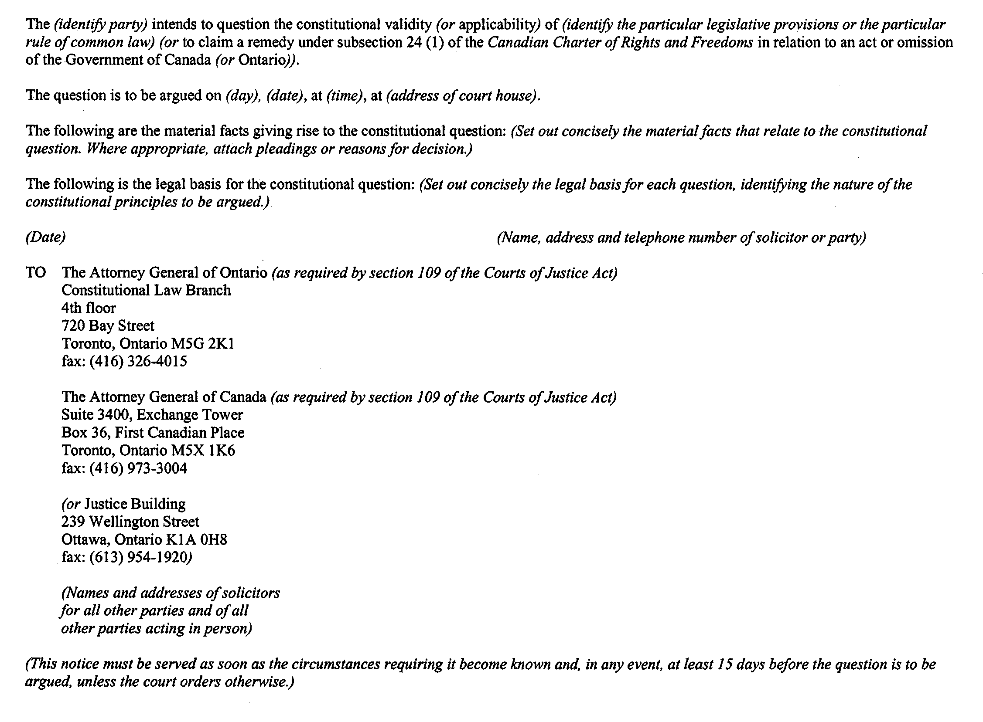
O. Reg. 132/04, s. 21.
See: O. Reg. 132/04, ss. 21, 25 (1).
Form 7A
Courts of Justice Act
Request for appointment of litigation guardian
(General heading)
Request for appointment of litigation guardian
THE PLAINTIFF (or as may be) BELIEVES THAT YOU ARE UNDER A LEGAL DISABILITY. As a party under disability, you must have a litigation guardian appointed by the court to act on your behalf in defending this proceeding.
YOU ARE REQUIRED to have some proper person make a motion to this court forthwith to be appointed as your litigation guardian.
IF YOU FAIL TO DO SO WITHIN TEN DAYS after service of this request, the plaintiff (or as may be) may move without further notice to have the court appoint a litigation guardian to act on your behalf.
(Date) | (Name, address and telephone number of solicitor or party)

TO : (Name and address of party under disability)
R.R.O. 1990, Reg. 194, Form 7A.
Form 7B
Courts of Justice Act
order to continue (minor reaching age of majority)
(General heading)
(Court seal)
order to continue
On the requisition of (identify party) and on reading the affidavit of (name), filed, which states that the minor (name of party) reached the age of majority on (date),
IT IS ORDERED that this proceeding continue by (or against) (name of party) without a litigation guardian and that the title of the proceeding be amended accordingly in all documents issued, served or filed after the date of this order.
Date | Signed by  Local registrar  Address of  court office

R.R.O. 1990, Reg. 194, Form 7B.
Form 8A
Courts of Justice Act
notice to alleged partner
(General heading)
notice to alleged partner
YOU ARE ALLEGED TO HAVE BEEN A PARTNER on (date) (or during (period)) in the partnership of (firm name) named as a party to this proceeding.
IF YOU WISH TO DENY THAT YOU WERE A PARTNER at any material time, you must defend this proceeding separately from the partnership, denying that you were a partner at the material time. If you fail to do so, you will be deemed to have been a partner on the date (or during the period) set out above.
AN ORDER AGAINST THE PARTNERSHIP MAY BE ENFORCED AGAINST YOU PERSONALLY if you are deemed to have been a partner, if you admit that you were a partner or if the court finds that you were a partner at the material time.
(Date) | (Name, address and telephone number of plaintiff’s solicitor or plaintiff)

TO (Name and address of alleged partner)
R.R.O. 1990, Reg. 194, Form 8A.
Form 11A
Courts of Justice Act
order to continue (transfer or transmission of interest)
(General heading)
(Court seal)
order to continue
On the requisition of (identify party or person) and on reading the affidavit of (name), filed, which indicates that on (date), (recite the details of the transfer or transmission of interest or liability),
IT IS ORDERED that this proceeding continue and that the title of the proceeding in all documents issued, served or filed after the date of this order be as follows: (Set out new title of proceeding, deleting name of party whose interest is transferred or transmitted and showing name of new party.)
Date | Signed by  Local registrar  Address of  court office

A party who wishes to set aside or vary this order must make a motion to do so forthwith after the order comes to the party’s attention.
Where a transmission of interest occurs by reason of bankruptcy, leave of the bankruptcy court may be required under section 69.4 of the Bankruptcy and Insolvency Act (Canada) before the proceeding may continue.
R.R.O. 1990, Reg. 194, Form 11A; O. Reg. 14/04, s. 42 (1).
Form 14A
Courts of Justice Act
statement of claim (general)
(General heading)
(Court seal)
statement of claim
TO THE DEFENDANT
A LEGAL PROCEEDING HAS BEEN COMMENCED AGAINST YOU by the plaintiff. The claim made against you is set out in the following pages.
IF YOU WISH TO DEFEND THIS PROCEEDING, you or an Ontario lawyer acting for you must prepare a statement of defence in Form 18A prescribed by the Rules of Civil Procedure, serve it on the plaintiff’s lawyer or, where the plaintiff does not have a lawyer, serve it on the plaintiff, and file it, with proof of service in this court office, WITHIN TWENTY DAYS after this statement of claim is served on you, if you are served in Ontario.
If you are served in another province or territory of Canada or in the United States of America, the period for serving and filing your statement of defence is forty days. If you are served outside Canada and the United States of America, the period is sixty days.
Instead of serving and filing a statement of defence, you may serve and file a notice of intent to defend in Form 18B prescribed by the Rules of Civil Procedure. This will entitle you to ten more days within which to serve and file your statement of defence.
IF YOU FAIL TO DEFEND THIS PROCEEDING, JUDGMENT MAY BE GIVEN AGAINST YOU IN YOUR ABSENCE AND WITHOUT FURTHER NOTICE TO YOU. IF YOU WISH TO DEFEND THIS PROCEEDING BUT ARE UNABLE TO PAY LEGAL FEES, LEGAL AID MAY BE AVAILABLE TO YOU BY CONTACTING A LOCAL LEGAL AID OFFICE.
(Where the claim made is for money only, include the following:)
IF YOU PAY THE PLAINTIFF’S CLAIM, and $ for costs, within the time for serving and filing your statement of defence you may move to have this proceeding dismissed by the court. If you believe the amount claimed for costs is excessive, you may pay the plaintiff’s claim and $400 for costs and have the costs assessed by the court.
Date | Issued by  Local registrar  Address of  court office

TO (Name and address of each defendant)
(In an action under the simplified procedure provided in Rule 76, add:)
THIS ACTION IS BROUGHT AGAINST YOU UNDER THE SIMPLIFIED PROCEDURE PROVIDED IN RULE 76 OF THE RULES OF CIVIL PROCEDURE.
claim
1. The plaintiff claims: (State here the precise relief claimed.)
(Then set out in separate, consecutively numbered paragraphs each allegation of material fact relied on to substantiate the claim.)
(Where the statement of claim is to be served outside Ontario without a court order, set out the facts and the specific provisions of Rule 17 relied on in support of such service.)

(Date of issue) | (Name, address and telephone number of solicitor or plaintiff)
R.R.O. 1990, Reg. 194, Form 14A; O. Reg. 533/95, s. 7; O. Reg. 652/00, s. 3; O. Reg. 653/00, s. 12; O. Reg. 14/04, s. 42 (2).
Form 14B
Courts of Justice Act
statement of claim (mortgage action — foreclosure)
(General heading)
(Court seal)
statement of claim (mortgage action — foreclosure)
TO THE DEFENDANT
A LEGAL PROCEEDING HAS BEEN COMMENCED AGAINST YOU by the plaintiff. The claim made against you is set out in the following pages.
IF YOU WISH TO DEFEND THIS PROCEEDING, you or an Ontario lawyer acting for you must prepare a statement of defence in Form 18A prescribed by the Rules of Civil Procedure, serve it on the plaintiff’s lawyer or, where the plaintiff does not have a lawyer, serve it on the plaintiff, and file it, with proof of service, in this court office, WITHIN 20 DAYS after this statement of claim is served on you, if you are served in Ontario.
If you are served in another province or territory of Canada or in the United States of America, the period for serving and filing your statement of defence is 40 days. If you are served outside Canada and the United States of America, the period is 60 days.
Instead of serving and filing a statement of defence, you may serve and file a notice of intent to defend in Form 18B prescribed by the Rules of Civil Procedure. This will entitle you to 10 more days within which to serve and file your statement of defence.
(Where payment of the mortgage debt is claimed, add:)
IF YOU PAY THE PLAINTIFF’S CLAIM, and $ for costs, within the time for serving and filing your statement of defence, you may move to have this proceeding dismissed by the court. If you believe the amount claimed for costs is excessive, you may pay the plaintiff’s claim and $400 for costs and have the costs assessed by the court.
REQUEST TO REDEEM
Whether or not you serve and file a statement of defence, you may request the right to redeem the mortgaged property by serving a request to redeem (Form 64A) on the plaintiff and filing it in this court office within the time for serving and filing your statement of defence or at any time before being noted in default. If you do so, you will be entitled to seven days notice of the taking of the account of the amount due to the plaintiff, and to 60 days from the taking of the account within which to redeem the mortgaged property.
If you hold a lien, charge or encumbrance on the mortgaged property subsequent to the mortgage in question, you may file a request to redeem, which must contain particulars of your claim verified by an affidavit, and you will be entitled to redeem only if your claim is not disputed or, if disputed, is proved on a reference.
REQUEST FOR SALE
If you do not serve and file a statement of defence, you may request a sale of the mortgaged property by serving a request for sale (Form 64F) on the plaintiff and filing it in this court office within the time for serving and filing your statement of defence, or at any time before being noted in default. If you do so, the plaintiff will be entitled to obtain a judgment for a sale with a reference and you will be entitled to notice of the reference.
If you hold a lien, charge or encumbrance on the mortgaged property subsequent to the mortgage in question and you do not serve and file a request to redeem, you may file a request for sale which must contain particulars of your claim verified by an affidavit, and must be accompanied by a receipt showing that $250 has been paid into court as security for the costs of the plaintiff(s) and of any other party having carriage of the sale.
DEFAULT JUDGMENT
IF YOU FAIL TO SERVE AND FILE A STATEMENT OF DEFENCE, JUDGMENT MAY BE GIVEN AGAINST YOU WITHOUT FURTHER NOTICE. IF YOU WISH TO DEFEND THIS PROCEEDING BUT ARE UNABLE TO PAY LEGAL FEES, LEGAL AID MAY BE AVAILABLE TO YOU BY CONTACTING A LOCAL LEGAL AID OFFICE.
Date | Issued by  Local registrar  Address of  court office

TO: (Name and address of each defendant)
REQUEST TO REDEEM (sale action)
Whether or not you serve and file a statement of defence, you may request the right to redeem the mortgaged property by serving a request to redeem (Form 64A) on the plaintiff and filing it in this court office within the time for serving and filing your statement of defence, or at any time before being noted in default. If you do so, you will be entitled to seven days notice of the taking of the account of the amount due to the plaintiff, and to 60 days from the taking of the account within which to redeem the mortgaged property.
DEFAULT JUDGMENT
IF YOU FAIL TO SERVE AND FILE A STATEMENT OF DEFENCE, JUDGMENT MAY BE GIVEN AGAINST YOU WITHOUT FURTHER NOTICE. IF YOU WISH TO DEFEND THIS PROCEEDING BUT ARE UNABLE TO PAY LEGAL FEES, LEGAL AID MAY BE AVAILABLE TO YOU BY CONTACTING A LOCAL LEGAL AID OFFICE.
Date | Issued by  Local registrar  Address of  court office

TO: (Name and address of each defendant)
(Subsequent encumbrancers are not to be named as defendants in this statement of claim in a sale action.)
(In an action under the simplified procedure provided in Rule 76, add:)
THIS ACTION IS BROUGHT AGAINST YOU UNDER THE SIMPLIFIED PROCEDURE PROVIDED IN RULE 76 OF THE RULES OF CIVIL PROCEDURE.
claim
1. The plaintiff claims:
(foreclosure)
(a) that the equity of redemption in the property secured by the mortgage mentioned below be foreclosed;
(or)
(sale)
(a) that the property secured by the mortgage mentioned below be sold and proceeds of sale applied towards the amount due under the mortgage, and payment to the plaintiff by the defendant (name of defendant against whom payment of any deficiency is claimed) personally of any deficiency if the sale proceeds are not sufficient to pay the amount found due to the plaintiff;
(possession)
(b) possession of the mortgaged property;
(payment of mortgage debt)
(c) payment by the defendant (name of defendant against whom payment of mortgage debt is claimed) of the sum of $
(from paragraph 6 below) now due under the mortgage together with interest at the rate of (mortgage rate) per cent per year until judgment;
(interest)
(d) post-judgment interest in accordance with the Courts of Justice Act (or where the mortgage provides for interest after judgment at the mortgage rate, substitute: post-judgment interest at the rate of (mortgage rate) per cent per year in accordance with the mortgage); and
(costs)
(e) the costs of this action (on a substantial indemnity basis if the mortgage so provides, or if it provides for costs on a solicitor and client basis).
2. The plaintiff’s claim is on a mortgage dated (date), made between (name of mortgagor) and (name of mortgagee), and registered (give particulars of registration and of any assignment of the mortgage), under which the defendant (or as may be) mortgaged the property described below for a term of years securing the sum of $ and interest on that sum at the rate of per cent per year. The mortgage provides for the payment of principal and interest as follows: (Set out terms of payment. Add a reference to provisions in the mortgage for solicitor and client costs and post-judgment interest if applicable.)
3. The mortgage provides that on default of payment of any sum required to be paid under the mortgage, the principal becomes due and payable and the plaintiff is entitled to possession of the mortgaged property and to foreclosure of the equity of redemption in the mortgaged property (or sale of the mortgaged property or as may be).
4. (Where a claim for payment is made under section 20 of the Mortgages Act against a person other than the original mortgagor, add:) The defendant (name) became liable under section 20 of the Mortgages Act to pay the amount of the mortgage debt to the plaintiff by reason of (set out particulars of the transfer of the mortgaged property from the original mortgagor to this defendant).
5. Default in payment of principal and interest (or as may be) occurred on (date), and still continues.
6. There is now due the terms of the mortgage:
(a) for principal $
(b) for taxes paid $
(c) for premiums of insurance paid $
(d) for maintenance costs paid $
(e) for heating costs paid $
(f) for utility costs paid $
(add any other costs in similar fashion)
(g) for interest (set out particulars) $
Total now due: $
The defendant (name) is liable to pay these sums and subsequent interest at the rate of per cent per year.
7. The following is a description of the mortgaged property: (Set out a description sufficient for registration. For Land Titles land, include the parcel number.)
(In a foreclosure action where one or more subsequent encumbrancers are named as defendants, add:)
8. The defendant (name) has been made a party to this action as a subsequent encumbrancer.
(Where the statement of claim is to be served outside Ontario without a court order, set out the facts and the specific provisions of Rule 17 relied on in support of the service.)
(Date) | (Name, address and telephone number of plaintiff’s solicitor or plaintiff)
O. Reg. 333/96, s. 5; O. Reg. 653/00, s. 13; O. Reg. 284/01, s. 31; O. Reg. 14/04, s. 42 (3).
Form 14C
Courts of Justice Act
notice of action
(General heading)
(Court seal)
notice of action
TO THE DEFENDANT
A LEGAL PROCEEDING HAS BEEN COMMENCED AGAINST YOU by the plaintiff. The claim made against you is set out in the statement of claim served with this notice of action.
IF YOU WISH TO DEFEND THIS PROCEEDING, you or an Ontario lawyer acting for you must prepare a statement of defence in Form 18A prescribed by the Rules of Civil Procedure, serve it on the plaintiff’s lawyer or, where the plaintiff does not have a lawyer, serve it on the plaintiff, and file it, with proof of service, in this court office, WITHIN TWENTY DAYS after this notice of action is served on you, if you are served in Ontario.
If you are served in another province or territory of Canada or in the United States of America, the period for serving and filing your statement of defence is forty days. If you are served outside Canada and the United States of America, the period is sixty days.
Instead of serving and filing a statement of defence, you may serve and file a notice of intent to defend in Form 18B prescribed by the Rules of Civil Procedure. This will entitle you to ten more days within which to serve and file your statement of defence.
IF YOU FAIL TO DEFEND THIS PROCEEDING, JUDGMENT MAY BE GIVEN AGAINST YOU IN YOUR ABSENCE AND WITHOUT FURTHER NOTICE TO YOU. IF YOU WISH TO DEFEND THIS PROCEEDING BUT ARE UNABLE TO PAY LEGAL FEES, LEGAL AID MAY BE AVAILABLE TO YOU BY CONTACTING A LOCAL LEGAL AID OFFICE.
(Where the claim made is for money only, include the following:)
IF YOU PAY THE PLAINTIFF’S CLAIM, and $ for costs, within the time for serving and filing your statement of defence, you may move to have this proceeding dismissed by the court. If you believe the amount claimed for costs is excessive, you may pay the plaintiff’s claim and $400 for costs and have the costs assessed by the court.
Date | Issued by  Local registrar  Address of  court office

TO: (Name and address of each defendant)
(In an action under the simplified procedure provided in Rule 76, add:)
THIS ACTION IS BROUGHT AGAINST YOU UNDER THE SIMPLIFIED PROCEDURE PROVIDED IN RULE 76 OF THE RULES OF CIVIL PROCEDURE.
claim
The plaintiff’s claim is for (set out a short statement of the nature of the plaintiff’s claim).
(Date of issue) | (Name, address and telephone number of solicitor or plaintiff)

R.R.O. 1990, Reg. 194, Form 14C; O. Reg. 533/95, s. 7; O. Reg. 652/00, s. 3; O. Reg. 653/00, s. 14.
Form 14D
Courts of Justice Act
statement of claim (action commenced by notice of action)
(General heading)
statement of claim
Notice of action issued on (date)

(In an action under the simplified procedure provided in Rule 76, add:)
THIS ACTION IS BROUGHT AGAINST YOU UNDER THE SIMPLIFIED PROCEDURE PROVIDED IN RULE 76 OF THE RULES OF CIVIL PROCEDURE.

1. The plaintiff claims: (State here the precise relief claimed).
(Then set out in separate, consecutively numbered paragraphs each allegation of material fact relied on to substantiate the claim.)
(Where the statement of claim is to be served outside Ontario without a court order, set out the facts and the specific provisions of Rule 17 relied on in support of such service.)
(Date) | (Name, address and telephone number of solicitor or plaintiff)
R.R.O. 1990, Reg. 194, Form 14D; O. Reg. 533/95, s. 8; O. Reg. 652/00, s. 4; O. Reg. 14/04, s. 42 (4).
Form 14E
Courts of Justice Act
notice of application
(General heading)
(Court seal)
notice of application
TO THE RESPONDENT
A LEGAL PROCEEDING HAS BEEN COMMENCED by the applicant. The claim made by the applicant appears on the following page.
THIS APPLICATION will come on for a hearing on (day), (date), at (time), at (address of court house).
IF YOU WISH TO OPPOSE THIS APPLICATION, to receive notice of any step in the application or to be served with any documents in the application, you or an Ontario lawyer acting for you must forthwith prepare a notice of appearance in Form 38A prescribed by the Rules of Civil Procedure, serve it on the applicant’s lawyer or, where the applicant does not have a lawyer, serve it on the applicant, and file it, with proof of service, in this court office, and you or your lawyer must appear at the hearing.
IF YOU WISH TO PRESENT AFFIDAVIT OR OTHER DOCUMENTARY EVIDENCE TO THE COURT OR TO EXAMINE OR CROSS-EXAMINE WITNESSES ON THE APPLICATION, you or your lawyer must, in addition to serving your notice of appearance, serve a copy of the evidence on the applicant’s lawyer or, where the applicant does not have a lawyer, serve it on the applicant, and file it, with proof of service, in the court office where the application is to be heard as soon as possible, but at least two days before the hearing.
IF YOU FAIL TO APPEAR AT THE HEARING, JUDGMENT MAY BE GIVEN IN YOUR ABSENCE AND WITHOUT FURTHER NOTICE TO YOU. IF YOU WISH TO OPPOSE THIS APPLICATION BUT ARE UNABLE TO PAY LEGAL FEES, LEGAL AID MAY BE AVAILABLE TO YOU BY CONTACTING A LOCAL LEGAL AID OFFICE.
Date | Issued by  Local registrar  Address of  court office

TO (Name and address of each respondent)
application
1. The applicant makes application for: (State here the precise relief claimed.)
2. The grounds for the application are: (Specify the grounds to be argued, including a reference to any statutory provision or rule to be relied on.)
3. The following documentary evidence will be used at the hearing of the application: (List the affidavits or other documentary evidence to be relied on.)
(Where the notice of application is to be served outside Ontario without a court order, state the facts and the specific provisions of Rule 17 relied on in support of such service.)
(Date of issue) | (Name, address and telephone number of solicitor or applicant)
R.R.O. 1990, Reg. 194, Form 14E; O. Reg. 351/94, s. 10; O. Reg. 288/99, s. 29.
Form 14F
Courts of Justice Act
Insert regs\Graphics\Source Law\2002\206\206014Fae.tif
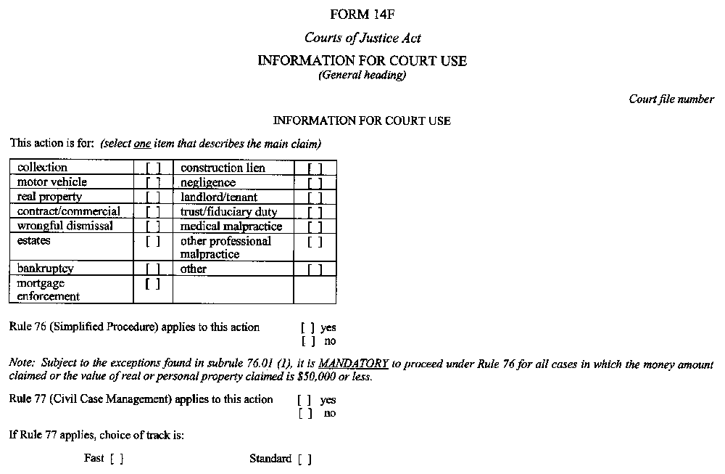
O. Reg. 206/02, s. 25.
Form 15A
Courts of Justice Act
notice of change of solicitors
(General heading)
notice of change of solicitors
The plaintiff (or as may be), formerly represented by (name of former solicitor), has appointed (name of new solicitor) as solicitor of record.
(Date) | (Name, address and telephone number of new solicitor)

TO (Name and address of former solicitor)
AND TO (Names and addresses of solicitors for all other parties, or names and addresses of all other parties)
R.R.O. 1990, Reg. 194, Form 15A.
Form 15B
Courts of Justice Act
notice of appointment of solicitor
(General heading)
notice of appointment of solicitor
The plaintiff (or as may be), formerly acting in person, has appointed (name) as solicitor of record.
(Date) | (Name, address and telephone number of solicitor of record)

TO (Names and addresses of solicitors for all other parties, or names and addresses of all other parties)
R.R.O. 1990, Reg. 194, Form 15B.
Form 15C
Courts of Justice Act
notice of intention to act in person
(General heading)
notice of intention to act in person
The plaintiff (or as may be), formerly represented by (name) as solicitor of record, intends to act in person.
(Date) | (Name, address for service and telephone number of party intending to act in person)

TO (Name and address of former solicitor of record)
AND TO (Names and addresses of solicitors for all other parties, or names and addresses of all other parties)
R.R.O. 1990, Reg. 194, Form 15C.
Form 16A
Courts of Justice Act
acknowledgment of receipt card
(General heading)
TO (full name)
You are served by mail with the documents enclosed with this card in accordance with the Rules of Civil Procedure.
You are requested to sign the acknowledgment below and mail this card immediately after you receive it. If you fail to do so, the documents may be served on you in another manner and you may have to pay the costs of service.
acknowledgment of receipt

I ACKNOWLEDGE that I have received a copy of the following documents: (To be completed in advance by the sender of the documents. Include sufficient particulars to identify each document.)
Signature of person served

(The reverse side of this card must bear the name and address of the sender and the required postage.)
R.R.O. 1990, Reg. 194, Form 16A.
Form 16B
Courts of Justice Act
affidavit of service
(If a separate document insert general heading)
affidavit of service
I, (full name), of the (City, Town, etc.) of , in the (County, Regional Municipality, etc.) of ..........................., MAKE OATH AND SAY (or AFFIRM):
(Personal service)
1. On (date), at (time), I served (identify person served) with the (identify documents served) by leaving a copy with him (or her) at (address where service was made). (Where the rules provide for personal service on a corporation, etc. by leaving a copy of the document with another person, substitute: by leaving a copy with (identify person by name and title) at (address where service was made).)
2. I was able to identify the person by means of (state the means by which the person’s identity was ascertained.)
(Service by leaving a copy with an adult person in the same household as an alternative to personal service)
1. I served (identify person served) with the (identify documents served) by leaving a copy on (date), at (time), with a person (insert name if known) who appeared to be an adult member of the same household in which (identify person served) is residing, at (address where service was made), and by sending a copy by regular lettermail (or registered mail) on (date) to (identify person served) at the same address.
2. I ascertained that the person was an adult member of the household by means of (state how it was ascertained that the person was an adult member of the household).
3. Before serving the documents in this way, I made an unsuccessful attempt to serve (identify person) personally at the same address on (date). (If more than one attempt has been made, add: and again on (date).)
(Service by mail as an alternative to personal service)
1. On (date), I sent to the (identify person served) by regular lettermail (or registered mail) a copy of the (identify documents served).
2. On (date), I received the attached acknowledgment of receipt card (or post office receipt) bearing a signature that purports to be the signature of (identify person).
(Service by mail on a solicitor)
1. I served (identify party served) with the (identify documents served) by sending a copy by regular lettermail (or registered mail) on (date) to (name of solicitor), the solicitor for the (identify party), at (full mailing address).
(Service on a solicitor by fax)
1. I served (identify party served) with the (identify documents served) by sending a copy by fax to (fax number) on (date) to (name of solicitor), the solicitor for the (identify party).
(Service on a solicitor by courier)
1. I served (identify party served) with the (identify documents served) by sending a copy by (name of courier), a courier, to (name of solicitor), the solicitor for the (identify party), at (full address of place for delivery).
2. The copy was given to the courier on (date).
(Service by mail on a party acting in person or a non-party)
1. I served (identify party or person served) with the (identify documents served) by sending a copy by regular lettermail (or registered mail) on (date) to (full mailing address), the last address for service provided by (identify party or person) (or, where no such address has been provided: the last known address of (identify party or person).)
SWORN (etc.)
R.R.O. 1990, Reg. 194, Form 16B; O. Reg. 535/92, s. 14; O. Reg. 351/94, s. 11; O. Reg. 536/96, s. 11.
Form 16C
Courts of Justice Act
certificate of service by sheriff
(If a separate document insert general heading)
certificate of service by sheriff
(Personal service)
I, (full name), Sheriff (or Sheriff’s Officer) of the (County, District, etc.) of , certify that on (date), at (time), I served (identify person served) with (identify documents served) by leaving a copy with him (or her) at (address where service was made). (Where the rules provide for personal service on a corporation, etc., by leaving a copy of the document with another person, substitute: by leaving a copy with (identify person by name and title) at (address where service was made).)
I was able to identify the person by means of (state the means by which the person’s identity was ascertained.)
(Service by leaving a copy with an adult person in the same household as an alternative to personal service)
I, (full name), Sheriff (or Sheriff’s Officer) of the (County, District, etc.) of , certify that I served (identify person served) with this document by leaving a copy in a sealed envelope addressed to him (or her) on (date), at (time), with a person (insert name if known) who appeared to be an adult member of the same household in which (identify person served) is residing at (address where service was made), and by sending a copy by regular lettermail (or registered mail) on (date) to (identify person served) at the same address.
I ascertained that the person was an adult member of the household by means of (state how it was ascertained that the person was an adult member of the household).
Before serving the document in this way, I made an unsuccessful attempt to serve (identify person) personally at the same address on (date). (If more than one attempt has been made, add: and again on (date).)
Date |  | (Signature of sheriff or sheriff’s officer)
R.R.O. 1990, Reg. 194, Form 16C; O. Reg. 770/92, s. 17.
Form 17A
Courts of Justice Act
request for service abroad of judicial or extrajudicial documents

Convention on the service abroad of judicial and
extrajudicial documents in civil or commercial matters,
signed at The Hague, November 15, 1965.
Identity and address of the applicant |  | Address of receiving Authority
The undersigned applicant has the honour to transmit - in duplicate - the documents listed below and, in conformity with article 5 of the above-mentioned Convention, requests prompt service of one copy thereof on the addressee, i.e.
(identity and address)
(a) in accordance with the provisions of sub-paragraph (a) of the first paragraph of article 5 of the Convention*;
(b) in accordance with the following particular method (sub-paragraph (b) of the first paragraph of article 5)*:
(c) by delivery to the addressee, if the addressee accepts it voluntarily (second paragraph of article 5)*.
The authority is requested to return or to have returned to the applicant a copy of the documents - and of the annexes* - with a certificate as provided on the reverse side.
(List of Documents)  *Delete if inappropriate | Done at , the  Signature or stamp.

certificate
The undersigned authority has the honour to certify, in conformity with article 6 of the Convention,
(1) that the document has been served*
- the (date)
- at (place, street, number)
- in one of the following methods authorized by article 5 -
(a) in accordance with the provisions of sub-paragraph (a) of the first paragraph of article 5 of the Convention*;
(b) in accordance with the following particular method*:
;
(c) by delivery to the addressee, who accepted it voluntarily.
The documents referred to in the request have been delivered to:
- (identity and description of person)
- relationship to the addressee (family, business or other)
(2) that the document has not been served, by reason of the following facts*:
In conformity with the second paragraph of article 12 of the Convention, the applicant is requested to pay or reimburse the expenses detailed in the attached statement*.
Annexes
Documents returned:  In appropriate cases, documents establishing the service:  *Delete if inappropriate | Done at , the  Signature or stamp.

R.R.O. 1990, Reg. 194, Form 17A.
Form 17B
Courts of Justice Act
summary of the document to be served
Convention on the service abroad of judicial and extrajudicial documents
in civil or commercial matters, signed at The Hague, November 15, 1965.
(article 5, fourth paragraph)
Name and address of the requesting authority:
Particulars of the parties*:

judicial document**
Nature and purpose of the document:
Nature and purpose of the proceedings and, where appropriate, the amount in dispute:
Date and place for entering appearance**:
Court which has given judgment**:
Date of judgment**:
Time limits stated in the document**:

extrajudicial document**
Nature and purpose of the document:
Time limits stated in the document**:
* If appropriate, identity and address of the person interested in the transmission of the document.
** Delete if inappropriate.

R.R.O. 1990, Reg. 194, Form 17B.
Form 17C
Courts of Justice Act
notice and summary of document
identity and address of the addressee

IMPORTANT
THE enclosed document is of a legal nature and may affect your rights and obligations. the summary of the document to be served will give you some information about its nature and purpose. you should however read the document itself carefully. it may be necessary to seek legal advice.
if your financial resources are insufficient you should seek information on the possibility of obtaining legal aid or advice either in the country where you live or in the country where the document was issued.
enquiries about the availability of legal aid or advice in the country where the document was issued may be directed to:
. . . . .
(It is recommended that the standard terms in the notice be written in English and French and where appropriate also in the official language, or in one of the official languages of the State in which the document originated. The blanks could be completed either in the language of the State to which the document is to be sent, or in English or French.)
SUMMARY OF THE DOCUMENT TO BE SERVED:
Name and address of the requesting authority:
*Particulars of the parties:
**JUDICIAL DOCUMENT:
Nature and purpose of the document:
Nature and purpose of the proceedings and where appropriate, the amount in dispute:
**Date and place for entering appearance:
**Court which has given judgment:
**Date of judgment:
**Time limits stated in the document:
**EXTRAJUDICIAL DOCUMENT
Nature and purpose of the document:
**Time limits stated in the document:
* If appropriate, identity and address of the person interested in the transmission of the document
** Delete if inappropriate
R.R.O. 1990, Reg. 194, Form 17C.
Form 18A
Courts of Justice Act
statement of defence
(General heading)
statement of defence

1. The defendant admits the allegations contained in paragraphs of the statement of claim.
2. The defendant denies the allegations contained in paragraphs of the statement of claim.
3. The defendant has no knowledge in respect of the allegations contained in paragraphs of the statement of claim.
4. (Set out in separate, consecutively numbered paragraphs each allegation of material fact relied on by way of defence.)

(Date) | (Name, address and telephone number of defendant’s solicitor or defendant)
TO (Name and address of plaintiff’s solicitor or plaintiff)

R.R.O. 1990, Reg. 194, Form 18A.
Form 18B
Courts of Justice Act
notice of intent to defend
(General heading)
notice of intent to defend

The defendant (or defendant added by counterclaim or third party) intends to defend this action.

(Date) | (Name, address and telephone number of solicitor or party serving notice)
TO (Name and address of solicitor or party on whom notice is served)

R.R.O. 1990, Reg. 194, Form 18B.
Form 19A
Courts of Justice Act
default judgment (debt or liquidated demand)
(General heading)
(Court seal)
judgment
On reading the statement of claim in this action and the proof of service of the statement of claim on the defendant, filed, and the defendant having been noted in default,
1. it is ordered and adjudged that the defendant pay to the plaintiff the sum of $ and the sum of $ for the costs of this action. (Where costs are to be assessed, substitute the costs of this action as assessed by the court.)
This judgment bears interest at the rate of per cent per year from its date.
Date | Signed by  Local registrar  Address of  court office

R.R.O. 1990, Reg. 194, Form 19A.
Form 19B
Courts of Justice Act
default judgment (recovery of possession of land)
(General heading)
(Court seal)
judgment
On reading the statement of claim in this action and the proof of service of the statement of claim on the defendant, filed, and the defendant having been noted in default,
1. it is ordered and adjudged that the defendant deliver to the plaintiff possession of the following land: (Where the description of the land is very lengthy, substitute the land described in the attached schedule.)
2. it is ordered and adjudged that the defendant pay to the plaintiff the sum of $ for the costs of this action. (Where costs are to be assessed, substitute the costs of this action as assessed by the court.)
The costs fixed by and payable under this judgment bear interest at the rate of per cent per year from its date.
Date | Signed by  Local registrar  Address of  court office

R.R.O. 1990, Reg. 194, Form 19B.
Form 19C
Courts of Justice Act
default judgment (recovery of possession of personal property)
(General heading)
(Court seal)
judgment
On reading the statement of claim in this action and the proof of service of the statement of claim on the defendant, filed, and the defendant having been noted in default,
1. it is ordered and adjudged that the defendant deliver to the plaintiff possession of the following personal property:
(or the personal property described in the attached schedule.)
2. it is ordered and adjudged that the defendant pay to the plaintiff the sum of $ for the costs of this action. (Where costs are to be assessed, substitute the costs of this action as assessed by the court.)
The costs fixed by and payable under this judgment bear interest at the rate of per cent per year from its date.

Date | Signed by  Local registrar  Address of  court office

R.R.O. 1990, Reg. 194, Form 19C.
Form 19D
Courts of Justice Act
requisition for default judgment
(General heading)
requisition for default judgment
to the local registrar at (place)
(Where the defendant has not been noted in default, begin with: I REQUIRE you to note the defendant (name) in default in this action on the ground that (state nature of default).)
I REQUIRE default judgment to be signed against the defendant (name).
Default judgement may properly be signed in this action because the claim is for:
[ ] a debt or liquidated demand in money
[ ] recovery of possession of land
[ ] recovery of possession of personal property
[ ] foreclosure, sale or redemption of a mortgage
(Debt or liquidated demand)
[ ] There has been no payment on account of the claim since the statement of claim was issued.
(Complete Parts B and C.)
OR
[ ] The following payments have been made on account of the claim since the statement of claim was issued. (Complete Parts A and C.)
part a — payment(s) received by plaintiff

(Complete this part only where part payment of the claim has been received. Where no payment has been received on account of the claim, omit this part and complete Part B.)
1. Principal
Principal sum claimed in statement of claim (without interest) $

Date of Payment | Amount of Payment | Payment Amount Principal | Applied to Interest | Principal Sum Owing
total | $ | $ | $ | A $

2. Prejudgment interest
(Under section 128 of the Courts of Justice Act, judgment may be obtained for prejudgment interest from the date the cause of action arose, if claimed in the statement of claim.)
Date on which statement of claim was issued
Date from which prejudgment interest is claimed
The plaintiff is entitled to prejudgment interest on the claim, calculated as follows:
(Calculate simple interest only unless an agreement relied on in the statement of claim specifies otherwise. Calculate interest on the principal sum owing from the date of the last payment. To calculate the interest amount, count the number of days since the last payment, multiply that number by the annual rate of interest, multiply the result by the principal sum owing and divide by 365.)

Principal  Sum Owing | Start Date | End Date  (Date of Payment) | Number of Days | Rate | Interest Amount

(The last End Date should be the date judgment is signed.)

 | TOTAL B $
Principal Sum Owing (Total A above) | $
Total Interest Amount (Total B above) | $
SIGN JUDGMENT FOR | $

part B — NO payment received by plaintiff

(Complete this part only where no payment has been received on account of the claim.)
1. Principal
Principal sum claimed in statement of claim (without interest) A $
2. Prejudgment interest
(Under section 128 of the Courts of Justice Act, judgment may be obtained for prejudgment interest from the date the cause of action arose, if claimed in the statement of claim.)
Date on which statement of claim was issued
Date from which prejudgment interest is claimed
The plaintiff is entitled to prejudgment interest on the claim, calculated as follows:
(Calculate simple interest only unless an agreement relied on in the statement of claim specifies otherwise. To calculate the interest amount, count the number of days and multiply that number by the annual rate of interest, multiply the result by the principal sum owing and divide by 365.)

Principal  Sum Owing | Start Date | End Date  (Date of Payment) | Number of Days | Rate | Interest Amount

 | TOTAL B $
Principal Sum Owing (Total A above) | $
Total Interest Amount (Total B above) | $
SIGN JUDGMENT FOR | $

part c — postjudgment interest and costs

1. Postjudgment interest
The plaintiff is entitled to postjudgment interest at the rate of per cent per year,
[ ] under the Courts of Justice Act, as claimed in the statement of claim.
OR
[ ] in accordance with the claim made in the statement of claim.
2. Costs
The plaintiff wishes costs to be,
[ ] fixed by the local registrar.
or
[ ] assessed by an assessment officer.
Date | ............................................................................................................................  (Signature of plaintiff’s solicitor or plaintiff)
 | (Name, address and telephone number of plaintiff’s solicitor or plaintiff)
R.R.O. 1990, Reg. 194, Form 19D.
Form 22A
Courts of Justice Act
special case
(General heading)
special case
THE FOLLOWING CASE is stated for the opinion of the court:
1. (Set out, in consecutively numbered paragraphs, the material facts of the case, as agreed on by the parties, that are necessary to enable the court to determine the questions stated. Refer to and include a copy of any relevant documents.)
the questions for the opinion of the court are:
1. (Set out the questions in consecutively numbered paragraphs.)
the RELIEF SOUGHT on the determination of the questions stated is:
1. (Set out the relief sought, as agreed on by the parties, in respect of each possible answer to each of the questions stated, in a form that could readily be incorporated into an order.)
(Date) | (Signature of all solicitors or parties in the proceeding)
 | (Names, addresses and telephone numbers of all solicitors or parties in the proceeding)
R.R.O. 1990, Reg. 194, Form 22A.
Form 23A
Courts of Justice Act
notice of discontinuance
(General heading)
notice of discontinuance
The plaintiff wholly discontinues this action. (Where applicable, add against the defendant (name).)
(Or The plaintiff discontinues that part of this action relating to Where applicable, add against the defendant (name).)
(Date) | (Name, address and telephone number of plaintiff’s solicitor or plaintiff)
TO (Name and address of defendant’s solicitor or defendant)
NOTE: If there is a counterclaim, the defendant should consider rule 23.02, under which the counterclaim may be deemed to be discontinued.
NOTE: If there is a crossclaim or third party claim, the defendant should consider rule 23.03, under which the crossclaim or third party claim may be deemed to be dismissed.
R.R.O. 1990, Reg. 194, Form 23A.
Form 23B
Courts of Justice Act
notice of election to proceed with counterclaim
(General heading)
notice of election
The defendant elects to proceed with the counterclaim in this action.

(Date) | (Name, address and telephone number of defendant’s solicitor or defendant)
TO (Name and address of plaintiff’s solicitor or plaintiff)
R.R.O. 1990, Reg. 194, Form 23B.
Form 23C
Courts of Justice Act
notice of withdrawal of defence
(General heading)
notice of withdrawal
The defendant withdraws the statement of defence in this action.
(Or The defendant withdraws paragraphs of the statement of defence in this action.)
(Date) | (Name, address and telephone number of defendant’s solicitor or defendant)
TO (Name and address of plaintiff’s solicitor or plaintiff)
R.R.O. 1990, Reg. 194, Form 23C.
Form 24.1A
Courts of Justice Act
(General heading)
NOTICE OF NAME OF MEDIATOR AND DATE OF SESSION
TO: MEDIATION CO-ORDINATOR
1. I certify that I have consulted with the parties and that the parties have chosen the following mediator for the mediation session required by Rule 24.1: (name)
2. The mediator is named in the list of mediators for (name county).
(or)
2. The mediator is not named in a list of mediators, but has been chosen by the parties under clause 24.1.08 (2) (a) or (c).
3. The mediation session will take place on (date).

(Date) | (Name, address, telephone number and fax number of plaintiff’s lawyer or of plaintiff)

O. Reg. 453/98, s. 2 (1); O. Reg. 627/98, s. 10.
Form 24.1B
Courts of Justice Act
(General heading)
NOTICE BY ASSIGNED MEDIATOR
TO:
AND TO:
The notice of name of mediator and date of session (Form 24.1A) required by rule 24.1.09 of the Rules of Civil Procedure has not been filed in this action. Accordingly, the mediation co-ordinator has assigned me to conduct the mediation session under Rule 24.1. I am a mediator named in the list of mediators for (name county).
The mediation session will take place on (date), from (time) to (time), at (place).
Unless the court orders otherwise, you are required to attend this mediation session. If you have a lawyer representing you in this action, he or she is also required to attend.
You are required to file a statement of issues (Form 24.1C) by (date) (seven days before the mediation session). A blank copy of the form is attached.
When you attend the mediation session, you should bring with you any documents that you consider of central importance in the action. You should plan to remain throughout the scheduled time. If you need another person’s approval before agreeing to a settlement, you should make arrangements before the mediation session to ensure that you have ready telephone access to that person throughout the session, even outside regular business hours.
YOU MAY BE PENALIZED UNDER RULE 24.1.13 IF YOU FAIL TO FILE A STATEMENT OF ISSUES OR FAIL TO ATTEND THE MEDIATION SESSION.
(Date) | (Name, address, telephone number and fax number of mediator)
cc. Mediation co-ordinator
O. Reg. 453/98, s. 2 (1).
Form 24.1C
Courts of Justice Act
(General heading)
STATEMENT OF ISSUES
(To be provided to mediator and parties at least seven days before the mediation session)
1. Factual and legal issues in dispute
The plaintiff (or defendant) states that the following factual and legal issues are in dispute and remain to be resolved.
(Issues should be stated briefly and numbered consecutively.)
2. Party’s position and interests (what the party hopes to achieve)
(Brief summary.)
3. Attached documents
Attached to this form are the following documents that the plaintiff (or defendant) considers of central importance in the action: (list)

(date) | (party’s signature)
 | (Name, address, telephone number and fax number of lawyer of party filing statement of issues, or of party)

NOTE: When the plaintiff provides a copy of this form to the mediator, a copy of the pleadings shall also be included.
NOTE: Rule 24.1.14 provides as follows:
All communications at a mediation session and the mediator’s notes and records shall be deemed to be without prejudice settlement discussions.
O. Reg. 453/98, s. 2 (1).
Form 24.1D
Courts of Justice Act
(General heading)
CERTIFICATE OF NON-COMPLIANCE
TO: MEDIATION CO-ORDINATOR
I, (name), mediator, certify that this certificate of non-compliance is filed because:
( ) | (Identify party(ies)) failed to provide a copy of a statement of issues to the mediator and the other parties (or to the mediator or to party(ies)).
( ) | (Identify plaintiff) failed to provide a copy of the pleadings to the mediator.
( ) | (Identify party(ies)) failed to attend within the first 30 minutes of a scheduled mediation session.

(Date) | (Name, address, telephone number and fax number, if any, of mediator)

O. Reg. 453/98, s. 2 (1).
Form 25A
Courts of Justice Act
REPLY
(General heading)
REPLY

1. The plaintiff admits the allegations contained in paragraphs of the statement of defence.
2. The plaintiff denies the allegations contained in paragraphs of the statement of defence.
3. The plaintiff has no knowledge in respect of the allegations contained in paragraphs of the statement of defence.
4. (Set out in separate, consecutively numbered paragraphs each allegation of material fact relied on by way of reply to the statement of defence.)
(Date) | (Name, address and telephone number of plaintiff’s solicitor or plaintiff)

TO (Name and address of defendant’s solicitor or defendant)
R.R.O. 1990, Reg. 194, Form 25A..
Form 27A
Courts of Justice Act
COUNTERCLAIM (AGAINST PARTIES TO MAIN ACTION ONLY)
(Where the counterclaim includes as a defendant to the counterclaim a person who is not already a party to the main action, use Form 27B.)
(Include the counterclaim in the same document as the statement of defence, and entitle the document STATEMENT OF DEFENCE AND COUNTERCLAIM. The counterclaim is to follow the last paragraph of the statement of defence. Number the paragraphs in sequence commencing with the number following the number of the last paragraph of the statement of defence.)
COUNTERCLAIM
The defendant (name if more than one defendant) claims: (State here the precise relief claimed.)
(Then set out in separate, consecutively numbered paragraphs each allegation of material fact relied on to substantiate the counterclaim.)
(Where the defendant to the counterclaim is sued in a capacity other than that in which the defendant is a party to the main action, set out the capacity.)
(Date) | (Name, address and telephone number of plaintiff’s solicitor or plaintiff)

TO (Name and address of solicitor for defendant to the counterclaim or of defendant to the counterclaim)
R.R.O. 1990, Reg. 194, Form 27A.
Form 27B
Courts of Justice Act
COUNTERCLAIM (AGAINST PLAINTIFF AND PERSON NOT ALREADY PARTY TO MAIN ACTION)
(Where all defendants to the counterclaim are already parties to the main action, use Form 27A.)
(General heading)
(Add a second title of proceeding, as follows:)
a n d b e t w e e n :
(name)
(Court seal)
Plaintiff by
counterclaim
and
(name)
Defendants to
the counterclaim
statement of defence and counterclaim
TO THE DEFENDANTS TO THE COUNTERCLAIM
A LEGAL PROCEEDING has been commenced against you by way of a counterclaim in an action in this court. The claim made against you is set out in the following pages.
IF YOU WISH TO DEFEND THIS COUNTERCLAIM, you or an Ontario lawyer acting for you must prepare a defence to counterclaim in Form 27C prescribed by the Rules of Civil Procedure, serve it on the plaintiff by counterclaim’s lawyer or, where the plaintiff by counterclaim does not have a lawyer, serve it on the plaintiff by counterclaim, and file it, with proof of service, in this court, WITHIN TWENTY DAYS after this statement of defence and counterclaim is served on you.
If you are not already a party to the main action and you are served in another province or territory of Canada or in the United States of America, the period for serving and filing your defence is forty days. If you are served outside Canada and the United States of America, the period is sixty days.
If you are not already a party to the main action, instead of serving and filing a defence to counterclaim, you may serve and file a notice of intent to defend in Form 18B prescribed by the Rules of Civil Procedure. This will entitle you to ten more days within which to serve and file your defence to counterclaim.
IF YOU FAIL TO DEFEND THIS COUNTERCLAIM, JUDGMENT MAY BE GIVEN AGAINST YOU IN YOUR ABSENCE AND WITHOUT FURTHER NOTICE TO YOU. IF YOU WISH TO DEFEND THIS PROCEEDING BUT ARE UNABLE TO PAY LEGAL FEES, LEGAL AID MAY BE AVAILABLE TO YOU BY CONTACTING A LOCAL LEGAL AID OFFICE.
(Where the counterclaim is for money only, include the following:)
IF YOU PAY THE AMOUNT OF THE COUNTERCLAIM AGAINST YOU, and $
for costs, within the time for serving and filing your defence to counterclaim, you may move to have the counterclaim against you dismissed by the court. If you believe the amount claimed for costs is excessive, you may pay the amount of the counterclaim and $400 for costs and have the costs assessed by the court.
Date | Issued by  Local registrar  Address of  court office

TO (Name and address of defendant to the counterclaim who is not already a party to the main action)
(Name and address of solicitor for other defendant to the counterclaim or of other defendant to the counterclaim)
(The counterclaim is to follow the last paragraph of the statement of defence. Number the paragraphs in sequence commencing with the number following the number of the last paragraph of the statement of defence.)
counterclaim
The defendant (name if more than one defendant) claims: (State here the precise relief claimed.)
(Then set out in separate, consecutively numbered paragraphs each allegation of material fact relied on to substantiate the counterclaim.)
(Where a defendant to the counterclaim who is not already a party to the main action is to be served outside Ontario without a court order, set out the facts and the specific provisions of Rule 17 relied on in support of such service.)
(Date of issue) | (Name, address and telephone number of plaintiff by counterclaim’s solicitor or plaintiff by counterclaim)

R.R.O. 1990, Reg. 194, Form 27B; O. Reg. 653/00, s. 15.
Form 27C
Courts of Justice Act
defence to counterclaim
(General heading, including second title of proceeding, if required)
(A plaintiff who delivers a reply in the main action must include the defence to counterclaim in the same document as the reply, and the document is to be entitled REPLY AND DEFENCE TO COUNTERCLAIM. The defence to counterclaim is to follow immediately after the last paragraph of the reply and the paragraphs are to be numbered in sequence commencing with the number following the number of the last paragraph of the reply.)
defence to counterclaim
1. The defendant to the counterclaim admits the allegations contained in paragraphs
of the counterclaim.
2. The defendant to the counterclaim denies the allegations contained in paragraphs
of the counterclaim.
3. The defendant to the counterclaim has no knowledge in respect of the allegations contained in paragraphs
of the counterclaim.
4. (Set out in separate, consecutively numbered paragraphs each allegation of material fact relied on by way of defence to the counterclaim.)
(Date) | (Name, address and telephone number of solicitor for defendant to the counterclaim or defendant to the counterclaim)

TO (Name and address of plaintiff by counterclaim’s solicitor or of plaintiff by counterclaim)
R.R.O. 1990, Reg. 194, Form 27C.
Form 27D
Courts of Justice Act
reply to defence to counterclaim
(General heading, including second title of proceeding, if required)
reply to defence to counterclaim
1. The plaintiff by counterclaim admits the allegations contained in paragraphs
of the defence to counterclaim.
2. The plaintiff by counterclaim denies the allegations contained in paragraphs
of the defence to counterclaim.
3. The plaintiff by counterclaim has no knowledge in respect of the allegations contained in paragraphs
of the defence to counterclaim.
4. (Set out in separate, consecutively numbered paragraphs each allegation of material fact relied on by way of reply to the defence to counterclaim.)
(Date) | (Name, address and telephone number of plaintiff by counterclaim’s solicitor or plaintiff by counterclaim)

TO (Name and address of solicitor for the defendant to the counterclaim or defendant to the counterclaim)
R.R.O. 1990, Reg. 194, Form 27D.
Form 28A
Courts of Justice Act
crossclaim
(Include the crossclaim in the same document as the statement of defence, and entitle the document STATEMENT OF DEFENCE AND CROSSCLAIM. The crossclaim is to follow the last paragraph of the statement of defence. Number the paragraphs in sequence commencing with the number following the number of the last paragraph of the statement of defence.)
crossclaim
The defendant (name) claims against the defendant (name): (State here the precise relief claimed.)
(Then set out in separate, consecutively numbered paragraphs each allegation of material fact relied on to substantiate the crossclaim.)
(Where a defendant to the crossclaim is sued in a capacity other than that in which the defendant is a party to the main action, set out the capacity. Where the statement of defence and crossclaim is to be served outside Ontario without a court order, include the facts and the specific provisions of Rule 17 relied on in support of such service.)
(Date) | (Name, address and telephone number of crossclaiming defendant’s solicitor or crossclaiming defendant)

TO (Name and address of defendant to crossclaim’s solicitor or defendant to crossclaim)
R.R.O. 1990, Reg. 194, Form 28A.
Form 28B
Courts of Justice Act
defence to CRossCLAIM
(General heading)
defence to CRossCLAIM
1. The defendant (name) admits the allegations contained in paragraphs
of the crossclaim.
2. The defendant (name) denies the allegations contained in paragraphs
of the crossclaim.
3. The defendant (name) has no knowledge in respect of the allegations contained in paragraphs
of the crossclaim.
4. (Set out in separate, consecutively numbered paragraphs each allegation of material fact relied on by way of defence to the crossclaim.)
(Date) | (Name, address and telephone number of defendant to crossclaim’s solicitor or defendant to crossclaim)

TO (Name and address of crossclaiming defendant’s solicitor or crossclaiming defendant)
R.R.O. 1990, Reg. 194, Form 28B.
Form 28C
Courts of Justice Act
reply to defence to CRossCLAIM
(General heading)
reply to defence to CRossCLAIM
1. The defendant (name) admits the allegations contained in paragraphs
of the defence to crossclaim.
2. The defendant (name) denies the allegations contained in paragraphs
of the defence to crossclaim.
3. The defendant (name) has no knowledge in respect of the allegations contained in paragraphs
of the defence to crossclaim.
4. (Set out in separate, consecutively numbered paragraphs each allegation of material fact relied on by way of reply to the defence to crossclaim.)
(Date) | (Name, address and telephone number of crossclaiming defendant’s solicitor or crossclaiming defendant)

TO (Name and address of defendant to crossclaim’s solicitor or defendant to crossclaim)
R.R.O. 1990, Reg. 194, Form 28C.
Form 29A
Courts of Justice Act
third party claim
(Court file no.)
ONTARIO
SUPERIOR COURT OF JUSTICE
b e t w e e n :
(name)
Plaintiff
and
(Court seal)
(name)
Defendant
and
(name)
Third Party
third party claim
TO THE THIRD PARTY
A LEGAL PROCEEDING HAS BEEN COMMENCED AGAINST YOU by way of a third party claim in an action in this court.
The action was commenced by the plaintiff against the defendant for the relief claimed in the statement of claim served with this third party claim. The defendant has defended the action on the grounds set out in the statement of defence served with this third party claim. The defendant’s claim against you is set out in the following pages.
IF YOU WISH TO DEFEND THIS THIRD PARTY CLAIM, you or an Ontario lawyer acting for you must prepare a third party defence in Form 29B prescribed by the Rules of Civil Procedure, serve it on the lawyers for the other parties or, where a party does not have a lawyer, serve it on the party, and file it, with proof of service, WITHIN TWENTY DAYS after this third party claim is served on you, if you are served in Ontario.
If you are served in another province or territory of Canada or in the United States of America, the period for serving and filing your third party defence is forty days. If you are served outside Canada and the United States of America, the period is sixty days.
Instead of serving and filing a third party defence, you may serve and file a notice of intent to defend in Form 18B prescribed by the Rules of Civil Procedure. This will entitle you to ten more days within which to serve and file your third party defence.
YOU MAY ALSO DEFEND the action by the plaintiff against the defendant by serving and filing a statement of defence within the time for serving and filing your third party defence.
IF YOU FAIL TO DEFEND THIS THIRD PARTY CLAIM, JUDGMENT MAY BE GIVEN AGAINST YOU IN YOUR ABSENCE AND WITHOUT FURTHER NOTICE TO YOU. IF YOU WISH TO DEFEND THIS PROCEEDING BUT ARE UNABLE TO PAY LEGAL FEES, LEGAL AID MAY BE AVAILABLE TO YOU BY CONTACTING A LOCAL LEGAL AID OFFICE.
(Where the third party claim is for money only, include the following:)
IF YOU PAY THE AMOUNT OF THE THIRD PARTY CLAIM AGAINST YOU, and $
for costs, within the time for serving and filing your third party defence, you may move to have the third party claim dismissed by the court. If you believe the amount claimed for costs is excessive, you may pay the amount of the third party claim and $400 for costs and have the costs assessed by the court.
Date | Issued by  Local registrar  Address of  court office

TO (Name and address of third party)
CLAIM
1. The defendant claims against the third party: (State here the precise relief claimed.)
(Then set out in separate, consecutively numbered paragraphs each allegation of material fact relied on to substantiate the third party claim.)
(Where the third party claim is to be served outside Ontario without a court order, set out the facts and the specific provisions of Rule 17 relied on in support of such service.)
(Date of issue) | (Name, address and telephone number of defendant’s solicitor or defendant)

R.R.O. 1990, Reg. 194, Form 29A; O. Reg. 292/99, s. 1 (3, 4); O. Reg. 653/00, s. 16.
Form 29B
Courts of Justice Act
third party defence
(General heading, with title of proceeding in accordance with Form 29A)
third party defence
1. The third party admits the allegations contained in paragraphs
of the third party claim.
2. The third party denies the allegations contained in paragraphs
of the third party claim.
3. The third party has no knowledge in respect of the allegations contained in paragraphs
of the third party claim.
4. (Set out in separate, consecutively numbered paragraphs each allegation of material fact relied on by way of defence to the third party claim.)
(Date) | (Name, address and telephone number of third party’s solicitor or third party)

TO (Name and address of defendant’s solicitor or defendant)
R.R.O. 1990, Reg. 194, Form 29B.
Form 29C
Courts of Justice Act
reply to third party defence
(General heading, with title of proceeding in accordance with Form 29A)
reply to third party defence
1. The defendant admits the allegations contained in paragraphs
of the third party defence.
2. The defendant denies the allegations contained in paragraphs
of the third party defence.
3. The defendant has no knowledge in respect of the allegations contained in paragraphs
of the third party defence.
4. (Set out in separate, consecutively numbered paragraphs each allegation of material fact relied on by way of reply to the third party defence.)

(Date) | (Name, address and telephone number of defendant’s solicitor or defendant)

TO (Name and address of third party’s solicitor or third party)
R.R.O. 1990, Reg. 194, Form 29C.
Form 30A
Courts of Justice Act
affidavit of documents (individual)
(General heading)
affidavit of documents
I, (full name of deponent), of the (City, Town, etc.) of , in the (County, Regional Municipality, etc.) of , the plaintiff (or as may be) in this action, MAKE OATH AND SAY (or AFFIRM) :
1. I have conducted a diligent search of my records and have made appropriate enquiries of others to inform myself in order to make this affidavit. This affidavit discloses, to the full extent of my knowledge, information and belief, all documents relating to any matter in issue in this action that are or have been in my possession, control or power.
2. I have listed in Schedule A those documents that are in my possession, control or power and that I do not object to producing for inspection.
3. I have listed in Schedule B those documents that are or were in my possession, control or power and that I object to producing because I claim they are privileged, and I have stated in Schedule B the grounds for each such claim.
4. I have listed in Schedule C those documents that were formerly in my possession, control or power but are no longer in my possession, control or power, and I have stated in Schedule C when and how I lost possession or control of or power over them and their present location.
5. I have never had in my possession, control or power any document relating to any matter in issue in this action other than those listed in Schedules A, B and C.
6. I have listed in Schedule D the names and addresses of persons who might reasonably be expected to have knowledge of transactions or occurrences in issue. (Strike out this paragraph if the action is not being brought under the simplified procedure.)
SWORN (etc.)

(Signature of deponent)

LAWYER’S certificate
I CERTIFY that I have explained to the deponent,
(a) the necessity of making full disclosure of all documents relating to any matter in issue in the action;
(b) what kinds of documents are likely to be relevant to the allegations made in the pleadings; and
(c) if the action is brought under the simplified procedure, the necessity of providing the list required under rule 76.03.
Date | (Signature of lawyer)

Schedule A
Documents in my possession, control or power that I do not object to producing for inspection.
(Number each document consecutively. Set out the nature and date of the document and other particulars sufficient to identify it.)
Schedule B
Documents that are or were in my possession, control or power that I object to producing on the grounds of privilege.
(Number each document consecutively. Set out the nature and date of the document and other particulars sufficient to identify it. State the grounds for claiming privilege for each document.)
Schedule C
Documents that were formerly in my possession, control or power but are no longer in my possession, control or power.
(Number each document consecutively. Set out the nature and date of the document and other particulars sufficient to identify it. State when and how possession or control of or power over each document was lost, and give the present location of each document.)
Schedule D
(To be filled in only if the action is being brought under the simplified procedure.)
Names and addresses of persons who might reasonably be expected to have knowledge of transactions or occurrences in issue.
R.R.O. 1990, Reg. 194, Form 30A; O. Reg. 533/95, s. 9; O. Reg. 652/00, s. 5; O. Reg. 206/02, s. 26 (1); O. Reg. 19/03, s. 22 (1).
Form 30B
Courts of Justice Act
affidavit of documents (corporation or partnership)
(General heading)
affidavit of documents
I, (full name of deponent), of the (City, Town, etc.) of , in the (County, Regional Municipality, etc.) of , MAKE OATH AND SAY (or AFFIRM) :
1. I am the (state the position held by the deponent in the corporation or partnership) of the plaintiff (or as may be), which is a corporation (or partnership).
2. I have conducted a diligent search of the corporation’s (or partnership’s) records and made appropriate enquiries of others to inform myself in order to make this affidavit. This affidavit discloses, to the full extent of my knowledge, information and belief, all documents relating to any matter in issue in this action that are or have been in the possession, control or power of the corporation (or partnership).
3. I have listed in Schedule A those documents that are in the possession, control or power of the corporation (or partnership) and that it does not object to producing for inspection.
4. I have listed in Schedule B those documents that are or were in the possession, control or power of the corporation (or partnership) and that it objects to producing because it claims they are privileged, and I have stated in Schedule B the grounds for each such claim.
5. I have listed in Schedule C those documents that were formerly in the possession, control or power of the corporation (or partnership) but are no longer in its possession, control or power and I have stated in Schedule C when and how it lost possession or control of or power over them and their present location.
6. The corporation (or partnership) has never had in its possession, control or power any documents relating to any matter in issue in this action other than those listed in Schedules A, B and C.
7. I have listed in Schedule D the names and addresses of persons who might reasonably be expected to have knowledge of transactions or occurrences in issue. (Strike out this paragraph if the action is not being brought under the simplified procedure.)
SWORN (etc.)

(Signature of deponent)

LAWYER’S certificate
I CERTIFY that I have explained to the deponent,
(a) the necessity of making full disclosure of all documents relating to any matter in issue in the action;
(b) what kinds of documents are likely to be relevant to the allegations made in the pleadings; and
(c) if the action is brought under the simplified procedure, the necessity of providing the list required under rule 76.03.
Date | (Signature of lawyer)

Schedule A
Documents in the corporation’s (or partnership’s) possession, control or power that it does not object to producing for inspection.
(Number each document consecutively. Set out the nature and date of the document and other particulars sufficient to identify it.)
Schedule B
Documents that are or were in the corporation’s (or partnership’s) possession, control or power that it objects to producing on the grounds of privilege.
(Number each document consecutively. Set out the nature and date of the document and other particulars sufficient to identify it. State the grounds for claiming privilege for each document.)
Schedule C
Documents that were formerly in the corporation’s (or partnership’s) possession, control or power but are no longer in its possession, control or power.
(Number each document consecutively. Set out the nature and date of the document and other particulars sufficient to identify it. State when and how possession or control of or power over each document was lost, and give the present location of each document.)
Schedule D
(To be filled in only if the action is being brought under the simplified procedure.)
Names and addresses of persons who might reasonably be expected to have knowledge of transactions or occurrences in issue.
R.R.O. 1990, Reg. 194, Form 30B; O. Reg. 533/95, s. 10; O. Reg. 652/00, s. 6; O. Reg. 206/02, s. 26 (2); O. Reg. 19/03, s. 22 (2).
Form 30C
Courts of Justice Act
request to inspect documents
(General heading)
request to inspect documents
You are requested to produce for inspection all the documents listed in Schedule A of your affidavit of documents (or the following documents referred to in your (identify pleading or affidavit) :)

(Date) | (Name, address and telephone number of requesting solicitor or party)

TO (Name and address of solicitor or party requested to produce)
R.R.O. 1990, Reg. 194, Form 30C.
Form 34A
Courts of Justice Act
notice of examination

(To be used only for a party to the proceeding, a person to be examined for discovery or in aid of execution on behalf or in place of a party or a person to be cross-examined on an affidavit. For the examination of any other person, use a summons to witness (Form 34B).)
(General heading)
notice of examination
TO (Name of person to be examined)
YOU ARE REQUIRED TO ATTEND, on (day), (date), at (time), at the office of (name, address and telephone number of examiner), for (choose one of the following):
 | [ ] | Cross-examination on your affidavit dated (date)
 | [ ] | Examination for discovery
 | [ ] | Examination for discovery on behalf of or in place of (identify party)
 | [ ] | Examination in aid of execution
 | [ ] | Examination in aid of execution on behalf of or in place of (identify party)

(Examination for discovery of a party or a person examined on behalf or in place of a party)
YOU ARE REQUIRED TO BRING WITH YOU and produce at the examination the documents mentioned in subrule 30.04 (4) of the Rules of Civil Procedure, and the following documents and things: (Set out the nature and date of each document and give particulars sufficient to identify each document and thing.)
(Other examinations)
YOU ARE REQUIRED TO BRING WITH YOU and produce at the examination the following documents and things: (Set out the nature and date of each document and give particulars sufficient to identify each document and thing.)

(Date) | (Name, address and telephone number of examining solicitor or party)

TO (Name and address of solicitor or of person to be examined)
R.R.O. 1990, Reg. 194, Form 34A; O. Reg. 14/04, s. 42 (5).
Form 34B
Courts of Justice Act
summons to witness (examination out of court)
(General heading)
(Court seal)
summons to witness
TO (Name and address of person to be examined)
YOU ARE REQUIRED TO ATTEND, on (day), (date), at (time), at the office of (name, address and telephone number of examiner), for (choose one of the following):
 | [ ] | Cross-examination on your affidavit dated (date)
 | [ ] | Examination for discovery with leave of the court
 | [ ] | Examination out of court as witness before hearing
 | [ ] | Examination in aid of execution
 | [ ] | Taking evidence before trial

YOU ARE REQUIRED TO BRING WITH YOU and produce at the examination the following documents and things: (Set out the nature and date of each document and give particulars sufficient to identify each document and thing.)
ATTENDANCE MONEY for day(s) of attendance is served with this summons, calculated in accordance with Tariff A of the Rules of Civil Procedure, as follows:

Attendance allowance of $ daily | $
Travel allowance | $
Overnight accommodation and meal allowance | $
TOTAL | $

If further attendance is required, you will be entitled to additional attendance money.
IF YOU FAIL TO ATTEND OR REMAIN UNTIL THE END OF THIS EXAMINATION, YOU MAY BE COMPELLED TO ATTEND AT YOUR OWN EXPENSE AND YOU MAYBE FOUND IN CONTEMPT OF COURT.
Date | Issued by  Local registrar  Address of  court office

This summons was issued at the request of, and inquires my be directed to:

(Name, address and telephone number of examining solicitor or party)

R.R.O. 1990, Reg. 194, Form 34B; O. Reg. 14/04, s. 42 (6).
Form 34C
Courts of Justice Act
commission
(General heading)
(Court seal)
commission
TO (Name and address of commissioner)
YOU HAVE BEEN APPOINTED A COMMISSIONER for the purpose of taking evidence in this proceeding now pending in this court by order of the court made on (date), a copy of which is attached.
YOU ARE GIVEN FULL AUTHORITY to do all things necessary for taking the evidence mentioned in the order authorizing this commission. (Where the commission is issued under Rule 36, add: You are also authorized, on consent of the parties, to take the evidence of any other witnesses who may be found in (name of province, state or country).)
You are to send to this court a transcript of the evidence taken, together with this commission, forthwith after the transcript is completed.
In carrying out this commission, you are to follow the terms of the attached order and the instructions contained in this commission.
THIS COMMISSION is signed and sealed by order of the court.
Date | Issued by  Local registrar  Address of  court office

The registrar is to attach to this commission a copy of Rules 34 and 36 and section 45 of the Evidence Act.
INSTRUCTIONS TO COMMISSIONER
1. This commission is to be conducted in accordance with Rules 34 and 36 of the Ontario Rules of Civil Procedure, a copy of which is attached, to the extent that it is possible to do so. The law of Ontario applies to the taking of the evidence.
2. Before acting on this commission, you must take the oath (or affirmation) set out below. You may do so before any person authorized by section 45 of the Evidence Act of Ontario, a copy of which is attached, to take affidavits or administer oaths or affirmations outside Ontario.

I, , swear (or affirm) that I will, according to the best of my skill and knowledge, truly and faithfully and without partiality to any of the parties to this proceeding, take the evidence of every witness examined under this commission, and cause the evidence to be transcribed and forwarded to the court. (In an oath, conclude: So help me God.)
Sworn (or Affirmed) before me at the (City, Town, etc.) of
, in
the (Province, State, etc.) of
, on (date).
(Signature of commissioner)
(Signature and office of person before whom oath or affirmation is taken)

3. The examining party is required to give the person to be examined at least days notice of the examination and, where the order so provides, to pay attendance money to the person to be examined.
4. You must arrange to have the evidence before you recorded and transcribed. You are to administer the following oath (or affirmation) to the person who records and transcribes the evidence:

You swear (or affirm) that you will truly and faithfully record and transcribe all questions put to all witnesses and their answers in accordance with the directions of the commissioner. (In an oath, conclude: So help you God.)

On consent of the parties, or where the order for this commission provides for it, the examination may be recorded by videotape or other similar means.
5. You are to administer the following oath (or affirmation) to each witness whose evidence is to be taken:

You swear (or affirm) that the evidence to be given by you touching the matters in question between the parties to this proceeding shall be the truth, the whole truth, and nothing but the truth. (In an oath, conclude: So help you God.)

6. Where a witness does not understand the language or is deaf or mute, the evidence of the witness must be given through an interpreter. You are to administer the following oath (or affirmation) to the interpreter:

You swear (or affirm) that you understand the
language and the language in which the examination is to be conducted and that you will truly interpret the oath (or affirmation) to the witness, all questions put to the witness and the answers of the witness, to the best of your skill and understanding. (In an oath, conclude: So help you God.)

7. You are to attach to this commission the transcript of the evidence and the exhibits, and any videotape or other recording of the examination. You are to complete the certificate set out below, and mail this commission, the transcript, the exhibits and any videotape or other recording of the examination to the office of the court where the commission was issued. You are to keep a copy of the transcript and, where practicable, a copy of the exhibits until the court disposes of this proceeding. Forthwith after you mail this commission and the accompanying material to the court office, you are to notify the parties who appeared at the examination that you have done so.
certificate of commissioner

I, , certify that:
1. I administered the proper oath (or affirmation) to her person who recorded and transcribed the evidence, to the witness the transcript of whose evidence is attached and to any interpreter through whom the evidence was given.
2. The evidence of the witness was properly taken.
3. The evidence of the witness was accurately transcribed.
Date
(Signature of commissioner)

R.R.O. 1990, Reg. 194, Form 34C.
Form 34D
Courts of Justice Act
letter of request
(General heading)
(Court seal)
letter of request
TO THE JUDICIAL AUTHORITIES OF (name of province, state or country)
A PROCEEDING IS PENDING IN THIS COURT at the (City, Town, etc.) of , in the Province of Ontario, Canada, between (name), plaintiff (or as may be), and (name), defendant (or as may be).
IT HAS BEEN SHOWN TO THIS COURT that it appears necessary for the purpose of justice that a witness residing within your jurisdiction be examined there.
THIS COURT HAS ISSUED A COMMISSION to (name of commissioner) of (address of commissioner), providing for the examination of the witness (name of witness), of (address of witness).
YOU ARE REQUESTED, in furtherance of justice, to cause (name of witness) (where the commission was issued under Rule 36, add and, on consent of the parties, any other witnesses who may be found in your jurisdiction) to appear before the commissioner by the means ordinarily used in your jurisdiction, if necessary to secure attendance, and to answer questions under oath or affirmation (where desired, add:) and to bring to and produce at the examination the following documents and things: (Set out the nature and date of each document and give particulars sufficient to identify each document and thing).
YOU ARE ALSO REQUESTED to permit the commissioner to conduct the examination of the witness in accordance with the law of evidence and Rules of Civil Procedure of Ontario and the commission issued by this court.
AND WHEN YOU REQUEST IT, the courts of Ontario are ready and willing to do the same for you in a similar case.
THIS LETTER OF REQUEST is signed and sealed by order of the court made on (date).
Date | Issued by  Local registrar  Address of  court office

R.R.O. 1990, Reg. 194, Form 34D.
Form 34E
Courts of Justice Act
oRDer for commission and letter of request
(Court file no.)
(Court)
(Name of judge or officer) (Day and date order made)
(Court seal) (Title of proceeding)
order
(Recitals in accordance with Form 59A)
1. THIS COURT ORDERS (give particulars of any directions given by the court under rule 34.07).
2. THIS COURT ORDERS that the registrar prepare and issue a commission naming (name), of (address), as commissioner to take the evidence of the witness (name of witness) in (name of province, state or country) (where the order is made under Rule 36, add and, on consent of the parties, any other witness who may be found there) for use at trial (or on examination for discovery, etc.)
3. THIS COURT ORDERS that the registrar prepare and issue a letter of request addressed to the judicial authorities of (name of province, state or country), requesting the issuing of such process as is necessary to compel the witness (or witnesses) to attend and be examined before the commissioner.
(Signature of judge, officer or registrar)

R.R.O. 1990, Reg. 194, Form 34E.
Form 35A
Courts of Justice Act
questions on written examination for discovery
(General heading)
questions on written examination for discovery
THE (identify examining party) has chosen to examine the (identify person to be examined) for discovery (where the person is not a party, state whether the person is examined on behalf or in place of or in addition to a party or under a court order) by written questions and requires that the following questions be answered by affidavit in Form 35B prescribed by the Rules of Civil Procedure, served within fifteen days after service of these questions.
(Where a further list of questions is served under rule 35.04 substitute:)
The (identify examining party) requires that the (identify person to be examined) answer the following further questions by affidavit in Form 35B prescribed by the Rules of Civil Procedure, served within fifteen days after service of these questions.
1. (Number each question. Where the questions are a further list under rule 35.04, number the questions in sequence following the last question of the previous list.)

(Date) | (Name, address and telephone number of examining party’s solicitor or examining party)

TO (Name and address of solicitor for person to be examined or of person to be examined)
R.R.O. 1990, Reg. 194, Form 35A.
Form 35B
Courts of Justice Act
answers on written examination for discovery
(General heading)
answers on written examination for discovery
I, (full name of deponent), of the (City, Town, etc.) of , in the (County, Regional Municipality, etc.) of , the (identify the capacity in which the deponent makes the affidavit), MAKE OATH AND SAY (or AFFIRM) that the following answers to the questions dated (date) submitted by the (identify examining party) are true, to the best of my knowledge, information and belief:
1. (Number each answer to correspond with the question. Where the deponent objects to answering a question, state: I object to answering this question on the ground that it is irrelevant to the matters in issue or that the information sought is privileged because (specify) or as may be.)
SWORN (etc.)
R.R.O. 1990, Reg. 194, Form 35B.
Form 37A
Courts of Justice Act
notice of motion
(General heading)
notice of motion
The (identify moving party) will make a motion to the court (or judge) on (day), (date), at (time), or soon after that time as the motion can be heard, at (address of court house).
PROPOSED METHOD OF HEARING: The motion is to be heard (choose appropriate option)
□ in writing under subrule 37.12.1 (1) because it is (insert one of on consent, unopposed or made without notice);
□ in writing as an opposed motion under subrule 37.12.1 (4);
□ orally.
THE MOTION IS FOR (state here the precise relief sought).
THE GROUNDS FOR THE MOTION ARE (specify the grounds to be argued, including a reference to any statutory provision or rule to be relied on).
THE FOLLOWING DOCUMENTARY EVIDENCE will be used at the hearing of the motion: (list the affidavits or other documentary evidence to be relied on).
(Date) | (Name, address and telephone number of moving party’s solicitor or moving party)

TO (Name and address of responding party’s solicitor or responding party)
R.R.O. 1990, Reg. 194, Form 37A; O. Reg. 465/93, s. 10.
Form 37B
Courts of Justice Act
CONFIRMATION OF MOTION
(General heading)
CONFIRMATION OF MOTION
Insert regs\Graphics\Source Law\2004\14\14037Bae.tif
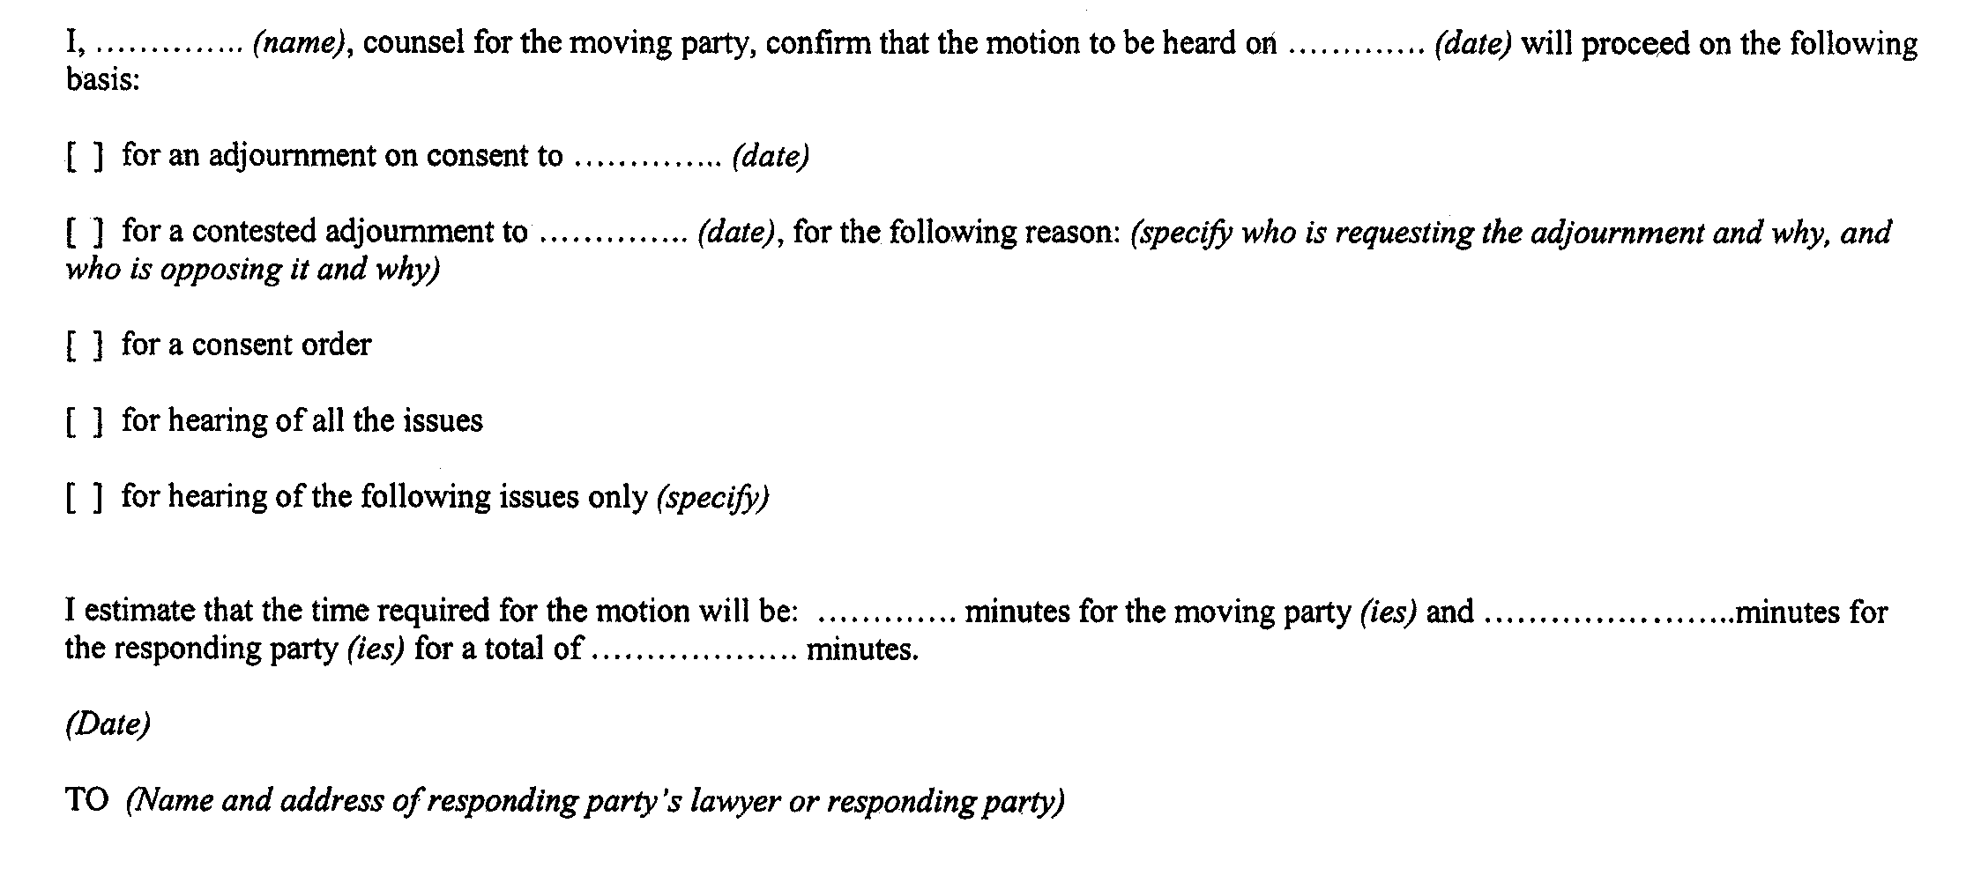
O. Reg. 14/04, s. 42 (7).
Note: On January 1, 2005, the Regulation is amended by adding the following Form:
Form 37C
Courts of Justice Act
refusals and undertakings chart
(General heading)
refusals and undertakings chart
Insert regs\Graphics\Source Law\2004\132\13237Cae.tif
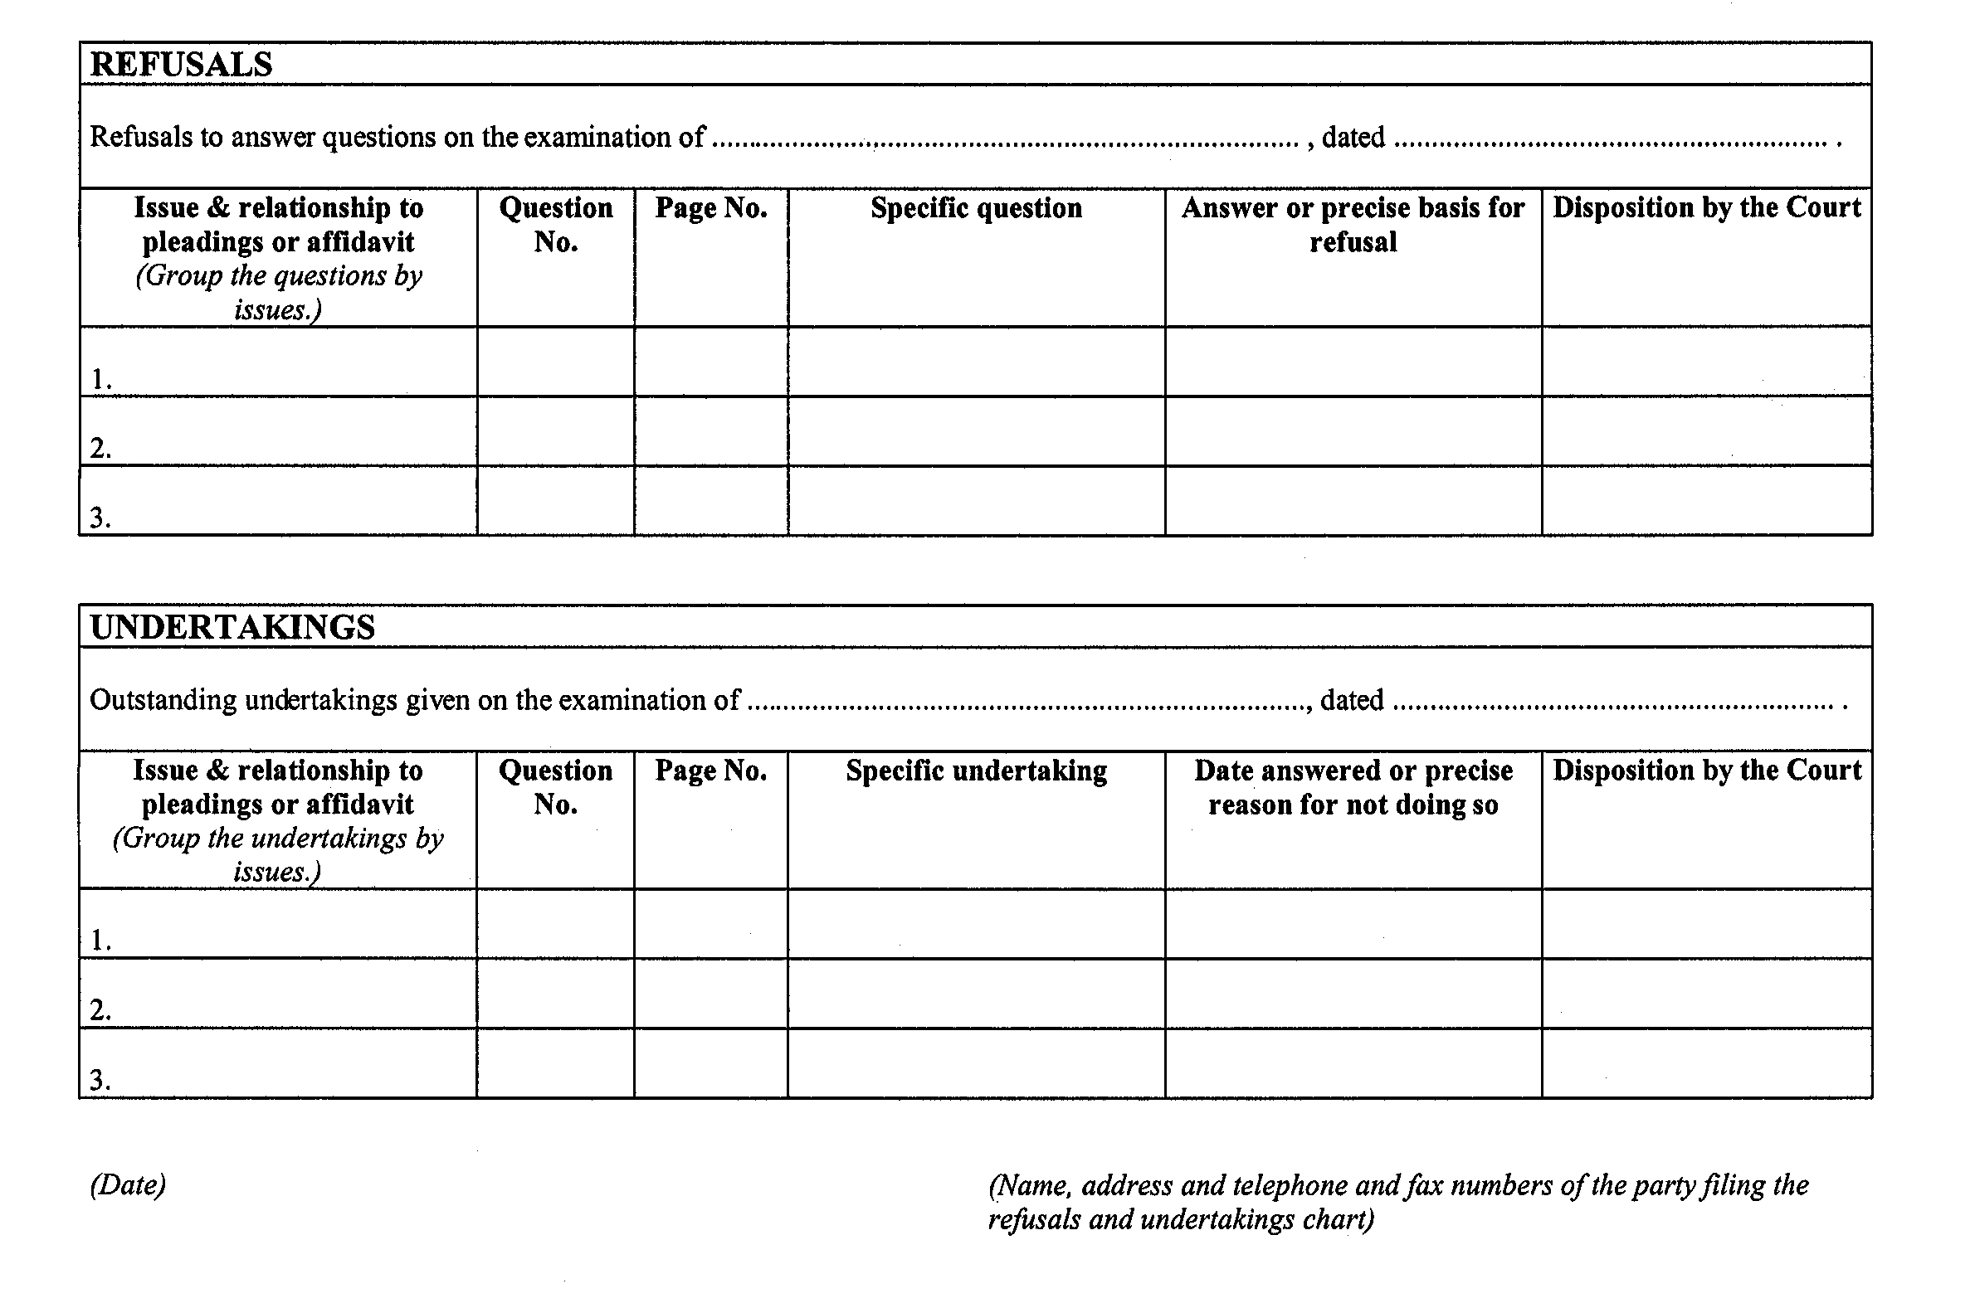
O. Reg. 132/04, s. 22.
See: O. Reg. 132/04, ss. 22, 25 (1).
Form 38A
Courts of Justice Act
notice of appearance
(General heading)
notice of appearance
The respondent intends to respond to this application.
(Date) | (Name, address and telephone number of respondent’s solicitor or respondent)
TO (Name and address of applicant’s solicitor or applicant)
R.R.O. 1990, Reg. 194, Form 38A.
Form 38B
Courts of Justice Act
Confirmation of Application
(General heading)
CONFIRMATION OF APPLICATION
Insert regs\Graphics\Source Law\2004\14\14038Bae.tif
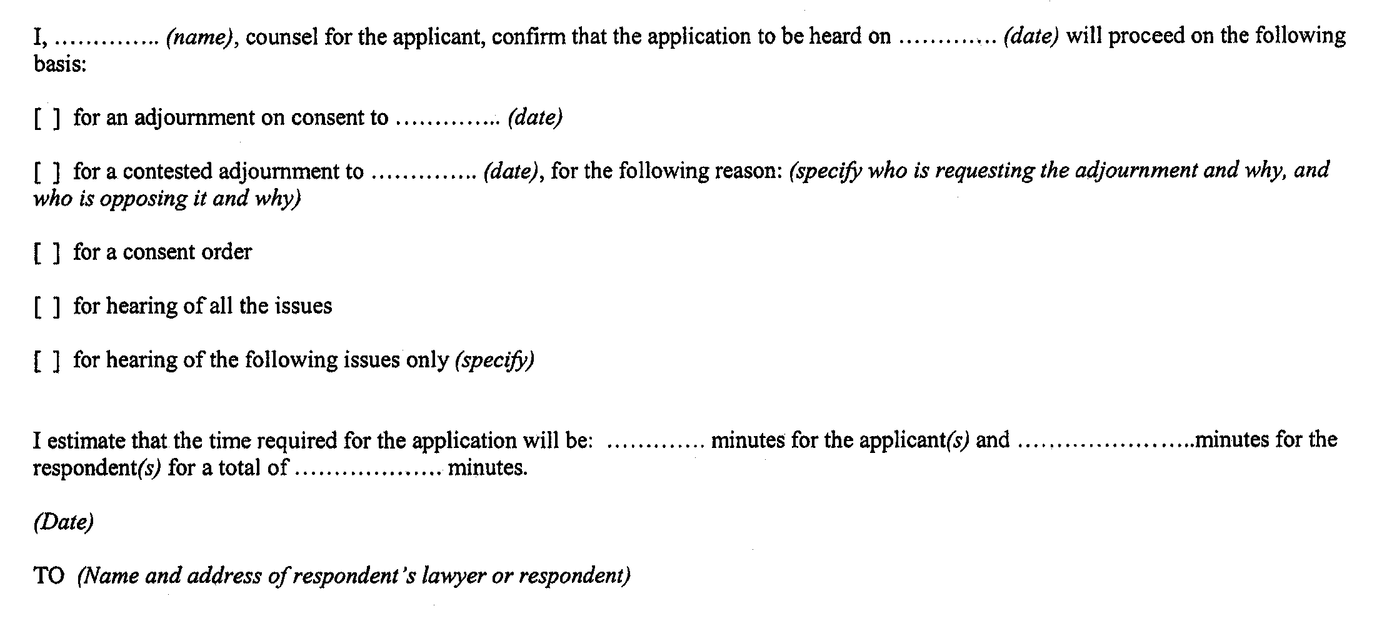
O. Reg. 14/04, s. 42 (7).
Form 42A
Courts of Justice Act
certificate of pending litigation
(General heading)
(Court seal)
certificate of pending litigation
I CERTIFY that in this proceeding an interest in the following land is in question:
(Set out a description of the land sufficient for registration. Where the land is registered under the Land Titles Act, include the parcel number. Attach a schedule if necessary.)
This certificate is issued under an order of the court made on (date).
Date | Issued by  Local registrar  Address of  court office

R.R.O. 1990, Reg. 194, Form 42A.
Form 43A
Courts of Justice Act
interpleader order — general
(Court file no.)
(Court)
(Name of judge or officer) (Day and date order made)
(Court seal) (Title of Proceeding)
interpleader ordeR
(Where an interpleader application results in a judgment, amend the form accordingly.)
(Recitals in accordance with Form 59A or 59B)
Payment of money into court
1. THIS COURT ORDERS that the (identify party) pay into court the sum of $ , less costs fixed at $ , to await the outcome of a proceeding in this court between (identify parties) (or to await the outcome of this proceeding).
2. THIS COURT DECLARES that on compliance with paragraph 1 of this order, the liability of (identify party) in respect of the above sum is extinguished.
3. THIS COURT ORDERS (include any other order made by the court under rule 43.04).
Sale of property and payment of proceeds into court
1. THIS COURT ORDERS that (identify property) be sold by (method of sale) and that the proceeds, less expenses of sale and the costs of (identify party) fixed at $ , be paid into court to await the outcome of a proceeding in this court between (identify parties) (or to await the outcome of this proceeding).
2. THIS COURT DECLARES that on compliance with paragraph 1 of this order, the liability of (identify party) in respect of the above sum is extinguished.
3. THIS COURT ORDERS (include any other order made by the court under rule 43.04).
Deposit of property with an officer of the court
1. THIS COURT ORDERS that (identify property) be deposited with the Sheriff of the (county or district) (or as may be) to await the outcome of a proceeding in this court between (identify parties) (or to await the outcome of this proceeding).
2. THIS COURT DECLARES that on compliance with paragraph 1 of this order, the liability of (identify party) in respect of the above property is extinguished.
3. THIS COURT ORDERS (include any other order made by the court under rule 43.04).
Trial of an issue
(This paragraph will normally form part of an order for payment into court or deposit of property with an officer of the court.)
4. THIS COURT ORDERS that there be a trial of the issue of (give particulars of issue to be tried), in which (identify party) shall be plaintiff and (identify party) shall be defendant.
5. THIS COURT ORDERS (include any directions given by the court respecting pleadings, discovery and other matters).
(Signature of judge, officer or local registrar)
R.R.O. 1990, Reg. 194, Form 43A.
Form 43B
Courts of Justice Act
interpleader order — motion by sheriff
(Court file no.)
(Court)
(Name of judge or officer) (Day and date order made)
(Court seal) (Title of Proceeding)
interpleader order
(Where an interpleader application results in a judgment, amend the form accordingly.)
(Recitals in accordance with Form 59A or 59B)
1. THIS COURT ORDERS that the sheriff sell (identify property) by (method of sale) and that the proceeds, less expenses of sale and the sheriff’s fees, be paid into court (or that the sheriff hold (identify property)) to await the outcome of a proceeding in this court between (identify parties).
2. THIS COURT DECLARES that on compliance with paragraph 1 of this order, the liability of the Sheriff of the (county or district) in respect of the above property is extinguished.
3. THIS COURT ORDERS (include any other order made by the court under rule 43.04 or 43.05).
(Signature of judge, officer or local registrar)
R.R.O. 1990, Reg. 194, Form 43B.
Form 44A
Courts of Justice Act
bond — interim recovery of personal property
(General heading)
bond
WE, (identify party) and (name of surety), jointly and severally bind ourselves and our successors to the Sheriff of the (county or district) in the sum of $ if (identify party) fails to return (identify property) to (identify opposite party) without delay when ordered to do so, and to pay any damages and costs that (identify opposite party) has sustained by reason of the interim order for recovery of possession of the property.
Date
Witness | (seal)Signature of party
Witness | (seal)Signature of surety

R.R.O. 1990, Reg. 194, Form 44A.
Form 47A
Courts of Justice Act
jury notice
(General heading)
jury notice
THE (identify party) REQUIRES that this action be tried (or that the issues of fact or that the damages in this action be assessed) by a jury.
(Date) | (Name, address and telephone number of solicitor or party delivering notice)

TO (Name and address of solicitor or party receiving notice)
R.R.O. 1990, Reg. 194, Form 47A.
Form 48A Revoked: O. Reg. 396/91, s. 14.
Form 48B Revoked: O. Reg. 396/91, s. 14.
Form 48C
Courts of Justice Act
status notice
(General heading)
status notice
TO THE PARTIES AND THEIR SOLICITORS
MORE THAN TWO YEARS HAVE PASSED since a statement of defence in this action was filed. According to the records in the court office, this action has not been placed on the trial list or terminated.
THIS ACTION WILL BE DISMISSED FOR DELAY unless within ninety days after the service of this notice: (a) it is set down for trial; (b) it is terminated; or (c) a judge presiding at a status hearing orders otherwise.
A party may request the registrar to arrange a status hearing.
IF A STATUS HEARING is held, the plaintiff must show cause why the action should not be dismissed for delay, and the presiding judge may set time periods for the completion of the remaining steps necessary to have the action placed on a trial list and may order that it be placed on a trial list within a specified time, or may adjourn the status hearing to a specified date, or may dismiss the action for delay.
Date | Signed by
 | Local registrar
Address of
court office

TO (Names and addresses of all solicitors and parties acting in person)
O. Reg. 396/91, s. 15.
Form 48D
Courts of Justice Act
order dismissing action for delay
(General heading)
order dismissing action
The plaintiff has not (give particulars of plaintiff’s default under rule 48.14) and has not cured the default.
IT IS ORDERED that this action be dismissed for delay, with costs.
Date | Signed by
 | Local registrar
 | (Address of court office)

NOTE: An order under rule 48.14 dismissing an action may be set aside under rule 37.14.
O. Reg. 770/92, s. 18.
Form 49A
Courts of Justice Act
offer to settle
(General heading)
offer to settle
The (identify party) offers to settle this proceeding (or the following claims in this proceeding) on the following terms: (Set out terms in consecutively numbered paragraphs.)
(Date) | (Name, address and telephone number of solicitor or party making offer)

TO (Name and address of solicitor or party to whom offer is made)
R.R.O. 1990, Reg. 194, Form 49A.
Form 49B
Courts of Justice Act
notice of withdrawal of offer
(General heading)
notice of withdrawal of offer
The (identify party) withdraws the offer to settle dated (date).
(Date) | (Name, address and telephone number of solicitor or party giving notice)

TO (Name and address of solicitor or party to whom notice is given)
R.R.O. 1990, Reg. 194, Form 49B.
Form 49C
Courts of Justice Act
acceptance of offer
(General heading)
acceptance of offer
The (identify party) accepts your offer to settle dated (date).
(Date) | (Name, address and telephone number of solicitor or party accepting offer)

TO (Name and address of solicitor or party whose offer is accepted)
R.R.O. 1990, Reg. 194, Form 49C.
Form 49D
Courts of Justice Act
offer to contribute
(General heading)
offer to contribute
The defendant (name of defendant making offer) offers to contribute to a settlement of the plaintiff’s claim on the following terms: (Set out terms in consecutively numbered paragraphs.)
(Date) | (Name, address and telephone number of solicitor or defendant making offer)

TO (Name and address of solicitor or defendant to whom offer is made)
R.R.O. 1990, Reg. 194, Form 49D.
Form 51A
Courts of Justice Act
request to admit
(General heading)
request to admit
YOU ARE REQUESTED TO ADMIT, for the purposes of this proceeding only, the truth of the following facts: (Set out facts in consecutively numbered paragraphs.)
YOU ARE REQUESTED TO ADMIT, for the purposes of this proceeding only, the authenticity (see rule 51.01 of the Rules of Civil Procedure) of the following documents: (Number each document and give particulars sufficient to identify each. Specify whether the document is an original or a copy and, where the document is a copy of a letter, telegram or telecommunication, state the nature of the document.)
Attached to this request is a copy of each of the documents referred to above. (Where it is not practicable to attach a copy or where the party already has a copy, state which documents are not attached and give the reason for not attaching them.)
YOU MUST RESPOND TO THIS REQUEST by serving a response to request to admit in Form 51B prescribed by the Rules of Civil Procedure WITHIN TWENTY DAYS after this request is served on you. If you fail to do so, you will be deemed to admit, for the purposes of this proceeding only, the truth of the facts and the authenticity of the documents set out above.
(Date) | (Name, address and telephone number of solicitor or party serving request)

TO (Name and address of solicitor or party on whom request is served)
R.R.O. 1990, Reg. 194, Form 51A.
Form 51B
Courts of Justice Act
response to request to admit
(General heading)
response to request to admit
In response to your request to admit dated (date), the (identify party responding to the request):
1. Admits the truth of facts numbers
2. Admits the authenticity of documents numbers
3. Denies the truth of facts numbers
4. Denies the authenticity of documents numbers
5. Refuses to admit the truth of facts numbers for the following reasons: (Set out reason for refusing to admit each fact.)
6. Refuses to admit the authenticity of documents numbers for the following reasons: (Set out reason for refusing to admit each document.)
(Date) | (Name, address and telephone number of solicitor or party serving response)

TO (Name and address of solicitor or party on whom response is served)
R.R.O. 1990, Reg. 194, Form 51B.
Form 53A
Courts of Justice Act
summons to witness (at hearing)
(General heading)
(Court seal)
summons to witness
TO (Name and address of witness)
YOU ARE REQUIRED TO ATTEND TO GIVE EVIDENCE IN COURT at the hearing of this proceeding on (day) , (date), at (time), at (address of court house), and to remain until your attendance is no longer required.
YOU ARE REQUIRED TO BRING WITH YOU and produce at the hearing the following documents and things: (Set out the nature and date of each document and give particulars sufficient to identify each document and thing.)
ATTENDANCE MONEY for day(s) of attendance is served with this summons, calculated in accordance with Tariff A of the Rules of Civil Procedure, as follows:

Attendance allowance of $ daily | $
Travel allowance | $
Overnight accommodation and meal allowance | $
TOTAL | $

If further attendance is required, you will be entitled to additional attendance money.
IF YOU FAIL TO ATTEND OR TO REMAIN IN ATTENDANCE AS REQUIRED BY THIS SUMMONS, A WARRANT MAY BE ISSUED FOR YOUR ARREST.
Date | Issued by
Date | Local registrar
Date | Address of  court office

This summons was issued at the request of, and inquiries may be directed to:
(Name, address and telephone number of solicitor or party serving summons)
R.R.O. 1990, Reg. 194, Form 53A.
Form 53B
Courts of Justice Act
warrant for arrest (defaulting witness)
(Court file no.)
(Court)
(Name of judge) (Day and date)
(Court seal) (Title of Proceeding)
warrant for arrest
TO ALL POLICE OFFICERS in Ontario
AND TO the officers of all correctional institutions in Ontario
WHEREAS the witness (name), of (address), was served with a summons to witness to give evidence at the hearing of this proceeding, and the proper attendance money was paid or tendered,
AND WHEREAS the witness failed to obey the summons, and I am satisfied that the evidence of the witness is material to this proceeding,
YOU ARE ORDERED TO ARREST and bring the witness (name of witness) before the court to give evidence in this proceeding, and if the court is not then sitting or if the witness cannot be brought forthwith before the court, to deliver the witness to a provincial correctional institution or other secure facility, to be admitted and detained there until the witness can be brought before the court.
(Signature of judge)
R.R.O. 1990, Reg. 194, Form 53B; O. Reg. 351/94, s. 12.
Form 53C
Courts of Justice Act
summons to A witness outside ontario
(General heading)
(Court seal)
summons to A witness outside ontario
TO (Name and address of witness)
YOU ARE REQUIRED TO ATTEND TO GIVE EVIDENCE (in court at the hearing of this proceeding, on an examination for discovery, on a cross-examination on your affidavit dated (date), etc.) on (day), (date), at (address of court house), and to remain until your attendance is no longer required.
YOU ARE REQUIRED TO BRING WITH YOU and produce at the hearing the following documents and things: (Set out the nature and date of each document and give particulars sufficient to identify each document and thing.)
ATTENDANCE MONEY for day(s) of attendance is served with this summons, calculated in accordance with the Interprovincial Summonses Act (Ontario), as follows:

Attendance allowance of $20 daily for each day of absence from your ordinary residence (not less than $60) | $
Travel allowance | $
Hotel accommodation allowance for not less than three days (not less than $60) | $
Meal allowance for not less than three days (not less than $48) | $
TOTAL | $

If further attendance is required, you will be entitled to additional attendance money.
OBEDIENCE TO THIS SUMMONS may be compelled by the courts of your province under the Interprovincial Summonses Act.
Date | Issued by
Date | Local registrar
Date | Address of  court office

This summons was issued at the request of, and inquiries may be directed to:
(Name, address and telephone number of solicitor or party serving summons)
Attach or endorse the judge’s certificate under section 5 of the Interprovincial Summonses Act.
R.R.O. 1990, Reg. 194, Form 53C.
Form 53D
Courts of Justice Act
order for attendance of witness in custody
(Court file no.)
(Court)
(Name of judge or master) (Day and date order made)
(Court seal) (Title of Proceeding)
order for attendance of witness in custody
TO THE OFFICERS OF (name of correctional institution)
AND TO ALL POLICE OFFICERS in Ontario
WHEREAS it appears that the evidence of the witness (name), who is detained in custody, is material to this proceeding,
1. THIS COURT ORDERS that the witness (name) be brought before this court (or as may be) on (day), (date), at (time), at (address), to give evidence on behalf of the (identify party), and that the witness be returned and readmitted immediately thereafter to the correctional institution or other facility from which the witness was brought.
(Signature of judge, officer or registrar)
R.R.O. 1990, Reg. 194, Form 53D; O. Reg. 351/94, s. 13.
Form 55A
Courts of Justice Act
notice of hearing for directions
(General heading)
notice of hearing for directions
By order of the court, a copy of which is served with this notice, a reference was directed to (person conducting reference) for the purpose of (set out purpose of reference).
The (identify party) has obtained an appointment with (name of person conducting reference) on (day), (date), at (time), at (address) for a hearing to consider directions for the conduct of the reference in this proceeding.
IF YOU FAIL TO ATTEND, in person or by an Ontario lawyer acting for you, directions may be given and the reference may proceed in your absence and without further notice to you, and you will be bound by any order made in the proceeding.
(Date) | (Name, address and telephone number of solicitor or party serving notice)

TO (Name and address of solicitor or party receiving notice)
R.R.O. 1990, Reg. 194, Form 55A..
Form 55B
Courts of Justice Act
notice to party added on reference
(General heading)
notice to party added on reference
TO (Name of party added on reference)
By order of the court, a copy of which is served with this notice, a reference was directed to (person conducting reference) for the purpose of (set out purpose of reference).
YOU HAVE BEEN MADE A PARTY TO THIS PROCEEDING by order of (name of person conducting reference), a copy of which is also served with this notice.
THE REFERENCE WILL PROCEED on (day), (date), at (time), at (address).
YOU MAKE A MOTION to a judge of this court WITHIN TEN DAYS (or where the person is to be served outside Ontario, such further time as the referee directs) after this notice is served on you to set aside or vary the order directing the reference or the order adding you as a party.
IF YOU FAIL TO DO SO OR IF YOU FAIL TO ATTEND ON THE REFERENCE, in person or by an Ontario lawyer acting for you, the reference may proceed in your absence and without further notice to you, and you will be bound by any order made in this proceeding.
(Date) | (Name, address and telephone number of solicitor or party serving notice)

TO (Name and address of party added on reference)
R.R.O. 1990, Reg. 194, Form 55B.
Form 55C
Courts of Justice Act
REPORT on reference (administration of estate)
(General heading)
report on reference
In accordance with the order directing a reference dated (date), I have disposed of the matters referred to me, and I report as follows:
1. The following parties were served with the order directing a reference and a notice of hearing for directions: (Set out names). (Where applicable, add: Service on the following parties was dispensed with: (Set out names and the reason for dispensing with service).) The following parties were added on the reference and were served with a notice to party added on reference: (Set out names).
2. The following parties did not attend on the reference: (Set out names).
3. The personal estate not specifically bequeathed by the testator received by the executors and for which they are chargeable amounts to $....., and they have paid or are entitled to be allowed the sum of $ , leaving a balance due from (or to) them of $ (or, where applicable: No personal estate has been received by the executors, nor are they chargeable with any.)
4. The creditors’ claims received in response to the advertisement for creditors and which I have allowed are set out in Schedule A and amount altogether to $ (or, where applicable: No creditor has sent in a claim in response to the advertisement for creditors, nor has any such claim been proved before me.)
5. The funeral expenses of the testator amounting to $ have been paid by the executors and are allowed to them in the account of personal estate.
6. The legacies given by the testator are set out in Schedule B, and with the interest therein mentioned, remain due to the persons named (or as the case may be).
7. The personal estate of the testator outstanding or undisposed of is set out in Schedule C.
8. The real estate owned by the testator and the encumbrances affecting it are set out in Schedule D.
9. The rents and profits of the testator’s real estate received by the executors and for which they are chargeable amount to $
and they have paid or are entitled to be allowed the sum of $ , leaving a balance due from (or to) them of $
(or, where applicable: No rents and profits have been received by the executors, nor are they chargeable with any).
10. I have allowed the executors the sum of $ as compensation for their services in the management of the estate.
11. I have caused the real estate, other than (identify property), which has specifically devised, to be sold and the purchasers have paid their purchase money into court.
12. In Schedule E, I have shown how the money in court is to be dealt with.
(Date) | (Signature of referee)

(All schedules should be as brief as possible. Only the general character of the things described should be shown. Land should be described without setting out a full legal description.)
(In Schedule C, the personal estate not specifically bequeathed should be set out separately from the other personal property outstanding or undisposed of. Where there is no specific bequest, the report should state that fact.)
R.R.O. 1990, Reg. 194, Form 55C.
Form 55D
Courts of Justice Act
notice of contested claim
(General heading)
notice of contested claim
YOUR CLAIM IN THIS PROCEEDING IS BEING CONTESTED. You are required to prove your claim before the referee on (day), (date), (time), at (address).
IF YOU FAIL TO ATTEND AND PROVE YOUR CLAIM, YOUR CLAIM MAY BE DISALLOWED.
(Date) | (Name, address and telephone number of party or solicitor serving notice)
TO (Name and address of creditor)
R.R.O. 1990, Reg. 194, Form 55D.
Form 55E
Courts of Justice Act
notice TO CREDITOR
(General heading)
notice To cREDITOR
YOU MAY OBTAIN PAYMENT of the amount allowed by the court in respect of your claim in this proceeding from the office of the Accountant of the Superior Court of Justice, 2nd floor, 123 Edward Street, Toronto, Ontario M5G 1E2 (or the local registrar of this court at (address)).
(Date) | (Name, address and telephone number of solicitor or party serving notice)

TO (Name and address of creditor)
R.R.O. 1990, Reg. 194, Form 55E; O. Reg. 292/99, s. 5.
Form 55F
Courts of Justice Act
Conditions of sale

1. No person shall advance the bidding in an amount less than $10 at any bidding under $500 nor in an amount less than $20 at any bidding over $500. No person shall be allowed to retract a bid.
2. The property shall be sold to the highest bidder. Where any dispute arises as to who is the last or highest bidder, the property shall be put up again.
3. All parties to the proceeding may bid, except the party having carriage of the sale and any trustee or agent for the party or other person in a fiduciary relationship to the party.
4. The purchaser shall, at the time of sale, pay to the party having carriage of the sale or to the party’s solicitor a deposit of ten per cent of the purchase price and shall pay the balance of the purchase price on completion of the sale. On payment of the balance, the purchaser shall be entitled to receive a transfer and to take possession. The purchaser shall, at the time of sale, sign an agreement for the completion of the sale.
5. The purchaser shall have the transfer prepared at the purchaser’s own expense and tender it to the party having carriage of the sale for execution.
6. Where the purchaser fails to comply with any of these conditions, the deposit and all other payments made shall be forfeited and the property may be resold. Any deficiency on the resale, together with all expenses incurred on the resale or caused by the default, shall be paid by the defaulting purchaser.
R.R.O. 1990, Reg. 194, Form 55F.
Form 55G
Courts of Justice Act
interim report on sale
(General heading)
interim report on sale
1. In accordance with the order in this proceeding dated (date), in the presence of (or after notice to) all parties concerned, I settled the form of an advertisement and the conditions of sale for the sale of the property referred to in the judgment.
2. The advertisement was published as directed, and the property was offered for sale by public auction by me (or by (name), an auctioneer appointed by me for that purpose) on (date).
3. The sale was conducted in a fair, open and proper manner and (name) was declared the highest bidder for and became the purchaser of the property at the price of $ , payable as follows: (Set out briefly the conditions of sale for payment of the purchase money.)
(Date) | (Signature of referee)

R.R.O. 1990, Reg. 194, Form 55G.
Form 56A
Courts of Justice Act
order for security for costs
(Court file no.)
(Court)
(Name of judge or master) (Day and date order made)
(Court seal) (Title of Proceeding)
order for security for costs
(Recitals in accordance with Form 59A)
1. THIS COURT ORDERS that within days after this order is served on the plaintiff, (or applicant), the plaintiff (or applicant) shall pay into court (or to (name)) the sum of $ as security for the costs of this proceeding.
(Where a plaintiff or applicant is ordered to give security for costs in some other form, give a description of the security required and vary the form of the order accordingly.)
2. THIS COURT ORDERS that until the security required by this order has been given, the plaintiff (or applicant) may not take any step in this proceeding, except an appeal from this order (or as otherwise ordered).
(Signature of judge, master or registrar)
R.R.O. 1990, Reg. 194, Form 56A.
Form 57A
Courts of Justice Act
Insert regs\Graphics\Source Law\2001\284\284057Aae.tif
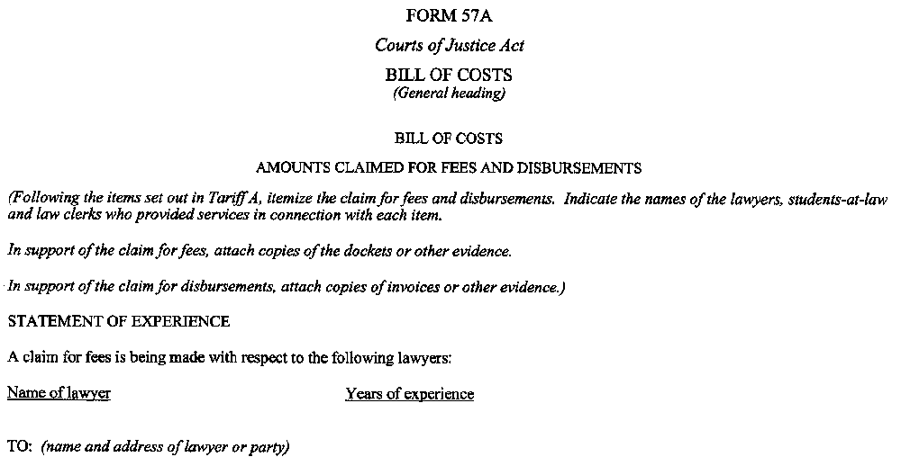
O. Reg. 284/01, s. 32.
Form 58A
Courts of Justice Act
notice of appointment for assessment of costs
(General heading)
notice of appointment for assessment of costs
TO THE PARTIES
I HAVE MADE AN APPOINTMENT to assess the costs of (identify party), a copy of whose bill of costs is attached to this notice, on (day), (date), at (time), at (address).
Date
Date | Assessment officer

TO (Name and address of solicitor or party on whom notice is served)
R.R.O. 1990, Reg. 194, Form 58A.
Form 58B
Courts of Justice Act
notice to deliver a bill of costs for assessment
(General heading)
notice to deliver a bill of costs for assessment
TO THE PARTIES
I HAVE MADE AN APPOINTMENT, at the request of (identify party who obtained appointment) to assess the costs of (identify party entitled to costs and what costs are to be assessed) on (day), (date), at (time), at (address).
TO (identify party entitled to costs)
YOU ARE REQUIRED to file your bill of costs with me and serve your bill of costs on every party interested in the assessment at least seven days before the above date.
Date
Date | Assessment officer

TO (Name and address of solicitor or party on whom notice is served)
R.R.O. 1990, Reg. 194, Form 58B.
Form 58C
Courts of Justice Act
certificate of assessment of costs
(General heading)
certificate of assessment of costs

I CERTIFY that I have assessed the costs of (identify party) in this proceeding (or as may be) under the authority of (give particulars of order or specify rule or statutory provision), and I ALLOW THE SUM OF $
(Where postjudgment interest is payable, add:)
THE COSTS ALLOWED IN THIS ASSESSMENT BEAR INTEREST at the rate of per cent per year commencing on (date).
Date
Date | Assessment officer

R.R.O. 1990, Reg. 194, Form 58C; O. Reg. 377/95, s. 7; O. Reg. 284/01, s. 33.
Form 59A
Courts of Justice Act
order
(Court file no.)
(Court)
(Name of judge or officer) | (Day and date order made)
(Court seal) | (Title of proceeding)

order
THIS MOTION, made by (identify moving party) for (state the relief sought in the notice of motion, except to the extent that it appears in the operative part of the order), (where applicable, add made without notice,) was heard this day (or heard on (date)), at (place), (recite any particulars necessary to understand the order).
ON READING the (give particulars of the material filed on the motion) and on hearing the submissions of counsel for (identify parties), (where applicable, add (identify party) appearing in person or no one appearing for (identify party), although properly served as appears from (indicate proof of service)),
1. THIS COURT ORDERS that
2. THIS COURT ORDERS that
(In an order for the payment of money on which postjudgment interest is payable, add:)
THIS ORDER BEARS INTEREST at the rate of per cent per year commencing on (date).
(Signature of judge, officer or registrar)
R.R.O. 1990, Reg. 194, Form 59A; O. Reg. 131/04, s. 20.
Form 59B
Courts of Justice Act
judgment
(Court file no.)
(Court)
(Name of judge or officer) | (Day and date judgment given)

(Court seal) | (Title of proceeding)

judgment
(Judgment after trial or hearing of application)
THIS ACTION (or APPLICATION) was heard this day (or heard on (date)) without (or with) a jury at (place) in the presence of counsel for all parties (where applicable, add (identify party) appearing in person, or no one appearing for (identify party) although properly served as appears from (indicate proof of service)),
(Action) ON READING THE PLEADINGS AND HEARING THE EVIDENCE and the submissions of counsel for the parties,
(Application) ON READING THE NOTICE OF APPLICATION AND THE EVIDENCE FILED BY THE PARTIES, (where applicable, add on hearing the oral evidence presented by the parties,) and on hearing the submissions of counsel for the parties.
(Judgment on motion)
THIS MOTION, made by (identify moving party), for (state the relief sought in the notice of motion, except to the extent that it appears in the operative part of the judgment), (where applicable, add made without notice,) was heard this day (or heard on (date)), at (place), (recite any particulars necessary to understand the judgment).
ON READING THE (give particulars of the material filed on the motion) and on hearing the submissions of counsel for (identify parties), (where applicable, add (identify party) appearing in person or no one appearing for (identify party), although properly served as appears from (indicate proof of service)),
1. THIS COURT ORDERS (or DECLARES, if applicable) (where applicable, add: AND ADJUDGES) that
2. THIS COURT ORDERS (or as may be) that
(In a judgment for the payment of money on which postjudgment interest is payable add:)
THIS JUDGMENT BEARS INTEREST at the rate of per cent per year commencing on (date).
(Signature of judge, officer or registrar)
R.R.O. 1990, Reg. 194, Form 59B; O. Reg. 131/04, s. 21.
Form 59C
Courts of Justice Act
order on appeal
(Court file no.)
(Court)
(Name(s) of judge(s)) | (Day and date order made)

(Court seal)
(Title of proceeding)
order
THIS APPEAL by (identify appellant) for (state the relief sought in the notice of appeal, except to the extent that it is stated in the operative part of the order) was heard this day (or heard on (date)), at (place), (recite any particulars necessary to understand the order).
ON READING the (give particulars of the material filed on the appeal), and on hearing the submissions of counsel for (identify parties), (where applicable, add (identify party) appearing in person or no one appearing for (identify party) although properly served as appears from (indicate proof of service)),
THIS COURT ORDERS (or CERTIFIES, if applicable) that
THIS ORDER BEARS INTEREST at the rate of per cent per year commencing on
(date)

(Signature of judge or registrar)
R.R.O. 1990, Reg. 194, Form 59C; O. Reg. 504/00, s. 5.
Form 60A
Courts of Justice Act
writ of seizure and sale
Writ of Seizure and Sale
Rules of Civil Procedure, Courts of Justice Act,
Form 60A

Court File No

ONTARIO
SUPERIOR COURT OF JUSTICE
BETWEEN
AND
WRIT OF SEIZURE AND SALE
TO the Sheriff of the
Under an order of this court made on ,
in favour of ,
YOU ARE DIRECTED to seize and sell the real and personal property within your county or district of

Surname of individual or name of corporation/firm, etc.

 | First given name (individual only) |  | Second given name (individual only) (if applicable) |  | Third given name (individual only) (if applicable)
and to realize from the seizure and sale the following sums:
(a) $ and interest at per cent per year commencing on
(Where the writ is for two or more periodic or instalment payments, substitute:)
Amount of payment Due Date
(a)
$ and interest at per cent per year on the payments in default commencing on the date of default;
(b) $ for costs together with interest at per cent per year commencing on
; and
(c) your fees and expenses in enforcing this writ.
YOU ARE DIRECTED to pay out the proceeds according to law and to report on the execution of this writ if required by the party or solicitor who filed it.
Dated at Issued by
Registrar
on
Address of court office

Form 60A Writ of Seizure and Sale, backsheet
(Short title of proceeding) |  |  |  |  |  |  | (Court file no.)
FEES |  |  |  |  |  |  |  | (Name of court)  Proceeding commenced at
Fee | Item | Officer
 | Paid for this writ
 | Solicitor’s fee  for issuing writ |  |  |  |  |  |  | WRIT OF SEIZURE AND SALE  Creditor’s name  Creditor’s Address  Solicitor’s name  Solicitor’s address and telephone no.
 | First renewal
 | Second renewal
 | Third renewal
RENEWAL
Date | Officer

R.R.O. 1990, Reg. 194, Form 60A; O. Reg. 377/95, s. 8; O. Reg. 292/99, s. 1 (3, 4); O. Reg. 131/04, s. 22.
Form 60B
Courts of Justice Act
writ of sequestration
(General heading)
(Court seal)
writ of sequestration
TO the Sheriff of the (name of county or district)
Under an order of this court made on (date) on motion of (name of moving party), YOU ARE DIRECTED to take possession of and hold the following property within your county or district of (name of person against whom order was made): (Set out a description of the property to be taken and held.)
AND YOU ARE DIRECTED to collect and hold any income from the property until further order of this court.

Date | Issued by
Date | Local registrar
Date | Address of  court office

R.R.O. 1990, Reg. 194, Form 60B; O. Reg. 131/04, s. 23.
Form 60C
Courts of Justice Act
writ of possession
(General heading)
(Court seal)
writ of possession
TO the Sheriff of the (name of county or district)
Under an order of this court made on (date) in favour of (name of party who obtained order), YOU ARE DIRECTED to enter and take possession of the following land and premises in your county or district: (Set out a description of the land and premises.)
AND YOU ARE DIRECTED to give possession of the above land and premises without delay to (name of party who obtained order).
Date | Issued by
Date | Local registrar
Date | Address of  court office

Renewed by order made on (date).
Local registrar

R.R.O. 1990, Reg. 194, Form 60C.
Form 60D
Courts of Justice Act
writ of delivery
(General heading)
(Court seal)
writ of delivery
TO the Sheriff of the (name of county or district)
Under an order of this court made on (date), YOU ARE DIRECTED to seize from (name of party) and to deliver without delay to (name of party who obtained order) possession of the following personal property: (Set out a description of the property to be delivered.)
Date | Issued by
Date | Local registrar
Date | Address of  court office

R.R.O. 1990, Reg. 194, Form 60D.
Form 60E
Courts of Justice Act
request to renew
(General heading)
request to renew
TO the Sheriff of the (name of county or district)
YOU ARE REQUESTED TO RENEW the writ of seizure and sale issued on (date) in this proceeding and filed in your office for a period of six years from the date of renewal.
(Date) | (Signature of party or solicitor)
(Date) | (Name, address and telephone number of party or solicitor)

R.R.O. 1990, Reg. 194, Form 60E.
Form 60F
Courts of Justice Act
direction to enforce writ of seizure and sale
(Sheriff’s file no.)
(Court)
b e t w e e n :
(name)
Creditor(s)
and
(name)
Debtor(s)
direction to enforce writ
TO the Sheriff of the (name of county or district)
Under an order of this court in favour of (name of creditor) made on (date), (name of debtor) was ordered to pay the sum of $
(where applicable, add each month or as may be) with interest at the rate of per cent per year commencing on (date) and costs of $ (as fixed or assessed) with interest at the rate of per cent per year commencing on (date). Since the order was made, the creditor has received the following payments:
Date of payment | Payment

Under rule 60.19 of the Rules of Civil Procedure, the creditor is entitled to costs in the amount of,
(a) $ in accordance with the regulations under the Administration of Justice Act and Tariff A, for issuing, renewing and filing with the sheriff a writ of execution or notice of garnishment;
(b) $ for disbursements paid to a sheriff, registrar, official examiner, court reporter or other public officer and to which the creditor is entitled under subrule 60.19 (1); (Attach copy of all receipts.)
(c) $ for an amount determined in accordance with the costs grid established by Part I of Tariff A for conducting an examination in aid of execution; (Attach affidavit confirming that examination was conducted.)
(d) $ for any other costs to which the creditor is entitled under subrule 60.19 (1). (Attach certificate of assessment.)
YOU ARE DIRECTED to enforce the writ of seizure and sale issued on (date) and filed in your office for a sum sufficient to satisfy the total of the amounts set out above, together with subsequent interest, and your fees and expenses.
(Date) | (Signature of party or solicitor)  (Name, address and telephone number of party or solicitor)

R.R.O. 1990, Reg. 194, Form 60F; O. Reg. 206/02, s. 27 (1).
Form 60G
Courts of Justice Act
requisition for garnishment
(General heading)
requisition for garnishment
TO: the local registrar at (place)
I REQUIRE a notice of garnishment to be issued in this proceeding, in accordance with the attached draft Form 60H. The total amount to be shown in the notice of garnishment is $ , made up as follows:
1. $ for principal owing under the judgment or order, including prejudgment interest.
2. $ for the costs of the action.
3. $ in accordance with the regulations under the Administration of Justice Act and Tariff A, for issuing, renewing and filing with the sheriff a writ of execution or notice of garnishment.
4. $ for disbursements paid to a sheriff, registrar, official examiner, court reporter or other public officer and to which the creditor is entitled under subrule 60.19 (1). (Attach copies of all receipts.)
5. $ for an amount determined in accordance with the costs grid established by Part I of Tariff A for conducting an examination in aid of execution. (Attach affidavit confirming that examination was conducted.)
6. $ for any other costs to which the creditor is entitled under subrule 60.19 (1). (Attach certificate of assessment.)
7. $ for postjudgment interest to today’s date. (Calculate by counting the number of days that the principal sum has been owing, multiplying that number by the annual rate of interest, then multiplying by the principal sum owing and dividing by 365.)
Date | Signature
Date | (Name, address and telephone number of creditor or creditor’s solicitor)

O. Reg. 535/92, s. 15; O. Reg. 206/02, s. 27 (2).
Form 60G.1
Courts of Justice Act
requisition for renewal of garnishment
(General heading)
requisition for renewal of garnishment
Insert regs\graphics\1990\194\19460G1ae.tif
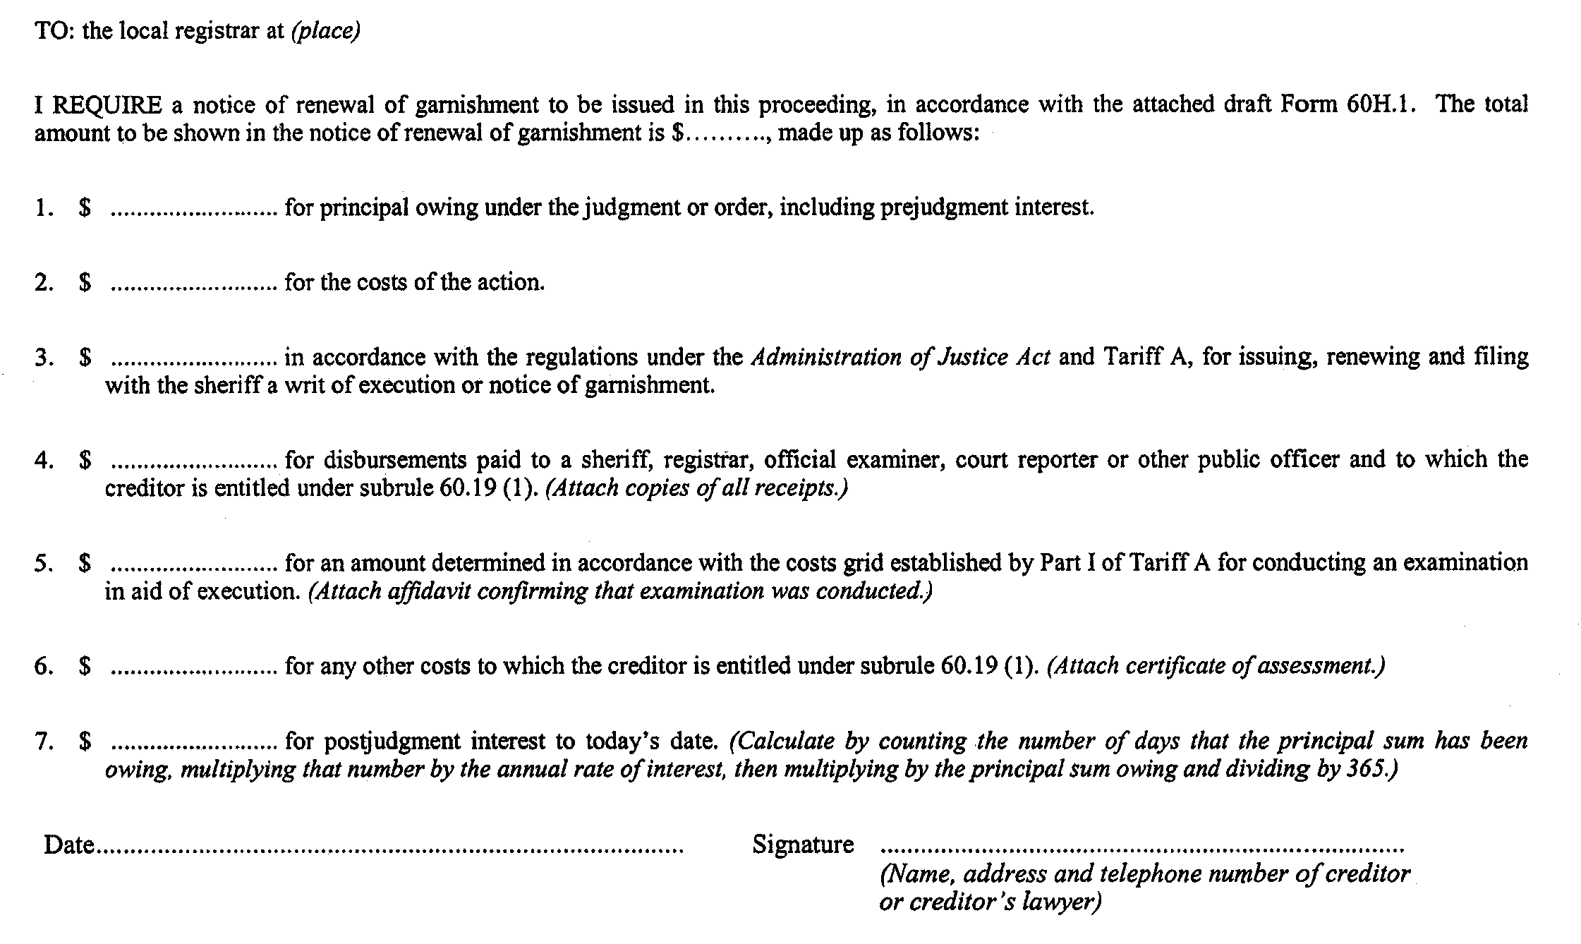
O. Reg. 14/04, s. 42 (8).
Form 60H
Courts of Justice Act
notice of garnishment
(Court file no.)
(Court)
B E T W E E N (name)
Creditor
(Court seal) (and)
(name)
Debtor
(and)
(name)
Garnishee
notice of garnishment
TO (name and address of garnishee)
A LEGAL PROCEEDING in this court between the creditor and the debtor has resulted in an order that the debtor pay a sum of money to the creditor. The creditor claims that you owe a debt to the debtor. A debt to the debtor includes both a debt payable to the debtor and a debt payable to the debtor and one or more co-owners. The creditor has had this notice of garnishment directed to you as garnishee in order to seize any debt that you owe or will owe to the debtor. Where the debt is payable to the debtor and to one or more co-owners, you must pay one-half of the indebtedness or the greater or lesser amount specified in an order made under subrule 60.08 (16).
YOU ARE REQUIRED TO PAY to the Sheriff of the (name of county or district),
(a) within 10 days after this notice is served on you, all debts now payable by you to the debtor; and
(b) within 10 days after they become payable, all debts that become payable by you to the debtor within 6 years after this notice is served on you,
subject to the exemptions provided by section 7 of the Wages Act. The total amount of all your payments to the sheriff is not to exceed $............less $10 for your costs of making each payment.
EACH PAYMENT MUST BE SENT with a copy of the attached garnishee’s payment notice to the sheriff at the address shown below.
IF YOU DO NOT PAY THE TOTAL AMOUNT OF $ LESS $10 FOR YOUR COSTS OF MAKING EACH PAYMENT WITHIN 10 DAYS after this notice is served on you, because the debt is owed to the debtor and to one or more co-owners or for any other reason, you must within that time serve on the creditor and the debtor and file with the court a garnishee’s statement in Form 60I attached to this notice.
IF YOU FAIL TO OBEY THIS NOTICE, THE COURT MAY MAKE AND ENFORCE AN ORDER AGAINST YOU for payment of the amount set out above and the costs of the creditor.
IF YOU MAKE PAYMENT TO ANYONE OTHER THAN THE SHERIFF, YOU MAY BE LIABLE TO PAY AGAIN.
TO THE CREDITOR, THE DEBTOR AND THE GARNISHEE.
Any party may make a motion to the court to determine any matter in relation to this notice of garnishment.
Date | Issued by
Date | Local registrar
Date | Address of  court office

Creditor’s address | Debtor’s address | Sheriff’s address
telephone no. .

(The top portion of the garnishee’s payment notice is to be completed by the creditor before the notice of garnishment is issued. Where it is anticipated that more than one payment will be made by the garnishee, the creditor should provide extra copies of the payment notice.)
garnishee’s payment notice

Make payment by cheque or money order payable to the Sheriff of the (the name of county or district) and send it, along with a copy of this payment notice, to the (address).
Court |  | File no.
Office at
Creditor
Debtor
Garnishee
TO BE COMPLETED BY GARNISHEE FOR EACH PAYMENT
Date of payment
Amount enclosed $
O. Reg. 536/96, s. 12; O. Reg. 171/98, s. 24; O. Reg. 131/04, s. 24.
Form 60H.1
Courts of Justice Act
Notice of Renewal of Garnishment
Insert regs\graphics\1990\194\19460H1ae.tif
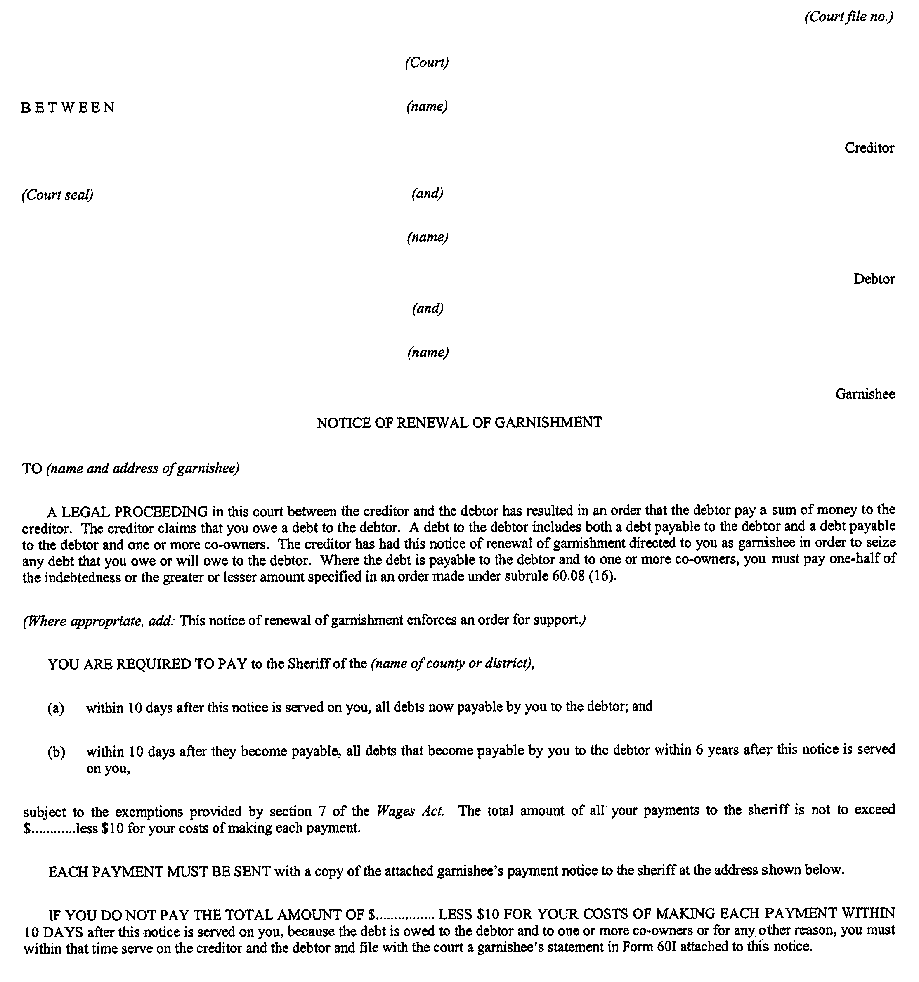
Insert regs\graphics\1990\194\19460H1be.tif
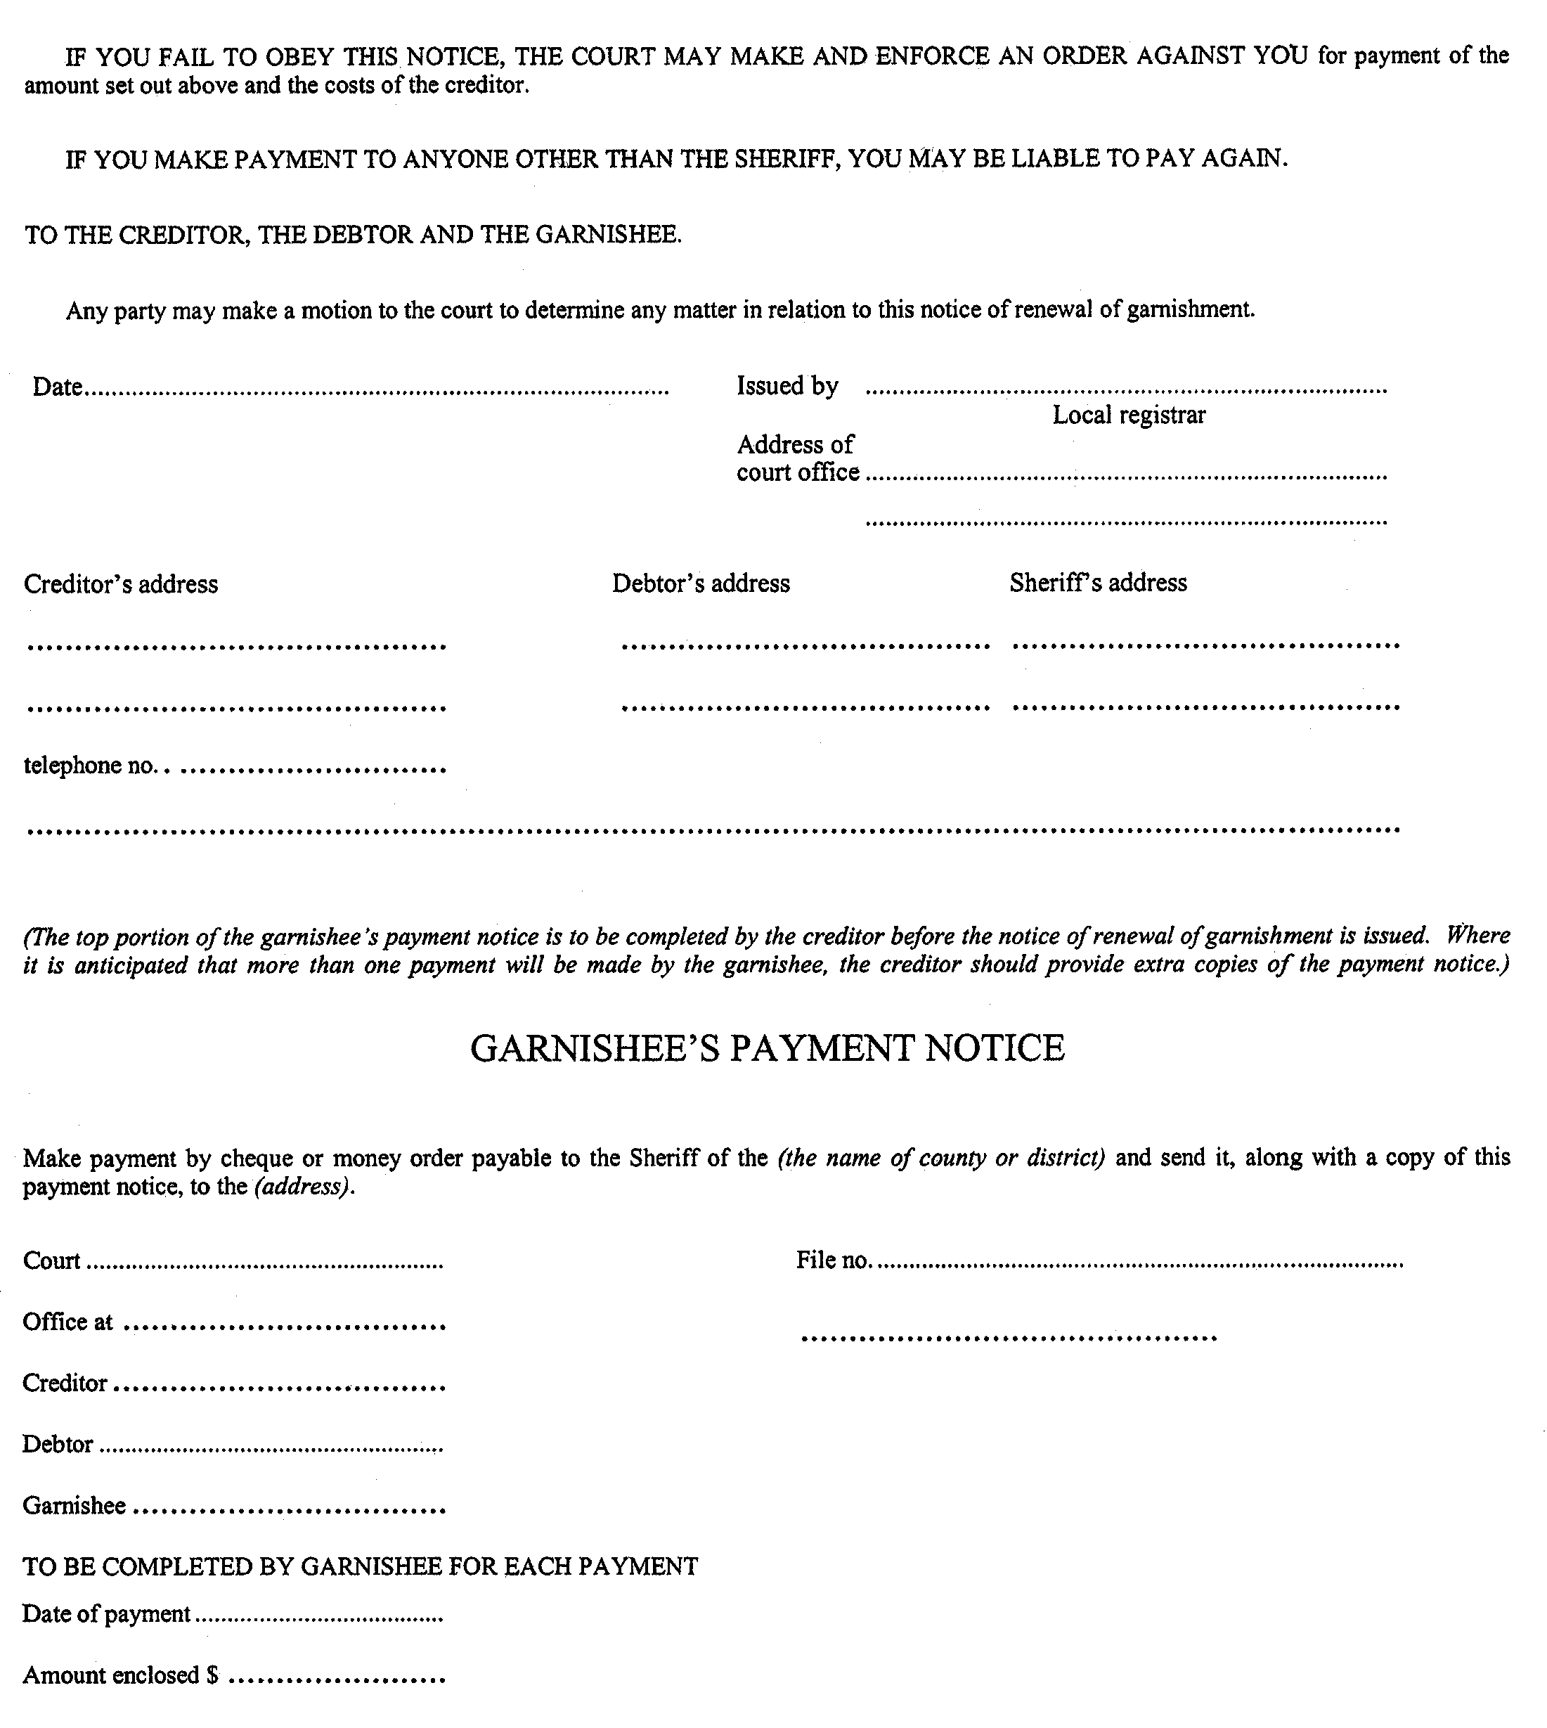
O. Reg. 14/04, s. 42 (8).
Form 60I
Courts of Justice Act
garnishee’s statement
(The general heading on this form is to be completed by the creditor and the form is to be attached to the notice of garnishment to be served on the garnishee before the notice of garnishment is issued.)
(General heading as in Form 60H)
garnishee’s statement
1. I/We acknowledge that I/we owe or will owe the debtor or the debtor and one or more co-owners the sum of $ ,
payable on (date) because (Give reasons why you owe the debtor or the debtor and one or more co-owners money. If you are making payment of less than the amount stated in line 2 of this paragraph because the debt is owed to the debtor and to one or more co-owners or for any other reason, give a full explanation of the reason. If you owe the debtor wages, state how often the debtor is paid. State the gross amount of the debtor’s wages before any deductions and the net amount after all deductions and attach a copy of a pay slip.)
1.1 (If debt owed to debtor and one or more co-owners, check here and complete the following:)
Co-owner(s) of the Debt (name, address)
2. (If you do not owe the debtor money, explain why. Give any other information that will explain your financial relationship with the debtor.)
3. (If you have been served with any other notice of garnishment or a writ of execution against the debtor, give particulars.)
Name of creditor Location of Sheriff Date of notice or writ Date of service on you
4. (If you have been served outside Ontario and you wish to object on the ground that service outside Ontario was improper, give particulars of your objection.)
Date | Signature of or for garnishee
Date | Name of garnishee
Date | Address
Date | Telephone number
O. Reg. 536/96, s. 12.
Form 60I.1
Courts of Justice Act
notice to co-OWNER OF THE DEBT
(General heading as in Form 60H)
TO (name and address of co-owner of the debt)
A LEGAL PROCEEDING in this court between the creditor and the debtor has resulted in an order that the debtor pay a sum of money to the creditor. The creditor has given a notice of garnishment to (name of garnishee) claiming that the garnishee owes a debt to the debtor. A debt to the debtor includes both a debt payable to the debtor and a debt payable to the debtor and one or more other co-owners. The garnishee has indicated in the attached garnishee’s statement that you are a co-owner. Under the notice of garnishment the garnishee has paid the greater of the debtor’s ownership interest, as known to the garnishee, or one-half of the indebtedness to the sheriff.
IF YOU HAVE A CLAIM to the money being paid to the sheriff by the garnishee, you have 30 days from service of this notice to make a motion to the court for a garnishment hearing. If you fail to do so, you may not hereafter dispute the enforcement of the creditor’s order for the payment of recovery of money under the Rules of Civil Procedure and the funds may be paid out in accordance with the Creditor’s Relief Act.
Date
O. Reg. 536/96, s. 12.
Form 60J
Courts of Justice Act
notice OF TERMINATION OF GARNISHMENT
(General heading as in Form 60H)
NOTICE OF TERMINATION OF GARNISHMENT
TO (name of garnishee)
AND TO the Sheriff of the (name of county or district)
THE NOTICE OF GARNISHMENT DATED (date) SERVED ON YOU IS TERMINATED and you are not to make any further payments under it.
(Date) | (Signature of creditor or solicitor)
(Date) | (Name, address and telephone number of creditor or solicitor)
R.R.O. 1990, Reg. 194, Form 60J.
Form 60K
Courts of Justice Act
warrant foR ARREST (CONTEMPT)
(Court file no.)
(Court)
(Name of judge) (Day and date)
(Court seal) (Title of proceeding)
warrant for arrest
TO ALL POLICE OFFICERS in Ontario
AND TO the officers of all correctional institutions in Ontario
WHEREAS it appears that (name), of (address) may be in contempt of this court,
AND WHEREAS I am of the opinion that attendance of (name) at the hearing of the motion for a contempt order is necessary in the interest of justice and it appears that he (or she) is not likely to attend voluntarily,
YOU ARE ORDERED TO ARREST and bring (name) before the court for the hearing of the motion for a contempt order, and if the court is not then sitting or if he (or she) cannot be brought forthwith before the court, you are ordered to deliver him (or her) to a provincial correctional institution or other secure facility, to be admitted and detained there until he (or she) can be brought before the court.
(Signature of judge)
R.R.O. 1990, Reg. 194, Form 60K; O. Reg. 351/94, s. 14.
Form 60L
Courts of Justice Act
warrant of committal
(Court file no.)
(Court)
(Name of judge) (Day and date)
(Court seal) (Title of proceeding)
warrant of committal
TO ALL POLICE OFFICERS in Ontario
AND TO THE OFFICERS OF (name of correctional institution)
WHEREAS I have found that (name) is in contempt of this court and have ordered imprisonment as punishment for the contempt,
YOU ARE ORDERED TO ARREST (name) and deliver him (or her) to a provincial correctional institution, to be detained there for (or until) (give particulars of sentence).
(Signature of judge)
R.R.O. 1990, Reg. 194, Form 60L; O. Reg. 351/94, s. 15.
Form 60M
Courts of Justice Act
notice of claim
(General heading)
TO THE CREDITORS OF (name of debtor)
I have received notice of a claim by (name), of (address), in respect of property or the proceeds of property taken or intended to be taken in execution against the debtor. Particulars of the claim are as follows: (Give particulars.)
You are required to give me notice in writing, within seven days after receiving this notice, stating whether you admit or dispute the claim.
(Date) | (Name, address and telephone number of sheriff)

TO (Name and address of each creditor or solicitor)
R.R.O. 1990, Reg. 194, Form 60M.
Form 60N
Courts of Justice Act
sheriff’s report
(General heading)
sheriff’s report
In response to your request of (date) concerning the execution of the writ of seizure and sale (or possession, delivery or sequestration) against (name of party) filed with me, I report that I have taken the following action, with the following results: (Give particulars.)
(Date) | (Signature of sheriff)

TO (Name and address of creditor or solicitor)
R.R.O. 1990, Reg. 194, Form 60N.
Form 60O
Courts of Justice Act
requEST TO WITHDRAW A WRIT
(General heading)
requEST TO WITHDRAW A WRIT
Insert regs\graphics\1990\194\19460Oae.tif
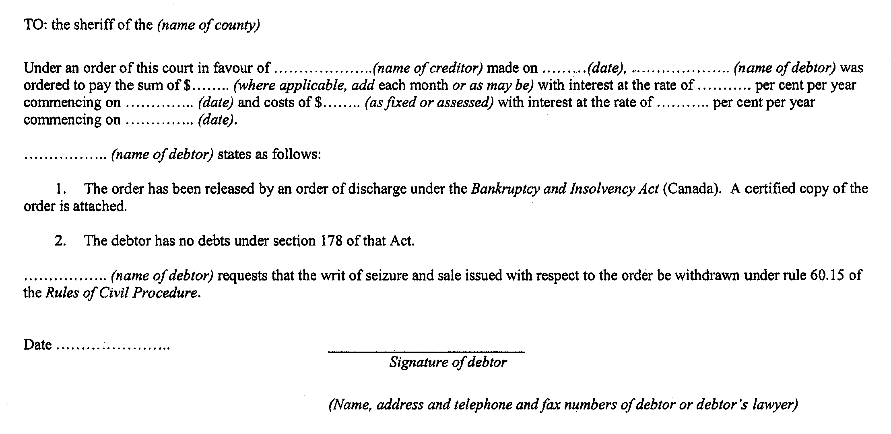
O. Reg. 14/04, s. 42 (8).
Form 61A
Courts of Justice Act
notice of appeal to an appellate court
(General heading in accordance with Form 61B)
Insert regs\graphics\1990\194\19461Aae.tif
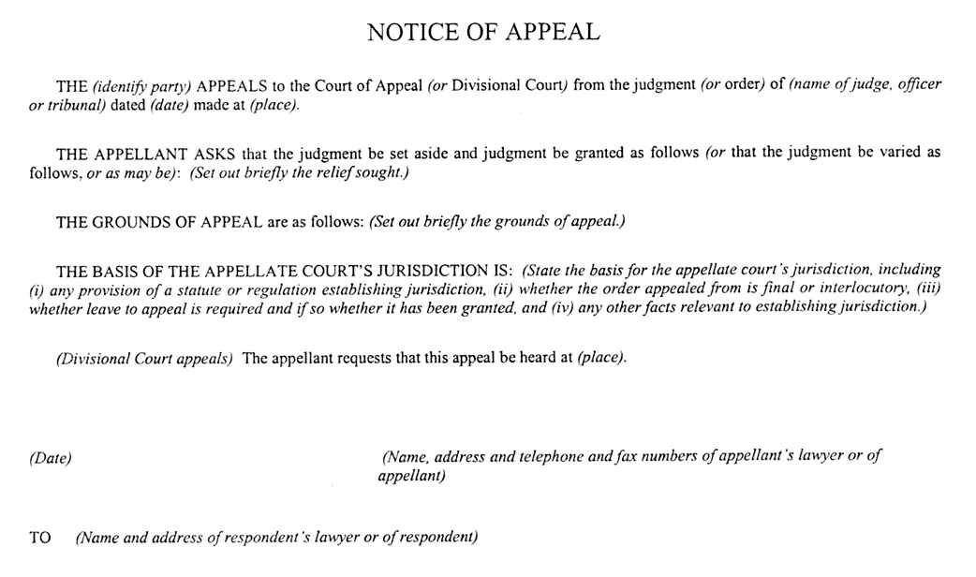
O. Reg. 19/03, s. 23.
Form 61B
Courts of Justice Act
general heading in proceedings in appellate courts
court of appeal for ontario (or divisional court, SUPERIOR COURT OF JUSTICE)
(Appeal in an action)
B E T W E E N :
(name)
Plaintiff
(Appellant) (or (Respondent))
and
(name)
Defendant
(Respondent) (or (Appellant))
(Appeal in an application)
B E T W E E N :
(name)
Applicant
(Appellant) (or (Respondent in appeal))
and
(name)
Respondent
(Respondent in appeal) (or (Appellant))
APPLICATION UNDER (statutory provision or rule under which the application is made)
(Where there are multiple parties in the proceeding at first instance and only some of them are parties to the appeal, include the names of all of the parties at first instance and underline the names of the parties to the appeal.)
R.R.O. 1990, Reg. 194, Form 61B; O. Reg. 219/91, s. 11; O. Reg. 292/99, s. 1 (2).
Form 61C
Courts of Justice Act
appellant’s certificate respecting evidence
(General heading in accordance with Form 61B)
appellant’s certificate

The appellant certifies that the following evidence is required for the appeal, in the appellant’s opinion:
1. Exhibits numbers
2. The affidavit evidence of (names of deponents)
3. The oral evidence of (names of witnesses)
(Date) | (Name, address and telephone and fax numbers of appellant’s lawyer or appellant)

TO (Name and address of respondent’s lawyer or respondent)
O. Reg. 570/98, s. 23.
Form 61D
Courts of Justice Act
respondent’s certificate respecting evidence
(General heading in accordance with Form 61B)
respondent’s certificate

The respondent confirms the appellant’s certificate (where necessary, add except for the following:)
ADDITIONS
1. Exhibits numbers are required for the appeal.
2. The affidavit evidence of (names of deponents) is required for the appeal.
3. The oral evidence of (names of witnesses) is required for the appeal.
DELETIONS
4. Exhibits numbers are not required for the appeal.
5. The affidavit evidence of (names of deponents) is not required for the appeal.
6. The oral evidence of (names of witnesses) is not required for the appeal.
(Date) | (Name, address and telephone and fax numbers of respondent’s lawyer or respondent)

TO (Name and address of appellant’s lawyer or appellant)
O. Reg. 570/98, s. 23.
Form 61E
Courts of Justice Act
notice of cross-appeal
(General heading in accordance with Form 61B)
notice of cross-appeal
THE RESPONDENT CROSS-APPEALS in this appeal and asks that the judgment be set aside and judgment be granted as follows: (or that the judgment be varied as follows, or as may be): (Set out briefly the relief sought.)
THE GROUNDS FOR THIS CROSS-APPEAL are as follows: (Set out briefly the grounds of cross-appeal.)
(Date) | (Name, address and telephone and fax numbers of respondent’s lawyer or respondent)
TO (Name and address of appellant’s solicitor or appellant)
R.R.O. 1990, Reg. 194, Form 61E.
Form 61F
Courts of Justice Act
supplementary notice of appeal or cross-appeal
(General heading in accordance with Form 61B)
supplementary notice of appeal (or cross-appeal)
The appellant (or respondent) amends the notice of appeal (or cross-appeal) dated (date) in the following manner: (Give particulars of the amendment.)
(Date) | (Name, address and telephone number of solicitor or party serving notice)
TO (Name and address of solicitor or party on whom notice is served)
R.R.O. 1990, Reg. 194, Form 61F.
Form 61G
Courts of Justice Act
notice of listing for hearing (appeal)
(General heading in accordance with Form 61B)
notice of listing for hearing
THIS APPEAL HAS BEEN PERFECTED and has been listed for hearing at (place). You may ascertain from my office the approximate date of hearing.
Date | Signed by
Date | Registrar of the Court of Appeal  (or Divisional Court )  (Address of court office)

TO (Name and address of every person listed in the certificate of perfection)
R.R.O. 1990, Reg. 194, Form 61G.
Form 61H
Courts of Justice Act
certificate of completeness of appeal book and compendium
(General heading in accordance with Form 61B)
certificate of completeness
I, (name), solicitor for the appellant (or appellant), certify that the appeal book and compendium in this appeal is complete and legible.

(Date) | (Signature of appellant’s solicitor or appellant)
 | (Name, address and telephone number of appellant’s solicitor or appellant)

R.R.O. 1990, Reg. 194, Form 61H; O. Reg. 19/03, s. 24.
Form 61I
Courts of Justice Act
order dismissing appeal or cross-appeal for delay
(General heading in accordance with Form 61B)
order dismissing appeal (or cross-appeal)
The appellant (or respondent) has not (give particulars of appellant’s or respondent’s default under rule 61.13) and has not cured the default, although given notice under rule 61.13 to do so.
IT IS ORDERED that this appeal (or cross-appeal) be dismissed for delay, with costs.

Date | Signed by
Date | Registrar of the Court of Appeal (or Divisional Court)

NOTE: If there is a cross-appeal, the appellant by cross-appeal should consider rule 61.15, under which the cross-appeal may be deemed to be abandoned.
R.R.O. 1990, Reg. 194, Form 61I.
Form 61J
Courts of Justice Act
order dismissing motion for leave to appeal for delay
(General heading in accordance with Form 61B)
order dismissing motion for leave
The moving party on this motion for leave to appeal from the order (or as may be) of (name of court or tribunal) dated (date) has not served and filed the motion record, factum and (if necessary) transcripts in accordance with clause 61.13 (8) (a) (motion by responding party) (or clause 61.13 (8) (b) (Registrar’s notice)) of the Rules of Civil Procedure.
IT IS ORDERED that this motion be dismissed for delay, with costs.
Date | Signed by
Date | Registrar of the Court of Appeal (or Divisional Court)

R.R.O. 1990, Reg. 194, Form 61J.
Form 61J.1
Courts of Justice Act
Order dismissing motion for delay
Insert regs\graphics\1990\194\19461J1ae.tif
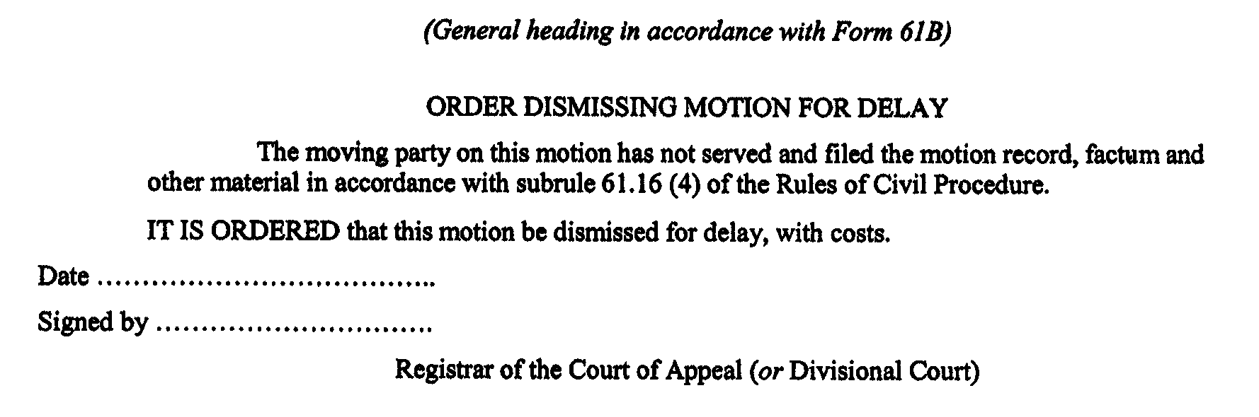
O. Reg. 263/03, s. 10.
Form 61K
Courts of Justice Act
notice of abandonment of appeal or cross-appeal
(General heading in accordance with Form 61B)
notice of abandonment
The appellant (or respondent) abandons this appeal (or cross-appeal).
(Date) | (Name, address and telephone number of solicitor or party serving notice)

TO (Name and address of solicitor or party on whom notice is served)
NOTE: If there is a cross-appeal, the appellant by cross-appeal should consider rule 61.15, under which the cross-appeal may be deemed to be abandoned.
R.R.O. 1990, Reg. 194, Form 61K.
Form 61L
Courts of Justice Act
notice of election to proceed with cross-appeal
(General heading in accordance with Form 61B)
notice of election
The respondent elects to proceed with the cross-appeal.
(Date) | (Name, address and telephone number of respondent’s solicitor or respondent)

TO (Name and address of appellant’s solicitor or appellant)
R.R.O. 1990, Reg. 194, Form 61L.
Form 62A
Courts of Justice Act
notice of appeal to a judge
(General heading)
notice of appeal
THE (identify party) APPEALS to a judge from the order (or certificate) of (name of judge or officers) dated (date).
THE APPEAL WILL BE HEARD ON (day), (date), at (time) at (address of court house).
THE (identify party) ASKS (state the precise relief sought).
THE GROUNDS OF APPEAL are as follows: (Set out briefly the grounds of appeal).
(Date) | (Name, address and telephone number of solicitor or party serving notice)
TO (Name and address of solicitor or party on whom notice is served)
R.R.O. 1990, Reg. 194, Form 62A.
Form 63A
Courts of Justice Act
certificate of stay
(General heading)
(Court seal)
certificate of stay
The Registrar of the Court of Appeal (or Divisional Court) (or the local registrar of this court at (place)) certifies that the order (or judgment) of (name of judge or officer) dated (date) have been stayed by the delivery of a notice of appeal from the order (or judgment) (or by order of (name of judge) dated (date)). (Where an order is made under Rule 63 limiting the stay, give particulars.)
Date | Issued by
Date | Registrar
Date | Address of  court office

R.R.O. 1990, Reg. 194, Form 63A.
Form 63B
Courts of Justice Act
CERTIFICATE OF STAY
(General heading)
(Court seal)
CERTIFICATE OF STAY
The Registrar of the Divisional Court certifies that, under subsection 25 (1) of the Statutory Powers Procedure Act, the order of the Ontario Rental Housing Tribunal dated (date) has been stayed by an appeal to this court.
Date | Issued by
Date | Registrar

O. Reg. 288/99, s. 30.
Form 64A
Courts of Justice Act
request TO redeem
(General heading)
request TO redeem
The defendant (name) requests an opportunity to redeem the mortgaged property.

(Date) | (Name, address and telephone number of defendant’s solicitor or defendant)

(Where the defendant is a subsequent encumbrancer, add:)
affidavit verifying claim
I, (full name of deponent), of the (City, Town, etc.) of , in the (County, Regional Municipality, etc.) of ,
(where the deponent is a party or the solicitor, officer, director, member or employee of a party, set out the deponent’s capacity), MAKE OATH AND SAY (or AFFIRM):
1. There is now due to me under a mortgage on (or an execution against or a construction lien registered against or as may be) the mortgaged property,
(a) for principal | $
(b) for interest (set out particulars) | $
(c) (set out particulars of any other amounts due | $
Total now due | $
Sworn (etc.)
R.R.O. 1990, Reg. 194, Form 64A.
Form 64B
Courts of Justice Act
default judgment for foreclosure with a reference
(General heading)
(Court seal)
judgment
On reading the statement of claim in this action and the proof of service of the statement of claim on the defendant(s), filed, no request to redeem or request for sale having been served and filed (or the defendant(s) (name(s)) having served and filed a request to redeem) and the defendant(s) having been noted in default, and the plaintiff wishing a reference (or the registrar having decided to sign judgment with a reference),
1. IT IS ORDERED AND ADJUDGED that all necessary inquiries be made, accounts taken, costs fixed or assessed and steps taken for redemption or foreclosure of the equity of redemption in the mortgaged property described in the attached schedule, and that for these purposes this action be referred to the master (or as may be) at (place). The mortgage is dated and made between (name of mortgagor) and (name of mortgagee), and registered (give particulars of registration and of any assignment of the mortgage).
(Where judgment is for possession, add:)
2. IT IS ORDERED AND ADJUDGED that the defendant (name) deliver to the plaintiff or as the plaintiff directs possession of the mortgaged property or of such part of it as is in the possession of the defendants.
(Where judgment is for payment of the mortgage debt and the registrar is to take the account, and the following two paragraphs:)
3. IT IS ORDERED AND ADJUDGED that the defendant (name) forthwith pay to the plaintiff the sum of $ , being the amount due to the plaintiff(s) today for principal, interest and costs; and on payment of the amount due to the plaintiff, the plaintiff convey the mortgaged property to the defendant or as the defendants directs, in accordance with section 2 of the Mortgages Act, and deliver up all documents relating to the mortgaged property.
THIS JUDGMENT BEARS INTEREST at the rate of (rate claimed in the statement of claim) per cent per year from its date.
(Where judgment is for payment of the mortgage debt and the plaintiff wishes the account to be taken on the reference or the registrar refers the taking of the account, substitute the following two paragraphs:)
3. IT IS ORDERED AND ADJUDGED that the defendant (name) pay to the plaintiff, forthwith after confirmation of the report on the reference, the amount found due for principal, interest and costs in accordance with the report, and on payment of the amount due to the plaintiff, the plaintiff convey the mortgaged property to the defendant or as the defendant directs, in accordance with section 2 of the Mortgages Act, and deliver up all documents relating to the mortgaged property.
THIS JUDGMENT BEARS INTEREST at the rate set out in the report on the reference from the date of confirmation of the report.
Date | Signed by
Date | Local registrar
Date | Address of  court office

(The description of the mortgaged property in the attached schedule must be the same as in the statement of claim.)
O. Reg. 333/96, s. 5.
Form 64C
Courts of Justice Act
default judgment for immediate foreclosure
(General heading)
(Court seal)
judgment
On reading the statement of claim in this action and the proof of service of the statement of claim on the defendant(s), filed, no request to redeem or request for sale having been served and filed, the defendant(s) having been noted in default, and the plaintiff not wishing a reference,
1. IT IS ORDERED AND ADJUDGED that the right, title and equity of redemption of the defendant(s) (name(s)) to and in the mortgaged property described in the attached schedule are foreclosed. The mortgage is dated and made between (name of mortgagor) and (name of mortgagee), and registered (give particulars of registration and of any assignment of the mortgage).
(Where judgment is for possession, add:)
2. IT IS ORDERED AND ADJUDGED that the defendant (name) forthwith deliver to the plaintiff or as the plaintiff directs possession of the mortgaged property or of such part of it as is in the possession of the defendant.
(Where judgment is for payment of the mortgage debt, add the following two paragraphs:)
3. IT IS ORDERED AND ADJUDGED that the defendant (name) forthwith pay to the plaintiff the sum of $ , being the amount due to the plaintiff today for principal, interest and costs.
THIS JUDGMENT BEARS INTEREST at the rate of (rate claimed in the statement of claim) per cent per year from its date.
Date | Signed by
Date | Local registrar
Date | Address of  court office

(The description of the mortgaged property in the attached schedule must be the same as in the statement of claim.)
O. Reg. 333/96, s. 5.
Form 64D
Courts of Justice Act
default judgment for foreclosure without a reference
(General heading)
(Court seal)
judgment
On reading the statement of claim in this action and the proof of service of the statement of claim on the defendant(s), filed, no request for sale having been served and filed the defendant(s) (name(s)) having served and filed a request to redeem and the defendant(s) having been noted in default, and the account having been taken in the presence of the solicitor(s) for the plaintiff(s) (or the plaintiff) and the solicitor(s) for the defendant(s) (where applicable, add (identify party) appearing in person or no one appearing for the defendant (name) although served with notice of the taking of the account as appears from the affidavit of (name), filed),
1. I FIND that the following sums are due to the plaintiff from the defendant (name of owner of equity of redemption) on (redemption date), the day I have fixed for payment under the mortgage in question in this action:
(a) | for principal | $
(b) | for taxes paid | $
(c) | for premiums of insurance paid | $
(d) | for maintenance costs paid | $
(e) | for heating costs paid | $
(f) | for utility costs paid (add any other costs in similar fashion) | $
(g) | for interest up to (date of judgment) | $
(h) | for costs of this action | $
(i) | for subsequent interest on the principal at the rate of per cent per year up to  the day fixed for payment | $
making a total amount due on (redemption date) of |  | $

2. IT IS ORDERED AND ADJUDGED that:
(a) on payment of the sum of $ (total amount due from paragraph 1) into the to (name of financial institution) at (address), to the joint credit of the plaintiff and the Accountant of the Superior Court of Justice (or the local registrar); or
(b) on recovery by the plaintiff of the amount due under paragraph 6 of this judgment, together with post-judgment interest,
on or before (redemption date), the plaintiff shall convey the mortgaged property described in the attached schedule to the defendant (name) or as the defendant(s) direct(s), in accordance with section 2 of the Mortgages Act, and deliver up all documents relating to the mortgaged property. The mortgage is dated and made between (name of mortgagor) and (name of mortgagee), and registered (give particulars of registration and of any assignment of the mortgage).
(Delete clause (b) where the judgment does not order payment of the mortgage debt.)
(Where more than one party is entitled to redeem, add:)
3. IT IS ORDERED AND ADJUDGED that the defendant (name of encumbrancer) is entitled to the first right to redeem and the defendant (name) is entitled to the second right to redeem (and so on) and the defendant (name of owner of equity of redemption) is entitled to the last right to redeem.
(Foreclosure on default in payment)
4. IT IS ORDERED AND ADJUDGED that, on default in payment as required by paragraph 2, the right, title and equity of redemption of the defendant(s) to and in the mortgaged property described in the attached schedule are foreclosed.
(Where judgment is for possession, add:)
5. IT IS ORDERED AND ADJUDGED that the defendant (name) forthwith deliver to the plaintiff or as the plaintiff directs, possession of the mortgaged property, or of such part of it as is in the possession of the defendant.
(Where judgment is for payment of the mortgage debt, add the following two paragraphs:)
6. IT IS ORDERED AND ADJUDGED that the defendant (name) forthwith pay to the plaintiff(s) the sum of $ , being the amount due to the plaintiff today for principal, interest and costs.
THIS JUDGMENT BEARS INTEREST at the rate of (rate claimed in statement of claim) per cent per year from its date.
Date | Issued by
Date | Local registrar
Date | Address of  court office

(The description of the mortgaged property in the attached schedule must be the same as in the statement of claim.)
O. Reg. 333/96, s. 5; O. Reg. 292/99, s. 5.
Form 64E
Courts of Justice Act
final order of foreclosure
(Court) (Court file no.)
(Name of judge or officer) (Day and date)
(Court seal) (Title of proceeding)
final order of foreclosure
THIS MOTION made by (identify moving party), without notice, was heard this day.
(Order following judgment granting redemption period)
ON READING the judgment in this action dated (date), (where there is an order fixing a new day for payment, add: the order for a new day for payment dated (date)), (where a notice of change of account has been delivered, add: the notice of change of account, with proof of service,) and the certificate of the (title) of the (financial institution) at (place), with affidavit of execution, and the affidavit of the plaintiff, and on hearing the submissions of counsel for the plaintiff, and since the defendant(s) entitled to redeem has (have) not redeemed the mortgaged property,
1. IT IS ORDERED that the right, title and equity of redemption of the defendant(s) (names of those who failed to serve and file a request to redeem, to attend and prove a claim on the taking of account or to redeem the mortgaged property) to and in the mortgaged property described in the attached schedule are foreclosed. The mortgage is date and made between (name of mortgagor) and (name of mortgagee), and registered (give particulars of registration and of any assignment of the mortgage).
(Order following report granting no redemption period)
ON READING the judgment in this action dated (date), and the report in this action dated (date) and confirmed on (date), with proof of service, (where there is an order fixing a new day for payment, add: the order for a new day for payment dated (date), with proof of service,) (where a notice of change of account has been delivered, add: the notice of change of account, with proof of service, and the certificate of the (title) of the (financial institution) at (place), with affidavit of execution,) and the affidavit of the plaintiff, and on hearing the submissions of counsel for the plaintiff, and since the defendant(s) entitled to redeem has (have) not redeemed the mortgaged property,
1. IT IS ORDERED that the right, title and equity of redemption of the defendant(s) (names of those who failed to serve and file a request to redeem, to attend and prove a claim on the reference or to redeem the mortgaged property) to and in the mortgaged property described in the attached schedule are foreclosed. The mortgage is dated and made between (name of mortgagor) and (name of mortgagee), and registered (give particulars of registration and of any assignment of the mortgage).
(Order following report granting no redemption period)
ON READING the judgment in this action dated (date) and the report in this action dated (date) and confirmed on (date), with proof of service, and the affidavit of the plaintiff, and on hearing the submissions of counsel for the plaintiff, and since no defendant is entitled to redeem,
1. IT IS ORDERED that the right, title and equity of redemption of the defendant(s) (names) to and in the mortgaged property described in the attached schedule are foreclosed. The mortgage is dated and made between (name of mortgagor) and (name of mortgagee), and registered (give particulars of registration and of any assignment of the mortgage).
(Order following redemption of plaintiff by encumbrancer)
ON READING the judgment in this action dated (date), (where there is a report, add: the report on the reference in this action dated (date) and confirmed on (date), with proof of service), the certificate of the (title) of the (financial institution) at (place), with affidavit of execution, and the affidavit of the defendant (name of defendant who has redeemed), on hearing the submissions of counsel for the defendant, and since the defendant has redeemed the plaintiff, and has obtained an assignment of the judgment and the mortgage and has registered the latter, and since the defendants (names) are in default,
1. IT IS ORDERED that the right, title and equity of redemption of the defendant(s) (names of those failed to serve and file a request to redeem, to attend and prove a claim on the reference or to redeem the mortgaged property) to and in the mortgaged property described in the attached schedule and foreclosed. The mortgage is dated and made between (name of mortgagor) and (name of mortgagee), and registered (give particulars of registration and of any assignment of the mortgage).
(Note: the preceding types of order in this form, which are for use in a foreclosure action, may be adapted for a redemption action by substituting “defendant” for “plaintiff” and “plaintiff” for “defendant”, whenever those words appear.)
(Order following report in redemption action, where necessary to refer back to the master (or as may be) to complete redemption.)
ON READING the judgment in this action dated (date), the report on the reference in this action dated (date) and confirmed on (date), with proof of service, the certificate of the (title) of the (financial institution) at (place), with affidavit of execution, and the affidavit of the defendant (name), and on hearing the submissions of counsel for the defendant, and since the plaintiff has failed to redeem (where there are subsequent encumbrancers and the defendant wishes to foreclose them, add: and it is necessary to take accounts between the defendants),
1. IT IS ORDERED that the right, title and equity of redemption of the plaintiff to and in the mortgaged property described in the attached schedule are foreclosed. The mortgage is dated and made between (name of mortgagor) and (name of mortgagee), and registered (give particulars of registration and of any assignment of the mortgage).
(Where subsequent encumbrancers are to be foreclosed)
2. IT IS ORDERED that all necessary inquiries be made, accounts taken, costs fixed or assessed and steps taken for redemption by or foreclosure against any subsequent encumbrancers, and that for these purposes this action be referred to the master (or as may be) at (place).
(Where accounts are to be taken)
3. IT IS ORDERED that all necessary inquiries be made, accounts taken, costs fixed or assessed and steps taken for the adjustment of the respective rights and liabilities of the original defendants.
(Signature of judge, master or registrar)
(The description of the mortgaged property in the attached schedule must be the same as in the statement of claim.)
O. Reg. 333/96, s. 5.
Form 64F
Courts of Justice Act
request for sale
(General heading)
request for sale
The defendant (name) requests a sale of the mortgaged property.
(Where the defendant is a subsequent encumbrancer, add:)
Attached is a certificate of the Accountant of the Superior Court of Justice (or the local registrar of the court at (place)) stating that the defendant has paid into court the sum of $250 as security for the costs of the plaintiff and of any other party having carriage of the sale.
(Date) (Name, address and telephone number of defendant’s solicitor or defendant)
(Where the defendant is a subsequent encumbrancer, add:)
affidavit verifying claim
I, (full name of deponent), of the (City , Town, etc.) of , in the (County Regional Municipality, etc.) of , (where the deponent if a party or the solicitor , officer, director, member or employee of a party, set out the deponent’s capacity), MAKE OATH AND SAY (or AFFIRM):
1. There is now due to me under a mortgage on (or and execution against or a construction lien registered against or as may be) the mortgaged property,
(a) | for principal | $
(b) | for interest (set out particulars) | $
(c) | (set out particulars of any other amounts due) | $
 | Total now due | $
SWORN (etc.)
R.R.O. 1990, Reg. 194, Form 64F; O. Reg. 292/99, s. 5.
Form 64G
Courts of Justice Act
default judgment for sale with a redemption period (action converted from foreclosure to sale)
(General heading)
(Court seal)
judgment
On reading the statement of claim in this action and the proof of service of the statement of claim on the defendant(s), filed, the defendant (name) having served and filed a request for sale, the defendant(s) having been noted in default and the defendant(s) (name(s)) having served and filed a request to redeem,
1. IT IS ORDERED AND ADJUDGED that all necessary inquiries be made, accounts taken, costs fixed or assessed and steps taken for redemption or sale of the mortgaged property described in the attached schedule, and that for these purposes this action be referred to the master (or as may be) at (place).
(Where judgment is for possession, add:)
2. IT IS ORDERED AND ADJUDGED that the defendant (name) deliver to the plaintiff or as the plaintiff directs possession of the mortgaged property or of such part of it as is in the possession of the defendant.
(Where judgment is for payment of the mortgage debt and the registrar is to take the account, add the following two paragraphs:)
3. IT IS ORDERED AND ADJUDGED that the defendant (name) forthwith pay to the plaintiff the sum of $ , being the amount due to the plaintiff today for principal, interest and costs; and that, on payment of the amount due to the plaintiff before the sale takes place, the plaintiff convey the mortgaged property to the defendant or as the defendant directs, in accordance with section 2 of the Mortgages Act, and deliver up all documents relating to the mortgage property.
THIS JUDGMENT BEARS INTEREST at the rate of (rate claimed in statement of claim) per cent per year from its date.
(Where judgment is for payment of the mortgage debt and the plaintiff wishes the account to be taken on reference or the registrar refers the taking of the account, substitute the following two paragraphs:)
3. IT IS ORDERED AND ADJUDGED that the defendant (name) pay to the plaintiff, forthwith after the confirmation of the report on the reference, the amount found due for principal, interest and costs in accordance with the report; and that on payment of the amount due to the plaintiff before the sale takes place, the plaintiff convey the mortgaged property to the defendant or as the defendant directs, in accordance with section 2 of the Mortgages Act, and deliver up all documents relating to the mortgaged property.
THIS JUDGMENT BEARS INTEREST at the rate set out in the report on the reference from the date of confirmation of the report.
Date | Signed by
Date | Local registrar
Date | Address of  court office

(The description of the mortgaged property in the attached schedule must be the same as in the statement of claim.)
O. Reg. 333/96, s. 5.
Form 64H
Courts of Justice Act
default judgment for immediate sale (action converted from foreclosure to sale)
(General heading)
(Court seal)
judgment
On reading the statement of claim in this action and the proof of service of the statement of claim on the defendant(s), filed, the defendant (name) having served and filed a request for sale, the defendant(s) having been noted in default and no request to redeem having been served and filed (or a request to redeem having been served and filed by the defendant (name of subsequent encumbrancer)),
1. IT IS ORDERED AND ADJUDGED that all necessary inquiries be made, accounts taken, costs fixed or assessed and steps taken for the immediate sale of the mortgaged property described in the attached schedule without a redemption period, and that for these purposes this action be referred to the master (or as may be) at (place).
2. IT IS ORDERED AND ADJUDGED that the purchasers pay the purchase money into court to the credit of this action and that the purchase money be applied in payment of what is found due to the plaintiff, together with subsequent interest and subsequent costs to be computed and fixed or assessed by the master (or as may be) and that the master (or as may be) also determine those parties or persons entitled to the balance of the money and the amounts to which they are entitled.
(Where judgment is for possession, add:)
3. IT IS ORDERED AND ADJUDGED that the defendant (name) forthwith deliver to the plaintiff or as the plaintiff directs possession of the mortgaged property, or of such part of it as is in the possession of the defendant.
(Where judgment is for payment of the mortgage debt and the registrar is to take the account, add the following two paragraphs:)
4. IT IS ORDERED AND ADJUDGED that the defendant (name) forthwith pay to the plaintiff the sum of $ , being the amount due to the plaintiff today for principal, interest and costs; and that on payment of the amount due to the plaintiff before the sale takes place, the plaintiff convey the mortgaged property to the defendant or as the defendant directs, in accordance with section 2 of the Mortgages Act, and deliver up all documents relating to the mortgaged property.
THIS JUDGMENT BEARS INTEREST at the rate of (rate claimed in the statement of claim) per cent per year from its date.
(Where judgment is for payment of the mortgage debt and the plaintiff wishes the account to be taken on the reference or the registrar refers the taking of account, substitute the following two paragraphs:)
4. IT IS ORDERED AND ADJUDGED that the defendant (name) pay to the plaintiff, forthwith after the confirmation of the report on the reference, the amount found due for principal, interest and costs in accordance with the report, and on payment of the amount due to the plaintiff before the sale takes place, the plaintiff convey the mortgaged property to the defendant or as the defendant directs, in accordance with section 2 of the Mortgages Act, and deliver up all documents relating to the mortgaged property.
THIS JUDGMENT BEARS INTEREST at the rate set out in the report on the reference from the date of confirmation of the report.
Date | Signed by
Date | Local registrar
Date | Address of  court office

(The description of the mortgaged property in the attached schedule must be the same as in the statement of claim.)
O. Reg. 333/96, s. 5.
Form 64I
Courts of Justice Act
default judgment for sale conditional on proof of claim (action converted from foreclosure to sale)
(General heading)
(Court seal)
judgment
On reading the statement of claim in this action and the proof of service of the statement of claim on the defendant(s), filed, no request to redeem having been served and filed (or the defendant (name) having served and filed a request to redeem), the defendant(s) having been noted in default, and the defendant (name of subsequent encumbrancer) having served and filed a request for sale and having paid into court the sum of $250 as security for costs,
1. IT IS ORDERED AND ADJUDGED that all necessary inquiries be made, accounts taken, costs fixed or assessed and steps taken for redemption or sale of the mortgaged property described in the attached schedule and that for these purposes this action be referred to the master (or as may be) at (place).
2. IT IS ORDERED AND ADJUDGED that, if the defendant (name of subsequent encumbrancer) fails to prove a claim on the reference for sale, the master (or as may be) shall proceed as on a reference for redemption or foreclosure.
(Where judgment is for possession, add:)
3. IT IS ORDERED AND ADJUDGED that the defendant (name) deliver to the plaintiff or as the plaintiff directs possession of the mortgaged property or of such part of it as is in the possession of the defendant.
(Where judgment is for payment of the mortgage debt and the registrar is to take the account, add the following two paragraphs:)
4. IT IS ORDERED AND ADJUDGED that the defendant (name) forthwith pay to the plaintiff the sum of $ , being the amount due to the plaintiff today for principal, interest and costs; and that on payment of the amount due to the plaintiff, the plaintiff convey the mortgaged property to the defendant or as the defendant directs, in accordance with section 2 of the Mortgages Act, and deliver up all documents relating to the mortgaged property.
THIS JUDGMENT BEARS INTEREST at the rate of (rate claimed in statement of claim) per cent per year from its date.
(Where judgment is for payment of the mortgage debt and the plaintiff wishes the account to be taken on the reference or the registrar refers the taking of the account, substitute the following two paragraphs:)
4. IT IS ORDERED AND ADJUDGED that the defendant (name) pay to the plaintiff, forthwith after the confirmation of the report on the reference, the amount found due for principal, interest and costs in accordance with the report, and on payment of the amount due to the plaintiff before the sale takes place, the plaintiff convey the mortgaged property to the defendant or as the defendant directs, in accordance with section 2 of the Mortgages Act, and deliver up all documents relating to the mortgaged property.
THIS JUDGMENT BEARS INTEREST at the rate set out in the report on the reference from the date of confirmation of the report.
Date | Signed by
Date | Local registrar
Date | Address of  court office

(The description of the mortgaged property in the attached schedule must be the same as in the statement of claim.)
O. Reg. 333/96, s. 5.
Form 64J
Courts of Justice Act
default judgment for immediate sale
(General heading)
(Court seal)
judgment
On reading the statement of claim in this action and the proof of service of the statement of claim on the defendant(s), filed, no request to redeem having been served and filed and the defendant(s) having been noted in default,
1. IT IS ORDERED AND ADJUDGED that all necessary inquiries be made, accounts taken, costs fixed or assessed and steps taken for the immediate sale of the mortgaged property described in the attached schedule without a redemption period, and that for these purposes this action be referred to the master (or as may be) at (place).
2. IT IS ORDERED AND ADJUDGED that the purchasers pay the purchase money into court to the credit of this action and that the purchase money be applied in payment of what is found due to the plaintiff, together with subsequent interest and subsequent costs to be computed and fixed or assessed by the master (or as may be) and that the master (or as may be) also determine those parties or persons entitled to the balance of the money and the amounts to which they are entitled.
(Where judgment is for possession, add:)
3. IT IS ORDERED AND ADJUDGED that the defendant (name) forthwith deliver to the plaintiff or as the plaintiff directs possession of the mortgaged property, or of such part of it as is in the possession of the defendant.
(Where judgment is for payment of the mortgage debt and the registrar is to take the account, add the following two paragraphs:)
4. IT IS ORDERED AND ADJUDGED that the defendant (name) forthwith pay to the plaintiff the sum of $ , being the amount due to the plaintiff today for principal, interest and costs; and that on payment of the amount due to the plaintiff before the sale takes place, the plaintiff convey the mortgaged property to the defendant or as the defendant directs, in accordance with section 2 of the Mortgages Act, and deliver up all documents relating to the mortgaged property.
THIS JUDGMENT BEARS INTEREST at the rate of (rate claimed in statement of claim) per cent per year from its date.
(Where judgment is for payment of the mortgage debt and the plaintiff wishes the account to be taken on the reference or the registrar refers the taking of the account, substitute the following two paragraphs:)
4. IT IS ORDERED AND ADJUDGED that the defendant (name) pay to the plaintiff, forthwith after the confirmation of the report on the reference, the amount found due for principal, interest and costs in accordance with the report, and on payment of the amount due to the plaintiff before the sale takes place, the plaintiff convey the mortgaged property to the defendant or as the defendant directs, in accordance with section 2 of the Mortgages Act, and deliver up all documents relating to the mortgaged property.
THIS JUDGMENT BEARS INTEREST at the rate set out in the report on the reference from the date of confirmation of the report.
Date | Signed by
Date | Local registrar
Date | Address of  court office

(The description of the mortgaged property in the attached schedule must be the same as in the statement of claim.)
O. Reg. 333/96, s. 5.
Form 64K
Courts of Justice Act
default judgment for sale with a redemption period
(General heading)
(Court seal)
judgment
On reading the statement of claim in this action and the proof of service of the statement of claim on the defendant(s), filed, the defendant(s) having been noted in default and the defendant (name) having served and filed a request to redeem,
1. IT IS ORDERED AND ADJUDGED that all necessary inquiries be made, accounts taken, costs fixed or assessed and steps taken for redemption or sale of the mortgaged property described in the attached schedule, and that for these purposes this action be referred to the master (or as may be) at (place).
(Where judgment is for possession, add:)
2. IT IS ORDERED AND ADJUDGED that the defendant (name) deliver to the plaintiff or as the plaintiff directs possession of the mortgaged property or of such part of it as is in the possession of the defendant.
(Where judgment is for payment of the mortgage debt and the registrar is to take the account, add the following two paragraphs:)
3. IT IS ORDERED AND ADJUDGED that the defendant (name) forthwith pay to the plaintiff the sum of $ , being the amount due to the plaintiff today for principal, interest and costs; and on payment of the amount due to the plaintiff before the sale takes place, the plaintiff convey the mortgaged property to the defendant(s) or as the defendant directs, in accordance with section 2 of the Mortgages Act, and deliver up all documents relating to the mortgaged property.
THIS JUDGMENT BEARS INTEREST at the rate of (rate claimed in statement of claim) per cent per year from its date.
(Where judgment is for payment of the mortgage debt and the plaintiff wishes the account to be taken on the reference or the registrar refers the taking of the account, substitute the following two paragraphs:)
3. IT IS ORDERED AND ADJUDGED that the defendant (name) pay to the plaintiff(s), forthwith after confirmation of the report on the reference, the amount found due for principal, interest and costs in accordance with the report; and that on payment of the amount due to the plaintiff before the sale takes place, the plaintiff convey the mortgaged property to the defendant or as the defendant directs, in accordance with section 2 of the Mortgages Act, and deliver up all documents relating to the mortgaged property.
THIS JUDGMENT BEARS INTEREST at the rate set out in the report on the reference from the date of confirmation of the report.
Date | Signed by
Date | Local registrar
Date | Address of  court office

(The description of the mortgaged property in the attached schedule must be the same as in the statement of claim.)
O. Reg. 333/96, s. 5.
Form 64L
Courts of Justice Act
final order for sale
(Court) (Court file no.)
(Name of judge or officer) (Day and date)
(Court seal) (Title of proceeding)
final order for sale
THIS MOTION made by the plaintiff, without notice, was heard this day.
ON READING the judgment in this action dated (date), and the report in this action dated (date) and confirmed on (date), with proof of service, the certificate of the (title) of the (financial institution) at (place), with affidavit of execution, and the affidavit of the plaintiff, and on hearing the submissions of counsel for the plaintiff, and since the defendant(s) entitled to redeem has (have) not redeemed the mortgaged property,
1. IT IS ORDERED that the mortgaged property described in the attached schedule be sold forthwith as directed by the judgment in this action under the direction of the master (or as may be) at (place).
(Where appropriate, add:)
2. IT IS ORDERED that the right, title and equity of redemption of the defendants (names of subsequent encumbrancers who failed to attend and prove a claim on the reference) to and in the mortgaged property described in the attached schedule are foreclosed.
(Signature of judge, master or registrar)
(The description of the mortgaged property in the attached schedule must be the same as in the statement of claim.)
R.R.O. 1990, Reg. 194, Form 64L.
Form 64M
Courts of Justice Act
default judgment for redemption
(General heading)
(Court seal)
judgment
On reading the statement of claim in this action and the proof of service of the statement of claim on the defendant(s), filed, and the defendant(s) having been noted in default,
1. IT IS ORDERED AND ADJUDGED that all necessary inquiries be made, accounts taken, costs fixed or assessed and steps taken for the redemption of the mortgaged property described in the attached schedule, and that for this purpose this action be referred to the master (or as may be) at (place).
2. IT IS ORDERED AND ADJUDGED that, on the plaintiff paying to the defendant (name of mortgagee) the amount found due on the mortgage in question, or, if nothing is found due, then forthwith after the confirmation of the report on the reference, the defendant convey the mortgaged property to the plaintiff or as the plaintiff directs, in accordance with section 2 of the Mortgages Act, and deliver up all documents relating to the mortgaged property.
3. IT IS ORDERED AND ADJUDGED that if the plaintiff defaults in payment of the amount found due to the defendant (name of mortgagee), the defendant is entitled, on motion without notice, to a final order of foreclosure against the plaintiff or to an order dismissing the action with costs.
4. IT IS ORDERED AND ADJUDGED that if nothing is found due to the defendant (name of mortgagee), the defendant pay the plaintiff’s costs of this action and, if any balance is found due from the defendant (name of mortgagee) to the plaintiff, that the defendant pay the balance to the plaintiff forthwith after confirmation of the report on the reference.
THIS JUDGMENT BEARS INTEREST at the rate set out in the report on the reference from the date of confirmation of the report.
Date | Signed by
Date | Local registrar
Date | Address of  court office

(The description of the mortgaged property in the attached schedule must be the same as in the statement of claim.)
R.R.O. 1990, Reg. 194, Form 64M.
Form 64N
Courts of Justice Act
notice of reference to subsequent encumbrancer added on reference
(Court file no.)
ONTARIO
SUPERIOR COURT OF JUSTICE
B E T W E E N : (name)
Plaintiff
and
(name(s))
Defendant(s)
and
(name(s))
Defendant(s) added
on the reference
notice of reference
An action has been commenced by the plaintiff for the foreclosure (or sale) of the mortgaged property described in the attached schedule. I have been directed by the judgment in this action dated (date) (where the judgment is for sale, insert: to conduct a sale of the property and) to inquire whether any person other than the plaintiff has a lien, charge or encumbrance on the property subsequent to the plaintiff’s claim. It appears that you may have a lien, charge or encumbrance on the property. I have therefore added you as a defendant in this action.
YOU ARE REQUIRED TO APPEAR before me and prove your claim, either in person or by an Ontario lawyer acting for you, on (day), (date), at (time), at (address). At that time, I shall determine the amount of the claim of the plaintiff, and of the encumbrancers who prove their claims before me. (Where the judgment is for sale without a redemption period, add: At the same time, I shall settle the conditions of sale and advertisement and make any other necessary preparations for the sale of the property.)
If you wish to set aside or vary my order adding you as a defendant or the judgment in this action, you must make a motion to the court within ten days after service on you of this notice (or where the person is to be served outside Ontario, such further time as the referee directs). If you fail to do so, you will be bound by the judgment and the subsequent steps in this action.
IF YOU FAIL TO ATTEND AND PROVE YOUR CLAIM at the time and place set out above, you will be treated as disclaiming all interest in the property and the action will proceed in your absence and without further notice to you. The property may be dealt with as if you had no claim, and your claim may be foreclosed.
(Date) | (Signature of referee)

TO (Names and addresses of defendants added on reference who appear to be subsequent encumbrancers)
(The description of the mortgaged property in the attached schedule must be the same as in the statement of claim.)
R.R.O. 1990, Reg. 194, Form 64N; O. Reg. 292/99, s. 1 (3, 4).
Form 64O
Courts of Justice Act
notice of reference to subsequent encumbrancer named as original party
(Court file no.)
ONTARIO
SUPERIOR COURT OF JUSTICE
B E T W E E N :
(name)
Plaintiff
and
(name)
Defendant(s)
and
(name(s))
Defendant(s) added
on the reference
notice of reference
The judgment in this action directs me (where the judgment is for sale, insert: to conduct a sale of the mortgaged property and) to inquire whether any person other than the plaintiff has a lien, charge or encumbrance on the mortgaged property in question in this action subsequent to the plaintiff’s claim, and to take an account of the amount due to the plaintiff and any such person. It appears that you may have a lien, charge or encumbrance on the property.
YOU ARE REQUIRED TO APPEAR before me and prove your claim, either in person or by an Ontario lawyer acting for you, on (day), (date), at (time), at (address). At that time, I shall determine the amount of the claim of the plaintiff, and of the encumbrancers who prove their claims before me. (Where the judgment is for sale without redemption period, add: At the same time, I shall settle the conditions of sale and advertisement and make any other necessary preparations for the sale of the property.)
IF YOU FAIL TO ATTEND AND PROVE YOUR CLAIM at the time and place set out above, you will be treated as disclaiming any lien, charged or encumbrance on the property and the action will proceed in your absence and without further notice to you. The property may be dealt with as if you had no such claim and your claim may be foreclosed.
(Date) | (Signature of referee)

TO (Names and addresses of defendants named in statement of claim who appear to be subsequent encumbrancers)
R.R.O. 1990, Reg. 194, Form 64O; O. Reg. 292/99, s. 1 (3, 4).
Form 64P
Courts of Justice Act
notice of reference to original defendants
(Court file no.)
ONTARIO
SUPERIOR COURT OF JUSTICE
B E T W E E N :
(name)
Plaintiff
and
(name(s))
Defendant(s)
and
(name(s))
Defendant(s) added
on the reference
notice of reference
The judgment in this action directs me (where the judgment is for sale, insert: to conduct a sale of the mortgaged property and) to inquire whether any person other than the plaintiff has a lien, charge or encumbrance on the mortgaged property in question in this action subsequent to the plaintiff’s claim, and to take an account due to the plaintiff and any such person.
It appears that the persons named in the attached schedule may have a lien, charge or encumbrance on the property (where the judgment directs the referee to add encumbrancers, add: and I have therefore added as defendants those persons who were not already parties to this action).
YOU ARE REQUIRED TO APPEAR before me and prove your claim, either in person or by an Ontario lawyer acting for you, on (day), (date), at (time), at (address). At that time, I shall determine whether any of the parties have a lien, charge or encumbrance on the property and ascertain the amount of those claims and of the plaintiff’s claim. (Where the judgment is for sale without a redemption period, add: At the same time, I shall settle the conditions of sale and advertisement and make any other necessary arrangements for the sale.)
(Where the judgment is for sale conditional on proof of a claim by a subsequent encumbrancer, add: The defendant (name of subsequent encumbrancer) has requested a sale of the property. If the defendant fails to attend and prove a claim before me, there will not be a sale of the property, and the claims of those who fail to appear before me may be foreclosed.)
IF YOU FAIL TO ATTEND at the time and place set out above, the action will proceed in your absence without further notice to you and your rights in the property may be foreclosed.
If you are a subsequent encumbrancer and fail to attend and prove your claim at the time and place set out above, you will be treated as disclaiming any lien, charge or encumbrance on the property, the property may be dealt with as if you had no such claim and your claim may be foreclosed.
(Date) | (Signature of referee)

TO (Names and addresses of defendants named in statement of claim)
SCHEDULE OF ENCUMBRANCERS
Name of  encumbrancer | Nature of  encumbrance | Instrument  no. | Date of  instrument | Date of  registration
R.R.O. 1990, Reg. 194, Form 64P; O. Reg. 292/99, s. 1 (3, 4).
Form 64Q
Courts of Justice Act
notice to added defendant having interest in equity
(Court file no.)
ONTARIO
SUPERIOR COURT OF JUSTICE
B E T W E E N : (name)
Plaintiff
and
(name(s))
Defendant(s)
and
(name(s))
Defendant(s) added
on the reference
notice to added defendant
An action has been commenced by the plaintiff for the foreclosure (or sale) of the mortgaged property described in the attached schedule. I have been directed by the judgment in this action dated (date) (where the judgment is for sale, insert: to conduct a sale of the property and) to inquire whether any person other than the plaintiff has a lien, charge or encumbrance on the property subsequent to the plaintiff’s claim or whether any other person has an interest in the property. It appears that you may have an interest in the property. I have therefore added you as a defendant in this action. A copy of my order and the judgment in the action are attached to this notice.
If you wish to set aside or vary my order adding you as a defendant or the judgment in this action, you must make a motion to the court within ten days after service on you of this notice (or where the defendant is to be served outside Ontario, such further time as the referee directs). If you fail to do so, you will be bound by the judgment and the subsequent steps in this action.
IF YOU WISH AN OPPORTUNITY TO REDEEM the property, you are required to appear before me, either in person or by an Ontario lawyer acting for you, on (day), (date), at (time), at (address).
IF YOU FAIL TO ATTEND at the time and place set out above, you may be deemed to submit to an immediate foreclosure of your interest (or an immediate sale of the property) and the action may proceed in your absence and without further notice to you.
(Date) | (Signature of referee)

TO (Names and addresses of defendants added on reference who appear to be interested in equity of redemption)
(The description of the mortgaged property in the attached schedule must be the same as in the statement of claim.)
R.R.O. 1990, Reg. 194, Form 64Q; O. Reg. 292/99, s. 1 (3, 4).
Form 65A
Courts of Justice Act
judgment for administration of estate
(Court file no.)
(Court)
(Name of judge or officer) (Day and date judgment given)
(Court seal) (Title of proceeding)
judgment
(Recitals in accordance with Form 59B)
1. THIS COURT ORDERS AND ADJUDGES that all necessary inquiries be made, accounts taken, costs assessed and steps taken by the master (or as may be) at (place) for the administration and final winding up of the estate of (name of deceased) and for the adjustment of the rights of all parties interested in the property.
2. THIS COURT ORDERS AND ADJUDGES that any balance found due from the applicant or the respondent(s) to the estate be paid into court to the credit of this proceeding, subject to further order of the court.
3. THIS COURT ORDERS AND ADJUDGES that the property of the estate or such parts of it as the referee directs be sold as the referee directs and that the purchasers pay the purchase money into court to the credit of this proceeding, subject to the order of the court.
4. THIS COURT ORDERS AND ADJUDGES that the referee execute transfers for any party who is a minor.
(Signature of judge or registrar)
R.R.O. 1990, Reg. 194, Form 65A.
Form 66A
Courts of Justice Act
judgment for partition or sale
(Court file no.)
(Court)
(Name of judge or officer) (Day and date judgment given)
(Court seal) (Title of proceeding)
judgment
(Recitals in accordance with Form 59B)
1. THIS COURT ORDERS AND ADJUDGES that all necessary inquiries be made, accounts taken, costs assessed and steps taken by the master (or as may be) at (place) for the partition or sale, or for the partition of part and sale of the remainder, of the land described in the attached schedule in accordance with the interests of the parties entitled to share in it.
2. THIS COURT ORDERS AND ADJUDGES that the land, or such part of it as the referee thinks fit, be sold under the direction of the referee, free of the claims of encumbrancers, if any, who have consented to the sale, and subject to the claims of encumbrancers who have not consented to the sale, and that the purchaser pay the purchase money into court to the credit of this proceeding, subject to the order of the court.
3. THIS COURT ORDERS AND ADJUDGES that the referee execute a transfer for any party who is a minor.
4. THIS COURT ORDERS AND ADJUDGES that, if the land is partitioned or if part of the land is partitioned and the proceeds of the sale of the remainder are insufficient to pay the costs in full, the unpaid costs be paid by the parties according to their interests in the land (where there are parties who are minors, add: and that the portion of the costs payable by the parties who are minors be a lien on their respective shares, and that the plaintiff (or applicant) pay the costs of their litigation guardian and that those costs be added to the plaintiff’s (or applicant’s) costs.)
(Signature of judge, officer or registrar)
R.R.O. 1990, Reg. 194, Form 66A.
Form 68A
Courts of Justice Act
notice of application to divisional court for judicial review
(General heading)
(Court seal)
notice of application for judicial review
TO THE RESPONDENT
A LEGAL PROCEEDING HAS BEEN COMMENCED by the applicant. The claim made by the applicant appears on the following page.
THIS APPLICATION for judicial review will come on for a hearing before the Divisional Court on a date to be fixed by the registrar at the place of hearing requested by the applicant. The applicant requests that this application be heard at (place where a Divisional Court sitting is scheduled).
IF YOU WISH TO OPPOSE THIS APPLICATION, to receive notice of any step in the application or to be served with any documents in the application, you or an Ontario lawyer acting for you must forthwith prepare a notice of appearance in Form 38A prescribed by the Rules of Civil Procedure, serve it on the applicant’s lawyer or, where the applicant does not have a lawyer, serve it on the applicant, and file it, with proof of service, in the office of the Divisional Court, and you or your lawyer must appear at the hearing.
IF YOU WISH TO PRESENT AFFIDAVIT OR OTHER DOCUMENTARY EVIDENCE TO THE COURT OR TO EXAMINE OR CROSS-EXAMINE WITNESSES ON THE APPLICATION, you or your lawyer must, in addition to serving your notice of appearance, serve a copy of the evidence on the applicant’s lawyer or, where the applicant does not have a lawyer, serve it on the applicant, and file it, with proof of service, in the office of the Divisional Court within thirty days after service on you of the applicant’s application record, or not later than 2 p.m. on the day before the hearing, whichever is earlier.
IF YOU FAIL TO APPEAR AT THE HEARING, JUDGMENT MAY BE GIVEN IN YOUR ABSENCE AND WITHOUT FURTHER NOTICE TO YOU. IF YOU WISH TO DEFEND THIS PROCEEDING BUT ARE UNABLE TO PAY LEGAL FEES, LEGAL AID MAY BE AVAILABLE TO YOU BY CONTACTING A LOCAL LEGAL AID OFFICE.
Date | Issued by
Date | Registrar
Date | Address of court office

TO (Name and address of each respondent)
application
 | 1. | The applicant makes application for: (State here the precise relief claimed.)
 | 2. | The grounds for the application are: (Specify the grounds to be argued, including a reference to any statutory provision to be relied on.)
 |  | (Where the notice of application is to be served outside Ontario without a court order, state the facts and the specific provisions of Rule 17 relied on in support of such service.)
 | 3. | The following documentary evidence will be used at the hearing of the application: (List the affidavits or other documentary evidence to be relied on.)
(Date) |  |  | (Name, address and telephone number of applicant’s solicitor or applicant)

R.R.O. 1990, Reg. 194, Form 68A; O. Reg. 351/94, s. 16.
Note: On January 1, 2005, Form 68A is revoked and the following substituted:
Form 68A
Courts of Justice Act
NOTICE OF application to divisional court for judicial review
(General heading)
Insert regs\Graphics\Source Law\2004\132\13268Aae.tif
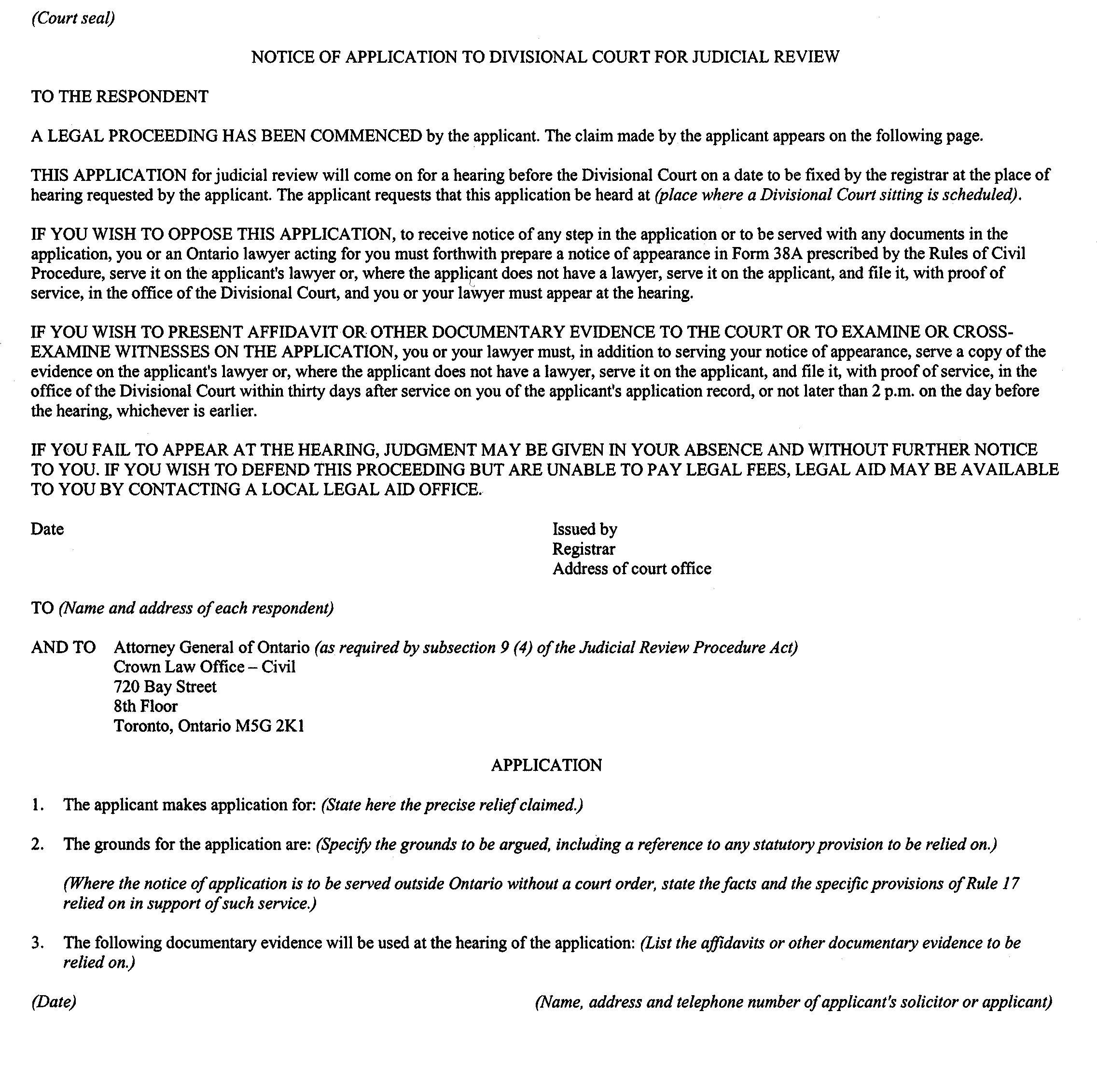
O. Reg. 132/04, s. 23.
See: O. Reg. 132/04, ss. 23, 25 (1).
Form 68B
Courts of Justice Act
notice of listing for hearing (Judicial review)
(General heading)
notice of listing for hearing
THIS APPLICATION FOR JUDICIAL REVIEW HAS BEN PERFECTED and has been listed for hearing at (place). You may ascertain from my office the approximate date of hearing.
Date | Signed by
Date | Registrar of the Divisional Court
 | (Address of court office)

TO (Name and address of every person listed in the certificate of perfection)
R.R.O. 1990, Reg. 194, Form 68B.
Form 68C
Courts of Justice Act
order dismissing application for judicial review
(General heading)
(Court seal)
order dismissing application for judicial review
The applicant has not (give particulars of applicant’s default under rule 68.06) and has not cured the default, although given notice under rule 68.06 to do so.
1. IT IS ORDERED that this application be dismissed for delay, with costs.
Date | Signed by
Date | Registrar of the Divisional Court
 | (Address of court office)

R.R.O. 1990, Reg. 194, Form 68C.
Form 69A Revoked: O. Reg. 131/04, s. 25.
Form 69B Revoked: O. Reg. 131/04, s. 25.
Form 69B.1 Revoked: O. Reg. 583/99, s. 3.
Form 69C Revoked: O. Reg. 131/04, s. 25.
Form 69D Revoked: O. Reg. 131/04, s. 25.
Form 69E Revoked: O. Reg. 131/04, s. 25.
Form 69F Revoked: O. Reg. 131/04, s. 25.
Form 69G Revoked: O. Reg. 131/04, s. 25.
Form 69H Revoked: O. Reg. 131/04, s. 25.
Form 69I Revoked: O. Reg. 131/04, s. 25.
Form 69J Revoked: O. Reg. 131/04, s. 25.
Form 69K Revoked: O. Reg. 131/04, s. 25.
Form 69L Revoked: O. Reg. 131/04, s. 25.
Form 69M Revoked: O. Reg. 131/04, s. 25.
Form 69N Revoked: O. Reg. 131/04, s. 25.
Form 69O Revoked: O. Reg. 131/04, s. 25.
Form 69P Revoked: O. Reg. 131/04, s. 25.
Form 69Q Revoked: O. Reg. 131/04, s. 25.
Form 69R Revoked: O. Reg. 131/04, s. 25.
Form 69S Revoked: O. Reg. 131/04, s. 25.
Form 69T Revoked: O. Reg. 131/04, s. 25.
Form 69U Revoked: O. Reg. 131/04, s. 25.
Form 69V Revoked: O. Reg. 131/04, s. 25.
Form 69W Revoked: O. Reg. 131/04, s. 25.
Form 69X Revoked: O. Reg. 131/04, s. 25.
Form 69Y Revoked: O. Reg. 131/04, s. 25.
Form 69Z Revoked: O. Reg. 131/04, s. 25.
Form 69Z.1 Revoked: O. Reg. 131/04, s. 25.
Form 69Z.2 Revoked: O. Reg. 131/04, s. 25.
Form 70A Revoked: O. Reg. 19/03, s. 25.
Form 70A.1 Revoked: O. Reg. 292/98, s. 8.
Form 70A.2 Revoked: O. Reg. 131/04, s. 25.
Form 70A.3 Revoked: O. Reg. 131/04, s. 25.
Form 70B Revoked: O. Reg. 131/04, s. 25.
Form 70C Revoked: O. Reg. 131/04, s. 25.
Form 70D Revoked: O. Reg. 131/04, s. 25.
Form 72A
Courts of Justice Act
notice of payment into court
(General heading)
notice of payment into court
The (identify party) paid into court on (date) the sum of $ under the offer to settle (or acceptance of offer) dated (date).
(Date) | (Name, address and telephone number of solicitor or party giving notice)

TO (Name and address of solicitor or party receiving notice)
R.R.O. 1990, Reg. 194, Form 72A.
Form 72B
Courts of Justice Act
affidavit (motion for payment out of court)
(General heading)
affidavit
I, (full name of deponent) of the (City, Town, etc.) of , in the (County, Regional Municipality,
etc.) of , (where the deponent is a party or the
solicitor, officer, director, member or employee of a party, set out the deponent’s capacity), MAKE OATH AND SAY (or AFFIRM):
1. This affidavit is filed in support of a motion for payment out of court of money belonging to (name of person under disability), of (address), who is (state the nature of the disability) and who was born on (date).
2. I am (state the deponent’s connection with the person under disability).
3. The Accountant (or local registrar at (place)) has informed me that the sum of $ , including interest accrued to (date), is in
court. There has been previously paid out the sum of $ on (date) (or as may be).
4. It is proposed that the sum of $ be paid out of court to (name) for the following purpose: (Give particulars.)
5. I believe that this expenditure is justified for the following reasons: (Give particulars.)
SWORN, etc.

R.R.O. 1990, Reg. 194, Form 72B.
Form 72C
Courts of Justice Act
stop order
(Court file no.)
(Court)
(Name of judge or officer) (Day and date order made)
(Court seal) (Title of proceeding)
order
(Recitals in accordance with Form 59A or 59B, followed by:) the (identify applicant or moving party) having undertaken by counsel to be bound by any order this court makes in respect of costs or damages caused by this order,
1. THIS COURT ORDERS that all money and securities held by the Accountant (or local registrar at (place)) in this proceeding now or in the future, together with any interest, to which (identify party) is or becomes entitled shall not be dealt with except on notice to (identify applicant or moving party).
(Signature of judge or officer)
R.R.O. 1990, Reg. 194, Form 72C.
Form 73A
Courts of Justice Act
notice of application for registration of united kingdom judgment
(General heading)
(Court seal)
notice of application
TO THE RESPONDENT
A LEGAL PROCEEDING HAS BEEN COMMENCED by the applicant for registration and enforcement in Ontario of a judgment granted against you by a court in the United Kingdom. The claim made by the applicant appears on the following pages.
THIS APPLICATION will come on for a hearing on (day), (date), at (time), at (address of court house).
IF YOU WISH TO OPPOSE THIS APPLICATION, to receive notice of any step in the application or to be served with any documents in the application, you or an Ontario lawyer acting for you must forthwith prepare a notice of appearance in Form 38A prescribed by the Rules of Civil Procedure, serve it on the applicant’s lawyer or, where the applicant does not have a lawyer, serve it on the applicant, and file it, with proof of service, in this court office, and you or your lawyer must appear at the hearing.
IF YOU WISH TO PRESENT AFFIDAVIT OR OTHER DOCUMENTARY EVIDENCE TO THE COURT OR TO EXAMINE OR CROSS-EXAMINE WITNESSES ON THE APPLICATION, you or your lawyer must, in addition to serving your notice of appearance, serve a copy of the evidence on the applicant’s lawyer or, where the applicant does not have a lawyer, serve it on the applicant, and file it, with proof of service, in the court office where the application is to be heard, as soon as possible, but not later than 2 p.m. on the day before the hearing.
IF YOU FAIL TO APPEAR AT THE HEARING, THE UNITED KINGDOM JUDGMENT MAY BE REGISTERED AND ENFORCED AGAINST YOU WITHOUT FURTHER NOTICE.
Date | Issued by  Local registrar  Address of  court office

TO (Name and address of each respondent)
application
The applicant applies under the Reciprocal Enforcement of Judgments (U.K.) Act for registration of the following judgment of a court in the United Kingdom:
(a) Name of court
(b) Plaintiff (or applicant)

(c) Defendant (or respondent)

(d) Date of judgment
(e) Amount awarded, in the currency of the judgment, in favour of each plaintiff (or applicant) and against each defendant (or respondent)

Judgment in favour of | Judgment against | Amount of judgment | Amount awarded for costs

(f) Post judgment interest
Rate per year
Commencing on (date)
Payable on (principal amount)
(g) Amount unpaid, in the currency of the judgment, to each plaintiff (or applicant) and by each defendant (or respondent)

Payable to | Payable by | Amount unpaid on  judgment, including interest | Amount unpaid on award  of costs, including interest

2. The grounds for the application are:
(a) The judgment is one to which the Act and the Convention appearing as a schedule to the Act apply.
(b) The Act and the Convention do not preclude registration of the judgment.
( ) appeared
(c) The defendant (or respondent)
( ) did not appear
before the United Kingdom court that granted the judgement.
(If the defendant (or respondent) did not appear, explain in detail why registration is nevertheless permitted under the Reciprocal Enforcement of Judgments (U.K.) Act.)
(d) The applicant is entitled to register and enforce the judgment as,
( ) a plaintiff (or applicant) named in the judgment
( ) an assignee of the judgment
( ) other (specify)

3. The following documentary evidence is relied on in support of the application:
(a) the original or a certified copy of the judgment;
(b) the affidavit of
(a) the original or a certified copy of proof of service of the originating process of the United Kingdom court.
4. The respondent in this application resides at:

(Date of issue) | (Name, address and telephone number of solicitor or applicant)

R.R.O. 1990, Reg. 194, Form 73A; O. Reg. 351/94, s. 18.
Form 74.1
Courts of Justice Act
notice to estate registrar of deposit of will or codicil
ONTARIO
SUPERIOR COURT OF JUSTICE
notice
TO THE ESTATE REGISTRAR FOR ONTARIO:
A will or codicil has been deposited in this office. Particulars of the document follow.
Details about the Testator

Complete in full as applicable | And if the testator is known by any other name, state below the full names used
First given name | Given name or names
Second given name
Third given name | Surname
Surname

Birth date of testator: | day | month | year
Date of will or codicil: | day | month | year
Estate trustees named in will or codicil:
Name Address
Date of deposit: | day | month | year
Office of deposit:
DATE: | day | month | year

Registrar
Address of court office
O. Reg. 484/94, s. 13; O. Reg. 292/99, s. 1 (3, 4); O. Reg. 24/00, s. 21.
Note: On January 1, 2005, Form 74.1 is revoked and the following substituted:
Form 74.1
Courts of Justice Act
notice to estate registrar of deposit of will or codicil
ontario
superior court of justice
notice
Insert regs\Graphics\Source Law\2004\132\132741ae.tif
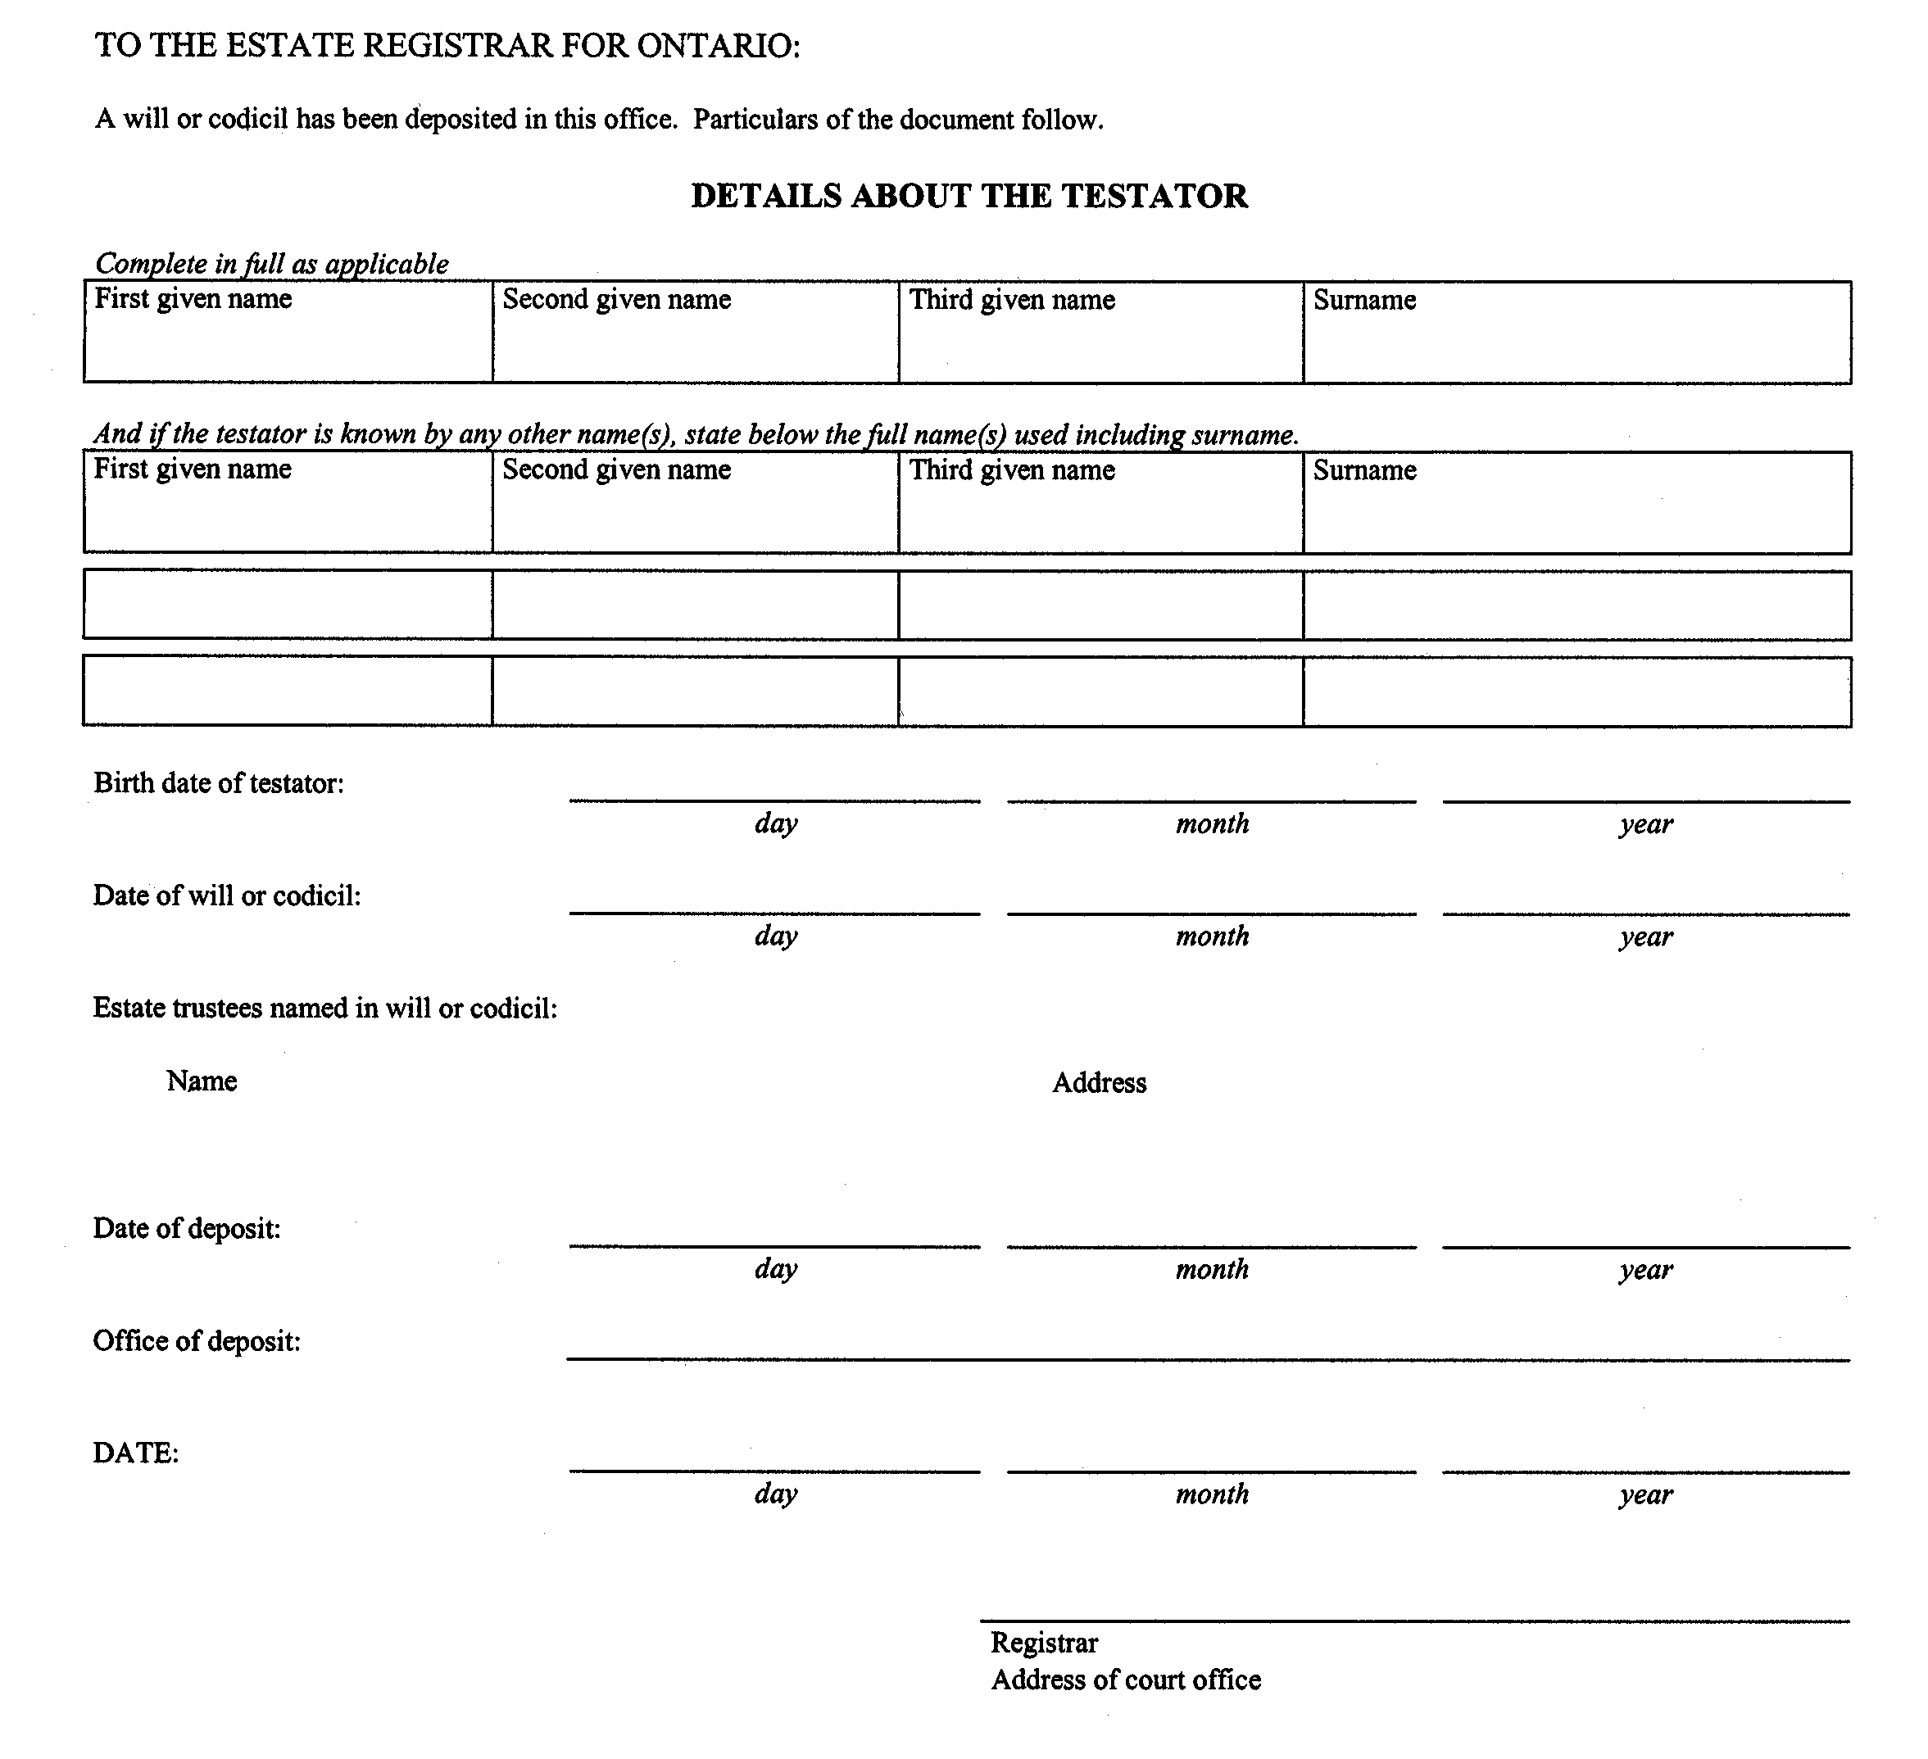
O. Reg. 132/04, s. 24
See: O. Reg. 132/04, ss. 24, 25 (1).
Form 74.2
Courts of Justice Act
notice to estate registrar of withdrawal of will or codicil
ONTARIO
SUPERIOR COURT OF JUSTICE
notice
TO THE ESTATE REGISTRAR FOR ONTARIO:
A will or codicil has been withdrawn from this office. Particulars of the document follow.
Details about the Testator

Complete in full as applicable | And if the testator is known by any other name, state below the full names used
First given name | Given name or names
Second given name
Third given name | Surname
Surname

Birth date of testator: | day | month | year
Date of will or codicil: | day | month | year
Date of deposit: | day | month | year
Date of withdrawal: | day | month | year
Office of deposit:

DATE: | day | month | year

Registrar
Address of court office
O. Reg. 484/94, s. 13; O. Reg. 292/99, s. 1 (3, 4); O. Reg. 24/00, s. 21.
Note: On January 1, 2005, Form 74.2 is revoked and the following substituted:
Form 74.2
Courts of Justice Act
notice to estate registrar of withdrawal of will or codicil
ontario
superior court of justice
notice
Insert regs\Graphics\Source Law\2004\132\132742ae.tif
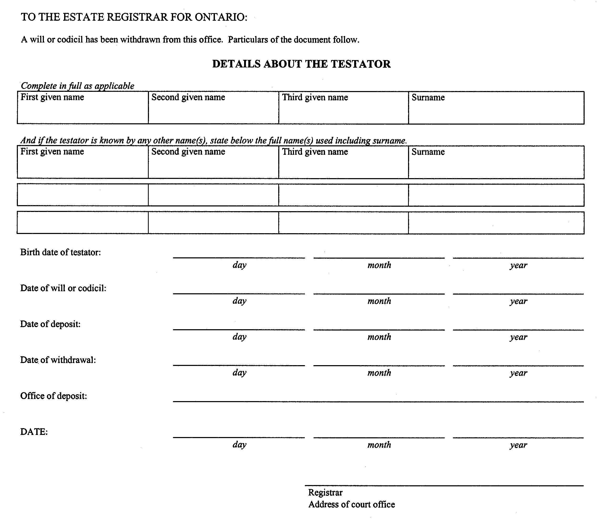
O. Reg. 132/04, s. 24.
See: O. Reg. 132/04, ss. 24, 25 (1).
Form 74.3
Courts of Justice Act
Request for notice of commencement of proceeding
ONTARIO
SUPERIOR COURT OF JUSTICE
In the Estate of the deceased person described below:
Details about the Deceased Person

Complete in full as applicable | And if the deceased was known by any other name, state below the full names used
First given name | Given name or names
Second given name
Third given name | Surname
Surname

REQUEST FOR NOTICE OF COMMENCEMENT OF PROCEEDING
I have or appear to have a financial interest in the estate and desire to be informed of the commencement of any proceeding in the estate.
Notice of the commencement of any proceeding may be mailed to me at the address shown below.
DATE | day | month | year

NAME OF INTERESTED PARTY: ADDRESS:
O. Reg. 484/94, s. 13; O. Reg. 292/99, s. 1 (3, 4); O. Reg. 24/00, s. 22; O. Reg. 653/00, s. 17.
Note: On January 1, 2005, Form 74.3 is revoked and the following substituted:
Form 74.3
Courts of Justice Act
request for notice of commencment of proceeding
ontario
superior court of justice
Insert regs\Graphics\Source Law\2004\132\132743ae.tif
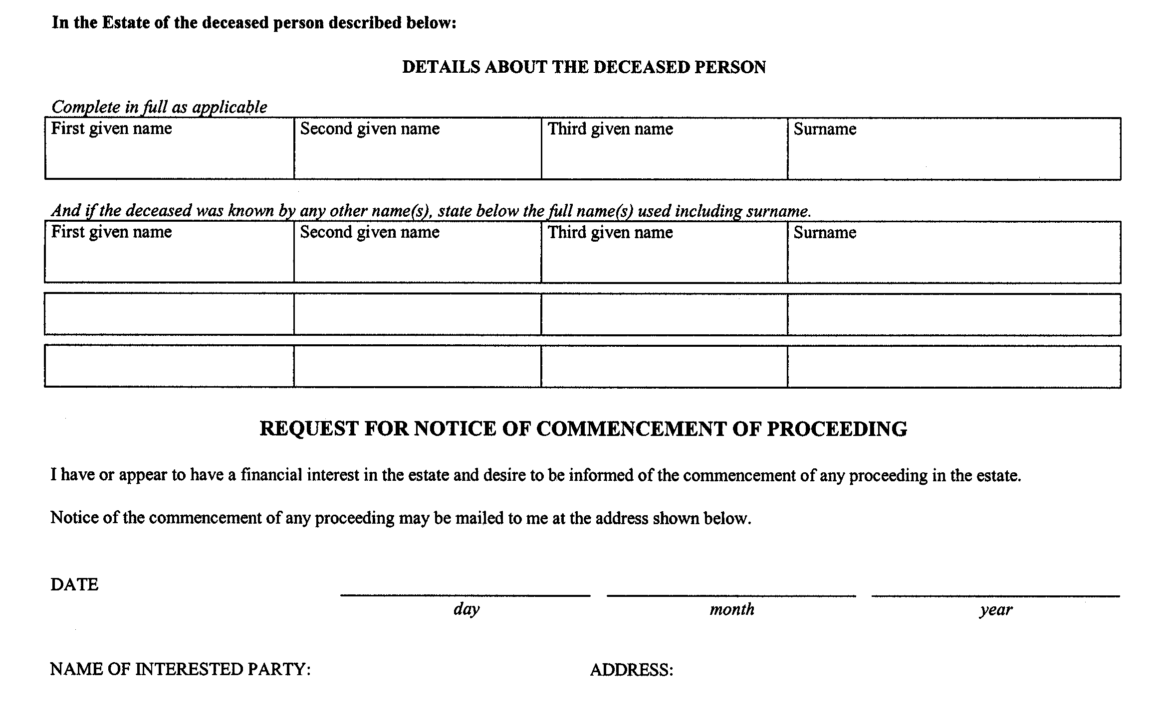
O. Reg. 132/04, s. 24.
See: O. Reg. 132/04, ss. 24, 25 (1).
Form 74.4
Courts of Justice Act
APPLICATION FOR CERTIFICATE OF APPOINTMENT OF ESTATE TRUSTEE WITH A WILL (INDIVIDUAL APPLICANT)
APPLICATION FOR CERTIFICATE WITH WILL (INDIVIDUAL) (Form 74.4 under the Rules)
ONTARIO APPLICATION FOR CERTIFICATE OF
SUPERIOR COURT OF JUSTICE APPOINTMENT OF ESTATE TRUSTEE
at WITH A WILL (INDIVIDUAL APPLICANT)
This application is filed by (insert name and address)
DETAILS ABOUT THE DECEASED PERSON
Complete in full as applicable | And if the deceased was known by any other name, state below the full names used
First given name | Given name or names
Second given name
Third given name | Surname
Surname

Address of fixed place of abode (street or postal address) (city or town) |  |  |  |  | (county, district, regional or  metropolitan municipality)
If the deceased person had no fixed place of abode in Ontario,  did he or she have property in Ontario? □ No □ Yes |  |  | Last occupation of deceased person
Place of death  (city or town; county, district, regional or metropolitan municipality) |  |  | Date of death  (day, month, year) |  |  |  | Date of last will  (marked as Exhibit “A”)  (day, month, year)
Was the deceased person 18 years of age or older at the date of the will (or 21 years of age or older if the will is dated earlier than
September 1, 1971)?  No  Yes
If not, explain why certificate is being sought. Give details in an attached schedule.
Date of codicil (marked as Exhibit “B”)  (day, month, year) |  | Date of codicil (marked as Exhibit “C”)  (day, month, year)
Marital status   Unmarried □ Widowed   Married □ Divorced |  | Did the deceased person marry after the date of the will   No  Yes  If yes, explain why certificate is being sought. Give details in an attached schedule.
Was a marriage of the deceased person terminated by a judgment absolute of divorce, or declared a nullity, after the date of the will?   No  Yes If yes, give details in an attached schedule. |  | Is any person who signed the will or a codicil as witness or for the testator, or the spouse of such person, a beneficiary under the will?   No  Yes If yes, give details in an attached schedule.
VALUE OF ASSETS OF ESTATE
Do not include in the total amount: insurance payable to a named beneficiary or assigned for value, property held jointly and passing by survivorship, or real estate outside Ontario.
Personal property  $ | Real estate,  net of encumbrances  $ |  |  |  |  | Total  $
Is there any person entitled to an interest in the estate who is not an applicant? □ No □ Yes
If a person named in the will or a codicil as estate trustee is not an applicant, explain.
If a person not named in the will or a codicil a estate trustee is an applicant, explain why that person is entitled to apply.
If the spouse of the deceased is an applicant, has the spouse elected to receive the entitlement under section 5 of the Family Law Act?
□ No □ Yes
If yes, explain why the spouse is entitled to apply
AFFIDAVIT(S) OF APPLICANT(S)
(Attach a separate sheet for additional affidavits, if necessary)
I, an applicant named in this application, make oath and say/affirm:
1. I am 18 years of age or older.  2. The exhibit(s) referred to in this application are the last will and each codicil (where applicable) of the deceased person and I do not know of any later will or codicil.  3. I will faithfully administer the deceased person’s property according to law and render a complete and true account of my administration when lawfully required. |  |  | 4. If I am not named as estate trustee in the will or codicil, consents of persons who together have a majority interest in the value of the assets of the estate at the date of death are attached.  5. The information contained in this application and in any attached schedules is true, to the best of my knowledge and belief.
Name (surname and forename(s)) |  |  |  |  | Occupation
Address (street or postal address) (city or town) (province) (postal code)
Sworn/Affirmed before me at the  of  in the  of  this day of , 20  A Commissioner for Taking Affidavits  (or as may be) |  |  |  | Signature of applicant

I, an applicant named in this application, make oath and say/affirm:
1. I am 18 years of age or older.  2. The exhibit(s) referred to in this application are the last will and each codicil (where applicable) of the deceased person and I do not know of any later will or codicil.  3. I will faithfully administer the deceased person’s property according to law and render a complete and true account of my administration when lawfully required. | 4. If I am not named as estate trustee in the will or codicil, consents of persons who together have a majority interest in the value of the assets of the estate at the date of death are attached.  5. The information contained in this application and in any attached schedules is true, to the best of my knowledge and belief.
Name (surname and forename(s)) |  |  | Occupation
Address (street or postal address) (city or town) (province) (postal code)
Sworn/Affirmed before me at the  of  in the  of  this day of , 20  A Commissioner for Taking Affidavits  (or as may be) |  | Signature of applicant

O. Reg. 332/96, s. 5; O. Reg. 292/99, s. 1 (3, 4); O. Reg. 24/00, s. 23
Note: On January 1, 2005, Form 74.4 is revoked and the following substituted:
Form 74.4
Courts of Justice Act
Application for certificate of appointment of estate trustee with a will (individual applicant)
Insert regs\Graphics\Source Law\2004\132\132744ae.tif
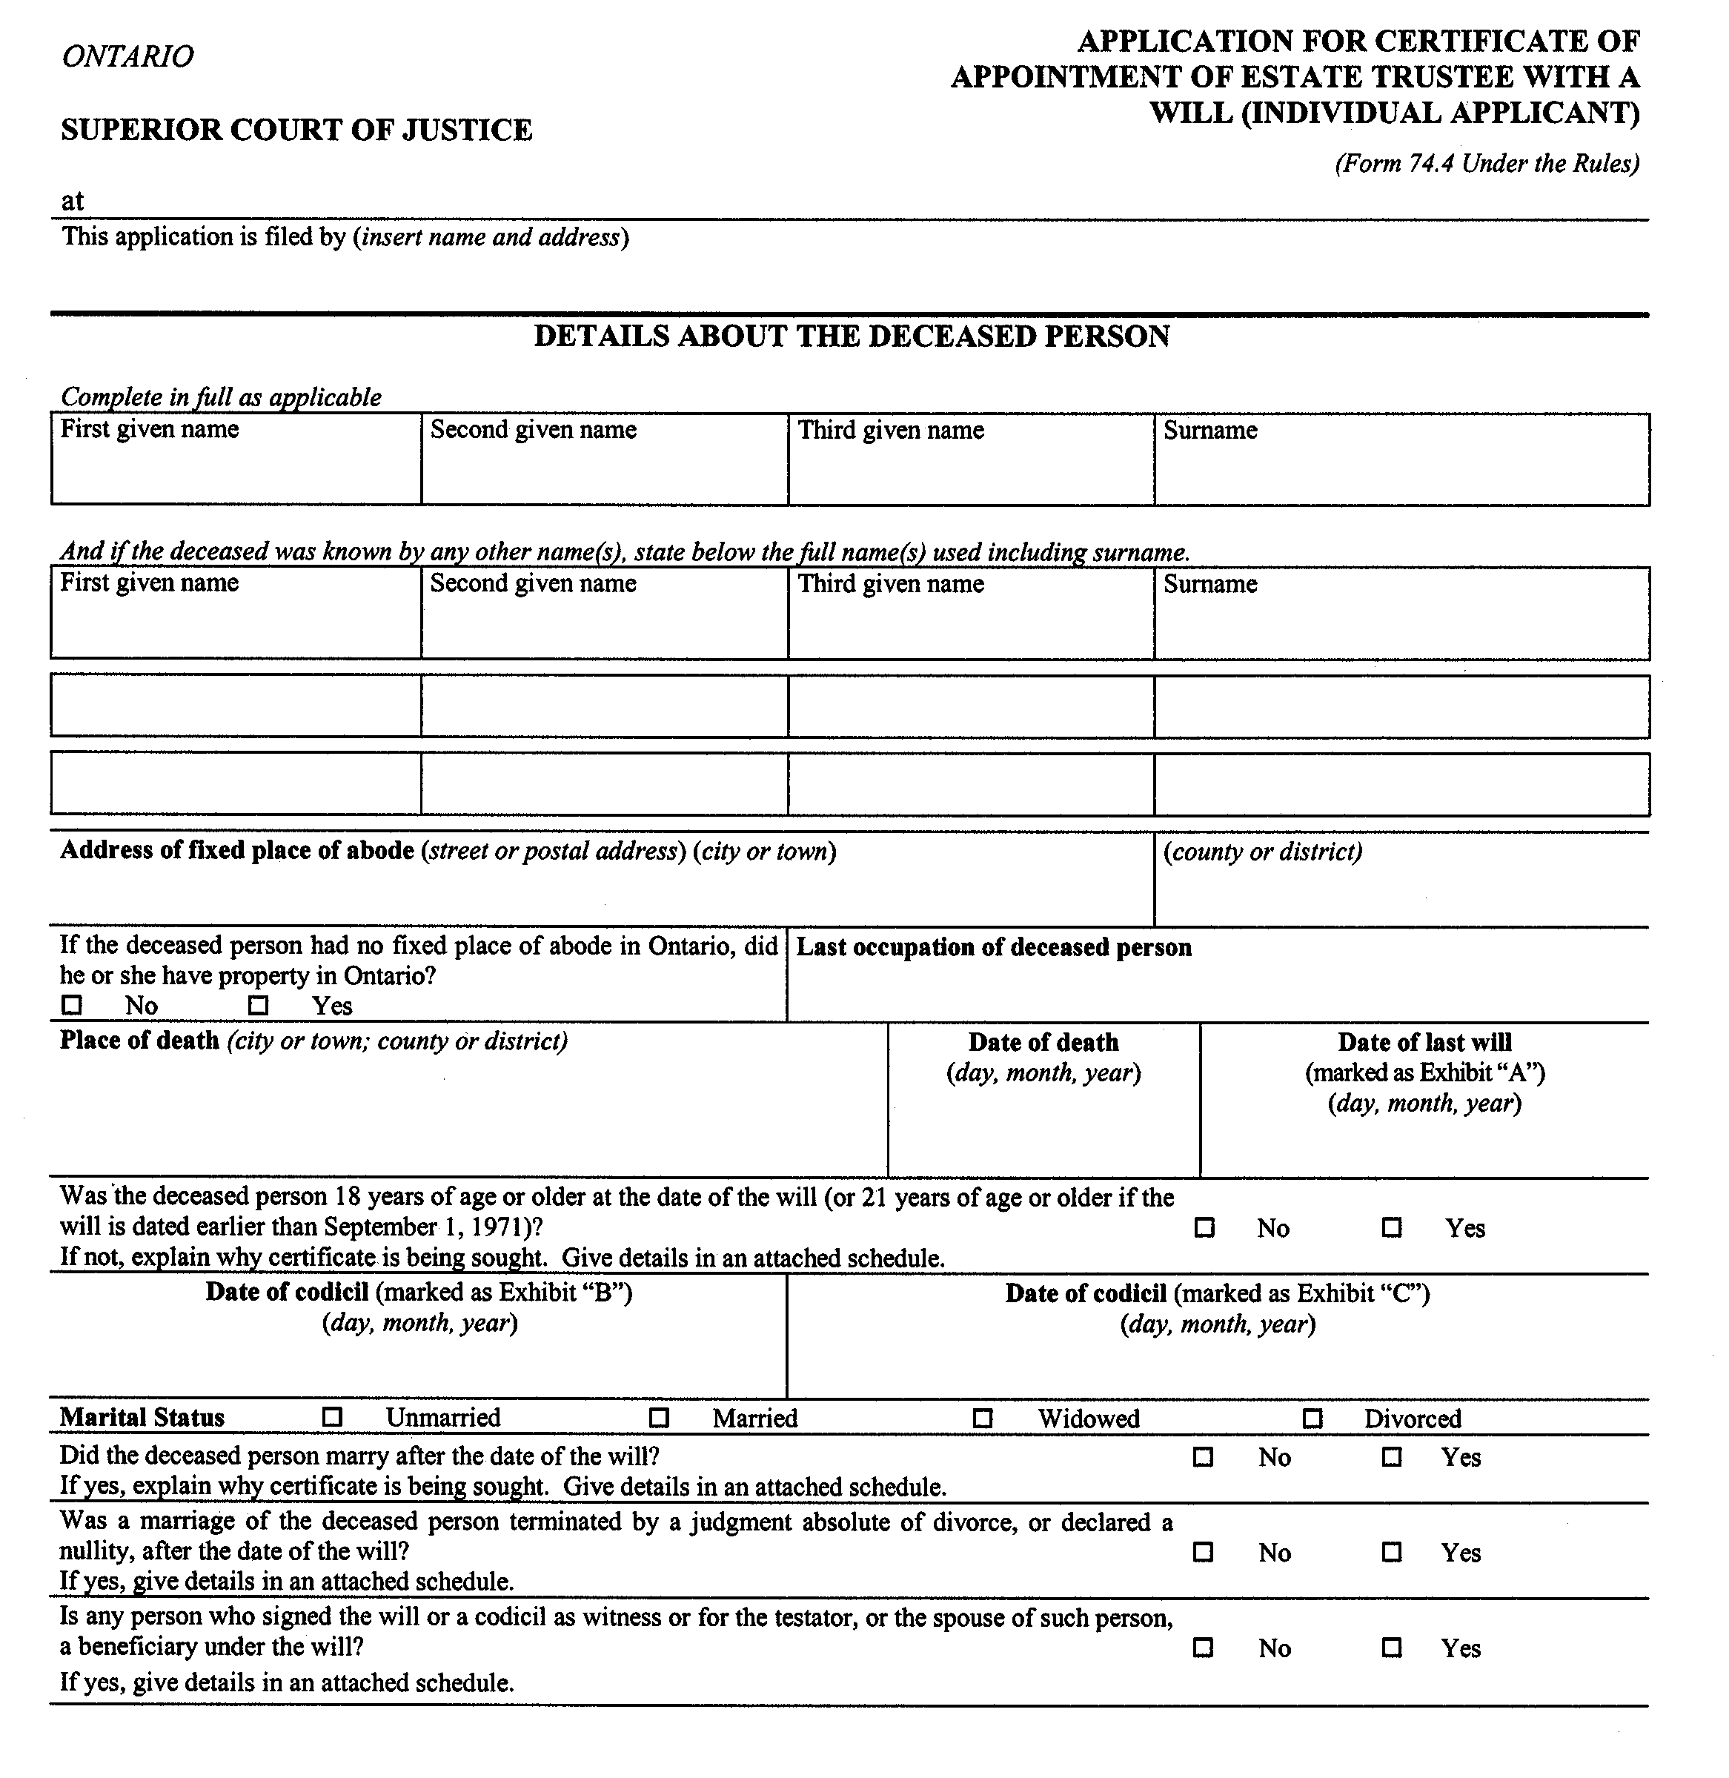
Insert regs\Graphics\Source Law\2004\132\132744be.tif
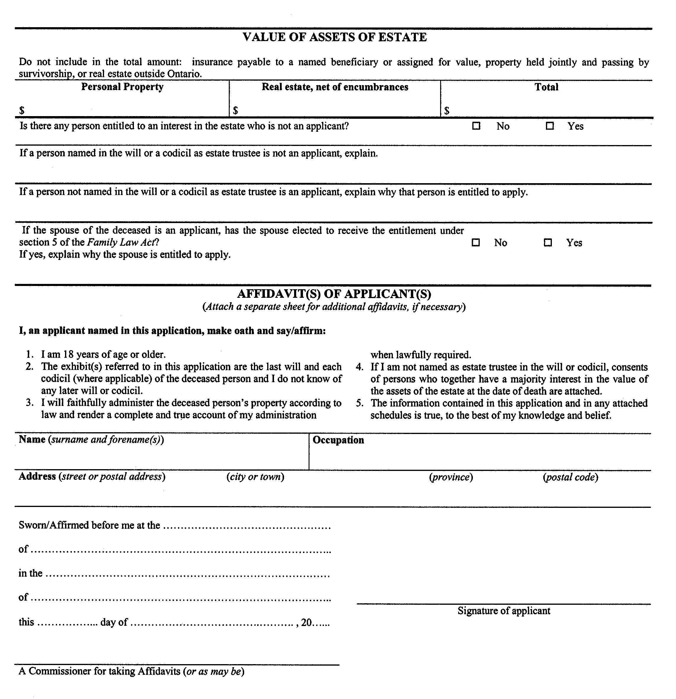
Insert regs\Graphics\Source Law\2004\132\132744ce.tif
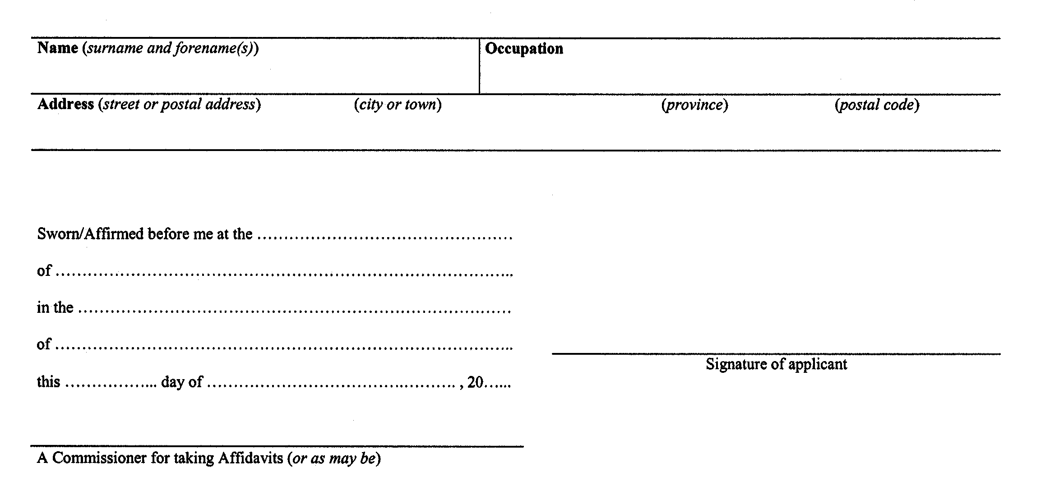
O. Reg. 132/04, s. 24.
See: O. Reg. 132/04, ss. 24, 25 (1).
Form 74.4.1
Courts of Justice Act
APPLICATION FOR CERTIFICATE OF APPOINTMENT OF ESTATE TRUSTEE
WITH A WILL (INDIVIDUAL APPLICANT)
LIMITED TO ASSETS REFERRED TO IN THE WILL
ONTARIO
SUPERIOR COURT OF JUSTICE
at
This application is filed by (insert name and address)
DETAILS ABOUT THE DECEASED PERSON
Complete in full as applicable |  |  |  | And if the deceased was known by any other name, state below the full names used
First given name |  |  |  | Given name or names
Second given name
Third given name |  |  |  | Surname
Surname
Address of fixed place of abode (street or postal address) (city or town) |  |  |  |  |  |  | (county, district, regional or  metropolitan municipality)
If the deceased person had no fixed place of abode in Ontario,  did he or she have property in Ontario? □ No □ Yes |  |  |  | Last occupation of deceased person
Place of death  (city or town; county, district, regional or metropolitan municipality) |  |  |  | Date of death  (day, month, year) |  |  |  |  | Date of last will  (marked as Exhibit “A”)  (day, month, year)
Was the deceased person 18 years of age or older at the date of the will (or 21 years of age or older if the will is dated earlier than
September 1, 1971)? □No □ Yes
If not, explain why certificate is being sought. Give details in an attached schedule.
Date of codicil (marked as Exhibit “B”)  (day, month, year) |  |  | Date of codicil (marked as Exhibit “C”)  (day, month, year)
Marital status  □ Unmarried □ Widowed  □ Married □ Divorced |  |  | Did the deceased person marry after the date of the will? No Yes  If yes, explain why certificate is being sought. Give details in an attached schedule.
Was a marriage of the deceased person terminated by a judgment absolute of divorce, or declared a nullity, after the date of the will?  No Yes If yes, give details in an attached schedule. |  |  | Is any person who signed the will or a codicil as witness or for the testator,  or the spouse of such person, a beneficiary under the will?  □ No □Yes If yes, give details in an attached schedule.
VALUE OF ASSETS REFERRED TO IN ATTACHED WILL
Do not include in the total amount: insurance payable to a named beneficiary or assigned for value, property held jointly and passing by survivorship, or real estate outside Ontario.
Personal property  $ |  | Real estate,  net of encumbrances  $ |  |  |  |  |  | Total  $
Is there any person entitled to an interest in the estate who is not an applicant? □ No □ Yes
If a person named in the will or a codicil as estate trustee is not an applicant, explain.
If a person not named in the will or a codicil as estate trustee is an applicant, explain why that person is entitled to apply.
If the spouse of the deceased is an applicant, has the spouse elected to receive the entitlement under section 5 of the Family Law Act?
□ No □ Yes
If yes, explain why the spouse is entitled to apply
AFFIDAVIT(S) OF APPLICANT(S)
(Attach a separate sheet for additional affidavits, if necessary)
I, an applicant named in this application, make oath and say/affirm:
1. | I am 18 years of age or older. |  |  | 4. | If I am not named as estate trustee in the will or codicil, consents
2. | The exhibit(s) referred to in this application are the last will and |  |  |  | of persons who together have a majority interest in the value of
 | each codicil (where applicable) of the deceased person relating to |  |  |  | the assets of the estate at the date of death are attached.
 | the assets referred to in the will and I do not know of any later |  |  | 5. | The information contained in this application and in any attached
 | will or codicil affecting those assets. |  |  |  | schedules is true, to the best of my knowledge and belief.
3. | I will faithfully administer the deceased person’s property
 | according to law and render a complete and true account of my
 | administration when lawfully required.
Name (surname and forename(s)) |  |  |  |  |  |  | Occupation
Address (street or postal address) (city or town) (province) (postal code)

Sworn/Affirmed before me at the  of  in the  of  this day of , 20  A Commissioner for Taking Affidavits  (or as may be) |  |  |  | Signature of applicant
AFFIDAVIT(S) OF APPLICANT(S)
(Attach a separate sheet for additional affidavits, if necessary)
I, an applicant named in this application, make oath and say/affirm:
1. | I am 18 years of age or older. |  |  | 4. | If I am not named as estate trustee in the will or codicil, consents
2. | The exhibit(s) referred to in this application are the last will and |  |  |  | of persons who together have a majority interest in the value of
 | each codicil (where applicable) of the deceased person relating to |  |  |  | the assets of the estate at the date of death are attached.
 | the assets referred to in the will and I do not know of any later |  |  | 5. | The information contained in this application and in any attached
 | will or codicil affecting those assets. |  |  |  | schedules is true, to the best of my knowledge and belief.
3. | I will faithfully administer the deceased person’s property
 | according to law and render a complete and true account of my
 | administration when lawfully required.
Name (surname and forename(s)) |  |  |  |  |  | Occupation
Address (street or postal address) (city or town) (province) (postal code)

Sworn/Affirmed before me at the  of  in the  of  this . day of , 20  A Commissioner for Taking Affidavits  (or as may be) |  |  |  | Signature of applicant

O. Reg. 653/00, s. 18; O. Reg. 84/01,s. 34.
Note: On January 1, 2005, Form 74.4.1 is revoked and the following substituted:
Form 74.4.1
Courts of Justice Act
application for certificate of appointment of estate trustee with a will (individual applicant) limited to assets referred to in the will
Insert regs\Graphics\Source Law\2004\132\1327441ae.tif
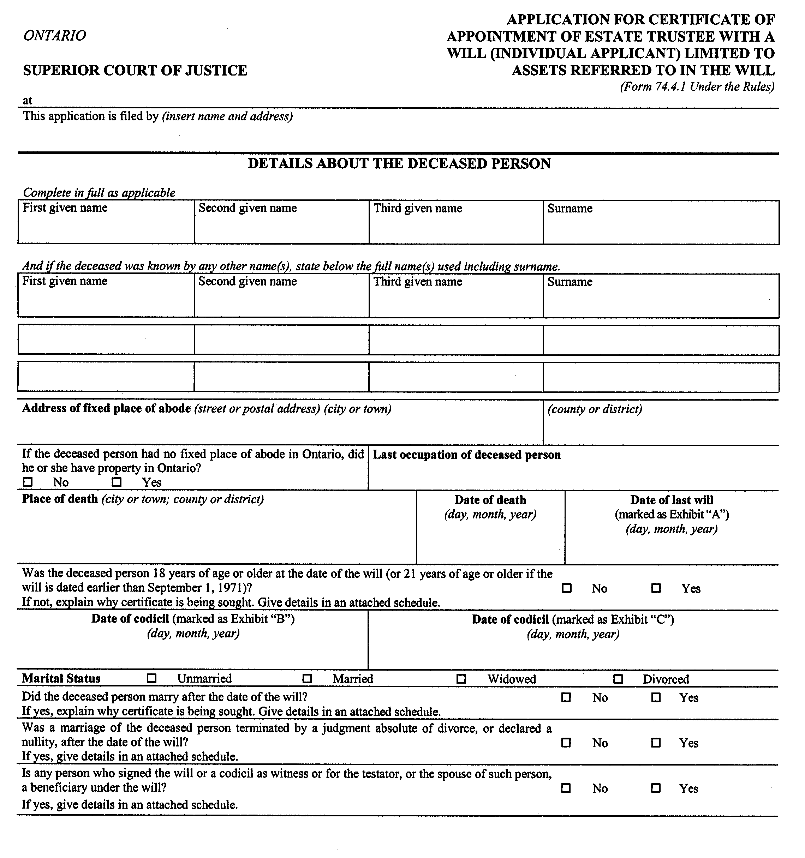
Insert regs\Graphics\Source Law\2004\132\1327441be.tif
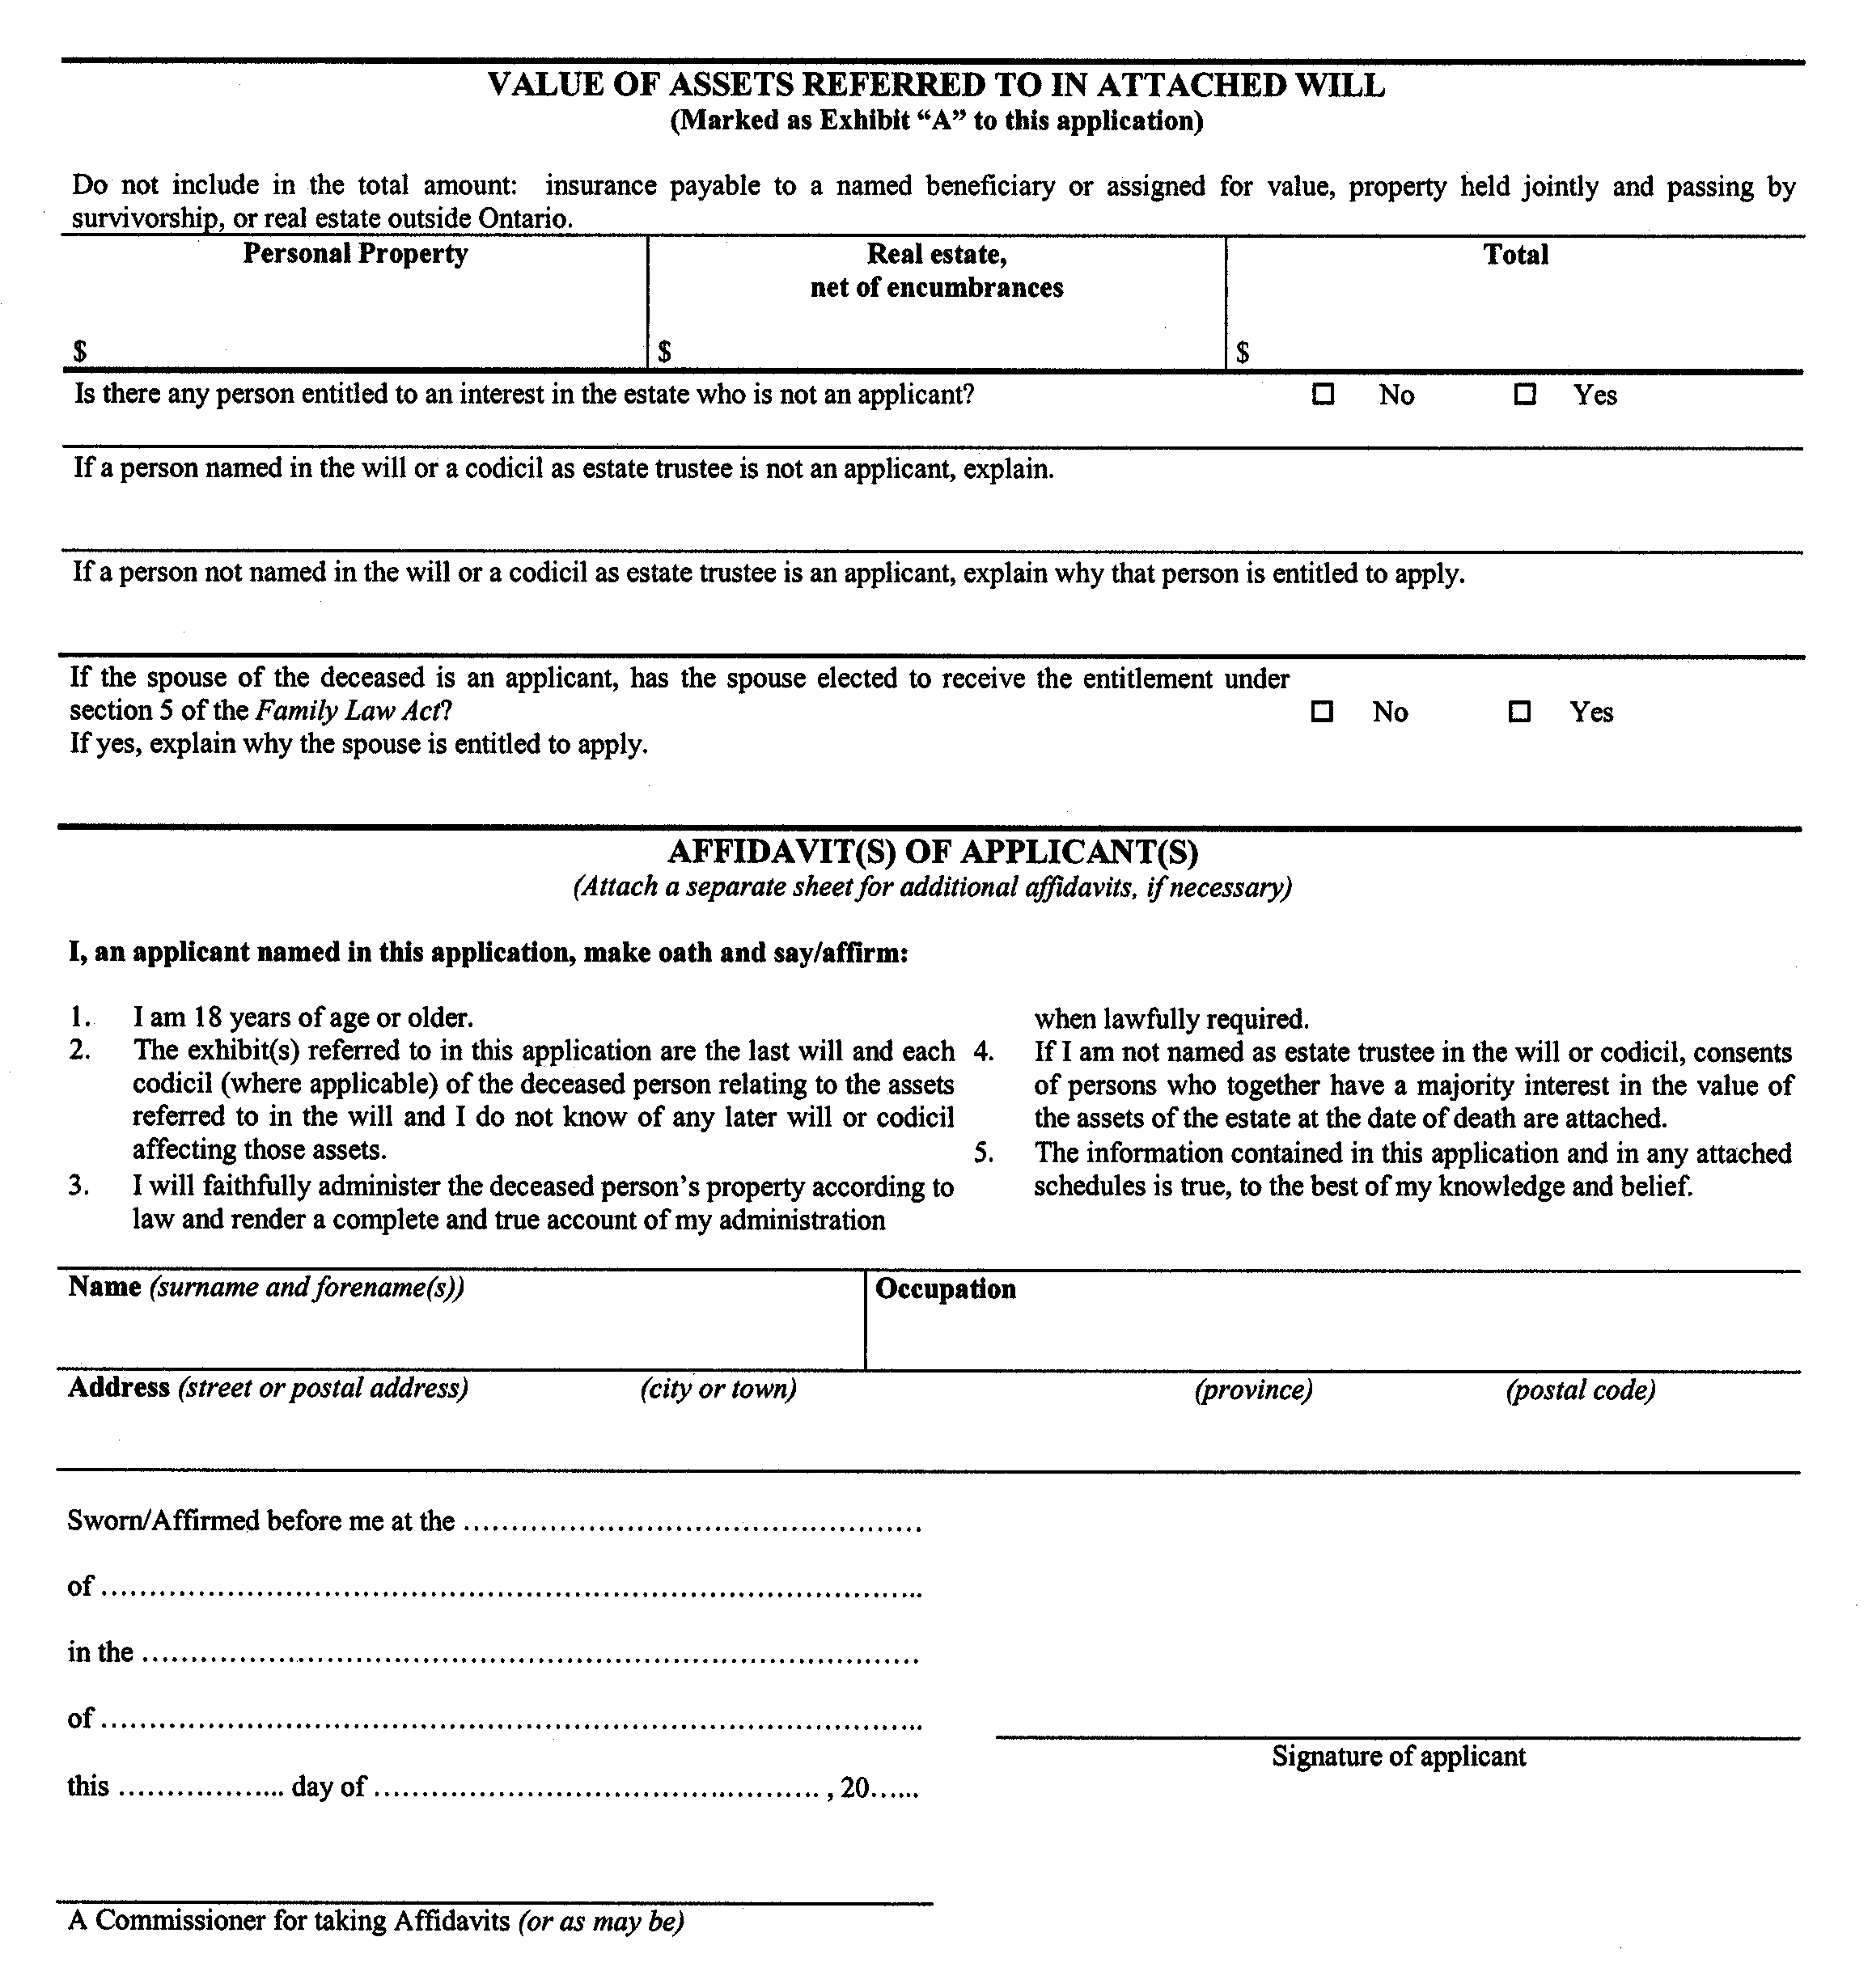
Insert regs\Graphics\Source Law\2004\132\1327441ce.tif
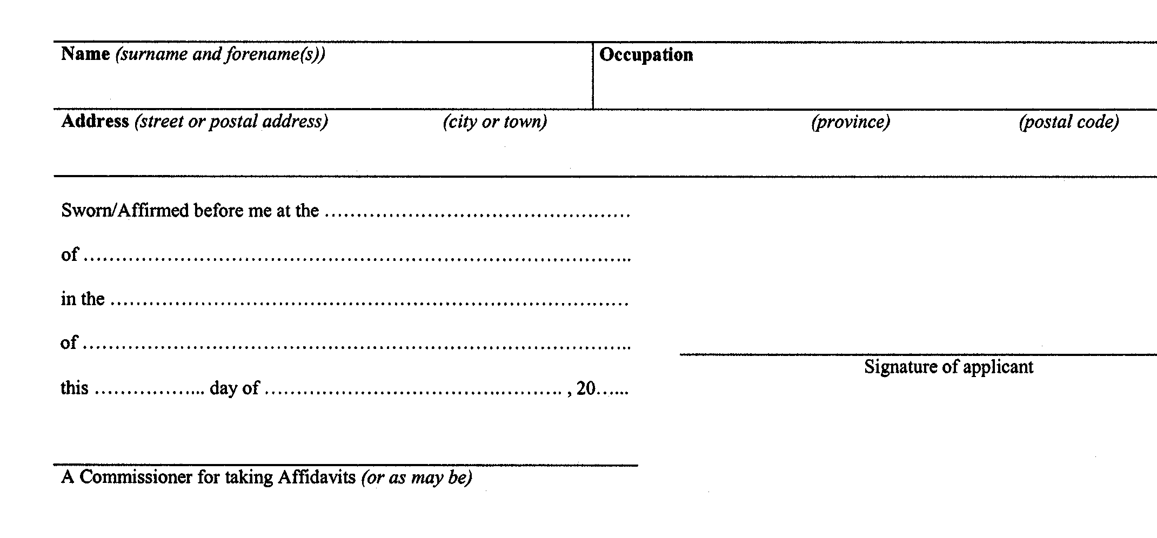
O. Reg. 132/04, s. 24.
See: O. Reg. 132/04, ss. 24, 25 (1).
Form 74.5
Courts of Justice Act
APPLICATION FOR CERTIFICATE OF APPOINTMENT OF ESTATE TRUSTEE WITH A WILL (CORPORATE APPLICANT)
APPLICATION FOR CERTIFICATE WITH WILL (CORPORATE) (Form 74.5 under the Rules)
ONTARIO APPLICATION FOR CERTIFICATE OF
SUPERIOR COURT OF JUSTICE APPOINTMENT OF ESTATE TRUSTEE
at WITH A WILL (CORPORATE APPLICANT)
This application is filed by (insert name and address)
DETAILS ABOUT THE DECEASED PERSON

Complete in full as applicable | And if the deceased was known by any other name, state below the full names used
First given name | Given name or names
Second given name
Third given name | Surname
Surname

Address of fixed place of abode (street or postal address) (city or town) |  |  |  |  | (county, district, regional or  metropolitan municipality)
If the deceased person had no fixed place of abode in Ontario,  did he or she have property in Ontario? □ No □ Yes |  |  | Last occupation of deceased person
Place of death  (city or town, county, district, regional or metropolitan municipality) |  |  | Date of death  (day, month, year) |  |  |  | Date of last will  (marked as Exhibit “A”)  (day, month, year)
Was the deceased person 18 years of age or older at the date of the will (or 21 years of age or older if the will is dated earlier than
September 1, 1971)? □ No □ Yes
If not, explain why certificate is being sought. Give details in an attached schedule.
Date of codicil (marked as Exhibit “B”)  (day, month, year) |  | Date of codicil (marked as Exhibit “C”)  (day, month, year)
Marital status  □ Unmarried □ Widowed  □ Married □ Divorced |  | Did the deceased person marry after the date of the will  □ No □ Yes  If yes, explain why certificate is being sought. Give details in an attached schedule.
Was a marriage of the deceased person terminated by a judgment absolute of divorce, or declared a nullity, after the date of the will?  □ No □ Yes If yes, give details in an attached schedule. |  | Is any person who signed the will or a codicil as witness or for the testator, or the spouse of such person, a beneficiary under the will?  □ No □ Yes If yes, give details in an attached schedule.
VALUE OF ASSETS OF ESTATE
Do not include in the total amount: insurance payable to a named beneficiary or assigned for value, property held jointly and passing by survivorship, or real estate outside Ontario.
Personal property  $ | Real estate,  net of encumbrances  $ |  |  |  |  | Total  $
Is there any person interested in the estate who is not an applicant? □ No □ Yes
If a person named in the will or a codicil as estate trustee is not an applicant, explain.
If a person not named in the will or a codicil a estate trustee is an applicant, explain why that person is entitled to apply.
If the spouse of the deceased is an applicant, has the spouse elected to receive the entitlement under section 5 of the Family Law Act?
□ No □ Yes
If yes, explain why the spouse is entitled to apply
AFFIDAVIT(S) OF APPLICANT(S)
(Attach a separate sheet for additional affidavits, if necessary)
I, a trust officer named in this application, make oath and say/affirm:
1. I am a trust officer of the corporate applicant.  2. I am 18 years of age or older.  3. The exhibit(s) referred to in this application are the last will and each codicil (where applicable) of the deceased person and I do not know of any later will or codicil.  4. The corporate applicant will faithfully administer the deceased person’s property according to law and render a complete and true account of its administration when lawfully required. |  |  | 5. If the corporate applicant is not named as estate trustee in the will or codicil, consents of persons who together have a majority interest in the value of the assets of the estate at the date of death are attached.  6. The information contained in this application and in any attached schedules is true, to the best of my knowledge and belief.
Name of corporate applicant |  |  |  |  | Name of trust officer
Address of corporate applicant (street or postal address) (city or town) (province) (postal code)
Sworn/Affirmed before me at the  of  in the  of  this day of , 20  A Commissioner for Taking Affidavits  (or as may be) |  |  |  | Signature of trust officer

I, an applicant named in this application, make oath and say/affirm:
1. I am 18 years of age or older.  2. The exhibit(s) referred to in this application are the last will and each codicil (where applicable) of the deceased person and I do not know of any later will or codicil.  3. I will faithfully administer the deceased person’s property according to law and render a complete and true account of my administration when lawfully required. | 4. If I am not named as estate trustee in the will or codicil, consents of persons who together have a majority interest in the value of the assets of the estate at the date of death are attached.  5. The information contained in this application and in any attached schedules is true, to the best of my knowledge and belief.
Name (surname and forename(s)) |  |  | Occupation
Address (street or postal address) (city or town) (province) (postal code)
Sworn/Affirmed before me at the  of  in the  of  this day of , 20  A Commissioner for Taking Affidavits  (or as may be) |  | Signature of applicant
O. Reg. 332/96, s. 5; O. Reg. 292/99, s. 1 (3, 4); O. Reg. 24/00, s. 24.
Note: On January 1, 2005, Form 74.5 is revoked and the following substituted:
Form 74.5
Courts of Justice Act
application for certificate of appointment of estate trustee with a will (corporate applicant)
Insert regs\Graphics\Source Law\2004\132\132745ae.tif
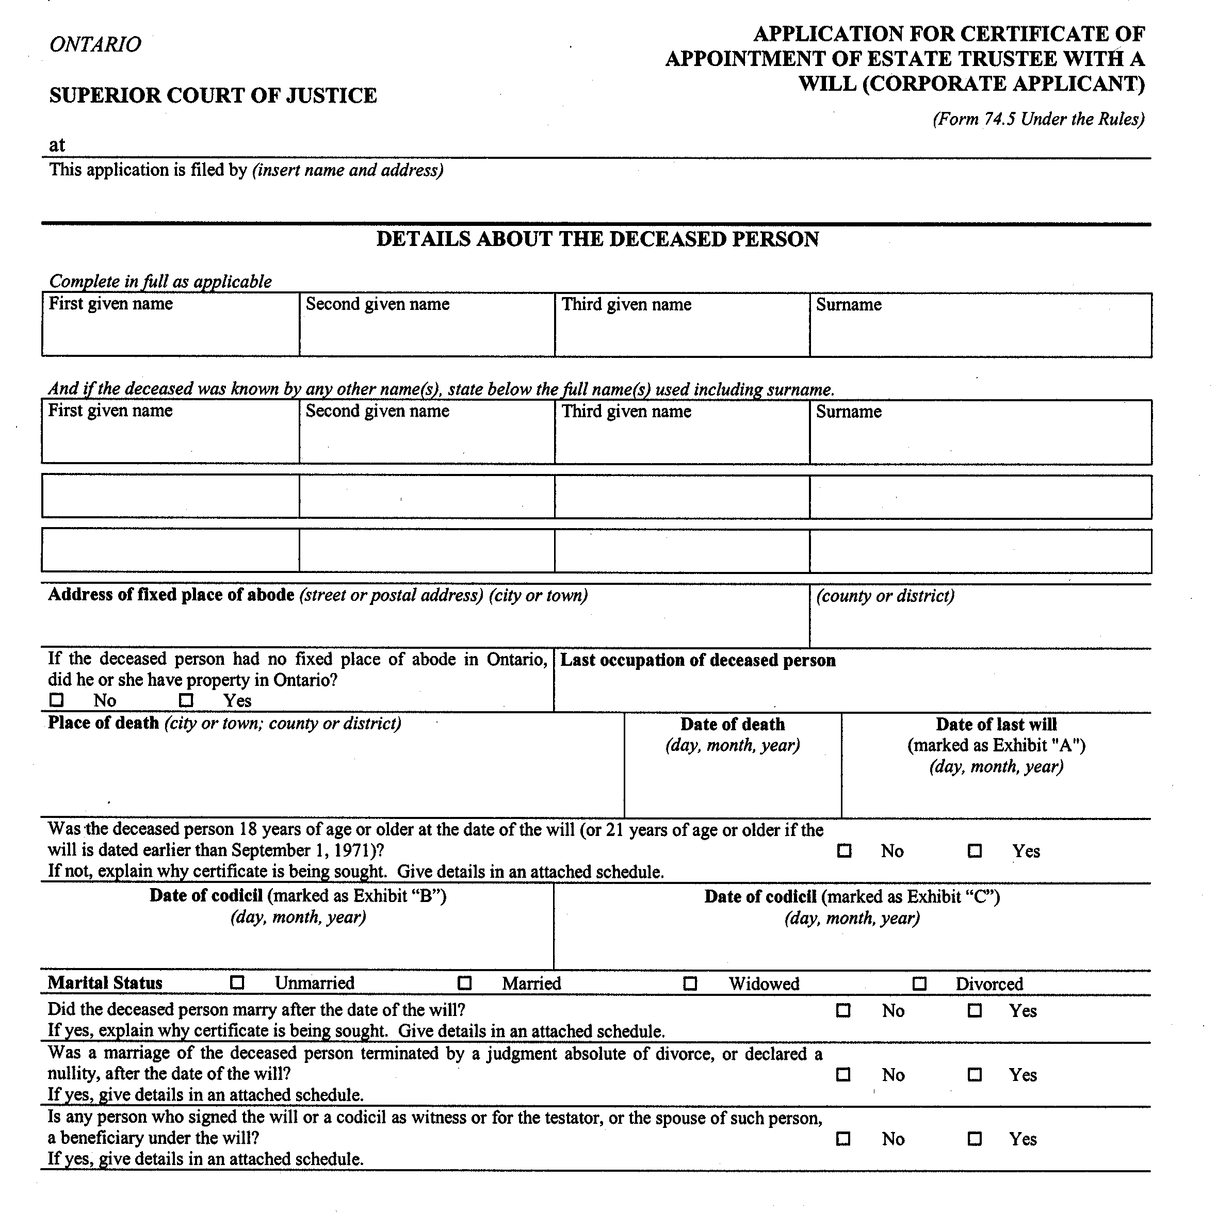
Insert regs\Graphics\Source Law\2004\132\132745be.tif
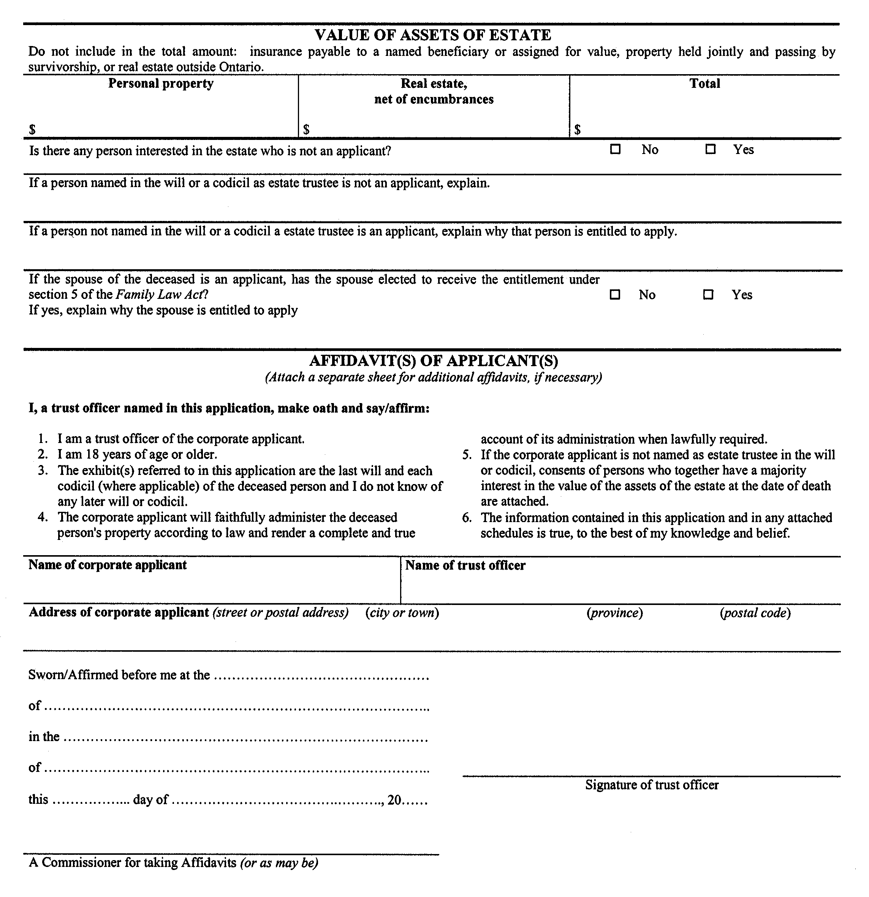
Insert regs\Graphics\Source Law\2004\132\132745ce.tif
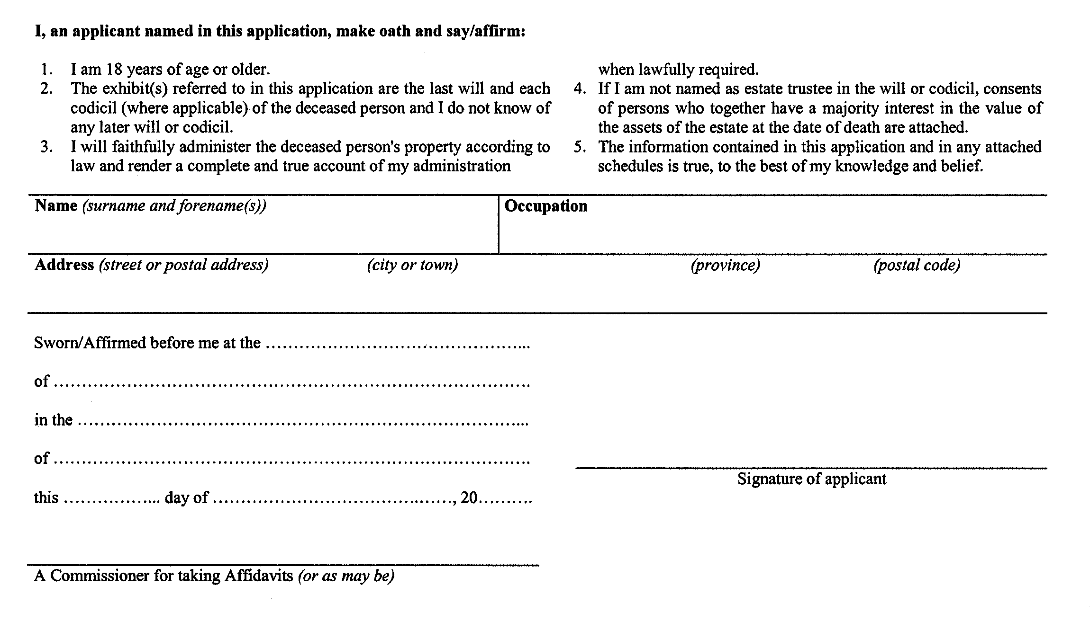
O. Reg. 132/04, s. 24.
See: O. Reg. 132/04, ss. 24, 25 (1).
Form 74.5.1
Courts of Justice Act
APPLICATION FOR CERTIFICATE OF APPOINTMENT OF ESTATE TRUSTEE
WITH A WILL (CORPORATE APPLICANT)
LIMITED TO ASSETS REFERRED TO IN THE WILL
ONTARIO
SUPERIOR COURT OF JUSTICE
at
This application is filed by (insert name and address)
DETAILS ABOUT THE DECEASED PERSON
Complete in full as applicable |  |  |  | And if the deceased was known by any other name, state below the full names used
First given name |  |  |  | Given name or names
Second given name
Third given name |  |  |  | Surname
Surname
Address of fixed place of abode (street or postal address) (city or town) |  |  |  |  |  |  |  |  | (county, district, regional or  metropolitan municipality)
If the deceased person had no fixed place of abode in Ontario,  did he or she have property in Ontario? □ No □ Yes |  |  |  | Last occupation of deceased person
Place of death  (city or town; county, district, regional or metropolitan municipality) |  |  |  | Date of death  (day, month, year) |  |  |  |  |  |  | Date of last will  (marked as Exhibit “A”)  (day, month, year)
Was the deceased person 18 years of age or older at the date of the will (or 21 years of age or older if the will is dated earlier than
September 1, 1971)? □ No □ Yes
If not, explain why certificate is being sought. Give details in an attached schedule.
Date of codicil (marked as Exhibit “B”)  (day, month, year) |  |  | Date of codicil (marked as Exhibit “C”)  (day, month, year)
Marital status  □ Unmarried □ Widowed  □ Married □ Divorced |  |  | Did the deceased person marry after the date of the will? □ No □ Yes  If yes, explain why certificate is being sought. Give details in an attached schedule.
Was a marriage of the deceased person terminated by a judgment absolute of divorce, or declared a nullity, after the date of the will?  □ No □ Yes If yes, give details in an attached schedule. |  |  | Is any person who signed the will or a codicil as witness or for the testator,  or the spouse of such person, a beneficiary under the will?  □ No □ Yes If yes, give details in an attached schedule.
VALUE OF ASSETS REFERRED TO IN ATTACHED WILL

Do not include in the total amount: insurance payable to a named beneficiary or assigned for value, property held jointly and passing by
survivorship, or real estate outside Ontario.
Personal property  $ |  | Real estate,  net of encumbrances  $ |  |  |  |  |  |  |  | Total  $
Is there any person interested in the estate who is not an applicant? □ No □ Yes
If a person named in the will or a codicil as estate trustee is not an applicant, explain.
If a person not named in the will or a codicil as estate trustee is an applicant, explain why that person is entitled to apply.
If the spouse of the deceased is an applicant, has the spouse elected to receive the entitlement under section 5 of the Family Law Act?
□ No □ Yes
If yes, explain why the spouse is entitled to apply
AFFIDAVIT(S) OF APPLICANT(S)
(Attach a separate sheet for additional affidavits, if necessary)
I, a trust officer named in this application, make oath and say/affirm:
1. | I am a trust officer of the corporate applicant. |  |  |  | 5. |  | If the corporate applicant is not named as estate trustee in the will
2. | I am 18 years of age or older. |  |  |  |  |  | or codicil, consents of persons who together have a majority
3. | The exhibit(s) referred to in this application are the last will and each |  |  |  |  |  | interest in the value of the assets of the estate at the date of death
 | codicil (where applicable) of the deceased person relating to the |  |  |  |  |  | are attached.
 | assets referred to in the will and I do not know of any later will or |  |  |  | 6. |  | The information contained in this application and in any attached
 | codicil affecting those assets. |  |  |  |  |  | schedules is true, to the best of my knowledge and belief.
4. | The corporate applicant will faithfully administer the deceased
 | person’s property according to law and render a complete and true
 | account of its administration when lawfully required.
Name of corporate applicant |  |  |  |  |  |  |  |  | Name of trust officer
Address of corporate applicant (street or postal address) (city or town) (province) (postal code)

Sworn/Affirmed before me at the  of  in the  of  this . day of , 20  .  A Commissioner for Taking Affidavits  (or as may be) |  |  |  | Signature of trust officer
AFFIDAVIT(S) OF APPLICANT(S)
(Attach a separate sheet for additional affidavits, if necessary)
I, an applicant named in this application, make oath and say/affirm:
1. | I am 18 years of age or older. |  |  | 4. |  | If I am not named as estate trustee in the will or codicil, consents
2. | The exhibit(s) referred to in this application are the last will and |  |  |  |  | of persons who together have a majority interest in the value of
 | each codicil (where applicable) of the deceased person relating to |  |  |  |  | the assets of the estate at the date of death are attached.
 | the assets referred to in the will and I do not know of any later |  |  | 5. |  | The information contained in this application and in any attached
 | will or codicil affecting those assets. |  |  |  |  | schedules is true, to the best of my knowledge and belief.
3. | I will faithfully administer the deceased person’s property
 | according to law and render a complete and true account of my
 | administration when lawfully required.
Name (surname and forename(s)) |  |  |  |  |  |  |  | Occupation
Address (street or postal address) (city or town) (province) (postal code)

Sworn/Affirmed before me at the  of  in the  of  this day of , 20  A Commissioner for Taking Affidavits  (or as may be) |  |  |  | Signature of applicant

O. Reg. 653/00, s. 19: O. Reg. 284/01, s. 35.
Note: On January 1, 2005, Form 74.5.1 is revoked and the following substituted:
Form 74.5.1
Courts of Justice Act
application for certificate of appointment of estate trustee with a will (corporate applicant) limited to assets referred to in the will
Insert regs\Graphics\Source Law\2004\132\1327451ae.tif
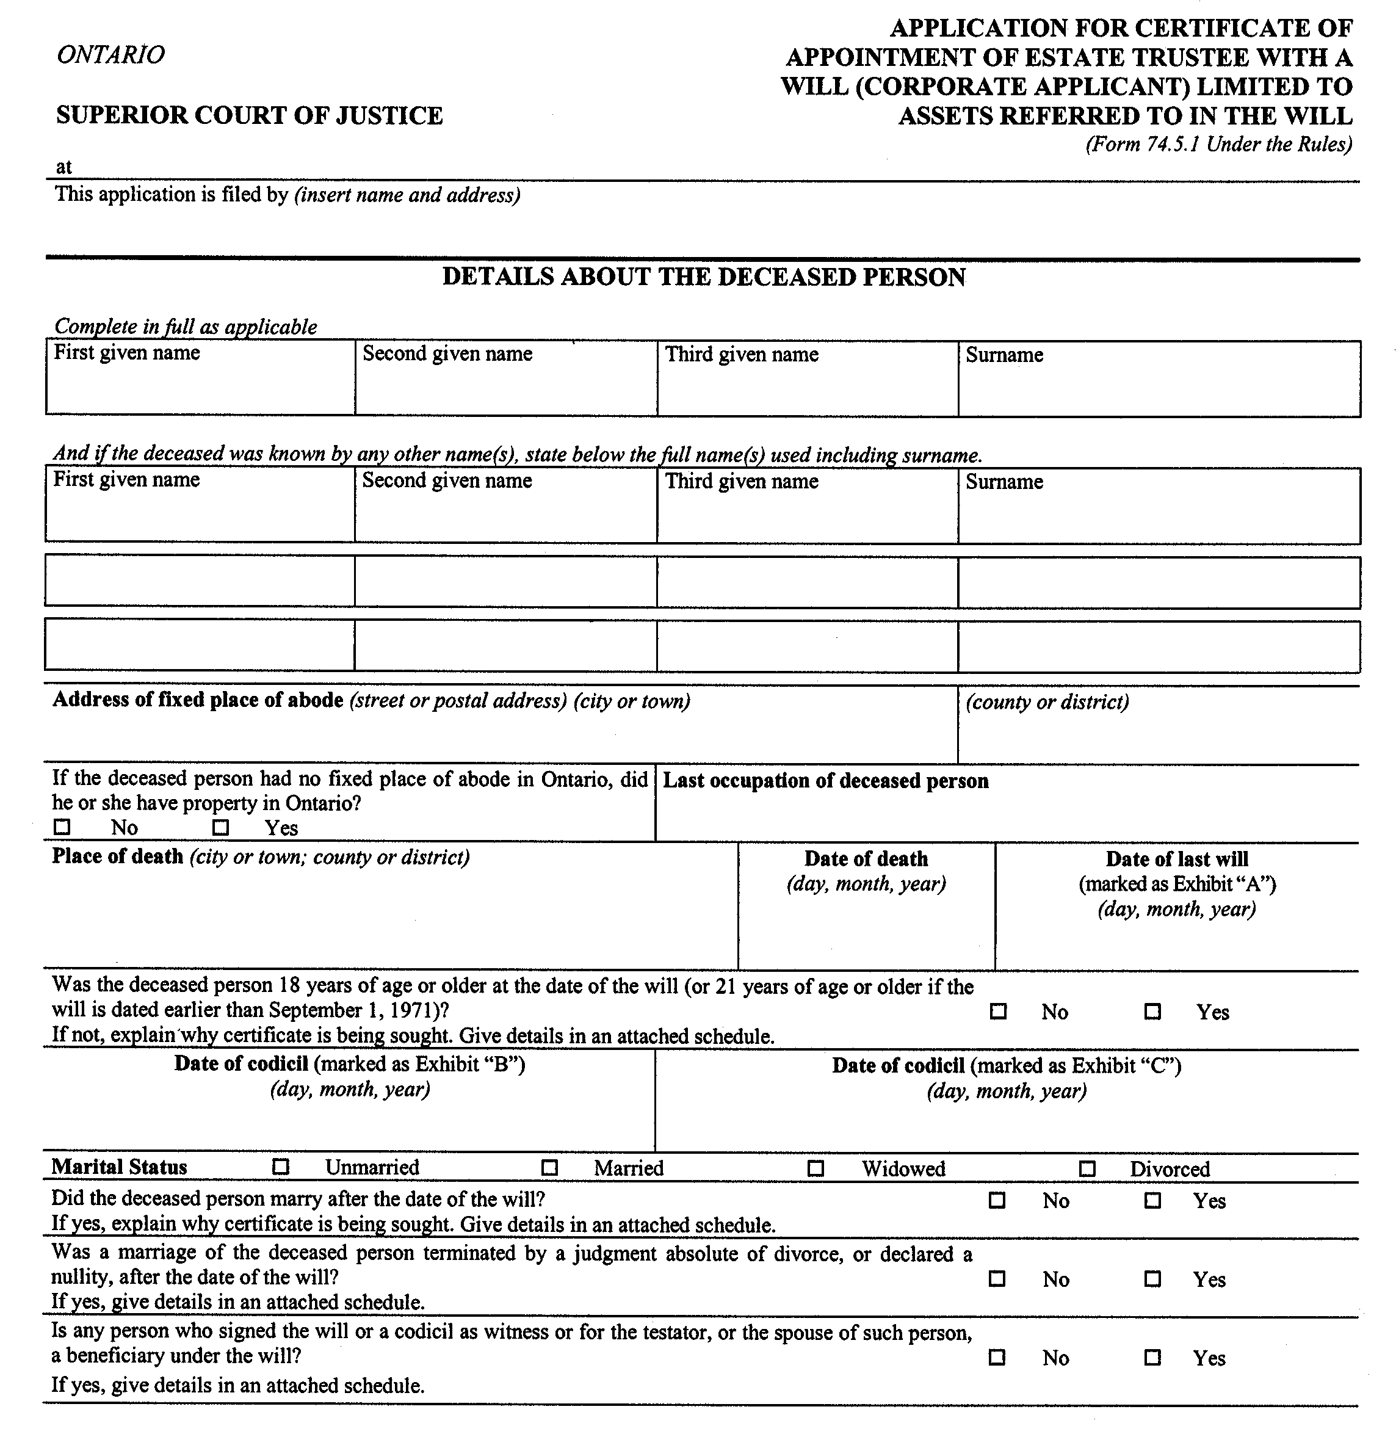
Insert regs\Graphics\Source Law\2004\132\1327451be.tif
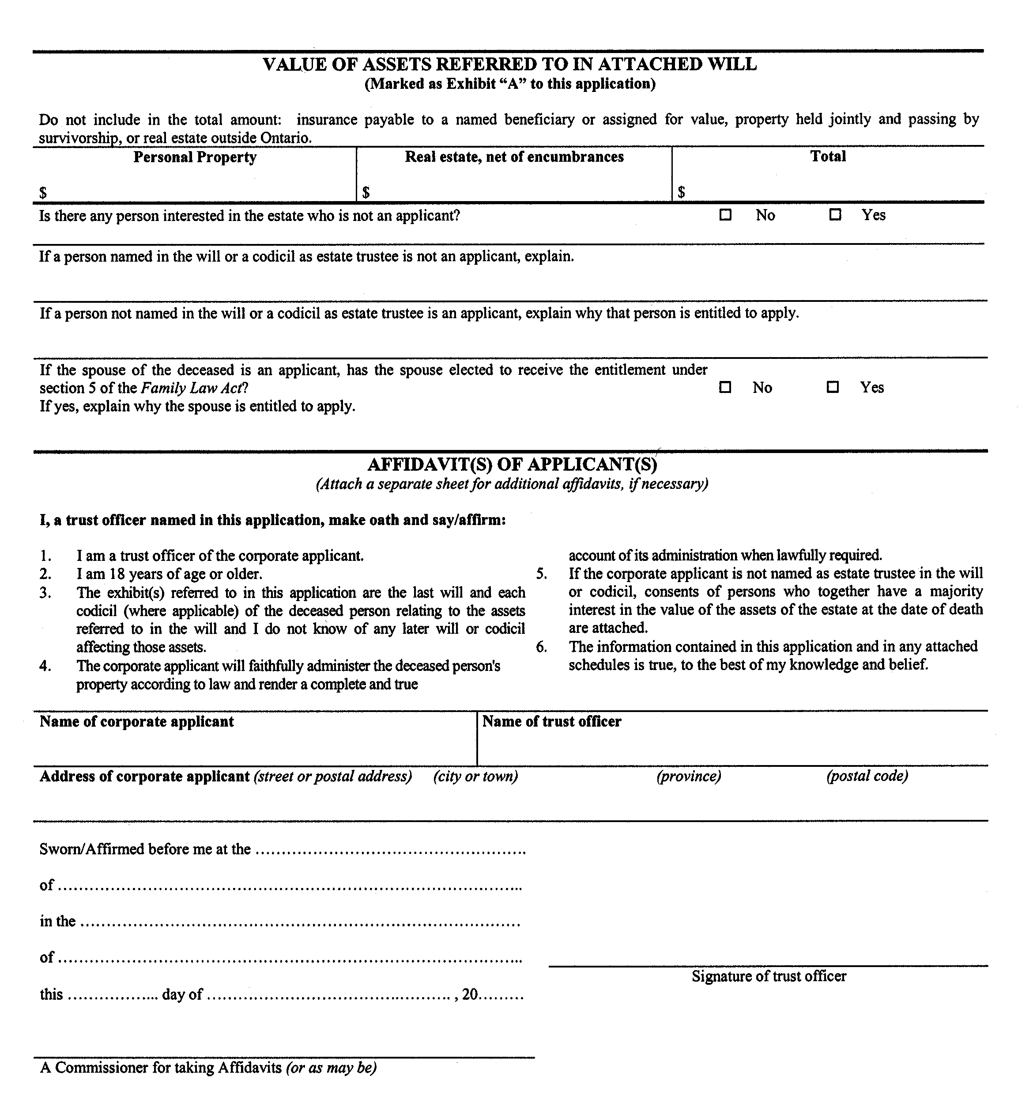
Insert regs\Graphics\Source Law\2004\132\1327451ce.tif
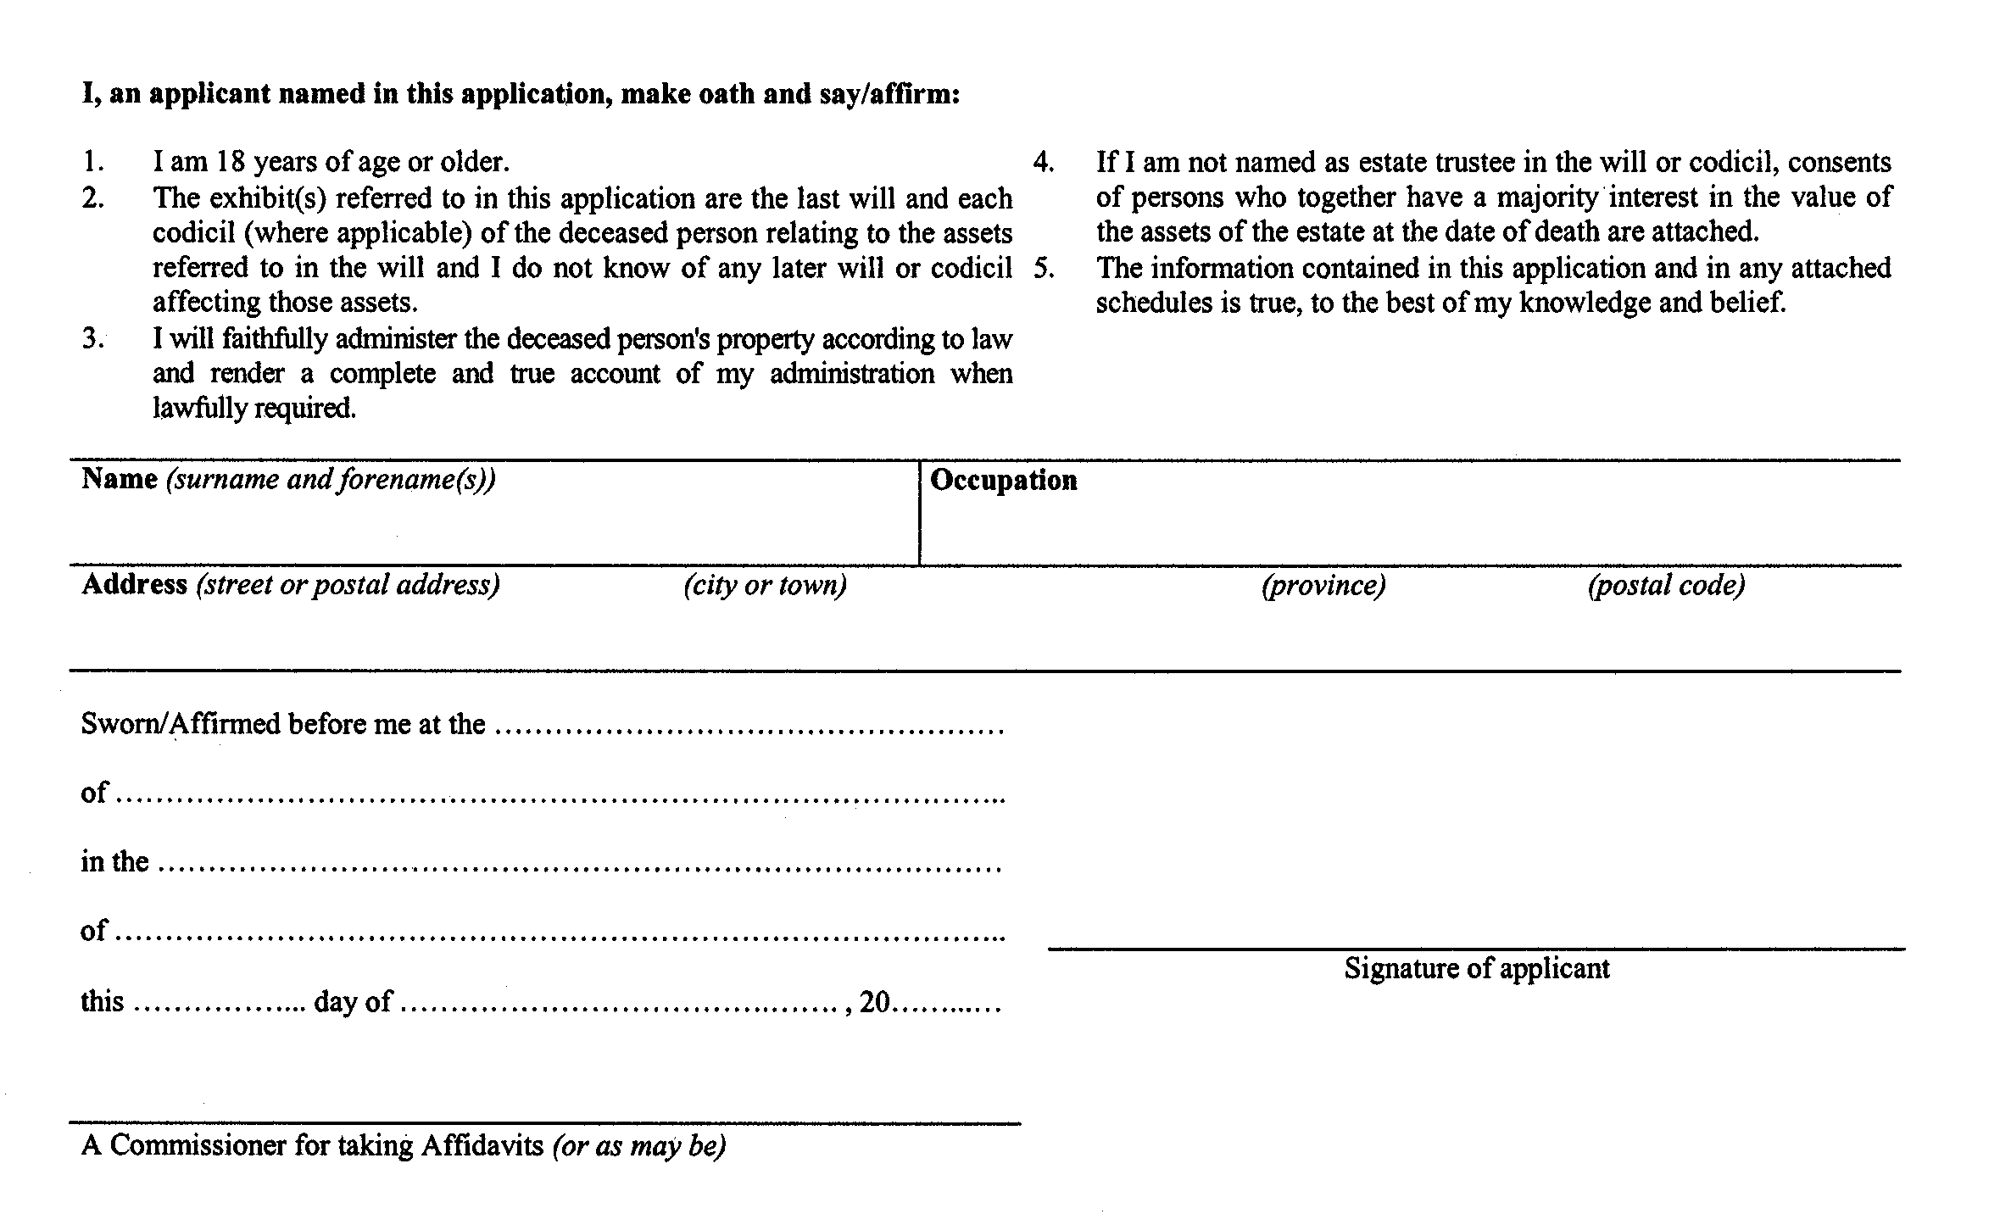
O. Reg. 132/04, s. 24.
See: O. Reg. 132/04, ss. 24, 25 (1).
Form 74.6
Courts of Justice Act
AFFIDAVIT OF SERVICE OF NOTICE
Ontario
superior court of justice
IN THE ESTATE OF (insert name), deceased.
AFFIDAVIT OF SERVICE OF NOTICE
I, (insert name), of (insert city or town and county or district, metropolitan or regional municipality of residence), make oath and say/affirm:
1. I am an applicant for a certificate of appointment of estate trustee with a will in the estate.
2. I have sent or caused to be sent a notice in Form 74.7, a copy of which is marked as Exhibit “A” to this affidavit, to all adult persons and charities named in the notice (except to an applicant who is entitled to share in the distribution of the estate), to the Public Guardian and Trustee if paragraph 6 of the notice applies, to a parent or guardian of the minor and to the Children’s Lawyer if paragraph 4 applies, to the guardian or attorney if paragraph 5 applies, and to the Children’s Lawyer if paragraph 7 applies, all by regular lettermail sent to the person’s last known address.
3. I attached or caused to be attached to each notice the following:
(A) In the case of a notice sent to or in respect of a person entitled only to a specified item of property or stated amount of money, an extract of the part or parts of the will or codicil relating to the gift, or a copy of the will (and codicil(s), if any).
(B) In the case of a notice sent to or in respect of any other beneficiary, a copy of the will (and codicil(s), if any).
(C) In the case of a notice sent to the Children’s Lawyer or the Public Guardian and Trustee, a copy of the will (and codicil(s), if any) and a statement of the estimated value of the interest of the person represented.
4. To the best of my knowledge and belief, the persons named in the notice are all the persons who are entitled to share in the distribution of the estate.

Sworn/affirmed before me at the )
of )
in the )
of )
this day of , 20 ) | Signature of applicant
)
)
)
)

A Commissioner for Taking Affidavits (or as may be)
NOTE: If any person cannot be served, add at the end of paragraph 4 “except for (insert name) who cannot be served because (give explanation)”.
O. Reg. 332/96, s. 5; O. Reg. 292/99, s. 1 (3, 4); O. Reg. 24/00, s. 25.
Note: On January 1, 2005, Form 74.6 is revoked and the following substituted:
Form 74.6
Courts of Justice Act
affidavit of service of notice
ontario
superior court of justice
Insert regs\Graphics\Source Law\2004\132\132746ae.tif
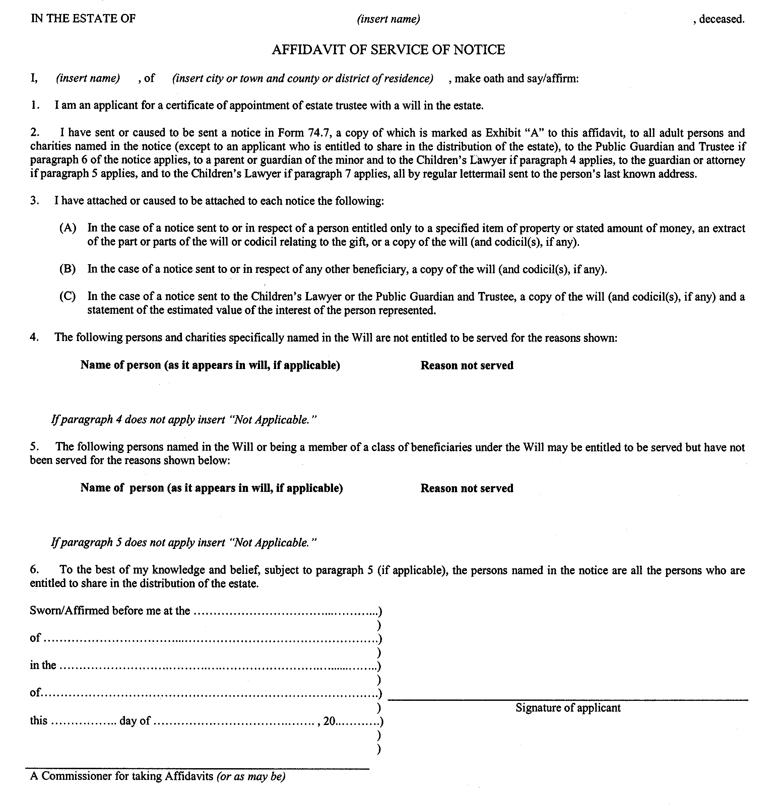
O. Reg. 132/04, s. 24.
See: O. Reg. 132/04, ss. 24, 25 (1).
Form 74.7
Courts of Justice Act
Insert regs\Graphics\Source Law\2000\24\024074.7ae.tif
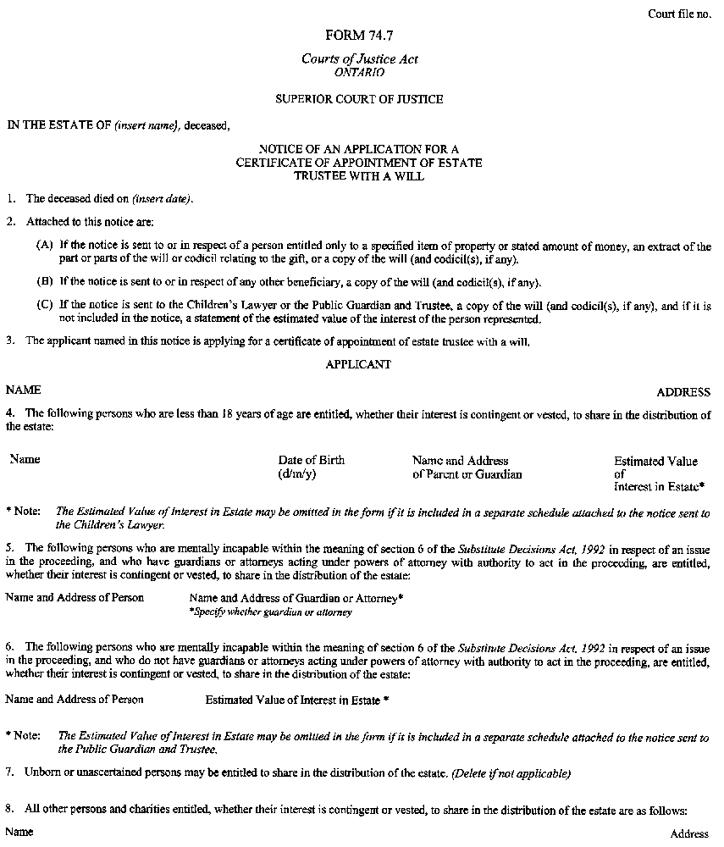
Insert regs\Graphics\Source Law\2000\24\024074.7be.tif
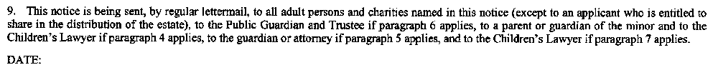
O. Reg. 24/00, s. 26.
Note: On January 1, 2005, Form 74.7 is revoked and the following substituted:
Form 74.7
Courts of Justice Act
notice of an application for a certificate of appointment of estate trustee with a will
ontario
superior court of justice
Insert regs\Graphics\Source Law\2004\132\132747ae.tif
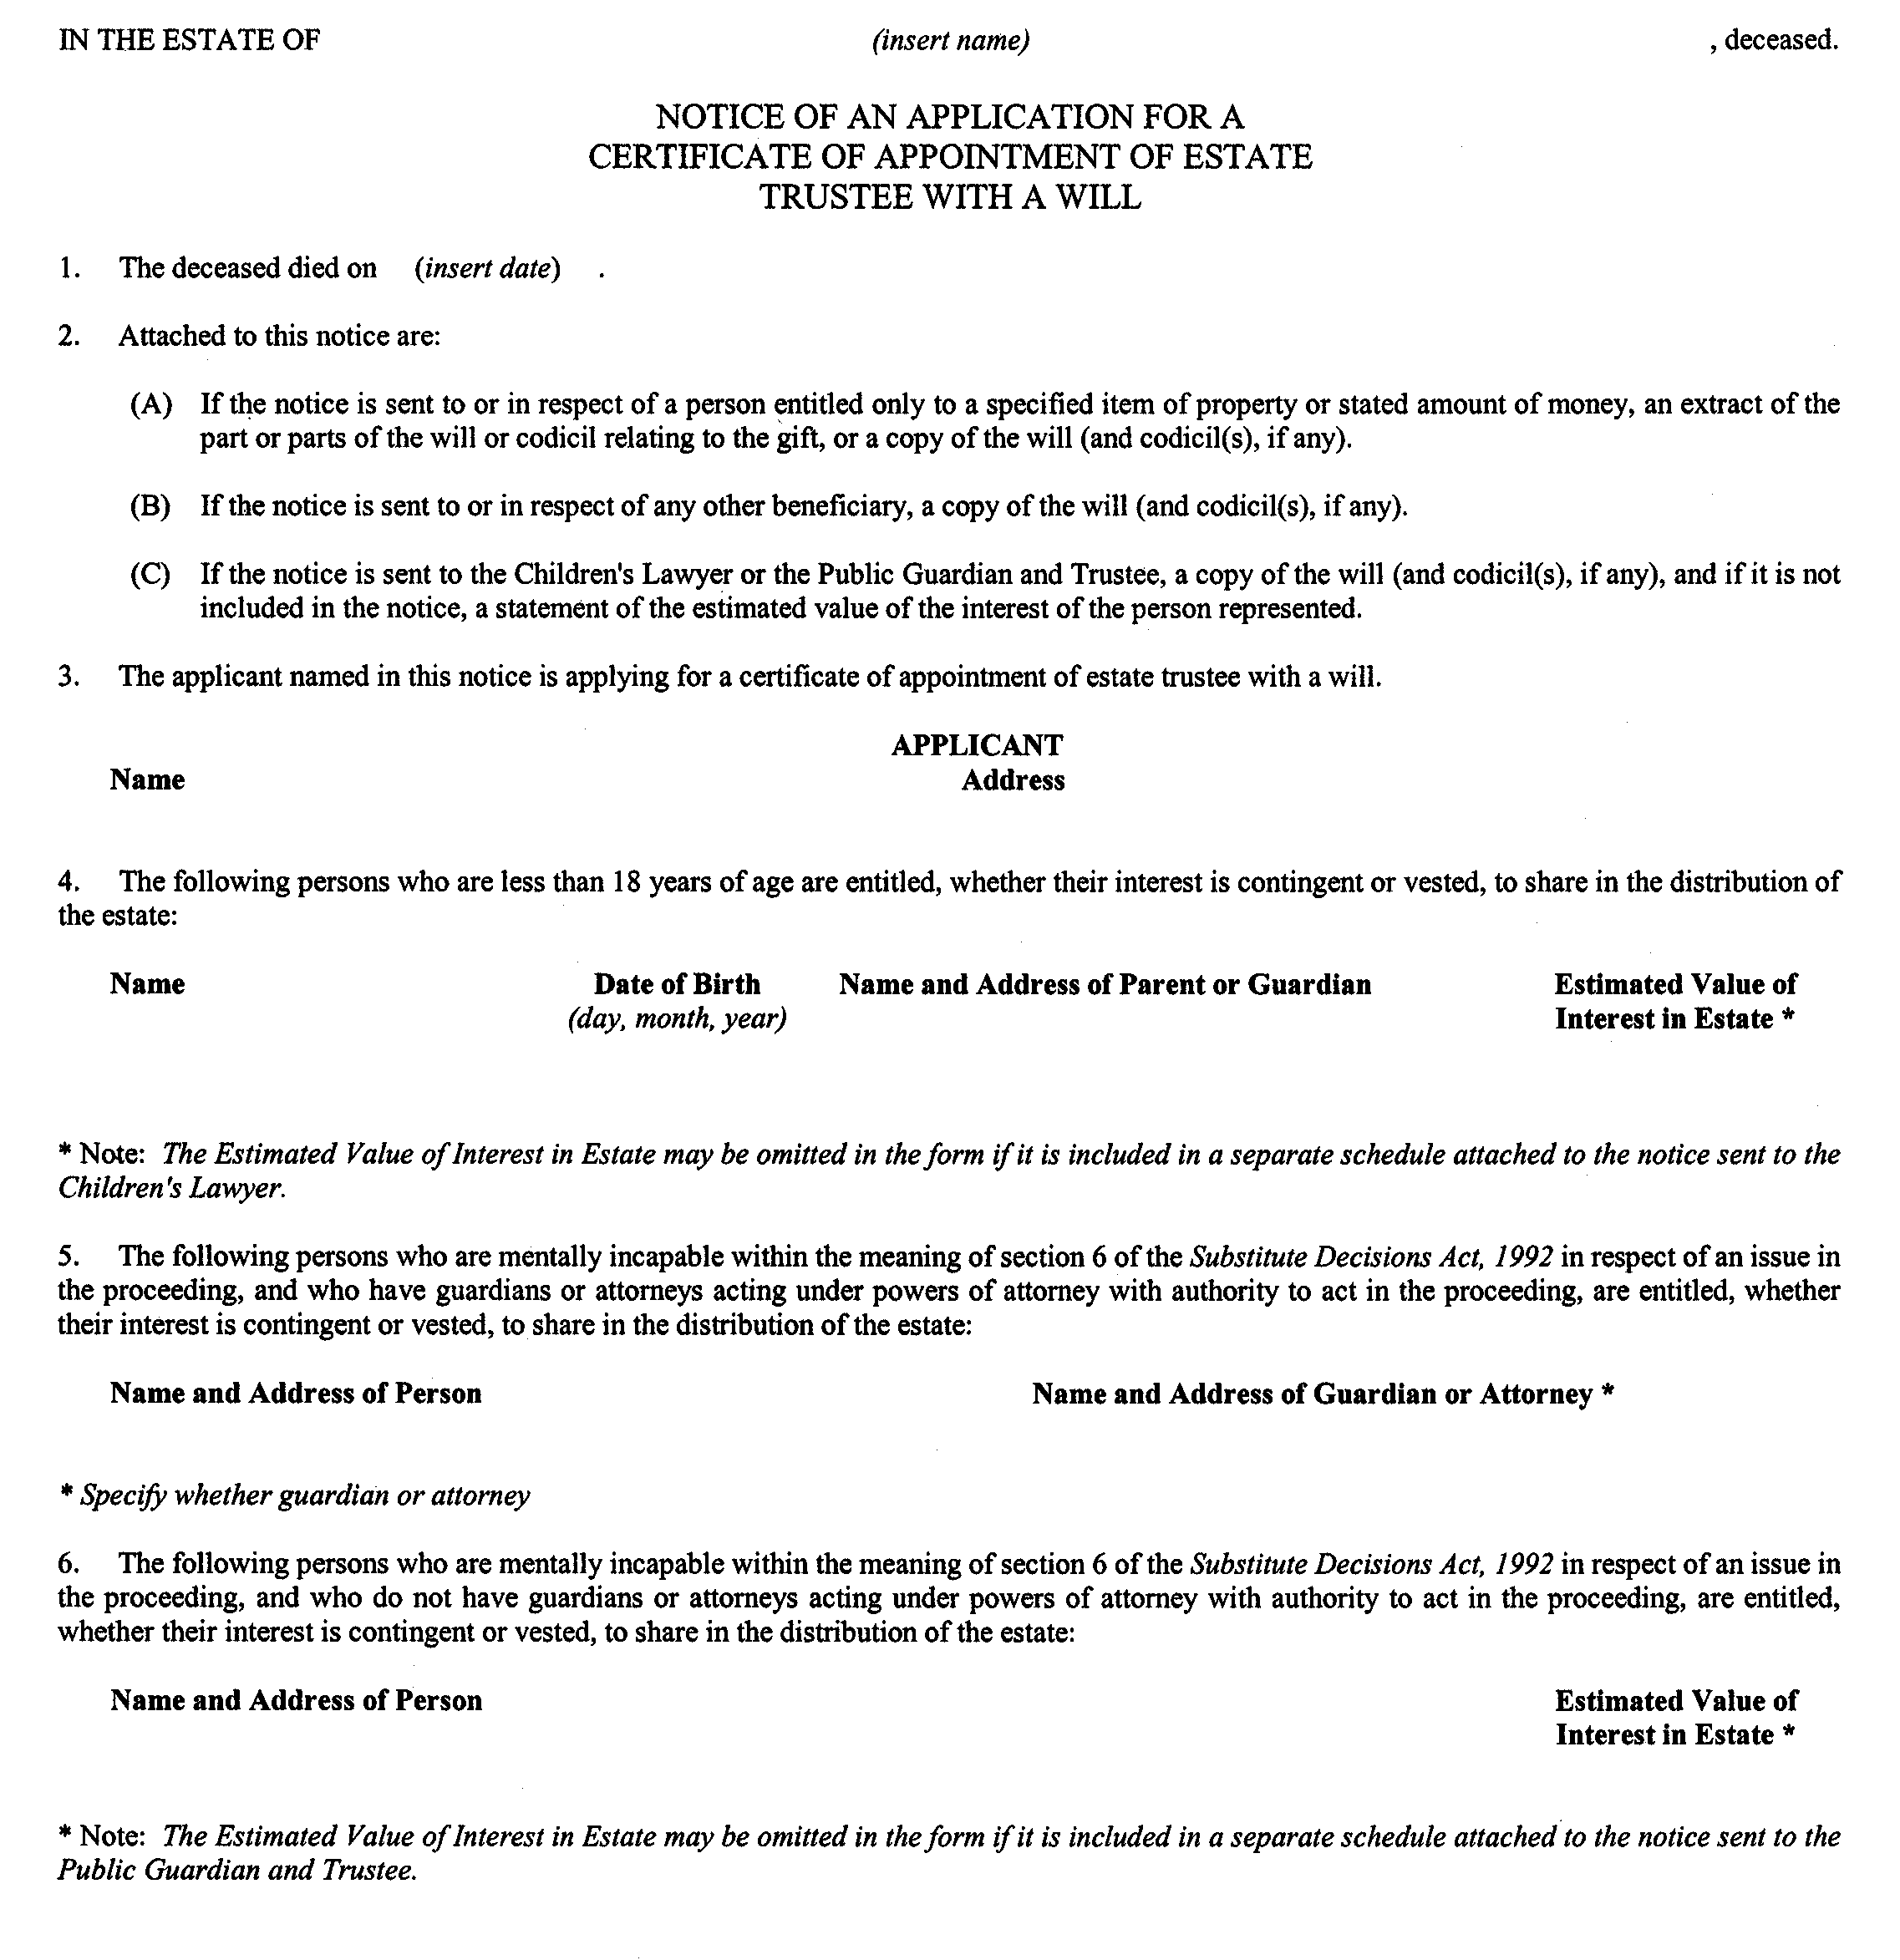
Insert regs\Graphics\Source Law\2004\132\132747be.tif
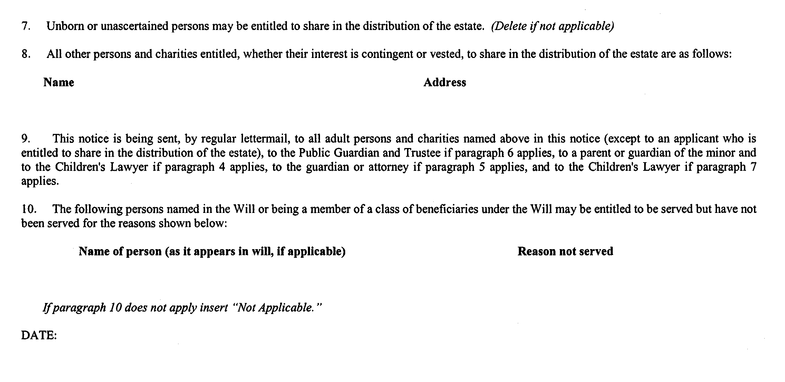
O. Reg. 132/04, s. 24.
See: O. Reg. 132/04, ss. 24, 25 (1).
Form 74.8
Courts of Justice Act
AFFIDAVIT OF execution of will or codicil
ONTARIO
SUPERIOR COURT OF JUSTICE
In the matter of the execution of a will or codicil of (insert name)
AFFIDAVIT
I, (insert name), of (insert city or town and county or district, metropolitan or regional municipality of residence), make oath and say/affirm:
1. On (date), I was present and saw the document marked as Exhibit “A” to this affidavit executed by (insert name).
2. (Insert name) executed the document in the presence of myself and (insert name of other witness and city or town, county or district, metropolitan or regional municipality of residence). We were both present at the same time, and signed the document in the testator’s presence as attesting witnesses.

SWORN/AFFIRMED BEFORE )
me at the of )
in the of )
this day of , 20 . )
)
)
)
)

A Commissioner for Taking Affidavits (or as may be)

NOTE: If the testator was blind or signed by making his or her mark, add the following paragraph: | WARNING: A beneficiary or the spouse of a beneficiary should not be a witness.
3. Before its execution, the document was read over to the testator, who (was blind) (signed by making his or her mark). The testator appeared to understand the contents.

O. Reg. 484/94, s. 13; O. Reg. 292/99, s. 1 (3, 4).
Form 74.9
Courts of Justice Act
AFFIDAVIT attesting to the handwriting and signature of a holograph will or codicil
ONTARIO
SUPERIOR COURT OF JUSTICE
IN THE ESTATE OF (insert name), deceased.
AFFIDAVIT attesting to the handwriting
and signature of a holograph will or codicil
I, (insert name), of (insert city or town and county or district, metropolitan or regional municipality of residence), make oath and say/affirm:
1. I was well acquainted with the deceased and have frequently seen the deceased’s signature and handwriting.
2. I believe the whole of the document dated (insert date), now shown to me and marked as Exhibit “A” to this affidavit, including the signature, is in the handwriting of the deceased.

SWORN/AFFIRMED BEFORE )
me at the of )
in the of )
this day of , 20 . )
)
)
)
)

A Commissioner for Taking Affidavits (or as may be)
O. Reg. 484/94, s. 13; O. Reg. 292/99, s. 1 (3, 4).
Form 74.10
Courts of Justice Act
AFFIDAVIT of condition of will or codicil
ONTARIO
SUPERIOR COURT OF JUSTICE
IN THE ESTATE OF (insert name), deceased.
AFFIDAVIT of condition of will or codicil
I, (insert name), of (insert city or town and county or district, metropolitan or regional municipality of residence), make oath and say/affirm:
1. On (date), I was present and saw the document marked as Exhibit “A” to this affidavit executed by the deceased, in the presence of myself and (insert name of other witness).
2. The following alterations, erasures, obliterations or interlineations that have not been attested appear in the document:
3. The document is now in the same condition as when it was executed.

SWORN/AFFIRMED BEFORE )
me at the of )
in the of )
this day of , 20 . )
)
)
)
)

A Commissioner for Taking Affidavits (or as may be)
NOTE: If paragraph 3 is not correct, add the words “except that” and give details of the exceptions.
O. Reg. 484/94, s. 13; O. Reg. 292/99, s. 1 (3, 4).
Form 74.11
Courts of Justice Act
renunciation of right to a certificate of appointment of estate trustee (or succeeding estate Trustee) with a will
ONTARIO
SUPERIOR COURT OF JUSTICE
IN THE ESTATE OF (insert name), deceased.
renunciation of right to a certificate of appointment
of estate trustee (or succeeding estate Trustee) with a will
The deceased died on (date).
In that person’s testamentary document dated (date), I, (insert name), was named an estate trustee.
I renounce my right to a certificate of appointment of estate trustee (or succeeding estate trustee) with a will.

DATE
)
)
)
)
)
)
Signature of witness )  ) | Signature of person renouncing
)

O. Reg. 484/94, s. 13; O. Reg. 292/99, s. 1 (3, 4).
Form 74.12
Courts of Justice Act
consent to applicant’s appointment as estate trustee with a will
ONTARIO
SUPERIOR COURT OF JUSTICE
IN THE ESTATE OF (insert name), deceased.
Consent to applicant’s
appointment as estate Trustee with a will
The deceased died on (date).
No estate trustee named in a testamentary document of that person is applying for a certificate of appointment of estate trustee with a will.
I, (insert name), am entitled to share in the distribution of the estate.
I consent to the application by (insert name) for a certificate of appointment of estate trustee with a will.
I consent to an order dispensing with the filing of a bond by the applicant (delete if inapplicable).

DATE
)
)
)
)
)
)
Signature of witness )  ) | Signature of person consenting
)

O. Reg. 484/94, s. 13; O. Reg. 292/99, s. 1 (3, 4).
Form 74.13
Courts of Justice Act
certificate of appointment of estate trustee with a will
ONTARIO
SUPERIOR COURT OF JUSTICE
IN THE ESTATE OF , deceased,
late of
occupation
who died on
certificate of appointment
of estate trustee with a will
Applicant Address Occupation
This CERTIFICATE OF APPOINTMENT OF ESTATE TRUSTEE WITH A WILL is hereby issued under the seal of the court to the applicant named above. A copy of the deceased’s last will (and codicil(s), if any) is attached.
DATE | Registrar  Address of court office

O. Reg. 484/94, s. 13; O. Reg. 740/94, s. 10; O. Reg. 292/99, s. 1 (3, 4).
Form 74.13.1
Courts of Justice Act
Insert regs\Graphics\Source Law\2000\653\653074.13.1ae.tif
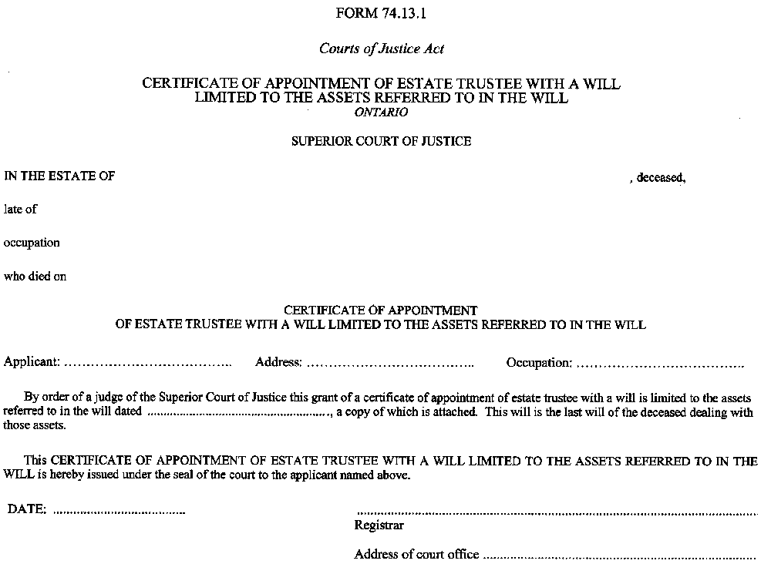
O. Reg. 653/00, s. 19.
Form 74.14
Courts of Justice Act
APPLICATION FOR CERTIFICATE OF APPOINTMENT OF ESTATE TRUSTEE WITHOUT A WILL (INDIVIDUAL APPLICANT)
ONTARIO
SUPERIOR COURT OF JUSTICE
at
This application is filed by (insert name and address)
DETAILS ABOUT THE DECEASED PERSON
Complete in full as applicable | And if the deceased was known by any other name, state below the full names used
First given name | Given name or names
Second given name
Third given name | Surname
Surname

Address of fixed place of abode (street or postal address) (city or town) |  |  |  |  |  |  |  |  | (county, district, regional or  metropolitan municipality)
If the deceased person had no fixed place of abode in Ontario,  did he or she have property in Ontario? □ No □ Yes |  |  | Last occupation of deceased person
Place of death  (city or town, county, district, regional or metropolitan municipality) |  |  |  |  |  |  |  | Date of death  (day, month, year)
Marital status  □ Unmarried □ Widowed  □ Married □ Divorced |  | Was the deceased person’s marriage terminated by a judgment absolute of divorce, or declared a nullity? □ No □ Yes  If yes, give the person’s name and address in an attached schedule.
Did the deceased person go through a form of marriage with another person where it appears uncertain whether an earlier marriage of the deceased person had been terminated by divorce or declared a nullity? □ No □ Yes
If yes, give the other person’s name and address, and the names and addresses of any children (including deceased children) of the marriage, in an attached schedule.
Was any earlier marriage of another person with whom the deceased person went through a form of marriage terminated  by divorce or declared a nullity? □ No □ Yes  If yes, give details in an attached schedule. |  | Was the deceased person immediately before his or her death,  living in a conjugal relationship outside marriage with a person  of the opposite sex or of the same sex?  No  Yes  If yes, give the person’s name and address in an attached schedule.
PERSONS ENTITLED TO SHARE IN THE ESTATE
(Attach a schedule if more space is needed. If a person entitled to share in the estate is not a spouse, child, parent, brother or sister of the deceased person, show how the relationship is traced.)
Name | Address |  |  |  |  |  |  | Relationship to  deceased person |  | Age  if under 18
VALUE OF ASSETS OF ESTATE
Do not include in the total amount: insurance payable to a named beneficiary or assigned for value, property held jointly and passing by survivorship, or real estate outside Ontario.
Personal property  $ | Real estate, net of  encumbrances  $ |  |  |  |  |  |  | Total  $
Explain why the applicant is entitled to apply.
AFFIDAVIT(S) OF APPLICANT(S)
(Attach a separate sheet for additional affidavits, if necessary)
I, an applicant named in this application, make oath and say/affirm:
1. I am 18 years of age or older and a resident of Ontario.  2. I have made a careful search and inquiry for a will or other testamentary document of the deceased person, but none has been found. I believe that the person did not leave a will or other testamentary document.  3. I will faithfully administer the deceased person’s property according to law and render a complete and true account of my administration when lawfully required. |  |  |  | 4. Consents of persons who together have a majority interest  in the value of the assets of the estate at the date of death  are attached.  5. The information contained in this application and in any  attached schedules is true, to the best of my knowledge  and belief.
Name (surname and forename(s)) |  |  |  |  |  |  | Occupation
Address (street or postal address) (city or town) (province) (postal code)
Sworn/Affirmed before me at the  of  in the  of  this day of , 20  A Commissioner for Taking Affidavits  (or as may be) |  |  |  |  | } | Signature of applicant

O. Reg. 740/94, s. 11; O. Reg. 377/95, s. 9; O. Reg. 292/99, s. 1 (3, 4); O. Reg. 24/00, s. 27; O. Reg. 25/00, s. 1.
Note: On January 1, 2005, Form 74.14 is revoked and the following substituted:
Form 74.14
Courts of Justice Act
application for certificate of appointment of estate trustee without a will (individual applicant)
Insert regs\Graphics\Source Law\2004\132\1327414ae.tif
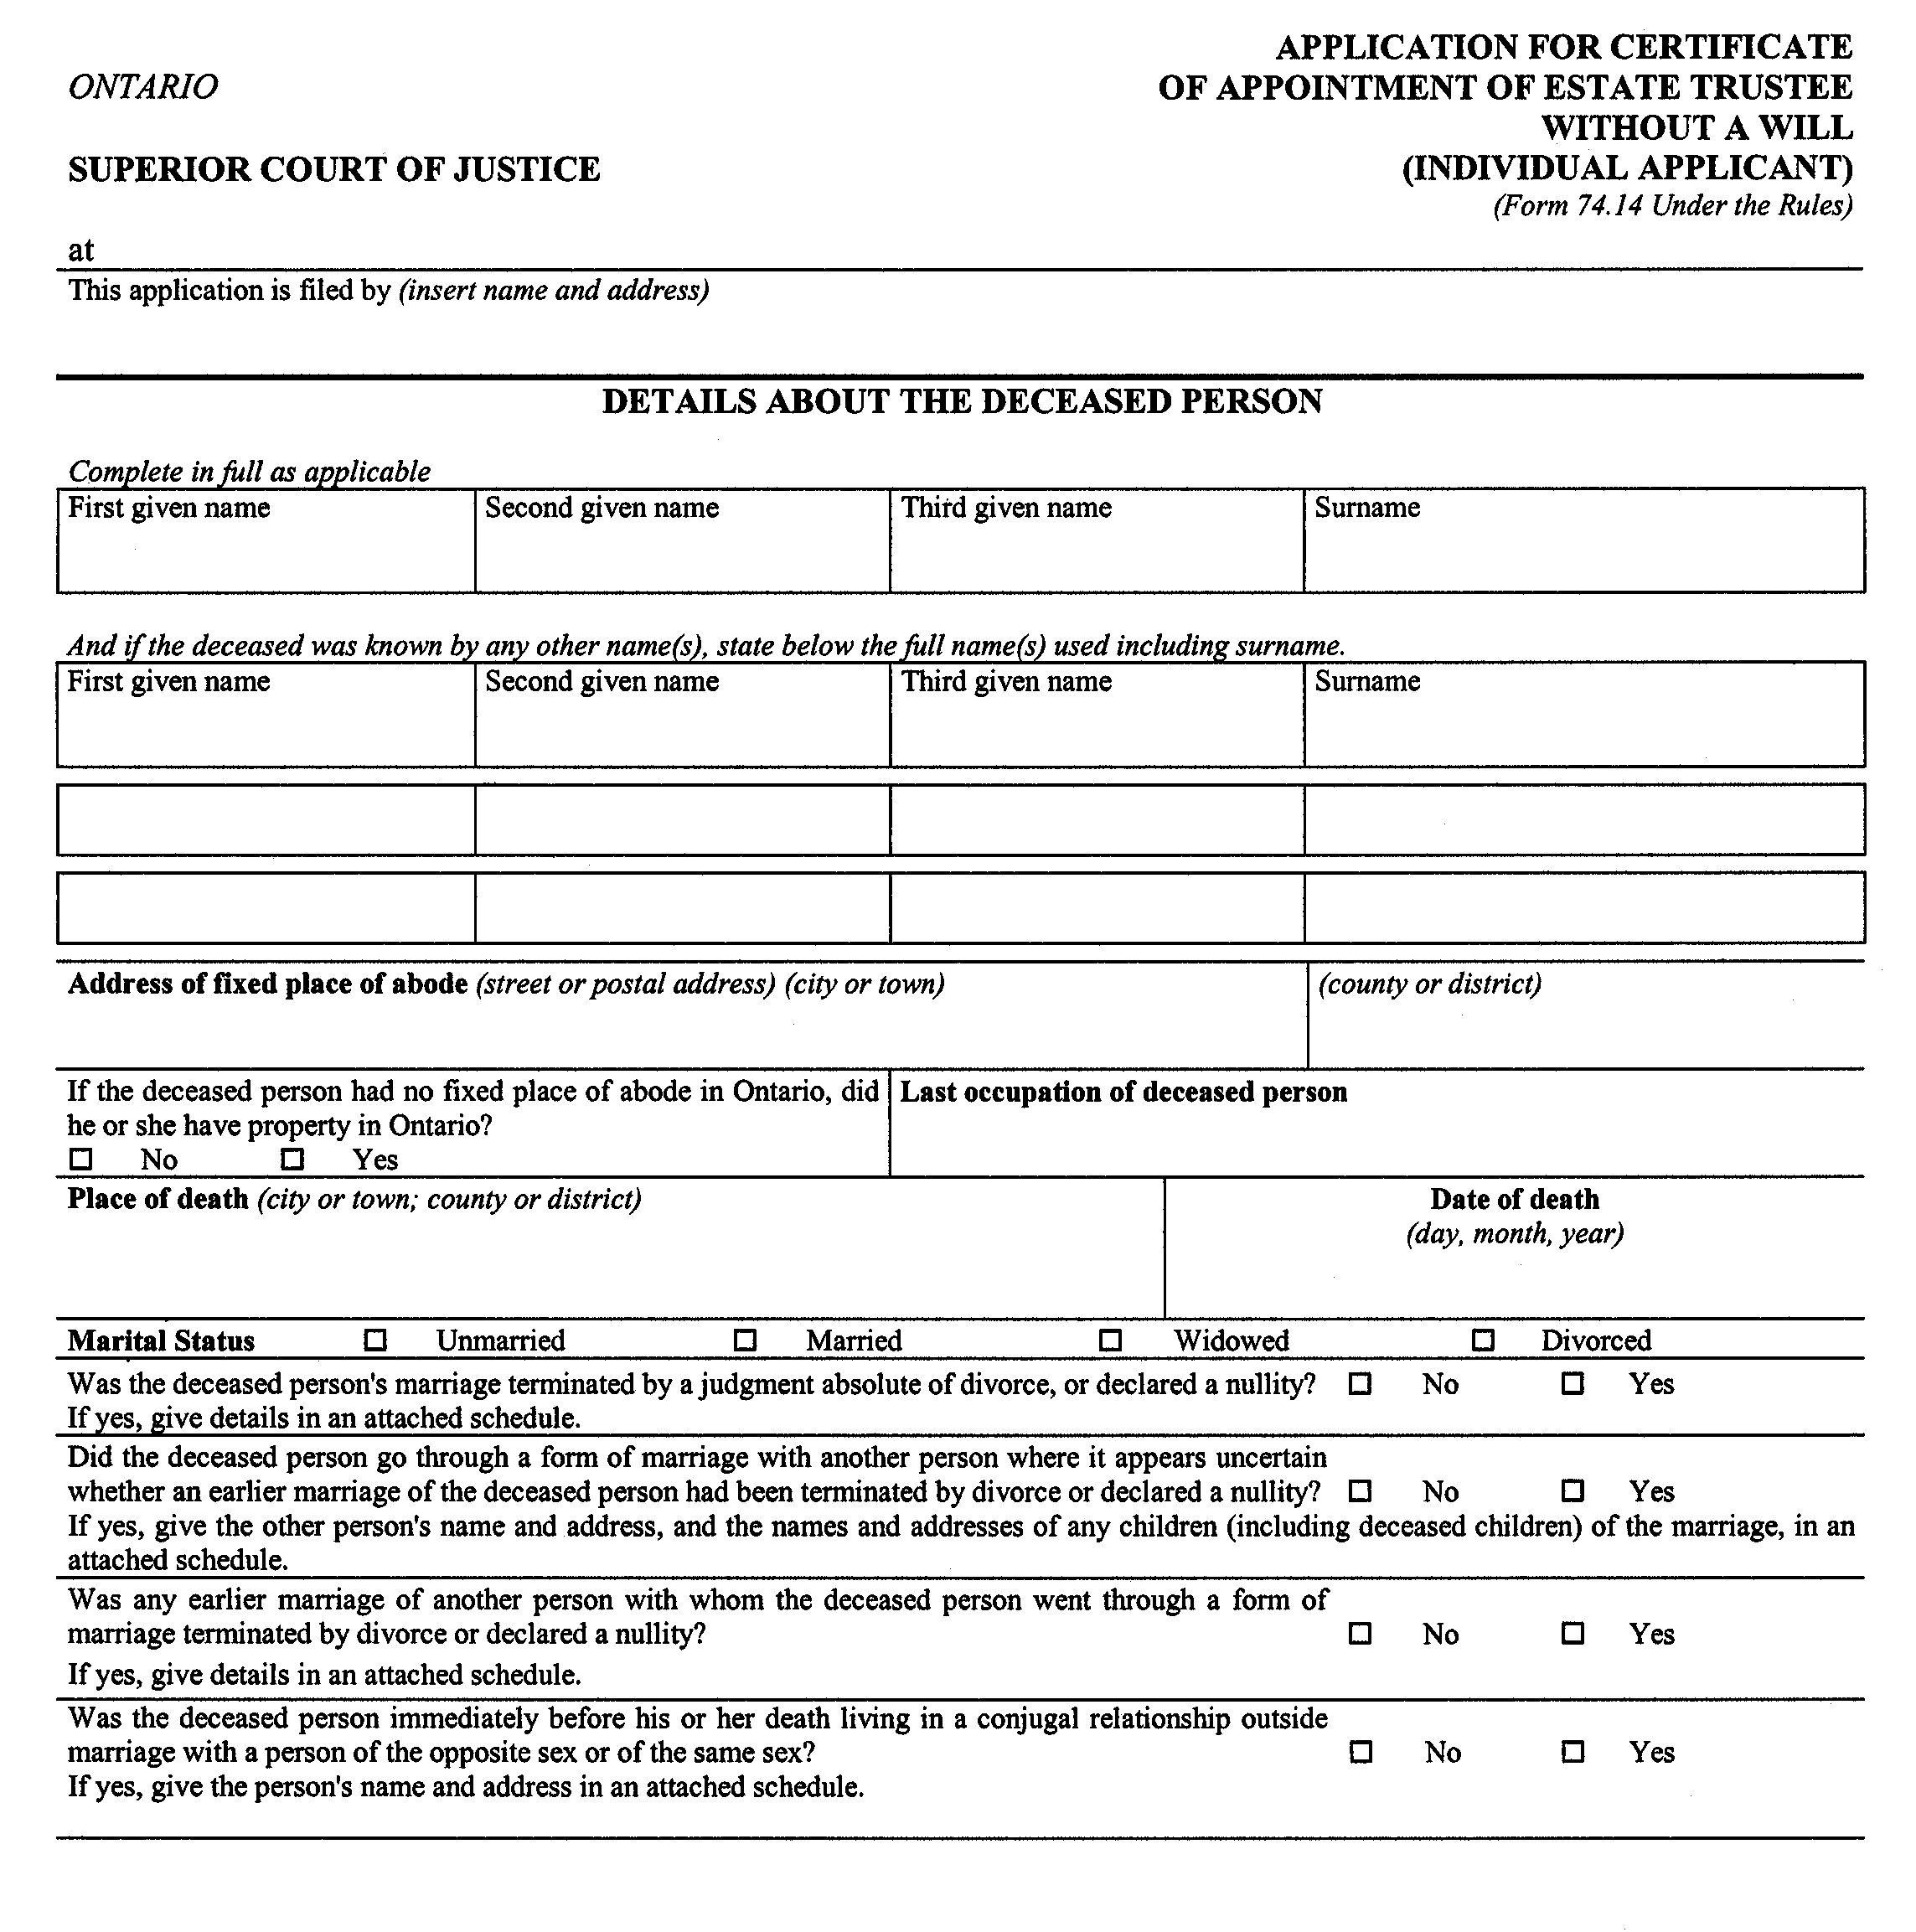
Insert regs\Graphics\Source Law\2004\132\1327414be.tif
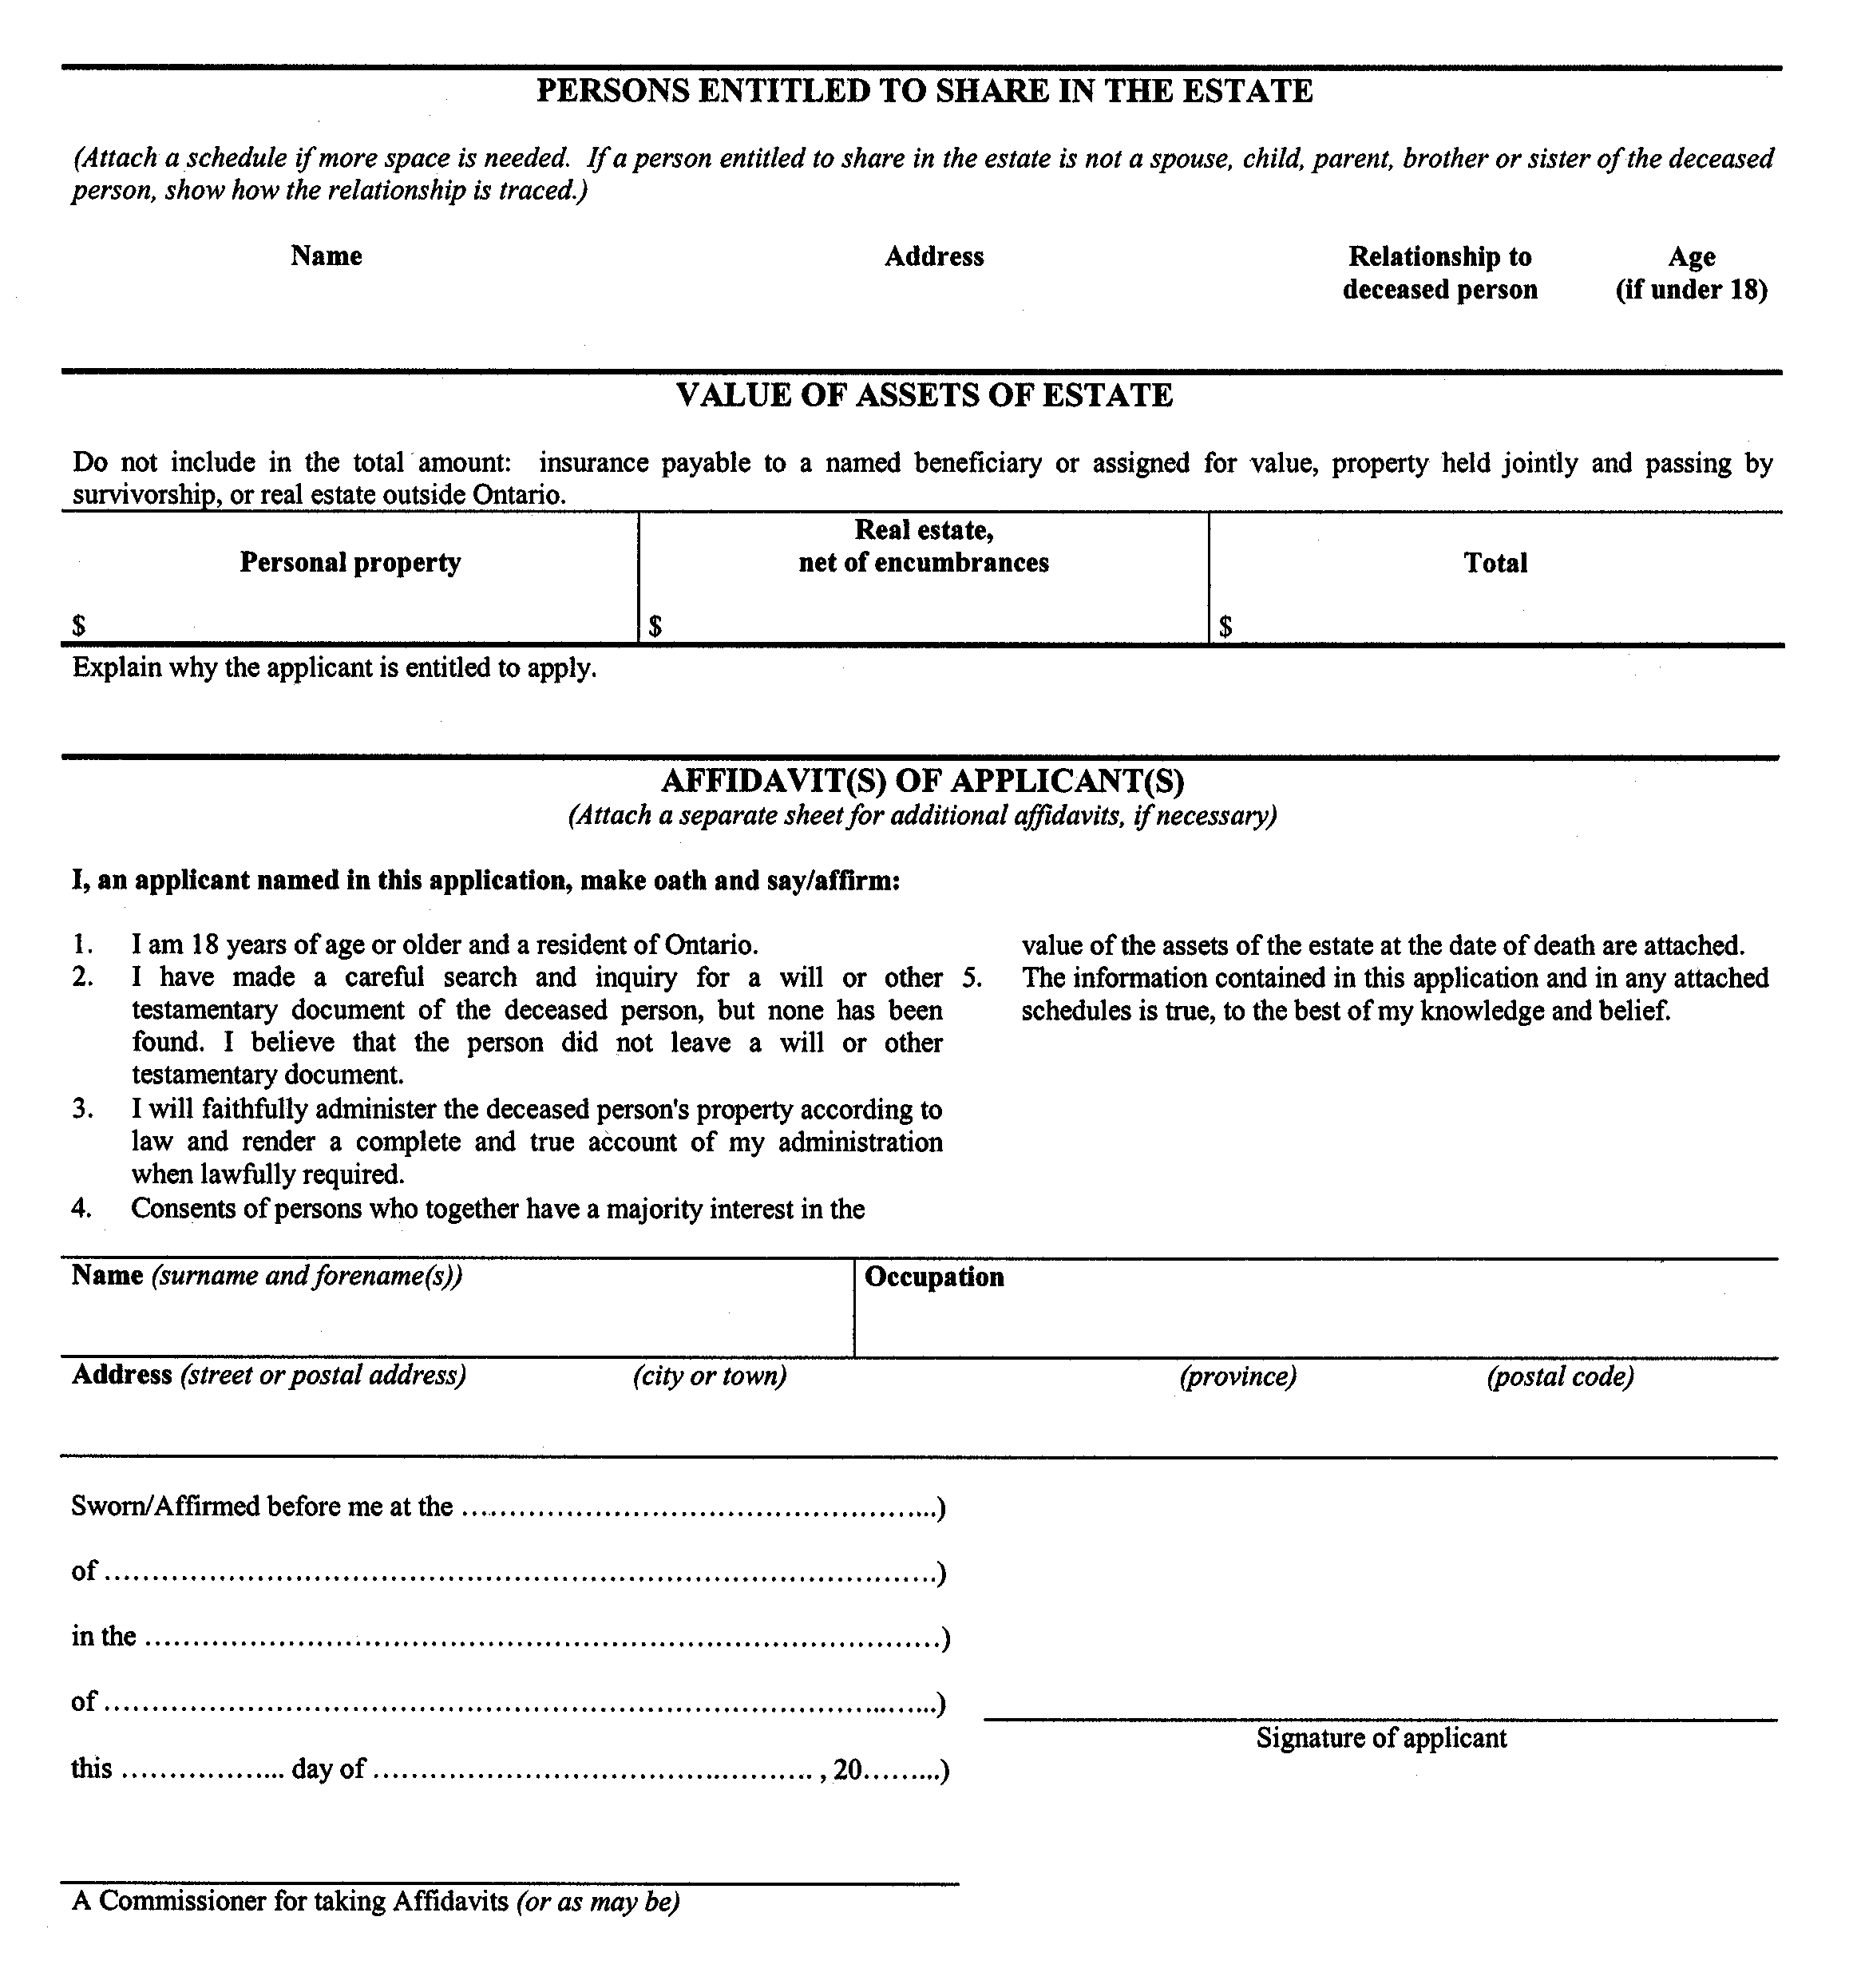
Insert regs\Graphics\Source Law\2004\132\1327414ce.tif
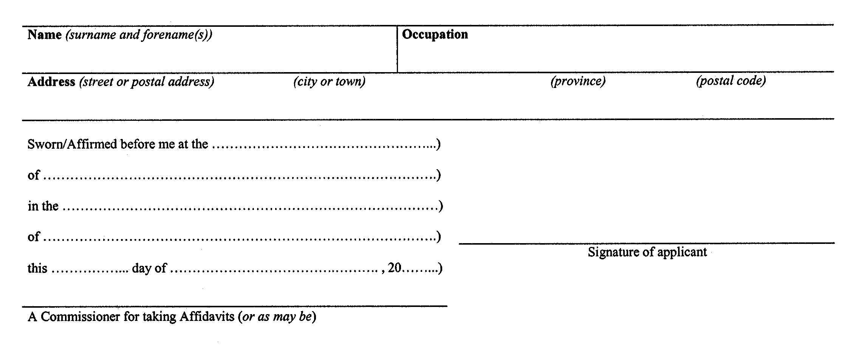
O. Reg. 132/04, s. 24.
See: O. Reg. 132/04, ss. 24, 25 (1).
Form 74.15
Courts of Justice Act
APPLICATION FOR CERTIFICATE OF APPOINTMENT OF ESTATE TRUSTEE WITHOUT A WILL (CORPORATE APPLICANT)
ONTARIO
SUPERIOR COURT OF JUSTICE
at
This application is filed by (insert name and address)
DETAILS ABOUT THE DECEASED PERSON
Complete in full as applicable | And if the deceased was known by any other name, state below the full names used
First given name | Given name or names
Second given name
Third given name | Surname
Surname

Address of fixed place of abode (street or postal address) (city or town) |  |  |  |  |  |  |  | (county, district, regional or  metropolitan municipality)
If the deceased person had no fixed place of abode in Ontario,  did he or she have property in Ontario? □ No □ Yes |  |  | Last occupation of deceased person
Place of death  (city or town, county, district, regional or metropolitan municipality) |  |  |  |  |  |  | Date of death  (day, month, year)
Marital status  □ Unmarried □ Widowed  □ Married □ Divorced |  | Was the deceased person’s marriage terminated by a judgment absolute of divorce, or declared a nullity? □ No □ Yes  If yes, give details in an attached schedule.
Did the deceased person go through a form of marriage with another person where it appears uncertain whether an earlier marriage of the deceased person had been terminated by divorce or declared a nullity? □ No □ Yes
If yes, give the other person’s name and address, and the names and addresses of any children (including deceased children) of the marriage, in an attached schedule.
Was any earlier marriage of another person with whom the deceased person went through a form of marriage terminated  by divorce or declared a nullity? □ No □ Yes  If yes, give details in an attached schedule. |  | Was the deceased person immediately before his or her death,  living in a conjugal relationship outside marriage with a person  of the opposite sex or of the same sex? □ No □ Yes  If yes, give the person’s name in an attached schedule.
PERSONS ENTITLED TO SHARE IN THE ESTATE
(Attach a schedule if more space is needed. If a person entitled to share in the estate is not a spouse, child, parent, brother or sister of the deceased person, show how the relationship is traced.)
Name | Address |  |  |  |  |  | Relationship to  deceased person |  | Age  if under 18
VALUE OF ASSETS OF ESTATE
Do not include in the total amount: insurance payable to a named beneficiary or assigned for value, property held jointly and passing by survivorship, or real estate outside Ontario.
Personal property  $ | Real estate, net of  encumbrances  $ |  |  |  |  |  | Total  $
Explain why the applicant is entitled to apply.
AFFIDAVIT(S) OF APPLICANT(S)
(Attach a separate sheet for additional affidavits, if necessary)
I, a trust officer named in this application, make oath and say/affirm:
1. I am a trust officer of the corporate applicant.  2. I am 18 years of age or older.  3. I have made a careful search and inquiry for a will or other testamentary document of the deceased person, but none has been found. I believe that the person did not leave a will or other testamentary document.  4. The corporate applicant will faithfully administer the deceased person’s property according to law and render a complete and true account of my administration when lawfully required. |  |  |  | 5. Consents of persons who together have a majority interest  in the value of the assets of the estate at the date of death  are attached.  6. The information contained in this application and in any  attached schedules is true, to the best of my knowledge  and belief.
Name of corporate applicant |  |  |  | Name of trust officer
Address of corporate applicant (street or postal address) (city or town) (province) (postal code)
Sworn/Affirmed before me at the  of  in the  of  this day of , 20  A Commissioner for Taking Affidavits  (or as may be) |  |  |  |  | } | Signature of trust officer

O. Reg. 740/94, s. 11; O. Reg. 377/95, s. 9; O. Reg. 292/99, s. 1 (3, 4); O. Reg. 24/00, s. 27; O. Reg. 25/00, s. 2.
Note: On January 1, 2005, Form 74.15 is revoked and the following substituted:
Form 74.15
Courts of Justice Act
application for certificate of appointment of estate trustee without a will (corporate applicant)
Insert regs\Graphics\Source Law\2004\132\1327415ae.tif
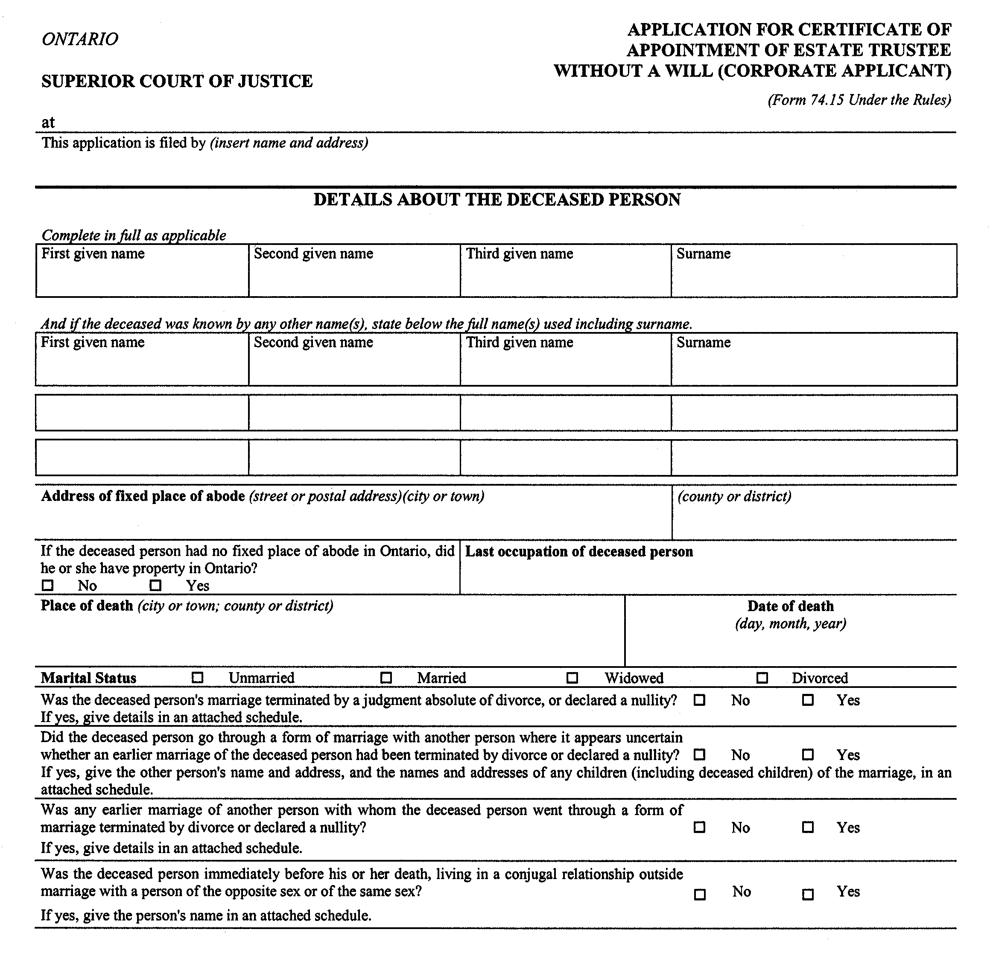
Insert regs\Graphics\Source Law\2004\132\1327415be.tif
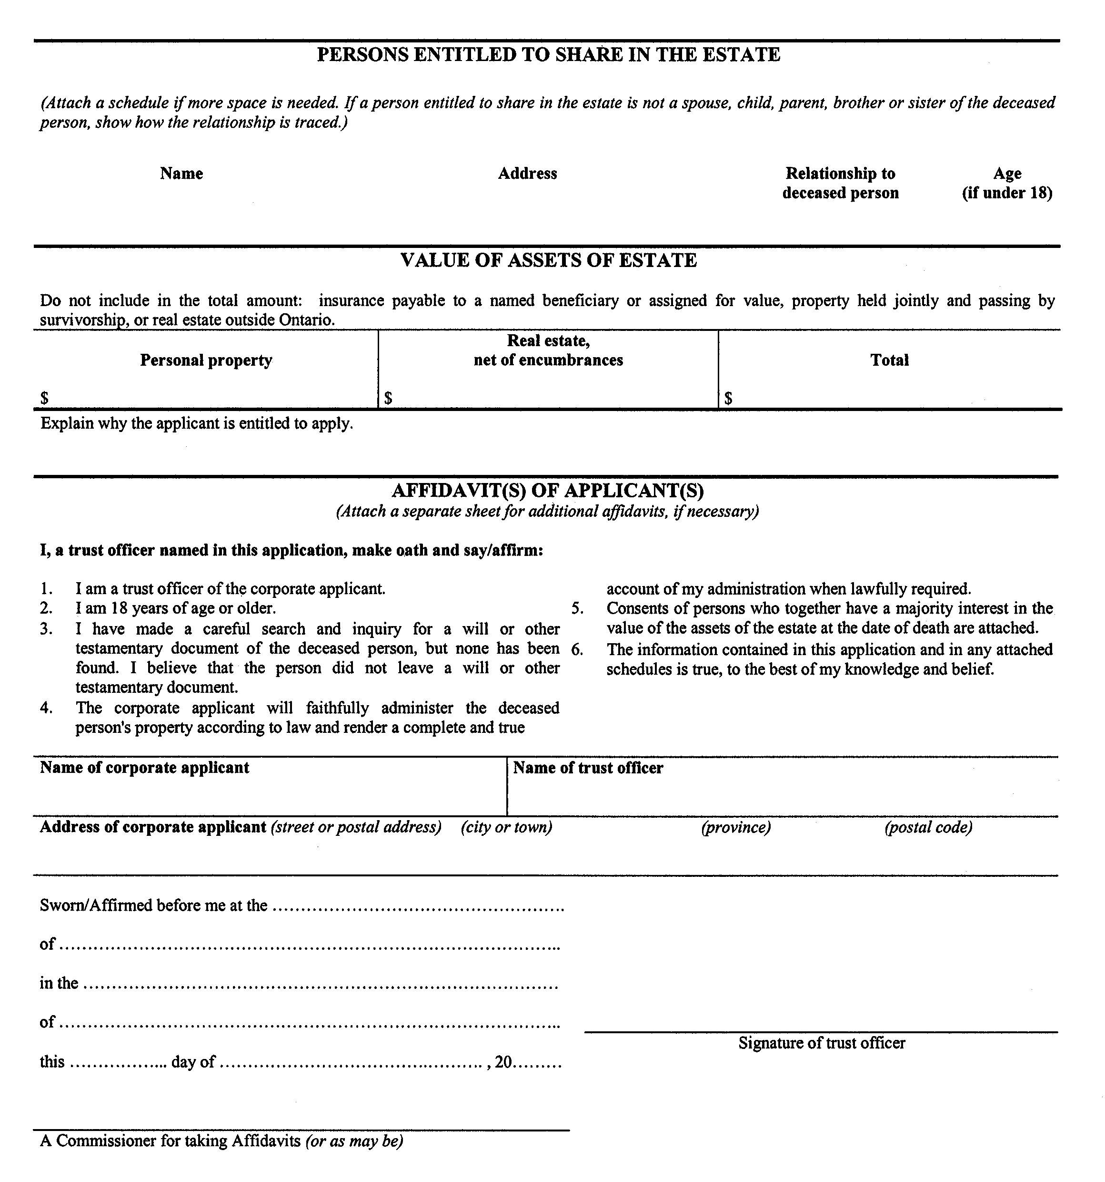
O. Reg. 132/04, s. 24.
See: O. Reg. 132/04, ss. 24, 25 (1).
Form 74.16
Courts of Justice Act
affidavit of service of notice
ONTARIO
SUPERIOR COURT OF JUSTICE
IN THE ESTATE OF (insert name), deceased.
affidavit of service of notice
I, (insert name), of (insert city or town and county or district, metropolitan or regional municipality of residence), make oath and say/affirm:
1. I am an applicant for a certificate of appointment of estate trustee with a will in the estate.
2. I have sent or caused to be sent a notice in Form 74.17, a copy of which is marked as Exhibit “A” to this affidavit, to all adult persons named in the notice (except to an applicant who is entitled to share in the distribution of the estate), to a parent or guardian of the minor and to the Children’s Lawyer if paragraph 3 of the notice applies, to the guardian or attorney if paragraph 4 applies and to the Public Guardian and Trustee if paragraph 5 applies, all by regular lettermail sent to the person’s last known address.
3. To the best of my knowledge and belief, the persons named in the notice are all the persons who are entitled to share in the distribution of the estate.

Sworn/affirmed before me at the | )
of | )
in the | )
of | )
this day of , 20 | ) | Signature of applicant
 | )
 | )
 | )
 | )

A Commissioner for Taking Affidavits (or as may be)
NOTE: If any person cannot be served, add at the end of paragraph 3 “except for (insert name) who cannot be served because (give explanation)”.
O. Reg. 332/96, s. 5; O. Reg. 292/99, s. 1 (3, 4).
Note: On January 1, 2005, Form 74.16 is revoked and the following substituted:
Form 74.16
Courts of Justice Act
affidavit of service of notice
ontario
superior court of justice
Insert regs\Graphics\Source Law\2004\132\1327416ae.tif
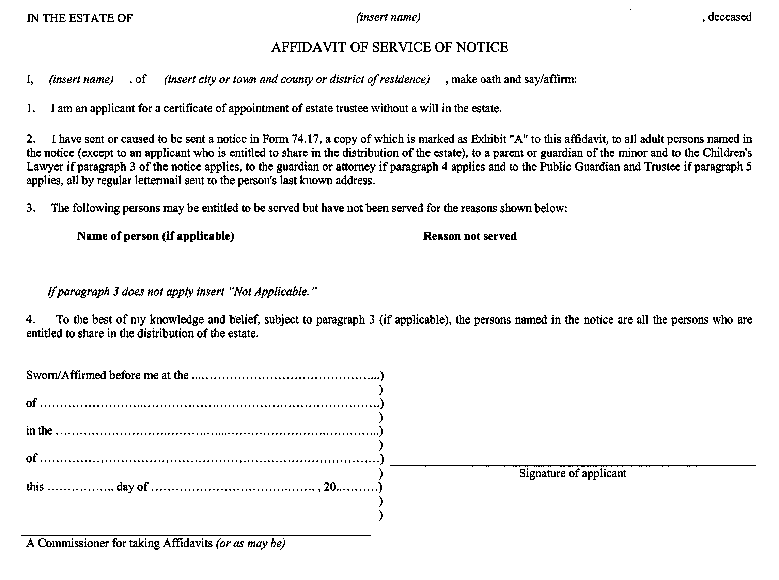
O. Reg. 132/04, s. 24.
See: O. Reg. 132/04, 24, 25 (1).
Form 74.17
Courts of Justice Act
NOTICE of an application for a certificate of appointment of estate trustee without a will
ONTARIO
SUPERIOR COURT OF JUSTICE
IN THE ESTATE OF (insert name), deceased.
NOTICE of an application for a
certificate of appointment of estate trustee without a will
1. The deceased died on (insert date), without a will.
2. The applicant named in this notice is applying for a certificate of appointment of estate trustee without a will.
applicaNt
NAME ADDRESS
3. The following persons who are less than 18 years of age are entitled to share in the distribution of the estate:
Name Date of birth Name and address Estimated value of
of parent or guardian interest in estate
4. The following persons who are mentally incapable within the meaning of section 6 of the Substitute Decisions Act, 1992 in respect of an issue in the proceeding, and who have guardians or attorneys acting under powers of attorney with authority to act in the proceeding, are entitled to share in the distribution of the estate:
Name and address Name and address Estimated value of
of person of guardian or attorney* interest in estate
*Specify whether guardian or attorney.
5. The following persons who are mentally incapable within the meaning of section 6 of the Substitute Decisions Act, 1992 in respect of an issue in the proceeding, and who do not have guardians or attorneys acting under powers of attorney with authority to act in the proceeding, are entitled to share in the distribution of the estate:
Name and address Estimated value of
of person interest in estate
6. All other persons entitled to share in the distribution of the estate are as follows:
Name Address
7. This notice is being sent, by regular lettermail, to all adult persons named in this notice (except to an applicant who is entitled to share in the distribution of the estate), to a parent or guardian of the minor and to the Children’s Lawyer if paragraph 3 applies, to the guardian or attorney if paragraph 4 applies, and to the Public Guardian and Trustee if paragraph 5 applies.
DATE
O. Reg. 332/96, s. 5; O. Reg. 292/99, s. 1 (3, 4).
Note: On January 1, 2005, Form 74.17 is revoked and the following substituted:
Form 74.17
Courts of Justice Act
notice of an application for a certificate of appointment of estate trustee without a will
ontario
superior court of justice
Insert regs\Graphics\Source Law\2004\132\1327417ae.tif
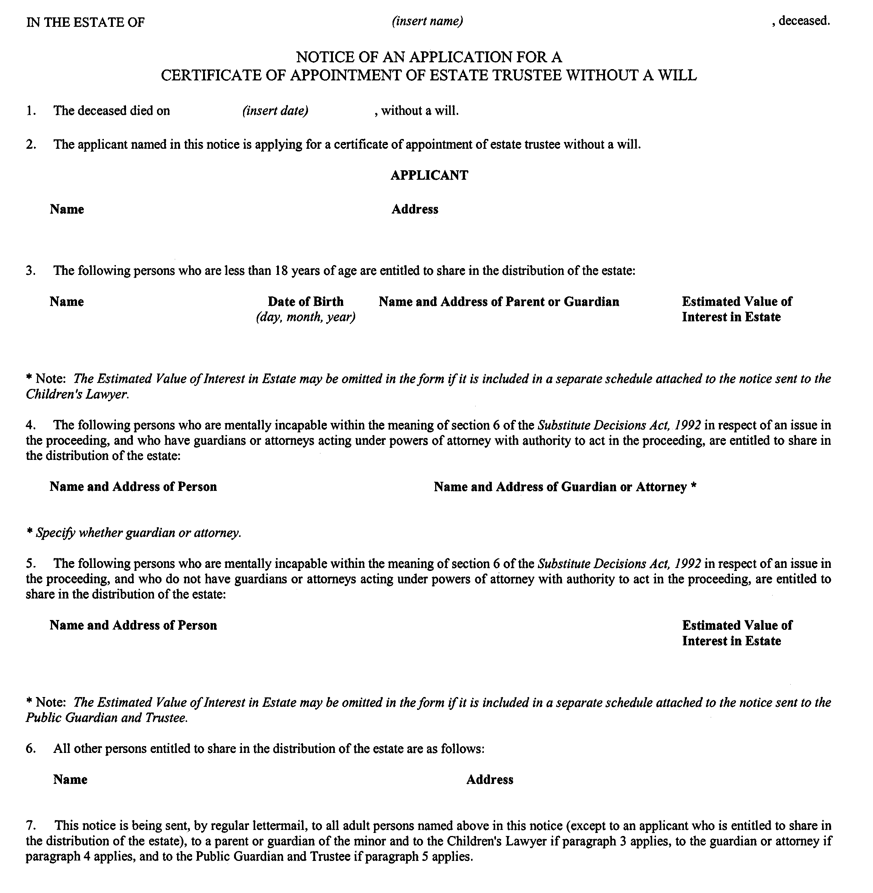
Insert regs\Graphics\Source Law\2004\132\1327417be.tif
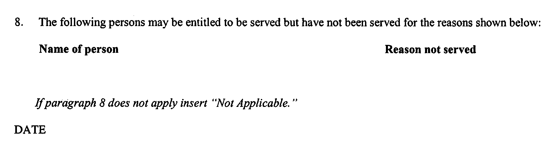
O. Reg. 132/04, s. 24.
See: O. Reg. 132/04, ss. 24, 25 (1).
Form 74.18
Courts of Justice Act
renunciation of prior right to a certificate of appointment of estate trustee without a will
ONTARIO
SUPERIOR COURT OF JUSTICE
IN THE ESTATE OF (insert name), deceased.
renunciation of prior right to a certificate of appointment
of estate trustee without a will
The deceased died on (date), without a will.
I, (insert name), am entitled to apply for a certificate of appointment of estate trustee without a will in priority to (insert name).
I renounce my right to a certificate of appointment of estate trustee without a will in priority to (insert name).

DATE
)
)
)
)
)
)
Signature of witness )  ) | Signature of person renouncing
)

O. Reg. 484/94, s. 13; O. Reg. 70/95, s. 3; O. Reg. 292/99, s. 1 (3, 4).
Form 74.19
Courts of Justice Act
COnsent to applicant’s appointment as estate trustee without a will
ONTARIO
SUPERIOR COURT OF JUSTICE
IN THE ESTATE OF (insert name), deceased.
COnsent to applicant’s appointment as
estate trustee without a will
The deceased died on (date), without a will.
I, (insert name), am entitled to share in the distribution of the estate.
I consent to the application by (insert name) for a certificate of appointment of estate trustee without a will.
I consent to an order dispensing with the filing of a bond by the applicant (delete if inapplicable).

DATE
)
)
)
)
)
)
Signature of witness ) | Signature of person consenting
)
)

O. Reg. 484/94, s. 13; O. Reg. 292/99, s. 1 (3, 4).
Form 74.20
Courts of Justice Act
certificate of appointment of estate trustee without a will
Court file no.
ONTARIO
SUPERIOR COURT OF JUSTICE
IN THE ESTATE OF , deceased,
late of
occupation
who died on
certificate of appointment
of estate trustee without a will
Applicant Address Occupation
This CERTIFICATE OF APPOINTMENT OF ESTATE TRUSTEE WITHOUT A WILL is hereby issued under the seal of the court to the applicant named above.
DATE | Registrar  Address of court office

O. Reg. 484/94, s. 13; O. Reg. 740/94, s. 10; O. Reg. 292/99, s. 1 (3, 4).
Form 74.20.1
Courts of Justice Act
APPLICATION FOR CERTIFICATE OF APPOINTMENT OF A FOREIGN ESTATE TRUSTEE’S NOMINEE AS ESTATE TRUSTEE WITHOUT A WILL
ONTARIO (Form 74.20.1 under the Rules)
APPLICATION FOR CERTIFICATE OF
SUPERIOR COURT OF JUSTICE APPOINTMENT OF A FOREIGN ESTATE TRUSTEE’S
NOMINEE AS ESTATE TRUSTEE WITHOUT A WILL
This application is filed by (insert name)
DETAILS ABOUT THE DECEASED PERSON
Complete in full as applicable | And if the deceased was known by any other name, state below the full names used

First given name | Given name or names
Second given name
Third given name | Surname
Surname

Address (street or postal address) (city or town) (province or state) (country)
Place of death  (city or town, country) |  |  |  |  | Date of death  (day, month, year)
Country of domicile
PARTICULARS OF FOREIGN CERTIFICATE
Country (and province or state if applicable) where issued | Issuing court |  |  |  | Date issued  (day, month, year)
TOTAL VALUE OF ASSETS OF ESTATE |  |  |  |  |  | Total  $
VALUE OF ASSETS LOCATED IN ONTARIO
Personal property  $ | Real estate,  net of encumbrances  $ |  |  |  | Total  $
AFFIDAVIT(S) OF APPLICANT(S)
(Attach a separate sheet for additional affidavits, if necessary.)
I, an applicant named in this application, make oath and say/affirm:
1. I am the nominee of the foreign estate trustee appointed in the jurisdiction where the deceased was domiciled at the date of death.  2. A copy of the document appointing the foreign estate trustee, certified by the court that issued it, is marked as Exhibit “A” to this affidavit.  3. I am 18 years of age or older. |  | 4. I will faithfully administer the deceased person’s property according to law and render a complete and true account of my administration when lawfully required.  5. The information contained in this application and in any attached schedules is true, to the best of my knowledge and belief.
Name (surname and forename(s)) |  |  |  | Occupation
Address (street or postal address) (city or town) (province) (postal code)
Sworn/Affirmed before me at the  of  in the  of  this day of , 20  A Commissioner for Taking Affidavits  (or as may be) |  |  | Signature of applicant

I, an applicant named in this application, make oath and say/affirm:
1. I am the nominee of the foreign estate trustee appointed in the jurisdiction where the deceased was domiciled at the date of death.  2. A copy of the document appointing the foreign estate trustee, certified by the court that issued it, is marked as Exhibit “A” to this affidavit.  3. I am 18 years of age or older. | 4. I will faithfully administer the deceased person’s property according to law and render a complete and true account of my administration when lawfully required.  5. The information contained in this application and in any attached schedules is true, to the best of my knowledge and belief.
Name (surname and forename(s)) |  |  | Occupation
Address (street or postal address) (city or town) (province) (postal code)
Sworn/Affirmed before me at the  of  in the  of  this day of , 20  A Commissioner for Taking Affidavits  (or as may be) |  | Signature of applicant

O. Reg. 332/96, s. 6; O. Reg. 292/99, s. 1 (3, 4); O. Reg. 24/00, s. 27.
Note: On January 1, 2005, Form 74.20.1 is revoked and the following substituted:
Form 74.20.1
Courts of Justice Act
application for certificate of appointment of a foreign estate trustee’s nominee as estate trustee without a will
Insert regs\Graphics\Source Law\2004\132\13274201ae.tif
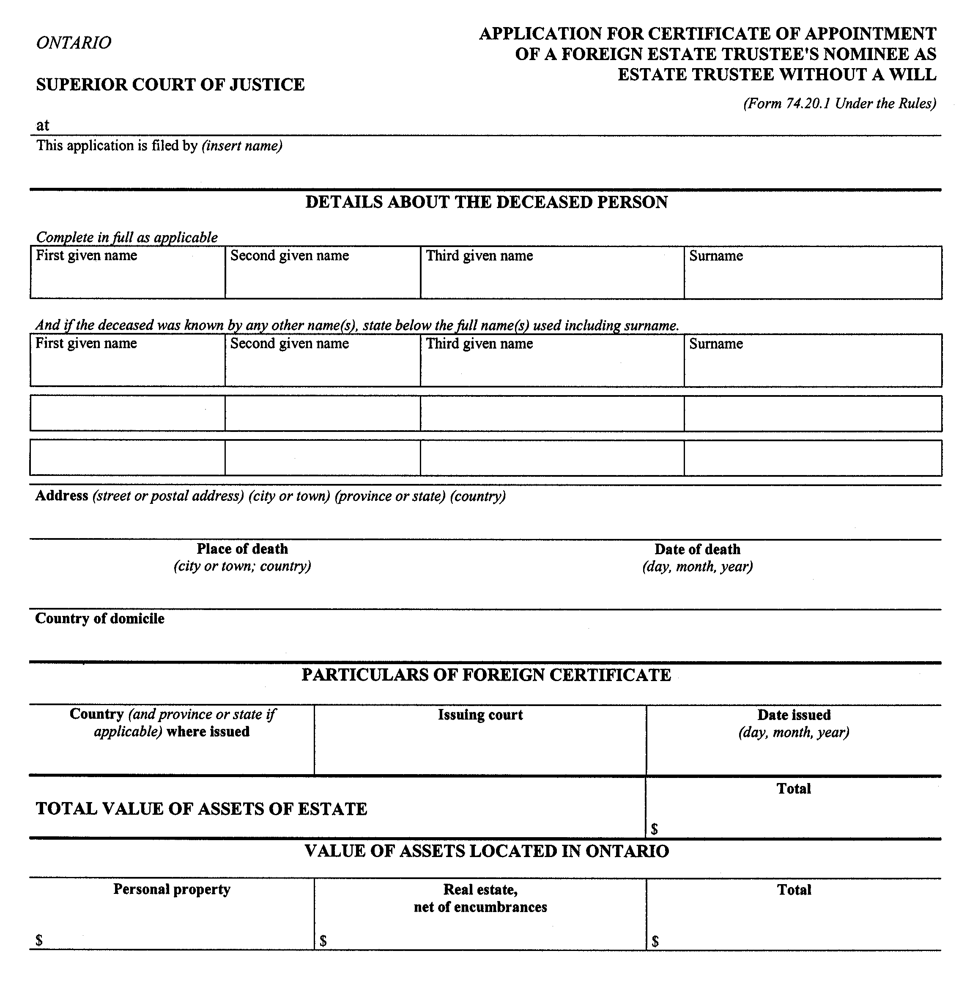
Insert regs\Graphics\Source Law\2004\132\13274201be.tif
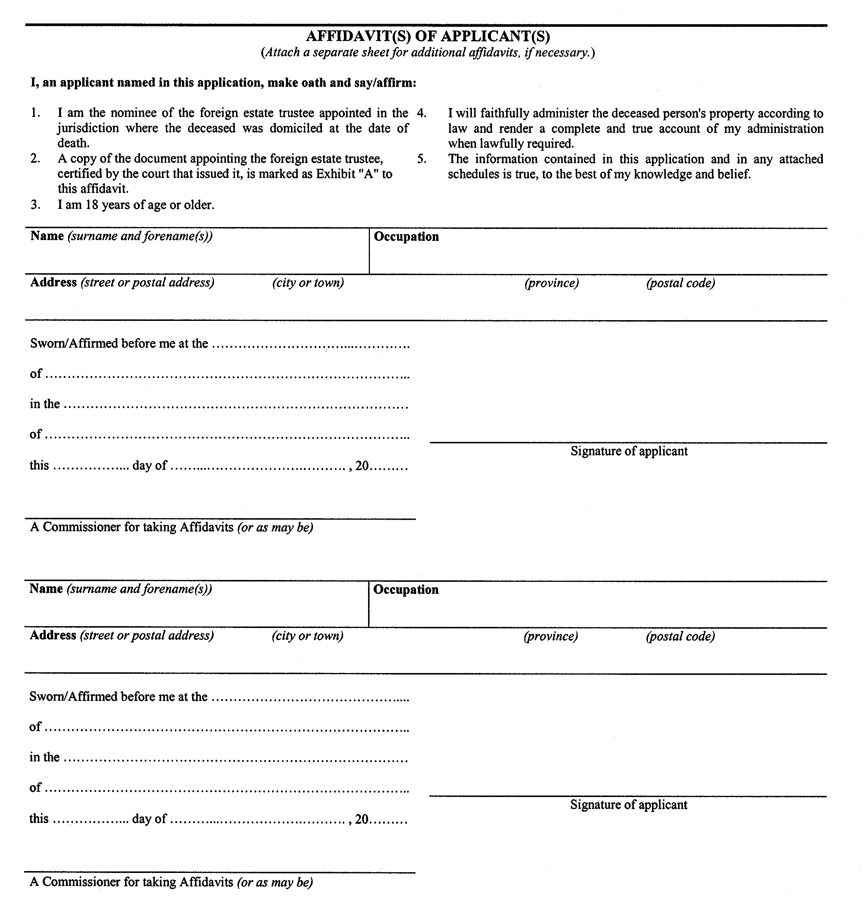
O. Reg. 132/04, s. 24.
See: O. Reg. 132/04, ss. 24, 25 (1).
Form 74.20.2
Courts of Justice Act
NOmination of applicant by foreign estate trustee
ONTARIO
SUPERIOR COURT OF JUSTICE
IN THE ESTATE OF (insert name), deceased.
NOmination of applicant by foreign estate trustee
1. The deceased died on (insert date), without a will.
2. I, was appointed estate trustee by the ,
in the jurisdiction where the deceased was domiciled at the date of death, on the day of 20
3. I nominate to apply in Ontario for a certificate of estate trustee without a will.
DATE:
Signature of witness | Signature of person nominating
O. Reg. 332/96, s. 6; O. Reg. 292/99, s. 1 (3, 4).
Form 74.20.3
Courts of Justice Act
certificate of appointment of foreign estate trustee’s nominee as estate trustee without a will
Court file no.
ONTARIO
SUPERIOR COURT OF JUSTICE
IN THE ESTATE OF , deceased,
late of
occupation
who died on
certificate of appointment of foreign estate
trustee’s nominee as estate trustee without a will
Applicant Address Occupation
This CERTIFICATE OF APPOINTMENT OF FOREIGN ESTATE TRUSTEE’S NOMINEE AS ESTATE TRUSTEE WITHOUT A WILL is hereby issued under the seal of the court to the applicant named above.
DATE | Registrar  Address of court office

O. Reg. 332/96, s. 6; O. Reg. 292/99, s. 1 (3, 4).
Form 74.21
Courts of Justice Act
APPLICATION FOR CERTIFICATE OF APPOINTMENT AS SUCCEEDING ESTATE TRUSTEE WITH A WILL
ONTARIO
SUPERIOR COURT OF JUSTICE
at
This application is filed by (insert name and address)
DETAILS ABOUT THE DECEASED PERSON
Complete in full as applicable | And if the deceased was known by any other name, state below the full names used
First given name | Given name or names
Second given name
Third given name | Surname
Surname

PARTICULARS OF FIRST CERTIFICATE
Name(s) of estate trustee(s) |  |  |  |  | Date issued  (day, month, year)
VALUE OF UNDISTRIBUTED ASSETS OF ESTATE
Personal property  $ | Real estate,  net of encumbrances  $ |  |  |  | Total  $
Explain why the applicant is entitled to apply.
AFFIDAVIT(S) OF APPLICANT(S)
(Attach a separate sheet for additional affidavits, if necessary)
I, a trust officer named in this application, make oath and say/affirm:
1. I am a trust officer of the corporate applicant.  2. I am 18 years of age or older.  3. The corporate applicant will faithfully administer the deceased person’s property according to law and render a complete and  true account of its administration when lawfully required. |  | 4. If the corporate applicant is not named as estate trustee in the  will or codicil, consents of persons who together have a majority interest in the value of the undistributed assets of the estate at  the date of this application are attached.  5. The information contained in this application and in any attached schedules is true, to the best of my knowledge and belief.
Name of corporate applicant |  | Name of trust officer
Address of corporate applicant (street or postal address) (city or town) (province) (postal code)
Sworn/Affirmed before me at the  of  in the  of  this day of , 20  A Commissioner for Taking Affidavits  (or as may be) |  |  | } | Signature of trust officer

AFFIDAVIT(S) OF APPLICANT(S)
(Attach a separate sheet for additional affidavits, if necessary.)
I, an applicant named in this application, make oath and say/affirm:
1. I am 18 years of age or older.  2. I will faithfully administer the deceased person’s property according to law and render a complete and true account of my administration when lawfully required. | 3. If I am not named as estate trustee in the will or codicil, consents of persons who together have a majority interest in the value of the undistributed assets of the estate at the date of this application are attached.  4. The information contained in this application and in any attached schedules is true, to the best of my knowledge and belief.
Name (surname and forename(s)) |  |  |  | Occupation
Address (street or postal address) (city or town) (province) (postal code)
Sworn/Affirmed before me at the  of  in the  of  this day of , 20  A Commissioner for Taking Affidavits  (or as may be) |  | } | Signature of applicant

O. Reg. 740/94, s. 14; O. Reg. 292/99, s. 1 (3, 4); O. Reg. 24/00, s. 27.
Note: On January 1, 2005, Form 74.21 is revoked and the following substituted:
Form 74.21
Courts of Justice Act
application for certificate of appointment as succeeding estate trustee with a will
Insert regs\Graphics\Source Law\2004\132\1327421ae.tif
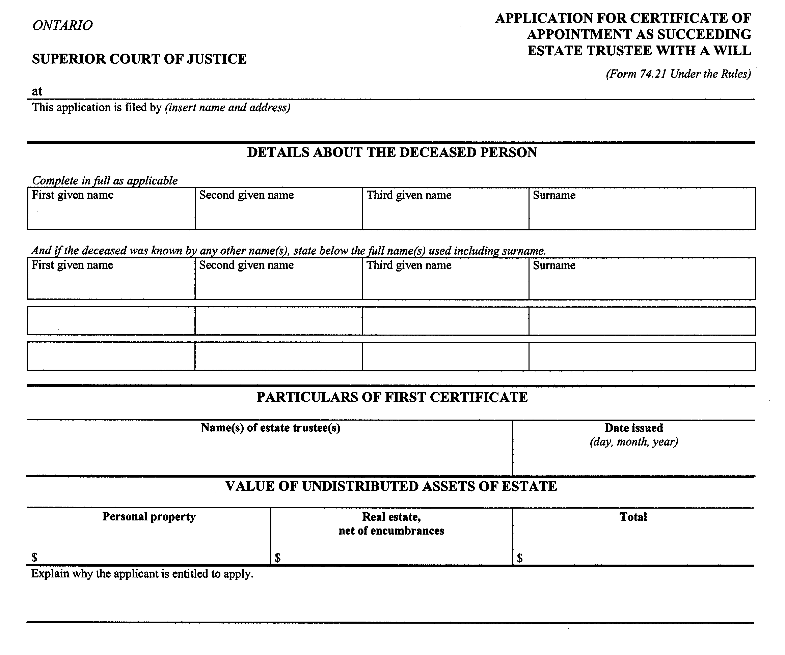
Insert regs\Graphics\Source Law\2004\132\1327421be.tif
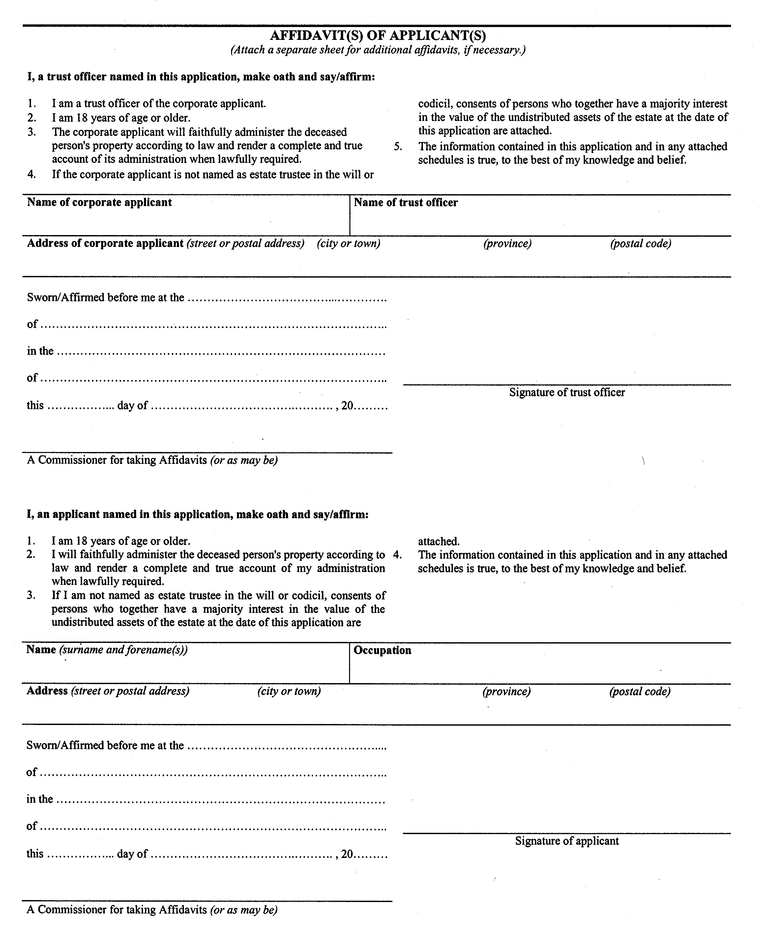
O. Reg. 132/04, s. 24.
See: O. Reg. 132/04, 24, 25 (1).
Form 74.22
Courts of Justice Act
COnsent to applicant’s appointment as SUCCEEDING estate trustee with a will
ONTARIO
SUPERIOR COURT OF JUSTICE
IN THE ESTATE OF (insert name) , deceased.
COnsent to applicant’s appointment
as succeeding estate trustee with a will
The deceased died on (date).
I, (insert name), am entitled to share in the distribution of the remaining estate.
I consent to the application by (insert name) for a certificate of appointment of succeeding estate trustee with a will.
I consent to an order dispensing with the filing of a bond by the applicant (delete if inapplicable).

DATE
)
)
)
)
)
)
Signature of witness ) | Signature of person consenting
)
)

O. Reg. 484/94, s. 13; O. Reg. 292/99, s. 1 (3, 4).
Form 74.23
Courts of Justice Act
certificate of appointment of succeeding estate trustee with a will
Court file no.
ONTARIO
SUPERIOR COURT OF JUSTICE
IN THE ESTATE OF , deceased,
late of
occupation
who died on
certificate of appointment
of succeeding estate trustee with a will
Applicant Address Occupation
This CERTIFICATE OF APPOINTMENT OF SUCCEEDING ESTATE TRUSTEE WITH A WILL is hereby issued under the seal of the court to the applicant named above. A copy of the deceased’s last will (and codicil(s), if any) is attached.
DATE | Registrar  Address of court office

O. Reg. 484/94, s. 13; O. Reg. 740/94, s. 10; O. Reg. 292/99, s. 1 (3, 4).
Form 74.24
Courts of Justice Act
APPLICATION FOR CERTIFICATE OF APPOINTMENT AS SUCCEEDING ESTATE TRUSTEE WITHOUT A WILL
ONTARIO
SUPERIOR COURT OF JUSTICE
at
This application is filed by (insert name and address)
DETAILS ABOUT THE DECEASED PERSON
Complete in full as applicable |  |  | And if the deceased was known by any other name, state below the full names used
First given name |  |  | Given name or names
Second given name
Third given name |  |  | Surname
Surname
PARTICULARS OF FIRST CERTIFICATE
Name(s) of estate trustee(s) or administrator(s) |  |  |  |  |  | Date issued  (day, month, year)
PERSONS ENTITLED TO SHARE IN THE ESTATE
(at date of this application)
(Attach a schedule if more space is needed. If a person entitled to share in the estate is not a spouse, child, parent, brother or sister of the deceased person, show how the relationship is traced.)
Name | Address |  |  |  |  | Relationship to  deceased person | Age  if under 18
VALUE OF UNDISTRIBUTED ASSETS OF ESTATE
Personal property  $ | Real estate,  net of encumbrances  $ |  |  |  |  | Total  $
Explain why the applicant is entitled to apply.
AFFIDAVIT(S) OF APPLICANT(S)
(Attach a separate sheet for additional affidavits, if necessary)
I, a trust officer named in this application, make oath and say/affirm:
1. I am a trust officer of the corporate applicant.  2. I am 18 years of age or older.  3. The corporate applicant will faithfully administer the deceased person’s property according to law and render a complete and  true account of its administration when lawfully required. |  | 4. Consents of persons who together have a majority interest in the value of the undistributed assets of the estate at the date of this application are attached.  5. The information contained in this application and in any attached schedules is true, to the best of my knowledge and belief.
Name of corporate applicant |  | Name of trust officer
Address of corporate application (street or postal address) (city or town) (province) (postal code)
Sworn/Affirmed before me at the  of  in the  of  this day of , 20  A Commissioner for Taking Affidavits  (or as may be) |  |  |  | } | Signature of trust officer

I, an applicant named in this application, make oath and say/affirm:
1. I am 18 years of age or older and a resident of Ontario.  2. I will faithfully administer the deceased person’s property according to law and render a complete and true account of my administration when lawfully required. | 3. Consents of persons who together have a majority interest in the value of the undistributed assets of the estate at the date of this application are attached.  4. The information contained in this application and in any attached schedules is true, to the best of my knowledge and belief.
Name (surname and forename(s)) |  |  |  | Occupation
Address (street or postal address) (city or town) (province) (postal code)
Sworn/Affirmed before me at the  of  in the  of  this day of , 20 . . . .  A Commissioner for Taking Affidavits  (or as may be) |  | } | Signature of applicant

O. Reg. 740/94, s. 14; O. Reg. 292/99, s. 1 (3, 4); O. Reg. 24/00, s. 27.
Note: On January 1, 2005, Form 74.24 is revoked and the following substituted:
Form 74.24
Courts of Justice Act
application for certificate of appointment as succeeding estate trustee without a will
Insert regs\Graphics\Source Law\2004\132\1327424ae.tif
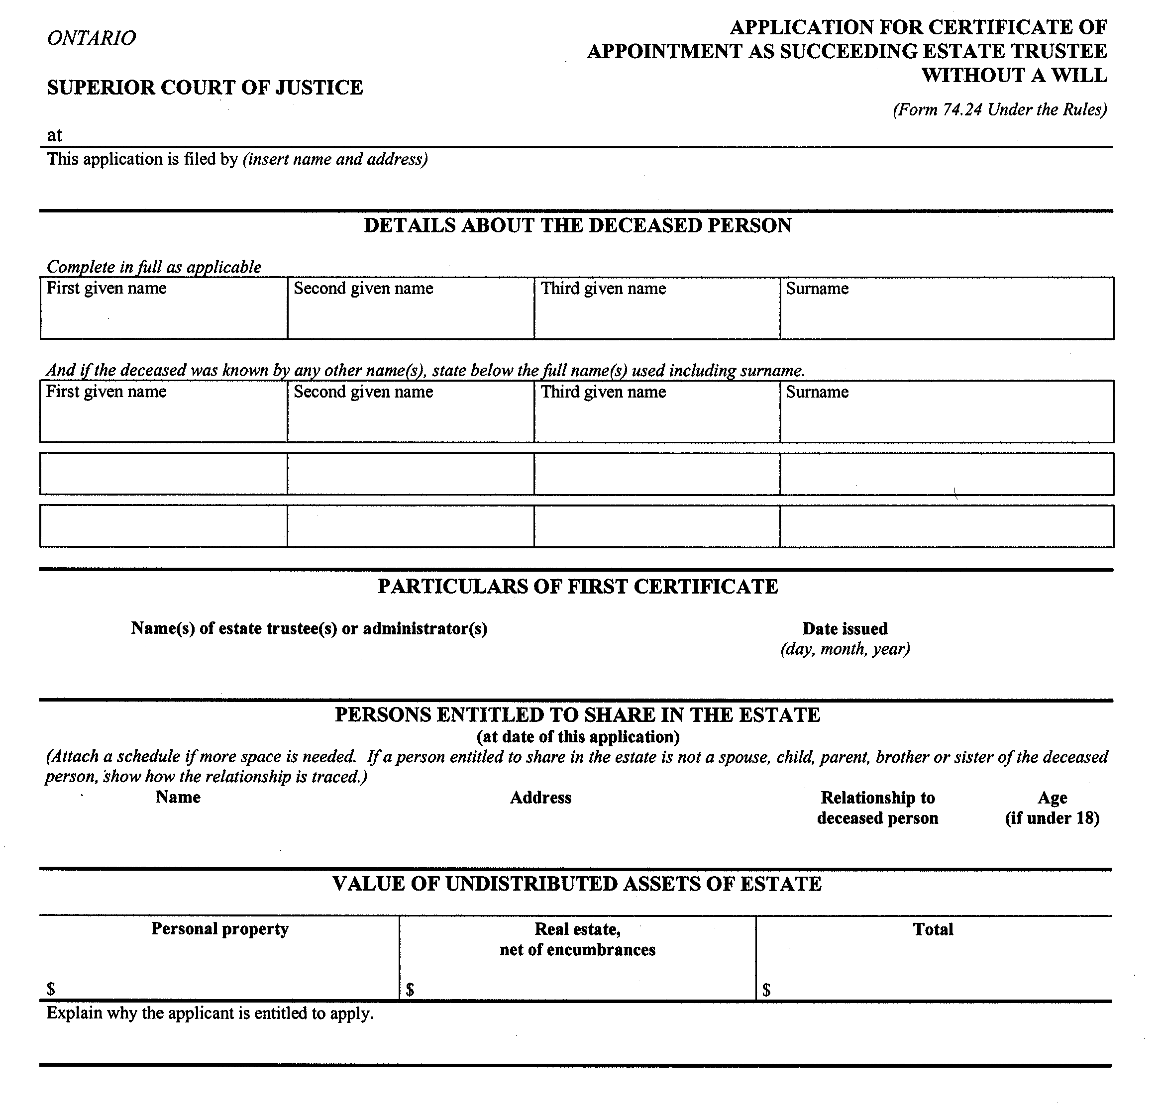
Insert regs\Graphics\Source Law\2004\132\1327424be.tif
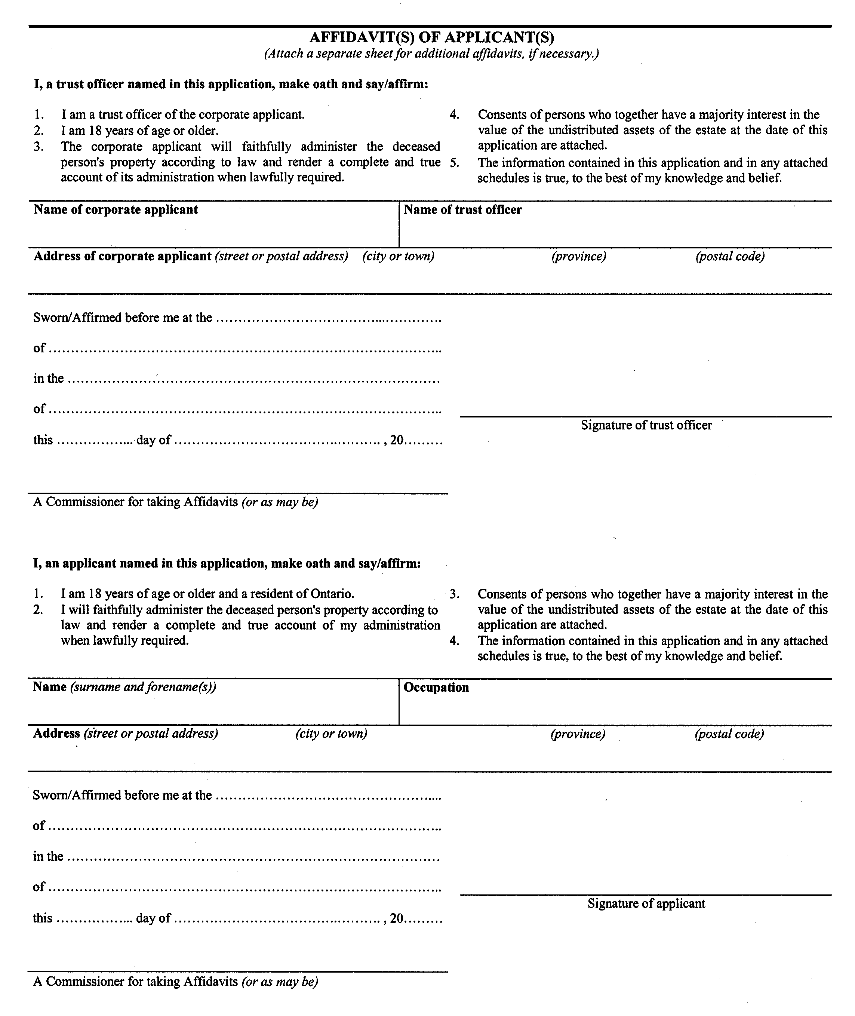
O. Reg. 132/04, s. 24.
See: O. Reg. 132/04, ss. 24, 25 (1).
Form 74.25
Courts of Justice Act
COnsent to applicant’s appointment as succeeding estate trustee without a will
ONTARIO
SUPERIOR COURT OF JUSTICE
IN THE ESTATE OF (insert name), deceased.
COnsent to applicant’s appointment
as succeeding estate trustee without a will
The deceased died on (date), without a will.
I, (insert name), am entitled to share in the distribution of the estate.
I consent to the application by (insert name) for a certificate of appointment of succeeding estate trustee without a will.
I consent to an order dispensing with the filing of a bond by the applicant (delete if inapplicable).

DATE
)
)
)
)
)
)
Signature of witness ) | Signature of person consenting
)
`

O. Reg. 484/94, s. 13; O. Reg. 292/99, s. 1 (3, 4).
Form 74.26
Courts of Justice Act
certificate of appointment of succeeding estate trustee without a will
Court file no.
ONTARIO
SUPERIOR COURT OF JUSTICE
IN THE ESTATE OF , deceased,
late of
occupation
who died on
certificate of appointment
of succeeding estate trustee without a will
Applicant Address Occupation
This CERTIFICATE OF APPOINTMENT OF SUCCEEDING ESTATE TRUSTEE WITHOUT A WILL is hereby issued under the seal of the court to the applicant named above.
DATE | Registrar  Address of court office

O. Reg. 484/94, s. 13; O. Reg. 740/94, s. 10; O. Reg. 292/99, s. 1 (3, 4).
Form 74.27
Courts of Justice Act
Insert regs\Graphics\Source Law\2000\653\653074.27ae.tif
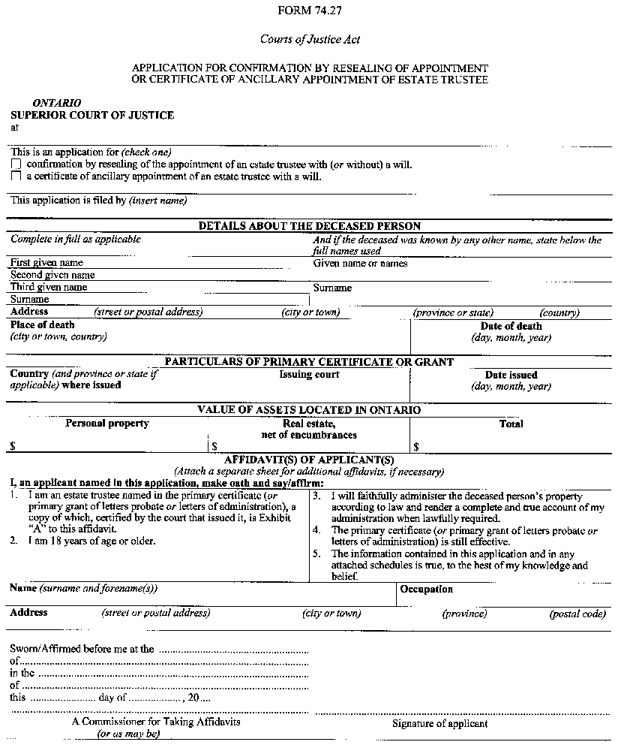
O. Reg. 653/00, s. 20.
Note: On January 1, 2005, Form 74.27 is revoked and the following substituted:
Form 74.27
Courts of Justice Act
application for confirmation by resealing of appointment or certificate of ancillary appointment of estate trustee
Insert regs\Graphics\Source Law\2004\132\1327427ae.tif
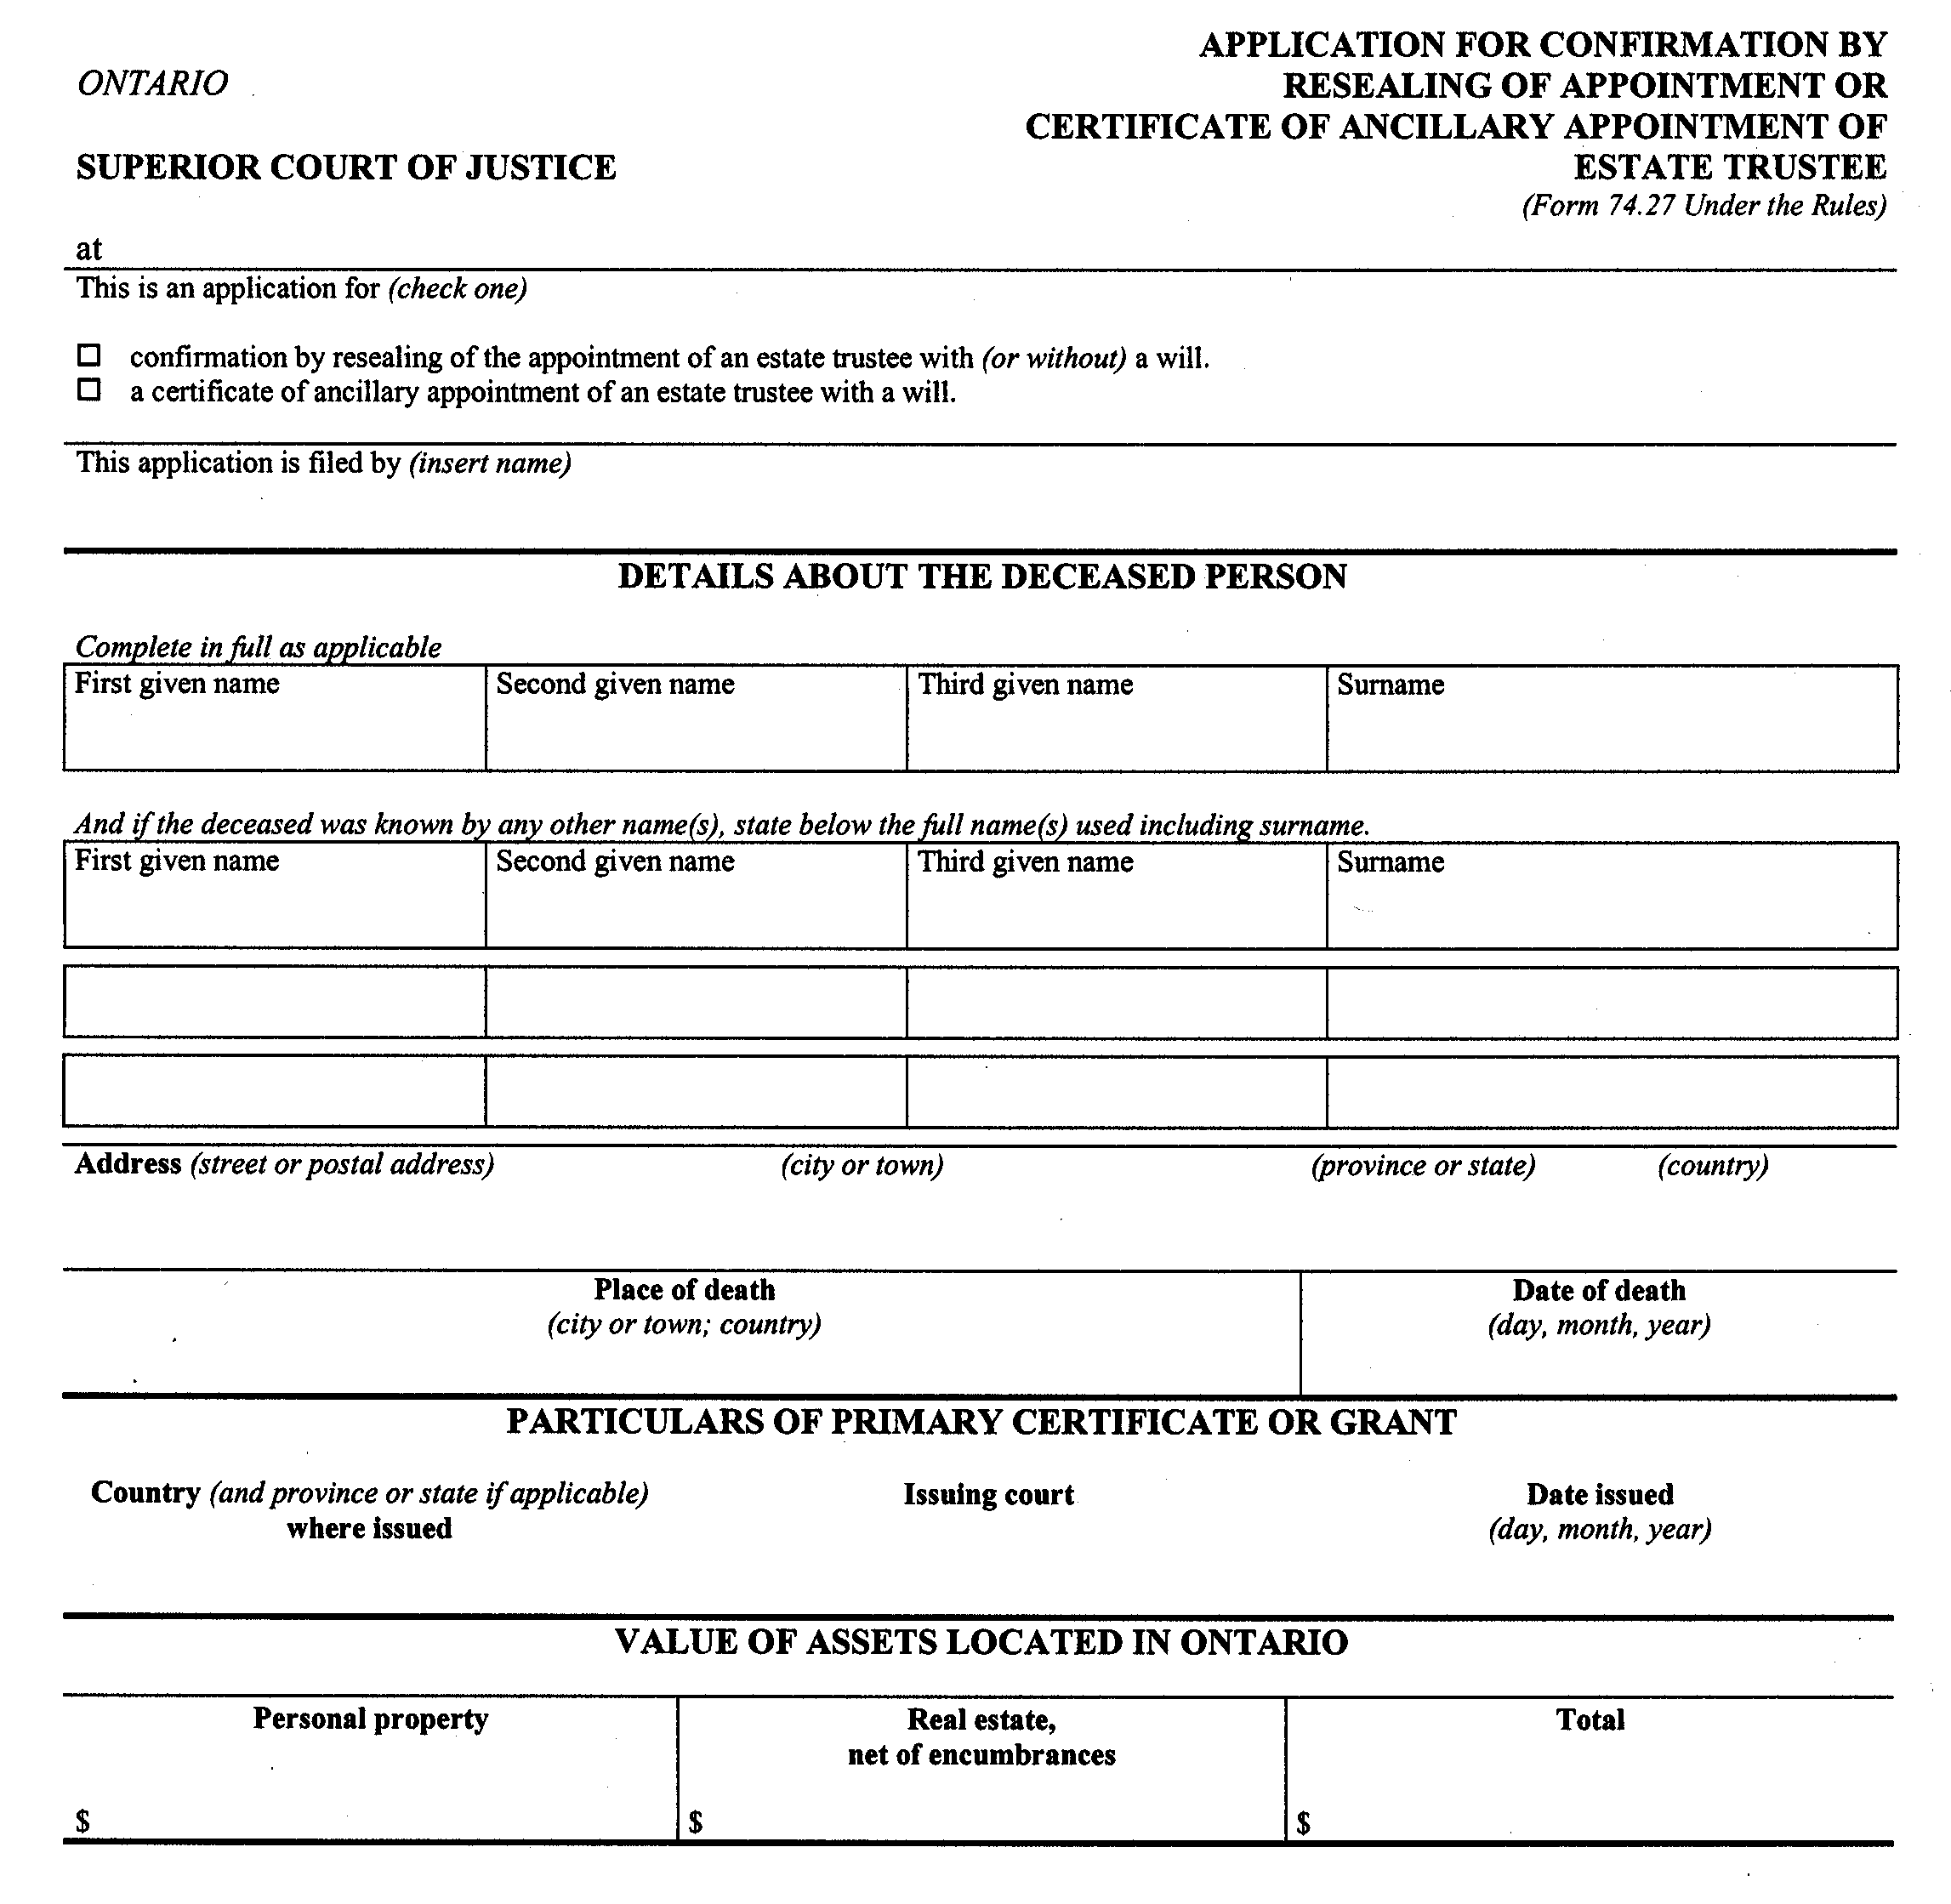
Insert regs\Graphics\Source Law\2004\132\1327427be.tif
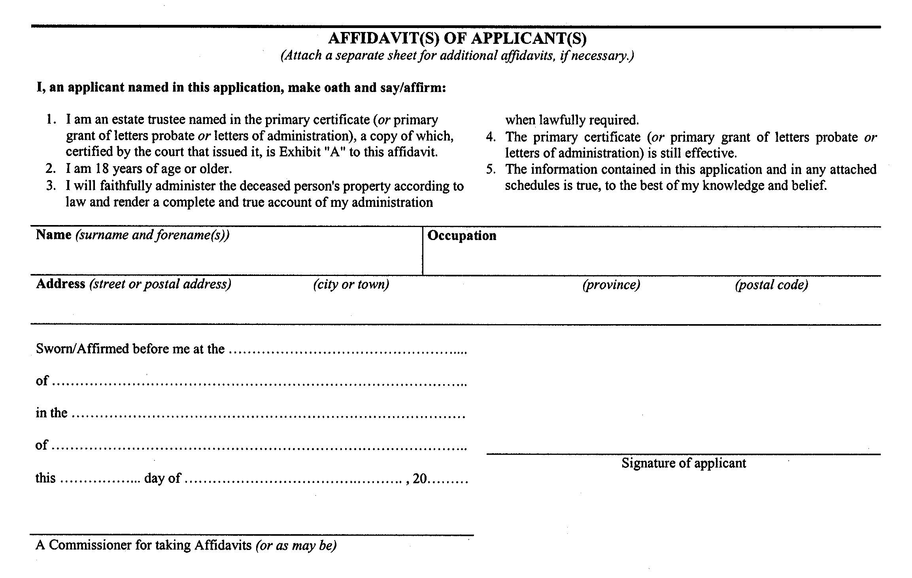
O. Reg. 132/04, s. 24.
See: O. Reg. 132/04, ss. 24, 25 (1).
Form 74.28
Courts of Justice Act
confirmation by resealing of appointment of estate trustee
Sealed with the seal of the Superior Court of Justice by order of that court dated (insert date), under subsection 52 (1) of the Estates Act.
DATE | Registrar  Address of court office

O. Reg. 484/94, s. 13; O. Reg. 292/99, s. 1 (2).
Form 74.29
Courts of Justice Act
certificate of ancillary appointment of estate trustee with a will
Court file no.
ONTARIO
SUPERIOR COURT OF JUSTICE
IN THE ESTATE OF , deceased,
late of
occupation
who died on
certificate of ancillary appointment
of estate trustee with a will
Applicant Address Occupation
Court of foreign grant
Date of foreign grant
This CERTIFICATE OF ANCILLARY APPOINTMENT OF ESTATE TRUSTEE WITH A WILL is hereby issued under the seal of the court to the applicant named above. A certified copy of the foreign grant, to which this certificate is ancillary, is attached.
DATE | Registrar  Address of court office

O. Reg. 484/94, s. 13; O. Reg. 740/94, s. 10; O. Reg. 292/99, s. 1 (3, 4).
Form 74.30
Courts of Justice Act
APPLICATION FOR CERTIFICATE OF APPOINTMENT OF ESTATE TRUSTEE DURING LITIGATION
ONTARIO
SUPERIOR COURT OF JUSTICE
at
This application is filed by (insert name)
DETAILS ABOUT THE DECEASED PERSON
Name (insert surname and forename(s), and, if applicable, any other name by which the deceased person was known)
Address of fixed place of abode (street or postal address) (city or town) |  |  |  |  | (county, district, regional or  metropolitan municipality)
If the deceased person had no fixed place of abode in Ontario,  did he or she have property in Ontario? □ No □ Yes |  | Last occupation of deceased person
Place of death  (city or town; county, district, regional or metropolitan municipality) |  |  |  |  |  | Date of death  (day, month, year)
VALUE OF ASSETS OF ESTATE
Do not include in the total amount: insurance payable to a named beneficiary or assigned for value, property held jointly and passing by survivorship, or real estate outside Ontario.
Personal property  $ | Real estate,  net of encumbrances  $ |  |  |  |  | Total  $
This application is made pursuant to an order for the appointment of an estate trustee during litigation, made by
on  (name of judge) |  | (day, month year)
AFFIDAVIT(S) OF APPLICANT(S)
(Attach a separate sheet for additional affidavits, if necessary)
I, a trust officer named in this application, make oath and say/affirm:
1. I am a trust officer of the corporate applicant.  2. I am 18 years of age or older.  3. The corporate applicant will faithfully administer the deceased person’s property according to law, make no distribution without |  | a court order, and render a complete and true account of its administration when lawfully required.  4. The information contained in this application and in any attached schedules is true, to the best of my knowledge and belief.
Name of corporate applicant |  | Name of trust officer
Address of corporate applicant (street or postal address) (city or town) (province) (postal code)
Sworn/Affirmed before me at the  of  in the  of  this day of , 20  A Commissioner for Taking Affidavits  (or as may be) |  |  |  | Signature of trust officer

I, an applicant named in this application, make oath and say/affirm:
1. I am 18 years of age or older.  2. I will faithfully administer the deceased person’s property according to law, make no distribution without a court order | and render a complete and true account of my administration when lawfully required.  3. The information contained in this application and in any attached schedules is true, to the best of my knowledge and belief.
Name (surname and forename(s)) |  |  |  | Occupation
Address (street or postal address) (city or town) (province) (postal code)
Sworn/Affirmed before me at the  of  in the  of  this day of , 20  A Commissioner for Taking Affidavits  (or as may be) |  |  | Signature of applicant

O. Reg. 484/94, s. 13; O. Reg. 292/99, s. 1 (3, 4).
Note: On January 1, 2005, Form 74.30 is revoked and the following substituted:
Form 74.30
Courts of Justice Act
application for certificate of appointment of estate trustee during litigation
Insert regs\Graphics\Source Law\2004\132\1327430ae.tif
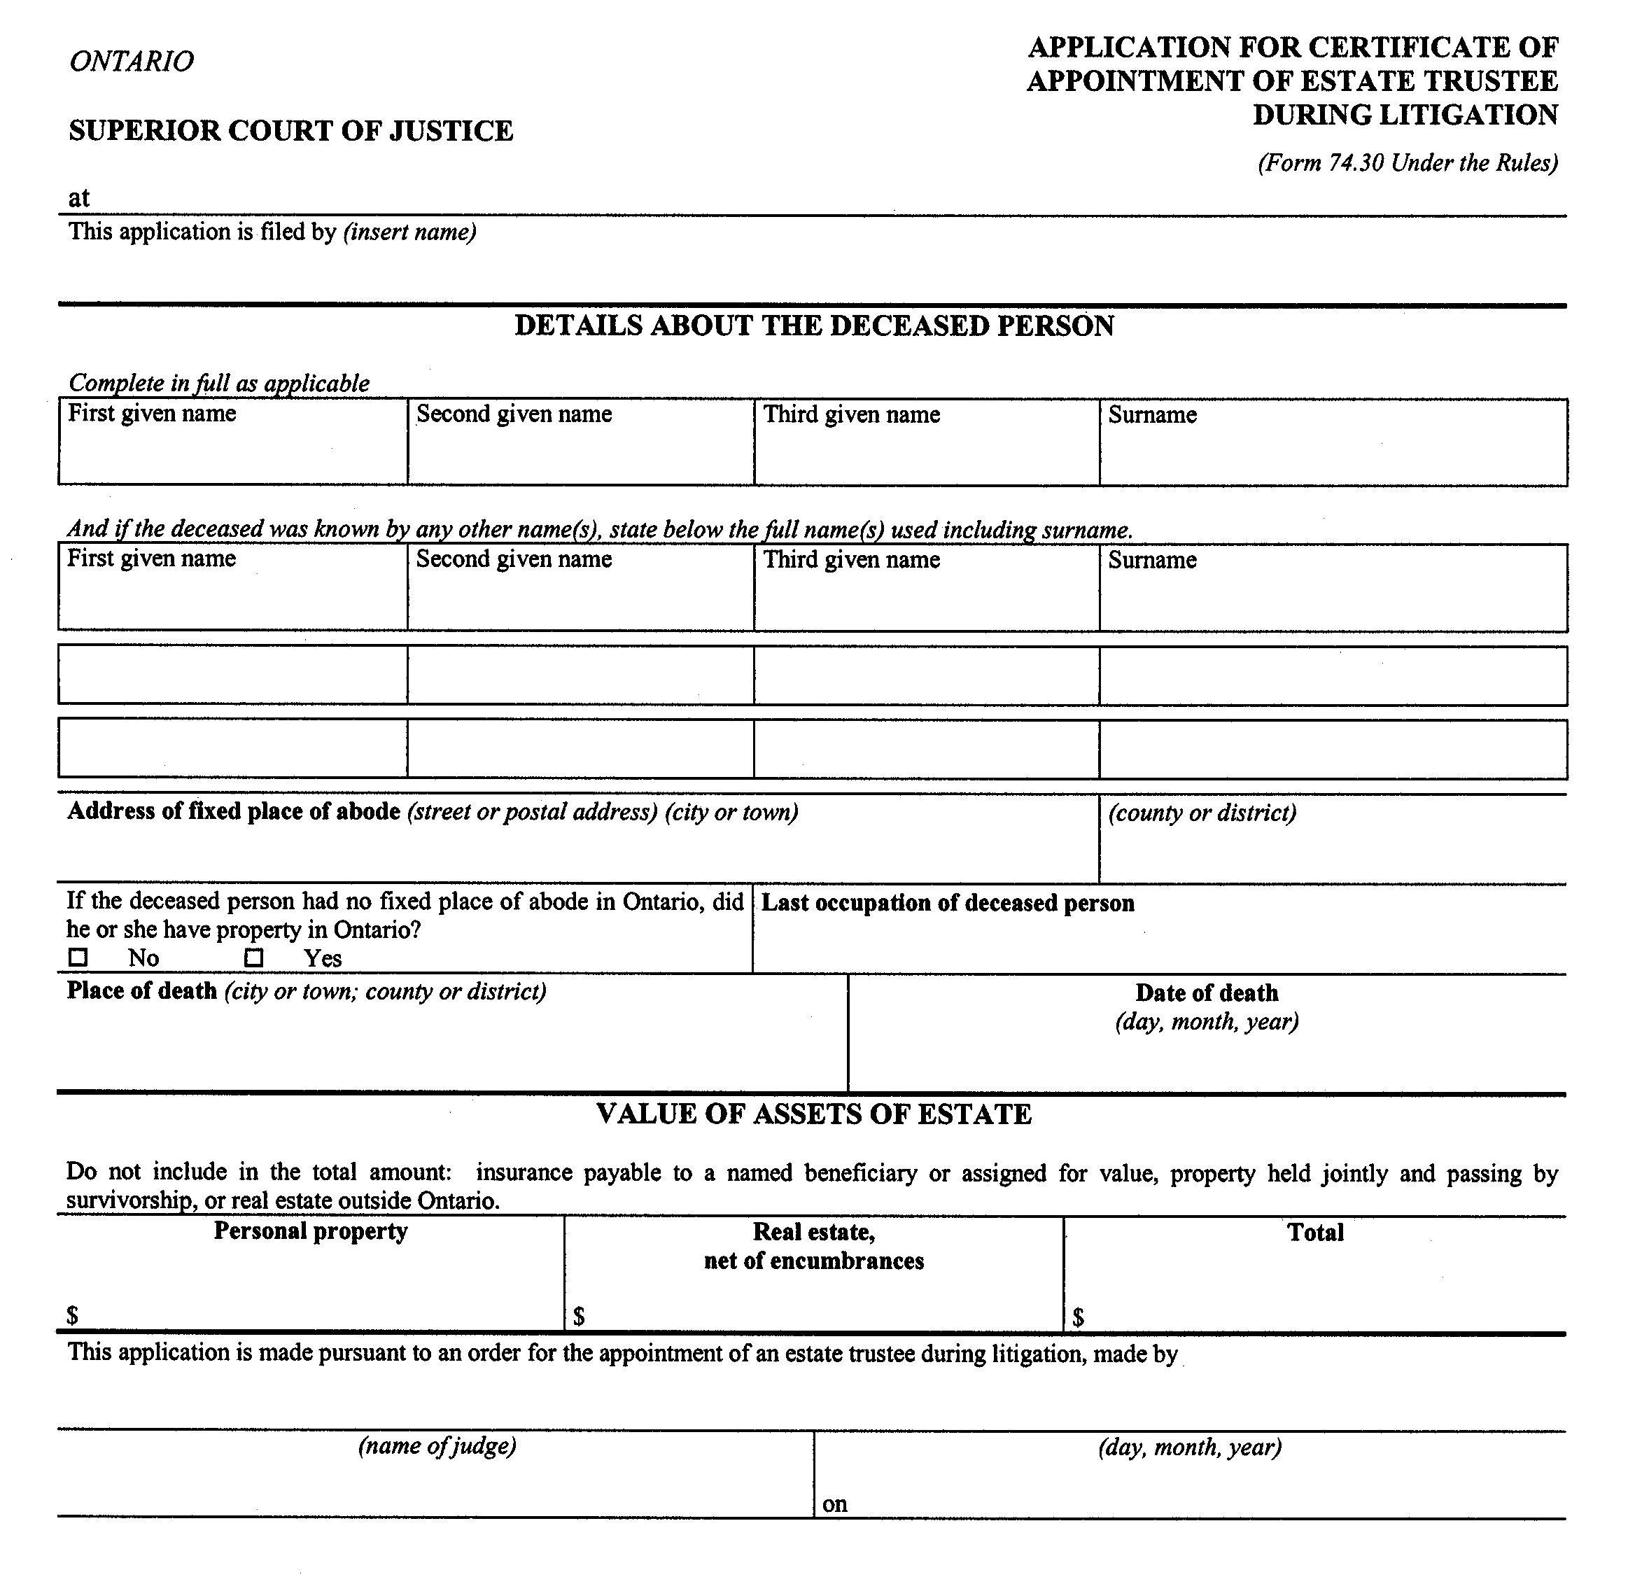
Insert regs\Graphics\Source Law\2004\132\1327430be.tif
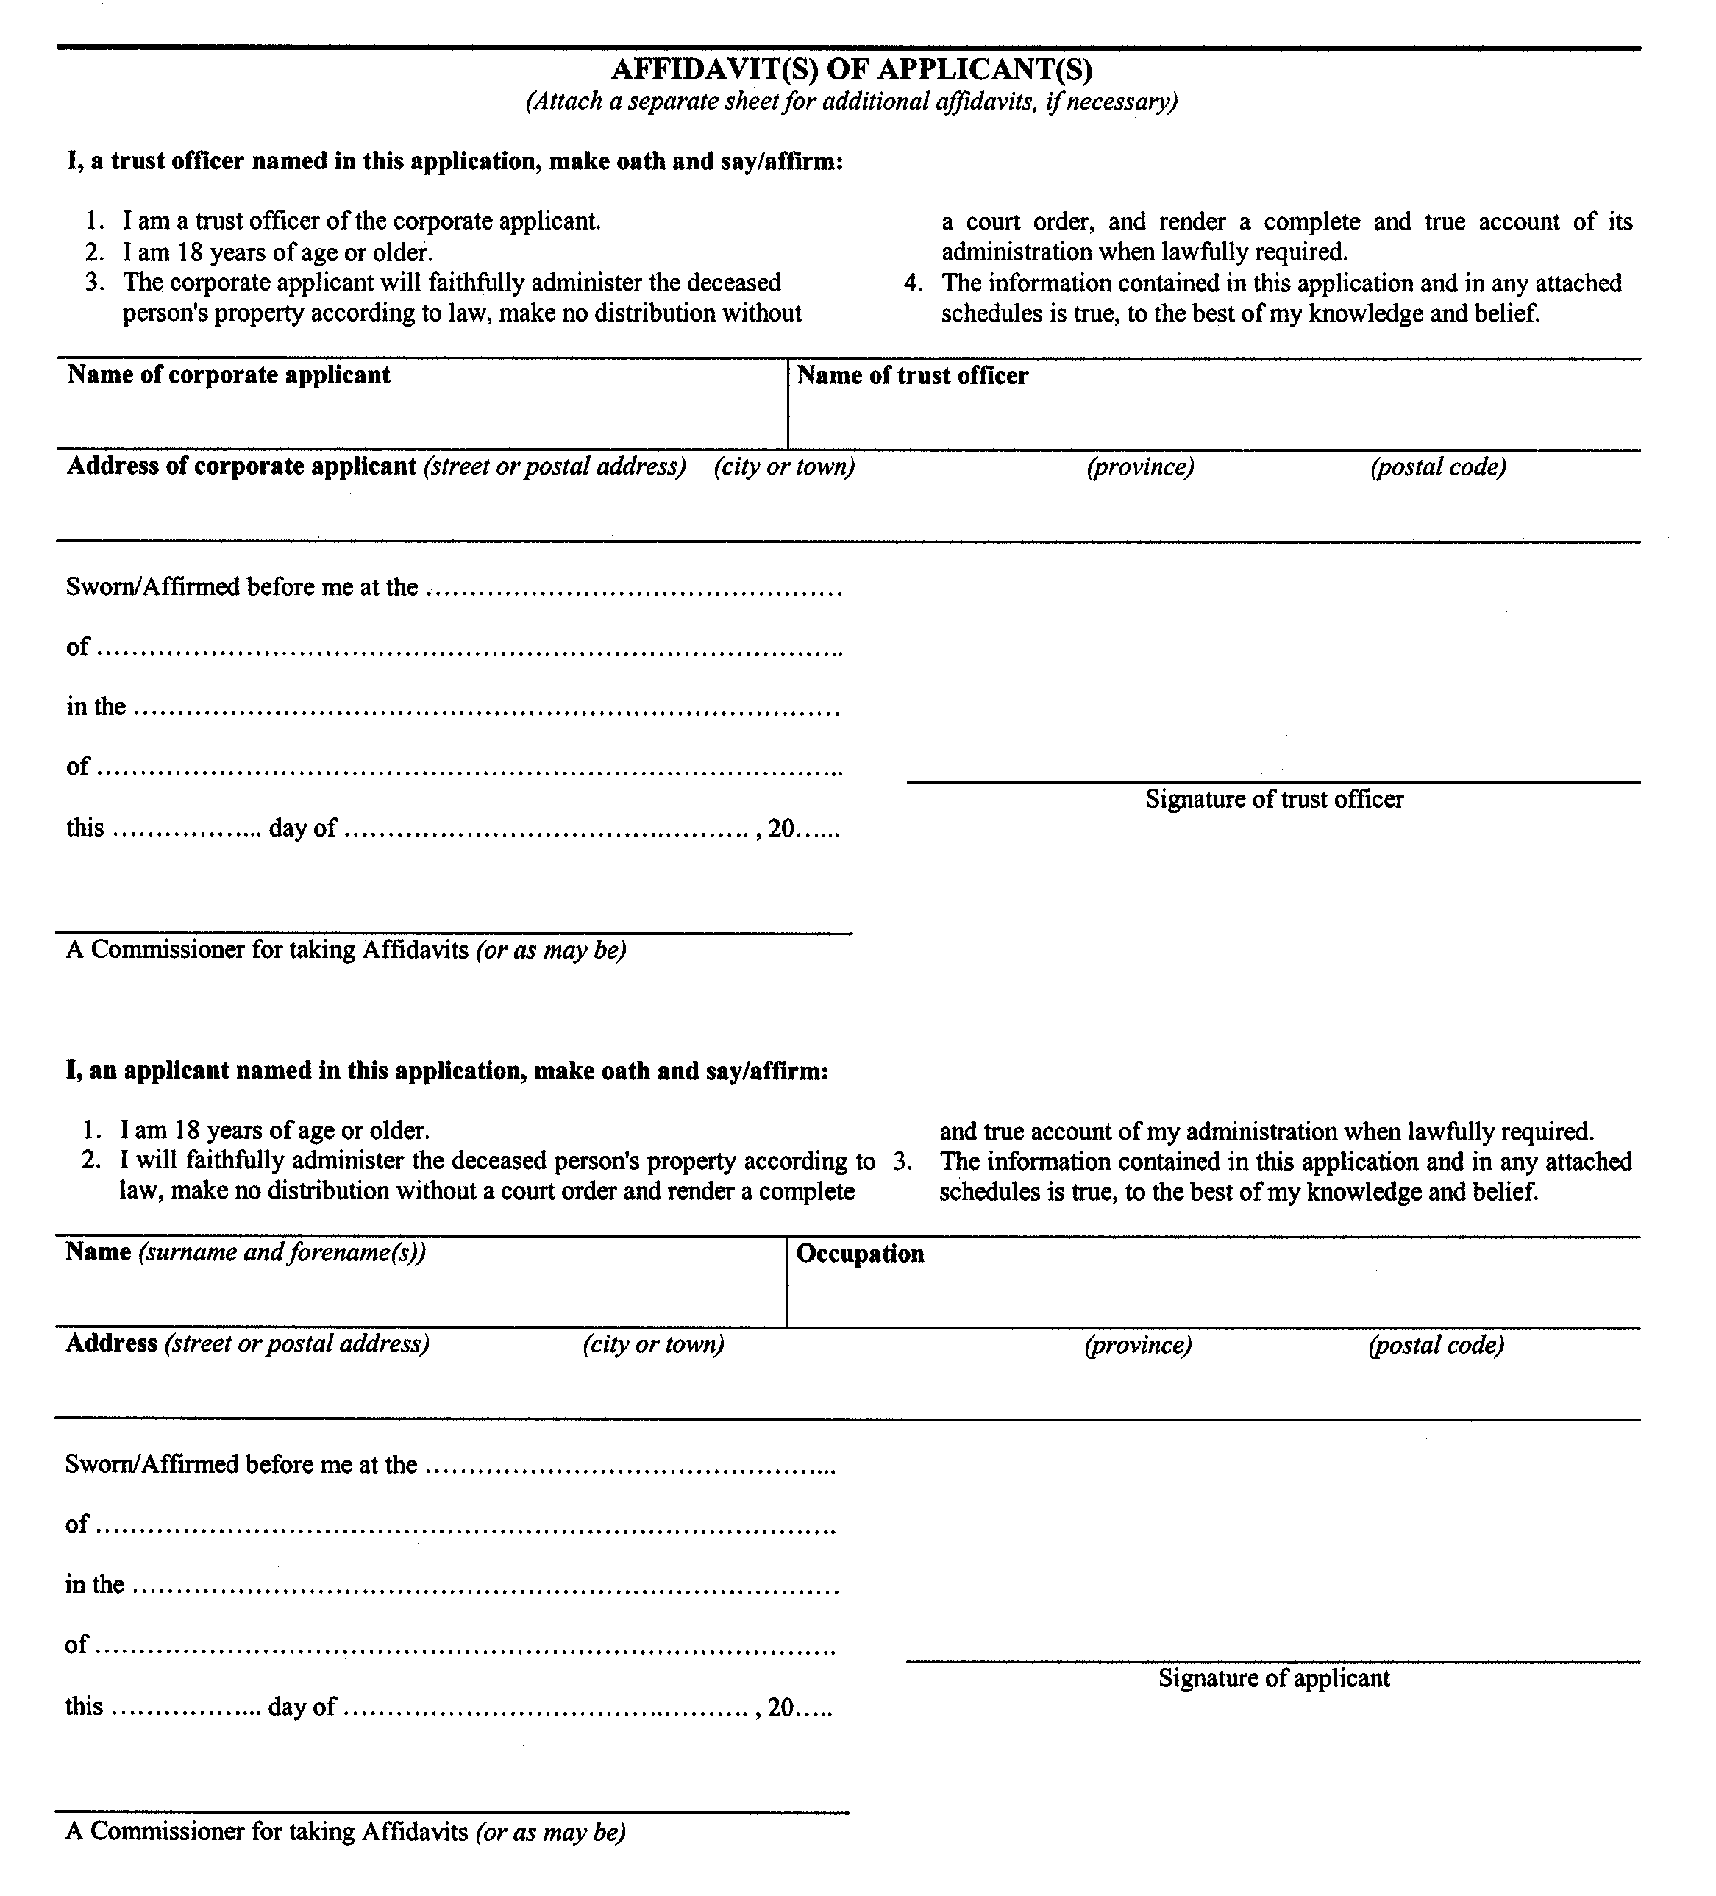
O. Reg. 132/04, s. 24.
See: O. Reg. 132/04, ss. 24, 25 (1).
Form 74.31
Courts of Justice Act
certificate of appointment of estate trustee during litigation
Court file no.
ONTARIO
SUPERIOR COURT OF JUSTICE
IN THE ESTATE OF , deceased,
late of
occupation
who died on
certificate of appointment
of estate trustee during litigation
Applicant Address Occupation
By order of the Superior Court of Justice, this CERTIFICATE OF APPOINTMENT OF ESTATE TRUSTEE DURING LITIGATION to determine the validity of a testamentary document of the deceased is hereby issued under the seal of the court to the applicant named above.
DATE | Registrar  Address of court office

O. Reg. 484/94, s. 13; O. Reg. 292/99, s. 1 (3, 4); O. Reg. 24/00, s. 28.
Form 74.32
Courts of Justice Act
bOnd — insurance or guarantee company
ONTARIO
SUPERIOR COURT OF JUSTICE
BOND NO. AMOUNT: $
IN THE ESTATE OF (insert name), deceased.
The principal in this bond is (insert name)
The surety in this bond is (insert name), an insurer licensed under the Insurance Act to write surety and fidelity insurance in Ontario.
The obligee in this bond is the Accountant of the Superior Court of Justice acting for the benefit of creditors and persons entitled to share in the estate of the deceased.
The principal and the surety bind themselves, their heirs, executors, successors and assigns jointly and severally to the Accountant of the Superior Court of Justice in the amount of Dollars ($ ).
The principal as an estate trustee is required to prepare a complete and true inventory of all the property of the deceased, collect the assets of the estate, pay the debts of the estate, distribute the property of the deceased according to law, and render a complete and true accounting of these activities when lawfully required.
The primary obligation under this bond belongs to the principal. The principal is liable under this bond for any amount found by the court to be owing to any creditors of the estate and persons entitled to share in the estate to whom proper payment has not been made.
The surety, provided it has been given reasonable notice of any proceeding in which judgment may be given against the principal for failure to perform the obligations of this bond shall, on order of the court, and on default of the principal to pay any final judgment made against the principal in the proceeding, pay to the obligee the amount of any deficiency in the payment by the principal, but the surety shall not be liable to pay more than the amount of the bond.
The amount of this bond shall be reduced by and to the extent of any payment made under the bond pursuant to an order of the court.
The surety is entitled to an assignment of the rights of any person who receives payment or benefit from the proceeds of this bond, to the extent of such payment or benefit received.

DATE
SIGNED, SEALED AND DELIVERED
in the presence of:
Principal
Surety

O. Reg. 484/94, s. 13; O. Reg. 292/99, ss. 1 (3, 4), 6; O. Reg. 24/00, s. 29.
Form 74.33
Courts of Justice Act
bOnd — personal sureties
ONTARIO
SUPERIOR COURT OF JUSTICE
BOND NO. AMOUNT: $
IN THE ESTATE OF (insert name), deceased.
The principal in this bond is (insert name)
The sureties in this bond are (insert names)
The obligee in this bond is the Accountant of the Superior Court of Justice acting for the benefit of creditors and persons entitled to share in the estate of the deceased.
The principal and the sureties bind themselves, their heirs, executors, successors and assigns jointly and severally to the Accountant of the Superior Court of Justice in the amount of Dollars ($ ).
The principal as an estate trustee is required to prepare a complete and true inventory of all the property of the deceased, collect the assets of the estate, pay the debts of the estate, distribute the property of the deceased according to law, and render a complete and true accounting of these activities when lawfully required.
The primary obligation under this bond belongs to the principal. The principal is liable under this bond for any amount found by the court to be owing to any creditors of the estate and persons entitled to share in the estate to whom proper payment has not been made.
The sureties, provided they have been given reasonable notice of any proceeding in which judgment may be given against the principal for failure to perform the obligations of this bond shall, on order of the court, and on default of the principal to pay any final judgment made against the principal in the proceeding, pay to the obligee the amount of any deficiency in the payment by the principal, but the sureties shall not be liable to pay more than the amount of the bond.
The amount of this bond shall be reduced by and to the extent of any payment made under the bond pursuant to an order of the court.
The sureties are entitled to an assignment of the rights of any person who receives payment or benefit from the proceeds of this bond, to the extent of such payment or benefit received.

DATE
SIGNED, SEALED AND DELIVERED
in the presence of:
Principal
Surety
Surety

affidavit of surety
I, (insert name), of (insert city or town and county or district, metropolitan or regional municipality of residence), make oath and say/affirm:
I am a proposed surety on behalf of the intended estate trustees of the property of (insert name), deceased, named in the attached bond.
I am eighteen years of age or over and own property worth $ over and above all encumbrances, and over and above what will pay my just debts and every sum for which I am now bail or for which I am liable as surety or endorser or otherwise.

SWORN/AFFIRMED BEFORE )
me at the of )
in the of )
)
this day of , 20 . )
)
)
)
)

A Commissioner for Taking Affidavits (or as may be)
affidavit of surety
I, (insert name), of (insert city or town and county or district, metropolitan or regional municipality of residence), make oath and say/affirm:
I am a proposed surety on behalf of the intended estate trustees of the property of (insert name), deceased, named in the attached bond.
I am eighteen years of age or over and own property worth $ over and above all encumbrances, and over and above what will pay my just debts and every sum for which I am now bail or for which I am liable as surety or endorser or otherwise.

SWORN/AFFIRMED BEFORE | )
the at the of | )
in the of | )
this day of , 20 . | )
 | )
 | )
 | )
 | )

A Commissioner for Taking Affidavits (or as may be)
O. Reg. 484/94, s. 13; O. Reg. 292/99, ss. 1 (3, 4), 6.
Form 74.34
Courts of Justice Act
registrar’s notice to estate trustee named in a deposited will of application for certificate of appointment of estate trustee with a will
ONTARIO
SUPERIOR COURT OF JUSTICE
NOtice
Attached are a copy of an application for appointment of an estate trustee with a will in the estate of (insert name), deceased, and a copy of a certificate of the Estate Registrar indicating that you were named as an estate trustee in a later will or codicil of the deceased that is on deposit in the Superior Court of Justice.

DATE
Registrar
Address of court office

TO:
O. Reg. 484/94, s. 13; O. Reg. 292/99, s. 1 (3, 4); O. Reg. 24/00, s. 28.
Form 74.35
Courts of Justice Act
registrar’s notice to estate trustee named in a deposited will of application for certificate of appointment of estate trustee without a will
ONTARIO
SUPERIOR COURT OF JUSTICE
NOtice
Attached are a copy of an application for appointment of an estate trustee without a will in the estate of (insert name), deceased, and a copy of a certificate of the Estate Registrar indicating that you were named as an estate trustee in a will or codicil of the deceased that is on deposit in the Superior Court of Justice.

DATE
Registrar
Address of court office

TO:
O. Reg. 484/94, s. 13; O. Reg. 292/99, s. 1 (3, 4); O. Reg. 24/00, s. 28.
Form 74.36
Courts of Justice Act
order to accept or refuse appointment as estate trustee with a will
(Heading in accordance with Form 59A)
IN THE ESTATE OF (insert name), deceased.
order to accept or refuse appointment
as estate trustee with a will
A motion for this order has been made by (insert name of moving party). From an affidavit made by (insert name of maker of affidavit) that has been filed it appears that you are named as estate trustee in a will or codicil of the deceased dated (insert date).
1. THIS COURT ORDERS THAT you file an application for a certificate of appointment of estate trustee with a will in the court office within days after this order is served on you.
2. THIS COURT ORDERS THAT if you do not do so within that time, you shall be deemed to have renounced your right to be appointed.

Registrar
Address of court office

TO:
O. Reg. 484/94, s. 13.
Form 74.37
Courts of Justice Act
order to accept or refuse appointment as estate trustee without a will
(Heading in accordance with Form 59A)
IN THE ESTATE OF (insert name), deceased.
order to accept or refuse appointment
as estate trustee without a will
A motion for this order has been made by (insert name of moving party). From an affidavit made by (insert name of maker of affidavit) that has been filed it appears that you may have a prior right to be appointed estate trustee without a will in the deceased’s estate.
1. THIS COURT ORDERS THAT you file an application for a certificate of appointment of estate trustee without a will in the court office within
days after this order is served on you.
2. THIS COURT ORDERS THAT if you do not do so within that time, you shall be deemed to have renounced your right to be appointed.

Registrar
Address of court office

TO:
O. Reg. 484/94, s. 13.
Form 74.38
Courts of Justice Act
order to consent or object to a proposed appointment of an estate trustee with or without a will
(Heading in accordance with Form 59A)
IN THE ESTATE OF (insert name), deceased.
order to consent or object to a proposed appointment
of an estate trustee with or without a will
A motion for this order has been made by (insert name of moving party). From an affidavit made by (insert name of maker of affidavit) that has been filed it appears that (insert name) is applying for a certificate of appointment as estate trustee with (or without) a will, that you are a person with a financial interest in the estate and that your consent to the appointment is being sought.
1. THIS COURT ORDERS THAT if you oppose that person’s appointment as estate trustee, you must file a notice of objection to appointment of estate trustee, in the form attached as Schedule “A”, in the court office within days after this order is served on you.
2. THIS COURT ORDERS THAT if you do not do so within that time, you shall be deemed to have consented to that person’s appointment.

Registrar
Address of court office

TO:
schedule “A”
ONTARIO
SUPERIOR COURT OF JUSTICE
IN THE ESTATE OF (insert name), deceased.
notice of objection to
appointment of estate trustee
I, (insert name), object to the appointment of (insert name) as estate trustee because (indicate reason).

DATE
(Name, address and telephone number of objecting person or solicitor for objecting person)

O. Reg. 484/94, s. 13; O. Reg. 292/99, s. 1 (3, 4).
Form 74.39
Courts of Justice Act
order to file a statement of assets of the estate
(Heading in accordance with Form 59A)
IN THE ESTATE OF (insert name), deceased.
order to a statement of assets of the estate
A motion for this order has been made by (insert name of moving party). From an affidavit made by (insert name of maker of affidavit) that has been filed it appears that you are an estate trustee of the estate and that you should provide further information about the assets of the estate.
THIS COURT ORDERS THAT you file a statement of the nature of each asset of the estate and its value at the date of death in the court office within days after this order is served on you.

Registrar
Address of court office

TO:
O. Reg. 484/94, s. 13.
Form 74.40
Courts of Justice Act
order to beneficiary witness
(Heading in accordance with Form 59A)
IN THE ESTATE OF (insert name), deceased.
order to beneficiary witness
A motion for this order has been made by (insert name of moving party). From an affidavit made by (insert name of maker of affidavit), it appears that (insert name of moving party) has made an application for a certificate of appointment of estate trustee with a will, that you are a beneficiary under the will or codicil dated (insert date) and that you or your spouse witnessed the will or codicil or signed for the testator.
1. THIS COURT ORDERS THAT if you wish the court to find that neither you nor your spouse exercised any improper or undue influence on the testator, you must make a motion, within days after this order is served on you, asking the court to make that finding.
2. THIS COURT ORDERS THAT if you do not make such a motion within that time, the applicant may proceed to obtain a certificate of appointment of estate trustee with a will, bearing a note stating that your benefits under the will are void under section 12 of the Succession Law Reform Act.

Registrar
Address of court office

TO:
O. Reg. 484/94, s. 13.
Form 74.41
Courts of Justice Act
order to former spouse
(Heading in accordance with Form 59A)
IN THE ESTATE OF (insert name), deceased.
order to former spouse
Subsection 17 (2) of the Succession Law Reform Act provides as follows:
“Except when a contrary intention appears by the will, where, after the testator makes a will, his or her marriage is terminated by a judgment absolute of divorce or is declared a nullity,
(a) a devise or bequest of a beneficial interest in property to his or her former spouse;
(b) an appointment of his or her former spouse as executor or trustee; and
(c) the conferring of a general or special power of appointment on his or her former spouse,
are revoked and the will shall be construed as if the former spouse had predeceased the testator.”
A motion for this order has been made by (insert name of moving party), who has also made an application for a certificate of appointment of estate trustee with a will. From the application it appears that the will is dated (insert date) (and that the codicil(s) is (are) dated ......), that you are a former spouse of the testator and that your marriage was terminated by a judgment absolute of divorce or declared a nullity after the date of the will (or codicil).
1. THIS COURT ORDERS THAT if you wish to take part in the determination of the question whether the provisions in the will that affect you are revoked under subsection 17 (2) of the Succession Law Reform Act, you must enter an appearance in the office of the registrar of the court within days after this order is served on you.
2. THIS COURT ORDERS THAT if you do not do so within that time, the question will be determined in your absence and you will be bound by the result.

Registrar
Address of court office

TO:
O. Reg. 484/94, s. 13.
Form 74.42
Courts of Justice Act
order to pass accounts
(Heading in accordance with Form 59A)
IN THE ESTATE OF (insert name), deceased.
order to pass accounts
A motion for this order has been made by (insert name of moving party). From an affidavit made by (insert name of maker of affidavit) that has been filed it appears that you are an estate trustee of the estate and that you have made no accounting to the court of your dealings with the estate during the period from (date) to (date).
THIS COURT ORDERS THAT you file accounts of the estate and an application to pass accounts, in accordance with rules 74.17 and 74.18 of the Rules of Civil Procedure, in the court office within days after this order is served on you.

Registrar
Address of court office

TO:
O. Reg. 484/94, s. 13.
Form 74.43
Courts of Justice Act
affidavit verifying estate accounts
ONTARIO
SUPERIOR COURT OF JUSTICE
IN THE ESTATE OF (insert name), deceased.
affidavit verifying estate accounts
I, (insert name), of (insert city or town and county or district, metropolitan or regional municipality of residence), make oath and say/affirm:
1. I am an estate trustee for this estate.
2. The accounts marked as Exhibit “A” to this affidavit are complete and correct.
3. The information contained in the notice of application to pass accounts with respect to this estate is true.
4. All persons having a financial interest in the estate are named as respondents in the notice of application to pass accounts.
5. For any party with a disability, a representative has been identified in the notice of application.

SWORN/AFFIRMED BEFORE | )
me at the of | )
in the of | )
this day of , 20 . | )
 | )
 | )
 | )
 | )

A Commissioner for Taking Affidavits (or as may be)
O. Reg. 484/94, s. 13; O. Reg. 292/99, s. 1 (3, 4).
Form 74.44
Courts of Justice Act
notice of application to pass accounts
ONTARIO
SUPERIOR COURT OF JUSTICE
IN THE ESTATE OF (insert name), deceased.
NOtice of application to pass accounts
This application to pass accounts will be heard on (date), at (time), at the court house at (full address of court house), if any person with a financial interest in the estate objects to the accounts or to the compensation claimed, or if a request for increased costs is served and filed.
The deceased died on (date).
A certificate of appointment of estate trustee was issued to (insert name) by this court on (date).
The accounts are for the period from (date) to (date).
The compensation claimed by the estate trustee, payable out of the estate, is (insert amount).
If there is no hearing, the costs of the application claimed by the estate trustee under Tariff C are (amount).
If there is no hearing, a person with a financial interest in the estate who retains a solicitor to review the accounts and makes no objection to them (or make an objection and later withdraws it) but serves on the estate trustee and files with the court a request for costs (Form 74.49 under the Rules of Civil Procedure), will be allowed one-half of the costs allowed to the estate trustee. However, where two or more persons are represented by the same solicitor, they are entitled to receive only one person’s costs. If the Children’s Lawyer or the Public Guardian and Trustee makes no objection to the accounts (or makes an objection and later withdraws it) but serves on the estate trustee and files with the court a request for costs (Form 74.49.1), he or she will be allowed three-quarters of the costs allowed to the estate trustee.
If the estate trustee or any person with a financial interest in the estate seeks costs of the application greater than the amount allowed in Tariff C, the estate trustee or other person shall serve on every other party and file, with proof of service, a request for increased costs (Form 74.49.2 or 74.49.3 under the Rules of Civil Procedure), at least 10 days before the hearing date specified in this notice of application. In that case, the hearing shall proceed on the date specified.
Any person with a financial interest in the estate who wishes to object shall do so by serving upon the estate trustee, or the solicitor for the estate trustee, a notice of objection to accounts (Form 74.45 under the Rules of Civil Procedure, a copy of which is attached to this notice of application), and by filing a copy of the notice in the court office at least 20 days before the date fixed for the hearing.
At the hearing, the only issues upon which the court adjudicates are those raised in the notices of objection to accounts and requests for increased costs that have been filed, unless the court grants leave to a party to raise other issues.
If no notice of objection to accounts or request for increased costs is served and filed, the estate trustee may, without a hearing, obtain a judgment passing the accounts and allowing the compensation and costs claimed.
Any person may contact the estate trustee or the estate trustee’s solicitor to find out whether there will be a hearing. A copy of the accounts may be obtained from the estate trustee or the estate trustee’s solicitor, or may be inspected in the court office during regular business hours.

DATE
Registrar
(Name, address and telephone number of estate trustee or solicitor for the estate trustee)

TO: (Name and address of each person with a financial interest in the estate)
(For a person under disability, also indicate name and address of personal representative)
(Attach blank copy of Form 74.45 (notice of objection to accounts).)
O. Reg. 332/96, s. 7; O. Reg. 292/99, s. 1 (3, 4).
Form 74.45
Courts of Justice Act
notice of objection to accounts
ONTARIO
SUPERIOR COURT OF JUSTICE
IN THE ESTATE OF (insert name), deceased.
NOtice of objection to accounts
1. I, (insert name), object to the amount of compensation claimed by the estate trustee on the following grounds:
(If applicable, set out each objection in separate consecutively numbered paragraphs. Attach separate sheet if necessary.)
2. I, (insert name), object to the accounts of the estate trustee on the following grounds:
(If applicable, set out each objection in separate consecutively numbered paragraphs. Attach separate sheet if necessary.)

DATE
(Name, address and telephone number of objecting person or solicitor for objecting person)

TO: (Name and address of estate trustee or solicitor for estate trustee)
O. Reg. 484/94, s. 13; O. Reg. 292/99, s. 1 (3, 4).
Form 74.46
Courts of Justice Act
notice of no objection to accounts
ONTARIO
SUPERIOR COURT OF JUSTICE
IN THE ESTATE OF (insert name), deceased.
NOTICE OF NO OBJECTION TO ACCOUNTS
The (Public Guardian and Trustee) (Children’s Lawyer) has no objection to the estate accounts and the claim for compensation by the estate trustee.

DATE
(Name, address and telephone number of Children’s Lawyer or Public Guardian and Trustee, or solicitor for Children’s Lawyer or Public Guardian and Trustee)

TO: (Name and address of estate trustee or solicitor for estate trustee)
O. Reg. 484/94, s. 13; O. Reg. 69/95, ss. 19, 20; O. Reg. 292/99, s. 1 (3, 4).
Form 74.46.1
Courts of Justice Act
notice of non-participation in passing of accounts
ONTARIO
SUPERIOR COURT OF JUSTICE
IN THE ESTATE OF (insert name), deceased.
notice of non-participation in passing of accounts
The (Public Guardian and Trustee) (Children’s Lawyer) does not intend to participate in the passing of accounts.

DATE
(Name, address and telephone number of Children’s Lawyer or Public Guardian and Trustee, or solicitor for Children’s Lawyer or Public Guardian and Trustee)

TO: (Name and address of estate trustee or solicitor for the estate trustee)
O. Reg. 332/96, s. 8; O. Reg. 292/99, s. 1 (3, 4).
Form 74.47
Courts of Justice Act
affidavit in support of unopposed judgment on passing of accounts
ONTARIO
SUPERIOR COURT OF JUSTICE
IN THE ESTATE OF (insert name), deceased.
affidavit support of unopposed judgment
on passing of accounts
I, (insert name), of (insert city or town and county or district, metropolitan or regional municipality of residence), make oath and say/affirm:
1. I am the applicant for an unopposed judgment on the passing of accounts in this estate with respect to estate accounts from (date) to (date).
2. A copy of the estate accounts has been provided to each person who was served with the notice of application and who requested a copy of the accounts.
3. The time for filing notices of objection to the estate accounts has expired.
4. No notice of objection has been received from any person served with the notice of application.
OR
4. Any notice of objection that was received has been withdrawn by the filing of a notice of withdrawal of objection.

SWORN/AFFIRMED BEFORE | )
me at the of | )
in the of | )
this day of , 20 . | )
 | )
 | )
 | )
 | )

A Commissioner for Taking Affidavits (or as may be)
NOTE: The two versions of paragraph 4 are in the alternative. Delete the one that does not apply.
O. Reg. 484/94, s. 13; O. Reg. 292/99, s. 1 (3, 4).
Form 74.48
Courts of Justice Act
notice of withdrawal of objection
ONTARIO
SUPERIOR COURT OF JUSTICE
IN THE ESTATE OF (insert name), deceased.
notice of withdrawal of objection
I, (insert name), filed a notice of objection to accounts and hereby withdraw that notice of objection.

DATE
(Name, address and telephone number of party or party’s solicitor)

TO: (Name and address of estate trustee or solicitor for estate trustee)
O. Reg. 484/94, s. 13; O. Reg. 292/99, s. 1 (3, 4).
Form 74.49
Courts of Justice Act
request for costs (person other than children’s lawyer or public guardian and trustee)
ONTARIO
SUPERIOR COURT OF JUSTICE
IN THE ESTATE OF (insert name), deceased.
request for costs
(person other than children’s lawyer or public guardian and trustee)
I, (insert name), have retained (insert name) as my solicitor to review the estate accounts. I have no objection to the estate accounts and the claim for compensation by the estate trustee.
I request that I be awarded costs payable out of the estate in the amount of $ , representing one-half of the amount payable to the estate solicitor under Tariff C.

DATE
(Name, address and telephone number of party or party’s solicitor)

TO: (Name and address of estate trustee or solicitor for estate trustee)
O. Reg. 332/96, s. 9; O. Reg. 292/99, s. 1 (3, 4).
Form 74.49.1
Courts of Justice Act
request for costs (children’s lawyer or public guardian and trustee)
ONTARIO
SUPERIOR COURT OF JUSTICE
IN THE ESTATE OF (insert name), deceased.
request for costs
(children’s lawyer or public guardian and trustee)
The (Public Guardian and Trustee) (Children’s Lawyer) has no objection to the estate accounts and the claim for compensation by the estate trustee.
The (Public Guardian and Trustee) (Children’s Lawyer) requests that he or she be awarded costs payable out of the estate in the amount of $ ,
representing three-quarters of the amount payable to the estate solicitor under Tariff C.

DATE
(Name, address and telephone number of Children’s Lawyer or Public Guardian and Trustee, or solicitor for Children’s Lawyer or Public Guardian and Trustee)

TO: (Name and address of estate trustee or solicitor for the estate trustee)
O. Reg. 332/96, s. 9; O. Reg. 292/99, s. 1 (3, 4).
Form 74.49.2
Courts of Justice Act
request for increased costs (estate trustee)
ONTARIO
SUPERIOR COURT OF JUSTICE
IN THE ESTATE OF (insert name), deceased.
request for increased costs (estate trustee)
I request that I be awarded costs payable out of the estate in the amount of $ , which is greater than the amount allowed under Tariff C. I understand that this necessitates a hearing on the date specified in the notice of application.

DATE
(Name, address and telephone number of estate trustee or solicitor for estate trustee)

TO: (Name and address of each person with a financial interest in the estate)
(For a person under disability, also indicate name and address of personal representative)
O. Reg. 332/96, s. 9; O. Reg. 292/99, s. 1 (3, 4).
Form 74.49.3
Courts of Justice Act
request for increased costs (person other than estate trustee)
ONTARIO
SUPERIOR COURT OF JUSTICE
IN THE ESTATE OF (insert name), deceased.
request for increased costs (person other than estate trustee)
1. I, (insert name), have retained (insert name) as my solicitor to review the estate accounts. I have no objection to the estate accounts and the claim for compensation by the estate trustee.
2. I request that I be awarded costs payable out of the estate in the amount of $ which is greater than one-half the amount payable to the estate trustee under Tariff C. I understand that this necessitates a hearing on the date specified in the notice of application.

DATE
(Name, address and telephone number of person or person’s solicitor)

TO: (Name and address of every other person with a financial interest in the estate)
(For a person under disability, also indicate name and address of personal representative)
(Name and address of estate trustee or solicitor for estate trustee)
O. Reg. 332/96, s. 9; O. Reg. 292/99, s. 1 (3, 4).
Form 74.50
Courts of Justice Act
judgment on unopposed passing of accounts
(Heading in accordance with Form 59B)
IN THE ESTATE OF (insert name), deceased.
judgment on passing of accounts
THIS APPLICATION was read on (date), at (place).
ON READING THE NOTICE OF APPLICATION TO PASS ACCOUNTS, the affidavit of service and the affidavit in support of an unopposed judgment on passing of accounts, as filed, and as there are no objections to the accounts or the claim for compensation by the estate trustee,
1. THIS COURT DECLARES that the estate accounts, as filed by the applicant for the period from (date) to (date), are hereby passed.
2. THIS COURT DECLARES that the capital receipts and capital disbursements of the applicant for the period are as follows:

CAPITAL ACCOUNT
Credit balance forward (if applicable)  Receipts | $  $ | $ (total)
Debit balance forward (if applicable)  Disbursements | $  $ | $ (total)
Credit (or debit) balance |  | $

3. THIS COURT DECLARES that the revenue receipts and revenue disbursements of the applicant for the period are as follows:

REVENUE ACCOUNT
Credit balance forward (if applicable)  Receipts | $  $ | $ (total)
Debit balance forward (if applicable)  Disbursements | $  $ | $ (total)
Credit (or debit) balance |  | $

4. THIS COURT ORDERS that the estate trustee shall be paid as fair and reasonable compensation for services as estate trustee of the estate and for disbursements expended in administering the affairs of the estate during the period the total amount of $
(including G.S.T.), of which $ shall be paid out of the capital of the estate and $
shall be paid out of the revenue of the estate.
5. THIS COURT ORDERS that the costs of the passing of the accounts allowed in accordance with Tariff C, and payable out of the capital of the estate, are as follows:
To the estate trustee $ , and G.S.T. of $ for a total of $
To (insert names and amounts, showing each person awarded costs on a separate line)
6. THIS COURT DECLARES that the accounts show that there remain in the estate trustee’s hands the original assets as set out in Schedule “A”, attached.
O. Reg. 484/94, s. 13; O. Reg. 740/94, s. 15.
Form 74.51
Courts of Justice Act
judgment on CONTESTED passing of accounts
(Heading in accordance with Form 59B)
IN THE ESTATE OF (insert name), deceased.
judgment on passing of accounts
THIS APPLICATION was heard on (date), at (place) in the presence of counsel for (insert name) (where applicable add and (insert name) appearing in person) (where applicable add and no one appearing for (insert name), although properly served as appears from the affidavit of service filed).
ON READING THE NOTICE OF APPLICATION TO PASS ACCOUNTS and on hearing the submissions made,
1. THIS COURT DECLARES that the estate accounts, as filed by the applicant for the period from (date) to (date), are hereby passed.
2. THIS COURT DECLARES that the capital receipts and capital disbursements of the applicant for the period are as follows:

CAPITAL ACCOUNT
Credit balance forward (if applicable)  Receipts | $  $ | $ (total)
Debit balance forward (if applicable)  Disbursements | $  $ | $ (total)
Credit (or debit) balance |  | $

3. THIS COURT DECLARES that the revenue receipts and revenue disbursements of the applicant for the period are as follows:

REVENUE ACCOUNT
Credit balance forward (if applicable)  Receipts | $  $ | $ (total)
Debit balance forward (if applicable)  Disbursements | $  $ | $ (total)
Credit (or debit) balance |  | $

4. THIS COURT ORDERS that the estate trustee shall be paid as fair and reasonable compensation for services as estate trustee of the estate and for disbursements expended in administering the affairs of the estate during the period the total amount of $
(including G.S.T.), of which $ shall be paid out of the capital of the estate and $
shall be paid out of the revenue of the estate.
5. THIS COURT ORDERS that the costs of the passing of the accounts allowed and payable out of the capital of the estate are as follows:
To the estate trustee $ , and G.S.T. of $ for a total of $
To (insert names and amounts, showing each person awarded costs on a separate line)
6. THIS COURT DECLARES that the accounts show that there remain in the estate trustee’s hands the original assets as set out in Schedule “A”, attached.
O. Reg. 484/94, s. 13; O. Reg. 740/94, s. 16.
Form 75.1
Courts of Justice Act
notice of objection
ONTARIO
SUPERIOR COURT OF JUSTICE
In the Estate of the deceased person described below:
Details about the Deceased Person

Complete in full  as applicable | And if the deceased was known by any other name, state below the full names used
First given name | Given name or names
Second given name
Third given name | Surname
Surname

IN THE MATTER OF an application for a certificate of appointment of estate trustee
NOTICE OF OBJECTION
I, (insert name), object to the issuing of a certificate of appointment of estate trustee to (insert name of applicant) without notice to me because (indicate reason, such as lack of testamentary capacity, undue influence or unfitness to act as estate trustee).
The nature of my interest in the estate is: (state relationship to the deceased whether a named beneficiary under the will, or other basis for financial interest).

DATE
(Name, address and telephone number of objector or solicitor for objector)

O. Reg. 484/94, s. 13; O. Reg. 292/99, s. 1 (3, 4); O. Reg. 24/00, s. 30.
Note: On January 1, 2005, Form 75.1 is revoked and the following substituted:
Form 75.1
Courts of Justice Act
notice of objection
ontario
superior court of justice
Insert regs\Graphics\Source Law\2004\132\132751ae.tif
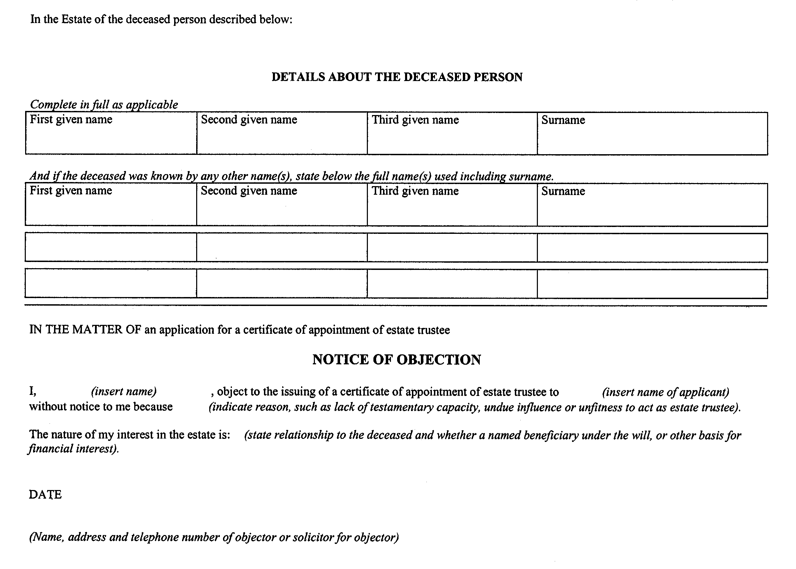
O. Reg. 132/04, s. 24.
See: O. Reg. 132/04, ss. 24, 25 (1).
Form 75.1A
Courts of Justice Act
REQUEST FOR ASSIGNMENT OF MEDIATOR
ONTARIO (Court file no.)
SUPERIOR COURT OF JUSTICE
IN THE ESTATE OF deceased,
late of ,
occupation ,
who died on .
REQUEST FOR ASSIGNMENT OF MEDIATOR
TO: Mediation co-ordinator for (county)
An order giving directions was made under rule 75.1.05 on (date of order). A copy of the order is attached to this request.
The designated parties have not chosen a mediator under subrule 75.1.06 (1). The 30-day period mentioned in subrule 75.1.07 (1) has expired.
This is a request that you assign a mediator from the list for the county.

 | (Date) | (Name, address, telephone number  and fax number, if any, of lawyer of  party filing request, or of party

O. Reg. 290/99, s. 5 (1).
Form 75.1B
Courts of Justice Act
NOTICE BY MEDIATOR
ONTARIO (Court file no.)
SUPERIOR COURT OF JUSTICE
IN THE ESTATE OF deceased,
late of ,
occupation ,
who died on .
NOTICE BY MEDIATOR
TO:
AND TO:
I am the mediator whom the mediation co-ordinator has appointed to conduct the mediation session under Rule 75.1. (Delete this paragraph if mediator was chosen by designated parties under clause 75.1.06 (1) (a) or (c).)
The mediation session will take place on (date), from (time) to (time), at (place).
You are required to attend this mediation session. If you have a lawyer representing you in this proceeding, he or she is also required to attend.
You are required to file a statement of issues (Form 75.1C) by (date) (seven days before the mediation session). A blank copy of the form is attached.
When you attend the mediation session, you should bring with you any documents that you consider of central importance in the proceeding. You should plan to remain throughout the scheduled time. If you need another person’s approval before agreeing to a settlement, you should make arrangements before the mediation session to ensure that you have ready telephone access to that person throughout the session, even outside regular business hours.
YOU MAY BE PENALIZED UNDER RULE 75.1.10 IF YOU FAIL TO FILE A STATEMENT OF ISSUES OR FAIL TO ATTEND THE MEDIATION SESSION.

 | (Date) | (Name, address, telephone number and fax number, if any, of mediator)

O. Reg. 290/99, s. 5 (1).
Form 75.1C
Courts of Justice Act
STATEMENT OF ISSUES
ONTARIO (Court file no.)
SUPERIOR COURT OF JUSTICE
IN THE ESTATE OF deceased,
late of ,
occupation ,
who died on .
STATEMENT OF ISSUES
(To be provided to mediator and designated parties at least seven days before the mediation session)
1. Factual and legal issues in dispute
The undersigned designated party states that the following factual and legal issues are in dispute and remain to be resolved.
(Issues should be stated briefly and numbered consecutively.)
2. Party’s position and interests (what the party hopes to achieve)
(Brief summary.)
3. Attached documents
Attached to this form are the following documents that the designated party considers of central importance in the proceeding: (list)
(Date) (party’s signature)
(Name, address, telephone number and fax number, if any, of lawyer of party filing statement of issues, or of party)
NOTE: Rule 75.1.11 provides as follows:
All communications at a mediation session and the mediator’s notes and records shall be deemed to be without prejudice settlement discussions.
O. Reg. 290/99, s. 5 (1).
Form 75.1D
Courts of Justice Act
CERTIFICATE OF NON-COMPLIANCE
ONTARIO (Court file no.)
SUPERIOR COURT OF JUSTICE
IN THE ESTATE OF deceased,
late of ,
occupation ,
who died on .
CERTIFICATE OF NON-COMPLIANCE
TO: (court)
I, (name), mediator, certify that this certificate of non-compliance is filed because:
( ) (Identify party(ies)) failed to provide a copy of a statement of issues to the mediator and the other parties (or to the mediator or to party(ies)).
( ) (Identify party(ies)) failed to attend within the first 30 minutes of a scheduled mediation session.

(Date) |  | (Name, address, telephone number and fax number, if any, of mediator)

O. Reg. 290/99, s. 5 (1).
Form 75.2
Courts of Justice Act
notice that objection has been filed
ONTARIO
SUPERIOR COURT OF JUSTICE
IN THE ESTATE OF (insert name), deceased.
IN THE MATTER OF an application for a certificate of appointment of estate trustee
notice that objection has been filed
A notice of objection, a copy of which is attached, has been filed with the court.
No further action regarding issuing a certificate of a appointment to you will be taken until you have complied with subrule 75.03 (4) of the Rules of Civil Procedure.

DATE
Registrar
Address of court office

TO: (Name, address and telephone number of applicant or solicitor for the applicant)
O. Reg. 484/94, s. 13; O. Reg. 292/99, s. 1 (3, 4).
Form 75.3
Courts of Justice Act
notice to objector
ONTARIO
SUPERIOR COURT OF JUSTICE
IN THE ESTATE OF (insert name), deceased.
IN THE MATTER OF an application for a certificate of appointment of estate trustee
NOTICE tO OBJECTOr
AN APPLICATION for a certificate of appointment of estate trustee in the estate has been made by (name of applicant).
IF YOU WISH TO OPPOSE this application, you or an Ontario lawyer acting for you must within 20 days of service on you of this notice to objector prepare a notice of appearance in Form 75.4 of the Rules of Civil Procedure, serve it on the applicant’s lawyer, or where the applicant does not have a lawyer serve it on the applicant, and file it with proof of service in the court office at (full court address where application for certificate of appointment was filed).
IF YOU FAIL to serve and file a notice of appearance, the application for certificate of appointment of estate trustee shall proceed as if your notice of objection had not been filed.

DATE
(Name, address and telephone number of applicant or solicitor for the applicant)

TO: (Name and address of the objector or solicitor for the objector)
O. Reg. 484/94, s. 13; O. Reg. 292/99, s. 1 (3, 4).
Form 75.4
Courts of Justice Act
notice of appearance
ONTARIO
SUPERIOR COURT OF JUSTICE
IN THE ESTATE OF (insert name), deceased.
IN THE MATTER OF an application for a certificate of appointment of estate trustee
NOTICE of appearance
I desire to oppose the issuing of a certificate of appointment of estate trustee for the reasons set out in the notice of objection filed.

DATE
(Name, address and telephone number of objector or solicitor for the objector)

TO: (Name address and telephone number of applicant or solicitor for the applicant)
O. Reg. 484/94, s. 13; O. Reg. 292/99, s. 1 (3, 4).
Form 75.5
Courts of Justice Act
notice of application for directions
ONTARIO
SUPERIOR COURT OF JUSTICE
IN THE ESTATE OF (insert name), deceased.
B E T W E E N :
(Name)
Applicant
- and-
(Name)
Respondent
NOTICE of application for directions
TO THE RESPONDENT
A LEGAL PROCEEDING HAS BEEN COMMENCED by the applicant. The claim made by the applicant appears on the following page.
THIS APPLICATION will come on for a hearing before a judge on (date) at (time), at the Court House at (place).
IF YOU WISH TO OPPOSE THIS APPLICATION, you or an Ontario lawyer acting for you must forthwith prepare a notice of appearance in Form 38A prescribed by the Rules of Civil Procedure, serve it on the applicant’s lawyer or, where the applicant does not have a lawyer, serve it on the applicant, and file it, with proof of service, in this court office, and you or your lawyer must appear at the hearing.
IF YOU WISH TO PRESENT AFFIDAVIT OR OTHER DOCUMENTARY EVIDENCE TO THE COURT OR TO EXAMINE OR CROSS-EXAMINE WITNESSES ON THE APPLICATION, you or your lawyer must, in addition to serving your notice of appearance, serve a copy of the evidence on the applicant’s lawyer or, where the applicant does not have a lawyer, serve it on the applicant, and file it with proof of service, in the court office where the application is to be heard, as soon as possible, but not later than two days before the hearing.
IF YOU FAIL TO APPEAR AT THE HEARING, JUDGMENT MAY BE GIVEN IN YOUR ABSENCE AND WITHOUT FURTHER NOTICE TO YOU.
If you wish to oppose this application but are unable to pay legal fees, legal aid may be available to you by contacting a local Legal Aid office.
Date: | Issued by  Local registrar  Address of court office

TO: (Name and address of respondent, or solicitor for respondent)
1. The applicant makes application or directions from the court with respect to: (state nature of proceeding)
2. The grounds for the application are rule 75.06 and (include a reference to any statutory provision or Rule to be relied on).
3. The following documentary evidence will be used at the hearing of the application for directions: (list the affidavits or other documentary evidence to be relied upon).
O. Reg. 484/94, s. 13; O. Reg. 292/99, s. 1 (3, 4); O. Reg. 653/00, s. 21.
Form 75.6
Courts of Justice Act
notice of motion for directions
ONTARIO
SUPERIOR COURT OF JUSTICE
IN THE ESTATE OF (insert name), deceased.
B E T W E E N :
(Name)
Moving Party
- and -
(Name)
Respondent
NOTICE of motion for directions
The moving party will make a motion to the court on (date), at (time), or so soon after that time as the motion can be heard at (full address of Court House).
The motion is for directions with respect to:
(state nature of proceeding)
The grounds for the motion are rule 75.06 and (specify the further grounds to be argued, including a reference to any statutory provision or Rule).
The following documentary evidence will be used at the hearing of the motion: (list the affidavits or other documentary evidence to be relied on).

DATE
(Name, address and telephone number of applicant or solicitor for the applicant)

TO: (Name and address of respondent or solicitor for the respondent)
O. Reg. 484/94, s. 13; O. Reg. 292/99, s. 1 (3, 4).
Form 75.7
Courts of Justice Act
statement of claim pursuant to order giving directions
ONTARIO
SUPERIOR COURT OF JUSTICE
IN THE ESTATE OF (insert name), deceased.
B E T W E E N :
(Name)
Plaintiff
- and -
(Name)
Defendant
- and -
(Name)
Persons Submitting Rights to the Court
statement of claim pursuant to order giving directions
TO THE DEFENDANT
A LEGAL PROCEEDING HAS BEEN COMMENCED by the Plaintiff. The claim made is set out in the following pages.
IF YOU WISH TO DEFEND THIS PROCEEDING, you or an Ontario lawyer acting for you must prepare a statement of defence in Form 18A prescribed by the Rules of Civil Procedure, serve it on the plaintiff’s lawyer, or, where the plaintiff does not have a lawyer, serve it on the plaintiff, and file it, with proof of service, in the court office, WITHIN 20 DAYS after this statement of claim is served upon you, if you are served in Ontario.
If you are served in another province or territory of Canada or in the United States of America, the period of serving and filing your statement of defence is 40 days. If you are served outside of Canada and the United States of America, the period is 60 days.
Instead of serving and filing a statement of defence, you may serve and file a Statement of Submission or Rights to the Court in Form 75.9 prescribed by the Rules of Civil Procedure.
IF YOU FAIL TO DEFEND THIS PROCEEDING, JUDGMENT MAY BE GIVEN AGAINST YOU IN YOUR ABSENCE AND WITHOUT FURTHER NOTICE TO YOU. IF YOU WISH TO DEFEND THIS PROCEEDING BUT ARE UNABLE TO PAY LEGAL FEES, LEGAL AID MAY BE AVAILABLE TO YOU BY CONTACTING A LOCAL LEGAL AID OFFICE.
1. The Plaintiff claims:
O. Reg. 484/94, s. 13; O. Reg. 292/99, s. 1 (3, 4).
Form 75.8
Courts of Justice Act
ORDER GIVING directions where pleadings directed
(Heading in accordance with Form 59A)
IN THE ESTATE OF (insert name), deceased.
B E T W E E N :
(Name)
Applicant
(Moving Party)
- and -
(Name)
Respondent
(Responding Party)
- and -
(Name)
Persons Submitting
Rights to the Court
order giving directions
THIS APPLICATION (or MOTION) made by (identify applicant or moving party) for directions, was heard on (date), at (place), in the presence of counsel for (insert name), and (insert name) appearing in person, and no one appearing for (insert name), although properly served as appears from the affidavit of service, filed.
ON READING the notice of application (or notice of motion) and on hearing the submissions made,
1. THIS COURT ORDERS that (insert name) shall be plaintiff and (insert name) shall be defendant, and that (insert names) are submitting their rights to the court.
2. THIS COURT ORDERS that the plaintiff(s) shall serve upon the defendant(s) and file with the court a statement of claim in Form 75.7 within ..... days after this order is entered, after which pleadings shall be served and filed under rule 75.07 of the Rules of Civil Procedure.
2.1 THIS COURT ORDERS that (insert directions relating to mandatory mediation under Rule 75.1).
3. THIS COURT ORDERS that the applicant and respondent shall serve and file affidavits of documents and attend and submit to examinations for discovery in accordance with the Rules of Civil Procedure.
4. THIS COURT ORDERS that on filing the appropriate documents with the court, (insert name) shall be appointed as estate trustee during litigation.
5. THIS COURT ORDERS that this order giving directions shall be served by an alternative to personal service pursuant to rule 16.03 of the Rules of Civil Procedure, on the following persons: (insert names)
6. THIS COURT ORDERS that the issues be tried by a judge with (or without) a jury at (place) on a date to be fixed by the registrar.
7. THIS COURT ORDERS that the costs of this application (or motion) shall be (insert amount)
O. Reg. 484/94, s. 13; O. Reg. 290/99, s. 3 (1).
Form 75.9
Courts of Justice Act
ORDER GIVING directions where trial of issues directed
(Headings in accordance with Form 59A)
IN THE ESTATE OF (insert name), deceased.
B E T W E E N :
(Name)
Applicant
(Moving Party)
- and -
(Name)
Respondent
(Responding Party)
- and -
(Name)
Persons Submitting
Rights to the Court
order giving directions
THIS APPLICATION (or MOTION) made by (identify applicant or moving party) for directions, was heard on (date), at (place), in the presence of counsel for (insert name), and (insert name) appearing in person, and no one appearing for (insert name), although properly served as appears from the affidavit of service, filed.
ON READING the notice of application (or notice of motion) and on hearing the submissions made,
1. THIS COURT ORDERS that the parties to the proceeding and the issues to be tried be as follows:
(a) (insert name) affirms and (insert name) denies that (state nature of allegation);
(b) (list each issue in a separate paragraph, specifying which parties affirm and which deny).
2. THIS COURT ORDERS that (insert names) are submitting their rights to the court.
2.1 THIS COURT ORDERS that (insert directions relating to mandatory mediation under Rule 75.1).
3. THIS COURT ORDERS that the applicant and respondent shall serve and file affidavits of documents and attend and submit to examinations for discovery in accordance with the Rules of Civil Procedure.
4. THIS COURT ORDERS that on filing the appropriate documents with the court, (insert name) shall be appointed as estate trustee during litigation.
5. THIS COURT ORDERS that this order giving directions shall be served by an alternative to personal service pursuant to rule 16.03 of the Rules of Civil Procedure, on the following persons: (insert names)
6. THIS COURT ORDERS that the issues be tried by a judge with (or without) a jury at (place) on a date to be fixed by the registrar.
7. THIS COURT ORDERS that the costs of this application (or motion) shall be (insert amount)
O. Reg. 484/94, s. 13; O. Reg. 290/99, s. 4 (1).
Form 75.10
Courts of Justice Act
statement of submission of rights to the court
ONTARIO
SUPERIOR COURT OF JUSTICE
IN THE ESTATE OF (insert name), deceased.
B E T W E E N :
(Name)
Applicant
- and-
(Name)
Respondent
statement of submission of rights to the court
I, (insert name), submit my rights to the court and understand that pursuant to rule 75.07.1 of the Rules of Civil Procedure, the following consequences apply to me:
(a) I shall not be entitled to receive any costs in the proceeding and shall not be liable to pay the costs of any party to the proceeding, except indirectly to the extent that costs are ordered by the court to be paid out of the estate;
(b) I shall not receive notice of any step taken in the proceeding except the notice of trial and a copy of the judgment disposing of the matter;
(c) If the proceeding is settled by agreement, a judgment on consent will not be given without notice to me.

DATE
(Name, address and telephone number of the person or solicitor acting for person)

TO: (Name and address of plaintiff, or solicitor for plaintiff)
O. Reg. 484/94, s. 13; O. Reg. 292/99, s. 1 (3, 4); O. Reg. 24/00, s. 31.
Form 75.11
Courts of Justice Act
notice of settlement
ONTARIO
SUPERIOR COURT OF JUSTICE
IN THE ESTATE OF (insert name), deceased.
B E T W E E N :
(Name)
Applicant
- and -
(Name)
Respondent
- and -
(Name)
Persons Submitting
Rights to the Court
notice of settlement
Pursuant to rule 75.07 of the Rules of Civil Procedure, attached as Schedule “A” is a copy of the settlement agreement that has been reached among the parties.
A judgment consistent with the settlement agreement will be sought. If you oppose that judgment, you or an Ontario lawyer acting for you must, within 10 days of service on you of this notice of settlement, serve a rejection of settlement in the form attached as Schedule “B” on the solicitor for the party serving this notice, or where the party serving this notice does not have a lawyer, serve it on the party serving this notice, and file it with proof of service in the court office at (place).
If you fail to serve and file a rejection of settlement, the court will consider the request for judgment without further notice to you.

DATE
(Name, address and telephone number of party or solicitor for the party)

TO: (Names and addresses of all persons who have submitted their rights to the court)
O. Reg. 484/94, s. 13; O. Reg. 292/99, s. 1 (3, 4).
Form 75.12
Courts of Justice Act
rejection of settlement
ONTARIO
SUPERIOR COURT OF JUSTICE
IN THE ESTATE OF (insert name), deceased.
B E T W E E N :
(Name)
Applicant
(Plaintiff)
- and-
(Name)
Respondent
(Defendant)
- and-
(Name)
Persons Submitting
Rights to the Court
rejection of settlement
I, (insert name), reject the settlement agreement attached to the notice of settlement dated (insert date), for the following reasons: (state reasons).
DATE | (Name, address and telephone number of person or solicitor for person)

TO: (Name and address of party who served the notice of settlement or the solicitor for the party)
O. Reg. 484/94, s. 13; O. Reg. 292/99, s. 1 (3, 4).
Form 75.13
Courts of Justice Act
notice of contestation
ONTARIO
SUPERIOR COURT OF JUSTICE
IN THE ESTATE OF (insert name), deceased.
B E T W E E N :
(Name)
Estate Trustee
- and -
(Name)
Claimant
NOTICE of contestation
Pursuant to section 44 or 45 of the Estates Act, the estate trustee of the estate contests the claim made by you against the estate, on the following grounds:
(state grounds)
You may apply to this court at (insert address of court office) for an order allowing your claim and determining its amount. If you do not apply within 30 days after receiving this notice, or within 3 months after that date if the judge on application so allows, you shall be deemed to have abandoned your claim and your claim shall be forever barred.

DATE
(Name, address and telephone number of estate trustee or solicitor for estate trustee)

TO: (Name and address of person submitting claim)
O. Reg. 484/94, s. 13; O. Reg. 292/99, s. 1 (3, 4).
Form 75.14
Courts of Justice Act
claim against estate
ONTARIO
SUPERIOR COURT OF JUSTICE
IN THE ESTATE OF (insert name), deceased.
B E T W E E N :
(Name)
Claimant
- and -
(Name)
Estate Trustee
claim against estate
1. The claim against the estate is for $ for (state grounds for claim).
* * *
affidavit
I, (name of claimant), of (insert city or town and country or district, metropolitan or regional municipality of residence), MAKE OATH/AFFIRM AND SAY:
1. The grounds set out in this claim are true.

SWORN/AFFIRMED BEFORE me at the )
of , in the )
, this day )
of , 20 . )
)
)
)
)

A Commissioner for taking Affidavits (or as may be)
O. Reg. 484/94, s. 13; O. Reg. 292/99, s. 1 (3, 4).
Form 76A
Courts of Justice Act
Insert regs\Graphics\Source Law\2001\284\284076Aae.tif
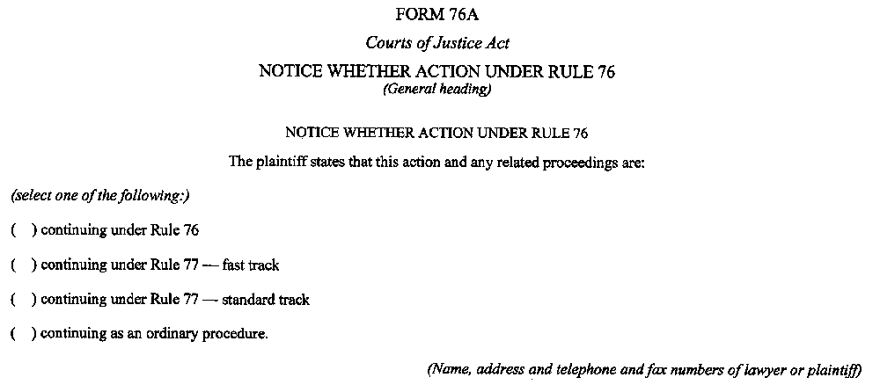
O. Reg. 284/01, s. 36.
Form 76B
Courts of Justice Act
Insert regs\Graphics\Source Law\2001\284\284076Bae.tif
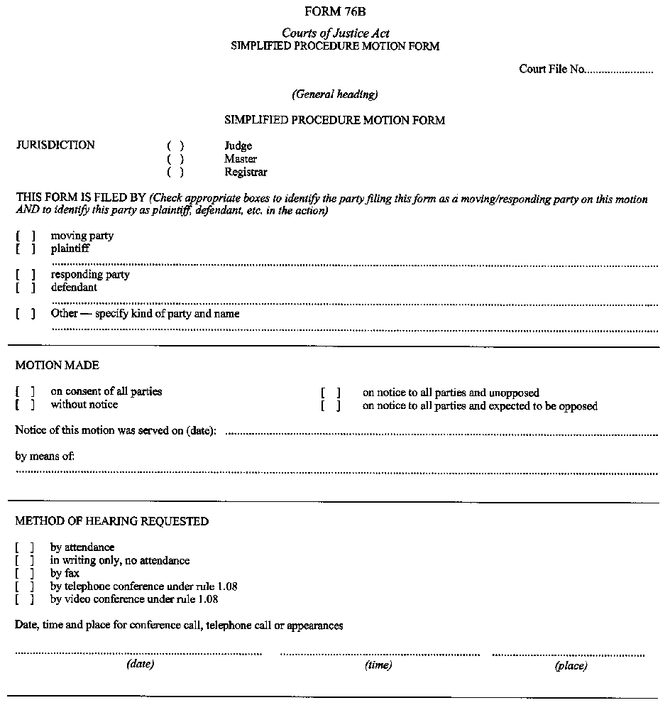
Insert regs\Graphics\Source Law\2001\284\284076Bbe.tif
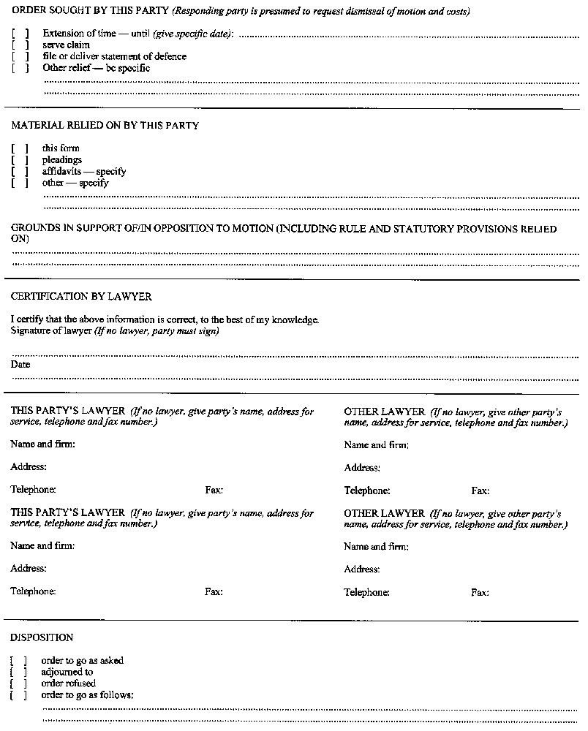
Insert regs\Graphics\Source Law\2001\284\284076Bce.tif
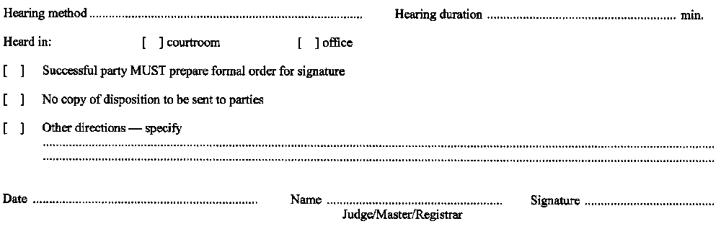
O. Reg. 284/01, s. 36.
Form 76C
Courts of Justice Act
Insert regs\Graphics\Source Law\2001\284\284076Cae.tif
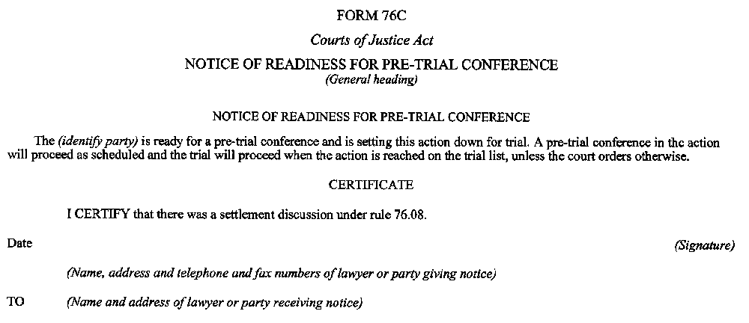
O. Reg. 284/01, s. 36.
Form 76D
Courts of Justice Act
Insert regs\Graphics\Source Law\2001\284\284076Dae.tif
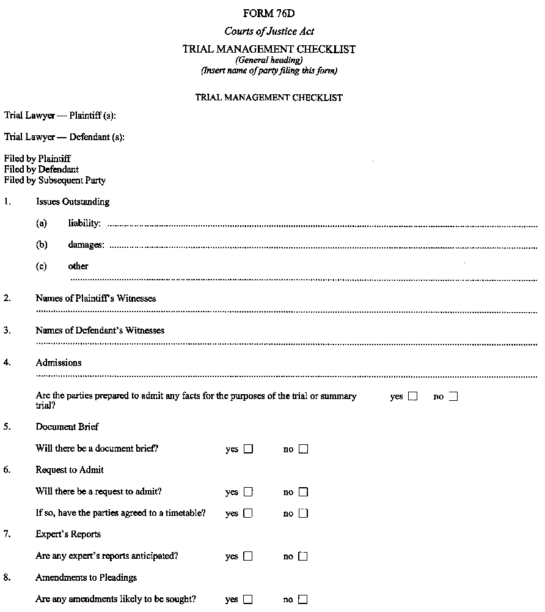
Insert regs\Graphics\Source Law\2001\284\284076Dbe.tif
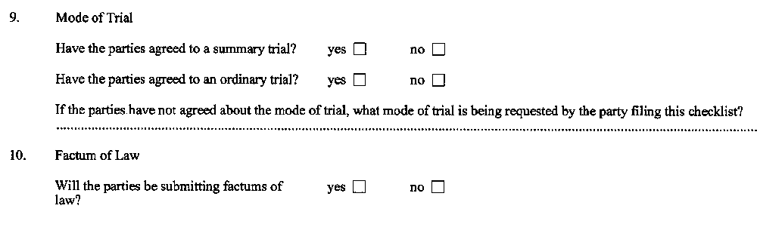
O. Reg. 284/01, s. 36.
Form 77A Revoked: O. Reg. 457/01, s. 17.
Form 77B Revoked: O. Reg. 457/01, s. 17.
Form 77C
Courts of Justice Act
(General heading)
case management motion form
JURISDICTION [ ] Case management judge
[ ] Case management master
THIS FORM FILED BY (Check appropriate boxes to identify the party filing this form as a moving/responding party on this motion AND to identify this party as plaintiff, defendant, etc. in the action)
[ ] moving party
[ ] plaintiff/applicant ……………………………………………………………………………………………..
[ ] responding party
[ ] defendant/respondent name
[ ] other - specify kind of party and name

MOTION MADE (filing fee required)
[ ] on consent of all parties [ ] on notice to all parties and unopposed**
[ ] without notice [ ] on notice to all parties and expected to be opposed**
(**Filing fee required)
Notice of this motion was served on (date): by means of:

METHOD OF HEARING REQUESTED
[ ] by attendance
[ ] in writing only, no attendance
[ ] by fax
[ ] by telephone conference under rule 1.08
[ ] by video conference under rule 1.08
Date, time and place for attendance or for telephone or video conference
……………………………………………………………………
(date) | (time) | (place)
ORDER SOUGHT BY THIS PARTY (Responding party is presumed to request dismissal of motion and costs)
[ ] | Extension of time ⎯ until (give specific date):
[ ] | serve claim/application [ ] file or deliver defence.
[ ] | complete discoveries
[ ] | Other
[ ] | Assignment of the proceeding (and related proceedings if applicable) to judge(s) for case management
[ ] | Other relief ⎯ be specific

MATERIAL RELIED ON BY THIS PARTY
[ ] this form [ ] pleadings [ ] affidavits – specify [ ] transcript – specify [ ] other - specify

GROUNDS IN SUPPORT OF/IN OPPOSITION TO MOTION (INCLUDING RULE AND STATUTORY PROVISIONS RELIED ON)

CERTIFICATION BY LAWYER
I certify that the above information is correct, to the best of my knowledge.
Signature of lawyer (If no lawyer, party must sign)

Date

THIS PARTY’S LAWYER (if no lawyer, give party’s address for service, telephone and fax number) | OTHER LAWYER (if no lawyer, give other party’s name address for service, telephone and fax number)
Name and firm  Address  Telephone Fax | Name and firm  Address  Telephone Fax
OTHER LAWYER (if no lawyer, give party’s address for service, telephone and fax number) | OTHER LAWYER (if no lawyer, give other party’s name address for service, telephone and fax number)
Name and firm  Address  Telephone Fax | Name and firm  Address  Telephone Fax

DISPOSITION BY CASE MANAGEMENT JUDGE/MASTER
[ ] order to go as asked [ ] adjourned to
[ ] order refused [ ] order to go as follows:

Hearing method Hearing duration min.
Heard in: [ ] courtroom [ ] office
[ ] Successful party MUST prepare formal order for signature
[ ] No copy of disposition to be sent to parties
[ ] Other directions - specify

Judge’s/Master’s Name Judge’s/Master’s Signature
Date
O. Reg. 555/96, s. 3; O. Reg. 118/97, s. 14; O. Reg. 348/97, s. 6; O. Reg. 570/98, s. 24; O. Reg. 113/01, s. 14; O. Reg. 131/04, s. 26.
Form 77D
Courts of Justice Act
(General heading)
TRIAL MANAGEMENT conference FORM
(Insert name of party filing this form)
Trial Management Judge or Case Management Master:
Date of Trial Management Conference:
Trial Lawyer: | Plaintiff
 | Defendant

Jury: | yes | no

1. | Issues Outstanding
a) liability:
b) damages:
c) other:

2. | Plaintiff’s Witnesses
 | Names |  | Estimated time for  Examination-in-chief  (to be completed by  plaintiff) |  | Estimated time for  Cross-examination  (to be completed at trial  management conference)
3. | Defendant’s Witnesses
 | Names |  | Estimated time for  Examination-in-chief  (to be completed by  defendant) |  | Estimated time for  Cross-examination  (to be completed at trial  management conference)
4. | Document Brief
 | a) Prepared: yes no
 | b) If no, will be prepared by lawyer for the and delivered by (date)
 | c) Comment
5. | Expert’s Reports
 | a) Are any “reply” reports anticipated? yes ............. no ............
 | b) If “yes”, do they create any timing problems regarding readiness for trial? yes .............. no .............
6. | Admissions Made
 | a) By plaintiff
 | b) By defendant #1
 | c) By defendant #2
7. | Notice to Admit Facts/Documents
 | a) Served by plaintiff: yes .............. no ....................
 | b) If no, will be served by: (date)
 | c) Served by defendant(s): yes .............. no ....................
 | d) If no, will be served by: (date)
 | e) Comment
 | f) Would a chronology, cast of characters or chart of corporate parties with shareholders, directors, officers, etc. be useful and if so, who will prepare them?
8. | Amendments to Pleadings
 | a) Have all parties considered the pleadings and are any amendments likely to be sought?
 | b) If amendments are likely, will this create problems with readiness for trial?
9. | Damages
 | a) Has a damages brief been delivered? yes .............. no ....................
 | b) If “no”, will one be delivered before trial? yes .............. no ....................
10. | Brief of Authorities
 | a) Has a brief of authorities been delivered? yes .............. no ....................
 | b) If “no”, will one be delivered before trial? yes .............. no ....................
11. | Settlement Conference
 | a) Already held on (date) by
 | b) Further settlement conference will be conducted: yes .............. no ....................
 | c) If yes, lawyer to arrange for such conference to be held prior to (date)
12. | Readiness for Trial
 | a) Estimated trial time required:
 | b) Are there any special circumstances which should be noted to assist in scheduling this matter for trial? (i.e. witnesses from out of town; large courtroom required due to number of lawyers or documents?)
O. Reg. 555/96, s. 3; O. Reg. 118/97, s. 15.
TARIFF A
Solicitors’ Fees and Disbursements Allowable under Rule 58.05
PART I — COSTS GRID
Where students-at-law or law clerks have provided services of a nature that the Law Society of Upper Canada authorizes them to provide, the fees for those services may be assessed and allowed under this costs grid.
Where counsel has special expertise, his or her hourly rate classification may be varied accordingly.
1. Fees other than Counsel Fee
Hourly rates for pleadings, mediation under Rule 24.1 or Rule 75.1, discovery of documents, drawing and settling issues on special case, setting down for trial, pre-motion conference, examination, pre-trial conference, settlement conference, notice or offer, preparation for hearing, attendance at assignment court, order, issuing or renewing a writ of execution or notice of garnishment, seizure under writ of execution, seizure and sale under writ of execution, notice of garnishment, or for any other procedure authorized by the Rules of Civil Procedure and not provided for elsewhere in the costs grid.
Note: On July 3, 2004, Part I is amended by striking out “mediation under Rule 24.1 or Rule 75.1” and substituting “mediation under Rule 24.1”. See: O. Reg. 284/01, s. 38 (2).
 | Partial Indemnity Scale | Substantial Indemnity Scale
Law Clerks | Up to $80.00 per hour | Up to $125.00 per hour
Student-at-law | Up to $60.00 per hour | Up to $90.00 per hour
Lawyer (less than 10 years) | Up to $225.00 per hour | Up to $300.00 per hour
Lawyer (10 or more but less than 20 years) | Up to $300.00 per hour | Up to $400.00 per hour
Lawyer (20 years and over) | Up to $350.00 per hour | Up to $450.00 per hour
2. Counsel Fee — Motion or Application
 | Partial Indemnity Scale | Substantial Indemnity Scale
0.25 hour | Up to $400.00 | Up to $800.00
1.00 hour | Up to $1,000.00 | Up to $1,500.00
2.00 hours (half day) | Up to $1,400.00 | Up to $2,400.00
1 day | Up to $2,100.00 | Up to $3,500.00
3. Counsel Fee — Trial or Reference
 | Partial Indemnity Scale | Substantial Indemnity Scale
Half Day | Up to $1,500.00 | Up to $2,500.00
Day | Up to $2,300.00 | Up to $4,000.00
Week | Up to $9,500.00 | Up to $17,500.00
4. Counsel Fee — Appeal
 | Partial Indemnity Scale | Substantial Indemnity Scale
1.00 hour | Up to $1,000.00 | Up to $1,500.00
2.00 hours (half day) | Up to $1,250.00 | Up to $2,000.00
1 day | Up to $2,000.00 | Up to $4,000.00
PART II — DISBURSEMENTS
21. | Attendance money actually paid to a witness who is entitled to attendance money, to be calculated as follows:
 | 1. Attendance allowance for each day of necessary attendance  2. Travel allowance, where the hearing or examination is held,  (a) in a city or town in which the witness resides, $3.00 for each day of necessary attendance;  (b) within 300 kilometres of where the witness resides, 24¢ a kilometre each way between his or her residence and the place of hearing or examination;  (c) more than 300 kilometres from where the witness resides, the minimum return air fare plus 24¢ a kilometre each way from his or her residence to the airport and from the airport to the place of hearing or examination.  3. Overnight accommodation and meal allowance, where the witness resides elsewhere than the place of hearing or  examination and is required to remain overnight, for each overnight stay | $50  $75
22. | Fees or expenses actually paid to a court, court reporter, official examiner or sheriff under the regulations under the Administration of Justice Act.
23. | For service or attempted service of a document,  (a) in Ontario, the amount actually paid, not exceeding the fee payable to a sheriff under the regulations under the Administration of Justice Act;  (b) outside Ontario, a reasonable amount;  (c) that was ordered to be served by publication, a reasonable amount.
23.1 | Fees actually paid to a mediator in accordance with Ontario Regulation 451/98 made under the Administration of Justice Act.
23.2 | Fees actually paid to a mediator in accordance with Ontario Regulation 291/99 made under the Administration of Justice Act.
24. | For an examination and transcript of evidence taken on the examination, the amount actually paid, not exceeding the fee payable to an official examiner under the regulations under the Administration of Justice Act.
25. | For the preparation of a plan, model, videotape, film or photograph reasonably necessary for the conduct of the proceeding, a reasonable amount.
26. | For experts’ reports that were supplied to the other parties as required by the Evidence Act or these rules and that were reasonably necessary for the conduct of the proceeding, a reasonable amount.
27. | The cost of the investigation and report of the Official Guardian.
28. | For an expert who gives opinion evidence at the hearing or whose attendance was reasonably necessary at the hearing, a reasonable amount not exceeding $350 a day, subject to increase in the discretion of the assessment officer.
29. | For an interpreter for services at the hearing or on an examination, a reasonable amount not exceeding $100 a day, subject to increase in the discretion of the assessment officer.
29.1 | Where ordered by the presiding judge or officer, for translation into English or French of a document that has been filed, a reasonable amount.
30. | Where ordered by the presiding judge or officer, such travelling and accommodation expenses incurred by a party as, in the discretion of the assessment officer, appear reasonable.
31. | For copies of any documents or authorities prepared for or by a party for the use of the court and supplied to the opposite party, a reasonable amount.
32. | For copies of records, appeal books and compendiums, and factums, a reasonable amount.
33. | The cost of certified copies of documents such as orders, birth, marriage, and death certificates, abstracts of title, deeds, mortgages and other registered documents where reasonably necessary for the conduct of the proceeding.
34. | The cost of transcripts of proceedings of courts or tribunals,  (a) where required by the court or the rules; or  (b) where reasonably necessary for the conduct of the proceeding.
35. | Where ordered by the presiding judge or officer, for any other disbursement reasonably necessary for the conduct of the proceeding, a reasonable amount in the discretion of the assessment officer.
36. | Goods and services tax actually paid or payable on the solicitor’s fees and disbursements allowable under rule 58.05.

R.R.O. 1990, Reg. 194, Tariff A; O. Reg. 219/91, s. 16; O. Reg. 351/94, s. 19; O. Reg. 533/95, s. 12 (2); O. Reg. 453/98, s. 3; O. Reg. 290/99, s. 6; O. Reg. 24/00, s. 32; O. Reg. 652/00, s. 8; O. Reg. 113/01, s. 15; O. Reg. 244/01, ss. 5, 6; O. Reg. 284/01, s. 38; O. Reg. 457/01, s. 18; O. Reg. 19/03, s. 26; O. Reg. 131/04, s. 27.
TARIFF B Revoked: O. Reg. 131/04, s. 28.
TARIFF C
Solicitors’ Costs Allowed on Passing of Accounts Without a Hearing

(1) | ESTATE TRUSTEE | Amount of costs
 | Amount of receipts  Less than $100,000 | $ 800
 | $100,000 or more, but less than $300,000 | 1,750
 | $300,000 or more, but less than $500,000 | 2,000
 | $500,000 or more, but less than $1,000,000 | 2,500
 | $1,000,000 or more, but less than $1,500,000 | 3,000
 | $1,500,000 or more, but less than $3,000,000 | 4,000
 | $3,000,000 or more | 5,000
(2) | PERSON WITH FINANCIAL INTEREST IN ESTATE
 | If a person with a financial interest in an estate retains a solicitor to review the accounts, makes no objection to the accounts (or makes an objection and later withdraws it) and serves and files a request for costs, the person is entitled to one-half of the amount payable to the estate trustee.
(3) | CHILDREN’S LAWYER OR PUBLIC GUARDIAN AND TRUSTEE
 | If the Children’s Lawyer or the Public Guardian and Trustee makes no objection to the accounts (or makes an objection and later withdraws it) and serves and files a request for costs, he or she is entitled to three-quarters of the amount payable to the estate trustee.

Note: If two or more persons are represented by the same solicitor, they are entitled to receive only one person’s costs.
Note: A person entitled to costs under this tariff is also entitled to the amount of G.S.T. on those costs.
O. Reg. 332/96, s. 10.
Note: For greater certainty, the amendments made by Ontario Regulation 292/99 do not affect the application of section 10 of the Courts Improvement Act, 1996. See: O. Reg. 292/99, s. 8.

Back to top

