Day Nurseries Act
R.R.O. 1990, REGULATION 262
Amended to O. Reg. 505/06
GENERAL
Historical version for the period November 3, 2006 to December 31, 2006.
This is the English version of a bilingual regulation.
Skip Table of Contents
CONTENTS
 |  | Sections
 |  | 1-2
 | Organization and Management | 3
 | Building and Accommodation | 4-13
 | Equipment and Furnishings | 14-20
 | Playground | 21-24
 | Inspection | 25
 | Insurance | 26
 | Fire Safety and Emergency Information | 27-29
 | Health and Medical Supervision | 30-38
 | Nutrition | 39-43
 | Behaviour Management | 44-47.3
 | Enrolment and Records | 48-49
 | Registers and Agreements | 50-51
 | Program | 52-54
 | Staff Numbers and Group Size | 55-57
 | Staff Qualifications | 58-61
 | Health Assessments and Immunization | 62
 | Staff Training and Development | 63
 | Financial Records and Returns | 64-66
 | Prescribed Services | 66.1
 | Income Test | 66.2-66.7
 | Computation of Provincial Grant | 67
 | Sharing of Costs | 67.1-68.4
 | Agreements for Sharing of Costs by Municipalities | 68.5-68.5.1
 | Arbitration Process | 68.6-74
 | Licences and Applications | 75
 | Hearings | 76
 | General | 77-80
 | Publication | 81
 | Power of Delivery Agents | 82
Schedule 1
Schedule 2
Schedule 3 | Number of staff required for a day nursery other than a day nursery for handicapped children
Schedule 4 | Number of staff required for a day nursery for handicapped children
Form 1 | Determination of available income
Form 2 | Provisional licence to operate a day nursery
Form 3 | Provisional licence to operate a private-home day care agency
Form 4 | Licence/renewal of licence to operate a day nursery
Form 5 | Licence/renewal of a licence to operate a private-home day care agency
Form 6 | Notice of intention
Form 7 | Request for hearing
Form 8 | Notice of hearing
Form 9 | Notice of direction
CONTENTS
1. In this Regulation,
“actual cost” means the cost of a building project and includes,
(a) fees payable for the services of an architect, professional engineer or other consultant,
(b) the cost of purchasing and installing furnishings and equipment,
(c) the cost of land surveys, soil tests, permits, licences and legal fees,
(d) the cost of paving, sodding and landscaping, and
(e) the cost of acquiring the land necessary for the building project; (“coût réel”)
Note: On January 1, 2007, section 1 is amended by adding the following definition:
“adjusted income” means adjusted income as defined in section 122.6 of the Income Tax Act (Canada); (“revenu modifié”)
See: O. Reg. 505/06, ss. 1 (1), 20 (2).
“approved cost” means that portion of the actual cost of a building project approved by the Minister; (“coût approuvé”)
“architect” means an architect who is a member in good standing of the Ontario Association of Architects; (“architecte”)
“building project” means a project composed of one or more of the following elements:
1. The purchase or other acquisition of all or any part of an existing building or buildings including the land contiguous thereto.
2. Any renovations or alterations to an existing building or buildings.
3. Additions to an existing building or buildings.
4. The purchase or other acquisition of vacant land for the purpose of constructing a building or buildings thereon.
5. The erection of a new building or any part thereof.
6. The demolition of a building.
7. The installation of public utilities, sewers and items or services necessary for access to the land or building or buildings; (“projet de construction”)
“children’s recreation program” means a program operated by a children’s recreation service provider listed in the Schedule to Regulation 797 of the Revised Regulations of Ontario, 1990; (“programme de loisirs pour les enfants”)
“common parentage”, with respect to the more than five children referred to in the definition of “day nursery” in section 1 of the Act, means that all of the children have as a parent the same individual; (“liens de famille”)
“designation date”, when used in connection with a geographic area or a proposed geographic area, means the first date on which an Ontario Works delivery agent is designated under the Ontario Works Act, 1997 for the geographic area; (“date de désignation”)
“handicapped child” means a child who has a physical or mental impairment that is likely to continue for a prolonged period of time and who as a result thereof is limited in activities pertaining to normal living as verified by objective psychological or medical findings and includes a child with a developmental disability; (“enfant handicapé”)
“integrated day nursery” means a day nursery that is licensed by the Minister to provide services for both handicapped children and children who are not handicapped; (“garderie intégrée”)
“licensed capacity” means the maximum number of children, including the number in each age group, allowed to be in attendance in the day nursery at one time as set out in the licence of the day nursery; (“capacité autorisée”)
“liquid assets” means cash, bonds, debentures, stocks, an interest in real property, the beneficial interest in assets held in trust and available to be used for maintenance and any other assets that can readily be converted into cash; (“liquidités”)
Note: On January 1, 2007, the definition of “liquid assets” is revoked. See: O. Reg. 505/06, ss. 1 (2), 20 (2).
“net cost” means operating cost less revenue from fees; (“frais nets”)
“Ontario Works administrator” means an administrator appointed under the Ontario Works Act, 1997; (“administrateur du programme Ontario au travail”)
“Ontario Works delivery agent” means a municipality or a prescribed board that is designated as a delivery agent under the Ontario Works Act, 1997; (“agent de prestation des services du programme Ontario au travail”)
“Ontario Works geographic area” means an area designated under the Ontario Works Act, 1997 as a geographic area for a designated delivery agent under that Act; (“zone géographique du programme Ontario au travail”)
“Ontario Works proposed geographic area” means an area designated under the Ontario Works Act, 1997 as a geographic area for the purpose of preparing to designate a single Ontario Works delivery agent for it; (“zone géographique proposée du programme Ontario au travail”)
“operating cost” means the gross expenditure, including administrative costs, reasonable and necessary for providing day nursery services, private-home day care or a children’s recreation program provided in accordance with the prescribed service mentioned in paragraph 8 of subsection 66.1 (2), less income other than revenue from fees; (“frais d’exploitation”)
“parent” includes a person having lawful custody of a child or a person who has demonstrated a settled intention to treat a child as a child of his or her family; (“père ou mère”)
“person in need” means,
(a) a person eligible for income support under the Ontario Disability Support Program Act, 1997,
(a.1) a person eligible for an allowance under the Family Benefits Act,
(b) a person eligible for income assistance under the Ontario Works Act, 1997 who is employed or participating in employment assistance activities under that Act or both, or
(c) a person who by reason of financial hardship, inability to obtain regular employment, lack of the principal family provider, illness, disability or old age, has available daily income, taking into account the liquid assets of the person, that is less than the daily cost of providing day nursery services or providing private-home day care, as the case may be, to the person’s child or children, as determined in accordance with Form 1 by an Ontario Works administrator, a Director or a person approved by a Director; (“personne dans le besoin”)
Note: On January 1, 2007, the definition of “person in need” is revoked. See: O. Reg. 505/06, ss. 1 (2), 20 (2).
“prescribed board” means a prescribed board under section 68.3; (“conseil prescrit”)
“prescribed costs” means the costs set out in section 68.4; (“coûts prescrits”)
“professional engineer” means a professional engineer who is a member in good standing of the Association of Professional Engineers of the Province of Ontario; (“ingénieur”)
“provider enhancement grant” means a grant for persons providing private-home day care; (“subvention d’aide aux fournisseurs”)
“serious occurrence” means,
(a) the death of a child while in attendance at a day nursery or in receipt of private-home care,
(b) any serious injury to a child while in attendance at a day nursery or in receipt of private-home day care,
(c) fire or other disaster occurring on the premises of a day nursery or on premises providing private-home day care,
(d) a complaint concerning operational, physical or safety standards on the premises of a day nursery or where private-home day care is being provided,
(e) abuse of a child within the meaning of the Child and Family Services Act by a staff member of a day nursery or person in charge of a location where private-home day care is being provided or by any other person while the child is attending the day nursery or location where private-home day care is being provided; (“événement grave”)
“spouse” has the same meaning as in Part III of the Family Law Act; (“conjoint”)
“the municipalities’ prescribed costs”, with respect to a geographic area or proposed geographic area, means that part of the prescribed costs incurred or to be incurred under this Regulation by all of the municipalities located in the geographic area or proposed geographic area; (“coûts prescrits des municipalités”)
“wage subsidy” means a subsidy for the enhancement of salaries and benefits for employees of day nurseries, private-home day care agencies, resource centres and agencies that provide staff, equipment, supplies or services for the purposes of paragraph 4 of subsection 66.1 (2). (“subvention salariale”) R.R.O. 1990, Reg. 262, s. 1; O. Reg. 708/92, s. 1; O. Reg. 112/97, s. 1; O. Reg. 482/97, s. 1; O. Reg. 139/98, s. 1; O. Reg. 231/98, s. 1; O. Reg. 277/98, s. 1; O. Reg. 38/99, s. 1; O. Reg. 38/00, s. 1; O. Reg. 501/00, s. 1; O. Reg. 534/00, s. 1; O. Reg. 435/01, s. 1; O. Reg. 287/05, s. 1.
2. (1) A corporation that operates or proposes to operate a day nursery may be approved under section 6 of the Act if,
(a) it is a corporation without share capital, Part III of the Corporations Act applies to it and the matters set out in subsection (2) are embodied in its letters patent;
(b) it is a corporation without share capital having objects of a charitable nature and it is incorporated under a general or special Act of the Parliament of Canada;
(c) the Co-operative Corporations Act applies to it and its articles provide that the corporation shall be carried on without the purpose of gain for its members and that any profits or other accretions to the corporation shall be used in promoting its objects; or
(d) it is a corporation without share capital having objects of a charitable nature and Part III of the Corporations Act applies to it. O. Reg. 708/92, s. 2; O. Reg. 17/94, s. 1 (1).
(2) For the purposes of clause (1) (a), the following matters shall be embodied in the corporation’s letters patent:
1. The corporation shall have at least five directors.
2. No employee of the corporation may be a director of it.
3. The corporation shall not purchase goods or services from any director, officer or person related to a director or officer of the corporation unless there is only one available source of the goods or services within a reasonable distance of the day nursery.
4. The corporation shall not sell goods or services, other than child care services, to any director, officer or person related to a director or officer of the corporation.
5. The corporation shall not lend money to or borrow money from any director, officer or person related to a director or officer of the corporation.
6. The corporation shall not rent property to or from any director, officer or person related to a director or officer of the corporation.
7. The corporation shall not engage in any other transaction which may directly or indirectly confer a financial benefit on one of its directors.
8. The directors of the corporation shall serve as directors without remuneration but may be reimbursed for reasonable expenses incurred in the performance of their duties.
9. No director of the corporation shall directly or indirectly receive any form of money or money’s worth as a result of his or her position as director.
10. Upon dissolution of the corporation and after payment of all of its debts and liabilities, the remaining property of the corporation shall be distributed or disposed of only to charitable or non-profit organizations which provide child care, which are beneficial to the community and which operate solely in Ontario. O. Reg. 708/92, s. 2; O. Reg. 17/94, s. 1 (2); O. Reg. 505/06, s. 2.
(3) For the purposes of paragraphs 3, 4 and 5 of subsection (2), a person is related to a director or officer if,
(a) the person is married to the director or officer;
(b) the person is living in a conjugal relationship outside marriage with the director or officer;
(c) the person is the son or daughter or mother or father of the director or officer;
(d) the person is a relative of the director or officer and they have the same home;
(e) the person is a corporation and voting securities in the corporation that together carry more than 10 per cent of the voting rights attached to all voting securities of the corporation outstanding at the time are beneficially owned directly or indirectly by any combination of,
(i) the director or officer,
(ii) any of the persons referred to in clauses (a) to (d), and
(iii) the partner or the employer of the director or officer. O. Reg. 708/92, s. 2; O. Reg. 38/00, s. 2; O. Reg. 287/05, s. 2.
Organization and Management
3. (1) Subject to subsections (2) and (3), every operator shall be responsible for the operation and management of each day nursery or private-home day care agency operated by the operator, including the program, financial and personnel administration of each such day nursery or private-home day care agency. R.R.O. 1990, Reg. 262, s. 3 (1).
(2) An operator may appoint a person who shall be responsible to the operator for the day-to-day operation and management of each day nursery or private-home day care agency in accordance with subsection (1). R.R.O. 1990, Reg. 262, s. 3 (2).
(3) Where an operator or a person appointed under subsection (2) is absent, the powers and duties of the operator or the person appointed under subsection (2) shall be exercised and performed by such person as the operator designates. R.R.O. 1990, Reg. 262, s. 3 (3).
(4) Every operator of a private-home day care agency shall employ at least one full-time private-home day care visitor, who shall be a person described in section 61, for each twenty-five locations where private-home day care is provided by the operator, unless otherwise approved by a Director, who shall provide support and supervision at each location where private-home day care is provided by the operator and who shall be responsible to the operator. R.R.O. 1990, Reg. 262, s. 3 (4).
(5) Every operator of a day nursery shall employ a supervisor, who shall be a person described in section 58, who shall plan and direct the program of the day nursery, be in charge of the children, oversee the staff and who shall be responsible to the operator. R.R.O. 1990, Reg. 262, s. 3 (5).
Building and Accommodation
4. (1) Every person who applies for a licence to establish, operate or maintain a day nursery under section 11 of the Act shall at the time of application file with a Director evidence that the premises used or to be used as a day nursery comply with,
(a) the laws affecting the health of inhabitants of the municipality or the reserve of a band, as the case may be;
(b) any rule, regulation, direction or order of the local board of health and any direction or order of the local medical officer of health that may affect the operation;
(c) any by-law of the municipality or any by-law of the council of the band on the reserve, as the case may be, and any other law for the protection of persons from fire hazards;
(d) any restricted area, standard of housing or building by-law passed by the municipality in which the premises are located pursuant to Part V of the Planning Act or any predecessor thereof and any by-law of the council of the band on the reserve to regulate the construction, repair or use of buildings;
(e) the requirements of the Building Code made under the Building Code Act, 1992, where applicable; and
(f) the requirements of the Fire Code made under the Fire Protection and Prevention Act, 1997, where applicable. R.R.O. 1990, Reg. 262, s. 4 (1); O. Reg. 505/06, s. 3.
(2) Every person who applies for a licence to establish, operate or maintain a private-home day care agency under section 11 of the Act shall ensure that each location used or to be used by the person to provide private-home day care complies with clauses (1) (a), (b), (c) and (d). R.R.O. 1990, Reg. 262, s. 4 (2).
5. (1) Where a person proposes that a new building be erected or an existing building be used, altered or renovated for use as a day nursery or that alterations or renovations be made to premises used by a day nursery, the person shall not commence the erection, use, alteration or renovation until plans, including those of the playground area for the day nursery, are approved by a Director, except where the plans are approved by the Minister under section 69. R.R.O. 1990, Reg. 262, s. 5 (1).
(2) The plans referred to in subsection (1) shall include space designated for each of the following:
1. Washing, dressing, toileting and isolation.
2. Storage for toys, indoor play materials and equipment.
3. Storage for food.
4. Storage of required records.
5. Storage for medical supplies, cleaning materials and equipment and other hazardous substances.
6. Heating and electrical equipment. R.R.O. 1990, Reg. 262, s. 5 (2).
(3) Every operator of a day nursery shall ensure that the spaces in each day nursery operated by the operator that are referred to in paragraphs 5 and 6 of subsection (2) are inaccessible to children. R.R.O. 1990, Reg. 262, s. 5 (3).
(4) The operator of a day nursery that has a program that runs for six hours or more in a day shall ensure that in addition to the spaces referred to in subsection (2) the day nursery has space designated for each of the following:
1. Eating and resting.
2. The preparation of food if meals are prepared on the premises.
3. Storage for beds and linen.
4. A staff rest area.
5. Storage for outdoor play equipment.
6. Office area. R.R.O. 1990, Reg. 262, s. 5 (4).
6. (1) Subject to subsection (2), every operator of a day nursery shall ensure that each day nursery operated by the operator has play activity space of at least 2.8 square metres of unobstructed floor space for each child based on the licensed capacity. R.R.O. 1990, Reg. 262, s. 6 (1).
(2) In the case of a day nursery for handicapped children, the play activity space referred to in subsection (1) shall,
(a) be at least five square metres of unobstructed floor space for each child based on the licensed capacity; and
(b) where more than twelve children but fewer than twenty-four children are enrolled, be divided into two separate rooms with one additional room being provided for each twelve children or less where there are in excess of twenty-three children. R.R.O. 1990, Reg. 262, s. 6 (2).
7. Every operator of an integrated day nursery that enrols handicapped children funded under the Act or the Developmental Services Act shall ensure that each such day nursery operated by the operator has one room or area set aside as a resource area for individual and small group training of the handicapped children. R.R.O. 1990, Reg. 262, s. 7; O. Reg. 435/01, s. 2.
8. (1) Every operator of a day nursery shall ensure that each day nursery operated by the operator has,
(a) where the day nursery is licensed to enrol children under eighteen months of age,
(i) a separate play activity room for each ten children or less based on the licensed capacity, and
(ii) a separate sleeping area that is separated from any play activity space for each ten children or less based on the licensed capacity;
(b) where a day nursery is licensed to care for children eighteen months of age or over up to and including thirty months of age, a separate play activity room for each fifteen children or less based on the licensed capacity;
(c) where the day nursery is licensed to care for children thirty-one months of age or over up to and including five years of age, a separate play activity room for each twenty-four children or less based on the licensed capacity;
(d) where the day nursery is licensed to care for children 44 months of age or over and up to and including 67 months of age as of August 31 of the year, a separate play activity room for each 20 children or less based on the licensed capacity;
(e) where the day nursery is licensed to care for children 56 months of age or over and up to and including 67 months of age as of August 31 of the year, a separate play area for each 24 children or less based on the licensed capacity; and
(f) where the day nursery is licensed to care for children 68 months of age or over as of August 31 of the year up to and including 12 years of age, a separate play area for each 30 children or less based on the licensed capacity, unless otherwise approved by a Director. R.R.O. 1990, Reg. 262, s. 8; O. Reg. 505/06, s. 4 (1).
(2) In respect of operators who held a licence before November 3, 2006, this section as it read immediately before November 3, 2006 continues to apply to those operators until the licence is renewed under subsection 75 (7). O. Reg. 505/06, s. 4 (2).
9. Every operator of a day nursery shall ensure that each room in each day nursery operated by the operator that is for the use of children under six years of age or for the use of handicapped children is on or below the second storey unless otherwise approved by a Director. R.R.O. 1990, Reg. 262, s. 9.
10. Every operator of a day nursery shall ensure that the window glass area in each play activity room of each day nursery operated by the operator that has a program that runs for six hours or more and that was licensed for the first time after the 31st day of December, 1983, contains an area that is at least equivalent to 10 per cent of the floor area of the play activity room. R.R.O. 1990, Reg. 262, s. 10.
11. Every operator of a day nursery shall ensure that artificial illumination in each play activity room of each day nursery operated by the operator is at the level of at least 55 dekalux. R.R.O. 1990, Reg. 262, s. 11.
12. Every operator shall ensure that in each day nursery operated by the operator and in each location where private-home day care is provided by the operator, the temperature is maintained at a level of at least twenty degrees Celsius. R.R.O. 1990, Reg. 262, s. 12.
13. (1) Every operator of a private-home day care agency shall ensure that before a premises is used as a location where private-home day care is to be provided by the operator, the premises, including the outdoor play space, is inspected by a private-home day care visitor employed by the operator to ensure compliance with the Act and this Regulation and, where the premises is so used, that further inspections are carried out every three months from the time of the initial inspection and at such other times as the operator or a Director considers necessary. R.R.O. 1990, Reg. 262, s. 13 (1).
(2) The operator shall ensure that a record is kept of each inspection made under subsection (1) and that the record is maintained for at least two years from the date of the inspection. R.R.O. 1990, Reg. 262, s. 13 (2).
Equipment and Furnishings
14. (1) Every operator of a day nursery shall ensure that the play equipment and furnishings in each day nursery operated by the operator are provided in numbers that are adequate to serve the licensed capacity of the day nursery and are of such a type and design so as to meet the needs of the children enrolled, having regard to the ages of the children, their developmental levels and the type of program offered in the day nursery. R.R.O. 1990, Reg. 262, s. 14 (1).
(2) Every operator of a day nursery shall ensure that the play equipment in each day nursery operated by the operator is sufficient in quantity to allow for rotation and includes equipment for gross motor activity in the playground area. R.R.O. 1990, Reg. 262, s. 14 (2).
15. Every operator of a day nursery shall ensure that the following equipment and furnishings are provided in each day nursery operated by the operator:
1. Where the day nursery is licensed to enrol children under eighteen months of age, a table or counter space for every ten children, based on the licensed capacity, that is adjacent to a sink and suitable for dressing or changing the diaper of one child at a time.
2. Where the day nursery is licensed to enrol children eighteen months of age or over up to and including thirty months of age, a table or counter space for every fifteen children, based on the licensed capacity, that is adjacent to a sink and suitable for dressing or changing the diaper of one child at a time.
3. Bedding for use during rest periods for each child enrolled for six hours or more.
4. For each child under eighteen months of age enrolled in the day nursery, a cradle or crib that complies with the standards for cradles and cribs in the regulations made under the Hazardous Products Act (Canada).
5. For each child eighteen months of age or over up to and including thirty months of age enrolled for six hours or more, a cot.
6. For each child thirty-one months of age or over up to and including five years of age enrolled for six hours or more, a cot, unless otherwise approved by a Director. R.R.O. 1990, Reg. 262, s. 15.
16. Every operator shall ensure that the equipment and furnishings in each day nursery operated by the operator or in each location where private-home day care is provided by the operator are maintained in a safe and clean condition and kept in a good state of repair. R.R.O. 1990, Reg. 262, s. 16.
17. Every operator of a private-home day care agency shall ensure that there are written policies, practices and procedures with respect to the provision of equipment in each location where private-home day care is provided by the operator, and the responsibilities of the operator and each person in charge of the children in each location where private-home day care is provided with respect to the equipment are contained in the written agreement referred to in subsection 51 (1). R.R.O. 1990, Reg. 262, s. 17.
18. Every operator of a private-home day care agency shall ensure that the equipment and furnishings in each location where private-home day care is provided by the operator include,
(a) indoor and outdoor play material and equipment in sufficient numbers and of a type suitable to meet the needs of the children in receipt of private-home day care;
(b) a cradle or crib or a playpen that complies with the standards for cradles, cribs and playpens in the regulations made under the Hazardous Products Act (Canada) for each child under eighteen months of age that is in receipt of private-home day care;
(c) a cradle or crib that complies with the standards for cradles and cribs in the regulations made under the Hazardous Products Act (Canada) or a cot or bed for each child eighteen months of age or over that is in receipt of private-home day care; and
(d) bedding for each child in receipt of private-home day care. R.R.O. 1990, Reg. 262, s. 18.
19. Every operator of a private-home day care agency shall ensure that in respect of each location where private-home day care is provided by the operator,
(a) all poisonous and hazardous substances are inaccessible to children in attendance; and
(b) all firearms and ammunition are locked up and the key, if any, is inaccessible to children in attendance. R.R.O. 1990, Reg. 262, s. 19; O. Reg. 505/06, s. 5.
20. Every operator shall ensure that each day nursery operated by the operator and each location where private-home day care is provided by the operator is equipped with telephone service or an alternative means of obtaining emergency assistance that is approved by a Director. R.R.O. 1990, Reg. 262, s. 20.
Playground
21. (1) Every operator of a day nursery shall ensure that each day nursery operated by the operator that has a program that runs for six hours or more in a day has an outdoor play space that is at least equivalent to 5.6 square metres for each child based on the licensed capacity, unless otherwise approved by a Director. R.R.O. 1990, Reg. 262, s. 21 (1).
(2) Where the licensed capacity of a day nursery is greater than sixty-four children, the play space referred to in subsection (1) may be divided into two or more areas by a fence to allow all the children to use the play space at one time, if each fenced-in area is not used for more than sixty-four children at one time. R.R.O. 1990, Reg. 262, s. 21 (2).
22. Every operator of a day nursery shall ensure that each playground in each day nursery operated by the operator,
(a) is at ground level and adjacent to the premises, unless otherwise approved by a Director;
(b) used by children under 44 months of age as of August 31 of the year, is fenced to a minimum height of 1.2 metres and the fence is furnished with one or more gates that are securely closed at all times;
(b.1) used by children 44 months of age or over and up to and including 67 months of age as of August 31 of the year, is fenced to a minimum height of 1.2 metres and the fence is furnished with one or more gates that are securely closed at all times, unless otherwise approved by the Director; and
(c) is so designed that the staff can maintain constant supervision of the children. R.R.O. 1990, Reg. 262, s. 22; O. Reg. 505/06, s. 6.
23. Every operator of a private-home day care agency shall ensure that in each location where private-home day care is provided by the operator, no child in attendance is permitted to play on a balcony unless an adult is present on the balcony. R.R.O. 1990, Reg. 262, s. 23.
24. Every operator of a private-home day care agency shall ensure that outdoor play in each location where private-home day care is provided by the operator is supervised in accordance with plans agreed upon by the person in charge of the children in that location and a parent of each child enrolled in that location and a private-home day care visitor. R.R.O. 1990, Reg. 262, s. 24.
Inspection
25. (1) Every operator shall ensure that, where a report is made by the local medical officer of health or any person designated by the local medical officer of health or the local fire department with respect to a day nursery operated by the operator or a location where private-home day care is provided by the operator, one copy of the report is kept on the premises of the day nursery or at the head office of the private-home day care agency for at least two years from the date of its making and another copy is sent forthwith to a program advisor. R.R.O. 1990, Reg. 262, s. 25 (1).
(2) Every operator shall ensure that in respect of each day nursery operated by the operator and each location where private-home day care is provided by the operator, a record is kept of all inspections made by any person referred to in subsection (1) and any person designated as a program advisor under subsection 16 (1) of the Act and that in the case of a day nursery any recommendations are recorded in the daily written record referred to in section 30. R.R.O. 1990, Reg. 262, s. 25 (2).
Insurance
26. Every operator shall ensure that a policy of insurance with respect to each day nursery or private-home day care agency operated by the operator is obtained and maintained in full force and effect that includes,
(a) comprehensive general liability coverage and personal injury coverage, including, where applicable, coverage for the employees of each day nursery, volunteers in each day nursery, employees of each private-home day care agency and each person in charge of a location where private-home day care is provided by the operator; and
(b) motor vehicle coverage for all vehicles owned by the operator. R.R.O. 1990, Reg. 262, s. 26.
Fire Safety and Emergency Information
27. (1) Every operator of a day nursery shall ensure that in respect of each day nursery operated by the operator,
(a) a written procedure approved by the local fire chief is established with respect to the duties of each member of the staff of each day nursery in the event of a fire;
(b) each staff member of each day nursery is instructed as to his or her responsibilities in the event of a fire before commencing work for the first time;
(c) the written procedure referred to in clause (a) is posted in a conspicuous place in each room in each day nursery that is used for the care of children;
(d) a fire drill is conducted at least once a month;
(e) a written record is kept of all fire drills, all tests of the fire alarm system and all tests of fire protection equipment and that each record is retained for at least two years from the date of the drill and test; and
(f) there is a designated place of shelter in the event the day nursery must be evacuated due to an emergency. R.R.O. 1990, Reg. 262, s. 27 (1).
(2) Every operator of a private-home day care agency shall ensure that a written procedure is established with respect to evacuation in the event of fire for each location where private-home day care is provided by the operator. R.R.O. 1990, Reg. 262, s. 27 (2).
28. Every operator shall ensure that there is an up-to-date list of telephone numbers in each day nursery operated by the operator or in each location where private-home day care is provided by the operator that is accessible in the event of an emergency and that includes the telephone numbers of,
(a) the fire department;
(b) the nearest hospital;
(c) the nearest ambulance service;
(d) the nearest poison control centre;
(e) the police department;
(f) a taxi service; and
(g) the private-home day care agency, in the case of a location where private-home day care is provided. R.R.O. 1990, Reg. 262, s. 28.
29. Every operator shall ensure that the following information is readily accessible in the event of an emergency to each staff member of each day nursery and each private-home day care agency operated by the operator and each person in charge of each location where private-home day care is provided by the operator:
1. The name, address and telephone number of the family physician of each child enrolled in each day nursery or with each private-home day care agency operated by the operator and the name and number shown on the child’s health insurance identification card.
2. The home and work addresses and telephone numbers of a parent of each child enrolled in each day nursery or with each private-home day care agency operated by the operator and a telephone number of a person to be contacted if a parent cannot be reached.
3. Any special medical or additional information provided by a parent of each child enrolled in each day nursery or with each private-home day care agency operated by the operator that could be helpful in an emergency. R.R.O. 1990, Reg. 262, s. 29; O. Reg. 17/94, s. 2.
Health and Medical Supervision
30. Every operator of a day nursery shall ensure that a daily written record is maintained that includes a summary of any incident affecting the health, safety or well-being of the staff or any child enrolled in a day nursery operated by the operator and that the record is kept for at least two years from the date of its making. R.R.O. 1990, Reg. 262, s. 30.
31. Every operator of a day nursery shall ensure that any recommendation or instruction of a medical officer of health with respect to any matter that may affect the health or well-being of a child enrolled in a day nursery operated by the operator is carried out by the staff of the day nursery. R.R.O. 1990, Reg. 262, s. 31.
32. Every operator shall ensure that there are policies and procedures approved by a Director with respect to sanitary practices in each day nursery operated by the operator or each location where private-home day care is provided by the operator. R.R.O. 1990, Reg. 262, s. 32.
33. (1) Every operator shall ensure that before a child is admitted to a day nursery operated by the operator or to a location where private-home day care is provided by the operator, and from time to time thereafter, the child is immunized as recommended by the local medical officer of health. R.R.O. 1990, Reg. 262, s. 33 (1).
(2) Subsection (1) does not apply where a parent of the child objects in writing to the immunization on the ground that the immunization conflicts with the sincerely held convictions of the parent’s religion or conscience or a legally qualified medical practitioner gives medical reasons in writing to the operator as to why the child should not be immunized. R.R.O. 1990, Reg. 262, s. 33 (2).
34. (1) Every operator shall ensure that a daily observation is made of each child in attendance in each day nursery operated by the operator or in each location where private-home day care is provided by the operator before the child begins to associate with other children in order to detect possible symptoms of ill health. R.R.O. 1990, Reg. 262, s. 34 (1).
(2) Every operator shall ensure that where a child in attendance in a day nursery operated by the operator or in a location where private-home day care is provided by the operator appears to be ill, the child is separated from other children and the symptoms of the illness noted in the child’s records. R.R.O. 1990, Reg. 262, s. 34 (2).
(3) Where a child is separated from other children because of a suspected illness, the operator shall ensure that,
(a) a parent of the child takes the child home; or
(b) where it is not possible for a parent of the child to take the child home or where it appears that the child requires immediate medical attention, the child is examined by a legally qualified medical practitioner or a nurse registered under the Health Disciplines Act. R.R.O. 1990, Reg. 262, s. 34 (3).
35. Every operator shall ensure that,
(a) there are written policies and procedures with respect to serious occurrences in each day nursery operated by the operator and each location where private-home day care is provided by the operator; and
(b) a program adviser is notified of any serious occurrence in any day nursery operated by the operator or any location where private-home day care is provided by the operator within twenty-four hours of its happening. R.R.O. 1990, Reg. 262, s. 35.
36. Every operator shall ensure that there is a first-aid kit and first-aid manual that is readily available for first-aid treatment in a day nursery operated by the operator and in each location where private-home day care is provided by the operator. R.R.O. 1990, Reg. 262, s. 36.
Note: On May 2, 2007, the Regulation is amended by adding the following section:
36.1 (1) Every operator shall ensure that each day nursery operated by the operator and that each location where private-home day care is provided by the operator has an anaphylactic policy that includes the following:
1. A strategy to reduce the risk of exposure to anaphylactic causative agents.
2. A communication plan for the dissemination of information on life-threatening allergies, including anaphylactic allergies.
3. Development of an individual plan, with input from the child’s parent or guardian and the child’s physician, for each child with an anaphylactic allergy that includes emergency procedures in respect of the child.
4. Training from a physician or a parent on procedures to be followed in the event of a child having an anaphylactic reaction. O. Reg. 505/06, s. 7.
(2) The individual plan for a child with anaphylaxis and the emergency procedures in respect of the child shall be reviewed as follows:
1. By all employees before they begin their employment and at least annually afterwards.
2. By volunteers and students who will be providing care or guidance at the day nursery before they begin providing that care or guidance and at least annually afterwards.
3. By the person in charge of a location where private-home day care is provided before the child is placed at that location and at least annually afterwards.
4. By volunteers and students who will be providing care or guidance at a premises where private-home day care is provided before they begin providing that care or guidance and at least annually afterwards.
5. By persons who are ordinarily residents of the premises where private-home day care is provided before the child is placed at that location and at least annually afterwards. O. Reg. 505/06, s. 7.
(3) In this section,
“anaphylaxis” means a severe systemic allergic reaction which can be fatal, resulting in circulatory collapse or shock, and “anaphylactic” has a corresponding meaning. O. Reg. 505/06, s. 7.
See: O. Reg. 505/06, ss. 7, 20 (3).
37. (1) Where an operator agrees to the administration of drugs or medications, the operator shall ensure that,
(a) a written procedure is established by a legally qualified medical practitioner or a nurse registered under the Health Disciplines Act for,
(i) the administration of any drug or medication to a child in attendance in a day nursery operated by the operator or in a location where private-home day care is provided by the operator, and
(ii) the keeping of records with respect to the administration of drugs and medications, including those records required under the Controlled Drugs and Substances Act (Canada);
(b) all drugs and medications on the premises of a day nursery or a location where private-home day care is provided are,
(i) stored in accordance with the instructions for storage on the label,
(ii) administered in accordance with the instructions on the label and the authorization received under clause (d),
(iii) inaccessible at all times to children, and
(iv) in the case of a day nursery, kept in a locked container;
(c) one person in each day nursery operated by the operator and each location where private-home day care is provided by the operator is in charge of all drugs and medications and that all drugs and medications are dealt with by that person or a person designated by that person in accordance with the procedures established under clause (a);
(d) a drug or medication is administered to a child only where a parent of the child gives written authorization for the administration of the drug or medication and that included with the authorization is a schedule that sets out the times the drug or medication is to be given and amounts to be administered; and
(e) a drug or medication is administered to a child only from the original container as supplied by a pharmacist or the original package and that the container or package is clearly labelled with the child’s name, the name of the drug or medication, the dosage of the drug or medication, the date of purchase and instructions for storage and administration. R.R.O. 1990, Reg. 262, s. 37; O. Reg. 505/06, s. 8.
(2) Despite subclauses (1) (b) (iii) and (iv) and clause (1) (c), the operator may permit a child to carry his or her own asthma medication or emergency allergy medication in accordance with the procedures established under clause (1) (a). O. Reg. 42/93, s. 1.
38. Every operator shall ensure that every dog and cat that is kept on the premises of a day nursery operated by the operator or location where private-home day care is provided by the operator is inoculated against rabies. R.R.O. 1990, Reg. 262, s. 38.
Nutrition
39. Every operator shall ensure that,
(a) each infant under one year of age that is in attendance in a day nursery operated by the operator or in a location where private-home day care is provided by the operator is fed in accordance with written instructions from a parent of the child;
(b) where food or drink or both is supplied by a parent of a child in attendance in a day nursery operated by the operator or location where private-home day care is provided by the operator, the container for the food or drink is labelled with the child’s name; and
(c) all food or drink is stored, prepared and served so as to retain maximum nutritive value and prevent contamination. R.R.O. 1990, Reg. 262, s. 39.
40. (1) Every operator shall ensure that each child one year of age or over that is in attendance in a day nursery operated by the operator or in a location where private-home day care is provided by the operator is provided with,
(a) subject to section 43, where the child is in attendance at meal time, a meal consisting of at least one serving from milk and milk products, one serving from meat and alternates, one serving from bread and cereals, and two servings from fruits and vegetables within the range set out in Column 2 or 3, as the case may be, of Schedule 1, for each food group set out opposite thereto in Column 1 of Schedule 1, except where otherwise approved by a Director in the case of a child who is 44 months of age or over as of August 31 of the year; and
(b) nutritious between-meal snacks consisting of foods that will promote good dental health at times that will not interfere with a child’s appetite for meal time. R.R.O. 1990, Reg. 262, s. 40 (1); O. Reg. 505/06, s. 9.
(2) Where a child referred to in subsection (1) is in attendance for six hours or more, the operator shall ensure that the total food offered to the child over the period of attendance for each food group set out in Column 1 of Schedule 2 is within the range set out opposite thereto in Column 2 of Schedule 2. R.R.O. 1990, Reg. 262, s. 40 (2).
41. (1) Every operator of a day nursery shall post planned menus for the current and following week in a conspicuous place in each day nursery operated by the operator with any substitutions noted on the posted menus. R.R.O. 1990, Reg. 262, s. 41 (1).
(2) A menu referred to in subsection (1) shall be retained by the operator for thirty days after the last day for which it is applicable. R.R.O. 1990, Reg. 262, s. 41 (2).
(3) Every operator of a private-home day care agency shall ensure that each person in charge of the children in each location where private-home day care is provided by the operator plans menus in consultation with the child’s parents, and a private-home day care visitor. R.R.O. 1990, Reg. 262, s. 41 (3).
42. Every operator of a day nursery shall ensure that a list is posted in each cooking and serving area of each day nursery operated by the operator that sets out the names of the children enrolled in the day nursery that have food allergies and their respective allergies. R.R.O. 1990, Reg. 262, s. 42.
43. Every operator shall ensure that where special dietary and feeding arrangements have been made with the operator with respect to a child enrolled in a day nursery operated by the operator or in a location where private-home day care is provided by the operator that the arrangements are carried out in accordance with the written instructions of a parent of the child. R.R.O. 1990, Reg. 262, s. 43.
Behaviour Management
44. Revoked: O. Reg. 677/94, s. 1.
45. (1) No operator shall permit,
(a) corporal punishment of a child;
(b) deliberate harsh or degrading measures to be used on a child that would humiliate a child or undermine a child’s self-respect; and
(c) deprivation of a child of basic needs including food, shelter, clothing or bedding. R.R.O. 1990, Reg. 262, s. 45 (1); O. Reg. 677/94, s. 2.
(2) No operator shall, unless otherwise approved by a Director,
(a) lock or permit to be locked for the purpose of confining a child the exits of a day nursery operated by the operator or location where private-home day care is provided by the operator; or
(b) use a locked or lockable room or structure to confine a child who has been withdrawn from other children. R.R.O. 1990, Reg. 262, s. 45 (2).
46. (1) Every operator of a day nursery shall ensure that there are written policies and procedures with respect to discipline, punishment and any isolation measures to be used in the day nursery. O. Reg. 677/94, s. 3.
(2) The operator shall review the policies and procedures at least annually. O. Reg. 677/94, s. 3.
(3) The operator shall ensure that the policies and procedures are reviewed,
(a) with employees before they begin their employment and at least annually afterwards; and
(b) with volunteers or students who will be providing care or guidance at the day nursery before they begin providing that care or guidance and at least annually afterwards. O. Reg. 677/94, s. 3.
47. (1) Every operator of a private-home day care agency shall ensure that there are written policies and procedures with respect to discipline, punishment and any isolation measures to be used in locations where private-home day care is provided by the operator. O. Reg. 677/94, s. 3.
(2) The operator shall review the policies and procedures at least annually. O. Reg. 677/94, s. 3.
(3) The operator shall ensure that the policies and procedures are reviewed,
(a) with each person in charge of a location where private-home day care is provided by the operator before any child is placed at that location and at least annually afterwards; and
(b) with persons described in subsection (4) who will be providing care or guidance at a location where private-home day care is provided by the operator before they begin providing that care or guidance and at least annually afterwards. O. Reg. 677/94, s. 3.
(4) The persons referred to in clause (3) (b) are volunteers, students and persons ordinarily resident at, or regularly on the premises of, the location where private-home day care is provided. O. Reg. 677/94, s. 3.
47.1 (1) The policies and procedures required under section 46 or 47 must set out what practices are permitted and what practices are prohibited. O. Reg. 677/94, s. 3.
(2) The policies and procedures must set out measures to deal with,
(a) a contravention of the policies and procedures; and
(b) the commission of anything that, under section 45, the operator must not permit or is prohibited from doing. O. Reg. 677/94, s. 3.
47.2 (1) Every operator shall ensure that a record is kept with the date of each review of the policies and procedures required under section 46 or 47. O. Reg. 677/94, s. 3.
(2) The operator shall ensure that each entry is signed by the person who made the review, or in the case of a review made by an operator that is a corporation, by an officer or employee of the corporation who had knowledge of the review. O. Reg. 677/94, s. 3.
(3) The operator shall ensure that each entry in the record is retained for at least two years after the entry is made. O. Reg. 677/94, s. 3.
47.3 (1) Every operator of a day nursery shall ensure that there is a written procedure for monitoring the behaviour management practices of employees and volunteers or students who provide care or guidance at the day nursery. O. Reg. 677/94, s. 3.
(2) Every operator of a private-home day care agency shall ensure that there is a written procedure for monitoring the behaviour management practices of,
(a) each person in charge of a location where private-home day care is provided by the operator; and
(b) persons described in subsection 47 (4) who will be providing care or guidance at a location where private-home day care is provided by the operator. O. Reg. 677/94, s. 3.
(3) Every operator shall ensure that a record is kept of the monitoring that is done under the procedure required under this section and that each entry in the record is retained for at least two years after the entry is made. O. Reg. 677/94, s. 3.
Enrolment and Records
48. (1) Every operator shall ensure that up-to-date records that are available for inspection by a program adviser at all times are kept on the premises of a day nursery or private-home day care agency operated by the operator that include in respect of each child enrolled,
(a) an application, in a form provided by the Minister, for enrolment signed by a parent of the child;
(b) the name, date of birth and home address of the child;
(c) the names, home addresses and telephone numbers of the parents of the child;
(d) the address and telephone number at which a parent of the child or other person can be reached in case of an emergency during the hours when the child is receiving care;
(e) the names of persons to whom the child may be released;
(f) the name, address and telephone number of the child’s family physician;
(g) Revoked: O. Reg. 505/06, s. 10 (1).
(h) the date of admission of the child;
(i) the date of discharge of the child;
(j) the child’s previous history of communicable diseases, conditions requiring medical attention, and in the case of a child who is not in attendance at a school within the meaning of the Education Act, immunization or any statement from a parent or legally qualified medical practitioner as to why the child should not be immunized;
(k) any symptoms indicative of ill health;
(l) written instructions signed by a parent of the child for any medical treatment or drug or medication that is to be administered during the hours the child is receiving care; and
(m) written instructions signed by a parent of the child concerning any special requirements in respect of diet, rest or exercise. R.R.O. 1990, Reg. 262, s. 48 (1); O. Reg. 17/94, s. 3; O. Reg. 505/06, s. 10 (1).
(2) Every operator shall ensure that a record is kept of the daily attendance of each child enrolled in each day nursery operated by the operator and in each location where private-home day care is provided by the operator. R.R.O. 1990, Reg. 262, s. 48 (2).
(3) In the case of a day nursery, the daily attendance record referred to in subsection (2) shall show the arrival and departure of each child or if a child is absent. R.R.O. 1990, Reg. 262, s. 48 (3).
(4) Every operator shall ensure that up-to-date records are kept in respect of each handicapped child who is enrolled in a day nursery operated by the operator or a location where private-home day care is provided by the operator and who is funded under the Act or under the Developmental Services Act, that include,
(a) where applicable, consent forms signed by a parent of the child allowing participation of the child in any special programs or services;
(b) a record of all referrals with respect to the child;
(c) a record of all home visits to the child by staff of the day nursery or the private-home day care agency; and
(d) a summary of any assessments carried out on the child together with the date of the assessment. R.R.O. 1990, Reg. 262, s. 48 (4); O. Reg. 435/01, s. 3.
(5) Every operator shall ensure that the records required to be maintained under this section with respect to a child are retained for at least two years after the discharge of the child. R.R.O. 1990, Reg. 262, s. 48 (5).
(6) Every operator shall ensure that,
(a) the medical officer of health or his or her designate, upon producing proper identification, is permitted to inspect the records referred to in clauses (1) (b), (c), (f), (j) and (k); and
(b) copies of those records are provided to him or her on request. O. Reg. 42/93, s. 2; O. Reg. 505/06, s. 10 (2).
49. No operator shall require as a condition of enrolling a child in a day nursery or with a private-home day care agency operated by the operator a prior consent from a parent of the child to the release of information with respect to the child. R.R.O. 1990, Reg. 262, s. 49.
Registers and Agreements
50. Every operator of a private-home day care agency shall ensure that an up-to-date register that lists the addresses of each location where private-home day care is provided by the operator, the names and addresses of the children enrolled in each location and the name of the person in charge of the children in each location is maintained at the head office of the private-home day care agency. R.R.O. 1990, Reg. 262, s. 50.
51. (1) Every operator of a private-home day care agency shall enter into an agreement with each person in charge of a location where private-home day care is provided by the operator and shall keep a copy of each such agreement at the head office of the private-home day care agency. R.R.O. 1990, Reg. 262, s. 51 (1).
(2) Every operator who agrees to provide day nursery services or private-home day care on behalf of a delivery agent, municipality, band or prescribed board shall ensure that a copy of the agreement with the delivery agent, municipality, band or prescribed board is kept at the head office of the day nursery or private-home day care agency. R.R.O. 1990, Reg. 262, s. 51 (2); O. Reg. 482/97, s. 2; O. Reg. 231/98, s. 2.
Program
52. (1) Every operator shall ensure that there is a written statement that outlines the program philosophy and method of operation of each program provided by the operator and that,
(a) contains the information required under subsection (2);
(b) is reviewed annually by the operator;
(c) is reviewed with a parent of a child prior to enrolling the child in a day nursery operated by the operator or in a location in which private-home day care is provided by the operator and whenever a revision of the statement occurs. R.R.O. 1990, Reg. 262, s. 52 (1).
(2) A statement referred to in subsection (1) shall set out,
(a) the services offered and the age range served;
(b) the times when the services are offered and the holidays observed;
(c) the fee for services and the admission and discharge policy; and
(d) the particular approach of the program including,
(i) the philosophy of the program,
(ii) program development,
(iii) personal and health care, including nutrition,
(iv) parental involvement,
(v) behaviour management,
(vi) specialized services, including individual program plans for handicapped children, and
(vii) activities off the premises. R.R.O. 1990, Reg. 262, s. 52 (2).
53. (1) Every operator shall ensure that there is a program of activities to be used in each day nursery operated by the operator or in each location where private-home day care is provided by the operator that is varied and flexible and that includes the following activities appropriate for the developmental levels of the children enrolled:
1. Group and individual activities.
2. Activities designed to promote gross and fine motor skills, language and cognitive, social and emotional development.
3. Active and quiet play. R.R.O. 1990, Reg. 262, s. 53 (1).
(2) Every operator shall ensure that the program of activities referred to in subsection (1) is,
(a) in the case of a day nursery operated by the operator, set out in a daily program plan that is posted in the day nursery and that is available at all times to any parent whose child is enrolled in the day nursery; and
(b) in the case of a private-home day care agency operated by the operator, provided to each location where private-home day care is provided by the operator and made available at any time to any parent whose child is enrolled with the private-home day care agency. R.R.O. 1990, Reg. 262, s. 53 (2).
(3) Every operator of a day nursery shall ensure that any variation in a daily program plan of a day nursery operated by the operator is noted in a daily written record kept for the purpose by the day nursery. R.R.O. 1990, Reg. 262, s. 53 (3).
(4) Every operator of a day nursery shall ensure that the daily program in each day nursery operated by the operator is so arranged that,
(a) infants not yet able to walk are separated from other children during active indoor and outdoor play periods;
(b) children under thirty months of age are separated from other children during active indoor and outdoor play periods, except in the case of handicapped children;
(c) Revoked: O. Reg. 50/91, s. 1.
(d) each child over thirty months of age that is in attendance for six hours or more in a day plays outdoors for at least two hours each day, weather permitting, unless a physician or parent of the child advises otherwise in writing. R.R.O. 1990, Reg. 262, s. 53 (4); O. Reg. 50/91, s. 1.
(5) Every operator shall ensure that the daily program in each day nursery operated by the operator and in each location where private-home day care is provided by the operator is so arranged that,
(a) each child over eighteen months of age up to and including five years of age that is in attendance for six hours or more in a day has a rest period not exceeding two hours in length following the mid-day meal;
(b) each child under thirty months of age that is in attendance for six hours or more in a day is outdoors for sleep or play or both for a period of up to two hours each day, weather permitting, unless a physician or parent of the child advises otherwise in writing;
(c) a child under 44 months of age as of August 31 of the year and who is unable to sleep during the rest period is not kept in bed for longer than one hour and is permitted to engage in quiet activities; and
(d) a child 44 months of age or over and up to and including 67 months of age as of August 31 of the year and who is unable to sleep during the rest period is permitted to engage in quiet activities. R.R.O. 1990, Reg. 262, s. 53 (5); O. Reg. 505/06, s. 11 (1).
(5.1) In respect of operators who held a licence before November 3, 2006, this section as it read immediately before November 3, 2006 continues to apply to those operators until the licence is renewed under subsection 75 (7). O. Reg. 505/06, s. 11 (2).
(6) Every operator of a private-home day care agency shall ensure that the daily program in each location where private-home day care is provided by the operator includes outdoor play for each child who is over thirty months of age who is in attendance for six hours or more. R.R.O. 1990, Reg. 262, s. 53 (6).
54. (1) Every operator shall ensure that a written program plan and training or treatment plans are developed for each handicapped child who is enrolled in a day nursery operated by the operator or a location where private-home day care is provided by the operator and who is funded under the Act or the Developmental Services Act. R.R.O. 1990, Reg. 262, s. 54 (1); O. Reg. 435/01, s. 4.
(2) Every operator of an integrated day nursery shall ensure that the daily program of the day nursery is so structured that,
(a) it will accommodate the individual training or treatment plans of each handicapped child referred to in subsection (1), for each day that the child is in attendance; and
(b) the activity programs are appropriate for the ages and developmental levels of the children enrolled in the day nursery. R.R.O. 1990, Reg. 262, s. 54 (2).
(3) Where a handicapped child referred to in subsection (1) is enrolled with a private-home day care agency, the operator of the private-home day care agency shall ensure that the training or treatment given the child is in accordance with the training or treatment plans developed for the child. R.R.O. 1990, Reg. 262, s. 54 (3).
Staff Numbers and Group Size
55. (1) Every operator of a day nursery shall ensure that the children enrolled in each day nursery operated by the operator are placed in groups according to age as set out in Schedule 3 or 4, as the case may be, except where a Director approves otherwise in accordance with subsection (2). R.R.O. 1990, Reg. 262, s. 55 (1).
(2) A Director may approve the placement of children in one age group with children in another age group if,
(a) the ratio of employees to children and the group size required for the younger age group are used for mixed age groups if more than 20 per cent of the children are from the younger age group; and
(b) younger or older children are placed in not more than one group for each category as set out in Schedule 3 for each day nursery operated by the operator. O. Reg. 50/91, s. 2.
(3) The number of employees required for the care and guidance of the children enrolled in a day nursery when on the premises or during activities off the premises shall be determined by the operator of the day nursery in accordance with the ratios set out in Column 2 of Schedule 3 or 4, unless otherwise approved by a Director. R.R.O. 1990, Reg. 262, s. 55 (3).
(4) Every operator of an integrated day nursery or private-home day care agency shall employ one resource teacher to plan and direct the individual and small group training for every four handicapped children who are enrolled in the day nursery operated by the operator or location where private-home day care is provided by the operator and who are funded under the Act or under the Developmental Services Act, unless otherwise approved by a Director. R.R.O. 1990, Reg. 262, s. 55 (4); O. Reg. 435/01, s. 5.
(5) A resource teacher shall not be included when calculating the number of employees under subsection (3). R.R.O. 1990, Reg. 262, s. 55 (5).
(6) Despite subsection (1), except where the children enrolled are under eighteen months of age, during the periods of arrival and departure of children and during the rest period the ratio of employees to children may be reduced to less than that set out in Schedule 3 or 4, as the case may be, if the observed ratio is not less than two-thirds of the required ratio. R.R.O. 1990, Reg. 262, s. 55 (6).
(7) Where,
(a) fewer than five full-time employees are required to meet the ratios as set out in Schedule 3 or 4, the supervisor may be counted as a full-time employee;
(b) five or six full-time employees are required to meet the ratios as set out in Schedule 3 or 4, a full-time supervisor may be counted as a full-time employee for up to half the time a full-time employee is required to be on staff; and
(c) seven or more full-time employees are required to meet the ratios as set out in Schedule 3 or 4, the supervisor shall not be counted as an employee. R.R.O. 1990, Reg. 262, s. 55 (7).
(8) Every operator of a day nursery shall ensure that where there are in attendance at a day nursery operated by the operator,
(a) fewer than six children eighteen months of age or over, there is at least one adult in attendance;
(b) six or more children eighteen months of age or over, there are at least two adults in attendance;
(c) fewer than four children under eighteen months of age, there is at least one adult in attendance; and
(d) four or more children under eighteen months of age, there are at least two adults in attendance. R.R.O. 1990, Reg. 262, s. 55 (8).
56. (1) Every operator of a private-home day care agency shall ensure that the number of children, including the children of the person in charge, who are under six years of age in attendance at each location where private-home day care is provided by the operator does not exceed five and that the following number of children in each of the following classifications is not exceeded at any one time:
1. Two handicapped children.
2. Two children, who are under two years of age.
3. Three children, who are under three years of age.
4. One handicapped child and one child who is under two years of age.
5. One handicapped child and two children who are over two years of age but under three years of age. R.R.O. 1990, Reg. 262, s. 56 (1).
(2) Every operator of a private-home day care agency shall establish a maximum capacity in accordance with subsection (1) for each location where private-home day care is provided by the operator and this capacity shall be set out in the agreement between the operator and the person in charge of the children in that location. R.R.O. 1990, Reg. 262, s. 56 (2).
57. Every operator shall ensure that every child who is in attendance in a day nursery operated by the operator or in a location where private-home day care is provided by the operator is supervised by an adult at all times. R.R.O. 1990, Reg. 262, s. 57.
Staff Qualifications
58. A supervisor shall be a person who,
(a) holds,
(i) a diploma in early childhood education from an Ontario College of Applied Arts and Technology, or
(ii) an academic qualification that a Director considers equivalent to a diploma referred to in subclause (i);
(b) has at least two years of experience working in a day nursery with children who are at the same age and developmental levels as the children in the day nursery where the supervisor is to be employed; and
(c) is approved by a Director,
or is in the opinion of a Director capable of planning and directing the program of a day nursery, being in charge of children and overseeing staff. R.R.O. 1990, Reg. 262, s. 58.
59. (1) Every operator of a day nursery, except a day nursery for handicapped children, shall employ in each day nursery operated by the operator at least one person for each group of children set out in Column 3 of Schedule 3 who,
(a) holds,
(i) a diploma in early childhood education from an Ontario College of Applied Arts and Technology, or
(ii) an academic qualification that a Director considers equivalent to a diploma referred to in subclause (i); or
(b) is otherwise approved by a Director. R.R.O. 1990, Reg. 262, s. 59 (1).
(2) Every operator of a day nursery for handicapped children shall employ in each such day nursery operated by the operator at least one person who holds the qualifications set out in subsection (1) for each group of children set out in Column 3 of Schedule 4. R.R.O. 1990, Reg. 262, s. 59 (2).
59.1 In respect of operators who held a licence before November 3, 2006, for the purpose of the following provisions, Schedule 3 as it read immediately before November 3, 2006 continues to apply to those operators until the licence is renewed under subsection 75 (7):
1. Subsection 55 (1).
2. Clause 55 (2) (b).
3. Subsection 55 (3).
4. Subsection 55 (6).
5. Subsection 55 (7).
6. Subsection 59 (1). O. Reg. 505/06, s. 12.
60. A resource teacher shall be a person who,
(a) holds,
(i) a diploma in early childhood education from an Ontario College of Applied Arts and Technology, or
(ii) an academic qualification that a Director considers equivalent to a diploma referred to in subclause (i);
(b) has completed a post-secondary program of studies approved by a Director that is both theoretical and practical and that relates to the needs of handicapped children; and
(c) if working with multi-handicapped children, has a current standard Red Cross or standard St. John’s Ambulance certificate in first-aid,
or is in the opinion of a Director capable of planning and directing individual and small group training for handicapped children. R.R.O. 1990, Reg. 262, s. 60.
61. A private-home day care visitor shall be a person who,
(a) has completed a post-secondary program of studies, approved by a Director, in child development and family studies;
(b) has at least two years of experience working with children who are at the same age and developmental levels as the children enrolled with the private-home day care agency where the person is to be employed; and
(c) is approved by a Director,
or is in the opinion of a Director capable of providing support and supervision in a location where private-home day care is being provided. R.R.O. 1990, Reg. 262, s. 61.
Health Assessments and Immunization
62. (1) Every operator of a day nursery shall ensure that, before commencing employment, each person employed in each day nursery operated by the operator has a health assessment and immunization as recommended by the local medical officer of health. R.R.O. 1990, Reg. 262, s. 62 (1).
(2) Subsection (1) does not apply where the person objects in writing to the immunization on the ground that the immunization conflicts with the sincerely held convictions of the person based on the person’s religion or conscience or a legally qualified medical practitioner gives medical reasons in writing to the operator as to why the person should not be immunized. R.R.O. 1990, Reg. 262, s. 62 (2).
(3) Every operator of a private-home day care agency shall ensure that, before any child being provided with private-home day care, each person in charge of a location where private-home day care is provided by the operator and each person ordinarily resident on the location or regularly on the premises has a health assessment and immunization as recommended by the local medical officer of health. R.R.O. 1990, Reg. 262, s. 62 (3).
(4) Subsection (3) does not apply where the person, or where the person is a child, a parent of the person, objects in writing to the immunization on the ground that the immunization conflicts with the sincerely held convictions of the person or parent based on the person’s or parent’s religion or conscience or a legally qualified medical practitioner gives medical reasons in writing to the operator as to why the person should not be immunized. R.R.O. 1990, Reg. 262, s. 62 (4).
Staff Training and Development
63. Every operator of a day nursery for handicapped children or a private-home day care agency shall ensure that there are written policies and procedures with respect to staff training and development for employees in each day nursery operated by the operator, private-home day care visitors employed by the operator and each person in charge of a location where private-home day care is provided by the operator. R.R.O. 1990, Reg. 262, s. 63.
Financial Records and Returns
64. (1) Every operator, except an approved corporation, shall keep financial records for each day nursery or private-home day care agency operated by the operator and shall retain such financial records for at least six years from the time of their making. R.R.O. 1990, Reg. 262, s. 64 (1).
(2) The financial records referred to in subsection (1) shall show at least the,
(a) assets;
(b) liabilities;
(c) income;
(d) expenses; and
(e) accumulated surplus and deficit,
of the day nursery or private-home day care agency, as the case may be. R.R.O. 1990, Reg. 262, s. 64 (2).
65. (1) Every approved corporation shall keep separate books of account for each day nursery maintained and operated by it and shall retain these books of account for at least six years from the date of the last entry in a book for a particular year. R.R.O. 1990, Reg. 262, s. 65 (1).
(2) The books of account referred to in subsection (1) shall,
(a) set forth the revenue and expenditures of the approved corporation;
(b) contain a record of money received by the approved corporation from sources other than under the Act and this Regulation; and
(c) be audited annually by a licensed public accountant who is not a member of the board of the approved corporation. R.R.O. 1990, Reg. 262, s. 65 (2).
(3) Every approved corporation shall furnish to a Director for each day nursery maintained and operated by it,
(a) not later than the last day of the fourth month following the end of each fiscal year, a financial statement of each day nursery for the immediately preceding fiscal year, including a calculation of operating subsidy based upon and reconciled with operating surplus or deficit, as the case may be, and the operating subsidy shall be compared with the subsidy paid by Ontario during the year and a calculation made of the balance owing by or repayable to Ontario; and
(b) not later than the last day of the fourth month following the end of each fiscal year, a report of a licensed public accountant stating whether, in the accountant’s opinion,
(i) the accountant has received all the information and explanations that the accountant has required,
(ii) the financial statement is in accordance with the books and records of the day nursery,
(iii) the calculation of the payment of provincial aid is in accordance with this Regulation, and
(iv) the financial statement has been prepared in accordance with generally accepted accounting principles applied on a basis consistent with that of the preceding year; and
(c) such other financial and statistical information as the Minister may require. R.R.O. 1990, Reg. 262, s. 65 (3).
(4) The fiscal year of an approved corporation is the period designated by the Minister as the fiscal year of the approved corporation. R.R.O. 1990, Reg. 262, s. 65 (4).
66. Every operator shall, in respect of each day nursery or private-home day care agency operated by the operator, furnish to a Director such statistical information as the Director may require with respect to the operation of the day nursery or private-home day care agency. R.R.O. 1990, Reg. 262, s. 66.
Prescribed Services
66.1 (1) Revoked: O. Reg. 501/00, s. 2.
(2) The following services are prescribed as services respecting the provision of which the Minister may enter into agreements with delivery agents for the purposes of subsection 7.2 (1) of the Act:
1. The provision of in-home services with respect to which a delivery agent enters into an agreement under subsection 5 (1) of the Act.
2. The provision of in-home services under an agreement with the Minister.
3. The provision of resource centres that provide information, public education, consultation, supports and services to individuals, including parents, with respect to the care they give to children.
4. With respect to the special needs of handicapped children, the provision of staff, equipment, supplies or services,
i. in a place where private-home day care is provided,
ii. in a place where a children’s recreation program is provided in accordance with the prescribed service mentioned in paragraph 8, or
iii. in a day nursery.
5. The provision of day nursery services by a day nursery.
6. The provision of private-home day care by a private-home day care agency.
7. The provision of funding to participants in employment assistance activities under the Ontario Works Act, 1997 for the care of a child less than 12 years of age or of a handicapped child less than 18 years of age, where the child care is provided to enable the participants to so participate.
8. The provision of children’s recreation programs for children who are at least six years of age but less than 13 years of age, or for handicapped children who are at least six years of age but less than 18 years of age that provide supervision for children and may include activities such as sport, recreation, fitness, arts and culture activities, youth leadership, camping and outdoor education. O. Reg. 231/98, s. 3; O. Reg. 534/00, s. 2.
Note: On January 1, 2007, the Regulation is amended by adding the following sections:
Income Test
66.2 (1) The following persons are eligible, as parents, for assistance with the cost of child care:
1. Persons eligible for income support under the Ontario Disability Support Program Act, 1997.
2. Persons eligible for an allowance under the Family Benefits Act.
3. Persons eligible for income assistance under the Ontario Works Act, 1997 who are employed or participating in employment assistance activities under that Act or both.
4. Persons who are eligible for assistance on the basis of their adjusted income. O. Reg. 505/06, s. 13.
(2) A parent who falls into paragraph 1, 2 or 3 of subsection (1) who is the recipient of a child care subsidy,
(a) shall, subject to clause (b), be fully subsidized for the cost of child care; or
(b) shall be provided with the amount of funding for child care provided under paragraph 7 of subsection 66.1 (2), if the parent is being provided with funding under that provision. O. Reg. 505/06, s. 13.
(3) A parent is eligible for assistance under paragraph 4 of subsection (1) if the amount that the parent would pay for child care on the basis of their adjusted income, as determined under section 66.4, is less than the amount the parent would otherwise pay for child care. O. Reg. 505/06, s. 13.
66.3 (1) Every year parents may apply to a delivery agent for assistance with the cost of child care. O. Reg. 505/06, s. 13.
(2) Subject to subsection (3), parents applying for assistance with the cost of child care on the basis of their adjusted income shall file with the delivery agent,
(a) a copy of their Notice of Assessment or Canada Child Tax Benefit Notice for the previous year; or
(b) if their Notice of Assessment or Canada Child Tax Benefit Notice for the previous year is not available, a copy of their most recent available Notice of Assessment or Canada Child Tax Benefit Notice. O. Reg. 505/06, s. 13.
(3) Parents who are applying for assistance with the cost child care on the basis of their adjusted income that were non-residents in Canada in the previous year are not required to file the documents referred to in subsection (2) and their adjusted income is deemed to be $0 for the purpose of their application for assistance. O. Reg. 505/06, s. 13.
66.4 (1) The amount of the child care subsidy for which a parent is eligible on the basis of their adjusted income is the amount by which the amount that the parent would otherwise pay for child care exceeds the amount the parent would pay as calculated under subsection (2) or (3). O. Reg. 505/06, s. 13.
(2) A parent shall not pay any of the cost of child care for their children, if the parent is the recipient of a child care subsidy and,
(a) has a total adjusted income of $20,000 or less; or
(b) the amount the parent would contribute on the basis of their adjusted income for each month of child care, as calculated under subsection (3), is less than $10. O. Reg. 505/06, s. 13.
(3) If a parent is the recipient of a child care subsidy and has a total adjusted income of more than $20,000, the parent shall pay, for each month the child is in care, the amount for the cost of child care for their children determined by the following calculation:
((A × .10) + (B × .30)) ÷ 12
where,
A is the amount by which their adjusted income exceeds $20,000 but is not more than $40,000, and
B is the amount by which their adjusted income exceeds $40,000.
O. Reg. 505/06, s. 13.
(4) Delivery agents shall calculate the daily amount paid for child care by parents who fall within subsection (3) in accordance with the following calculation:
A ÷ (B × 4.35)
where,
A is the monthly amount paid by the parent for child care determined under subsection (3), and
B is the number of days per week the child attends child care.
O. Reg. 505/06, s. 13.
66.5 (1) Despite the definition of adjusted income in section 1, if a parent of a child has a disability or the child is a handicapped child, the delivery agent shall reduce the adjusted income of the parent by the amount of any expenses related to the disability for which the parent is not reimbursed and for which there are no deductions under the Income Tax Act (Canada) and the reduced adjusted income shall be treated as the parent’s adjusted income for the purposes of section 66.4. O. Reg. 505/06, s. 13.
(2) For the purposes of this section a parent has a disability if,
(a) the person has a substantial physical or mental impairment that is continuous or recurrent and that is expected to last one year or more; and
(b) the direct and cumulative effect of the impairment on the person’s ability to attend to his or her personal care, function in the community and function in a workplace results in a substantial restriction in one or more of these activities of daily living. O. Reg. 505/06, s. 13.
(3) For the purposes of this section, the following persons may determine whether a person has a disability or a child is a handicapped child:
1. A member of the College of Physicians and Surgeons of Ontario.
2. A member of the College of Psychologists of Ontario.
3. A member of the College of Optometrists of Ontario.
4. A member of the College of Nurses of Ontario who is a registered nurse and who holds an extended certificate of registration in accordance with the regulations made under the Nursing Act, 1991. O. Reg. 505/06, s. 13.
66.6 (1) A parent may apply to the delivery agent during the year for a decrease in the amount he or she pays for the cost of child care if the parent has a reduction in their adjusted income of 20 per cent or more during the year compared to their adjusted income,
(a) in the previous year; or
(b) in the year before the previous year, if proof of their adjusted income is not available for the previous year. O. Reg. 505/06, s. 13.
(2) On application under subsection (1), the delivery agent may recalculate the child care subsidy in accordance with this section. O. Reg. 505/06, s. 13.
(3) In applying for a decrease under subsection (1), the parent shall provide satisfactory evidence of the reduction in income and of the amount of the reduction to the delivery agent. O. Reg. 505/06, s. 13.
(4) If a delivery agent is satisfied that there has been a reduction of 20 per cent or more in adjusted income, the delivery agent shall re-calculate the amount that the parent pays for child care using the reduced adjusted income as the basis of the calculation under section 66.4. O. Reg. 505/06, s. 13.
66.7 (1) Despite sections 66.2 and 66.4, a parent who was a person in need with respect to a child in child care before January 1, 2007 may receive assistance with the cost of child care in respect of that child in accordance with this section. O. Reg. 505/06, s. 13.
(2) If the amount that the parent would pay under section 66.4 is greater than the amount the parent would have paid as a person in need as calculated on the basis of this Regulation as it read on December 31, 2006, the parent shall continue to pay the lesser amount. O. Reg. 505/06, s. 13.
(3) This section continues to apply with respect to a child in child care before January 1, 2007 until September 1 of the year in which the child turns six years of age. O. Reg. 505/06, s. 13.
(4) In each year in which this section applies, the amount the parent pays for child care is the amount the parent would have paid as a person in need as calculated on the basis of this Regulation as it read on December 31, 2006. O. Reg. 505/06, s. 13.
(5) Despite subsection (3), if a parent’s adjusted income increases by 20 per cent or more in a year over the adjusted income as determined in the first year the parent applied for assistance under subsection 66.3 (1), the amount the parent pays for child care is the amount determined under section 66.4 and this section ceases to apply in that year and in subsequent years in which it otherwise would have applied. O. Reg. 505/06, s. 13.
(6) If a parent who received a child care subsidy as a person in need with respect to a child before January 1, 2007 has another child who was not in child care before January 1, 2007 or who is older than six years of age or, after September 1 in the year, turns six years of age in the year, the cost of child care is determined in accordance with the following procedure:
1. Determine the weekly cost of child care for all children based on the delivery agent’s daily or monthly rate. Do not include children who were not in child care before January 1, 2007 and children who are older than six years of age or, after September 1 in the year, children who turn six years of age in the year.
2. Determine the weekly cost for child care for the following children based on the delivery agent’s daily or monthly rate,
i. children who are older than six years of age and, after September 1 in the year, children who turn six years of age in the year, and
ii. children who were not in child care before January 1, 2007.
3. Determine the total weekly cost of child care for all children in the family.
4. Determine the percentage of the total cost of child care that relates to children included in paragraph 1. The child care subsidy for these children is the amount calculated in accordance with this Regulation as it read on December 31, 2006 at the most recent date of application multiplied by the percentage of the total cost attributed to these children.
5. Determine the percentage of the total cost of child care that relates to children included in paragraph 2. The child care subsidy for these children is the amount determined in accordance with section 64.4 at the most recent date of application multiplied by the percentage of the total cost attributed to these children. O. Reg. 505/06, s. 13.
(7) Despite any thing in this section, if the amount that the parent to whom this section applies would pay under section 64.4 is less than the amount the parent would have paid as a person in need as calculated on the basis of this Regulation as it read on December 31, 2006, the parent shall pay the amount determined under section 64.4. O. Reg. 505/06, s. 13.
See: O. Reg. 505/06, ss. 13, 20 (2).
Computation of Provincial Grant
67. (1) Every band or approved corporation claiming payment under the Act shall annually before a date fixed by a Director in each year prepare and submit to a Director, on a form approved by the Minister, an estimate of the costs and revenue and of the amount the Minister is to pay for the next fiscal year. O. Reg. 482/97, s. 4 (1); O. Reg. 501/00, s. 3 (1).
(2) A band or approved corporation may at any time during the fiscal year after the estimate has been approved by a Director submit an amendment to the estimate for the fiscal year. R.R.O. 1990, Reg. 262, s. 67 (2); O. Reg. 482/97, s. 4 (2); O. Reg. 501/00, s. 3 (2).
(3) The Director may approve the amount of any estimate or amendment thereto, as the case may be, as submitted under subsection (1) or (2) or the Director may vary the amount of the estimate or the amendment and approve the amount as so varied. R.R.O. 1990, Reg. 262, s. 67 (3).
(4) Subject to subsection (5), an amount payable to a band or approved corporation shall be calculated in accordance with section 68 but the total amount payable shall not exceed the total amount of the estimate as finally approved by a Director. R.R.O. 1990, Reg. 262, s. 67 (4); O. Reg. 482/97, s. 4 (3); O. Reg. 501/00, s. 3 (3).
(5) An amount paid under section 68 for a fiscal year may be adjusted upon receipt of the annual financial statement of an approved corporation referred to in section 65 or the financial information of a band referred to in section 64, as the case may be. R.R.O. 1990, Reg. 262, s. 67 (5); O. Reg. 482/97, s. 4 (4); O. Reg. 501/00, s. 3 (4).
(6) The amount of an adjustment referred to in subsection (5) shall either be paid to the band or approved corporation by Ontario or refunded by the band or approved corporation to Ontario, as the case may be. R.R.O. 1990, Reg. 262, s. 67 (6); O. Reg. 482/97, s. 4 (5); O. Reg. 501/00, s. 3 (5).
(7) The money paid under this section to a band or approved corporation shall be expended by it in accordance with the estimate, as approved by the Director. O. Reg. 482/97, s. 4 (6); O. Reg. 501/00, s. 3 (6).
(8), (9) Revoked: O. Reg. 482/97, s. 4 (7).
Sharing of Costs
67.1 (1) The amount payable to a delivery agent under an agreement with the delivery agent under section 7.2 of the Act with respect to the services prescribed under paragraphs 1, 2 and 7 of subsection 66.1 (2) is,
(a) 80 per cent of the total costs to be paid for services prescribed under paragraphs 1, 2 and 7 of subsection 66.1 (2) that are provided in municipalities, as set out in the agreement;
(b) 100 per cent of the total costs to be paid for services prescribed under paragraphs 1, 2 and 7 of subsection 66.1 (2) that are provided in territory without municipal organization, as set out in the agreement;
(c) 100 per cent of the delivery agent’s costs of administration attributable to the agreement in respect of services prescribed under paragraphs 1, 2 and 7 of subsection 66.1 (2) that are provided in territory without municipal organization, as approved by the Director; and
(d) 50 per cent of the delivery agent’s costs of administration attributable to the agreement in respect of services prescribed under paragraphs 1, 2 and 7 of subsection 66.1 (2) that are provided in municipalities, as approved by the Director. O. Reg. 38/99, s. 2; O. Reg. 130/99, s. 1 (1).
(2) The amount payable to a delivery agent under an agreement with the delivery agent under section 7.2 of the Act with respect to the services prescribed under paragraphs 3 and 4 of subsection 66.1 (2) is,
(a) 80 per cent of the total costs to be paid for services prescribed under paragraphs 3 and 4 of subsection 66.1 (2) that are provided in municipalities, including the costs of providing wage subsidies, as set out in the agreement;
(a.1) 50 per cent of the delivery agent’s costs of administration attributable to the agreement in respect of services prescribed under paragraphs 3 and 4 of subsection 66.1 (2) that are provided in municipalities, as approved by the Director;
(b) 100 per cent of the total costs to be paid for services prescribed under paragraphs 3 and 4 of subsection 66.1 (2) that are provided in territory without municipal organization, including the costs of providing wage subsidies, as set out in the agreement; and
(c) 100 per cent of the delivery agent’s costs of administration attributable to the agreement in respect of services prescribed under paragraphs 3 and 4 of subsection 66.1 (2) that are provided in territory without municipal organization, as approved by the Director. O. Reg. 38/99, s. 2; O. Reg. 130/99, s. 1 (2).
(3) The amount payable to a delivery agent under an agreement with the delivery agent under section 7.2 of the Act with respect to the services prescribed under paragraphs 5 and 6 of subsection 66.1 (2) is,
(a) with respect to children whose parents are persons in need and who are in attendance at day nurseries or private-home day care in municipalities, 80 per cent of the net cost of providing those day nursery services or that private-home day care for those children;
(a.1) with respect to children whose parents are persons in need and who are in attendance at day nurseries or private-home day care in municipalities, 50 per cent of the delivery agent’s costs of administration attributable to the purchase of those day nursery services or that private-home day care, as approved by the Director;
(b) with respect to children whose parents are persons in need and who are in attendance at day nurseries or private-home day care in territory without municipal organization, 100 per cent of the net cost of providing those day nursery services or that private-home day care for those children;
(c) 100 per cent of the delivery agent’s costs of administration attributable to the purchase of day nursery services or private-home day care for children whose parents are persons in need and who are in attendance at day nurseries or private-home day care in territory without municipal organization, as approved by the Director;
(d) with respect to handicapped children in attendance at day nurseries or private-home day care in municipalities, 80 per cent of the net cost of providing those day nursery services or that private-home day care for those handicapped children;
(d.1) with respect to handicapped children in attendance at day nurseries or private-home day care in municipalities, 50 per cent of the delivery agent’s costs of administration attributable to the purchase of those day nursery services or that private-home day care, as approved by the Director;
(e) with respect to handicapped children in attendance at day nurseries or private-home day care in territory without municipal organization, 100 per cent of the net cost of providing those day nursery services or that private-home day care for those handicapped children;
(f) 100 per cent of the delivery agent’s costs of administration attributable to the purchase of day nursery services or private-home day care for handicapped children who are in attendance at day nurseries or private-home day care in territory without municipal organization, as approved by the Director;
(g) 50 per cent of the costs incurred by the delivery agent under the agreement with respect to determining whether parents in municipalities are persons in need;
(h) 100 per cent of the costs incurred by the delivery agent under the agreement with respect to determining whether parents in territory without municipal organization are persons in need;
(i) with respect to wage subsidies or provider enhancement grants in municipalities, 80 per cent of the costs of providing those wage subsidies or those provider enhancement grants;
(i.1) with respect to wage subsidies or provider enhancement grants in municipalities, 50 per cent of the delivery agent’s costs of administration attributable to the provision of those wage subsidies or those provider enhancement grants, as approved by the Director;
(j) with respect to wage subsidies or provider enhancement grants in territory without municipal organization, 100 per cent of the costs of providing those wage subsidies or those provider enhancement grants; and
(k) with respect to wage subsidies or provider enhancement grants in territory without municipal organization, 100 per cent of the delivery agent’s costs of administration attributable to the provision of those wage subsidies or those provider enhancement grants, as approved by the Director. O. Reg. 38/99, s. 2; O. Reg. 130/99, s. 1 (3-6); O. Reg. 609/99, s. 1 (1-4).
Note: On January 1, 2007, subsection (3) is revoked and the following substituted:
(3) The amount payable to a delivery agent under an agreement with the delivery agent under section 7.2 of the Act with respect to the services prescribed under paragraphs 5 and 6 of subsection 66.1 (2) is,
(a) with respect to children whose parents are eligible for assistance with the cost of child care under subsection 66.2 (1) or section 66.7 and who are in attendance at day nurseries or private-home day care in municipalities, 80 per cent of the net cost of providing those day nursery services or that private-home day care for those children;
(b) with respect to children whose parents are eligible for assistance with the cost of child care under subsection 66.2 (1) or section 66.7 and who are in attendance at day nurseries or private-home day care in municipalities, 50 per cent of the delivery agent’s costs of administration attributable to the purchase of those day nursery services or that private-home day care, as approved by the Director;
(c) with respect to children whose parents are eligible for assistance with the cost of child care under subsection 66.2 (1) or section 66.7 and who are in attendance at day nurseries or private-home day care in territory without municipal organization, 100 per cent of the net cost of providing those day nursery services or that private-home day care for those children;
(d) 100 per cent of the delivery agent’s costs of administration attributable to the purchase of day nursery services or private-home day care for children whose parents are eligible for assistance with the cost of child care under subsection 66.2 (1) or section 66.7 and who are in attendance at day nurseries or private-home day care in territory without municipal organization, as approved by the Director;
(e) 50 per cent of the costs incurred by the delivery agent under the agreement with respect to determining whether parents in municipalities are eligible for assistance with the cost of child care under subsection 66.2 (1) or section 66.7;
(f) 100 per cent of the costs incurred by the delivery agent under the agreement with respect to determining whether parents in territory without municipal organization are eligible for assistance with the cost of child care under subsection 66.2 (1) or section 66.7;
(g) with respect to wage subsidies or provider enhancement grants in municipalities, 80 per cent of the costs of providing those wage subsidies or those provider enhancement grants;
(h) with respect to wage subsidies or provider enhancement grants in municipalities, 50 per cent of the delivery agent’s costs of administration attributable to the provision of those wage subsidies or those provider enhancement grants, as approved by the Director;
(i) with respect to wage subsidies or provider enhancement grants in territory without municipal organization, 100 per cent of the costs of providing those wage subsidies or those provider enhancement grants; and
(j) with respect to wage subsidies or provider enhancement grants in territory without municipal organization, 100 per cent of the delivery agent’s costs of administration attributable to the provision of those wage subsidies or those provider enhancement grants, as approved by the Director. O. Reg. 505/06, s. 14 (1).
See: O. Reg. 505/06, ss. 14 (1), 20 (2).
(4) In subsection (3),
“net cost” does not include wage subsidies or provider enhancement grants. O. Reg. 609/99, s. 1 (5).
(5) The amount payable to a delivery agent under an agreement with the delivery agent under section 7.2 of the Act with respect to the services prescribed under paragraph 8 of subsection 66.1 (2) of this Regulation is,
(a) with respect to children whose parents are persons in need and who are in attendance at a children’s recreation program that is provided in municipalities, 80 per cent of the net cost of providing that recreation program for those children;
(b) with respect to children whose parents are persons in need and who are in attendance at a children’s recreation program that is provided in municipalities, 50 per cent of the delivery agent’s costs of administration attributable to the purchase of that children’s recreation program, as approved by the Director;
(c) with respect to children whose parents are persons in need and who are in attendance at a children’s recreation program that is provided in territory without municipal organization, 100 per cent of the net cost of providing that recreation program for those children;
(d) 100 per cent of the delivery agent’s costs of administration attributable to the purchase of a children’s recreation program for children whose parents are persons in need and who are in attendance at a children’s recreation program in territory without municipal organization, as approved by the Director;
(e) with respect to handicapped children in attendance at a children’s recreation program in municipalities, 80 per cent of the net cost of providing that recreation program to those handicapped children;
(f) with respect to handicapped children in attendance at a children’s recreation program in municipalities, 50 per cent of the delivery agent’s costs of administration attributable to the purchase of that children’s recreation program, as approved by the Director;
(g) with respect to handicapped children in attendance at a children’s recreation program in territory without municipal organization, 100 per cent of the net cost of providing that recreation program to those handicapped children;
(h) 100 per cent of the delivery agent’s costs of administration attributable to the purchase of a children’s recreation program for handicapped children who are in attendance at a children’s recreation program in territory without municipal organization, as approved by the Director;
(i) 50 per cent of the costs incurred by the delivery agent under the agreement with respect to determining whether parents in municipalities are persons in need;
(j) 100 per cent of the costs incurred by the delivery agent under the agreement with respect to determining whether parents in territory without municipal organization are persons in need. O. Reg. 534/00, s. 3.
Note: On January 1, 2007, subsection (5) is revoked and the following substituted:
(5) The amount payable to a delivery agent under an agreement with the delivery agent under section 7.2 of the Act with respect to the services prescribed under paragraph 8 of subsection 66.1 (2) of this Regulation is,
(a) with respect to children whose parents are eligible for assistance with the cost of child care under subsection 66.2 (1) or section 66.7 and who are in attendance at a children’s recreation program that is provided in municipalities, 80 per cent of the net cost of providing that recreation program for those children;
(b) with respect to children whose parents are eligible for assistance with the cost of child care under subsection 66.2 (1) or section 66.7 and who are in attendance at a children’s recreation program that is provided in municipalities, 50 per cent of the delivery agent’s costs of administration attributable to the purchase of that children’s recreation program, as approved by the Director;
(c) with respect to children whose parents are eligible for assistance with the cost of child care under subsection 66.2 (1) or section 66.7 and who are in attendance at a children’s recreation program that is provided in territory without municipal organization, 100 per cent of the net cost of providing that recreation program for those children;
(d) 100 per cent of the delivery agent’s costs of administration attributable to the purchase of a children’s recreation program for children whose parents are eligible for assistance with the cost of child care under subsection 66.2 (1) or section 66.7 and who are in attendance at a children’s recreation program in territory without municipal organization, as approved by the Director;
(e) 50 per cent of the costs incurred by the delivery agent under the agreement with respect to determining whether parents in municipalities are eligible for assistance with the cost of child care under subsection 66.2 (1) or section 66.7; and
(f) 100 per cent of the costs incurred by the delivery agent under the agreement with respect to determining whether parents in territory without municipal organization are eligible for assistance with the cost of child care under subsection 66.2 (1) or section 66.7. O. Reg. 505/06, s. 14 (2).
See: O. Reg. 505/06, ss. 14 (2), 20 (2).
(6) In this section, services provided in respect of the Town of Moosonee shall be considered as if they were provided in territory without municipal organization. O. Reg. 621/00, s. 1.
68. (1), (1.1) Revoked: O. Reg. 482/97, s. 5 (1).
(1.2) Subject to subsection (3), the amount payable under section 8 of the Act to a band is,
(a) 80 per cent of the net cost of providing day nursery services to children in attendance at day nurseries operated by the band; and
(b) 80 per cent of the net cost incurred under agreements to provide day nursery services or private-home day care, or both, to children whose parents are persons in need. O. Reg. 112/97, s. 2.
Note: On January 1, 2007, clause (b) is revoked and the following substituted:
(b) 80 per cent of the net cost incurred under agreements to provide day nursery services or private-home day care, or both, to children whose parents are eligible for assistance with the cost of child care under subsection 66.2 (1) or section 66.7.
See: O. Reg. 505/06, ss. 15 (1), 20 (2).
(2) Subject to subsection (3), the amount payable under section 8 of the Act to an approved corporation is 80 per cent of the operating costs of providing day nursery services in day nurseries operated by the corporation to children whose parents are persons in need or, if the fees payable by those parents exceed 20 per cent of those operating costs, the amount necessary to ensure that the sum of the amount payable to the corporation and the fees payable by those parents equals those operating costs. O. Reg. 112/97, s. 2.
(3) The amount payable under section 8 of the Act in respect of handicapped children is,
(a) to a band or approved corporation for providing day nursery services to handicapped children in attendance at day nurseries operated by the band or approved corporation,
(i) 100 per cent of the net cost for the handicapped children five years of age or older, and
(ii) 87 per cent of the operating costs for the handicapped children under five years of age or, if the fees payable by their parents exceed 13 per cent of those operating costs, the amount necessary to ensure that the sum of the amount payable under section 8 of the Act and the fees payable by the parents equals those operating costs; and
(b) to a band, under an agreement to provide day nursery services or private-home day care, or both,
(i) 100 per cent of the net cost for the handicapped children five years of age or older, and
(ii) 87 per cent of the operating costs for the handicapped children under five years of age or, if the fees payable by their parents exceed 13 per cent of those operating costs, the amount necessary to ensure that the sum of the amount payable under section 8 of the Act and the fees payable by the parents equals those operating costs. O. Reg. 112/97, s. 2; O. Reg. 482/97, s. 5 (2).
(4) The available income of a person for the purpose of this Regulation shall be determined by an Ontario Works administrator, a Director or such person as the Director approves, in accordance with Form 1. R.R.O. 1990, Reg. 262, s. 68 (4); O. Reg. 139/98, s. 3.
Note: On January 1, 2007, subsection (4) is revoked and the following substituted:
(4) The adjusted income and the available income of a person for the purpose of this Regulation shall be determined by an Ontario Works administrator, a Director or such person as the Director approves. O. Reg. 505/06, s. 15 (2).
See: O. Reg. 505/06, ss. 15 (2), 20 (2).
(5) In determining whether a person is a person in need there may be excluded in determining available income an exemption on net earnings not exceeding an amount equal to 25 per cent of the monthly net earnings of the person. R.R.O. 1990, Reg. 262, s. 68 (5).
Note: On January 1, 2007, subsection (5) is revoked. See: O. Reg. 505/06, ss. 15 (3), 20 (2).
68.1, 68.2 Revoked: O. Reg. 501/00, s. 4.
68.3 Every district social services administration board under the District Social Services Administration Boards Act is prescribed as a board for the purposes of this Regulation. O. Reg. 277/98, s. 3.
68.4 The prescribed costs for the purposes of section 7.3 of the Act are the costs that are to be shared by Ontario and delivery agents under section 67.1 with respect to services prescribed in section 66.1. O. Reg. 501/00, s. 5.
Agreements for Sharing of Costs by Municipalities
68.5 (1) The municipalities set out in the designation of an Ontario Works geographic area or an Ontario Works proposed geographic area may enter into an agreement under which the municipalities’ prescribed costs payable or to be payable under this Regulation are apportioned among the municipalities set out in the designation. O. Reg. 277/98, s. 4.
(2) The agreement becomes effective,
(a) in the case of an Ontario Works proposed geographic area, on the designation date; or
(b) in the case of an Ontario Works geographic area,
(i) if a date is specified in the agreement, on the specified date, and
(ii) otherwise, on the day the agreement is made. O. Reg. 277/98, s. 4.
(3) Subject to subsection (4), the agreement may be effective with respect to a period before it is made and, in that case, shall provide for a monetary reconciliation among the parties. O. Reg. 277/98, s. 4.
(4) If the Ontario Works delivery agent is a district social services administration board, the agreement shall not be effective with respect to a period before July 1, 1998. O. Reg. 277/98, s. 4.
(5) The Ontario Works delivery agent shall provide a copy of the agreement to the Minister forthwith after it is made. O. Reg. 277/98, s. 4.
(6) Haldimand County and Norfolk County may not enter into an agreement under subsection (1) that apportions between them their prescribed costs payable or to be payable under this Regulation for a period before January 1, 2002. O. Reg. 14/02, s. 1.
68.5.1 (1) If, by March 1, 2002, Haldimand County and Norfolk County have entered into an agreement under subsection 68.5 (1) that apportions between them their prescribed costs payable or to be payable under this Regulation for the period commencing on January 1, 2002, subsections 68.5 (2) and (3) do not apply to the agreement. O. Reg. 14/02, s. 2.
(2) The agreement becomes effective on January 1, 2002, even if it is made after that date. O. Reg. 14/02, s. 2.
(3) If the agreement is made after January 1, 2002, it shall provide for a monetary reconciliation between the parties. O. Reg. 14/02, s. 2.
Arbitration Process
68.6 Sections 68.7 to 68.11 do not apply with respect to a geographic area whose Ontario Works delivery agent is a district social services administration board or a band or a proposed geographic area whose Ontario Works delivery agent is to be a district social services administration board or a band. O. Reg. 277/98, s. 4.
68.7 Arbitrations under sections 68.8, 68.8.1, 68.9 and 68.10 are governed by the Arbitration Act, 1991, subject to those sections and to the following rules:
1. The parties may jointly appoint a single arbitrator on or after the day the arbitration is commenced.
2. If the parties have not appointed an arbitrator, the Superior Court of Justice may make the appointment on a party’s application under section 10 of the Arbitration Act, 1991.
3. The arbitrator shall make a final award that disposes of the issue, within three months after being appointed.
4. The date by which the arbitrator is required to make an award shall not be extended by a court, despite section 39 of the Arbitration Act, 1991. However, that date may be extended by agreement of the parties.
5. The final award shall apportion among the parties the municipalities’ prescribed costs.
6. The arbitration shall not deal with the municipalities’ prescribed costs incurred before the designation date.
6.1 An arbitration between Haldimand County and Norfolk County shall not deal with the prescribed costs payable or to be payable under this Regulation by either of them for a period before January 1, 2002.
7. The final award may be effective with respect to a period before it is made and, in that case, shall provide for a monetary reconciliation among the parties.
8. A party may appeal the final award to the Superior Court of Justice only on a question of law, with leave, which the court shall grant only if it is satisfied that the conditions in clauses 45 (1) (a) and (b) of the Arbitration Act, 1991 are met. No appeal lies on a question of fact or of mixed law and fact, despite any agreement by the parties.
9. The arbitrator shall provide a copy of the final award to the Minister forthwith after it is made.
10. At any time during the arbitration, the parties may enter into an agreement under section 68.5 that includes an agreement apportioning the costs of the arbitration, in which case the arbitration terminates.
11. The parties may, at any time, amend the final award by agreement or replace the award with an agreement under section 68.5. O. Reg. 277/98, s. 4; O. Reg. 14/02, s. 3; O. Reg. 505/06, s. 16.
68.8 (1) If, by September 8, 1998, the municipalities set out in the designation of a proposed geographic area have not entered into an agreement under section 68.5, they shall be deemed to have commenced an arbitration on September 8, 1998 of the apportionment among them of the municipalities’ prescribed costs. O. Reg. 277/98, s. 4.
(2) At any time before September 8, 1998, a party may, by serving a notice on the other parties, commence an arbitration of the apportionment. O. Reg. 277/98, s. 4.
(3) The rules set out in section 68.7 and the following rule apply to an arbitration under subsection (1) or (2):
1. The final award shall come into effect or be deemed to have come into effect on the designation date, and remains in effect unless superseded by an agreement under section 68.5 or a final award in a subsequent arbitration. O. Reg. 277/98, s. 4.
68.8.1 (1) If, by March 1, 2002, Haldimand County and Norfolk County have not entered into an agreement under subsection 68.5 (1) that apportions between them their prescribed costs payable or to be payable under this Regulation for the period commencing on January 1, 2002, they shall be deemed to have commenced an arbitration on March 1, 2002 of the apportionment between them of those costs. O. Reg. 14/02, s. 4.
(2) At any time before March 1, 2002, either of Haldimand County and Norfolk County may, by serving a notice on the other, commence an arbitration of the apportionment between them of their prescribed costs payable or to be payable under this Regulation for the period commencing on January 1, 2002. O. Reg. 14/02, s. 4.
(3) The rules set out in section 68.7 and the following rule apply to an arbitration under subsection (1) or (2):
1. The final award shall come into effect or be deemed to have come into effect on January 1, 2002, and remains in effect unless superseded by an agreement under section 68.5 or a final award in a subsequent arbitration. O. Reg. 14/02, s. 4.
68.9 (1) If a final award has been in effect for at least two years, a party may, by serving a notice on the other parties, commence a new arbitration to deal with the apportionment among the parties of the municipalities’ prescribed costs. O. Reg. 277/98, s. 4.
(2) The rules set out in section 68.7 and the following rule apply to an arbitration under subsection (1):
1. The final award shall come into effect and supersede the previous award or be deemed to have come into effect and superseded the previous award on the later of the day that is three years after the effective date of the last award and the day the notice is served. O. Reg. 277/98, s. 4.
68.10 (1) If an agreement expires or is terminated in accordance with the agreement and the parties have not entered into a new agreement, they shall be deemed to have commenced an arbitration on the day of expiry or termination of the apportionment among them of the municipalities’ prescribed costs. O. Reg. 277/98, s. 4.
(2) The date of expiry or termination of the agreement,
(a) shall be the date determined in accordance with the agreement or notice of termination, if that date is the last day of a month; or
(b) otherwise, shall be deemed to be the last day of the month in which that date falls. O. Reg. 277/98, s. 4.
(3) A party may commence an arbitration of the apportionment by serving a notice on the other parties,
(a) if a notice of termination of the agreement is served, on or after the day it is served; or
(b) otherwise, at any time during the 12 months preceding the date of expiry of an agreement. O. Reg. 277/98, s. 4.
(4) The rules set out in section 68.7 and the following rules apply to an arbitration under this section:
1. Subject to paragraph 2, the final award shall come into effect or be deemed to have come into effect on the day the agreement expires or is terminated.
2. If the agreement expires or is terminated before the final award is made,
i. the agreement shall be deemed to be in effect until the final award is made, and
ii. the final award shall provide for a monetary reconciliation among the parties. O. Reg. 277/98, s. 4.
68.11 (1) If an arbitration is commenced or deemed to have been commenced under this Regulation and an arbitration involving the same parties is also commenced under a regulation made under provisions listed in subsection (2) but an arbitrator has not yet been appointed for any of the arbitrations,
(a) one arbitrator shall be appointed for all of the arbitrations; and
(b) the arbitrations shall be held as one arbitration. O. Reg. 132/01, s. 1.
(2) Subsection (1) applies with respect to an arbitration commenced under a regulation made under:
1. Clause 22 (1) (e.2) and paragraph 2 of subsection 22 (2.1) of the Ambulance Act.
2. Clause 22 (1) (e.5) and paragraph 2 of subsection 22 (2.3) of the Ambulance Act.
3. Subsection 22.0.1 (1), clause 22.0.1 (2) (b) and paragraph 2 of subsection 22.0.1 (2.1) of the Ambulance Act.
4. Paragraph 42 of subsection 55 (1) and paragraph 2 of subsection 55 (8) of the Ontario Disability Support Program Act, 1997.
5. Paragraph 38 of subsection 74 (1) and paragraph 2 of subsection 74 (7) of the Ontario Works Act, 1997.
6. Paragraph 9 or 11 of subsection 174 (1) and paragraph 2 of subsection 174 (2) of the Social Housing Reform Act, 2000. O. Reg. 132/01, s. 1.
(3) An arbitration under this section is governed by the Arbitration Act, 1991, subject to the following rules:
1. The parties may jointly appoint a single arbitrator on or after the day the arbitrations are consolidated.
2. If the parties are entitled to appoint an arbitrator jointly but have not done so, the Superior Court of Justice may make the appointment on a party’s application under section 10 of the Arbitration Act, 1991.
3. The arbitrator shall make a final award that disposes of the issue within three months after being appointed.
4. The date by which the arbitrator is required to make an award shall not be extended by a court, despite section 39 of the Arbitration Act, 1991. However, that date may be extended by agreement of the parties.
5. The final award shall apportion among the parties the municipalities’ prescribed costs.
6. The arbitration shall not deal with the municipalities’ prescribed costs incurred before the designation date.
6.1 An arbitration between Haldimand County and Norfolk County shall not deal with the prescribed costs payable or to be payable under this Regulation by either of them for a period before January 1, 2002.
7. The final award may be effective with respect to a period or periods before it is made and, in that case, shall provide for a monetary reconciliation among the parties.
8. A party may appeal the final award to the Superior Court of Justice only on a question of law, with leave, which the court shall grant only if it is satisfied that the conditions in clauses 45 (1) (a) and (b) of the Arbitration Act, 1991 are met. No appeal lies on a question of fact or of mixed law and fact, despite any agreement by the parties.
9. The arbitrator shall provide a copy of the final award to the Minister forthwith after it is made.
10. At any time during the arbitration, the parties may enter into an agreement under section 68.5 that includes an agreement apportioning among the parties that part of the costs of the arbitration attributable to the municipalities’ prescribed costs, in which case that part of the arbitration terminates.
11. The parties may at any time amend that part of the final award concerning the municipalities’ prescribed costs by agreement or replace that part of the award with an agreement under section 68.5.
12. That part of the final award in the consolidated arbitration attributable to the municipalities’ prescribed costs comes into effect in accordance with subsection 68.8 (3), 68.8.1 (3), 68.9 (2) or 68.10 (4), as the case may be. O. Reg. 277/98, s. 4; O. Reg. 14/02, s. 5; O. Reg. 505/06, s. 17.
69. (1) An application for payment under section 9 of the Act for a building project shall be made to the Minister on a form provided by the Minister. R.R.O. 1990, Reg. 262, s. 69 (1).
(2) An applicant who applies under subsection (1) shall file with the Minister two copies of a site plan showing the location of the building or buildings, if any, on the site and, in the case of a building project with one or more of the elements referred to in paragraph 1, 2, 5 or 7 of the definition of “building project” in section 1,
(a) building plans and specifications prepared by an architect or professional engineer showing the structure, fixtures and arrangements of the building or buildings and describing the areas of the building or buildings to be used for the purposes of the Act; or
(b) where the Minister approves, structural sketches and specifications prepared by a person other than an architect or professional engineer describing the building or buildings and the areas of the building or buildings or contiguous to the building or buildings to be used for the purposes of the Act,
and the site plan, the building plans and specifications or the structural sketches and specifications, as the case may be, shall be approved by the Minister. R.R.O. 1990, Reg. 262, s. 69 (2).
(3) No plan, specification or structural sketch filed with the Minister shall be amended or altered without the approval of the Minister. R.R.O. 1990, Reg. 262, s. 69 (3).
70. (1) No payment under section 9 of the Act shall be made for a building project except where,
(a) the building project has been approved by the Minister;
(b) the approved cost has been determined; and
(c) the approvals of the Minister under section 6 of the Act, subsections 69 (2) and (3) and section 71 of this Regulation have been obtained. R.R.O. 1990, Reg. 262, s. 70 (1).
(2) An approval of a building project by the Minister referred to in subsection (1) expires on the first anniversary of the date upon which the approval is given unless the building project has been commenced before such anniversary date. R.R.O. 1990, Reg. 262, s. 70 (2).
(3) A payment under section 9 of the Act may be paid as a single payment or in two or more instalments and, except where the Minister directs otherwise, the aggregate of the amounts of the payments made at any point in time shall not exceed the greater of,
(a) an amount that bears the same proportion to the estimated total payment as the amount of progress made at the time towards completion of the project bears to the total estimated amount of work required for completion; and
(b) an amount that bears the same proportion to the estimated total payment as the amount of cost incurred at the time bears to the total estimated cost of the project. R.R.O. 1990, Reg. 262, s. 70 (3).
(4) A single payment or, in the case of payment in two or more instalments the final payment of an amount payable for a building project shall not be made until,
(a) an architect or professional engineer certifies, or the Minister is otherwise satisfied, that the building project has been completed in accordance with the plans filed under clause 69 (2) (a) or the sketches thereof approved by the Minister under clause 69 (2) (b) and the building or addition is ready for use and occupancy; and
(b) the applicant for the payment submits a report stating,
(i) the actual cost of the building project,
(ii) that the total of the unpaid accounts applicable to the building project does not exceed the amount of the grant remaining to be paid,
(iii) that the amount of the grant remaining to be paid will be applied first to the payment of the unpaid accounts, and
(iv) that all refundable sales tax has been taken into account. R.R.O. 1990, Reg. 262, s. 70 (4).
71. No applicant for or recipient of a payment under section 9 of the Act for a building project shall, without the approval of the Minister,
(a) acquire a building or land for the building project;
(b) call tenders for the building project;
(c) commence construction of the building project; or
(d) erect any temporary or permanent sign, tablet or plaque on the single or building project. R.R.O. 1990, Reg. 262, s. 71.
72. Expenditures incurred by a municipality, band or approved corporation for furnishings or equipment that are not replacements or for repairs to or maintenance of a capital asset that,
(a) are approved by the Minister as capital expenditures;
(b) are, in the opinion of the Minister, necessary for the efficient operation of the day nursery and the cost of which is not excessive for the purpose; and
(c) are in excess of $1,000,
are capital expenditures for which a grant may be paid, upon application by the municipality, band or approved corporation, in an amount equal to 80 per cent of the approved expenditures incurred. R.R.O. 1990, Reg. 262, s. 72.
73. Every municipality, band or approved corporation that receives a payment under this Regulation shall keep and maintain a current inventory of all furnishings and equipment acquired by it and the inventory shall set forth each addition to or removal from inventory and the reasons therefor and shall be prepared in such manner as a Director may require. R.R.O. 1990, Reg. 262, s. 73.
74. It is a term and condition of a payment of a capital grant under the Act in respect of a building, buildings or land forming part of a building project that the applicant for payment shall enter into an agreement with the Minister in which the applicant shall,
(a) agree not to change the site, structure, use of or sell, agree to sell, lease, mortgage, encumber, donate or otherwise dispose of all or any part of the building, buildings or land without the approval of the Minister;
(b) agree not to demolish or make alterations or additions to all or any part of the building or buildings without the approval of the Minister; and
(c) agree to reimburse the Ministry in the same ratio as the Ministry’s contribution to the acquisition of the building, buildings or land, the construction of the building or buildings or the renovations upon termination of the agreement or where there is contravention of any term of the agreement or where a circumstance set out in clause (a) or (b) takes place. R.R.O. 1990, Reg. 262, s. 74.
Licences and Applications
75. (1) A provisional licence to establish, operate or maintain a day nursery shall be in Form 2. R.R.O. 1990, Reg. 262, s. 75 (1).
(2) A provisional licence to establish, operate or maintain a private-home day care agency shall be in Form 3. R.R.O. 1990, Reg. 262, s. 75 (2).
(3) A licence to establish, operate or maintain a day nursery shall be in Form 4. R.R.O. 1990, Reg. 262, s. 75 (3).
(4) A licence to establish, operate or maintain a private-home day care agency shall be in Form 5. R.R.O. 1990, Reg. 262, s. 75 (4).
(5) An application for a licence or a renewal thereof shall be made to a Director in a form provided by the Minister and shall be accompanied by such other information as the Director considers necessary to enable the Director to determine whether the applicant, if licensed, would be in compliance with the Act and this Regulation. R.R.O. 1990, Reg. 262, s. 75 (5).
(6) Subject to subsection (7), a licence or renewal thereof expires with the anniversary date on which the licence or renewal was issued. R.R.O. 1990, Reg. 262, s. 75 (6).
(7) A Director may issue or renew any licence for such period as the Director considers proper, but in no case shall the period be for more than one year. R.R.O. 1990, Reg. 262, s. 75 (7).
(8) The fee payable by an applicant for a licence other than a renewal is $15. R.R.O. 1990, Reg. 262, s. 75 (8); O. Reg. 373/93, s. 1 (1).
(9) The fee payable for the renewal of a licence is,
(a) $10, where the application for the renewal of the licence is made on or before the anniversary date in the year in which the licence or the renewal thereof expires; and
(b) $25, where the application for the renewal of the licence is made after the anniversary date in the year in which the licence or the last renewal thereof expires. R.R.O. 1990, Reg. 262, s. 75 (9); O. Reg. 373/93, s. 1 (2).
(10) For the purpose of subsection (9), an application for the renewal of a licence shall be deemed to have been made on the day on which it is received by a Director. R.R.O. 1990, Reg. 262, s. 75 (10).
(11) Every operator shall ensure that the operator’s licence is posted in a conspicuous place in the day nursery or office of the private-home day care agency, as the case may be. R.R.O. 1990, Reg. 262, s. 75 (11).
(12) An application to a private-home day care agency to provide private-home day care shall be in a form provided by the Minister. R.R.O. 1990, Reg. 262, s. 75 (12).
Hearings
76. (1) A notice that a Director is required to give to an applicant or licensee under subsection 13 (1) of the Act shall be in Form 6. R.R.O. 1990, Reg. 262, s. 76 (1).
(2) The Director shall serve the notice under subsection (1), accompanied by two copies of Form 7 in accordance with subsection 20 (1) of the Act. R.R.O. 1990, Reg. 262, s. 76 (2).
(3) A notice that an applicant or licensee may give to the Director and to the Board under subsection 13 (2) of the Act or subsection 14 (1) of the Act shall be in Form 7. R.R.O. 1990, Reg. 262, s. 76 (3).
(4) The Board shall serve notice on the parties to the hearing in Form 8 within fifteen days of receiving the notice of the request for the hearing in Form 7. R.R.O. 1990, Reg. 262, s. 76 (4).
(5) The Board shall send the notice under subsection (1) to each party to the hearing by registered mail addressed to the party at the party’s address last known to the Board. R.R.O. 1990, Reg. 262, s. 76 (5).
General
77. Where an approval is required by a Director or where something is to be done as required by a Director under this Regulation, the approval or requirement is prescribed to be a power of a Director. R.R.O. 1990, Reg. 262, s. 77.
78., 79. Revoked: O. Reg. 501/00, s. 6.
80. A notice under clause 15 (2) (b) of the Act shall be in Form 9. R.R.O. 1990, Reg. 262, s. 80.
Publication
81. (1) No delivery agent, municipality, band or approved corporation shall print for public distribution, broadcast or post up in a public place or cause to be so printed, broadcast or posted up or otherwise cause to be made public, the identity of any person referred to in a claim, return or report required to be made under the Act or this Regulation who is eligible for or receives assistance under the Act or this Regulation. R.R.O. 1990, Reg. 262, s. 81 (1); O. Reg. 482/97, s. 7 (1); O. Reg. 231/98, s. 5 (1); O. Reg. 501/00, s. 7 (1).
(2) Subsection (1) does not apply to the exchange of information between a delivery agent, municipality, band or approved corporation and the Ministry, the Government of Canada, the government of any other province or a territory of Canada or an agency of any of them in order to verify information for the purpose of determining or verifying the eligibility of any person for assistance. R.R.O. 1990, Reg. 262, s. 81 (2); O. Reg. 482/97, s. 7 (2); O. Reg. 231/98, s. 5 (2); O. Reg. 501/00, s. 7 (2).
(3) For purposes of subsection (2),
“agency” includes the operator of a day nursery or a private-home day care agency. R.R.O. 1990, Reg. 262, s. 81 (3).
(4) It is a condition of the making of any payment to a delivery agent, municipality, band or approved corporation that it comply with this section. R.R.O. 1990, Reg. 262, s. 81 (4); O. Reg. 482/97, s. 7 (3); O. Reg. 231/98, s. 5 (3); O. Reg. 501/00, s. 7 (3).
(5) A payment owing under this Regulation to a delivery agent, municipality, band or approved corporation that fails to comply with subsection (1) may be suspended or withheld. R.R.O. 1990, Reg. 262, s. 81 (5); O. Reg. 482/97, s. 7 (4); O. Reg. 231/98, s. 5 (4); O. Reg. 501/00, s. 7 (4).
Power of Delivery Agents
82. A delivery agent may enter into an agreement with a municipality or other person for the provision of any of the following and the administrator may make expenditures as are necessary for the purpose:
1. Resource centres that provide information, public education, consultation, supports and services to individuals, including parents, with respect to the care they give to children.
2. With respect to the special needs of handicapped children, the provision of staff, equipment, supplies or services,
i. in a place where private-home day care is provided,
ii. in a place where a children’s recreation program is provided in accordance with the prescribed service mentioned in paragraph 8 of subsection 66.1 (2), or
iii. in a day nursery.
3. Funding to participants in employment assistance activities under the Ontario Works Act, 1997 for the care of a child less than 12 years of age or of a handicapped child less than 18 years of age, where the child care is provided to enable the participants to so participate.
4. Children’s recreation programs provided for children who are at least six years of age but less than 13 years of age, or for handicapped children who are at least six years of age but less than 18 years of age that provide supervision for children and may include activities such as sport, recreation, fitness, arts and culture activities, youth leadership, camping and outdoor education. O. Reg. 231/98, s. 6; O. Reg. 534/00, s. 4.
Schedule 1
Item | Column 1 | Column 2 | Column 3
 | Food Group | Range of Serving Size | Range of Serving Size
 |  | Children under six years of age but more than one year old | Children six years of age and over
1. | Milk and milk products | 125 to 175 millilitres | 175 to 250 millilitres
2. | Meat and alternates | 30 to 60 grams | 60 to 90 grams
3. | Bread and cereals | ½ to 1 slice or 50 to 125 millilitres | 1 slice or 125 to 175 millilitres
4. | Fruits and vegetables | ¼ to 1 whole fruit or 80 to 125 millilitres | 1 whole fruit or 125 millilitres
R.R.O. 1990, Reg. 262, Sched. 1.
Schedule 2
Item | Column 1 | Column 2
 | Food Group | Amounts offered each Child in attendance for six hours or more
1. | Milk and milk products | 250 to 375 millilitres
2. | Meat and alternates | 60 to 90 grams
3. | Bread and cereals | 1½ to 2½ slices or 175 to 450 millilitres
4. | Fruits and vegetables | 2 to 2½ whole fruits or 250 to 300 millilitres
R.R.O. 1990, Reg. 262, Sched. 2.
Schedule 3
NUMBER OF STAFF REQUIRED FOR A DAY NURSERY OTHER THAN A DAY NURSERY FOR HANDICAPPED CHILDREN
Item | Column 1 | Column 2 | Column 3
 | Age of Children in Group | Ratio of Employees to Children | Maximum Number of Children in Group
1. | Under 18 months of age | 3 to 10 | 10
2. | 18 months of age and over up to and including 30 months of age | 1 to 5 | 15
3. | More than 30 months of age up to and including 5 years of age | 1 to 8 | 16
4. | 44 months of age or over and up to and including 67 months of age as of August 31 of the year | 1 to 10 | 20
5. | 56 months of age or over and up to and including 67 months of age as of August 31 of the year | 1 to 12 | 24
6. | 68 months of age or over as of August 31 of the year and up to and including 12 years of age | 1 to 15 | 30
R.R.O. 1990, Reg. 262, Sched. 3; O. Reg. 505/06, s. 18.
Schedule 4
NUMBER OF STAFF REQUIRED FOR A DAY NURSERY FOR HANDICAPPED CHILDREN
Item | Column 1 | Column 2 | Column 3
 | Age of Children in Group | Ratio of Employees to Children | Maximum Number of Children in Group
1. | 2 years of age and over but less than 6 years of age | 1 to 4 | 4
2. | 6 years of age and over up to and including 18 years of age | 1 to 3 | 3
R.R.O. 1990, Reg. 262, Sched. 4.
FORM 1
DETERMINATION OF AVAILABLE INCOME
Day Nurseries Act
Insert regs\Graphics\Source Law\2005\287\287001ae.tif
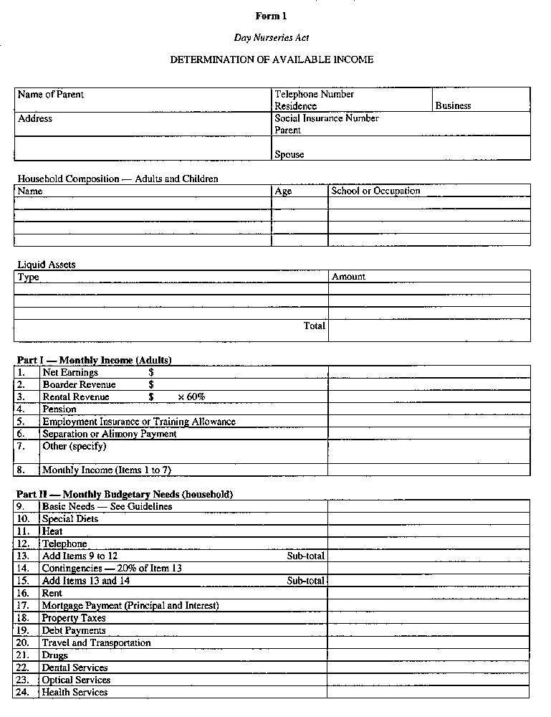
Insert regs\Graphics\Source Law\2005\287\287001be.tif
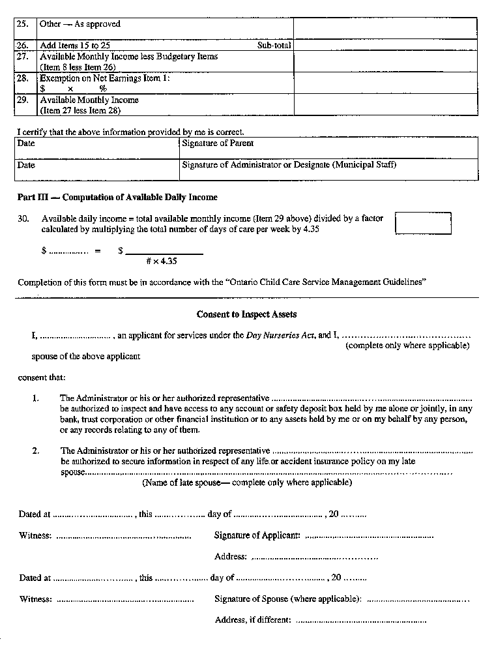
Insert regs\Graphics\Source Law\2005\287\287001ce.tif
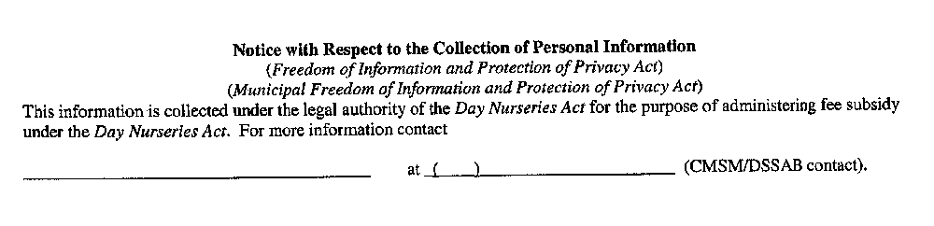
O. Reg. 287/05, s. 3.
Note: On January 1, 2007, Form 1 is revoked. See: O. Reg. 505/06, ss. 19, 20 (2).
Form 2
PROVISIONAL LICENCE TO OPERATE A DAY NURSERY
Day Nurseries Act
Insert regs\graphics\1990\262\262002ae.tif
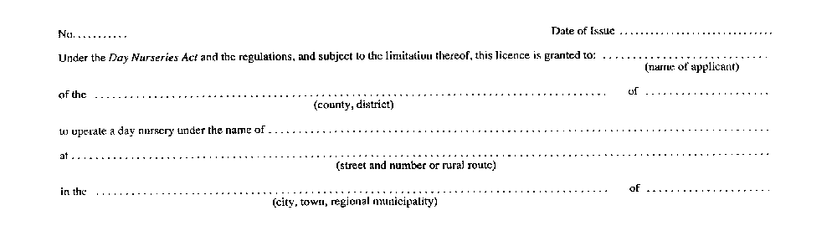
Insert regs\graphics\1990\262\262002be.tif
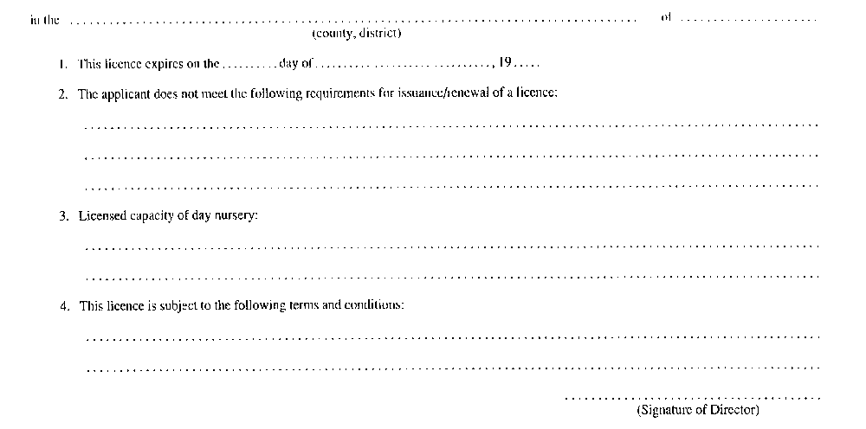
R.R.O. 1990, Reg. 262, Form 2.
Form 3
PROVISIONAL LICENCE TO OPERATE A PRIVATE-HOME DAY CARE AGENCY
Day Nurseries Act
Insert regs\graphics\1990\262\262003ae.tif
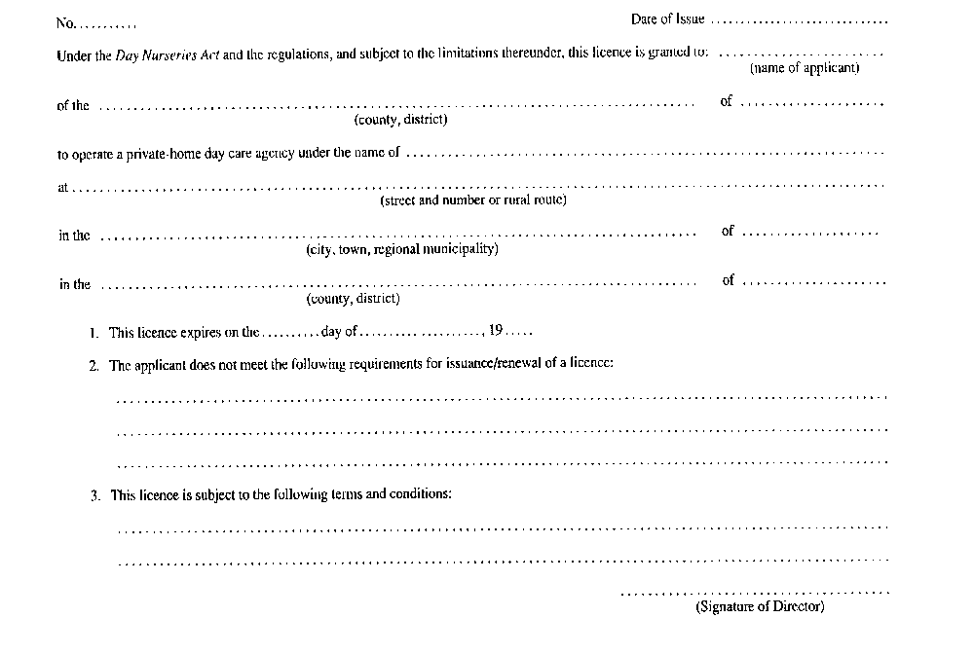
R.R.O. 1990, Reg. 262, Form 3.
Form 4
LICENCE/RENEWAL OF LICENCE TO OPERATE A DAY NURSERY
Day Nurseries Act
Insert regs\graphics\1990\262\262004ae.tif
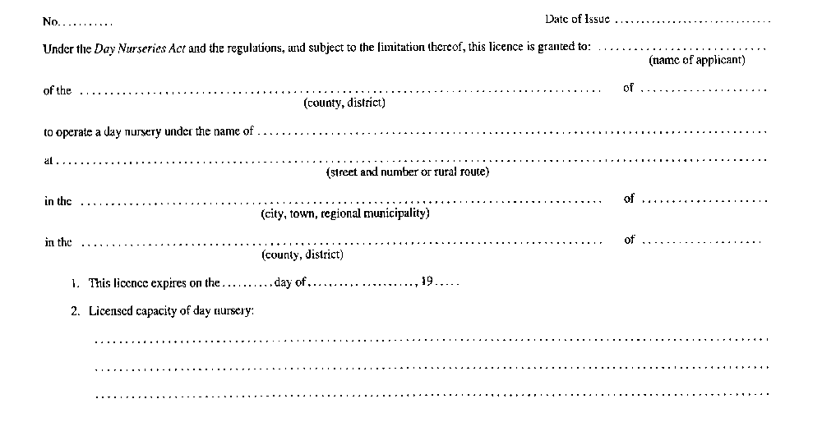
Insert regs\graphics\1990\262\262004be.tif

R.R.O. 1990, Reg. 262, Form 4.
Form 5
LICENCE/RENEWAL OF A LICENCE TO OPERATE A PRIVATE-HOME DAY CARE AGENCY
Day Nurseries Act
Insert regs\graphics\1990\262\262005ae.tif

Insert regs\graphics\1990\262\262005be.tif
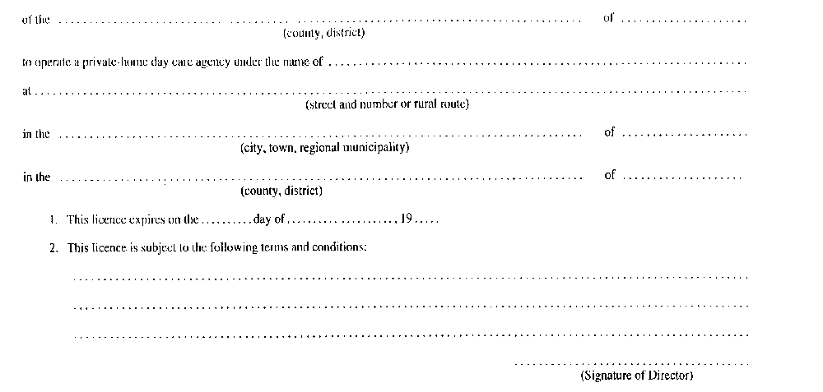
R.R.O. 1990, Reg. 262, Form 5.
Form 6
NOTICE OF INTENTION
Day Nurseries Act
Insert regs\graphics\1990\262\262006ae.tif
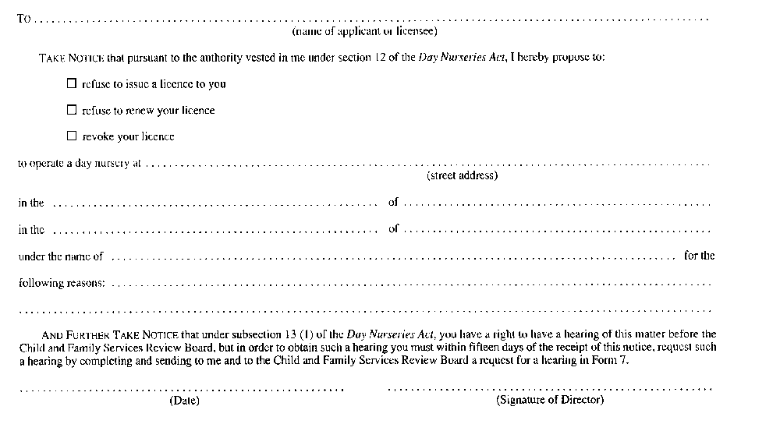
R.R.O. 1990, Reg. 262, Form 6.
Form 7
REQUEST FOR HEARING
Day Nurseries Act
Insert regs\graphics\1990\262\262007ae.tif
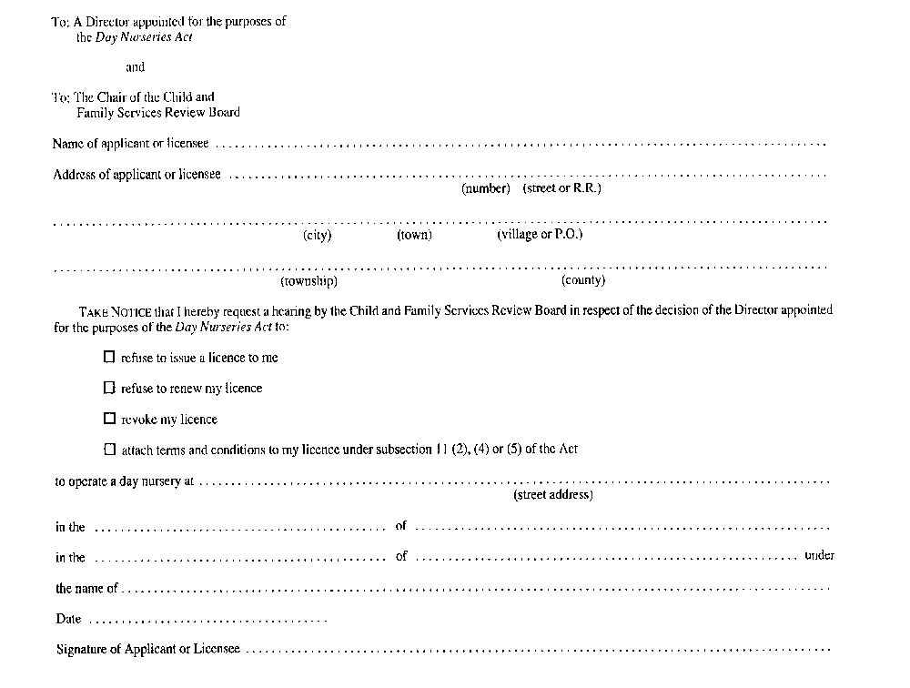
R.R.O. 1990, Reg. 262, Form 7.
Form 8
NOTICE OF HEARING
Day Nurseries Act
Insert regs\graphics\1990\262\262008ae.tif
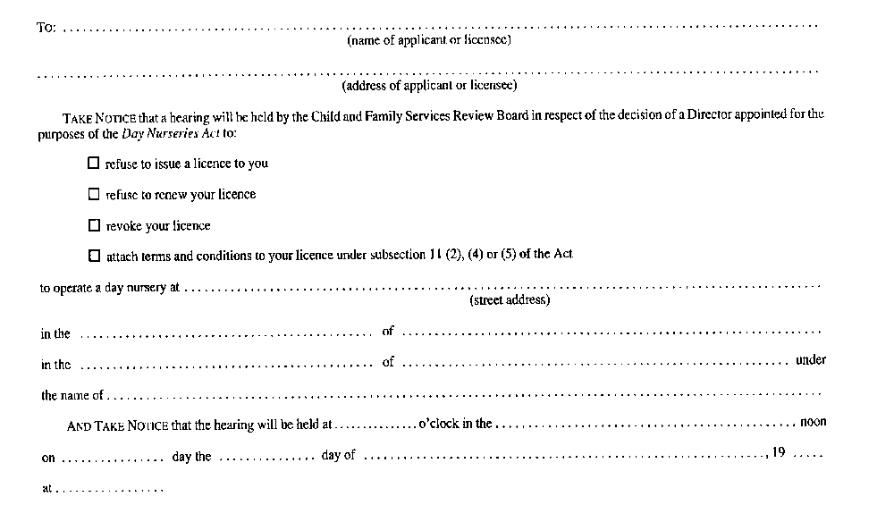
Insert regs\graphics\1990\262\262008be.tif
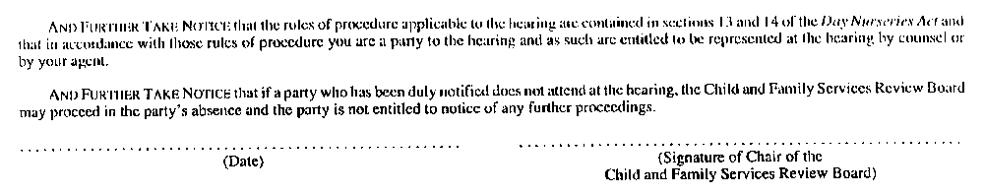
R.R.O. 1990, Reg. 262, Form 8.
Form 9
NOTICE OF DIRECTION
Day Nurseries Act
Insert regs\graphics\1990\262\262009ae.tif
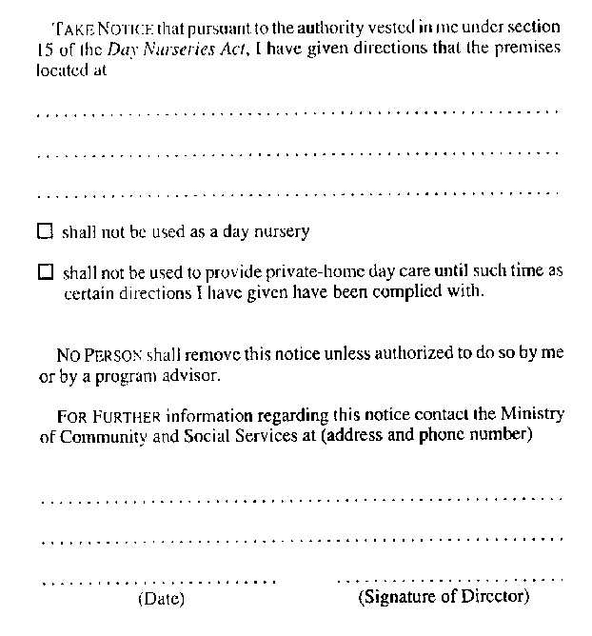
R.R.O. 1990, Reg. 262, Form 9.

Back to top

