Drugless Practitioners Act
Loi sur les praticiens ne prescrivant pas de médicaments
R.R.O. 1990, REGULATION 280
Amended to S. O. 1991, c. 18, s. 46
OSTEOPATHS
Historical version for the period November 25, 1991 to October 24, 2004.
Note: This Regulation is revoked on the day subsection 46 (2) of the Regulated Health Professions Act, 1991 is proclaimed in force. See: 1991, c. 18, s. 46 (2).
This Regulation is made in English only.
Definitions
1. In this Regulation,
“Board” means Board of Directors of Osteopathy;
“secretary-treasurer” means secretary-treasurer of the Board. R.R.O. 1990, Reg. 280, s. 1.
Registration
2. The secretary-treasurer shall maintain a register of persons admitted to practise as osteopaths. R.R.O. 1990, Reg. 280, s. 2.
3. The secretary-treasurer shall register as an osteopath any person who,
(a) is of good moral character;
(b) is at least eighteen years of age;
(c) has passed the examinations prescribed by section 12; and
(d) has paid the registration fee prescribed by clause 7 (a). R.R.O. 1990, Reg. 280, s. 3.
4. The secretary-treasurer shall register any person who,
(a) is registered as an osteopath in a jurisdiction outside Ontario under regulations similar to this Regulation; and
(b) pays the registration fee prescribed by clause 7 (a). R.R.O. 1990, Reg. 280, s. 4.
5. (1) The registration of an osteopath expires with the first Monday in February in each year. R.R.O. 1990, Reg. 280, s. 5 (1).
(2) The secretary-treasurer shall renew the registration for one year where the osteopath pays the renewal fee prescribed by clause 7 (b). R.R.O. 1990, Reg. 280, s. 5 (2).
6. (1) Where a registered osteopath fails to pay the renewal fee on or before the expiry date, the secretary-treasurer shall notify the osteopath by registered mail addressed to his or her last known address appearing on the register that his or her registration has expired. R.R.O. 1990, Reg. 280, s. 6 (1).
(2) Where an osteopath whose registration has expired pays the fee prescribed by clause 7 (c), the secretary-treasurer shall register the osteopath. R.R.O. 1990, Reg. 280, s. 6 (2).
Fees
7. The fees to be paid by an osteopath are,
(a) on registration, $75;
(b) on renewal of registration, $50; and
(c) where his or her registration has expired, for each year or part of a year that has passed since the date of expiry of registration, $25. R.R.O. 1990, Reg. 280, s. 7.
Discipline
8. (1) The Board may, after a hearing, suspend or cancel the registration of any person found to be guilty of misconduct or to have been ignorant or incompetent. R.R.O. 1990, Reg. 280, s. 8 (1).
(2) Before holding a hearing, the Board shall send by registered mail to the osteopath at his or her last known address appearing on the register a notice,
(a) giving the details of the alleged misconduct, ignorance or incompetence and the nature of the evidence in support thereof; and
(b) appointing the date, time and place for the hearing. R.R.O. 1990, Reg. 280, s. 8 (2).
(3) The Board shall allow at least ten clear days between the date of sending the notice and the date for the hearing. R.R.O. 1990, Reg. 280, s. 8 (3).
(4) If the osteopath fails to attend the hearing on the date and at the time and place appointed, the hearing may proceed and a decision may be made in his or her absence. R.R.O. 1990, Reg. 280, s. 8 (4).
(5) At the hearing, the osteopath is entitled to hear the evidence against him or her, to cross-examine thereon, to call witnesses in his or her behalf and to present his or her argument. R.R.O. 1990, Reg. 280, s. 8 (5).
(6) The osteopath may be represented at the hearing by counsel or by an agent. R.R.O. 1990, Reg. 280, s. 8 (6).
(7) Where the Board decides to suspend the registration, the period of suspension shall not be longer than thirty days. R.R.O. 1990, Reg. 280, s. 8 (7).
9. (1) The Board may appoint an inspector for the investigation of complaints made against an osteopath. R.R.O. 1990, Reg. 280, s. 9 (1).
(2) A member of the Board is not eligible for appointment as an inspector. R.R.O. 1990, Reg. 280, s. 9 (2).
(3) The inspector shall investigate a complaint made in writing that an osteopath has been guilty of misconduct or displayed such ignorance or incompetence as to render it desirable in the public interest that his or her registration be cancelled or suspended. R.R.O. 1990, Reg. 280, s. 9 (3).
(4) The inspector shall report to the Board on every investigation made by the inspector. R.R.O. 1990, Reg. 280, s. 9 (4).
Designations
10. No person other than an osteopath registered under the Act shall advertise or use any title or add any affix to the person’s name signifying that the person is qualified to practise as an osteopath. R.R.O. 1990, Reg. 280, s. 10.
Allowance for Board
11. (1) Members of the Board shall be paid,
(a) a daily allowance; and
(b) an allowance for travelling and living expenses,
in the amounts prescribed by subsection (2) while engaged on the business of the Board. R.R.O. 1990, Reg. 280, s. 11 (1).
(2) The allowance is,
(a) $78 a day; and
(b) the actual amount spent in travelling and living expenses. R.R.O. 1990, Reg. 280, s. 11 (2).
(3) The amount of the allowance paid under clause (2) (a) to each member shall not exceed $750 in any one year. R.R.O. 1990, Reg. 280, s. 11 (3).
(4) In addition to the allowance paid under subsection (3), the secretary-treasurer shall be paid an annual allowance of $600. R.R.O. 1990, Reg. 280, s. 11 (4).
Examinations
12. (1) The Board shall prescribe written, oral and practical examinations for the admission of osteopaths to practise in Ontario, upon the subjects prescribed by subsection (2). R.R.O. 1990, Reg. 280, s. 12 (1).
(2) The subjects for examination are,
(a) anatomy and applied anatomy, including histology and embryology;
(b) physiology, including physiological chemistry;
(c) pathology and bacteriology, including parasitology, immunology, public health and preventive medicine;
(d) surgery, including surgical specialties;
(e) obstetrics, gynaecology and paediatrics;
(f) neurology, psychology and psychiatry; and
(g) osteopathic medicine, including principles, therapeutics, pharmacology, materia medica and jurisprudence. R.R.O. 1990, Reg. 280, s. 12 (2).
13. (1) The Board shall conduct or cause to be conducted examinations at least once a year. R.R.O. 1990, Reg. 280, s. 13 (1).
(2) When necessary, the Board shall conduct or cause to be conducted supplemental examinations within four months after the examinations under subsection (1). R.R.O. 1990, Reg. 280, s. 13 (2).
14. (1) A person may apply to the secretary-treasurer as a candidate for the examination if the person,
(a) is of good moral character;
(b) is the holder of an Ontario Secondary School Graduation Diploma or an equivalent certificate as determined by the Minister of Health;
(c) has successfully completed at least two years of preliminary study at a college or university in a course that includes physics, organic and inorganic chemistry, biology and English; and
(d) has graduated from a school or college of osteopathy referred to in section 18. R.R.O. 1990, Reg. 280, s. 14 (1).
(2) Application for examination shall be made in Form 1 to the secretary-treasurer. R.R.O. 1990, Reg. 280, s. 14 (2).
(3) The applicant shall submit with the application,
(a) evidence of preliminary education prior to admission to a college of osteopathy;
(b) references as to character, professional status and previous experience in the practice of osteopathy;
(c) a certificate in Form 2 from the head of the teaching staff of a school or college referred to in section 18; and
(d) the examination fee prescribed by section 17. R.R.O. 1990, Reg. 280, s. 14 (3).
(4) The Board shall review the application and, if it complies with this Regulation, the Board shall cause the secretary-treasurer to notify the candidate of the time and place fixed for the examination. R.R.O. 1990, Reg. 280, s. 14 (4).
15. (1) A person may take the examinations if the person has,
(a) been notified under subsection 14 (4); and
(b) paid the fee prescribed by section 17. R.R.O. 1990, Reg. 280, s. 15 (1).
(2) A person who has,
(a) taken the examinations;
(b) failed in three subjects or fewer; and
(c) paid the fee prescribed by section 17,
may try at a supplemental examination the subjects in which he or she has failed. R.R.O. 1990, Reg. 280, s. 15 (2).
16. A person who is taking an examination or supplemental examination shall be allowed,
(a) 2½ hours for each subject written; and
(b) thirty minutes for the oral examination in each subject. R.R.O. 1990, Reg. 280, s. 16.
Fees on Examination
17. A candidate for examination or supplemental examination shall pay on examination a fee,
(a) not exceeding $50 in amount; and
(b) calculated on the basis of,
(i) $10 for each subject at an examination, and
(ii) $20 for each subject at a supplemental examination. R.R.O. 1990, Reg. 280, s. 17.
Osteopathic Colleges
18. (1) An applicant for examination shall have completed a course of instruction in a school or college that conducts a course in osteopathy of not less than four academic years with a minimum of 5,000 hours of instruction and that requires students to have completed at least two years of pre-medical study. R.R.O. 1990, Reg. 280, s. 18 (1).
(2) The course of instruction shall include the following subjects:
1. Anatomy, comprising,
i. gross anatomy,
ii. dissection,
iii. embryology, and
iv. histology.
2. Physiology.
3. Biochemistry.
4. Pharmacology, comprising,
i. comparative therapeutics,
ii. materia medica and associated subjects, and
iii. toxicology.
5. Pathology.
6. Public health and preventive medicine, comprising,
i. hygiene,
ii. sanitation,
iii. bacteriology,
iv. parasitology, and
v. immunology.
7. Surgery, comprising,
i. general surgery,
ii. orthopaedic surgery,
iii. urology,
iv. ophthalmology,
v. radiology,
vi. anaesthesiology, and
vii. otorhinolaryngology.
8. Obstetrics and gynaecology.
9. Principles, practice and technique of osteopathy.
10. Neurology.
11. Psychology.
12. Psychiatry.
13. Paediatrics.
14. Dermatology and syphilology.
15. Therapeutics.
16. Tropical medicine.
17. Medical jurisprudence.
R.R.O. 1990, Reg. 280, s. 18 (2).
Meetings of the Board
19. (1) The chair or, in his or her absence, the vice-chair shall call and preside at all meetings of the Board and the presiding officer shall, in the case of a tie vote, have the deciding vote. R.R.O. 1990, Reg. 280, s. 19 (1).
(2) Meetings of the Board shall be upon the written call of the chair or upon the written request of any two members of the Board stating the reason for calling the meeting. R.R.O. 1990, Reg. 280, s. 19 (2).
Secretary-Treasurer
20. The secretary-treasurer shall,
(a) conduct the correspondence of the Board;
(b) keep a true and accurate record of the minutes of all meetings of the Board;
(c) notify all members of the Board of all meetings at least seven days in advance of such meetings;
(d) keep a record of all osteopaths taking the examinations and the results of such examinations;
(e) receive all money and securities and keep a proper record of all business transactions of the Board, the receipt and expenditure of all money and securities, and forthwith deposit all such money or securities received in such bank listed in Schedule I or II to the Bank Act (Canada) as the Board selects; and
(f) carry out such other duties as the Board from time to time directs. R.R.O. 1990, Reg. 280, s. 20.
21. All cheques of the Board shall be signed by the chair or vice-chair and the secretary-treasurer. R.R.O. 1990, Reg. 280, s. 21.
Auditors
22. The accounts of the Board shall be audited annually by a chartered accountant appointed by the Board. R.R.O. 1990, Reg. 280, s. 22.
Form 1
APPLICATION FOR REGISTRATION AS AN OSTEOPATH BY EXAMINATION
Drugless Practitioners Act
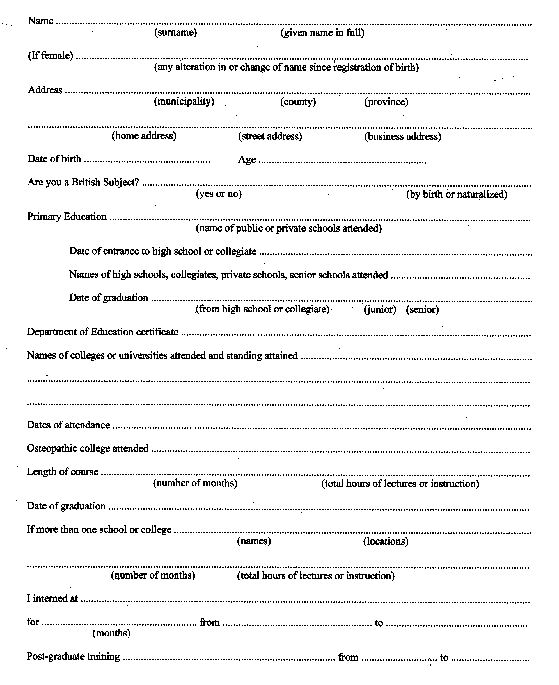
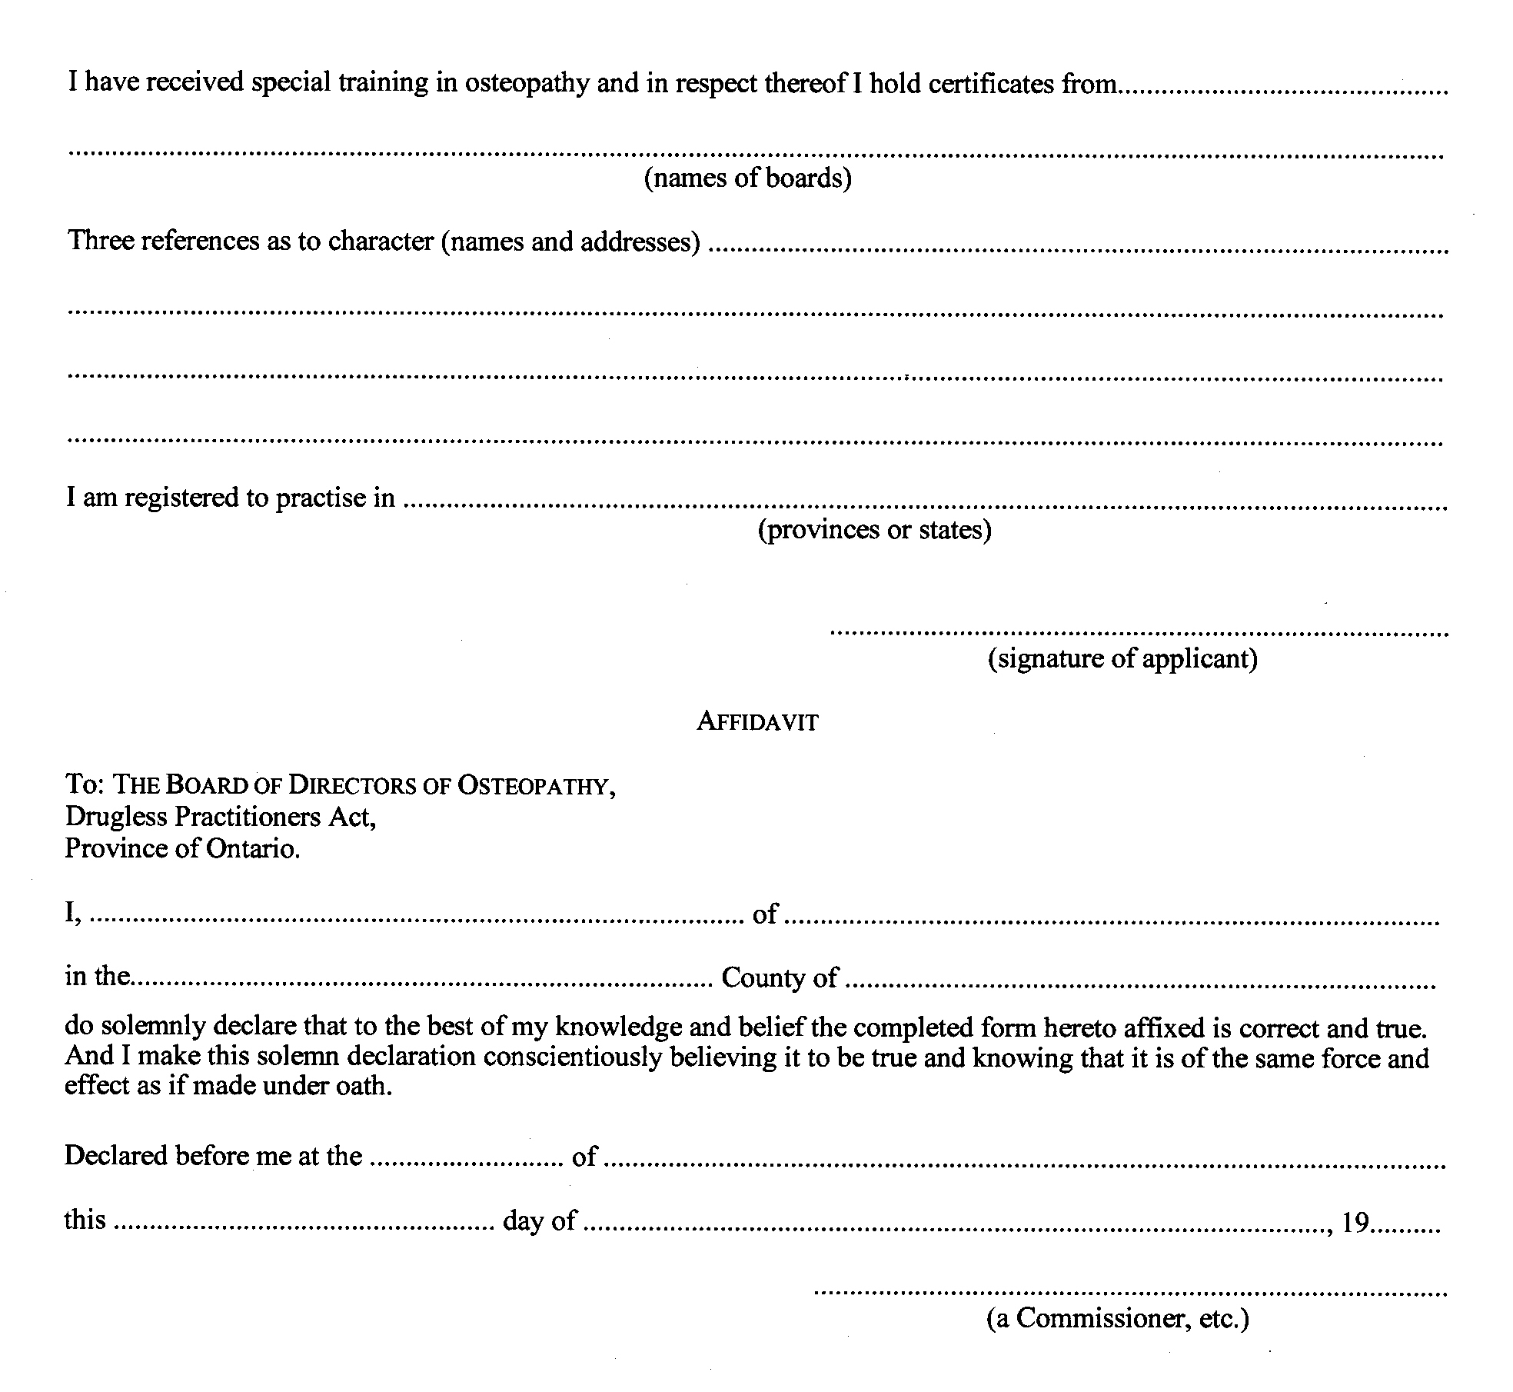
R.R.O. 1990, Reg. 280, Form 1.
Form 2
CERTIFICATE OF EDUCATION IN OSTEOPATHIC MEDICINE
Drugless Practitioners Act
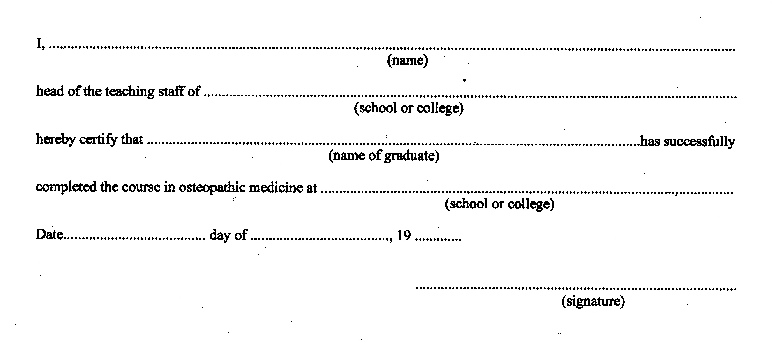
R.R.O. 1990, Reg. 280, Form 2.

Back to top

