Highway Traffic Act
Code de la route
R.R.O. 1990, REGULATION 581
Amended to O. Reg. 612/05
DISABLED PERSON PARKING PERMITS
Historical version for the period December 1, 2005 to January 15, 2006.
This Regulation is made in English only.
Note: On January 16, 2006, the title to this Regulation is revoked and the following substituted:
Accessible PARKING for persons with disabilities
See: O. Reg. 612/05, ss. 1, 7.
1. In this Regulation,
“disabled person” means an individual described in clause 2 (1) (a);
“medical practitioner” means a person legally qualified to practise in Canada as a physician, chiropractor, occupational therapist, osteopath or physiotherapist. R.R.O. 1990, Reg. 581, s. 1.
Note: On January 16, 2006, section 1 is revoked and the following substituted:
1. In this Regulation,
“person with a disability” means an individual,
(a) who cannot walk without the assistance of another individual or of a brace, cane, crutch, lower limb prosthetic device or similar assistive device or who requires the assistance of a wheelchair,
(b) who suffers from lung disease to such an extent that his or her forced expiratory volume in one second is less than one litre,
(c) for whom portable oxygen is a medical necessity,
(d) who suffers from cardiovascular disease to such an extent that the individual’s functional capacity is classified as Class III or Class IV according to Nomenclature and Criteria for Diagnosis of Diseases of the Heart and Great Vessels, ninth edition, published by Little, Brown & Co. in 1994,
(e) whose ability to walk is severely limited due to an arthritic, neurological, musculoskeletal or orthopaedic condition,
(f) whose visual acuity is 20/200 or poorer in the better eye, with corrective lenses if required, or whose maximum field of vision using both eyes has a diameter of 20 degrees or less, or
(g) whose mobility is severely limited by one or more conditions or functional impairments;
“registered nurse in the extended class” means a member of the College of Nurses of Ontario who is a registered nurse holding an extended certificate of registration under the Nursing Act, 1991;
“regulated health practitioner” means a person legally qualified to practise in Canada as a physician, chiropractor, occupational therapist, physiotherapist or registered nurse in the extended class;
“traveller permit” means a disabled person parking permit for use related to travel issued under subsection 2 (4) to an individual holding an unexpired disabled person parking permit for general use issued under subsection 2 (1). O. Reg. 612/05, s. 2.
See: O. Reg. 612/05, ss. 2, 7.
2. (1) The Minister shall issue a disabled person parking permit to every applicant therefor if,
(a) the applicant is an individual who is unable to walk unassisted for more than 200 metres without great difficulty or danger to his or her health or safety; and
(b) the applicant submits a certificate of a medical practitioner, on a form to be provided by the Ministry, certifying that the applicant is a disabled person and setting out whether the disability is temporary or permanent and, if temporary, the anticipated length of time the disability is expected to continue, if known.
(2) The Minister shall issue a disabled person parking permit,
(a) to a corporation in respect of the number of vehicles that are owned or leased by the corporation primarily to provide transportation services to disabled persons; and
(b) to an organization in respect of the number of vehicles that are owned or leased by the organization and used on a non-profit basis to provide transportation services to disabled persons.
(3) No more than one disabled person parking permit shall be issued to any individual under subsection (1).
(4) Subsection (3) does not apply so as to prevent the renewal or replacement of a disabled person parking permit. R.R.O. 1990, Reg. 581, s. 2.
Note: On January 16, 2006, section 2 is revoked and the following substituted:
2. (1) The Minister shall issue a disabled person parking permit to every individual who applies for it on a form provided by the Ministry, if a regulated health practitioner certifies the following on the form:
1. That the applicant is a person with a disability.
2. The nature of the disability.
3. Whether the disability is temporary or permanent or whether this fact is unknown.
4. If the disability is temporary, the anticipated length of time the disability is expected to continue, if known. O. Reg. 612/05, s. 2.
(2) If, after January 16, 2006, a regulated health practitioner certifies on an application for a disabled person parking permit that the applicant is a person with a permanent disability, no certification from a regulated health practitioner is required on any application for renewal of that permit, despite subsection (1). O. Reg. 612/05, s. 2.
(3) If an individual holds an unexpired disabled person parking permit for general use issued under subsection (1), the Minister shall not issue another disabled person parking permit for general use to the individual under subsection (1). O. Reg. 612/05, s. 2.
(4) The Minister shall issue a disabled person parking permit for use related to travel to every individual who applies for it and holds an unexpired disabled person parking permit for general use issued under subsection (1). O. Reg. 612/05, s. 2.
(5) Every disabled person parking permit for use related to travel issued under subsection (4) shall specify the locations or circumstances in which it may be used. O. Reg. 612/05, s. 2.
(6) The Minister shall issue disabled person parking permits,
(a) to a corporation, in respect of the number of vehicles that are owned or leased by the corporation primarily to provide transportation services to persons with a disability; and
(b) to an organization, in respect of the number of vehicles that are owned or leased by the organization and used on a non-profit basis to provide transportation services to persons with a disability. O. Reg. 612/05, s. 2.
See: O. Reg. 612/05, ss. 2, 7.
3. The Minister shall issue a disabled person parking permit to a visitor to Ontario if the visitor,
(a) provides evidence that he or she is the holder of a currently valid permit, number plates, marker or device bearing the international symbol of access for the disabled issued by the visitor’s home jurisdiction; or
(b) provides other evidence that he or she is from another jurisdiction and is a disabled person. R.R.O. 1990, Reg. 581, s. 3.
Note: On January 16, 2006, section 3 is revoked and the following substituted:
3. The Minister shall issue a disabled person parking permit to a visitor to Ontario, if the visitor,
(a) provides evidence that he or she is the holder of a currently valid permit, number plate or other marker or device bearing the international symbol of access for persons with a disability issued by the visitor’s home jurisdiction; or
(b) provides other evidence that he or she is from another jurisdiction and is a person with a disability. O. Reg. 612/05, s. 2.
See: O. Reg. 612/05, ss. 2, 7.
4. If a disabled person parking permit is lost or stolen, the Minister shall issue a replacement permit if,
(a) the loss or theft is reported to the Ministry on a form supplied by the Ministry; and
(b) the applicant continues to meet the requirements of section 2 or 3, as applicable. R.R.O. 1990, Reg. 581, s. 4.
5. (1) A disabled person parking permit issued to an individual shall be issued,
(a) for sixty months, if the medical practitioner has certified that the disability is permanent;
(b) for the anticipated length of the disability, up to a maximum of twenty-four months, if the medical practitioner has certified that the disability is temporary and has specified the anticipated length of the disability;
(c) for twenty-four months, if the medical practitioner has certified that the disability is temporary and of unknown duration; and
(d) for the length of the visit, up to a maximum of six months, if the applicant is a visitor described in section 3.
(2) A disabled person parking permit issued to a corporation shall be issued for a term that reflects the contractual or other obligations of the corporation to provide transportation services primarily to disabled persons, up to a maximum of sixty months.
(3) A disabled person parking permit issued to an organization under clause 2 (2) (b) shall be issued for the length of time that the organization anticipates that it will be transporting disabled persons, up to a maximum of sixty months.
(4) Despite subsections (1), (2) and (3), disabled parking permits issued before the 1st day of May, 1991 may be issued for a lesser or greater term than set out in those subsections in order to stagger the projected renewal dates of the permits. R.R.O. 1990, Reg. 581, s. 5.
Note: On January 16, 2006, section 5 is revoked and the following substituted:
5. (1) A disabled person parking permit issued to an individual shall be issued,
(a) if the regulated health practitioner certifies that the disability is permanent, for 60 months;
(b) if the regulated health practitioner certifies that the disability is temporary and specifies the anticipated length of time the disability is expected to continue, for the anticipated length of time the disability is expected to continue, up to a maximum of 24 months;
(c) if the regulated health practitioner certifies that it is not possible to determine whether the disability is temporary or permanent, or if the regulated health practitioner certifies that the disability is temporary but of unknown duration, for 60 months;
(d) if the individual is a visitor described in section 3, for the length of the visit, up to a maximum of six months; and
(e) if it is a traveller permit, for the lesser of 12 months and the period ending on the date of expiry of the individual’s disabled person parking permit for general use. O. Reg. 612/05, s. 3.
(2) A disabled person parking permit issued to a corporation under clause 2 (6) (a) shall be issued for a term that reflects the contractual or other obligations of the corporation to provide transportation services to persons with a disability, up to a maximum of 60 months. O. Reg. 612/05, s. 3.
(3) A disabled person parking permit issued to an organization under clause 2 (6) (b) shall be issued for the length of time that the organization anticipates that it will be providing transportation services to persons with a disability, up to a maximum of 60 months. O. Reg. 612/05, s. 3.
See: O. Reg. 612/05, ss. 3, 7.
6. (1) A disabled person parking permit ceases to be in force if the holder of the permit ceases to meet the requirements of clause 2 (1) (a) or section 3.
(2) A disabled person parking permit issued to an individual is not valid when displayed on a vehicle and the vehicle is not being used to pick up or transport the holder of the disabled person parking permit.
(3) A disabled person parking permit issued to a corporation or organization is not valid when displayed on a vehicle and the vehicle is not being used to pick up or transport a disabled person. R.R.O. 1990, Reg. 581, s. 6.
Note: On January 16, 2006, section 6 is revoked and the following substituted:
6. (1) A disabled person parking permit ceases to be in force if the holder of the permit ceases to be a person with a disability. O. Reg. 612/05, s. 3.
(2) A disabled person parking permit issued to an individual is not valid when it is displayed on a vehicle and,
(a) the vehicle is not being used to pick up or transport the holder of the permit; or
(b) the disabled person parking permit is a traveller permit and is being used in locations or circumstances not specified on the permit. O. Reg. 612/05, s. 3.
(3) A disabled person parking permit issued to a corporation or an organization is not valid when it is displayed on a vehicle and the vehicle is not being used to pick up or transport a person with a disability. O. Reg. 612/05, s. 3.
See: O. Reg. 612/05, ss. 3, 7.
7. A disabled person parking permit shall be displayed on the sun visor or on the dashboard of a vehicle so that the international symbol of access for the disabled, the permit number and the expiry date of the permit are clearly visible from the outside of the vehicle. R.R.O. 1990, Reg. 581, s. 7.
Note: On January 16, 2006, section 7 is revoked and the following substituted:
7. A disabled person parking permit shall be displayed on the sun visor or on the dashboard of a vehicle so that the international symbol of access for persons with a disability, the permit number and the expiry date of the permit are clearly visible from the outside of the vehicle. O. Reg. 612/05, s. 3.
See: O. Reg. 612/05, ss. 3, 7.
8. Vehicles displaying currently valid permits, number plates and other markers and devices bearing the international symbol of access for the disabled and issued by other jurisdictions are entitled to the same privileges as vehicles displaying disabled person parking permits issued under the Act. R.R.O. 1990, Reg. 581, s. 8.
Note: On January 16, 2006, section 8 is revoked and the following substituted:
8. A vehicle displaying a currently valid permit, number plate or other marker or device bearing the international symbol of access for persons with a disability and issued by another jurisdiction is entitled to the same privileges as a vehicle displaying a disabled person parking permit issued under the Act. O. Reg. 612/05, s. 3.
See: O. Reg. 612/05, ss. 3, 7.
9. An unexpired disabled person parking permit shall be returned to the Ministry promptly if,
(a) the holder no longer meets the requirements of section 2 or 3;
Note: On January 16, 2006, clause (a) is revoked and the following substituted:
(a) the holder is no longer a person with a disability;
See: O. Reg. 612/05, ss. 4, 7.
(b) the permit is cancelled; or
(c) the permit contains incorrect information. R.R.O. 1990, Reg. 581, s. 9.
10. A parking space designated by a sign under section 11 on land owned and occupied by the Crown may be used only by vehicles displaying a valid disabled person parking permit in accordance with this Regulation. R.R.O. 1990, Reg. 581, s. 10.
11. A parking space designated on Crown land or under a municipal by-law for the use of disabled persons shall be distinctly indicated by erecting a disabled person parking permit sign which shall,
Note: On January 16, 2006, section 11 is amended by striking out the portion before clause (a) and substituting the following:
11. A parking space designated on Crown land or under a municipal by-law for the use of persons with a disability shall be distinctly indicated by erecting a disabled person parking permit sign which shall,
See: O. Reg. 612/05, ss. 5, 7.
(a) be not less than forty-five centimetres in height and not less than thirty centimetres in width and bear the markings and have the dimensions as described and illustrated in the following Figure:
Insert regs\graphics\1990\581\581fg01u.tif
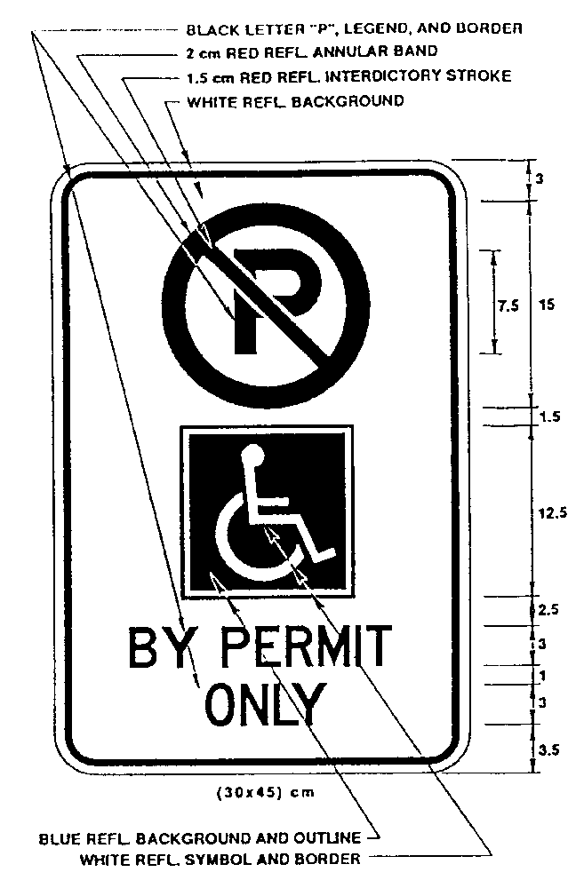
or,
(b) be not less than sixty centimetres in height and not less than thirty centimetres in width and bear the markings and have the dimensions as described and illustrated in the following Figure:
Insert regs\graphics\1990\581\581fg02b.tif
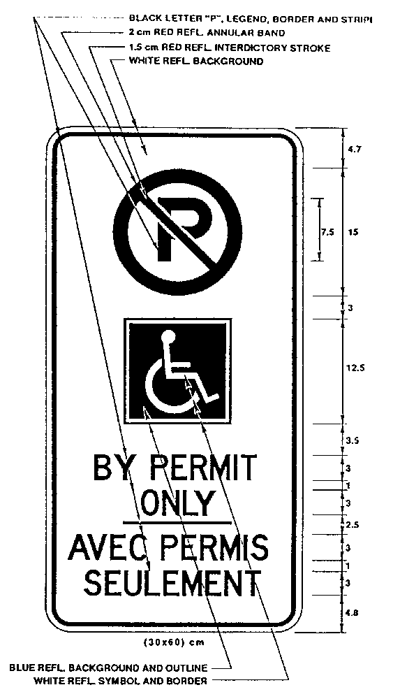
R.R.O. 1990, Reg. 581, s. 11.
12. Despite section 11, a municipality shall replace any signs erected by the municipality in respect of disabled person parking with the signs described under that section as soon as practicable but no later than the 1st day of November, 1991. R.R.O. 1990, Reg. 581, s. 12.
Note: On January 16, 2006, section 12 is revoked. See: O. Reg. 612/05, ss. 6, 7.
13. (1) A sign that prohibits stopping except the stopping of vehicles displaying a valid disabled person parking permit shall be not less than seventy-five centimetres in height and not less than thirty centimetres in width and bear the markings and have the dimensions as described and illustrated in the following Figure:
Insert regs\graphics\1990\581\581fg03u.tif
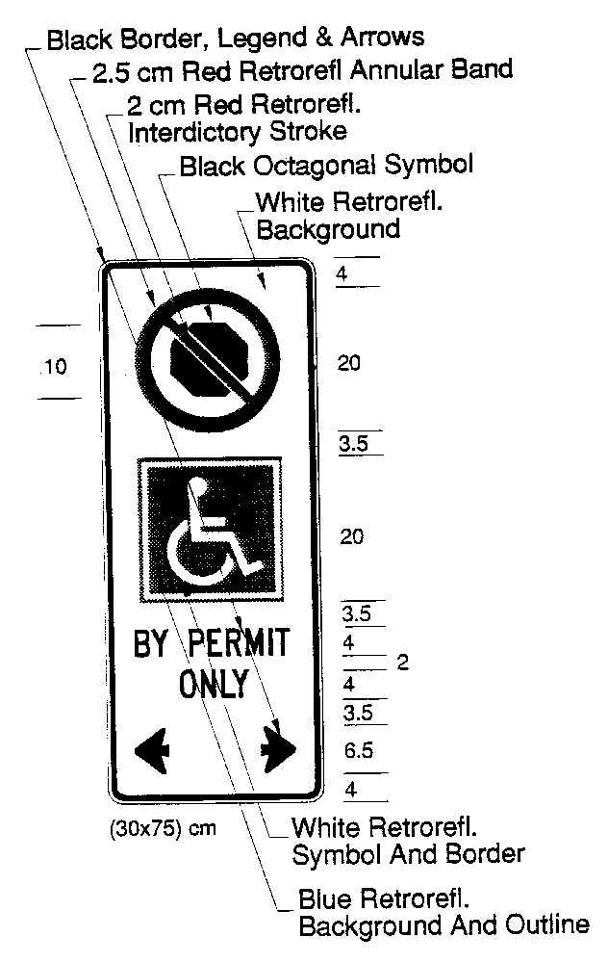
(2) Despite subsection (1), in an area designated by the French Language Services Act, a sign that prohibits stopping except the stopping of vehicles displaying a valid disabled person parking permit shall be not less than seventy-five centimetres in height and not less than thirty centimetres in width and bear the markings and have the dimensions as described and illustrated in the following Figure:
Insert regs\graphics\1990\581\581fg04b.tif
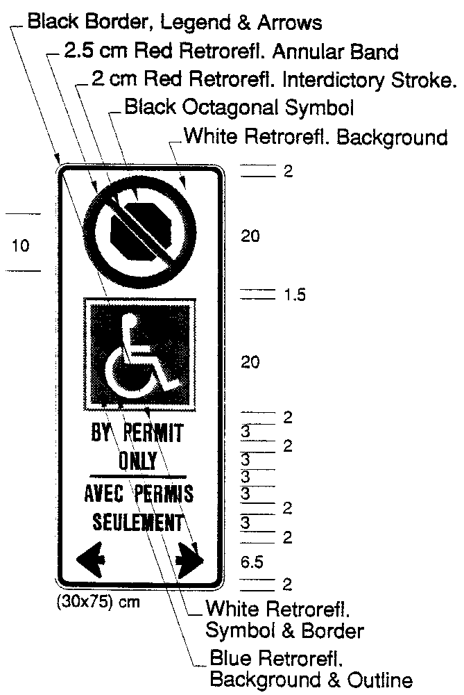
O. Reg. 908/93, s. 1.
14. (1) A sign that prohibits standing except the standing of vehicles displaying a valid disabled person parking permit shall be not less than sixty centimetres in height and not less than thirty centimetres in width and bear the markings and have the dimensions as described and illustrated in the following Figure:
Insert regs\graphics\1990\581\581fg05u.tif
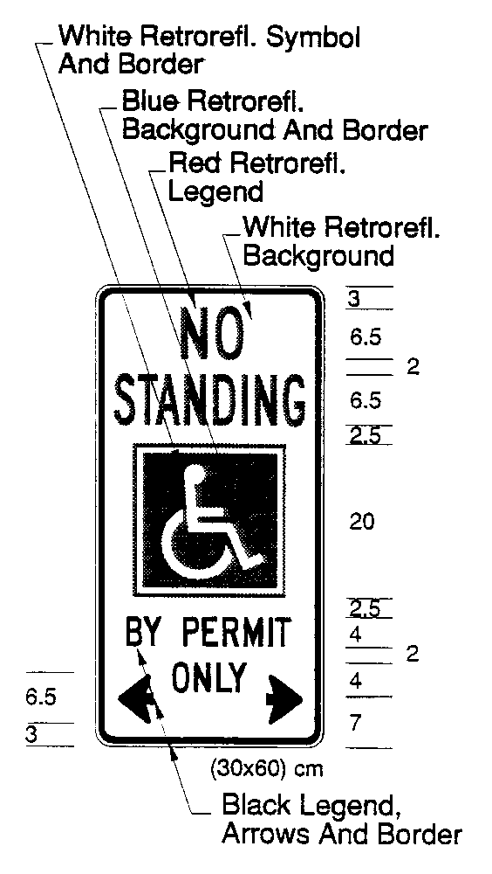
(2) Despite subsection (1), in an area designated by the French Languge Services Act, a sign that prohibits standing except the standing of vehicles displaying a valid disabled person parking permit shall be not less than seventy-five centimetres in height and not less than thirty centimetres in width and bear the markings and have the dimensions as described and illustrated in the following Figure:
Insert regs\graphics\1990\581\581fg06b.tif
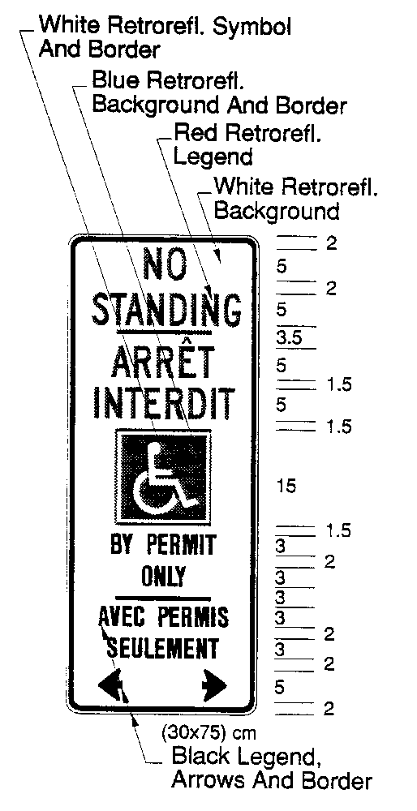
O. Reg. 908/93, s. 1.

Back to top

