Highway Traffic Act
Code de la route
R.R.O. 1990, REGULATION 608
RESTRICTED USE OF LEFT LANES BY COMMERCIAL MOTOR VEHICLES
Historical version for the period December 2, 2011 to September 24, 2012.
Last amendment: O. Reg. 460/11.
This Regulation is made in English only.
Skip Table of Contents
CONTENTS
 |  | Sections
 |  | 1-3
Schedule 1 | Highway no. 400 | 1
Schedule 2 | Highway no. 401 | 1-5
Schedule 3 | Highway no. 403 | 1-3
Schedule 4 | Highway no. 404 | 1
Schedule 5 | Highway no. 407 | 1-2
Schedule 6 | Highway no. 409 | 1
Schedule 7 | Highway no. 410 | 1
Schedule 8 | Highway no. 417 | 1-2
Schedule 9 | Highway no. 427 | 1-3
Schedule 10 | Queen elizabeth way | 1-5
Schedule 11 | Queen elizabeth way and highway no. 403 | 1-2
1. (1) Subject to subsection (2), no person shall operate a commercial motor vehicle or any combination of a commercial motor vehicle and a towed vehicle that exceeds 6.5 metres in length, except a bus, an ambulance or a fire apparatus, in the left lane or, where the left lane has been designated as a high occupancy vehicle lane, in the lane adjacent to the high occupancy vehicle lane of those portions of the King’s Highway described in the Schedules. R.R.O. 1990, Reg. 608, s. 1 (1); O. Reg. 619/05, s. 1 (1).
(2) Subsection (1) does not apply to a commercial motor vehicle engaged in maintenance or construction or where an emergency requires the use of the lane by a commercial motor vehicle. R.R.O. 1990, Reg. 608, s. 1 (2); O. Reg. 619/05, s. 1 (2).
2. (1) A sign indicating that commercial motor vehicles are prohibited in a lane of a highway shall be in the form and dimensions prescribed and illustrated in the following Figure:
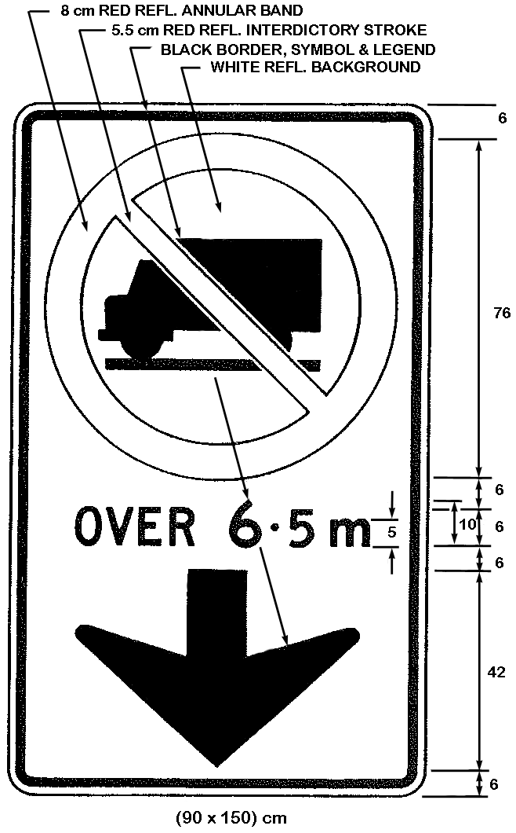
Text alternative: Illustration of an overhead sign containing an image at the top of a truck in a circle with an interdictory stroke “no” symbol. Below that appear the words “OVER 6.5 m” and a thick black arrow appears at the bottom of the sign pointing down. The sign has a white reflective background with the truck image, arrow and words appearing in black. The circular “no” symbol is in red. The following measurements are written below the sign: (90 x 150 cm). The sign is surrounded by measurements of its different elements. This text alternative is provided for convenience only and does not form part of the official law.
R.R.O. 1990, Reg. 608, s. 2 (1); O. Reg. 619/05, s. 2 (1).
(1.1) Despite subsection (1), in an area designated under the French Language Services Act, a sign indicating that commercial motor vehicles are prohibited in a lane of a highway shall be in the form and dimensions prescribed and illustrated in the following Figure:
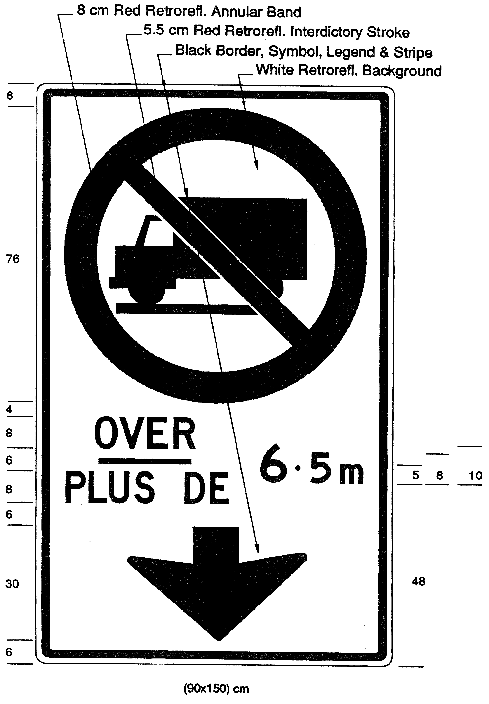
Text alternative: Illustration of a ground-mount sign containing an image at the top of a truck in a circle with an interdictory stroke “no” symbol. Below that appear the words “OVER 6.5 m”. At the bottom of the sign on the left side appear the words “THIS LANE” and on the right side appears a thick black arrow pointing down and diagonally to the right. The sign has a white reflective background with the truck image, arrow and words appearing in black. The circular “no” symbol is in red. The following measurements are written below the sign: (90 x 150 cm). The sign is surrounded by measurements of its different elements. This text alternative is provided for convenience only and does not form part of the official law.
O. Reg. 442/93, s. 1 (1); O. Reg. 619/05, s. 2 (2).
(2) The sign referred to in subsection (1) or (1.1) shall be erected directly above the lane on those portions of the King’s Highway described in the Schedules. O. Reg. 442/93, s. 1 (2); O. Reg. 619/05, s. 2 (3).
3. (1) Where the conditions make it impracticable to place a sign in accordance with the requirements of section 2, a sign indicating that commercial motor vehicles are prohibited in a lane of a highway shall be in the form and dimensions illustrated in the following Figure:
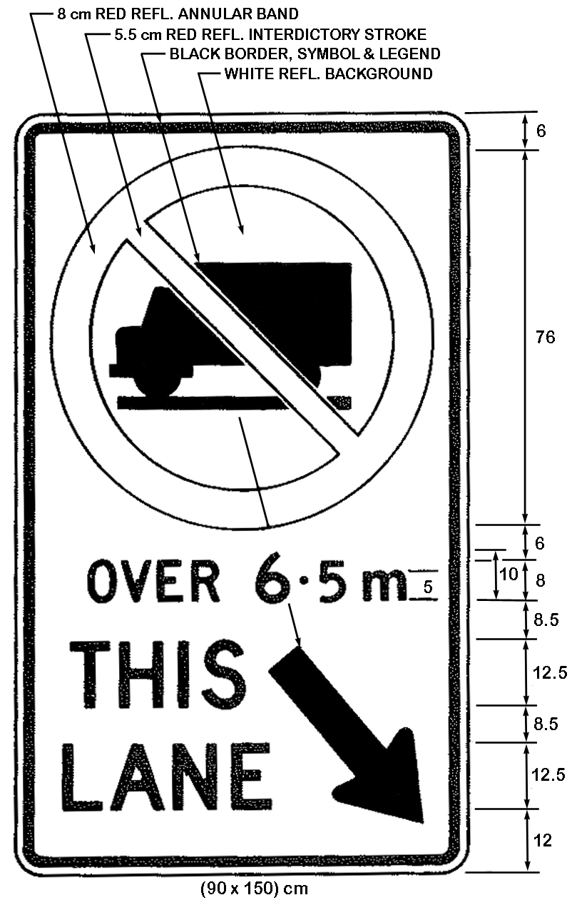
Text alternative: Illustration of a ground-mount sign containing an image at the top of a truck in a circle with an interdictory stroke “no” symbol. Below that appear the words “OVER 6.5 m”. At the bottom of the sign on the left side appear the words “THIS LANE” and on the right side appears a thick black arrow pointing down and diagonally to the right. The sign has a white reflective background with the truck image, arrow and words appearing in black. The circular “no” symbol is in red. The following measurements are written below the sign: (90 x 150 cm). The sign is surrounded by measurements of its different elements. This text alternative is provided for convenience only and does not form part of the official law.
R.R.O. 1990, Reg. 608, s. 3 (1); O. Reg. 619/05, s. 3 (1).
(1.1) Despite subsection (1), in an area designated under the French Language Services Act, where the conditions make it impracticable to place a sign in accordance with the requirements of section 2, a sign indicating that commercial motor vehicles are prohibited in a lane of a highway shall be in the form and dimensions illustrated in the following Figure:
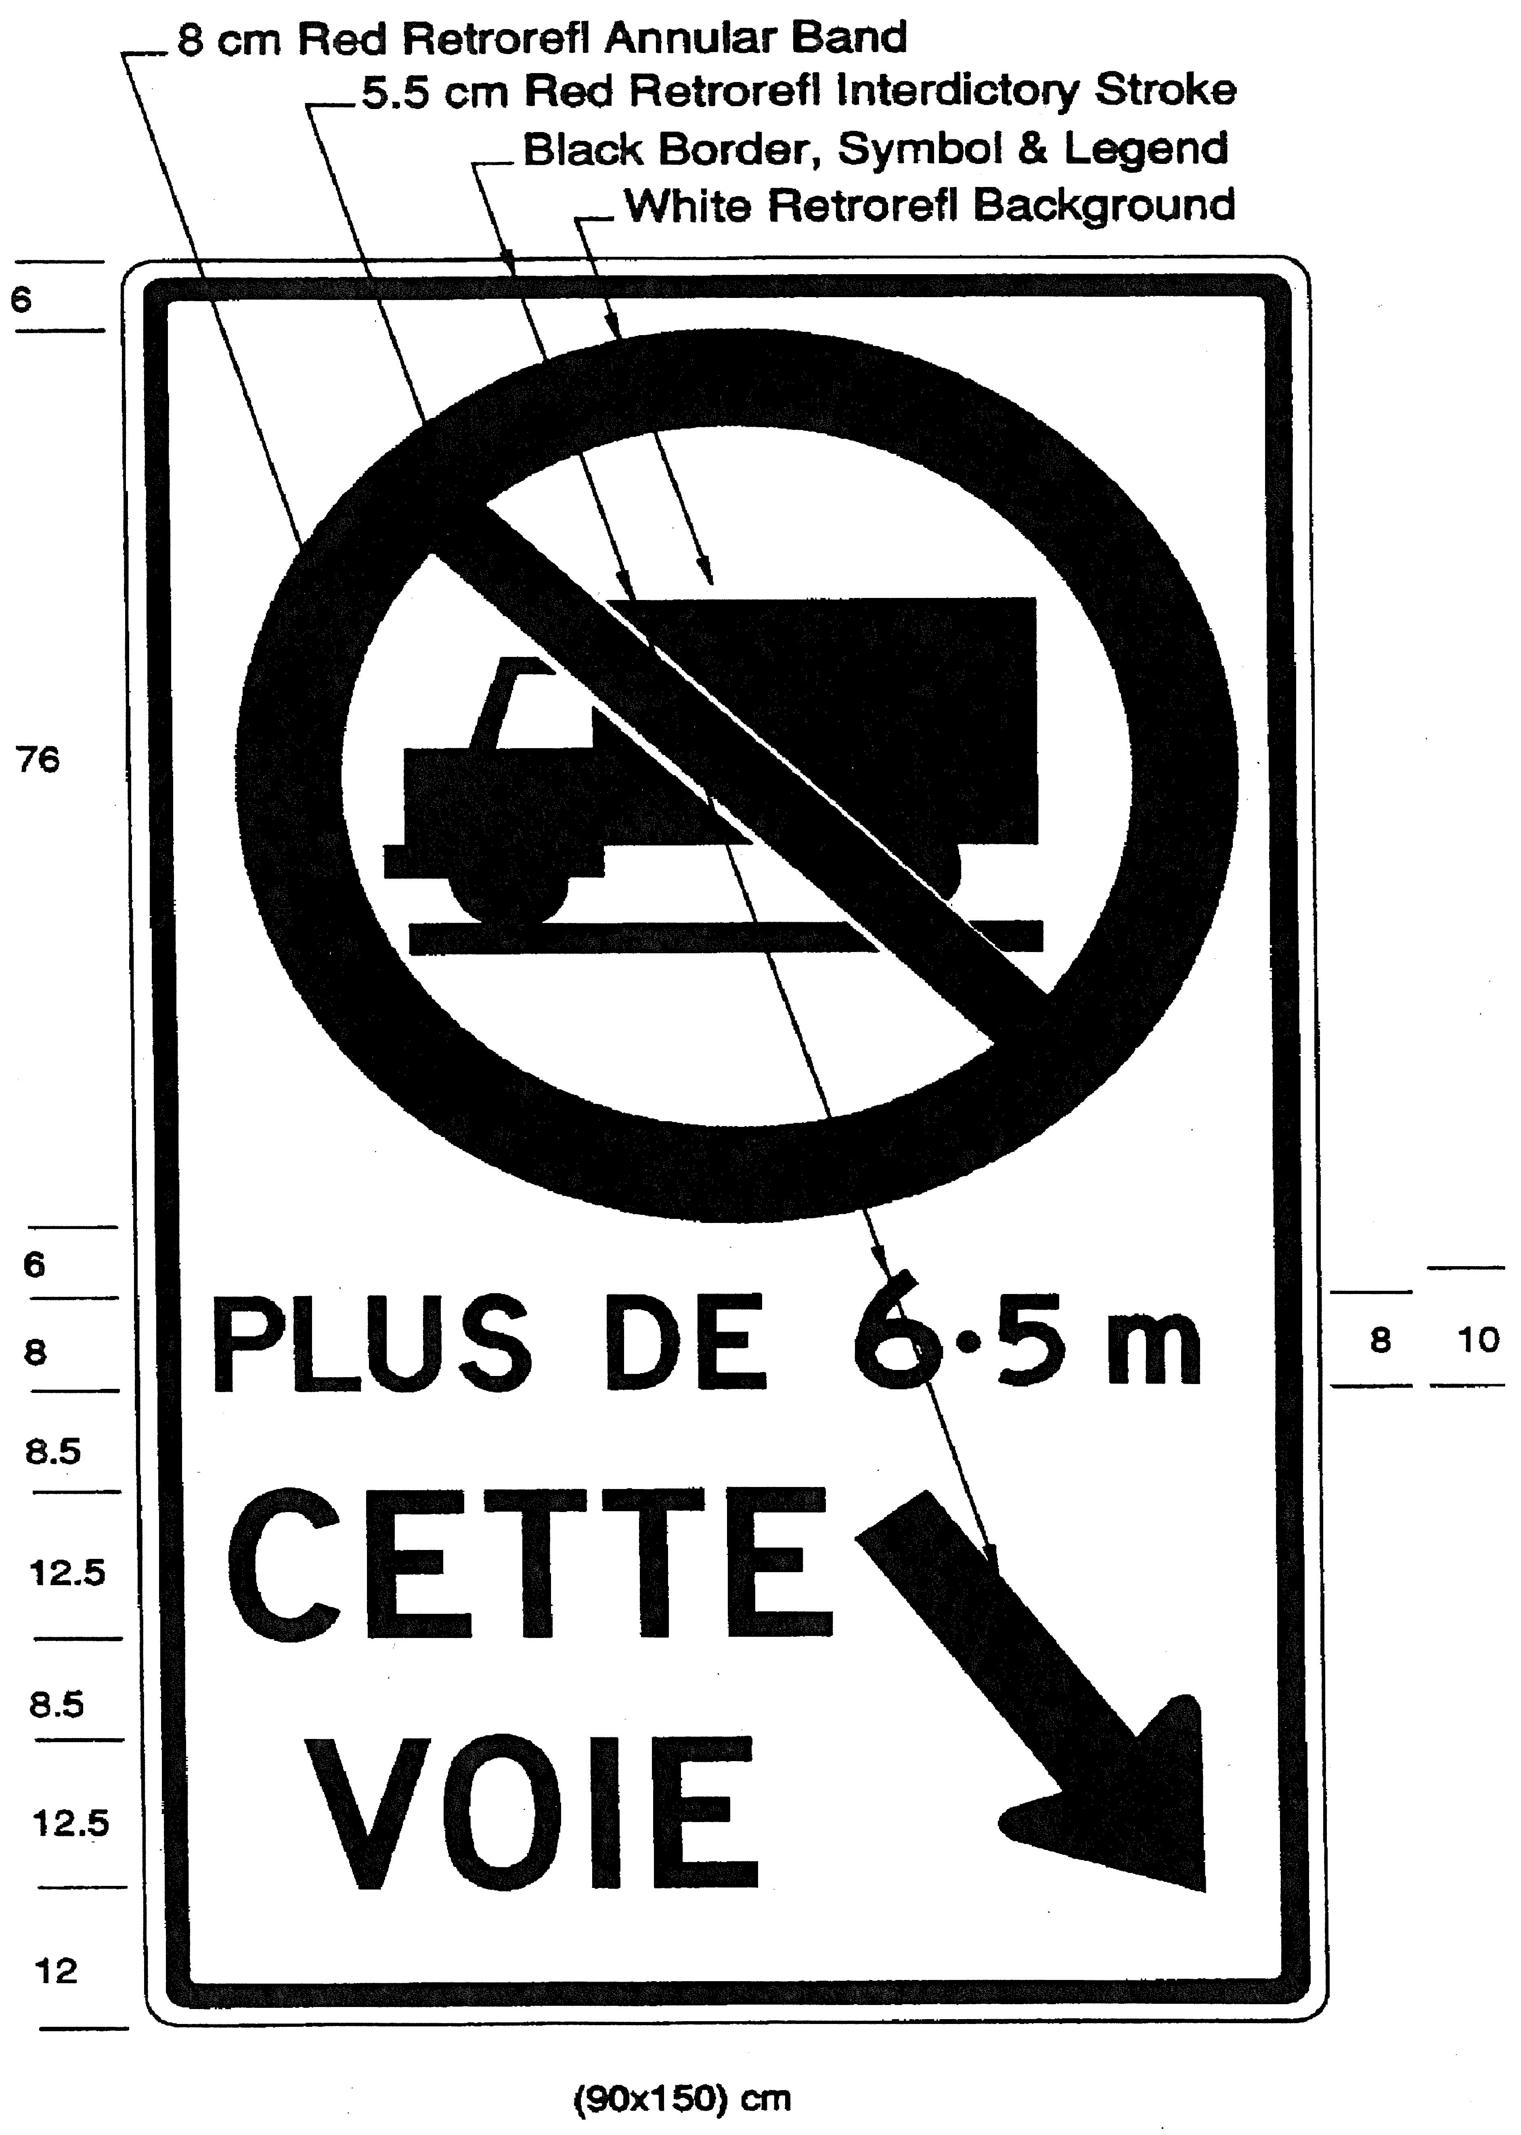
Text alternative: Illustration of a ground-mount sign containing an image at the top of a truck in a circle with an interdictory stroke “no” symbol. Below that appear the words “PLUS DE 6.5 m”. At the bottom of the sign on the left side appear the words “CETTE VOIE” and on the right side appears a thick black arrow pointing down and diagonally to the right. The sign has a white reflective background with the truck image, arrow and words appearing in black. The circular “no” symbol is in red. The following measurements are written below the sign: (90 x 150 cm). The sign is surrounded by measurements of its different elements. This text alternative is provided for convenience only and does not form part of the official law.
O. Reg. 442/93, s. 2; O. Reg. 619/05, s. 3 (2).
(2) The sign referred to in subsection (1) shall be erected not less than 1.5 metres or more than 2.5 metres above the level of the King’s Highway described in the Schedules. R.R.O. 1990, Reg. 608, s. 3 (2).
(3) The sign referred to in subsection (1.1) shall be erected not less than 1.5 metres or more than 2.5 metres above the level of the King’s Highway described in the Schedules and shall be erected in combination with the sign required by subsection (1), below it, to the right of it or up to 100 metres beyond it. O. Reg. 442/93, s. 2.
SCHEDULE 1
HIGHWAY NO. 400
1. That part of the King’s Highway known as No. 400 lying between a point situate at its intersection with the King’s Highway known as No. 401 in the City of Toronto and a point situate at its intersection with the King’s Highway known as No. 11 in the Township of Springwater.
O. Reg. 42/08, s. 1.
SCHEDULE 2
HIGHWAY NO. 401
1. That part of the King’s Highway known as No. 401 lying between a point situate at its intersection with the King’s Highway known as Nos. 35 and 115 in the Municipality of Clarington and a point situate at its intersection with the King’s Highway known as No. 8 in the City of Cambridge.
2. That part of the King’s Highway known as No. 401 lying between a point situate at its intersection with the King’s Highway known as No. 403 in the City of Woodstock and a point situate at its intersection with the roadway known as Wellington Road in the City of London.
3. That part of the King’s Highway known as No. 401 lying between a point situate 829 metres measured easterly from its intersection with the centre line of the roadway known as Oxford County Road 2 in the Township of Blandford-Blenheim and a point situate 1740 metres measured westerly from its intersection with the centre line of the roadway known as Wellington Road in the City of London.
4. That part of the King’s Highway known as No. 401 in the Town of Lakeshore lying between a point situate 603 metres measured easterly from its intersection with the centre line of the roadway known as Essex County Road 42 (also known as Queens Line) and a point situate 3425 metres measured westerly from its intersection with the centre line of the roadway known as Essex County Road 31 (also known as French Line Road).
5. That part of the King’s Highway known as No. 401 lying between a point situate 1281 metres measured easterly from its intersection with the centre line of the roadway known as Essex County Road 25 (also known as Puce Road) in the Town of Lakeshore and a point situate 1275 metres measured westerly from its intersection with the centre line of the roadway known as Essex County Road 19 (also known as Manning Road) in the Town of Tecumseh.
O. Reg. 42/08, s. 1; O. Reg. 384/08, s. 1.
SCHEDULE 3
HIGHWAY NO. 403
1. That part of the westbound lanes of the King’s Highway known as No. 403 in the City of Mississauga lying between a point situate at its intersection with the roadway known as Cawthra Road and a point situate at its intersection with the roadway known as Glen Erin Drive.
2. That part of the eastbound lanes of the King’s Highway known as No. 403 in the City of Mississauga lying between a point situate 910 metres measured westerly from its intersection with the centre line of the roadway known as Winston Churchill Boulevard and a point situate at its intersection with the roadway known as Eglinton Avenue East.
3. That part of the westbound lanes of the King’s Highway known as No. 403 lying between a point situate at its intersection with the roadway known as King Road in the City of Burlington and a point situate at its intersection with the roadway known as Golf Links in the City of Hamilton.
O. Reg. 42/08, s. 1.
SCHEDULE 4
HIGHWAY NO. 404
1. That part of the King’s Highway known as No. 404 lying between a point situate at its intersection with the roadway known as Van Horne Avenue in the City of Toronto and a point situate 1400 metres measured southerly from its intersection with the centre line of the roadway known as Aurora Road in the Town of Aurora.
O. Reg. 42/08, s. 1.
SCHEDULE 5
HIGHWAY NO. 407
1. That part of the King’s Highway known as No. 407 lying between a point situate at its intersection with the King’s Highway known as No. 401 in the Town of Halton Hills and a point situate at its intersection with the roadway known as Markham Road in the Town of Markham.
2. That part of the King’s Highway known as No. 407 lying between a point situate at its intersection with the King’s Highway known as the Queen Elizabeth Way in the City of Burlington and a point situate at its intersection with the King’s Highway known as No. 403 in the Town of Oakville.
O. Reg. 42/08, s. 1.
SCHEDULE 6
HIGHWAY NO. 409
1. That part of the King’s Highway known as No. 409 in the City of Toronto lying between a point situate at its intersection with the King’s Highway known as No. 401 and a point situate at its intersection with the roadway known as Carlingview Drive.
O. Reg. 42/08, s. 1.
SCHEDULE 7
HIGHWAY NO. 410
1. That part of the King’s Highway known as No. 410 lying between a point situate at its intersection with the King’s Highway known as No. 401 in the City of Mississauga and a point situate at its intersection with the roadway known as Bovaird Drive in the City of Brampton.
O. Reg. 42/08, s. 1.
SCHEDULE 8
HIGHWAY NO. 417
1. That part of the westbound lanes of the King’s Highway known as No. 417 in the City of Ottawa lying between a point situate 610 metres measured easterly from its intersection with the centre line of the roadway known as Eagleson Road and a point situate 346 metres measured easterly from its intersection with the roadway known as St. Laurent Boulevard.
2. That part of the eastbound lanes of the King’s Highway known as No. 417 in the City of Ottawa lying between a point situate 116 metres measured easterly from its intersection with the centre line of the roadway known as Eagleson Road and a point situate at its intersection with the roadway known as St. Laurent Boulevard.
O. Reg. 42/08, s. 1; O. Reg. 366/11, s. 1.
SCHEDULE 9
HIGHWAY NO. 427
1. That part of the southbound lanes of the King’s Highway known as No. 427 in the City of Toronto lying between a point situate at its intersection with the roadway known as Finch Avenue and a point situate at its intersection with the roadway known as Airport Road where Airport Road continues as Dixon Road.
2. That part of the northbound lanes of the King’s Highway known as No. 427 in the City of Toronto lying between a point situate at its intersection with the roadway known as Renforth Drive and a point situate at its intersection with the roadway known as Clubhouse Road.
3. That part of the King’s Highway known as No. 427 in the City of Toronto lying between a point situate at its intersection with the roadway known as Rathburn Road and a point situate at its intersection with the roadway known as Dundas Street West.
O. Reg. 42/08, s. 1.
SCHEDULE 10
QUEEN ELIZABETH WAY
1. That part of the eastbound lanes of the King’s Highway known as the Queen Elizabeth Way lying between a point situate 1500 metres measured westerly from its intersection with the centre line of the roadway known as Ford Drive in the Town of Oakville and a point situate 25 metres measured westerly from its intersection with the centre line of the roadway known as The East Mall in the City of Toronto.
2. That part of the westbound lanes of the King’s Highway known as the Queen Elizabeth Way lying between a point situate 25 metres measured westerly from its intersection with the centre line of the roadway known as The East Mall in the City of Toronto and a point situate 500 metres measured westerly from its intersection with the centre line of the roadway known as Ford Drive in the Town of Oakville.
3. That part of the eastbound lanes of the King’s Highway known as the Queen Elizabeth Way lying between a point situate 500 metres measured northerly from its intersection with the roadway known as North Shore Boulevard in the City of Burlington and a point situate 800 metres measured westerly from its intersection with the roadway known as Glendale Avenue in the Town of Niagara-on-the-Lake.
4. That part of the westbound lanes of the King’s Highway known as the Queen Elizabeth Way lying between a point situate at its intersection with the centre line of the roadway known as Mountain Road in the City of Niagara Falls and a point situate 500 metres measured northerly from its intersection with the roadway known as North Shore Boulevard in the City of Burlington.
5. That part of the eastbound lanes of the King’s Highway known as the Queen Elizabeth Way lying between a point situate 1120 metres measured easterly from its intersection with the roadway known as Glendale Avenue in the Town of Niagara-on-the-Lake and a point situate at its intersection with the centre line of the roadway known as Mountain Road in the City of Niagara Falls.
O. Reg. 42/08, s. 1; O. Reg. 408/11, s. 1.
SCHEDULE 11
QUEEN ELIZABETH WAY AND HIGHWAY NO. 403
1. That part of the eastbound lanes of the King’s Highway known as the Queen Elizabeth Way and No. 403 lying between a point situate 785 metres measured westerly from its intersection with the centre line of the roadway known as Guelph Line in the City of Burlington and a point situate 1500 metres measured westerly from its intersection with the centre line of the roadway known as Ford Drive in the Town of Oakville.
2. That part of the westbound lanes of the King’s Highway known as the Queen Elizabeth Way and No. 403 lying between a point situate 500 metres measured westerly from its intersection with the centre line of the roadway known as Ford Drive in the Town of Oakville and a point situate 15 metres measured easterly from its intersection with the centre line of the roadway known as Walkers Line in the City of Burlington.
O. Reg. 42/08, s. 1; O. Reg. 460/11, s. 1.

Back to top

