Highway Traffic Act
Code de la route
R.R.O. 1990, REGULATION 612
SCHOOL BUSES
Historical version for the period December 16, 2008 to April 5, 2010.
Last amendment: O. Reg. 450/08.
This Regulation is made in English only.
1. (1) Every school bus, as defined in subsection 175 (1) of the Act, that is registered in Ontario shall,
(a) display the words “school bus” on the front and rear thereof placed as near as is practicable to the top of the vehicle in a clearly visible position in black letters at least 200 millimetres high with the lines forming the letters being at least 32 millimetres wide on a yellow background;
(b) display the words “do not pass when signals flashing” on the rear thereof placed below and as near as is practicable to the words “school bus” in a clearly visible position in black letters not less than 75 and not more than 125 millimetres high with the lines forming the letters having a width of not less than one-sixth of the height of the letters on a yellow background;
(c) be equipped with signal lights that have an effective illuminating area of at least 120 square centimetres, that produce a light of an intensity that is clearly visible at a distance of at least 150 metres and that are attached and operated as follows:
1. One or two signal lights shall be placed on each side of the front of the bus in as high a position as is practicable and only one light on each side shall operate at a time so as to produce flashes of red light alternately on opposite sides of the bus that are visible only from the front of the bus.
2. One or two signal lights shall be placed on each side of the rear of the bus in as high a position as is practicable and as far apart as is practicable and only one light on each side shall operate at a time so as to produce flashes of red light alternately on opposite sides of the bus that are visible only from the rear of the bus.
3. In the case of a school bus equipped with two signal lights on each side, the two innermost signal lights shall be actuated when the school bus is about to stop on a highway for a purpose described in clause 175 (6) (a) of the Act and the two outermost signal lights shall be actuated while the school bus is stopped on a highway as described in clause 175 (6) (c) of the Act.
4. The signal lights shall be actuated by a control device accessible to the driver and equipped to give the driver a clear and unmistakable signal either visible or audible when the signal lights are operating;
(d) be equipped with a first aid kit,
(i) in the case of a school bus manufactured in accordance or modified to comply with Canadian Standards Association Standard D250-98 or D250-03, that complies with the Standard to which it was manufactured or modified, or
(ii) in the case of a school bus not manufactured in accordance or modified to comply with Canadian Standards Association Standard D250-98 or D250-03, that either complies with one of those Standards or consists of a sturdy dustproof metal or plastic container containing,
(A) four packets each containing four hand cleansers and 12 gauze cleansing pads,
(B) 150 individually wrapped 25 millimetre by 75 millimetre adhesive dressings,
(C) eight 50 millimetre compress dressings,
(D) six 100 millimetre compress dressings,
(E) two eye dressing kits each containing one eye shield and two gauze pads,
(F) three four-ply gauze dressings at least 900 millimetres square,
(G) two 50 millimetre by 5.5 metre gauze bandages,
(H) one packet of 25 millimetre by 4.6 metre adhesive tape,
(I) six triangular bandages,
(J) one 70 millimetre by 610 millimetre rolled metal splint,
(K) one pair of scissors,
(L) one pair of sliver tweezers, and
(M) twelve 50 millimetre safety pins;
(e) be equipped with an interior mirror designed and adjusted to provide the seated driver with a view of the passengers, and,
(i) in the case of a school bus manufactured on or after November 30, 1997, comply with Canada Motor Vehicle Safety Standard 111 as it read when the school bus was manufactured, including being equipped with,
(A) two rear-view exterior mirrors on each side of the bus, one flat and one convex, and
(B) two convex cross-view exterior mirrors consisting of one mirror on each front corner of the school bus, or
(ii) in the case of a school bus manufactured before November 30, 1997, having a seating capacity for 24 or more passengers, be equipped with,
(A) a convex cross-over exterior mirror, at least 190 millimetres in diameter, securely mounted and adjusted so that the seated driver may see the reflection of the area immediately in front of the front bumper of the bus,
(B) a convex right front side-view exterior mirror, securely mounted and adjusted on the roof, right windshield corner post or exterior right rear-view mirror so that the seated driver may observe the reflection of the ground surface immediately adjacent to the right front wheel of the bus, and
(C) exterior mirrors securely mounted and adjusted on each side of the vehicle in such a position to afford the seated driver a clearly reflected view of the roadway in the rear and of any vehicle approaching from the rear;
(f) in the case of a school bus manufactured on or after the 1st day of September, 1975, having a seating capacity for twenty-four or more passengers, have,
(i) the chassis and the front bumper painted black, and
(ii) the hood, grill and outside surfaces that are in direct line with the seated driver’s vision painted lustreless black; and
(g) in the case of a school bus manufactured on or after the 1st day of December, 1982, have,
(i) the chassis and the front bumper painted black, and
(ii) the hood, grill and outside surfaces that are in direct line with the seated driver’s vision painted lustreless black. R.R.O. 1990, Reg. 612, s. 1 (1); O. Reg. 319/91, s. 1 (2); O. Reg. 307/00, s. 1; O. Reg. 308/04, s. 1 (1-4); O. Reg. 450/08, s. 1.
(1.1) Every school bus referred to in subsection (1) and registered in Ontario shall display,
(a) a sign affixed to the bottom of the left window on the rear of the school bus that has the dimensions and bears the markings as illustrated in Figure 1; and
(b) a sign affixed to the bottom of the right window on the rear of the bus that has the dimensions and bears the markings as illustrated in Figure 2.
Figure 1
Insert regs\Graphics\Source Law\2004\308\308fg01ae.tif
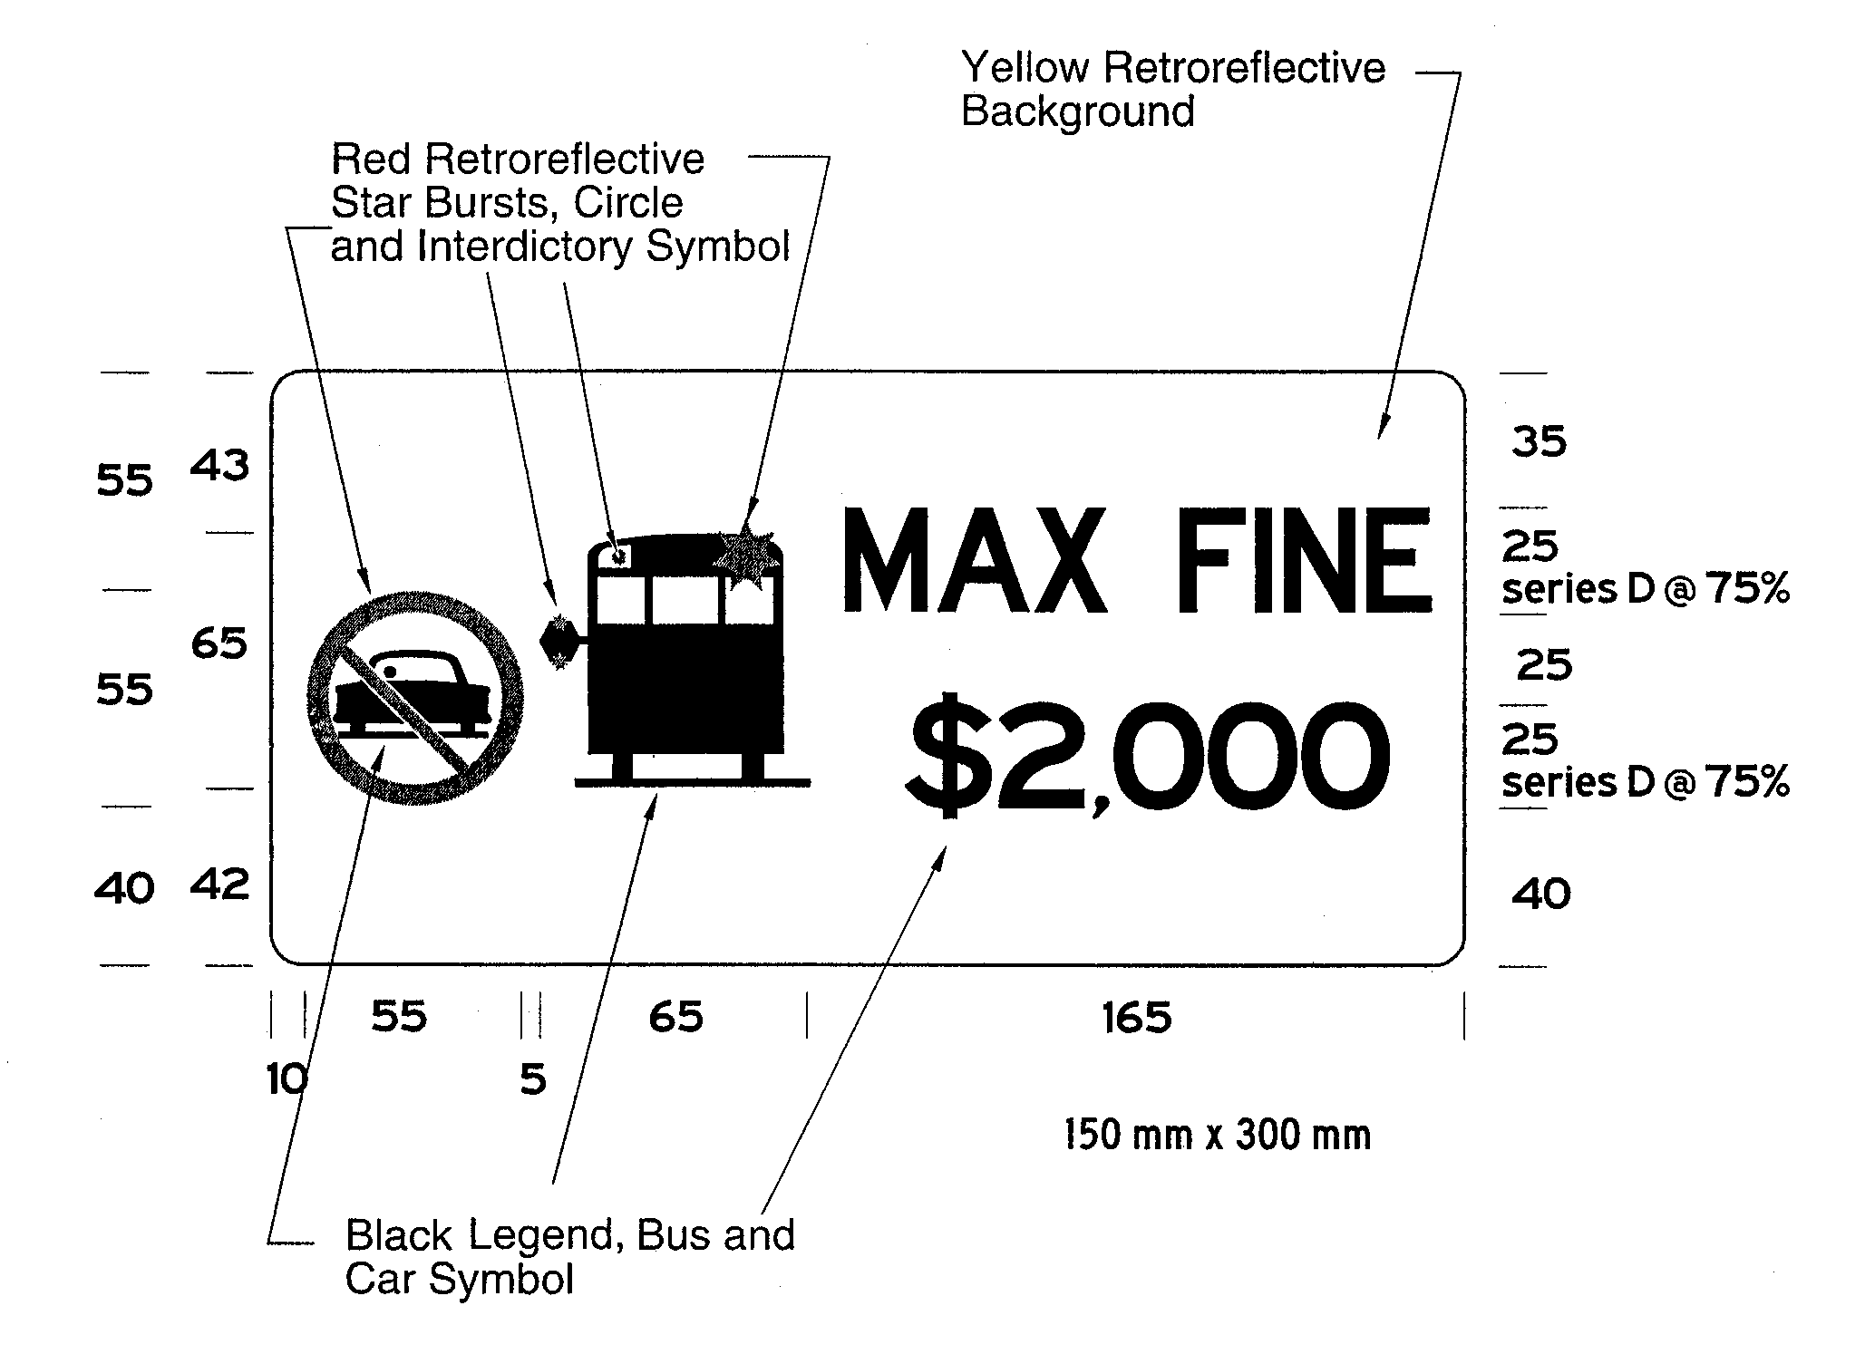
Figure 2
Insert regs\Graphics\Source Law\2004\308\308fg02af.tif
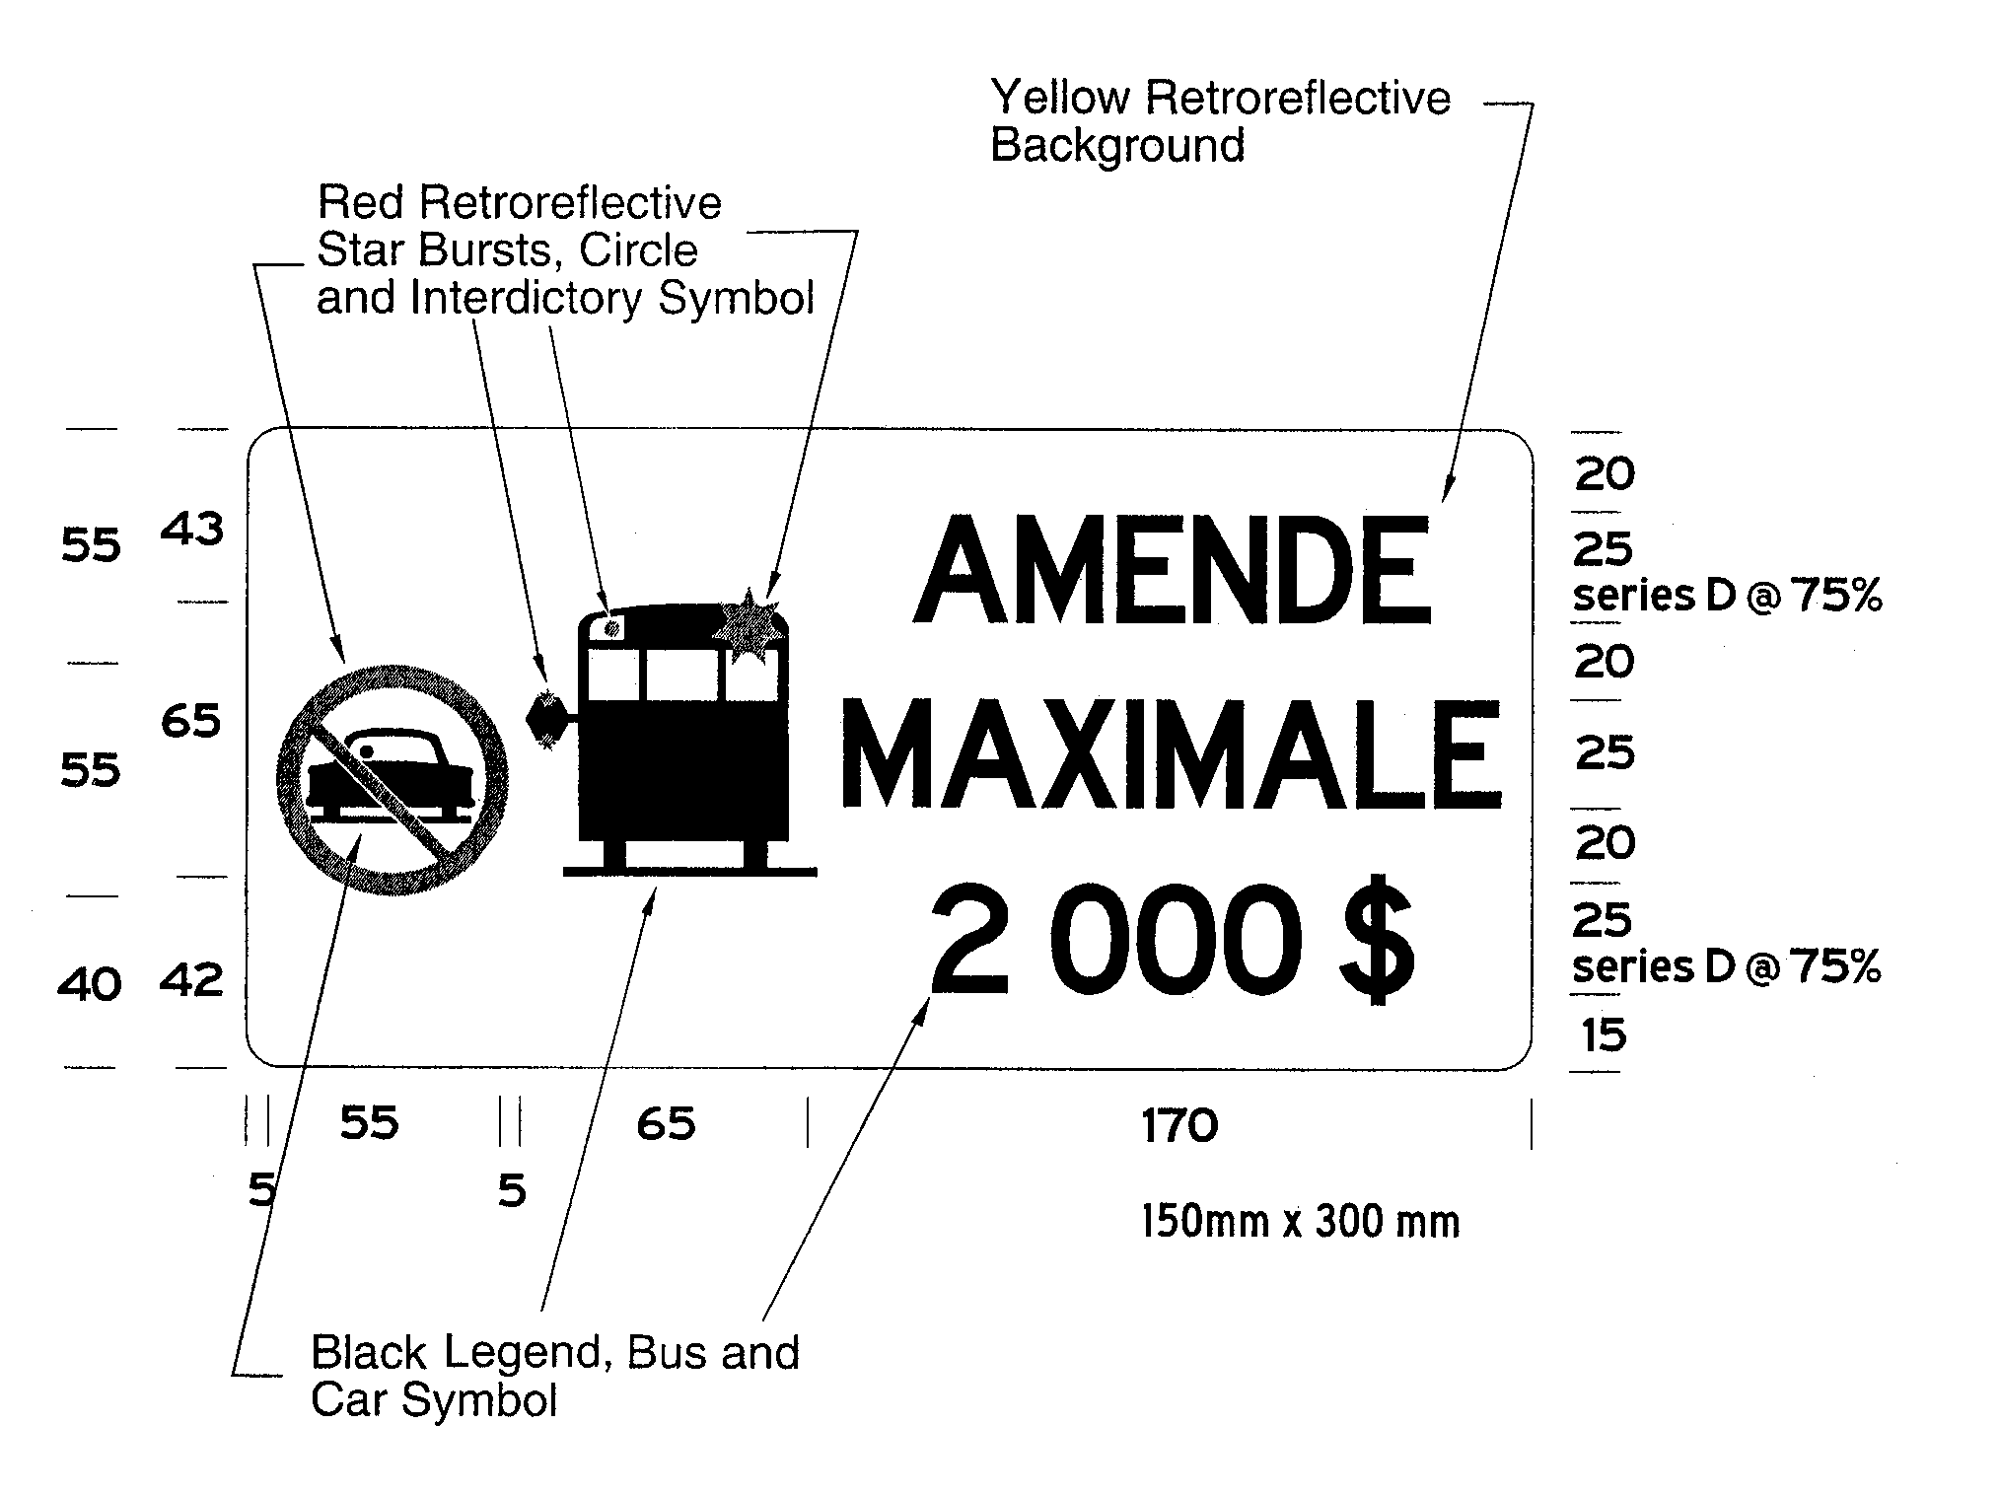
O. Reg. 308/04, s. 1 (5).
(1.2) If the dimensions of the left or right window on the rear of a school bus cannot accommodate either or both of the signs as required by subsection (1.1), both signs shall be affixed to the rear bumper directly below the locations prescribed by clauses (1.1) (a) and (b). O. Reg. 308/04, s. 1 (5).
(1.3) The signs affixed in accordance with subsection (1.1) or (1.2) must be visible at all times to vehicles approaching from the rear of the school bus and shall not be obstructed by any part of or attachment to the school bus. O. Reg. 308/04, s. 1 (5).
(1.4) The signs required by subsection (1.1) must meet the performance requirements of any of the types of sheeting specified in the American Society for Testing and Materials Standard D 4956-01a and the sheeting must have a Luminance Factor (Y%) of at least 15. O. Reg. 308/04, s. 1 (5).
(2) Every school bus referred to in subsection (1) shall be equipped with a stop arm device that complies with the requirements set out in subsection (3). R.R.O. 1990, Reg. 612, s. 1 (2).
(3) A stop arm device shall,
(a) be at least 450 millimetres high and 450 millimetres wide and octagonal in shape;
(b) display on the front and rear thereof the word “STOP” in white letters at least 150 millimetres high with the lines forming the letters being at least twenty millimetres wide on a red reflectorized background;
(c) be equipped with double-faced lamps located in the top and bottom portions of the stop arm, one above the other, that are automatically activated so as to produce alternating flashes of red light, visible to the front and rear of the bus, at the commencement of the stop arm cycle and deactivated when the stop arm is retracted;
(d) be installed on the left outside of the bus body and be mounted so as to be readily seen by motorists approaching from the front or rear of the bus when the stop arm is in the extended position;
(e) operate automatically so as to move to the fully extended position when the service door of the bus is opened and return to the retracted position when the door is closed; and
(f) operate only when the alternating light circuit on the front and rear of the bus is energized. R.R.O. 1990, Reg. 612, s. 1 (3).
(3.1) Every school bus referred to in subsection (1) that was manufactured before January 1, 2005 shall be equipped with a pedestrian-student safety crossing arm that,
(a) is mounted on the right front corner of the chassis;
(b) measures, from its arm assembly pivot point,
(i) a minimum of 1.78 metres, or
(ii) that length that is less than 1.78 metres such that, when retracted, it extends to the left edge of the front of the body of the school bus, but not beyond that point, if the length required by subclause (i) would result in the arm, when retracted, extending beyond the left edge of the front of the body of the school bus;
(c) operates automatically so as to move to the extended position when the stop arm device required by subsection (2) is operated and returns to the retracted position when the stop arm device is retracted;
(d) operates electrically or by means of an air-pressure or vacuum system;
(e) is designed to operate in temperatures of -50° C or higher; and
(f) may have a system to override its operation as described in clause (c) to allow for off-street or confined parking. O. Reg. 129/07, s. 1.
(4) Revoked: O. Reg. 198/07, s. 1.
2. (1) No person shall operate or permit the operation of a school bus registered in Ontario unless the school bus was manufactured in accordance with,
(a) in the case of a school bus manufactured on or after December 1, 1982 and before September 1, 1987, Canadian Standards Association Standard D250-M 1982 or D250-M 1985;
(b) in the case of a school bus manufactured on or after September 1, 1987 and before June 1, 2000, Canadian Standards Association Standard D250-M 1985 or D250-98;
(c) in the case of a school bus manufactured on or after June 1, 2000 and before January 1, 2005, Canadian Standards Association Standard D250-98 or D250-03;
(d) in the case of a school bus manufactured on or after January 1, 2005, Canadian Standards Association Standard D250-03. O. Reg. 307/00, s. 2; O. Reg. 308/04, s. 2 (1).
(2) Subsection (1) does not apply to a school bus that was registered in a jurisdiction other than Ontario before it was registered in Ontario and that is registered in Ontario on December 1, 2008 if the school bus has been modified to comply with the appropriate Canadian Standards Association Standard for the school bus depending on its date of manufacture, as set out in subsection (1). O. Reg. 450/08, s. 2.
(3) On and after August 15, 2009, no person shall operate or permit the operation of a school bus described in subsection (2) unless the school bus has been inspected by a person approved by the Minister or belonging to a class of persons approved by the Minister and certified by that person to have been modified to comply with the appropriate Canadian Standards Association Standard for the school bus depending on its date of manufacture, as set out in subsection (1). O. Reg. 450/08, s. 2.
(4) The inspection and certification required by subsection (3) must be completed and issued before November 1, 2009. O. Reg. 450/08, s. 2.
(5) No person shall operate or permit the operation of a school bus registered in Ontario and manufactured in accordance or modified to comply with Canadian Standards Association Standard D250-98 or D250-03 unless the school bus continues to meet the Standard to which it was manufactured or modified. O. Reg. 450/08, s. 2.
3. (1) No bus shall be operated by or under contract with a school board or other authority in charge of a school to transport adults with a developmental disability or children and no bus shall be operated unless,
(a) Revoked: O. Reg. 307/00, s. 3.
(b) it is equipped with tire chains or snow tires for each driving wheel that is not of the dual type that are placed on the wheels when the conditions of the highway require their use;
(c) it is equipped with an accurate speedometer placed to indicate to the driver the speed of the vehicle at all times;
(d) it has a body floor constructed and insulated to prevent exhaust gases of the engine from entering the passenger compartment of the vehicle;
(e) it is equipped with two windshield wipers that operate at a constant speed and an effective defrosting device that provides clear vision through the windshield and the windows on the left and right sides of the driver;
(f) it is equipped with a light or lights arranged to provide light to the whole of the interior except the driver’s position, and that are constantly lighted during darkness when there are passengers in the vehicle;
(g) it is equipped with an axe or clawbar and an adequate fire extinguisher both securely mounted in such a manner and place as to be readily accessible;
(h) it is equipped with dependable tires that in the case of front tires have not been rebuilt;
(i) it is equipped with at least one door or exit and,
(i) a door or exit for emergency use situated at the rear of the vehicle or near the rear on the left side of the vehicle and which has a door lock equipped with an interior handle which releases the lock when lifted up, or
(ii) subject to subsection (2), at least three pushout windows on each side of the passenger compartment of the vehicle each of which,
(A) has a minimum height of 500 millimetres and a minimum width of 760 millimetres,
(B) is designed, constructed and maintained to open outwards when a reasonable amount of manual force is applied to the inside of the window, and
(C) displays on or adjacent to the window adequate directions for its emergency use.
R.R.O. 1990, Reg. 612, s. 3 (1); O. Reg. 319/91, s. 2; O. Reg. 307/00, s. 3, O. Reg. 66/02, s. 2.
(2) A motor vehicle that is equipped in accordance with subclause (1) (i) (ii) shall be equipped with an additional pushout window located in the rear of the vehicle. R.R.O. 1990, Reg. 612, s. 3 (2).
4., 5. Revoked: O. Reg. 198/07, s. 2.
6. For the purposes of this Regulation, the date that a school bus was manufactured shall be deemed, in the absence of evidence to the contrary, to be the date on the school bus’s compliance label. O. Reg. 307/00, s. 4.
Schedules 1, 2 Revoked: O. Reg. 198/07, s. 3.

Back to top

