Juries Act
R.R.O. 1990, REGULATION 680
GENERAL
Historical version for the period August 14, 2009 to June 9, 2010.
Last amendment: O. Reg. 311/09.
This is the English version of a bilingual regulation.
1. The jury service notice and return to the jury service notice referred to in subsection 6 (1) of the Act shall be in Form 1. R.R.O. 1990, Reg. 680, s. 1.
2. The jury roll referred to in section 7 of the Act shall be in Form 2. R.R.O. 1990, Reg. 680, s. 2.
3. The precept referred to in section 12 of the Act shall be in Form 3. R.R.O. 1990, Reg. 680, s. 3.
4. The summons referred to in subsection 19 (1) of the Act shall be in Form 4. R.R.O. 1990, Reg. 680, s. 4.
5. The notice that the attendance of jurors is not required referred to in subsection 21 (1) of the Act shall be in Form 5. R.R.O. 1990, Reg. 680, s. 5.
6. The notice referred to in subsection 21 (2) of the Act shall be in Form 6. R.R.O. 1990, Reg. 680, s. 6.
7. The notice to a juror that his or her attendance is not required referred to in subsection 21 (3) of the Act shall be in Form 7. R.R.O. 1990, Reg. 680, s. 7.
8. The notice to a juror that his or her attendance is not required until a day specified referred to in subsection 21 (3) of the Act shall be in Form 8. R.R.O. 1990, Reg. 680, s. 8.
9. The jury panel lists referred to in section 18 of the Act shall be in Form 9. R.R.O. 1990, Reg. 680, s. 9.
10. The following areas are established as jury areas:
1. The Timmins Jury Area, consisting of that part of Dundonald Township that is within the municipal boundary of the City of Timmins, those parts of Walker Township and Benoit Township that are within the Municipality of Black River-Matheson, as well as all of the following townships: Adams; Beatty; Black; Blackstock; Bond; Bowman; Bristol; Byers, Cote; Carman; Carr; Carscallen; Cody; Cook; Cowan; Currie; Deloro; Denton; Egan; Eldorado; Evelyn; Flayfair; German; Godfrey; Hislop; Hoyle; Jamieson; Jessop; Keefer; Kidd; Langmuir; Loveland; MacDiarmid; Macklem; Massey; Matheson; McCann; McEvay; Melba; Mountjoy; Murphy; Ogden; Price; Robb; Shaw; Sheraton; Stock; Taylor; Thomas; Thorneloe; Timmins; Tisdale; Tolstoi; Turnbull; Wark; Whitesides; Whitney.
2. The Cochrane Jury Area, consisting of all territory in the District of Cochrane other than the territory described in paragraph 1. O. Reg. 334/96, s. 1.
Form 1/
Formule 1
QUESTIONNAIRE AS TO QUALIFICATIONS FOR JURY SERVICE/
Questionnaire concernant les qualitÉs requises pour remplir les fonctions de jurÉ
Juries Act/
Loi sur les jurys
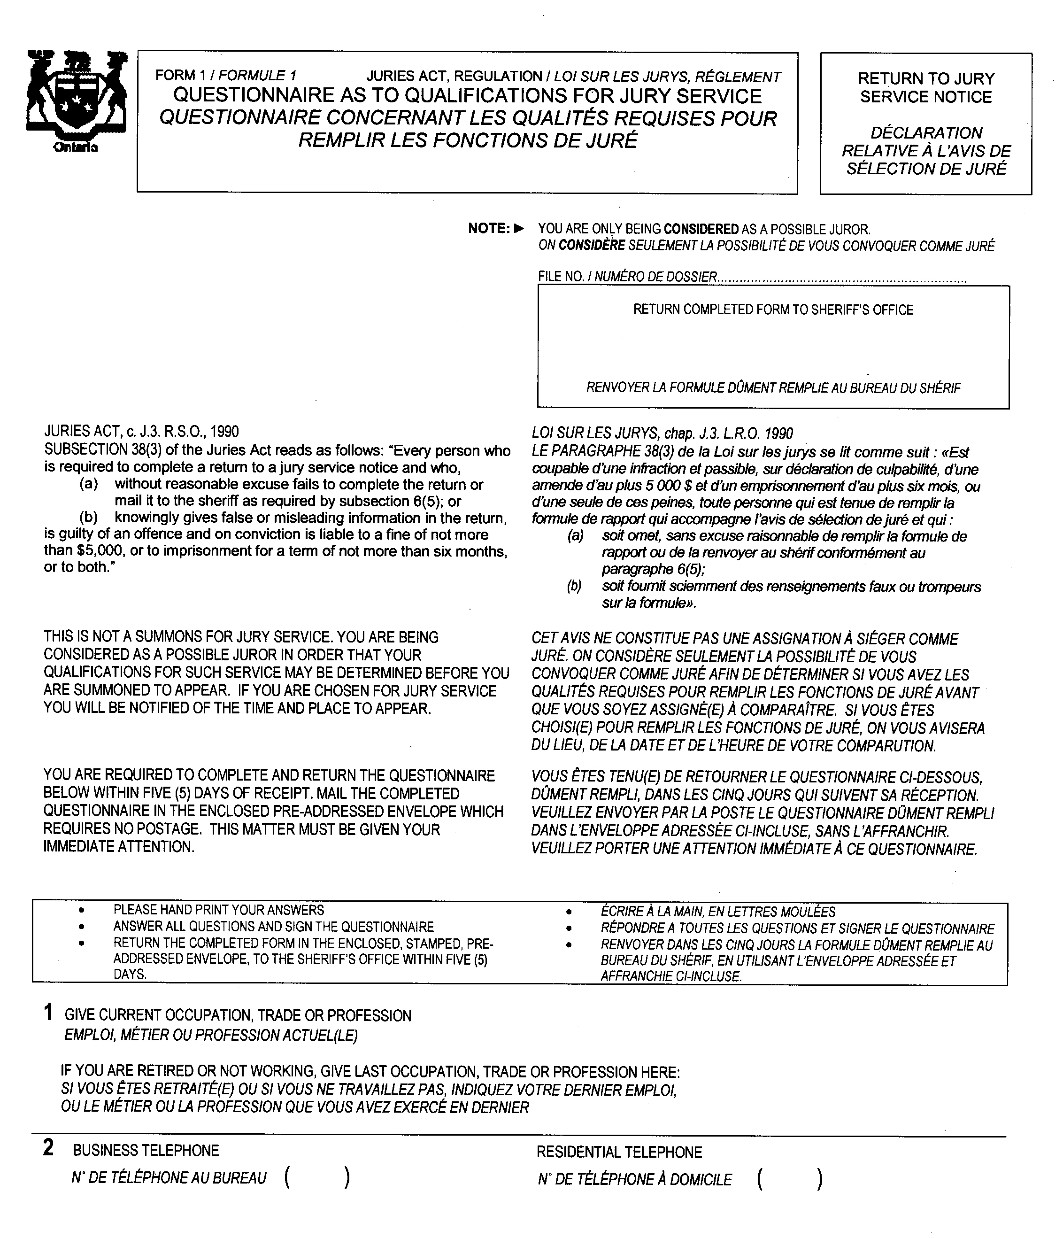
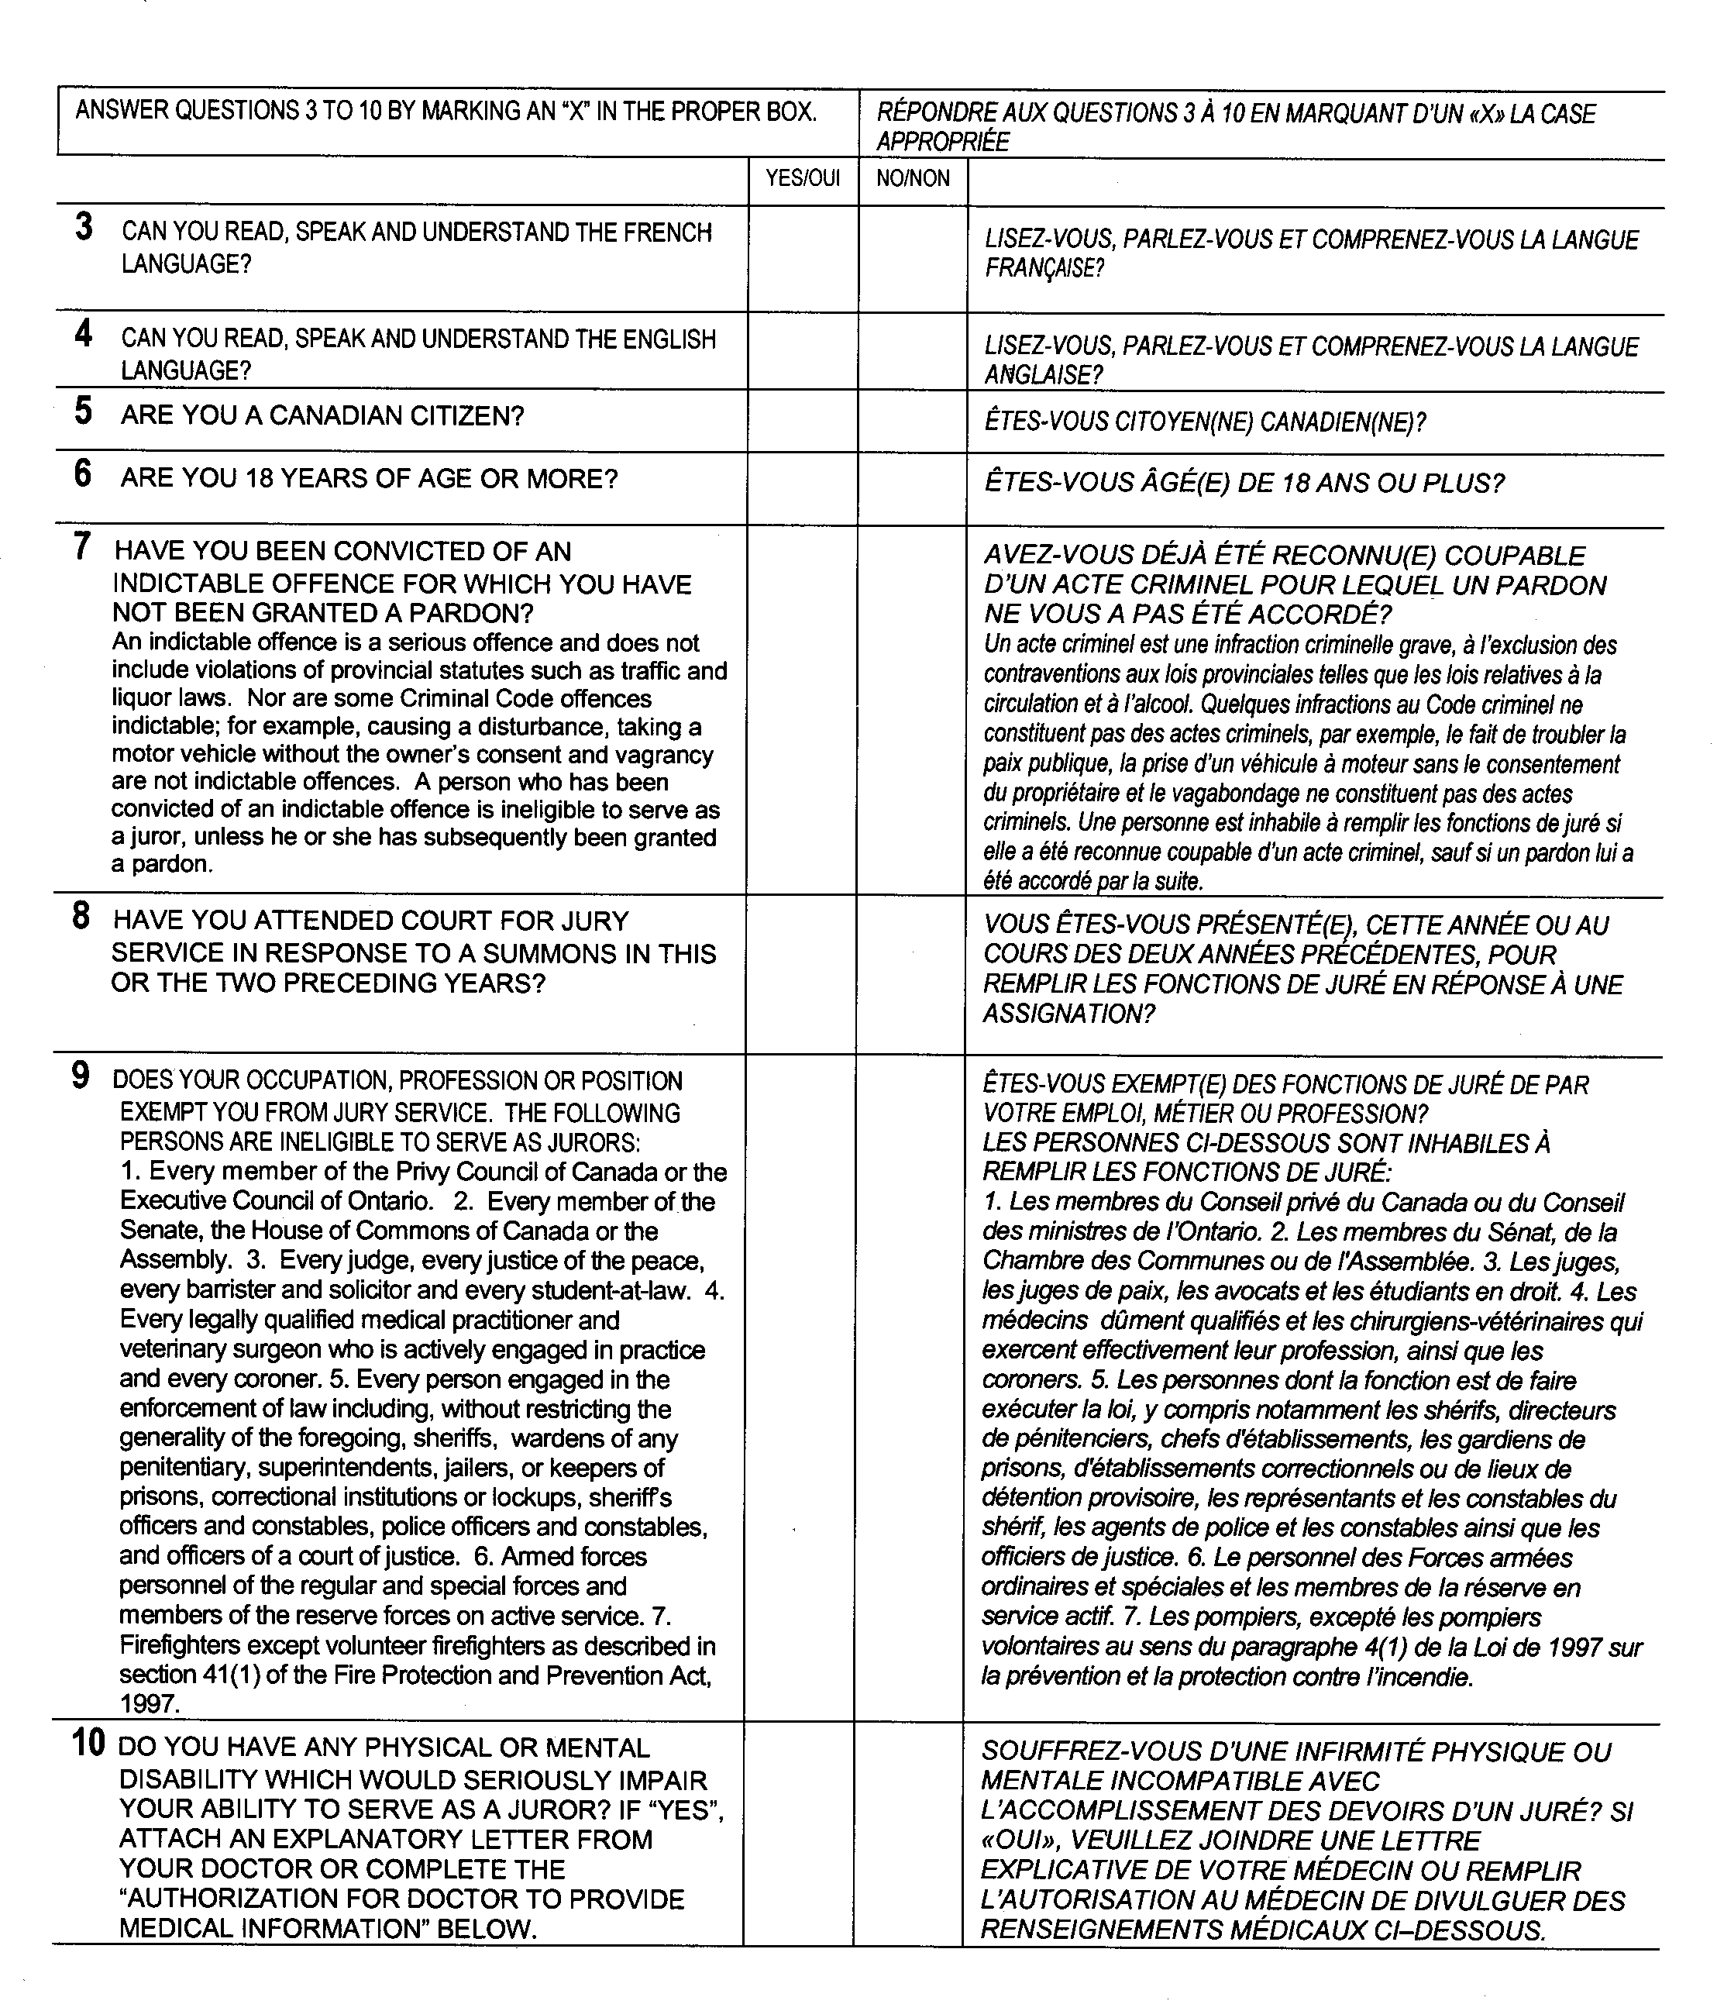
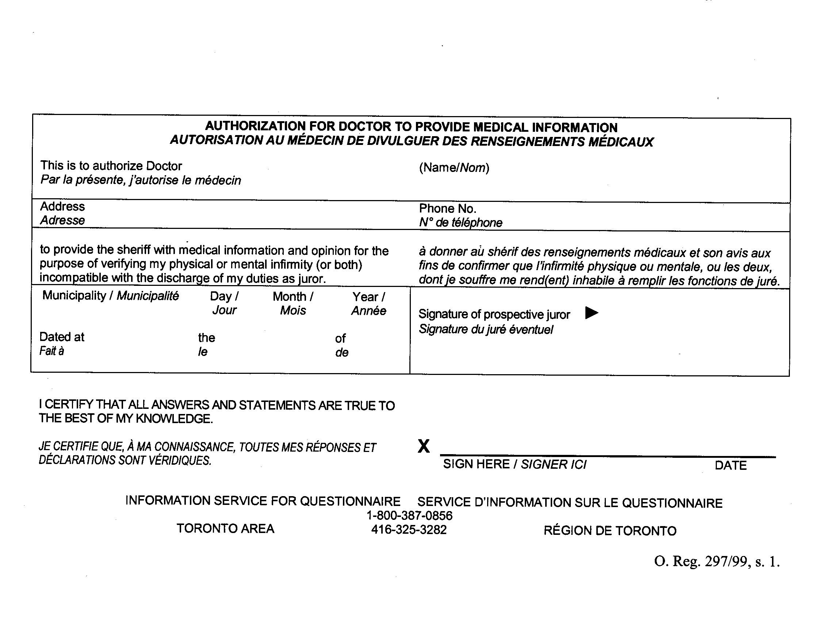
O. Reg. 297/99, s. 1.
Form 2
JURY ROLL
Juries Act
Insert regs\graphics\1990\680\680002au.tif
R.R.O. 1990, Reg. 680, Form 2.
Form 3
PRECEPT FROM JUDGE TO SHERIFF
Juries Act
Insert regs\graphics\1990\680\680003au.tif

R.R.O. 1990, Reg. 680, Form 3.
Form 4/
Formule 4
Juries Act/
Loi sur les jurys
Insert regs\graphics\1990\680\680004ab.tif
Insert regs\graphics\1990\680\680004bb.tif
R.R.O. 1990, Reg. 680, Form 4.
Form 5
NOTICE TO SHERIFF REGARDING NUMBER OF JURORS REQUIRED
Juries Act
Insert regs\graphics\1990\680\680005au.tif
R.R.O. 1990, Reg. 680, Form 5.
Form 6
NOTICE TO SHERIFF REGARDING NUMBER OF JURORS REQUIRED ON OPENING DAY
Juries Act
Insert regs\graphics\1990\680\680006au.tif
R.R.O. 1990, Reg. 680, Form 6.
Form 7
NOTICE TO JUROR REGARDING CANCELLATION OF SUMMONS
Juries Act
Insert regs\graphics\1990\680\680007au.tif
Insert regs\graphics\1990\680\680007bu.tif
R.R.O. 1990, Reg. 680, Form 7.
Form 8
NOTICE TO JUROR REGARDING AMENDMENT OF DATE TO REPORT FOR SERVICE
Juries Act
Insert regs\graphics\1990\680\680008au.tif
R.R.O. 1990, Reg. 680, Form 8.
Form 9
JURY PANELS FOR THE ONTARIO COURT (GENERAL DIVISION)
Juries Act
Insert regs\graphics\1990\680\680009au.tif
Insert regs\graphics\1990\680\680009bu.tif
R.R.O. 1990, Reg. 680, Form 9.

Back to top

